Australian Public Assessment Report for Opsynvi
  - Active ingredient/s: Macitentan, tadalafil
  - Sponsor: Janssen-Cilag Pty Ltd
June 2025

About the Therapeutic Goods Administration (TGA)
- The Therapeutic Goods Administration (TGA) is part of the Australian Government Department of Health, Disability and Ageing and is responsible for regulating therapeutic goods, including medicines, medical devices, and biologicals.
- The TGA administers the Therapeutic Goods Act 1989 (the Act), applying a risk management approach designed to ensure therapeutic goods supplied in Australia meet acceptable standards of quality, safety, and efficacy.
- The work of the TGA is based on applying scientific and clinical expertise to decision-making, to ensure that the benefits to the Australian public outweigh any risks associated with the use of therapeutic goods.
- The TGA relies on the public, healthcare professionals and industry to report problems with therapeutic goods. The TGA investigates reports received to determine any necessary regulatory action.
- To report a problem with a therapeutic good, please see the information on the TGA website.

About AusPARs
- The Australian Public Assessment Report (AusPAR) provides information about the evaluation of a prescription medicine and the considerations that led the TGA to approve or not approve a prescription medicine submission. Further information can be found in Australian Public Assessment Report (AusPAR) guidance.
- AusPARs are prepared and published by the TGA.
- AusPARs are static documents that provide information that relates to a submission at a particular point in time. The publication of an AusPAR is an important part of the transparency of the TGA’s decision-making process.
- A new AusPAR may be provided to reflect changes to indications or major variations to a prescription medicine subject to evaluation by the TGA.

Copyright
© Commonwealth of Australia 2025
This work is copyright. You may reproduce the whole or part of this work in unaltered form for your own personal use or, if you are part of an organisation, for internal use within your organisation, but only if you or your organisation do not use the reproduction for any commercial purpose and retain this copyright notice and all disclaimer notices as part of that reproduction. Apart from rights to use as permitted by the Copyright Act 1968 or allowed by this copyright notice, all other rights are reserved and you are not allowed to reproduce the whole or any part of this work in any way (electronic or otherwise) without first being given specific written permission from the Commonwealth to do so. Requests and inquiries concerning reproduction and rights are to be sent to the TGA Copyright Officer, Therapeutic Goods Administration, PO Box 100, Woden ACT 2606 or emailed to <tga.copyright@tga.gov.au>.

Contents
Product submission 6
Submission details 6
Product background 7
The disease 7
Current treatment options 8
Clinical rationale 10
Regulatory status 11
Australian regulatory status 11
Foreign regulatory status 11
Registration timeline 11
Submission overview and risk/benefit assessment 12
Quality 12
Nonclinical 13
Clinical 13
Summary of clinical studies 13
Pharmacology 13
Efficacy 16
Safety 19
Recommendation following the clinical evaluation 23
Risk management plan 23
Risk-benefit analysis 24
Delegate’s considerations 24
Proposed action 25
Advisory Committee considerations 25
Outcome 26
Specific conditions of registration applying to these goods 27
Attachment 1. Product Information 27

List of abbreviations
Abbreviation | Meaning
6MWD | 6-minute walk distance
ACM | Advisory Committee on Medicines
ADRs | Adverse drug reactions
AE(s) | Adverse event(s)
AESI | Adverse events of special interest
ARTG | Australian Register of Therapeutic Goods
ASA | Australia-specific annex
AUC | Area under the concentration-time curve
AUC_{0-t} | Area under concentration-time curve from time zero to the time of last measurable concentration
AUC_{0-inf} | Area under the concentration time curve from time zero to infinity
CI | Confidence interval(s)
C_{max} | Maximum concentration
CMI | Consumer Medicine Information
DLP | Data lock point
ERA | Endothelin receptor antagonists
ERS | European Respiratory Society
ESC | European Society of Cardiology
EU | European Union
FC | Functional class
FDC | Fixed dose combination
FDC2 | Fixed dose combination 2
HIV | Human immunodeficiency virus
PAH | Pulmonary arterial hypertension
PDE5i | Phosphodiesterase-5 inhibitors
PI | Product Information
PK | Pharmacokinetic(s)
RMP | Risk management plan
TEAE(s) | Treatment emergent adverse event(s)
TGA | Therapeutic Goods Administration
USA | United States of America
WHO | World Health Organization

Product submission

Submission details
Type of submission: | New combination of active ingredients
Product name: | Opsynvi
Active ingredients: | Macitentan, tadalafil
Decision | Approved
Date of decision | 11 September 2024
Date of entry onto ARTG: | 16 September 2024
ARTG number: | 420130
Black Triangle Scheme | No
Sponsor’s name and address: | Janssen-Cilag Pty Ltd  Locked Bag 2070, North Ryde, NSW, 1670  Australia
Dose form: | Film-coated tablet
Strength: | 10 mg macitentan/40 mg tadalafil
Container: | Blister pack
Pack size: | 30
Approved therapeutic use for the current submission: | Opsynvi is indicated for the maintenance treatment of pulmonary arterial hypertension (PAH, World Health Organization [WHO] Group 1) in adult patients of WHO functional class (FC) II and III whose PAH is idiopathic, heritable or associated with connective tissue disease or congenital heart disease with repaired shunts.  Opsynvi is intended as substitution treatment only for patients currently treated concomitantly with stable doses of macitentan 10 mg and tadalafil 40 mg (20 mg x 2) as separate tablets.
Route of administration: | Oral
Dosage: | Treatment with Opsynvi should only be initiated and monitored by a physician experienced in the treatment of pulmonary arterial hypertension (PAH).  Dosage in adults 18 years of age and older  The recommended dose of Opsynvi is one tablet taken once daily.  For further information regarding dosage, such as dosage modifications to manage adverse reactions, refer to the Product Information.
Pregnancy category: | Category X  Drugs which have such a high risk of causing permanent damage to the fetus that they should not be used in pregnancy or when there is a possibility of pregnancy.  The use of any medicine during pregnancy requires careful consideration of both risks and benefits by the treating health professional. The pregnancy database must not be used as the sole basis of decision making in the use of medicines during pregnancy. The TGA does not provide advice on the use of medicines in pregnancy for specific cases. More information is available from obstetric drug information services in your state or territory.

Product background
This AusPAR describes the submission by Janssen-Cilag Pty Ltd (the sponsor) to register Opsynvi (macitentan/tadalafil) 10 mg/40 mg, film-coated tablet, blister pack for the following proposed indication:
Opsynvi is indicated for the maintenance treatment of pulmonary arterial hypertension (PAH, World Health Organization [WHO] Group 1) in adult patients of WHO functional class (FC) II, III and IV who are on stable doses of macitentan 10 mg and tadalafil 40 mg (20 mg x 2) as separate tablets.

The disease
Pulmonary arterial hypertension (PAH) is characterised by vasculopathy and remodelling of the pulmonary circulation leading to increased pulmonary arterial resistance and pressure. Initial symptoms are exertional dyspnoea and fatigue. As the disease progresses, right heart failure develops and then worsens, with its associated burden of morbidity and mortality.
Pulmonary arterial hypertension defines class I pulmonary hypertension in the World Health Organization (WHO) system. It has a number of recognised aetiologies, with idiopathic being the most common (this reflects available registry data which are generally from areas without endemic schistosomiasis). Other aetiologies include heritable and associated with congenital heart disease, liver disease, human immunodeficiency virus (HIV), connective tissue disease and use of certain drugs (such as anorectics).
Pulmonary arterial hypertension may be suspected on testing such as echocardiography or cross-sectional imaging. It is confirmed by invasive haemodynamic testing (that is, measurement of an elevated pulmonary artery pressure and resistance, together with a normal or insufficiently high left sided pressure/pulmonary capillary wedge pressure). Current haemodynamic definitions for PAH are a mean pulmonary artery pressure of > 20 mmHg, pulmonary artery wedge pressure ≤ 15 mmHg and pulmonary vascular resistance > 2 Wood units.
Current medical therapies for PAH are mainly pulmonary vasodilators, although some may have pleotropic actions (for example, antiproliferative activity). Heart and lung transplant is the only potentially curative option.

Current treatment options
The following drugs and indications appear in the Australian Register of Therapeutic Goods (ARTG).

Phosphodiesterase-5 inhibitors
Sildenafil is used to treat patients with pulmonary arterial hypertension classified as WHO functional class (FC) II and III, to improve exercise capacity. Efficacy has been shown in primary pulmonary hypertension and pulmonary hypertension associated with connective tissue disease. The efficacy of sildenafil has not been evaluated in patients currently on Bosentan therapy.
Tadalafil is indicated in adults for the treatment of PAH classified as WHO FC II and III, to improve exercise capacity. Efficacy has been shown in idiopathic PAH and in PAH related to collagen vascular disease.

Endothelin receptor antagonists
Ambrisentan is indicated for the treatment of idiopathic pulmonary arterial hypertension and, PAH associated with connective tissue disease, in patients with WHO FC II, III or IV symptoms.
Bosentan is indicated for the treatment of idiopathic PAH, familial PAH, PAH associated with scleroderma, and PAH associated with congenital systemic to pulmonary shunts including Eisenmenger’s physiology in patients with WHO FC II, III or IV symptoms.
Macitentan as monotherapy or in combination with approved PAH treatments (phosphodiesterase-5 inhibitors or inhaled prostanoids), is indicated for the treatment of idiopathic PAH, heritable PAH, PAH associated with connective tissue disease, and PAH associated with congenital heart disease with repaired shunts in patients with WHO FC II, III or IV symptoms.

Prostacyclin receptor agonists
Iloprost is indicated for treatment of patients with primary PAH or secondary PAH due to connective tissue disease or drug-induced, in moderate or severe stages of the disease.
Epoprostenol is indicated for the long-term treatment, via continuous intravenous infusion, in WHO FC III or IV patients with idiopathic PAH, familial PAH and PAH associated with the scleroderma spectrum of diseases.
Selexipag is indicated for the treatment of idiopathic PAH, heritable PAH, PAH associated with connective tissue disease, PAH associated with congenital heart disease with repaired shunts, and PAH associated with drugs and toxins, in patients with WHO FC II, III or IV symptoms.

Soluble guanylate cyclase stimulator
Riociguat is indicated for PAH. Riociguat, as monotherapy or in combination with approved PAH treatments (endothelin receptor antagonists or inhaled or subcutaneous prostanoids), is indicated for the treatment of idiopathic PAH, heritable PAH, PAH associated with connective tissue diseases or, PAH associated with congenital heart disease in adult patients with WHO FC II, III or IV symptoms.

Treatment guidelines
International guidelines have been published by the European Society of Cardiology (ESC) and the European Respiratory Society (ERS),2 and the American College of Chest Physicians. Both guidelines are detailed and complex and what follows is a high-level summary. As only a very small proportion of patients are vasoreactive (that is, on invasive testing) and can be initially trialled on calcium channel blockers, this treatment is not discussed further.
European Society of Cardiology (ESC)/ European Respiratory Society (ERS) guideline:
- Patients with low or intermediate risk, initial combination of an endothelin receptor antagonists (ERA) and phosphodiesterase-5 inhibitors (PDE5i) is recommended.
- Patients who present with high risk, initial combination with a PDE5i, ERA and parenteral prostacyclin analogues should be considered.
- Patients who present at low or intermediate risk while on combination ERA/PDE5i should be considered for selexipag or may be considered for riociguat (in latter case, will need to cease PDE5i).
- In patients who present at intermediate or high risk while on combination ERA/PDE5i should be considered for parenteral prostacyclin analogues.
- The recommended combination ERA/PDE5i combinations are ambrisentan and tadalafil, and macitentan and tadalafil.
American College of Chest Physicians:
- Patients who are treatment naïve and with WHO FC I symptoms should be monitored for disease progression.
- Patients who are treatment naïve and with WHO FC II and III symptoms should be treated with a combination of tadalafil and ambrisentan.
- If monotherapy is preferred, options include PDE5i, ERA or riociguat (the Delegate noted that selexipag is discussed in the guideline, but no recommendations are given).
- Patients who are treatment naïve with WHO FC III symptoms and rapid disease progression or markers of poor prognosis should initially be treated with parenteral prostanoid.
- Patients who are WHO FC III despite treatment with one or two oral agents and who have disease progression or markers of poor prognosis should be treated with parenteral or inhaled prostanoid.
- Patients who are treatment naïve and with WHO FC IV symptoms should be treated with parenteral prostanoid.
The Delegate noted the intersection in both guidelines of assessing patients based on symptoms (that is, WHO FC) and prognostic markers/risk.
Aside from these standard drug therapies, other important medical treatments include oxygen, diuretics, other supportive care and heart-lung transplantation.

Clinical rationale
Opsynvi macitentan/tadalafil is a single tablet fixed dose combination (FDC) containing macitentan 10 mg and tadalafil 40 mg. The original proposed indication was ‘for the maintenance treatment of pulmonary arterial hypertension (PAH, World Health Organization [WHO] Group 1) in adult patients of WHO functional class (FC) II, III and IV who are on stable doses of macitentan 10 mg and tadalafil 40 mg (20 mg x 2) as separate tablets.’
The justification for this FDC (note that justification is required per the Guideline on clinical development of fixed combination medicinal products) is based on its intended use as ‘substitution indication only’, that is, patients already stabilised on macitentan 10 mg and tadalafil 40 mg can switch over to the fixed dose combination. The sponsor put forward that the FDC could address suboptimal adherence to drug therapy, which is known to occur in PAH, and can relate to the use of dose regimens involving multiple medications with frequent administration times. Also, the PAH population is ageing and has a burden of comorbidities, which can contribute to reduced adherence. In addition, the sponsor suggested there may be a safety benefit to using a FDC by reducing the risk of medication errors.
The original proposed indication was questioned by the TGA as it is broader than the indications for each of the component medicines and that this is not consistent with a substitution indication. The original proposed indication was questioned on the basis that:
- Macitentan is only indicated for 4 subtypes of PAH (idiopathic, heritable, associated with connective tissue disease, associated with congenital heart disease with repaired shunts). Opsynvi is proposed for use broadly in PAH (that is, potentially all subgroups).
- Tadalafil is only indicated in WHO FC II and III. Opsynvi is proposed for use in FC IV as well.
The sponsor was asked to align the indication with the individual ARTG indications for macitentan and tadalafil but decided to proceed with the submission without changes. Following the TGA evaluation the proposed indication was changed to:
- The long-term maintenance treatment of pulmonary arterial hypertension (PAH, World Health Organization [WHO] Group 1) in adult patients of WHO functional class (FC) II, III and IV whose PAH is idiopathic, heritable or associated with connective tissue disease or congenital heart disease.
- Opsynvi should be used in patients who are currently treated concomitantly with stable doses of macitentan 10 mg and tadalafil 40 mg (20 mg x 2) as separate tablets.
This indication is more aligned with the individual indications for tadalafil and macitentan. There is a remaining discrepancy with Opsynvi being proposed for use in WHO FC IV, whereas tadalafil is not indicated in FC IV. This issue was addressed further during the course of the evaluation and is discussed in this AusPAR.
The Delegate acknowledged the phrasing of the tadalafil indication that ‘efficacy has been shown in idiopathic PAH and in PAH related to collagen vascular disease’. This is considered as relevant information for making a prescribing decision with regard to tadalafil, but not as limiting its indication to these group 1 subtypes (by contrast, the language in the macitentan indication is direct, that is, ‘indicated for the treatment of’ the four subtypes as above).

Regulatory status

Australian regulatory status
This product is considered a new combination of active ingredients. The component drugs of Opsynvi, macitentan7 and tadalafil4 were previously registered on the ARTG individually.

Foreign regulatory status
At the time the TGA considered this submission, a similar submission had been considered by other regulatory agencies. The following table summarises these submissions and provides the indications where approved.
Table 1: International regulatory status for Opsynvi
Region | Submission date | Status | Approved indications
Canada | 29 October 2020 | Approved on 14 October 2021 | Long-term treatment of pulmonary arterial hypertension (PAH, World Health Organization [WHO] Group 1) to reduce morbidity in patients of WHO functional class (FC) II or III whose PAH is idiopathic, heritable or associated with connective tissue disease or congenital heart disease. Opsynvi should be used in patients who are currently treated concomitantly with stable doses of macitentan 10 mg and tadalafil 40 mg (20 mg x 2) as separate tablets.
United States of America | 24 May 2023 | Approved on 22 March 2024 | Chronic treatment of pulmonary arterial hypertension (PAH, WHO Group 1) in adult patients of WHO functional class (FC) II – III.
European Union | 22 June 2023 | Under consideration | Under consideration
Switzerland | 14 July 2023 | Under consideration | Under consideration
Singapore | 24 April 2024 | Under consideration | Under consideration

Registration timeline
The following table captures the key steps and dates for this submission.
This submission was evaluated under the standard prescription medicines registration process.
Table 2: Timeline for Submission PM-2023-03702-1-3
Description | Date
Submission dossier accepted and first round evaluation commenced | 5 October 2023
First round evaluation completed | 18 March 2024
Sponsor provides responses on questions raised in first round evaluation | 18 April 2024
Second round evaluation completed | 31 May 2024
Delegate’s Overall benefit-risk assessment and request for Advisory Committee advice | 2 July 2024
Sponsor’s pre-Advisory Committee response | 12 July 2024
Advisory Committee meeting | 1 and 2 August 2024
Registration decision (Outcome) | 11 September 2024
Administrative activities and registration in the ARTG completed | 16 September 2024
Number of working days from submission dossier acceptance to registration decision* | 187
*Statutory timeframe for standard submissions is 255 working days

Submission overview and risk/benefit assessment
A summary of the TGA’s assessment for this submission is provided below.
Relevant guidelines or guidance documents referred to by the Delegate are listed below:
- EMA: Guideline on the clinical investigations of medicinal products for the treatment of pulmonary arterial hypertension (EMEA/CHMP/EWP/356954/2008)
TGA-adopted, effective date: 1 May 2010
- EMA: Guideline on clinical development of fixed combination medicinal products (EMA/CHMP/158268/2017)
TGA-adopted, effective date: 1 October 2017

Quality
The drug product is an immediate release, oblong-shaped, film-coated tablet for oral administration.
During Opsynvi development, the reference products were Opsumit 10 mg (macitentan; AUST R 205624) and Adcirca 20 mg (tadalafil; AUST R 172882). The in vitro dissolution profiles were similar for Opsynvi and its respective components. The finalised manufacturing process is considered to be a standard manufacturing process. All excipients are typical and comply with compendial monographs.
Drug product specifications were described and deemed acceptable. The risk for nitrosamine formation is considered negligible. The primary container system is aluminium blister pack, and the recommended shelf life is 24 months when stored below 30 ℃.
The use of European Union (EU) and Canadian reference products in the bioequivalence (and food effect) trials described (Study AC-077-103 and Study 67896062PAH1006) was considered acceptable. The quality evaluation considered both of these trials as showing bioequivalence between the proposed fixed dose combination and loose tadalafil and macitentan.
Approval was recommended from a quality perspective.

Nonclinical
The nonclinical dossier was as expected for a fixed combination where the combination is already approved for use in free combination. No nonclinical data on potential pharmacokinetic or toxicological interactions were submitted and none were warranted. The pregnancy category X is considered appropriate. Some minor amendments to the Product Information (PI) were requested and resolved.
Two in vivo pharmacology studies were submitted to support efficacy. The nonclinical evaluation noted that such studies are not generally warranted when the free combination is already approved.
The first study looked at the antihypertensive effects of combined macitentan and tadalafil in rat models of systemic hypertension (Dahl salt-sensitive rats and spontaneously hypertensive rats). The combination led to additive effects on mean arterial pressure and synergistic effects on mean arterial pressure versus time in both models.
The second study looked at the effects of the combination treatment on pulmonary pressure in rat models of pulmonary hypertension. The combination led to additive effects on mean pulmonary arterial blood pressure and synergistic effects on mean pulmonary arterial pressure versus time.
There were no objections on nonclinical grounds to the registration of Opsynvi.

Clinical

Summary of clinical studies
The clinical dossier consisted of:
- Five Phase I studies
- Five Phase III studies
- Three Phase IV studies

Pharmacology

Pharmacokinetics
Overseas products were used in the bioequivalence and other pharmacokinetic (PK) studies. For the macitentan component the sponsor confirmed that the overseas reference and the Australian product are identical in all respects (Janssen-Cilag Pty Ltd manufactures both). For the tadalafil component, the TGA has advised that the Australian product Adcirca 20 mg is considered identical to the EU, United States of America (USA) and Canada sourced Adcirca 20 mg tablets. Therefore, the reference products used in the clinical studies have been adequately bridged to the products appearing in the ARTG.
The dossier contained three main studies supporting bioequivalence of the proposed FDC and the loose combination of macitentan 10 mg and tadalafil 40 mg.
Study AC-077-101 was a single dose, two period crossover Phase I study to demonstrate the bioequivalence of two FDC formulations (each given to a different group, Groups 1 and 2) and the free combination of macitentan 10 mg and USA sourced tadalafil 40 mg (Groups 1 and 2) in healthy volunteers. The primary objective was to demonstrate bioequivalence (that is, 90% confidence interval (CI) of geometric mean ratio between -0.80 to 1.25) of maximum concentration (C_{max}), area under concentration-time curve from time zero to the time of last measurable concentration (AUC_{0-t}) and area under the concentration time curve from time zero to infinity (AUC_{0-inf}). Tadalafil, macitentan and its metabolite, ACT-132577, were examined. A total of 57 out of 62 of Group 1 subjects and 58 out of 62 of Group 2 subjects had evaluable PK. Fixed dose combination 1 did not demonstrate bioequivalence due to the lower limit of the geometric mean ratio 90% confidence interval for C_{max} being 0.7167 (for tadalafil). Fixed dose combination 2 (FDC2) was bioequivalent to the free combination for C_{max}, AUC_{0-t} and AUC_{0-inf} (that is, 90% CI of the geometric mean ratios FDC2 versus free combination were within -0.80 to 1.25).
Study AC-077-103 was a single dose, two period, crossover Phase I study to demonstrate the bioequivalence of FDC2 and free combination of macitentan 10 mg and EU sourced tadalafil 40 mg in healthy volunteers. The primary objective was to demonstrate bioequivalence by showing that the 90% confidence interval of the ratio of geometric means of AUC_{0-t} and AUC_{0-inf} was within the range -0.80 to 1.25. Tadalafil, macitentan and its metabolite, ACT-132577, were examined (only macitentan and tadalafil were included in the primary outcome). Treatments were given under fasting conditions, and randomisation determined the treatment sequence for subjects (that is, FDC or loose combination 1 or 2). Table 3 shows the exposure and PK parameters from this study. Bioequivalence of the FDC to the free combination was found.
Table 3: Summary of pharmacokinetic parameters for macitentan, tadalafil and metabolite AT-132577 by treatment
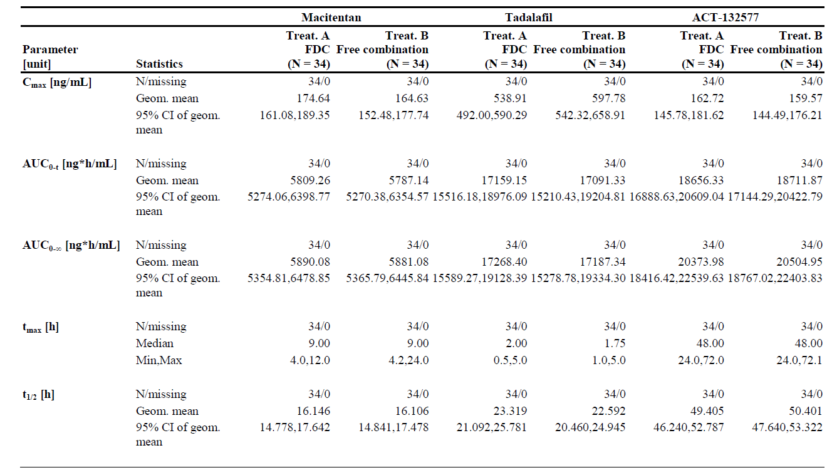
Treatment (Treat.) A = fixed dose combination (FDC) of macitentan and tadalafil (test), Treatment (Treat.) B = free combination of macitentan and tadalafil (reference), AUC_{0-t} = AUC from zero to time of the last measured concentration above the lower limit of quantification (LLOQ), AUC_{0-∞} = AUC from zero to infinity. C_{max} = maximum plasma concentration, CI = confidence interval, t_{½} = terminal half-life, t_{max} = time to reach maximum plasma concentration.
Study 67896062PAH1006 was a single dose, two period crossover Phase I study to demonstrate the bioequivalence of tadalafil when administered as part of FDC2 or as loose combination of macitentan 10 mg and tadalafil 40 mg (Canada sourced) in healthy volunteers. Whilst the primary objective concerned bioequivalence of tadalafil, macitentan was studied as a secondary objective. Thirty-three participants completed both treatment periods with evaluable PK. Bioequivalence of the FDC and the loose combination, for both tadalafil and macitentan was shown (Table 4).
Table 4: Exposure ratios comparing the fixed dose combination (treatment A) and the free combination (treatment B) in fasted conditions in healthy volunteers
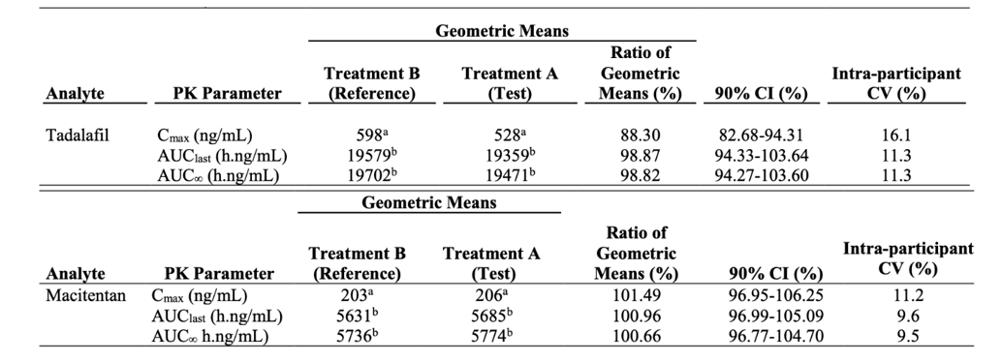
ª N=34 C_{max} ^{b} N=33 AUC_{last} and AUC∞
Note: Analysis done on log transformed data and the results were back-transformed using anti-logarithm.
Participants who have completed both treatment periods and have PK parameter estimated are included in the analysis.
Treatment A: Single oral dose of FDC of macitentan/tadalafil (10 mg/40 mg) in fasted conditions (test)
Treatment B: Single oral dose of a free combination of 10 mg macitentan and 40 mg Canada-sourced tadalafil in fasted conditions (reference)
Intra-participant CV(%) = 100* (sqrt(exp(MSE)-1).
In the food effect part of the study (high fat breakfast 30 minutes before dosing) a positive effect of food was noted on the C_{max} of both macitentan and tadalafil. Macitentan C_{max} increased from 207 ng/mL to 240 ng/mL (ratio of geometric means 116%; 90% CI 107.1-125.8%). Tadalafil C_{max} increased from 454 ng/mL to 659 ng/mL (ratio of geometric means 145%; 90% CI 129-163%). Maximum concentration (C_{max}) for metabolite ACT-132577 and area under the concentration-time curve (AUC) exposures for tadalafil, macitentan and metabolite ACT-132577 showed bioequivalence.
In addition to the above three studies, the dossier contained two studies of a macitentan 10 mg/ tadalafil 20 mg FDC, which has not been put forward for registration in this submission.
Study 67896062PAH1001 was a single dose, randomised, two way-crossover Phase I study in healthy volunteers to assess the relative bioavailability of a FDC containing macitentan 10 mg/ tadalafil 20 mg and the loose combination of macitentan 10 mg and EU sourced tadalafil 20 mg, all under fasting conditions. Sixteen participants completed both treatment periods (two provided PK data for only one of the periods). The exposure was similar for the FDC and the loose combination, although tended to be slightly higher for tadalafil as part of the FDC.
Study 67896062PAH1002 was a single dose, randomised three-way crossover in healthy volunteers to assess the bioequivalence of a FDC containing macitentan 10 mg/EU sourced tadalafil 20 mg and the loose combination of each drug under fasting conditions and the FDC under fed conditions. Participants were randomised to one of six treatment sequences. The primary objective was to demonstrate bioequivalence of the FDC and loose combination under fasting conditions and to evaluate the PK under fed conditions. The FDC was shown to be bioequivalent to the loose combination for macitentan, metabolite ACT-132577 and tadalafil (that is, geometric mean ratio 90% confidence interval was contained within the -0.80 to 1.25 bounds). No significant food effect was detected.
In summary, FDC2 containing macitentan 10 mg/ tadalafil 40 mg was bioequivalent to a loose combination of macitentan 10 mg and tadalafil 2 x 20 mg (USA, EU and Canada sourced). A food effect was seen for FDC2 whereby the C_{max} increased by 45% for tadalafil following a high-fast meal. The AUC remained unchanged (suggesting that it was the rate of absorption, rather than extent of absorption, that was affected). No food effect was seen for the FDC containing macitentan 10 mg/ tadalafil 20 mg.

Efficacy
Study AC-077A301 (A DUE) was a multicentre, double-blind, randomised, active-controlled, triple-dummy, parallel group, adaptive Phase III clinical trial comparing FDC macitentan 10 mg/ tadalafil 40 mg to monotherapy with its components in patients with PAH (WHO Group 1, WHO FC II and III).
The trial (Figure 1) included a 2-week titration period for participants not on a stable dose of PDE-5i. An open-label period followed the 16 week double-blind period. The open-label period included a 14-day titration phase, during which participants had therapy titrated towards to FDC macitentan 10 mg/tadalafil 40 mg using loose combination therapy.
Figure 1: Study design
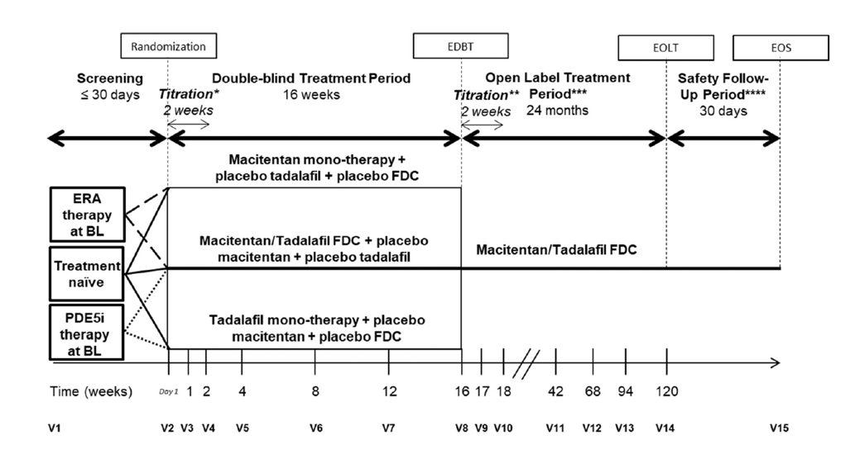
Abbreviations: BL = Baseline, EDBT = end of double-blind treatment, EOLT = end of open-label treatment, EOS = end of study, ERA = endothelin receptor antagonist, FDC = fixed dose combination, IRT = Interactive Response Technology, LC = loose combination, M/T FDC = macitentan/tadalafil FDC, PDE-5i = phosphodiesterase type-5 inhibitor, V = visit.
The primary objectives were to evaluate the effects of the FDC versus either macitentan 10 mg or tadalafil 40 mg on pulmonary vascular resistance (PVR) at the end of double-blind treatment in participants who were either treatment naïve or being treated for at least 3 months before Baseline with ERA or PDE5i monotherapy. The secondary objectives were to evaluate the effects of the FDC compared with the respective monotherapies on exercise capacity, PAH symptoms and impact, WHO FC, safety and tolerability. The primary outcome was change in PVR expressed as the ratio of geometric means from end of double-blind treatment to Baseline. The secondary outcomes were change from Baseline to end of double-blind treatment in 6-minute walk distance (6MWD), pulmonary arterial hypertension-symptoms and impact questionnaire (PAH-SYMPACT) cardiopulmonary symptom domain score, and cardiovascular symptom domain score and proportion of participants with no worsening of WHO FC.
The study was conducted in 76 centres in Asia, Africa, Europe, North America and South America.
The final analysis was based on 187 randomised participants (this number was reached after the sponsor stopped recruitment following the planned interim analysis due to crossing of efficacy thresholds).
The major inclusion criteria include being 18 years or older with a confirmed diagnosis of symptomatic PAH in WHO FC II or III. Acceptable aetiologies were idiopathic, heritable, drug/toxin induced, or associated with connective tissue disease, HIV infection, portal hypertension and congenital heart disease. Major exclusion criteria include treatment with a soluble guanyl acetylase stimulator, L-arginine, prostanoid or prostacyclin agonist within 3-months prior to start of treatment and treatment with or intolerance to combination ERA/PDE5i within 3-months prior to start of treatment.
Subjects were stratified as treatment naïve, on ERA therapy or on PDE5i therapy. The treatment naïve subjects were randomised 2:1:1 to the FDC, macitentan 10 mg or tadalafil 40 mg. Subjects on ERA therapy were randomised 2:1 to the FDC or macitentan 10 mg. Subjects on PDE5i were randomised 2:1 to FDC or tadalafil 40 mg daily.
The full analysis set included all randomised participants who received at least one dose of study treatment. The full analysis set was analysed by intention to treat. The safety set also included all randomised participants who received at least one dose of study treatment but were analysed according to treatment received. In regard to participant flow, a total of 187 were randomised and 186 received treatment (107 with FDC, 44 with tadalafil and 35 with macitentan). There were 9 subjects (8.3%) in the FDC arm who were withdrawn from the study due to withdrawal by subject (n = 4), death (n = 3) and physician decision (n = 2). Only one monotherapy subject (tadalafil; 2.3%) terminated the study prematurely due to withdrawal by subject.
Median age in the arms ranged from 48 to 54.5 years. Females represented 76.3 to 82.9% of participants. All were in WHO FC II or III and the two commonest aetiologies were idiopathic and associated with connective tissue disease. Some imbalance was noted in the proportion of participants in WHO FC II between groups (higher for the FDC compared to the monotherapy groups).
For the primary efficacy outcome, there was a decrease in PVR at end of double-blind treatment in all arms (that is, with FDC and both monotherapies) and this was statistically significant. For the treatment effect, there was a statistically significant greater effect with FDC compared to each monotherapy. The adjusted geometric mean ratio for FDC versus monotherapy was 0.71 (p <0.001) for macitentan and 0.72 (p <0.0001) for tadalafil. This was consistent with the effect size being similar whether the comparator was tadalafil or macitentan. Significant effects were seen for the predefined subgroups of treatment naïve and monotherapy experienced.
In terms of secondary outcomes, there was no statistically significant difference between treatment arms in the 6MWD (nominal increase with FDC of 16 metres compared with macitentan and 25 metres compared with tadalafil). There was a nominally greater proportion of patients experiencing clinical worsening with the FDC compared to each monotherapy (measured by change in WHO FC). There was a statistically significant decrease in N-terminal prohormone of brain natriuretic peptide in the FDC groups compared to their respective monotherapy arms.
Study A DUE is an ongoing open-label single arm study of the FDC to evaluate its long-term safety and effect on exercise capacity, WHO FC, time to first morbidity/mortality event and time to death due to PAH/PAH-related hospitalisation. There were 177 participants enrolled for the open-label period. A combination safety set included 185 participants from the double-blind and open-label periods taking the FDC.
In terms of efficacy, the mean change from double-blind Baseline to open-label Month 12 in the 6-minute walk distance was 76.1 metres in those originally randomised to macitentan, 33.9 metres in those originally randomised to tadalafil and 71.8 metres in those originally randomised to FDC. Amongst those originally randomised to the FDC, the greatest difference in 6MWD was seen in treatment naïve rather than monotherapy experienced participants. Figure 2 shows the 6MWD over time (note that after Week 16 all participants were receiving the FDC, treatment was open-label and the numbers in the study steadily reduced.
Figure 2: Mean change from Baseline in 6-minute walking distance for double-blind and open-label periods
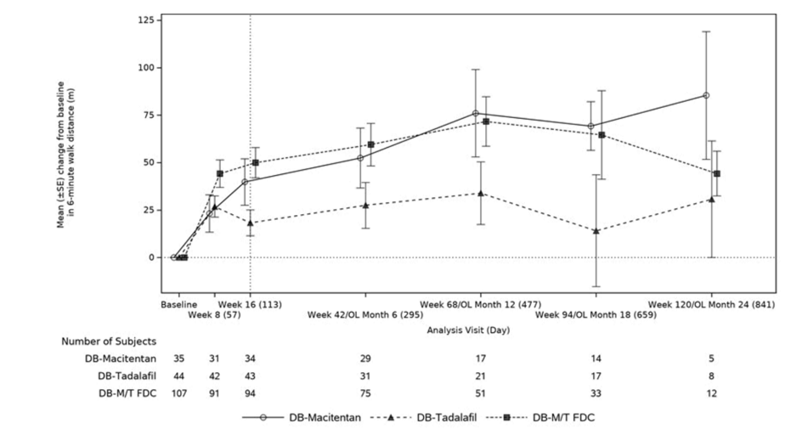
Abbreviations: DB = double-blind, FDC = fixed dose combination, m = metres, M/T = macitentan/tadalafil, OL = open-label.
A number of indirect treatment comparisons (supportive study A and B) from previous clinical trials of combination and monotherapies of tadalafil and macitentan were included in the dossier. These trials are TRITON, REPAIR, SERAPHIN, ORCHESTRA and SYMPHONY. The clinical evaluation noted that due to the nature of the studies, lack of randomisation, complexities of stratifying for covariates and the different population groups, the data does not provide much more guidance in terms of efficacy of the FDC versus the different components taken sequentially.

Safety
The main dataset is derived from the A DUE study. During the double-blind period 107 participants were exposed to the FDC macitentan 10 mg/tadalafil 40 mg. The median duration of exposure was 16.1 weeks and 64.5% were exposed for 16 weeks or longer. Considering both the double-blind and open-label periods, 185 were exposed to the FDC at any time, the median exposure was 59.86 weeks and 65.4% (n = 121) were exposed for 42 weeks or longer. In addition to the A DUE data the dossier contained safety data based on the supportive trials (TRITON, SYMPHONY, ORCHESTRA, REPAIR) and two observational studies (OPUS/OrPHeUS, EXPOSURE). These supportive and observational studies included 1071 participants who were treated with the macitentan/tadalafil combination for at least 12 months (Table 5).
Table 5: Exposure to fixed dose combination or macitentan/tadalafil loose combination in clinical studies
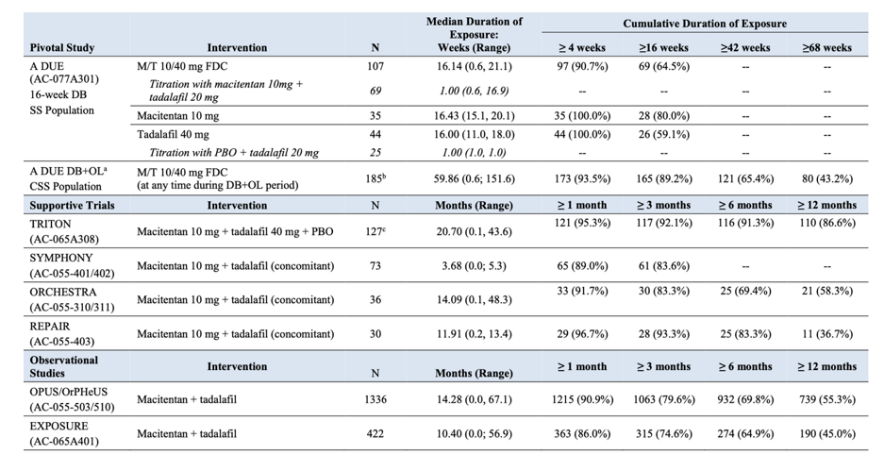
Abbreviations: CSS = A DUE combined safety set, DB = double-blind, FDC = fixed dose combination, M = macitentan, OL = open-label, PBO = placebo, SS = A DUE safety set, T = tadalafil.
a. Data are presented up to a cut-off date of 31 December 2022 for the combination safety set.
b. In addition to the 69 participants who titrated with macitentan 10 mg and tadalafil 20 mg at start of double-blind period, this cohort includes a further 35 participants randomised to macitentan monotherapy arm who received a loose combination of macitentan 10 mg and tadalafil 20 mg over a 7-day titration period at start of the open-label period.
c. Per TRITON protocol, participants received macitentan 10 mg and tadalafil 20 mg from Day 1 to Day 7 (1 week). On Day 8 (±3 days), the dosage of tadalafil were increased to 40 mg depending on individual tolerability
In addition to the clinical trials in patients with PAH, 272 healthy volunteers received the FDC during the development program.
In the A DUE double-blind period, adverse events (AEs) were more frequent with the FDC (82.2%) than with macitentan (71.4%) or tadalafil (79.5%), considering all strata. Serious AEs were also more frequent with FDC (14%) than monotherapy (macitentan 8.6%; tadalafil 9.1%). Two deaths occurred in the FDC arm and none in the monotherapy arms.
It is noteworthy that certain safety signals appeared worse for treatment naïve participants in the FDC arm compared to those with previous monotherapy experience. For example, during the double-blind period, more than half of FDC participants discontinuing due to an adverse event were treatment naïve (12.2%) compared with prior ERA (4.8%) and prior PDE5i (5.4%).
The imbalance in serious AEs between FDC and monotherapy was mainly driven by heart failure. Regarding the treatment-emergent deaths, one participant died 2 weeks after discontinuing treatment due to hypotension (had resumed ambrisentan treatment in the intervening period). The cause of death was worsening heart failure. One participant died on Day 105 after developing multi-organ failure due to Clostridium difficile gastroenteritis.
Table 6 shows treatment-emergent adverse events (TEAEs) occurring in at least 2% of participants. Noteworthy TEAEs that were significantly more frequent in the FDC arm include anaemia, haemoglobin decreased, hypotension and peripheral swelling.
Table 6: treatment-emergent adverse events occurring in at least 2% during A DUE double-blind period
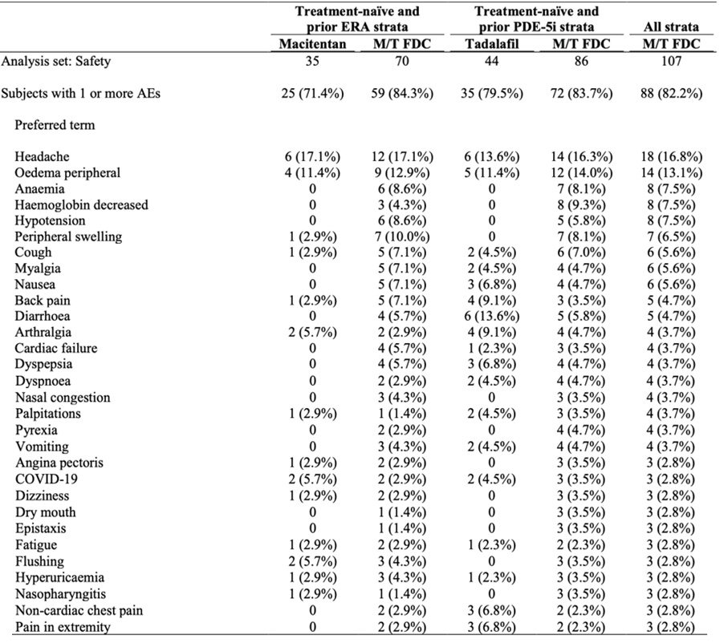
Abbreviations: AE = adverse event, EOT-DB = end of treatment in double-blind treatment period, ERA = endothelin receptor antagonist, M/T FDC = macitentan/tadalafil fixed dose combination, PDE-5i = phosphodiesterase type-5 inhibitor.
Note: Treatment-emergent period is defined from first intake of study treatment in the double-blind period up to and including min (EOT-DB+30 days, start date of open-label treatment).
Note: Subjects are counted only once for any given event, regardless of the number of times they actually experienced the event. Adverse events are coded using MedDRA Version 25.0.
Note: Treatment-naïve participants randomised to M/T FDC are counted in each M/T FDC arm and as such contribute twice in the display.
During the open-label period there was one further death due to right ventricular failure (in addition to the PAH, there was hepatic cirrhosis, portal hypertension with oesophageal varices and acute kidney injury). No new safety signals were observed.
Four adverse events of special interest (AESI) were looked at in the A DUE dataset:
- Oedema – oedema was observed more frequently with the FDC (20.6%) compared to macitentan (14.3%) and tadalafil (15.9%) during the double-blind period. Most of the oedema was mild to moderate intensity.
- Anaemia – anaemia and decreased haemoglobin were more frequent with FDC (18.7%) than with macitentan (2.9%) and tadalafil (2.3%) during the double-blind period. Most of the anaemia was mild to moderate intensity. Two participants discontinued treatment due to anaemia during the double-blind period. One participant discontinued treatment due to anaemia during the open-label period.
- Hypotension – hypotension only occurred in the FDC arm (7.5%) during the double-blind period and in general was considered manageable.
- Hepatic events – liver aminotransferase elevation occurred in FDC (0.9%), macitentan (2.9%) and tadalafil (9.1%) arms during the double-blind period and led to two participants discontinuing treatment. No Hy’s cases were reported. In the open-label period, hepatic AESI occurred at a frequency of 4.9%.
Cardiac disorders were considered as an additional adverse event of interest. Cardiac disorders were reported more frequently with the FDC (15%) than macitentan (5.7%) and tadalafil (9.1%) during the double-blind period. This was driven by AEs of cardiac failure, which occurred within one month of treatment initiation and were generally manageable. These AEs tended to occur in participants 65 years or older, treatment naïve and with pre-existing relevant comorbidities. Participants transitioning from monotherapy to FDC (during open-label) experienced an incidence of 2.6% of these AEs.
Menstrual disorders were considered as an additional adverse event of interest. Amongst female participants, menstrual disorders were more frequent (driven by menstrual/vaginal haemorrhage) with the FDC (6.1%) than with macitentan (3.4%) or tadalafil (2.9%) monotherapies. Participants with these AEs generally had additional risk factors for menstrual disorders. Menstrual disorders were reported infrequently during the open-label period of A DUE and were mainly heavy or abnormal menstrual bleeding. The frequency and nature of menstrual disorders in A DUE was consistent with the supportive trials that utilised the loose combination of macitentan and tadalafil.
The supportive studies were a combination of clinical trials and observational studies, summarised as follows:
- TRITON – Phase IIIb randomised controlled trial which included a macitentan 10 mg/ tadalafil 40 mg arm.
- SYMPHONY – Phase IIIb open-label study of macitentan 10 mg in which a proportion of participants were receiving background tadalafil therapy.
- ORCHESTRA – Phase IIIb open-label study of macitentan 10 mg in which a proportion of participants were receiving background tadalafil therapy.
- REPAIR – Phase IV open-label study of macitentan 10 mg in which a proportion of participants were receiving background tadalafil therapy.
- OPUS/OrPHeUS – drug registry of new macitentan users in the USA, some of whom were treated concomitantly with tadalafil.
- EXPOSURE – observational cohort study of patients with PAH newly treated with PAH specific drug therapy, some of whom were using combination macitentan and tadalafil.
The supportive studies generally showed safety results consistent with the A DUE study. The most frequent AEs seen were headache, oedema and gastrointestinal AEs. Vasodilatory AEs and AEs associated with tadalafil (back pain, myalgia, arthralgia) were frequently reported.
In the OPUS observational study (n = 604), events reported with a frequency > 10% were dyspnoea (21.2%), headache (12.3%) and nausea (10.9%). Adverse events reported with a frequency > 5% were diarrhea (9.8%), peripheral oedema (9.6%), dizziness (8.1%), anaemia (7.8%), cough (7.6%), hypoxia (7.6%), pneumonia (7.1%), fatigue (6.6%), oedema (6.3%), vomiting (6.3%), condition aggravated (6.0%), chest pain (5.8%), hypervolemia (5.8%), nasal congestion (5.6%), and pyrexia (5.1%).
During the double-blind period AEs were more frequent in participants ≥ 65 years old (n = 20), in particular peripheral oedema, anaemia and headache.

Recommendation following the clinical evaluation
The clinical evaluation supported registration of the FDC as a long-term treatment for adults who are stabilised on both macitentan and tadalafil as individual treatments at the relevant doses. The benefits in terms of adherence are both not immediately obvious (for example, only reducing tablet burden by two tablets), not supported by any direct data, and balanced by risks such as the inability to modify each component drug (for example, temporarily during an acute infection or more long term in case of intolerable adverse effects at the FDC doses). The dossier contained evidence suggesting a worsened safety profile with combination therapy, although this would also occur with use of the loose combination.
Overall, the evaluation supported a substitution indication for macitentan 10 mg/tadalafil 40 mg FDC for the maintenance treatment of pulmonary arterial hypertension (PAH, World Health Organization [WHO] Group 1) in adult patients of WHO functional class (FC) II, III who are on stable doses of macitentan 10 mg and tadalafil 40 mg (20 mg x 2) as separate tablets. From the evidence submitted the only evidence-based Group 1 subtypes would be the idiopathic, heritable, connective tissue disease, congenital heart disease groups that is, the same as the Canadian indication.

Risk management plan
Janssen-Cilag Pty Ltd has submitted EU risk management plan (RMP) version 1.1 (dated 15 June 2023; data lock point (DLP) 05 February 2023) and Australia-specific annex (ASA) version 1.0 (dated 21 August 2023) in support of this application.
In the response to TGA questions, the sponsor has submitted EU-RMP version 1.2 (dated 13 February 2024; DLP 5 February 2023) in association with ASA version 2.0 (dated 20 March 2024) in support of this application.
The summary of safety concerns and their associated risk monitoring and mitigation strategies are summarised in Table 7. The TGA may request an updated RMP at any stage of a product's life cycle, during both the pre-approval and post-approval phases.
Table 7: Summary of safety concerns
Summary of safety concerns |  | Pharmacovigilance |  | Risk Minimisation
 |  | Routine | Additional | Routine | Additional
Important identified risks | Anemia/decrease in hemoglobin concentration | ü | – | ü | –
Important identified risks | Hepatotoxicity | ü† | – | ü | ü§
Important identified risks | Teratogenicity | ü† | – | ü‡ | ü§
Important identified risks | Hypotension | ü | – | ü | –
Important potential risks | Menstrual disorders (primarily bleeding) | ü† | – | ü | –
Important potential risks | Ovarian cysts | ü† | – | ü | –
Important potential risks | Pulmonary edema associated with PVOD | ü | – | ü | –
Important potential risks | Testicular disorders and male infertility | ü | – | ü | –
Missing information | PAH patients with HIV infection* | ü | – | ü | –
*Australian specific safety concern
† Targeted questionnaires
§ Patient Card
‡ Boxed warning
The summary of safety concerns for macitentan/tadalafil have been identified based on the known safety concerns of the separate components (macitentan and tadalafil), as reported in their respective EU‐RMPs and ASAs. The summary of safety concerns aligns with the EU-RMP and is acceptable from an RMP perspective.
Routine pharmacovigilance activities have been proposed for all safety concerns, which includes Targeted Follow‐up Questionnaires (TFUQs) for ‘Teratogenicity’, ‘Menstrual disorders’, ‘Ovarian cysts’, and ‘Hepatotoxicity’. TFUQ for Hepatic Events is a commitment in the ASA and is not included in the EU‐RMP.
Routine pharmacovigilance activities are acceptable from an RMP perspective.
Routine risk minimisation activities have been proposed in the form of the Product Information (PI) and Consumer Medicine Information (CMI) for all safety concerns. It consists of a boxed warning in the PI and CMI for the risk of teratogenicity (pregnancy). The sponsor has been requested to include the CMI it as a pack insert.
Additional risk minimisation activities have been proposed in the form of a Patient Card to address the important identified risks of ‘Teratogenicity’ and ‘Hepatotoxicity’.
The RMP evaluation recommended conditions of registration relating to the versions of the risk management plan.

Risk-benefit analysis

Delegate’s considerations

Bioequivalence
The bioequivalence (C_{max}, AUC) of the FDC macitentan 10 mg/tadalafil 40 mg and the macitentan 10 mg/tadalafil 40 mg loose combination has been demonstrated.

Efficacy data
There is a reasonably well defined role for combination therapy with PDE5i and ERA in patients with PAH. Both major international guidelines (that is, ESC/ERS and the American College of Chest Physicians) advocate combination therapy, although in somewhat different populations. It is noted that the American College of Chest Physicians prefer the ‘ambrisentan/tadalafil’ combination, whereas ESC/ERS puts forward either that combination or ‘macitentan/tadalafil’.
These major guidelines are based, in part, on various clinical trials exploring PDE5i and ERA combination therapy. The dossier includes data from an original trial (A DUE) as well as supportive studies which investigated the safety and efficacy of the combination. Furthermore, the ARTG already allows such combination therapy (that is, macitentan is indicated for use in combination with PDE5i).
The pivotal clinical study A DUE (Study AC-077A301) excluded participants in WHO FC IV. Current guidelines emphasise the use of prostacyclin therapy in WHO FC IV and consideration for transplant. The dossier did not include data specifically supporting use of a macitentan/tadalafil FDC in FC IV. Although beyond the scope of a substitution indication, there is insufficient support to consider extending the indication based on the submitted data.
The A DUE study is considered supportive when considering the substitution indication. It provides data on the safety and efficacy of combined treatment which is consistent with the established and ongoing use of the combination of macitentan 10 mg and tadalafil 40 mg in clinical practice.

Safety
Although no new safety signals were detected when comparing treatment with the FDC (in A DUE or loose combination in the supportive studies), there were more frequent AEs with combination therapy rather than monotherapy. Of note were hypotension, heart failure, anaemia, oedema and mortality. These issues would be the same whether the patient is taking a FDC or a loose combination. It is important that Opsynvi’s indication and any sponsor prepared materials for prescribers do not encourage use of macitentan 10 mg/tadalafil 40 mg beyond the confines of a substitution indication FDC.
As there appears to be increased risk early after commencement of the FDC, especially for haemodynamic problems such as heart failure, in the group that was treatment naïve, this should be mitigated in the PI. The PI should warn that the FDC is not intended for initial macitentan/tadalafil combination therapy in treatment naïve or monotherapy patients and that using it in this way may increase the risk for adverse effects.

Deficiencies in data
There was no data to support there being a benefit to patients (in terms of adherence, convenience, quality of life) being able to take macitentan and tadalafil as a single tablet. The risks of a FDC, in particular in reducing the flexibility to alter the dose of one of the two drugs, have not been addressed, including by any particular data sets.

Proposed action
The Delegate supports approval of the proposed macitentan/tadalafil FDC for a substitution indication. The substitution indication should cover the overlap of the individual indications for tadalafil and macitentan as well as being clear about the substitution purpose.

Advisory Committee considerations
The Advisory Committee on Medicines (ACM), having considered the evaluations and the Delegate’s overview, as well as the sponsor’s response to these documents, advised the following.

Specific advice to the Delegate
- Provide comment on Opsynvi’s indication, including reference to inclusion of functional class IV which is not consistent with a substitution indication FDC.
The ACM was of the view that efficacy data has not been provided to support the use of Opsynvi in the treatment of functional class IV PAH patients. The ACM advised that while in practice, many class IV patients are treated with tadalafil and it is likely that this will continue to be the case with this FDC, that is not a sufficient basis to support registration of this indication. The ACM agreed that restriction of the indication to class II and III patients in line with the USA and Canada was appropriate. The ACM noted that addition of the words ‘with repaired shunts’ to the end of the congenital heart disease indication would align with the macitentan indication for congenital heart disease.
- Comment on this new FDC for the indications specified, including risks, and whether the PI is adequate in this regard.
The ACM noted that in its pre-ACM response, the sponsor has agreed to include a section 4.4 warning that Opsynvi is not indicated as initial combination therapy in treatment naïve patients or as a step-up therapy in patients already taking either an ERA or PED5i as monotherapy. It was agreed that this is sufficient guidance for prescribers.
The ACM noted there was a typo in the PI ‘decreased or sudden hearing loss… including tadalafil which contains tadalafil’.
The ACM also noted that the PI is inconsistent throughout regarding advice on the use of the drug in the elderly.
- Comment on the additional adverse drug reactions for tadalafil 40 mg from the company core data sheet?
The ACM observed that it was unusual to see new adverse drug reactions (ADRs) presented in the PI for this FDC. These new ADRs have come from the European tadalafil summary of product characteristics and are not present in the Australian originator tadalafil PI. The ACM agreed that there should be consistency in the Australian PI for tadalafil ADRs between both the FDC and monotherapy products and that simply removing the additional ADRs that had originated from the EU summary of product characteristics to achieve this, as the sponsor has proposed, is not the ideal way to address the problem. However, it was the view of the ACM that the majority of the additional ADRs in question were more likely to be related to the disease or co-morbidities rather than being true drug reactions from tadalafil and on that basis could reasonably be left out if felt appropriate by the TGA in order to ensure consistency between the Australia PIs.

Conclusion
The ACM considered this product to have an overall positive benefit-risk profile for the indication:
Opsynvi is indicated for the long-term maintenance treatment of pulmonary arterial hypertension (PAH, World Health Organization [WHO] Group 1) in adult patients of WHO functional class (FC) II and III whose PAH is idiopathic, heritable or associated with connective tissue disease or congenital heart disease with repaired shunts.
Opsynvi should be used in patients who are currently treated concomitantly with stable doses of macitentan 10 mg and tadalafil 40 mg (20 mg X 2) as separate tablets.

Outcome
Based on a review of quality, safety, and efficacy, the TGA decided to register Opsynvi (macitentan/tadalafil) 10 mg/40 mg, film-coated tablet, blister pack, indicated for:
Opsynvi is indicated for the maintenance treatment of pulmonary arterial hypertension
(PAH, World Health Organization [WHO] Group 1) in adult patients of WHO functional
class (FC) II and III whose PAH is idiopathic, heritable or associated with connective
tissue disease or congenital heart disease with repaired shunts.
Opsynvi is intended as substitution treatment only for patients currently treated
concomitantly with stable doses of macitentan 10 mg and tadalafil 40 mg (20 mg x 2) as
separate tablets.

Specific conditions of registration applying to these goods
- The Opsynvi EU-Risk Management Plan (RMP) (version 1.2, dated 13 February 2024, data lock point 5 February 2023), with Australia-specific Annex (version 2.0, dated 20 March 2024), included with submission PM-2023-03702-1-3, and any subsequent revisions, as agreed with the TGA will be implemented in Australia.

Attachment 1. Product Information
The Product Information (PI) associated with this submission for Opsynvi is available via the link on this AusPAR webpage.
For the most recent PI and Consumer Medicines Information (CMI) associated with this medicine, query the medicine in the PI/CMI search facility.

Therapeutic Goods Administration
PO Box 100 Woden ACT 2606 Australia
Email: info@tga.gov.au Phone: 1800 020 653 Fax: 02 6203 1605
https://www.tga.gov.au

This is the original indication proposed by the sponsor when the TGA commenced the evaluation of this submission. It may differ to the final indication approved by the TGA and registered in the Australian Register of Therapeutic Goods.
Humbert, M. (2022). 2022 ESC/ERS Guidelines for the diagnosis and treatment of pulmonary hypertension. Eur Respir J, 1-141.
Sildenafil was first registered in Australia on 4 September 1998.
Tadalafil was first registered in Australia on 23 October 2002.
Ambrisentan was first registered in Australia on 24 November 2008.
Bosentan was first registered in Australia on 20 November 2002.
Macitentan was first registered in Australia on 5 February 2014.
Iloprost was first registered in Australia on 21 January 2004.
Epoprostenol was first registered in Australia on 28 February 2014.
Selexipag was first registered in Australia on 24 March 2016.
Riociguat was first registered in Australia on 14 April 2014.
Klinger, J. (2019). Therapy for Pulmonary Arterial Hypertension in Adults. CHEST, 155(3), 565-586.
In this report the ‘Delegate’ is the Delegate of the Secretary of the Department of Health, Disability and Ageing who decided the submission under section 25 of the Act.
Sponsor clarification: results should be considered in the context that the A DUE open-label period of the study is ongoing, and the duration of follow-up is variable.
Sponsor clarification: neither death was assessed by investigators as related to study treatment.

