
AUSTRALIAN PRODUCT INFORMATION
OPSYNVI® 10/40
(macitentan/ TADALAFIL)

OPSYNVI® may cause birth defects and is contraindicated in pregnancy. See section 4.3 CONTRAINDICATIONS and Section 4.6 FERTILITY, PREGNANCY and LACTATION.

Name of the medicine
macitentan/ tadalafil

Qualitative and quantitative composition
OPSYNVI 10 /40 contains 10 mg macitentan and 40 mg tadalafil.

Excipients with known effects: sugars as lactose

For the full list of excipients, see Section 6.1 LIST OF EXCIPIENTS.

Pharmaceutical form
Film-coated tablet.

White to almost-white, oblong, film-coated tablet debossed with “1040” on one side and “MT” on the other side.

Clinical particulars

Therapeutic indications
OPSYNVI is indicated for the maintenance treatment of pulmonary arterial hypertension (PAH, World Health Organization [WHO] Group 1) in adult patients of WHO functional class (FC) II and III whose PAH is idiopathic, heritable or associated with connective tissue disease or congenital heart disease with repaired shunts.

OPSYNVI is intended as substitution treatment only for patients currently treated concomitantly with stable doses of macitentan 10 mg and tadalafil 40 mg (20 mg x 2) as separate tablets.

Dose and method of administration
Treatment with OPSYNVI should only be initiated and monitored by a physician experienced in the treatment of PAH.

Dosage – Adults 18 years of age and older
The recommended dose of OPSYNVI is one tablet taken once daily.

Switch from macitentan and tadalafil as individual components to OPSYNVI
Patients who are currently treated with macitentan 10 mg and tadalafil 40 mg (20 mg x 2) once daily as individual components may be switched to OPSYNVI.

Special Populations

Elderly (65 years of age and older)
No dose adjustment is required in patients over the age of 65 years.

Renal impairment
In patients with mild to moderate renal impairment, OPSYNVI may be used based on individual efficacy and tolerability. OPSYNVI is not recommended for patients with severe renal impairment due to limited clinical experience in these patients. OPSYNVI is not recommended in patients undergoing dialysis.

Macitentan
Based on pharmacokinetic data, no dose adjustment is required in patients with renal impairment. There is no clinical experience with the use of macitentan in PAH patients with severe renal impairment. The use of macitentan is not recommended in patients undergoing dialysis (See section 4.4 Special Warnings and Precautions for Use, Special warnings and precautions related to macitentan - Use in renal impairment and section 5.2 Pharmacokinetic properties, Macitentan - Renal impairment).

Tadalafil
Although clinical pharmacology studies in patients with renal impairment have not been performed with 40mg the dose may be increased to 40 mg once per day, based on individual efficacy and tolerability. In patients with severe renal impairment the use of tadalafil is not recommended due to limited clinical experience in these patients (See section 4.4 Special Warnings and Precautions for Use, Special warning and precautions related to tadalafil - Use in renal impairment and section 5.2 Pharmacokinetic properties, Tadalafil - Renal impairment).

Hepatic impairment
No dose adjustment is required in patients with mild to moderate hepatic impairment (Child Pugh Class A or B), although a careful individual benefit/risk evaluation should be undertaken by the prescribing physician. OPSYNVI is contraindicated in patients with severe hepatic impairment, with or without cirrhosis (Child-Pugh Class C), or clinically significant elevated hepatic aminotransferases (greater than 3 times the Upper Limit of Normal (> 3 × ULN).

Macitentan
Based on pharmacokinetic data, no dose adjustment is required in patients with mild or moderate hepatic impairment. There is no clinical experience with the use of macitentan in PAH patients with moderate or severe hepatic impairment. Macitentan is contraindicated in patients with severe hepatic impairment, or clinically significant elevated hepatic aminotransferases (greater than 3 times the Upper Limit of Normal (> 3 × ULN)) (See Section 4.3 CONTRAINDICATIONS).

Tadalafil
If tadalafil is prescribed for patients with mild to moderate cirrhosis (Child Pugh A and B), a careful individual benefit/risk evaluation should be undertaken by the prescribing physician. Patients with severe hepatic cirrhosis (Child-Pugh Class C) have not been studied and therefore dosing of tadalafil is not recommended. (See section 4.4 Special Warnings and Precautions for Use, Special warning and precautions related to tadalafil - Use in hepatic impairment and section 5.2 Pharmacokinetic properties, Tadalafil – Hepatic Impairment).

Paediatrics (below 18 years of age)
OPSYNVI should not be used in individuals below 18 years of age. Safety and efficacy have not been established in this population.

Administration
OPSYNVI should be taken orally once daily with or without food. The film-coated tablets must be swallowed whole, with water, and must not be chewed, divided or crushed.

Contraindications
OPSYNVI is contraindicated in patients who have hypersensitivity to the active substances or to any of the excipients listed in Section 6.1 LIST OF EXCIPIENTS.

As OPSYNVI contains macitentan and tadalafil, the contraindications associated with each component are applicable.

Contraindications related to macitentan
Macitentan is contraindicated in:
- Women who are or may become pregnant (See Boxed Warning and Section 4.6 FERTILITY, PREGNANCY AND LACTATION).
- Women of child-bearing potential who are not using reliable contraception (See Section 4.6 FERTILITY, PREGNANCY AND LACTATION). Women must not become pregnant for at least 3 months after stopping treatment with macitentan.
- Patients with severe hepatic impairment (with or without cirrhosis) (See Section 4.4 SPECIAL WARNINGS AND PRECAUTIONS FOR USE, Special warnings and precautions related to macitentan – Liver function).
- Patients with baseline values of hepatic aminotransferases (aspartate aminotransferase [AST] and/or alanine aminotransferase [ALT]) greater than 3 times the Upper Limit of Normal (ULN) (See Section 4.4 SPECIAL WARNINGS AND PRECAUTIONS FOR USE, Special warnings and precautions related to macitentan – Liver function).

Contraindications related to tadalafil
Nitrates and tadalafil must not be used concomitantly. Co-administration of tadalafil with nitric oxide donors, organic nitrates or organic nitrites in any form either regularly or intermittently is contraindicated. Drugs which must not be used concomitantly include, but are not limited to, glyceryl trinitrate (injection, tablets, sprays or patches), isosorbide salts, sodium nitroprusside, amyl nitrite, nicorandil or organic nitrates in any form. In clinical studies, tadalafil was shown to potentiate the hypotensive effects of both acute and chronic nitrate administration. This is thought to result from the combined effects of nitrates and tadalafil on the nitric oxide/cGMP pathway.

Administration of tadalafil to patients who are using any form of organic nitrate is contraindicated. In a patient prescribed tadalafil where nitrate administration is deemed medically necessary in a life-threatening situation, at least 48 hours in most patients and 4-5 days in the elderly (approximately 4-5 half-lives) should have elapsed after the last dose of tadalafil before nitrate administration is considered. In such circumstances, nitrates should only be administered under close medical supervision with appropriate haemodynamic monitoring (see section 4.5 Interactions with other medicines and other forms of interactions, Tadalafil).

Tadalafil is contraindicated in patients who have loss of vision in one eye because of non-arteritic anterior ischemic optic neuropathy (NAION), regardless of whether this episode was in connection or not with previous PDE5 inhibitor exposure (See Section 4.4 SPECIAL WARNINGS AND PRECAUTIONS FOR USE, Special warning and precautions related to tadalafil).

The following groups of patients with cardiovascular disease were not included in tadalafil clinical trial and the use of tadalafil is therefore contraindicated:
- Patients who had acute myocardial infarction within the last 90 days.
- Patients with severe hypotension (< 90/50 mmHg).
- Patients with unstable angina
- Patients with uncontrolled arrhythmias
- Patients with uncontrolled hypertension
- Patients with a stroke within the last 6 months

Guanylate cyclase stimulators – The combination of tadalafil and guanylate cyclase stimulators such as riociguat, is contraindicated, as it may potentially lead to symptomatic hypotension.

Special warnings and precautions for use
OPSYNVI is not indicated as initial combination therapy in treatment-naïve patients or as a step-up therapy in patients already taking ERA or PDE5i monotherapies.

In the A DUE study, which included treatment-naïve patients, as well as patients pre-treated with either ERA or PDE5i monotherapies, combination therapy with macitentan and tadalafil (as in OPSYNVI) was associated with increased adverse events, in particular hypotension, oedema and anaemia compared to monotherapies.

Elderly patients (>65 years) may be at increased risk of adverse events when using combination therapy.

Pulmonary veno-occlusive disease
Cases of pulmonary oedema have been reported with vasodilators (mainly prostacyclins) when used in patients with pulmonary veno-occlusive disease. Consequently, if signs of pulmonary oedema occur when OPSYNVI is administered in patients with PAH, the possibility of pulmonary veno-occlusive disease should be considered. Discontinuation of OPSYNVI should be considered in patients with treatment-related pulmonary veno-occlusive disease Since there are no clinical data on administration of tadalafil to patients with veno-occlusive disease, administration of OPSYNVI to such patients is not recommended.

Cardiac failure
In the double-blind portion of the A DUE study (See Section 5.1 PHARMACODYNAMICS PROPERTIES, Clinical trials), which included treatment-naïve patients, patients on ERA monotherapy or PDE5i monotherapy, cardiac failure events (n=4) were reported within one month of treatment initiation with OPSYNVI in patients over 65 years of age not previously treated with PAH-specific medications (n=16). Two cases out of four resolved while on treatment, whereas the other two were discontinued due to other adverse events [a newly established diagnosis of Pulmonary Veno-Occlusive Disease (exclusionary as per study protocol) and anaemia].

As OPSYNVI contains macitentan and tadalafil, the Special Warnings and Precautions for Use associated with each component should be considered.

Special warnings and precautions related to macitentan

Macitentan has only been studied in a limited number of patients with PAH due to HIV, drugs or toxins.
The efficacy and safety of macitentan when co-administered with epoprostenol has not been specifically studied in controlled clinical trials.

Liver function
Hepatic enzyme elevations, and in some cases serious hepatic events, potentially related to therapy have been observed with endothelin receptor antagonists (ERAs).
The incidence of aminotransferase elevations (ALT/AST) > 3 × ULN was 3.4% on macitentan 10 mg and 4.5% on placebo in a double-blind study in patients with PAH. The incidence of elevations in ALT > 3 × ULN were 3.4% on macitentan 10 mg and 1.6% on placebo (see Section 4.8 ADVERSE EFFECTS (UNDESIRABLE EFFECTS)). The incidence of ALT > 8 × ULN were 2.1% on macitentan 10 mg and 0.4% on placebo.
Macitentan is not to be initiated in patients with severe hepatic impairment or elevated aminotransferases (> 3 × ULN) (see Section 4.3 CONTRAINDICATIONS) and is not recommended in patients with moderate hepatic impairment. Liver enzyme tests should be obtained prior to initiation of macitentan and monthly monitoring of aminotransferases during treatment with macitentan is recommended. Patients should be monitored for signs of hepatic injury.
If clinically relevant aminotransferase elevations occur, or if elevations are accompanied by an increase in bilirubin >2 × ULN, or by clinical symptoms of hepatic injury (e.g. jaundice), OPSYNVI treatment should be discontinued. Re-initiation of macitentan may be considered following the return of hepatic enzyme levels to within the normal range in patients who have not experienced clinical symptoms of hepatic injury and following the advice of a liver specialist.
Caution should be exercised when macitentan is used concomitantly with medicinal products known to be associated with hepatic injury as the additive effects of macitentan with these agents are not known.

Haematological changes
Decreases in haemoglobin concentration and haematocrit have occurred following administration of other ERAs and were observed in clinical studies with macitentan (see Section 4.8 ADVERSE EFFECTS (UNDESIRABLE EFFECTS)).
In placebo-controlled studies, macitentan-related decreases in haemoglobin concentration were not progressive, stabilised after the first 4-12 weeks of treatment and remained stable during chronic treatment. Cases of anaemia requiring blood cell transfusion have been reported with macitentan and other ERAs. Initiation of macitentan is not recommended in patients with clinically significant anaemia. It is recommended that haemoglobin concentrations be measured prior to initiation of treatment and tests repeated during treatment as clinically indicated.

Fluid retention
Oedema or fluid retention has been observed with ERAs and may also be a clinical consequence of PAH. Macitentan 10 mg was not associated with increased incidences of treatment-emergent oedema or fluid retention in SERAPHIN, a long-term placebo-controlled trial (see Section 4.8 ADVERSE EFFECTS (UNDESIRABLE EFFECTS)).
If clinically significant fluid retention develops during therapy with macitentan, with or without associated weight gain, further evaluation should be undertaken to determine the cause, such as underlying heart failure, and the possible need for specific treatment should be considered.

Use in renal impairment
Patients with renal impairment may run a higher risk of experiencing hypotension and anaemia during treatment with macitentan. Therefore, monitoring of blood pressure and haemoglobin should be considered. There is no clinical experience with the use of macitentan in patients with severe renal impairment. Caution is recommended in this population. There is no experience with the use of macitentan in patient undergoing dialysis, therefore macitentan is not recommended in this population.

Use in patients with pre-existing hypotension
Hypotension has been associated with the use of ERAs. Caution should be exercised when initiating macitentan in patients with pre-existing hypotension and blood pressure in such patients should be monitored closely.

Use in the elderly
Of the total number of subjects in the clinical study of macitentan for PAH, 14% were 65 and over. No overall differences in safety or effectiveness were observed between these subjects and younger subjects. Limited data are available in those >75 years of age, therefore caution is recommended.

Special warnings and precautions related to tadalafil

Cardiovascular
The following groups of patients with cardiovascular disease treated with tadalafil were not included in PAH clinical studies:
- Patients with clinically significant aortic and mitral valve disease
- Patients with pericardial constriction
- Patients with restrictive or congestive cardiomyopathy
- Patients with significant left ventricular dysfunction
- Patients with life-threatening arrhythmias
- Patients with symptomatic coronary artery disease

Since there are no clinical data on the safety of tadalafil in these patients, the use of tadalafil is not recommended.
As with other PDE5 inhibitors, tadalafil has systemic vasodilatory properties that may result in transient decreases in blood pressure. Prior to prescribing tadalafil, physicians should carefully consider whether their patients with certain underlying conditions, such as severe left ventricular outflow obstruction, fluid depletion, autonomic hypotension or patients with resting hypotension, could be adversely affected by such vasodilatory effects.
Tadalafil potentiates the hypotensive effect of nitrates. Therefore, coadministration of tadalafil and nitrates is contraindicated (see Section 4.3 Contraindications). Tadalafil also potentiates the effect of some classes of antihypertensive medications, and this may be clinically important in some individuals. When initiating daily treatment with tadalafil, appropriate clinical considerations should be given to a possible dose adjustment of the antihypertensive therapy (see Section 4.5 Interactions with other medicines and other forms of interactions).
Caution should be exercised when prescribing tadalafil to patients who are taking alpha[1] blockers, such as doxazosin, as simultaneous administration may lead to symptomatic hypotension in some patients (see Section 4.5 Interactions with other medicines and other forms of interactions).

Vision
Physicians should advise patients to stop use of all PDE5 inhibitors, including tadalafil, and seek medical attention in the event of any sudden visual defect including loss of vision in one or both eyes (see Section 4.3 Contraindications). Such an event may be a sign of non-arteritic anterior ischaemic optic neuropathy (NAION), a cause of decreased vision, including permanent loss of vision that has been reported rarely postmarketing in temporal association with the use of all PDE5 inhibitors. An increased risk of acute NAION has been suggested from analyses of observational data in men with erectile dysfunction within 1 to 4 days of episodic PDE5 inhibitor use. Patients with known hereditary degenerative retinal disorders, including retinitis pigmentosa, were not included in the clinical trials, and use in these patients is not recommended.

Decreased or sudden hearing loss
Physicians should advise patients to stop taking PDE5 inhibitors, including tadalafil, and seek prompt medical attention in the event of sudden decrease or loss of hearing. This may be accompanied by tinnitus, which has been reported in association with the use of PDE5 inhibitors, including tadalafil. It is not possible to determine whether these events are related directly to the use of PDE5 inhibitors or to other factors (see Section 4.8 ADVERSE EFFECTS (UNDESIRABLE EFFECTS)).

Priapism and anatomical deformation of the penis
Priapism has been reported in men treated with PDE5 inhibitors, including tadalafil. Patients who experience erections lasting 4 hours or more should be instructed to seek immediate medical assistance. If priapism is not treated immediately, penile tissue damage and permanent loss of potency may result.
Tadalafil should be used with caution in patients who have conditions that might predispose them to priapism (such as sickle cell anaemia, multiple myeloma or leukemia), or in patients with anatomical deformation of the penis (such as angulation, cavernosal fibrosis or Peyronie’s disease).

Use with CYP3A4 inducers or inhibitors
For patients chronically taking potent inducers of CYP3A4, such as rifampicin, the use of tadalafil is not recommended (see section 4.5 Interactions with other medicines and other forms of interactions)
For patients taking concomitant potent inhibitors of CYP3A4, such as ketoconazole or ritonavir, the use of tadalafil is not recommended (see section 4.5 Interactions with other medicines and other forms of interactions).

Treatments for erectile dysfunction
The safety and efficacy of combinations of tadalafil and other PDE5 inhibitors or other treatments for erectile dysfunction have not been studied. Patients should be informed not to take tadalafil with these medicinal products.

Prostacyclin and its analogues
The efficacy and safety of tadalafil co-administered with prostacyclin or its analogues has not been studied in controlled clinical studies. Therefore, caution is recommended in case of co- administration with tadalafil.

Use in hepatic impairment
Patients with severe hepatic cirrhosis (Child-Pugh Class C) have not been studied and therefore dosing of tadalafil is not recommended.

Use in renal impairment
Due to increased tadalafil exposure (AUC), limited clinical experience, and the lack of ability to influence clearance by dialysis, tadalafil is not recommended in patients with severe renal impairment.

Use in the elderly
No data available.

Paediatric use
No data available.

Effects on laboratory tests
No data available.
  - Interactions with other medicines and other forms of interactions
Based on the known characteristics of macitentan and tadalafil, no pharmacokinetic interaction is expected between these individual components in the OPSYNVI.
Based on the information of the individual components, in the presence of strong CYP3A4 inhibitors, exposure to macitentan and tadalafil could be increased. Co-administration of OPSYNVI with strong CYP3A4 inhibitors (e.g., itraconazole, ketoconazole, ritonavir, voriconazole, clarithromycin, and saquinavir) should be avoided.
Based on the information of the individual components, in the presence of strong CYP3A4 inducers, exposure to macitentan and tadalafil and efficacy of OPSYNVI could be reduced. Co-administration of OPSYNVI with strong CYP3A4 inducers (e.g., rifampicin, St. John’s Wort, carbamazepine, and phenytoin) should be avoided.
As OPSYNVI contains macitentan and tadalafil, the interactions associated with each component should be considered.

Macitentan

In vitro studies
The metabolism of macitentan to its active metabolite is catalysed by CYP3A with minor contributions from CYP2C8, CYP2C9 and CYP2C19.
Macitentan and its active metabolite do not have clinically relevant inhibitory or inducing effects on CYP enzymes.
Macitentan and its active metabolite are not substrates of the multi-drug resistance protein (P-gp, MDR-1) or organic anion transporting polypeptides (OATP1B1 and OATP1B3).
Macitentan and its active metabolite are unlikely to inhibit hepatic or renal drug transporters at clinically relevant concentrations, including the multi-drug resistance protein (P-gp, MDR-1), the multidrug and toxin extrusion transporters (MATE1 and MATE2-K), the organic anion transporters (OAT1 and OAT2), the organic cation transporters (OCT1 and OCT2), the bile salt export pump (BSEP), the sodium-dependent co-transporting polypeptide (NTCP), and the organic anion transporting polypeptides (OATP1B1 and OATP1B3).

In vivo studies
Warfarin: Macitentan given as multiple doses of 10 mg once daily had no effect on exposure to S-warfarin (CYP2C9 substrate) or R-warfarin (CYP3A4 substrate) after a single dose of 25 mg warfarin. The pharmacodynamic effect of warfarin on International Normalised Ratio (INR) was not affected by macitentan. The pharmacokinetics of macitentan and its active metabolite were not affected by warfarin.
Sildenafil: At steady-state, the exposure to sildenafil 20 mg three times daily was increased by 15% during concomitant administration of macitentan 10 mg once daily. Sildenafil, a CYP3A4 substrate, did not affect the pharmacokinetics of macitentan, while there was a 15% reduction in the exposure to the active metabolite of macitentan. These changes are not considered clinically relevant. In a placebo-controlled trial in patients with PAH, the efficacy and safety of macitentan in combination with sildenafil were demonstrated.
Strong CYP3A4 inhibitors: In the presence of ketoconazole 400 mg once daily, a strong CYP3A4 inhibitor, exposure to macitentan increased approximately 2-fold. The predicted increase was approximately 3-fold in the presence of ketoconazole 200 mg twice daily using physiologically based pharmacokinetic (PBPK) modelling. Exposure to the active metabolite of macitentan was reduced by 26%.
Fluconazole: In the presence of fluconazole 400 mg daily, a moderate dual inhibitor of CYP3A4 and CYP2C9, exposure to macitentan may increase approximately 3.8-fold based on physiologically based pharmacokinetic (PBPK) modelling. Caution should be exercised when macitentan is administered concomitantly with moderate dual inhibitors of CYP3A4 and CYP2C9 (e.g., fluconazole and amiodarone).
Caution should also be exercised when macitentan is administered concomitantly with both a moderate CYP3A4 inhibitor (e.g., ciprofloxacin, ciclosporin, diltiazem, erythromycin, verapamil) and moderate CYP2C9 inhibitor (e.g., miconazole, piperine).
HIV drugs: Effects of other strong CYP3A4 inhibitors such as ritonavir on macitentan were not studied, but are likely to result in an increase in macitentan exposure at steady state similar to that seen with ketoconazole.
Ciclosporin A: Concomitant treatment with ciclosporin A 100 mg twice daily, combined CYP3A4 and OATP inhibitor, did not alter the steady-state exposure to macitentan and its active metabolite to a clinically relevant extent.
Strong CYP3A4 inducers: Concomitant treatment with rifampicin 600 mg daily, a potent inducer of CYP3A4, reduced the steady-state exposure to macitentan by 79% but did not affect the exposure to the active metabolite. Reduced efficacy of macitentan in the presence of a potent inducer of CYP3A4 such as rifampicin should be considered. The combination of OPSYNVI with strong CYP3A4 inducers (e.g., rifampicin, St. John’s Wort, carbamazepine, and phenytoin) should be avoided.
Hormonal contraceptives: Macitentan does not affect the exposure to CYP3A4 substrates. In healthy subjects, macitentan 10 mg once daily did not affect the pharmacokinetics of a single dose of an oral contraceptive (norethisterone 1 mg and ethinyl estradiol 35 micrograms).
Breast cancer resistance protein (BCRP) substrate drugs: Macitentan 10 mg once daily did not affect the pharmacokinetics of oral riociguat or rosuvastatin (riociguat 1 mg, rosuvastatin 10 mg).

Tadalafil

Tadalafil is not expected to cause clinically significant inhibition or induction of the clearance of drugs metabolised by CYP450 isoforms. Studies have confirmed that tadalafil does not inhibit or induce CYP450 isoforms, including CYP1A2, CYP3A4, CYP2C9, CYP2C19, CYP2D6 and CYP2E1.

Effects of other substances on tadalafil

Cytochrome P450 Inhibitors
Azole Antifungals (e.g. ketoconazole)
Tadalafil is principally metabolised by CYP3A4. A selective inhibitor of CYP3A4, ketoconazole (400 mg daily), increased tadalafil (20 mg) single-dose exposure (AUC) by 312% and C_{max} by 22%, and ketoconazole (200 mg daily) increased tadalafil (10 mg) single-dose exposure (AUC) by 107% and C_{max} by 15% relative to the AUC and C_{max} values.

Protease inhibitors (e.g. ritonavir)
Ritonavir (200 mg twice daily), which is an inhibitor of CYP3A4, CYP2C9, CYP2C19, and CYP2D6, increased tadalafil (20 mg) single-dose exposure (AUC) by 124% with no change in C_{max}. Ritonavir (500 mg or 600 mg twice daily) increased tadalafil (20 mg) single-dose exposure (AUC) by 32% and decreased C_{max} by 30%. Although specific interactions have not been studied, other HIV protease inhibitors such as saquinavir, and other CYP3A4 inhibitors, such as erythromycin, clarithromycin, itraconazole and grapefruit juice should be avoided because they would be expected to increase plasma concentrations of tadalafil.

Cytochrome P450 Inducers
Endothelin-1 receptor antagonists (e.g. bosentan)
Bosentan (125 mg twice daily), a substrate of CYP2C9 and CYP3A4 and a moderate inducer of CYP3A4, CYP2C9 and possibly CYP2C19, reduced tadalafil (40 mg once per day) systemic exposure by 42% and C_{max} by 27% following multiple dose co-administration.
The efficacy of tadalafil in patients already on bosentan therapy has not been conclusively demonstrated. Tadalafil did not affect the exposure (AUC and C_{max}) of bosentan or its metabolites.

Antimicrobial medicinal products (e.g. rifampicin)
A selective CYP3A4 inducer, rifampicin (600 mg daily), reduced tadalafil single-dose exposure (AUC) by 88% and C_{max} by 46% relative to the AUC and C_{max} values for tadalafil alone (10 mg). This reduced exposure can be anticipated to decrease the efficacy of once-a-day-dosed tadalafil; the magnitude of decreased efficacy is unknown. It can be expected that concomitant administration of other CYP3A4 inducers such as phenobarbitone, phenytoin and carbamazepine would also decrease plasma concentrations of tadalafil.

Cytochrome P450 Substrates
Studies with the CYP3A4 probe substrates midazolam with tadalafil 10 mg and lovastatin with tadalafil 20 mg showed little alteration in the kinetics suggesting that tadalafil is unlikely to have interactions with CYP3A4 substrates.

Antacids (magnesium hydroxide/aluminium hydroxide)
Simultaneous administration of an antacid (magnesium hydroxide/aluminium hydroxide) and tadalafil reduced the apparent rate of absorption of tadalafil without altering exposure (AUC) to tadalafil (10 mg).

H2 antagonists
An increase in gastric pH resulting from administration of nizatidine had no significant effect on tadalafil (10 mg) pharmacokinetics.

Effects of tadalafil on other medicinal products
Nitrates
In clinical pharmacology studies, tadalafil 10 mg was shown to potentiate the hypotensive effects of nitrates. Therefore, administration of tadalafil to patients who are using any form of organic nitrate is contraindicated. A placebo-controlled study was conducted to assess the degree of interaction between nitroglycerine and tadalafil. One hundred and fifty subjects received daily doses of tadalafil 20 mg for 7 days. On the 7th day, 0.4 mg sublingual nitroglycerine was given at various times following the daily dose of tadalafil. This interaction lasted for more than 24 hours and was no longer detectable when 48 hours had elapsed after the last tadalafil dose (see Section 4.3 Contraindications).

Recreational Drugs called “poppers” or “amyl”
Due to the known interaction between tadalafil and nitrates or other nitric oxide donors on nitrogen monoxide/cGMP metabolism, patients must be expressly informed that they should never use recreational drugs called “poppers” or “amyl”, typically taken through inhalation. These drugs represent various alkyl nitrites including amyl nitrite, butyl nitrite and isobutyl nitrite.

Anti-hypertensives
Tadalafil has systemic vasodilatory properties and may augment the blood pressure lowering effects of antihypertensive agents. Patients should be advised of this possibility. In a clinical pharmacology study measuring ambulatory blood pressure, when tadalafil (20 mg) was administered to 17 hypertensive patients treated with angiotensin II receptor blockers, ambulatory systolic blood pressure fell by 30 mmHg or more in 9 (53%) subjects on tadalafil treatment and in 5 (29%) subjects on placebo treatment, with a maximum fall of 57 mmHg following tadalafil compared to 37 mmHg following placebo. None of the decreases were associated with any hypotensive symptoms. Additionally, in patients taking multiple antihypertensive agents whose hypertension was not well controlled compared to subjects whose blood pressure was well controlled, greater reductions in blood pressure were observed. These reductions were not associated with hypotensive symptoms in the vast majority of patients. Appropriate clinical advice should be given to patients when they are treated with antihypertensive medications and tadalafil.

When initiating daily treatment with tadalafil, appropriate clinical considerations should be given to a possible dose adjustment of the antihypertensive therapy.

In other clinical pharmacology studies, tadalafil 10 mg was added to angiotensin converting enzyme (ACE) inhibitors (enalapril), beta blockers (metoprolol) or thiazide diuretics (bendrofluazide). Tadalafil 10 mg and 20 mg was added to calcium channel blockers (amlodipine) or alpha-blockers (tamsulosin). In all these studies, tadalafil did not produce a significant additional reduction in mean systolic or diastolic blood pressure. However, potentially significant blood pressure reductions occurred in some individuals. Analysis of phase 3 clinical trial data showed no difference in the overall incidence of adverse events in patients taking tadalafil with or without hypertensive medications.

In two clinical pharmacology studies, no significant decreases in blood pressure were observed when tadalafil was co-administered to healthy subjects taking the selective alpha[1A]-adrenergic blocker, tamsulosin.

In three clinical pharmacology studies when tadalafil was co-administered to healthy subjects taking doxazosin (4-8 mg daily), an alpha[1]-adrenergic blocker, there was an augmentation of the blood-pressure-lowering effect of doxazosin. The number of patients with potentially clinically significant standing-blood-pressure decreases was greater for the combination. In these clinical pharmacology studies there were symptoms associated with the decrease in blood pressure including syncope.

Caution is advised when PDE5 inhibitors are co-administered with nonselective alpha (α1)-blockers. PDE5 inhibitors, including tadalafil, and alpha-adrenergic blocking agents are both vasodilators with blood-pressure-lowering effects. When vasodilators are used in combination, an additive effect on blood pressure may be anticipated. In some patients, concomitant use of these two drug classes can lower blood pressure significantly, which may lead to symptomatic hypotension (e.g., fainting). Consideration should be given to the following:

- Patients should be stable on alpha-blocker therapy prior to initiating a PDE5 inhibitor. Patients who demonstrate haemodynamic instability on alpha-blocker therapy alone are at increased risk of symptomatic hypotension with concomitant use of PDE5 inhibitors.
- In those patients who are stable on alpha-blocker therapy, PDE5 inhibitors should be initiated at the lowest recommended dose.
- In those patients already taking an optimised dose of PDE5 inhibitor, alpha-blocker therapy should be initiated at the lowest dose. Stepwise increase in alpha-blocker dose may be associated with further lowering of blood pressure when taking a PDE5 inhibitor.
- Safety of combined use of PDE5 inhibitors and alpha-blockers may be affected by other variables, including intravascular volume depletion and other anti-hypertensive drugs.

Human platelets contain the PDE5 enzyme system. Tadalafil, in limited studies, did not affect platelet function in vivo. In in vitro studies tadalafil was shown to potentiate the antiaggregatory effect of sodium nitroprusside (a nitric oxide donor).

Riociguat
Preclinical studies showed an additive systemic blood pressure lowering effect when PDE5 inhibitors were combined with riociguat. In clinical studies, riociguat has been shown to augment the hypotensive effects of PDE5 inhibitors. There was no evidence of favourable clinical effect of the combination in the population studied. Concomitant use of riociguat with PDE5 inhibitors, including tadalafil, is contraindicated as it may potentially lead to symptomatic hypotension (see Section 4.3 Contraindications).

Alcohol
Tadalafil did not affect alcohol concentrations, and alcohol did not affect tadalafil concentrations. At high doses of alcohol (0.7 g/kg), the addition of tadalafil 20 mg did not induce statistically significant mean blood pressure decreases. In some subjects, postural dizziness and orthostatic hypotension were observed. When tadalafil was administered with lower doses of alcohol (0.6 g/kg), hypotension was not observed and dizziness occurred with similar frequency to alcohol alone.

CYP1A2 substrates (e.g. theophylline)
Tadalafil (10 mg) had no clinically significant effect on the pharmacokinetics or pharmacodynamics of theophylline (CYP1A2 substrate). The only pharmacodynamic effect was a small (3.5 bpm) increase in heart rate.

CYP2C9 substrates (e.g. R-warfarin)
In a crossover study, 12 healthy volunteers received a single dose of warfarin 25 mg after taking tadalafil 10 mg or placebo once daily for 6 days. Tadalafil reduced the exposure (AUC) to R- and S-warfarin by 11% and 13%, respectively but did not alter the effect of warfarin on prothrombin time (PT). The clinical implications of these findings are unclear. The possibility of an increase or decrease in PT and/or international normalised ratio (INR) should be considered when patients begin taking or cease taking tadalafil.

Aspirin (Acetylsalicylic acid)
When administered in combination with aspirin, tadalafil 20 mg did not prolong bleeding time, relative to aspirin alone. Tadalafil has not been administered to patients with bleeding disorders or significant active peptic ulceration. Although tadalafil has not been shown to increase bleeding times in healthy subjects, use in patients with bleeding disorders or significant active peptic ulceration should be based upon a careful risk-benefit assessment.

P-glycoprotein substrates (e.g. digoxin)
Tadalafil (40 mg once per day) had no clinically significant effect on the pharmacokinetics of digoxin.

Oral contraceptive pill
At steady-state, tadalafil (40 mg once per day) increased ethinylestradiol exposure (AUC) by 26% and C_{max} by 70% relative to oral contraceptive administered with placebo. There was no statistically significant effect of tadalafil on levonorgestrel which suggests the effect of ethinylestradiol is due to inhibition of gut sulphation by tadalafil. The clinical relevance of this finding is uncertain.

Terbutaline
A similar increase in AUC and C_{max} seen with ethinylestradiol may be expected with oral administration of terbutaline, probably due to inhibition of gut sulphation by tadalafil. The clinical relevance of this finding is uncertain.

Other PDE5 inhibitors
The safety and efficacy of combinations of tadalafil and other PDE5 inhibitors have not been studied. Therefore, the use of such combinations is not recommended.

Fertility, pregnancy and lactation

Effects on fertility
The effect of OPSYNVI on human fertility has not been evaluated.

As OPSYNVI contains macitentan and tadalafil, the fertility information associated with each component should be considered.

Macitentan
Male fertility
Reversible testicular tubular dilatation was observed in chronic toxicity studies at exposures greater than 7- fold and 23 - fold the human exposure in rats and dogs, respectively. After 2 years of treatment, tubular atrophy was seen in rats at 4-fold the human exposure. Macitentan did not affect male or female fertility in rats at exposures ranging from approximately 18- to 44-fold the human exposure, respectively. In a 26-week study in male rats treated with macitentan, there was no effect on sperm count or motility but there was a dose-dependent increase in the incidence of morphologically abnormal sperm at or above 7-fold the human exposure. No testicular findings were noted in mice after treatment up to 2 years.

Decreases in sperm count have been observed in patients taking ERAs. Macitentan, like other ERAs, may have an adverse effect on spermatogenesis.

Tadalafil
There were no effects on fertility, reproductive performance or reproductive organ morphology in male or female rats given oral doses of tadalafil up to 400 mg/kg/day (a dose producing AUCs for unbound tadalafil of 7-fold for males or 18-fold for females the exposures at the recommended human dose of 40 mg). However, regression of the seminiferous tubular epithelium of the testes resulting in oligospermia or aspermia in the epididymides was observed in dogs treated for 3, 6 or 12 months with oral tadalafil doses ≥ 10 mg/kg/day. AUC-based exposure approximately 0.3 to 3-fold the exposure at the recommended human dose of 40 mg). A no-effect level for these effects in dogs was not established. Similar findings were not observed in mice in a carcinogenicity study at AUC-based exposures similar to exposure at the recommended human dose of 40 mg. The potential relevance of the male reproductive-toxicity findings to humans treated chronically with tadalafil is unknown.

Use in pregnancy - Category X
There are no data on the use of OPSYNVI during pregnancy. OPSYNVI is contraindicated during pregnancy and in women of childbearing potential who are not using reliable contraception due to teratogenicity identified in the animal studies with macitentan. As OPSYNVI contains macitentan and tadalafil, the pregnancy information associated with each component should be considered.

Macitentan
Due to a high mortality risk to both mother and fetus, pregnancy is considered contraindicated in PAH.

Teratogenicity is a class effect of endothelin receptor antagonists.

There are no data on the use of macitentan in pregnant women. Macitentan is contraindicated during pregnancy and in women of child-bearing potential who are not using reliable contraception. If macitentan is used during pregnancy, or if the patient becomes pregnant while taking macitentan, advise the patient of the potential harm to the fetus.

Macitentan was teratogenic in rabbits and rats at all doses tested. In both rabbits and rats, there were cardiovascular and mandibular arch fusion abnormalities. A no effect level for teratogenicity has not been established. Administration of macitentan to female rats from late pregnancy through lactation caused reduced pup survival and impairment of the male fertility of the offspring at all dose levels tested.

Tadalafil
Studies in rats have shown that tadalafil and/or its metabolites cross the placenta and distribute to the fetus. No evidence of embryofetal toxicity or teratogenicity was observed in pregnant rats or mice given oral doses of tadalafil up to 1000 mg/kg/day. These doses were associated with systemic exposure to tadalafil ca 7-8-fold that expected at the recommended dose of 40 mg taken once daily, based on AUC for unbound drug at steady state. Increased postnatal pup mortality was observed in rats after oral treatment with tadalafil doses ≥60 mg/kg/day during gestation and lactation. The no-effect dose of 30 mg/kg/day was associated with systemic exposure ca 5-fold that expected in humans at the recommended dose of 40 mg tadalafil taken once daily, based on AUC for unbound drug at steady state. There are no studies of tadalafil in pregnant women.

Use in women of child-bearing potential
In females of child-bearing potential, pregnancy should be excluded before the start of treatment with OPSYNVI and prevented thereafter by the use of two reliable methods of contraception. If necessary, patients should discuss with their doctor or gynaecologist which methods would be most suitable for them. Given the teratogenic nature of the drug, women should not become pregnant for 3 months after discontinuation of OPSYNVI. Monthly pregnancy tests during treatment with OPSYNVI are recommended to allow the early detection of pregnancy.

It is not known whether macitentan is present in semen. It is therefore not known whether there is the potential for fetal harm (teratogenicity) resulting from transfer of macitentan via semen.

Use in lactation
OPSYNVI should not be used during breast-feeding based on the macitentan and tadalafil individual component data.

Macitentan
In rats, macitentan and its metabolites were excreted into milk during lactation. Breast-feeding is not recommended during treatment with macitentan. A risk to newborns/infants cannot be excluded.

Tadalafil
Tadalafil and/or its metabolites are excreted in the milk of lactating rats at concentrations up to 2.4-fold higher than the maximal maternal plasma concentration. Increased postnatal pup mortality was observed in rats after treatment with oral tadalafil doses ≥60 mg/kg/day during gestation and lactation (see Section 4.6 Fertility, pregnancy and lactation - Use in pregnancy).

There are no human data on the excretion of tadalafil into breast milk or on the safety of tadalafil exposure in infants.

Effects on ability to drive and use machines
No studies on the effect of OPSYNVI on the ability to drive and use machines have been performed. However, as OPSYNVI contains macitentan and tadalafil, the patient should be informed of the individual component data before driving vehicles or operating machinery.

Although the frequency of reports of dizziness in placebo and tadalafil arms in clinical trials was similar, patients should be aware of how they react to tadalafil before driving or operating machinery.

Adverse effects (Undesirable effects)
The overall safety profile of OPSYNVI is based on the data from the pivotal study for OPSYNVI as well as the individual component safety data.

As OPSYNVI contains macitentan and tadalafil, the adverse reactions associated with each component may be expected.

OPSYNVI

Experience from A DUE clinical study [PAH]
The overall safety profile of OPSYNVI is based on data from a double-blind, active-controlled, Phase 3 clinical study (A DUE) and an open-label (OL) extension study, in patients with PAH. In the double-blind (DB) portion of the study, a total of 107 patients were treated with OPSYNVI 10 mg/40 mg, 35 patients were treated with 10 mg macitentan monotherapy, and 44 patients were treated with 40 mg tadalafil monotherapy. The duration of exposure to OPSYNVI during the double-blind portion was 16 weeks. One-hundred eighty-five patients received OPSYNVI in the double-blind/open-label combined period. The median exposure to OPSYNVI during the combined double-blind/open-label period was 59.9 weeks with a mean exposure of 63.2 weeks.

Table 1 Adverse events occurring in ≥ 3% patients treated with OPSYNVI in A DUE during DB period

 | A DUE DB
 | OPSYNVI N=107 |  |  | Macitentan N=35 |  | Tadalafil N=44
System/Organ Class | No. | % |  | No. | % | No. | %
General disorders and administration site conditions
Oedema peripheral | 14 | 13.1% |  | 4 | 11.4% | 5 | 11.4 %
Peripheral swelling | 7 | 6.5% |  | 1 | 2.9% | 0 | 0%
Pyrexia | 4 | 3.7% |  | 0 | 0% | 0 | 0%
Gastrointestinal disorders
Nausea | 6 | 5.6% |  | 0 | 0% | 3 | 6.8%
Diarrhoea | 5 | 4.7% |  | 0 | 0% | 6 | 13.6%
Dyspepsia | 4 | 3.7% |  | 0 | 0% | 3 | 6.8%
Vomiting | 4 | 3.7% |  | 0 | 0% | 2 | 4.5%
Nervous system disorders
Headache | 18 | 16.8% |  | 6 | 17.1% | 6 | 13.6%
Musculoskeletal and connective tissue disorders
Myalgia | 6 | 5.6% |  | 0 | 0% | 2 | 4.5%
Back pain | 5 | 4.7% |  | 1 | 2.9% | 4 | 9.1%
Arthralgia | 4 | 3.7% |  | 2 | 5.7% | 4 | 9.1%
Respiratory, thoracic and mediastinal disorders
Cough | 6 | 5.6% |  | 1 | 2.9% | 2 | 4.5%
Dyspnoea | 4 | 3.7% |  | 0 | 0% | 2 | 4.5%
Nasal congestion | 4 | 3.7% |  | 0 | 0% | 0 | 0%
Cardiac disorders
Cardiac failure | 4 | 3.7% | 0 |  | 0% | 1 | 2.3%
Palpitations | 4 | 3.7% | 1 |  | 2.9% | 2 | 4.5%
Blood and lymphatic system disorders
Anaemia | 8 | 7.5% | 0 |  | 0% | 0 | 0%
Haemoglobin decreased | 8 | 7.5% | 0 |  | 0% | 0 | 0%
Vascular disorders
Hypotension | 8 | 7.5% | 0 |  | 0% | 0 | 0%

The incidence of treatment discontinuations due to adverse events among patients receiving OPSYNVI in the double-blind phase of the study was 8.4%.

The majority of adverse drug reactions were mild to moderate in intensity.

Frequency determination does not account for other factors, including varying study duration, pre-existing conditions, and baseline patient characteristics.

Frequency estimate: Very common (1/10), common (1/100 to <1/10), uncommon (1/1,000 to <1/100), rare (1/10,000 to <1/1,000), very rare (<1/10,000) and not known (cannot be estimated from the available data).

The frequencies of the adverse reactions listed in Table 2 were determined based on double-blind data from A DUE.

Table 2 Adverse Drug Reactions Occurring in Patients Treated with OPSYNVI in A DUE (Safety Analysis Set)

System/Organ Class | Frequency Category
General disorders and administration site conditions
Oedema/fluid retentionª | Very common
Swelling face | Common
Chest pain | Uncommon
Gastrointestinal disorders
Nausea | Common
Dyspepsia | Common
Vomiting | Common
Abdominal discomfort | Common
Abdominal pain | Common
Gastroesophageal reflux disease | Uncommon
Nervous system disorders
Headache | Very common
Migraine | Uncommon
Syncope | Uncommon
Infections and infestations
Nasopharyngitis | Common
Influenza | Common
Urinary tract infection | Common
Upper respiratory tract infection | Uncommon
Musculoskeletal and connective tissue disorders
Myalgia | Common
Back pain | Common
Pain in extremity | Common
Respiratory, thoracic and mediastinal disorders
Nasal congestion | Common
Epistaxis | Common
Cardiac disorders
Palpitations | Common
Tachycardia | Common
Investigations
Transaminases increased | Uncommon
Blood and lymphatic system disorders
Anaemia/Haemoglobin decrease^{b} | Very common
Vascular disorders
Hypotension | Common
Flushing^{c} | Common
Skin and subcutaneous tissue disorders
Rash | Common
Eye disorders
Vision blurred | Common
Reproductive system and breast disorders
Increased uterine bleeding^{d} | Common
Immune system disorders
Hypersensitivity | Uncommon
Angioedema | Uncommon
ª Grouped term includes preferred terms (PTs) of edema peripheral, peripheral swelling, generalized edema, swelling, fluid retention, bone marrow edema, joint swelling, edema, hypervolemia, and pericardial effusion.
^{b} Grouped term includes PTs of anaemia, iron deficiency anaemia, anaemia of chronic disease, haemoglobin decreased, normochromic anaemia, pancytopenia, blood loss anaemia, and myelofibrosis.
^{c} Grouped term includes PTs of flushing, and hot flush.
^{d} Grouped term includes PTs of heavy menstrual bleeding, intermenstrual bleeding, polymenorrhagia, and vaginal haemorrhage. Frequency based on exposure in female subjects.

Long term safety data
One-hundred eighty-five patients received OPSYNVI in the double-blind/ open-label period of the A DUE study. The median exposure to OPSYNVI during the combined double-blind/open-label period was 59.9 weeks with a mean exposure of 63.2 weeks. The safety profile of OPSYNVI was consistent with that described above.

Laboratory abnormalities
Liver aminotransferases
The incidence of elevated aminotransferases in the double-blind and combined double-blind /open-label arms of the study of OPSYNVI in PAH are shown in Table 3.

Table 3 Incidence of Elevated Aminotransferases in the A DUE Study
 | OPSYNVI DB  (N=107) | OPSYNVI DB/OL  (N=185)
≥3 x ULN | 1.0% | 3.4%
≥8 x ULN | 1.0% | 1.1%

The overall incidence of treatment discontinuations for hepatic adverse events in the double-blind and combined double-blind/open-label arms study of OPSYNVI in PAH data were 0.9% and 2.2% respectively.

Haemoglobin decrease
Decreases in haemoglobin concentration and haematocrit have occurred following administration of other ERAs and were observed in clinical studies with OPSYNVI. These decreases occurred early and stabilised thereafter.

In the double-blind phase of the study, the mean decrease up to week 16 in haemoglobin from baseline in OPSYNVI compared to macitentan and tadalafil alone was 1.4 g/dL, 0.7 g/dL and 0.1 g/dL, respectively. A decrease in haemoglobin to below 10 g/dL was reported in 11.0% of the OPSYNVI treated patients compared to 2.9% and 0.0% in macitentan and tadalafil treated patients, respectively. In the combined double-blind/open-label data, the mean decrease in haemoglobin concentration was 0.95 g/dL up to week 47 (106 patients) and 0.56 g/dL up to week 120 (16 patients). A decrease in haemoglobin to below 10 g/dL was reported in 13.8 % of the OPSYNVI treated patients.

Macitentan

Experience from clinical studies
The safety of macitentan has been evaluated in a long-term placebo-controlled trial of 742 patients with symptomatic PAH. The mean treatment duration was 103.9 weeks in the macitentan 10 mg group, and 85.3 weeks in the placebo group. The majority of adverse events were mild to moderate in intensity. The most commonly reported adverse events were nasopharyngitis (14.0% vs 10.4%), headache (13.6% vs 8.8%) and anaemia (13.2% vs 3.2%) (Table 4).

Table 5 presents adverse reactions occurring in macitentan-treated subjects at an incidence < 3 % and with a placebo-corrected difference ≥ 1 % (during treatment and up to 28 days after treatment discontinuation). Adverse reactions are listed by system organ class and frequency category, using the convention: common (≥ 1/100 and < 1/10). Within each frequency group, adverse reactions are presented in order of decreasing seriousness.

Frequency determination does not account for other factors including varying study duration, pre-existing conditions, and baseline patient characteristics.

Table 4 Adverse events occurring in ≥ 3 % of macitentan-treated subjects and at a greater incidence than placebo (during treatment and up to 28 days after treatment discontinuation)
System Organ Class /  Preferred Term | Placebo  N=249 |  | Macitentan  10 mg  N=242
System Organ Class /  Preferred Term | No. | % | No. | %
Blood and lymphatic system disorders
Anaemia | 8 | 3.2% | 32 | 13.2%
Thrombocytopenia | 7 | 2.8% | 12 | 5.0%
Gastrointestinal disorders
Diarrhoea | 17 | 6.8% | 22 | 9.1%
Abdominal pain upper | 11 | 4.4% | 11 | 4.5%
General disorders and administration site conditions
Oedema peripheral | 45 | 18.1% | 44 | 18.2%
Pyrexia | 9 | 3.6% | 9 | 3.7%
Infections and infestations
Upper respiratory tract infection | 33 | 13.3% | 37 | 15.3%
Nasopharyngitis | 26 | 10.4% | 34 | 14.0%
Bronchitis | 14 | 5.6% | 28 | 11.6%
Urinary tract infection | 14 | 5.6% | 21 | 8.7%
Respiratory tract infection viral | 9 | 3.6% | 15 | 6.2%
Pharyngitis | 7 | 2.8% | 15 | 6.2%
Influenza | 4 | 1.6% | 14 | 5.8%
Sinusitis | 6 | 2.4% | 11 | 4.5%
Gastroenteritis | 3 | 1.2% | 8 | 3.3%
Rhinitis | 2 | 0.8% | 8 | 3.3%
Metabolism and nutrition disorders
Hypokalaemia | 14 | 5.6% | 14 | 5.8%
Musculoskeletal and connective tissue disorders
Arthralgia | 10 | 4.0% | 11 | 4.5%
Myalgia | 4 | 1.6% | 8 | 3.3%
Nervous system disorders
Headache | 22 | 8.8% | 33 | 13.6%
Psychiatric disorders
Insomnia | 10 | 4.0% | 17 | 7.0%
Depression | 8 | 3.2% | 8 | 3.3%
Skin and subcutaneous tissue disorders
Skin ulcer | 3 | 1.2% | 8 | 3.3%
Vascular disorders
Hypotension | 11 | 4.4% | 15 | 7.0%

Table 5 Adverse reactions occurring in macitentan-treated subjects at an incidence < 3 % and with a placebo-corrected difference ≥ 1 % (during treatment and up to 28 days after treatment discontinuation)
System Organ Class | Common  (≥ 1/100 and < 1/10)
Eye disorders | Conjunctivitis
Gastrointestinal disorders | Abdominal pain, Irritable bowel syndrome, Haemorrhoids
Hepatobiliary disorders | Cholelithiasis
Infections and infestations | Lower respiratory tract infection, Gastroenteritis viral, Tracheitis, Tonsillitis
Investigations | Haemoglobin decreased, Haematocrit decreased, Blood urea increased
Metabolism and nutrition disorders | Hyperkalaemia
Musculoskeletal and connective tissue disorders | Systemic sclerosis, Costochondritis
Nervous system disorders | Migraine
Reproductive system and breast disorders | Metrorrhagia, Menorrhagia, Ovarian cyst, Gynaecomastia
Respiratory, thoracic and mediastinal disorders | Rhinorrhoea, Productive cough, Bronchial hyperreactivity
Skin and subcutaneous tissue disorders | Pruritus, Eczema, Urticaria
Vascular disorders | Flushing

Oedema/fluid retention has been associated with the use of ERAs and is also a clinical manifestation of right heart failure and underlying PAH disease. In a long-term double-blind study in patients with PAH, the incidence of oedema AEs in the macitentan 10 mg and placebo treatment groups was 21.9% and 20.5% respectively. This corresponded to 11.0 events / 100 patient-years on macitentan 10 mg compared to 12.5 events / 100 patient-years on placebo.

Long-term safety
550 patients entered a long-term open-label extension study (182 patients who continued on macitentan 10 mg and 368 patients crossed over to macitentan 10 mg from either placebo or macitentan 3 mg) and were followed for a median exposure of 3.3 years and a maximum exposure of 10.9 years. 242 patients received macitentan10 mg in the double-blind study with 182 continuing in the open label study, giving a median exposure of 4.6 years and a maximum exposure of 11.8 years. The safety profile was consistent with that described above.

Post-marketing experience
Table 6 Post Marketing Adverse Events: common (> 1/100, < 1/10); uncommon (> 1/1,000, < 1/100)
System organ class | Frequency | Adverse reaction
Immune system disorders | Uncommon* | Hypersensitivity reactions (angioedema, and rash)
Immune system disorders | Common* | pruritus
Respiratory, thoracic & mediastinal disorders | Common† | Nasal congestion
General disorders & Administration site conditions | Very common§ | Oedema/fluid retention
Vascular disorders | Common | Flushing
*Frequency Classification "common" and "uncommon" based on pooled double-blind studies.
†Frequency Classification "common" based on pooled double-blind studies.
§ Frequency Classification "very common" based on double-blind studies

Laboratory abnormalities
Liver aminotransferases
The incidence of elevated aminotransferases in the study of macitentan in PAH is shown in Tables 7and 8.

Table 7 Incidence of Elevated Aminotransferases (ALT/AST) in the SERAPHIN Study
 | Macitentan 10 mg  (N=242) | Placebo  (N=249)
>3 x ULN | 3.4% | 4.5%
>5 x ULN | 2.5% | 2%
>8 x ULN | 2.1% | 0.4%

Table 8 Incidence of Elevated ALT in the SERAPHIN Study
 | Macitentan 10 mg  (N=242) | Placebo  (N=249)
>3 x ULN | 3.4% | 1.6%
>5 x ULN | 2.5% | 1.2%
>8 x ULN | 2.1% | 0.4%

In a double-blind study in patients with PAH, discontinuations for hepatic adverse events were 3.3% in the macitentan 10 mg group vs. 1.6% for placebo.

Haemoglobin
In a double-blind study in patients with PAH, macitentan 10 mg was associated with a mean decrease in haemoglobin versus placebo of 10 g/L. A decrease from baseline in haemoglobin concentration to below 100 g/L was reported in 8.7% of patients treated with macitentan 10 mg and 3.4% of placebo-treated patients.

White blood cells
In a double-blind study in patients with PAH, macitentan 10 mg was associated with a decrease in mean leucocyte count from baseline of 0.7 × 10⁹/L versus no change in placebo-treated patients.

Platelets
In a double-blind study in patients with PAH, macitentan 10 mg was associated with a decrease in mean platelet count of 17 × 10⁹/L, versus a mean decrease of 11 × 10⁹/L in placebo-treated patients.

Tadalafil

In the pivotal placebo-controlled study of tadalafil for the treatment of PAH, a total of 323 patients were treated with tadalafil at doses ranging from 2.5 mg to 40 mg once daily and 82 patients were treated with placebo. The duration of treatment was 16 weeks. The overall frequency of discontinuation due to adverse events was low (tadalafil 11%, placebo 16%). Three hundred and fifty seven (357) subjects who completed the pivotal study entered a long-term extension study. Doses studied were 20 mg and 40 mg once daily.

Table 9 below lists the adverse events reported in greater than or equal to 4% of patients taking tadalafil 40 mg during the placebo-controlled clinical trial. Please note that some of these adverse events occurred more often in patients receiving placebo and may not necessarily be causally related to tadalafil use.

Table 9 Treatment Emergent Adverse Events Reported by ≥4% of Patients Receiving tadalafil 40 mg
ADVERSE EVENT | Placebo (%) (N=82) |  | Tadalafil 40 mg (%) (N=79)
Infections and Infestations
Nasopharyngitis |  | 7 | 13
Respiratory Tract Infection (Upper and Lower) |  | 6 | 13
Bronchitis |  | 0 | 5
Urinary Tract Infection |  | 0 | 4
Psychiatric disorders
Insomnia |  | 2 | 4
Nervous System Disorders
Headache |  | 15 | 42
Dizziness |  | 9 | 8
Vascular disorders
Flushing |  | 2 | 13
Hot Flush |  | 2 | 4
Respiratory Tract, Thoracic and Mediastinal Disorders

Cough |  | 9 | 9
Nasal Congestion (including sinus congestion) |  | 1 | 9
Pulmonary hypertension |  | 9 | 8
Dyspnoea |  | 4 | 6
Upper Respiratory Tract Infection |  | 4 | 6
Respiratory tract infection |  | 3 | 5
Epistaxis |  | 4 | 4
Gastrointestinal Disorders
Diarrhoea |  | 10 | 11
Nausea |  | 6 | 11
Dyspepsia |  | 2 | 10
Vomiting |  | 1 | 6
Gastroesophageal Reflux Disease |  | 4 | 5
Constipation |  | 1 | 4
Skin and subcutaneous tissue disorders
Rash |  | 3 | 5
Musculoskeletal and Connective Tissue Disorders
Myalgia |  | 4 | 14
Pain in Extremity |  | 2 | 11
Back Pain |  | 6 | 10
Musculoskeletal Stiffness |  | 0 | 4
Reproductive system and breast disorders
Menorrhagia (including increased uterine bleedingª) |  | 0 | 4
General Disorders and Administration Site Conditions
Oedema peripheral |  | 9 | 6
Fatigue |  | 4 | 6
Chest Pain |  | 1 | 6
Oedema |  | 1 | 5
Non-Cardiac Chest Pain |  | 0 | 4
Therapeutic response unexpected |  | 0 | 4
ª Clinical non-MedDRA term to include reports of abnormal/excessive menstrual bleeding conditions such as menorrhagia, metrorrhagia, menometrorrhagia, or vaginal haemorrhage.

The Table 10 below lists the adverse reactions reported during the placebo-controlled clinical trial in patients with PAH treated with tadalafil. These adverse reactions have been found to occur more often in patients receiving tadalafil compared to placebo and are considered to be causally related to tadalafil use. The adverse reactions reported were transient, and generally mild or moderate. At the beginning of therapy headache may occur; and decreases over time even if treatment is continued. Adverse reaction data are limited in patients over 75 years of age. Also included in the table are some adverse events/reactions which have been reported in clinical trials and/or post marketing with tadalafil in the treatment of male erectile dysfunction.

The most frequently noted adverse reactions in the pivotal study were headache, nausea, back pain, pain in extremity, dyspepsia, flushing, myalgia and nasopharyngitis.

Adverse reactions
Frequency estimate: Very common (≥1/10), Common (≥1/100 to <1/10), Uncommon (≥1/1000 to <1/100), Rare (≥1/10,000 to <1/1000), Very Rare (<1/10,000) and Not known.

Table 10 Treatment Emergent Adverse Reactions Reported by Patients Receiving Tadalafil 40 mg
Very common  (≥1/10) | Common  (≥1/100 to <1/10) | Uncommon  (≥1/1000 to  <1/100) | Rare  (≥1/10,000 to  < 1/1000)
Nervous system disorders
Headache
Eye disorders
 | Blurred vision
Vascular disorders
Flushing | Hypotension
Respiratory, thoracic and mediastinal disorders
Nasopharyngitis  (including nasal  congestion, sinus  congestion and  rhinitis) | Epistaxis
Gastrointestinal disorders
Nausea,  Dyspepsia  (including  abdominal  pain/discomfort¹) | Vomiting
Musculoskeletal, connective tissue and bone disorders
Myalgia,
Back pain
Pain in extremity
(including limb
discomfort)
Reproductive system and breast disorders
Increased uterine
bleeding²

¹ Actual MedDRA terms included are abdominal discomfort, abdominal pain, abdominal pain lower, abdominal pain upper, and stomach discomfort.
² Clinical non-MedDRA term to include reports of abnormal/excessive menstrual bleeding conditions such as menorrhagia, metrorrhagia, menometrorrhagia, or vaginal haemorrhage.

Adverse reactions identified from spontaneous post marketing surveillance
The following adverse reactions have been identified during post approval use of tadalafil, in which tadalafil was authorised for the treatment of erectile dysfunction. These events have been chosen for inclusion either due to their seriousness, reporting frequency, lack of clear alternative causation, or a combination of these factors. Because these reactions are reported voluntarily from a population of uncertain size, it is not always possible to reliably estimate their frequency or establish a causal relationship to drug exposure.

Body as a whole: hypersensitivity reactions including rash, urticaria, and facial oedema.

Cardiovascular and cerebrovascular: serious cardiovascular events, including myocardial infarction, sudden cardiac death, stroke, chest pain, palpitations, and tachycardia, have been reported post marketing in temporal association with the use of tadalafil. Most of the patients in whom these events have been reported had pre-existing cardiovascular risk factors. However, it is not possible to definitively determine whether these events are related directly to these risk factors, to tadalafil, to sexual activity, or to a combination of these or other factors.

Hypotension (more commonly reported when tadalafil is given to patients who are already taking antihypertensive agents), hypertension, and syncope.

Ear and labyrinth disorders: sudden hearing loss

Skin and subcutaneous tissues: hyperhidrosis (sweating), Stevens-Johnson syndrome, and exfoliative dermatitis.

Nervous system: migraine, seizure, transient amnesia.

Respiratory system: epistaxis.

Special senses: blurred vision, retinal vein occlusion, , visual field defect, non-arteritic anterior ischaemic optic neuropathy.

Non-arteritic anterior ischaemic optic neuropathy, a cause of decreased vision including permanent loss of vision, has been reported rarely post-marketing in temporal association with the use of PDE5 inhibitors, including tadalafil. Most, but, not all, of these patients had underlying anatomic or vascular risk factors for development of NAION, including but not necessarily limited to: low cup to disc ratio (“crowded disc”), age over 50, diabetes, hypertension, coronary artery disease, hyperlipidaemia, and smoking. It is not possible to determine whether these events are related directly to the use of PDE5 inhibitors, to the patient’s underlying vascular risk factors or anatomical defects, to a combination of these factors, or to other factors.

Urogenital: priapism and prolonged erection.

Reporting suspected adverse effects
Reporting suspected adverse reactions after registration of the medicinal product is important. It allows continued monitoring of the benefit-risk balance of the medicinal product. Healthcare professionals are asked to report any suspected adverse reactions at https://www.tga.gov.au/safety/reporting-problems.

Overdose
There is no human experience of acute overdose with OPSYNVI. As OPSYNVI contains macitentan and tadalafil, the risk of overdose associated with each component should be considered.

In the event of an overdose with OPSYNVI, standard supportive measures must be taken, as required. Based on the individual component data, dialysis is unlikely to be effective.

Macitentan has been administered as a single dose of up to and including 600 mg to healthy subjects. Adverse events of headache, nausea, and vomiting were observed. In the event of an overdose, standard supportive measures must be taken, as required. Due to the high degree of protein binding of macitentan, dialysis is unlikely to be effective.

Single doses of up to 500 mg of tadalafil have been given to healthy subjects and multiple daily doses of up to 100 mg have been given to male patients with erectile dysfunction. Adverse events were similar to those seen at lower doses. In cases of overdose, standard supportive measures should be adopted as required. Haemodialysis contributes negligibly to tadalafil elimination.

For information on the management of overdose, contact the Poisons Information Centre on 13 11 26 (Australia).

Pharmacological properties

Pharmacodynamic properties
Pharmacotherapeutic group: Anti-hypertensives, anti-hypertensives for pulmonary arterial hypertension, ATC code: C02KX54.

Mechanism of action
OPSYNVI is a single tablet combination therapy containing two oral components with synergistic mechanisms of action to improve pulmonary arterial hypertension: macitentan, an endothelin receptor antagonist (ERA), and tadalafil, a phosphodiesterase 5 inhibitor (PDE5i). As OPSYNVI contains macitentan and tadalafil, the mechanism of action of each component should be considered.

Nonclinical pharmacology studies with macitentan co-administered with tadalafil were performed and demonstrated a synergistic antihypertensive effect on systemic hypertension and pulmonary hypertension when compared to monotherapy with the individual components in rodent PAH models.

Macitentan
Endothelin (ET)-1 and its receptors (ETA and ETB) mediate a variety of effects such as vasoconstriction, fibrosis, proliferation, hypertrophy, and inflammation. In disease conditions such as PAH, the local ET system is upregulated and is involved in vascular hypertrophy and in organ damage.

Macitentan is an orally active, dual ETA and ETB receptor antagonist that prevents the binding of ET-1 to its receptors. Macitentan displays high affinity for and sustained occupancy of the ET receptors in human pulmonary arterial smooth muscle cells and has physicochemical properties favouring penetration into lung tissue, particularly in disease conditions.

In animal models of pulmonary hypertension, macitentan selectively decreased mean pulmonary arterial pressure without affecting systemic blood pressure, prevented pulmonary arterial hypertrophy and right ventricular remodelling, and significantly increased survival.

Cardiac Electrophysiology: In a randomised, placebo-controlled four-way crossover study with a positive control in healthy subjects, repeated doses of macitentan 10 and 30 mg (3 times the recommended dosage) had no significant effect on the QTc interval.

Tadalafil
Tadalafil is a reversible inhibitor of cyclic guanosine monophosphate (cGMP) – specific phosphodiesterase type 5 (PDE5). Pulmonary arterial hypertension is associated with impaired release of nitric oxide by the vascular endothelium and consequent reduction of cGMP concentrations within the pulmonary vascular smooth muscle. PDE5 is the predominant phosphodiesterase in the pulmonary vasculature. Inhibition of PDE5 by tadalafil increases the concentrations of cGMP resulting in relaxation of the pulmonary vascular smooth muscle cell and vasodilation of the pulmonary vascular bed.

Studies in vitro have shown that tadalafil inhibits PDE5 more potently than other PDEs. PDE5 is an enzyme found in the corpus cavernosum smooth muscle, vascular and visceral smooth muscle, skeletal muscle, platelets, kidney, lung and cerebellum.

Tadalafil is >10,000-fold more potent for PDE5 than for PDE1, PDE2, PDE4, and PDE7 enzymes which are found in the heart, brain, blood vessels, liver, leukocytes, skeletal muscle and other organs. Tadalafil is >10,000-fold more potent for PDE5 than for PDE3, an enzyme found in the heart and blood vessels. This selectivity for PDE5 over PDE3 is important because PDE3 is an enzyme involved in cardiac contractility. Additionally, tadalafil is approximately 700-fold more potent for PDE5 than for PDE6, an enzyme which is found in the retina and is responsible for phototransduction. Tadalafil is also >9,000-fold more potent for PDE5 than for PDE8, 9 and 10 and 14-fold more potent for PDE5 than for PDE11. The tissue distribution and physiological effects of the inhibition of PDE8 through PDE11 have not been elucidated.

In a study to assess the effects of tadalafil on vision, no impairment of colour discrimination (blue/green) was detected using the Farnsworth-Munsell 100-hue test. This finding is consistent with the low affinity of tadalafil for PDE6 compared to PDE5. In addition, no effects were observed on visual acuity, electroretinograms, intraocular pressure or pupillometry. Across all clinical studies, reports of changes in colour vision were rare (see Section 4.8 Adverse effects (Undesirable Effects)).

Tadalafil administered to healthy subjects produced no significant difference compared to placebo in supine systolic and diastolic blood pressure (mean maximal decrease of 1.6/0.8 mm Hg, respectively), in standing systolic and diastolic blood pressure (mean maximal decrease of 0.2/4.6 mm Hg, respectively) and no significant change in heart rate. Larger effects were recorded among subjects receiving concomitant nitrates (see Section 4.3 Contraindications).

Three studies were conducted in men to assess the potential effect on spermatogenesis of tadalafil 10 mg (one 6-month study) and 20 mg (one 6-month and one 9-month study) administered daily. There were no adverse effects on sperm morphology or sperm motility in any of the three studies. In the study of 10 mg tadalafil for 6 months and the study of 20 mg tadalafil for 9 months, results showed a decrease in mean sperm concentrations relative to placebo. This effect was not seen in the study of 20 mg tadalafil taken for 6 months. In all 3 studies there were no statistically significant differences between the placebo and tadalafil groups for mean total sperm counts. In addition there was no adverse effect on mean concentrations of reproductive hormones, testosterone, luteinising hormone or follicle stimulating hormone with either 10 or 20 mg of tadalafil compared to placebo.

Clinical trials

Efficacy of OPSYNVI in patients with pulmonary arterial hypertension
The efficacy of OPSYNVI was demonstrated in a multi-national, multi-centre, double-blind, adaptive, randomised, active-controlled, parallel-group study [NCT03904693 (A DUE)] in 187 patients with PAH (WHO FC II–III). The study was designed to compare the efficacy and safety of OPSYNVI to each monotherapy macitentan or tadalafil. Patients with pulmonary vascular resistance (PVR) of at least 240 dyn s/cm⁵ were randomised to receive OPSYNVI (n=108), 10 mg macitentan monotherapy (n=35) or 40 mg tadalafil monotherapy (n=44), once daily.

Patients who received treatment during the double-blind treatment period (n=186) were either treatment-naïve (52.7%) or on an ERA (17.2%) or a PDE5i (30.1%). Patients enrolled had idiopathic PAH (50.5%), heritable PAH (4.8%), PAH associated with connective tissue disease (34.9%), or PAH associated with congenital heart disease (3.2%). The mean age was 50.2 years (range 18 - 80), 20.4% of patients were ≥ 65 years of age, 22.0% were male and 61.8% were white. At the time of enrolment, 51.1% of patients were WHO FC II and 48.9% were WHO FC III.

Patients who were not on a therapeutic PDE5i dose at baseline, received a 1-week titration period of macitentan 10 mg and tadalafil 20 mg.

The primary endpoint of the study was change from baseline in PVR vs the individual component monotherapies after 16 weeks. The 6-minute walk distance (6MWD) was the main secondary endpoint measured as a change from baseline to Week 16.

Haemodynamic
Treatment with OPSYNVI resulted in a highly statistically significant and clinically meaningful effect of 0.71 (95% CL 0.61, 0.82, p < 0.0001) representing a 29% reduction in PVR as compared to macitentan, and of 0.72 (95% CLs 0.64, 0.80, p < 0.0001) representing a 28% reduction in PVR as compared to tadalafil (Table 11).

Table 11 Change from Baseline in PVR at Week 16
 | Treatment-naive and Prior ERA Treatment |  | Treatment-naive and Prior PDE5i Treatment
 | Macitentan  (n=35) | OPSYNVI  (n=70) | Tadalafil  (n=44) | OPSYNVI  (n=86)
Baseline mean (SD) | 815.9 (401.2) | 834.3 (630.9) | 802.1 (552.0) | 884.7 (640.3)
Reduction at Week 16 (dynes *sec /cm⁵) Mean (SD) | -162 (240) | -371 (429) | -181 (237.5) | -385 (396)
Geometric mean (Week 16/ Baseline) | 0.77 | 0.55 | 0.78 | 0.56
Treatment effects ratios  (95% CI) |  | -29%  (-39%, -18%) |  | -28%  (-36%, -20%)
2-sided p-value |  | <0.0001 |  | <0.0001

Consistent efficacy of OPSYNVI in PVR was seen across subgroups of age, sex, race, geographical region and baseline WHO FC (see Figure 1). Additionally, consistent efficacy was observed in patients who were either treatment-naïve, or previously exposed to an ERA or PDE5i.

Figure 1: Subgroup Analysis of the A DUE Study
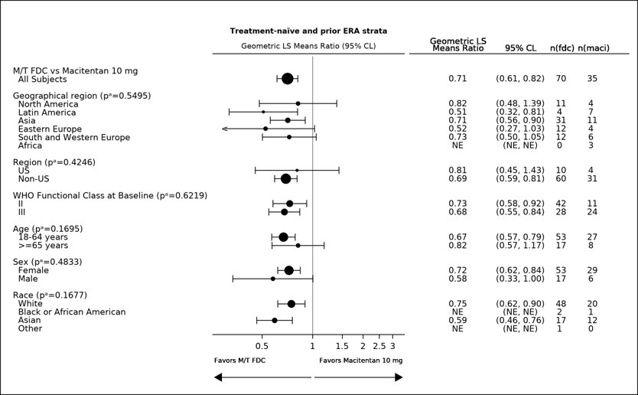
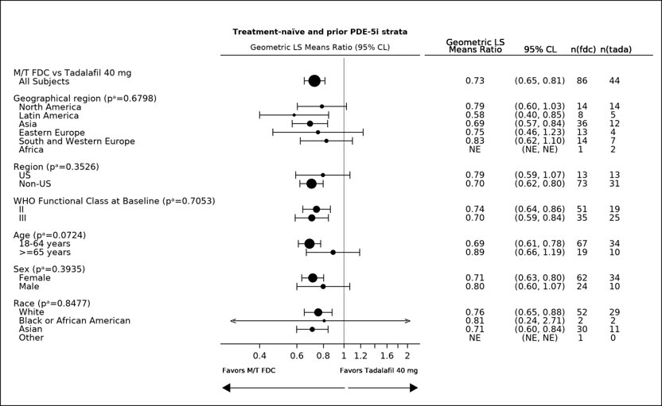

Exercise capacity
Mean change from baseline in 6-Minute Walk Distance (6MWD) at week 16 was a key secondary endpoint. A trend for clinically relevant improvement in 6MWD in favour of OPSYNVI compared to either macitentan or tadalafil was observed (Table 12).

Table 12 Change from Baseline in 6MWD at Week 16
 | Treatment-naive and Prior ERA Treatment |  | Treatment-naive and Prior PDE-5i Treatment
 | Macitentan  (n=35) | OPSYNVI  (n=70) | Tadalafil  (n=44) | OPSYNVI  (n=86)
Baseline mean (SD) | 347.2 (88.82) | 354.3 (103.49) | 361.8 (70.44) | 351.0 (98.85)
Change from baseline  at Week 16 (m) mean (SD) | 38.5 (70.4) | 52.9 (88.2) | 15.9 (45.0) | 43.4 (78.0)
Treatment effect means  (95% CI) |  | 16.0  (-17.0, 49.1) |  | 25.4  (-0.93, 51.6)
2-sided p-value |  | 0.3802 |  | 0.0591

Efficacy of macitentan and tadalafil as individual components in patients with pulmonary arterial hypertension
As OPSYNVI contains macitentan and tadalafil, the efficacy of the individual components should be considered.

Efficacy of macitentan in patients with pulmonary arterial hypertension
A multicentre, double-blind, placebo-controlled, parallel-group, event-driven, Phase 3 outcome study (AC-055-302/SERAPHIN) was conducted in 742 patients with symptomatic PAH, who were randomised to three treatment groups (placebo [N=250], 3 mg [N=250] or 10 mg [N=242] of macitentan once daily), to assess the long-term effect on morbidity or mortality. At baseline, the majority of enrolled patients (64%) were treated with a stable dose of specific therapy for PAH, either oral phosphodiesterase inhibitors (61%) and/or inhaled/oral prostanoids (6%). The primary study endpoint was the time to first occurrence of a morbidity or mortality event, up to end of treatment (EOT), defined as death, or atrial septostomy, or lung transplantation, or initiation of intravenous (i.v.) or subcutaneous (s.c.) prostanoids, or other worsening of PAH. Other worsening of PAH was defined as the presence of all of the three following components: a sustained decrease in 6-minute walk distance (6MWD) of at least 15% from baseline; worsening of PAH symptoms (worsening of WHO Functional Class [FC] or right heart failure); and need for new treatment for PAH. All events were confirmed by an independent adjudication committee, blinded to treatment allocation.

The median treatment duration was 101, 116, and 118 weeks in the placebo, macitentan 3 mg, and 10 mg group, respectively, up to a maximum of 188 weeks on macitentan.

Efficacy was evaluated up to the end of double-blind treatment (EOT). The EOT either coincided with end of study (EOS) for patients who completed the study as scheduled or occurred earlier in case of premature discontinuation of study drug. For those patients who stopped treatment prior to EOS, PAH therapy, including macitentan, may have been initiated. All patients were followed up to EOS for vital status. The ascertainment rate for vital status at the EOS was greater than 95%.

The mean age of all patients was 46 years (range 12–85 years of age) with the majority of subjects being Caucasian (55%) and female (77%). Approximately 52%, 46%, and 2% of patients were in WHO FC II, III, and IV, respectively. Patients with WHO Functional Class I were excluded from the study.

Idiopathic or heritable PAH was the most common aetiology in the study population (57%), followed by PAH due to connective tissue disorders (31%), PAH associated with congenital heart disease with shunts (8%), and PAH associated with other aetiologies (drugs and toxins [3%] and HIV [1%]).

Outcome endpoints
Treatment with OPSUMIT 10 mg resulted in a 45% reduction (HR 0.55, 97.5% CI 0.39-0.76; logrank p<0.0001) in the occurrence of the primary endpoint up to end of double-blind treatment compared to placebo (Figure 2 and Table 13). The beneficial effect of OPSUMIT 10 mg was primarily attributable to a reduction in clinical worsening events (deterioration in 6MWD and worsening of PAH symptoms and need for additional PAH treatment). The treatment effect was established early and sustained for a median duration of 2 years.

Figure 2 Kaplan-Meier estimates of the risk of first morbidity/mortality event in SERAPHIN

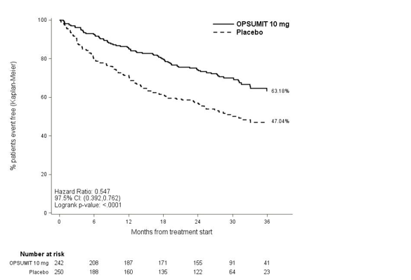

Table 13 Summary of Primary Endpoint Events
 | Placebo  N = 250  n (%) | OPSUMIT 10 mg  N = 242  n (%) | Treatment Comparison:  OPSUMIT 10 mg vs Placebo
 | Placebo  N = 250  n (%) | OPSUMIT 10 mg  N = 242  n (%) | Relative Risk Reduction  (97.5% CI) | HR  (97.5% CI) | Log rank p-value
Patients with a primary endpoint event | 116  (46.4) | 76  (31.4) | 45%  (24%; 61%) | 0.55  (0.39; 0.76) | < 0.0001
Component as first event§
Death | 17 (6.8) | 16 (6.6)
Worsening PAH | 93 (37.2) | 59 (24.4)
i.v./s.c. Prostanoid | 6 (2.4) | 1 (0.4)
§ Due to competing risks, HR and p-values are not provided for the component events; No patients experienced an event of lung transplantation or atrial septostomy in the placebo or OPSUMIT 10 mg treatment groups.

Subgroup analyses were performed to examine their influence on outcome as shown in Figure 3. Consistent efficacy of OPSUMIT 10 mg on the primary endpoint was seen across subgroups of age, sex, race, etiology, by monotherapy or in combination with another PAH therapy, baseline 6MWD, and baseline WHO FC.
Figure 3 Subgroup analysis of the SERAPHIN study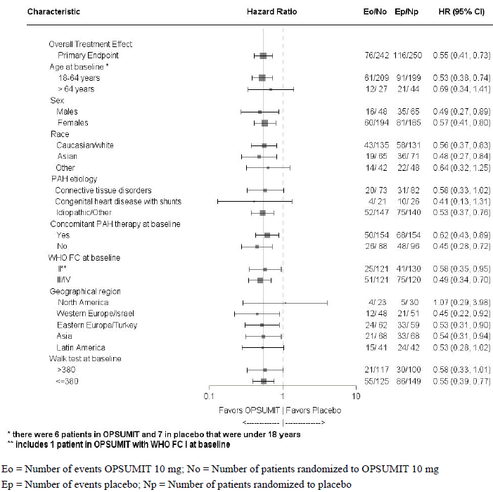
The SERAPHIN study was not powered to assess the effect on mortality. Treatment with OPSUMIT 10 mg resulted in a statistically non-significant 36% relative risk reduction (HR 0.64, 97.5% CI 0.29 1.42; logrank p=0.2037) in the occurrence of death of all causes up to EOT regardless of prior worsening. The number of deaths of all causes up to EOS on macitentan 10 mg was 35 versus 44 on placebo (HR 0.77; 97.5% CI: 0.46 to 1.28; logrank p=0.2509).
The risk of PAH-related death or hospitalisation for PAH up to the end of double-blind treatment was reduced by 50% in patients receiving macitentan 10 mg (50 events) (HR 0.50; 97.5% CI 0.34–0.75; logrank p < 0.0001) compared to placebo (84 events) [Figure 4 and Table 14].
Figure 4 Kaplan-Meier estimates of risk of death due to PAH or hospitalization for PAH in SERAPHIN
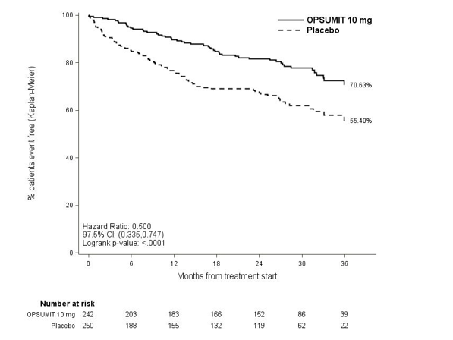
Table 14 Summary of Death due to PAH and Hospitalisation due to PAH
 | Placebo  (N=250)  n (%) | OPSUMIT 10 mg  (N=242)  n (%)
Death due to PAH or hospitalisation for PAH | 84 (33.6) | 50 (20.7)
Component as first event  Death due to PAH  Hospitalisation for PAH | 5 (2.0)  79 (31.6) | 5 (2.1)  45 (18.6)

Symptomatic endpoints
Exercise capacity was evaluated as a secondary endpoint. Treatment with macitentan 10 mg at Month 6 resulted in a placebo-corrected mean increase in Six Minute Walk Distance (6MWD) of 22 metres (97.5% CI 3–41). Evaluation of 6MWD by functional class resulted in a placebo-corrected mean increase from baseline to Month 6 in FC III/IV patients of 37 metres (97.5% CI 5–69) and in FC I/II of 12 metres (97.5% CI −8–33). The increase in 6MWD achieved with macitentan was maintained for the duration of the study.

Treatment with macitentan 10 mg led to a 74% higher chance of WHO FC improvement relative to placebo (risk ratio 1.74; 97.5% CI 1.10–2.74). Treatment with macitentan 10 mg led to an improvement of at least one WHO FC at Month 6 in 22% of patients compared to 13% of patients treated with placebo.
Macitentan 10 mg improved quality of life assessed by the SF-36 questionnaire.
Haemodynamic endpoints
Haemodynamic parameters were assessed in a subset of patients (placebo, N = 67, macitentan 10 mg, N = 57) after 6 months of treatment. Patients treated with macitentan 10 mg achieved a median reduction of 36.5% (CI 21.7–49.2%) in pulmonary vascular resistance and an increase of 0.58 L/min/m2 (CI 0.28–0.93 L/min/m2) in cardiac index compared to placebo.
Long-term treatment of PAH
In long-term follow-up of patients who were treated with OPSUMIT 10 mg in the double blind / open-label extension studies (N=242), Kaplan-Meier estimates of survival at 1, 2, 3, 5 and 7 years were 95%, 89%, 84%, 73% and 63%. The median follow-up time was 5.9 years. Without a control group, these data must be interpreted cautiously.

Efficacy of tadalafil in patients with pulmonary arterial hypertension
A randomized, double-blind, 16 week placebo-controlled study was conducted in 405 patients with pulmonary arterial hypertension, defined as a resting mean pulmonary artery pressure (mPAP) ≥25 mm Hg, pulmonary capillary wedge pressure (PCWP) ≤15 mm Hg, and pulmonary vascular resistance (PVR) ≥3 Wood units via right heart catheterization. Allowed background therapy included bosentan (maintenance dosing up to 125 mg twice daily) and chronic anticoagulation. The use of prostacyclin or analogue, L-arginine, phosphodiesterase inhibitor, or other chronic PAH medications were not permitted.

Subjects were randomly assigned to 1 of 5 treatment groups (tadalafil 2.5, 10, 20, 40 mg, or placebo) in a 1:1:1:1:1 ratio. Subjects had to be at least 12 years of age and had a diagnosis of PAH that was idiopathic, related to collagen vascular disease, anorexigen use, human immunodeficiency virus (HIV) infection, associated with an atrial-septal defect, or associated with surgical repair of a congenital systemic-to-pulmonary shunt of least 1 year in duration (for example, ventricular septal defect, patent ductus arteriosus). Patients with a history of left-sided heart disease, severe renal insufficiency, or pulmonary hypertension related to conditions other than specified in the inclusion criteria were not eligible for enrolment.

The mean age of all subjects was 54 years (range 14 - 90 years) with the majority of subjects being Caucasian (81%) and female (78%). PAH etiologies were predominantly idiopathic PAH (61%) and related to collagen vascular disease (23%). More than half (53%) of the subjects in the study were receiving concomitant bosentan therapy. The majority of subjects had a World Health Organization (WHO) Functional Class III (65%) or II (32%). The mean baseline 6-minute walk distance (6-MWD) was 344 meters. Of the 405 subjects, 341 completed the study.

The primary efficacy endpoint was the change from baseline at week 16 in 6-MWD (see Figure 5, Table 15). In the tadalafil 40 mg treatment group, the placebo-adjusted mean change increase in 6-MWD was 33 metres (95% C.I. 15-50 meters; p=0.0004). The improvement in 6-MWD was apparent at 8 weeks of treatment and then maintained at week 12 and week 16 (p<0.05).

Figure 5 6-Minute Walk Distance (metres) Mean Change from Baseline, with 95% Confidence Intervals

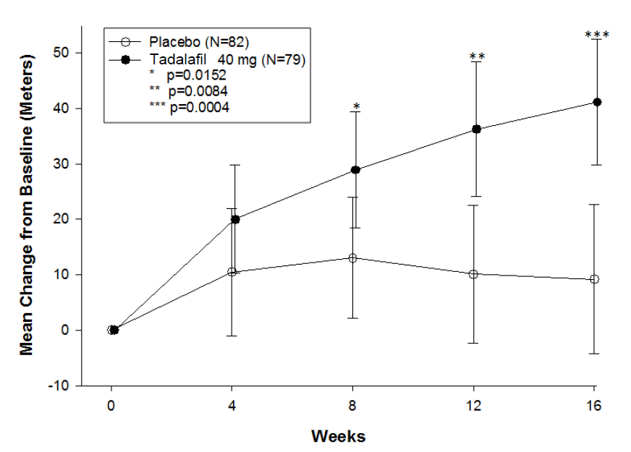

Table 15 6-Minute Walk Distance (metres) Mean Change from Baseline to Endpoint

 | Placebo  (N=82) | Tadalafil  10 mg  (N=80) | Tadalafil  20 mg  (N=82) | Tadalafil  40 mg  (N=79)
Mean (SD) | 9.21 (59.96) | 28.60 (62.17) | 36.23 (47.53) | 41.14 (49.39)
Treatment differenceª |  | 19.9 | 27.5 | 32.8
95% C.I.ª |  | 0.9, 38.8 | 10.6, 44.3 | 15.2, 50.3
p-value^{b} |  | 0.0466 | 0.0278 | 0.0004
ª ANCOVA model with Type II sum of squares including the centered baseline of 6-MW distance (cont.), PAH etiology, and bosentan use. Treatment difference is the Active Least Square mean subtract Placebo Least Square mean.
^{b} Permutation test stratified by PAH etiology, bosentan use, and baseline 6-minute walk distance (<= 325 m and >325 m) on rank compared to placebo.

Placebo-adjusted changes in 6-MWD at 16 weeks were evaluated in subgroups (see Figure 6), although the study was not powered to demonstrate statistical significance within subgroups. In patients taking only tadalafil 40 mg (i.e., without concomitant bosentan), the placebo-adjusted mean change in 6-MWD was 44 metres (p<0.01). In patients taking tadalafil 40 mg and concomitant bosentan therapy, the placebo adjusted mean change in 6-MWD was 23 meters (p>0.05).

Figure 6 Placebo-adjusted Mean Change in 6-Minute Walk Distance (metres) of tadalafil 40 mg, with 95% Confidence Intervals

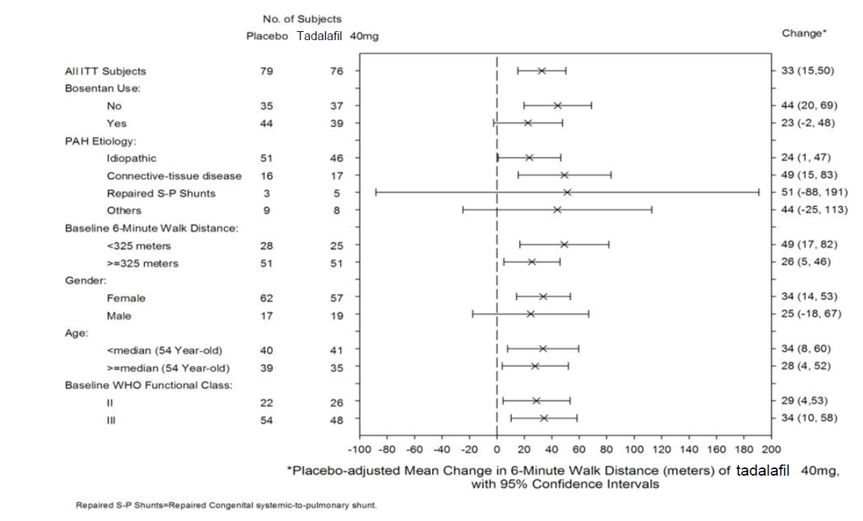

The secondary endpoints were tested in a sequential order specified in the protocol, which is the order listed in Table 16, with no further inferential testing once a statistically non-significant result was reached. Inferential testing did not proceed beyond WHO functional Class since this comparison was statistically non-significant.

Table 16 Secondary Endpoints (Change from Baseline to End of Treatment – Week 16)
 | Placebo  (N=82) | Tadalafil 10 mg (N=80) | Tadalafil 20 mg  (N=82) | Tadalafil 40 mg  (N=79)
Change in WHO Functional Class No. (%)
Improved | 17 (20.7) | 19 (23.8) | 30 (36.6) | 18 (22.8)
No Change | 52 (63.4) | 50 (62.5) | 37 (45.1) | 53 (67.1)
Worsen | 13 (15.9) | 11 (13.75) | 15 (18.3) | 8 (10.1)
P-value |  | 0.5758 | 0.1694 | 0.3630
Clinical Worseningª

Probability of No Clinical Worsening at Week 16 (95% C.I.) | 0.84  (0.74, 0.90) | 0.91  (0.82,0.95) | 0.90  (0.80, 0.95) | 0.94  (0.85, 0.98)
No. of patients (%) with Clinical Worsening | 13 (15.9) | 7 (8.8) | 8 (9.8) | 4 (5.1)
Change in Borg Dyspnoea^{b} Score
Mean (SD) | 0.41 (1.89) | -0.36 (1.92) | -0.29 (2.08) | -0.70 (1.75)
ª Clinical worsening was defined as death, lung transplantation, atrial septostomy, hospitalization due to worsening PAH, initiation of new PAH therapy, and worsening WHO functional class.
^{b} A positive change in Borg-Dyspnea score represents a worsening of patient perceived breathlessness during the 6 minute walk.

A statistically significant (p<0.05) increase in quality of life, compared to placebo, was demonstrated in the tadalafil 40 mg group in 6 of the 8 SF36 domains (physical functioning, role physical, bodily pain, general health, vitality and social functioning) and in all questions of EuroQoL.

Long-term treatment
357 patients from the placebo-controlled study entered a long-term extension study. Of these, 311 patients had been treated with tadalafil for at least 6 months and 293 for 1 year (median exposure 365 days; range 2 days to 415 days). For those patients for which there are data, the survival rate at 1 year is 96.4%. Additionally, 6 minute walk distance and WHO functional class status appeared to be stable in those treated with tadalafil for 1 year.

Pharmacokinetic properties
The bioavailability of all components of OPSYNVI was comparable to when macitentan 10 mg and tadalafil 40 mg were co-administered separately; bioequivalence was established following single-dose administration in healthy subjects (N=162). As OPSYNVI contains macitentan and tadalafil, the pharmacokinetic properties of the individual components should be considered.

Food effect
When OPSYNVI (10 mg macitentan/40 mg tadalafil) tablet was administered to healthy subjects with a high-fat meal, no effect of food on the pharmacokinetics of macitentan was observed and the AUC for tadalafil remained unchanged, while C_{max} increased by 45%. This increase in C_{max} is not considered clinically significant.

Macitentan

The pharmacokinetics of macitentan and its active metabolite have mainly been documented in healthy subjects. Exposure to macitentan in patients with PAH was approximately 1.2-fold greater than in healthy subjects. The exposure to the active metabolite in patients, which is approximately 5-fold less potent than macitentan, was approximately 1.3-fold higher than in healthy subjects. The pharmacokinetics of macitentan in PAH patients were not influenced by the severity of the disease.

After repeated administration, the pharmacokinetics of macitentan are dose-proportional up to and including 30 mg.

Absorption
Maximum plasma concentrations of macitentan are achieved about 8 hours after administration. The absolute bioavailability after oral administration is not known. Thereafter, plasma concentrations of macitentan and its active metabolite decrease slowly, with an apparent elimination half-life of approximately 16 hours and 48 hours, respectively.

In healthy subjects, the exposure to macitentan and its active metabolite is unchanged in the presence of food and, therefore, macitentan may be taken with or without food.

Distribution
Macitentan and its active metabolite are highly bound to plasma proteins (> 99%), primarily to albumin and to a lesser extent to alpha-1-acid glycoprotein. The apparent volumes of distribution (Vss/F) of macitentan and its active metabolite were about 50 L and 40 L, respectively, in healthy subjects.

Metabolism
Macitentan has four primary metabolic pathways. The most important is oxidative depropylation of the sulfamide to yield a pharmacologically active metabolite. This reaction is dependent on the cytochrome P450 system, mainly CYP3A4 (approximately 99%) with minor contributions from CYP2C8, CYP2C9 and CYP2C19. The active metabolite circulates in human plasma and may contribute to the pharmacological effect.

Other metabolic pathways yield products without pharmacological activity. For these pathways, CYP2C9 plays a predominant role with minor contributions from CYP2C8, CYP2C19 and CYP3A.

Excretion
Macitentan is only excreted after extensive metabolism. The major excretion route is via urine, accounting for about 50% of the dose.

Special populations
There is no clinically relevant effect of age, sex or ethnic origin on the pharmacokinetics of macitentan and its active metabolite.

Renal impairment
Exposure to macitentan and its active metabolite was increased by 1.3- and 1.6-fold, respectively, in patients with severe renal impairment.

Hepatic impairment
Exposure to macitentan was decreased by 21%, 34%, and 6% and for the active metabolite by 20%, 25%, and 25% in subjects with mild, moderate or severe hepatic impairment, respectively.

Tadalafil

Absorption
Tadalafil is rapidly absorbed after oral administration and the mean maximum observed plasma concentration (C_{max}) is achieved at a median time of 4 hours after dosing. There is no clinically relevant effect of food on the rate and extent of absorption of tadalafil, thus tadalafil may be taken with or without food. The time of dosing (morning versus evening after a single 10 mg administration) has no clinically relevant effects on the rate and extent of absorption. The absolute bioavailability of oral tadalafil has not been established. The mean bioavailability of the tadalafil 20 mg tablet has been estimated to be 88% relative to an oral suspension dosage form.

Distribution
The mean volume of distribution after oral dosing is approximately 77 L at steady state. At therapeutic concentrations, 94% of tadalafil in plasma is bound to proteins. Protein binding is not affected by impaired renal function. Less than 0.0005% of the administered dose appears in the semen of healthy subjects.

Metabolism
Tadalafil is metabolised mainly (>80%) by the cytochrome P450 (CYP) 3A4 isoform, with minor contributions by CYPs 2C8, 2C9, 2C19 and 2D6 (<20% collectively). The major circulating metabolite is the methylcatechol glucuronide. This metabolite is at least 13,000-fold less potent than tadalafil for PDE5. Consequently, it is not expected to be clinically active at observed metabolite concentrations.

Excretion
The mean oral clearance for tadalafil is 3.4 L/hr and the mean terminal half-life is 16 hours in healthy subjects. Tadalafil is excreted predominantly as inactive metabolites, mainly in the faeces (approximately 61% of the dose) and to a lesser extent in the urine (approximately 36% of the dose).

Linearity/non-linearity
Over a dose range of 2.5 to 20 mg, tadalafil exposure (AUC) increases proportionally with dose in healthy subjects. Between 20 mg to 40 mg, a less than proportional increase in exposure is observed. During tadalafil 20 mg and 40 mg once daily dosing, steady-state plasma concentrations are attained within 5 days, and exposure is approximately 1.5fold of that after a single dose.

Population pharmacokinetics
In patients with pulmonary hypertension not receiving concomitant bosentan, the average tadalafil exposure at steady-state following 40 mg was 26% higher when compared to those of healthy volunteers. There were no clinically relevant differences in C_{max} compared to healthy volunteers. The results suggest a lower clearance of tadalafil in patients with pulmonary hypertension compared to healthy volunteers.

Special populations
Elderly (65 years of age and older)
Healthy elderly subjects (65 years or over) had a lower clearance of tadalafil, resulting in a half-life of 22 hours and 25% higher exposure (AUC), relative to healthy subjects aged 19 to 45 years after a 10 mg dose (half-life of 16-17 hours). This effect does not appear to warrant a dose adjustment (see Section 4.2 Dose and method of administration - Elderly). The half-life of tadalafil in the elderly increases the period after the last dose of tadalafil during which nitrates should be avoided (see section 4.3 Contraindications).

Renal impairment
In clinical pharmacology studies using single-dose tadalafil (5-20 mg), tadalafil exposure (AUC) approximately doubled in subjects with mild (creatinine clearance 51 to 80 mL/min) or moderate (creatinine clearance 31 to 50 mL/min) renal impairment and in subjects with end-stage renal disease on dialysis. In haemodialysis patients in these studies, C_{max} was 41% higher than that observed in healthy subjects. Haemodialysis contributed negligibly to tadalafil elimination.

Due to increased tadalafil exposure (AUC), limited clinical experience, and the lack of ability to influence clearance by dialysis, tadalafil is not recommended in patients with severe renal impairment.

Hepatic impairment
A clinical pharmacology study was conducted using a single 10-mg dose of tadalafil to investigate the effect of hepatic impairment on the pharmacokinetics of tadalafil in subjects with hepatic dysfunction as defined by the Child-Pugh classification. Tadalafil exposure (AUC) in subjects with mild and moderate hepatic impairment (Child-Pugh Class A and B) was comparable to exposure in healthy subjects after a 10-mg dose. There are no available data about the administration of doses higher than 10 mg of tadalafil to patients with hepatic impairment. No controlled data are available in patients with severe hepatic impairment (Child-Pugh Class C) and therefore dosing of tadalafil in these patients is not recommended. If tadalafil is prescribed, a careful individual benefit/risk evaluation should be undertaken by the prescribing physician.

Patients with diabetes
Tadalafil exposure (AUC) in patients with diabetes was approximately 19% lower than the AUC value for healthy subjects after a 10 mg dose. This difference in exposure does not warrant a dose adjustment.

Race
Pharmacokinetic studies have included subjects and patients from different ethnic groups, and no differences in the typical exposure to tadalafil have been identified. No dose adjustment is warranted.

Gender
In healthy female and male subjects following single and multiple-doses of tadalafil, no clinically relevant differences in exposure were observed. No dose adjustment is warranted.

Preclinical safety data

Macitentan

Genotoxicity
Macitentan was not genotoxic in a standard battery of in vitro and in vivo assays.

Carcinogenicity
Studies of 2 years duration did not reveal a carcinogenic potential at exposures 18-fold and 116-fold the human exposure in rats and mice, respectively.

Tadalafil

Genotoxicity
Tadalafil was not mutagenic or genotoxic in in vitro bacterial and mammalian cell assays, and in in vitro human lymphocytes and in vivo rat micronucleus assays.

Carcinogenicity
Oral administration of tadalafil at doses of 400 mg/kg/day for up to two years in mice resulted in increased development of hepatocellular adenomas in males but not in females. Tadalafil also caused hepatocellular microsomal enzyme induction in rodents and it is possible that this could lead to an increased incidence of hepatocellular neoplasms. However, hepatic microsomal enzyme induction is a common non-genotoxic biologic effect associated with hepatocellular tumour formation in rodents and is not considered relevant to human cancer risk. The no effect dose of 60 mg/kg/day was associated with systemic exposure to tadalafil approximately 2 to 3- fold that expected in humans taking the recommended dose of 40 mg daily, based on unbound drug concentrations.

Pharmaceutical particulars

List of excipients

Tablet core
Hyprolose
Lactose monohydrate
Magnesium stearate
Microcrystalline cellulose
Polysorbate 80
Povidone
Sodium starch glycollate
Sodium lauryl sulfate

Film coating
Opadry II Complete Film Coating System 30K580008 White, ARTG PI No. 146235

Incompatibilities
Not applicable.

Shelf life
In Australia, information on the shelf life can be found on the public summary of the Australian Register of Therapeutic Goods (ARTG). The expiry date can be found on the packaging.

Special precautions for storage
Store below 30˚C. Store in original package.

Nature and contents of container
30 tablets in aluminium perforated unit dose blisters with integrated desiccant aluminium push-through lidding foil.

Special precautions for disposal
In Australia, any unused medicine or waste material should be disposed of by taking to your local pharmacy.

Physicochemical properties

Macitentan

Chemical structure

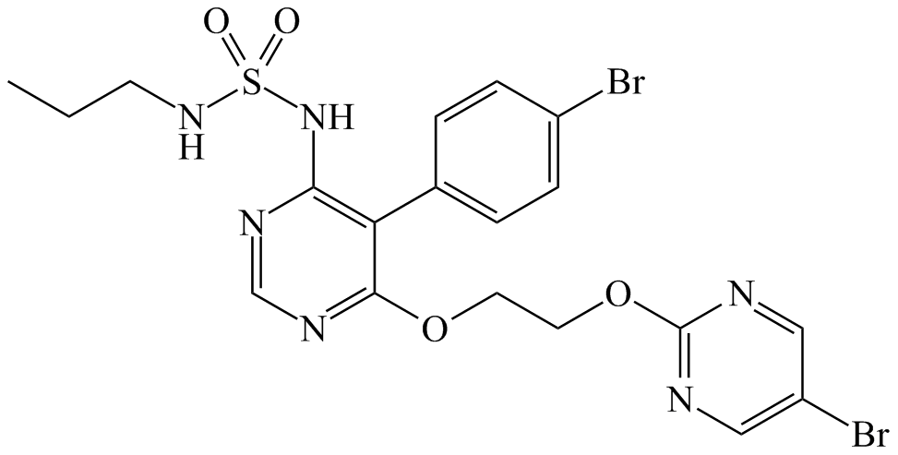
Molecular formula: C₁₉H₂₀Br₂N₆O₄S
Relative molecular mass: 588.27 g/mol.

CAS number
441798-33-0

Tadalafil

Chemical structure
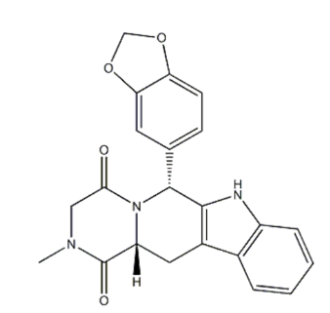
Molecular formula: C₂₂H₁₉N₃O₄
Molecular weight: 389.40

CAS number
171596-29-5

Medicine schedule (Poisons Standard)
SCHEDULE 4 - Prescription Only Medicine

8 Sponsor
JANSSEN-CILAG Pty Ltd
1-5 Khartoum Rd
Macquarie Park NSW 2113 Australia
Telephone: 1800 226 334

NZ Office: Auckland New Zealand

Date of first approval
16 September 2024

DATE of REVISION
NA

SUMMARY table of changes
Section Changed | Summary of new information
NA | NA

