Australian Public Assessment Report for JOENJA
  - Active ingredient: Leniolisib
  - Sponsor: Ballia Holdings Pty Ltd
June 2025

About the Therapeutic Goods Administration (TGA)
- The Therapeutic Goods Administration (TGA) is part of the Australian Government Department of Health, Disability and Ageing and is responsible for regulating therapeutic goods, including medicines, medical devices, and biologicals.
- The TGA administers the Therapeutic Goods Act 1989 (the Act), applying a risk management approach designed to ensure therapeutic goods supplied in Australia meet acceptable standards of quality, safety, and efficacy.
- The work of the TGA is based on applying scientific and clinical expertise to decision-making, to ensure that the benefits to the Australian public outweigh any risks associated with the use of therapeutic goods.
- The TGA relies on the public, healthcare professionals and industry to report problems with therapeutic goods. The TGA investigates reports received to determine any necessary regulatory action.
- To report a problem with a therapeutic good, please see the information on the TGA website.

About AusPARs
- The Australian Public Assessment Report (AusPAR) provides information about the evaluation of a prescription medicine and the considerations that led the TGA to approve or not approve a prescription medicine submission. Further information can be found in Australian Public Assessment Report (AusPAR) guidance.
- AusPARs are prepared and published by the TGA.
- AusPARs are static documents that provide information that relates to a submission at a particular point in time. The publication of an AusPAR is an important part of the transparency of the TGA’s decision-making process.
- A new AusPAR may be provided to reflect changes to indications or major variations to a prescription medicine subject to evaluation by the TGA.

Copyright
© Commonwealth of Australia 2025
This work is copyright. You may reproduce the whole or part of this work in unaltered form for your own personal use or, if you are part of an organisation, for internal use within your organisation, but only if you or your organisation do not use the reproduction for any commercial purpose and retain this copyright notice and all disclaimer notices as part of that reproduction. Apart from rights to use as permitted by the Copyright Act 1968 or allowed by this copyright notice, all other rights are reserved and you are not allowed to reproduce the whole or any part of this work in any way (electronic or otherwise) without first being given specific written permission from the Commonwealth to do so. Requests and inquiries concerning reproduction and rights are to be sent to the TGA Copyright Officer, Therapeutic Goods Administration, PO Box 100, Woden ACT 2606 or emailed to <tga.copyright@tga.gov.au>.

Contents
List of abbreviations 4
JOENJA (leniolisib) submission 5
Proposed indication 6
The condition 6
Current treatment options 7
Clinical rationale 7
Regulatory status 7
Registration timeline 8
Assessment overview 8
Quality evaluation summary 8
Nonclinical evaluation summary 9
Clinical evaluation summary 9
Pharmacology 9
Efficacy 11
Safety 15
Risk management plan evaluation summary 18
Risk-benefit analysis 19
Delegate’s considerations 19
Proposed action 20
Advisory Committee considerations 20
Assessment outcome 21
Specific conditions of registration 21
Product Information and Consumer Medicines Information 22

List of abbreviations
Abbreviation | Meaning
ACM | Advisory Committee on Medicines
AE | adverse events
APDS | activated phosphoinositide 3 kinase δ syndrome
ARTG | Australian Register of Therapeutic Goods
AUC | area under the concentration-time profile
BD | twice daily dosing
CL/F | drug clearance
C_{max} | maximum plasma concentration
CMI | Consumer Medicines Information
EMA | European Medicines Agency
MHRA | Medicines and Healthcare products Regulatory Agency
PD | pharmacodynamic(s)
PI | Product Information
PI3Kδ | phosphoinositide-3-kinase-δ
PK | pharmacokinetic(s)
popPK | population pharmacokinetic(s)
PSUR | periodic safety update report
RMP | risk management plan
SAE | serious adverse events
SF-36 | Short Form 36
TEAE | treatment emergent adverse events
TGA | Therapeutic Goods Administration
V/F | volume of distribution
WPAI-CIQ | Work Productivity Activity Impairment plus Classroom Impairment Questionnaire

JOENJA (leniolisib) submission
Type of submission: | New chemical entity
Product name: | JOENJA
Active ingredient: | leniolisib
Decision: | Approved
Date of decision: | 13 March 2025
Date of entry onto ARTG: | 18 March 2025
ARTG number: | 416199
Black Triangle Scheme | Yes
Sponsor’s name and address: | Ballia Holdings Pty Ltd PO Box 3203, Kew VIC 3101
Dose form: | Film-coated tablet
Strength: | 70 mg
Container: | High density polyethylene bottles with aluminum induction seal and child-resistant polypropylene screw cap
Pack size: | 60 tablets/bottle
Approved therapeutic use for the current submission: | JOENJA is indicated for the treatment of activated phosphoinositide 3-kinase delta syndrome (APDS) in adults and adolescents 12 years of age and older.
Route of administration: | Oral
Dosage: | The recommended dose in adult and paediatric patients who weigh more than 45 kg is 70 mg JOENJA twice daily approximately 12 hours apart  For further information regarding dosage, refer to the Product Information.
Pregnancy category: | Category D  Drugs which have caused, are suspected to have caused or may be expected to cause, an increased incidence of human fetal malformations or irreversible damage. These drugs may also have adverse pharmacological effects.  The use of any medicine during pregnancy requires careful consideration of both risks and benefits by the treating health professional. The pregnancy database must not be used as the sole basis of decision making in the use of medicines during pregnancy. The TGA does not provide advice on the use of medicines in pregnancy for specific cases. More information is available from obstetric drug information services in your state or territory.

Proposed indication
This AusPAR describes the submission by Ballia Holdings Pty Ltd (the Sponsor) to register JOENJA - leniolisib for the following proposed indication:
treatment of activated phosphoinositide 3-kinase delta syndrome (APDS) in adults
and adolescents 12 years of age and older.

The condition
Activated phosphoinositide 3 kinase δ syndrome (APDS) is a rare immunodeficiency syndrome with an estimated prevalence of 1-1.5 per million people. It is caused by a gain of function mutation in the activity of phosphoinositide-3-kinase-delta (PI3Kδ), which controls post receptor signalling of tyrosine kinase activated receptors on cells. This system is widely distributed in human cells, among them immune cells (Figure 1).
Figure 1: The phosphoinositide-3-kinase PI3K signalling pathway
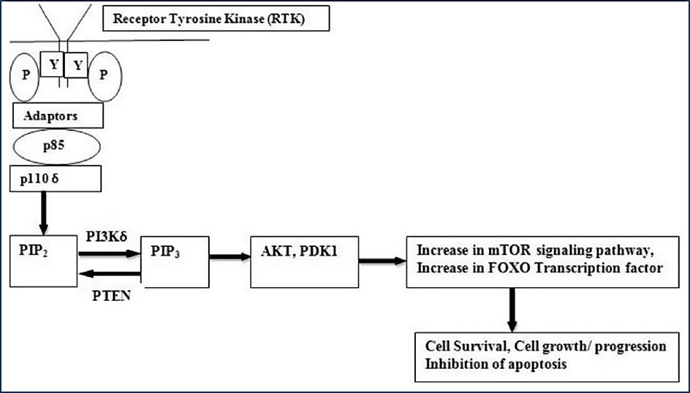
PIP2=phosphatidylinositol 4,5-bisphosphate; Y=Tyrosine, P=phosphate groups; PIP3=phosphatidylinositol (3,4,5) trisphosphate, PDK1=3-phosphoinositide-dependent protein kinase 1; PTEN=phosphatase and Tensin homolog deleted on chromosome TEN; mTOR= mammalian target of rapamycin; p100δ=phosphoinositide 3-kinase p110 delta; p85=p85 regulatory component of the PI3K (phosphoinositide 3-kinase)
APDS significantly impacts the differentiation, development and activation of B cells. This produces proliferation of pathologically ‘stimulated’ immune cells, and a reduction in the population of naïve (not stimulated by antigen) B-cells. There is a reduction in circulating B-cell numbers (lymphopenia) and hypo-gammaglobulinaemia with normal or elevated IgM levels.
Clinical signs of lymphoproliferation, lymphadenopathy and splenomegaly develop with reduced immune responses to respiratory pathogens and viruses (Epstein-Barr virus and cytomegalovirus), and an increased risk of lymphoma.
Symptoms of APDS originate from chronic and recurrent infections, from the mass effect of lymphoid tissue (e.g. pressure on mediastinal structures), and from malignancy. APDS patients have a reduced response to vaccination, which leaves them vulnerable to vaccine preventable diseases.
APDS is a cumulative and progressive lifelong condition that significantly reduces patient’s expected lifespan. Conditional survival of a review population of APDS patients indicated survival of 87% at 20 years, 74% at 30 years, 68% at 40 and 50 years. The general Australian population has a 68% survival rate of about 75 years.

Current treatment options
There are currently no treatments which target the primary cause of APDS. Supportive therapy for immunodeficiency includes antibiotic prophylaxis and intravenous immunoglobulin support. Lymphoproliferation has been treated with rituximab, or homologous stem cell transplant when malignant transformation occurs.

Clinical rationale
Leniolisib is a small molecule oral inhibitor of p110δ that selectively inhibits the production of phosphatidylinositol-3,4,5-trisphosphate (PIP3) and, consequently, its downstream messenger phosphorylated protein kinase B (pAkt). Leniolisib inhibits the p110δ subunit of phosphoinositide 3-kinase (PI3K) class IA that reduces the hyperactive PI3Kδ. It is proposed that leniolisib targets and inhibits the hyperactive PI3Kδ pathway in leukocytes, thereby normalizing immune responses and reducing lymphadenopathy, hepatosplenomegaly, and occurrence of infections, thus reducing the level of supportive therapy required in APDS.

Regulatory status

Australian regulatory status
This product is considered a new chemical entity for Australian regulatory purposes.

International regulatory status
At the time the TGA considered this submission, a similar submission had been considered by other regulatory agencies. Table 1 summarises these submissions and provides the indications where approved.
Table 1. International regulatory status for JOENJA
Agency | Status | Date | Indications
FDA | Approved | 24 March 2023 | Treatment of activated phosphoinositide 3-kinase delta syndrome (APDS) in adult and pediatric patients 12 years of age or older
EMA | In progress |  | Proposed: Treatment of activated phosphoinositide 3-kinase delta syndrome (APDS) in adults and adolescents 12 years of age or older weighing 45kg or more
MHRA | Approved | 25 September 2024 | JOENJA is indicated for the treatment of activated phosphoinositide 3-kinase delta (P13Kδ) syndrome (APDS) in adult and paediatric patients 12 years of age and older.

Registration timeline
Table 2 captures the key steps and dates for this submission.
This submission was evaluated under the priority registration process and the active ingredient with its proposed indication was given orphan drug designation.
Table 2. Registration timeline for JOENJA (leniolisib), submission PM-2023-03256-1-2
Description | Date
Priority determination | 31 May 2023
Orphan designation | 31 May 2023
Submission dossier accepted and evaluation commenced | 31 August 2023
Evaluation completed | 2 February 2024
Advisory committee meeting | 7 February 2025
Registration decision (Approved) | 13 March 2025
Registration in the ARTG completed | 18 March 2025
Number of working days from submission dossier acceptance to registration decision* | 393 days
*Target timeframe for priority submissions is 150 working days from acceptance for evaluation to the decision.

Assessment overview

Quality evaluation summary
The application and the supporting data relating to the composition, development, manufacture, quality control, stability and bioavailability of the product have been assessed and checked for compliance, as applicable, with Australian legislation and requirements for new medicines and in accordance with pharmacopoeial standards and the technical guidelines adopted by the TGA.

Nonclinical evaluation summary
The non-clinical evaluator has not objected to approval of leniolisib.
The in vitro and in vivo pharmacology data provided a mechanism of action of using leniolisib for the treatment of APDS.
Secondary pharmacology studies suggest that insulin insensitivity/resistance may occur in patients at the proposed clinical dose of leniolisib.
In vitro studies predicted:
- inhibitors and inducers of CYP3A4 may alter the systemic exposure to leniolisib
- leniolisib may increase the exposure of co-administered drugs that are substrates of CYP1A2, UGT1A1, BCRP, OATP1B1, OATP1B3, OCT2, MATE1 or MATE2-K
Notable target organs/systems for toxicity are:
- Lymphoid organs (lymphoid depletion in the thymus, spleen, lymph nodes and GALT and opportunistic infections)
- Heart (QTc prolongation)
- GIT (inflammation)
- Male reproductive organs (decreased tubular germinal epithelium and hypospermatogenesis)
leniolisib is not genotoxic. leniolisib was not carcinogenic in transgenic mice in a 26- week study that was considered deficient. Therefore, conclusions on the carcinogenic potential of leniolisib cannot be made. However, it is noted that a long-term carcinogenicity study in rats is currently underway. This study should be submitted to the TGA for evaluation upon completion.
Delayed sexual maturation in males, early vaginal opening in females and reduced femur length were observed in juvenile rats. The effects on sexual maturation could be secondary to changes in sex hormones given the opposite effects on male and female sex maturation.
The nonclinical studies (malformations in rats and rabbits) and pharmacological activities of leniolisib predicted embryofetal toxicity if administered to pregnant patients at the proposed clinical dose. A pregnancy category D is recommended.

Clinical evaluation summary

Pharmacology

Pharmacokinetics
Leniolisib is rapidly absorbed. While no bioavailability study was performed, in vitro data and mass-balance studies support complete absorption of oral doses in fasted patients. There is a reduction in leniolisib C_{max} when administered with food, but no change in AUC. Absorption is reduced by increased pH, but a dedicated study in patients taking gastric acid inhibitors has not been conducted.
Leniolisib is highly bound to plasma proteins in circulation (94.5%) with a volume of distribution in people with APDS of 28.5L. Inter-individual variability in AUC in APDS patients range from 21.7-38.6% for C_{max} and 18.4-35.3% for AUC across the dosage range 10mg-70mg.
The main form of leniolisib in circulation is unchanged drug (93-96%). Metabolism of leniolisib occurs in the liver, driven primarily by CYP3A4 (95.4%). Excretion at 168 hours post- dose was primarily faecal (67%) for oxidised leniolisib, with 25% excreted in urine primarily as unchanged drug.
In the population PK analysis of the healthy participant data, the estimated CL/F was 4.01 L/h. In patients with APDS, the estimated typical value of clearance at steady state was 3.72 L/h (geometric mean). The renal clearance of leniolisib at steady state in healthy participants ranged from 0.0861 to 0.251 L/h following twice daily dosing from 20 to 140 mg. With twice daily dosing in healthy participants, the geometric mean accumulation ration (Racc) ranged from 1.32 to 1.57 and steady state was achieved within 2 to 3 days following onset of therapy, consistent with an effective half-life of approximately 5.56 to 8.08 hours.
There were no dedicated studies in patients with hepatic or renal impairment (a study involving patients with hepatic impairment is on-going)
Administration of leniolisib with a strong CYP3A4 inhibitor (itraconazole) led to an approximately two-fold increase in the leniolisib AUC. Modelling/simulation submitted by the Sponsor suggest that administration of leniolisib with a moderate CYP3A4 inhibitor (erythromycin) would lead to an increase the Cmax and AUC of leniolisib by 30% and 60% respectively. Administration of leniolisib with a CYP3A4 inducer (rifampicin) would be expected to reduce leniolisib AUC and C_{max} by 80% and 50% respectively. Although this is estimated to remain above the therapeutic concentration of leniolisib, the CE has noted that
co-administration of leniolisib and CYP3A4 inducers should be avoided.
A drug-interaction study with the OCP (oestrogen and levonorgestrel) indicate a 30% reduction in oestrogen exposure and no reduction in levonorgestrel when co-administered with leniolisib. This is unlikely to be clinically significant.
In vitro studies suggest leniolisib can potentially interact with a number of CYP isoforms but interaction studies have not been performed.

Population PK data
A population PK model was constructed using 2803 leniolisib concentration measurement from 118 health participants who received leniolisib at doses between 10 and 400mg as single doses, or 20 and 140mg BD for 14 days. A two-compartment (central and peripheral) model was considered to describe the pharmacokinetic data well. Body weight was a relevant variable, with the volume of distribution in both compartments increasing with body weight (Table 3). There was no effect of sex.
Table 3. Population pharmacokinetics estimates of key variables
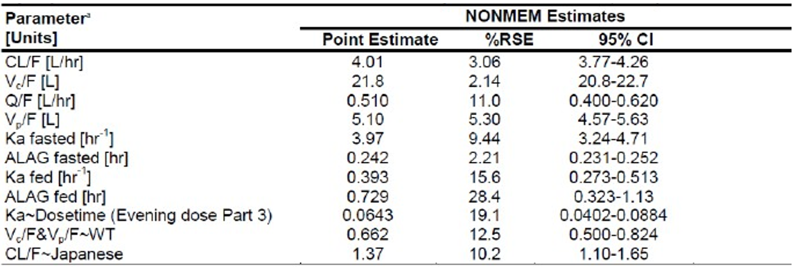
ALAG: absorption lag time; CL/F: apparent oral clearance; K_{a}: absorption rate constant; Q/F: intercompartmental clearance; V_{c}/F: apparent volume of central compartment; V_{p}/F: apparent volume of peripheral compartment

Pharmacodynamics
The primary pharmacodynamic endpoint measured was the percentage of phosphokinase B (Akt) positive B cells in stimulated and unstimulated populations of B cells. Phosphokinase B levels are increased by the action of PI3K and so forms an indirect measure of the action of this enzyme. There was a reduction in phosphokinase B levels measured in B cells examined after leniolisib treatment, which occurred rapidly (within 1 hour) of administration.
QTc prolongation was also measured in one study (2101) and no QT prolongation was found from leniolisib treatment.

Efficacy
The clinical efficacy data consisted of the phase II/III study 2201, which was conducted in two 12-week control stages (part 1 and 2), followed by an open label extension stage (E1). Part 1 of the study only enrolled 6 patients, and so Part 2 has been evaluated as the pivotal efficacy data. The extension phase of the study is ongoing (Table 4).
Table 4. Stages of leniolisib clinical program for study 2201
 | Study 2201 Part 1 | Study 2201 Part 2 | Study 2201E1
Dosing Regimen | Leniolisib 10/30/70 mg bd | Leniolisib 70 mg bd | Leniolisib 70 mg bd
Control | None | Placebo | None
Length of treatment | 12 weeks (4 at each dose level) | 12 weeks | up to 6 years
Design | Multicentre, OL, non- randomised, within-patient, dose-finding | Multicentre, randomised, placebo-controlled, double- blind. | Multicentre, OLE, non- randomised.
Primary Objective | Dose-PD and PK/PD for dose selection safety and tolerability | Clinical efficacy: lymphadenopathy and immunophenotype normalisation | Long-term safety and tolerability
Secondary Objective | PK, clinical outcome assessments, and biomarkers | Safety, PK, clinical outcome assessments, and biomarkers | Long-term efficacy: clinical outcome assessments, biomarkers, PK, and relative BA
Patients: Planned (n)/Actual (n) | 6/6 | 30/31(leniolisib n=21; placebo n=10) | 42/37
Evaluable for Efficacy (PD analysis set) | 6 | 27 | 37
Study status | Completed | Completed | Ongoing
APDS=activated phosphoinositide 3-kinase delta syndrome; BA = bioavailability: bid=twice daily; CSR=clinical study report; OLE =open label extension; PD=pharmacodynamic; PK=pharmacokinetic.

Pivotal study 2201 part 2 (2201/2)
Study 2201/2 was a 12-week placebo-controlled study that examined APDS patients (n=31) randomised 2:1 to placebo (n=10) or leniolisib 70mg BD (n=21) (Figure 2). Included patients were aged 12-75 years of age and had genetically confirmed APDS with a mutation of the PI3Kδ gene. Patients with either APDS type 1 or 2 could be included.
Figure 2: Design of study 2201/2
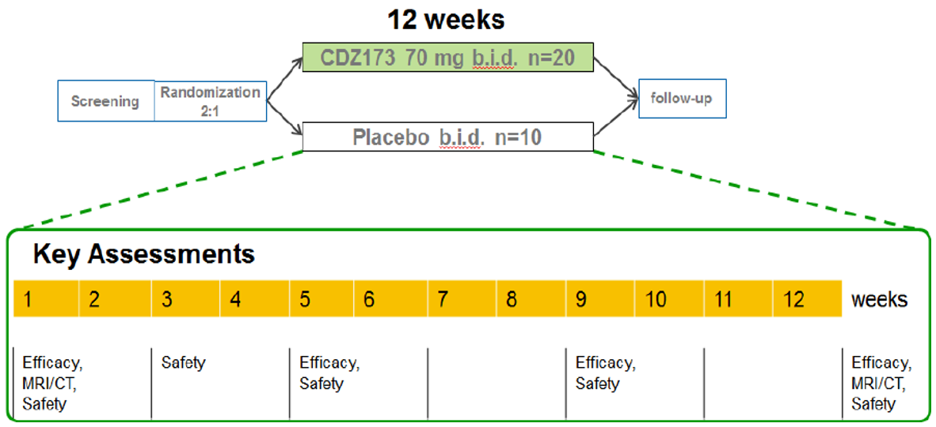
Included patients had nodal or extranodal lymphoproliferation and clinical findings consistent with APDS such as recurrent infections and/or organ dysfunction. Patients were required to have at least one measurable nodal lesion on CT or MRI for evaluation.
Patients were excluded if they had taken B-cell depleters (e.g. rituximab) within 6 months of the study. Patients taking concurrent use of a strong CYP3A4 inducer that could not be discontinued were excluded.
The primary endpoints of the study were:
- reduction in the volume of an index nodal lesion, as measured by CT or MRI. This was assessed by taking the log of the sum of the product of the diameters of the lesion (Log₁₀SPD). Up to 14 lesions (6 lymph nodes, 4 liver or spleen and 4 other extranodal) were selected for monitoring in each patient, and between 1 and 6 of the largest lymph nodes were used to calculate the SPD for the primary endpoint.
- Change in the percentage of naïve B cells out of total B cells in whole blood measured in patients with less than 48% naïve B-cells at baseline.
Of the enrolled patients, 27 (18 leniolisib and 8 placebo) patients were evaluable for efficacy.
Table 5 outlines the secondary endpoints included in the study.
Table 5. Secondary endpoints of study 2201/2
Objective | Endpoint
To assess the effect of CDZ173 on lymphadenopathy (non-index lesions and spleen) | MRI/CT imaging — e.g. 3D volume of index and measurable non-index lesions selected as per the Cheson methodology, and 3D volume and bi-dimensional size of the spleen
To assess the PK of CDZ173 in patients with APDS/PASLI | Single dose CDZ173 PK parameters (including but not limited to Cmax and AUC) and trough evaluations after multiple dose
To assess the efficacy of CDZ173 to modify health-related quality of life in patients with APDS/PASLI | SF-36 (Short Form 36) Survey and WPAI-CIQ (Work Productivity Activity Impairment plus Classroom Impairment Questionnaire)
To assess the efficacy of CDZ173 by the Physician's Global Assessment (PGA) and the Patient's Global Assessment (PtGA) | Visual analogue scales for PGA and PtGA (for Part II the PGA is a key secondary endpoint)
To assess biomarkers reflecting the efficacy of CDZ173 to reduce systemic inflammatory components of the disease | C-reactive protein (CRP), Lactate dehydrogenase (LDH) β2 microglobulin, ferritin, fibrinogen and erythrocyte sedimentation rate (ESR)
To assess the treatment benefit to individual patients | Narratives
To assess the safety and tolerability of CDZ173 in patients with APDS/PASLI | All safety parameters, including AEs. physical exam, vital signs, ECG, safety laboratory (hematology, blood chemistry, urinalysis)

Results for primary endpoint study 2201/2
Table 6. Primary analysis in change from baseline at day 85 in the log10 transformed SPD.
 | Leniolisib (n=18) | Placebo (n=8)
Baseline mean (SD) | 3.03 (0.42) | 3.05 (0.39)
Change from baseline, LS mean (SE) | -0.27 (0.04) | -0.02 (0.05)
Difference vs placebo (95% Cl); p value | -0.25 (-0.38, -0.12); p = 0.0006, 2-sided
Data were analysed using an ANCOVA model with treatment as a fixed effect and log10-transformed baseline SPD as a covariate. The use of both glucocorticoids and concomitant IRT at baseline were included as categorical (yes/no) covariates. The PD analysis set excluded 2 patients from each treatment group. In addition, 1 patient had a complete response and was excluded.
For the primary endpoint analysis there was a statistically significant reduction in Log₁₀SPD at 12 weeks for patients treated with leniolisib compared to those who received placebo. The Sponsor has stated that a difference of -0.225 corresponds to a difference of about 40% in the volume of the lesions.
Table 7. Analysis of B-cell phenotype normalisation in patients with less than 48% naïve B-cells at baseline
 | Leniolisib (n=8) | Placebo (n=5)
Baseline mean (SD) | 27.16 (13.16) | 30.51 (7.97)
Change from baseline, LS mean {SE) | 37.39 (5.35) | 0.09 {6.66)
Difference vs placebo {95% Cl); p value | 37.30 (24.06, 50.54) p = 0.0002, 2-sided
Data were analysed using an ANCOVA model with treatment as a fixed effect and baseline as a covariate. and log10-transformed baseline SPD as a covariate. The use of both baseline glucocorticoids and IRT were included as categorical covariates (yes/no). Baseline was defined as the arithmetic mean of the baseline and Day 1 values when both are available, and if either baseline or the Day 1 value is missing., the existing value is used. The PD analysis set excluded 2 patients from each treatment group. In addition, 5 patients in the leniolisib group and 3 patients in the placebo group had .48% naïve B cells at Baseline. The leniolisib group had 5 patients with no measurement on Day 85 and 1 patient with no baseline measurement.
There was a statistically significant improvement in the percentage of naïve B-cells circulating in patients treated with leniolisib compared to those who received placebo, in whom there was essentially no change. The Delegate notes that this is a small subset of the total efficacy population with 8 patients treated with leniolisib and 5 treated with placebo.

Quality of life endpoints study 2201/2
The difference in quality-of-life indexes (SF-36, WPAI-CIQ, Physicians Global Assessment score and Patients Global Assessment score) showed no statistically significant improvement for patients treated with leniolisib over 12 weeks compared to placebo, although there was generally a numerical improvement.

Study 2201 open-label-extension (2201/E1)
Study 2201/E1 was an extension study that included patients who had participated in study 2201 parts 1 or 2 (including placebo), or newly enrolled patients with APDS. Overall, 37 patients were enrolled, two of whom were new to the study. Of these, 31 patients were ongoing at the time of the data analysis submitted in this application.
The endpoints examined in the extension phase were all considered equally ranked and included:
- inflammatory biomarkers/clinical chemistry parameters: hsCRP/LDH
- patient reported outcomes: SF-36 and WPAI-CIQ questionnaires.
- Physicians Global Assessment (PGA and PtGA) of disease severity
- investigator narratives.
The extension study provided data for a mean exposure duration of 159.76 weeks, ranging from 62.3 to 312.9 weeks. 30/37 patients received >96 weeks of leniolisib treatment, and 5 patients received >260 weeks of treatment.
Table 8. Mean change from baseline in PGA and PtGA of disease severity.
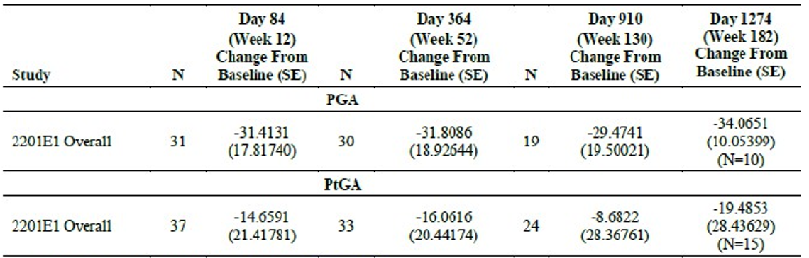
The extension phase showed that the numerical improvements in global assessment endpoints were sustained over longer treatment, but did not significantly improve.
A similar pattern of sustained, but not significantly improving, numerical improvement was observed for the SF-36 (physical and mental component) and the WPAI-CIQ (examining workplace or classroom impairment).
The EMA requested additional information regarding direct clinical benefits, and the Sponsor has conducted a review of real-world data on the quality-of-life effects of leniolisib treatment. The key findings of the review are that frequent infections and lymphoproliferation are common clinical manifestations which have real effects on health-related quality of life. The notable impacts on patients with APDS include difficulties completing ADLs due to fatigue or pain, with significant impacts on work and education as well as emotional impacts.
Of the 35 participants with treatment experience with leniolisib included in this study, 20 (57.1%) participants reported experiencing at least one symptom-related improvement since starting treatment with leniolisib, 13 (37.1%) reported no improvement in the identified symptoms, and 2 (5.7%) reported a worsening. Of the 20 participants reporting symptom improvements, improvement in fatigue was the most frequently reported (n=14, 70%), followed by improvement in GI symptoms (n=7, 35%). Most notably, 12 (34.3%) individuals explicitly noted an improvement in their fatigue since beginning treatment with leniolisib, which enabled them to do more in their daily lives and increased their ability to do physical activities, such as improved attendance at work and school, attend to household chores, and to travel and exercise.

Safety
The submitted dossier contains data on 38 patients with APDS who received leniolisib (Figure 3).
Figure 3: Exposure of APDS patients to leniolisib
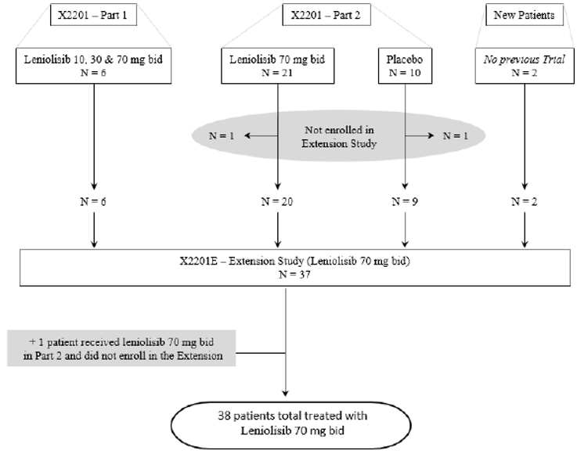
Table 9. Summary of duration of exposure to leniolisib in study 2201
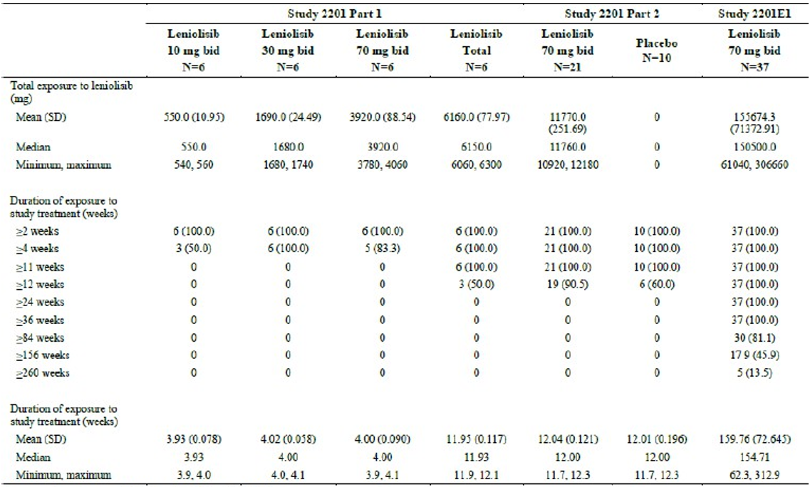
There are a relatively small number of patients available for safety analysis due to the extreme rarity of APDS. The majority of patients have received leniolisib for between 84-156 weeks in the open label extension stage of 2201. However, there is only 12 weeks of controlled exposure providing comparative adverse event rates to placebo.
Table 10. Adverse events reported by at least 2 patients in study 2201/2
Adverse Event | Leniolisib (N=21); n (%) | Placebo (N=l0); n (%)
Headache | 5 (23.8) | 2 (20.0)
Sinusitis | 4 (19.0) | 0
Fatigue | 2 (9.5) | 1 (10.0)
Alopecia | 2 (9.5) | 0
Back pain | 2 (9.5) | 0
Diarrhoea | 2 (9.5) | 0
Eczema | 2 (9.5) | 0
Neck pain | 2 (9.5) | 0
Pyrexia | 2 (9.5) | 0

The most frequently reported AE was infection/infestations, which occurred in 52.4% of leniolisib patients and 40.0% of placebo patients in the entire safety analysis population (data not shown). Headache and sinusitis were more frequently reported in the leniolisib than placebo arm of the controlled stage of study 2201, although the Delegate notes the small patient numbers involved.
The majority of AE occurred in the early stages of leniolisib treatment with lower rates reported over longer periods of treatment.
Of the adverse effects considered related to treatment in study 2201/2 included alopecia (2 patients), weight increased (1 patient), aphthous ulcer (1 patient), vomiting (1 patient), taste disorder (1 patient).
Two deaths were reported across the APDS clinical development program.
- One death was reported in a 22-year-old male Caucasian who was in the 70 mg bd group (Study 2202 Part 2 rolled over to Study 2201E1), who had been exposed to leniolisib for 866 days. The cause of death/PT was cardiac arrest (not considered related to treatment), attributed to the multiple medical issues the patient was experiencing, including a worsening of chronic disseminated mycoplasma orale infection and underlying cardiomyopathy. The patient had a medical history of malnutrition, tachycardia, cardiomyopathy, pericardial effusion, ECG QT prolonged, and failure to thrive.
- One death was reported in a 44-year-old female who had completed treatment with placebo in Study 2201 Part 2 and died of pulmonary hypertension approximately 4.5 months after the last dose of study medication. The patient had a long and protracted medical history of bronchiectasis and pseudomonas infections.
Serious adverse events occurred in 3 (14.3%) of the leniolisib arm and 2 (20.0%) of the placebo arm of study 2201/2. In the leniolisib group these included mastoiditis (1 patient), failure to thrive and fatal cardiac arrest (1 patient), and alcohol poisoning (1 patient). None of these were treatment-related.
No new malignancies were reported in study 2201/2.
Haematological adverse events showed no trend in leniolisib treated patients’ in study 2021/2 and parameters outside the normal were not considered clinically significant.
There was one case of hyperglycaemia which occurred in a patient taking leniolisib after 2 years of treatment. The Sponsor has noted that hyperglycaemia is relatively common in treatment with PI3Kα inhibitors, of which several are approved for treatment of cancer (e.g. duvelisib used to treat chronic lymphocytic leukaemia and lymphoma). However, leniolisib lacks any activity against PI3Kα and in vitro studies do not suggest off-target activity against this isoform. Therefore, the relevance of the case of hyperglycaemia to leniolisib treatment is unclear.

Other PI3K inhibitors
Idelalisib is a PI3Kδ inhibitor that is registered in Australia for the treatment of leukaemia and lymphoma. The PI for idelalisib includes a black box warning to the effect that there is an increased risk of serious infections, pneumonitis and death associated with treatment.
The EMA raised the potential of comparable adverse effects with leniolisib treatment in their evaluation.
The Sponsor was required by the EMA to include in the draft labelling and the RMP that immune mediated adverse events (e.g. pneumonitis) are a potential class effect of PI3K inhibitors. For this reason, surveillance of these adverse events has been added to the RMP although there is no direct evidence of them occurring with leniolisib treatment.
The oncology population is quite different from the APDS population. Furthermore, while leniolisib and idelalisib are both PI3Kδ inhibitors, the specificity for this isoform over other isoforms differs.
An approximate calculation (‘rule of 3’) suggests that the absence of immune mediated toxicity in the leniolisib population means that the rate is less than about 3/37 or 8.1% with 95% confidence.
The Delegate notes that there is very little safety data in leniolisib to make a determination of the potential for class effects of PI3Kδ to occur. However, mitigating this is the low number of patients exposed to treatment for APDS as this reduces the potential for stochastic adverse events to occur.

Risk management plan evaluation summary
Safety concerns and their associated risk monitoring and mitigation strategies are summarised in Table 11.
Table 11. Summary of safety concerns
Summary of safety concerns |  | Pharmacovigilance |  | Risk minimisation
 |  | Routine | Additional | Routine | Additional
Important identified risks | None | - | - | - | -
Important potential risks | Immune-related adverse events |  | § |  | -
Important potential risks | Embryofetal toxicity |  | § |  | -
Missing information | Safety in patients with hepatic or renal impairment |  | ‡ |  | -
Missing information | Long-term safety | * | †§ |  | -
*Study CCDZ173X2201E1
†National APDS observational registry
§ PAESS (LE4401)
‡Hepatic impairment study

Risk-benefit analysis

Delegate’s considerations
APDS is a very rare condition and the small number of patients in the clinical development program make conclusions about the safety and efficacy of treatment difficult to validate statistically. This is not an unusual situation for Regulators when considering data to support the registration of treatments for rare conditions, and large clinical studies are very unlikely to ever be conducted in APDS. Data for longer treatment timelines should become available but is limited in balancing losses from study with a low rate of recruiting new patients.
The pivotal data in study 2201/2 and 2201/E1 provide evidence of a positive effect of leniolisib treatment on some pathological features of APDS. Treatment reduces lymphadenopathy and improves the phenotype of circulating B-cells compared to placebo over 12 weeks. The extension phase showed that the numerical improvements in global assessment endpoints were sustained over longer treatment, but did not significantly improve. A similar pattern of sustained, but not significantly improving, numerical improvement was observed for the SF-36 (physical and mental component) and the WPAI-CIQ (examining workplace or classroom impairment).
The major clinical improvements observed on leniolisib treatment in the long term OLE study appear to be in qualitative symptoms such as fatigue (which is significant for activities of daily living, work and employment) and GI symptoms. There is no good evidence that leniolisib improves the rate of infections or malignancy, both of which are a significant component of the morbidity and mortality from APDS (the Sponsor will conduct ongoing post-marketing surveillance to address this malignancy risk). The Delegate notes, however, that these endpoints may never be reached in clinical trials for such a rare condition unless the effect of treatment is large enough to be compared to historical controls. Improvements in clinical outcomes persisted for patients in the extension Study 2201E1. The B and T cell compartments continued to normalize, and lymphadenopathy and splenomegaly continued to resolve without an increase in antibiotic use. In addition, leniolisib reduced infections over time and reduced the use of IRT due to a sustained stabilization of the immune system. Patients also experienced clinical outcome improvements exceeding the thresholds for clinically meaningful changes.
Long-term aspects of the natural history of APDS were reduced or absent in Study 2201E1 including no surgeries to treat lymphoproliferation or complications of infection
There is very little on which to base an analysis of the safety of leniolisib, which is to be expected in such a rare condition. The Delegate considers it likely that long term treatment will lead to the emergence of rarer adverse events associated with PI3Kδ inhibition in some patients. However, as noted, the rate of these events will be difficult to quantify given the low number of patients who will ever be exposed to leniolisib for APDS treatment and may only be known if leniolisib acquires a more common indication in the future. The Delegate, however, considers the safety of leniolisib to be acceptable in the context of APDS being an incurable, debilitating and life-threatening condition. Certainly, the alternative standard of care for APDS also has significant potential adverse treatment effects.

Proposed action
The Delegate is currently minded to register leniolisib for the treatment of activated phosphoinositide 3 kinase delta syndrome (APDS) in adults and adolescents 12 years of age and older weighing 45kg or more.

Advisory Committee considerations
The Advisory Committee on Medicines (ACM) having considered the evaluations and the Delegate’s overview, as well as the sponsor’s response to these documents, advised the following:
Is the scale and kind of efficacy of leniolisib demonstrated for the treatment of APDS sufficient to support registration?
The ACM advised that the efficacy of leniolisib was sufficient to support registration, with the data showing excellent short-term efficacy. There were clinically significant improvements in parameters such as immunodeficiency, lymphoproliferation and autoimmune features, which don’t normally respond to other treatment modalities.
The ACM noted that there was a trend toward similar outcomes for adults and adolescents.
The ACM were uncertain if early treatment could lead to the prevention of long-term structural disease or malignancy.
Are there specific safety concerns for the treatment of APDS with leniolisib and, if so, are there specific regulatory actions recommended to address these?
The ACM noted that the available data were encouraging and did not raise safety issues of concern with leniolisib treatment.
The ACM highlighted the small numbers of patients in the studies, noting that treatment emergent adverse events may become more apparent in time. The ACM was of the view that due to the ultra-rare nature of APDS, larger datasets would be difficult to acquire.
The ACM noted that, due to leniolisib’s mechanism of action (highly targeted to the aberrant protein), the drug is less likely to cause notable safety issues.
The ACM advised that ongoing pharmacovigilance regarding adverse effects would be beneficial, especially following long term use, acknowledging the limited duration of follow up, including placebo-controlled follow-up
The ACM discussed the relevance of having a 45kg weight restriction in the proposed indication for treatment. The ACM noted that many patients with APDS struggle to gain and maintain weight, and that patients with a lower body weight tend to have increased symptoms. The ACM expressed concern that the clinical studies had an exclusion criterion for patients with a body weight of less than 45kg. The ACM supported not having a weight restriction in the proposed indication for leniolisib, as this could disadvantage patients with low body weight, including adolescents.
The ACM also highlighted the importance of an accurate diagnosis of APDS and advised that a finding of a ‘Pathogenic’ or ‘Likely Pathogenic’ variant in an APDS-associated gene, through a National Association of Testing Authorities accredited laboratory, be included in the proposed PI.

ACM conclusion
The ACM considered this product to have an overall positive benefit-risk profile for the indication:
For treatment of severe manifestations of APDS in adults and adolescents 12 years of age and older confirmed to have APDS and being treated by a clinical immunologist.

Assessment outcome
Based on a review of quality, safety, and efficacy, the TGA decided to register JOENJA (leniolisib) for the following indication:
JOENJA is indicated for the treatment of activated phosphoinositide 3-kinase delta syndrome (APDS) in adults and adolescents 12 years of age and older.

Specific conditions of registration
JOENJA (leniolisib) is to be included in the Black Triangle Scheme. The PI and CMI for JOENJA must include the black triangle symbol and mandatory accompanying text for five years, which starts from the date of first supply of the product.
The JOENJA EU-Risk Management Plan (RMP) (version 0.3, dated 4 October 2023, data lock point 19 July 2023), with Australian Specific Annex (version 0.3, dated 17 November 2023), included with submission PM-2023-03256-1-2, and any subsequent revisions, as agreed with the TGA will be implemented in Australia.
An obligatory component of risk management plans is routine pharmacovigilance. Routine pharmacovigilance includes the submission of periodic safety update reports (PSURs).
Unless agreed separately between the supplier who is the recipient of the approval and the TGA, the first report must be submitted to TGA no later than 15 calendar months after the date of this approval letter. The subsequent reports must be submitted no less frequently than annually from the date of the first submitted report until the period covered by such reports is not less than three years from the date of this approval letter. The annual submission may be made up of two PSURs each covering six months. If the sponsor wishes, the six monthly reports may be submitted separately as they become available.
If the product is approved in the EU during the three years period, reports can be provided in line with the published list of EU reference dates no less frequently than annually from the date of the first submitted report until the period covered by such reports is not less than three years from the date of this approval letter.
The reports are to at least meet the requirements for PSURs as described in the European Medicines Agency’s Guideline on good pharmacovigilance practices (GVP) Module VII-periodic safety update report (Rev 1), Part VII.B Structures and processes. Note that submission of a PSUR does not constitute an application to vary the registration. Each report must be submitted within ninety calendar days of the data lock point for that report.
The Sponsor must submit a post-approval variation application with the TGA to redefine the regulatory starting materials as PH-D4, D5-OH and PH-D9 and to add the new active material manufacturing site by 30 June 2026.

Product Information and Consumer Medicines Information
For the most recent Product Information (PI) and Consumer Medicines Information (CMI), please refer to the TGA PI/CMI search facility.

Therapeutic Goods Administration
PO Box 100 Woden ACT 2606 Australia
Email: info@tga.gov.au Phone: 1800 020 653 Fax: 02 6203 1605
https://www.tga.gov.au

A sponsor is a person or company who does one or more of the following: a) exports therapeutic goods from Australia, b) imports therapeutic goods into Australia, c) manufactures therapeutic goods for supply in Australia or d) elsewhere arranges for another party to import, export or manufacture therapeutic goods
Singh, A, Joshi, B, Kumar, A, An updated review on activated PI3 kinase delta syndrome (APDS), Genes and Diseases, 7 (2020)
Hanson, J, Bonnen, P, Systematic review of morality and survival rates for APDS, Clin Exp Med 24 (2024)
Evaluators are TGA experts, or external experts engaged by the TGA, that assess the safety, quality, and efficacy of therapeutic goods before they can be registered and supplied in Australia.
A "Delegate" refers to a person within the TGA who has been conferred the authority to make decisions about the approval of therapeutic goods for supply in Australia, under section 25 of the Therapeutic Goods Act.

