Australian Public Assessment Report for AWIQLI
  - Active ingredient: insulin icodec
  - Sponsor: Novo Nordisk Pharmaceuticals Pty Ltd
June 2025

About the Therapeutic Goods Administration (TGA)
- The Therapeutic Goods Administration (TGA) is part of the Australian Government Department of Health, Disability and Ageing and is responsible for regulating therapeutic goods, including medicines, medical devices, and biologicals.
- The TGA administers the Therapeutic Goods Act 1989 (the Act), applying a risk management approach designed to ensure therapeutic goods supplied in Australia meet acceptable standards of quality, safety, and efficacy.
- The work of the TGA is based on applying scientific and clinical expertise to decision-making, to ensure that the benefits to the Australian public outweigh any risks associated with the use of therapeutic goods.
- The TGA relies on the public, healthcare professionals and industry to report problems with therapeutic goods. The TGA investigates reports received to determine any necessary regulatory action.
- To report a problem with a therapeutic good, please see the information on the TGA website.

About AusPARs
- The Australian Public Assessment Report (AusPAR) provides information about the evaluation of a prescription medicine and the considerations that led the TGA to approve or not approve a prescription medicine submission. Further information can be found in Australian Public Assessment Report (AusPAR) guidance.
- AusPARs are prepared and published by the TGA.
- AusPARs are static documents that provide information that relates to a submission at a particular point in time. The publication of an AusPAR is an important part of the transparency of the TGA’s decision-making process.
- A new AusPAR may be provided to reflect changes to indications or major variations to a prescription medicine subject to evaluation by the TGA.

Copyright
© Commonwealth of Australia 2025
This work is copyright. You may reproduce the whole or part of this work in unaltered form for your own personal use or, if you are part of an organisation, for internal use within your organisation, but only if you or your organisation do not use the reproduction for any commercial purpose and retain this copyright notice and all disclaimer notices as part of that reproduction. Apart from rights to use as permitted by the Copyright Act 1968 or allowed by this copyright notice, all other rights are reserved and you are not allowed to reproduce the whole or any part of this work in any way (electronic or otherwise) without first being given specific written permission from the Commonwealth to do so. Requests and inquiries concerning reproduction and rights are to be sent to the TGA Copyright Officer, Therapeutic Goods Administration, PO Box 100, Woden ACT 2606 or emailed to <tga.copyright@tga.gov.au>.

Contents
List of abbreviations 4
AWIQLI (insulin icodec) submission 6
Proposed indication 8
The disease 8
Current treatment options 8
Regulatory status 8
Registration timeline 9
Assessment overview 9
Quality evaluation summary 9
Nonclinical evaluation summary 11
Clinical evaluation summary 14
Summary of clinical studies 14
Pharmacology 14
Efficacy 24
Safety 47
Risk management plan evaluation summary 62
Risk-benefit analysis 63
Advisory Committee considerations 66
Assessment outcome 67
Specific conditions of registration 67
Product Information and Consumer Medicines Information 68

List of abbreviations
Abbreviation | Meaning
ACM | Advisory Committee on Medicines
ARTG | Australian Register of Therapeutic Goods
ASA | Australia-specific annex
AUC_{GIR} | area under the glucose infusion rate (GIR) curve
BW | body weight
CGM | continuous glucose monitoring
CL/F | apparent total plasma clearance
CMI | Consumer Medicines Information
Delegate | The delegate of the Secretary of the Department of Health and Aged Care who made the final decision to either include the new medicine/indication on the ARTG or reject the submission, under section 25 of the Therapeutic Goods Act
DPP4 | dipeptidyl peptidase-4
DTSQ | Diabetes Treatment Satisfaction Questionnaire
eGFR | estimated glomerular filtration Rate
ETD | estimated treatment difference
ETR | estimated treatment ratio
FPG | fasting plasma glucose
GIR | glucose infusion rate
HbA1c | Haemoglobin A1C
IR-A | human insulin receptor A
IR-B | human insulin receptor B
IIco | insulin icodec
IDeg | insulin degludec
IGlar | insulin glargine
MDI | multiple dose injection
PD | pharmacodynamic(s)
PI | Product Information
PK | pharmacokinetic(s)
PG | plasma glucose
popPK | population pharmacokinetic(s)
PSUR | Periodic Safety Update Report
QD | once daily dosing
QW | once weekly dosing
RMP | risk management plan
T1DM | type 1 diabetes mellitus
T2DM | type 2 diabetes mellitus
SGLT2 | sodium-glucose cotransporter 2
TAR | time above range
TBR | time below range
TIR | time in range
TGA | Therapeutic Goods Administration
V/F | apparent volume of distribution

AWIQLI (insulin icodec) submission

Submission details
Type(s) of submission: | New biological entity
Product name(s): | AWIQLI
Active ingredient(s): | Insulin icodec
Decision: | Approved
Date of decision: | 17 May 2024
Date of entry onto ARTG: | 28 June 2024
ARTG number(s): | 440650, 407360, 440652, 440651, 440653, 407359
Sponsor’s name and address: | Novo Nordisk Pharmaceuticals Pty Ltd, Level 10,  118 Mount Street,  North Sydney NSW 2060
Dose form(s): | Solution for injection.
Strength(s): | 1 mL solution contains 700 units of insulin icodec (equivalent to 26.8 mg insulin icodec)
Container(s): | 1, 1.5 or 3 mL solution in a cartridge (Type I glass) with a plunger (halobutyl) and a laminated rubber sheet (halobutyl/polyisoprene) contained in a pre-filled multidose disposable pen made of polypropylene, polyoxymethylene, polycarbonate and acrylonitrile butadiene styrene. The outer packaging is in light green with the formulation strength indicated in a yellow-coloured box. The pen body is in light green while the pen label is in darker green with a yellow box highlighting the formulation strength.
Pack size(s): | AWIQLI 700 units/mL solution for injection in pre-filled pen:  - Each pre-filled pen contains 700 units of insulin icodec in 1 mL solution  - Each pre-filled pen contains 1,050 units of insulin icodec in 1.5 mL solution  Each pre-filled pen contains 2,100 units of insulin icodec in 3 mL solution
Approved therapeutic use for the current submission: | Treatment of type 2 diabetes in adults.  Treatment of type 1 diabetes in adults, in conjunction with a bolus insulin, where daily basal insulin injections are not suitable.
Route(s) of administration: | Subcutaneous
Dosage: | This medicinal product is a basal insulin for once-weekly subcutaneous administration. It is intended to be taken on the same day of the week.  AWIQLI is available in one strength, 700 units/mL. The needed dose is dialled in units (The potency of insulin analogues, including insulin icodec, is expressed in units. One (1) unit of insulin icodec corresponds to 1 unit of insulin glargine (100 units/mL), 1 unit of insulin detemir, 1 unit of insulin degludec, or 1 international unit of human insulin). A dose of 10-700 units per injection, in steps of 10 unit increments, can be administered.  In patients with type 2 diabetes mellitus, this medicinal product can be administered alone or in any combination with oral antidiabetic medicinal products, glucagon-like peptide-1 receptor agonists and bolus insulin.  In patients with type 1 diabetes mellitus, this medicinal product must be combined with bolus insulin to cover mealtime insulin requirements.  AWIQLI is to be dosed in accordance with the individual patient’s needs. It is recommended to optimise glycaemic control via dose adjustment based on fasting plasma glucose.  Due to the long half-life of insulin icodec, adjustment of dose is not advised during acute illness nor if patients make short-term changes in their physical activity level or usual diet. In these situations, other applicable adjustments, e.g. glucose intake or changes to other glucose lowering medication, may be considered.  For further information regarding dosage, refer to the medicine’s Product Information.
Pregnancy category: | Category B3  Drugs which have been taken by only a limited number of pregnant women and women of childbearing age, without an increase in the frequency of malformation or other direct or indirect harmful effects on the human fetus having been observed.  Studies in animals have shown evidence of an increased occurrence of fetal damage, the significance of which is considered uncertain in humans.  The use of any medicine during pregnancy requires careful consideration of both risks and benefits by the treating health professional. The pregnancy database must not be used as the sole basis of decision making in the use of medicines during pregnancy. The TGA does not provide advice on the use of medicines in pregnancy for specific cases. More information is available from obstetric drug information services

Proposed indication
This AusPAR describes the submission by Novo Nordisk Pharmaceuticals Pty Ltd (the sponsor) to register AWIQLI (insulin icodec) for the following proposed indication:
Treatment of diabetes mellitus in adults.

The disease
Type 1 diabetes mellitus (T1DM) is an autoimmune disease targeting pancreatic β-cells. Ultimately, this leads to their destruction and insulin deficiency. The disease most commonly affects children and adolescents but may also occur during adulthood (latent autoimmune diabetes in adults).
Type 2 diabetes mellitus (T2DM) is a non-autoimmune disease caused by advancing insulin resistance, frequently in association with a metabolic syndrome. The initial relative insulin deficiency is thought to trigger an inadequate compensatory increase of beta cell secretion and progressive loss of beta-cell function. Ultimate stages of T2DM may complete loss of beta-cell function and absolute insulin deficiency.
It is well-established that maintenance of normal or near normal blood sugar levels is important not only for the control of the symptoms of diabetes mellitus attributable to hyperglycaemia, but also for the prevention of long-term vascular, neurological and other complications.

Current treatment options
The first step in the management of T2DM is with diet and lifestyle modifications, including exercise. If conservating measures are unsuccessful, metformin is the first line medical treatment in most of the cases. In cases where metformin is not tolerated or successful other treatment options include sulphonylureas, dipeptidyl peptidase IV inhibitors, pioglitazone, insulin, glucagon-like peptide-1 agonists and sodium-glucose transport protein 2 inhibitors. Clinical practice guidelines presently recommend a patient-orientated approach to the choice of medications after metformin. Multiple medications may be required in patients with long standing diabetes to achieve optimal glycaemic control.
T1DM is characterised by near total loss of beta-cell function. Insulin is the mainstay of treatment for T1DM, which is typically administered by subcutaneous (SC) injections or continuous sub-cutaneous insulin infusion (insulin pump therapy). Multiple dose injection (MDI) therapy uses fast-acting insulin analogues (bolus) to cover the food consumed and long-acting insulin analogues (bolus) to cover basal insulin demand. Basal insulins currently marketed include Lantus (insulin glargine U100), Toujeo (insulin glargine U300), Levemir (insulin detemir U100), and Xultophy (insulin degludec) and Tresiba (insulin degludec U100).

Regulatory status

Australian regulatory status
This product is considered a new biological entity for Australian regulatory purposes.

International regulatory status
At the time the TGA considered this submission, a similar submission had been considered by other regulatory agencies including those of the European Union (submitted 4 April 2023), United States (submitted 21 April 2023), Canada (31 March 2023) and Switzerland (13 April 2023).

Registration timeline
Table 1 captures the key steps and dates for this submission.
This submission was evaluated under the standard prescription medicines registration process.
Table 1: Timeline for AWIQLI (insulin icodec), submission PM-2023-01464-1-5
Description | Date
Submission dossier accepted and evaluation commenced | 17 May 2023
Evaluation completed | 21 December 2023
Advisory committee meeting | 5 April 2024
Registration decision (Approved) | 17 May 2024
Number of working days from submission dossier acceptance to registration decision* | 255
*Statutory timeframe for standard submissions is 255 working days

Assessment overview
This submission was evaluated as part of the Australia-Canada-Singapore-Switzerland-United Kingdom (ACCESS) Consortium with work-sharing between the TGA, Swissmedic and Health Canada. Each regulator made independent decisions regarding approval (market authorisation) of the new medicine.

Quality evaluation summary
Insulin icodec (IIco) is a recombinant insulin modified to incorporate a C20 fatty acid sidechain derivative to the peptide backbone via the amino group in the side chain at LysB29.
IIco binds to and activates the human insulin receptor. The molecular mode of action of the IIco drug substance is similar to human insulin. IIco is an acylated analogue, which is a specific, low-affinity insulin receptor agonist with full efficacy that binds strongly, but reversibly, to albumin. Binding to albumin results in decreased renal clearance and protection from metabolic degradation. Compared to native human insulin, IIco half-life is extended (by approximately 1 week).
The finished product is presented as a solution for SC administration containing 700 U/mL of IIco as active drug substance (DS).
The DS manufacturing process is a cultivation process with nutritive feeds. One vial of the working cell bank is thawed, and the cells cultured on agar within a Fernbach flask then expanded in seed bioreactors. The production bioreactor is harvested sequentially after a defined production period and a clarification step is performed. The IIco DS is produced using recombinant DNA technology. A precursor of the active ingredient is expressed in yeast. The secreted IIco precursor is enzymatically cleaved to structurally resemble native insulin. This is followed by acylation (where the C20 fatty acid is coupled to the cleaved structure) and then purification (by chromatography and ultrafiltration). The purification process has been described in sufficient detail, providing process parameters and satisfactory acceptance criteria, for each step. Suitable elution profiles have been provided for the chromatography steps. Critical information regarding the manufacture, storage and control facilities for the drug substance were provided in the dossier. Good Manufacturing Practice (GMP) compliance for the drug substance manufacturers is current.
Insulin icodec active substance is stored in low density polyethylene bags covered by an outer aluminium laminated bag at -20°C ± 5°C and shipped to the finished product manufacturing facility at controlled conditions. Details and specifications of the bags, compatibility of the container and a summary of an extractable and leachable study were acceptable. Substance leaching into the IIco active substance was shown to be negligible.
The overall quality of the active substance was demonstrated via adequate control of the starting material, control of critical steps and intermediates, process validation, extensive characterisation using orthogonal and state-of-the-art analytical methods, control of impurities and contaminants, generation of robust reference materials and batch analyses that covered multiple manufacturing campaigns.
Insulin icodec drug product (DP), AWIQLI, is a solution for injection presented at the concentration of 700 U/mL. The product is available in a cartridge (type I glass) with a chlorobutyl rubber plunger at one end and a laminated bromobutyl and isoprene rubber disc at the other with the bromobutyl rubber contacting the DP. The disc is covered by an aluminium cap.
One mL contains 26.8 mg of IIco, 0.101 mg zinc acetate, 5.65 mg phenol, 1.08 mg metacresol, 15 mg glycerol, 1.17 mg sodium chloride at a pH 7.10-7.70. The formulation development has been adequately described and the final formulation intended for marketing was used in the phase III clinical trials.
All excipients are common pharmaceutical ingredients and their quality is compliant with international pharmacopeial standards. There are no novel excipients used in the DP. The container closure system is suitable for its intended use as demonstrated by compatibility and stability studies.
The IIco DP manufacturing process consists of active substance dissolution, filtration and aseptic filling of the pre-formulated active substance. All filled containers, i.e. filled cartridges, are subject to visual inspection. The vials are stored at 5° ± 3°C pending labelling and packaging. The description of the DP manufacturing process has been provided in sufficient detail.
To ensure that the finished DP meets required quality standards, the DP manufacturing process was developed with well-defined manufacturing procedures, process validations, critical process parameters and in-process parameters. Batch analyses confirmed the similarity of DP across multiple manufacturing campaigns.
All analytical methods used for testing of the DP were satisfactorily described in the dossier and non-compendial methods were validated. Many test methods used for release testing and stability testing of the finished product are the same as those used for release testing and stability testing of the active substance.
The reference standard used in the testing and release of IIco finished product is the same as the one used for the testing and release of insulin icodec active substance.
There are no objections to the registration of AWIQLI from a manufacturing and quality perspective.

Nonclinical evaluation summary
The submitted nonclinical data was of high quality and suitably comprehensive. All pivotal safety-related studies were GLP-compliant.
In vitro studies showed that IIco binds to the human insulin receptor (IR-A and IR-B isoforms) with low affinity (<1% relative to native human insulin) [which is intentional, being part of the mechanism for protracted action]. The drug’s affinity for rat, dog and pig insulin receptor forms was similar to that of human. Low affinity for the insulin-like growth factor 1 (IGF-1) receptor (human, rat and dog) was also demonstrated. Insulin icodec dissociated from human IR-A faster than native human insulin. In in vitro functional studies, IIco elicited similar IR activation, metabolic and mitogenic responses as native human insulin, but with lower potency (consistent with lower binding affinity). The balance of metabolic : mitogenic potency of IIco was comparable with native human insulin.
The apparent binding affinity and functional potency of IIco was reduced in the presence of human serum albumin, reflecting binding of the drug to albumin. Such binding gives rise to a circulating albumin-bound depot in vivo (and represents the primary mechanism for protraction of action).
In vivo studies performed in diabetic rats and normoglycaemic dogs and pigs showed long-lasting dose-dependent reductions in HbA1c and/or blood glucose.
The submitted pharmacology studies offer support for the utility of IIco for the proposed indication.
Results of screening assays, coupled with follow-up functional studies and findings in the repeat-dose toxicity program, indicate no relevant off-target pharmacological activity for IIco.
Safety pharmacology studies did not indicate clinically relevant effects on CNS, cardiovascular or respiratory function. A modest multiple of the average clinical Cmax was obtained in the CNS and respiratory function studies in rats (2.5-fold). Exposure in dogs, though, to examine effects on cardiovascular function was subclinical. High margins of the clinical C_{max} are not achievable in vivo due to hypoglycaemia. Allaying concern for potential effects on ECG, in vitro assays showed only very weak inhibition of the hERG K+ channel and no significant effects on action potential parameters in rabbit Purkinje fibres with IIco up to 10 μM, a concentration ~38-times higher than the average clinical C_{max}. CNS-related clinical signs observed in animals are seen to be related to hypoglycaemia rather than to reflect a direct neurological effect.
animal species was via both urine and faeces, and mostly as metabolites. Biliary excretion was demonstrated in the rat. In humans, only a small proportion of subjects were found to have detectable intact IIco in urine.
The pharmacokinetic profiles in the key laboratory animal species — rats and dogs — are seen to be sufficiently similar to that of humans to allow them to serve as appropriate models for the assessment of IIco toxicity in humans. The shorter plasma half-life in animals cf. humans is compensated for in the toxicity studies by the use of more frequent dose administration cf. that proposed clinically.
In vitro experiments indicated no clinically relevant effect of palmitate (the most abundant fatty acid in human blood) on the binding of IIco to serum albumin. Some CYP induction was evident with IIco in rats, with liver samples from male animals treated in the 26-week repeat-dose toxicity study showing increases in the activity of CYP1A, CYP2C, CYP3A and CYP2E subfamily enzymes and increased CYP2B subfamily activity in females. This was minor (≤2.2-fold increase in males and <2-fold in females) and without clear dose-dependence; no clinically relevant effect is expected in patients.
No dedicated single-dose toxicity studies were performed, with acute toxicity assessable from the repeat-dose toxicity program instead.
Repeat-dose toxicity studies were conducted in rats (up to 52 weeks) and dogs (up to 26 weeks). Administration was by the SC route (as in patients). Dosing was once daily in rats and twice weekly in the dog studies; daily dosing was additionally employed in a pilot dog study. The pivotal studies were appropriately designed and conducted in terms of the species used, dose selection, duration, group size and range of endpoints examined.
The highest doses tested in the pivotal studies yield average steady-state plasma levels 3.8-times higher (male rats), 2.5-times higher (female rats) and 0.6-times (dogs) that of patients at the median clinical dose of 230 U/week.
All IIco -related changes were considered to be related to primary pharmacology. Hypoglycaemia was dose-limiting in rats and dogs, and associated with clinical signs (e.g., decreased activity, staggering gait, trembling, convulsions; in both species) and mortality (in rats). Key treatment-related histopathological changes in rats involved:
- pancreas - atrophy of the islets of Langerhans
- liver - decreased rarefaction
- sciatic or tibial nerve - axonal degeneration
- skeletal muscle - myofiber degeneration/necrosis
- brown fat - increase in fat vacuoles / cellular size
- bone marrow (femur, sternum) - increased amount of fat
- adrenal gland - increased vacuolation in zona fasciculata
- Testes - tubular degeneration/atrophy; and
- heart - myocardial fibrosis.
These have been observed with other insulins previously. Of particular note, the axonal degeneration was more prominent here, but this is explained by pharmacokinetics, with axonal degeneration a consequence of persistent (cf. short term) hypoglycaemia. There were no treatment-related microscopic changes in dogs.
Reflecting exaggerated pharmacology in normoglycaemic animals, the findings observed in the repeat-dose toxicity studies are considered to be of limited clinical relevance.
Negative results were returned for IIco in a bacterial reverse mutation assay (non-GLP). The absence of a GLP-compliant standard battery of genotoxicity studies is acceptable given the nature of the drug (in accordance with ICH S6 [R1]). Quantitative Structure-Activity Relationship analysis indicated no genotoxic potential for the linker + fatty acid moiety of IIco.
Standard (2-year) rodent carcinogenicity studies were not conducted, in line with ICH S6 (R1). Instead, carcinogenic potential was assessed through consideration of in vitro and other in vivo data — a strategy consistent with TGA-adopted EMA guidance.
In vitro studies showed that IIco maintains the balance of metabolic : mitogenic potency as native human insulin, and does not dissociate from the IR more slowly cf. insulin (to cause sustained receptor activation, associated with increased mitogenic potential).
The 52-week repeat-dose toxicity study in rats included palpation for tissue masses and evaluation of (pre-)neoplastic lesions, with particular focus on the mammary gland. No carcinogenic effect and no increase in the incidence/severity of mammary gland hyperplasia cf. vehicle or native human insulin were seen in IIco -treated animals up to the highest dose tested (60 nmol/kg/day for males and 40 nmol/kg/day for females; associated with exposure margins of 3.7 and 2.0 based on C_{avg}).
The data are sufficient to conclude that the mitogenic potential of IIco does not exceed that of native human insulin.
Reproductive and developmental toxicity studies with IIco submitted by the sponsor covered all stages (fertility, early embryonic development, embryofetal development, and pre- and postnatal development). The studies were appropriately designed and conducted. All involved SC administration. High-dose levels were limited by hypoglycaemia.
Limited placental transfer of IIco was seen in the rat (fetal plasma concentrations were 3–6% of the maternal plasma concentration). Excretion in milk was not studied, but is expected from data for other insulins.
Fertility was unaffected in male and female rats up to the highest doses tested (100 and 60 nmol/kg/day in the respective sexes; relative exposure based on C_{avg}, 4.3 and 2.6).
No adverse effects on embryofetal development were observed with IIco in rats (≤60 nmol/kg/day; relative exposure, 1.5). In rabbits, abortion occurred at ≥18 nmol/kg/day (relative exposure, 1.7), with this seen to be related to hypoglycaemia; there were no treatment-related malformations. Post-implantation loss was increased at 24 nmol/kg/day in a pilot study in rabbits (relative exposure, 1.9).
Adverse effects were observed in the offspring of rats treated at 50 nmol/kg/day during gestation and lactation, comprising decreased body weight gain (in the pre-weaning period), clinical signs (decreased activity, abnormal gait, uncoordinated, partially closed eyelids, tremors, reduced body tone; consistent with hypoglycaemia) and reduced survival. This dose was maternotoxic and associated with an exposure multiple of 1.5. Insulin icodec was only rarely detectable in pup plasma, and then only at very low levels. Reduced maternal support due to hypoglycaemia (cf. a direct effect of IIco) is seen to be the most likely explanation for the effects observed in pups. The no-observed-adverse-effect level (NOAEL) for effects on pup development was 35 nmol/kg/day (relative exposure, 0.9).
The sponsor has proposed Pregnancy Category B1. This category is considered to be inappropriate given the finding of abortion and embryolethality in rabbits (albeit occurring in the context of maternal toxicity/hypoglycaemia). Category B3 should be used instead. This matches the existing categorisation of other long-acting insulins (insulin degludec, insulin glargine and insulin glulisine).
Acceptable local tolerance of the commercial formulation was demonstrated in a dedicated study in minipigs, involving once weekly SC administration for 13 weeks, with only mild inflammatory changes observed.
Proposed impurity limits in the IIco drug substance and drug product are toxicologically acceptable, qualified from the 26-week repeat-dose toxicity study in rats. Potential mutagenic impurities are adequately controlled.
Insulin icodec is not proposed for paediatric use and no specific studies in juvenile animals were submitted.
Key nonclinical findings:
- Nonclinical data are adequate and support the safety of IIco.
- Adverse effects observed with IIco in toxicity studies in animals are seen to reflect exaggerated pharmacology. Occurring as a consequence of hypoglycaemia with treatment of normoglycaemic animals, limited clinical relevance is seen.
- The mitogenic potential of IIco does not exceed that of native human insulin.
- There are no nonclinical objections to the registration of AWIQLI for the proposed indication.

Clinical evaluation summary

Summary of clinical studies
The current application for once-weekly IIco includes data from 18 clinical trials:
- 6 phase 3a confirmatory efficacy and safety trials (ONWARDS 1-6)
- 3 phase 2 exploratory trials
- 9 clinical pharmacology trials
The pharmacokinetic (PK) and pharmacodynamic (PD) properties in T1DM and T2DM patients were evaluated in nine Phase 1 studies. Sparse PK samples were collected in one Phase 2 study and four Phase 3 studies and contributed exclusively to the population PK analysis. In the majority of Phase 1 studies, IIco was administered as individual doses based on run-in periods. If a comparator was included in the study, QD insulin glargine (IGlar) or insulin degludec (IDeg) were administered.

Pharmacology

Pharmacokinetics

Absorption
In Caucasian T2DM patients, the median time to maximum IIco concentration at steady state was 15 h to 16 h (studies 4314 and 4569). The steady state was reached after 3 to 4 doses, and the accumulation ratio was approximately 2. Overall, the IIco exposure was well distributed across the dosing interval.
Generally, IIco exposures increased with the dose in T2DM patients. Whereas the exposures increased dose-proportionally between 1.53 U/kg and 5.64 U/kg in study 4569, there was a trend towards less than dose-proportional increases between 2.0 U/kg and 4.0 U/kg in study 4314.
In Caucasian T1DM patients, the median time to maximum IIco concentration at steady state was 18 h (study 4225). As in patients with T2DM, the steady state was reached after 3 to 4 doses, and the accumulation ratio was approximately 2. Overall, the IIco exposure was well distributed across the dosing interval.
Generally, IIco exposures increased with the dose in T1DM patients; however, there was a trend towards less than dose-proportional increases between 1.1 U/kg and 3.3 U/kg in study 4225.
Within-subject variability was generally low (<10%).

Distribution, metabolism, and elimination
The extension of the half-life of IIco was achieved due to strong but reversible binding to albumin. As expected, plasma protein binding of IIco was high (>99%) and albumin was the major binding protein. Based on the population analysis, the V/F was estimated at
9.79 L reflecting high protein binding.
Using samples from T2DM patients enrolled in study 4314, the predominant circulating entity was IIco. The identified metabolites do not exert any pharmacological activity. No unique IIco metabolites were found in vitro. Insulin icodec was primarily eliminated via insulin receptor binding, whereas non-specific degradation was minor. Only a small proportion of subjects with different degrees of renal impairment had detectable IIco in urine (study 4226).
The mean half-life in T2DM and T1DM patients was 155 h to 196 h and 175 h, respectively (studies 4314, 4569, and 4225).
The terminal half-life of IIco at steady state was approximately 1 week independent of dose, supporting once-weekly dosing . The geometric mean terminal half-life across subjects with T2DM was 172 hours. Pooling data from studies including subjects with T2DM and T1DM resulted in terminal half-life of 173 hours.

Population pharmacokinetics
Using data from one Phase 2 and four Phase 3 studies, a population PK (popPK) analysis was conducted to identify factors that account for variability in IIco PK. A total of 1244 subjects with 6939 samples were included to the population PK analysis. The PK of IIco was well described by a 1-compartment model with first-order absorption and elimination. All investigated covariates were included in the full model to assess their impact. Body weight showed the biggest impact on IIco PK, characterised by decreasing exposure with increasing body weight. When adjusting for body weight, none of the investigated covariates including age, ethnicity, race, sex, antibody level, albumin, and population were found to have a relevant effect on IIco PK. Of note, the impact of hepatic and renal impairment was not evaluated. Overall, no dose adjustments are required in view of the individual titration of IIco.
Figure 1: Forest plot of covariate effects on IIco exposure
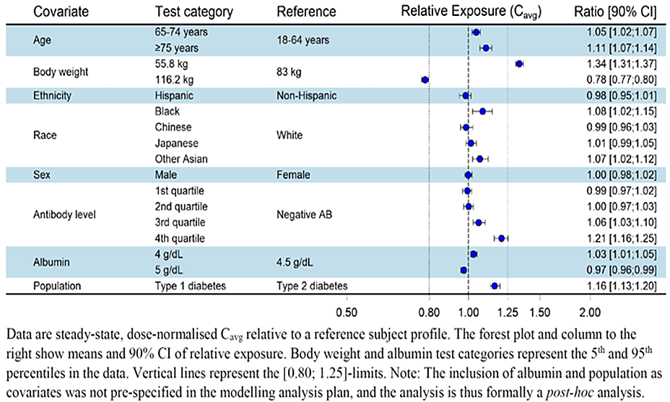
Data are steady-state, dose-normalised C_{avg} relative to a reference subject profile. The forest plot and column to the right show means and 90% CI of relative exposure. Body weight and albumin test categories represent the 5th and 95th percentiles in the data. Vertical line represents the [0.80; 1.25]-limits. Note: The inclusion of albumin and population as covariates was not pre-specified in the modelling analysis plan, and the analysis is thus formally a post-hoc analysis.
The popPK analysis has some shortcomings. Only sparse PK data from the Phase 2 and Phase 3 studies was used. Model development as well as the selection of some assumptions were based on modelling findings using rich PK data from Phase 1 studies. Furthermore, the findings regarding dose proportionality were not conclusive. The covariate analysis was restricted to CL/F except for body weight due to the sparse PK data.
The PK of IIco following QW dosing was well described by a one-compartment model in the majority of the Phase 1 studies. The sponsor claimed that pooling with rich data was therefore not considered to add value to the estimation of the model structure. Furthermore, the sponsor highlighted the various sensitivity analyses that were conducted to show the robustness of the covariate effects. In particular, the sensitivity analyses showed that the fixed value for the absorption rate was adequate. The sponsor also emphasized that the extent of the covariate analysis would not be increased due to the relatively homogenous nature of the Phase 1 data.

Interactions
Although no formal drug-drug interaction studies were conducted, interactions of IIco with CYPs are unlikely.

Pharmacodynamics
Insulin icodec is a long-acting human insulin analogue covering basal insulin requirements. Through binding to the human insulin receptor, it exerts the same pharmacological effect, i.e. glycaemic control, as human insulin. The extension of the half-life of peptides was achieved by the addition of a fatty acid sidechain and the modification of the peptide backbone.
The glucose-lowering effect in T1DM and T2DM patients at steady state has been investigated in the Phase 1 studies using euglycemic clamps and glucose infusion rates (GIR) as measurements of glucose metabolism. Since the dosing interval could not be fully covered with the clamp, the PD effect during the entire week was evaluated using PK/PD modelling based on clamp measurement at the beginning and the end of the interval.
In Caucasian T2DM patients, the entire dosing interval was covered by the duration of the glucose-lowering effect (studies 4314 and 4569). The glucose-lowering effect was close to evenly distributed.
Figure 2: Full week steady-state GIR profile for IIco Caucasian subjects with T2DM (PK/PD modelling)
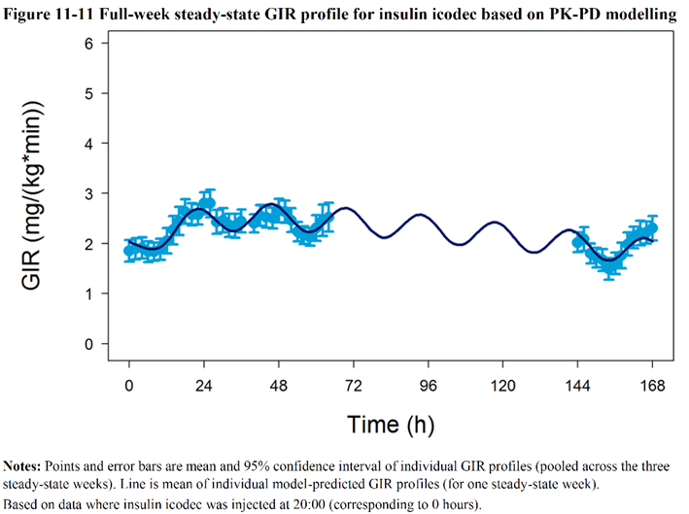
Notes: Points and error bars are mean and 95% confidence interval of individual GIR profiles (pooled across the three steady-state weeks). Line is mean of individual model-predicted GIR profiles (for one steady-state week). Based on data where IIco was injected at 20:00 (corresponding to 0 hours).
Figure 3: Distribution of model predicted GIR effect per day in Caucasian subjects with T2DM over a one-week dosing interval
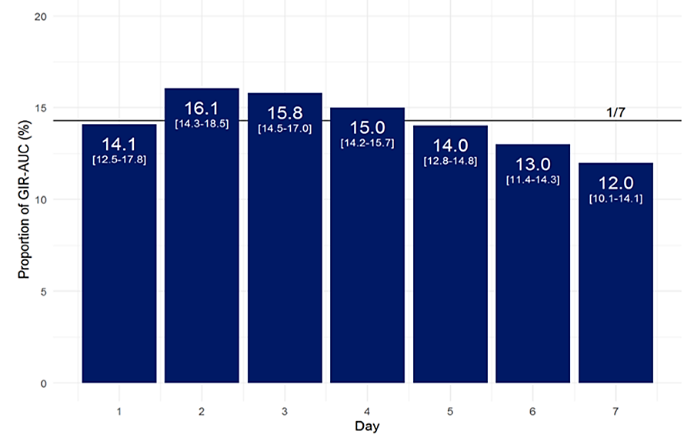
Notes: Numbers on bars are mean and range of daily proportions of total weekly GIR-AUC based on individual model-predicted GIR profiles. Horizontal line represents equal distribution of effect across the seven days of the week. Abbreviations: AUC = area under curve; GIR = glucose infusion rate.
In contrast to patients with T2DM, the GIR effect was not evenly distributed in T1DM and decreased over time. More fluctuations of the blood glucose levels were observed at the end of the dosing interval.
Figure 4: Full-week mean steady-state GIR profile for IIco in Caucasian subjects with T1DM (PK/PD modelling)- sufficiently dosed subjects
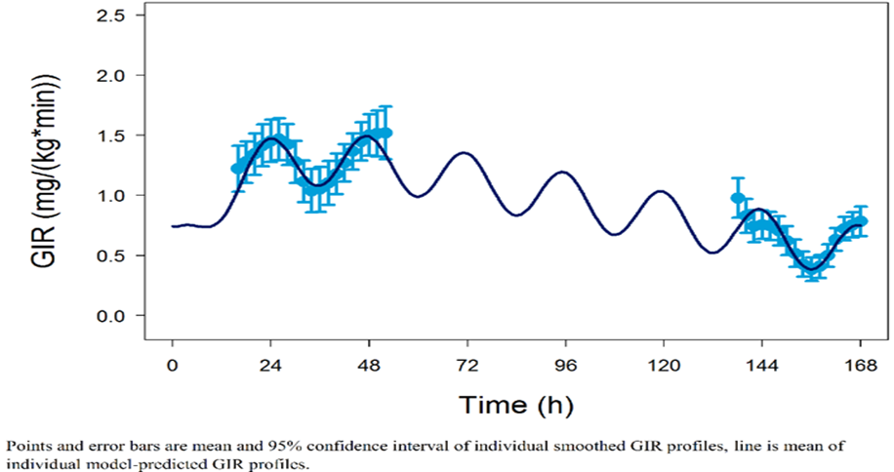
Points and error bars are mean and 95% confidence interval of individual smoothed GIR profiles, line is mean of individual model- predicted GIR profiles.
Figure 5: Distribution of model-predicted GIR effect per day in Caucasian subjects with T1DM over a one-week dosing interval
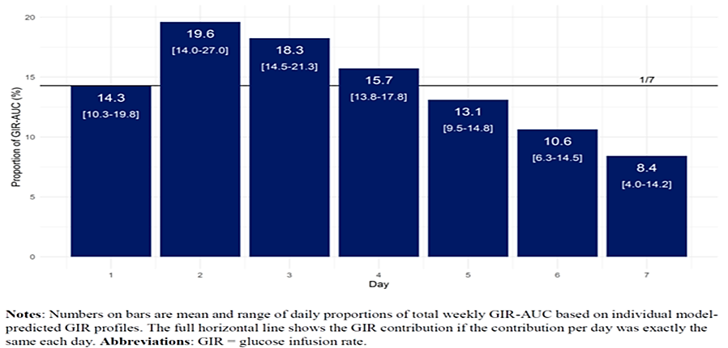
Notes: Numbers on bars are mean and range of daily proportions of total weekly GIR-AUC based on individual model-predicted GIR profiles. The full horizontal line shows the GIR contribution if the contribution per day was exactly the same each day. Abbreviations: GIR — glucose infusion rate
Three Phase 1 studies included a comparator arm: IDeg in study 4314 and IGlar in studies 4225 and 4422. In order to demonstrate a comparable PD effect, the relative bio-efficacy using AUC_{GIR} of IIco and the respective comparator was determined. Based on estimated relative bio efficacy between 101% and 119%, the sponsor concluded that IIco, IDeg, and IGlar have an equipotent glucose-lowering effect.

Secondary pharmacology (Safety)
Hypoglycaemia frequency and the physiological response following double or triple doses of IIco or IGlar in subjects with T2DM were investigated (study 4462). The double and the triple dose of IIco and IGlar induced clinically significant hypoglycaemia (PG(plasma glucose)_{nadir}<3.0 mmol/L [<54 mg/dL]), which was the primary endpoint. Comparable proportions of patients experienced clinically significant hypoglycaemia following both double (39.5% vs. 35.7%) and triple (52.6% vs. 70.0%) doses of IIco versus IGlar. The proportion of patients with PG_{nadir}≤2.5 mmol/L (≤45 mg/dL) was significantly higher for IGlar after a triple dose. Time to recover from PG_{nadir} to PG 5.5 mol/L was comparable for IIco and IGlar.
Figure 6: Proportion of individuals with clinically significant hypoglycaemia after double and triple dose
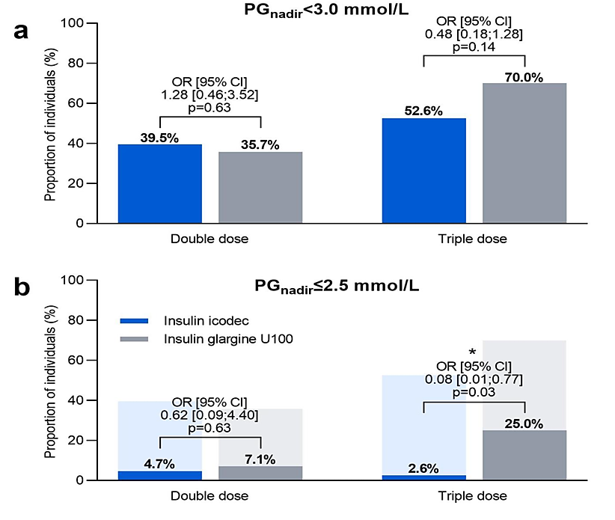
Whereas cognitive and symptomatic responses were comparable, the endocrine response was overall moderately greater for IIco.

Dose finding
Dosing of insulin varies widely depending on patients’ insulin sensitivity and body weight. In order to accommodate the large differences in insulin requirements, the dose of basal insulin is generally titrated according to product-specific treat-to-target algorithms.
Three Phase 2 studies (4383, 4465, and 4466) investigated treat-to-target titration algorithms in patients with T2DM. Study 4383 provided a proof of concept for the use of once-weekly IIco (QW) in insulin-naïve patients. Study 4465, insulin-naïve patients as well, examined various titration algorithms. Study 4466 examined different approaches (+/- loading dose) for switching from once-daily IGlar to account for the fact that plasma concentrations of IIco (IIco) QW reach steady state only after 4-6 doses (i.e., after 4-6 weeks).

Study 4383
This was a 26-week study in insulin-naïve patients with T2DM who failed to achieve adequate glycaemic control (HbA1c>7%) with prior treatment (metformin +/- DPP4i). At baseline, the mean age, body weight, HbA1c, duration of diabetes, and eGFR [estimated glomerular filtration rate] were ~60 years, ~125 kg, ~8%, ~10 years, and >90 ml/min/1.73 m², respectively).
The glucose-lowering action of IIco was comparable (numerically stronger) with that of IGlar. The change from baseline to week 26 in HbA1c was -1.33% with IIco as compared with -1.15% for IGlar (estimated treatment difference [95% CI]: -0.18% [-0.38; 0.02]). Noteworthy, the weekly insulin dose required appeared to be reduced with IIco versus IGlar.
Study 4383 provided initial evidence for a robust glucose-lowering efficacy of IIco QW in insulin-naïve patients with T2DM who used the treat-to-target dose titration algorithm described above. The study further detected no new safety signals for an insulin analogue.

Study 4465
This was a 23-week study in patients with T2DM who failed adequate glycaemic control (HbA1C ≥ 7%) with their prior treatment lacking insulin (metformin +/- DPP4i +/- SGLT2i). The actual treatment period (16 weeks) explored three titration algorithms for IIco (A, B, and C) in comparison with the active comparator IGlar U100 titrated according to the widely established titration algorithm D. Noteworthy, the two titration algorithms A and B used a pre-breakfast SMPG (i.e., usually identical with fasting plasma glucose[FPG]) of 4.4 mmol/L (80 mg/dL) as threshold below which dose reduction was triggered.
Table 2: Study protocol for algorithm A, B and D
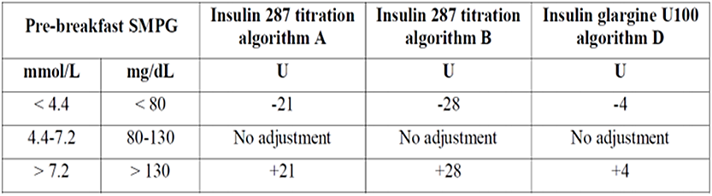
The titration algorithm C used a lesser threshold of 3.9 mmol/L (70 mg/dL) expected to result in more stringent lowering of plasma glucose. But at the same time, it would be expected to be more prone to result in hypoglycaemic events.
Table 3: Study Protocol for algorithm C
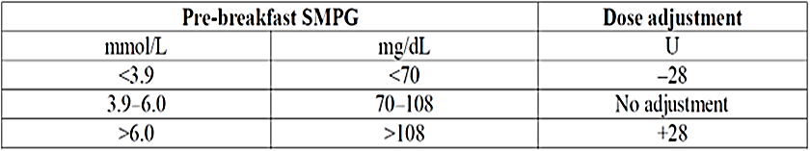
The primary endpoint was the continuous glucose monitoring (CGM) parameter TIR(%) during week 15 and 16 of the treatment period. The secondary endpoint included A1C, ΔFPG, ΔBW(body weight), and the insulin dose.
The results for TIR further substantiated that once-weekly IIco is a practical approach to control blood glucose levels in insulin-naïve patients with T2DM. Remarkably, the TIR for the titration algorithm B was superior to that in the IGlar U100 arm (ETD [95% CI]: 7.08% [2.12; 12.04]; p =0.0051) without meaningful increase in the risk for hypoglycaemia (ETD [95% CI] of the time spent <3.9 mmol/L: 0.68% [-0.15, 1.50]). Regarding secondary endpoints, the titration algorithm B was associated with a numerically larger decrease in ΔA1C (ETD [95% CI]: -0.20% [-0.42, 0.02]) and a neutral outcome for ΔFPG (ETD [95% CI]: -0.08 mmol/L [-0.56, 0.40]) versus once-daily IGlar U100. Given an ~1.2-fold higher dose of insulin, a numerical weight gain (ETD [95% CI]: -0.48 kg [-0.49, 1.44]) observed in comparison with once-daily IGlar U100 was not surprising.
Once-weekly IIco titration algorithm C (dose reduction only if FPG dropped <3.9 mmol/L) was associated with a significant increase in the time spent <3.9 mmol/L (ETD [95% CI]: 1.18% [0.34, 2.02]; p=0.006). This could be interpreted as failure of non-inferiority for the risk of hypoglycaemia compared with once-daily IGlar U100. Not surprisingly, and in line with this, titration algorithm C required the largest weekly insulin dose (~1.44 fold the dose of once-daily IGlar U100). The benefits of titration algorithm C were a small numerical advantage for TIR versus once-daily IGlar (ETD [95% CI]: 5.01% [-0.04, 10.05]; p=0.0519) and favourable outcomes for the secondary glycaemic endpoints (ETD [95% CI] for ΔA1C and ΔFPG were 0.36% [-0.58, -0.14] and -0.67 mmol/L [ 1.14, -0.19], respectively).
Once weekly IIco titration algorithm A resulted in similar TIR as compared with once-daily IGlar U100 (ETD [95% CI]: 0.76% [-4.28, 5.80]). Likewise, ΔA1C (ETD [95% CI]: 0.02% [-0.20, 0.24]) and ΔFPG (ETD [95% CI]: 0.12% [-0.36, 0.59]) were equivalent with that in the active control arm.
Once-weekly IIco titrated according to algorithm B provided the most favourable outcomes with regard to the glucose level achieved, while titration algorithm A appeared to be more modest in this regard. At the same time, both algorithms were associated with only marginally increased risk of hypoglycaemia (vs. once-daily IGlar U100). In contrast, titration algorithm C appeared to carry an increase in the risk of hypoglycaemia.

Study 4466
This was a 23-week study in patients with T2DM who failed adequate glycaemic control (A1C ≥ 7%) with prior treatment including a once- or twice-daily basal insulin (i IDeg, insulin detemir, IGlar U100 or U300, total daily dose of 10-50 U for ≥ 90 days) on top of metformin +/- DPP4i +/- SGLT2i. The actual treatment period (16 weeks) explored two switch approaches, switch with additional 100% loading dose (I287 + load) vs. switch with no loading dose (I287), both in comparison with the active comparator IGlar U100 (IGlar).
The primary endpoint was the CGM parameter TIR(%) during week 15 and 16 of the treatment period. Secondary endpoint included ΔA1C, ΔFPG, ΔBW , and the insulin dose.
The following are the outcomes for primary and secondary endpoints:
Table 4: Primary and secondary end points outcomes for Study 4466
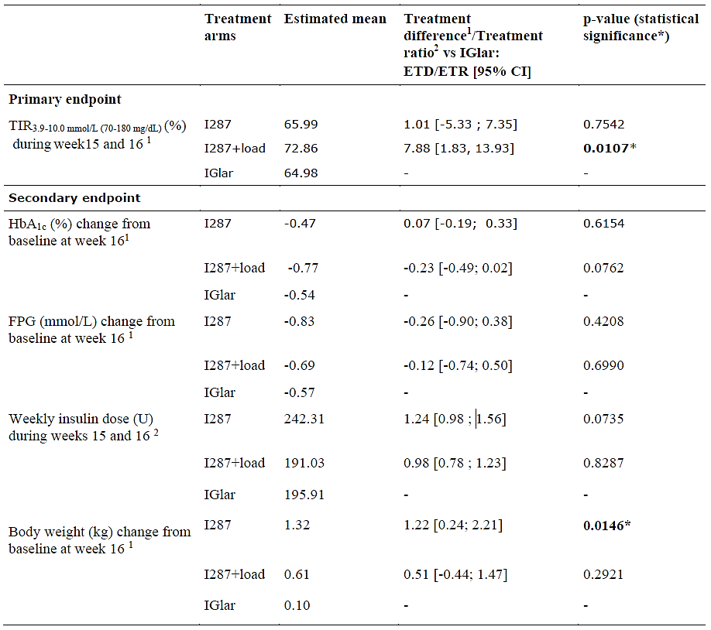
Abbreviations: ETD: estimated treatment difference, ETR: estimated treatment ratio, *: statistically significant difference, CI: confidence interval, TIR: time in range, FPG: fasting plasma glucose.
This meant that I287 + load switching approach was superior to IGlar in terms of TIR and lead to numerically larger reductions in ΔA1C and ΔFPG. The I287 switching approach yielded results similar (non-inferior) to that in the IGlar arm for TIR, ΔA1C, and ΔFPG. Both regimens decreased the time spent >10 mmol/L, I287 numerically and I28 + load statistically significant.
Table 5: Time Above Range (TAR) _{>10mmoL (180mg/dL )}(%) during the last two weeks of treatment (week 15 and 16)- post hoc statistical analysis
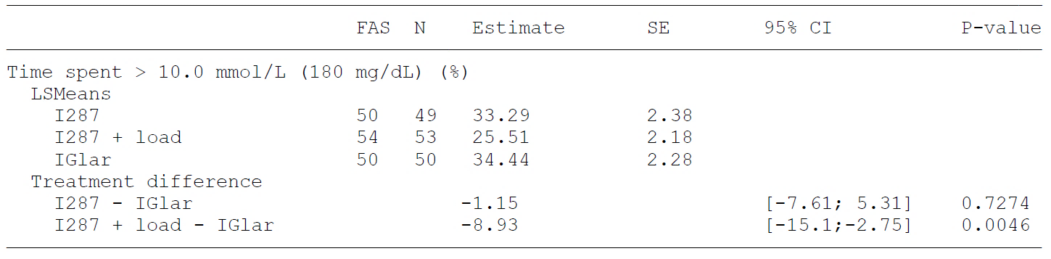
Abbreviations: CI: Confidence interval, N: Number of subjects contributing to the analysis, SE: Standard error of the mean, SGLT2i: Sodium-glucose cotransporter 2 inhibitor
P-value: Two-sided p-value for test of no treatment difference. No correction for multiplicity. Time spent above range is defined as 100 times the number of recorded measurements >10.0 mmol/L (180 mg/dL), divided by the total number of recorded measurements. The response during the last two weeks of treatment (week 15 and 16) is analysed using an analysis of covariance (ANCOVA) model with treatment and SGLT2i use as fixed factors, and baseline response as covariate. Missing endpoint values are imputed using multiple imputation based on own treatment arm with baseline response as a covariate. Each imputed dataset is analysed separately, and estimates are combined using Rubin's rules.
At the same time, the I28 + load switching approach was unfavourably associated with a significant rise of the time spent <3.9 mmol/L.
Table 6: Time below range (TBR) _{<3.9mmoL (70mg/dL)} (%) during the last two weeks of treatment (week 15 and 16)-post hoc statistical analysis
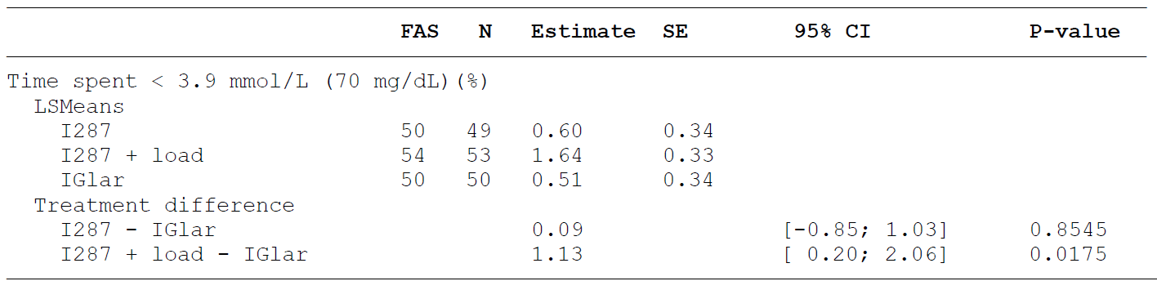
Abbreviations: CI: Confidence interval, N: Number of subjects contributing to the analysis, SE: Standard error of the mean, SGLT2i: Sodium-glucose cotransporter 2 inhibitor.
Note: P-value: Two-sided p-value for test of no treatment difference. No correction for multiplicity. Time spent below range is defined as 100 times the number of recorded measurements <3.9 mmol/L (70 mg/dL), divided by the total number of recorded measurements. The response during the last two weeks of treatment (week 15 and 16) is analysed using an analysis of covariance (ANCOVA)model with treatment and SGLT2i use as fixed factors, and baseline response as covariate. Missing endpoint values are imputed using multiple imputation based on own treatment arm with baseline response as a covariate. Each imputed dataset is analysed separately, and estimates are combined using Rubin's rules.
In summary, switching from once-daily basal insulin to once-weekly IIco according to two approaches with (I287 + load) and without loading dose (I287) were generally practicable. However, given the increase in the time spent in the hypoglycaemic range in the I287 + load arm, the I287 approach appears preferable.
Of-note, the Phase 3 studies ONWARDS 2, 4 and 6 initiated IIco QW treatment with a reduced initial additional loading dose of 50%.

Efficacy
The efficacy for IIco is supported by the ONWARDS program consisting of six pivotal Phase 3 studies sharing most features of design and conduct. Two of the trials (ONWARDS 1 and 6) include a main phase with primary analysis at week 52 and week 26 respectively. A treat-to-target approach was followed in all trials except ONWARDS 5, which was designed to mimic a clinical practice setting where IIco was used together with a dosing guidance application. For this trial, a broad patient population was included to reflect the range of T2DM subjects in real life, i.e. subjects with any comorbidities were not excluded in this trial, visit frequency was lower (every 3 months) and there was no upper limit on the HbA1c value at screening.
Figure 7: ONWARDS Trial Designs
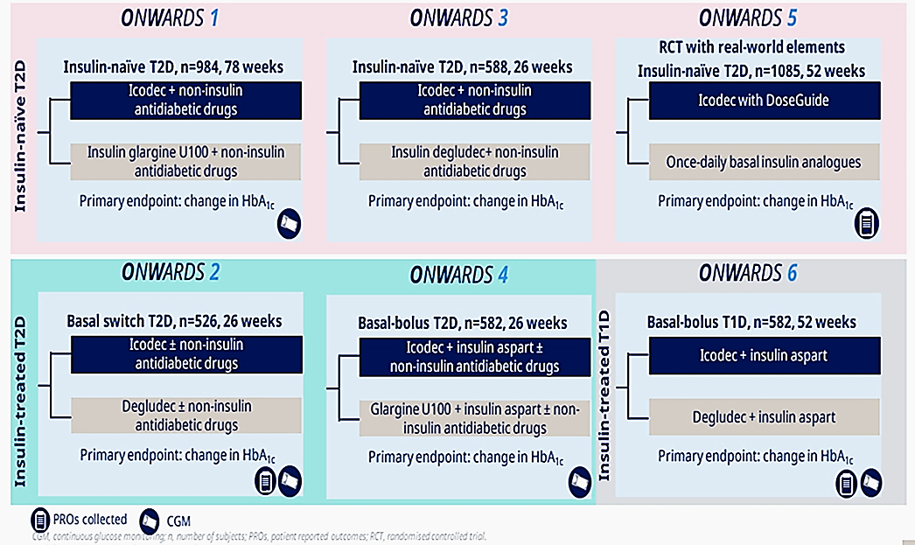

Table 7: Pivotal Studies – ONWARDS Development Programme Overview
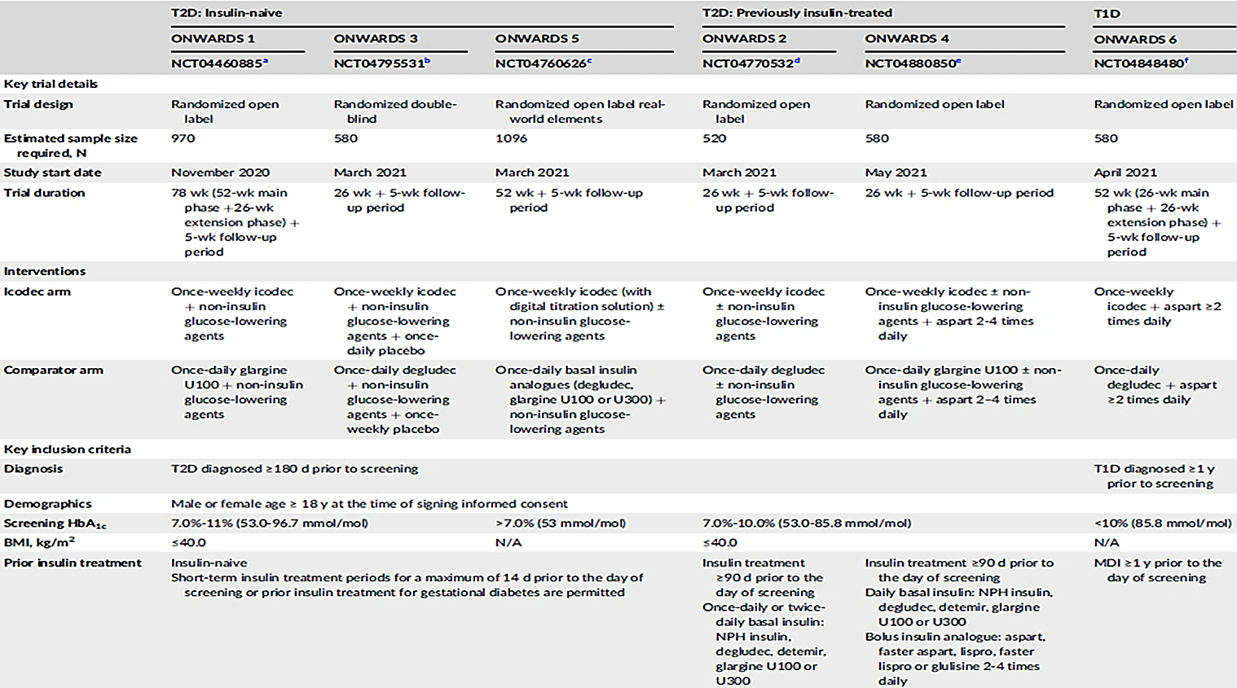

Objectives and estimands
The primary objective for the phase 3a trials was to demonstrate the effect of glycaemic control of once-weekly IIco compared to a daily basal insulin in both T2DM and T1DM patient populations. The primary endpoint, change in HbA1c, was assessed from baseline to week 26 in ONWARDS 2, 3, 4 and 6, and from baseline to week 52 in ONWARDS 1 and 5. To further evaluate glycaemic control, ONWARDS 1, 2, 4, and 6 had continuous glucose monitoring (CGM) profiles collected. To evaluate treatment satisfaction, patient reported outcomes were included in ONWARDS 2, 5, and 6.
The primary endpoint was the change in HbA1c from baseline to week 26. The estimands was defined as the treatment difference between IIco and daily basal insulin comparator of the change in HbA1c from baseline to week 26 (ONWARDS 2, 3, 4 and 6) or week 52 (ONWARDS 1 and 5) for all randomised subjects, irrespective of adherence to randomised treatment and changes to anti-diabetic background medication. The treatment policy strategy was applied to the intercurrent events of 1) treatment discontinuation or 2) initiation of bolus treatment lasting for more than 2 weeks in bolus-naïve subjects (ONWARDS 1, 2, and 3). This estimand intends to give an estimation of the population-level treatment effect, i.e. an ‘intention-to treat’ analysis.

Main eligibility criteria
Across the phase 3a ONWARDS trials, the patient populations comprised of insulin-naïve T2DM subjects (ONWARDS 1, 3, and 5), insulin-experienced T2DM switching from another basal insulin (ONWARDS 2), and T2DM and T1DM subjects on a basal-bolus regimen (ONWARDS 4 and 6). The eligibility criteria for ONWARDS 5 were broader to include a wider patient population more reflective of the targeted T2DM population in the real world.

Statistical analyses
In all trials, an upper limit of 95% confidence interval for the mean difference of the primary endpoint (change in HbA1c from baseline) was compared to the pre-specified non-inferiority margin of 0.3%. In ONWARDS 1, 2, 3 and 5, additional clinically relevant confirmatory hypotheses were assessed and adjusted for multiplicity via a hierarchical testing approach and tested at a 5% two-sided significance level. If non-inferiority was demonstrated, there were subsequent tests for superiority in HbA1c. In ONWARDS 1, if non-inferiority in HbA1c was demonstrated, there was a subsequent test for superiority in percentage of TIR before the superiority test in HbA1c.
Continuous endpoints (including the primary endpoint) except time below glycaemic range (TBR) were analysed using an analysis of covariance (ANCOVA) including treatment, stratification factor (ONWARDS 3 and 6), personal CGM device use (y/n) (ONWARDS 2 and 4) and region as fixed effects and the baseline value of the response as covariate (where relevant). Log-transformation was applied for analyses of mean insulin dose during the last 2 weeks of treatment. Binary assessments were analysed using a logistic regression model with the same fixed factors as specified for the ANCOVA model and the applicable baseline value as covariate. Hypoglycaemic episodes and TBR were analysed using a negative binomial regression model with a log-link function, and the logarithm of the observation period as offset. The model included the same fixed factors as specified for the ANCOVA model.

Patient population
The subjects enrolled in the phase 3a programme represented a diverse global population (33 countries) in both T2DM and T1DM. In the clinical phase 3a programme of IIco, 2170 individuals in total have been exposed to IIco of which 1880 subjects with T2DM and 290 subjects with T1DM. In the phase 3a pool, total exposure to IIco was 1681.23 patient years exposure (PYE) (1538.92 PYE in the T2DM pool and 142.31 PYE in T1DM).

Pen injector device
In all phase 3a trials, the PDS290 device injector, intended for market for IIco, was used to administer IIco, is based on the variants of the PDS290 pen-injector that are already approved for use with various Novo Nordisk insulin products (under the brand name modifier FlexTouch®).

ONWARDS 1 STUDY
ONWARDS 1 was 78-week, randomised (1:1), open label, multicentre, multinational, Phase 3 trial comparing the treatment effects of IIco (IIco) administered once-weekly (QW) and IGlar administered once-daily (QD) in patients with T2DM.
Figure 8: ONWARDS 1Trial Design
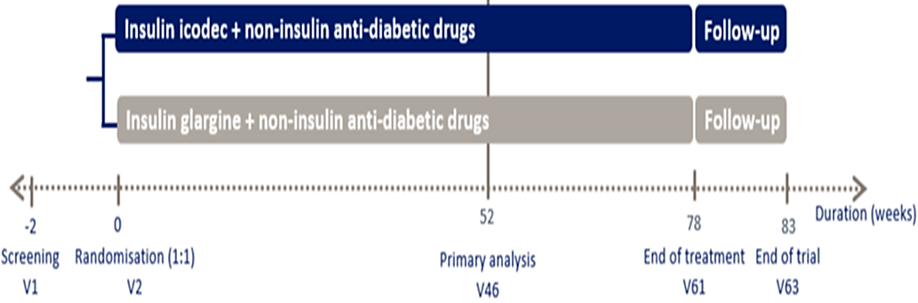
Patients in both treatment arms were insulin-naïve and had inadequate glycaemic control (HbA1c ≥7.0-≤11.0% [≥53.0-≤96.7 mmol/mol]) on a combination with oral antihyperglycaemic agents. Randomized treatments (IIco QW or IGlar QD) both followed a treat-to-target strategy. Titration of IIco QW and IGlar QD was based on pre-breakfast SMPG values and followed the titration guideline outlined in the protocol.
Primary endpoint was the change in HbA1c from baseline to week 52 (DA1C). The primary hypothesis was that IIco QW was non-inferior to IGlar QD in terms of DA1C (pre-specified non-inferiority margin 0.3 %). Confirmatory secondary endpoint was the time in range 3.9-10.0 mmol/L (70-180 mg/dL) from Week 48 – 56 (TIR).
A testing hierarchy was predefined to account for multiplicity. Noteworthy, there appear to be no planned subgroup analyses. Demographics and baseline characteristics showed no meaningful imbalances between the treatment arms. At baseline, the mean age, body weight, HbA1c, FPG, duration of diabetes, and eGFR were ~59 years, ~85 kg, ~8.5%, ~185 mg/dL, ~11.5 years, and ~85 ml/min/1.73 m².
The glucose-lowering effect of IIco QW was non-inferior to that of IGlar QD.
Table 8: HbA1C between the two arms ONWARDS 1
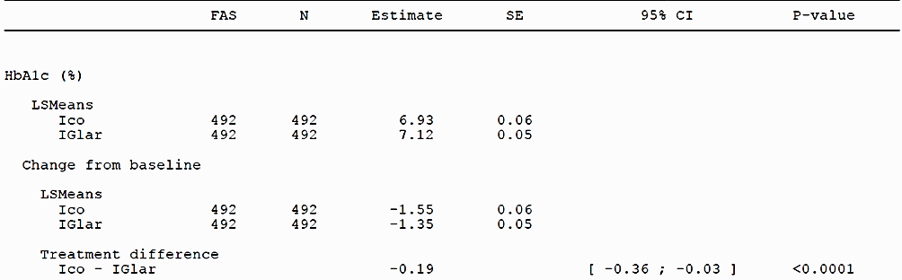
Figure 9: HbA1C comparison between the two arms ONWARDS 1
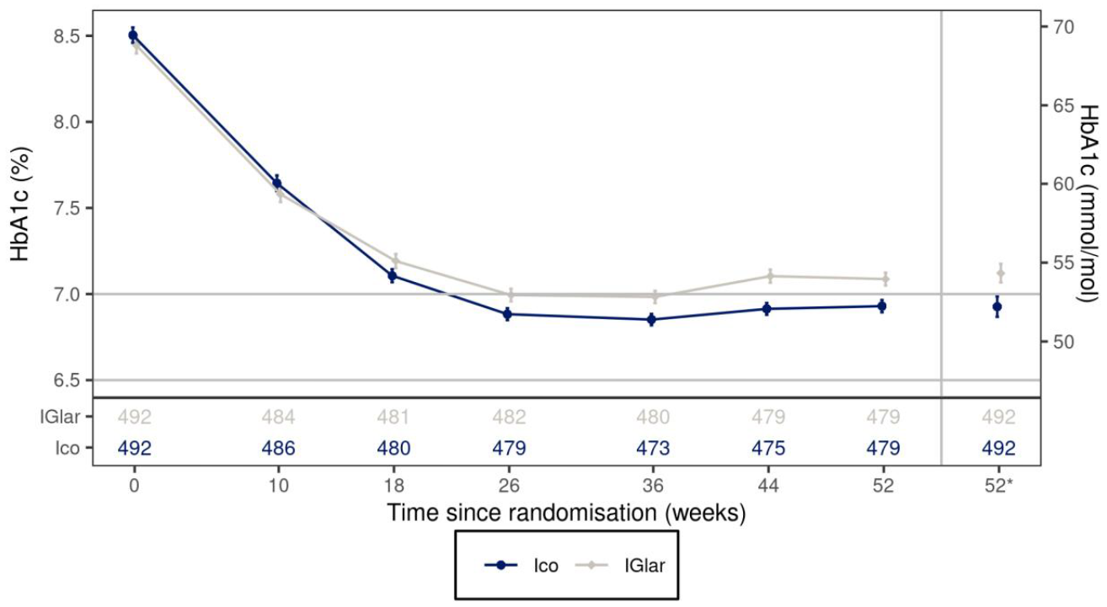
52*: Estimated mean values and the corresponding standard error at week 52 derived based on MI. MI: Multiple imputation, Full analysis set. Observed data including data obtained after premature treatment discontinuation. Number of subjects contributing to the data points appears in the bottom panel. Legend: Mean (symbol) and mean ± standard error to the mean (error bars). HbA1 c: Haemoglobin Alc.
Subsequent analysis proved superiority of IIco QW versus Igla QD for ΔA1C (p=0.021). Sensitivity analyses supported the robustness of these results. IIco QW was superior to IGlar QD for the key secondary endpoint TIR.
The results for other secondary endpoints corroborated with the above findings.
Favourable outcomes were observed for ΔFPG and the time spent > 10 mmol/L (i.e., in evident hyperglycaemia).
However, the time spent <3.0 mmol/L (54 mg/dL) was numerically increased in patients treated with IIco QW versus IGlar QD. Of note, this was not due to an increase in the weekly insulin dose estimated treatment ratio (ETR [95% CI]: 0.96 [0.89, 1.05]).
Results from the ONWARDS 1 study support the superiority in terms of the glucose-lowering effect for IIco QW vs. IGlar QD, both dosed in a treat-to-target manner based on titration algorithms as predefined per protocol. However, this superior anti-hyperglycaemic effect was associated with numerical increase for the time spent in the hypoglycaemic range.

ONWARDS 2 Study
A 26-week trial comparing the effect and safety of once weekly IIco and once daily IDeg, both with or without non-insulin anti-diabetic drugs, in subjects with type 2 diabetes treated with basal insulin.
The primary objective of ONWARD 2 was to demonstrate non-inferiority (non-inferiority margin 0.3%) of the antihyperglycaemic effect of IIco QW versus IDeg QD in patients with T2DM who are receiving basal insulin +/- oral glucose-lowering agents.
Figure 10: ONWARD 2 trial design
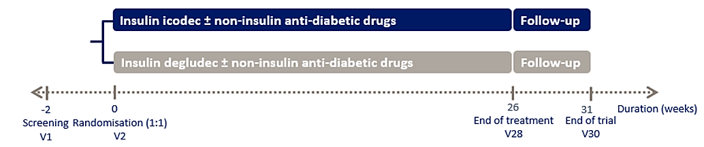
Switching from previous basal insulin to IDeg QD occurred according to the local label. Patients switched to IIco QW received an initial loading dose (total daily basal insulin dose prior to randomisation x 7 + 50% of their total daily basal insulin dose x 7) at randomization (Visit 2). The following week (Visit 3), a dose equal to the total daily basal insulin dose x 7 was administered. Treatments in both arms followed a treat-to-target strategy using a predefined titration algorithm.
The primary endpoint was the change in HbA1c from baseline to Week 26 (ΔA1C). The primary hypothesis was that IIco QW was non-inferior to IDeg QD in terms of ΔA1C (pre-specified non-inferiority margin 0.3 %). Secondary endpoints were the change in FPG from baseline to Week 26 (ΔFPG), time in range 3.9-10.0 mmol/L (70-180 mg/dL) from Week 22 – 26 (TIR), and the change in Diabetes Treatment Satisfaction Questionnaire (DTSQ) score.
A hierarchical testing procedure was applied to control the overall Type I error at a 5% level. No subgroup analyses was performed.
Demographics and baseline characteristics showed no meaningful imbalances between the treatment arms. At baseline, the mean age, body weight, HbA1c, FPG, duration of diabetes, and eGFR were ~62.5 years, 81.5 – 83.7 kg, ~8.1%, ~150 mg/dL, nearly 17 years, and ~80 ml/min/1.73 m². At baseline, the most common basal insulins were IGlar U100 QD, IDeg QD, and IGlar U300 QD (in order of their use).
Table 9: Basal insulin at screening
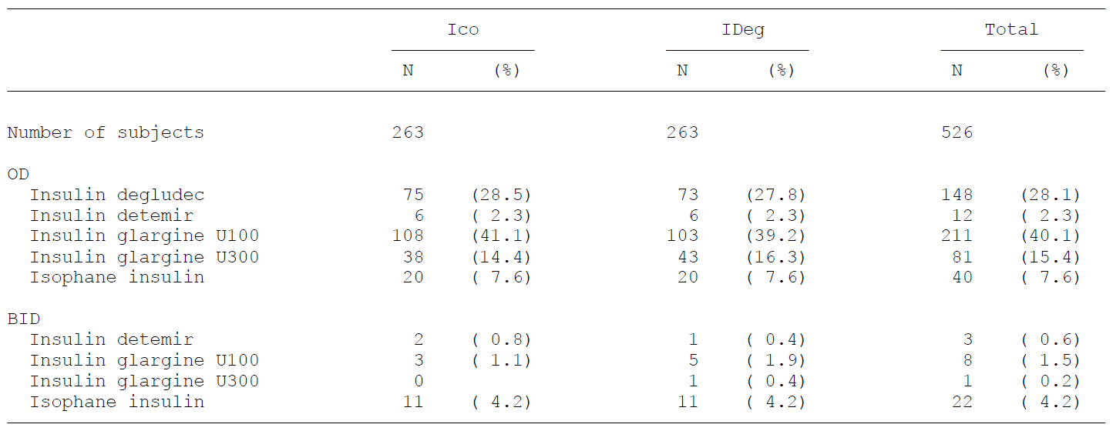
N: Number of subjects, %: Percentage of subjects, OD: Once daily, BID: twice a day.
The glucose-lowering efficacy of IIco QW was non-inferior to that of IDeg QD. The subsequent testing according to the predefined hierarchy confirmed even superiority.
Figure 11: HbA1C Comparison between the two arms ONWARDS 2
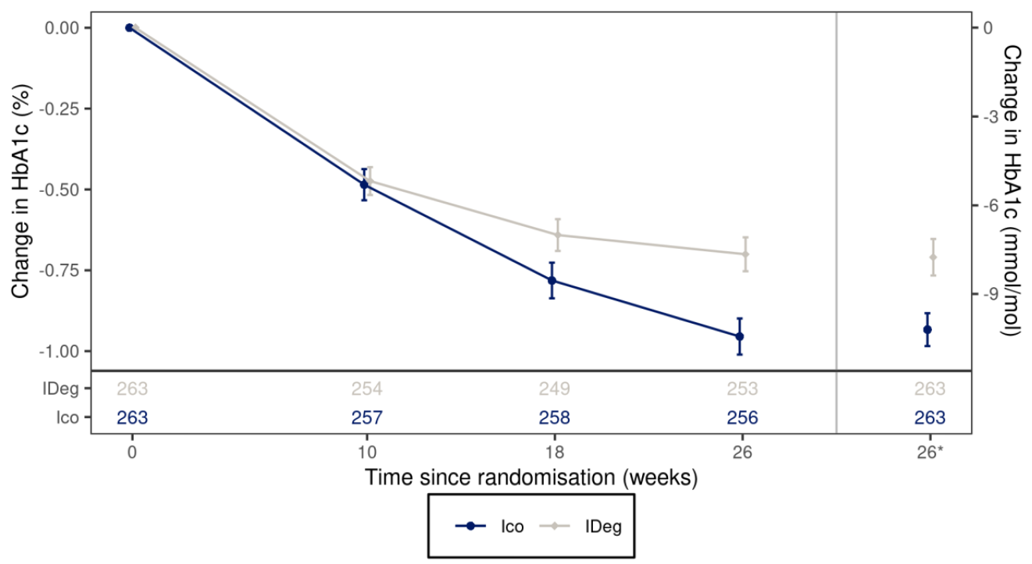
26*: Estimated mean values and the corresponding standard error at week 26 derived based on MI. MI: Multiple imputation, Full analysis set. Observed data including data obtained after premature treatment discontinuation. Number of subjects contributing to the data points appears in the bottom panel. Legend: Mean (symbol) and mean ± standard error to the mean (error bars). HbA1 c: Haemoglobin Alc.
However, similar to the ONWARDS 1 , in this trial also the time spent <3.0 mmol/L (54 mg/dL) was numerically increased in patients treated with IIco QW versus IDeg QD.
Table 10: time spent <3.0 mmol/L (54 mg/dL) ONWARDS 2
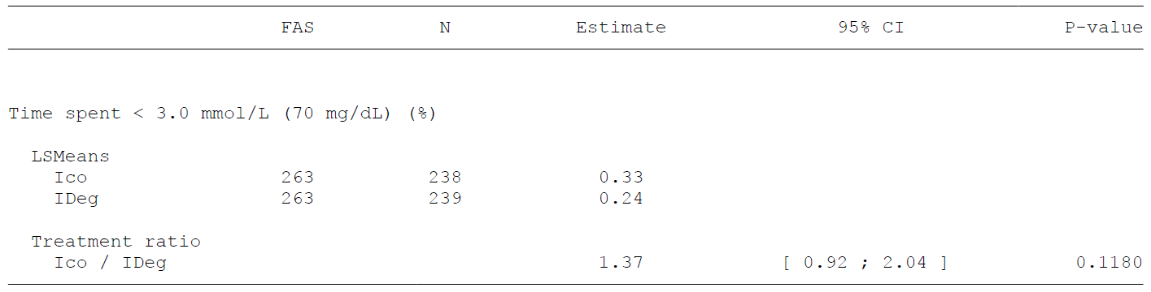
FAS: Number of subjects in full analysis set, N: Number of subjects contributing to the analysis, SE: Standard error of the mean, CI: Confidence interval, MI: Multiple imputation. P-value: Two-sided p-value for test of no treatment difference. No correction for multiplicity. Time spent is analysed using a negative binomial regression model (log link) on the number of recorded measurements in a given range. The model includes treatment, region and personal CGM device use as fixed factors, and the logarithm of the total number of recorded measurements as an offset.. Time spent < 3.0 mmol/ L (54 mg/dL) is defined as 100 times the number of recorded measurements < 3.0 mmol/L (54 mg/dL) divided by the total number of recorded measurements.
No severe hypoglycaemic event (level 3) occurred in the IIco QW arm during the ONWARDS 2 study. But there was a marked imbalance for clinically significant hypoglycaemia (level 2) between the treatment groups (72.79 [IIco] vs. 26.84 [IDeg] per 100 patient-years). However, the responder rates for patients achieving their glycaemic target without level 2 or 3 hypoglycaemia was favourable for IIco QW: the ETRs [95% CI] for target HbA1c <7% and <6.5 were 1.8 [1.22, 2.67] and 1.84 [1.08, 3.13], respectively.
QW injections appeared to have a positive impact at patients’ treatment satisfaction: the DTSQ total treatment score which improved significantly more in the IIco QW arm than in IDeg QD arm (ETD [95% CI]: 1.25 [0.41, 2.10]; p<0.005). The meaning of this small differences remains uncertain.
The weekly insulin dose was not meaningfully increased with IIco QW versus IDeg QD (ETR: 1.1).
The results from the ONWARDS 2 study support superiority of IIco QW versus IDeg QD in terms of the glucose-lowering effect, following a switch of patients with T2DM from their prior basal insulin. This study also suggested an increased risk with IIcoQW for hypoglycaemia. However, responder rates of patients achieving suitable glycaemic targets without clinically significant hypoglycaemia favoured IIco QW treatment.

ONWARDS 3 Study
ONWARDS 3 was a 26-week randomised (1:1), double blinded, double dummy, multicentre, multinational, Phase 3 trial comparing the treatment effects of IIco administered once-weekly (IIco QW) and IDeg administered once-daily (IDeg QD) in insulin-naïve patients with T2DM.
Study participants were insulin-naïve and had inadequate glycaemic control on their prior treatment (combination of oral and injectable anti-hyperglycaemic agents). Treatments in both arms followed a treat-to-target strategy using a titration algorithm.
Figure 12: ONWARDS 3 Study Design
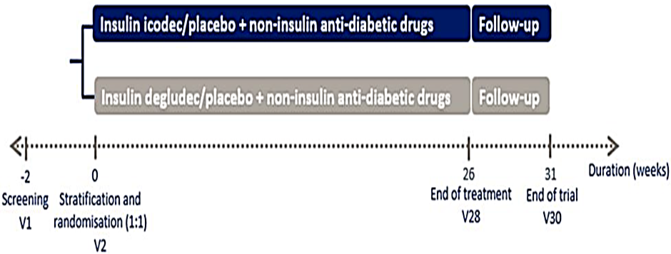
The primary endpoint was the change in HbA1c from baseline to Week 26 (ΔA1C).
Secondary non-confirmatory efficacy endpoint was the change in FPG from baseline to Week 26 (ΔFPG). Additional secondary safety endpoints were the number of episodes of hypoglycaemia of different levels as defined by the International Hypoglycaemia Study Group.
The study was generally well designed and conducted with >95% of the participants completing until Week 26 without permanent treatment discontinuation. A hierarchical testing procedure was applied to control the overall Type I error at a 5% level for D A1C.
Results:
Demographics and baseline characteristics matched well for the two treatment arms ((except the baseline medications). At baseline, the mean age, body weight, HbA1c, FPG, duration of diabetes, and eGFR were ~58 years, 83.4 – 85.8 kg, ~8.5%, 176 - 187 mg/dL, 11 years, and >90 ml/min/1.73 m2 respectively. Most common background medications were metformin (~90%), sulphonylurea (~44%), DPP4 inhibitors (~26%), GLP-1 receptor-agonists (21.8% [IIco QW] vs. 16.3 [Idec QD]), and SGLT2 inhibitors (40.5% [IIco QW] vs. 32.3% [Idec QD]) with obvious imbalances for the two latter classes.
The glucose-lowering efficacy of IIco QW was non-inferior to that of IDeg QD. The subsequent testing according to the predefined hierarchy confirmed even superiority.
Table 11: Primary and secondary endpoints outcome for ONWARDS 3
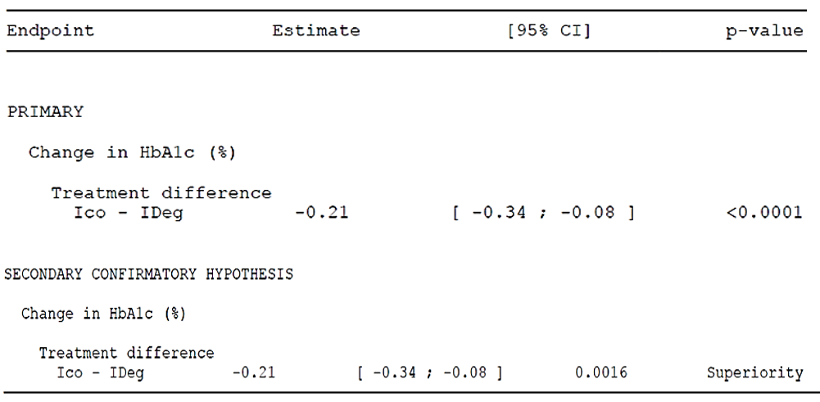
Subsequent testing according also confirmed superiority (p=0.0016).
Figure 13: HbA1C Comparison between the two arms ONWARDS 3
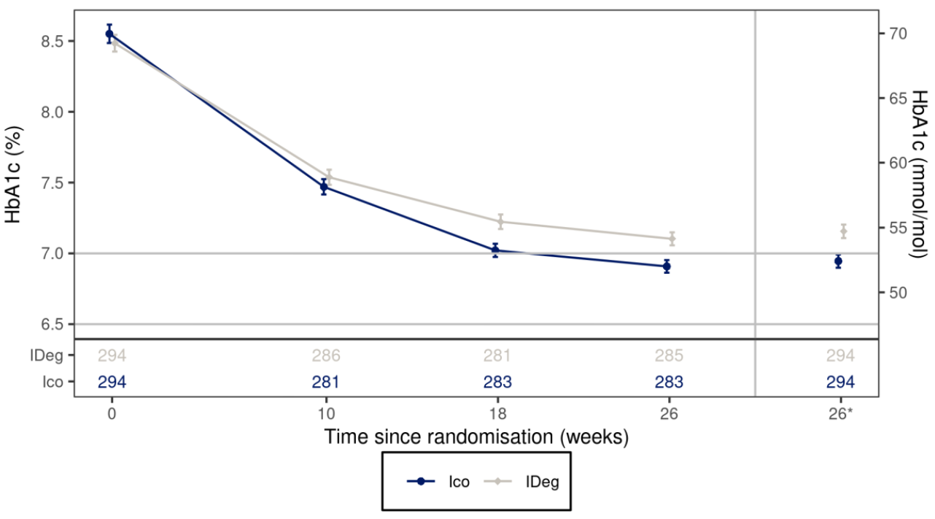
26*: Estimated mean values and the corresponding standard error at week 26 derived based on MI, MI: Multiple imputation, Full analysis set. Observed data including data obtained after premature treatment discontinuation. Number of subjects contributing to the data points appears in the bottom panel. Legend: Mean (symbol) and mean ± standard error to the mean (error bars). HbA1c: Haemoglobin Alc.
No severe hypoglycaemia (level 3) occurred in the ONWARDS 3 trial, while there was a marked in¬ in the rate of clinically significant hypoglycaemic episodes (level 2): 34.8 (IIco) vs. 11.7 (IDeg) per 100 patient-years with an ERR [95% CI] of 2.09 [0.99, 4.41]. However, the responder rates for patients achieving adequate glycaemic control without level 2 or worse hypoglycaemia were significantly more in the IIco QW arm vs. IDeg QD: e.g., the ETR [95% CI] for target HbA1c <6.5% was 1.72 [1.16, 2.54].
The mean weekly insulin dose from week 24 - 26 was slightly (but not significantly) increased (204.28 U for IIco QW versus 186.52 U for IDeg QD), and there was no statistically significant difference between treatment arms (ETR [95% CI]: 1.10 [0.98, 1.22]). Patients in the IIco QW rm showed a marginally larger weight gain as compared with the IDeg QD control arm (ETD [95% CI]: 0.46 kg [-0.19, 1.10]).
The results from the ONWARDS 3 study support the superiority IIco QW to IDeg QD in terms of the glucose-lowering action following initiation of basal insulin in insulin-naïve patients with T2DM. However, this superior anti-hyperglycaemic effect was associated with increase in clinically significant hypoglycaemia (level 2).

ONWARDS 4 Study
The OMNWARDS 4 study was a 26-week, randomised (1:1), open label, multicentre, multinational, Phase 3 trial comparing the treatment effects of IIco administered once-weekly (IIco QW) and IGlar administered once-daily (IGlar QD) in patients with T2DM.
Study participants were patients at more advanced stages of the disease (>15 years median duration of T2DM) unable to reach adequate glycaemic control on prior treatment with a basal insulin + bolus insulin +/- oral/injectable antihyperglycaemic agents. Approximately 18% of the study participants used a personal CGM or flash GM device.
Figure 14: OMNWARDS 4 study design
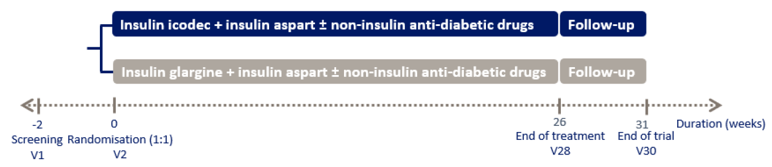
The primary endpoint was the change in HbA1c from baseline to Week 26 (ΔA1C). Secondary endpoints were the change in FPG from baseline to Week 26 (ΔFPG) and the time in range 3.9-10.0 mmol/L (70-180 mg/dL) from Week 22 – 26 (TIR).
Demographics and baseline characteristics were balanced between the treatment arms. At baseline, the mean age, body weight, HbA1c, FPG, duration of diabetes, and eGFR were ~63 years, 83.1 – 85.5 kg, ~8.3%, 167 – 173 mg/dL, 16 – 18 years, and ~82 ml/min/1.73 m² respectively.
The basal insulins most commonly used prior to randomization were those to be administered QD: among the randomized patients, IGlar U100 QD was used 49.5 % (IIco QW) and 44.3% (IGlar QD), IDeg QD was used by 25.1 % (IIco QW) and 23.0% (IGlar QD), and IGlar U300 QD was used by 19.2% (IIco QW) and 23.0% (IGlar QD).
Table 12: HbA1C after 26 weeks- change from baseline -primary statistical analysis- full analysis set
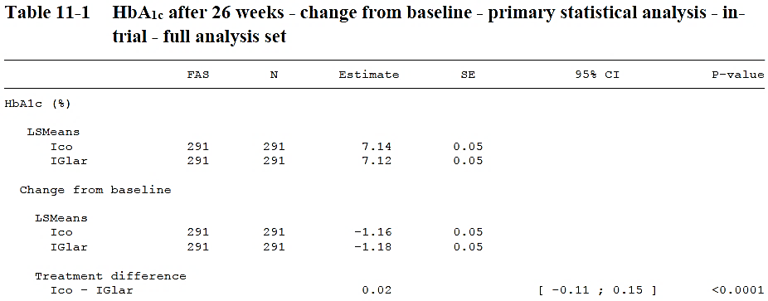
Figure 15: HbA1c by treatment week change from baseline -mean plot - full analysis set(FAS)
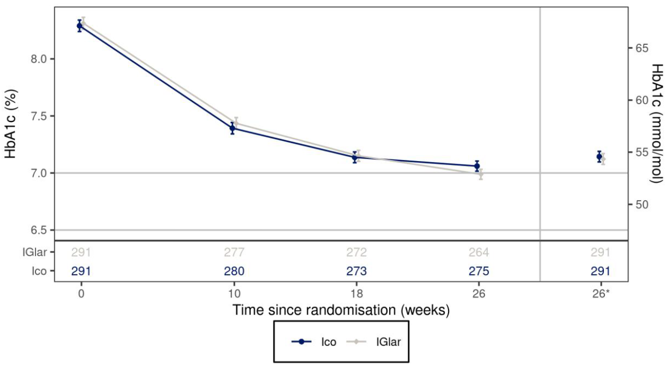
26*: Estimated mean values and the corresponding standard error at week 26 derived based on MI, MI: Multiple imputation, Full analysis set. Observed data including data obtained after premature treatment discontinuation. Number of subjects contributing to the data points appears in the bottom panel. Legend: Mean (symbol) and mean ± standard error to the mean (error bars). HbA1c: Haemoglobin Alc.
The outcomes for secondary endpoints were consistent with the result for the primary endpoint. The ETD [95% CI] for ΔFPG was -2.48 mg/dL [-10.59, 5.63]. Likewise, the ETD [95% CI] for the TIR was 0.29% [-2.52, 3.09]. In parallel, IIco QW cause a slight numerical reduction of the time spent >10.0 mmol/L (ETD [95% CI]: -0.60% [-3.47, 2.28]). Of note, patients were still hyperglycaemic nearly 1/3 of the time as conferred from the estimates of the mean time spent > 10.0 mmol/L from week 22 to week 26 (30.47% [IIco QW] and 30.47% [IGlar QD]).
In addition, patients treated with IIco QW spent nominally more time < 3.0 mmol/L (ETR [95% CI]: 1.20 [0.91, 1.58]) and had more severe (level 3) hypoglycaemic episodes than patients in the IGlar control (4.26 vs. 1.95 events per 100 PY; ETR [95% CI]: 2.19 [0.20, 24.44]). A similar excess of events in the IIco QW arm has been observed for hypoglycaemia alert value (level1) and clinically significant hypoglycaemia (level 2). This was ultimately reflected in the responder rates basically all favouring the active comparator (i.e., except for one, all ETRs were nominally <1).
Table 13: Achievement of Hb A1c target after 26 weeks without hypoglycaemia- supportive statistical analysis- full analysis set
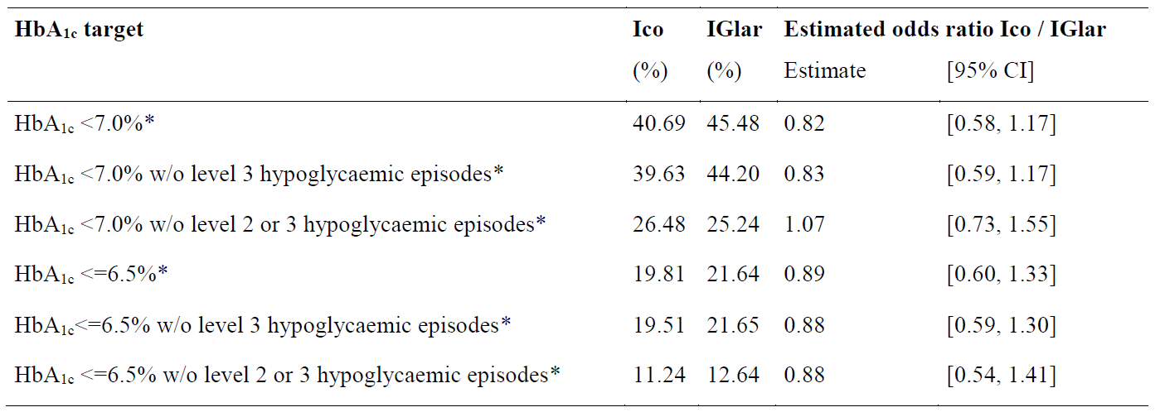
Note: The binary response after 26 weeks is analysed using a binary logistic regression model (logit link) with treatment, region and personal CGM device use as fixed factors, and the baseline HbA1c value as covariate. Missing HbA1c measurements are imputed using the same method as specified for the primary analysis before the target achievement criterion is applied. Subjects who discontinue treatment prematurely are set to being non-achievers for the composite endpoints. Subjects who discontinued treatment prematurely have the outcome set to "No". * indicates no statistically significant difference.
Abbreviations: without hypoglycaemia: without hypoglycaemia during the prior 12 weeks; CI: Confidence interval, No correction for multiplicity; HbA1c: Haemoglobin A1c, w/o: without; Severe hypoglycaemia (level 3): Hypoglycaemia with severe cognitive impairment requiring external assistance for recovery; Clinically significant hypoglycaemia (level 2): Plasma glucose value of < 3.0 mmol/L (54 mg/dL) confirmed by BG meter; BG: Blood glucose.
The weekly insulin dose in the IIco QW arm was slightly lower than in the IGlar QD control (ETR [95% CI]: 0.92 [0.85, 0.99]). At the same time, patients in the IIco QW arm on average gained slightly more weight than patients in the IGlar QD arm (ETD [95% CI]: 0.57 kg [-0.39, 1.54]; p=0.2444).
Results from the ONWARDS 4 study support the glucose-lowering efficacy of IIco QW in patients with long-standing T2DM, treated with a basal-bolus regimen additionally to non-insulin anti-hyperglycaemics. In this vulnerable study population, severe (level 3) hypoglycaemic episodes were more frequent with IIco QW treatment than with IGlar QD treatment (4.18 vs. 1.80 events per 100 PY).

ONWARDS 5 study
The ONWARDS 5 study was a 52-week randomised (1:1), open label, multicentre, multinational, Phase 3 trial with a real world elements. The study compared IIco administered once-weekly according to a DoseGuide (IIco QW per DoseGuide) with once daily basal insulin analogues (IBasal QD) in insulin-naïve subjects with T2DM who required initiation of insulin treatment as per discretion of the treating investigator (HbA1c > 7.0% [>53 mmol/mol). Background medications allowed included oral antihyperglycaemics and injectable GLP-1 receptor agonists. While being a randomized study, the ONWARDS 5 trial included aspects of real-world.
Figure 16: ONWARDS 5 trial design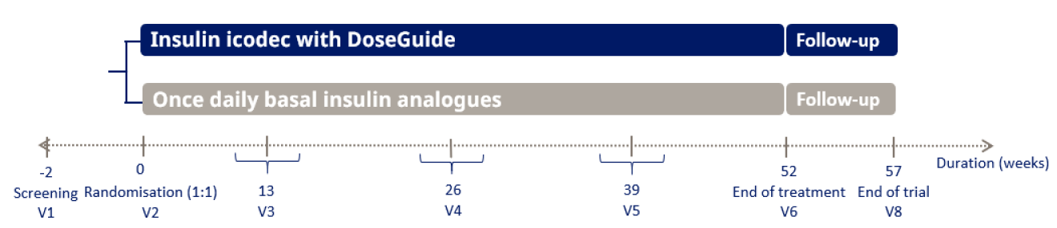
Primary endpoint was the change in HbA1c from baseline to Week 52 (A1C). The study had no confirmatory secondary effectiveness endpoints. Other secondary effectiveness endpoints included the time from baseline to treatment discontinuation or intensification (defined as change to a basal-bolus regimen or continuous use of bolus insulin), the change in DTSQ total treatment satisfaction score (DDTSQ), and the change in Treatment Related Impact Measure for Diabetes (TRIM-D) compliance domain. Secondary safety and exploratory endpoints were hypoglycaemic events.
Demographics and baseline characteristics had no meaningful imbalances between the treatment arms. The mean baseline values for body weight, HbA1c, and duration of diabetes at study start were ~93 kg, ~8.9%, and ~12 years, respectively. The study population had near-normal kidney function at baseline (mean eGFR: ~88 ml/min/1.73 m2).
Most common background medications were metformin (used by >90% of the participants), SGLT2 inhibitors (used by ~45%), and sulphonylurea (used by ~40%). Injectable GLP-1RAs were used by ~27% of the participants.
In total, 542 and 538 subjects were exposed to IIco QW per DoseGuide and IBasal QD, respectively, with a total [mean] duration of exposure to trial product of 559.54 PYE [1.03] in the IIco QW per DoseGuide treatment group and 560.72 PYE [1.04] in the IBasal QD treatment group.
At baseline, the observed mean HbA1c was 8.96% for subjects in the IIco QW per DoseGuide treatment group and 8.88% for subjects in the IBasal QD treatment group. At Week 52, the estimated mean HbA1c was 7.24% for subjects in the IIco QW per DoseGuide treatment group and 7.61% for subjects in the IBasal QD control arm. The ETD [95% CI] for A1C IIco QW per DoseGuide versus IBasal QD was 0.38% [-0.66, -0.09] (NI test: p<0.0001). Hierarchical testing confirmed the superiority of IIco QW per DoseGuide to IBasal QD (p=0.0092).
Table 14: Statistical analysis of primary and confirmatory secondary endpoints (52 weeks)- FAS
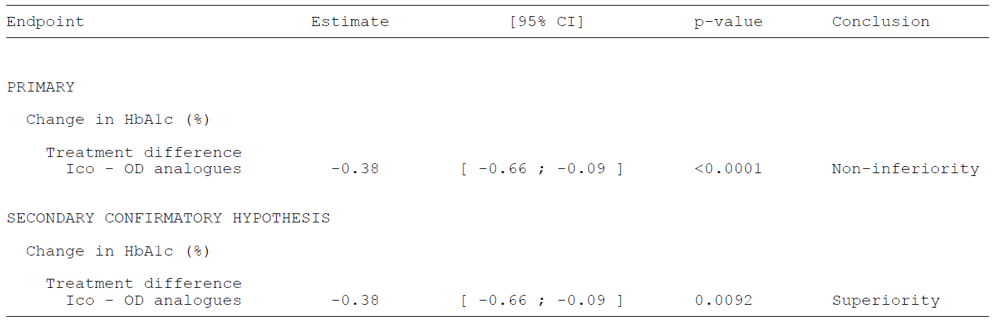
CI: Confidence interval, HbA1c: Haemoglobin A1c, P-value: Two-sided p-value for test of noninferiority/ superiority. A hierarchical testing procedure is used to control the overall type I error on a 5% level two sided. The change from baseline in HbA1c is analysed using an analysis of covariance (ANCOVA) model. Missing values are imputed using multiple imputation.. IIco: IIco used with DoseGuide. OD analogues: Once-daily basal insulin analogues (IDeg, IGlar U100, IGlar U300).
Superior glucose-lowering became apparent only after Week 26. Whereas HbA1c further slowly decline up to Week 56, no such decrease occurred in the IBasal QD arm, Instead, the HbA1c of the patients in IBasal QD arm even slightly deteriorated after Week 26.
Figure 17: HbA1c by treatment week- change from baseline -mean plot - full analysis set
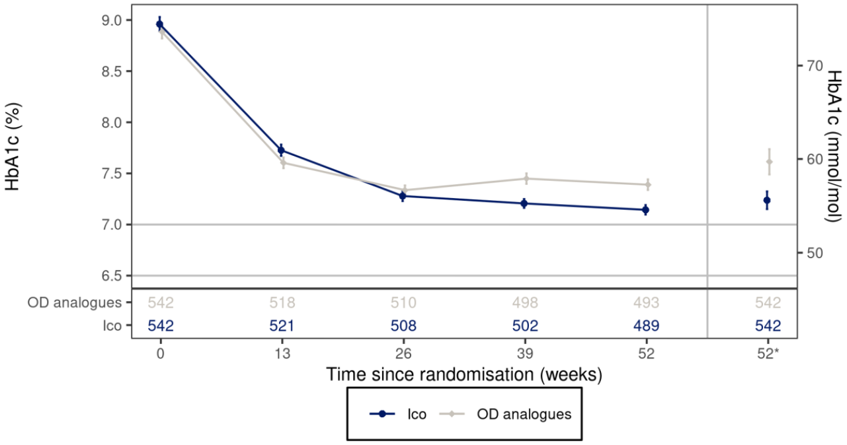
52*: Estimated mean values and the corresponding standard error at week 52 derived based on MI, MI: Multiple imputation, Full analysis set. Observed data including data obtained after premature treatment discontinuation. Number of subjects contributing to the data points appears in the bottom panel. Legend: Mean (symbol) and mean ± standard error to the mean (error bars). HbA1c: Haemoglobin A1c. IIco: IIco used with DoseGuide. OD analogues: Once-daily basal insulin analogues (IDeg, IGlar U100, IGlar U300).
The primary objective was met and the primary analysis showed that the effect on ΔA1C was non-inferior to that of IBasal QD (ETD [95% CI]: -0.38 [-0.66, -0.09]; p<0.0001), and sequential testing also proved the superiority hypothesis (p=0.0092). The robustness of these conclusions for the primary endpoint is supported by adequate sensitivity analyses (tipping point analyses).
Figure 18: HbA1c after 52 weeks-change from baseline -tipping point plot for non-inferiority-FAS
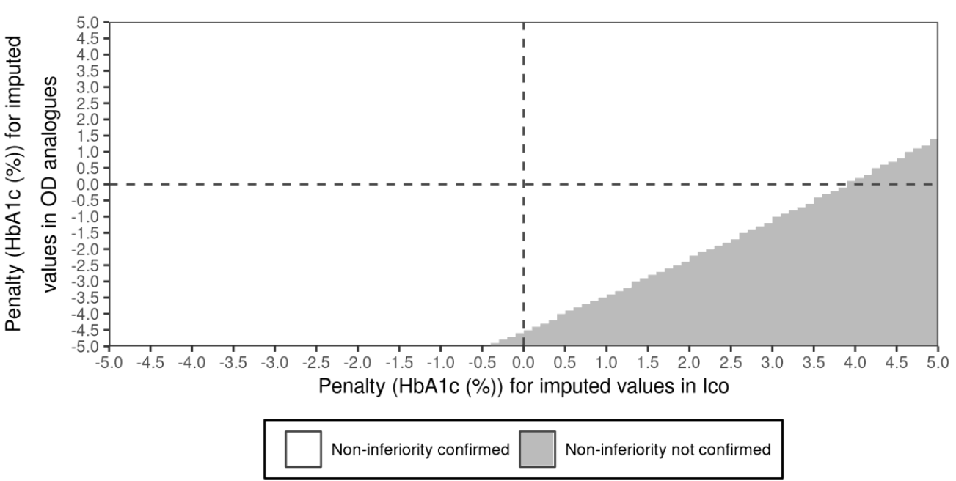
HbA1c: Haemoglobin A1c. Full analysis set. Observed data with missing values imputed using multiple imputation. The response and change from baseline in response after 52 weeks are analysed using an analysis of covariance (ANCOVA) model with treatment and region as fixed factors, and baseline response as covariate. Missing values at week 52 are imputed using multiple imputation based on the change from LAOT value to week 52 for subjects that have discontinued randomised treatment but have a measurement at week 52. The model includes treatment as a fixed factor and the LAOT value and the time point of this assessment as covariates. Each imputed dataset is analysed separately and estimates are combined using Rubin's rules. lay IIco used with DoseGuide. OD analogues: Once-daily basal insulin analogues (IDeg, IGlar U100, IGlar U300).
Figure 19: HbA1c after 52 weeks-change from baseline -tipping point plot for Superiority-FAS
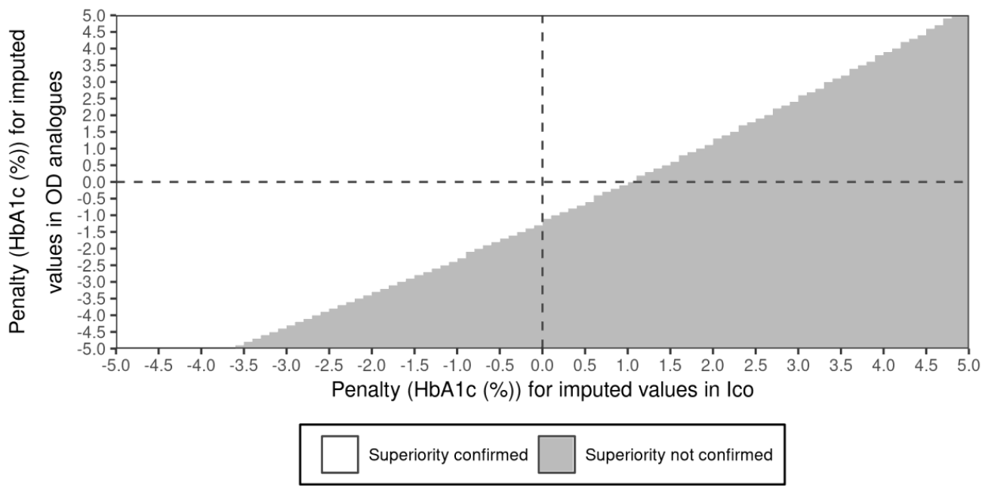
HbA1c: Haemoglobin A1c. Full analysis set. Observed data with missing values imputed using multiple imputation. The response and change from baseline in response after 52 weeks are analysed using an analysis of covariance (ANCOVA) model with treatment and region as fixed factors, and baseline response as covariate. Missing values at week 52 are imputed using multiple imputation based on the change from LAOT value to week 52 for subjects that have discontinued randomised treatment but have a measurement at week 52. The model includes treatment as a fixed factor and the LAOT value and the time point of this assessment as covariates. Each imputed dataset is analysed separately and estimates are combined using Rubin's rules. IIco: IIco used with DoseGuide. OD analogues: Once-daily basal insulin analogues (IDeg, IGlar U100, IGlar U300).
Regarding the non-confirmatory secondary outcomes, the outcome for the risk of treatment discontinuation or intensification from baseline to Week 52 was not favouring the IIco QW per DoseGuide arm, although there was no statistically significant difference between the treatment groups (p=0.337). There appeared to be a geographical regional difference regarding this endpoint.
Figure 20: Time from baseline to treatment discontinuation or intensification by region- full set
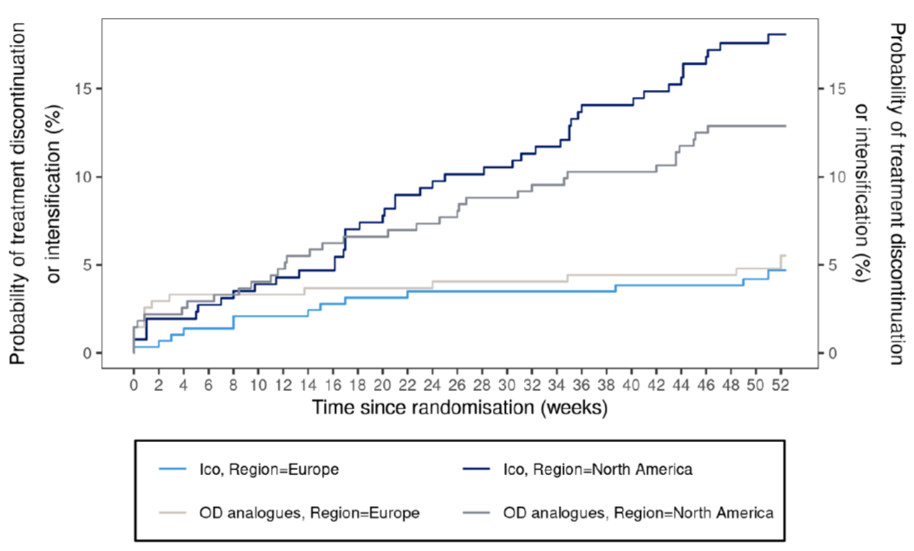
Full analysis set. Observed data. IIco: IIco used with DoseGuide. OD analogues: Once-daily basal insulin analogues (IDeg, IGlar U100, IGlar U300).
Other non-confirmatory secondary endpoints consistently support therapeutic benefits of IIco QW per DoseGuide. For example, the ETD [95% CI] for DDTSQ was 0.78 [0.10, 1.47] (p=0.0247). The clinical meaning of this subtle advantage remains uncertain. In addition, the ETD [95% CI] for the TRIM-D compliance domain was 3.04 [1.28, 4.81] (p=0.0007). Ultimately, the responder rates were all favouring the IIco QW per DoseGuide treatment group: all ETRs were significantly >1.
Table 15: Achievement of HbA1c target after 52 weeks without hypoglycaemia during the prior 12 week-Full analysis set
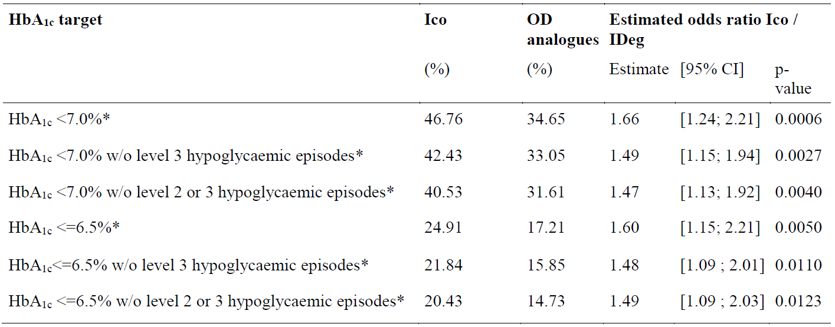
CI: Confidence interval, P-value: Two-sided p-value for test of no treatment difference. No correction for multiplicity. HbA1c: Haemoglobin A1c, w/o: without, Severe hypoglycaemia (level 3): Hypoglycaemia with severe cognitive impairment requiring external assistance for recovery. Clinically significant hypoglycaemia (level 2): Plasma glucose value of < 3.0 mmol/L (54 mg/dL) confirmed by BG meter. BG: Blood glucose. The binary response after 52 weeks is analysed using a binary logistic regression model (logit link) with treatment and region as fixed factors, and the baseline HbA1c value as covariate. Missing HbA1c measurements are imputed using the same method as specified for the primary analysis before the target achievement criterion is applied. Subjects who discontinue treatment prematurely are set to being non-achievers. Subjects who discontinued treatment prematurely have the outcome set to "No". IIco: IIco used with DoseGuide. OD analogues: Once-daily basal insulin analogues (IDeg, IGlar U100, IGlar U300. * indicates a statistically significant result in favour of IIco with DoseGuide.
Overall, the results from the ONWARDS 5 study support the therapeutic benefit of IIco QW per DoseGuide in real world treatment (practice setting) of insulin-naïve patients with T2DM.

ONWARDS 6 Study
The ONWARDS 6 study was a 26-week, randomised, multicentre, open-label, active-controlled, parallel group, two armed, treat-to-target trial investigating the effect on glycaemic control and safety of treatment with once weekly IIco compared to once daily IDeg, both in combination with insulin aspart in adults with type 1 diabetes (at least one year on a multiple daily injection insulin therapy), with a 26-week extension investigating long term safety of main ONWARDS 6.
The primary objective of ONWARD 6 was to confirm the glucose-lowering effect of once weekly IIco (IIco QW) in combination with insulin aspart, in subjects with T1DM. Specifically, this included a comparison of the difference in change from baseline in HbA1c in patients treated with IIco QW and once daily IDeg both in combination with insulin aspart after 26 weeks of treatment to a non-inferiority limit of 0.3%. Primary efficacy endpoint was the change in HbA1c from baseline to Week 26 (ΔA1C). There were no confirmatory secondary endpoints. Other secondary endpoints were the change in fasting plasma glucose (FPG) from baseline to Week 26 (ΔFPG), the time in range 3.9-10.0 mmol/L (70-180 mg/dL) from baseline to Week 22 to Week 26 (TIR), and the change in DTSQs in total treatment satisfaction (DDTSQ). The change in HbA1c from baseline will be analysed for the ongoing part of the trial.
Figure 21: ONWARDS 6 Trial Design
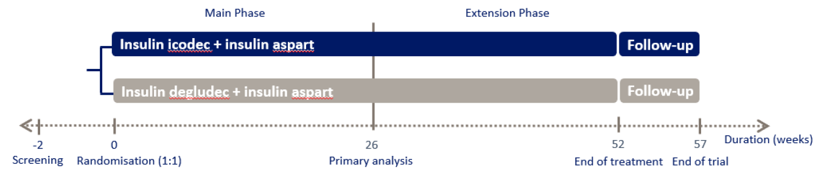
In general, demographics and baseline characteristics were well balanced between treatments. There were some imbalances with regard to the representation of the regions Asia (16.6% vs. 23.3%) and North America (36.6% vs. 29.1%). The mean baseline values for age, body weight, HbA1c, FPG, and eGFR were ~44 years, ~78 kg, ~7.6%, 172.3 – 179.2 mg/dL, and ~98 ml/min/1.73 m2 respectively. The most common basal insulin analogues prior to randomization were IDeg QD (40.3% to 37.7%), IGlar QD U100 (27.9% to 25.7%), and IGlar QD U300 (15.5% to 19.9%).
The primary hypothesis was met: the glucose-lowering efficacy of IIco QW was non-inferior to that of IDeg QD.
Table 16: HbA1c after 26 weeks - change from baseline - primary statistical analysis - in-trial – full analysis set
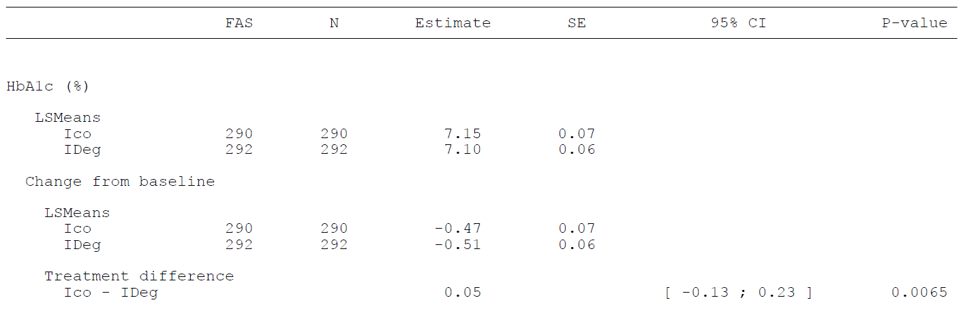
Figure 22: HbA1c by treatment week - change from baseline - in-trial - mean plot - full analysis set
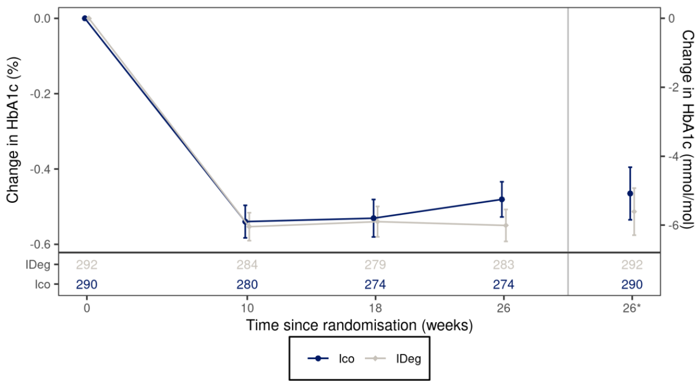
26*: Estimated mean values and the corresponding standard error at week 26 derived based on MI, MI: Multiple imputation, Full analysis set. Observed data including data obtained after premature treatment discontinuation. Number of subjects contributing to the data points appears in the bottom panel. Legend: Mean (symbol) and mean ± standard error to the mean (error bars). HbA1c: the data points appears in the bottom panel. Legend: Mean (symbol) and mean ± standard error to the mean (error bars). HbA1c: Haemoglobin A1c
Although robustness of the non-inferiority conclusion was supported by a sensitivity (tipping point) analysis, it is obvious that the outcome in patients with T1DM was less favourable than that in patients with T2DM. This is further substantiated by the findings for the secondary endpoints FPG (ETD [95% CI]: 18.6 mg/dL [8.6, 28.6]), TIR (ETD [95% CI]: -2.0% [-4.4, 0.4]), and the patient-reported outcome DDTSQ (ETD [95% CI]: -1.1 [-1.9, 0.3]) which all numerically favour active control. Likewise, patients in the IIco QW treatment group spent numerically more time in hyperglycaemia than patients in the IDeg QD arm (ETD [95% CI]: 1.14% [-1.34, 3.61]). Finally, the improvement in DTSQ score in the IIco QW group was significantly worse than in the IDeg QD group (ETD [95% CI]: -1.09 [ 1.85, 0.34]).
Figure 23: Time Course of mean FPG between two arms - full analysis set
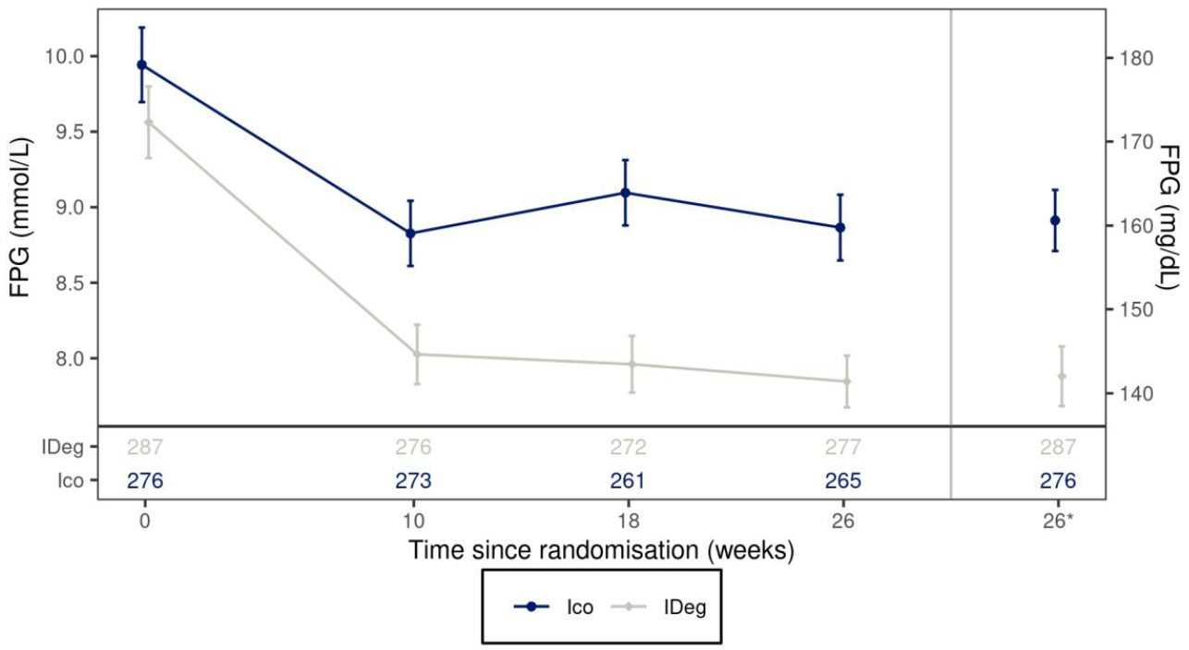
26*: Estimated mean values and the corresponding standard error at week 26 derived based on MI, MI: Multiple imputation, Full analysis set. Observed data including data obtained after premature treatment discontinuation. Number of subjects contributing to the data points appears in the bottom panel. Legend: Mean (symbol) and mean ± standard error to the mean (error bars). FPG: Fasting plasma glucose.
On the other hand, patients in the IIco QW treatment group spent significantly more time in hypoglycaemia than patients in the IDeg QD arm (ETR [95% CI]: 1.46% [1.16, 1.85]; p=0.0012). Consistent with this, the rate of clinically significant (level 2) hypoglycaemia was significantly increased in the IIco QW treatment group (2056.4 vs. 1091.3 [IDeg QD] events per 100 PY corresponding to an ETR [95 CI] of 1.88 [1.53, 2.32]; p<0.0001). The results for severe (level 3) hypoglycaemic events were similarly alarming (33.0 vs. 15.9 [IDeg QD] events per 100 PY corresponding to an ETR [95 CI] of 2.08 [0.39, 10.96]). The fact that the difference was not statistically significant may be merely due to a too small sample size. After all, the proportion of patients reaching a target HbA1c <7% without experiencing any level 2 or 3 hypoglycaemia was significantly in favour of the IDeg QD control (9.55% vs. 16.74% corresponding to an odds ratio [95% CI] of 0.52 [0.33, 0.85]; p=0.008).
The total weekly insulin dose was not different between treatment arms (ETR [95% CI]: 0.96 [0.9, 1.03]) which is reflected in a negligible difference in the change in body weight (ETD [95% CI]: 0.28 kg [-0.37, 0.92]). The distribution between basal and bolus insulin differed between treatments.
Figure 24: Actual weekly total basal insulin dose (U) by treatment week - main-on-treatment – geometric mean plot - safety analysis set
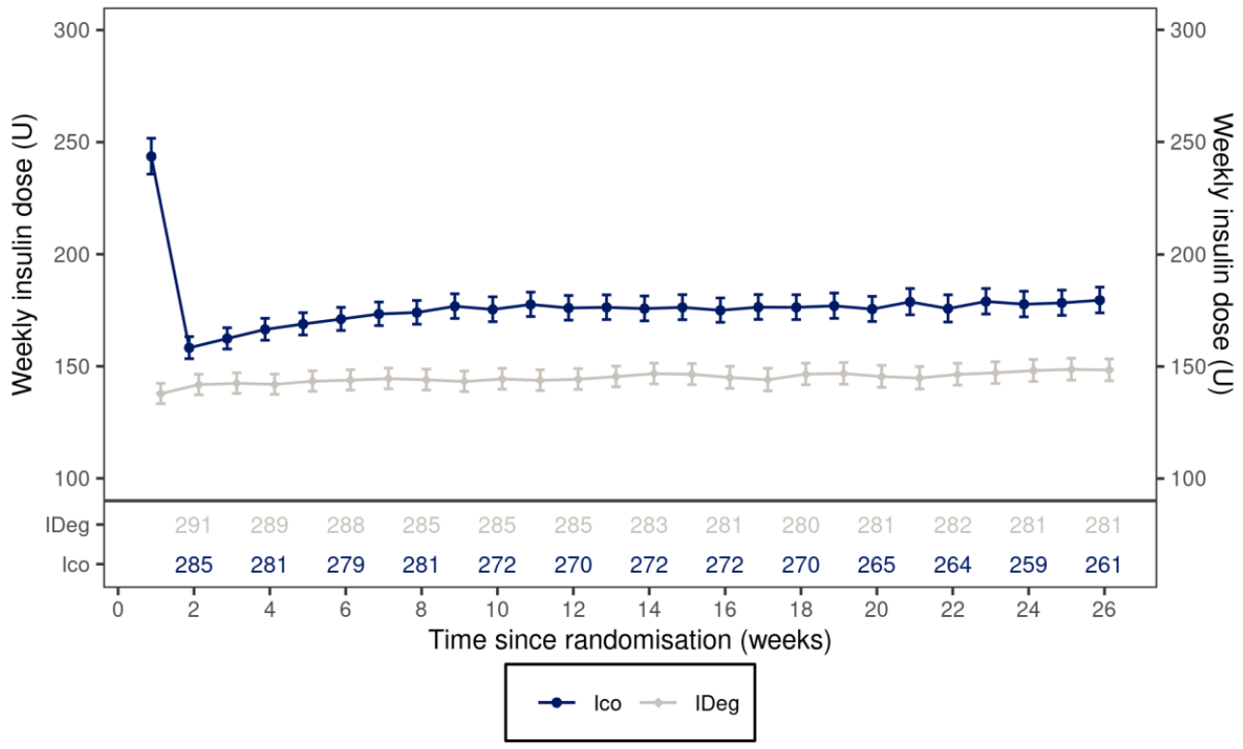
Safety analysis set. Observed data. Number of subjects contributing to the data points appears in the bottom panel. Legend: Geometric mean (symbol) and mean ± standard error to the mean on log-scale back transformed (error bars).
Figure 25: Actual weekly total bolus insulin dose (U) by treatment week - main-on-treatment – geometric mean plot - safety analysis set
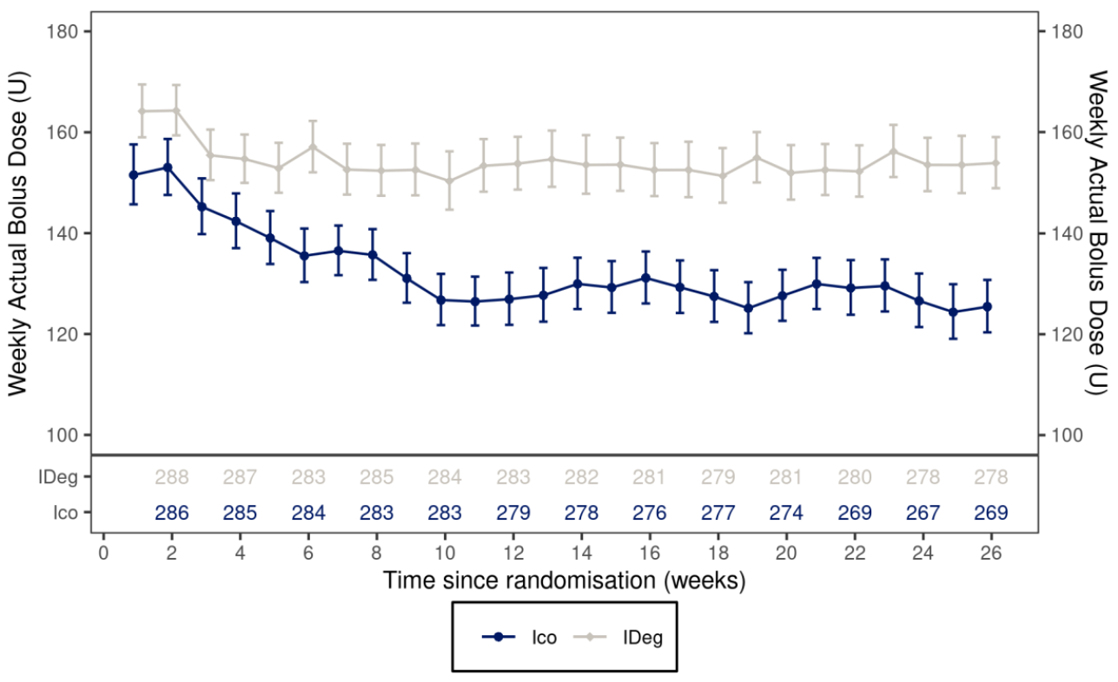
Safety analysis set. Observed data. Number of subjects contributing to the data points appears in the bottom panel. Legend: Geometric mean (symbol) and mean ± standard error to the mean on log-scale back transformed (error bars).
Results from the ONWARDS 6 study support the glucose-lowering efficacy of IIco QW in patients with long-standing T1DM treated with a multiple daily injection (MDI) regimen. However, the benefit-risk ratio for IIco QW in patients with T1DM must be weighed carefully in view of- a) the increase in the risk of hypoglycaemia is clearly more prominent in than in patients with T2DM, and b) the efficacy outcomes consistently favour the active comparator group.

Safety

Exposure
The total exposure to IIco in the on-treatment/main-on-treatment observation period was 1681.23 PYE in the phase 3a pool, 1538.92 PYE in the T2DM pool, and 142.31 PYE in T1DM (ONWARDS 6).
Subject disposition, baseline characteristics and demography were generally well balanced across treatment groups for individual trials and pooled data.
Table 17: Exposure by pool and trial – summary – safety analysis set
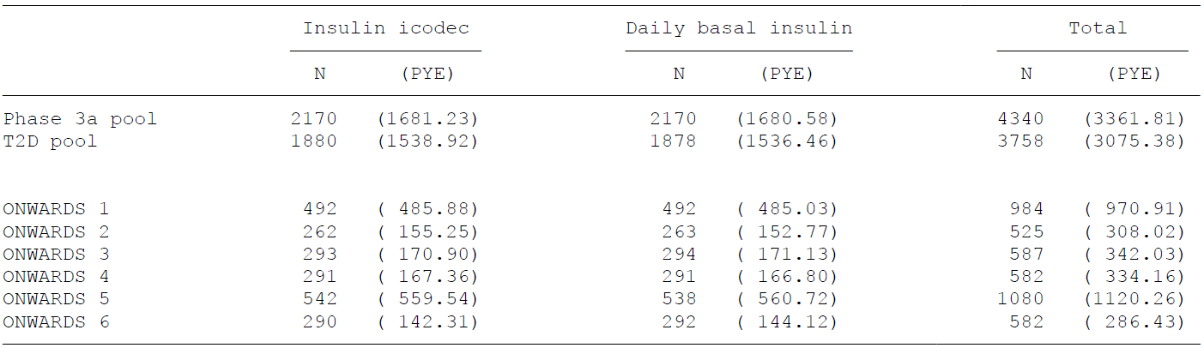
N: Number of subjects, PYE: Patient years of exposure (1 PYE = 365.25 days), T2D: Type 2 diabetes. Daily basal insulin: IDeg (ONWARDS 2, ONWARDS 3, ONWARDS 6), IGlar U100 (ONWARDS 1, ONWARDS 4), and once-daily analogues (IDeg, IGlar U100, IGlar U300) (ONWARDS 5). Phase 3a pool: ONWARDS 1-6, only main part of ONWARDS 1 and 6. T2D pool: ONWARDS 1-5, only main part of ONWARDS 1.
A broad range of subjects recruited across the clinical development programme, including elderly subjects (≥65 years [30.8%]), subjects with cardiac disorders (20.9%) and subjects with chronic kidney disease (4.5%).

Medication errors
25 events (20 in IIco and 5 in daily basal group) of accidental overdose, prescribed overdose, overdose, incorrect dose administered, and extra dose administered) occurred with the administration of the 1st and 2nd dose of IIco QW across all trials. Majority of these errors happened around the period when using or omitting loading dose (50% additional IIco on initiation and omitted from 2nd dose onwards)

Adverse events (AE)
The proportion of subjects reporting AEs was generally comparable between the IIco and daily basal insulin treatment groups, across the individual trials and in the phase 3a pool.
Differences in trial duration, trial population and trial design account for the differences seen between trials. The distribution of the most frequently reported (≥5%) AEs by PT was similar across the 6 phase 3a trials. A similar pattern was observed in the reporting of AEs, SAEs and severe AEs across the 6 trials.
Table 18: Summary of AEs reported in phase 3a trials – safety analysis set
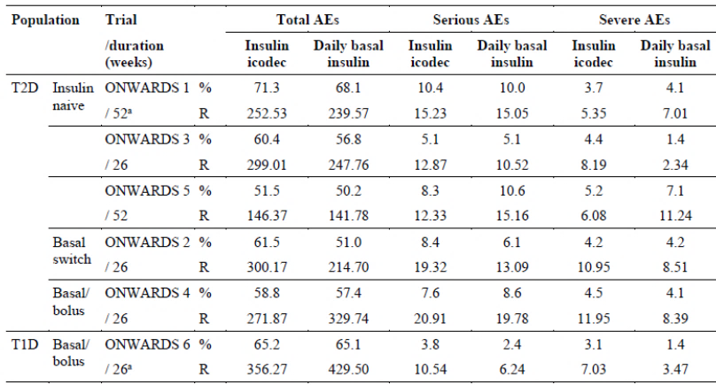
Notes: main part of trial. Abbreviations: AE = adverse event: = percentage of subjects with one or more events: R = rate (number of adverse events per 100 PYE): PYE = patient years of exposure (1 PYE = 365.25 days).
Figure 26: Adverse events – on-treatment/main-on-treatment -safety analysis set – phase 3a pool
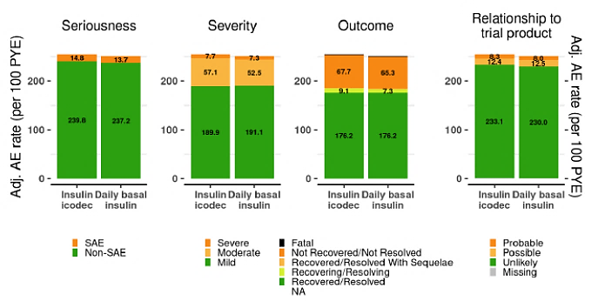
AE rate: Rate (number of adverse events per 100 patient years of exposure). Adj.: Adjusted rates were calculated using the Cochran-Mantel-Haenszel method to account for differences between trials. Safety analysis set. Event rates <5.0 are shown in bar plots but numbers are not displayed. Daily basal insulin: IDeg. IGIar U100. and IGIar U300. Phase 3a pool: ONWARDS 1-6. only main part of ONWARDS 1 and 6.
The ONWARDS 2 showed a slightly higher proportion of subjects reporting AEs in the IIco group compared to daily basal insulin driven by more reported events of the PT nasopharyngitis.
The ONWARDS 6 (T1DM population) showed a higher rate and proportion of subjects reporting SAEs and severe AEs in the IIco group compared to the IDeg group both driven by events of the PT hypoglycaemia.
The distribution of the most frequently reported AEs by PT was similar across the 6 Phase 3 trials.
COVID-19 and nasopharyngitis were the most reported AEs across all ONWARDS trials followed by diarrhoea in the T2DM population (while frequency was lower in the T1DM population).
Figure 27: AEs by preferred term- most frequent (>=5%) Safety analysis pool -phase 3a
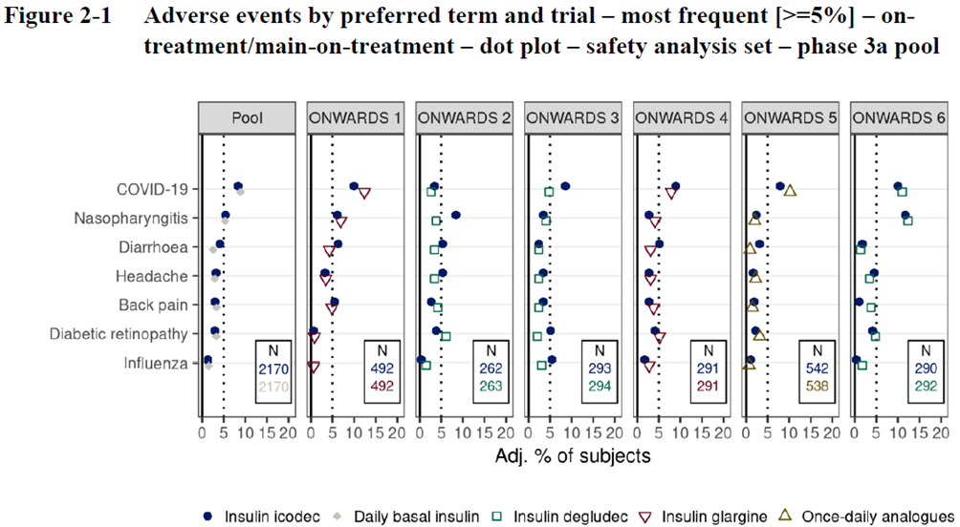
Phase 3 safety Pool
Overall, the data in the Phase 3 pool were similar to (consistent with) the data in the individual trials. Similar proportions of subjects in the IIco and daily basal insulin groups reported AEs, SAEs, and severe AEs. Similar rates of AEs by seriousness, severity, and relationship to trial product were also observed.
Figure 28: AEs-Safety analysis set-phase 3a pool
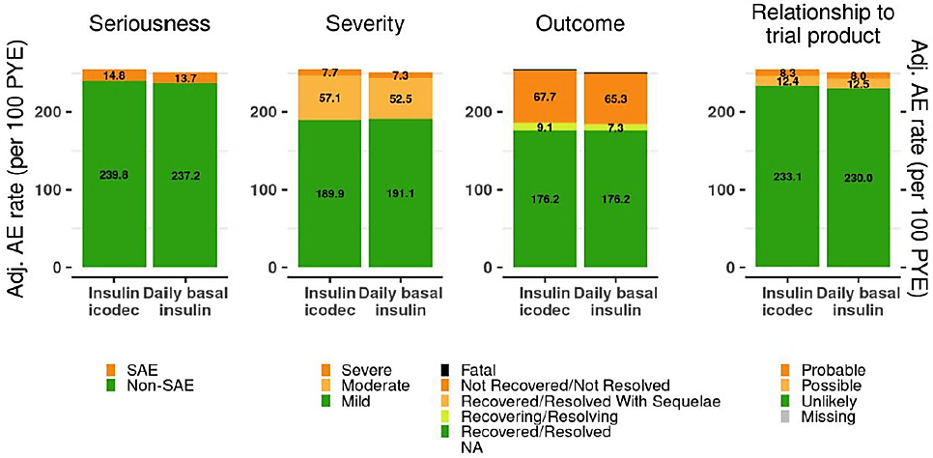
The majority of AEs reported in the IIco group and daily basal insulin group were non-serious, of mild severity, judged unlikely to be related to trial product by the investigator, and resulted in no sequelae (outcome «recovered»).
The proportion of subjects with AEs leading to permanent discontinuation of trial product and the rate of such AEs were also similar in the IIco and daily basal insulin groups.
AEs within each SOC were generally reported by a similar proportion of subjects and with comparable event rates in the IIco and daily basal insulin groups. AEs were reported most frequently within the SOCs infections and infestations, gastrointestinal disorders, musculoskeletal and connective tissue disorders, and general disorders and administration site conditions with both IIco and daily basal insulin.
Figure 29: AEs by SOC on-treatment/main-on-treatment -safety analysis set – phase 3a pool
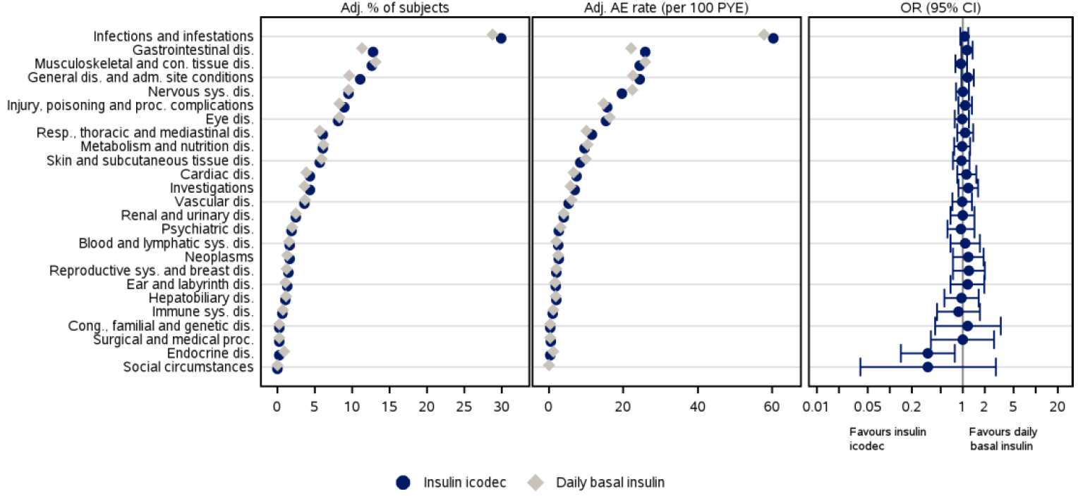
% of subjects: Percentage of subjects with one or more events. AE rate: Rate (number of adverse events per 100 patient years of exposure). CI: Confidence interval. OR: Odds ratio. dis.: disorders, adm.: administration. con.: connective. proc.: procedural/procedures, sys.: system, resp.: respiratory, tong.: congenital. Adj.: Adjusted percentages and rates were calculated using the Cochran-Mantel-Haenszel method to account for differences between trials. The binary endpoint of subjects having at least one event is analysed using a binary logistic regression model (logit link) applying Firth's penalised likelihood approach. The model includes treatment and trial as fixed factors. Safety analysis set. MedDRA version 24.1. Daily basal insulin: IDeg. IGlar U100, and IGlar U300. Phase 3a pool: ONWARDS 1-6, only main part of ONWARDS 1 and 6.
The overall pattern of AEs in the T2DM pool and T1DM population was similar to that in the overall Phase 3 pool, except for a lower proportion of subjects reporting SAEs in the T1DM population. In the T2DM pool, there was a similar pattern of AEs by SOC compared to the Phase 3 pool, whereas in the T1DM population (ONWARDS 6), AEs were reported most frequently within the SOCs of infections and infestations, general disorders and administration site conditions, and injury, poisoning and procedural conditions.

Common AEs reported by ≥5% of subjects

Phase 3a Pool
In the phase 3a pool, the most reported AEs (reported by ≥5% of subjects) were COVID-19 and nasopharyngitis, which were similar subjects from both groups.
Table 19: Adverse events by system organ class and preferred term - most frequent [>=5%] - on-treatment/main- on-treatment - summary - safety analysis set - phase 3a pool
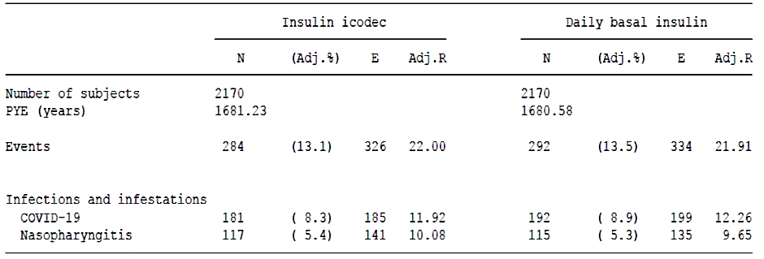
A treatment difference of >0.5% points was selected for the evaluation of AEs reported by ≥1% and <5% of subjects, providing that the rates also were different.
T2DM pool
Table 20: Adverse events by system organ class and preferred term – most frequent [>=5%] – on-treatment/main-on-treatment – summary – safety analysis set – T2DM pool
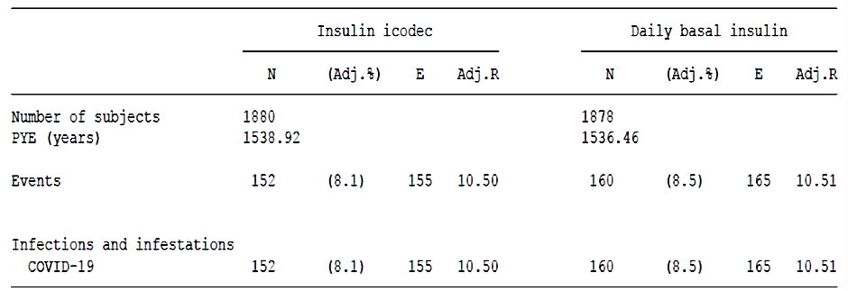
T1DM population (ONWARDS 6)
Table 21: Adverse events by system organ class and preferred term – most frequent [>=5%] – main-on-treatment – summary – safety analysis set – ONWARDS 6
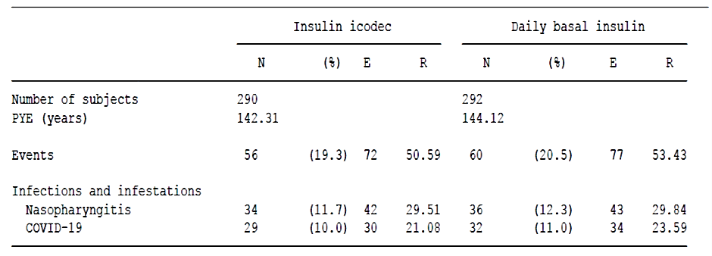

AEs reported by ≥1% and <5% of subjects
Phase 3a pool
Table 22: Adverse events by system organ class and preferred term - most frequent[>=1%] reported in same or greater proportion of subjects on IIco vs on daily basal insulin - on-treatment/main-on- treatment - summary – safety analysis set - phase 3a pool
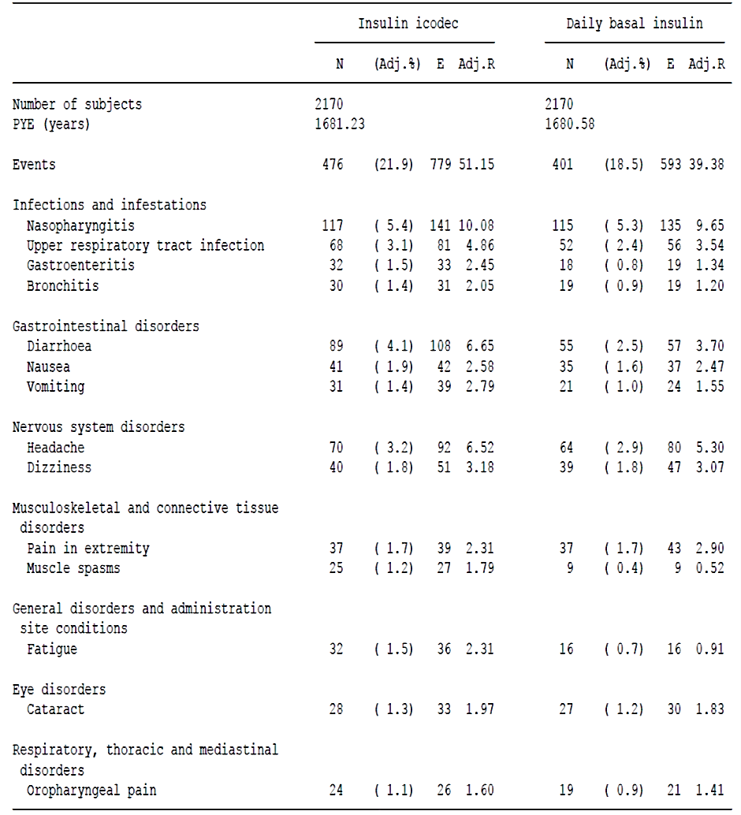
T2DM pool
Table 23: Adverse events by system organ class and preferred term - most frequent [>=1%] reported in same or greater proportion of subjects on IIco vs on daily basal insulin - on-treatment/main-on- treatment - summary – safety analysis set - T2DM pool
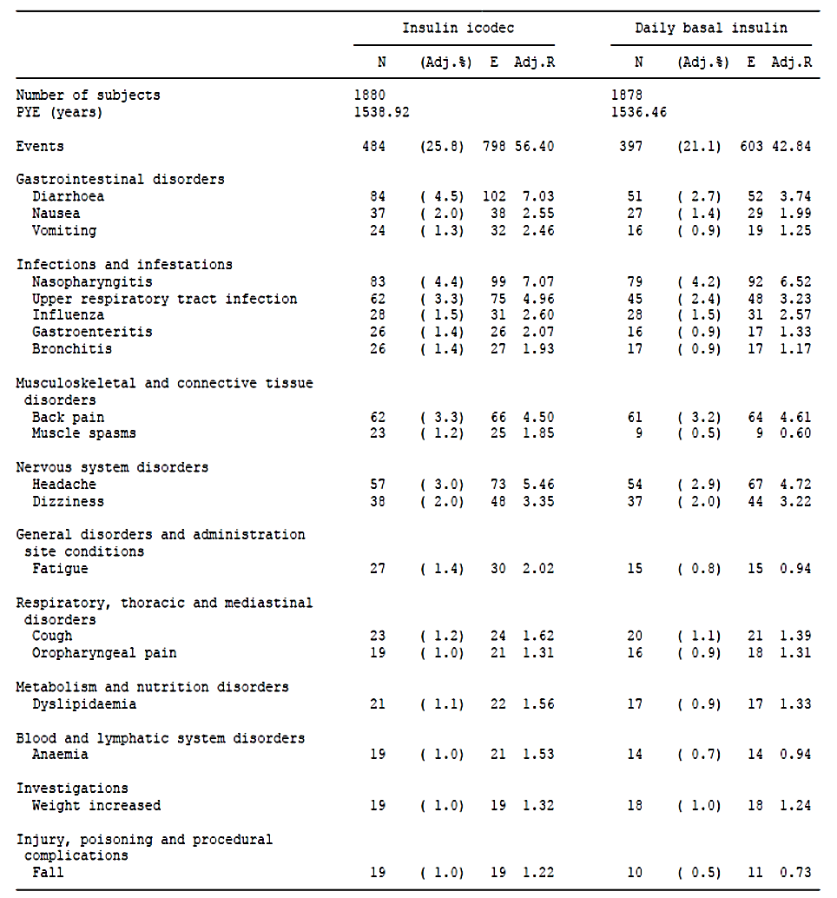
PTs reported by ≥1% and <5% of subjects and by a higher proportion of subjects (>0.5% points) in the IIco group vs daily basal insulin group for the T2DM pool were nausea (2.0% vs 1.4%) and fall (1.0% vs 0.5%)
Table 24: Adverse events by system organ class and preferred term - most frequent [>=1%] reported in same or greater proportion of subjects on IIco vs on daily basal insulin - main-on- treatment - summary - safety analysis set - T1DM population ONWARDS 6
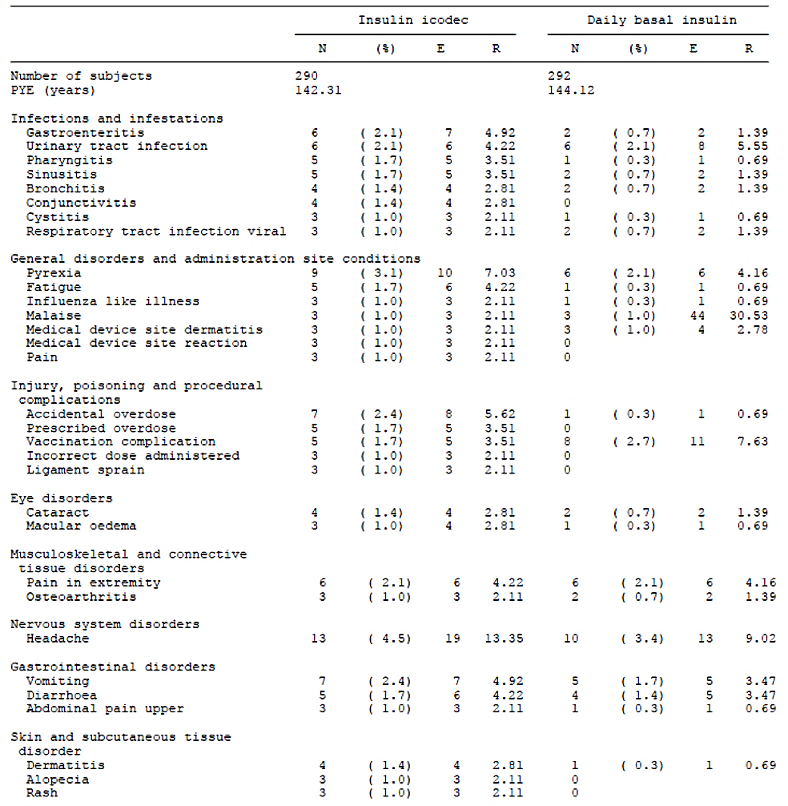

Severe adverse events (SAEs)
In the Phase 3 pool, the proportions of subjects with SAEs and rates of SAEs were low and similar for IIco QW (7.7%; 14.87 events per 100 PYO) and QD basal insulin (7.8%; 13.73 events per 100 PYO).
The same pattern for SAEs was observed across the T2DM trials and in the T2DM pool. In the T1DM population (ONWARDS 6), the proportion of subjects and rates reporting SAEs were higher in the IIco QW group (3.8%; 10.54 events per 100 PYE, respectively) compared to the IDeg group (2.4%; 6.24 events per 100 PYE, respectively), of which only hypoglycaemia was reported more than once in either treatment group.
In the Phase 3 pool, the majority of subjects recovered from SAEs. The proportions of subjects with SAEs reported as not recovered or recovered with sequelae were low and similar in the IIco QW group and QD basal insulin group.
The proportions of subjects reporting severe SAEs were 3.7% in the IIco QW group vs 3.3% in the QD basal insulin group. For the majority of the events, the investigator assessed the relationship to trial product as unlikely.
In the phase 2 trials, in which 383 subjects were exposed to IIco QW and 223 subjects were exposed to IGlar, a total of 29 SAEs were reported: 14 in 8 subjects on IIco QW and 15 in 6 subjects on IGlar. The SAEs were dispersed across different SOCs, except for 5 SAEs that resulted from an accidental fall in one subject in the IIco QW group (SOC: injury, poisoning and procedural complications).
A total of 7 SAEs in 4 subjects were reported in clinical pharmacology trials.
Table 25: SAEs-summary-Safety analysis set- Phase3a pool
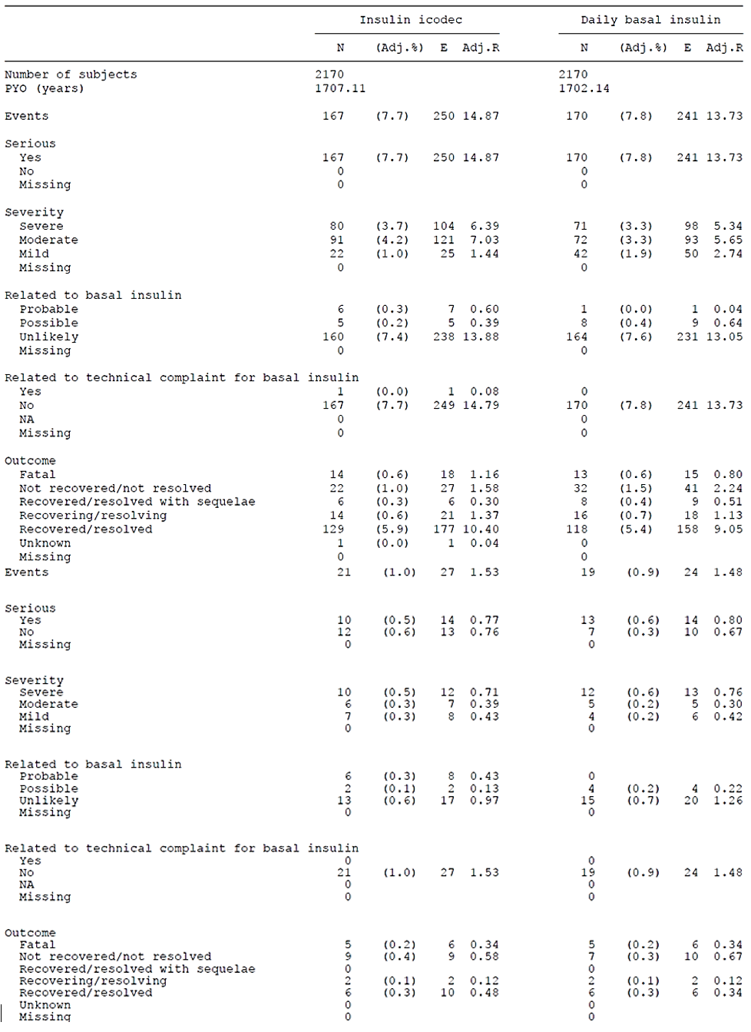

Adverse events of special interest

Hypoglycaemia
Table 26: Classification of hypoglycaemia
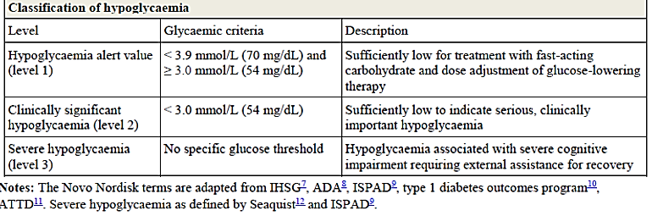
In the phase 3a trials in insulin-experienced subjects, subjects were to be excluded in case of known hypoglycaemic unawareness or recurrent severe hypoglycaemic episodes within the last year before screening.

Hypoglycaemic episodes in the T2DM population (ONWARDS 1-5)

Severe (level 3) hypoglycaemic episodes
The rates were highest (1.4%) in the T2DM population on a previous basal-bolus insulin regimen (ONWARDS 4) and lower in the populations that were either insulin-naïve (ONWARDS 1, 3 and 5) or on a basal insulin regimen (ONWARDS 2).
Table 27: Severe (level 3) hypoglycaemic episodes in the T2DM population – on treatment / main-on-treatment - summary - safety analysis set
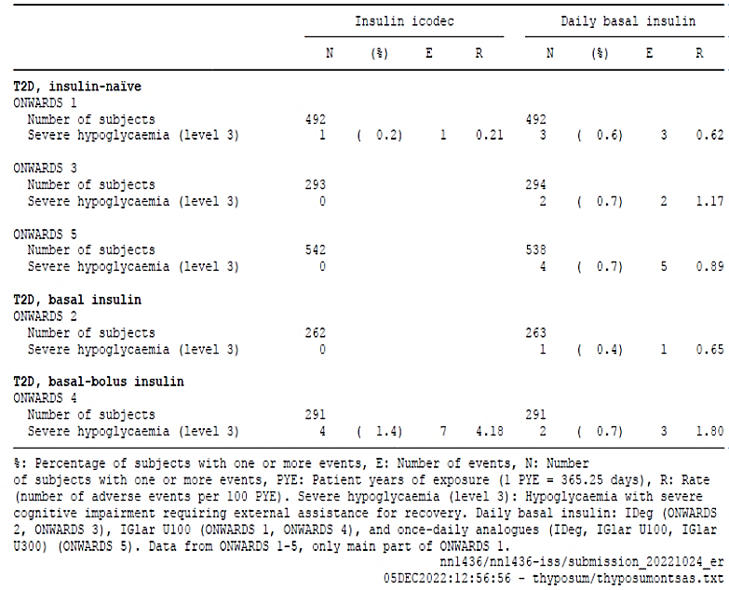
%: Percentage of subjects with one or more events, E: Number of events, N: Number of subjects with one or more events, PYE: Patient years of exposure (1 PYE = 365.25 days), R: Rate (number of adverse events per 100 PYE). Severe hypoglycaemia (level 3): Hypoglycaemia with severe cognitive impairment requiring external assistance for recovery. Daily basal insulin: IDeg (ONWARDS 2, ONWARDS 3), IGlar 0100 (ONWARDS 1, ONWARDS 4), and once-daily analogues (IDeg, IGlar U100, IGlar U300) (ONWARDS 5). Data from ONWARDS 1-5, only main part of ONWARDS 1.

Severe (level 3) or clinically significant (level 2) hypoglycaemic episodes (combined)
Rates for severe (level 3) or clinically significant (level 2) hypoglycaemic episodes were comparable in ONWARDS 1 (insulin-naïve) and ONWARDS 4 (basal bolus) and higher in insulin-naïve ONWARDS 3, 5 (insulin-naïve) and ONWARDS 2 (basal bolus) for the IIco groups.
Table 28: Severe (level 3) or clinically significant (level 2) hypoglycaemic episodes in the T2DM population - on-treatment/main-on-treatment - summary - safety analysis set
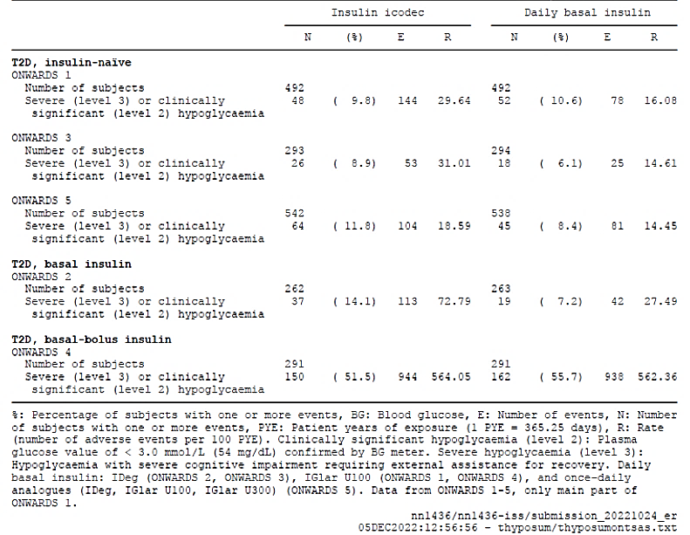
%: Percentage of subjects with one or more events, BG: Blood glucose, E: Number of events, N: Number of subjects with one or more events, PYE: Patient years of exposure (1 PYE = 365.25 days), R: Rate (number of adverse events per 100 ?YE). Clinically significant hypoglycaemia (level 2): Plasma glucose value of < 3.0 mmol/L (54 mg/dL) confirmed by BG meter. Severe hypoglycaemia (level 3): Hypoglycaemia with severe cognitive impairment requiring external assistance for recovery. Daily basal insulin: IDeg (ONWARDS 2, ONWARDS 3), IGlar U100 (ONWARDS 1, ONWARDS 4), and once-daily analogues (IDeg, IGlar U100, IGlar U300) (ONWARDS 5). Data from ONWARDS 1-5, only main part of ONWARDS 1.

Time below glycaemic range
In T2DM, the time spent below 3.0 mmol/L (54 mg/dL) during the last four weeks of the evaluated treatment period was 0.21-0.73% and time below 3.9 mmol/L (70 mg/dL) was 1.20-2.65% across treatment groups for all three T2DM trials (ONWARDS 1, 2 and 4). For time spent below 3.0 mmol/L , there was no statistically significant difference between IIco and daily basal insulin.

Hypoglycaemic episodes in the T1DM population (ONWARDS 6)

Severe (level 3) hypoglycaemic episodes
Number and proportion of subjects reporting severe (level 3) hypoglycaemic episodes were the same in both groups (9 subjects). However, the rate of severe episodes was higher in the IIco group than in the IDeg group (33.03 vs 11.80 episodes per 100 PYE). the increase in hypoglycaemia events is maximal shortly (within 1-3 days) after its injection, which mirrored differences in the PK/PD profile of Insulin codec and daily basal insulins. Of note, patients with a history of hypoglycaemia unawareness or recurrent severe hypoglycaemia were excluded from the ONWARDS trials.
Table 29: Severe (level 3) hypoglycaemic episodes in the T1DM population - main-on treatment - summary - safety analysis set
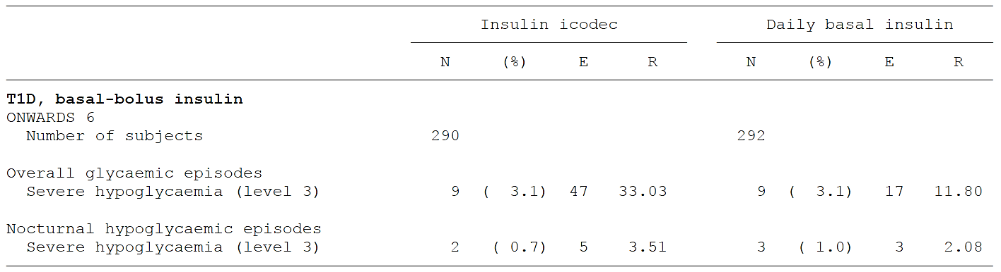
%: Percentage of subjects with one or more events, E: Number of events, N: Number of subjects with one or more events, PYE: Patient years of exposure (1 PYE = 365.25 days), R: Rate (number of adverse events per 100 PYE). Severe hypoglycaemia (level 3): Hypoglycaemia with severe cognitive impairment requiring external assistance for recovery. Daily basal insulin: IDeg (ONWARDS 6). Data from main part of ONWARDS 6. Nocturnal: The period between 00:01 and 05:59 (both included).

Severe (level 3) or clinically significant (level 2) hypoglycaemic episodes
The proportion of subjects with severe (level 3) or clinically significant (level 2) hypoglycaemic episodes was higher in the IIco group than in the IDeg group (85.2% vs 76.4%), and the rate of these episodes was statistically significantly higher in the IIco. group compared to the IDeg group (1992.86 vs 1037.33 episodes per 100 PYE, treatment rate ratio: 1.89 [1.54;2.33]95%CI, p-value: <0.0001).
The proportion of subjects in the IIco group and IDeg group with ≥20 severe (level 3) or clinically significant (level 2) hypoglycaemic episodes was 43(14.8%) and 17 (5.8%) respectively.
Table 30: Severe (level 3) or clinically significant (level 2) hypoglycaemic episodes in the T1DM population - main-on-treatment - summary - safety analysis set
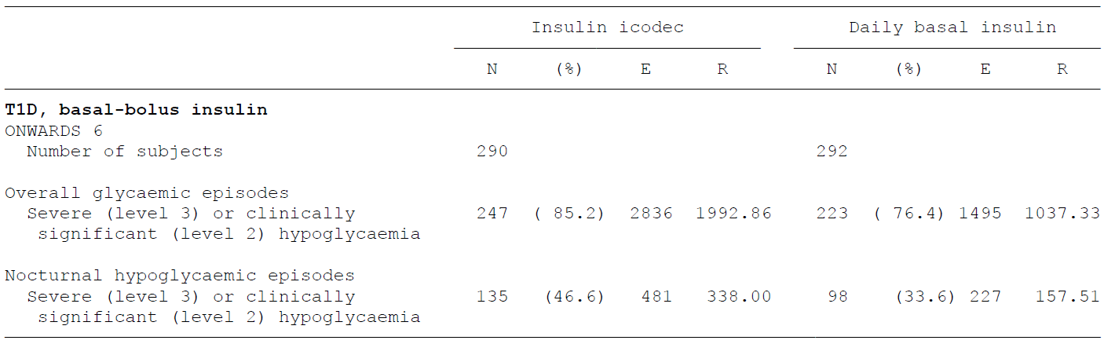
%: Percentage of subjects with one or more events, BG: Blood glucose, E: Number of events, N: Number of subjects with one or more events, PYE: Patient years of exposure (1 PYE = 365.25 days), R: Rate (number of adverse events per 100 PYE). Clinically significant hypoglycaemia (level 2): Plasma glucose value of < 3.0 mmol/L (54 mg/dL) confirmed by BG meter. Severe hypoglycaemia (level 3): Hypoglycaemia with severe cognitive impairment requiring external assistance for recovery. Daily basal insulin: IDeg (ONWARDS 6). Data from main part of ONWARDS 6. Nocturnal: The period between 00:01 and 05:59 (both included).

Time below glycaemic range
The time spent below 3.0 mmol/L (54 mg/dL) during the last four weeks of evaluated treatment period was 1.02% for the IIco group and 0.68% in the IDeg group, which was statistically significant difference in favour of IDeg (p-value: 0.0014). and the time below 3.9 mmol/L (70mg/dL) was 3.86% in the IIco group.

Hypoglycaemia leading to discontinuation
Across the 6 ONWARDS trials with approximately 4300 subjects, a total of 5 subjects including 4 in the IIco and 1 in the IGlar group, discontinued the trials due to hypoglycaemia.

Neoplasms – MedDRA search for Phase 3 pool
The number [rate] of neoplasm AEs was 74 in 62 subjects [4.44 events per 100 PYO] and 86 events in 66 subjects [5.18 events per 100 PYO] in the IIco QW group and the QD basal insulin group. The corresponding proportions were 2.9% and 3.0%. All neoplasms AEs were judged by investigator as unlikely related to trial product.
Presented safety data did not show any obvious imbalance between treatment groups suggesting an increased risk for neoplasms in patients treated with IIco QW. Moreover, the database available is too small to make any final conclusions.

Retinal disorders - MedDRA search in the Phase3 pool
The rate of AEs within the MedDRA search for diabetic retinopathy or maculopathy was similar in the two treatment groups (9.85 [IIco QW] versus 10.22 [QD basal insulin] events per 100 PYO).

Hyperglycaemia including diabetic ketoacidosis (DKA)

Hyperglycaemia including diabetic ketoacidosis - MedDRA search
In the phase 3a pool, the rate of AEs of hyperglycaemia or diabetic ketoacidosis was 0.66 events per 100 PYE in the IIco group and 1.38 events per 100 PYE in the daily basal insulin group.
No serious events of hyperglycaemia or diabetic ketoacidosis events were reported in the IIco group, while 3 serious events were reported in the daily basal insulin group.

Time above glycaemic range ( >10.0 mmol/L or 180 mg/dL)
In ONWARDS 1, the time spent above 10.0 mmol/L (180 mg/dL) from week 48 to week 52 was 26.86% in the IIco group and 32.27% in the IGlar group, and the treatment difference was statistically significantly in favour of IIco. There was no statistically significant difference for time spent above 10.0 mmol/L (180 mg/dL) during the last four weeks of the evaluated treatment period in ONWARDS 2, 4 and in the T1D population (ONWARDS 6).
Overall, the data does not indicate any increased risk of hyperglycaemia or DKA in patients treated with IIco QW.

Anti-IIco antibodies – ONWARDS 2-4 and 6
Across trials, between 59.6% and 79.2% (in insulin-naïve patients) of the subjects were positive for anti-insulin IIco antibodies (ADA) at any time on-trial which exceeded to some extent the corresponding numbers reported recently for IGlar preparations [26]. The assay’s specificity in detecting ADA is a matter a major uncertainty when interpreting the data. In fact, cross-reactivity with human insulin was common among patients positive for anti-insulin IIco antibodies (According to Module 2.7.4: 66.7% to 77.4%).
There were no events of ADA formation leading to change in clinical efficacy across the Phase 3 trials. The safety correlation analysis suggested that the ADA titer had no impact on the rate of severe (level 3) or clinically significant (levels 2) hypoglycaemia across Phase 3 trials.

Body Weight
In ONWARDS 2, the estimated change in body weight from baseline to end of evaluated treatment period, was statistically significantly different in favour of daily basal insulin with an estimated treatment difference of 1.70 kg more in the IIco group (ETD: 1.70 kg [0.76; 2.63]95% CI).
In the other ONWARD trials, weight gain was higher in the Insulin IIcodec group as compared to daily basal insulin group, but not statistically significant.
Table 31: Body weight at end of treatment by trial – change from baseline – in-trial – supportive statistical analysis – full analysis set
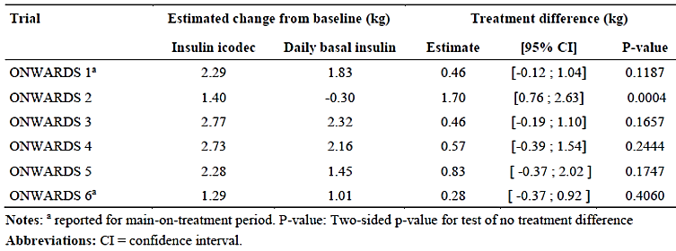
Notes: a reported for main-on-treatment period; P-value: two-sided p-value for test of no treatment difference. Abbreviations: CI=confidence interval

Risk management plan evaluation summary
Novo Nordisk Pharmaceuticals Pty Ltd has submitted Global-RMP version 0.1 (dated 15 March 2023; DLP 19 September 2022) and ASA version 0.1 (dated 31 March 2023) in support of this application. In its Section 31 response, the sponsor has submitted an updated ASA only (version 0.2; dated 26 October 2023) in support of its application.
The proposed summary of safety concerns and their associated risk monitoring and mitigation strategies are summarised below:
Table 32: Summary of safety concerns
Summary of safety concerns |  | Pharmacovigilance |  | Risk minimisation
 |  | Routine | Additional | Routine | Additional
Important  identified  risks | Hypoglycaemia | * | – |  | –
Important  identified  risks | Hypersensitivity | * | – |  | –
Important  potential  risks | Immunological events − formation of neutralising insulin antibodies |  | – |  | –
Important  potential  risks | Medication errors due to potential mix-up | * | – |  | –
Important  potential  risks | Medication errors during switch from daily basal insulin | * | – |  | –
Missing  information | Pregnancy and lactation | * | – |  | –
Missing  information | Elderly patients ≥75 years of age |  | – |  | –
*Follow-up questionnaires
The safety concerns in the ASA align with the Global RMP. Hypoglycaemia is the most common and critical adverse reaction identified and has been included as an Important Identified Risk. The safety concerns are satisfactory.
Routine pharmacovigilance activities only have been proposed. This includes follow-up questionnaires for all the Important Identified Risks and for the Important Potential Risks regarding Medication Error. There is also an existing follow up questionnaire for gathering information regarding pregnancy (used for all Novo Nordisk products). This is acceptable.
Routine risk minimisation activities only have been proposed. This is acceptable as the proposed safety concerns do not require any additional risk minimisation activities.

Risk-benefit analysis

Clinical Efficacy and comments
Clinical development plan to assess IIco efficacy included six phase 3a trials (ONWARDS 1-6). The phase 3a trials were designed to prospectively test for HbA1c non-inferiority against active comparators. Furthermore, ONWARDS 1, 2, 3 and 5 were designed to prospectively test for superiority if non-inferiority was confirmed. ONWARDS 1, further included a superiority test on percentage of time in range (TIR). ONWARDS 1-5 included Type2DM and ONWARD 6 enrolled Type1DM subjects. Onwards 1,3 and 5 had insulin naïve subjects, ONWARDS 2,4 and 6 had insulin experiences subjects. ONWARDS 5 had “real world” elements to the trial.
Once-weekly IIco (IIco QW) showed robust glucose-lowering efficacy in different diabetes populations and clinical settings examined in the ONWARDS trial 1-6 (see tabular summary of the results for the primary endpoint - change in HbA1c).
Table 33: Summary of the results for the primary efficacy endpoint - change in HbA1c (ONWARDS 1-6)
Study | Population / Comment | ETD_{IIco QW - QD basal insulin} [95% CI] for DA1C | Superiority (S)  Non-inferiority (NI)
ONWARDS 1 | T2DM insulin-naïve | -0.19% [-0.36, -0.03] | S
ONWARDS 2 | T2DM treated with a basal insulin ±  combination of non-insulin anti-hyperglycaemics | -0.22% [-0.37, -0.08] | S
ONWARDS 3 | T2DM insulin-naïve | -0.21% [-0.34, -0.08] | S
ONWARDS 4 | T2DM treated with basal insulin + bolus insulin ±  combination of oral or injectable anti-hyperglycaemic agents | -0.02% [-0.11, 0.15] | NI
ONWARDS 5 | T2DM insulin-naïve / clinical practice setting | -0.38 [-0.66, -0.09] | S
ONWARDS 6 | T1DM ≥1 year of basal-bolus therapy | 0.05% [-0.13, 0.23] | NI

Findings for secondary efficacy endpoints including the change in FPG and the time in range further corroborated the glucose-lowering efficacy of IIco QW.
Efficacy data from ONWARDS trials support IIco QW to cover the demand in basal insulin using one weekly injection. Efficacy outcomes with IIco QW were similar or better to QD basal insulin in patients with T2DM. Efficacy outcomes with QW IIco were less favourable in patients with T1DM, though non-inferiority for the change in HbA1c was met in this population as well.
the proportion of patients who achieved target glucose levels of HbA1c <7% or ≤6.5% without level 2 or 3 hypoglycaemia was larger in the IIco arm than in comparator arm (once-daily basal insulin).
Glucose-lowering efficacy of IIco is further reflected in the time spent within the target range (TIR). ONWARDS 1 investigating TIR during weeks 48 to 52 as a confirmatory secondary endpoint showed a clinically meaningful difference in TIR favouring IIco and an average TIR in the IIco arm of >70%. In ONWARDS 2 and 4, TIR was comparable between IIco and daily basal insulin.
Based on the results for the DTSQs from ONWARDS 2 and 5, subjects in the IIco arm were more satisfied with their treatment than patients in the daily basal insulin arm. Patients in both treatment arms showed a positive change in total DTSQs score from baseline, but the fraction of patients reporting a clinically meaningful DTSQs improvement was higher in the IIco treatment arm than in the daily basal insulin arm. In addition, measurements of compliance (TRIM-D questionnaire) for each treatment arm in ONWARDS 5 indicated that treatment compliance at the end was higher with IIco than with daily basal insulin.

Clinical safety
The proportions of subjects reporting AEs and SAEs were comparable between treatment groups in the ONWARDS trials involving subjects with T2DM. A lower proportion of subjects reported SAEs in the T1DM population compared to the T2DM pool. The rate was higher though, mostly driven by reported events of the PT hypoglycaemia for both SAEs and severe AEs.
The results from the ONWARDs program clearly suggested an increased risk of hypoglycaemia in patients with both T2DM and T1DM, more prominently in T1DM.
Findings for the time spent <3 mmol/L further substantiated the increased risk for hypoglycaemia. Estimated treatment ratios [95% CI] were 1.27 [0.94, 1.71] (ONWARDS 1), 1.37 [0.92, 2.04] (ONWARDS 2), 1.20 [0.91, 1.58] (ONWARDS 4), and 1.46 [1.16, 1.85] (ONWARDS 6). Furthermore, the risk of hypoglycaemia showed an apparent peak between days 2 and 4 after administration of IIco QW mirroring the PK/PD profile with larger C_{max} and the GIR during the initial days of the weekly dosing interval (as compared with a once-daily administration).

Association of hypoglycaemia with Loading dose and Medication errors
The 3-arm Phase 2 study 4466 compared glycaemic outcomes for IIco + 100% loading dose, IIco without loading dose, and IGlar in subjects with T2DM who were already on basal insulin. A “glycaemic slip” observed in the absence of a loading dose could be mitigated by the 100% loading dose. Taking into further account the data for TBR from study 4466, a 50% loading dose was chosen to be further investigated in ONWARDS 2,4 and 6. Both trials substantiated that the 50% loading dose can efficiently prevent a “glycaemic slip” in patients with T2DM switching to IIco.
Based on above, ONWARDS 2, 4, and 6 used an additional loading dose for the switch from prior basal insulin to IIco QW. On the single occasion of treatment initiation, patients in the IIco QW arm received routinely a dose of IIco QW matching the total daily dose of their prior basal insulin x 7 + 50% (100% loading dose in ONWARDS6 if HbA1c>8). Additional loading dose was associated with more hypoglycaemia episodes However, submitted modelling reports supported that the time to steady state can be reduced by one week when administering a 50% one-time additional dose.
With regards to the injection site reactions, higher rates were observed in the IIcoQW group. Phase 3 pooled data showed rate of 6.04 (IIco QW) versus 3.97 (QD basal insulin). None of injection site reactions in IIco QW-treated patients was serious, and there was no rise in the rate of unresolved cases without recovery (0.09 events per 100 PYE in both groups). Data provided does not support a causal link between immunogenicity and injection site reaction.

Oedema
Peripheral oedema is commonly considered a class effect with insulin products. The submitted data suggests higher incidences (1.1% versus 0.6%) and events rates (1.57 versus 0.87 per 100 PYE) of peripheral oedema in the patients treated with IIco QW as compared to the patients on QD basal insulin.

Data limitations
ONWARDS trials had several limitations, including the open-label design (RCT is not feasible though), the characteristics of included participants, and the use of self-measured blood glucose measurements rather than continuous glucose monitoring for insulin dose adjustments. The exclusion of those with comorbidities or hypoglycaemia unawareness in ONWARDS 6, limits the generalisability of these findings to the wider type 1 diabetes population.
There is no data on pregnancy and lactation.
There was no evaluable data in elderly subjects (>75 years)

Advisory Committee considerations
The Advisory Committee on Medicines (ACM), having considered the evaluations and the delegate’s overview, as well as the sponsor’s response to these documents, advised the following.
Does the ACM agree with proposed indication for use of insulin-icodec in diabetes mellitus?
The ACM agreed that there was sufficient safety and efficacy data to support use of IIco in diabetes mellitus for an amended indication separating out treatment of T2DM and T1DM:
Treatment of Type 2 Diabetes in adults.
Treatment of Type 1 Diabetes in adults, in conjunction with a bolus insulin, where daily basal insulin injections are not suitable.’
In T2DM, across the five trial populations, the evidence suggests minimally superior glycaemic control at the expense of modest increase in hypoglycaemia, including severe hypoglycaemia. The hypoglycaemia risk is increased at day 2-3, consistent with the insulin effect curve.
In T1DM, compared with insulin degludec, treatment with IIco lead to numerically higher HbA1c, inferior fasting plasma glucose, and increase in hypoglycaemia. In well-selected patients the advantage of weekly basal insulin may be beneficial.
Does ACM agree with the overall safety profile of insulin-icodec. Especially in view of the increased hypoglycaemic episodes with insulin-icodec once weekly.
When IIco is used in addition to short acting insulin to treat T1DM (ONWARDS 6 trial), severe hypoglycaemia increased: 33.03 episodes per 100 patient years exposure with insulin-icodec once weekly compared to 11.80 episodes per 100 patient years exposure with insulin degludec.
Given the increased risk of hypoglycaemia in patients with T1DM, the ACM advised that IIco should be prescribed with caution and only where the expected benefit outweighs the potential risks.
The ACM advised that the general safety signals are slightly inferior in comparison to daily basal insulin due to the once a week dosing schedule without stable systemic availability over 7 days.
The committee is also requested to provide advice on Product information or any other issues that it thinks may be relevant to this application?
Individuals with hypoglycaemia unawareness were excluded from the trial populations, other than ONWARDS 5 (which focused on dose titration). The ACM raised concerns with this exclusion criteria as these patients would otherwise may be appropriate candidates for IIco therapy.
The ACM endorsed the changes to the Product Information (PI) suggested by the delegate. The ACM raised additional concerns with the dose titration section of the PI, suggesting that the titration algorithm used in the ONWARDS trials be provided in the clinical trial section with cross-reference in the dose titration section.
The ACM additionally advised the inclusion in the dosing section of the PI that clinical steady state is, achieved in 2 to 4 weeks (3 to 4 doses) after a dose change, and that dose intensification should be undertaken with caution during this period.

Advisory committee conclusion
The ACM considered this product to have an overall positive benefit-risk profile for the indication:
Treatment of Type 2 Diabetes in adults.
Treatment of Type 1 Diabetes in adults, in conjunction with a bolus insulin, where daily basal insulin injections are not suitable.

Assessment outcome
Based on a review of quality, safety, and efficacy, the TGA decided to register AWIQLI (IIco) for the following indication:
Treatment of Type 2 Diabetes in adults.
Treatment of Type 1 Diabetes in adults, in conjunction with a bolus insulin, where daily basal insulin injections are not suitable.

Specific conditions of registration
AWIQLI (IIco) is to be included in the Black Triangle Scheme. The PI and CMI for AWIQLI must include the black triangle symbol and mandatory accompanying text for five years, which starts from the date of first supply of the product.
The AWIQLI Global RMP (version 0.1, dated 15 March 2023, data lock point 19 September 2022), with Australian Specific Annex (version 0.2, dated 26 October 2023), included with submission PM-2023-01464-1-5, and any subsequent revisions, as agreed with the TGA will be implemented in Australia.
An obligatory component of risk management plans is routine pharmacovigilance. Routine pharmacovigilance includes the submission of periodic safety update reports (PSURs).
Unless agreed separately between the supplier who is the recipient of the approval and the TGA, the first report must be submitted to TGA no later than 15 calendar months after the date of this approval letter. The subsequent reports must be submitted no less frequently than annually from the date of the first submitted report until the period covered by such reports is not less than three years from the date of this approval letter. The annual submission may be made up of two PSURs each covering six months. If the sponsor wishes, the six monthly reports may be submitted separately as they become available.
If the product is approved in the EU during the three years period, reports can be provided in line with the published list of EU reference dates no less frequently than annually from the date of the first submitted report until the period covered by such reports is not less than three years from the date of this approval letter.
The reports are to at least meet the requirements for PSURs as described in the European Medicines Agency’s Guideline on good pharmacovigilance practices (GVP) Module VII-periodic safety update report (Rev 1), Part VII.B Structures and processes. Note that submission of a PSUR does not constitute an application to vary the registration. Each report must have been prepared within ninety calendar days of the data lock point for that report.
All batches of AWIQLI IIco supplied in Australia must comply with the product details and specifications approved during evaluation and detailed in the Certified Product Details (CPD).
When requested by the TGA, the sponsor should be prepared to provide product samples, specified reference materials and documentary evidence to enable the TGA to conduct laboratory testing on the Product. Outcomes of laboratory testing are published biannually in the TGA Database of Laboratory Testing Results http://www.tga.gov.au/ws-labs-index and periodically in testing reports on the TGA website.
The Certified Product Details (CPD), as described in Guidance 7: Certified Product Details of the Australian Regulatory Guidelines for Prescription Medicines (ARGPM), in PDF format, for the above products should be provided upon registration of these therapeutic goods. In addition, an updated CPD should be provided when changes to finished product specifications and test methods are approved in a Category 3 application or notified through a self-assessable change.
A template for preparation of CPD for biological prescription medicines can be obtained from the TGA website:
[for the form] https://www.tga.gov.au/form/certified-product-details-cpd-biological-prescription-medicines
[for the CPD guidance] https://www.tga.gov.au/guidance-7-certified-product-details

Product Information and Consumer Medicines Information
For the most recent Product Information (PI) and Consumer Medicines Information (CMI), please refer to the TGA PI/CMI search facility.

Therapeutic Goods Administration
PO Box 100 Woden ACT 2606 Australia
Email: info@tga.gov.au Phone: 1800 020 653 Fax: 02 6203 1605
https://www.tga.gov.au

This is the original indication proposed by the sponsor when the TGA commenced the evaluation of this submission. It may differ to the final indication approved by the TGA and registered in the Australian Register of Therapeutic Goods.
International Conference on Harmonisation of Technical Requirements for Registration of Pharmaceuticals for Human Use. ICH S6 (R1) Preclinical safety evaluation of biotechnology-derived pharmaceuticals - Scientific guideline. June 2011
European Medicines Agency. Points to Consider Document on the Non-Clinical Assessment of the Carcinogenic Potential of Insulin Analogues. 2002
TIR = time in range 3.9-10.0 mmol/L (70–180 mg/dL)
Δ = change from baseline
ETD = estimated treatment difference vs. once-daily insulin glargine U100
Δ=change from baseline
HbA1c ≥7.0 -≤10.0% (≥53.0 - ≤85.8 mmol/mol)
FGM = flash glucose monitoring which means that (interstitial) glucose levels are followed using small glucose sensor. The synonym intermittent scanning GM refers to the fact that information about glucose levels can read out at user’s convenience (e.g., by means of a mobile phone app).
Based on the CGM parameter « time spent > 10 mmol/l (180 mg/dL)
Based on the CGM parameter « time spent < 3 mmol/l (54 mg/dL)
The latter in in contrast to the findings in patients with T2DM
An international consensus defines TIR as the time that glucose readings are within the target glucose range of 70–180 mg/dL (3.9–10.0 mmol/L). A difference of the change in TIR of ≥3% between treatment groups of a clinical trial is considered as clinically meaningful. Likewise, a change of ≥5% in TIR is considered clinically meaningful in an individual study participant. The treatment goal for both T1DM and T2DM is to spend >70% of time (i.e., 16 h 48 min per day) in the target range (i.e., TIR > 70%).

