Screening, identification and content of nicotine in e-cigarette liquids

June 2025

Copyright

© Commonwealth of Australia 2025
This work is copyright. You may reproduce the whole or part of this work in unaltered form for your own personal use or, if you are part of an organisation, for internal use within your organisation, but only if you or your organisation do not use the reproduction for any commercial purpose and retain this copyright notice and all disclaimer notices as part of that reproduction. Apart from rights to use as permitted by the Copyright Act 1968 or allowed by this copyright notice, all other rights are reserved and you are not allowed to reproduce the whole or any part of this work in any way (electronic or otherwise) without first being given specific written permission from the Commonwealth to do so. Requests and inquiries concerning reproduction and rights are to be sent to the TGA Copyright Officer, Therapeutic Goods Administration, PO Box 100, Woden ACT 2606 or emailed to <tga.copyright@tga.gov.au>.

Contents
Chromatographic conditions 4
System suitability 4
Buffer preparation 4
Mobile phase/Diluent preparation 4
Identification and content of nicotine in samples 5
Standard stock (200 µg/mL) – prepare in duplicate 5
Working standard (20 µg/mL) 5
Sample preparation – prepare in duplicate: 5
Acceptance criteria: 5
Example chromatograms 6

Screening, identification and content of nicotine in e-cigarette liquids
This method describes the screening, identification and content of nicotine in e-cigarette liquids by Ultra-Performance Liquid Chromatography (UPLC).

Chromatographic conditions
Table 1. General Chromatographic conditions
Apparatus: | Waters Acquity H-Class UPLC system with PDA detector; or  Agilent 1260 with DAD detector.
Column: | Waters Acquity BEH C18, 2.1 × 50 mm, 1.7 µm,  with Waters Acquity Column in-Line filter, 0.2 µm
Mobile Phase: | 85 : 15, 10mM Ammonium Formate (pH10.1) : Acetonitrile
Diluent: | Mobile Phase
Flow rate: | 0.5 mL/min
Injection volume: | 1.5 μL
Sample temperature: | 20 °C
Column temperature: | 35 °C
Detection: | 261 nm.  PDA detection from 190-400 nm. Resolution 1.2 nm, 20 Hz.
Needle wash: | 50 : 50, Methanol : HPLC water
Purge wash: | 20 : 80, Acetonitrile : HPLC water
Seal wash: | 20 : 80, Acetonitrile : HPLC water
Run time: | 5 minutes

System suitability
The system suitability solution will be a standard solution.
For six replicate injections of the system suitability solution, the % RSD on retention time and response (Area, Height or Internal Standard Ratio) is ≤ 1.0 % and ≤ 2.0% respectively. The Symmetry Factor for the nicotine peak is between 0.8 and 2.5.

Buffer preparation
To prepare 1 litre of buffer solution, measure approximately 995mL H₂O, then add 378µL formic acid and 4.98mL 30% ammonium hydroxide solution. Mix, then check the pH of the buffer solution. Adjust to pH 10.1 as necessary with ammonium hydroxide solution or formic acid.

Mobile phase/Diluent preparation
85 : 15, Buffer : Acetonitrile

Identification and content of nicotine in samples

Standard stock (200 µg/mL) – prepare in duplicate
Accurately prepare a standard stock solution in diluent with an equivalent concentration of nicotine (as base) of 200 µg/mL.
Note: Stock standard solution is stable for 4 weeks, stored at 4°C and protected from light.

Working standard (20 µg/mL)
Dilute the Standard Stock 10x in diluent.

Sample preparation – prepare in duplicate:
Accurately dilute 100 µL of sample to 15 mL with diluent and mix thoroughly. Further dilute to obtain a solution with a nicotine concentration of approximately 20 µg/mL. See Table 2 for suggested dilutions.
Note: Dilutions can be performed using a positive displacement piston-operated volumetric apparatus (POVA).
Table 2. Suggested dilutions for varying Nicotine strengths (mg/mL)
Nicotine Strength | Dilution 1 (stock) |  | Dilution 2 (working sample) |  | Dilution Factor
Nicotine Strength | Volume of Sample | Volume of Diluent | Aliquot of Stock Sample | Volume of Diluent added | Dilution Factor
1.5-5 mg/mL | 100 µL | 14,900 µL |  |  | 150x
5-15 mg/mL | 100 µL | 14,900 µL | 250 µL | 500 µL | 450x
15-30 mg/mL | 100 µL | 14,900 µL | 225 µL | 1275 µL | 1000x
30-50 mg/mL | 100 µL | 14,900 µL | 90 µL | 1410 µL | 2500x

Acceptance criteria:
The retention time for the nicotine peak in the Sample chromatogram should be ± 0.1 minutes of the retention time of the corresponding peak in the Standard chromatogram.
The symmetry factor of the nicotine peak should be between 0.8 and 2.5.
The absorption maxima in the spectrum of nicotine in the sample chromatogram shall be the same wavelength as that of the reference standard within ± 2 nm range.
Standard: %RSD ≤ 2.0; Standard correlation 98.0-102.0%.
Sample replicates: %RSD ≤ 2.0
The test is invalid when there is interference with the peak of nicotine.

Example chromatograms
Blank:
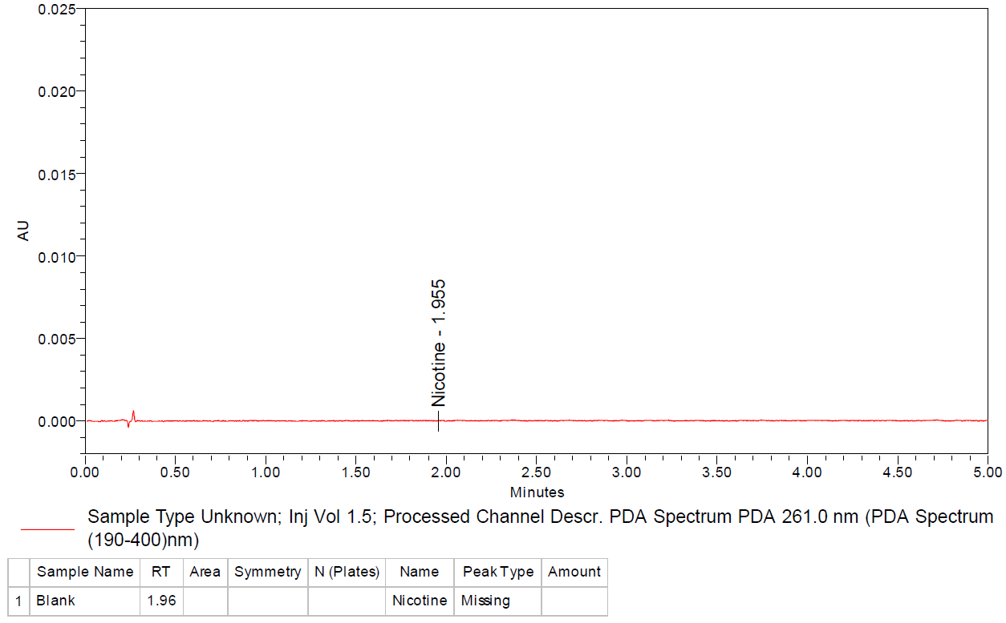
Standard (20 ppm):
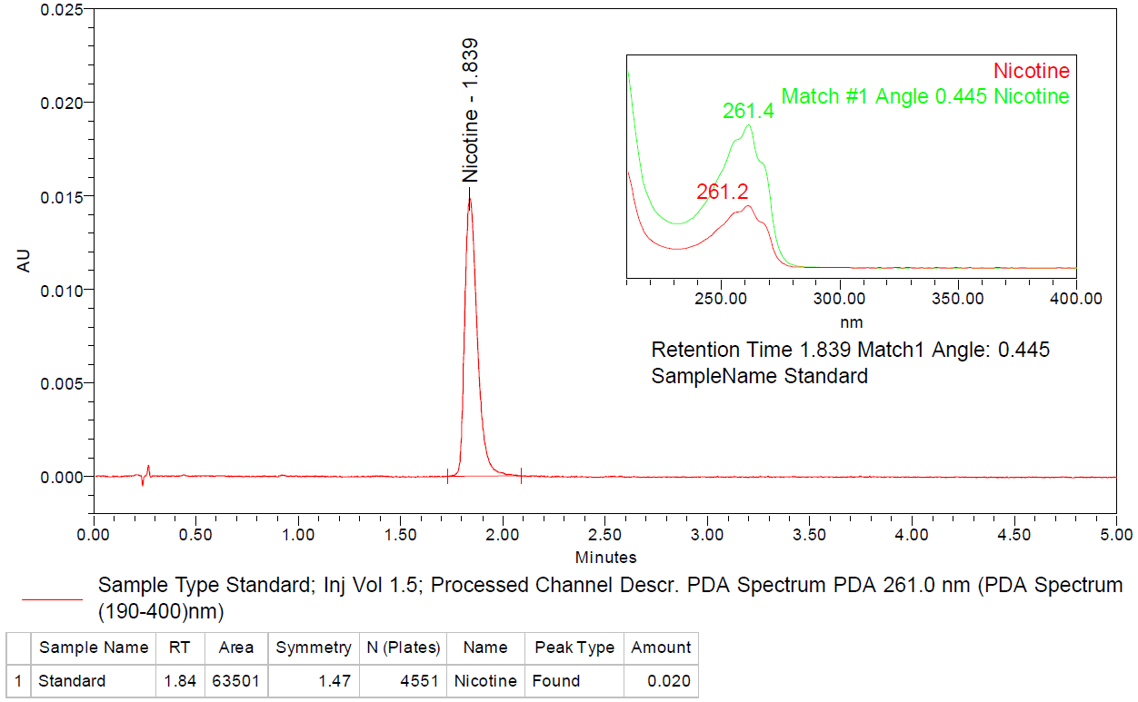
Sample:
