Australian Public Assessment Report for Pombiliti
  - Active ingredient: Cipaglucosidase alfa
  - Sponsor: Amicus Therapeutics Pty Ltd
June 2025

About the Therapeutic Goods Administration (TGA)
- The Therapeutic Goods Administration (TGA) is part of the Australian Government Department of Health and Aged Care and is responsible for regulating therapeutic goods, including medicines, medical devices, and biologicals.
- The TGA administers the Therapeutic Goods Act 1989 (the Act), applying a risk management approach designed to ensure therapeutic goods supplied in Australia meet acceptable standards of quality, safety, and efficacy.
- The work of the TGA is based on applying scientific and clinical expertise to decision-making, to ensure that the benefits to the Australian public outweigh any risks associated with the use of therapeutic goods.
- The TGA relies on the public, healthcare professionals and industry to report problems with therapeutic goods. The TGA investigates reports received to determine any necessary regulatory action.
- To report a problem with a therapeutic good, please see the information on the TGA website.

About AusPARs
- The Australian Public Assessment Report (AusPAR) provides information about the evaluation of a prescription medicine and the considerations that led the TGA to approve or not approve a prescription medicine submission. Further information can be found in Australian Public Assessment Report (AusPAR) guidance.
- AusPARs are prepared and published by the TGA.
- AusPARs are static documents that provide information that relates to a submission at a particular point in time. The publication of an AusPAR is an important part of the transparency of the TGA’s decision-making process.
- A new AusPAR may be provided to reflect changes to indications or major variations to a prescription medicine subject to evaluation by the TGA.

Copyright
© Commonwealth of Australia 2025
This work is copyright. You may reproduce the whole or part of this work in unaltered form for your own personal use or, if you are part of an organisation, for internal use within your organisation, but only if you or your organisation do not use the reproduction for any commercial purpose and retain this copyright notice and all disclaimer notices as part of that reproduction. Apart from rights to use as permitted by the Copyright Act 1968 or allowed by this copyright notice, all other rights are reserved, and you are not allowed to reproduce the whole or any part of this work in any way (electronic or otherwise) without first being given specific written permission from the Commonwealth to do so. Requests and inquiries concerning reproduction and rights are to be sent to the TGA Copyright Officer, Therapeutic Goods Administration, PO Box 100, Woden ACT 2606 or emailed to <tga.copyright@tga.gov.au>.

Contents
List of abbreviations 4
Product submission 6
Submission details 6
Product background 7
Disease or condition 7
Current treatment options 8
Clinical rationale 8
Regulatory status 9
Australian regulatory status 9
International regulatory status 9
Registration timeline 10
Submission overview and risk/benefit assessment 11
Quality evaluation summary 11
Nonclinical (toxicology) evaluation summary 11
Clinical evaluation summary 13
Pharmacology 13
Efficacy 15
Safety 22
Immunogenicity 27
Risk management plan evaluation summary 28
Delegate’s considerations - Risk-benefit analysis 28
Questions for the sponsor 30
Regulatory decision (Outcome) 31
Specific conditions of registration applying to Pombiliti 31
Product Information and Consumer Medicines Information 32

List of abbreviations
Abbreviation | Meaning
6MWD | 6-minute walk distance
6MWT | 6-minute walk time
ACM | Advisory Committee on Medicines
ADA | Anti-drug antibody
ANCOVA | Analysis of covariance
ARTG | Australian Register of Therapeutic Goods
ASA | Australia-specific annex
ATB200 | Cipaglucosidase alfa; Pombiliti
AT2221 | Miglustat; Opfolda
AUC | Area under the drug concentration-time curve
AUC_{0-∞} | Area under the concentration time curve from time zero to infinity
CER | Clinical evaluation report
CHMP | Committee for Medicinal Products for Human Use
CI | Confidence interval
CI-MPR | Cation-independent mannose 6 phosphate receptor
CK | Creatine kinase
C_{max} | Maximum observed plasma concentration
CMI | Consumer Medicines Information
CYP | Cytochrome P450
DLP | Data lock point
ERT | Enzyme replacement therapy
EU | European Union
FAS | Full Analysis Set
FDA | Food and Drug Administration
FVC | Forced vital capacity
GAA | Acid alfa-glucosidase
GLP | Good Laboratory Practices
GSGC | Gait, Stairs, Gowers’ manoeuvre, and Chair
Hex4 | Hexose tetrasaccharide
IAR | Infusion-associated reaction
Ig | Immunoglobulin
IOPD | Infantile-onset Pome disease
ITT | Intent-to-treat
ITT-LOCF | ITT-last observation carried forward
ITT-OBS | ITT-observed
IV | Intravenous
LOPD | Late-onset Pompe disease
M6P | Mannose 6-phosphate
MEP | Maximum expiratory pressure
MIP | Maximum inspiratory pressure
MMRM | Mixed-effect model for repeated measures
MMT | Manual muscle test
NAb | Neutralising antibody
OLE-ES | Open-label extension-enrolled subjects
PD | Pharmacodynamic
PGIC | Physician Global Impression of Change
P-gp | P-glycoprotein
PI | Product Information
PK | Pharmacokinetic
PopPK | Population pharmacokinetics
PRO | Patient-reported outcome
PROMIS | Patient-reported Outcomes Measurement Information System
PSUR | Periodic safety update report
PT | Preferred term
rhGAA | Recombinant human acid α-glucosidase
RMP | Risk management plan
SAE | Serious adverse event
SD | Standard deviation
SE | Standard error
TEAE | Treatment-emergent adverse event
TGA | Therapeutic Goods Administration
t_{max} | Time to maximum plasma concentration

Product submission

Submission details
Type of submission: | New biological entity
Product name: | Pombiliti
Active ingredient: | cipaglucosidase alfa
Decision: | Approved
Date of decision: | 10 February 2025
Date of entry onto ARTG: | 17 February 2025
ARTG number: | 430450
Black Triangle Scheme | Yes
for the current submission: | Pombiliti (cipaglucosidase alfa) is to be included in the Black Triangle Scheme. The PI and CMI for Pombiliti must include the black triangle symbol and mandatory accompanying text for five years, which starts from the date of first supply of the product.
Sponsor’s name and address: | Amicus Therapeutics Pty Ltd  Level 10, 20 Martin Place  Sydney NSW 2000  Australia
Dose form: | 105 mg/ 7 mL powder for injection.
Strength: | After reconstitution of each vial, the concentrated solution contains 15 mg / ml of cipaglucosidase alfa.
Container: | Neutral clear glass vial.
Pack sizes: | Packs containing 1, 10, and 25 vials.
Approved therapeutic use for the current submission: | Pombiliti (cipaglucosidase alfa) is a long-term enzyme replacement therapy used in combination with the enzyme stabiliser miglustat for the treatment of adults with late onset Pompe disease (acid α-glucosidase [GAA] deficiency).
Route of administration: | Intravenous infusion (IV)
Dosage: | The recommended dose of Pombiliti is 20 mg/kg body weight administered every other week as an intravenous solution for IV administration.  Pombiliti must be used in combination with miglustat 65 mg capsules. The prescribing information for miglustat 65 mg capsules should be consulted before prescribing Pombiliti.  Treatment should be supervised by a physician experienced in the management of patients with Pompe disease or other inherited metabolic or neuromuscular diseases.  For further information regarding dosage, such as dosage modifications to manage adverse reactions, refer to the Product Information.
Pregnancy category: | Category D  There are no clinical data for the use of Pombiliti in combination with Opfolda in pregnant women.  Reliable contraceptive measures must be used by women of childbearing potential during treatment with Pombiliti in combination with Opfolda, and for 4 weeks after the last dose. The medicinal product is not recommended in women of childbearing potential not using reliable contraception.  The use of any medicine during pregnancy requires careful consideration of both risks and benefits by the treating health professional. The pregnancy database must not be used as the sole basis of decision making in the use of medicines during pregnancy. The TGA does not provide advice on the use of medicines in pregnancy for specific cases. More information is available from obstetric drug information services in your state or territory.

Product background
This AusPAR describes the submission by Amicus Therapeutics to register Pombiliti (cipaglucosidase alfa) 105mg powder for injection vial for the following proposed indication -
Pombiliti (cipaglucosidase alfa) is a long-term enzyme replacement therapy used in combination with the enzyme stabiliser miglustat for the treatment of adults with late onset Pompe disease (acid α-glucosidase [GAA] deficiency).

Disease or condition
Pompe disease is a rare autosomal recessive genetic disorder caused by mutations in the gene that encodes human acid α-glucosidase (GAA), an enzyme responsible for the breakdown of lysosomal glycogen. Impaired function of this enzyme results in lysosomal glycogen accumulation, leading to progressive disruption of cellular function, particularly in the heart, skeletal muscle, and liver.
Symptoms of Pompe disease can first appear at any age. The age at onset of clinical manifestations, severity of signs and symptoms, and degree of organ/muscular involvement largely depend on the severity of the mutation and the residual enzyme activity.
Pompe disease is now considered to be a continuous spectrum of phenotypes. The most severe, rapidly progressive phenotype is infantile-onset Pompe disease (IOPD), which appears in the first 3 months of life and is characterised by muscle weakness, cardiomyopathy, and respiratory dysfunction, with life expectancy ∼2 years. Late-onset Pompe disease (LOPD) can present in childhood or adulthood and is not characterised by cardiomyopathy. LOPD in paediatric patients is also referred to as juvenile-onset Pompe disease. LOPD has a slower rate of progression than IOPD, with patients typically experiencing progressive limb-girdle weakness and respiratory failure due to involvement of muscles in the proximal lower and upper limbs, paraspinal muscles, and diaphragm. Clinical manifestations include difficulty walking and climbing stairs and progressive limitations of motor activities of daily living with progression to a need for ambulatory support followed by wheelchair dependence. The progressive nature of LOPD generally results in the need for mechanically assisted ventilation. Life expectancy for patients with LOPD can range from childhood to late adulthood, depending on the age of onset, the rate of disease progression, the extent of respiratory muscle involvement, and the presence of comorbidities.
Diagnostic testing for Pompe disease includes deficiency of GAA enzyme activity in white blood cells or dried blood spots (or muscle or skin fibroblasts), genetic testing for disease-causing mutations in the GAA gene, and elevated urinary tetrasaccharides.

Current treatment options
The current approved treatments for Pompe disease in Australia are enzyme replacement therapies (ERTs) with a recombinant human acid α-glucosidase (rhGAA) to provide an exogenous supply of enzyme to treat the enzyme deficit. Enzyme replacement therapy with alglucosidase alfa (Myozyme) is indicated for the long-term treatment of patients with a confirmed diagnosis of Pompe disease. A second enzyme, avalglucosidase alfa (Nexviazyme), was approved in 2021 as a long-term treatment for patients with Pompe disease.
Treatment with alglucosidase alfa provides an initial modest improvement/stabilisation of the disease progression, usually for several years, followed by a slow decline in muscle function. Despite ERT, the burden of disease in individuals with Pompe disease remains high, substantial morbidity persists, and many patients continue to progress, requiring ambulatory and ventilatory support. Therefore, there remains an unmet medical need for more effective treatments with longer-term benefits for Pompe disease.

Clinical rationale
Cipaglucosidase alfa is a new biological entity developed as a next generation ERT for Pompe disease, which has the same mechanism of action as alglucosidase alfa but differs structurally based on its post translational N-linked oligosaccharide structures. Cipaglucosidase alfa contains higher amounts of mannose 6-phosphate (M6P), which is the natural motif for identifying and transporting soluble lysosomal enzymes to lysosomes, than alglucosidase alfa. Cipaglucosidase alfa contains bis-phosphorylated high mannose (bis-M6P) oligosaccharide structures, which are known to have the highest affinity of all known carbohydrates for the CI-MPR. This leads to substantially better binding to the CI-MPR on cell surfaces, mediating the internalisation and delivery of exogenous rhGAA to lysosomes, particularly at low enzyme concentrations in muscles post-dosing.
Cipaglucosidase alfa is unstable at neutral pH and can be denatured and inactivated in the bloodstream following IV infusion. Miglustat (Opfolda) is a small molecule enzyme stabiliser that binds to and prevents inactivation of the rhGAA enzyme in blood. This selective binding between cipaglucosidase alfa and miglustat is transient, with dissociation of cipaglucosidase alfa-miglustat strongly favoured in the acidic environment of the lysosome. Miglustat alone has no specific effects on glycogen reduction in Pompe disease.
The applications for approval of cipaglucosidase alfa/miglustat for the treatment of adults with LOPD are based on the following clinical evidence:
- Efficacy and safety data from the pivotal Study ATB200-03 that compared cipaglucosidase alfa/miglustat with approved therapy (alglucosidase alfa).
- Efficacy, safety, and pharmacokinetic (PK) data from Study ATB200-02 and historical data on alglucosidase alfa from the literature providing supportive evidence of clinical benefit.
- Population PK/pharmacodynamic (PD) based on pooled data from Studies ATB200-02 and ATB200-03, with exposure-response assessments of efficacy, safety, and biomarker data supporting the proposed dosing regimen.
- Long-term efficacy data from Study ATB200-02 and studies ATB200-03 and ATB200-07.
- Analyses of immunogenicity, which demonstrated no clinically meaningful impact upon PK, PD, safety, and efficacy.

Regulatory status

Australian regulatory status
This product is considered a new chemical entity for Australian regulatory purposes.

International regulatory status
At the time the TGA considered this submission, similar applications had been submitted to other regulatory agencies in the USA, UK, EU and Switzerland. The application has been approved by USFDA (Sep 2023), EU (Mar 2023) and UK (Jun 2023), as per the following table.
Table 1: International regulatory status
Region | Submission Date | Status | Approved indications
Europe Union (EU) | 5 November 2021 | Approved  20 March 2023 | Pombiliti (cipaglucosidase alfa) is a long-term enzyme replacement therapy used in combination with the enzyme stabiliser miglustat for the treatment of adults with late-onset Pompe disease (acid α-glucosidase [GAA] deficiency).
United Kingdom (UK) | 19 December 2022 | Approved  30 June 2023 | Pombiliti (cipaglucosidase alfa) is a long-term enzyme replacement therapy used in combination with the enzyme stabiliser miglustat for the treatment of adults with late-onset Pompe disease (acid α-glucosidase [GAA] deficiency).
Switzerland | 9 June 2023 | Approved  4 July 2024 | Pombiliti (cipaglucosidase alfa) is a long-term enzyme replacement therapy used in combination with the enzyme stabiliser miglustat for the treatment of adults with late-onset Pompe disease (acid α-glucosidase [GAA] deficiency).
United States of America | 20 November 2020 | Approved  28 September 2023. | Pombiliti is indicated, in combination with Opfolda, for the treatment of adult patients with late-onset Pompe disease (lysosomal acid alpha-glucosidase [GAA] deficiency) weighing ≥40 kg and who are not improving on their current enzyme replacement therapy (ERT).

Registration timeline
The following table captures the key steps and dates for this submission.
This submission was evaluated under the standard prescription medicines registration process.
Table 2: Timeline for Submission PM-2023-05418-1-3
Description | Date
Submission dossier accepted and first round evaluation commenced | 31 January 2024
First round evaluation completed | 6 June 2024
Sponsor provides responses on questions raised in first round evaluation | 13 September
Second round evaluation completed | 2 October 2024
Delegate’s Overall benefit-risk assessment | 5 November 2024
Registration decision (Outcome) | 10 February 2025
Administrative activities and registration in the ARTG completed | 17 February 2025
Number of working days from submission dossier acceptance to registration decision* | 191
*Statutory timeframe for standard submissions is 255 working days

Submission overview and risk/benefit assessment

Quality evaluation summary
Cipaglucosidase alfa is a human recombinant acid α-glucosidase derived from a recombinant Chinese hamster ovary (CHO) cell culture. Cipaglucosidase alfa is intended to replace the absent or impaired endogenous enzyme. Cipaglucosidase alfa is stabilised by Opfolda (miglustat) minimising the loss of enzyme activity in the blood during infusion of this hydrolytic glycogen-specific enzyme with bis-M6P N-glycans for high affinity cation-independent mannose-6-phosphate receptor (CI-MPR) binding. After binding, it is internalised in the lysosome where it undergoes proteolytic cleavage and N-glycan trimming which are both required to yield the most mature and active form of the GAA enzyme, 7- to 10-fold more active than the precursor enzyme. The enzyme activity reduces intramuscular glycogen and ameliorates tissue damage.
The recommended dose of cipaglucosidase alfa is 20 mg/kg body weight administered every other week by intravenous (IV) infusion. The infusion can be administered in the hospital, clinic, or home, after a comprehensive evaluation of infusion-associated reactions (IARs) risks, under the supervision of a healthcare professional. Opfolda (miglustat) must be used in combination with Pombiliti.
Cipaglucosidase alfa is a colourless to slightly yellowish liquid that appears clear to opalescent. The Opfolda 65 mg hard capsules are to be taken on an empty stomach and swallowed whole with water. One 20 mL vial contains 105 mg of cipaglucosidase alfa. It is supplied in a neutral borosilicate clear glass vial sealed with a 20 mm chlorobutyl rubber stopper with an aluminium over-seal with a dark grey flip-off cap.
There are no issues pertaining to the stability of the drug substance or drug product. The recommended shelf life for the drug product is 36 months when stored at 2˚C to 8˚C, protect from light, refrigerate. After reconstituting the vial, the solution should be diluted with sodium chloride 0.9% solution for injection and then stored in an infusion bag. Once reconstituted and diluted, cipaglucosidase alfa solution should be administered without delay. If it is not possible to start the infusion following dilution, the reconstituted and diluted solution is stable for up to 24 hours refrigerated at 2°C to 8°C. Storage at room temperature is not recommended, refer to the in-use stability storage conditions. Do not freeze or shake.

Nonclinical (toxicology) evaluation summary
The submitted dossier contained data for cipaglucosidase alfa alone and in combination with miglustat and was in accordance with the relevant ICH guideline for the non-clinical assessment of biological medicines (ICH S6(R1)). The overall quality of the non-clinical dossier was high. All pivotal safety-related studies were GLP compliant.
In vitro, cipaglucosidase alfa contains a higher percentage of bis-phosphorylated mannose-6-phosphate (bis-M6P) than alglucosidase alfa resulting in binding to the cation-independent M6P receptor (CI-MPR) with a higher affinity than alglucosidase alfa. Cipaglucosidase alfa was internalised, via CI-MPR, into Pompe patient fibroblasts. Miglustat stabilised cipaglucosidase alfa and preserved its activity in human blood.
In in vivo studies conducted in acid α-glucosidase (GAA) knockout mice, treatment with cipaglucosidase alfa reduced glycogen content in the heart and skeletal muscle (quadriceps, triceps and gastrocnemius), improved muscle function (grip strength) and reduced autophagic buildup. Miglustat co-administration did not convincingly improve these outcomes compared to cipaglucosidase alfa alone. Nevertheless, the combination of cipaglucosidase alfa plus miglustat was consistently superior to the current standard of care, alglucosidase alfa.
No secondary pharmacodynamics or pharmacodynamic drug interaction studies were conducted with cipaglucosidase alfa, which is reasonable, given it is an enzyme replacement therapy.
No dedicated safety pharmacology studies were conducted. Cardiovascular, respiratory, and central nervous system evaluations were included in the repeat-dose toxicity study in rats and monkeys. These studies revealed no adverse effects of cipaglucosidase alfa or miglustat, alone or in combination, on the cardiovascular, central nervous, or respiratory systems.
The pharmacokinetic (PK) profile of cipaglucosidase alfa was linear with dose-proportional increases in exposure. Plasma half-life was short (<1.5 h) in laboratory animals and humans. Cipaglucosidase alfa half-life and exposure were approximately half that of alglucosidase alfa, reflecting greater muscle uptake of the former versus the latter. Miglustat exposure was also dose-proportional, with short half-life (30 minutes) in mice and longer (5-7h) in cynomolgus monkeys and humans. The half-life of cipaglucosidase alfa in muscle is ∼58.1-87.3 hours. There were no sex differences in PK parameters in mice, rats or monkeys. Co-administration of cipaglucosidase alfa did not affect miglustat exposure, however miglustat oral co-administration increased cipaglucosidase alfa half-life and AUC by approximately 2-fold in cynomolgus monkeys. Overall, the non-clinical PK data suggest that the animal models are sufficient to act as appropriate models for the assessment of cipaglucosidase alfa and miglustat toxicity in humans.
Cipaglucosidase alfa had a low order of acute oral toxicity in rats and cynomolgus monkeys. Repeat-dose toxicity studies by the IV route were conducted with cipaglucosidase alfa in rats and cynomolgus monkeys (26 weeks), and with cipaglucosidase alfa in combination with oral miglustat in cynomolgus monkeys (13 weeks). Maximum exposures (AUC) were moderate in both species. No adverse effects were observed at any dose. No genotoxicity or carcinogenicity studies were submitted, which is acceptable. As a recombinant glycoprotein, cipaglucosidase alfa is not expected to exhibit carcinogenic potential.
Fertility was unaffected in male and female rats treated with cipaglucosidase alfa every other day at exposure levels ≥28 times the clinical AUC. No adverse effects were seen in embryofetal development studies in rats dosed with cipaglucosidase alfa alone or in combination with miglustat (~19- and 4.1-fold the clinical exposure for cipaglucosidase alfa and miglustat, respectively). However, rabbits dosed with cipaglucosidase alfa plus miglustat displayed an increase in cardiac and great vessel malformations (16- and 3-fold the clinical exposure for cipaglucosidase alfa and miglustat, respectively), suggesting that co-administration could impart risk to the foetus. In pre-/post-natal studies in rats, increased maternal and pup mortality was observed following treatment with cipaglucosidase alfa alone at a dose of 150 mg/kg every second day (5-fold the clinical exposure) and in combination with miglustat at doses of 400 mg/kg for cipaglucosidase alfa and 60 mg/kg miglustat every second day (20-fold and 4.1-fold the clinical exposure for cipaglucosidase alfa and miglustat, respectively). Decreased pup weight was also observed following treatment with the combination at this dose. Evaluation of milk in rats from the combination treatment group showed secretion of miglustat and excretion of cipaglucosidase alfa in rat milk. The proposed Pregnancy Category D is considered appropriate for the combination of cipaglucosidase alfa and miglustat and is consistent with the pregnancy category of miglustat.
There is no non-clinical objection to the registration of Pombiliti for the proposed indication.

Clinical evaluation summary

Pharmacology
The clinical development program of cipaglucosidase alfa/miglustat for the treatment of adults with LOPD comprises 4 studies:
- AT2221-01: Phase 1 study in healthy volunteers.
- ATB200-02: Phase 1/2 study with long-term extension.
- ATB200-03: Pivotal Phase 3 double-blind, randomised, active-controlled study.
- ATB200-07: Phase 3 long-term extension (subjects who complete Study ATB200-03).
These studies are supported by PopPK analyses, modelling and simulations, immunogenicity analyses, cardiac safety analyses, integrated summaries, and non-company studies involving Zavesca.

Pharmacokinetics (PK)

Cipaglucosidase alfa
The PK of cipaglucosidase alfa has been well characterised. Findings from ATB200-02 demonstrate a t_{max} of ∼4 hours, and a mean 44% increase in AUCt_{max-24h} exposures following 20 mg/kg cipaglucosidase alfa + 260 mg miglustat co-administration relative to 20 mg/kg cipaglucosidase alfa alone. Co-administration of miglustat with cipaglucosidase alfa did not alter C_{max} compared to cipaglucosidase alfa monotherapy. The addition of 260 mg miglustat to 20 mg/kg cipaglucosidase alfa increased distribution half-life by 48%. No unexpected accumulation was observed after once every 2 weeks dosing.
As a glycoprotein, cipaglucosidase alfa is expected to be metabolised into small peptides and amino acids via catabolic pathways. Study ATB200-02 demonstrated a mean terminal elimination half-life for cipaglucosidase alfa when given in combination with 260 mg miglustat of ∼2.2 hours, and a 27% decrease in clearance of cipaglucosidase alfa when co-administered with 260 mg miglustat.
No studies have been conducted in subjects with renal or hepatic impairment. No drug interaction studies were conducted but CYP450 mediated drug interactions are not expected with cipaglucosidase alfa because it is a recombinant human protein.
PopPK study AMC0206 demonstrated no meaningful effect of age, race, ERT-history, and sex on cipaglucosidase alfa AUC and C_{max}. Body weight appeared to be a covariate for cipaglucosidase alfa clearance. Cipaglucosidase alfa AUC in a 104 kg subject was approximately 26% higher than that in a 70 kg reference subject. Over the weight range examined (51 – 104 kg) this was not considered to be clinically relevant. Simulations in varying degrees of renal impairment predicted no meaningful impact on cipaglucosidase alfa exposures.

Miglustat
The PK of miglustat (Zavesca) is well characterised. PK data following a single dose was compared for Opfolda (65 mg capsule) and Zavesca (100 mg capsule) to provide a bridge to the general PK properties of Zavesca. Dose-normalised data showed comparable PK for Opfolda and Zavesca (dose-normalised plasma miglustat C_{max} and AUC_{0-∞} were within 80-125% bioequivalence margins).
The time to maximum plasma concentration (t_{max}) of miglustat is ~2 to 3 hours. The PK of miglustat is dose proportional. When taken with a high-fat meal, plasma miglustat C_{max} was decreased by 36%, AUC_{0-∞} was decreased by 14%, and t_{max} was delayed by ∼2 hours when compared to dosing in a fasted state.
Miglustat does not bind to plasma proteins. The terminal phase volume of distribution is ∼90 L. Miglustat is largely unmetabolised, with urinary recovery of unchanged drug accounting for 70-80% of the dose. Several metabolites were identified in urine and faeces; the most abundant metabolite in urine was miglustat glucuronide accounting for 5% of the dose. Miglustat is mainly eliminated by renal excretion. Clearance was approximately 10.5 L/h, independent of the dose administered and whether miglustat was co-administered with cipaglucosidase alfa. The terminal elimination half-life of miglustat was ∼6 hours.

Pharmacodynamics (PD)
Studies ATB200-02, ATB200-03, and ATB200-07 evaluated creatine kinase (CK), an indicator of muscle damage in Pompe disease, and urine hexose tetrasaccharide (Hex4), which is produced by intravascular degradation of glycogen released from damaged tissues. Study ATB200-02 also assessed plasma GAA activity.
Study ATB200-02 demonstrated dose-dependent increases in plasma GAA activity following single ascending doses of cipaglucosidase alfa, and the addition of 130 mg or 260 mg miglustat resulted in dose-dependent increases in plasma GAA activity during the distribution phase.
In the pivotal efficacy study ATB200-03, in all 3 populations (the overall population, the ERT-experienced population, and the ERT-naïve population), reductions in biomarkers of muscle damage (CK) and disease substrate (Hex4) were significantly greater with cipaglucosidase alfa/miglustat compared to alglucosidase alfa/placebo (nominal p-values < 0.001). Results from the long-term Study ATB200-07 showed that CK and Hex4 levels remained stable during continued treatment with Pombiliti/Opfolda from Week 52 to Week 104.
Exposure-response modelling of Hex4 and CK levels in Study AMC-0206 was consistent with the results from Study ATB200-03. Effects of cipaglucosidase alfa and alglucosidase alfa on Hex4 and CK were lower in ERT-experienced subjects.

Dose selection for the pivotal study
Dose-finding data were initially generated through preclinical PK/PD translational modelling and allometric scaling in Study AMIC-PCS-102, which informed the clinical dose-finding evaluation conducted as part of the Phase 1/2 Study ATB200-02. In Study ATB200-02, cipaglucosidase alfa exposures and plasma total GAA protein concentrations and activity increased in a dose-dependent manner after single ascending doses of 5 mg/kg, 10 mg/kg, and 20 mg/kg cipaglucosidase alfa, and after multiple doses of 20 mg/kg cipaglucosidase alfa + 130 mg miglustat and 20 mg/kg cipaglucosidase alfa + 260 mg miglustat. In Cohort 1, AUC_{0-∞} increased by 16.3% and 28.5% following co-administration of cipaglucosidase alfa with 130 mg and 260 mg miglustat, respectively, compared to cipaglucosidase alfa alone; C_{max} was not appreciably altered. The increased AUC during the early terminal elimination phase suggests improved stabilisation of cipaglucosidase alfa in circulation with co-administration of miglustat.
Study ATB200-02 concluded that exposures from single dose administration with 20 mg/kg cipaglucosidase alfa confirmed preclinical models that targeted 20 mg/kg as the optimised dose level. Additionally, the observed increases in total GAA protein and activity when co-administered with miglustat, particularly the 260 mg dose, supported the proposed combination regimen. These findings informed the selection of 20 mg/kg cipaglucosidase alfa (intravenous infusion) in combination with 260 mg or 195 mg miglustat (oral) for the pivotal clinical study.

Efficacy

Study ATB200-03 (Pivotal study)
This was a randomised, double-blind, multicentre, international study designed to evaluate the efficacy, PD, PK, immunogenicity, safety and tolerability of cipaglucosidase alfa co-administered with miglustat compared with alglucosidase alfa co-administered with placebo in adult subjects with LOPD. The study was conducted at 62 sites in 24 countries, including 4 sites in Australia. The first subject enrolled on 3 December 2018 and the last subject completed on 15 December 2020. The study consisted of a 30-day screening period, a 12-month double-blind treatment period, and a 30-day follow-up period. Key inclusion criteria were:
- Men and women aged ≥ 18 years old and weighing ≥ 40 kg at screening
- Diagnosis of LOPD based on documented deficiency of GAA enzyme activity or by GAA genotyping
- Sitting FVC ≥ 30% of the predicted value for healthy adults
- Performance of two 6MWTs at screening that were valid, as determined by the clinical evaluator, and that met all of the following criteria:
  - both screening values of 6MWD were ≥ 75 m;
  - both screening values of 6MWD were ≤ 90% of the predicted value for healthy adults;
  - the lower value of 6MWD was within 20% of the higher value of 6MWD.
The study recruited ERT-naïve (never received investigational or commercially available ERT) and ERT-experienced (alglucosidase alfa 20 mg/kg Q2W for ≥2 years) subjects. ERT-experienced subjects continued to take alglucosidase alfa during the screening period and subsequently switched to randomised treatment on the same schedule without interruption.
Subjects were randomised 2:1 to receive treatment with cipaglucosidase alfa and miglustat, or alglucosidase alfa and placebo, with randomisation stratified by ERT status (ERT-experienced or ERT-naïve) and baseline 6MWD (75 to < 150 m, 150 to < 400 m, or ≥ 400 m). Cipaglucosidase alfa and alglucosidase alfa were dosed at 20 mg/kg body weight and administered every 2 weeks as a 4-hour IV infusion. The dose of miglustat was 260 mg (4 x 65 mg capsules) for subjects weighing ≥ 50 kg, or 195 mg (3 x 65 mg capsules) for subjects weighing ≥ 40 kg to < 50 kg. Miglustat or matching placebo were administered orally approximately 1 hour before the infusion. Subjects were fasted for at least 2 hours before and 2 hours after administration of miglustat/placebo. In general, study drug administration was performed at a hospital or study site, but subjects may have been eligible for administration at home after participating in the study for 6 months.
Efficacy assessments were performed at baseline and every 12 weeks and included functional assessments and patient-reported outcomes (PROs).
The primary efficacy endpoint was the change in 6MWD (the distance walked in the 6MWT, in metres) from baseline to Week 52. Key secondary efficacy endpoints in sequential order were:
- Change in sitting FVC (% predicted) from baseline to Week 52
- Change in the manual muscle test (MMT) lower extremity score from baseline to Week 52
- Change in 6MWD from baseline to Week 26
- Change in the Patient-Reported Outcomes Measurement Information System (PROMIS)-Physical Function total score from baseline to Week 52
- Change in the PROMIS-Fatigue total score from baseline to Week 52
- Change in the Gait, Stairs, Gowers’ manoeuvre, and Chair (GSGC) total score from baseline to Week 52.
The ITT population consisted of all randomised subjects who received at least 1 dose of study drug. The primary efficacy endpoint (change in 6MWD from baseline to Week 52) was analysed using an MMRM model to compare between treatment and control on the ITT-OBS Population. Each key secondary endpoint was analysed using an analysis of covariance (ANCOVA) model on the ITT-LOCF Population. The test for the primary endpoint was conducted first at the 1-sided 0.025 significance level, and if significant, the key secondary endpoints were tested sequentially at the same significance level. If at any point the null hypothesis failed to be rejected, then that comparison and any other comparison below it could not be claimed as statistically significant on superiority, and subsequent analyses would be to assess for nominal significance on superiority.
123 subjects (95 ERT-experienced and 28 ERT-naïve) were enrolled in the study and received study treatment (85 received cipaglucosidase alfa/miglustat and 38 received alglucosidase alfa/placebo). 117 subjects completed the study (94.1% in the cipaglucosidase alfa/miglustat group and 97.4% in the alglucosidase alfa/placebo group). The median age was 47 years, 54.5% of the subjects were women, and 84.6% were White. The median age at diagnosis of LOPD was 40 years, and median 6MWD at baseline was 359.5 m.
For the primary endpoint, the change (improvement) in 6MWD was numerically greater in the cipaglucosidase alfa/miglustat group compared to the alglucosidase alfa/placebo group, but statistical superiority was not demonstrated (Table 3). From a formal statistical perspective, no further confirmatory conclusions were possible, but findings for the key secondary endpoints numerically favoured cipaglucosidase alfa/miglustat over alglucosidase alfa/placebo (Table 3).
A prespecified analysis of 6MWD in the overall ITT Population that excluded outliers with externally studentised residuals >3 in magnitude was performed. In this analysis, the difference in LS means was 13.96 m in favour of cipaglucosidase alfa/miglustat, but statistical superiority was not demonstrated (Table 4).
Table 3: Study ATB200-03: Summary of Primary and Key Secondary Endpoints
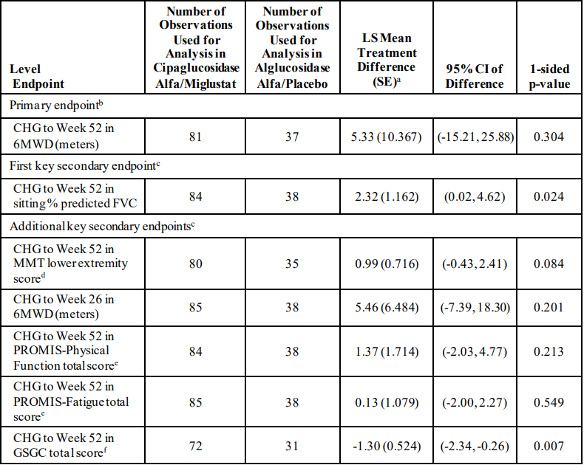
6MWD= 6-minute walk distance; CHG= change from baseline; CI = confidence interval; FVC = forced vital capacity; GSGC = Gait, Stairs, Gowers’ manoeuvre, and Chair; ITT = Intent-to-Treat; ITT-LOCF= Intent-to-Treat-Last Observation Carried Forward; ITT-OBS= Intent-to-Treat–Observed; LS= least squares; MMT = manual muscle testing; PROMIS = Patient-reported Outcomes Measurement Information System; SE = standard error. a Cipaglucosidase alfa/miglustat – alglucosidase alfa/placebo. b Mixed-effect model for repeated measures approach was used for the primary analysis of the primary endpoint based on the ITT-OBS Population. c Analysis of covariance model was used for the primary analysis of the key secondary endpoints based on the ITT-LOCF Population. d The total score for the MMT lower extremity strength included the following 8 body parts: right/left hip flexion, right/left hip abduction, right/left knee flexion, and right/left knee extension. Total score ranged from 0 to 40, with the lower score indicating weaker muscle strength. e The total score was calculated by summing scores (1 to 5) across all items. f GSGC total score was the sum of 4 tests and ranged from a minimum of 4 points (normal performance) to a maximum of 27 points (worst score).
Table 4: Study ATB200-03: Sensitivity Analysis for Primary Endpoint: ANCOVA for Change from Baseline in 6MWD (m) at Week 52 - ITT-LOCF Population Excluding Outliers with Externally Studentized Residuals > 3
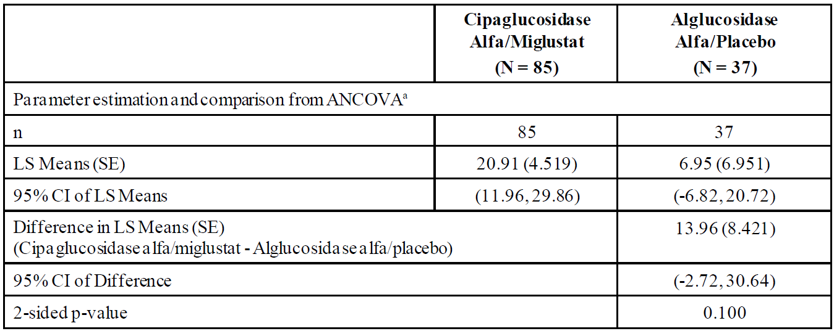
Note: ANCOVA was based on ITT-LOCF excluding outliers with externally studentized residuals > 3 in magnitude (absolute value).
a All estimates were obtained from the ANCOVA model including terms for treatment, baseline 6MWD, age, height, weight (all as continuous covariates), ERT-status (ERT-naive versus ERT-experienced), and gender.
After the database was locked and treatment assignments were unblinded, an outlier subject was identified whose baseline 6MWD result may have been adversely affected by his use of ostarine, an investigational anabolic steroid, prior to study enrolment. Ostarine was discontinued ∼2 to 4 weeks before enrolling in Study ATB200-03. After data base lock, this subject admitted to intentionally underperforming during the baseline assessment to gain entry into the study. His study Screening Visits on 5 and 6 August 2019 showed a 6MWD average of 320 meters and a percent predicted FVC of 83.5%. Previous history shows a percent predicted FVC on 4 December 2018 of 93% and a 6MWD result on 15 April 2019 of 585 meters. The aberrant data points from this subject alone accounted for approximately 56% of the mean change from baseline at Week 52 in the comparator arm. Analysis of the primary endpoint excluding this subject is shown in Table 5. The difference in LS Means was 14.21 m in this analysis, and statistical superiority was not demonstrated.
Table 5: Study ATB200-03: Results for the primary efficacy endpoint by MMRM analysis (ITT-OBS Population) and nonparametric ANCOVA (ITT-LOCF Population) excluding Outlier Subject
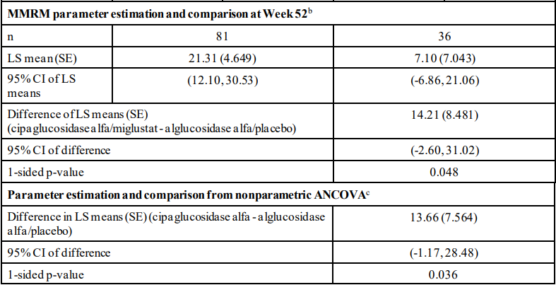
b The MMRM approach (using restricted maximum likelihood estimation) was used for analysis. The model included terms for treatment, baseline 6MWD, age, height, weight (all as continuous covariates), ERT status (ERT-naïve versus ERT-experienced), gender, time, and treatment-by-time interaction. Time was used as a repeated measure, and an unstructured covariance approach was applied. c Nonparametric ANCOVA compared between the treatment groups, adjusting for baseline 6MWD, age, height, weight (all as continuous covariates), ERT status (ERT-naïve versus ERT-experienced) as strata, and gender.
Additional analyses were conducted at the request of the EU CHMP, using an MMRM model with actual time point of assessments in the ITT-OBS Population excluding the outlying subject (Table 6).
Table 6: Study ATB200-03: Summary of Results on 6MWD Based on MMRM Model, Actual Time Point of Assessments - ITT-OBS Population Excluding Outlier Subject
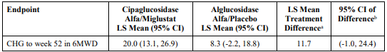
Abbreviations: 6MWD = 6-minute walk distance; CHG = change from baseline; CI = confidence interval; ERT = enzyme replacement therapy; ITT-OBS = Intent-to-Treat Population that includes all available, observed data without any missing data imputation at Week 52; LS = least squares; MMRM = mixed-effect model for repeated measures. a difference = cipaglucosidase alfa/miglustat – alglucosidase alfa/placebo. b MMRM model is used for the analysis based on the ITT-OBS population. The model includes terms for treatment, assessment time, treatment by assessment time interaction, baseline 6MWD value, age, height, weight (all as continuous covariates), ERT-status (ERT-naïve versus ERT-experienced), and gender.
A summary of all efficacy endpoints, with green shading indicating the treatment group favoured, is presented in Table 7. Results for ERT-experienced subjects were similar, with the majority of endpoints improved at Week 52 and directionally favouring cipaglucosidase alfa/miglustat over alglucosidase alfa/placebo (Table 8). Analyses of ERT-naïve subjects were limited by the small sample size (n=27), but most endpoints showed improvement from baseline in both treatment groups, with some endpoints numerically favouring cipaglucosidase alfa/miglustat and some endpoints numerically favouring alglucosidase alfa/placebo (Table 9).
Table 7: Study ATB200-03: Summary of All Endpoints for the ITT Population Excluding Outlier Subject
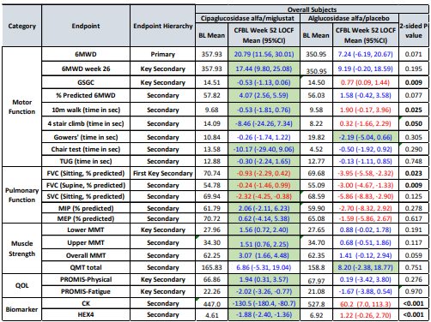
CFBL = change from baseline; TUG = Timed Up and Go; SVC = slow vital capacity; MEP = maximum expiratory pressure; MIP = maximum inspiratory pressure; MMT = manual muscle testing; QMT = Quantitative Muscle Testing; QoL = quality of life. Note: Blue font = CFBL improved; red font = CFBL worsened.
Green shading indicates treatment group favoured. P-values are nominal and based on ANCOVA except for 6MWD, which is based on nonparametric randomisation-based ANCOVA. Bold p-values indicate the superiority test of the specified endpoint (e.g., 6MWD) in that specified population (e.g., overall, or ERT-experienced) was nominally significant.
Table 8: Study ATB200-03: Summary of All Endpoints for the ERT-experienced Population
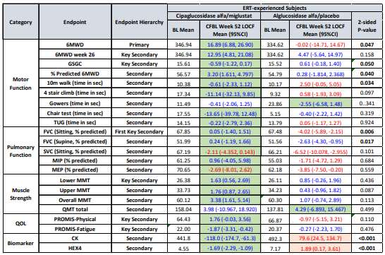
Refer to Table 7 for definitions.
Table 9: Study ATB200-03: Summary of All Endpoints for the ERT-naïve Population excl Outlier Subject
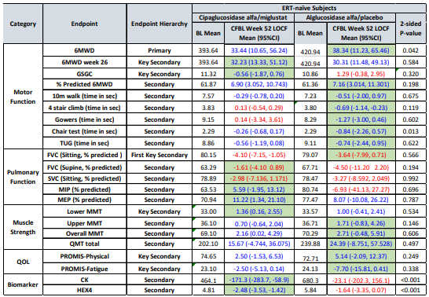
Refer to Table 7 for definitions.

Study ATB200-07 (Long-term extension)
This is an ongoing Phase 3, open-label extension study in which Pombiliti 20 mg/kg IV was co-administered with oral Opfolda 260 mg (or 195 mg if body weight was ≥ 40 kg to < 50 kg) every 2 weeks in adult subjects with LOPD who had completed the pivotal Study ATB200-03. The primary objective is to assess the long-term safety and tolerability of cipaglucosidase alfa/miglustat co-administration. There are multiple secondary objectives assessing efficacy using endpoints including 6MWT, sitting FVC, MMTs, and PROs. The first patient was enrolled on 18 December 2019 and interim efficacy results to Week 52 of the OLE are presented.
Subjects were eligible for treatment with fortnightly cipaglucosidase alfa/miglustat irrespective of which treatment they had received in Study ATB200-03. After 3 months in the study without any moderate to severe IARs, subjects may have been eligible for administration of study drug at their home in countries/sites where home administration of alglucosidase alfa is permitted.
119 subjects enrolled and 116 subjects were eligible for inclusion in the Full Analysis Set (FAS), of whom 36 (31%) had received alglucosidase alfa/placebo and 80 (69%) had received cipaglucosidase alfa/miglustat in Study ATB200-03.
Effects on 6MWD and FVC observed in Study ATB200-03 (to Week 52) were generally maintained through Week 104 of the OLE (Figure 1 and Figure 2, respectively). Findings for MMT lower extremity, PROMIS-Physical Function, PROMIS-Fatigue, and GSGC were generally consistent with those observed for 6MWD. Analyses of ERT-experienced and ERT-naïve subjects were consistent with the overall population.
Figure 1: Studies ATB200-03 and ATB200-07: Line Chart for Mean (± SE) of Change from Study ATB200-03 Baseline over Time in 6MWD (meters) - OLE-ES Population Excluding Outlier Subject
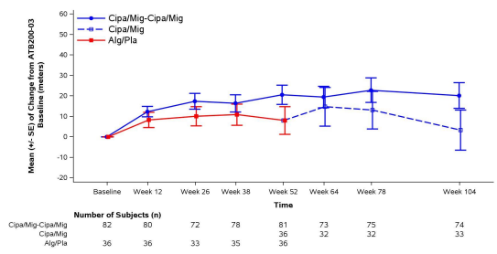
Figure 2: Studies ATB200-03 and ATB200-07: Line Chart for Mean (± SE) of Change from Study ATB200-03 Baseline over Time in Sitting % Predicted FVC - OLE-ES Population Excluding Subject 4005-2511
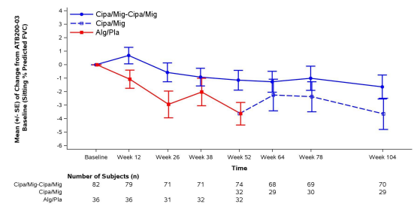

Safety
The safety evaluation focussed on two pools of safety data:
- Pool 1 included participants in the pivotal Study ATB200-03 who received either cipaglucosidase alfa/miglustat or alglucosidase alfa/placebo.
- Pool 2 included subjects in studies ATB200-02, ATB200-03, and ATB200-07 who received cipaglucosidase alfa/miglustat.
Duration of exposure in the pivotal study (Pool 1) is summarised in Table 10.
Table 10: Study ATB200-03: Study Drug Exposure Overall - Safety Population
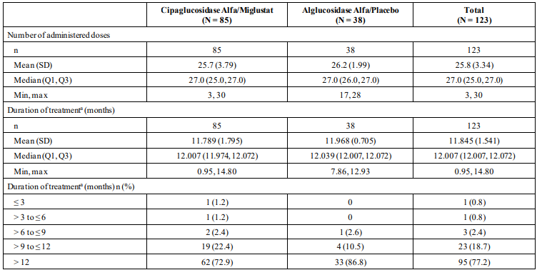
The safety population in Pool 2 comprised 151 subjects treated with cipaglucosidase alfa/miglustat (Table 11). In Pool 2, the majority of subjects were female, had a mean (SD) age of 46.9 (13.42) years, and were White (80.1% of subjects). 17 (11.3%) subjects were ≥ 65 years of age. Most subjects (77.5%) were ERT-experienced at the time of enrolment in studies ATB200-02 or ATB200-03, with a mean (SD) ERT treatment duration of 7.7 (3.49) years. 25.2% of subjects had a history of infusion-associated reactions (IARs).
Table 11: Studies ATB200-02/03/07: Study Drug Exposure Overall – Pool 2 - Safety Population
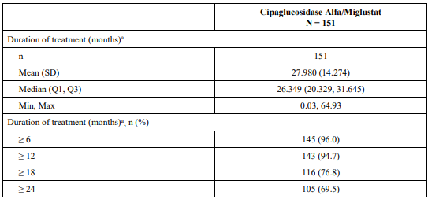

Study ATB200-03 (Pool 1)
A summary of treatment-emergent adverse event (TEAEs) in Study ATB200-03 is presented in Table 12. The two TEAEs leading to study drug discontinuation in the cipaglucosidase alfa/miglustat group (anaphylactic reaction, chills) were both assessed as treatment-related IARs. The incidence of TEAEs by Preferred Term (PT) was generally similar between the treatment groups with the exception of nasopharyngitis and urinary tract infection (Table 13), which occurred more frequently in the cipaglucosidase alfa/miglustat group than in the alglucosidase alfa/placebo group. Most TEAEs during the study were mild or moderate in severity. There were no TEAEs that led to death. Serious TEAEs were reported by 9.4% of subjects in the cipaglucosidase alfa/miglustat group and in 2.6% of subjects in the alglucosidase alfa/placebo group, but only 1 SAE in the cipaglucosidase alfa/miglustat group (anaphylactoid reaction) was assessed as related to study treatment.
Table 12: Overall Summary of treatment-emergent adverse event (TEAEs) (Safety Population)
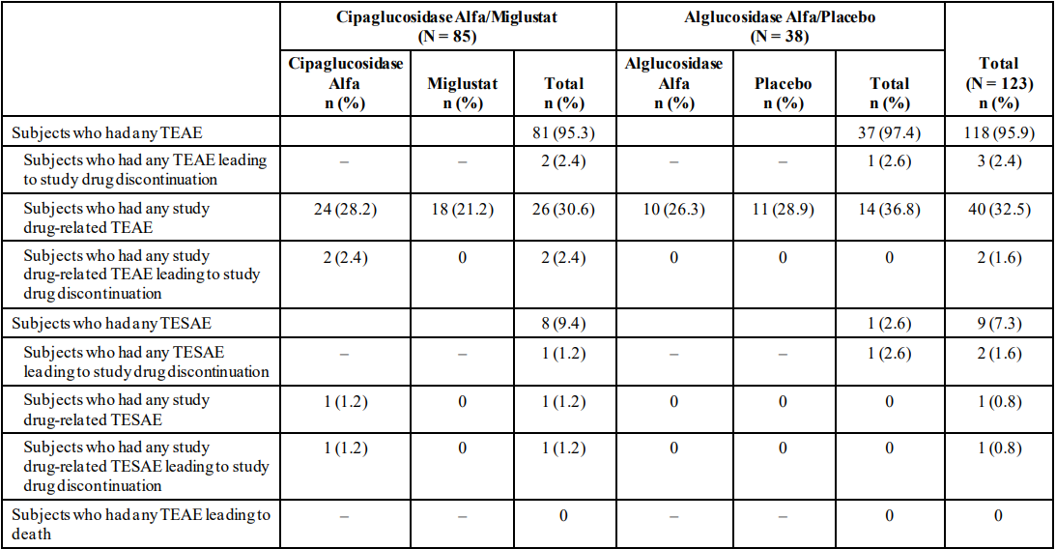
Table 13: Study ATB200-03: Incidence of TEAEs ≥ 10% Subjects (in any Group) by PT - Safety Population
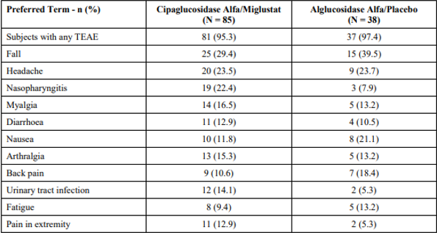
Adverse events of special interest (AESI) included anaphylactic reaction and hypersensitivity, and IARs. IARs were defined as adverse reactions occurring during or within hours following infusion and could include life-threatening anaphylaxis or other severe allergic responses.
Hypersensitivity/anaphylactic reaction TEAEs were reported in 25.9% of cipaglucosidase alfa/miglustat subjects and 39.5% of alglucosidase alfa/placebo subjects. The proportion of cipaglucosidase alfa/miglustat-treated subjects who experienced hypersensitivity/anaphylactic reaction TEAEs was similar between ERT-experienced (24.6%) and ERT-naïve subjects (30.0%). The most frequent events by PT were dyspnoea (7.1%), cough (4.7%), and conjunctivitis, flushing, mouth ulceration, pruritus, and rash (2.4% each). Most of the hypersensitivity/anaphylactic reaction TEAEs were non-serious and did not lead to discontinuation of study drug, but one cipaglucosidase alfa/miglustat-treated subject experienced a serious anaphylactic reaction TEAE that led to discontinuation of study drug (withdrawal of subject consent).
Across both treatment groups, 128 infusion-associated reaction (IARs) were reported in 31 subjects, and the incidence of IARs was similar between the cipaglucosidase alfa/miglustat and alglucosidase alfa groups (Table 14). The mean time to onset was similar between the treatment groups (8.0 weeks and 7.2 weeks, respectively). IARs were experienced by similar proportions of ERT-naïve subjects and ERT-experienced subjects (25.0% versus 24.6%, respectively). Most subjects who experienced IAR-TEAEs had 1-3 events. Overall, 2.7% of all infusions in the cipaglucosidase alfa/miglustat group and 2.8% of all infusions in the alglucosidase alfa/placebo group were associated with 1 or more IAR-TEAEs. Analyses of immunogenicity markers indicated no clear association between hypersensitivity/anaphylaxis AEs or IARs and the presence or absence of total ADA, NAbs, antibodies cross-reactive to alglucosidase alfa, anti-rhGAA IgE, and ADA titres.
Table 14: Study ATB200-03: Overall Summary of TEAEs Reported to be IARs - Safety Population
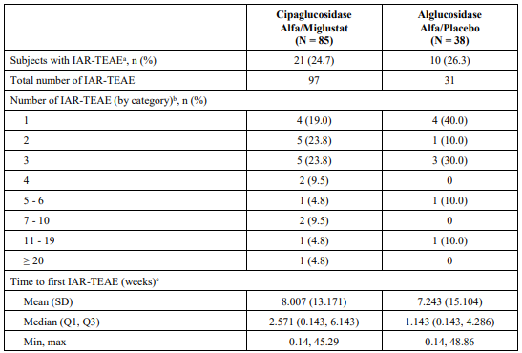
Safety risks relevant to other ERT (MYOZYME, NEXVIAZYME) or miglustat/Zavesca (as treatment for type 1 Gaucher disease and Niemann-Pick type C disease at doses up to 200 mg TDS) were evaluated.
Immune complex-related reactions including necrotising skin lesions, severe inflammatory arthropathy, and proteinuria and nephrotic syndrome secondary to membranous glomerulonephritis have been observed with alglucosidase alfa. In Study ATB200-03, 30.6% of cipaglucosidase alfa/miglustat-treated subjects experienced potential immune complex-related reaction TEAEs compared to 31.6% of alglucosidase alfa/placebo-treated subjects, based on the selected PTs. The proportion of cipaglucosidase alfa/miglustat-treated subjects who experienced potential immune complex-related reaction TEAEs was similar among ERT-experienced subjects (30.8%) compared to ERT-naïve subjects (30.0%). Among cipaglucosidase alfa/miglustat-treated subjects, the most frequent potential immune complex related reaction TEAEs by PT were myalgia (16.5%), arthralgia (15.3%), influenza-like illness (4.7%), and haematuria (3.5%). Many of the events were non-specific and may be attributed to other medical conditions, including the underlying history of LOPD.
Gastrointestinal disorders (including abdominal pain, diarrhoea, nausea, retching, vomiting) are known safety risks with ERT and Zavesca. In Study ATB200-03, 32.9% of cipaglucosidase alfa/miglustat-treated subjects experienced gastrointestinal disorder TEAEs compared to 44.7% of alglucosidase alfa/placebo-treated subjects. Gastrointestinal disorder TEAEs occurring with a higher frequency in the cipaglucosidase alfa/miglustat group compared to the alglucosidase alfa/placebo group (more than 2% difference) included abdominal pain lower (2.4% versus 0.0%, respectively), diarrhoea (12.9% versus 10.5%, respectively), mouth ulceration (2.4% versus 0.0%, respectively), and vomiting (5.9% versus 2.6%, respectively). The proportion of cipaglucosidase alfa/miglustat-treated subjects who experienced gastrointestinal disorder TEAEs was lower for ERT-experienced subjects compared to ERT-naïve subjects (30.8% and 40.0%, respectively). Abdominal distension, abdominal pain, abdominal pain lower, abdominal pain upper, diarrhoea, dyspepsia, flatulence, nausea, and vomiting have been classified as adverse reactions for both cipaglucosidase alfa and miglustat, and constipation has been classified as an adverse reaction for miglustat only. Based on the non-serious nature of gastrointestinal TEAEs observed and the different posology for Opfolda compared to Zavesca, gastrointestinal disorders are not classified as an important safety risk.
Tremor, peripheral neuropathy, and paraesthesia are known risks associated with Zavesca. In Study ATB200-03, 2.4% cipaglucosidase alfa/miglustat-treated subjects experienced tremor TEAEs (all occurring within the first 4 months of treatment) compared to 0% of alglucosidase alfa/placebo-treated subjects. All tremor TEAEs were assessed as non-serious and mild except for one event of moderate severity. No peripheral neuropathy TEAEs were reported in the 151 subjects treated with cipaglucosidase alfa/miglustat in Pool 2. Nine paraesthesia TEAEs were reported in 4/151 (2.6%) subjects treated with cipaglucosidase alfa/miglustat in Pool 2 (1 subject in Study ATB200-02, and 3 in Study ATB200-07), all of which were mild and nonserious. One event was considered to be possibly related and 1 event was considered to be probably related to study treatment. No paraesthesia TEAEs were reported in Study ATB200-03. Paraesthesia has been classified as an adverse drug reaction.
No clinically meaningful safety concerns were identified with respect to ECG parameters and laboratory parameters, including serum chemistry, haematology, and urinalysis.
One pregnancy was reported in Study ATB200-03 in a woman in the cipaglucosidase alfa/miglustat group. It was detected by urine pregnancy test administered according to the protocol on Day 72, and the subject scheduled an elective abortion.
Subgroup analyses for age, sex, race, and ERT status were limited by small numbers, but did not raise meaningful safety concerns between subgroups.
Post-market safety updates included two semi-annual Periodic Benefit-Risk Evaluation Reports (PBRERs) which were prepared for cipaglucosidase alfa and miglustat in accordance with regulatory requirements in the EU. Cumulatively (through 19 March 2024), two serious cases (both IARs) were reported from post-marketing experience – 1 case of Urticaria and 1 case of Anaphylaxis. These reactions are expected ADRs for both products (Pombiliti and Opfolda). Reported non-serious IARs included urticaria, swollen tongue, and rash pruritic, which are known risks. One non-serious case of tremor after Opfolda was reported from a post-marketing spontaneous source. Tremor is included in the Opfolda RMP as a non-important potential risk. Overall, no new safety findings or signals emerged from post-marketing experience as of 19 March 2024.

Immunogenicity
In studies ATB200-02, ATB200-03, and ATB200-07, ADA results were evaluable in 151 subjects treated with cipaglucosidase alfa/miglustat, of whom 117 were ERT-experienced and 34 were ERT-naïve. For ERT-experienced subjects, the ADA prevalence was 83.8% at baseline and 91.5% after treatment with cipaglucosidase alfa/miglustat. For ERT-naïve subjects, the ADA prevalence was 11.8% at baseline and 100% after treatment with cipaglucosidase alfa/miglustat. Across the 3 NAb assays, the prevalence of NAb positivity after treatment ranged from 36.8% to 70.1% for ERT-experienced subjects and 20.6% to 64.7% for ERT-naïve subjects.
Pharmacometric analyses and descriptive summaries of the effects of immunogenicity on PK, PD, and efficacy indicated no clinically meaningful impact of immunogenicity markers on PK disposition, PD measures (Hex4 and CK), and key efficacy endpoints (6MWD and FVC). From a safety perspective, association between ADAs and immunogenicity-related AEs was evaluated by subject level analysis of the presence/absence of ADA and ADA titre analysis. Due to the small number of ADA negative subjects, additional analyses focused on the association of events with coincident ADA titres or with NAbs. Less than half (34 to 46%) of ADA positive subjects developed hypersensitivity/anaphylaxis or IAR events, and a similar percentage of ADA negative subjects (20 to 60%) also developed such reactions. The proportions of subjects with hypersensitivity/anaphylaxis or IARs who were positive for ADA, NAbs, antibodies cross-reactive to alglucosidase alfa, and anti-rhGAA IgE were similar to the proportions of subjects without IARs who were positive for these types of antibodies.
In the pivotal study, there was no clear trend of the effects of immunogenicity on PK, PD measures, efficacy measures, or TEAEs including IAR events.

Summary of clinical studies
The clinical development program of cipaglucosidase alfa/miglustat for the treatment of adults with LOPD comprises 4 studies:
- AT2221-01: Phase 1 study in healthy volunteers.
- ATB200-02: Phase 1/2 study with long-term extension.
- ATB200-03: Pivotal Phase 3 double-blind, randomised, active-controlled study.
- ATB200-07: Phase 3 long-term extension (subjects who completed Study ATB200-03).
These studies are supported by PopPK analyses, modelling and simulations, immunogenicity analyses, cardiac safety analyses, integrated summaries, and studies involving Zavesca.
No paediatric data were submitted in this application.
The clinical evaluator supports the registration of Pombiliti and Opfolda for the proposed indications.

Risk management plan evaluation summary
The summary of safety concerns and their associated risk monitoring and mitigation strategies for Pombiliti is outlined in Table 15. The TGA may request an updated Risk Management Plan (RMP) at any stage of a product's life cycle, during both the pre-approval and post-approval phases.
Table 15: Summary of Safety Concerns
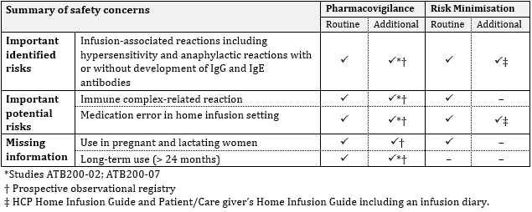
The RMP evaluation recommended conditions of registration relating to the versions of the risk management plan, requirement for periodic safety update reports, and inclusion of the medicine in the Black Triangle Scheme.
In support of this application, Amicus Therapeutics Pty Ltd submitted EU-RMP version 1.2 (dated 9 February 2023; DLP 23 August 2022) with ASA version 1.1 (dated 2 August 2024). This and any subsequent revisions, as agreed with the TGA, will also be implemented in Australia.
Further information regarding the TGA’s risk management approach can be found in risk management plans for medicines and biologicals and the TGA's risk management approach. Information on the Australia-specific annex (ASA) can be found on the TGA website.

Delegate’s considerations - Risk-benefit analysis

Efficacy
The pivotal efficacy study, ATB200-03, was a double-blind, randomised, controlled study which compared the efficacy of cipaglucosidase alfa/miglustat to alglucosidase alfa/placebo on measures of motor function, pulmonary function, and muscle strength. The primary and key efficacy endpoints were consistent with other trials assessing treatments for Pompe disease. The primary endpoint was change in 6MWD from baseline to Week 52 and the key secondary endpoint was change in sitting FVC from baseline to Week 52. The ITT population comprised 123 adults with LOPD with a median age of 47 years, and of whom 77.2% were ERT-experienced.
Study ATB200-03 was designed to evaluate superiority of cipaglucosidase alfa/miglustat compared to alglucosidase alfa/placebo. No non-inferiority analyses were planned or conducted. The change (improvement) in 6MWD from baseline to Week 52 (primary endpoint) was numerically greater with cipaglucosidase alfa/miglustat compared to alglucosidase alfa/placebo, but superiority was not demonstrated. Various pre-specified sensitivity analyses showed numerically greater improvements in 6MWD with cipaglucosidase alfa/miglustat compared to alglucosidase alfa/placebo, but none reached nominal significance. A post hoc analysis of the primary endpoint excluding one subject with aberrant data favoured cipaglucosidase alfa/miglustat but did not demonstrate superiority (LS mean 21.3 m vs 7.1 m; 95% CI -2.6, 31.0; 1-sided p = 0.048). No confirmatory conclusions can be drawn from secondary outcomes, but the key secondary endpoints numerically favoured cipaglucosidase alfa/miglustat over alglucosidase alfa/placebo.
Study ATB200-03 did not demonstrate superiority of cipaglucosidase alfa/miglustat over alglucosidase alfa/placebo and did not formally assess non-inferiority, but the key efficacy findings favoured cipaglucosidase alfa/miglustat compared to alglucosidase alfa/placebo, supporting a conclusion of similar efficacy.
For ERT-experienced subjects, most endpoints numerically favoured cipaglucosidase alfa/miglustat compared to alglucosidase alfa/placebo. For ERT-naïve subjects (n=28), most endpoints showed improvement in both treatment groups, with some endpoints numerically favouring cipaglucosidase alfa/miglustat and some endpoints numerically favouring alglucosidase alfa/placebo.
Interim efficacy data from the OLE study support maintenance of treatment effect to Week 104.

Safety
The safety dataset presented in this application included 151 subjects exposed to cipaglucosidase alfa and miglustat at the proposed doses, with mean duration of exposure ∼28 months and maximum duration of exposure ∼65 months. The most frequently reported TEAEs in subjects treated with cipaglucosidase alfa/miglustat were fall, headache, arthralgia, nasopharyngitis, myalgia, pain in extremity, back pain, diarrhoea, and nausea.
In the pivotal Study ATB200-03, the incidence of TEAEs by PT was generally similar between the cipaglucosidase alfa/miglustat and alglucosidase alfa/placebo groups, although nasopharyngitis and urinary tract infection occurred more frequently in the cipaglucosidase alfa/miglustat group. Most TEAEs were mild to moderate in severity. Hypersensitivity and anaphylactic reaction TEAEs were reported in 25.9% of cipaglucosidase alfa/miglustat subjects and 39.5% of alglucosidase alfa/placebo subjects. The proportion of cipaglucosidase alfa/miglustat-treated subjects who experienced hypersensitivity/anaphylactic reaction TEAEs was similar between ERT-experienced (24.6%) and ERT-naïve subjects (30.0%). Most of the hypersensitivity/anaphylactic reaction TEAEs were non-serious and did not lead to discontinuation of study drug, but one cipaglucosidase alfa/miglustat-treated subject experienced a serious anaphylactic reaction TEAE that led to discontinuation of study drug. IARs were reported in 24.7% of cipaglucosidase alfa/miglustat-treated subjects and 26.3% of alglucosidase alfa/placebo-treated subjects. IARs were experienced by similar proportions of ERT-naïve (25.0%) and ERT-experienced (24.6%) subjects. Most subjects who experienced IAR-TEAEs had 1-3 events. Overall, 2.7% of all infusions in the cipaglucosidase alfa/miglustat group and 2.8% of all infusions in the alglucosidase alfa/placebo group were associated with 1 or more IAR-TEAEs. There was no clear association between hypersensitivity/anaphylaxis AEs or IARs and the presence or absence of immunogenicity markers. IARs including hypersensitivity and anaphylactic reactions with or without development of IgG and IgE antibodies have been classified as an important identified risk for cipaglucosidase alfa.
Immune complex-related reactions have been reported with other ERTs in patients who had high IgG antibody titres, including severe cutaneous reactions and nephrotic syndrome. The safety dataset for cipaglucosidase alfa/miglustat did not raise concern regarding serious immune complex-related reactions, but the safety dataset is small and a potential class effect has not been excluded. Immune complex-related reactions have been classified as an important potential risk.

Proposed Indications
The proposed use is in adults with LOPD, in line with the submitted clinical dataset. The proposed indications are the same as the approved indications in the EU.

Uncertainties and limitations of the data
Cipaglucosidase alfa/miglustat is being investigated in paediatric patients, but the current application is only for adults, in line with the clinical dataset presented in this application. Study ATB200-04 is an ongoing Phase 3, open-label, multicentre study to evaluate the safety, PK, efficacy, PD, and immunogenicity of cipaglucosidase alfa/miglustat treatment in subjects aged 0 to <18 years with Pompe disease. Only 10 subjects had been dosed as of the data cut-off date for this application, so results from this study were not presented in detail.
The proposed use of cipaglucosidase alfa is in combination with miglustat. The efficacy of cipaglucosidase alfa as monotherapy has not been established.
All participants in the pivotal study were ambulatory, so there is uncertainty regarding benefit in non-ambulatory patients.
Most patients treated with cipaglucosidase alfa/miglustat develop ADAs. The clinical development program did not raise specific concern regarding effects of ADAs on PK, PD, efficacy, and safety, but there remains uncertainty regarding long-term impact of immunogenicity on efficacy and safety.

Questions for the sponsor
The sponsor provided the following response to questions from the Delegate.
- The current applications are for adult patients. Please provide a brief outline of the current status of the paediatric development strategy.
Response from the Sponsor:
A paediatric development program for cipaglucosidase alfa/miglustat is investigating the benefit/ risk across all paediatric groups, including paediatric late-onset Pompe disease (LOPD) and infantile-onset Pompe disease (IOPD). There are two paediatric clinical studies ongoing, which are currently recruiting subjects at sites globally.
- ATB200-04: Open-label, uncontrolled study to evaluate safety, pharmacokinetics (PK), efficacy, pharmacodynamics (PD) and immunogenicity of cipaglucosidase alfa/miglustat in children from birth to less than 18 years with LOPD.
- ATB200-08: Open-label, uncontrolled study to evaluate safety, efficacy, PK, PD, and immunogenicity of cipaglucosidase alfa/miglustat in children from birth to less than 18 years with classic IOPD.

Conclusion
The efficacy and safety of cipaglucosidase alfa in combination with miglustat in adults with LOPD have been satisfactorily established. The proposed indications are acceptable. There are no outstanding issues requiring advice from the Advisory Committee on Medicines (ACM). Therefore, the Delegate did not refer this submission to the ACM for advice.

Regulatory decision (Outcome)
Based on a review of quality, safety, and efficacy, the TGA decided to register Pombiliti (cipaglucosidase alfa) 105 mg/ 7ml powder for injection indicated for:
Pombiliti (cipaglucosidase alfa) is a long-term enzyme replacement therapy used in
combination with the enzyme stabiliser miglustat for the treatment of adults with late onset Pompe disease (acid α-glucosidase [GAA] deficiency).

Specific conditions of registration applying to Pombiliti
- POMBILITI (cipaglucosidase alfa) is to be included in the Black Triangle Scheme. The PI and CMI for POMBILITI must include the black triangle symbol and mandatory accompanying text for five years, which starts from the date of first supply of the product.
- The POMBILITI EU-Risk Management Plan (RMP) (version 1.2, dated 9 February 2023, data lock point 23 August 2022), with Australian Specific Annex (version 1.1, dated 2 August 2024), included with submission PM-2023-05418-1-3, and any subsequent revisions, as agreed with the TGA will be implemented in Australia.
- An obligatory component of risk management plans is routine pharmacovigilance. Routine pharmacovigilance includes the submission of periodic safety update reports (PSURs).
Reports are to be provided in line with the current published list of EU reference dates and frequency of submission of PSURs until the period covered by such reports is not less than three years from the date of this approval letter.
Each report must be submitted within ninety calendar days of the data lock point for that report.
The reports are to at least meet the requirements for PSURs as described in the European Medicines Agency’s Guideline on good pharmacovigilance practices (GVP) Module VII-periodic safety update report (Rev 1), Part VII.B Structures and processes. Note that submission of a PSUR does not constitute an application to vary the registration.
- Laboratory testing & compliance with Certified Product Details (CPD)
  - All batches of POMBILITI cipaglucosidase alfa 105 mg powder for injection, vial supplied in Australia must comply with the product details and specifications approved during evaluation and detailed in the Certified Product Details (CPD).
  - When requested by the TGA, the Sponsor should be prepared to provide product samples, specified reference materials and documentary evidence to enable the TGA to conduct laboratory testing on the Product. Outcomes of laboratory testing are published biannually in the TGA Database of Laboratory Testing Results http://www.tga.gov.au/ws-labs-index and periodically in testing reports on the TGA website.
- Certified Product Details
The Certified Product Details (CPD), as described in Guidance 7: Certified Product Details of the Australian Regulatory Guidelines for Prescription Medicines (ARGPM) [http://www.tga.gov.au/industry/pm-argpm-guidance-7.htm], in PDF format, for the above products should be provided upon registration of these therapeutic goods. In addition, an updated CPD should be provided when changes to finished product specifications and test methods are approved in a Category 3 application or notified through a self-assessable change.

Product Information and Consumer Medicines Information
For the most recent Product Information (PI) and Consumer Medicines Information (CMI), please refer to the TGA PI/CMI search facility.

Therapeutic Goods Administration
PO Box 100 Woden ACT 2606 Australia
Email: info@tga.gov.au Phone: 1800 020 653 Fax: 02 6203 1605
https://www.tga.gov.au
Reference/Publication #

Opfolda (miglustat) was first registered in Australia on 16 December 2024. ARTG number 438811.
The non-clinical statements in this section of the CER will be considered by the Module 4 evaluator
Tong PY, Kornfeld S. Ligand interactions of the cation-dependent mannose 6-phosphate receptor. Comparison with the cation-independent mannose 6-phosphate receptor. J Biol Chem. 1989;264(14):7970-7975
In this report the ‘Delegate’ is the Delegate of the Secretary of the Department of Health and Aged Care who decided the submission under section 25 of the Act.
Good Laboratory Practices (GLPs) are the minimum standards used for benchmarking the proper conduct of animal safety studies, in a nonclinical environment, applying both in vivo and in vitro testing.
MYOZYME, Sanofi Genzyme.
Functional assessments included pulmonary function assessments (maximal expiratory and inspiratory pressure, Sniff Nasal Inspiratory Pressure [SNIP], FVC, and slow vital capacity), motor function assessments (Timed Up and Go; Gait [10 m walk], Climb [4-stair], Gowers’ manoeuvre, and Chair test [GSGC]; and 6MWT), and muscle strength assessments (manual muscle strength [MMT] and quantitative muscle strength [handheld dynamometer]).
PROs included the Rasch-built Pompe-specific Activity (R-Pact) scale; PROMIS instruments for physical function, fatigue, dyspnoea, and upper extremity; EuroQol 5 Dimensions 5 Levels instrument; and Physician Global Impression of Change (PGIC) and Subject Global Impression of Change (SGIC).
Clinical Study Report, Table 14.2.2.1.1
OLE-ES (open-label extension-enrolled subjects) Population: all subjects who satisfied the eligibility requirements (based on the inclusion and exclusion criteria) and entered Study ATB200-07
The following PTs were applied: arthralgia, arthritis, arthropathy, cutaneous vasculitis, erythema multiforme, erythema nodosum, glomerulonephritis, haematuria, haemolytic anaemia, influenza like illness, lymphadenopathy, myalgia, myocarditis, nephritis, nephrotic syndrome, proteinuria, purpura, serositis, serum sickness, skin lesion, skin necrosis, type III immune complex mediated reaction, and vasculitis.

