Australian Public Assessment Report for LITFULO
  - Active ingredient: ritlecitinib
  - Sponsor: Pfizer Australia Pty Ltd
June 2025

About the Therapeutic Goods Administration (TGA)
- The Therapeutic Goods Administration (TGA) is part of the Australian Government Department of Health, Disability and Ageing and is responsible for regulating therapeutic goods, including medicines, medical devices, and biologicals.
- The TGA administers the Therapeutic Goods Act 1989 (the Act), applying a risk management approach designed to ensure therapeutic goods supplied in Australia meet acceptable standards of quality, safety, and efficacy.
- The work of the TGA is based on applying scientific and clinical expertise to decision-making, to ensure that the benefits to the Australian public outweigh any risks associated with the use of therapeutic goods.
- The TGA relies on the public, healthcare professionals and industry to report problems with therapeutic goods. The TGA investigates reports received to determine any necessary regulatory action.
- To report a problem with a therapeutic good, please see the information on the TGA website.

About AusPARs
- The Australian Public Assessment Report (AusPAR) provides information about the evaluation of a prescription medicine and the considerations that led the TGA to approve or not approve a prescription medicine submission. Further information can be found in Australian Public Assessment Report (AusPAR) guidance.
- AusPARs are prepared and published by the TGA.
- AusPARs are static documents that provide information that relates to a submission at a particular point in time. The publication of an AusPAR is an important part of the transparency of the TGA’s decision-making process.
- A new AusPAR may be provided to reflect changes to indications or major variations to a prescription medicine subject to evaluation by the TGA.

Copyright
© Commonwealth of Australia 2025
This work is copyright. You may reproduce the whole or part of this work in unaltered form for your own personal use or, if you are part of an organisation, for internal use within your organisation, but only if you or your organisation do not use the reproduction for any commercial purpose and retain this copyright notice and all disclaimer notices as part of that reproduction. Apart from rights to use as permitted by the Copyright Act 1968 or allowed by this copyright notice, all other rights are reserved and you are not allowed to reproduce the whole or any part of this work in any way (electronic or otherwise) without first being given specific written permission from the Commonwealth to do so. Requests and inquiries concerning reproduction and rights are to be sent to the TGA Copyright Officer, Therapeutic Goods Administration, PO Box 100, Woden ACT 2606 or emailed to <tga.copyright@tga.gov.au>.

Contents
List of abbreviations 4
LITFULO (ritlecitinib) submission 5
Proposed indication 6
Alopecia areata 6
Current treatment options for alopecia areata 6
Clinical rationale for the use of LITFULO in alopecia areata 7
Regulatory status 7
Australian regulatory status 7
International regulatory status 7
Registration timeline 8
Assessment overview 8
Quality evaluation summary 8
Nonclinical evaluation summary 9
Clinical evaluation summary 12
Summary of clinical studies 12
Pharmacology 12
Efficacy 14
Safety 19
Risk management plan 24
RMP evaluator recommendations regarding condition/s of registration 25
Discussion 26
Assessment outcome 26
Product Information and Consumer Medicines Information 26

List of abbreviations
Abbreviation | Meaning
AA | alopecia areata
ARTG | Australian Register of Therapeutic Goods
ASA | Australia-specific annex
AT | alopecia totalis
AU | alopecia universalis
AUC_{inf} | area under the concentration-time profile from time zero extrapolated to infinite time
AUCτ | area under the concentration-time profile from time zero to time tau (τ), the dosing interval
C_{avg} | the average drug concentration during the time interval between the previous and current SALT score
C_{max} | maximum plasma concentration
CL | clearance
CMI | Consumer Medicines Information
MACE | major adverse cardiovascular events
PD | pharmacodynamics
PI | Product Information
PSUR | Periodic safety update report
PGI-C | Patient Global Impression of Change PGI-C
PK | pharmacokinetics
popPK | population pharmacokinetics
QD | once daily dosing
RMP | Risk management plan
SALT | Severity of Alopecia Tool
SAE | serious adverse event
TGA | Therapeutic Goods Administration
ULN | upper limit of normal

LITFULO (ritlecitinib) submission
Type of submission: | New chemical entity
Product name: | LITFULO
Active ingredient: | Ritlecitinib tosylate
Decision: | Approved
Date of decision: | 26 June 2024
Date of entry onto ARTG: | 9 July 2024
ARTG numbers: | 427294, 427296
Black Triangle Scheme | Yes
Sponsor’s name and address: | Pfizer Australia Pty Ltd Level 17, 151 Clarence Street, Sydney, NSW 2000
Dose form: | Hard capsule
Strength: | Each hard capsule contains ritlecitinib tosylate 80.128 mg, equivalent to ritlecitinib 50 mg
Containers and pack size: | High-density polyethylene (HDPE) bottle with a silica gel desiccant and polypropylene child- resistant closure containing 28 hard capsules.  OPA/Al/PVC/Al blisters containing 10 hard capsules. Each pack contains 10 (starter pack) or 30 hard capsules.
Approved therapeutic use for the current submission: | LITFULO is indicated for the treatment of severe alopecia areata (AA) in adults and adolescents 12 years of age and older
Routes of administration: | Oral
Dosage: | 50 mg once daily  For further information regarding dosage refer to the Product Information.
Pregnancy category: | Category D  Drugs which have caused, are suspected to have caused or may be expected to cause, an increased incidence of human fetal malformations or irreversible damage. These drugs may also have adverse pharmacological effects.  The use of any medicine during pregnancy requires careful consideration of both risks and benefits by the treating health professional. The pregnancy database must not be used as the sole basis of decision making in the use of medicines during pregnancy. The TGA does not provide advice on the use of medicines in pregnancy for specific cases. More information is available from obstetric drug information services in your state or territory.

Proposed indication
This AusPAR describes the submission by Pfizer Australia Pty Ltd to register LITFULO (ritlecitinib tosylate) for the following proposed indication:
LITFULO is indicated for the treatment of severe alopecia areata (AA) in adults and adolescents 12 years of age and older

Alopecia areata
Alopecia areata (AA) is a chronic, immune-mediated disorder that leads to non-scarring hair loss. There is a lifetime risk of AA of 2 percent, and it tends to affect males and females similarly. It most commonly affects the scalp but can also affect any hair bearing areas. In severe AA, the entire scalp (alopecia totalis, AT), or the entire body (alopecia universalis, AU), may be involved. The most common clinical scenario is of patchy alopecia, with round, discrete areas of complete hair loss developing over a period of weeks. Sometimes these discrete areas continue to enlarge and can coalesce.
The disease course is variable. Almost 50% of patients with limited and patchy hair loss will recover within a year, although recurrence is to be expected. In other patients AA persists for years or indefinitely. A small proportion of patients follow a progressive course to complete loss of scalp and even all body hair. Alopecia can lead to reduced quality of life and is associated with an increased prevalence of anxiety and mood disorders.
Diagnosis is generally made through history and examination, with clinical features including discrete areas of non-scarring hair loss and the presence of exclamation point hairs. Biopsies are not usually required. Based on a review of electronic health records in Australian general practices, the estimated incidence of new-onset AA was 0.278 per 1000 person-years (95% CI 0.26-0.295). By age, the incidence was highest in the 19- to 34-year-old age bracket (0.503 per 1000 person-years: 95% CI 0.453-0.554). AA incidence was lower among females than males (IRR 0.763, p < 0.001, 95% CI 0.673-0.865). The point prevalence of AA at 31/12/2020 was estimated to be 0.13% (1.26 per 1000 persons; 95% CI 1.15-1.37).

Current treatment options for alopecia areata
First line treatment of AA is with local corticosteroids, either applied topically or as intralesional injections. Intralesional injections are most suitable for localised disease and are probably effective, leading to hair regrowth in around 60% of patients. Topical immunotherapy has been shown to be effective, however it requires multiple treatments by a specialist and can cause adverse reactions such as severe dermatitis. Topical minoxidil has produced mixed results in trials. Systemic immunosuppressants (e.g. prednisolone, methotrexate) are sometimes used for treatment of severe and refractory disease. Oral minoxidil is sometimes recommended. The Janus Kinase (JAK) inhibitor baricitinib, which preferentially targets JAK-1 and JAK-2, was registered in Australia for the treatment of AA in May 2023, with the indication:
Olumiant is indicated for the treatment of severe alopecia areata in adult patients in whom other treatments have failed or are not appropriate and no spontaneous improvement is observed.

Clinical rationale for the use of LITFULO in alopecia areata
AA is an autoimmune T-cell disease that causes non-scarring hair loss, which may be chronic with unpredictable relapses, affecting all ages, races, and genders. The complex pathophysiology of AA is still not completely understood. CD8+ T cells, natural killer (NK) cells and mast cells are likely involved in the pathogenesis of AA and their development and function are known to be regulated by both JAK3 and TEC kinases (such as inducible T-cell kinase [ITK]). Mouse models have shown that interleukins 2 and 15 play a role in the initiation of auto‑reactive CD8+ cells.
Ritlecitinib has been shown to inhibit cytolytic activities of CD8+ T cells and NK cells in vitro, which is attributable to its inhibition of JAK3 and TEC kinase family members, which provides a basis for studying ritlecitinib as a treatment for AA. Additional evidence for its use in AA comes from several clinical reports that have shown clinical efficacy of JAK inhibitors (such as baricitinib [approved for the treatment of severe AA in adults], and tofacitinib and ruxolitinib [when used off-label]) in AA.

Regulatory status

Australian regulatory status
This product is considered a new chemical entity for Australian regulatory purposes.

International regulatory status
This submission was submitted through the TGA’s Comparable Overseas Regulator A (COR-A) process, using evaluation reports from the European Medicines Agency (EMA). The full dossier was submitted to the TGA.
LITFULO was given marketing approval by the US FDA on 23 Jun 2023, with the indication:
“LITFULO is a kinase inhibitor indicated for the treatment of severe alopecia areata in adults and adolescents 12 years and older.
Limitations of Use: Not recommended for use in combination with other JAK inhibitors, biologic immunomodulators, cyclosporine or other potent immunosuppressants”.
LITFULO was given marketing authorisation by the EMA (centralised process) on 15 Sep 2023, for
“The treatment of severe alopecia areata in adults and adolescents 12 years of age and older”.
LITFULO has been approved, with similar indications, in Japan (26 Jun 2023), Canada (29 Nov 2023) and the UK (31 Oct 2023).
The product was under evaluation in Singapore and in Switzerland at the time the TGA considered this submission.

Registration timeline
Table 2 captures the key steps and dates for this submission.
Table 2: Timeline for LITFULO (ritlecitinib), Submission PM-2023-04714-1-1
Description | Date
Submission dossier accepted and evaluation commenced | 30 November 2023
Evaluation completed | 20 May 2024
Registration decision (Outcome) | 26 June 2024
Registration in the ARTG completed | 9 July 2024
Number of working days from submission dossier acceptance to registration decision* | 87 days
* The COR-A process has a 120 working day evaluation and decision timeframe.

Assessment overview
Relevant guidelines or guidance documents referred to by the Delegate are listed below:
- European Medicines Agency. CPMP/EWP/2330/99 Points to consider on applications with 1. Meta-analyses; 2. One pivotal study
- European Medicines Agency. CPMP/ICH/375/95 (ICH Topic E1) Note for guidance on population exposure: the extent of population exposure to assess clinical safety

Quality evaluation summary
The evaluator assessed Australian-specific data relating to the composition, development, manufacture, quality control, stability and bioavailability of the product and checked for compliance, as applicable, with Australian legislation and requirements for new medicines. There are no pharmacopoeial monographs for ritlecitinib tosylate drug substance or for drug products containing ritlecitinib.
There is no objection to the registration of LITFULO (Ritlecitinib tosylate; Figure 1) from a quality perspective.
Figure 1: Chemical structure of LITFULO drug substance, Ritlecitinib tosylate
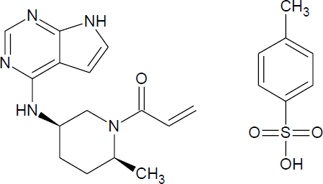
The manufacture of ritlecitinib tosylate drug substance includes five synthetic steps followed by a recrystallisation. The drug substance is milled post-recrystallisation. The manufacturing process for the drug product is conventional and involves blending of the drug substance with excipients followed by encapsulation.
LITFULO is presented as an opaque hard capsule with a yellow body and blue cap approximately 16 mm long and 6 mm wide, of which the body is printed with “RCB 50” and the cap is printed with “Pfizer” in black. The proposed shelf life of 30 months when stored below 30°C store in the original container in order to protect from light is adequately supported.

Nonclinical evaluation summary
The submitted nonclinical dossier was in accordance with the relevant ICH guideline for the nonclinical assessment of pharmaceuticals (ICH M3(R2)). The overall quality of the nonclinical dossier was adequate. No major deficiencies were identified. All pivotal safety-related studies were Good Laboratory Practice (GLP) compliant. The evaluator had no nonclinical objection to registration of ritlecitinib for the proposed indication, provided that the clinical benefit to risk profile was considered favourable.
In vitro, ritlecitinib inhibited JAK3 and the five TEC kinase family members (BMX, BTK, ITK, TEC and TXK) through covalent binding, but had no effect on other JAKs (JAK1, JAK2 and TYK2).
Ritlecitinib was also shown to inhibit JAK3-dependent STAT phosphorylation but was less effective against non-JAK3-dependent processes. In a mouse model of AA, ritlecitinib reduced skin inflammation and suppressed T cell proliferation and function, thereby preventing or reversing hair loss and supporting the proposed clinical indication. Main human metabolite M2 is pharmacologically inactive against JAK1, JAK2, JAK3, and TYK2, and TEC kinase family kinases BMX, BTK, ITK, TEC, and TXK.
In an in vitro binding screen against a panel of various human receptors, ion channels and enzymes (including kinases), ritlecitinib inhibited binding of Abl kinase, EGFR kinase and VEGFR2 kinase. Further examination in in vitro studies did not reveal any meaningful functional effects. However, binding of ritlecitinib to off-target proteins (via covalent reaction with thiol groups of cysteine residues) has been observed and has been presumed to occur with several polypeptides or proteins.
Safety pharmacology studies assessed effects of ritlecitinib on the cardiovascular, respiratory and central nervous systems. No adverse effects were seen on CNS or respiratory function in rats. No inhibition of hERG K+ channel tail current was observed at clinically relevant concentrations. No cardiovascular effects were observed at clinically relevant doses in rats and dogs. Ritlecitinib is not predicted to prolong the QT interval in patients.
The pharmacokinetic profile of ritlecitinib in animals was qualitatively similar to that of humans. Absorption was rapid with a similar Tmax observed in all species. Oral bioavailability was comparable between rodents and humans (61-85% cf. ~64%, respectively). Plasma half-life was short in all species, ranging between 0.33 h in rats to 1.1 in dogs (cf. 1.3–2.3 h in humans). Plasma protein binding of ritlecitinib was variable across species, with low binding in dogs, monkeys and humans, and high in rodents and rabbits (free fraction of mice 0.22, rabbits 0.29, rats 0.67, dogs 0.82, monkeys 0.86 and humans 0.86). Tissue distribution of ritlecitinib- associated radioactivity was wide, with highest concentrations seen in metabolic and excretory system organs, as well as in the uveal tract, thyroid gland, adrenal glands and whole blood; however, penetration into brain and spinal cord was very limited in rats.

However, in orally dosed dogs ritlecitinib and main metabolite M2 were present in brain tissue extracts (superior olivary nucleus, cochlear nucleus, and hippocampus), suggesting that the ability for ritlecitinib and its metabolites to cross the blood-brain barrier may vary across species. Biotransformation of ritlecitinib involves glutathione-related conjugation and CYP-mediated oxidative reactions, resulting in mainly conjugates of glutathione, N-acetylcysteine, cysteine-glycine and cysteine, and products of hydroxylation. No unique human metabolites were identified. Major human metabolite M2 (a cysteine conjugate) showed negligible protein binding in all species. Adequate multiples of clinical exposures to M2 were demonstrated in a rat bridging study. Drug-related material excretion occurs via urinary and faecal routes, with urine the predominant route in humans.
Based on in vitro studies, ritlecitinib is a substrate of CYP3A4/5, CYP1A2, CYP2C8 and CYP2C9. Inhibitors and inducers of these enzymes may alter systemic exposures to ritlecitinib.
Ritlecitinib is also a substrate for P-gp and BCRP but high apparent passive permeability under in vitro conditions suggests inhibitors of these transporters are unlikely to affect ritlecitinib absorption. Ritlecitinib is a reversible inhibitor of CYP3A4/5 and time-dependent (irreversible) inhibitor of CYPs 3A and 1A2 and therefore may alter the exposure of co-administered drugs that are CYP3A4/5 and CYP1A2 substrates. In vitro ritlecitinib inhibited transporters BCRP, OAT3, OATP1B1, OCT1, OCT2, MATE1 and MATE2K at clinically relevant concentrations. Main metabolite M2 was also shown to inhibit BCRP, P-gp, OATP1B1, OATP1B3 and OCT1.
Ritlecitinib had a low order of acute oral toxicity in rats and dogs.
Repeat-dose toxicity studies were conducted in rats (up to 6 months) and dogs (up to 9 months). Maximum exposures (AUC) were moderate to high in mice, and high in rats and dogs.
Treatment-related effects were seen in the immune and haematolymphopoietic systems of rats and dogs, and central and peripheral nerves of dogs. Ritlecitinib dose-dependently decreased white blood cells, lymphocytes, monocytes, eosinophils and basophils, and decreased lymphoid cellularity in organs associated with haematopoiesis (e.g., thymus, spleen, GALT). Associated with these effects was over-immunosuppression, which was observed in dogs at high doses, and manifested mainly as systemic skin infections.
A notable treatment-related finding (observed only in dogs) was axonal dystrophy of central and peripheral nerves, seen microscopically as spheroids, with no other signs of degeneration, necrosis or inflammation. Axonal dystrophies correlated with functional neurological impairments (loss of hearing capacity and brain-stem auditory evoked potential waveform defects) and occurred at low safety margins (7× the clinical free AUC). A role for JAK3 was ruled out; however, no other definitive mechanism was identified, and it remains uncertain whether effects are clinically relevant or dog-specific. As cumulative exposures to ritlecitinib were an important factor in development of axonal dystrophy, potential risk to patients taking ritlecitinib long-term cannot be ruled out.
Warning statements have been included in the draft Product Information on these findings.
In vitro, ritlecitinib was not mutagenic in the bacterial reverse mutation assay but was positive in the micronucleus assay in a human lymphoblast cell line (TK6 cells) – an effect established to be due to an aneugenic mode of action. In vivo, ritlecitinib returned negative findings in the rat micronucleus test following repeat daily dosing for 8 weeks and at high relative exposures (81× the clinical free C_{max}). Thus, although ritlecitinib is an in vitro aneugen, the in vivo and clinical relevance is low.
No treatment related increase in tumour incidence was observed in the 6-month carcinogenicity study in mice. In the 2-year study in rats, ritlecitinib was associated with a higher incidence of benign and malignant thymomas, as well as hyperplasia in the thymus. There was also a dose- related increase in benign thyroid follicular adenomas and combined follicular adenomas and carcinomas rats, which are generally regarded as rodent-specific neoplasms with little relevance to humans. The clinical relevance of the thymomas is unknown but common to JAK inhibitors and may be related to chronic immunosuppression. Relative exposure at the no-observed-adverse-effect level (NOAEL) and no-observed-adverse-effect level (NOEL) were 6 and 1.9, respectively.
Findings from the rat fertility study suggest that ritlecitinib has the potential to impair male fertility. Oral administration of ritlecitinib to pregnant rats and rabbits during organogenesis caused adverse developmental outcomes including embryo-fetal mortality (post-implantation loss), reduced fetal weights, delayed fetal ossification and increased incidences of fetal malformations and variations at systemic exposures 49× and 55× the clinical unbound AUC in rats and rabbits, respectively. Ritlecitinib was shown to concentrate in the milk of lactating rats Ritlecitinib is contraindicated in pregnancy and breastfeeding.
In a rat juvenile toxicity study, oral administration of ritlecitinib (PND day 10 to 60, comparable to infant through adolescence human age) was not associated with effects on growth and development (including effects on the skeletal and nervous systems and neurobehavior) at exposures 19 times the unbound AUC at the MRHD. Delayed attainment of balanopreputial separation and vaginal patency (denoting sexual maturity) was observed in the rat pre-/ postnatal development study and was considered secondary to reduced postnatal weigh gain. Ritlecitinib had no other effects on pre-/postnatal development in rats.
No ritlecitinib-related hypersensitivity was observed in the mouse allergy model.
There was no evidence of dermal or ocular phototoxicity in pigmented rats dosed with ritlecitinib.
The following are the key conclusions from the nonclinical evaluation:
- Studies demonstrated pharmacological activity for the intended targets: JAK3 and TEC family kinases.
- Ritlecitinib is (an irreversible) time-dependent inhibitor of CYP3A and CYP1A2 and may increase exposures of substrates of these enzymes, when co-administered.
- Off-target binding of ritlecitinib due to covalent binding was observed with several proteins (e.g. human serum albumin, glutathione, CYP3A4, UGT1A1, MAP2K7 and DOCK10) and may be of clinical interest.
- The collective safety studies indicated the following as potentially clinically relevant:
- Decreases in lymphocytes, decreased lymphoid cellularity in spleen, thymus, and generalised immunosuppression with a consequent higher risk of opportunistic infection and malignancies.
- Axonal dystrophies in central and peripheral system nerves of dogs, with no definitive cause identified, that were associated with functional impairments to hearing capacity.
- Impairments to male fertility
- Embryotoxicity and teratogenicity in rats and rabbit
- Adverse embryofetal development findings support a Pregnancy Category D for ritlecitinib.

Clinical evaluation summary

Summary of clinical studies
The phase 2/3 clinical development program for ritlecitinib comprised four interventional and three non-interventional studies and one interventional study with patients with vitiligo. The three non-interventional studies included a patient preference study (048) and two cohort studies (051 and 049) examining demographic and clinical characteristics of patients with AA. The main clinical study in AA was the pivotal placebo-controlled dose-ranging phase 2b/3 study B7981015 (Study 015), which was supported by a phase 2a randomized double blind placebo- controlled study B7931005 (05) and an open-label phase 3 study (032). The latter study is ongoing. Studies 015 and 032 included both adults and adolescents ≥12 years of age, the rest of the studies were performed in adults only.

Pharmacology
The sponsor submitted 21 studies in healthy volunteers and in patients with AA to describe the pharmacokinetics (PK) of ritlecitinib. In addition, PK data were included in population PK (popPK) analyses.

Pharmacokinetics
After oral dosing, maximal plasma concentrations of ritlecitinib in adults were reached about one hour after administration.
The absolute bioavailability of ritlecitinib is about 64%. Based on oral and intravenous administration of the labelled active substance, the relative urinary recovery (oral/intravenous) of the labelled compounds was about 89%, indicating a high fraction absorbed. After a single dose of ritlecitinib, Cmax increased dose proportionally; ritlecitinib AUC_{inf} increased dose- proportionally with up to 200 mg dosing, but more than dose-proportionally between 200 and 800 mg doses.
In multiple daily dose studies steady state was achieved after about four days, and the estimated accumulation ratio was about 1.45 (popPK estimation). The elimination half-life was approximately two hours. The accumulation indicates non-stationary PK characteristics, where ritlecitinib clearance (CL) changes following multiple doses resulting in a lower CL than seen with single doses. The mechanism contributing to this change in CL after multiple dosing is not clear.
Non-compartmental and population PK analyses show higher exposures in AA patients than in healthy study participants. The sponsor hypothesised that the inflammatory condition in AA patients leads to reduced ritlecitinib clearance.

Distribution
Ritlecitinib binding to plasma proteins is low, with a free fraction of 86% (14% unbound). Binding is mainly to serum albumin. The blood to plasma ratio was 1.62, indicating distribution to red blood cells.
The volume of distribution of ritlecitinib after intravenous administration is observed to be 74L, indicating substantial tissue distribution.

Metabolism
In vitro, metabolite profiling of ritlecitinib in liver microsomes and hepatocytes indicated that cytochrome P (CYP) 3A4 was the primary CYP contributing to ritlecitinib metabolism.
In plasma, ritlecitinib was the most abundant drug compound (about 30% of total drug-related materials), with a cysteine conjugate of ritlecitinib (M2) as the major circulating metabolite showing abundance of about 17%. Other minor circulating drug-related components included glutathione-related metabolites and downstream oxidations. The abundance of the other metabolites identified in human plasma was trace or minor (<10%). No individual clearance pathway contributed ≥25% of systemic clearance. The total recovery of an orally administered radioactive dose of ritlecitinib over 240 hours post-dose was 85.6±9.2%, with 66.1±13.4% in the urine and 19.5±4.0% in the faeces.
Renal impairment: The PK of ritlecitinib has been evaluated in subjects with severe renal impaired function. The analysis of variance (ANOVA) analysis indicated that AUC_{tau} and C_{max} were 55% and 44% higher in subjects with severe renal impairment, respectively, compared to healthy subjects. These were not considered clinically significant.
Hepatic impairment: The PK of ritlecitinib has been evaluated in subjects with a moderate hepatic impaired function (Child-Pugh B score). ANOVA analysis indicated that AUC_{tau} and C_{max} in subjects with moderate hepatic impairment were 18.5% and 4% higher, respectively, compared to healthy subjects.

Population PK data
PK data and population PK (popPK) analysis were used to evaluate the impact of covariates on the PK of ritlecitinib.
PopPK analysis was conducted iteratively using a model of ritlecitinib in healthy volunteers and patients with moderate-to-severe rheumatoid arthritis, moderate-to-severe AA, moderate-to-severe ulcerative colitis, or active non-segmental vitiligo. The PK of ritlecitinib could be adequately described by a 2-compartment model with first-order oral absorption with a direct response nonstationary clearance and bioavailability driven by peripheral concentrations in the analysis population. Goodness-of-fit plots of the model and a prediction-corrected visual predictive check demonstrated that the model adequately described the time course of ritlecitinib plasma concentrations after oral dosing.
A final model was developed that included healthy volunteers, adults with severe renal impairment, and patients with AA. The final model was also a 2-compartment model with first-order absorption with inter-individual variance on apparent clearance and apparent central volume of distribution, a proportional random unexplained variability model, and non-stationary clearance and bioavailability directly driven by peripheral concentrations. This model introduced a non-stationary effect of ritlecitinib concentrations from the peripheral compartment on both apparent clearance (CL/F) and bioavailability (F). Different structural models were tested in the development, and the model with peripheral concentration dependent CL and F provided the best fit.
Population PK studies estimated geometric mean AUC_{tau} of 1249 ng.h/mL (CV: 73%) and Cmax of 370 ng/mL (39%) with the recommended dosing scheme of 50 mg daily in AA patients.

Pharmacodynamics
Data from the main clinical study B07981015 (Study 015) in participants with AA were used to examine ritlecitinib pharmacodynamics (PD).
The exposure-efficacy analysis characterised the longitudinal relationship between ritlecitinib exposure and Severity of Alopecia Tool (SALT) score. C_{avg} (the average drug concentration during the time interval between the previous and current SALT score) was selected as the exposure metric. Goodness-of-fit and Visual Predictive Checks (VPC) plots indicated that the developed model adequately described the observed data. Based on simulations, the response rate at Week 24 can be influenced by dose interruptions, depending on the length of the period of the interruption. The exposure-response analyses support the choice of a daily dose of 50 mg QD without a loading dose.

Efficacy

B7981015 (Study 015)
Study 015 tested multiple dose regimens, including a 50mg daily dose (QD) regimen following a loading dose of 200mg QD for four weeks, which had been demonstrated to be efficacious and safe in Study 05 in adult or adolescent participants with AA. The study participants were randomised to six treatment arms: ritlecitinib 50 or 30mg QD (either with or without a loading dose of 200mg QD during the first four weeks, referred to as 200/50mg or 200/30mg), ritlecitinib 10mg QD and placebo.
Both ritlecitinib and placebo were provided as tablets for oral administration. The 50 mg and
10 mg tablets and their matching placebos were supplied in blister cards such that all participants took the same number of tablets per day. The placebo- controlled phase lasted 24 weeks, after which participants of the placebo arm were blindly re- assigned to either the 200/50mg or 50mg treatment group. The participants of other arms remained on the originally assigned dose. This Extension Phase lasted another 24 weeks, through to Week 48. Treatment with the study drug was discontinued in case of adverse effects such as serious infections requiring parenteral antimicrobial therapy or hospitalisation for treatment, treatment-related serious adverse event (SAE) or ECG abnormalities. Drugs were discontinued if:
- Absolute neutrophil count <750/mm3 (<0.75 × 109/L);
- Haemoglobin <9.0 g/dL (<5.59 mmol/L or <90 g/L) or a decrease of >30% from baseline (either criterion or both);
- Platelet count <75,000/mm³ (<75.0 × 109/L);
- Absolute lymphocyte count <500/mm3 (<0.5 × 109/L);
- Creatine kinase >10 × upper limit of normal (ULN);
- Aspartate aminotransferase (AST) or alanine aminotransferase (ALT) >3 times ULN with at least one total bilirubin value >2 times ULN, or >3 times ULN accompanied by signs or symptoms consistent with hepatic injury (e.g., new onset elevated PT/INR), or two sequential AST or ALT elevations >5 ULN, regardless of total bilirubin or accompanying signs or symptoms.
Other reasons for discontinuation were pregnancy, suicidal ideation and non-compliance (under certain circumstances).
The primary objective of study 015 was to evaluate the efficacy of ritlecitinib compared to placebo in adults and adolescents with AA with 50% or greater scalp hair loss (SALT score ≥50), on regrowth of lost hair measured as SALT Score ≤10 at Week 24. The key secondary objective was to evaluate the effect of ritlecitinib on patient-reported outcomes as assessed by Patient Global Impression of Change (PGI-C) score of ‘moderately improved’ or ‘greatly improved’ at Week 24. Other main secondary endpoints were: SALT ≤20 at week 24, SALT ≤10 up to week 48 and SALT ≤20 up to week 48; regrowth of eyelashes and of eyebrows up to week 48 as measured by at least a 2-grade improvement from baseline or a score of 3 in Eyelash Assessment (ELA) and Eyebrow Assessment (EBA); the proportion of participants with PGI-C score of ‘moderately improved’ or ‘greatly improved’ up to Week 48 and change in baseline in Alopecia Areata Patient Priority Outcomes (AAPPO) scales up to week 48.
The study participants were 718 adults and adolescents with a diagnosis of AA who passed screening and were randomised to treatment.
The main inclusion criteria were:
- Male or female participants ≥12 years of age at the time of informed consent/assent.
- A clinical diagnosis of AA with no other aetiology of scalp hair loss (e.g. telogen effluvium, androgenic alopecia).
- At least 50% hair loss of the scalp as measured by SALT without evidence of terminal hair regrowth within 6 months at both screening and baseline visits. Participants with AT and AU were included in the study.
- The current episode of scalp hair loss is less than 10 years.
Exclusion criteria included hearing loss with progression over the previous 5 years, sudden hearing loss, middle or inner ear disease, or other auditory condition considered acute, fluctuating, or progressive. Previous use of any JAK inhibitor for use in any disease indication or any non-B-cell selective lymphocyte-depleting agent was also an exclusion criterion.
Topical or systemic treatments which could affect AA such as other JAK-inhibitors, immunosuppressants including steroids, and phototherapy, were prohibited medications during the study. Further, medications with potential drug-drug interactions or potential safety concerns were also prohibited (e.g. lymphocyte-depleting agents, live attenuated vaccines, moderate to potent CYP3A inducers, and some sensitive to moderate sensitive CYP3A substrates).
Any other locally approved medication for other indications in an appropriate dose was allowed. Subjects were instructed to refrain from starting new or changing doses of permitted drugs (including vitamins and dietary supplements) within 7 days or 5 half-lives to Day 1 and prior to study visits throughout the study unless it was considered medically essential.

Results
The majority (85%) of the participants were adults (≥18 years of age), and 15% were adolescents (12 – 17 years of age). The mean age of the participants was 34 years. The proportion of elderly (>65 years of age) participants was limited to <5%. There were more female (62%) than male (38%) participants. Most (60-70%) participants were Caucasian. Age, gender, and race were evenly distributed over treatment groups.
The disease characteristics such as the median duration since AA diagnosis (6.9 years), median duration of the current episode (2.5 years), the proportion of participants with AT or AU (46%) and the mean SALT score (88-93) at baseline were also similar across the groups. Over treatment groups, on average 69% (60-77%) of participants had received prior pharmacologic treatment for AA. The most frequent prior pharmacological treatment for AA were topical corticosteroids (38%); oral/IV/IM steroids (29%); intralesional corticosteroid injection (28%); and topical vasodilator (24%). On average, 25% of participants had received prior non-drug treatments/procedures for AA.
Of the randomised participants, 715 (99.6%) received treatment and 101 (14%) discontinued treatment. The proportions of participants discontinuing during the Placebo-Controlled Period (weeks 0-24) were similar across treatment groups with 5-8%, except for the 30 mg group in which 11% of patients discontinued. During the Extension Period (weeks 25-48), discontinuation ranged from 3.8% (50 mg) to 8.5% (200/30 mg). Overall, 614 (86%) of participants completed treatment. In all groups, adverse events, lack of efficacy and physicians decision were the most common reasons for discontinuation.
The primary endpoint was met. The proportion of participants reporting SALT≤10 responses in the ritlecitinib 200/50mg (21.3%), 200/30mg (12.9%), 50mg (13.4%) and 30mg (10.6%) groups at week 24 were all statistically significantly greater than in the placebo group (1.5%, Table 3). The effect in the ritlecitinib 10mg group did not differ from the effect in the placebo group. The response became statistically different from placebo at week 18 for the ritlecitinib 200/50mg group, or at week 24 for the 200/30mg, 50mg, and 30mg groups.
Table 3: Study 015 Primary outcome: SALT<10 at 24 weeks
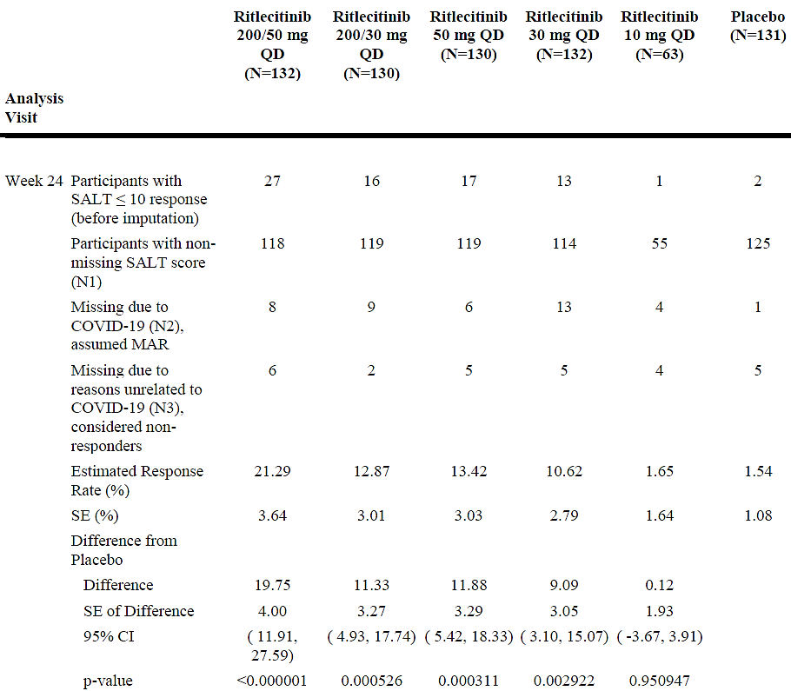
N = Number of participants in the FAS; N=N1+N2+N3.
In this analysis, a generalized linear mixed effect model without imputation using observed data up to Week 24 was used as the imputation model. Estimation of model parameters was performed assuming MAR using Bayesian framework with non-informative/weakly informative prior densities and MCMC. For a participant with missing response at Week 24 that is due to COVID-19, imputation was done based on predictive Bernoulli distribution with a probability equal to the probability under MAR calculated using the sampled parameters.
Participants with missing SALT score at Week 24 due to reasons other than COVID-19 were considered non-responders.
A single complete imputed data set for Week 24 was analyzed using the Miettinen and Nurminen method as the analysis model.
The proportion of participants with SALT≤10 continued to increase beyond week 24. While at week 24, the proportion of participants with SALT ≤10 was greater in participants who had received a 200mg loading dose for four weeks than in participants treated for 24 weeks without
a loading dose, by week 48 the proportion of participants with SALT≤10 was similar between the participants who received a 200mg loading dose for four weeks and those who were treated for 48 weeks without a loading dose: 200/50mg (33%) versus 50mg (31%); 200/30mg (28%) versus 30mg (25%).
The key secondary endpoint was met. In all ritlecitinib treatment groups except 10mg QD statistically significantly more patients reported “moderately improved” or “greatly improved” hair loss on PGI-C at 24 weeks than participants receiving placebo (200/50mg: 52.2%, 200/30mg: 45.4%, 50mg: 49.2%, 30mg: 42.0%, PBO: 9.2%).
Other secondary outcomes and sensitivity analyses supported the clinical findings. Of note, the proportions of study participants achieving SALT≤20 by week 24 in the 200/50mg (29.9%), 200/30mg (21.7%), 50mg (23.0%), and 30mg (13.8%) treatment groups were all statistically significantly greater than in the placebo group (1.6%).
Of participants who were re-randomised from placebo to ritlecitinib 200/50mg or 50mg after week 24, 25% and 14% respectively achieved SALT≤10 by 48 weeks (24 weeks on active treatment). Subgroup analysis of SALT≤10 responses in the group treated with 50mg ritlecitinib without a loading dose supported the overall efficacy outcome, however in some smaller subgroups, including the adolescent cohort, confidence intervals included 0 (Figure 1).
Figure 1: Study 015 Forest plot SALT≤10 at 24 weeks by sub-group, 50mg daily dosing
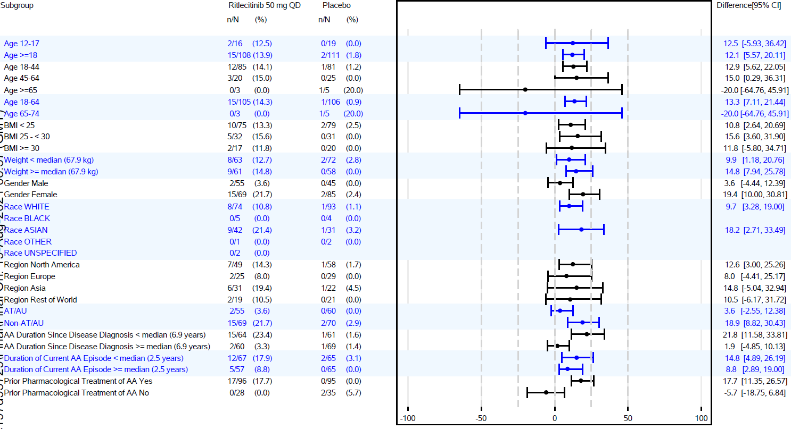

B7931005 (Study 05)
Study 05 consisted of three periods: a 24-week double-blind treatment period, a four week ‘drug holiday’ followed by a 24-week single-blind extension period, and a 24-week cross-over open label period. Patients who had at least 50% hair loss of the scalp (SALT score ≥50%) without evidence of hair regrowth within the previous six months and a current episode of hair loss not longer than seven years were randomised (2:1) to ritlecitinib or to placebo (an additional treatment arm with brepocitinib is not further discussed). Patients and investigators were blinded for treatment allocation.
The primary endpoint was the change in SALT score from weeks 0-24. Secondary outcomes calculated post-hoc included improvements >2 grade in Numeric Rating Scale (NRS) for eyelash and eyebrow hair growth and SALT10. The induction dose of ritlecitinib was 200mg QD for four weeks, followed by 20 weeks of 50mg QD.
Patients who had completed the double-blind phase were eligible for the single-blind extension phase. Patients who were responders (decrease of >30% from baseline SALT score) were treated with placebo for up to 24 weeks to evaluate the course of hair loss and were retreated with ritlecitinib if the SALT score increased to >30%. Non-responders to ritlecitinib or placebo (n=33) were continued/commenced on ritlecitinib during the second 24 weeks.
At baseline, there were 48 participants included in the ritlecitinib group and 47 participants included in the placebo group. After 24 weeks, 34 (72%) of the patients in the placebo group and 45 (94%) of the patients in the ritlecitinib group had completed the study. In each group, two patients had discontinued treatment for adverse events.
The primary outcome measure was the Least Squares Means (LSM) difference in SALT score from baseline up to week 24 between ritlecitinib 200/50mg and placebo. The primary outcome was met with a LSM difference of 31% (95% CI:19%,44%; p<0.0001). The change from baseline in SALT score in the placebo group was 1.4%. The proportion of patients who had a SALT10 response at week 24 (post-hoc calculation of primary endpoint in the pivotal study), was 25% in the ritlecitinib 200/50mg group and 0% in the placebo group (p<0.001).
Additional studies in different patient populations and of varying duration support the pivotal study, and in combination the studies have sufficiently demonstrated efficacy as revealed by primary and secondary outcomes at various time-points and across various subgroups.

Safety
The clinical development programme of ritlecitinib in AA included 21 phase 1 studies, 4 phase 2/phase 3 studies in AA and 1 phase 2b study in vitiligo. The study in vitiligo was considered relevant for the evaluation of safety in AA owing to similarities between the AA and vitiligo populations, similar ritlecitinib dosing regimens and similar safety monitoring protocols.
The Phase 2/3 studies included in the all exposure pool are summarised in Table 4.
Table 4: Studies included in the all exposure pool
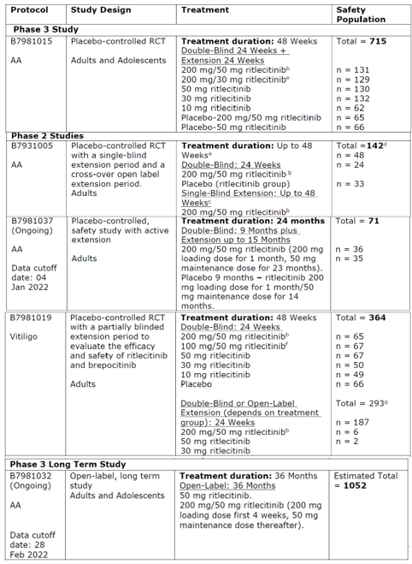
a. Cross-Over Open Label Extension Period is not included.
b. 200 mg loading dose first 4 weeks, 50 mg maintenance dose for 20 weeks
c. Single-Blind Extension noted here only includes the Non-Responder Segment.
d. Brepocitinib group included, therefore total number of participants is greater than the placebo and ritlecitinib groups combined.
e. 200 mg loading dose first 4 weeks, 30 mg maintenance dose for 20 weeks
f. 100 mg loading dose first 4 weeks, 50 mg maintenance dose for 20 weeks
g. Brepocitinib and ritlecitinib + nbUVB included, therefore total number of participants is greater than the ritlecitinib groups combined.
The cumulative exposure to ritlecitinib in the Phase 2/3 studies in AA or vitiligo is summarised in Table 5.
Table 5: Ritlecitinib exposure, Phase 2/3 studies in AA, or vitiligo
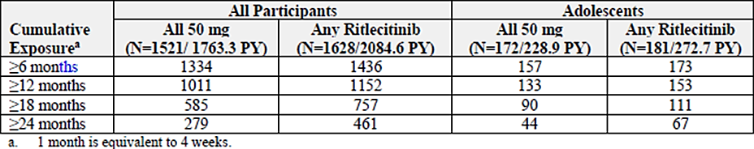
The frequencies of treatment-emergent adverse events, including serious adverse events and severe adverse events, were generally similar in patient groups with AA treated with ritlecitinib and with placebo. Temporary discontinuations from study drug were higher in ritlecitinib groups than in placebo, but discontinuations from the study for adverse events were similar (Table 6).
Table 6. Summary of treatment emergent adverse events (placebo-controlled AA pool)
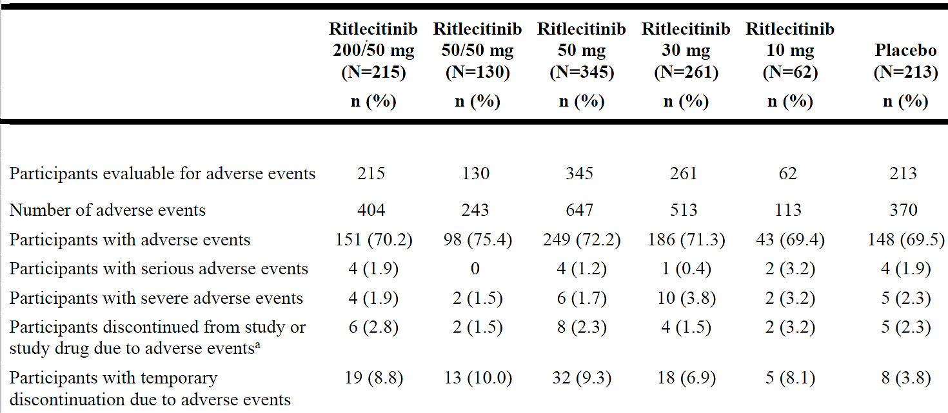
Placebo-Controlled AA Pool includes the placebo-controlled portion of studies B7931005 (0-24 weeks), B7981015 (0-24 weeks) and B79S 1037 (0-24 weeks).
Ritlecitinib 50 mg: participants from Ritlecitinib 200/50 mg and 50/50 mg QD combined: Ritlecitinib 30 mg: participants from Ritlecitinib 200/30 mg and 30/30 mg QD combined.
Except for the Number of Adverse Events, participants are counted only once per treatment in each row.
Serious Adverse Events - according to the investigator's assessment
a. Participants who had an AE record that indicated that the AE caused the participant to be discontinued front the study or study drug.
MedDRA v24.1 coding dictionary applied.
B7981037 data cutoff date: 4 January 2022.
In the placebo-controlled AA pool, the most frequent events (2% in any treatment group) that occurred more commonly (>1%) in the ritlecitinib 50/50 mg group than in the placebo group included: nasopharyngitis, diarrhoea, headache, acne, urticaria, rash, upper abdominal pain, pyrexia, folliculitis, SARS-CoV-2 test positive and Covid-19, dizziness, and atopic dermatitis. When groups taking either 200/50 mg or 50/50mg were combined (combined 50mg group) tinnitus, gastroenteritis, nasopharyngitis, blood creatinine phosphokinase increased, and back pain, were more common in the combined group as compared to placebo (Table 7).
Infections and infestations (SOC) occurred in 38% of patients in the combined 50 mg group, in 37% in the combined 30 mg group, in 32% in the 10 mg group and in 31% of the placebo group; this proportion was higher in the 200/50 mg group (41%) as compared to the 50/50 mg group (33%). Herpes zoster was infrequent; reported in two patients (1.5%) of the 50/50 mg group and in two patients (0.8%) of the 30 mg group, but not in the 10 mg group or the placebo group (Table 7).
Table 7: Adverse events in the placebo-controlled AA pool by System Organ Class and Preferred Term
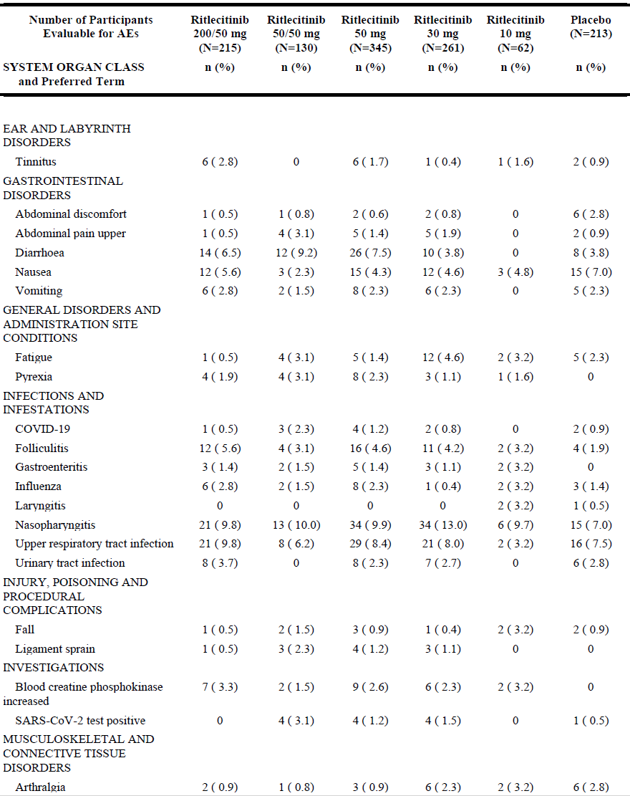
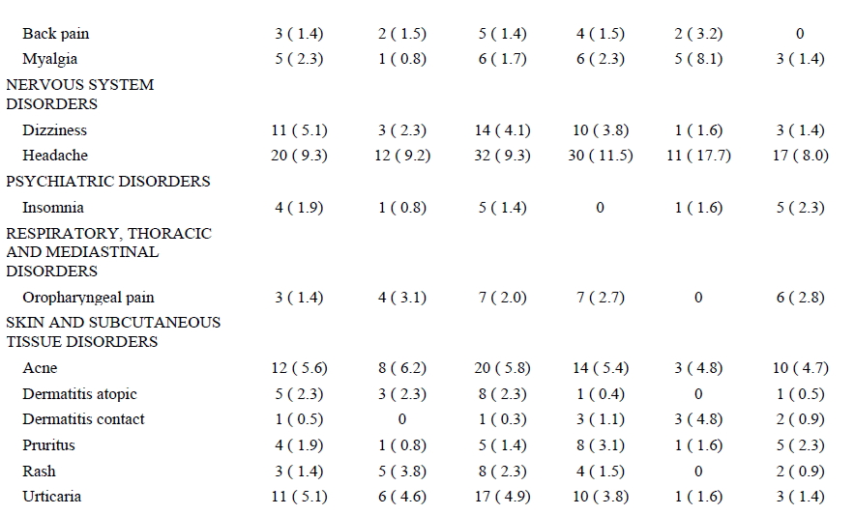
Placebo-Controlled AA Pool includes the placebo-controlled portion of studies B7931005 (0-24 weeks), B7981015 (0-24 weeks) and B7981037 (0-24 weeks)
Ritlecitinib 50 mg: participants from Ritlecitinib 200/50 mg and 50/50 mg QD combined; Ritlecitinib 30 mg: participants from Ritlecitinib 200/30 mg and 30/30 mg QD combined
Participants are only counted once per treatment per event
MedDRA v24.1 coding dictionary applied.
B7981037 data cutoff date: 4 January 2022.
No treatment-related deaths have been reported in patients receiving ritlecitinib. Although three deaths have been reported across all ritlecitinib studies, they were not considered treatment-related. Cause of death was breast cancer in one patient and acute respiratory failure in one patient in the AA studies, and severe myocardial infarction in one patient (in an Ulcerative Colitis clinical study).
Serious adverse events (SAE) were uncommon in the 50/50 mg groups. In the one-year exposure pool, the System Organ Classifications (SOC) of ‘Infections and Infestations’ and of ‘Neoplasms’ included the highest proportions of participants with SAEs. There were relatively more participants with an SAE in the combined 50 mg group (n=6, 2.3%) as compared to the 30 mg group (1.1%) but not the 10 mg group (3.2%). SAEs that had occurred in the 50 mg group were: appendicitis, empyema, sepsis, breast cancer and invasive lobular breast cancer, spontaneous abortion, and pulmonary embolism. SAEs of appendicitis, diverticulitis, chemical poisoning, and suicidal behaviour had occurred in the 30 mg group. In the 10 mg group, there was a SAE of suicidal behaviour and one of eczema.
Infections, malignancies and non-melanoma skin cancers (NMSC), major adverse cardiovascular events (MACE) and thromboembolic events were considered adverse events of special interest (AESI) in consideration of class effects reported for other JAK inhibitors. In addition, neurological and audiological findings were specifically considered in light of the preclinical study findings of axonal dystrophies in central and peripheral system nerves of dogs, with no definitive cause identified.
Overall, the occurrence of malignancies, NMSC, MACE and thromboembolic events in the clinical population was low. In view of the relatively short safety follow up period in the studies, it is appropriate that they should be included as precautions in the product information at this point while causality cannot be excluded. Similarly, there were no reports of significant neurotoxicity in the clinical studies. Potential participants were excluded from the AA studies if they had underlying hearing loss or middle or inner ear disease.
While preclinical studies have indicated that there is potential for embryofetal toxicities and for effects on male fertility, there is no human data available. Ritlecitinib has been appropriately recommended to carry a Category D pregnancy warning, and the product information carries warnings regarding appropriate contraception while taking ritlecitinib.
The safety profile of ritlecitinib is considered acceptable, taking note of the precautions and warnings that will be included in the PI. It should be prescribed and its use monitored by a medical professional with expertise in alopecia areata and after a considered individual risk-benefit assessment.

Risk management plan
Pfizer Australia Pty Ltd submitted EU-RMP version 1.2 (date 18 July 2023; DLP 30 May 2022) and Australia-specific annex (ASA) version 1.0 (date 19 October 2023) in support of this application. The sponsor provided an updated ASA version 1.1 (date 12 April 2024).
The summary of safety concerns and their associated risk monitoring and mitigation strategies are summarised in Table 8. The TGA may request an updated RMP at any stage of a product's life-cycle, during both the pre-approval and post-approval phases.
Table 8: Summary of safety concerns
Summary of safety concerns |  | Pharmacovigilance |  | Risk Minimisation
 |  | Routine | Additional | Routine | Additional
Important identified risks | Herpes zoster | ✓ | *†‡ |  | ✓¶
Important potential risks | Serious and Opportunistic infections |  | *†‡ |  | ✓
Important potential risks | Malignancy |  | *†‡ |  | ✓
Important potential risks | Thromboembolic events including deep vein thrombosis, pulmonary embolism and arterial thrombosis |  | *†‡ |  | ✓
Important potential risks | Embryofoetal toxicity following exposure in utero |  | ✓† |  | ✓
Important potential risks | Major adverse cardiovascular events (MACE) |  | *‡ |  | ✓
Important potential risks | Neurotoxicity |  | *‡ |  | ✓
Missing information | Long-term safety |  | *‡ | – | –
Missing information | Long-Term safety in adolescent patients including growth and bone development, and maturation and pubertal development. |  | *‡ | – | –
*Surveillance study (PASS)
†Drug utilisation study
‡Long-term safety & efficacy phase 3 study
¶HCP Guide & Patient card
The risk minimisation plan is acceptable. The sponsor will provide draft copies of additional risk minimisation materials to the TGA for review 6 weeks prior to launch.
The delegate notes that the FDA approved product information includes a boxed warning with advice regarding serious infections, mortality, malignancy, MACE and thrombosis. The EU SmPC does not include a boxed warning, but these risks are appropriately discussed in warnings and precautions. The same approach is acceptable for the Australian product information.
The US PI (Section 8.1) states that there is a Pregnancy Exposure Registry and advises to report if a patient becomes pregnant while receiving LITFULO. However, a pregnancy registry is not mentioned in the EU RMP or the EU SmPC. The sponsor has not proposed to include Australian patients who get exposed to LITFULO in a registry.

RMP evaluator recommendations regarding condition/s of registration
Any changes to which the sponsor has agreed should be included in a revised RMP and ASA. However, irrespective of whether or not they are included in the currently available version of the RMP document, the agreed changes become part of the risk management system.
The suggested wording is:
The LITFULO EU-Risk Management Plan (RMP) (version 1.2, date 18 July 2023; DLP 30 May 2022), with Australia-Specific Annex (version 1.1, date 12 April 2024), included with submission PM-2023-04714-1-1, and any subsequent revisions, as agreed with the TGA will be implemented in Australia.
An obligatory component of risk management plans is routine pharmacovigilance. Routine pharmacovigilance includes the submission of periodic safety update reports (PSURs).
Reports are to be provided in line with the current published list of EU reference dates and frequency of submission of PSURs until the period covered by such reports is not less than three years from the date of this approval letter. Each report must be submitted within ninety calendar days of the data lock point for that report.
The reports are to at least meet the requirements for PSURs as described in the European Medicines Agency’s Guideline on good pharmacovigilance practices (GVP) Module VII- periodic safety update report (Rev 1), Part VII.B Structures and processes. Note that submission of a PSUR does not constitute an application to vary the registration.
LITFULO is to be included in the Black Triangle Scheme. The PI and CMI for LITFULO must include the black triangle symbol and mandatory accompanying text for five years, which starts from the date of first supply of the product.

Discussion
Ritlecitinib is a tyrosine kinase inhibitor that targets JAK3 and TEC kinases, with no or little effect on JAK1 and JAK2. This may be considered a distinguishing feature from other registered JAK inhibitors that have been associated with major adverse cardiovascular events, thromboembolic events and malignancies in an older patient population with rheumatoid arthritis. At present, the submitted safety data does not support a similar association for ritlecitinib, although the potential for long term use may reveal a relationship. This unknown has been addressed by the sponsor in both the risk management program and appropriately in the proposed product information. A boxed warning regarding the JAK associated adverse events was considered, but in alignment with the COR evaluation, these conditions are considered appropriately addressed in the warnings of the proposed product information.
A second concern, the potential for neurotoxicity in humans, has been addressed by the sponsor. The sponsor defended their stance that sensorineural hearing loss is not likely to be a safety concern for ritlecitinib, and that reversible central auditory toxicities were seen only in dogs at doses well beyond maximum recommended human doses. However, a warning has been included in the proposed product information and clinicians would be expected to consider this potential risk with their patients.
Although the pivotal and supporting clinical studies considered several dosage regimens that were proven to be efficacious in populations with AA and hair loss of between 50% and 100%, the applicant has proposed to register a dose of 50mg daily without a loading dose. This is considered appropriate given that after 48 weeks of treatment the efficacy of the 50mg dose without a loading dose was similar to that of the 50mg dose with a loading dose. Furthermore, in the placebo-controlled studies, for up to 24 weeks, severe adverse events including infections and malignancy (one case each), were seen with the loading dose regimen and not without the loading dose.
It is also noted that while the pivotal study was not powered to examine efficacy in sub-groups, at baseline between 23% and 40% of study participants in the different treatment arms had not had prior pharmacological treatment for AA. The Forest plot of efficacy in the population receiving the proposed dose numerically did not favour ritlecitinib in the small number of participants in this sub-group, however it seems unlikely that it would be more efficacious in patients for whom other treatments had failed than in treatment-naïve populations. Ritlecitinib represents an important addition to the armamentarium of treatments for AA.

Assessment outcome
Based on a review of quality, safety, and efficacy, the TGA decided to register LITFULO (ritlecitinib) for the following indication:
The treatment of severe alopecia areata in adults and adolescents 12 years of age and older

Product Information and Consumer Medicines Information
For the most recent Product Information (PI) and Consumer Medicines Information (CMI), please refer to the TGA PI/CMI search facility.

Therapeutic Goods Administration
PO Box 100 Woden ACT 2606 Australia
Email: info@tga.gov.au Phone: 1800 020 653 Fax: 02 6203 1605
https://www.tga.gov.au

This is the original indication proposed by the sponsor when the TGA commenced the evaluation of this submission. It may differ to the final indication approved by the TGA and registered in the Australian Register of Therapeutic Goods.
Messenger AG. (2024) Alopecia areata: Clinical manifestations and diagnosis, UpToDate (Updated Apr 29, 2024; viewed June 10, 2024).
Sinclair R, Eisman S, Song W, Heung B, Surian C, Lee CMY, Witcombe D. Incidence and prevalence of alopecia areata in the Australian primary care setting: A retrospective analysis of electronic health record data. Australas J Dermatol. 2023 Aug;64(3):330-338. doi: 10.1111/ajd.14126. Epub 2023 Jul 6. PMID: 37408523.
Messenger AG. (2024)
Alopecia areata [published 2022 Aug]. In: Therapeutic Guidelines. Melbourne: Therapeutic Guidelines Limited; accessed 10 June 2024. https://www.tg.org.au
International Council for Harmonisation of Technical Requirements for Pharmaceuticals for Human Use. ICH guideline M3(R2) on non-clinical safety studies for the conduct of human clinical trials and marketing authorisation for pharmaceuticals. December 2009.
Severity of Alopecia Tool (SALT) is a quantitative assessment tool of AA severity based on measures of terminal hair loss from the scalp. The score can vary between 0% (no hair loss) to 100% (100% hair loss) and represents an absolute value.
Alopecia Areata Patient Priority Outcomes (AAPPO) questionnaire developed to assess hair loss signs, emotional symptoms, and activity limitations associated with AA.

