User guide for viewing and responding to notifications on the Consent for Non-compliance Dashboard on the TGA Business Services (TBS) Portal
  - User guide for viewing and responding to notifications for devices that are part of a consent application

Version 2.0, June 2025

Copyright

© Commonwealth of Australia 2025
This work is copyright. You may reproduce the whole or part of this work in unaltered form for your own personal use or, if you are part of an organisation, for internal use within your organisation, but only if you or your organisation do not use the reproduction for any commercial purpose and retain this copyright notice and all disclaimer notices as part of that reproduction. Apart from rights to use as permitted by the Copyright Act 1968 or allowed by this copyright notice, all other rights are reserved and you are not allowed to reproduce the whole or any part of this work in any way (electronic or otherwise) without first being given specific written permission from the Commonwealth to do so. Requests and inquiries concerning reproduction and rights are to be sent to the TGA Copyright Officer, Therapeutic Goods Administration, PO Box 100, Woden ACT 2606 or emailed to <tga.copyright@tga.gov.au>.

Contents
Introduction 4
The consent for Non-compliance Dashboard 5
Viewing a notification 8
Responding to a notification 12
Consent approved notification 12
Additional information notification 21
Other notification 23
Regulatory notifications that do not require a response 23
Regulatory notifications that require a response 24
Request an extension to a notification response 26

Introduction
This document provides guidance on how to view and respond to notifications related to medical devices that are part of an application for consent to import, supply, or export that do not meet with the Essential Principles (EPs). There is a separate guidance document for drafting and submitting an application for consent.
Notifications can include an informal request for additional information regarding a submitted application, letters advising of the outcome of an application submission, and regulatory letters related to devices that are part of an approved consent application.

The Non-compliance Dashboard
- Log in to the TBS portal.
- In the ‘Applications’ drop-down menu, select the ‘Regulatory Compliance’ heading (Figure 1).
- Under ‘Regulatory Compliance’, choose the ‘Medical Device Post Market Compliance’ option (Figure 1).
- You will be taken to the ‘PMR Compliance Dashboard’ (Figure 2).
- Select the ‘Consent for Non-compliance Applications’ tile.
- Access the ‘Consent for Non-compliance Dashboard’.
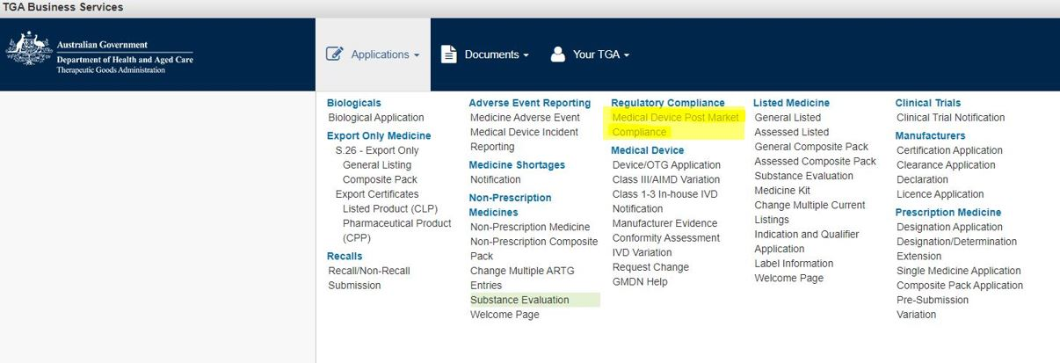
Figure 1
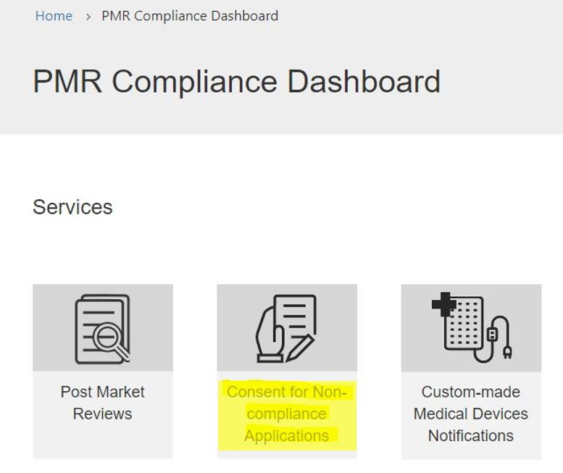
Figure 2
- On the ‘Consent for Non-compliance Dashboard’, you will find three tabs to (Figure 3):
  - View and edit ‘Draft’ consent applications.
  - View ‘Submitted’ consent applications.
  - View, edit, and respond to ‘Notifications’ related to consent applications.
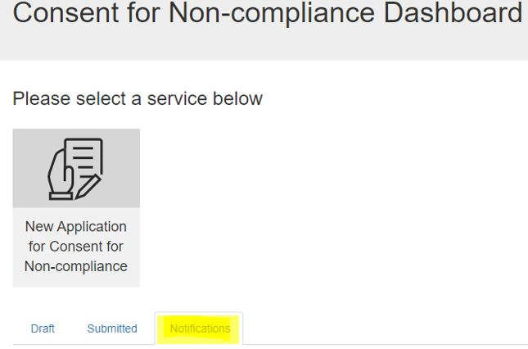
Figure 3

This guidance document only relates to the features found in the ‘Notifications’ tab.


Note
The screenshots shown below are what will be displayed if your application is in relation to ‘Device(s) included in the ARTG’ or ‘Device(s) included in Applications for Inclusion).’ Although the section text and table column headers maybe different for applications related to Device(s) NOT included in the ARTG or Applications for Inclusion’, the process of viewing and responding to a notification is the same as outlined below.

- Click on the ‘Notifications’ tab to view notifications related to submitted consent applications (Figure 4).
- Use the search box (indicated by the magnifying glass symbol) to search for a notification by (Figure 4):
  - Name (title) of the application
  - Consent application ID
  - Notification ID
- The search function allows for partial text searches by typing an asterisk (*) as the wildcard character.
- Sort the table by clicking on the column heading to change the order by:
  - Notification ID
  - Application name
  - Notification type
  - Notification status
  - Response due date
  - Received date
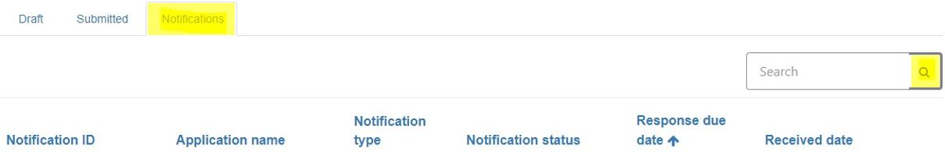
Figure 4

Viewing a notification
- On the ‘Notifications’ tab, you will see a list of notifications for the submitted consent applications (Figure 5).
- The notifications table is by default set up in ascending order of ‘Response due date’.
- The notification with the earliest response due date will appear at the top of the list.
  - For example, a notification with a response due date of 31 January 2023 will appear above a notification with a response due date of 19 August 2023.
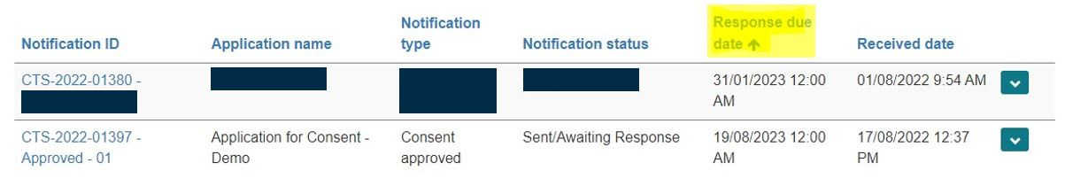
Figure 5

- To view a notification (Figure 6):
  - Click on the down-arrow on the right-hand side of the row.
  - Select ‘View details’.
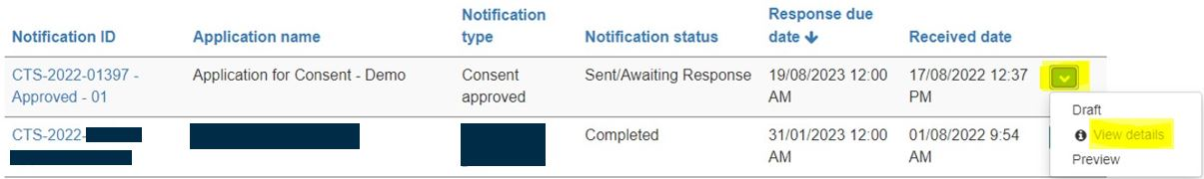
Figure 6

- This will display the ‘Consent for Non-compliance – Notification View’ page (Figure 7).
- On this page, there are five non-editable sections related to the notification.
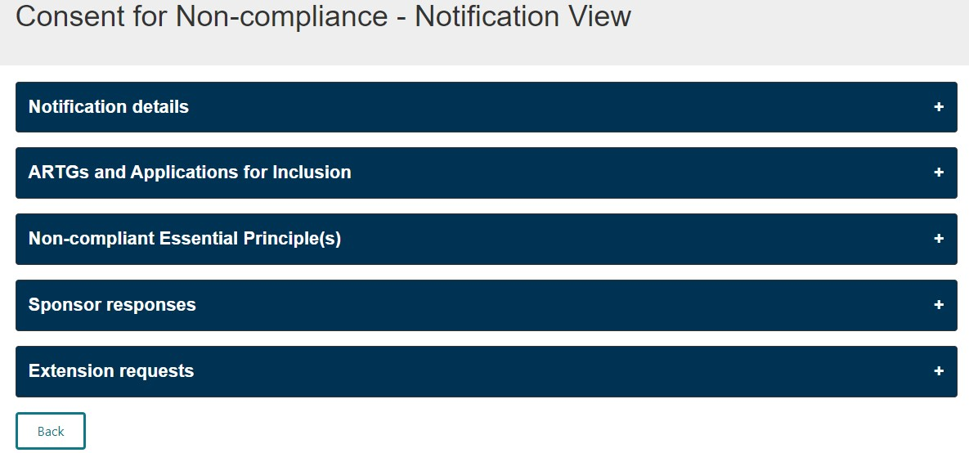
Figure 7

- Click on the ‘Notification details’ section (Figure 7) to view:
  - Notification ID and type (Figure 8)
  - Consent to Supply (CTS) application number (to be quoted in communication with the TGA regarding this notification) (Figure 8)
- Click on the ‘Emails’ folder at the bottom of this section to view (Figure 8):
  - The email and letter associated with the notification sent by the TGA
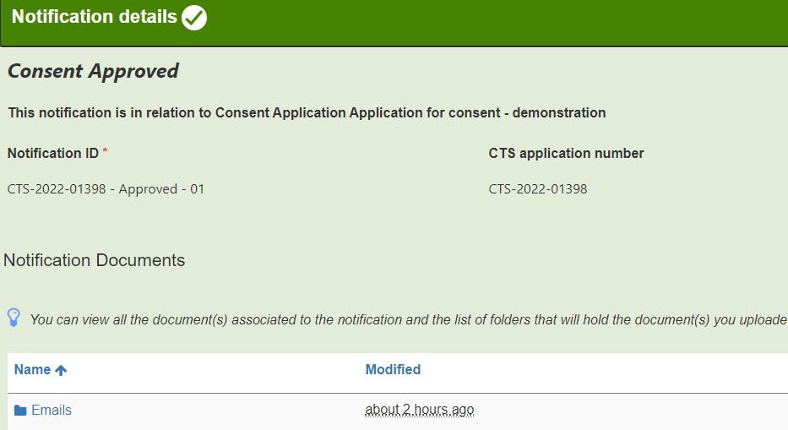
Figure 8

- Any documents uploaded as part of a response to a notification will be listed under the ‘Notification Documents’ section once the response is saved.
- The ‘Notification details’ section will change colour from blue to green when clicked upon, indicating that all mandatory information in this section is auto-populated and complete.
- Click on the ‘ARTGs and Applications for Inclusion’ or ‘Non-included devices’ section to view the devices related to the notification (Figure 9).

NOTE: A notification may be related to all or only some of the devices in the consent application.

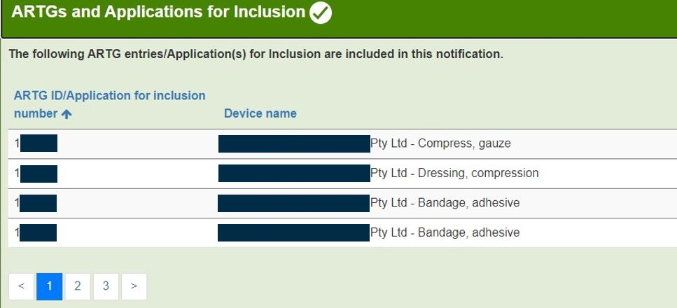
Figure 9

- This section will change colour from blue to green when clicked upon, indicating that all mandatory information in this section is auto-populated and complete.
- Click on the ‘Non-compliant Essential Principle(s)’ section to view the Essential Principles (EPs) related to the notification (Figure 10).

NOTE: The EPs in this section may differ from those selected in the application for consent and are populated by the Therapeutic Goods Administration (TGA).

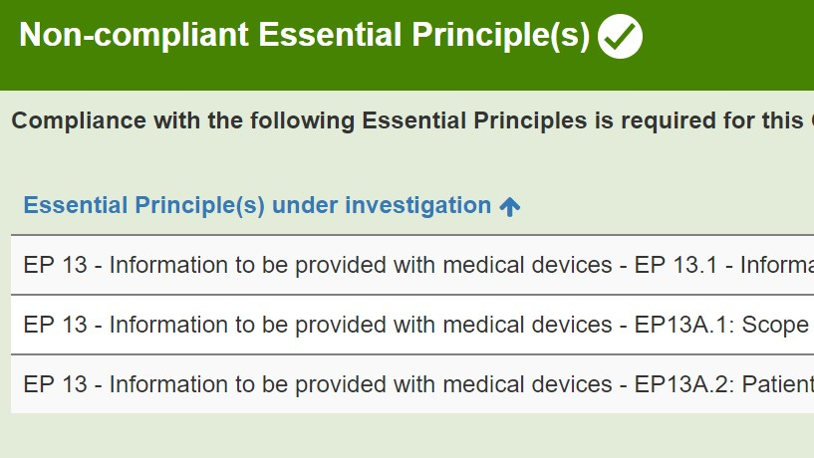
Figure 10

- This section will change colour from blue to green when clicked upon, indicating that all mandatory information in this section is auto-populated and complete.
- Some notifications will require a response from the sponsor, while others will not.
- Examples of notifications requiring a response include:
  - Consent approved notification (you will need to submit evidence of compliance with the EPs before the end of the consent period)
  - Section 41JA request for information
  - Proposal to cancel a device
  - Proposal to suspend a device
- Examples of notifications that do not require a response include:
  - Consent not-approved notification
  - Consent withdrawal notification
  - Consent expiry notification
  - Consent revoked notification
  - Device cancellation notification
- The ‘Sponsor responses’ and ‘Extension requests’ sections will change colour from blue to amber when clicked upon (Figure 11).
  - These sections will remain amber even when all mandatory information has been provided in a response.

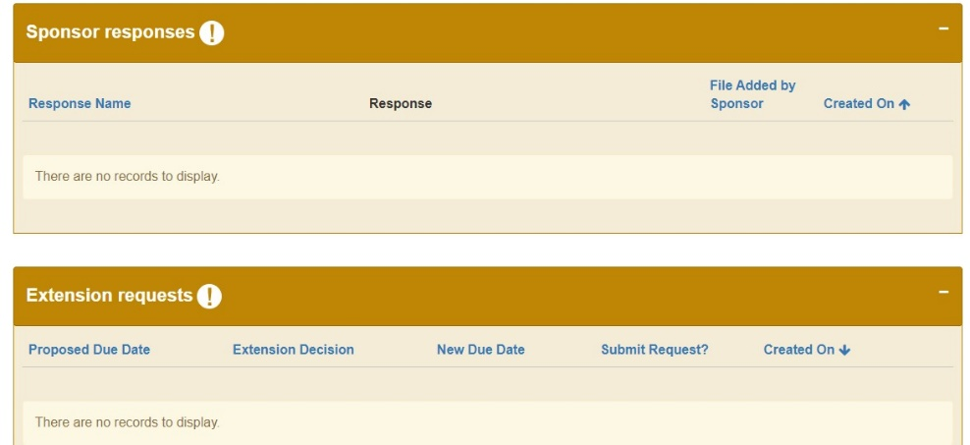
Figure 11

- After viewing the notification:
  - Click on the ‘Back’ button at the bottom of the page to return to the ‘Notifications’ tab (Figure 12).
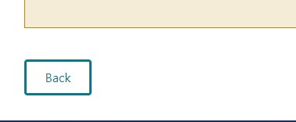
Figure 12

Responding to a notification
- Responses to notifications can only be submitted by an authorised user with submitter access for the TBS sponsor portal.
- Users with drafter access can:
  - Draft and save a response to a notification.
  - However, they are not authorised to submit a response through the TBS portal.

Consent approved notification
- When a consent application is approved.
  - A notification and letter of approval is issued and can be viewed on the ‘Notification’ table.
- As part of the consent process, sponsors are required to provide evidence of compliance with the EPs before the end of the consent period.
  - This evidence is provided as part of your response to the ‘Consent approved’ notification.
  - You may provide compliance evidence multiple times during the consent period if devices become compliant with the EPs at different times.
- You can only respond to a ‘Consent approved’ notification if the ‘Notification status’ is ‘Sent/Awaiting Response’ in the ‘Consent for Non-compliance – Notification View’ table.
  - If you have evidence of compliance to submit and the ‘Consent approved’ notification shows ‘Complete’ status, contact the TGA at mdconsent@health.gov.au to discuss.
- To respond to the ‘Consent approved’ notification (Figure 13):
  - Click on the down-arrow on the right-hand side of the row.
  - Select the ‘Draft’ option.
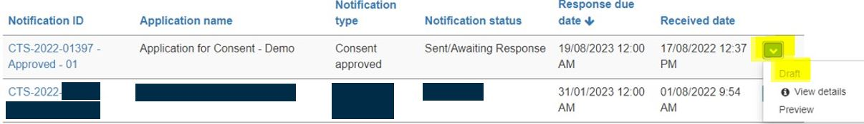
Figure 13

- On the ‘Consent for Non-compliance – Notification Draft’ page (Figure 14), there are five sections related to the notification.
- You have two options to expand sections (Figure 14):
  - Click on ‘Expand All’ to expand all sections at once.
  - Click on the section you wish to expand to open it individually.
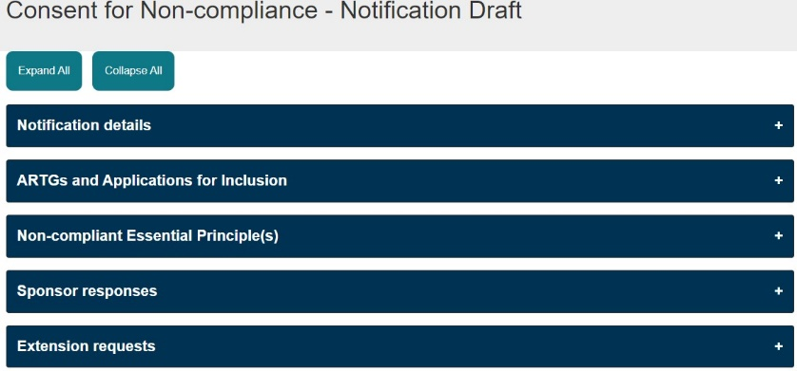
Figure 14
- The ‘Notification details’, ‘Non-included Devices’, ‘ARTGs and Applications for Inclusion’, and ‘Non-compliant Essential Principle(s)’ sections are non-editable.
  - These sections will change colour to green when selected, indicating that all mandatory information in this section is auto-populated and complete.
- Follow these steps to create and submit your response to the notification:
- To create a response for this notification (Figure 15):
  - Click on the ‘Sponsor responses’ section.
  - Click on the ‘Add response’ button.
Figure 15

- You can include multiple ARTG entries/Applications for Inclusion/Non-included devices and EPs in one response if the evidence of compliance is relevant to these devices.
  - For example, you can add evidence of compliance for EP 13A.2 and 13A.3 by providing a copy of the compliant Patient Implant Card (PIC) and Patient Information Leaflet (PIL) for multiple ARTG entries, if relevant, in one response.
- Provide a relevant name for the response to identify different responses within the notification.
- Click ‘Save and Close’ after you enter the response name (Figure 16).
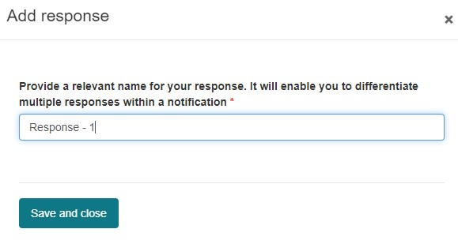
Figure 16

- Now that you have created and named the response, it will be ready for you to edit and add evidence of compliance (Figure 17).
  - Click the down-arrow on the right side of the row.
  - Select ‘Edit’.
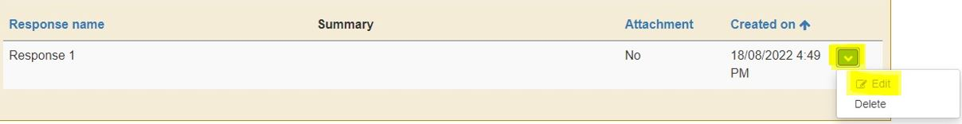
Figure 17

- By default, the ARTG number(s)/Application(s) for Inclusion/Non-included device(s) and EP(s) displayed for this notification will be included in the response.
NOTE: If the ARTG number(s)/Application(s) for Inclusion/Non-included device(s) or EP(s) do not appear in the tables when you begin to edit the response, press on the blue column header of the table to refresh the page, and the information should appear.
- If you are not providing compliance evidence for all devices within the consent at this time, or you wish to submit your evidence in multiple responses, you will need to exclude the devices that you are not including in the response.
- To exclude an ARTG entry/Application for Inclusion/Non-included device (Figure 18):
  - Click the down-arrow next to the device name.
  - Select ‘Exclude’.
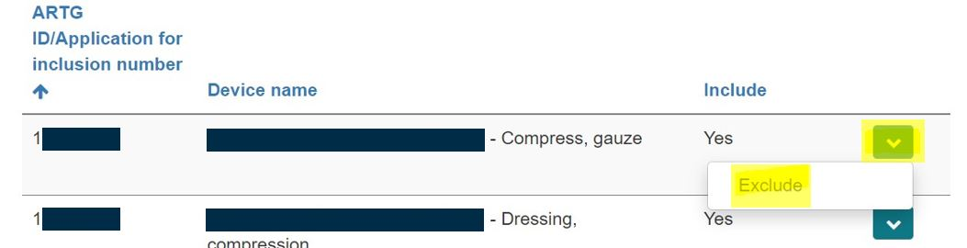
Figure 18

- Similarly, if you are not providing evidence of compliance with all of the EPs in this response (Figure 19):
  - Click the down-arrow next to the EP you wish to exclude.
  - Select ‘Exclude’.
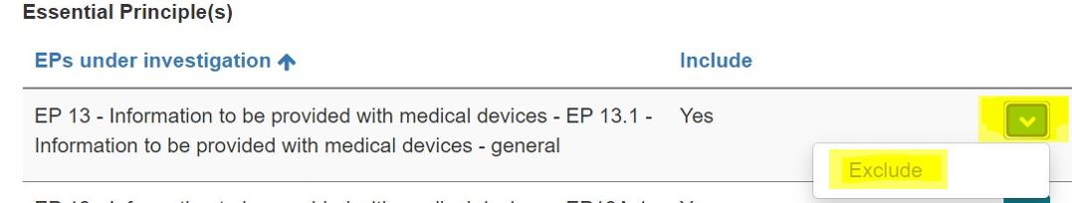
Figure 19

- Select how you wish to provide a response (Figure 20). Responses can be provided by:
  - Typing a summary in the free text box provided.
  - Attaching relevant documents.
  - Providing both a summary and documents.
  - Microsoft Word, Excel, and Adobe Acrobat documents with a file size of up to 50MB can be uploaded.
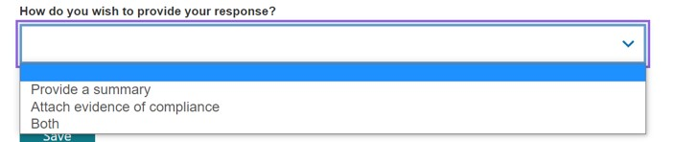
Figure 20
- Provide a summary in the text box available if you selected the ‘Provide a summary’ or the ‘Both’ option (Figure 21).
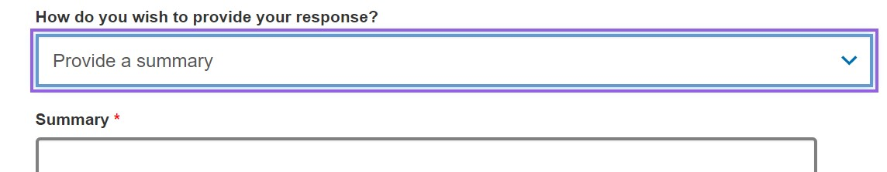
Figure 21

- If you are providing a document as part of the response:
  - Select the ‘Attach evidence of compliance’ option (Figure 22).
  - Click on the ‘Add files’ button (Figure 22).
  - Click on ‘Choose files’ to upload a document from your computer (Figure 23).
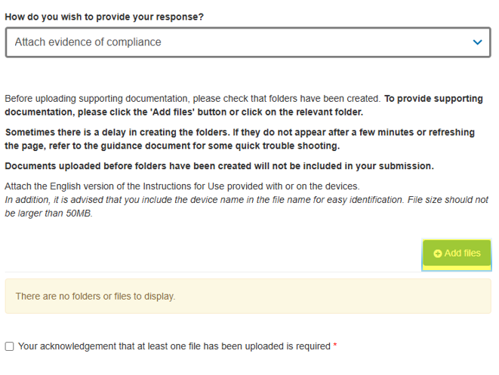
Figure 22

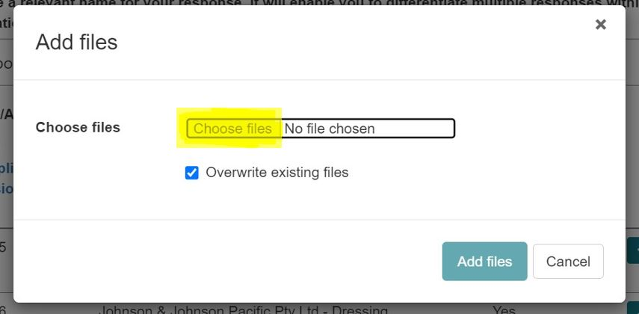
Figure 23
- Once you have selected the document from your computer (Figure 24):
  - Click on the ‘Add files’ button to attach the document to the response.
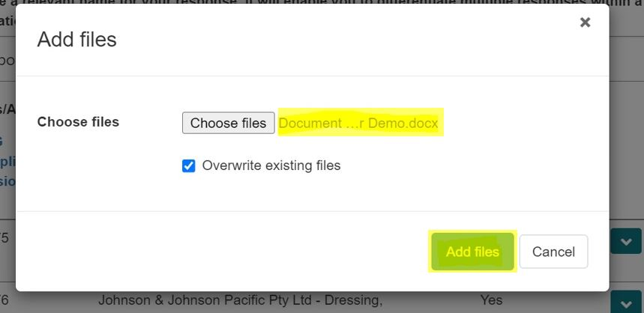
Figure 24

- The uploaded file will be displayed (Figure 25).
- You may add more files to this response by repeating the steps above.
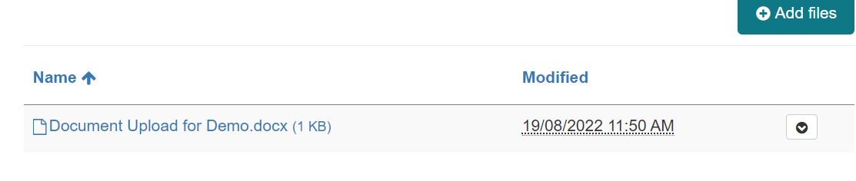
Figure 25

- Select the checkbox to acknowledge that at least one file has been uploaded (Figure 26).
- Click ‘Save’ to complete the response (Figure 26).
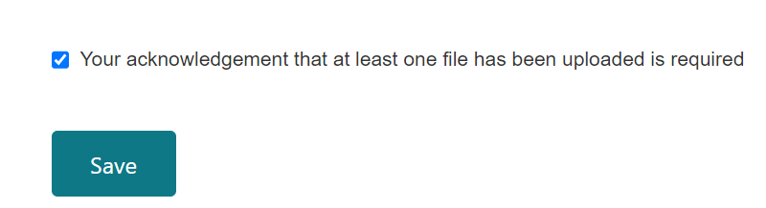
Figure 26

- The added response will be displayed in the ‘Sponsor responses’ section (Figure 27).
- You may edit or delete a response by:
  - Clicking the down-arrow on the right side.
  - Selecting the relevant option.
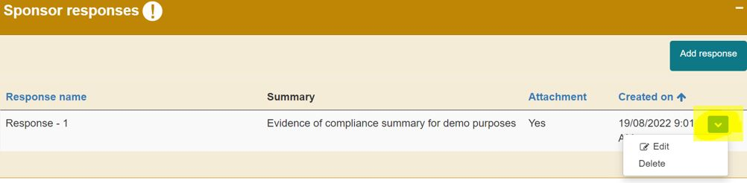
Figure 27

- To provide evidence of compliance for any remaining ARTG entries/Applications for Inclusion/Non-included devices:
  - Select the ‘Add response’ button.
  - Repeat the above steps to provide information for any remaining ARTG entries, Applications for Inclusion or Non-included devices.
- To view the documents uploaded in a response (Figure 28):
  - Click on the ‘Notification details’ section from the ‘Consent for Non-compliance - Notification Draft’ page.
  - A SharePoint folder is created for each response made for this notification and is listed in chronological order (e.g., the first response created will be ‘Response-01’ and the second response folder will be ‘Response-02’).
  - View the documents uploaded for each response by clicking on the relevant response folder.
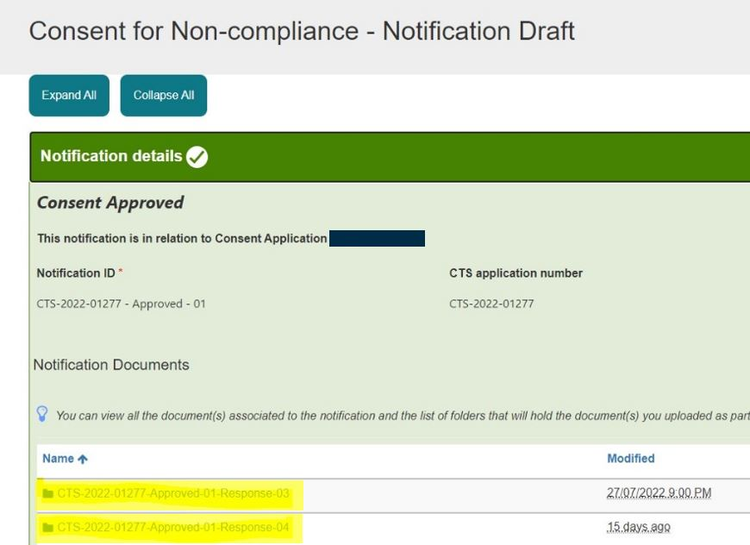
Figure 28

- A response to a notification can only be submitted by an authorised user with submitter access for the TBS sponsor portal.
- Users with drafter access who are not authorised to submit a response can only draft and save a response.
- Once ready to submit a response (Figure 29):
  - Click the ‘Validate’ button at the bottom of the ‘Consent for Non-compliance - Notification Draft’ page.
  - Only users with submitter access will have a ‘Validate’ button.
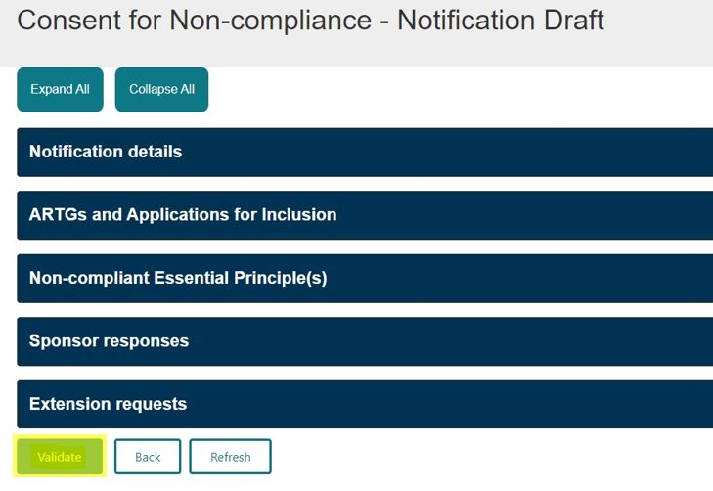
Figure 29

- Select ‘OK’ to complete your action (Figure 30).
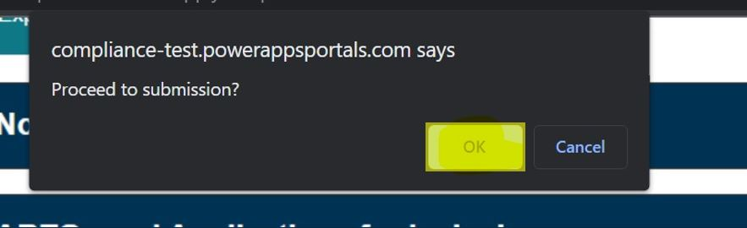
Figure 30

- To proceed with your response (Figure 31):
  - Select ‘Preview’ to preview the response before submission.
  - Select ‘Declare’ to submit the response.

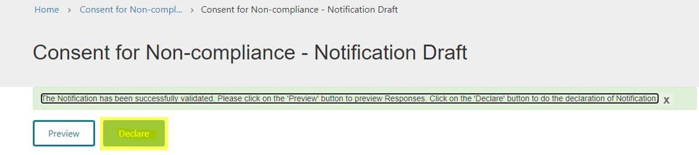
Figure 31
- When you are ready to submit the response:
- Select ‘Declare’ to begin the submission process (Figure 31).
- On the ‘Declaration’ page (Figure 32):
  - Select ‘Yes’ to confirm.
  - Click ‘Submit’ to finalise the submission.
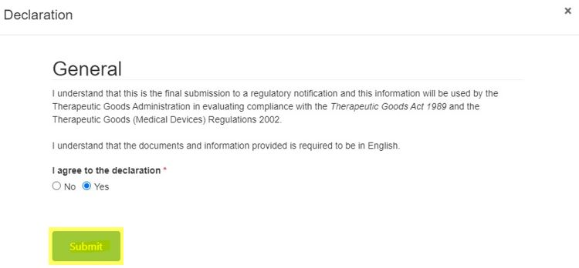
Figure 32

- Click ‘OK’ to complete your action and submit the response (Figure 33).
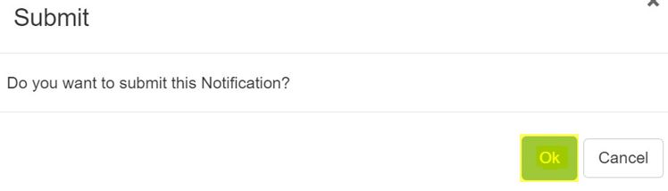
Figure 33

- After submitting the response (Figure 34):
  - The notification status of the approved notification should display as ‘Completed’ on the ‘Notification’ page.
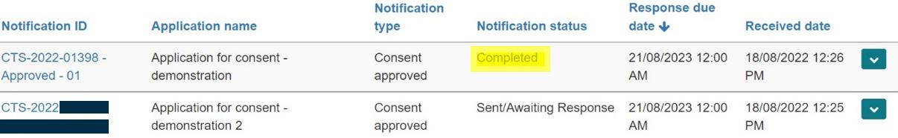
Figure 34

NOTE: If your response does not provide evidence of compliance for all devices and EPs in the consent application:
- The TGA will review the response and may reopen the notification to allow you to provide additional responses.
- TGA staff will change the notification status from ‘Completed’ to ‘Sent/Awaiting Response’ to reopen the portal.

- To save or print your response (Figure 34):
  - Go to the ‘Notification’ page.
  - Click the down-arrow on the right side of the relevant notification.
  - Select the ‘Preview’ option.
  - A new window will open showing the preview of the notification, which you can then save or print.
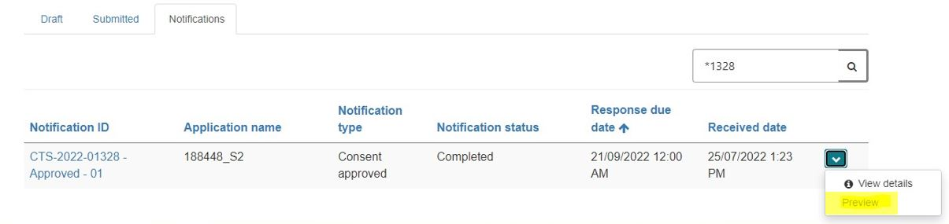
Figure 34

- Click on the ‘Print’ button (Figure 35).
  - This will open a new window in the current view, allowing you to print the previewed notification.
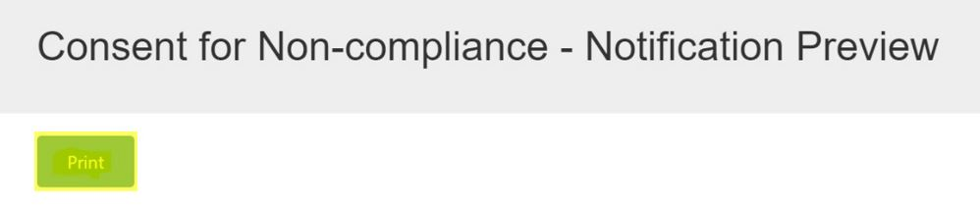
Figure 35

- To save a copy of your response (Figure 36):
  - In the ‘Destination’ section of the print window, select ‘Save as PDF’.
  - Click ‘Save’ at the bottom of the window.
  - Choose your desired folder location to save the document on your computer.
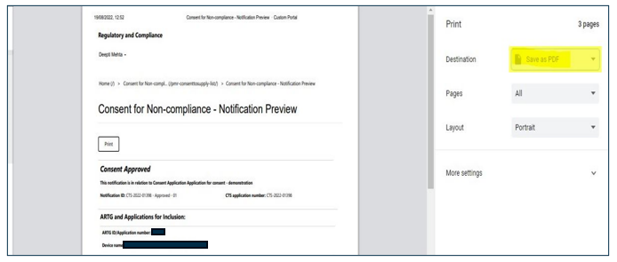
Figure 36
- To print the response (Figure 36):
  - In the ‘Destination’ section of the print window, select the appropriate printer.
  - Click the ‘Print’ button at the bottom of the window.

Additional information notification
If the TGA requires further information for the review of your consent application or for a response to a notification, you will receive an ‘Additional information’ notification. Unlike a ‘Consent approved’ notification, you can only respond once to this notification. This notification is different to a formal request for information under section 41JA of the Therapeutic Goods Act 1989, and has no regulatory letter attached to the notification.

- To respond to an ‘Additional information’ notification (Figure 37):
  - Click on the down-arrow on the right side of the relevant notification.
  - Select ‘Draft’ to begin drafting your response.
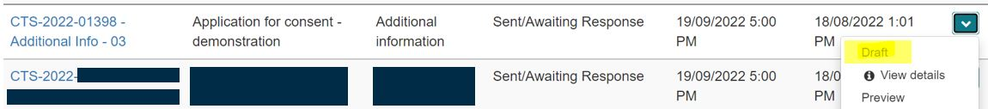
Figure 37

- On the ‘Consent for Non-compliance – Notification Draft’ page (Figure 38) there are five sections related to the notification.
- You can choose to:
  - Click ‘Expand All’ to open all sections at once, or
  - Click on an individual section to expand it one at a time.
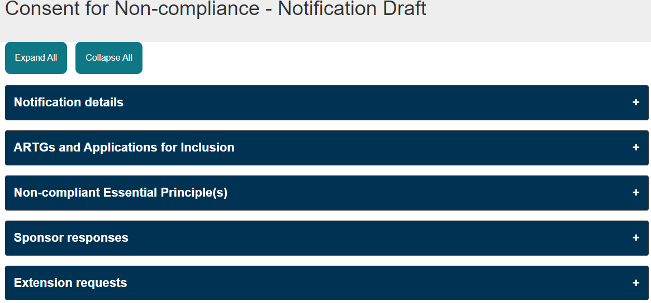
Figure 38

- The following sections on the ‘Consent for Non-compliance – Notification Draft’ page are non-editable (Figure 39):
  - Notification details
  - Non-included Devices
  - ARTGs and Applications for Inclusion
  - Non-compliant Essential Principle(s)
- These sections will change colour to green when clicked, indicating that all mandatory information is auto-populated and complete.
- To access the email related to the notification:
  - Click on the ‘Emails’ folder located within the ‘Notification details’ section.
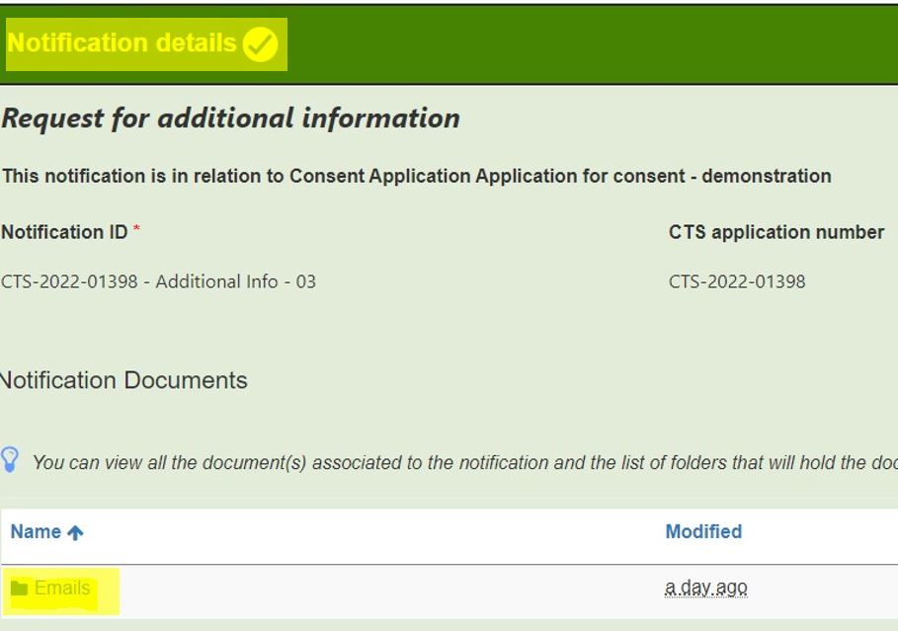
Figure 39

- To create a response for the notification (Figure 40):
  - Go to the ‘Sponsor responses’ section.
  - Click the ‘Add response’ button.
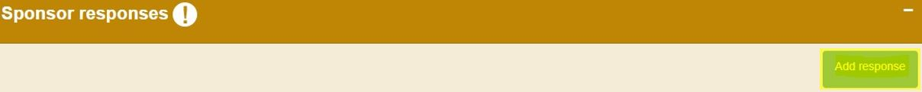
Figure 40

- Your response to an ‘Additional information’ notification is created and submitted using the same process as for a ‘Consent approved’ notification (refer to the steps in the ‘Consent approved notification for further details).
- Important distinctions:
  - The ‘Consent approved’ notification is the only type that allows multiple responses to be submitted.
  - For all other notification types, including ‘Additional information’, only one response can be submitted.
- You can still create multiple response groups within your notification response.
  - Ensure that all devices and Essential Principles (EPs) in the notification are covered before submitting the response to the TGA.

Other notification
- The TGA sends sponsors notifications regarding the status of a consent application, including:
  - Consent approved
  - Consent not-approved
  - Consent withdrawn
  - Consent revoked
  - Consent expired
- For devices included in the ARTG or Applications for Inclusion that are part of an approved consent application. The TGA may send regulatory notifications, such as:
  - A request for information under section 41JA of the Act
  - A proposal to cancel a device under section 41GN(2)
- These notifications will include a regulatory letter attached to the email sent by the TGA.
- For non-included devices that are part of an approved consent application:
  - The TGA may send regulatory notifications such as a request for information under section 45AB of the Act.

Regulatory notifications that do not require a response
- For notifications that do not require a response (Figure 41):
  - The ‘Notification status’ will be displayed as ‘Completed’.
- To view the notification (Figure 41):
  - Click on the down-arrow on the right-hand side of the notification.
  - Select ‘View details’.
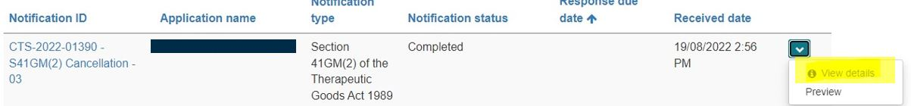
Figure 41

- To view the regulatory letter and email related to the notification (Figure 42):
  - Click on the ‘Emails’ folder located in the ‘Notification details’ section.
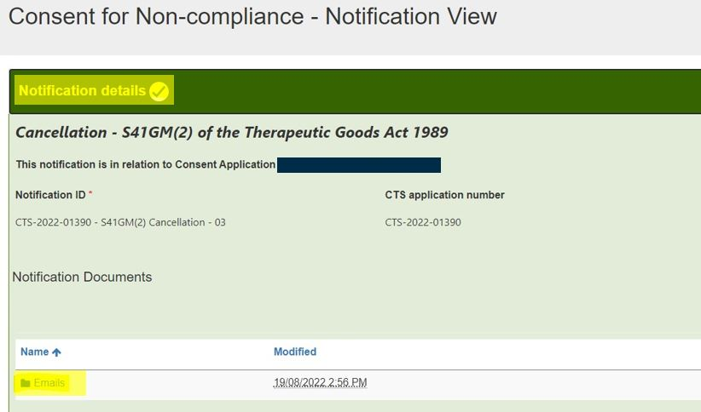
Figure 42

Regulatory notifications that require a response
- For notifications that require a response (Figure 43):
  - The ‘Notification status’ will be displayed as ‘Sent/Awaiting Response’.
- To view the notification (Figure 43):
  - Click on the down-arrow on the right-hand side.
  - Select ‘View details’.
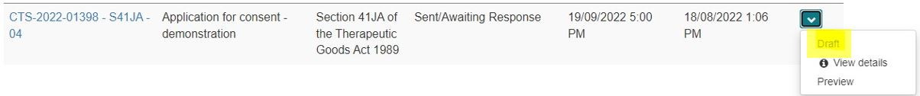
Figure 43

- On the ‘Consent for Non-compliance – Notification Draft’ page (Figure 44). There are five sections related to the notification.
- You can:
  - Click ‘Expand All’ to open all sections at once, or
  - Click on an individual section to expand it one at a time.
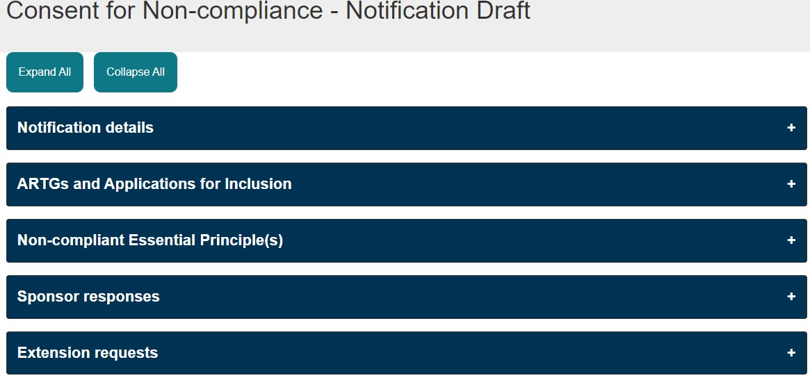
Figure 44

- The following sections on the ‘Consent for Non-compliance – Notification Draft’ page are non-editable:
  - Notification details
  - ARTGs and Applications for Inclusion
  - Non-included devices
  - Non-compliant Essential Principle(s)
- These sections will change colour to green when clicked, indicating that all mandatory information is auto-populated and complete (Figure 45).
- To access the regulatory letter and email related to the notification (Figure 45):
  - Click on the ‘Emails’ folder located in the ‘Notification details’ section.
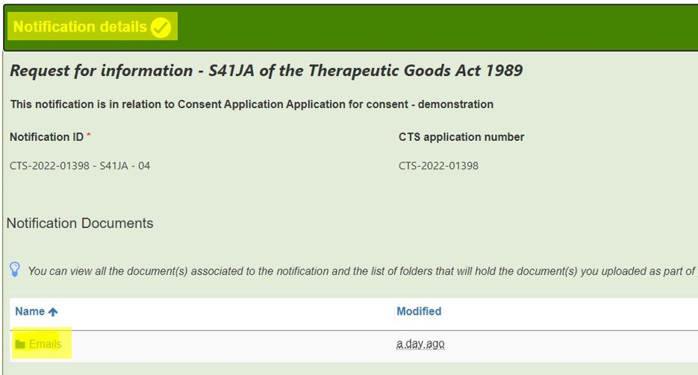
Figure 45

- To create a response for the notification (Figure 46):
  - Click the ‘Add response’ button in the ‘Sponsor responses’ section .
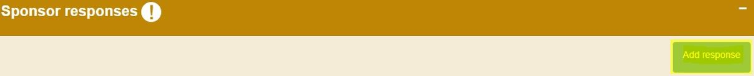
Figure 46

- Your response to the notification is created using the same process as for a ‘Consent approved’ notification.
  - Repeat the steps in the ‘Consent approved notification to draft and submit your response.
- Important distinctions:
  - The ‘Consent approved’ notification is the only type that allows multiple responses to be submitted.
  - For all other notification types, only one response can be submitted.
- You can create multiple response groups within your notification response.
  - Ensure that all devices and Essential Principles (EPs) in the notification are covered before submitting the response to the TGA.

Request an extension to a notification response
- If you are having difficulty providing the required information within the specified timeframe:
  - You can submit a request for an extension to the due date.
- Key points about extension requests:
  - All extension requests are considered by the TGA on a case-by-case basis.
  - An extension request can only be submitted for notifications that are current and have not expired.
  - The notification status of a current notification will be displayed as ‘Sent/Awaiting Response’ (Figure 47).
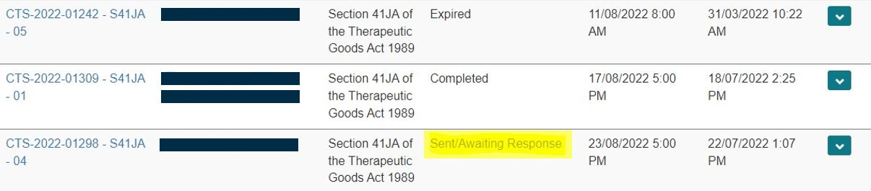
Figure 47

NOTE: Only authorised users with submitter access for the TBS sponsor portal can draft and submit an extension request.

- Users with drafter access cannot draft or request an extension to a notification.
- To request an extension (Figure 48):
  - Click on the down-arrow on the right-hand side of the relevant notification.
  - Select ‘Draft’ to begin the extension request process.
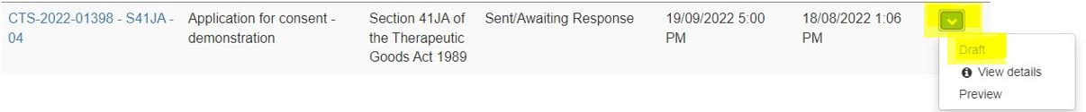
Figure 48

- To request an extension (Figure 49):
  - On the ‘Consent for Non-compliance – Notification Draft’ page, expand the ‘Extension requests’ section.
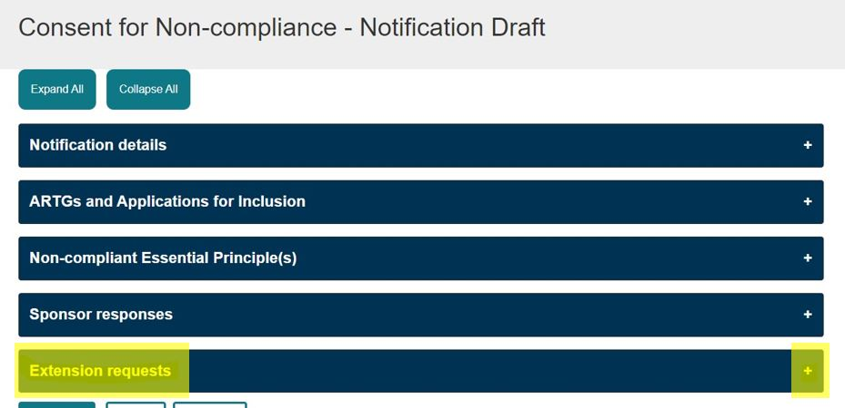
Figure 49

- Click on the ‘Request Extension’ button located on the right-hand side of the ‘Extension requests’ section (Figure 50).
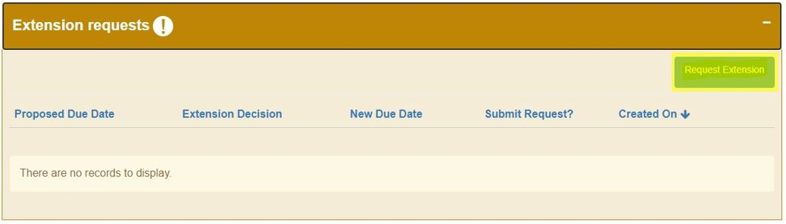
Figure 50

- In the ‘Extension Request’ window, complete the following field ‘Proposed Due Date’ (Figure 51):
  - Click on the calendar icon next to the field.
  - Select a new proposed due date for the notification.
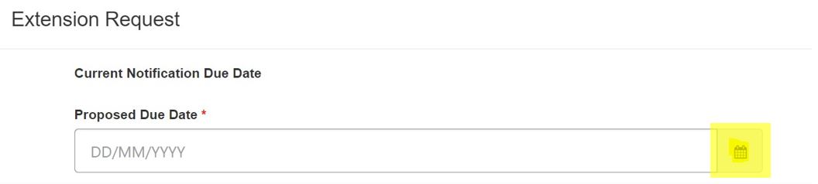
Figure 51

- In the ‘Extension Request’ window, complete the following field ‘Extension Request’:
  - Enter the reason for requesting an extension to this notification.
  - The text must be at least 20 characters long to be valid.
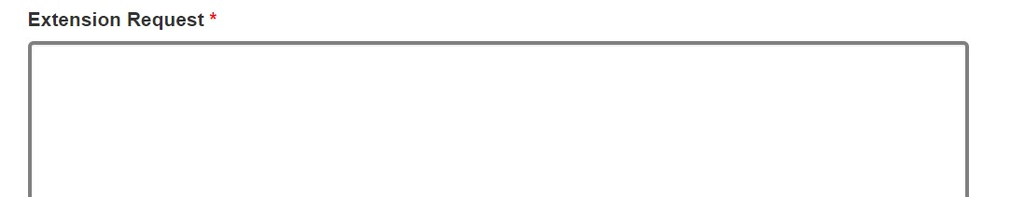
Figure 52

- In the ‘Extension Request’ window, complete the following field: ‘Submit Request’ (Figure 53):
  - Select ‘Yes’ if the request is ready to be submitted.
  - Select ‘No’ if you wish to save the request and submit it later.
- Finalise the request:
  - Click the ‘Save’ button at the bottom of the ‘Extension Request’ window.
  - Click ‘OK’ to finalise and submit your request.
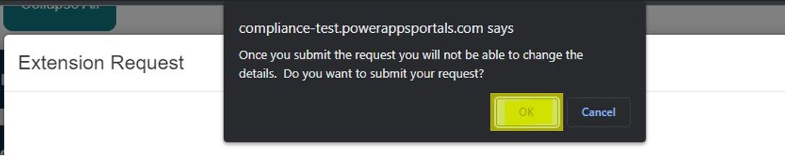
Figure 53

- Once the extension request is submitted (Figure 54):
  - The extension request decision will display as ‘Pending’ until a decision has been made by the TGA.
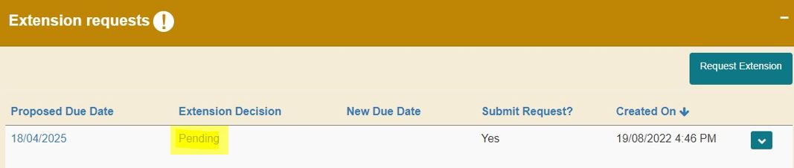
Figure 54

- If the extension request is accepted by the TGA (Figure 55):
  - The extension decision will display as ‘Approved’.
  - The notification response due date will be updated to reflect the new due date.
- The TGA may assign a different due date than the one you proposed.
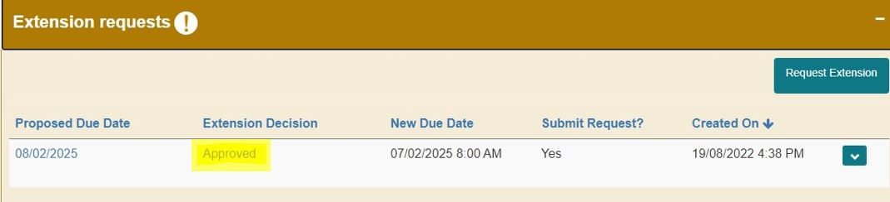
Figure 55

- If the extension request is rejected by the TGA (Figure 56):
  - The extension decision will display as ‘Disapproved’.
  - The notification response due date will remain unchanged.
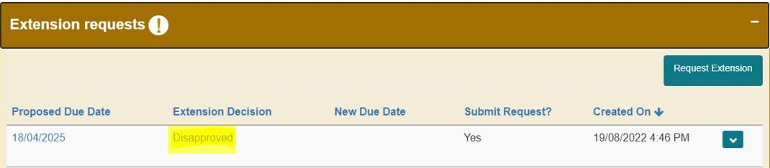
Figure 56
Version history
Version | Description of change | Author | Effective date
V1.0 | Original publication | Authorisations branch | September 2022
V2.0 | Updated to include changes in dashboard and additional features. | Medical Devices  Authorisation Branch  Surveillance Branch | June 2025

