Australian Public Assessment Report for Voranigo
  - Active ingredient: Vorasidenib
  - Sponsor: Servier Laboratories (Aust) Pty Ltd
May 2025

About the Therapeutic Goods Administration (TGA)
- The Therapeutic Goods Administration (TGA) is part of the Australian Government Department of Health and Aged Care and is responsible for regulating therapeutic goods, including medicines, medical devices, and biologicals.
- The TGA administers the Therapeutic Goods Act 1989 (the Act), applying a risk management approach designed to ensure therapeutic goods supplied in Australia meet acceptable standards of quality, safety, and efficacy.
- The work of the TGA is based on applying scientific and clinical expertise to decision-making, to ensure that the benefits to the Australian public outweigh any risks associated with the use of therapeutic goods.
- The TGA relies on the public, healthcare professionals and industry to report problems with therapeutic goods. The TGA investigates reports received to determine any necessary regulatory action.
- To report a problem with a therapeutic good, please see the information on the TGA website.

About AusPARs
- The Australian Public Assessment Report (AusPAR) provides information about the evaluation of a prescription medicine and the considerations that led the TGA to approve or not approve a prescription medicine submission. Further information can be found in Australian Public Assessment Report (AusPAR) guidance.
- AusPARs are prepared and published by the TGA.
- AusPARs are static documents that provide information that relates to a submission at a particular point in time. The publication of an AusPAR is an important part of the transparency of the TGA’s decision-making process.
- A new AusPAR may be provided to reflect changes to indications or major variations to a prescription medicine subject to evaluation by the TGA.

Copyright
© Commonwealth of Australia 2025
This work is copyright. You may reproduce the whole or part of this work in unaltered form for your own personal use or, if you are part of an organisation, for internal use within your organisation, but only if you or your organisation do not use the reproduction for any commercial purpose and retain this copyright notice and all disclaimer notices as part of that reproduction. Apart from rights to use as permitted by the Copyright Act 1968 or allowed by this copyright notice, all other rights are reserved and you are not allowed to reproduce the whole or any part of this work in any way (electronic or otherwise) without first being given specific written permission from the Commonwealth to do so. Requests and inquiries concerning reproduction and rights are to be sent to the TGA Copyright Officer, Therapeutic Goods Administration, PO Box 100, Woden ACT 2606 or emailed to <tga.copyright@tga.gov.au>.

Contents
List of abbreviations 4
Voranigo (vorasidenib) submission 6
Voranigo (vorasidenib) – proposed indication 7
Gliomas 7
Current treatment options for adult type glioma 9
Clinical rationale for the use of Voranigo in IDH-mutant gliomas 10
Regulatory status 10
Australian regulatory status 10
International regulatory status 10
Registration timeline 10
Evaluation overview 11
Quality evaluation summary 11
Nonclinical evaluation summary 13
Clinical evaluation summary 14
Summary of clinical studies 14
Pharmacology 15
Efficacy 21
Safety 35
Risk Management Plan evaluation 45
Discussion 45
Advisory Committee considerations 49
Decision outcome 51
Specific conditions of registration applying to these goods 51
Product Information 52

List of abbreviations
Abbreviation | Meaning
2-HG | 2-hydroxyglutarate
ACM | Advisory Committee on Medicines
AE | Adverse events
AESI | Adverse event of special interest
ARTG | Australian Register of Therapeutic Goods
ASA | Australia-specific annex
AUC | Area under the concentration-time curve
AUC_{0-inf} | Area under the curve from time 0 extrapolated to infinite time
AUC_{tau} | Area under the concentration-time curve during a dosing interval
CI | Confidence intervals
Cl/F | Apparent plasma clearance of drug after extravascular administration
C_{max} | The maximum concentration that a drug attains in a specified compartment
CMI | Consumer Medicine Information
CNS | Central nervous system
CYP | Cytochrome P450
DoR | Duration of response
DS | Drug substance
EMA | European Medicines Agency
 | Functional Assessment of Cancer Therapy – Brain (Fact-Br)
FAS | Full analysis set
FDA | Food and Drug Administration (United States of America)
HR | Hazard ratio
IDH | isocitrate dehydrogenase
MedDRA | Medical Dictionary for Medical Activities
NADP⁺ | Nicotinamide adenine dinucleotide phosphate, oxidised form
NADPH | Nicotinamide adenine dinucleotide phosphate, reduced form
NCCN | National Comprehensive Cancer Network
NMT | No more than
ORR | Objective response rate
OS | Overall survival
PBPK | Physiologically-based pharmacokinetic modelling
PCV | Procarbazine, lomustine and vincristine
PD | Pharmacodynamics
PFS | Progression-free survival
PI | Product Information
PK | Pharmacokinetics
popPK | Population pharmacokinetics
PSUR | Periodic safety update report
RANO-LGG | Response Assessment in Neuro-Oncology criteria for low-grade gliomas
RMP | Risk management plan
SAEs | Serious adverse event(s)
SD | Standard deviation
t_{1/2} | Half life
TEAE | Treatment emergent adverse event(s)
TGA | Therapeutic Goods Administration
T_{max} | The time it takes for a drug to reach the maximum concentration (C_{max})
TTNI | Time to next intervention
V_{d} | Volume of distribution
V/F | Apparent volume of distribution after extravascular administration
V_{ss} | Volume of distribution at steady-state following intravenous administration
V_{z} | Volume of distribution during the terminal phase following intravenous administration
WHO | World Health Organization

Voranigo (vorasidenib) submission
Type of submission: | New chemical entity
Product name: | Voranigo
Active ingredient: | vorasidenib
Decision and Date of decision | Approved
Approved therapeutic use for the current submission: | Voranigo is indicated for the treatment of Grade 2 astrocytoma or oligodendroglioma with a susceptible isocitrate dehydrogenase-1 (IDH1) mutation or isocitrate dehydrogenase-2 (IDH2) mutation in adults and paediatric patients 12 years and older, who are not in need of immediate chemotherapy or radiotherapy following surgical intervention.
Date of entry onto ARTG: | 11 September 2024
ARTG number: | 435450, 438499
Black Triangle Scheme | Yes
Sponsor’s name and address: | Servier Laboratories (Aust.) Pty. Ltd. Level 4, Building 9 588A, Swan Street, Burnley, 3121, Victoria
Dose Form: | White to off-white, round, film-coated tablets
Strength: | 10 mg and 40 mg
Container: | White, high-density polyethylene (HDPE) bottle with polypropylene (PP) child resistant closure and polyethylene (PE) faced induction heat seal liner. The bottles are packaged in a cardboard box; each box contains 1 bottle.
Pack size: | Each bottle contains 30 film-coated tablets and a silica gel desiccant in a HDPE canister.
Route of administration: | Oral
Dosing: | The recommended dose of Voranigo in adults and adolescents 12 years of age and older:  - 40 mg taken orally once daily for patients weighing at least 40 kg  - 20 mg taken orally once daily for patients weighing less than 40 kg  For additional details regarding dosing, consult the product’s product information.
Pregnancy category: | Category D  Drugs which have caused, are suspected to have caused or may be expected to cause, an increased incidence of human fetal malformations or irreversible damage. These drugs may also have adverse pharmacological effects.  The use of any medicine during pregnancy requires careful consideration of both risks and benefits by the treating health professional. The pregnancy database must not be used as the sole basis of decision making in the use of medicines during pregnancy. The TGA does not provide advice on the use of medicines in pregnancy for specific cases. More information is available from obstetric drug information services in your state or territory.

Voranigo (vorasidenib) – proposed indication
This AusPAR describes the submission by Servier Laboratories (Aust) Pty Ltd (the Sponsor) to register Voranigo (vorasidenib) for the following proposed indication.
Treatment of predominantly non-enhancing astrocytoma or oligodendroglioma with an isocitrate dehydrogenase-1 (IDH-1) mutation or isocitrate dehydrogenase-2 (IDH-2) mutation in adults and paediatric patients 12 years and older following surgical intervention.

Gliomas
Gliomas are neuroepithelial tumours that originate from glial cells or precursor neural stem cells in the central nervous system (CNS). They are the most common malignant primary CNS tumour. The estimated 2024 prevalence of oligodendroglioma and astrocytoma patients is 1.1 per 10,000 persons in Australia, although this may be slightly greater using next generation sequencing.
The 2021 World Health Organization (WHO) classification of tumours of the CNS categorises gliomas into distinct tumour subtypes and tumour grades according to a combination of histological and molecular features.
In general, WHO Grade is assigned using both histological features and molecular markers. In certain circumstances, however, the molecular markers prevail over histological features. For example, a glioblastoma multiforme is always considered Grade 4.
Figure 1 shows a diagnostic flow chart for gliomas.
Figure 1: A diagnostic flow chart of diffuse gliomas in adults and paediatrics⁴
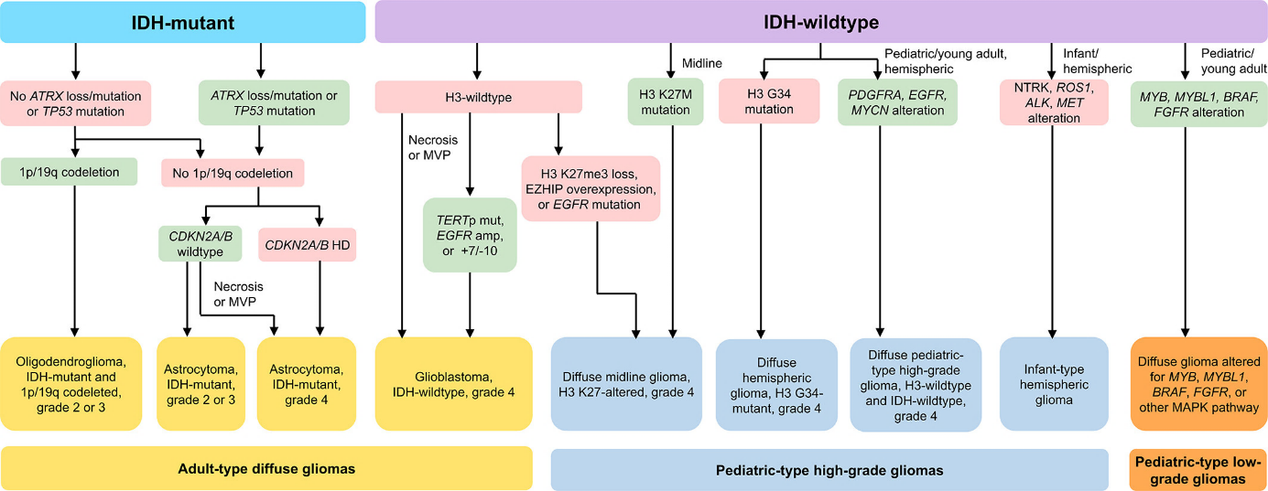
Abbreviations: amp=amplification; HD = homozygous deletion; mut = mutation; MVP = microvascular proliferation.

IDH1 and IDH2 in glioma
Five genes encode three human isocitrate dehydrogenase (IDH) catalytic isoenzymes: IDH1, IDH2 and IDH3. The proteins encoded by IDH1 and IDH2 in the cytosol and mitochondria, respectively, generate reduced nicotinamide adenine dinucleotide phosphate (NADPH) from NADP+ by catalysing the oxidative decarboxylation of isocitrate to α-ketoglutarate outside of the Krebs cycle. On exposure to free radicals and reactive oxygen species, cells with low levels of IDH become more sensitive to oxidative damage.
Mutations in IDH1/2 occur in around 80% of patients with low grade gliomas. The more common mutations in these tumours occur in IDH-1 and is typically a substitution of arginine with histidine at site 132 of the protein (R132H). Other observed substitutions for arginine include cysteine (R132C), glycine (R132G), serine (R132S), leucine (R132L), valine (R132V) and proline (R132P).
IDH-2 mutations have been described in approximately 3% of grade 2 or 3 diffuse gliomas. The most common mutation observed results in the substitution of arginine with lysine at site 172 of the protein (R172K). Other observed substitutions for arginine include methionine (R172M) and tryptophan (R172W).
Cancer-associated IDH1/2 mutations occur early in tumorigenesis, cluster in the active site of the enzymes and cause the mutant enzymes to produce D-2—hydroxyglutarate. Accumulation of this substance leads to competitive inhibition of α-ketoglutarate-dependent enzymes, causing epigenetic dysregulation and impaired differentiation.
Contrast enhancement on MRI represents areas of neovascularisation. The Sponsor notes it reflects ‘areas that are histopathologically showing higher tumour cell density, increased cell proliferation, microvascular hyperplasia, and necrosis’. Grade 2 gliomas are not expected to have contrast enhancement as an MRI finding.

Current treatment options for adult type glioma
The treatment algorithm in the National Comprehensive Cancer Network (NCCN) is guided by whether surgery is feasible or not, the tumour classification and performance score.
Initial treatment is the maximal safety resection, where resection is feasible, with needle biopsy recommended for deep or critical brain regions, while noting that these tumours are heterogeneous, and biopsy is not always a representative sample of the whole tumour. Residual tumour volume post-resection may be a prognostic factor.
Therapy following surgery is dependent upon type of tumour (oligodendroglioma vs. astrocytoma) and tumour grade. The current treatment landscape for IDH-1/2 mutant gliomas is summarised below:
- Oligodendroglioma grade 2
  - Participants with positive prognostic factors (those who have undergone complete resection and are of younger age [e.g. ≤ 40 years]) may be observed (watch and wait approach). Such patients are followed with regular MRI examinations.
  - In these participants, disease progression is considered inevitable, requiring further treatment. The objective of the observation approach is to defer the need for further treatments (radiotherapy and chemotherapy, which are associated with significant toxicity), until there is evidence of disease progression or clinical deterioration.
  - For other participants, adjuvant radiotherapy and maintenance chemotherapy with a combination of procarbazine, lomustine and vincristine (PCV) is recommended.
- Oligodendroglioma grade 3
  - Adjuvant radiotherapy and PCV chemotherapy is generally recommended.
- Astrocytoma grade 2
  - Participants with positive prognostic factors (those who have undergone complete resection and of younger age [e.g. ≤ 40 years]) may be observed (watch and wait approach). Such patients are followed with regular MRI examinations.
  - For other participants, adjuvant radiotherapy and PCV chemotherapy is recommended.
- Astrocytoma grade 3
  - Adjuvant radiotherapy and maintenance chemotherapy with temozolomide is recommended.
- Astrocytoma grade 4
  - Adjuvant radiotherapy and maintenance chemotherapy with temozolomide is recommended.
  - There are no standard therapies for the treatment of recurrent disease. Treatment options include second surgery, radiotherapy and chemotherapy (e.g. temozolomide, PCV).

Clinical rationale for the use of Voranigo in IDH-mutant gliomas
There is an urgent unmet need for alternative therapies that target IDH-mutant gliomas early in their development, to delay or prevent disease progression so that the use of more toxic treatments such as radiotherapy and chemotherapy may be deferred. Vorasidenib is an inhibitor of both mutant IDH-1 and mutant IDH-2. Inhibition of these enzymes could be expected to inhibit the growth of tumours harbouring these mutations.

Regulatory status

Australian regulatory status
This product is considered a new chemical entity for Australian regulatory purposes. The current submission was granted priority review, and vorasidenib designated as an orphan drug, by the TGA on 6 December 2023. The indication for which orphan drug designation was granted was for “the treatment of IDH-mutant diffuse glioma”.

International regulatory status
This evaluation was facilitated through Project Orbis, an initiative of the United States Food and Drug Administration (FDA) Oncology Center of Excellence. Under this project, the FDA, Health Canada, Swissmedic (Switzerland), Anivsa (Brazil), Israel’s Ministry of Health (MoH, Israel) and the TGA collaboratively reviewed the submission. This evaluation process provided a framework for process alignment and management of evaluation issues in real-time across jurisdictions. Each regulator made independent decisions regarding approval (market authorisation) of the new medicine.
At the time of lodgement of the submission with the TGA (January 2024) similar submissions had been lodged in the United States (December 2023) and the European Union, Canada and Switzerland, Brazil and Israel (January 2024 for all).

Registration timeline
Table 1 captures the key steps and dates for this submission.
This submission was evaluated under the priority registration process.
Table 1: Registration timeline for Voranigo (submission PM-2023-06126-1-4)
Description | Date
Priority determination | 6 December 2023
Orphan designation | 6 December 2023
Evaluation completed | 17 June 2024
Advisory Committee meeting | 16 August 2024
Registration decision - Approved | 10 September 2024
Number of working days from submission dossier acceptance to registration decision* | 135
*Target timeframe for priority submissions is 150 working days from acceptance for evaluation to the decision.

Evaluation overview
Relevant guidelines or guidance documents referred to by the Delegate are listed below:
- Guideline on the clinical evaluation of anticancer medicinal products;
- Appendix 1 to the guideline on the clinical evaluation of anticancer medicinal products – methodological considerations for PFS/DFS;
- Guideline on clinical investigation of medicinal products in the paediatric population.

Quality evaluation summary
The chemical structure of vorasidenib (the hemicitric acid, hemihydrate co-crystal) is shown in Figure 2.
Figure 2: Vorasidenib chemical structure
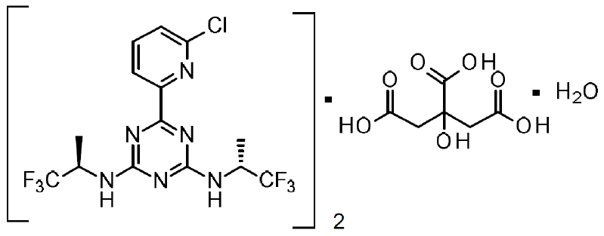
Vorasidenib has a molecular weight of 414.7 g/mol. It has two stereocentres, both with an R-configuration. It is practically insoluble in water at (solubility of <0.1 mg/mL), and in buffered solutions, across the physiological pH range 1 – 6.8, the solubility is significantly lower at, or below, 0.07 mg/mL.
Vorasidenib is produced by chemical synthesis. The formation of potentially mutagenic impurities is controlled throughout the manufacturing process in line with the ICH M7 guideline and has been justified based on purge and spiking studies. The control of in-process parameters, critical steps, materials and intermediates are considered acceptable. For chiral centres in the DS, appropriate control of enantiomeric and diastereomeric impurities is present.
The DS is manufactured as a hemicitric acid hemihydrate co-crystal which has been fully characterised. Detailed discussion on the DS polymorphism and there is an appropriate polymorphic form test and limit present in the finished drug substance specification (XRPD).
The DS specifications are sufficient to ensure quality and consistency of the DS.
Vorasidenib is classified as a BCS Class II compound (low solubility, high permeability).
The re-test period is 24 months when stored below 30 °C/75% RH and is supported by stability data.
The drug product (DP), Vorasidenib film-coated tablets, are available in 2 strengths – 10 mg and 40 mg. The tablets are white to off-white round (10 mg) or oblong (40 mg). The tablets are coated and imprinted with “10” or “40” on one side. The strengths are also distinguished by mass and size.
The DP formulation has been appropriately optimised and uses standard excipients for this type of DP (microcrystalline cellulose, croscarmellose sodium, silicified microcrystalline cellulose, magnesium stearate, sodium lauryl sulfate, Opadry II White and Opacode WB water-based ink). The initial formulation (F1) batches were manufactured as uncoated tablets in 5 mg, 25 mg and 100 mg strengths. These were used in phase 1 clinical trials and the initial portion of the Phase 3 study. The late-stage formulation (F2) batches were manufactured as film-coated tablets in 10 mg, 40 mg and 50 mg strengths. The F2 formulation is proposed for the commercial product and has been used in the Phase 3 clinical study. The bioequivalence of the F1 and F2 formulations was compared in a single dose relative bioavailability (study AG881-C-007). When compared to the clinical trial formulation (F1), the proposed market formulation (F2) was found to produce a 35-38% increase in AUC and a 46% increase in Cmax. As a result of this finding the recommended dose was reduced from 50 mg OD with the F1 formulation to 40 mg OD with the F2 formulation.
An appropriate dissolution method has been developed and its discriminatory power has been demonstrated with regards to the changes in the excipient amount and tablet hardness.
The manufacturing process has been developed based on the process knowledge and consists of a series of blending steps to produce the final blend for direct compression, followed by film-coating and imprinting. The process remained essentially unchanged since the introduction of the commercial formulation F2. Proprietary excipients Opadry II White and Opacode WB water-based ink are used for coating and imprinting, respectively.
The DP specifications are sufficient to ensure quality and consistency of the DP. Nitrosamine risk assessment has been provided and the risk of nitrosamine formation is considered negligible.
Primary closure for both strengths is a 100 cc round white HDPE bottle with three silica gel desiccant canisters. The bottle is closed with a polypropylene child resistant closure with a polyethylene-faced induction heat seal liner. Each bottle contains 30 tablets. Secondary packaging is a paperboard carton with packaging inserts.
Recommended shelf-life is 24 months when stored in the proposed packaging below 30 °C, which is supported by the stability data. No other conditions are required.
The quality Evaluator recommended approval of the submission from a pharmaceutical perspective.

Nonclinical evaluation summary
The submitted nonclinical dossier was in accordance with the relevant ICH guideline for the nonclinical assessment of anticancer pharmaceuticals (ICH S9). All pivotal safety-related studies were GLP compliant.
Vorasidenib inhibited wild type and mutant IDH1R132 (H, C, G, L and S) and IDH2R140Q enzymes at the clinical plasma levels of vorasidenib with ten times weaker inhibition of IDH2R172 in vitro.
The levels of intracellular 2-hydroxyglutarate (2-HG) are a measure of IDH1/2 inhibition. Vorasidenib reduced 2-HG concentrations in human cancer cell lines expressing IDH1R132 (C, G, L, S), IDH2R140Q and IDH2R172K mutants. Vorasidenib induced cellular differentiation in human erythroleukemia cell line expressing IDH1R132H and IDH2R140Q in vitro and in primary patient-derived AML blast cells expressing IDH1R132C, IDH2R140Q, and IDH2R172K in vitro. In vivo, vorasidenib decreased 2-HG levels in tumour tissues in subcutaneous fibrosarcoma (IDH1R132), subcutaneous glioma (IDH2 R140Q) and intracranial glioma (IDH1R132H) models and induced cellular differentiation.
The major human circulating metabolite, AGI-69460, is a less potent inhibitor of IDH1R132C activity in cancer cell lines compared to vorasidenib.
Nonclinical studies suggest that vorasidenib can effectively inhibit the activity of mutated IDH1 and IDH2 enzymes in cancer patients with these mutations. This, in turn, may help to overcome the differentiation block in tumour cells. There are no studies on tumour growth inhibition in animal models, and thus nonclinical studies did not provide evidence of tumour regression or survival benefits.
No clinically-relevant off-target sites were identified in in vitro screening assays with vorasidenib and AGI-69460.
No adverse effects on CNS, cardiovascular or respiratory function are expected in patients based on nonclinical findings.
Following oral dosing, the rate of absorption of vorasidenib was rapid to moderate in animals and humans. Plasma half-life varies significantly between laboratory animals and humans, with shorter half-lives in animals compared to humans. In general, good oral bioavailability of vorasidenib was seen in animals and humans. Plasma protein binding of vorasidenib was very high in all animal species and humans. Plasma protein binding of AGI-69460 was moderate to high in animal species and humans.
Vorasidenib is primarily metabolised by CYP1A2 with possible contributions from CYP2B6, CYP2C19, CYP2D6, and CYP3A4/5. No unique human metabolites were observed, but the major human metabolite, AGI-69460, was only a very minor metabolite in rats and monkeys (relatively high levels in rabbit plasma). The majority of vorasidenib is metabolised in the liver and eliminated through the bile, with a small amount eliminated through urine. Liver metabolism is a major clearance pathway for vorasidenib in both animals and humans. Tissue distribution of vorasidenib was widespread with no binding to melanin. Vorasidenib crosses the blood brain barrier. Brain penetration of AGI-69460 were not assessed in animals.
Clinically relevant interactions are predicted for CYP1A2 inhibitors or inducers, which may increase/decrease plasma vorasidenib concentrations. Vorasidenib is an inhibitor of Breast Cancer Resistance Protein (BCRP) and AGI-69460 an inhibitor of OATP1B3, and thus it may increase plasma concentrations of BCRP and OATP1A3 substrates. As an inducer of CYP2B6, CYP2C8, CYP2C9, CYP2C19, CYP3A4/5 and UGT1A4, vorasidenib may decrease plasma concentrations of substrates of these isoenzymes. Metabolite AGI-69460 did not inhibit CYP isozymes (1A2, 2B6, 2C8, 2C9, 2C19, 2D6, and 3A4) under in vitro conditions. It induced several CYP enzymes (2B6, 2C8, 2C9, and 3A4).
Vorasidenib had a low order of acute oral toxicity in monkeys.
Repeat-dose toxicity studies by the oral route were conducted in rats and cynomolgus monkeys up to 13 weeks with acceptable exposures of vorasidenib. Target organs were identified as the liver (findings suggesting hepatic enzyme induction, including increased liver weights, hepatocellular hypertrophy), gastrointestinal system (mucosal erosions, ulcers inflammation, epithelial degeneration and/or hyperplasia) in rats and monkeys, and reproductive organs (atrophy/degeneration), kidney (tubular degeneration), muscle (neurogenic atrophy) and skin (epidermal hyperplasia, desquamation) in rats. Effects on liver, GI system, reproductive organs and skin are likely clinically relevant. Middle ear effects (inflammation characterised by mild neutrophil infiltration of the epithelial lining of the middle ear and Eustachian tube, macrophages, and luminal exudate in the tympanic cavity) were observed in rats treated with vorasidenib up to 28 days and could be due to vorasidenib pharmacology, warranting a statement in the PI.
Vorasidenib showed no genotoxic potential. Carcinogenicity studies were not conducted, which is acceptable. The metabolite AGI-69460 was not mutagenic in the bacterial mutation assay. Clastogenicity of AGI-69460 has not been investigated.
Both male and female reproductive organs were affected following vorasidenib treatment to rats. Male rats exhibited effects including testicular degeneration and prostate and seminal vesicle atrophy, and females experienced disrupted oestrous cycles, decreased corpora lutea, and atrophic reproductive organs. These findings suggest vorasidenib may impair male and female fertility in clinical settings.
Embryofetal toxicity included early resorptions and decreased fetal weight associated with developmental variations in rats and rabbits, and visceral malformations in rats. Pregnancy Category D is considered appropriate based on the findings in rats and rabbits.
Vorasidenib is not expected to be phototoxic.
The impurities are toxicologically qualified.

Clinical evaluation summary

Summary of clinical studies
The submission included a single phase 3 study (AG881-C-004, INDIGO study) and two phase 1 studies (AG881-C-001 and AG881-C-002).

Pharmacology

Pharmacokinetics

Absorption
Absorption of vorasidenib is rapid. T_{max} was typically around 2 hours (range 0.38 to 4.07 hours per study report AG881-C-004-PK). In the mass balance study 55.5% of an orally administered dose was recovered unchanged in the faeces, suggesting that up to 44.5% of the drug is absorbed.
Absolute bioavailability was estimated to be 34.1% (range 14.2 to 58.5).
Food affects absorption. A high fat diet was associated with a 29-37% increase in AUC and a 3-fold increase in C_{max}, and a 34-39% increase in AUC and a 2.3-fold increase in C_{max} with a low fat meal.
Pharmacokinetic (PK) data from multiple dose studies across a dose range spanning 10 mg to 300 mg daily demonstrated dose proportionality for AUC and C_{max} across the dose range 10 mg to 100 mg. Increases at higher dosages were less than dose proportional.
Accumulation ratios for glioma patients taking 50 mg doses for 28 days were 4.43 for AUC and 3.83 for C_{max}. Steady state was reached between 14 and 29 days with once daily dosing.

Distribution
The V_{z} was estimated to be 1110 L (geometric mean ) and the V_{ss} was estimated to be 572 L (geometric mean). In studies where the sampling extended out to 21 days after oral administration the V/F was >2,500 L.
In the population pharmacokinetics analyses a typical patient had an estimated central compartment V2/F of 371L and the estimated volumes for the two peripheral compartments (V3/F and V4/F) were 2,160 and 1,450 L respectively.
Vorasidenib is highly plasma protein bound (>97%). The overall mean percent unbound was 2.66 ± 0.18%, and this was independent of concentration over the tested concentration range.
There is a low partition coefficient of 0.23 in human blood.
Vorasidenib distributes to brain tumour tissue. The ratio of brain tumour tissue concentration to plasma concentration was approximately 2.0. Vorasidenib was also measurable in cerebrospinal fluid after 28 days of treatment in a small number of participants tested.

Metabolism
CYP1A2 is the major enzyme responsible for vorasidenib metabolism contributing between 53% to 90% of vorasidenib hepatic metabolic clearance, with negligible to minor contributions from CYP2B6, CYP2C8, CYP2C9, CYP2C19, CYP2D6, and/or CYP3A4/5.
There did not appear to be any clear PK differences between CYP1A2 normal and rapid metabolisers.
Eleven metabolites were identified in faeces, and together accounted for around 18% of the administered dose. M266 was the most common urinary metabolite, accounting for 2.54% of the administered dose.

Metabolite AGI-69460
The main active metabolite in plasma (AGI-69460). In a study in healthy volunteers AGI-69460 was not detectable in plasma until 24 hours after oral administration of a single dose of vorasidenib. Median T_{max} was at 336 hours.
In the pivotal study the mean molar ratio of AGI-69460 to vorasidenib at steady state (predose at day 1 cycle 10) was 1.173, indicating comparable concentrations of metabolite and parent drug.
Protein binding for AGI-69460 was >85% and mean fraction unbound was 13.0 ± 1.07%.
AGI-69460 is a less potent inhibitor of 2-HG than vorasidenib. From the in vitro data, the contribution of this metabolite may depend on the IDH mutation. For example, based on plasma exposure the potential contribution of AGI-69460 to overall target engagement was < 10% on average for the mutation IDH1R132H but was on average 52.4% for the IDH1R132C mutation.

Excretion
Following oral administration of an oral dose of radiolabelled vorasidenib, mean recovery of radioactivity in faeces was 84.7% (range 77.5 to 90.6). Most of the radioactivity recovered in faeces was associated with unchanged vorasidenib (55.5% of the administered dose). Metabolites accounted for approximately 18% of the administered dose. In the same study the mean recovery of radioactivity in urine was 4.52% (range 1.57 to 7.64). All the radioactivity was in the form of metabolites.
Following intravenous administration of a microdose (100 µg) of radiolabelled vorasidenib geometric mean clearance was estimated to be 24.8 L/hr and mean half-life was estimated to be 47.6 hours.
In study AG881-C-007, after oral 50 mg dosing, mean values for apparent clearance (CL/F) were in the range of 12-21 L/hr and mean values for half-life were in the range of 260 to 302 hours. In study PKH-95032-009, after oral 40 mg dosing, mean values for apparent clearance (CL/F) were in the range of 9.9 – 14.0 L/hr and mean values for half-life were in the range of 238-239 hours.

Special populations
The submission did not include a dedicated study for patients with chronic kidney disease. The population PK analysis predicted that there would be a moderate increase in systemic exposure (36% increase in AUC) in participants with mild renal impairment. The Sponsor is not proposing any dosage reduction for participants with mild or moderate renal impairment (defined as CrCl > 40 ml/min per Cockcroft Gault).
The submission did include a dedicated study to investigate the PK of vorasidenib in participants with moderate hepatic impairment (as per the Child-Pugh classification) (Group A) compared with matched participants with normal hepatic function (Group B). Median T_{max} was 3 hours in Group B and 2 hours in Group A. The geometric mean average fraction of unbound vorasidenib (measured at 2 and 24 hours on day 1) was 2.2% in Group A and 2.9% in Group B. Geometric mean half-life was prolonged in both groups (363 and 318 hours respectively). The geometric mean AUC_{0-τ} for vorasidenib in participants with moderate hepatic impairment was elevated by approximately 26% compared to participants with normal hepatic function. Geometric mean C_{max} values were similar in the two groups.
The population PK analysis predicted that there would be no clinically significant effect of mild hepatic impairment on vorasidenib PK.
The Sponsor is not proposing a study in patients with severe hepatic impairment.

Pharmacometrics

Adults
A population pharmacokinetic (popPK) study built a model using data from studies AG881-C-006, AG881-C-007, AG881-C-008 conducted in healthy volunteers, and the three studies in patients with glioma. Data from 333 individuals (78 healthy volunteers and 255 patients) yielded 7316 vorasidenib concentrations for analysis.
The base model was a 3 compartment PK model with first-order absorption with a lag-time and linear elimination. Noteworthy findings were the very fast absorption (ka 1.09 hr-1), the reduction in relative bioavailability due to the F1 formulation (reduced by about 33%) and the large inter-individual variability in CL/F (CV 61.7%). Model evaluation was appropriate, and the model fit appears to be reasonable.
The metabolite AGI-69460 was not included in the PK modelling.
In the final model the Sponsor found that ethnicity (Hispanic/Latino) resulted in a 29% lower CL/F, and that female sex predicted a 34% lower CL/F and a 33% lower V2/F.
No other covariates, including total body weight, were included in the final model. Total body weight had minimal impact on the inter-individual variability on CL, so this could be a reasonable approach. A weight effect was seen when female sex was added as a covariate to the model, however this may reflect more the effect of body weight and composition or different CYP1A2 activity between males and females on the PK rather than female sex per se. Weight was added back into the model to allow scaling of clearance and to predict dosing in simulations for adolescents.
The model informed the exposure – response analyses. The E-R model-based simulations were adjusted for expected dose reductions and interruptions, therefore the average observed dose of 37.8 mg was used.
No statistically significant association between disease progression and exposure HR = 1.04 [95%CI: 0.703 to 1.38]; p = 0.859), or between time to next intervention and exposure (HR = 0.816 [95%CI: 0.457 to 1.25]; p = 0.496).
A trend for increasing incidence of newly occurring or worsening grade ≥ 2 AST elevations with increasing AUC_{avg} was observed, as shown in Table 2.
Table 2: Exposure-Response Analysis – Hepatic Enzyme Elevation
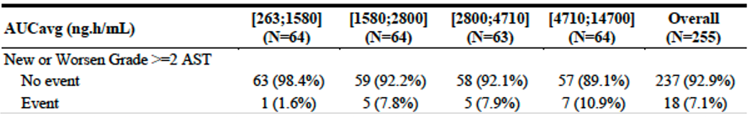
Abbreviations: AST=aspartate aminotransferase; AUCavg=AUC at steady state based on the average dose up to the time of the event or up to end of treatment; N=number of subjects.
Logistic regression analysis indicated that the relationship was not statistically significant (p=0.160). There were no trends in the relationships between other liver enzymes and exposure.
Additional analyses examined the relationship between AUC quartiles and the incidence of grade ≥ 3 AST elevations and grade ≥ 3 ALT elevations. A trend towards increased incidence of these event with increasing AUC was observed. However, these trends were not statistically significant (p = 0.244 and p = 0.138 respectively).
The Evaluator noted the results were similar if C_{max,avg} was used as the exposure metric.

Paediatric
PopPK modelling in study AG881-C-004-PPK-PED-ADDENDUM-01 was an important component of the justification for the dosing to support the paediatric indication. Only one patient aged < 18 years contributed observed PK data.
Body measurement parameters based on the Centre for Disease Control and Prevention growth chart were used for the simulated adolescent population. Age and sex were cross referenced to the percentiles of expected body weights to create a virtual population with a realistic distribution of weight while maintaining any correlation between age and sex. Body weights simulated covered a reasonable distribution from 25-30 kg, and then from 30 kg -120 kg in 10 kg bins.
For each body weight group, a virtual adolescent population (ages 12 years to < 18 years) of 600 male patients and 400 female patients was simulated. The sex distribution represented the distribution in the clinical trial.
The simulations were performed for 10mg once daily, 20 mg once daily, 30 mg once daily and 40 mg once daily. All simulations used F2.
The systemic exposures in adolescents were compared with exposures in adults, predicted using the adult population PK model. These were generated from individual plasma concentration-time profiles at steady-state for participants with glioma from study AG881-C-004 who had been included in the population PK analysis dataset and who were treated with vorasidenib formulation F2 at 40 mg once daily. This population included 184 participants.
Figures 3 and 4 depict the distribution of AUC_{ss} values predicted using the revised model for the range of weight groups, compared to the adult 40 mg once daily dosing (pink box and whisker plot).
Figure 3: Study AG881-C-004-PPK-PED-ADDENDUM-01 Boxplots of C_{trough,ss} per Weight Group and Coloured by Dosing Regimen
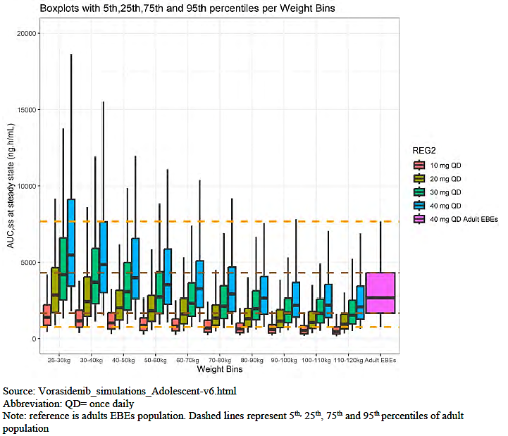
QD=once daily
Figure 4: AG881-C-004-PPK-PED-ADDENDUM-01 Boxplots of AUC,ss per Dosing Regimen and Coloured by Weight Group
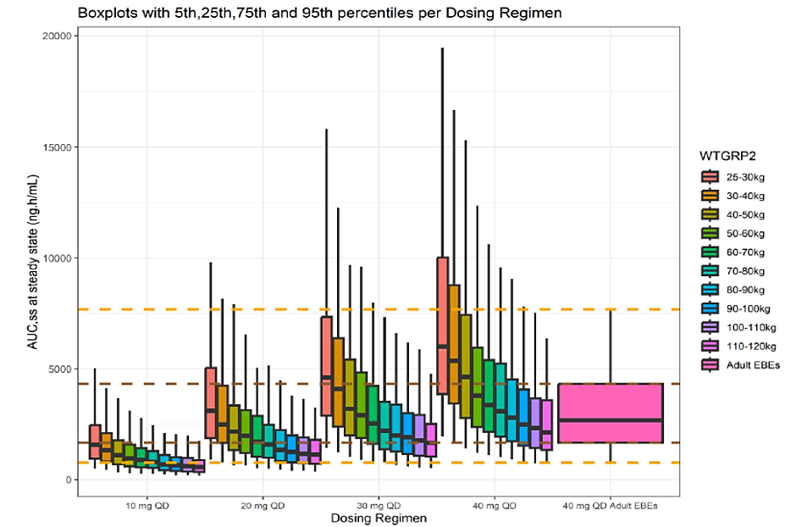
QD=once daily
Note: reference is adult EBE population. Dashed lines represent 5th, 25th, 75th and 95th percentiles.
Based on these predictions the following dosing regimens are proposed.
- 20 mg once daily in the 25 – 30 kg group was predicted to provide similar exposures (1.07-fold) to 40 mg once daily in adults.
- 20 mg once daily in the 30 – 40 kg group was predicted to provide similar exposures (0.91-fold) to 40 mg once daily in adults.
- 40 mg once daily for 40 – 50 kg group was predicted to provide similar exposure (1.5-fold) to 40 mg once daily in adults, whereas 30 mg was predicted to provide a 1.15-fold exposure compared to 40 mg once daily dose in adults.
- 40 mg once daily for 60 -70 kg group was predicted to provide similar exposure (1.23-fold) to 40 mg once daily in adults and for a 30 mg once daily dose predicted to provide a 1.0-fold exposure compared to 40 mg once daily dose in adults.
- 40 mg once daily for 80 – 90kg group was predicted to provide similar exposure (0.86-fold) to 40 mg once daily in adults.
The dosing is chosen to equate to adult 40 mg dosing rather than to align with the therapeutic range. The exposure response was flat.

Drug interactions – conventional and pharmacometric studies
Repeated administration of omeprazole had no significant effect on the single-dose PK of vorasidenib.
CYP1A2 is an important interaction for vorasidenib. In the physiologically-based pharmacokinetic modelling (PBPK) analysis, co-administration of fluvoxamine (a strong CYP1A2 inhibitor) was predicted to increase vorasidenib AUC_{0-tau} (after repeated dosing at 40 mg OD) 7.18-fold and C_{max} by 5.7-fold.
Co-administration of ciprofloxacin (a strong CYP1A2 inhibitor) with a single dose of vorasidenib was associated with a 1.94 to 2.53-fold increase in vorasidenib AUC and a 1.29-fold increase in vorasidenib C_{max}. In the PBPK analysis, co-administration of ciprofloxacin was predicted to increase vorasidenib AUC_{0-tau} (after repeated dosing at 40 mg OD) 1.78-fold and C_{max} by 1.6-fold.
In the PBPK analysis, co-administration of moderate CYP1A2 inducer was predicted to decrease vorasidenib exposure. Phenytoin (a moderate CYP1A2 inducer) was predicted to decrease vorasidenib AUC_{0-tau} (after repeated dosing at 40 mg OD) by approximately 39% and C_{max} by approximately 30%, and co-administration of rifampicin was predicted to decrease vorasidenib AUC_{0-tau} (after repeated dosing at 40 mg OD) by approximately 39% and C_{max} by approximately 30%.
Preclinical data indicated that vorasidenib was an inducer of CYP3A4. In the PBPK analysis, co-administration of vorasidenib (repeated dosing at 40 mg OD) was predicted to decrease exposure to midazolam (a CYP3A4 substrate). After a single dose of midazolam, AUC_{0-inf} would be decreased by approximately 82% and C_{max} by approximately 79%.
Preclinical data indicated that vorasidenib may be an inducer of CYP2C19. In the PBPK analysis, co-administration of vorasidenib (repeated dosing at 40 mg OD) was predicted to decrease exposure to S-mephenytoin (a CYP2C19 substrate). After a single dose of S-mephenytoin, AUC_{0-inf} would be decreased by approximately 35% and C_{max} by approximately 29%.
Preclinical data indicated that vorasidenib may be an inducer of CYP2B6. In the PBPK analysis, co-administration of vorasidenib (repeated dosing at 40 mg OD) was predicted to decrease exposure to bupropion (a CYP2B6 substrate). After a single dose of bupropion, AUC_{0-inf} would be decreased by approximately 21% and C_{max} by approximately 18%.
Preclinical data indicated that vorasidenib may be an inhibitor or inducer of CYP2C8 and CYP2C9, but in the PBPK analyses co-administration of vorasidenib (repeated dosing at 40 mg OD) was predicted to have no significant effect on exposure to repaglinide (a CYP2C8 substrate) or S-warfarin (a CYP2C9 substrate) after a single dose.
In the PBPK analyses, co-administration of vorasidenib (repeated dosing at 40 mg OD) was predicted to have no significant effect on exposure to digoxin (a P-glycoprotein substrate) or rosuvastatin (a BRCP substrate) after a single dose.
Repeated dosing with vorasidenib had no significant effect on the PK of lamotrigine, a uridine 5’-diphospho-glucuronyl transferase (UGT) substrate.

Pharmacodynamics
Human pharmacodynamics (PD) studies revealed a reduction in the concentration of 2-HG in brain tumour tissue of patients who received vorasidenib preoperatively, compared with a brain tumour tissue from patients who did not receive it. The effect was significant in patients who had received 50mg dosing (F1) but did not reach significant in patients who received a 10 mg dose. This supports the 50 mg (F1) or equivalent dosing.
In two separate studies (AG881-C-001 and AG881-C-002) in patients with gliomas and in a cohort of patients with haematological malignancies at various doses of vorasidenib the plasma 2-HG was reduced.

Dose finding
In the AG881-C-002 study in patients with gliomas, the doses of 100 mg and higher of formulation 1 (F1) was associated with dose limiting toxicities of elevated liver transaminases. The next lowest F1 dose studied was 50 mg was taken forward for further study. Vorasidenib was reformulated for commercial production (formulation 2, F2). The relative bioavailability of F1 and F2 from study AG881-C-007 showed F2 had a 36 – 38% increase in AUC and 64% increase in Cmax. As a result, the Sponsor took forward 40 mg of F2 for study in the Phase 3 study and for commercialisation.

Efficacy

Study AG881-C-004
This phase 3, multicentre, multinational, randomised, double-blind, placebo-controlled trial in participants aged ≥ 12 years and ≥ 40 kg with Grade 2 oligodendroglioma or astrocytoma (per WHO 2016 criteria) who had had their tumour resected and no other glioma treatment commenced in 2020. It was ongoing at the time of the 6 September 2022 data cut that was used for the efficacy analysis presented in the submission.

Inclusion and exclusion criteria
The key inclusion and exclusion criteria are summarised in Table 3.
Table 3: Study AG881-C-004 Key Inclusion and Exclusion Criteria
Inclusion Criteria
- Aged ≥ 12 years, weight ≥ 40 kg.
- Grade 2 oligodendroglioma or astrocytoma per WHO 2016 criteria.
- ≥ 1 prior surgery for glioma (biopsy, sub-total resection, gross-total resection), with the most recent surgery ≥ 1 year (-1 month) and ≤ 5 years (+3 months) before the date of randomisation, and no other prior anticancer therapy, including chemotherapy and radiotherapy, and not in need immediate chemotherapy or radiotherapy in the opinion of the Investigator. (Note: Participants undergoing biopsy solely to obtain tissue for central confirmation of IDH mutation status [e.g., tissue from previous surgery was exhausted or not available] were considered an exception and did not need to wait an additional year from biopsy to be eligible.
- Confirmed IDH1 (IDH1 R132H/C/G/S/L mutation variants tested) or IDH2 (IDH2R172K/M/W/S/G mutation variants tested) gene mutation status disease by central laboratory testing during the pre-screening period, and available 1p19q status by local testing (e.g., FISH, CGH array, sequencing) using an accredited laboratory.
- MRI-evaluable, measurable, non-enhancing disease, as confirmed by the blinded independent review committee (BIRC), assessed at screening on 2D T2-weighted or 2D T2-weighted fluid-attenuated inversion recovery (FLAIR) MRI with ≤4 mm slice thickness and no interslice gap. Measurable non-enhancing disease is defined as at least 1 target lesion measuring ≥1 cm × ≥1 cm (bidimensional). Enhancement that is centrally confirmed by the BIRC to be minimal, non-nodular, and non-measurable and that has not changed between the 2 most recent scans (including screening scan) permitted.
- Karnofsky Performance Scale (KPS) score (for participants ≥16 years of age) or Lansky Play-Performance Scale (LPPS) score (for participants <16 years of age) of ≥80%.
- An expected survival of ≥12 months.
- Adequate bone marrow, hepatic and renal function.
- Recovered from any clinically relevant toxicities associated with any prior surgery for the treatment of glioma unless stabilized under medical management.
- Female participants of childbearing potential must have a negative serum pregnancy test before the start of therapy. Women of childbearing potential as well as fertile men with partners who are women of childbearing potential must agree to abstain from sexual intercourse or to use 2 highly effective forms of contraception, at least one of which must be a barrier method, from the time of giving informed consent or assent, throughout the study, and for 90 days after the last dose of vorasidenib.
Exclusion Criteria
- Any prior anticancer therapy other than surgery (biopsy, sub-total resection, gross-total resection) for treatment of glioma including systemic chemotherapy, radiotherapy, vaccines, small-molecules, IDH inhibitors, investigational agents, laser ablation, etc.
- High-risk features per investigator assessment including brainstem involvement (primary location or tumour extension), clinically relevant functional or neurocognitive deficits due to the tumour (deficits resulting from surgery are allowed), uncontrolled seizures (persistent seizures interfering with activities of daily life AND failed 3 lines of antiepileptic drug regimens including ≥ 1 combination regimen).
- Concurrent active malignancy except a) curatively resected nonmelanoma skin cancer or b) curatively treated carcinoma in situ. Participants with previously treated malignancies eligible if disease-free for 3 years at screening.
- Pregnant or breastfeeding.
- Active infection requiring systemic anti-infective therapy or an unexplained fever > 38.5°C <7 days of C1D1.
- Known hypersensitivity to any components of vorasidenib.
- Significant active cardiac disease within 6 months before the start of study treatment, including NHYA Class III or IV congestive heart failure, myocardial infarction, unstable angina, ± stroke.
- Left ventricular ejection fraction <40% by ECHO (or by other methods according to institutional practice) obtained ≤28 days before start of study treatment.
- Heart-rate corrected QT interval using Fridericia’s formula (QTcF) ≥ 450 msec or at increased risk of QT prolongation or arrhythmic events. Bundle branch block and prolonged QTcF permitted with approval of the Medical Monitor.
- Taking therapeutic doses of steroids for signs/symptoms of glioma. Participants taking physiologic doses (equivalent of ≤10 mg prednisone daily) for unrelated medical conditions permitted.
- Taking lamotrigine as an antiseizure medication (In original protocol but removed in a protocol amendment).
- Taking any medications that are CYP2C8, CYP2C9, CYP2C19, or CYP3A substrates with a narrow therapeutic index. Could be transferred to alternative before receiving first dose of study drug.
- Known active HBV, HCV, HIV, or AIDS related illness. Participants with sustained viral response to HCV treatment or immunity to prior HBV infection permitted. Chronic HBV adequately suppressed by institutional practice will be permitted.
- Known condition that limits the ingestion or gastrointestinal absorption of oral drugs. Treated gastroesophageal reflux disease allowed if no drug interaction potential.

Statistics
In a retrospective study of the natural history of grade 2 or 3 non-enhancing gliomas, the median time from surgery to next intervention was approximately 24 months.
Participants in study AG881-C-004 were required to have a 12-month interval between surgery and enrolment in the trial. The interval between randomisation and next intervention would have been approximately 12 months. It was assumed that progression free survival (PFS) in the placebo arm would be approximately 18 months.
Statistical hypotheses were established to examine the primary objective of PFS for vorasidenib vs placebo. A second pair of hypotheses were established to examine the key secondary endpoint of time to next intervention (TTNI).
The median PFS for participants in the vorasidenib arm was assumed to be 30 months, corresponding to a hazard ratio (HR) of 0.6. It was calculated that a total of 164 PFS events were required to have at least 90% power to detect a HR of 0.6 using a 1-sided log-rank test stratified by the randomization stratification factors at a significance level of 0.025. A total of 340 participants were to be randomised.
TTNI was assumed to be equal to PFS plus an additional 3 months to accommodate any required washout periods for subsequent anticancer therapy and to prepare for subsequent anticancer therapy. Median TTNI was assumed to be 21 months in the placebo arm and 33 months in the vorasidenib arm (HR of 0.636). A total of 152 TTNI events would be required to have approximately 80% power to detect this difference between the two arms.
To preserve the overall type I error, fixed sequence testing was to be used, with TTNI tested only if PFS had reached statistical significance at either interim analysis 2 (IA2) or the final analysis.
Other statistics were to be descriptive.

Randomisation
Randomisation was 1:1 to either vorasidenib or placebo, stratified by tumour size and chromosome 1p19q codeletion status determined locally.

Baseline characteristics
The demographics and disease characteristics have been tabulated separately by the Sponsor and are presented in a similar fashion, in sequence in Tables 4 and 5.
Table 4: Study AG-881—C-004 Baseline Participant Characteristics
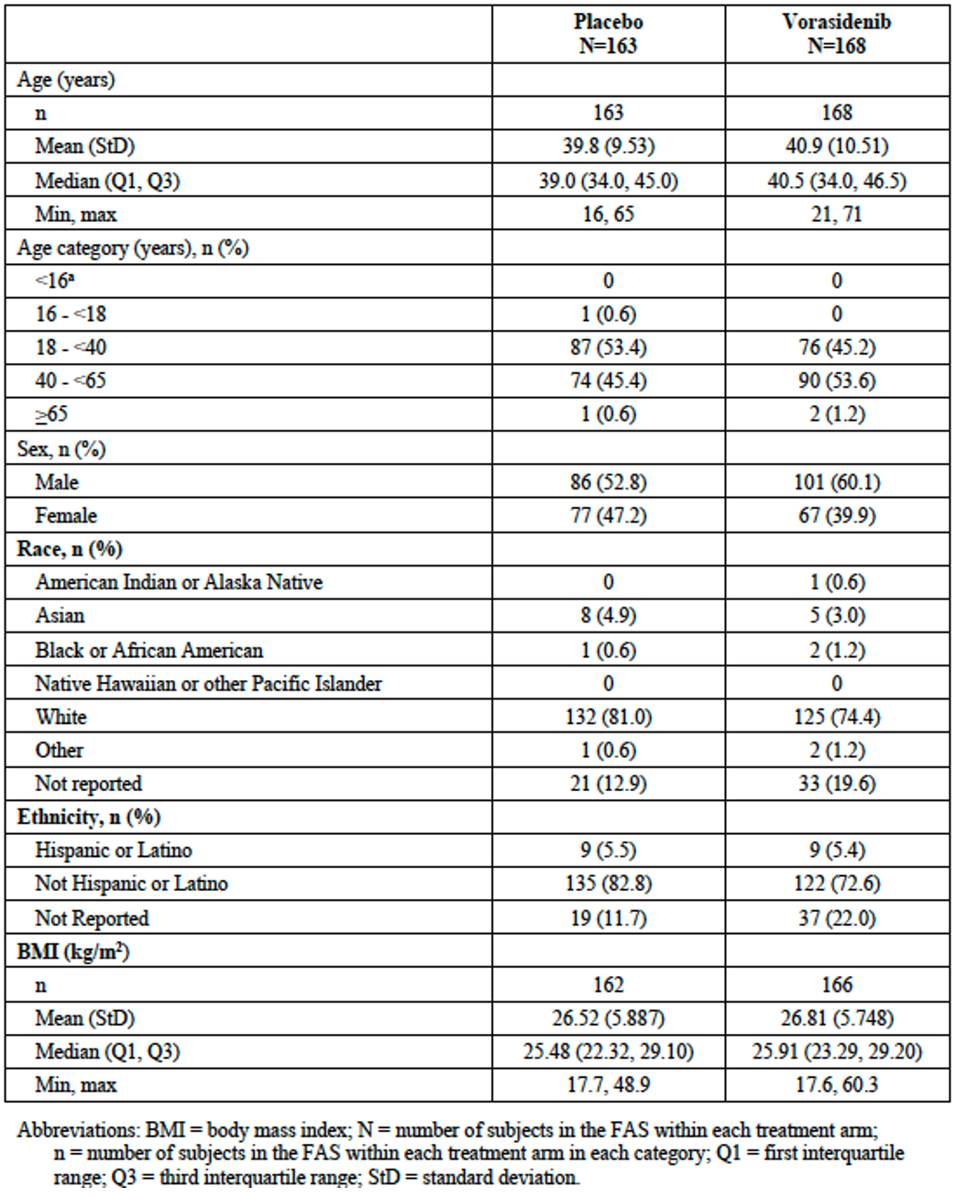Abbreviations: BMI = body mass index; N = number of subjects in the FAS within each treatment arm; n = number of subjects in the FAS within each treatment arm in each category; Q1= first interquartile range; Q3 = third interquartile range; StD = standard deviation.
Notes: The denominator used to calculate percentages is N. Baseline is defined as the last assessment on or before the date of randomization (for subjects randomized and not dosed), and as the last assessment on or before the start of study treatment (for subjects randomized and dosed). Age (years): (year of informed consent — year of birth). BMI = weight (kg) / height (cm)². a. The minimum age for enrolment was 12 years.
Table 5: Study AG881-C-004 Baseline Participant Characteristics
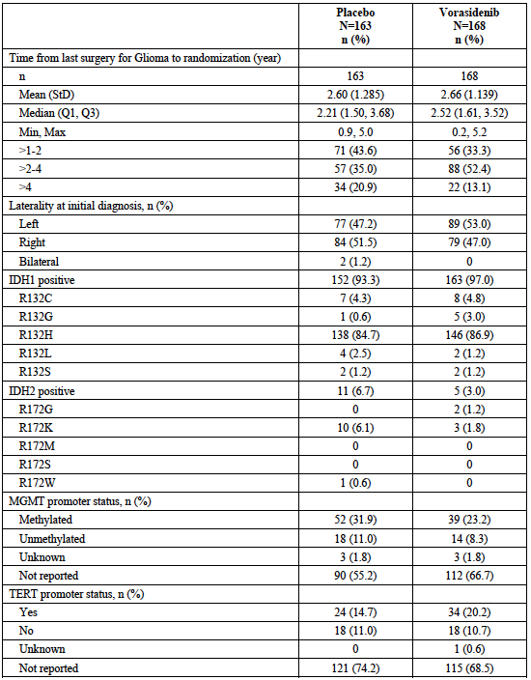
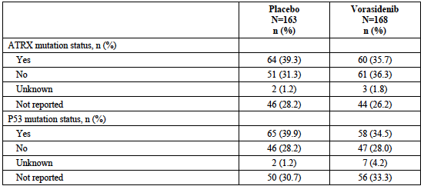
Abbreviations: ATRX= a-thalassemia/menta retardation syndrome X-linked gene; eCRF = electronic case report form; FAS = Full Analysis Set: IDH = isocitrate dehydrogenase; IWRS = interactive web response system: Max = maximum: MGNIT= 06 methylguanine-DNA-methyltransferase- Min = minimum: N = number of subjects in the FAS within each treatment arm; n = number of subjects in the FAS within each treatment arm in each category; Q1= first interquartile range: Q3 = third interquartile range; StD = standard deviation:. TERT = telomerase reverse transcriptase. a. There were no Karnofsky Performance Scale scores for 50-40. or 30-10. No data were reported for the Lanky Play-Performance Scale score. b. For pre-treatment growth rate, n is the number of subjects with pre-treatment volume data available.

Participant flow
A total of 331 patients were randomised: 163 to the placebo arm and 168 to the vorasidenib arm.
At the time of data cut-off, 41.7% of participants in placebo arm had discontinued treatment, compared with 21.4% in the vorasidenib arm. Disease progression was the most common reason for discontinuation in both arms: 36.2% of the placebo arm and 14.3% of the vorasidenib arm.
Major protocol violations occurred in similar proportions in each arm, the most frequent of which were ICH good clinical practice (GCP) deviations (approximately 11% of each arm), including instances of which involved incorrect template or version of consent documents were used or instances of missing documents.

Treatments
Treatments were either vorasidenib or placebo tablets given once daily fasted (or at least 2 hours after food) at the same time each day. Food consumption was avoided for 1 hour after administration.
At study commencement, five patients in the vorasidenib group received 50 mg daily of formulation 1 before switching to 40 mg of formulation 2 and the remaining 163 participants in the vorasidenib group received only 40 mg formulation 2 tablets.
Vorasidenib was supplied as 5 and 25 mg uncoated tablets (F 1) or 10 and 40 mg tablets (F2).
Treatments were administered once daily in 28-day cycles.
Treatment continued until radiological progression (per blinded independent central review), unacceptable toxicity, commencement of another therapy, pregnancy, death, consent withdrawal, loss to follow up or study end.
Dose reductions were allowed in the event of toxicity: 40 mg to 20 mg to 10 mg (for F2).
Placebo arm participants could cross over into the vorasidenib arm if the disease progressed.

Assessments
MRI scans (minimum of 2D T1-weighted MRI pre- and postcontrast enhancement, 2D T2-weighted MRI, and 2D fluid-attenuated inversion recovery scans) were obtained at screening and repeated 12 weekly until cycle 37 when the assessments were conducted 6 monthly.
The Functional Assessment of Cancer Therapy – Brain (Fact-Br) questionnaires were administered at the beginning of the first 4 treatment cycles then 3 monthly thereafter and at the end of treatment visit.
Six-monthly follow up was conducted for overall survival after the end of treatment visit.

Results
The efficacy analysis included below is based on the 6 September 2022 data cut.
It is the second interim analysis for the study and was conducted after 135 of the required 164 PFS events had occurred. The median duration of follow-up was 13.7 months (95% CI: 11.2, 14.1 months) in the vorasidenib arm and 14.1 months (95% 11.1, 15.2 months) in the placebo arm. These efficacy data were collected prior to the unblinding of the study in March 2023.
The primary endpoint was progression free survival, was radiological, and assessed by the BIRC.
Disease progression and tumour response were assessed using the Response Assessment in Neuro-Oncology (RANO) criteria for low-grade gliomas (RANO-LGG).
PFS was tested at a one-sided efficacy α-level of 0.000359, based on an updated efficacy boundary corresponding to the 82% information fraction observed at IA2.
PFS events are shown in Table 6 and in Figure 5.
Table 6. Study AG881-C-004 Primary Endpoint Results – Progression Free Survival per Blinded Independent Review Committee.
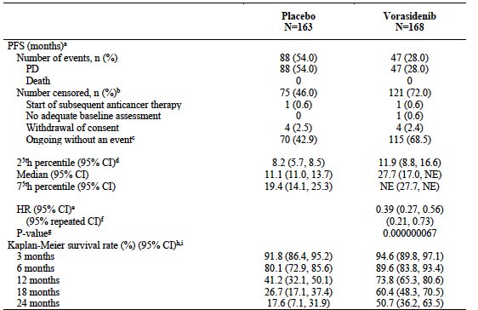
Abbreviations: BIRC = Blinded Independent Review Committee; CI = confidence interval; FAS = Full Analysis Set, HR = hazard ratio; IA2 = Interim Analysis 2; IWRS = interactive web response system; N = number of subjects in each treatment arm; n = number of observed values; NE = not estimable; PD = progressive disease; PFS = progression-free survival; RANO-LGG = Response Assessment in Neuro-oncology for Low-grade Gliomas
Note: PFS per the BIRC refers to death or documented radiographic PD as assessed by the BIRC per modified RANO-LGG.
PFS = (date of event or censoring — randomization date + 1) / 30.4375.
- Five subjects crossed over to receive vorasidenib following centrally confirmed radiographic PD by the BIRC; however, these subjects are censored as Ongoing without an event for the primary analysis for PFS per the BIRC.
- Quartile estimates from product-limit (Kaplan-Meier) method. CIs were calculated with the Brookmeyer and Crowley method with log-log transformation.
- HR was calculated from the Cox regression model stratified by the randomization strata with placebo as the denominator, with two-sided 95% CIs.
- Method for the 2-sided repeated CI for the HR..
- P-value was calculated from the one-sided log-rank test stratified by the randomization factors (Chromosome 1p19q co-deletion status and tumour size at baseline per local assessment per IWRS). For IA2, PFS was tested at a one-sided efficacy a-level of 0.000359, based on an updated efficacy boundary corresponding to the 82% information fraction observed at IA2.
- Based on survival distribution function estimates from product-limit method.
- Kaplan-Meier survival rate was not evaluable from 30 to 48 months, inclusive.
Figure 5. Study AG881-C-004 Kaplan-Meier Plot Progression Free Survival.
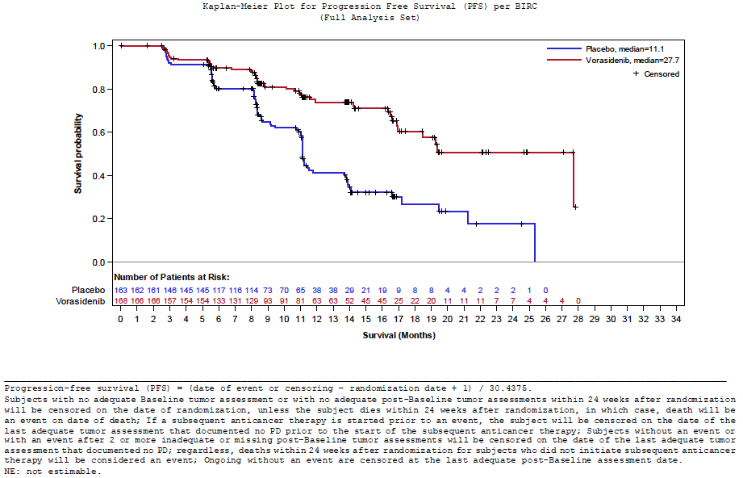
Progression-free survival (PFS) = (date of event or censoring - randomization date + 1) / 30.4375. Subjects with no adequate Baseline tumour assessment or with no adequate post-Baseline tumour assessments within 24 weeks after randomization will be censored on the date of randomization, unless the subject dies within 24 weeks after randomization, in which case, death will be an event on date of death; If a subsequent anticancer therapy is started prior to an event, the subject will be censored on the date of the last adequate tumour assessment that documented no PD prior to the start of the subsequent anticancer therapy; Subjects without an event or with an event after 2 or more inadequate or missing post-Baseline tumour assessments will be censored on the date of the last adequate tumour assessment that documented no PD; regardless, deaths within 24 weeks after randomization for subjects who did not initiate subsequent anticancer therapy will be considered an event; Ongoing without an event are censored at the last adequate post-Baseline assessment date. NE: not estimable.
The Kaplan-Meier plot, above, shows early and persistent separation of the curves.
In the PFS subgroup analyses, the point estimates of the HR were generally consistent with the overall study result (Figure 6).
Figure 6: Study AG881-C-004 Subgroup Analyses Primary Endpoint
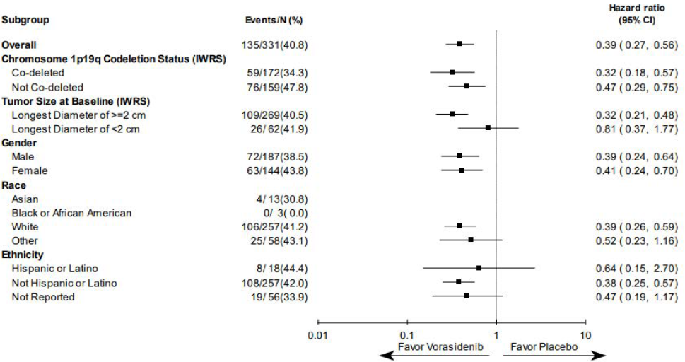
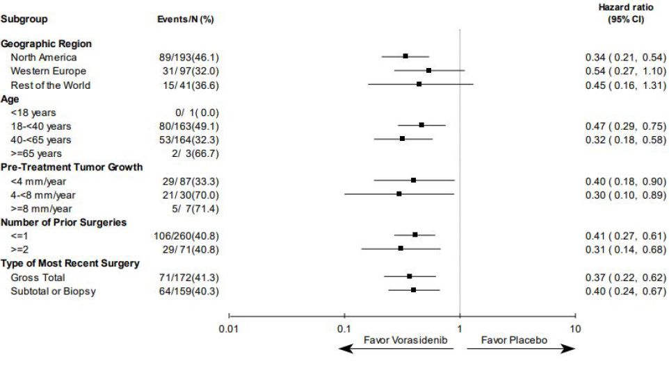
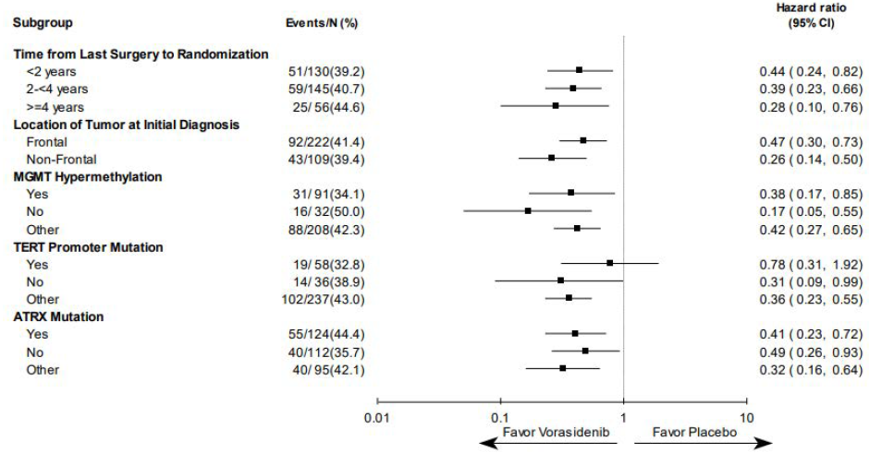
Abbreviations: ATRX = a-thalassemia/mental-retardation-syndrome-X-linked gene; BIRC = Blinded Independent Review Committee; CI = confidence interval; IWRS = interactive web response system; MGMT = 06 methylguanine-DNA-methyltransferase gene; PD = progressive disease; PFS = progression-free survival; RANO-LGG = Response Assessment in Neuro-oncology for Low-grade Gliomas; TERT = telomerase reverse transcriptase. Notes: PFS = (date of event or censoring — randomization date + 1) / 30.4375. PFS based on the BIRC refers to death or documented radiographic PD as assessed by the BIRC per modified RANO-LGG. Hazard ratios for each subgroup were calculated from the unstratified Cox regression model. Two-sided 95% Cls are displayed. Time from last surgery to randomization (years) = (date of randomization — date of last surgery + 1)/365.25.
The key secondary endpoint was time to next intervention. TTNI included cross-over to vorasidenib for those randomised to placebo, and included death from any cause (Figure 7).
Figure 7: Study AG881-C-004 – TTNI results (FAS) Kaplan-Meier Plot for Time to Next Intervention (Full Analysis Set)
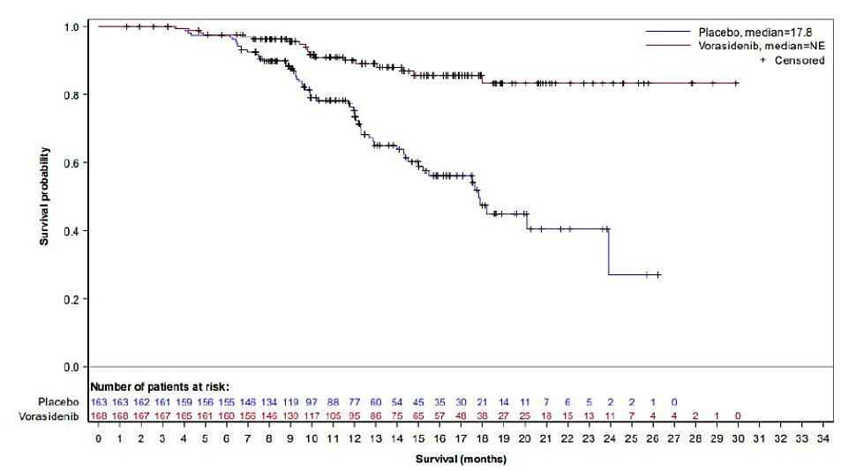
Abbreviations: NE = not estimable; TTNI = time to next intervention. TTNI = (date of event or censoring — randomization date + 1) / 30.4375. Notes: TTNI is the time from randomization to the initiation of first subsequent anticancer therapy (including vorasidenib for subjects randomized to placebo who subsequently crossover to vorasidenib) or death due to any cause.
In the placebo arm, 58 participants (35.6%) started a new intervention. The most common intervention was crossover to vorasidenib for 52 participants and 6 participants had been treated with other anticancer therapy (3 received surgery, 3 received chemotherapy and 5 received radiotherapy).
In the vorasidenib arm, 19 participants (11.3%) started a new intervention. All 19 participants were treated with other anticancer therapy (10 received surgery, 13 received chemotherapy and 11 received radiotherapy).
Median TTNI was an estimated 17.8 months (95%CI: 15.0 to not estimable) in the placebo arm and was not estimable in the vorasidenib arm (HR 0.26 (95%CI: 0.15 to 0.43; p=0.00000019)).

Other secondary endpoints
Tumour growth rate was evaluable in 161 participants in the placebo arm and 167 participants in the vorasidenib arm. No statistical analysis was performed. The change in tumour volume was:
- Placebo arm: +13.9% (95% CI, 11.1% to 16.8%) every 6 months.
- Vorasidenib arm: - 2.5% (95% CI, -4.7%, -0.2%) every 6 months.
Objective response rate (ORR): A response (per BIRC) was observed in 2.5% of the placebo arm and 10.7% of the vorasidenib arm (odds ratio = 4.88 [95%CI: 1.56 to 15.25]). All responders in the placebo arm had a minor response. In the vorasidenib arm 2 participants had a partial response, and 16 participants had a minor response.
Among responders in the vorasidenib arm the median duration of response (DoR) was 16.6 months (95% CI: 2.8 to 16.6), and 15 of the 18 responses were ongoing. A median DoR could not be estimated in the placebo arm. All 4 of the responses were ongoing.
The median TTR (per BIRC) for the 4 responders in the placebo arm was 6.9 months (range 3 to 11) and for the 18 participants in the vorasidenib arm was 11.0 months (range 3 to 17).
The secondary endpoints were also measured by the Investigator.
There were no overall survival (OS) events in either arm.
The Evaluator noted the following regarding the patient reported outcome that was reported as a secondary endpoint. The FACT-Br questionnaire is a validated patient-reported outcome measure designed to assess Health-Related Quality of Life (HRQoL) in patients with brain tumours. It consists of 27 items from the FACT-General questionnaire (assessing four domains - physical well-being, social/family well-being, emotional wellbeing and functional well-being) and 23 items relating to brain cancer-specific issues. Participants respond to each item using a 5-point rating scale (0 = not at all, 1 = a little bit, 2 = somewhat, 3 = quite a bit, and 4 = very much). Each item is rated for the preceding 7 days. Potential scores range from 0-200 with higher scores indicating better QoL. A minimally important difference (MID) has not been defined.
Completion rates were generally > 80% up until Cycle 13 (52 weeks).
- At baseline, total FACT-Br mean scores (± SD) were comparable in the two study arms - 158.2 (± 26.40) in the vorasidenib arm and 158.8 (±23.33) in the placebo arm.
- At Cycle 13, the mean (± SD) FACT-Br total score was 161.4 (± 23.6) and 163.3 (± 25.05) in the placebo and vorasidenib arms, respectively.
Various analyses were performed on the data. No notable changes in scores or differences between treatment arms were detected.
In response to questions the impact of dose reduction due to adverse events was considered by the Sponsor. A swimmer plot was provided in support of the concept that disease control occurs after dose reduction in those that need it. The plot includes details regarding timing and duration of TEAEs leading to dose reduction, timing and duration of reduced dose, as well as disease response by BIRC at each assessment timepoint (Figure 8).
Of the 18 subjects who experienced a TEAE leading to dose reduction, 13 subjects required a dose reduction from 40 mg QD to 20 mg QD only, and 5 subjects required a second dose reduction from 20 mg QD to 10 mg QD.
Two of the subjects, 840168-105 and 840176-106, remained on treatment beyond an assessment of PD by BIRC. Per protocol, central confirmation of disease progression by BIRC prior to unblinding of treatment assignment only occurs following an assessment of PD by the Investigator. For these subjects the disease response was assessed as SD by the Investigator at these timepoints; therefore, central confirmation of PD was not performed and subjects remained on study treatment.
Figure 8: Disease Response (per BIRC) after Dose Reduction due to Treatment Emergent Adverse Events
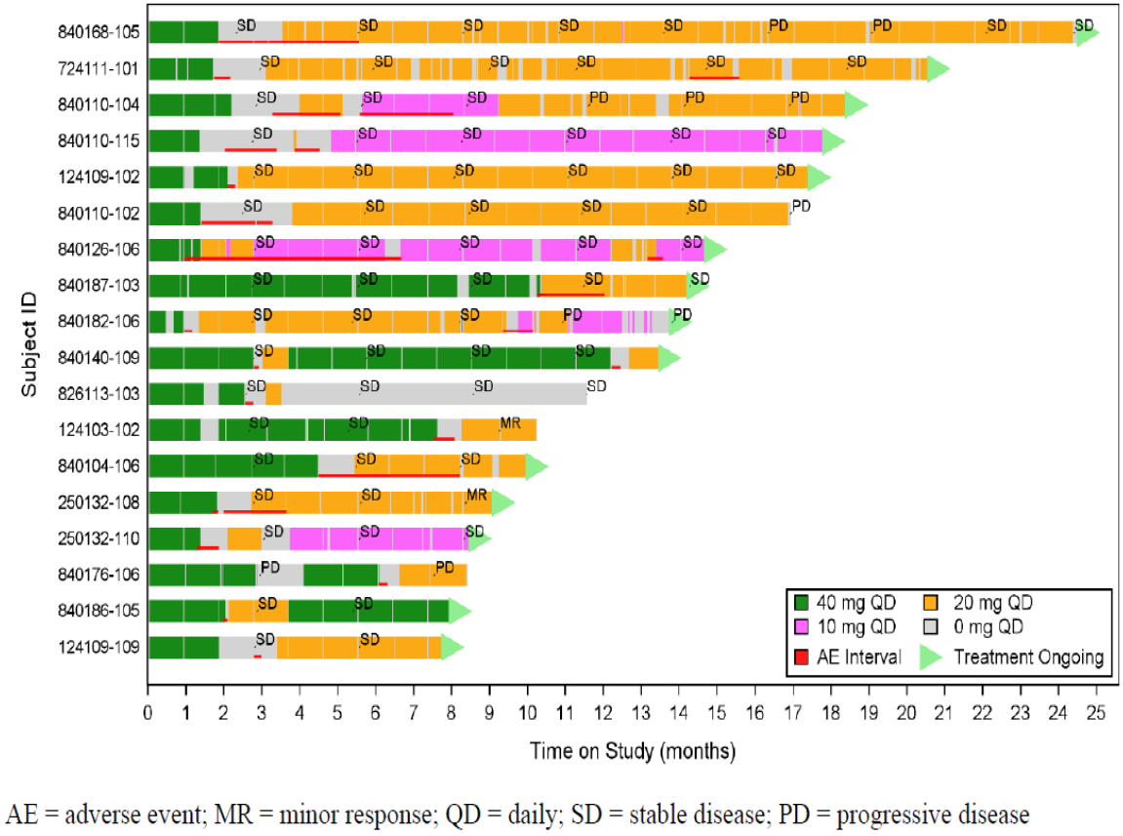
Abbreviations: AE=adverse event; MR-minor response; QD=daily; SD=stable disease; PD=progressive disease

Supportive efficacy studies

Study AG881-C-002
This was a first-in-human, phase 1, open-label, dose escalation study to determine the maximum tolerated dose and/or the recommended phase 2 dose (RP2D) of vorasidenib in participants with advanced non-glioma solid tumours and in participants with glioma. A secondary outcome was to characterise preliminary clinical activity associated with vorasidenib.
Dosing (using F1) included 10 mg OD, 25 mg OD, 100 mg OD, 200 mg OD and 300 mg OD.
The glioma patients were adults with histologically or cytologically confirmed glioma with documented IDH-1 or IDH-2 gene mutation based on local assessment with disease that had recurred after or not responded to standard therapy and/or an IDH1/2 inhibitor, or for whom the investigator believed there was suitable therapy. Gliomas were classified using the WHO 2007 classification.
The study enrolled 52 patients with a mean aged of 41.8 years (range 16 to 73 years), and with equal numbers of males and females. Of those, 22 had non-enhancing gliomas, of which 20 were IDH1 mutant, 1 was IDH2 mutant and 1 was not tested. Eight had 1p/19q codeletion (oligodendroglioma in current classification), 9 did not have 1p/19q codeletion (astrocytoma in current classification) and 5 were not tested. Most (17/22) had Grade 2 tumours, with the remainder Grade 3.
The ORR for the 22 patients with 18.2% (95% CI: 5.19%, 40.28%) with 1 partial response (PR) and 3 minor responses (mR), and for the Grade 2 only patients the ORR was 11.8% (995% CI: 1.46, 36.44) with on partial and 1 minor response. The median time to response was 22.5 months and the duration of response ranged from 11.76 to 57.04 months.

Study AG120-881-C-001
This phase 1, randomised, open-label study investigated vorasidenib and ivosidenib. The results for vorasidenib are relevant for this submission. The primary objective was to measure 2- HG concentration in tumours, and the clinical activity of vorasidenib was a secondary outcome.
Participants were adults with Grade 2 or 3 low grade glioma per the WHO 2016 classification, documented IDH1 R132H mutation by local testing, and with known 1p/19q or ATRX status also by local testing with primarily non-enhancing disease on MRI, and for whom surgery in the next 2 – 4 months was indicated and appropriate.
Patients received vorasidenib 10 mg daily or 50 mg daily or no treatment for a minimum of 28 days up to and including the day of surgery. PK/PD measurements were taken during the pre-surgery/surgery period. Treatment could be continued post-surgery.
Twenty-four participants, aged 31 to 75 years, received vorasidenib for a median of 38.23 months. Twelve were allocated 50 mg dosing and continued this before and after surgery. Two of the 5 patients allocated no preoperative treatment crossed over to the 50 mg vorasidenib dose. All 10 patients allocated to the 10 mg group continued vorasidenib post-surgery and all but one crossed into the 50 mg vorasidenib group. Two patients from the original 10 mg group did not have a post-surgery baseline scan and were excluded from the efficacy analysis.
No patient had a preoperative response.
Overall, 10/22 evaluable patients had a response in the post-surgical period: 4 with a PR 6 with a mR. The median DOR was 25.56 months. Responses were reported participants with oligodendrogliomas and astrocytomas.
The two patients with Grade 3 disease had tumour progression after surgery (PFS 0.95 months, and 1.58 months, respectively).

Safety
On 15 April 2024, the TGA received the 90 day Safety Update that included data from a 6 September 2023 data cut. Since the commencement of the study in Japan in August 2022, 16 participants have enrolled and their data are included in the updated safety data set. The updated safety set includes data from 174 enrolled in the vorasidenib arm and 172 enrolled in the placebo arm. As this includes the most recent safety data cut, and a longer period of safety information emphasis has been placed on this more contemporaneous information.
As of 6 September 2023, the median duration of treatment in the vorasidenib arm was 22.77 months (range 1.0 – 41.9 months) and 14.26 months (0.4 – 32.41 months) in the placebo arm. After cross-over the median treatment duration was 5.26 months (range 0 – 28.6 months). The median relative dose intensity was 99.2% in both arms.
At the time of the analysis 6 September 2023 data cut, 249 participants were on vorasidenib treatment, including 123 (70.7%) who were initially randomised and 126 (83.4%) who crossed over from the placebo arm. No patient remained on placebo after study unblinding in March 2023. Of those that discontinued treatment from the vorasidenib arm, 17.8% had disease progression, 5.7% had an adverse event, 2.9% withdrew and 0.6% discontinued per investigator decision. Of those randomised to placebo, and discontinued prior to cross-over, 45.3% had progressive disease, 1.2% discontinued due to adverse event, 4.7% withdrew and 1.2% discontinued per investigator decision. Of the 151 patients who crossed-over to vorasidenib 16.6% discontinued treatment – 9.3% due to progressive disease, 2.0% due to AE and 4.0% withdrew, 0.7% discontinued per investigator decision, and 1 patient (0.7%) withdrew because they became pregnant.
Safety events from the original submission are shown in Table 7.
Table 7. Study AG881-C-004 Adverse Events from Original Application
Description | New Drug Application (6 September 2022)
Description | Vorasidenib 40 mg QDª |  | Placebo
Description | Without crossover^{b} N=167 | Post-crossover^{c} N=52 | Pre-crossover^{d} N=163
Any TEAEs | 158 (94.6) | 40 (76.9) | 152 (93.3)
Grade ≥3 TEAEs | 38 (22.8) | 6 (11.5) | 22 (13.5)
Treatment-related TEAEs | 109 (65.3) | 23 (44.2) | 95 (58.3)
Grade ≥3 treatment-related TEAEs | 22 (13.2) | 4 (7.7) | 6 (3.7)
Serious TEAEs | 11 (6.6) | 4 (7.7) | 8 (4.9)
Serious treatment-related TEAEs | 3 (1.8) | 2 (3.8) | 0
TEAEs leading to study treatment discontinuation | 6 (3.6) | 1 (1.9) | 2 (1.2)
TEAEs leading to study treatment interruption | 50 (29.9) | 11 (21.2) | 37 (22.7)
TEAEs leading to study treatment dose reduction | 18 (10.8) | 2 (3.8) | 5 (3.1)
TEAEs leading to death | 0 | 0 | 0
Treatment-related TEAEs leading to death | 0 | 0 | 0
Any AESIs^{e} | 73 (43.7) | 15 (28.8) | 34 (20.9)
Serious AESIs^{e} | 1 (0.6) | 1 (1.9) | 0
AESIs^{e} leading to death | 0 | 0 | 0
Abbreviations: AE = adverse event; AESI = adverse event of special interest; CTCAE = common terminology criteria for adverse events; N = number of participants in each arm; NDA = New Drug Application; SAS = safety analysis set; SUR = safety update report; TEAE = treatment emergent adverse event; QD = once daily.
Notes: The SAS for this table includes all participants from AG881-C-004 who have received at least 1 dose of vorasidenib or placebo.
Percentages are calculated based on N in each column.
TEAEs presented in the summary tables include the AEs that begin or worsen from baseline during the on-treatment period.
Grading of TEAE severity used CTCAE v5.0 for Study AG881-C-004.
A participant with multiple occurrences of an AE is counted only once in the AE category. If the same AE appears more than once with different intensity or grade, the event with the highest grade is considered.
TEAEs with relationship missing (unknown), probable, or possible are also considered as treatment-related.
- 40 mg QD population includes patients treated with vorasidenib 50 mg QD uncoated.
- Includes data from participants in Study AG881-C-004 who were randomized to and treated with vorasidenib 40 mg QD, those randomized to placebo but received at least one dose of vorasidenib without crossover, and pre-crossover data from participants who received at least one dose of vorasidenib prior to crossover.
- Includes data from participants who were randomized to placebo who subsequently crossed over to receive vorasidenib 40 mg QD in Study AG881-C-004. Only data after crossover is included in this column.
- Includes data from participants whose actual treatment was placebo in Study AG881-C-004. For participants that subsequently cross over to receive vorasidenib 40 mg QD, only data before crossover is included.
- AESIs for this table are defined by a broad standard MedDRA query (SMQ) of liver-related investigations, signs, and symptoms that included medically equivalent terminology that could represent potential hepatic enzyme elevations.
An updated summary of safety events has also been provided (Table 8).
Table 8: Study AG881-C-004 Treatment Related Adverse Events from Safety Update
Description | Safety Update (06 September 2023)
Description | Vorasidenib 40 mg QDª |  | Placebo
Description | Without crossover^{b} N=174 | Post-crossover^{c} N=151 | Pre-crossover^{d} N=172
Any TEAEs | 172 (98.9) | 130 (86.1) | 158 (91.9)
Grade ≥3 TEAEs | 49 (28.2) | 21 (13.9) | 26 (15.1)
Treatment-related TEAEs | 127 (73.0) | 87 (57.6) | 102 (59.3)
Grade ≥3 treatment-related TEAEs | 25 (14.4) | 14 (9.3) | 9 (5.2)
Serious TEAEs | 22 (12.6) | 9 (6.0) | 10 (5.8)
Serious treatment-related TEAEs | 4 (2.3) | 3 (2.0) | 0
TEAEs leading to study treatment discontinuation | 10 (5.7) | 3 (2.0) | 2 (1.2)
TEAEs leading to study treatment interruption | 59 (33.9) | 41 (27.2) | 41 (23.8)
TEAEs leading to study treatment dose reduction | 21 (12.1) | 13 (8.6) | 7 (4.1)
TEAEs leading to death | 0 | 0 | 0
Treatment-related TEAEs leading to death | 0 | 0 | 0
Any AESIs^{e} | 91 (52.3) | 70 (46.4) | 40 (23.3)
Serious AESIs^{e} | 2 (1.1) | 2 (1.3) | 0
AESIs^{e} leading to death | 0 | 0 | 0
Abbreviations: AE = adverse event; AESI = adverse event of special interest; CTCAE = common terminology criteria for adverse events; N = number of participants in each arm; NDA = New Drug Application; SAS = safety analysis set; SUR = safety update report; TEAE = treatment emergent adverse event; QD = once daily.
Notes: The SAS for this table includes all participants from AG881-C-004 who have received at least 1 dose of vorasidenib or placebo.
Percentages are calculated based on N in each column.
TEAEs presented in the summary tables include the AEs that begin or worsen from baseline during the on-treatment period.
Grading of TEAE severity used CTCAE v5.0 for Study AG881-C-004.
A participant with multiple occurrences of an AE is counted only once in the AE category. If the same AE appears more than once with different intensity or grade, the event with the highest grade is considered.
TEAEs with relationship missing (unknown), probable, or possible are also considered as treatment-related.
- 40 mg QD population includes patients treated with vorasidenib 50 mg QD uncoated.
- Includes data from participants in Study AG881-C-004 who were randomized to and treated with vorasidenib 40 mg QD, those randomized to placebo but received at least one dose of vorasidenib without crossover, and pre-crossover data from participants who received at least one dose of vorasidenib prior to crossover.
- Includes data from participants who were randomized to placebo who subsequently crossed over to receive vorasidenib 40 mg QD in Study AG881-C-004. Only data after crossover is included in this column.
- Includes data from participants whose actual treatment was placebo in Study AG881-C-004. For participants that subsequently cross over to receive vorasidenib 40 mg QD, only data before crossover is included.
- AESIs for this table are defined by a broad standard MedDRA query (SMQ) of liver-related investigations, signs, and symptoms that included medically equivalent terminology that could represent potential hepatic enzyme elevations.
Using the most recent safety data, the TEAEs occurring by System Organ Class and Preferred Term are shown in Table 9.
Table 9: Study AG881-C-004 Treatment Related Adverse Events by System Organ Class and Preferred Term, Updated Safety Analysis
System Organ Class  Preferred Term | Safety Update (06 September 2023)
System Organ Class  Preferred Term | Vorasidenib 40 mg QDª |  | Placebo
System Organ Class  Preferred Term | Without crossover^{b} N=174 | Post-crossover^{c} N=151 | Pre-crossover^{d} N=172
Participants with any events | 172 (98.9) | 130 (86.1) | 158 (91.9)
Nervous system disorders | 103 (59.2) | 55 (36.4) | 93 (54.1)
Headache | 51 (29.3) | 18 (11.9) | 46 (26.7)
Seizure | 28 (16.1) | 12 (7.9) | 20 (11.6)
Dizziness | 31 (17.8) | 8 (5.3) | 29 (16.9)
Paresthesia | 18 (10.3) | 9 (6.0) | 14 (8.1)
Investigations | 105 (60.3) | 76 (50.3) | 57 (33.1)
Alanine aminotransferase increased | 78 (44.8) | 61 (40.4) | 29 (16.9)
Aspartate aminotransferase increased | 61 (35.1) | 37 (24.5) | 16 (9.3)
Gamma-glutamyltransferase increased | 34 (19.5) | 22 (14.6) | 8 (4.7)
Gastrointestinal disorders | 98 (56.3) | 49 (32.5) | 88 (51.2)
Diarrhoea | 46 (26.4) | 17 (11.3) | 33 (19.2)
Nausea | 45 (25.9) | 28 (18.5) | 44 (25.6)
Constipation | 22 (12.6) | 6 (4.0) | 21 (12.2)
Vomiting | 17 (9.8) | 6 (4.0) | 20 (11.6)
Infections and infestations | 99 (56.9) | 33 (21.9) | 88 (51.2)
COVID-19 | 62 (35.6) | 16 (10.6) | 54 (31.4)
General disorders and administration site conditions | 90 (51.7) | 45 (29.8) | 74 (43.0)
Fatigue | 64 (36.8) | 34 (22.5) | 57 (33.1)
Musculoskeletal and connective tissue disorders | 71 (40.8) | 26 (17.2) | 55 (32.0)
Arthralgia | 19 (10.9) | 5 (3.3) | 19 (11.0)
Psychiatric disorders | 46 (26.4) | 13 (8.6) | 50 (29.1)
Insomnia | 19 (10.9) | 4 (2.6) | 15 (8.7)

Abbreviations: AE = adverse event; MedDRA = Medical Dictionary for Regulatory Activities; N = number of participants in each arm; NDA = New Drug Application; SAS = safety analysis set; SUR = safety update report; TEAE = treatment emergent adverse event; QD = once daily.
Notes: The SAS for this table includes all participants from AG881-C-004 who have received at least 1 dose of vorasidenib or placebo.
Percentages are calculated based on N in each column.
TEAEs presented in the summary tables include the AEs that begin or worsen from baseline during the on-treatment period.
A participant with multiple occurrences of an AE is counted only once in the AE category. If the same AE appears more than once with different intensity or grade, the event with the highest grade is considered.
TEAEs with relationship missing (unknown), probable, or possible are also considered as treatment-related.
System organ classes and preferred terms are coded from MedDRA v25.1 (initial NDA) and MedDRA v26.0 (SUR).
- 40 mg QD population includes patients treated with vorasidenib 50 mg QD uncoated.
- Includes data from participants in Study AG881-C-004 who were randomized to and treated with vorasidenib 40 mg QD, those randomized to placebo but received at least one dose of vorasidenib without crossover, and pre-crossover data from participants who received at least one dose of vorasidenib prior to crossover.
- Includes data from participants who were randomized to placebo who subsequently crossed over to receive vorasidenib 40 mg QD in Study AG881-C-004. Only data after crossover is included in this column.
- Includes data from participants whose actual treatment was placebo in Study AG881-C-004. For participants that subsequently cross over to receive vorasidenib 40 mg QD, only data before crossover is included.
Grade 3 events occurring in ≥2% of participants from the updated safety analysis are shown in Table 10.
Table 10: Study AG881-C-004 Grade 3 Treatment Related Adverse events, Updated Safety Analysis
System Organ Class  Preferred Term | Safety Update (06 September 2023)
System Organ Class  Preferred Term | Vorasidenib 40 mg QDª |  | Placebo
System Organ Class  Preferred Term | Without crossover^{b} N=174 | Post-crossover^{c} N=151 | Pre-crossover^{d} N=172
Participants with any events | 49 (28.2) | 21 (13.9) | 26 (15.1)
Investigations | 25 (14.4) | 12 (7.9) | 6 (3.5)
Alanine aminotransferase increased | 19 (10.9) | 11 (7.3) | 2 (1.2)
Aspartate aminotransferase increased | 10 (5.7) | 6 (4.0) | 0
Gamma-glutamyltransferase increased | 5 (2.9) | 1 (0.7) | 2 (1.2)
Nervous system disorders | 13 (7.5) | 4 (2.6) | 13 (7.6)
Seizure | 7 (4.0) | 2 (1.3) | 5 (2.9)
Abbreviations: AE = adverse event; AESI = adverse event of special interest; CTCAE = common terminology criteria for adverse events; MedDRA = Medical Dictionary for Regulatory Activities; N = number of participants in each arm; NDA = New Drug Application; SAS = safety analysis plan; SUR = safety update report; TEAE = treatment emergent adverse event; QD = once daily.
Notes: The SAS for this table includes all participants from AG881-C-004 who have received at least 1 dose of vorasidenib or placebo.
Percentages are calculated based on N in each column.
TEAEs presented in the summary tables include the AEs that begin or worsen from baseline during the on-treatment period.
A participant with multiple occurrences of an AE is counted only once in the AE category. If the same AE appears more than once with different intensity or grade, the event with the highest grade is considered.
Grading of TEAE severity used CTCAE v5.0 for Study AG881-C-004.
System organ classes and preferred terms are coded from MedDRA v25.1 (initial NDA) and MedDRA v26.0 (SUR).
- 40 mg QD population includes patients treated with vorasidenib 50 mg QD uncoated.
- Includes data from participants in Study AG881-C-004 who were randomized to and treated with vorasidenib 40 mg QD, those randomized to placebo but received at least one dose of vorasidenib without crossover, and pre-crossover data from participants who received at least one dose of vorasidenib prior to crossover.
- Includes data from participants who were randomized to placebo who subsequently crossed over to receive vorasidenib 40 mg QD in Study AG881-C-004. Only data after crossover is included in this column.
- Includes data from participants whose actual treatment was placebo in Study AG881-C-004. For participants that subsequently cross over to receive vorasidenib 40 mg QD, only data before crossover is included.
The most common treatment related adverse events in either analysis were elevations of liver enzymes (ALT, AST, GGT increased), fatigue, nausea, and diarrhoea. Grade ≥3 events occurring in more than one patient were only reported for evaluations of liver enzymes in the original and updated analyses.
There were no on-treatment deaths in either safety analysis. Two deaths due to progressive disease occurred. Both occurred off treatment and after subsequent interventions.
In the safety update, serious adverse events (SAEs) were reported in 12.6% of the vorasidenib arm, 5.8% of the placebo arm and 6.0% of the cross-over group. Of those, 6/174 in the vorasidenib arm and 6/172 in the placebo arm reported seizure or partial seizure or epilepsy. Two patients in the vorasidenib arm and two patients on cross-over reported ALT increased. Two patients in the placebo arm reported suicidal ideation. All other events occurred in single patients. Of these events, only ALT increased was considered treatment related.
In the safety update, dose modification of any kind was reported for 42.0% of the vorasidenib arm, 30.2% of the placebo arm and 27.2% of patients who crossed over to vorasidenib from placebo. TEAEs leading to treatment discontinuation were reported for 5.7% of the vorasidenib arm, 2.0% of the cross-over group and 1.2% of the placebo arm pre-cross-over. In the same analysis, TEAEs leading to treatment interruption were reported for 33.9% of the vorasidenib arm, 27.2% of cross-over group and 23.8% of the pre-crossover placebo arm. Most commonly these were ALT increased (17.2% vs 18.5% vs 2.9%) and AST increased (7.5% vs 6.6% vs 2.3%) for the vorasidenib arm, the cross-over group, and the pre-crossover placebo groups, respectively.
In the safety update, TEAEs leading to dose reduction were reported for 12.1% vs 8.6% vs 4.1% of the vorasidenib arm, the cross-over group, and the pre-crossover placebo groups, respectively. The most frequently reported were ALT increased (9.2% vs 7.9% vs 1.2%) and AST increased (2.3% vs 1.3% vs 0).

Hepatic enzymes
Liver enzyme increases were an adverse event of special interest. The median time to first event was 57 days (range 1 – 759 days) in the vorasidenib arm, 54 days (range 1 – 451 days) after cross-over and 128 days (5 – 526 days) in the pre-cross-over placebo arm.
The time to resolution of each of these events is shown in Table 11.
Table 11. Study AG881-C-004 Time to Resolution of Elevations of Hepatic Enzymes, Updated Safety Analysis
 | Vorasidenib 40 mg QDª |  |  |  | Placebo
 | Without crossover^{b} |  | Post-crossover^{c} |  | Pre-crossover^{d}
 | n | Median (range) | n | Median (range) | n | Median (range)
ALT increased | 21 | 87.0 (14 – 389) | 12 | 69.5 (8 – 246) | 2 | 56.0 (29 – 83)
AST increased | 11 | 50.0 (5 – 220) | 7 | 57.0 (31 - 92) | 0 | -
GGT increased | 4 | 70.5 (15 – 112) | 0 | - | 3 | 112.0 (85 – 239)
Abbreviations: ALT = alanine aminotransferase; AST = aspartate aminotransferase; GGT = gamma-glutamyl transferase; MedDRA = Medical Dictionary for Regulatory Activities; N = number of participants in each arm; n = number TEAEs that resolved; SAS = safety analysis set; SMQ = standardized MedDRA query; SUR = safety update report; TEAE = treatment-emergent adverse event.
Notes: The SAS for this table includes all participants from AG881-C-004 who have received at least 1 dose of vorasidenib or placebo. TEAEs include the AEs that begin or worsen from baseline during the on-treatment period.
Time to resolution is the time from the start of a TEAE, until resolution to participant’s baseline or normal range, including any grade escalation.
All TEAEs with end date (complete date or partially missing) are included in this table. If the same PT occurred multiple times for a participant, and the new AE started within 3 days of the end date of the previous AE, they were counted (grouped) as a single AE for this table. For AEs that are grouped, the grade of the grouped AE was reported as the worst grade of any of the component AEs. Grading of TEAE severity used CTCAE v5.0 for Study 881-C-004.” Preferred terms are coded from MedDRA v26.0.
- 40 mg QD population includes patients treated with vorasidenib 50 mg QD uncoated.
- Includes data from participants in Study AG881-C-004 who were randomized to and treated with vorasidenib 40 mg QD, those randomized to placebo but received at least one dose of vorasidenib without crossover, and pre-crossover data from participants who received at least one dose of vorasidenib prior to cross over.
- Includes data from participants who were randomized to placebo who subsequently crossed over to receive vorasidenib 40 mg QD in Study AG881-C-004. Only data after crossover is included in this column.
- Includes data from participants whose actual treatment was placebo in Study AG881-C-004. For participants that subsequently cross over to receive vorasidenib 40 mg QD, only data before crossover is included.
The Sponsor also conducted an analysis of hepatotoxic events that were not included in the hepatic enzyme elevation SMQ. It found hepatic steatosis reported in 2 patients in the vorasidenib arm, and hypoalbuminemia, autoimmune hepatitis, benign hepatic neoplasm, hepatic failure and hepatic necrosis in 1 patient each.
The Evaluator noted two patients in the vorasidenib arm developed liver enzyme abnormalities consistent with Hy’s Law criteria in the pivotal study.
A summary of the clinically important laboratory abnormalities from the safety analyses of the pivotal study proposed for the Voranigo PI is shown in Table 12.
Table 12: Study AG881-C-004 Clinically Important Laboratory Abnormalities
Parameterª | Voranigoª  40 mg daily, N=167 |  |  | Placebo^{b}  N=163
Parameterª | All Grades^{b}  (%) | Grades 3 or 4^{b} (%) | All Grades^{b}  (%) |  | Grades 3 or 4^{b} (%)
Chemistry
Increased ALT | 59 | 10 | 25 |  | 0
Increased AST | 46 | 4.8 | 20 |  | 0
Increased Creatinine | 11 | 0.6 | 7 |  | 0
Decreased Calcium | 10 | 0 | 7 |  | 0
Decreased Glucose | 22 | 2.4 | 25 |  | 0.6
Increased Glucose^{c} | 10 | 0 | 4.3 |  | 0
Increased GGT | 38 | 3 | 10 |  | 1.8
Decreased Phosphate^{d} | 8 | 0.6 | 4.9 |  | 0
Increased Potassium | 23 | 0.6 | 20 |  | 0
Increased ALP | 10 | 1.2 | 7 |  | 0.6
Hematology
Increased Hemoglobin | 13 | 0 | 3.1 |  | 0
Decreased Hemoglobin | 5 | 0.6 | 14 |  | 0
Decreased Lymphocytes | 11 | 1.8 | 8 |  | 0.6
Decreased Leukocytes | 13 | 0.6 | 12 |  | 0.6
Decreased Neutrophils | 14 | 2.4 | 12 |  | 1.8
Decreased Platelets | 12 | 0 | 4.3 |  | 0
Abbreviations: AST: Aspartate Aminotransferase; ALT: Alanine Aminotransferase; GGT: Gamma-Glutamyl Transferase; ALP: Alkaline Phosphatase.
- Based on NCI CTCAE v5.0
- Denominator used to calculate percentages is N, number of participants in the Safety Analysis Set within each treatment group.
- Increased glucose is based on the treatment-emergent adverse event incidence and not laboratory values. In the INDIGO trial, glucose high does not have a corresponding CTCAE grading.
- Grouped term includes hypophosphatemia and blood phosphorus decreased. In the INDIGO trial, decreased phosphate does not have a corresponding CTCAE grading.
Treatment with vorasidenib did not appear to increase the risk of seizures. At baseline 69.9% and 61.3% of the placebo and vorasidenib arms, respectively, were receiving ≥1 antiseizure medication. The addition of ≥1 antiseizure medication was required for 54 participants in the placebo arm and 55 participants in the vorasidenib arm. No serious skin reactions were reported in the studies.
A single participant reported a positive pregnancy test one day after cross-over to vorasidenib. The Sponsor notes vorasidenib was immediately discontinued, and the pregnancy continued to full term with no reported complications.
Tumour histology did not appear to influence the safety profile of vorasidenib.
Safety information in the paediatric age range is limited to data from a single patient aged 16 years.
The safety profile appeared similar between Asian and non-Asian patients.
An analysis was conducted looking for relationships between female or male sex and adverse events. In the vorasidenib arm, 106 participants identified as male, and 66 participants identified as female. Events occurring in ≥10% more females in this arm were AST increased, nausea and dizziness.
In the placebo arm, 82 participants identified as male, and 76 participants identified as female. The event occurring in ≥10% more females in this arm was nausea. The event occurring in ≥10% more males in this arm was ALT increased.
In the crossover group, 66 participants identified as male, and 64 participants identified as female. On cross-over, the event occurring in ≥10% more females in this group was diarrhoea.
Five participants in the vorasidenib arm and none of the placebo arm were assessed to have had a malignant transformation. This endpoint was only analysed in patients who had surgery or biopsy as an intervention, and who demonstrated histopathological evidence of transformation together with radiographic changes (e.g., new enhancement, TGR changes). The median time to event was 13.0 months (range 6.5 to 18.0). The Sponsor commented that the number of participants was too small to perform an analysis.
There were no patients of a paediatric age who received the proposed vorasidenib dose. One patient in study AG881-C-002 received 100mg – 200 mg OD for 12 months, had a dose interruption but not discontinuation because of Grade 3 liver enzyme elevation, and ultimately had disease progression. In response to questions data from three additional patients from an expanded access program were described. All patients remained on treatment. A 12-year-old female with an IDH2-mutant Grade 2 brainstem astrocytoma who received 40 mg daily for 266 days had one Grade 1 elevation of ALT. A 13-year-old female with an IDH1-mutant Grade 2 oligodendroglioma who received 40 mg OD for 31 days reported no AEs. A 13-year-old male with a Grade 2 IDH1-mutant astrocytoma who received 40 mg OD for 56 days reported Grade 1 elevation of AST and ALT.
There are limited data from patients who were allocated doses other than 40 mg. The clinical study report includes the following analysis of adverse events by increasing dose (<40 mg OD vs. 40 mg OD vs. > 40 mg OD; Table 13).
Table 13: Adverse events by increasing dose (<40 mg OD vs. 40 mg OD vs. > 40 mg OD)
ALT increased | 19.2% vs. 36.3% vs. 42.4%
AST increased | 19.2% vs. 26.7% vs. 42.4%
Bilirubin increased | 0.0% vs. 2.8% vs. 5.1%
Decreased appetite | 7.7% vs. 9.6% vs. 18.6%
Vomiting | 7.7% vs. 10.4% vs. 27.1%
Non-cardiac chest pain | 0.0% vs. 2.4% vs. 8.5%
Peripheral neuropathy | 0.0% vs. 0.8% vs. 10.2%
Lymphocyte count decreased | 0.0% vs. 2.8% vs. 5.1%
Platelet count decreased | 0.0% vs. 2.8% vs. 5.1%

Other (e.g. companion diagnostic considerations, drug delivery device)
IDH-1/2 mutation positivity will be essential for the safe and effective use of vorasidenib for the proposed indication, and it is therefore a companion diagnostic. IDH-1/2 mutation testing is available in Australia, and both are components of Next Generation Sequencing (NGS) panels that are funded. The funding is brand agnostic, and the MSAC was satisfied with the quality and reproducibility of the tests. There is a low likelihood of testing being performed using unfunded tests., After consultation with the TGA in-vitro Diagnostics team it was determined a companion diagnostic plan was not needed for this submission.
By definition, RWE includes data regarding the usage, or the potential benefits or risks, of a therapeutic good derived from sources other than traditional clinical trials. Limited real world evidence/real world data are included in responses to questions from the Sponsor.

Risk Management Plan evaluation
The European Union Risk Management Plan (EU-RMP) version 0.1 dated 19 December 2023; data lock point 6 September 2022 and Australia-specific annex version 0.1 dated 9 January 2024 and version 0.2 dated 4 April 2024 have been evaluated in this submission.
The summary of safety concerns are outlined in Table 14.
Table 14. Risk Management Plan Summary of Safety Concerns
Summary of safety concerns |  | Pharmacovigilance |  | Risk Minimisation
 |  | Routine | Additional | Routine | Additional
Important identified risks | Hepatotoxicity | ü* | - | ü | -
Important potential risks | Embryo-foetal development toxicity | ü | – | ü | –
Important potential risks | Impairment of Fertility | ü | – | ü | –
Missing information | Pregnancy and breastfeeding | ü* | – | ü | –
*=Follow-up forms
The Evaluator found the RMP acceptable from a RMP perspective. The Delegate accepts the current recommended conditions of registration of the RMP Evaluator to include vorasidenib in the Black Triangle Scheme, and the recommended PSUR requirement.

Discussion
Vorasidenib is an IDH1/2 inhibitor. It is a new molecule that does not currently have registration in Australia or internationally.
The submission seeks registration for:
Voranigo is indicated following surgical intervention for the treatment of grade 2 astrocytoma or oligodendroglioma with an isocitrate dehydrogenase-1 (IDH-1) mutation or isocitrate dehdryogenase-2 (IDH-2) mutation in adults and paediatric patients 12 years and older, who are not in need of immediate chemotherapy or radiotherapy.

Pharmacology considerations
Vorasidenib has a potentially significant food effect so the Sponsor proposes vorasidenib should not be taken with food (no food for at least two hours before or one hour after food). It is highly plasma protein bound. It penetrates the CNS and has been shown to penetrate brain tumour tissue.
The parent drug is not renally excreted. Metabolism is via CYP1A2 (variable proportion) and to a lesser extent other CYP enzymes and the metabolites are excreted in bile. The main metabolite is less active than the parent.
CYP1A2 is a mechanism for clinically important drug-drug interactions. Fluvoxamine and ciprofloxacin have been formally studied. These strong inhibitors potentially increase the plasma concentration of vorasidenib, and the PI recommends avoidance of strong inhibitors of CYP1A2 in the Product Information.
CYP1A2 is a relevant interaction when choosing anti-seizure medication. The CYP1A2 induction is expected to reduce the serum concentration of midazolam, which may mean patients appear refractory to this medicine. In addition, this interaction may impact concentrations of phenytoin. While other agents are more likely to be used chronically, IV phenytoin does appear in the algorithm of difficult to manage seizures. However, there are alternative treatments.
Nicotine is not an inducer of CYP1A2 but polycyclic aromatic hydrocarbons in tobacco smoke induce transcription activation of CYP1A2. It will be important to remind prescribers and patients about tobacco smoking. Tobacco smoking cessation after commencement of vorasidenib could result in increased exposure, conversely it could decrease if tobacco smoking is a substitute for other nicotine products such as vapes. Patients switching between tobacco smoking and vaping could be impacted, as could patients who use tobacco as a combustible when smoking cannabis.

Adult population
The main clinical evidence is derived from the single pivotal study AG881-C-004. This phase 3 randomised controlled trial compared vorasidenib at the proposed registration doses with placebo. The Delegate considers the comparator is acceptable. These patients are in a group where watch and wait, placebo is a reasonable management option. The indication specifically excludes patients who require immediate chemotherapy or radiotherapy. Patients all had to be at least 12 months post-surgery, and the median time from diagnosis was 30 – 35 months.
Patients were identified as having IDH-1/2 mutation per local then centrally confirmed test. The Delegate notes IDH-1/2 mutation testing is available and funded in Australia. Most (around 93 – 97%) were IDH-1 mutation positive in both groups. The distribution of IDH-1 to IDH-2 mutations is in keeping with literature. There are no specific concerns about the identification of eligible patients provided tissue is available for testing using the testing available in Australia.
In the pivotal study patients had a median age of approximately 40 years. The youngest patient in the vorasidenib arm was 21 years. This is of concern when an important component of the indication is patients aged > 12 years to 18 years.
The median time from diagnosis was 30 – 35 months. Most of the tumours had the longest diameter of ≥ 2 cm and in both arms the median pre-treatment tumour growth was around 2 mm per year. The Delegate notes these parameters are one way of establishing participants were not in immediate need of chemotherapy or radiotherapy, consistent with the limitation added to the indication in the most recent amendment by the Sponsor. Time since last surgery and size of tumour are not mandatory considerations for starting treatment with vorasidenib.
Treatments were either 40 mg PO daily of vorasidenib or equivalent placebo. Treatment was once daily in 28-day cycles until disease progression, unacceptable toxicity or discontinuation from the study for some reason. The ideal duration of treatment has not been determined. It is noted the dose intensity input into the PopPK modelling was 37.8 mg reflecting that most patients are expected to have a dose reduction or interruption at some stage in their treatment journey.
The primary endpoint is PFS. In the context of the relatively slow progression of IDH-1/2 mutant tumours PFS is a reasonable primary endpoint. At the 6 September 2022, the median duration of follow up of 13.7 months in the vorasidenib arm and 14.1 months in the placebo arm. There was an additional 16.6 months of PFS in the vorasidenib arm ((HR 0.39 [95% CI: 0.27, 0.56]) that was statistically significant. The KM curves separate at approximately 5 months and remain separated. The HR point estimates of all subgroups favour vorasidenib. The duration of effect has not yet been determined.
The secondary endpoint of TTNI, 36% of the placebo arm started the next intervention after a median of 17.8 months. Most (52/58) started vorasidenib. In contrast, 11.3%% of the vorasidenib arm started a new intervention. The median time to commencement was not estimable. This was also statistically significant benefit.
ORR was modest, as was tumour shrinkage, suggesting a more tumour-static mode of action.
The findings were supported by findings from studies AG881-C-0002 and 001.
The findings in the pivotal study are both clinically relevant and meaningful, and statistically significant. These data were sufficiently robust for the findings to meet the threshold of substantial evidence of benefit needed to support the Priority Review. Benefit is also demonstrated for patients who have a dose reduction after the recommended initial dose, based on the swimmer plot.
Not all tumours grow at the same rate. There may be patients whose tumours grow very slowly and for whom there will be no additional benefit over watching and waiting. There are uncertainties about the long term efficacy and whether there is a critical period of dose interruption after which dose recommencement is futile. There is limited experience of next treatment after vorasidenib. It is not possible to determine with any certainty whether there are flow-on detrimental or beneficial effects on the next treatment from vorasidenib treatment.
High risk participants (those with brainstem involvement, those with functional or neurocognitive deficits due to the tumour and those with uncontrolled seizures) were not included in the study. It is likely these patients would be candidates for immediate therapy and would not be eligible for vorasidenib per the proposed indication.
Because of these limitations the magnitude of benefit in the clinical context is most important for establishing efficacy. The Delegate considers the more than doubling of median PFS together with the HR of 0.39, and the clear and persistent separation of the survival curves in the pivotal study is sufficient to satisfactorily establish the efficacy of the medicine for the proposed use in adults.
The safety of the proposed dose is primarily derived from the pivotal study. Over 90% of patients reported an AE. Grade ≥3 events were more frequent in the vorasidenib arm as were SAEs.
There was a strong safety signal for an increased risk of elevated hepatic enzymes, including two cases that met Hy’s Law criteria. The increased risk was seen in the vorasidenib arm and in the cross-over group. The time to resolution analysis shows a median of 60 – 80 days for the enzyme abnormalities to resolve and for some patients the time to resolution was over 12 months. Close monitoring for liver events is proposed and detailed instructions for dose interruption and modification are proposed for the Product Information as risk mitigation strategies. The risk of increased liver enzymes was increased for dosing > 40 mg OD (or equivalent). Prescribers will need to be mindful of potential additive risks for increased exposure (e.g. lower body weight and drug-drug interactions).
Other events with vorasidenib included diarrhoea, decreased appetite, hyperglycaemia, hypophosphataemia and decreased platelet count. These were generally grade 1 or 2 in severity.
As noted by the Evaluator, these events appear manageable. Drug discontinuations were low, and dose interruptions with subsequent dose reduction appeared to allow study participants to continue treatment.
There are limitations to the long-term safety data, and the safety in adult patients with body weight <40 kg has not been demonstrated. The Delegate recognises the condition IDH-1/2 mutant glioma meets the prevalence criteria for an Orphan Drug, and that the indication proposes to treat a subset of those patients. Therefore, it is not unexpected that the safety data set is relatively small. At this time, it would appear the benefit risk balance is in favour of vorasidenib for the adult population.

Paediatric population
The submission relies on extrapolation to support the position that adult data can be sufficiently representative of paediatric data and can therefore support the proposed indication in the absence of any clinical trial data at the proposed dose.
The Delegate has considered the TGA adopted International Guidelines on the extrapolation of the development of medicines in paediatrics. Key considerations in an extrapolation of this type are whether the pharmacology of the drug would be different in the proposed population, whether the disease is different in the proposed population, whether the clinical efficacy and safety is likely to be different.
The Delegate is satisfied the disease is likely to be similar in adolescents and young adults, and that it occurs even less frequently in this population than it does in adults. While a dedicated study may be difficult to enrol, real world data collection will be essential to capture safety, efficacy, and consequences for next therapy in this population. The Delegate recognises data sets from a larger population base such as in Europe or the USA may yield a broader data set so there is no expectation such an activity would or should be limited to the Australian clinical context.
If it is accepted that the disease would be the same in the adult and paediatric populations it follows that the efficacy should also be the same, as the mechanism of vorasidenib in suppressing tumour growth is expected to be the same regardless of the age of the patient with the tumour.
Elevation of liver enzymes has been demonstrated in some of the younger patients from the real world evidence data set. This suggests that at least the liver enzyme elevation aspect of the safety profile is likely to be the same in adults and paediatrics. There are too few patients to determine whether the reactions are likely to be of similar severity to adults. Nevertheless, these data provide some evidence that extrapolation of safety is reasonable.
Reliance on the PK modelling requires an acceptance of the concept that the model adequately predicts exposure in this population and that exposure predicts response. While there are scant data to support efficacy and safety in paediatric patients the PK modelling has not been validated using observed patient data, and that is a significant limitation to the exercise.
In the opinion of the Delegate the minimum exposure and therefore minimum dose needed to establish disease stability has not been established. The efficacy dose-response relationships are described as being relatively flat, however too few patients have started on a dose lower than 40 mg once daily to form a view about the minimum dose needed for efficacy. The efficacy swimmer plot of patients from the pivotal study with a dose reduction help understand the consequence of a lower dose taken forward, but all participants received 40 mg OD as an initial dose. The importance of the initial dose for disease control is not known. This is the only regimen with established efficacy therefore the extrapolation exercise will need to ensure the resultant dosing information provides equivalent exposure to 40 mg OD. Following that logic, a lower starting dose of 20 mg OD for patients with body weight < 40 kg could be acceptable, particularly given the increased frequency of liver enzyme elevations among patients administered greater than 40 mg OD or equivalent doses.
Before reaching a conclusion on the PK component of the extrapolation exercise the Delegate is seeking the advice of the ACM. The Delegate identified the following in their request for ACM advice:
The pivotal study supporting the proposal was study AG881-C-004, a Phase III study in patients with Grade 2 IDH-1/2 – mutant, multicentre, multinational, randomised, double-blind, placebo-controlled trial in participants aged ≥ 12 years and ≥ 40 kg with Grade 2 oligodendroglioma or astrocytoma (per WHO 2016 criteria) after surgical intervention but no other treatment that compared oral vorasidenib (40 mg orally daily) or matched placebo. The youngest patient in the study allocated to the vorasidenib arm was 21 years old.
The primary endpoint of PFS was met. The second interim analysis for the study and was conducted after 135 of the required 164 PFS events had occurred. The median duration of follow-up was 13.7 months (95% CI: 11.2, 14.1 months) in the vorasidenib arm and 14.1 months (95% CI: 11.1, 15.2 months) in the placebo arm. The median PFS was 27.7 months (95% CI: 17.0, NE months) in the vorasidenib arm and 11.1 months (95% CI: 11.0, 13.7 months) in the placebo arm [HR 0.39 (0.27, 0.56); p=0.000000067]. It was supported by a time to next intervention (TTNI) as the secondary endpoint. Median TTNI was an estimated 17.8 months (95% CI: 15.0 to not estimable) in the placebo arm and was not estimable in the vorasidenib arm (HR 0.26 (95% CI: 0.15, 0.43; p=0.00000019)).
The main safety signal was an increased risk of elevation of hepatic enzymes, that included 2 Hy’s Law cases.
The paediatric component of the indication and dosing is supported by PK modelling and simulation, an extrapolation of efficacy and safety from adult patients, together with real world data from 3 patients in the paediatric age range.

Advisory Committee considerations
The Advisory Committee on Medicines (ACM), having considered the evaluations and the Delegate’s overview, as well as the Sponsor’s response to these documents, advised the following.

Nonclinical
- Repeat dose toxicity nonclinical studies have been conducted for vorasidenib. Animal species may not be adequate to predict human toxicity due to the low levels of AGI-69460 in rats and monkeys, compared with humans. Does the ACM consider repeat dose toxicity studies with AGI-69460 are needed?
- Clastogenicity studies of the metabolite AGI-69460 were not included in the submission. What is the ACM’s view of imposing the conducting of such studies as a condition of registration?
The ACM advised that given the low levels of exposure to AGI-69460 in the in vivo micronucleus study (S95032-1), it appears that the potential for genotoxicity including clastogenicity has not been fully elucidated.
The ACM advised to apply the precautionary principle and require sufficient evidence of the safety of this new active ingredient. After considering the limited animal exposure to the metabolite AGI-69460, the disproportionate human exposure, and relevant guidelines, the ACM advised that further safety testing is warranted. Additional studies might include:
- subchronic toxicity studies.
- completion of the genotoxicity profile, such as an additional micronucleus study employing AGI-69460. This could be included in the repeat-dose toxicity study.

Clinical
- IDH-1/2 mutant gliomas infrequently occur in the paediatric age group. Please comment on the extrapolation of the adult data to the paediatric population. Does the ACM support a specific paediatric component to the indication?
The ACM noted that exposure of the paediatric age is exceptionally limited: the youngest patient in the pivotal study allocated to the vorasidenib arm was 21 years old; only 1 patient under 18 years of age contributed to the population pharmacokinetic analysis; in the expanded access program 3 children (aged 12 and 13 years) are receiving 40 mg vorasidenib but further pharmacokinetic data is not being collected.
The ACM noted that paediatric gliomas are histologically similar to adults but clinically molecularly distinct. IDH-1/2 mutant gliomas are present in approximately 9% of paediatric low grade glioma patients, and the gliomas are similar to adult IDH-mutant glioma.
The ACM advised that the indication should reflect the disease which by its nature is adult with a small tail in incidence in teenagers. The trial was open to people aged 12 years and older. As a rare disease, use in paediatric age group will be small but acquisition of further data will be challenging. The biological similarities between paediatric and adult disease make it reasonable to include 12+ years in the indication.
- The pivotal study included patients with a body weight ≥ 40 kg and all patients commenced on a 40 mg dose. Does the ACM support a starting dose of 20 mg in patients of body weight <40 kg?
The ACM noted that there is no safety data for individuals under 40 kg bodyweight.
The ACM advised that while it is highly plausible that a starting dose of 20 mg for patients under 40 kg is appropriate, the ACM noted potential methodological issues in the described approach to population PK simulation and recommended further review to ensure that the simulation results are based on popPK modelling that has been performed validly, including re-estimation of parameters and covariates once inclusion of allometric scaling is included. The model used for dose simulations should be validated to ensure fit, ideally including additional pediatric pharmacokinetic data.
- Tobacco smoking as a potential drug interaction, but this kind of exposure would not typically be included in the product information as a drug-drug interaction. Should a statement to this effect be included in the PI and CMI?
The ACM noted that as smoking induces CYP1A2, smokers may have lowered exposure to vorasidenib and increased exposure to its metabolites, however there would be expected to be variability in the effect in the population. A statement to observe for potential adverse effects if tobacco smoking reduced or ceased during treatment would be reasonable.
The ACM noted that smoking status was not collected in the pivotal study.
Overall, the ACM favoured consistency across medicines in the approach to addressing tobacco smoking as a drug-drug interaction in PI. There is no special case for vorasidenib.

Decision outcome
Based on a review of quality, safety, and efficacy, the TGA decided to register Voranigo for the following indication:
Voranigo is indicated for the treatment of Grade 2 astrocytoma or oligodendroglioma with a susceptible isocitrate dehydrogenase-1 (IDH1) mutation or isocitrate dehydrogenase-2 (IDH2) mutation in adults and paediatric patients 12 years and older, who are not in need of immediate chemotherapy or radiotherapy following surgical intervention.

Specific conditions of registration applying to these goods
Voranigo (Vorasidenib) is to be included in the Black Triangle Scheme. The PI and CMI for Voranigo must include the black triangle symbol and mandatory accompanying text for five years, which starts from the date of first supply of the product.
The Voranigo EU-Risk Management Plan (RMP) (version 0.1, dated 19 December 2023, data lock point 6 September 2022), with Australian Specific Annex (version 0.2, dated 4 April 2024), included with submission PM-2023-06126-1-4, and any subsequent revisions, as agreed with the TGA will be implemented in Australia.
An obligatory component of risk management plans is routine pharmacovigilance. Routine pharmacovigilance includes the submission of periodic safety update reports (PSURs). Unless agreed separately between the supplier who is the recipient of the approval and the TGA, the first report must be submitted to TGA no later than 15 calendar months after the date of this approval letter. The subsequent reports must be submitted no less frequently than annually from the date of the first submitted report until the period covered by such reports is not less than three years from the date of approval. The annual submission may be made up of two PSURs each covering six months. If the Sponsor wishes, the six monthly reports may be submitted separately as they become available.
If the product is approved in the EU during the three years period, reports can be provided in line with the published list of EU reference dates no less frequently than annually from the date of the first submitted report until the period covered by such reports is not less than three years from the date of approval.
The reports are to at least meet the requirements for PSURs as described in the European Medicines Agency’s Guideline on good pharmacovigilance practices (GVP) Module VII-periodic safety update report (Rev 1), Part VII.B Structures and processes. Submission of a PSUR does not constitute an application to vary the registration. Each report must be submitted within ninety calendar days of the data lock point for that report.
The Sponsor must conduct and submit to the TGA for evaluation:
- An in vivo micronucleus assay in rat bone marrow following oral dosing with AGI-69460 to assess genotoxicity.
- A study to assess the carcinogenicity of vorasidenib and AGI-69460 in Wistar rats.
- A study to assess the carcinogenicity of vorasidenib and AGI-69460 in transgenic RasH2 mice.

Product Information
The Product Information (PI) associated with this submission for Voranigo is available via the link on this AusPAR’s webpage.
For the most recent PI and Consumer Medicine Information (CMI) associated with this medicine, query the medicine in the PI/CMI search facility.

Therapeutic Goods Administration
PO Box 100 Woden ACT 2606 Australia
Email: info@tga.gov.au Phone: 1800 020 653 Fax: 02 6203 1605
https://www.tga.gov.au

This is the original indication proposed by the Sponsor when the TGA commenced the evaluation of this submission. It may differ to the final indication approved by the TGA and registered in the Australian Register of Therapeutic Goods.
Mellinghoff IK, van den Bent MJ, Blumenthal DT, Peters KB et al Vorasidenib in IDH1- or IDH2-Mutant Low Grade Glioma N Eng J Med 2023;389-589-601.
Louis DN, Perry A, Wesseling P, Brat DJ et al The 2021 WHO Classification of Tumors of the Central Nervous system: a summary Neuro Oncol 2021; 23(8): 1231-1251
Park YW, Vollmuth P, Foltyn-Dumitru M, Sahm F, Ahn SS, Chang JH, Kim SH. The 2021 WHO Classification for Gliomas and Implications on Imaging Diagnosis: Part 1-Key Points of the Fifth Edition and Summary of Imaging Findings on Adult-Type Diffuse Gliomas. J Magn Reson Imaging. 2023 Sep;58(3):677-689. doi: 10.1002/jmri.28743. Epub 2023 Apr 17. PMID: 37069792.
Cohen A, Homen S and Colman H IDH1 and IDH2 Mutations in Gliomas Curr Neurol Neurosci Rep 2013; 13(5): 345
Lu VM, McDonald KL. Isocitrate dehydrogenase 1 mutation subtypes at site 132 and their translational Potential in glioma. CNS Oncol. 2018; 7(1): 41-50.
Hartmann C, Meyer J, Balss J et al. Type and frequency of IDH1 and IDH2 mutations are related to astrocytic and oligodendroglial differentiation and age: a study of 1,010 diffuse gliomas. Acta Neuropathol. 2009; 118(4): 469-74
National Comprehensive Cancer Network Guidelines Version 1.2024 Central nervous System Cancers cns.pdf (nccn.org )
European Medicines Agency. Guideline on the evaluation of anticancer medicinal products in man. European Medicines Agency. EMA/CHMP/205/95/Rev.6; 2023.
Appendix 1 to the guideline on the evaluation of anticancer medicinal products in man. Methodological consideration for using progression-free survival (PFS) or disease-free survival (DFS) in confirmatory trials. European Medicines Agency. EMA/CHMP/27994/2008/Rev.1;2012.
ICH E11(R1) guideline on clinical investigation of medicinal products in the pediatric population. European Medicines Agency. EMA/CPMP/ICH/2711/1999; 2017.
ICH M7 Assessment and control of DNA reactive (mutagenic) impurities in pharmaceuticals to limit potential carcinogenic risk - step 5 - Scientific guideline. European Medicines Agency. EMA/CHMP/ICH/83812/2013; 2023
ICH guideline S9 on nonclinical evaluation for anticancer pharmaceuticals.
Brookmeyer, R., & Crowley, J. (1982). A Confidence Interval for the Median Survival Time. Biometrics, 38(1), 29–41. https://doi.org/10.2307/2530286
Auton, Tim. (2000). Group Sequential Methods with Applications to Clinical Trials by C. Jennison; B. W. Turnbull. Journal of the Royal Statistical Society. Series D (The Statistician). 49. 444-445. 10.2307/2681077.
Somatic gene testing for the diagnosis of glioma, including glioblastoma; Medical Services Advisory Committee.
Public Summary Document, Application No. 1709. Somatic gene testing for the diagnosis of glioma, including glioblastoma.
As set by the FDA: RWE is defined as “data regarding the usage, or the potential benefits or risks, of a therapeutic good derived from sources other than traditional clinical trials”.
Reflection paper on the use of extrapolation in the development of medicines for paediatrics - Final (europa.eu)

