Australian Public Assessment Report for Kisunla
  - Active ingredient: Donanemab
  - Sponsor: Eli Lilly Australia Pty Ltd
May 2025

About the Therapeutic Goods Administration (TGA)
- The Therapeutic Goods Administration (TGA) is part of the Australian Government Department of Health and Aged Care and is responsible for regulating therapeutic goods, including medicines, medical devices, and biologicals.
- The TGA administers the Therapeutic Goods Act 1989 (the Act), applying a risk management approach designed to ensure therapeutic goods supplied in Australia meet acceptable standards of quality, safety, and efficacy.
- The work of the TGA is based on applying scientific and clinical expertise to decision-making, to ensure that the benefits to the Australian public outweigh any risks associated with the use of therapeutic goods.
- The TGA relies on the public, healthcare professionals and industry to report problems with therapeutic goods. The TGA investigates reports received to determine any necessary regulatory action.
- To report a problem with a therapeutic good, please see the information on the TGA website.

About AusPARs
- The Australian Public Assessment Report (AusPAR) provides information about the evaluation of a prescription medicine and the considerations that led the TGA to approve or not approve a prescription medicine submission. Further information can be found in Australian Public Assessment Report (AusPAR) guidance.
- AusPARs are prepared and published by the TGA.
- AusPARs are static documents that provide information that relates to a submission at a particular point in time. The publication of an AusPAR is an important part of the transparency of the TGA’s decision-making process.
- A new AusPAR may be provided to reflect changes to indications or major variations to a prescription medicine subject to evaluation by the TGA.

Copyright
© Commonwealth of Australia 2025
This work is copyright. You may reproduce the whole or part of this work in unaltered form for your own personal use or, if you are part of an organisation, for internal use within your organisation, but only if you or your organisation do not use the reproduction for any commercial purpose and retain this copyright notice and all disclaimer notices as part of that reproduction. Apart from rights to use as permitted by the Copyright Act 1968 or allowed by this copyright notice, all other rights are reserved and you are not allowed to reproduce the whole or any part of this work in any way (electronic or otherwise) without first being given specific written permission from the Commonwealth to do so. Requests and inquiries concerning reproduction and rights are to be sent to the TGA Copyright Officer, Therapeutic Goods Administration, PO Box 100, Woden ACT 2606 or emailed to <tga.copyright@tga.gov.au>.

Contents
List of abbreviations 5
Kisunla (donanemab) submission 8
Kisunla (donanemab) – proposed indication 9
Alzheimer’s disease 9
Cognitive and functional testing in Alzheimer’s disease 10
Current treatment options for Alzheimer’s disease 10
Clinical rationale for the use of Kisunla in Alzheimer’s disease 11
Regulatory status 11
Australian regulatory status 11
International regulatory status 11
Registration timeline 12
Evaluation overview 12
Quality evaluation summary 13
Nonclinical evaluation summary 13
Clinical evaluation summary 14
Summary of clinical studies 14
Pharmacology 16
Efficacy 23
Safety 40
Discussion 48
Recommendation following the clinical evaluation 51
Advisory Committee considerations 51
ACM conclusion 53
Risk/benefit assessment 53
Efficacy 53
Safety 55
Conclusion 57
Risk management plan evaluation summary 57
Decision 60
Specific conditions of registration applying to these goods 60
Laboratory testing & compliance with Certified Product Details (CPD) 60
Product Information 61

List of abbreviations
Abbreviation | Meaning
Aβ | Amyloid-beta
AACC | Study I5T-MC-AACC
AACD | Study I5T-MC-AACD
AACG | Study I5T-MC-AACG, also called TRAILBLAZER-ALZ
AACH | Study I5T-MC-AACH, also called TRAILBLAZER-EXT
AACI | Study I5T-MC-AACI, also called TRAILBLAZER-ALZ2
AACI-LTE | Study I5T-MC-AACI, long-term extension study period
AACI-PC | Study I5T-MC-AACI, 76-week placebo-controlled, double-blind study period
AACI-Safety Addendum | Study I5T-MC-AACI, Safety Addendum 9
AACM | Study I5T-MC-AACM, also called TRAILBLAZER-ALZ3
AACN | Study I5T-MC-AACN, also called TRAILBLAZER-ALZ4
ACM | Advisory Committee on Medicines
AACQ | Study I5T-MC-AACQ, also called TRAILBLAZER-ALZ6
AD | Alzheimer’s disease
ADA | Anti-drug antibodies
ADAS-Cog13 | Alzheimer’s Disease Assessment Scale – 13-item Cognitive subscale
ADCS-iADL | Alzheimer’s Disease Cooperative Study – Activities of Daily Living scale
AE | Adverse events
APOE | apolipoprotein E
ARIA | Amyloid-Related Imaging Abnormalities
ARIA-E | Amyloid-Related Imaging Abnormalities with oedema
ARIA-H | Amyloid-Related Imaging Abnormalities with microhaemorrhage or superficial siderosis
ARTG | Australian Register of Therapeutic Goods
ASA | Australia-specific annex
AUC | Area under the concentration-time curve
AUC_{τ, ss} | Area under the concentration versus time curve during one dosing interval at steady state
BACE1 | β-site amyloid precursor protein cleaving enzyme 1
C_{avg} | Average concentration
C_{av,ss} | Average serum concentration at steady state
CDR-G | Clinical Dementia Rating Scale – Global score
CDR-SB | Clinical Dementia Rating Scale – Sum of Boxes
CI | Confidence intervals
CL | Clearance
C_{max} | Maximum observed concentration
CMI | Consumer Medicines Information
CSF | Cerebrospinal fluid
C_{trough,ss} | Pre-dose concentration observed at steady state
DLP | Data lock point
DPM | Disease progression model
EMA | European Medicines Agency
FDA | Food and Drug Administration (United States of America)
GFAP | Plasma glial fibrillary acidic protein
HR | Hazard ratio
iADRS | Integrated Alzheimer’s Disease Rating Scale (iADRS)
IRR | Infusion-related reaction
ITT | Intention to treat
IV | Intravenous
LTE | Long-term extension
LSM | Least squares means
LY3002813 | Donanemab
MCI | Mild cognitive impairment
MCID | Minimum clinically important difference
MMRM | Mixed methods for repeat measures
MMSE | Mini-mental state examination
NCS | Natural cubic spline
NfL | Neurofilament light chain
p-tau | phospho tau
PC | Placebo-controlled
PD | Pharmacodynamic(s)
PET | Positron Emission Tomography
PI | Product Information
PK | Pharmacokinetic(s)
P-tau217 | Plasma concentrations of tau phosphorylated at threonine 217
popPK | Population pharmacokinetics
PSUR | Periodic safety update report
QW | Dosing every week
Q2W | Dosing every 2 weeks
Q4W | Dosing every 4 weeks
RMP | Risk management plan
SAEs | Serious adverse event(s)
SD | Standard deviation
SUVr | Standardised uptake value ratio
TCR | Tissue cross-reactivity
TEAE | Treatment emergent adverse event(s)
TGA | Therapeutic Goods Administration
t_{max} | Time of maximum observed drug concentration
V_{d} | Volume of distribution
vMRI | Volumetric Magnetic Resonance Imaging

Kisunla (donanemab) submission
Type of submission: | New chemical entity
Product name: | Kisunla
Active ingredient: | Donanemab
Decision and Date of decision | Approved 19 May 2025
Approved therapeutic use for the current submission: | Kisunla is indicated for the treatment of patients with Mild Cognitive Impairment (MCI) due to Alzheimer’s disease and Mild Alzheimer’s dementia (Early Symptomatic Alzheimer’s disease) that are apolipoprotein E ε4 (ApoE ε4) heterozygotes or noncarriers.  Beta amyloid evidence consistent with Alzheimer’s disease (AD) should be confirmed using a validated test prior to initiating treatment.
Date of entry onto ARTG: | 22 May 2025
ARTG number: | 420194
Black Triangle Scheme | Yes
Sponsor’s name and address: | Eli Lilly Australia Pty Ltd, Level 9, 60 Margaret Street, Sydney, NSW 2000, Australia.
Dose form: | Concentrated solution
Strength: | Each vial contains 350 mg/20mL (17.5 mg/mL) donanemab.
Container: | Kisunla 350 mg/20 mL is supplied as a clear glass vial with a rubber stopper and aluminum seal. The stopper is not made with natural rubber latex
Pack size: | Kisunla is available in pack size of 1 vial.
Route of administration: | Intravenous infusion.
Dosage: | The recommended dose of donanemab is 350 mg for the first dose, 700 mg for the second dose, 1050 mg for the third dose (350/700/1050 mg), followed by 1400 mg every 4 weeks, as outlined in the following table:  Treatment should be maintained until amyloid plaques are cleared, as confirmed using a validated method, up to a maximum of 18 months. Treatment should be continued for up to 18 months if monitoring of amyloid plaque clearance with a validated method is not possible.  The benefit-risk of treatment should be reassessed at regular intervals on an individual basis and if the patient progresses to moderate Alzheimer’s disease.  KISUNLA must be diluted and is administered as an intravenous infusion over approximately 30 minutes every four weeks.  For further information regarding dosage, refer to the medicine’s Product Information.
  Intravenous Infusion  (every 4 weeks) | Kisunla Dosage  (administered over  approximately 30 min)
  Infusion 1 | 350 mg
  Infusion 2 | 700 mg
  Infusion 3 | 1050 mg
  Infusion 4 and beyond | 1400 mg
Pregnancy category: | Category B2  Drugs which have been taken by only a limited number of pregnant women and women of childbearing age, without an increase in the frequency of malformation or other direct or indirect harmful effects on the human fetus having been observed.  Studies in animals are inadequate or may be lacking, but available data show no evidence of an increased occurrence of fetal damage.  The use of any medicine during pregnancy requires careful consideration of both risks and benefits by the treating health professional. The pregnancy database must not be used as the sole basis of decision making in the use of medicines during pregnancy. The TGA does not provide advice on the use of medicines in pregnancy for specific cases. More information is available from obstetric drug information services in your state or territory.

Kisunla (donanemab) – proposed indication
This AusPAR describes the submission by Eli Lilly Australia Pty Ltd (the sponsor) to register Kisunla (donanemab) for the following proposed indication:
The indication sought for Kisunla is to slow disease progression in adult patients with Alzheimer’s disease (AD). Treatment with Kisunla should be initiated in patients with evidence of amyloid beta pathology and either mild cognitive impairment or mild dementia.

Alzheimer’s disease
Alzheimer’s disease (AD) is a neurodegenerative disease that causes progressive impairments in memory, language, and thinking, with the eventual loss of the ability to perform social and functional activities in daily life. The Australian Institute of Health and Welfare (AIHW) estimated that in 2023, 411,100 Australians were living with dementia, including AD dementia . While figures specific to AD were not included, it is generally accepted that AD is the most common cause of dementia, with estimates varying between 60 – 80% of cases.
The principal risk factor for AD is age. After 65 years of age, the incidence of the disease doubles every 5 years. After the age of 85, one in three individuals will have dementia. Genetic forms of AD have been identified. An increased risk of AD is conferred on carriers of the epsilon 4 (ε4) allele of a gene coding for apolipoprotein E (ApoE). Deposition of Aβ is markedly greater in this population, whereas ApoE ε2 appears to confer a small protective effect.
Two pathological hallmarks of AD are extracellular deposits of amyloid or Aβ plaques (deposits of the amyloid-beta (Aβ) protein), and intracellular aggregates of hyperphosphorylated protein tau, described as neurofibrillary tangles. Accumulation of Aβ in the brain is proposed to be the primary driver of the AD process, and the presence of Aβ plaques precedes the accumulation of tau and subsequent neural degeneration. Therapies to inhibit Aβ production or to enhance Aβ clearance are being investigated to see whether they slow or halt the disease process. There is widely held agreement that the accumulation of Aβ is only part of the pathology that contributes to deterioration in AD, and that downstream mechanisms including tau neurofibrillary degeneration, microglial and astrocyte responses, and blood-brain barrier disruption are also important contributors.

Cognitive and functional testing in Alzheimer’s disease
Several clinical outcome measures have been used to assess cognition and function in patients with AD. Some may be used in clinical practice, whereas others are more commonly applied in clinical trials and may have less utility in routine practice. Recently accepted criteria for clinical staging of Alzheimer’s disease describe stages from 0 (Asymptomatic. No evidence of clinical change. Biomarkers in normal range) to 6 (Dementia with severe functional impairment. Progressive cognitive and functional impairment, and complete dependence for basic activities of daily living), which “bear a close resemblance to the Global Deterioration Scale…”, but do not recommend specific tools for this assessment. Some clinical outcome measures utilized in the clinical development program for donanemab and applied as primary or secondary clinical efficacy measures for donanemab include the Clinical Dementia Rating Scale – Sum of Boxes (CDR-SB) , the Alzheimer’s Disease assessment scale – 13-item cognitive subscale (ADAS-Cog13) , the Alzheimer’s Disease cooperative study – activities of daily living scale (ADCS-iADL), and the Mini-mental State Examination (MMSE). The sponsor also has linearly combined the ADAS-Cog13 and ADCS-iADL scores to develop an Integrated Alzheimer’s Disease Rating Scale (iADRS) .

Current treatment options for Alzheimer’s disease
Current therapeutic options for patients with AD include enhancers of cholinergic function in the central nervous system, for example donepezil, rivastigmine and galantamine, and the N-methyl-D-aspartate receptor antagonist, memantine. These agents provide symptomatic benefit by addressing neurotransmitter imbalances but do not prevent progression of the disease process. The clinical benefit of these treatments is modest.
There is currently no disease modifying therapy for AD registered in Australia. TGA received applications for registration of two other monoclonal antibodies targeting Aβ. An application to register aducanumab (Aduhelm) was submitted to TGA in 2021 and was subsequently withdrawn by the sponsor in May 2022 following the completion of the evaluation phase and discussion at an Advisory Committee for Medicines (ACM) meeting, and prior to a regulatory decision regarding registration. An application to register lecanemab (Leqembi) was brought to the ACM in 2024 and subsequently rejected.

Clinical rationale for the use of Kisunla in Alzheimer’s disease
Donanemab (referred to as LY3002813 during drug development) belongs to a class of anti-amyloid (anti-Aβ) monoclonal antibody agents intended to treat AD. It is a humanised immunoglobulin gamma 1 (IgG1) antibody that preferentially binds to an insoluble, modified N-terminal truncated form of amyloid beta (Aβp3-x, also referred to as ‘N3pE’) that is a major component of amyloid plaques. It is proposed that by binding to the plaque, donanemab aids the removal of amyloid by microglial-mediated phagocytosis.

Regulatory status

Australian regulatory status
This product is considered a new biological entity for Australian regulatory purposes.

International regulatory status
This submission was evaluated as part of the Australia-Canada-Singapore-Switzerland-United Kingdom (ACCESS) Consortium, applying the New Active Substance Work Sharing Initiative (NASWSI), with work-sharing between the TGA and the Health Sciences Authority, Singapore. The TGA provided the primary evaluators for the quality and nonclinical modules, and Singapore Health Sciences Authority (HSA) provided the primary evaluators for the clinical module. Swissmedic participated in the work sharing as peer evaluators. TGA provided supplemental evaluation of additional clinical safety data that was provided after completion of the collaborative evaluation phase. The TGA provided its own Risk Management Evaluation. Each regulator made independent decisions regarding approval (market authorisation) of the new medicine.
Donanemab received marketing approval from the US FDA on 2 July 2024 following a meeting of the FDA Peripheral and Central Nervous System Drugs Advisory Committee (PCNS) on 10 June 2024. The approved indication is:
Kisunla is an amyloid beta-directed antibody indicated for the treatment of Alzheimer’s disease. Treatment with Kisunla should be initiated in patients with mild cognitive impairment or mild dementia stage of disease, the population in which treatment was initiated in the clinical trials.
Since then, Japan PMDA approved donanemab on 24 September 2024
for slowing the progression of mild cognitive impairment and mild dementia due to Alzheimer’s disease.
UK MHRA approved donanemab on 23 October 2024, with the indication
Donanemab is indicated for the treatment of mild cognitive impairment and mild dementia due to Alzheimer's disease (AD) in adult patients that are apolipoprotein E ε 4 (ApoEε4) heterozygotes or non-carriers.
National Medical Products Administration (NMPA) in China approved donanemab 17 December 2024.
Singapore HSA approved donanemab on 11 March 2025, for
Donanemab is indicated to slow disease progression in adult patients with Alzheimer’s disease. Treatment with donanemab should be initiated in patients with evidence of amyloid beta pathology and either mild cognitive impairment or mild dementia.
Donanemab remains under review by the EU EMA (centralised process, since 24 July 2023), and Health Canada (since December 2023).

Registration timeline
Table 1 captures the key steps and dates for this submission.
This submission was evaluated under the standard prescription medicines registration process.
Table 1: Timeline for Kisunla (Submission PM-2023-093683-1-1)
Description | Date
Submission accepted and evaluation commenced | 3 October 2023
Evaluation completed | 14 June 2024
Advisory Committee meeting | 22 April 2025
Registration decision: Approved | 19 May 2025
Number of working days from submission dossier acceptance to registration decision* | 594
*Statutory timeframe for standard submissions is 255 working days

Evaluation overview
Relevant guidelines or guidance documents referred to by the delegate are listed below:
- Guideline on the clinical investigation of medicines for the treatment of Alzheimer’s disease, CPMP/EWP/553/95 Rev. 2
- EMA guideline “Points to consider on application with 1. meta-analyses, 2. one pivotal study”
The primary clinical evaluation (HSA) referred also to
- ASEAN Guidelines for the conduct of bioavailability and bioequivalence studies
- EMA guideline “CPMP/EWP/QWP/1401/98 Guideline on the investigation of bioequivalence”
- US FDA draft Guidance on Early Alzheimer’s Disease: Developing Drugs for Treatment, Feb 2018

Quality evaluation summary
There are no objections to the approval of Kisunla from a TGA quality perspective.
The antibody sequence was derived from the B cells of mice, humanised, optimised and then plasmids containing the sequence were used to transduce Chinese hamster ovarian (CHO) cells which secreted the antibody product. The secreted antibody is purified through a process typical for monoclonal antibodies (various chromatography steps, including an initial protein A purification), to yield the drug substance which is stored frozen.
The drug product manufacturing process appears standard for a monoclonal antibody, where the drug substance is formulated to generate a concentrate for intravenous infusion.
The calculated theoretical molecular weight of donanemab is 145,111 Da, based on two identical heavy and light chains with disulphide linkages and no glycosylation. Post-translational modifications of glycosylation to the G0F form and cyclisation of the N-terminal glutamine to pyroglutamic acid gives a calculated molecular weight of 147,968 Da.
The drug product is supplied as a sterile, non-pyrogenic, preservative-free solution in a 20 mL glass vial closed with an elastomeric stopper, intended for single use. The stopper is sealed with an aluminium cap consisting of a two-piece, polypropylene/aluminium design.
The proposed storage condition for donanemab injection, 350 mg/20 mL, is 2°C to 8°C. A shelf-life of 24 months at 2°C to 8°C protected from light is proposed.
A section 14 request for consent to import and supply material which does not comply with paragraphs 8(1)(f) and (g) and paragraphs 10(4)(h) and (i) of the Therapeutic Goods Order (TGO) No. 91 - Standard for labels of prescription and related medicines, has been requested. The batch number prefix and expiry number prefix do not precede their respective batch number and expiry date.
All GMP certificates were current at the time of completion of the quality evaluation.

Nonclinical evaluation summary
There were no nonclinical objections to the registration of donanemab. The submitted nonclinical dossier was in accordance with the relevant ICH guideline for the nonclinical assessment of biological medicines (ICH S6(R1)). The overall quality of the nonclinical dossier was generally acceptable. The pivotal safety-related studies were Good Laboratory Practice (GLP) compliant.
In vitro, donanemab bound the target (N3pE) with picomolar affinity. The homologous mouse antibodies, mE8 (IgG1 isotype) and mE8C (IgG2a isotype), had a binding profile comparable to donanemab. Exposure to mE8 and mE8c cleared deposited Aβ, both ex vivo (in brain sections from an AD patient, incubated with microglia) and in vivo, in aged PDAPP mice (transgenic mice which overexpress human amyloid precursor protein (APP717V→F). The PDAPP mouse is an acceptable transgenic mouse model for cerebral amyloidosis. The submitted primary pharmacodynamic studies supported the concept on which the development of donanemab was based. The extent to which the nonclinical data support the proposed clinical indication depends on the exact role of deposited Aβ in the pathogenesis of AD which has yet to be fully elucidated.
No off-target binding sites were identified in a panel of human and cynomolgus monkey tissues in a tissue cross-reactivity (TCR) study. Complement dependent cytotoxicity (CDC) and antibody dependent cellular cytotoxicity (ADCC) are unlikely because the target (deposited Aβ) is extracellular. However, the Fc region of donanemab is important for activating microglia.
Examination of the safety pharmacology of donanemab was incorporated into the repeat-dose toxicity study in cynomolgus monkeys. No effects were observed on central nervous system (CNS) function (including body temperature) or respiratory function, or on ECGs at high donanemab doses. No adverse effects on cardiovascular or respiratory function are predicted during clinical use. No off-target CNS effects are predicted based on the findings in monkeys. On-target effects on CNS function will need to be addressed by clinical data.
In both cynomolgus monkeys and humans, donanemab showed pharmacokinetic characteristics that were typical of an IgG1 monoclonal antibody: a long half-life and limited distribution. Pharmacokinetically, the monkey is an appropriate animal model.
A 6-week repeat-dose toxicity study with donanemab (weekly IV dosing) examining off-target effects was conducted in cynomolgus monkeys. Three repeat-dose toxicity studies (weekly subcutaneous dosing of mE8c up to 6 months) for hazard identification were conducted in target-relevant aged PDAPP mice. No target organs for toxicity were identified in either species. Abnormal findings in PDAPP mice were age-related (comparable for all groups) rather than treatment related.
Amyloid-related imaging abnormalities (ARIA) with oedema (ARIA-E) or with microhaemorrhage or superficial siderosis (ARIA-H) are the major clinical adverse effects of donanemab and other Aβ-targeting therapeutic monoclonal antibodies developed for managing AD. A special nonclinical in vivo study (non-GLP) was conducted to investigate the potential for mE8 and mE8c to induce cerebral amyloid angiopathy-associated microhaemorrhage, or other neurodegenerative effects, in PDAPP mice. Treatments with mE8 and mE8c were not found to induce cerebral amyloid angiopathy -associated microhaemorrhage or other neurodegenerative effects in this study.
No genotoxicity studies were conducted. Given the protein nature of the drug, this is acceptable. No carcinogenicity studies were conducted. The sponsor submitted a carcinogenicity risk assessment suggesting a low carcinogenic risk for donanemab.
No developmental and reproductivity studies were conducted. Instead, the sponsor submitted a reproductive risk assessment . The points made in this assessment, and the conclusion that the potential for donanemab to induce reproductive toxicity is low, were considered appropriate. It is not considered that there is a need to conduct new studies such as a fetal tissue cross-reactivity (TCR study). However, if a fetal TCR study is conducted, the report should be submitted to HSA, SMC and TGA separately in a subsequent submission when available.
Based on limited animal data, injection site reactions are not expected during clinical use.
Overall, no findings of clinical concern have been raised by the submitted nonclinical studies.

Clinical evaluation summary

Summary of clinical studies
The pivotal clinical efficacy data to support this submission were provided by a Phase 3 study, I5T-MC-AACI (AACI, TRAILBLAZER-ALZ2), with supportive evidence from a Phase 2 Study I5T-MC-AACG (AACG, TRAILBLAZER-ALZ). Other studies supporting biomarker assessments included 6-month efficacy data from a comparator Phase 3 Study I5T-MC-AACN (AACN), and pharmacokinetic/pharmacodynamic and dose finding Phase 1 Studies I5T-MC-AACC (AACC) and I5T-MC-AACD (AACD).
The safety profile of donanemab is predominantly based on the integrated safety results of studies AACI (placebo-controlled phase, AACI-PC) and AACG. Additional safety data includes a safety addendum to Study AACI, an extension period to Study AACI (AACI-LTE), an extension study for Study AACG (Study AACH), an active comparator study of donanemab and aducanumab (Study AACN) and the safety analysis of a study comparing dose regimens (Study AACQ).
I5T-MC-AACI (AACI) was a randomised, parallel-group, double-blind, placebo-controlled, Phase 3 study enrolling 1736 participants to investigate the safety, tolerability and efficacy of LY3002813 in adults with early symptomatic Alzheimer’s disease (mild cognitive impairment and mild dementia due to AD) with the presence of brain amyloid and tau pathology.
The study was conducted at multiple sites, in men or women aged 60 to 85 years, who had self-reported or informant-reported gradual and progressive change in memory function for ≥ six months, MMSE score of 20-28 at first visit, evidence of intermediate or high brain tau burden on flortaucipir PET scan at screening (requiring the standardised uptake value ratio (SUVr) of the tracer, using the cerebellum as a reference region, to be 1.10 or greater, Table 2) and evidence of brain amyloid burden on florbetapir or florbetaben PET scan at screening.
Table 2: Populations analysed in study AACI.
Study I5T-MC-AACG (AACG) was a Phase 2 randomised, double blind, placebo-controlled study enrolling 272 participants to assess the safety, tolerability and efficacy of LY3002813 in patients with early symptomatic AD.
The study was also conducted at multiple sites, in men or women aged 60 to 85 years, who had self-reported or informant-reported gradual and progressive change in memory function for ≥ six months, and MMSE score of 20-28 at first visit or historical evidence of intermediate brain tau burden on flortaucipir PET scan within six months. In AACG, flortaucipir PET scans were required to demonstrate Standardised uptake value ratios (SUVr) 1.10 to 1.46, indicating low or medium brain tau burden. SUVr could be below 1.10 (minimal tau) if the topographic deposition pattern of tau was consistent with advanced AD. Patients with tau SUVr greater than 1.46 at baseline (high tau) were excluded.
Study AACQ is a multicentre (USA and UK), randomised, double-blind, Phase 3b study designed to investigate different donanemab dosing regimens and their effect on the frequency and severity of ARIA-E in adults with early symptomatic AD. The standard dosing regimen was the regimen used in Study AACI (700mg Q4W x 3 doses, then 1400mg Q4W for a total duration of up to 72 weeks). Primary safety analyses compared the standard regimen with a modified titration regimen which commenced with a 350mg dose, followed 4 weeks later with a 700mg dose, then 4 weeks later with a 1050mg dose, then 1400mg Q4W for a total duration of up t o72 weeks.

Pharmacology
Four formulations of LY3002813 were used during clinical development: three lyophilised formulations and one solution formulation, of which the solution formulation is the final commercial formulation. The lyophilised formulations were used in the Phase 1 Studies AACC and AACD, the Phase 2 Study AACG, and a small number (n=18) of participants in the Phase 3 Study AACI. The solution formulation was administered in the ongoing Phase 2 extension Study AACH, Phase 3 Studies AACI and AACN and study AACQ.
The sponsor appropriately demonstrated comparability of the lyophilised and solution formulations of LY3002813.

Pharmacokinetics
The pharmacokinetic (PK) profile of LY3002813 in patients with mild to moderate AD following single (0.1 to 40 mg/kg) and multiple doses (0.1 to 40 mg/kg, 700 mg and 1400 mg) was evaluated in Phase 1 studies AACC and AACD, Phase 2 studies AACG and AACH and Phase 3 studies AACI and AACN.
In study AACC, serum concentrations after a single IV infusion dose of LY3002813 (0.1 to 10 mg) followed a bi-exponential decline. Geometric mean C_{max} values ranged from 2.90 to 218μg/mL across the 100-fold dose range and the C_{max} values were dose-proportional across the doses administered. The mean clearance (CL) in each dose group appeared to be comparable with an overall mean value of 0.748 L/day, whereas the volume of distribution (V_{D}) appeared to increase with dose with an overall mean value of 5.22 L. The calculated elimination half-life also increased with increasing doses with an overall mean value of 4.84 days (range from 2.26 to 10.5 days). Moderate-to-high inter-subject variability in CL and V_{D} were generally observed; with the coefficient of variation (CV) ranging from 25% to 69%.
In the multiple-dose phase of AACC, participants received IV LY3002813 (0.3 – 10mg/kg) every four weeks (Q4W) for between three and five doses. Most serum concentrations of LY3002813 in patients receiving dose levels ≤3 mg/kg were below the limits of detection 28 days after dosing; only patients receiving 10 mg/kg had sustained quantifiable concentrations 28 days after dosing (specific values were not found in the report, but visually between 5-50 μg/mL).
Treatment-emergent antidrug antibodies (ADA) were detected in study participants exposed to any dose of LY3002813 by 12 weeks after commencing treatment and in all but one study participant (treated with 3mg/kg Q4W) throughout the duration of the study.
In the multiple dose cohorts in study AACD (10mg/kg Q2W, 10mg/kg Q4W, 20mg/kg Q4W), the median T_{max} of LY3002813 at steady state (Day 127 or Day 141 depending on the cohort), ranged from 1.38 to 2.23 hours post dose, independent of dose. Both Cmax and exposure increased with dose. The geometric mean CL was similar across the multiple dose cohorts (approximately 0.02 L/h).
PK parameters were approximately dose proportional following multiple dosing of 10 mg/kg Q2W, 10 mg/kg Q4W, and 20 mg/kg Q4W. Doubling the dose from 10 to 20 mg/kg Q4W resulted in 1.9 fold increase in exposure on days 127/141.
In study AACG, the geometric mean trough concentrations of donanemab measured in serum ranged between 4.19 and 10.6 μg/mL in study participants receiving 700 mg doses IV Q4W, and 10.5 and 17.3 μg/mL in study participants receiving 1400 mg doses IV Q4W. Dose-proportional increases in donanemab concentrations were observed at 24 weeks, although there was some overlap in individual measurements owing to between patient variability.
Donanemab pharmacokinetics as well as quantification of ADAs against donanemab (treatment emergent ADAs and neutralising antibodies) were exploratory outcomes of Study AACI. Trough serum donanemab concentrations in participants receiving 700mg donanemab IV Q4W and 1400mg donanemab IV Q4W were consistent with those reported in Study AACG.
In Study AACQ, PK/PD data at week 24 in the standard and enhanced titration dosing regimens were compared to support extrapolation of the pivotal efficacy data from Study AACI to a modified titration dosing regimen.
In total, 6158 donanemab concentration samples were received and 6042 donanemab concentration data points were included for 841 participants receiving donanemab. Among the 116 excluded PK concentrations, 84 were deemed as outliers and 32 were pre-dose samples.
Simulated steady state serum donanemab concentration-time profiles completely overlapped from Week 12 onwards, which aligns with the same dose (1400 mg QW) being given in both treatment groups. Both the planned and observed cumulative exposures (AUC 0 to 12 weeks, (AUC_{0-12w})) for donanemab for the standard and enhanced titration dosing regimens were similar. Simulated donanemab exposure metrics (geometric means) for AUC_{0-12w,} C_{av,ss} and C_{trough,ss} were comparable for the standard and enhanced titration dosing groups and the 95% CIs for these parameters were overlapping.
Based on the C_{av,ss}, the enhanced titration dosing regimen was noninferior relative to the standard dosing regimen as the lower bound 90% CI for the geometric mean ratios was ≥ 0.8. The sponsor used C_{av,ss} to define exposure noninferiority primarily because it was related to safety (ARIA-E) and was also associated with reduction of amyloid plaque. Noninferiority was also demonstrated for both AUC_{0-12w} and C_{trough,ss}.
PK bridging between the standard and enhanced titration dosing groups is supported by the similarity of the planned and observed cumulative doses (0 to 12 weeks); the overlapping simulated donanemab concentration-time profiles from Week 12 onwards in the two groups, and comparable simulated exposure (PK) parameters for the enhanced titration and standard dosing regimens (AUC_{0-12w}, C_{av,ss} and C_{trough,ss}), together with noninferiority of these two regimens for each of the exposure parameters.

Population pharmacokinetics
Pharmacokinetic and pharmacodynamic data collected in studies AACD, AACG, and AACI (PC and Safety Addendum, SA) were used to characterise the PK of donanemab, to identify factors that would impact the PK of donanemab in patients with early symptomatic Alzheimer’s disease; and to characterize exposure-response relationships and identify factors that may influence these relationships for a range of endpoints.
- Biomarker endpoints: amyloid plaque reduction as measured by PET tracer, plasma concentrations of tau phosphorylated at threonine 217 (P-tau217), plasma glial fibrillary acidic protein (GFAP)
- Efficacy endpoints: Integrated Alzheimer’s Disease Rating Scale (iADRS) and Clinical Dementia Rating Scale – Sum of Boxes (CDR-SB)
- Safety endpoint: amyloid-related imaging abnormalities – oedema/effusion (ARIA-E)
The PK data were analysed with NONMEM software (Version 7.5.0, Icon Development Systems, Hanover, MD). Exploratory graphical analyses were used to identify outliers prior to initiation of modelling. The final model included covariate effect of titre change over time on clearance (CL). Visual predictive checks (based on 500 simulations) verified that the model predictions described the observed data well.
Donanemab follows a 2-compartment disposition after IV administration. CL is low (0.0255 L/h with between-participant variability of 24.9%), and the central V_{D} is slightly higher than plasma volume (3.36 L, with between participant variability of 18.7%). The estimated median terminal elimination half-life is approximately 12.1 days.
Age, gender, race, Cockcroft-Gault creatinine clearance, and ApoE ε4 carrier status do not influence the PK of donanemab. Higher body weight is associated with increased CL and V_{D} of donanemab. Compared with reference participants (72 kg BW with low titre anti-drug antibodies (ADA)), area and the curve (AUC) and C_{max} were predicted to be approximately 27% lower for subjects weighing 104 kg (representing the 95th percentile of the PK analysis set) while C_{max} and AUC were predicted to be about 40% higher for subjects weighing 48kg (representing the 5th percentile of the PK analysis set). The differences were not considered likely to be clinically significant. Donanemab clearance increased linearly with ADA titre. At the highest titre (1:5,242,880) observed in Study AACI, median CL increased by a maximum of 39% compared with the median CL at low titre (<1:5120). This increase in CL with ADA titre resulted in a predicted 17% decrease in AUC_{τ,ss} and a 31% decrease in C_{trough,ss} comparing low (<1:5120) to high (>1:20,480) titre groups. The differences were not considered likely to be clinically significant.

Pharmacodynamics
For pharmacodynamic (PD) studies, florbetapir scans for brain amyloid load were performed at baseline and at various scheduled times in each of the contributing studies. The SUVr of the florbetapir tracer was calculated and then converted to Centiloid units. The Centiloid approach allowed for conversion of florbetapir SUVr values into a common scale to support comparisons of amyloid measurements performed using different tracers and quantification methods. The changes from baseline amyloid concentrations in SUVr and Centiloids were compared across dose cohorts.
In study AACC, there was a statistically significant reduction in cerebral amyloid after 28 weeks at the highest intravenous dose of LY3002813 (10 mg/kg: p<0.0002, n=4 patients) and not in the other dose levels up to 3 mg/kg. The study participants receiving 10 mg/kg had a mean Centiloid change of -47.6 (SD 13.5) at 28 weeks, compared to minimal change in placebo arms, corresponding to a mean 40% to 50% reduction in brain amyloid. All the participants in the 10mg/kg cohort had notable amyloid reduction, regardless of ApoE genotype.
There were no clinically meaningful changes in plasma concentrations of Aβ1-40 and Aβ1-42 after administration of LY3002813 at any dose.
In study AACD, florbetapir PET scans were performed at baseline and at 12, 24, 36, 48, and 72 weeks after commencing treatment with LY3002813 or placebo. Cerebrospinal fluid (CSF) and plasma biomarkers, tau PET, and brain volumes by volumetric Magnetic Resonance Imaging (vMRI) were measured as exploratory biomarkers in the study.
Of 61 participants treated with LY3002813, 46 completed the study. There was a statistically significant greater reduction from baseline in Aβ plaques in participants exposed to LY3002813, compared to placebo, across most treatment regimens (mean LS difference ranged from -24.34 to -64.65 Centiloids, Figure 1). In the 10 mg/kg single dose cohort a numerical reduction in amyloid did not reach statistical significance up to 72 weeks after dosing. Reductions in amyloid were sustained to Week 72 in single dose cohorts and in multiple dose cohorts where treatment was stopped at 24 weeks. There was no significant reduction in amyloid after 72 weeks of placebo (90.85 vs 104.42 Centiloids).
Figure 1: Least square mean change from baseline on florbetapir PET (centiloid) per visit per treatment group
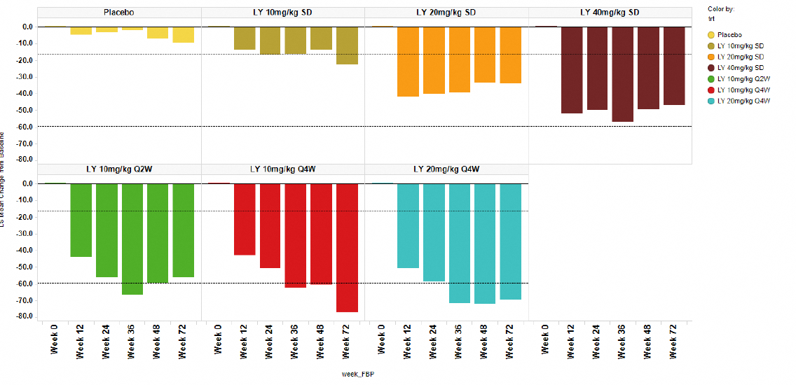
A mean amyloid reduction of approximately 50% was observed at 36 weeks after a single dose of LY3002813 40 mg/kg. In the multiple-dose Q4W cohorts treated for 72 weeks, the mean reduction in amyloid at Week 72 exceeded 60%. Overall, 11 study participants achieved <24 Centiloids (considered amyloid negative status) including one treated with a single dose of 20mg/kg, one with a single dose of 40mg/kg, two with 10mg/kg Q2W for up to 24 weeks, two treated with 10mg/kg Q4W for up to 72 weeks and five treated with 20mg/kg Q4W for up to 72 weeks.
Regarding exploratory PD biomarkers, throughout the study there were no clinically meaningful changes in CSF Aβ1-40, CSF Aβ1-42 or in CSF or plasma concentrations of the non-specific biomarker of neurodegeneration, neurofilament light chain (NfL). In contrast, CSF p-tau and tau were lower at 24 weeks after treatment with multiple dose LY3002813 compared to placebo. Plasma p-tau181 and p-tau217 also showed decreases. There were no significant changes in brain tau content, or in brain volume (total, hippocampal, entorhinal or lateral ventricular), in any treatment cohort at any time during the treatment period.
Brain amyloid results in studies AACG and AACI aligned with the Phase 1 studies. In AACG at week 76, donanemab-treated participants (700 mg Q4W for three doses, then 1400mg Q4W for up to 18 months) had statistically significantly less Aβ deposits in the brain than placebo-treated participants. Mean amyloid plaque levels in the donanemab groups had decreased by the first PET assessment (week 24). The percentage of participants in the donanemab group who had amyloid-negative status at 24, 52, and 76 weeks was 40.0%, 59.8%, and 67.8%, respectively, whereas small increases in brain amyloid were observed at 76 weeks in the placebo group. The change in global tau load at week 76 from baseline was not significantly different in donanemab-treated participants and placebo-treated participants. Donanemab-treated participants had statistically significantly greater reduction from baseline in bilateral whole brain volume and increase in bilateral ventricular volume at 72 weeks than did placebo-treated participants.
In AACI, 34% of participants with intermediate levels of brain tau at baseline had cleared amyloid plaque as early as six months after commencing treatment (700mg Q4W for three doses, then 1400mg Q4W for up to 18 months), and 80% had amyloid clearance at 18 months. In the overall population (study participants with intermediate or high baseline brain tau) 30% and 76%, respectively, were amyloid negative at the same time points. In donanemab-treated participants who achieved amyloid clearance during the study period and who were switched to placebo infusion, total amyloid concentrations remained low and similar at follow up assessments. There was no significant difference in the change in frontal tau from baseline to Week 76 in the donanemab group or the placebo group. Donanemab treatment resulted in a greater decrease in whole brain volume, a greater increase in ventricular volume, and a lesser decrease in the hippocampal volume compared with placebo in both the intermediate tau and overall populations. Plasma P-tau217, P-tau181 and GFAP levels were statistically significantly lower in the donanemab group than in the placebo group at 6 months and at 18 months in both the intermediate tau and overall populations (p<0.0001).

Population pharmacodynamics
Maintaining a threshold serum donanemab concentration above 15.2 μg/mL (95% CI: 8.54, 18.0 μg/mL) was associated with reduction of amyloid plaque as measured by PET. The time to achieve amyloid plaque clearance (<24.1 Centiloids) was dependent on the baseline amyloid plaque level, i.e. patients with high baseline amyloid load required a longer time to achieve amyloid clearance. Age, weight, baseline tau, ADA titre, time from diagnosis of AD, and ApoE ε4 carrier status were not significant covariates in the model.
The of impact of completing active treatment (ceasing donanemab when amyloid plaque clearance was achieved) on re-accumulation of amyloid plaque and on the estimation of the re-accumulation rate was predicted via simulations using a treatment exposure-response (amyloid plaque) model. No increase in amyloid PET was identified at up to 18 months after ceasing treatment in the group of participants from studies AACG and AACI who achieved amyloid plaque levels below 11 Centiloids after six months of treatment. There was also no measurable re-accumulation of amyloid in a smaller group with PET scans available for up to three years after ceasing treatment. Assuming a linear rate of increase over time beyond the observed period of three years, the modelling predicted that it would take 10 to 15 years after last treatment for amyloid plaque levels to return to baseline, and approximately four years to return from below 11 Centiloids to above the threshold of 24.1 Centiloids. No definitive recommendation can be provided on a time point for retesting of amyloid levels and reinitiation of treatment as there is no data to support the efficacy and safety of retreatment.
Plasma P-tau217 and plasma GFAP were elevated in patients with AD. Donanemab treatment reduced the rate at which plasma P-tau217 and GFAP formed. Age at entry, ApoE ε4 carrier status, gender, race, weight at entry, presence of treatment emergent (TE) ADA, time since onset of symptoms of AD, and time since diagnosis of AD were not significant covariates for P-tau217; and age at entry, gender, weight at entry, eGFR, baseline tau SUVr, baseline MMSE, and baseline P-tau217 were not significant covariates for baseline GFAP concentration.
The relationship between donanemab treatment and disease progression (using either iADRS or CDR-SB scales) was explored using Richard’s logistic model, constraining the predictions within the range of scores for each clinical scale (0 to 18 for CDR-SB and 0 to 144 for iADRS), as well as accounting for nonlinear disease progression (i.e., participants with worse disease at baseline tending to progress faster) and heteroscedasticity of the residual error (i.e., less residual error at either extreme of each clinical scale and greater residual error in between).
The model-estimated treatment effect of donanemab on CDR-SB and iADRS scores differed by both disease state (mild cognitive impairment [MCI] or mild AD, as defined by baseline MMSE score) and baseline tau. Simulations with the disease progression model, assuming a linear disease progression rate, suggested that disease slowing with donanemab, compared to placebo, increases over time for up to five years in the low to medium tau population. When amyloid was cleared and treatment with donanemab ceased, the simulation also estimated that the rate of slowing of disease progression would persist, suggesting no added benefit in continuing the treatment once amyloid is cleared.
Higher baseline tau was associated with worse disease status and more rapid disease progression than low/medium baseline tau. Older age was associated with worse disease status. This was recorded as worse baseline scores and a faster rate of disease progression on both iADRS and CDR-SB. Similarly, a longer time since diagnosis of AD was associated with worse disease status on both CDR-SB and iADRS. Model estimates indicated that disease progression in ApoE ε4 carriers was more rapid than in noncarriers. ADA titre did not have a statistically significant effect on disease progression.
Population PK/PD analysis showed that the instantaneous risk of ARIA-E was driven by several factors. The baseline hazard of developing ARIA-E by week 24 was 1.8 times higher in ApoE ε4 heterozygotes compared with noncarriers, 3.9 times higher in ApoE ε4 homozygotes compared with noncarriers, and 2.1 times higher in ApoE ε4 homozygotes compared to heterozygotes. The baseline hazard for ARIA-E was 1.2 times higher in participants with the highest observed donanemab concentration at steady state (C_{av,ss} 233 μg/mL, n=1; 0.05% of the PK evaluable population) compared with those with median C_{av,ss} (52.1 μg/mL, n = 2131; 50% of the PK evaluable population). The baseline hazard for ARIA-E increased with the increase in number of microhaemorrhages at baseline (evaluated for up to and including 4 microhaemorrhages). The risk of ARIA-E appeared to plateau by Week 24.

Efficacy

Study AACI (TRAILBLAZER-ALZ2)
The pivotal efficacy study (AACI, TRAILBLAZER-ALZ2) was a multicentre, randomised, parallel-group, double-blind, placebo-controlled, Phase 3 study in 1736 adults determined to have early symptomatic AD (MCI or mild dementia due to AD). The study was originally planned to be a Phase 2 study with 500 participants (Protocol dated 30 Jan 2020). A protocol amendment one year later (Protocol dated 17 February 2021) implemented a higher sample size of 1500 participants and re-prioritised the primary efficacy assessments. Protocol amendments are summarised below. First participant first visit was 19 June 2020, and last participant last visit was 14 April 2023.
The study was conducted at sites in the United States, Canada, Australia, the Netherlands, Poland, the United Kingdom, the Czech Republic and Japan. It enrolled men and women aged 60 to 85 years, who had self-reported or informant-reported gradual and progressive change in memory function for ≥ six months, MMSE score of 20-28 at first visit (screening), evidence of intermediate or high brain tau burden on flortaucipir PET scan at screening as outlined in Table 1, and evidence of brain amyloid burden on florbetapir or florbetaben PET scan at screening. Patients with no or with very low brain tau were excluded. A total population of 1736 patients were randomised 1:1 to donanemab or placebo. The dose regime was IV doses of 700 mg donanemab Q4W for three doses, then uptitrated to 1400 mg donanemab Q4W for up to 72 weeks of treatment. Protocol-specified dose reductions were permitted. Protocol-specified reductions were not treated as discontinuations unless they were for adverse events and the study participants did not recommence treatment.
The maximum total duration of study for any participant, including screening and the post-treatment follow-up periods, was up to 205 weeks (Figure 2). The maximum duration of treatment was 150 weeks.
- Lead-In: Any time prior to complete screening
- Complete Screening: Up to 7 weeks
- Double-Blind (placebo-controlled, PC): 76 weeks
- Extension: 78 weeks
- Follow-Up: Up to 44 weeks
Figure 2: Study Design for Study AACI
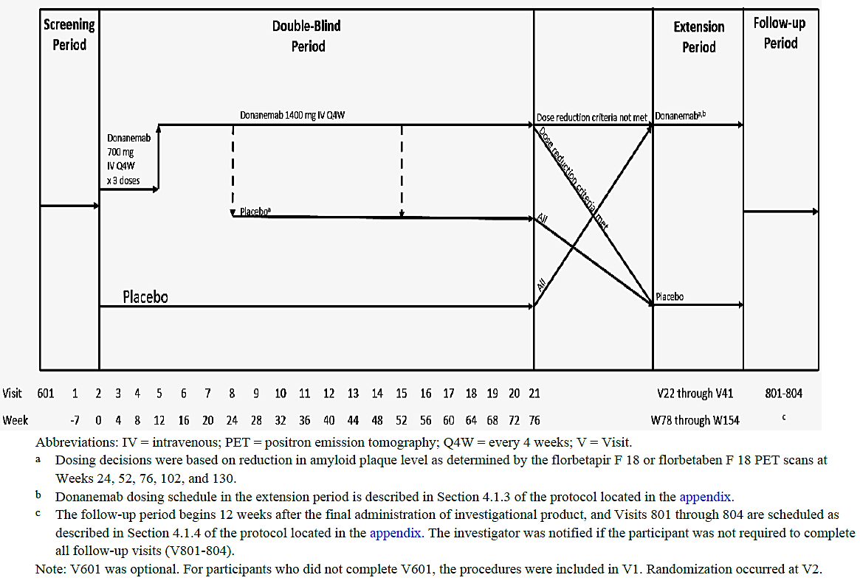
Abbreviations: IV intravenous: PET - positron emission tomography. Q4W = every 4 weeks: V = Visit
- Dosing decisions were based on reduction in amyloid plaque level as determined by the florbetapir F 18 or florbetaben F 18 PET scans at Weeks 24, 52. 76. 102. and 130.
- The follow-up period begins 12 weeks after the final administration of investigational product.. The investigator was notified if participant was not required to complete all follow-up visits (V801-304). Note: V601 was optional. For participants who did not complete V601, the procedures were included in VI. Randomization occurred al V2.
The primary objective of the study was to assess the ability of donanemab compared to placebo to slow the progression of AD over 76 weeks in participants with early symptomatic AD, regardless of any initiation or change to standard of care medications and regardless of whether a participant stopped taking the study drug. The primary efficacy outcome was the change from baseline in iADRS through week 76 in the study group with intermediate brain tau pathology or in the overall population (intermediate or high brain tau pathology). The original primary endpoint of change from baseline in CDR-SB was retained as a secondary outcome. The goal of protocol amendment (b) was to adapt Study AACI from a Phase 2 study to a Phase 3 study and to change the primary endpoint to replicate the Phase 2 Study AACG in which the primary outcome was iADRS and the enrolled population had low-medium brain tau levels at baseline.
Additional secondary endpoints included the change from baseline through week 76 in ADAS-Cog13 score, ADCS-iADL score (the scales underpinning the iADRS), MMSE score and brain amyloid plaque and brain tau deposition. Tertiary and exploratory endpoints included the change from baseline through week 76 in blood-based biomarkers including neurofilament light chain (NfL), glial fibrillary acidic protein (GFAP), phosphorylated (p)tau and Aβ levels, change in digit symbol substitution test (medicines version) score and change in the Clinical Dementia Rating Scale – Global (CDR-G) score.
Time-based analyses including time to clinical worsening (slowing of disease progression time), time to substantial decline, and the probability of non-progressing were performed for iADRS, CDR-SB and CDR-G. A clinical worsening event was defined as meeting the relevant criterion for the clinical endpoints (described below) at two consecutive visits during the AACI-placebo controlled (PC) period:
- iADRS: 5 points decrease from baseline for participants with screening clinical status as MCI, or 9 points decrease from baseline for participants with screening clinical status as mild AD,
- CDR-SB: 1 point or more increase in CDR-SB from baseline for participants with screening clinical status of MCI, or 2 points increase from baseline for participants with screening clinical status of mild AD, or
- CDR-G: Any increase in CDR-G score from baseline.
Key inclusion criteria were:
- Men or women aged 60 to 85 years,
- Self-reported or informant-reported gradual and progressive change in memory function for ≥ six months,
- MMSE score of 20-28 at first visit,
- Evidence of intermediate or high brain tau burden on flortaucipir PET scan at screening (SUVr 1.10 – 1.46 inclusive, or > 1.46, respectively), and
- Evidence of brain amyloid burden on florbetapir or florbetaben PET scan at screening.
The tau levels were selected by the sponsor to capture a population that according to published literature were likely to experience measurable cognitive decline over 18 months.
The inclusion criteria also required that the participant had a study partner who was able to attend appointments when Columbia-suicide severity rating scale, CDR and ADCS-ADL assessments were performed, and/or be contactable by phone for evaluation of adverse events (AEs) and concomitant medications; that the participant had adequate literacy, vision and hearing to successfully complete neuropsychological testing; that concomitant regular medicines had been stable for at least one month; and that participants were using gender-appropriate contraception for the duration of the study and for 90 days following the last dose of investigational product, or did not have childbearing potential.
The exclusion criteria were extensive. Notably, the criteria outlined in the following text effectively excluded a significant proportion of participants with concomitant medical conditions that are typical of the elderly population with AD, thereby potentially limiting the generalizability of the study results. The underlying premises for these exclusions were stated to be to decrease the safety risks to the population (specifically regarding ARIA events), or to minimise the risk of confounding symptomatology from a concurrent condition rather with consequences of study treatment:
- Current serious or unstable illnesses including cardiovascular, hepatic, renal, gastroenterological, respiratory, endocrinologic, neurologic (other than AD), psychiatric, immunologic, or hematologic disease and other conditions that, in the investigator’s opinion, could interfere with the analyses in this study; or has a life expectancy of <24 months.
- History of cancer within the last 5 years, except non-metastatic basal and/or squamous cell carcinoma of the skin, in situ cervical cancer, nonprogressive prostate cancer, or other cancers with low risk of recurrence or spread.
- Any current primary psychiatric diagnosis other than AD if, in the judgment of the investigator, the psychiatric disorder or symptom was likely to confound interpretation of drug effect, affect cognitive assessment, or affect the patient’s ability to complete the study. Patients with a history of schizophrenia or other chronic psychosis were excluded.
- In the judgment of the investigator, actively suicidal and therefore deemed to be at significant risk for suicide.
- History of alcohol or drug use disorder (except tobacco use disorder) within 2 years before the screening visit.
A natural cubic spline (NCS) analysis with 2 degrees of freedom (DF) was used to assess the statistical difference in iADRS score at Week 76 between the treatment groups. The primary efficacy analysis was conducted on two populations: the population with intermediate tau at baseline and the overall population. The hypothesis was tested following a hierarchical procedure with control of family wise 2-sided type I error rate set to 5%. Statistical analyses included patients who had discontinued treatment and who had discontinued the study on the intention-to-treat principle.
The iADRS score (at baseline and at each of the postbaseline visits) was included in the NCS2 model as a dependent variable. Study visit was treated as a continuous variable with values equal to weeks between baseline and postbaseline exam dates. The model included fixed effects including age at baseline and concomitant AChEI and/or memantine use at baseline (yes/no). An unstructured variance-covariance matrix was used to adjust for intra-subject correlation. Sensitivity analyses included a Bayesian disease progression model (DPM) and mixed methods for repeat measures (MMRM) analysis for the iADRS. NCS2, DPM, and MMRM analyses were also performed on each of the secondary outcomes for the intermediate tau population and overall population.
A rank analysis of co-variance (ANCOVA) analysis of CDR-SB including CDR-SB score as a covariate and stratification variables as factors was performed post hoc at the request of the evaluator.
All efficacy analyses followed the intent-to-treat (ITT) principle unless otherwise specified. All pairwise tests of treatment effects were conducted at a 2-sided α level of 0.05 (or equivalently, a 1-sided α level of 0.025); 2-sided confidence intervals (CI) were displayed with a 95% confidence level. All tests of interactions between treatment and other factors were conducted at an α level of 0.05.

Results
Over 8000 adults with AD were screened for inclusion in study AACI, of which 1736 (21.1%) satisfied screening criteria and were randomized to treatment and 1727 (21.0%) were treated with investigational product (donanemab or placebo). Most screen failures were based on florbetapir PET out of range (1601, 24.6%), flortaucipir PET out of range (1631, 25.1%), and MMSE out of range (1510, 23.2%), with fewer based on MRI or p-tau findings, and 19.0% for “other” reasons.
In terms of study disposition, a total of 1320 participants (76%, donanemab, n = 622; placebo, n = 698) completed the 76-week AACI-PC period of the study, 12 participants (donanemab, n = 7; placebo, n = 5) did not complete a final visit prior to data lock, 404 participants (donanemab, n = 231; placebo, n = 173) discontinued from the study, and 1258 participants (donanemab, n = 584; placebo, n = 674) entered the long-term extension (LTE) period. A higher proportion of participants in the donanemab group (5.8%) discontinued from the study during the AACI-PC period owing to AEs compared with the placebo group (2.4%). Most study withdrawals in the donanemab and placebo groups were attributed to “withdrawal by subject” (12.9% and 10.7%, respectively), whereas “withdrawal due to caregiver circumstances” was attributed to 2.4% of discontinuations overall; loss to follow-up, death, and physician decision contributed 1.1% to 2.2% of discontinuations, the latter two were higher in the donanemab group.
In terms of treatment disposition, a total of 1289 participants (donanemab, n = 595; placebo, n = 694) completed treatment in the 76-week AACI-PC period, and 428 participants (donanemab, n = 252; placebo, n = 176) discontinued treatment. A higher proportion of participants in the donanemab group (11.4%) discontinued from treatment due to AEs than in the placebo group (3.2%). Withdrawal by subject was the most common reason (other than AE in the donanemab treatment group), 10.5% overall.
The baseline demographics, and clinical and biomarker measures were balanced between the donanemab and placebo groups. The mean age at entry was 73.0 years in both groups. In the donanemab and placebo groups respectively, 57.3% and 57.4% were female, 90.9% and 92.1% were White. In the donanemab group 69.8% of participants were ApoE ε4 carriers (homozygotes 16.7%, heterozygotes 53.1%) and in the placebo group 71.2% were ApoE ε4 carriers (homozygotes 16.7%, heterozygotes 54.5%) ApoE. Around half of all participants were using concomitant acetylcholinesterase (AChE) inhibitors (predominantly donepezil), and one in five were using concomitant memantine. Hypertension, anxiety/ depression, arthritis/osteoarthritis were all very common comorbidities in the overall population, whereas malignant or unspecified tumours, thyroid disease, obesity and diabetes were comorbidities in 17-22% of participants, and ischemic heart disease including history of acute myocardial infarction were diagnoses in 12.7% of participants.
The use of anti-thrombotic medicines was of interest. While around a third of the study population used aspirin, and 10% used anticoagulant medicines, use of non-aspirin antiplatelet medicines (donanemab group 6.1%, placebo group 3.8%) was relatively low and of thrombolytics (donanemab n=1, placebo n=2), was low.
The mean (SD) iADRS at baseline (Visit 2) in the overall population was 103.8 (14.2), CDR-SB was 3.9 (2.1), ADAS-Cog13 was 29.0 (8.0), ADCS-ADL was 66.4 (8.5), ADCS-iADL was 47.8 (7.9), and MMSE was 22.3 (3.9). Almost all participants (96.7%) had CDR-G scores of 0.5 to 1. The mean (SD) amyloid PET Centiloid at baseline was 102.5 (34.5) and AD signature weighted neocortical flortaucipir SUVr was 1.3 (0.3).
The proportions of study participants considered to have MCI due to AD and mild AD based on MMSE scores changed between screening (visit 1) and baseline (visit 2). MMSE scores at baseline of 27 or 28 (consistent with MCI) were reported for 151 participants and scores at baseline of 20 to 26 (mild AD) were reported for 961 participants. Furthermore, 72 participants who initially satisfied screening criteria had MMSE scores at baseline of 29/30, but 384 study participants (22%) who initially satisfied screening criteria had MMSE scores at baseline below 20 (consistent with moderate AD). The sponsor provided the following justification for retaining these patients in the study:
The protocol required MMSE at screening (not at baseline) to be above 20. This design was purposeful to avoid entry bias and entry skew of baseline values that occurs at the edge of eligibility cutoffs ... In addition, based on the CDR-G, …97.1% of enrolled participants at baseline were accurately selected in the early symptomatic stage of the disease, which was defined as MCI due to AD or mild AD dementia (note CDR-G was also not an exclusion).
The sponsor took the position that most of the differences between screening and baseline scores can be explained by random measurement error and test-retest variability owing to various influencing factors, but entry bias could not be completely excluded in a small number of cases.

Intermediate tau population

Primary objective
At Week 76, the LS mean (±SE) change from baseline in iADRS score in the intermediate tau population was -9.27±0.49 in the placebo group and -6.02±0.50 in the donanemab group, with LS mean difference (±SE) between the groups of 3.25±0.70, 95% CI 1.88, 4.62, p<0.001 (Figure 3). This corresponds to a 35% (95%CI 19.9, 50.2) slowing of clinical progression in donanemab-treated participants compared with placebo-treated participants. The investigators concluded that donanemab-treated participants with intermediate tau burden had statistically significantly less clinical progression over 18 months compared with placebo-treated participants.
Figure 3: AACI-PC iADRS13 change from baseline by treatment, intermediate tau population (NCS2 analysis)
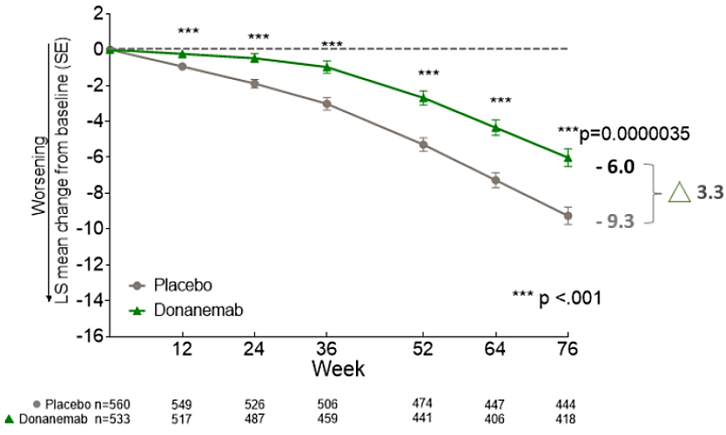
Abbreviations: iADRS=integrated Alzheimer’s Disease Rating Scale; LS=least squares; NCS2=natural cubic spline model with 2 degrees of freedom; PC=placebo-controlled; SE=standard error.
In the MCI subgroup the LS mean (±SE) change from baseline in iADRS score in the placebo group was -5.09±1.04 and in the donanemab group was –2.41±1.04, LS mean difference 2.69±1.47, 95%CI -0.195,5.569, NS. In the mild AD subgroup the LS mean (±SE) change from baseline in iADRS score at 76 weeks in the placebo group was -10.40±0.55 and in the donanemab group was -7.00±0.57, LS mean difference 3.40±0.78, 95%CI 1.858,4.939, p<0.001). In the moderate AD subgroup, the LS mean (±SE) change from baseline in iADRS score in the placebo group was -15.96±1.14 and in the donanemab group was -10.45±1.22, LS mean difference 5.51±1.67 (95%CI 2.23, 8.79), p=0.001. In both MCI and mild AD groups, more patients treated with placebo experienced clinical worsening by 76 weeks than did patients treated with donanemab.
In terms of slowing of disease progression, the estimated slowing over 18 months was 52.8% (95%CI -7.61,113.12) in the MCI subgroup, 32.7% (95%CI 17.58,47.76) in the mild AD subgroup and 34.5% (95%CI 13.55, 55.49) in the moderate AD subgroup.
Forest plots of percent slowing of disease progression in other subgroups show that the overall benefit of donanemab was seen in most populations with adequate numbers in the subgroup but note that in participants with MCI at baseline and in participants homozygous for ApoE ε4, the confidence intervals included 0 (Figure 4).
Figure 4: AACI-PC change from baseline iADRS at 76 weeks, Subgroup analysis by demographic and baseline characteristics, intermediate tau population
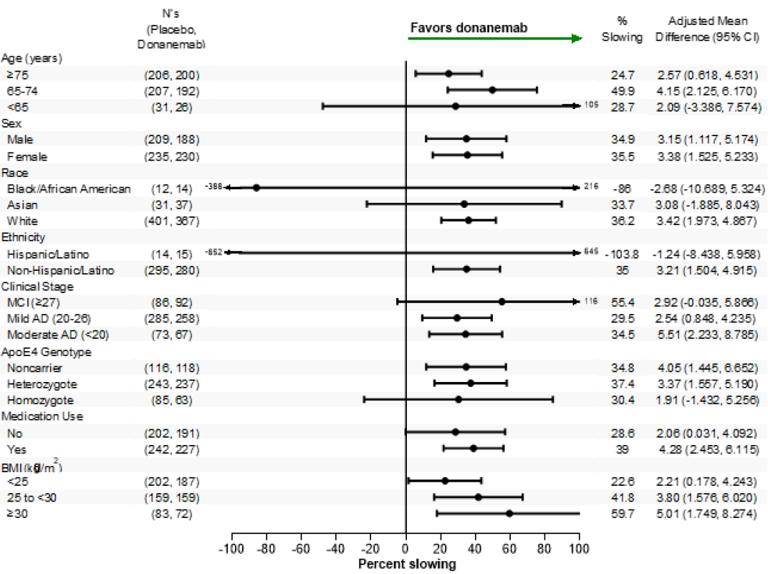
Abbreviations: AD = Alzheimer’s disease; ApoE4 = apolipoprotein E allele 4; BMI = body mass index; CI = confidence interval; LS = least squares; iADRS = integrated Alzheimer’s Disease Rating Scale; MCI = mild cognitive impairment; PC = placebo controlled.
Sensitivity analyses applying a time-saved progression model for repeated measures (Time-PMRM) supported the results. In the iADRS analysis in the per protocol population (n=763), similar numerical superiority for donanemab over placebo did not achieve statistical significance.

Secondary objectives
At Week 76, the LS mean (±SE) change from baseline in CDR-SB score (applying MMRM analysis) in the intermediate tau population was 1.88±0.10 in the placebo group and 1.20±0.10 in the donanemab group (LS mean change difference ± SE: -0.67±0.141, 95%CI -0.95, -0.40, p<0.001, Figure 5). This corresponds to a 36% slowing of clinical progression in donanemab-treated participants compared with placebo-treated participants. The investigators concluded that donanemab-treated participants had statistically significantly less clinical progression compared with placebo-treated participants. Sensitivity analyses applying NCS2 analyses were supportive.
The overall benefit of donanemab was seen in most subgroups with adequate numbers in the subgroup but as with the iADRS, confidence intervals for participants with MCI and in participants homozygous for ApoE ε4 included 0. More study participants treated with placebo experienced clinical worsening by 76 weeks than did patients treated with donanemab. The average deterioration in CDR-SB in both groups surpassed the defined level for clinical worsening in patients with MCI but did not reach the defined level for clinical worsening in patients with mild AD in either group.
Figure 5: AACI-PC CDR-SB change from baseline by treatment, intermediate tau population (MMRM analysis)
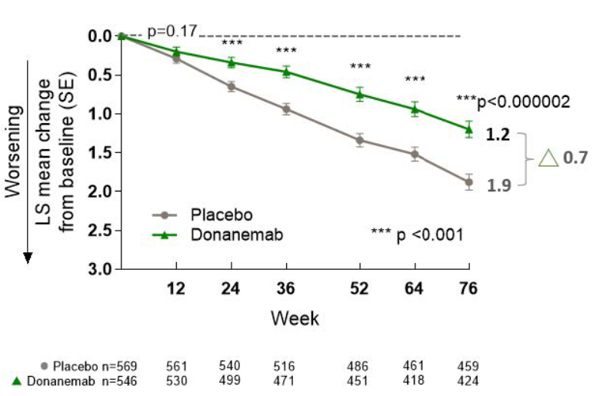
Abbreviations: CDR-SB = Clinical Dementia Rating – Sum of Boxes; LS = least squares; PC = placebo-controlled; MMRM = Mixed Model for Repeated Measures; SE = Standard error.
Among other secondary outcomes, the ADAS-Cog13 LS mean change from baseline values at week 76 was 4.69±0.26 in the placebo group and 3.17±0.27 in the donanemab group. The difference in LS mean change was -1.52±0.37, 95%CI -2.25, -0.79, p<.001, corresponding to a 32% (95%CI 17, 48%) slowing of clinical progression in donanemab-treated participants compared with placebo-treated participants.
Similarly, the ADCS-iADL LS mean change from baseline values was -4.59±0.32 in the placebo group and was -2.76±0.34 in the donanemab group. The difference in LS mean change value was 1.83±0.47, 95%CI 0.91, 2.75, p<.001, corresponding to a 40% (95%CI 19, 61%) slowing of clinical progression in donanemab-treated participants compared with placebo-treated participants.
Additional analyses included Cox proportional hazards estimate of the hazard of progressing to an episode of clinical worsening (the minimum clinically important difference, MCID), based on CDR-G, in the placebo and donanemab groups (Table 3).
Table 3: AACI-PC Hazard of progressing to CDR-G MCID by treatment evaluable efficacy set, participants with baseline intermediate tau level
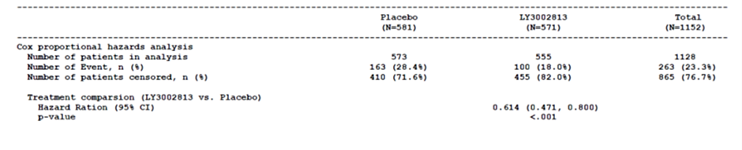
Abbreviations: MCID = minimal clinically important difference; HR = hazard ratio; CI = confidence interval; n = number of patients with non-missing values; N = number of patients in the evaluable efficacy set; CDR = Clinical Dementia Rating Scale;
HR, 95% CI and p-value are calculated using Cox proportional hazards model. The model included these covariates: baseline age, baseline value, baseline AChEI/Memantine use and stratified by pooled investigator. The ties were handled using discrete method. MCID for CDR-Global was defined as any increase in CDR-Global score for 2 consecutive visits; analysis will use the first event for modelling.
At Week 76, donanemab-treated participants in the intermediate tau population showed a 39% lower risk of progression to a later stage of disease (Hazard ratio (HR): 0.61, 95% CI 0.47, 0.80; p<.001). A total of 100 (18%) donanemab-treated participants compared to 163 (28%) placebo-treated participants progressed by the MCID based on CDR-G scores (any increase in CDR-G score from baseline at two consecutive time points).
Donanemab treatment statistically significantly delayed disease progression over 18 months by 4.4 months based on iADRS scores (estimated by model without proportionality assumption) and 7.5 months based on CDR-SB scores (estimated by model with proportionality assumption) in the intermediate tau population.
Decline in MMSE scores was included in the exploratory objectives but was not included in the hierarchical testing strategy controlling for multiplicity. In the intermediate tau population, the LS mean change in MMSE score at 76 weeks in the placebo group was -2.09±0.14 and in the donanemab group was -1.61±0.14. The LS mean difference was 0.48±0.20, 95%CI 0.09, 0.9.

Overall population

Primary objective
In the overall study population, which included patients with intermediate and with high brain tau burden, both placebo and donanemab treated groups showed greater declines from baseline iADRS scores at 76 weeks than were reported in the intermediate tau population (Figure 6).
At Week 76, the LS mean (±SE) change from baseline in iADRS score in the overall population was -13.11±0.50 in the placebo group and -10.19±0.53 in the donanemab group, with LS mean difference (±SE) between the groups of 2.92±0.72, 95% CI 1.51, 4.33, p<0.001 (Figure 6). This corresponds to a 22% (95%CI 11.4, 33.2) slowing of clinical progression in donanemab-treated participants compared with placebo-treated participants. The investigators concluded that donanemab-treated participants had statistically significantly less clinical progression over 18 months compared with placebo-treated participants.
Figure 6: AACI-PC iADRS change from baseline by treatment, overall population, NCS2 analysis
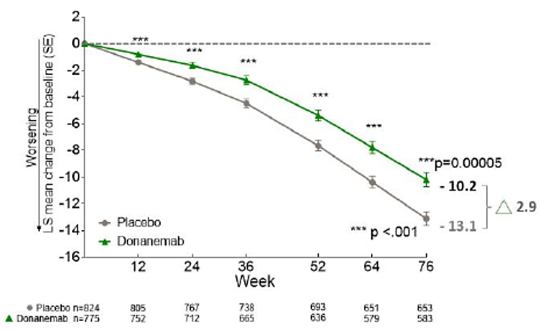
Abbreviations: iADRS=integrated Alzheimer’s disease rating scale; LS = least squares; PC = placebo-controlled; NCS2 = natural cubic spline model with 2 degrees of freedom; SE = Standard error.
In the MCI subgroup the LS mean (±SE) change from baseline in iADRS score in the placebo group was -5.92±1.21 and in the donanemab group was –4.59±1.17, LS mean difference 1.33±1.67, 95%CI -1.954, 4.606, NS. In the mild AD subgroup the LS mean (±SE) change from baseline in iADRS score at 76 weeks in the placebo group was -14.55±0.54 and in the donanemab group was -11.45±0.58, LS mean difference 3.10±0.79, 95%CI 1.558,4.646, p<0.001). In the moderate AD subgroup, the LS mean (±SE) change from baseline in iADRS score in the placebo group was -20.92±0.98 and in the donanemab group was -17.22±1.12, LS mean difference 3.70±1.48 (95%CI 0.79, 86.61), p=0.013 . In both MCI and mild AD groups, more patients treated with placebo experienced clinical worsening by 76 weeks than did patients treated with donanemab.
In terms of slowing of disease progression, the estimated slowing over 18 months based on change from baseline iADRS score was 22.4% (95%CI -33.65, 78.46) in the MCI subgroup, 21.3% (95%CI 10.53, 32.09) in the mild AD subgroup and 17.7% (95%CI 3.77, 31.60) in the moderate AD subgroup.
The statistically better result in iADRS change from baseline with donanemab in the overall population was seen in several subgroups with adequate numbers in the subgroup (Figure 7). As in the intermediate tau cohort the confidence intervals included 0 for participants with MCI and for participants homozygous for ApoE ε4. Of note, the treatment effect was also not clear for the small number of patients in the overall population aged younger than 65, patients who were not taking concomitant treatments for AD, participants with BMI <25 or ≥30 or participants with high brain tau PET.
Figure 7: AACI-PC: Forest plot iADRS change from baseline, Subgroup analysis, overall population
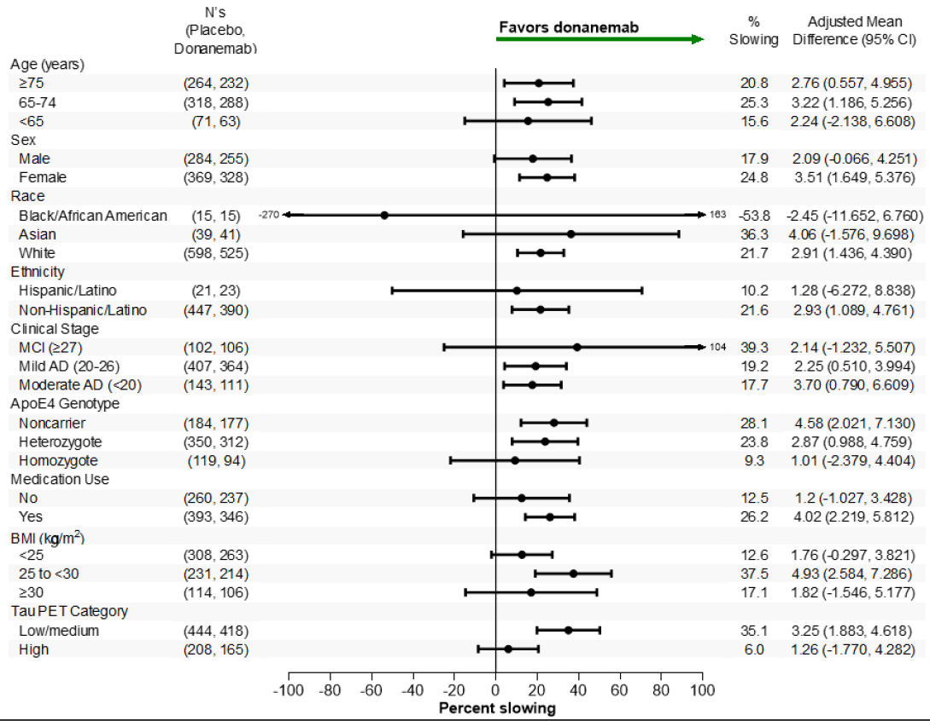
Abbreviations: AD = Alzheimer’s disease; ApoE4 = apolipoprotein E allele 4; BMI = body mass index; CI = confidence interval; LS = least squares; iADRS = integrated Alzheimer’s Disease Rating Scale; MCI = mild cognitive impairment; PC = placebo controlled.

Secondary objectives
At Week 76, the LS mean (±SE) change from baseline in CDR-SB score was 2.42±0.09 in the placebo group and 1.72±0.10 in the donanemab group. The LS mean difference was -0.70±0.13, 95%CI -0.95, -0.45, p<0.001, corresponding to a slowing in decline of 28.9%. Sensitivity analyses utilising NCS2 and Time-PMRM were supportive of the primary and key secondary outcomes.
Of the other secondary outcomes in the overall population, the ADAS-Cog13 change from baseline values at week 76 was 6.79±0.27 in the placebo group and 5.46±0.28 in the donanemab group. The difference in LS mean change was -1.33±0.39, 95%CI -2.09, -0.57, p=0.0006, corresponding to a 20% (95% CI 8, 31%) slowing of clinical progression in donanemab-treated participants compared with placebo-treated participants.
Similarly, the LS mean change in ADCS-iADL from baseline values was -6.13±0.30 in the placebo group and -4.42±0.32 in the donanemab group. The difference in LS mean change was 1.70±0.44, 95%CI 0.84, 2.57, p=.0001, corresponding to a 28% (95%CI 13, 42%) slowing of clinical progression in donanemab-treated participants compared with placebo-treated participants.
At Week 76, donanemab-treated participants showed 37% lower risk of time progression to a later stage of disease as measured by CDR-G score in the overall population (HR: 0.63; p<.0001) compared with placebo-treated participants (Table 4). A total of 186 (23%) donanemab-treated participants and 288 (34%) placebo-treated participants showed substantial decline.
Table 4: Study AACI-PC Hazard of progressing to CDR-G MCID by Treatment Evaluable Efficacy Set (EES), all participants
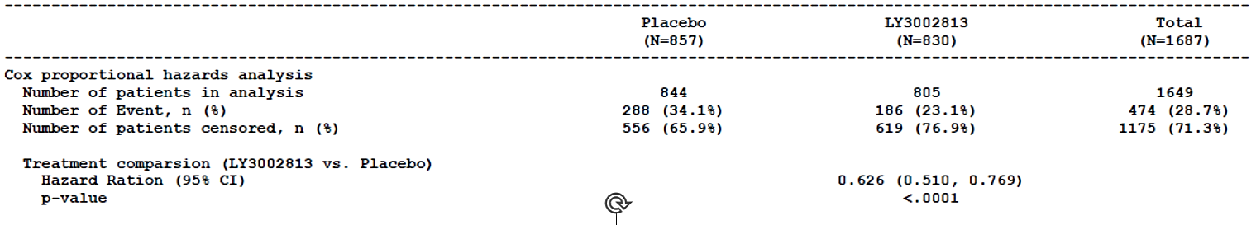
Abbreviations: MCID = minimal clinically important difference; HR = hazard ratio; CI = confidence interval;
n = number of patients with non-missing values; N = number of patients in the evaluable efficacy set; CDR = Clinical Dementia Rating Scale.
HR, 95% CI and p-value are calculated using Cox proportional hazards model. The model included these covariates: baseline age, baseline value, baseline AchI/Memantine use and stratified by pooled investigator and baseline tau level. The ties were handled using discrete method. MCID for CDR-Global was defined as any increase in CDR-Global score for 2 consecutive visits; analysis will use the first event for modelling.
In the overall population, donanemab treatment delayed disease progression by 1.4 months as assessed by iADRS (estimated by model with proportionality assumption) and 5.4 months as assessed by CDR-SB (estimated by model with proportionality assumption).
Sensitivity analysis of iADRS using the per-protocol population, which included fewer than half of the enrolled population, observed non-significant trends to benefit in the donanemab treated group.
The sponsor provided additional post hoc sensitivity analyses for the primary and main secondary outcomes, to address concerns with handling of missing data. The sensitivity analyses, including the copy increment from reference and jump to reference methods for missing imputation consistently showed the treatment benefit of donanemab with strong statistical significance. Tipping point analysis also demonstrated robustness of treatment benefit as seen from the pre-planned analyses with iADRS and CDR-SB.
Additional post hoc analyses on request for the ApoE ε4 carriers confirmed significant benefit based on changes in iADRS and CDR-SB from baseline in heterozygotes, whereas while the point estimates for adjusted mean difference from placebo at 76 weeks were favourable in the population homozygous for ApoE ε4, the confidence intervals encompassed 0.
In post hoc analyses performed on request for the patient subgroup with high brain tau burden at baseline, the LS mean difference on CDR-SB was of similar magnitude compared with the intermediate tau population (-0.69), but the LS mean difference observed on the iADRS was smaller (1.26) and not statistically significant. The sponsor opined that there was no single cut point on brain tau load for which there is no potential for benefit from treatment with donanemab.
The clinical evaluator concluded:
“In study AACI, in participants with early symptomatic AD, the study met its primary endpoint as donanemab-treated participants had a statistically significantly slowed clinical progression on the primary outcome, iADRS, compared with placebo in both intermediate tau (35% slowing; p<0.001) and overall (22.3% slowing; p<0.001) populations at 18 months.
Subgroup analyses showed consistent results and favoured donanemab in terms of iADRS across the subgroups including in the clinical stage (MCI, mild and moderate AD) and in Asian patients (n=68). Although the point estimate for the treatment effect was similar or larger in patients with MCI compared to mild and moderate AD, the treatment difference did not reach statistical significance”.

Study AACG (TRAILBLAZER-ALZ)
Study AACG (TRAILBLAZER-ALZ) was a Phase 2, double-blind, placebo-controlled study of donanemab in patients with early symptomatic AD (prodromal AD and mild dementia due to AD) with intermediate (low/medium) brain tau burden on flortaucipir PET. Study participants were recruited to sites in the US and Canada. First participant first visit was 18 Dec 2017 and last participant last visit was 4 Dec 2020.
The study was originally designed as a 3-group study comparing donanemab monotherapy (donanemab-M) or donanemab in combination with another drug (donanemab-C) versus placebo. Early versions of the protocol included a group assigned to receive donanemab in combination with LY3202626, a small-molecule inhibitor of beta-site amyloid precursor protein cleaving enzyme 1 (BACE1). After the study began, the BACE1 inhibitor program was ceased due to a finding of futility in a different Phase 2 study with the agent. Study AACG was amended to eliminate continued enrolment into the donanemab-C group. Participants randomised to donanemab-C (n=15) were allowed to continue in the study receiving monthly infusions of donanemab without oral dosing of the BACE1 inhibitor but were not included in the statistical analyses. Of 48 patients randomized before the removal of oral BACE1 inhibitor in protocol amendment (d), patients randomized to donanemab monotherapy or to placebo were pooled with patients randomized after protocol amendment (d) to form the Full Analysis Set and safety analysis sets. Data from 15 patients initially randomized to the combination therapy arm were summarised separately and were not included in treatment comparisons on efficacy endpoints.
A total of 272 participants were enrolled in AACG, after satisfying the same inclusion criteria applied in study AACI. The exclusion criteria were extensive as in study AACI, other than that participants with high brain tau on PET were excluded from AACG.
The participants were randomised equally into IV donanemab 700 mg Q4W for the first three doses then 1400 mg Q4W, or to IV placebo Q4W, for up to 72 weeks. Regarding the dosing protocol, AACG allowed protocol-specified dose reductions from 1400 mg Q4W to 700 mg Q4W, based on amyloid PET Centiloid value observed from florbetapir PET scans obtained at Weeks 24 and 52, or on confirmation of ARIA-E by MRI. The dose could be reduced further to placebo if indicated. The occurrence of ARIA-H triggered discontinuation of treatment. All new cases of ARIA-H required unscheduled MRI scans every 4-6 weeks until the condition stabilised without new findings before retreatment.
The 133-week study included a screening period of up to nine weeks, a treatment period of up to 72 weeks with final evaluations at Week 76, and a 48-week immunogenicity and safety follow-up period (ongoing at the time of submission).
The primary endpoint was the change in cognition and function as measured by the change in the iADRS score from baseline to 76 weeks, applying MMRM analysis. Sensitivity analyses applied a Bayesian DPM and other exploratory approaches. The secondary endpoints included the change from baseline to 76 weeks in CDR-SB score, ADAS-Cog13 score, ADCS-iADL score, and MMSE score (MMRM analyses). The results of additional outcomes including brain amyloid PET, brain tau PET and vMRI are presented in the pharmacodynamics section.

Results
Of 1955 patients screened, a total of 272 participants were randomized into the study, with 15 participants randomised to the donanemab/ BACE inhibitor combination group prior to amendment of the study to discontinue that group. High screen failure rates were attributed to tau PET out of range (592/1563, 37.9%), MMSE or historical tau PET out of range (347/1563, 22.2%) and Cognitive State Brief Battery score out of range (334/1563, 21.4%). A total of 187 participants (donanemab, n=94; placebo, n=93) completed the study and 69 participants were discontinued from the study (donanemab, n=37; placebo, n=32). A statistically significantly higher proportion of participants in the donanemab group (15.3%) discontinued from the study for AEs than in the placebo group (4.8%, p=0.007).
The demographics and baseline characteristics were balanced between groups (Table 5). In the placebo and donanemab groups respectively, the mean ages were 75.4 and 75.0 years; proportions of females were 51.6% and 51.9%; proportion of White participants were 96.0% and 93.1% and proportion of ApoE ε4 carriers were 74.2% (homozygotes 22.6%) and 72.5% (homozygotes 19.1%). In terms of medication history, 67.9% of donanemab-treated participants and 65.9% of placebo-treated participants were on stable doses of acetylcholinesterase inhibitors or memantine at study baseline. A total of 254 participants (99.2%) used a concomitant therapy during the study. Concomitant medication use was reported by approximately 99% of participants in each treatment group. The most frequently used concomitant medications (>25% total) were donepezil (50.8%), acetylsalicylic acid (41.4%), memantine (27.3%), plain multivitamins (27.3%), atorvastatin (27.0%), cholecalciferol (26.6%), and paracetamol (26.2%).
Table 5. Characteristics of Participants at Baseline, Including donanemab/BACE Combo Group
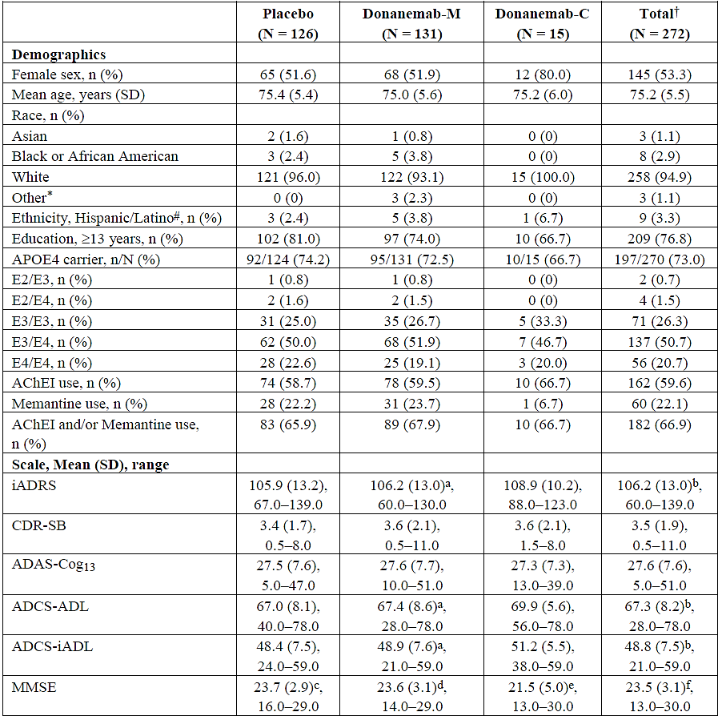
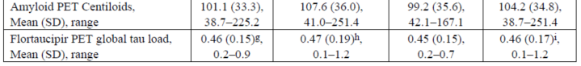
Abbreviations: APOE4 = apolipoprotein E allele 4; AChEI = acetylcholinesterase inhibitor; ADAS-Cog13 = Alzheimer's Disease Assessment Scale — Cognitive 13-item subscale; ADCS-ADL = Alzheimer's Disease Cooperative Study — Activities of Daily Living scale; ADCS-iADL=Alzheimer's Disease Cooperative Study — instrumental Activities of Daily Living subscale; iADRS = integrated Alzheimer's Disease Rating Scale; MMSE = Mini-Mental State Examination; CDR-SB = Clinical Dementia Rating Scale — Stun of Boxes; PET = positron emission tomography; N = number of participants in the population; n = number of participants in the specified category; SD = standard deviation. A0Donanemab monotherapy N = 130; b) Total N = 271 c; c) Placebo N = 121 d) donanemab monotherapy N = 126; e) donanemab/BACE Combo N = 14; f) Total N = 261; g) Placebo N = 124; h) donanemab monotherapy N = 130 Total N = 269; i) Includes Multiple & American Indian or Alaska Native. † Includes participants in the combo group; # Number of participants with non-missing data, used as denominator
There were 176 participants in the mild AD subgroup (20≤MMSE≤26) and 45 participants in the MCI subgroup (MMSE≥27). Of the 257 participants who satisfied MMSE criteria at screening, 16 had MMSE scores below 20 at baseline and 11 completed the study. Individual data from these participants were unlikely to unduly influence final outcomes.
The incidence of protocol deviations was balanced between groups: 57.3% of donanemab-treated participants and 50% of placebo-treated participants. The most frequently reported important protocol deviation pertained to study procedures criteria (32.4%). Others included visit schedule criteria (7.4%), concomitant medication criteria (7.7%), and informed consent (11.0%). Results from 117 participants (43.0%) were excluded from per protocol set analyses.

Primary objective
At Week 76, the LS mean (±SE) change from baseline in iADRS score was -10.06±1.14 in the placebo group and -6.86 ± 1.14 in the donanemab group; LS mean difference (± SE) 3.20±1.56, 95% CI 0.12, 6.27, p=0.042, Figure 8). This corresponded to a 32% slowing of clinical progression in donanemab-treated participants compared with placebo-treated participants.
Figure 8: Study AACG Change from baseline on iADRS, full analysis set – MMRM analysis
Abbreviations: iADRS=integrated Alzheimer’s disease rating scale; LS = least squares; PC = placebo-controlled; n=number of participants in the specified category; MMRM = Mixed Model for Repeated Measures; SE = Standard error.
In the mild AD subgroup at the 76-week endpoint, donanemab-treated participants had significantly less cognitive and functional decline, as measured by iADRS, compared with placebo-treated participants (LS mean difference 3.99, 95%CI 0.42, 7.56; p=0.029). The treatment difference was similar in the smaller MCI stratum but not statistically significant (LS mean difference 4.35, 95%CI -2.67, 11.37, p=0.223).
The Bayesian DPM supported the conclusion of the primary MMRM analysis, with estimated percent slowing in the donanemab group of 30.2% (95% credible interval 15.8,43.3).

Secondary objectives
Comparisons of change from baseline at 76 weeks in the secondary outcome measures in placebo and donanemab treated groups are summarised in Table 6. While there were numerical trends supporting the efficacy of donanemab, these were not statistically significant.
Table 6. Comparisons of change from baseline at 76 weeks in the secondary outcome measures in placebo and donanemab treated groups
Scale | Placebo | Donanemab | LS mean diff
CDR-SB | 1.58±0.18 | 1.22±0.18 | -0.36±0.24, 95% CI 0.83, 0.12, NS
ADAS-Cog13 | 4.77±0.66 | 2.91±0.66 | -1.86±0.90, 95% CI 3.63,0.09; nominal p=.040
ADCS-iADL | -5.2±0.74 | -3.98±0.74 | 1.21 ± 1.009; NS
MMSE | -2.98±0.39 | -2.35±0.39 | 0.64 ± 0.525; NS
Alternative statistical approaches, including Bayesian DPM and NCS with 2 or 3 degrees of freedom directionally agreed with the primary MMRM analysis of efficacy.
The clinical evaluator concluded:
“In study AACG, in patients with early symptomatic AD (prodromal AD and mild dementia due to AD) with presence of intermediate brain tau burden, the study met its primary endpoint as donanemab-treated participants had statistically significantly less decline in cognition/function than placebo-treated participants as assessed by the iADRS at Week 76 (LS mean change difference ± SE: 3.20 ± 1.56, p=0.042). The results demonstrated a 32% reduction in cognitive/functional decline for donanemab-treated participants compared with placebo.
However, the statistical significance achieved by donanemab versus placebo was not observed in other secondary endpoints … this could be due to the small sample size (N=272) as the bigger study AACI (N=1736) showed statistical significance across all the secondary endpoints”.
In the pharmacodynamic studies, donanemab resulted in a statistically significant reduction in amyloid PET, but there was no associated reduction in tau. This is not unexpected as tau deposits could be irreversible. Correlation analyses did not demonstrate a relationship between the change from baseline in amyloid and tau PET biomarker values and change from baseline in clinical efficacy scales. The lack of effect of donanemab on the biomarker could be owing to a time lag between amyloid and tau deposition, such that any effect on tau of reducing amyloid concentrations may not be identified until several years later.

Safety
The safety data were predominantly derived from the placebo-controlled studies AACG and AACI (“Dona-PC data”). Additional safety data from ongoing studies are included in a larger pool (“All Dona data”). The additional, mainly open label, data was collected from a safety addendum to Study AACI (AACI-Safety Addendum), an extension period to Study AACI (AACI-LTE), an extension study for Study AACG and AACC (Study AACH), an open-label active comparator study of donanemab and aducanumab (Study AACN) and the safety analysis of a study comparing dose regimens (Study AACQ).
Based on the submitted summary of clinical safety over 2700 adults with Alzheimer’s disease had received at least one dose of donanemab, and 984 patients had been exposed to donanemab for at least 12 months, more than half of these in placebo-controlled conditions (Table 7).
Table 7: Donanemab exposures at recommended dosing regimen
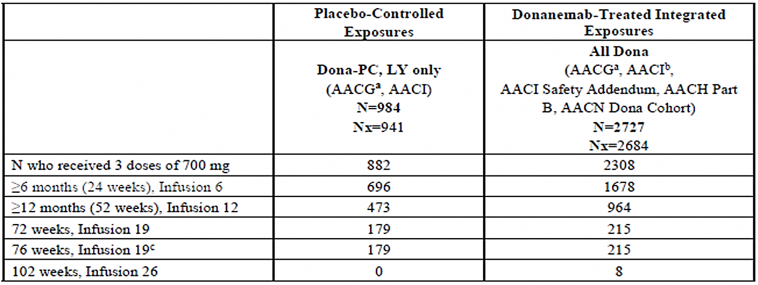
Abbreviations: AACG = Study I5T-MC-AACG; AACH = Study I5T-MC-AACH; AACI = Study I5T-MC-AACI; AACN = Study 15T-MC-AACN; BACE = p-site amyloid precursor protein-cleaving enzyme; Dona = donanemab; LY = LY3002813; LTE = long-term extension; N = number of participants in the analysis populationNx = number of participants in the analysis population who received at least 1 initial dose of 700 mg; n = number of participants; PC = placebo controlled. a) Includes only participants from Study AACG who received donanemab as monotherapy (n=131). Does not include participants who received donanemab plus BACE inhibitor (n=15. combination arm); b) Study AACI main includes AACI-PC and AACI-LTE.; c) Week 76 is the last visit of the double-blind treatment period and is 4 weeks after last infusion at Week 71 The next infusion for those proceeding to the LTE is Week 78.
Treatment-emergent adverse events (TEAE) were common in all studies. Reports of discontinuations from treatment, discontinuations from studies, serious adverse events (SAE) and deaths were all more frequent in the donanemab arms of placebo-controlled studies, although in the All Dona population the proportion of donanemab treated participants with reported SAE and deaths was similar to the proportion of patients treated with placebo in the placebo-controlled studies (Table 8).
Table 8. Overview of Adverse Events Dona-PC and all Dona.
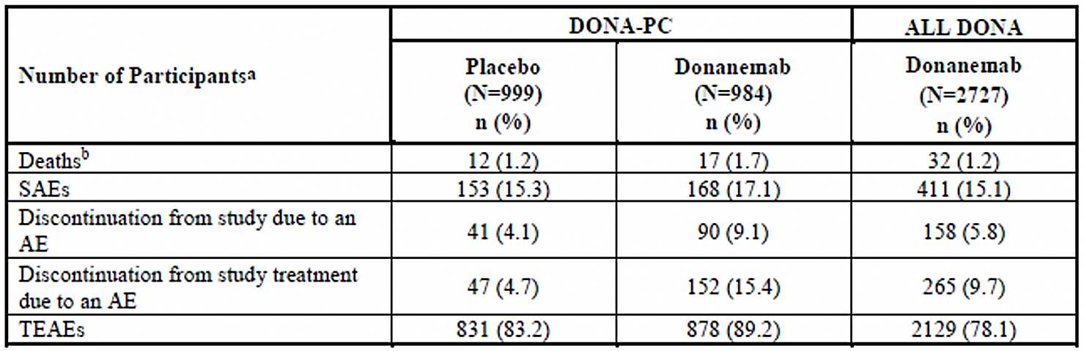
Abbreviations: AE = adverse event; Dona = donanemab; N = number of participants: n = number of subjects with at least 1 AE; PC = placebo controlled; SAE = serious adverse event; TEAE = treatment-emergent adverse event. A) Participants may be counted in more than 1 category; b) Deaths are also included as SAEs and discontinuations due to an AE.
As has been seen with other amyloid-targeting monoclonal antibodies, ARIA-E and ARIA-H were common events and were reported more frequently in donanemab-treated patients than in placebo treated patients (Table 9). Falls and headaches were common in both treatment groups and more frequent in donanemab-treated patients. Reports of nausea were also more common in the donanemab group.
Table 9: Common treatment-emergent adverse events in placebo-controlled and all studies at 14 April 2023
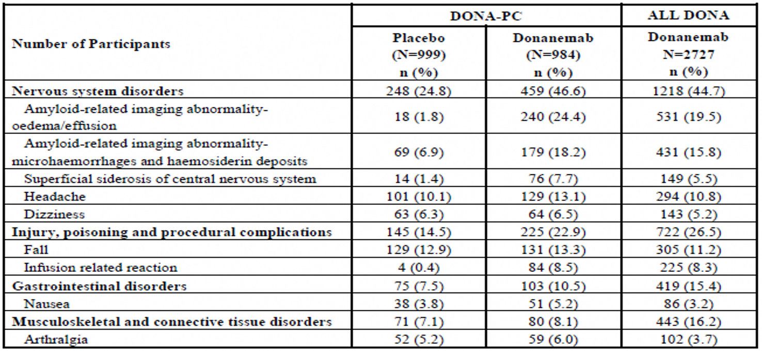
Abbreviations: Dona = donanemab; N = number of participants: n = number of subjects with at least 1 TEAE; PC = placebo controlled; TEAE = treatment-emergent adverse event.
Mild, moderate and severe TEAEs were approximately equally reported (mild, 33.8%; moderate, 33.7%) within the donanemab treatment group.
By system organ classification, SAE were most common in the nervous system and infections and infestations (Table 10). By preferred term ARIA-E was the most frequently reported SAE, higher in donanemab treated patients (24.4%) than in placebo treated patients (1.8%). The incidence of AEs including ARIA-H (placebo, 6.9%; donanemab, 18.2%), and infusion related reaction (IRR, placebo, 0.4%; donanemab, 8.5%) were also higher in the donanemab group compared to the placebo group. Events reported in at least 1% of participants in Dona-PC that led to permanent discontinuation of study treatment were IRR (placebo, 0; donanemab, 3.9%), ARIA-E (placebo, 0.4%; donanemab, 2.8%), ARIA-H (placebo, 0.2%; donanemab; 1.0%), and ARIA-superficial siderosis (SS) (placebo, 0.1%; donanemab, 1.1%).
Table 10: Serious adverse events in placebo-controlled and all donanemab studies at 14 April 2023.
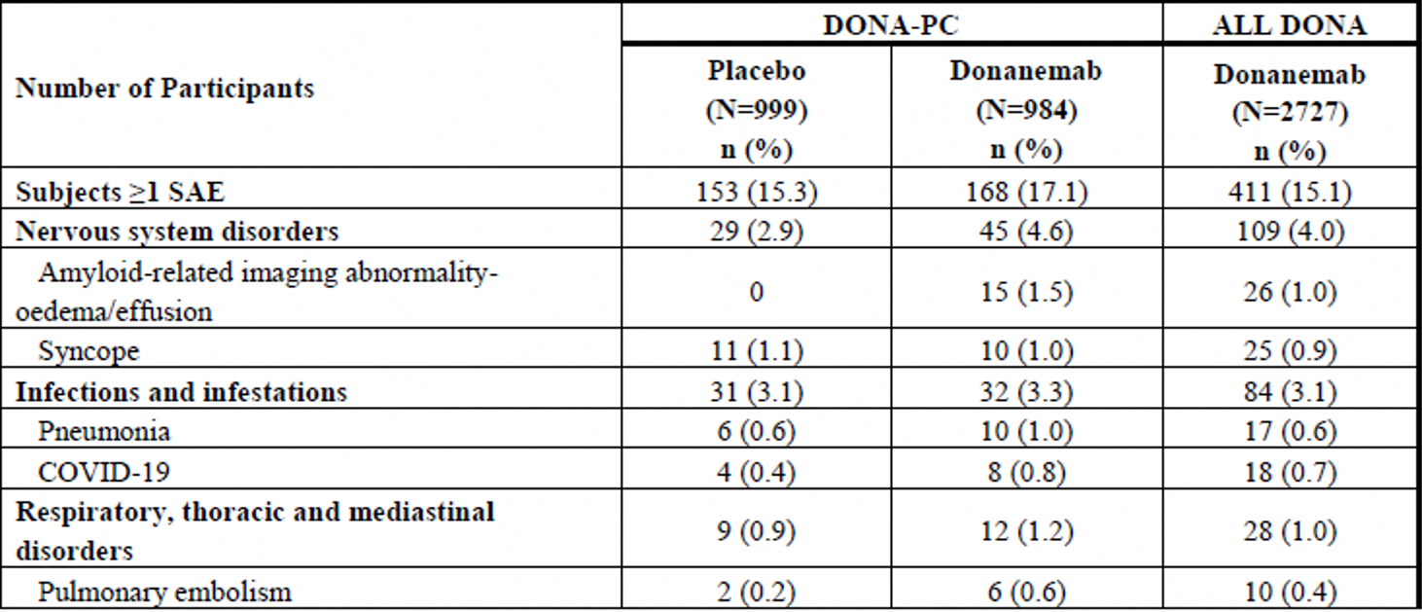
In Dona-PC there were 12 (1.2%) deaths in the placebo-treated group and 17 (1.7%) deaths in the donanemab-treated group. Cause of death in two or more participants in either treatment group were:
- Placebo-treated: Pneumonia (two participants)
- Donanemab-treated: ARIA (three participants), completed suicide (two participants), COVID-19 (two participants, one with pneumonia), and pulmonary embolism (two participants).
Of the three participants in the donanemab-treated group who reported serious ARIA and subsequently died, one (0.1%) death was attributed to ARIA-E, one (0.1%) death to ARIA-H, and the third death (0.1%) was attributed to ARIA-E and ARIA-H.
Among all the reports, five deaths (four in the donanemab-treated and one in the placebo-treated participants) were considered related to study treatment.

Adverse events of special interest

Amyloid related imaging abnormalities (ARIA)
Overall, 37.0% of patients receiving donanemab in the Dona-PC pool, and 30.3% of patients in the All Dona pool experienced one or more ARIA events, as assessed by MRI and/or adverse event reports/ARIA case report forms. Most ARIA events were asymptomatic and therefore only detected on scheduled MRI. In the Dona-PC pool, 31.3% had ARIA-H reports and 24.4% had ARIA-E reports. Around 16% of study participants receiving donanemab experienced simultaneous ARIA-H and ARIA-E. By comparison 14.2% of patients receiving placebo experienced one or more ARIA events, 13.0% having ARIA-H and 1.9% having ARIA-E (Table 11). ARIA-SS also occurred more frequently in donanemab-treated participants (16%) compared with placebo-treated (2.8%) participants, whereas the frequency of macro haemorrhage (intracerebral haemorrhage greater than 1 cm) was similar in the donanemab-treated and the placebo-treated groups (0.3% versus 0.2%, respectively).
Table 11: Overview of ARIA events in placebo-controlled and all donanemab studies at 14 April 2023
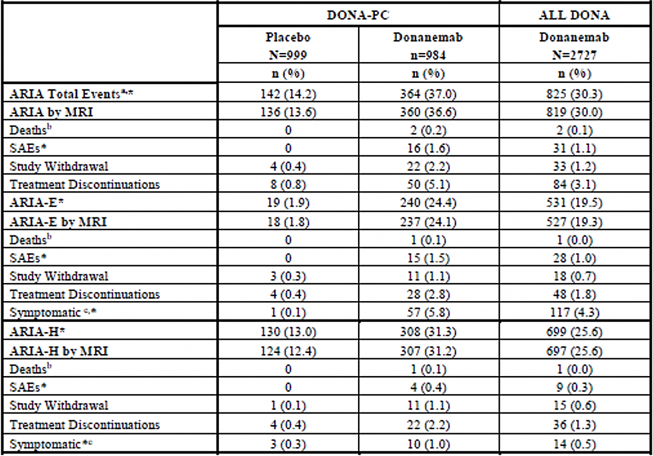Abbreviations: AE = adverse event: ARIA = amyloid-related imaging abnormality; ARIA -E = ARIA-oedema/effusions; ARIA-H = ARIA-haemorrhage/haemosiderin deposition; CRF = case report form; Dona = donanemab; MRI = magnetic resonance imaging: N = number of participants: n = number of subjects with at least 1 AE: PC = placebo controlled; SAE=serious adverse event: TEAS= treatment-emergent adverse event; a) Participants may be counted in more than 1 category; b) Deaths are also included in SAEs and discontinuations due to an AE C Based on ARIA CRF for ARIA-E or AE reporting for -ARIA-H; * Based on NI:ILI or TEAE cluster output.
There were no severe ARIA-E or ARIA-H in the patients treated with placebo; in the All Dona pool 41 (1.5%) and 11 (0.4%) participants, respectively, experienced severe ARIA-E or ARIA-H.
The majority of first ARIA events in the Dona-PC pool occurred within 28 weeks of initiation of treatment. As most were asymptomatic, the exact timing of occurrence could not be determined, however over half of the donanemab-treated participants with ARIA-E (54.9%) had their first event by week 12 and 87.8% had the first event by Week 24. In the All Dona pool, most donanemab-treated participants with serious ARIA-E (28/31) had their first event after receiving up to five infusions of donanemab (i.e., at some time during the first 20 weeks treatment).
Study drug infusion was temporarily withheld in 62.9% and permanently discontinued in 8.0% of donanemab-treated participants experiencing a first ARIA-E episode. For those experiencing a first ARIA-H episode, study drug was temporarily withheld in 33.6% and permanently discontinued in 6.5% of donanemab-treated participants.
The median time to radiographic resolution of ARIA-E was 52.5 days for placebo-treated patients versus 59 days for donanemab-treated participants. Complete radiographic resolution by week 20 was reported for 55.6% of placebo-treated and 89.0% of donanemab-treated participants; resolution of symptomatic ARIA-E was reported for 100.0% of placebo-treated (n=1) and 80.0% of donanemab-treated patients. Where severe ARIA-E events were recorded, more than 90% resolved radiographically and if symptomatic, more than 73% resolved radiographically and clinically. Case descriptions provided in a response to a request for information clarified that of eight patients with ongoing evidence of ARIA-E, three died, four discontinued the study with ongoing symptoms (one aphasia, one seizure, one somnolence and confusional state, one suspected stroke) and one continued in the study with ongoing symptoms of balance disorder and diplopia. Both symptoms eventually resolved. About 80% of severe ARIA-H events radiographically stabilised, but no data was systematically collected regarding symptoms of ARIA-H.
Recurrence of ARIA was observed for both ARIA-E and ARIA-H in donanemab-treated participants but only for ARIA-H in placebo-treated participants. Most patients experienced one or two recurrences. The maximum number of ARIA-E episodes was four (n=1 donanemab-treated participant) and the maximum number of ARIA-H episodes was six in the donanemab group (n=1) and four in the placebo-treated group (n=1).
A post hoc ARIA risk factor analysis confirmed that baseline abnormalities on MRI (microhaemorrhages, superficial siderosis and white matter disease), and ApoE ε4 genotype were associated with higher ARIA risk. Age, baseline weight and baseline amyloid level were also associated with ARIA risk but the magnitude of the association was smaller.
ApoE ε4 carrier status influenced the frequency of any ARIA. A higher frequency for both ARIA-E and ARIA-H was observed for ApoE ε4 homozygous carriers and by heterozygous carriers compared with noncarriers (41.1% versus 23.8% versus 14.8%, respectively). The same was also observed for serious and severe ARIA-E and ARIA-H. The frequency of serious ARIA-E was higher in ApoE ε4 carriers (homozygote 3.0%, heterozygote 1.7%) compared with noncarriers (0.3%). For ARIA-H, the frequencies were 1.2%, 0.2%, and 0.3%, respectively. Similarly, the frequency of symptomatic ARIA-E and ARIA-H was higher in carriers and symptomatic ARIA-E was the highest in homozygous carriers.
Patients who received donanemab and an antithrombotic medicine (acetylsalicylic acid, other antiplatelets, or anticoagulants), did not have an increased frequency of ARIA. The most frequently used antithrombotic was aspirin, followed by anticoagulants, and non-aspirin antiplatelets, and finally thrombolytics. The number of events and the limited exposure to non-aspirin antithrombotic medicines limit definitive conclusions about the risk of ARIA or intracerebral haemorrhage in patients taking antithrombotic medicines. Given the limited number of exposures to thrombolytics, no conclusions could be made regarding the risk of concomitant thrombolytic use.

Study AACQ
Study AACQ is an ongoing, multicentre (USA and UK), randomised, double-blind, Phase 3b study designed to investigate different donanemab dosing regimens and their effect on the frequency and severity of ARIA-E in adults with early symptomatic AD. The study was initiated on 28 February 2023 (first participant first visit). A total of 843 study participants were randomly allocated to treatment in four different donanemab regimens in 1:1:1:1 ratio (Table 12). The analyses presented in the submitted CSR report included the results of the 24-week treatment period and are based on the interim database lock date of 02 August 2024.
Table 12: Dosing regimens studied in Study AACQ
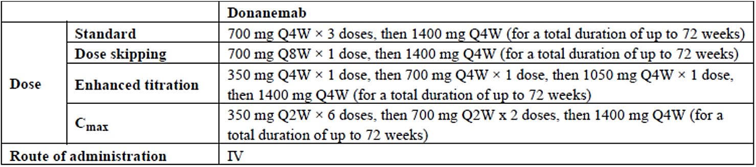
Abbreviations: IV=intravenous; Q2W = every 2 weeks; Q4W = every 4 weeks; Q8W = every 8 weeks.
The inclusion and exclusion criteria for AACQ largely matched those of Study AACI, however, no assessment of brain tau burden was performed. The standard dosing regimen was the regimen used in Study AACI. The outcomes investigated in Study AACQ included interim safety, immunogenicity, PK and PD data at Week 24 comparing three alternative dosing regimens to the standard dosing regimen. The primary focus in Study AACQ was on the comparisons between the proposed “enhanced titration dosing” regimen and the standard dosing regimen. Unless otherwise specified, analyses of ARIA-E events were based on MRI findings or AE reporting by Week 24. Bayesian methods of analysis were applied to test that the posterior probability of at least one alternative dosing regimen reducing ARIA-E risk by at least 20% by Week 24, compared with the standard dosing regimen, was more than 80%.
At Week 24, the enhanced titration dosing regimen met the primary safety endpoint showing a 41% relative risk reduction in ARIA-E frequency compared to the standard dosing regimen, with a 94% probability that the relative risk reduction is at least 20%. The proportion of participants with ARIA-E by 24 weeks was greater in the standard dosing group compared to the enhanced titration dosing group (23.7% [49/207] vs 13.7% [29/212]), and the absolute difference of -10.0% between the groups (enhanced titration minus standard) was statistically significant (95% CI: -17.4, -2.6; p=0.012; Table 13). The comparisons between each of the other alternative dosing regimens and the standard dosing regimen did not meet the pre-specified criterion relating to risk-reduction and are not discussed further.
Table 13: Amyloid-Related Imaging Abnormalities in study AACQ
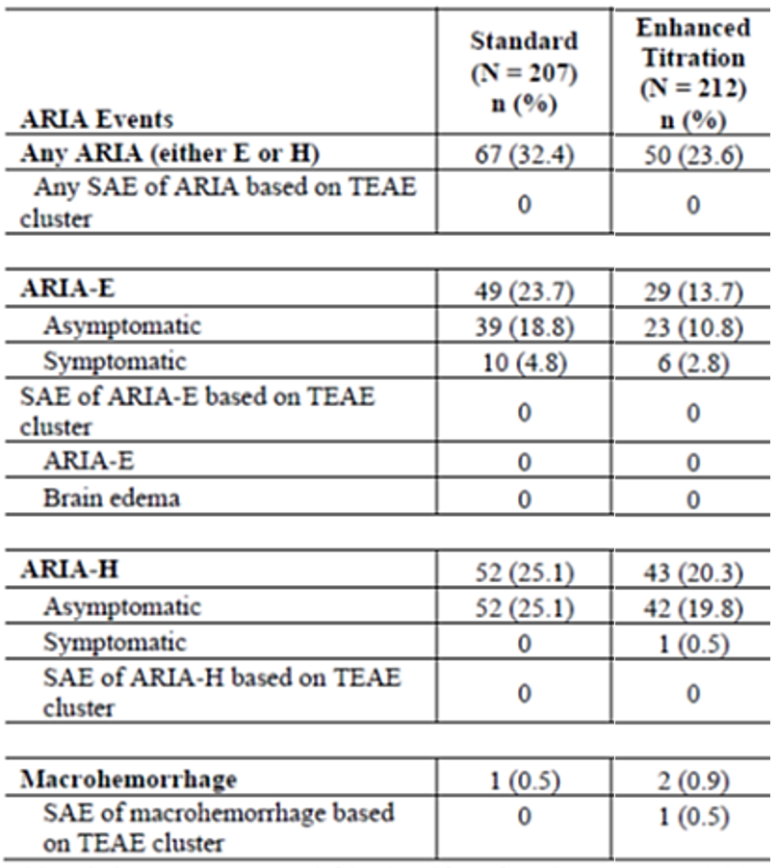
Abbreviations: ARIA = amyloid-related imaging abnormalities; ARIA-E = amyloid-related imaging abnormalities—oedema/effusions (also known as vasogenic edema); ARIA-H = amyloid-related imaging abnormalities—hemorrhage/hemosiderin deposition (including brain microhemorrhage and superficial siderosis); MRI = magnetic resonance imaging; n = number of participants within the specified category; N = number of participants in the analysis population; SAE = serious adverse event; TEAE = treatment-emergent adverse event.
The secondary endpoints of relative-risk reduction in the frequency of ARIA-H, amyloid change from baseline, and severity of ARIA-H showed no significant differences between the enhanced titration dosing regimen and the standard dosing regimen, but the secondary endpoint of severity of ARIA-E was significantly lower in the enhanced titration dosing group than in the standard dosing group. For the secondary immunogenicity endpoint of the presence of ADA-antibodies, the post-baseline treatment-emergent ADA+ rate in evaluable participants was 82.2% (166/202) in the enhanced titration dosing group and 86.8% (171/197) in the standard dosing group. All treatment-emergent ADA+ participants were also positive for neutralising antibodies against donanemab.
Other treatment-emergent AE and SAE data were generally comparable between the enhanced titration and standard dosing groups at Week 24, as were laboratory findings and vital signs. One death occurred in a patient in the enhanced titration dosing group. The cause of death was reported as large right intraparenchymal haemorrhage, secondary to tenecteplase, massive right hemispheric intraparenchymal brain haemorrhage, and thrombolytic administration for presumed stroke. Per the investigator, the SAE of “Large right cerebral intraparenchymal haemorrhage” was not deemed related to study treatment, and the SAE of “MCA (middle cerebral artery) stroke” was deemed to be related to study treatment.

Hypersensitivity, anaphylaxis and infusion-related reactions
The hypersensitivity risk with donanemab was predominantly related to immediate events such as IRRs and anaphylaxis. The incidence of IRR was higher in donanemab-treated participants compared to placebo-treated participants (8.5% versus 0.4%). The events were transient, usually occurring during the infusion or within 30 minutes of the end of infusion (92.1%), and most resolved on the same day. The majority (>59%) of the first-onset IRRs occurred by the third or fourth infusion. Most IRRs associated with donanemab treatment were mild to moderate in severity, 5.1% of IRRs were severe.
The incidences of anaphylactic reaction and hypersensitivity in donanemab-treated participants were low (≤1.0%). Among all donanemab-treated participants, 13 (0.5%) had a hypersensitivity-related SAE. Four participants (0.1%) had an anaphylactic reaction SAE. All serious IRR/ hypersensitivity events occurred by the fourth infusion.
Prophylaxis medication did not notably reduce the risk of experiencing an IRR associated with rechallenge in participants who previously had experienced an IRR. Whether prophylaxis was used or not, approximately 40% of individuals rechallenged with donanemab experienced an IRR on the rechallenge dose.
Non-immediate hypersensitivity events associated with donanemab exposure were infrequent (0.2 – 1.1%) and included dermatitis, dermatitis contact, eczema, rhinitis allergic, dermatitis allergic, angioedema, IRR, rash erythematous, and urticaria.
In clinical studies, 88% of donanemab-treated patients developed ADA and all had neutralising antibodies. Although donanemab exposure decreased with increasing ADA titre, the development of ADA was not associated with loss of clinical efficacy of donanemab.
In Study AACQ, the post-baseline treatment-emergent ADA+ rate in evaluable participants was 82.2% (166/202) in the enhanced titration dosing group and 86.8% (171/197) in the standard dosing group. All treatment-emergent ADA+ participants were also positive for neutralising antibodies against donanemab.
Summarised safety data from Phase 1 studies aligned with reports in Dona-PC and All Dona pools. ARIA events were more common at higher doses; the investigators implemented starting doses at 10mg/kg for the first three doses before escalating to maximum doses of 20mg/kg (and later starting doses of 700mg and maximum doses of 1400mg).
Additional safety data presented in the final clinical study report for the open-label active comparator study of donanemab and aducanumab AACN largely reflected the safety risks identified in the double-blinded placebo-controlled studies AACG and AACI and the All Dona pool reports. The risk of ARIA events with aducanumab were consistently greater than with donanemab.
Overall, the safety profile of donanemab was consistent with what is known for the anti-amyloid class of monoclonal antibodies and the safety risks are clinically manageable. For management of ARIA, infusion of study drug could be temporarily withheld or permanently discontinued with or without the use of supportive treatment. The sponsor would need to ensure that sufficient information regarding ApoE testing, monitoring with MRI and dosing interruptions is included in the product information.

Other (e.g. companion diagnostic considerations, drug delivery device)
The requirements for enrolment in the pivotal and supportive studies included satisfying stringent criteria based on brain imaging modalities including PET (for amyloid and for tau) and MRI. Furthermore, continued treatment also was subject to repeat MRI at fixed intervals, and if new changes (ARIA-E, ARIA-H, white matter disease) were identified, possible additional unscheduled investigations.
The efficacy and safety findings vary with ApoE genotype, and both study AACG and AACI indicated directionally positive but equivocal efficacy in patients homozygous for ApoE ε4 with AD. Furthermore, it is highly likely that this patient population is more likely to experience significant adverse events after treatment with donanemab. The sponsor has proposed to exclude patients homozygous for ApoE ε4 from the treatment population.

Discussion

Efficacy
During the evaluation, the sponsor was asked to address several concerns regarding the design of the pivotal study. These included multiple variations in the study protocol, including changing the primary outcome measure after commencing the study; applying a previously unvalidated primary outcome measure in the iADRS; screening out almost 80% of potential study participants using PET screening methodologies that are not readily available in many jurisdictions, and including in the analyses results from around 20% of patients who at screening satisfied inclusion and exclusion criteria, but, based on MMSE at baseline, could be considered to have progressed to or already have moderate AD.
The sponsor responded to most of the queries to the satisfaction of the evaluators. Specifically, various protocol changes were discussed with the EU CHMP and ultimately approved by ethics committees at the different sites. Similarly, specific PET requirements were implemented to identify a population of patients with AD that may respond to donanemab during the proposed study duration. Finally, the choice of statistical analysis methodologies was challenged by the evaluators and the sponsor was asked to provide several post hoc analyses encompassing different contingencies, all of which directionally supported the primary analyses.
Noting the queries and responses regarding study design and statistical analysis, study AACI met its primary endpoint. Donanemab-treated participants had statistically significantly slowed clinical progression on the primary outcome, iADRS, compared with placebo in both intermediate tau (35% slowing; p<0.001) and overall (22.3% slowing; p<0.001) populations at 18 months. The results were directionally supported by all secondary outcomes including the CDR-SB. While subgroup analyses showed consistent results and nominally favoured donanemab in terms of iADRS across most subgroups, some uncertainties arise regarding clinical efficacy in patients with higher brain tau or homozygous for ApoE ε4.
Study AACG also met its primary endpoint. Donanemab-treated participants had statistically significantly less decline in cognition/function than placebo-treated participants as assessed by the iADRS at Week 76. The results demonstrated a 32% delay in decline for donanemab-treated participants compared with placebo. Statistical significance over placebo was not achieved by donanemab on the key secondary endpoint CDR-SB. The sponsors argue that this could be attributed to a lack of sensitivity of the CDR-SB, the reason the iADRS was developed. Nonetheless, there was numerical superiority in CDR-SB scores with donanemab versus placebo. However, uncertainties regarding efficacy in patients homozygous for ApoE ε4 were again flagged in this smaller population.
While patient and observer-reported outcomes were included in the assessment tools applied in the clinical studies, these did not satisfy the TGA definition of real world data or real world evidence.
The sponsor makes a case that the apparent delay in deterioration with Alzheimer’s disease in patients treated with donanemab is an important and significant outcome not withstanding that the difference between the mean change from baseline iADRS in donanemab patients and in placebo treated patients, although statistically significant, was arguably not sufficient to be clinically detectable. However, in the pivotal study and in the supporting study, more patients treated with placebo than with donanemab exceeded the projected minimal clinically important difference (MCID) of a 9-point reduction in iARDS (as defined for patients with mild AD) at 76 weeks. All the secondary outcomes showed similar trends which were robust in various sensitivity analyses. Based on this data, it seems that donanemab may have modest efficacy in delaying the progress of early Alzheimer’s dementia in a small, tightly selected population – particularly excluding those who have had cerebrovascular disease and/or other potential contributors to dementia - of patients with confirmed brain amyloid. Whether this modest effect can be sustained in the longer term is currently unknown.

Safety
In comparison to the potential modest effect of donanemab on progression of Alzheimer’s disease in some patients, the major risks of treatment with donanemab were common or very common and clearly described in all subgroups of the study population. The most frequently reported TEAEs for donanemab-treated participants in the first placebo-controlled studies were ARIA-E (24.4%), ARIA-H (18.2%), infusion related reaction (8.5%), nausea (5.2%), and headache (13.1%), all of which have been designated adverse drug reactions. Most of the TEAEs were of mild (34.9%) or moderate severity (41.9%), however severe TEAEs were reported in 12.5% of donanemab-treated participants. Of these, the most common severe TEAE was ARIA-E. The other AEs of clinical importance included hypersensitivity, anaphylaxis and IRR, and immunogenicity and hypersensitivity. The incidence of IRR was higher in donanemab-treated participants compared to placebo-treated participants. The majority (>59%) of the first-onset IRRs occurred by the third or fourth infusion and the incidences of anaphylactic reaction and hypersensitivity in donanemab-treated participants were low (≤1.0%).
Four of 17 deaths in donanemab-treated populations (thalamic haemorrhage, death, ARIA-E and ARIA-H) were considered treatment-related and although overall the risk of death in donanemab-treated patients was not much greater than in placebo-treated patients this must be taken in consideration of a population who although not necessarily healthy, could anticipate remaining relatively well for at least several years before succumbing to the cognitive decline associated with AD.
The underlying concern is that there are currently no evidence-based treatments for ARIA-E or ARIA-H, and patients are generally managed symptomatically. Further, there is no clear understanding of the long-term sequelae of ARIA events. The sponsor has monitored study participants following ARIA events and indicated that some 80% of patients with symptomatic ARIA-E experienced resolution of symptoms. Ongoing information for the patients with unresolved symptoms was either not available or confounded by other conditions. The sponsor acknowledges this uncertainty, stating “There appears to be no conclusive evidence that the unresolved symptoms are long-term sequelae of ARIA-E, and no frequency or pattern of unresolved symptoms is observed to inform on the clinical implications”.
The sponsor has proposed several risk management measures to decrease the risk of frequent, significant, and serious ARIA events. These include more frequent MRI scans early in treatment, excluding patients homozygous for ApoE ε4 from treatment, and additionally excluding those patients eligible for donanemab treatment based on ApoE ε4 carrier status if they have baseline MRI evidence of intracerebral haemorrhage greater than 1 cm, more than 2 microhaemorrhages, superficial siderosis or vasogenic oedema suggestive of cerebral amyloid angiopathy.
With study AACG, the sponsor provided an alternative titration regimen, demonstrating favourable safety outcomes compared to the regimen applied in the pivotal study.
A secondary safety concern, which at present has been signalled in exploratory analyses, is the significantly greater reduction from baseline in bilateral whole brain volume and increase in bilateral ventricular volume in patients treated with donanemab compared to patients treated with placebo. Age-dependent decreases in white matter and increases in CSF-filled spaces, particularly the inferior lateral ventricle, have been described in aging adults with normal cognition. In Japanese adults with normal cognition, serial MRIs estimated an annual decrease of 0.4% in whole-brain volume, ranging from 0.3% per year among individuals in their 40s to 0.5% per year in individuals in their 80s. The study also reported an overall annual increase in ventricle volume of 1.8%, with a range of 1.0% per year among individuals in their 40s to 2.5% per year among individuals in their 80s. Interindividual differences were present in the trends of volume changes in brain structures during follow-up, even in the same age range.
It is not yet clear whether the potential acceleration of changes in brain volume by donanemab, irrespective of the potential mechanism, may result in long-term consequences.
Accessibility to genetic testing and to advanced brain imaging technology would be pre-requisite to identify those patients with AD, if any, who may benefit from treatment with donanemab, as well as those more likely to develop ARIA secondary to treatment. Additional restrictions include use in “specialised centres under the supervision of a multidisciplinary team trained in detection, monitoring and management of ARIA and experienced in detecting and managing infusion related reactions” in addition to being initiated by a physician “experienced in the diagnosis and treatment of Alzheimer’s disease”.

Conclusions
There are questions about the robustness of the efficacy outcomes reported in the pivotal and supportive studies of donanemab in patients with MCI or mild AD. Despite these doubts, all the measures indicated a trend to delayed progression of disease in the population treated with donanemab when compared to placebo. In the presented studies, there was an apparent delay in clinical deterioration seen in the populations treated with donanemab, regardless of which measurement tool was applied. This delay was estimated at between six weeks and seven months over 18 months. While longer term studies may be considered helpful in deciding whether this apparent delay can be sustained over the course of deteriorating AD, it is appropriate to consider the importance of such a delay to the appropriately informed individual patient who is still living independently and with minimum requirements for support.
The evidence of moderate benefit appeared better supported in patients with lower tau burden, and the potential clinical advantage was not as great in more progressed disease (higher tau, more symptomatic patients) or in patients homozygous for ApoE ε4.
In the context of these significant risks for which there is no evidence-based treatment careful patient selection is demanded. Donanemab treatment also resulted in a greater decrease in the whole brain volume, a greater increase in ventricular volume, and a lesser decrease in the hippocampal volume. The potential long-term consequences of ARIA events and treatment-related changes in brain volume cannot be discerned.

Recommendation following the clinical evaluation
The delegate is acutely aware that there is a need for effective treatments for AD, and that there is some evidence of moderate efficacy of donanemab in a subset of patients with mild AD dementia or MCI, notwithstanding the known and not inconsiderable risks, and unknowable potential long term concerns of anti-amyloid therapies.
In view of this apparent equipoise the sought the advice of the Committee regarding the benefit-risk balance for donanemab (Kisunla) for the indication:
“Kisunla is indicated for the treatment of patients with Mild Cognitive Impairment (MCI) due to Alzheimer’s disease and Mild Alzheimer’s dementia (Early Alzheimer’s disease) that are apolipoprotein E ε4 (ApoE ε4) heterozygotes or non-carriers”.
Additional actions described in the PI, to limit use of donanemab in populations more likely to suffer serious or severe adverse events are generally supported.

Advisory Committee considerations
The Advisory Committee on Medicines (ACM), having considered the evaluations and the delegate’s overview, as well as the sponsor’s response to these documents, advised the following:
- What is the committee’s perspective on the clinical benefit demonstrated for donanemab in the pivotal study?
The ACM was of the opinion that the trial data demonstrated a potential minimal slowing of disease progression. Participants with a lower tau burden showed a lesser decline in cognitive and physical function than those with a higher tau burden. The minimal clinically important differences of the measures used as the endpoints of the trial were unclear, with limited consensus in the literature.
The ACM noted that the eligibility criteria as per the pivotal trials could exclude as many as 95% AD patients from receiving Kisunla.
The ACM agreed that while an effect was measurable, the clinical significance of the effect remained uncertain.
- Is there a case that potential clinical decline in the population of patients with Mild Cognitive Impairment (MCI) is slower than could be detected over the period of the study and would require a longer period of observation to detect an effect of donanemab?
The ACM advised that subgroup analyses found that the effect of Kisunla in participants with MCI was likely to be consistent to those with mild or moderate AD, but that these results did not reach statistical significance. The ACM noted that the data for participants with MCI was from a smaller sample size and that while the point estimates of efficacy were supportive, these were bounded by wide confidence intervals that crossed zero. The study was not sufficiently powered for this subgroup analysis.
The ACM noted that in the trial data, MCI was defined as a MMSE score greater than or equal to 27. This measure was not considered to be consistent with current clinical practice, and this patient population would be less impaired than the broader accepted interpretation of MCI would suggest. This could have led to cognitive decline being slower than would otherwise be expected with a case of MCI.
- Is the initial proposed dosage regimen of donanemab (700mg Q4W for 3 doses, then 1400 mg Q4W for a maximum total treatment period of 18 months) approvable in the targeted treatment population proposed by the sponsor?
The ACM expressed significant concern with the safety profile of Kisunla, noting that there were considerable risks associated with treatment. The ACM considered these risks in the context of the minimal clinical benefit demonstrated from treatment. The ACM discussed the treatment and monitoring burden imposed on patients and carers.
Ultimately, the ACM advised that the initial dosing regimen was not approvable due to the significant treatment emergent risks, and the impact of the increased treatment and monitoring burden, combined with a minimal efficacy.
- Is the evidence of pharmacokinetic (PK) and pharmacodynamic (PD) comparability of the “enhanced titration” dosage regimen of donanemab (350mg/700mg/1050mg Q4W then 1400mg Q4W to a maximum total treatment period of 18 months) to the standard dosage regimen at 24 weeks sufficient to support approval of the enhanced titration regimen in the targeted treatment population?
The ACM noted no apparent differences in the PD or PK between the two regimens after 24 weeks treatment and held the view that the data provided may support the use of the enhanced titration regimen, noting that this data was immature. The additional data included in the research article published in April 2025 was also supportive of the enhanced titration regimen to preserve minimal to moderate efficacy, while reducing the risk of ARIA events, but had not been independently reviewed by the TGA.
- What is the committee’s perspective on the adequacy of the warnings and precautions in the Product Information?
- The ACM Advised that the warnings and precautions in the Product Information described the risks of treatment with Kisunla but could potentially be strengthened.
- The ACM proposed a modification of the indication requiring confirmation of amyloid-β pathology via imaging prior to initiation of Kisunla.
- The ACM noted that wording from the FDA boxed warning could be appropriate to inform patients of the risk of “focal deficits that could mimic an acute ischaemic stroke”.
- The ACM suggested including information in the PI reporting the rates of ARIA, stratified by ApoE ε4 genetic status.
- The ACM was also supportive of the inclusion of a standardised imaging monitoring protocol.
- The ACM acknowledged that the majority of infusion related reactions were reported as mild to moderate, with 5.1% of the reported as severe.
- The ACM were of the opinion that Kisunla should be prescribed only under the care of specialist physicians with experience using anti-amyloid therapies.
- The ACM acknowledges that data about the longer-term cognitive outcomes after treatment is not yet available.
- The ACM raised particular concerns with the unknown long-term effects of anti-amyloid treatments, as well as the rate of amyloid-β re-accumulation after discontinuation of therapy.

ACM conclusion
The proposed indication considered by the ACM was:
“Kisunla is indicated for the treatment of patients with Mild Cognitive Impairment (MCI) due to Alzheimer’s disease and Mild Alzheimer’s dementia (Early Symptomatic Alzheimer’s disease) that are apolipoprotein E ε4 (ApoE ε4) heterozygotes or non-carriers.”
The ACM advised that Kisunla had an overall negative benefit-risk profile for the proposed indication as the evidence submitted did not satisfactorily establish the efficacy and safety of the product.
The ACM acknowledged there is an unmet clinical need for treatments of AD. Despite this unmet need, the outstanding safety concerns of the unknown long-term effects of anti-amyloid therapies, rare severe infusion reactions, and ARIA reactions were not justified by the minimal efficacy provided by Kisunla.

Risk/benefit assessment

Efficacy
The evaluation of efficacy of donanemab in the proposed indication is based primarily on one pivotal Phase 3 study (Study AACI), supported by a Phase 2 study (Study AACG) in adults with early symptomatic AD with PET-confirmed brain amyloid and low or intermediate levels of brain tau. The safety profile of donanemab is predominantly based on the integrated safety results of studies AACI (placebo-controlled phase, AACI-PC) and AACG. Additional safety data is included from ongoing studies including a safety addendum to Study AACI (AACI-Safety Addendum), an extension period to Study AACI (AACI-LTE), an extension study for Study AACG (Study AACH), an active comparator study of donanemab and aducanumab (Study AACN), and a study comparing the frequency of adverse events associated with donanemab treated with a “standard dosing regimen” compared to a “modified titration regimen” (AACQ).
For the pivotal study AACI, more than 8000 adults aged 60 to 85 years, who had self-reported or informant-reported gradual and progressive change in memory function for six months or longer, were screened for inclusion in the study applying the MMSE. Those who scored between 20 and 28 points on the MMSE were then screened with PET scans of the brain for Aβ consistent with AD, and PET scans of the brain for tau.
The primary objective of the study was to assess the ability of donanemab compared to placebo to slow the progression of AD over 76 weeks in participants with early symptomatic AD, regardless of any initiation or change to standard of care medications and regardless of whether a participant stopped taking the study drug. The primary efficacy outcome was the change from baseline in the iADRS (range 0-144, lower scores indicate greater impairment) through week 76 in the study group with intermediate brain tau pathology and in the overall population (intermediate or high brain tau pathology). The main secondary outcomes were the change from baseline in the CDR-SB (range 0-18, higher scores indicate greater impairment) in the intermediate brain tau pathology and in the overall population groups, and additional secondary outcomes included change from baseline in the ADAS-Cog13 score (range 0-85, higher scores indicate greater impairment), the ADCS-iADL (range 0-59, lower scores indicate greater impairment) score (the scales underpinning the iADRS), MMSE score (0-30, scores below 25 indicate impairment) and brain amyloid plaque and brain tau deposition
Of note, while 1112 study participants who satisfied initial screening criteria based on MMSE recorded baseline (visit 2) MMSE scores consistent with early symptomatic AD, 384 participants (22%) recorded scores below 20, suggestive of moderate AD. Although direct comparison with the population of patients with early AD enrolled in lecanemab trials is not possible, owing to divergent screening, enrolment and outcome criteria, it is worth noting that in the lecanemab trials, mean (SD) CDR-SB scores at baseline were both 3.2 (1.3) in the treatment and placebo groups, and mean MMSE scores at baseline were 25.5 (2.2) and 25.6 (2.2) respectively (range 22-30). While CDR-G scores were comparable in the two study populations, it is feasible that AD in the donanemab study population was moderately further progressed than in the lecanemab study population.
At Week 76, the LS mean (±SE) change from baseline in iADRS score in the intermediate tau population was -9.27±0.49 in the placebo group and -6.02±0.50 in the donanemab group, with LS mean difference (±SE) between the groups of 3.25±0.70, 95% CI 1.88, 4.62, p<0.001. This corresponds to a 35% (95%CI 19.9, 50.2) slowing of clinical progression in donanemab-treated participants compared with placebo-treated participants.
In the overall study population, both placebo and donanemab treated groups showed greater mean declines from baseline iADRS scores at 76 weeks than were reported in the intermediate tau population. The LS mean (±SE) change from baseline in iADRS score in the overall population was -13.11±0.50 in the placebo group and -10.19±0.53 in the donanemab group, with LS mean difference (±SE) between the groups of 2.92±0.72, 95% CI 1.51, 4.33, p<0.001. This corresponds to a 22% (95%CI 11.4, 33.2) slowing of clinical progression in donanemab-treated participants compared with placebo-treated participants. The investigators concluded that donanemab-treated participants had statistically significantly less clinical progression over 18 months compared with placebo-treated participants.
The results for the primary outcome were supported by the key secondary and other secondary outcomes at week 76.
In the smaller, supportive study AACG, 272 participants were enrolled after satisfying the same inclusion criteria applied in study AACI. The exclusion criteria were extensive as in study AACI, other than that participants with high brain tau on PET were excluded from AACG. A total of 187 participants (donanemab, n=94; placebo, n=93) completed the study and 69 participants were discontinued from the study (donanemab, n=37; placebo, n=32). The demographics and baseline characteristics were balanced between groups.
At Week 76, the LS mean (±SE) change from baseline in iADRS score was -10.06±1.14 in the placebo group and -6.86 ± 1.14 in the donanemab group; LS mean difference (± SE) 3.20±1.56, 95% CI 0.12, 6.27, p=0.042). This corresponded to a 32% slowing of clinical progression in donanemab-treated participants compared with placebo-treated participants. Numerical trends in CDR-SB, ADAS-Cog13, ADCS-iADL and MMSE supported superiority of donanemab over placebo but were not statistically significant.
Two specialist advisors and a member of ACM with expertise in the management of patients with AD were invited to discuss the submission at the 50th meeting of the ACM on 4 April 2025. Two declared that they had minor involvement in clinical trials with patients with AD, including trials with donanemab, as part of their salaried clinical roles. None were or had been principal investigators or had received any direct financial compensation from the applicant for their work. The ACM agreed that each would be allowed to present at the meeting and answer specific questions, but none would be present for the ACM discussion, including the ACM member.
Each of the specialist advisors agreed that donanemab demonstrated statistically significant and clinically important modest slowing of disease progression over 18 months. The studies suggested better efficacy in study participants with lower tau burden. One speaker also provided an alternative presentation of the published data that highlighted the difference in proportions of patients with low/medium tau who did not progress over 12 months when treated with donanemab compared to those treated with placebo, based on unchanged CDR-SB scores from baseline.
Each of the speakers also highlighted that the treatment would only be suitable for a small number of individuals with early symptomatic AD. All concluded that donanemab administered as three doses of 700mg IV each four weeks, followed by doses of 1400mg IV every four weeks until PET evidence of amyloid clearance or to a maximum of 18 months demonstrated clinical efficacy.
The ACM acknowledged the specialist opinions, however queried whether the statistically significant difference in change from baseline scores of the primary and secondary outcome measures could be considered clinically important. A major question, which had been considered with earlier submissions for anti-Aβ therapies, was whether a relatively small difference in mean scores derived from a population of patients could be deemed clinically significant at an individual level. Further, they questioned whether estimates of delay in disease progression between 1.4 and 6 months over 18 months was clinically important.

Safety
While common adverse events in study participants included headache, nausea and infusion-related reactions, the main safety concern with donanemab, as with other anti-Aβ agents, was the significantly greater risk of ARIA events. The mechanism responsible for ARIA is currently unknown. One theory is that accelerated breakdown of and clearance of Aβ may lead to disruption of cerebrovascular integrity, leading to leakage, resulting in oedema (ARIA-E) or microhemorrhages (ARIA-H).
ARIA, particularly ARIA-H are relatively common incidental findings on MRI scans of patients with AD. In the DONA-PC analysis during the 18-month treatment period, ARIA-H were reported in 13.0% of study participants treated with placebo and in 33.1% of study participants treated with donanemab, whereas ARIA-E were reported in 1.8% and 24.4%, respectively. The applicant highlights that most ARIA events are asymptomatic and only detected retrospectively on MRI scans. The majority of first ARIA events in the Dona-PC pool occurred within 28 weeks of initiation of treatment. Over half of the donanemab-treated participants with ARIA-E (54.9%) had their first event by week 12 and 87.8% had the first event by Week 24. In the All Dona pool, most donanemab-treated participants with serious ARIA-E (28/31) had their first event after receiving up to five infusions of donanemab (i.e. at some time during the first 20 weeks treatment). Recurrence of ARIA was observed for both ARIA-E and ARIA-H in donanemab-treated participants but only for ARIA-H in placebo-treated participants. Most patients experienced one or two recurrences. The maximum number of ARIA-E episodes was four (n=1 donanemab-treated participant) and the maximum number of ARIA-H episodes was six in the donanemab group (n=1) and four in the placebo-treated group (n=1).
There were no severe ARIA-E or ARIA-H events reported in the patients treated with placebo; in the All Dona pool 41 (1.5%) and 11 (0.4%) participants, respectively, experienced severe ARIA-E or ARIA-H. Where severe ARIA-E events were recorded, more than 90% had resolved on repeat MRI and if symptomatic, more than 73% resolved radiographically and clinically.
A post hoc ARIA risk factor analysis confirmed that baseline abnormalities on MRI (microhaemorrhages and superficial siderosis), and ApoE ε4 genotype were associated with higher ARIA risk. Baseline amyloid level were also associated with ARIA risk but the magnitude of the association was smaller.
ApoE ε4 carrier status influenced the frequency of any ARIA. A higher frequency for both ARIA-E and ARIA-H was observed for ApoE ε4 homozygous carriers and for heterozygous carriers compared with noncarriers (41.1% versus 23.8% versus 14.8%, respectively). The same was also observed for serious and severe ARIA-E and ARIA-H. The frequency of serious ARIA-E was higher in ApoE ε4 carriers (homozygote 3.0%, heterozygote 1.7%) compared with noncarriers (0.3%). For ARIA-H, the frequencies were 1.2%, 0.2%, and 0.3%, respectively. Similarly, the frequency of symptomatic ARIA-E and ARIA-H was higher in carriers and symptomatic ARIA-E was highest in homozygous carriers.
The primary focus in Study AACQ was on the comparisons between a proposed “enhanced titration dosing” regimen and the standard dosing regimen. The enhanced titration regimen commenced with a lower first dose of 350mg, followed four weeks later with a dose of 700mg, a further four weeks later with 1050mg, and then with the maximum dose of 1400mg every four weeks to a maximum of 18 months. Unless otherwise specified, analyses of ARIA-E events were based on MRI findings or AE reporting by Week 24.
The study reported that the enhanced titration dosing regimen met the primary safety endpoint, showing a 41% relative risk reduction in the frequency of ARIA-E compared to the standard dosing regimen, with a 94% probability that the relative risk reduction is at least 20%. The proportion of participants with ARIA-E by 24 weeks was greater in the standard dosing group (49/207, 23.7%) compared to the enhanced titration dosing group (29/212, 13.7%), and the absolute difference of -10.0% between the groups was statistically significant (95% CI: -17.4, -2.6; p=0.012). The secondary endpoints of relative-risk reduction in the frequency of ARIA-H, amyloid change from baseline, and severity of ARIA-H showed no significant differences between the enhanced titration dosing regimen and the standard dosing regimen, but the secondary endpoint of severity of ARIA-E was significantly lower in the enhanced titration dosing group than in the standard dosing group. One death occurred in a patient in the enhanced titration dosing group. Like a death reported in the All Dona safety pool, the cause of death was reported as large right intraparenchymal haemorrhage, secondary to tenecteplase, a thrombolytic administered for suspected stroke.
It is worth noting that the participants in study AACQ satisfied the similar inclusion and exclusion criteria applied in the pivotal study AACI but were not subject to tau PET scans. This means that the reported safety results also include results from participants homozygous for ApoE ε4 and are not restricted to the population with fewer pathologies on screening brain MRI.
The specialist advisors considered the safety risks of treatment with donanemab manageable. Restricting access to donanemab to ApoE ε4 noncarriers and heterozygous carriers, confirming the presence of brain Aβ with a validated test and implementing a scheduled MRI monitoring program for ARIA were considered essential for managing the risk of ARIA.
The ACM took a more conservative stance, concluding that Kisunla had an overall negative benefit-risk profile for the proposed indication owing to the modest clinical benefit and known risks of ARIA. This decision aligned with similar advice provided for previous applications for anti-Aβ therapies.
The decision also aligned with recommendations against marketing approval in the European Union by the EMA CHMP. The delegate noted that the EMA had not considered the additional study AACQ as part of their evaluation.

Conclusion
The delegate is of the view that the benefit-risk balance of donanemab is favourable in a small, tightly circumscribed population of patients with evidence of early cognitive decline who have demonstrated evidence of brain amyloid deposition consistent with AD. The delegate acknowledged that absolute differences in clinical scores of cognitive and instrumental function in study participants treated with placebo and donanemab in the clinical trials were small. The delegate also acknowledged that similarly small absolute differences in cognitive outcomes with other anti-Aβ therapies were not considered clinically meaningful. However, the delegate accepts the opinions of the specialist advisors that the estimated delays in progression between 20 and 40% over 18 months in some patients will be considered clinically meaningful by individuals with early evidence of AD and their caregivers.
Furthermore, the enhanced titration dosing regimen demonstrated an important safety benefit over the standard dosing regimen. Both the frequency and the severity of ARIA-E events were markedly less in the population treated with donanemab applying the titrated dosing, noting that this study still included study participants homozygous for ApoE ε4, and/or who may have had up to 4 microhaemorrhages on screening MRI.
As an additional point, the sponsor has restricted the use of donanemab to a maximum of 18 months. While the presence of brain amyloid is not considered the sole contributor to declining cognitive and instrumental function in AD, it is encouraging to note that in most study participants brain amyloid levels had decreased to very low levels, and that preliminary evidence indicated that these levels were unlikely to rise significantly within the first years after ceasing treatment.
The sponsor has considered several approaches to minimising the risk of serious and/or severe adverse events, particularly of ARIA-E, for which the long-term consequences are unknown. Prescription and treatment with donanemab should be restricted to specialist centres and according to strict protocols, with careful consideration of the individual circumstances of the patient, the expected benefits, and the safety risks. Key safety risks must be described in the Product Information and Consumer Medicine Information to support informed decision-making. The applicant has agreed to several PI amendments recommended by the delegate, and additional amendments as recommended by the ACM and the specialist advisors will also be requested.
The specialist advisors have also advised that given that patient suitability for treatment with donanemab will partly be based on minor differences in brain MRI scan appearances (for example, two or less rather than four or less microhaemorrhages at screening; evidence of cerebral oedema, and relative size of cerebral haemorrhages), minimum standards should be applied to sequences for baseline and monitoring MRIs, to ensure sufficient sensitivity.

Risk management plan evaluation summary
The sponsor submitted European Union Risk Management Plan (EU-RMP) version 0.1 (dated 17 July 2023; data lock point [DLP] 28 April 2023) and Australia-specific annex (ASA) version 2.0 (dated 18 August 2023) in support of this application. In subsequent responses, the sponsor submitted EU-RMP version 0.2 (dated 16 February 2024; DLP 28 April 2023) and ASA version 3.0 (dated 15 April 2024), EU-RMP version 0.3 (dated 28 June 2024; DLP 28 April 2023) and ASA version 4.0 (dated 8 July 2024).
The draft EU-RMP version 0.4 (dated 30 October 2024; DLP 28 April 2023) and ASA version 5.0 dated 7 November 2024) were provided with the supplemental submission.
The summary of safety concerns is outlined in Table 14.
Table 14: Summary of safety concerns
Summary of safety concerns |  | Pharmacovigilance |  | Risk Minimisation
 |  | Routine | Additional | Routine | Additional
Important identified risks | ARIA-E (cerebral oedema/effusion) | * | †,§,δ | ¶ | Ω∞^‡
Important identified risks | ARIA-H (cerebral microhaemorrhage and superficial siderosis) | * | †,§,δ | ¶ | Ω∞^‡
Important identified risks | Hypersensitivity events (including infusion-related reaction (IRR)) |  | †,§ |  | ^‡
Important potential risks | Intracranial haemorrhageª | * | †,§,δ | ¶ | Ω^‡
Missing information | None | – | – | – | –
ª Intracranial haemorrhage includes subdural haemorrhage, subdural haematoma, subarachnoid haemorrhage, cerebral haemorrhage, cerebral haematoma, haemorrhagic stroke, extradural haematoma, haemorrhage intracranial, intraventricular haemorrhage, thalamus haemorrhage, macro-haemorrhage, and cerebrovascular accident.
*Targeted follow-up questionnaires.
†Site-based observational study to characterise ARIA within a cohort of EU donanemab-treated patients.
§Secondary database study to characterise safety and drug utilisation in donanemab-treated European patients.
δ Healthcare professionals (HCP) survey EU/UK
Ω HCP Educational Material including Prescriber checklist
∞ Patient Card
¶ Boxed warning
^ Controlled Access Program
‡ Specialised Centre
The summary of safety concerns in the ASA (version 5.0) is consistent with the proposed EU-RMP (Version 0.4). Treatment is limited to a maximum of 18 months and “long term safety” is not included as Missing Information.
Routine and additional pharmacovigilance activities have been proposed. Routine pharmacovigilance includes follow-up questionnaires for all safety concerns excluding “Hypersensitivity events”. The sponsor will consider the possibility of undertaking similar studies in Australia if donanemab fails to be granted marketing authorisation in the EU.
Routine and additional risk minimisation activities have been proposed. Additional risk minimisation activities include HCP Educational Material including a prescriber checklist, a Patient Card, a Controlled Access Programme (CAP), and Specialised Centre. This is acceptable. The sponsor will provide the materials to the TGA for review at least 6 weeks prior to dissemination. There are further recommendations made to the risk minimisation plan.
A commitment in the ASA that the HCP education materials and Patient Card will also be distributed in an ongoing basis/as requested.
Include a detailed information about the CAP and Specialised Centre in the ASA (and in HCP education materials as appropriate).
Amend Table 5 ‘Summary of the RMP in Australia’ of the ASA to reflect that the CAP and Specialised Centre have been implemented as additional risk minimisation activities to address all safety concerns, and the Patient Card has been implemented to address the risk of Intracranial haemorrhage.

RMP evaluator recommendations regarding conditions of registration
Should donanemab be registered by the TGA, any changes to which the sponsor has agreed should be included in a revised RMP and ASA. However, irrespective of whether or not they are included in the currently available version of the RMP document, the agreed changes become part of the risk management system.
The suggested wording is:
The Kisunla EU-Risk Management Plan (RMP) (version 0.4, dated 30 October 2024, data lock point 28 April 2023), with Australian Specific Annex (version 5.0, dated 7 November 2024), included with submission PM-2023-03683-1-1, and any subsequent revisions, as agreed with the TGA will be implemented in Australia.
The following wording is recommended for the periodic safety update reports (PSUR) requirement:
An obligatory component of risk management plans is routine pharmacovigilance. Routine pharmacovigilance includes the submission of PSURs.
Unless agreed separately between the supplier who is the recipient of the approval and the TGA, the first report must be submitted to TGA no later than 15 calendar months after the date of this approval letter. The subsequent reports must be submitted no less frequently than annually from the date of the first submitted report until the period covered by such reports is not less than three years from the date of this approval letter. The annual submission may be made up of two PSURs each covering six months. If the sponsor wishes, the six monthly reports may be submitted separately as they become available.
If the product is approved in the EU during the three years period, reports can be provided in line with the published list of EU reference dates no less frequently than annually from the date of the first submitted report until the period covered by such reports is not less than three years from the date of this approval letter.
The reports are to at least meet the requirements for PSURs as described in the European Medicines Agency’s Guideline on good pharmacovigilance practices (GVP) Module VII-periodic safety update report (Rev 1), Part VII.B Structures and processes. Note that submission of a PSUR does not constitute an application to vary the registration. Each report must be submitted within ninety calendar days of the data lock point for that report.
As Kisunla is a new biological entity it should be included in the Black Triangle Scheme as a condition of registration. The following wording is recommended for the condition of registration:
Kisunla (donanemab) is to be included in the Black Triangle Scheme. The PI and CMI for Kisunla must include the black triangle symbol and mandatory accompanying text for five years, which starts from the date of first supply of the product.

Decision
Based on a review of quality, safety, and efficacy, the TGA decided to register Kisunla (donanemab) for the following indication:
KISUNLA is indicated for the treatment of patients with Mild Cognitive Impairment (MCI) due to Alzheimer’s disease and Mild Alzheimer’s dementia (Early Symptomatic Alzheimer’s disease) that are apolipoprotein E ε4 (ApoE ε4) heterozygotes or noncarriers.
Beta amyloid evidence consistent with Alzheimer’s disease (AD) should be confirmed using a validated test prior to initiating treatment.

Specific conditions of registration applying to these goods
Kisunla (donanemab) is to be included in the Black Triangle Scheme. The PI and CMI for Kisunla must include the black triangle symbol and mandatory accompanying text for five years, which starts from the date of first supply of the product.
The Kisunla EU-Risk Management Plan (RMP) (version 0.4, dated 30 October 2024, data lock point 28 April 2023), with Australian Specific Annex (version 5.0, dated 7 November 2024), included with submission PM-2023-03683-1-1, and any subsequent revisions, as agreed with the TGA will be implemented in Australia.
An obligatory component of risk management plans is routine pharmacovigilance. Routine pharmacovigilance includes the submission of periodic safety update reports (PSURs).
Unless agreed separately between the supplier who is the recipient of the approval and the TGA, the first report must be submitted to TGA no later than 15 calendar months after the date of this approval letter. The subsequent reports must be submitted no less frequently than annually from the date of the first submitted report until the period covered by such reports is not less than three years from the date of this approval letter. The annual submission may be made up of two PSURs each covering six months. If the sponsor wishes, the six monthly reports may be submitted separately as they become available.
If the product is approved in the EU during the three years period, reports can be provided in line with the published list of EU reference dates no less frequently than annually from the date of the first submitted report until the period covered by such reports is not less than three years from the date of this approval letter.
The reports are to at least meet the requirements for PSURs as described in the European Medicines Agency’s Guideline on good pharmacovigilance practices (GVP) Module VII-periodic safety update report (Rev 1), Part VII.B Structures and processes. Note that submission of a PSUR does not constitute an application to vary the registration. Each report must be submitted within ninety calendar days of the data lock point for that report.

Laboratory testing & compliance with Certified Product Details (CPD)
All batches of Kisunla donanemab supplied in Australia must comply with the product details and specifications approved during evaluation and detailed in the Certified Product Details (CPD).
When requested by the TGA, the sponsor should be prepared to provide product samples, specified reference materials and documentary evidence to enable the TGA to conduct laboratory testing on the Product. Outcomes of laboratory testing are published biannually in the TGA Database of Laboratory Testing Results http://www.tga.gov.au/ws-labs-index and periodically in testing reports on the TGA website.

Certified Product Details
The Certified Product Details (CPD), as described in Guidance 7: Certified Product Details of the Australian Regulatory Guidelines for Prescription Medicines (ARGPM), in PDF format, for the above products should be provided upon registration of these therapeutic goods. In addition, an updated CPD should be provided when changes to finished product specifications and test methods are approved in a Category 3 application or notified through a self-assessable change.
A template for preparation of CPD for biological prescription medicines can be obtained from the TGA website
- [for the form] https://www.tga.gov.au/resources/guidance/submitting-certified-product-details-cpd-biological-prescription-medicines
- [for the CPD guidance] https://www.tga.gov.au/guidance-7-certified-product-details.

Product Information
The Product Information (PI) associated with this submission for Kisunla is available via the link on this AusPAR’s webpage.
For the most recent PI and Consumer Medicines Information (CMI) associated with this medicine, query the medicine in the PI/CMI search facility.

Therapeutic Goods Administration
PO Box 100 Woden ACT 2606 Australia
Email: info@tga.gov.au Phone: 1800 020 653 Fax: 02 6203 1605
https://www.tga.gov.au

This is the original indication proposed by the sponsor when the TGA commenced the evaluation of this submission. It may differ to the final indication approved by the TGA and registered in the Australian Register of Therapeutic Goods.
Dementia in Australia. Australian Institute of Health and Welfare. 2024.
Jack CR et al (2024) Revised criteria for diagnosis and staging of Alzheimer’s disease: Alzheimer’s Association Workgroup. Alzheimer’s & Dementia 20:5143-69.
CDR-SB scale ranges from 0 – 18, higher scores indicate greater impairment.
ADAS-Cog13 scale ranges from 0 – 85, higher scores indicate greater impairment.
ADCS-ADL scale ranges from 0 - 78, lower scores indicate greater impairment.
MMSE scale ranges from 0 – 30, lower scores indicate greater impairment.
iADRS scale ranges from 0 – 144, lower scores indicate greater impairment.
Flortaucipir tracer is a cortical marker of paired helical filaments of tau in the brain, evidence of tauopathy in AD.
The florbetapir tracer is a PET ligand that binds to fibrillar amyloid plaque.
The florbetaben tracer is an alternative ligand that identifies amyloid plaque accumulation.
The Centiloid scale is a 100-point scale that represents the amount of amyloid-β deposits in the brain, with zero being the average value of young healthy controls and 100 being the average value of typical Alzheimer's disease patients.
According to the first protocol, 30 Jan 2020, AACI was a Phase 2 study; sample size approx. 500 participants; Primary efficacy assessment: CDR-SB; secondary efficacy assessments: MMSE, ADAS-Cog13, iADRS, ADCS-ADL; biomarker efficacy measures: florbetapir PET scan, flortaucipir PET scan, vMRI. In protocol amendment (a), 30 Dec 2020, a titration dose of 700 mg for the first three doses was introduced owing to more frequent than anticipated ARIA events reported with the starting dose of 1400 mg in the early stages of the study. Further, calculation of iADRS score was modified to adjust for missing items on the scale. With protocol amendment (b), 17 Feb 2021, the study phase was changed to Phase 3; sample size was increased to approximately 1500 participants overall (1000 newly randomized participants in the low-medium tau pathology population, 500 in the high tau pathology population); the primary efficacy assessment was changed to iADRS baseline-Week 76; secondary efficacy assessments were: CDR-SB, ADAS-Cog13, ADCS-iADL, MMSE. Protocol Amendment (c), 03 Sep 2021, increased the sample size further by approximately 300 participants to 1800. Approximately the same number of participants enrolled early in the study were specified as Cohort 1 (unblinded to sponsor, but remain blinded at site, participant, and study partner level). Cohort 1 was to be utilized to inform analyses of safety and efficacy of donanemab and to plan future studies in AD. The results for the remaining study participants (Cohort 2) would remain blinded to all groups. Cohort 1 analysis was not performed. In Protocol Amendment (d), 05 Oct 2021, a long-term extension phase was added. In Protocol Amendment (e), 10 Nov 2022, the method for the analysis of the primary endpoint was changed.
43 patients enrolled in the study prior to protocol amendment (a) were treated with donanemab 1400 mg Q4W without a titration period. Results from these participants were not expected to significantly affect overall outcomes and were retained in the analyses.
Donanemab-treated participants could be switched to placebo in a blinded manner during the study if they met either one of two criteria at Week 24, 52, or 76: - Amyloid level was <11 CL at any single amyloid PET scan, or - Amyloid level was ≥11 to <25 CL in two consecutive amyloid PET scans. For participants who developed ARIA during the titration period (that is, before the fourth infusion of study drug of the AACI-PC period or of the extension period), the investigator could decide to: - Temporarily suspend dosing, then determine if the participant needed to remain on the pre-suspension dose (700 mg/placebo equivalent) either temporarily beyond the first three doses or throughout the remainder of the treatment period; or - Continue the same dose (700 mg/placebo equivalent) either temporarily beyond the first three doses or throughout the remainder of the treatment period; or - Continue the dosing schedule.
Under hierarchical testing rules statistical significance could not be claimed after failure of the previous outcome of CDR-SB
abnormal buildup of tau protein, described as neurofibrillary tangles, is seen in patients with AD
Bhalala O et al (2024) Contextualising the benefits and risks of anti-amyloid therapy for patients with Alzheimer disease and their care team. MJA 221(2):78-82

