Australian Public Assessment Report for Omjjara
  - Active ingredient: momelotinib dihydrochloride monohydrate
  - Sponsor: GlaxoSmithKline Australia Pty Ltd
April 2025

About the Therapeutic Goods Administration (TGA)
- The Therapeutic Goods Administration (TGA) is part of the Australian Government Department of Health and Aged Care and is responsible for regulating therapeutic goods, including medicines, medical devices, and biologicals.
- The TGA administers the Therapeutic Goods Act 1989 (the Act), applying a risk management approach designed to ensure therapeutic goods supplied in Australia meet acceptable standards of quality, safety, and efficacy.
- The work of the TGA is based on applying scientific and clinical expertise to decision-making, to ensure that the benefits to the Australian public outweigh any risks associated with the use of therapeutic goods.
- The TGA relies on the public, healthcare professionals and industry to report problems with therapeutic goods. The TGA investigates reports received to determine any necessary regulatory action.
- To report a problem with a therapeutic good, please see the information on the TGA website.

About AusPARs
- The Australian Public Assessment Report (AusPAR) provides information about the evaluation of a prescription medicine and the considerations that led the TGA to approve or not approve a prescription medicine submission. Further information can be found in Australian Public Assessment Report (AusPAR) guidance.
- AusPARs are prepared and published by the TGA.
- AusPARs are static documents that provide information that relates to a submission at a particular point in time. The publication of an AusPAR is an important part of the transparency of the TGA’s decision-making process.
- A new AusPAR may be provided to reflect changes to indications or major variations to a prescription medicine subject to evaluation by the TGA.

Copyright
© Commonwealth of Australia 2025
This work is copyright. You may reproduce the whole or part of this work in unaltered form for your own personal use or, if you are part of an organisation, for internal use within your organisation, but only if you or your organisation do not use the reproduction for any commercial purpose and retain this copyright notice and all disclaimer notices as part of that reproduction. Apart from rights to use as permitted by the Copyright Act 1968 or allowed by this copyright notice, all other rights are reserved and you are not allowed to reproduce the whole or any part of this work in any way (electronic or otherwise) without first being given specific written permission from the Commonwealth to do so. Requests and inquiries concerning reproduction and rights are to be sent to the TGA Copyright Officer, Therapeutic Goods Administration, PO Box 100, Woden ACT 2606 or emailed to <tga.copyright@tga.gov.au>.

Contents
List of abbreviations 4
Product submission 6
Submission details 6
Product background 7
Disease or condition 7
Current treatment options 9
Clinical rationale 10
Regulatory status 11
Australian regulatory status 11
International regulatory status 11
Registration timeline 12
Submission overview and risk/benefit assessment 12
Quality evaluation summary 12
Nonclinical (toxicology) evaluation summary 13
Recommendations following the nonclinical evaluation 17
Clinical evaluation summary 18
Pharmacology 18
Efficacy 25
Safety 57
Risk management plan evaluation summary 70
Delegate’s considerations – risk benefit analysis 71
Efficacy 71
Safety 73
Regulatory decision (outcome) 74
Specific conditions of registration applying to these goods 74
Black Triangle Scheme 74
RMP evaluator recommendations regarding conditions of registration 74
Periodic safety update reports (PSURs) 75
Product Information (PI) and Consumer Medicines Information (CMI) 75

List of abbreviations
Abbreviation | Meaning
ACM | Advisory Committee on Medicines
AE | Adverse Events
ACV | Advisory Committee on Vaccines
AML | Acute myeloid leukemia
ARTG | Australian Register of Therapeutic Goods
ASA | Australian specific annex
AUC_{tau} | Area under the concentration-time curve during a dosing interval
BTS | Black Triangle Scheme
CALR | Calreticulin
CMI | Consumer Medicines Information
DIPSS | Dynamic International Prognostic Scoring System
DLP | Data lock point
eGFR | Estimated glomerular filtration rate
EMA | European Medicines Agency
ET | Essential Thrombocythaemia
EU | European Union
FDA | Food and Drug Administration
HSCT | hematopoietic stem cell transplantation
HgB | Haemoglobin
HSC | Hematopoietic stem cell
IPSS | International Prognostic Scoring System
ITT | Intention-to-treat analysis set
JAKi | Janus Kinase inhibitor
MACE | Major Adverse Cardiovascular Events
MF | Myelofibrosis
MMB | Momelotinib
MPN | Myeloproliferative Neoplasm
MPN-SAF | Myeloproliferative neoplasm symptom assessment form
PI | Product Information
PMAB | Prescription Medicines Authorisation Branch
PMF | Primary myelofibrosis
PSUR | Periodic safety update report
PV | Polycythaemia Vera
QD | ‘quaque die’ (latin), every day or once daily
RMP | Risk management plan
RT | Randomised treatment
SEB | Scientific Evaluation Branch
SMQ | Standardised MedDRA query
SmPC | Summary of Product Characteristics
SOC | System Organ Class
SRR | Splenic response rate
TGA | Therapeutic Goods Administration
TI | Transfusion independence
TSS | Total symptom score

Product submission

Submission details
Type of submission: | New chemical entity
Product name: | Omjjara
Active ingredient: | Momelotinib dihydrochloride monohydrate
Decision: | Approved
Date of decision: | 17 December 2024
Date of entry onto ARTG: | 18 December 2024
ARTG numbers: | 442230 – Omjjara momelotinib (as dihydrochloride monohydrate) 100 mg film-coated tablet bottle  442231 - Omjjara momelotinib (as dihydrochloride monohydrate) 150 mg film-coated tablet bottle  442232 - Omjjara momelotinib (as dihydrochloride monohydrate) 200 mg film-coated tablet bottle
Black Triangle Scheme | Yes  Omjjara -momelotinib- is to be included in the Black Triangle Scheme. The PI and CMI for Omjjara must include the black triangle symbol and mandatory accompanying text for five years, which starts from the date of first supply of the product.
Sponsor’s name and address: | GlaxoSmithKline Australia Pty Ltd  Level 4, 436 Johnston Street,  Abbotsford,  Victoria, 3067  Australia
Dose/ strength forms: | 100 mg, 150mg and 200mg film-coated tablet
Containers: | White, high-density polyethylene (HDPE) bottles with child-resistant polypropylene cap and induction-sealed, aluminium faced liner.
Pack sizes: | Each bottle contains 30 film-coated tablets.
Approved therapeutic use for the current submission: | Omjjara is indicated for the treatment of disease-related splenomegaly or symptoms in adult patients with moderate to severe anaemia who have primary myelofibrosis, post  polycythaemia vera myelofibrosis or post essential thrombocythaemia myelofibrosis and who are Janus Kinase (JAK) inhibitor naïve or have been treated with ruxolitinib.
Route of administration: | Oral
Dosage: | 200 mg taken orally once daily.  For further information regarding dosage, such as dosage modifications to manage adverse reactions, refer to the Product Information.
Pregnancy category: | Pregnancy Category D: Drugs which have caused, are suspected to have caused or may be expected to cause, an increased incidence of human fetal malformations or irreversible damage. These drugs may also have adverse pharmacological effects.  Omjjara should not be used during pregnancy and breastfeeding.  The use of any medicine during pregnancy requires careful consideration of both risks and benefits by the treating health professional. The pregnancy database must not be used as the sole basis of decision making in the use of medicines during pregnancy. The TGA does not provide advice on the use of medicines in pregnancy for specific cases. More information is available from obstetric drug information services in your state or territory.

Product background
This AusPAR describes the submission by GlaxoSmithKline Australia to register Omjjara (Momelotinib dihydrochloride monohydrate) -100 mg, 150 mg and 200 mg film-coated tablets for the following proposed indication:
Omjjara is indicated for the treatment of disease-related splenomegaly or symptoms in adult patients with moderate to severe anaemia who have primary myelofibrosis, post polycythaemia vera myelofibrosis or post essential thrombocythaemia myelofibrosis and who are Janus Kinase (JAK) inhibitor naïve or have been treated with ruxolitinib.

Disease or condition
The classic Philadelphia chromosome-negative myeloproliferative neoplasms (MPN) consist of myelofibrosis (MF), polycythaemia vera (PV), and essential thrombocythemia (ET) and are a heterogeneous group of clonal blood disorders characterised by an overproduction of blood cells. MF may occur de novo as primary MF (PMF) or arise from pre-existing PV or ET.
MPNs are the result of a driver mutation (such as the JAK2V617F mutation in the JAK2 gene, or mutations in calreticulin [CALR] or myeloproliferative leukemia virus [MPL]) occurring in a hematopoietic stem cell (HSC). This results in aberrant activation of the JAK-signal transducers and activators of transcription (JAK-STAT) pathway, clonal expansion of the mutant haemopoietic stem cells (HSCs) and therefore high populations of downstream mature cells peripherally. Further somatic mutation amongst the clone can lead to a malignant clonal evolution and progression (i.e. to MPN secondary acute myeloid leukemia (AML)). Clonal expansion of the lymphoid compartment is not conspicuous, because JAK2 is increasingly expressed in the myeloid lineage and in the more mature cell populations.
JAK2, CALR, and MPL mutations are mutually exclusive in up to 50% of patients with MPN, and between them, almost all MPN are explained by one of these three driver mutations (or the Philadelphia chromosome, in CML). Still, a classic driver mutation is not detected in up to 10% of patients with ET or MF, defined as “triple negative.”
Symptoms vary and patients may initially be asymptomatic. As the disease progresses, all patients become symptomatic due to bone marrow fibrosis/failure, systemic inflammation, and/or organomegaly. Patients may experience constitutional symptoms such as fatigue, night sweats, fever, cachexia, bone pain, and pruritus; anaemia, sometimes in association with thrombocytopenia or other cytopenias, and extramedullary haematopoiesis resulting in organomegaly principally of the spleen, which can cause associated symptoms such as abdominal pain and discomfort.
The diagnosis of MPN should be based on the 2017 WHO diagnostic criteria and requires a combination of clinical, laboratory, cytogenetic, and molecular testing. The diagnosis of PMF requires meeting all 3 major criteria and at least one minor criterion as outlined in the revised 2017 WHO criteria. The diagnosis of PV requires meeting either all three major criteria or the first two major criteria and the minor criterion, whereas the diagnosis of ET requires meeting all four major criteria or the first three major criteria and the minor criterion as outlined in the revised 2017 WHO criteria. The diagnosis of post-PV MF or post-ET MF is based on the 2008 IWG-MRT diagnostic criteria, requiring the documentation of a previous diagnosis of PV or ET as defined by the WHO criteria and the development of European bone marrow fibrosis grade MF-2 to MF-3 (or 3–4+, depending on the scale) and at least 2 minor criteria.
The International Prognostic Scoring System (IPSS), dynamic IPSS (DIPSS), and DIPSS-Plus are the three most common prognostic scoring systems used for the risk stratification of patients with MF. Other prognostic models incorporating cytogenetic information and mutational status such as Mutation-Enhanced International Prognostic Scoring System 70 (MIPSS70), MIPSS70-Plus, and Genetically Inspired Prognostic Scoring System (GIPSS) have been developed to refine the risk stratification. The IPSS, DIPSS, and DIPSS plus prognostic models for PMF all include Hb < 10 g/dL as a risk factor. For patients with post-PV or post-ET MF, the Myelofibrosis Secondary to PV and ET-Prognostic Model (MYSEC-PM) is a prognostic model that stratifies patients with post-PV or post-ET MF into 4 risk groups, with distinct survival outcomes (low risk, intermediate-1, intermediate-2, and high risk) based on age, haemoglobin level (<11 g/dL), circulating blasts (≥3%), CALR mutation status, platelet count (<150 × 10⁹/L), and constitutional symptoms can be applied.
Anaemia is one of the major risk factors for survival in PMF. Current prognostic models in PMF, including the IPSS, DIPSS and DIPSS-plus all list haemoglobin level (Hgb) of <10 g/dL as one of their risk variables. However, the 10 g/dL Hgb threshold used in these prognostic models overlooks the significant difference in Hgb levels between men and women and assumes similar prognostic weight between moderate and severe anaemia. Additionally, red cell transfusion need confers an additional point of prognostic adversity in DIPSS-plus that is independent of and in addition to what is accounted for a Hgb level of <10 g/dL. The ’dose-dependent’ prognostic effect of anaemia and the effect of sex on the selection of prognostically relevant Hgb thresholds, has previously been recognised in myelodysplastic syndromes.

Current treatment options
Allogeneic hematopoietic stem cell transplantation is the only potentially curative therapy for MF, however, it is associated with high morbidity and mortality, particularly in older adults, and is thus generally considered for only a limited subset of patients aged < 70 years with suitable donors, lack of significant comorbidities, and good performance status. Medicinal treatments are largely palliative and directed toward amelioration of disease sequelae, such as splenomegaly, hypercatabolic symptoms, and anaemia. While the emergence of JAK2 inhibition has provided substantial benefit for splenomegaly and systemic symptoms, anaemia and thrombocytopenia have remained challenges in the management of MF and are unmet needs.
There are no registered therapies specific to the treatment of MF, but there are therapeutic goods that are approved in Australia for symptomatic control. Ruxolitinib is an inhibitor of JAK1 and JAK2, with registered indications that include:
…for the treatment of disease-related splenomegaly or symptoms in patients with primary myelofibrosis, post-polycythemia vera myelofibrosis or post essential thrombocythemia myelofibrosis.
Ruxolitinib is associated with dose-dependent anaemia, thrombocytopenia and neutropenia. Discontinuation due to AEs, regardless of causality, was observed in 30.0% of patients treated with ruxolitinib. The safety of ruxolitinib in MF patients was evaluated using long term follow-up data from the two phase 3 studies COMFORT-I and COMFORT-II including data from patients initially randomised to ruxolitinib (n=301) and patients who received ruxolitinib after crossing over from control treatments (n=156). The median exposure upon which the adverse drug reactions (ADR) frequency categories for MF patients are based was 30.5 months (range 0.3 to 68.1 months). The most frequently reported ADRs were anaemia (83.8%) and thrombocytopenia (80.5%). Haematological ADRs (any CTCAE grade; Common Terminology Criteria for Adverse Events) included anaemia (83.8%), thrombocytopenia (80.5%) and neutropenia (20.8 %). Anaemia, thrombocytopenia and neutropenia are dose related effects (Product Information for Jakavi)⁵.
Busufan (Busulfex) is indicated for use in combination with cyclophosphamide, melphalan or fludarabine in conditioning prior to haematopoietic stem cell transplantation. Busulfan use in MF is very limited and not included in current treatment guidelines. Its use was predominantly before availability of JAK inhibitors.
As for busulfan, hydoxyurea was predominantly an option prior to JAK Inhibitors. Its indication: “Significant tumour response to HYDREA has been demonstrated in chronic myelocytic leukaemia (pretreatment phase and palliative care) …”.

Clinical rationale
Omjjara inhibits cytokine-induced STAT3 phosphorylation in whole blood from patients with myelofibrosis. Maximal inhibition of STAT3 phosphorylation occurred 2 hours after Omjjara dosing with inhibition persisting for at least 6 hours. Omjjara also demonstrated both acute and prolonged reduction of circulating hepcidin in patients with myelofibrosis, resulting in increased iron availability and erythropoiesis.
The efficacy of Omjjara in the treatment of patients with intermediate-1, intermediate-2, or high-risk myelofibrosis, including PMF, post-PV myelofibrosis or post-ET myelofibrosis, was established in two randomised, active-controlled Phase 3 studies, MOMENTUM and SIMPLIFY-1. All patients received a starting dose of Omjjara 200 mg once daily, irrespective of their baseline platelet count (in MOMENTUM study, the minimum platelet count was 25 × 10⁹/L; in SIMPLIFY 1 study, the minimum platelet count was 50 × 10⁹/L).

MOMENTUM study
Momentum was a double-blind, 2:1 randomised, active-controlled study in 195 symptomatic and anaemic patients with myelofibrosis who had previously received a JAK inhibitor. The median age was 71 years (range 38 to 86 years) with sixty-four percent (64%) of patients experiencing primary myelofibrosis, 19% had post-PV myelofibrosis, and 17% had post-ET myelofibrosis. Five percent (5%) of patients had intermediate-1 risk, 57% had intermediate-2 risk, and 35% had high-risk disease. Patients were treated with Omjjara 200 mg once daily or danazol 300 mg twice daily for 24 weeks, followed by open-label treatment with Omjjara.
The efficacy of Omjjara in the treatment of patients with primary or secondary myelofibrosis and anaemia was established based on a significantly higher percentage of patients treated with Omjjara compared to danazol, achieving a Myelofibrosis Symptom Assessment Form (MFSAF) v4.0 Total Symptom Score (TSS) reduction of 50% or more at Week 24 compared with their own baseline score and by establishing non-inferiority of Omjjara with danazol in transfusion independence (TI) in the last 12 weeks of randomised treatment.
A key secondary endpoint measured the percentage of subjects with ≥35% reduction in spleen volume from baseline at week 24. At Week 24, a significantly higher percentage of patients treated with OMJJARA achieved a spleen volume reduction by 35% or greater from baseline.

SIMPLIFY-1 study
Simplify-1 was a double-blind, randomised, active-controlled study in 432 patients with myelofibrosis who had not previously received a JAK inhibitor. The median age was 66 years (range 25 to 86 years) with 56% of patients diagnosed with PMF, 23% had post-PV MF, and 21% had post-ET PF. 21% of patients had intermediate-1 risk, 33% had intermediate-2 risk, and 46% had high-risk disease. Patients were treated with OMJJARA 200 mg or ruxolitinib adjusted dose twice daily for 24 weeks, followed by open-label treatment with Omjjara without tapering of ruxolitinib.
The primary efficacy endpoint was percentage of patients with spleen volume response (reduction by 35% or greater) at Week 24; analyses were also conducted in a subset of patients with moderate to severe anaemia (Hgb < 10 g/dL). A similar percentage of patients treated with OMJJARA or ruxolitinib achieved a spleen volume response in both populations. Other endpoints included TSS response and red blood cell transfusion requirements. Non-inferiority of OMJJARA with ruxolitinib was not demonstrated for the first of the secondary endpoints, TSS reduction of 50% or greater.

Regulatory status

Australian regulatory status
This product is considered a new chemical entity for Australian regulatory purposes. Orphan drug designation for Omjjara was granted on 25 Sept 2023.

International regulatory status
This submission was submitted through the TGA’s Comparable Overseas Regulator (COR-A) process, using evaluation reports from European Medicines Agency (EMA). The full dossier was submitted to the TGA.
At the time the TGA considered this submission, a similar submission had been approved Europe on 25 January 2024. Similar submissions were also under consideration in Brazil, Canada, Republic of Korea, Switzerland, and Taiwan.
Table 1: International regulatory status
Region | Submission date | Status | Approved indications
European Union | 1 December 2022 | Approved  25 January 2024 | Omjjara is indicated for the treatment of disease-related splenomegaly or symptoms in adult patients with moderate to severe anaemia who have PMF, post polycythaemia vera myelofibrosis or post essential thrombocythaemia myelofibrosis and who are Janus Kinase (JAK) inhibitor naïve or have been treated with ruxolitinib.
United States of America |  | Approved  15 September 2023 | Indicated for the treatment of intermediate or high-risk myelofibrosis (MF), including primary MF or secondary MF [post-polycythemia vera (PV) and post-essential thrombocythemia (ET)], in adults with anemia.
United Kingdom |  | Approved  30 January 2024 | Omjjara is indicated for the treatment of disease-related splenomegaly or symptoms in adult patients with moderate to severe anaemia who have PMF, post polycythaemia vera myelofibrosis or post essential thrombocythaemia myelofibrosis and who are Janus Kinase (JAK) inhibitor naïve or have been treated with ruxolitinib.

Registration timeline
The following table captures the key steps and dates for this submission.
The active ingredient with its proposed indication was given orphan drug designation.
Table 2: Timeline for Submission PM-2023-04136-1-4
Description | Date
Designation (Orphan) | 25 September 2023
Submission dossier accepted and first round evaluation commenced | 29 February 2024
First round evaluation completed | 31 July2024
Sponsor provides responses on questions raised in first round evaluation | 2 September 2024
Delegate’s Overall benefit-risk assessment | 5 November 2024
Registration decision (Outcome) | 17 December 2024
Administrative activities and registration in the ARTG completed | 18 December 2024
Number of working days from submission dossier acceptance to registration decision* | 117 days
*The COR-A process has a 120 working day evaluation and decision timeframe.

Submission overview and risk/benefit assessment

Quality evaluation summary
Momelotinib is a small molecule inhibitor of wild type Janus Kinase 1 and 2 (JAK1/JAK2) and mutant JAK^{2V617F}, which contribute to signalling of several cytokines and growth factors that are important for haematopoiesis and immune function. Additionally, Momelotinib and its major human circulating metabolite, M21, inhibit ACVR1 which subsequently down regulates liver hepcidin expression resulting in increased iron availability and red blood cell production. Omjjara inhibits cytokine-induced STAT3 phosphorylation in whole blood from patients with myelofibrosis. Maximal inhibition of STAT3 phosphorylation occurred 2 hours after Omjjara dosing with inhibition persisting for at least 6 hours. Omjjara also demonstrated both acute and prolonged reduction of circulating hepcidin in patients with myelofibrosis, resulting in increased iron availability and erythropoiesis.
The application and the supporting data relating to the composition, development, manufacture, quality control, stability and bioavailability of the product have been assessed for compliance, as applicable, with Australian legislation and requirements for new medicines, in accordance with pharmacopoeial standards and the technical guidelines adopted by the TGA.
The drug substance is light yellow to brown to reddish-brown solid, very slightly soluble to practically insoluble in aqueous medium over the physiological range. It is a Biopharmaceutics Classification System (BCS) class II substance (high permeability but low solubility). The product is an immediate release film-coated tablet. Three strengths are proposed for registration: 100 mg, 150 mg and 200 mg. Individual strengths are differentiated by colours, size, shape and debossing.
The tablets are manufactured by simple dry granulation, compression and coating. The drug product specifications adequately control the quality of the drug product at release and throughout the shelf-life. The impurities are controlled to either ICH Q3B or where higher were adequately qualified. The analytical methods used to analyse the product were adequately described and validated. Nitrosamine impurities are adequately controlled. The dissolution limits were adequately justified based on the dissolution profiles of the clinical study batches.
Shelf-life is 36 months (3 years) when stored below 30 °C. Store below 30°C in the original bottle in order to protect from moisture. Do not remove the desiccant.

Nonclinical (toxicology) evaluation summary
The submitted Module 4 dossier was in accordance with the relevant ICH guideline for the nonclinical assessment of pharmaceuticals (ICH M3(R2)) and anticancer pharmaceuticals (ICH S9). All pivotal safety-related studies were GLP compliant. However, the nonclinical dossier had deficiencies, including the inadequate safety assessment of the major human metabolite (M21).
In vitro, momelotinib (MMB) and its major human metabolite (M21) displayed marginally greater potency at JAK2- and JAK1-dependent pathways than other JAK/TYK signalling pathways. MMB and M21 inhibited cytokine-induced signalling through JAK1 and JAK2 pathways, inhibiting STAT1, STAT3, STAT5 and/or STAT6 phosphorylation. MMB inhibited JAK2-dependent tumour cell and erythroid and myeloid progenitor proliferation in vitro. In vitro, MMB and M21 were potent inhibitors of ACVR1 and reduced hepcidin RNA levels. M21 is considered to contribute substantially to efficacy in patients.
MMB given orally displayed efficacy in vivo, in a murine myeloproliferative neoplasm model, with a normalisation of white blood cell count, haematocrit level, spleen size, reduction of extramedullary haematopoiesis, restoration of haematopoiesis to the bone marrow and decrease in circulating inflammatory cytokines. MMB inhibited JAK/STAT and ACVR1/SMAD signalling pathways in the liver, reduced hepatic hepcidin gene transcription, decreased serum hepcidin levels, increased serum iron levels, and RBC production in the bone marrow in a rat model of anaemia of chronic disease.
Secondary pharmacodynamic studies revealed inhibitory activity against UGT1A1, IKK-α, IKK-β and IKK-ε. MMB and/or M21 were also shown to display some inhibitory activity for JNK family members, TBK1, BMPR1B, IRAK1, PDGFRB, CDK1/cyclin B, CDK2/cyclin A/E, FLT3 and BCR-ABL. The selectivity of MMB and M21 for potential off-targets has not been adequately assessed. This is a deficiency. To address this deficiency the sponsor has agreed to conduct additional in vitro selectivity studies of MMB and M21 and has indicated that the “Study Reports will be provided to TGA when available (estimated Q1 2026) at the same time as provided to EMA and SwissMedic.”
In a safety pharmacology study in dogs, MMB induced decreases in blood pressure and increases in heart rate associated with shortening of the PR and RR intervals. No primary QTc prolongation was observed. In vitro no significant effects on cardiac ion channels (hERG, hNav, hHCN2 and Kv) were observed for MMB at clinically-relevant concentrations. Negligible or no M21 was detected in dogs, and M21 was not assessed for effects on cardiac ion channels, and thus the potential cardiovascular effects of M21 were not adequately assessed. Therefore, no firm conclusions on cardiovascular effects can be drawn from the nonclinical studies. However, mild effects on blood pressure and heart rate may be seen in patients. No CNS and respiratory effects were observed in rats, but effects on CNS and respiratory function cannot be completely dismissed as the safety of M21 has not been adequately assessed. Slowing of caudal and digital nerve conduction velocity was seen in the 26-week general repeat-dose toxicity study in rats.
Rapid absorption of MMB after oral administration was seen in all laboratory animal species
and humans. Oral bioavailability in rats and dogs was moderate (not determined in humans). Plasma half-life was short in the laboratory animal species (~2 h), shorter than in humans
(4-8 h). MMB and M21 plasma protein binding varied between species. The systemic exposure to M21 was significantly lower than that of the parent compound in all laboratory species
(M21: parent ratio <0.02), in contrast to humans, where systemic exposure to M21 was approximately similar. Rapid and wide tissue distribution of ¹⁴C-MMB-derived radioactivity was demonstrated in rats, with only limited penetration of the blood-brain barrier apparent in rodents. MMB binds to melanin.
Metabolism of MMB involved oxidation and hydrolysis, with a chief role for CYP3A and smaller contribution from CYP2C8, CYP2C19, CYP2C9 and CYP1A2 identified. Excretion of MMB and/or its metabolites was predominantly via the faeces in all laboratory animal species and humans. Biliary excretion was demonstrated in rats and dogs.
  - In vitro data indicate a number of potential pharmacokinetic drug interactions:
- Inhibitors or inducers of CYP3A4 may alter MMB exposures in patients.
- MMB and M21 are substrates for P-glycoprotein, BCRP, OATP1B1 and OATP1B3.
- MMB and M21 are inhibitors of UGT1A1 and UGT1A9 and may increase plasma concentrations of drugs that are predominantly cleared by these UGT enzymes.
- MMB as an inhibitor of BCRP has the potential to alter the disposition of drugs that are substrates of BCRP.
- M21 has the potential to alter the disposition of drugs that are substrates of OATP1B1, OATP1B3, and MATE1 via inhibition of these transporters.
- Interactions with CYP3A4 and P-glycoprotein substrates via intestinal CYP3A and P-glycoprotein cannot be excluded.
- The potential inhibitory effect of MMB and M21 on MATE2-K has not been investigated.
  - MMB had a low order of acute toxicity by the oral route in animals. Repeat-dose toxicity studies by the oral route were conducted in mice (up to 2 months), rats (6 months) and dogs (9 months). The NOAEL exposures (AUC) to MMB were moderate in mice and rats and subclinical to low in dogs. Target systems for toxicity were the haematolymphopoietic and male reproductive organs in all species. Lymphoid depletion, decreased circulating white blood cells and bone marrow hypocellularity were associated with JAK1 inhibition and effects on erythropoiesis that included decreased red blood cell parameters were associated with JAK2 inhibition. Irreversible changes in the testes (degeneration/atrophy) and epididymides (oligospermia/germ cell debris) were seen in rats and/or dogs. Other effects were observed in the vascular system (haemorrhages), kidney (renal tubular degeneration), eyes (cataract) and central and peripheral nervous system (slowing of caudal and digital nerve conduction velocity). These effects are considered potentially clinically relevant. Ovary and cervix findings (luteal and follicular cysts and epithelial degeneration of cervix) were observed in rats at high doses. Estimated exposures to M21 were subclinical. Therefore, it is considered that the toxicity of this metabolite has not been adequately assessed.
  - MMB was not genotoxic in the standard battery of in vitro and in vivo tests. No in vitro genotoxicity studies have been conducted with metabolite M21 and this is a deficiency.
  - MMB was not carcinogenic in a 6-month study in transgenic mice. An increased incidence of testicular interstitial (Leydig) cell adenoma was observed in a 2-year study in rats. Occurring at a low exposure margin but by a rat-specific mechanism (JAK2-mediated inhibition of the prolactin signalling pathway), the finding is not regarded to indicate that MMB poses a carcinogenic risk to patients. Exposures to M21 were subclinical. The carcinogenicity potential of this metabolite has not been adequately assessed.
Impairment of male and female fertility was observed in rats at a dose level producing substantial toxicity. These were seen at low exposure margin and are likely associated with combination of inhibition of ACVR1 (ALK2) and reduced JAK/STAT signalling. Reduced fertility was associated with effects on male and female reproductive organs. Embryofetal lethality was observed in rats and rabbits (at very low exposure multiples). Decreased fetal weight, increased incidence of fetal skeletal variations, impaired ossification and teratogenicity (visceral malformation) were observed at subclinical exposures in rats and/or rabbits (in the context of maternotoxicity). Given the known role of JAK/STAT signalling in embryofetal development, MMB should not be used in pregnancy. In a pre/postnatal development study, reduced offspring survival and body weight was seen in rats at subclinical exposures. Patients should not breastfeed during treatment. Estimated exposures to M21 were subclinical. The potential reproductive and developmental toxicity of this metabolite has not been adequately assessed.
While Omjjara is not proposed for paediatric use, the submission did include data on juvenile toxicity, which revealed effects on growth and development (including effects on bone growth, pubertal maturation, motor activity and learning and memory).
MMB was shown to be corrosive and a severe eye irritant in in vitro assays but was not a skin sensitiser in vivo.
MMB was shown to be not phototoxic in an in vitro assay.
The impurity profile is toxicologically acceptable.
The major human metabolite, M21, is minimally produced in laboratory animal species compared to humans. M21 is considered to have a similar primary and secondary pharmacology profile to MMB, with lower activities than MMB in the inhibition of JAK1/2 and ACVR1 (primary pharmacology). While the toxicity of M21 has not been fully investigated in nonclinical studies because of the very low levels in laboratory animal species, the absence of general toxicity, carcinogenicity, reproductive and developmental toxicity studies specifically with M21 may not preclude the approval of MMB for the proposed indication provided the safety of MMB has been adequately assessed in clinical studies.
No new structural alerts for mutagenicity exist in M21 cf. MMB and the negative results in the in vivo clastogenicity assay with MMB overcome the absence of dedicated studies with M21. A low genotoxic potential exists for MMB dihydrochloride monohydrate.
The Sponsor does not consider additional studies necessary to adequately establish the safety of M21 based on comparable primary pharmacological activity, similar potential off-targets of MMB and M21. The Sponsor indicated that treatment-related effects seen in mice and dogs — in which no to low levels of M21 were detected — were similar to that in rats, in which higher exposures were achieved. The Sponsor further justified that the highest M21 overall exposures were achieved on Day 178 in the 26-week repeat-dose toxicity study in male rats given 50 mg/kg/day, with AUC of 3210 ng·h/mL (Study 1668-023), which the Sponsor reported as being approximately 10% of the human M21 AUC when adjusted for free-fraction (rat = 2.5%; human = 19.2%).

The nonclinical evaluator acknowledged that:
- in vitro, MMB and M21 display comparable activity for the primary pharmacologic targets (i.e., JAK1, JAK2 and ACVR1)
- off-target pharmacological activity of MMB and M21 are overall similar, albeit full extend of MMB and M21 off-target potential still being under investigation
- the toxicological profile of MMB is consistent with those reported for other JAK inhibitors.
The nonclinical evaluator commented that:
- the general safety of M21 is extractable from clinical data. Therefore, general toxicity studies specifically with M21 might not be required if the clinical safety data are sufficient and adequate to support approval.
- the low exposure ratios achieved for M21 in the reproductive and developmental toxicity studies are limitations, but the available evidence suggests a similar reproductive and developmental toxicity profile for M21 cf. MMB. The risk mitigation strategy in place in Section 4.6 of the Product Information document is sufficient to deal with concerns related to reproductive and developmental toxicity with use of Omjjara. It is noted that contraindication during pregnancy and breastfeeding is disputed by the Sponsor. However, the level of concern drawn from the nonclinical dataset is sufficiently high to warrant contraindication during pregnancy and breastfeeding (in line with the EMA SmPC).
The carcinogenicity studies submitted have shown limitations to uncover the toxicity of M21, given the low exposure achieved. However, the pharmacological and structural similarities have shown a similar toxicity profile for M21 cf. the parent.
Therefore, it can be reasonably assumed that the carcinogenicity risk proposed by M21 is expected to be similar to the parent.
This issue is resolved, pending satisfactory negotiation of the Product Information
The Sponsor contends that genotoxicity studies with M21 are not required based on:
- the comparable pharmacological activity of MMB and M21
- the negative results obtained for MMB in the standard battery of genotoxicity tests
- the lack of carcinogenicity finding for MMB in the 6-month transgenic mouse study (at MMB doses up to 100 mg/kg/day) and the 2-year rat study (at MMB doses up to 15 mg/kg/day and MMB/M21 dose of 5/25 mg/kg/day)
- the negative structural alerts for M21 in newly submitted in silico studies (see evaluation below).
The Sponsor performed in silico analyses using two (Q)SAR methodologies — expert rule-based method and statistical-based (DEREK and Leadscope) — for MMB and M21 and submitted these studies in response to the request for genotoxicity studies in the Nonclinical Evaluation Report.
DEREK Nexus analysis returned plausible in vitro chromosomal damage for MMB, while Leadscope analysis returned negative results for mutagenicity. M21 did not return alerts for mutagenicity in either in silico analyses. The Sponsor conducted a standard battery of in vitro and in vivo tests to the potential genotoxicity of MMB, which all returned negative results. Thus, the Sponsor did not consider genotoxicity testing necessary for M21.
The nonclinical evaluator considered that:
- M21 is not mutagenic based on in silico analysis.
- The high dose of the parent used in the in vivo clastogenicity study provide adequate coverage compared to the low formation of M21 in rats. Additionally, the lack of clastogenic potential of MMB in this study and the high degree of structural similarity between the parent and M21 and the nature of the structural difference do not raise additional clastogenicity concern.
This issue is now resolved.

Recommendations following the nonclinical evaluation
Findings from embryofetal lethality and teratogenicity warrant assignment to Pregnancy Category D and the sponsor has agreed to amend the PI to reflect this change.
The evaluator considered the application is approvable for the proposed indication, from a nonclinical perspective provided that: 1) the clinical data are sufficient and adequate to support approval, and 2) that the Sponsor satisfactorily addresses the following deficiencies:
- As recommended in the EMA report for MMB, the Sponsor should commit to conduct in vitro studies to clarify the selectivity of MMB and M21, as well as discuss the clinical relevance of the findings. These nonclinical studies, being conducted post-milestone 5, are to be submitted to TGA in subsequent submissions, once the full audited study reports are available.
- The toxicity of the metabolite has not been characterised by the nonclinical studies. The Sponsor was requested to provide studies to establish the safety of M21. This was resolved during the evaluation.
- Genotoxicity studies were not conducted with M21. The Sponsor was requested to provide genotoxicity studies for M21. This was resolved during the evaluation.
Amendments to the draft PI have been recommended by the evaluator and are finalised.

Clinical evaluation summary

Pharmacology
Fourteen clinical studies contributed to the characterisation of the clinical pharmacology of MMB in this application, including 6 in healthy volunteers (relative bioavailability, mass balance, drug-drug interaction, race/ethnicity, thorough QT, food effect), 1 in subjects with moderate or severe renal impairment, 1 in subjects with moderate or severe hepatic impairment, and 6 in subjects with MF. A population PK and E-R analysis integrating data from multiple studies was also conducted.
Two dihydrochloride salt forms of MMB with similar solubility and physical properties were evaluated in MMB clinical studies. The 2 salt forms differ in hydration state and crystalline structure. MMB dihydrochloride Form I is the anhydrous salt and MMB dihydrochloride monohydrate Form II is the monohydrate salt. Early phase 1 and 2 clinical studies were performed using a powder-in-capsule formulation of MMB dihydrochloride salt Form I at 50 mg and 150 mg free base equivalent doses in hard gelatine capsules. MMB dihydrochloride salt Form I demonstrated some hygroscopicity and physical instability when exposed to moisture.
The majority of later phase 1 and 2 studies and all phase 3 studies were performed using film-coated tablets containing MMB dihydrochloride monohydrate salt Form II at 50 mg, 100 mg, 150 mg, or 200 mg free base equivalent doses. The drug product used in pivotal phase 3 studies was identical to the planned commercial drug product.

Pharmacokinetics (PK)
Table 3: PK characteristics and details for MMB
Characteristic | Details
Absorption | Absolute bioavailability: not determined. Median T_{max}: 2 hours (range 1 – 3 hours).  The C_{max} and AUC are slightly increased and the T_{max} is delayed when MMB was taken with meals but not to a clinically significant extent. The change in exposure of the active metabolite, M21 was not clinically significant.
Distribution | Plasma protein-bound fraction: approximately 91% in healthy human subjects.  The mean (%CV) apparent volume of distribution for MMB is 984 L (118%) in patients with MF.  Steady-state exposure reached within 14 days  There is no meaningful accumulation of MMB or M21 following once-daily administration in patients with MF.
Metabolism | A single dose mass balance study was performed. In total, 19 metabolites were characterised from plasma, urine, and faeces samples. In plasma, the major radioactivity peaks were the unchanged parent compound and M21, accounting for approximately 17.3 and 64.2 % of total radioactivity exposure (AUC_{0-24h}). The other circulating metabolites (M5, M8, M19, M20, and M28) accounted for less than 6% of total radioactivity. The active metabolite M21 was the only major metabolite contributing to > 10% of total radioactivity and > 25% of parent exposure.  In vitro metabolism data indicate that hepatic MMB metabolism is predominantly mediated by CYP enzymes. Based on the effect of selective enzyme inhibitors on the metabolism of MMB in human hepatocytes, CYP1A2, CYP2C8, CYP2C9, CYP2C19 and CYP3A4 are involved in the metabolism of MMB and formation of M21.  The formation of M21 was also investigated in a separate experiment and indicated that this occurred in at least two steps with involvement of aldehyde oxidase following metabolism by CYP enzymes.
Elimination | MMB clearance (%CV) at steady state is 103 L/h (87%) in patients with MF.  The mean elimination half-life of MMB is approximately 4 to 8 hours; the half-life of M21 is similar.  Approximately all radioactivity (27.3% and 74.2% of dose) could be identified in urine and faeces, respectively. Only 12.6% and 0.6% of the dose was retrieved as parent drug in faeces and urine, respectively. MMB was primarily eliminated as metabolites. M14 was the predominant metabolite excreted in faeces (21.4% of dose). The active metabolite, M21, was found both in faeces and urine (12.7% and 11.5% of dose, respectively).

Renal impairment
No clinically relevant effects on elimination for subjects with estimated glomerular filtration rate (eGFR) (Modification of Diet in Renal Disease equation [MDRD], range: 19.6 to >120 mL/min) were identified for either MMB or its active metabolite M21. In a dedicated study in subjects with renal impairment, MMB AUC decreased by 13% in subjects with moderate renal impairment (eGFR 30-59 mL/min/1.73 m²) and AUC decreased by 16% in subjects with severe renal impairment (eGFR 15-29 mL/min/1.73 m²) compared to subjects with normal renal function (eGFR ≥90 mL/min/1.73 m²). The AUC of the active metabolite, M21, increased by 20% and 41%, respectively, in subjects with moderate and severe renal impairment compared to subjects with normal renal function. There are no data in patients with end-stage renal disease receiving dialysis. These effects are considered not clinically relevant on elimination for subjects with eGFR (MDRD equation, range: 19.6 to >120 mL/min) were identified for either MMB or its active metabolite M21.

Hepatic impairment
MMB AUC was comparable, whereas C_{max} was decreased by 21%, between patients with moderate hepatic impairment (Child-Pugh B) and patients with normal hepatic function.
MMB C_{max} was increased by 13% and AUC was increased by 97% in patients with severe hepatic impairment (Child-Pugh C) compared with patients with normal hepatic function. The differences in plasma exposures (C_{max} and AUC) of MMB and its M21 metabolite between subjects with moderate hepatic impairment and healthy control subjects are not considered to be clinically relevant. Dose adjustments of MMB are not considered necessary in subjects with mild or moderate hepatic impairment. However, based on the observed increase in plasma exposures of MMB in subjects with severe hepatic impairment, a reduction of the starting dose from 200 mg to 150 mg once daily is recommended to account for the potential increase in plasma exposures of MMB and the decrease in plasma exposures of M21 in subjects with severe hepatic impairment.
Age and body weight: Age (range 28 – 92 years) and body weight (range: 34.3 to 138 kg) were not predicted to significantly alter the pharmacokinetics of MMB or M21. No dose adjustments for age and body weight are recommended.

Drug interactions
MMB as victim: MMB is not a sensitive substrate of CYP3A, p-glycoprotein (P-gp), or breast cancer resistance protein (BCRP). The effects of single dose of rifampin (as an inhibitor of OATP1B1/1B3) and multiple doses of rifampin (as a strong inducer of CYP3A/2C8/2C19 and P-gp) on the single-dose PK profile of MMB showed coadministration of single-dose rifampin and MMB resulted in a moderate increase in MMB plasma exposure however when co-administered with inhibitors of OATP1B1/1B3. Multiple-dose rifampin treatment resulted in a moderate decrease in MMB plasma exposure compared with MMB PK parameters with single-dose rifampin. The net effect of multiple-dose rifampin did not change MMB PK compared with MMB alone; hence MMB can be co-administered with rifampin without dose modification.
However, coadministration of other strong CYP3A4 inducers may decrease MMB exposure. The sponsor has proposed a warning statement regarding patient monitoring if coadministration with other strong CYP3A4 inducers is necessary.
Coadministration of omeprazole, a representative PPI, slightly decreased MMB exposure.

MMB as perpetrator: In vitro data for MMB or M21 suggest a clinically relevant inhibitory potential for BCRP, OATP1B1, OATP1B3 and MATE1. No or only minor inhibition has been observed in vitro for BSEP, OAT1, OAT3 and OCT2 at clinically relevant concentrations. Clinically relevant inhibition of P-gP in the intestine cannot be excluded.
The Phase 1 study GS-US-352-1151 also investigated the effect of multiple doses of MMB on the PK of rosuvastatin, a sensitive substrate of BCRP.
Rosuvastatin C_{max} was increased by 3.2-fold and AUCinf was increased by 2.7-fold with coadministration of MMB. The data suggested that dose modification or alternative medications for rosuvastatin when co-administered with MMB would be required.

Population pharmacokinetic modelling
A population PK analysis was performed to develop a model to characterise the PK of MMB and its major metabolite, M21, and to evaluate the covariates including intrinsic and extrinsic factors that may explain the variability in the PK of MMB and M21.
The final model was used to simulate concentration-time profiles and predict daily average exposures of both MMB and M21 in patients with MF at 200 mg once daily with the consideration of dose adjustment and/or interruption during Phase 3 trials.
Data from the 5 clinical studies in phases 1 through 3 were included (CCL09101, YM387-II-02, SIMPLIFY-1, SIMPLIFY-2, MOMENTUM). A total of 3548 and 2223 observed concentrations of MMB and M21, respectively, were included from 616 subjects with MF. This is 4 fewer MMB observations and 5 fewer M21 observations, and 2 fewer patients than the original model, due to data exclusions.
Figure 1: PK model structure schematic MMB and M21
The following errors were identified in the initial popPK dataset:
- Issue 1/popPK dataset: In studies CCL09101 and YM387-II-02, several missing dosing times in the source data needed to be imputed. Missing dosing were imputed incorrectly for 46 patients.
- Issue 2/E-R dataset: The E-R dataset included exposure metrics (e.g., area under the curve during a dosing interval [AUCtau], Cmax, and Cavg) for all patients that had evaluable PK data. This included patients switching from standard of care ruxolitinib (GS-US-352-0101), or best available therapy (GS-US-352-1214) to MMB if they had PK data collected at Week 4 during the open-label/extended treatment phase. Response and simulated exposure data from 89 patients (17.6% of the original E-R dataset) were mistakenly included. These patient’s data were excluded from the updated E-R analysis.
In the original popPK model and the corresponding posterior predictions to derive Phase 3 individual PK exposure metrics for MMB and M21 for the E-R analysis, the individual exposures were based on the assumptions that patients were at steady state from the initial dosage
(i.e., 200 mg once daily [QD] in Phase 3 studies) without considering any dose adjustments and/or interruptions. In the updated model the corrected popPK dataset was used to re-estimate the model parameters for the final popPK model for both MMB and M21 and drug exposure in the clinical studies. To better reflect drug exposure levels in the clinical studies, individual exposure metrics were re-evaluated taking subject-level dose modifications into account. The structural models were kept intact.
Population PK analyses were conducted using NONMEM version 7.3 (ICON Development Solutions, Ellicott City, MD, USA) on a validated GSK modelling platform. Perl-speaks-NONMEM (PsN) version 4.6.0 was utilized to execute the models. Output tables were post-processed and diagnostic plots were generated using R version 3.2.5. Exposures were obtained by simulation using the R package mrgsolve version 0.8.9. Exploratory E-R plots were generated using
R version 3.2.5.
The parameter estimates for the final MMB model are listed below.
Table 4: Parameter estimate for the final MMB popPK model
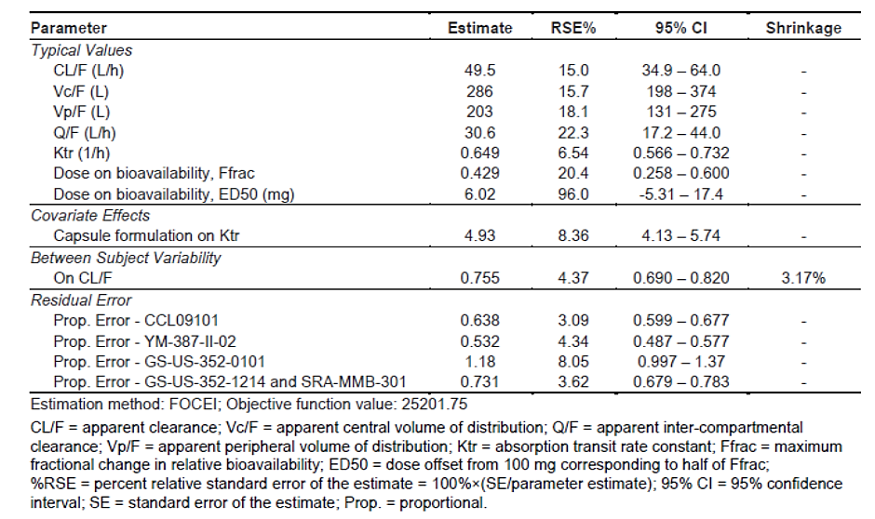

Exposure-response
AUC_{tau} at steady state based on the initial (randomised) dosing regimen (i.e., 200 mg QD for all phase 3 studies) for MMB and M21 were generated using the final updated popPK model.
Daily average AUC_{tau} for MMB and M21 were obtained by simulating from the final updated popPK model for MMB and M21 using the actual dosing records and EBE (post hoc) estimates of model parameters for each patient. During the simulations, differential equations were numerically solved to integrate the concentration-time curve for MMB and M21, yielding the cumulative AUC as a function of time. The cumulative AUC at the end of the relevant exposure period was divided by time (in hours) and multiplied by 24 to give the daily average AUC_{tau}.
The duration of the relevant exposure period (i.e., the number of days of treatment to simulate) differed by endpoint (in all cases, the exposure period started at the first dose of MMB).
- For efficacy endpoints (i.e., SVC24% and responder status, TSS24% and responder status) as well as ≥ 2-fold increase in indirect bilirubin, the relevant exposure period was taken to be the period ending at the last visit in the 24-week randomised treatment phase, or treatment discontinuation, whichever occurred first.
- For all safety endpoints other than early discontinuation of treatment (i.e., grade 3+ anaemia, any grade 3+ AE, grade 3+ thrombocytopenia, diarrhea (any grade), peripheral neuropathy (any grade)), the relevant exposure period was taken to be the period ending at the first occurrence of the specific adverse event, or the last visit in the 24-week randomised treatment phase, or treatment discontinuation, whichever occurred first.
- For early discontinuation of treatment, the relevant exposure period was taken to be the period ending at the day of the last dose of MMB taken during the 24-week randomised treatment phase.
Thus, the same patient could potentially have different exposures (i.e., daily average AUC_{tau}) in each exposure-response analysis. The updated E-R analysis for efficacy and safety included 416 patients from 3 Phase 3 studies, 91 fewer than the original analysis after excluding 89 patients that were not randomised to receive MMB during the 24 week randomised treatment phase of studies GS-US-352-0101, GS-US-352-1214 and SRA-MMB-301 and 2 patients that were excluded from the popPK analysis.
The regression analysis demonstrated a statistically significant relationship for a greater reduction in splenic volume at Week 24 and a higher probability of achieving ≥35% SVR with higher daily average exposures of MMB when considering the subject-level dose modifications. There appeared a large overlap in efficacy and exposure quartiles due to the variability (as shown below). There was no relationship identified between TSS efficacy endpoints and daily average exposures of MMB or M21.
Figure 2: Binned Box-Plots for Daily Average AUCtau of MMB vs. Spleen Volume Change from Baseline at Week 24
Data are binned by quartiles and the range is labelled for each quartile.

Pharmacodynamics (PD)
- Myelofibrosis is a myeloproliferative neoplasm known to be associated with constitutive activation and dysregulated JAK signalling that contributes to elevated inflammation and hyperactivation of ACVR1.
- MMB is an inhibitor of wild type Janus Kinase 2 (JAK2) and mutant JAK2V617F, which contribute to signalling of several cytokines and growth factors that are important for haematopoiesis and immune function. MMB and its major human circulating metabolite, M21, have higher inhibitory activity for JAK2 compared to JAK1, JAK3 and TYK2. MMB and M21 also inhibit ACVR1, also known as activin receptor like kinase 2 (ALK2), that produces subsequent inhibition of liver hepcidin expression and increases iron availability resulting in increased red blood cell production.
- MMB has an active metabolite, M21 which has approximately 40% of the pharmacological activity of MMB.
- At 4 times the highest recommended dosage of 200 mg, MMB did not prolong the QT interval to any clinically relevant extent.

Study GS-US-352-1672
This was a single-arm, open-label study of MMB in transfusion-dependent subjects with PMF, post-PV MF, or ET MF. Subjects received MMB for 24 weeks (± 7 days) on study.
While the primary objective of this study concerned efficacy, secondary objectives concerned the PK of MMB and the following PD assessments: changes in markers of iron metabolism; inhibition of Janus kinase (JAK) 1 /2; and changes in circulating cytokine and inflammatory markers. Secondary endpoints related to iron metabolism and inflammation
included baseline and change in hepcidin, markers of anaemia, liver iron content, and C-reactive protein (CRP). Inhibition of JAK1/2 was assessed by analysis of phosphorylated signal transducer and activator of transcription (pSTAT) 3 in interleukin-6-stimulated T cells at predose and 2, 4, and 6 hours post-dose at specified visits.
The starting dose of MMB for all 41 subjects was 200 mg in a single tablet. Hepcidin production is regulated by inflammation and iron levels through JAK1/2 and ACVR1, respectively. Increased circulating hepcidin is associated with reduced iron availability for erythropoiesis. At every time point, peripheral hepcidin decreased 6 hours after dosing with MMB. In all subjects, daily inhibition of hepcidin did not lead to an increase from baseline in serum iron at Week 24A transient median 39.8% increase in serum iron was observed in TI responders at Week 4. Transfusion independence response was associated with lower baseline serum hepcidin, CRP, liver iron content, serum iron, ferritin, and transferrin saturation, and higher baseline haematocrit, erythrocytes, reticulocytes, platelets, and baseline haemoglobin ≥ 8 g/dL. These biomarkers suggest that TI responders tended to be less inflamed and had greater erythropoietic potential. Transient increases in the reticulocyte/erythrocyte ratio and serum iron in transfusion independence responders were observed. Increased haematocrit, haemoglobin, and total iron binding capacity in TI responders are all consistent with increased erythropoiesis.
At Week 24, there was a median 54.8% decrease from baseline in CRP.

Exposure-response assessments
The sponsor has proposed the following dose adjustments for MMB, based on AEs:
Table 5: Proposed MMB dose adjustments
Similar but more detailed dose adjustments were applied in the Phase 3 clinical studies.

Efficacy

Dose-finding

Study CCL09101
Study CCL09101 assessed safety, tolerability, dose limiting toxicities, maximum tolerated dose (MTD), and PK of the MMB capsule Form I. This was an open-label, nonrandomised study conducted in 2 phases: a single-centre dose-escalation phase and a multiple-centre dose-confirmation phase that was a cohort expansion at or below the MTD of MMB. In the absence of treatment delays due to AEs, treatment continued up to a maximum of nine 28-day cycles. Subjects were followed for 30 days after the conclusion of their last dose of MMB or until death, whichever occurred first.
In the Phase 1 dose-escalation phase of the study, the MMB dose was escalated through 5 successive cohorts of 3 subjects each from 100 mg to 400 mg. In the Phase 2 dose-confirmation phase of the study, enrolment was expanded for 150- and 300-mg once daily (QD) and 150-mg BID dose cohorts.

Study YM387-II-02
Assessed the PK of capsule Form 1 administered BID. This was a multicentre, open-label, nonrandomised study, conducted in 2 phases:
- a dose-escalation phase (Part 1), to determine the safety and tolerability of MMB, and to identify a therapeutic dose for the expanded cohort. Doses started at 200 mg MMB BID.
- Part 2 was a cohort expansion. In the dose-confirmation phase of the study (Part 2), subjects were to be treated at the MTD or at a lower dose shown to have significant clinical activity (efficacy) as chosen by the SRC (150 mg BID; see above). The MMB doses received were 200 mg or 250 mg BID. Subjects were evaluated every 2 weeks during the first treatment cycle, and then monthly for 5 cycles for a total of 6 cycles.
Cross-study comparisons of the above studies suggested that 300 mg once daily (OD) Form 1 dose had similar efficacy for spleen size reduction, transfusion reduction, anaemia response, and decreased symptoms when compared to 200 mg BID (Form 1). There were fewer dose reductions and fewer discontinuations due to AEs with the 300 mg OD dose compared with the 200 mg BI dose.

Study GS US 352 0102
Assessed the relative bioavailability between Form 2 (the tablet formulation proposed for marketing) and the Form 1, capsule formulation. Relative bioavailability of MMB doses of 100, 150, 200 or 300 mg were compared. The 200 mg Form 2 tablet dose provided similar exposure to the 300 mg Form 1 capsule dose used in earlier studies.

Study GS-US-352-1672
An open-label, Phase 2, translational study is described in the pharmacodynamics subsection above. The primary objective of this study was to determine the transfusion independence response rate for transfusion-dependent subjects with MF treated with MMB.
The study was conducted in transfusion-dependent subjects with PMF, post-PV MF, or post- ET MF. Subjects received the dose and formulation of MMB proposed for marketing for 24 weeks (± 7 days) on study. Subjects who responded had the option of maintenance therapy with MMB on Study GS-US-352-1154 at the MMB dose they tolerated and/or derived clinical benefit from during the 24-week treatment period.
The primary endpoint was transfusion independence response rate by Week 24, defined as becoming transfusion independent for ≥ 12 weeks at any time on study. A subject was
considered transfusion independent on study if no RBC transfusion occurred in any 12 weeks during the 24-week treatment period. Secondary efficacy endpoints were: transfusion response rate by Week 24 (defined as becoming not transfusion dependent for ≥ 8 weeks at any time on study); splenic response rate (SRR) at Week 24 (defined as ≥ 35% reduction in spleen volume from baseline as measured by MRI); and response rate in TSS at Week 24 (defined as achieving a ≥ 50% reduction from baseline in TSS as measured by the modified myeloproliferative neoplasm symptom assessment form [MPN-SAF] TSS diary).
Due to the exploratory nature, this study was not designed to detect a specific effect size. A sample size of 40 subjects was considered adequate for this study. Transfusion independence response rate, transfusion response rate, SRR, and TSS response rate were presented with corresponding 2-sided 90% exact confidence intervals (CIs) using the binomial distribution.
A total of 41 subjects were enrolled in the study and received MMB, 25 subjects (61.0%) completed the study, and 16 subjects (39.0%) discontinued prematurely. The most commonly reported reasons for discontinuation were:
- subject decision (5 subjects, 12.2%),
- adverse event (4 subjects, 9.8%),
- investigator’s discretion (3 subjects, 7.3%).
Most subjects were male at birth (26 subjects, 63.4%), and white (36 subjects, 87.8%). Mean (range) age was 70 (44 to 87) years. Most subjects (78.0%) had PMF. The median (Q1, Q3) time since diagnosis was 3.0 (1.2, 4.3) years. Of the subjects with available JAK2V617F mutation status, 28 subjects (68.3%) were positive for the mutation.
By Week 24:
- 34.1% were transfusion independent for at least 12 weeks (90% CI = 22.0%,48.1%).
- 39.0% had no RBC transfusion for at least 8 weeks at any time (90% CI = 26.2%, 53.1%).
- 12.2% had a ≥ 35% reduction in spleen volume (90% CI = 4.9%, 23.9%), and 15.8% had ≥ 50% reduction from baseline to Week 24 in TSS based on the modified MPN-SAF TSS (90% CI = 7.1%, 28.8%).

Pivotal efficacy studies:

SIMPLIFY-1 (Study GS-US-352-0101)
A Phase 3, international, randomised, double-blind, active-controlled, study to evaluate efficacy and safety of momelotinib (MMB) vs. ruxolitinib (RUX) in JAK inhibitor-naïve subjects with intermediate- or high-risk PMF or post-PV/ET MF. This study enrolled 432 subjects at 131 study centres including in Australia. The first patient was screened in December 2013 and the last subject visit was in May 2019. This study examined JAK inhibitor naïve subjects.
Figure 3: Schema for SIMPLIFY-1
NB: The starting dose of Ruxolitinib, as indicated above, was adjusted based on baseline platelet counts and other clinical features.
Key inclusion criteria were:
- Aged ≥ 18 years
- Confirmed diagnosis of PMF or post-PV/ET MF
- High-risk or intermediate-2 risk MF defined by the International Prognostic Scoring System (IPSS) for PMF, or intermediate-1 risk MF defined by the IPSS and associated with symptomatic splenomegaly, hepatomegaly, anaemia (Hb < 10 g/dL), and/or unresponsiveness to available therapy.
- Palpable splenomegaly ≥ 5 cm below the left costal margin
- Require MF therapy in the opinion of the investigator
No prior treatment with a JAK inhibitor was allowed, and those unlikely to benefit from study treatment or who could be at risk for treatment toxicities were excluded.
Subjects were randomly assigned 1:1 to blinded treatment with either MMB and placebo or RUX and placebo. Randomisation was stratified by baseline transfusion dependence (TD; yes or no) and platelet count (< 100, ≥ 100 and ≤ 200, or > 200 × 10⁹/L).
MMB was administered at a starting dose of 200 mg once daily. RUX was administered at a starting dose between 5 and 20 mg BID, inclusive, based on platelet count, creatinine clearance, and transaminase levels (aspartate aminotransferase [AST] or alanine aminotransferase [ALT]) at screening, as per dosing instruction in the PI for RUX. Dose reductions were required for thrombocytopenia, neutropenia and non-haematological toxicities. These were consistent with proposed more abbreviated dose reductions in the current draft Product Information.
Blinded study treatment was for 24 weeks, consistent with the COMFORT-1 study of RUX in MF.⁵ This period all subjects remaining on therapy in the study were to continue or begin open-label treatment with MMB for up to an additional 216 weeks.

Efficacy endpoints
The primary endpoint was the SRR at week 24, defined as the proportion of subjects with a reduction in spleen volume ≥ 35% from baseline at week 24. Spleen volume measurement was assessed using abdominal MRI or CT scans performed at baseline and every 12 weeks thereafter.
Secondary endpoints in hierarchical order were total symptom score (TSS) response rate at wk 24; transfusion independence (TI) rate at wk 24; and RBC transfusion rate during double-blind treatment period. Efficacy assessments included abdomen MRI or CT, MPN-SAF TSS v2, transfusion recording, bone marrow aspirate and biopsy, treatment response, and other patient reported outcomes (PROs). The TSS was a modified Myeloproliferative Neoplasm Symptom Assessment Form Total Symptom Score (MPN-SAF v2), an 8-item questionnaire developed to assess symptom burden and quality of life in patients with MPN. Subjects are asked to assess the following symptoms in the past 24 hours using a scale of from 0 (“absent) to 10 (“worst imaginable”): fatigue; early satiety; abdominal discomfort; night sweats; itching (pruritus); bone pain (diffuse not joint pain or arthritis); pain under ribs on the left side; and inactivity (not included in TSS). The TSS, ranged from 0 to 70 and does not include scores for the inactivity symptom, is assessed over time to evaluate changes in MPN-related symptoms. The questionnaire was to be completed daily on an eDiary device.
The response rate in TSS from baseline to Wk 24 was defined as the proportion of subjects who achieved a ≥ 50% reduction from baseline in TSS at Week 24 as measured by the modified MPN-SAF TSS v2.0 diary. The rate of RBC transfusion in the double-blind phase was defined as the average number of RBC units transfused not associated with clinically overt bleeding per subject month during the double-blind phase. The response rate for transfusion independence (TI) at Wk 24, defined as the proportion of subjects who were TI at Wk 24, where TI was defined as absence of RBC transfusion and no haemoglobin level < 8 g/dL in the prior 12 weeks, excluding cases associated with clinically overt bleeding. The response rate for transfusion dependence (TD) at Wk 24 was defined as the proportion of subjects who were TD at Wk 24, where TD was defined as at least 4 units of RBC transfusion or a haemoglobin level < 8 g/dL in the prior 8 weeks excluding cases associated with clinically overt bleeding. Dose adjustments for MMB and RUX were required for thrombocytopenia and neutropenia. The dose reduction for RUX was as per the PI for Jakavi (ruxolitinib). The dose reduction schedule for MMB is below:
Table 6: Momelotinib dose reduction schedule for thrombocytopenia SIMPLIFY-1
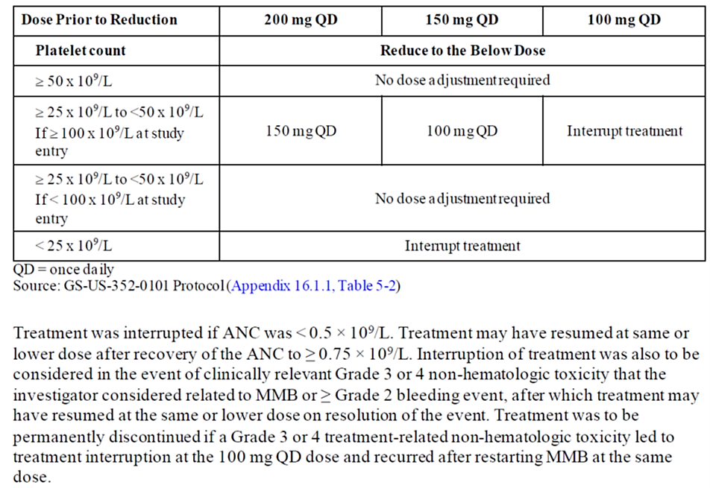

Statistical methods
The sample size assumed a common treatment effect on SRR of 34% (lower bound of the 95% CI on the ruxolitinib effect on SRR observed in ruxolitinib Study Comfort I as described in the PI for Jakavi). A sample size of 420 subjects (1:1 randomisation ratio) would provide > 90% power for testing the noninferiority hypothesis on SRR at week 24.
The primary inference for SRR at Week 24 was noninferiority. Noninferiority was to be declared if 60% of the response rate in the RUX arm was preserved in the MMB arm. A 2-sided 95% CI was calculated based on stratum-adjusted Cochran–Mantel-Haenszel (CMH) proportions (Koch et al. 1989) for the difference between the proportion of subjects with splenic response in the MMB arm and 60% of the proportion of subjects with splenic response in the RUX arm (i.e., p(MMB)-0.6*p(RUX)). If the lower bound of the CI was greater than 0, MMB was to be declared noninferior to RUX. In addition, the 2-sided 95% exact CI of SRR at Week 24 based on the Clopper-Pearson method was provided for each treatment group. The SRR at Week 24 was also compared in the sixth order in the statistical testing hierarchy between the treatment groups (MMB versus RUX) for superiority. The two-sided 95% CI was also calculated based on stratum-adjusted Cochran–Mantel-Haenszel (CMH) proportions for the difference between the proportion of subjects with splenic response in the MMB arm and the proportion of subjects with splenic response in the RUX arm (i.e., p(MMB)-p(RUX)) for the assessment of superiority.
The second endpoint in the statistical testing hierarchy is the response rate in TSS from baseline to Week 24, defined as the proportion of subjects who achieved a ≥50% reduction from baseline in mMPN-SAF v2.0 TSS at Week 24. The primary inference for response rate in TSS from baseline to Week 24 was noninferiority. Noninferiority was to be declared if 67% of the response rate in the RUX arm was preserved in the MMB arm. A 2-sided 95% CI was calculated based on stratum-adjusted Cochran–Mantel-Haenszel (CMH) proportions for the difference between the proportion of subjects with TSS response in the MMB arm and 67% of the proportion of subjects with TSS response in the RUX arm (i.e., p(MMB)-0.67*p(RUX)). If the lower bound of the CI was greater than 0, MMB was to be declared noninferior to RUX. In addition, the 2-sided 95% exact CI of TSS response rate at Wk 24 based on the Clopper-Pearson method was provided for each treatment group. The response rate in TSS from baseline to Week 24 was also compared in the seventh order in the statistical testing hierarchy between the treatment groups (MMB versus RUX) for superiority using the same method as the superiority analysis for the primary endpoint. The 67% of RUX effect retention for the key secondary endpoint response rate in TSS from baseline to Wk 24 was proposed by the Applicant to accommodate the placebo response rate of TSS of 5% (COMFORT-1 study in RUX). Duration of TSS response beyond week 24 was not assessed.
The third and fourth secondary endpoints of rate of RBC TI at Wk 24 and response rate for TD at Wk 24 were assessed for superiority. The two-sided 95% CI was calculated based on stratum-adjusted Cochran–Mantel-Haenszel (CMH) proportions for the difference between the proportion of subjects a response in the MMB arm and the proportion of subjects with a response in the RUX arm (i.e., p(MMB)-p(RUX)). The fifth secondary endpoint of the rate of RBC transfusion in the double-blind phase was analysed using a negative binomial regression method with an offset parameter to account for follow-up time.
The family-wise Type I error rate for the primary and secondary efficacy endpoint comparisons were controlled at a 2-sided 0.05 significance level through the sequential testing procedure in the order presented below:
- Noninferiority of MMB to RUX on SRR at Week 24
- Noninferiority of MMB to RUX on TSS response rate at Week 24
- Superiority of MMB to RUX on TI response rate at Week 24
- Superiority of MMB to RUX on TD response rate at Week 24
- Superiority of MMB to RUX on rate of RBC transfusion in the double-blind phase
- Superiority of MMB to RUX on SRR at Week 24
- Superiority of MMB to RUX on TSS response rate at Week 24
If a null hypothesis was not rejected, formal sequential testing was stopped, and only nominal significance was cited for the subsequent hypotheses and considered exploratory.
The primary and secondary endpoints were summarised by treatment (including forest plots) in the following subgroups: age (< 65 years or ≥ 65 years), gender (male or female), race (white or all other races), baseline spleen volume (< median or ≥ median), baseline TSS (quartiles: < Q1, ≥ Q1 and < median, ≥median and < Q3, ≥ Q3), baseline transfusion dependence (defined as requiring at least 4 units of transfusion or a haemoglobin < 8 g/dL in the 8 weeks prior to randomisation), baseline haemoglobin (< 8 g/dL or ≥ 8 g/dL), baseline platelet count (< 100, ≥100 and ≤ 200, > 200 [x 109/L]), IPSS prognostic category (intermediate or high-risk), MF disease status (PMF, post-PV MF, or post-ET MF), JAK2V617F mutation (positive or negative, based on medical history), Region (Western Europe, Eastern Europe, or Asia).

Results
Figure 4: Subject disposition flow chart (SIMPLIFY- 1)
A total of 432 subjects were enrolled and randomised to either MMB (215 subjects) or RUX (217 subjects) treatment in the double-blind phase. In the double-blind treatment phase, 1 subject in each treatment group was randomised but not treated. Thus, a total of 214 subjects in the MMB group and 216 subjects in the RUX group received treatment. Overall, 175 subjects (81.4%) in the MMB group and 201 subjects (92.6%) in the RUX group completed double-blind study treatment. There was an imbalance in early discontinuation mainly due to an excess of low-grade AEs in the MMB group and the proportion with a dose reduction or interruption in the RUX group was more than twice that for MMB (26.2% MMB, 56.0% RUX).
A total of 40 subjects (18.6%) in the MMB group and 16 subjects (7.4%) in the RUX group prematurely discontinued study drug. A total of 368 entered the open-label treatment phase: 171 subjects (79.5%) continued MMB and 197 (90.8%) subjects switched from RUX to MMB. The Sponsor terminated the study prior to subjects completing the 5 years of follow-up. Subjects receiving MMB at the time of study termination were eligible to transition to an extended access study (SRA-MMB-4365) to continue MMB treatment.
Demographics and baseline disease characteristics were comparable between treatment groups and were consistent with the patients group identified in the proposed indication. In the double-blind phase, the median age at baseline for the ITT analysis set was 66.0 years and 57.2% were ≥ 65 years old. Overall, 56.5% of subjects were male, 82.6% of subjects were White.
Most subjects (56.5%) were diagnosed with PMF at study entry, with the remaining subjects diagnosed with post-ET MF (20.8%) or post-PV MF (22.7%). The median (range) time since MF diagnosis for all subjects was 1.5 (0.0 to 28.0) years. A total of 33.0% of patients in the MMB arm and 32.7% of patients in the RUX arm had received prior MF therapy. In both treatment arms, hydroxycarbamide was the most frequent used prior MF therapy (around 20 – 25% of patients).
Using the IPSS scoring system, all subjects were classified as either high risk (46.3%), intermediate 2 risk (33.1%), or intermediate-1 risk (20.6%); no subjects were classified as low risk. Most subjects had a baseline ECOG PS of 0 (34.3%) or 1 (56.0%) and a bone marrow fibrosis assessment grade of 3 (57.9%). Median (range) spleen volume at baseline was 1915.6 (206 to 9022) cm³ and 63.2% of subjects had a palpable splenomegaly ≥ 10 cm. Median spleen volume and size were higher in the MMB group (2009.6 cm³ and 12.0 cm, respectively) than in the RUX group (1910.8 cm³ and 11.0 cm, respectively). Median TSS at baseline was 17.4 (range: 0 to 53) in the MMB group and 16.4 (range: 0 to 56) in the RUX group.
The median (range) haemoglobin at baseline was 10.4 (range: 6 to 19) g/dL and was similar between the MMB and RUX groups. However, the proportion of subjects with the lowest haemoglobin levels in the 12 weeks prior to screening (< 8 g/dL) was higher in the MMB group (13.0%) compared with the RUX group (9.7%). The proportion of subjects with baseline haemoglobin ≥ 10 g/dL was also higher in the MMB group (60.0%) compared with the RUX group (56.2%).
Table 7: Summary baseline demographic characteristics (ITT analysis set) SIMPLIFY-1
Table 8: Baseline disease characteristics (ITT analysis set) SIMPLIFY-1

Table 9: Baseline haematology and transfusion status ITT analysis set SIMPLIFY-1
The primary efficacy endpoint of noninferiority of MMB compared to RUX in the SRR, which was defined as the proportion of subjects who achieved a spleen volume reduction of ≥35% from baseline at the Wk 24 assessment as measured by MRI or CT scans was met. SRR was 26.5% (95% CI: 20.7%, 32.9%) for the MMB group and 29.5% (95% CI: 23.5%, 36.0%) for the RUX group. The adjusted proportion difference for noninferiority (defined as p[MMB] - 0.6 x p[RUX]) was 9% (95% CI: 2%, 16%), with 2-sided p-value 0.014. As the lower bound of this 95% CI was greater than 0, MMB was declared noninferior to RUX.
This study failed to demonstrate noninferiority of MMB compared to RUX in the mMPN-SAF TSS v2.0 TSS response rate, which was defined as the proportion of subjects who achieved a ≥50% reduction in mMPN-SAF TSS v2.0 TSS at Week 24 versus baseline. The mMPN-SAF TSS v2.0 TSS response rate was 28.4% (95% CI: 22.5%, 35.0%) for the MMB group and 42.2% (95% CI: 35.4%, 49.2%) for the RUX group. The adjusted proportion difference for noninferiority (defined as p[MMB] - 0.67 x p[RUX]) was 0% (95% CI: -8%, 8%), with 2-sided p-value 0.98.

Table 10: Splenic response rate (ITT analysis set) SIMPLIFY-1
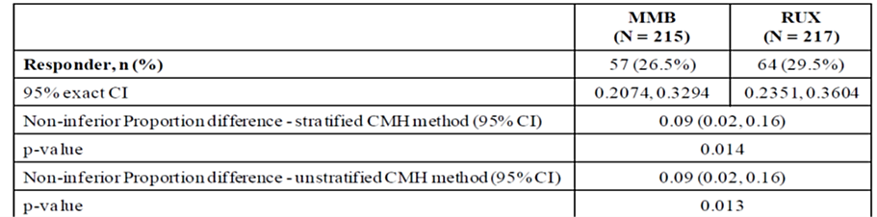
Because the first secondary endpoint in the testing hierarchy failed to demonstrate non-inferiority for MMB compared to RUX, formal testing of the statistical testing hierarchy stopped, and the results of all subsequent endpoints are considered only descriptive.
Table 11: Analysis of Response Rate in Total Symptom Score at Week 24 (Double-blind Treatment Phase, ITT Analysis Set) SIMPLIFY-1
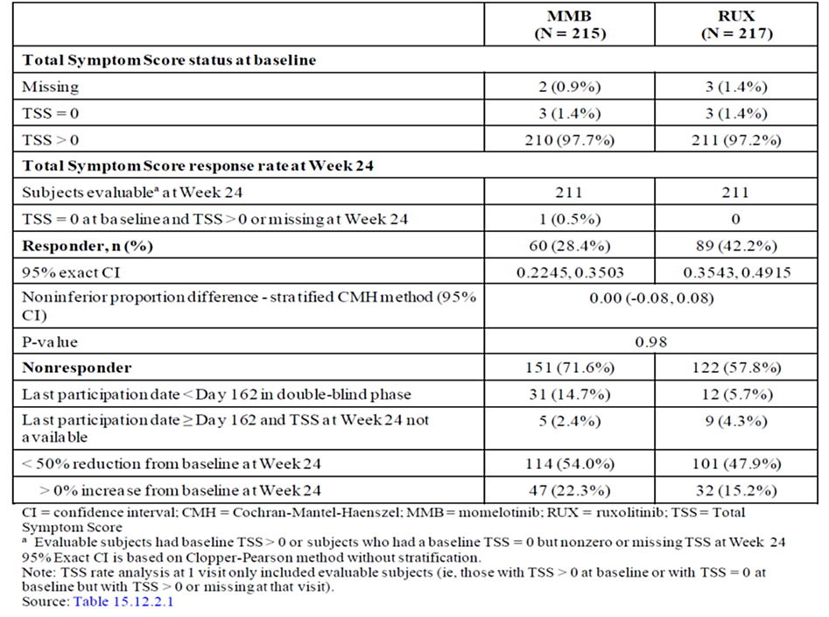
For the next secondary endpoint of transfusion independence, MMB was nominally statistically superior to RUX: Week 24: 66.5% (143 subjects) compared with the RUX group 49.3% (107 subjects), a treatment difference of 18%, favouring MMB. Of note, given the proposed indication is restricted to patients with Hgb <10mg/dL the subgroup analysis for those patients showed considerably higher rates of TI in those subjects who were TI at baseline and TI in those who were not TI at baseline (i.e., non-TI and TD) for subjects given MMB compared with subjects given RUX, as shown below.
Table 12: Week 24 TI Response Rate in Anaemia and Platelet Subgroups (ITT analysis set) SIMPLIFY-1
Ad-hoc subgroup analyses were also performed by TI at baseline; non-TI at baseline; baseline TSS ≥ 10; baseline haemoglobin < 10 g/dL, < 12 g/dL and ≥ 12 g/dL; TSS ≥ 10 and haemoglobin < 10 g/dL at baseline; and baseline platelet count (≤ 150,> 150 and ≤ 300, > 300 x 109/L. Consistent with the ITT population, TI response was higher for MMB-treated subjects who were TD or not TI (TD or transfusion requiring) at baseline. Specifically, in the subset of subjects who were TD at baseline, 16/53 (30.2%) MMB-treated subjects and 9/52 (17.3%) RUX-treated subjects were Wk 24 TI responders. In the subset of subjects who were not TI at baseline, 24/68 (35.3%) subjects in the MMB group were TI responders at Wk 24 compared with 13/65 (20.0%) of 65 subjects in the RUX group. In addition, a higher proportion of subjects in the MMB group who were TI at baseline remained TI at Wk 24 (MMB: 81.0%; RUX: 61.8%, respectively).
The analysis of subjects with baseline Hgb <10 g/dL is of most interest because the proposed indication is restricted to patients with moderate to severe anaemia (defined as Hgb <10 g/dL). The major endpoints for this subgroup are summarised below.
Table 13: Subgroup Analysis of Response Rates by Haemoglobin <10g/dL at Baseline Double-Blind Phase (ITT analysis set) SIMPLIFY-1
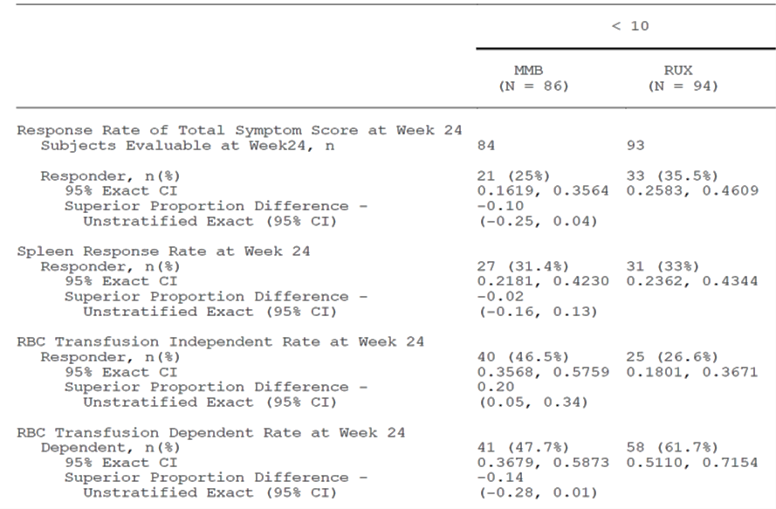
In the Hgb <10 g/dL subgroup, the Hgb levels were consistently higher in the MMB group compared to the RUX group throughout the randomised treatment period. Treatment with MMB resulted in a >0.5 g/dL increase in mean Hgb levels by Wk 2 that remained stable and above baseline levels over the 24-week treatment period. In the RUX Hgb <10 g/dL subgroup there was a modest increase in Hgb levels by Week 2 (<0.5 g/dL). Following this, Hgb levels decreased to a new nadir around Wk 4 and remained stable then returned Hgb to baseline levels by Wk 24, however 61.1% of the RUX group were transfusion dependent by week 24. The RUX effect on Hgb levels in the Hgb <10 g/dL subgroup were not consistent with the overall ITT population, in which Hgb levels remained below baseline, possibly due to the confounding factor of transfusions and/or RUX dose adjustments.
Figure 5: Mean (±SE) Haemoglobin Levels Over Time during the double-blind phase (Hgb 10 g/dL subpopulation, SIMPLIFY-1)<
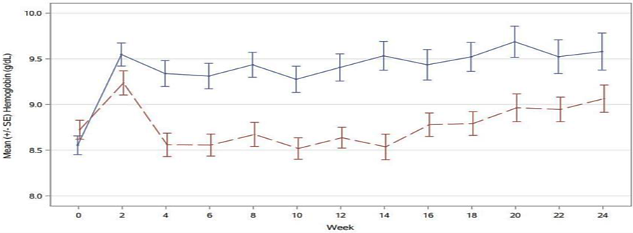
MMB in blue continuous line, RUX in brown interrupted line.

MOMENTUM (Study SRA-MMB-301)
A randomised, double-blind, Phase 3 study to evaluate the activity of MMB vs. danazol (DAN) in symptomatic, anaemic subjects with PMF, post- PV myelofibrosis, or post-ET myelofibrosis who were previously treated with JAK Inhibitor therapy.
The first subject was screened in Feb 2020 and the last subject visit in the double-blind period was in Dec. 2021. The database lock for this analysis was 13 January 2022. This was an international study with 107 study sites, including sites in Australia. The primary objectives were:
- To determine the efficacy of MMB vs. danazol (DAN) assessed by improvement in (MFSAF) TSS in subjects with PMF, post-PV MF, or post-ET MF who were previously treated with approved JAK inhibitor therapy.
- To compare the effect of MMB vs DAN on transfusion independence (TI) status at week 24.

Design
Subjects were randomised 2:1 to receive MMB or DAN. Randomisation was stratified by baseline MFSAF TSS (< 22, ≥ 22), baseline palpable spleen length below the left costal margin (LCM; < 12, ≥ 12 cm); baseline RBC or whole blood units transfused in the 8 weeks before randomisation (0, 1-4, ≥ 5 units), and study site.
There were 2 parts: a randomised, double-blinded treatment period (24 weeks) when subjects received their assigned study treatment of MMB plus DAN-placebo (hereafter, MMB) or DAN plus MMB-placebo (hereafter DAN), followed by an open-label period.
(MMB-treated subjects who completed treatment through the end of Week 24 could continue MMB as open-label treatment for up to an additional 180 weeks.
Subjects who completed 24 weeks of DAN could elect to continue DAN as open-label treatment for an additional 24 weeks. Subjects who received DAN during the first 24 weeks and discontinued early because of splenic progression, or discontinued treatment early for other reasons but completed scheduled assessments through week 24, were allowed to cross over and received open label MMB for up to 180 weeks.
Figure 6: Schema for MOMENTUM
The MMB starting dose was 200 mg daily and the DAN starting dose was 600 mg daily. Blinded treatment (MMB or DAN) and open-label treatment with MMB or DAN was to be interrupted or reduced due to thrombocytopenia, neutropenia, or other toxicities at investigator discretion. During the randomised treatment (RT) period, doses of both components of the study treatment (i.e., MMB plus DAN-placebo or DAN plus MMB-placebo) were reduced by sequential decrements according to the criteria below.
Table 14: Study drug dose reductions MOMENTUM
Table 15: Dose reduction criteria for thrombocyteopenia MOMENTUM
Study drug was tapered (if appropriate) and interrupted for subjects with ANC < 0.5 × 10⁹/L. Following ANC recovery to ≥ 0.75 × 10⁹/L, study treatment could resume with reduction by 1 dose decrement (or at the same dose for subjects receiving dose decrement 3). Dose re-escalation was allowed when toxicity resolved or returned to baseline grade at investigator discretion. Treatment interruption or taper could also be required due to a clinically relevant grade 3 or 4 non-haematologic toxicity considered by the investigator to be related to study drug or due to an adverse event of grade ≥ 2 bleeding. Treatment was allowed to resume when the toxicity resolved to grade ≤ 1 or baseline grade, with a dose reduction of 1 decrement.
Key efficacy evaluations included electronic patient-reported outcome (ePRO) questionnaires throughout the study, including daily MFSAF assessments at baseline and during the randomised treatment period, recording of RBC transfusion and complete blood count (CBC) data, and spleen volume measurements. Clinical, laboratory, and disease assessments were also conducted.
The main inclusion criteria were:
- Aged ≥ 18 years
- Confirmed diagnosis of PMF or post-PV/ET MF
- Intermediate- or high-risk MF defined by the Dynamic International Prognostic Scoring System (DIPSS) or DIPSS-plus
- Prior MF therapy with an approved JAK inhibitor for ≥ 90 days, or for ≥ 28 days if the therapy was complicated by red blood cell transfusion requirements of ≥ 4 units in an 8-week period or grade 3 or 4 AEs of thrombocytopenia, anaemia, or hematoma
- Symptomatic, defined as MFSAF TSS ≥ 10 based on a single MFSAF version 4.0 (v4.0) assessment at screening before baseline day 1 (day BL1). The baseline TSS was the average of the daily TSS from the 7-day baseline period before randomisation.
- Anaemia, defined as haemoglobin (Hgb) < 10 g/dL
- Palpable splenomegaly ≥ 5 cm below the left costal margin or spleen volume ≥ 450 cm3 on imaging (ultrasound, MRI or CT) at screening
Subjects receiving JAK inhibitor therapy at the start of screening were required to taper the therapy and then complete a ≥ 2-week nontreatment interval to avoid confounding the baseline for comparing the efficacy of MMB vs. DAN. A screening TSS of ≥ 10 on a scale of 0 to 70 was required to ensure that all subjects were evaluable for symptom response in a range considered clinically meaningful.
The staring dose for MMB was 200 mg once daily and for DAN was 600 mg given in 2 divided doses of 300 mg each. MMB was given without regard to food.

Primary efficacy endpoints
Dual primary endpoints were adjusted for multiplicity by hierarchical testing in the following order:
- First: MFSAF TSS response rate at week 24, defined as the proportion of subjects with a ≥ 50% reduction in mean MFSAF TSS over the 28 days immediately before the end of week 24 compared with baseline. MFSAF v4.0 (Cardellino A) was used in this study. It comprises 7 domains representing the 7 most relevant symptoms of MF identified through existing patient- and clinician-based evidence: fatigue, night sweats, pruritus, abdominal discomfort, pain under the left ribs, early satiety, and bone pain. Subjects scored each symptom domain using an 11-point numeric rating scale ranging from 0 (absent) to 10 (worst imaginable) using a 24-hour recall period. The TSS was calculated as the sum of scores of the 7 domains for a possible range of scores of 0 to 70, with a higher TSS corresponding to more severe symptoms.
- Second: TI rate at week 24, defined as the proportion of subjects with TI in the terminal 12 weeks of the 24-week randomised treatment period. TI was defined as not requiring RBC transfusion (except in the case of clinically overt bleeding) for ≥ 12 weeks, with Hgb level ≥ 8 g/dL.

Secondary efficacy endpoints
Key secondary endpoints for hierarchical testing to control the study-wide type I error rate:
- First: SRR at week 24, defined as the proportion of subjects who had splenic response based on ≥ 25% reduction in spleen volume from baseline
- Second: Change in MFSAF TSS from baseline at week 24, defined as the change from baseline in mean MFSAF TSS over the 28 days immediately before the end of week 24
- Third: SRR at week 24, defined as the proportion of subjects who had splenic response based on ≥ 35% reduction in spleen volume from baseline
- Fourth: Rate of no transfusion at week 24, defined as the proportion of subjects with zero RBC or whole blood units transfused during the 24-week randomised treatment period
Other secondary endpoints were: Duration of wk 24 MFSAF TSS response; Duration of wk 24 TI; Proportion with ≤ 4 RBC units transfused during the randomised period; Cumulative transfusion risk at wk 24; Proportion with TD at wk 24 (TD rate at wk 24); Proportion with Hgb responses (i.e., increases of ≥ 1, ≥ 1.5, or ≥ 2 g/dL from baseline) during the randomised period; Proportion with TI at wk 24 in subjects with baseline TD; and Duration of wk 24 TI in subjects with baseline TD.

Statistical methods
Two statistical analysis plans were created for MOMENTUM, one for the European Union (EU) and one for other regions to address differing feedback from the CHMP and FDA on the primary endpoint. The plans differed only in the primary endpoint analysis. In the EU there were co-primary endpoints as listed above whereas in the USA the primary efficacy endpoint was MFSAF v4.0 TSS response rate at Week 24, defined as the proportion of subjects with a ≥50% reduction in mean MFSAF v4.0 TSS over the 28 days immediately before the end of Week 24 compared with baseline.
A sample size of 180 subjects randomised to MMB or DAN in a 2:1 ratio with a 2-sided significance level of 0.05 provided 98.8% power to detect a true difference of 21% (23% with MMB vs 2% with DAN) or 90% power to detect a true difference of 15% (17% vs 2%) in the first primary endpoint of TSS response rate at week 24, 90% power to detect a true difference of 24% in the second primary endpoint of proportion of subjects with TI at week 24 (45% vs 21%), and 90% power to detect a true difference of 14% in the first key secondary endpoint of SRR at week 24 (15% vs 1%).
MFSAF TSS response rate at week 24 and TI rate at week 24 were dual primary endpoints. Multiplicity between the 2 primary endpoints was adjusted by hierarchical testing, with TSS response rate at week 24 evaluated first. If superiority for TSS response rate at week 24 was statistically significant (p ≤ 0.05) in favour of MMB, the study was to be considered positive and a superiority test was to be performed for TI rate at week 24. If the result of the superiority test was not significant, a noninferiority test was to be performed for TI rate at week 24; 80% of the DAN response rate had to be preserved in the MMB group to demonstrate noninferiority. Non-inferiority of MMB was based on synthesis approach (FDA Guidance, 2016) where the treatment effect of the active control (DAN here) is not pre-specified, but the percentage of the active control effect to be preserved is specified. 80% of the response rate in the DAN arm should be preserved in the MMB arm to declare non-inferiority.
A stratum-adjusted 2-sided 95% CI based on Koch et al (1989), was to be calculated for the difference:
Non-inferiority difference = p(MMB) – 0.80 x p(DAN)
where p(MMB) is the proportion of subjects with TI status in the MMB arm and p(DAN) is the proportion of subjects with TI status in the DAN arm.
Both primary endpoints were met if superiority for TSS response rate at week 24 and at least noninferiority for TI rate at week 24 were statistically significant, regardless of the significance of superiority for TI rate at week 24. If both primary efficacy endpoints were met, 4 key secondary efficacy endpoints were to be evaluated in hierarchical order to control the study-wide type I error rate. Analyses of all other secondary and related endpoints were descriptive with nominal p-values.

For the primary efficacy endpoints:
- MFSAF TSS response was compared between treatments using a Cochran-Mantel-Haenszel (CMH) test stratified by baseline MFSAF TSS (< 22 vs ≥ 22), baseline palpable spleen length below the LCM (< 12 cm vs ≥ 12 cm), and baseline RBC or whole blood units transfused in the 8-week period before randomization (0, 1-4, ≥ 5 units). The exact binomial 95% CI was generated for the per-arm proportion estimate and the magnitude of difference between the 2 proportions was estimated by Mantel-Haenszel common risk difference. Primary inference was based on the asymptotic p-value based on the Wald statistic from this CMH test.
- For TI rate at week 24, superiority was evaluated by comparing TI response between treatments using the stratified CMH test. Primary inference was based on the asymptotic p-value based on the Wald statistic from this CMH test. If the result of the superiority test was not significant, a noninferiority test was to be performed using a stratum-adjusted 2-sided 95% CI calculated for the difference between the proportion of subjects with TI in the MMB group and 80% of the proportion of subjects with TI in the DAN group. If the CI lower bound was > 0, MMB was to be declared noninferior to DAN.

For key secondary efficacy endpoints:
- SRR at week 24 based on reduction in spleen volume of ≥ 25% from baseline was compared between treatments using the stratified CMH test.
- Change in MFSAF TSS from baseline at week 24 was analysed using a mixed model for repeated measures (MMRM), including factors for treatment arm and baseline stratification factors. Least squares (LS) mean, SE, and 95% CI were presented by treatment and the p-value for the LS mean difference between the 2 treatments was used as the primary inference.
- SRR at week 24 based on reduction in spleen volume of ≥ 35% from baseline was compared between treatments using the stratified CMH test.
- Rate of no transfusion at week 24 was compared between treatments using the stratified CMH test.

Results
The analysis data cutoff date of 03 Dec 2021 was used for all analyses presented in this report unless otherwise specified. The ITT and safety populations were identical. The disposition of subjects is shown below.
Figure 7: Subject disposition MOMENTUM
A total of 195 subjects were enrolled, randomly assigned to MMB (130 subjects) or DAN (65 subjects) and received blinded study drug in the randomised treatment period. Ninety-four subjects (72.3%) in the MMB group and 38 (58.5%) in the DAN group completed randomised treatment. The most common reasons for early treatment discontinuation were adverse event (12.3% MMB, 16.9% DAN) and subject decision (4.6% MMB, 7.7% DAN). A total of 132 subjects (67.7%), including 127 (70.8% MMB, 53.8% DAN) who completed randomised treatment and 5 who prematurely discontinued randomised DAN treatment, started open-label MMB treatment (70.8% MMB, 61.5% DAN; called MMB→MMB and DAN→MMB groups in open-label treatment period). No subject who completed randomised treatment with DAN chose to continue open-label treatment with DAN.
Subject Baseline Characteristics (ITT Population): Baseline demographics and disease history and characteristics were similar between treatment groups. The overall median age at baseline was 71 years, 63.1% of subjects were male, 80.5% were White. Most subjects had a diagnosis of PMF (63.6%), intermediate-2 risk (57.4%), ECOG performance status of 1 (60.0%), and positive JAK2V617F mutation status (75.9%); 49.7% had TD, and 36.4% were transfusion requiring. The median duration of prior JAK inhibitor therapy was 98.57 weeks (1.9 years). The baseline stratification categories with the greatest proportion of subjects were MFSAF TSS ≥ 22 (59.5%), palpable spleen length below the LCM < 12 cm (50.3%), and 1 to 4 RBC or whole blood units transfused in the 8-week period before randomisation (43.6%).
A higher proportion of subjects in the MMB arm had high risk disease compared to the DAN arm (39% versus. 29%). A lower proportion of subjects in the MMB arm had a diagnosis of the primary MF compared to the DAN arm (60% versus 71%), and a lower proportion of subjects in the MMB arm had baseline platelet count <50x 10⁹ compared to the DAN arm (14% vs. 20%).
Table 16: Summary demographic and disease characteristics (ITT) MOMENTUM

Efficacy results
The study met its first primary efficacy endpoint of statistically significant superiority of MMB over DAN in the proportion of subjects with ≥50% reduction from baseline at week 24 in MFSAF v4.0 TSS. The MFSAF v4.0 TSS response rate was 24.6% (95% CI: 17.5%, 32.9%) for the MMB group and 9.2% (95% CI: 3.5%, 19.0%) for the DAN group, with a treatment difference of 15.7% (95% CI: 5.5%, 25.8%), 2-sided p-value 0.0095.
For the second primary endpoint of TI at week 24 the superiority test did not demonstrate a statistically significant between-group difference (p = 0.1265). The response rate was 30.8% (95% CI: 22.28, 38.66) for the MMB group and 20.00% (95% CI: 11.10, 31.77) for the DAN group, with a treatment difference of 9.80% (95% CI: -2.03, 21.62). A noninferiority test demonstrated statistically significant noninferiority of MMB compared with DAN, with a delta for noninferiority (defined as p[MMB] - 0.8 × p[DAN]) of 13.58% (95% CI: 1.86, 25.30). MMB could be declared noninferior to DAN because the lower bound of the 95% CI was greater than 0. The proportion of subjects with TI at baseline was low in both groups (13.1% MMB, 15.4% DAN). Overall, the proportion of subjects with TI at week 24 increased from baseline by 16.9% in the MMB group and 4.6% in the DAN group.
Table 17: Summary of dual primary efficacy endpoints (ITT population) MOMENTUM

Figure 8: Forest Plot of MFSAF Version 4.0 TSS Response Rate at Week 24 by Subgroup (ITT Population)

MMB demonstrated statistically significant superiority to DAN for all key secondary endpoints:
- SRR at week 24 based on ≥ 25% reduction from baseline in spleen volume: 40% MMB versus 6.2% DAN, proportion difference 35.24% (95% CI: 23.85, 44.65), p < 0.0001
- Change from baseline in MFSAF TSS at week 24: Least squares (LS) mean change -9.36 MMB and -3.13 DAN, LS mean difference -6.22 (95% CI: -10.0, -2.43), p = 0.0014
- SRR at week 24 based on ≥ 35% reduction from baseline in spleen volume: 23.1% MMB versus 3.1% DAN, proportion difference 19.37% (95% CI: 10.96, 27.77), p = 0.0006
- Proportion with zero RBC units transfused during the randomised treatment period: 35.4% MMB versus 16.9% DAN, proportion difference 17.20% (95% CI: 7.99, 26.40), p = 0.0012
Overall survival was a prespecified secondary endpoint. Preliminary survival data is shown below:
Figure 9: Kaplan-Meier Plot of Overall Survival (ITT Population, MOMENTUM)
Vertical line at week 24 indicates when ongoing subjects received MMB as open-label treatment.+ indicates a censored observation.
Duration of the week 24 TSS response was a secondary endpoint. For the 38 subjects (32 MMB, 6 DAN) with MFSAF TSS response at week 24, the response was maintained for up to 40 weeks as of the data cutoff date of 03 Dec 2021; only 1 subject lost response at 286 days after the start of response, when only 2 subjects were still being followed and had response assessments available from the week 48 and study discontinuation visits.

Supportive efficacy study

SIMPLIFY-2 (Study GS-US-352-1214)
A phase 3, randomised study to evaluate the efficacy of MMB vs. Best Available Therapy (BAT) in anaemic or thrombocytopenic subjects with PMF, post- PV MF, or post-ET myelofibrosis who were treated with ruxolitinib. It was conducted in 55 centres throughout Europe, Israel and North America. The first subject was screened in June 2014 and the last subject visit was in April 2019.
Figure 10: Schema for SIMPLIFY-2
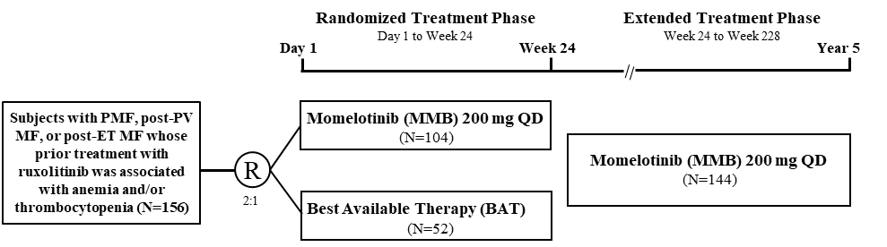
The study was conducted in 2 phases. The primary phase (Randomised Treatment [RT] Phase) of the study consisted of up to 30 days of screening and 24 weeks of randomised treatment. After completion of the RT phase, subjects were eligible to receive MMB in the Extended Treatment (ET) phase up to an additional 204 weeks.
At baseline, 156 adult (age ≥ 18 years old) subjects were randomised on a 2:1 basis to receive either MMB 200 mg tablet once daily or BAT. Treatment assignment was stratified by transfusion dependence (yes or no) and baseline TSS (< 18 or ≥ 18). Following screening, subjects received an electronic diary (eDiary) for daily completion of the modified Myeloproliferative Neoplasm Symptom Assessment Form Total Symptom Score (MPNSAF TSS).
Subjects completed the modified MPN-SAF TSS daily through 24 weeks of study participation. Patient-reported outcomes (PROs), clinical, laboratory, and disease assessments were completed at regular study visits. Efficacy assessments included abdomen MRI or CT, MPN-SAF TSS v2, transfusion recording, bone marrow aspirate and biopsy, treatment response, and PROs.
The modified MPN-SAF v2 is an 8-item questionnaire developed to assess symptom burden and quality of life in patients with MPN. Subjects are asked to assess the following symptoms in the past 24 hours using a scale of from 0 (“absent) to 10 (“worst imaginable”): fatigue; early satiety; abdominal discomfort; night sweats; itching (pruritus); bone pain (diffuse not joint pain or arthritis); pain under ribs on the left side; and inactivity (not included in TSS). The TSS, a score ranging from 0 to 70 and which does not include scores for symptoms of inactivity, is assessed over time to evaluate changes in MPN-related symptoms. The questionnaire was to be completed daily on an eDiary device.
Subjects recorded transfusion events in a diary during the screening period and throughout the study, and were to include the date, type (e.g., whole blood, platelets, packed cells), and number of units of the transfusion. Transfusion events and haemoglobin or platelet value at the time of the transfusion were reported on the electronic case report form (eCRF).
Bone marrow aspirate and biopsy samples were assessed by a local hematopathologist for grading of bone marrow fibrosis, including assessments of reticulin (e.g., silver stain) and collagen fibrosis (e.g., trichrome stain).
Treatment response was assessed using the Revised IWG-MRT/European Leukemia Net (ELN) Response Criteria for MF, which classify treatment response based on laboratory (e.g., bone marrow histology, hematology), physical examination (e.g., splenomegaly), and symptoms assessment.
Following discontinuation of treatment with study drug, subjects completed 12 weeks of post-treatment follow-up and were then followed for survival approximately every 6 months for up to 5 years, or until study termination.

Inclusion criteria
The major inclusion criteria were: Age ≥ 18 years old; Palpable splenomegaly at least 5 cm below left costal margin; Confirmed diagnosis of PMF in accordance with the World Health Organization (WHO) criteria, post-PV MF, or post-ET MF in accordance with International Working Group for Myelofibrosis Research and Treatment (IWG-MRT) criteria; Current or previous treatment with RUX for PMF, post-PV MF, or post-ET MF for ≥ 28 days and characterised by the following: Requirement for RBC transfusion while on RUX treatment, or dose adjustment of RUX to < 20 mg BID at the start of or during RUX; treatment and at least 1 of the following while on RUX treatment: ≥ Common Terminology Criteria for Adverse Events (CTCAE) Grade 3 thrombocytopenia, or ≥ CTCAE Grade 3 anaemia, or ≥ CTCAE Grade 3 haematoma; High or intermediate risk as defined by DIPSS and associated with symptomatic splenomegaly and/or hepatomegaly; ECOG PS 0, 1, or 2 and Life expectancy > 24 weeks.

Efficacy endpoints
The primary endpoint was SRR at Week 24, defined as the proportion of subjects who achieved a ≥ 35% reduction in spleen volume at Week 24 versus baseline as measured by MRI or CT.
The following were secondary endpoints:
- Response rate in TSS from baseline to Week 24, defined as the proportion of subjects who achieved a ≥ 50% reduction from baseline in TSS at Week 24 as measured by the modified MPN-SAF TSS v2.0 diary
- Rate of RBC transfusion in the RT phase, defined as the average number of RBC units transfused not associated with clinically overt bleeding per subject month during the RT phase
- Response rate for transfusion independence (TI) at Week 24, defined as the proportion of subjects who were TI at Week 24, where TI was defined as absence of RBC transfusion and no haemoglobin level < 8 g/dL in the prior 12 weeks, excluding cases associated with clinically overt bleeding
- Response rate for transfusion dependence (TD) at Week 24, defined as the proportion of subjects who were TD at Week 24, where TD was defined as at least 4 units of RBC transfusion or a haemoglobin level < 8 g/dL in the prior 8 weeks excluding cases associated with clinically overt bleeding

Statistical methods
The SRR at Week 24 was compared between the MMB and BAT groups using the Cochran Mantel-Haenszel (CMH) approach adjusted for stratification factors based on the intent-to-treat (ITT) Analysis Set.
To evaluate the superiority of MMB over BAT, a conventional 2-sided confidence interval (CI) was calculated for the difference in SRR at Week 24, 𝛿𝛿 = 𝑝𝑝̂𝑎𝑎 − 𝑝𝑝̂𝑐𝑐. If the lower bound of the 2-sided 95% CI for δ was greater than 0, MMB was declared to be superior to BAT in SRR at Week 24. The 2-sided 95% CI of δ was calculated based on stratum-adjusted MH proportions. In addition, the 2-sided 95% exact CI of SRR at Week 24 based on the Clopper-Pearson method was calculated for each treatment group.
A statistical testing hierarchy was planned for the secondary efficacy endpoints however due to the nonsignificant analysis result for the primary endpoint the statistical testing hierarchy could not be performed for any secondary endpoints.

Results
Subjects were followed for a median duration of 28.2 months and 27.2 months, respectively in the MMB and BAT groups. From the 244 subjects screened, the majority, approximately 64%, were randomised. Of those randomised, 66% in the MMB arm and 79% in the BAT arm completed the randomised treatment. The difference in completion rates between arms was driven primarily by a higher rate of AEs in the MMB arm. Subject disposition is shown below.
Figure 11: Subject disposition SIMPLIFY-2
Baseline disease characteristics of patients enrolled were consistent with that of a high-risk patient MF population with a high unmet medical need. Of these previously Janus kinase (JAK) inhibitor treated subjects, at baseline, 57.7% were categorised as DIPSS intermediate-2 and 17.3% were DIPSS high risk; 21.2% had haemoglobin level < 8 g/dL and 67.3% had haemoglobin level < 10 g/dL; 54.5% were TD, 67.3% were TD or transfusion requiring (TR) (i.e., not TI); and 44.2% of subjects had platelet level count < 100 × 10⁹/L.
Table 18: Demographic characteristics (ITT analysis set) SIMPLIFY-2
The primary endpoint of superiority on SRR at Week 24 was not met. A similar proportion of subjects achieved a splenic response in the MMB group (6.7%) and the BAT group (5.8%). Elements of study design contributed to this outcome including:
- 88% of subjects in the BAT group treated with ruxolitinib.
- Subjects did not have a wash out period for prior ruxolitinib treatment before randomisation. Lack of a wash out period did not allow for the baseline spleen size to be reset, potentially impacting the assessment of a subsequent splenic response.
- Additional therapies were not allowed for subjects in the MMB group while subjects who received ruxolitinib in the BAT group were allowed other concurrent or sequential MF therapies.
Key anaemia response findings are summarised below.
- A nominally-statistically superior rate of TI was noted for the MMB group compared to the BAT group (p < 0.001) whether assessed at the Week 24 landmark (43.3% vs 21.2%) or by a rolling 12-week analysis (51.9% vs 26.9%).
- While the proportion of MMB-treated subjects who were TI rose over the 24-week study, the corresponding proportion decreased over time in the BAT group (88% of whom received ruxolitinib); 30.7% and 43.2% of the MMB group were TI at baseline and Week 24 respectively, whereas 36.5% and 21.1% of BAT group were TI at baseline and Week 24 respectively.
- Transfusion-free response by Week 24 was higher in the MMB group compared with the BAT group (58.7% versus 42.3%, respectively).
- Duration of TI in the combined RT and ET phases was 72 weeks (95% CI: 59.0; NA) for subjects randomised to MMB including those who continued MMB in the ET Phase. Duration of TI was 101 weeks (95% CI: 53.6; NA) for subjects randomised to BAT including those who switched to MMB in the ET Phase.
- Subgroup analysis demonstrated that TI response rate was nominally higher in the MMB group compared to the BAT group for anaemic subjects and symptomatic subjects. Similar results were observed for subjects who were TD at baseline (32.8% in the MMB group and 3.7% in the BAT group) and those who were non-TI at baseline (34.7% in the MMB group and 3.0% in the BAT group).
- The TI response observed with MMB treatment was preserved in subjects whose baseline platelet counts were < 100 × 10⁹/L, 100 to 200 × 10⁹/L, and > 200 × 10⁹/L.
- The rate of RBC transfusion was nominally lower in the MMB group with a median (Q1, Q3) 0.5 [0.0, 2.4] units/month compared with 1.2 [0.0, 2.8] units/month the BAT group
- MMB induced increases in haemoglobin at Week 24 in the ITT and TI populations. A total of 13.5% of MMB-treated subjects demonstrated haemoglobin ≥ 2 g/dL compared to 0% of BAT-treated subjects in the ITT population. In the TI population 15.6% of MMB treated subjects demonstrated haemoglobin ≥ 2 g/dL compared to 0% of BAT-treated subjects.
A median survival of 34.3 months was demonstrated for MMB-treated subjects and 37.5 months for BAT-treated subjects for the combined RT and ET phases (hazard ratio = 0.96).

Safety
Exposure
A total of 781 subjects were treated in the 3 phase 3 studies of MMB, including 195 in MOMENTUM (130 MMB, 65 DAN), 430 in SIMPLIFY-1 (214 MMB, 216 RUX), and 156 in SIMPLIFY-2 (104 MMB, 52 BAT). SIMPLIFY-2 included 46 subjects who received RUX and 2 subjects who received no therapy as BAT. Subjects randomized to BAT could receive additional MF therapies. Subject disposition by study (Safety population) for the randomised study period is shown below.
Table 19: Subject disposition by study (Safety population)
Most subjects in each study received MMB treatment during the open-label/extended treatment period (67.7% MOMENTUM, 85.6% SIMPLIFY-1, 66.7% SIMPLIFY-2). As of the data cutoff date, MOMENTUM was the only phase 3 study with ongoing subjects receiving open-label MMB (40.0% MMB, 33.8% DAN). A total of 151 subjects were enrolled in the extended access study XAP. A total of 725 phase 3 subjects were treated with MMB overall, including 448 during RT and 604 during open-label treatment. The mean (SD) duration of exposure to MMB for these was 20.3(22.35) months and 367 subjects enrolled in the Phase 3 studies received MMB for ≥48 weeks.

Study drug dose modifications
Dose modifications are shown by study below, however dose reductions and interruptions for BAT in SIMPLIFY-2 were inconsistently collected and reported due to the discretionary changes in therapy (dose, combination agents, change of agents) or cessation of therapy permitted for this treatment group.
Table 20: Dose modifications in Phase 3 studies

Adverse events during randomised treatment (RT)
The following table summarises the reporting of AEs during the RT period for the Phase 3 studies, allowing a comparison of the incidence of various events across studies and treatment groups.
Table 21: By study – overall summary of adverse events during randomised treatment period

Commonly reported adverse events during RT
During RT, the most frequently reported AEs by treatment were:
MMB: diarrhea (22.8%), thrombocytopenia (19.4%), and nausea (16.7%)
RUX: anaemia (34.4%), thrombocytopenia (26.3%), diarrhea (19.1%), and headache (17.6%) DAN: anaemia and increased blood creatinine (each 15.4%). for DAN.
The RUX group had the greatest proportion of subjects with hematologic AEs of anaemia (13.8% MMB,34.4% RUX, 15.4% DAN) and thrombocytopenia (19.4% MMB, 26.3% RUX, 10.8% DAN).
Table 22: By-Study Commonly Reported Adverse Events in ≥ 5% of Subjects in Any Group by Preferred Term During Randomised Treatment (Safety Population)

Treatment-related adverse events during RT
During RT, the most reported AEs considered related to treatment for MMB were thrombocytopenia (15.4% MMB, 22.5% RUX, 4.6% DAN), diarrhea (11.8%, 7.6%, 3.1%), and nausea (10.9%, 1.1%, 4.6%); for RUX were anaemia (6.5%, 26.3%, 1.5%) and thrombocytopenia (15.4%, 22.5%, 4.6%); and for DAN was increased ALT (3.1%, 1.5%, 7.7%).
Treatment-related hematologic toxicity was greater in proportion for RUX over MMB and greater for MMB over DAN (anaemia, 6.5% MMB, 26.3% RUX, 1.5% DAN; thrombocytopenia, 15.4% MMB, 22.5% RUX, 4.6% DAN). Neutropenia was similar across treatments (4.2% MMB, 4.6% RUX, 3.1% DAN).
Table 23: By-Study Commonly Reported Treatment-Related Adverse Events in ≥ 5% of Subjects in Any Group by Preferred Term During Randomised Treatment (Safety Population)
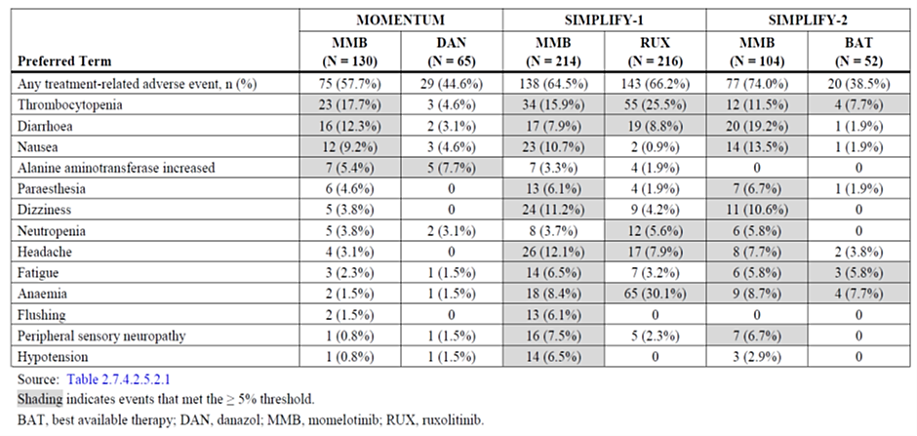
First-dose effects were more frequent in subjects given MMB cf. DAN or BAT. These were mostly gastrointestinal and vascular.
Table 24: By-Study Summary of Treatment-Related Adverse Events Within 24 Hours After the First Dose in > 2 Subjects in Any Group by Preferred Term (Safety Population)
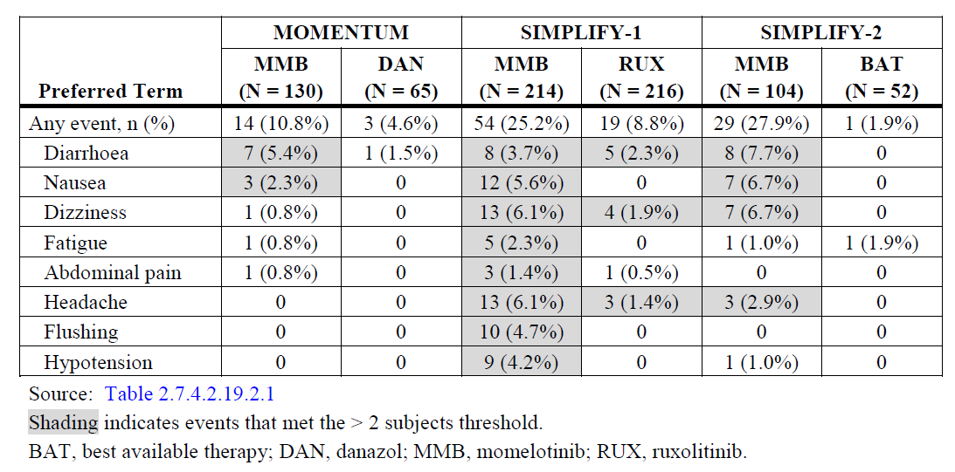
Grade ≥ 3 adverse events during RT: During RT, grade ≥ 3 adverse events across the 3 studies were reported as follows: MOMENTUM (53.8% MMB, 64.6% DAN); SIMPLIFY-1: (36.0% MMB,43.5% RUX); SIMPLIFY-2 (57.7% MMB, 42.3% BAT). The only grade ≥ 3 adverse event reported in ≥ 5% of subjects in every treatment group across the 3 studies was anaemia (7.7% MMB, 10.8% DAN; 6.1% MMB, 22.7% RUX; 13.5% MMB, 17.3% BAT). Grade ≥ 3 thrombocytopenia was also reported frequently across studies (16.9% MMB, 7.7% DAN; 7.0% MMB, 4.6% RUX; 10.6% MMB, 5.8% BAT). Thrombocytopenia was the only grade ≥ 3 adverse event that was ≥ 5 percentage points higher for MMB over any comparator treatment (16.9% MMB, 7.7% DAN).
Pneumonia and acute kidney injury were ≥ 5 percentage points higher for DAN over MMB (pneumonia, 2.3% MMB, 9.2% DAN; acute kidney injury, 3.1% MMB, 9.2% DAN) and anaemia was ≥ 5 percentage points higher for RUX over MMB (6.1% MMB, 22.7% RUX).
There were only two grade ≥ 3 adverse events considered treatment-related that occurred in ≥5% of subjects in any treatment group. These were thrombocytopaenia and anaemia.
Table 25: By-Study Adverse Events of Grade ≥ 3 Severity in ≥ 5% of Subjects in Any Group by System Organ Class and Preferred Term During Randomised Treatment (Safety Population)
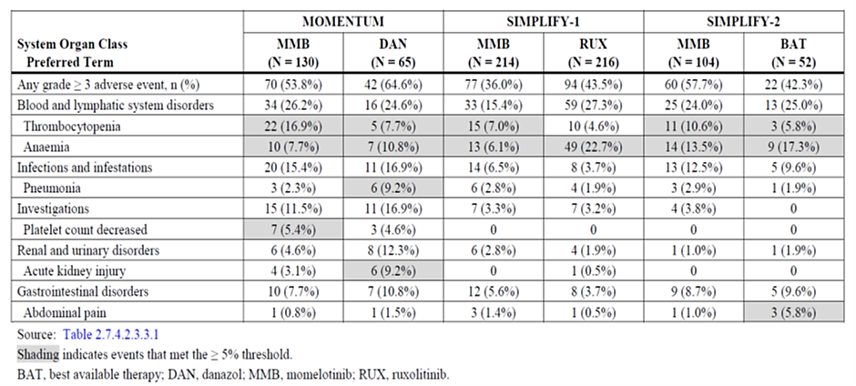

Serious adverse events
During RT, serious adverse events of any relationship were reported for in MOMENTUM (34.6% MMB, 40.0% DAN), SIMPLIFY-1 (22.9% MMB, 18.1% RUX), and SIMPLIFY-2 (35.6% MMB, 23.1% BAT). The most reported serious adverse events across studies for all treatment groups were anaemia (3.8% MMB, 4.6% DAN; 1.9% MMB, 3.7% RUX; 3.8% MMB, 0 BAT) and pneumonia (2.3% MMB, 9.2% DAN; 1.9% MMB, 1.4% RUX; 2.9% MMB, 1.9% BAT). Pneumonia was the only serious adverse event with a ≥ 5 percentage point difference between groups (DAN over MMB in MOMENTUM). The other serious adverse events reported in ≥ 3% of subjects in any group were acute kidney injury (3.1% MMB, 4.6% DAN), transformation to AML and general physical health deterioration (each 1.5% MMB, 3.1% DAN), and splenic infarction (0.8% MMB, 3.1% DAN) in MOMENTUM; and sepsis and general physical health deterioration (each 1.9% MMB, 3.8% BAT) and abdominal pain (0 MMB, 3.8% BAT) in SIMPLIFY-2. No other serious adverse events were reported in ≥ 3% of subjects in either group of SIMPLIFY-1.
Table 26: By-Study Serious Adverse Events Reported in ≥ 2 Subjects in Any Group by System Organ Class and Preferred Term During Randomised Treatment (Safety Population)

Fatal adverse events
During RT, fatal adverse events were reported between the first dose of study drug and up to 30 days after the last dose of RT study drug. Fatalities were reported in MOMENTUM (12.3% MMB, 16.9% DAN), SIMPLIFY-1 (3.3% MMB, 3.2% RUX) and SIMPLIFY-2 (5.8% MMB, 7.7% BAT).
Most fatal adverse events across studies were each reported in 1 or 2 subjects. Events reported in 3 subjects in any study included COVID-19 and COVID-19 pneumonia in the MMB group (each 2.3%) and anaemia in the DAN group (4.6%) of MOMENTUM. The SIMPLIFY studies RT period was prior to COVID-19.
Table 27: By-Study Fatal Adverse Events in ≥ 1% of Subjects in Any Group by System Organ Class and Preferred Term During Randomised Treatment (Safety Population)
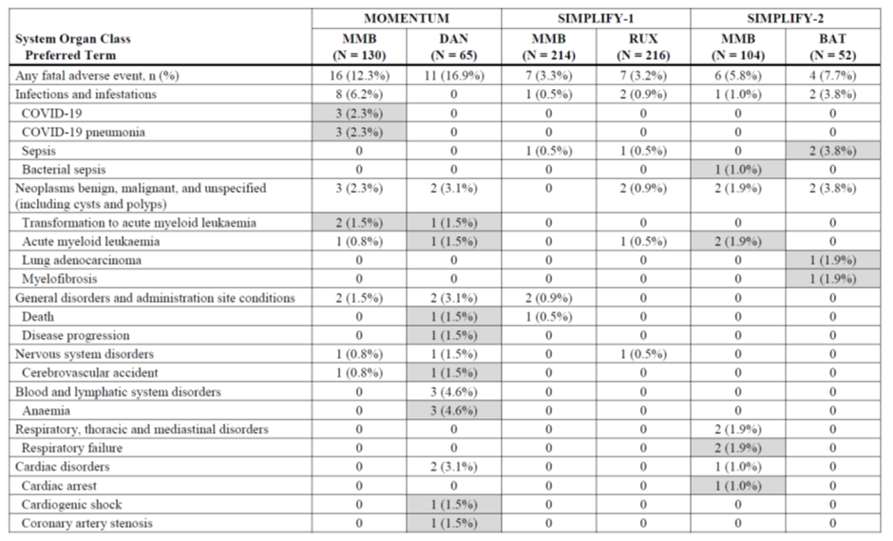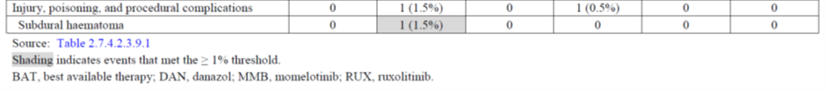

Overall survival
OS was calculated starting from the first dose of study drug in the RT period and was summarised for subjects who received MMB, RUX, or DAN during RT and for MMB overall. The date of death or date last known alive collected after the exposure period for each RT group were used for the analysis. Survival data from study XAP were included in this analysis. Long-term survival and leukemic transformation follow-up assessments were added to XAP by protocol amendment in 2021 (Version 4.0, 31 Aug 2021) for this ongoing safety study initiated in May 2018, and data for these assessments were not collected by the ISS data cutoff date (03 Dec 2021). After RT, subjects received only MMB during the open-label/extended treatment period.
Deaths were reported for 140 of 448 subjects (31.3%) initially randomised to MMB, 93 of 262 subjects (35.5%) initially randomised to RUX, and 16 of 65 subjects (24.6%) initially randomised to DAN. A total of 222 (30.6%) of all MMB-treated subjects died. The median overall survival was 5.36 years (95% CI: 3.85, not estimated [NE]) for subjects who received MMB during RT and NE for subjects who received RUX or DAN during RT or for all MMB-treated subjects. The median follow-up time was 3.00 years for subjects who received MMB during RT, 3.47 years for RUX during RT, 0.84 years for DAN during RT, and 3.04 years for all MMB-treated subjects. The 1-, 2-, 4-, and 6-year survival probabilities by RT groups were estimated as follows:
- Year 1: MMB 86.0%, RUX 90.2%, DAN 73.7%
- Year 2: MMB 73.7%, RUX 77.4%, DAN NE
- Year 4: MMB 56.4%, RUX 61.7%, DAN NE
- Year 6: MMB 48.6%, RUX 52.0%, DAN NE
Survival probabilities for MMB overall: year 1, 89.1%; year 2, 76.5%; year 4, 59.6%; year 6, 51.1%
Figure 12: Integrated Kaplan-Meier Curve for Overall Survival
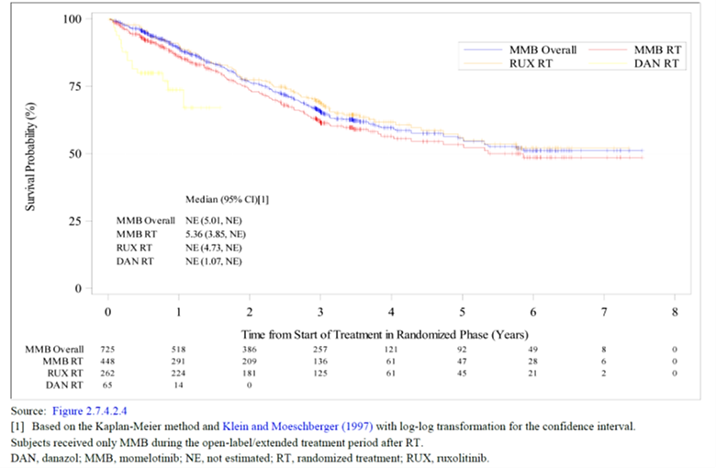

Adverse events of clinical importance
Adverse event categories of clinical importance include all infections, opportunistic infections, AML/transformation, malignancies, nonmelanoma skin cancer, MACE, thrombocytopenia, neutropenia, anaemia, peripheral neuropathy, thromboembolism, and haemorrhage. Search criteria for these categories of AEs were based on several criteria including System Organ Class (SOC) (infections, malignancies), nosological categories of similar preferred terms selected based on clinical review (opportunistic infections, AML/ transformation, nonmelanoma skin cancer, MACE, thrombocytopenia, neutropenia, anaemia), or standardised MedDRA query (SMQ) (peripheral neuropathy, thromboembolism, haemorrhage).
The infections SOC had the greatest proportion of subjects with AEs of clinical importance across treatment groups during RT (39.7% MMB, 42.7% RUX, 35.4% DAN), followed by thrombocytopenia (21.0%, 26.3%, 15.4%). For both MMB and DAN, the next greatest proportion of subjects with adverse events of clinical importance was the haemorrhage narrow SMQ, which was similar across treatment groups (21.2% MMB,19.8% RUX, 18.5% DAN). For RUX, the second greatest proportion of subjects with AEs of clinical importance after infections was anaemia, which had more than twice the proportion of subjects than MMB (14.1% MMB, 35.1% RUX), followed by thrombocytopenia (21.0% MMB, 26.3% RUX).
During MMB open-label treatment and overall, infections remained the category with the greatest proportion of subjects with adverse events of clinical importance (49.5% open label, 55.4% overall) followed by the haemorrhage narrow SMQ (22.5%, 28.6%), anaemia (21.2%, 23.4%), and thrombocytopenia (18.9%, 25.0%).
SAEs in SOC 'Cardiac disorders' were higher during the RT period in MMB than in RUX or DAN. The most frequent PT in cardiac disorders is atrial fibrillation.
Table 28: Overall Summary of Adverse Events of Clinical Importance by Time Window (MMB Overall)
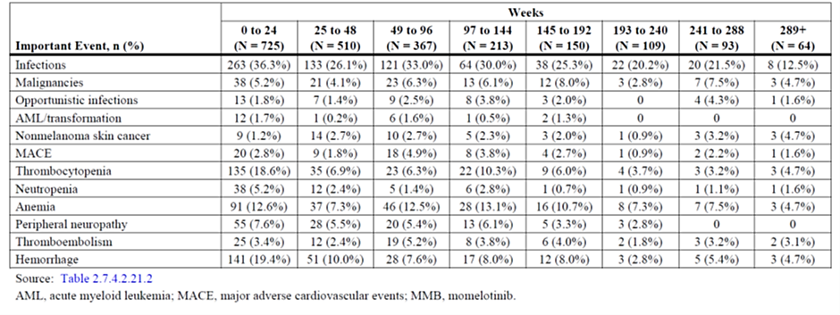
The timeline of events of clinical importance gives an indication of whether these events increase over time.
Table 29: Overall Summary of Adverse Events of Clinical Importance by Time Window (MMB Overall)
When assessed based on laboratory data rather than AE reporting, new or worsening anaemia of grade 3/4 by laboratory data occurred in 8% of subjects treated with MMB in SIMPLIFY-1 and MOMENTUM compared to 32% in the RUX arm and 15% in the DAN arm. In the Integrated Safety Population (ISP) the frequency of the AE anaemia was 23%. When examined by time window, the frequency of the AE anaemia is highest during the first 24 weeks of treatment and appears to decrease over time. This may be due to stabilisation of the effect, discontinuation of affected subjects or a combination of these effects.
After adjusting for exposure, event rates for neutropenia during RT were 32.4 events per 100 person-years for MMB, 35.3 events per 100 person-years for RUX, and 21.4 events per 100 person-years for DAN. Event rates for neutropenia decreased from MMB RT to open-label treatment (from 32.4 to 5.5 events per 100 person-years).
After adjusting for exposure, event rates for thrombocytopenia during RT were 114.3 events per 100 person-years for MMB, 103.3 events per 100 person-years for RUX, and 60.0 events per 100 person-years for DAN. Event rates for thrombocytopenia decreased from MMB RT to open-label treatment.
The incidence of haemorrhagic events during RT were similar across treatment groups, 21.2% MMB, 19.8% RUX, and 18.5% DAN. After adjusting for exposure, event rates for haemorrhage during RT were 84.1 events per 100 person-years for MMB, 58.6 events per 100 person-years for RUX, and 72.9 events per 100 person-years for DAN.
After adjusting for exposure, event rates for thromboembolism during RT were 11.9 events per 100 person-years for MMB, 1.7 events per 100 person-years for RUX, and 30.0 events per 100 person-years for DAN. Event rates for thromboembolism decreased from MMB RT to open-label treatment (from 11.9 to 6.5 events per 100 person-years), suggesting no cumulative toxicity of treatment
The frequency of AEs of infection was similar across arms during the RT for MOMENTUM and SIMPLIFY-1. Across the MMB arms, the incidence was 35%, compared to 43% RUX, and 35% DAN. subjects The frequency of SAEs of infection in the MMB arms during the RT period was 10%. The most common SAEs of infection in the MMB arms during the RT period, occurring in ≥4 subjects, were pneumonia (n = 10, 2.2%), COVID-19/COVID-19 pneumonia (n = 6, 1.3%), cellulitis (n = 4, 0.9%), and sepsis (n = 4, 0.9%). The frequency of Grade 3/4 infections was 7%. In 4 subjects infection was associated with neutropenia. The infections were: enterocolitis with clostridium difficile; pyelonephritis; sepsis; and cellulitis. In the ISP, the frequency of the AE infection was 55%. The most common AEs of infection in the ISP were urinary tract infection (12%), pneumonia (11%), and upper respiratory tract infection (10%).
AML Overall, the rate of leukemia or transformation to leukemia was low, with 1.5% of subjects treated with MMB in MOMENTUM or SIMPLIFY-1 reporting this AE during RT. This was similar to the rates observed in the DAN arm (4.6%) and the RUX arm (0.9%). There were 5 fatal cases in the MMB arms (1.5%), 3 in the DAN arm (4.6%), and 2 in the RUX arm (0.9%).
After adjusting for exposure, event rates for peripheral neuropathy during RT were 31.3 events per 100 person-years for MMB, 11.2 events per 100 person-years for RUX, and 4.3 events per 100 person-years for DAN. Event rates for peripheral neuropathy decreased from MMB RT to open-label treatment (from 31.3 to 8.9 events per 100 person-years).
After adjusting for exposure, event rates for MACE during RT were 9.2 events per 100 person-years for MMB, 7.7 events per 100 person-years for RUX, and 25.7 events per 100 person-years for DAN. Event rates for MACE decreased from MMB RT to open-label treatment to 5.6 events per 100 person-years).
The frequency of NMSC was rare during the RT, occurring in only 1.2% of subjects who received MMB. This is slightly lower than observed in the RUX arm (3.2%). There were no cases in subjects who received DAN. All cases reported in the MMB arms were grade 1 or 2. In the ISP, the frequency of the AESI/CI of nonmelanoma skin cancer was 4.8%. W
There were two cases of probable Drug Induced Liver Injury.
First-dose effects: Most first-dose effects on the initial day of MMB dosing (treatment-related nausea, diarrhea, dizziness, headache, hypotension) were grade 1, transient, and reported in < 5% of subjects in the pooled group overall. Fewer first-dose effects were reported for RUX, DAN, and BAT than for MMB.

Key laboratory findings
Blood: During the first 24 weeks of treatment, mean Hgb levels, leukocytes, and platelet counts were sustained with MMB treatment compared with RUX. Mean Hgb levels and platelet counts were also sustained over time with DAN. Mean Hgb levels, leukocytes, and platelet counts decreased from baseline for RUX. The CTCAE grades for decreased neutrophil and platelet counts remained predominately grades 0, 1, and 2 throughout 24 weeks of MMB treatment.
During open-label treatment with MMB, there was an increase in mean Hgb from week 2 to week 4 (0.8 g/dL) and levels continued to be sustained throughout the entire MMB open-label period.
Table 30: Integrated Haematology – Shift from Baseline Grade 0, 1, or 2 to Worst Postbaseline Grade 3 or 4 by Key Parameter During 24 Weeks of Randomised Treatment (Safety Population)
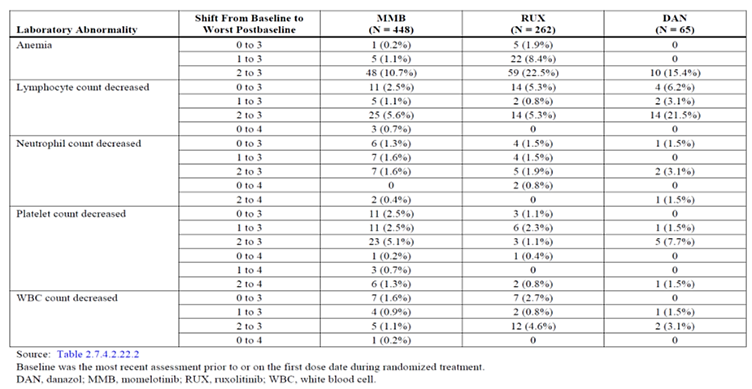

Liver:
During RT, laboratory findings for abnormal liver function were reported as follows:
- ALT ≥ 3 × ULN (3.6% MMB, 2.7% RUX, 6.3% DAN)
- ALT or AST ≥ 3 × ULN (3.8% MMB, 3.1% RUX, 6.3% DAN)
- ALT or AST ≥ 5 × ULN (1.8% MMB, 0.4% RUX, 3.1% DAN)
The MMB group had greater proportions of subjects with abnormalities in alkaline phosphatase > 1.5 × ULN (16.9% MMB, 12.0% RUX, 6.3% DAN).
Two subjects (0.3%) in the MMB open-label group and overall had liver abnormalities that met the laboratory criteria for Hy’s Law (ALT or AST ≥ 3 × ULN, total bilirubin > 2 × ULN, and alkaline phosphatase < 2 × ULN). Both subjects were from the same study site in SIMPLIFY-1. The time from first MMB dose to onset of abnormal liver function was 21 months (subject 93039) and 10 months (subject 96182). Subject 93039 had a high baseline total bilirubin nearly > 2 × ULN (normal direct bilirubin). All liver function test abnormalities for both subjects were resolving or resolved (returned to normal or baseline) at last follow-up. These liver abnormalities were judged to be associated with MF or intercurrent illnesses rather than drug-induced liver injury.

Summary of clinical studies
- The clinical evidence presented in this submission demonstrates that MMB provides a safe and well tolerated treatment option that can wholistically address splenomegaly, disease-related symptoms, and anaemia for patients with myelofibrosis and moderate to severe anaemia.
- The pivotal evidence for MMB in Janus kinase inhibitor (JAKi) naïve patients is the SIMPLIFY-1 trial, a Phase III, randomised, double-blind, multicentre study comparing momelotinib and ruxolitinib.
- Evidence for MMB in JAKi experienced patients is the SIMPLIFY-2 trial, a Phase III, randomised, open label, multicentre study comparing momelotinib and best available therapy, which for the majority of patients (88.5%) included ruxolitinib.
- The MOMENTUM trial, a Phase III, randomised, double-blind, multicentre study comparing MMB and danazol, is included as pivotal evidence for the efficacy and safety of MMB in JAKi experienced patients.
- The primary endpoint of both the SIMPLIFY-1 and SIMPLIFY-2 trials was the proportion of patients who achieved a ≥ 35% reduction in splenic volume at Week 24.
- Key secondary endpoints of both trials were the proportion of patients who achieved a ≥ 50% reduction in TSS, the proportion of patients who were red blood cell transfusion independent and transfusion dependent, and the rate of RBC transfusions in the randomised treatment period.
In line with the TGA indication for MMB in myelofibrosis patients with moderate to severe anaemia, this section is focussed on presenting the efficacy and safety data for the SIMPLIFY-1 and SIMPLIFY-2 trials in the overall (intention to treat; ITT) population and the subgroup of patients with baseline haemoglobin (Hgb) < 100 g/L. The results for the complement subgroup (Hgb ≥ 100 g/L) are presented for comparison.

JAKi naïve patients – SIMPLIFY-1
- A similar proportion of patients achieved a response in the MMB group (26.5%) as in the ruxolitinib group (29.5%) in the ITT population and the non-inferiority proportion difference in response rates was statistically significant (p = 0.014). In the Hgb < 100 g/L subgroup, a similar proportion of patients achieved a splenic response in the MMB group as in the ruxolitinib group (31.4% versus 33.0%; p = 0.029).
- A post-hoc mixed effect model analysis conducted for the TSS secondary endpoint indicated a consistent, clinically meaningful rate of symptomatic benefit for MMB that is comparable to ruxolitinib (Δ at Week 24: 2.05 points on a 70-point scale).
- A higher proportion of patients in the MMB group were transfusion independent at Week 24 (46.5% vs 26.6%; p = 0.001), despite having a lower rate of transfusion independence at baseline (29.1% vs 43.6%).
- MMB tolerability was broadly comparable with that of ruxolitinib during the double-blind period. Unlike ruxolitinib, MMB provides a clinically meaningful improvement in anaemia-related outcomes and has a safety advantage in lowering the risk of anaemia adverse events (AEs).

JAKi experienced patients – SIMPLIFY-2 and MOMENTUM
- Trial design failures in SIMPLIFY-2, including a lack of treatment washout of prior JAKi therapy, resulted in few patients achieving a splenic volume reduction of ≥ 35% (6.7% in the MMB group versus 5.8% in the BAT group; p = 0.90). In the Hgb < 100 g/L subgroup, a similar proportion of patients achieved a splenic response in the MMB group as in the BAT group (9.1% versus 5.1%; p = 0.59).
- Clinically meaningful improvements in the rates of symptom burden were observed compared to BAT (32.3% vs 2.6%; p < 0.001) and danazol (24.6% vs 9.2%; p = 0.0095) in the SIMPLIFY-2 and MOMENTUM trials, respectively.
- A higher proportion of patients in the MMB group were transfusion independent at Week 24 (33.3% vs 12.8%; p = 0.009) in SIMPLIFY-2, despite having a lower rate of transfusion independence at baseline (7.6% vs 23.1%).
- In MOMENTUM, MMB demonstrated a trend toward a higher transfusion independence rate at week 24 compared to the active comparator danazol (30.0% vs 20.0%; p = 0.1265 in the superiority test), and the threshold for non-inferiority was met (p = 0.0116).
Although higher rates of AEs were observed in the MMB group compared to the BAT group in SIMPLIFY-2, the open-label trial design and permissibility of changes to therapy and no-therapy in the BAT arm may have confounded the reporting of relationship to study drug and premature treatment discontinuation. Overall, the safety profile of MMB was consistent across the Phase III clinical studies.

Recommendation following the clinical evaluation
The quality, nonclinical, RMP and clinical Evaluators have all recommended approval. The clinical delegate considers that sufficient data and justification have been provided to approve Omjjara- 100 mg, 150mg and 200mg film-coated tablet (bottle) with the proposed indication:
Omjjara is indicated for the treatment of disease-related splenomegaly or symptoms in adult patients with moderate to severe anaemia who have primary myelofibrosis, post polycythaemia vera myelofibrosis or post essential thrombocythaemia myelofibrosis and who are Janus Kinase (JAK) inhibitor naïve or have been treated with ruxolitinib.

Risk management plan evaluation summary
The summary of safety concerns and their associated risk monitoring and mitigation strategies are summarised in Table 31. The TGA may request an updated RMP at any stage of a product's life-cycle, during both the pre-approval and post-approval phases.
Table 31: Summary of safety concerns
Summary of safety concerns |  | Pharmacovigilance |  | Risk Minimisation
 |  | Routine | Additional | Routine | Additional
Important identified risks | Serious Infections |  | – |  | –
Important potential risks | Major Adverse Cardiovascular Events (MACE) |  | – | – | –
Important potential risks | Thromboembolism |  | – | – | –
Important potential risks | Secondary Malignancies |  | – | – | –
Missing information | None | – | – | – | –

- The summary of safety concerns in the ASA are consistent with those in the EU-RMP. There will be no TGA clinical evaluation for this COR-A application and the delegate will consider the Australian clinical context and Australian patient population. The safety concerns are acceptable from an RMP perspective.
- Routine pharmacovigilance activities only are proposed. This is consistent with the EU-RMP and is acceptable. The RMP evaluation recommended conditions of registration relating to the versions of the risk management plan, requirement for periodic safety update reports, and inclusion of the medicine in the Black Triangle Scheme.
The TGA may request an updated RMP at any stage of a product's life cycle, during both the pre-approval and post-approval phases. Further information regarding the TGA’s risk management approach can be found in risk management plans for medicines and biologicals and the TGA's risk management approach. Information on the Australia-specific annex (ASA) can be found on the TGA website.

Delegate’s considerations – risk benefit analysis

Efficacy
Efficacy was primarily assessed in 3 studies:
- GS-US-352-0101 (SIMPLIFY-1), a double-blind, randomised, controlled, phase 3 trial evaluating MMB vs. RUX in patients with primary MF or post-PV or post-ET MF who were intermediate- or high-risk PMF or post-PV/ET MF and had not previously received a JAK inhibitor.
- GS-US-352-1214 (SIMPLIFY-2), an open-label, randomised, controlled, phase 3 trial evaluating MMB vs. best available therapy (BAT) in anaemic or thrombocytopenic patients with primary MF, post-PV or post ET MF who were previously treated with RUX.
- SRA-MMB-301 (MOMENTUM), a double-blind, randomised, controlled, phase 3 study evaluating MMB vs. danazol (DAN) in symptomatic, anaemic patients with primary MF, post-PV or post-ET MF who were previously treated with JAK inhibitor therapy.
While both SIMPLIFY-1 and SIMPLIFY-2 included subjects who were non-anaemic at study entry, MOMEMTUM enrolled only subjects who were anaemic at study entry.
The MOMENTUM study met its primary efficacy endpoint of statistically significant superiority of MMB over DAN in the proportion of subjects with ≥50% reduction from baseline at week 24 in MFSAF v4.0 TSS. The MFSAF v4.0 TSS response rate was 24.6% (95% CI: 17.5%, 32.9%) for the MMB group and 9.2% (95% CI: 3.5%, 19.0%) for the DAN group, with a treatment difference of 15.7% (95% CI: 5.5%, 25.8%), 2-sided p-value 0.0095.
The first key secondary efficacy endpoint of transfusion independence (TI) rate at Week 24 was met as demonstrated by noninferiority of MMB compared with DAN for this endpoint. The response rate was 30% (95% CI: 22.3%, 38.7%) for the MMB group and 20% (95% CI: 11.1%, 31.8%) for the DAN group, with an adjusted proportion difference for noninferiority (defined as p[MMB] - 0.8 x p[DAN]) of 13.6% (95% CI: 1.9%, 25.3%). MMB was declared noninferior to DAN because the lower bound of the 95% CI was greater than 0. Superiority of MMB over DAN for this endpoint was not demonstrated.
Key secondary efficacy endpoints showed superiority of MMB over DAN. While this study establishes that MMB is more efficacious in terms of clinically important endpoints it is only applicable to patients who have moderate to severe anaemia and who have already taken RUX. Danazol is not approved for treatment of myelofibrosis in Australia, however it is given as a supportive therapy for MF associated anaemia.
For patients who are naïve to JAK inhibitors, SIMPLIFY-1 provides a comparison of MMB and ruxolitinib (RUX). At the time this study was designed, the only European Medicines Agency (EMA)-approved treatment of disease-related splenomegaly or symptoms in patients with MF was RUX, a JAK1/JAK2 inhibitor; thus, RUX was selected as the control for this study. This remains the case in Australia.
The primary efficacy endpoint of SRR required at least a 35% reduction from baseline in splenic volume at week 24. The selection and the definition of SRR was consistent with the COMFORT 1 study that established use of RUX in MF. Non-inferiority of MMB with RUX for SRR over 24 weeks was established, however SRR does not directly measure how a patient feels, functions or survives.
SIMPLIFY-1 included TSS (the other standard efficacy endpoint used for drugs intended for the treatment of MF that is a direct measure of clinical benefit) as the first secondary endpoint in the hierarchical testing strategy. However, it failed to demonstrate noninferiority of MMB compared to RUX on this endpoint, where a responder was defined as the proportion of subjects who achieved a ≥50% reduction in TSS at Week 24 versus baseline, as measured by the mMPN-SAF TSS v2.0 diary. The mMPN-SAF TSS response rate was 28.4% (95% CI: 22.5%, 35.0%) for the MMB group and 42.2% (95% CI: 35.4%, 49.2%) for the RUX group.
TSS was determined using different methods across the studies. The MOMENTUM and SIMPLIFY-1 studies used different versions of the target PRO instrument, mMPN-SAF TSS v2.0 in SIMPLIFY-1 and The MFSAF v4.0 in MOMENTUM so these aren’t directly comparable. Both studies required a 50% reduction in TSS to be considered responders.
Ad-hoc analyses of SIMPLIFY-1 showed a descriptive reduction in measures of transfusion independence across subgroups, including subjects with moderate to severe anaemia (Hgb <10 g/dL) compared with RUX. The proposed indication excludes patients who do not have moderate to severe anaemia. An Ad-hoc subgroup analysis for those subjects showed that the SRR (31.4% MMB vs. 33% RUX) was similar for MMB and RUX while the transfusion independence rate (MMB 46.5% vs. RUX 26.6%) and transfusion dependence rate (47.7% MMB vs. 61.7% RUX) were more favourable for MMB. These are descriptive due to the ad-hoc nature of the analyses.
Little additional efficacy information can be obtained from SIMPLIFY-2. This was a failed study. It failed to demonstrate superiority of MMB over BAT for the primary endpoint of SRR, defined as in SIMPLIFY-1. There were design flaws in this study that may have influenced the result. Firstly, most subjects in the BAT group received RUX, making this study largely an assessment of MMB vs. RUX for superiority of SRR at week 24. The sponsor opined that at the time the study was designed, it was anticipated that most subjects in the BAT group would receive a therapeutic agent other than RUX or a subtherapeutic dose of RUX. However, despite most subjects enrolled in SIMPLIFY-2 having a history of RUX-related toxicities, most subjects in the BAT group received RUX and that this likely reflected increased availability of dosing guidelines for RUX and increased clinical experience with RUX which became available after enrolment began. Secondly, because of the risks of symptom-relapse and life-threatening adverse events upon discontinuation of RUX, there was no washout period for subjects receiving MF therapy at the time of screening. Subjects were required to be on a stable dosage of RUX from at least 2 weeks prior to screening through the end of the screening period. This potentially confounded the baseline used for analyses of splenic response. Additionally, over 30% of study subjects had Hgb ≥ 10g/dL, thus the efficacy results are not directly applicable to the patient population proposed to be treated.
Although SIMPLIFY-2 was a failed study, examination of the TI endpoint suggests that MMB has an advantage over RUX in reducing the need for transfusion in the first 24 weeks of treatment. This was also either demonstrated or suggested by secondary and subgroup analyses in the SIMPLIFY-1 and MOMENTUM studies. Taken as a whole, these studies provide satisfactory evidence of the efficacy of MMB for treatment of patients MF with moderate to severe anaemia, defined as Hgb <10 mg/dL.
Only limited long term efficacy data are available due to the design of the Phase 3 studies, which were open-label after week 24. In the MOMENTUM study, duration of the wk 24 TSS response was a secondary endpoint. For the 38 subjects (32 MMB, 6 DAN) with MFSAF TSS response at week 24, the response was maintained for up to 40 weeks as of the data cutoff date of 03 Dec 2021.
The relative duration of symptom response, spleen response and transfusion requirements could only be assessed on cross-study comparisons however the definition of these endpoints as well as the subject’s disease characteristics vary across studies. Preliminary OS data from MOMENTUM suggests that for patients who had previously been treated with a JAK inhibitor, MMB is associated with a higher proportion of patients surviving up to week 24 compared with patients taking danazol.
The proportion of missing data at Week 24 was substantial in the MOMENTUM and SIMPLIFY-2 studies in JAK inhibitor treated patients, mainly due to early discontinuation of treatment before completing the double-blind phase at Week 24, while the proportion is lower in SIMPLIFY-1 in JAK inhibitor naïve patients (MOMENTUM: 26.2% MMB, 40.0% DAN; SIMPLIFY-2: 22.1% MMB, 19.2% BAT, SIMPLIFY-1: 12.6% MMB, 4.1% RUX). In the primary analyses, these patients with missing data at Week 24 were considered non-responders, which introduces uncertainty on the estimation of MMB treatment effects, particularly in MOMENTUM.

Safety
The events of most clinical interest for MMB are: anaemia, neutropenia and thrombocytopenia with associated infections, bleeding or thrombotic events; malignant transformation; peripheral neuropathy; MACE; and liver abnormalities.
Worsening anaemia doesn’t appear to be associated with MMB treatment. New or worsening anaemia of grade 3/4 by laboratory data reported in 8% of subjects treated with MMB in SIMPLIFY-1 and MOMENTUM compared to 32% in the RUX arm and 15% in the DAN arm.
Neutropenia events were similar with MMB and RUX, this is likely due to a class effect. During RT there were 32.4 events per 100 person-years for MMB, 35.3 events per 100 person-years for RUX, and 21.4 events per 100 person-years for DAN. Thrombocytopenia was somewhat more frequent with MMB than RUX (114.3 events per person-years with MMB vs. 103.3 events/person-years with RUX) as were haemorrhagic events (84.1 events per 100 person-years for MMB, 58.6 events per 100 person-years for RUX). Thromboembolism events were more frequent with MMB than RUX (during RT were 11.9 events per 100 person-years for MMB, 1.7 events per 100 person-years for RUX).
During RT, adverse events of thrombocytopenia were reported for 21.0% MMB, 26.3% RUX, and 15.4% DAN; most events were the preferred term thrombocytopenia (19.4% MMB, 26.3% RUX, and 10.8% DAN). The worst severity grade for the greatest proportion of subjects was grade 3 for both MMB and DAN (7.4% MMB, 3.4% RUX, 7.7% DAN), and grade 1 for RUX (5.1% MMB, 11.1% RUX, 0 DAN). The proportion of subjects with serious adverse events of thrombocytopenia was small across groups (0.7% MMB, 1.1% RUX, 0 DAN) and no event was fatal. Adverse events of thrombocytopenia led to study drug discontinuation in 2.5% MMB, 1.5% RUX, and 0 DAN. The sponsor has postulated that these results may be explained in part by the higher incidence of thrombocytopenia (platelets < 150 ×109/L) at baseline for MMB in MOMENTUM compared with SIMPLIFY-1 (Section 1.3.2.1), as RUX was not a comparator treatment in MOMENTUM.
Peripheral neuropathy events were more frequent with MMB compared with RUX (during RT were 31.3 events per 100 person-years for MMB, 11.2 events per 100 person-years for RUX). Infection was common and similar on an exposure adjusted basis for MMB and RUX. NMSC and malignant transformation were of relatively low frequency in all groups and a longer period of observation would be required to determine the extent of MMB on these events.
There were 2 Hy’s law cases during the clinical study program and appropriate statements are included in the PI.
A pregnancy category of D has been agreed with the sponsor. The nonclinical evaluator identified embryofetal lethality in rats and rabbits (at very low exposure multiples), decreased fetal weight, increased incidence of fetal skeletal variations, impaired ossification and teratogenicity (visceral malformation) at subclinical exposures in rats and/or rabbits (in the context of maternotoxicity). The nonclinical evaluator stated that “Given the known role of JAK/STAT signalling in embryofetal development, MMB should not be used in pregnancy”. JAK inhibitors indicated for allergic and auto-immune indications such as tofacitinib and baricitinib are Use in Pregnancy category D and this should be the case for MMB.

Regulatory decision (outcome)
Based on a review of quality, safety, and efficacy, the TGA decided to register:
Omjjara momelotinib (as dihydrochloride monohydrate) 100 mg film-coated tablet bottle
Omjjara momelotinib (as dihydrochloride monohydrate) 150 mg film-coated tablet bottle
Omjjara momelotinib (as dihydrochloride monohydrate) 200 mg film-coated tablet bottle
for the following indication:
the treatment of disease-related splenomegaly or symptoms in adult patients with moderate to severe anaemia who have primary myelofibrosis, post polycythaemia vera myelofibrosis or post essential thrombocythaemia myelofibrosis and who are Janus Kinase (JAK) inhibitor naïve or have been treated with ruxolitinib.

Specific conditions of registration applying to these goods

Black triangle scheme
Omjjara (momelotinib) is to be included in the Black Triangle Scheme. The PI and CMI for Omjjara must include the black triangle symbol and mandatory accompanying text for five years, which starts from the date of first supply of the product.

RMP evaluator recommendations regarding conditions of registration
The Omjjara (momelotinib) EU-Risk Management Plan (RMP) (version 1.0, dated 22 November 2023, data lock point 17 May 2022), with Australia-Specific Annex (ASA) (version 1.2, dated October 2024), included with submission PM-2024-00653-1-4, and any subsequent revisions, as agreed with the TGA will be implemented in Australia.

Periodic safety update reports (PSURs)
An obligatory component of risk management plans is routine pharmacovigilance. Routine pharmacovigilance includes the submission of periodic safety update reports (PSURs).
Reports are to be provided in line with the current published list of EU reference dates and frequency of submission of PSURs until the period covered by such reports is not less than three years from the date of this approval letter. Each report must be submitted within ninety calendar days of the data lock point for that report.
The reports are to at least meet the requirements for PSURs as described in the European Medicines Agency’s Guideline on good pharmacovigilance practices (GVP) Module VII-periodic safety update report (Rev 1), Part VII.B Structures and processes. Note that submission of a PSUR does not constitute an application to vary the registration.
As Omjjara is a new chemical entity it should be included in the Black Triangle Scheme as a condition of registration. The following wording is recommended for the condition of registration:
Omjjara (momelotinib) is to be included in the Black Triangle Scheme. The PI and CMI for Omjjara must include the black triangle symbol and mandatory accompanying text for five years, which starts from the date of first supply of the product.
As a post-approval commitment within two years after approval, the applicant should conduct additional studies to clarify the selectivity of MMB and M21 over other JAK family kinases and other targets, as well as to discuss the clinical relevance.

Product Information (PI) and Consumer Medicines Information (CMI)
For the most recent Product Information (PI) and Consumer Medicines Information (CMI), please refer to the TGA PI/CMI search facility.

Therapeutic Goods Administration
PO Box 100 Woden ACT 2606 Australia
Email: info@tga.gov.au Phone: 1800 020 653 Fax: 02 6203 1605
https://www.tga.gov.au
Reference/Publication #

V. Giai et al. Philadelphia-negative MPN: A Molecular Journey from Stem Cell to Clinical Features. Medicina 2021, 57(10), 1043; https://doi.org/10.3390/medicina57101043
A. Tefferi. Primary myelofibrosis: 2021 update on diagnosis, risk-stratification and management. Am J Hematol. 2021,96:145-162.
Gerds AT et al. Myeloproliferative Neoplasms, Version 3.2022, NCCN Clinical Practice Guidelines in Oncology. J Natl Compr Canc Netw. 2022 Sep;20(9):1033-1062. doi: 10.6004/jnccn.2022.0046. PMID: 36075392.
Naymagon L, Mascaren J. Myelofibrosis-Related Anemia: Current and Emerging Therapeutic Strategies. HemaSphere (2017) 1:1(e1). http://dx.doi.org/10.1097/HS9.0000000000000001
Australian Product Information JAKAVI (ruxolitinib) 03 July 2023 https://www.ebs.tga.gov.au/ebs/picmi/picmirepository.nsf/pdf?OpenAgent&id=CP-2013-PI-01918-1&d=20230920172310101
International Conference on Harmonisation of Technical Requirements for Registration of Pharmaceuticals for Human Use. Impurities In New Drug Products (ICHQ3B(R2)). CPMP/ICH/2738/99 01/08/2003.
International Conference on Harmonisation of Technical Requirements for Registration of Pharmaceuticals for Human Use. Non-clinical safety studies for the conduct of human clinical trials for pharmaceuticals (ICH M3 (R2)) CPMP/ICH/286/95.01/12/2009.
International Conference on Harmonisation of Technical Requirements for Registration of Pharmaceuticals for Human Use. ICH S9 Guideline on nonclinical evaluation for anticancer. May 2010. ICH/646107/2008
Verstovsek, S., Gerds, A. T., Vannucchi, A. M., Al-Ali, H., Lavie, D., Kuykendall, A. T., . . . Su-Peng, Y. (2023). Momelotinib versus danazol in symptomatic patients with anaemia and myelofibrosis (MOMENTUM): Results from an international, double-blind, randomised, controlled, phase 3 study. The Lancet, 401(10373), 269-280. doi:https://doi.org/10.1016/S0140-6736(22)02036-0

