Australian Public Assessment Report for mRESVIA
  - Active ingredient: Respiratory syncytial virus F protein mRNA (nucleoside modified) vaccine

  - Sponsor: Moderna Australia Pty Ltd
April 2025

About the Therapeutic Goods Administration (TGA)
- The Therapeutic Goods Administration (TGA) is part of the Australian Government Department of Health and Aged Care and is responsible for regulating therapeutic goods, including medicines, medical devices, and biologicals.
- The TGA administers the Therapeutic Goods Act 1989 (the Act), applying a risk management approach designed to ensure therapeutic goods supplied in Australia meet acceptable standards of quality, safety, and efficacy.
- The work of the TGA is based on applying scientific and clinical expertise to decision-making, to ensure that the benefits to the Australian public outweigh any risks associated with the use of therapeutic goods.
- The TGA relies on the public, healthcare professionals and industry to report problems with therapeutic goods. The TGA investigates reports received to determine any necessary regulatory action.
- To report a problem with a therapeutic good, please see the information on the TGA website.

About AusPARs
- The Australian Public Assessment Report (AusPAR) provides information about the evaluation of a prescription medicine and the considerations that led the TGA to approve or not approve a prescription medicine submission. Further information can be found in Australian Public Assessment Report (AusPAR) guidance.
- AusPARs are prepared and published by the TGA.
- AusPARs are static documents that provide information that relates to a submission at a particular point in time. The publication of an AusPAR is an important part of the transparency of the TGA’s decision-making process.
- A new AusPAR may be provided to reflect changes to indications or major variations to a prescription medicine subject to evaluation by the TGA.

Copyright
© Commonwealth of Australia 2025
This work is copyright. You may reproduce the whole or part of this work in unaltered form for your own personal use or, if you are part of an organisation, for internal use within your organisation, but only if you or your organisation do not use the reproduction for any commercial purpose and retain this copyright notice and all disclaimer notices as part of that reproduction. Apart from rights to use as permitted by the Copyright Act 1968 or allowed by this copyright notice, all other rights are reserved and you are not allowed to reproduce the whole or any part of this work in any way (electronic or otherwise) without first being given specific written permission from the Commonwealth to do so. Requests and inquiries concerning reproduction and rights are to be sent to the TGA Copyright Officer, Therapeutic Goods Administration, PO Box 100, Woden ACT 2606 or emailed to <tga.copyright@tga.gov.au>.

Contents
List of abbreviations 5
mRESVIA submission 8
mRESVIA – proposed indication 9
Respiratory syncytial virus (RSV) 9
Current treatment options for RSV infection 12
Regulatory status 12
Australian regulatory status 12
International regulatory status 12
Registration timeline 13
Evaluation overview 14
Quality evaluation summary 14
Nonclinical (toxicology) evaluation summary 15
Clinical evaluation summary 16
Summary of clinical studies 16
Pharmacology 16
Efficacy 20
Safety 32
Risk management plan evaluation summary 36
Risk-benefit analysis 37
Recommendation following the clinical evaluation 39
Advisory Committee on Vaccines – 31 January 2024 39
ACV meeting (31 January 2024) conclusion 41
Risk-benefit assessment: Additional data 41
Discussion 68
Conclusion 74
Advisory Committee on Vaccines –1 May 2024 74
ACV Meeting (1 May 2024) conclusion 75
Initial outcome 76
Section 60 request for reconsideration 77
Outcome of Remittal for Fresh Decision Process 78
Final Outcome 79
Specific conditions of registration applying to these goods 80
Product Information 82

List of abbreviations
Abbreviation | Meaning
Ab | Antibody(ies)
ACV | Advisory Committee on Vaccines
ADEM | Acute demyelinating encephalomyelitis
AE | Adverse event
AESI | Adverse event of special interest
AR | Adverse reaction
ARD | Acute respiratory disease
AU | Arbitrary units
bAb | Binding antibody(ies)
CD4 | Cluster of differentiation 4
CD8 | Cluster of differentiation 8
CDC | Centres for Disease Control and Prevention
CHF | Congestive heart failure
CHMP | Committee for Medicinal Products for Human Use
CI | Confidence interval
COPD | Chronic obstructive pulmonary disease
COVID-19 | Coronavirus disease 2019
CRID | Clinical research for infectious diseases
CRO | Clinical research organization
DBL | Database lock
DSMB | Data safety monitoring board
eCRF | Electronic case report form
eDiary | Electronic diary
EMA | European medicines agency
ERD | Enhanced respiratory disease
FAS | Full analysis set
FDA | United States Food and Drug Administration
GBS | Guillain-Barré syndrome
GM | Geometric mean
GMC | Geometric mean concentration
GMFR | Geometric mean fold rise
GMT | Geometric mean titre
HLGT | High level group term
hMPV | Human metapneumovirus
HR | Hazard ratio
ICH | International Council for Harmonisation
ICS | Intracellular cytokine staining
IEC | Independent Ethics Committee
IFNγ | Interferon gamma
IgG | Immunoglobulin G
IM | Intramuscular(ly)
IU | International units
IV | Intravenous
LB | Lower bound
LNP | Lipid nanoparticle
LRT | Lower respiratory tract
LRTD | Lower respiratory tract disease
MAAE | Medically attended adverse event
MedDRA | Medical Dictionary for Regulatory Activities
mITT | Modified intent-to-treat
mRNA | Messenger ribonucleic acid
mRNA-1345 | Proposed vaccine which is the single mRNA sequence encoding the RSV F glycoprotein stabilised in the prefusion conformation
nAb | Neutralising antibody(ies)
PostF | Postfusion
PP | Per protocol
PPE | Per-protocol Efficacy
PreF | Prefusion
PT | Preferred term
RNA | Ribonucleic acid
RSV | Respiratory syncytial virus
RSV-A | RSV subtype A
RSV-ARD | Respiratory syncytial virus-associated acute respiratory disease
RSV-B | RSV subtype B
RSV-LRTD | Respiratory syncytial virus-associated lower respiratory tract disease
SAE | Serious adverse event
SARS-CoV-2 | Severe acute respiratory syndrome coronavirus 2
SD | Standard deviation
SM-102 | Heptadecan-9-yl 8-((2-hydroxyethyl) (6-oxo-6-(undecyloxy) hexyl) amino) octanoate
SMQ | Standardised MedDRA Queries
SOC | System organ class
Study CRID-001 | Study mRNA-CRID-001
Study P101 | Study mRNA -1345-P101
Study P301 | Study mRNA -1345-P301
TEAE | Treatment-emergent adverse event
Th1 | T helper type 1
Th2 | T helper type 2
VE | Vaccine efficacy
VRBPAC | Vaccines and Related Biologic Products Advisory Committee

mRESVIA submission
Product name: | mRESVIA
Active ingredient: | Respiratory syncytial virus F protein (nucleoside modified) vaccine
Type of submission: | New biological entity
Initial decision: | Not Approved
Date of initial decision: | 12 June 2024
Final decision following Section 60 Remittal for Fresh Decision: | Approved
Date of final decision: | 28 March 2025
Approved therapeutic use for the current submission: | mRESVIA is a vaccine indicated for active immunisation for the prevention of lower respiratory tract disease (LRTD) caused by respiratory syncytial virus (RSV) in adults 60 years of age and older. mRESVIA should be used in accordance with official recommendations.
Sponsor’s name and address: | Moderna Australia Pty Ltd, Level 10, 101 Collins Street Melbourne 3000
Date of entry onto ARTG: | 28 March 2025
ARTG number: | 411450
Black Triangle Scheme | Yes
Dose form: | White to off white suspension for injection.
Strength/Dose: | One dose (0.5 mL) contains 50 micrograms of respiratory syncytial virus F protein mRNA (nucleoside modified).  For further information regarding dosage, refer to the Product Information.
Container: | Plastic pre-filled syringe
Pack size: | 1, 2 or 10 plastic pre-filled syringes per carton
Route of administration: | Intramuscular injection
Pregnancy category: | Category B1  Drugs which have been taken by only a limited number of pregnant women and women of childbearing age, without an increase in the frequency of malformation or other direct or indirect harmful effects on the human fetus having been observed.  Studies in animals have not shown evidence of an increased occurrence of fetal damage.  The use of any medicine during pregnancy requires careful consideration of both risks and benefits by the treating health professional. The pregnancy database must not be used as the sole basis of decision making in the use of medicines during pregnancy. The TGA does not provide advice on the use of medicines in pregnancy for specific cases. More information is available from obstetric drug information services in your state or territory.

mRESVIA – proposed indication
mRESVIA is a lipid nanoparticle (LNP)-encapsulated mRNA- based vaccine against respiratory syncytial virus (RSV). It consists of an mRNA sequence encoding a membrane-anchored RSV F glycoprotein, derived from an RSV-A strain (A2), and stabilised in the prefusion conformation through structural engineering. The F glycoprotein is expressed on the surface of the virus and is essential for virus entry into host cells and for cell-to-cell spread; it is a major surface antigen of RSV; it is well conserved among the two antigenically distinct RSV-A and RSV-B subgroups and it is the main target of the host’s neutralising antibody response to RSV.
This AusPAR describes the submission by Moderna Australia Pty Ltd (the Sponsor) to register mRESVIA (Respiratory syncytial virus F protein (nucleoside modified) vaccine) for the following proposed indication:
mRESVIA is a vaccine indicated for active immunisation for the prevention of lower respiratory tract disease (LRTD) and acute respiratory disease (ARD) caused by respiratory syncytial virus (RSV) in adults 60 years of age and older.

Respiratory syncytial virus (RSV)
RSV is an enveloped, single stranded RNA virus belonging to the Pneumovirus genus in the
Paramyxoviridae family. There are 2 antigenically distinct subtypes; RSV-A and RSV-B; differentiated based on the attachment glycoprotein G sequence. The RSV fusion (F) protein, a major viral surface glycoprotein, facilitates entry into host cells. The F glycoprotein is highly conserved between subtypes and is the main target of RSV neutralising antibodies. Both A and B strains are usually present in an outbreak although one strain may predominate in a particular season. Severity and outcomes are similar for both strains.,
RSV is a highly contagious human pathogen that causes respiratory tract infections in people of all ages. Traditionally, RSV causes annual epidemics, (winter in temperate climates, rainy season in tropical regions) although year-round circulation of RSV may occur, especially in warmer climates. Symptoms of RSV infection vary in severity from mild upper respiratory symptoms to severe disease involving the lower respiratory tract. RSV infection does not confer lasting immunity and re-infections occur throughout individual lifespans.
Most people experience an RSV infection as an infant or young child., Usually, re-infections manifest as acute upper respiratory tract infection. In older adults, changes in the immune system and lung function regarding clearance of microbes lead to an inflammatory state that impairs responses to infection and prolongs inflammation after an infection has cleared. Effector T cell responses to infection and vaccination have been associated with limiting disease severity and have been shown to persist for decades, conferring a role in immunological memory and protection. Potential explanations for increased severity in older adults include age-related declines in circulating memory CD4+ and CD8+ T cells, increases in immunosuppressive regulatory T cells, and shifts in the response to RSV infection from a Th1 to Th2 phenotype.,,,
High-risk populations for RSV infections include infants/young children (where bronchiolitis and respiratory distress occur) and the elderly, immunocompromised (hematologic malignancies, hematopoietic stem cell and lung transplant recipients), and those with underlying cardiopulmonary conditions. In older adults, RSV infections can lead to severe disease, requiring hospitalization for respiratory support, including supplemental oxygen, and/or mechanical ventilation, and can be fatal., After older patients experience RSV infection, return to pre-RSV respiratory functioning and ability to perform activities of daily living may take several months.
There is emerging evidence on the burden of RSV-related disease in older people. Despite gaps in the data regarding RSV-associated morbidity, mortality and the economic burden of disease, evidence shows increased risk with advancing age, especially in those ≥ 75 years, and those with underlying health conditions. The impact of RSV in older adults from both the individual and health system perspectives may be comparable to other viral acute respiratory disease, such as influenza.
RSV became a nationally notifiable disease in Australia in 2021 and cases are recorded in the National Notifiable Disease Surveillance System (NNDSS). In 2024, over 175,000 cases of RSV were reported (Table 1). The highest number of cases were in the 0-4 years age group followed by 5-9 years, and then > 60 years age groups (Table 2).
Table 1. Respiratory Virus incidence [Source: NINDSS Portal (https://nindss.health.gov.au/ )]
 | 2022 | 2023 | 2024
COVID-19 | 10,318,886 | 864,391 | 342,751
Influenza (laboratory confirmed) | 233,454 | 289,154 | 365,597
Respiratory Syncytial Virus | 95,961 | 128,123 | 175,921

Table 2. RSV notifications by age - 2024 [Source: NINDSS Portal (https://nindss.health.gov.au/ )]
Age Group | Count
00-04 | 86,287
05-09 | 14,797
10-14 | 7,579
15-19 | 4,031
20-24 | 2,901
25-29 | 3,315
30-34 | 4,265
35-39 | 4,294
40-44 | 3,700
45-49 | 3,609
50-54 | 4,533
55-59 | 4,443
60-64 | 5,175
65-69 | 5,036
70-74 | 5,208
75-79 | 5,346
80-84 | 4,567
85+ | 6,824
No information provided | 12
Total | 175,922
In terms of RSV related hospitalisations, an Australian study (2006-2015) found that whilst the highest incidence of RSV-associated hospitalisations was among young children; adults aged ≥ 65 are more frequently hospitalised than younger adults, and Indigenous Australians are hospitalised more than other Australians. This study also found that of 138 in-hospital RSV deaths 120 episodes were coded as RSV pneumonia (87%) and 15 as RSV bronchiolitis (11%) and 82 deaths (59%) were in adults aged ≥ 65 years of age. Another Australian study, based on modelling estimates of hospitalisations attributable to RSV, showed that risk increases with age and is particularly pronounced in elderly ≥75 years of age (Table 3).
Table 3. Estimated average annual RSV- and seasonal influenza-attributable hospitalisation rates per 100,000 population (95% confidence intervals), from 2009 to 2017 for RSV and 2010 to 2017 for seasonal influenza, in Australia.
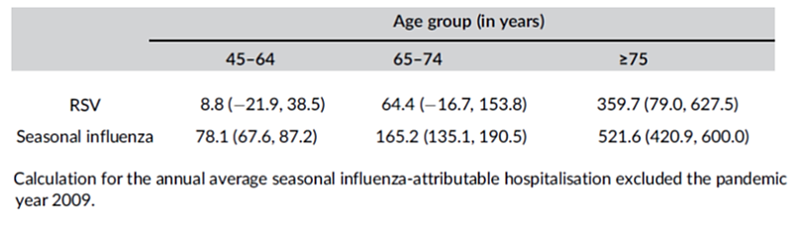

Current treatment options for RSV infection
There is currently no specific treatment for RSV infections in adults, treatment being supportive, and including treatment of complications (e.g., pneumonia). Vaccination to protect against RSV is likely to provide protection against severe disease, hospitalisation, and death in the populations most at risk. There is an evolving understanding of key aspects of vaccine associated protection, such as safety, efficacy, and the duration of protection from vaccination in high-risk groups.
The TGA has recently approved the registration of two protein subunit RSV vaccines for the prevention of lower respiratory tract disease (LRTD) in adults ≥ 60 years of age in Australia:
- Arexvy (Respiratory Syncytial Virus Vaccine, Adjuvanted; Glaxo-SmithKline Biologicals)
- Abrysvo (Respiratory Syncytial Virus Vaccine; Pfizer)

Regulatory status

Australian regulatory status
mRESVIA is considered a new biological entity for Australian regulatory purposes. This application was granted a priority designation in Australia by the TGA on 30 March 2023.

International regulatory status
The FDA approved mRESVIA on 31 May 2024 for the following indication:
mRESVIA is indicated for active immunization for the prevention of lower respiratory tract disease (LRTD) caused by respiratory syncytial virus (RSV) in individuals 60 years of age and older.
Similar applications have been approved in Canada (06 November 2024), the United Kingdom (27 February 2025) and the European Union (22 August 2024) and a decision is pending in Switzerland.

Registration timeline
Table 4 captures the key steps and dates for this submission. This application was granted a priority determination by the TGA on 30 March 2023.
This submission was evaluated under the priority registration process.
Table 4. Registration timeline for mRESVIA (submission no. PM-2023-02734-1-2) – Key Dates.
Priority review pathway
Description | Date
Priority Determination | 30 March 2023
Submission dossier accepted and first round evaluation commenced | 31 July 2023
First round evaluation completed | 1 November 2023
Sponsor provides responses on questions raised in first round evaluation | 1 December 2023
Second round evaluation completed | 2 January 2024
Delegate’s Overall benefit-risk assessment and request for Advisory Committee advice. | 3 January 2024
Advisory Committee meeting 1 | 31 January 2024
Delegate’s overall benefit-risk assessment - update | 8 April 2024
Advisory Committee meeting 2 | 1 May 2024
Initial registration decision (not approved) | 12 June 2024
Application for reconsideration of initial decision under Section 60 of the Therapeutic Goods Act 1989 | 5 August 2024
Decision following reconsideration of initial decision under Section 60 of the Therapeutic Goods Act 1989 | 3 October 2024
Remittal of submission back to the TGA for a fresh decision process | 3 October 2024
Final registration decision post Section 60 review (approved) | 28 March 2025

Evaluation overview
A summary of the TGA’s assessment for this submission is provided below.
Relevant guidelines or guidance documents referred to by the Delegate are listed below:
- Guideline on clinical evaluation of new vaccines. EMEA/CHMP/VWP/164653/2005
- Guideline on adjuvants in vaccines for human use. EMEA/CHMP/VEG/134716/2004
- Guideline on the clinical evaluation of medicinal products indicated for the prophylaxis or treatment of respiratory syncytial virus (RSV) disease. EMA/CHMP/257022/2017

Quality evaluation summary
The Sponsor used their mRNA-based platform (from the manufacture of COVID vaccines) to develop mRESVIA (mRNA-1345). The platform is based on the principle and observations that cells in vivo can take up mRNA, translate it, and then express protein viral antigen(s). mRESVIA is manufactured in a cell-free, in vitro transcription reaction. The proprietary LNPs encapsulating the mRNA optimise its delivery efficiency and protects the mRNA from rapid degradation in plasma and serum by nucleases. The LNP used in mRESVIA is the same as that used in the Sponsor’s approved SPIKEVAX COVID-19 vaccine.
The F protein exists in two primary conformational states: prefusion and postfusion; the prefusion state facilitates entry into the host cell through a conformational change to the postfusion state. The prefusion conformation displays all the epitopes known to elicit neutralising antibodies (nAb) and is the primary target of the nAb response following RSV infection.
The mRNA in mRESVIA is chemically similar to naturally occurring mammalian mRNA, except that the uridine nucleoside is completely replaced with N1-methyl-pseudouridine, a naturally occurring pyrimidine base present in mammalian transfer RNAs. N1-methyl-pseudouridine is included in the mRNA in place of the uridine base to minimise indiscriminate recognition of the mRNA by pathogen-associated molecular pattern receptors.
There were no significant issues identified to indicate the product should not be registered on the basis of quality, nor were any potential safety-related issues identified arising from the quality of the product. The Evaluator was satisfied that the Sponsor had fulfilled all requirements with respect to:
- GMP compliance
- stability and release specifications (which dictate the medicine’s physicochemical properties, biological activity, immunochemical properties, potency and purity)
- validation of analytical procedures
- appropriate choice of reference standards and reference materials
- consistency of medicine manufacture as demonstrated by appropriate in-process acceptance criteria and action limits; multiple batches that conformed to established specifications.
- medicine sterility
- appropriate/compatible container closure systems.
- labelling that conformed to relevant Therapeutic Goods Orders.
These requirements were met for drug precursors/intermediates, the drug substance and the drug product.
The quality information submitted by the Sponsor supported the registration of mRESVIA.

Nonclinical (toxicology) evaluation summary
The non-clinical Evaluator has stated that the Sponsor conducted adequate studies on the pharmacology and toxicity of the vaccine. The submitted pivotal toxicity studies were Good Laboratory Practice compliant. The composition of the nonclinical dossier submitted met regulatory guidelines for vaccines.
mRNA-1345 was immunogenic in mice and rats, inducing a dose-dependent increase in RSV neutralising and binding antibodies, a Th1 response, RSV-specific CD8+ T cells, and protection following RSV challenge. Induced immunogenic response between the liquid and lyophilized presentations of mRNA-1345 were comparable. mRNA-1345 induced a dose-dependent increase in RSV neutralising antibody, correlated with protection from RSV challenge in rats. mRNA-1345 did not enhance lung inflammation or induce a Th2-biased response after RSV viral challenge, even at dose levels inducing suboptimal immunity and breakthrough virus replication. No studies were submitted with neutralisation data against the RSV-B subtype. The Sponsor provided data from a mouse pharmacology study to demonstrate that RNA-100-AR02 produces a comparable immunogenic response to RNA-100-AR01. However, RNA-100-AR02 was not tested in the repeat-dose and reproductive and developmental toxicity studies.
There was no evidence of vaccine-enhanced respiratory disease (VA-ERD) with mRNA-1345 in the animal models. Induction of functional nAb and a balanced Th1-Th2 response was seen at immunogenic or subimmunogenic doses.
A GLP repeat dose toxicity study in rats with the mRNA-1345 vaccine (2 dosing occasions at a dose of 98 µg once every 3 weeks, which is 394 times the human dose on a µg/kg basis) showed immune response-related findings including injection site inflammation (swelling, oedema, erythema), limited use of hindlimb and/or hind-paw, enlargement and inflammation of draining lymph nodes, decreased cellularity of spleen and some perturbations of haematology, coagulation and clinical chemistry parameters. The study did not include a recovery phase. In another study with mRNA-1345 which was non-GLP, clinical examination showed recovery 6 days after dosing. The findings were similar to those in repeat dose toxicity studies with surrogate mRNA vaccines.
No genotoxicity studies were conducted for the vaccine, in line with relevant guidelines. The components of mRNA-1345 (mRNA and lipids) are not expected to be genotoxic.
A combined fertility and developmental toxicity study was conducted in female rats with mRNA-1345. Female rats were given a dose of 96 µg (>400 times the human dose on a µg/kg basis) 28 and 14 days prior to mating and on days 1 and 13 of gestation. No effects on fertility, fetal development, fetal malformations or variations or postnatal (pre-weaning) development were observed. Exposure of fetuses and pups to vaccine-specific antibodies was demonstrated in this study, with similar serum antibody titres in dams and pups. The effect on male fertility was not determined.
There was no dedicated local tolerance study with mRNA-1345. Local reactions observed in the repeat dose toxicity studies in rats with mRNA-1345 and surrogate mRNA vaccines formulated in LNPs are common findings for LNP-encapsulated mRNA vaccines.
The nonclinical Evaluator noted that the safety of mRNA-1345 with RNA-100-AR02 was not assessed in the submitted nonclinical toxicity studies and referred the matter to the clinical Delegate. The Delegate has taken this information into consideration in the clinical assessment (refer to the risk benefit assessment: additional data).

Clinical evaluation summary

Summary of clinical studies
The clinical dossier consisted of:
- Pivotal study P301: A phase 2/3 study involving 35,413 patients randomised 1:1 to single 50 μg mRNA-1345 dose or placebo which evaluated clinical safety and efficacy in the prevention of RSV disease in adults ≥60 years of age.
- Supportive study P101: A first-in-human Phase 1 study for dose and regimen selection for pivotal, Phase 2/3 study.
- Supportive study CRID-001: A phase 1 study to assess mRNA-1345-induced specific cellular immune responses in healthy adults.

Pharmacology
The mRNA-1345 vaccine is delivered via IM injection. The biodistribution of mRNA-based vaccines formulated in LNPs is consistent with administration of IM vaccines and distribution via the lymphatic system. mRNA does not persist past 1 to 3 days in tissues other than muscle (injection site), proximal popliteal and distal axillary lymph nodes, and the spleen, in which the average half-life values ranged from 14.9 to 63.0 hours in Sprague Dawley rats.
After delivery into cells, the mRNA utilises the cell’s translational machinery to produce the RSV F protein in the prefusion conformation, which after proper assembly and processing is trafficked to the cell membrane. mRNA-1345 stimulates innate and adaptive immune responses, resulting in secretion of antibodies that neutralize RSV-A and RSV-B subtypes and induction of RSV F-specific Th1-biased CD4+ T cells, as well as CD8+ T cells.

Pharmacodynamics
mRNA-1345 stimulates innate and adaptive immune responses, resulting in secretion of antibodies that neutralise RSV-A and RSV-B subtypes and induction of RSV F-specific Th1-biased CD4+ T cells, as well as CD8+ T cells (Study CRID-001). The delivered mRNA does not enter the cell nucleus or interact with the genome, is non-replicating, delivers only the genetic elements required for expression of the encoded protein, is expressed transiently, and does not persist in the body.

Dose finding study (P101)
Study P101 was a first in human Phase 1, randomised, observer-blind, placebo-controlled, dose escalation study to evaluate the safety, reactogenicity, and immunogenicity of mRNA-1345, in the following cohorts: healthy adults 18 to 49 Years, and aged 65 to 79 Years, Japanese older adults aged ≥60 years, women of child-bearing potential aged 18 to 40 years, Japanese adults aged ≥60 Years, and RSV-seropositive children aged 12 to 59 months.
As participants would have been previously exposed to RSV, a single IM dose was considered sufficient to boost natural immunity. However, the safety and immunogenicity of a 3-injection regime was also evaluated at 100 μg dose level in adults aged 18 to 49 years (cohort 3). Details of the study design are in Figure 1. Data from Cohorts 1 to 4, 7 to 11 and 15 were provided to the TGA in this submission.
Figure 1. P101 study schematic diagram with study cohorts, their regimen and the number of participants enrolled in each cohort (mRNA-1345 and placebo).
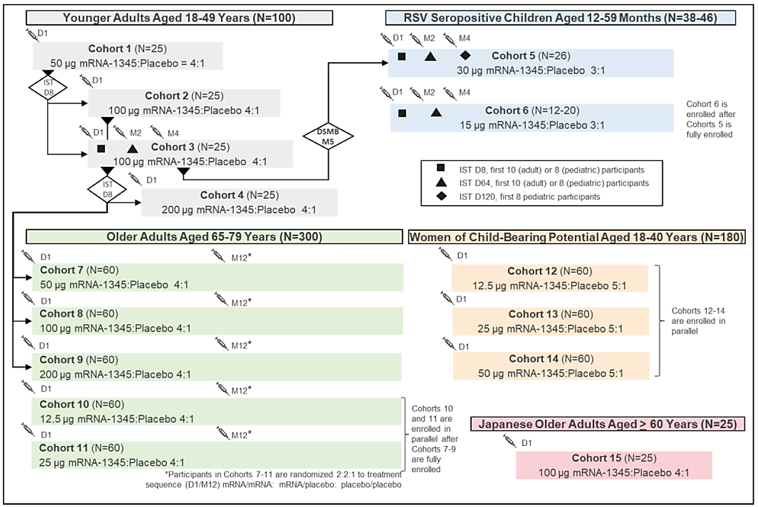
Abbreviations: D = Day; DSMB = Data Safety Monitoring Board; IST = Internal Safety Team; M = Month;

Results (data base lock 06 February 2023)
No data from women of child-bearing potential or children were included in this submission.

Immunogenicity
A single mRNA-1345 vaccination boosted RSV-A and RSV-B nAb titres and RSV PreF-bAb concentrations at all dose levels evaluated in the adult cohorts studied. At matched dose levels, the RSV nAb fold-rise from baseline was numerically higher in younger than older adults. A second and third mRNA-1345 vaccination (month 2 and 4) did not further boost RSV antibody levels compared to a single vaccination. RSV nAb titres after a single mRNA-1345 vaccination were maintained above baseline through 12 months. This study demonstrated that mRNA-1345 induced nAb responses against both RSV-A and RSV-B subtypes (1 month nAb GMFR relative to baseline was 12.03 for RSV-A and 8.96 for RSV-B in adults 65 to 79 years of age). A booster administered at 12 months resulted in RSV nAb titres similar to those after the first vaccination.

Safety
Injection with mRNA-1345 was well tolerated at all dose levels, and dose regimens studied. Local and systemic reactogenicity was lower among older adults compared with younger adults. The incidence and severity of adverse events was dose level dependent regardless of age group. Reactogenicity after a single dose was lower in the groups that received ≤50 μg mRNA-1345 compared to those receiving ≥100 μg mRNA-1345. Among participants who received a booster injection or a 3-injection regimen, reactogenicity after subsequent doses of mRNA-1345 did not differ appreciably from reactogenicity after the first injection; sample size in the single treatment group and the booster groups were small. There were no vaccine related SAEs, TEAEs leading to discontinuation of vaccine studies, TEAEs leading to discontinuation from study participation, or AESIs reported up to the end of study or data cut-off.

Conclusions
Data from study 101 supported the dose selection of a single injection of 50 μg mRNA-1345 for subsequent clinical development in adults, based on the favourable immune response, safety and tolerability profile observed. No concerning safety signals were identified.

Study CRID-001
This ongoing, open label, randomised, Phase 1b study in the US, aims to evaluate the safety, reactogenicity, and immunogenicity of modified mRNA vaccines in healthy adults (18 to 75 years old) to assess innate and adaptive immune responses of mRNA lipid nanoparticle vaccines encoding different viral antigens (SARS-CoV-2, RSV, CMV, multiple influenza hemagglutinin A and B strains).
From 61 participants who received a single injection of mRNA-1345 (50 μg), a randomised subset of 15 participants 50 to 75 years of age and 15 participants 18 to 49 years of age were selected.
At baseline, RSV F-specific interferon-γ (IFNγ)-producing T-cells were of low magnitude or below the lower limit of detection. RSV F-specific CD4+ and CD8+ IFNγ+ responses increased by 8 days after vaccination, peaked within 2 weeks, and remained above baseline at day 91, the last day evaluated (Figure 2).

Figure 2. Study CRID-001: Geometric Mean Frequency and 95% CI of RSV F-specific IFNγ+ CD4+ T Cells (A) and CD8+ T Cells (B) by Age Cohort.
A.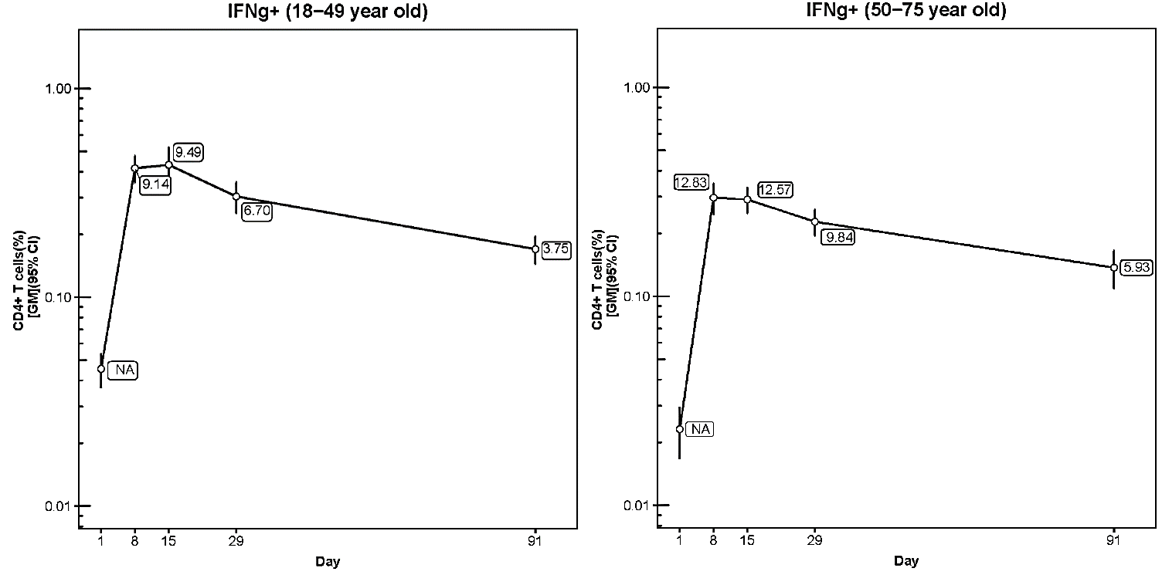
B.
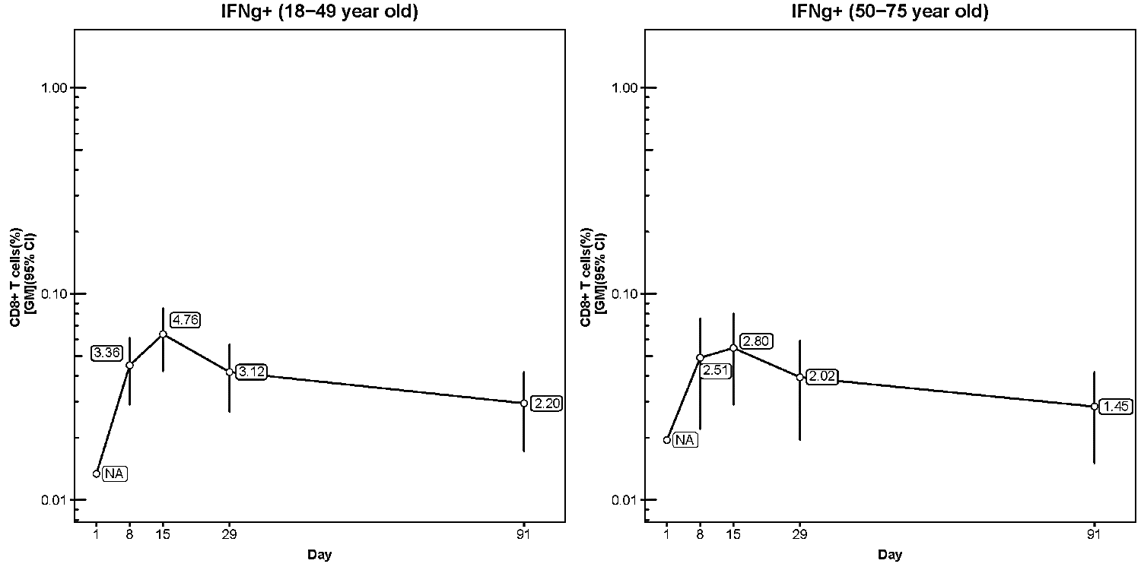
CD4 = cluster of differentiation 4; CD8 = cluster of differentiation 8; CI = confidence interval; CRID = clinical research for infectious diseases; F = fusion; GM = geometric mean; GMFR = geometric mean fold rise; IFNγ=interferon gamma; RSV = respiratory syncytial virus. Values in the figures represent the GMFR from baseline. Error bars are 95% CI.
The peak frequency of elicited RSV F-specific T-cells was higher for CD4+ T cells (GM: 0.29%; 95% CI: 0.22%, 0.39%) than for CD8+ T cells at Day 15 (GM: 0.06%; 95% CI: 0.02%, 0.15%). RSV F-specific CD4+ T cells were skewed toward production of Th1 cytokines (IFNγ, IL-2, TNFα), with IFNγ as the predominant cytokine expressed.
This study reinforced selection of the 50 μg mRNA-1345 dose, demonstrating that this dose elicited RSV F-specific CD4+ and CD8+ T cells expressing a predominance of Th1 cytokines. This study provides preliminary evidence to support the potential contribution of vaccine-elicited
T cell responses to the clinical efficacy of mRNA-1345 vaccination in adults.

Efficacy

Pivotal study P301 (mRNA-1345-P301)
This global phase 2/3, randomised, observer-blind, placebo-controlled study evaluated the safety and efficacy of mRNA-1345, for RSV infection (Figure 3). Participants were ≥ 60 years of age, with/without underlying medical conditions with 1:1 randomisation. The primary objectives were to assess the reactogenicity, safety, and efficacy of mRNA-1345 in the prevention of RSV- LRTD.
The phase 2 segment commenced on 17 Nov 2021. An Independent Data Safety Monitoring Board (DSMB) reviewed Day 29 safety data from over 400 Phase 2 participants and supported advancement to full Phase 3 enrolment. Given participants in Phase 2 and Phase 3 segments were randomised and followed in the same way (phase 2 had an additional day 15 blood collection), a single dataset for both segments was utilised.
Participants were screened (up to 14 days); were given a single injection (Day 1) and followed for 24 months. Participants received 50 μg of mRNA-1345 or placebo. Stratification occurred based on age (60 to 74, ≥75 years) and presence/absence of congestive heart failure (CHF) and/or chronic obstructive pulmonary disease (COPD). There was a target of 30% of participants aged 70-79 and 10% of participants ≥80 years of age.
Figure 3. Study P301 design
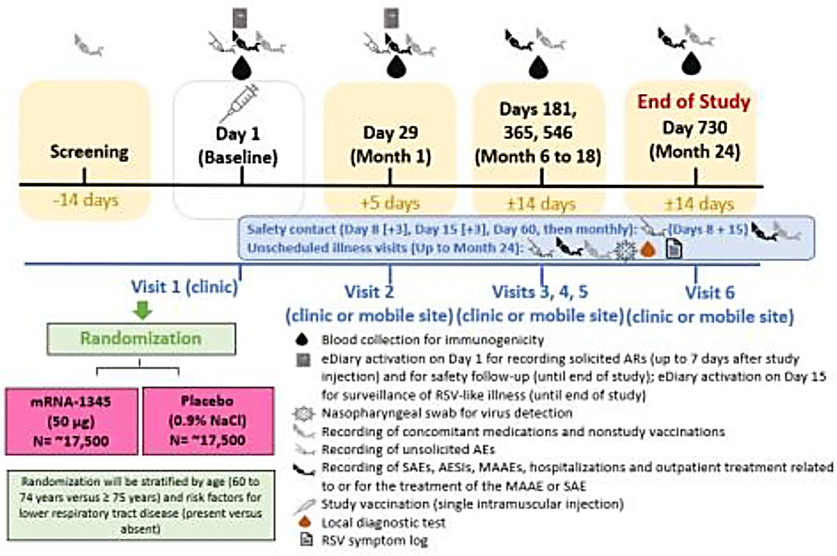
Abbreviations: AE = adverse event; AESI = adverse event of special interest; AR = adverse reaction; MAAE = medically attended adverse event; NaCl = sodium chloride (normal saline); RSV = respiratory syncytial virus.
Participants were permitted to have ≥ chronic medical diagnoses if they were considered stable. The study was designed to target a total of 86 evaluable RSV-LTRD cases with ≥2 symptoms and 32 cases with ≥3 symptoms (Table 5: case definition). It was estimated that up to 37,000 participants would be required to reach these targets. The study objects/endpoints are summarised in Table 6.
Table 5. Case Definition: RSV-lower respiratory tract disease (LRTD)/ acute respiratory disease (ARD)
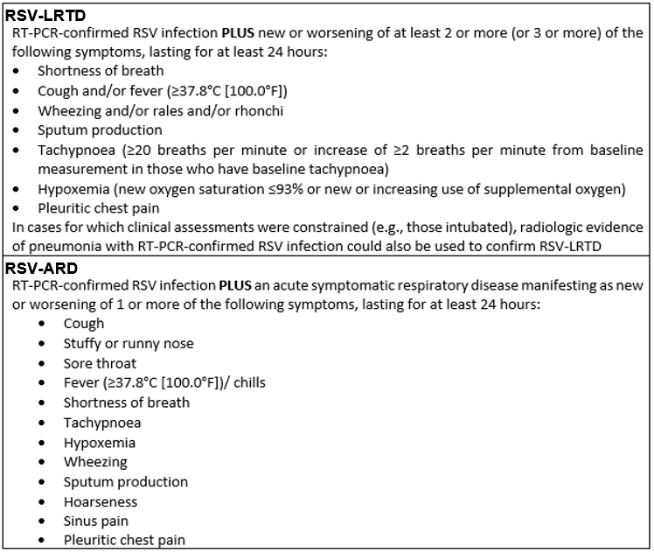
Table 6. Primary and Secondary Objectives and Endpoints for pivotal study P301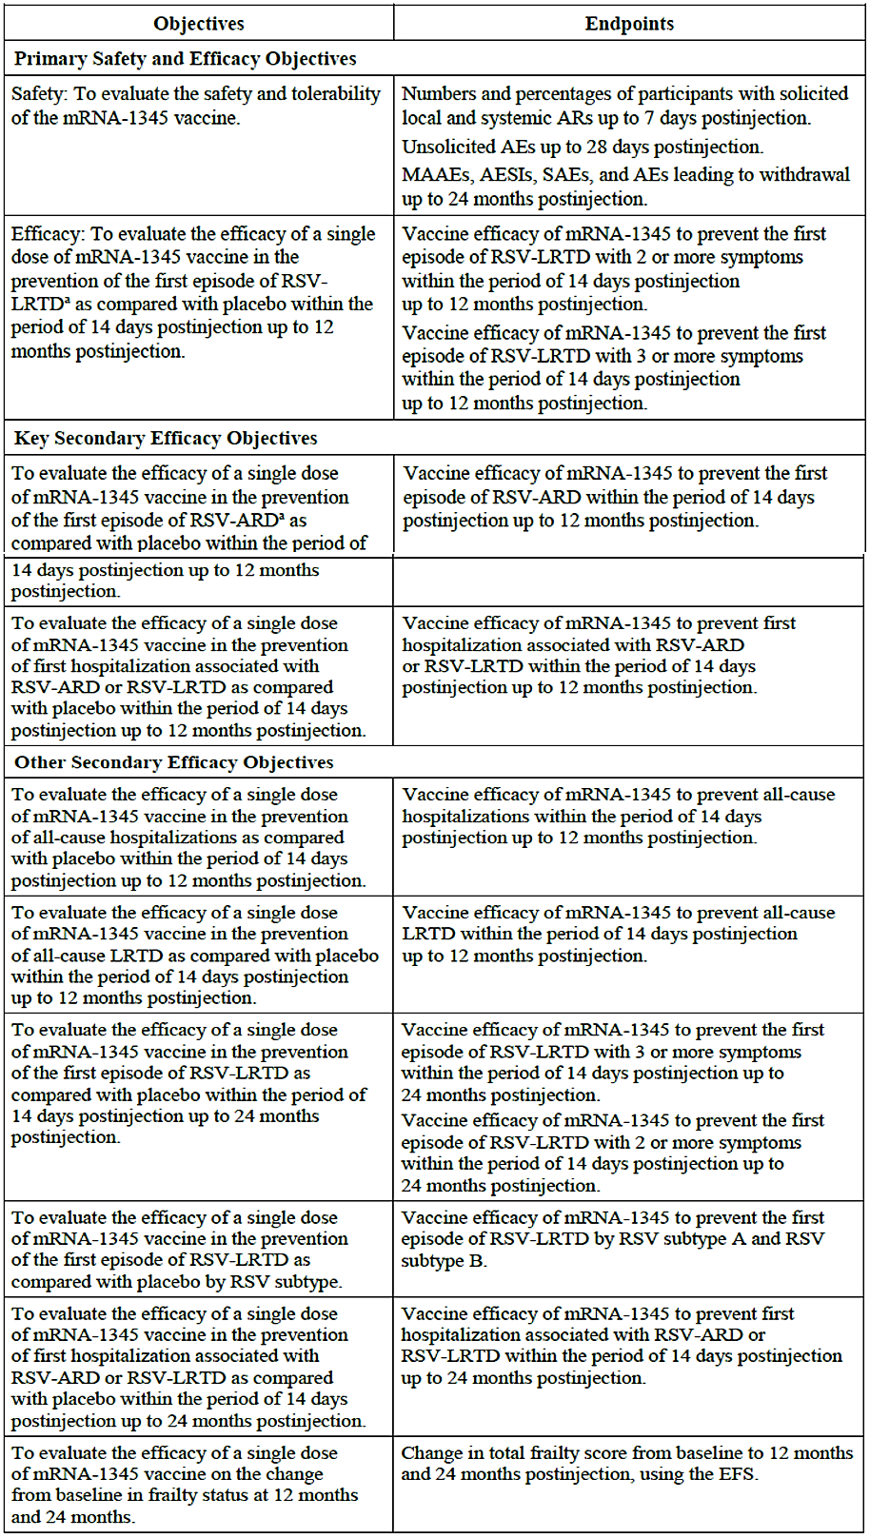
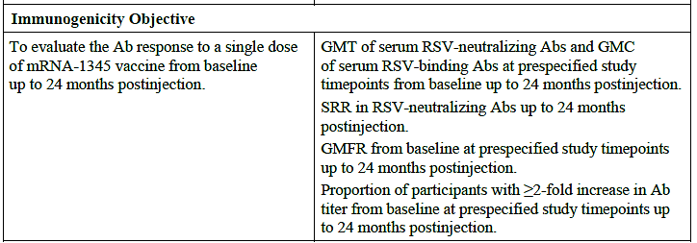
The primary endpoints were vaccine efficacy (VE) to prevent first episode of RSV-LRTD with ≥ 2 or ≥ 3 symptoms (from 14 days to 12 months) post injection. A sequential/hierarchical testing strategy was used to test the 2 primary efficacy endpoints and the key secondary efficacy endpoint of RSV-ARD.
The primary and secondary efficacy endpoints (Table 6) comply with TGA-adopted guidelines and are similar to those used for the recently approved (by US-FDA) RSV vaccines (ABRYSVO and AREXVY). Although primary/secondary endpoints assessed VE against the first episode of RSV-associated respiratory disease starting 14 days and occurring up to 12 months post-injection (the first RSV season), blinded surveillance will continue to 24 months, (i.e., over two RSV seasons).
Immunogenicity data and results of secondary objectives (other than VE against RSV-ARD, hospitalisation and against RSV by subtype) were not provided in the current submission.

Results (data cut of 30 November 2022)
Of 35,541 participants randomised almost all [n=35413; 17,734 (mRNA-1345), 17679 (placebo)] received their allocated vaccination. Most participants were in the US (54.9%) and South America (26.5%). At the DCO, 421 participants (2.4%) in the mRNA-1345 and 450 (2.5%) in the placebo group had discontinued, most due to withdrawal of consent or loss to follow-up.
Baseline demographics and baseline characteristics were similar between groups. (Table 7) The median age was 67.0 years and included 30.9% aged 70 to 79 years and 5.6% ≥80 years old with similar numbers of males and females. Most (63.4 %) were White, (12.3% Black; 8.7% Asian). Almost 30% had at least one comorbidity of interest although only 7% had CHF and/or COPD (associated with higher risk of RSV-LRTD), and 16.2% had high vulnerability and 5.7% were frail based on Edmonton Frail scores (Table 7). Baseline demographics and characteristics of participants in the per-protocol efficacy (PPE) Set (n=35,088) were comparable to those of participants in the safety set.
Table 7: Study P301: Baseline Demographics and Characteristics (Safety Set)
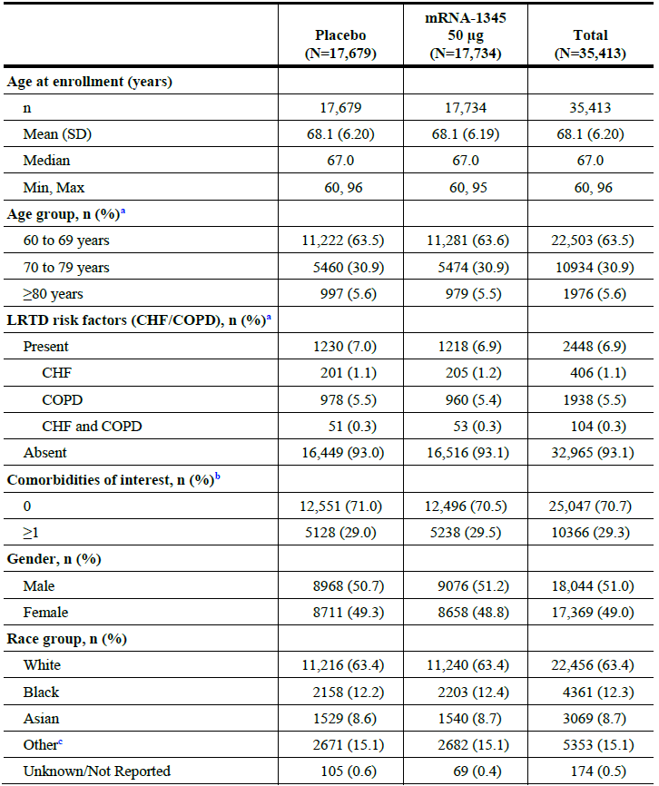
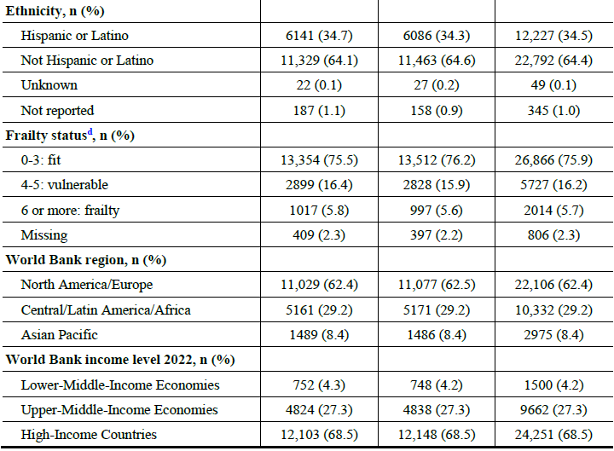
Abbreviations: CHF=congestive heart failure; COPD=chronic obstructive pulmonary disease; eCRFs=electronic case report forms; LRTD=lower respiratory tract disease; SD=standard deviation. Baseline value Edmonton Frail Scale total score is defined as the most recent non-missing measurement collected on or before the date of IP injection. a Derived from age and risk collected on eCRFs. b Comorbidities of interest included COPD, asthma, chronic respiratory disease, diabetes, CHF, advanced liver disease, and advanced renal disease. c Included American Indian or Alaska Native, Native Hawaiian/other Pacific Islander, Other, Multiple. d Frailty assessed by Edmonton Frail Scale.
From 35,413 participants (Safety Set: 17,734 in mRNA-1345; 17,679 in placebo), 96.2% had ≥42 days, 20.4% had ≥6 months, 5.9% had ≥9 months, and 0.2% had ≥12 months of follow-up after injection; with a median duration of 112.0 days (range: 1 to 379).
At the first interim analysis (>50% of cases accrued); the prespecified success criteria were met for both primary endpoints. The study remains blinded and ongoing; with planned follow-up for 24 months.

Primary efficacy
The VE of mRNA-1345 against RSV-LRTD with ≥2 symptoms was 83.7% (Table 8), with 9 cases in the mRNA-1345 and 55 cases in the placebo group.
The VE of mRNA-1345 against RSV-LRTD with ≥3 symptoms was 82.4% (Table 8), with 3 cases in the mRNA-1345 and 17 cases in the placebo group.

Table 8. Study P301: Vaccine Efficacy of mRNA-1345 to Prevent First Episode of RSV-LRTD (≥ 2,3 symptoms) or RSV-ARD (14 Days up to 12 Months Post injection (Per-Protocol Efficacy Set).
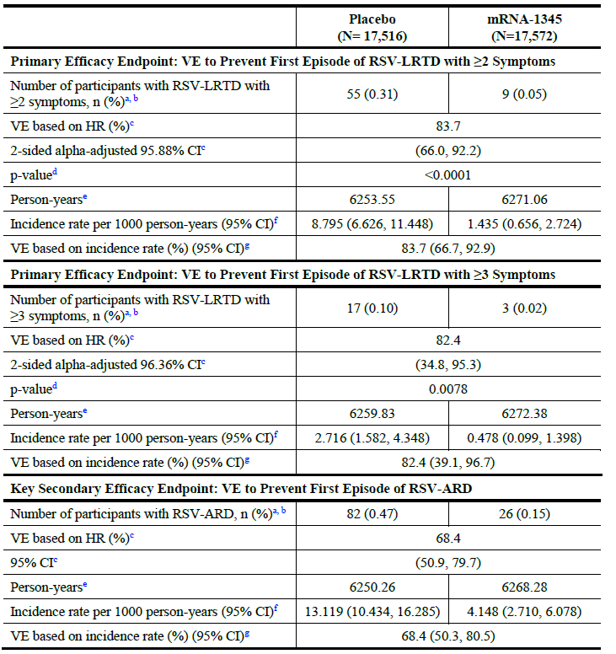
CI=confidence interval; HR=hazard ratio; RSV-LRTD=respiratory syncytial virus-associated lower respiratory tract disease; RSV-ARD=respiratory syncytial virus-acute respiratory disease, RT-PCR=reverse transcriptase polymerase chain reaction; VE=vaccine efficacy.
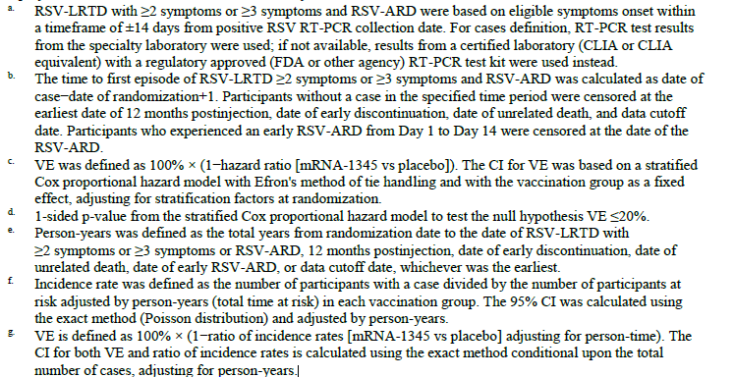
Most cases of RSV-LRTD occurred 1-6 months after injection with a steady increase in cumulative incidence rate for the placebo group while the cumulative incidence rate for the mRNA-1345 group remained low and stable (Figure 4).

Figure 4. Cumulative Incidence Curves for First Episode of RSV-LRTD (≥2 or ≥3 Symptoms) and RSV-ARD Between 14 Days and 12 Months Post injection (Per-Protocol Efficacy Set)
RSV-LRTD with ≥2 Symptoms
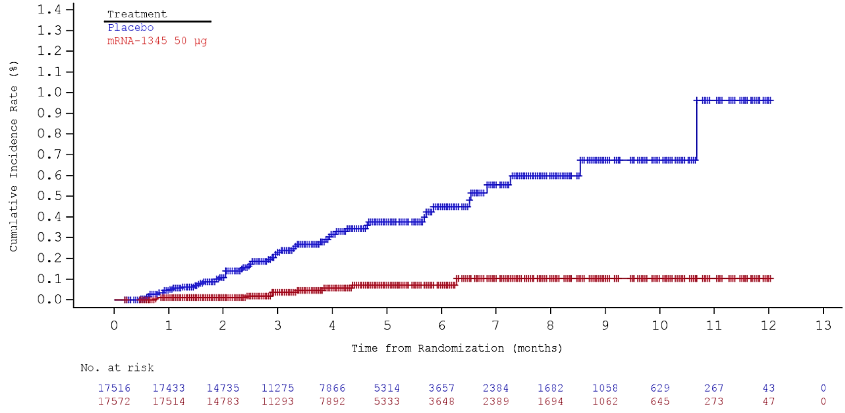
RSV-LRTD with ≥3 Symptoms
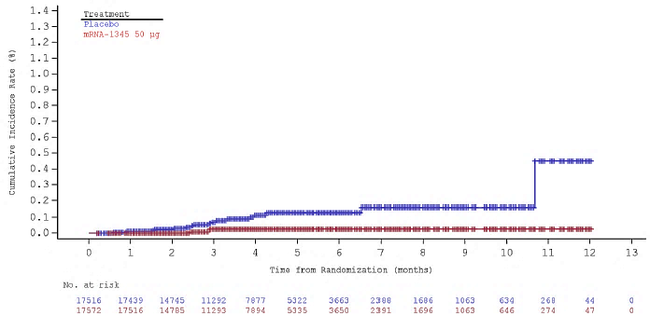
RSV-ARD
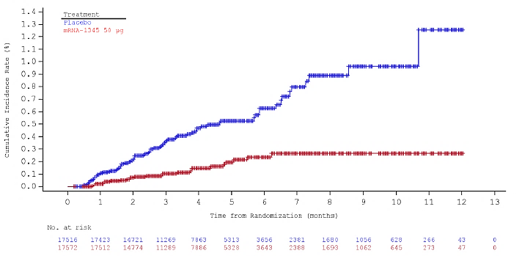
The VE of mRNA-1345 against RSV-LRTD with ≥2 symptoms in subgroups (age, sex, race, ethnicity, region, pre-specified comorbidities, other risk factors) was mostly consistent with VE of the overall primary efficacy set, although was limited by small case numbers in some groups (with wide 95% CIs). VE by subgroups of increasing age comorbidity, and region show robust VE point estimates and LB of the 95% CI>20%. Whilst similar results were observed for the subgroup analyses in those with ≥3 symptoms, interpretation was limited by fewer RSV-LRTD cases in these groups.
The VE point estimate to prevent RSV-LRTD was much lower in subgroup with CHF/COPD 49.4% compared to those without these risk factors 85.0%. However, this analysis is limited by the small number of participants with these conditions (6.9%) and low number of cases (n=3) in this subgroup.
There was a higher VE (95.4%) in the 70-79 age group, compared to the 60-69 group (76%). VE in those aged > 80 years (5.6% of total) could not be evaluated as no cases of RSV-LRTD occurred in this group.

Secondary outcomes
RSV-ARD required ≥1 prespecified symptom (Table 5) representing all RSV (including mild) disease.
The VE of mRNA-1345 against RSV-ARD was 68.4% (Table 8), with 26 cases in the mRNA-1345 and 82 cases in the placebo group.
Most cases of RSV-ARD occurred 1-6 months after injection; separation of cumulative incidence of RSV-ARD was observed early and maintained through 12 months post-injection (Figure 3) The VE of mRNA-1345 against RSV-ARD in subgroups analyses was consistent with the overall set.
As of the data cut-off date, one hospitalised case of RSV-LRTD was reported (placebo participant)

Efficacy endpoints by RSV subtype
There were 64 (RSV-A: n=39, RSV-B: n= 25) and 20 (RSV-A: n=11, RSV-B: n=9) cases of RSV-LRTD with ≥2 and ≥3 symptoms respectively.
VE for disease caused by RSV-A for those ≥ 2 symptoms was 91.7% (95% CI: 73.0%, 97.4%) and for ≥ 3 symptoms was 90.0% (95% CI: 22.0%, 98.7%).
For RSV-B the VE was 68.5% (95% CI: 21.1%, 87.4%) and 71.5% (95% CI: -37.0%, 94.1%).
The LB of the 95% CI of the VE for both RSV subtypes exceeded 20% for RSV A and RSV B (≥ 2 symptoms). In cases of RSV B with ≥ 3 symptoms, there was a wide CI that crossed zero.
VE of mRNA-1345 against RSV-ARD was 78.5% (95% CI: 58.8%, 88.8%) for RSV-A and 51.7% (95% CI: 10.6%, 73.9%) for RSV-B. The LB of the 95% CI of the VE point estimate was >20% for RSV-A.

Conclusions
Results for the primary efficacy endpoints demonstrated the efficacy of a single dose of mRNA-1345 (50 µg) in preventing RSV-LRTD (with ≥2, ≥3 symptoms) in adults ≥60 years of age. Most cases of RSV-LRTD occurred 1-6 months after injection with a progressive increase in cumulative incidence rate for the placebo group and a low and stable rate for the mRNA-1345 group. There is currently a lack of adequate data on long-term efficacy beyond 12 months, with only 63 participants (34 and 29 in mRNA-1345 and placebo groups, respectively) having completed > 12 months of follow-up.
The VE of mRNA-1345 against RSV-LRTD in subgroups of participants based on age, sex, race, ethnicity, region, pre-specified comorbid conditions was generally consistent with VE of the overall primary efficacy set. Interpretation was limited by small case numbers in some subgroups (with wide 95% CIs).

Safety
There were 18,073 individuals who have received at least one injection of mRNA-1345 at any dose; of these 17,781 participants ≥60 years of age were administered at least 1 dose of 50 μg mRNA-1345 (Table 9) in Study P301 (n=17,734) and Study P101 (n=47).
Key safety data collected were solicited adverse reactions, unsolicited adverse events (AEs), serious AE (SAE), medically attended AEs (MAAE), AE of special interest (AESI), and AEs leading to study discontinuation as reported by study investigators. In addition, further analysis of TEAEs of clinical interest was performed using programmed Standardized MedDRA Query (SMQs). The SMQs were selected to facilitate assessment of potential risks of mRNA-1345 use based on risks observed with other vaccines.
Table 9. Summary of Exposure to mRNA-1345 50 μg or Placebo (Safety Set)
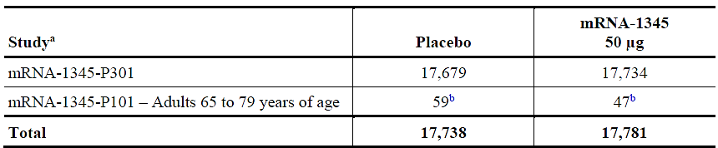
IP=investigational product a. Numbers are participants in the Safety Set and includes all randomized participants who received any study injection. b. Of these, 18 mRNA-1345 participants and 52 placebo participants received a booster injection with the same IP at month 12.
Among 35,413 participants in study P301, 35,233 (99.5%) had ≥28 days, 34,082 (96.2%) had ≥42 days, 29,705 (83.9%) had ≥60 days, 7216 (20.4%) had ≥6 months, 2098 (5.9%) had ≥9 months, and 64 (0.2%) had ≥12 months of follow-up. The median duration of follow-up was 112.0 days (range: 1 to 379 days).
In Study P101 among the 47 participants 65 to 79 years who received the first injection of 50 μg mRNA-1345, the median duration of follow-up (end of study or booster) was 364.0 days (range: 86 to 389 days) with 87.2% ≥6 months and 36.2% ≥12 months of safety follow-up. Placebo data were similar.

Adverse events
Solicited adverse events– study P301 (Figure 5)
Local AEs
- Incidence higher in the mRNA-1345 compared to placebo group (58.7% vs 16.2%) with injection site pain reported most frequently (56.3% vs 13.7%).
- Most were Grade 1; with low incidence of Grade 3 AEs (3.2% vs 1.7%) and no Grade 4 events.
Systemic AEs
- Higher in the mRNA-1345 compared to placebo group (47.7% vs 32.9%); most common: fatigue (31% vs 20%), headache (27% vs 18.9%), myalgia (25.9% vs 14.4%), arthralgia (21.9% vs 14.1%).
- Most were Grade 1; with low incidence Grade 3 or higher (4.0% vs 2.9%)
- Fever (oral temperature >40.0°C/>104.0°F) was the only Grade 4 AE (0.2% in each group).
Figure 5. Study P301: Percentages of Participants with Solicited Local (a) and systemic (b) Adverse Reactions Reported within 7 Days after Injection (Solicited Safety Set)
- Local Adverse Events
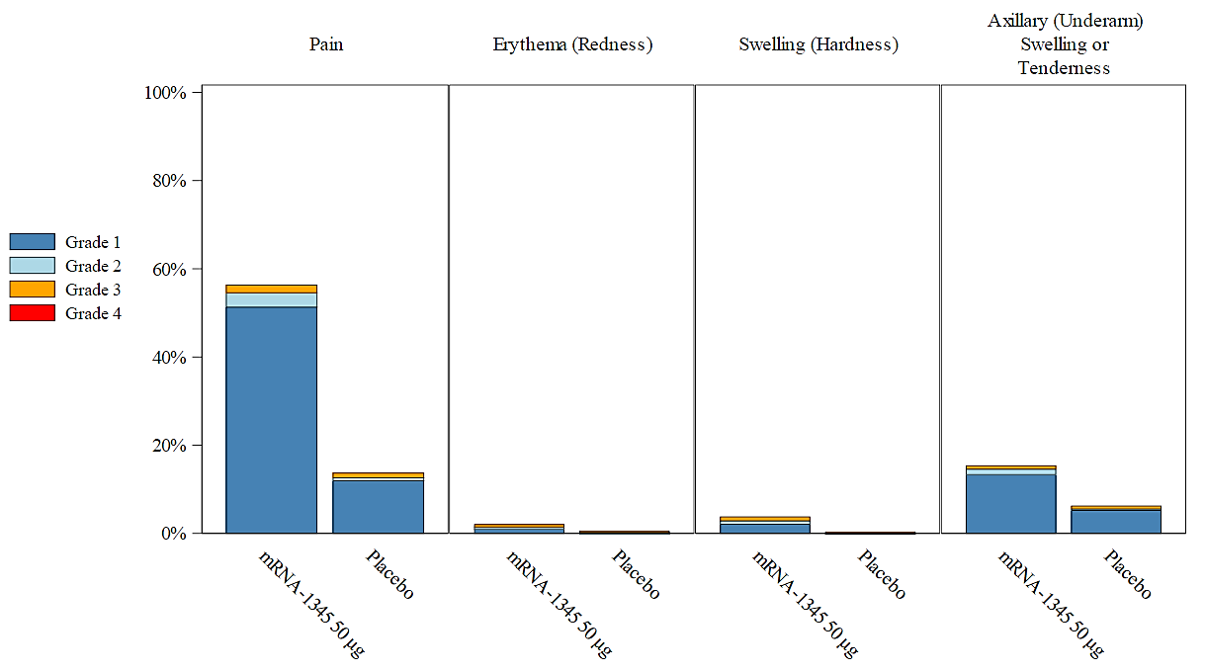

- Systemic Adverse Reactions
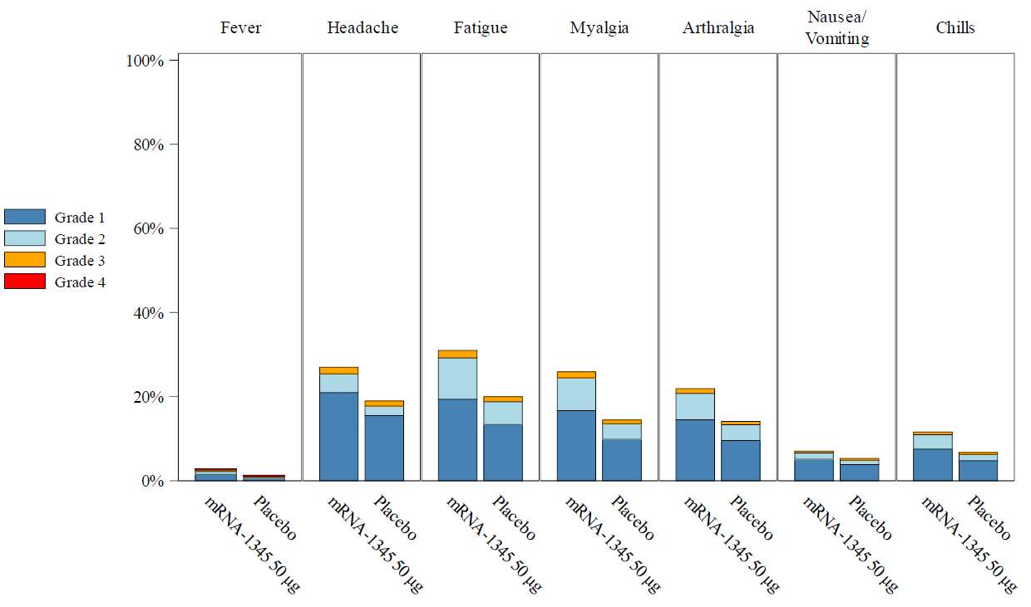

The incidence of solicited ARs with onset within 60 minutes after injection was similar in the mRNA-1345 and placebo groups (6.7% vs 6.6%). Onset of most solicited local and systemic ARs was within 1 to 2 days after injection and most resolved within 1 to 2 days after onset.

Unsolicited adverse events – study P301
The incidence of unsolicited TEAEs within 7 days were 9.6% in the mRNA-1345 and 7.9% in the placebo groups.
- Most TEAEs within 7 and 28 days after injection were associated with reactogenicity or were common infections and were mild/moderate in severity.
- General disorders and administration site conditions (mRNA-1345 vs placebo: 3.8% vs 2.7%), at 7 days and 4.5% vs 3.4% at 28 days.
- Musculoskeletal and connective tissue disorders (2.9% vs 2.6%), and 4.1% vs 4.0%, at 7 days and 28 days respectively.
- Infections and infestations (1.6% vs 1.5%) at 7 days and 7.6% vs 7.2% at day 28.,
- Nervous system disorders: 1.6% vs 1.3% and 2.3% vs 2.0% at 7 days and 28 days respectively.
Up to the data cut-off date (30 Nov 2022) the incidence of SAEs, fatal events, MAAEs, AESIs, and TEAEs leading to study discontinuation, were similar between the groups. (Table 10)
Table 10: Study P301: Unsolicited Adverse Events, Up to Data Cutoff (Safety Set)
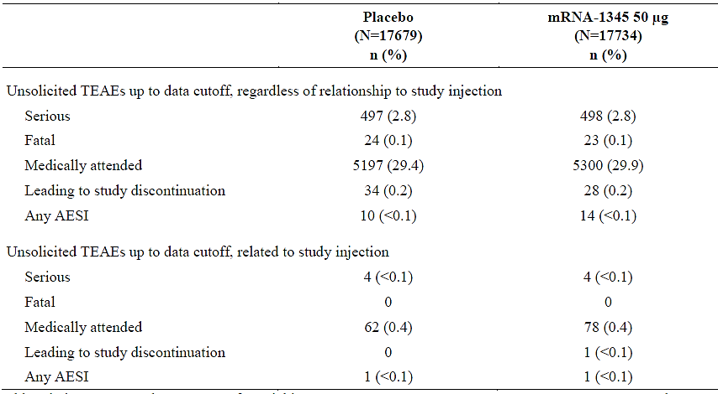
AESI=adverse event of special interest; ER=emergency room; TEAE=treatment-emergent adverse event (event not present before exposure to study injection or that worsened in intensity or frequency after exposure). Medically attended TEAEs included ER/urgent care, outpatient physician visits, and per-protocol illness visits. Percentages were based on the number of participants in the Safety Set

Serious adverse events – study P301
Up to data cut-off (cumulative), SAEs regardless of causality were reported for 2.8% in each group. The types and incidence of SAEs were similar between groups; most commonly in the infections and infestations SOC (0.6% in each group). The only SAE reported in ≥0.1% of participants in either group was pneumonia, 0.1% in each group. No participant with an SAE of pneumonia tested positive for RSV. A total of 4 participants (<0.1%) in each group had SAEs up to data cut-off that were considered related to study injection by the investigator.

Adverse events of special interest up to data cut-off – study P301
AESIs were defined as unsolicited TEAEs that were considered by the investigator to represent protocol-defined medical concepts including thrombocytopenia, new onset or worsening neurologic diseases (Bell’s palsy/facial paralysis, GBS, ADEM, and seizures), anaphylaxis, and myocarditis/pericarditis.
The incidence of investigator assessed AESIs was low (<0.1%) in both groups. (Table 11) No safety concerns or other trends were identified based on review of all investigator-assessed AESIs and additional medical concepts by narrow and/or narrow/broad SMQ analyses.
No Guillain-Barré syndrome (GBS) or acute disseminated encephalomyelitis (ADEM) were reported.
Table 11. Study P301: Incidence of TEAEs of Special Interest as Assessed by Investigator (Safety Set)
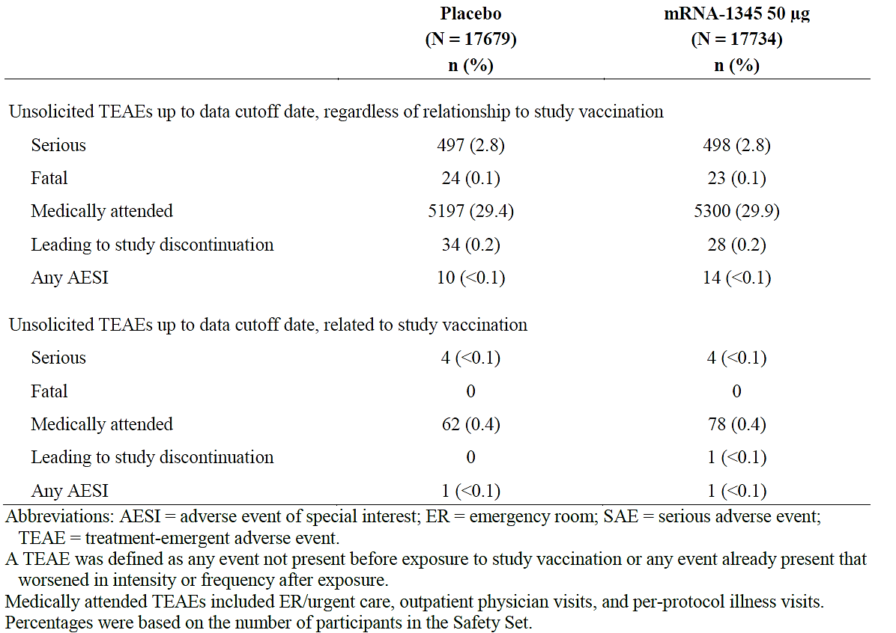

Deaths – study 301
Up to data cut-off, fatal TEAEs were reported for 23 participants in the mRNA-1345 group versus 24 participants (0.1%) in the placebo group. None of the fatal events were considered related to study injection by the investigator.
- Six participants in each group died due to events in the infections and infestations SOC and 5 participants in each group died due to events in the cardiac disorders SOC.
- Incidence of deaths of broadly defined respiratory causes including pneumonia, sepsis, respiratory failure, pulmonary haemorrhage, aspiration, COPD exacerbation, and pulmonary tuberculosis occurred in 9 participants in the mRNA-1345 group and 7 in the placebo group.

Drug-drug/vaccination reactions
No interaction studies have been performed. There is no data on effects of the proposed mRNA-1345 on laboratory tests. The concomitant administration with other vaccines has not been evaluated.

Adverse events – study P101
- Local ARs were present in 61.7% in the 50 μg mRNA-1345 and 12.7% in the placebo group; the most common being injection site pain. All were grade 1 or 2.
- Systemic ARs: 53.2% in 50 μg mRNA-1345 group and 45.5% of the placebo, most commonly headache, fatigue, myalgia, and arthralgia. There were low numbers of Grade 3 events: 10.6% in 50 μg mRNA-1345 group and 1.8% in the placebo group. No Grade 4 events were present.
- The incidence of solicited local and systemic ARs after one injection of mRNA-1345 was dose-dependent: lower in the 12.5 μg, 25 μg, and 50 μg groups than in the 100 μg and 200 μg groups.
- There were no vaccine related SAEs, TEAEs leading to discontinuation of study vaccine, TEAEs leading to discontinuation from study participation, or AESIs reported up to the end of study or data cut-off.

Safety conclusions
Most adverse events were related to reactogenicity, and were mild in severity, and as expected were more common in the mRNA-1345 compared to placebo group. There was a low incidence of SAEs, AESI and deaths with none thought by the investigators to be related to the study injection. There is a lack of adequate data on long-term efficacy/safety beyond 12 months.

Risk management plan evaluation summary
Moderna Australia Pty Ltd has submitted EU-RMP version 0.1 (date 16 June 2023; DLP 30 November 2022) and ASA version 1.0 (date 20 June 2023) in support of this application.
The summary of safety concerns and their associated risk monitoring and mitigation strategies are summarised in Table 12.
Table 12: Summary of safety concerns
Summary of safety concerns |  | Pharmacovigilance |  | Risk Minimisation
 |  | Routine | Additional | Routine | Additional
Important identified risks | None | – | – | – | –
Important potential risks | Anaphylaxis | * | †‡ |  | –
Important potential risks | Myocarditis/pericarditis | * | †‡ | – | –
Missing information | Interaction with other vaccines |  | †‡ |  | –
Missing information | Use in immunocompromised individuals |  | †‡ |  | –
Missing information | Use in individuals with autoimmune or inflammatory disorders |  | †‡ | – | –
Missing information | Long-term safety |  | †‡ | – | –
* Targeted Follow-Up Questionnaires, † Clinical Trial, ‡ Post Authorisation Safety Study
The Sponsor has proposed routine pharmacovigilance for all safety concerns which also includes specific adverse reaction follow-up questionnaires for the important potential risks of ‘anaphylaxis’ and ‘myocarditis/pericarditis’. Additional pharmacovigilance activities have been proposed to address all safety concerns in the form of clinical trials (mRNA-1345-P101, mRNA-1345-P301, mRNA-1345-P302 and mRNA-1345-P303) and post authorisation safety studies (mRNA-1345-P902 and/or mRNA-1345-P903).
The summary of safety concerns and pharmacovigilance plan is acceptable from an RMP perspective. The Delegate agrees. The RMP Evaluator has also recommended that “New onset or worsening of neurological disease” will be reported in the PSUR and is to be a condition of registration. as they are considered adverse events of special interest (AESI). The Delegate agrees.

Risk-benefit analysis
Respiratory syncytial virus (RSV) causes respiratory tract infections in individuals of all age groups. The severity of RSV disease increases with age and comorbidities and is an important cause of acute respiratory infection, lower respiratory tract disease, clinical complications, and death in older adults. There is currently no specific treatment for RSV infection in older adults. Thus, treatment for RSV-associated illness in adults is supportive.
Vaccines to protect against RSV are likely to be important for the elderly Australian population in reducing the risks posed by RSV infection in this population. Several vaccine candidates are being tested in ongoing clinical trials.

Vaccine efficacy
The efficacy of mRNA-1345 was evaluated in one large randomised, placebo controlled pivotal study involving 35,541 adults ≥60 years of age in 22 countries. Vaccine efficacy of a single dose of mRNA-1345 (50 μg) was 83.7% (95.88% CI: 66.0%, 92.2%) against RSV-LRTD with ≥2 symptoms, 82.4% (96.36% CI: 34.8%, 95.3%) against RSV-LRTD with ≥3 symptom and 68.4% (95% CI: 50.9%, 79.7%) against RSV-ARD VE point estimates by subgroups (age, sex, race, comorbidities, frailty) were largely similar to the VE point estimates for the overall population. For some subgroups, RSV case numbers permitted assessment of point estimate and CI; however, for others, small total RSV case numbers led to wide CIs. VE results for the RSV-A subtype tended to be higher than for RSV-B, although the prespecified success criteria for efficacy was generally met for both subtypes.
Whilst almost all participants (96%) had ≥ 42 days of follow up, the median follow up duration was 112 days (range: 15 to 379 days), and only 1/5 of participants have been followed for ≥ 6 months following vaccination. This study is ongoing, with a planned follow up of 24 months post-vaccination.

Immunogenicity
In study P101, a single mRNA-1345 vaccination boosted RSV-A and RSV-B nAb titres and RSV PreF-bAb concentrations at all dose levels evaluated and were maintained above baseline through 12 months. Immunogenicity results from study P301 are pending.

Safety
The mRNA-1345 vaccine administered as a single 50 μg dose was generally well tolerated as shown by solicited ARs and had an acceptable safety profile based on unsolicited TEAEs in the target population of adults ≥60 years in the P301 and P101 studies.
Solicited local and systemic ARs were reported more commonly in the mRNA-1345 group (58.7%, 47.7%) compared to the placebo group (16.2%, 32.9%). The most commonly reported local AR was injection site pain, and the most common systemic reactions were fatigue, headache, myalgia, and arthralgia. Most were mild, had an onset within 2 days of vaccination and resolved quickly.
The incidence of SAEs, AEs leading to discontinuation, AESIs and deaths up to data cut-off was low and were balanced between the groups in Study P301. No safety concerns were identified based on AESI reporting and SMQ analyses for specified events that have been identified to be of potential concern for vaccines in general or for mRNA vaccines, including anaphylaxis, myocarditis/pericarditis, Bell’s palsy/facial paralysis, GBS, ADEM, seizures, thrombocytopenia, autoimmune disorders, cardiac arrhythmias, demyelinating disorders, and peripheral neuropathy.

Overall data limitations
Study P301 is an ongoing study, with limited duration of follow up at this time. Only approximately 1/5 of participants have been followed for ≥ 6 months. There is currently a lack of adequate data on long-term efficacy and safety for the mRNA-1345 vaccination.
Whilst the study design attempted to ensure adequate representation to enable evaluation of VE in those at higher risk of developing RSV-LRTD, and included 30% with ≥ one comorbidity of interest, only 7% had CHF and/or COPD, only 5.6% were ≥ 80 years age and approximately 1/5 had high vulnerability or frailty. Thus, evaluation for some subgroups is limited by the smaller number of cases in some subgroups. Possible skewing of the study population towards healthier older adults rather than those most at risk of RSV-LRTD/ARD and thus most likely to benefit from the vaccine may impact on the generalisability of these results to older, sicker, and frailer populations.
There is no data for use in people who are immunocompromised or who have an immune-mediated disease, or an inflammatory disorder; these people were excluded from study P301.
The potential need and efficacy/safety of booster doses to maintain protection in the target patient populations has not been evaluated. To date, participants have only been exposed to RSV during their first season following vaccination. Immunogenicity results from study P101 had indicated that antibodies decrease over time although effect of this on VE was not evaluated in the study. Furthermore, immunogenicity data from the pivotal study were not submitted in current dossier.
There is a lack of data regarding safety/efficacy of proposed mRNA-1345 vaccine when co-administered with other vaccines (such as influenza, COVID-19).

Future data expectations and pending clinical studies.
Study P301: Further data including 24 month follow up data, immunogenicity data and safety.
Study P101: Data from cohorts in women of childbearing potential and in children 12 to 59 months of age with RSV seropositivity.
The Sponsor has also indicated the following studies are occurring as part of the clinical development plan for mRNA-1345:
- mRNA-1345-P302 is an ongoing Phase 3 randomized, observer-blind study designed to assess the safety, tolerability, and immunogenicity of mRNA-1345 when given alone or co administered with licensed influenza or SARS-CoV-2 vaccines in adults ≥50 years of age.
- mRNA-1230-P101 is an ongoing Phase 1, randomized, observer-blind study to evaluate the safety, reactogenicity, and immunogenicity of mRNA-1045 (influenza/RSV multi-component) or mRNA-1230 (SARS-CoV-2/influenza/RSV multi-component) compared with mRNA-1010 (influenza), mRNA-1345, or mRNA-1273.214 (SARS-CoV-2) vaccines in adults 50 to 75 years of age.
- mRNA-1365-P101 is an ongoing Phase 1, randomized, observer-blind, placebo-controlled, age de-escalation study of the safety, tolerability, and immunogenicity of mRNA-1345 and mRNA-1365 (RSV/hMPV multi-component) vaccines in children 5 to <24 months of age.

Conclusions
From the currently available data, it can be concluded that respiratory syncytial virus F Protein mRNA (nuceloside modified) (mRESVIA) vaccine is efficacious in protecting individuals against RSV-LRTD and to a lesser extent more mild RSV disease (RSV-ARD). The safety profile is acceptable, with adequate pharmacovigilance activities outlined in the RMP. The vaccine is of public health importance. There is currently a lack of longer-term efficacy and safety data, and the need for need for repeat vaccination is not yet known. Further the impacts of coadministration with other vaccines are not yet known.

Recommendation following the clinical evaluation
Considering the current RSV situation with a lack of registered vaccines and no RSV-specific treatment and noting the high short-term efficacy with acceptable safety demonstrated in the submitted studies, the Delegate is of the view that registration for respiratory syncytial virus F protein mRNA (nuceloside modified) (mRESVIA) is appropriate.
Proposed indication:
For active immunisation for the prevention of lower respiratory tract disease caused by respiratory syncytial virus (RSV) in adults 60 years of age and older.
The use of this vaccine should be in accordance with official recommendations.
The decision to approve this indication has been made on the basis of initial efficacy and safety demonstrated in the clinical trial program. Continued approval depends on the evidence of longer-term efficacy and safety from ongoing clinical trials and post-market assessment.
The final decision will be made following the ACV discussion and the satisfactory negotiation of the Product Information, Conditions of Registration and finalisation of nonclinical approval.

Advisory Committee on Vaccines – 31 January 2024
The Advisory Committee on Vaccines (ACV), having considered the evaluations and the Delegate’s overview, as well as the Sponsor’s response to these documents, advised the following.
The ACV advised the following in response to the Delegate’s specific request for advice:
- Does ACV consider that there is a favourable benefit-risk balance to recommend approval of the MRESVIA vaccine?
The ACV overall view is that the data are not sufficiently mature to form a view on the benefit risk balance for this new mRNA vaccine seeking full registration.
In addition to the areas of insufficient data highlighted by the Delegate (current follow up time following vaccination is a median of 112 days/3.7 months, the enrolled population in study P301 is skewed to more healthy adults, with no data on coadministration of mRESVIA with other vaccines). The ACV also considered:
- there is no completed trial using the mRNA-1345 vaccine and in the presented dossier only 0.2% of participants have reached 12-months post-vaccination, so there is no confidence on whether VE has been maintained or declined over 12 months, e.g., into a second RSV season
- the response to RSV-B appears lower than for RSV-A, suggesting the potential for reduced short term protection, to potentially wane to very low efficacy in time
- only about 30% of participants have at least one comorbidity of interest, including that only 7% have congestive heart failure and/or chronic obstructive pulmonary disease and are at higher risk of developing RSV-LRTD
- there are no data on safety in individuals with past adverse events with COVID-19 mRNA vaccines, or safety or immunogenicity with coadministration with other vaccines, such as for influenza or COVID-19 which are recommended in the target age group
- long-term data on immunogenicity, safety, clinical efficacy, and sub-group analysis are pending and would potentially address these questions and concerns.
- Does the ACV agree that the risk mitigation strategies for this submission are adequate? If not, please comment on what else is necessary.
The ACV commented that while the risk management plan appears adequate, the risk mitigation strategy would need to be reviewed once further data becomes available.
The ACV noted the US experience of inappropriate administration to children of RSV vaccines that have no paediatric indication. Additional effort to reduce vaccination errors should be further considered.
- Please comment on the inclusion of ‘acute respiratory disease’ in the wording of the indication.
If the vaccine is approved, the ACV did not support the inclusion of acute respiratory disease (ARD) caused by RSV in the indication, as this is a secondary endpoint in the pivotal study.
In the first interim analysis, VE against ARD is lower (68.4%) than against RSV-LRTD with at least 2 symptoms (83.7%).
The ACV favoured, as far as possible, consistency of indication across vaccines for the same disease.
- Please comment on the lack of data for coadministration of mRESVIA with other vaccines, and the practicalities that may arise.
The ACV noted the lack of coadministration data of mRESVIA with other vaccines, especially against influenza (where seasonal coadministration could be anticipated) and SARS-CoV-2.
The ACV highlighted that there are no data on the coadministration of two mRNA vaccines, such as the proposed mRESVIA and Moderna’s Spikevax.
Concomitant vaccination using any new vaccine in a vulnerable (older) population can make post-market monitoring and attribution of adverse effects to mRESVIA more difficult to confirm. Hence suitable proposals for active surveillance, that compare adverse events following immunisation (AEFI) with concomitant and non-concomitant vaccination are highly recommended.
The ACV expressed the view that the PI could allow potential concomitant administration as a practical and pragmatic way to support vaccination of older Australians. However, in providing this view, the ACV noted that data from mRNA-1345 coadministration studies (with influenza and COVID-19) are currently underway and data from these studies are important. The newly registered RSV vaccine (Arexvy), an adjuvanted recombinant protein vaccine, does provide information on coadministration with other vaccines.
- The committee is also requested to provide advice on any other issues that it thinks may be relevant to a decision on whether or not to approve this application.
The ACV noted that the interval for revaccination is unclear pending further data.
The ACV reiterated the importance of inclusion of sufficient participants with comorbidities in RSV clinical trials and of individuals with very advanced age (e.g., 75 years and above) noting that in practice this is a key population that requires protection from RSV-LRTD.
The ACV noted that there are a number of ongoing clinical studies with mRNA-1345.

ACV meeting (31 January 2024) conclusion
The proposed indication considered by the ACV was:
For active immunisation for the prevention of lower respiratory tract disease caused by respiratory syncytial virus (RSV) in adults 60 years of age and older.
The use of this vaccine should be in accordance with official recommendations.
The decision to approve this indication has been made on the basis of initial efficacy and safety demonstrated in the clinical trial program. Continued approval depends on the evidence of longer-term efficacy and safety from ongoing clinical trials and post-market assessment.
The ACV advised that there are currently insufficient data to make a recommendation on the overall risk-benefit balance of the vaccine.
The ACV recommended that further data should be provided to the TGA to inform the risk-benefit balance, including:
- a median of least 6 months post-vaccination efficacy data for the overall study population, and preferably data inclusive of the second RSV season.
- additional subgroup analysis / stratification for the longer follow-up period, including efficacy against RSVA and RSVB separately, by age group, and by comorbid health conditions
- coadministration studies, including with a COVID-19 mRNA vaccine
- long-term data on immunogenicity, safety, clinical efficacy, and sub-group analysis.

Risk-benefit assessment: Additional data
The following data were provided for consideration by the TGA after the issuing of the first Delegate’s overview of 3rd January 2024 and after the January 2024 ACV. The data package included:
- An updated clinical study report from study P301 which included an additional analysis where >90% of participants had completed ≥6 months of study follow-up.
- Immunogenicity data from study P301
- Preliminary coadministration data of mRNA-1345 with quadrivalent influenza or COVID 19 bivalent vaccines.
- Updated data from study P101 for adults aged 65-79 years.

Additional Analysis of study P301 (November 2021-April 2023)
The Primary Analysis of Efficacy and Safety data set (30 Nov 2022) showed a median duration of follow-up of 112.0 days (range: 1 to 379). The Additional Analysis (30 Apr 2023) had a median time on study after injection of 257 days (range: 1 to 530) Enrolment occurring after the Primary Analysis (November 30, 2022), cutoff) prioritized participants who had comorbidities (additional 190 participants with COPD and/or CHF, ≥ 1 comorbidity of interest additional 330 participants) or were ≥80 years of age (additional 919 participants).
Of 36,557 participants randomised 99.6% [n=36429; 18,245 (mRNA-1345), 18,184 (placebo)] received their allocated vaccination. Most participants were in the US (54.9%) and South America (26.5%). At data cut-off, 954 participants (5.2%) in the placebo and 904 (4.9%) in the mRNA-1345 group had discontinued, most due to withdrawal of consent (n=843), loss to follow-up (n=640) or death (n=163).
Baseline demographics and characteristics were similar between groups (Table 13) and similar in the Per-Protocol Efficacy (PPE) Set (n=35,088) and in the Safety Set (n=36429).
The median age was 67.0 years and included 30.1% aged 70 to 79 years and 7.9% ≥80 years old with similar numbers of males and females. Most (61.8 %) were White, (12.0% Black; 11% Asian). The median BMI was 27; 72.3% having a BMI < 30. Of the 29.3% who had at least one comorbidity of interest although only 7.2% had CHF and/or COPD. There were 15.8% who had high vulnerability and 5.6% frail based on Edmonton Frail scores. There was 10.3% who reported a history of COVID-19.
From 36,429 participants in the safety set mRNA-1345:18,245; placebo:18184:), 99.4% had ≥28 days, 93.9 % ≥6 months, and 12.9% ≥12 months of follow-up after injection; with median duration of 257.0 days (range: 1 to 530). The study remains blinded and ongoing; with planned follow-up for 24 months.
Table 13. Study P301: Additional Analysis: Baseline Demographics and Characteristics (Safety Set)
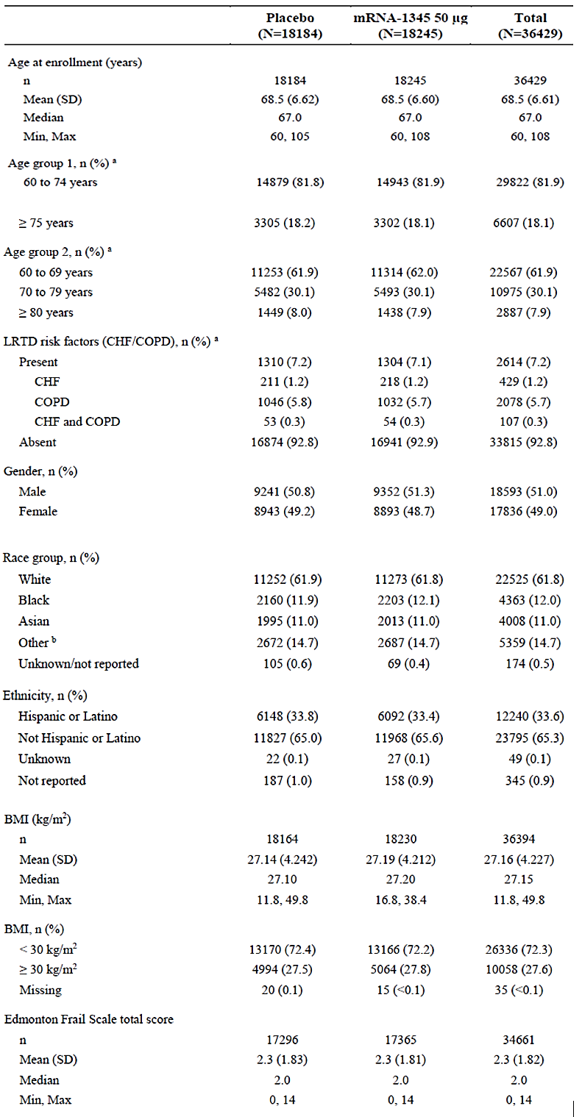

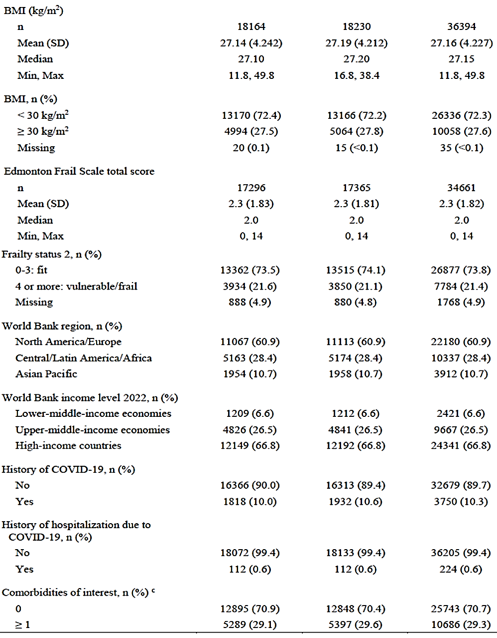
BMI = body mass index; CHF = congestive heart failure; COPD = chronic obstructive pulmonary disease; COVID-19 = coronavirus disease 2019; eCRFs = electronic case report forms; IP = investigational product; LRTD = lower respiratory tract disease; max = maximum; min = minimum; SD = standard deviation. Percentages were based on the number of participants in the Safety Set. Baseline value for height, weight, BMI, and Edmonton Frail Scale total score was defined as the most recent non missing measurement (scheduled or unscheduled) collected on or before the date of IP injection. BMI = (body weight in kilograms)/ (height in meters)².
ª Derived from age and risk collected on eCRFs. ^{b} Other race included American Indian or Alaska Native, Native Hawaiian or other Pacific Islander, Other, or Multiple. ^{c} Comorbidities of interest included COPD, asthma, chronic respiratory disease, diabetes, CHF, advanced liver disease, or advanced renal disease.

Primary outcomes - Primary Analysis of Efficacy (30 November 2022)
- The VE of mRNA-1345 against RSV-LRTD with ≥2 symptoms was 83.7% with 9 cases in the mRNA-1345 and 55 cases in the placebo group (Table 8).
- The VE of mRNA-1345 against RSV-LRTD with ≥3 symptoms was 82.4% with 3 cases in the mRNA-1345 and 17 cases in the placebo group (Table 8).

Additional Analysis of Efficacy (30 April 2023)
For RSV-LRTD with ≥ 2 symptoms there were an additional 110 cases in the updated analysis compared to the first analysis, 72 on placebo and 38 on mRNA-1345. For RSV-LRTD with ≥ 3 symptoms there were 50 additional cases, 34 on placebo and 16 on mRNA-1345.
- The VE of mRNA-1345 against RSV-LRTD with ≥2 symptoms was 63.3% (Table 14), with 47 cases in the mRNA-1345 and 127 cases in the placebo group.
- The VE of mRNA-1345 against RSV-LRTD with ≥3 symptoms was 63% (Table 14), with 19 cases in the mRNA-1345 and 51 cases in the placebo group.
Table 14. Study P301: Additional Analysis Vaccine Efficacy of mRNA-1345 to Prevent First Episode of RSV-LRTD (≥ 2,3 symptoms) or RSV-ARD (14 Days to 12 Months Post injection (Per-Protocol Efficacy Set)
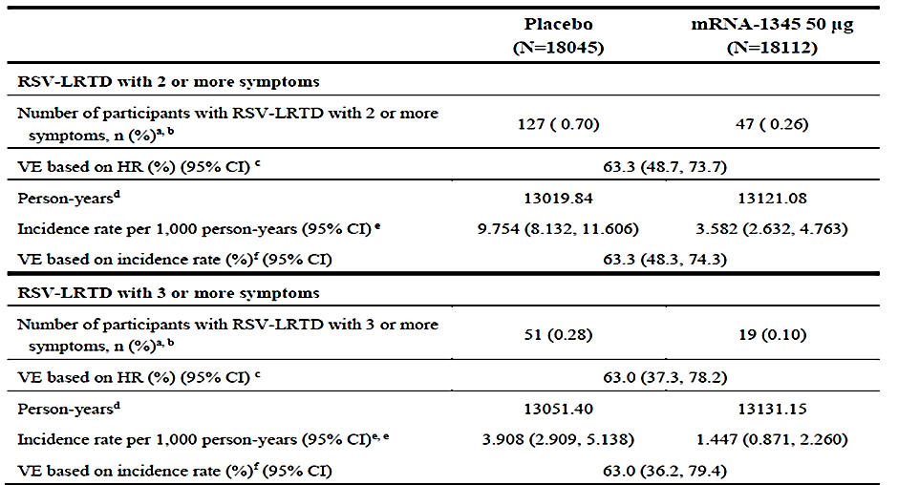
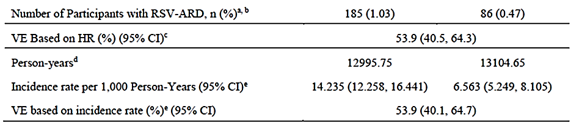
CI=confidence interval; HR=hazard ratio; RSV-LRTD=respiratory syncytial virus-associated lower respiratory tract disease; RSV-ARD=respiratory syncytial virus-acute respiratory disease, RT-PCR=reverse transcriptase polymerase chain reaction; VE=vaccine efficacy.
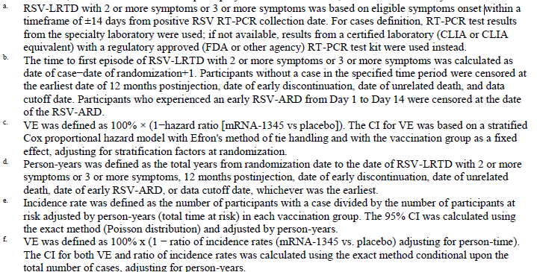
Following vaccination there is separation of the cumulative incidence rate curves at 1-2 months, with a steady increase in placebo group while a slower rise for the mRNA-1345 group (Figure 6)

Figure 6. Additional Analysis: Cumulative Incidence Curves for First Episode of RSV-LRTD (≥2 or ≥3 Symptoms) and RSV-ARD Between 14 Days and 12 Months Post injection (Per-Protocol Efficacy Set)
RSV-LRTD with ≥2 Symptoms
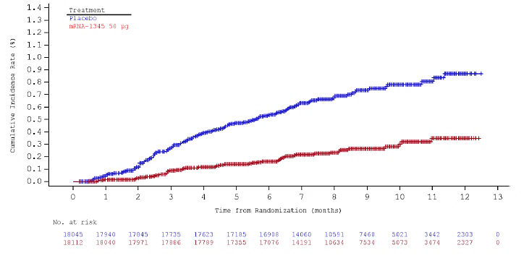
RSV-LRTD with ≥3 Symptoms
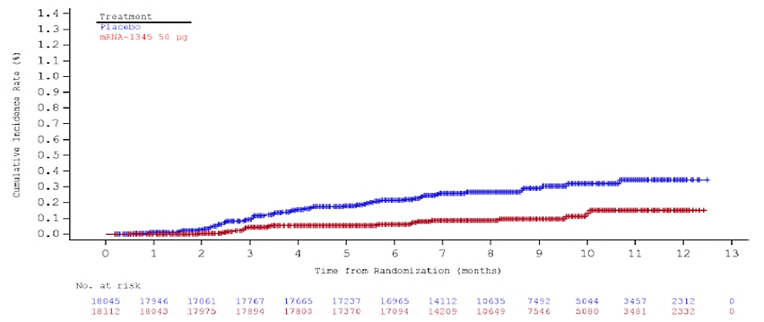
RSV-ARD
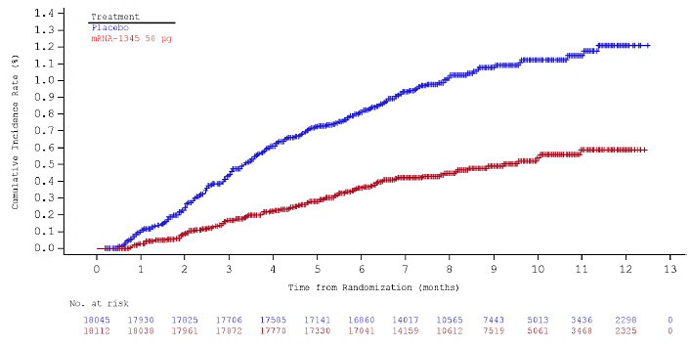

RSV-LRTD analysis by time periods
In the additional analysis, VE was analysed for 2 postinjection time intervals:
- cases occurring between 14 days and 6 months postinjection, and
- cases occurring between 6 and 12 months postinjection).

For both RSV-LRTD with ≥2 and ≥3 symptoms, the point estimates of VE were lower in the interval between 6 and 12 months postinjection than between 14 days to 6 months postinjection. (Table 15) The study was not powered for this analysis, and most participants had not yet reached a duration of 12 months since their vaccination.
Table 15. Additional Analysis: Analysis of VE of mRNA-1345 to Prevent First Episode of RSV-LRTD (with ≥ 2 or ≥ 3 Symptoms) by Follow-up Time Periods (PPE Set)
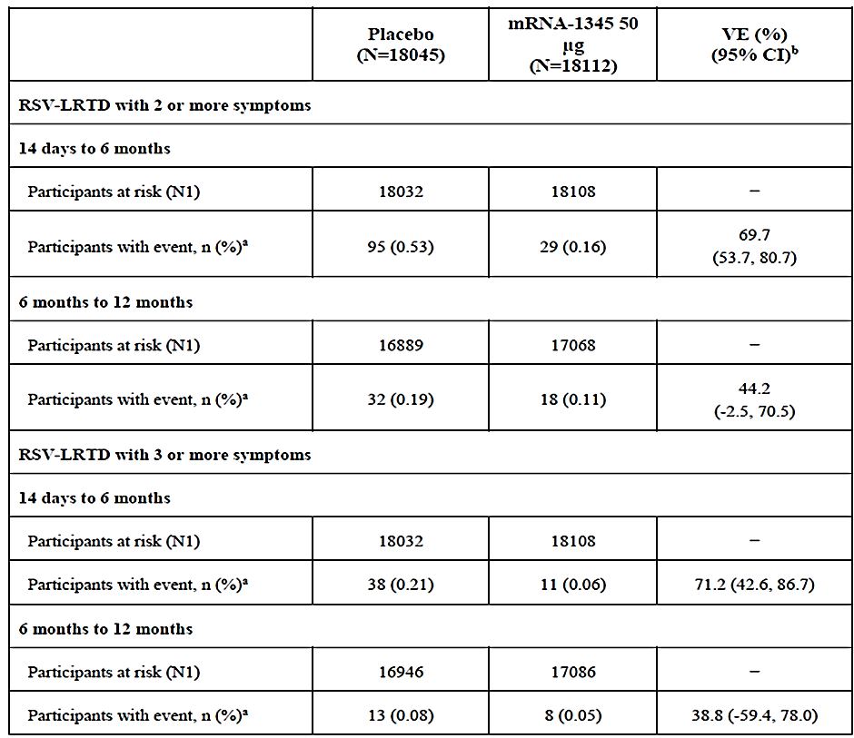
CI = confidence interval; PPE = Per-Protocol Efficacy; RSV-LRTD = respiratory syncytial virus lower respiratory tract disease; VE = vaccine efficacy. N1 in each time period includes participants who had follow-up beyond the start of the time period and did not have any protocol-defined RSV-LRTD cases prior to the start of the time period. a. Percentages were based on N1. b. Vaccine efficacy was defined as 100% x (1 – ratio of incidence rates [mRNA-1345 vs. placebo] adjusting for person-time).

Additional analysis: subgroup analysis of primary outcomes
The VE of mRNA-1345 against RSV-LRTD with ≥2 symptoms in subgroups (age, comorbidities of interest, COPD/CHF, frailty, sex, race, ethnicity, region) was generally consistent with VE of the overall additional efficacy set but was limited by small case numbers in some groups (with wide 95% CIs). This is especially note in those with COPD/CHF, and age ≥ 80 years of age (Table 16).
Whilst similar results were observed for the subgroup analyses in those with ≥3 symptoms, interpretation is limited by fewer RSV-LRTD cases in these groups (Table 17).
Table 16: Additional Analysis: VE of mRNA-1345 to Prevent First Episode of RSV-LRTD (With ≥ 2 Symptoms) 14 Days Postinjection up to 12 Months Postinjection by Subgroups (PPE Set)
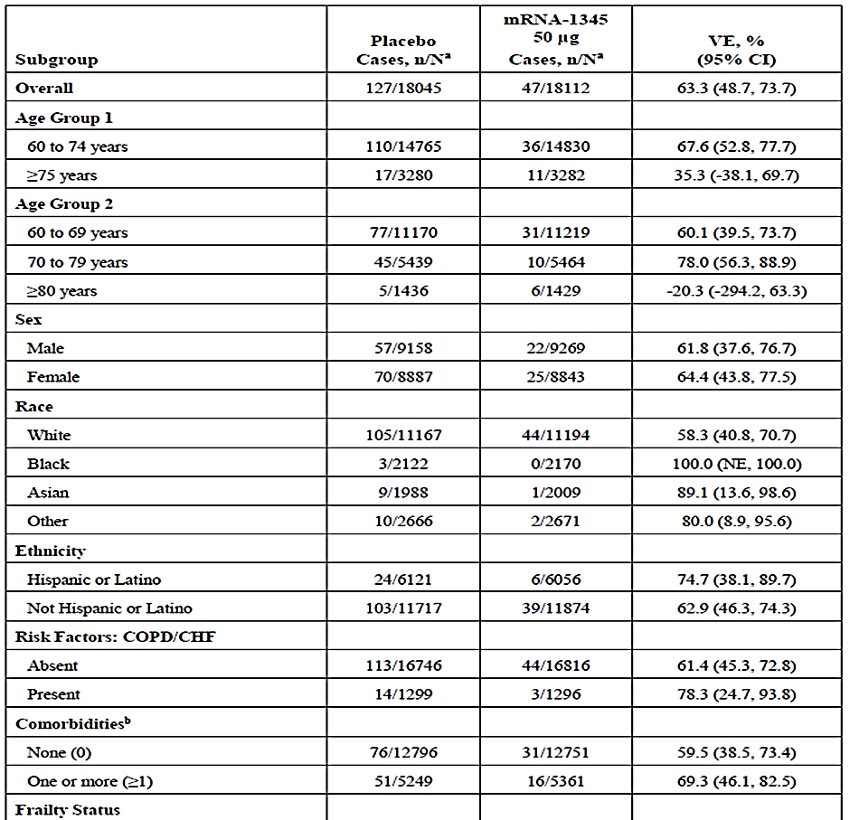
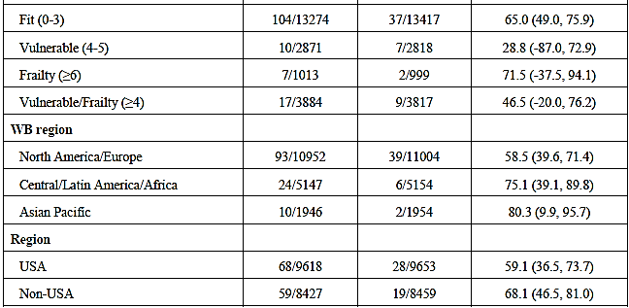

Table 17. Additional Analysis: VE of mRNA-1345 to Prevent First Episode of RSV-LRTD (With ≥ 3 Symptoms) 14 Days Postinjection up to 12 Months Postinjection by Subgroups (PPE set)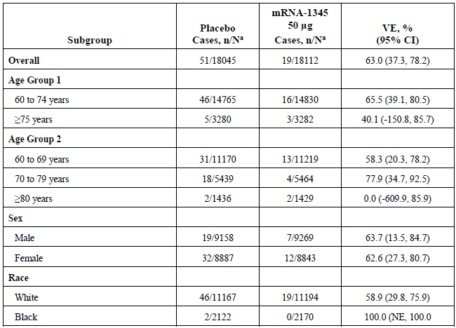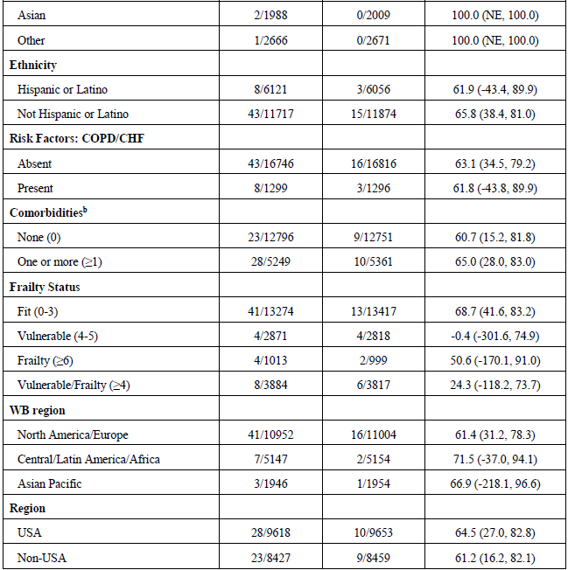

Additional Analysis: Secondary outcomes
The VE of mRNA-1345 against RSV-ARD was 53.9% (Table 14), with 86 cases in the mRNA-1345 and 185 cases in the placebo group.
- As shown in figure 6, separation of cumulative incidence of RSV-ARD was observed early and maintained through 12 months post-injection. The VE of mRNA-1345 against RSV-ARD in subgroups analyses was consistent with the overall set. Coinfection among those meeting a case definition of RSV-ARD was noted in 34 out of 271 total participants with RSV-ARD and included infection with human metapneumovirus, SARS-CoV-2, coronavirus, human parainfluenza virus 1, human parainfluenza virus 3, human rhinovirus/enterovirus, influenza A, and influenza A H. When cases of coinfection were excluded, the VE was 51.4%.
- Two participants in the placebo group were hospitalized in association with RSV- RSV-LRTD. There were no participants in the mRNA-1345 group hospitalized in association with RSV-LRTD.

Additional Analysis: Efficacy Endpoints by RSV Subtype
There were 174 (RSV-A: n=101, RSV-B: n= 71, both: n=1, and unknown: n=1) and 70 (RSV-A 39, RSV-B 30, both 1) cases of RSV-LRTD with ≥2 and ≥3 symptoms respectively. (Figure 7)
- VE by RSV-A for those ≥ 2 symptoms was 69.4% and for ≥ 3 symptoms was 66.9%.
- VE by RSV-B for those ≥ 2 symptoms was 56.3% and for ≥ 3 symptoms was 59.3%.
- VE to prevent RSV-ARD was 59.7% against RSV-A and was 47.9% against RSV-B.

Figure 7: Vaccine Efficacy Against RSV-A and RSV-B by endpoint.
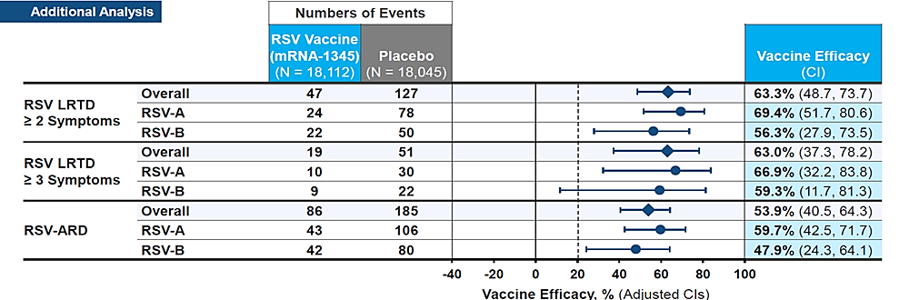

Additional Analysis: Exploratory Endpoint
Vaccine efficacy against RSV-LRTD with shortness of breath (surrogate measure of more severe disease). This was included as breathlessness is a key driver of accessing medical care.
- VE for those with RSV-LRTD associated shortness of breath was 74.6% (50.7%, 86.9%)

Additional Analysis: hospitalisations
There were 2 hospitalizations in placebo recipients (both >70 years with comorbid conditions [asthma]; both recovered), and nil hospitalisations in the mRNA-1345 group.

Immunogenicity: Study P301
A stratified random sample of participants was selected from all participants randomized and dosed by 31 Oct 2022, where the stratified selection ensured balanced representation of age group (60 to 74 years, ≥75 years), LRTD risk factor (absent/present), and region (Northern/Southern Hemisphere).
The PPI Set contained participants in the Random Immunogenicity Sub cohort who also:
- Received the assigned IP dose according to protocol,
- Had RSV immunogenicity titre results at Baseline (before the IP administration) and
- ≥1 valid result after the IP administration at the timepoint of interest,
- Had no major protocol deviation affecting the primary immunogenicity outcomes.
Of 1922 participants in the Immunogenicity Sub cohort, 1848 (96.1%) (Placebo, n=333 mRNA-1345, n=1515) were in the PPI Set. Most of those who were excluded did not have a valid immunogenicity result after vaccination.

The PPI Set had a mean age of participants of 72.1 years; 54.9% were male, 77.9% White, 56.1% were from high-income countries. There were 45.7% of participants with age ≥75 years, 39.8% participants with an RSV-LRTD risk factor, 56.4% participants from the Northern Hemisphere, and 19.9% who were vulnerable or frail.

The immunogenicity objective for Study P301 was to evaluate the response to a single dose
(50 μg) of mRNA-1345 vaccine at timepoints starting from Baseline and up to 24 months after injection. The immunogenicity objectives and end points are shown in Table 18. Data for baseline and DAY 29 antibody responses are provided here. Additional day data will be provided at a later date.
Table 18. Immunogenicity Objectives and Endpoints: Study P301
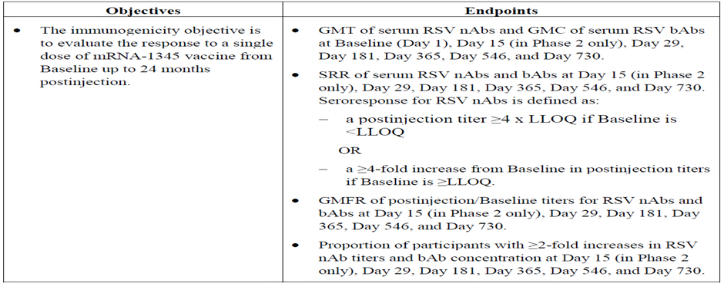
bAb = binding antibody; GMC = geometric mean concentration; GMFR = geometric mean fold-rise; GMT = geometric mean titre; LLOQ = lower limit of quantification; nAb = neutralizing antibody; RSV = respiratory syncytial virus; SRR = seroresponse rate.

RSV-specific neutralising antibody (nAb) and bAb (binding antibody) were measured using the assays described below. Serum nAb was measured in titres and serum bAb was measured in concentration.
- Serum nAb titres against RSV-A and RSV-B were measured using validated microneutralization assays, which quantitatively measured the nAbs against RSV-A and RSV-B.
- Serum bAb against RSV preF and RSV postF antigens were measured using a validated multiplex assay that quantitatively measures the IgG antibodies to RSV preF and postF.
All subjects in both treatment groups had measurable RSV-specific nAb levels at Baseline, (expected as common respiratory virus). Levels were similar in both groups, and consistent with an adult population with prior RSV exposure.
In the mRNA-1345 group, the GMT for RSV-A increased from 2552.82 IU/mL at Baseline to 21475.40 IU/mL at Day 29, representing a GMFR of 8.44. The GMT for RSV-B increased from 1425.35 IU/mL at Baseline to 7245.98 IU/mL at Day 29, representing a GMFR of 5.11. No meaningful difference in nAb levels was observed in the placebo group from Baseline to Day 29. (Table 19)
In the mRNA-1345 group, the Day 29 seroresponse rate (SRR) for RSV-A was 74.2% and for RSV-B was 56.5%. Applying the pre-specified criterion of ≥2-fold increase, 91.4% of participants (RSV-A) and 84.3% of participants (RSV-B) achieved his increase.
Table 19. Summary of RSV-A and RSV-B Neutralizing Antibody Levels (IU/mL) by Visit (PPI Set)
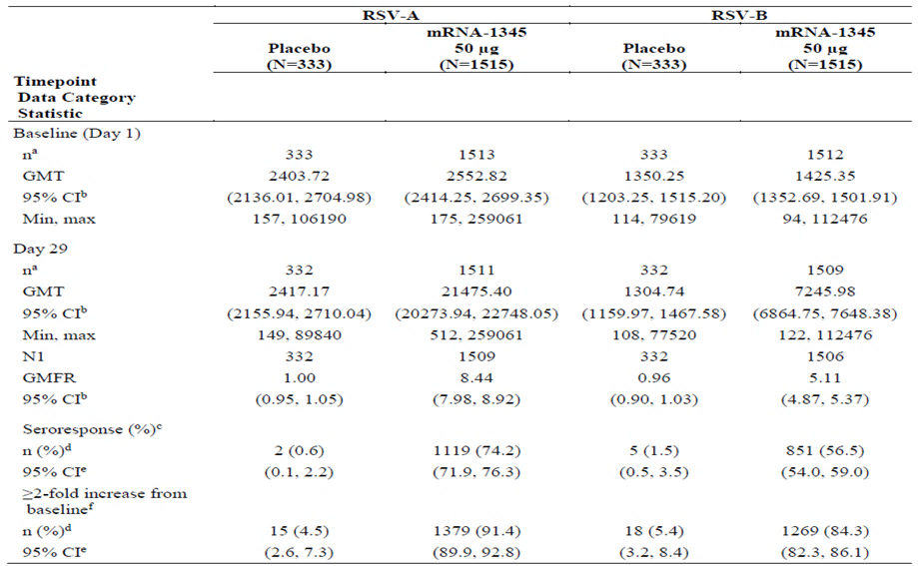
CI = confidence interval; GM = geometric mean; GMFR = geometric mean fold-rise; GMT = geometric mean titer; LLOQ = lower limit of quantification; max = maximum; min = minimum; PPI = Per-Protocol Immunogenicity Set; RSV = respiratory syncytial virus; SRR = seroresponse rate; ULOQ = upper limit of quantification
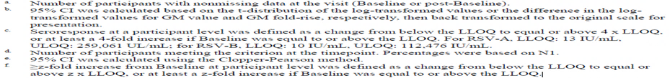
For both RSV-A and RSV-B, Day 29 nAb GMTs and GMFRs for the evaluated subgroups were generally consistent with those of the overall PPI Set. (Tables 20, 21, figure 8). Subgroups considered at higher risk of severe RSV-LRTD, including older individuals, those with underlying comorbidities and those considered frail, showed nAb responses generally consistent with the overall PPI Set.
Table 20. RSV-A Neutralizing Antibody (IU/mL) Responses by Subgroup at Day 29 (PPI Set)
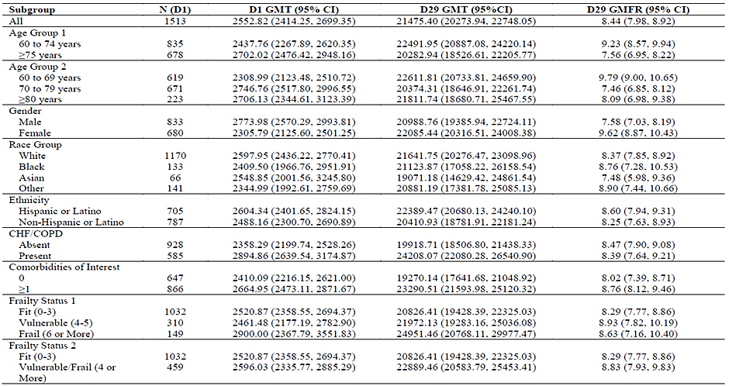
Table 21. RSV-B Neutralising Antibody (IU/mL) Responses by Subgroup at Day 29 (PPI Set)
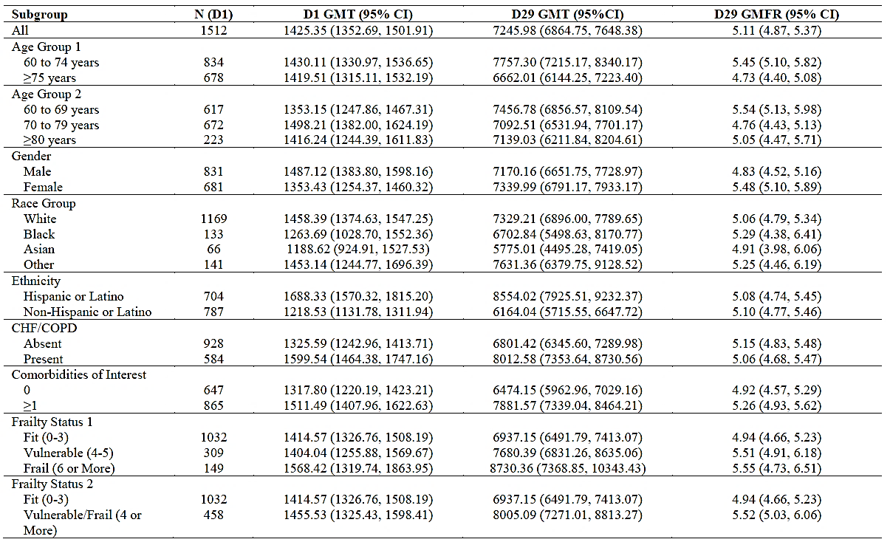

Figure 8. Neutralising Antibody Response by RSV Subtype and Age (PPI Set) (Source ACIP)
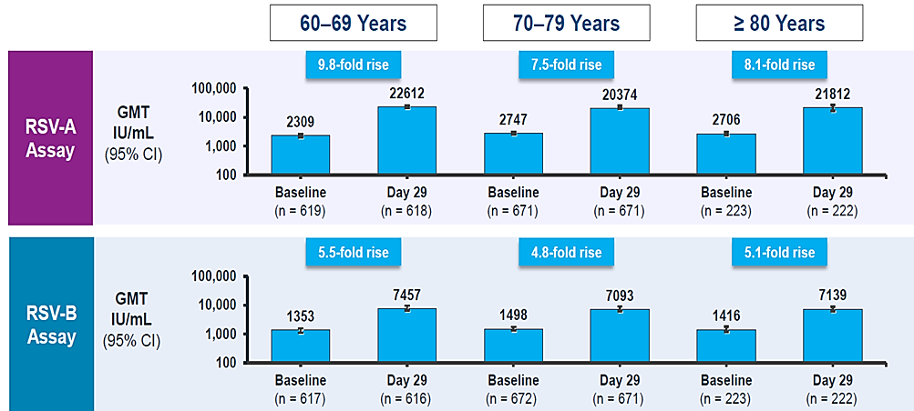

Baseline RSV preF bAb GMCs were comparable between the placebo and mRNA-1345 groups, At Day 29, RSV preF bAb GMC was higher in the mRNA-1345 group (81884.16 AU/mL) compared to the placebo group (10060.15 AU/mL), representing a GMFR of 7.65 Day 29 GMC in the placebo group remained similar to Baseline. RSV preF bAb SRR at Day 29 was 79.1%, in the mRNA-1345 group and 94.2% of mRNA-1345 participants achieved a ≥2-fold increase in GMC.
Assessments of RSV preF bAb responses across subgroups, were generally consistent with those of the overall PPI Set. As with nAb assessment, subgroups considered at risk of severe RSV-LRTD, were generally consistent with the overall PPI Set (Table 22).

Table 22. Summary of RSV Binding Antibody (PreF, AU/mL) Responses For the mRNA-1345 Treatment Group by Subgroup at Day 29 (PPI Set).
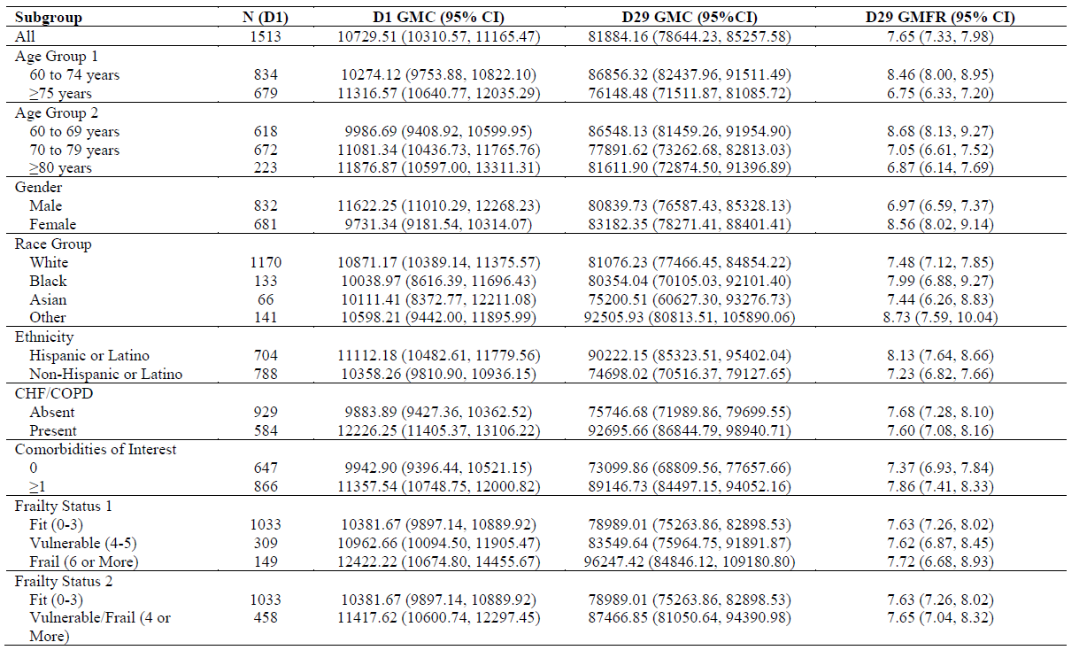

Safety
There were 18,584 individuals who have received ≥ 1 injection of mRNA-1345 at any dose; with 18,292 participants ≥60 years of age who received ≥1 dose of 50 μg mRNA-1345 (Table 23) in Study P301 (n=18,245) and P101 (n=47). Primary safety endpoints are shown in Figure 9.
Table 23. Summary of Exposure (safety set)
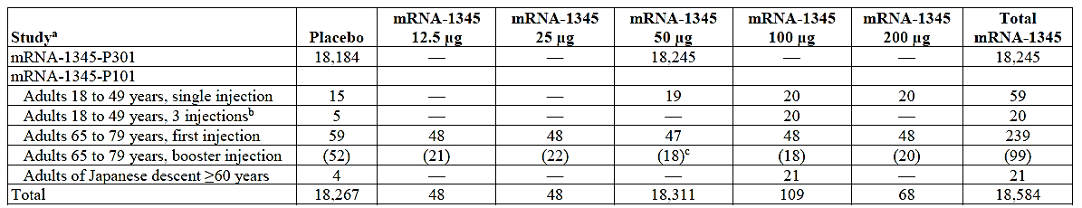
ª Numbers are participants in the Safety Set and includes all randomized participants who received any study injection. ^{c}. Only participants for whom the booster was the same as the first injection are presented.
Among the 36,429 participants in study P301, (as of 30 Apr 2023), 99% had ≥ 28 days of safety follow up, 94% had ≥ 6 months follow up and 12.9% had ≥ 12 months of follow up and was similar in the mRNA-1345 placebo groups. The median duration of follow-up was 257.0 days (range: 1 to 530 days).
Figure 9. Primary Safety Endpoints and Duration of follow-up
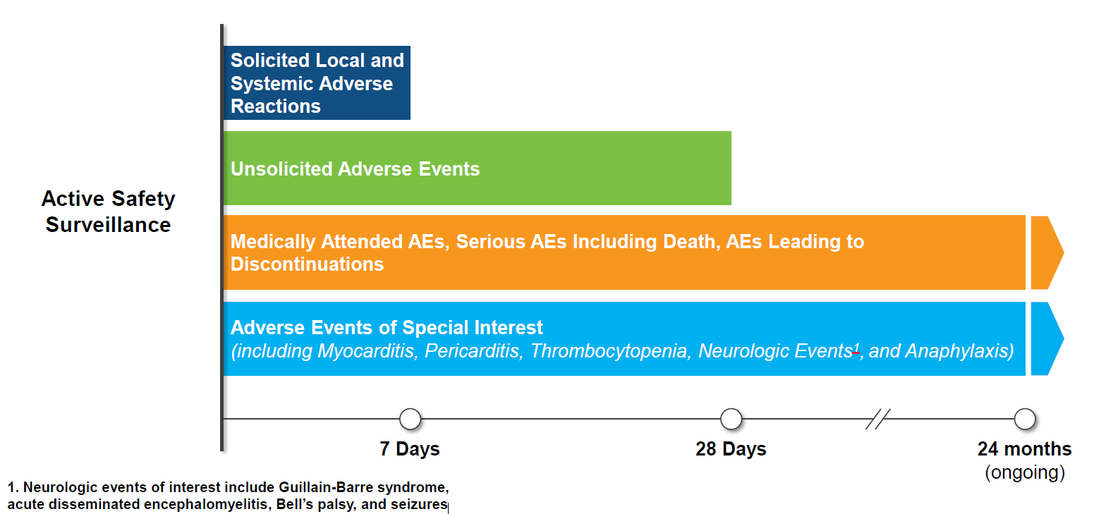

Adverse events
Solicited adverse events– study P301 (Figure 10)
Local AEs
- Incidence higher in the mRNA-1345 compared to placebo group (58.3% vs 16.2%) with injection site pain reported most frequently (55.9% vs 13.8%).
- Most were Grade 1; with low incidence of Grade 3 AEs (3.1% vs 1.7%) and no Grade 4 events.
Systemic AEs
- Higher in the mRNA-1345 compared to placebo group (47.4% vs 32.9%); most common: fatigue (30.8% vs 20%), headache (26.7% vs 18.8%), myalgia (25.6% vs 14.4%), arthralgia (21.7% vs 14.0%).
- Most were Grade 1; with low incidence Grade 3 or higher (3.8% vs 2.7%)
- Fever (oral temperature >40.0°C/>104.0°F) was the only Grade 4 AE (0.2% in each group).

Figure 10. Study P301: Percentages of participants with solicited local (a) and systemic (b) adverse reactions reported within 7 Days after injection (solicited safety set).
(a) Local Adverse Events
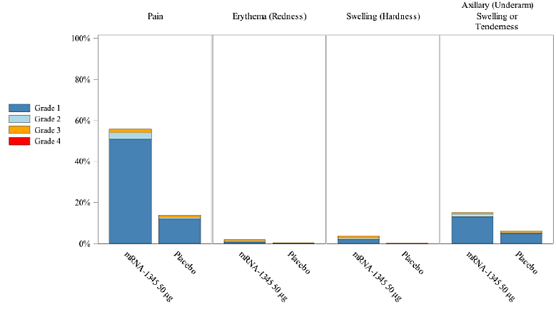

(b) Systemic Adverse Reactions
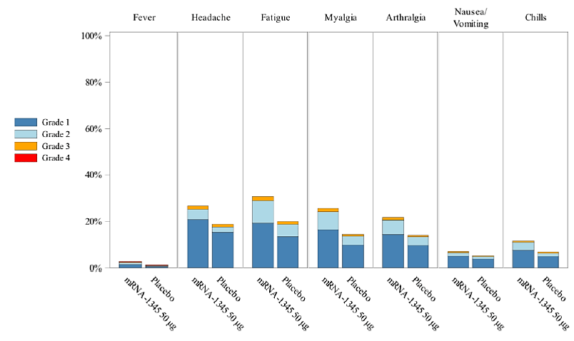

Unsolicited adverse events-study P301
The incidence of unsolicited TEAEs up to 7 days after injection were 9.6% in the mRNA-1345 and 7.9% in the placebo groups.
Most TEAEs within 7 and 28 days after injection were associated with reactogenicity or were common infections and were mild/moderate in severity.
- General disorders and administration site conditions: mRNA-1345 vs placebo: 3.8% vs 2.7% at 7 days and 4.4% vs 3.3% at 28 days.
- Musculoskeletal and connective tissue disorders: 2.9% vs 2.6%, and 4.2% vs 4.0%, at 7 days and 28 days respectively.
- Infections and infestations:1.6% vs 1.5% at 7 days and 7.8% vs 7.2% at day 28.,
- Nervous system disorders: 1.5% vs 1.2% and 2.3% vs 2.0% at 7 days and 28 days respectively.
Up to the data cut-off date (30 April 2023) the incidence of SAEs, fatal events, MAAEs, AESIs, and TEAEs leading to study discontinuation, were similar between the groups (Table 24).
Table 24. Summary of unsolicited TEAEs after, to data cutoff (30 Apr 2023, Safety Set)
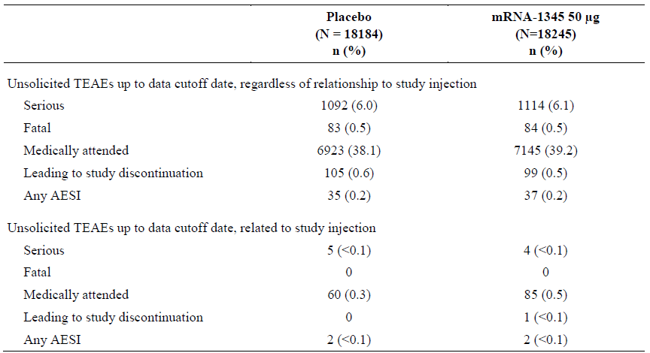
AESI=adverse event of special interest; ER=emergency room; TEAE=treatment-emergent adverse event (event not present before exposure to study injection or that worsened in intensity or frequency after exposure). Medically attended TEAEs included ER/urgent care, outpatient physician visits, and per-protocol illness visits. Percentages were based on the number of participants in the Safety Set

Serious adverse events – study P301
Up to data cut-off SAEs regardless of causality were reported for 6.0% in placebo and 6.1% in mRNA-1345 group. The types and incidence of SAEs were similar between groups; most commonly in the infections and infestations SOC (1.3% and 1.4% respectively). The SAEs reported in >0.1% of participants in either group were pneumonia (64 participants in the mRNA-1345 group [0.4%] and 56 participants in the placebo group [0.3%]), COPD (51 participants [0.3%] and 41 participants [0.2%]), osteoarthritis (29 participants [0.2%] and 28 participants [0.2%]), urinary tract infection (29 participants [0.2%] and 33 participants [0.2%]), and atrial fibrillation (23 participants [0.1%] and 35 participants [0.2%])

Adverse events of special interest up to data cut-off – study P301
The incidence of investigator assessed AESIs was low (0.2%) in both groups (Table 25). No safety concerns or other trends were identified based on review of all investigator-assessed AESIs and additional medical concepts by narrow and/or narrow/broad SMQ analyses.
The incidence of urticaria was higher in the mRNA-1345 group (15 participants) than in the placebo group (5 participants) up to 28 days after injection.
No vaccine-associated events of anaphylactic reaction were reported up to data cutoff.
No Guillain-Barré syndrome (GBS) or acute disseminated encephalomyelitis (ADEM) were reported.
Table 25. Study P301: Incidence of TEAEs of Special Interest as Assessed by Investigator (Safety Set)
System Organ Class: Preferred Term | Participants  n (%) | Participants  n (%)
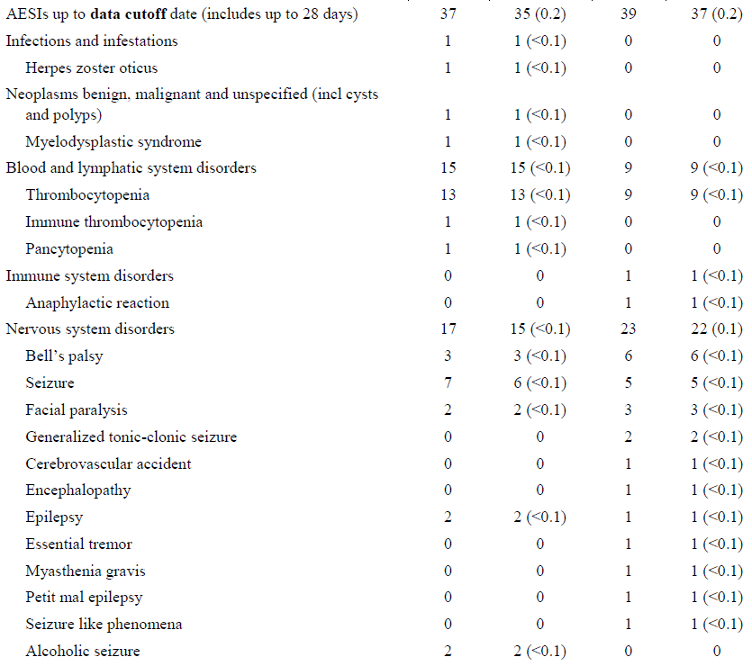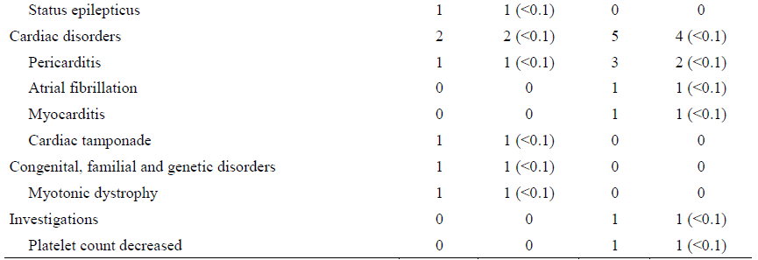

Deaths - Study 301
Up to data cut-off, fatal TEAEs were reported for 84 participants (0.5%) in the mRNA-1345 group versus 83 participants (0.5%) in the placebo group. The median time to death was 178.0 days (range: 21 to 448 days) in the mRNA-1345 group and 144.0 days (range: 6 to 324 days) in the placebo group. None of the fatal events were considered related to study injection by the investigator.
- None of the participants who had fatal AEs had evidence of associated RSV infection.
- in the cardiac disorders SOC, deaths were reported for 24 participants (0.1%) in the mRNA-1345 group and 29 participants (0.2%) in the placebo group.
- in the infections and infestations SOC there were 12 (<0.1%) in the mRNA-1345 group, and 9 (<0.1%) in the placebo group.
- Incidence of deaths of broadly defined respiratory causes including pneumonia, sepsis, respiratory failure, pulmonary haemorrhage, aspiration, COPD exacerbation, and pulmonary tuberculosis occurred in 11 participants in the mRNA-1345 group and 7 in the placebo group.

Coadministration of mRESVIA (mRNA-1345) with other vaccines
There are two coadministration studies that are ongoing:

- Study P302: Phase 3 study investigating the safety, tolerability, and immunogenicity of Concomitant Administration of mRNA-1345 with Quadrivalent Influenza Vaccine (Afluria) or COVID-19 Bivalent Vaccine in Adults ≥ 50. Preliminary data has been provided by the Sponsor (March 5th, 2024), and data were presented at ACIP, February 29, 2024. Preliminary results are summarised below.
- Study P304: evaluating mRNA-1345 co-administered with high dose quadrivalent influenza vaccination in individuals of ≥65 years. Data from this study are not currently available.

Study P302
The study (NCT05330975) is being conducted in the USA, and recruitment commenced in April 2022. The study design schema is shown in Figure 11.

Figure 11. Study P302 design
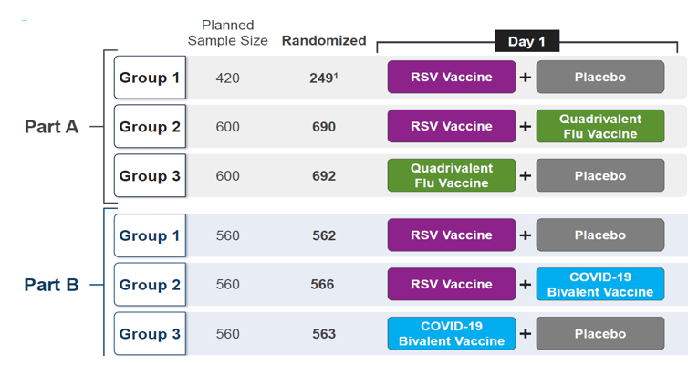
^{1.}Due to randomisation error – sample size lower than planned.
The study (Part A) was designed to enrol approximately 1620 medically stable adults ≥50 years of age to enable the establishment of non-inferiority of immunogenicity for coadministration of mRNA-1345 and influenza vaccine (Afluria) in comparison to a single vaccine. A total of 1631 participants were randomized in the study. Currently, a total of 1528 participants (93.7%) completed the study and 103 participants (6.3%) discontinued from the study. The proportions of participants who discontinued early from the study were similar across the groups.

Immunogenicity

Part A: Comparing the day 29 geometric mean titre ratios (GMRs) for concomitant versus individual administration of mRNA-1345 or influenza vaccination, demonstrated that non-inferiority criteria were achieved (LB of the 2-sided 95% CI of GMR > 0.667) for all antigens (RSV-A, RSV-B, Influenza A/H1N1, Influenza A/H3N2, Influenza B/Phuket, and Influenza B/Washington Antibody). (Figure 12)

Part B: Comparing the day 29 GMRs for concomitant versus individual administration of mRNA-1345 or COVID-19 booster vaccine, non-inferiority criteria were achieved for all antigens (RSV-A, RSV-B, COVID-19 Wuhan, and COVID-19 Omicron) (Figure 13)

Figure 12. Comparison of Day 29 Geometric Mean Titre Ratio (GMR) – Concomitant vs Non concomitant Administration of mRNA-1345 and Quadrivalent Influenza Vaccine
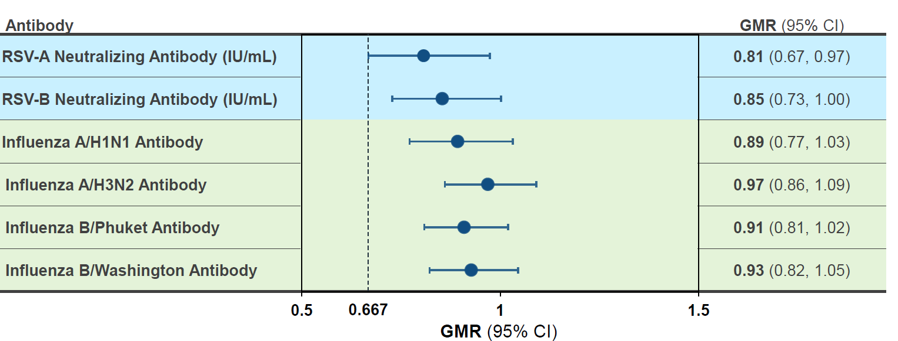

Figure 13. Comparison of day 29 geometric mean titre ratio (GMR) – concomitant vs
non- concomitant administration of mRNA-1345 and COVID-19 bivalent vaccine
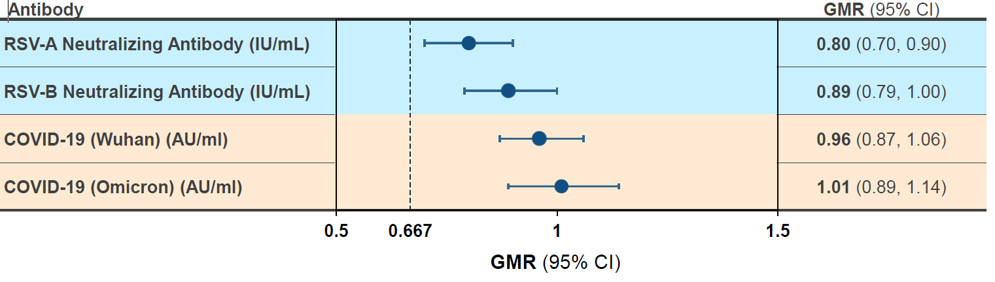

Safety

Solicited local and systemic reactions within 7 days after vaccination.

Part A: There were 678 participants who received mRNA-1345 + Afluria; 249 who received mRNA-1345 + placebo, and 683 who received Afluria + placebo. The incidence of solicited local and systemic adverse reactions are shown in figures 10 and 11. The most common local reaction was injection site pain. The most common systemic reactogenicity events were headache, fatigue, myalgia, and arthralgia. Most local and systemic reactions were grade 1 to 2, transient and resolved within 1-2 days.
Part B: There were 558 participants who received mRNA-1345 + COVID-19 vaccine; 555 who received mRNA-1345 + placebo, and 557 who received COVID-19 vaccine + placebo. The incidence of solicited local and systemic adverse reactions are shown in figures 14 and 15. The most common local reactions were injection site pain and axillary swelling/tenderness. The most common systemic reactogenicity events reported were headache, fatigue, myalgia, arthralgia, and chills. Systemic reactogenicity was higher in the co-administration group when compared to mRNA-1345 or COVID-19 administered alone. Most local and systemic reactions were grade 1 to 2, transient and resolved within 1-2 days.

Figure 14. Solicited Local Reactions within 7 Days After mRNA-1345 Alone or Co-administered with Quadrivalent influenza Vaccine (Afluria) - Part A or COVID-19 Bivalent Vaccine - Part B.

Part A
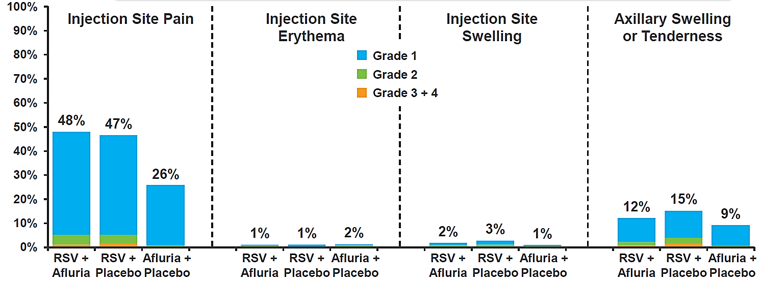

Part B
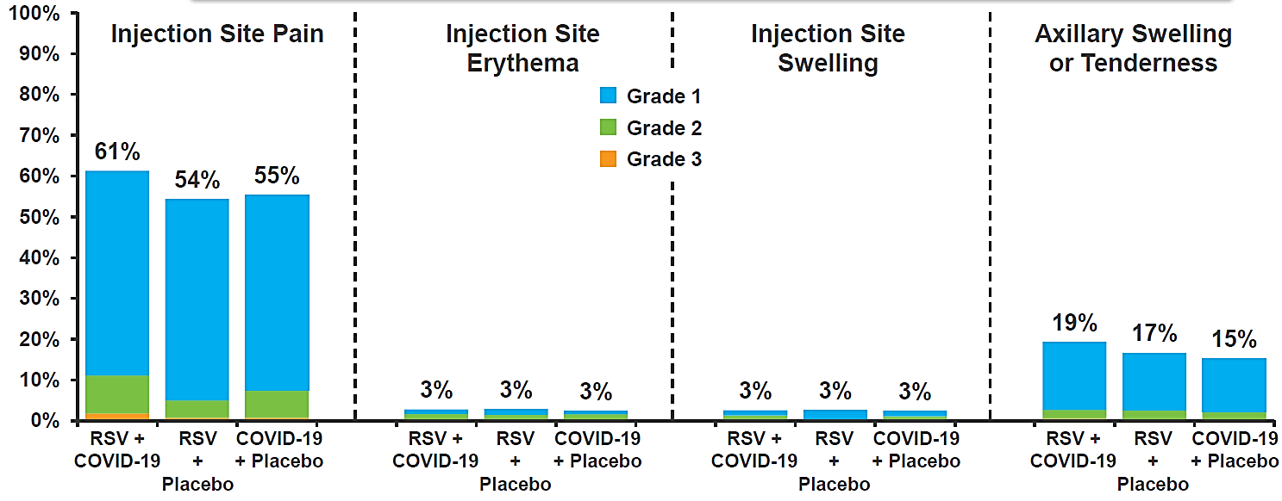

Figure 15. Solicited systemic reactions within 7 days After mRNA-1345 alone or
co-administered with quadrivalent influenza vaccine (Afluria) - Part A or COVID-19 bivalent vaccine - Part B

Part A
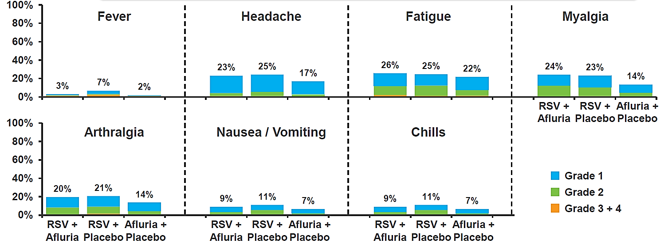

Part B

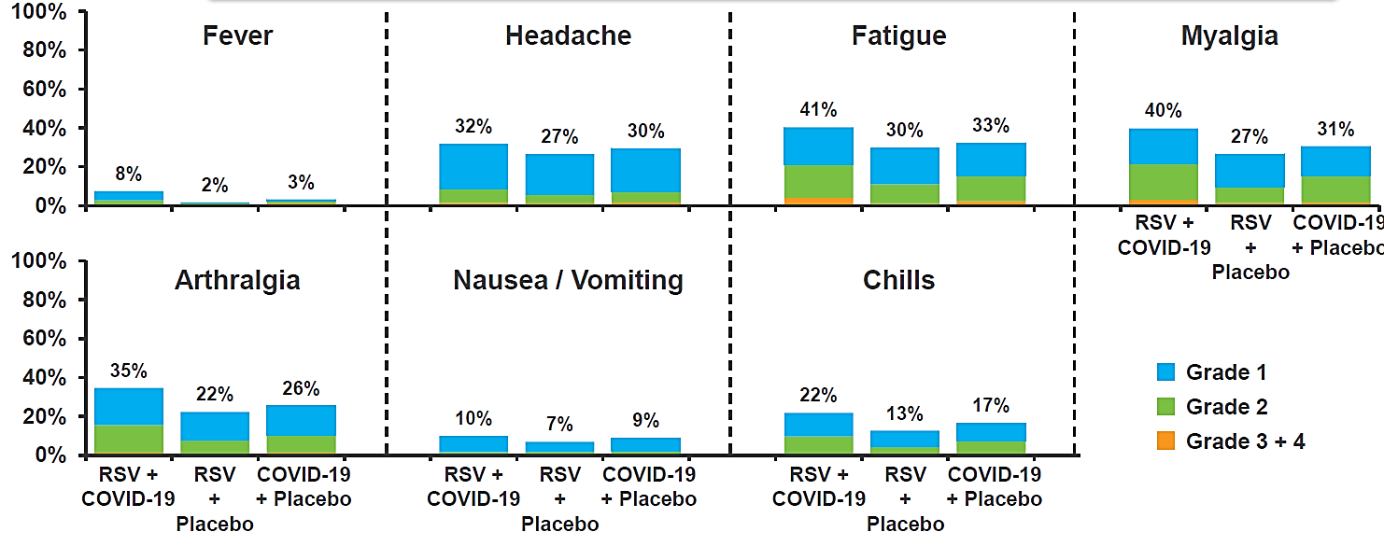

Other adverse events (Based on 6 months of follow-up)
There were no reports of:
- Deaths, SAEs, or AESIs as assessed as related by the investigator.
- Anaphylaxis
- Guillain Barre Syndrome
- Acute disseminated encephalomyelitis (ADEM)
- Bell’s palsy/facial paralysis
- Acute myocarditis or acute pericarditis

Discussion
Whilst respiratory syncytial virus causes infections in all age groups, beyond infants, the most severe disease occurs in older adults, especially those with certain comorbidities. Vaccines to protect against RSV are likely important for the elderly Australian population in reducing risks posed by RSV infection.

The TGA approved AREXVY (Respiratory Syncytial Virus Vaccine, Adjuvanted; Glaxo-SmithKline Biologicals), in January 2024, and ABRYSVO (Respiratory Syncytial Virus Vaccine; Pfizer)] in March 2024 for registration in Australia, with the following indication:

“For the prevention of lower respiratory tract disease (LRTD) caused by respiratory syncytial virus in adults 60 years of age and older”.
Both approved vaccines are protein-based; mRESVIA is the first RSV mRNA vaccine being evaluated by the TGA and is also being evaluated in other jurisdictions. AREXVY and ABRYSVO have also been approved in other jurisdictions for adult use. Neither of these approved products has included an indication for ARD. This is appropriate, given in each of the pivotal studies, the primary outcome is prevention of LRTD. mRESVIA is a mRNA vaccine. The Delegate proposes to align the mRESVIA vaccine indication with the already approved vaccines.

Study population
Although the proposed indication is for immunisation of subjects over 60 years, the individuals most affected by the burden of RSV disease are those ≥75 years of age. Overall, more than 6,600 (18.1%) subjects ≥ 75 years old and > 7,800 vulnerable or frail subjects were enrolled in the mRESVIA pivotal trial to support this submission. People with underlying comorbidities that are known risk factors for LRTD were also enrolled in this trial, in particular COPD and/or CHF (7%), asthma (8%), diabetes (18%), advanced renal or liver disease (~1%).
The size of this high-risk subpopulation in study P301 is comparable with those reported in the pivotal trials of AREXVY (GSK) and ABRYSVO (Pfizer). (Papi, 2023; Walsh 2023) (Table 26) It should be noted that direct comparisons of study populations are difficult, due to variation in definitions and specifics of inclusion criteria.
Table 26. Key demographics from RSV pivotal trials (summary table developed by Delegate)
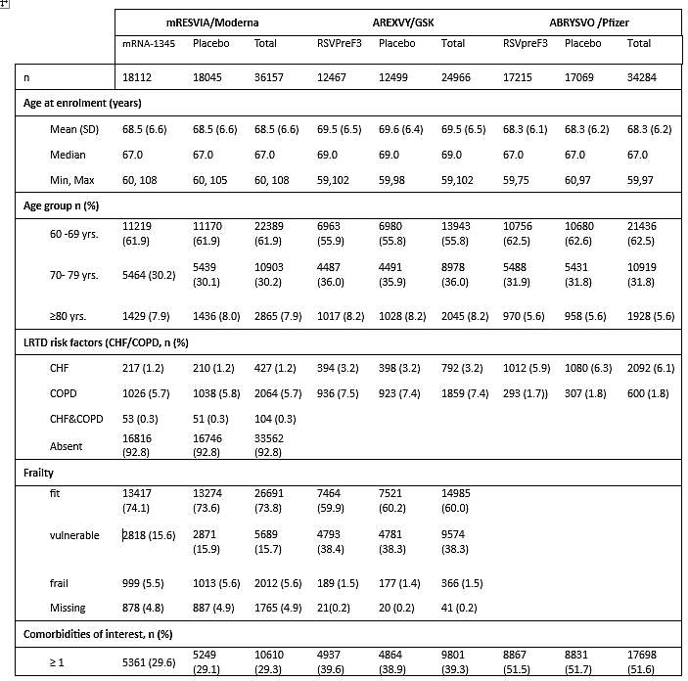

Vaccine efficacy
Whilst study P301 demonstrates the efficacy of a single dose of mRNA-1345 (50 µg) in preventing RSV-LRTD (with ≥2, and ≥3 symptoms) in adults ≥60 years of age, the VE (based on estimation of the hazard ratio) was lower after the extended follow-up (Additional Analysis of efficacy) than in the Primary Analysis. For both primary endpoints VE in the Additional Analysis was 63%, moving from 83.7% and 82.4% for ≥ 2 and 3 symptoms respectively at the Primary Analysis.
For RSV-LRTD with ≥2 symptoms there were an additional 110 cases included in the Additional Analysis compared to the Primary Analysis, 72 on placebo and 38 on mRNA-1345. For RSV-LRTD with ≥ 3 symptoms there were 50 additional cases, 34 on placebo and 16 on mRNA-1345. The case split over the Additional Analysis period still favoured mRNA-1345, showing VE of around 50% over this period.
The Sponsor has suggested that the difference in VE between the Additional Analysis and the primary analysis is related to differences in the RSV season between November 2021-November 2022 (the period covered by the primary analysis) and December 2022-April 2023 (the period of the additional analysis). However, given limited data regarding RSV seasons is currently available to review in detail, meaningful interpretation of these data is difficult. It has been shown for other RSV vaccines that VE might vary according to RSV seasons.
The VE of mRNA-1345 against RSV-LRTD in subgroups based on age, sex, race, ethnicity, region, pre-specified comorbid conditions was generally consistent with VE of the overall primary efficacy set. However, interpretation was limited by small case numbers in some subgroups (with wide 95% CIs). No conclusion can be drawn about VE against hospitalisations due to RSV disease, an important endpoint from public health/health economic perspective, due to the very limited number of cases reported. There is currently a lack of adequate data on long-term efficacy following mRESVIA RSV vaccination. Up to the data cutoff (30 Apr 2023), a total of 4647 participants had follow-up of ≥12 months postinjection. For the period ≥12 months, 3 participants – all in the placebo group – reported RSV-LRTD with ≥2 symptoms. No cases of RSV-LRTD with≥3 symptoms were reported beyond 12 months postinjection. Further data with longer follow up will be available at a later date.
VE results for the RSV-A subtype were generally higher than for RSV-B, although the prespecified success criteria for efficacy was generally met for both subtypes. This was present in study P101 and P301. The reasons for this are unknown.

Immunogenicity
Immunogenicity data from study P301 were provided by the Sponsor on March 5th, 2024. In the absence of efficacy data in subjects ≥ 80 years old, and other at-risk populations, immunogenicity data is valuable to assist in determining whether the vaccine is likely to provide protection for these individuals. Immunogenicity data included a random sample of 1848 participants (333 placebo, 1515 mRNA-1345 50 μg) who were stratified by age, RSV- LRTD risk factors and geographic region.
A single dose of mRNA-1345 (50 μg) increased nAb GMT levels (i.e., GMFR) by 8.44-fold for RSV-A and 5.11- fold for RSV-B. Subgroups considered at higher risk of severe RSV-LRTD (older individuals, those with underlying comorbidities) showed neutralising antibody responses similar to the total study population. Similar to the neutralising antibody findings, mRNA-1345 enhanced levels of preF bAb to a similar degree. Responses were largely consistent across subgroups of age, race, ethnicity, comorbid condition, and geographic region.
Given neutralising antibodies and preF bAb are likely to be an important marker of protection from RSV disease, immunobridging based on these markers is a reasonable strategy for considering the likely efficacy in at risk populations where the number of enrolled participants are lower. Thus, based on these immunogenicity findings, it is expected that people at higher risk of severe RSV illness would gain benefit from mRESVIA vaccination.

Whilst available data is currently limited, (only a small number of participants studied) following vaccination, the nAb titres slowly declined through 12 months but were maintained above baseline for both RSV-A and RSV-B. A second (booster) vaccination at 12 months increased titres. It is not currently known whether a booster vaccine is required, and the appropriate timeframe if needed, but preliminary data suggest a waning vaccine effect over time. Revaccination at 1 and 2 years is being evaluated in Phase 3 studies, and data will be provided when available.

Similar to that seen regarding VE, with higher VE for RSV-A compared to RSV-B, the immunogenicity data follows a similar pattern. In the overall mRNA-1345 group, the GMFR at day 29 was of 8.44, whilst in the RSV-B group the day 29 GMFR was 5.11.

Safety
The mRNA-1345 vaccine administered as a single 50 μg dose was generally well tolerated as shown by solicited ARs and had an acceptable safety profile based on unsolicited TEAEs in the target population of adults ≥60 years in study P301. In both the Primary Analysis and the Additional Analysis, most adverse events were related to reactogenicity, and were mild in severity, and as expected were more common in the mRNA-1345 compared to placebo group. There was a low incidence of SAEs, AESI and deaths with none thought by the investigators to be related to the study injection. No new safety concerns have been identified in the review of the Additional Analysis data as compared to the Primary Analysis data.

There is lack of adequate data on long-term safety beyond 6-12 months, but all studies are ongoing.

Coadministration of mRNA-1345 with other vaccines
Preliminary data has been provided regarding concomitant administration of mRNA-1345 with either the standard dose quadrivalent influenza vaccine or the mRNA COVID-19 bivalent booster vaccine. Further data is expected later in 2024.
Data from study P302 has shown that concomitant administration of the RSV and influenza vaccine (Afluria) produced robust immunogenicity against RSV-A, RSV-B, and all four influenza strains. Similarly concomitant administration of the RSV and COVID-19 booster vaccine produced robust immunogenicity against RSV-A, RSV-B, and two COVID-19 strains (Wuhan and Omicron). Comparing the day 29 GMRs for concomitant versus individual administration, non-inferiority criteria were achieved for all measured antigens, thus demonstrating lack of immune interference with coadministration.

From a safety perspective, the incidence of local and systemic adverse reactions in participants who received mRNA-1345 or influenza vaccine administered alone were similar when compared to participants who received co-administered of mRNA-1345 and influenza vaccine. In participants who received mRNA-1345 and COVID-19 together or individually, there was a similar local incidence of local reactions. However, systemic reactogenicity was higher in the co-administration group.

Overall data limitations
Study P301 is ongoing, with limited duration of follow up currently. Only 12.9% of participants have been followed for ≥ 12 months. There is currently a lack of adequate data on long-term efficacy and safety for the mRNA-1345 vaccine. It is unclear how many participants have been followed for more than 1 RSV season. Given the low numbers of people who have currently been exposed to the mRESVIA vaccine, it is possible that rarer adverse events have been missed. Ongoing studies and post market commitments will assist to monitor this concern.
A recent publication summarised nonclinical data with mRNA drug products and discussed potential toxicities which could be derived from the proteins produced from the complexed mRNA’s, LNP structural components and/or production methods. In this review, however, data regarding the clinical dose, safety margins relative to animal studies, and reversibility of effects were not discussed. Thus, long term clinical studies of mRNA vaccines are essential.

Whilst the study design attempted to ensure adequate representation to enable evaluation of VE in those at higher risk of developing RSV-LRTD, some subgroups had small numbers, making interpretation difficult. Possible skewing of the study population towards healthier older adults rather than those most at risk of RSV-LRTD/ARD may impact on the generalisability of these results to older, sicker, and frailer populations. However, the availability of immunogenicity data, to facilitate immunobridging, overcomes these concerns to a large degree.
Efficacy against hospitalisation associated with RSV disease could not be evaluated due to the lack of cases. Given the potential importance of this endpoint, data from the ongoing studies, and post authorisation data are likely to be important.
There is currently no data for use in people who are immunocompromised or who have an immune-mediated disease, or inflammatory disorder as these people were excluded from study P301. Immunocompromised participants are included in study P303 which is ongoing.
The potential need and efficacy/safety of booster doses to maintain protection in the target patient populations has not been fully evaluated, with ongoing studies occurring. To date, most participants have only been exposed to RSV during their first season following vaccination. Immunogenicity results from study P101 had indicated that antibodies decrease over time although effect of this on VE was not evaluated in the study. Furthermore, submitted immunogenicity data from the pivotal study are currently only out to day 29. Further data are anticipated, and the need for revaccination can be ascertained further when evidence is presented for assessment.
There is a current lack of data regarding the safety and efficacy of proposed mRNA-1345 vaccine when co-administered with other vaccines, (such as influenza, COVID-19) and in particular other mRNA vaccines. Preliminary data from study P302 show no new safety concerns and non-inferiority criteria were met. Studies are ongoing. As might be expected there is higher reactogenicity adverse events found when more than 1 mRNA vaccine is co administered. The clinical significance of this is not yet known.
The mRNA used in the drug product which was utilised during the pivotal study (RNA-100-AR01) is different to the mRNA (RNA-100-AR02) used in the drug product to be made available commercially.

The Sponsor has also stated that mRNA-1345 including RNA-100-AR02 is currently being utilized in the mRNA-1345 clinical development program. It is being used in the ongoing studies P303, P304, and for revaccination in P101, and P301 (Part B), and P302 (Part C).
Currently, over 3800 participants have been administered drug product. These studies are ongoing. The Sponsor is continuing to monitor studies using this drug product including via the Moderna global safety database. (MGSD). No new safety signals having been identified. There have been no reports of myocarditis, pericarditis, disseminated encephalomyelitis, Guillain-Barre Syndrome, thrombocytopaenia or seizures. Monitoring of adverse events related to COVID-19 vaccines both on study and from a post-marketing exposure have not shown any new safety concerns.

Future data expectations and pending clinical studies.
Study P301: Further data including 24 month follow up data, including efficacy, immunogenicity, and safety.
Study P101: Data from cohorts in women of childbearing potential and in children 12 to 59 months of age with RSV seropositivity.
The Sponsor has also indicated the following studies are occurring as part of the clinical development plan for mRNA-1345:
- mRNA-1345-P301 – Part B – 24-month revaccination
- mRNA-1345-P303: Phase 3 Study to Evaluate the Immunogenicity and Safety of mRNA-1345 in High-risk Adults – Parts A (single dose) and B (2 doses approximately 60 days apart)
- mRNA-1345-P302 is an ongoing Phase 3 randomized, observer-blind study designed to assess the safety, tolerability, and immunogenicity of mRNA-1345 when given alone or co administered with licensed influenza or SARS-CoV-2 vaccines in adults ≥50 years of age.
- mRNA-P304 is a phase 3 randomised observer blinded study to evaluate safety, tolerability and immunogenicity of mRNA-1345 when coadministered with High-Dose Fluzone quadrivalent seasonal influenza vaccine in adults ≥65 years of age.
- mRNA-1230-P101 is an ongoing Phase 1, randomized, observer-blind study to evaluate the safety, reactogenicity, and immunogenicity of mRNA-1045 (influenza/RSV multi-component) or mRNA-1230 (SARS-CoV-2/influenza/RSV multi-component) compared with mRNA-1010 (influenza), mRNA-1345, or mRNA-1273.214 (SARS-CoV-2) vaccines in adults 50 to 75 years of age.
- mRNA-1365-P101 is an ongoing Phase 1, randomized, observer-blind, placebo-controlled, age de-escalation study of the safety, tolerability, and immunogenicity of mRNA-1345 and mRNA-1365 (RSV/hMPV multi-component) vaccines in children 5 to <24 months of age.

Conclusion
From the data available at the time of evaluation, it can be concluded that mRESVIA vaccine is efficacious in protecting individuals against RSV-LRTD and to a lesser extent more mild RSV disease (RSV-ARD). The safety profile from clinical studies is acceptable, with adequate pharmacovigilance activities outlined in the RMP. The vaccine is of potential public health importance. There is currently a lack of longer-term efficacy and safety data, and the need for need for repeat vaccination is not yet known.

The Delegate was unable to make a final decision regarding registration of respiratory syncytial virus F Protein mRNA (nuceloside modified) (mRESVIA) at this time.
A decision will be made following the further ACV discussion, advice sought from mRNA experts and the satisfactory negotiation of the Product Information and Conditions of Registration.
Where possible the Delegate expects to align the wording in the PI for mRESVIA with that for other registered RSV vaccines.
Proposed indication:
For active immunisation for the prevention of lower respiratory tract disease caused by respiratory syncytial virus (RSV) in adults 60 years of age and older.
The use of this vaccine should be in accordance with official recommendations.

Advisory Committee on Vaccines –1 May 2024
The ACV advised the following in response to the Delegate’s specific request for advice:
- Does ACV consider that there is a favourable benefit-risk balance to recommend approval of the mRESVIA vaccine? If not, please comment on what else is necessary.
The ACV had previously advised that the data (as available to the TGA up to 3 January 2024) were not sufficiently mature to form a view on the benefit risk balance for this new mRNA vaccine seeking full registration. As the follow-up time following vaccination was only a median of 112 days/3.7 months there was no confidence on whether VE would be maintained or decline over 12 months.
The ACV acknowledged that the Sponsor had provided substantial additional data since the ACV meeting on 31 January 2024. For the pivotal study P301, overall, 93.9% of trial participants had reached 6 months and 12.9% of participants had reached 12 months (previously 0.2%).
The ACV now advised that based on data available to the TGA up to 8 April 2024 that there was not a favourable benefit-risk balance for the administration of mRESVIA to adults 60 years and older in the proposed single dose regimen. The ACV advised:
- the available evidence indicates waning of protection beyond 6 months. In the additional analysis of protection against RSV-LRTD with ≥2 symptoms, in the first 6 months following vaccination VE was 69.7% (95% CI: 53.7, 80.7) while in months 6 to 12 VE was not significant at 44.2% (95% CI: −2.5, 70.5). In the additional analysis of protection against RSV-LRTD with ≥3 symptoms, in the first 6 months following vaccination VE was 71.2% (95% CI: 42.6, 86.7) while in months 6 to 12 VE was 38.8% (95% CI: −59.4, 78.0)
- there were limited additional data in the cohorts of most interest (over 80 years, vulnerable and frail). The study results to date are underpowered to demonstrate clinical efficacy in these cohorts. There were no data on VE in adults over 75 years with comorbidities
- there was no evidence of a durable response into a second RSV season
- in an RSV season dominated by RSV-B strain, there could be limited or no protection against RSV in cohorts who are most at-risk from RSV infection; current data do not provide sufficient evidence on protection in this context, particularly beyond 6 months after vaccination.
The ACV advised that its view reflected the absence of VE data from a full second RSV season. The ACV advised that immunogenicity data alone would be insufficient to form a favourable view about the vaccine.
- Does the ACV agree that the risk mitigation strategies for this submission are adequate? If not, please comment on what else is necessary.
The ACV noted some potential practical safety issues from the distribution, storage and handling of relabelled thawed vaccine, use of expired product, and the 10 to 20 minutes wait time prior to administration.
The ACV had previously noted US experience of inappropriate administration to children of RSV vaccines that have no paediatric indication.
The ACV noted a recent safety signal in the USA for Guillain–Barré syndrome with recombinant protein vaccines against RSV and monitoring for Guillain–Barré syndrome should be considered for mRESVIA, while noting the different manufacturing platforms of these vaccines.
Longer follow-up of participants is needed to formulate advice on co-administration of mRESVIA with other mRNA vaccines. Preliminary data of co-administration of mRESVIA with a bivalent mRNA COVID-19 vaccine suggest a higher rate of systemic adverse events.
- The committee is also requested to provide advice on any other issues that it thinks may be relevant to a decision on whether or not to approve this application.
The ACV noted the changes between the formulation (including active ingredient) used in the pivotal study and the vaccine proposed to be supplied in Australia, and that the TGA had obtained additional expert advice on the chemistry of the mRNA changes.

ACV Meeting (1 May 2024) conclusion
The proposed indication considered by the ACV was:
mRESVIA is a vaccine indicated for active immunisation for the prevention of lower respiratory tract disease (LRTD) caused by respiratory syncytial virus (RSV) in adults 60 years of age and older.
mRESVIA should be used in accordance with official recommendations.
The ACV advised that that there was not a favourable benefit-risk balance for the proposed regimen of mRESVIA in the proposed population. The current data do not demonstrate durable VE in the population over 60 years of age and there is limited evidence of clear benefit in key populations at highest risk of RSV disease, being individuals aged over 75 years or with comorbidities. The lack of adequate benefit over time leads to an unfavourable benefit-risk balance, although there was no particular safety concern.

Initial outcome
Based on a review of quality, safety, and efficacy, the TGA decided NOT to register mRESVIA (respiratory syncytial virus F protein (nucleoside modified) vaccine) for the proposed indication:
mRESVIA is a vaccine indicated for active immunisation for the prevention of lower respiratory tract disease (LRTD) and acute respiratory disease (ARD) caused by respiratory syncytial virus (RSV) in adults 60 years of age and older.
The Delegate was not satisfied that the evidence submitted by the Sponsor had satisfactorily established the efficacy of the vaccine for the above proposed indication.
In particular, the Delegate was not satisfied that the efficacy of the vaccine had been satisfactorily established in the target population at highest risk: individuals aged over 75 years. The groups at most risk of severe RSV disease includes older populations, most notably those ≥ 75 years of age, and people with cardiorespiratory diseases such as COPD and heart failure. In the pivotal study P301 only 6607 participants (18%) of the population were aged ≥ 75 years of age, and 2887 (7.9%) were ≥ 80 years of age. Of the included 2887 people ≥ 80 years of age, 919 were enrolled after 30 November 2022, thus follow up time prior to 30 April 2023 data cut off is < 5 months. In these age groups (≥75 and ≥80 years of age) VE was lower than for the overall study population.
There is evidence for waning of VE over time. The VE was lower after the extended follow-up (additional analysis of efficacy) than in the primary analysis. For both primary endpoints (VE for ≥ 2 and ≥3 symptoms) the VE in the additional analysis (median time after study injection of 257 days) was 63%, moving from 83.7% and 82.4% for ≥ 2 and 3 symptoms, respectively, at the primary analysis (median follow up time of 257 days). For RSV-LRTD with ≥3 symptoms, the point estimates of VE were lower in the interval between 6 and 12 months postinjection (VE 38.8%) than between 14 days to 6 months postinjection (71.2%).
VE results for the RSV-A subtype were generally higher than for RSV-B. This is a concern for seasons where RSV-B is the predominant strain.
Efficacy against hospitalisation associated with RSV disease could not be evaluated due to the lack of cases. There were only 2 people hospitalised in Study P301, which is less than would be expected based on the literature. This questions whether the participants in Study P301 are representative of the most at-risk populations.
The current immunogenicity data available is short term, being only for day 29 following vaccination (day 1 = day of vaccination).
In view of these data, the Delegate was not satisfied that the efficacy of the vaccine for the purposes for which it is to be used had been satisfactorily established. The Delegate decided (under s 25(3)(b) of the Therapeutic Goods Act) not to register the vaccine.

Section 60 request for reconsideration
Following the initial decision described in this AusPAR, the Sponsor sought a reconsideration of the initial decision under the provisions of section 60 of the Therapeutic Goods Act 1989.
After completing a review of materials considered by the initial decision maker and additional information provided as part of the reconsideration request, the s60 Delegate formed the view that information attached to the request for reconsideration, including Data Memos, were material to the decision. However, these data were presented in a summary form only. This limited the s60 Delegate’s ability to undertake a more detailed evaluation of the data or utilise these data to address uncertainties in the submission.
On 12 September 2024, the s60 Delegate subsequently requested from the Sponsor any more granular data that underpins the Data Memo (for example granular data underpinning the summary results and/or opinion data) that was in existence at the time the initial decision was made or any options that was wholly or substantially based on such information (whether these opinions were formed before or after the initial decision was made). On 19 September 2024, the TGA received this additional information from the Sponsor. This submission included:
(a) Granular data in the manner of source tables and figures, and analyses that underpin the mRNA-1345 P301 18.8 Month (Median) follow-up Data Memo and the mRNA-1345 P302 (Part C) Data Memo.
(b) An opinion from the United States Centres for Disease Control (CDC) Advisory Committee on Immunization Practices (ACIP) at its June 2024 meeting.
The s60 Delegate undertook a review of the information and found that the information met the definition of ‘initial new information’ within the meaning of s 60A(8)) for the purposes of s 60A(2) of the Act for the following reasons:
(a) The Underpinning Data was in existence at the time that the initial decision was made;
(b) The Underpinning Data or Opinion Data was not offered (or provided) to the Delegate of the Secretary, such that it was not made available to the Secretary for the purposes of making the initial decision; and
(c) The Underpinning Data or Opinion Data is relevant to the initial decision.
Further, the Delegate identified substantive questions and concerns relating to the extent to which the Underpinning Data (and other available data) satisfactorily establishes the efficacy of the vaccine for the purposes of s 60(1)(c) of the Act. The Delegate also identified concerns relating to the product information given by the Applicant in relation to the vaccine, which was a matter the Delegate must consider where the medicine is a restricted medicine (as is the case here).
The Delegate considered that their ability to seek and consider information in respect of the outstanding questions and concerns is necessarily limited by the statutory timeframe within which the Delegate was required to make a reconsideration decision, noting that if the Delegate did not make a decision within 60 days of the making of the request for reconsideration, the Delegate was, under s 60(4) of the Act) taken to have confirmed the initial decision.
The Delegate considered it likely that many (or all) of the outstanding questions and concerns could reasonably be canvassed and the relevant information provided considered by an authorised Delegate making a fresh decision in relation to this matter in circumstances where the authorised Delegate was not subject to such time limitations. In those circumstances, the Delegate was minded to exercise their discretion to remit the matter to an authorised Delegate for a fresh decision under s 60A(2)(b) of the Act.
The Delegate noted for completeness that this exercise of discretion is consistent with the rationale behind section 60A, as articulated in the explanatory memorandum that accompanied the bill to implement section 60A, which provides that:
The effect of this amendment [to introduce section 60A] is to encourage Sponsors applying for general marketing of therapeutic goods to lodge all relevant material with the Secretary so that the vigorous evaluation process employed in processing the product may be conducted properly in respect of all material sought to be relied upon by the applicant, and that when review of a decision is undertaken by the Administrative Appeals Tribunal any technical and scientific data not previously evaluated by the Secretary would first undergo proper evaluation before the matter is considered by the Tribunal and a decision on merits made (see Therapeutic Goods Amendment Bill 1996 Explanatory Memorandum (Act No. 6 of 1996), page 17).
For these reasons, The Delegate decided to remit the matter to an authorised Delegate for a fresh decision under s 60A(2)(b) of the Act.
This process of remittal involves the payment of a new evaluation fee and the TGA must undertake the evaluation and make the fresh decision in a timely manner. Noting that there is no express statutory timeframe for the evaluation following remittal under s 60A(2)(b) of the Therapeutic Goods Act 1989, the TGA endeavours to make this decision within 255 days of the matter being remitted.

Outcome of Remittal for Fresh Decision Process
The Delegate was satisfied that the additional evidence submitted by the Sponsor satisfactorily established the efficacy of the vaccine for the above proposed indication.
The Sponsor explained that during review by the US FDA, a reanalysis of the primary efficacy endpoints was requested for inclusion in the US label. This analysis included cases with onset up to the Primary Analysis DCO date (30 Nov 2022) incorporating test confirmation after the DCO. Results of the reanalysis for the Primary Analysis of efficacy demonstrated VE of 78.7% (95.04% CI 62.8, 87.9) and 80.9% (95% CI 50.1, 92.7) against RSV-LRTD with ≥2 symptoms and ≥3 symptoms, respectively) and the Additional Analysis demonstrating a VE of 62.5% (95% CI 47.7, 73.1) and 61.1% [34.7, 76.8] for these same case definitions, respectively). This information was included in the Australian Product Information.
The additional data remitted via the section 60 response included a separate extended analysis (Data Memo for a data cut-off 08 March 2024)) reflecting 18.8 month median follow up. Results included:
- In the summary data for the period from 14 days to 12 months, VE was 56.1% [42.2, 66.7] and 54.9% [30.5, 70.7] against RSV-LRTD with ≥2 symptoms and ≥3 symptoms, respectively. For RSV-LRTD with ≥ 2 symptoms there were 165 cases on placebo and 73 on mRNA-1345. For RSV-LRTD with ≥ 3 symptoms there 66 cases on placebo and 30 on mRNA-1345.
- In the summary data for the period from 14 days to 18 months, the VE calculated on HR was not provided, however the VE of mRNA-1345 against RSV-LRTD with ≥2 symptoms based on incidence rate per 100 person-years was 50.3% (95% CI 37.5%, 60.7%), with 113 cases in the mRNA-1345 and 255 cases in the placebo group. The VE of mRNA-1345 against RSV-LRTD with ≥3 symptoms was 49.9% (95% CI 27.8%, 65.6%), with 46 cases in the mRNA-1345 and 91 cases in the placebo group.
- In the summary data for the period from 14 days to 24 months, VE was 47.4% (95% CI 35.0, 57.4) and 48.4% (95% CI 27.9, 63.1) against RSV-LRTD with ≥2 symptoms and ≥3 symptoms, respectively. For RSV-LRTD with ≥ 2 symptoms there were 248 cases on placebo and 132 cases on mRNA-1345. For RSV-LRTD with ≥ 3 symptoms there 100 cases on placebo and 52 cases on mRNA-1345.
Neutralising antibody (nAbs) data available out to Day 181 postinjection was presented in the additional information. The Delegate found that there was some waning of nAbs observed 6 months after mRESVIA administration, however the nAb levels remain elevated above baseline and compared to placebo out to Day 181.
For the age group 75 years and older, the Primary Analysis described the VE point estimate to prevent RSV-LRTD with ≥2 symptoms at 83.3% but the finding did not reach significance (95% CI -38.9, 98.0) due to small case numbers (7 cases) in this age group. In the Data Memo, VE results for the age group >75 years did not reach statistical significance in analyses between 14 days and 12 months post injection. Data to 24 months post injection was more supportive with case splits numerically in favour of mRESVIA, however, the lower bound of the 95% confidence interval was less than 20% (VE 40.8 %, 95% CI 5.4, 62.9). In contrast, the statistical significance of VE in the age group of 70-79 years was achieved in both the Additional Analysis and Extended data, with the lower bound of the 95% CI greater than 20% in the tables supporting the Data Memo. These figures are larger than the VE findings in the overall 60-and-over population, which was well justified by the Applicant. Together with the nAb data and the Applicant’s justifications, the Delegate considered that this supports a finding of vaccine efficacy in patients aged 75 and older.
Whilst it is agreed that the data supports vaccine efficacy to Prevent First Episode of RSV-LRTD with shortness of breath and ≥1 other symptom, the Delegate did not agree that the data is direct evidence that mRESVIA is effective in the prevention of severe disease, especially where the premise of severe disease includes presentations to medical practitioners and hospitalisation. Further, there were insufficient hospitalisations of participants in the P301 pivotal clinical trial to assess VE against an endpoint of hospitalisations. As such, no claim is made in the Australian Product Information that the product can prevent severe disease or hospitalisations.
In view of these additional data, the Delegate was satisfied that the efficacy, safety and quality of the vaccine for the purposes for which it is to be used had been satisfactorily established. The Delegate decided (under s 25(3)(b) of the Therapeutic Goods Act) to register the vaccine.

Final Outcome
Based on a review of quality, safety, and efficacy, the TGA decided to register mRESVIA (respiratory syncytial virus F protein (nucleoside modified) vaccine) for the proposed indication:
mRESVIA is a vaccine indicated for active immunisation for the prevention of lower respiratory tract disease (LRTD) caused by respiratory syncytial virus (RSV) in adults 60 years of age and older.
mRESVIA should be used in accordance with official recommendations

Specific conditions of registration applying to these goods

Black Triangle Scheme
Respiratory syncytial virus F protein mRNA (mRNA-1345) (mRESVIA) is to be included
in the Black Triangle Scheme. The PI and CMI for mRNA-1345 must include the black triangle symbol and mandatory accompanying text for five years, which starts from the date of first supply of the product.

RMP Conditions
The mRNA-1345 EU-Risk Management Plan (RMP) (version 0.1, dated 16 June 2023, data lock point 30 November 2023), with Australian Specific Annex (version 1.0, dated 20 June 2023), included with submission PM-2023-02734-1-2, and any subsequent revisions, as agreed with the TGA, will be implemented in Australia.

An obligatory component of risk management plans is routine pharmacovigilance. Routine pharmacovigilance includes the submission of periodic safety update reports (PSURs).

Unless agreed separately between the supplier who is the recipient of the approval and the TGA, the first report must be submitted to TGA no later than 15 calendar months after the date of this approval letter. The subsequent reports must be submitted no less frequently than annually from the date of the first submitted report until the period covered by such reports is not less than three years from the date of this approval letter. The annual submission may be made up of two PSURs each covering six months. If the sponsor wishes, the six monthly reports may be submitted separately as they become available.

If the product is approved in the EU during the three years period, reports can be provided in line with the published list of EU reference dates no less frequently than annually from the date of the first submitted report until the period covered by such reports is not less than three years from the date of this approval letter.

The reports are to at least meet the requirements for PSURs as described in the European Medicines Agency’s Guideline on good pharmacovigilance practices Module VII-periodic safety update report (Rev 1), Part VII.B Structures and processes.

Note that submission of a PSUR does not constitute an application to vary the registration. Each report must be submitted within ninety calendar days of the data lock point for that report.

Clinical Conditions
The following data from ongoing clinical studies must be provided when available.
- Study P301: Further data including 24 month follow up data, and Part B data.
- Study P101: Data from cohorts in women of childbearing potential and children 12 to 59 months of age
- mRNA-1345-P302 study reports
- mRNA-1345-P303 study reports
- mRNA-1345-P302 study reports
- mRNA-1230-P101 study reports
- mRNA-1365-P101 study reports

Quality Conditions
GMP clearance for listed manufacturers: It is a condition of registration that all relevant manufacturing sites have approved and current GMP Clearances prior to Australian supply. A commitment is required from the Sponsor that they maintain the validity of all manufacturer GMP Clearances for the duration of product supply to Australia. Additionally, that adherence to the conditions of GMP Clearance approval is upheld.
Post-approval stability protocol and stability commitment: It is a condition of registration that the manufacturer has provided commitment to continue the ongoing stability studies presented in the stability studies protocol. Additionally, one (1) batch of drug product per year for all relevant products will be placed on long term stability program and on accelerated stability testing where significant changes are made to the manufacturing process. The manufacturer has committed to communicate any out of specifications stability test results to the TGA.

Batch Release Testing and Compliance
It is a condition of registration that all independent batches of mRESVIA respiratory syncytial virus F protein mRNA (nucleoside modified), 50 micrograms in 0.5 mL, suspension for injection, prefilled syringe [AUST R 411450] vaccine imported into Australia are not released for sale until samples and the manufacturer’s release data have been assessed and you have received notification acknowledging release from the Laboratories Branch, TGA. For each independent batch of the product imported into Australia, the Sponsor must supply the following:
- A completed Request for Release Form, available from vaccines@health.gov.au.
- Complete summary protocols for manufacture and QC, including all steps in production in the agreed format.
- At least ten (10) pre-filled syringes (Samples) of each manufacturing batch of the above listed vaccine with the Australian approved labels, PI and packaging (unless an exemption to supply these has been granted) representative of all batches of product seeking distribution in Australia.
- At least five (5) pre-filled syringes (Samples) of any further consignments of a manufacturing batch of the above listed vaccine with the Australian approved labels, PI and packaging (unless an exemption to supply these has been granted). Further consignments cover batches previously supplied to TGA for the purposes of batch release testing but are seeking to be supplied again.
- If the manufacturing batch has been released in Europe or United Kingdom a copy of the EU Official Control Authority Batch Release (OCABR) certificate (or equivalent from the UK) must be provided.
- Any reagents, reference material and standards required to undertake testing, as requested by Laboratories Branch, TGA.

Sponsors must provide all required Samples and data to the TGA in sufficient time (at least 5 business days) prior to any distribution date to allow the TGA to perform testing and review. Distribution of each batch of vaccine is conditional upon fulfilment of these conditions and receipt of a letter from the Laboratories Branch acknowledging release. Samples and data must be forwarded to the Biotherapeutics Section, Laboratories Branch before release of each batch and with sufficient lead time to allow for Laboratories Branch testing. The address for courier delivery is:

ATTN: Batch Release Coordinator
Batch Release Unit
TGA Laboratories Branch
1 Tindal Lane
Canberra Airport
ACT 2609

The shipments (including reagents) to TGA are the responsibility of the Australian Sponsor/Agent who will be required to facilitate the import and customs clearance process.

Certified Product Details
It is a condition of registration that an electronic copy of the Certified Product Details (CPD) as described in Guidance 7: Certified Product Details of the Australian Regulatory Guidelines for Prescription Medicines (ARGPM) https://www.tga.gov.au/guidance-7- certified-product-details be provided upon registration of the therapeutic good.
In addition, an updated CPD, for the above products incorporating the approved changes is to be provided within one (1) month of the date of approval letter.
A template for preparation of CPD for biological prescription medicines and Vaccines can be obtained from the TGA website https://www.tga.gov.au/form/certifiedproduct-details-cpd-biological-prescription-medicines]. The CPD should be sent as a single bookmarked PDF document to Vaccines@health.gov.au as soon as possible after registration/approval of the product or any subsequent changes as indicated above.

Product Information
The Product Information (PI) associated with this submission for mRESVIA is available via the link on this AusPAR’s webpage.
For the most recent PI and Consumer Medicines Information (CMI) associated with this medicine, query the medicine in the PI/CMI search facility.

Therapeutic Goods Administration
PO Box 100 Woden ACT 2606 Australia
Email: info@tga.gov.au Phone: 1800 020 653 Fax: 02 6203 1605
https://www.tga.gov.au

This is the original indication proposed by the Sponsor when the TGA commenced the evaluation of this submission.
Borchers AT, Chang C, Gershwin ME, Gershwin LJ. Respiratory syncytial virus – a comprehensive review. Clin Rev Allergy Immunol. 2013;45(3):331-79.
Graham BS. Vaccine development for respiratory syncytial virus. Curr Opin Virol. 2017;23;107-12
Belongia EA, King JP, Kieke BA, Pluta J, Al-Hilli A, Meece JK, et al. Clinical features, severity, and incidence of RSV illness during 12 consecutive seasons in a community cohort of adults ≥60 years old. Open Forum Infect Dis. 2018;5(12)
Staadegaard L, Meijer A, Rodrigues AP, Huang S, Cohen C, Demont C, et al. Temporal variations in respiratory syncytial virus epidemics, by virus subtype, 4 countries. Emerg Infect Dis. 2021;27(5):1537-40.
Lambert L, Sagfors AM, Openshaw PJ, Culley FJ. Immunity to RSV
Zylbersztejn A, Pembrey L, Goldstein H, Berbers G, Schepp R, van der Klis F, et al. Respiratory syncytial virus in young children: community cohort study integrating serological surveys, questionnaire and electronic health records, Born in Bradford cohort, England, 2008 to 2013. Euro Surveill.2021;26(6):2000023
Boe DM, Boule LA, Kovacs EJ. Innate immune responses in the ageing lung. Clin Exp Immunol. 2017;187(1):16–25.
Russell CD, Unger SA, Walton M, Schwarze J. 2017. The human immune response to respiratory syncytial virus infection. Clin Microbiol Rev 30:481–502
Cherukuri A, Patton K, Gasser RA Jr, Zuo F, Woo J, Esser MT, et al. Adults 65 years old and older have reduced numbers of functional memory T cells to respiratory syncytial virus fusion protein. Clin Vaccine Immunol. 2013;20(2):239-47
Crooke SN, Ovsyannikova IG, Poland GA, Kennedy RB. Immunosenescence and human vaccine immune responses. Immun Ageing. 2019;16:25.
Cusi MG, Martorelli B, Di Genova G, Terresa C, Campoccia G, Correale P. Age related changes in T cell mediated immune response and effector memory to respiratory syncytial virus (RSV) in healthy subjects. Immun Ageing. 2010; 7:14
de Bree GJ, Heidema J, van Leeuwen EMM, van Bleek GM, Jonkers RE, Jansen HM, et al. Respiratory syncytial virus-specific CD8+ memory T cell responses in elderly persons. J Infect Dis. 2005;191(10):1710-8
Prasad N, Walker TA, Waite B, Wood T, Trenholme AA, Baker MG et al. Respiratory syncytial virus associated hospitalizations among adults with chronic medical conditions. Clin Infect Dis.2021;73(1):e158-63
Falsy AR, Hennessey PA, Formica MA, Cox C, Walsh EE. Respiratory syncytial virus infection in elderly and high risk adults. N Engl J Med. 2005;352(17): 1749-59
Branche A, Granieri E, Walsh E, et al. 733. Incidence and evaluation of the change in functional status associated with respiratory syncytial virus infection in hospitalized older adults. Open Forum Infect Dis. 2018;5(suppl_1): S263–S263
Farquharson KA, Anthony D, Menzies R, Homaira N. Burden of respiratory syncytial virus disease across the lifespan in Australia and New Zealand: a scoping review. Public Health 2024; 226: 8-16. doi: 10.1016/j.puhe.2023.10.031
Saravanos, G.L., Sheel, M., Homaira, N., Dey, A., Brown, E., Wang, H., Macartney, K. and Wood, N.J. (2019), Respiratory syncytial virus-associated hospitalisations in Australia, 2006–2015. Med. J. Aust., 210: 447-453
Nazareno AL, Muscatello DJ, Turner RM, Wood JG, Moore HC, Newall AT. Modelled estimates of hospitalisations attributable to respiratory syncytial virus and influenza in Australia, 2009– 2017. Influenza Other Respi Viruses. 2022; 16(6): 1082-1090
In this report the ‘Delegate’ is the Delegate of the Secretary of the Department of Health and Aged Care who made the final decision to either include the new medicine/indication on the ARTG or reject the submission, under section 25 of the Therapeutic Goods Act.
Centres for Disease Control and Prevention, Advisory Committee on Immunization Practices (ACIP). Update on Moderna’s RSV Vaccine, mRESVIA (mRNA-1345), in Adults ≥60 Years of Age. https://www.cdc.gov/vaccines/acip/meetings/downloads/slides-2024-02-28-29/02-RSV-Adults-Das-508.pdf
Bitounis D, Jacquinet E, Rogers MA, Amiji MM. Strategies to reduce the risks of mRNA drug and vaccine toxicity. Nat Rev Drug Discov. 2024 Apr;23(4):281-300. doi: 10.1038/s41573-023-00859-3. Epub 2024 Jan 23. PMID: 38263456.

