This medicinal product is subject to additional monitoring in Australia. This will allow quick identification of new safety information. Healthcare professionals are asked to report any suspected adverse events at www.tga.gov.au/reporting-problems.

Australian Product Information – eladynos® (abaloparatide) solution for injection

Name of the medicine
Abaloparatide

Qualitative and quantitative composition
Each dose (40 microlitres) contains 80 micrograms of abaloparatide.

Each pre-filled pen contains 3 mg of abaloparatide in 1.5 mL of solution (corresponding to 2 mg per mL).

For the full list of excipients, see Section 6.1 List of excipients.

Pharmaceutical form
ELADYNOS is a colourless, clear solution for injection in a prefilled pen.

Clinical particulars

Therapeutic indications
ELADYNOS is indicated for the treatment of osteoporosis in postmenopausal women at increased risk of fracture.

Dose and method of administration

Dosage
The recommended dose of ELADYNOS is 80 micrograms once daily at approximately the same time each day.
The maximum total duration of treatment with abaloparatide should be 18 months (see Sections 4.4 Special warnings and precautions for use and 5.1 Pharmacodynamic properties).
Patients should receive supplemental calcium and vitamin D if dietary intake is inadequate.
Following cessation of abaloparatide therapy, patients may be continued on other osteoporosis therapies such as bisphosphonates.

Missed dose
If a patient forgets or cannot administer their dose at the usual time, it can be injected within 12 hours of the normal scheduled time. Patients should not administer more than one injection in the same day and should not try to make up for a missed dose.

Method of Administration
For subcutaneous use only.

The first injection(s) administered by the patient or caregiver should be performed under the guidance of an appropriately qualified health care professional (see Section 4.4 Special warnings and precautions for use). Patients and/or caregivers should be trained in the subcutaneous administration of ELADYNOS.

ELADYNOS should be injected in the lower abdomen. The site of the injection should be rotated every day. Injections should be administered at approximately the same time each day.

Detailed instructions for use are provided below and included in each pack to instruct patients on the correct use of ELADYNOS.

Instructions for Use
Do not inject Eladynos until you or your caregiver receive training from a doctor or pharmacist on how to use the Eladynos pen.

Follow the instructions carefully whenever using the Eladynos pen. Contact your doctor or pharmacist if you have any questions about how to use the Eladynos pen.

Important information before using ELADYNOS:
- Do not share needles with other people.
- Use a new needle for each injection.

Supplies required for each injection of ELADYNOS which are not provided in the pack:
- 1 needle (Needles are not included with ELADYNOS). The correct needles to use with ELADYNOS are 8 mm, 31-gauge needles.
- 1 alcohol swab
- 1 cotton ball or gauze pad
- 1 sharps disposal container for needles and the used ELADYNOS pen

Parts of the ELADYNOS Pen
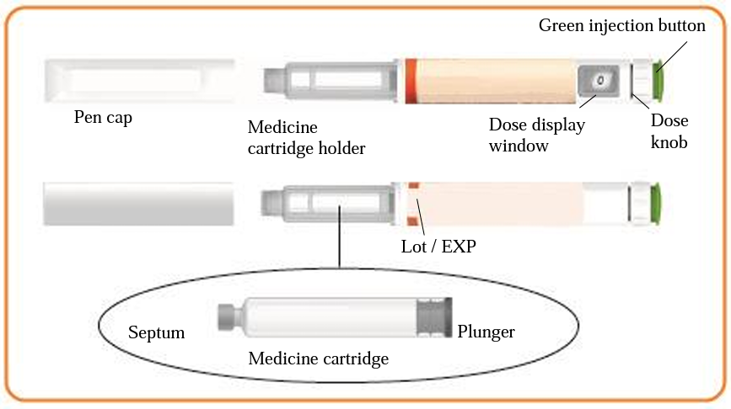

Parts of the needle (not included with ELADYNOS) to use with the ELADYNOS pen
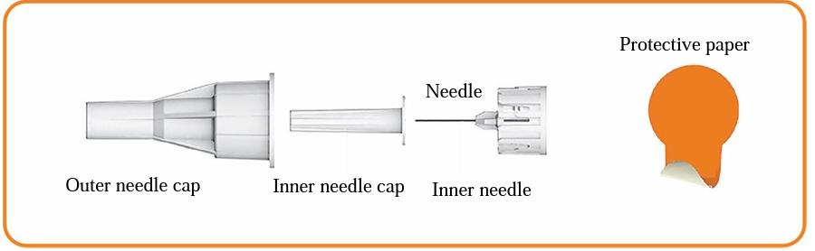

Injecting ELADYNOS

Step 1 – Check the ELADYNOS PEN
Wash your hands.

Check the pen label to make sure it is the correct medicine. Check the expiry date (EXP) on the pen to make sure it has not passed.

Note the date of Day 1 to ensure the pen is not used for more than 30 consecutive days.

Pull off the pen cap from the pen.

Check that the pen, including the medicine cartridge is not damaged. The liquid should be clear, colourless, and free of particles; if not, do not use. You may see small air bubblies in the liquid. This is normal.
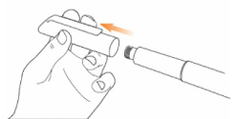

Step 2 – Attach the needle to the ELADYNOS PEN
Remove the protective paper from a new needle.
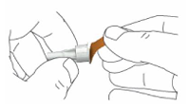

Push the capped needle straight onto the pen and twist until it is secure. Make sure the needle is straight so that it doesn't bend when inserting. The pen will not work if the needle is not properly attached. Do not over-tighten as this may make the needle difficult to remove. If the needle becomes bent, see below under 'Troubleshooting'.
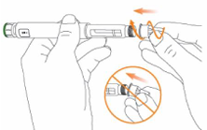

Pull off the outer needle cap from the needle and keep it to use after the injection.
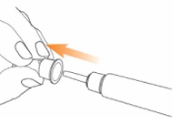

Carefully pull off the inner needle cap and dispose of it.
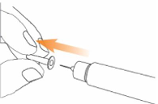

Step 3 – Day 1 Only - Testing an ELADYNOS pen prior to first injection
The ELADYNOS pen has medicine for 30 days plus a small amount to test each pen once to confirm it is working properly.

If the pen is tested before every injection the pen will run out of medicine early. Therefore, perform Step 3 only on Day 1, prior to the first injection with each pen. For day 2 through to Day 30 do not test the pen again; go directly to Step 4 to set the dose for your injection.

Holding the pen as illustrated, turn the dose knob on the pen away from you until it stops.
"•80" will be lined up in the dose display window.
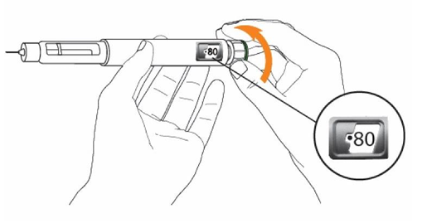

Hold the pen with the needle pointing up. Press the green injection button until it will not go any further. Liquid as a drop or stream should come from the needle tip.
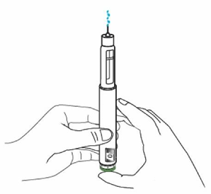

"•0" should be lined up in the dose display window.
Note: If liquid does not come from the needle tip, see under "Troubleshooting".
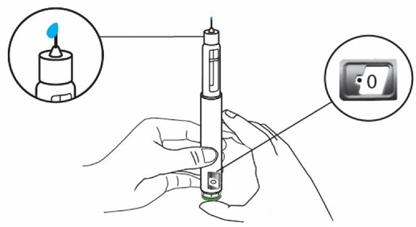

Step 4 – Set the dose on the ELADYNOS pen
Turn the white dose knob on the pen away from you until the knob stops and "•80" is lined up in the display window. The ELADYNOS pen is now ready for injection.
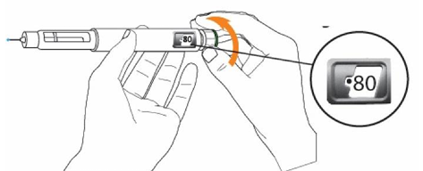

Note: If the pen cannot be set to "•80", see below under "Troubleshooting".

Step 5 – Choose and clean the injection site
Injections should be given in the lower abdomen as shown by the grey shaded area. Avoid the
5 cm around the belly button.
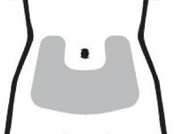

Select a different injection site on the abdomen each day. Only inject into clear skin. Do not inject into areas where the skin is tender, bruised, red, scaly, or hard. Avoid areas with scars or stretch marks.

Wipe the injection site with an alcohol swab and allow it to dry. Do not touch, fan, or blow on the injection site after it has been cleaned.
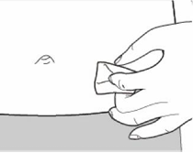

Note: Your doctor, nurse or pharmacist may recommend that you pinch up the skin at the injection site. Once the needle enters the skin, the pinch can be released.

Step 6 – Administering the ELADYNOS injection
Insert the needle straight into the skin.
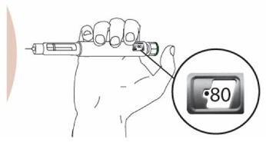

Press and HOLD the green button until ALL the below events are complete:
- "•0" is displayed
- Hold for 10 seconds to give full dose
- Withdraw pen from skin
And THEN release the button.

Do not press the green button without a needle attached.
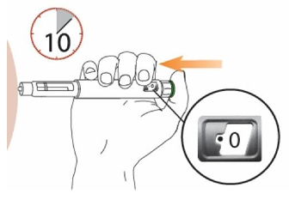

Note: Do not move the pen after inserting. If the green injection button cannot be pressed down or stops before the "•0", see below under "Troubleshooting".

Slowly remove the pen from the injection site by pulling the pen needle straight out.
There may be slight bleeding; this is normal. Do not rub the injection site. If slight bleeding occurs, press a cotton ball or gauze pad to the injection site as required. The area may also be covered with a small adhesive bandage.

Step 7 – Remove the pen needle
Caution: To prevent needle stick injury, follow this step carefully.

Carefully place the outer needle cap back on the needle. Then carefully press on the outer needle cap until it snaps into place and is secure.
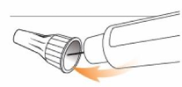

Unscrew the capped needle. To unscrew the capped needle, squeeze the cap at the base against the needle, then turn it 8 or more times before gently pulling until the capped needle comes off.

Note: Do not push down on the outer needle cap while unscrewing the needle.
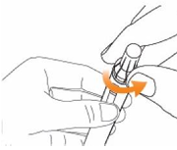

Note: A gap widening between the outer needle cap and the pen should be seen as the needle is unscrewed.
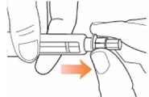

Step 8 – After injection
Firmly replace the pen cap onto the ELADYNOS pen.

Keep the cap on the pen between injections.
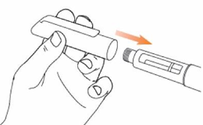

Troubleshooting

What if the needle is bent?
- Carefully remove the bent needle and follow Step 2 to attach a new needle to the pen. The pen needle has a visible portion which goes into the skin and there is a hidden inner needle portion and goes into the pen's septum.
- Review the parts of the pen needle, paying close attention to the inner needle portion. The visible portion of the needle may look straight, but the inner needle can become bent when attaching the needle to the pen.
- Be sure to keep the entire pen needle straight when attaching it to the pen to avoid bending the inner needle.

What if liquid does not come out of the needle tip when testing the pen on Day 1?
- If there is no liquid coming out of the needle, the pen setup is not complete. The needle may be blocked, bent, or improperly attached.
- Follow Step 2 to attach a new needle to the pen and repeat Step 3 "Testing an ELADYNOS pen prior to first injection".
- If there is still no drop of liquid contact your pharmacist or doctor.

What if the white dose knob cannot be turned to set the ELADYNOS pen to "•80"?
- There is not enough medicine in the pen to give a full dose. A new ELADYNOS pen will be required.

What if the green injection button is difficult to press?
- If the green injection button cannot be pressed down or stops before the "•0" in the dose display window, the new pen test is not complete. The needle may be blocked or improperly attached.
- Follow Step 2 to attach a new needle to the pen.
- If the green injection button still cannot be pressed down or stops before the "•0" is in the display window, contact your pharmacist or doctor.

Contraindications
ELADYNOS is contraindicated in women who:
- Have hypersensitivity to the active substance or to any of the excipients listed in Section 6.1 List of excipients
- Are pregnant or breastfeeding (see Section 4.6 Fertility, pregnancy and lactation)
- Are of childbearing potential (see Section 4.6 Fertility, pregnancy and lactation)
- Have pre-existing hypercalcaemia
- Have severe renal impairment (see Section 4.2 Dose and method of administration and 5.2 Pharmacokinetic properties)
- Have unexplained elevations of serum alkaline phosphatase
- Have known risks for osteosarcoma such as those who have received prior external beam or implant radiation therapy involving the skeleton (see Section 5.3 Preclinical safety data)
- Have skeletal malignancies or bone metastases

Special warnings and precautions for use

Risk of Osteosarcoma
The maximum total duration of treatment with ELADYNOS should be 18 months. Studies in rats indicate an increased incidence of osteosarcoma with long-term administration of abaloparatide (see section 5.3 Preclinical safety data).

Orthostatic hypotension and increased heart rate
Orthostatic hypotension and transient episodes of increase in heart rate may occur with abaloparatide, typically within 4 hours of injection. Symptoms may include dizziness, palpitations, tachycardia, or nausea, and may resolve by having the patient lie down. The first injection(s) of ELADYNOS should be performed under the guidance of an appropriately qualified health care professional who may observe the patient during the first hour after injection. ELADYNOS should always be administered where the patient can sit or lie down if necessary.

Abaloparatide may have vasodilating effect on vascular smooth muscle and positive chronotropic/inotropic effects on cardiac muscle. Individual benefit risk assessment is important. Blood pressure, cardiac status and ECG should be assessed prior to beginning treatment with abaloparatide. Patients with cardiac disease should be monitored for worsening of their disease. If severe orthostatic hypotension or severe cardiovascular symptoms occur, the treatment should be discontinued.

Hypercalcaemia
In normocalcaemic patients, transient elevations of serum calcium concentrations have been observed following ELADYNOS injection. Serum calcium concentrations reach a maximum at approximately 4 hours and return to baseline by 24 hours after each dose. Therefore, if blood samples for serum calcium measurements are taken, this should be done approximately
24 hours after the most recent injection. Routine calcium monitoring during therapy is not required in patients without additional risk factors for hypercalcaemia.

Hypercalciuria and urolithiasis
Abaloparatide may cause hypercalciuria. It is unknown whether abaloparatide may exacerbate urolithiasis in patients with active or a history of urolithiasis. If active urolithiasis or pre-existing hypercalciuria is suspected, measurement of urinary calcium excretion should be considered (see section 4.8 Adverse effects (Undesirable effects)).

Use in renal impairment
ELADYNOS must not be used in patients with severe renal impairment including patients with end-stage renal disease (see Section 4.3 Contraindications). In patients with mild to moderate renal impairment, dose-based adjustment is not required (see Section 5.2 Pharmacokinetic properties).

Use in hepatic impairment
No data are available in patients with impaired hepatic function. Dose adjustment is not required for these patients, as it is unlikely that hepatic impairment will have a significant effect on abaloparatide exposure (see Section 5.2 Pharmacokinetic properties).

Use in the elderly
Dose adjustment based on age is not required (see Section 5.2 Pharmacokinetic properties).

Paediatric use
The safety and efficacy of ELADYNOS has not been studied in paediatric populations. ELADYNOS should not be used paediatric patients or young adults with open epiphyses because of concerns of osteosarcoma (see Section 5.3 Preclinical safety data).

Effects on laboratory tests

Serum calcium
ELADYNOS can cause transient increases in serum calcium levels measured 4 hours post-dose, see section 4.8 Adverse effects (Undesirable effects)).

Serum uric acid
ELADYNOS increased serum uric acid concentrations, see section 4.8 Adverse effects (Undesirable effects)).

Interactions with other medicines and other forms of interactions
No dedicated clinical drug-drug interaction studies have been performed with ELADYNOS. The interaction potential of abaloparatide is considered to be low based on in vitro data. Abaloparatide was shown to not inhibit or induce cytochrome P450 enzymes at clinically relevant concentrations, to not be a substrate of the renal transporters P-gp, OAT1, OAT3, OCT2, MATE1 or MATE2K, and to not inhibit P-gp, BCRP, OAT1, OAT3, OCT2, OATP1B1 or OATP1B3 transporters at clinically relevant concentrations.

There is no data on efficacy of ELADYNOS in patients with prior or concomitant bisphosphonate or glucocorticoid treatment.

Concomitant use of vasoactive medicinal products may predispose to orthostatic hypotension since the blood pressure lowering effect of abaloparatide may be increased, see Section 4.4 Special warnings and precautions for use.

Sporadic case reports have suggested that hypercalcaemia may predispose patients to digitalis toxicity. Because abaloparatide has been shown to increase serum calcium, it should be used with caution in patients taking digitalis.

Fertility, pregnancy and lactation

Effects on fertility
ELADYNOS is contraindicated in women of childbearing potential. No data are available on the effect of ELADYNOS on human fertility, and no fertility study has been performed with abaloparatide in female animals. Fertility was unaffected in male rats receiving abaloparatide at subcutaneous doses up to 70 µg/kg/day (yielding systemic exposure [plasma AUC] 27 times higher than in patients at the recommended human dose of 80 µg/day).

Use in pregnancy – Pregnancy Category B3
ELADYNOS is contraindicated during pregnancy and in women of childbearing potential (see Section 4.3 Contraindications). No embryofetal development studies have been conducted with abaloparatide in animals. ELADYNOS is not to be used in women who are, or may be, pregnant.

Use in lactation.
It is unknown whether abaloparatide is excreted in milk. A risk to the newborn/infant cannot be excluded. ELADYNOS is contraindicated during breast-feeding (see Section 4.3 Contraindications).

Effects on ability to drive and use machines
ELADYNOS has no or negligible influence on the ability to drive and use machines. Transient orthostatic hypotension or dizziness may occur following administration of ELADYNOS (see Section 4.8 Adverse effects (Undesirable effects)). These patients should refrain from driving or the use of machines until symptoms have subsided.

Adverse effects (Undesirable effects)

Clinical Trial Adverse Effects
Treatment-emergent adverse event data for ELADYNOS from a randomised, double blind, placebo-controlled, multicentre phase 3 safety and efficacy study (ACTIVE) is presented in Table 1. This study included 1381 postmenopausal women with osteoporosis of whom 694 received abaloparatide and 687 received placebo daily for 18 months. Pooling of safety data from other studies was not possible due to differences in treatment duration.
Table 1 – Frequent (incidence ≥2%) treatment-emergent adverse events in the ELADYNOS group of the ACTIVE study with a greater incidence than placebo
System Organ Class  Preferred Term | Placebo  n = 687  n (%) | ELADYNOS  n = 694  n (%)
Blood and lymphatic system disorders
Anaemia | 12 (1.7) | 21 (3.0)
Cardiac disorders
Palpitations | 3 (0.4) | 39 (5.6)
Ear and labyrinth disorders
Vertigo | 9 (1.3) | 14 (2.0)
Gastrointestinal disorders
Nausea | 21 (3.1) | 59 (8.5)
Abdominal pain upper | 16 (2.3) | 7 (2.4)
Dyspepsia | 12 (1.7) | 14 (2.0)
General disorders and administration site conditions
Fatigue | 9 (1.3) | 18 (2.6)
Injection site erythema | 13 (1.9) | 14 (2.0)
Infections and infestations
Upper respiratory tract infection | 61 (8.9) | 65 (9.4)
Influenza | 21 (3.1) | 43 (6.2)
Urinary tract infection | 36 (5.2) | 37 (5.3)
Cystitis | 20 (2.9) | 23 (3.3)
Injury, poisoning and procedural complications
Contusion | 20 (2.9) | 21 (.3.0)
Investigations
Creatinine renal clearance decreased | 4 (0.6) | 16 (2.3)
Urine calcium/creatinine ratio increased | 12 (1.7) | 15 (2.2)
Blood urea increased | 8 (1.2) | 14 (2.0)
Musculoskeletal and connective tissue disorders
Osteoarthritis | 25 (3.6) | 32 (4.6)
Muscle spasms | 15 (2.2) | 21 (3.0)
Nervous system disorders
Dizziness | 49 (7.1) | 77 (11.1)
Headache | 40 (5.8) | 59 (8.5)
Sciatica | 11 (1.6) | 16 (2.3)
Renal and urinary disorders
Hypercalciuria | 73 (10.6) | 93 (13.4)
Vascular disorders
Hypertension | 37 (5.4) | 47 (6.8)

List of Adverse Reactions
Adverse reactions associated with the use of ELADYNOS in osteoporosis in the ACTIVE study are summarised below.

The following MedDRA convention has been used for the classification of the adverse reactions: very common (≥1/10), common (≥1/100 to <1/10), uncommon (≥1/1 000 to <1/100), rare (≥1/10 000 to <1/1 000), very rare (<1/10 000), and frequency not known (cannot be estimated from the available data).

Metabolism and nutrition disorders
Common: Hypercalcaemia; Hyperuricaemia

Cardiac disorders
Common: Tachycardia (including sinus tachycardia)

Investigations
Common: Blood uric acid increased

Vascular disorders
Common: Orthostatic hypotension

Description of selected adverse reactions

Increased heart rate
In the QT study, the placebo-adjusted mean heart rate increase was 14.5 beats per minute (bpm) 15 minutes after administration. This increase in heart rate was most prominent during the first hour post dose but was seen up to 6 hours in some subjects.

In the ACTIVE study, heart rate was measured one hour post dose of every study visit, with median heart rate increase from pre-dose of 14 bpm in abaloparatide treated patients as compared to 7 bpm in placebo treated patients. Patients with >20 bpm increase in heart rate at 1 hour after the first dose were more likely to experience palpitations and/or increases in heart rate >20 bpm during subsequent treatment. Adverse reactions of tachycardia and sinus tachycardia were reported in 1.6% of patients receiving abaloparatide and 0.4% of patients in the placebo group.

Orthostatic hypotension
In women with postmenopausal osteoporosis, adverse reactions of orthostatic hypotension were reported in 1% of patients receiving abaloparatide and 0.6% of patients in the placebo group.

Injection site reactions
ELADYNOS can cause injection site reactions including injection site bruising, erythema, haemorrhage, hypersensitivity, pain, rash, and swelling. The overall incidence in the abaloparatide arm was 5.0% compared to 3.9% in the placebo group.

Laboratory findings

Serum calcium
ELADYNOS can cause transient increases in serum calcium levels measured 4 hours post-dose. The overall incidence of hypercalcaemia, defined as albumin-corrected serum calcium
≥2.67 mmol/L (or ≥10.7 mg/dL) in the abaloparatide arm was higher (3.3%) compared to the placebo group (0.4%).

Serum uric acid
ELADYNOS increased serum uric acid concentrations. In the ACTIVE study, 25% of patients in the abaloparatide group had normal baseline uric acid concentrations which were increased above the normal range at post-baseline, compared with 5% in the placebo group.

Hypercalciuria and urolithiasis
In the clinical trial of women with postmenopausal osteoporosis, the overall incidence of urine calcium: creatinine ratio >0.00113 mmol/μmol (or >400 mg/g) was higher with abaloparatide than with placebo (20% vs 15%, respectively). Urolithiasis was reported in 1.4% of abaloparatide-treated patients and 1.2% of placebo-treated patients.

Immunogenicity
Of the patients receiving abaloparatide for 18 months, 42.9% developed anti-abaloparatide antibodies and 28.5% developed in vitro neutralising antibodies. Formation of anti-abaloparatide antibodies is associated with increased clearance of abaloparatide. These changes in clearance could be related to anti-abaloparatide antibodies interfering with the accurate measurement of abaloparatide plasma concentrations. Compared to antibody negative patients, no clinically relevant differences in safety or efficacy were observed for patients who were antibody positive or who were positive for in vitro neutralising antibodies.

Post-marketing data
The following additional adverse reactions have been identified during the post-approval use of abaloparatide. Because these reactions are reported voluntarily from a population of uncertain size, it is not possible to reliably estimate their frequency.

Immune system disorders
Anaphylactic reaction
Dyspnoea (in the context of allergic reactions)
Hypersensitivity reaction

Metabolism and nutrition disorders
Decreased appetite

Psychiatric disorders
Insomnia

Nervous system disorders
Lethargy

Cardiac disorders
Blood pressure increased

Vascular disorders
Hot flush

Gastrointestinal disorders
Abdominal distension
Abdominal discomfort
Abdominal pain
Constipation
Diarrhea
Vomiting

Skin and subcutaneous tissue disorders
Pruritus
Rash

Musculoskeletal and connective tissue disorders
Arthralgia
Back pain
Bone pain
Muscle spasms (leg and back)
Pain in extremity

General disorders and administration site conditions
Asthenia
Feeling abnormal
Injection site bruising
Injection site hemorrhage
Injection site pruritis
Injection site rash
Malaise
Pain

Reporting suspected adverse effects
Reporting suspected adverse reactions after registration of the medicinal product is important. It allows continued monitoring of the benefit-risk balance of the medicinal product. Healthcare professionals are asked to report any suspected adverse reactions at www.tga.gov.au/reporting-problems.

Overdose

Signs and symptoms
In clinical trials, ELADYNOS has been administered subcutaneously in single doses of up to
320 micrograms and in repeated doses of up to 120 micrograms/day for 7 days. The primary dose-limiting adverse effect was postural dizziness.

The effects of overdose that might be expected include transient hypecalciuria, hypercalcaemia, nausea, vomiting, dizziness, palpitations, orthostatic hypotension and headache.

In the clinical programme with an earlier pen design, accidental overdose was reported in a patient who received 400 micrograms in one day (5 times the recommended clinical dose). The patient experienced asthenia, headache, nausea, and vertigo. Serum calcium was not assessed on the day of the overdose, but on the following day the patient’s serum calcium was within the normal range.

Overdose management
There is no specific antidote for ELADYNOS. Treatment of suspected overdose may include transitory discontinuation of treatment, monitoring of serum calcium and implementation of appropriate supportive measures, such as hydration.

For information on the management of overdose, contact the Poisons Information Centre on 13 11 26 (Australia).

Pharmacological properties

Pharmacodynamic properties
Pharmacotherapeutic group: Calcium homeostasis, parathyroid hormones and analogues, ATC code: H05AA04

Mechanism of action
Abaloparatide is an agonist of the parathyroid hormone receptor 1 (PTHR1). It shares sequence homology with the first 34 amino acids of parathyroid hormone related peptide [PTHrP(1–34)] (76% homology) and of parathyroid hormone [PTH(1–34)] (41% homology). Abaloparatide stimulates new bone formation on trabecular and cortical bone surfaces by stimulation of osteoblastic activity.

Abaloparatide causes transient and limited increases in bone resorption and increases bone density.

Clinical trials
The efficacy and safety of once daily abaloparatide was evaluated in a randomised, multicentre, double-blind, placebo- and open-label active comparator-controlled (teriparatide) clinical study (ACTIVE study) for 18 months of treatment with 1 month follow-up in 2070 postmenopausal women aged 50 to 86 years (mean age of 69; 15% were <65 years of age, 65% were 65 to
˂75 years of age, and 20% were ≥75 years of age) who were enrolled and randomised to receive abaloparatide 80 micrograms (N=696), placebo (N=688), or 20 micrograms teriparatide (N=686). Approximately 76% of patients were Caucasian, 19% were Asian, and 4% were Black. Of the total study population, 28% were Hispanic. Women took daily supplemental calcium (500 to 1 000 mg) and vitamin D (400 to 800 IU) per day. The primary endpoint in ACTIVE was the incidence of new vertebral fractures in abaloparatide-treated patients versus placebo.

At baseline, the mean T-scores were -2.9 at the lumbar spine, -2.2 at the femoral neck, and -1.9 at the total hip. At baseline, 42% of patients had no prior fracture, 23% of patients had at least one prevalent vertebral fracture, and 43% had at least one prior non-vertebral fracture.

Effect on new vertebral fractures
In the ACTIVE study at 18 months, abaloparatide and teriparatide significantly reduced the absolute risk of new vertebral fractures versus placebo in postmenopausal patients with osteoporosis (p<0.0001; see Table 2).

Table 2 - ACTIVE Trial: the effect* of abaloparatide on the risk of new vertebral fracture at 18 months
Parameter | PBO  (N=600) | ABL  (N=583) | TER  (N=600)
Number of women with vertebral fracture, n (%) | 25 (4.2) | 3 (0.5) | 4 (0.7)
Absolute risk difference vs placebo^{ǂ} (%)  (95% CI) | n/a | 3.7 (2.0, 5.6) | 3.5 (1.8, 5.5)
*Based on Modified Intent to Treat Population (patients with baseline and post-baseline spine radiographs)
^{ǂ} Absolute risk difference was calculated as (PBO – ABL) and (PBO – TER).
PBO=placebo, ABL=abaloparatide, TER=teriparatide, CI=Confidence Interval

Effect on non-vertebral fractures
In the ACTIVE study at 19 months, the incidence of non-vertebral fractures was similar between the abaloparatide (2.7%) and teriparatide (2.0%) groups, and not statistically different compared to placebo (3.6%) (see Table 3).

Table 3 - ACTIVE Trial: time-to-event of non-vertebral fracture at 19 months
Parameter | PBO  (N=688) | ABL  (N=696) | TER  (N=686)
K-M estimated event rate (%)  (95% CI) | 3.6  (2.3, 5.4) | 2.7  (1.6, 4.4) | 2.0  (1.1, 3.4)
Number of patients with event  n (%) | 21 (3.1) | 15 (2.2) | 12 (1.7)
Absolute risk difference vs placebo* (%)  (95% CI) | n/a | 0.9  (-1.1, 2.9) | 1.6  (-0.3, 3.5)
p-value vs placebo |  | 0.3675 | 0.1095
p-value vs teriparatide |  | 0.4919
* Absolute risk difference was calculated as (PBO – ABL) and (PBO – TER).
PBO=placebo, ABL=abaloparatide, TER=teriparatide, K-M=Kaplan Meier, CI=Confidence Interval

Effect on bone mineral density (BMD)
In the ACTIVE study, abaloparatide significantly increased BMD at all anatomical sites measured, versus placebo at 6, 12 and 18 months. The mean percent change in BMD at
18 months was 9.1% vs 0.5% at the lumbar spine, 3.3% vs 0% at the total hip, and 2.7% vs
-0.4% at the femoral neck for abaloparatide versus placebo groups, respectively (all p<0.0001). At the ultra-distal radius, the mean percent change in BMD at 18 months was 1.2% vs -1.0% for abaloparatide versus placebo groups.

Abaloparatide demonstrated consistent increases in BMD measurements regardless of age, years since menopause, race, geographic region, presence or absence of prior fracture (vertebral, non-vertebral), severity of disease, and BMD at baseline.

Post treatment management

Extension study
Upon completion of the ACTIVE trial, 963 patients, enrolled in the ACTIVExtend trial, an open-label extension study, where all patients received up to 24 months of treatment with 70 mg alendronate (ALN) weekly and calcium and vitamin D supplements. This included 494 patients who had previously received placebo and 469 patients who had previously received abaloparatide. Patients who received teriparatide during the ACTIVE trial were not eligible to participate in the ACTIVExtend trial. Results for vertebral fracture risk reduction at 43 months since randomisation are presented in Table 4.

Effect on new vertebral fractures – Extension study
In the ACTIVExtend study at 43 months, abaloparatide/ALN significantly reduced the absolute risk of new vertebral fractures vs placebo/ALN (p<0.0001; see Table 4). Teriparatide followed by alendronate has not been studied.

Table 4 - ACTIVExtend trial: the effect* of abaloparatide/ALN on the risk of new cerebral fractures at 43 months†
Parameter | PBO/ALN | ABL/ALN
Number of women with vertebral fracture, n (%) | 26 (5.3) | 4 (0.9)
Absolute risk difference vs placebo/ALN‡ (%)  (95% CI) | n/a | 4.4  (2.3, 6.9)
* Based on Modified Intent to Treat Population (patients with baseline and post-baseline spine radiographs)
† Alendronate stated at 19 months
‡ Absolute risk difference was calculated as (PBO/ALN – ABL/ALN)
PBO=placebo, ABL=abaloparatide, ALN=alendronate, CI=confidence interval

Effect on non-vertebral fractures – Extension study
In the ACTIVExtend study at 43 months, abaloparatide/ALN numerically reduced the risk of non-vertebral fractures versus placebo/ALN. The incidence of non-vertebral fractures with abaloparatide/ALN (4.2%) was not statistically different compared to placebo (6.7%) (see Table 5).

Table 5 - ACTIVExtend trial: time-to-event of non-vertebral fracture at 43 months*
Parameter | PBO/ALN | ABL/ALN
K-M estimated event rate (%)  (95% CI) | 6.7  (4.8, 9.3) | 4.2  (2.7, 6.4)
Number of patients with event  n (%) | 32 (6.5) | 19 (4.1)
Absolute risk difference vs placebo/ALN‡ (%)  (95% CI) | n/a | 2.5  (-0.4, 5.4)
p-value vs placebo |  | 0.0877
* Alendronate stated at 19 months
‡ Absolute risk difference was calculated as (PBO/ALN – ABL/ALN)
PBO=placebo, ABL=abaloparatide, ALN=alendronate, K-M=Kaplan Meier, CI=confidence interval

Effect on bone mineral density (BMD) – Extension study
The mean percent change in BMD through 43 months was 14.7% vs 6.8% at the lumbar spine, 6.3% vs 2.9% at the total hip, 5.0% vs 1.6% at the femoral neck, and 1.1% vs 1.1% at the ultra-distal radius for abaloparatide/ALN versus placebo/ALN groups, respectively.

Pharmacokinetic properties

Absorption
The median (range) time to peak concentration of abaloparatide 80 micrograms was 0.5 h (0.25 to 0.52 h) following subcutaneous administration. The absolute bioavailability of abaloparatide in healthy subjects after subcutaneous administration of 80 micrograms dose was about 39%.

Distribution
The in vitro plasma protein binding of abaloparatide was approximately 70%. The volume of distribution was approximately 45 L.

Metabolism
No specific metabolism or excretion studies have been performed with abaloparatide. The metabolism of abaloparatide is consistent with non-specific proteolytic degradation into smaller peptide fragments, followed by elimination by renal clearance.

Linearity
Abaloparatide systemic exposure was generally increasing with the increase of its subcutaneous doses from 5 micrograms up to 240 micrograms. There was a general tendency towards less than dose-proportional increases, and no further increase in abaloparatide systemic exposure was observed as its dose increased to 280 micrograms and 320 micrograms.

Renal impairment
Abaloparatide exposure increased with decreasing CrCl. Subjects with mild, moderate and severe renal impairment had Cmax increases of 3%, 28% and 44%, respectively, and AUC increases of 17%, 68% and 113%, respectively, compared to subjects with normal renal function (see Section 4.2 Dose and method of administration and 4.3 Contraindications).

No studies have been performed in patients undergoing dialysis for chronic renal failure.

Hepatic impairment
No studies have been performed in patients with hepatic impairment. Abaloparatide is a peptide and not an inhibitor or an inducer of hepatic drug metabolising enzymes. The elimination is through proteolytic degradation and renal excretion, and it is unlikely that hepatic impairment will have any significant effect on abaloparatide exposure. No dose adjustment is needed for these patients (see Section 4.2 Dose and method of administration).

Elderly
No age-related differences in abaloparatide pharmacokinetics were detected during clinical studies, including postmenopausal women ranging from 49 to 86 years of age.

Excretion
The mean apparent total plasma clearance for subcutaneous administration is 168 L/h in healthy subjects, and the mean half-life of abaloparatide is about 1 h. The peptide fragments are primarily eliminated through renal excretion. Active secretion of abaloparatide in the kidneys cannot be ruled out.

Preclinical safety data

Genotoxicity
Abaloparatide was not genotoxic in assays for bacterial reverse mutation (Ames test), chromosomal aberrations in vitro (in human lymphocytes) and in vivo in the mouse bone marrow micronucleus test .

Carcinogenicity
In a 2-year rat carcinogenicity study involving daily subcutaneous administration, abaloparatide produced a marked increase in the incidence of osteosarcoma in both sexes and at all dose levels tested (≥10 µg/kg/day). This occurred at systemic exposure levels (plasma AUC) 4 times higher than in patients at the recommended human dose. Osteoblastomas were also increased by treatment. The relevance of these rat findings to humans is uncertain. Due to the potential risk of osteosarcoma, a maximum total duration of 18 months applies to ELADYNOS and its use is contraindicated in patients at known increased risk of osteosarcoma.

Pharmaceutical particulars

List of excipients
Phenol
Water for injections
Sodium acetate trihydrate
Acetic acid

Incompatibilities
In the absence of compatibility studies, this medicinal product must not be mixed with other medicinal products.

Shelf life
In Australia, information on the shelf life can be found on the public summary of the Australian Register of Therapeutic Goods (ARTG). The expiry date can be found on the packaging.

Special precautions for storage
Store in a refrigerator (2 °C–8 °C). Do not freeze.

Each pen should be used by only one patient. A new, sterile needle must be used for every injection. The pen should only be used with 8 mm, 31-gauge needles. No needles are supplied with the medicinal product. Do not store the pen with the needle attached.

ELADYNOS should not be used if the solution is cloudy, coloured or contains particles.

After first use or once removed from the refrigerator, store the pen below 25 °C. It must be used within 30 days.

Nature and contents of container
Cartridge (siliconised Type I glass) with a plunger (chlorobutyl rubber), crimp cap (bromobutyl rubber seal)/aluminium assembled into a disposable pen.

Each pre-filled pen contains 1.5 mL of solution (30 doses).

ELADYNOS is supplied in a pack size of 1 or 3 pre-filled pens. A starter pack containing 1 pre-filled pen may also be supplied. Not all pack sizes may be marketed.

Special precautions for disposal
In Australia, any unused medicine or waste material should be disposed of by taking to your local pharmacy.

Physicochemical properties

Chemical structure
Chemical name: [Glu^{22,25}, Leu^{23,28,31}, Aib²⁹, Lys^{26,30}] hPTHrP (1-34)-NH₂

Molecular formula and molecular mass: C₁₇₄H₃₀₀N₅₆O₄₉ (3961 Da)

Structural formula: H-Ala-Val-Ser-Glu-His-Gln-Leu-Leu-His-Asp-Lys-Gly-Lys-Ser-Ile-Gln-Asp-Leu-Arg-Arg-Arg-Glu-Leu-Leu-Glu-Lys-Leu-Leu-Aib-Lys-Leu-His-Thr-Ala-NH₂

CAS number
247062-33-5

Medicine schedule (Poisons Standard)
Prescription Only Medicine (Schedule 4)

Sponsor
Theramex Australia Pty Ltd
Level 22, 60 Margaret Street,
Sydney NSW 200
1800 THERAMEX or 1800 843 726

Date of first approval
28 November 2024

Date of revision

Summary table of changes
Section Changed | Summary of new information

