Australian Public Assessment Report for VERDYE
  - Active ingredient: Indocyanine Green
  - Sponsor: Clinect Pty Ltd
January 2025

About the Therapeutic Goods Administration (TGA)
- The Therapeutic Goods Administration (TGA) is part of the Australian Government Department of Health and Aged Care and is responsible for regulating therapeutic goods, including medicines, medical devices, and biologicals.
- The TGA administers the Therapeutic Goods Act 1989 (the Act), applying a risk management approach designed to ensure therapeutic goods supplied in Australia meet acceptable standards of quality, safety, and efficacy.
- The work of the TGA is based on applying scientific and clinical expertise to decision-making, to ensure that the benefits to the Australian public outweigh any risks associated with the use of therapeutic goods.
- The TGA relies on the public, healthcare professionals and industry to report problems with therapeutic goods. The TGA investigates reports received to determine any necessary regulatory action.
- To report a problem with a therapeutic good, please see the information on the TGA website.

About AusPARs
- The Australian Public Assessment Report (AusPAR) provides information about the evaluation of a prescription medicine and the considerations that led the TGA to approve or not approve a prescription medicine submission. Further information can be found in Australian Public Assessment Report (AusPAR) guidance.
- AusPARs are prepared and published by the TGA.
- AusPARs are static documents that provide information that relates to a submission at a particular point in time. The publication of an AusPAR is an important part of the transparency of the TGA’s decision-making process.
- A new AusPAR may be provided to reflect changes to indications or major variations to a prescription medicine subject to evaluation by the TGA.

Copyright
© Commonwealth of Australia 2025
This work is copyright. You may reproduce the whole or part of this work in unaltered form for your own personal use or, if you are part of an organisation, for internal use within your organisation, but only if you or your organisation do not use the reproduction for any commercial purpose and retain this copyright notice and all disclaimer notices as part of that reproduction. Apart from rights to use as permitted by the Copyright Act 1968 or allowed by this copyright notice, all other rights are reserved and you are not allowed to reproduce the whole or any part of this work in any way (electronic or otherwise) without first being given specific written permission from the Commonwealth to do so. Requests and inquiries concerning reproduction and rights are to be sent to the TGA Copyright Officer, Therapeutic Goods Administration, PO Box 100, Woden ACT 2606 or emailed to <tga.copyright@tga.gov.au>.

Contents
List of abbreviations 4
VERDYE (Indocyanine green) submission 6
VERDYE (indocyanine green) 8
Liver function diagnostics 9
Indocyanine green clearance 9
Use in ophthalmic angiography 9
Measurement of cardiac output and circulating blood volumes 9
Regulatory status 10
Australian regulatory status 10
International regulatory status 10
Registration timeline 10
Submission overview and risk/benefit assessment 11
Quality evaluation summary 11
Nonclinical (toxicology) evaluation summary 12
Clinical evaluation summary 13
Summary of clinical studies 13
Pharmacology 13
Efficacy 14
Safety 29
Risk management plan evaluation summary 34
Risk-benefit analysis 34
Efficacy 34
Safety 35
Conclusions 35
Advisory Committee considerations 35
Outcome 36
Specific conditions of registration applying to these goods 36
Attachment 1. Product Information 36

List of abbreviations
Abbreviation | Meaning
3D-iDSA | 3D intraoperative digital subtraction angiography
ABT | ¹³C-aminopyrine breath
ACM | Advisory Committee on Medicines
AE | Adverse event
APRI | AST to Platelet Ratio Index
ATP | Adenosine triphosphate
AUC | Area under the curve
CAS | Chemical Abstract Services
CBF | Cerebral blood flow
CBV | central blood volume
Χ² | chi-square test
Cl | clearance
CNV | choroidal neovascularization
CO | Cardiac output
COTPID | transpulmonary indicator dilution (TPID) technique for the measurement of cardiac output
DIMA | dye-induced mobility alteration
DIPA | dye-induced precipitin activity alteration
DSA | digital subtraction angiography
ICG | Indocyanine Green
ICG-A | Indocyanine green angiography
ICGR15 | ICG retention ratio after 15 min
IODSA | intraoperative digital subtraction angiography
ITBV | Intrathoracic blood volume
IV | Intravenous
k or K | disappearance rate constant
LBS | Literature-based submission
MELD | Model for end-stage liver disease
NIR | Near infrared
PAC | Pulmonary artery catheter
PDD | Pulse dye densitometry
PDRICG | Plasma disappearance rate of ICG
PI | Product Information
PK | Pharmacokinetics/pharmacokinetic
r | Pearson’s regression coefficient
ROC | Receiver operating characteristics
RPE | Retinal pigment epithelium
SAE | Serious Adverse Events
SD | Standard deviation
SEM | Standard error of the mean
SmPC | Summary of product characteristics
t_{1/2} | terminal half life
TBV | Total blood volume
TGA | Therapeutic Goods Administration
t_{max} | Time to maximum plasma/serum concentration
TPID | Transpulmonary indicator dilution
V_{d} | volume of distribution
Vd_{ss} or V_{ss} | volume of distribution at steady state
VKH | Vogt-Koyanagi-Harada syndrome

VERDYE (Indocyanine green) submission
Type of submission: | New chemical entity
Product name: | VERDYE
Active ingredient: | Indocyanine green
Decision: | Approved
Date of decision: | 21 February 2024
Date of entry onto ARTG: | 15 March 2024
ARTG number: | 391356
Black Triangle Scheme | Yes
Sponsor’s name and address: | Clinect Pty Ltd, Level 7, 737 Bourke Street, Docklands, VIC 3008
Dose form: | Powder for Injection. Dark-green powder.
Strength: | Each vial contains 25 mg indocyanine green (to be reconstituted with 5 mL of water for injections)  1 mL of the reconstituted solution for injection contains 5 mg indocyanine green, a lyophilised sterile dark green powder. The reconstituted solution is clear and free from visible particles.
Container: | Container: amber glass vial (type I)  Closure: rubber stopper (bromobutyl, grey) fixed by an aluminium cap covered by a blue polypropylene cap
Pack size: | 5 vials, each with a content of 25 mg powder for solution for injection.
Approved therapeutic use for the current submission: | This medicinal product is for diagnostic use only.  Diagnostic indications  Cardiac, circulatory and micro-circulatory diagnostics:  -measurement of cardiac output and stroke volume  -measurement of circulating blood volumes  -measurement of cerebral perfusion  Liver function diagnostics:  -measurement of liver blood flow  -measurement of excretory function of the liver  Ophthalmic angiography diagnostics:  -measurement of perfusion of the choroid
Routes of administration: | Injection via an injection needle, a central or peripheral catheter or cardiac catheter.

Dosage: | SINGLE DOSE PER MEASUREMENT IN ADULTS, ELDERLY, CHILDREN:  Cardiac, circulatory, micro-circulatory and tissue perfusion diagnostics as well as cerebral blood flow: 0.1 to 0.3 mg/kg body weight as bolus injection  Liver function diagnostics: 0.25 – 0.5 mg/kg body weight as bolus injection  Ophthalmic angiography: 0.1 to 0.3 mg/kg body weight as bolus injection  TOTAL DAILY DOSE:  Adults, elderly, adolescents 11-18 years:  The total daily dose of VERDYE should be kept below 5 mg/kg body weight.  Children 2 – 11 years:  The total daily dose should be kept below 2.5 mg/kg body weight.  Children 0 - 2 years:  The total daily dose should be kept below 1.25 mg/kg body weight.  Methods of measurement  The absorption and emission maximum of indocyanine green are both in the near infrared range, the absorption maximum at 800 nm and the emission maximum for fluorescence measurement at 830 nm.  In in-vitro tests indocyanine green remains stable in human serum for several days.  Measurement of cardiac, circulatory, and cerebral blood flow and liver function  Areas under the first pass curve, transit time, half-life, plasma disappearance rate and retention rate of VERDYE can be determined.  - non-invasively by pulse dye densitometry or near infrared spectroscopy  - invasively by fibreoptic probes/catheters in suitable vessels  - conventionally by determination of the concentration either by continuous withdrawal of heparinised blood through a cuvette densitometer or by collection of blood samples and measurement of the plasma concentration in a photometer.  Evaluation of fundus perfusion in ophthalmic angiography  The perfusion of the fundus of the eye can be determined and quantified by ophthalmic fluorescence angiography.  Measurement of tissue perfusion  Tissue perfusion of the superficial tissue layers can be made visible and quantified by near infrared fluorescence video angiography.
Pregnancy category: | This therapeutic good is exempted from pregnancy categorisation.  Data on a limited number (242) of exposed pregnancies indicate no adverse effects of indocyanine green on pregnancy or on the health of the fetus/newborn child. To date, no other relevant epidemiological data are available.  No embyrofetal development studies in animals are available. The potential risk for humans is unknown.  Caution should be exercised when prescribing to pregnant women. VERDYE should be given to a pregnant woman only if clearly indicated. Repeated applications on one day have to be avoided.  The use of any medicine during pregnancy requires careful consideration of both risks and benefits by the treating health professional. The pregnancy database must not be used as the sole basis of decision making in the use of medicines during pregnancy. The TGA does not provide advice on the use of medicines in pregnancy for specific cases. More information is available from obstetric drug information services in your state or territory.

VERDYE (indocyanine green)
This AusPAR describes the submission by Clinect Pty Ltd (the Sponsor) to register VERDYE (indocyanine green) for the following proposed indications:
This medicinal product is for diagnostic use only.
Diagnostic Indications
- Cardiac, circulatory and micro-circulatory diagnostics:
  - measurement of cardiac output and stroke volume
  - measurement of circulating blood volumes
  - measurement of cerebral perfusion
- Liver function diagnostics:
  - measurement of liver blood flow
  - measurement of excretory function of the liver
- Ophthalmic angiography diagnostics:
  - measurement of perfusion of the choroid

Liver function diagnostics
Assessment of liver function and injury can be based on “static” tests, such as plasma concentrations of liver enzymes, hepatically synthesised proteins such as albumin and clotting factors and bilirubin. However, these proteins are also affected by a range of other physiology. “Dynamic” tests such as that undertaken with dyes such as ICG measure the ability of the liver to metabolise and eliminate defined substances and provide direct measures of the actual functional state of the liver at the time of the assessment.

Indocyanine green clearance
ICG is a water soluble inert anionic compound that is injected intravenously. In plasma, ICG is 98% protein bound. ICG is selectively taken up by hepatocytes independent of adenosine triphosphate (ATP) and later excreted unchanged into the bile via an ATP-dependent transport system. The plasma disappearance rate of ICG (PDRICG) is a commonly used parameter for assessment of liver function. PDRICG can be measured non-invasively at the bedside by a transcutaneous system and results can be obtained within 6-8 minutes.

Use in ophthalmic angiography
Fluorescein angiography, discovered in 1961 enables reasonable resolution of retinal capillaries but not the choroidal circulation. This is due to poor transmission of fluorescence through the retinal pigment epithelium (RPE), fundus pigmentation, and pathological manifestations such as haemorrhage and exudate, combined with rapid dye leakage into the extravascular space.
ICG ophthalmic fluorescent angiography (as opposed to absorption angiography) was first investigated in the early 1970s, with later developments consisting of improved films and improved absorption and microscopy being more recent additions to this technology. In distinction to fluorescent angiography, ICG angiography enables visualisation of the choroidal vessels and blood flow to RPE and the ocular circulation.

Measurement of cardiac output and circulating blood volumes
The thermodilution method is considered the gold standard for measuring cardiac output, but the method is invasive and thus generally reserved for only the most critically ill patients. Other methods for measuring cardiac output include oesophageal Doppler, lithium dilution, CO₂ rebreathing, uncalibrated pulse contour analysis and ICG pulse dye densitometry.
ICG pulse dye densitometry: ICG pulse dye densitometry is a non-invasive method, which has shown good agreement with the pulmonary artery catheter (PAC) thermodilution gold standard. After injection of ICG via a distal port of the central venous catheter, the blood concentration of ICG is determined by pulse dye densitometry. The measuring device is a clip attached to the patient’s nasal wing or fingertip. Pulse dye densitometry detects the relative ICG concentration over a period of 30 pulse waves. Entering the actual haemoglobin concentration obtained by blood gas analysis, the dye densitometer calculates the absolute ICG concentration referring the haemoglobin and dye concentration. As in the thermodilution method, cardiac output is calculated by using the Steward-Hamilton equation.

Regulatory status

Australian regulatory status
This product is considered a new chemical entity medicine for Australian regulatory purposes.

International regulatory status
At the time the TGA considered this submission, a similar submission had been considered by other regulatory agencies. Table 1 summarises these submissions and provides the indications where approved.
Table 1: International regulatory status at evaluation commencement (August 2022)
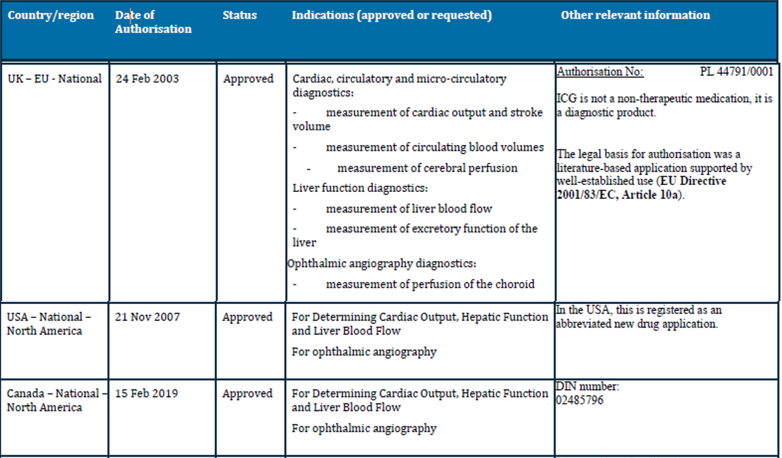
The overseas regulatory history includes approvals in: Austria (2005), Netherlands,, Belgium, Portugal, Sweden, Germany (all 2005), Chilli (2005), Italy and Spain (2017), UK (2003), USA (2007), Canada(2019) – note registered as a generic product, El Salvador and Argentina (2021), Ukraine (2020), Russia (2012), Croatia, Denmark, Czech, Finland, Greece, Hungary, Poland, Romania, Ireland, Slovenia (2022).

Registration timeline
Table 2 captures the key steps and dates for this submission.
This submission was evaluated under the standard prescription medicines registration process.
Table 2: Timeline for Submission PM-2022-01478-1-2
Description | Date
Submission dossier accepted and first round evaluation commenced | 1 August 2022
Evaluation completed | 19 May 2023
Delegate’s Overall benefit-risk assessment and request for Advisory Committee advice | 2 January 2024
Advisory Committee meeting | 16 February 2024
Registration decision (Outcome) | Approved
Administrative activities and registration in the ARTG completed | 15 March 2024
Number of working days from submission dossier acceptance to registration decision* | 237
*Statutory timeframe for standard submissions is 255 working days

Submission overview and risk/benefit assessment

Quality evaluation summary
ICG is a closed-chain, water-soluble tricarbocyan dye with two benzoyl indole moieties (Figure 1), with a peak spectral absorption at 800 nm in blood plasma, blood and serum. The 25 mg lyophilised dark-green powder is to be reconstituted with 5 mL of water for injections, administered intravenously.
Figure 1. Structure of indocyanine green
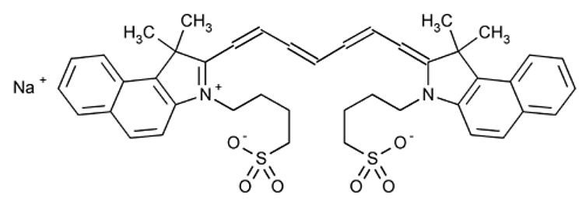
There were no significant issues identified from the quality evaluation of the submitted data that would indicate the product should not be registered on the basis of quality, or safety-related issues arising from the quality of the product. The evaluator was satisfied that the Sponsor had satisfied all requirements with respect to:
- GMP compliance
- Justification of stability and release specifications (which dictate the medicine’s physicochemical properties, biological activity/potency, immunochemical properties and purity)
- Appropriately conducted stability studies that support the proposed shelf life/storage conditions.
- Validation of analytical procedures utilised to assess drug specifications.
- appropriate choice/synthesis and validation of reference standards and reference materials
- Appropriate in-process controls within the manufacturing process and identification of critical manufacturing steps
- consistency of medicine manufacture verified by process validation and demonstrated through batch analysis (consecutive data from multiple manufacturing campaigns and sampling from multiple batches and different manufacturing processes i.e. validation, pre-validation, clinical, commercial batches).
- Satisfactory control of impurities.
- Adequate characterisation and justification of excipients
- medicine sterility/appropriate control of infectious disease & adventitious agents.
- appropriate/compatible container closure systems
- labelling that conformed to Therapeutic Goods Order 91.
These requirements were met for drug precursors/intermediates, the drug substance and the drug product.
The quality information submitted by the Sponsor supported the registration of VERDYE.

Nonclinical (toxicology) evaluation summary
The nonclinical dossier focussed on genotoxicity and published literature using commercially available ICG form to support the overall efficacy and safety of VERDYE. Submitted published literature focussed on primary pharmacology, pharmacokinetics, single-dose toxicity, phototoxicity and ocular toxicity. ICG has previously been evaluated (with limited data) and registered in Australia between 1996 and 2003. Therefore, the Sponsor’s nonclinical approach and justifications are considered acceptable.
Submitted published literature on primary pharmacology demonstrated the successful use of ICG (IV route) in animal models for the measurement of plasma volume and cardiac output, assessment of hepatic function by monitoring the ICG disappearance rate, as well as ophthalmic fluorescence angiography (measurement of perfusion of the choroid) and measurement of cerebral perfusion. The submitted published literature supported the proposed clinical indications.
No safety pharmacology studies were conducted with ICG. The clinical safety profile for ICG is well established as it was first approved for >60 years ago by the FDA, USA and was also registered in Australia as noted above.
Based on published literature, ICG highly binds to plasma proteins, especially lipoproteins, which confines it to the intravascular compartment. The binding to plasma proteins shifts the absorption peak towards the longer wavelengths. Following intravenous injection, ICG is not metabolized and is excreted by the liver. It is not reabsorbed from the intestine and does not undergo enterohepatic circulation. ICG is taken up by hepatic parenchymal cells and excreted into the bile.
Plasma clearance of ICG is biphasic, with a distribution half-life of around 6 minutes and a slightly slower elimination half-life of ~20 min in pigs, and a faster elimination in rats (t_{½} ~6 min). Overall, the pharmacokinetic profile in animals was qualitatively comparable to that of humans.
Indocyanine green has a medium order of acute intravenous toxicity with an intravenous LD₅₀ of 60 mg/kg in mice (no observable effects at 35 mg/kg) and no observable effects at 20 mg/kg IV in rats. The maximum recommended dose of ICG in humans is 2 mg/kg, which is several fold lower than the tested doses in animal studies.
No repeat-dose toxicity studies were conducted with ICG. It has a well-established clinical safety profile and no known pharmacological effects on vital organ function. Indocyanine green is proposed to be used as an injectable diagnostic in all its applications, with very limited re-administration. ICG is not intended to be administered on a repeated dose schedule. Considering the short-term duration of treatment for the proposed indications and long history of clinical use, absence of a repeat-dose toxicity study is acceptable.
ICG was non-genotoxic in three in vitro tests. The absence of carcinogenicity studies was considered acceptable based on the proposed intended clinical use as an intraoperative imaging agent and long history of clinical use.
No reproductive and developmental toxicity studies with ICG have been performed in animals. No reproductive and developmental toxicity studies reported in the published literature were submitted. It is not known whether ICG is excreted in milk.
Phototoxicity studies were not conducted using ICG. This is acceptable as the peak absorption s greater than 700 nm, which indicates that ICG is unlikely to be photoreactive. There was minimal decomposition of ICG from light irradiation in the presence of plasma in vitro. ICG at ≥ 10 µg/mL displayed phototoxic effects on mammalian cells in vitro when combined with near infrared light (800-830 nm). Given ICG is largely confined to the intravascular space and the proposed clinical dose of up to 0.5 mg/kg (estimated blood concentration ~7 μg/mL assuming a blood volume of 70 mL/kg), ICG is not expected to cause phototoxicity at the proposed clinical dose.
ICG is proposed for paediatric use. However, no specific preclinical studies in juvenile animals were submitted. Support for use in the paediatric patient group relies solely on clinical data.
Overall, there are no nonclinical objections to the registration of VERDYE for the proposed indications.

Clinical evaluation summary

Summary of clinical studies
This was a literature based submission, based on a TGA-approved search strategy (TGA-approved search strategy). The clinical searches were performed in the PubMed, Embase and Biosis databases.

Pharmacology

Pharmacokinetics
As noted in the PI, use of ICG can enable measurement of cardiac, circulatory, and cerebral blood flow and liver function using areas under the first pass curve, transit time, half-life, plasma disappearance rate and retention rate of ICG, using:
- non-invasive measures such as pulse dye densitometry or near infrared spectroscopy
- invasive measures e.g. by fibreoptic probes/catheters in suitable vessels
- conventionally by determination of the concentration either by continuous withdrawal of heparinised blood through a cuvette densitometer or by collection of blood samples and measurement of the plasma concentration in a photometer.
ICG is a non-toxic tricarbocyanine dye. ICG is an inert water-soluble anionic compound administered intravenously and highly protein bound. ICG is not metabolised. The average plasma half-life of ICG in persons who have normal hepatic function is 3 to 5 minutes.
The main issues in the PK data are around the optical absorption changes, effect of concomitant drugs on ICG clearance and effect of disease on ICG PK. Optical absorption is reduced by injectables containing sodium bisulphite (e.g., in combination with heparin). It is also noted that ICG contains residual amounts of inorganic iodine, which may interfere with thyroidal uptake of radioiodine during diagnostic or therapeutic procedures.
Substances that can enhance the clearance rate (or reduce the half-life) of ICG include anticonvulsants, haloperidol, nifedipine, nitrofurantoin, opiates (morphine, methadone, or opium alkaloids, pethidine (meperidine)), phenobarbital, and phenylbutazone. Substances that can reduce the clearance rate (or increase the half-life) of ICG are cyclopropane, enalapril maleate, probenecid, propranolol, and rifamycin. Some of these interactions are likely to be due to changes in hepatic blood flow rather than hepatocellular function. Liver blood flow is known to change in proportion to increasing liver volume, which would be expected to yield greater clearance of a flow-limited substrate such as ICG.
In severe liver disease, ICG elimination is significantly impaired in fatty liver, chronic hepatitis, chronic persistent hepatitis, chronic active hepatitis, liver cirrhosis, compensated liver disease, decompensated liver disease, and congested liver.
These interactions and comorbidity are of relevance especially for timing and interpretation of the intravenous use of ICG in the context of liver function diagnostics rather than safety.

Pharmacodynamics
The utility of ICG is that it is to enable to be tracked during intravascular journey via absorption of infrared light and/or excited near infrared (NIR) fluorescence and is thus used as a diagnostic agent. It displays no pharmacological effects when administered intravenously.
ICG has a sharply defined spectral peak absorption of near-infrared light at 800 - 810 nm in blood plasma or blood, the same wavelength at which the optical density of oxygenated haemoglobin in blood approximately equals that of reduced haemoglobin thus ICG concentrations can be measured independent of variations in oxygen saturation level.
ICG has no primary or secondary pharmacodynamic activity and is not metabolised. There are no pharmacodynamic studies.
Pharmacodynamic issues with ICG are unlikely, apart from the potential to bind with a variety of plasma proteins. However, this is likely to pose low clinical significance over and above the known binding to lipoproteins and albumin, dynamic events which reduce extravasation out of vessels and enable the diagnostic interpretation of interest.

Efficacy
Although the specific criteria for selection of dosing regimens are not provided in the reports, the studies showed maximum and minimum doses that were safe and effective. The Sponsor’s statement is noted – i.e., that due to increased sensitivity of imaging devices over time, current users of VERDYE much lower than those in the clinical studies. Thus, according to the review of the above dosing data, and in view of increased sensitivity of current imaging devices, the Sponsor recommends an ICG dosage of 0.1 to 0.3 mg/kg body weight as an intravenous bolus injection for ophthalmic angiography diagnostics in adults, the elderly, and children, noting that higher doses are tolerated. It also recommends the same dosing for cardiology and cerebral perfusion studies and 0.25-0.5 mg/kg for liver imaging. This is acceptable.
In this section, publications from studies with this agent are presented. For the earlier studies e.g., 1960s-1990s, ethical approvals and current standard statistics were not always used nor described. Therefore, descriptive data will be used in this section, and if appropriate, by grouping studies supporting each indication as per the submission.

Liver function
A 2006 study contributes towards the evaluation of hepatic blood flow using ICG in critically ill patients. Specifically, plasma disappearance rate of ICG (PDRICG) represents the percentage of ICG that is taken up into the liver from the plasma in the 15-minute period following i.v. administration of ICG and is thus a relatively accurate surrogate for ICG clearance, as well as a good correlate with the model for end-stage liver disease (MELD) score. Normal values for ICG clearance and PDRICG are over 700 mL/min/m² and over 18%/min, respectively. Reproducibility of PDRICG has been confirmed, with coefficients of variation between 14.6% and 16.4% and the ratio of ICG clearance/PDRICG validated as the standard of reference.,
A total of 27 studies were included into the assessment of the diagnostic performance of ICG in liver function diagnostics. Overall, the studies presented in the submission here indicate the importance of the assessment of ICG clearance in the assessment of hepatic dysfunction in critically ill patients.

Critically Ill patients including those with septic shock
In a retrospective study which included 336 critically ill patients (including patients with sepsis/septic shock (n = 166), acute respiratory distress syn-drome (n = 43), severe head trauma (n = 45), haemorrhagic shock (n = 28), and intracranial haemorrhage (n = 54), PDRICG correlated with ICU survival. Non-survivors (N=168) had median PDRICG values below 8%/min, whereas survivors (N=168) had median PDRICG values of >16%/min (P <0.001, Mann-Whitney-U-test).

Mortality as a function of PDRICG -
Mortality was approximately 80% in patients with PDRICG <8%/min, and survival was approximately 80% in patients with PDRICG >16%/min.
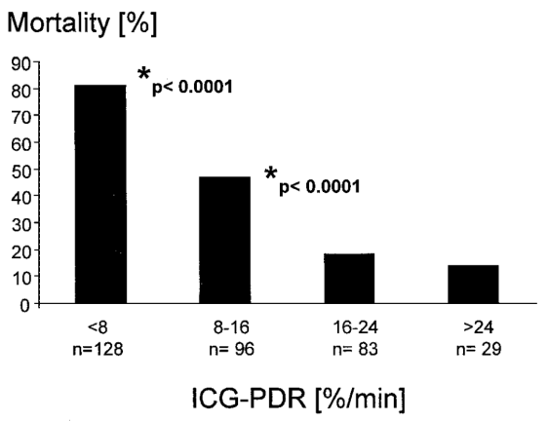
In this study, patients were classified into four groups according to their lowest PDRICG value. The asterisk indicates statistical significance to the next higher PDRICG group (χ2 test). Receiver operating characteristics (ROC) of conventional markers for liver injury (e.g., ALT: AUC, 0.48; P = 0.084; and bilirubin: AUC, 0.43; P = 0.412) failed to predict poor outcome, whereas PDRICG of less than 8%/min (AUC, 0.81; P = 0.006) as a complex estimate of perfusion, energy metabolism, and transporter function predicted death with a sensitivity of 81% and specificity of 70%. Similar data was seen for other liver conditions in terms of the utility of ICG e.g., post-transplant, hepatitides, fibrosis and cirrhosis, liver cancer, septic shock, obstructive jaundice, liver transplant post chemotherapy and in children. As an example, utility of PDFICG is seen for cirrhosis below (Table 3).
Table 3. Diagnostic indices for occurrence of severe complications according to Child–Pugh score, PDRICG, MELD score, liver stiffness, ABT, and APRI score in 138 patients with cirrhosis (VERDYE data boxed).
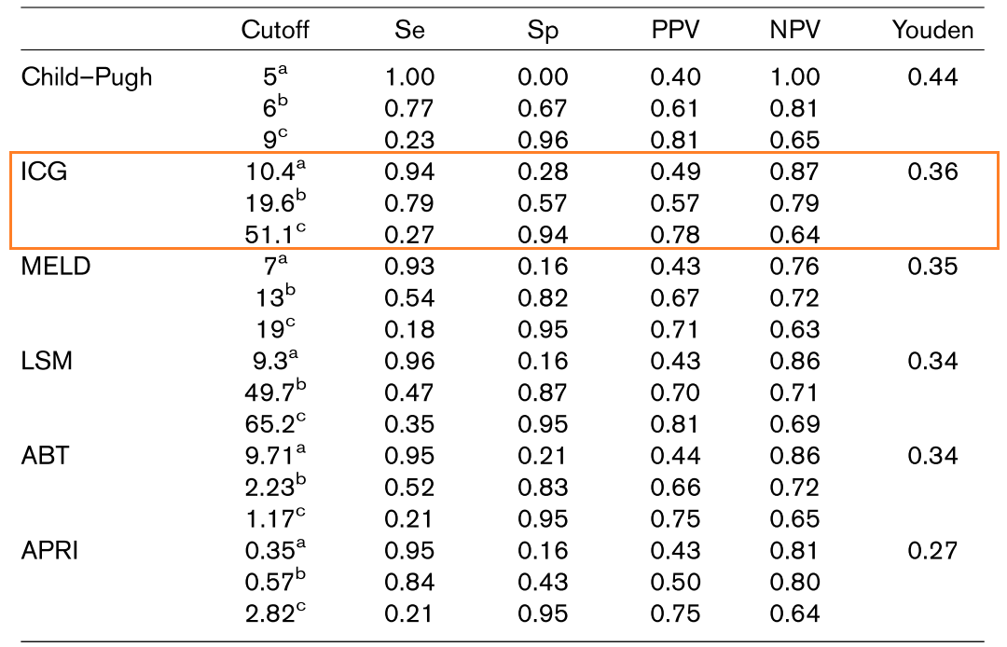
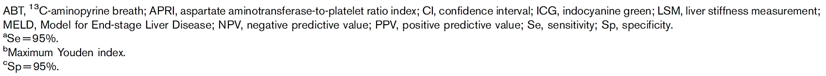
Table 4. Preoperative parameters, median (range), for survivors versus non-survivors after liver resection. In this study ICG was the only dynamic test to predict outcome.
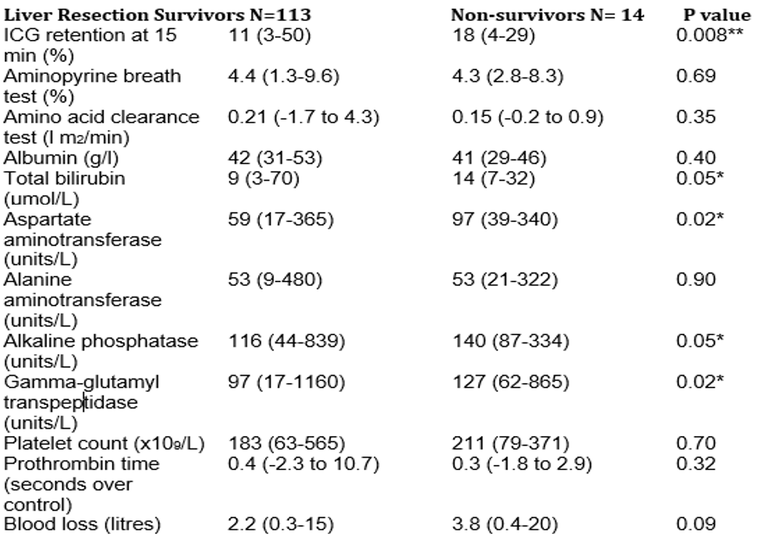
In a prospective German study, 96 patients (91% with malignant primary or secondary liver tumours) who had undergone elective hepatic resection had perioperative measurements of PDRICG. ICG was administered at a dose of 0.25 mg/kg. Receiver operating characteristic analysis (Figure 2) indicated that PDRICG (AUC: 0.867) provided a better indication of liver failure and liver dysfunction than bilirubin (AUC: 0.633) or prothrombin time (AUC: 0.570).
Figure 2. Receiver operating characteristics (ROC) curves of postoperative PDRICG values and other diagnostic parameters regarding postoperative liver dysfunction.
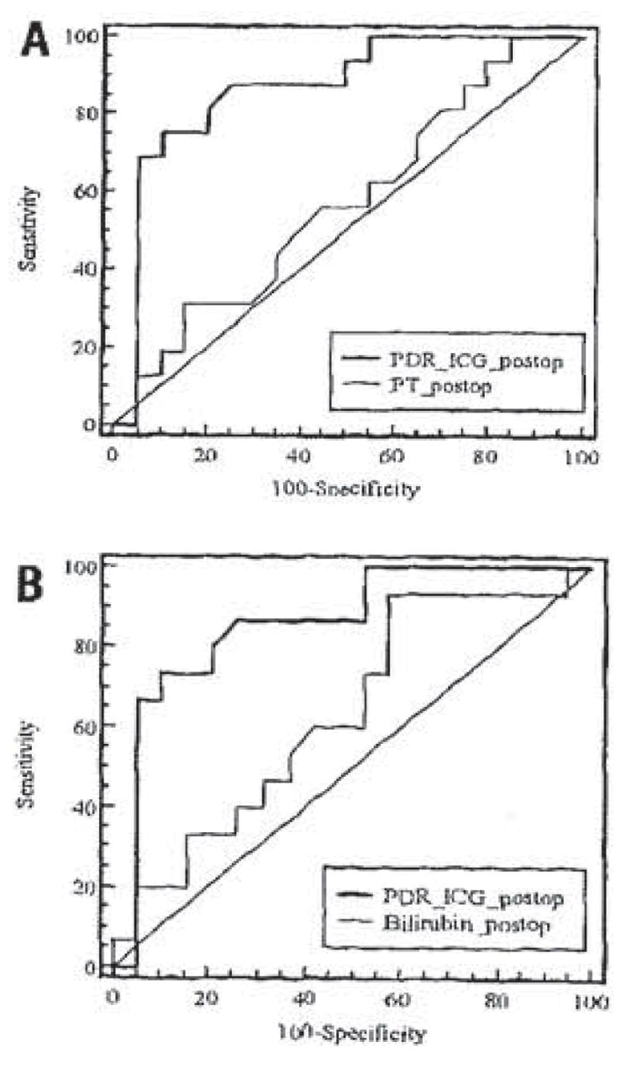
In another trial of 14 patients who underwent biliary drainage for obstructive jaundice, an i.v. bolus injection of ICG (0.5 mg/kg) was administered,. The hepatic ATP concentration significantly correlated with the 5-hour biliary ICG excretion rate, suggesting biliary ICG excretion provides knowledge of hepatic energy status in patients who are to undergo surgery after relief of obstructive jaundice. In other liver conditions, both graft survival and sepsis were associated with impaired ICG elimination following liver transplantation. Using a dose of 0.5mg/kg, correlation with ICG clearance was significant for hepatic graft loss (P = 0.0003), ICU stay of more than 7 days (P = 0.004), hospital stay of more than 30 days (P <0.0001), prolonged graft dysfunction (P = 0.0001), preservation injury (P <0.0001), and sepsis (P = 0.0001).
Table 5. ICG Clearance in liver transplant recipients. Clearance on PO Day 1.
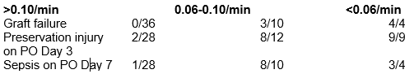
In orthoptic liver transplant, PDRICG measurements on postoperative day 7 are predictive of early patient outcomes
Table 6. Ability of different parameters and PDRICG over time to predict graft loss or death or graft loss, death, or complications.
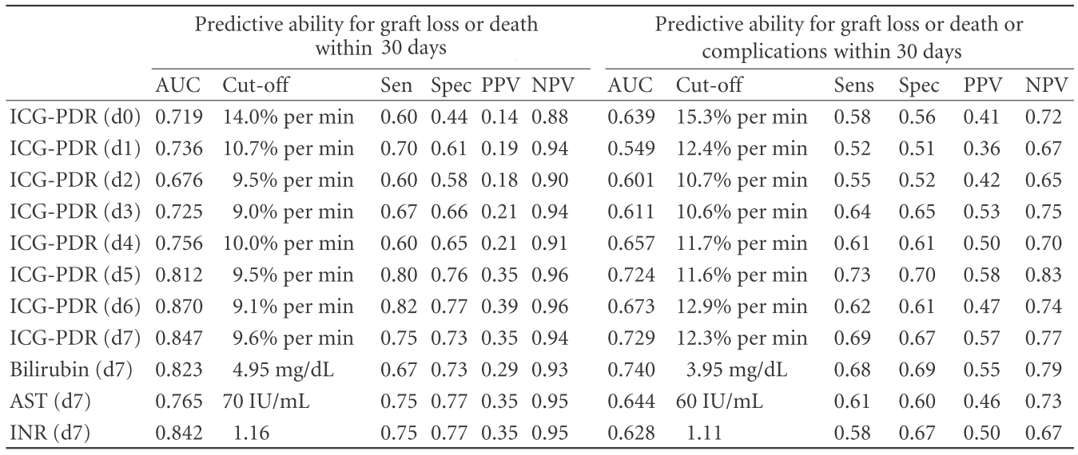
Note: Results of ROC analysis. Values are given for the indicated day post-OLT. AUC: area under the curve; AST: aspartate aminotransferase; INR: international normalized ratio; ICG-PDR: indocyanine-green plasma disappearance rate; CI: confidence interval; Sens: sensitivity; Spec: specificity; PPV: positive predictive value; NPV: negative predictive value.
Another study also concluded that determination of PDRICG provides a useful prognostic index of potential donor grafts prior to liver transplantation.

Paediatric Investigations
The diagnostic value of indocyanine green plasma disappearance rate (PDRICG) for the classification of paediatric patients with acute liver failure was prospectively investigated. A total of 154 PDRICG measurements were taken during the study (median 12.4 %/min, range: 6.2 - 26.3). The PDRICG was significantly lower in patients who suffered irreversible liver damage compared with those who survived without liver transplantation (median PDRICG 4.1 %/min; range: 4.0 - 5.7 vs. median PDRICG 20.3 %/min; range: 9.1 - 30.1; respectively. P < 0.001). Using a ROC curve, the cut off of PDRICG for assessing the need for liver transplantation was set at 5.9 %/min (sensitivity 92.3%, specificity 97.1%).
The aim of a prospective validation study was to evaluate minimally invasive estimation of ICG elimination by pulse dye spectrophotometry, in comparison with traditional spectrophotometry using serial blood samples, in patients with paediatric liver disease. In this study, 100 children and adolescents between 0–18 years of age with chronic liver disease, acute liver failure, previous liver transplant, or suspected liver disease with affected liver enzymes were included. In the 100 patients, a total of 142 measurements of ICG elimination kinetics were obtained simultaneously. In conclusion, the present study shows that ICGPDR can be obtained by a minimally invasive method and thus replace measures by serial blood samples in children with liver disease of different aetiologies and severities.

Cardiac, circulatory, and micro-circulatory diagnostics
Measurement of ICG is based on a spectrophotometric technology. The principle of pulse oximetry can be used to measure the relative concentration of substances in the blood stream that absorb a certain wavelength. Pulse dye densitometry has been shown to allow measurement of cardiac output (CO), total blood volume (TBV), and central blood volume (CBV).
ICG pulse densitometry is used for determination of cardiac output and circulating blood volumes in critically ill patients, patients undergoing surgery, and patients with liver disease. In this submission there were eight studies examining ICG pulse and its comparison with the PAC thermodilution method - gold standard in this field.

Studies in healthy volunteers
The measurement of CBV by PDD using 20mg ICG was compared with the ¹³¹I-human serum albumin dilution method. This data showed that PDD using ICG can measure CBV with an imprecision of 3.99 ± 10.54%, 0.259 ± 0.593 L (nose probe), and is as accurate as the conventional radioisotope method.
Assessment of cardiac output with transpulmonary thermodilution and indocyanine green dilution (15 ml of 0.5 mg/ml = 7.5mg) during exercise in humans was undertaken. Transpulmonary thermodilution with bolus injection into the femoral vein is an accurate and reproducible method to assess CO during exercise in humans (when ICG dilution is used as the reference method).

Critically ill patients
A prospective clinical study studied the agreement between transpulmonary aortic fibreoptic-based and PDD measurements of cardiac output and circulatory blood volumes in 16 deeply sedated patients receiving mechanical ventilation with acute respiratory distress syndrome (n=8), sepsis/septic shock (n=6), subarachnoid haemorrhage (n=1) or severe head injury (n=1). Automatic calculation of the transpulmonary indicator dilution (TPID) technique for the measurement of cardiac output, intrathoracic blood volume, and total blood volume measured by TPID technique (TBVTPID) was undertaken. An ICG sensor was attached to one nasal wing and connected to an analyser for PDD measurement of cardiac output, central blood volume (CBV), and TBV measured by PDD.
ICG was injected at a dose of 30 mg.
Over all 55 measurements there was moderate correlation. Specifically, TPID were on average 11.5% (cardiac output) and 17.6% (TBV) higher than PDD measurements. The differences between both measurements ranged from -58 to 81% (cardiac output) and from -47 to 82% (TBV; 95% reference ranges). The main source of variation were the intra-individual differences, resulting in different peaks and trends in the patients’ time courses depending on which measurement method was used. According to the reported data, PDD measurement of cardiac output and circulatory blood volumes shows moderate agreement with transpulmonary thermo-dye dilution technique in critically ill patients.

Patients undergoing cardiac surgery
A prospective study was undertaken in 22 patients, monitored with PAC thermodilution, and ICG pulse densitometry (dose of 5mg for each measurement). Both curves were simultaneously measured to calculate CO. The percentage error with low CO (<3.5L/min; 9.3 +/- 19.3%) was higher than those for patients with moderate (3.5-6L/min) or high (>6L/min ; -0.5 +/- 11.3%) CO. PDD can thus measure CO repeatedly in major surgery with same degree of accuracy as the thermodilution method, noting that there was significant variation in some patients, similar to that seen with other measures of CO.
Another study also examined CO obtained by ICG PDD (5mg per measurement) and PAC thermodilution and the direct Fick method. CO was 5.3 ± 1.8 L/min for ICG PDD; 5.7 ± 1.68L/min for thermodilution and 6.2 ± 1.7. L/min for the direct Fick measurement. There was a good correlation between ICG pulse densitometry and PAC thermodilution (r² = 0.93) and between ICG PDD and the direct Fick method (r² = 0.77). ICG pulse densitometry tended to yield lower values than the thermodilution or Fick method, particularly in patients with cardiac output values below 5 L/min.
In 43 post cardiac surgery patients, CO was measured by ICG pulse dye densitometry (5mg ICG) and compared with pulmonary artery thermodilution. Reproducibility of consecutive measurements was slightly better for PAC-thermodilution than for PDD (median coefficient of variation of the triplicate measurements: 3.5% versus 5.4%, P < 0.01). Both methods correlated well (r = 0.84, p < 0.001). Using Bland and Altman analyses with PAC-thermodilution as the reference method, PDD showed a bias of -0.68 ± 0.82 L/min, mainly due to differences in higher ranges of cardiac output (>6.5 L/min). Measured changes in cardiac output were 81% concordant (i.e. <1 L/min different) between both methods. The data indicate that PDD correlates well with PAC-thermodilution.
Another study investigated a non-invasive method for measuring systemic hemodynamic parameters using ICG in liver transplant patients. There was a high correlation between cardiac output values obtained by PDD and those obtained by the invasive catheter technique (r² = 0.826, P <0.0001, Pearson’s correlation) with PDD accurately measuring blood volumes more accurately compared with radioactive isotope methods.

Patients undergoing haemodialysis.
The validity of measurement of cardiac output and blood volume during haemodialysis using the dye dilution technique was investigated using an opto-electronic instrumentation that uses ICG in the haemodialysis circuit to estimate cardiac output and blood volume based on indicator dilution principles in patients receiving haemodialysis. The instrument and technique were tested in 24 adult end-stage renal failure subjects during 64 haemodialysis sessions. Intra-subject variability of the measurements over time was <10%. Stroke volume index (mean ± SEM = 34 ± 1 vs. 39 ± 2 mL/m²) and CBV index (783 ± 36 vs. 881 ± 33 mL/m²) were lower at the beginning of the sessions in which dialysis eventually occurred. Thus, using ICG dilution as a diagnostic tool, haemodynamic monitoring can be implemented in patients receiving haemodialysis with minimal disruption of the treatment.

Cerebral perfusion - diagnostic performance in measurement.
A total of 18 studies was included into the assessment of the diagnostic performance of ICG in cerebral angiography and measurement of cerebral perfusion. All angiography studies were descriptive by nature (i.e., did not report diagnostic metrics or correlation data), whereas most brain perfusion studies (4/6) represent prospective validation studies (providing diagnostic metrics or correlation data of ICG-based measurements against a standard of reference).
In 7 of 9 studies that investigated ICG-based angiography in patients undergoing aneurysm surgery, the concordance between intraoperative ICG-based angiography and the applied standard of truths (postoperative digital subtraction angiography (DSA)) was ≥ 90%. In most cases discordance occurred when aneurysms were treated in deeper brain regions or in cases of haemorrhages obscuring the ICG picture. A retrospective study reported only 75.5% concordance between both methods and recommended a combination of ICG-V and DSA during aneurysm surgery. Another retrospective study which compared aneurysm surgery outcomes of patients in the ‘pre-ICG era’ and ‘ICG era’ does not report quantitative concordance data but concludes that ICG-video angiography is as safe and effective as DSA. And these studies showed that non-invasive ICG-based bedside monitoring using PDD provides reliable results in comparison with the standard of reference.
ICG video-angiography is becoming increasingly widely used to visualize brain vessels during neurosurgery. The method has been validated against digital subtraction angiography, which is currently the “gold standard” in the intraoperative evaluation of aneurysms but is associated with X-ray exposure and is not widely available. ICG NIR spectroscopy has been used clinically for the monitoring of changes in cerebral oxygenation since the 1980s. Non-invasive, “bedside” measurement of regional cerebral blood flow (CBF) as determined with ICG NIR spectroscopy has been validated against magnetic resonance imaging.

Video angiography during neurosurgery
ICG video-angiographic investigations were conducted on 14 patients. ICG angiographic results were divided into arterial, capillary, and venous phases, comparable to those observed with digital subtraction angiography. In all cases, the postoperative angiographic results corresponded to the intraoperative ICG video angiographic findings. In three cases, the information provided by intraoperative ICG angiography significantly changed the surgical procedure.

Aneurysm surgery
Digital subtraction angiography is currently the “gold standard” in the intraoperative evaluation of aneurysms, however, ICG video-angiography is becoming more and more widely used in this application. For example, a large prospective evaluation was undertaken of surgical microscope-integrated intraoperative ICG NIR video-angiography guided aneurysm surgery in 114 patients in which 124 aneurysms were clipped. ICG was injected IV at a dose of 25 mg per patient (ca. 0.4 mg/kg); and intravascular fluorescence from within the blood vessels was imaged using a video camera attached to a microscope. The results of ICG video-angiography corresponded with intra- or post-operative DSA in 90% of cases. The ICG technique missed mild/hemodynamically irrelevant stenosis that was evident on DSA in 7.3% of cases. The authors conclude that microscope based ICG video angiography is useful during routine aneurysm surgery as an independent form.
The reliability of ICG video-angiography was assessed in the evaluation of neck residuals and patency of branches after micro neurosurgical clipping of intracranial aneurysms in 289 patients. Intraoperative ICG video-angiography (using 0.2 to 0.5 mg/kg per dose) was performed during micro neurosurgical clipping of 239 intracranial aneurysms in 190 patients. Postoperative imaging studies revealed no incomplete occlusions of aneurysm domes.
Unexpected neck residuals were observed in 14 aneurysms (6%). There were no parent artery occlusions. Unexpected branch occlusions including both major and minor branching arteries were observed in 15 aneurysms (6%). Intraoperative interpretation of ICG video-angiography in assessing the neck residual or the patency of vessels after clipping of each single aneurysm were recorded and correlated with postoperative computed tomography angiography and/or digital subtraction angiography.
In a retrospective study a total of 208 ICG angiography investigations were carried out. Intraoperative ICG video angiography (intravenous ICG at 0.2 to 0.5 mg/kg per dose) revealed incomplete clipping in four patients, parent and/or branching artery stenosis in five patients, and delayed perfusion in one patient. Pre-and postoperative digital subtraction angiography findings were consistent with intraoperative ICG angiography findings for 92.6% (100/108) of patients. Liu et al 2009 showed that pre-clipping ICG angiography displayed the relationship of aneurysm and its parent artery clearly. The results of ICG angiography corresponded to those of postoperative digital subtraction angiography in 97% of patients.
In an Austrian study using 2.5-25 mg per ICG bolus injection ICGA-derived information during cerebral aneurysm surgery was compared with data simultaneously generated from other intraoperative monitoring and vascular imaging techniques. In a retrospective study, the accuracy of ICG video angiography was compared with intraoperative digital subtraction angiography (IDSA) and it was investigated if ICG video angiography can be used without follow-up IDSA. A 25-mg bolus of ICG dye solution was injected. A total of 155 patients underwent craniotomies for clipping of aneurysms. The post-ICG videoangiography clip adjustment rate was 4.1% (2 of 49). The ICG videoangiography-DSA discordance rate requiring post-IA clip adjustment was 14.3% (7 of 49), thus concluding that the combination of ICG videoangiography and IDSA ultimately proves to be the most effective strategy for maximizing the safety and efficacy of aneurysm surgery.
In another study, a comparison of 3D intraoperative digital subtraction angiography (3D-iDSA) and intraoperative ICG video-angiography (ICG-VA) during intracranial aneurysm surgery was conducted. In this retrospective study of prospectively collected data, 140 consecutive patients underwent microsurgical treatment of intracranial aneurysms (IAs). Variables analysed included patient demographics, aneurysm-specific characteristics, intraoperative ICG-VA and 3D-iDSA findings, and the need for intraoperative clip readjustment. Clip repositioning was needed in 7 patients (6%) based on 3D-iDSA, yielding an ICG-VA accuracy rate of 94%. According to the authors’ conclusion, ICG-VA demonstrated high accuracy when compared with 3D-iDSA imaging, which, supports its routine use in IA surgery. Another retrospective study produced similar results.

Brain tumour surgery
The added value of the application of intraoperative indocyanine green video-angiography to brain tumour surgery was investigated. Here use of ICG during microsurgery for a brain tumour was demonstrated to be a viable alternative to intraoperative angiography or Doppler ultrasonography. The utility of tumour blood flow imaging by intraoperative ICG video angiography has also been investigated for hemangioblastoma surgery. The study showed that in surgery for hemangioblastomas, careful interpretation of dynamic ICG images can provide useful information on transit feeders and hidden vessels.

Surgery of stenoocclusive arterial disease
ICG videoangiography was used in 30 patients with haemodynamic cerebrovascular insufficiency due to stenoocclusive arterial disease. Bypass patency reached 100% was confirmed by intraoperative ICG angiography, postoperative computed tomography angiography, and digital subtraction angiography.
A rapid bedside test using ICG as a tracer and NIR spectroscopy was used to detect cerebral perfusion reductions in patients with acute ischaemic stroke in the territory of the middle cerebral artery. The kinetics of an IV bolus of ICG (dose: 0.1 to 0.5 mg/kg) was monitored by NIR spectroscopy in 13 patients with acute infarction in the territory of the middle cerebral artery versus 12 controls. NIRS optodes were placed bitemporally, with an interoptode distance of 4–5 cm. Absolute concentration changes in ICG were calculated. Patients with ischaemic stroke had increased time to peak (P=0.01), interval (P=0.01), and rise time (P=0.01), while maximum ICG concentration (P=0.03), slope (P=0.01), and blood flow unaffected hemisphere; whereas these variables showed consistent results between the left and right hemisphere in healthy controls whereas these variables showed consistent results between the left and right hemisphere in healthy controls.
An advanced method for simultaneous bedside assessment of global cerebral blood flow and effective cerebral perfusion pressure in patients with intracranial hypertension using ICG was evaluated. Transcerebral double-indicator dilution for global cerebral blood flow (CBF) as well as the concept of effective cerebral perfusion pressure (CPP(eff)) during different treatment options for intracranial hypertension were evaluated. The authors compared global CBF and CPP (eff) with simultaneously obtained conventional parameters. For calculation of global CBF, injections of ice-cold indocyanine green boluses (25 mg) were performed and temperature and dye concentration changes were monitored in the thoracic aorta and the jugular bulb. CBF was then calculated according to the mean transit time principle. CPP (eff) was calculated as mean arterial pressure minus critical closing pressure (CPP(eff) = MAP(c) - CCP). In this study, elevated ventilation caused a decrease in both ICP (P < 0.001) and CBF (P < 0.001). While CPP (conv) increased (P < 0.001), CPP(eff) decreased during this observation (P = 0.002). According to the authors’ conclusion, trans cerebral double-indicator dilution including ICG allows repeated measurements of global CBF at the bedside with good accuracy. One study included 6 patients undergoing decompressive hemi craniotomy for middle cerebral artery stroke. ICG videoangiography was shown to be a valuable tool in the precise mapping of relative cortical tissue perfusion.

Ophthalmic angiography
The diagnostic performance of ICG in measurement of perfusion of the choroid was assessed in 19 included studies. These are representative of the current use of ICG in ophthalmic angiography.
In studies that investigated patients with age-related macular degeneration (AMD), ICG-based angiography provided additional information regarding the extent of neovascularization that led to an improvement of diagnosis in 26% – 44% of investigated eyes. In all 3 studies that investigated patients with central serous chorioretinopathy (CSC), ICG-based angiography provided additional information regarding the location of vascular leakage that led to an improvement of diagnosis in 33% – 37% of investigated eyes or found that the leakage pattern identified by ICG was a discriminative marker between AMD and CSC. In this study, a 50 mg ICG dose was used to examine choroidal leakage in 41 patients with central serous chorioretinopathy and compared to a control group of 120 patients >64 years old with occult choroidal neovascularization (CNV) due to AMD.

Age-related macular degeneration
ICG initially and predominantly has been used in the diagnosis and interpretation of occult CNV in age-related AMD. Biomicroscopy, fluorescein angiography, and optical coherence tomography are the standard of care for baseline assessment. If a neovascular membrane is not visible upon fluorescein angiography, confirmation regarding active disease progression must be obtained via other methods. ICG angiography is likely the best way to confirm the presence of occult CNV in AMD. In cases of doubt, a combination of examinations including ICG angiography is the only way to obtain a clear diagnosis before recommending appropriate treatment. Also, feeder vessels of the CNV can be visualized with ICG angiography for a more targeted approach to therapy with direct focal laser treatment. ICG angiography can also diagnose other types of neovascularisations e.g. retinal angiomatous proliferation lesion or a neovascular membrane with retinochoroidal anastomoses.
In one study, 129 patients were evaluated with exudative AMD as an aid to diagnosis. Overall, 39% (50/129) of patients in this study with occult CNV could be reclassified as having well-delineated CNV by the findings provided by ICG angiography. In this series, ICG angiography (50 mg dose) was particularly useful in identifying occult CNV in eyes with a large, serous pigment epithelial detachment (Table 7).
Table 7. Results of ICG video-angiography in Occult Choroidal Neovascularisation (CNV).
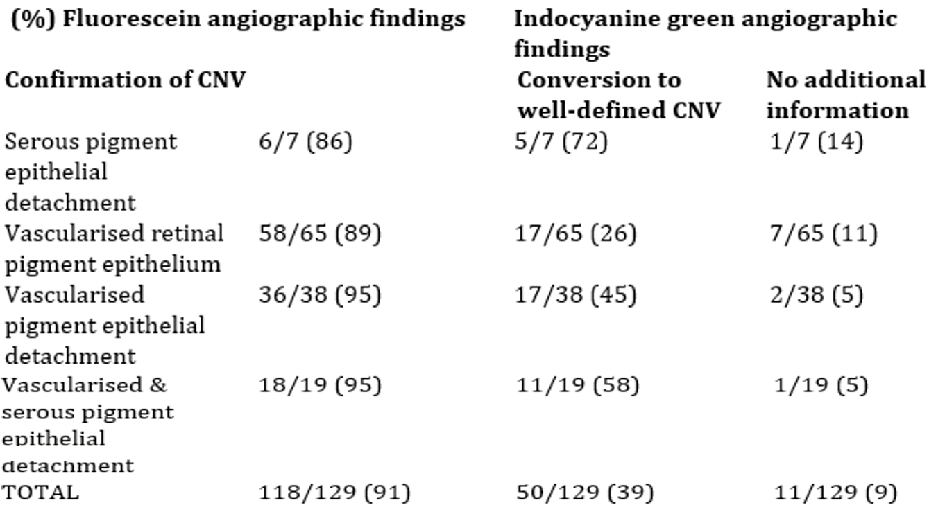
Similarly, in another study, digital ICG video-angiography was executed in 34 eyes of 24 patients with AMD, including drusen, either alone or in association with other AMD changes. Fluorescein angiography showed 9/34 eyes to have well defined or occult CNV. With ICG video-angiography (50 mg dose), it was possible to further define CNV from occult CNV in all cases.
Table 8. Results of indocyanine green video-angiography in well-defined and occult CNV fluorescein angiographic findings.
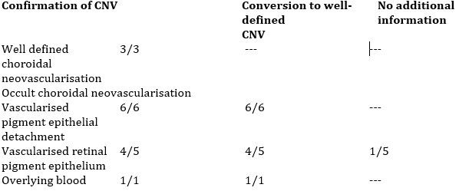
Similarly, ICG video-angiography (25 mg ICG dose) was used to evaluate the choroidal filling pattern of 145 eyes from 145 patients affected by AMD. In the 139 eyes where an agreement between the two observers was found, the macular vascular structure, studied through ICG angiography could be reclassified. With fluorescein angiography, only 26% of cases had agreement with that determined by ICG angiography.
Retinal choroidal anastomoses are likely to occur in the early stages of acute exudative AMD with occult CNV. Angiographic characteristics of retinal choroidal anastomoses include intraretinal leakage of both fluorescein and ICG dyes. The angiograms of 292 eyes of 187 consecutive patients with a recent diagnosis of exudative AMD were included in a retrospective review. The ICG dose for angiography was 25 mg. Occult CNV was diagnosed in 205 eyes (153 patients). Retinal choroidal anastomoses, which indicate a poor prognosis for successful ICG-guided laser treatment, were found in 57 eyes (28%) following ICG angiography. Haddad et al., 2002 performed a retrospective review and found similarly. In summary, up to half of eyes with occult CNV would be converted by ICG-A into well delineated focal spots.
Optical coherence tomography assists in the early detection of a neuro-sensory detachment and/or RPE detachment but is not of use in the identification of the underlying disease process. Fluorescein angiography enables the identification of active lesions with sub-retinal leakage or inactive lesions with RPE window defects and can lead to a diagnosis of presumed central serous choroidopathy. The added value of ICG angiography is that it can confirm changes characteristic of central serous choroidopathy and thereby confirm the diagnosis. It is also useful in guiding treatment, especially in the application of reduced fluence rate photodynamic therapy to areas of active choroidopathy. ICG angiography in central serous choroidopathy shows a characteristic choroidopathy of dilated veins and hyperfluorescent patches in the intermediate phase, along with washout of the dye in the later phase.
ICG angiography (25 mg dose) has been used successfully with scanning laser ophthalmoscopy to investigate the cause of central serous chorioretinopathy. Nineteen patients with central serous chorioretinopathy participated in the study. Focal exudation was found in all patients with fluorescein angiography and in 15 (79%) patients with ICG angiography. More widespread exudation of ICG into the choroid around the focal hyperfluorescent spot was observed in 7 (37%) patients.
Serous pigment epithelium detachment (PED) is a non-specific reaction of the RPE to injuries involving its adhesion with Bruch’s membrane. ICG videoangiography in patients with idiopathic serous PEDs, showed PEDs to be frequently associated with choroidal leakage and venous dilatation, which suggests that idiopathic serous PED is a variant of central serous chorioretinopathy. Giovannini et al.1997 examined 25 consecutive patients (36 eyes) with idiopathic serous PED with ICG videoangiography (ICG dose 25 mg). In 30 eyes (83.3%), choroidal hyper-permeability was observed. An irregular dilatation of the choroidal veins at the site or within an area the size of one disk diameter from the detachments could be visualized on ICG video-angiography in 12 of 36 affected eyes (33.3%); in three cases an active focus of central serous chorioretinopathy with subretinal leakage developed in the follow-up period.
Several other clinical studies demonstrate the utility of ICG angiography in this application e.g. Ahuja et al., 2000, Hikichi et al., 2009, Lafaut 1998.
The ICG-based imaging and grading protocol, and baseline characteristics of a randomised con-trolled trial of combination therapy with photodynamic therapy and intravitreal ranibizumab in 61 patients with polypoidal choroidal vasculopathy (PCV) was reported. In the prospective, multicentre study, confocal scanning laser ophthalmoscope indocyanine green angiography (ICG-A) was performed using a standardised imaging protocol. ICG-A characteristics included: nodular appearance stereoscopically (56 eyes, 91.8%), hypofluorescent halo (42, 68.9%), abnormal vascular network (54, 88.5%) and pulsation of the polyps (4, 6.6%). Colour fundus photography revealed orange subretinal nodules (34, 55.7%) and massive submacular haemorrhage (8, 13.1%). The mean area of the PCV lesion was 3.11 mm2 (range, 0.2–10.7 mm²⁾. The vascular channels filled within 7.3–32.0 s (mean: 17.9 s) while the mean filling time for polyps was 21.9 s (range, 7.3–40.4 s). Patients with massive submacular haemorrhage were less likely to have abnormal vascular channels seen on ICG-A (28.6% vs 83.3% for those without massive haemorrhage, p=0.001).

Active choroiditis
Identification of active foci of choroiditis is necessary, as infectious, and non-infectious choroiditis can threaten not only ocular function but are often associated with neurologic and systemic diseases that require prompt treatment. Active choroiditis is present in toxoplasmosis and Vogt-Koyanagi-Harada (VKH) disease. The following is a description of the diagnostic findings rather than comparative clinical efficacy.
- Vogt-Koyanagi-Harada (VKN) Disease
Patients with confirmed VKH (N=10) who underwent at least one angiogram with fluorescein and ICG (50 mg dose) were studied. The authors concluded that ICG angiography confirmed the predominantly choroidal localisation of the inflammatory process in VKH disease.
- Toxoplasmosis
A study on 23 immunocompetent patients with recurrent ocular toxoplasmosis underwent examination by fluorescein angiography and ICG angiography. More morphological features of the condition were apparent with ICG compared with fluorescein angiography.

Choroidal haemangiomas
Diagnosis of this tumour is challenging with many patients initially misdiagnosed with choroidal melanoma or metastasis. Tests such as ultrasonography, fluorescein angiography, ICG angiography, and magnetic resonance imaging help differentiate this tumour from other lesions.

Variants of Retinal Pigment Epithelial (RPE) detachment
It was shown that CNV associated with pigment epithelial detachment is easier to detect with ICG than with fluorescein angiography.

Other patterns recognised with ICG angiography
ICG angiography is also used to visualise pattern maculopathies and serpiginous choroiditis.

Analyses performed across trials: pooled and meta-analyses.
Formal pooling across the studies was not done; however, this would not be easy to interpret as the studies span 50 years. Therefore, the comparator, population groups, dose and endpoints among other aspects are very different. Most studies were observational. Apart from ethnicity, majority of patients undergoing ICG-based diagnostics appears to reflect the clinical reality.

Safety
ICG is an aromatic heteropolycyclic compound, belonging to the naphthalene class of organic compounds. The main safety issue is effects on thyroid function in patients with autonomous thyroid nodule and anaphylactic or urticarial reactions have been reported in patients with or without history of allergy to iodides. Also, in rare cases coronary artery spasm has been described. Among the reported serious AEs in case reports and retrospective surveys that reported, hypersensitivity-related responses (manifested as anaphylactic/anaphylactoid shock, urticarial reactions, etc.) in patients with or without history of allergy to iodides predominate besides cardiovascular and respiratory responses (manifested as hypotension, ST elevation, cardiac arrest, shortness of breath, bronchospasm, laryngospasm, etc) are reported.

All adverse events (irrespective of relationship to study treatment)
Overall, adverse events following intravenous exposure to ICG are rare to very rare. Among a total of >6000 study subjects/patients exposed to ICG (different brands and manufacturers of ICG) in the frame of clinical studies analysed only three mild ICG-related adverse reactions (2 x hives and 1 x nausea and vomiting) were reported. All three ICG-related AEs occurred in an ophthalmic angiography study (Yannuzzi et al., 1992) at the rather high flat dose of 50 mg ICG (0.78 mg/kg for a patient of 65 kg body weight – the requested dose for listing is 0.1-0.3mg/kg. None of the patients developed any sequelae from these mild adverse effects.
No allergic reactions were reported for the >6000 study subjects/patients exposed to ICG in the frame of clinical studies. Given the total number study subjects in clinical trials of ICG, the calculated frequencies of AEs are:
- Hives: 2/6000 = 0.03%; ≥ 0.01% and < 0.1% -> Rare
- Nausea & vomiting: 1/6000 = 0.017% ≥ 0.01% and < 0.1% -> Rare

Deaths and other serious adverse events
No serious adverse events (SAE) were observed among a total of >6000 study subjects/patients exposed to ICG (different brands and manufacturers of ICG) in the frame of clinical studies analysed for clinical pharmacology and efficacy.
However, a few serious AEs following exposure to ICG can be identified in 13 published case re-ports and retrospective surveys as well as in the pharmacovigilance and PSUR database of the applicant.
During the cumulative period from the international birth date of VERDYE in 2003 up to the last official PSUR in 2020, a total of approx. 1437000 patients can be estimated to have been exposed to VERDYE or its predecessor, ICG-Pulsion. Among the 81 AEs reported directly to the applicant from users of VERDYE/ICG-Pulsion or from authorities with reference to the use of VERDYE/ICG-Pulsion, 51 were ranked as serious. The frequency of serious AEs can therefore be estimated as 0.004% (< 0.01%; very rare). The majority of severe AEs referred to anaphylactic or anaphylactoid reactions (30/51) ranging in severity from urticaria to anaphylactic shock. This was followed by cardiovascular events (6/51) ranging in severity from hypotension to cardiac arrest. Part of the reported cardiovascular events showed overlap or causal relation with reported anaphylactic and anaphylactoid reactions.
In terms of deaths, there were two presumably ICG-related deaths in the database of 13 case reports and retrospective surveys,. Both deaths occurred as sequelae of anaphylactic shock. One of these was in a patient with a history of penicillin and sulfa allergy. Although the database of case reports and retrospective surveys does not allow for calculation of the frequencies of fatal AEs, one study⁵³ reported a fatal AE when more than 240,000 procedures had been performed using ICG. Thus, fatal AEs related to ICG appear to be very rare (< 0.01%).
No reports of fatal AEs to ICG could be identified based on ICSRs in the pharmacovigilance and PSUR database of the applicant.
There are no new concerns around laboratory testing results or vital signs. several safety issues with possible regulatory impact, however these are well known and well documented as this drug has been in use for 60 years. Further, the risk of some AEs is significantly lower with the doses currently used and proposed for the indications in this Submission.

Pre-existing allergies
The incidence of adverse reactions to ICG has been investigated in patients undergoing intravenous fundus angiography with and without pre-existing allergies. The study concludes that ICG-angiography is a generally safe procedure with an acceptable incidence of adverse reactions. However, patients with drug allergy history seem to have a higher incidence and greater severity of an adverse reaction to ICG.

Serious skin reactions
There were no cases of photosensitivity, erythema multiforme, Stevens Johnson syndrome, drug reaction with eosinophilia and systemic symptoms (DRESS) or toxic epidermal necrolysis reported in the clinical studies. However, urticaria and itching were reported at a rare frequency.

Safety in paediatrics
ICG appears to be well tolerated in paediatric patients with no increased rates of AEs in the studies of 135 paediatric patients who underwent liver function testing using ICG, at 0.25 mg/kg dose of ICG injected intravenously as a bolus,.
Anaesthetic records of paediatric patients who received ICG over a 2-year time period and examined demographic, surgical, and medication data were reviewed. The study cohort included 100 patients with a median age of 12 years (9.5 ± 7.4 years) and the median weight being 44.5 kg (45.9 ± 36.9 kg). ICG was administered intravenously to all patients. In all cases, 2.5 mg/mL ICG solution was used, with a median dose of 1.1 mL (1.79 ± 1.8 mL). Eight patients received more than 1 dose of ICG, with no adverse respiratory or hemodynamic effects related to its use. The authors conclude that ICG fluorescence can be safely used in the paediatric population.

Safety related to drug-drug interactions and other interactions
There are no obvious safety issues arising from such changes in exposure, changes in half-life or maximum concentrations. There was one report in the ICSR database that describes an increase in free thyroxine following exposure to ICG (Report 71). The PI of VERDYE points out that the iodine content of VERDYE can interfere with thyroid tests performed before or after administration of the dye. Therefore, radioactive iodine uptake studies should not be performed for at least a week following the use of VERDYE.
There are no apparent safety issues of particular concern such as overdose, abuse potential, rebound phenomena, driving safety and dependence.

Post marketing experience
As stated above, during the cumulative period from the international birth date of VERDYE in 2003 up to the last official PSUR in 2020, a total of approx. 1437000 patients can be estimated to have been exposed to VERDYE or its predecessor product ICG-Pulsion. Thus, for the estimation of overall exposure, 63 mg ICG corresponds to one patient.
A total of 81 AEs that occurred following of VERDYE or its predecessor product ICG-Pulsion (reported in 76 ICSRs) were retrieved. 51 of these were categorised as SAEs. The majority referred to anaphylactic or anaphylactoid reactions (30/81) ranging in severity from urticaria to anaphylactic shock. This was followed by cardio-vascular events (6/81) ranging in severity from hypotension to cardiac arrest. Part of the reported cardiovascular events showed overlap or causal relation with reported anaphylactic and anaphylactoid reactions.
The database of case reports and retrospective surveys does not give information regarding the total number of exposed subjects. Therefore, this database does not allow an estimation of the frequencies of the respective AEs.
Table 9. Cumulative summary tabulations of serious and non-serious adverse reactions from post-marketing data sources.
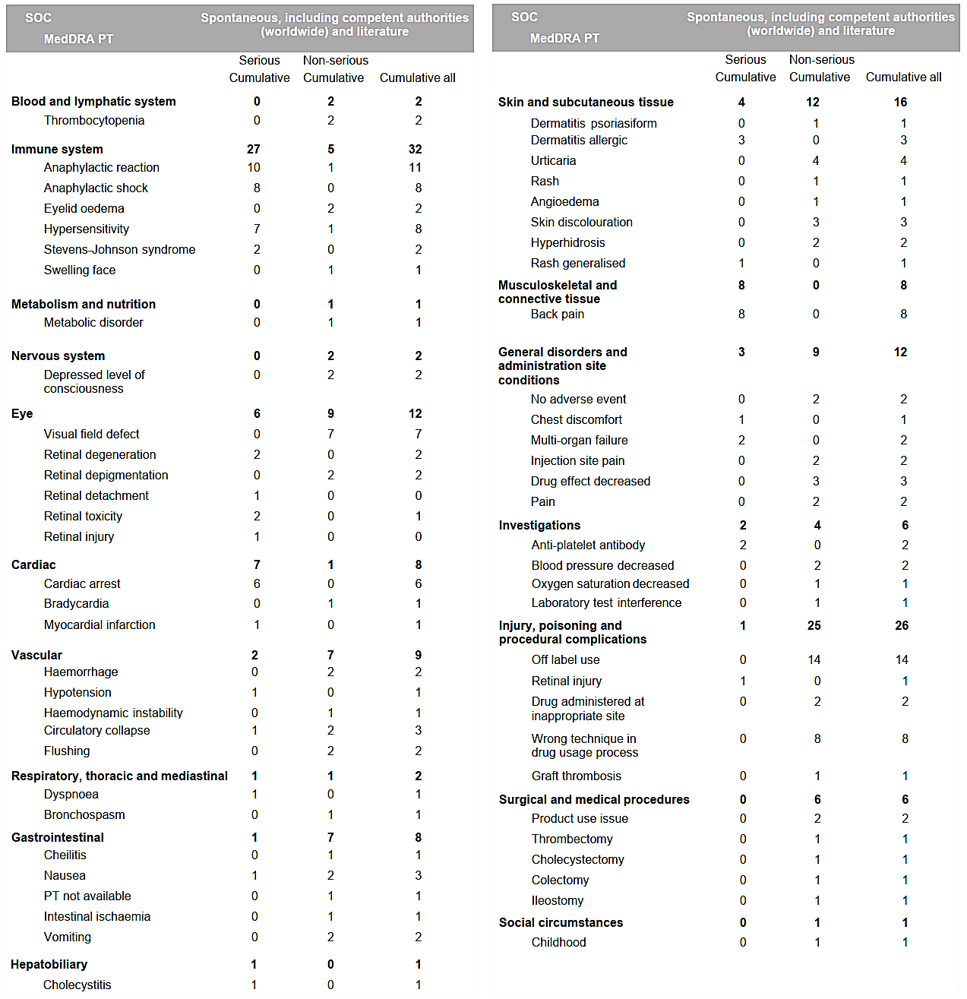
In summary, there was total of 81 AEs that occurred in the context of application of VERDYE or its predecessor product ICG-Pulsion in the cumulative period from 2003 to 2020 (reported in 76 ICSRs) were identified in this stratified database. Among these 81 AEs, 51 were ranked as serious, and 30 as non-serious. Regarding the 30 non-serious AEs, the majority of reported AEs refers to some kind of hypersensitivity reaction, encompassing rash, pruritus, exanthema, and milder manifestations of urticaria (13/30). This is followed by missing or reduced drug efficacy (7/30) and skin discoloration after sub-/intradermal administration of ICG (4/30). Given the total number of 1,436,779 patients exposed worldwide to VERDYE/ICG-Pulsion during the cumulative period of 2003 – 2019, the calculated frequencies of AEs are:
Non-serious AEs*: 30/1,436,779 = 0.002% < 0.01% -> Very rare* (Note: * non-serious AEs can be assumed to be heavily under-reported in the product-specific ICSR database).
Frequencies with regard to MedDRA System Organ Class for the most prominent AEs (irrespective of severity) are:
Immune system disorders: 72/1,436,779 = 0.005%; < 0.01% -> Very rare (anaphylactic/anaphylactoid shock, urticaria, exanthema, etc.)
Cardiovascular disorders: 7/1,436,779 = 0.0005%; < 0.01% -> Very rare (cardiac arrest, bradycardia, myocardial infarction, etc.)

Risk management plan evaluation summary
A risk management plan will not be required for this literature-based submission for indocyanine green injection as this is an unscheduled product.

Risk-benefit analysis

Efficacy
ICG in the settings and indications and doses used, which include the lower doses requested in this submission is effective in terms of its diagnostic accuracy. There were some limitations noted with the use of ICG in these settings such as heterogeneity in clinical conditions, endpoints, analytical methods, and diagnostic metrics.

Liver function diagnostics
Measurement of PDRICG has become an established bedside tool in the diagnosis and prognosis of various conditions affecting the liver. In hepatocellular carcinoma, hepatic dysfunction as determined by PDRICG is an important factor in prognosis and can be used as a guide to determine the extent of liver resection. PDRICG measurements of patients who have undergone liver transplant can be critical in assessing graft function in the early post-operative period. Determination of hepatic excretory function after biliary drainage via PDRICG is a prognostic tool for liver resection.

Measurement of cardiac output
ICG pulse dye densitometry is a non-invasive method, which has shown good agreement with the PAC thermodilution gold standard in the measurement of cardiac output. ICG pulse densitometry is routinely used for determination of cardiac output and circulating blood volumes in critically ill patients, patients undergoing surgery, and patients with liver disease.

ICG ophthalmic angiography
ICG angiography has been shown to be essential in the diagnosis of ocular conditions affecting the choroid, including age-related macular degeneration, polypoidal choroidopathy, pattern maculopathies, central serous choroidopathy, active choroiditis, and choroidal haemangiomas.

Measurement of cerebral perfusion and cerebral angiography
Measurement of cerebral perfusion applies to ICG videoangiography, which is used to visualize brain vessels and cerebral microcirculation during neurosurgery, and ICG spectroscopy, which is used to measure CBV and CBF.
The total daily dose caps are reasonable and consistent with the published studies and current clinical use.

Safety
It is important to note that in the setting of use of this agent ICG in diagnostic imaging, that such use is based on single-dose exposure or multiple exposures over a short period of time. In addition, adverse events following ICG exposure are very rarely observed. There are some limitations of the databases which means that an analysis of frequency or severity of adverse events in relation to dose, dose regimen, or treatment duration is difficult.
Overall, the use of intravenous administration of ICG over decades has been proven remarkably safe, with only very rare, isolated cases of anaphylactic/anaphylactoid reactions in the context of thousands of applications over many years in healthy individuals as well as the critically ill.
There may be a dose-response relationship and as the drug dose is significantly reduced from earlier usage the risk of AEs may be less than that reported to date. It is suggested however that this may not hold for anaphylactic reactions.

Conclusions
The effectiveness and the benefit-risk profile of ICG in liver function diagnostics (measurement of liver blood flow and of excretory function of the liver) and in perfusion diagnostics (ophthalmic fluorescence angiography; and measurement of cardiac output and circulating blood volumes, as well as cerebral perfusion) appears well established from the clinical data obtained so far. The Post-Authorization Data also supports its continued favourable benefit risk. The Delegate considers the benefit risk profile of indocyanine green (VERDYE) for the proposed indication in this application as positive.

Advisory Committee considerations
The Advisory Committee on Medicines (ACM), having considered the evaluations and the Delegate’s overview, as well as the Sponsor’s response to these documents, advised the following.
Please comment on the benefit risk profile of Indocyanine Green (VERDYE) for the proposed indication in this application
The ACM noted that this literature-based submission includes very heterogenous literature from over 50 years of use. On balance, the ACM was of the view that there was a reasonable benefit risk profile for the proposed indications.
The ACM agreed that ICG has demonstrated clinical utility via a composite of literature and clinical experience, in settings such as pre-operative evaluation prior to liver resection and use in choroidal diagnoses. In other settings, such as dynamic testing in chronic liver disease and non-invasive monitoring of cardiac output in critical illness, there appears to be a lower level of clinical value in current clinical practice; however, there is evidence of diagnostic / prognostic benefit.
The ACM also acknowledged the long history of use of ICG and the reasonable safety profile, with very limited reports of adverse drug reactions.

Outcome
Based on a review of quality, safety, and efficacy, the TGA decided to register VERDYE (indocyanine green) for the following extension of indications:
This medicinal product is for diagnostic use only.
DIAGNOSTIC INDICATIONS
- Cardiac, circulatory and micro-circulatory diagnostics:
  - measurement of cardiac output and stroke volume
  - measurement of circulating blood volumes
  - measurement of cerebral perfusion
- Liver function diagnostics:
  - measurement of liver blood flow
  - measurement of excretory function of the liver
- Ophthalmic angiography diagnostics:
  - measurement of perfusion of the choroid

Specific conditions of registration applying to these goods
VERDYE is to be included in the Black Triangle Scheme. The PI and CMI for VERDYE must include the black triangle symbol and mandatory accompanying text for five years. The Black Triangle Scheme identifies new prescription medicines with a black triangle on the medicine information documents and serves as a visual reminder to encourage health practitioners and patients to report a problem or side effect associated with the medicine.

Attachment 1. Product Information
The Product Information (PI) approved with the submission for VERDYE which is described in this AusPAR can be found as Attachment 1. It may have been superseded. For the most recent PI and Consumer Medicines Information (CMI), please refer to the TGA PI/CMI search facility.

Therapeutic Goods Administration
PO Box 100 Woden ACT 2606 Australia
Email: info@tga.gov.au Phone: 1800 020 653 Fax: 02 6203 1605
https://www.tga.gov.au

In this report the ‘Delegate’ is the Delegate of the Secretary of the Department of Health and Aged Care who decided the submission under section 25 of the Act.
Sakka SG, van Hout N. Relation between indocyanine green (ICG) plasma disap-pearance rate and ICG blood clearance in critically ill patients. Intensive care medicine. 2006;32:766–9. doi:10.1007/s00134-006-0109-6.
Sakka SG. Assessing liver function. Current opinion in critical care. 2007;13:207–14. doi:10.1097/MCC.0b013e328012b268.
Yoneyama T, Fukukura Y, Kamimura K, Takumi K, Umanodan A, Ueno S, Nakajo M. Efficacy of liver parenchymal enhancement and liver volume to standard liver volume ratio on Gd-EOB-DTPA-enhanced MRI for estimation of liver function. Eur Radiol. 2014;24:857–65. doi:10.1007/s00330-013-3086-5.
Kamimura K, Fukukura Y, Yoneyama T, Takumi K, Tateyama A, Umanodan A, et al. Quantitative evaluation of liver function with T1 relaxation time index on Gd-EOB-DTPA-enhanced MRI: Comparison with signal intensity-based indices. J. Magn. Reson. Imaging. 2014;40:884–9. doi:10.1002/jmri.24443.
Sakka SG, Reinhart K, Meier-Hellmann A. Prognostic value of the indocyanine green plasma disappearance rate in critically ill patients. Chest. 2002;122:1715–20. doi:10.1378/chest.122.5.1715.
Ibid.
Scheingraber S, Richter S, Igna D, Flesch S, Kopp B, Schilling MK. Indocyanine green disappearance rate is the most useful marker for liver resection. Hepato-gastroenterology. 2008;55:1394–9.
Chijiiwa K, Mizuta A, Ueda J, Takamatsu Y, Nakamura K, Watanabe M, et al. Relation of biliary bile acid output to hepatic adenosine triphosphate level and biliary indocyanine green excretion in humans. World J Surg. 2002;26:457–61. doi:10.1007/s00268-001-0249-3.
Chijiiwa K, Watanabe M, Nakano K, Noshiro H, Tanaka M. Biliary indocyanine green excretion as a predictor of hepatic adenosine triphosphate levels in pa-tients with obstructive jaundice. Am J Surg. 2000;179:161–6. doi:10.1016/s0002-9610(00)00274-9.
Tsubono T, Todo S, Jabbour N, Mizoe A, Warty V, Demetris AJ, Starzl TE. Indo-cyanine green elimination test in orthotopic liver recipients. Hepatology (Balti-more, Md.). 1996;24:1165–71. doi:10.1002/hep.510240531.
Schneider L, Spiegel M, Latanowicz S, Weigand MA, Schmidt J, Werner J, et al. Noninvasive indocyanine green plasma disappearance rate predicts early complications, graft failure or death after liver transplantation 2011. doi:10.1016/S1499-3872(11)60061-1.
Ibid.
Wesslau C, Krüger R, May G. Clinical investigations using indocyanine green clearance for evaluation of liver function in organ donors. Transplantology. 1994;5:1–3.
Quintero J, Miserachs M, Ortega J, Bueno J, Dopazo C, Bilbao I, et al. Indocyanine green plasma disappearance rate: a new tool for the classification of paediatric patients with acute liver failure. Liver Int. 2014;34:689–94.
Nielsen J, Nerup N, Møller S, de Nijs R, Rasmussen A, Bo Svendsen L, Kjaer MS, Brix Christensen V, Borgwardt L. Minimally invasive assessment of hepatic function in children with indocyanine green elimination: a validation study. Scand J Gastroenterol. 2019 Apr;54(4):485-491. doi: 10.1080/00365521.2019.1591497. Epub 2019 Mar 29. PMID: 30924709.
Iijima T, Iwao Y, Sankawa H. Circulating blood volume measured by pulse dye-densitometry: comparison with (131)I-HSA analysis. Anesthesiology. 1998;89:1329–35. doi:10.1097/00000542-199812000-00009.
Calbet JAL, Boushel R. Assessment of cardiac output with transpulmonary thermodilution during exercise in humans. Journal of applied physiology (Bethesda, Md. : 1985). 2015;118:1–10. doi:10.1152/japplphysiol.00686.2014.
Sakka SG, Reinhart K, Wegscheider K, Meier-Hellmann A. Comparison of cardiac output and circulatory blood volumes by transpulmonary thermo-dye dilution and transcutaneous indocyanine green measurement in critically ill patients. Chest. 2002;121:559–65. doi:10.1378/chest.121.2.559.
Imai T, Takahashi K, Fukura H, Morishita Y. Measurement of cardiac output by pulse dye densitometry using indocyanine green: a comparison with the thermodilution method. Anesthesiology. 1997 Oct;87(4):816-22. doi: 10.1097/00000542-199710000-00015. PMID: 9357883.
Imai T, Takahashi K, Goto F, Morishita Y. Measurement of blood concentration of indocyanine green by pulse dye densitometry--comparison with the conventional spectrophotometric method. J Clin Monit Comput. 1998 Dec;14(7-8):477-84. doi: 10.1023/a:1009948128543. PMID: 10385856.
Bremer F, Schiele A, Tschaikowsky K. Cardiac output measurement by pulse dye densitometry: a comparison with the Fick's principle and thermodilution method. Intensive care medicine. 2002;28:399–405. doi:10.1007/s00134-002-1252-3.
Kroon M, Groeneveld ABJ, Smulders YM. Cardiac output measurement by pulse dye densitometry: comparison with pulmonary artery thermodilution in post-cardiac surgery patients. Journal of clinical monitoring and computing. 2005;19:395–9. doi:10.1007/s10877-005-6865-y.
Hori T, Yamamoto C, Yagi S, Iida T, Taniguchi K, Hasegawa T, et al. Assessment of cardiac output in liver transplantation recipients. Hepatobiliary Pancreat Dis Int. 2008;7:362–6.
Maarek JMI, Rubinstein EH, Guo Y, Lane CJ, Campese VM, Holschneider DP. Measurement of Cardiac Output and Blood Volume During Hemodialysis with Fluorescent Dye Dilution Technique. Ann Biomed Eng. 2017;45:580–91. doi:10.1007/s10439-016-1711-6.
Washington CW, Zipfel GJ, Chicoine MR, Derdeyn CP, Rich KM, Moran CJ, et al. Comparing indocyanine green videoangiography to the gold standard of in-traoperative digital subtraction angiography used in aneurysm surgery. Journal of neurosurgery. 2013;118:420–7. doi:10.3171/2012.10.JNS11818.
Hardesty DA, Thind H, Zabramski JM, Spetzler RF, Nakaji P. Safety, efficacy, and cost of intraoperative indocyanine green angiography compared to intraoperative catheter angiography in cerebral aneurysm surgery. J Clin Neurosci. 2014;21:1377–82. doi:10.1016/j.jocn.2014.02.006.
Keller E, Nadler A, Alkadhi H, Kollias SS, Yonekawa Y, Niederer P. Noninvasive measurement of regional cerebral blood flow and regional cerebral blood volume by near-infrared spectroscopy and indocyanine green dye dilution. NeuroImage. 2003;20:828–39. doi:10.1016/S1053-8119(03)00315-X.
Raabe A, Beck J, Gerlach R, Zimmermann M, Seifert V. Near-infrared indocya-nine green video angiography: a new method for intraoperative assessment of vascular flow. Neurosurgery. 2003;52:132-9; discussion 139. doi:10.1097/00006123-200301000-00017.
Raabe A, Nakaji P, Beck J, Kim LJ, Hsu FPK, Kamerman JD, et al. Prospective evaluation of surgical microscope-integrated intraoperative near-infrared indocya-nine green videoangiography during aneurysm surgery. Journal of neurosurgery. 2005;103:982–9. doi:10.3171/jns.2005.103.6.0982.
Dashti R, Laakso A, Niemelä M, Porras M, Hernesniemi J. Microscope-integrated near-infrared indocyanine green videoangiography during surgery of intracranial aneurysms: the Helsinki experience. Surgical neurology. 2009;71:543-50; discus-sion 550. doi:10.1016/j.surneu.2009.01.027.
Li M, Wang J, Song J, Shen F, Song L, Ni X, et al. Preoperative ICG Test to Predict Posthepatectomy Liver Failure and Postoperative Outcomes in Hilar Cholangiocarcinoma. Biomed Res Int. 2021;2021:8298737. doi:10.1155/2021/8298737.
Gruber A, Dorfer C, Standhardt H, Bavinzski G, Knosp E. Prospective comparison of intraoperative vascular monitoring technologies during cerebral aneurysm surgery. Neurosurgery. 2011;68:657-73; discussion 673. doi:10.1227/NEU.0b013e31820777ee.
Washington CW, Zipfel GJ, Chicoine MR, Derdeyn CP, Rich KM, Moran CJ, et al. Comparing indocyanine green videoangiography to the gold standard of intraoperative digital subtraction angiography used in aneurysm surgery. Journal of neurosurgery. 2013;118:420–7. doi:10.3171/2012.10.JNS11818
Marbacher S, Mendelowitsch I, Grüter BE, Diepers M, Remonda L, Fandino J. Comparison of 3D intraoperative digital subtraction angiography and intraoperative indocyanine green video angiography during intracranial aneurysm surgery. Journal of neurosurgery. 2018;131:64–71. doi:10.3171/2018.1.JNS172253.
Hardesty DA, Thind H, Zabramski JM, Spetzler RF, Nakaji P. Safety, efficacy, and cost of intraoperative indocyanine green angiography compared to intraoperative catheter angiography in cerebral aneurysm surgery. J Clin Neurosci. 2014;21:1377–82. doi:10.1016/j.jocn.2014.02.006.
Kim EH, Cho JM, Chang JH, Kim SH, Lee KS. Application of intraoperative in-docyanine green videoangiography to brain tumor surgery. Acta neurochirurgica. 2011;153:1487-95; discussion 1494-5. doi:10.1007/s00701-011-1046-x.
Hojo M, Arakawa Y, Funaki T, Yoshida K, Kikuchi T, Takagi Y, et al. Useful-ness of tumor blood flow imaging by intraoperative indocyanine green videoangiography in hemangioblastoma surgery. World Neurosurg. 2014;82:e495-501. doi:10.1016/j.wneu.2013.02.009.
Peña-Tapia PG, Kemmling A, Czabanka M, Vajkoczy P, Schmiedek P. Identifi-cation of the optimal cortical target point for extracranial-intracranial bypass sur-gery in patients with hemodynamic cerebrovascular insufficiency. Journal of neu-rosurgery. 2008;108:655–61
Terborg C, Bramer S, Harscher S, Simon M, Witte OW. Bedside assessment of cerebral perfusion reductions in patients with acute ischaemic stroke by near-infrared spectroscopy and indocyanine green. J Neurol Neurosurg Psychiatry. 2004;75:38–42.
Jägersberg M, Schaller C, Boström J, Schatlo B, Kotowski M, Thees C. Simultaneous bedside assessment of global cerebral blood flow and effective cerebral perfusion pressure in patients with intracranial hypertension. Neurocritical care. 2010;12:225–33. doi:10.1007/s12028-009-9300-2.
Woitzik J, Peña-Tapia PG, Schneider UC, Vajkoczy P, Thomé C. Cortical perfusion measurement by indocyanine-green videoangiography in patients undergoing hemicraniectomy for malignant stroke. Stroke. 2006 Jun;37(6):1549-51. doi: 10.1161/01.STR.0000221671.94521.51. Epub 2006 Apr 27. PMID: 16645136.
Lafaut BA, Salati C, Priem H, Laey JJ de. Indocyanine green angiography is of value for the diagnosis of chronic central serous chorioretinopathy in elderly patients. Graefe's archive for clinical and experimental ophthalmology = Albrecht von Graefes Archiv fur klinische und experimentelle Ophthalmologie. 1998;236:513–21. doi:10.1007/s004170050114.
Yannuzzi LA, Slakter JS, Sorenson JA, Guyer DR, Orlock DA. Digital indocyanine green videoangiography and choroidal neovascularization. Retina (Philadelphia, Pa.). 1992;12:191–223.
Bottoni FG, Aandekerk AL, Deutman AF. Clinical application of digital indocya-nine green videoangiography in senile macular degeneration. Graefe's archive for clinical and experimental ophthalmology = Albrecht von Graefes Archiv fur klinische und experimentelle Ophthalmologie. 1994;232:458–68. doi:10.1007/BF00195354.
Giovannini A, Mariotti C, Ripa E, Scassellati Sforzolini B, Tittarelli R. Choroidal filling in age-related macular degeneration: indocyanine green angiographic findings. Ophthalmologica. Journal international d'ophtalmologie. International journal of ophthalmology. Zeitschrift fur Augenheilkunde. 1994;208:185–91. doi:10.1159/000310483.
Axer-Siegel R. Angiographic and flow patterns of retinal choroidal anastomoses in age-related macular degeneration with occult choroidal neovascularization. Ophthalmology. 2002;109:1726–36. doi:10.1016/s0161-6420(02)01149-1.
Scheider A, Nasemann JE, Lund OE. Fluorescein and indocyanine green an-giographies of central serous choroidopathy by scanning laser ophthalmoscopy. American journal of ophthalmology. 1993;115:50–6. doi:10.1016/s0002-9394(14)73524-x.
Bouchenaki N, Herbort CP. The contribution of indocyanine green angi-ography to the appraisal and management of Vogt-Koyanagi-Harada disease. Ophthalmology. 2001;108:54–64. doi:10.1016/s0161-6420(00)00428-0.
Amaro MH, Muccioli C, Abreu MT, Belfort R. Remote hypofluorescent dots in recurrent ocular toxoplasmosis on indocyanine green angiography. Arq Bras Of-talmol. 2007;70:901–4. doi:10.1590/s0004-27492007000600003.
Mashayekhi A, Shields CL. Circumscribed choroidal hemangioma. Current opinion in ophthalmology. 2003;14:142–9. doi:10.1097/00055735-200306000-00006. 152. Yuzawa M, Kawamura A, Yamaguchi C, Shouda M, Shimoji M, Matsui M. Indocyanine green videoangiographic findings in detachment of the retinal pigment
Yuzawa M, Kawamura A, Yamaguchi C, Shouda M, Shimoji M, Matsui M. Indocyanine green videoangiographic findings in detachment of the retinal pigment epithelium. Ophthalmology. 1995;102:622–9. doi:10.1016/s0161-6420(95)30990-6.
Yannuzzi LA, Hope-Ross M, Slakter JS, Guyer DR, Sorenson JA, Ho AC, et al. Analysis of vascularized pigment epithelial detachments using indocyanine green videoangiography. Retina (Philadelphia, Pa.). 1994;14:99–113. doi:10.1097/00006982-199414020-00003.
Carski TR, Staller BJ, Hepner G, Banka VS, Finney RA. Adverse reactions after administration of indocyanine green. JAMA. 1978;240:635. doi:10.1001/jama.240.7.635b.
Benya R, Quintana J, Brundage B. Adverse reactions to indocyanine green: a case report and a review of the literature. Cathet Cardiovasc Diagn. 1989;17:231–3.
Su Z, Ye P, Teng Y, Zhang L, Shu X. Adverse reaction in patients with drug allergy history after simultaneous intravenous fundus fluorescein angiography and indocyanine green angiography. J Ocul Pharmacol Ther. 2012;28:410–3. doi:10.1089/jop.2011.0221.
Quintero J, Miserachs M, Ortega J, Bueno J, Dopazo C, Bilbao I, et al. Indocy-anine green plasma disappearance rate: a new tool for the classification of paedi-atric patients with acute liver failure. Liver Int. 2014;34:689–94.
Nielsen J, Nerup N, Møller S, Nijs R de, Rasmussen A, Bo Svendsen L, et al. Minimally invasive assessment of hepatic function in children with indocyanine green elimination: a validation study. Scand J Gastroenterol. 2019;54:485–91. doi:10.1080/00365521.2019.1591497.
Shafy SZ, Hakim M, Lynch S, Chen L, Tobias JD. Fluorescence Imaging Using Indocyanine Green Dye in the Pediatric Population. J Pediatr Pharmacol Ther. 2020;25:309–13. doi:10.5863/1551-6776-25.4.309.

