Australian Public Assessment Report for Columvi
Active ingredient: Glofitamab
Sponsor: Roche Product Pty Ltd

18 December 2024

About the Therapeutic Goods Administration (TGA)
- The Therapeutic Goods Administration (TGA) is part of the Australian Government Department of Health and Aged Care and is responsible for regulating therapeutic goods, including medicines, medical devices, and biologicals.
- The TGA administers the Therapeutic Goods Act 1989 (the Act), applying a risk management approach designed to ensure therapeutic goods supplied in Australia meet acceptable standards of quality, safety, and efficacy.
- The work of the TGA is based on applying scientific and clinical expertise to decision-making, to ensure that the benefits to the Australian public outweigh any risks associated with the use of therapeutic goods.
- The TGA relies on the public, healthcare professionals and industry to report problems with therapeutic goods. The TGA investigates reports received to determine any necessary regulatory action.
- To report a problem with a therapeutic good, please see the information on the TGA website.
About AusPARs
- The Australian Public Assessment Report (AusPAR) provides information about the evaluation of a prescription medicine and the considerations that led the TGA to approve or not approve a prescription medicine submission. Further information can be found in Australian Public Assessment Report (AusPAR) guidance.
- AusPARs are prepared and published by the TGA.
- AusPARs are static documents that provide information that relates to a submission at a particular point in time. The publication of an AusPAR is an important part of the transparency of the TGA’s decision-making process.
- A new AusPAR may be provided to reflect changes to indications or major variations to a prescription medicine subject to evaluation by the TGA.
Copyright
© Commonwealth of Australia 2024
This work is copyright. You may reproduce the whole or part of this work in unaltered form for your own personal use or, if you are part of an organisation, for internal use within your organisation, but only if you or your organisation do not use the reproduction for any commercial purpose and retain this copyright notice and all disclaimer notices as part of that reproduction. Apart from rights to use as permitted by the Copyright Act 1968 or allowed by this copyright notice, all other rights are reserved and you are not allowed to reproduce the whole or any part of this work in any way (electronic or otherwise) without first being given specific written permission from the Commonwealth to do so. Requests and inquiries concerning reproduction and rights are to be sent to the TGA Copyright Officer, Therapeutic Goods Administration, PO Box 100, Woden ACT 2606 or emailed to <tga.copyright@tga.gov.au>.
Contents
List of abbreviations 4
Product submission 6
Submission details 6
Product background 7
The product 7
The condition 8
Current treatment options 9
Regulatory status 10
Australian regulatory status 10
Foreign regulatory status 10
Concurrent submission 12
Registration timeline 12
Submission overview and risk/benefit assessment 12
Quality 13
Nonclinical 14
Clinical 15
Summary of clinical studies 15
Pharmacology 16
Efficacy 23
Safety 33
Risk management plan 40
Questions for the sponsor 41
Risk-benefit analysis 42
Delegate’s considerations 42
Proposed action 44
Advisory Committee considerations 44
Outcome 46
Specific conditions of registration applying to these goods 46
Attachment 1. Product Information 47

List of abbreviations
Abbreviation | Meaning
95% CI | 95% confidence interval
ACM | Advisory Committee on Medicines
ADA | Anti-drug antibody
AE | Adverse events
ALT | Alanine aminotransferase
ARTG | Australian Register of Therapeutic Goods
ASA | Australia-specific annex
AST | Aspartate aminotransferase
ASTCT | American Society for Transplantation and Cellular Therapy
AUC | Area under concentration time curve
AUC_{C1+C2} | Area under the concentration-time curve to the end of cycle 2 of glofitamab treatment
AUC_{D1} | Area under the concentration-time curve for 24h after the first glofitamab dose
AvgRO%_{D1} | Average receptor occupancy % over the first 24 hours after the first dose
C1D1 and analogous terms | Cycle 1, Day 1, and analogous meanings
CCOD | Clinical cut-off date
Cl_{L} | Time-independent (linear) clearance
CL_{T} | Time varying clearance
CL_{T0} | Initial time varying clearance
C_{max} | Maximum glofitamab concentration in serum
CMI | Consumer Medicines Information
CNS | Central nervous system
CR | Complete response
CRS | Cytokine release syndrome
CYP | Cytochrome
DLBCL | Diffuse large B-cell lymphoma
DLP | Data lock point
DOCR | Duration of complete response
DOR | Duration of response
ECG | Electrocardiogram
ECOG PS | Eastern Cooperative Oncology Group Performance Status
ELISA | Enzyme linked immunoassay
FL | Follicular lymphoma
HGBCL | High grade B-cell lymphoma
IRC | Independent Review Committee
k_{des} | Decay coefficient of time varying clearance
LDH | Lactate dehydrogenase
NHL | Non-Hodgkin lymphoma
NOS | Not otherwise specified
OR | Overall response
PBPK | Physiologically-based pharmacokinetic (model)
PD | Pharmacodynamic(s)
PI | Product Information
PK | Pharmacokinetic(s)
PMBCL | Primary mediastinal large B-cell lymphoma
popPK | Population pharmacokinetics
PSUR | Periodic safety update report
RMP | Risk management plan
R/R | Relapsed/refractory
SAE | Serious adverse events
TCB | T-cell-engaging bispecific antibody
trFL | transformed Follicular lymphoma
TGA | Therapeutic Goods Administration
ULN | Upper limit of normal
US(A) | United States (of America)
V1 | Central volume of distribution
V2 | Peripheral volume of distribution

Product submission

Submission details
Type of submission: | New biological entity
Product name: | Columvi
Active ingredient: | Glofitamab
Decision: | Approved
Date of decision: | 3 August 2023
Date of entry onto ARTG: | 9 August 2023
ARTG numbers: | 389650, 392331
▼Black Triangle Scheme | Yes
Sponsor’s name and address: | Roche Products Pty Ltd  Level 8, 30-34 Hickson Road  Sydney NSW 2000
Dose form: | Concentrate for solution for infusion
Strengths: | 2.5 mg/2.5 mL (in 6 mL vial)  10 mg/10 mL (in 15 mL vial)
Container: | Vial
Pack size: | One vial
Approved therapeutic use for the current submission: | Columvi monotherapy with obinutuzumab pretreatment has provisional approval for the treatment of adult patients with relapsed or refractory diffuse large B-cell lymphoma (DLBCL) after two or more lines of systemic therapy. Columvi is not indicated for the treatment of patients with primary central nervous system lymphoma.  The decision to approve this indication has been made on the basis of Complete Response and the Overall Response Rate from an uncontrolled, open label phase I/II study. Continued approval of this indication depends on verification and description of benefit in confirmatory trials.
Route of administration: | Intravenous infusion
Dosage: | For information regarding dosage, refer to the Product Information (PI).  Columvi therapy should only be administered under the supervision of a healthcare professional experienced in the treatment of cancer patients and who has access to appropriate medical support to manage severe reactions associated with cytokine release syndrome (CRS).  The PI provides information on: Pre-treatment with Obinutuzumab; Premedication and Prophylactic Medications, including CRS prophylaxis; Recommended dosage, including Columvi dose step-up schedule, and monitoring after infusion; Duration of treatment; Delayed or Missed doses, during step-up dosing and after cycle 2; Preparation and Administration of Columvi; Dose modifications; Management of CRS; Special populations.
Pregnancy category: | C  Drugs which, owing to their pharmacological effects, have caused or may be suspected of causing, harmful effects on the human fetus or neonate without causing malformations. These effects may be reversible. Accompanying texts should be consulted for further details.  The use of any medicine during pregnancy requires careful consideration of both risks and benefits by the treating health professional. The pregnancy database must not be used as the sole basis of decision making in the use of medicines during pregnancy. The TGA does not provide advice on the use of medicines in pregnancy for specific cases. More information is available from obstetric drug information services in your state or territory.

Product background
This AusPAR describes the submission by Roche Product Pty Ltd (the sponsor) to register Columvi (glofitamab (rch)) as 2.5 mg/2.5 mL and 10 mg/10 mL concentrated solution for infusion in vials for the following proposed indication:
Glofitamab as monotherapy is indicated for the treatment of adult patients with relapsed or refractory diffuse large B-cell lymphoma (DLBCL) after two or more lines of systemic therapy.

The product
Glofitamab is a novel T-cell-engaging bispecific (TCB) antibody with a ‘2:1’ molecular format comprising 2 fragment antigen binding regions that bind CD20 (on the surface of B-cells) and CD3 (on the surface of T-cells). Simultaneous binding of glofitamab to CD20 expressed on target B-cells and CD3 expressed on effector T-cells results in the formation of immunological synapses and CD3 cross-linking, ultimately leading to T-cell activation and target cell lysis. The secreted cytokines and chemokines recruit additional T-cells to tumours, leading to the increase of intra-tumour T-cell counts, which can be engaged by the TCB antibody, further contributing to tumour cell killing.
Glofitamab is based on the human immunoglobulin G1 isotype but contains a fragment crystallizable (Fc) part without Fc gamma receptor (FcγR) and complement 1Q binding, thereby preventing FcγR-mediated coactivation of innate immune effector cells, natural killer cells, monocytes/macrophages and neutrophils. The anti-CD20 Fab domains of glofitamab are identical to that of obinutuzumab.

The condition
Diffuse large B-cell lymphoma (DLBCL) is the most common Non-Hodgkin lymphoma (NHL) diagnosed in the United States (US) and Western Europe, accounting for approximately 30 to 58% of NHL cases. The incidence of DLBCL increases with age, with a median age of 64 years at diagnosis. The Australian Institute of Health and Welfare estimates that about 2000 people will be diagnosed with DLBCL in Australia each year. It is the most common subtype of NHL in Australia and about 30% of Australians with NHL will have a subtype of DLBCL.
DLBCL is a life-threatening disease with aggressive natural history and fatal if left untreated. Patients typically present with rapidly enlarging masses at nodal or extranodal sites and 45 to 60% of patients present with advanced-stage disease (Ann Arbor Stage III or IV; Table 1). The clinical course can be debilitating due to constitutional symptoms, local symptoms of lymphadenopathy, and bone marrow failure that may lead to infections, anaemia, thrombocytopenia, organ failure, and death. Relapses of DLBCL are characterised by increasing refractoriness and decreasing duration of response to subsequent lines of therapy.
The International Prognostic Index for DLBCL (IPI) predicts overall and progression-free survival in DLBCL based on risk factors. The IPI is used in CD20+ DLBCL patients. It is not used in patients with HIV, secondary malignancies, low grade lymphoproliferative disorders, or comorbidities precluding curative therapy attempt. It is a 5-point scale with points allocated on the basis of: age (up to and including 60 years; over 60 years): Ann Arbor Stage III-IV (No or Yes); Eastern Cooperative Oncology Group Performance Status (ECOG PS) of 2 or higher; serum lactate dehydrogenase (LDH) above normal (No or Yes); and presence of more than one extranodal site. A score of 4 or 5 is high risk, 3 is intermediate-high risk and scores of 1 or 2 are of low-intermediate risk and have a 79% probability of 4-year overall survival.

Current treatment options
Nearly one-third of patients relapse after achieving a complete response of DLBCL using R-CHOP, while 10% are refractory to initial therapy. Management is influenced by whether the patient has: primary refractory disease, first relapse, or second or later relapse; prior treatments; and the level of medical fitness.
A morphological diagnosis of DLBCL should be confirmed in all cases by immunophenotypic investigations, either immunohistochemistry or flow cytometry or a combination of both techniques. Based on recent consensus recommendations for staging and restaging of lymphoma developed by the clinical and imaging working groups of the international conference of malignant lymphomas (Lugano classification), fluorodeoxyglucose positron emission tomography / computed tomography scan is now recommended as the gold standard for staging DLBCL patients. The staging is established according to the Ann Arbor classification system, as below.
Table 1: Synopsis of Ann Arbor classification system for Non-Hodgkin Lymphoma
Stage | Features
I | Involvement of a single lymphatic region (I) or localised involvement of single extralymphatic organ or site (I_{E})
II | Involvement of 2 or more lymphatic regions on the same side of the diaphragm (II) or localized involvement of a single extralymphatic organ or site and of one or more lymphatic regions on the same side of the diaphragm (II_{E})
III | Involvement of lymphatic regions on both sides of the diaphragm
IV | Diffuse or disseminated involvement of one or more extralymphatic organs with or without lymphatic involvement

Figure 1 shows the treatment algorithm for DLBCL in Australia that was provided by the sponsor and which is consistent with the European Society for Medical Oncology treatment guideline for DLBCL.
Figure 1: Current standard of care in DLBCL
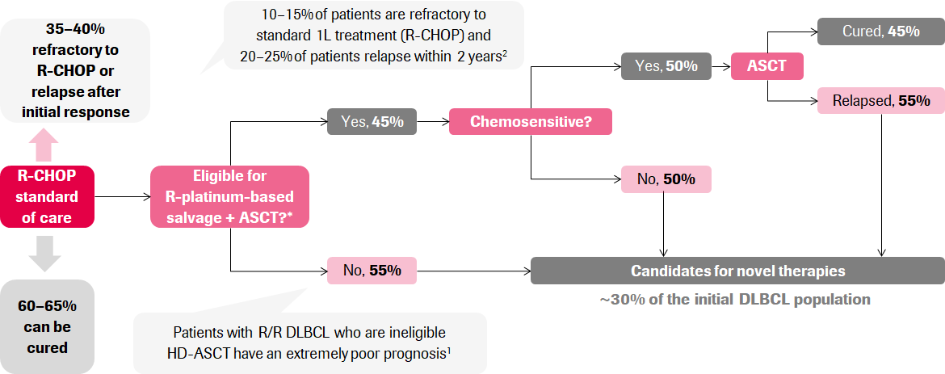
*Based on age and comorbidities
Abbreviations: 1L = first line; ASCT = autologous stem cell transplantation; DLBCL = diffuse large B-cell lymphoma; HD-ASCT = high-dose therapy and autologous stem cell transplantation; R-CHOP = rituximab, cyclophosphamide, doxorubicin, vincristine and prednisone; R/R = relapsed/refractory.

There are limited effective therapeutic options for patients with relapsed/refractory (R/R) DLBCL who have received 2 or more lines of systemic therapy. Two chimeric antigen receptor T-cell (CAR-T) therapies, axicabtagene ciloleucel (Yescarta) and tisagenlecleucel (Kymriah), are currently approved for patients with R/R DLBCL who have received 2 or more lines of systemic therapy. A newer CAR-T therapy, lisocabtagene maraleucel (Breyanzi), has been approved by the European Medicines Agency for the indication of treatment of adult patients with R/R DLBCL, primary mediastinal large B-cell lymphoma (PMBCL) and follicular lymphoma (FL) Grade 3B, after 2 or more lines of systemic therapy.

Regulatory status

Australian regulatory status
Glofitamab is considered a new biological entity for Australian regulatory purposes.

Foreign regulatory status
At the time the TGA considered this submission, a similar submission had been considered by other regulatory agencies. The following table summarises these submissions and provides the indications where approved.
Table 2: International regulatory status at time of TGA approval
Region | Submission date | Status | Approved indications
Canada | 23 June 2022 | Approved 24 March 2023 | COLUMVI is indicated for the treatment of adult patients with relapsed or refractory diffuse large B-cell lymphoma (DLBCL) not otherwise specified, DLBCL arising from follicular lymphoma (trFL), or primary mediastinal B-cell lymphoma (PMBCL), who have received two or more lines of systemic therapy and are ineligible to receive or cannot receive CAR-T cell therapy or have previously received CAR-T cell therapy.
United States of America (USA) | 1 November 2022 | Approved 15 June 2023 | COLUMVI is indicated for the treatment of adult patients with relapsed or refractory diffuse large B-cell lymphoma, not otherwise specified (DLBCL, NOS) or large B-cell lymphoma (LBCL) arising from follicular lymphoma, after two or more lines of systemic therapy.  This indication is approved under accelerated approval based on response rate and durability of response. Continued approval for this indication may be contingent upon verification and description of clinical benefit in a confirmatory trial(s).
European Union | 25 March 2022 | Approved 7 July 2023 | Columvi as monotherapy is indicated for the treatment of adult patients with relapsed or refractory diffuse large B-cell lymphoma (DLBCL), after two or more lines of systemic therapy.
New Zealand | 31 August 2022 | Under consideration
Switzerland | 30 November 2022 | Submitted
Singapore | 16 December 2022 | Under consideration

Concurrent submission
The submission for extension of indication of obinutuzumab (Gazyva) (submission PM-2022-03031-1-6) for pre-treatment to reduce the risk of cytokine release syndrome (CRS) induced by glofitamab was submitted concurrently with this submission for Columvi and relied on the same clinical dataset.

Registration timeline
The following table captures the key steps and dates for this submission.
The active ingredient with its proposed indication was given orphan drug designation.
This submission was evaluated under the provisional registration process.
Table 3: Timeline for Submission PM-2022-01989-1-6
Description | Date
Designation (Orphan) | 21 April 2022
Determination (Provisional) | 21 April 2022
Submission dossier accepted and first round evaluation commenced | 30 June 2022
First round evaluation completed | 1 December 2022
Sponsor provides responses on questions raised in first round evaluation | 23 December 2022
Second round evaluation completed | 10 February 2022
Sponsor’s notification to the TGA of errors/omissions in evaluation reports | 22 February 2023
Delegate’s Overall benefit-risk assessment and request for Advisory Committee advice | 22 February 2023
Sponsor’s pre-Advisory Committee response | 13 March 2023
Advisory Committee meeting | 30 and 31 March 2023
Registration decision (Outcome) | 3 August 2023
Administrative activities and registration in the ARTG completed | 9 August 2023
Number of working days from submission dossier acceptance to registration decision* | 195
*Statutory timeframe for standard submissions is 255 working days.

Submission overview and risk/benefit assessment
A summary of the TGA’s assessment for this submission is provided below.

Quality
Glofitamab is a glycosylated protein which is based on the structure of an immunoglobulin G1 molecule, but includes an extra antigen binding domain fused to one of the 2 standard antigen binding surfaces. The complex consists of one conventional immunoglobulin G heavy chain which encodes part of the anti-CD20 specificity, one extended heavy chain which encodes part of the anti-CD3 specificity to which is fused a second heavy chain encoding a second anti-CD20 sequence. These are complexed to light chains for the CD20-specificities and a light chain which uses the crossMab approach for the CD3 specificity. Here the Vh and Vl anti-CD3 domains are swapped in the antibody chains such that the Vh domain is resident on the light chain fragment and the Vl domain on the heavy chain. This modification, together with charge modifications engineered in the CD20 component and point mutations in the CH3 domains of the antibody chains, facilitates assembly of the complex with appropriate partner protein chains.
The active ingredient is produced using recombinant DNA technology.
Figure 2: Design, structure and key characteristics of glofitamab
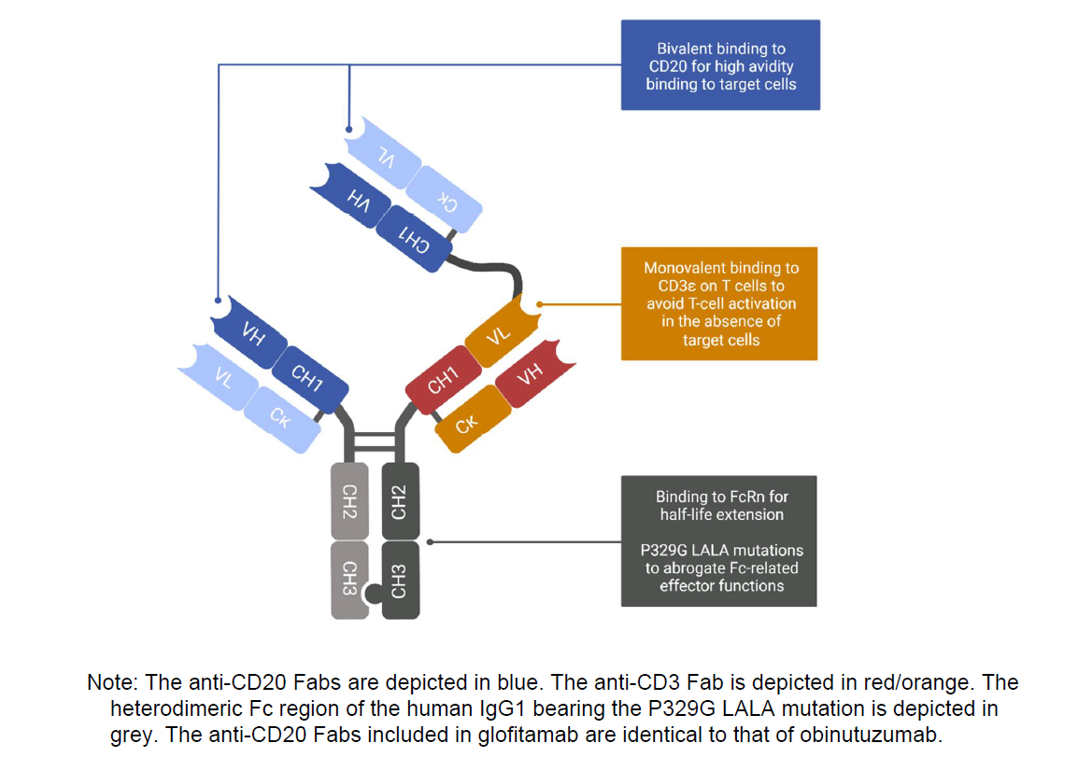
The molecular weight of the complex consisting of 2 heavy chains and three light chains is approximately 194 kD.
The type I glass vials are used with fluororesin-laminated rubber stoppers and aluminium seals with plastic flip-off caps.
Based on stability data submitted by the sponsor, the recommended shelf life and storage conditions for Columvi is 24 months at 2 to 8°C.
There are no objections on quality grounds to the approval of Columvi.
The Quality evaluation recommended conditions of registration relating to laboratory testing and compliance with Certified Product Details.

Nonclinical
There were no nonclinical objections to the registration of glofitamab for the proposed indication. The nonclinical evaluators noted the following points.
The nonclinical data contained an adequate set of studies conducted in general accordance with the International Council for Harmonisation (ICH) guideline S9 on nonclinical evaluation for anticancer pharmaceuticals, and the ICH guideline S6 on preclinical safety evaluation of biotechnology-derived pharmaceuticals.. The overall quality of the nonclinical dossier was high. All pivotal safety-related studies were Good Laboratory Practice-compliant.
Glofitamab is intended to simultaneously bind to CD20 (expressed on the surface of target B-cells) and CD3 (expressed on effector T-cells) to cause T-cell activation and target cell lysis. Supporting utility in the proposed indication, anti-tumour activity was demonstrated for glofitamab in vitro against various human DLBCL tumour cell lines and in primary tumour-infiltrated bone marrow aspirates from patients with Non-Hodgkin lymphoma, as well as in vivo in DLBCL tumour-bearing humanised mice. The anti-tumour activity of glofitamab was shown to not be affected by obinutuzumab pre-treatment, the use of step-up dosing, or by pre-medication with dexamethasone. Also demonstrated for glofitamab were B-cell depletion, and induction of T-cell activation and proliferation. The T-cell activation by glofitamab occurs only in the presence of simultaneous binding to CD3-expressing T-cells and CD20-expressing target cells, and not upon binding to T-cells only.
Immunohistochemical experiments involving a suitably comprehensive panel of human tissues revealed a pattern of binding consistent with known target (CD20/CD3) expression, and also some apparent off-target binding, observed in the cytoplasm of smooth, skeletal and cardiac myocytes. With the cytoplasmic compartment being largely inaccessible to the antibody in vivo, no toxicological significance to the apparent cross-reactivity is seen.
Glofitamab was shown to also recognise the cynomolgus monkey forms of CD20 and CD3, (displaying comparable affinity compared to human), but not that of other routine laboratory animal species (mouse, rat, rabbit, dog or pig).
Examination of safety pharmacology endpoints — incorporated into the general repeat-dose toxicity program in monkeys — indicated no effects on central nervous system (CNS) or respiratory function. Effects on electrocardiogram (ECG) were limited to increased heart rate. Glofitamab-treated monkeys also showed increased body temperature. These effects are seen to be secondary to cytokine release rather than to reflect a direct effect of the drug.
The pharmacokinetic profile of glofitamab in cynomolgus monkeys was characterised by rapid clearance and target-mediated drug disposition. The serum half-life of the antibody was unusually short in monkeys (typically 4 to 8 hours without obinutuzumab pre-treatment and approximately 2 to 3 days with obinutuzumab pre-treatment to de-bulk B-cells). In contrast, a serum half-life typical of a monoclonal antibody was evident in humans (6.5 days) and in laboratory animal species without target binding (5 to 8.5 days). To accommodate the much shorter half-life of glofitamab in cynomolgus monkeys compared with humans, more frequent dose administration was employed in the pivotal repeat-dose toxicity study.
Single-dose and repeat-dose toxicity studies were performed in cynomolgus monkeys, selected as a single pharmacologically relevant species. The pivotal repeat-dose toxicity study was of 4 weeks duration and involved a step-up design then dosing every second day (compared with a 21-day cycle in patients). The duration of the pivotal study is short but acceptable, with longer studies not feasible due to the development of anti-drug antibodies that neutralised pharmacological activity. The development of anti-drug antibodies in animals (to this humanised protein) is not predictive of immunogenicity in patients.
The major findings in the toxicity studies are attributable to the drug’s primary pharmacology. They comprised:
- B-cell depletion (in the circulation and lymphoid tissues)
- transient activation and expansion of T-cells
- a suite of effects seen to be related to cytokine release, including emesis, decreased activity, hunched posture, increased heart rate and body temperature, various changes in haematology and clinical chemistry, microscopic changes in the gastrointestinal tract (erosions, single cell apoptosis/necrosis of mucosal glandular tissue), and inflammatory cell infiltrates in the liver, spleen and sporadically various other organs.
Findings relating to cytokine release were transient and most prominent after the first dose. They were shown to be attenuated by step-up dosing in the repeat-dose toxicity program or by obinutuzumab pre-treatment in a single-dose study. This is consistent with the extent of cytokine release being mainly driven by the number of B-cells. The risk of cytokine release syndrome with glofitamab in patients is reduced by obinutuzumab pre-treatment and prominently flagged in the Product Information document.
Good local tolerance of the formulated product by the intravenous and subcutaneous routes was demonstrated in monkeys.
Genotoxicity and carcinogenicity studies were not conducted, in line with ICH guidelines.
No reproductive and developmental toxicity studies were performed with glofitamab, with the potential for adverse effects on embryofetal development assessable from the class/mechanism of action. No particular risk of malformations is seen, but fetal B-cell depletion is expected, and cytokine release may pose a risk for embryofetal loss. Assignment to Pregnancy Category C is recommended.

Clinical

Summary of clinical studies
The clinical dossier consisted of:
- one Phase I/II study, Study NP30179, an ongoing first-in-human, multicentre, open-label, dose-escalation and expansion study evaluating the efficacy, safety and tolerability, and pharmacokinetics (PK) of glofitamab monotherapy, administered after a fixed, single dose of obinutuzumab (Gazyva) given as pre-treatment to reduce the risk of CRS in patients with R/R DLBCL. The interim clinical study report from the first patient enrolled (14 February 2017) up to the clinical cut-off date (CCOD) of 14 September 2021 was supplemented by additional data (CCOD 15 June 2022) during the evaluation process.
Two analyses based on the above study were also provided:
- 1114236, which examines the population pharmacokinetics (popPKs), exposure-response and concentration-QT analyses for glofitamab
- 1113507, which uses physiologically based pharmacokinetic (PBPK) modelling to assess the potential impact of increasing interleukin-6 levels following glofitamab administration on the activity of a range of cytochrome (CYP) P450 substrates.

Pharmacology

Pharmacokinetics
A validated, target-binding competent sandwich enzyme linked immunoassay (ELISA) was used in clinical Study NP30179 to determine the concentration of glofitamab in human serum samples. The ELISA was developed and validated at 2 different sites and had a lower limit of quantification of 0.625 ng/mL in human serum.
Anti-drug antibodies (ADAs) to glofitamab in human serum were determined using a validated bridging ELISA with screening sensitivities ranging from 2.62 ng/mL to 11.2 ng/mL.
Clinical pharmacology data was determined from Study NP30179. The study is also evaluating the efficacy and safety of glofitamab in combination with obinutuzumab in patients with R/R DLBCL; however, data from those cohorts was not included in this initial application for glofitamab.
Patients were treated in the single and multiple dose escalation cohorts and dose expansion cohorts with fixed doses of intravenous glofitamab ranging from 0.005 mg to 25 mg (every 2 weeks or every 3 weeks) and step-up doses of 2.5/10/16 mg glofitamab and 2.5/10/30 mg glofitamab (every 3 weeks) on C1D8, C1D15 and C2D1 in the multiple patient dose escalation and dose expansion cohorts. Pharmacokinetics in a cohort of patients with an extended step-up dosing regimen of glofitamab 0.5/2.5/10/30 mg on C1D8, C1D15, C2D1, C3D1 (every 3 weeks from Cycle 3 onwards) was also explored.
Obinutuzumab pre-treatment was administered 7 days prior to the initial dose of glofitamab (that is, Day 7) which corresponds to Cycle 1 Day 1 (C1D1). Consequently, in the analyses, the first dose of glofitamab corresponds to C1D8 and for patients receiving the step-up dosing regimen, administration of the initial low dose of glofitamab (2.5 mg) 7 days after obinutuzumab corresponds to C1D8 (Day 8) and administration of the intermediate 10 mg glofitamab dose 7 days after the first glofitamab dose corresponds to C1D15 (Day 15).
Following an intravenous infusion, maximum concentrations were reached shortly after the end of the infusion and exhibited a biphasic disposition with an initial rapid distribution phase followed by a slower elimination phase towards the end of the dosing interval. The mean Cycle 1 maximum glofitamab concentration in serum (C_{max}) values following first administration were dose proportional from 0.015 mg to 25 mg.
Due to the restricted sampling schedule, it was not possible to determine PK parameters for all cohorts by non-compartmental analysis.
Sparse sampling of obinutuzumab and tocilizumab indicated that serum concentrations were within the range previously reported for the respective drugs.
Figure 3: Study NP30179 Mean serum concentration-time profiles for glofitamab following first dose (Cycle 1 Day 8) for administration across doses
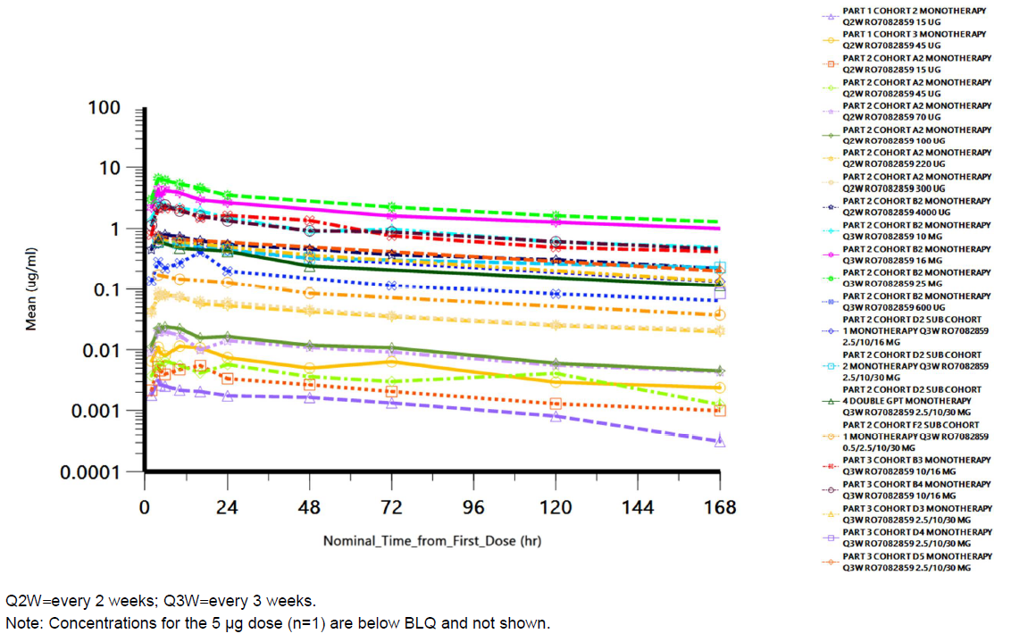
No treatment emergent ADAs (negative at baseline, positive after first dose) against glofitamab were observed. Fifteen (4.1%) patients had a positive baseline sample prior to glofitamab treatment with one patient exhibiting a high clearance and reduced exposure but no positive ADA on treatment.

Population pharmacokinetics
A total of 399 patients (221 in Part I and II, and 178 in Part III) who had at least one post dose quantifiable glofitamab PK sample were included in the PK analysis. There were 9566 concentration-time observations across a wide range of doses and regimens, ranging from 5 micrograms to 30 mg, from the glofitamab monotherapy cohorts only. Exposure-response analyses for efficacy, safety and characterisation of the concentration-QT relationship were also performed using the popPK data. The PK CCOD was 6 July 2021. The analysis populations are shown below.
Table 4: Study NP30179 Key analysis populations supporting the evaluation of clinical pharmacology of glofitamab intravenous monotherapy in patients with R/R DLBCL (PK Evaluable Population)
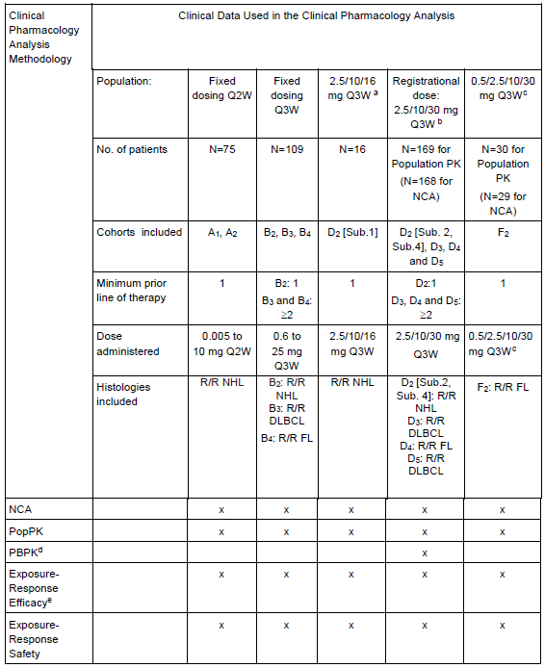
DLBCL=diffuse large B-cell lymphoma; FL=follicular lymphoma; NCA = non-compartmental analyses; NHL=non-Hodgkin lymphoma; PopPK=population pharmacokinetic; PBPK=physiologically based pharmacokinetic; Q2W=every 2 weeks; Q3W=every 3 weeks.
a 2.5/10/16 mg Q3W: Glofitamab step-up dosing: 2.5 mg administered on Day 8 and 10 mg administered on Day 15 at Cycle 1, followed by 16 mg on Day 1 at Cycles 2-12 (21-day cycles [every 3 weeks, Q3W])
b 2.5/10/30 mg Q3W: Glofitamab step-up dosing: 2.5 mg administered on Day 8 and 10 mg administered on Day 15 at Cycle 1, followed by 30 mg on Day 1 at Cycles 2-12 (21-day cycles [every 3 weeks, Q3W])
c 0.5/2.5/10/30 mg Q3W: Glofitamab extended step-up dosing (0.5 mg administered on Day 8, 2.5 mg administered on Day 15 at Cycle 1, followed by 10 mg on Day 1 at Cycle 2 followed by 30 mg on Day 1 at Cycles 3-12 [every 3 weeks, Q3W])
d 2.5/10/30 mg Q3W step-up dosing patients with interleukin-6 data were included in the PBPK (n=163)
e All DLBCL, PMBCL, HGBCL and trFL patients with available PK and efficacy were included in the exposure-efficacy analysis either looking at D3 only (n=95) or from all monotherapy Cohorts (n=259).
The serum sampling schedule for the quantification of obinutuzumab and glofitamab concentrations and glofitamab ADA titres comprised extensive sampling for the first glofitamab administration to enable non-compartment analysis. Subsequent doses had sparse sampling for population PK methodology. The primary form of pharmacokinetic analysis for the study as whole is population PK modelling.
R (version 4.0.5) was used for data processing, data visualisation and reporting, supported by a range of additional packages. PK/PD model fitting and Bayesian feedback were performed using the non-linear mixed effect modelling software NONMEM (version 7.4.3). Obinutuzumab models were fitted using importance sampling with maximum a posteriori estimation, whereas glofitamab models were fitted using the first-order conditional estimation method with interaction.
Simulations were performed using a combination of NONMEM and R.
Analyses and data processing were performed on an Intel Core i9-9900K CPU-based personal computer, running under Windows 11 Professional (64-bit). Model fitting in NONMEM was performed using the Intel Visual Fortran compiler (64-bit Intel Parallel Studio XE 2015 Update 3 Composer Edition (package 208)). Simulation-based diagnostics such as visual predictive checks were the primary method of assessing model appropriateness.
Findings included the following points.
- Non-compartmental analyses indicate that glofitamab reaches C_{max} at the end of infusion and declines in a bi-exponential fashion.
- Glofitamab exhibits linear and dose-proportional pharmacokinetics in the dose range studied (0.005 mg to 30 mg) and is independent of time.
- The serum concentration-time data was well-described in the 399 PK evaluable population by a popPK model with 2 compartments and both time-independent (Cl_{L})and time-varying clearance (CL_{T}) pathways.
  - The time independent clearance pathway was estimated as 0.602 L/day and the initial time varying clearance pathway (CL_{T0}) as 0.396 L/day, with a relatively quick exponential decay over time (k_{des} approximately 0.445 per day). The estimated decay half-life from the initial total clearance value to the time independent clearance only was estimated as 1.56 days.
- While the half-life of the elimination phase is not readily calculated or interpretable in the presence of nonlinear clearance, the effective half-life in the linear phase (that is, the contribution of time-varying clearance has collapsed to a negligible amount) can be approximated, based on the final population PK model, to a typical linear effective half-life of 6.54 days.
- The central volume of distribution (V1) was 3.33 L and peripheral volume of distribution (V2) was 2.18 L. The central volume of distribution of 3.33 L is close to total serum volume.
- The popPK model was built with a high precision of parameters that were estimated (that is, low standard error of estimates) and well qualified using (Prediction-Corrected) Visual Predictive Check.
- No clinically meaningful baseline covariates were identified for glofitamab pharmacokinetics which require dose adjustment.
- High inter-individual variability was observed on parameters describing the time-varying clearance pathway (from 159% on k_{des}, to 190% on CL_{T0}).
- Moderate to high inter-individual variability was observed for the remaining PK parameters (from 24.1%, 26.2%, 36.7% to 76.2% for V1, CL_{L}, V2 to inter-compartment clearance, respectively).
- Significant baseline covariate effects include:
  - body weight on clearances and volumes (allometric scaling was the preferred option with fixed exponents of 0.75 for clearances, 1 for V2 and estimated exponent of 0.505 for V1)
  - baseline C-reactive protein on CL_{L}, CL_{T0} and V1
  - baseline obinutuzumab pre-treatment concentrations on CL_{T0}
  - transformed follicular lymphoma (trFL) compared to other histologies on kdes.
None of the above covariates resulted in changes in glofitamab exposure (that is, AUC_{D1} or over Cycle 1 and Cycle 2[AUC_{C1+C2}]) of more than 20% when evaluated at upper and lower value limits of the 2.5th to 97.5th percentiles range compared to the typical patient (that is, patient with the median value of the covariate for continuous covariates or with the most frequent categorical covariate in the dataset such –namely non trFL patients), except for body weight which resulted in a −18.7% up to +28.0% of the AUC_{D1} and in a −24.4% up to +39.5%of the AUC_{C1+C2} in the higher (107 kg) and lower (47.5 kg) limits of the 2.5th to 97.5th percentiles body weight range, respectively, as compared to the median value (74.0 kg), when considering the model estimates. Age, body weight, race, and sex did not have a clinically significant effect on PK. There was a significant relationship between tumour histology (trFL versus other histologies) and k_{des} (that is, a 4.76-fold higher k_{des} in DLBCL arising from follicular lymphoma (trFL) versus non-trFL patients).

Pharmacodynamics

Exposure-response for efficacy
For the analyses of efficacy, 2 patient populations were considered: the 2.5/10/30 mg step-up dosing patients enrolled in Cohort D3 (n=95) and all PK-evaluable patients with DLBCL, high grade B-cell lymphoma (HGBCL), primary mediastinal B-cell lymphoma (PMBCL) or trFL histology types (n=259).
Logistic regression was applied to explore exposure-response relationships for efficacy and safety. After using univariable fits and graphical analysis to identify the most appropriate metrics of exposure, full models including all potential predictors of interest were constructed. Finally, a stepwise reduction process was performed to identify only those predictors significant at p < 0.01, which were retained in final reduced models for the endpoints of interest. Duration of complete response (DOCR) and duration of response (DOR) were explored using graphical analysis.
In the Cohort D3 population (the primary population for efficacy assessment), the complete response (CR) rate and overall response (OR) rate were 40% and 56.8%, respectively, whereas in the DLBCL/HGBCL/PMBCL/trFL population the corresponding values were 35.1% and 50.2%, respectively. In Cohort D3, glofitamab exposure alone was a significant predictor of both CR and OR at the p < 0.05 level, but the significance of these relationships were reduced when other covariate predictors were included in the analysis. By contrast, in the DLBCL/HGBCL/PMBCL/trFL population, a significant relationship was found between AUC_{C1+C2} and both the CR and OR rates even when other covariate predictors were considered.
In both populations, CR likelihood was significantly associated with decreasing baseline sum of product of diameters (SPD)of the target lesions and with increasing time since last prior anti-CD20 treatment. For instance, for SPD in the D3 cohort the odds ratio was 0.605 per log mm² and the 95% confidence interval (95% CI) ranged from 0.398 to 0.886, and for time since last treatment the odds ratio was 2.22 per log month (95% CI:1.46, 3.64). Whereas, in the DLBCL/HGBCL/PMBCL/trFL population, increasing AUC_{C1+C2} was also associated with increasing CR likelihood with odds ratio 1.55 per 25 μg.d/mL (95% CI: 1.18, 2.05).
In both populations, OR likelihood was significantly associated with decreasing baseline LDH and with increasing time since last prior anti-CD20 treatment. Whereas, in the DLBCL/HGBCL/PMBCL/trFL population, OR likelihood was also associated with AUC_{C1+C2} with odds ratio 1.62 per 25 μg.day/mL (95% CI: 1.25, 2.14).
Duration of complete response and DOR were ongoing, with most responders not progressing by the cut-off time and response occurring rapidly after the start of glofitamab treatment. There was little difference in DOCR or DOR by exposure in any of the populations explored. Median DOCR was not attained in either of the efficacy populations. Median DOR was reached only for the DLBCL/HGBCL/ PMBCL/trFL population (22.1 months, with a lower 95% confidence limit of 14.4 months while no upper 95% limit could be estimated).

Exposure-response for safety
Dosing of glofitamab following the 2.5/10/30 mg step-up dosing regimen is associated with an incidence of Grade 2 or higher CRS of 16.4%, according to American Society for Transplantation and Cellular Therapy [ASTCT] consensus grading, of 16.4% across all cycles in the safety population (n=152) and an incidence of 12.7% following the first dose of 2.5 mg.
The exposure-CRS analysis on the total PK-evaluable population of 399 patients with starting doses over a 5,000- fold range from 0.005 mg to 25 mg, indicated that the risk of experiencing CRS Grade 2 or higher significantly increases (p-value = 0.00380) with increasing glofitamab average receptor occupancy (RO)% over the first 24 hours after the first dose (AvgRO%_{D1}). This observation was confirmed when looking at the AvgRO%_{D1} quartiles with 20.6%, 24.8%, 18.8% and 35.6% in quartiles 1, 2, 3 and 4, respectively.
Most CRS events of Grade 2 and higher took place within the first day of treatment. A strong exposure-response signal was seen in the highest exposure quartiles when comparing CRS (Grade 2 and higher) incidence by quartiles of AvgRO%_{D1}, AUC_{D1} and Cmax_{Day 1}.
The exposure-neutropenia analysis on the total PK-evaluable patient population indicated the absence of any relationship between glofitamab exposure and the incidence of Grade 2 and higher neutropenia (p-value of 0.711 for AUC_{C1+C2} and 0.364 for AvgRO%_{C1+C2}).

Concentration-QT
A graphical analysis was performed to explore the pro-arrhythmic potential of glofitamab in 408 patients with suitable ECG data. Mixed-effects analysis was subsequently performed to quantify the relationship and simulations were carried out to predict the proportions of patients receiving 2.5/10/30 mg glofitamab in which QT prolongation thresholds of concern would be exceeded.
Although the available ECG data was limited, graphical analyses suggested the presence of a drug-induced QT prolongation effect. The QT prolongation signal associated with glofitamab concentration was best described by an maximum effect model (a model in which effect reaches a maximum beyond which it does not increase further, regardless of concentration). Maximal prolongation was estimated to be 10.6 msec (95% CI: 9.29, 11.8%), with an associated glofitamab concentration to give the half-maximal effect of 1.25 μg/mL (95% CI: 1.11, 1.39 μg/mL). Simulations predicted that 49.0% of patients receiving the proposed step-up regimen of 2.5/10/30 mg would exceed a QTc prolongation threshold of 10 msec; 23.0% would exceed 20 msec; 12.8% would exceed an absolute individually-corrected QT interval of 450 msec; and less than 1% were predicted to exceed 480 msec.

Evaluation of the potential impact of increasing interleukin-6 levels following glofitamab administration on activity of various Cytochrome P450 substrates
Cytokine release syndrome (CRS), a systemic inflammatory response driven by cytokine release, is a common dose-limiting adverse event for TCBs products as well as with other cancer immunotherapy treatments such as CAR-T therapies. CRS is mainly a first administration adverse event and when seen in subsequent administrations it is usually less severe. A transient elevation of cytokines (mainly interleukin-6, interleukin-10 and interferon-gamma) has been observed within the first 48 hours of glofitamab administration. To mitigate this effect, a ‘priming’ dose strategy (that is, a lower initial dose followed by a higher maintenance dose also called step-up dosing) was implemented.
Interleukin-6 suppression of CYP mediated metabolism in vitro has been described. The CYP suppression can result in decreased clearance and higher exposures to concomitantly administered drugs that are CYP substrates. A physiologically-based pharmacokinetic (PBPK) model was applied to predict the effect of transient elevations of interleukin-6.
The PBPK predictions were performed for the virtual North European Caucasian population with age, body weight and gender characteristics matching those of the 2.5/10/30 mg step-up dosing patients from the NP30179 study.
The model predicted that the magnitude of the suppressive effect of transient interleukin-6 increase on hepatic CYP enzyme activities would be less than 50% so that changes in exposures for CYP substrates are expected to be lower than or equal to 2-fold in the worst-case scenario. Based on these predictions, the sponsor recommended that there are no restrictions on administration of CYP3A4 substrates, however consideration maybe be given for potential drug-drug interactions during the first cycle in patients who are receiving concomitant CYP substrates with a narrow therapeutic index. In these patients, monitoring for toxicity (for example, warfarin) or for drug concentrations (for example, ciclosporin) may be warranted.

Efficacy
Study NP30179 is an ongoing, multicentre, open-label, Phase I/II study to evaluate the safety, efficacy, tolerability and pharmacokinetics of escalating doses of glofitamab as a single agent and in combination with obinutuzumab administered after a fixed, single dose pre-treatment of obinutuzumab (Gazyva) in patients with R/R NHL. The study is being conducted at 41 centres across 13 countries including Australia and New Zealand. The study start date (date first patient enrolled) was 14 February 2017. An interim clinical study report included data to 14 September 2021 and a subsequent report included data to 15 June 2022. The proposed indication is for a sub-group of patients with R/R DLBCL.
The median duration of follow-up for the primary efficacy cohort (cohort D3) in the updated analysis is 15 months (range: 0 to 21 months). Following health authority feedback, the primary efficacy population, initially only the D3 subgroup population with DLBCL, was expanded to include all patients with R/R DLBCL (at least 2 prior lines of systemic therapy) who were treated with glofitamab doses of 2.5/10/30 mg pooled from Cohorts D2 [Sub. 2], D3, and D5.

Study objectives
The primary objectives included evaluation of the safety, tolerability, and pharmacokinetics of glofitamab, determination of the maximum tolerated dose or optimal biological dose and a dose schedule for glofitamab both as a single agent and in combination with obinutuzumab pre-treatment in patients with relapsed/refractory CD20+ B-cell Non-Hodgkin Lymphoma (R/R NHL).
The primary efficacy objective for this component of the study was to evaluate the efficacy of glofitamab as single agent following pre-treatment with obinutuzumab in patients diagnosed with DLBCL (R/R DLBCL not otherwise specified [NOS], HGBCL, primary mediastinal B-cell lymphoma [PMBCL], DLBCL arising from FL [transformed FL; trFL]) (and R/R FL) as measured by Independent Review Committee (IRC)-assessed complete response rate according to standard NHL response criteria (Lugano Classification).⁵

Study design
The study is divided into 3 parts. Patients in Part I were treated with glofitamab monotherapy, and patients in Parts II and III were treated with glofitamab monotherapy or combination therapy with pre-treatment with obinutuzumab.
- dose-escalation Part I (single patient cohorts; glofitamab fixed doses of 0.005 mg to 0.045 mg) and Part II (multiple patient cohorts; glofitamab fixed doses of 0.015 mg to 25 mg and step-up doses up to 30 mg).
- dose-expansion Part III (multiple patient cohorts; patients with R/R DLBCL or R/R FL treated with glofitamab at 10/16 mg or 2.5/10/30 mg step-up dosing).
A schematic of the study is shown in Figure 4.

Figure 4: Overall design schematic for Study NP30179
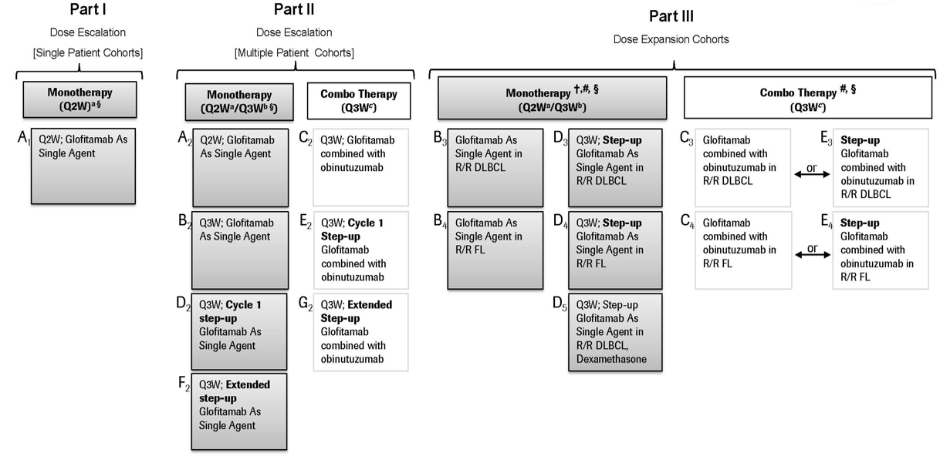
The primary efficacy endpoint is CR rate by the Lugano classification,⁵ as assessed by an IRC. Secondary efficacy endpoints include: CR rate by investigator; OR rate by IRC and investigator; DOCR by IRC and investigator; DOR by IRC and investigator; time to first complete response by IRC and investigator; time to first overall response by IRC and investigator; progression-free survival by IRC and investigator; and overall survival. All response assessments were according to the Lugano classification.
Given the proposed indication the emphasis in this AusPAR is on combined cohorts given the proposed dose regimen of glofitamab (all patients with R/R DLBCL (at least 2 prior lines of systemic therapy) who were treated with glofitamab doses of 2.5/10/30 mg pooled from Cohorts D2 [Sub. 2], D3, and D5. The study is still enrolling patients. The first interim clinical study report included efficacy data for R/R DLBCL patients receiving glofitamab as monotherapy in the dose escalation (Parts I and II) and dose expansion (Part III) cohorts up to the CCOD of 14 September 2021. In that clinical study report, the primary efficacy population comprised patients with R/R DLBCL treated with at least 2 prior systemic therapies in Cohort D3 treated at the proposed registrational step-up glofitamab dose of 2.5/10/30 mg every 3 weeks (N = 108). That data is supported by efficacy data from:
- Cohort D2: patients with R/R DLBCL treated with at least 2 prior systemic therapies in Cohort D2 [Sub. 2] plus Cohort D3 treated at the proposed registrational glofitamab step-up dose of 2.5/10/30 mg every 3 weeks (N = 115)
- Cohorts B2 ,B3 and D2 {Sub. 1}: patients with R/R DLBCL treated with at least 2 prior systemic therapies receiving doses of at least 10 mg glofitamab (glofitamab doses of 10 mg, 16 mg, 25 mg [Cohorts B2 in Study Part II], 10/16 mg fixed dosing [Cohort B3 in Study Part III] or step-up dosing 2.5/10/16 mg [Cohort D2 {Sub. 1} in Study Part II) (N =100).

Figure 5: Study NP30179 Initial study schema: patients treated with glofitamab monotherapy
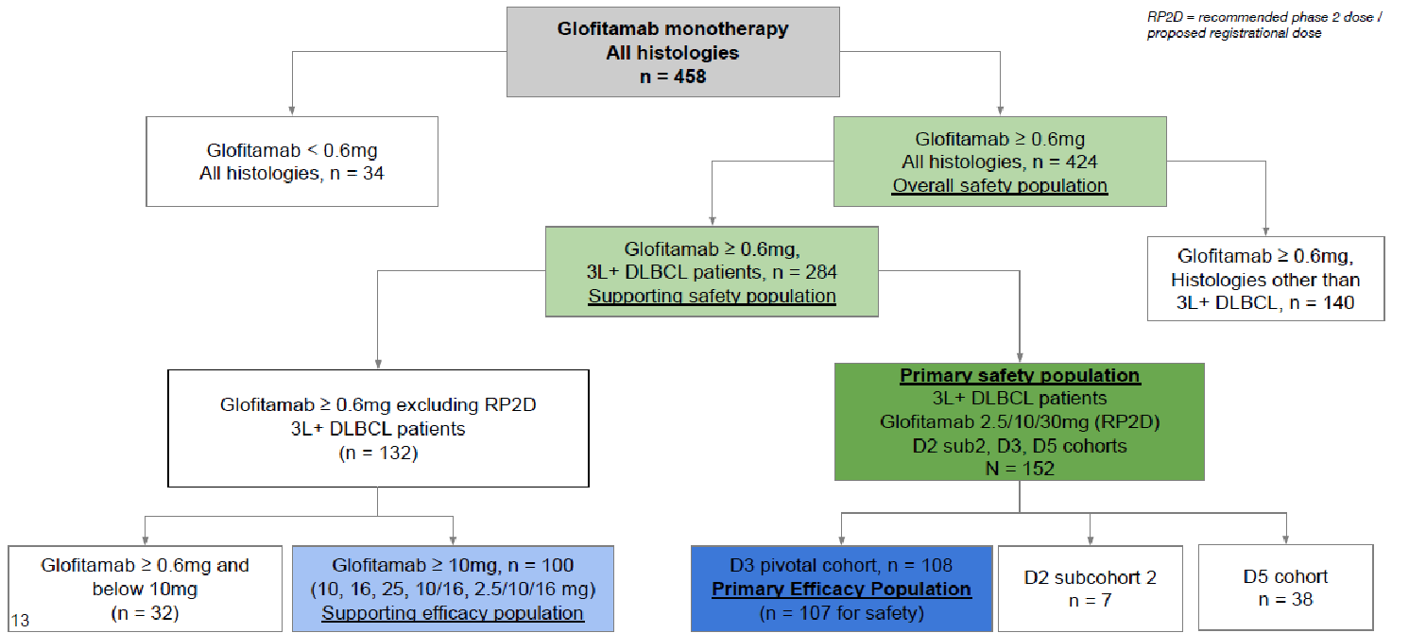

Key inclusion and exclusion criteria
Eligible patients were male and female adults (at least 18 years old) with a histologically-confirmed haematological malignancy that was expected to express CD20, with relapse after or failure to respond to at least one prior treatment regimen, and no available treatment options that were expected to prolong survival (for example, standard chemotherapy or autologous stem cell transplant).
Eligible patients had to have measurable disease, defined as at least one bi-dimensionally measurable nodal lesion, defined as greater than 1.5 cm in its longest dimension, or at least one bi-dimensionally measurable extranodal lesion, defined as greater than 1.0 cm in its longest dimension. Other inclusion criteria included life expectancy (in the opinion of the investigator) of at least 12 weeks.
In the Part III R/R DLBCL cohort, patients must have relapsed after or failed to respond to at least 2 prior systemic treatment regimens (including at least one prior regimen containing anthracycline, and at least one containing an anti CD20-directed therapy).
Exclusion criteria of note include:
- prior treatment with systemic immunotherapeutic agents, within 4 weeks or 5 half-lives of the drug, whichever was shorter, before the obinutuzumab infusion 7 days prior to glofitamab
- treatment with standard radiotherapy, any chemotherapeutic agent, or treatment with any other investigational anti-cancer agent, including CAR-T therapy within 4 weeks prior to obinutuzumab infusion
- prior allogeneic stem cell transplantation
- autologous stem cell transplantation within 100 days prior to obinutuzumab infusion
- current or past history of CNS lymphoma
- significant cardiovascular disease such as New York Heart Association Class III or IV cardiac disease, myocardial infarction within the last 6 months, unstable arrhythmias, or unstable angina
- ECOG performance status of 2 or higher
- creatinine clearance below 50 mL/min
- hepatic transaminases above 3 × ULN (upper limit of normal).

Dosing regimens
The glofitamab dosing regimens were as follows:
- In Part I (applied to monotherapy only, Cohort A1) and in Part II (Cohort A2) glofitamab was administered on Day 8 and Day 15 as a single agent every 2 weeks.
- Patients who entered the trial under Protocol NP30179 v5 or above could receive glofitamab monotherapy on an every 2 weeks dose schedule (Cohort A2) or receive glofitamab on every 3 weeks dosing schedule (Cohorts B2, D2, F2, B3, B4, D3, D4 and D5).
- Beginning with Protocol NP30179 v8, Part II dose escalation explored step-up dosing regimens every 3 weeks, in which an initial lower dose of glofitamab was administered on C1D8 followed by a higher dose administered on C1D15.
- Beginning with Protocol NP30179 v9, Part II dose escalation could explore an alternative step-up dosing schedule in selected dosing cohorts (extended step-up dosing). In the extended step-up dosing, an initial lower dose of glofitamab was to be administered on C1D8 and C1D15 followed by an intermediate dose in Cycle 2 and the first administration of the target treatment dose in Cycle 3. Alternatively, an intermediate dose could also be administered in Cycle 3 and first target dose in Cycle 4. The treatment period was fixed at 12 cycles of glofitamab with every 2 weeks or every 3 weeks dosing.
- The first administration of glofitamab (C1D8) was to be administered over 4 hours, plus or minus 15 minutes.
- For patients who developed CRS during glofitamab infusion, the infusion was to be discontinued immediately with no further re-starts of the infusion for this administration, unless limited to Grade 1. In the absence of infusion-related adverse events, the infusion time of glofitamab in subsequent cycles could be reduced to 2 hours plus or minus 15 minutes, at the discretion of the investigator.
- For patients who may be at an increased risk of CRS, patients who experience IRRs or CRS with their previous dose of glofitamab or who were at increased risk of recurrent IRR/CRS with subsequent doses, the time of infusion could be extended to up to 8 hours.
- Patients who underwent intra-patient dose-escalation in Part I could also receive the next higher dose of glofitamab over a minimum of 4 hours. Patients in step-up dosing cohorts were to receive C1D8 and C2D1 doses over a minimum of 4 hours.
- The initial treatment period was fixed at 12 cycles of glofitamab with every 3 weeks dosing (every 2 weeks was tested at lower doses). Patients eligible for re-treatment received glofitamab for up to 12 cycles at a dose and schedule that had been previously demonstrated in the dose escalation to be safe.
The obinutuzumab dosing regimen was a single 1000 mg intravenous infusion on C1D1, 7 days before the first dose of glofitamab on C1D8. Double pre-treatment with obinutuzumab prior to the first dose of glofitamab was also given patients in Cohort D2 Sub. 4 as an additional mitigation of CRS. Obinutuzumab was to be administered in a clinic or hospital equipped for systemic cancer treatment.
Corticosteroid premedications (80 mg intravenous methylprednisolone or prednisone (100 mg) or prednisolone (100 mg) or dexamethasone (20 mg intravenous)) was mandatory for all patients in the study and was to be administered at least 60 minutes prior to the administration of obinutuzumab and glofitamab. An exploratory cohort D5 investigated the potential of dexamethasone premedication (20 mg intravenous prior to the obinutuzumab and glofitamab infusions) to further reduce the occurrence and severity of CRS.
Tocilizumab was to be administered when necessary for the management of CRS during or after any infusion of glofitamab.

Statistical methods
The initial primary comparison was the IRC assessment of Complete Responses (CRs) between the primary efficacy population with R/R DLBCL treated with glofitamab 2.5/10/30 mg in Cohort D3 and an historical control. The historical CR rate for patients in the R/R DLBCL cohort was based on a systematic literature review of regimens used in the treatment of R/R DLBCL, including CAR-T therapies, anti-CD20 therapy plus chemotherapy, lenalidomide, and polatuzumab vedotin. That CR estimate was 20%. An exact binomial test with a 2-sided alpha level of 5% according to the following hypothesis was applied: H0: CR rate = 20% versus H1: CR rate ≠ 20%.
Secondary measures were: CR by investigator assessment; OR rate; DOCR; DOR; progression-free survival; overall survival; time to first complete response; and time to first overall response. These measures were assessed by an IRC and by investigators. Tumour and response evaluations were determined by the IRC and investigator on the basis of radiological assessments and bone marrow examinations (if appropriate), using the Lugano classification.⁵

Results

Pre-planned analysis
Only results for the DLBCL cohorts are reported below.
Table 5: Study NP30179 Disposition of patients assigned to DLBCL cohorts glofitamab monotherapy
 | R/R DLBCL ^{b} *  Fixed and  Step-up doses  ≥ 0.60 mg  Cohorts A2, B2, B3, B4, D2 [Sub. 1, 2, 4], D3, D4, D5^{b}, F2 | R/R DLBCL ^{b} *  Step-up doses  2.5/10/30 mg  Cohorts D2 [Sub. 2], D3, D5^{b} | R/R DLBCL ^{b} *  Step-up doses  2.5/10/30 mg  Cohort D3
Treated | N = 287 | N = 154 | N = 107
Completed initial treatment | 74 (25.8%) | 41 (26.6%) | 27 (25.2%)
Discontinued initial treatment | 209 (72.8%) | 109 (70.8%) | 80 (74.8%)
Active on initial treatment | 4 (1.4%) | 4 (2.6%) | 0
Discontinued study | 182 (63.4%) | 91 (59.1%) | 71 (66.4%)
Ongoing on study ^{c} | 105 (36.6%) | 63 (40.9%) | 36 (33.6%)
b Patients with R/R DLBCL: at least 2 prior lines of systemic therapy
c As of the CCOD (15 June 2022)
* Note that the numbers in the cohort columns are the number of patients in that analysis group to match the presentation of the data in the text. They cannot be accumulated to match the number of patients treated, as a particular cohort may appear in more than one analysis group and therefore counted more than once.
Figure 6: Study NP30179 Overall response rate by IRC assessment: Glofitamab dose escalation and dose expansion cohorts for patients with R/R DLBCL with at least 2 prior lines of systemic therapy (ITT population – pre-planned analysis)
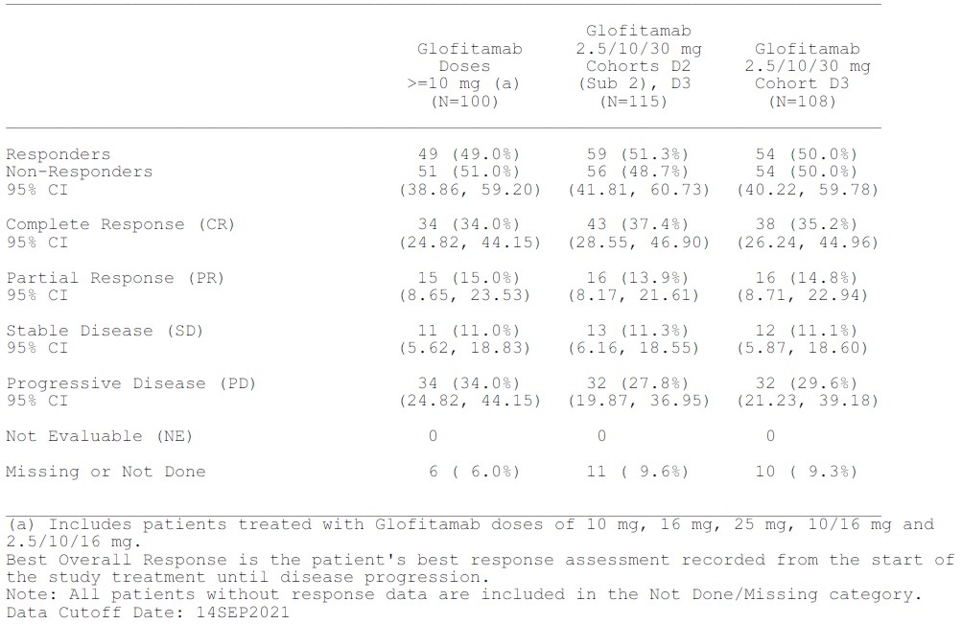

June 2022 analysis
In this analysis results the primary efficacy population was the ITT population given the proposed dose regimens for obinutuzumab and glofitamab who had R/R DLBCL and had received at least 2 prior lines of therapy. These were Cohorts D2[Sub.2] plus D3 plus D5 (n=155). At the CCOD of 15 June 2022, median follow-up from the date of first treatment for this population was 13.4 months. With an additional nine months of data after CCOD 14 September 2021, enrolment in Cohort D5 was complete with all responders having at least one response assessment and a minimum of 6 months follow-up for response.
In the revised primary efficacy population, patients were predominantly white (76.8% patients), male (65.2% patients) with a median age of 66.0 years (range: 21 to 90 years). Of these patients, 74.8% had Ann Arbor Stage III/IV disease and 41.3% had bulky disease defined as tumour lesions measuring more than 6 cm. Extranodal disease was reported in 61.3% of patients. The most common histological cancer subtype was DLBCL NOS (71.0%; 110 of 155 patients), followed by trFL (18.7%; 29 of 155 patients), HGBCL (6.5%; 10 of 155 patients) and PMBCL (3.9%; 6 of 155 patients).
All patients in the Part III expansion cohorts (Cohorts D2 [Sub. 2] plus D3 plus D5) were required to have relapsed after or failed to respond to at least 2 prior lines of systemic therapy, including at least one prior regimen containing anthracycline and at least one containing anti-CD20 directed therapy. One patient was enrolled in error and their data on prior therapy was not reported. The median number of prior cancer therapies was 3.0 (range: 2 to 7). Overall, 60.6% of patients had received 3 or more prior lines of cancer therapy. Of all patients enrolled, 100% had received prior chemotherapy and anti-CD20 monoclonal therapy, and 98.1% had received prior anthracycline therapy. Three patients in Cohorts D2 [Sub. 2] plus D3 plus D5 did not have a prior line of therapy including anthracycline. Overall, 33.5% of patients had received prior CAR-T therapy with a smaller proportion having undergone autologous stem cell transplants (18.1%). The median time from last prior therapy to start of study treatment was 2.7 months.
The majority of the patients (89.7%) were refractory to any prior therapy with most also being refractory to their first line therapy (58.7%) and to their last prior therapy (84.5%). The proportion of patients who were refractory to any prior anti-CD20 therapy was 83.2%. The proportion of patients who were refractory to any prior CAR-T therapy was 29.7% representing 88.5% of patients with prior CAR-T therapy.
For response endpoints the exact 95% confidence intervals using the Clopper-Pearson method for CR rate was determined. For DOCR and DOR was assessed by the IRC and investigator using the Lugano Classification,⁵ and summarised separately for both. A Kaplan-Meier plot and estimates at 3, 6, 9, and 12 months was calculated. The Brookmeyer-Crowley method will be used to construct the 95% CI for the median duration of CR and OR. Duration included all patients with a CR or OR according to the respective review (IRC or investigator). Patients still in CR/ OR at the time of analysis were censored at date of the last response assessment.
The median duration of follow-up for IRC-assessed DOCR was 11.6 months (95% CI: 7.6, 15.9) for patients with R/R DLBCL treated with glofitamab 2.5/10/30 mg in the primary efficacy population (Cohorts D2 [Sub. 2] plus D3 plus D5). The median time to first IRC assessed CR was 42 days (95% CI: 42.0, 44.0).
The OR rate as assessed by IRC and investigator was 51.6% (95% CI: 43.5, 59.7) and 58.7% (95% CI: 50.5, 66.6) respectively. The median duration of follow-up for an IRC-assessed OR was 12.0 months (95% CI: 7.6, 16.6) for patients with R/R DLBCL treated with glofitamab 2.5/10/30 mg in the primary efficacy population (Cohorts D2 [Sub. 2] plus D3 plus D5).
The median IRC-assessed DOCR was not reached at the time of CCOD. The Kaplan-Meier estimated event-free rates among complete responders at 6, 12, and 18 months after the first CR were 88.4%, 73.1%, and 63.9%, respectively.
The median will change with increased follow-up as 47 of 62 CRs were ongoing at the time of CCOD. After a median DOCR/DOR follow-up of 11.6 months (95% CI: 7.6, 15.9) and 12.0 months (95% CI: 7.6, 16.6) respectively, 75.8% of patients with a CR (47 of 62 patients) and 62.5% of patients with a response (50 of 80 patients) were still in remission at the time of the CCOD.
The median OS time was 12.0 months (95% CI: 8.0, 16.1). At the CCOD, 81 of 155 (52.3%) patients had died. The majority of deaths were in patients who never had a response to treatment.
Figure 7: Study NP30179 Overall response rate by IRC assessment of patients with R/R DLBCL and at least 2 prior lines of systemic therapy (ITT population)
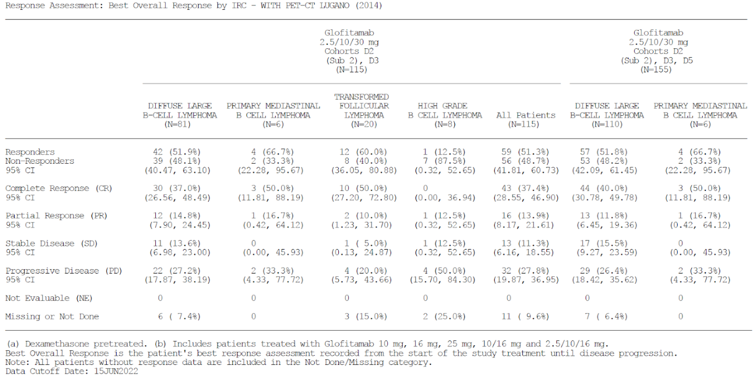
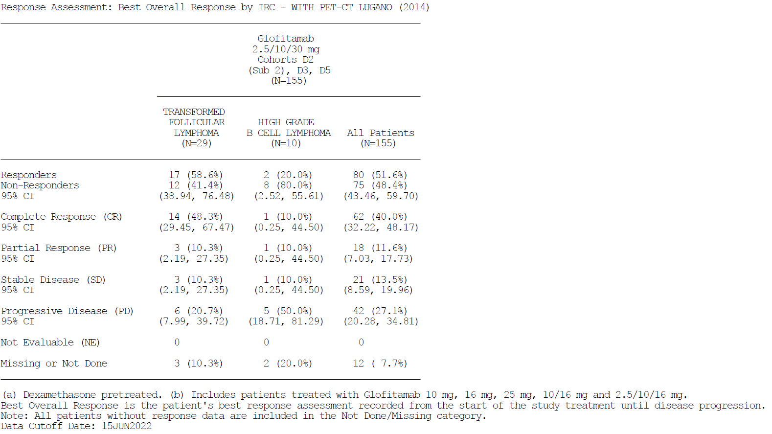
Best Overall Response is the patient's best response assessment recorded from the start of the study treatment until disease progression.
Note: All patients without response data are included in the Not Done/Missing category.
Data Cut-off Date: 15 June 2022
Figure 8: Study NP30179 Kaplan-Meier plot of IRC assessed duration of complete response: Glofitamab 2.5/10/30 mg in the primary efficacy population Cohorts D2 [Sub. 2] plus D3 plus D5 (R/R DLBCL patients with at least 2 prior lines of systemic therapy) (complete responder population)
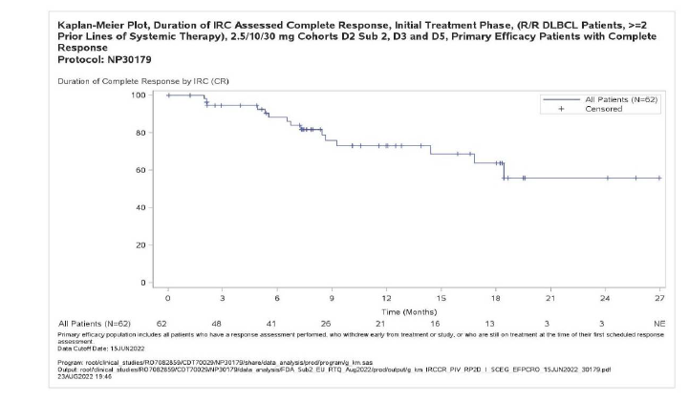

Figure 9: Study NP30179 Kaplan-Meier plot of IRC assessed duration of response: Glofitamab 2.5/10/30 mg in the primary efficacy population Cohorts D2 [Sub. 2] plus D3 plus D5 (R/R DLBCL patients with at least 2 prior lines of systemic therapy) (responder population)
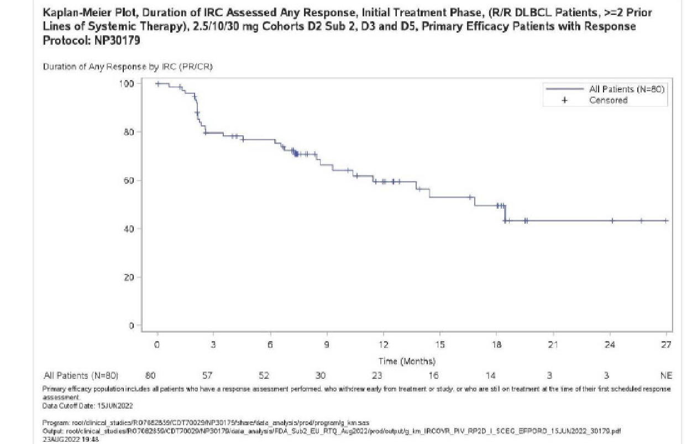

Safety
The overall safety population (N = 469) from Study NP30179 was defined as all patients with R/R NHL who received glofitamab doses of at least 0.6 mg with pre-treatment with obinutuzumab. Patients were predominantly white (78.5%), male (61.8%) with a median age of 65.0 years (range: 21 to 90). At baseline, 51.8% of patients had an ECOG PS of 1. The overall safety population included patients with R/R NHL with the following histologies: DLBCL/trFL (55.5%); FL Grades 1 to 3A (24.9%); mantle cell lymphoma (10.0%); HGBCL (4.1%); PMBCL (2.6%); Richter’s transformation (2.3%); and other histologies (0.6%).
The primary safety population (N = 154) from Study NP30179 was defined as patients with R/R DLBCL (DLBCL NOS, trFL, HGBCL, PMBCL) who have received at least one dose of study medication ([obinutuzumab pre-treatment, glofitamab]) treated with 2.5/10/30 mg step-up doses of glofitamab in the proposed indication . Patients were predominantly white (76.6%), male (64.9%) and with a median age of 66.0 years (range: 21 to 90). At baseline, 44.8% of patients had an ECOG PS of 0 and 54.5% had an ECOG PS of 1. The majority of patients (71.4%) had DLBCL NOS at study entry; 18.2% had trFL; 6.5% HGBCL; and 3.9% PMBCL.
At the 15 June 2022 CCOD, the primary safety population had received a median of 5.0 (range: 1 to 13) treatment cycles, 61.4% of patients received less than 8 cycles and 29.7% of patients received 12 cycles of treatment. The median treatment duration was 79.0 days (range: 1 to 326 days). Among 62 of 155 patients in the corresponding pooled efficacy population (R/R DLBCL at least 2 prior lines from Cohorts D2 [Sub. 2], D3, and D5) with a CR, 41 patients (66.1%) received 12 cycles of treatment while non-responders received fewer cycles largely due to study treatment discontinuation.
All 154 patients (100%) in the primary safety population had at least one medication that was started after initial treatment baseline. The most common was paracetamol (98.1%) and other frequently used (at least 15%) concomitant medications started after baseline included: methylprednisolone (66.2% patients), dexamethasone (40.9% patients), sodium chloride (32.5% patients), filgrastim (31.8% patients), allopurinol (27.9% patients), chlorphenamine (27.3% patients), rasburicase (24.0% patients), dexchlorpheniramine maleate (22.1% patients), furosemide (20.1% patients), piperacillin sodium; tazobactam sodium (17.5% patients), oxygen (17.5% patients), sulfamethoxazole; trimethoprim (16.9% patients), ibuprofen (16.2% patients), and morphine (15.6% patients).
Dexamethasone pre-medication was mandated prior to the administration of glofitamab 2.5/10/30 mg for all patients with R/R DLBCL in Cohort D5. All 37 glofitamab-exposed patients in Cohort D5 received at least one dose of dexamethasone.
Sixty-one of 154 patients (39.6%) received at least one new anti-lymphoma treatment during the initial phase of the study, the most common being radiotherapy in 7 patients (4.5%) and R-GemOx in 3 patients (1.9%). All other new anti-lymphoma treatments (including CAR-T cell therapy in 2 patients) occurred in 1 or 2 patients (1.3%).
In the primary safety population 152 of 154 patients (98.7%) experienced at least one adverse event (AE). According to MedDRA terminology, the SOCs in which AEs were most frequently reported (at least 50% patients) included Immune system disorders (105 patients [68.2%]), driven mainly by CRS (66.9% by Lee (2014) or 64.3% by ASTCT (2019)), and Blood and lymphatic system disorders (86 patients [55.8%], driven mostly by neutropenia [35.7%], anaemia [30.5%], and thrombocytopenia [21.4%]). Most AEs occurred during the first treatment cycle (665 events).

Adverse events in the primary safety population
Almost all patients (152; 98.7%) treated with glofitamab step-up dosing (2.5/10/30 mg) experienced at least one AE. Adverse events in 144 patients (93.5%) were assessed as related to study treatment by the investigator.
Cytokine release syndrome (assessed by ASTCT criteria)²⁰ was the most common AE reported, with 99 (64.3%) patients reporting a CRS AE.
Other common AEs (at least 20% incidence by PT) were neutropenia/neutrophil count decreased (58 patients [37.7%]), anaemia (47 patients [30.5%]), and thrombocytopenia / platelet count decreased (38 patients [24.7%]).
Grade 1 or 2 AEs were reported in 54 patients (35.1%). Grade 3 and higher AEs were reported in 98 patients (63.6%). The most frequent Grade 3 or higher AEs (with at least 5% incidence) were neutropenia/neutrophil count decreased (42 patients [27.3%]), anaemia (12 patients [7.8%]), thrombocytopenia/platelet count decreased (12 patients [7.8%]) and hypophosphatemia (9 patients [5.8%]).
Grade 5 AEs were reported in 9 patients (5.8%), which included COVID-19 pneumonia (3 patients), COVID-19 (3 patients), sepsis (2 patients) and delirium (1 patient).
Serious AEs (SAE)were reported in 75 patients (48.7%), of which 46 patients (29.9%) reported as related to glofitamab treatment. The most frequently reported SAE was CRS (34 patients [22.1%] by Lee (2014);²² 32 patients [20.8%] by ASTCT (2019)²⁰). Other SAEs reported at a frequency of at least 2% were sepsis (6 patients [3.9%], COVID-19 (5 patients [3.2%]), COVID-19 pneumonia (5 patients [3.2%]) and tumour flare (5 patients [3.2%]).
Adverse events leading to withdrawal from glofitamab were reported in 14 patients (9.1%), and AEs leading to dose modification/interruption of glofitamab were reported in 28 patients (18.2%).
A summary of AEs reported in at least 10% of patients in the primary safety population is presented below together with Grade 5 AEs and investigator assessed relationship to glofitamab treatment.
Figure 11: NP30179 Tornado plot of AEs with at least 10% incidence or NCI CTCAE Grade 5 (Patients with R/R DLBCL, at least 2 prior lines of systemic therapy, glofitamab 2.5/10/30 mg step-up dosing) (Cohorts D2 [Sub2], D3, D5) (CCOD 15 June 2022)
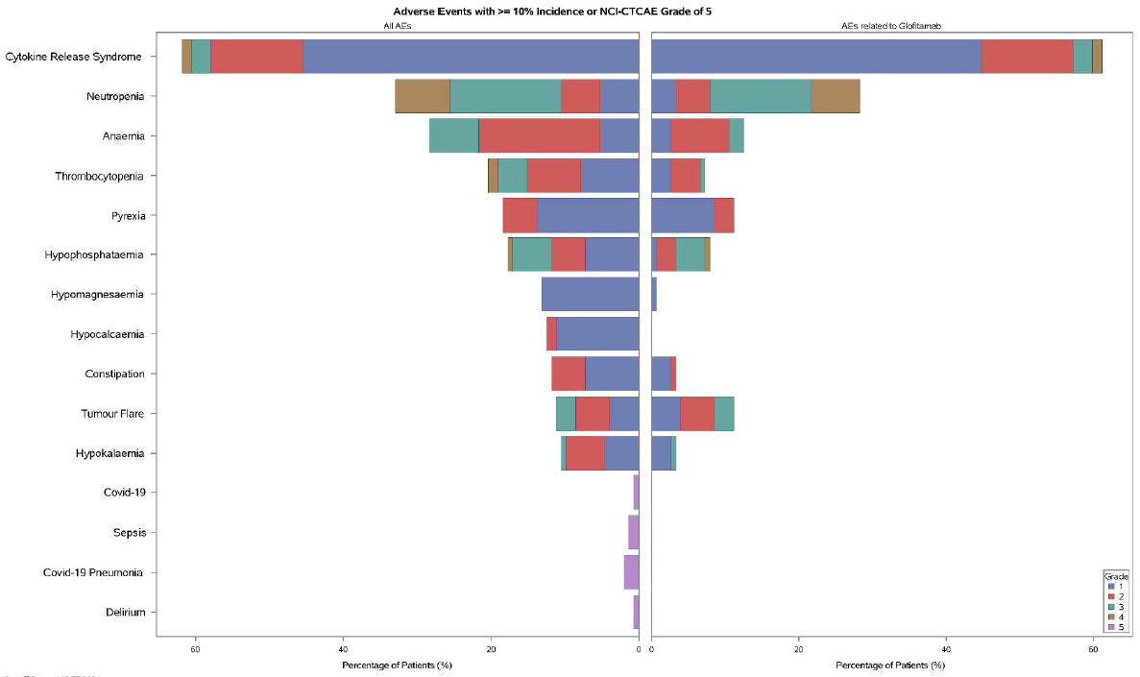

The most commonly reported AEs (at least 10% in the primary safety population) by PT included the following:
- CRS: 103 patients (66.9% by Lee 2014) or 99 patients (64.3% by ASTCT 2019)
- neutropenia/neutrophil count decreased: 58 patients (37.7%)
- anaemia: 47 patients (30.5%)
- thrombocytopenia/platelet count decreased: 38 patients (24.7%)
- hypophosphataemia: 27 patients (17.5%)
- pyrexia: 25 patients (16.2%)
- hypomagnesaemia: 22 patients (14.3%)
- constipation: 21 patients (13.6%)
- diarrhoea: 20 patients (13.0%)
- hypercalcaemia: 19 patients (12.3%)
- fatigue: 18 patients (11.7%)
- tumour flare: 17 patients (11.0%)
- hypokalaemia: 17 patients (11.0%)
- nausea: 16 patients (10.4%)
- back pain: 16 patients (10.4%).
The adverse events of special interest (AESIs) in study NP30179 (Protocol v. 11 for glofitamab) include:
- Grade 2 or higher CRS
- Grade 2 or higher neurological adverse event
- any suspected hemophagocytic lymphohistiocytosis (HLH)
- tumour lysis syndrome (minimum Grade 3 by definition)
- febrile neutropenia (minimum Grade 3 by definition)
- Grade 2 or higher aspartate aminotransferase (AST), alanine aminotransferase (ALT), or total bilirubin elevation
- any grade disseminated intravascular coagulation (minimum Grade 2 by definition)
- Grade 2 or higher tumour inflammation/flare (for example, manifestation of signs/symptoms associated with an increase in size of known nodal or extranodal lesions by clinical or radiographic assessment)
- any grade pneumonitis or interstitial lung disease (excluding pneumonia of infectious etiology)*
- colitis of any grade (excluding infectious etiology).*
*Pneumonitis or Interstitial lung disease: refers to all reported- AEs or preferred terms present in medical concepts from MedDRA Standard Medical Query "Interstitial Lung Disease" or Preferred term "Pneumonitis" excluding pneumonia of infectious etiology./*Colitis refers to all reported AEs reported within High Level Term of 'Colitis (excl infective)’.
Cytokine release syndrome (CRS)
At the 15 June 2022 CCOD, the incidence of CRS of any grade (ASTCT grading) in the primary safety population was 64.3%. Grade 2 or higher CRS was reported in 25 of 154 (16.2%) patients. Only 1 patient was withdrawn from glofitamab due to CRS. In patients who received glofitamab step-up dosing 2.5/10/30 mg (N=236), 74 patients and 72 patients reported multiple CRS events by Lee and ASTCT grading, respectively.
On C2D1 patients were given 30 mg glofitamab without pre-treatment with obinutuzumab but with other pre-glofitamab medications. Of these, 34 of 127 (26.8%) patients had any grade of CRS (33 patients had Grade 1 and one patient had Grade 2 CRS).
Effect of dexamethasone pre-treatment in reducing CRS: At the CCOD, Cohort D5 (N = 40) showed a trend to a reduction in the incidence of all-grade CRS compared with Cohort D3 (by ASTCT 2019 [47.5% versus 70.1%] and Lee 2014 [50.0% versus 72.9%], respectively), serious CRS (15.0% versus 25.2%) and Grade 2 or higher CRS (by ASTCT 2019 [10.0% versus 17.8%] and Lee 2014 [10.0% versus 21.5%], respectively).
There were some differences in baseline demographic and disease characteristics between patients enrolled in Cohort D5 and Cohort D3 with regards to potential risk factors for CRS. Patients enrolled in Cohort D5 compared to Cohort D3 were older (median age: 73.0 years versus 66.0 years, respectively), had less extranodal disease (47.5% versus 65.4%, respectively), similar tumour burden (SPD less than 3000: 47.5% versus 46.7%, respectively; SPD 3000 or more: 52.5% versus 52.3%, respectively), and lower baseline LDH (median 275.0 U/L versus 350.0 U/L, respectively). A greater proportion of patients had Ann Arbor Stage II and III disease in Cohort D5 compared to Cohort D3 (Stage II: 22.5% versus 15.0%, respectively; Stage III: 25.0% versus 18.0%, respectively); whereas, a slightly lower proportion of patients had Ann Arbor Stage IV disease in Cohort D5 compared to Cohort D3 (50.0% versus 57.0%, respectively).
Additionally, no patients in Cohort D5 had circulating malignant cells compared to 3.7% of patients in Cohort D3. The majority of patients had DLBCL histology in both cohorts (approximately 72% in both cohorts), with a greater proportion of patients with trFL histology in Cohort D5 versus Cohort D3 (22.5% versus 15.0%, respectively).
CRS AEs by dexamethasone use per step up dose was also explored. For the 2.5 mg C1D8 dose, in patients who received dexamethasone as a premedication (N = 39) versus patients who did not receive dexamethasone as a premedication (N = 106), a lower incidence of all-grade CRS was 48.7% (19 of 39 patients) versus 56.6% (60 of 106 patients): Grade 1 CRS in 38.5% versus 43.4% of patients; Grade 2 CRS in 7.7% versus 9.4% of patients; Grade 3 CRS in 2.6% versus 1.9% of patients; and Grade 4 CRS in 0% versus 1.9% of patients after the 2.5 mg dose of glofitamab at C1D8.
For the 30 mg C2D1 dose, in patients who received dexamethasone as a premedication (N = 32) versus patients who did not receive dexamethasone as a premedication (N = 95), there was a trend to a reduction in the incidence of all-grade CRS with dexamethasone, 6.3% versus 33.7%, respectively: Grade 1 CRS events 6.3% vs 32.6%; one patient who did not receive dexamethasone as a premedication for the 30 mg C2D1 dose experienced a Grade 2 CRS event. For the 30 mg C2D1 dose, in patients who received dexamethasone as a premedication 3.1% (one patient) received tocilizumab versus 2.1% (2 patients) who did not receive dexamethasone.
Use of tocilizumab: The CRS management guideline (Protocol NP30179, Section 5.2.6.1) covered the recommended dose of tocilizumab in the treatment of CRS. An exploratory objective of the NP30179 study was to make a preliminary assessment of the efficacy of tocilizumab in ameliorating the symptoms of severe CRS following glofitamab treatment. Among the patients who received at least one dose of glofitamab (fixed and step-up doses) in Study NP30179, 96 patients received at least one dose of tocilizumab irrespective of whether this was to treat CRS, and hence, are included in the Tocilizumab Safety Population. A total of 89 patients received tocilizumab to treat any-grade CRS (by ASTCT grading) and are included in the Tocilizumab Efficacy Population; 7 patients received tocilizumab for other reasons. Of the 96 patients who received any tocilizumab administration, 45 patients (46.9%) had discontinued from study and 51 patients (53.1%) were still on study at the data cut-off date of 14 March 2022.
During the study the protocol was amended to such that tocilizumab was recommended for patients with CRS Grade 1 if symptoms persisted for 2 days or more and to treat CRS Grade 2 and higher. Of the 236 NHL patients who received glofitamab step-up dosing 2.5/10/30 mg, 156 patients (66.1%) had a CRS event. Grade 1 CRS (by ASTCT 2019) occurred in 104 patients (66.7%) with tocilizumab administered for management of Grade 1 CRS in 12 patients either with or without corticosteroids. Forty-one patients (26.3%) with CRS had Grade 2 events, tocilizumab was administered to 31 of these 41 patients, with or without corticosteroids, 4 patients were admitted to the ICU, and 20 required use of low flow oxygen. Grade 3 CRS was experienced by 7 of 156 patients (4.5%) with any CRS, that is, 7 of 236 (0 3%) patients who received glofitamab step-up dosing. Tocilizumab was administered in all 7 patients for management of Grade 3 CRS, corticosteroids were administered in 5 patients, and tocilizumab and corticosteroids were administered together in 5 patients (3.2%). All 7 patients were admitted to the ICU.
Two Grade 4 CRS events were reported with tocilizumab and corticosteroids administered to both patients. One patient was admitted to the ICU, while both patients required mechanical ventilation and use of a single pressor. No Grade 5 CRS event was reported.
Not all patients received dexamethasone for step-up dosing in the primary safety population and specifically in the intended Cohort D5. An analysis CRS incidence and severity in patients who received dexamethasone versus patients who did not receive dexamethasone by step-up dosing was performed. There was a trend towards fewer and less severe CRS events in patients premedicated with dexamethasone compared with alternative corticosteroids.

Neurologic adverse events
In NHL patients who received glofitamab step-up dosing 2.5/10/30 mg (N = 236), 35 patients (14.8%) reported Grade 2 or higher neurologic AE. Thirty of the 35 patients had a Grade 2 event, 3 patients had a Grade 3 event, one patient a Grade 4 event (myelitis), and one patient had a Grade 5 (fatal) event of delirium. In the primary safety population 59 of 154 (38.3%) patients experienced neurological AEs (all grades) following treatment with glofitamab step-up dosing, 55 (35.7%) had Grade 1 or Grade 2 neurological AEs, 2 (1.3%) Grade 3 neurological AEs (PTs: somnolence and delirium), and one patient (0.6%) had a Grade 4 (PT: myelitis) and Grade 5 (PT: delirium) neurological AE, respectively. The most commonly reported PTs (any Grade, at least 3% of patients) included: headache (9.7%), dizziness (5.2%), anxiety (3.9%), and paraesthesia (3.2%).
The majority of neurologic AEs occurred during Cycle 1 and Cycle 2 of glofitamab treatment.

Suspected hemophagocytic lymphohistiocytosis
At the time of the CCOD, no event of suspected hemophagocytic lymphohistiocytosis had been reported.

Tumour lysis syndrome
In patients who received glofitamab step-up dosing 2.5/10/30 mg (N = 236), 3 patients (1.3%) reported Grade 3 or higher tumour lysis syndrome. Two of these 3 patients had Grade 3 events and 1 had a Grade 4 event.

Tumour flare
In the supporting population of patients with R/R DLBCL with at least 2 prior therapies who received 2.5/10/30 mg glofitamab in Part II Cohort D2 [Sub. 2] and Part III Cohort D3 (N = 114), 8 patients (7.0%) experienced Grade 2 or higher tumour flare (6 Grade 2 events, 2 Grade 3 events).

Infections and infestations
Infections and infestations were reported in 62 of 154 patients (40.3%) in the updated analysis and were considered serious in 28 patients (18.2%). The most frequently reported serious infections by preferred term included sepsis (3.9%) and COVID-19 pneumonia and COVID-19 (3.2% each). Infection-related deaths were reported in 5.2% of patients (due to COVID-19, COVID-19 pneumonia, and sepsis). Four patients (2.6%) reported a serious infection concurrent with Grade 3 or Grade 4 neutropenia.

Fatalities
At the 15 June 2022 CCOD, 81 of 154 patients (52.6%) in the primary safety population had died. Progressive disease accounted for the majority of deaths (61 of 81 patients [75.3%]). Of the remaining 20 deaths (24.7%), nine were due to AEs including COVID- 19 pneumonia (3 patients), COVID-19 (3 patients), sepsis (2 patients), and delirium (1 patient), none of which was assessed as related to glofitamab by the investigator.

Overall safety population
Results in the overall safety population (R/R NHL patients treated at doses of at least 0.6 mg (N=469) were generally similar to those in the primary safety population except for a higher incidence of serious adverse events (SAEs) which is primarily due to the higher incidence of SAEs in patients treated with fixed doses of glofitamab (10 mg, 16 mg, 25 mg).
Febrile neutropenia occurred in 4 of 236 patients (1.7%) who received glofitamab step-up dosing 2.5/10/30 mg (2 events of each of Grade 3 and Grade 4). A similar proportion of Grade 3 and higher febrile neutropenia AEs were reported in patients who received step-up dosing 2.5/10/30 mg (any histology) (N=236) compared with the primary safety population (N=154) (1.7% versus 2.6%, respectively).
There was no report of disseminated intravascular coagulation in patients who received glofitamab step-up dosing 2.5/10/30 mg (N=236).
In patients who received glofitamab step-up dosing 2.5/10/30 mg (N=236), 2 patients (0.8%) had pneumonitis or interstitial lung disease (Grade 2 and Grade 3, respectively). Both events were considered unrelated to study treatment. Events were resolved in both the patients at the time of the CCOD. A similar proportion of pneumonitis or interstitial lung disease were reported in patients who received step-up dosing 2.5/10/30 mg (any histology) (N=236) compared with the primary safety population (N=154) (0.8% versus 1.3%, respectively).

Laboratory abnormalities
The most frequent treatment−emergent Grade 3 or higher worsening of haematological laboratory parameter shifts were decreases in lymphocytes (120 patients [81.1%]), as expected based on the mechanism of action of glofitamab and obinutuzumab, neutrophils (38 patients [25.5%]), leukocytes (20 patients [13.3%]), platelets (14 patients [9.4%]) and haemoglobin (12 patients [8.0%]).
The most frequent Grade 3 or higher, treatment−emergent shifts in chemistry laboratory abnormalities in patients in the primary safety population (N = 154) were decreases in phosphorus (26.4%), increases in uric acid (22.5%), and increases in glucose (12.1%).
Analysis of laboratory results identified 7 patients in the primary safety population as potential Hy’s law cases, due to corresponding laboratory results of 3 × ULN for AST and ALT and/or 2 × ULN for total bilirubin. All these potential Hy’s law cases occurred either in the context of reported CRS or occurred concurrently with disease progression.

Anti-drug antibodies
There were 442 patients who were evaluable for immunogenicity assessment with a baseline sample and at least one post dose sample, with 418 patients (94.6%) negative for ADAs at baseline and who remained negative on treatment. Nineteen patients (4.3%) had a positive ADA sample at baseline and became negative after glofitamab treatment. Three patients (0.7%) positive at baseline had at least one subsequent positive ADA sample on treatment. Two patients (0.5%) that were negative at baseline, developed ADAs while on study, one at Treatment Completion/Early Termination Visit and one at Follow Up till Progression visit of 12 months. In both cases the ADA titre was below10, which is reported for samples that were screening positive and could be confirmed however in the titre assay the value was below the minimum required dilution.

Risk management plan
The summary of safety concerns and their associated risk monitoring and mitigation strategies are presented in Table 6.
Table 8: Summary of safety concerns
Summary of safety concerns |  | Pharmacovigilance |  | Risk minimisation
 |  | Routine | Additional | Routine | Additional
Important identified risks | Cytokine release syndrome | ✔ | ✔* | ✔ | ✔†
Important identified risks | Tumour flare | ✔ | ✔* | ✔ | ✔‡
Important potential risks | Nil
Missing information | Nil
∗ Non-interventional study using a survey to evaluate the effectiveness of additional risk minimisation measures for glofitamab use.
† Healthcare Professional Brochure and Patient Card
‡ Healthcare Professional Brochure
The Summary of Safety Concerns is acceptable from the RMP perspective The planned non-interventional study is not to be conducted in Australia, however, the results of the study will be provided to the TGA in an updated Australia-specific annex (ASA) when available. The sponsor has provided draft copies of the Healthcare Professional Brochure and Patient Card and committed to providing the final copies to the TGA at least 6 weeks prior to distribution.
The RMP evaluation recommended conditions of registration relating to the versions of the risk management plan, requirement for periodic safety update reports, inclusion of the medicine in the Black Triangle Scheme, and confirmatory trial data in support of provisional registration as described in the clinical study plan in the ASA.

Questions for the sponsor
The sponsor provided the following response to questions from the Delegate.
- Please advise the TGA of the design of confirmatory studies for COLUMVI in the treatment of DLBCL?
To support the conversion of the provisional registration to a full approval, the sponsor is conducting a Phase III, open-label, multicentre, randomised study of glofitamab in combination with gemcitabine and oxaliplatin (Glofit-GemOx) versus rituximab in combination with gemcitabine and oxaliplatin (R-GemOx) in patients with R/R DLBCL (Study GO41944). The primary endpoint is overall survival and approximately 270 eligible DLBCL NOS patients who have received at least one prior line of therapy will be randomised in a 2:1 ratio to receive either Glofit-GemOx or R-GemOx.
Roche believes that the data from this trial will offer further evidence to the data provided in the initial dossier and a consistent profile suitable for a full approval.
Justification of the confirmatory study design and its appropriateness to convert third line indication: There is no standard of care available for third line R/R DLBCL except for CAR-T therapy; however, this type of therapy is not suitable for all R/R DLBCL patients. Moreover, the complex eligibility criteria (that is, CAR-T eligible versus non-eligible), cost, and manufacturing issues make it difficult to operationalise a randomised control trial against CAR-T therapy. Therefore, to confirm the benefit-risk balance and to convert the provisional registration of glofitamab monotherapy for the treatment of third line R/R DLBCL to a full approval, Roche proposes the randomised control study GO41944.
Rationale for why the primary conversion study is in combination with Gem-Ox: GemOx (gemcitabine and oxaliplatin regimen) and glofitamab therapies have each been shown to be efficacious in patients with R/R DLBCL. Thus, it is anticipated that the combination of these agents will result in additive activity. Furthermore, there is additional rationale beyond this to support the glofitamab-GemOx combination in terms of complementary effects on the tumour immune microenvironment. Indeed, while gemcitabine and oxaliplatin are cytotoxic chemotherapies, they have not been shown to inhibit the anti-tumour function of the T-cells. Rather, the GemOx regimen can modulate the tumour immune microenvironment to enhance the immunogenicity of tumours, thus supporting the combination with a T-cell-directed therapy such as a CD20-bispecific antibody.
- When are initial study reports of the confirmatory studies expected to be available to the TGA?
The currently estimated date of the availability of a clinical study report from Study GO41944 for submission to TGA is Q3 2024. This estimate is subject to change as the timing of the analysis is event driven.

Risk-benefit analysis

Delegate’s considerations
Glofitamab is a bispecific monoclonal antibody that binds bivalently to CD20 expressed on the surface of B-cells and monovalently to CD3 in the T-cell receptor complex expressed on the surface of T-cells. By simultaneous binding to CD20 on the B-cell and CD3 on the T-cell, glofitamab mediates the formation of a synapse with subsequent T-cell activation and proliferation, secretion of cytokines and release of cytolytic proteins that results in lysis of CD20-expressing B cells.
Glofitamab has been developed as a novel therapy for third and subsequent line treatment of DLBCL. There are limited effective therapeutic options for these patients and both the approved therapies are chimeric antigen receptor T-cells (CAR-T), axicabtagene ciloleucel (Yescarta) and tisagenlecleucel (Kymriah).
The data to support provisional approval are from a single, uncontrolled study with multiple parts and multiple revisions to protocol. Dependent on results from earlier (first-in-human) phases of that study and nonclinical studies, a proposed dose regimen was developed. The exposure-efficacy and exposure-safety assessments give support to the proposed dose regimen which the sponsor expects will maximise clinical efficacy for the patient population with a manageable safety profile.
Efficacy of glofitamab in a heavily pre-treated population with R/R DLBCL was positively correlated to exposure as has the risk of experiencing CRS Grade2 and higher. Exposure-response analyses indicated that clinical responses including CR rate and OR rate significantly increase (p-value of 3.59 × 10⁻⁶ and 1.40 × 10⁻⁶, respectively) with increasing glofitamab exposure for all histologies.
As with the approved CAR-T therapies, patients with CNS lymphoma were excluded from the study. I consider that those patients should also be excluded from the indication for Columvi. It is not clear whether only those DLBCL subgroups included in the study should be included in the indication. Different approaches have been proposed in other regulatory jurisdictions. At this time my preference is to exclude patients with CNS lymphoma, as that was the approach taken with the indications for Yescarta and Kymriah. I note that in Canada the proposed indication is to be limited to patients who have already received or who cannot receive CAR-T therapy, though that restriction is not included in the proposed indications in the EU or USA. In both the USA and Canada subtypes of DLBCL are specified in the indication, though that is not the case in the proposed EU indication.
While the D3 cohort was the primary cohort in the initial interim assessment, data from a larger patient group with R/R DLBCL and at least 2 prior lines of treatment, given the proposed dose regimen, that is, a combination of patients from cohorts D2 [Sub.2] plus D3 plus D5, was presented in the second analysis (June 2022) and allows assessment of efficacy and safety in a larger population with a longer follow-up than was available in the initially submitted analysis. At this stage of development I consider that the D2(Sub.2) plus D3 plus D5 population to be the most useful for assessing efficacy and safety.
Statistics were descriptive and the primary efficacy measure is CR. The OR rate and PFR are secondary endpoints with very preliminary OS data available. The CR rate in the D2[Sub.2] plus D3 plus D5 population was 40.0% with a median of 11.6 months follow-up. This result was in a heavily pre-treated population with a median of 3 .0 (range: 2 to 7) prior treatments, 33.5% of patients having received prior CAR‑T therapy, and 18.1% having received a prior autologous stem cell transplant. The median OS time was 12.0 months (95% CI: 8.0, 16.1). At the CCOD, 81 of 155 (52.3%) patients had died.
A limited cross-study comparison can be made with approved therapies for third and subsequent therapy for DLBCL. For Yescarta in the ZUMA-1 study, the CR rate for Yescarta in DLBCL treated arm was 54%. In a 36-month analysis (median study follow up of 39.1 months) the median overall survival time was 25.8 months with Yescarta. In a 48-month analysis (median study follow-up of 51.1 months) the median overall survival time was 25.8 months. For Kymriah in study C2201(a single arm, open study), the CR rate was 37% with a median OS of 11.7 months. In the population given Kymriah 49% had had prior autologous stem cell transplantation.
As with the above CAR-T therapies, CRS is the major safety concern with glofitamab. Pharmacodynamic assessments suggest that pre-treatment with the proposed single 1000 mg dose of obinutuzumab significantly reduces the frequency and severity of CRS; however, the risk remains and was most apparent in the first treatment cycle of glofitamab. In that cycle the administered doses were only 2.5 mg and 10 mg compared with a single 30 mg dose given in each subsequent 21-day cycle. This strongly supports use of the proposed step-up dose regimen and dosing with obinutuzumab prior to the initial dose of glofitamab to reduce the frequency and severity of CRS associated with glofitamab. Whether additional obinutuzumab prior to dosing in subsequent cycles would further reduce the risk of CRS has not been assessed; however, CRS events after the first cycle were considerably less frequent and less severe.
The management strategy for CRS that was developed during the Phase I/II study presented in the submission has been successful in managing Grade 2 and higher CRS. However, 66% of patients given glofitamab had some CRS. The pre-treatment regimen, in-hospital commencement of treatment, healthcare professional brochure, and patient management card have been agreed for the management of CRS. The sponsor has also proposed a survey to evaluate the effectiveness of additional risk minimisation measures for glofitamab use. I consider that a boxed warning statement is required in the Product Information for Columvi to highlight the risk of CRS. It should include that the first dose of Columvi should not be administered without a prior dose of obinutuzumab.

Proposed action
Currently the place of glofitamab in the management of R/R DLBCL is unclear due to the preliminary nature of the available data. The relative efficacy and safety of glofitamab in comparison to approved treatments for R/R DLBCL is not clear. Glofitamab is more rapidly available than CAR-T therapies in that it can be administered immediately. It can be given to patients who have already received CAR-T therapy and autologous SCT.
Pending committee advice, including on conditions of provisional registration and the wording of the indication, I propose to approve the following indication:
Columvi has provisional approval as monotherapy for the treatment of adult patients with relapsed or refractory diffuse large B-cell lymphoma (DLBCL) after two or more lines of systemic therapy. Columvi is not indicated for the treatment of patients with primary central nervous system lymphoma.
The decision to approve this indication has been made on the basis of Complete Response and Duration of Complete Response from an uncontrolled, open-label phase I/II study. Continued approval of this indication depends on verification and description of benefit in confirmatory trials.

Advisory Committee considerations
The Advisory Committee on Medicines (ACM), having considered the evaluations and the Delegate’s overview, as well as the sponsor’s response to these documents, advised the following.

Specific advice to the Delegate
- Does the Committee consider that the indication proposed by the Delegate is satisfactory? If not what additions or deletions does the Committee consider should be made to the indication?
The ACM noted that the USA and Canada have both listed the subtypes that can be considered for this therapy in the indication, but the EU have not.
The ACM considered the exclusion of patients with primary central nervous system lymphoma and agreed that there was no evidence provided for this subgroup. The ACM agreed it is acceptable to add an exclusion of primary central nervous system lymphoma to the indication. The ACM also noted that other diffuse large B cell lymphoma (DLBCL) subgroups were considered small, and the data were not significant enough to limit treatment.
The ACM recommended that the indication should also reflect that glofitamab must be given with obinutuzumab.
- The PI does not currently include a warning statement regarding QT prolongation. Does the Committee consider such a statement is warranted?
The ACM was of the view that a warning statement regarding QT prolongation should be included in the PI as the clinical data provided warrant the inclusion of a warning given 49% of patients receiving 2.5, 10 and 30 mg of glofitamab were likely to exceed a QT prolongation threshold of 10 milliseconds and 23% of patients might be expected to exceed 20 milliseconds on this dosing regimen.
- Is the Committee satisfied with the amended statement in the PI regarding drug-drug interactions for narrow therapeutic index drugs?
The ACM was of the view that considering no studies have specifically been done regarding drug-drug interaction for narrow therapeutic index drugs, the amended statement in the PI is satisfactory.
- Please comment on the most clinically relevant efficacy endpoints for assessment of response in R/R DLBCL.
The ACM advised that the most clinically relevant efficacy endpoints were progression free survival, overall survival, complete response and partial response. The ACM considered these endpoints to be well summarised in the data, reliable measures for DLBCL, and they reflect long term outcomes.
The ACM discussed the relevance of the efficacy endpoints and concluded that overall survival is a reasonable outcome measure in relapse/refractory (R/R) DLBCL as it is a moderately aggressive disease with fewer options once it reaches R/R stage. Complete and partial response were considered relevant as they relate to the success of the treatment as a potential cure and also reflect the benefit of Columvi as a potential bridging treatment to other therapies.
- Please comment on the role that Columvi could be expected to play in the management of R/R DLBCL in Australia given the available evidence of efficacy and safety.
The ACM considered other therapies available to patients with R/R DLBCL. The main therapy available to these patients is CAR-T cells. Considering the extensive lag time from collection to treatment, limited accessibility, especially to those in regional and rural areas, and the toxicity of CAR-T cells as well the favourable efficacy of Columvi there is potential for Columvi to become the favoured second/third line option for patients with DLBCL.
- Other advice
The ACM discussed the administration of Gazyva before the administration of Columvi and the potential for cytokine release syndrome and tumour lysis. The ACM advised that wording should be included in the indication as well as in the dosing instructions in the PI stating Columvi is to be given 7 days after a 1000 mg dose of Gazyva. This is consistent across all drug products approved by the TGA.

ACM conclusion
The ACM considered this product to have an overall positive benefit-risk profile for the indication:
Columvi in combination with obinutuzumab has provisional approval for the treatment of adult patients with relapsed or refractory diffuse large B-cell lymphoma (DLBCL) after two or more lines of systemic therapy. Columvi is not indicated for the treatment of patients with primary central nervous system lymphoma.
The decision to approve this indication has been made on the basis of Complete Response and the Overall Response Rate from an uncontrolled, open label phase I/II study. Continued approval of this indication depends on verification and description of benefit in confirmatory trials.

Outcome
Based on a review of quality, safety, and efficacy, the TGA decided to register Columvi (glofitamab (rch)) as 2.5 mg/2.5 mL and 10 mg/10 mL concentrated solution for infusion in vials, indicated for:
Columvi monotherapy with obinutuzumab pretreatment has provisional approval for the treatment of adult patients with relapsed or refractory diffuse large B-cell lymphoma (DLBCL) after two or more lines of systemic therapy. Columvi is not indicated for the treatment of patients with primary central nervous system lymphoma.
The decision to approve this indication has been made on the basis of Complete Response and the Overall Response Rate from an uncontrolled, open label phase I/II study. Continued approval of this indication depends on verification and description of benefit in confirmatory trials.

Specific conditions of registration applying to these goods
- Columvi (glofitamab) is to be included in the Black Triangle Scheme. The PI and CMI for Columvi must include the black triangle symbol and mandatory accompanying text for 5 years, or the product’s entire period of provisional registration, whichever is longer.
- The glofitamab EU Risk Management Plan (RMP) (version 1.0; dated 22 March 2022; data lock point 4 March 2022), with Australia-specific annex (version 1.0; dated 27 May 2022), included with submission PM-2022-01989-1-6, and any subsequent revisions, as agreed with the TGA will be implemented in Australia.
An obligatory component of risk management plans is routine pharmacovigilance. Routine pharmacovigilance includes the submission of periodic safety update reports (PSURs).
Unless agreed separately between the supplier who is the recipient of the approval and the TGA, the first report must be submitted to TGA no later than 15 calendar months after the date of the approval letter. The subsequent reports must be submitted no less frequently than annually from the date of the first submitted report until the period covered by such reports is not less than 3 years from the date of the approval letter, or the entire period of provisional registration, whichever is longer.
The reports are to at least meet the requirements for PSURs as described in the European Medicines Agency’s Guideline on good pharmacovigilance practices (GVP) Module VII – Periodic safety update report (Rev 1), Part VII.B Structures and processes. Note that submission of a PSUR does not constitute an application to vary the registration. Each report must have been prepared within 90 calendar days of the data lock point for that report.
- Laboratory testing and compliance with Certified Product Details (CPD)
  - All batches of Columvi (glofitamab) supplied in Australia must comply with the product details and specifications approved during evaluation and detailed in the Certified Product Details (CPD).
  - When requested by the TGA, the sponsor should be prepared to provide product samples, specified reference materials and documentary evidence to enable the TGA to conduct laboratory testing on the product. Outcomes of laboratory testing are published biannually in the TGA Database of Laboratory Testing Results <http://www.tga.gov.au/ws-labs-index> and periodically in testing reports on the TGA website.
- Certified Product Details
The Certified Product Details (CPD), as described in Guidance 7: Certified product details of the Australian Regulatory Guidelines for Prescription Medicines (ARGPM), in PDF format, for the above products should be provided upon registration of these therapeutic goods. In addition, an updated CPD should be provided when changes to finished product specifications and test methods are approved in a Category 3 application or notified through a self-assessable change. A template for preparation of CPD for biological prescription medicines can be obtained from the TGA website.
- The sponsor must conduct studies as described in the clinical study plan in version 1.0 (dated 27 May 2022) of the Australia-specific annex. The following study reports should be submitted to TGA within 6 months of completion (this estimate is subject to change as the timing of the analysis is event driven):
  - Study GO41944 by Q1 2024
  - Study NP30179 by Q2 2023
  - Further data from cohort D5 should be submitted in any application for review of provisional registration.

Attachment 1. Product Information
The Product Information (PI) approved with the submission for Columni can be found at Attachment 1. It may have been superseded. For the most recent PI and Consumer Medicines Information (CMI), please use the TGA PI/CMI search facility.

Therapeutic Goods Administration
PO Box 100 Woden ACT 2606 Australia
Email: info@tga.gov.au Phone: 1800 020 653 Fax: 02 6203 1605
https://www.tga.gov.au
D25-191689

Obinutuzumab (Gazyva) was first registered in the ARTG in May 2014; the extension of indication for Gazyva as pre-treatment to reduce the risk of CRS induced by glofitamab was approved May 2023.
This is the original indication proposed by the sponsor when the TGA commenced the evaluation of this submission. It may differ to the final indication approved by the TGA and registered in the Australian Register of Therapeutic Goods.
International Non-Hodgkin’s Lymphoma Prognostic Factors Project. A predictive model for aggressive non-Hodgkin’s lymphoma. N Engl J Med 1993; 329(14):987-994.
Eastern Cooperative Oncology Group Performance Status: The ECOG has developed criteria used by doctors and researchers to assess how a patient's disease is progressing, to assess how the disease affects the patient’s daily living, and to determine appropriate treatment and prognosis. The ECOG Performance Status Scale is as follows: Grade 0 = Fully active, able to carry on all pre-disease performance without restriction; Grade 1 = Restricted in physically strenuous activity but ambulatory and able to carry out work of a light or sedentary nature, for example, light house work, office work; Grade 2 = Ambulatory and capable of all selfcare but unable to carry out any work activities. Up and about more than 50% of waking hours; Grade 3 = Capable of only limited selfcare, confined to bed or chair more than 50% of waking hours; Grade 4 = Completely disabled. Cannot carry on any selfcare. Totally confined to bed or chair; Grade 5 = Dead.
R-CHOP is a combination treatment using rituximab, cyclophosphamide, doxorubicin, vincristine, and prednisolone.
Cheson BD, Fisher RI, Barrington SF, Cavalli F, Schwartz LH, Zucca E, et al. Recommendations for Initial Evaluation, Staging, and Response Assessment of Hodgkin and Non-Hodgkin Lymphoma: The Lugano Classification. J Clin Oncol 2014;27:3059-3067. doi: 10.1200/JCO.2013.54.8800.
Tilly H, Gomes da Silva M, Vitolo U, Jack A, Meignan M, Lopez-Guillermo A, et al. Diffuse large B-cell lymphoma (DLBCL): ESMO Clinical Practice Guidelines for diagnosis, treatment and follow-up. Ann Oncol. 2015;26 Suppl 5:v116-125. doi: 10.1093/annonc/mdv304. See also Sarkozy C, Sehn LH. New drugs for the management of relapsed or refractory diffuse large B-cell lymphoma. Ann Lymphoma 2019;3:10. doi: 10.21037/aol.2019.09.01. Sehn L, Gascoyne RD. Diffuse large B-cell lymphoma: optimizing outcome in the context of clinical and biologic heterogeneity. Blood 2015;125:22–32. doi: 10.1182/blood-2014-05-577189.
Axicabtagene ciloleucel was first included in the ARTG in 2020.
Tisagenlecleucel was first included in the ARTG in 2018.
In this report the ‘Delegate’ is the Delegate of the Secretary of the Department of Health and Aged Care who decided the submission under section 25 of the Act.
The International Council for Harmonisation of Technical Requirements for Registration of Pharmaceuticals for Human Use (ICH) brings together regulatory authorities and the pharmaceutical industry. It makes recommendations towards achieving greater harmonisation in the interpretation and application of technical guidelines and requirements for pharmaceutical product registration.
EMA/CHMP/ICH/646107/2008, effective May 2010.
EMA/CHMP/ICH/731268/1998 (Revision 1) effective June 2011.
Good Laboratory Practice is a code of standards following the ICH relevant to testing of medicines in laboratories during drug development.
Pregnancy Category C: Drugs which, owing to their pharmacological effects, have caused or may be suspected of causing, harmful effects on the human fetus or neonate without causing malformations. These effects may be reversible. Accompanying texts should be consulted for further details.
The QT interval is the time from the start of the QRS wave complex to the end of the corresponding T wave on an electrocardiogram. It approximates to the time taken for ventricular depolarisation and repolarisation (the period of ventricular systole from ventricular isovolumetric contraction to isovolumetric relaxation).
Cytochrome P450 (CYP) enzymes: CYPs are the major enzymes involved in drug metabolism, accounting for large part of the total metabolism. Most drugs undergo deactivation by CYPs, either directly or by facilitated excretion from the body. Also, many substances are bioactivated by CYPs to form their active compounds. Many drugs may increase or decrease the activity of various CYP isozymes either by inducing the biosynthesis of an isozyme (enzyme induction) or by directly inhibiting the activity of the CYP (enzyme inhibition). This is a major source of adverse drug interactions, since changes in CYP enzyme activity may affect the metabolism and clearance of various drugs. Such drug interactions are especially important when using drugs of vital importance to the patient, drugs with important side-effects, and drugs with small therapeutic windows, but any drug may be subject to an altered plasma concentration due to altered drug metabolism.
See most recent AusPAR for obinutuzumab (Gazyva).
Tocilizumab (Actemra) was first registered in the ARTG in 2009. The approved indications include for Cytokine Release Syndrome (CRS) (intravenous formulation only), for the treatment of CAR-T cell-induced severe or life-threatening CRS in adults and paediatric patients 2 years of age and older.
Skusa C, Weber MA, Böttcher S, Thierfelder KM. Criteria-Based Imaging and Response Evaluation of Lymphoma 20 Years After Cheson: What is New? Rofo. 2020 Jul;192(7):657-668. English, German. doi: 10.1055/a-1091-8897.
Lee DW, Santomasso BD, Locke FL, Ghobadi A, Turtle CJ, Brudno JN, et al. ASTCT Consensus Grading for Cytokine Release Syndrome and Neurologic Toxicity Associated with Immune Effector Cells. Biol Blood Marrow Transplant. 2019;25(4):625-638. doi: 10.1016/j.bbmt.2018.12.758.
ITT: The randomised clinical trials analysed by the intention-to-treat (ITT) approach provide unbiased comparisons among the treatment groups. In the ITT population, none of the subjects are excluded, regardless of treatment compliance or attrition due to dropout or crossover, and the subjects are analysed according to the randomisation scheme.
R-GemOx is a combination treatment of rituximab in combination with gemcitabine and oxaliplatin.
The Medical Dictionary for Regulatory Activities (MedDRA) is an internationally used set of terms relating to medical conditions, medicines and medical devices. It was created to assist regulators with sharing information. It is also used by industry, academics, health professionals and other organisations that communicate medical information. System Organ Class (SOC) is the highest level of the MedDRA terminology for classification of adverse events. There are 27 classes.
Lee DW, Gardner R, Porter DL, Louis CU, Ahmed N, Jensen M, et al. Current concepts in the diagnosis and management of cytokine release syndrome. Blood 2014;124(2):188-95. doi: 10.1182/blood-2014-05-552729. Erratum in: Blood 2015; 126(8):1048. Dosage error in article text. Erratum in: Blood 2016;128(11):1533.
In MedDRA, preferred terms (PT) are single concepts for symptoms, signs, disease diagnosis, therapeutic indications, investigations, procedures, and characteristics. There are over 20,000 preferred terms.
The adverse event severity grading scale for the US National Cancer Institute Common Terminology Criteria for Adverse Events (NCI CTCAE) v4.03 was used for assessing adverse event severity. In general: Grade 1 = Mild; Grade 2 = Moderate; Grade 3 = Severe or medically significant but not immediately life-threatening; Grade 4 = Life-threatening consequences; Grade 5 = Death related to AE.
Hy’s law: Evidence of hepatocellular injury with a rise in ALT and/or AST more than 3 × ULN) and total bilirubin more than 2 × ULN, and no other reason to explain rise in aminotransferases and total bilirubin. Hy's law is a rule of thumb that a patient is at high risk of a fatal drug-induced liver injury if given a medication that causes hepatocellular injury with jaundice.
Thieblemont C, Legouill S, Di Blasi R, Cartron G, Morschhauser F, Bachy E, et al. S1600 REAL-WORLD RESULTS ON CD19 CAR T-CELL FOR 60 FRENCH PATIENTS WITH RELAPSED/REFRACTORY DIFFUSE LARGE B-CELL LYMPHOMA INCLUDED IN A TEMPORARY AUTHORIZATION FOR USE (ATU) PROGRAM. HemaSphere 3: 736-737. doi: 10.1097/01.HS9.0000564648.09127.09. Nastoupil LJ, Jain MD, Spiegel JY, Ghobadi A, Lin Y, Dahiya S, et al. Axicabtagene Ciloleucel (Axi-cel) CD19 Chimeric Antigen Receptor (CAR) T-Cell Therapy for Relapsed/Refractory Large B-Cell Lymphoma: Real World Experience. Blood 2018; 132 (Supplement 1): 91. doi: 10.1182/blood-2018-99-114152.
See Product Information for Yescarta, available from TGA website.
See Product Information for Kymriah, available from TGA website.

