Australian Public Assessment Report for Brukinsa
  - Active ingredient: Zanubrutinib
  - Sponsor: BeiGene AUS Pty Ltd
November 2024

About the Therapeutic Goods Administration (TGA)
- The Therapeutic Goods Administration (TGA) is part of the Australian Government Department of Health and Aged Care and is responsible for regulating therapeutic goods, including medicines, medical devices, and biologicals.
- The TGA administers the Therapeutic Goods Act 1989 (the Act), applying a risk management approach designed to ensure therapeutic goods supplied in Australia meet acceptable standards of quality, safety, and efficacy.
- The work of the TGA is based on applying scientific and clinical expertise to decision-making, to ensure that the benefits to the Australian public outweigh any risks associated with the use of therapeutic goods.
- The TGA relies on the public, healthcare professionals and industry to report problems with therapeutic goods. The TGA investigates reports received to determine any necessary regulatory action.
- To report a problem with a therapeutic good, please see the information on the TGA website.

About AusPARs
- The Australian Public Assessment Report (AusPAR) provides information about the evaluation of a prescription medicine and the considerations that led the TGA to approve or not approve a prescription medicine submission. Further information can be found in Australian Public Assessment Report (AusPAR) guidance.
- AusPARs are prepared and published by the TGA.
- AusPARs are static documents that provide information that relates to a submission at a particular point in time. The publication of an AusPAR is an important part of the transparency of the TGA’s decision-making process.
- A new AusPAR may be provided to reflect changes to indications or major variations to a prescription medicine subject to evaluation by the TGA.

Copyright
© Commonwealth of Australia 2024
This work is copyright. You may reproduce the whole or part of this work in unaltered form for your own personal use or, if you are part of an organisation, for internal use within your organisation, but only if you or your organisation do not use the reproduction for any commercial purpose and retain this copyright notice and all disclaimer notices as part of that reproduction. Apart from rights to use as permitted by the Copyright Act 1968 or allowed by this copyright notice, all other rights are reserved and you are not allowed to reproduce the whole or any part of this work in any way (electronic or otherwise) without first being given specific written permission from the Commonwealth to do so. Requests and inquiries concerning reproduction and rights are to be sent to the TGA Copyright Officer, Therapeutic Goods Administration, PO Box 100, Woden ACT 2606 or emailed to <tga.copyright@tga.gov.au>.

Contents
List of abbreviations 4
Brukinsa (zanubrutinib) submission 6
Brukinsa (zanubrutinib) 7
Chronic lymphocytic leukemia (CLL) & small lymphocytic lymphoma (SLL) 7
Current treatment options for CLL and SLL 8
Clinical rationale for Brukinsa use in CLL/SLL 11
Regulatory status 11
Registration timeline 13
Submission overview and risk/benefit assessment 14
Clinical evaluation summary 14
Pharmacology 14
Efficacy 15
Safety 28
Risk-benefit analysis 33
Proposed action 35
Advisory Committee considerations 36
Outcome 37
Attachment 1. Product Information 38

List of abbreviations
Abbreviation | Meaning
ACM | Advisory Committee on Medicines
AE | adverse event
alloSCT | allogeneic stem cell transplantation
ALT | alanine aminotransferase
ARTG | Australian Register of Therapeutic Goods
AST | aspartate aminotransferase
AUC | area under the concentration-time curve
BD | twice daily dosing
B+R | bendamustine + rituximab
BTK | Bruton’s tyrosine kinase
CI | confidence interval
CLL | chronic lymphocytic leukaemia
Cmax | maximum plasma concentration
CMI | consumer medicine information
CR | complete response
CRi | complete response w/incomplete bone marrow recovery
CSR | clinical study report
CV | coefficient of variation
CYP | cytochrome P450
DCO | Data cut-off
del(17p) | loss of TP53 locus on chromosome 17p13.1
ECOG | Eastern Cooperative Oncology Group
EQ-5D-5L | European quality of life 5 dimension 5 level
EORTC QLQ-C30 | European Organisation for Research and Treatment of Cancer quality of life questionnaire core 30
E-R | exposure-response
ESMO | European Society for Medical Oncology
FCR | fludarabine/cyclophosphamide/rituximab
FDA | Food and Drug Administration
GCP | good clinical practice
GHS | global health status
GM | geometric mean
ITT | intent-to-treat
IV | intravenous
IWCLL | International Workshop on Chronic Lymphocytic Leukaemia
MCL | mantle cell lymphoma
MZL | marginal zone lymphoma
NHL | non-Hodgkin lymphoma
ORR | overall response rate
PD | pharmacodynamics
PFS | progression-free survival
PI | product information
PK | pharmacokinetics
popPK | population pharmacokinetics
PR | partial response
PR-L | partial response with lymphocytosis
PRO | patient reported outcome
PT | preferred term
QoL | quality of life
QTc F | QT interval using the Fridericia correction
RR | relapsed/refractory
SAE | serious adverse events
SLL | small lymphocytic lymphoma
SOC | system organ class
TEAE | treatment emergent adverse event
TEC | tyrosine kinase expressed in hepatocellular carcinoma
TGA | Therapeutic Goods Administration
Tmax | time to maximum observed plasma concentration
TN | treatment-naïve
WM | Waldenström’s macroglobulinaemia

Brukinsa (zanubrutinib) submission
Type of submission: | Extension of indications
Product name: | Brukinsa
Active ingredient: | zanubrutinib
Decision: | Approved
Date of decision: | 1 March 2023
Date of entry onto ARTG: | 3 March 2023
ARTG number: | 338475
Black Triangle Scheme | No
Sponsor’s name and address: | BeiGene AUS Pty Ltd, 66 Goulburn Street, Sydney NSW 2000
Dose form: | White to off-white opaque hard capsule
Strength: | Each capsule contains 80 mg zanubrutinib.
Container: | High-density polyethylene bottles with a child-resistant polypropylene closure.
Pack size: | Each carton contains one bottle. Each bottle contains 120 capsules.
Approved therapeutic use for the current submission: | Chronic Lymphocytic Leukaemia (CLL)/Small Lymphocytic Lymphoma (SLL)  Brukinsa is indicated as monotherapy for the treatment of adult patients with chronic lymphocytic leukaemia (CLL) or small lymphocytic lymphoma (SLL), including patients with deletion 17p and/or TP53 mutation.
Route of administration: | Oral
Dosage: | The recommended total daily oral dose of Brukinsa is 320 mg  For further information regarding dosage, such as dosage modifications to manage adverse reactions, refer to the Product Information.
Pregnancy category: | Category D: Drugs which have caused, are suspected to have caused or may be expected to cause, an increased incidence of human fetal malformations or irreversible damage. These drugs may also have adverse pharmacological effects.  The use of any medicine during pregnancy requires careful consideration of both risks and benefits by the treating health professional. The pregnancy database must not be used as the sole basis of decision making in the use of medicines during pregnancy. The TGA does not provide advice on the use of medicines in pregnancy for specific cases. More information is available from obstetric drug information services in your state or territory.

Brukinsa (zanubrutinib)
This AusPAR describes the submission by BeiGene AUS Pty Ltd (the Sponsor) to register Brukinsa (zanubrutinib) for the following proposed extension of indications:
Brukinsa (zanubrutinib) is indicated for the treatment of adult patients with chronic lymphocytic leukemia (CLL) or small lymphocytic lymphoma (SLL).

Chronic lymphocytic leukemia (CLL) & small lymphocytic lymphoma (SLL)
CLL is a B cell lymphoproliferative disease that produces immunologically immature cells. These cells accumulate in peripheral blood and have a solid component that is primarily found in lymph nodes and bone marrow. The median age at diagnosis is 72 years. About 10% of CLL patients are reported to be younger than 55 years. According to the World Health Organization (WHO) classification small lymphocytic lymphoma (SLL) and CLL are a single entity. If B lymphocytes in the peripheral blood are <5 x 10⁹L and lymphadenopathy and/or splenomegaly is present, SLL instead of CLL is diagnosed. SLL cells show the same immunophenotype as CLL cells.
Most patients are asymptomatic at diagnosis and in early-stage disease there is a ‘watch and wait’ period prior to commencement of active therapy. The decision to commence treatment is generally for patients with intermediate and high-risk disease and is also based on the presence of active, symptomatic or progressive disease e.g. progressive bone marrow failure, massive, progressive or symptomatic splenomegaly or lymphadenopathy, progressive lymphocytosis, autoimmune complications, or significant constitutional symptoms. The European Society for Medical Oncology (ESMO) guidelines state that in most cases CLL remains an incurable disease and therefore the goals of therapy are to improve quality of life and to prolong survival.
Life-long observation and follow-up is recommended for all patients. CLL patients have a twofold to sevenfold increased risk of developing secondary malignancies [mostly solid cancers, but also secondary MDS or acute myeloblastic leukaemia (AML)]. The transformation into a diffuse large B-cell lymphoma (DLBCL) occurs in 2%-15% of CLL patients during the course of their disease, in particular after several lines of chemoimmunotherapy (CIT).
The important prognostic markers for the disease are deletion and or mutation of the TP53 gene which codes for the tumour suppressor protein P53. These TP53 aberrations are associated with poorer prognosis and impaired response to chemoimmunotherapy. Conversely, mutation of the immunoglobulin heavy chain variable (IGHV) gene has been associated with improved survival compared to those with an unmutated gene. Consequently, ESMO recommends that del17p, TP53 mutations and IGHV status are relevant for choice of therapy and should be assessed before treatment.
The 2022 update to ESMO treatment guidelines note that since in most cases CLL remains an incurable disease, the goals of therapy are to improve quality of life and to prolong survival. In daily life, important treatment end points in clinical trials, such as response rate, minimal residual disease status or progression-free-survival (PFS), may be more relevant for young and/or fit patients than in older patients and/or patients with relevant comorbidity.
Ultimately, in most patients, survival depends on the effect and choice of treatment sequences given along the course of the disease.

Current treatment options for CLL and SLL
In most patients, survival depends on the effect and choice of treatment sequences given along the course of the disease.
Early, asymptomatic stage disease, as determined by either the Rai or the Binet staging system, does not need further risk assessment. Previous studies have shown that early treatment with chemotherapeutic agents does not translate into a survival advantage in patients with early- stage CLL. Results of clinical trials evaluating early treatment with novel agents are still pending. The standard treatment of patients with early disease is a watch-and-wait strategy.
Blood cell counts and clinical examinations should be carried out every 3-12 months after the first year, when 3-monthly intervals should be applied for all patients. The criteria for commencing therapy are documented in the attached ESMO clinical practice guidelines.
For first-line therapy, treatment choice takes into consideration the patient’s fitness, age, comorbidities, as well as assessment of IGHV, del17p and TP53 status. There are a number of treatment strategies available including: continuous treatment with Bruton’s tyrosine kinase (BTK) inhibitors, such as ibrutinib, until progression; time-limited therapy with chemotherapy backbone and anti-CD20 antibodies (e.g. rituximab); or the combination of venetoclax plus obinutuzumab.
For symptomatic treatment naïve and for relapsed CLL, the following treatment options are recommended:
- venetoclax plus rituximab or venetoclax plus obinutuzumab;
- ibrutinib or acalabrutinib or other BTK inhibitors (if available) as continuous therapy;
- idelalisib plus rituximab;
- chemoimmunotherapy (unless TP53 mutation or del(17p).
Details of treatment options for treatment naïve and relapsed CLL, extracted from the ESMO CLL clinical practice guidelines for diagnosis, treatment and follow-up are shown in Figure 1.
Figure 1. Treatment options for symptomatic early stage CLL or advanced stage CLL and symptomatic relapsed CLL
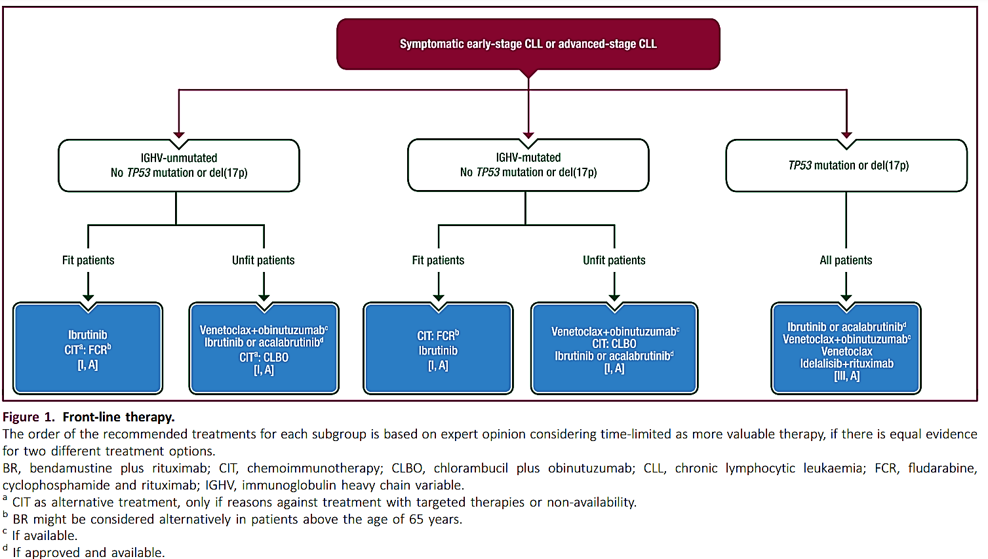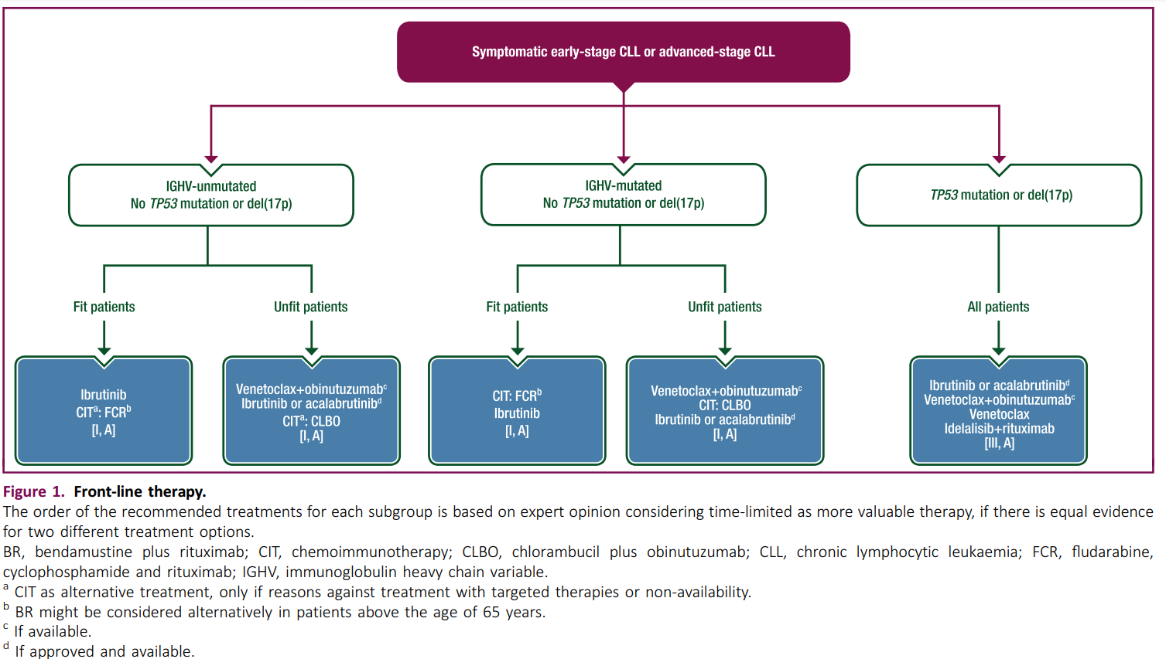
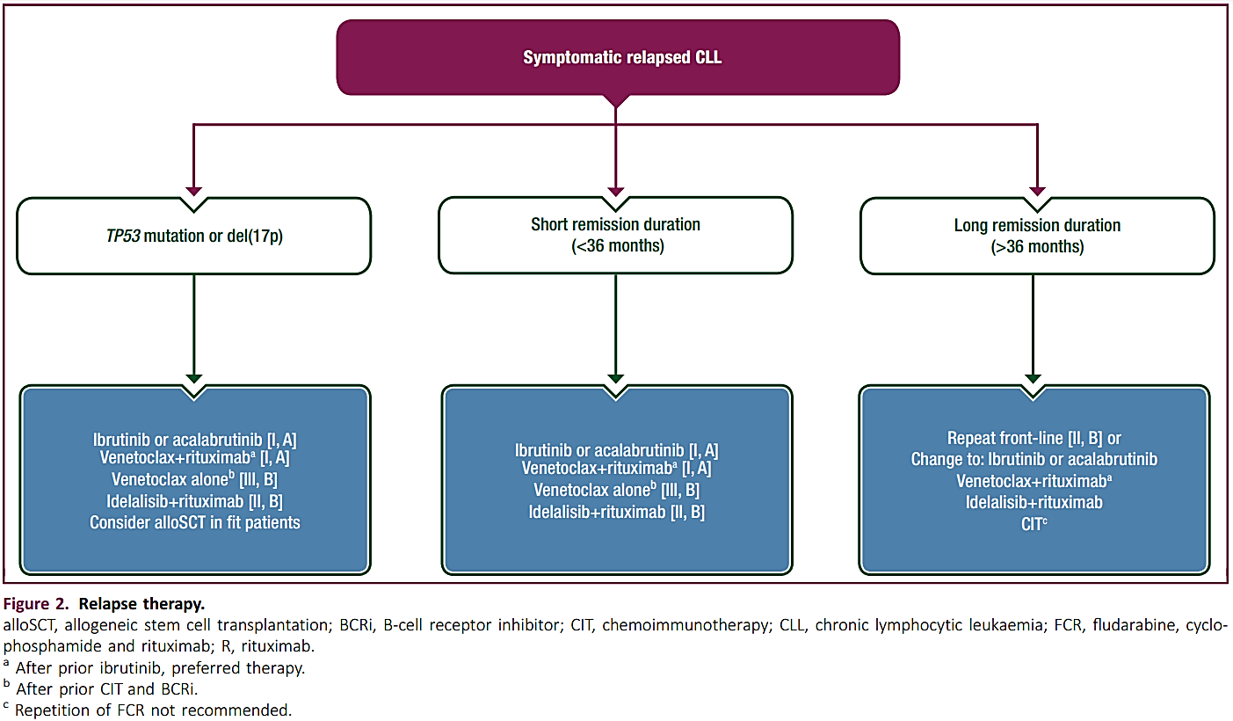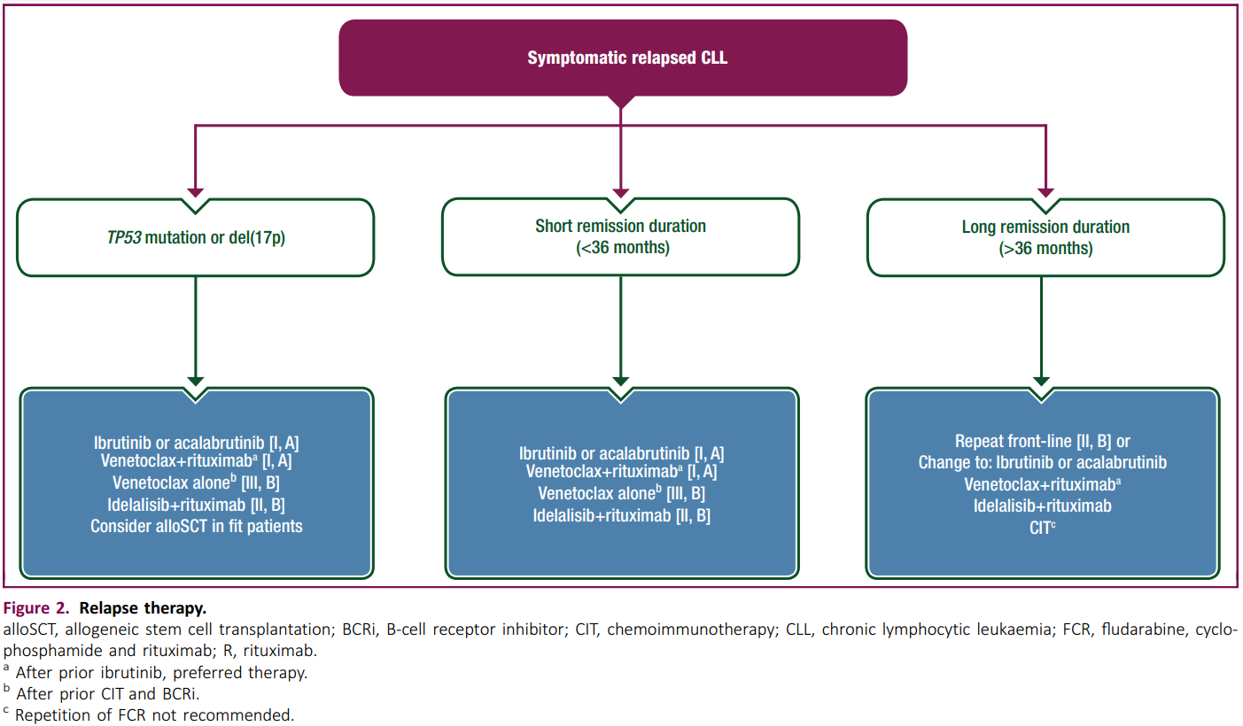
The ESMO guidelines also state that autologous stem cell transplantation is not useful in CLL. Allogeneic stem cell transplantation (alloSCT) should be considered for:
- patients refractory to chemoimmunotherapy (CIT) with TP53 mutation or del(17p), but fully responsive to novel inhibitor therapy. AlloSCT should be discussed with the patient as an option for curative treatment if risk of transplantation is low;
- patients refractory to CIT and to novel inhibitor therapy, even for patients with a higher risk of non-relapse mortality [haematopoietic cell transplant comorbidity index (HCT- CI) score of ≥3];
- patients with Richter's transformation in remission after therapy and clonally related to CLL.
Treatment with chimeric antigen receptor T (CAR-T) cells or bi-specific T-cell engager (BiTE) antibodies within clinical trials could be an alternative to alloSCT for all three groups. While there is less experience with CAR-T cell therapy in CLL it is very different from alloSCT in at least two aspects:
- Lower non-relapse mortality and different, mostly acute, toxicity (cytokine release syndrome; CAR-T-cell-related encephalopathy syndrome) which renders this approach available to patients with some comorbidities;
- Uncertain long-term curative potential.
Two other BTK inhibitors are approved for the treatment of CLL/ SLL in Australia, ibrutinib and acalabrutinib (as monotherapy or in combination with chlorambucil). Both are approved for treatment naïve and previously treated CLL/ SLL. Idelalisib, another B cell receptor signalling inhibitor is also approved for treatment of CLL but only in combination with either rituximab or ofatumumab for patients who have relapsed and who are not considered suitable for chemo- immunotherapy.

Clinical rationale for Brukinsa use in CLL/SLL
Zanubrutinib is a potent and irreversible next-generation BTK inhibitor. Zanubrutinib is more selective than ibrutinib for BTK inhibition, exhibiting less off-target activity against other kinases, such as TEC kinases, HER2, Csk, epidermal growth factor receptor, and interleukin 2–inducible T cell kinase. BTK is a central component of the B cell receptor signaling pathway and is highly expressed in B-cell malignancies, including CLL/SLL. Aberrant BTK activity plays a key role in the proliferation and survival of malignant B-cells. Therefore, targeting BTK may disrupt signalling and proliferation of malignant B-cells.

Regulatory status

Australian regulatory status
Brukinsa (zanubrutinib) was first registered in October 2021 for the second line treatment of Waldenström’s macroglobulinemia. It was subsequently provisionally approved for second line treatment of mantle cell lymphoma.
The indications were further extended in November 2022 to include provisional approval for treatment of marginal zone lymphoma in adult patients who have received at least one-prior anti-CD20-based therapy.

International regulatory status
Approval of zanubrutinib for the proposed CLL/SLL indication was recommended by the European Medicines Agency in October 2022.
Similar applications have been submitted in the US, and Canada and are currently under review (Table 1).
Table 1. International regulatory status of Brukinsa
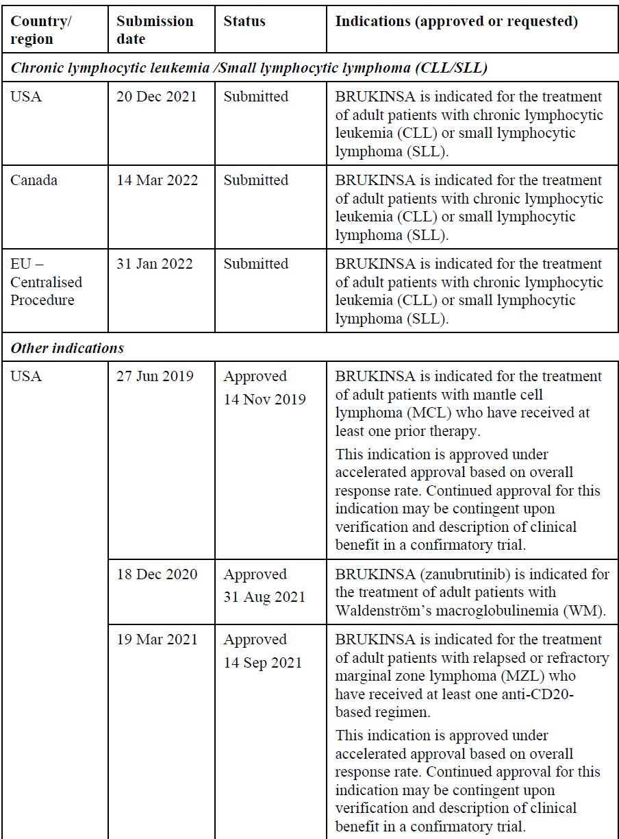
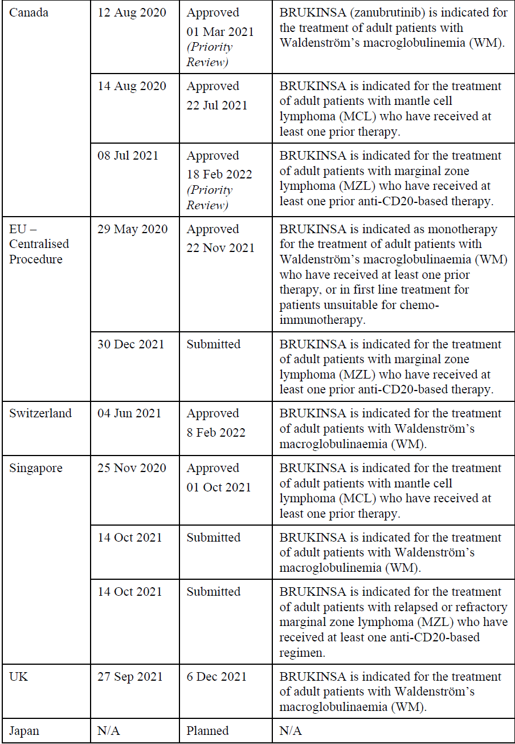

Registration timeline
Table 2 captures the key steps and dates for this submission.
This submission was evaluated under the standard prescription medicines registration process.
Table 2: Timeline for Brukinsa Submission PM-2022-01012-1-4
Description | Date
Submission dossier accepted and first round evaluation commenced | 2 May 2022
Evaluation completed | 23 November 2022
Delegate’s Overall benefit-risk assessment and request for Advisory Committee advice | 20 December 2022
Advisory Committee meeting | 17 February 2023
Registration decision (Outcome) | 1 March 2023
Registration in the ARTG | 2 March 2023
Number of working days from submission dossier acceptance to registration decision* | 215
*Statutory timeframe for standard submissions is 255 working days

Submission overview and risk/benefit assessment

Clinical evaluation summary

Pharmacology

Pharmacokinetics
New data comprised a drug-drug interaction study of zanubrutinib with rifabutin, a moderate CYP3A inducer. Zanubrutinib exposure decreased approximately 1.8 to 1.9 fold when co-administered with rifabutin.

Population Pharmacokinetics
An updated population pharmacokinetics (popPK) model which incorporated data from the two phase 3 studies found that patients with B cell malignancies had a lower exposure to zanubrutinib than did healthy volunteers. Inter-individual variability was notable with the coefficient of variation (CV) ranging from 37% to 123% across the PK parameters. The geometric mean elimination half-life was 2.52 hours with a CV of 47.6%. Health status, baseline ALT and age were statistically significant covariates on the PK of zanubrutinib. Healthy volunteers were expected to have 61.2% higher AUCss and 41.2% higher Cmax,ss than patients with B cell malignancies. The impact of ALT and age on exposure to zanubrutinib was small particularly when compared with population variability. Other covariates of baseline body weight, sex, race, AST, bilirubin, creatinine clearance, tumour type and use of acid reducing agents did not have a statistically significant impact on the PK of zanubrutinib. The impact of ALT and age on exposure, while statistically significant, was low and unlikely to be clinically meaningful.

Pharmacodynamics
Zanubrutinib is an irreversible inhibitor of Bruton’s tyrosine kinase (BTK) that was designed to be more selective than ibrutinib for BTK inhibition and with less off target activity. The Sponsor has stated that zanubrutinib was developed under the hypothesis that those pharmacologic and selectivity advantages might result in more sustained BTK occupancy, greater response depth and/or quality, and greater safety and tolerability as compared to the first generation BTK inhibitor.
An exposure/ response analysis was conducted with data from studies BGB-3111-304 and BGB- 311-305. The objectives were:
- Explore whether there is an exposure-response (E-R) relationship between zanubrutinib exposure metrics of (model predicted steady-state trough concentration [Cmin,ss], maximal concentration [Cmax,ss], and area under the curve [AUCss]) and the efficacy endpoints (progression-free survival [PFS], objective response rate [ORR], and ORR including partial response with lymphocytosis [PR-L]).
- Explore whether there is an E-R relationship between the zanubrutinib exposure metrics (Cmin,ss, Cmax,ss and AUCss) and adverse events (AEs) leading to treatment discontinuation or specified AEs of interest (grade ≥3 neutropenia, grade ≥3 thrombocytopenia, grade ≥ 3 anaemia, grade ≥ 3 infections/infestations, all events of secondary primary malignancies, all events of atrial fibrillation and flutter, major bleeding events, and any bleeding events).
No relationships between any of the exposure measures and either efficacy or AEs of interest were detected in the analysis.

Efficacy
The zanubrutinib dose regimen proposed for treatment of CLL is 320 mg p.o. daily, taken as either 320 mg (four 80 mg capsules) once daily, or as 160 mg (two 80 mg capsules) twice daily. This regimen is the same as the regimen recommended for the current indications. That dose regimen was selected for the Phase 3 studies based on sustained target occupancy, high rates of objective response in multiple types of B-cell malignancies, and a favourable safety and tolerability profile.

Study BGB-3111-304 (SEQUOIA)
This is an ongoing, Phase 3, open-label, randomised study of zanubrutinib compared with bendamustine (B) + rituximab (R) in patients with previously untreated CLL or SLL. The study is being conducted at 153 study centres in 14 countries and 1 region, including Australia. It commenced on 31 October 2017. This submission contained an interim report with data cut-off (DCO) 7 May 2021. The study design is shown in Figure 1.
Figure 1. Study 304 Schema
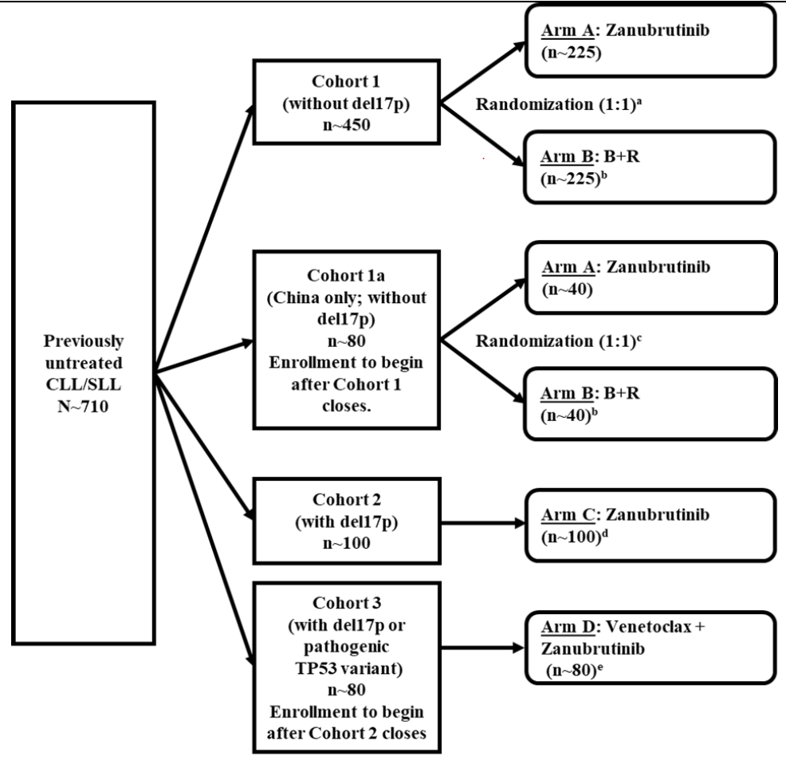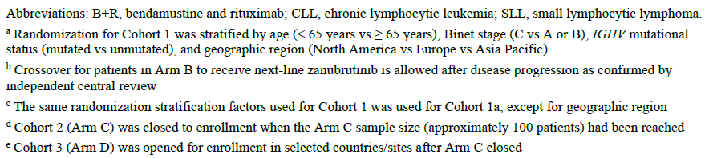
The primary objective of this interim analysis was to compare efficacy between treatment groups in Cohort 1.

Efficacy endpoint
The primary endpoint was progression-free survival (PFS) as determined by independent review committee (IRC). PFS was defined as the interval between the first treatment day (in phase 3 trials: day of randomisation for intent-to-treat analysis) to the first sign of disease progression or death from any cause, using 2008 International Workshop on Chronic Lymphocytic Leukemia (IWCLL) guidelines for CLL and Lugano criteria for SLL.
Secondary objectives in Cohort 1 included a comparison of overall response rate (ORR) as determined by the IRC or by investigator, overall survival (OS), PFS determined by the investigator, and duration of response. Additional secondary objectives included efficacy assessment from Chinese sites (Cohort 1a), in pooled Cohorts 1 and 1a, in patients with del17p (Cohort 2) and in patients with del17p or pathogenic TP53 variant (Cohort 3). Secondary endpoints included the ORR, OS, and DOR.
The study consisted of screening, treatment, post treatment and long term follow up phases. Long term follow up commenced after documented IRC disease progression. Patients were centrally randomised via interactive response technology in a 1:1 ratio to either zanubrutinib (Arm A) or bendamustine + rituximab (B+R) (Arm B) in cohorts 1 and 1a. Randomisation was stratified by age (<65 versus ≥65 years), Binet stage (C versus A or B), IGHV mutational status (mutated versus unmutated) and geographic region (North America versus Europe versus Asia- Pacific apart from in Cohort 1a). Treatment was open label. The IRC for response assessment was blinded to study treatment.
Assessments of CLL/SLL status to be performed during the study include: disease-related constitutional symptoms; physical examination of lymph nodes, liver, and spleen; complete blood count (CBC); bone marrow examination; genetic alterations in the tumour cells (including del17p, del11q, Trisomy 12, del13q, IGHV mutation analysis); computed tomography (CT) scan of the neck, chest, abdomen, and pelvis; and patient-reported outcomes (PROs; EQ-5D-5L and EORTC QLQ-C30). CLL with del(17p) is known to be resistant to rituximab. Fluorescence in situ hybridisation (FISH) results from the central laboratory were used to confirm the presence or absence of del(17p). Patients with CLL with this deletion were excluded from Cohorts 1 and 1a only, additional key inclusion and exclusion criteria are listed below:

Key inclusion criteria
- Adults with a confirmed diagnosis of CD20-positive CLL or SLL requiring treatment as defined by at least one of the following: progressive marrow failure; massive, progressive, or symptomatic splenomegaly; massive, progressive, or symptomatic lymphadenopathy; progressive lymphocytosis with rapid doubling time; or constitutional symptoms.
- ≥65 years of age at time of informed consent, or 18-64 years of age and unsuitable for chemoimmunotherapy with fludarabine, cyclophosphamide, and rituximab (FCR) based on 1 or more of the following factors: Cumulative Illness Rating Scale (CIRS) score > 6; creatinine clearance <70 mL/min; or history of previous serious infection or multiple infections in the past 2 years.
- Measurable disease, defined as ≥1 lymph node >1.5 cm in longest diameter and measurable in 2 perpendicular diameters.
- No prior systemic treatment for CLL/SLL (eligibility allowed 1 prior aborted regimen administered for less than 14 days).
- No history of prolymphocytic leukemia or Richter’s transformation,
- No currently active clinically significant cardiovascular disease, and no active infection including no active hepatitis B or C or HIV.
- ECOG performance status of 0, 1, or 2.
- Life expectancy ≥6 months.
- Adequate bone marrow, renal and hepatic function.

Key exclusion criteria
- Previous systemic treatment for CLL/SLL (other than 1 aborted regimen <2 weeks in duration and >4 weeks before randomisation).
- Required ongoing need for corticosteroid treatment.
- Known prolymphocytic leukaemia or history of, or suspected, Richter’s transformation.
- Clinically significant cardiovascular disease
- Prior malignancy within the past 3 years, except for curatively treated basal or squamous cell skin cancer, non-muscle-invasive bladder cancer, carcinoma in situ of the cervix or breast, or localised Gleason score 6 prostate cancer.
- History of severe bleeding disorder
- History of stroke or intracranial haemorrhage within 6 months.
- Severe or debilitating pulmonary disease.
- Unable to swallow capsules or disease significantly affecting gastrointestinal function
- Active fungal, bacterial, and/or viral infection requiring systemic therapy.
- Known central nervous system involvement by leukaemia or lymphoma.
- Required ongoing treatment with a strong CYP3A inhibitor or inducer.
- Active and/or ongoing autoimmune anaemia and/or autoimmune thrombocytopenia.
- Arm D only: required ongoing treatment with warfarin or warfarin derivatives.

Study treatments
Cohorts 1 and 1a: Zanubrutinib 160 mg bd until disease progression or unacceptable toxicity or bendamustine (B) 90 mg/m2/day via IV infusion on the first 2 days of each cycle for 6 x 28 day cycles and rituximab (R) 375 mg/m2 via IV infusion for Cycle 1 and 500 mg/m2 for Cycles 2 to 6. At investigator discretion, patients randomised to B+R in Cohort 1/1a could be eligible to receive crossover treatment with zanubrutinib at the time disease progression was confirmed by the IRC.
Cohort 2: zanubrutinib 160 mg bd monotherapy until disease progression or unacceptable toxicity.
Cohort 3: zanubrutinib 160 mg bd and venetoclax.
Dose adjustments were consistent with the current dose adjustments for zanubrutinib ADRs in the zanubrutinib PI. Adjustments for comparator treatments were based on local guidelines. No further information on Cohort 3 was included in the interim clinical study report (CSR).

Statistical planning
Assuming a PFS hazard ratio (HR) (Arm A/Arm B) in Cohort 1 of 0.58, 118 events were required to achieve 83.5% power at 2-sided alpha of 0.05 to reject the null hypothesis when one interim analysis was planned after 73% of the target number of events at final analysis. A median PFS in Arm B of 42 months was assumed. Comparison of PFS in the two arms in Cohort 1 was based on a log rank test stratified by randomisation stratification factors (age [< 65 years versus ≥ 65 years], Binet stage [C versus A or B], and IGHV mutational status [mutated versus unmutated]) per IRT in the ITT analysis Set. The hazard ratio (HR) and its two-sided 95% confidence interval (CI) were estimated from a stratified Cox regression model. The distribution of PFS was estimated using Kaplan-Meier method. Multiplicity adjustment was undertaken for the primary endpoint by O’Brien Fleming type Lan-DeMets alpha spending function. For the secondary endpoints, overall survival, and PRO, were to be tested if the primary endpoint, PFS, was significant (using fixed sequencing Bonferroni method). No inferential testing was done for other secondary endpoints.
As superiority was met at this interim analysis, a final analysis of PFS is not planned. The overall survival final analysis is planned for the study end at approximately 5 years.

Results
Cohort 1: 479 patients were randomised, 241 to zanubrutinib and 238 to the B+R. Twelve patients were randomised but did not receive study treatment. In the zanubrutinib arm, 34 (14.1%) patients discontinued from study treatment. B+R was a fixed duration therapy (6x28 day cycles), all patients had discontinued/completed therapy as of the data cutoff date.
Median age in both study arms was 70 years with 19% aged <65 years, 91.6% of patients had CLL with the remaining patients having SLL. The median time from initial diagnosis was 31.3 and 28.7 months in the zanubrutinib and B+R arms, respectively. Staging levels were similar, around 57% stage B and 30% stage C. The rate of genetic mutations (zanubrutinib vs B+R) were similar between the groups: del17p (0.8% vs 0.0%), unmutated IGHV (51.9% vs 50.8%),
del(11q) (17.8% vs 19.3%), TP53 mutations (6.2% vs 5.5%), del(13q) (56.4% vs 54.2%), and
Trisomy 12 (18.7% vs 20.6%).
Cohort 2: 110 patients were enrolled. Median age was 70 years with 14.4% aged <65 years, 90.1% of patients had CLL and 9.9% SLL. The median time from diagnosis of CLL/SLL was 21.4 months, most CLL cases were stage B (49.0%) or stage C (37.0%). One patient did not have del17p and was not included in the efficacy analysis. Unmutated IGHV rate was 60.4%.
The median study follow-up times for patients in Cohort 1 assigned to zanubrutinib and B+R were 26.35 months and 25.92 months, respectively (from clinical summary module 2.7.3). The median study follow-up time for patients assigned to zanubrutinib in Cohort 2 (Arm C) as 30.52 months. PFS and ORR assessments by IRC for Cohorts 1 and 2 are shown in Table 4.
Table 4: PFS by IRC for Cohort 1 (Arm A and B) and Cohort 2 (ARM C) Study 304
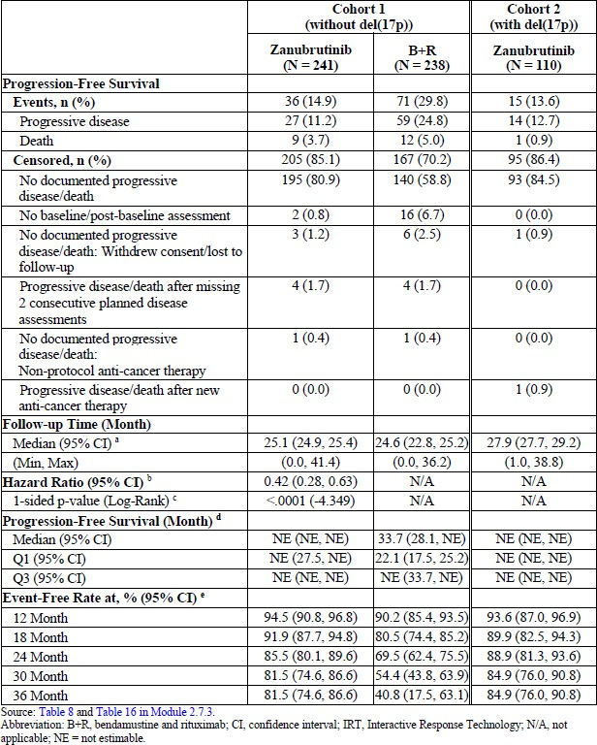
A forest plot of PFS by subgroup for Cohort 1 (Arms 1 and 2) shows higher PFS rates by IRC for zanubrutinib in each of the subgroups (data not shown). The HR statistics presented in that plot are descriptive.
Results for ORR by IRC in Cohorts 1 and 2 are shown in Table 5. As of the data cutoff date of 7 May 2021 there were 228 responders in the zanubrutinib arm and 203 responders in the B+R arm. Of the 27 responders with reported events in the zanubrutinib arm, 21 patients had progressive disease and 6 patients died; of the 58 responders with reported events in the B+R arm 53 patients had progressive disease and 5 patients died. Median follow-up time was 22.1 months in both arms. The estimated 18-month event-free rate was 91.7% in the zanubrutinib arm and 81.3% in the B+R arm. The 24-month event-free rate was 87.5% in the zanubrutinib arm and 70.3% in the B+R arm.
Table 5. Analysis of Disease Response by ICR in Cohorts 1 and 2 (ITT Analysis Set [Cohort 1] and Safety Analysis Set with Central Lab del17p Patients [Cohort 2]). Study 304
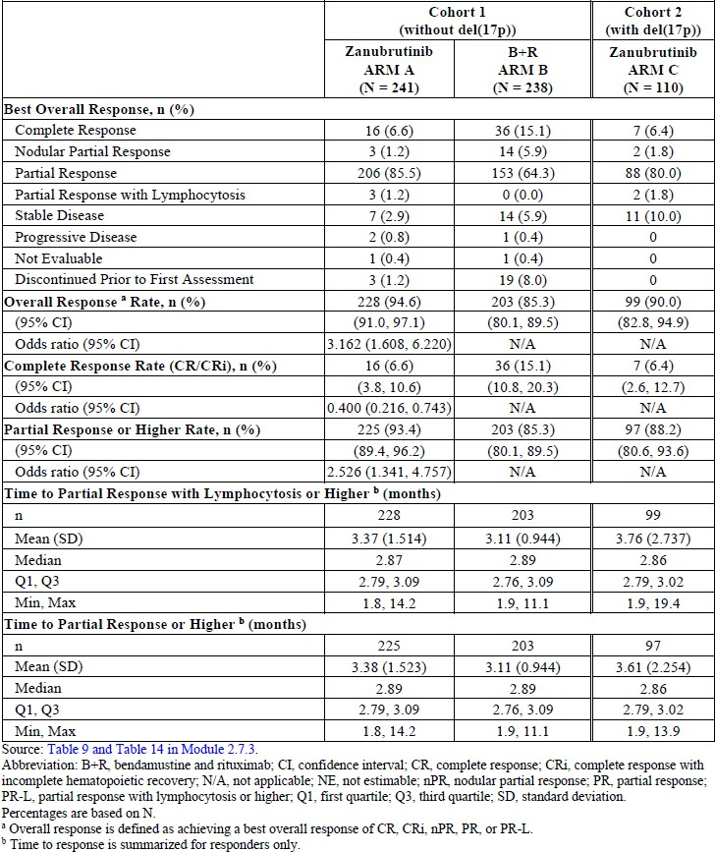
The overall survival was similar between groups (94% at 24 months), however the study was not powered or designed for OS assessment and most patients were alive at the data cut off point.
In the uncontrolled high-risk group of del(17p) patients in Cohort 2, results were concordant with the unmutated del17p patients of Cohort 1, and the IRC-assessed ORR was 90.0% after a medium 27.9 months follow up.
The Patient-reported Outcomes (PRO) key endpoints include Global Health Status/ Quality of Life (GHS/QoL), physical function, role function, pain, fatigue, nausea and vomiting, and diarrhoea. In Cohort 1 the zanubrutinib arm had a better overall outcome compared with the B+R arm as indicated in the mean changes from baseline (standard deviation) of the PRO key endpoints of GHS, physical and role functions scales and decreased symptoms of fatigue and nausea/vomiting and diarrhoea.

Study 305 (ALPINE)
This is an ongoing phase 3, randomised study of zanubrutinib compared with ibrutinib in patients with relapsed/refractory (RR) CLL or SLL. The study was conducted at 117 study centres in 15 countries including Australia. It commenced in November 2018 and the interim CSR included data to 31 December 2020. At that time 415 patients had been randomised and had a potential of at least 12 months of study treatment. The interim CSR included efficacy results for the first 415 randomised patients as well as results for the total population of 652 patients.
The primary objective was to compare the efficacy of zanubrutinib versus ibrutinib as measured by overall response rate determined by investigator assessment. PFS by investigator and IRC as well as ORR by IRC were secondary objectives.

Key eligibility criteria
Patients were required to have a confirmed diagnosis of CLL or SLL that meets the iwCLL criteria and require treatment, as defined by at least 1 of the following: progressive marrow failure; massive, progressive, or symptomatic splenomegaly; massive, progressive, or symptomatic lymphadenopathy; progressive lymphocytosis with rapid doubling time; or constitutional symptoms. Patients must be 18 years or older, relapsed or refractory to at least 1 prior systemic therapy for CLL/SLL, with the last dose of prior therapy for CLL/SLL > 14 days before randomisation, and have measurable disease (defined as ≥ 1 lymph node > 1.5 cm in longest diameter, and measurable in 2 perpendicular diameters or an extranodal lesion must measure > 10 mm in longest perpendicular diameter).
A line of therapy is defined as completing at least 2 cycles of treatment of standard regimen according to current guidelines, or of an investigational regimen on a clinical trial. Patients were to have no history of prolymphocytic leukaemia or Richter’s transformation, no currently active clinically significant cardiovascular disease, and no HIV infection or active infection with hepatitis B or C.

Study treatments
Patients were randomised to zanubrutinib 160 mg (two 80mg capsules) p.o twice daily or ibrutinib 420 mg p.o once daily. Randomisation was stratified by age (< 65 years vs. ≥ 65 years), geographic region (China vs. non-China), refractory status (yes or no), and del17p/TP53 mutation status (present or absent). For the purposes of stratification, refractory disease was defined as either no objective response or disease progression within 6 months of the last CLL/SLL treatment, and relapsed disease was defined as disease that relapsed more than 6 months after the last CLL/SLL treatment and subsequently progressed.
Treatment modification due to toxicities was as per local prescribing guidelines. The dose modifications were essentially the same as in study 304 except any intracranial hemorrhage resulted in in permanent discontinuation of zanubrutinib.
Study treatment continued until disease progression, or any of the events specified in the study protocol. The study duration was estimated to be approximately 51 months. Other anticancer therapies were prohibited until disease progression, unmanageable toxicity, or lack of further clinical benefit from study treatment, which required permanent discontinuation of the study drug.

Efficacy endpoints
The primary endpoint was ORR (PR or higher, defined as CR/CRi + PR + nodular PR) determined by investigator assessment. For CLL the “modified” 2008 iwCLL guidelines with modification for treatment-related lymphocytosis were applied. For SLL, the Lugano Classification for NHL with CT based response criteria were applied. In the initial protocol ORR assessed by the IRC was the primary efficacy endpoint and in the USA, ORR assessed by independent review will be the basis for regulatory decisions.
The secondary endpoints included PFS by investigator assessment and IRC, incidence of atrial fibrillation/flutter, ORR by IRC, duration of response and time to treatment failure, rate of PR-L or higher by IRC, overall survival, and Patient Reported Outcomes (PROs).

Statistical planning
The primary analysis set for all efficacy analyses is the Intent-to-Treat Analysis Set (all patients randomised). For the non-inferiority testing for the primary endpoint of ORR by independent central review.
The primary hypothesis testing for ORR was for non-inferiority. Non-inferiority of zanubrutinib to ibrutinib was assessed on the ORR using a stratified Wald test adjusting for the four randomisation stratification factors. Superiority was to be tested if non-inferiority was demonstrated. The monitoring boundaries for the non-inferiority and superiority tests were based on the O’Brien-Fleming boundary approximated by the Lan-DeMets spending function. The Sponsor stated that the non-inferiority margin of 0.8558 in the response ratio (zanubrutinib/ibrutinib) was derived using a fixed margin approach and took into account the response rates published from the RESONATE and RESONATE2 trials of ibrutinib. The one-sided p value boundaries for non-inferiority testing were 0.005 and 0.0235 for the interim and final analyses, respectively. Superiority testing had the same p value boundaries which corresponded to chi-squared p-value cut offs of 0.0099 and 0.0469, respectively.
Stepwise hierarchical testing was used for assessment of key secondary endpoints to control for type I error. This included non-inferiority and superiority of PFS by investigator assessment and the incidence of atrial flutter/fibrillation). Assessment of other endpoints was descriptive. The non-inferiority of zanubrutinib to ibrutinib on PFS assessment used a margin of 1.3319 (for the hazard ratio of zanubrutinib/ibrutinib) and was analysed using a stratified Wald test. A stratified Cox regression model estimated the hazard ratio for PFS and its 95% CI.
There was one interim analysis for non-inferiority of the ORR after the first 415 patients were randomised patients (207 zanubrutinib and 208 ibrutinib). If the primary study non-inferiority objective was met, then the study was to continue to follow up PFS until 205 events were observed.

Results
This CSR included analyses performed on data collected through to December 2020 for the planned interim analysis. Of the first 415 randomised patients, 207 patients were randomised to zanubrutinib, and 208 to the ibrutinib. Results for patients randomised after the first 415 patients were also included in the CSR. A total of 652 patients were randomised: 327 to zanubrutinib and 325 to the ibrutinib. Median study follow-up times were 13.60 months and
13.47 months in the zanubrutinib and ibrutinib arms, respectively.
The two arms were relatively balanced on baseline characteristics apart from a greater proportion of women in the zanubrutinib group (34.9% vs 28.6%). Mean age was 66.7 and 67.1 years in the zanubrutinib and ibrutinib arms, respectively. ECOG performance stage was 0 or 1 in 96-98% of the patients. The disease type was balanced (CLL: 96.0% vs 95.1%, SLL: 4.0% vs 4.9%). Medical conditions were generally balanced. History of infections/infestations was 34.3 vs 35.7% and the rate of atrial fibrillation was 4.9% vs 5.8% in the zanubrutinib and ibrutinib arm, respectively.
The median time from initial diagnosis to randomisation was 83.3 months in the zanubrutinib arm and 82.0 months in the ibrutinib arm. The majority of patients had CLL (96.0% in the zanubrutinib arm and 95.1% in the ibrutinib arm) at stage B (45.0% in the zanubrutinib arm and 47.4% in the ibrutinib arm) and stage C (41.0% in the zanubrutinib arm and 36.9% in the ibrutinib arm). Patients with SLL accounted for 4.0% in the zanubrutinib and 4.9% in the ibrutinib arms. Genetic mutations, including del17p (zanubrutinib [13.8%] versus ibrutinib [15.4%]), del11q (zanubrutinib [27.8%] versus ibrutinib [27.1%]), TP53 mutations
(zanubrutinib [15.3%] versus ibrutinib [13.8%]), unmutated IGHV (zanubrutinib [70.0%] versus ibrutinib [72.0%]), were comparable between the zanubrutinib and the ibrutinib arms.

Interim analysis of the first 415 patients (by investigator)
The overall median treatment duration in the first 415 randomised patients was 15.277 months in the zanubrutinib arm and 14.587 months in the ibrutinib arm (Table 6). The study met its primary endpoint. The ORR as determined by investigator was 78.3% in the zanubrutinib group and 62.5% in the ibrutinib group with a response ratio of 1.25 (95% CI: 1.10, 1.41, p<0.0001). This met the criteria for non-inferiority (prespecified 1-sided alpha of 0.005) and also for superiority (p=0.0006 compared to prespecified 2-sided alpha of 0.0099).
Table 6: Interim Analysis of Disease Response per Investigator Assessment (Intent-to- Treat Analysis Set, First 415 Patients Randomised)
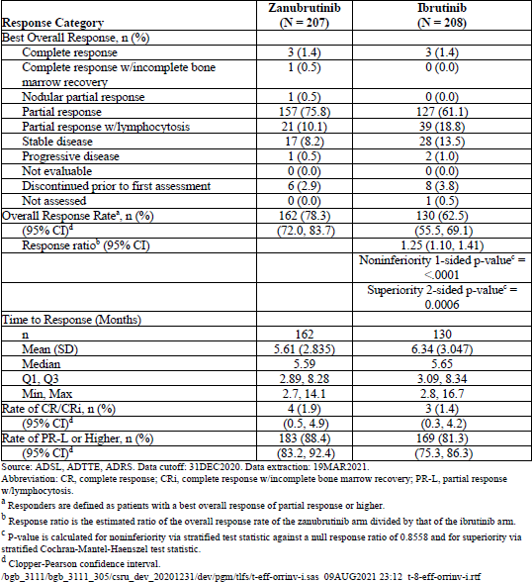
Overall, the concordance rates between investigator and ICR were high. For the first 415 randomised patients, the concordance rate for best overall response of PR or higher for the zanubrutinib and ibrutinib arms were 94.2% (195/207 patients) and 93.3% (194/208 patients), respectively.
The rate of CR/CRi was similar (1.9% vs 1.4%) while the PR rate was higher in the zanubrutinib group 75.8% vs 61.1%). Sensitivity analyses were supportive, including analysis of the per protocol population and excluding patients who died from COVID-19. Consistently higher ORR for zanubrutinib compared with ibrutinib was seen across subgroups, including in patients with a del17p/TP53 mutation, with a trend in favour of zanubrutinib, though only 79 patients had del(17)p/TP53 mutation at baseline. (risk difference 30.5 95% CI: 10.5, 50.5). Median time to response was 5 to 6 months in both treatment arms.
Figure 2 Forest Plot of Interim Analysis of Overall Response Rate by Investigator Assessment (ITT Analysis Set, First 415 Patients Randomised) Study 305
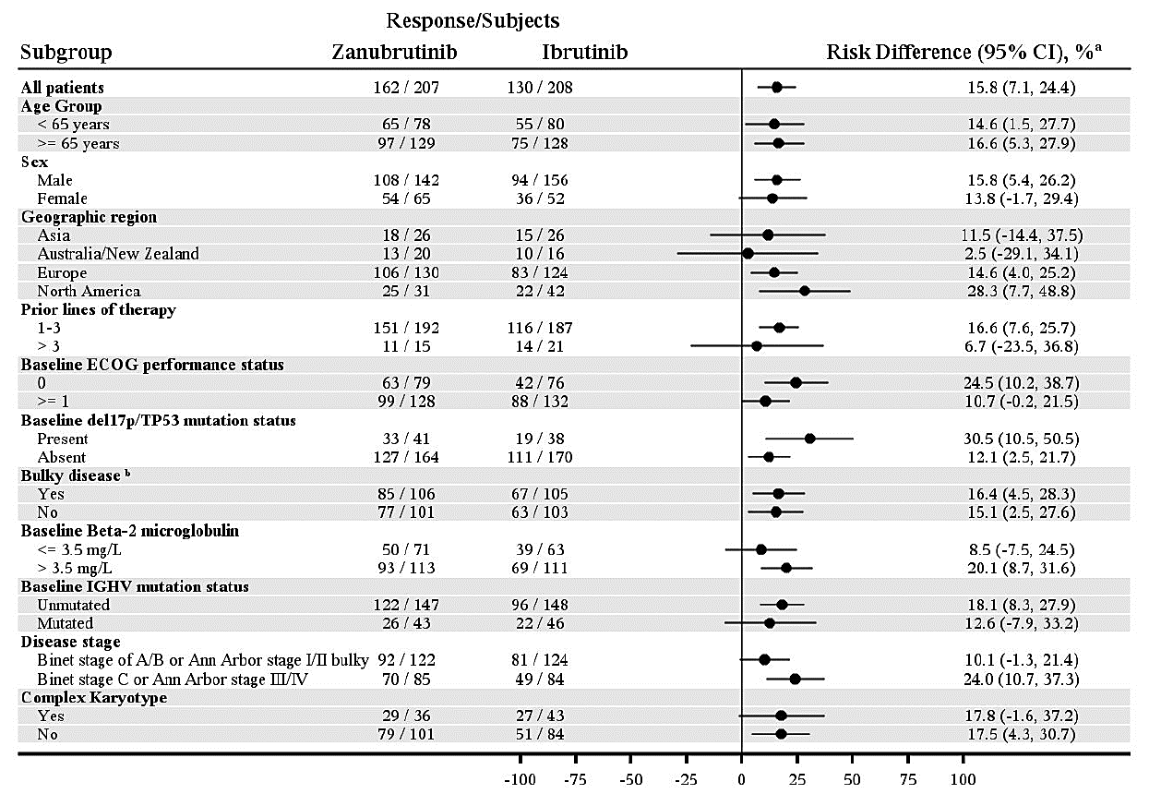
a) Unstratified rate difference and 95% confidence interval. B) Bulky disease of yes is derived from any target lesion longest diameter ≥ 5cm. /bgb_3111/bgb_3111_305/csru_dev_20201231/dev/pgm/tlfs/f-eff-forest-i.sas 09AUG2021 23:39 f-34-eff-forestinv-i.rtf

Duration of response for the first 415 patients was also assessed by the investigators. As of DCO 31 December 2020, there were 162 responders in the zanubrutinib arm and 130 responders in the ibrutinib arm. Of these 9 patients had PD (5 patients) or died (4 patients) in the zanubrutinib arm. Sixteen patients had PD (14 patients) or died (2 patients) in the ibrutinib arm. Median duration of response was not reached in the zanubrutinib arm and was 16.6 months (95%CI: 13.7, NE) in the ibrutinib arm. The KM estimated 12-month event-free rate was 89.8% in the zanubrutinib arm and 77.9% in the ibrutinib arm. The rate of treatment failure (discontinuation of treatment for any reason) was lower in the zanubrutinib group (9.5% vs 18.8%) with a HR of 0.45 (95% CI 0.29, 0.70, p=0.0003). Median follow-up time was 10.1 months in the zanubrutinib arm and 8.3 months in the ibrutinib arm.

Interim analysis of the first 415 patients (by ICR)
At the DCO the ORR for the first 415 randomised patients was (76.3% [95% CI: 69.9, 81.9]) in the zanubrutinib arm compared with (64.4% [95% CI: 57.5, 70.9]) the ibrutinib arm. The response ratio was 1.17 (95% CI: 1.04, 1.33), and noninferiority to ibrutinib was demonstrated (p<0.0001). The 2-sided p-value was 0.0121 for superiority, which is slightly higher than the prespecified 2- sided alpha of 0.0099 for the interim analysis and so was not met.
The CR/CRi rate was 1.4% in the zanubrutinib arm and 1.0 % in the ibrutinib arm. Best overall response of PR in the zanubrutinib arm was (154 [74.4%] patients) compared with the ibrutinib arm (132 [63.5%] patients. For the duration of response by ICR, the median follow up time was 10.1 and 8.3 months in the zanubrutinib and ibrutinib arms, respectively and the median duration of response was 16.7 months (95% CI: 14.3, NE) in the zanubrutinib arm and not reached in the ibrutinib arm.
Figure 3 shows a forest plot of the ORR by subgroups.
Figure 3. Forest Plot of Interim Analysis of Overall Response Rate by Investigator Assessment (ITT Analysis Set, First 415 Patients Randomised) Study 305
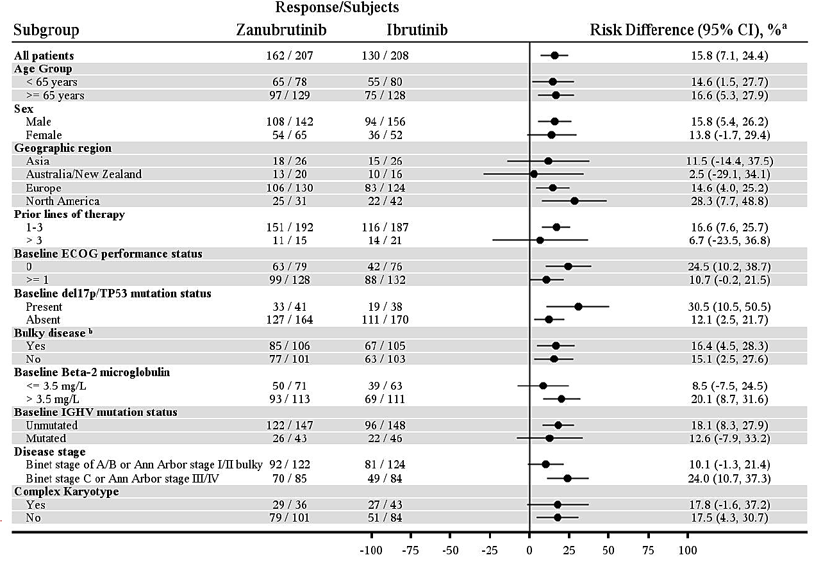
a Unstratified rate difference and 95% confidence interval.
b Bulky disease of yes is derived from any target lesion longest diameter ≥ 5 cm.
/bgb_3111/bgb_3111_305/csru_dev_20201231/dev/pgm/tlfs/f-eff-forest-i.sas 09AUG2021 23:39 f-34-eff-forestinv-i.rtf
As of the DCO, there were 158 responders in the zanubrutinib arm and 134 responders in the ibrutinib arm. Of these responders, 14 patients had PD (11 patients) or died (3 patients) in the zanubrutinib arm. Eighteen patients had PD (16 patients) or died (2 patients) in the ibrutinib arm. The 12-month event-free rate was 90.3% in the zanubrutinib arm and 78.0% in the ibrutinib arm.

PFS for full ITT analysis population (by investigator)
As of the DCO a total of PFS events had been observed in 27 (8.3%) patients in the zanubrutinib arm and 50 (15.4%) patients in the ibrutinib arm. The median follow-up time was 11.6 months in the zanubrutinib arm and 11.3 months in the ibrutinib arm. The 12-month event-free rate was 93.3% in the zanubrutinib arm and 83.1% in the ibrutinib arm in the ITT analysis set. The PFS HR was 0.47 (95% CI: 0.29, 0.76) of the zanubrutinib arm compared with the ibrutinib arm in the ITT Analysis Set.
The proportion of patients with treatment failure was lower in the zanubrutinib arm (9.5%) compared with the ibrutinib arm (18.8%). The HR of treatment failure comparing the zanubrutinib arm to ibrutinib arm was 0.45 (95% CI: 0.29, 0.70). As of the DCO, the median time to treatment failure was not reached in either arm. The 12-month event-free rate was 91.8% in the zanubrutinib arm and 80.4% in the ibrutinib arm.
OS was premature. At DCO there were 15 (4.6%) deaths reported in the zanubrutinib arm and 23 (7.1%) deaths reported in the ibrutinib arm. Median overall survival was not reached in either arm with median follow-up time of 13.8 months in the zanubrutinib arm and 13.6 months in the ibrutinib arm.

PFS for full ITT analysis population by ICR
The HR for PFS was 0.61 (95% CI: 0.39, 0.95) for the zanubrutinib arm compared with the ibrutinib arm in the ITT Analysis Set. The 12-month event-free rate was 90.4% in the zanubrutinib arm and 81.7% in the ibrutinib arm. PFS events were observed in 36 (11.0%) patients in the zanubrutinib arm and 52 (16.0%) patients in the ibrutinib arm in ITT Analysis Set. The median follow-up time was 11.3 months in both arms.
Study 205 is an uncontrolled, open Phase 2 study. It is considered supportive of the relapsed or recurrent component of the proposed CLL indication. It was conducted between 2017 and 2020 in 11 centres in China. The primary objective was to evaluate the efficacy of zanubrutinib at a dose of 160 mg orally twice a day, in patients with R/R CLL or SLL as assessed by an Independent Review Committee (IRC) using the overall response rate (complete response, including complete response with incomplete blood count recovery, and partial response, including nodular partial response, and partial response with lymphocytosis) for patients with chronic lymphocytic leukemia according to modified IWCLL guidelines and complete response and partial response for patients with small lymphocytic lymphoma according to the Revised Criteria for Response for Malignant Lymphoma in patients with small lymphocytic lymphoma.
Approximately 80 patients were to be enrolled and treated with zanubrutinib 160 mg administered orally twice daily in repeated 28-day cycles. Patients were to receive treatment for up to 3 years or until progressive disease, unacceptable toxicity, death, withdrawal of consent, or study termination by the Sponsor, whichever occurred first. The primary efficacy endpoint of this study was overall response rate.
As of the final data cutoff date (11 September 2020), a total of 91 Chinese patients (82 patients with CLL and 9 patients with SLL) with a median age of 61.0 years (range: 35 to 87 years) were enrolled. Most patients were < 65 years of age (65.9%) and 57.1% were male.
Most patients had ≥ 1 poor prognostic factor and advanced clinical stage disease (Binet Stage C CLL [67.1%], Rai Stage III or IV CLL [67.1%], or Stage IV SLL [77.8%]). Over half of all patients (56.0%) had unmutated IGHV. Approximately one-quarter of all patients had disease with≥ 1 poor prognostic cytogenetic feature including del(17p), del(11q), and/or TP53 mutation.
Approximately half of all patients had received ≥ 2 prior lines of anticancer drug therapy; 79.1% of all patients were refractory to the most recent systemic therapy. Median time since diagnosis of CLL/SLL was 39.43 months (range: 3.2 to 185.1 months).
The ORR was 87.9% with CR reached in 6.6% of patients. The median time to response was 2.79 months. As of the median follow-up time of 30.7 months, the median duration of response has not been reached. The estimated 24-month and 36-month duration of response event-free rates were 83.4% and 69.9%, respectively. Median PFS and OS have not been reached.

Study AU-003
The final report of this first-in man study for zanubrutinib was included in the submission. This study has been previously evaluated. There were 103 patients with R/R CL and 22 treatment naïve CLL patients evaluable for efficacy, having received ≥ 1 dose of zanubrutinib. The ORR was 94.2% in the R/R CLL arm and 100% in the TN CLL arm. Responses were durable regardless of treatment status. In patients with R/R CLL the median duration of response (PR-L or better) was 58.6 months (95% CI:52.6 months, NE) after a median follow-up time of 35.5 months (range: 0.0 to 65.1 months). The estimated duration of response landmark rate was 86.6% at 36 months after first response.
The median duration of response was not reached in patients with TN CLL after a median follow-up time of 44.6 months. The estimated duration of response landmark rate was 81.0% at 36 months after first response. Overall survival rates at 36 months were high at 91.2% in patients with R/R CLL and 90.5% in patients with TN CLL.

Safety
The adverse events of special interest associated with BTK’s are haemorrhage, atrial fibrillation/ flutter, hypertension, second primary malignancies, tumour lysis syndrome, cytopenia, neutropenia, thrombocytopenia and anaemia.
The existing integrated safety analysis was based on data from 779 patients enrolled in 6 earlier studies has been updated to include data from the 3 new studies included in this submission.
That analysis now includes data from 1550 patients with CLL/SLL and other B-cell malignancies enrolled into 9 clinical studies (2 Phase 1 studies, 4 Phase 2 studies, and 3 Phase 3 studies). All 9 studies have completed enrolment, 5 studies are closed and 4 are ongoing. Only patients with a planned dose of zanubrutinib at a dose of 160 mg orally twice a day or 320 mg once a day are included. The median duration of exposure was 22.95 months (range 0.1- 71.2 months) in the total patient group and was 26.58 months (range 0.5 – 42.2 months) in study 304 and 13.58 months (range 0.4 – 23.0) in study 305.
Of the 1550 patients receiving zanubrutinib, 73.6% were exposed for at least 1 year, 48% for at least 2 years, 23.5% for at least 3 years and 6.7% for at least 4 years. In study 304 there were 341 patients exposed to zanubrutinib for at least 12 months and 341 exposed for at least 2 years. In study 305 there were 190 patients exposed to zanubrutinib for at least 12 months. No patients were exposed for at least 2 years by the DCO date for the interim CSR.
The most commonly occurring adverse reactions (≥ 20%) in the 9 studies included in the combined safety analysis were: neutropenia, thrombocytopenia, upper respiratory tract infection, haemorrhage/haematoma, bruising, rash, anaemia, and musculoskeletal pain. The most common Grade 3 or higher adverse reactions (≥ 5%) were: neutropenia, pneumonia, and thrombocytopenia.
In study 304 there were 391 patients treated with zanubrutinib (including 240 patients in Cohort 1, 40 patients in Cohort 1a, and 111 patients in Cohort 2). There were 265 patients treated with B+R. In study 305 there were 324 patients treated with zanubrutinib and 324 treated with ibrutinib. There are no major differences in the incidences of ≥3 grade AEs, SAEs, deaths, dose reductions, treatment changes and AEs considered to be treatment related across the various subgroups within the integrated analysis and in the integrated analysis as a whole. Dose interruptions were very common and occurred in 30.2% to 44.8% of patients across the CLL subgroups in the overall safety analysis. Grade ≥3 TEAEs occurred in over 50% of patients with CLL with 76 (4.9%) of these events leading to death. Summary TEAEs from the integrated analysis and each of the new pivotal studies, all R/R CLL and all CLL/SLL are shown in Table 7.
Table 7. Overall Summary of Treatment-Emergent Adverse Events (Safety Analysis Set)
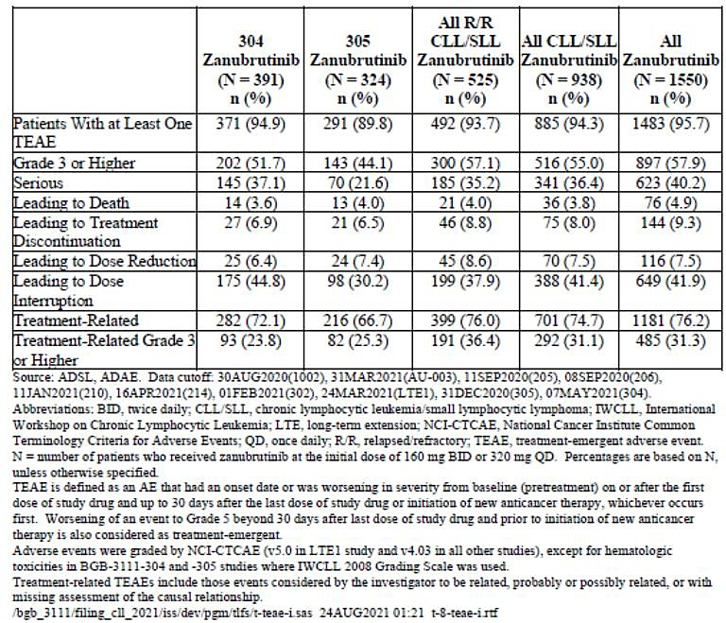
Across all groups, the most frequently reported (>10%) TEAEs were upper respiratory tract infection (URTI), diarrhoea, contusion, neutropenia and hypertension (Table 8). Pneumonia, URTI and neutrophil count decreased were more commonly reported in the All RR CLL/SLL population. In the All CLL/SLL population, the grade 3 AEs reported in ≥5% of patients were neutropenia (9.5%), decreased neutrophil count (8.3%), pneumonia (6.3%) and hypertension (6.4%) (Table 9). These incidence rates are very similar to those previously reported in the earlier integrated safety data of 779 patients.
Table 8. TEAE Reported in ≥ 10% of Patients in Any Patient Group by System Organ Class and Preferred Term (Safety Analysis Set)
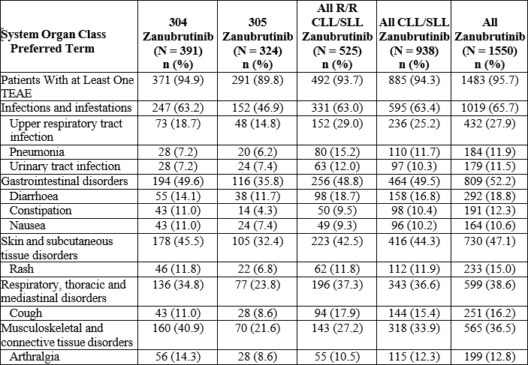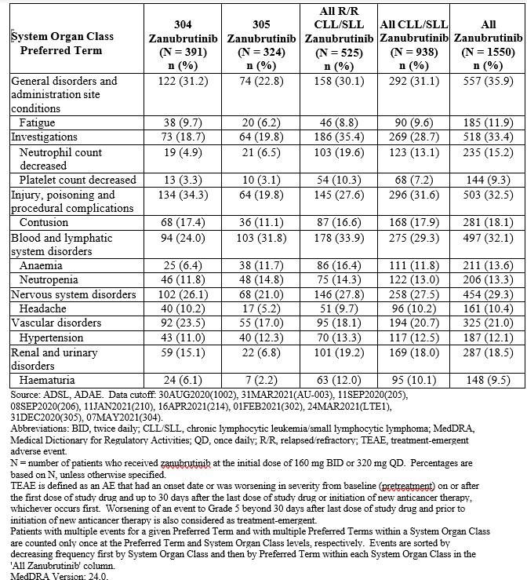
Table 9. Grade 3 or Higher TEAE Reported in ≥ 3% of Patients in Any Patient Group by System Organ Class and Preferred Term (Safety Analysis Set)
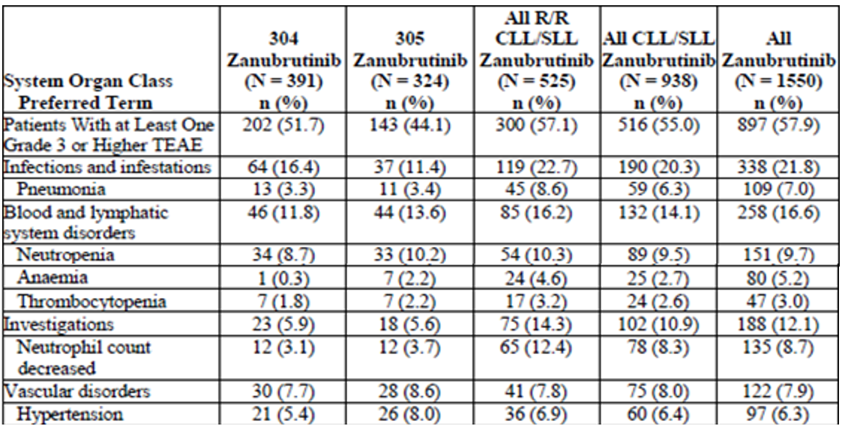
The incidences of various adverse events of special interest (AESI) are shown in Table 10. With the exception of tumour lysis syndrome, these events are adequately described in the current PI and the proposed statement in the draft PI included with this submission was also adequate to describe TLS in patients with CLL given zanubrutinib.
Table 10. TEAE of Special Interest by Category (Safety Analysis Set)
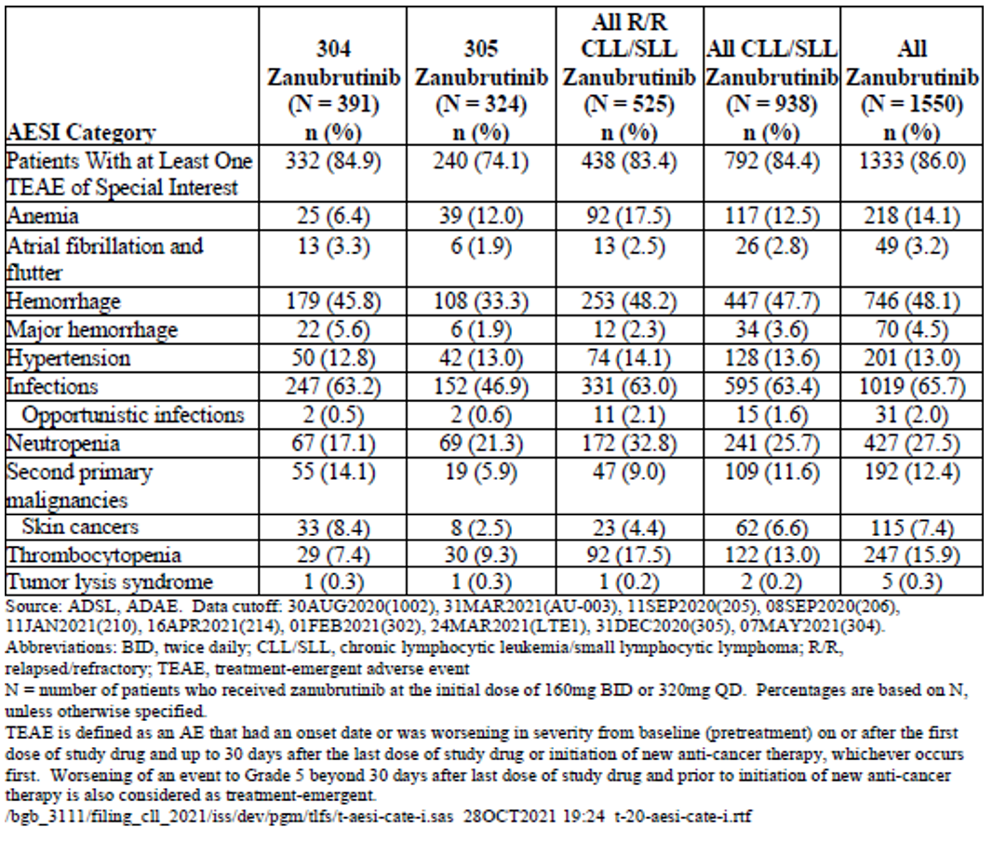
Study 305 allows for a comparison of AEs between ibrutinib and zanubrutinib (Table 11).
Table 11 Overall Summary of Treatment-Emergent Adverse Events (Safety Analysis Set)
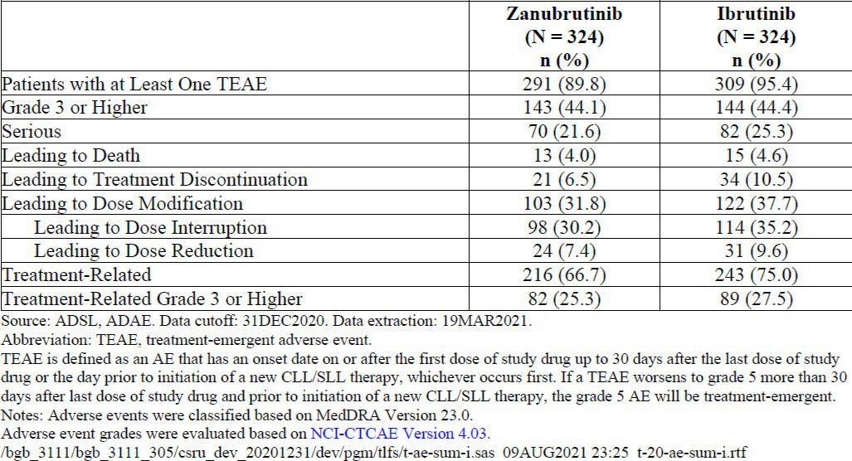
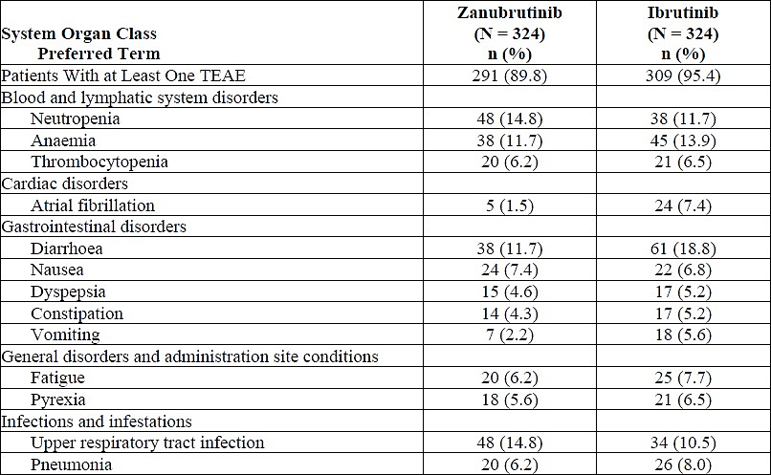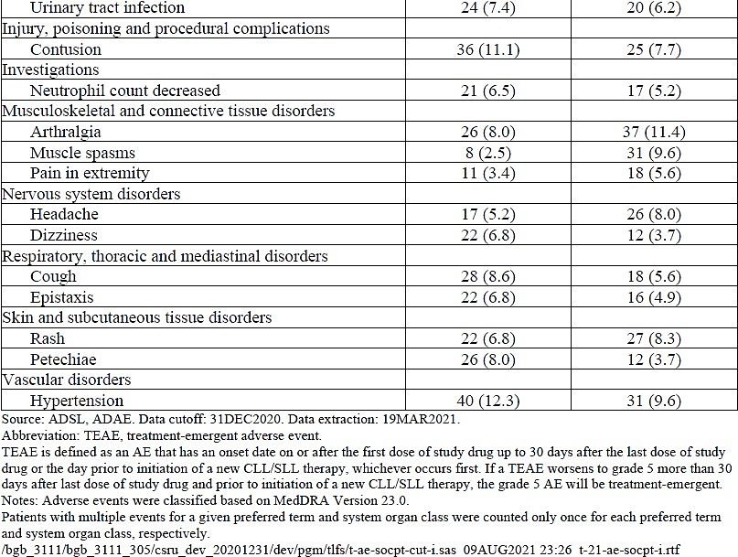
In Study 305 the incidences of AEs were generally comparable between the zanubrutinib arm and ibrutinib arm except for the following events which had an incidence difference of ≥ 5% between the 2 arms:
- Diarrhoea: zanubrutinib 11.7% versus ibrutinib 18.8%
- Muscle spasms: zanubrutinib 2.5% versus ibrutinib 9.6%
- Atrial fibrillation: zanubrutinib 1.5% versus ibrutinib 7.4%
The most common Grade 3 or higher adverse events in the zanubrutinib arm and the ibrutinib arm, respectively, were:
- Neutropenia: 10.2% versus 8.6%
- Hypertension: 8.0% versus 5.2%
- Neutrophil count decreased: 3.7% versus 3.7%
- Pneumonia: 3.4% versus 4.6%
Of note while there were fewer atrial fibrillation/flutter events associated with zanubrutinib compared with ibrutinib there were somewhat more hypertension events, including grade ≥3 events in patients given zanubrutinib compared with ibrutinib.
An analysis of AEs in patients aged ≥75 years compared with those <75 years was conducted within the pooled safety analysis of the All Zanubrutinib group (n=1550) of whom 335 were aged 75 years and older. The median treatment duration was 21.9 months and 23.3 months in the ≥75 years and <75 years age groups, respectively. Compared to younger patients, those aged ≥75 years had a higher rate of Grade ≥3 TEAEs (65.7% vs 55.7%), SAEs (50.1% vs 37.4%), TEAEs leading to death (8.4% vs 4.0%), TEAEs leading to treatment discontinuation (12.5% vs 8.4%) and TEAEs leading to dose reduction (11.0% vs 6.5%). The 95% confidence intervals for the rates showed overlap between the age groups.
For AEs of special interest, there was a higher rate of AF/flutter (7.2% vs 2.1%), haemorrhage (54.9% vs 46.3%) and major haemorrhage (8.4% vs 3.5%) in the ≥75 years compared to the <75 years age group. The Sponsor considered that the higher rates in the very elderly are ‘driven by more concomitant use of anti-coagulants or anti-platelets and relevant medical history’. This seems likely. The higher prevalence of AF/flutter in the very elderly could be anticipated given it is known to increase with increasing age.

Risk-benefit analysis
The proposed indication for Brukinsa assumes use in both treatment naïve and all stages of previously treated patients with and without mutations that may affect responses to treatment.
The designs of the two pivotal efficacy and safety studies, 304 (treatment naïve CLL) and 305 (relapsed or recurrent CLL) were consistent with the iwCLL guidelines with modification for treatment related lymphocytosis and per the Lugano Classification for NHL for SLL. Appropriate nature and frequency of assessments were undertaken to monitor disease response (12 weekly to 96 weeks then every 24 weeks). Blinded tumour response assessment by an independent review committee was undertaken in both studies.
The outcomes of most interest to patients and treating doctors are overall response rate (ORR), which consists of the complete and partial response rates, and duration of ORR. Both the 2008 and 2018 iwCLL guidelines state that responses that should be considered clinically beneficial include CR and PR; all others (e.g., stable disease, nonresponse, PD, death from any cause) should be rated as a treatment failure.
In study 304, PFS was the primary endpoint rather than ORR. In the CSR, it was stated that prolongation of PFS is likely to delay or prevent symptoms of progressive CLL/SLL and delay the need for subsequent therapies to treat CLL/SLL and was the basis of regulatory approval for several new therapeutic agents, including ibrutinib and acalabrutinib. While this may be so cohort 1 of study 304 also demonstrated superiority of zanubrutinib over its ICH comparator, bendamustine + rituximab, for ORR which was a secondary endpoint. The ORR for the uncontrolled zanubrutinib cohort with del(17p) was also similar to that of patients without that mutation given zanubrutinib.
The appropriate standard of initial treatment regimen for CLL/SLL is dependent on patient age, presence or absence of comorbidities, and molecular features, particularly the presence of del(17p). Infections are a common complication of the disease and of treatment, and the risk of recurrent infection can limit treatment choices. Patients with 17p are not recommended to received bendamustine and rituximab and those patients in study 304 received zanubrutinib only.
The American Society of Clinical Oncology (ASCO) highlights of the 2022 meeting included a presentation on the efficacy of first-line treatment for CLL that referred to zanubrutinib. The following was extracted from that summary:
The SEQUOIA (ClinicalTrials.gov Identifier: NCT03336333) is a network meta-analysis of randomized controlled trials (RCTs) that compared the efficacy of the second-generation BTK inhibitor zanubrutinib with frontline therapies usually administered to adult patients with CLL who are treatment-naive. Patients who received zanubrutinib achieved a statistically significant improvement in PFS compared with patients randomly assigned to bendamustine plus rituximab (hazard ratio [HR], 0.42; 95% CI, 0.27-0.65).
In the CLL11 study (ClinicalTrials.gov Identifier: NCT01010061), patients treated with zanubrutinib achieved a statistically significant PFS improvement compared with those treated with obinutuzumab plus chlorambucil (HR, 0.45; 95% CI, 0.23-0.86). In the ALLIANCE trial (ClinicalTrials.gov Identifier: NCT01886872), patients who received zanubrutinib achieved a statistically significant improvement in PFS compared with those who received chlorambucil plus rituximab (HR, 0.22; 95% CI, 0.12-0.41). In the MaBLe trial (ClinicalTrials.gov Identifier: NCT01056510),treatment with zanubrutinib achieved PFS outcomes comparable to those seen with ibrutinib (HR, 1.07; 95% CI, 0.59-1.94).
Clinical Impact: In recent RCTs, Zanubrutinib demonstrated greater efficacy than the 3 combination regimens currently used to treat CLL. The study findings suggest that, in terms of PFS, it is as promising a therapy as ibrutinib, the standard first-line treatment for CLL.
Cross study comparison of monotherapy zanubrutinib with monotherapy acalabrutinib in 1-L CLL (Elevate-TN study in PI for CALQUENCE) showed a similar ORR for CLL with and without del(17p).
Zanubrutinib also demonstrated superiority over ibrutinib in a patient population with R/R CLL that included those with and without IGHV, and TP53 mutations/ del(17p) in study 305. Efficacy across the subgroups examined was consistent. Further follow-up to assess overall survival in both studies 304 and 305 should be a condition of approval of the CLL indication.
Durability of response has been best assessed in study AU-003 where, for patients with R/R CLL, the median duration of response (PR-L or better) was 58.6 months (95% CI:52.6 months, NE) after a median follow-up time of 35.5 months (range: 0.0 to 65.1 months). The estimated duration of response landmark rate was 86.6% at 36 months after first response. The median duration of response was not reached in patients with TN CLL after a median follow-up time of 44.6 months. The estimated duration of response landmark rate was 81.0% at 36 months after first response. Overall survival rates at 36 months were high at 91.2% in patients with R/R CLL and 90.5% in patients with TN CLL.
No major differences in the established safety profile of zanubrutinib have been identified in this submission. Across all groups, the most frequently reported (>10%) TEAEs were upper respiratory tract infection (URTI), diarrhoea, contusion, neutropenia and hypertension. Pneumonia, URTI and neutrophil count decreased were more commonly reported in the All RR CLL population. In the All CLL population, the grade 3 AEs reported in ≥5% of patients were neutropenia (9.5%), decreased neutrophil count (8.3%), pneumonia (6.3%) and hypertension (6.4%). These incidence rates are very similar to those previously reported in the earlier integrated safety data of 779 patients.
The Sponsor has stated that zanubrutinib was designed to be more selective than ibrutinib for BTK inhibition and with less off target activity. The Sponsor has postulated that those pharmacologic and selectivity advantages might result in more sustained BTK occupancy, greater response depth and/or quality, and greater safety and tolerability as compared to the first generation BTK inhibitor.
Study 305 allowed a comparison of safety with ibrutinib. Zanubrutinib was slightly better tolerated than ibrutinib with a lower rate of treatment discontinuation (6.5% vs 10.5%) and dose modification (31.8% vs 37.7%) due to an AE (see Table 7). There were lower rates of diarrhoea, major haemorrhage, atrial fibrillation and infections with zanubrutinib. Other events of interest occurred at similar rates. In a predefined analysis, there was a statistically significant lower rate of atrial fibrillation/flutter with zanubrutinib than ibrutinib (2.5% vs 10.1%, rate difference = -7.7% 95% CI: -12.3, -3.1). Hypertension was somewhat more frequent in patients given zanubrutinib than in those given ibrutinib.

Proposed action
The delegate proposes to approve an extension to the indication for Brukinsa (zanubrutinib) to include:
Brukinsa is indicated as monotherapy for the treatment of adult patients with chronic lymphocytic leukaemia (CLL) or small lymphocytic lymphoma (SLL).
The delegate does not consider it necessary to include that zanubrutinib is effective in CLL/SLL with del(17p) and/or TP53 mutation in the indication. This effect appears to be a characteristic of BTKs to date and is not included in the indications for ibrutinib or acalabrutinib. If it became routine to include a list the major mutations in which a product is effective as part of each indication it is likely that for many products the indications would become very cumbersome as more mutations are identified. The effect of Brukinsa in CLL/SLL with del(17p) and/or TP53 mutation is adequately described in the clinical trials section of the PI.
The final study reports for studies BGB-3111-304 and BGB-3111-305 should be submitted to the TGA within 6 months of their completion.

Advisory Committee considerations
The Advisory Committee on Medicines (ACM) having considered the evaluations and the Delegate’s overview, as well as the Sponsor’s response to these documents, advised the following.
Please discuss the current treatments for TN and R/R CLL/SLL that are in use in Australia at present. Do these differ markedly from the ESMO guidelines? Does the Committee see a role for zanubrutinib in the treatment options for CLL/SLL in Australia?
The ACM noted that current Australian treatment for treatment naïve CLL/SLL differs from the ESMO guidelines primarily due to the limited availability of BTK inhibitors.
The ACM advised that for relapsed and refractory CLL/SLL the Australian treatment algorithms are similar to the ESMO guidelines (noting that BTK inhibitors are available within these treatment lines in Australia).
The ACM was of the view that there is a role for zanubrutinib within the treatment options for CLL/SLL in Australia. The ACM noted the availability of a number of BTK inhibitors will allow clinician choice and greater options to manage tolerability and toxicity challenges in both first-line and relapsed/refractory CLL/SLL.
Please comment on the use of PFS as the primary endpoint in study 304 (treatment naïve CLL/SLL).
The ACM was of the view that the use of progression free survival (PFS) as a primary endpoint within the treatment naïve CLL/SLL study is reasonable and provides a strong signal regarding clinically relevant efficacy.
The ACM noted that this study is ongoing and overall survival (OS) data is often only mature several years after the study. The ACM advised that PFS is a validated surrogate for OS in CLL, in both relapsed disease and first-line treatment (especially for higher genetic risk disease i.e. del17p, unmutated IGHV).
Please comment on the appropriateness of bendamustine + rituximab as the comparator in Cohort 1 of study 304.
The ACM advised that bendamustine + rituximab is an acceptable comparator within the study.
The ACM noted that CLL predominately affects patients aged 70 years and older and that bendamustine + rituximab is often utilised within this population for first-line CLL treatment, as patients may not be fit enough / suitable for FCR (fludarabine, cyclophosphamide and rituximab).
Study 305 presents an opportunity to directly compare the relative safety of zanubrutinib and ibrutinib. Does the Committee consider there are clinically significant differences in specific adverse events between these treatments in that study? If so, please identify them.
The ACM noted that Study 305 is a randomised but open label study and is not powered for major safety events (n=324 in zanubrutinib group).
The ACM advised that the pattern of treatment emergent adverse events is typical for a BTK inhibitor and noted that a concern with BTK inhibitors is cardiac safety. The ACM indicated that the data appear to suggest less atrial fibrillation, cardiac events, serious or fatal cardiac events, and cardiac events leading to treatment discontinuation with zanubrutinib compared to ibrutinib.
The ACM commented that overall, the data indicate that zanubrutinib is at least as safe as ibrutinib over the moderate length term of this study to date.
Does the Committee consider that it is useful to include in the indications that zanubrutinib is indicated in patients with deletion 17p and/or TP53 mutation? I note that activity against mutations are not listed in the indications for either ibrutinib or acalabrutinib.
The ACM was of the view that it is not necessary to include patients with deletion 17p and/or TP53 mutation within the indication, but information on this group should be listed within the PI. The ACM noted that this approach is consistent with other BTK inhibitors.
The ACM also noted that the proposed indication does not separate treatment naïve and relapsed/refractory patients. The ACM noted that this is a different approach to other BTK inhibitors but was of the view this was appropriate.

ACM conclusion
The ACM considered this product to have an overall positive benefit-risk profile for the indication:
Brukinsa is indicated as monotherapy for the treatment of adult patients with chronic lymphocytic leukaemia (CLL) or small lymphocytic lymphoma (SLL).

Outcome
Based on a review of quality, safety, and efficacy, the TGA decided to register Brukinsa (zanubritinib) for the following extension of indications :
Chronic Lymphocytic Leukaemia (CLL)/Small Lymphocytic Lymphoma (SLL)
Brukinsa is indicated as monotherapy for the treatment of adult patients with chronic lymphocytic leukaemia (CLL) or small lymphocytic lymphoma (SLL), including patients with deletion 17p and/or TP53 mutation.
The full indications at this time were:
Waldenström’s Macroglobulinaemia (WM)
Brukinsa is indicated for the treatment of adult patients with Waldenström’s macroglobulinaemia (WM) who have received at least one prior therapy, or in first line treatment for patients unsuitable for chemo-immunotherapy.
Mantle cell lymphoma (MCL)
Brukinsa is indicated for the treatment of adult patients with mantle cell lymphoma (MCL) who have received at least one prior therapy.
This indication was approved via the provisional approval pathway, based on objective response rate. Continued approval for this indication depends on verification and description of clinical benefit in the confirmatory trials.
Marginal Zone Lymphoma (MZL)
Brukinsa is indicated for the treatment of adult patients with marginal zone lymphoma (MZL) who have received at least one-prior anti-CD20-based therapy.
This indication was approved via the provisional approval pathway, based on objective response rate. Continued approval for this indication depends on verification and description of clinical benefit in the confirmatory trials.
Chronic Lymphocytic Leukaemia (CLL)/Small Lymphocytic Lymphoma (SLL)
Brukinsa is indicated as monotherapy for the treatment of adult patients with chronic lymphocytic leukaemia (CLL) or small lymphocytic lymphoma (SLL), including patients with deletion 17p and/or TP53 mutation.

Attachment 1. Product Information
The Product Information (PI) approved with the submission for Brukinsa which is described in this AusPAR can be found as Attachment 1. It may have been superseded. For the most recent PI and Consumer Medicines Information (CMI), please refer to the TGA PI/CMI search facility.

Therapeutic Goods Administration
PO Box 100 Woden ACT 2606 Australia
Email: info@tga.gov.au Phone: 1800 020 653 Fax: 02 6203 1605
https://www.tga.gov.au

Eichhorst B. et al. Chronic lymphocytic leukaemia: ESMO Clinical Practice Guidelines for diagnosis, treatment and follow-up. Annals of Oncology January 2021.
The ‘Delegate’ is the Delegate of the Secretary of the Department of Health and Aged Care who made the final decision to either include the new medicine/indication on the ARTG or reject the submission, under section 25 of the Therapeutic Goods Act
Hallek et al. iwCLL guidelines for diagnosis, indications for treatment, response assessment, and supportive management of CLL. Blood .2018;131(250;2745-2760.
Cancer Content Hub. ASCO 2022 Highlights: Combination Therapy for Chronic Lymphocytic leukemia https://www.cancertherapyadvisor.com/downloadingthedata/asco-2022-conference-highlights-on-combination- therapies-for-chronic-lymphocytic-leukemia/

