Australian Public Assessment Report for Ebglyss
  - Active ingredient: Lebrikizumab
  - Sponsor: Eli Lilly Australia Pty Ltd
October 2024

About the Therapeutic Goods Administration (TGA)
- The Therapeutic Goods Administration (TGA) is part of the Australian Government Department of Health and Aged Care and is responsible for regulating therapeutic goods, including medicines, medical devices, and biologicals.
- The TGA administers the Therapeutic Goods Act 1989 (the Act), applying a risk management approach designed to ensure therapeutic goods supplied in Australia meet acceptable standards of quality, safety, and efficacy.
- The work of the TGA is based on applying scientific and clinical expertise to decision-making, to ensure that the benefits to the Australian public outweigh any risks associated with the use of therapeutic goods.
- The TGA relies on the public, healthcare professionals and industry to report problems with therapeutic goods. The TGA investigates reports received to determine any necessary regulatory action.
- To report a problem with a therapeutic good, please see the information on the TGA website.

About AusPARs
- The Australian Public Assessment Report (AusPAR) provides information about the evaluation of a prescription medicine and the considerations that led the TGA to approve or not approve a prescription medicine submission. Further information can be found in Australian Public Assessment Report (AusPAR) guidance.
- AusPARs are prepared and published by the TGA.
- AusPARs are static documents that provide information that relates to a submission at a particular point in time. The publication of an AusPAR is an important part of the transparency of the TGA’s decision-making process.
- A new AusPAR may be provided to reflect changes to indications or major variations to a prescription medicine subject to evaluation by the TGA.

Copyright
© Commonwealth of Australia 2024
This work is copyright. You may reproduce the whole or part of this work in unaltered form for your own personal use or, if you are part of an organisation, for internal use within your organisation, but only if you or your organisation do not use the reproduction for any commercial purpose and retain this copyright notice and all disclaimer notices as part of that reproduction. Apart from rights to use as permitted by the Copyright Act 1968 or allowed by this copyright notice, all other rights are reserved and you are not allowed to reproduce the whole or any part of this work in any way (electronic or otherwise) without first being given specific written permission from the Commonwealth to do so. Requests and inquiries concerning reproduction and rights are to be sent to the TGA Copyright Officer, Therapeutic Goods Administration, PO Box 100, Woden ACT 2606 or emailed to <tga.copyright@tga.gov.au>.

Contents
List of abbreviations 4
Ebglyss (lebrikizumab) submission 8
Ebglyss (lebrikizumab) 9
Atopic dermatitis 9
Current treatment options for atopic dermatitis 10
Clinical rationale for Ebglyss use in atopic dermatitis 10
Regulatory status 11
Registration timeline 12
Evaluation overview 12
Quality evaluation summary 12
Nonclinical (toxicology) evaluation summary 13
Clinical evaluation summary 14
Pharmacology 16
Efficacy 26
Safety 50
Risk management plan evaluation summary 62
Risk-benefit analysis 63
Conclusions 66
Advisory Committee considerations 66
Outcome 67
Specific conditions of registration applying to these goods 67
Attachment 1. Product Information 68

List of abbreviations
Abbreviation | Meaning
ACM | Advisory Committee on Medicines
AD | atopic dermatitis
ADA | anti-drug antibody
ADhere | Study KGAD - Study J2T-DM-KGAD (KGAD/AD06), DRM06-AD06
ADhere-J | Study KGAL - Study J2T-JE-KGAL
ADjoin | Study KGAA - Study J2T-DM-KGAA (KGAA/AD07), DRM06/AD07
ADopt-VA | Study KGAK - Study J2T-DM-KGAK
ADore | Study KGAE - Study J2T-DM-KGAE (KGAE/AD17), DRM06-AD17
ADvantage | Study M-17923-30
ADvocate 1 | Study KGAB - Study J2T-DM-KGAB (KGAB/AD04), DRM06-AD04
ADvocate 2 | Study KGAC - Study J2T-DM-KGAC (KGAC/AD05), DRM06/AD05
ADR | adverse drug reaction
AE | adverse event
AESI | adverse event of special interest
AI | autioinjector
ARBAN | KGAH - Study J2T-DM-KGAH (KGAH/ARBAN)
ALT | alanine aminotransferase
ALP | alkaline phosphatase
ANCOVA | analysis of covariance
ARTG | Australian Register of Therapeutic Goods
AST | aspartate aminotransferase
BMI | body mass index
BP | blood pressure
bpm | beats per minute
BSA | body surface area
BUN | blood urea nitrogen
Cavg,ss | average concentration at steady state
CHMP | Committee for Medicinal Products for Human Use
CI | confidence interval
Cmax,ss | maximum concentration at steady state
CER | clinical evaluation report
COPD | chronic obstructive pulmonary disease
COVID-19 | coronavirus disease 2019
CRF | case report form
CSR | clinical study report
CTCAE | Common Terminology Criteria for Adverse Events
Ctrough,ss | concentration before the next dose at steady state
CYP | cytochrome
DBP | diastolic blood pressure
DILI | drug-induced liver injury
DLQI | dermatology life quality index
DRM06-AD01 | KGAF - Study J2T-DM-KGAF
EAIR | exposure-adjusted incidence rate
EASI 50, 75, 90 | eczema area and severity index: 50%, 75%, or 90% improvement from baseline
EC50 | drug concentration that produces 50% of maximum effect (Emax)
ECG | electrocardiogram
EMA | European Medicines Agency
Emax | maximum effect
E-R; ER | exposure–response
FDA | Food and Drug Administration
GCP | good clinical practice
GGT | gamma-glutamyl transferase
HLT | high level term
HR | hazard ratio
ICE | intercurrent events
Ig | immunoglobulin
IGA | Investigator’s Global Assessment
IgG4 | immunoglobulin G subclass 4
IL | interleukin
IR | incidence rate
IRR | incidence rate ratio
ISR | injection site reaction
IV | intravenous
JAK | Janus kinase
LEB | lebrikizumab
Lilly | Eli Lilly and Company
MAA | Marketing Authorisation Applicant
mAb | monoclonal antibody
MCMC-MI | Markov chain Monte Carlo multiple imputation
MedDRA | Medical Dictionary for Regulatory Activities
Mono | monotherapy
MSAP | modified safety analysis population
NMSC | non-melanoma skin cancer
NRS | numeric rating scale
OI | opportunistic infection
PBO | placebo
PFS-NSD | pre-filled syringe with needle safety device
PI | Product Information
PK | pharmacokinetic
POEM | patient-oriented eczema measure
POI | potential opportunistic infection
PROMIS | patient-reported outcomes information system
PROs | patient-reported outcomes
PSAP | program statistical analysis plan
PT | preferred term
PY | patient-years
PYE | patient-years of exposure
Q2W | every 2 weeks
Q4W | every 4 weeks
QTcF | corrected time from the start of the Q wave to the end of the T wave interval - Fridericia formula
RMP | Risk management plan
SAE | serious adverse event
SAP | statistical analysis plan
SBP | systolic blood pressure
SC | subcutaneous
SCC | squamous cell carcinoma
SCE | summary of clinical efficacy
SCP | summary of clinical pharmacology
SCS | summary of clinical safety
SD | standard deviation
SJS | Stevens Johnson Syndrome
SMQ | standardised MedDRA query
SOC | system organ class
TBL | total bilirubin
TCI | topical calcineurin inhibitors
TCS | topical corticosteroid
TE | treatment-emergent
TEAE | treatment-emergent adverse event
TGA | Therapeutic Goods Administration
TREBLE | Study KGAG - Study J2T-DM-KGAG (KGAG/TREBLE)
ULN | upper limit of normal
URTI | upper respiratory tract infection

Ebglyss (lebrikizumab) submission
Type of submission: | New Biological Entity
Product name: | Ebglyss
Active ingredient: | lebrikizumab
Decision: | Approved
Date of decision: | 16 May 2024
Date of entry onto ARTG: | 29 May 2024
ARTG number: | 406290
Black Triangle Scheme | Yes
Sponsor’s name and address: | Eli Lilly Australia Pty Ltd, Level 9, 60 Margaret Street, Sydney, NSW 2000 AUSTRALIA
Dose form: | Solution for subcutaneous injection.
Strength: | Each Ebglyss autoinjector (pre-filled pen) contains 250 mg/ 2 mL of lebrikizumab.
Container: | Ebglyss is supplied in a 2 mL autoinjector (pre-filled pen) that delivers 250 mg/2 mL of lebrikizumab. The solution is contained in a clear glass syringe barrel with plunger. The plunger is not made with natural rubber latex.
Pack size: | 1 autoinjector
Approved therapeutic use for the current submission: | Ebglyss is indicated for the treatment of adult and adolescent patients (12 years of age and older) with moderate to severe atopic dermatitis (AD) who are candidates for systemic therapy.
Route of administration: | Subcutaneous injection
Dosage: | For information regarding dosage, such as dosage modifications to manage adverse reactions, refer to the Product Information.
Pregnancy category: | B1.  Drugs which have been taken by only a limited number of pregnant women and women of childbearing age, without an increase in the frequency of malformation or other direct or indirect harmful effects on the human fetus having been observed.  Studies in animals have not shown evidence of an increased occurrence of fetal damage.  There are limited data on lebrikizumab use in pregnant women. Human IgG is known to cross the placental barrier, therefore, lebrikizumab may be transmitted from the mother to the developing fetus. The background risk of major birth defects and miscarriage for the indicated population is unknown.  The use of any medicine during pregnancy requires careful consideration of both risks and benefits by the treating health professional. The pregnancy database must not be used as the sole basis of decision making in the use of medicines during pregnancy. The TGA does not provide advice on the use of medicines in pregnancy for specific cases. More information is available from obstetric drug information services in your state or territory.

Ebglyss (lebrikizumab)
Ebglyss (lebrikizumab) is a humanised anti-interleukin (IL)-13 antibody that inhibits IL-13 signaling through the IL-4Rα/IL-13Rα1 pathway. IL-13 plays a central role in the pathogenesis of AD.
This AusPAR describes the submission by Eli Lilly Australia Pty Ltd (the sponsor) to register Ebglyss (lebrikizumab) for the following proposed indication:
For the treatment of adult and adolescent patients (12 years of age and older) with moderate-to-severe atopic dermatitis (AD).

Atopic dermatitis
Atopic dermatitis (AD) is the most prevalent chronic inflammatory skin disease. A recent narrative review of the management of AD by Australian clinicians reports that the condition affects 20–30% of infants, 15–25% of children and 5–10% of adults. The onset of AD is usually in early childhood (in the first year of life in 60% of patients, and by 5 years of age in 85% of patients), and in 40–70% it resolves by adolescence. AD persists into adulthood in about 25% of patients. Approximately 25% of affected adults have disease onset in adulthood.
Clinically, AD is characterised by xerosis (dry skin), pruritus (itch), erythematous crusted eruption (dermatosis), and lichenification (thickening). Infants typically start with scalp, cheek and extensor limb involvement, before developing childhood flexural limb involvement. Adult-onset atopic dermatitis tends to be localised to flexures, eyelids, face, neck and/or hands. In addition to disfigurement, itch, skin pain and recurrent infections, a number of co-morbid conditions have been reported, including respiratory, food and gut allergy, obesity, growth and developmental impairment, chronic sleep deprivation, mental health and behavioural problems, and complications of social withdrawal. Moderate to severe AD is associated with substantial psychosocial, personal, and financial burdens.
The multifactorial pathogenesis of atopic dermatitis comprises impaired epidermal barrier function and immune dysregulation predominantly involving Th2 cytokine inflammatory pathway. A skew towards the Th2 pathway is consistently seen in atopic dermatitis especially in its acute phase (mediated by IL-4, IL-5, IL-13 and IL-31 cytokines), together with Th22 upregulation (IL-22). Additionally, Th1 (IL-12, IFN-γ) and Th17 (IL-17) activation are variably observed. IL-31 and substance P (neurokinin NK-1 receptor) are key itch neuromodulators. The Janus kinase–signal transducer and activator of transcription (JAK–STAT) pathway is implicated in atopic dermatitis, mediating the production of pro-inflammatory cytokines along the Th2, Th1 and Th17 pathways. Phosphodiesterase type 4 (PDE4) activity is elevated in atopic dermatitis, which increases pro-inflammatory cytokines through degradation of cyclic adenosine monophosphate.

Current treatment options for atopic dermatitis
Regular use of emollient moisturisers is a key part of the management of AD. Topical corticosteroids (TCS) are typically the first-line pharmacological therapy for moderate to severe AD and are effective as a short-term treatment or intermittent long-term treatment. However, continuous long-term use of TCS may be associated with risks of local and systemic side effects. Topical calcineurin inhibitors (TCIs) such as pimecrolimus and tacrolimus, are non-steroidal anti-inflammatory drugs used in particular for flexures and the face, especially on and around the eyelids, to avoid skin atrophy and other facial complications of potent TCSs. Pimecrolimus 1% cream is registered in Australia for patients 3 months of age and older with AD. Tacrolimus 0.03–0.1% ointment is not registered in Australia but can be sourced at compounding pharmacies. Crisaborole 2% ointment, a topical PDE4 inhibitor, was registered in 2019 for mild to moderate AD in patients 2 years of age and older.

Clinical rationale for Ebglyss use in atopic dermatitis
Lebrikizumab is a new biological entity proposed for the treatment of adult and adolescent patients (12 years of age and older) with moderate-to-severe atopic dermatitis (AD). Lebrikizumab is an immunoglobulin G4 (IgG4) monoclonal antibody that binds with high affinity to interleukin (IL)-13 and inhibits IL-13 signalling through the IL-4 receptor alpha (IL-4Rα)/IL-13 receptor alpha 1 (IL-13Rα1) pathway, thereby blocking the downstream effects of IL-13 with high selectivity. Studies have shown that Il-13 plays a central role in AD pathogenesis including skin changes and inflammation typical of AD. IL-13 skin expression is correlated with AD severity, eosinophil levels and serum IgE.
Systemic therapies may be required for patients with moderate to severe AD which is not adequately controlled by topical therapies. Systemic therapies registered in Australia for the treatment of moderate to severe atopic dermatitis include:
- Dupilumab (Dupixent), an IgG4 monoclonal antibody that inhibits IL-4 and IL-13 signalling by specifically binding to the IL-4Rα subunit shared by the IL-4 and IL-13 receptor complexes. Dupixent inhibits IL-4 signalling via the Type I receptor (IL-4Rα/γc), and both IL-4 and IL-13 signalling through the Type II receptor (IL-4Rα/IL-13Rα). The approved AD indications are:
Adults and adolescents
Dupixent is indicated for the treatment of moderate to severe atopic dermatitis in patients aged 12 years and older who are candidates for chronic systemic therapy. Dupixent is not intended for episodic use.
Children 6 to 11 years of age
Dupixent is indicated for the treatment of severe atopic dermatitis in patients aged 6 to 11 years old who are candidates for chronic systemic therapy. Dupixent is not intended for episodic use.
Dosing guidance for paediatric and adolescent patients 6 to 17 years of age with AD is shown in Table 1:
Table 1: Ebglyss dosing in adolescent patients.
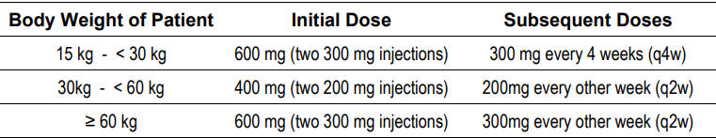
- Baricitinib (Olumiant), a selective and reversible inhibitor of JAK1 and JAK2. The approved AD indication is:
Olumiant is indicated for the treatment of moderate to severe atopic dermatitis (AD) in adult patients who are candidates for systemic therapy.
- Upadacitinib (Rinvoq), a selective and reversible inhibitor of JAK1. The approved AD indication is:
Rinvoq is indicated for use in adults and adolescents aged 12 years and above who weigh at least 40 kg, for the treatment of moderate to severe atopic dermatitis which is inadequately controlled with active topical pharmacotherapies and for whom systemic therapy is indicated.
Other systemic therapies approved internationally for the treatment of moderate to severe atopic dermatitis include tralokinumab and abrocitinib.

Regulatory status

Australian regulatory status
This product is considered a new biological entity for Australian regulatory purposes.

International regulatory status
USA: A Biologics License Application (BLA) was submitted on 28 September 2022. A Complete Response Letter was issued by the FDA on 28 September 2023 in response to deficiencies relating to drug substance and drug product manufacturing identified in a pre-license and surveillance inspection of a third-party supplier, Samsung Biologics Co. Ltd.
EU: Marketing authorisation was approved on 17 November 2023:
Ebglyss is indicated for the treatment of moderate-to-severe atopic dermatitis in adults and adolescents 12 years and older with a body weight of at least 40 kg who are candidates for systemic therapy.
Japan: Marketing authorisation was approved on 18 January 2024:
Atopic dermatitis patients who have inadequate response to conventional therapies.
Canada: Submitted 22 February 2023, approved 24 June 2024.

Regulatory guidance
Regulatory interactions with the FDA and EMA occurred throughout the development of lebrikizumab for AD and feedback from regulators was incorporated into the development program. Scientific advice was obtained from the FDA and the EMA following completion of the Phase 2 program, which was incorporated into the Phase 3 clinical development program.

Registration timeline
Table 2 captures the key steps and dates for this submission.
This submission was evaluated under the standard prescription medicines registration process.
Table 2: Timeline for Ebglyss submission
Description | Date
Submission dossier accepted and first round evaluation commenced | 1 May 2023
Evaluation completed | 4 January 2024
Delegate’s Overall benefit-risk assessment and request for Advisory Committee advice | 1 March 2024
Advisory Committee meeting | 22 April 2024
Registration decision (Outcome) | 16 May 2024
Registration in the ARTG | 29 May 2024
Number of working days from submission dossier acceptance to registration decision* | 245
*Statutory timeframe for standard submissions is 255 working days

Evaluation overview

Quality evaluation summary
Lebrikizumab is an IgG4 monoclonal antibody derived from genetically modified Chinese Hamster Ovary (CHO) cells. To increase the stability of the antibody, the hinge region is modified with a S226P substitution. The active ingredient is produced using recombinant DNA technology.
The drug substance and drug product manufacturing processes and controls are detailed in the evaluation report. The overall quality of the active substance was demonstrated via adequate control of the starting material, control of critical steps and intermediates, process validation, extensive characterisation using orthogonal and state-of-the-art analytical methods, control of impurities and contaminants, generation of robust reference materials, and batch analyses that covered multiple manufacturing campaigns.
Manufacturing concerns identified by the FDA in the Complete Response Letter were reviewed by the Module 3 evaluator and the Manufacturing Quality Branch. All of the questions raised in relation to those concerns were satisfactorily addressed by the Sponsor. This issue is considered resolved from a quality perspective.
The proposed presentation is a single-dose pre-filled pen (autoinjector) containing 250mg/2mL of lebrikizumab for administration by subcutaneous injection. The formulation development has been adequately described and the final formulation intended for marketing was used in the phase 3 clinical trials. All excipients are well known pharmaceutical ingredients and their quality is compliant with Ph. Eur/USP/JP standards. The container closure is considered suitable for its intended use as demonstrated by compatibility and stability studies.
The recommended shelf-life for the drug product in the autoinjector when stored in the original carton protected from light at 2°C to 8°C is 18 months. The recommended shipping temperature is +2°C to +15°C (for a period of up to 24 days). To further support this shipping temperature, the Sponsor has committed to submit the final results from the ongoing Definitive Shipping study and the Temperature Cycling study to the TGA via a Category 3 variation application and to report any confirmed out-of-specification results in these studies immediately to the TGA.
There is no objection from a manufacturing and quality perspective to the approval of Ebglyss lebrikizumab 250 mg /2 mL solution for injection autoinjector (pre-filled pen).

Nonclinical (toxicology) evaluation summary
The submitted Module 4 dossier was in accordance with the relevant ICH guideline for the non-clinical assessment of biological medicines (ICH S6[R1]). The overall quality of the non-clinical dossier was adequate. All pivotal safety-related studies were GLP compliant.
Most of the toxicity studies were conducted with early manufacturing batches of the drug. The comparability between the early and commercial manufacturing processes was not fully demonstrated in the Module 4 data, and the evaluator recommended that comparability needs to be adequately demonstrated by Module 3 data. This has been satisfactorily addressed in the Module 3 evaluation.
Primary pharmacology studies indicate that lebrikizumab is a relatively specific anti-IL-13 monoclonal antibody. However, direct evidence to support the proposed indication of atopic dermatitis is absent. No off-target sites were identified in a panel of human tissues. Lebrikizumab is not expected to induce complement dependent cytotoxicity or antibody dependent cellular cytotoxicity.
Safety pharmacology examinations incorporated in general repeat-dose toxicity studies in monkeys revealed no effects of lebrikizumab on the central nervous system, respiratory function, or cardiovascular endpoints.
The pharmacokinetics of lebrikizumab in monkeys and human subjects was generally consistent with the protein nature of the drug and was characterised by long half-lives and limited distribution.
Lebrikizumab had a low order of acute toxicity in monkeys.
Repeat-dose toxicity studies by the SC and IV route were conducted in sexually immature cynomolgus monkeys (up to 9 months). The studies in adolescent animals were adequately conducted, achieving sufficient relative exposures. Repeat-dose toxicity endpoints in adult monkeys were sourced from single sex, surrogate fertility studies of comparable duration and dose strength. No target organs for toxicity were identified in adult animals. In adolescent monkeys lower uterine weights were observed, but apart from this finding, lebrikizumab was generally well tolerated.
No genotoxicity studies were conducted. Given the protein nature of the drug this is considered acceptable. The Sponsor submitted a carcinogenicity risk assessment based on literature data for IL-13. Lebrikizumab is unlikely to convey an increased risk of cancer.
Reproductive and development studies performed in cynomolgus monkeys revealed no effects on male or female fertility surrogate endpoints, and no obvious treatment-related adverse effects on embryofetal or postnatal development.
Lebrikizumab was well tolerated locally in monkeys following SC administration. Given the pharmacological action of the drug, an increased susceptibility to infections cannot be completely excluded.
No clinically relevant toxicities were identified in adult animals. In sexually immature animals the effect of the drug on impaired uterus development cannot be unequivocally excluded but is not considered adverse. In the absence of any maternal or fetal effects in adequately conducted embryofetal development and pre- and post-natal development studies in cynomolgus monkeys, Pregnancy Category B1 is considered appropriate for this product.
There are no non-clinical objections to the registration of lebrikizumab. The proposed Product Information is acceptable from a non-clinical perspective.

Clinical evaluation summary

Summary of clinical studies
Clinical studies submitted with the initial application included:
- 7 Phase 1 clinical pharmacology studies (Table 3) in healthy volunteers (KGBB, KGBA, KGAZ, KGAY, KGBG, KGAM) and in patients with mild intermittent asthma (KGBF).
- 3 Phase 2 studies in adults with AD: KGAG, KGAH, KGAF (Table 4).
- 3 pivotal Phase 3 clinical efficacy and safety studies in adults and adolescents with AD: KGAB, KGAC, KGAD (Table 5).
- a completed open-label Phase 3 study: KGAE.
- an ongoing Phase 3 long-term extension study: KGAA.
- Population PK and PK-PD (exposure-response) analyses.
In addition, two completed, non-pivotal, supportive Phase 3 studies (KGAK, KGAL) were submitted during the course of the clinical evaluation providing additional safety data. The proposed commercial formulation was used in all AD clinical trials. The clinical evaluator has no objection to the registration of Ebglyss in the proposed indication.
Table 3. Lebrikizumab Phase 1 Clinical Pharmacology Studies
ID | Description | Population | Dosing Regimen | N
KGBB | Single-ascending dose, safety, tolerability, PK | HV | LEB/PBO bolus IVI over 15 minutes for 5 groups: 0.1 mg/kg; 0.3 mg/kg; 1.0 mg/kg; 3.0 mg/kg; or 5.0 mg/kg | 41
KGBF | Multiple-ascending dose, safety, tolerability, PK | Asthma | LEB/PO bolus IVI over 2-3 to 15 minutes, depending on volume, Q4W for 12 weeks (total of 4 doses) for 3 groups: 0.3 mg/kg; 1.0 mg/kg; or 3.0 mg/kg | 47
KGBA | Single-dose, safety, tolerability, PK | HV | Two groups: LEB 1 mg/kg bolus IVI over ~ 15 minutes; or LEB 1 mg/kg SC by syringe | 22
KGAZ | Single-dose, safety, tolerability, PK | HV – Japanese/ Caucasian | Three groups: LEB 125 mg (1 x SC injection of 125 mg); LEB 250 mg (2 x SC injections of 125 mg ); or PBO. | 60
KGBG | Single-dose, safety, tolerability, PK, BE (definitive) | HV | Two parallel groups: LEB 250 mg (2 x SC injections of 125 mg/L) via PFS-NSD; or LEB 250 mg (2 x SC injections of 125 mg/mL) via AI | 241
KGAY | Single dose, safety, tolerability, PK, “BE” (bridging) | HV | Two parallel groups: LEB 37.5 mg (0.3 mL of 125 mg/mL) SC by needle and syringe; or LEB 37.5 mg (1 mL of 37.5 mg/mL) SC by PFS-NSD | 176
KGAM | Single dose safety, tolerability, PK, “BE” (bridging) | HV | Two parallel groups: LEB 250 mg SC by two 1-mL (125 mg) syringes; or LEB 250 mg SC by one 2-mL (250 mg) syringe | 41
Abbreviations: BE = bioequivalence; PopPK = population pharmacokinetic analysis; HV = heathy volunteers; LEB = lebrikizumab; PBO = placebo; IVI = intravenous infusion; SC = subcutaneous; PFS-NSD = prefilled syringe with needle safety device; AI = autoinjector; N = total number of participants randomised; Q4W = every 4 weeks. Source: SCP, Table 2.7.2.1 plus CSR, KGBG.
Table 4. Lebrikizumab Phase 2 Studies
ID | Description | Population | Dosing Regimen | N
KGAG | Efficacy of LEB + TCS vs TCS, safety, PD biomarkers | AD adults | Week 0-12 dosing, 4 groups: LEB 250 mg sd SC + TCS; LEB 125 mg sd SC + TCS; LEB 125 mg Q4W × 3 SC i + TCS; or PBO Q4W SC + TCS | 212
KGAH | Safety of LEB monotherapy vs TCS, PK | AD adults | Week 0-12 dosing, 2 groups: LEB 125 mg SC Q4W × 3 (monotherapy); or TCS cream twice daily | 55
KGAF | Safety and efficacy of LEB vs PBO, PK | AD adults | Week 0-16 dosing, 4 groups: LEB 250 mg SC at baseline, followed by 125 mg Q4W × 3; LEB 500 mg SC at baseline, followed by 250 mg SC Q4W × 3; LEB 500 mg SC at baseline and Week 2, followed by 250 mg SC Q2W × 6; or PBO Q2W | 280
Abbreviations: LEB = lebrikizumab; PBO = placebo; TCS = topical corticosteroid; SC = subcutaneous injection; AD = moderate-to-severe atopic dermatitis; N = total number of participants randomised; Q2W = every 2 weeks; Q4W = every 4 weeks.
Table 5. Lebrikizumab Phase 3 Studies
ID | Description | Population | Dosing Regimen | N
KGAB | Pivotal efficacy and safety for LEB vs PBO, PK sparse sampling | AD – adults/  adolescents | Induction (WK 0-16): LEB loading dose 500 mg SC at WK 0 and 2, followed by 250 mg Q2W × 6, or PBO Q2W. Maintenance (WK 16-52): in the maintenance blinded period WK16 responders to LEB were re-randomised 2:2:1 to LEB Q2W, LEB Q4W or PBO Q2W; in the maintenance escape period non-responders received open-label LEB 250 mg Q2W through WK52 maintenance period. | 424
KGAC | Pivotal efficacy and safety for LEB vs PBO, PK sparse sampling | AD – adults/ adolescents | Same as KGAB | 445
KGAD | Pivotal efficacy and safety data for LEB + TCS vs PBO + TCS, PK | AD – adults/ adolescents | WK 0-16: LEB 500 mg SC at baseline and Week 2, followed by 250 mg Q2W × 6 + TCS; or PBO Q2W + TCS. TCS initiated at baseline could be tapered or stopped as warranted | 228
KGAA | Supportive long-term extension safety and efficacy data | AD – adults/ adolescents | Interim results to WK 40 for participants enrolling from KGAD and randomised 2:1 to 250 mg Q2W + TCS or 250 mg Q4W + TCS | 86
KGAE | Supportive single-arm efficacy and safety data, PK | AD - adolescents | WK 0-52: LEB 500 mg SC at baseline and Week 2, then 250 mg SC Q2W through Week 52 | 206 *
Abbreviations: HV = heathy volunteers; LEB = lebrikizumab; PBO = placebo; TCS = topical corticosteroid; SC = subcutaneous injection; AD – moderate-to-severe atopic dermatitis; N = total number of participants randomised (* apart from non-randomised study KGAE which included only one study arm); Q2W = every 2 weeks Q4W = every 4 weeks; WK = weeks.

Pharmacology
The clinical studies contributing to the PK and PD analyses (Table 6) are described in the clinical evaluation report and the main findings are summarised below.
Table 6. Summary of PK and PD Analyses for the Cross-Study Comparisons for Lebrikizumab
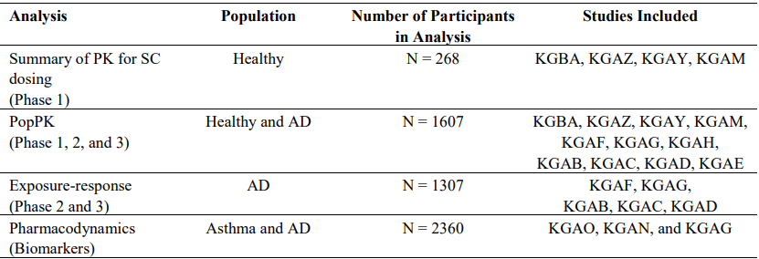

Pharmacokinetics
In the Phase 1 clinical pharmacology studies, the PK of lebrikizumab was assessed following IV doses over a range of 0.1 to 5.0 mg/kg and SC doses over a range of 37.5 to 375 mg. Following single SC doses of lebrikizumab in healthy participants, peak concentrations were achieved within 4 to 10 days across the Phase 1 studies (KGBA, KGAZ, KGAY, and KGAM). Lebrikizumab demonstrated linear PK with dose-proportional increase in exposure across single IV doses of 0.1 to 5.0 mg/kg in Study KGBB and across single SC doses of 125 to 375 mg in Study KGAZ.
In Study KGBA, the absolute bioavailability of lebrikizumab was 85% following a single-dose SC injection of 1 mg/kg based on AUC_{0-∞} (Table 7).
Table 7. Statistical analysis of PK data of lebrikizumab (SC injection relative to IV infusion) – Study KGBA
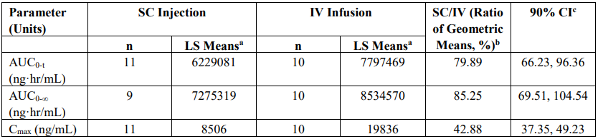
In the bioequivalence study KGBG comparing 250 mg single-dose SC administration with an autoinjector vs pre-filled syringe with needle safety device (PFS-NSD), peak concentration occurred ∼7 to 8 days post-administration. Bioequivalence was demonstrated for autoinjector (the presentation proposed for marketing in Australia) versus PFS-NSD (Table 8). PK exposure parameters were similar across injection sites (arm, thigh, or abdomen) and across the three stratified weight categories (<70 kg, 70–80 kg, >80 kg).
The relative bioavailability study KGAY (bridging study) demonstrated bioequivalence of lebrikizumab as a single SC dose of 37.5 mg (0.3 mL of 125 mg/mL solution) withdrawn from a vial and administered using a needle and syringe with a single SC dose of 37.5 mg (1 mL of a 37.5 mg/mL solution) administered using a PFS-NSD. The relative bioavailability study KGAM (bridging study) showed similar PK for 250 mg SC doses administered as two injections of 1 mL each vs one injection of 2 mL. The 90% CI of the geometric LSM ratio for lebrikizumab AUC_{last} was completely contained within the BE range, but the 90% CIs for the AUC_{inf}, and C_{max} were not contained completely within the range.
Table 8. Statistical Analysis of Serum Lebrikizumab Pharmacokinetic Parameters after Single Subcutaneous Administration of 2-mL (125 mg/mL) Lebrikizumab via AI (test) or PFS-NSD (reference) – Study KGBG
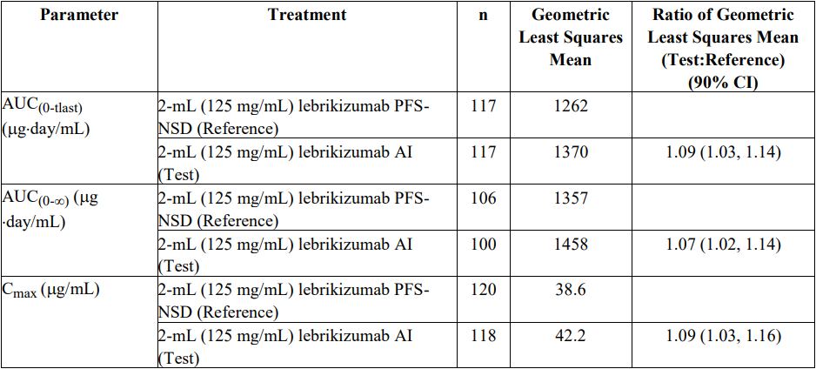
No studies on the metabolism of lebrikizumab have been conducted, but lebrikizumab is a monoclonal antibody and is expected to be degraded into small peptides and amino acids via catabolic pathways in the same manner as endogenous IgG. In Study KGBA, mean terminal half-life values were comparable between the IV group (24.7 days) and the SC group (26.0 days).
There were no dedicated PK studies in subjects with impaired hepatic function or impaired renal function. The PopPK analysis showed that markers of hepatic function (ALT and AST) and renal function (eGFR) did not affect the PK of lebrikizumab.
No drug interaction studies were conducted. No PK drug interactions are expected based on the characteristics of lebrikizumab.

Population PK data
The objectives of the population pharmacokinetics (PopPK) analysis were:
- to characterise the PK of lebrikizumab in adult and adolescent participants with AD.
- to identify patient factors and laboratory parameters that may influence lebrikizumab disposition in this patient population.
- to derive individual PK parameters/exposure metrics for the assessment of exposure-response (ER) relationships.
The PopPK analysis included data from four Phase 3 studies in patients with AD (KGAB, KGAC, KGAD, KGAE), three Phase 2 studies in patients with AD (KGAF, KGAG, KGAH), and four Phase 1 studies in healthy participants (KGAM, KGAY, KGAZ, KGBA). The final PopPK dataset comprised 6860 measurable observations from 1607 participants, including 304 adolescents (aged 12 to <18 years with body weight ≥ 40 kg).
The PK profile of lebrikizumab was best described by a 2-compartment model with first order absorption and linear elimination over a dose range of 37.5 mg to 500 mg when lebrikizumab was administered SC in healthy participants and patients with AD. Lebrikizumab bioavailability after SC administration was 86.1%. The total volume of distribution at steady state was 5.14 L. Clearance was 0.154 L/day and was independent of dose over the range 37.5 mg to 500 mg. The mean elimination half-life was 24.5 days.
Simulations of induction and maintenance dosing were performed, including the dosing regimen evaluated in the pivotal studies and proposed for registration (Figure 1). Following 500 mg loading doses at Weeks 0 and Week 2, steady-state serum concentrations were achieved at Week 4. After Week 4, lebrikizumab serum concentrations were consistent across the treatment period from Week 4 to Week 16 with 250 mg Q2W. For participants switching from 250 mg Q2W to 250 mg Q4W, the new lower steady-state concentrations were reached after 3 doses (12 weeks) on Q4W dosing. Simulated median lebrikizumab concentrations were ∼50% lower for 250 mg Q4W dosing compared to 250 mg Q2W dosing at Week 52.
Figure 1. Simulations of lebrikizumab concentration-time to 52 weeks (Phase 3 dosing regimens) using final PopPK model.
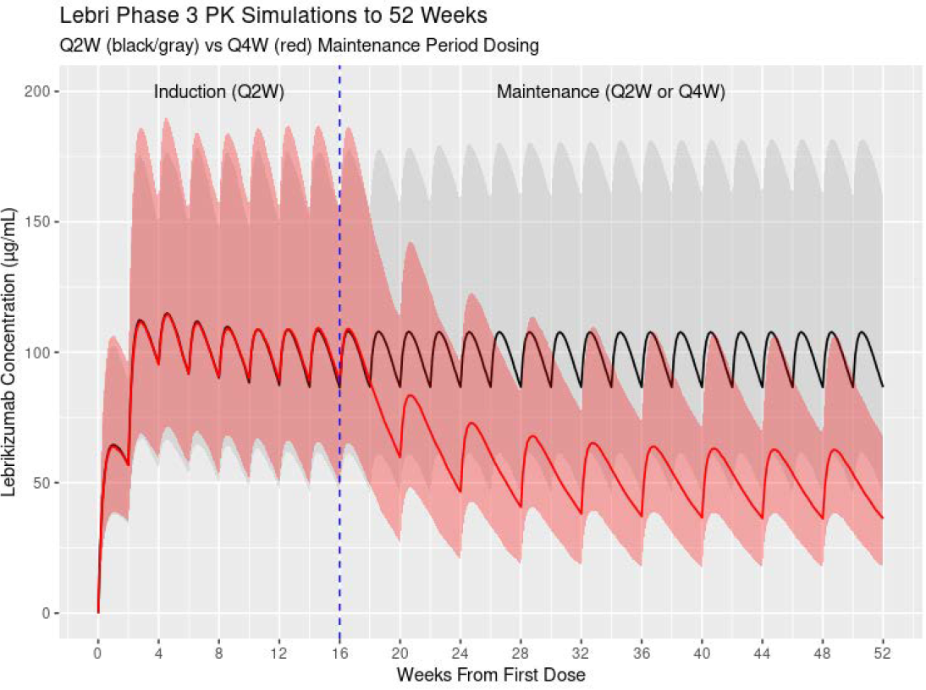
Notes: Simulated patients received 500 mg loading doses at Weeks 0 and 2, followed by 250 mg Q2W dosing until Week 16. At Week 16, 1 group remained on 250 mg Q2W (black/grey) and 1 group reduced their dose to 250 mg Q4W (red) for remainder of maintenance period to Week 52. Simulation of N = 500 participants for each group. Body weights for simulated participants were sampled from observed baseline weights of Phase 3 adults and adolescents in the PK dataset. Lines represent medians, and shaded areas represent 5th and 95th percentiles of simulated values at each time point.
Body weight was identified as a significant covariate on lebrikizumab clearance, inter-compartment clearance, central volume of distribution, and peripheral volume of distribution, but the analysis concluded that differences in body weight do not require dosage modification for the proposed treatment population. Simulations of 250 mg Q2W dosing at steady state showed that the highest and lowest quartiles for body weight had median lebrikizumab concentrations of 75.7 μg/mL and 133 μg/mL, respectively, compared to the overall population median of 100 μg/mL. The simulated median C_{trough,ss} values were above 50 µg/mL for the Q2W regimen for all body weight quartiles and generally 25 to 50 µg/mL for the Q4W regimen for all body weight quartiles.
Covariates assessed as having no significant influence on the PK of lebrikizumab included age, sex, race (Caucasian, African, Asian), injection site location (arm, abdomen, thigh), disease state (AD vs healthy), hepatic function (ALT, AST), and renal function (eGFR). The age of participants in the PopPK dataset ranged from 12 to 93 years, with 77 participants over the age of 65 years, 16 participants over the age of 75 years, and 304 adolescent participants (12 to <18 years of age, body weight ≥40 kg). Age was tested as both a categorical (adult or adolescent) and continuous covariate and was found not to have a significant effect on the PK of lebrikizumab. The PK exposure for adolescents was 17% to 21% higher than adults (Figure 2), consistent with the lower mean body weight in adolescents (66 kg) compared to adults (79 kg).
Figure 2. Simulations of lebrikizumab concentration-time to 52 weeks using final PopPK model for adults (black/grey) and adolescents (red). Phase 3 dosing regimens 500 mg loading doses at Weeks 0 and 2, then 250 mg Q2W doses to Week 16, then 250 mg Q2W (upper panel) or 250 mg Q4W (lower panel) from Week 16.
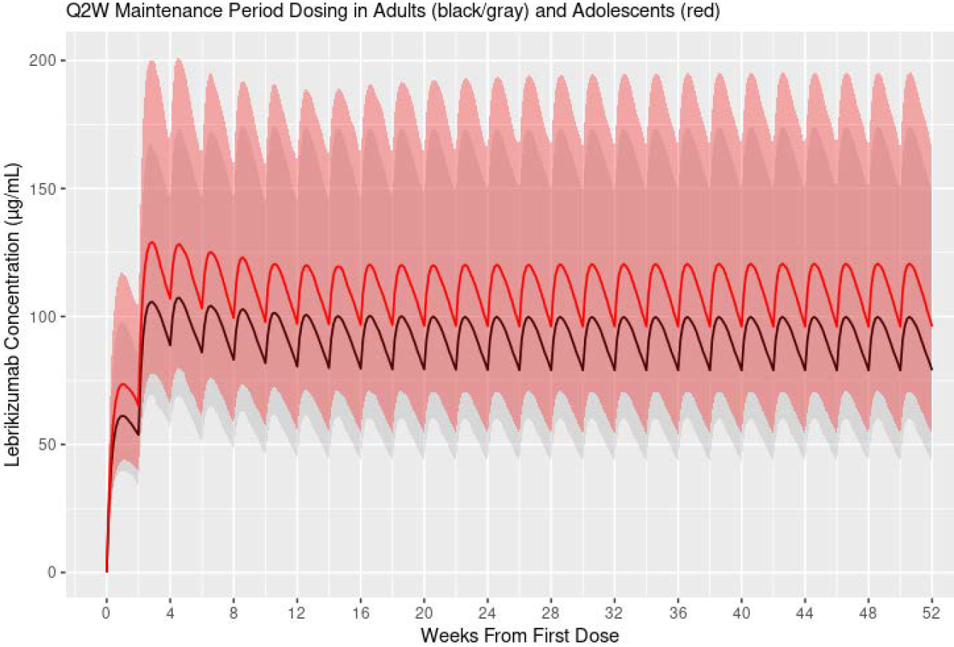
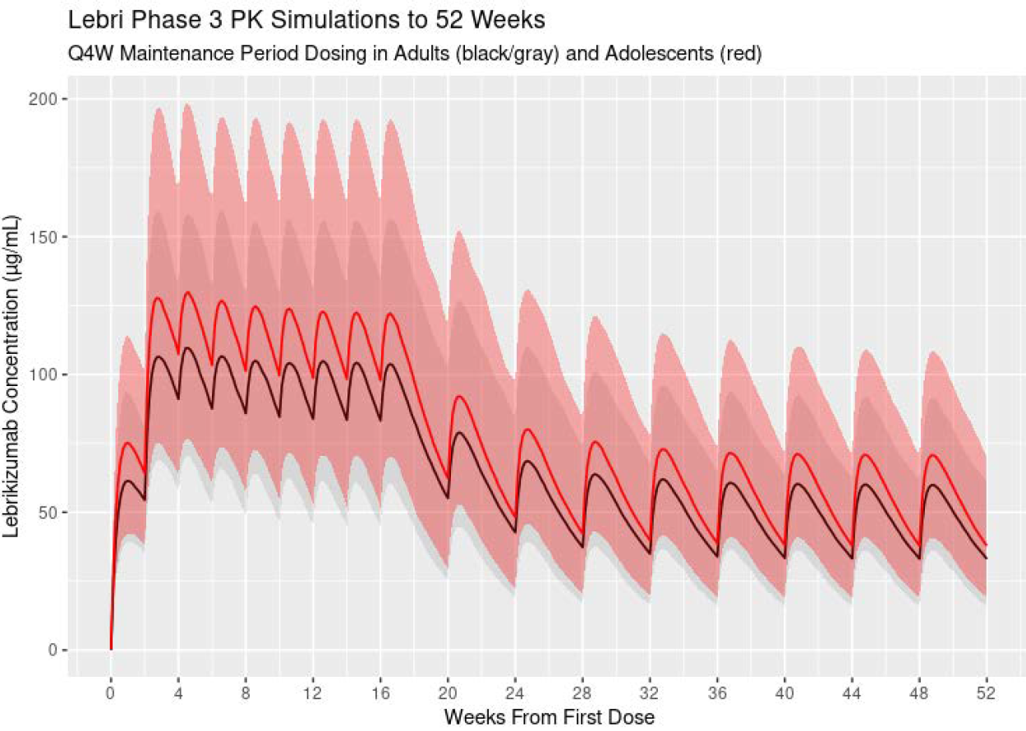

Pharmacodynamics
The pharmacodynamics (PD) of lebrikizumab was evaluated in a Phase 2 randomised, double-blind, placebo-controlled study in 212 patients with AD (Study KGAG) and in two Phase 3, randomised, double-blind, placebo-controlled studies in 2148 patients with asthma (Studies KGAN and KGAO). Multiple serum biomarkers were explored as potential markers of IL-13 activity, including serum periostin, IgE, CCL-13 (monocyte chemotactic protein-4), CCL-17 (thymus and activation-regulated chemokine), and CCL-18 (pulmonary and activation-regulated chemokine).
In Study KGAG, treatment with lebrikizumab (combined with TCS) generally appeared to have a greater effect compared to placebo (TCS only) on the levels of CCL-13, CCL-18, periostin, and IgE, but no dose-response relationship was observed. In Studies KGAN and KGAO in patients with asthma, treatment with lebrikizumab generally appeared to have a greater effect compared to placebo on the levels of CCL-13, CCL-17, periostin, and IgE. These findings provide indirect support for inhibition of the IL-13 pathway by lebrikizumab.

Exposure-response analysis
A PK/PD analysis was performed to characterise the relationship between exposure and Eczema Area and Severity Index (EASI) response to support the proposed dosing regimen. The E-R analysis included data from 1307 participants (131 adolescents and 1176 adults) with AD from 5 studies (KGAF, KGAG, KGAB, KGAC, KGAD). The maximum effect (E_{max} ) was estimated to be 0.831 (95% CI: 0.761, 0.883) and the lebrikizumab concentration that produces 50% of maximum effect (EC₅₀) was estimated to be 16.5 ug/mL (95% CI: 9.84, 27.6 ug/mL).
Simulations using the final E-R model predicted EASI responses with various induction regimens up to Week 24, with and without daily TCS (Figure 3). The EASI-75 and EASI-90 response rates were highest for the 500/250 mg Q2W regimen and the response curves tended to flatten after Week 16, supporting the induction regimen used in the pivotal Phase 3 studies (500 mg at Weeks 0 and 2 followed by 250 mg Q2W through to Week 16). The estimated effect of TCS usage (whether transitory or consistent) was small. Body weight was not found to be a statistically significant covariate in the PK-PD model.
Simulations were conducted to compare 250 mg Q2W and 250 mg Q4W dosing regimens for the maintenance period. For responders at Week 16, the simulations predicted that the 250 mg Q2W and Q4W regimens would maintain a similar percent change in EASI from Week 16 to Week 52 (Figure 4), and similar EASI-75 and EASI-90 response rates through to Week 52 (Figure 5). Non-responders had not achieved EASI 75 at Week 16, but EASI-75 response rates improved with maintenance treatment (Figure 6). EASI-75 response rates at Week 52 were numerically higher for Q2W vs Q4W (41% vs 26%), but with substantial overlap in the 95% confidence intervals. EASI-90 response rates remained low for non-responders at Week 16.
The simulations explored 250 mg QXW as maintenance dosing; 250 mg QXW dosing was not evaluated in the pivotal AD studies.
Figure 3. Simulations using the final E-R model of various induction dosing regimens up to Week 24 to illustrate the dose-response for lebrikizumab for EASI 75 and EASI 90, with and without daily use of TCS.
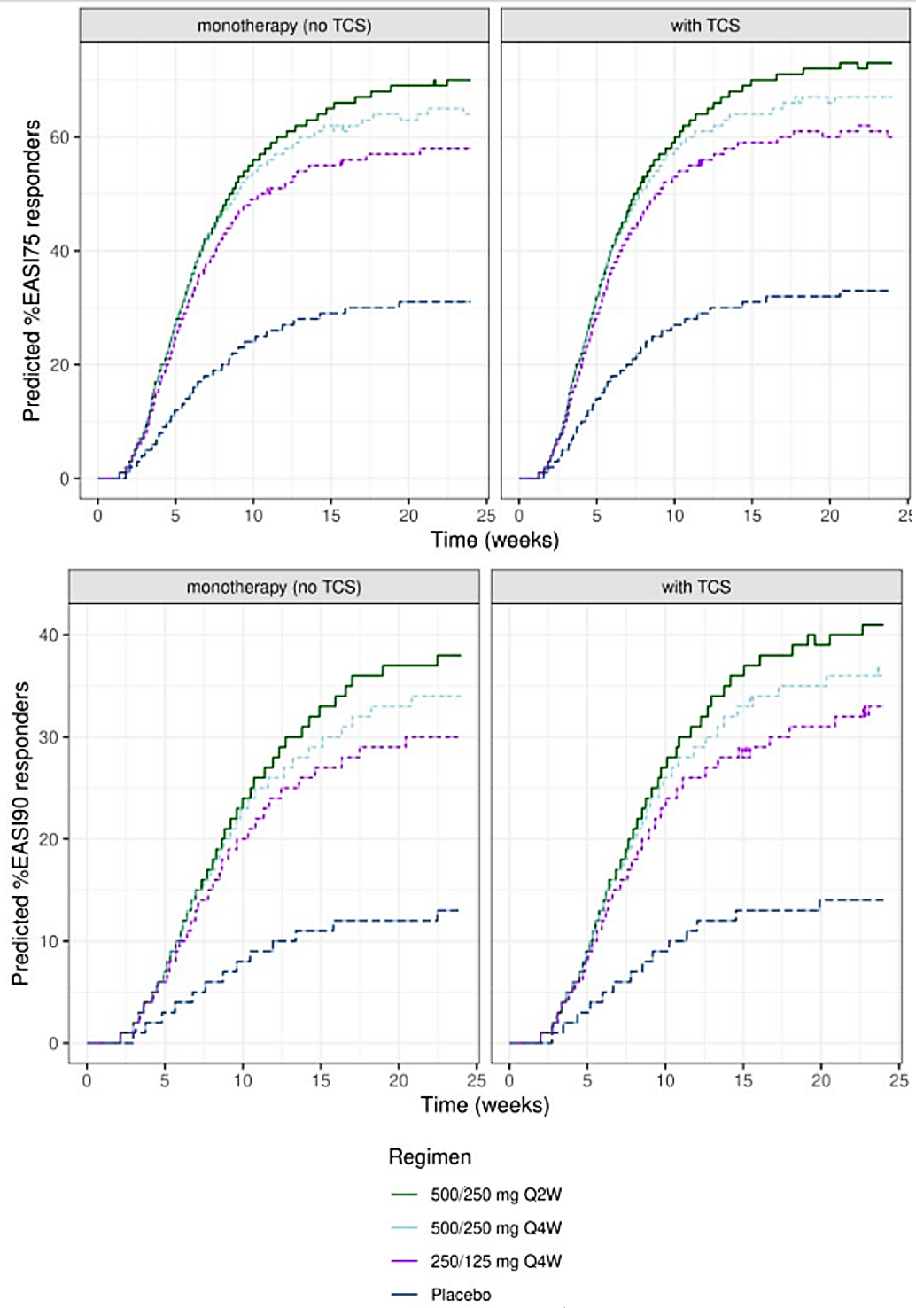
500/250 mg Q2W: loading doses of 500 mg at Weeks 0 and 2 followed by 250 mg Q2W; 500/250 mg Q4W: single loading dose of 500 mg followed by 250 mg Q4W; 250/125 mg Q2W: single loading dose of 250 mg followed by 125 mg Q4W.
Figure 4. Simulated EASI percent change from baseline for Week 16 responders and non-responders
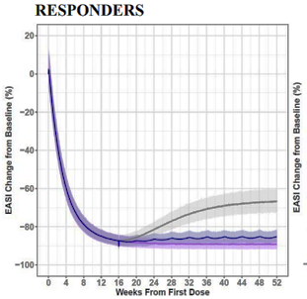
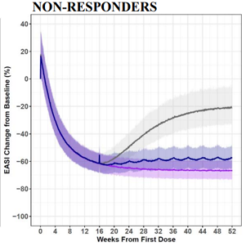
Coloured lines and shaded regions show median and 95% CI of simulated values, respectively, for each regimen.
Figure 5. Simulated EASI-75 (upper panels) and EASI-90 (lower panels) for Week 16 responders (left panels) and non-responders (right panels).
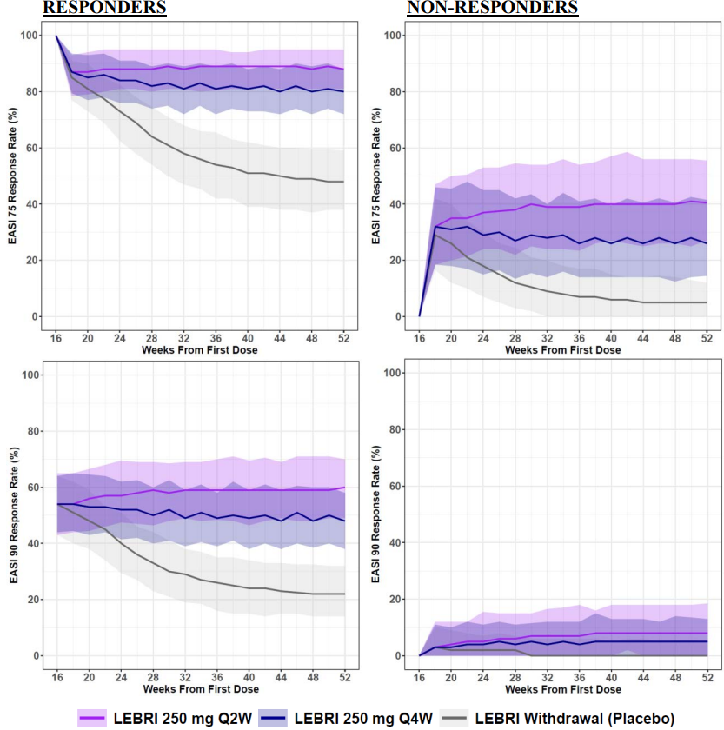
Coloured lines and shaded regions show median and 95% CI of simulated values, respectively, for each regimen.

Phase 2 studies

Study KGAF
This was a Phase 2b, randomised, double-blind, placebo-controlled, dose-ranging trial designed to evaluate the efficacy and safety of lebrikizumab in adult patients with moderate to severe AD. The study was conducted in the USA from January 2018 to May 2019.
The study included a screening period (up to 4 weeks), a treatment period (Baseline to Week 16), and a follow-up period (Week 16 to Week 32). Patients were randomised 3:3:3:2 to:
- Baseline loading dose of LEB 250 mg, followed by LEB 125 mg Q4W.
- Baseline loading dose of LEB 500 mg, followed by LEB 250 mg Q4W.
- Baseline and Week 2 loading doses of LEB 500 mg, followed by LEB 250 mg Q2W.
- Placebo Q2W.
The primary efficacy endpoint was the percent change in EASI from baseline to Week 16 and key secondary efficacy endpoints were EASI-75 at Week 16 and IGA 0,1 with a ≥2-point reduction from baseline to Week 16 (Table 9).
Table 9. KGAF – Summary of Primary and Select Secondary Endpoints at Week 16
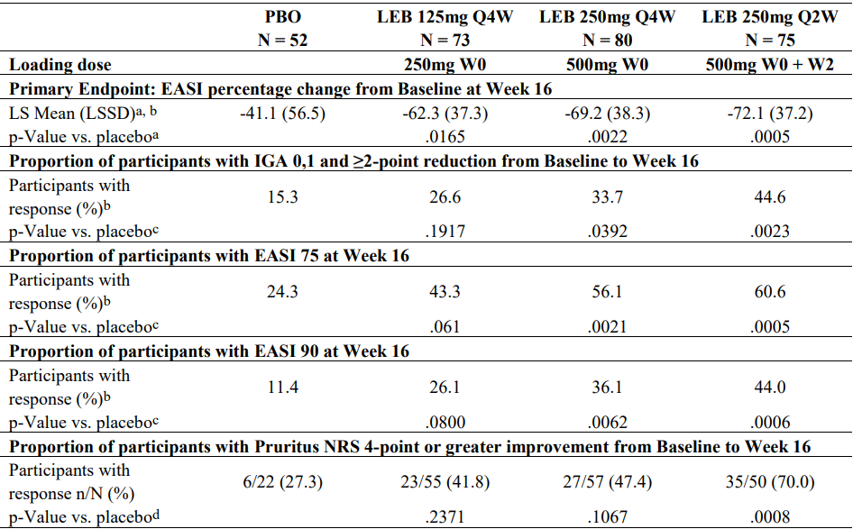Source: Table 2.7.3.8, Summary of Clinical Efficacy.

Study KGAG
This was a multinational, Phase 2, randomised, double-blind, placebo-controlled trial designed to evaluate the safety and efficacy of lebrikizumab in combination with TCS in adult patients with persistent moderate to severe AD for at least a year, inadequately controlled by TCS. The study was conducted from May 2015 to April 2016.
Patients were randomised to one of four treatment groups: (1) LEB 250 mg SC single-dose (Day 1) followed by 2 placebo doses (Weeks 4 and 8) + TCS; (2) LEB 125 mg SC single-dose (Day 1) followed by 2 placebo doses (Weeks 4 and 8) + TCS; (3) LEB 125 mg SC Q4W for a total of 3 doses + TCS; and (4) placebo SC Q4W for a total of 3 doses + TCS. The primary efficacy endpoint was the percentage of patients achieving EASI-50 at Week 12. A statistically significant difference was observed for treatment group 3 vs treatment group 4 (82.4% vs 62.3%; Δ = 20.1% [95% CI: 3.4, 36.8], p=0.0261). There was no statistically significant difference between either of the single-dose lebrikizumab regimens and placebo.

Study KGAH
This was a Phase 2, randomised, open-label, clinical trial designed to evaluate the safety of lebrikizumab monotherapy in adult patients with persistent moderate to severe AD inadequately controlled by TCS. The study was conducted in USA and Canada from June 2015 to May 2016. Study treatment was 3 doses of lebrikizumab 125 mg Q4W SC monotherapy or TCS cream administered twice a day (Weeks 0 to 12). Efficacy endpoints were exploratory. Two (7.1%) patients in the LEB 125 mg Q4W arm achieved IGA 0,1 at Week 12 compared to 7 (25.9%) patients in the TCS arm, a difference of 18.8% (95% CI: 0.3, 37.3) in favour of the TCS arm. The proportion of patients achieving EASI-75 at Week 12 was similar for the two arms: 11 (39.3%) patients in the LEB 125 mg Q4W arm vs 10 (37.0%) patients in the TCS arm.

Dose selection for the pivotal studies
The induction dosing regimen in the Phase 3 trials was 500 mg at Weeks 0 and 2, followed by 250 mg Q2W from Weeks 4 to 16. This regimen was informed by the Phase 2b Study KGAF which demonstrated a dose-response over the range of doses tested and an acceptable safety profile. Pop PK simulations predicted that administration of 500 mg loading doses at Week 0 and Week 2 would achieve steady-state concentrations by Week 4, whereas 250 mg Q2W without loading doses would achieve steady-state concentrations at ∼Week 12. Maintenance dosing regimens evaluated in the Phase 3 trials were 250 mg Q2W or 250 mg Q4W starting at Week 16 for responders based on EASI-75 or IGA 0,1. Non-responders at Week 16 received 250 mg Q2W in the maintenance period. These regimens were informed by the exposure-response analyses.

Efficacy
The dossier included three pivotal Phase 3 studies, two assessing lebrikizumab as monotherapy (KGAB, KGAC) and one in combination with TCS (KGAD), plus two supportive single-arm studies (KGAE, KGAA). The formulation used in the Phase 3 studies was the same as the proposed commercial formulation.
Efficacy measures evaluated in the clinical trials include the Investigator’s Global Assessment (IGA) scale, the Eczema Area and Severity Index (EASI), and patient-reported outcomes including the Pruritis Numeric Rating Scale (NRS), Dermatology Life Quality Index (DLQI), Sleep-Loss Scale, Patient-Oriented Eczema Measure (POEM), and Patient-Reported Outcomes Measurement Information System (PROMIS®) Anxiety and Depression measures.

Pivotal monotherapy studies: KGAB (ADvocate 1) and KGAC (ADvocate 2)
The two pivotal monotherapy studies, KGAB and KGAC, shared the same design. They were Phase 3, randomised, double-blind, placebo-controlled, parallel-group trials of 52 weeks duration designed to confirm the efficacy and safety of lebrikizumab as monotherapy in adults and adolescents with moderate to severe AD. Study KGAB was conducted at 89 centres in Australia, Canada, Estonia, France, Latvia, Lithuania, Poland, South Korea, Spain, and USA from September 2019 to May 2022. Study KGAC was conducted at 82 centres in Bulgaria, Canada, Germany, Mexico, Singapore, Taiwan, Ukraine, and USA from October 2019 to April 2022.
The study design (Figure 6) included a 16-week induction period in which participants were randomised 2:1 to lebrikizumab (500 mg loading doses at Baseline and Week 2 and 250 mg Q2W from Week 4 through Week 14) or matching placebo, with stratification based on geographic region (US vs EU vs rest of world), age (adolescents aged 12 to <18 years vs adults ≥ 18 years), and disease severity (IGA score of 3 vs 4). The induction period was followed by a 36-week blinded maintenance period in which lebrikizumab responders at Week 16 were re-randomised 2:2:1 to lebrikizumab 250 mg Q2W, lebrikizumab 250 mg Q4W, or placebo (lebrikizumab withdrawal). Non-responders at Week 16 and participants who received topical or systemic rescue therapy from Baseline to Week 16 were assigned to an escape arm and received open-label lebrikizumab 250 mg Q2W through Week 52. Responders at Week 16 who did not maintain an EASI-50 response at Weeks 24, 32, 40, or 48 were also assigned to the escape arm and received open-label lebrikizumab 250 mg Q2W through Week 52. Participants in the escape arm not achieving an EASI 50 response after 8 weeks of treatment were discontinued from the study.
Figure 6. Study design, KGAB and KGAC.
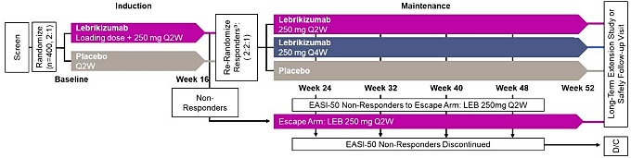
Study drug was supplied as a pre-filled syringe (lebrikizumab 250 mg in 2 mL or matching placebo) for subcutaneous injection. In the induction period, study drug was administered in the clinic. In the maintenance period, participants were instructed to self-administer the study drug at home.
The key inclusion criteria were:
- adults or adolescents (aged 12 to <18 years and weighing 40 kg or more)
- diagnosis of chronic AD as defined by the American Academy of Dermatology Consensus Criteria, for at least 1 year before the screening visit
- moderate-to-severe AD, defined as having all the following at the Baseline visit
  - EASI ≥16
  - IGA score ≥3
  - BSA ≥10%
- a candidate for systemic therapy.
The exclusion criteria included:
- prior treatment with dupilumab or tralokinumab.
- treatment with TCS, TCI, or PDE-4 inhibitor within 1 week prior to the Baseline visit.
- treatment with immunosuppressive or immunomodulating drugs within 4 weeks prior to the Baseline visit.
- treatment with phototherapy and photochemotherapy within 4 weeks prior to the Baseline visit.
Efficacy endpoints were informed by regulatory guidance from the FDA and EMA. The FDA defined a single primary efficacy endpoint and the EMA defined two co-primary endpoints (Table 10). The major secondary efficacy endpoints specified by the FDA and EMA for the induction period are summarised in Table 11. The FDA did not specify any major secondary efficacy endpoints for the maintenance period, but the EMA included major secondary efficacy endpoints for the maintenance period in their testing scheme (Table 12).
A pre-specified graphical multiple testing approach was used to control the overall Type I error rate at 2-sided alpha of 0.05 for superiority tests for all primary and major secondary endpoints. For the FDA and the EMA, the primary and major secondary endpoints in the induction period were included in the graphical testing scheme, and for the EMA the major secondary endpoints in the maintenance period were separately controlled using a graphical testing scheme.
Efficacy analyses for the Induction Period were conducted on the ITT population for Study KGAB (n=424) and the mITT population for Study KGAC (n=427). Efficacy analyses for the Maintenance Blinded Period were conducted on the Maintenance Primary Population (MPP) for Study KGAB (n=157) and the modified MPP for Study KGAC (n=134). Both studies included a comprehensive analysis of the efficacy data based on primary and supportive estimands for the induction and maintenance periods.
Table 10. KGAB and KGAC – Primary efficacy endpoints for the induction period.
Primary efficacy endpoints for induction period | FDA | EMA
Percentage of patients with an IGA score of 0 or 1 and a reduction ≥ 2 points from Baseline to Week 16. | X | X
Percentage of patients achieving EASI-75 (≥ 75% reduction from Baseline in EASI) at Week 16 | - | X
Table 11. KGAB and KGAC – Major secondary efficacy endpoints for the induction period.
Major Secondary efficacy endpoints for induction period | FDA | EMA
Percentage of patients achieving EASI-75 (≥ 75% reduction from Baseline in EASI) at Week 16 | X | Co-P
Percentage of patients achieving EASI-90 (≥ 90% reduction from Baseline in EASI) at Week 16 | X | X
Percentage change in Pruritus Numeric Rating Scale (NRS) score from Baseline to Week 16 | - | X
Percentage of participants with a Pruritus NRS score ≥ 4 points at Baseline who achieve a ≥ 4-point reduction from Baseline to Week 16 | X | X
Percentage change in EASI from Baseline to Week 16 | - | X
Percentage of patients achieving EASI-90 (≥ 90% reduction from Baseline in EASI) at Week 4 | - | X
Percentage of patients with a Sleep-Loss Scale score ≥2 points at Baseline who achieve a ≥ 2 points reduction from Baseline at Week 16. | X | X
Change from Baseline in Sleep-Loss Scale score at Week 16 | - | X
Percentage of participants with a Pruritus NRS score ≥ 4 points at Baseline who achieve a ≥ 4-point reduction from Baseline to Week 4 | X | X
Percentage of participants with a Pruritus NRS score ≥ 4points at Baseline who achieve a ≥ 4-point reduction from Baseline to Week 2 | X | X
Percentage of patients with an IGA score of 0 or 1 and a reduction ≥ 2 points at Week 4. | X | -
Percentage of patients with an IGA score of 0 or 1 and a reduction ≥ 2 points at Week 16 in adults. | X | -
Change from Baseline in Dermatology Life Quality Index (DLQI) total score at Week 16 | - | X
Percentage of patients with a DLQI score of ≥ 4 points at Baseline who achieve a ≥ 4 -point improvement from Baseline to Week 16 | - | X

Table 12. KGAB and KGAC – Major secondary efficacy endpoints for the maintenance period specified by the EMA for the graphical testing scheme.
Major Secondary Endpoints for the Maintenance Blinded Period specified by the EMA for the graphical testing scheme
Percentage of patients from those re-randomised to Q2W or Q4W having achieved EASI-75 at Week 16 who continue to exhibit EASI-75 at Week 52 (EASI-75 calculated relative to Baseline EASI).
Percentage of patients from those re-randomised to Q2W or Q4W having achieved IGA 0 or 1 and a ≥ 2-point improvement from Baseline at Week 16 who continue to exhibit an IGA 0 or 1 and a ≥ 2-point improvement from Baseline at Week 52
Percentage of patients from those with a Pruritus NRS of ≥4-points at baseline and re-randomised to Q4W maintenance therapy having achieved ≥4-point reduction from baseline at Week 16 who continue to exhibit ≥4-point reduction from baseline at Week 52
Percentage change in EASI Score from baseline to Week 52 for those patients re-randomised to Q2W or Q4W maintenance therapy at Week 16

In Study KGAB, 536 patients were screened and 424 patients were enrolled and randomised to study treatment. In Study KGAC, 606 patients were screened and 445 patients were enrolled and randomised to study treatment. The SAP for KGAC was revised following the closure of 1 study site identified in a site audit as producing unreliable data due to non-compliance with protocol entry criteria related to severity of AD at baseline. 18 participants from that study site were excluded from efficacy analyses, resulting in a modified ITT population of 427. Disposition in the induction and maintenance periods is summarised in Table 13 and Table 14, respectively.
Table 13. Disposition in the Induction Period
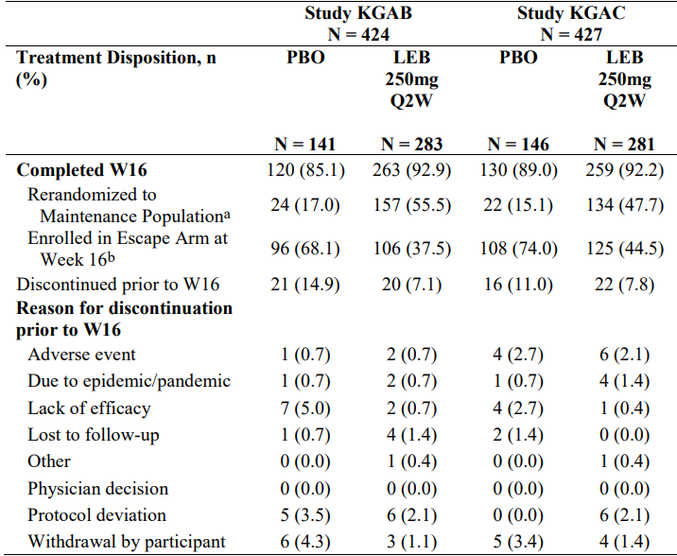
ª 7 participants in Study KGAB and 3 participants in Study KGAC were erroneously re-randomised at Week 16.
^{b} 6 participants in Study KGAB and 14 participants in Study KGAC were erroneously assigned to the Escape Arm at Week 16.
Table 14. Disposition in the Maintenance Period for lebrikizumab responders re-randomised at Week 16
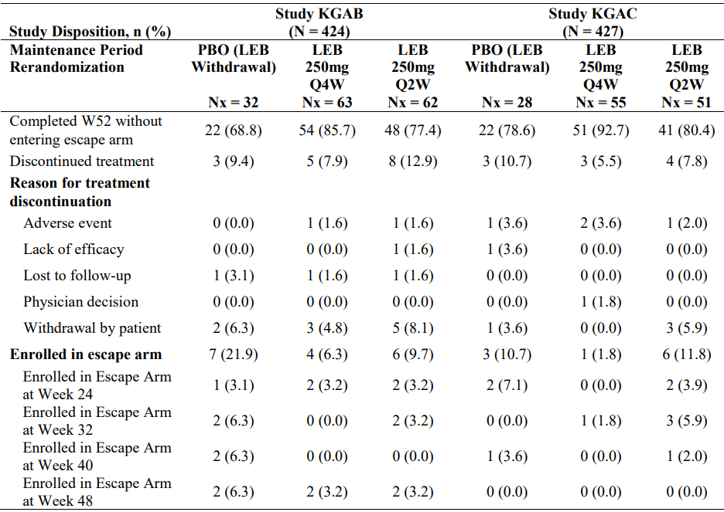

Demographic and baseline disease characteristics are summarised in Table 15 and Table 16. Across the two studies, 88% of participants were adults and 12% were adolescents. 61.5% had IGA score of 3 (moderate) and 38.5% had IGA score of 4 (severe). Mean EASI score was 29.6. Prior AD treatment history was well balanced across the treatment arms in both studies. Per protocol, all participants were required to wash-out topical and systemic therapy prior to randomisation. Concomitant AD therapies were prohibited during the study unless part of rescue therapy.
Table 15. Summary of Participant Demographics
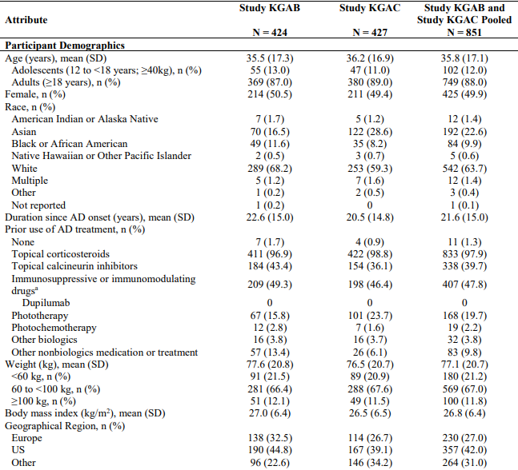
Table 16. Summary of Baseline Disease Characteristics
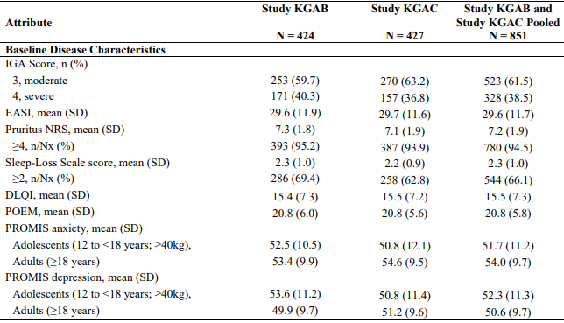
The primary endpoints specified by the FDA and EMA were met in both studies. The percentage of participants with IGA score 0 or 1, with ≥ 2-point reduction from baseline at Week 16 (FDA primary, EMA co-primary) was significantly greater in the lebrikizumab arm compared to placebo in both studies (Table 17). Both studies demonstrated superiority of lebrikizumab to placebo at Week 16, with a significant benefit observed from Week 4 in both studies (Figure 7).
Table 17. IGA 0 or 1 with ≥2-Point Reduction at Week 16, primary estimand (hybrid) with MCMC-MI
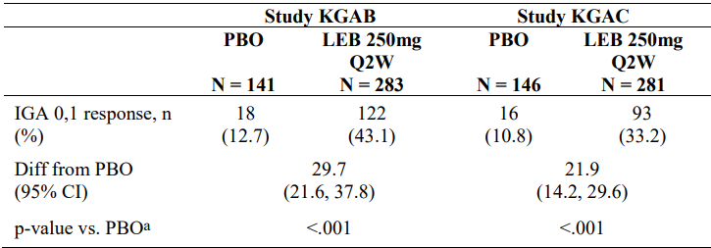
MCMC-MI = Markov Chain Monte Carlo multiple imputation. ª Cochran-Mantel-Haenszel test adjusted by geographic region (US versus EU versus rest of world), age (adolescent versus adult), and disease severity (IGA 3 versus 4).
Figure 7. Proportion of participants achieving IGA 0 or 1 with a ≥2-point improvement from baseline through Week 16, primary estimand (hybrid) with MCMC-MI
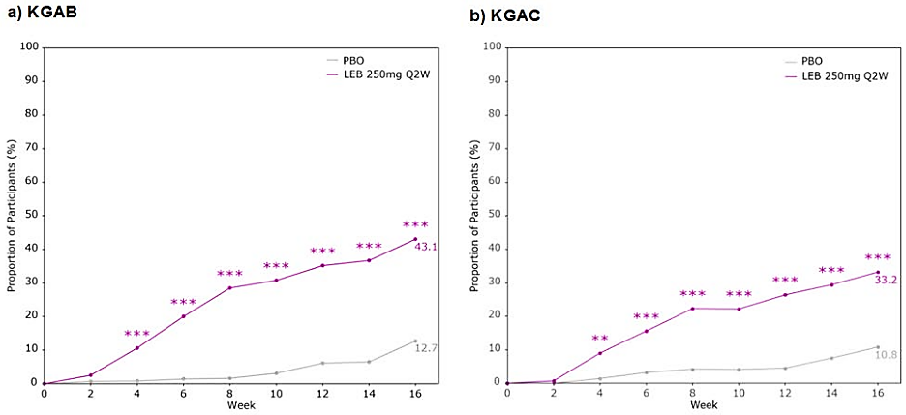
LEB vs PBO: *p <0.05, **p <0.01, ***p <0.001.
The percentage of participants achieving EASI-75 at Week 16 (EMA co-primary, FDA major secondary) was significantly greater in the lebrikizumab arm compared to placebo in both studies (Table 18). Both studies demonstrated superiority of lebrikizumab to placebo at Week 16, with a significant benefit observed from Week 2 and Week 4 in KGAB and KGAC, respectively (Figure 8).
Table 18. Percentage of participants achieving EASI-75 at week 16.
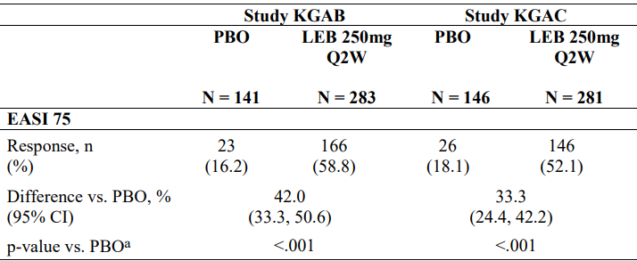
ª Cochran-Mantel-Haenszel test adjusted by geographic region (US versus EU versus rest of world), age (adolescent versus adult), and disease severity (IGA 3 versus 4).
Figure 8. Proportion of participants achieving EASI-75 from baseline through Week 16.
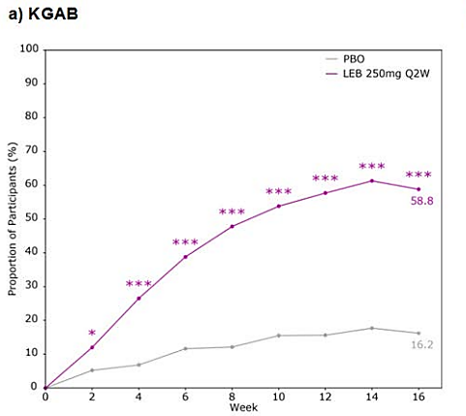
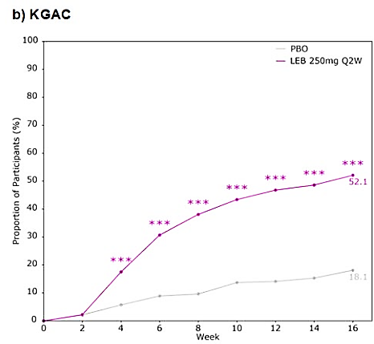
LEB vs PBO = *p <0.05, **p <0.01, ***p <0.001.
In Study KGAB, treatment with lebrikizumab resulted in statistically significant improvement compared to placebo in all FDA and EMA major secondary endpoints in the induction period (Table 19). In Study KGAC, treatment with lebrikizumab resulted in statistically significant improvement compared to placebo in all FDA and EMA major secondary endpoints in the induction period, except for percentage of participants with a Pruritus NRS score of ≥ 4 points at baseline who achieved a ≥ 4-point reduction from baseline to Week 2. That endpoint favoured lebrikizumab but did not reach statistical significance (3.6% lebrikizumab vs 0.7% placebo, 95% CI -0.1, 5.4; p=0.113).
Subgroup analyses of pooled data from KGAB and KGAC were generally consistent with the overall population (Figure 9). There was a trend to greater treatment effect in participants <60 kg and lesser treatment effect in participants ≥100 kg. Findings in adolescents were similar to adults, with numerically higher responses in adolescents consistent with lower body weight.
Table 19. Major secondary efficacy endpoints in the induction period.
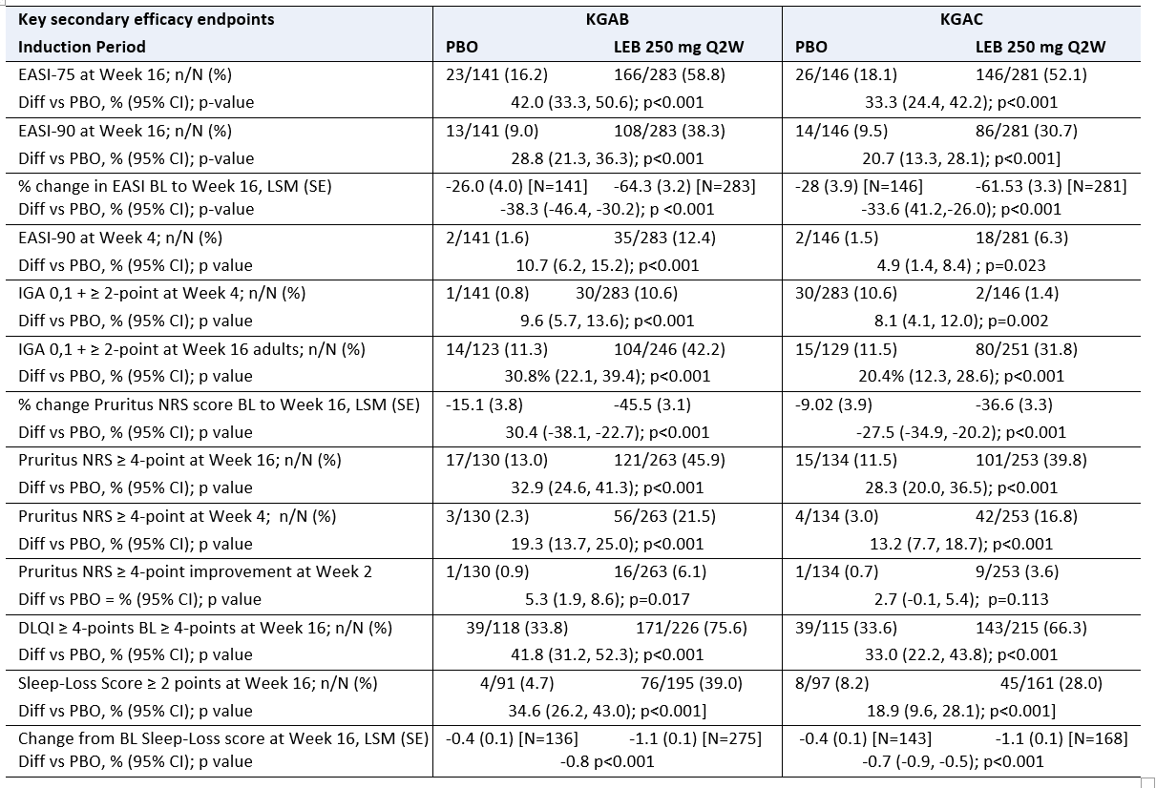
Note: The analyses of reduction of at least 4 points in the pruritus NRS scores at weeks 16, 4 and 2 were assessed only in patients who had a score of 4 at baseline. The analyses of reduction of at least 2 points in the Sleep-Loss Scale score from baseline to weeks 16 was assessed only in patients who had a score of at least 2 at baseline.
Figure 9. Subgroup analysis of pooled data from the Induction Periods of KGAB and KGAC at Week 16
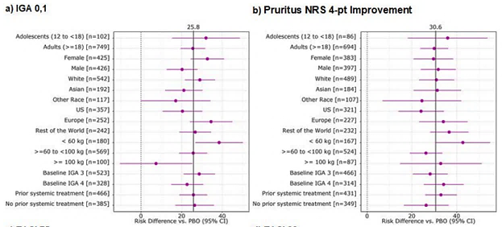
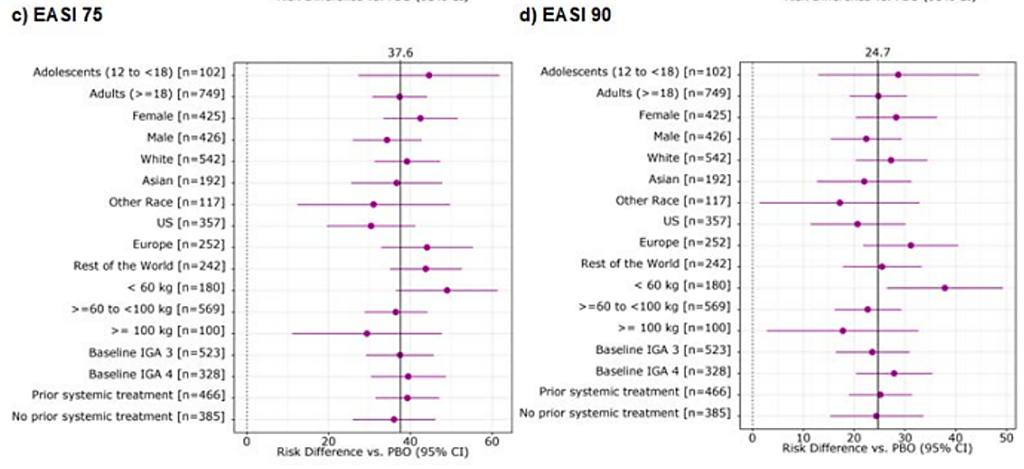

Maintenance blinded period
The EMA specified four major secondary endpoints for the maintenance blinded period. Efficacy in the maintenance period was evaluated in lebrikizumab responders at Week 16 who were then re-randomised to treatment with lebrikizumab 250 mg Q4W, 250 mg Q2W, or placebo (lebrikizumab withdrawal). Results for the major secondary endpoints for the maintenance blinded period are shown in Table 20. In both studies, efficacy findings at Week 52 were generally similar for the two lebrikizumab arms, and numerically favoured the lebrikizumab arms compared to placebo. Based on the pre-specified graphical testing scheme to control for multiplicity, none of the major secondary efficacy endpoints in the maintenance period were statistically significant for either of the lebrikizumab arms compared to placebo. In the pooled analysis (KGAB & KGAC), there was a nominally significant benefit with 250 mg Q4W maintenance treatment compared to placebo for EASI-75 and IGO 0,1 at Week 52 (Figure 10).
Table 20. Major secondary endpoints for the maintenance blinded period.
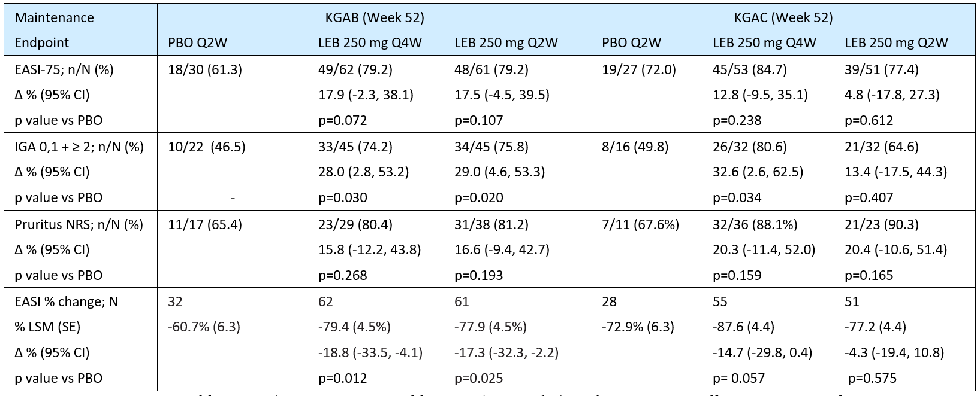
EASI-75 = Percentage of patients from those randomly re-assigned having achieved EASI-75 at Week 16 who continued to exhibit EASI-75 at Week 52 (EASI-75 calculated relative to baseline EASI). IGA 0,1 + ≥ 2 = Percentage of patients from those randomly re-assigned having achieved an IGA score of 0 or 1 and a ≥ 2-point improvement from baseline at Week 16 who continued to exhibit an IGA score of 0 or 1 and a ≥2-point improvement from baseline at Week 52. Pruritus NRS = Percentage of participants from those with a score of ≥ 4 points at Baseline randomly reassigned after achieving a ≥ 4-point reduction from Baseline at Week 16 who continue to exhibit ≥ 4-point reduction from Baseline at Week 52. EASI % change: Percentage change in EASI from Baseline at Week 52 in the subset of patients who were randomly re-assigned at Week 16. Source: CSR Table KGAB.5.2 & Table KGAC5.2.
Figure 10. Proportion of participants maintaining IGA 0 or 1 with ≥ 2-point improvement from Baseline (left panel) and proportion of participants maintaining EASI-75 (right panel), Week 16 through Week 52, Pooled Population KGAB and KGAC.
IGO 0,1 with ≥2-point improvement
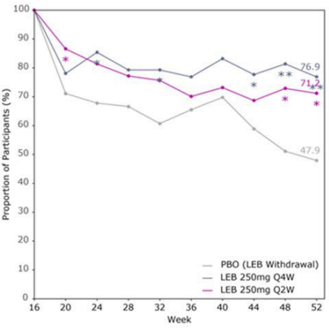
EASI-75 response
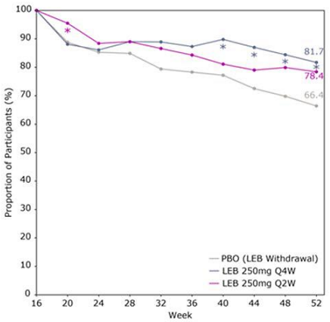
vs. PBO: *p <0.05, **p <0.01, ***p <0.001.

Rescue therapy
Participants who experienced intolerable AD symptoms could use rescue therapy, including topical (TCS, TCI, crisaborole) and systemic treatments (systemic corticosteroids, immunosuppressants, biologics, phototherapy or photochemotherapy). The most commonly used rescue treatments during both the induction and maintenance blinded periods of both studies were TCS.
During the induction period of KGAB, TCS use was higher in the placebo than the lebrikizumab arm (29.8% vs 8.5%, respectively), and systemic corticosteroids were used in 6.4% and 2.1%, respectively. During the induction period of KGAC, TCS use was higher in the placebo than the lebrikizumab arm (37% vs 16.7%, respectively), and systemic corticosteroids were used by 5.5% and 2.5%, respectively. In the pooled studies KGAB and KGAC, any rescue therapy used in the maintenance period (Week 16 to Week 52) were used by 11 (18.3%) participants in the placebo group, 19 (16.1%) participants in the 250 mg Q4W group, and 14 (12.4%) participants in the 250 mg Q2W group.

Maintenance treatment in the escape population
Participants assigned to the escape arm received open-label lebrikizumab 250 mg Q2W during the maintenance period. Responses during the maintenance period were similar for participants originally assigned to lebrikizumab or placebo (Figure 11).
Figure 11. Proportion of participants achieving (a) IGA 0,1 or (b) EASI 75 during Maintenance Period, among Maintenance Week 16 Escape Population (pooled Studies KGAB and KGAC, observed data).
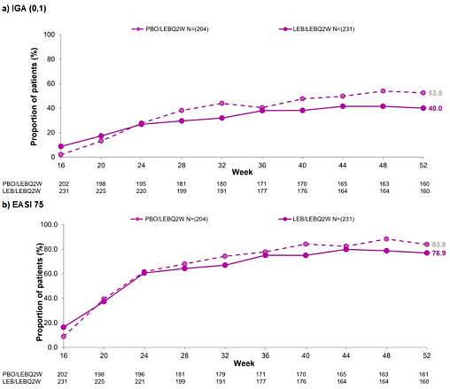

Pivotal study in combination with TCS: Study KGAD (ADhere)
This was a Phase 3, multicentre, randomised, double-blind, placebo-controlled, parallel-group clinical trial of 16 weeks duration in adults (aged >18 years) and adolescents (aged 12 to <18 years weighing ≥40 kg). The study objective was to evaluate the safety and efficacy of lebrikizumab in combination with TCS compared with placebo in combination with TCS in patients with moderate-to-severe AD. The study was conducted at 54 centres in Canada, Germany, Poland, and USA between February 2020 and September 2021. Participants completing the 16-week treatment period were offered continued treatment in a separate long-term extension safety study (KGAA). The study design is shown in Figure 12.
The key inclusion criteria were:
- adults or adolescents (aged 12 years to < 18 years and weighing ≥ 40 kg).
- diagnosis of chronic AD as defined by the American Academy of Dermatology Consensus Criteria, for at least 1 year before the screening visit.
- moderate-to-severe AD, defined as having all the following at the baseline visit: EASI ≥ 16; IGA score ≥ 3; and BSA ≥ 10%.
- history of inadequate response to treatment with topical medications.
- candidate for systemic therapy.
Participants were required to have stopped treatment with TCS, TCI, or PDE-4 inhibitor within 1 week prior to the Baseline visit, and treatment with immunosuppressive or immunomodulating drugs, phototherapy or photochemotherapy within 4 weeks prior to the Baseline visit.
Figure 12. KGAD – Study design
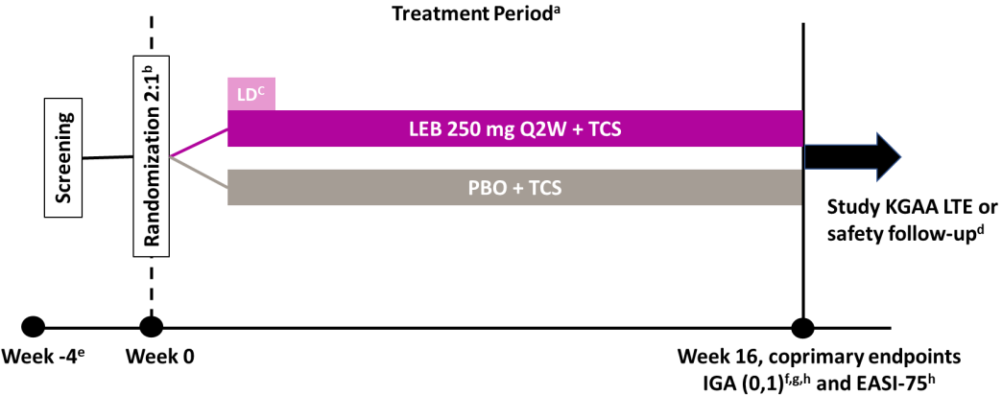
ª Use of TCS was required at baseline but could be used, tapered, stopped, and resumed as needed after that. ^{b} A total of 228 participants with moderate-to-severe AD, including 53 adolescent participants. ^{c} 500 mg loading dose at W0 and W2.
^{d} Participants who completed Study KGAD had the option to enrol in Study KGAA long-term extension. Otherwise, participants entered a safety follow-up period for 12 weeks after their last dose. ^{e} ≤30-day screening period. ^{f} IGA (0,1) with ≥2-point improvement from baseline. ^{g} FDA primary endpoint. ^{h} EMA co-primary endpoint.
Participants who met all the eligibility criteria at baseline visit were randomised in a 2:1 ratio to 16 weeks of double-blind treatment with SC lebrikizumab + TCS or matching placebo + TCS, with stratification based on geographic region (USA vs EU vs rest of world), age (adolescent vs adult), and disease severity (IGA = 3 vs IGA = 4). Study treatment was two 500 mg loading doses of lebrikizumab at Weeks 0 and 2, then 250 mg Q2W SC through Week 14 administered SC by PFS-NSD, or matching placebo. TCS treatment was initiated at Baseline and applied as required, and could be tapered, stopped, or resumed, as needed. Participants were supplied with a mid-potency TCS (triamcinolone acetonide 0.1% cream) and a low potency TCS (hydrocortisone 1% cream) for use on sensitive skin areas. TCI use was permitted for use on sensitive areas only, and all use of TCS and TCI was recorded daily by the participant using an electronic diary.
A total of 312 participants enrolled in the study, and 228 participants were randomly assigned to the treatment groups. Following the primary outcome database lock (Week 16), a site audit triggered by statistically implausible data at one study site showed GCP noncompliance with protocol entry criteria related to severity of AD at Baseline. Data from all 17 participants at that site were excluded from efficacy analyses, creating an mITT population of 211 participants (66 in the placebo arm and 145 in the lebrikizumab arm). 134 (92.4%) in the lebrikizumab arm and 58 (87.9%) in the placebo arm completed Week 16.
The mean age of participants was 37.2 years, and 21.8% were adolescents. The population was approximately evenly divided between females and males. 61.6% of participants were White, 14.7% Asian, and 13.3% Black or African American. The mean duration since AD onset was 21.1 years. Baseline IGA score was 3 (moderate) in 69.2% and 4 (severe) in 30.8%. Mean EASI score at Baseline was 27.3.
The primary and major secondary efficacy endpoints specified by the EMA and FDA are shown in Table 21. Multiplicity-adjusted testing schemes were used to control the overall Type I error rate at a 2-sided alpha of 0.05.
Table 21. Study KGAD – primary and major secondary efficacy endpoints.
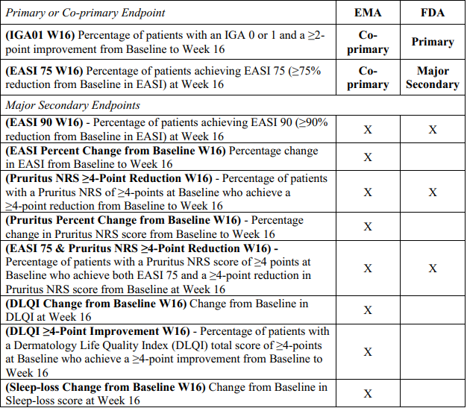
During the 16 weeks of the study, based on case report form (CRF) data, 97.0% of patients in the placebo + TCS arm and 96.6% of patients in the lebrikizumab + TCS arm used mild or moderate TCS, and 4.5% and 3.4% of patients, respectively, used TCIs.
All primary and major secondary endpoints were met (Table 22). Response rates for IGA 0,1 and EASI-75 from baseline through Week 16 are shown below in Figure 13.
In terms of other patient-reported secondary efficacy endpoints, a nominally significant improvement in disease severity as assessed by POEM score from baseline to Week 16 was observed for lebrikizumab + TCS compared to placebo + TCS, but no significant difference was observed in PROMIS® scores for anxiety and depression.
Subgroup analyses at Week 16 were generally consistent with the overall population (Figure 14), though a greater treatment effect was observed in males than females for EASI-75 and EASI-90. The treatment effect in adolescents was similar to adults.
Table 22. KGAD - Primary and Secondary Endpoints Included in Gatekeeping Testing Schemes for EU and US Submissions and Summary of Results, mITT population
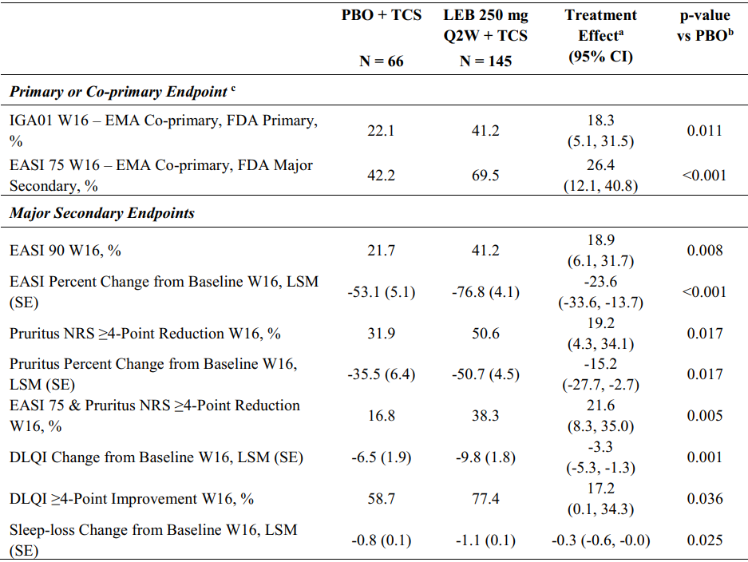
a Common Risk Difference (percentage of patients), LSM Diff (percentage or absolute change from Baseline). b Cochran-Mantel-Haenszel test adjusted by geographic region (US versus EU versus rest of world), age (adolescent versus adult), and disease severity (IGA 3 vs 4) for categorical endpoints. c Participants who received high potency topical or systemic rescue medication, or discontinued treatment due to lack of efficacy, set to their baseline value subsequent to this time through Week 16; MCMC-MI was used to handle the remaining missing data.
Figure 13. KGAD – Response rates for IGA 0,1 and EASI-75, primary estimand (hybrid) with MCMC-MI.
IGO 0,1 with ≥2-point improvement
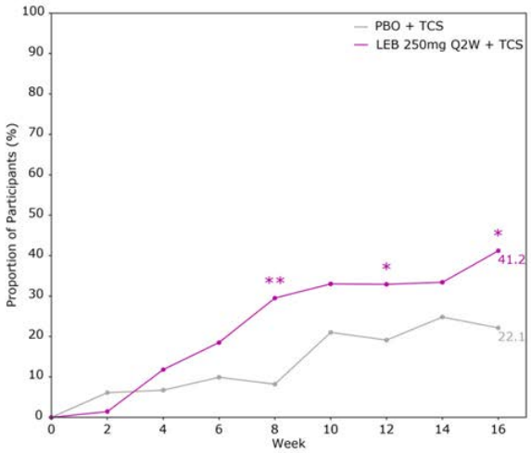
EASI-75 response
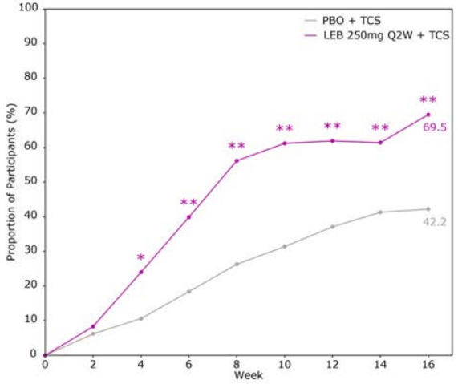
Figure 14. KGAD - Subgroup analyses at Week 16
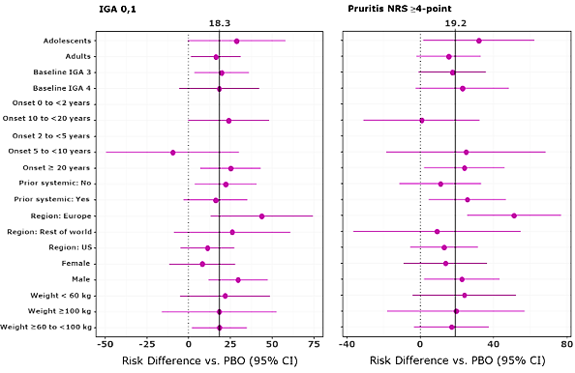
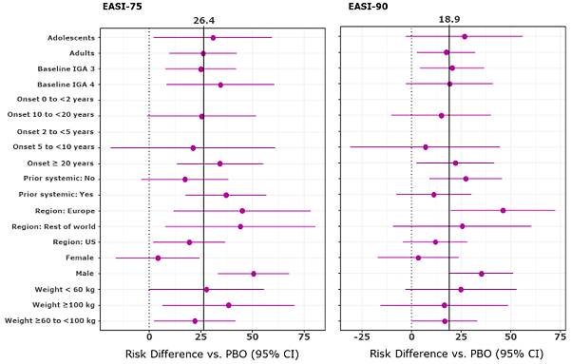

Rescue therapy
Rescue therapy was used by more participants in the placebo + TCS arm (7 participants, 10.6%) than in the lebrikizumab + TCS arm (6 participants, 4.1%). Topical rescue therapy, including high potency TCS, was used by 3 participants (4.5%) in the placebo + TCS arm and 2 participants (1.4%) in the lebrikizumab + TCS arm. Systemic rescue therapy was used by 5 participants (7.6%) in the placebo + TCS arm and 5 participants (3.4%) in the lebrikizumab + TCS arm.

Supportive Study: KGAA (ADjoin)
KGAA is an ongoing, long-term, Phase 3 safety study of 100 weeks duration for adult and adolescent patients with moderate-to-severe AD who complete Studies KGAB, KGAC, KGAD, KGAE, or KGAK (vaccine). An additional cohort of 88 participants was enrolled directly into KGAA without first completing a parent study. KGAA is being conducted at 199 centres (999 enrolled participants) in Australia, Bulgaria, Canada, Estonia, France, Germany, Latvia, Lithuania, Mexico, Poland, Singapore, South Korea, Spain, Taiwan, Ukraine, and USA. The date of first participant visit was 15 June 2020.
The primary objective of this ongoing study is to describe the long-term safety of lebrikizumab in participants with moderate-to-severe AD. The secondary objective is to describe the long-term efficacy of lebrikizumab in participants with moderate-to-severe AD. The endpoints used to assess this objective are: (1) proportion of participants with a response of IGA 0,1 at each visit; and (2) proportion of participants achieving response of EASI-75 from baseline of parent study at each visit.
The interim KGAA study report included limited efficacy data at Week 40 for a subset of participants who completed Week 16 of KGAD. This subset included lebrikizumab responders who received blinded lebrikizumab 250 mg Q2W + TCS in KGAD and achieved EASI-75 or IGA 0,1 with ≥2-point reduction from baseline at Week 16, without receiving rescue therapy. In KGAA, lebrikizumab responders from KGAD were randomised 1:2 to receive either lebrikizumab 250 mg Q4W or 250 mg Q2W, with placebo injections used to maintain the blind for patients randomised to 250 mg Q4W until unblinding of the parent study, KGAD. Participants were allowed to taper, stop, and resume TCS as needed.
The KGAA interim efficacy findings (Table 23) show similar outcomes for IGA 0,1 response and EASI-75 response at Week 40 in the 250 mg Q4W and 250 mg Q2W arms.
Table 23. KGAA – Summary of the two secondary efficacy endpoints for lebrikizumab responders from KGAD, mITT population.
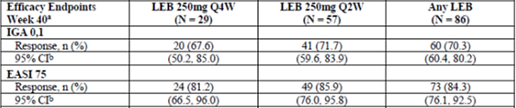

Supportive study in adolescents: KGAE (ADore)
KGAE was a 52-week, open-label, single-arm study in adolescent participants aged 12 to < 18 years and weighing ≥ 40 kg with the objective to evaluate the safety and efficacy of lebrikizumab in adolescent patients with moderate-to-severe AD. The study was conducted at 55 centres (245 enrolled patients) in Australia, Canada, Poland, and USA between February 2020 and June 2022.
The primary endpoint was a safety endpoint: the proportion of patients discontinued from study treatment due to AEs through the last treatment visit. The secondary efficacy endpoints were: percentage of patients with an IGA score of 0 or 1 and a reduction of ≥ 2-points from baseline, percentage of patients achieving response of EASI-75, percentage change from baseline in EASI score and percentage of patients achieving EASI-50 and EASI-90, change from baseline in BSA, change from baseline in PROMIS Anxiety and Depression measures, and change from baseline and improvement in DLQI/CDLQI. Efficacy data were summarised using descriptive statistics. No inferential testing was performed and no adjustments were made for multiplicity.
All participants were given SC loading doses of lebrikizumab 500 mg at the baseline and Week 2 visits. From Week 4 onwards, all participants were treated with lebrikizumab 250 mg Q2W SC through Week 52. Findings for IGA 0,1 and EASI-75 are presented in Figure 15.
Figure 15. KGAE - Percentage of participants with IGA score of 0 or 1 and a reduction ≥ 2 points from baseline by visit (upper panel), and percentage of participants achieving EASI 75 by visit (lower panel).
IGA 0,1 with ≥2-point improvement from baseline:
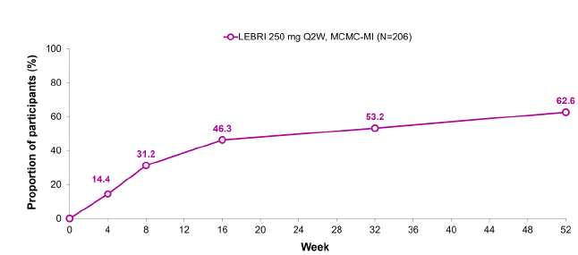
EASI-75:
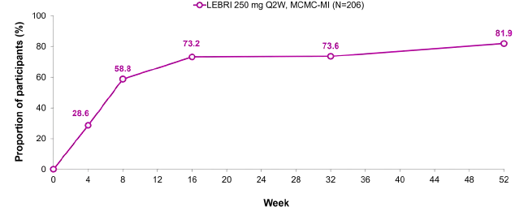

Safety
The initial application included a comprehensive integrated assessment of the safety of lebrikizumab from 8 clinical studies in adults and adolescents with moderate-to-severe AD (KGAG, KGAF, KGAB, KGAC, KGAD, KGAE, KGAA, and KGAH). During the course of the evaluation, the Sponsor submitted safety data from two recently completed supportive Phase 3 studies: KGAK (Adopt-VA), a 16-week study designed to assess the impact of lebrikizumab on vaccine response, efficacy and safety in adult patients with moderate-to-severe AD, and KGAL (ADhere-J), a 68-week efficacy and safety study evaluating lebrikizumab + TCS in Japanese patients with moderate-to-severe AD.
The primary safety analysis population for the integrated assessment of safety is the modified safety population, defined as all participants who received at least 1 dose of study drug except for 38 participants excluded due to GCP site audit findings (17 participants in both KGAD and KGAA, 18 participants in KGAC, and 3 participants in KGAA open-label addendum). In addition to the analyses using the modified safety population, sensitivity analyses using the entire safety analysis population were conducted.
As of the data cut-off date of 6 June 2022, the AD safety database included 1720 participants (including 372 adolescents) exposed to lebrikizumab at any dose. Of the 1720 participants, 891 (including 270 adolescents) were exposed to lebrikizumab for at least 1 year, 744 (including 246 adolescents) were exposed only to 250 mg Q2W for at least 1 year, and 132 (including 23 adolescents) were exposed to 250 mg Q2W induction followed by 250 mg Q4W for at least 1 year.
The proportion of participants with historical illnesses and pre-existing conditions was balanced across the treatment groups. Co-morbid conditions reported at baseline by lebrikizumab-treated participants in the Phase 3 studies included allergic rhinitis (50.1%), asthma (30.6%), food allergy (30.1%), and allergic conjunctivitis (14.5%).
In the placebo-controlled induction period, treatment-emergent adverse events (TEAEs) and serious adverse events (SAEs) were reported more frequently in the placebo group than the lebrikizumab group, but treatment-related TEAEs and discontinuations due to AE were reported more frequently in the lebrikizumab group than placebo (Table 24). In the AD All PC Weeks 0-16 analysis set, TEAEs reported in at least 1% of participants in the lebrikizumab group and more frequently than in the placebo group included conjunctivitis, nasopharyngitis, headache, conjunctivitis allergic, dry eye, and allergic rhinitis (Table 26).
In the maintenance period (AD Mono PC Weeks 16-52 analysis set), TEAEs overall occurred with comparable frequencies across the three treatment groups (Table 25). TEAEs reported in at least 2% of participants in the LEB 250 mg Q2W and Q4W groups are shown in Table 27.
Table 24. Overview of adverse events in the placebo-controlled induction period.
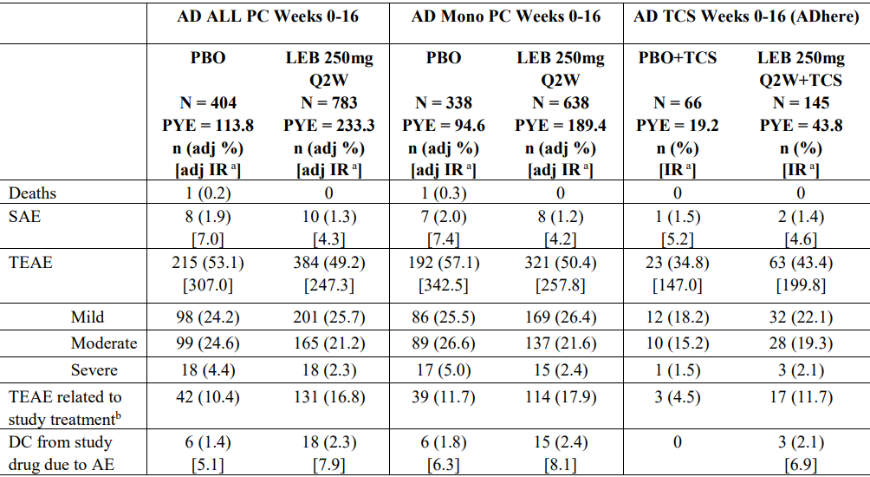
AE = adverse event; adj % = adjusted percentage; DC = discontinuation; IR = incidence rate; LEB = lebrikizumab; Mono = monotherapy; n = number of patients in the specified category; N = number of patients in the analysis population; PBO = placebo; PC = placebo-controlled; PY = patient-year; PYE = patient-years of exposure; Q2W = every 2 weeks; SAE = serious adverse event; TCS = topical corticosteroids; TEAE = treatment-emergent adverse event. a. Events per 100 PY. b. Relationship to study treatment is assessed by the investigator. Source: Table 2.7.4.10, Summary of Clinical Safety.
Table 25. Overview of adverse events in the Maintenance period, Combined Induction and Maintenance period, and AD All LEB Analyses Sets.
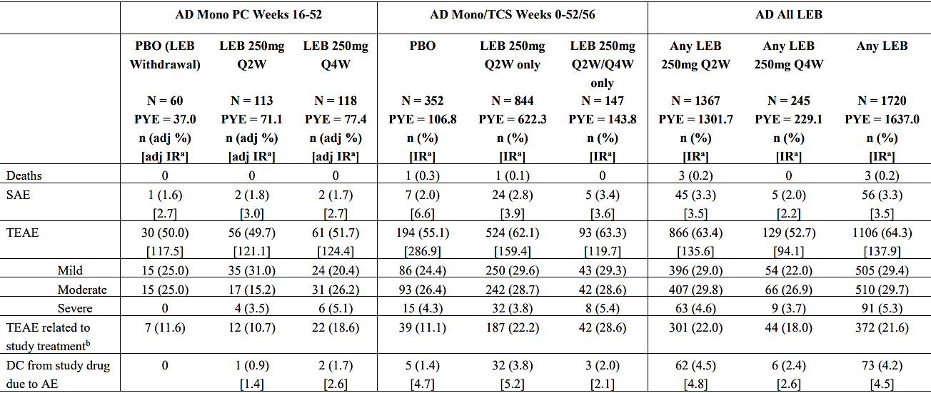
AD = atopic dermatitis; adj % = adjusted percentage; AE = adverse event; DC = discontinuation; IR = incidence rate; LEB = lebrikizumab; Mono = monotherapy; n = number of patients in the specified category; N = number of patients in the analysis population; PBO = placebo; PC = placebo-controlled; PY = patient-years; PYE = patient years of exposure; Q2W = every 2 weeks; Q4W = every 4 weeks; SAE = serious adverse event; TCS = topical corticosteroids; TEAE = treatment-emergent adverse event.
a. Events per 100 PY. b. Relationship to study treatment is assessed by the investigator.
Table 26. AD All PC Weeks 0-16 analysis set, TEAEs occurring in at least 1% of participants in the LEB 250 mg Q2W (with or without TCS) group, by descending order of frequency, versus placebo in the induction period.
 | Placebo  N = 404; PYE = 13.8 |  | LEB 250 mg Q2W (with or without TCS)  N = 783; PYE = 233.3
 | n (adj %) | [IR adj %] | n (adj %) | [IR adj %]
Patients with at least 1 TEAE | 215 (53.1) | [307.0] | 384 (49.2) | [247.3]
Conjunctivitis | 7 (1.8) | [6.2] | 51 (6.5) | [22.8]
Dermatitis atopic | 74 (18.4) | [76.9] | 47 (6.0) | [21.2]
Nasopharyngitis | 13 (3.2) | [11.8] | 34 (4.4) | [15.2]
Headache | 12 (2.9) | [10.5] | 34 (4.4) | [15.0]
Oral herpes | 9 (2.3) | [8.1] | 15 (1.9) | [6.5]
Conjunctivitis allergic | 3 (0.7) | [2.6] | 14 (1.8) | [6.1]
Dry eye | 4 (0.9) | [3.4] | 11 (1.4) | [4.8]
Pruritis | 7 (1.8) | [6.4] | 9 (1.2) | [3.9]
COVID-19 | 5 (1.3) | [4.4] | 9 (1.1) | [3.8]
Hypertension | 4 (1.0) | [3.6] | 9 (1.1) | [3.8]
Rhinitis allergic | 1 (0.2) | [0.9] | 8 (1.0) | [3.5]
Injection site pain | 4 (1.0) | [3.5] | 7 (1.0) | [3.2]
Abbreviations: n (adj %) = number of participants with an event study size-adjusted percentage; adj IR = study-size adjusted incidence rate per 100 patient years; Q2W = every 2 weeks; PYE = patient years of exposure. Source: SCS, Table 2.7.4.14.
Table 27. AD Mono PC Weeks 16 to 52 analysis set – TEAEs occurring in at least 2% of participants in the LEB 250 mg Q2W and Q4W groups, by descending order of frequency in the LEB Q2W group.
 | Placebo |  | LEB 250 mg Q2W - mono |  | LEB 250 mg Q4W – mono
 | N=60; PYE=37.0 |  | N=113, PYE=71.1 |  | N=118, PYE=77.4
 | n (adj %) | [adj IR] | n (adj %) | [adj IR] | n (adj %) | [adj IR]
Participants with ≥1 TEAE | 30 (50.0) | [117.5] | 56 (49.7) | [121.1] | 61 (51.7) | [124.4]
Dermatitis atopic | 7 (11.7) | [19.8] | 5 (4.4) | [7.2] | 7 ( 5.9) | [9.3]
Nasopharyngitis | 3 ( 5.0) | [8.3] | 4 (3.5) | [5.8] | 9 ( 7.6) | [12.2]
Vaccination complication | 2 ( 3.3) | [5.4] | 3 (2.7) | [4.5] | 3 (2.5) | [3.9]
Folliculitis | 0 | [0.0] | 3 (2.7) | [4.4] | 3 ( 2.5) | [3.9]
COVID-19 | 2 (3.3) | [5.5] | 3 (2.6) | [4.2] | 11 ( 9.4) | [14.9]
Conjunctivitis allergic | 2 (3.3) | [5.5] | 2 (1.8) | [2.9] | 7 (5.9) | [9.4]
URTI | 3 (5.1)] | [8.8] | 2 (1.8) | [2.9] | 2 ( 1.7) | [2.6]
Headache | 1 (1.6) | [2.7] | 1 (0.9) | [1.5] | 5 (4.2) | [6.5]
Oral herpes | 1 (1.6) | [2.7] | 1 (0.9) | [1.4] | 4 (3.4) | [5.2]
Food allergy | 0 | [0.0] | 1 (0.9) | [3.0] | 3 (2.5) | [3.9]
Herpes dermatitis | 0 | [0.0] | 1 (0.9) | [1.4] | 3 (2.5) | [3.9]
Conjunctivitis | 3 [ 5.0] | [8.4] | 0 | [0.0] | 6 (5.0) | [8.1]
TEAE = treatment emergent adverse events (AEs); n (adj %) = number of participants with an event study size-adjusted percentage; adj IR = study-size adjusted incidence rate per 100 patient years; Q2W = every 2 weeks; Q4W = every 4 weeks; PYE = patient years of exposure; LEB = lebrikizumab; mono = monotherapy.
In the AD All PC Weeks 0-16 analysis set, SAEs were reported in 1.3% of participants in the lebrikizumab group and 1.9% of participants in the placebo group, with none of the SAE preferred terms in the lebrikizumab group reported in more than 1 participant. In the AD Mono PC Weeks 16 to 52 analysis set, SAEs were reported in 1 (1.6%), 2 (1.8%), and 2 (1.7%) participants in the placebo, LEB 250 mg Q2W and LEB 250 mg Q4W groups, respectively (Table 23). There were 4 deaths reported in the lebrikizumab clinical development program: 1 death due to myocardial infarction in the placebo group during the induction period of KGAC and 3 deaths in participants treated with lebrikizumab 250 mg Q2W, none of which were assessed as related to study drug.
In the AD All PC Weeks 0-16 analysis set, discontinuation of study treatment due to AE was reported in 18 (2.3%) participants in the lebrikizumab group and 6 (1.4%) participants in the placebo group. In the lebrikizumab group, AEs leading to discontinuation of study treatment included atopic dermatitis (4 [0.5%] participants), conjunctivitis (2 [0.3%] participants), and atopic keratoconjunctivitis, cerebellar syndrome, conjunctivitis bacterial, dermatitis allergic, dermatitis exfoliative generalised, folliculitis, drug hypersensitivity, injection site dermatitis, injection site rash, keratitis, oedema peripheral, and panic attack (1 participant each). Discontinuation of study treatment due to AE remained infrequent throughout the maintenance period to Week 52 (Table 25).
12-lead ECGs were collected for detailed safety assessments in three clinical pharmacology Phase 1 studies in healthy subjects (KGAY, KGAZ, and KGBB). There were no clinically significant ECG findings or TEAEs related to ECG findings. The totality of the data for cardiac disorders and ECG abnormalities indicates that treatment with lebrikizumab in patients with moderate-to-severe AD is not associated with clinically significant cardiac toxicity.
No clinically meaningful impacts on clinical chemistry or haematological laboratory parameters were observed in the placebo-controlled induction and maintenance periods. Hepatic safety was assessed as an adverse events of special interest (AESI) and the evaluation did not identify concern regarding hepatic toxicity.
Other AESIs included conjunctivitis and keratitis, infections, eosinophilia and eosinophil-related disorders, hypersensitivity reactions, injection site reactions, AD exacerbation, suicide/self-injury, and malignancies.
Conjunctivitis was defined as an AESI due to the potential association with the mechanism of action of lebrikizumab, the AEs observed for other drugs in the same class, and the increased likelihood for this disorder in the AD population. The evaluation assessed broadly defined clusters of conjunctivitis, keratitis, ocular symptoms, and dry eye, as well as blepharitis. Conjunctivitis cluster TEAEs reported in the induction period are summarised in Table 28. In the AD ALL PC Weeks 0-16 analysis set, all TEAEs in these clusters reported in the LEB 250 mg Q2W group were mild or moderate in severity. A severe TEAE of blepharitis was reported in 1 lebrikizumab-treated participant. Five lebrikizumab-treated participants reported TEAEs that led to treatment discontinuation (conjunctivitis [n = 2], conjunctivitis bacterial [n = 1], keratitis [n = 1], and atopic keratoconjunctivitis [n = 1]). One placebo-treated participant reported conjunctivitis that led to treatment discontinuation. For the maintenance period, TEAEs for the AD Mono PC Weeks 16-52 analysis set for the 4 broadly defined clusters and the PT blepharitis are summarised in Table 29.
Table 28. Summary of conjunctivitis clusters from the Induction Period placebo-controlled analysis sets.
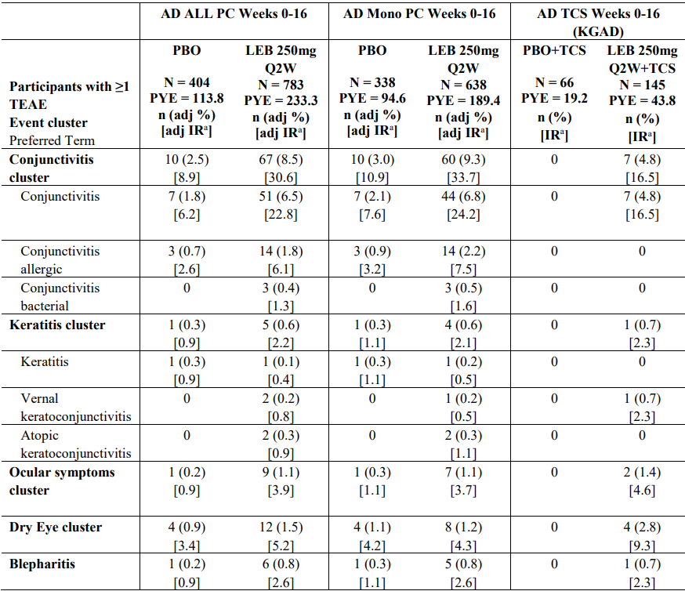
ª Events per 100 PY
Table 29. AD Mono PC Weeks 16-52 – Maintenance period, AD Mono PC Weeks 16-52 analysis set.
 | Placebo |  | Lebrikizumab 250 mg Q4W |  | Lebrikizumab 250 mg Q2W
Events | N=60; PYE=37.0 |  | N=118, PYE=77.4 |  | N=113, PYE=71.1
Participants with ≥ TEAE | n (adj %) | [adj IR] ª | n (adj %) | [adj IR] ª | n (adj %) | [adj IR] ª
Conjunctivitis cluster | 5 (8.3%) | [14.3] | 12 (10.1%) | [16.8] | 2 (1.8%) | [2.9]
Keratitis cluster | 0 | 0 | 1 (0.8) | [1.3] | 1 (0.9) | [1.4]
Ocular symptom cluster | 0 | 0 | 1 (0.8) | [1.3] | 0 | 0
Dry eye cluster | 0 | 0 | 1 (0.8) | [1.3] | 1 (0.9) | [1.4]
Blepharitis | 0 | 0 | 0 | 0 | 1 (0.9) | [1.4]
ª Events per 100 PY.
The evaluation of infections included overall infections, herpes infections, parasitic (helminth) infections, potential opportunistic infections, skin infections, and serious and severe infections. Treatment-emergent infections reported in the induction period are summarised in Table 30. In the AD All PC Weeks 0-16 analysis set, the overall frequencies of Infections and infestations (SOC) were similar between the two treatment groups, but the preferred terms of conjunctivitis, nasopharyngitis, and herpes zoster were reported more frequently in the lebrikizumab group than in the placebo group (TEAEs of herpes zoster were reported only in lebrikizumab-treated participants). Skin infections were reported less frequently in the lebrikizumab group compared to placebo. No parasitic (helminth) infections or confirmed opportunistic infections were reported in the placebo-controlled induction period. Most infections in the induction period were mild or moderate in severity, with only 3 serious events being reported: 1 (0.2%) placebo-treated participant reported 2 serious events of cellulitis and sepsis and 1 (0.1%) lebrikizumab-treated participant reported a serious event of severe infectious colitis.
Table 30. Treatment-Emergent Infections Occurring in at Least 1% of Lebrikizumab-Treated Participants for the Induction Period Placebo-Controlled Analysis Sets
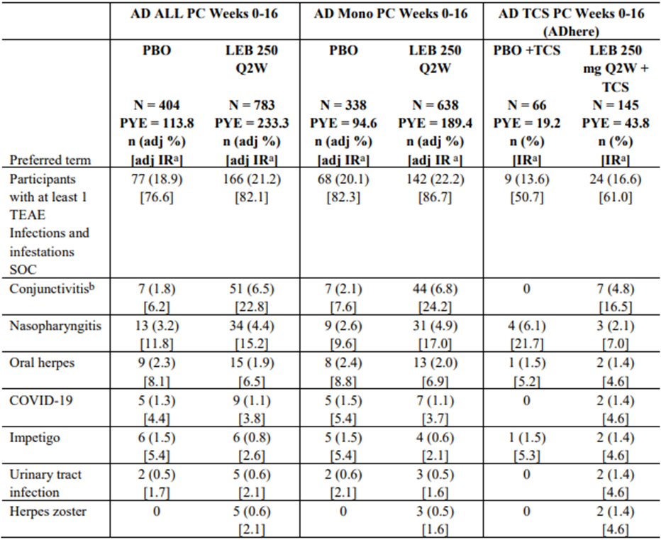
a: Events per 100 PY. b: Conjunctivitis infections have been considered above under the conjunctivitis and keratitis clusters.
In the maintenance period (AD Mono PC Weeks 16-52 analysis set), treatment-emergent infections were reported more frequently in the LEB 250 mg Q4W group than the LBE 250 mg Q2W and placebo groups (Table 31). All events were non-serious, and mild or moderate in severity. One (0.9%) case of conjunctivitis in the LEB 250 mg Q4W group led to treatment discontinuation. One helminth infection was reported in the AD Mono/TCS Weeks 0-52/56 analysis set.
Table 31. AD Mono PC Weeks 16-52 – Treatment-emergent infections in the Infections and infestations (SOC) occurring in at least 1% of participants in the LEB Q4W group by descending order of frequency in the AD maintenance period placebo-controlled analysis set (KGAB, KGAC).
 | Placebo |  | LEB 250 mg Q4W |  | LEB 250 mg Q2W
 | N=60; PYE=37.0 |  | N=118, PYE=77.4 |  | N=113, PYE=71.1
 | n (adj %) | [adj IR] ª | n (adj %) | [adj IR] ª | n (adj %) | [adj IR] ª
Participants with ≥ 1 TEAE Infections and infestations SOC | 12 (20.1) | [37.8] | 36 (30.5) | [56.0] | 23 (20.4) | [36.0]
Covid-19 | 2 ( 3.3) | [5.5] | 11 ( 9.4) | [14.9] | 3 (2.6) | [4.2]
Nasopharyngitis | 3 ( 5.0) | [8.3] | 9 ( 7.6) | [12.2] | 4 ( 3.5) | [5.8]
Conjunctivitis | 3 ( 5.0) | [8.4] | 6 ( 5.0) | [8.1] | 0 | 0
Oral herpes | 1 ( 1.6) | [2.7] | 4 ( 3.4) | [5.2] | 1 ( 0.9) | [1.4]
Folliculitis | 0 | 0 | 3 ( 2.5) | [3.9] | 3 ( 2.7) | [4.4]
Herpes dermatitis | 0 | 0 | 3 (2.5) | [3.9] | 1 ( 0.9) | [1.4]
URTI | 3 ( 5.1) | [8.8] | 2 ( 1.7) | [2.6] | 2 ( 1.8) | [2.9]
Sinusitis | 0 | 0 | 2 ( 1.7) | [2.7] | 0 | 0
Pneumonia | 0 | 0 | 2 ( 1.7) | [2.6] | 0 | 0
Vulvovaginal candidiasis *b | 0 | 0 | 1 ( 1.4) | [2.2] | 0 | 0
ª Events per 100 PY ^{b} Adjusted for female participants.
The frequency of participants with increased blood eosinophils at any time point post-baseline was higher in lebrikizumab-treated participants (20.3%) compared to placebo-treated participants (11.7%). In the placebo-controlled period, 3 lebrikizumab-treated participants (0.4%) and no placebo-treated participants had a shift from mild or moderate to severe eosinophilia (≥5000 per microliter). In the placebo-controlled period, 5 (0.6%) participants in the lebrikizumab group and 3 (0.8%) participants in the placebo group reported at least 1 TEAE of eosinophilia. All events were non-serious, mild or moderate in severity, and did not lead to treatment discontinuation.
During the placebo-controlled induction period, there was no clinically significant imbalance in hypersensitivity reactions in the lebrikizumab (2.8%) and placebo (6.2%) groups, with the difference mostly driven by dermatitis atopic events (4.7% in the placebo group, 1.5% in the lebrikizumab group). No serious events of immediate hypersensitivity or anaphylaxis were reported. One serious event of Stevens Johnson Syndrome (SJS) was reported in a 56-year-old male with a medical history of previous SJS episode in 2019 after taking sulfamethoxazole + trimethoprim. On Study Day 13, 12 days after beginning lebrikizumab and 7 days after starting sulfamethoxazole + trimethoprim for treatment of a dog bite, he was hospitalised due to severe SJS and treatment was discontinued.
Injection site reactions were reported more frequently with lebrikizumab (2.6%) than placebo (1.5%) in the induction period (AD ALL PC Weeks 0-16 analysis set). The majority of events were mild or moderate in severity and did not lead to treatment discontinuation.
The clinical trial data do not support an increased risk of suicide/self-injury or an increased risk of malignancy with lebrikizumab treatment.
Analyses of safety in adolescents compared to adults did not identify any additional safety risks.

Immunogenicity
Immunogenicity of the proposed treatment regimen was evaluated in the Combined Induction and Maintenance Periods Immunogenicity Analysis Set comprising all participants in the two pivotal monotherapy studies (KGAB and KGAC) and the pivotal TCS combination study (KGAD) up to 52/56 weeks. The treatment-emergent ADA evaluable population included 822 participants in the 250 mg Q2W only group, 145 participants in the 250 mg Q2W/Q4W group, and 330 participants in the placebo group. The findings are presented in Table 32. 8.8% of evaluable participants in the 250 mg Q2W only group, 9.7% in the 250 mg Q2W/Q4W group, and 9.1% in the placebo group had ADA at baseline. 3.4% of evaluable participants in the 250 mg Q2W only group, 2.8% in the 250 mg Q2W/Q4W group, and 0.9% in the placebo group were reported as treatment-emergent ADA-positive. A subset analysis of adolescent participants (12 to <18 years) showed similar immunogenicity to the overall population.
Table 32. Incidence of Anti-Drug Antibodies Atopic Dermatitis Combined Induction and Maintenance Periods Immunogenicity Analysis Set, Induction and Maintenance (Weeks 0-52/56), Age category: Overall
- 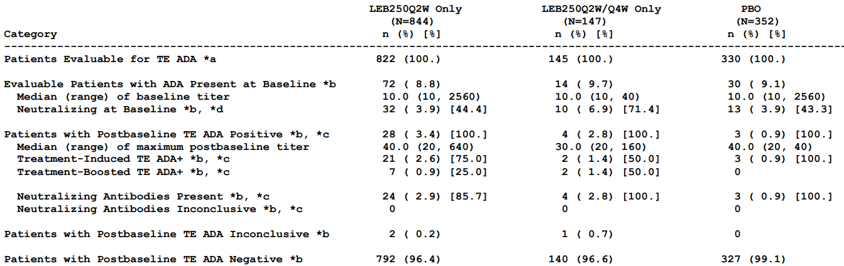
The effect of immunogenicity on the PK of lebrikizumab after 250 mg Q2W dosing was explored using graphical analyses. Lebrikizumab exposure was similar for treatment-emergent ADA-positive and ADA-negative participants. Similar findings were observed with 250 mg Q4W dosing.
Figure 16. Observed lebrikizumab serum concentrations following SC dosing of lebrikizumab 250 mg Q2W during Weeks 0-52 (induction and maintenance and open-label escape arm) in studies KGAB, KGAC, KGAD, and KGAE by TE ADA status and titre.
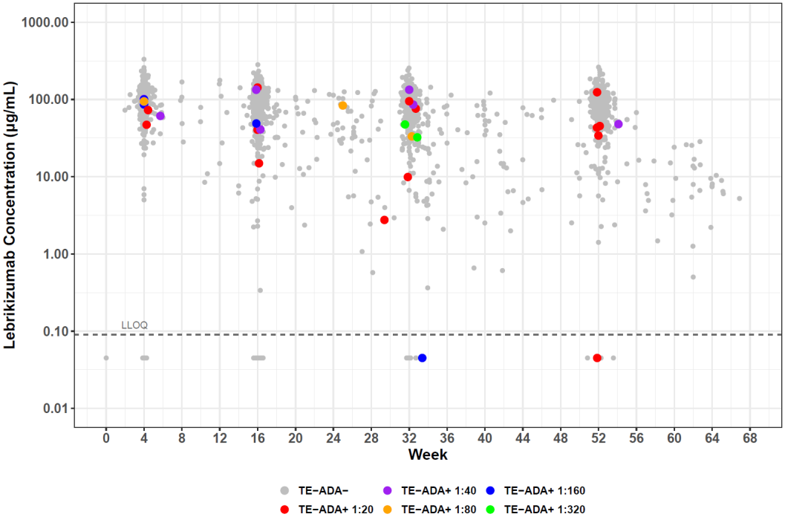
The influence of immunogenicity on efficacy was assessed in the Pooled Modified Maintenance Primary Analysis Set using integrated data from the induction and maintenance periods from the 2 pivotal monotherapy studies (KGAB and KGAC). In these 2 studies, participants were initially randomised to lebrikizumab 250 mg Q2W or placebo during the induction period (Weeks 0-16). At Week 16, clinical responders to 250 mg Q2W were re-randomised to 250 mg Q2W, 250 mg Q4W, or placebo for the maintenance period. Evaluation of the effect of ADA on efficacy was limited by the small number of TE-ADA-positive participants. For Week 16 responders re-randomised to 250 mg Q2W, EASI-75 response rates at Week 52 were 77.2% (83/107) in TE-ADA-negative participants and 100.0% (5/5) in TE-ADA-positive participants. For Week 16 responders re-randomised to 250 mg Q4W, EASI-75 response rates at Week 52 were 81.9% (93/113) in TE-ADA-negative participants and 100.0% (2/2) in TE-ADA-positive participants.
The safety analysis evaluated the frequency of hypersensitivity reactions and injection site reactions in TE-ADA-negative and TE-ADA-positive participants using the Atopic Dermatitis Combined Induction and Maintenance Periods Immunogenicity Analysis Set. The frequency of hypersensitivity reactions (narrow and broad search terms) in the 250 mg Q2W group was similar for TE-ADA-negative and TE-ADA-positive participants (208 of 792 [26.3%] and 7 of 28 [25.0%], respectively). In the 250 mg Q2W/Q4W group, 35 of 140 (25.0%) TE-ADA-negative participants and no (0 of 4) TE-ADA-positive participants reported hypersensitivity reactions (narrow and broad search terms). Although the frequency of injection site reactions was higher in participants who were TE-ADA-positive treated with lebrikizumab 250 mg Q2W compared to placebo (10.7% vs 0%, respectively), the number of events in TE-ADA-positive participants was low and there was no temporal association with injection site reactions and development of TE-ADA.

Risk management plan evaluation summary
Risk management for this application is supported by the Australian-Specific Annex (ASA) version 2.0 (dated 14 November 2023) in association with the Core RMP version 1.0 (dated 2 September 2022; DLP 06 July 2022). The summary of safety concerns in the ASA is presented in Table 33. There are no outstanding issues from the RMP evaluation.
Table 33. Summary of Safety Concerns
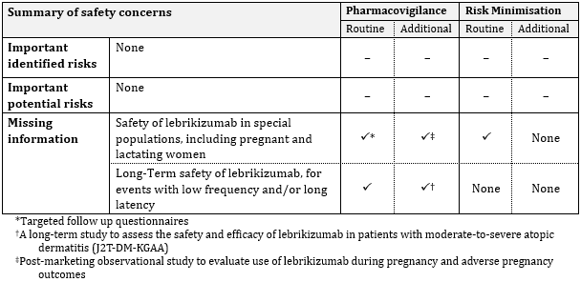
RMP evaluator recommendations regarding conditions of registration
- The Ebglyss Core-Risk Management Plan (RMP) (version 1.0, dated 2 September 2022, data lock point 06 July 2022), with Australian Specific Annex (version 2.0, dated 14 November 2023), included with submission PM-2023-01192-1-1, and any subsequent revisions, as agreed with the TGA will be implemented in Australia.
- An obligatory component of risk management plans is routine pharmacovigilance. Routine pharmacovigilance includes the submission of periodic safety update reports (PSURs).
Unless agreed separately between the supplier who is the recipient of the approval and the TGA, the first report must be submitted to TGA no later than 15 calendar months after the date of this approval letter. The subsequent reports must be submitted no less frequently than annually from the date of the first submitted report until the period covered by such reports is not less than three years from the date of this approval letter. The annual submission may be made up of two PSURs each covering six months. If the sponsor wishes, the six-monthly reports may be submitted separately as they become available.
If the product is approved in the EU during the three years period, reports can be provided in line with the published list of EU reference dates no less frequently than annually from the date of the first submitted report until the period covered by such reports is not less than three years from the date of this approval letter.
- The reports are to at least meet the requirements for PSURs as described in the European Medicines Agency’s Guideline on good pharmacovigilance practices (GVP) Module VII-periodic safety update report (Rev 1), Part VII.B Structures and processes. Note that submission of a PSUR does not constitute an application to vary the registration. Each report must have been prepared within ninety calendar days of the data lock point for that report.
- Lebrikizumab (Ebglyss) is to be included in the Black Triangle Scheme. The PI and CMI for Ebglyss must include the black triangle symbol and mandatory accompanying text for five years, which starts from the date of first supply of the product.

Risk-benefit analysis

Efficacy
The efficacy of lebrikizumab in adult and adolescent patients with moderate-to-severe AD was evaluated in three pivotal Phase 3 studies, including two monotherapy studies (KGAB, KGAC) and one in combination with TCS (KGAD), as well as two supportive Phase 3 studies (KGAE, KGAA).
The pivotal monotherapy studies KGAB and KGAC shared the same design. Across the two studies, 749 participants (88%) were adults and 102 (12%) were adolescents. At baseline, 61.5% had IGA score of 3 (moderate) and 38.5% had IGA score of 4 (severe), and mean EASI score was 29.6.
Studies KGAB and KGAC both demonstrated the superiority of lebrikizumab versus placebo for the key efficacy endpoints, percentage of patients achieving IGA score of 0 or 1 with ≥ 2-point improvement from Baseline to Week 16 (EMA co-primary, FDA primary) and percentage of patients achieving EASI-75 at Week 16 (EMA co-primary, FDA major secondary). Treatment with lebrikizumab compared to placebo produced statistically significant and clinically meaningful improvements in both key endpoints, with significant treatment effects observed from Week 4 in both studies (and from Week 2 for EASI-75 in KGAB). In Study KGAB, treatment with lebrikizumab resulted in statistically significant improvement compared to placebo in all major secondary endpoints in the induction period, including significant improvements in Pruritus NRS, DLQI, and Sleep-loss score. In Study KGAC, treatment with lebrikizumab resulted in statistically significant improvement compared to placebo in all major secondary endpoints in the induction period except for percentage of participants with a Pruritus NRS score of ≥ 4 points at baseline who achieved a ≥ 4-point reduction from baseline to Week 2, which favoured lebrikizumab but did not reach statistical significance. During the induction period, the proportion of participants requiring topical or systemic rescue therapy was lower in the lebrikizumab arm than the placebo arm.
Subgroup analyses of pooled data from KGAB and KGAC showed a trend to greater treatment effect in participants <60 kg and lesser treatment effect in participants ≥100 kg. The treatment effect was similar (numerically higher) in adolescents compared to adults.
The FDA did not specify any major secondary endpoints for the maintenance blinded period, but the EMA specified four major secondary endpoints which were evaluated in lebrikizumab responders at Week 16 who were re-randomised to maintenance treatment with lebrikizumab 250 mg Q4W, 250 mg Q2W, or placebo (lebrikizumab withdrawal). In both studies, efficacy outcomes at Week 52 were similar in the two lebrikizumab arms, and numerically favoured the lebrikizumab arms compared to placebo. In the pooled analysis, nominal significance was seen for EASI-75 and IGO 0,1 at Week 52 for participants assigned to lebrikizumab 250 mg Q4W compared to placebo. The findings support maintenance dosing with lebrikizumab 250 mg Q4W.
Participants who did not achieve an adequate response to lebrikizumab in the induction period or who required topical or systemic rescue treatment during the induction period were assigned to an escape arm and received open-label lebrikizumab 250 mg Q2W during the maintenance period to Week 52. The proportion of participants in the escape population achieving IGO 0,1 and EASI-75 increased over this period, particularly during the first 8 weeks of escape treatment.
Study KGAD, the pivotal study of lebrikizumab in combination with TCS, demonstrated the superiority of lebrikizumab + TCS versus placebo + TCS for all primary and major secondary efficacy endpoints. Treatment with lebrikizumab + TCS compared to placebo + TCS produced statistically significant and clinically meaningful improvements in the percentage of patients achieving IGA score of 0 or 1 with ≥ 2-point improvement from Baseline to Week 16 (EMA co-primary, FDA primary) and the percentage of patients achieving EASI-75 at Week 16 (EMA co-primary, FDA major secondary). There were statistically significant and clinically meaningful improvements in all major secondary endpoints, including EASI-90 at Week 16 and improvements from baseline in EASI, Pruritus NRS, DLQI, and Sleep-loss score at Week 16. The proportion of participants requiring topical or systemic rescue therapy was lower in the lebrikizumab + TCS arm than the placebo + TCS arm.
Subgroup analyses at Week 16 were generally consistent with the overall population, with a similar treatment effect in adolescents and adults. In KGAD, a greater treatment effect on EASI-75 and EASI-90 was observed in males than females. This was not a consistent finding across the pivotal studies, as the monotherapy studies showed a trend to lower treatment effect on EASI-75 and EASI-90 in males than females.
In the ongoing study KGAA, interim efficacy findings for participants who were lebrikizumab responders at Week 16 in KGAD and were randomised to 250 mg Q4W or 250 mg Q2W in KGAA showed similar outcomes for IGA 0,1 and EASI-75 at Week 40 in the two treatment arms.

Safety
The safety database presented in the initial application included 1720 participants (including 372 adolescents) exposed to lebrikizumab at any dose. Of these 1720 participants, 891 (including 270 adolescents) were exposed to lebrikizumab for at least 1 year, 744 (including 246 adolescents) were exposed only to 250 mg Q2W for at least 1 year, and 132 (including 23 adolescents) were exposed to 250 mg Q2W induction followed by 250 mg Q4W for at least 1 year. Safety data from two supportive studies (KGAK and KGAL) submitted during the course of the evaluation were consistent with the main safety dataset.
Throughout the AD clinical development program, treatment with lebrikizumab was generally well tolerated. In the placebo-controlled induction period, TEAEs and SAEs were reported more frequently in the placebo group than the lebrikizumab group, but treatment-related TEAEs and discontinuations due to AE were reported more frequently in the lebrikizumab group than placebo. In the induction period, TEAEs reported more frequently in the lebrikizumab group than the placebo group included conjunctivitis, nasopharyngitis, headache, conjunctivitis allergic, dry eye, and rhinitis allergic (AD ALL PC Weeks 0-16 analysis set). TEAEs in the conjunctivitis, keratitis, ocular symptom, and dry eye clusters and blepharitis were reported more frequently in the lebrikizumab group than placebo. In the maintenance period (AD Mono PC Weeks 16-52 analysis set), the TEAE IRs (events/100 PY) were generally comparable for the placebo (LEB withdrawal), LEB 250 mg Q2W, and LEB 250 mg Q4W groups. No clinically meaningful differences were observed in the safety profile between the LEB 250 mg Q2W and LEB 250 mg Q4W groups.
Adverse drug reactions identified in the clinical development program include conjunctivitis, conjunctivitis allergic, conjunctivitis bacterial, keratitis, herpes zoster, injection site reactions, and eosinophilia.
The safety profile in adolescents was similar to adults and no additional safety concerns were identified.
No clinically meaningful association between ADA status and hypersensitivity events or injection site reactions was identified. The safety evaluation did not identify concerns with hepatic, renal, or cardiac toxicity.

Proposed Indication
The initially proposed indication was:
Ebglyss is indicated for the treatment of adult and adolescent patients (12 years of age and older) with moderate-to-severe atopic dermatitis (AD).
In response to the clinical evaluation, the proposed indication was amended to:
Ebglyss is indicated for the treatment of adult and adolescent patients (12 years of age and older) with moderate-to-severe atopic dermatitis (AD) who are candidates for systemic therapy.
In the EU, the accepted indication specifies “adolescents 12 years and older with a body weight of at least 40 kg”, reflecting the inclusion criteria of the pivotal studies. In the Australian Product Information, minimum body weight in adolescents is specifically addressed in sections 4.2, 4.4, and 5.1. The dosing guidance for lebrikizumab in adolescents is for patients 12 years of age and older who weigh at least 40 kg, and the precautions in Paediatric use in section 4.4 advise that “The safety and effectiveness of Ebglyss in paediatric subjects aged 12 years to less than 18 years who weigh less than 40 kg and paediatric subjects less than 12 years of age with moderate to severe atopic dermatitis have not been established.” The proposed indication for Ebglyss is consistent with the DUPIXENT indications which specify age but not body weight. I am of the view that the proposed indication is acceptable and that the proposed Product Information adequately addresses the lack of data informing dosing, efficacy, and safety in adolescent patients <40 kg body weight.
For consistency with other systemic AD therapies registered in Australia, it would be preferable to remove the hyphenation of moderate-to-severe (i.e. moderate to severe).

Proposed dosing
The proposed dosing guidance is:
Adults and Adolescents (12 years of age and older who weigh at least 40 kg) Treatment with Ebglyss should be initiated and supervised by a dermatologist or physician with expertise in management of atopic dermatitis.
The recommended dose of lebrikizumab is an initial dose of 500 mg (two 250 mg injections) injected subcutaneously at Week 0 and Week 2, followed by 250 mg every two weeks until Week 16. For patients who achieve an adequate clinical response at Week 16, the maintenance dose is 250 mg every four weeks.
Consideration should be given to discontinuing treatment in patients who have shown no clinical response after 16 weeks of treatment.
For patients who have had a less than adequate clinical response at Week 16, consideration may be given to continuing lebrikizumab 250 mg every two weeks until an adequate clinical response is achieved. Patients achieving an adequate clinical response can then continue maintenance treatment with lebrikizumab 250 mg every four weeks. Lebrikizumab can be used with or without topical corticosteroids (TCSs) or topical calcineurin inhibitors (TCIs).
Efficacy and safety findings from the three pivotal studies support the proposed dosing regimen.

Uncertainties and limitations of the data
PopPK and PK-PD simulations explored 250 mg QXW as a maintenance dosing option for responders at Week 16, but the efficacy of QXW maintenance dosing has not been evaluated in the clinical studies.
Rare safety risks or those with long latency may not have been identified in the clinical studies. Long-term safety is listed as missing information in the ASA/RMP and is being assessed in the ongoing safety study KGAA.
Lebrikizumab has not been studied in women who are pregnant or breastfeeding. Guidance for prescribers and patients regarding use in pregnancy and lactation should be consistent with the regulatory guideline.

Conclusions
All manufacturing and quality issues have been satisfactorily addressed.
The efficacy and safety of lebrikizumab in the proposed indication have been satisfactorily demonstrated. The proposed dosing guidance is consistent with the pivotal clinical trials but the delegate sought ACM’s perspective regarding dosing for patients who have an inadequate response to induction treatment.

Advisory Committee considerations
The Advisory Committee on Medicines (ACM), having considered the evaluations and the Delegate’s overview, as well as the sponsor’s response to these documents, advised the following:
What is ACM’s view regarding the proposed dosing guidance for patients who have an inadequate response to the 16-week induction regimen?
The ACM discussed the ongoing treatment of patients who have an inadequate response to the 16-week induction regimen.
The ACM noted that simulations were conducted to compare 250 mg Q2W and Q4W dosing regimens for the maintenance period. For non-responders, EASI-75 response rates at Week 52 were numerically higher for Q2W compared to Q4W (41% versus 26%), but with substantial overlap in the 95% confidence intervals (CI). From those results, the ACM considered that 250 mg Q2W could be given to non-responders from Week 16 until adequate clinical response was achieved, giving prescribers flexibility for when to drop to Q4W maintenance treatment.
At the same time, the ACM noted that within the pivotal trials non-responders at Week 16 were given lebrikizumab 250 mg Q2W through the maintenance period. Within this non-responder cohort, the majority of responses occurred in the first 8 weeks of the maintenance period. However, some patients did not see a benefit until close to Week 52, while others continued to show no clinically adequate response.
Noting these results, the ACM was of the view that a statement could be included in the dosing and administration section of the PI, that consideration should be given to discontinuing treatment in patients who have shown inadequate clinical response after 24 weeks of Q2W dosing. The ACM also highlighted that patients are unlikely to continue with injections if no clinical benefit is seen. The ACM noted that Ebglyss will be initiated and supervised by a dermatologist or physician with expertise in the management of atopic dermatitis. Given the possible inter- and intra-observer error in measuring EASI scores the ACM also noted the importance of patient centred clinical decision making and providing flexibility for clinicians to appropriately manage the variability in the presentation of atopic dermatitis, patient factors and partial responses.
The ACM supported the following dosing guidance, with the addition of the statement in bold:
Adults and Adolescents (12 years of age and older who weigh at least 40 kg)
The recommended dose of lebrikizumab is an initial dose of 500 mg (two 250 mg injections) injected subcutaneously at Week 0 and Week 2, followed by 250 mg every two weeks until Week 16. For patients who achieve an adequate clinical response at Week 16, the maintenance dose is 250 mg every four weeks.
Consideration should be given to discontinuing treatment in patients who have shown no clinical response after 16 weeks of treatment.
For patients who have had a less than adequate clinical response at Week 16, consideration may be given to continuing lebrikizumab 250 mg every two weeks until an adequate clinical response is achieved. Patients achieving an adequate clinical response can then continue maintenance treatment with lebrikizumab 250 mg every four weeks. Consideration should be given to discontinuing treatment in patients who have shown inadequate clinical response after 24 weeks of Q2W dosing.

ACM conclusion
The ACM considered this product to have an overall positive benefit-risk profile for the indication:
Ebglyss is indicated for the treatment of adult and adolescent patients (12 years of age and older) with moderate to severe atopic dermatitis (AD) who are candidates for systemic therapy.

Outcome
Based on a review of quality, safety, and efficacy, the TGA decided to register Ebglyss (lebrikizumab) for the following indication:
Ebglyss is indicated for the treatment of adult and adolescent patients (12 years of age and older) with moderate to severe atopic dermatitis (AD) who are candidates for systemic therapy.

Specific conditions of registration applying to these goods
Ebglyss is to be included in the Black Triangle Scheme. The PI and CMI for Ebglyss must include the black triangle symbol and mandatory accompanying text for five years. The Black Triangle Scheme identifies new prescription medicines with a black triangle on all associated medicine information documents and serves as a visual reminder to encourage health practitioners and patients to report a problem or side effect they have experienced with the medicine.
The Ebglyss Core-Risk Management Plan (RMP) (version 1.0, dated 2 September 2022, data lock point 06 July 2022), with Australian Specific Annex (version 2.0, dated 14 November 2023), included with submission PM-2023-01192-1-1, and any subsequent revisions, as agreed with the TGA will be implemented in Australia. An obligatory component of risk management plans is routine pharmacovigilance. Routine pharmacovigilance includes the submission of periodic safety update reports (PSURs).
Unless agreed separately between the supplier who is the recipient of the approval and the TGA, the first report must be submitted to TGA no later than 15 calendar months after the date of this approval letter. The subsequent reports must be submitted no less frequently than annually from the date of the first submitted report until the period covered by such reports is not less than three years from the date of this approval letter.
The annual submission may be made up of two PSURs each covering six months. If the sponsor wishes, the six monthly reports may be submitted separately as they become available.
If the product is approved in the EU during the three years period, reports can be provided in line with the published list of EU reference dates no less frequently than annually from the date of the first submitted report until the period covered by such reports is not less than three years from the date of this approval letter. The reports are to at least meet the requirements for PSURs as described in the European Medicines Agency’s Guideline on good pharmacovigilance practices (GVP) Module VII-periodic safety update report (Rev 1), Part VII.B Structures and processes.
Note that submission of a PSUR does not constitute an application to vary the registration. Each report must have been prepared within ninety calendar days of the data lock point for that report.
All batches of Ebglyss lebrikizumab supplied in Australia must comply with the product details and specifications approved during evaluation and detailed in the Certified Product Details (CPD).
When requested by the TGA, the Sponsor should be prepared to provide product samples, specified reference materials and documentary evidence to enable the TGA to conduct laboratory testing on the Product. Outcomes of laboratory testing are published biannually in the TGA Database of Laboratory Testing Results http://www.tga.gov.au/ws-labs-index and periodically in testing reports on the TGA website.
The Certified Product Details (CPD), as described in Guidance 7: Certified Product Details of the Australian Regulatory Guidelines for Prescription Medicines (ARGPM), for the above products should be provided upon registration of these therapeutic goods. In addition, an updated CPD should be provided when changes to finished product specifications and test methods are approved in a Category 3 application or notified through a self-assessable change.

Attachment 1. Product Information
The Product Information (PI) approved with the submission for Ebglyss which is described in this AusPAR can be found as Attachment 1. It may have been superseded. For the most recent PI and Consumer Medicines Information (CMI), please refer to the TGA PI/CMI search facility.

Therapeutic Goods Administration
PO Box 100 Woden ACT 2606 Australia
Email: info@tga.gov.au Phone: 1800 020 653 Fax: 02 6203 1605
https://www.tga.gov.au

Goh MSY, Yun JSW, Su JC. Management of atopic dermatitis: a narrative review. Med J Aust. 216 (11):587-593; 20 June 2022.
Napolitano M, di Vico F, Ruggiero A, Fabbrocini G, Patruno C. The hidden sentinel of the skin: An overview on the role of interleukin-13 in atopic dermatitis. Front Med (Lausanne). 2023 Apr 18;10:1165098. doi: 10.3389/fmed.2023.1165098. PMID: 37144036; PMCID: PMC10151557.
The ‘Delegate’ is the Delegate of the Secretary of the Department of Health and Aged Care who made the final decision to either include the new medicine/indication on the ARTG or reject the submission, under section 25 of the Therapeutic Goods Act
ICH harmonised tripartite guideline preclinical safety evaluation of biotechnology-derived pharmaceuticals s6(r1) 16 July 1997, addendum dated 12 June 2011. International Conference on Harmonisation of technical requirements for registration of pharmaceuticals for human use https://database.ich.org/sites/default/files/S6_R1_Guideline_0.pdf
A 5-point scale providing a global clinical assessment of severity ranging from 0 (clear) to 4 (severe).
A composite index measuring the severity of 4 clinical signs at 4 body regions (maximum score of 72, with higher values indicating more severe and/or extensive disease).
Patient-reported scale of itch severity from 0 to 10.
Patient-reported, 10-item, QoL questionnaire.
Patient-reported 5-point scale of sleep loss.
Patient-reported, 7-item scale of eczema symptom severity.
The protocol-defined Week 16 response criteria were EASI 75 or IGA 0 or 1 with a ≥ 2-point improvement from baseline.

