Australian Public Assessment Report for Xeljanz
  - Active ingredient: Tofacitinib
  - Sponsor: Pfizer Australia Pty Ltd
August 2024

About the Therapeutic Goods Administration (TGA)
- The Therapeutic Goods Administration (TGA) is part of the Australian Government Department of Health and Aged Care and is responsible for regulating therapeutic goods, including medicines, medical devices, and biologicals.
- The TGA administers the Therapeutic Goods Act 1989 (the Act), applying a risk management approach designed to ensure therapeutic goods supplied in Australia meet acceptable standards of quality, safety, and efficacy.
- The work of the TGA is based on applying scientific and clinical expertise to decision-making, to ensure that the benefits to the Australian public outweigh any risks associated with the use of therapeutic goods.
- The TGA relies on the public, healthcare professionals and industry to report problems with therapeutic goods. The TGA investigates reports received to determine any necessary regulatory action.
- To report a problem with a therapeutic good, please see the information on the TGA website.

About AusPARs
- The Australian Public Assessment Report (AusPAR) provides information about the evaluation of a prescription medicine and the considerations that led the TGA to approve or not approve a prescription medicine submission. Further information can be found in Australian Public Assessment Report (AusPAR) guidance.
- AusPARs are prepared and published by the TGA.
- AusPARs are static documents that provide information that relates to a submission at a particular point in time. The publication of an AusPAR is an important part of the transparency of the TGA’s decision-making process.
- A new AusPAR may be provided to reflect changes to indications or major variations to a prescription medicine subject to evaluation by the TGA.

Copyright
© Commonwealth of Australia 2024
This work is copyright. You may reproduce the whole or part of this work in unaltered form for your own personal use or, if you are part of an organisation, for internal use within your organisation, but only if you or your organisation do not use the reproduction for any commercial purpose and retain this copyright notice and all disclaimer notices as part of that reproduction. Apart from rights to use as permitted by the Copyright Act 1968 or allowed by this copyright notice, all other rights are reserved and you are not allowed to reproduce the whole or any part of this work in any way (electronic or otherwise) without first being given specific written permission from the Commonwealth to do so. Requests and inquiries concerning reproduction and rights are to be sent to the TGA Copyright Officer, Therapeutic Goods Administration, PO Box 100, Woden ACT 2606 or emailed to <tga.copyright@tga.gov.au>.

Contents
List of abbreviations 4
Submission details 9
Xeljanz (tofacitinib) - background 10
Ankylosing spondylitis (AS) 11
Current treatment options for AS 11
Clinical rationale for Xeljanz use in AS 12
Juvenile idiopathic arthritis (JIA) 12
Current treatment options for JIA 12
Clinical rationale for Xeljanz use in JIA 13
Regulatory status 14
Australian regulatory status 14
International regulatory status 14
Registration timeline 14
Submission overview and risk/benefit assessment 15
Quality 15
Nonclinical 16
Clinical 17
Pharmacology 18
Efficacy 20
Safety 29
Risk management plan evaluation summary 35
Risk-benefit analysis 37
Ankylosing spondylitis 37
Juvenile idiopathic arthritis 38
Advisory Committee considerations 39
Outcome 40
Attachment 1. Product Information 41

List of abbreviations
Abbreviation | Meaning
ACR | American College of Rheumatology
AE | Adverse event
AESI | Adverse event of special interest
ALT | Alanine Aminotransferase
ANCOVA | Analysis of covariance
ARTIS | Anti- Rheumatic Therapies in Sweden
AS | Ankylosing spondylitis
ASA | Australia-Specific Annex
ASAS | Assessment of Spondyloarthritis international Society
ASDAS(CRP) | Ankylosing Spondylitis Disease Activity Score using CRP
ASQoL | Ankylosing Spondylitis Quality of Life
AST | Aspartate aminotransferase
ATE | Arterial thromboembolism
AUC | Area under the curve
AUC₂₄ | Area under the plasma concentration-time profile from time zero to 24 hours
AUC_{inf} | Area under the plasma concentration-time profile from time zero extrapolated to infinite time
AUC_{last} | Area under the plasma concentration-time profile from time zero to the time of the last quantifiable concentration
AUC_{tau} | Area under the plasma concentration-time profile from time 0 to time tau (τ), the dosing interval, where τ=12 hours.
BASDAI | Bath Ankylosing Spondylitis Disease Activity Index
BASFI | Bath Ankylosing Spondylitis Functional Index
BASMI | Bath Ankylosing Spondylitis Metrology Index
BCCL | Baseline creatinine clearance
bDMARD | Biological disease-modifying antirheumatic drug
BE | Bioequivalent
BID | Twice daily
BMI | Body mass index
BSA | Body surface area
BWT | Body weight
CARRA | Childhood Arthritis and Rheumatology Research Alliance
C_{ave} | Average concentration
C_{avg} | Steady-state average concentration over the dosing interval
CHAQ | Childhood Health Assessment Questionnaire
CHQ | Child Health Questionnaire
CI | Confidence interval
CISAP | Continuous Integrated Safety Analysis Population
CK | Creatine kinase
CL/F | Apparent clearance
C_{max} | Maximum observed plasma concentration
CMH | Cochran-Mantel-Haenszel
CMI | Consumer Medicines Information
C_{min} | Lowest observed plasma concentration during the dosing interval
CORRONA | Consortium of Rheumatology Researchers of North America
CRP | C-reactive protein
CS | Corticosteroid
csDMARD | Conventional synthetic disease-modifying antirheumatic drug
CSR | Clinical study report
C_{trough} | Trough (predose) concentration
CV | Cardiovascular
DB | Double-blind
DBERA | Double-blind ERA set
DBFAS | Doble blind full analysis set
DBJAS | Doble blind polyarticular course juvenile idiopathic arthritis analysis set
DBJPP | Double-blind per-protocol set
DBPsA | Double-blind PsA set
DILI | Drug-induced liver injury
DMARD | Disease-modifying antirheumatic drug
DVT | Deep venous thrombosis
E Oligo | Extended oligoarthritis
EMA | European Medicines Agency
EOS | End of study
ER | Exposure response
ERA | Enthesitis-related arthritis
ESR | Erythrocyte sedimentation rate
EU | European Union
FACIT-F | Functional Assessment of Chronic Illness Therapy-Fatigue
FAS | Full Analysis Set
FDA | Food and Drug Administration
GI | Gastrointestinal
HLA | Human leucocyte antigen
HR | Hazard ratio
hsCRP | High sensitivity C-reactive protein
HZ | Herpes zoster
IBD | Inflammatory bowel disease
IL | Interleukin
ILD | Interstitial lung disease
ILAR | International League Against Rheumatism
IR | Inadequate response OR incidence rate
ISAP | Integrated safety analysis population
JADAS | Juvenile Arthritis Disease Activity Score
JADAS MDA | Juvenile Arthritis Disease Activity Score - Minimal Disease Activity
JIA | Juvenile idiopathic arthritis
jPsA | Juvenile psoriatic arthritis
ka | First-order absorption rate constant
LC/MS/MS | Liquid chromatography tandem mass spectrometric method
LLOQ | Lower limit of quantification
LS | Least squares
LTE | Long term extension
MACE | Major adverse cardiovascular events
MAR | Missing at random
MAS | Macrophage activation syndrome
MMRM | Mixed model for repeated measures
MNAR | Missing not at random
MTX | Methotrexate
NCA | Non compartmental analysis
NMSC | Non-melanoma skin cancer
NSAID | Nonsteroidal anti-inflammatory drug
OFV | Objective function value
OI | Opportunistic infection
OL | Open label
OLE | Open-label extension
PASS | Post-authorisation safety study
PC | Placebo-controlled
pJIA/pcJIA | Polyarticular course juvenile idiopathic arthritis
PE | Pulmonary embolism
PGA | Patient Global Assessment
PI | Product Information
PK | Pharmacokinetic(s)
PopPK | Population pharmacokinetic(s)
PRCSG/PRINTO | Pediatric Rheumatology Clinical Study Group/Pediatric Rheumatology International Trials Organization
PRO | Patient reported outcome
PsA | Psoriatic arthritis
PSUR | Periodic Safety Update Report
PT | Preferred term
PY | Patient-years
QD | Once daily
QOL | Quality of life
RA | Rheumatoid arthritis
RF | Rheumatoid factor
RMP | Risk management plan
ROW | Rest of the world
SAE | Serious adverse event
SBS | Summary of Biopharmaceutic Studies and Associated Analytical Methods
SCE | Summary of Clinical Efficacy
SCP | Summary of Clinical Pharmacology
SCS | Summary of Clinical Safety
SD | Standard deviation
SE | Standard error
SF-36v2-PCS | 36-Item Short-Form-Health Survey Version 2 - Physical Component Summary
SIE | Serious infection event(s)
sJIA | Systemic juvenile idiopathic arthritis
SmPC | Summary of Product Characteristics
SOC | System organ class
t_{½} | Terminal half-life
TEAEs | Treatment-emergent adverse events
T_{max} | Time for C_{max}
TNF(i) | Tumour necrosis factor (inhibitor)
Tofa | Tofacitinib
tsDMARD | Targeted synthetic disease-modifying antirheumatic drug
UC | Ulcerative colitis
ULN | Upper limit of normal
URTI | Upper respiratory tract infection
US | United States
VTE | Venous thromboembolism
V/F | Volume of distribution
W | Week
Δ | Change from baseline

Submission details
Type of submission: | Extension of indications
Product name: | Xeljanz
Active ingredient: | tofacitinib
Decision: | Approved
Date of decision: | 23 January 2023
Date of entry onto ARTG: | 25 January 2023
ARTG number: | 196987, 233439, 298307, 381790, 381810, 386772
Black Triangle Scheme | Yes
Sponsor’s name and address: | Pfizer Australia Pty Ltd, Level 17, 151 Clarence Street. Sydney, NSW 2000
Dose form: | Tablets, film-coated or extended release.  Oral solution.
Strength: | Each 5 mg tablet contains 8.078 mg of tofacitinib citrate equivalent to 5 mg of tofacitinib free base active pharmaceutical ingredient.  Each 10 mg tablet contains 16.155 mg of tofacitinib citrate equivalent to 10 mg of tofacitinib free base active pharmaceutical ingredient.  Each 11 mg tablet contains 17.771 mg of tofacitinib citrate equivalent to 11 mg of tofacitinib free base active pharmaceutical ingredient.  Each 1 mL of oral solution contains 1.62 mg of tofacitinib citrate equivalent to 1 mg of tofacitinib free base active pharmaceutical ingredient.
Container: | HDPE bottles with desiccant and child-resistant caps. Aluminium/PVC-backed Aluminium blisters
Pack size: | 5 mg:  Bottle: 60 or 180 film-coated tablets.  Aluminium blisters: 14 or 56 film-coated tablets.  10 mg:  Aluminium blisters: 14 or 56 film-coated tablets.  11 mg:  Bottle: 14 or 30 extended release film-coated tablets.  Aluminium-backed foil blisters: 7 or 28 extended release film-coated tablets.  Oral Solution:  250 mL HDPE bottle with a child-resistant polypropylene closure containing 240 mL of solution.
Approved therapeutic use for the current submission: | Ankylosing Spondylitis (AS)  Xeljanz is indicated for the treatment of adult patients with active ankylosing spondylitis who have responded inadequately to conventional therapy.  Juvenile Idiopathic Arthritis (JIA)  Xeljanz is indicated for the treatment of active polyarticular course juvenile idiopathic arthritis (rheumatoid factor positive [RF+] or negative [RF-] polyarthritis, extended oligoarthritis and systemic juvenile arthritis without systemic features for six months) and juvenile psoriatic arthritis in patients 2 years of age and older, who have responded inadequately to previous therapy with DMARDs.
Route of administration: | Oral
Dosage: | For information regarding dosage, such as dosage modifications to manage adverse reactions, refer to the Xeljanz Product Information.
Pregnancy category: | Category D: Drugs which have caused, are suspected to have caused or may be expected to cause, an increased incidence of human fetal malformations or irreversible damage. These drugs may also have adverse pharmacological effects. Accompanying texts should be consulted for further details.  The use of any medicine during pregnancy requires careful consideration of both risks and benefits by the treating health professional. The pregnancy database must not be used as the sole basis of decision making in the use of medicines during pregnancy. The TGA does not provide advice on the use of medicines in pregnancy for specific cases. More information is available from obstetric drug information services in your state or territory.

Xeljanz (tofacitinib) - background
Tofacitinib is a selective inhibitor of the Janus-associated kinase (JAK) family of enzymes. In a panel of in vitro assays, tofacitinib was a potent inhibitor of JAK3 with crossover to JAK1 and moderate selectivity for JAK2 and tyrosine kinase 2 (TyK2). Inhibition of JAK1 and JAK3 blocks signalling for several cytokines, including interleukins (IL)-2, -4, -7, -9, -15, and -21. These cytokines are integral to lymphocyte activation, proliferation, and function. Inhibition modulates multiple aspects of the immune response.
This AusPAR describes the submission by Pfizer Australia Pty Ltd (the sponsor) to register Xeljanz (tofacitinib) for the following proposed extension of indications:
Ankylosing Spondylitis (AS):
Xeljanz is indicated for the treatment of adult patients with active ankylosing spondylitis who have responded inadequately to conventional therapy.
Juvenile Idiopathic Arthritis (JIA):
Xeljanz is indicated for the treatment of active polyarticular course juvenile idiopathic arthritis and juvenile psoriatic arthritis in patients 2 years of age and older.
The submission also includes an application to register a new oral solution dosage form of tofacitinib. The proposed oral solution dosage form has been developed to support the paediatric dosing required for JIA. Each mL of the solution contains 1.62 mg of tofacitinib citrate (equivalent to 1 mg of tofacitinib). The recommended dose for children who weigh 10 to 20 kg is 3.2 mL twice daily (BD). For children 20 to 40 kg, it is 4 mL BD. Patients over 40 kg may use the 5mg tablet BD or, if unable to swallow tablets, 5 mL of solution BD.

Ankylosing spondylitis (AS)
Ankylosing spondylitis (AS, also knowns as radiographic (r)-axial spondyloarthritis) is a subgroup of axial spondyloarthritis (axSpA), which along with a second subgroup known as non-radiographic axial SpA (nr-axSpA). It is a chronic inflammatory condition manifested by back pain and progressive spinal stiffness. AS affects up to 0.5% of the population and occurs predominantly in men. Disease severity varies considerably between patients. Initially AS usually affects the sacroiliac joints (sacroiliitis) before involving other areas of the spine, progressively the lumbar spine and then the thoracic and cervical spine. Although primarily thought of as a spinal disease, enthesitis and arthritis of peripheral joints may occur in up to 50% of patients with AS. In addition, other organs such as the eyes, bowel, lungs, heart, and kidneys can develop chronic inflammation with AS.

Current treatment options for AS
The Australian Therapeutic Guidelines (eTG) consider symptom control with non-steroidal anti-inflammatory drugs (NSAIDs) as first line therapy for AS, in combination with an appropriate exercise program and other lifestyle changes. Disease modifying anti-rheumatic drugs (DMARDs), in particular biological (b)DMARDs, are added for persistent axial inflammation and enthesitis not responding to NSAIDs. Although patients may be treated with conventional synthetic (cs)DMARDs (sulfasalazine, methotrexate, leflunomide), these are generally considered to have limited effect on axial inflammation and to be more useful in patients with predominantly peripheral arthritis.
The IL-17A inhibitors secukinumab and ixekizumab, and five tissue necrosis factor inhibitors (TNFi): adalimumab, certolizumab pegol, etanercept, golimumab and infliximab, are bDMARDs currently approved in Australia for the treatment of active AS. All the bDMARDs may be administered by subcutaneous injection, a small number are also provided as intravenous infusions. Upadacitinib, a JAK inhibitor that predominantly targets JAK1, is the first targeted synthetic (ts)DMARD approved for the treatment of active AS in Australia.
The approved AS indications vary slightly between drugs, and fall into three main groups:
- Treatment of adult patients with active AS (secukinumab, ixekizumab, golimumab, upadacitinib)
- Reducing signs and symptoms in adults with active AS (adalimumab, etanercept), or reducing signs and symptoms and improving physical function in patients with active AS (infliximab).
- Treatment of adult patients with active AS who have been intolerant to or have had inadequate response to at least one NSAID (certolizumab pegol).

Clinical rationale for Xeljanz use in AS
There are a number of candidate pro-inflammatory cytokines associated with the pathogenesis of AS, some of which are susceptible to direct inhibition by tofacitinib. Of these, IL-6, IL-7, IL-21, and IL-23 are involved in Th17 cell differentiation and maintenance. Inhibition of these cytokine pathways would lead to a decrease in the release from Th17 cells of additional pro-inflammatory cytokines such as TNFα, IL-17a, IL-17f, and IL-22. In addition, tofacitinib directly inhibits IFNγ, IL-2, and IL-12 involved in Th1 differentiation, which indirectly decreases downstream the release of additional cytokines by Th1 cells such as TNFα, IL-2, and IFNγ. Thus, the action of tofacitinib at multiple checkpoints in the inflammatory cascade is expected to result in inhibiting the differentiation of Th17 and Th1 lymphocytes. This in turn would curtail the downstream TNFα and IL-17 pathways, and may be a contributory mechanism to the efficacy of tofacitinib in a number of inflammatory conditions including AS.

Juvenile idiopathic arthritis (JIA)
Juvenile idiopathic arthritis (JIA) is accepted nomenclature for inflammatory arthritis beginning before 16 years of age, lasting at least six weeks, with no underlying cause identified after appropriate investigation. The Australian eTG note that JIA affects approximately 1 in 1000 children, with several different patterns of joint involvement and extra-articular disease. These have been classified into seven main groups: oligoarthritis, rheumatoid factor negative (RF-) polyarthritis, rheumatoid factor positive (RF+) polyarthritis, systemic (s)JIA (previously called Still’s disease), enthesitis-related arthritis (ERA), juvenile psoriatic arthritis (jPsA) and undifferentiated arthritis. The prevalence of RF- polyarthritis is estimated to represent between 10% and 30% of clinical presentations and RF+ polyarthritis up to 7%. The prevalence of jPsA is estimated to be between 2% and 11% of presentations of children with JIA, whereas oligoarthritis, defined as four or fewer affected joints within the first six months of illness, is the most common presentation, affecting over half of children with JIA. Some children presenting with oligoarthritis may subsequently develop polyarthritis (nominally, no earlier than six months into the illness) and this group may be described as experiencing “extended oligoarthritis” (eOligo). Those who do not develop polyarthritis are described as having “persistent oligoarthritis” (pOligo).
The sponsor has requested an indication for “polyarticular course JIA”. This delegate interprets that the sponsor intended to include children with RF+ polyarthritis, RF- polyarthritis, eOligo, sJIA without systemic features (such as fever, rash, hepatosplenomegaly, lymphadenopathy), or jPsA in the proposed treatment population. Children with pOligo, sJIA with systemic symptoms, or ERA are presumably excluded.

Current treatment options for JIA
Australian standards of care for the management of JIA published in 2014 recommend that DMARDs, including biological medicines, for JIA should only be prescribed by specialist rheumatologists. According to the eTG, the recommended treatment for active JIA is largely based on the predominant pattern of joint involvement. For RF+ and RF- polyarthritis, early treatment with cDMARDs (methotrexate, leflunomide) to achieve remission is the mainstay of therapy and bDMARDs should be used in children and adolescents with inadequate response to csDMARDs. Children who develop eOligo despite initial treatment with NSAIDs and/or intra-articular steroid injections of large joints should also commence csDMARDs. NSAIDs and corticosteroids are recommended for the treatment of sJIA. In those children with sJIA who eventually develop prolonged arthritis but no longer have systemic features, methotrexate, adalimumab and etanercept have been recommended. Treatment options for the initial management of jPsA depend on whether the presentation is predominantly with oligoarthritis or polyarthritis. The polyarthritic form may respond to similar treatment as RF- polyarthritis. Suggested csDMARDs for jPsA with persistent symptoms and poor response to NSAIDs include sulfasalazine, methotrexate, leflunomide or hydroxychloroquine and bDMARDs are used in children with inadequate response to csDMARDs. Children with ERA are recommended indomethacin as a first line therapy but may also require and respond better to csDMARDs including sulfasalazine or methotrexate. The TNFi adalimumab and etanercept have PBS funding for ERA. All children being treated with methotrexate should also be given supplementary folic acid.
Biological DMARDs currently registered in Australia for different presentations of JIA include adalimumab (registered for polyarticular JIA and ERA), etanercept (registered for JIA, specifically active RF+ or RF- polyarthritis, active eOligo, ERA and jPsA – the latter two only in adolescents aged 12-17 years), tocilizumab (for moderate to severe polyarticular JIA and active sJIA) and more recently secukinumab (registered for ERA in children over four years old and jPsA in children over two years old). There is an apparent need for more treatment options for ERA and JPsA, particularly for younger children. Effective and more easily tolerated oral treatments for active JIA are also needed.

Clinical rationale for Xeljanz use in JIA
As an inhibitor of JAK1/Tyk2-dependent IFNα signaling, tofacitinib will modulate the production and action of IFNα. Tofacitinib also directly inhibits several cytokines involved in Th17 cell differentiation and maintenance (namely IL-6, IL-15, IL-21, IL-23), which in turn decreases cytokines released by Th17 cells (i.e., TNFα, IL-17a, IL-17f, IL-22) . In addition, tofacitinib directly inhibits IFNγ, IL-2, IL-12 involved in Th1 differentiation, which in turn decreases the cytokines released by Th1 cells (i.e., TNFα, IL-2, IFNγ). Thus, the action of tofacitinib at multiple checkpoints is expected to result in inhibiting the differentiation of Th17 and Th1 lymphocytes (inhibiting the TNFα and IL-17 pathways).
Key cytokines in rheumatoid arthritis (RA) pathogenesis that utilize the JAK pathway to transmit signals include IFNα, IFNγ, IL-6, IL-7, IL-10, IL-12, IL-15, IL-21, and IL-23. In RA, B cells, T cells, macrophages and other leukocytes infiltrate the synovium in response to pro-inflammatory cytokines and chemokines, leading to inflammation and tissue destruction. Inhibiting cytokine signaling by inhibiting the JAK pathways may, therefore, interrupt the cycle of leukocyte recruitment, activation, and pro-inflammatory cytokine expression at sites of inflammation. Many of the intracellular signaling pathways mediated by JAK signaling in RA have also been implicated in pJIA and therefore the distinct mechanism of action, efficacy in pJIA, and oral administration of tofacitinib 5 mg BID will likely address the unmet medical need in the treatment pJIA.

Regulatory status

Australian regulatory status
Tofacitinib was first registered in Australia in 2015, for adults with rheumatoid arthritis (RA) with a poor response or intolerance to methotrexate (MTX). Subsequent applications were approved in 2018 for PsA in adults who have had an inadequate response to DMARDs and in 2019 for ulcerative colitis in adults with an inadequate response, lost response, or intolerance to either conventional therapy or a biological therapy. Tofacitinib was subject to a post-market safety review by TGA in 2022, where it has been implicated in reports of increased frequency of MACE, malignancy, mortality and thromboembolism in patients with rheumatoid arthritis prescribed the medicine compared to those patients prescribed TNFi.

International regulatory status
In the EU (centralized procedure) tofacitinib was approved in August 2021 for “the treatment of active polyarticular juvenile idiopathic arthritis (rheumatoid factor positive [RF+] or negative [RF-] polyarthritis and extended oligoarthritis) and juvenile psoriatic arthritis (PsA) in patients 2 years of age and older, who have responded inadequately to previous therapy with DMARDS”, and in November 2021 for “the treatment of adult patients with active ankylosing spondylitis (AS) who have responded inadequately to conventional therapy”.
Notably, the EU have specified in the indication which groups of children with JIA should be treated with tofacitinib; these include only four classifications, excluding children with sJIA (regardless of the presence or absence of systemic features), ERA, pOligo and unspecified arthritis. The SmPC states “The European Medicines Agency has deferred the obligation to submit results of studies with tofacitinib in one or more subsets of the paediatric population in other rarer types of juvenile idiopathic arthritis…”. The overview of the JIA study states that results from children with ERA were not included in the efficacy analysis and that “inconclusive results have been seen in the subgroup of patients with systemic JIA with active arthritis and no current systemic symptoms.”
In the USA, tofacitinib (Xeljanz/Xeljanz Oral Solution) was approved in September 2020 “for the treatment of active polyarticular course arthritis (pcJIA) in patients 2 years of age and older who have had an inadequate response or intolerance to one or more TNF blockers”, and Xeljanz/Xeljanz XR was approved in December 2021 for “the treatment of adult patients with active ankylosing spondylitis (AS) who have had an inadequate response or intolerance to one or more TNF blockers”.
In January 2022, the sponsor advised TGA that, following an FDA review of a Post Authorization Safety Study (PASS) ‘Phase 3b/4 Randomized Safety Endpoint Study of 2 Doses of Tofacitinib in Comparison to A Tumor Necrosis Factor (TNF) Inhibitor in Subjects with Rheumatoid Arthritis’ (Study A3921133), all Xeljanz indications in the US now include “who have had an inadequate response or intolerance to one or more TNF blockers”.
Tofacitinib was approved in Switzerland on 17th April 2023 for the indication: “Tofacitinib is indicated for the treatment of adult patients with active ankylosing spondylitis (AS) who have had an inadequate response to or did not tolerate non-steroidal anti-inflammatory drugs (NSAIDs) and at least one TNF inhibitor (TNFi)”.

Registration timeline
This submission was evaluated under the standard prescription medicines registration process.
Table 1 captures the key steps and dates for this submission.
Table 1: Timeline for Xeljanz Submission PM-2021-04843-1-3
Description | Date
Submission dossier accepted and evaluation commenced | 30 November 2021
Evaluation completed | 16 June 2022
Delegate’s Overall benefit-risk assessment and request for Advisory Committee advice | 4 October 2022
Advisory Committee meeting | 16 December 2022
Registration decision (Outcome) | 23 January 2023
Registration in the ARTG | 25 January 2023
Number of working days from submission dossier acceptance to registration decision* | 295
*Statutory timeframe for standard submissions is 255 working days

Submission overview and risk/benefit assessment
Relevant guidelines or guidance documents referred to by the Delegate are listed below:
EMA Guideline on the investigation of bioequivalence (PMP/EWP/QWP/1401/98 Rev. 1/ Corr ** ) https://www.ema.europa.eu/en/documents/scientific-guideline/guideline-investigation-bioequivalence-rev1_en.pdf
EMA Guideline on the Clinical Investigation of Medicinal Products for the Treatment of Axial Spondyloarthritis (EMA/CPMP/EWP/4891/03 Rev.1, Corr 1*). https://www.ema.europa.eu/en/documents/scientific-guideline/guideline-clinical-investigation-medicinal-products-treatment-axial-spondyloarthritis-revision-1_en.pdf
EMA Guideline on the Clinical Investigation of Medicinal Products for the Treatment of Juvenile Idiopathic Arthritis (EMA/CHMP/239770/2014 Rev. 2) https://www.ema.europa.eu/en/documents/scientific-guideline/guideline-clinical-investigation-medicinal-products-treatment-juvenile-idiopathic-arthritis_en.pdf

Quality
The manufacturing and quality control evaluation focused on the process for manufacturing the 1 mg/mL drug product solution. The standard manufacturing process includes compounding, filtration, filling, and packaging. The application and the supporting data relating to the composition, development, manufacture, quality control, stability and bioavailability of the 1mg/ml oral solution have been assessed and checked for compliance, as applicable, with Australian legislation and requirements for new medicines and in accordance with pharmacopoeial standards and the technical guidelines adopted by the TGA. Approval for registration of the proposed product can be recommended from a pharmaceutical chemistry perspective, although the issue of bioequivalence of the oral solution and tablet formulations should be considered in the clinical context.
The drug product is a clear colourless solution packaged in a 250 mL bottle. Each bottle contains 240 mL of water-based solution. Each mL contains 1 mg of tofacitinib free base (1.62 mg of tofacitinib citrate). Conventional preservatives, buffering agents and sweeteners are used as excipients. The solution contains natural grape flavour, supplied by Firmenich Inc., USA, which is considered a novel excipient. The excipient was deemed acceptable.
The oral solution is packed in a polyethylene bottle with a polypropylene child resistant closure. The bottle is co-packaged in a carton with a press-in bottle adaptor, which is incorporated into the bottle at first use, and an oral-dosing syringe.
The sponsor conducted a randomised, open label, two-period, crossover, single dose study in healthy adults to demonstrate bioequivalence between tofacitinib oral solution and immediate release tablet formulations (Study A3921354). The bioanalytical methods have been appropriately validated. Although the study concluded that bioequivalence was achieved between the oral solution and tablet formulations (90% confidence interval for C_{max} 99.90% - 121.13%; AUC_{last} 100.16% - 108.99) the study did not strictly meet requirements as outlined in the EMA Guideline on the Investigation of Bioequivalence, which state that a minimum number of 12 study participants are required for a bioequivalence study. In this case, although 12 participants were enrolled, one dropped out before the study concluded. On this basis bioequivalence cannot be formally concluded. The evaluator noted that tofacitinib citrate is classified as a BCS highly soluble drug substance and that the tablets dissolve rapidly across the physiological pH range. Both the tablets and oral solution are likely to be fully dissolved in the acidic stomach environment. It is likely that the oral solution would be bioequivalent to the tablets. The evaluator recommended that the assessment of bioequivalence should depend on the clinical data as a whole and not just this study.

Nonclinical
There are no nonclinical objections to the proposed extension of indications for tofacitinib in adults with AS and for juvenile patients ≥2 years of age with polyarticular course JIA or jPsA. There are also no nonclinical objections to registration of the new dose form of Xeljanz as an oral liquid formulation of tofacitinib.
The evaluator provided the following summary of the nonclinical evaluation:
The nonclinical dossier included a repeat-dose juvenile toxicity study in rats to assess the potential effects of tofacitinib on paediatric bone development and growth. The sponsor’s Nonclinical Overview included a summary of the oral solution formulation impurity assessment and a safety summary for CP-703058 (hydrolysis product) and PF 04471928 (oxidation product; as well as a rat, monkey and human metabolite).
A repeat-dose (PO) toxicity study in juvenile rats with tofacitinib indicated reversible findings of slightly shorter femur lengths at 20 mg/kg/day (relative exposure [RE]_{AUC} 41) in the absence of any corresponding histopathological findings. On balance, the effect of tofacitinib treatment on bone growth was not likely a direct treatment-related effect, but likely secondary to the (reversible) tofacitinib-related lower body weights. Effects on the thymus and lymphoid tissues in juvenile animals were consistent with those seen in adult animals and are expected based on the drug’s primary pharmacological activity.
Overall, the new nonclinical study does not predict adverse effects of tofacitinib on bone growth or bone development in juvenile patients. Similarly, there were no other indications of adverse effects on developing tissues (as in studies in the original submission for tofacitinib in juvenile rats and monkeys).
The proposed limits for CP-703058 (process-related impurity of drug substance tofacitinib and degradant in drug product) and for PF-04471928 (human metabolite) in tofacitinib oral solution (1 mg/mL) drug product were considered to be toxicologically acceptable.

Clinical
Approval of the use of tofacitinib for the treatment of adults with active AS and for the treatment of active polyarticular course JIA and jPsA in patients 2 years of age and older was considered acceptable, pending agreement to recommendations for the production information.
The pivotal clinical study of tofacitinib in the treatment of AS was a Phase 3, randomized, double-blind, placebo-controlled study of efficacy and safety (Study A3921120, further simply referenced as Study 1120) in 270 adults with active AS determined by the modified New York Criteria for Ankylosing Spondylitis and the Bath Ankylosing Spondylitis Disease Activity Index (BASDAI) and BASDAI back pain score. The pivotal study was supported by a Phase 2 randomized, double-blind, placebo-controlled dose-ranging study (Study A3921119, further referenced as Study 1119), a population pharmacokinetic (popPK) analysis (Study 1064), an Exposure-Response (E-R) evaluation for efficacy (Study 1065), reports of safety events from an external medical claims database in the US (Truven MarketScan Database, Study 1350) and reports of safety events from the Swedish Anti-Rheumatic Therapies in Sweden (ARTIS) Register (Study 1391).
The pivotal clinical study of tofacitinib in the treatment of JIA was a double-blind, placebo-controlled, randomized withdrawal study of efficacy, safety and tolerability of tofacitinib 5mg BD (or weight-based equivalent) in 225 children and adolescents aged 2 years to <18 years (Study 1104/pcJIA-I). Children were enrolled into the study if they satisfied the International League Against Rheumatism (ILAR) JIA classifications for:
- Polyarticular JIA (minimum of five active joints at screening and baseline), either eOligo, RF+ polyarthritis, RF- polyarthritis, or sJIA without active systemic features
- jPsA (minimum of three active joints at screening and baseline)
- ERA (minimum of three active joints at screening and baseline)
The pivotal paediatric study was supported by a Phase 1 bioequivalence study between tofacitinib oral solution and tablet formation in healthy adults (Study 1354), an open-label multiple dose study in paediatric patients (Study 1103), a long-term open-label follow up study (Study 1145) and two popPK analyses (Study 941, Study 942) and a Post Authorization Safety Study examining reports of safety events from the Childhood Arthritis and Rheumatology Research Alliance (CARRA) Registry (Study 1371).
Two supportive studies in adults with Rheumatoid Arthritis (RA) were also evaluated but will not be further discussed in this overview.

Pharmacology

Pharmacokinetics (PK)

Bioequivalence
An open-label, randomized, 2-period, 2-sequence, crossover, single-dose study in 12 healthy adults evaluated the bioequivalence of the 1mg/mL oral solution (5 mL) and 5mg tablet formulations of tofacitinib after a minimum 10 hour overnight fast. Although only 11 participants completed the study, and sampling times for PK evaluations were not ideal, the clinical evaluator was satisfied that bioequivalence of the two formulations was supported.

Ankylosing spondylitis
Pharmacokinetic data in this population were based on results of clinical efficacy and safety studies and popPK analyses, see below.

Juvenile idiopathic arthritis
Paediatric participants with JIA were enrolled in Study 1103 in three cohorts and received tofacitinib BD according to two dosing schedules based on age and body weight, either as the oral solution or the tablet. Eight participants aged between 12 and <18 years (Cohort 1), and nine participants aged between six and <12 years (Cohort 2), received between 2mg (for children weighing between 19 and 24kg) and 5mg tofacitinib (for children weighing ≥40 kg) BD for five days, and steady state PK were assessed on day 5. Nine children aged between two and <6 years (Cohort 3) were dosed after analysis of PK data from the older children had been completed. Based on the PK results of the older children, children in Cohort 3 also received between 2.5mg and 5mg doses, but at lower weights (ranging from 2.5mg BD if weight between 13 and 15kg, to 5mg BD if weight ≥30 kg), to achieve comparable plasma concentrations to those observed in Cohort 1. The lowest dose required was 2mg BD in Cohort 2.
The sponsor reported that the mean apparent clearance (CL/F) of tofacitinib in children with JIA in this study were 52.7%, 38.5% and 11.6% higher than reported in adult patients with RA (18.4 L/h) in Cohorts 1, 2 and 3, respectively, noting that the youngest and lightest patients experienced higher maximum concentrations (C_{max}), but lower trough concentrations (C_{trough}) than heavier patients. A summary of the PK of tofacitinib in Cohorts 1, 2 and 3 is presented in Table 2.
Table 2: Study 1103 – Descriptive summary of plasma tofacitinib PK parameters in children with JIA by age group
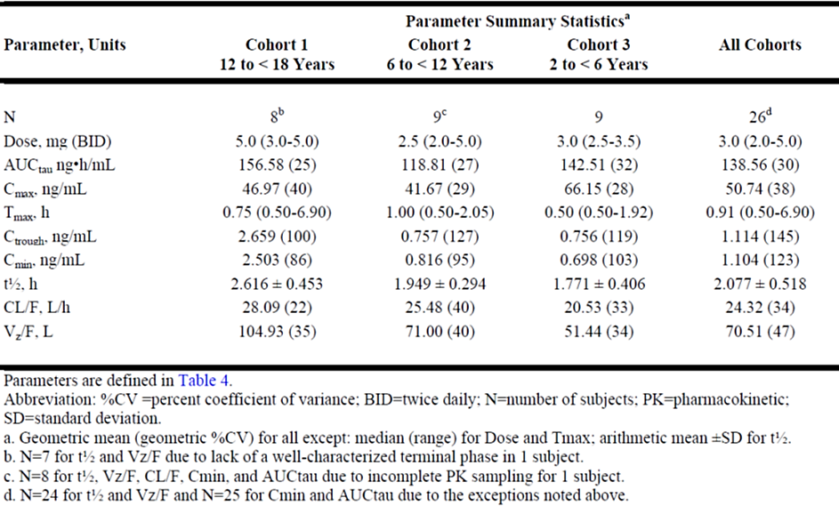

Population PK data

Ankylosing spondylitis
The objectives of Study 1064 were to characterise the PK of tofacitinib in adults with AS; to identify intrinsic and extrinsic factors (covariates) that impact the PK of tofacitinib in these patients; and to obtain individual steady-state exposures and PK parameters for subsequent exposure-response analyses. Pharmacokinetic data were drawn from Study 1119 and 1120, and included 1917 observations from 279 study participants, who had received between 2mg BD and 10mg BD tofacitinib, or placebo, for up to 16 weeks.
Population PK analysis was conducted using the nonlinear mixed effects modelling approach. Tofacitinib PK was described by a one-compartment disposition model with first-order absorption, parameterised in terms of CL/F, apparent volume of distribution (V/F), and first-order absorption rate constant (ka). Covariates evaluated in the PK model were baseline age, sex, race, baseline creatinine clearance (calculated from Cockcroft-Gault equation), and C-reactive protein (CRP) at baseline as potential predictors of CL/F and baseline age and weight as predictors of V/F. The study concluded that the popPK of tofacitinib in adults with AS are comparable to those in adults with PsA, RA and psoriasis, and that dose modifications on the bases of age, gender, body weight or race are not required for adults with AS.

Juvenile idiopathic arthritis
The objectives of Study 941 were to describe the PK of tofacitinib in children with JIA aged from 2 to less than 18 years; to identify potential covariates in the study population(s) which account for the variability in tofacitinib exposure; to assess the formulation effect and relative bioavailability of tofacitinib oral solution versus tablet formulation administered during clinical development; to evaluate PK similarity between the two formulations using a model-based simulation approach; and to provide individual-level exposure parameters for subsequent analyses. Pharmacokinetic data were drawn from Study 1103, Study 1104 and Study 1145, and included 1392 observations from 246 children, treated at a range of doses with either the solution or tablet formulations, for a maximum of 18 weeks.
Population PK analysis was conducted using the nonlinear mixed effects modelling approach. Tofacitinib PK was described by a one compartment disposition model parameterized in terms of apparent oral clearance (CL/F), apparent volume of distribution (V/F), and with first order absorption and a lag time estimated at 0.186 hour. Covariates evaluated in the model included sex, age, race, patient type (JIA category), extent of disease at baseline, renal function, CRP, albumin, ALT, AST, ALP, concomitant medications on CL/F; sex, age, race, patient type on V/F, formulation on K_{a}, and formulation on bioavailability (F).
Based on the covariate analysis results, tofacitinib does not require dose modification or restrictions for any covariates, except for weight, to account for differences in exposure. The formulation effect was only found significant on the absorption rate, suggesting 1.64-fold more rapid absorption associated with oral solution, which is expected to result in 113.9% [95%CI 108.0%, 120.7%] higher C_{max}, but no significant effect on steady state average concentrations.
Models supported a simplified dosing regimen to achieve a consistent average exposure in different weight groups, specifically 5 mg BD for children weighing ≥ 40kg, 4mg BD in children weighing 20 to <40 kg and 3.2 mg BD in children weighing 10 to < 20 kg.

Pharmacodynamics (PD)
No pharmacodynamic studies were included with this submission.

Efficacy

Ankylosing spondylitis
In the pivotal Phase 3, double-blind, placebo-controlled randomised clinical trial (Study 1120), 270 adults with active AS (with both total BASDAI score ≥4 and BASDAI back score ≥4, at screening and baseline) were randomized 1:1 to 16 weeks of treatment with tofacitinib 5mg twice daily (BD) or matching placebo (PBO). After 16 weeks in the study, all participants were treated with open label tofacitinib 5mg BD until the end of study (48 weeks, plus four weeks safety follow-up).
Figure 1: Study 1120 schema
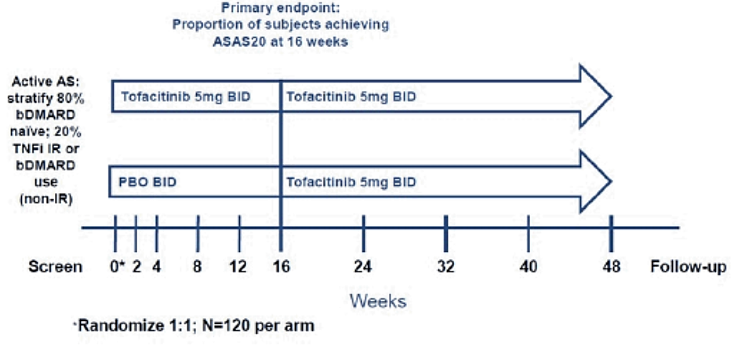
Adults with a diagnosis of AS based on the Modified New York Criteria for Ankylosing Spondylitis (1984), BASDAI score of ≥4 and BASDAI back pain score of ≥4 at both screening and baseline, and who had intolerance or inadequate response to at least two different NSAIDs were enrolled in the study. Radiographs of the sacroiliac joints were required as evidence for the diagnosis. The study population was further stratified to include a sub-group naïve to bDMARDs (∼80%), and a second sub-group who had received prior treatment with bDMARDs. The second sub-group included participants who had an inadequate response to at least one but no more than two TNFi, (TNF-IR) and participants who had not had an inadequate response to a bDMARD (non-IR). Any prior bDMARD had to be discontinued for at least five half-lives prior to the first dose of study treatment.
Key exclusion criteria included a history of known or suspected complete ankylosis of the spine; previous exposure or current use of targeted synthetic DMARDs or thalidomide, and other prohibited concomitant medications; and history of any other autoimmune rheumatic disease.
The primary efficacy outcome compared the efficacy of tofacitinib 5 mg BD and PBO BD on the ASAS20 response rate at week 16. The key secondary efficacy outcome compared the efficacy of tofacitinib 5 mg BD and PBO BD on the ASAS40 response rate at week 16. Both the primary efficacy outcome and key secondary outcome confirmed that tofacitinib 5mg BD was statistically significantly superior to PBO. The ASAS20 response rate at week 16 in the tofacitinib group was 56.39% compared to 29.41% in the PBO treated group (Table 3).
Table 3: Study 1120 - ASAS20 at week 16
The ASAS40 response rate at week 16 in the tofacitinib group was 40.60% compared to 12.50% in the PBO treated group (Table 4).
Table 4: Study 1120 - ASAS40 at week 16
Sub-group and sensitivity analyses were consistent with the key analyses. Most study participants who were initially randomized to PBO in the double-blind phase and then switched to open label tofacitinib 5mg BD achieved comparable efficacy to those patients maintained on tofacitinib 5mg by week 24 (eight weeks after switch, first assessment in the open label period).
The supportive dose-finding Study 1119 was a Phase 2, randomised, double blind placebo-controlled trial in adults with active AS who had an inadequate response to NSAIDs. The primary objective was to compare the efficacy of tofacitinib, in doses of 2 mg BID, 5 mg BID, and 10 mg BID versus PBO on the ASAS20 response rate at week 12. The key exclusion criteria were comparable to the pivotal Study 1120. Participants in Study 1119 were randomised 1:1:1:1 to BD doses of 2mg, 5mg or 10mg tofacitinib or of PBO. The treatment period was 84 days (12 weeks) and participants were allowed to continue on established stable doses of MTX (maximum 20mg/week), sulfasalazine (maximum 3g/day) or oral corticosteroids (maximum 10mg/day of prednisolone or equivalent). A total of 196 participants (94.2%) completed the study; ~98% of participants taking 2mg or 5mg tofacitinib BD completed the study, compared to ~90% of those in the tofacitinib 10 mg BD and PBO groups. Discontinuations associated with treatment-related AEs were similar in the tofacitinib 5 mg BID and 10 mg BID groups (1.9% each), and lower in the tofacitinib 2 mg BID group (0%) and higher in the PBO group (3.9%).
The observed (mean%, (SE)) ASAS20 response rates at week 12 in the PBO, 2mg, 5mg and 10mg tofacitinib groups were 41.18 (6.89), 51.92 (6.93), 80.77 (5.47) and 55.77 (6.89), respectively. Only the 5mg BD dose achieved statistical significance according to the pre-determined analysis. Sampling variability was suggested as the reason for the apparently anomalous results with the higher dose. Notwithstanding the statistical analysis, higher response rates to all doses of tofacitinib than to placebo are supportive of the pivotal study.

Juvenile idiopathic arthritis
The pivotal efficacy study in JIA was Study 1104, a Phase 3, randomised withdrawal, double blind (DB), placebo (PBO)-controlled comparison of efficacy and safety of weight-based doses of tofacitinib (up to 5mg BD) in children aged 2 to <18 years with RF+ polyarthritis (PA), RF- PA, extended oligoarthritis (eOligo) or sJIA with active arthritis but no active systemic features (together labelled polyarticular course JIA, or polyarticular (p)JIA), or with jPsA, or with ERA. All participants received open-label (OL) weight-based tofacitinib for the 18-week run-in period. Of this population, all participants who achieved a JIA ACR30 response at 18 weeks were randomised (double blind) 1:1 to ongoing tofacitinib based on weight, or to PBO, for a further 26 weeks. Groups were also stratified according to JIA category and CRP at baseline (normal, above normal) in the pJIA group, or JIA category alone (for jPsA and ERA). Participants who did not achieve JIA ACR30 at week 18 exited the study, as did participants who experienced disease flare at any time during the study.
Children were enrolled if they satisfied any of the classification groups in the ILAR JIA classifications (excluding undifferentiated arthritis and sJIA with systemic features) and had experienced active disease for at least six weeks prior to screening; had experienced an inadequate response or intolerance to any cDMARD or bDMARD; if the diagnosis was jPsA or ERA only an inadequate response to NSAIDs was required. Exclusion criteria were previous treatment with tofacitinib; any evidence or history of untreated/inadequately treated/latent tuberculosis; a range of chronic or recently treated (within two weeks) infections; active uveitis; and history of any other rheumatological disease except Sjogren’s syndrome.
The primary efficacy outcome compared the percentage of patients with pJIA taking tofacitinib who experienced a disease flare during the DB withdrawal period (between week 18 and the end of study at week 44), to the percentage of patients with pJIA taking PBO that experienced a disease flare during the same period. Flares were defined applying the Pediatric Rheumatology Clinical Study Group/Pediatric Rheumatology International Trials Organization (PRCSG/ PRINTO) Disease Flare criteria. Secondary efficacy outcomes included comparisons between the rates of patients with pJIA taking tofacitinib and patients with pJIA taking PBO with JIA ACR30, 50 and 70 responses, and changes from baseline in the Childhood Health Assessment Questionnaire (CHAQ), at various times during the double-blind study period.
Efficacy outcomes in participants in the JIA categories jPsA and ERA were treated as secondary outcomes. In the jPsA group these included the change from baseline in body surface area (BSA) affected by psoriasis and the change from baseline in physician’s global assessment (PGA) of disease activity, in the OL phase and in the DB phase. In the ERA group these included change from baseline in the Tender Entheseal Assessment, the Modified Schober’s Test, overall back pain, and nocturnal back pain in the OL phase and in the DB phase.
Weight-based doses of tofacitinib were given according to Table 5.
Table 5: Study 1104: Study treatment dosing and administration
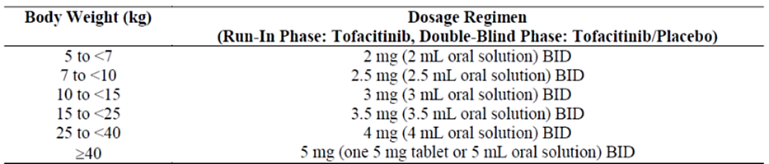
Treatment with stable doses of an NSAID and/or oral glucocorticoid (the lower of 0.20 mg/kg/day or 10 mg/day), and/or MTX (the lower of 25 mg/week or 20 mg/m²/week) was permitted. For those with jPsA, non-medicated emollients were allowed for use over the whole body; topical steroids for the palms, soles, face, and intertriginous areas only; and tar, salicylic acid preparations, and shampoos free of corticosteroids were permitted for the scalp. MTX was the most frequent concomitant cDMARD used (on Day 1, 156 of 157 patients on cDMARDs were taking MTX).
Statistical analyses for efficacy outcomes were performed separately for the three groups pJIA, jPsA and ERA and included analyses during the DB period and separately in the OL run-in period. The following endpoints were assessed hierarchically for the pJIA group only; statistical significance could be claimed for the second endpoint only if the first endpoint in the sequence met the requirements for significance:
- Disease flare by W44/EOS (primary)
- ACR 50 at W44/EOS
- ACR 30 at W44/EOS
- ACR 70 at W44/EOS
- Change from DB baseline in CHAQ disability index at W44/EOS
Other secondary or exploratory endpoints, including those specific to the groups with jPsA or ERA, were not subjected to hierarchical statistical testing.
Participant flow is outlined in Error! Reference source not found.. The following terms were used to describe different subsets in the efficacy and safety analyses. OLFAS: all enrolled participants who received at least one dose of tofacitinib; OLJAS: subset of OLFAS with pJIA; OLERA: subset of OLFAS with ERA; OLPsA: subset of OLFAS with jPsA; DBFAS: all participants enrolled in the DB phase who received at least one dose of study treatment; DBJAS: subset of DBFAS with pJIA; DBJPP: subset of DBFAS with pJIA and treated per protocol; DBERA: subset of DBFAS with ERA; DBPsA: subset of DBFAS with jPsA; DBSAS: all participants who were enrolled in the DB phase who received at least one dose of study treatment, included in the safety analysis set.
A total of 225 children were enrolled in the OL run-in phase of the study. In the pJIA group there were 28 children with eOligo; 39 with RF+ PA; 104 with RF- PA and 13 with sJIA. In the other study groups 20 children with jPsA and 21 with ERA were enrolled. There were no children younger than six years old with RF+ PA, jPsA or ERA enrolled in the study, and only two children younger than six years old with sJIA in the study. The mean and median ages at enrolment varied between eight years (for children with sJIA) and 14.5 years (for children with jPsA) in the different JIA types. Mean and median number of joints involved at enrolment varied between seven (children with ERA or with eOligo) and 14.2 (children with RF+ PA). Mean and median PGA scores at enrolment (between 5 and 7.5), CHAQ scores and inflammatory indices (baseline CRP, baseline ESR) were comparable in all subtypes (the latter two moderately higher in children with RF+ PA and sJIA).
All participants received OL treatment with tofacitinib. Of these, 185 completed the OL run-in phase, and 173 participants achieved JIA ACR30 and were randomised into the DB withdrawal study. This included 142 with pJIA (eOligo 18, RF+ PA 28, RF- PA 87, sJIA 9), 15 with juvenile PsA, and 16 with ERA.
Figure 2: Study PcJIA-1 participant flow
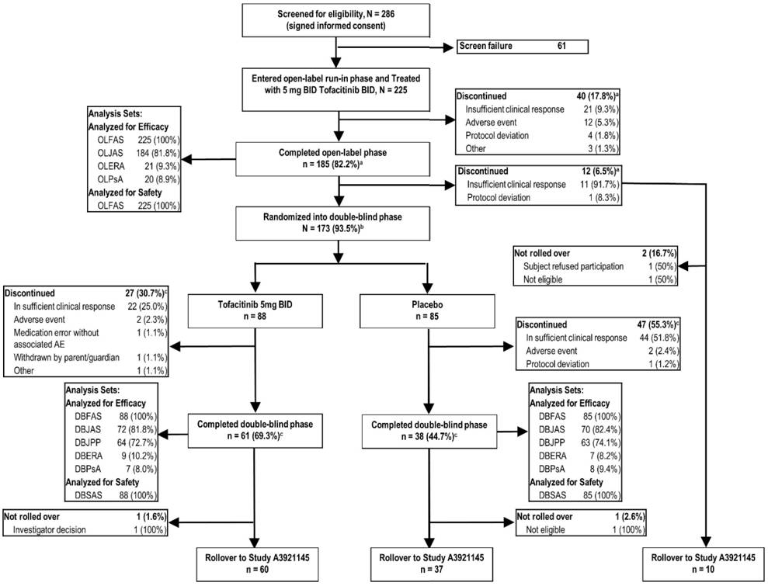
There was a high rate of protocol deviations in both the OL and DB phases of the study. The sponsor did not consider that these were likely to affect the outcomes. In the OL phase, protocol deviations occurred most frequently in relation to laboratory issues (14.7%, usually specimen could not be analysed), the investigational product (13.3%, usually missed doses), informed consent (7.1%), concomitant medications (5.3%), and inclusion/exclusion criteria (5.3%). In the DB phase, protocol deviations occurred most frequently (for tofacitinib and PBO groups, respectively) in relation to laboratory issues (20.5%, 18.8%), the investigational product (12.5%, 18.8%), informed consent (11.4%, 7.1%), procedures/tests (10.2%, 7.1%), and the visit schedule (8.0%, 4.7%).
Overall, the baseline demographics and disease characteristics for those children randomised into the DB phase were similar in the tofacitinib group and PBO group and consistent with a population of JIA subjects with active disease (see clinical evaluation report, Table 94, page 226), but varied substantially within the smaller treatment groups and types of JIA. There were more female (N=169) than male (N=56) participants in the study. Approximately 62% of participants were aged 12 to <18 years; 26% were aged 6 to <12 years; and 11% were aged 2 to <6 years.
Prior use of bDMARDs (most frequently etanercept) and csDMARDs (most commonly MTX) was reported in 37.8% and 91.6% of participants, respectively, at baseline for the OL run-in phase. Oral corticosteroids had been used by 49.3% and NSAIDS had been used by 70.7% of participants.
In the DBERA analysis set, additional baseline disease characteristics (after 18 weeks OL treatment with tofacitinib) in the children randomized to tofacitinib in the DB phase appeared more severe than in the children randomized to the PBO group; the ability to interpret the significance of this is limited by the small numbers of patients (Table 6).
Table 6: Study 1104 - Additional baseline disease characteristics - DBERA
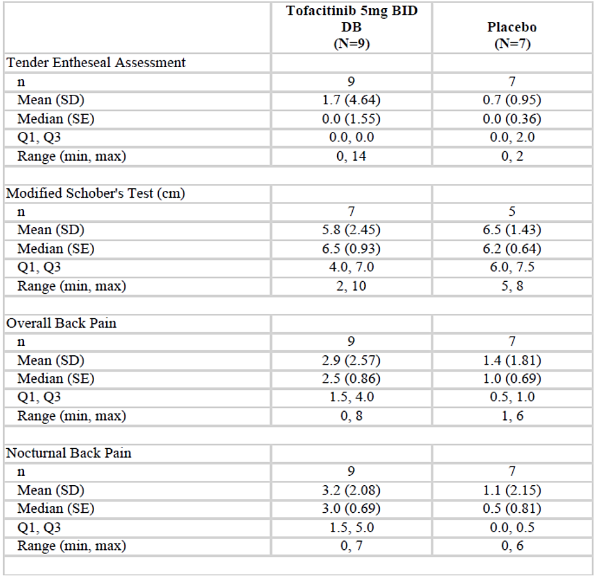
In the DBPsA analysis set, PGA (after 18 weeks OL treatment with tofacitinib) of disease activity was possibly worse in the patients with jPsA randomized to PBO in the DB period, but BSA affected by psoriasis was higher in the patients with jPsA randomized to tofacitinib in the DB period (Table 7). Small numbers again limit assessments of the significance of these differences.
Table 7: Study 1104 – Additional baseline disease characteristics - DBPsA
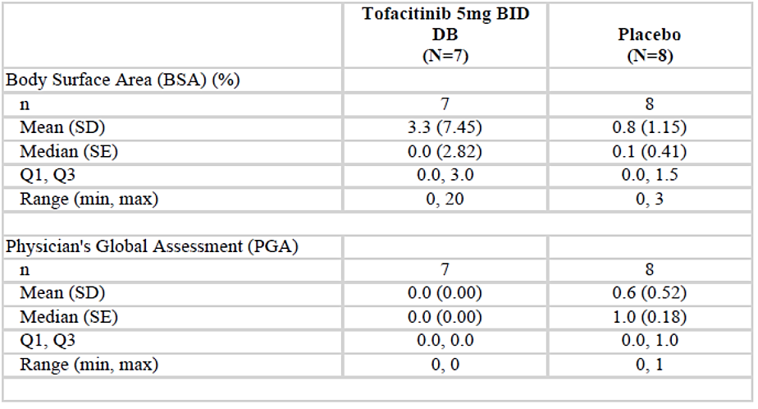
The primary efficacy endpoint was met in this study, with a statistically significantly lower occurrence of disease flare by week 44 in the tofacitinib group compared to the PBO group in subjects with pJIA (Table 8: Study 1104: Occurrence of Disease Flare at W44 – DBJASTable 8). Overall, fewer children with eOligo, RF+ PA, RF- PA or sJIA experienced flares while taking tofacitinib than children with the same types of JIA taking PBO.
Table 8: Study 1104: Occurrence of Disease Flare at W44 – DBJAS
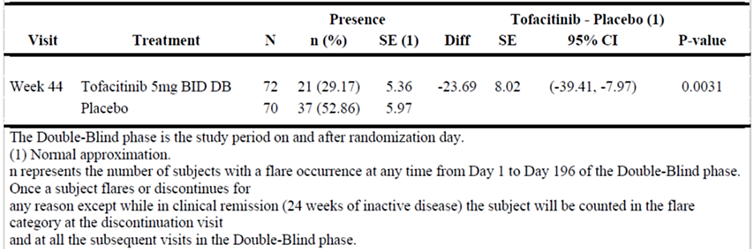
Sensitivity analyses and subgroup analyses (JIA category, baseline CRP, age, geographical region and baseline body weight) were numerically consistent with the primary analysis, although possibly owing to low numbers, in several subgroups the 95% CI crossed unity (Error! Reference source not found.). While the effect of geographical region on the results is likely to be irrelevant, it is possible that efficacy in the notably small population with sJIA, in patients with normal baseline CRP and patients weighing ≥ 40kg may all have been influenced by the primary JIA diagnosis.
Figure 3: Forest plot analysis of occurrence of disease flare by subgroups.
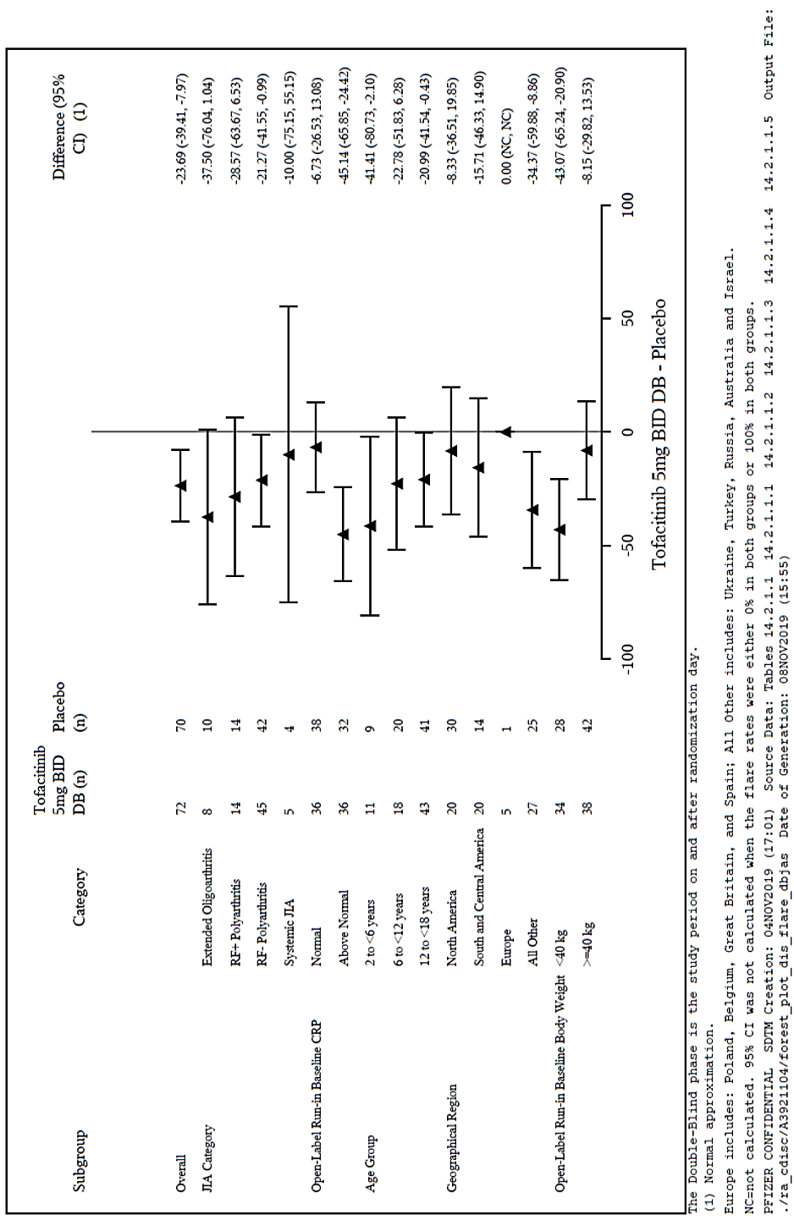
The key secondary analyses in the group with pJIA were consistent with the primary outcome. As participants who experienced disease flare in the DB phase of the study were allowed to exit the study only a total of 99 participants completed the study to week 44 (61 in the tofacitinib arm and 38 in the PBO arm).
At week 44, a significantly greater proportion of subjects treated with tofacitinib achieved JIA ACR 50, 30, and 70 responses compared to subjects treated with PBO (p=0.0166, p=0.0031, and p=0.0387, respectively, Table 9).
Table 9: Study 1104: JIA ACR responses 50/30/70 at W44 - DBJAS
In the small group of participants with jPsA included in the DB phase, the efficacy results for the primary and key secondary endpoints were consistent with those for pJIA, in that the outcomes favoured tofacitinib (Table 10).
Table 10: Study 1104: Primary and key secondary efficacy results for jPsA subtype
While there appeared to be numerical improvements in the efficacy assessments in children with ERA during the OL run-in phase, children randomised to tofacitinib and children randomised to PBO in the DB withdrawal phase demonstrated similar changes in all outcomes. Differences in disease severity assessments in the two groups after 18 weeks treatment with OL tofacitinib, as noted earlier, may have contributed to the outcome. The Sponsor noted that the small number of participants with ERA did not allow any efficacy conclusions to be drawn. The Sponsor is not proposing that tofacitinib be approved for use in children with ERA.
The pivotal efficacy study in JIA is supported by Study 1145, an ongoing Phase 2/3, long-term, OL, follow-up study for participants in preceding studies 1103, 1104 and 1165 with sufficient evidence of JIA disease activity (in the opinion of the investigator) to warrant use of tofacitinib as a DMARD. The primary objective is to determine the long-term safety and tolerability of tofacitinib for treatment of the signs and symptoms of JIA. A secondary objective is to evaluate the persistence of efficacy of tofacitinib for treatment of the signs and symptoms of JIA. At the time of the interim clinical study report, 26 subjects from Study 1103, 197 subjects from Study 1104, and 2 subjects from Study 1165 were enrolled and treated. Tofacitinib dosages are based on body weight, with oral solution (1 mg/mL concentration) used for participants weighing <40 kg, and oral tablets (5 mg) used by those weighing ≥40 kg; children who are unable to swallow tablets have the option of taking oral solution. Of the 223 participants included in the interim analysis, the primary diagnosis was eOligo in 27 children, RF+ PA in 36 children, RF- PA in 109 children, sJIA in 11 children, jPsA in 19 children, and ERA in 21 children. Efficacy outcomes include arthritic flares as defined by JIA ACR, and JIA ACR30/50 responses at defined follow up points. At data cut-off for this report, disease flares had been reported by between 2% and 5% of study participants up to 18 months of follow-up. Approximately half of patients reported ACR30/ACR50 responses for up to 21 months of follow-up.

Safety

Ankylosing spondylitis
Primary safety data were collected from the pivotal study 1120 and dose-ranging study 1119, supplemented by supportive data (reports of safety events in defined patient populations of AS, not exposed to tofacitinib) from a US claims database (Study 1350) and from the Swedish Anti-Rheumatic Therapies in Sweden (ARTIS) Register (Study 1391). Clinical trial safety data were reported for separate phases of the pivotal study and also analysed in two pools – the All Tofa 5 mg pool (patients who were treated with tofacitinib 5 mg BD in study 1119 or study 1120); and the All Tofa pool (patients who were treated with tofacitinib 2 mg, 5 mg, or 10mg BD in the two trials). In the All Tofa 5mg pool, 108 adults had been exposed to 5 mg tofacitinib BD for at least 12 months (total exposure 100.46 patient-years) and 375 adults had been exposed to any dose (2 mg, 5mg or 10 mg tofacitinib BD) for at least three months (total exposure 224.24 patient years, Table 11).
Table 11: Overall exposure to tofacitinib in the AS clinical trials
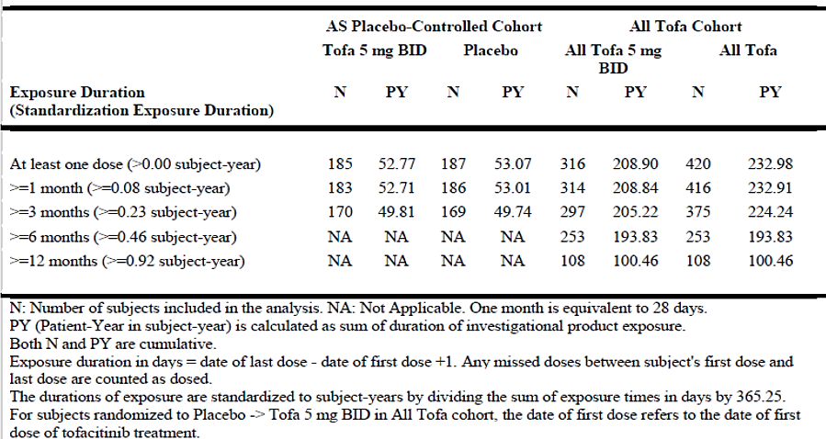
Adverse event (AE) data in the double-blind phase of study 1120 was collected for 185 participants in the tofacitinib group and 187 participants in the PBO group. One or more adverse events were reported by 54.6% of the tofacitinib group and 49.2% of the PBO group. Treatment-emergent (TE) AE considered related to treatment are summarised in Table 12.
Table 12: Study 1120 – Treatment related TEAE during the placebo-controlled period
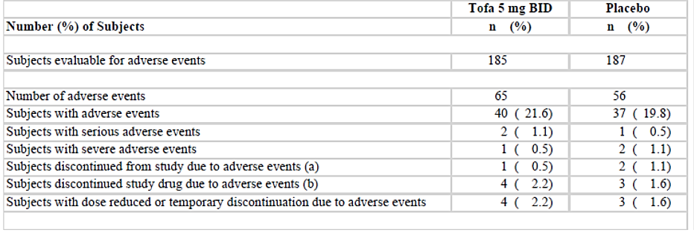
The most frequent TEAEs by system organ class (SOC) in the tofacitinib group were Infections and infestations, Gastrointestinal (GI) disorders, Investigations, and Musculoskeletal and connective tissue disorders and were mild or moderate in severity (Table 13). The reported events reflected common AE reported previously in adults with RA or with PsA taking tofacitinib. The most frequent (≥2% in either group) TEAEs were upper respiratory tract infection (URTI) and nasopharyngitis. TEAE frequencies by preferred term (PT) that were >1% higher in the tofacitinib group compared to the PBO group included fatigue, influenza, respiratory tract infection viral, URTI, ALT increased, AST increased, protein urine present, and arthritis.
Table 13: Study 1120 – Treatment-related TEAE reported in ≥2% of participants in either group in the placebo-controlled period by SOC
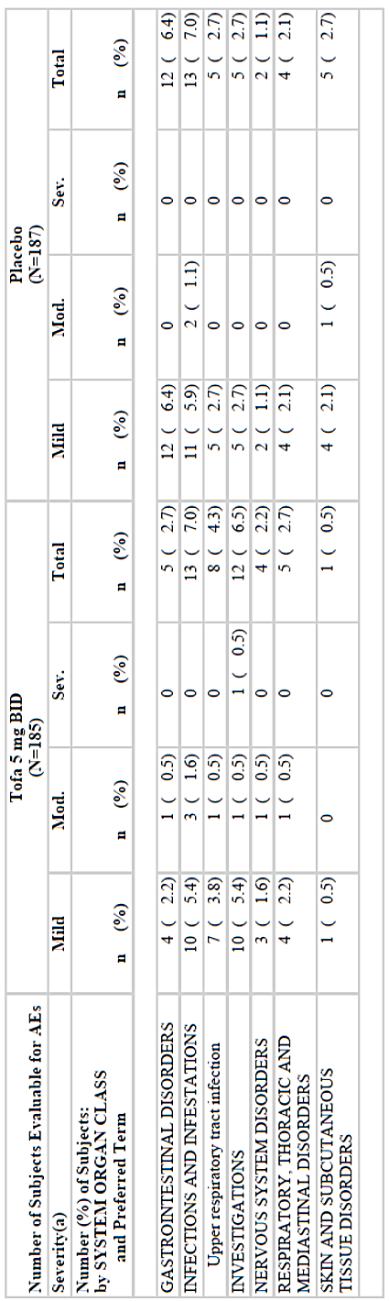
In the All Tofa 5mg group 507 AE were experienced by 63.6% of participants, and in the All Tofa group 617 AEs were experienced by 59.8% of participants (Table 14). Most AEs were mild to moderate intensity and comparable to those reported in the Placebo-controlled Cohort, with the following additional PTs reported at a ≥2% frequency for the All Tofa 5 mg BID group: Hepatic function abnormal, Blood CK increased, Weight increased, Arthralgia, Cough and Oropharyngeal pain.
Table 14: Ankylosing Spondylitis - TEAE in the pooled analysis sets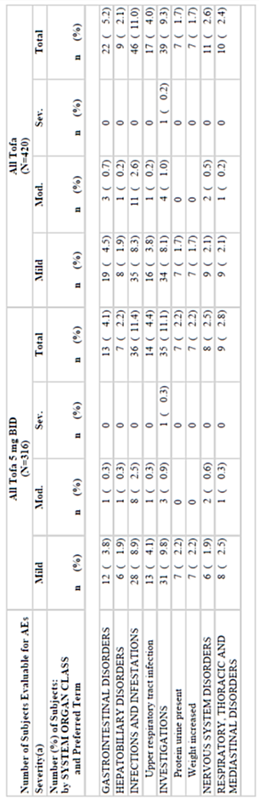

No new safety signals were noted. There were no reports of treatment-related deaths or opportunistic infections, malignancies, GI perforations, MACE, interstitial lung disease, or thrombosis events in the AS studies. The evaluator noted that most (81.6%) patients in the All Tofa 5 mg group and in the All Tofa group were bDMARD-naïve. There was a trend towards higher incidence rates of TEAEs, SAEs, severe AEs, infections, herpes zoster, and discontinuations of study treatment due to AEs, in bDMARD-experienced patients compared to the bDMARD-naïve patients.
Comparisons with adverse event reports gathered by US and Swedish registers did not indicate that within the context of known limitations of registers, reports of serious AE were any higher in patients with AS treated with tofacitinib in the clinical trial program than in similar populations treated with other therapies.

Juvenile idiopathic arthritis
Primary safety data from children with JIA were presented for the pivotal study 1104 (all patients in the OL phase who received at least one dose of tofacitinib, OLSAS; all patients in the DB phase who received at least one dose of tofacitinib, DBSAS; and a combined all exposure safety set, which excluded the children in the placebo group during the DB phase); and for all children who received at least one dose of tofacitinib in the pivotal study 1104, the pharmacokinetic study 1103 and/or in the open-label follow-up study 1145 (the integrated safety analysis population, ISAP). A third analysis set was presented for all children who had received continuous tofacitinib (any break in dosing had to be shorter than 14 days) from the first day in the index study until either discontinuation from the program, the date of last dose before a dosing interruption exceeding 14 days, or the date of data cut-off in Study 1145 (the continuous integrated safety population, CISAP). Comparisons were also drawn with the safety profile of tofacitinib in RA studies, and with the safety profile of bDMARDs in JIA.
Total exposure in the ISAP was reported as 251 participants exposed to tofacitinib 5mg BD (or weight-based equivalent), for overall exposure of 351 patient-years, mean duration of 511 days, median duration 485 days. Of these, 161 participants had been exposed for over 12 months, and 57 for over two years (Table 15).
Table 15: Juvenile Idiopathic Arthritis - Total exposure to tofacitinib in the ISAP
In the CISAP, total continuous exposure to tofacitinib in 251 patients was 253 patient-years, mean duration 368 days, and median duration 216 days. Of these, 104 participants had continuous exposure of at least 12 months, and 42 for over two years.
Treatment-emergent AEs, regardless of causality, for the ISAP are summarised in Table 16. Most AE were considered mild or moderate severity, and around 9% of reports were of serious AE. No deaths were reported in the JIA clinical study program.
Table 16: Juvenile Idiopathic Arthritis - Summary of TEAE in the ISAP
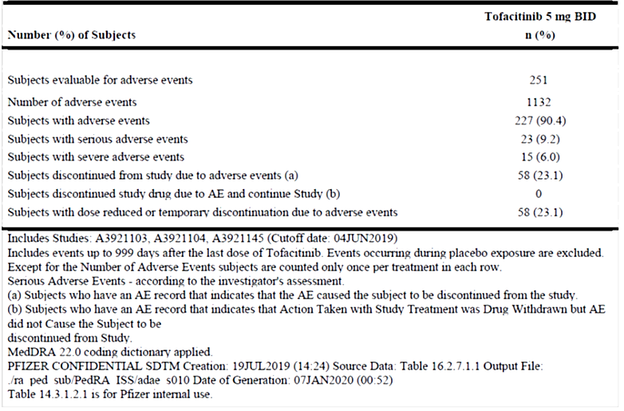
In the pivotal clinical study 1104 during the entire tofacitinib exposure period, 554 TEAEs regardless of causality were reported for 176 (78.2%) participants exposed to tofacitinib, with SAEs reported for eight (3.6%) participants. Most TEAEs were mild to moderate in severity; severe AE were reported for five (2.2%) children. The SAEs included three participants requiring hospitalization during the OL period: one with pneumonia, one with appendicitis and one child with a history of craniosynostosis repair was hospitalized for epidural empyema, sinusitis and subperiosteal abscess. Additional reported SAEs (more than one may have been reported by a single patient) were Crohn’s disease, diarrhoea, vomiting, JIA and “condition aggravated” which also referred to JIA.
In the OL phase of study 1104, TEAEs were experienced by 68.0% of participants. Most TEAEs were mild-moderate in severity. The most frequently reported TEAEs (≥2% occurrence) were URTI (10.7%), headache (7.1%), nausea (5.8%), and vomiting (5.8%). During the placebo-controlled phase, 160 TEAEs were experienced by 77.3% of participants in the tofacitinib group compared to 166 TEAEs experienced by 74.1% of participants in the PBO group. The most frequently reported AEs by preferred term were URTI (14.8%), disease progression (9.1%), and nasopharyngitis (8.0%) in the tofacitinib group, and disease progression (15.3%), JIA (14.1%), and URTI (10.6%) in the PBO group. In the placebo-controlled phase, one child in the tofacitinib group experienced an SAE of pilonidal cyst, and one child each in the PBO group experienced intussusception and severe JIA.
Serious AEs reported in the ISAP included abdominal pain, Crohn’s disease, diarrhoea and vomiting in the Gastrointestinal disorders SOC; abscess limb, appendicitis, epidural empyema, herpes zoster, influenza, pilonidal cyst, pneumonia, pyelonephritis acute, sinusitis, subperiosteal abscess and urinary tract infection in the Infections and infestations SOC; forearm fracture in the Injury, poisoning and procedural complications SOC; joint effusion and muscle spasms in the Musculoskeletal and connective tissue disorders SOC; headache and migraine in the Nervous system disorders SOC; and homicidal ideation, major depression, suicidal ideation and suicide attempt in the Psychiatric disorders SOC. Each SAE was reported only once, but one patient may have reported more than one SAE. Juvenile idiopathic arthritis was reported as an SAE three times (under the Musculoskeletal and connective tissues disorders SOC) and is likely to be the underlying issue in single reports of disease progression and condition aggravated under the General disorders and administration site Conditions SOC. SAEs were the most common reason for discontinuation from study treatment across the program.
The adverse reactions in JIA patients in the clinical development program were consistent in type and frequency with those seen in adult RA patients however reports of influenza, pharyngitis, sinusitis, viral infection and gastrointestinal or general disorders (abdominal pain, nausea, vomiting, pyrexia, headache, cough) were more common in the JIA paediatric population.

Risk management plan evaluation summary
In support of the extended indications, the sponsor submitted EU-RMP version 18.1 (date 24 August 2021; DLP 5 November 2020) (AS indication), EU-RMP version 21.1 (date 8 September 2021; DLP 5 May 2021) (JIA indication); and ASA version 5.0 (date 22 October 2021). With the section 31 response, the sponsor submitted EU-RMP version 29.1 (date 02 June 2022; DLP 05 November 2021) and ASA version 6.0 (date 20 June 2022).
The summary of safety concerns outlined in the following table was acceptable to the RMP evaluator. The sponsor has committed to providing drafts of all additional risk minimisation materials to the TGA for review at least six weeks prior to marketing. Final agreed versions of the new materials will be included with the next ASA.
The summary of safety concerns and their associated risk monitoring and mitigation strategies are summarised in Table 17. The TGA may request an updated RMP at any stage of a product's life-cycle, during both the pre-approval and post-approval phases.
Table 17: Summary of safety concerns
Summary of safety concerns |  | Pharmacovigilance |  | Risk minimisation
 |  | Routine | Additional | Routine | Additional
Important identified risks | Venous thromboembolic events (DVT/PE) | ü | ü^{1,2,3} | ü | ü^{5,6,7}
Important identified risks | Serious and other important infections | ü | ü^{1,2,3} | ü | ü^{5,6,7}
Important identified risks | Herpes zoster reactivation | ü | ü^{1,2,3,4} | ü | ü^{5,6,7}
Important identified risks | Lung cancer | ü | ü^{1,2,3} | ü | ü^{5,6}
Important identified risks | Lymphoma | ü | ü^{1,2,3} | ü | ü^{5,6}
Important identified risks | Myocardial infarction | ü | ü^{1,2,3} | ü | ü^{5,6,7}
Important identified risks | Decrease in Hgb levels and anaemia | ü | – | ü | ü^{5,6}
Important identified risks | NMSC | ü | ü^{1,2,4} | ü | ü^{5,6,7}
Important identified risks | Transaminase elevation and potential for DILI | ü | ü⁴ | ü | ü^{5,6}
Important identified risks | Higher incidence and severity of AEs in the elderly | ü | ü² | ü | ü^{5,6}
Important potential risks | Malignancy | ü | ü^{1,2,3,4} | ü | ü^{5,6}
Important potential risks | Cardiovascular risk (excl MI) | ü | ü^{1,2,3} | ü | ü^{5,6}
Important potential risks | GI perforation | ü | ü^{1,2,3,4} | ü | ü^{5,6,7}
Important potential risks | ILD | ü | ü¹ | ü | ü^{5,6}
Important potential risks | PML | ü | ü^{1,2} | – | –
Important potential risks | All-cause mortality | ü | ü^{1,2,3} | ü | ü⁵
Important potential risks | Fractures | ü | ü¹ | ü | ü^{5,6}
Important potential risks | Increased risk of AEs when tofacitinib is administered in combination with MTX in RA or PsA patients | ü | ü^{2,4} | ü | ü⁵
Important potential risks | Primary viral infection following live vaccination | ü | ü^{4,8} | ü | ü⁵
Missing information | Effects on pregnancy and the foetus | ü | ü^{4 ,9} | ü | ü^{5,6}
Missing information | Use in breastfeeding | ü | ü⁴ | ü | ü^{5,6}
Missing information | Effect on vaccination efficacy and the use of live/attenuated vaccines | ü | ü⁴ | ü | ü⁵
Missing information | Use in patients with mild, moderate, or severe hepatic impairment | ü | ü^{3,4} | ü | ü^{5,6}
Missing information | Use in patients with moderate or severe renal impairment | ü | – | ü | ü^{5,6}
Missing information | Use in patients with evidence of hepatitis B or hepatitis C infection | ü | – | ü | ü^{5,6}
Missing information | Use in patients with malignancy | ü | ü³ | ü | ü^{5,6}
Missing information | Long-term safety in pJIA patients and juvenile PsA patients (e.g. growth or development disturbances) | ü | ü^{1,2,10,11} | – | –
1 Post-Authorisation Active Safety Surveillance Program, 2 Active surveillance study, 3 Drug utilisation study, 4 EU-based survey for prescribers, 5 Prescriber guide, HCP Guide, 6 Patient booklet, 7 Medical Alert card, 8 Clinical Trial, 9 Pregnancy Registry, 10 Toxicity study, 11 Open-label follow up study.

RMP evaluator recommendations regarding condition/s of registration
Any changes to which the sponsor has agreed should be included in a revised RMP and ASA. However, irrespective of whether or not they are included in the currently available version of the RMP document, the agreed changes become part of the risk management system.
The suggested wording is:
The Xeljanz EU-Risk Management Plan (RMP) (version 29.1, dated 02 June 2022, data lock point 5 November 2021), with Australian Specific Annex (version 6.0, dated 20 June 2022), included with submission PM-2021-04843-1-3, and any subsequent revisions, as agreed with the TGA will be implemented in Australia.
The following wording is recommended for the PSUR requirement:
An obligatory component of risk management plans is routine pharmacovigilance. Routine pharmacovigilance includes the submission of periodic safety update reports
Reports are to be provided in line with the current published list of EU reference dates and frequency of submission of PSURs until the period covered by such reports is not less than three years from the date of this approval letter.
The reports are to at least meet the requirements for PSURs as described in the European Medicines Agency’s Guideline on good pharmacovigilance practices (GVP) Module VII-periodic safety update report (Rev 1), Part VII.B Structures and processes. Note that submission of a PSUR does not constitute an application to vary the registration.
As the indications for Xeljanz are being extended into a significantly different population and/or disease/condition it should be included in the Black Triangle Scheme as a condition of registration. The following wording is recommended for the condition of registration:
Xeljanz (tofacitinib) is to be included in the Black Triangle Scheme. The PI and CMI for Xeljanz must include the black triangle symbol and mandatory accompanying text for five years, which starts from the date the new indication is registered.

Risk-benefit analysis

Ankylosing spondylitis
The clinical study program in AS was small, but appropriately designed to examine the efficacy and safety of tofacitinib in adults with active disease. The pivotal study concluded that tofacitinib 5 mg BD had statistically significant and clinically important efficacy gains over placebo in the treatment of active AS in adults who had poor responses or intolerance to NSAIDs. Efficacy was confirmed in patients who had not had previous experience with bDMARDs, and in patients who had previously been treated with bDMARDs, both successfully and unsuccessfully (poor response, no response or intolerance). No new safety signals were observed in this population of patients compared to adult populations with RA or PsA treated with tofacitinib in the relatively short period of exposure. The sponsor stated that adverse events in this population occurred at similar rates to background rates in this population, as reported by registry evidence.

Juvenile idiopathic arthritis
Tofacitinib has been approved for marketing for JIA in both the USA and EU. In the USA, tofacitinib, as Xeljanz/Xeljanz Oral Solution, was approved in September 2020 “for the treatment of active polyarticular course arthritis (pcJIA) in patients 2 years of age and older who have had an inadequate response or intolerance to one or more TNF blockers. The restriction to use only after failure of TNF blockers was enforced after a review of a PASS in adult patients with RA with risk factors for cardiovascular disease triggered sufficient concern among the US authorities that tofacitinib is implicated in higher reporting rates of MACE, malignancy, thromboembolic disease and mortality.
The study description for polyarticular course JIA in the US product information provided overall efficacy results for the patient population stating
“Patients 2 years to 17 years of age with active RF negative polyarthritis, RF positive polyarthritis, extended oligoarthritis, and systemic JIA without systemic manifestations who had an inadequate response or intolerance to at least one DMARD which could have included MTX or biologic agents; the study also included patients ages 2 years to 17 years of age with active juvenile psoriatic arthritis (JPsA) and enthesitis-related arthritis (ERA) who had an inadequate response to NSAIDs.”
The study further reported that 76.9% of patients enrolled in the run-in phase achieved JIA ACR30 response at week 18 and were randomized to the double-blind phase. No granular data was provided that might allow a clinician to consider efficacy in the sJIA sets.
In contrast, the EU SmPC was more restrictive in its approval of the use of tofacitinib in JIA, notably excluding children with primary diagnoses of sJIA (irrespective of the presence or absence of systemic features) and ERA in the indication. Low numbers of patients with sJIA were enrolled in the pivotal JIA study, and particularly in the DB phase (five in the tofacitinib arm and four in the placebo arm). While overall the demographics of the JIA population randomized to tofacitinib and placebo in the DB phase were comparable, it is possible that there are sufficient differences in the demographics and disease characteristics of different types of JIA that affected responsiveness to tofacitinib. In the current submission, it is possible that the pooled efficacy results may have been driven by the positive findings in the larger subset of patients with RA- polyarthritis. The ongoing OL study 1145 may provide additional data to support efficacy in the small groups of patients. The sponsor has also committed to, and provided a study protocol for, a long-term safety study in children with polyarticular JIA or jPsA which may as an additional outcome provide useful long-term efficacy information.
Efficacy results for children with jPsA or ERA were not included in the primary efficacy analysis (DBJAS population). In the jPsA group, efficacy outcomes in the OL phase and in the DB phase were consistent with outcomes in the larger study group. In the ERA group though, results were not as convincing, and the sponsor has not requested that tofacitinib be approved for the treatment of children with ERA. The delegate supports this decision.
The benefit-risk balance of the use of tofacitinib in the treatment of adults with active AS is positive. There are some unresolved concerns with the potential for serious adverse events associated with long-term use of tofacitinib which may result in further TGA action. On the evidence provided in this submission, I am inclined to approve tofacitinib for the indication
Xeljanz is indicated for the treatment of adult patients with active ankylosing spondylitis who have responded inadequately to conventional therapy.
The benefit-risk balance of the use of tofacitinib in the treatment of children aged over two years with extended oligoarthritis or RF- polyarthritis, and the treatment of children aged ≥ six years with RF+ polyarthritis or jPsA is positive. While there is no efficacy or safety data specific to children with RF+ polyarthritis or jPsA younger than six years, this is likely to be a small subset of the population and it is unlikely that there would be critical differences in the patient population or disease features that would affect efficacy and safety of tofacitinib. I am inclined to align with the EU indication and approve tofacitinib for the treatment of children with eOligo, RF+ polyarthritis, RF- polyarthritis and jPsA.
The benefit-risk balance of the use of tofacitinib in the treatment of children with sJIA (with or without systemic manifestations) and ERA is uncertain. The number of children with sJIA without systemic manifestations exposed to tofacitinib in the DB phase of the pivotal study was small, and the treatment effect compared to PBO in the pivotal study was not convincing. In the separate efficacy analysis for children with ERA, there appeared to be sufficient differences in the tofacitinib and PBO treated populations prior to the DB phase to confound assessments of efficacy. On the evidence provided in this submission, I am inclined to approve tofacitinib for the indication:
Xeljanz is indicated for the treatment of active polyarticular juvenile idiopathic arthritis (rheumatoid factor positive [RF+] or negative [RF-] polyarthritis and extended oligoarthritis) and juvenile psoriatic arthritis in patients 2 years of age and older, who have responded inadequately to previous therapy with DMARDs.

Advisory Committee considerations
The Advisory Committee on Medicines (ACM), having considered the evaluations and the Delegate’s overview, as well as the sponsor’s response to these documents, advised the following.
What is the opinion of the Committee on the generalisability of efficacy in the ‘polyarticular course’ JIA population enrolled in this study to the broader population of children with different types of JIA?
The ACM advised that ‘polyarticular course’ is standard nomenclature and is used as an umbrella term capturing a number of JIA subtypes with 5 or more active joints affected. The ACM also noted that the term has not been applied uniformly in published studies of JIA treatment.
The ACM highlighted the clinical need for treatments for JIA and acknowledged the challenges associated with conducting studies with patients with different JIA subtypes, where efficacy outcomes may be driven by larger groups with specific subtypes. The ACM advised that it is appropriate in this instance to accept that efficacy demonstrated in pooled analyses across subtypes and/or in common subtypes of JIA (i.e. RF- polyarticular disease) may be extrapolated to all subtypes.
The clinical trial description of polyarticular course JIA includes extended oligoarthritis, polyarthritis RF+, polyarthritis RF-, and sJIA with active arthritis but without active systemic features for at least 6 months. The ACM noted that the clinical study subgroup analysis was performed on these subtypes, however these were based on small numbers which impacted on the individual subgroup results. The ACM highlighted these challenges with the small sJIA subgroup. The ACM advised that while sJIA can begin with systemic features such as fever and rash, it often evolves to share the symptomatology of other polyarticular course JIA. The ACM took the view that it is appropriate in this case to include sJIA without systemic features within the definition of polyarticular course JIA.
The ACM was of the view that the term polyarticular course JIA may be utilised within the PI, including within the indication, and that it was appropriate to list the included subtypes within the indication. The ACM noted that this definition of polyarticular course JIA is generally consistent with literature / clinical trial data for which the nomenclature polyarticular course JIA is used.
Does the study description in the PI sufficiently describe which populations of children with JIA are likely to benefit from treatment with tofacitinib?
The ACM was supportive of the Delegate’s proposed amendments to the PI. The ACM agreed that a description of the subtypes of JIA defined in the clinical study and the number of enrolled patients by subtype should be included within the PI, noting that this will add clarity for prescribers.
The ACM reiterated the recommendation that the term ‘polyarticular course JIA’ rather than ‘polyarticular JIA’ be used within the PI unless specifically referring to the RF+ and RF- polyarticular subtypes.
Does the Committee have any other advice regarding this submission?
The ACM expressed strong support for approving the 1 mg/mL oral solution.
The ACM discussed an emergent high fatality lung disease in children with sJIA and highlighted the challenges in treating children with HLA-DRB1*15:01. The ACM noted that a range of treatment options will be important for management.

ACM conclusion
The ACM considered this product to have an overall positive benefit-risk profile for the indication:
Xeljanz is indicated for the treatment of adult patients with active ankylosing spondylitis who have responded inadequately to conventional therapy.
Xeljanz is indicated for the treatment of active polyarticular course juvenile idiopathic arthritis (rheumatoid factor positive [RF+] or negative [RF-] polyarthritis, extended oligoarthritis, and systemic JIA without systemic features for 6 months) and juvenile psoriatic arthritis in patients 2 years of age and older, who have responded inadequately to previous therapy with DMARDs.

Outcome
Based on a review of quality, safety, and efficacy, the TGA decided to register Xeljanz (tofacitinib) for the extension of indications listed above.
The full indications for Xeljanz are now:
Rheumatoid Arthritis (RA)
Xeljanz and Xeljanz XR are indicated for the treatment of moderate to severe active rheumatoid arthritis in adults who have had an inadequate response or are intolerant to methotrexate. Xeljanz and Xeljanz XR can be used alone or in combination with conventional synthetic disease-modifying antirheumatic drugs (DMARDs), including methotrexate.
Psoriatic Arthritis (PsA)
Xeljanz and Xeljanz XR in combination with conventional synthetic DMARDs are indicated for the treatment of active psoriatic arthritis in adult patients who have had an inadequate response to a prior DMARD therapy.
Ulcerative Colitis (UC)
Xeljanz is indicated for the treatment of adult patients with moderately to severely active ulcerative colitis who have had an inadequate response, lost response, or were intolerant to either conventional therapy or a biological therapy.
Ankylosing Spondylitis (AS)
Xeljanz is indicated for the treatment of adult patients with active ankylosing spondylitis who have responded inadequately to conventional therapy.
Juvenile Idiopathic Arthritis (JIA)
Xeljanz is indicated for the treatment of active polyarticular course juvenile idiopathic arthritis (rheumatoid factor positive [RF+] or negative [RF-] polyarthritis, extended oligoarthritis and systemic juvenile arthritis without systemic features for six months) and juvenile psoriatic arthritis in patients 2 years of age and older, who have responded inadequately to previous therapy with DMARDs.

Specific conditions of registration applying to these goods
Xeljanz (tofacitinib citrate) is to be included in the Black Triangle Scheme. The PI and CMI for Xeljanz must include the black triangle symbol and mandatory accompanying text for five years, which starts from the date that the sponsor notifies the TGA of supply of the product.
The Xeljanz EU-Risk Management Plan (RMP) (version 29.1, dated 02 June 2022, data lock point 5 November 2021), with Australian Specific Annex (version 6.0, dated 20 June 2022), included with submission PM-2021-04843-1-3, and any subsequent revisions, as agreed with the TGA will be implemented in Australia.
An obligatory component of risk management plans is routine pharmacovigilance. Routine pharmacovigilance includes the submission of periodic safety update reports
Reports are to be provided in line with the current published list of EU reference dates and frequency of submission of PSURs until the period covered by such reports is not less than three years from the date of this approval letter.
The reports are to at least meet the requirements for PSURs as described in the European Medicines Agency’s Guideline on good pharmacovigilance practices (GVP) Module VII-periodic safety update report (Rev 1), Part VII.B Structures and processes. Note that submission of a PSUR does not constitute an application to vary the registration.

Attachment 1. Product Information
The Product Information (PI) approved with the submission for Xeljanz which is described in this AusPAR can be found as Attachment 1. It may have been superseded. For the most recent PI and Consumer Medicines Information (CMI), please refer to the TGA PI/CMI search facility.

Therapeutic Goods Administration
PO Box 100 Woden ACT 2606 Australia
Email: info@tga.gov.au Phone: 1800 020 653 Fax: 02 6203 1605
https://www.tga.gov.au

This is the original indication proposed by the sponsor when the TGA commenced the evaluation of this submission. It may differ to the final indication approved by the TGA and registered in the Australian Register of Therapeutic Goods.
eTG complete, Ankylosing spondylitis, accessed 29 September 2022
eTG March 2021 ed, Overview of juvenile idiopathic arthritis, accessed 26 September 2022
Munro J, et al. (2014) Australian Paediatric Rheumatology Group standards of care for the management of juvenile idiopathic arthritis. J Paediatr Child Health 50(9):663-6
The ‘Delegate’ is the Delegate of the Secretary of the Department of Health and Aged Care who made the final decision to either include the new medicine/indication on the ARTG or reject the submission, under section 25 of the Therapeutic Goods Act
The sponsor collectively described this group as “Polyarticular course JIA” (pcJIA).
20% improvement in the Assessment in Ankylosing Spondylitis response criteria
40% improvement in the Assessment in Ankylosing Spondylitis response criteria
30% improvement in JIA according to American College of Rheumatology assessment criteria
Study A3921104 – JIA Study Report Body Tables 14.1.2.1.1.1 et seq, p. 249 et seq.
Saper VE, Chen G, Deutsch GH, et al. Emergent high fatality lung disease in systemic juvenile arthritis Ann Rheum Dis. 2019 Dec; 78(12): 1722–1731. doi: 10.1136/annrheumdis-2019-216040

