Australian Public Assessment Report for Wegovy
  - Active ingredient: Semaglutide
  - Sponsor: Novo Nordisk Pharmaceuticals Pty Ltd
September 2024

About the Therapeutic Goods Administration (TGA)
- The Therapeutic Goods Administration (TGA) is part of the Australian Government Department of Health and Aged Care and is responsible for regulating therapeutic goods, including medicines, medical devices, and biologicals.
- The TGA administers the Therapeutic Goods Act 1989 (the Act), applying a risk management approach designed to ensure therapeutic goods supplied in Australia meet acceptable standards of quality, safety, and efficacy.
- The work of the TGA is based on applying scientific and clinical expertise to decision-making, to ensure that the benefits to the Australian public outweigh any risks associated with the use of therapeutic goods.
- The TGA relies on the public, healthcare professionals and industry to report problems with therapeutic goods. The TGA investigates reports received to determine any necessary regulatory action.
- To report a problem with a therapeutic good, please see the information on the TGA website.

About AusPARs
- The Australian Public Assessment Report (AusPAR) provides information about the evaluation of a prescription medicine and the considerations that led the TGA to approve or not approve a prescription medicine submission. Further information can be found in Australian Public Assessment Report (AusPAR) guidance.
- AusPARs are prepared and published by the TGA.
- AusPARs are static documents that provide information that relates to a submission at a particular point in time. The publication of an AusPAR is an important part of the transparency of the TGA’s decision-making process.
- A new AusPAR may be provided to reflect changes to indications or major variations to a prescription medicine subject to evaluation by the TGA.

Copyright
© Commonwealth of Australia 2024
This work is copyright. You may reproduce the whole or part of this work in unaltered form for your own personal use or, if you are part of an organisation, for internal use within your organisation, but only if you or your organisation do not use the reproduction for any commercial purpose and retain this copyright notice and all disclaimer notices as part of that reproduction. Apart from rights to use as permitted by the Copyright Act 1968 or allowed by this copyright notice, all other rights are reserved and you are not allowed to reproduce the whole or any part of this work in any way (electronic or otherwise) without first being given specific written permission from the Commonwealth to do so. Requests and inquiries concerning reproduction and rights are to be sent to the TGA Copyright Officer, Therapeutic Goods Administration, PO Box 100, Woden ACT 2606 or emailed to <tga.copyright@tga.gov.au>.

Contents
List of abbreviations 4
Wegovy (Semaglutide) submission 5
Wegovy (semaglutide) – proposed indication 7
Obesity 7
Current treatment options for obesity 9
Clinical rationale for Wegovy use in obesity. 11
Regulatory status 11
Australian regulatory status 11
International regulatory status 12
Registration timeline 12
Evaluation overview 13
Clinical Evaluation Summary 13
Pharmacology 13
Efficacy 16
Safety 28
Risk Management Plan (RMP) evaluation 31
Risk-benefit analysis 33
Efficacy 33
Safety 35
Conclusions 35
Advisory Committee on Medicines considerations 36
Outcome 37
Specific conditions of registration applying to these goods 38
Product Information Error! Bookmark not defined.

List of abbreviations
Abbreviation | Meaning
AE | Adverse event
ARTG | Australian Register of Therapeutic Goods
AUC | Area under the curve
BMI | Body mass index
CI | Confidence interval
CL/F | Apparent clearance
C_{max} | Maximum concentration
DEXA | Dual-energy X-ray absorptiometry
DXA | DEXA analysis set
GLP-1 | Glucagon-like peptide-1
GLP-1 RA | Glucagon-like peptide-1 receptor antagonist
HDL | High-density lipoprotein
LDL | Low-density lipoprotein
PK | Pharmacokinetics
RMP | Risk management plan
SAE | Serious adverse event
SBP | Systolic blood pressure
STEP | Semaglutide Treatment Effect in People with obesity
T2DM | Type 2 diabetes mellitus
t_{½} | Terminal half-life
TEAE | Treatment-emergent adverse event
T_{max} | Time to maximum concentration
V_{ss}/F | Apparent volume of distribution at steady state

Wegovy (Semaglutide) submission
Type of submission: | Extension of indication
Product name: | Wegovy
Active ingredient: | Semaglutide
Approved therapeutic use for the current submission: |  | Adolescents  Wegovy is indicated as an adjunct to a reduced-calorie diet and increased physical activity for weight management in adolescents ages 12 years and above with initial:  - obesity* and  - body weight above 60 kg  Treatment with Wegovy should be re-evaluated and discontinued if adolescent patients have not reduced their body mass index (BMI) by at least 5% after 12 weeks on the 2.4 mg or maximum tolerated dose.  *Obesity (BMI ≥ 95th percentile) as defined on sex- and age-specific BMI growth charts (CDC.gov) (Table 1)  Table 1. BMI cut-off points for obesity (≥95th percentile) by sex and age for paediatric patients aged 12 and older (CDC criteria).  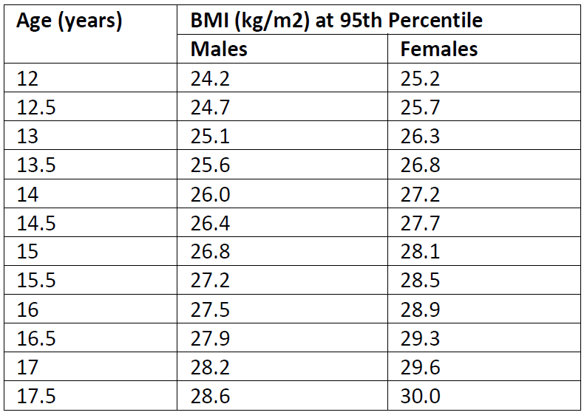
Date of decision: | 3 January 2024
Date of entry onto ARTG: | 29 February 2024
ARTG numbers: | 356286 , 356285, 356288, , 356270, 356287
Black Triangle Scheme | Yes
Sponsor’s name and address: | Novo Nordisk Pharmaceuticals Pty Limited Level 10, 118 Mount Street, North Sydney, NSW 2060, Australia.
Dose form: | Clear and colourless isotonic solution (pH=7.4) for injection in pre-filled pen.
Strength: | 0.25 mg dose pen: One mL of solution contains 0.5 mg of semaglutide. One pre-filled pen contains 0.25 mg semaglutide in 0.5 mL  0.5 mg dose pen: One mL of solution contains 1 mg of semaglutide. One pre-filled pen contains 0.5 mg semaglutide in 0.5 mL  1 mg dose pen: One mL of solution contains 2 mg of semaglutide. One pre-filled pen contains 1.0 mg semaglutide in 0.5 mL  1.7 mg dose pen: One mL of solution contains 2.27 mg of semaglutide. One pre-filled pen contains 1.7 mg semaglutide in 0.75 mL  2.4 mg dose pen: One mL of solution contains 3.2 mg of semaglutide. One pre-filled pen contains 2.4 mg of semaglutide in 0.75 mL
Container: | The primary packaging contains a 1 ml glass syringe (Type I glass) with attached stainless-steel needle, rigid needle shield (Type II/polyisoprene) and a rubber plunger (Type I/chlorobutyl).
Pack size: | For all strengths, 2 or 4 pre-filled pens per pack.
Route of administration: | Wegovy is to be injected subcutaneously in the abdomen, in the thigh or in the upper arm.
Dosage: | The maintenance dose of 2.4 mg once-weekly is reached by starting with a dose of 0.25 mg (Table 2):  Table 2. Wegovy dose escalation schedule  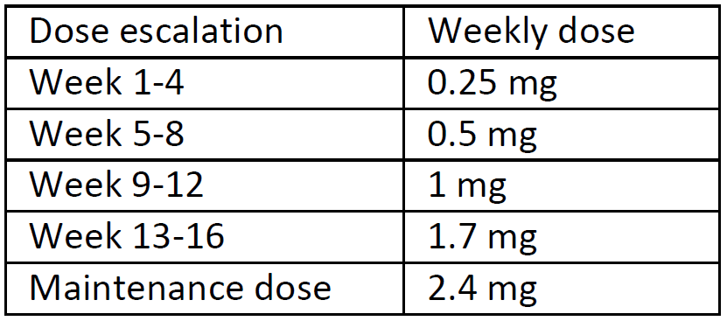  For further information regarding dosage, such as dosage modifications to manage adverse reactions, refer to the Product Information.
Pregnancy category: | D  Semaglutide should not be used during pregnancy. Women of childbearing potential are recommended to use contraception when treated with semaglutide. If a patient wishes to become pregnant, or pregnancy occurs, semaglutide should be discontinued. Semaglutide should be discontinued at least 2 months before a planned pregnancy due to the long half-life.  The use of any medicine during pregnancy requires careful consideration of both risks and benefits by the treating health professional. The pregnancy database must not be used as the sole basis of decision making in the use of medicines during pregnancy. The TGA does not provide advice on the use of medicines in pregnancy for specific cases. More information is available from obstetric drug information services in your state or territory.

Wegovy (semaglutide) – proposed indication
This AusPAR describes the submission by Novo Nordisk Pharmaceuticals Pty Limited (the Sponsor) to register Wegovy (semaglutide) for the following proposed extension of indications:
Adolescents
Wegovy is indicated as an adjunct to a reduced-calorie diet and increased physical activity for weight management in adolescents ages 12 years and above with initial:
- obesity* and
- body weight above 60 kg
Treatment with Wegovy should be re-evaluated and discontinued if adolescent patients have not reduced their BMI by at least 5% after 12 weeks on the 2.4 mg or maximum tolerated dose.

Obesity

Adult population
Obesity is a common condition with high associated morbidity and mortality. Body mass index (BMI) is used as a surrogate measure of being overweight and obese:
- 25.0 to 29.9 kg/m² is classified as overweight but not obese
- ≥30.0 kg/m² is classified as obese.
- >35.0 kg/m² is classified as severely obese.
These definitions of obesity and overweight align with the World Health Organisation definitions.
BMI is a composite measure of weight and height:
$$BMI=\frac{body weight (kg)}{{(height \left[cm\right])}^{2}}$$
Hence, this measure is not a direct measure of adiposity, but is a surrogate measure. Hence, these definitions may not apply to a highly muscled individual or to children and adolescents. Interpretation of BMI may vary between ethnic groups. Waist circumference in adults may be a better measure of adiposity and a better measure of obesity-related morbidity.
The Australian Institute of Health and Welfare reports that in 2017–18, an estimated 2 in 3 (67%) Australians aged 18 and over were overweight or obese, 36% were overweight but not obese, and 31% were obese. This equates to approximately 12.5 million adults in Australia. The prevalence of overweight and obesity was higher in males (75% compared to 60% in females) and also the prevalence of obesity was higher in males (33% compared to 30% in females). Obesity is more prevalent in older age groups: 16% of adults aged 18–24 compared with 41% of adults aged 65 to 74 years.
Obesity is associated with increased prevalence of cardiovascular disease, hypertension, type 2 diabetes mellitus (T2DM) and metabolic syndrome, non-alcoholic fatty liver disease, cholelithiasis, cancer, sleep apnoea, osteoarthritis and reduced psychosocial function. Overall, obesity is associated with increased mortality, increased morbidity and decreased quality of life.
It has been estimated that in 2015 high BMI accounted for 4.0 million deaths globally, representing 7.1% of deaths from any cause, and 120 million disability-adjusted life-years, representing 4.9% of disability adjusted life-years. More than two thirds of deaths related to high BMI were due to cardiovascular disease.

Adolescent population
Measuring obesity in the paediatric and adolescent population differs from the adult in that normal body proportions change with development. Hence, particularly in younger children, the normal ranges of BMI are different in paediatric populations compared to adults. It may be more appropriate in the paediatric population to refer to age appropriate Z-scores (number of SDs from the mean, also referred to by the Sponsor as Standard Deviation Score [SDS]) which indicate the degree of variation from the average. A higher Z-score represents a greater BMI in relation to the age group. Response to treatment would therefore be best expressed as a decrease in the Z-score.
The AIHW has prepared a report on the prevalence of obesity and overweight in children and adolescents in Australia. When interpreting this report, it is important to recognise that the age bands used differ from those used in medicines regulation. In particular, the age band used for adolescents is 15 to <20 years, and not 12 to <18 years. The key findings of the report are:
- One quarter (25%) of Australian children and adolescents aged 2 to 17 were overweight or obese in 2017 to 2018, and 8.2% were obese.
- The obesity rate in the lowest socioeconomic areas (11%) was more than twice as high as the rate in the highest areas (4.4%).
- The proportion of Aboriginal and Torres Strait Islander children and adolescents aged 2 to 17 who were overweight or obese increased from 31% in 2012 to 2013 to 38% in 2018 to 2019. The biggest increase was for those aged 5 to 9 years (from 27% to 36%).
- The prevalence of overweight and obesity, and obesity alone, increased for 5 to 17 year old Australians between 1995 and 2007 to 2008, but has been relatively stable since.
- When measuring the same children every 2 years in the Longitudinal Study of Australian Children, overweight and obesity generally increased with age. Over 4 in 10 were overweight or obese at least once but only a small proportion of children were overweight or obese every time they were measured.
- Adolescents and young people aged 15 to 24 years in 2017 to 2018 were more likely to be overweight or obese compared with people at the same age 10 and 22 years earlier.
The consequences of obesity in adolescents and children are abnormal serum lipids, hypertension, non-alcoholic fatty liver disease, polycystic ovarian syndrome, obstructive sleep apnoea, insulin resistance and type 2 diabetes, gastrointestinal, musculoskeletal and orthopaedic complications, asthma, gallstones, and heartburn ,. These consequences translate to both short- and long-term poorer health outcomes.
Hence, obesity in adolescents is common, has a high disease burden and disproportionately affects disadvantaged sections of the Australian community.

Current treatment options for obesity
Currently there are limited treatment options for adolescents with obesity or who are overweight. The National Health and Medical Research Council guidelines recommend weight maintenance rather than weight loss in most children and many adolescents, with the anticipation that with linear growth weight maintenance will result in improvement in BMI and waist circumference measurements. However, particularly in adolescents, weight maintenance may be insufficient to result in significant benefit.
In adults, a 5% decrease in body weight, in patients with obesity, is associated with significant improvements in cardiovascular risk factors, such as hypertension and lipid profile. Hence, this has become the target for measuring treatment effectiveness, and treatments should achieve at least a 5% sustained reduction in body weight. However, in children the effectiveness of an intervention should consider linear growth, therefore changes in indexes, such as BMI or waist circumference, may be better measures of efficacy.
Lifestyle modification: diet and exercise with or without psychological support. In adolescents these interventions may be family interventions in preference to individual.
Pharmacological treatments approved for adults:
- Orlistat: a selective inhibitor of pancreatic lipase, resulting in decreased absorption of fat. Orlistat is a Schedule 3 drug in Australia and is available over the counter. However, the PI for Xenical (orlistat) contains the warning: “The safety and efficacy of Xenical in children have not been established.”
- Liraglutide: a GLP-1 agonist, is approved in Australia for the indication:
Saxenda (liraglutide) is indicated as an adjunct to a reduced-calorie diet and increased physical activity for weight management in adult patients with an initial BMI of
• ≥ 30 kg/m² (obese) or
• ≥ 27 kg/m² to < 30 kg/m² (overweight) in the presence of at least one weight related comorbidity, such as dysglycaemia (pre-diabetes and type 2 diabetes mellitus), hypertension, dyslipidaemia, or obstructive sleep apnoea.
Treatment with Saxenda should be discontinued after 12 weeks on the 3.0 mg/day dose if a patient has not lost at least 5% of their initial body weight.
However, the PI for Saxenda states: “The safety and efficacy of Saxenda in children and adolescents below 18 years of age have not been established [see section 5.1 Pharmacodynamic Properties]. No data are available. Saxenda is not indicated for use in paediatric patients.”
- Phentermine: sympathomimetic agent with anorectic actions. Phentermine is approved for adolescents aged over 12 years but has cardiovascular and CNS adverse effects that may discourage use in the adolescent age group.
- Naltrexone/bupropion is approved for the following indication in Australia:
Contrave (naltrexone/bupropion) is indicated, as an adjunct to a reduced-calorie diet and increased physical activity, for the management of weight in adult patients (≥18 years) with an initial BMI of
• ≥ 30 kg/m² (obese) or
• ≥ 27 kg/m² to < 30 kg/m² (overweight) in the presence of one or more weight-related comorbidities (e.g., type 2 diabetes, dyslipidaemia, or controlled hypertension).
Treatment with Contrave should be discontinued after 16 weeks if patients have not lost at least 5% of their initial body weight (see section 5.1 PHARMACODYNAMIC PROPERTIES - CLINICAL TRIALS).
Pharmacological treatments not approved in Australia:
- Phentermine/topiramate: is approved in the US for weight control. Topiramate is associated with weight loss due to an unknown mechanism (approved in the US).
- Lorcaserin: an appetite suppressant through activation of hypothalamic 5-HT^{2C} receptors (approved in the US)
Pharmacological treatments in development:
Products in development include GLP-1 agonists (such as semaglutide), dual GLP-1/GIP receptor antagonists and GLP-1/GIP/glucagon triple agonists. SGLT-2 inhibitors are also under development as potential weight control agents. Amylin mimetics, leptin analogues and ghrelin vaccines and antagonists, neuropeptide Y inhibitors and melanocortin-4 receptor antagonists are potential therapeutic agents for this indication
Bariatric surgery:
Bariatric surgery is available for adolescents and is usually reserved for patients with severe obesity: a BMI ≥40 kg/m² or >35 kg/m² with obesity-related co-morbidity ,(Williams 2020, NHMRC 2013). Surgical interventions include devices (e.g., intragastric balloon, endoscopic sleeve gastroplasty, vagal nerve blockade, hydrogels) and surgery [e.g., laparoscopic adjustable gastric banding, Roux-en-Y gastric bypass, biliopancreatic diversion with duodenal switch. These surgical interventions have considerable peri-operative and post-operative morbidity.

Clinical rationale for Wegovy use in obesity.
Semaglutide is a glucagon-like peptide 1 (GLP-1) analogue with 94% sequence homology to human GLP-1. Semaglutide acts as a GLP-1 receptor agonist that binds to and activates the GLP-1 receptor, the target for native GLP-1. GLP-1 is a physiological regulator and has multiple actions in glucose and appetite regulation. The glucose and appetite effects are specifically mediated via GLP-1 receptors in the pancreas and the brain.
Compared to native GLP-1, semaglutide has a prolonged half-life of approximately 1 week making it suitable for once weekly subcutaneous administration. The principal mechanism of protraction is albumin binding, which results in decreased renal clearance and protection from metabolic degradation. Furthermore, semaglutide is stabilised against degradation by the dipeptidyl peptidase-4 (DPP-4) enzyme.
Clinical studies show that semaglutide reduces energy intake, increases feelings of satiety, fulness and control of eating, and reduces feelings of hunger, and frequency and intensity of cravings. Animal studies show that semaglutide works in the brain through the GLP-1 receptor. Semaglutide has direct effects on areas in the brain involved in homeostatic regulation of food intake in the hypothalamus and the brainstem. Semaglutide affects the hedonic reward system through direct and indirect effects in brain areas including the septum, thalamus and amygdala. Semaglutide has shown an effect to change food intake in animals away from more rewarding high fat, sweet items. Semaglutide orchestrates the homeostatic and hedonic contributions with executive function to regulate caloric intake, appetite, reward and food choice , .

Regulatory status

Australian regulatory status
Wegovy received initial registration in the Australian Register of Therapeutic Goods (ARTG) on 1 September 2022. It was approved for the following indication:
Wegovy is indicated as an adjunct to a reduced-energy diet and increased physical activity for chronic weight management (including weight loss and weight maintenance) in adults with an initial Body Mass Index (BMI) of
• ≥30 kg/m² (obesity), or
• ≥27 kg/m² to <30 kg/m² (overweight) in the presence of at least one weight-related comorbidity (see Section 5.1 of the Product Information document: Pharmacodynamic Properties – Clinical trials).

International regulatory status
EMA:
Approved Indications and Usage:
Adults
Wegovy is indicated as an adjunct to a reduced-calorie diet and increased physical activity for weight management, including weight loss and weight maintenance, in adults with an initial BMI of
• ≥30 kg/m² (obesity), or
• ≥27 kg/m² to <30 kg/m² (overweight) in the presence of at least one weight-related comorbidity e.g. dysglycaemia (prediabetes or type 2 diabetes mellitus), hypertension, dyslipidaemia, obstructive sleep apnoea or cardiovascular disease.
Adolescents (≥12 years)
Wegovy is indicated as an adjunct to a reduced-calorie diet and increased physical activity for weight management in adolescents ages 12 years and above with
• obesity* and
• body weight above 60 kg.
Treatment with Wegovy should be discontinued and re-evaluated if adolescent patients have not reduced their BMI by at least 5% after 12 weeks on the 2.4 mg or maximum tolerated dose.
*Obesity (BMI ≥95th percentile) as defined on sex- and age-specific BMI growth charts (see Table 1).
FDA:
Approved Indications and Usage:
Wegovy is indicated as an adjunct to a reduced calorie diet and increased physical activity for chronic weight management in:
adults with an initial body BMI of:
- 30 kg/m² or greater (obesity) or
- 27 kg/m² or greater (overweight) in the presence of at least one weight-related comorbid condition (e.g., hypertension, type 2 diabetes mellitus, or dyslipidaemia)
paediatric patients aged 12 years and older with an initial BMI at the 95th percentile or greater standardized for age and sex (obesity).

Registration timeline
This submission was evaluated under the standard prescription medicines registration process.
Table 3 captures the key steps and dates for this submission.
Table 3: Registration timeline for Wegovy (submission no. PM-2022-04980-1-5) – Key Dates.
Description | Date
Submission dossier accepted and first round evaluation commenced | 3 January 2023
First round evaluation completed | 31 May 2023
Second round evaluation completed | 8 September 2023
Delegate’s Overall benefit-risk assessment and request for Advisory Committee advice | 31 October 2023
Sponsor’s pre-Advisory Committee response | 13 November 2023
Advisory Committee meeting | 22 December 2023
Registration decision (Outcome) | 3 January 2024
Administrative activities and registration in the ARTG completed | 29 February 2024
Number of working days from submission dossier acceptance to registration decision* | 279
*Statutory timeframe for standard submissions is 255 working days

Evaluation overview

Clinical Evaluation Summary
The following regulatory guidance applies to the present application:
- Guideline on Clinical Evaluation of Medicinal Products Used in Weight Management (EMA/CHMP/311805/2014) 23 June 2016
- Guideline on Clinical Evaluation of Medicinal Products Used in Weight Control (CPMP/EWP/281/96 Rev. 1) Addendum on Weight Control in Children
- Reflection Paper on Investigation of Pharmacokinetics and Pharmacodynamics in the Obese Population - draft (EMA/CHMP/535116/2016) 25 January 2018
- Guideline on Reporting the Results of Population Pharmacokinetic Analyses. (CHMP/EWP/185990/06) 21 June 2007.

Pharmacology

Pharmacokinetics
The dossier contained PK data from one population pharmacokinetic study (NN9536-4451 Modelling Report) to support the proposed dosing for semaglutide in adolescents (aged 12 to <18 years).

Population PK data (popPK)

Study NN9536-4451 Modelling Report
The objective of the analysis was to support the dose selection in the target adolescent population (12 to <18 years), and in the STEP Young trial in children (6 to <12 years).
The Study NN9536-4451 Modelling Report (refer to the CER for full details) conducted a population PK analysis of plasma concentration and covariate data from STEP TEEN (a randomised placebo-controlled study of semaglutide 2.4 mg in overweight or obese adolescents) and STEP1 (a Phase IIIa study conducted in adults). A one-compartment model with first-order absorption and elimination was used to describe the semaglutide PK in adults and adolescents.
The diagnostic plots showed a good fit for the model (Figure 1)

Figure 1. Standard goodness-of-fit plot for the full PK model including all the covariates.
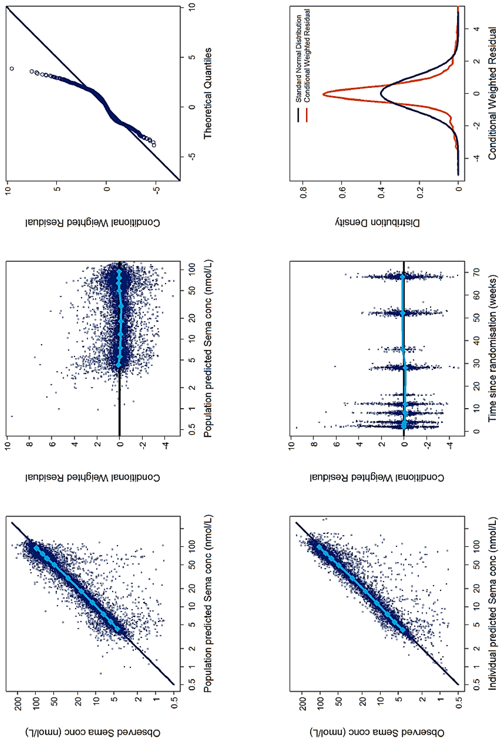
Data are observed concentrations versus population predictions and versus individual predictions, conditional weighted residuals versus population predictions and versus time, QQ-plot of conditional weighted residuals and distribution plot of conditional weighted residuals. Light blue lines are median values for quantiles of concentration or time.
In the analysis, the only clinically significant covariate for exposure was body weight, with decreased semaglutide exposure with increasing body weight. From the model, in the adolescent population geometric mean (CV%) C_{avg} was 74 nmol/L (26%), AUC_{0-168h} was 12366 nmol•h/L (26%) and CL/F was 0.047 L/h (26%). The modelling study demonstrates increased exposure to semaglutide in subjects with lower body weight. Given a median weight of 100 kg, the increase in exposure for a subject of 76 kg was approximately 25% and the decrease in exposure in a subject of 147 kg was approximately 25% (Figure 2). This range of variation appears unlikely to be clinically important. There were no other significant covariate effects on exposure, which appears acceptable. Hence, the PK data support the proposed dosing regimen for the 12 to <18 years population.
Figure 2: Forest plot of covariate effects for semaglutide exposure.
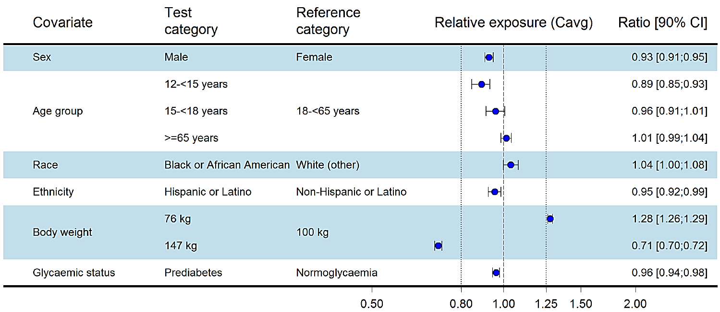Data are steady-state dose-normalised average semaglutide exposures relative to a reference subject profile (non-Hispanic or Latino, normoglycaemic white female aged 18-<65 years (STEP 1) and with a body weight of 100 kg). The forest plot and the column to the right show means and 90% CI for the relative exposures. Body weight test categories (76 and 147 kg) represent the 5% and 95% percentiles, respectively in the data set. Vertical dotted lines indicate the acceptance interval for bioequivalence (0.80;1.25).
Using the model, CL/F and C_{avg} were simulated for a semaglutide 2.4 mg dose, for a population with body weight from 47.2 to 114.1 kg, representing a population with overweight or obesity aged 6 to <18 years. The starting dose of 0.25 mg in the paediatric population did not result in greater exposure than the 0.5 mg dose in the adult population.

Pharmacodynamics
The dossier contained PD data from the population pharmacokinetic study (NN9536-4451 Modelling Report) to support the proposed dosing for semaglutide in adolescents (aged 12 to <18 years).
In the Study NN9536-4451 Modelling Report there was a linear relationship between exposure and decrease in BMI with decreasing BMI with increasing exposure. There was poor precision for the estimate of baseline BMI effect, but the remaining parameters were estimated with adequate precision. There was no clear relationship between either nausea or vomiting and exposure in these analyses. There was poor precision of the estimates in the linear models and the plots of exposure vs % subjects effected did not have a slope significantly different to 0.

Efficacy
There was one pivotal efficacy study, in adolescents, submitted to support the extension of indications to include weight management in adolescents with overweight or obesity: Study NN9536-4451 (STEP TEENS).
There were three other efficacy studies submitted were in adults and to support changes to the Product Information:
- Study NN9536-4378 (STEP 5): extended treatment
- Study NN9536-4376 (STEP 8): comparison with liraglutide
- Study NN9536-4373 (STEP 1) Extension: effect of ceasing semaglutide.

Study NN9536-4451 (STEP TEENS)
This was a Phase IIIa, randomised, parallel group, placebo-controlled study of the effect and safety of semaglutide 2.4 mg once weekly on weight management in adolescents with overweight or obesity (Figure 3). The study duration was 68 weeks. The study was conducted from October 2019 to March 2022, at 37 sites in eight countries.
Figure 3. TEP TEENDS trial design overview
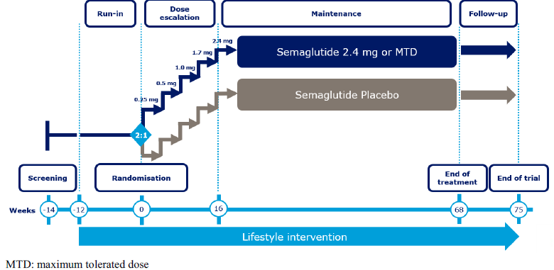

Inclusion criteria:
- Male or female, aged 12 to <18 years
- BMI ≥95th percentile, or ≥85th percentile (on gender and age-specific CDC growth charts) with ≥1 weight related comorbidity (treated or untreated): hypertension, dyslipidaemia, obstructive sleep apnoea or type 2 diabetes
- History of at least one self-reported unsuccessful dietary effort to lose weight
- For subjects with T2DM, HbA1c ≤10.0% (86 mmol/mol) as measured by central laboratory at screening; and: subject treated with either diet and exercise alone or stable treatment for at least 90 days prior to screening with metformin

Key exclusion criteria:
- Prepubertal subjects (Tanner stage 1)
- History of type 1 diabetes (T1DM)
- A self-reported change in body weight >5 kg (11 lbs) within 90 days before screening irrespective of medical records
- Subjects with secondary causes of obesity (i.e., hypothalamic, monogenic or endocrine causes)

The study treatments were:
- Semaglutide: initially 0.25 mg once weekly and then followed a fixed-dose escalation regimen, with dose increases every 4 weeks (to doses of 0.5, 1.0, 1.7 and 2.4 mg/week).
- Placebo
The treatments were administered by s.c. injection once weekly, in the thigh, abdomen or upper arm at any time of day irrespective of meals. The device used for injections was a 3 mL PDS290 pre-filled pen-injector. If a subject did not tolerate the maintenance dose of 2.4 mg, the subject could stay at a lower dose level if the subject would otherwise discontinue trial product completely and if it was considered safe to continue on trial product.

Primary efficacy outcome
The primary efficacy outcome measure was the % change in BMI from baseline (week 0) to week 68.
The confirmatory secondary efficacy outcome measure was the proportion of subjects achieving ≥5% reduction of body weight from baseline (week 0) to week 68.
The safety outcomes measured were adverse events (AEs), pulse rate and levels of amylase, lipase, and calcitonin.

Statistical methods
For the primary endpoint, % change in BMI, a linear regression (ANCOVA) on randomised treatment, using the stratification groups (gender and Tanner stage group) and the interaction between gender and Tanner stage as factors, and baseline BMI (kg/m²) as a covariate. Secondary binary endpoints were tested using logistic regression. Missing data were imputed using multiple imputation using retrieved subjects.
There were 229 subjects screened and 201 were randomised to treatment: 134 to semaglutide and 67 to placebo. All randomised subjects were included in the efficacy analysis. There were 133 (99.3%) subjects in the semaglutide group and 67 (100%) in the placebo who were exposed to treatment. All exposed subjects were included in the safety analysis. There were 120 (89.6%) subjects in the semaglutide group and 60 (89.6%) in the placebo who completed treatment. The most frequent reason for discontinuing treatment was AE: six (4.5%) subjects in the semaglutide group and four (6.0%) in the placebo. There were no protocol deviations that were considered to have a significant impact on the accuracy and reliability of the study data.

Results

Demographics and other baseline characteristics
There was only one subject within the overweight (BMI ≥ 85th percentile) with comorbidities category included at baseline (Table 3).
Table 3: Demographics and baseline characteristics – summary – full analysis set
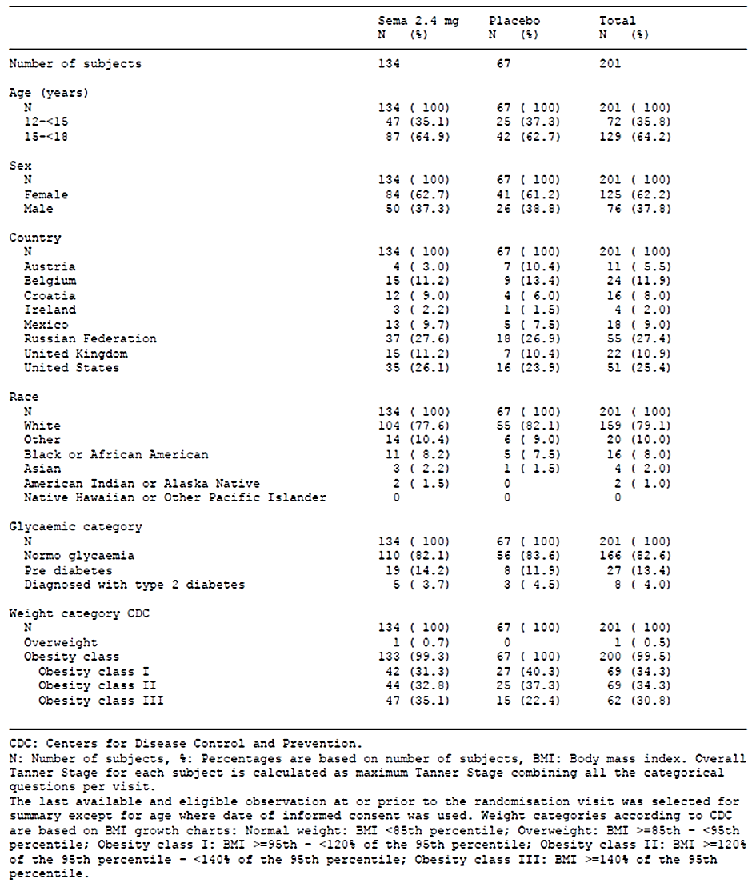

All the adolescent subjects included in the study were with a body weight >60 kg. The treatment experience with Wegovy in only in the individuals with a body weight >60 kg (Table 4).
Table 4: Demographics and baseline characteristics for continuous variables
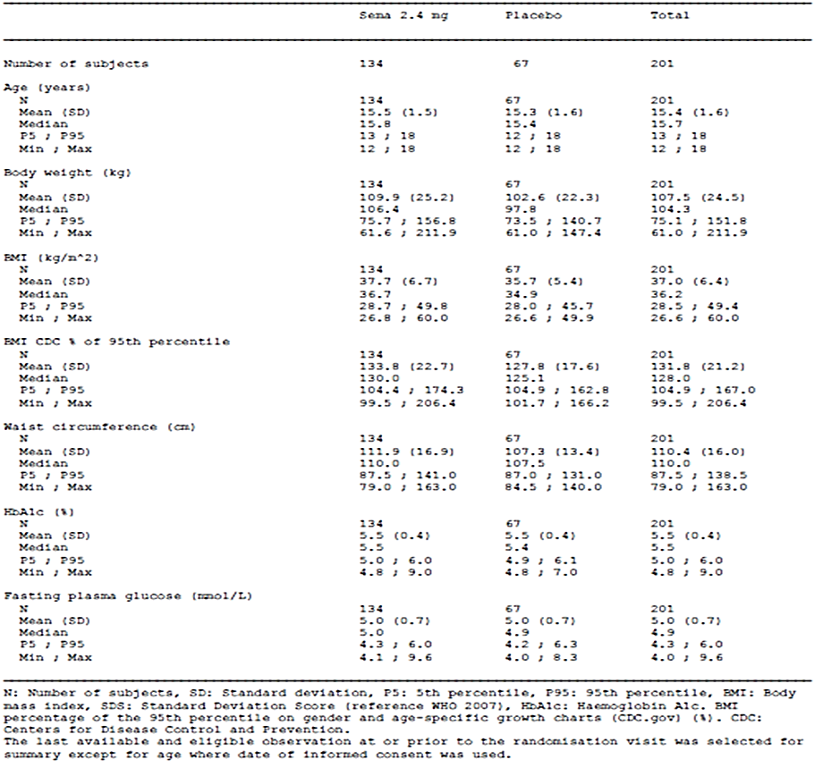
There were 125 (62.2%) females and 76 (37.8%) males. There were 159 (79.1%) White subjects and 16 (8.0%) Black or African American. The treatment groups were similar in weight and pubertal staging. The age range was 12 to 18 years. The BMI range was 26.6 to 60.0 kg/m² and the BMI SDS score ranged from 2.0 to 6.6. The treatment groups were similar in anthropomorphic measures. There were 25 (18.7%) subjects in the semaglutide group and eight (11.9%) in the placebo with pre-existing hepatic disorders (predominantly hepatic steatosis). The incidence of comorbidity was dyslipidaemia 18.4%; hypertension 13.4%, T2DM 4.0%; and obstructive sleep apnoea 1.5%. There were 29 (21.6%) subjects in the semaglutide group and 13 (19.4%) in the placebo treated with biguanides at baseline. There were eight (6.0%) subjects in the semaglutide group and four (6.0%) in the placebo treated with thyroid hormones at baseline.

Primary efficacy analyses
The mean (SD)% change in BMI from baseline to Week 68 was -16.2 (12.9) % in the semaglutide group and -0.1 (8.6) % in the placebo, difference (95% CI) -16.75 (-20.27 to -13.23) %;
p <0.0001 (Figure 4). The rate of weight loss was greatest in the first 44 weeks of treatment.

Figure 4: BMI (%) change from baseline by week - mean plot - on-treatment - full analysis set
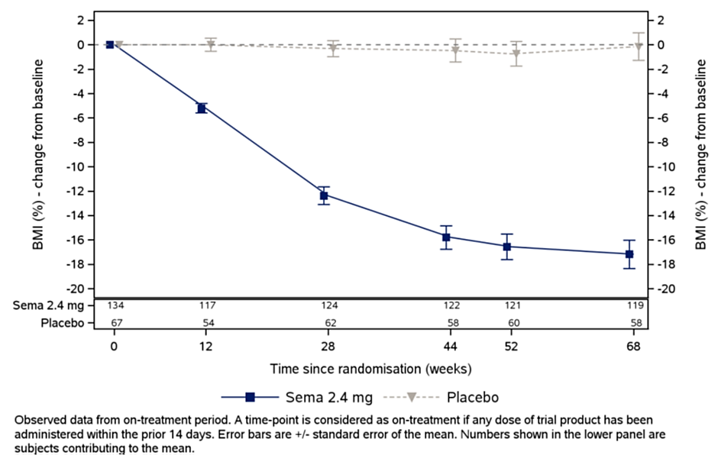

Confirmatory secondary efficacy analyses
The proportion of subjects in the semaglutide group with body weight loss ≥5% at week 68 was 72.5% and in the placebo group was 17.7%, OR (95% CI) 14.02 (6.34 to 31.02), p <0.001 (Figure 5).
Figure 5. Proportion of subjects achieving body weight loss response criteria since baseline at week 68 - bar plot - in-trial - full analysis set.
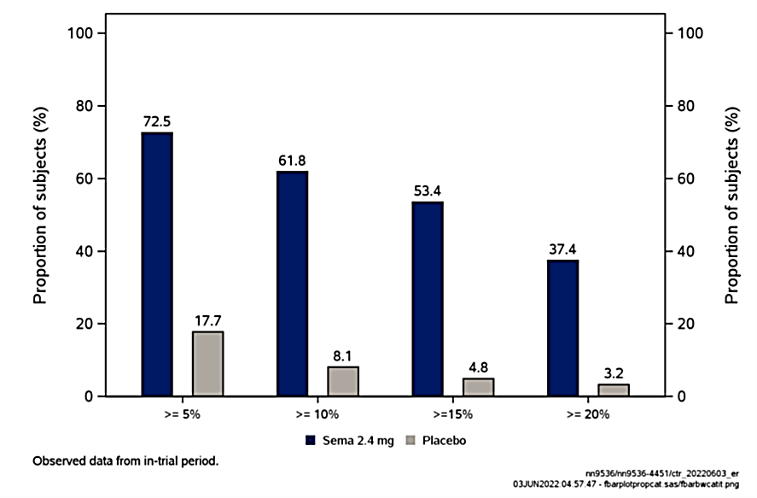

Supportive secondary efficacy outcome measures were:
- From baseline to week 68, BMI was reduced in approximately 90% of subjects on semaglutide 2.4 mg compared to approximately 50% of subjects on placebo.
- There was a significant decrease in body weight in the semaglutide group relative to placebo at Week 68; treatment difference (95% CI) semaglutide – placebo: -17.73 (-21.76 to -13.70) kg.
- There was a significant decrease in % in body weight in the semaglutide group relative to placebo; treatment difference (95% CI) semaglutide – placebo: -17.42 (21.08 to 13.75) (%).
- The proportion of subjects in the semaglutide group with body weight loss ≥10% at week 68 was 61.8% and in the placebo group was 8.1%, OR (95% CI) 23.04 (8.34 to 63.67), p <0.001.
- The proportion of subjects in the semaglutide group with body weight loss ≥15% at week 68 was 53.4% and in the placebo group was 4.8%, OR (95% CI) 25.78 (7.55 to 88.01), p <0.001.
- The proportion of subjects in the semaglutide group with body weight loss ≥20% at week 68 was 37.4% and in the placebo group was 3.2%, OR (95% CI) 19.99 (4.63 to 86.30), p <0.001.
- The estimated mean change in BMI percentage of the 95th percentile on gender and age-specific growth charts (CDC.gov) from baseline to Week 68 was -24.58 %-points with semaglutide and -4.18 %-points with placebo; estimated mean treatment difference (95% CI) -20.40 (-25.01 to -15.79) %-points.
- Improvement in weight category was recorded for 71.8% subjects in the semaglutide group compared with 21.0% in the placebo.
- The mean change in BMI standard deviation score was -1.22 in the semaglutide group and -0.05 in the placebo: estimated mean treatment difference (95% CI) -1.17 (-1.41 to -0.93) p <0.0001.
- The estimated mean change in BMI from baseline to Week 68 was -5.85 kg/m² in the semaglutide group and 0.11 kg/m² in the placebo: estimated treatment difference (95% CI) -5.96 (-7.29 to -4.62) kg/m².
- The mean change in waist circumference from baseline to Week 68 was -12.69 cm in the semaglutide group and -0.55 cm in the placebo; estimated on-trial mean treatment difference (95% CI) -12.14 (-15.59 to -8.69) cm, p <0.0001.
- The proportion of subjects achieving ≥5% reduction of BMI was 77.1% in the semaglutide group and 19.7% in the placebo; OR (95% CI), semaglutide/placebo, 13.76 (6.31 to 30.02).
Exploratory secondary efficacy endpoints demonstrated improvements in serum lipids (a cardiovascular risk factor) and in glycaemic indices (HbA1c in subjects with T2DM, and FPG in subjects without T2DM.

Other efficacy studies (submitted in support of changes to the PI)

Study NN9536-4378 (STEP 5): extended treatment
Study NN9536-4378 was a randomised, double-blind, placebo-controlled, two-armed, parallel group, clinical trial comparing semaglutide 2.4 mg once weekly with semaglutide placebo in subjects with overweight or obesity. The objective of the study was to examine the efficacy and safety of semaglutide 2.4 mg over a 2-year period. The study was conducted at 41 sites in five countries: Canada (9 sites), Hungary (6), Italy (5), Spain (6) and the US (15). The study was conducted from October 2018 to March 2021.
The study included males and females, aged ≥18 years, with BMI ≥30 kg/m² or ≥27 kg/m² with the presence of at least one of the following weight-related comorbidities (treated or untreated): hypertension, dyslipidaemia, obstructive sleep apnoea or cardiovascular disease; and a history of at least one self-reported unsuccessful dietary effort to lose body weight. The study excluded subjects with HbA_{1c} ≥48 mmol/mol (6.5%); or a self-reported change in body weight >5 kg (11 lbs) within 90 days before screening.
The study treatments were:
- Semaglutide 2.4 mg weekly
- Placebo
Semaglutide was administered using a PDS290 pre-filled pen-injector with a 3 mL cartridge containing semaglutide 1.0 mg/mL or 3.0 mg/mL (depending on dose level). Dose escalation was to take place during the first 16 weeks after randomisation with dose increase every 4 weeks (from 0.25 mg/week to doses of 0.5, 1.0, 1.7 and 2.4 mg/week). If a subject could not tolerate the recommended dose of semaglutide 2.4 mg, the subject could stay at a lower dose level.
The primary efficacy outcome measures were:
- Change from baseline (week 0) to week 104 in body weight (%)
- Proportion of subjects with body weight reduction ≥5% from baseline at 104 weeks
The secondary efficacy outcome measures were:
- Proportion of subjects who at Week 104 achieved body weight reduction from baseline ≥10%, ≥15% and ≥ 20%
- Change from baseline to Week 104 in: waist circumference (cm), body weight (kg) and BMI (kg/m²)
- Cardiovascular endpoints: Change from baseline to Week 104 in: systolic blood pressure (mmHg), diastolic blood pressure (mmHg), serum lipids and CRP
- Glucose metabolism endpoints: Change from baseline to Week 104 in HbA1c, FPG and fasting serum insulin
One-year endpoints were:
- Change from baseline to Week 52 in body weight, BMI and waist circumference
- Proportion of subjects who after 52 weeks achieved body weight reduction ≥5%, ≥10%, ≥15% and ≥20%
The safety outcome measures were AEs, vital signs, amylase, lipase, and calcitonin.
The Full Analysis Set (FAS) included all randomised subjects and the Safety Analysis Set (SAS) included all randomised subjects exposed to at least one dose of randomised treatment. Continuous outcome measures were tested using ANOVA models and dichotomous outcome measures were tested using logistic regression models. Hypothesis testing was hierarchical, using a decision criterion of p<0.05. The sample size estimation was based on a power of 43% for the first six endpoints and was for 150 subjects in each group.
There were 347 subjects screened, and 304 were randomised to treatment: 152 to semaglutide and 152 to placebo. All were included in both the FAS and SAS. There were 148 (97.4%) subjects in the semaglutide group and 134 (88.2%) in the placebo who completed the trial. There were 132 (86.8%) subjects in the semaglutide group and 111 (73.0%) in the placebo who completed treatment.
There were 236 (77.6%) females, 68 (22.4%) males and the age range was 21 to 78 years. The range for BMI was 27.6 to 82.7 kg/m². The range for waist circumference was 83.0 to 193.4 cm. The treatment groups were similar in demographic and baseline characteristics.
Semaglutide was superior to placebo for both primary endpoints. The mean (SD) -change in body weight from baseline to Week 104 was -17.3 (11.9) % in the semaglutide group and -2.0 (8.6%) in the placebo: treatment difference (95% CI) -12.55 (-15.33 to -9.77) %, p <0.0001. There was weight loss to Week 68 of treatment, after which the weight loss was maintained to Week 104. The proportion of subjects with body weight reduction ≥5% from baseline at 104 weeks was 77.1% in the semaglutide group and 34.4% in the placebo: OR (95% CI) 4.99 (2.95 to 8.42) p <0.0001.
For the secondary efficacy endpoints:
- The proportion of subjects with body weight reduction ≥10% from baseline at 104 weeks was 61.8% in the semaglutide group and 13.3% in the placebo: OR (95% CI) 7.23 (3.95 to 13.23) p <0.0001.
- The proportion of subjects with body weight reduction ≥15% from baseline at 104 weeks was 52.1% in the semaglutide group and 7.0% in the placebo: OR (95% CI) 9.40 (4.41 to 20.04) p <0.0001.
- The proportion of subjects with body weight reduction ≥20% from baseline at 104 weeks was 36.1% in the semaglutide group and 2.3% in the placebo: OR (95% CI) 12.84 (3.94 to 41.88) p <0.0001.
- The mean (SD) change from baseline to Week 104 in waist circumference was -16.4 (12.2) cm in the semaglutide group and -4.4 (9.2) cm in the placebo: treatment difference (95% CI), semaglutide – placebo, -9.17 (-12.17 to -6.17) cm, p <0.0001. There was a decrease in mean waist circumference in the semaglutide group to Week 60, and after that the improvement was maintained to Week 104.
- The mean (SD) change from baseline to Week 104 in body weight was -18.3 (13.7) kg in the semaglutide group and -2.2 (9.5) kg in the placebo: treatment difference (95% CI) -12.91 (-16.05 to -9.77) kg, p <0.0001. The decrease in weight was to Week 68, after which time weight stabilised to Week 104.
- The mean (SD) change from baseline to Week 104 in BMI was -6.8 (5.2) kg/m2 in the semaglutide group and -0.8 (3.4) kg/m2 in the placebo: treatment difference, semaglutide – placebo, -4.30 (-5.73 to -2.87), p <0.0001. The decrease in BMI was to Week 68, after which time BMI stabilised to Week 104.
- There was a decrease in SBP and DBP in the semaglutide group from baseline to Week 20, which was then maintained throughout the treatment period. The proportion of subjects who had a decrease or stopped taking antihypertensive medication was higher with semaglutide 2.4 mg (32%) compared to placebo (16%) and a lower proportion of subjects had an increase with semaglutide 2.4 mg (6%) compared to placebo (23%).
- There was a decrease in total cholesterol, VLDL cholesterol and triglycerides in the semaglutide group relative to the placebo from baseline to Week 104.
- For CRP, the estimated ratio to baseline at Week 104 was 0.43 for semaglutide, and 0.92 for placebo: estimated treatment ratio (95% CI) 0.47 (0.37 to 0.60).
- HBA1c decreased in the semaglutide group relative to placebo: for the treatment policy estimand, the estimated mean change in HbA1c from baseline to Week 104 was −0.43%-points with semaglutide and −0.10 %-points with placebo: ETD (95% CI) −0.33 (−0.41 to −0.25) %-points.
- FPG decreased in the semaglutide group relative to placebo: for the treatment policy estimand, the estimated mean change in FPG from baseline to Week 104 was −0.42 for semaglutide and 0.09 mmol/L for placebo; ETD (95% CI) −0.51 (−0.66 to −0.36) mmol/L.
- Fasting serum insulin decreased in the semaglutide group relative to placebo: estimated mean ratio to baseline at Week 104 was 0.67 for semaglutide and 0.93 for placebo: treatment ratio (95% CI) 0.73 (0.61 to 0.87).
Of the subjects who had pre-diabetes at baseline, 80% treated with semaglutide switched to being normo-glycaemic by Week 104 and 20% remained having pre-diabetes. None of the subjects treated with semaglutide switched to having diabetes.
- For subjects treated with placebo, a lower proportion of subjects switched from having pre-diabetes to being normo-glycaemic (37%), while higher proportions of subjects remained having pre-diabetes (59%) and 4% switched to having diabetes. The Control of Eating Questionnaire indicated better control for semaglutide compared to placebo.

Study NN9536-4376 (STEP 8): comparison with liraglutide
Study NN9536-4376 was a randomised, open-label, pairwise placebo-controlled, efficacy and safety study comparing semaglutide with liraglutide. The objective of the study was to compare the efficacy and safety of semaglutide with liraglutide. The study was conducted over a 68 week period. The study was conducted at 19 sites in the US from 11th September 2019 to 11th May 2021.
The inclusion criteria included:
- Male or female, age ≥18 years at the time of signing informed consent.
- Body mass index (BMI) ≥30.0 kg/m2 or ≥27.0 kg/m2 with the presence of at least one of the following weight-related comorbidities (treated or untreated): hypertension, dyslipidaemia, obstructive sleep apnoea or cardiovascular disease.
- History of at least one self-reported unsuccessful dietary effort to lose body weight.
The exclusion criteria included:
- HbA1c ≥48 mmol/mol (6.5%) as measured by the central laboratory at screening.
- History of Type 1 or Type 2 diabetes mellitus.
- A self-reported change in body weight > 5 kg (11 lbs) within 90 days before screening irrespective of medical records.
The study treatments were:
- Semaglutide: dose escalation of semaglutide was to take place during the first 16 weeks after randomisation with dose increases every 4 weeks (to doses of 0.5, 1.0, 1.7 and 2.4 mg/week), aiming at reaching the maintenance dose of 2.4 mg once weekly after 16 weeks. If a subject did not tolerate the maintenance dose of 2.4 mg, the subject could stay at a lower dose of 1.7 mg semaglutide once weekly.
- Placebo for semaglutide.
- Liraglutide: Dose escalation of liraglutide was to take place during the first 4 weeks after randomisation with dose increases every week (to doses of 1.2, 1.8, 2.4 and 3.0 mg), aiming at reaching the maintenance dose of 3.0 mg once daily after 4 weeks.
- Placebo for liraglutide.
Semaglutide was administered using a PDS290 pre-filled pen-injector up to Week 44, then subsequently a DV3396 single-dose pen-injector. Liraglutide was administered using aPDS290 pre-filled pen-injector.
The primary efficacy outcome measures were:
- Change from baseline (week 0) to Week 68 in body weight (%)
The secondary efficacy outcome measures were:
- Proportion of subjects who at Week 68 achieved body weight reduction from baseline ≥10%, ≥15% and ≥ 20%.
- Change from baseline to Week 68 in: waist circumference (cm) and body weight (kg).
- Cardiovascular endpoints: change from baseline to Week 68 in: systolic blood pressure (mmHg), diastolic blood pressure (mmHg), serum lipids and high-sensitivity c-reactive protein .
- Glucose metabolism endpoints: change from baseline to Week 68 in HbA1c, FPG, fasting serum insulin, and glycaemic category.
The exploratory endpoint was:
- Proportion of subjects with body weight reduction ≥5% from baseline at 68 weeks.
The safety outcome measures were AEs and vital signs.
Randomisation was in the ratio 3:1:3:1 for semaglutide: placebo: liraglutide: placebo.
There were 387 subjects screened and 338 were randomised, all of whom were treated: 126 in the semaglutide group, 127 in the liraglutide and 85 in the placebo. There were 109 (86.5%) in the semaglutide group, 92 (72.4%) in the liraglutide and 70 (82.4%) in the placebo who completed treatment.
There were 265 (78.4%) females and 73 (21.6%) males. The age range was 18 to 79 years, and the BMI range was 26.5 to 81.0 kg/m². The treatment groups were similar in demographic and baseline variables.
Semaglutide was superior to liraglutide for the primary and confirmatory secondary efficacy outcome measures. The mean (SD) change in body weight % at Week 68 was -16.4 (10.5) % for semaglutide, -6.4 (7.7) % for liraglutide and -1.6 (8.6) % for placebo: treatment difference, semaglutide – liraglutide, estimand (95% CI) -9.38 (-11.97 to -6.80) %, p <0.0001.
For the secondary efficacy outcome measures:
- The % subjects with change in body weight ≥10% at Week 68 was 70.9% for semaglutide, 25.6% for liraglutide and 15.4% for placebo: OR (95% CI), semaglutide / liraglutide, 6.28 (3.53 to 11.18) %, p <0.0001.
- The % subjects with change in body weight ≥15% at Week 68 was 55.6% for semaglutide, 12.0% for liraglutide and 6.4% for placebo: OR (95% CI), semaglutide / liraglutide, 7.90 (4.06 to 15.38) %, p <0.0001.
- The % subjects with change in body weight ≥20% at Week 68 was 38.5% for semaglutide, 6.0% for liraglutide and 2.6% for placebo: OR (95% CI), semaglutide / liraglutide, 8.19 (3.51 to 19.13) %, p <0.0001.
- The mean (SD) change in body weight (kg) at Week 68 was -15.8 (10.2) kg for semaglutide, -6.8 (9.5) kg for liraglutide and -1.4 (9.6) kg for placebo: treatment difference, semaglutide – liraglutide, estimand (95% CI) -8.49 (-11.24 to -5.74) kg, p <0.0001; semaglutide – placebo, estimand (95% CI) -13.79 (-16.83 to -10.74) kg, p<0.0001; and liraglutide – placebo, estimand (95% CI) -5.30 (-8.30 to -2.29) kg, p = 0.0006
- The mean (SD) change in waist circumference (cm) at Week 68 was -13.6 (10.0) cm for semaglutide, -6.8 (8.4) cm for liraglutide and -2.0 (7.2) kg for placebo: treatment difference, semaglutide – liraglutide, estimand (95% CI) -6.61 (-9.06 to -4.16) cm, p <0.0001.
- SBP decreased to a similar extent in the semaglutide and liraglutide groups relative to placebo.
- For the majority of the treatment period there was no significant difference in DBP between the study groups.
- Between baseline and week 68, the proportion of subjects who had a decrease or stopped taking antihypertensive medication was higher with semaglutide 2.4 mg (29.2%) compared to liraglutide 3.0 mg (16.3%) and pooled placebo (9.7%) and a lower proportion of subjects had an increase in antihypertensive medication with semaglutide 2.4 mg (20.8%) compared to liraglutide 3.0 mg (23.3%) and pooled placebo (22.6%).
- The semaglutide group had a decrease in total serum cholesterol, VLDL cholesterol and triglycerides relative to liraglutide.
- The ratio of hsCRP at Week 68 to baseline was 0.5 for semaglutide, 0.8 for liraglutide and 0.8 for placebo; estimated treatment ratio (95% CI) semaglutide / liraglutide, 0.6 (0.5 to 0.8).
- The mean (SD) change in HbA1c at Week 68 was -0.3 (0.2) % for semaglutide, -0.1 (0.2) % for liraglutide and 0.1 (0.2) % for placebo: treatment difference, semaglutide – liraglutide, estimand (95% CI) -0.16 (-0.22 to -0.09) cm, p <0.0001.
- The mean (SD) change in FPG at Week 68 was -0.5 (0.5) mmol/L for semaglutide, -0.3 (0.6) mmol/L for liraglutide and 0.1 (0.6) mmol/L for placebo: treatment difference, semaglutide – liraglutide, estimand (95% CI) -0.22 (-0.40 to -0.04) mmol/L, p = 0.0174
- The geometric mean ratio (CV%) for fasting serum insulin at Week 68 / baseline was 0.73 (57.3) semaglutide, 0.85 (47.5) for liraglutide and 0.98 (56.8): treatment ratio (95% CI), semaglutide / liraglutide 0.85 (0.73 to 1.00) p = 0.0540
- Of subjects who were normoglycaemic at baseline, the proportion who shifted to pre-diabetes at Week 68 was 2.8% for semaglutide, 12.2% for liraglutide and 27.7% for placebo. Of subjects who were pre-diabetic at baseline, the proportion who shifted to normoglycaemic at Week 68 was 89.5% for semaglutide, 64.9% for liraglutide and 13.3% for placebo.
- The % subjects with change in body weight ≥5% at Week 68 was 87.2% for semaglutide, 58.1% for liraglutide and 129.5% for placebo (hypothesis not tested as was exploratory endpoint).

Study NN9536-4373 (STEP 1) Extension: effect of ceasing semaglutide
Study NN9536-4373 (STEP 1) was randomised, double-blind, two-armed, parallel group, placebo-controlled study of the effect on body weight of semaglutide as an adjunct to reduced-calorie diet and increased physical activity. The results of the 68-week main phase have previously been submitted and the results of the 52-week off-treatment extension phase were included in the present submission. The extension study was conducted at 37 sites in five countries: Canada (6), Germany (13), Japan (3), United Kingdom (10) and US (5). The trial was commenced in June 2018 and the extension phase was completed in March 2021.
The trial included Males and females, aged ≥18 years; with BMI ≥30.0 kg/m² or ≥27.0 kg/m² with the presence of at least one of the following weight-related comorbidities (treated or untreated): hypertension, dyslipidaemia, obstructive sleep apnoea or cardiovascular disease; and a history of at least one self-reported unsuccessful dietary effort to lose body weight.
There was no intervention treatment for the extension phase.
There were 333 patients included in the extension study, 232 from the semaglutide group and 101 from the placebo. There were 216 (93.1%) subjects in the semaglutide group and 96 (95.0%) in the placebo who completed the extension phase. There were 228 (98.3%) subjects in the semaglutide group and 99 (98.0%) in the placebo who were included in the extension analysis set. There were 219 (67.0%) females and 108 (33.0%) males and the age range was 18 to 83 years.
In the semaglutide group there was weight loss through to Week 68 when on treatment with semaglutide, but when treatment was ceased weight was regained through to Week 120. At Week 68, in the semaglutide group the mean (SD) body weight was 87.5 (21.4) kg and at Week 120 it was 99.0 (22.5) kg; mean (SD) increase 12.0 (8.4) kg. This was a mean (SD) increase of 14.8 (10.7) % in the semaglutide group. At Week 68, in the placebo group the mean (SD) body weight was 103.2 (25.6) kg and at Week 120 it was 105.5 (26.2) kg; mean (SD) increase 2.0 (4.8) kg. This was a mean (SD) increase of 2.1 (4.9) % in the placebo group.
In the semaglutide group there was decrease in BMI through to Week 68 when on treatment with semaglutide, but when treatment was ceased BMI increased through to Week 120, but with some preservation of treatment effect over the year without treatment. At Week 68, in the semaglutide group the mean (SD) BMI was 31.2 (7.2) kg/m² and at Week 120 it was 35.0 (7.1) kg/m²; mean (SD) increase 4.3 (2.9) kg/m². At Week 68, in the placebo group the mean (SD) BMI was 36.9 (8.0) kg/m² and at Week 120 it was 37.6 (8.2) kg/m²; mean (SD) increase 0.7 (1.7) kg/m².
In the semaglutide group there was an increase in HbA_{1c} after treatment was ceased, predominantly in the first 12 weeks, and by one year off treatment was not significantly different to the placebo group. At Week 68, in the semaglutide group the mean (SD) HbA_{1c} was 33.6 (3.1) mmol/mol and at Week 120 it was 37.5 (3.8) mmol/mol; mean (SD) increase 3.9 (2.9) mmol/mol. At Week 68, in the placebo group the mean (SD) HbA_{1c} was 37.1 (4.2) mmol/mol and at Week 120 it was 38.4 (5.6) mmol/mol; mean (SD) increase 1.4 (2.9) mmol/mol.
The benefits in decreased blood pressure with semaglutide treatment were lost within 12 weeks of ceasing treatment.
Total cholesterol and LDL cholesterol were decreased during semaglutide treatment and returned to the same concentrations as placebo within 12 weeks of ceasing treatment. However, HDL cholesterol increased with semaglutide treatment, and remained elevated after treatment was ceased. Higher concentrations of HDL cholesterol are associated with decreased cardiovascular risk.
CRP concentrations decreased with semaglutide treatment, and increased following ceasing treatment, but were still less than those of the placebo group after one year off treatment.

Safety
In the pivotal study (Study NN9536-4451-STEP TEENS) the safety outcome measures were AEs, pulse rate, amylase, lipase, and calcitonin. There were 133 adolescents exposed to semaglutide and 67 to placebo.
In Study NN9536-4376 (126 subjects exposed to semaglutide group, 127 to liraglutide and 85 to placebo) and Study NN9536-4378 (152 subjects exposed to semaglutide and placebo) the safety outcome measures were AEs, vital signs, clinical laboratory tests (including lipase, amylase and calcitonin) and ECGs.
In Study NN9536-4373 Extension (232 from the semaglutide group and 101 from the placebo) AEs were not systematically collected. There were no reports of deaths, SAEs or withdrawals due to AE. Clinical laboratory tests were not performed routinely. Vital signs were recorded as part of the efficacy assessment.

Study NN9536-4451-STEP TEENS
In Study NN9536-4451 there were 812 TEAEs reported in 106 (79.7%) subjects in the semaglutide group and 333 in 56 (83.6%) in the placebo. Gastrointestinal disorders were the most frequently reported group of disorders and were more frequent in the semaglutide group: 82 (61.7%) subjects compared with 28 (41.8%) in the placebo. There was a higher incidence of nausea with semaglutide (56 [42.1%] subjects compared with 12 [17.9%] in the placebo) and vomiting (48 [36.1%] subjects compared with seven [10.4%] in the placebo). The prevalence of gastrointestinal adverse events in the semaglutide group was constant over the period of treatment.
In Study NN9536-4451 there were 396 possible or probable treatment related TEAEs reported in 77 (57.9%) subjects in the semaglutide group and 98 in 26 (38.8%) in the placebo. There was a higher incidence of nausea attributed to treatment with semaglutide (52 [39.1%] subjects compared with 12 [17.9%] in the placebo), vomiting (40 [30.1%] subjects compared with four [6.0%] in the placebo), abdominal pain (17 [12.8%] subjects compared with two [3.0%] in the placebo) and headache (13 [9.8%] subjects compared with two [3.0%] in the placebo). Injection site AEs were recorded for four (3.0%) subjects in the semaglutide group and three (4.5%) in the placebo.
In Study NN9536-4451 there were no deaths. There were 17 SAEs reported in 15 (11.3%) subjects in the semaglutide group and seven in six (9.0%) in the placebo.
There were four (3.0%) subjects with hepatobiliary disorders and two (1.5%) with appendicitis in the semaglutide group and none with either of these conditions in the placebo. There were six SUSARs in the semaglutide group and two in the placebo. These were predominantly gastrointestinal. there was one subject in each treatment group with elevated lipase, and one subject in the placebo group with elevated calcitonin.
In Study NN9536-4451 the incidence of hepatic AEs was higher in the semaglutide group: 13 events in 10 (7.5%) subjects, compared with one in one (1.5%) in the placebo. There were three (2.3%) subjects with increased ALT in the semaglutide group. There were no clinically significant abnormalities in haematology parameters.
In Study NN9536-4451 there were 13 cardiovascular AEs in 10 (7.5%) subjects in the semaglutide group and seven in seven (10.4%) in the placebo. There were no clinically significant abnormalities in ECGs. mean pulse rate was similar for the two treatment groups. There were no significant differences in vital signs or physical examination findings between the treatment groups.
In Study NN9536-4451 there were 14 allergic AEs in 12 (9.0%) subjects in the semaglutide group and four in four (6.0%) in the placebo. In the semaglutide group these were predominantly dermatological. One subject in the semaglutide group was positive for anti-semaglutide antibodies at Week 68, but negative at Week 75.
In Study NN9536-4451 there was no significant difference between the treatment groups in growth parameters. The mean (SD) change from baseline in height was 1.3 (2.1) cm for semaglutide and 2.1 (2.6) cm for placebo. The mean (SD) change from baseline in height SDS was -0.076 (0.252) for semaglutide and -0.048 (0.249) for placebo. The mean (SD) change from baseline in bone age was 1.3 (0.8) years for semaglutide and 1.5 (0.9) years for placebo. There were no significant differences between the treatment groups in bone metabolism biomarkers. There were no significant differences between the treatment groups in the shifts in pubertal status from baseline to Week 68. There were no clinically significant differences between the treatment groups in the serum concentrations of TSH, FT₄, dehydroepiandrosterone sulphate, estradiol, FSH, IGF-1, LH, or prolactin.

Other studies

Study NN9536-4378
There were 1606 adverse events reported in 146 (96.1%) patients in the semaglutide group and 1004 in 136 (89.5%) in the placebo. The most frequently reported TEAEs, which were also more frequent in the semaglutide group, were nausea, diarrhoea, constipation and vomiting. Most TEAEs were reported in the first 20 weeks of treatment. There were 696 gastrointestinal AEs reported in 125 (82.2%) subjects in the semaglutide group and 252 in 82 (53.9%) in the placebo. There were four (2.6%) subjects with hepatobiliary disorders in the semaglutide group and two (1.3%) in the placebo. There were 734 adverse events possibly or probably related to study drug reported in 123 (80.9%) patients in the semaglutide group and 267 in 77 (50.7%) in the placebo.
There was one death in the semaglutide group (acute myocardial infarction). There were 18 SAEs reported in 12 (7.9%) patients in the semaglutide group and 20 in 18 (11.8%) in the placebo. There was no apparent pattern to the SAEs.
There were three (2.0%) subjects with hepatic AEs in the semaglutide group and three (2.0%) in the placebo. Two subjects in each group had elevated ALT. There were no significant differences between the treatment group in mean haematology parameters. There were no treatment emergent cases of pancreatitis. Mean amylase and lipase concentrations increased in the semaglutide group but not to abnormal levels. There were no elevations of amylase or lipase >3xULN. There was no increase in mean calcitonin concentrations. There were no calcitonin concentrations >100 ng/L during the on-treatment period. there were 24 reports of neoplastic events in 19 (12.5%) subjects in the semaglutide group and 23 in 19 (12.5%) in the placebo. There were two reports of malignant neoplastic events in two (1.3%) subjects in the semaglutide group and four in four (2.6%) in the placebo. No events related to malignant neoplasms were reported.
There were fewer cardiovascular AEs in the semaglutide group (19 events in 17 [11.2%] subjects) than in the placebo group (41 events in 30 [19.7%) subjects). There were three subjects in the semaglutide group and two in the placebo with post-baseline clinically significant ECG abnormalities. There was an increase in pulse rate in the semaglutide group relative to placebo: estimated EOT treatment difference (95% CI) 4.14 (2.05 to 6.24) bpm. There was a decrease in SBP and DBP in the semaglutide group from baseline to Week 20, which was then maintained throughout the treatment period.
There were 36 allergic reaction AEs in 23 (15.1%) subjects in the semaglutide group and nine in eight (5.3%) in the placebo. The excess in reactions in the semaglutide group was due to more dermatological reactions, including urticaria and contact dermatitis.

Study NN9536-4376
There were 904 TEAEs reported in 120 (95.2%) subjects in the semaglutide group, 823 in 122 (96.1%) in the liraglutide and 522 in 81 (95.3%) in the placebo. Gastrointestinal AEs were more frequent with semaglutide and liraglutide than placebo, particularly nausea, with no clear differences between semaglutide and liraglutide. There were 483 AEs possibly or probably related to study treatment reported in 107 (84.9%) subjects in the semaglutide group, 350 in 106 (83.5%) in the liraglutide and 141 in 49 (57.6%) in the placebo.
There were no deaths. There were 14 SAEs reported in 10 (7.9%) subjects in the semaglutide group, 18 in 14 (11.0%) in the liraglutide and nine in six (7.1%) in the placebo. There was no apparent pattern to the SAEs.
There was one (0.8%) subject in the semaglutide group with elevated ALT. There were no significant differences between the treatment group in mean haematology parameters. there was one subject with acute pancreatitis in the liraglutide group and none in the semaglutide or placebo groups. At Week 68, there were eight (7.7%) subjects in the semaglutide group, seven (7.9%) in the liraglutide and one (1.5%) in the placebo with elevated serum lipase. At Week 68, there were three (2.9%) subjects in the semaglutide group, four (4.5%) in the liraglutide and one (1.5%) in the placebo with elevated serum amylase. there were 16 reports of neoplastic events in 13 (10.3%) subjects in the semaglutide group, 24 in 17 (13.4%) in the liraglutide and 16 in 12 (14.1%) in the placebo. There were three malignant neoplasms reported in the semaglutide group, three in the liraglutide and one in the placebo.
At Week 68, there were seven (6.7%) subjects in the semaglutide group, one (1.1%) in the liraglutide and two (3.0%) in the placebo with elevated calcitonin. There were no cases of medullary thyroid carcinoma (MTC).
Cardiovascular AEs were reported in 16 (12.7%) subjects in the semaglutide group, 18 (14.2%) in the liraglutide and nine (10.6%) in the placebo. There were no clinically significant changes in ECG findings. An increase in pulse rate was recorded on-treatment for both the semaglutide and liraglutide treatment groups. SBP decreased to a similar extent in the semaglutide and liraglutide groups relative to placebo. For the majority of the treatment period there was no significant difference in DBP between the study groups.
There were 13 allergic reactions in nine (7.1%) subjects in the semaglutide group, 12 in 11 (8.7%) in the liraglutide and 13 in 10 (11.8%) in the placebo. The majority of these events were dermatological.

Risk Management Plan (RMP) evaluation
The proposed summary of safety concerns and their associated risk monitoring and mitigation strategies as listed in the ASA, are summarised in Table 6.
Table 6. Summary of safety concerns
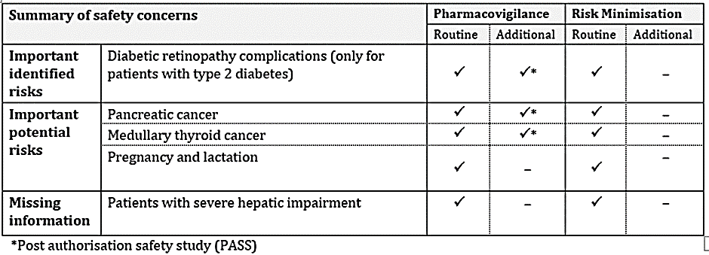
The Evaluator has confirmed that there is nothing outstanding from an RMP perspective.
- The summary of safety concerns mostly aligns with the updated EU-RMP. In its Milestone 5 response, Sponsor re-categorised the risk of ‘pregnancy and lactation’ from missing information to important potential risk as requested in Round 2 and based on its Pregnancy Category D classification. The summary of safety concerns is acceptable from an RMP perspective.
- Routine pharmacovigilance activities for all safety concerns have been proposed. Additional pharmacovigilance activities for the risks of pancreatic cancer, medullary thyroid cancer and long-term effects on diabetic retinopathy in subjects with type 2 diabetes in the form of post authorisation safety studies, have been proposed. The pharmacovigilance plan aligns with the EU-RMP and is acceptable as no new safety concerns have been identified as a result of the proposed extension of indication.
- The Sponsor has proposed routine risk minimisation activities for all safety concerns. The Sponsor has proposed no additional risk minimisation activities. This is considered acceptable. The proposed changes to the PI and CMI relate to the proposed extension of the indication to the adolescent population. The warning of pregnancy in the CMI has been strengthened in accordance with the warning in the PI.
The Sponsor has provided an assurance that the CMI and Instruction for Use will be included as a package insert.

RMP evaluator recommendations regarding condition/s of registration

Wording for conditions of registration
Any changes to which the Sponsor has agreed should be included in a revised RMP and ASA. However, irrespective of whether or not they are included in the currently available version of the RMP document, the agreed changes become part of the risk management system.
The suggested wording is:
The Wegovy EU-Risk Management Plan (RMP) (version 7.1, dated 26 April 2022, data lock point 31 May 2021), with Australian Specific Annex (version 1.5, dated 15 September 2023), included with submission PM-2022-04980-1-5, and any subsequent revisions, as agreed with the TGA will be implemented in Australia.
An obligatory component of risk management plans is routine pharmacovigilance. Routine pharmacovigilance includes the submission of periodic safety update reports (PSURs).
Reports are to be provided in line with the current published list of EU reference dates and frequency of submission of PSURs until the period covered by such reports is not less than three years from the date of this approval letter.
The reports are to at least meet the requirements for PSURs as described in the European Medicines Agency’s Guideline on good pharmacovigilance practices (GVP) Module VII-periodic safety update report (Rev 1), Part VII.B Structures and processes. Note that submission of a PSUR does not constitute an application to vary the registration. Each report must have been prepared within ninety calendar days of the data lock point for that report.
As the indication for Wegovy is being extended into a significantly different population it should be included in the Black Triangle Scheme as a condition of registration. The following wording is recommended for the condition of registration:
Wegovy (Semaglutide) is to be included in the Black Triangle Scheme. The PI and CMI for Wegovy must include the black triangle symbol and mandatory accompanying text for five years, which starts from the date the new indication is registered. The Black Triangle Scheme identifies new prescription medicines with a black triangle on the medicine information documents. The scheme also applies to prescription medicines being used in new ways, such as a medicine that is now being used for children. The black triangle is a visual reminder to encourage health practitioners and patients to report a problem or side effect encountered with a particular medicine.

Risk-benefit analysis

Efficacy
The population pharmacokinetic study (NN9536-4451 Modelling Report) analysed the PK and PD data from Study NN9536-4451 (STEP TEENS) in comparison with an adult population from Study NN9536-4373 (STEP 1). The population PK analysis showed that exposure was inversely correlated with body weight. Age caused no clinically relevant change in semaglutide exposure. Other covariates such as sex, race, ethnicity, and glycaemic status had no or only minor effects on exposure. The estimates for apparent clearance and exposure (CL/F and C_{avg}) were comparable between adolescent and adult subjects with obesity. As expected, CL/F increased with baseline BW, whereas the CL/F appeared to be independent of age. It indicated that the only significant covariate effect on semaglutide exposure was body weight. The PK data support the proposed dosing regimen for the 12 to <18 years population.

Efficacy in the adolescent population (age range 12 to ≤18 years)- Study NN9536-4451 (STEP TEENS)
Primary efficacy analyses: The mean (SD)% change in BMI from baseline to Week 68 was -16.2 (12.9) % in the semaglutide group and -0.1 (8.6) % in the placebo, difference (95% CI) -16.75 (-20.27 to -13.23) %; p <0.0001.
Confirmatory efficacy analyses: The proportion of subjects in the semaglutide group with body weight loss ≥5% at week 68 was 72.5% and in the placebo group was 17.7%, OR (95% CI) 14.02 (6.34 to 31.02), p <0.001.
The primary and confirmatory efficacy analyses demonstrated superiority for semaglutide. Although this semaglutide benefit has statistical superiority and appears clinically relevant, 27.5% of the patients treated with semaglutide still had a body weight loss of less than 5% even at week 68. From baseline to week 68, BMI was reduced in approximately 90% of subjects on semaglutide 2.4 mg compared to approximately 50% of subjects on placebo. Almost 10% of the patients on Wegovy did not have a decrease in BMI or an increase. This raises the first issue for discussion and concern about a knowledge gap of the length of treatment needed with semaglutide. The Delegate considers inclusion, in the indication, of a stopping and re-evaluating rule for adolescents who haven’t reduced their BMI by at least 5% after 12 weeks of treatment with Wegovy 2.4mg or maximum tolerated dose, would prevent unnecessary long-term treatment in them, similar to the EU SmPC.
“Treatment with Wegovy should be discontinued and re-evaluated if adolescent patients have not reduced their BMI by at least 5% after 12 weeks on the 2.4 mg or maximum tolerated dose.”
The second issue for discussion is about the two patient categories (obesity or overweight with ≥1 weight related comorbidity) included in the Adolescents therapeutic indication proposed by the Sponsor in this submission which are based on the STEP TEENS Study Inclusion criteria.
There was only one subject within the ‘overweight (BMI ≥ 85th percentile) with comorbidities’ category included in the study at baseline. It is not possible to assess and establish a positive benefit risk profile of Wegovy in this patient category of overweight (BMI ≥85th percentile) and at least one-weight-related comorbidity. Therefore, the Delegate doesn’t support Wegovy indication in overweight adolescents with comorbidity.
The third issue for discussion is the inclusion of the graph (with BMI cut-off points) in the indication/PI. Considering the therapeutic indication now includes the Table with BMI cut-off points, the Delegate believes that the graph with BMI cut-off points included in the PI causes duplicity, hard to decipher and don’t add any value. The Delegate believes that this graph can be removed from the PI (therapeutic indication).
The fourth issue for discussion is the fact that all the adolescent subjects included in the pivotal STEP TEENS study were with a body weight >60 kg. The treatment experience with Wegovy in only in the individuals with a body weight >60 kg. In the EU both Wegovy and Saxenda are only indicated for adolescents with a body weight above 60 kg.

Supportive studies in adult population (aged ≥18 years)
In the supportive Study NN9536-4378 (STEP 5), for a two-year treatment duration, in adults (aged ≥18 years) there was weight loss for the first year, and preservation of weight loss for the second year, with weekly semaglutide 2.4 mg. The treatment difference (95% CI), semaglutide – placebo, in % body weight was -12.55 (-15.33 to -9.77) %, p <0.0001 (i.e., treatment effect size). There was weight loss to Week 68 of treatment, after which the weight loss was maintained to Week 104. The improvements in cardiovascular risk factors and glycaemic indices were also preserved during the second year of treatment.
Study NN9536-4376 (STEP 8) reported superiority for semaglutide in comparison with liraglutide in adults (age ≥18 years). The mean (SD) change in body weight % at Week 68 was -16.4 (10.5) % for semaglutide, -6.4 (7.7) % for liraglutide and -1.6 (8.6) % for placebo: treatment difference, semaglutide – liraglutide, estimand (95% CI) -9.38 (-11.97 to -6.80) %, p <0.0001. The dosing regimen for both treatments was the same as recommended in their respective Product Information.
Study NN9536-4373 (STEP 1), in adults (age ≥18 years), demonstrated that the weight loss following one year of semaglutide treatment is not preserved when the treatment is ceased. There was some preservation of weight loss after one year off treatment, but this was despite a clinically significant increase in weight in the semaglutide group after cessation of treatment. There was also loss of the benefits of glycaemic control and blood pressure. However, the semaglutide group retained the benefits of an increase in HDL cholesterol and a decrease in CRP.

Safety
The profile of adverse effects in the adolescent population is similar to the adult population. There were more adverse effects with semaglutide than with placebo, primarily due to an increase in gastrointestinal AEs, as expected. However, although a large proportion of the Wegovy treated patients experienced gastrointestinal AEs there were relatively few SAEs. There were double the number of SAEs in the Wegovy (semaglutide) group compared with placebo, also due to an excess of gastrointestinal SAEs. There were few discontinuations due to AEs. There were dose reductions in 12% of adolescent subjects, primary related to gastrointestinal disturbance. Hence, the majority of gastrointestinal AEs were tolerable, with or without dose reduction. There were no clinically significant abnormalities in ECGs. mean pulse rate was similar for the two treatment groups. There were no significant differences in vital signs or physical examination findings between the treatment groups. Mental health questionnaires (the PHQ-9 and C-SSRS) showed no relevant differences between semaglutide and placebo.
Wegovy did not interfere with growth, development, or puberty in the adolescent population. There were no malignancies reported in the adolescent population. There was one subject treated with semaglutide with elevated lipase, and no reports of pancreatitis. There were no subjects in the semaglutide group with elevated calcitonin.
With extended treatment, over a two-year period, most TEAEs were reported in the first 20 weeks of treatment. These were predominantly gastrointestinal in the Wegovy treatment group and did not increase over time. The rate of SAEs in the semaglutide population was similar to that in the placebo. There was one death in the semaglutide group that was not attributed to study treatment. Over a two-year period, the incidence of neoplasia in the semaglutide group was that same as the placebo group. The incidence of cardiovascular AEs was approximately half that of the placebo group.
The profile of adverse effects was similar for Wegovy and liraglutide. Both treatments had increased incidences of gastrointestinal AEs compared to placebo. There were more AEs leading to discontinuation in the liraglutide group, and more leading to dose reductions in the semaglutide. Hence, semaglutide may have better tolerability than liraglutide.
With discontinuation of semaglutide, there was weight gain and other losses of treatment effect. However, there were no reports of AEs related to withdrawal and no rebound effects.

Conclusions
Population PK analysis in adolescents was aligned with the adult data, it showed that exposure was inversely correlated with body weight. There were no clear differences observed between adolescents and adults based on the presented exposure-response data (BMI) or exposure-safety data (nausea and vomiting).
In general, the benefit of Wegovy on body weight and BMI management in adolescents, seen in Study NN9536-4451 (STEP TEENS), was significant and appears clinically relevant. The safety data presented in the dossier confirm the known adverse event profile of Wegovy and no new safety concerns were identified. In general, the safety and tolerability data in adolescents (from Study STEP Teens) are comparable with the safety profile established in the adult clinical development programmes with semaglutide 2.4 mg.
Overall, the Delegate considers treatment of eligible adolescents with Wegovy as a positive intervention. However, considering there was only one subject within the ‘overweight (BMI ≥ 85th percentile) with comorbidities’ category included in the study at baseline, it is not possible to establish a positive benefit risk profile and the Delegate doesn’t support this indication.

Advisory Committee on Medicines considerations
The Advisory Committee on Medicines (ACM), having considered the evaluations and the Delegate’s overview, as well as the Sponsor’s response to these documents, provided the following responses to the Delegate’s questions:
Please advise on the Sponsor proposal to extend Wegovy (semaglutide) weight management indication in adolescents considering the above listed issues and Delegate proposed (amended) therapeutic indication.
The Sponsor originally proposed the adolescent indication include both obesity (>95% BMI) and overweight (>85%) and at least one weight-related comorbidity. The ACM noted that there was only one participant within the overweight (>85%) and at least one weight-related comorbidity group within the pivotal study. Considering this the ACM was supportive of restricting the indication to obesity (>95% BMI).
The ACM discussed the inclusion of a stopping and/or re-evaluation rule for adolescents noting that 27.5% of the participants treated with Wegovy had a body weight loss of less than 5% even at week 68. The ACM also noted that almost 10% of the participants on Wegovy did not have a decrease in BMI (or in fact had an increase in BMI). The ACM noted the current proposed wording:
Treatment with Wegovy should be re-evaluated and discontinued if adolescent patients have not reduced their BMI by at least 5% after 12 weeks on the 2.4 mg or maximum tolerated dose
On balance the ACM agreed that a stopping and re-evaluation rule, as proposed above, is a sensible approach to include in the Product Information given the variability of weight related outcomes among participants in the clinical study and the current lack of longer-term data within this population. However, the ACM also acknowledged that application of a strict numerical value for weight loss may have an unintended consequence of creating anxiety in patients. The ACM noted the challenges surrounding body image within the adolescent population and was therefore also supportive of clinician discretion and individual benefit versus risk considerations regarding discontinuation.
The ACM was of the view that the inclusion of a table with BMI cut-off points in the indication is appropriate, and a graph with BMI cut-off points is not required.
Should a lower bound of body weight be included in the indication of Wegovy restricting it for adolescents with a body weight above 60 kg?
The ACM advised that a lower bound of body weight should be included in the indication, restricting it for adolescents with a body weight above 60 kg. The ACM noted that this approach is in alignment with the pivotal clinical study where all participants weighed above 60 kg.
The ACM also reiterated the importance of a multidisciplinary approach to weight management and highlighted the importance of dietary and psychological support. The ACM also noted that Wegovy is not first line treatment for adolescent weight management.
Other advice:
The ACM provided the following proposed changes to the PI
Section 4.8 Adverse effects, within the paediatric population paragraph currently states “No effects on growth or pubertal development were found”. Suggest rephrasing to “semaglutide did not appear to affect growth or pubertal development during the trial period”
Section 5.1 Pharmacodynamic Properties currently states “all patients were on a reduced-calorie diet and increased physical activity throughout the trial”. The ACM noted it may be more accurate to state “All patients were counselled on healthy nutrition and physical activity with the goal of obtaining weight loss”.
Section 5.2 Pharmacokinetic Properties, within the paediatrics paragraph currently states N=124 and should read n=133 patients. Additionally, the ACM noted that additional clarification regarding the following statement would be useful “The semaglutide exposure in adolescents was similar to that in adults with obesity or overweight”. Does ‘exposure’ in this context refer to cumulative dose received?
The ACM advised that a statement to recommend that the prescribing clinician reviews the goals of treatment regularly, particularly once target weight achieved (e.g. BMI <85th percentile) be included in the PI.
The ACM advised that the following (or similar wording) be added to Section 4.8: “To date, there are no long-term data on safety or efficacy in adolescents”.

Conclusion
The ACM considered this product to have an overall positive risk-benefit profile for the proposed indication.

Outcome
Based on a review of quality, safety, and efficacy, the TGA decided to register [Tradename (active ingredient) strength, dose form, container], indicated for [or] for the following extension of indications or change in dose regime:
Adolescents
Wegovy is indicated as an adjunct to a reduced-calorie diet and increased physical activity for weight management in adolescents ages 12 years and above with initial:
•obesity* and
•body weight above 60 kg
Treatment with Wegovy should be re-evaluated and discontinued if adolescent patients have not reduced their BMI by at least 5% after 12 weeks on the 2.4 mg or maximum tolerated dose.
*Obesity (BMI ≥ 95th percentile) as defined on sex- and age-specific BMI growth charts (CDC.gov)
As such, the full indications at this time were:
Adults
Wegovy is indicated as an adjunct to a reduced-energy diet and increased physical activity for chronic weight management (including weight loss and weight maintenance) in adults with an initial Body Mass Index (BMI) of
• ≥30 kg/m² (obesity), or
• ≥27 kg/m² to <30 kg/m² (overweight) in the presence of at least one weight-related comorbidity (see Section 5.1 Pharmacodynamic Properties – Clinical trials).
Adolescents
Wegovy is indicated as an adjunct to a reduced-calorie diet and increased physical activity for weight management in adolescents ages 12 years and above with initial:
•obesity* and
•body weight above 60 kg
Treatment with Wegovy should be re-evaluated and discontinued if adolescent patients have not reduced their BMI by at least 5% after 12 weeks on the 2.4 mg or maximum tolerated dose.
*Obesity (BMI ≥ 95th percentile) as defined on sex- and age-specific BMI growth charts (CDC.gov).

Specific conditions of registration applying to these goods
Wegovy is to be included in the Black Triangle Scheme. The PI and CMI for Wegovy must include the black triangle symbol and mandatory accompanying text for five years, which starts from the date the new indication is registered.
The Wegovy EU-Risk Management Plan (RMP) (version 7.1, dated 26 April 2022, DLP 31 May 2021), with Australian Specific Annex (version 1.5, dated 15September 2023), as agreed with the TGA will be implemented in Australia.
An obligatory component of risk management plans is routine pharmacovigilance. Routine pharmacovigilance includes the submission of periodic safety update reports (PSURs).
Reports are to be provided in line with the current published list of EU reference dates and frequency of submission of PSURs until the period covered by such reports is not less than three years from the date of this approval letter.
The reports are to at least meet the requirements for PSURs as described in the European Medicines Agency’s Guideline on good pharmacovigilance practices Module VII-periodic safety update report (Rev 1), Part VII.B Structures and processes. Note that submission of a PSUR does not constitute an application to vary the registration. Each report must have been prepared within ninety calendar days of the data lock point for that report.

Attachment 1. Product Information
The Product Information (PI) approved with this submission for Wegovy which is referred to in this AusPAR (and can be accessed on this AusPAR’s webpage) may have been superseded. For the most recent PI and Consumer Medicines Information (CMI), please refer to the TGA PI/CMI search facility.

Therapeutic Goods Administration
PO Box 100 Woden ACT 2606 Australia
Email: info@tga.gov.au Phone: 1800 020 653 Fax: 02 6203 1605
https://www.tga.gov.au

This is the original indication proposed by the Sponsor when the TGA commenced the evaluation of this submission. It may differ to the final indication approved by the TGA and registered in the Australian Register of Therapeutic Goods.
Australian Institute of Health and Welfare. Overweight and obesity. 23rd July 2020: https://www.aihw.gov.au/reports/australias-health/overweight-and-obesity
Bray GA. Medical consequences of obesity. J Clin Endocrinol Metab. 2004;89(6):2583-9.
Afshin A, Forouzanfar MH, Reitsma MB, et al. Health effects of overweight and obesity in 195 countries over 25 years. N Engl J Med. 2017;377(1): 13–27.
Australian Institute of Health and Welfare 2020. Overweight and obesity among Australian children and adolescents. Cat. no. PHE 274. Canberra: AIHW
Kelsey MM, Zaepfel A, Bjornstad P, Nadeau KJ. Age-related consequences of childhood obesity. Gerontology, 2014; 60(3):222–8
Centers for Disease Control and Prevention. Consequences of obesity in children and adults. https://www.cdc.gov/obesity/basics/consequences.html accessed 4th February 2023
National Health and Medical Research Council (2013) Clinical practice guidelines for the management of overweight and obesity in adults, adolescents and children in Australia. Melbourne: National Health and Medical Research Council.
Look AR, Wing RR. Long-term effects of a lifestyle intervention on weight and cardiovascular risk factors in individuals with type 2 diabetes mellitus: four-year results of the Look AHEAD trial. Arch Intern Med. 2010;170(17):1566–75
Williams DM, Nawaz A. Evans M. Drug Therapy in Obesity: A Review of Current and Emerging Treatments. Diabetes Ther (2020) 11:1199–1216
Ibid
Ibid
National Health and Medical Research Council (n, 8)
Holst JJ. GLP-1 physiology in obesity and development of incretin-based drugs for chronic weight management. Nat Metab. 2024 Aug 19. doi: 10.1038/s42255-024-01113-9..
Mahapatra MK, Karuppasamy M, Sahoo BM. Semaglutide, a glucagon like peptide-1 receptor agonist with cardiovascular benefits for management of type 2 diabetes. Rev Endocr Metab Disord. 2022 Jun;23(3):521-539. doi: 10.1007/s11154-021-09699-1. Epub 2022 Jan 7. PMID: 34993760; PMCID: PMC8736331.
Weghuber D, Barrett T, Barrientos-Pérez M, Gies I, Hesse D, Jeppesen OK, Kelly AS, Mastrandrea LD, Sørrig R, Arslanian S; STEP TEENS Investigators. Once-Weekly Semaglutide in Adolescents with Obesity. N Engl J Med. 2022 Dec 15;387(24):2245-2257. doi: 10.1056/NEJMoa2208601. Epub 2022 Nov 2. PMID: 36322838; PMCID: PMC9997064.
Forst T, De Block C, Del Prato S, Armani S, Frias J, Lautenbach A, Ludvik B, Marinez M, Mathieu C, Müller TD, Schnell O. The role of incretin receptor agonists in the treatment of obesity. Diabetes Obes Metab. 2024 Jul 29. doi: 10.1111/dom.15796. Epub ahead of print. PMID: 39072877..
In this report the ‘Delegate’ is the Delegate of the Secretary of the Department of Health and Aged Care who decided the submission under section 25 of the Act.

