▼This medicinal product is subject to additional monitoring in Australia. This will allow quick identification of new safety information. Healthcare professionals are asked to report any suspected adverse events at www.tga.gov.au/reporting-problems.

AUSTRALIAN PRODUCT INFORMATION
Wegovy® (semaglutide) solution for injection
- NAME OF THE MEDICINE
semaglutide (rys)

QUALITATIVE AND QUANTITATIVE COMPOSITION
0.25 mg dose pen: One mL of solution contains 0.5 mg of semaglutide. One pre-filled pen contains 0.25 mg semaglutide in 0.5 mL
0.5 mg dose pen: One mL of solution contains 1 mg of semaglutide. One pre-filled pen contains
0.5 mg semaglutide in 0.5 mL
1 mg dose pen: One mL of solution contains 2 mg of semaglutide. One pre-filled pen contains
1.0 mg semaglutide in 0.5 mL
1.7 mg dose pen: One mL of solution contains 2.27 mg of semaglutide. One pre-filled pen contains 1.7 mg semaglutide in 0.75 mL
2.4 mg dose pen: One mL of solution contains 3.2 mg of semaglutide. One pre-filled pen contains
2.4 mg of semaglutide in 0.75 mL
Semaglutide is a human glucagon-like peptide-1 (GLP-1) analogue produced by recombinant DNA technology in a Saccharomyces cerevisiae strain followed by purification.
For the full list of excipients, see Section 6.1 List of excipients.

PHARMACEUTICAL FORM
Solution for injection in pre-filled pen.
Clear and colourless isotonic solution; pH=7.4.

CLINICAL PARTICULARS

Therapeutic indications

Adults
Wegovy is indicated as an adjunct to a reduced-energy diet and increased physical activity for chronic weight management (including weight loss and weight maintenance) in adults with an initial Body Mass Index (BMI) of
    - ≥30 kg/m² (obesity), or
    - ≥27 kg/m² to <30 kg/m² (overweight) in the presence of at least one weight-related comorbidity (see Section 5.1 Pharmacodynamic Properties – Clinical trials).

Adolescents
Wegovy® is indicated as an adjunct to a reduced-calorie diet and increased physical activity for weight management in adolescents ages 12 years and above with initial:
    - obesity* and
    - body weight above 60 kg
Treatment with Wegovy should be re-evaluated and discontinued if adolescent patients have not reduced their BMI by at least 5% after 12 weeks on the 2.4 mg or maximum tolerated dose.
*Obesity (BMI ≥ 95th percentile) as defined on sex- and age-specific BMI growth charts (CDC.gov) (see Table 1).
Table 1 BMI cut-off points for obesity (≥95th percentile) by sex and age for paediatric patients aged 12 and older (CDC criteria)

Age (years) | BMI (kg/m2) at 95th Percentile
Age (years) | Males | Females
12 | 24.2 | 25.2
12.5 | 24.7 | 25.7
13 | 25.1 | 26.3
13.5 | 25.6 | 26.8
14 | 26.0 | 27.2
14.5 | 26.4 | 27.7
15 | 26.8 | 28.1
15.5 | 27.2 | 28.5
16 | 27.5 | 28.9
16.5 | 27.9 | 29.3
17 | 28.2 | 29.6
17.5 | 28.6 | 30.0

Dose and method of administration
The maintenance dose of 2.4 mg once-weekly is reached by starting with a dose of 0.25 mg. To reduce the likelihood of gastrointestinal symptoms, the dose should be escalated over a 16-week period to a maintenance dose of 2.4 mg once weekly (see Table 2). In case of significant gastrointestinal symptoms, consider delaying dose escalation until symptoms have improved. If patients do not tolerate the 2.4 mg dose, the dose can be temporarily decreased to 1.7 mg weekly. Patients should re-escalate to the therapeutic/ maintenance 2.4 mg dose.

Table 2 Dose escalation schedule
Dose escalation | Weekly dose
Week 1-4 | 0.25 mg
Week 5-8 | 0.5 mg
Week 9-12 | 1 mg
Week 13-16 | 1.7 mg
Maintenance dose | 2.4 mg
Method of administration
Wegovy is administered once weekly at any time of the day, with or without meals.
Wegovy is to be injected subcutaneously in the abdomen, in the thigh or in the upper arm. The injection site can be changed without dose adjustment. Wegovy should not be administered intravenously or intramuscularly. The Wegovy pen is for single use in one patient only. Discard any residue. The day of weekly administration can be changed if necessary, as long as the time between two doses is at least 3 days (72 hours). After selecting a new dosing day, once-weekly dosing should be continued.
When administering semaglutide, the pen should be pressed firmly against the skin until the yellow bar has stopped moving. The injection takes about 5-10 seconds.
Patients should be advised to read the instruction for use included in the package leaflet carefully before administering Wegovy.

Missed Dose
If a dose is missed, it should be administered as soon as possible and within 5 days after the missed dose. If more than 5 days have passed, the missed dose should be skipped, and the next dose should be administered on the regularly scheduled day of the week. In each case, patients can then resume their regular once weekly dosing schedule. If more doses are missed, reducing the starting dose for re-initiation should be considered.

Special Populations
Patients with Type 2 diabetes:
Wegovy should not be used in combination with other GLP-1 receptor agonist products.
When initiating Wegovy, consider reducing the dose of concomitantly administered insulin or insulin secretagogues (such as sulfonylureas) to reduce the risk of hypoglycaemia.
Elderly (≥ 65 years old)
No dose adjustment is required based on age. Therapeutic experience in patients ≥75 years of age is
limited (see section 5.2 Pharmacokinetic Properties).
Gender
No dose adjustment is required based on gender.
Race and Ethnicity
No dose adjustment is required based on race and ethnicity.
Patients with renal impairment
No dose adjustment is required for patients with renal impairment. Experience with the use of semaglutide in patients with severe (CrCL <30 mL/min) renal impairment is limited. Semaglutide is not recommended for use in patients with end-stage renal disease (see section 5.2 Pharmacokinetic Properties).
Patients with hepatic impairment
No dose adjustment is required for patients with hepatic impairment (see section 5.2 Pharmacokinetic properties). Experience with the use of semaglutide in patients with severe hepatic impairment is limited. Caution should be exercised when treating these patients with semaglutide.
Children and adolescents
Safety and efficacy of Wegovy in children below 12 years have not been studied.
For adolescents ages 12 years and above, the same dose escalation schedule as for adults should be applied (see Table 2). The dose should be increased until 2.4 mg (maintenance dose) or maximum tolerated dose has been reached. Weekly doses higher than 2.4 mg are not recommended.
It is recommended to regularly review the goals of treatment with Wegovy, particularly once target weight (e.g. BMI <85th percentile) has been achieved.
Contraindications
Hypersensitivity to the active substance or to any of the excipients listed in section 6.1 (List of excipients).

Special warnings and precautions for use

Gastrointestinal effects and dehydration
Use of GLP-1 receptor agonists may be associated with gastrointestinal adverse reactions. This should be considered when treating patients with impaired renal function as nausea, vomiting, and diarrhoea, may cause dehydration which could cause a deterioration of renal function. There have been postmarketing reports of acute kidney injury and worsening of chronic renal failure, which have in some cases required haemodialysis, in patients treated with semaglutide.

Acute pancreatitis
Acute pancreatitis has been observed with the use of GLP-1 receptor agonists. Patients should be informed of the characteristic symptoms of acute pancreatitis. If pancreatitis is suspected, Wegovy should be discontinued; if confirmed, Wegovy should not be restarted. Caution should be exercised in patients with a history of pancreatitis.
The clinical significance of elevations in lipase or amylase with WEGOVY is unknown in the absence of other signs and symptoms of pancreatitis.

Populations not studied
There is no experience in patients with congestive heart failure New York Heart Association (NYHA) class IV. The use of semaglutide is not recommended in these patients. There is limited experience in patients aged 75 years or more.

Patients with type 2 diabetes
Wegovy must not be used as a substitute for insulin in patients with diabetes.
Hypoglycaemia in patients with overweight or obesity and type 2 diabetes
Insulin and sulfonylurea are known to cause hypoglycaemia. Patients treated with Wegovy in combination with a sulfonylurea or insulin may have an increased risk of hypoglycaemia. The risk of hypoglycaemia can be lowered by reducing the dose of sulfonylurea or insulin when initiating treatment with a GLP-1 receptor agonists.
The addition of Wegovy in patients treated with insulin has not been evaluated.
Diabetic retinopathy in patients with overweight or obesity and type 2 diabetes
Rapid improvement in glucose control has been associated with a temporary worsening of diabetic retinopathy. Long-term glycaemic control decreases the risk of diabetic retinopathy. Patients with a history of diabetic retinopathy should be monitored for worsening and treated according to local clinical guidelines.

Use in the elderly
See section 5.2 Pharmacokinetic Properties.

Paediatric use
Safety and efficacy of Wegovy in children below 12 years have not been studied.
Use in renal impairment
Experience with the use of semaglutide in patients with severe (CrCL <30 mL/min) renal impairment is limited. Semaglutide is not recommended for use in patients with end-stage renal disease (see sections 5.1 Pharmacodynamic Properties and 5.2 Pharmacokinetic Properties).

Use in hepatic impairment
Experience with the use of semaglutide in patients with severe hepatic impairment is limited. Caution should be exercised when treating these patients with semaglutide.

Effects on laboratory tests
No data available.

Interactions with other medicines and other forms of interactions
In vitro studies have shown very low potential for semaglutide to inhibit or induce CYP enzymes, and to inhibit drug transporters.
The delay of gastric emptying with semaglutide may influence the absorption of concomitantly administered oral medicinal products, therefore semaglutide should be used with caution in patients receiving oral medicinal products that require rapid gastrointestinal absorption. No clinically relevant effect on the rate of gastric emptying was observed with semaglutide 2.4 mg.
In clinical pharmacology trials assessing the effect of semaglutide 1.0 mg on the absorption of co- administered oral medications at steady state no clinically relevant drug-drug interactions with semaglutide (Figure 2) was observed based on the evaluated medications. Therefore, no dose adjustment is required when co-administered with semaglutide.
Figure 1 (Forest Plot) - Impact of semaglutide on the pharmacokinetics of co-administered medications

Co-administered medication
Relative exposure Ratio and 90% CI
Recommendation

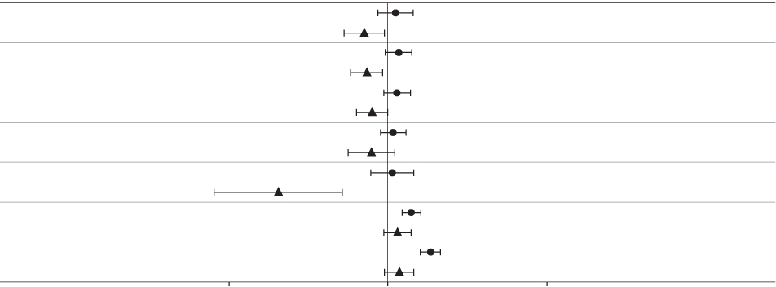
Metformin S-warfarin

Digoxin
AUC0-12h
Cmax AUC0-168h
Cmax AUC0-168h
Cmax AUC0-120h
Cmax AUC0-72h
Cmax AUC0-24h
Cmax AUC0-24h
Cmax
No dose adjustment

No dose adjustment
R-warfarin
No dose adjustment
No dose adjustment
Atorvastatin
No dose adjustment
Ethinylestradiol
No dose adjustment
Levonorgestrel
No dose adjustment
0.5 1 2

Relative exposure in terms of AUC and Cmax for each medication when given with semaglutide compared to without semaglutide. Metformin and oral contraceptive drug (ethinylestradiol/levonorgestrel) were assessed at steady state. Warfarin (S-warfarin/R-warfarin), digoxin and atorvastatin were assessed after a single dose.
Abbreviations: AUC: area under the curve. Cmax: maximum concentration. CI: confidence interval

Oral contraceptives
Semaglutide is not anticipated to decrease the effectiveness of oral contraceptives as semaglutide did not change the overall exposure of ethinylestradiol and levonorgestrel to a clinically relevant
degree, when an oral contraceptive combination medicinal product (0.03 mg ethinylestradiol/0.15 mg levonorgestrel) was co-administered with semaglutide. Exposure of ethinylestradiol was not affected; an increase of 20% was observed for levonorgestrel exposure at steady state. Cmax was not affected for any of the compounds.

Atorvastatin
Semaglutide did not change the overall exposure of atorvastatin following a single dose administration of atorvastatin (40 mg). Atorvastatin Cmax was decreased by 38%. This was assessed not to be clinically relevant.

Digoxin
Semaglutide did not change the overall exposure or Cmax of digoxin following a single dose of digoxin
(0.5 mg).

Metformin
Semaglutide did not change the overall exposure or Cmax of metformin following dosing of 500 mg twice daily over 3.5 days.

Warfarin
Semaglutide did not change overall exposure or Cmax of R- and S-warfarin following a single dose of warfarin (25 mg), and the pharmacodynamic effects of warfarin as measured by the international normalised ratio were not affected in a clinically relevant manner.

Fertility, pregnancy and lactation

Effects on fertility
The effect of semaglutide on fertility in humans is unknown. Semaglutide did not affect male fertility in rats at daily SC doses of 828 μg/kg, resulting in exposures approximately 4.5 times the clinical AUC. In female rats, an increase in oestrous length and a small reduction in number of ovulations were observed at doses associated with maternal body weight loss (≥30 μg/kg/day SC, resulting in subclinical exposures).

Use in pregnancy – Pregnancy Category D
Semaglutide should not be used during pregnancy. Women of childbearing potential are recommended to use contraception when treated with semaglutide. If a patient wishes to become pregnant, or pregnancy occurs, semaglutide should be discontinued. Semaglutide should be discontinued at least 2 months before a planned pregnancy due to the long half-life (see section 5.2 Pharmacokinetic properties).
Studies in animals have shown reproductive toxicity when semaglutide was administered during organogenesis. In pregnant rats, embryofetal toxicity (lethality, impaired growth and an increased incidence of fetal abnormalities) was observed at subclinical plasma exposures. Mechanistic studies suggest a direct GLP-1 receptor mediated role of semaglutide on some of the effects in rats (species specific). In pregnant rabbits, pharmacologically mediated reductions in maternal body weight gain and food consumption were observed at all dose levels. Early pregnancy losses and increased incidences of minor visceral (kidney, liver) and skeletal (sternebra) fetal abnormalities were observed at ≥0.0025 mg/kg/day, at clinically relevant exposures. In pregnant cynomolgus monkeys, pharmacologically mediated, marked initial maternal body weight loss and reductions in body weight gain and food consumption coincided with the occurrence of sporadic abnormalities (vertebra, sternebra, ribs) and with an increase in early pregnancy losses at ≥0.075 mg/kg twice weekly (>1.4- fold clinical exposure at 2.4 mg/week). Exposures at the NOAEL in all species were subclinical and a direct effect of semaglutide on the fetus cannot be excluded.

Use in lactation
In lactating rats, semaglutide was excreted in milk. A risk to a breast-fed child cannot be excluded. Semaglutide should not be used during breast-feeding.

Effects on ability to drive and use machines
Wegovy has no or negligible influence on the ability to drive or use machines. However, dizziness can be experienced mainly during the dose escalation period. Driving or use of machines should be done cautiously if dizziness occurs.
Effect on the ability to drive and use machines for patients with overweight or obesity and type 2 diabetes
If Wegovy is used in combination with a sulfonylurea or insulin, patients should be advised to take precautions to avoid hypoglycaemia while driving and using machines.

Adverse effects (Undesirable effects)

Summary of safety profile
In 4 phase 3a trials, 2,650 adult patients were exposed to Wegovy. The duration of the trials were 68 weeks. Similar to other GLP-1 receptor agonists, the most frequently reported adverse reactions were gastrointestinal disorders including nausea, diarrhoea, constipation and vomiting.

Reporting suspected adverse effects
Reporting suspected adverse reactions after registration of the medicinal product is important. It allows continued monitoring of the benefit-risk balance of the medicinal product. Healthcare professionals are asked to report any suspected adverse reactions at www.tga.gov.au/reporting- problems.
Tabulated List of Adverse Events
Table 3 Adverse events in Placebo-Controlled Trials Reported in ≥1% of Wegovy-Treated Adult Patients

 | Wegovy N = 2650  % | Placebo N = 1529  %
Nervous system disorders
Headache | 12.8 | 8.7
Dizziness | 6.8 | 3.3
Gastrointestinal Disorders
Nausea | 38.3 | 14.0
Diarrhea | 26.8 | 14.3
Constipation | 21.8 | 10.2
Vomiting | 21.8 | 5.7
Abdominal Paina | 18.1 | 9.0
Dyspepsia | 7.6 | 2.7
Eructation | 6.5 | 0.4
Abdominal Distension | 6.3 | 4.3
Flatulence | 5.3 | 3.7
Gastroesophageal Reflux Disease | 4.6 | 2.1
Gastritisc | 3.2 | 1.5
Metabolism and nutrition disorders
Decreased Appetite | 7.8 | 2.8
Hepatobiliary disorders
Cholelithiasis | 1.6 | 1.1
Skin and subcutaneous tissue disorders

Hair Loss | 2.5 | 1.0
General disorders and administration site conditions
Fatigueb | 9.6 | 4.7
Injection site reactionsd | 4.2 | 4.9
Tabulated list of adverse reactions
Table 3 lists adverse reactions identified in phase 3a clinical trials in adult patients. The frequencies
are based on a pool of the phase 3a trials.
Adverse reactions associated with Wegovy are listed by body system and frequency. Frequency categories are defined as: Very common (≥1/10); common (≥1/100 to <1/10); uncommon (≥1/1,000 to <1/100); rare (≥1/10,000 to <1/1,000); very rare (<1/10,000).

Table 4 Adverse reactions from controlled phase 3 studies in adults

MedDRA system organ  class | Very common | Common | Uncommon | Rare
Immune system disorders |  |  |  | Anaphylactic reaction
Metabolism and nutrition disorders |  | Hypoglycaemia in patients with type 2  diabetesª
Nervous system disorders | Headache^{b} | Dizziness^{b}
Eye disorders |  | Diabetic retinopathy in patients with type 2  diabetesª
Cardiac disorders |  |  | Increased heart  rate^{a,c}
Gastrointestinal disorders | Vomiting^{a,b} Diarrhoea^{a,b} Constipation^{a,b} Nausea^{a,b} Abdominal pain^{b,c} | Gastritis^{b,c} Gastrooesophageal reflux disease^{b} Dyspepsia^{b} Eructation^{b} Flatulence^{b} Abdominal  distension^{b} | Acute pancreatitisª Delayed gastric emptying
Hepatobiliary disorders |  | Cholelithiasisª
Skin and subcutaneous  disorders |  | Hair lossª
General disorders and administration site conditions | Fatigue^{b,c} | Injection site reactions^{c}
Investigations |  |  | Increased amylase^{c}  Increased lipase^{c}
a) See description of selected adverse reactions below
b) Mainly seen in the dose-escalation period
c) Grouped preferred terms

Description of selected adverse reactions
Gastrointestinal adverse reactions
The events were most frequently reported during dose escalation. Over 68 weeks, nausea occurred in 43.9% of patients when treated with Wegovy (16.1% for placebo), diarrhoea in 29.7% (15.9% for placebo) and vomiting in 24.5% (6.3% for placebo). Most events were mild to moderate in severity and of short duration. Constipation occurred in 24.2% of patients treated with Wegovy (11.1% for placebo) and were mild to moderate in severity and of longer duration.
The gastrointestinal events led to permanent treatment discontinuation in 4.3% of patients.
Acute pancreatitis
The frequency of adjudication-confirmed acute pancreatitis reported in phase 3a clinical trials was 0.2% for Wegovy and <0.1% for placebo, respectively.

Acute gallstone disease/Cholelithiasis
Cholelithiasis was reported in 1.6% and led to cholecystitis in 0.6% of patients treated with Wegovy. Cholelithiasis and cholecystitis were reported in 1.1% and 0.3%, respectively, of patients treated with placebo.
Hair loss
Hair loss was reported in 2.5% of patients treated with Wegovy and in 1.0% of patients treated with placebo. The events were mainly of mild severity and most patients recovered while on continued treatment. Hair loss was reported more frequently in patients with a greater weight loss (≥ 20%).
Increased heart rate
In the phase 3a trials, a mean increase of 3 beats per minute (bpm) from a baseline mean of 72 bpm was observed in patients treated with Wegovy. The proportions of patients with a maximum increase from baseline ≥20 bpm at any timepoint during the on-treatment period were 26.0% in the Wegovy group vs 15.6% in the placebo group.
Immunogenicity
Consistent with the potentially immunogenic properties of medicinal products containing proteins or peptides, patients may develop antibodies following treatment with semaglutide. The proportion of patients testing positive for anti-semaglutide antibodies at any time post-baseline was low (2.9%) and no patients had anti-semaglutide neutralising antibodies or anti-semaglutide antibodies with endogenous GLP-1 neutralising effect at end-of-trial.
Patients with type 2 diabetes
Hypoglycaemia in patients with overweight or obesity and type 2 diabetes
In STEP 2, clinically significant hypoglycaemia was observed in 6.2% (0.1 events/patient year) of subjects treated with Wegovy compared with 2.5% (0.03 events/patient year) of subjects treated with placebo. One episode (0.2% of subjects, 0.002 events/patient year) was reported as severe. The risk of hypoglycaemia was increased when Wegovy was used with a sulfonylurea.
Diabetic retinopathy in patients with overweight or obesity and type 2 diabetes
Few episodes of diabetic retinopathy (4.0 % vs 2.7% of patients treated with Wegovy vs placebo, respectively) were observed in STEP 2.
Long-term glycaemic control decreases the risk of diabetic retinopathy. A 2-year clinical trial investigated semaglutide 0.5 mg and 1 mg vs. placebo in 3,297 patients with type 2 diabetes, with high cardiovascular risk, long duration of diabetes and poorly controlled blood glucose. In this trial, adjudicated events of diabetic retinopathy complications occurred in more patients treated with semaglutide (3.0%) compared to placebo (1.8%). This was observed in insulin-treated patients with known diabetic retinopathy. The treatment difference appeared early and persisted throughout the trial.
In STEP 2, retinal disorders were reported by 6.9% of patients treated with Wegovy, 6.2% of patients treated with semaglutide 1 mg, and 4.2% of patients treated with placebo. The majority of events were reported as diabetic retinopathy (4.0%, 2.7%, and 2.7%, respectively) and non-proliferative retinopathy (0.7%, 0%, and 0%, respectively).
Paediatric population
In a clinical trial conducted in adolescents of 12 years to below 18 years with obesity or overweight with at least one weight-related comorbidity, 133 patients were exposed to Wegovy. The trial duration was 68 weeks.
Overall, the frequency, type and severity of adverse reactions in the adolescents were comparable to that observed in the adult population. Cholelithiasis was reported in 3.8% of patients treated with Wegovy.
Semaglutide did not appear to affect growth or pubertal development during the trial period.
To date, there are no long-term (beyond 68 weeks) clinical trial data on safety or efficacy in adolescents.

Overdose
Overdose with semaglutide may be associated with gastrointestinal disorders which could lead to dehydration. In the event of overdose the patient should be observed for clinical signs and appropriate supportive treatment initiated. A prolonged period of observation and treatment for these symptoms may be necessary, taking into account the long half-life of Wegovy of approximately 1 week (see section 5.2 Pharmacokinetic Properties).
For information on the management of overdose, contact the Poisons Information Centre on
13 11 26 (Australia).

PHARMACOLOGICAL PROPERTIES

Pharmacodynamic properties

Mechanism of action
Semaglutide is a GLP-1 analogue with 94% sequence homology to human GLP-1. Semaglutide acts as a GLP-1 receptor agonist that binds to and activates the GLP-1 receptor, the target for native GLP-1.
GLP-1 is a physiological regulator and has multiple actions in glucose and appetite regulation. The glucose and appetite effects are specifically mediated via GLP-1 receptors in the pancreas and the brain.
Compared to native GLP-1, semaglutide has a prolonged half-life of around 1 week making it suitable for once weekly s.c. administration. The principal mechanism of protraction is albumin binding, which results in decreased renal clearance and protection from metabolic degradation.
Furthermore, semaglutide is stabilised against degradation by the DPP-4 enzyme.
Clinical studies show that semaglutide reduces energy intake, increases feelings of satiety, fulness and control of eating, and reduces feelings of hunger, and frequency and intensity of cravings.
Animal studies show that semaglutide works in the brain through the GLP-1 receptor. Semaglutide have direct effects on areas in the brain involved in homeostatic regulation of food intake in the hypothalamus and the brainstem. Semaglutide affects the hedonic reward system through direct and indirect effects in brain areas including the septum, thalamus and amygdala. Semaglutide has shown an effect to change food intake in animals away from more rewarding high fat, sweet items.
Semaglutide orchestrates the homeostatic and hedonic contributions with executive function to regulate caloric intake, appetite, reward and food choice.
In addition, in clinical studies semaglutide have shown to reduce blood glucose through a mechanism where it stimulates insulin secretion and lowers glucagon secretion, both in a glucose- dependent manner. The mechanism of blood glucose lowering also involves a minor delay in gastric emptying in the early postprandial phase. During hypoglycaemia, semaglutide diminishes insulin secretion and does not impair glucagon secretion.
Weight loss distribution
In a sub-study in STEP 1 (N = 140), body composition was measured using dual energy X-ray absorptiometry (DEXA). The results of the DEXA assessment showed that treatment with Wegovy was accompanied by greater reduction in fat mass than in lean body mass leading to an improvement in body composition compared to placebo after 68 weeks. Furthermore, this reduction in total fat mass was accompanied by a reduction in visceral fat. In the semaglutide group, there was a mean (SD) decrease in total fat mass proportion of 3.9%-points (5.4%-points), an increase in lean body mass proportion of 3.4% (5.1%) and a decrease in regional visceral fat mass proportion of 2.2%-points (4.4%). These results suggest that most of the total weight loss was attributable to a reduction in fat tissue, including visceral fat.
Appetite regulation, energy intake and food choice
Wegovy reduces appetite by increasing feelings of fullness and satiety, while lowering hunger and prospective food consumption. In a phase 1 trial, energy intake during an ad libitum meal was 35% lower with Wegovy compared to placebo after 20 weeks of dosing. This was supported by improved control of eating, less food cravings (for dairy and savoury foods), less desire for sweet food and a relatively lower preference for high fat food. Food cravings were further assessed in STEP 5 by a Control of Eating Questionnaire (CoEQ). At week 104, the estimated treatment difference both for control of cravings and craving for savoury food significantly favoured semaglutide, whereas no clear effect was seen for craving of sweet food.
Cardiac electrophysiology (QTc)
The effect of semaglutide on cardiac repolarization was tested in a thorough QTc trial. Semaglutide did not prolong QTc intervals at doses up to 1.5 mg at steady state.
The semaglutide exposure for subjects with overweight or obesity treated with Wegovy is comparable to the exposure evaluated in the semaglutide QTc study in healthy volunteers.

Clinical trials
The efficacy and safety of Wegovy for weight management in combination with a reduced calorie intake and increased physical activity were evaluated in four 68-week double-blinded randomised placebo-controlled phase 3a trials (STEP 1-4). A total of 4684 patients (2652 randomised to treatment with Wegovy) were included in these trials. Furthermore, the two-year efficacy and safety of Wegovy compared to placebo were evaluated in a double-blinded randomised placebo- controlled phase 3b trial (STEP 5) including 304 patients (152 on treatment with Wegovy).

Treatment with Wegovy demonstrated superior, clinically meaningful, and sustained weight loss
compared with placebo in patients with obesity (BMI ≥30 kg/m²) or overweight (BMI ≥27 kg/m² to
<30 kg/m²) and at least one weight-related comorbidity (Figure 3). Furthermore, across the trials, a higher proportion of patients achieved ≥5%, ≥10% and ≥15% weight loss with Wegovy compared with placebo.
Treatment with Wegovy also showed statistically significant improvements in waist circumference and systolic blood pressure compared to placebo. Wegovy also showed statistically significant improvements in physical functioning compared to placebo, except for STEP 3 where the improvement was not statistically significant.
Wegovy demonstrated efficacy regardless of age, sex, race, ethnicity, baseline body weight, BMI, presence of type 2 diabetes and level of renal function.

Figure 3 Body weight (%) change from baseline to week 68 and 104
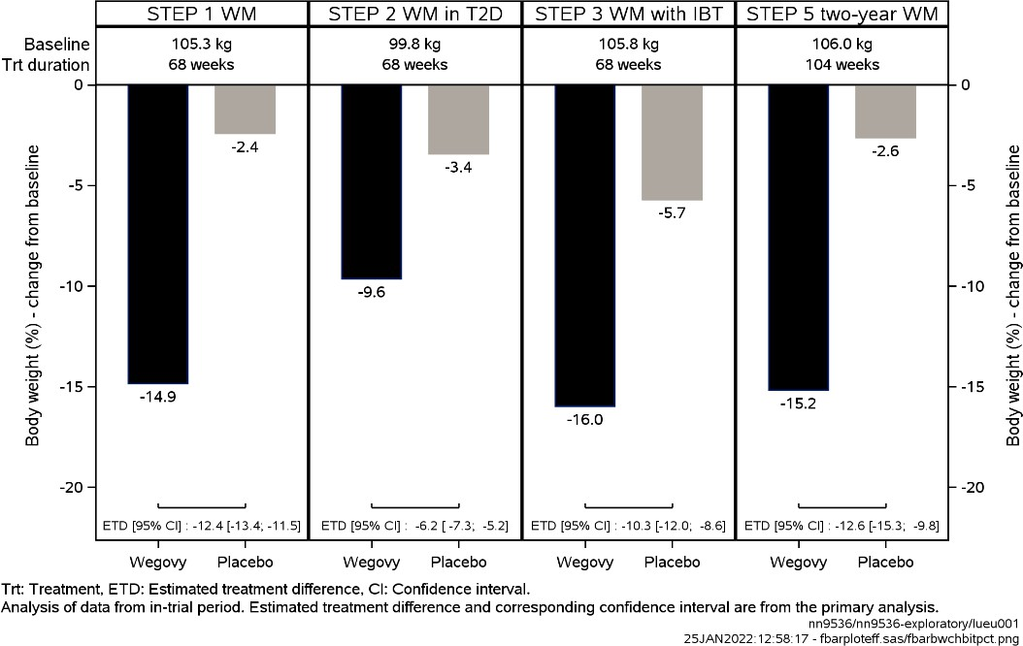

STEP 4 Sustained WM*
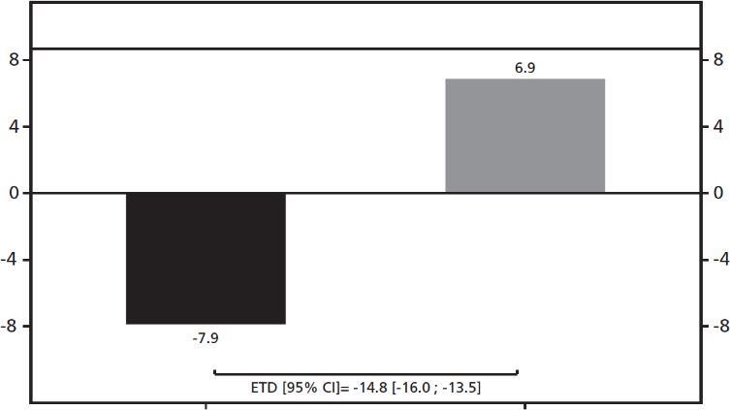



Baseline (week 20): 96.1 kg
WEGOVY Placebo

*baseline for STEP 4 was defined as the start of the randomisation period at week 20

STEP 1: Weight management
In a 68-week double-blind trial, 1961 patients with obesity (BMI ≥30 kg/m²), or with overweight (BMI
≥27 to <30 kg/m²) and at least one weight-related comorbidity were randomised to Wegovy or placebo. All patients received counselling with regards to diet (500 kcal/2092 kJ deficit per day) relative to the estimated total energy expenditure (TEE) (calculated once at randomisation), and
physical activity (150 min of physical activity per week was encouraged).
At baseline, patients had a mean BMI of 37.9 kg/m² and a mean body weight of 105.3 kg. The mean age of patients was 46 years. There were 75.1% Caucasian/White, 5.7% Black/African American, and 13.3% Asian. A total of 12.0% were Hispanic or Latino. The majority of patients had at least one weight-related comorbidity. These included, but were not limited to, pre-diabetes (43.7%), dyslipidaemia (37.0%), hypertension (36.0%), knee or hip osteoarthritis (15.9%), obstructive sleep apnoea (11.7%), asthma/chronic obstructive pulmonary disease (COPD) (11.6%), liver disease (non- alcoholic fatty liver disease (NAFLD) or non-alcoholic steatohepatitis (NASH)) (8.6%) and polycystic ovary syndrome (PCOS) (6.6%).
Weight loss with Wegovy occurred early and continued throughout the trial. At end of treatment (week 68), the weight loss with Wegovy was superior and clinically meaningful compared with placebo (see Table 4 and Figure 4). Furthermore, a higher proportion of patients achieved ≥5%,
≥10%, ≥15% and ≥20% weight loss with Wegovy compared with placebo (see Table 5 and Figure 5). Among patients with pre-diabetes at baseline, 84.1% and 47.8% achieved a normo-glycaemic status at end of treatment with Wegovy and placebo, respectively.
Following the 68-week trial, a 52-week off-treatment extension was conducted including 327 patients who had completed the main trial period on the maintenance dose of Wegovy or placebo. The trial extension consisted of four clinic visits and did not include structured lifestyle intervention. In the off-treatment period from week 68 to week 120, mean body weight increased in both treatment groups. However, for patients that had been treated with semaglutide for the main trial period the weight remained 5.6% below baseline compared to 0.1% for the placebo group.

Table 5 Results of a 68-week trial comparing Wegovy with placebo in patients with obesity, or overweight and at least one weight-related comorbidity (STEP 1)
 |  | Wegovy | Placebo
Full analysis set (N) |  | 1306 | 655
Body weight
Baseline (kg) |  | 105.4 | 105.2
Change (%) from baseline^{1,2} |  | -14.9 | −2.4
Difference (%) from placebo¹ [95% CI] |  | -12.4 [-13.4;-11.5]* | -
Change (kg) from baseline |  | -15.3 | -2.6
Difference (kg) from placebo¹ [95% CI] |  | -12.7 [-13.7;-11.7] | -
Patients (%) achieving weight loss ≥5%³ |  | 83.5* | 31.1
Patients (%) achieving weight loss ≥10%³ |  | 66.1* | 12.0
Patients (%) achieving weight loss ≥15%³ |  | 47.9* | 4.8
Patients (%) achieving weight loss ≥20%³ |  | 30.2 | 1.7
Waist circumference (cm)
Baseline |  | 114.6 | 114.8
Change from baseline¹ |  | −13.5 | −4.1
Difference from placebo¹ [95% CI] |  | -9.4 [−10.3; −8.5]* | -
Cardiometabolic factors
Systolic blood pressure (mmHg)
Baseline |  | 126 | 127
Change from baseline¹ |  | -6.2 | −1.1
Difference from placebo¹ [95% CI] |  | -5.1 [-6.3; -3.9]* | -
Diastolic blood pressure (mmHg)
Baseline | 80 |  | 80
Change from baseline¹ | -2.8 |  | −0.4
Difference from placebo¹ [95% CI] | -2.4 [-3.3; -1.6] |  | -
Lipids
Total cholesterol
Baseline (mmol/L)⁴ | 4.9 |  | 5.0
Change (%) from baseline¹ | −3.3 |  | 0.1
Relative Difference (%) from placebo¹ [95% CI] | −3.3 [−4.8; −1.8] |  | -
LDL cholesterol
Baseline (mmol/L)⁴ | 2.9 |  | 2.9
Change (%) from baseline¹ | −2.5 |  | 1.3
Relative Difference (%) from placebo¹ [95% CI] | −3.8 [−5.9; −1.5] |  | -
HDL cholesterol
Baseline (mmol/L)⁴ | 1.3 |  | 1.3
Change (%) from baseline¹ | 5.2 |  | 1.4
Relative Difference (%) from placebo¹ [95% CI] | 3.8 [2.2; 5.4] |  | -
Triglycerides
Baseline (mmol/L)⁴ | 1.4 |  | 1.4
Change (%) from baseline¹ | −21.9 |  | −7.3
Relative Difference (%) from placebo¹ [95% CI] | −15.8 [−18.8; −12.7] |  | -
CRP
Baseline (mg/L)⁴ | 3.9 |  | 3.9
Change (%) from baseline¹ | −52.6 |  | −15.0
Relative Difference (%) from placebo¹  [95% CI] | -44.3 [−49.5; −38.5] |  | -
Glycaemic factors
HbA1c (%)
Baseline | 5.7 |  | 5.7
Change from baseline^{1,2} | −0.5 |  | −0.2
Difference from placebo¹ [95% CI] | −0.3 [−0.3; −0.3] |  | -
FPG (mmol/L)
Baseline | 5.3 |  | 5.3
Change from baseline¹ | −0.5 |  | −0.03
Difference from placebo¹ [95% CI] | −0.4 [−0.5; −0.4] |  | -
Glycaemic status⁵
Patients (%) with pre-diabetes at baseline | 43.7
Patients (%) achieving normo-glycaemic status at end of treatment | 84.1 |  | 47.8
* p<0.0001 (unadjusted 2-sided) for superiority.
1 Estimated using an ANCOVA model using multiple imputation based on all data irrespective of discontinuation of randomised treatment or initiation of other anti-obesity medication or bariatric surgery.
2 During the trial, randomised treatment was permanently discontinued by 17.1% and 22.4% of patients randomised to Wegovy and placebo, respectively. Assuming that all randomised patients stayed on treatment and did not receive additional anti-obesity therapies, the estimated changes from randomisation to week 68 for body weight based on a Mixed Model for Repeated Measures including all observations until first discontinuation were -16.9% and -2.4% for Wegovy and placebo respectively.
3 Estimated from binary regression model based on same imputation procedure as in primary analysis.
4 Geometric mean
5 exploratory endpoint

Figure 4 STEP 1 - Mean change in body weight (%) from baseline to week 68
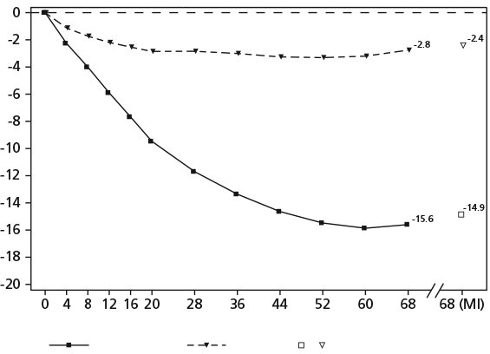

Wegovy
Weeks
Placebo
Multiple imputation (MI)

Observed values for patients completing each scheduled visit, and estimates with multiple imputations (MI) from retrieved dropouts

Figure 5 STEP 1 - Cumulative distribution of change (%) in body weight after 68 weeks of treatment
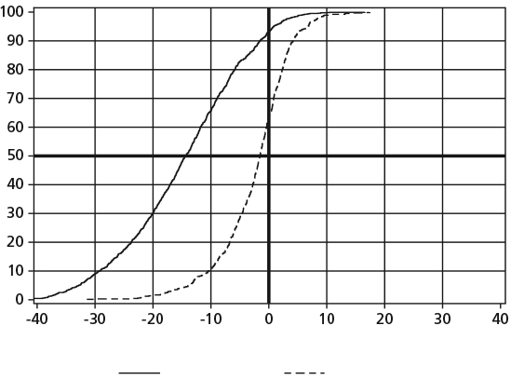


Change in body weight (%)
Wegovy Placebo

Observed data from in-trial period including imputed data from retrieved dropouts for missing observations.

STEP 2: Weight Management in patients with type 2 diabetes
In a 68-week, double-blind and double-dummy trial, 1210 patients with overweight or obesity (BMI
≥27 kg/m²) and type 2 diabetes were randomised to either Wegovy, semaglutide 1 mg once-weekly or placebo. Patients included in the trial had insufficiently controlled diabetes (HbA1c 7–10%) and were treated with either: diet and exercise alone or 1–3 oral anti-diabetic drugs. All patients received counselling with regards to diet (500 kcal/2092 kJ deficit per day) relative to the estimated total energy expenditure (TEE) (calculated once at randomisation), and physical activity (150 min of physical activity per week was encouraged).
At baseline, patients had a mean BMI of 35.7 kg/m², a mean body weight of 99.8 kg and a mean
HbA1C of 8.1%. The mean age was 55 years. There were 62.1% Caucasian/White, 8.3% Black/African
American, and 26.2% Asian. A total of 12.8% were Hispanic or Latino. The majority of patients had at least two weight-related comorbidities. Besides type 2 diabetes these included, but were not limited to, hypertension (69.8%), dyslipidaemia (68.0%), liver disease (NAFLD or NASH) (22.6%), knee or hip osteoarthritis (19.6%), obstructive sleep apnoea (15.1%), asthma/COPD (8.4%) and PCOS (4.1%).
Treatment with Wegovy for 68 weeks resulted in superior and clinically meaningful reductions in body weight and in HbA1c compared to placebo (see Table 6 and Figure 6).

Table 6 Results of a 68-week trial comparing Wegovy with placebo in patients with obesity or overweight, and type 2 diabetes (STEP 2)

 | Wegovy | Placebo
Full analysis set (N) | 404 | 403
Body weight
Baseline (kg) | 99.9 | 100.5
Change (%) from baseline^{1,2} | -9.6 | −3.4
Difference (%) from placebo¹ [95% CI] | -6.2 [-7.3;-5.2]* | -
Change (kg) from baseline | -9.7 | -3.5
Difference (kg) from placebo¹ [95% CI] | -6.1 [-7.2;-5.0] | -
Patients (%) achieving weight loss ≥5%³ | 67.4* | 30.2
Patients (%) achieving weight loss ≥10%³ | 44.5* | 10.2
Patients (%) achieving weight loss ≥15%³ | 25.0* | 4.3
Patients (%) achieving weight loss ≥20%³ | 12.8 | 2.3
Waist circumference (cm)
Baseline | 114.5 | 115.5
Change from baseline¹ | -9.4 | -4.5
Difference from placebo¹ [95% CI] | -4.9 [-6.0; -3.8]* | -
Cardiometabolic factors
Systolic blood pressure (mmHg)
Baseline | 130 | 130
Change from baseline¹ | -3.9 | -0.5
Difference from placebo¹ [95% CI] | -3.4 [-5.6; -1.3]** | -
Diastolic blood pressure (mmHg)
Baseline | 80 | 80
Change from baseline¹ | -1.6 | -0.9
Difference from placebo¹ [95% CI] | -0.7 [-2.0; 0.6] | -
Lipids
Total cholesterol
Baseline (mmol/L)⁴ | 4.4 | 4.4
Change (%) from baseline¹ | -1.4 | -0.5
Relative Difference (%) from placebo¹ [95% CI] | -0.9 [-3.6; 2.0] | -
LDL cholesterol
Baseline (mmol/L)⁴ | 2.3 | 2.3
Change (%) from baseline¹ | 0.5 | 0.1
Relative Difference (%) from placebo¹ [95% CI] | 0.4 [-4.0; 4.9] | -
HDL cholesterol
Baseline (mmol/L)⁴ | 1.2 | 1.1
Change (%) from baseline¹ | 6.9 | 4.1
Relative Difference (%) from placebo¹ [95% CI] | 2.7 [0.3; 5.1] | -
Triglycerides

Baseline (mmol/L)⁴ | 1.7 | 1.8
Change (%) from baseline¹ | -22.0 | -9.4
Relative Difference (%) from placebo¹ [95% CI] | -13.9 [-19.0; -8.4] | -
CRP
Baseline (mg/L)⁴ | 3.5 | 3.4
Change (%) from baseline¹ | -48.9 | -16.7
Relative Difference (%) from placebo¹ [95% CI] | -38.7 [-46.5; -29.8] | -
Glycaemic factors
HbA1c (%)
Baseline | 8.1 | 8.1
Change from baseline^{1,2} | -1.6 | -0.4
Difference from placebo¹ [95% CI] | -1.2 [-1.4; -1.1]* | -
Patients (%) achieving HbA1c <7%³ | 77.4 | 26.0
Patients (%) achieving HbA1c ≤6.5%³ | 65.9 | 15.1
FPG (mmol/L)
Baseline | 8.5 | 8.8
Change from baseline¹ | -2.1 | -0.1
Difference from placebo¹ [95% CI] | -2.0 [-2.4; -1.7] | -
* p<0.0001 (unadjusted 2-sided) for superiority; **p<0.05 (unadjusted 2-sided) for superiority
1 Estimated using an ANCOVA model using multiple imputation based on all data irrespective of discontinuation of randomised treatment or initiation of other anti-obesity medication or bariatric surgery.
2 During the trial, randomised treatment was permanently discontinued by 11.6% and 13.9% of patients randomised to Wegovy and placebo, respectively. Assuming that all randomised patients stayed on treatment and did not receive additional anti-obesity therapies, the estimated changes from randomisation to week 68 for body weight based on a Mixed Model for Repeated Measures including all observations until first discontinuation were -10.6% and -3.1% for Wegovy and placebo respectively.
3 Estimated from binary regression model based on same imputation procedure as in primary analysis.
4 Geometric mean.

Figure 6 STEP 2 - Mean change in body weight (%) and HbA1c (%) from baseline to week 68
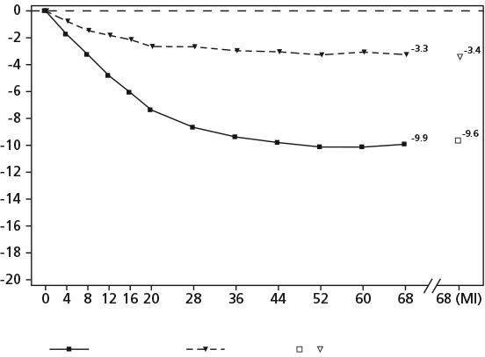
Wegovy
Weeks
Placebo
Multiple imputation (MI)

Observed values for patients completing each scheduled visit, and estimates with multiple imputations (MI) from retrieved dropouts

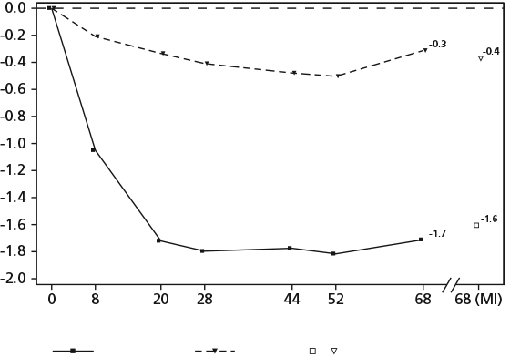
Wegovy
Weeks
Placebo
Multiple imputation (MI)
HbA1c: Haemoglobin A1c
Observed values for patients completing each scheduled visit, and estimates with multiple imputations (MI) from retrieved dropouts

STEP 3: Weight Management with Intensive Behavioural Therapy
In a 68-week double-blind trial, 611 patients with obesity (BMI ≥30 kg/m²), or with overweight (BMI
≥27 to <30 kg/m²) and at least one weight-related comorbidity were randomised to Wegovy or placebo. During the trial, all patients received intensive behavioural therapy (IBT) consisting of an initial 8 weeks low calorie diet followed by a 60 weeks hypo-caloric diet, increased physical activity and behavioural counselling. The first 8 weeks included a 1000-1200 kcal/day (4184-5020.8 kJ/day) low-calorie diet provided as meal replacements and portion-controlled meals. From week 8 and onwards, daily caloric targets were defined based on baseline body weight and ranged from 1200 to 1800 kcal/day (5020.8-7531.2 kJ/day). Physical activity was prescribed with a target of 100 minutes physical activity per week, progressing gradually by 25 minutes every 4 weeks and up to 200 minutes/week.
At baseline, patients had a mean BMI of 38.0 kg/m² and a mean body weight of 105.8 kg. The mean age was 46 years. There were 76.1% Caucasian/White, 19.0% Black/African American, and 1.8% Asian. A total of 19.8% were Hispanic or Latino. The majority of patients had at least one weight- related comorbidity. These included, but were not limited to, pre-diabetes (49.8%), hypertension (34.7%), dyslipidaemia (34.7%), knee or hip osteoarthritis (18.7%), asthma/COPD (15.1%), obstructive sleep apnoea (12.6%), liver disease (NAFLD or NASH) (6.1%) and PCOS (5.5%).
Treatment with Wegovy and IBT for 68 weeks resulted in superior and clinically meaningful reduction in body weight compared to placebo (see Table 7 and Figure 7). Among patients with pre- diabetes at baseline, 89.5% and 55.0% of patients achieved normo-glycaemic status at end of treatment with Wegovy and placebo, respectively.

Table 7 Results of a 68-week trial comparing Wegovy with placebo in patients with obesity, or overweight and at least one weight-related comorbidity, on IBT (STEP 3)

 | Wegovy | Placebo
Full analysis set (N) | 407 | 204
Body weight
Baseline (kg) | 106.9 | 103.7
Change (%) from baseline^{1,2} | -16.0 | -5.7
Difference (%) from placebo¹ [95% CI] | -10.3 [-12.0;-8.6]* | -
Change (kg) from baseline | -16.8 | -6.2
Difference (kg) from placebo¹ [95% CI] | -10.6 [-12.5;-8.8] | -
Patients (%) achieving weight loss ≥5%³ | 84.8* | 47.8
Patients (%) achieving weight loss ≥10%³ | 73.0* | 27.1
Patients (%) achieving weight loss ≥15%³ | 53.5* | 13.2
Patients (%) achieving weight loss ≥20%³ | 33.9 | 3.5
Waist circumference (cm)
Baseline | 113.6 | 111.8
Change from baseline¹ | -14.6 | -6.3
Difference from placebo¹ [95% CI] | -8.3 [-10.1; -6.6]* | -

* p<0.0001 (unadjusted 2-sided) for superiority1
Estimated using an ANCOVA model using multiple imputation based on all data irrespective of discontinuation of randomised treatment or initiation of other anti-obesity medication or bariatric surgery.
2 During the trial, randomised treatment was permanently discontinued by 16.7% and 18.6% of patients randomised to Wegovy and placebo, respectively. Assuming that all randomised patients stayed on treatment and did not receive additional anti-obesity therapies, the estimated changes from randomisation to week 68 for body weight based on a Mixed Model for Repeated Measures including all observations until first discontinuation were -17.6% and -5.0% for Wegovy and placebo respectively
3 Estimated from binary regression model based on same imputation procedure as in primary analysis.

Figure 7 STEP 3 - Mean change in body weight (%) from baseline to week 68
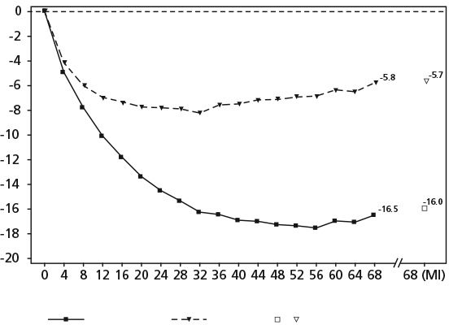
Wegovy
Weeks
Placebo
Multiple imputation (MI)

Observed values for patients completing each scheduled visit, and estimates with multiple imputations (MI) from retrieved dropouts
STEP 4: Sustained Weight Management
In a 68-week double-blind withdrawal trial, 902 patients with obesity (BMI ≥30 kg/m²), or with overweight (BMI ≥27 to <30 kg/m²) and at least one weight-related comorbidity were included. All patients received counselling with regards to diet (500 kcal/2092 kJ deficit per day) relative to the estimated total energy expenditure (TEE) (calculated once at randomisation), and physical activity (150 min of physical activity per week was encouraged). From week 0 to week 20 (run-in), all patients received Wegovy. At week 20 (baseline), 803 patients who had reached the maintenance dose of Wegovy were randomised to continue Wegovy or switch to placebo for the remaining 48 weeks.
At the beginning of the run-in period (week 0), patients had a mean BMI of 38.4 kg/m2, a mean body weight of 107.2 kg and a mean age of 46 years. At baseline (week 20), patients had a mean BMI of
34.4 kg/m² and a mean body weight of 96.1 kg. There were 83.7% Caucasian/White, 13.0% Black/African American, and 2.4% Asian. A total of 7.8% were Hispanic or Latino. The majority of patients had at least one weight-related comorbidity. These included, but were not limited to, pre- diabetes (46.8%), hypertension (37.1%), dyslipidaemia (35.9%), knee or hip osteoarthritis (13.3%), obstructive sleep apnoea (11.7%), asthma/COPD (11.5%), liver disease (NAFLD and NASH) (7.3%) and PCOS (3.9%).
Patients who had reached the maintenance dose of Wegovy at week 20 (baseline) and continued treatment with Wegovy for 48 weeks continued losing weight and had a superior and clinically meaningful reduction in body weight compared to those switched to placebo (see Table 8 and Figure 8). On the other hand, in patients switching to placebo at week 20 (baseline), body weight increased steadily from week 20 to week 68. However, the observed mean body weight was lower at week 68 than at start of the run-in period (week 0) (see Figure 8). Patients treated with Wegovy from week 0 (run-in) to week 68 (end of treatment) achieved a mean change in body weight of 17.4%, with weight loss ≥5% achieved by 87.8%, ≥10% achieved by 78.0%, ≥15% achieved by 62.2% and ≥20% achieved by 38.6% of these patients.

Table 8 Results from the 48-week (week 20 to week 68) randomised period of the trial comparing Wegovy with placebo in patients with obesity, or overweight and a least one weight-related comorbidity (STEP 4)

 | Wegovy | Placebo
Full analysis set (N) | 535 | 268
Body weight
Baseline¹ (kg) | 96.5 | 95.4
Change (%) from baseline^{1,2,3} | -7.9 | 6.9
Difference (%) from placebo² [95% CI] | -14.8 [-16.0;-13.5]* | -
Change (kg) from baseline¹ | -7.1 | 6.1
Difference (kg) from placebo² [95% CI] | -13.2 [-14.3;-12.0] | -
Waist circumference (cm)
Baseline¹ | 105.5 | 104.7
Change from baseline^{1,2} | -6.4 | 3.3
Difference from placebo² [95% CI] | -9.7 [-10.9; -8.5]* | -
* p<0.0001 (unadjusted 2-sided) for superiority, 1Baseline = week 20
2 Estimated using an ANCOVA model using multiple imputation based on all data irrespective of discontinuation of randomised treatment or initiation of other anti-obesity medication or bariatric surgery.
3 During the trial, randomised treatment was permanently discontinued by 5.8% and 11.6% of patients randomized to Wegovy and placebo, respectively. Assuming that all randomised patients stayed on treatment and did not receive additional anti-obesity therapies, the estimated changes from randomisation to week 68 for body weight based on a Mixed Model for Repeated Measures including all observations until first discontinuation were -8.1% and 6.5% for Wegovy and placebo respectively.

Figure 8 STEP 4 - Mean change in body weight (%) from week 0 to week 68
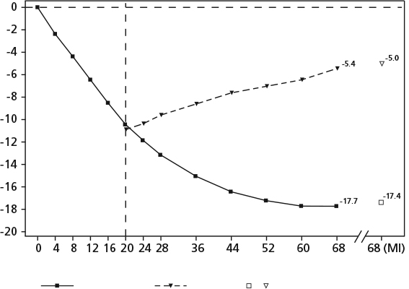

Wegovy
Weeks
Placebo
Multiple imputation (MI)

Observed values for patients completing each scheduled visit, and estimates with multiple imputations (MI) from retrieved dropouts
STEP 5: long term efficacy
In a 104-week double-blind trial, 304 patients with obesity (BMI ≥30 kg/m²), or with overweight (BMI ≥27 to <30 kg/m²) and at least one weight-related comorbidity, were randomised to Wegovy or placebo. All patients were counselled on healthy nutrition and physical activity with the goal of obtaining weight loss.
At baseline, patients had a mean BMI of 38.5 kg/m², a mean body weight of 106.0 kg. The mean age was 47 years. There were 93.1% Caucasian/White, 3.9% Black/African American, and 0.7% Asian. A total of 12.8% were Hispanic or Latino. The majority of patients had at least one weight-related comorbidity. These included, but were not limited to, hypertension (38.8%), dyslipidaemia (35.2%), obstructive sleep apnoea (16.8%) and knee osteoarthritis (15.1%).

Treatment with Wegovy® for 104 weeks resulted in a superior and clinically meaningful reduction in body weight compared to placebo (see Table 9 and Figure 9). Mean body weight decreased from baseline through to week 68 with Wegovy® after which a plateau was reached. With placebo, mean body weight decreased less, and a plateau was reached after approximately 20 weeks of treatment. A higher proportion of patients achieved ≥5%, ≥10%, ≥15% and ≥20% weight loss with Wegovy® compared with placebo. Among patients with pre-diabetes at baseline, 80% and 37% achieved a normo-glycaemic status at end of treatment with Wegovy® and placebo, respectively.

Table 9 Results of a 104-week trial comparing Wegovy® with placebo in patients with obesity or overweight and at least one weight-related comorbidity (STEP 5)
 | Wegovy® | Placebo
Full analysis set (N) | 152 | 152
Body weight
Baseline (kg) | 105.6 | 106.5
Change (%) from baseline^{1,} ² | -15.2 | -2.6
Difference (%) from placebo¹ [95% CI] | -12.6 [-15.3; -9.8]* | -
Change (kg) from baseline | -16.1 | -3.2
Difference (kg) from placebo¹ [95% CI] | 12.9[-16.1;-9.8] | -
Patients (%) achieving weight loss ≥5%³ | 74.7* | 37.3
Patients (%) achieving weight loss ≥10%³ | 59.2* | 16.8
Patients (%) achieving weight loss ≥15%³ | 49.7* | 9.2
Patients (%) achieving weight loss ≥20%³ | 34.5* | 4.0
Waist circumference (cm)
Baseline | 115.8 | 115.7
Change from baseline¹ | -14.4 | 5.2
Difference from placebo¹ [95% CI] | -9.2 [-12.2; -6.2]* | -
Systolic blood pressure (mmHg)
Baseline | 126 | 125
Change from baseline¹ | -5.7 | -1.6
Difference from placebo¹ [95% CI] | -4.2 [-7.3; -1.0]* | -
* p<0.0001 (unadjusted 2-sided) for superiority.
1 Estimated using an ANCOVA model using multiple imputation based on all data irrespective of discontinuation of randomised treatment or initiation of other anti-obesity medication or bariatric surgery.
2 During the trial, randomised treatment was permanently discontinued by 13.2% and 27.0% of patients randomized to Wegovy® and placebo, respectively. Assuming that all randomised patients stayed on treatment and did not receive additional anti-obesity therapies, the estimated changes from randomisation to week 68 for body weight based on a Mixed Model for Repeated Measures including all observations until first discontinuation were -16.7% and -0.6% for Wegovy® and placebo respectively.
3 Estimated from binary regression model based on same imputation procedure as in primary analysis.

Figure 9 Mean body weight change from baseline to week 104

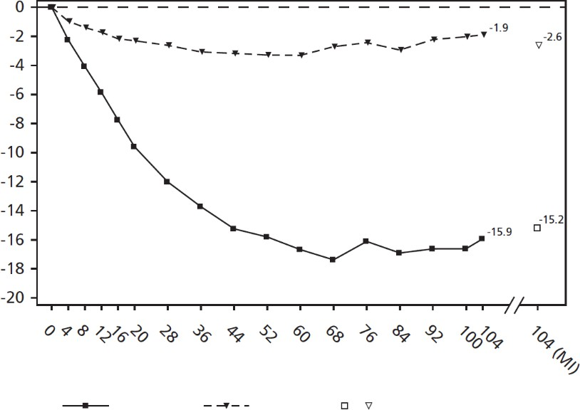

Wegovy Placebo Multiple imputation (MI)
Weeks
Observed values for patients completing each scheduled visit, and estimates with multiple imputations (MI) from retrieved dropouts

Step 8: Semaglutide vs liraglutide
In a 68-week, randomised, open-label, pairwise placebo-controlled trial, 338 patients with obesity (BMI ≥30 kg/m²), or with overweight (BMI ≥27 to <30 kg/m²) and at least one weight-related comorbidity, were randomised to Wegovy once weekly, liraglutide 3.0 mg once daily or placebo. Wegovy once weekly and liraglutide 3 mg were open-label, but each active treatment group was double-blinded against placebo administered at the same dosing frequency. All patients were on a reduced-calorie diet and increased physical activity throughout the trial.

At baseline, patients had a mean BMI of 37.5 kg/m², a mean body weight of 104.5 kg. The mean age was 49 years. There were 73.7% Caucasian/White, 18.9% Black/African American, and 3.8% Asian. A total of 11.5% were Hispanic or Latino. The majority of patients had at least one weight-related comorbidity. These included, but were not limited to, dyslipidaemia (47.6%), hypertension (42.0%), knee osteoarthritis (18.3%) and obstructive sleep apnoea (18.0%).

Treatment with Wegovy once weekly for 68 weeks resulted in superior and clinically meaningful reduction in body weight compared to liraglutide. Mean body weight decreased from baseline through to week 68 with Wegovy, with liraglutide, mean body weight decreased less, and with placebo less yet. 37.4% of the patients treated with semaglutide lost ≥20%, compared to 7.0% treated with liraglutide. Table 10 shows the results of the confirmatory endpoints ≥10%, ≥15% and
≥20% weight loss.

Table 10 Results of a 68-week trial comparing Wegovy with liraglutide in patients with obesity or

overweight (STEP 8)

 | Wegovy | Liraglutide 3 mg
Full analysis set (N) | 126 | 127
Body weight
Baseline (kg) | 102.5 | 103.7
Change (%) from baseline^{1,} ² | -15.8 | -6.4
Difference (%) from liraglutide¹ [95% CI] | -9.4 [-12.0;-6.8]* | -
Change (kg) from baseline | -15.3 | -6.8
Difference (kg) from liraglutide¹ [95% CI] | -8.5 [-11.2;-5.7] | -
Patients (%) achieving weight loss ≥10%³ | 69.4* | 27.2
Patients (%) achieving weight loss ≥15%³ | 54.0* | 13.4
Patients (%) achieving weight loss ≥20%³ | 37.4* | 7.0
1 Estimated using an ANCOVA model using multiple imputation based on all data irrespective of discontinuation of randomised treatment or initiation of other anti-obesity medication or bariatric surgery.
2 During the trial, randomised treatment was permanently discontinued by 13.5% and 27.6% of patients randomized to Wegovy® and liraglutide, respectively. Assuming that all randomised patients stayed on treatment and did not receive additional anti-obesity therapies, the estimated changes from randomisation to week 68 for body weight based on a Mixed Model for Repeated Measures including all observations until first discontinuation were -16.7% and -6.7% for Wegovy® and liraglutide respectively.
3 Estimated from binary regression model based on same imputation procedure as in primary analysis.

Body weight
Across all trials, treatment with Wegovy demonstrated clinically meaningful and sustained weight loss for up to 104 weeks compared to placebo in patients with obesity or overweight. In the phase 3a trials, the reduction in body weight was shown to occur irrespective of the presence of gastrointestinal symptoms such as nausea, vomiting or diarrhoea.
Cardiovascular risk factors
Wegovy reduced waist circumference, systolic blood pressure and CRP, and improved lipid profile compared with placebo.
Lipids
Wegovy improved total cholesterol by -0.9% to -5.9%, HDL-cholesterol by 0.3% to 3.8% LDL- cholesterol by 0.4% to -7.1%, and triglycerides by -17.8% to -15.8%, after 68 weeks of treatment.
Blood Pressure
Wegovy reduced systolic and diastolic blood pressure by 3.4 mmHg to 5.1 mmHg and 0.7 mmHg to
2.4 mmHg respectively after 68 weeks of treatment
Waist circumference
Wegovy reduced waist circumference by 4.9 cm to 9.4 cm after 68 weeks of treatment.
C-Reactive Protein (CRP)
Wegovy reduced CRP (marker of systemic inflammation) by 38.7% to 47.6% after 68 weeks of
treatment.
Cardiovascular outcomes
In the SUSTAIN 6 trial for OZEMPIC (semaglutide) for a type 2 diabetes indication unrelated to weight loss, 3,297 patients with type 2 diabetes and at high risk of cardiovascular events were randomised to semaglutide s.c. 0.5 mg or 1 mg once-weekly or placebo in addition to standard-of- care. The treatment duration was 104 weeks. The mean age was 65 years and the mean BMI was 33 kg/m².
The primary endpoint was the time from randomisation to first occurrence of a major adverse cardiovascular event (MACE): cardiovascular death, non-fatal myocardial infarction or non-fatal stroke. The secondary endpoint was time from randomisation to first occurrence of an expanded composite cardiovascular outcome, defined as MACE, revascularisation (coronary and peripheral), unstable angina requiring hospitalisation or hospitalisation for heart failure. The total number of the primary component MACE endpoint was 254, including 108 (6.6%) with semaglutide and 146 (8.9%) with placebo.
Treatment with semaglutide reduced the rate of MACE vs. placebo with a risk reduction of 26%, HR 0.74, [0.58, 0.95] [95% CI]. This was mainly driven by a significant (39%) decrease in the rate of non- fatal stroke and a non-significant (26%) decrease in non-fatal myocardial infarction with no difference in cardiovascular death (see Figure 10).

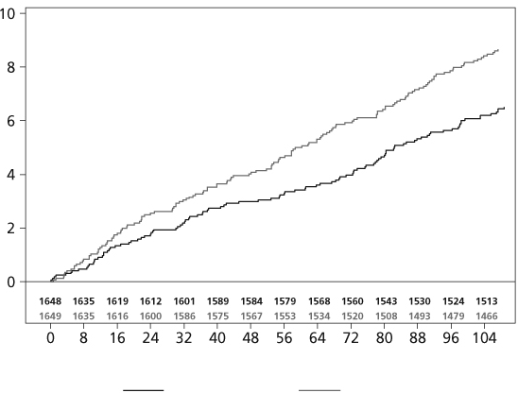
Figure 10 Kaplan-Maier plot of time to first occurrence of the composite outcome: Cardiovascular death, non-fatal myocardial infarction or non-fatal stroke (SUSTAIN 6)
HR: 0.74
95% CI 0.58: 0.95
p<0.0001 for non-inferiority p=0.017 for superiority
Number of subjects at risk
Semaglutide Placebo
Time from randomization (week)
Semaglutide Placebo
Patients with event (%)

Semaglutide also significantly reduced the risk of a composite of coronary or peripheral revascularisation. See Figure 11 for results on primary and secondary cardiovascular endpoints.

Figure 11 Forest plot: Analyses of each individual cardiovascular event types (SUSTAIN 6)

 |  | Hazard Ratio (95% CI) | Semaglutide N (%) | Placebo N (%)
FAS |  |  | 1648 (100) | 1649 (100)
Primary endpoint – MACE |  | 0.74 (0.58-0.95) | 108 (6.6) | 146 (8.9)
Components of MACE
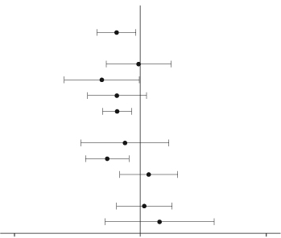  Cardiovascular death |  | 0.98 (0.65-1.48) | 44 (2.7) | 46 (2.8)
Non-fatal stroke |  | 0.61 (0.38-0.99) | 27 (1.6) | 44 (2.7)
Non-fatal myocardial infarction |  | 0.74 (0.51-1.08) | 47 (2.9) | 64 (3.9)
Expanded MACE |  | 0.74 (0.62-0.89) | 199 (2.1) | 264 (16.0)
Additional components in expanded MACE
Unstable angina requiring hospitalisation |  | 0.82 (0.47-1.44) | 22 (1.3) | 27 (1.6)
Revascularisation |  | 0.65 (0.50-0.86) | 83 (5.0) | 126 (7.6)
Hospitalisation for heart failure |  | 1.11 (0.77-1.61) | 59 (3.6) | 54 (3.3)
Other endpoints
All cause death |  | 1.05 (0.74-1.50) | 62 (3.8) | 60 (3.6)
Non-cardiovascular death |  | 1.28 (0.64-2.58) | 18 (1.1) | 14 (0.8)
0.2 | 1 | 5
Favors Semaglutide |  | Favors Placebo

Glycaemic control
Treatment with Wegovy significantly improved glycaemic parameters in patients with type 2 diabetes (Table 6).
Wegovy improved glycaemic control through sustained reduction of HbA1c and fasting plasma glucose (FPG) levels. Reduction in HbA1c was 1.2% and reduction in FPG was 2.0 mmol/L.
In STEP 2, 78.5% of patients with type 2 diabetes treated with Wegovy achieved an HbA1c <7% compared to 26.5% with placebo. A total of 67.5% of the patients treated with Wegovy achieved an HbA1c ≤6.5% compared to 15.5% with placebo.
In STEP 1, STEP 3 and STEP 5, among those patients with pre-diabetes at baseline, more Wegovy- treated patients had achieved normo-glycaemic status by the end of the trials (week 68 or week 104) compared to placebo-treated patients (STEP 1: 84.1% vs. 47.8%; STEP 3: 89.5% vs. 55.0%; STEP
5: 80% vs. 37%).

Table 11 Results on glycaemic factors in STEP 1, 2 and 3
 | STEP 1 |  | STEP 2 |  | STEP 3
 | Wegovy | Placebo | Wegovy | Placebo | Wegovy | Placebo
Full analysis set (N) | 1306 | 655 | 404 | 403 | 407 | 204
Glycaemic
factors
HbA1c (mmol/mol)
Baseline | 38.9 | 39.0 | 65.3 | 65.3 | 39.3 | 39.5
Change from  baseline¹ | −4.9² | −1.7² | -17.5³ | -4.1³ | -5.6 | -3.0
Difference from placebo¹ [95% CI] | −3.2  [−3.5; −2.9] | - | -13.5  [-15.5; -11.4]* | - | -2.6  [-3.1; -2.1] | -
FPG (mg/dL)
Baseline | 95.4 | 94.7 | 152.7 | 157.9 | 93.9 | 94.0
Change from  baseline¹ | −8.4 | −0.5 | -38.0 | -1.4 | -6.7 | -0.7
Difference from placebo¹  [95% CI] | −7.9  [−9.0; −6.7] | - | -36.6  [-43.2; -30.0] | - | -6.1  [-8.1; -4.0] | -
* p<0.0001 (unadjusted 2-sided) for superiority, 1 Estimated using an ANCOVA model using multiple imputation based on all data irrespective of discontinuation of randomised treatment or initiation of other anti-obesity medication or bariatric surgery.

Paediatric Population
In a 68-week double-blind trial 201 pubertal adolescents, ages 12 to <18 years, with obesity or overweight and at least one weight-related comorbidity were randomised 2:1 to Wegovy or placebo. All patients were on a reduced-calorie diet and increased physical activity throughout the trial.
At baseline, patients had a mean BMI of 37.0 kg/m² and a mean body weight of 107.5 kg. The mean age of patients was 15.4 years. There were 37.8% males, 79.1% Caucasian/White, 8.0% Black/African American and 2.0% Asian. A total of 10.9% were Hispanic or Latino.

At end of treatment (week 68), the improvement in BMI with Wegovy was superior and clinically meaningful compared with placebo (see Table 12 and Figure 12). Furthermore, a higher proportion of patients achieved ≥5%, ≥10%, ≥15% and ≥20% weight loss with Wegovy compared with placebo (see Table 12). Also, improvement in weight category was seen for a larger proportion of patients with Wegovy (71.8%) compared to placebo (21.0%). Improvement was defined as changing from a higher to a lower obesity class, or to overweight or normal weight. At end of treatment, a higher proportion of patients with Wegovy (53.7%) changed at least 2 categories compared to placebo (3.8%).
Greater reductions in absolute BMI, BMI standard deviation score (SDS), BMI percentage of the 95th percentile (sex- and age-specific growth charts) and body weight were observed with Wegovy compared to placebo at week 68.

Table 12 Results of a 68-week trial comparing Wegovy® with placebo in adolescents ages 12 years
and above with obesity, or overweight and at least one weight-related comorbidity (STEP TEENS)

 | Wegovy | Placebo
Full analysis set (N) | 134 | 67
BMI
Baseline (BMI) | 37.7 | 35.7
Change (%) from baseline in BMI^{1,} ³ | -16.1 | 0.6
Difference (%) from placebo¹ [95% CI] | -16.7 [-20.3; -13.2]* | -
Baseline (BMI SDS) | 3.4 | 3.1
Change from baseline in BMI SDS¹ | -1.1 | -0.1
Difference from placebo¹ [95% CI] | -1.0 [-1.3; -0.8] | -
Baseline (BMI % of the 95th percentile) | 133.8 | 127.8
Change from baseline in BMI percentage of the  95th percentile¹ | -24.6 | -4.2
Difference from placebo¹ [95% CI] | -20.4 [-25.0; -15.8] | -
Body Weight
Baseline (kg) | 109.9 | 102.6
Change (%) from baseline¹ | -14.7 | 2.8
Difference (%) from placebo¹ [95% CI] | -17.4 [-21.1; -13.8] | -
Baseline (mmol/L) | 4.1 | 4.2
Change (%) from baseline¹ | -8.3 | -1.4
Relative Difference (%) from placebo¹ [95% CI] | -7.1 [-10.5; -3.5] | -
LDL cholesterol
Baseline (mmol/L) | 2.3 | 2.4
Change (%) from baseline¹ | -9.9 | -3.6
Relative Difference (%) from placebo¹ [95% CI] | -6.6 [-11.3; -1.6] | -
HDL cholesterol
Baseline (mmol/L) | 1.1 | 1.1
Change (%) from baseline¹ | 8.0 | 3.2
Relative Difference (%) from placebo¹ [95% CI] | 4.7 [-1.0; 10.7] | -
Triglycerides
Baseline (mmol/L) | 1.3 | 1.2
Change (%) from baseline¹ | -28.4 | 2.6
Relative Difference (%) from placebo¹ [95% CI] | -30.2 [-38.0; -21.5] | -
Glycaemic factors
HbA1c (%)²
Baseline | 5.5 | 5.4
 | Wegovy | Placebo
Change from baseline¹ | -0.4 | -0.1
Difference from placebo¹ [95% CI] | -0.2 [-0.3; -0.1] | -
Full analysis set (N) | 134 | 67
FPG (mmol/L)²
Baseline | 5.0 | 5.0
Change from baseline¹ | -0.2 | -0.02
Difference from placebo¹ [95% CI] | -0.2 [-0.3; -0.03] | -
ALT
Baseline (U/L) | 23 | 20
Change (%) from baseline¹ | -18.3 | -4.9
Relative Difference (%) from placebo¹ [95% CI] | -14.1 [-25.2; -1.4] | -

* p<0.0001 (unadjusted 2-sided) for superiority.
1 Estimated using an ANCOVA model using multiple imputation based on all data irrespective of discontinuation of randomised treatment or initiation of other anti-obesity medication or bariatric surgery.
2 The numbers are for patients without type 2 diabetes.
3 During the trial, randomised treatment was permanently discontinued by 10.4% and 10.4% of patients randomised to Wegovy® and placebo, respectively. Assuming that all randomised patients stayed on treatment and did not receive additional anti-obesity therapies, the estimated changes from randomisation to week 68 for BMI based on a Mixed Model for Repeated Measures including all observations until first discontinuation were -17.9% and 0.6% for Wegovy® and placebo respectively
4 Estimated from logistic regression model based on same imputation procedure as in primary analysis.

Figure 12 STEP TEENS – Mean change in BMI (%) from baseline to week 68
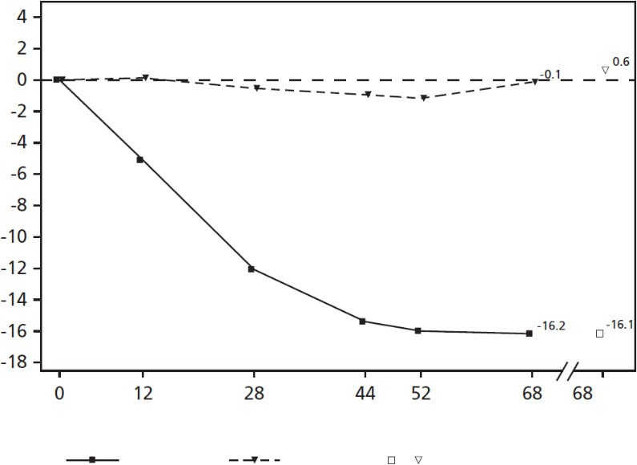

(MI)
Wegovy
Weeks
Placebo
Multiple imputation (MI)
Observed values for patients completing each scheduled visit, and estimates with multiple imputations (MI) from retrieved dropouts

Patient-reported outcomes
Wegovy showed statistically significant improvement in physical functioning scores and more patients with Wegovy achieved a clinically meaningful improvement compared to placebo in STEP 1 and STEP 2. Improvement in physical functioning score with Wegovy compared to placebo was also observed in STEP 3; however, not statistically significant (Table 13). Physical functioning was assessed using both the Short Form-36v2 Health Survey, Acute Version (SF-36v2) and the Impact of Weight on Quality of Life Lite Clinical Trials Version (IWQOL-Lite-CT). Beneficial effects of Wegovy vs. placebo were demonstrated in STEP 1 and 2 in all additional scores on SF-36v2 (Role-Physical, Bodily Pain, General Health, Vitality, Social Functioning, Role-Emotional, Mental Health, Physical Component Summary and Mental Component Summary), except for Role-Emotional in STEP 2.
Beneficial effects of Wegovy vs. placebo were also demonstrated in STEP 1 and 2 in all additional scores on IWQOL-Lite-CT (Physical, Psychosocial, and Total). In STEP 3, beneficial effects of Wegovy vs. placebo were demonstrated for the following scores in SF-36: General Health, Vitality, Social Functioning, Role-Emotional and Mental Component Summary.

Table 13 Results on physical functioning in STEP 1,-2 and 3

 | STEP 1 |  | STEP 2 |  | STEP 3
 | Wegovy | Placebo | Wegovy | Placebo | Wegovy | Placebo
SF-36v2 Physical Functioning¹
Baseline | 51.0 | 50.8 | 49.2 | 49.6 | 51.9 | 52.1
Change from baseline | 2.2 | 0.4 | 2.5 | 1.0 | 2.4 | 1.6
Difference from placebo [95% CI] | 1.8  [1.2; 2.4]* | - | 1.5  [0.4; 2.6]* | - | 0.8 [-0.2;  1.9]
Patients (%) achieving clinically meaningful improvement^{2,4} | 39.8 | 24.1 | 41.0 | 27.3 | 36.3 | 25.5
IWQOL-Lite-CT Physical Function
Baseline | 65.4 | 64.0 | 67.1 | 69.2 | -5 | -5
Change from baseline | 14.7 | 5.3 | 10.1 | 5.3 | -5 | -5
Difference from placebo [95% CI] | 9.4  [7.5; 11.4]* | - | 4.8  [1.8 ; 7.9] | - | -5
Patients (%) achieving clinically meaningful improvement^{3,4} | 51.8 | 28.3 | 39.6 | 29.5 | -5 | -5
* p<0.0001 (unadjusted 2-sided) for superiority
1 Norm-based score
2 Change in norm-based score ≥3.7
3Change in score ≥14.6
4Estimated from binary regression model based on same imputation procedure as in primary analysis.
5IWQOL-Lite-CT was not applied in STEP 3

In STEP TEENS, the clinical outcome assessments with the IWQOL-Kids questionnaire, improved (higher score) in favour of Wegovy at end of treatment (week 68) compared to baseline for all 4 domain scores and the total score. The estimated treatment differences for the physical comfort score and the total score were statistically significant in favour of Wegovy compared to placebo (Table 14).

Table 14 Results on physical comfort score in STEP TEENS

 | Wegovy® | Placebo
Physical comfort score
Change from baseline | 6.4 | -0.3
Difference from placebo [95% CI] | 6.6 [2.0; 11.2] | -
Total score
Change from baseline | 5.2 | 1.0
Difference from placebo [95% CI] | 4.3 [0.2; 8.3] | -

Pharmacokinetic properties
Compared to native GLP-1, semaglutide has a prolonged half-life of around 1 week making it suitable for once weekly s.c. administration. The principal mechanism of protraction is albumin binding, which results in decreased renal clearance and protection from metabolic degradation.
Furthermore, semaglutide is stabilised against degradation by the DPP-4 enzyme.

Absorption
The average semaglutide steady state concentration following s.c. administration of Wegovy was approximately 75 nmol/L in patients with either overweight (BMI ≥27 kg/m² to <30 kg/m²) or obesity (BMI ≥ 30 kg/m2). The steady state exposure of semaglutide increased proportionally with doses up to 2.4 mg once weekly.
Similar exposure was achieved with s.c. administration of semaglutide in the abdomen, thigh, or
upper arm. The absolute bioavailability of semaglutide was 89%

Distribution
The mean volume of distribution of semaglutide following s.c. administration in patients with overweight or obesity is approximately 12.4 L. Semaglutide is extensively bound to plasma albumin (> 99%).

Metabolism
Semaglutide is metabolised through proteolytic cleavage of the peptide backbone and sequential beta-oxidation of the fatty acid side chain.

Excretion
Semaglutide has pharmacokinetic properties compatible with once-weekly administration, with an elimination half-life of approximately 1 week.
The primary excretion routes of semaglutide-related material are via the urine and faeces.
Approximately 3% of the dose was excreted in the urine as intact semaglutide.
Clearance of semaglutide in patient with overweight (BMI ≥27 kg/m² to <30 kg/m²) or obesity (BMI ≥ 30 kg/m²) was approximately 0.05 L/h. With an elimination half-life of approximately 1 week, semaglutide can be present in the circulation for approximately 7 weeks after the last dose of 2.4 mg.

Special populations
Based on a population pharmacokinetic analysis, age, sex, race, and ethnicity, and renal impairment do not have a clinically meaningful effect on the pharmacokinetics of semaglutide. The exposure of semaglutide decreases with an increase in body weight. However, semaglutide 2.4 mg provide

adequate systemic exposure over the body weight range of 54.4-245.6 kg evaluated in the clinical trials. The effects of intrinsic factors on the pharmacokinetics of semaglutide are shown in Figure 13.

Figure 13 Impact of intrinsic factors on semaglutide exposure

Intrinsic factor
Relative exposure (Cavg) Ratio and 90% CI
Recommendation

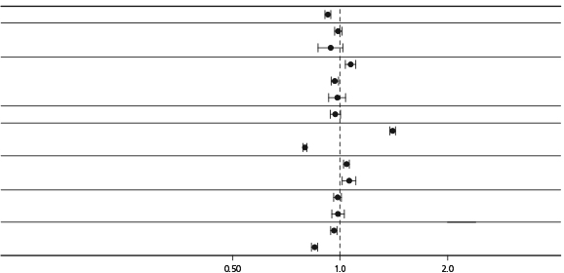
Sex Male
Age group 65−<75 years
>=75 years
Race Black or African American Asian
American Indian or Alaska Native
Ethnicity Hispanic or Latino Body weight 74 kg
143 kg
Renal function Mild Moderate
Injection site Thigh
Upper arm
Glycemic status Prediabetes (STEP 1)
Diabetes (STEP 2)
No dose adjustment
No dose adjustment No dose adjustment
No dose adjustment No dose adjustment No dose adjustment
No dose adjustment
No dose adjustment No dose adjustment
No dose adjustment No dose adjustment
No dose adjustment No dose adjustment
No dose adjustment No dose adjustment
Data are steady-state dose-normalised average semaglutide exposures relative to a reference subject profile (non-Hispanic or Latino, normoglycaemic (STEP 1) white female aged 18-<65 years, with a body weight of 110 kg and normal renal function, who injected in the abdomen). Body weight test categories (74 and 143 kg) represent the 5% and 95% percentiles in the data set.
Age
Age had no effect on the pharmacokinetics of semaglutide based on data from phase 3 trials including patients 18−86 years of age.
Sex
Gender had no effect on the pharmacokinetics of semaglutide.
Race
Race (White, Black or African-American, Asian) had no effect on the pharmacokinetics of semaglutide.
Ethnicity
Ethnicity (Hispanic or Latino) had no effect on the pharmacokinetics of semaglutide.
Body weight
Body weight had an effect on the exposure of semaglutide. Higher body weight was associated with lower exposure. The 2.4 mg weekly dose of semaglutide provided adequate systemic exposures over the body weight range of 54.4-245.6 kg evaluated for exposure response in the clinical trials.
Renal impairment
Renal impairment did not impact the pharmacokinetics of semaglutide in a clinically relevant manner. This was shown with a single dose of 0.5 mg semaglutide for patients with different degrees of renal impairment (mild, moderate, severe or subjects in dialysis) compared with subjects with normal renal function. This was also shown for subjects with overweight (BMI ≥27 kg/m² to <30 kg/m²) or obesity (BMI ≥ 30 kg/m²) and mild to moderate renal impairment based on data from phase 3a trials

kg/m²) or obesity (BMI ≥ 30 kg/m²) and mild to moderate renal impairment based on data from
phase 3a trials.
Hepatic impairment
Hepatic impairment did not have any impact on the exposure of semaglutide. The pharmacokinetics of semaglutide were evaluated in patients with different degrees of hepatic impairment (mild, moderate, severe) compared with subjects with normal hepatic function in a study with a single- dose of 0.5 mg semaglutide.
Paediatrics
Semaglutide has not been studied in children below 12 years of age. Pharmacokinetic properties for semaglutide 2.4 mg were assessed in a clinical trial for adolescent patients with obesity or overweight and at least one weight-related comorbidity ages 12 to less than 18 years (124 patients, body weight 61.6-211.9 kg). The semaglutide exposure in adolescents was similar to that in adults with obesity or overweight.

Preclinical safety data

Genotoxicity
Semaglutide was not mutagenic in the bacterial reverse mutation assay, and was not clastogenic in vitro (cytogenetic assay in human lymphocytes), or in vivo (rat bone marrow micronucleus test).

Carcinogenicity
Non-lethal thyroid C-cell tumours observed in rodents are a class effect for GLP-1 receptor agonists. In 2-year carcinogenicity studies in rats and mice, semaglutide caused thyroid C-cell tumours at clinically relevant exposures (at ≥ 1.2× the clinical AUC in mice [based on the plasma AUC at the maximum recommended human dose of 2.4 mg/week] and subclinical exposures in rats; a no effect level was not established in either species). No other treatment-related tumours were observed. The rodent C-cell tumors are caused by a non-genotoxic, specific GLP-1 receptor mediated mechanism to which rodents are particularly sensitive. The relevance for humans is considered to be low, but cannot be excluded.

Juvenile toxicity
In juvenile rats, semaglutide caused delayed sexual maturation in both males and females. These delays had no impact upon fertility and reproductive capacity of either sex, or on the ability of the females to maintain pregnancy.

PHARMACEUTICAL PARTICULARS

List of excipients
Dibasic sodium phosphate dihydrate Sodium chloride
Hydrochloric acid Sodium hydroxide Water for injections

Incompatibilities
Substances added to Wegovy may cause degradation of semaglutide. Wegovy must not be mixed with other medicinal products, e.g. infusion fluids.

Shelf life
In Australia, information on the shelf life can be found on the public summary of the Australian Register of Therapeutic Goods (ARTG). The expiry date can be found on the packaging.

Special precautions for storage
Store in a refrigerator (2°C to 8°C). Keep away from the cooling element.
May be stored unrefrigerated for up to 28 days at a temperature not above 30°C
Always store the pen in the original carton in order to protect from light. Do not freeze Wegovy and do not use Wegovy if it has been frozen.
Wegovy should be protected from excessive heat.
Wegovy should not be used if it does not appear clear and colourless After use: Discard Wegovy after use.

Nature and contents of container
The primary packaging contains a 1 ml glass syringe (Type I glass) with attached stainless-steel needle, rigid needle shield (Type II/polyisoprene) and a rubber plunger (Type I/chlorobutyl).
There are five variants of the pre-filled pen for Wegovy:
Wegovy 0.25 mg/dose is provided in a pre-filled, fixed dose, single use disposable pen, which contains the drug solution semaglutide 0.5 mg/mL, 0.5 mL in a 1 mL pre-filled syringe. The pen contains one dose. This pen is intended to be used for dose escalation.
Wegovy 0.5 mg/dose is provided in a pre-filled, fixed dose, single use disposable pen, which contains the drug solution semaglutide 1.0 mg/mL, 0.5 mL in a 1 mL pre-filled syringe. The pen contains one dose. This pen is intended to be used for dose escalation.
Wegovy 1 mg/dose is provided in a pre-filled, fixed dose, single use disposable pen, which contains the drug solution semaglutide 2.0 mg/mL, 0.5 mL in a 1 mL pre-filled syringe. The pen contains one dose. This pen is intended to be used for dose escalation.
Wegovy 1.7 mg/dose is provided in a pre-filled, fixed dose, single use disposable pen, which contains the drug solution semaglutide 2.27 mg/mL, 0.75 mL in a 1 mL pre-filled syringe. The pen contains one dose. This pen is intended to be used for dose escalation.
Wegovy 2.4 mg/dose is provided in a pre-filled, fixed dose, single use disposable pen, which contains the drug solution semaglutide 3.2 mg/mL, 0.75 mL in a 1 mL pre-filled syringe. The pen contains one dose. This pen is intended to be used for maintenance treatment.
Pack sizes of*:
Wegovy 0.25 mg/dose:
2 or 4 pre-filled pens
Wegovy 0.5 mg/dose:
2 or 4 pre-filled pens
Wegovy 1 mg/dose:
2 or 4 pre-filled pens
Wegovy 1.7 mg/dose:
2 or 4 pre-filled pens

Wegovy 2.4 mg/dose:2 or 4 pre-filled pens
*not all pack sizes may be available

Special precautions for disposal
The patient should be advised to discard the pre-filled pen after each injection in accordance with local requirements.

Physicochemical properties

Chemical structure
Molecular formula: C187H291N45O59.
Molecular weight: 4113.6 dalton.
Semaglutide is an Aib8, Arg34-GLP-1(7-37) analogue substituted on the ε-amino group of the lysine residue in position 26 with an (S)-22,40-dicarboxy-10,19,24-trioxo-3,6,12,15-tetraoxa-9,18,23- triazatetracontan-1-oyl side chain. The side chain consists of two 8-amino-3,6-dioxaoctanoic acid (ADO) spacers, one γ-glutamic acid (Glu) spacer, and a fatty diacid (1,18-octadecanedioic acid).
Semaglutide is produced using recombinant DNA technology in yeast (Saccharomyces cerevisiae) and chemical modification.
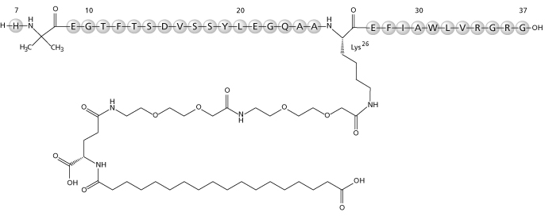

CAS number
RN910463-68-2.

MEDICINE SCHEDULE (POISONS STANDARD)
S4

SPONSOR
Novo Nordisk Pharmaceuticals Pty Limited Level 10, 118 Mount Street,
North Sydney, NSW 2060,
Australia. www.novonordisk.com.au

DATE OF FIRST APPROVAL
01 September 2022

DATE OF REVISION
N/A
Summary table of changes

Section Changed | Summary of new information
4.1 | Addition of indication for use in adolescents
4.2 | Dosing for adolescents added
5.1 | Updated clinical trial data for adolescents (STEP TEENS), long term data (STEP 1 extension and STEP 5), semgalutide vs liraglutide (STEP 8)

