Australian Public Assessment Report for Polivy
Active ingredient: Polatuzumab vedotin
Sponsor: Roche Products Pty Ltd
August 2024

About the Therapeutic Goods Administration (TGA)
- The Therapeutic Goods Administration (TGA) is part of the Australian Government Department of Health and Aged Care and is responsible for regulating therapeutic goods, including medicines, medical devices, and biologicals.
- The TGA administers the Therapeutic Goods Act 1989 (the Act), applying a risk management approach designed to ensure therapeutic goods supplied in Australia meet acceptable standards of quality, safety, and efficacy.
- The work of the TGA is based on applying scientific and clinical expertise to decision-making, to ensure that the benefits to the Australian public outweigh any risks associated with the use of therapeutic goods.
- The TGA relies on the public, healthcare professionals and industry to report problems with therapeutic goods. The TGA investigates reports received to determine any necessary regulatory action.
- To report a problem with a therapeutic good, please see the information on the TGA website.
About AusPARs
- The Australian Public Assessment Report (AusPAR) provides information about the evaluation of a prescription medicine and the considerations that led the TGA to approve or not approve a prescription medicine submission. Further information can be found in Australian Public Assessment Report (AusPAR) guidance.
- AusPARs are prepared and published by the TGA.
- AusPARs are static documents that provide information that relates to a submission at a particular point in time. The publication of an AusPAR is an important part of the transparency of the TGA’s decision-making process.
- A new AusPAR may be provided to reflect changes to indications or major variations to a prescription medicine subject to evaluation by the TGA.

Copyright
© Commonwealth of Australia 2024
This work is copyright. You may reproduce the whole or part of this work in unaltered form for your own personal use or, if you are part of an organisation, for internal use within your organisation, but only if you or your organisation do not use the reproduction for any commercial purpose and retain this copyright notice and all disclaimer notices as part of that reproduction. Apart from rights to use as permitted by the Copyright Act 1968 or allowed by this copyright notice, all other rights are reserved and you are not allowed to reproduce the whole or any part of this work in any way (electronic or otherwise) without first being given specific written permission from the Commonwealth to do so. Requests and inquiries concerning reproduction and rights are to be sent to the TGA Copyright Officer, Therapeutic Goods Administration, PO Box 100, Woden ACT 2606 or emailed to <tga.copyright@tga.gov.au>.
Contents
List of abbreviations 4
Product submission 7
Submission details 7
Diffuse large B-cell lymphoma (DLBCL) 8
Current treatment options for DLBCL 9
Clinical rationale for polatuzumab vedotin use in DLBCL 10
Regulatory status 10
Australian regulatory status 10
International regulatory status 11
Registration timeline 11
Submission overview and risk/benefit assessment 11
Clinical evaluation summary 11
Pharmacology 11
Efficacy 12
Safety 25
Risk Management Plan evaluation summary 28
Risk-benefit analysis 28
Recommendation following the clinical evaluation 30
Advisory Committee considerations 30
Outcome 31
Attachment 1. Product Information 32

List of abbreviations
Abbreviation | Meaning
ABC | Activated B-cell subtype
ADA | Anti-drug antibody
ADC | Antibody-drug conjugate
AE | Adverse Event
AlkP | Alkaline Phosphatase
ALT | Alanine Transaminase
ANC | Absolute neutrophil count
ASCT | Autologous stem cell transplantation
AST | Aspartate Transaminase
AUC | Area under the curve
BG | Bendamustine and obinutuzumab
BICR | Blinded independent central review
BMI | Body mass index
BOR | Best objective response
BR | Bendamustine plus rituximab
BSA | Body surface area
CHP | Cyclophosphamide, doxorubicin, prednisone
CI | Confidence interval
CL | Clearance
CLL | Chronic lymphocytic leukaemia
Cmax | Maximum concentration
CMI | Consumer Medicines Information
CNS | Central nervous system
CR | Complete Response
CrCL | Creatinine clearance
CT | X-Ray Computed Tomography
CTCAE | Common terminology criteria for adverse events
DFS | Disease free survival
DLBCL | Diffuse large B-cell lymphoma
DLT | Dose-limiting toxicity
DOR | Duration of response
ECG | Electrocardiograph
ECOG | Eastern Cooperative Oncology Group
EFS | Event-free survival
EFS_{all} | Event-free survival – all causes
EFS_{eff} | Event-free survival for efficacy reasons
EMA | European Medicines Agency
EORTC | European Organisation for Research and Treatment of Cancer
ETTV | Early treatment termination visit
FACT | Functional Assessment of Cancer Therapy
FDA | Food and Drug Administration
FL | Follicular lymphoma
GCB | Germinal centre B-cell subtype
GOG-NTX | Gynaecology Oncology Group – Neurotoxicity questionnaire
GCP | Good Clinical Practice
GIT | Gastrointestinal
HR | Hazard ratio
HSCT | Haemopoietic stem cell transplantation
IPI | International prognostic index
ITT | Intention to Treat
IV | Intravenous
L | Litre(s)
LDH | Lactate dehydrogenase
LFTs | Liver function tests
LLOQ | Lower limit of quantification
MDS | Myelodysplastic syndrome
MedDRA | Medical dictionary for regulatory activities
MMAE | Monomethyl auristatin E
MRI | Magnetic Resonance Imaging
MTD | Maximum tolerated dose
NCI | National Cancer Institute
NHL | Non-Hodgkin lymphoma
ORR | Objective Response Rate
OS | Overall Survival
PD | Pharmacodynamics or Progressive disease
PET | Positron emission tomography
PFS | Progression free survival
PI | Product Information
PK | Pharmacokinetics
PN | Peripheral neuropathy
Pola+R-CHP | Polatuzumab with rituximab, cyclophosphamide, doxorubicin and prednisolone
PR | Partial Response
PRO | Patient reported outcome
R-CHOP | Rituximab, cyclophosphamide, doxorubicin, vincristine and prednisolone
R-CHP | Rituximab, cyclophosphamide, doxorubicin and prednisolone
SAE | Serious Adverse Event
SD | Stable Disease or standard deviation
SMQ | Standardised MedDRA query
TCV | Treatment completion visit
TGA | Therapeutic Goods Administration
ULN | Upper Limit of Normal
Vss | Volume of distribution at steady state
Vz | Volume of distribution

Product submission

Submission details
Type of submission: | Extension of indications
Product name: | Polivy
Active ingredient: | Polatuzumab vedotin
Decision: | Approved
Date of decision: | 14 February 2023
Date of entry onto ARTG: | 17 February 2023
ARTG number: | 314866, 374135
▼Black Triangle Scheme | Yes
Sponsor’s name and address: | Roche Products Pty Limited, 30 – 34 Hickson Road, Sydney, NSW 2000
Dose form: | Powder for concentrate for solution for infusion.
Strength: | 1 vial is designed to deliver a total of 30 mg or 140 mg of polatuzumab vedotin
Container: | Single-use glass vial
Pack size: | 1 vial
Approved therapeutic use for the current submission: | Polivy in combination with rituximab, cyclophosphamide, doxorubicin, and prednisone (R-CHP) is indicated for the treatment of adult patients with previously untreated diffuse large B-cell lymphoma (DLBCL).
Route of administration: | Intravenous infusion
Dosage: | Previously untreated patients:  The recommended dose of Polivy is 1.8 mg/kg given as an intravenous infusion every 21 days for 6 cycles in combination with rituximab, cyclophosphamide, doxorubicin and prednisone (R-CHP). Polivy, rituximab, cyclophosphamide, and doxorubicin can be administered in any order on Day 1 after the administration of prednisone. Prednisone is administered on Days 1–5 of each cycle. Cycles 7 and 8 consist of rituximab as monotherapy.  Previously treated patients:  The recommended dose of Polivy is 1.8 mg/kg given as an intravenous infusion every 21 days in combination with bendamustine and rituximab for 6 cycles. Polivy, bendamustine and rituximab can be administered in any order on Day 1 of each cycle. The recommended dose of bendamustine is 90 mg/m²/day on Day 1 and 2 when administered with Polivy and rituximab.  Previously untreated and previously treated patients:  An antihistamine and anti-pyretic should be administered to patients prior to administration of Polivy. The initial dose of Polivy should be administered as a 90-minute intravenous infusion. Patients should be monitored for infusion-related reactions during the infusion and for at least 90 minutes following completion of the initial dose. If the prior infusion was well tolerated, the subsequent dose of Polivy may be administered as a 30-minute infusion and patients should be monitored during the infusion and for at least 30 minutes after completion of the infusion.  Duration of Treatment  The recommended duration of treatment is for 6 cycles.  For further information regarding dosage, such as dosage modifications to manage adverse reactions, refer to the Product Information.
Pregnancy category: | Category D: Drugs which have caused, are suspected to have caused or may be expected to cause, an increased incidence of human fetal malformations or irreversible damage. These drugs may also have adverse pharmacological effects.  The use of any medicine during pregnancy requires careful consideration of both risks and benefits by the treating health professional. The pregnancy database must not be used as the sole basis of decision making in the use of medicines during pregnancy. The TGA does not provide advice on the use of medicines in pregnancy for specific cases. More information is available from obstetric drug information services in your state or territory.

Polivy (polatuzumab vedotin)
This AusPAR describes the submission by Roche Products Pty Limited (the sponsor) to register Polivy (polatuzumab vedotin) for the following proposed extension of indications:
Polivy in combination with rituximab, cyclophosphamide, doxorubicin and prednisone (RCHP), is indicated for the treatment of adult patients with previously untreated diffuse large B-cell lymphoma.

Diffuse large B-cell lymphoma (DLBCL)
Diffuse large B-cell lymphoma (DLBCL) is a form of Non-Hodgkin Lymphoma (NHL) arising in mature B-lymphocytes. It is the most common form of NHL, accounting for approximately 30% of cases. The term DLBCL encompasses a heterogeneous group of B-cell malignancies. The 2016 WHO classification includes the following subtypes^{2,,}:
- DLBCL not otherwise specified (NOS), which is further divided into the following subtypes:
  - Germinal centre B-cell (GCB) subtype;
  - Activated B-cell (ABC) subtype;
  - Unclassified subtype.
- T-cell/histiocyte-rich large cell lymphoma;
- Primary DLBCL of the central nervous system;
- Epstein-Barr virus positive DLBCL;
- Epstein-Barr virus mucocutaneous ulcer;
- DLBCL associated with chronic inflammation;
- Primary cutaneous DLBCL, leg type.
The most common type is DLBCL, NOS, which accounts for > 80% of cases of all large B-cell lymphomas. DLBCL can also arise as a transformation from an underlying low-grade B-cell lymphoma.
DLBCL can present with a wide range of clinical manifestations. Median age at onset is approximately 60-70 years ^{(4,)}. The disease is slightly more common in males. About 70% of subjects have lymph node disease, and 30% extranodal disease³. DLBCL is an aggressive form of NHL and subjects typically present with a rapidly enlarging mass at a single site⁶.
As with other lymphomas, extent of disease is usually staged using the Ann Arbor staging system. Approximately 75% of patients with DLBCL present with stage III or IV disease⁵.
Adverse prognostic factors include advanced disease stage, age > 60 years, elevated serum lactate dehydrogenase (LDH), poor performance status, and extensive extranodal involvement. These factors have been combined to derive a prognostic score (the International Prognostic Index or IPI).
Other clinical factors that have been associated with poor prognosis include the presence of B symptoms, bulky disease (i.e. tumour diameter ≥7.5 cm or ≥10 cm), elevated serum β2-microglobulin level, low haemoglobin and serum albumin levels, and bone marrow involvement⁵.

Current treatment options for DLBCL
Current clinical practice guidelines^{2,,}, recommend the use of R-CHOP immunochemotherapy (i.e., rituximab [R], cyclophosphamide [C], doxorubicin (H), vincristine (O] and prednisolone [P]) regimen as first line therapy of DLBCL. Therapy is generally continued for 6-8 cycles. In subjects with early stage (I or II) non-bulky disease 3-4 cycles are recommended.
Involved site radiation treatment (ISRT) is also recommended for the treatment of bulky, early-stage disease.
R-CHOP therapy results in complete and sustained remission of disease in approximately 60-65% of cases ⁴. The disease is refractory to first-line therapy in approximately 10-15% of subjects and disease relapse after an initial response occurs in a further 20-25%. Most relapses occur within the first 2 years⁵.
This submission seeks approval of polatuzumab vedotin as an alternative to the vincristine component in the R-CHOP regimen component of first-line therapy of DLBCL.

Clinical rationale for polatuzumab vedotin use in DLBCL
Polatuzumab vedotin is a CD79b-targeted antibody drug conjugate (ADC) that preferentially delivers a potent anti-mitotic agent (monomethyl auristatin E [MMAE]) to B cells, which results in anti-cancer activity against B-cell malignancies. Polatuzumab vedotin specifically binds human CD79b, a signalling component of the B-cell receptor located on the surface of B cells. As such, CD79b expression is restricted to normal cells within the B-cell lineage (with the exception of plasma cells) and malignant B-cells; it is expressed in 95% of diffuse large B-cell lymphoma (DLBCL). Therefore, targeted delivery of MMAE is expected to be restricted to these cells. Upon binding CD79b, polatuzumab vedotin is rapidly internalized and the linker is cleaved by lysosomal proteases, leading to intracellular release of MMAE. The released MMAE binds to microtubules and kills dividing cells by inhibiting cell division and inducing apoptosis,,.
The sponsor argued that there is an unmet clinical need for new improved first-line therapies in DLBCL for the following reasons:
- Despite the availability of 2nd and later-line therapies, most patients who have relapsed or refractory DLBCL experience further relapse or die from their disease.
- Therapies for relapsed or refractory DLBCL are associated with significant toxicities.
Improved outcomes with first-line therapy may offer the chance of cure for these patients.

Regulatory status

Australian regulatory status
Polatuzumab was first registered in Australia in October 2019:
Polivy in combination with bendamustine and rituximab is indicated for the treatment of previously treated adult patients with diffuse large B-cell lymphoma who are not candidates for hematopoietic stem cell transplant.

International regulatory status
On 24 May 2022 a similar submission was approved in the EU:
Polivy in combination with rituximab, cyclophosphamide, doxorubicin, and prednisone (R-CHP) is indicated for the treatment of adult patients with previously untreated diffuse large B-Cell lymphoma (DLBCL).
Similar submissions were submitted to the USA (2 June 2022), Canada (17 December 2021), New Zealand (21 January 2022), Singapore (15 December 2021), Switzerland (19 November 2021), and the UK (28 January 2022).

Registration timeline
This submission was evaluated under the standard prescription medicines registration process.
Table 1: Timeline for Submission PM-2021-05903-1-4
Description | Date
Submission dossier accepted and first round evaluation commenced | 31 January 2022
Evaluation completed | 27 September 2022
Delegate’s Overall benefit-risk assessment and request for Advisory Committee advice. | 31 October 2022
Advisory Committee meeting | 2 December 2022
Registration decision (Outcome) | 14 February 2023
Registration in the ARTG | 17 February 2023
Number of working days from submission dossier acceptance to registration decision* | 268
*Statutory timeframe for standard submissions is 255 working days

Submission overview and risk/benefit assessment

Clinical evaluation summary
Clinical data were derived from two studies: the pivotal POLARIX study and study G029044.

Pharmacology

Population PK data
Sparse PK sampling from the pivotal POLARIX study was used to validate a previously developed population PK (popPK) model. The model was found to adequately predict the observed PK data in the pivotal study.

Immunogenicity
Treatment-emergent anti-drug antibodies (ADA) against polatuzumab vedotin were detected in 1.4% (6/427) of ADA-evaluable patients in the POLARIX study and no patients in study G029044.

Efficacy
The POLARIX study was a phase 3, randomised, double-blind, placebo-controlled trial in 879 patients (Figure 1). The study compared standard immunochemotherapy (R-CHOP) (n=440) with the test arm in which polatuzumab vedotin replaced the vincristine (O) component of R-CHOP (n=439).
The study, conducted at 211 centres in 22 countries, commenced in November 2017 and the final analysis was presented from a data cut of 15 June 2022.
The study design included enrolment of an extended cohort of subjects from China, after completion of enrolment of the main study cohort. Results for the extended China cohort were not included in the study report.
The study included a screening period (day -28 to day 1), a treatment period (eight 21-day cycles) and a post-treatment period.
Figure 1. POLARIX Study Schematic
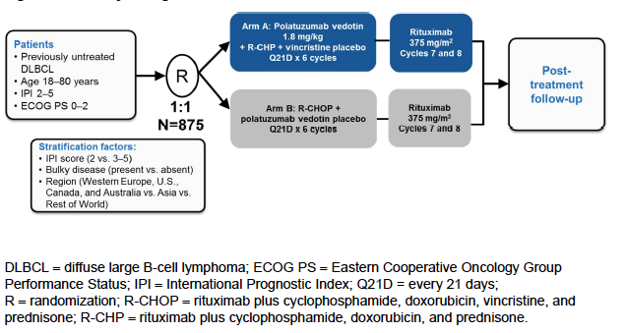

POLARIX Study inclusion and exclusion criteria
Inclusion criteria
- Previously untreated patients with CD20 positive DLBCL, including one of the following:
  - DLBCL, not otherwise specified (NOS) including germinal centre B-cell type, activated B-cell type;
  - T-cell/histiocyte-rich large B-cell lymphoma;
  - Epstein-Barr virus-positive DLBCL, NOS;
  - ALK-positive large B-cell lymphoma;
  - HHV8-positive DLBCL, NOS;
  - High-grade B-cell lymphoma with MYC and BCL2 and/or BCL6 rearrangements (double-hit or triple-hit lymphoma)
- High-grade B-cell lymphoma, NOS.
- Availability of archival or freshly collected tumour tissue before study enrolment
- IPI score of 2-5.
- Age 18-80 years
- ECOG Performance Status of 0, 1, or 2
- Life expectancy ≥ 12 months.
- ≥ 1 bi-dimensionally measurable lesion (>1.5 cm in longest dimension by CT or MRI).
- Left ventricular ejection fraction (LVEF) ≥ 50% on cardiac multiple-gated acquisition (MUGA) scan or cardiac echocardiogram (ECHO)
- Adequate hematologic function (unless due to underlying disease or hypersplenism secondary to the involvement of the spleen by DLBCL per investigator)
  - Haemoglobin ≥ 9.0 g/dL, RBC transfusion during 14 days before first treatment.
  - ANC ≥ 1,000/μL.
  - Platelet count ≥ 75,000/μL.

Exclusion criteria
- Contraindication to any of the individual components of R-CHOP.
- Current Grade >1 peripheral neuropathy or demyelinating form of Charcot-Marie-Tooth disease.
- History of progressive multifocal leukoencephalopathy.
- History of indolent lymphoma.
- Current diagnosis of the following: follicular lymphoma grade 3B; B-cell lymphoma, unclassifiable, with features intermediate between DLBCL and classical Hodgkin lymphoma (grey-zone lymphoma); primary mediastinal (thymic) large B-cell lymphoma; Burkitt lymphoma; CNS lymphoma (primary or secondary involvement), primary effusion DLBCL, and primary cutaneous DLBCL.
- Prior treatment with cytotoxic drugs within 5 years of screening for any condition or prior use of any anti-CD20 antibody.
- Prior use of any monoclonal antibody ≤ 3 months of start of Cycle 1; any investigational therapy ≤ 28 days before start of Cycle 1;
- Vaccination with live vaccines ≤ 28 days before start of Cycle 1.
- Prior therapies:
  - organ transplantation.
  - mediastinal/pericardial radiotherapy
  - therapy for DLBCL.
  - Corticosteroid use > 30 mg/day of prednisone or equivalent, for purposes other than lymphoma symptom control (Could be on ≤ 30 mg/day of prednisone or equivalent for reasons other than lymphoma symptom control (e.g., rheumatoid arthritis) if on stable dose ≥ 4 weeks’ duration before start of Cycle 1.)
- History of other malignancy that could affect protocol compliance or interpretation of results, but curatively treated basal or squamous cell carcinoma or melanoma of the skin, in situ carcinoma of the cervix at any time prior to study, low-grade, early-stage prostate cancer (Gleason score 6 or below, Stage 1 or 2) not requiring therapy, or if malignancy appropriately treated with curative intent and in remission without treatment for ≥ 2 years were eligible.
- Evidence of significant, uncontrolled cardiac disease (e.g. NYHA Class III or IV, myocardial infarction in ≤ 6 months, unstable arrhythmias, or unstable angina) or pulmonary disease (including obstructive pulmonary disease and history of bronchospasm).
- History or presence of an abnormal ECG including complete LBBB, 2nd - or 3rd degree heart block, or evidence of prior myocardial infarction.
- Known active bacterial, viral, fungal, mycobacterial, parasitic, or other infection at study enrolment or significant infections ≤2 weeks before start of Cycle 1. Suspected active or latent tuberculosis.
- Clinically significant liver disease
- Illicit drug or alcohol abuse ≤12 months prior to screening, in the investigator’s judgment.
- Any of the following abnormal laboratory values (unless due to underlying lymphoma):
  - INR or PT > 1.5 x ULN in the absence of therapeutic anticoagulation;
  - PTT or aPTT > 1.5 x ULN in the absence of a lupus anticoagulant;
  - Serum AST and ALT ≥ 2.5 x ULN;
  - Total bilirubin ≥ 1.5 x ULN, unless documented Gilbert disease then total bilirubin ≤ 3.0 x ULN.
  - Serum creatinine clearance < 40 mL/min (per Cockcroft-Gault)
- Positive hepatitis B surface antigen [HBsAg] serology), occult or prior hepatitis B infection, positive for HCV (eligible only if polymerase chain reaction (PCR) is negative for HCV RNA), history of HIV seropositive, positive for HTLV-1
Patients were randomised (1:1) to the two treatments. Randomisation was stratified by IPI score (IPI 2 vs IPI 3-5); bulky disease, defined as one lesion ≥ 7.5 cm (present vs absent); geographical region (Western Europe, United States, Canada, and Australia vs Asia vs Rest of World).
All drugs were administered on a 21-day cycle. Patients received 8 cycles of rituximab (375 mg/m² on Day 1) and 6 cycles each of the assigned other treatments [On Day 1: cyclophosphamide 750 mg/m², doxorubicin 50 mg/m², and either vincristine/placebo 1.4 mg/m² (max 2 mg) or polatuzumab vedotin/placebo 1.8 mg/kg; and on Day 1-5 prednisolone 100 mg/day].
Drugs were administered in the following order: prednisone (at least 1 hour prior to subsequent drugs), rituximab, blinded polatuzumab vedotin/placebo third. Subsequent infusions of blinded vincristine/placebo, cyclophosphamide, and doxorubicin were administered according to institutional preference.
The initial dose of polatuzumab vedotin/placebo was administered over 90 minutes and patients were observed for a further 90 minutes for infusion-associated symptoms. If infusions were well tolerated, subsequent doses of polatuzumab/placebo could be administered over 30 (± 10) minutes, followed by a 30-minute observation period after the infusion.
Dose reductions for toxicity were specified: polatuzumab vedotin could be reduced to 1.4 mg/mg and then 1.0 mg/kg per cycle, and if not tolerated at that dose was to be discontinued.
Premedication before rituximab and/or polatuzumab/placebo consisted of an antihistamine (e.g. 50-100 mg of diphenhydramine) and an analgesic/antipyretic (e.g. 650-1000 mg of paracetamol).
Patients in the R-CHOP arm whose disease progressed were not permitted to crossover to the pola+R-CHP arm.
Tumour response and disease progression were determined using the 2014 Lugano response criteria.
CT and PET-CT scans were required at screening and at 6-8 weeks after the last dose of study treatment. For all patients who had not progressed, diagnostic contrast-enhanced CT scans (or PET-CT alone) were to be performed every 6 months for the next 24 months, then every 12 months for the next 36 months, and then only if clinically indicated.
Bone marrow examination was required for all patients at screening and was repeated if there was bone marrow involvement at screening, to confirm a radiological assessment of CR and/or to confirm bone marrow relapse.
A sample size of 875 patients with 228 PFS events would be required to detect a hazard ratio of 0.69 for PFS, with 80% power at a one-sided 2.5% significance level. The minimal detectable difference (MDD) for the PFS hazard ratio at the final PFS analysis would be 0.771, and the 3-year PFS would be expected to improve from 62% to 70% under the MDD.
A hierarchical testing procedure was in place to adjust for multiple statistical testing of the primary and key secondary efficacy endpoints, to control the overall type I error rate at a one-sided 0.025 level of significance. The other secondary endpoints were to be tested without adjusting for multiplicity.
Of the 1063 patients screened, 184 failed screening, and 879 were randomised, 440 to the pola+R-CHP arm and 439 to the R-CHOP arm. Of those, 86.9% of subjects completed the 8 cycles of study treatment and 12.4% discontinued treatment early. The most common reasons for early discontinuation were progressive disease (3.3%) or adverse event (3.0%). Of note discontinuations in the pola+R-CHP vs R-CHOP arms, respectively, occurred due to adverse events in 2.1% vs 4.3%, due to deaths in 2.3% vs 0.7% and progressive disease in 1.4% vs 2.8%.
At the primary analysis, 83.8% were still ongoing in the study, with the most common reason for study discontinuation being death (12.3%).
Across the study 5.7% of patients had major protocol deviation. Events occurring in >1% of patients were noncompliance with study treatment modification or stopping rules (1.1% R-CHOP arm vs 0.7% pola+R-CHP arm) and exclusion criteria not met (1.1% of R-CHOP arm vs 2.7% pola+R-CHP arm).
Mean age of the study population was 63.06 years, 53.1% were aged ≥65 years, and 53.8% of subjects were male. Most patients (84.2%) had a diagnosis of DLBCL not otherwise specified (NOS), and 10.6% had high grade B-cell lymphoma, double or triple hit lymphoma. Most subjects had stage III (26.4%) or IV (62.3%) disease, IPI score was 2 in 38.0% of subjects and 3-5 in 62.0%, and 44.1% had baseline bulky disease. Pre-phase steroid treatment was received by 37.7% of patients in the pola+R-CHP arm and 38.6% of patients in the R-CHOP arm.

Primary efficacy endpoint
The primary efficacy endpoint was progression-free survival (PFS): the time from randomisation to the first occurrence of disease progression or relapse (per investigator), or death from any cause. The PFS primary (final) analysis was conducted after approximately 228 PFS events had occurred in the ITT population and at least 24 months had elapsed since enrolment of the last patient, whichever occurred later (Figure 2).
The median duration of follow-up was 28.1 months in the pola+R-CHP arm and 28.2 months in the R-CHOP arm. Median PFS was not expected to be reached at the time of the primary PFS analysis. Therefore, the 1-year and 2-year rates were to be used to describe PFS in addition to the hazard ratio.
Events occurred in 24.3% of the pola+R-CHP arm and 30.5% of the R-CHOP arm. The risk of experiencing a PFS event in the pola+R-CHP vs the R-CHOP arm (HR) = 0.73 (95% CI: 0.57 to 0.95); p = 0.0177.
At 24 months, PFS was 76.71% in the pola+R-CHP arm vs 70.20% in the R-CHOP arm (difference = 6.50% [95%CI: 0.52 to 12.49%]).
Figure 2 POLARIX Study Kaplan-Meier Curve Progression Free Survival ITT Population
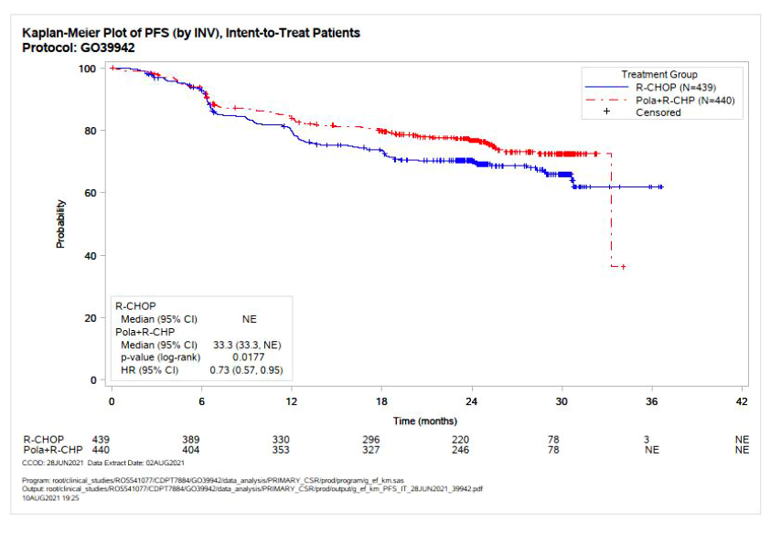

Sensitivity analyses
- Effect of missing scheduled PFS assessments (analysis using interval censoring): stratified HR 0.75 (95% CI: 0.58, 0.96) in favour of pola+R-CHP
- Impact of new anti-lymphoma therapy (NALT) before, or in the absence of, subsequent death or disease progression: HR for PFS censored at the last adequate tumour assessment before the initiation of NALT 0.77 (95% CI: 0.59 to 1.01) favouring pola+R-CHP.

Subgroup analyses
Subgroup analyses of PFS are illustrated in Figure 3. These suggested a consistent efficacy benefit for the pola+R-CHP arm, with hazard ratios being < 1.0.

Subgroup analyses
Figure 3 POLARIX Study Subgroup Analysis
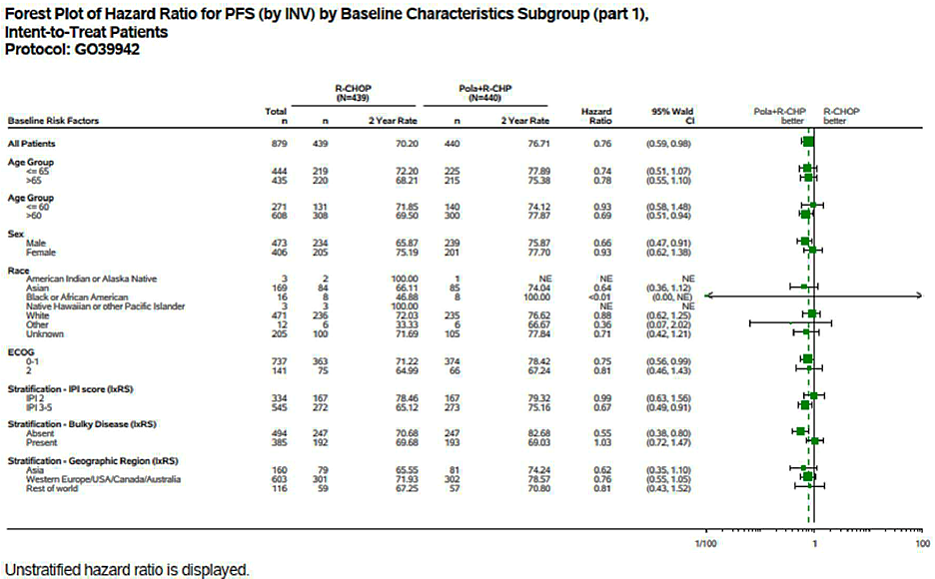

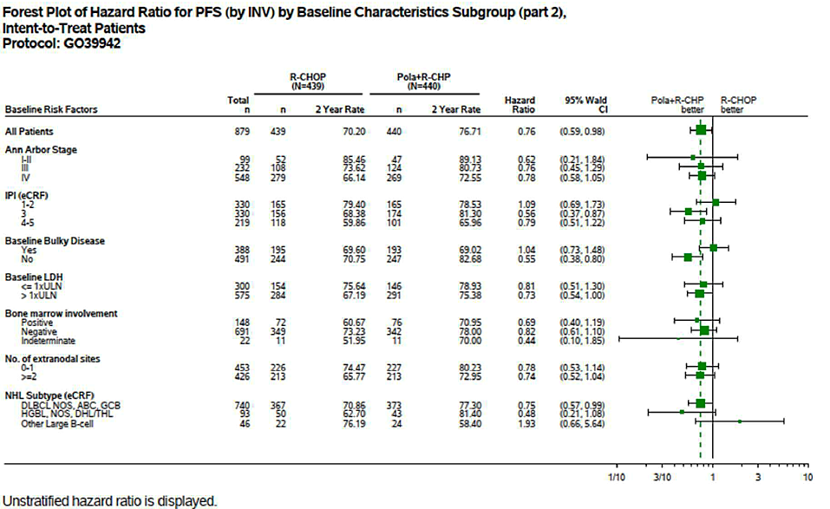

Results for key secondary efficacy outcomes
Event-free survival for efficacy reasons (EFS_{eff}) was defined as the time from date of randomisation to the earliest occurrence of any of disease progression/relapse; death due to any cause; an event (per investigator) other than disease progression/relapse, that led to initiation of any non-protocol specified new anti-lymphoma treatment (NALT) (e.g., a PET-CT scan, bone marrow test, CT/MRI, or physical examination suggests residual disease); post-treatment-completion positive biopsy, positive for residual disease, regardless of whether NALT is initiated or not.
At 24 months, the EFS_{eff} rates for pola+R-CHP vs R-CHOP were 75.57% vs 69.39% (difference = 6.19% [95%CI: 0.14 to 12.23%]). HR 0.75 (95%CI: 0.58 to 0.96); p = 0.0244.
Complete response (CR)% at end of treatment by PET-CT per BICR for pola+R-CHP vs R-CHOP: 78.0% (95% CI: 73.79 to 81.74) vs 74.0% (95% CI: 69.66 to 78.07), p = 0.1557.

Overall survival (OS)
At the final PFS analysis 110/879 subjects (12.5%) had died: HR = 0.94 (95%CI: 0.65 to 1.37); p = 0.7524. At 24 months, the estimated OS was 88.66% in the pola+R-CHP arm vs 88.61% in the R-CHOP arm (difference = 0.05% [95%CI: -4.21 to +4.31]). NALT use was more common in the R-CHOP arm - 30.3% vs. 22.5% of subjects (Figure 4).
The final OS analysis was to occur 36 months after the last patient was enrolled.
The duration of survival follow-up was 39.6 months in the R-CHOP arm and 39.7 months in the pola+R-CHP arm. In the final OS analysis 15.3% of the R-CHOP arm and 14.5% of the pola+R-CHP arm had died (estimated OS 83.3% vs 85.0% for the R-CHOP and pola+R-CHP arms, respectively; HR = 0.94 (95% CI: 0.67 to 1.33); p = 0.7326).
Figure 4 POLARIX Study Kaplan-Meier Curves Overall Survival ITT population
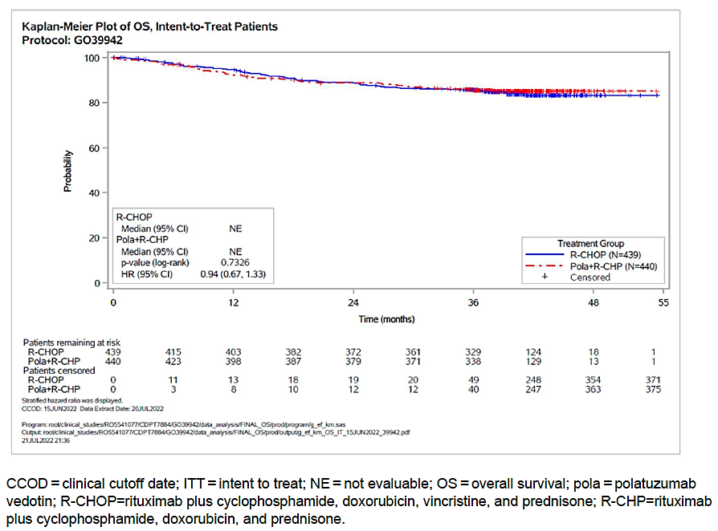
CCOD=clinical cut-off ate; ITT=intent to treat; NE=not evaluable; OS=overall survival; pola=polatuzumab vedotin;
R-CHOP=rituximab plus cyclophosphamide, doxorubicin, vincristine and prednisone; R-CHP= rituximab plus cyclophosphamide, doxorubicin, and prednisone.

Results for other secondary efficacy outcomes
Analysis of the other secondary endpoints was performed at the time of the PFS primary analysis. Results are summarised, below.
Table 2 POLARIX Study Secondary Endpoints
Other Secondary Endpoint |  | Pola+R-CHP | R-CHOP
CR at end of treatment (PET-CT per Inv) |  | 75.0% (95% CI 70.68, 78.98) | 72.2% (95% CI: 67.76, 76.35)
ORR at end of treatment (PET-CT) | per Inv | 84.5% (95% CI: 80.82, 87.79) | 80.9% (95% CI: 76.87, 84.44)
ORR at end of treatment (PET-CT) | per BICR | 85.5% (95% CI: 81.88, 88.61) | 83.8% (95% CI: 80.04, 87.15)
Best Overall Response (BOR)(per Inv) | BOR CR | 86.6% (95% CI: 83.05, 89.63) | 82.7% (95% CI: 78.82, 86.11)
Best Overall Response (BOR)(per Inv) | BOR PR | 9.3% (95% CI: 6.77, 12.43) | 11.4% (95% CI: 8.57, 14.74)
Duration Of Response (24 months) % responders, median |  | 75.7%, NE | 71.7%, NE
Disease Free Survival (CR) (24 months)* |  | 81.79% | 77.35%
PFS at 24 months (per Inv) |  | 76.71% (95%CI: 65.80, 80.76) | 70.20% (95%CI: 65.80, 74.61)
Event Free Survival (EFS_{all}) (24 months)^ |  | 70.42% | 63.38%
*HR 0.70; 95%CI: 0.50 to 0.98; ^HR 0.73 (95%CI: 0.58 to 0.92)
Disease progression or relapse with CNS involvement was reported in 3% and 2.7% of the pola+R-CHP group and R-CHOP groups, respectively.

Patient-reported outcome (PRO) endpoints
The EORTC QLQ-C30 cancer specific questionnaire results included time to deterioration in physical functioning and fatigue as the main analysis, and change from baseline in treatment-related symptoms as a secondary analysis. While on treatment, a small improvement in scores for constipation was observed in the pola+R-CHP arm compared to the R-CHOP arm (range of mean change from baseline: -4.9 to -7.6 vs. -1.1 to -5.3). A small increase in diarrhea scores in the pola+R-CHP arm compared to the R-CHOP arm was observed at Cycle 2 (mean change from baseline: 6.3 vs. -0.02), however subsequent scores improved (range of mean change from baseline: 1.2 to 1.6 vs. -0.6 to 0.1). Scores for nausea and vomiting were very low at baseline (mean [SE]: 8.4 [0.916] vs. 6.2 [0.722]), and no difference was observed while on treatment (range of mean change from baseline: 1.7 to 1.7 vs. -0.1 to 1.2). Any increase observed was reversed by treatment completion. There was no difference in the risk of deterioration of physical functioning was observed between arms (stratified HR: 0.97 [95% CI: 0.79, 1.19]). The median time to clinically meaningful deterioration in physical functioning was not reached in the pola+R-CHP arm and was 25.5 months in the R-CHOP arm. While there was no difference in risk for deterioration in fatigue score, the time to deterioration was 6.7 vs 3.0 months for the pola+R-CHP vs R-CHOP arms, with clinically meaningful improvement in fatigue reported in 74.8% vs 68.2% [difference 6.61% (95% CI: 0.28 to 12.88)] for the pola+R-CHP vs R-CHOP arms.
The FACT-Lym questionnaire 15-item lymphoma subscale showed no difference between the two arms in risk for deterioration in lymphoma symptoms. The time to deterioration had not been reached, and there was a 1.01% (95% CI: -4.43 to 6.45) difference between the two arms in the number of patients reaching a clinically meaningful improvement.
FACT/GOG-NTX questionnaire showed no meaningful difference between the treatment arms. There were low baseline levels of peripheral neuropathy in both arms. Mean scores decreased in both arms, indicating increased levels of peripheral neuropathy, but at all time points differences in mean score between the treatment arms were small (usually < 1 point) and below the clinically meaningful threshold for the questionnaire.

Study GO29044
This phase 1b/2 open-label, multicentre, dose-escalation study of polatuzumab vedotin in combination with CHP chemotherapy (cyclophosphamide, doxorubicin, and prednisolone or prednisone) and either rituximab (R) or obinutuzumab (G) consisted of two initial phase 1b dose-escalation phases in which escalating doses of polatuzumab were combined with either R-CHP or G-CHP.
The dose-escalation phase enrolled subjects with any B-cell NHL, either previously untreated or relapsed/refractory (to one prior regimen). The expansion phase only included subjects with previously untreated DLBCL, with an IPI score of 2-5. For both phases subjects were required to be age ≥ 18, ECOG performance score of 0, 1 or 2, and to have adequate bone marrow function.
After determination of the recommended phase 2 dose (RP2D), there were two phase 2 expansion phases that compared pola+R-CHP and pola+G-CHP in a 1:1 randomisation.
A total of 82 subjects were treated in the study in eight different cohorts. The evaluator considered the results for the 50 patients from the pola+R-CHP cohorts were relevant to the current submission. Of those 45 of these were assigned with the dose proposed for registration (1.8 mg/kg of polatuzumab) for the duration of the study, 5 additional patients commenced in the dose escalation cohort; 2 patients on 1.0 mg/kg and 3 patients on 1.4 mg/kg.
The mean age of participants in the pola+R-CHP cohorts was 68.9 years (range 45-80), 52.0% were female, 86.0% were white and 70% had an ECOG of 0 or 1. Most patients had stage III (18.0%) or IV (66.0%) disease and their IPI score was 2 in 22.0% and 3-5 in 72.0%.
Assessment of efficacy was a secondary objective of the trial. Tumour response and progression were assessed by the investigator using the modified Revised Response Criteria for Malignant Lymphoma³ and the modified Lugano Response Criteria.
The CR rate by PET-CT for all polatuzumab doses (n=50) was 78.0% (90% CI: 66.22 to 87.14). The ORR was 92.0% (90% CI: 82.62 to 97.22).
24% of patients receiving 1.8mg/kg of pola+R-CHP had an event (disease progression or death). The estimated PFS at 2 years was 80.0%.
The median duration of response could not be estimated, but an estimated 85% of responders maintained a response at 2 years.
EFS events, defined as the time from randomisation to disease progression or relapse, as per investigator, death from any cause, or initiation of any new anti-lymphoma therapy (NALT), were experienced in 36.0%. The estimated median EFS was 35.45 months, and the estimated EFS at 2 years was 70.0%.
The estimated OS at 2 years was 94.0%.

Safety
In the POLARIX study a total of 435 subjects were treated with the pola+R-CHP combination and 438 subjects were treated with the R-CHOP combination.
Subjects in the pola+R-CHP arm received a mean number of 5.8 cycles of polatuzumab, compared with a mean of 5.7 cycles of vincristine for the R-CHOP arm. Mean relative dose intensity for the two drugs was also comparable (98.1% vs. 98.5%).
In the G029044 drug exposure for subjects treated with the pola+R-CHP regimen (n=50). The median number of cycles received for each drug was 6.0.
The exposure data from both studies POLARIX and G029044 are summarised in Table 3 below.
Table 3. Exposure Data from the POLARIX and G029044 studies
Study | Group | Treatment | n | Treatment Duration (months)  Median  (min, max) | Number of cycles  Median  (min, max)
POLARIX | R-CHOP (n=438) | Rituximab | 438 | 4.9  (0-11) | 8.0  (1-8)
POLARIX | R-CHOP (n=438) | Cyclophosphamide | 436 | 3.5  (0-8) | 6.0  (1-6)
POLARIX | R-CHOP (n=438) | Doxorubicin | 436 | 3.5  (0-8) | 6.0  (1-6)
POLARIX | R-CHOP (n=438) | Vincristine | 436 | 3.5  (0-8) | 6.0  (1-6)
POLARIX | R-CHOP (n=438) | Prednisolone | 438 | 3.6  (0-6) | 6.0  (1-6)
POLARIX | Pola+R-CHP (n=435) | polatuzumab | 435 | 3.5  (0-5) | 6.0  (1-6)
POLARIX | Pola+R-CHP (n=435) | rituximab | 435 | 4.9  (0-8) | 8.0  (1-8)
POLARIX | Pola+R-CHP (n=435) | cyclophosphamide | 435 | 3.5  (0-5) | 6.0  (1-6)
POLARIX | Pola+R-CHP (n=435) | doxorubicin | 435 | 3.5  (0-5) | 6.0  (1-6)
POLARIX | Pola+R-CHP (n=435) | prednisolone | 435 | 3.6  (0-5) | 6.0  (1-6)
G029044 | Pola+R-CHP (n=50) | polatuzumab | 50 | 3.49  (0.7-5.5) | 6.0  (2-8)
G029044 | Pola+R-CHP (n=50) | Rituximab | 50 | 3.5  (0.7-5.6) | 6.0  (2-8)
G029044 | Pola+R-CHP (n=50) | Cyclophosphamide | 50 | 3.51  (0.7-5.6) | 6.0  (2-8)
G029044 | Pola+R-CHP (n=50) | Doxorubicin | 50 | 3.51  (0.7-5.6) | 6.0  (2-8)
G029044 | Pola+R-CHP (n=50) | Vincristine | 50 | 3.66  (0.9-5.7) | 6.0  (2-8)

Adverse events
For the POLARIX study, information on new adverse events was collected at each study visit, from cycle 1 day 1 until to 90 days after the last dose of study treatment. Any treatment related serious AEs were to be reported indefinitely and any treatment-related adverse events of special interest were to be reported up to 12 months after the last dose. AEs were graded for severity using the National Cancer Institute (NCI) Common terminology criteria for adverse events (CTCAE) version 4.0. AE terminology was standardised using Medical Dictionary for Regulatory Activities (MedDRA) version 24. Safety monitoring in study GO29044 was generally similar to that employed in the pivotal study. A more extensive list of adverse events of special interest, referred to as ‘selected AEs’ was defined (Table 4).
Table 4 Summary of Adverse Events
 | POLARIX study |  | G029044
 | R-CHOP | Pola+R-CHP | Pola+R-CHP
Treatment-emergent adverse events (TEAEs)
Subjects with at least one TEAE, % | 98.4 | 97.9 | 100
Most common TEAEs (>10% in any group):
nausea, % | 36.8 | 41.6 | 44.0
neutropenia,% | 32.6 | 30.8 | 36.0
constipation, % | 29.0 | 28.7 | 22.0
anaemia, % | 26.0 | 28.7 | 28.0
fatigue, % | 26.5 | 25.7 | 44.0
diarrhoea, % | 20.1 | 30.8 | 44.0
alopecia , % | 24.0 | 24.4 | 14.0
Peripheral neuropathy, % | 22.6 | 24.1 | 16.0
Peripheral sensory neuropathy, % | 21.5 | 19.5 | 14.0
Decreased appetite, % | 14.2 | 16.3 | 14.0
vomiting, % | 14.4 | 14.9 | 14.0
pyrexia,% | 12.6 | 15.6 | 18.0
headache, % | 13.0 | 12.9 | 14.0
cough, % | 12.1 | 12.9 | 6.0
Weight decreased, % | 11.9 | 12.6 | 18.0
asthenia, % | 12.1 | 12.2 | 18.0
dysgeusia, % | 13.0 | 11.3 | 12.0
Febrile neutropenia, % | 8.0 | 14.3 | 12.0
Back pain, % | 11.0 | 9.4 | 8.0
dyspnoea, % | 8.2 | 11.0 | 8.0
Deaths
Patients who had a fatal drug related adverse event, % | 2.5 | 3.0 | 8.0
Fatal AEs considered treatment related, % | 1.1 | 1.4 | 0
Serious TEAEs (SAE)
Subjects with at least one SAE, % | 30.6 | 34.0 | 38.0
Most common SAE (>2% of any group or > 2 patients in study G029044):
pneumonia, % | 3.9 | 4.1 | 4.0
febrile neutropenia, % | 6.4 | 9.9 | 8.0
Diarrhoea, % | 0.5 | 2.5 | 2.0
Treatment related SAEs, % | 19.6 | 25.7 | 22.0
Higher grade TEAEs
Subjects with at least ≥1 Grade 3 AE, % | 59.8 | 60.7 | 62.0
Most common Grade 3-4 AEs (≥3% in any group):
neutropenia, % | 30.8 | 28.3 | 26.0
Febrile neutropenia, % | 8.0 | 13.8 | 12.0
anaemia % | 8.4 | 12.0 | 4.5
Neutrophil count decreased, % | 6.4 | 6.9 | 0
leukopenia, % | 6.8 | 5.7 | 10.0
thrombocytopenia, % | 4.3 | 3.2 | 6.0
White blood cell decreased, % | 3.2 | 4.1 | 3.0
pneumonia, % | 3.9 | 3.2 | 4.0
Lymphocyte count decreased, % | 3.4 | 3.0 | 2.0
Diarrhoea, % | 1.8 | 3.9 | 2.0
AEs leading to study discontinuation (%) | 2.3 | 3.0 | 4.0
AEs leading to any study dose discontinuation (%) | 6.6 | 6.2 | 8.0
Polatuzumab vedotin/placebo discontinuation  Vincristine/placebo discontinuation  Rituximab discontinuation | 5.0  5.0  4.8 | 4.4  4.4  4.6 | 4.4  4.4  4.6
AEs leading to any study treatment dose reduction (%)  Polatuzumab vedotin/placebo dose reduction  Vincristine/placebo dose reduction | 13.0  10.3  10.3 | 9.2  5.5  5.5 | 10.0  -
AE leading to any study treatment dose interruption (%)  Polatuzumab vedotin/placebo dose interruption  Vincristine/placebo dose interruption | 25.3  14.2  13.7 | 23.7  14.0  13.8 | 6.0  -

Serious AEs and grade ≥ 3 AEs were more common in subjects aged ≥ 65 years than in those aged < 65 years in both study arms in the POLARIX study. There were no consistent differences in the incidence of AEs between White and Asian subjects.
In the POLARIX study the 111 deaths reported by the clinical data cut-off date (12.0% of the pola+R-CHP arm and 13.5% of the R-CHOP arm), 59 were accounted for as disease progression, accounted for deaths, 24 as adverse events, and 28 were accounted for from other causes. Infections were the most common AEs leading to death in both arms. There were four unexplained deaths in the pola+R-CHP arm vs. one in the R-CHOP arm. Otherwise, there were no notable differences between arms in the types of fatal AEs.
The treatment-related fatal AEs in the pola+R-CHP arm were pneumonia (three patients), one each of sudden cardiac death, acute kidney injury, and unexplained death. Treatment-related fatal AEs in the R-CHOP arm were pneumonia (2 patients), and one each of multiple organ dysfunction syndrome, and sepsis. One patient died due to acute myeloid leukemia during the follow-up period (day 926) that was assessed as related to study treatment.
In Study G029044 the four deaths (8.0%) with the pola+R-CHP regimen - three due to disease progression and one due to an adverse event, all occurred in the expansion cohort. None were assessed as being related to study treatment.
Adverse events of special interest
Peripheral neuropathy was an adverse event of special interest (AESI), but there were no notable differences between the treatments.
Most of the hepatic AEs, which were assessed using standardised MedDRA queries (SMQs), were reports of abnormal LFTs. They were more common in the pola+R-CHP arm (10.6% vs. 7.3%). Grade 3 or 4 abnormalities were uncommon and occurred with a similar frequency in the two treatment arms. A total of 4 patients (8.0%) had events of hepatic toxicity; 2 patients in the 1.8mg/kg dose group and 2 patients in the 1.8mg/kg dose expansion group. While most were abnormal LFTs, one patient reported hepatic steatosis. There were no confirmed Hy’s Law cases.
There was no clear signal for renal toxicity in the AEs for polatuzumab vedotin.
Tumour lysis syndrome has been previously reported for polatuzumab vedotin. In the POLARIX study hyperuricaemia was very common in both study arms. Grade 3 or 4 abnormalities in the remaining parameters were uncommon and occurred with a similar frequency in the two study arms. In Study 029044 grade 3 or 4 hyperuricaemia, hyperglycaemia and hypophosphataemia were common.
Myelosuppression is a known toxicity associated with polatuzumab vedotin, therefore haematological toxicity was an AESI. Common events are listed in the table above.
Cardiac AEs were reported in 7.8% of subjects in the pola+R-CHP arm and 12.6% of subjects in the R-CHOP arm. Cardiac arrythmia were comparable in the two arms (3.0% vs.4.6%). In study G029044 cardiac AEs were reported in 12.0% of subjects, most commonly tachycardia (6.0%).
More infections (49.7% vs. 42.7%), grade ≥ 3 infections (15.2% vs. 12.6%), and serious infections (14.0% vs. 10.3%) were reported in the pola+R-CHP arm. By individual infection AE term urinary tract infection was most common in the pola+R-CHP arm (8.0% vs. 5.5%). There were no notable differences between treatments in the occurrence of opportunistic infections, and no cases of progressive multifocal leukoencephalopathy.
Events reported under the system organ class (SOC) of “Immune system disorders” occurred with a similar frequency in the two study arms.
There was one serious skin AE reported – a case of decubitus ulcer in the R-CHOP arm, and none in Study GO29044. There were no cases in either study of photosensitivity, erythema multiforme, Stevens Johnson syndrome, drug reaction with eosinophilia and systemic symptoms (DRESS) or toxic epidermal necrolysis (TEN).
No post-marketing data were included in the submission.

Risk management plan evaluation summary
A Risk Management Plan waiver was granted by the RMP team for this submission.

Risk-benefit analysis
The sponsor seeks a new indication for polatuzumab vedotin as a component of 5 drug regimen in first line systemic therapy for DLBCL. It proposes polatuzumab vedotin as an alternative to vincristine in the well-established R-CHOP regimen in first line DLBCL.
Supportive evidence is derived primarily from the pivotal POLARIX study with supportive evidence from the relevant cohort of study GO29044.
POLARIX was a phase 3, randomised, double-blind, placebo-controlled trial in which standard therapy (R-CHOP) was compared with pola+R-CHP. The comparator regimen and efficacy endpoints were appropriate. This was not a non-inferiority study.
The population enrolled in the study was typical of that expected for newly diagnosed DLBCL, with a mean age of 63 years, a slight preponderance of males and most subjects having stage III or IV disease. Patients with a good prognosis (IPI 0-1), DLBCL transformed from an indolent lymphoma, and patients with CNS disease were not included. The two study arms were well balanced with respect to baseline prognostic factors, and 62% were IP3-5.
The study demonstrated an efficacy benefit for PFS for the pola+R-CHP regimen over the standard R-CHOP regimen; HR = 0.73 (95%CI: 0.57 to 0.95), p = 0.0177. The PFS difference between treatments at 24 months was modest (6.50% [95%CI: 0.52 to 12.49%]). This was supported by similar results for event free survival for efficacy reasons (EFS_{eff}): HR = 0.75 (95%CI: 0.58 to 0.96).
The use of second-line therapies (NALT) in the trial was more frequent in the R-CHOP arm (30.3% vs. 22.5%). While then this is accounted for in the censoring strategy it adds some uncertainty to the strength of the findings. The stratified HR for PFS censored at the last adequate tumour before the initiation of NALT was 0.77 (95% CI: 0.59 to 1.01).
The benefit observed for PFS did not translate into a clear improvement in overall survival. The estimated OS was 83.3% vs 85.0% for the R-CHOP and pola+R-CHP arm, HR = 0.94 (95%CI: 0.67 to 1.3); p = 0.7326. While there was no clear detriment to overall survival with pola+R-CHP, fatal adverse events were more frequent in that arm.
A total of 485 patients were treated with the proposed pola+R-CHP regimen, and most completed 6 cycles of treatment. Both MMAE (the cytotoxic component of polatuzumab vedotin) and vincristine are tubulin inhibitors and might therefore be expected to have similar toxicity. When considering the proportions of patients reporting adverse events by general category (AEs, Grade 3-4 AEs etc) the safety profiles are somewhat similar but there are important differences. Notably, the pola+R-CHP regimen was associated with an increased proportion of patients reporting Grade 3-4 events of diarrhoea (30.8% vs. 20.1%), febrile neutropenia (14.3% vs. 8.0%), and anaemia (12.0% vs 8.4%). Peripheral neuropathy is an anticipated event with vincristine and MMAE, and events occurred in similar proportions of patients in each treatment arm. The discontinuation of study drugs was similar with both treatment regimens (6.2%, and 6.6%).
In terms of patient experience, the 6.61% improvement in improvement in fatigue score with the pola+R-CHP regimen is counterbalanced by a 10% greater proportion of patients with Grade 3-4 diarrhoea events.
The POLARIX study was designed to demonstrate whether the polatuzumab vedotin containing first-line regimen was superior to the existing regimen. As the MMAE component of polatuzumab vedotin and vincristine have a similar mechanism of action, a study to investigate the non-inferiority of the two regimens would have been an appropriate alternative strategy. Statistically the POLARIX study was positive, but the statistical significance of the PFS primary is sensitive to the type of censoring applied, adding some uncertainty about the robustness of the findings.
OS is recognised as a gold standard endpoint in haematology and oncology trials. For a new first-line treatment regimen in DLBCL it is very relevant, given the expected outcomes of the R-CHOP regimen. The 1.5% difference in estimated OS is not statistically significant and not clinically meaningfully different. While there was no detriment, a superior OS outcome was not demonstrated.
The modest PFS gain is countered by the increased proportion of patients with specific Grade 3-4 events that are both clinically important and relevant to the patient experience. The types of events were similar in both groups, and haematologists would be very familiar with managing these events.

Recommendation following the clinical evaluation
DLBCL is a life-threatening condition with a 60- 65% complete and durable response to the established R-CHOP first-line treatment regimen. The advice of the ACM is sought to assist with the considerations about whether the evidence is sufficient to accept polatuzumab vedotin + rituximab + cyclophosphamide + prednisone as an alternative to R-CHOP in first line DLBCL. At this stage the Delegate is not persuaded that pola+R-CHP is an overall superior regimen to R-CHOP.

Advisory Committee considerations
The Advisory Committee on Medicines (ACM), having considered the evaluations and the Delegate’s overview, as well as the sponsor’s response to these documents, advised the following.
- Does the ACM consider sufficient evidence has been submitted to support the proposed indication?
The ACM discussed the pivotal study (POLARIX) and considered it to be a robust, large multinational, randomised control trial with low risk of bias. The ACM noted that the primary endpoint of progression free survival (PFS) was met however there was no improvement in the key secondary endpoint overall survival (OS) compared to standard of care (R-CHOP).
The ACM commented with interest that improvement in PFS does not appear to lead to an improvement in OS within the study. The ACM was of the view that the lack of benefit seen in OS is not a reflection of the immaturity of the data and noted that newer data with a 48 week follow up does not demonstrate an improvement in OS. Overall, the ACM interpreted this to mean that patients who go into remission may remain in remission for longer.
The ACM discussed the safety profile of polatuzumab and noted the increase in diarrhoea, febrile neutropenia and anaemia. While there appears to be a marginally higher toxicity profile compared to the standard of care the ACM noted that polatuzumab in combination would be prescribed by specialists familiar with managing toxicity.
The ACM advised that while the modest benefit in PFS is offset by increased safety concerns polatuzumab in combination (Pola-R-CHP) is considered similar to standard care (R-CHOP) and does offer an alternative treatment option for previously untreated DLBCL.
On balance the ACM was of the view that sufficient evidence has been submitted to support the indication Polivy in combination with rituximab, cyclophosphamide, doxorubicin, and prednisone (R-CHP) is indicated for the treatment of adult patients with previously untreated diffuse large B-cell lymphoma (DLBCL).

ACM conclusion
The ACM considered this product to have an overall positive benefit-risk profile for the indication:
Polivy in combination with rituximab, cyclophosphamide, doxorubicin, and prednisone (R-CHP) is indicated for the treatment of adult patients with previously untreated diffuse large B-cell lymphoma (DLBCL).

Post-ACM conclusion
The ACM recommended approval of polatuzumab vedotin (Polivy) based on the findings of the POLARIX study.
The ACM noted the PFS benefit did not translate into a clear OS benefit but interpreted the finding to show that patients who go into remission are likely to stay in remission for longer. The ACM advised that while there was a marginally higher toxicity physicians prescribing the product would be experienced in managing these types of toxicities.
The ACM weighed the incremental PFS benefit with the incremental toxicity and advised sufficient evidence had been provided to support the proposed indication Polivy in combination with rituximab, cyclophosphamide, doxorubicin, and prednisone (R-CHP) is indicated for the treatment of adult patients with previously untreated diffuse large B-cell lymphoma (DLBCL).
The delegate considered the advice and the evidence presented in the submission, including in the pre-ACM response and proposed to approve the submission. The sponsor has provided further drafts of the Polivy PI and an acceptable text.
After the ACM meeting, the sponsor, having reviewed the PARs for the submission, became aware it had only requested the new indication for the 140 mg strength. On 23 January 2023, the sponsor added a new s23 application request for the 30 mg strength for the same indication [Polivy in combination with rituximab, cyclophosphamide, doxorubicin, and prednisone (R-CHP) is indicated for the treatment of adult patients with previously untreated diffuse large B-cell lymphoma (DLBCL)].
The sponsor has provided satisfactory responses and amendments to the Polivy PI.
No specific conditions of registration are proposed for this submission.

Outcome
Based on a review of quality, safety, and efficacy, the TGA decided to register Polivy (polatuzumab vedotin) extension of indications:
Polivy in combination with rituximab, cyclophosphamide, doxorubicin, and prednisone
(R-CHP) is indicated for the treatment of adult patients with previously untreated diffuse large B-cell lymphoma (DLBCL).

The full indications are now:

Polivy in combination with rituximab, cyclophosphamide, doxorubicin, and prednisone (R-CHP) is indicated for the treatment of adult patients with previously untreated diffuse large B-cell lymphoma (DLBCL).

Polivy in combination with bendamustine and rituximab is indicated for the treatment of previously treated adult patients with diffuse large B-cell lymphoma who are not candidates for hematopoietic stem cell transplant.

Attachment 1. Product Information
The Product Information (PI) approved with the submission for Polivy which is described in this AusPAR can be found as Attachment 1. It may have been superseded. For the most recent PI and Consumer Medicines Information (CMI), please refer to the TGA PI/CMI search facility.

Therapeutic Goods Administration
PO Box 100 Woden ACT 2606 Australia
Email: info@tga.gov.au Phone: 1800 020 653 Fax: 02 6203 1605
https://www.tga.gov.au

This is the original indication proposed by the sponsor when the TGA commenced the evaluation of this submission. It may differ to the final indication approved by the TGA and registered in the Australian Register of Therapeutic Goods.
National Comprehensive Cancer Network (NCCN). NCCN Clinical Practice Guidelines in Oncology. B-Cell Lymphomas. Version 3.2022. 2022. Available from: https://www.nccn.org/professionals/physician_gls/pdf/b-cell.pdf
Beham-Schmid C. Aggressive lymphoma 2016: revision of the WHO classification. Memo. 2017; 10(4): 248-254. doi: 10.1007/s12254-017-0367-8. Epub 2017 No v 30.
Swerdlow SH, Campo E, Pileri SA et al. The 2016 revision of the World Health Organization classification of lymphoid neoplasms. Blood. 2016; 127 (20): 2375-90.
Sehn LH, Salles G. Diffuse Large B-Cell Lymphoma. N Engl J Med. 2021; 384 (9): 842-858.
Martelli M, Ferreri AJ, Agostinelli C et al. Diffuse large B-cell lymphoma. Crit Rev Oncol Hematol. 2013; 87 (2): 146-71.
Tilly H, Gomes da Silva M, Vitolo U et al. Diffuse large B-cell lymphoma (DLBCL): ESMO Clinical Practice Guidelines for diagnosis, treatment and follow-up. Ann Oncol. 2015; 26 Suppl 5: v116-25.
Chaganti S, Illidge T, Barrington S et al. Guidelines for the management of diffuse large B-cell lymphoma. Br J Haematol. 2016; 174 (1): 43-56.
Polatuzumab vedotin is a CD79b-targeted antibody drug conjugate (ADC) that preferentially delivers a potent anti-mitotic agent (monomethyl auristatin E [MMAE]) to B cells, which results in anti-cancer activity against B-cell malignancies
Bai RL, Pettit GR, Hamel E. Binding of dolastatin 10 to tubulin at a distinct site for peptide antimitotic agents near the exchangeable nucleotide and vinca alkaloid sites. J Biol Chem. 1990 Oct 5;265(28):17141-9. PMID: 2211617.
Francisco JA, Cerveny CG, Meyer DL, Mixan BJ, Klussman K, Chace DF, Rejniak SX, Gordon KA, DeBlanc R, Toki BE, Law CL, Doronina SO, Siegall CB, Senter PD, Wahl AF. cAC10-vcMMAE, an anti-CD30-monomethyl auristatin E conjugate with potent and selective antitumor activity. Blood. 2003 Aug 15;102(4):1458-65. doi: 10.1182/blood-2003-01-0039. Epub 2003 Apr 24. PMID: 12714494.
Doronina SO, Toki BE, Torgov MY, Mendelsohn BA, Cerveny CG, Chace DF, DeBlanc RL, Gearing RP, Bovee TD, Siegall CB, Francisco JA, Wahl AF, Meyer DL, Senter PD. Development of potent monoclonal antibody auristatin conjugates for cancer therapy. Nat Biotechnol. 2003 Jul;21(7):778-84. doi: 10.1038/nbt832. Epub 2003 Jun 1. PMID: 12778055.
The ‘Delegate’ is the Delegate of the Secretary of the Department of Health and Aged Care who made the final decision to either include the new medicine/indication on the ARTG or reject the submission, under section 25 of the Therapeutic Goods Act

