AUSTRALIAN PRODUCT INFORMATION OPDIVO® (NIVOLUMAB)
WARNING: IMMUNE-RELATED ADVERSE REACTIONS WITH OPDIVO AND IPILIMUMAB COMBINATION THERAPY
Immune-related adverse reactions are seen more frequently, and are more severe, with OPDIVO and ipilimumab combination therapy than with OPDIVO or ipilimumab monotherapy.
Immune-related adverse reactions can involve any organ system. The majority of these initially manifest during treatment; however, a minority can occur weeks to months after discontinuation. Some immune-related adverse reactions can be permanent (such as thyroid dysfunction and diabetes mellitus). Life-threatening or fatal immune-related adverse reactions that have occurred include colitis, intestinal perforation, hepatitis, pneumonitis, hypophysitis, adrenal insufficiency, toxic epidermal necrolysis, myocarditis, encephalitis and myasthenia gravis (see Sections 4.4 Special warnings and precautions for use and 4.8 Adverse Effects).
Early diagnosis and appropriate management are essential to minimise life-threatening complications (see Section 4.2 Dose and method of administration). Monitoring at least prior to each dose is recommended. Advise patients of the importance of immediately reporting possible symptoms.
Physicians should consult the ipilimumab product information prior to initiation of OPDIVO in combination with ipilimumab. The combination of OPDIVO and ipilimumab should be administered and monitored under the supervision of physicians experienced with the use of immunotherapy in the treatment of cancer.

NAME OF THE MEDICINE
Nivolumab

QUALITATIVE AND QUANTITATIVE COMPOSITION
10 mg/mL concentrate solution for infusion
Each 1 mL of concentrate contains 10 mg of nivolumab. One 10 mL vial contains 40 mg of nivolumab in 4 mL. One 10 mL vial contains 100 mg of nivolumab in 10 mL. One 25 mL vial contains 240 mg of nivolumab in 24 mL.
OPDIVO (nivolumab (rch)) is a fully human anti-PD-1 monoclonal antibody (IgG4) produced in mammalian (Chinese hamster ovary) cells by recombinant DNA technology.

Excipient with known effect
Each 1 mL of concentrate contains 0.1 mmol (or 2.5 mg) sodium. For the full list of excipients, see section 6.1 List of excipients.

PHARMACEUTICAL FORM
Concentrate for solution for infusion.
Clear to opalescent, colourless to pale yellow liquid that may contain few light particles. The solution has a pH of approximately 6.0 and an osmolarity of approximately 340 mOsm/kg.

CLINICAL PARTICULARS
  - THERAPEUTIC INDICATIONS

Melanoma
OPDIVO, as monotherapy, is indicated for the adjuvant treatment of patients with melanoma with involvement of lymph nodes or metastatic disease who have undergone complete resection.
OPDIVO, as monotherapy, is indicated for the treatment of patients with unresectable or metastatic melanoma.
OPDIVO, in combination with ipilimumab, is indicated for the treatment of patients with unresectable or metastatic melanoma. The approval of this indication is based on a pre-specified comparison to ipilimumab monotherapy. All analyses comparing nivolumab monotherapy with the nivolumab/ipilimumab combination are descriptive.

Non-Small Cell Lung Cancer (NSCLC)
OPDIVO, in combination with platinum-doublet chemotherapy, is indicated for the neoadjuvant treatment of patients with resectable non-small cell lung cancer (NSCLC).
OPDIVO, in combination with ipilimumab and 2 cycles of platinum-doublet chemotherapy, is indicated for the first-line treatment of patients with metastatic or recurrent non-small cell lung cancer (NSCLC) with no EGFR or ALK genomic tumour aberrations.
OPDIVO, as monotherapy, is indicated for the treatment of locally advanced or metastatic squamous non-small cell lung cancer (NSCLC) with progression on or after prior chemotherapy.
OPDIVO, as monotherapy, is indicated for the treatment of locally advanced or metastatic non- squamous non-small cell lung cancer (NSCLC) with progression on or after prior chemotherapy. In patients with tumour EGFR or ALK genomic aberrations, OPDIVO should be used after progression on or after targeted therapy.

Malignant Pleural Mesothelioma (MPM)
OPDIVO, in combination with ipilimumab, is indicated for the first-line treatment of patients with unresectable malignant pleural mesothelioma.

Renal Cell Carcinoma (RCC)
OPDIVO, in combination with ipilimumab, is indicated for the treatment of patients with intermediate/poor-risk, previously untreated advanced renal cell carcinoma.
OPDIVO, in combination with cabozantinib, is indicated for the first-line treatment of patients with advanced renal cell carcinoma.
OPDIVO, as monotherapy, is indicated for the treatment of patients with advanced clear cell renal cell carcinoma after prior anti-angiogenic therapy.

Classical Hodgkin Lymphoma (cHL)
OPDIVO, as monotherapy, is indicated for the treatment of patients with relapsed or refractory classical Hodgkin lymphoma (cHL) after autologous stem cell transplant and treatment with brentuximab vedotin. The approval of this indication is based on objective response rate in a single arm study.

Squamous Cell Carcinoma of the Head and Neck (SCCHN)
OPDIVO, as monotherapy, is indicated for the treatment of recurrent or metastatic squamous cell cancer of the head and neck in patients progressing on or after platinum based therapy.

Urothelial Carcinoma (UC)
OPDIVO, as monotherapy, is indicated for the adjuvant treatment of patients with muscle invasive urothelial carcinoma (MIUC) who are at high risk of recurrence after undergoing radical resection of MIUC.
OPDIVO, as monotherapy, is indicated for the treatment of patients with locally advanced unresectable or metastatic urothelial carcinoma after prior platinum-containing therapy. The approval of this indication is based on objective response rate and duration of response in a single arm study.

Hepatocellular Carcinoma (HCC)
OPDIVO, as monotherapy, is indicated for the treatment of patients with hepatocellular carcinoma after prior sorafenib therapy. This indication is approved based on objective response rate and duration of response in a single arm study. An improvement in survival or disease-related symptoms has not been established.

Oesophageal Squamous Cell Carcinoma (OSCC)
OPDIVO, as monotherapy, is indicated for the treatment of patients with unresectable advanced, recurrent or metastatic oesophageal squamous cell carcinoma after prior fluoropyrimidine and platinum based chemotherapy.

Adjuvant Oesophageal Cancer (OC) or Gastro-Oesophageal Junction Cancer (GOJC)
OPDIVO, as monotherapy, is indicated for the adjuvant treatment of resected oesophageal or gastro- oesophageal junction cancer in patients who have received neoadjuvant chemoradiotherapy.

Gastric Cancer (GC), Gastro-oesophageal Junction Cancer (GOJC), or Oesophageal Adenocarcinoma (OAC)
OPDIVO, in combination with fluoropyrimidine- and platinum-based combination chemotherapy, is indicated for the first-line treatment of patients with HER2 negative advanced or metastatic gastric or gastro-oesophageal junction or oesophageal adenocarcinoma.

DOSE AND METHOD OF ADMINISTRATION
Treatment must be initiated and supervised by specialist physicians experienced in the treatment of cancer.
OPDIVO infusion must not be administered as an intravenous push or bolus injection.
Dose escalation or reduction is not recommended. Guidelines for permanent discontinuation or withholding of doses are described in Table 3 . Detailed guidelines for the management of immune- related adverse reactions are described in Section 4.4 Special warnings and precautions for use.
Nivolumab was originally developed using an every-two-weeks monotherapy dosing regimen (see Section 5.1 Pharmacodynamic Properties – Clinical Trials). Subsequent approval of the every-four- weeks monotherapy dosing regimen was based on pharmacokinetic and exposure-response modelling

and simulations, with supporting clinical safety data. Data from randomised controlled trials of every- two-weeks versus every-four-weeks dosing of nivolumab, with sufficient sample size to demonstrate non-inferiority using clinical endpoint data (such as PFS or OS), is not available.

Recommended Doses
The recommended doses of OPDIVO as a single agent are presented in Table 1.

Table 1 Recommended Doses for OPDIVO as Monotherapy

Indication^ | Recommended OPDIVO Dosage | Duration of Therapy
Unresectable or metastatic |  | Treatment should be continued as long as clinical benefit is observed or until treatment is no longer tolerated.
melanoma
Locally advanced or metastatic
squamous non-small cell lung
cancer
Locally advanced or metastatic  non-squamous non-small cell | 3 mg/kg every 2 weeks  (30-minute intravenous infusion)
lung cancer | or
 | 240 mg every 2 weeks
Advanced renal cell carcinoma | 240 mg every 2 weeks
Advanced renal cell carcinoma | (30-minute intravenous infusion) or  480 mg every 4 weeks
Relapsed/refractory classical Hodgkin lymphoma | (30-minute intravenous infusion) or  480 mg every 4 weeks
 | (30-minute intravenous infusion)
Recurrent or metastatic | (30-minute intravenous infusion)
squamous cell carcinoma of the
head and neck
Unresectable or metastatic
urothelial carcinoma
Hepatocellular carcinoma
 | 240 mg every 2 weeks | Treatment should be
Oesophageal Squamous Cell Carcinoma | (30-minute intravenous infusion) or  480 mg every 4 weeks | continued as long as clinical benefit is observed or until  treatment is no longer
 | (30-minute intravenous infusion) | tolerated.
 | 3 mg/kg every 2 weeks
 | (30-minute intravenous infusion) | Treatment should be
 | or | continued as long as clinical
Adjuvant treatment of | 240 mg every 2 weeks | benefit is observed or until
melanoma | (30-minute intravenous infusion) | treatment is no longer
 | or | tolerated to maximum
 | 480 mg every 4 weeks | duration of 12 months.
 | (30-minute intravenous infusion)
Adjuvant treatment of resected oesophageal or gastro- oesophageal junction cancer | 240 mg every 2 weeks  (30-minute intravenous infusion) or  480 mg every 4 weeks  (30-minute intravenous infusion) | After completing 16 weeks of therapy, administer as 480 mg every 4 weeks until disease progression or unacceptable toxicity for a total treatment duration of 1 year

Indication^ | Recommended OPDIVO Dosage | Duration of Therapy
Adjuvant Treatment of Muscle Invasive Urothelial Carcinoma | 240 mg every 2 weeks  (30-minute intravenous infusion) or  480 mg every 4 weeks  (30-minute intravenous infusion) | Treatment should be continued as long as clinical benefit is observed or until treatment is no longer tolerated to maximum duration of 12 months.
^ As per monotherapy indications in Section 4.1 Therapeutic Indications.
The recommended doses of OPDIVO in combination with other therapeutic agents are presented in Table 2. Refer to the respective Product Information for each therapeutic agent administered in combination with OPDIVO for the recommended dose information, as appropriate.

Table 2 Recommended Doses of OPDIVO in Combination with Other Therapeutic Agents

Indication^ | Recommended OPDIVO Dosage | Duration of Therapy
Unresectable or metastatic melanoma | 1 mg/kg every 3 weeks  (30-minute intravenous infusion) with ipilimumab 3 mg/kg intravenously  over 90 minutes | In combination with ipilimumab for 4 doses
Unresectable or metastatic melanoma | 3 mg/kg every 2 weeks  (30-minute intravenous infusion) or  240 mg every 2 weeks*  (30-minute intravenous infusion) or  480 mg every 4 weeks*  (3 0-minute intravenous infusion) | After completing 4 doses of combination therapy, administer as single agent as long as clinical benefit is observed or until treatment is no longer tolerated by the patient.
Neoadjuvant treatment of resectable non-small cell lung cancer | 360 mg every 3 weeks  (30-minute intravenous infusion) with platinum-doublet chemotherapy on  the same day every 3 weeks | In combination with platinum-doublet chemotherapy for 3 cycles
Metastatic or recurrent non-small cell lung cancer | 360 mg every 3 weeks  (30-minute intravenous infusion) with ipilimumab 1 mg/kg every 6 weeks  (30-minute intravenous infusion) and platinum chemotherapy every 3 weeks | After completion of 2 cycles of chemotherapy, treatment is continued with 360 mg OPDIVO administered as an intravenous infusion every 3 weeks in combination with 1 mg/kg ipilimumab every 6 weeks until disease progression, is no longer tolerated, or up to 2 years in patients without disease progression.
Malignant pleural mesothelioma | 3 mg/kg every 2 weeks  (30-minute intravenous infusion) or  360 mg every 3 weeks  (30-minute intravenous infusion)  Administer OPDIVO in combination with ipilimumab 1 mg/kg every 6 weeks  (30-minute intravenous infusion). | Treatment should be continued until disease progression, is no longer tolerated, or up to 2 years in patients without disease progression.

Indication^ | Recommended OPDIVO Dosage | Duration of Therapy
Gastric cancer, Gastro-oesophageal junction cancer, or Oesophageal adenocarcinoma | 360 mg every 3 weeks  (30-minute intravenous infusion) with fluoropyrimidine- and platinum-containing chemotherapy every 3 weeks  or  240 mg every 2 weeks  (30-minute intravenous infusion) with fluoropyrimidine- and platinum-containing chemotherapy every 2 weeks | Treatment should be continued until disease progression, is no longer tolerated or up to 2 years in patients without disease progression.
Advanced renal cell carcinoma | 3 mg/kg every 3 weeks  (30-minute intravenous infusion) or  240 mg every 2 weeks  (30-minute intravenous infusion) or  480 mg every 4 weeks  (30-minute intravenous infusion)  Administer OPDIVO in combination with ipilimumab 1 mg/kg (30-minute intravenous infusion) | In combination with ipilimumab for 4 doses
Advanced renal cell carcinoma | 3 mg/kg every 2 weeks*  (30-minute intravenous infusion) or  240 mg every 2 weeks*  (30-minute intravenous infusion) or  480 mg every 4 weeks*  (30-minute intravenous infusion) | After completing 4 doses of combination therapy, administer as single agent as long as clinical benefit is observed or until treatment is no longer tolerated by the patient.
Advanced renal cell carcinoma | 240 mg every 2 weeks  (30-minute intravenous infusion) or  480 mg every 4 weeks  (30-minute intravenous infusion)  Administer OPDIVO in combination with cabozantinib 40 mg orally once daily. Patients should be instructed to not eat anything for at least 2 hours before and 1 hour after taking cabozantinib. | OPDIVO: Treatment should be continued as long as clinical benefit is observed, until treatment is no longer tolerated by the patient, or up to 2years in patients without disease progression.  Cabozantinib: Until disease progression or unacceptable toxicity
*Following the last dose of the combination of nivolumab and ipilimumab, the first dose of nivolumab monotherapy should be administered after 3 weeks when using 3 mg/kg or 240 mg or 6 weeks when using 480 mg
^ As per combination indications in Section 4.1 Therapeutic Indications.

Recommended treatment modifications for OPDIVO as monotherapy and OPDIVO in combination with other therapeutic agents
Dose escalation or reduction is not recommended for OPDIVO as monotherapy or in combination with other therapeutic agents. Dosing delay or discontinuation may be required based on individual safety and tolerability. When nivolumab is administered in combination, refer to the Product Information of the other combination therapy agents regarding dosing.

When OPDIVO is administered in combination with ipilimumab, if either agent is withheld, the other agent should also be withheld. Atypical responses (i.e., an initial transient increase in tumour size or small new lesions within the first few months followed by tumour shrinkage) have been observed. It is recommended to continue treatment with nivolumab for clinically stable patients with initial evidence of disease progression until disease progression is confirmed.
When OPDIVO is administered in combination with chemotherapy, refer to the Product Information of the other combination therapy agents regarding dosing. Dose escalation or reduction is not recommended for OPDIVO. If any agents are withheld, the other agents may be continued. If dosing is resumed after a delay, either the combination treatment, OPDIVO monotherapy or chemotherapy alone could be resumed based on the evaluation of the individual patient.

Table 3 Recommended treatment modifications for OPDIVO as monotherapy or OPDIVO in combination with other therapeutic agents

Immune-related adverse reaction

Immune-related pneumonitis
Severity of Adverse Reactionª Treatment modification

Grade 2 pneumonitis Withhold dose(s) until symptoms resolve, radiographic abnormalities improve, and management with corticosteroids is complete.

Grade 3 or 4 pneumonitis Permanently discontinue treatment.
Grade 2 diarrhoea or colitis Withhold dose(s) until symptoms resolve and management with corticosteroids, if needed, is complete.

Immune-related colitis
Grade 3 diarrhoea or colitis
- OPDIVO monotherapy
Withhold dose(s) until symptoms resolve and management with corticosteroids is complete.

Grade 3 diarrhoea or colitis
- OPDIVO+ipilimumab Permanently discontinue treatment.
Grade 4 diarrhoea or colitis
Patients with normal AST/ALT/bilirubin at baseline:

Immune-related hepatitis
Grade 2 elevation in aspartate aminotransferase (AST), alanine aminotransferase (ALT), or total bilirubin

Grade 3 or 4 elevation in AST, ALT, or total bilirubin
Withhold dose(s) until laboratory values return to baseline and management with corticosteroids, if needed, is complete.
Permanently discontinue treatment.

Table 3 Recommended treatment modifications for OPDIVO as monotherapy or OPDIVO in combination with other therapeutic agents

Immune-related
Severity of Adverse Reactionª Treatment modification

adverse reaction

HCC patients with elevated AST/ALT at baseline:
Grade 1 elevation in AST/ALT at

baseline (>1 to 3 times upper limit of normal [ULN]) and on-treatment AST/ALT elevation at >5-10 times the ULN.
Grade 2 elevation in AST/ALT at baseline (>3 to 5 times ULN) and on-treatment AST/ALT elevation at
>8-10 times ULN.
Withhold dose(s) until laboratory values return to baseline and management with corticosteroids, if needed, is complete.

AST/ALT >10 time ULN or Grade 3 or 4 elevation in total bilirubin.
Permanently discontinue treatment.

Immune-related nephritis and renal dysfunction
Grade 2 or 3 creatinine elevation Withhold dose(s) until creatinine
returns to baseline and management with corticosteroids is complete.

Grade 4 creatinine elevation Permanently discontinue treatment.
Withhold dose(s) until symptoms resolve and management with

Immune-related endocrinopathies
Symptomatic Grade 2 or 3 hypothyroidism, hyperthyroidism, hypophysitis
Grade 2 adrenal insufficiency Grade 3 diabetes
corticosteroids (if needed for symptoms of acute inflammation) is complete. OPDIVO should be continued in the presence of hormone replacement therapy^{b} as long as no symptoms are present.

Grade 4 hypothyroidism
Grade 4 hyperthyroidism
Grade 4 hypophysitis
Grade 3 or 4 adrenal insufficiency
Grade 4 diabetes

Permanently discontinue treatment.

Grade 3 rash Withhold dose(s) until symptoms resolve and management with corticosteroids is complete.

Immune-related skin adverse reactions
Suspected Stevens-Johnson syndrome (SJS) or toxic epidermal necrolysis (TEN)
Withhold dose(s).

Immune-related neurological adverse reactions
Grade 4 rash Confirmed SJS/TEN

New onset moderate or severe neurologic signs or symptoms
Permanently discontinue treatment.

Withhold dose(s) until symptoms resolve and management with corticosteroids is complete.

Table 3 Recommended treatment modifications for OPDIVO as monotherapy or OPDIVO in combination with other therapeutic agents

Immune-related
Severity of Adverse Reactionª Treatment modification

adverse reaction

Immune-related encephalitis

Immune-related myasthenic syndrome/myasthenia gravis
Permanently discontinue treatment.

Immune-related myocarditis
Grade 2 myocarditis Withhold dose(s) until symptoms resolve and management with corticosteroids is complete.
Retreatment may be considered after
recovery. Grade 3 myocarditis Permanently discontinue treatment.

Other Grade 3 adverse reaction
First occurrence Withhold dose(s) until symptoms resolve and management with corticosteroids is complete.
Recurrence of same Grade 3 adverse Permanently discontinue treatment.

Other immune-related adverse reactions
reaction Grade 3 myotoxicity Permanently discontinue treatment.

Life-threatening or Grade 4 adverse reaction

Inability to reduce corticosteroid dose to 10 mg prednisone or equivalent per day Persistent Grade 2 or 3 adverse reactions despite treatment modification
Permanently discontinue treatment.

a Note: Toxicity grades are in accordance with National Cancer Institute Common Terminology Criteria for Adverse Events Version 4.0 (NCI-CTCAE v4).
b Recommendation for the use of hormone replacement therapy is provided in Section 4.4 Precautions.

OPDIVO in combination with cabozantinib in RCC
For RCC patients treated with OPDIVO in combination with cabozantinib, see the Product Information regarding treatment modifications of cabozantinib.
For liver enzyme elevations, in patients with RCC being treated with OPDIVO in combination with cabozantinib:
If ALT or AST > 3 times ULN but ≤10 times ULN without concurrent total bilirubin ≥ 2 times ULN, both OPDIVO and cabozantinib should be withheld until these adverse reactions recover to Grades 0-
1. Corticosteroid therapy may be considered. Rechallenge with a single medicine or rechallenge with both medicines after recovery may be considered. If rechallenging with cabozantinib, refer to cabozantinib Product Information.
If ALT or AST > 10 times ULN or > 3 times ULN with concurrent total bilirubin ≥ 2 times ULN, both OPDIVO and cabozantinib should be permanently discontinued and corticosteroid therapy may be considered.

SPECIAL POPULATIONS

Paediatric patients
The safety and efficacy of OPDIVO in children below 18 years of age have not been established. No data are available. OPDIVO should not be used in children below 18 years of age.

Elderly patients
No overall differences in safety or efficacy were reported between elderly (≥ 65 years) and younger patients (< 65 years). No dose adjustment is required for elderly patients (≥ 65 years) (see Section 5.2 Pharmacokinetics).

Patients with renal impairment
Based on the population pharmacokinetic (PK) results, no dose adjustment is required in patients with mild or moderate renal impairment (see Section 5.2 Pharmacokinetics). OPDIVO has not been studied in patients with severe renal impairment.

Patients with hepatic impairment
Based on the population PK results, no dose adjustment is required in patients with mild or moderate hepatic impairment, although data in moderate hepatic impairment are limited (see Section 5.2 Pharmacokinetics). OPDIVO has not been studied in patients with severe hepatic impairment or cirrhosis of Child-Pugh B or C severity and OPDIVO must be administered with caution in these patients (see Section 4.4 Special warnings and precautions for use).

METHOD OF ADMINISTRATION
OPDIVO infusion must not be administered as an intravenous push or bolus injection. Administer the OPDIVO infusion intravenously over a period of 30 minutes.
OPDIVO infusion should not be infused at the same time in the same intravenous line with other agents. Use a separate infusion line for the infusion.
Administer OPDIVO or OPDIVO in combination with other therapeutic agents as follows:
- With ipilimumab: administer OPDIVO first followed by ipilimumab on the same day.
- With platinum-doublet chemotherapy: administer OPDIVO first followed by platinum-doublet chemotherapy on the same day.
- With ipilimumab and platinum-doublet chemotherapy: administer OPDIVO first followed by ipilimumab and then platinum-doublet chemotherapy on the same day.
- With fluoropyrimidine- and platinum-containing chemotherapy: administer OPDIVO first followed by fluoropyrimidine- and platinum-containing chemotherapy on the same day.
Use separate infusion bags and filters for each infusion. Administer OPDIVO first followed by ipilimumab, no earlier than 30 minutes after completion of the OPDIVO infusion.
Use an infusion set and an in-line, sterile, non-pyrogenic, low protein binding filter (pore size of 0.2 μm to 1.2 μm).
OPDIVO infusion is compatible with:
- PVC or non-PVC containers
- Polyolefin containers
- Glass bottles
- PVC infusion sets
- In-line filters with polyethersulfone membranes with pore sizes of 0.2 μm to 1.2 μm.
After administration of dose, flush the line with sodium chloride 9 mg/mL (0.9%) solution for injection or 50 mg/mL (5%) glucose solution for injection.

Calculating the dose
More than one vial of OPDIVO concentrate may be needed to give the total dose for the patient.

When the prescribed dose for the patient is 240 mg, 360 mg or 480 mg, it is given regardless of body weight.
When the prescribed dose for the patient is 3 mg/kg or 1 mg/kg, calculate the total dose to be given.
- Each 4 mL vial of OPDIVO concentrate contains 40 mg of nivolumab; each 10 mL vial of OPDIVO contains 100 mg of nivolumab.
- The total nivolumab dose in mg = the patient’s weight in kg × the prescribed dose in mg/kg.
- The volume of OPDIVO concentrate to prepare the dose (mL) = the total dose in mg, divided by 10 (the OPDIVO concentrate strength is 10 mg/mL).

Preparing the infusion
Preparation should be performed by trained personnel in accordance with good practices rules, especially with respect to asepsis.
OPDIVO can be used for intravenous administration without dilution, after transfer to an infusion container using an appropriate sterile syringe.
OPDIVO can also be used for intravenous administration after diluting with either sodium chloride 9 mg/mL (0.9%) solution for injection or 50 mg/mL (5%) glucose solution for injection. For 3 mg/kg or 1 mg/kg dose, the final infusion concentration should range between 1 and 10 mg/mL. For 240 mg, 360 mg or 480 mg, the concentrate may be diluted to not exceed a total infusion volume of 160 mL. For patients with body weight less than 40 kg, the total volume of infusion must not exceed 4 mL/kg of body weight.

STEP 1
- Inspect the OPDIVO concentrate for particulate matter or discoloration. Do not shake. OPDIVO concentrate is a clear to opalescent, colourless to pale yellow liquid that may contain a few light particles. Discard the vial if the solution is cloudy, is discoloured, or contains particulate matter other than a few translucent-to-white particles.
- Withdraw the required volume of OPDIVO concentrate using an appropriate sterile syringe.

STEP 2
- Transfer the concentrate into a sterile, evacuated glass bottle or IV container (PVC, non-PVC or polyolefin).
- If applicable, dilute with the required volume of sodium chloride 9 mg/mL (0.9%) solution for injection or 50 mg/mL (5%) glucose solution for injection. For ease of preparation, the concentrate can also be transferred directly into a pre-filled bag containing the appropriate volume of sodium chloride 9 mg/mL (0.9%) solution for injection or 50 mg/mL (5%) glucose solution for injection.
- Gently mix the infusion by manual rotation. Do not shake.

CONTRAINDICATIONS
Hypersensitivity to the active substance or to any of the excipients listed in section 6.1.

SPECIAL WARNINGS AND PRECAUTIONS FOR USE
Early identification of adverse reactions and appropriate intervention are an important part of the safe use of OPDIVO with or without ipilimumab.
OPDIVO monotherapy is associated with immune-related adverse reactions. In clinical trials, almost all immune-related adverse reactions have occurred at higher frequencies when OPDIVO was administered in combination with ipilimumab compared with OPDIVO as a monotherapy. Most

immune-related adverse reactions improved or resolved with appropriate management, including initiation of corticosteroids and dose modifications.
Patients should be monitored continuously, as an immune-related adverse reaction with OPDIVO monotherapy or OPDIVO in combination with ipilimumab may occur at any time during or after discontinuation of therapy. The majority of these initially manifested during treatment; however, a minority occurred weeks to months after discontinuation.
Clinicians should consider immune-related adverse reactions for all unexplained illnesses. Adequate evaluation should be performed to confirm aetiology or exclude other causes.
Based on the severity of the adverse reaction, OPDIVO monotherapy or OPDIVO in combination with ipilimumab should be withheld (see Section 4.2 Dose and method of administration) and corticosteroids administered.
If immunosuppression with corticosteroids is used to treat an adverse reaction, a taper of at least one month duration should be initiated upon improvement. Rapid tapering may lead to worsening or recurrence of the adverse reaction.
Non-corticosteroid immunosuppressive therapy should be added if there is worsening or no improvement despite corticosteroid use.
OPDIVO monotherapy or OPDIVO in combination with ipilimumab should not be resumed while the patient is receiving immunosuppressive doses of corticosteroids or other immunosuppressive therapy.
Prophylactic antibiotics should be used to prevent opportunistic infections in patients receiving immunosuppressive therapy.
OPDIVO monotherapy or OPDIVO in combination with ipilimumab must be permanently discontinued for any severe immune related adverse reaction that recurs and for any life threatening immune related adverse reaction (see Section 4.2 Dose and method of administration).

Immune-related pneumonitis
Severe pneumonitis or interstitial lung disease, including fatal cases, has been observed with OPDIVO monotherapy, OPDIVO in combination with ipilimumab or OPDIVO in combination with chemotherapy.
Patients should be monitored for signs and symptoms of pneumonitis such as radiographic changes (e.g., focal ground glass opacities, patchy filtrates), dyspnoea, and hypoxia. Infectious and disease- related aetiologies should be ruled out.
For Grade 3 or 4 pneumonitis, OPDIVO monotherapy or OPDIVO in combination with ipilimumab must be permanently discontinued and corticosteroids should be initiated at a dose of 2 to 4 mg/kg/day methylprednisolone equivalents.
For Grade 2 (symptomatic) pneumonitis, OPDIVO monotherapy or OPDIVO in combination with ipilimumab should be withheld and corticosteroids initiated at a dose of 1 mg/kg/day methylprednisolone equivalents. Upon improvement, OPDIVO monotherapy or OPDIVO in combination with ipilimumab may be resumed (after corticosteroid taper). If worsening or no improvement occurs despite initiation of corticosteroids, corticosteroid dose should be increased to 2 to 4 mg/kg/day methylprednisolone equivalents and OPDIVO monotherapy or OPDIVO in combination with ipilimumab must be permanently discontinued.

Immune-related colitis
Severe diarrhoea or colitis has been observed with OPDIVO monotherapy or OPDIVO in combination with ipilimumab. Patients should be monitored for diarrhoea and additional symptoms of colitis, such as abdominal pain and mucus or blood in stool. Infectious and disease-related aetiologies should be ruled out. Cytomegalovirus (CMV) infection/reactivation has been reported in patients with corticosteroid refractory immune-related colitis. Stool infections work-up (including CMV, other viral

aetiology, culture, Clostridium difficile, ova, and parasite) should be performed upon presentation of diarrhoea or colitis to exclude infectious or other alternate aetiologies.
For Grade 4 diarrhoea or colitis, OPDIVO monotherapy or OPDIVO in combination with ipilimumab must be permanently discontinued and corticosteroids should be initiated at a dose of 1 to 2 mg/kg/day methylprednisolone equivalents.
For Grade 3 diarrhoea or colitis observed with OPDIVO in combination with ipilimumab, permanently discontinue both agents and follow the management guideline for Grade 4 diarrhoea or colitis above.
OPDIVO monotherapy should be withheld for Grade 3 diarrhoea or colitis and corticosteroids initiated at a dose of 1 to 2 mg/kg/day methylprednisolone equivalents. Upon improvement, OPDIVO monotherapy may be resumed (after corticosteroid taper). If worsening or no improvement occurs despite initiation of corticosteroids, OPDIVO monotherapy must be permanently discontinued.
For Grade 2 diarrhoea or colitis, OPDIVO monotherapy or OPDIVO in combination with ipilimumab should be withheld. Persistent diarrhoea or colitis should be managed with corticosteroids at a dose of
0.5 to 1 mg/kg/day methylprednisolone equivalents. Upon improvement, OPDIVO monotherapy or OPDIVO in combination with ipilimumab may be resumed (after corticosteroid taper). If worsening or no improvement occurs despite initiation of corticosteroids, corticosteroid dose should be increased to
1 to 2 mg/kg/day methylprednisolone equivalents and OPDIVO monotherapy or OPDIVO in combination with ipilimumab must be permanently discontinued.
The experience from clinical trials on the management of corticosteroid-refractory diarrhoea or colitis is limited. Addition of an alternative immunosuppressive agent to the corticosteroid therapy, or replacement of the corticosteroid therapy, should be considered in corticosteroid-refractory immune- related colitis if other causes are excluded (including CMV infection/reactivation evaluated with viral PCR on biopsy, and other viral, bacterial, and parasitic aetiology).

Immune-related hepatitis
Severe hepatitis has been observed with OPDIVO monotherapy or OPDIVO in combination with ipilimumab. Infectious and disease-related aetiologies should be ruled out.
Elevations in liver function tests may develop in the absence of clinical symptoms. Monitor patients for abnormal liver tests prior to and periodically during treatment as indicated based on clinical evaluation.
For Grade 3 or 4 transaminase or total bilirubin elevation, OPDIVO monotherapy or OPDIVO in combination with ipilimumab must be permanently discontinued and corticosteroids should be initiated at a dose of 1 to 2 mg/kg/day methylprednisolone equivalents.
For Grade 2 transaminase or total bilirubin elevation, OPDIVO monotherapy or OPDIVO in combination with ipilimumab should be withheld. Persistent elevations in these laboratory values should be managed with corticosteroids at a dose of 0.5 to 1 mg/kg/day methylprednisolone equivalents. Upon improvement, OPDIVO monotherapy or OPDIVO in combination with ipilimumab may be resumed (after corticosteroid taper).
If worsening or no improvement occurs despite initiation of corticosteroids, corticosteroid dose should be increased to 1 to 2 mg/kg/day methylprednisolone equivalents and OPDIVO monotherapy or OPDIVO in combination with ipilimumab must be permanently discontinued.
Management of transaminase elevation in patients with HCC (see also Section 4.2 Dose and method of administration).
In patients with HCC, nivolumab monotherapy should be withheld or permanently discontinued based on the following criteria and corticosteroids initiated at a dose of 1 to 2 mg/kg methylprednisolone equivalent.
- For Grade 1 transaminase levels at baseline (>1 to 3 times ULN) and on-treatment transaminase elevation at >5 to 10 times ULN, nivolumab should be withheld
- For Grade 2 transaminase levels at baseline (> 3 to 5 times ULN) and on-treatment transaminase elevation at >8 to 10 times ULN, nivolumab should be withheld

- Regardless of baseline transaminase levels, nivolumab must be permanently discontinued for on- treatment transaminase increases > 10 times ULN or Grade 3 or 4 total bilirubin increases.

Immune-related nephritis and renal dysfunction
Severe nephritis and renal dysfunction have been observed with OPDIVO monotherapy or OPDIVO in combination with ipilimumab. Disease-related aetiologies should be ruled out.
Creatinine elevations may develop in the absence of clinical symptoms. Monitor patients for elevated serum creatinine prior to and periodically during treatment as indicated based on clinical evaluation.
For Grade 4 serum creatinine elevation, OPDIVO monotherapy or OPDIVO in combination with ipilimumab must be permanently discontinued and corticosteroids should be initiated at a dose of 1 to 2 mg/kg/day methylprednisolone equivalents.
For Grade 2 or 3 serum creatinine elevation, OPDIVO monotherapy or OPDIVO in combination with ipilimumab should be withheld and corticosteroids should be initiated at a dose of 0.5 to 1 mg/kg/day methylprednisolone equivalents. Upon improvement, OPDIVO monotherapy or OPDIVO in combination with ipilimumab may be resumed (after corticosteroid taper). If worsening or no improvement occurs despite initiation of corticosteroids, corticosteroid dose should be increased to 1 to 2 mg/kg/day methylprednisolone equivalents and OPDIVO monotherapy or OPDIVO in combination with ipilimumab must be permanently discontinued.

Immune-related endocrinopathies
Severe endocrinopathies, including hypothyroidism, hyperthyroidism, adrenal insufficiency (including secondary adrenocortical insufficiency), hypophysitis (including hypopituitarism), hypoparathyroidism, diabetes mellitus, and diabetic ketoacidosis have been observed with OPDIVO monotherapy or OPDIVO in combination with ipilimumab.
Patients should be monitored for clinical signs and symptoms of endocrinopathies and for changes in thyroid function (at the start of treatment, periodically during treatment, and as indicated based on clinical evaluation).
Patients may present with fatigue, headache, mental status changes, abdominal pain, unusual bowel habits, hypotension, or other nonspecific symptoms which may resemble those associated with other causes such as brain metastasis or underlying disease. Unless an alternate aetiology has been identified, signs or symptoms of endocrinopathies should be considered immune-related.
For symptomatic hypothyroidism, OPDIVO monotherapy or OPDIVO in combination with ipilimumab should be withheld, and thyroid hormone replacement should be initiated as needed. For symptomatic hyperthyroidism, OPDIVO monotherapy or OPDIVO in combination with ipilimumab should be withheld and an antithyroid medicine should be initiated as needed. Corticosteroids at a dose of 1 to 2 mg/kg/day methylprednisolone equivalents should also be considered if acute inflammation of the thyroid is suspected. Upon improvement, OPDIVO monotherapy or OPDIVO in combination with ipilimumab may be resumed (after corticosteroid taper). Monitoring of thyroid function should continue to ensure appropriate hormone replacement is utilised. OPDIVO monotherapy or OPDIVO in combination with ipilimumab should be permanently discontinued for life-threatening (Grade 4) hypothyroidism or hyperthyroidism.
For symptomatic Grade 2 adrenal insufficiency, OPDIVO monotherapy or OPDIVO in combination with ipilimumab should be withheld, and physiologic corticosteroid replacement should be initiated as needed. OPDIVO monotherapy or OPDIVO in combination with ipilimumab must be permanently discontinued for severe (Grade 3) or life-threatening (Grade 4) adrenal insufficiency. Monitoring of adrenal function and hormone levels should continue to ensure appropriate corticosteroid replacement is utilised.
For symptomatic Grade 2 or 3 hypophysitis, OPDIVO monotherapy or OPDIVO in combination with ipilimumab should be withheld, and hormone replacement should be initiated as needed. Corticosteroids at a dose of 1 to 2 mg/kg/day methylprednisolone equivalents should also be considered if acute inflammation of the pituitary gland is suspected. Upon improvement, OPDIVO monotherapy or

OPDIVO in combination with ipilimumab may be resumed (after corticosteroid taper). OPDIVO monotherapy or OPDIVO in combination with ipilimumab must be permanently discontinued for life- threatening (Grade 4) hypophysitis. Monitoring of pituitary function and hormone levels should continue to ensure appropriate hormone replacement is utilised.
For symptomatic diabetes, OPDIVO monotherapy or OPDIVO in combination with ipilimumab should be withheld, and insulin replacement should be initiated as needed. Monitoring of blood sugar should continue to ensure appropriate insulin replacement is utilised. OPDIVO monotherapy or OPDIVO in combination with ipilimumab should be permanently discontinued for life-threatening (Grade 4) diabetes.

Immune-related skin adverse reactions
Patients should be monitored for rash. Severe rash has been observed with OPDIVO in combination with ipilimumab and less commonly with OPDIVO monotherapy. OPDIVO monotherapy or OPDIVO in combination with ipilimumab should be withheld for Grade 3 rash and permanently discontinued for Grade 4 rash. Severe rash should be managed with high-dose corticosteroids at a dose of 1 to 2 mg/kg/day methylprednisolone equivalents.
Rare cases of Stevens-Johnson syndrome (SJS) and toxic epidermal necrolysis (TEN), some with fatal outcome, have been observed. If symptoms or signs of SJS or TEN appear, OPDIVO or OPDIVO in combination with ipilimumab should be withheld and the patient referred for specialist assessment and treatment. If the patient has confirmed SJS or TEN, permanent discontinuation of OPDIVO or OPDIVO in combination with ipilimumab is recommended.
Caution should be used when considering the use of OPDIVO in a patient who has previously experienced a severe or life-threatening skin adverse reaction on prior treatment with other immunostimulatory anticancer agents.

Immune-related neurological adverse reactions
The following adverse events have been observed across clinical trials of OPDIVO or OPDIVO in combination with ipilimumab: demyelination, autoimmune neuropathy (including facial and abducens nerve paresis), Guillain-Barré syndrome, myasthenic syndrome/myasthenia gravis and encephalitis.
Withhold OPDIVO in patients with new-onset moderate to severe neurologic signs or symptoms and evaluate to rule out infectious or other causes of moderate to severe neurologic deterioration. Evaluation may include consultation with a neurologist, brain MRI, and lumbar puncture. While other aetiologies are being ruled out, administer corticosteroids at a dose of 1 to 2 mg/kg/day methylprednisolone equivalents, followed by corticosteroid taper.
Permanently discontinue OPDIVO for immune-related encephalitis and myasthenic syndrome/myasthenia gravis.

Complications of allogeneic Haematopoietic Stem Cell Transplant (HSCT) in classical Hodgkin Lymphoma
PD-1/PD-L1 inhibitors including nivolumab, when administered before allogeneic haematopoietic stem cell transplant (HSCT), may be associated with an increased risk of transplant-related complications, including GVHD. Fatal cases have been reported in clinical studies.
Until further data become available, careful consideration to the potential benefits of HSCT and the possible increased risk of transplant related complications should be made case by case (see Section 4.8 Adverse effects - Selected immune-related adverse reactions). Patients should be monitored closely for early evidence of transplant-related complications.

Other immune-related adverse reactions
Other clinically significant immune-related adverse reactions, including some with fatal outcome, have been observed across clinical trials of OPDIVO or OPDIVO in combination with ipilimumab investigating various doses across tumour types (see Section 4.8 Adverse effects).

For suspected immune-related adverse reactions, adequate evaluation should be performed to confirm aetiology or exclude other causes. Based on the severity of the adverse reaction, OPDIVO monotherapy or OPDIVO in combination with ipilimumab should be withheld and corticosteroids administered. Upon improvement, OPDIVO monotherapy or OPDIVO in combination with ipilimumab may be resumed after corticosteroid taper. OPDIVO monotherapy or OPDIVO in combination with ipilimumab must be permanently discontinued for any severe immune-related adverse reaction that recurs and for any life-threatening immune-related adverse reaction.
Cases of myotoxicity (myositis, myocarditis, and rhabdomyolysis), some with fatal outcome, have been reported with nivolumab or nivolumab in combination with ipilimumab.
If a patient develops signs and symptoms of myotoxicity, close monitoring should be implemented, and the patient referred to a specialist for assessment and treatment without delay. Based on the severity of myotoxicity, nivolumab or nivolumab in combination with ipilimumab should be withheld or discontinued (see Section 4.2 Dose and method of administration), and appropriate treatment instituted.
Some cases of myocarditis can be asymptomatic, so a diagnosis of myocarditis requires a high index of suspicion. Therefore, patients with cardiac or cardio-pulmonary symptoms should undergo a prompt diagnostic workup to evaluate for myocarditis with close monitoring. Troponin is a sensitive but not diagnostic marker of myocarditis. If myocarditis is suspected, prompt initiation of a high dose of steroids (prednisone 1 to 2 mg/kg/day or methylprednisolone 1 to 2 mg/kg/day), and prompt cardiology consultation with diagnostic workup including electrocardiogram, troponin, and echocardiogram should be initiated. Additional testing may be warranted, as guided by the cardiologist, and may include cardiac magnetic resonance imaging. Once a diagnosis is established, nivolumab or nivolumab in combination with ipilimumab should be withheld. For grade 3 myocarditis, nivolumab or nivolumab in combination with ipilimumab therapy should be permanently discontinued (see Section 4.2 Dose and method of administration).
Cases of Vogt-Koyanagi-Harada syndrome have been reported during post approval use of nivolumab or nivolumab in combination with ipilimumab (see Section 4.8 Adverse effects - Postmarketing Experience).
Solid organ transplant rejection has been reported in the post‐marketing setting in patients treated with PD‐1/PD-L1 inhibitors. Treatment with nivolumab may increase the risk of rejection in solid organ transplant recipients. Consider the benefit of treatment with nivolumab versus the risk of possible organ rejection in these patients.
Rapid-onset and severe graft-versus-host disease (GVHD), some with fatal outcome, has been reported in the post-marketing setting in patients who had undergone prior allogeneic stem cell transplant and subsequently received PD-1/PD-L1 inhibitors.

Infusion reaction
Severe infusion reactions have been reported in clinical trials of OPDIVO monotherapy or OPDIVO in combination with ipilimumab (see Section 4.8 Adverse effects). In case of a severe or life-threatening infusion reaction, the infusion must be discontinued and appropriate medical therapy administered. Patients with mild or moderate infusion reaction may continue to receive OPDIVO monotherapy or OPDIVO in combination with ipilimumab with close monitoring and use of premedication according to local treatment guidelines for prophylaxis of infusion reactions.

Opdivo in combination with ipilimumab
Review the full prescribing information for ipilimumab prior to initiation of the OPDIVO in combination with ipilimumab. Both agents are associated with immune-related adverse reactions and may require immunosuppression. In clinical trials, the immune-related adverse reactions that are described in the PRECAUTIONS section occurred at higher frequencies when OPDIVO was administered in combination with ipilimumab compared with OPDIVO as a monotherapy. Most immune-related adverse reactions (except for endocrinopathies) improved or resolved with appropriate management, including initiation of corticosteroids and treatment modifications.

Patients receiving OPDIVO in combination with ipilimumab should be monitored for immune-related adverse reactions clinically and with appropriate investigations prior to each dose during the combination phase.

Opdivo in combination with cabozantinib
When nivolumab is given with cabozantinib, higher frequencies of Grades 3 and 4 ALT and AST elevations have been reported in patients with advanced RCC (see section 4.8 Adverse effects). Liver enzymes should be monitored before initiation of and periodically throughout treatment. Medical management guidelines for both medicines should be followed (see section 4.2 Dose and method of administration and refer to the Product Information for cabozantinib).

Opdivo and EGFR TKIs in NSCLC
OPDIVO is not approved for combination with epidermal growth factor receptor tyrosine kinase inhibitor (EGFR TKI) use in NSCLC. Serious adverse events, including deaths (one case of pneumonitis and one case of toxic epidermal necrolysis), have been reported in a Phase II non- randomised trial of nivolumab in combination with an investigational 3rd generation TKI.
In patients transitioning from an EGFR TKI to OPDIVO monotherapy, a sufficient wash-out period should be observed to minimise the risk of adverse events occurring from the combination. Clinical judgement should be used to determine if any serious or clinically relevant adverse events occurring from an EGFR TKI are resolved prior to initiation of OPDIVO.

Increased mortality in patients with multiple myeloma (not an approved indication) when a PD-1 blocking antibody is added to a thalidomide analogue and dexamethasone
In randomised clinical trials in patients with multiple myeloma, the addition of a PD-1 blocking antibody, including nivolumab, to a thalidomide analogue plus dexamethasone, a use for which no PD- 1 blocking antibody is indicated, resulted in increased mortality. Treatment of patients with multiple myeloma with a PD-1 blocking antibody in combination with a thalidomide analogue plus dexamethasone is not recommended outside of controlled clinical trials.

Patient counselling information
Patients should be advised to report immediately any signs or symptoms suggestive of adverse reactions (as described in Section 4.4 Special warnings and precautions for use). The importance of reporting any worsening of symptoms or severity should be emphasised. Patients should be strongly advised not to treat any of these symptoms with over-the-counter medications without consultation with a health care provider.

Patient Alert Card
All prescribers of OPDIVO must be familiar with the immune-related adverse reactions. The prescriber must discuss the risks of OPDIVO therapy with the patient. Each patient must be provided with the OPDIVO patient alert card.

Special populations

Populations excluded from registrational clinical trials
Populations excluded from clinical studies of OPDIVO or OPDIVO in combination with other therapeutic agents are listed in Table 4 according to studied indication. In the absence of data, OPDIVO should be used with caution in these populations after careful consideration of the potential benefit-risk on an individual basis (see also Section 5.1 Pharmacodynamic properties - Clinical Trials).

Table 4 Populations excluded from registrational clinical trials
Indication | Excluded populations
All | - Patients with autoimmune disease  - Patients with active brain metastases (or leptomeningeal metastases)  - Patients with Eastern Cooperative Oncology Group (ECOG) performance score ≥2 or Karnofsky performance score (KPS) <70%  - Patients receiving systemic immunosuppressants prior to study entry
Adjuvant melanoma | - Patients with prior therapy for melanoma except surgery, adjuvant radiotherapy after neurosurgical resection for lesions of the central nervous system, and prior adjuvant interferon completed ≥ 6 months prior to randomisation
Melanoma | - Patients with ocular/uveal melanoma  - CA209037 only: patients who had a Grade 4 adverse reaction related to anti-CTLA-4 therapy (except for resolved nausea, fatigue, infusion reaction or endocrinopathy controlled by hormone replacement)
NSCLC | - Patients with symptomatic interstitial lung disease
 | Previously untreated NSCLC
 | - Patients with sensitising EGFR mutations or ALK translocations
 | Resectable NSCLC
- Patients who received prior anticancer treatments for resectable disease
- Patients with known EGFR mutations or ALK translocations
MPM | - Patients with primitive peritoneal, pericardial, testis, or tunica vaginalis mesothelioma, or interstitial lung disease
cHL | - Patients with symptomatic interstitial lung disease
SCCHN | - Patients with carcinoma of the nasopharynx or salivary gland as the primary tumour site
HCC | - Patients with a Child-Pugh score other than A, any history of hepatic encephalopathy, clinically significant ascites on physical exam, infection with HIV, active coinfection with HBV/HCV or HBV/HDV, or history of concurrent brain metastases.
OSCC | - Patients with apparent tumour invasion on organs located adjacent to the oesophageal disease (eg the aorta or respiratory tract).
Adjuvant OC, GOJC | - Patients who did not receive concurrent chemoradiotherapy (CRT) prior to surgery, stage IV resectable disease, autoimmune disease, any condition requiring systemic treatment with either corticosteroids (>10 mg daily prednisone or equivalent) or other immunosuppressive medications.
GC, GOJC or OAC | - Patients positive for human epidermal growth factor receptor 2 (HER2)

Adjuvant MIUC | - Patients with a baseline performance score of ≥2 (except patients with a baseline performance score of 2 who have not received cisplatin based neoadjuvant chemotherapy and are considered ineligible for cisplatin adjuvant chemotherapy)  - Evidence of disease after surgery

Use in renal impairment
The safety and efficacy of OPDIVO have not been studied in patients with severe renal impairment. See Section 4.2 Dose and method of administration – renal impairment.

Use in hepatic impairment
The safety and efficacy of OPDIVO have not been studied in patients with severe hepatic impairment or with cirrhosis of Child-Pugh B or C severity. OPDIVO must be administered with caution in these patients. Data in patients with moderate hepatic impairment are limited (see Section 5.2 Pharmacokinetic properties, 4.2 Dose and method of administration - hepatic impairment and 4.7 Adverse effects (undesirable effects) – Description of selected immune-related adverse reactions – Immune-related hepatitis).

Patients on controlled sodium diet
Each mL of this medicinal product contains 0.1 mmol (or 2.5 mg) sodium. To be taken into consideration when treating patients on a controlled sodium diet.

Use in the elderly
See Section 4.2 Dose and method of administration.

Paediatric use
The safety and efficacy of OPDIVO in children below 18 years have not been established. The use of OPDIVO in children or adolescents is not recommended.

INTERACTIONS WITH OTHER MEDICINES AND OTHER FORMS OF INTERACTIONS
Pharmacokinetic interaction studies have not been conducted. Nivolumab is a human monoclonal antibody. As monoclonal antibodies are not metabolised by cytochrome P450 (CYP) enzymes or other drug metabolizing enzymes, inhibition or induction of these enzymes by co-administered medicinal products is not anticipated to affect the pharmacokinetics of nivolumab. Nivolumab is not expected to have an effect on CYP or other drug metabolizing enzymes in terms of inhibition or induction.

Other forms of interaction

Systemic immunosuppression
The use of systemic corticosteroids and other immunosuppressants at baseline, before starting nivolumab, should be avoided because of their potential interference with the pharmacodynamic activity. However, systemic corticosteroids and other immunosuppressants can be used after starting nivolumab to treat immune-related adverse reactions. The use of systemic immunosuppression after starting nivolumab treatment does not appear to impair the efficacy of nivolumab.

FERTILITY, PREGNANCY AND LACTATION

Effects on fertility
Studies to evaluate the effect of OPDIVO on fertility have not been performed. Thus, the effect of OPDIVO on male and female fertility is unknown.

Use in pregnancy (Category D)
OPDIVO is not recommended during pregnancy or in women of childbearing potential not using effective contraception, unless the clinical benefit outweighs the potential risk. Advise females of reproductive potential to use effective contraception during treatment with OPDIVO for at least 5 months following the last dose of OPDIVO.
There are no data on the use of OPDIVO in pregnant women. Human IgG4 is known to cross the placental barrier and OPDIVO is an IgG4; therefore OPDIVO has the potential to be transmitted from the mother to the developing foetus. It is not known whether nivolumab can cause foetal harm when administered to a pregnant woman (See 5.3 Preclinical safety data).

Use in lactation
It is not known whether OPDIVO is secreted in human breast milk. Because many drugs, including antibodies, can be secreted in human milk, a risk to newborns/infants cannot be excluded. Clinical judgement is required to determine whether to discontinue breast-feeding or to discontinue OPDIVO therapy, taking into account the benefit of breast-feeding for the child and the benefit of therapy for the mother.

EFFECTS ON ABILITY TO DRIVE AND USE MACHINES
No studies on the effects on the ability to drive and use machines have been performed. Based on its pharmacodynamic properties, OPDIVO is unlikely to affect this ability. Because of potential adverse reactions such as fatigue (see Section 4.8 Adverse effects), patients should be advised to use caution when driving or operating machinery until they are certain that OPDIVO does not adversely affect them.

ADVERSE EFFECTS (UNDESIRABLE EFFECTS)

Nivolumab monotherapy across tumour types
Nivolumab is most commonly associated with immune-related adverse reactions. Most of these, including severe reactions, resolved following initiation of appropriate medical therapy or withdrawal of nivolumab (see Section 4.8 Adverse effects - Selected immune-related adverse reactions).
The overall safety profile of nivolumab 3 mg/kg two weekly as monotherapy was assessed from a pooled dataset (n=4122) which excluded study CA209040. The most frequent adverse reactions in the pooled dataset (≥ 10%) were fatigue (29.3%), rash (18.6%), pruritus (14.8%), diarrhoea (14.8%) and nausea (10.9%). The majority of adverse reactions were mild to moderate (Grade 1 or 2).
Adverse reactions reported in the pooled dataset for patients treated with nivolumab monotherapy (n = 4122) are presented in Table 5. These reactions are presented by system organ class and by frequency. Frequencies are defined as: very common (≥ 1/10); common (≥ 1/100 to < 1/10); uncommon (≥ 1/1,000 to < 1/100); rare (≥ 1/10,000 to < 1/1,000); very rare (< 1/10,000).
Table 5 Adverse reactions from a pooled dataset of nivolumab monotherapy clinical trials

Infections and infestations
Uncommon | upper respiratory tract infection, pneumoniaª , bronchitis
Rare | meningitis
Neoplasms benign, malignant and unspecified (including cysts and polyps)
Rare | histiocytic necrotising lymphadenitis (Kikuchi lymphadenitis)
Blood and lymphatic system disorders
Uncommon | eosinophilia
Immune system disorders
Common | infusion related reaction, hypersensitivity (including anaphylactic reaction)

Table 5 Adverse reactions from a pooled dataset of nivolumab monotherapy clinical trials

Uncommon | sarcoidosis
Endocrine disorders
Common | hypothyroidism, hyperthyroidism
Uncommon | adrenal insufficiency^{h}, hypopituitarism, thyroiditis, hypophysitis, diabetes mellitus,
Rare | diabetic ketoacidosis
Metabolism and nutrition disorders
Common | decreased appetite
Uncommon | dehydration
Hepatobiliary disorders
Uncommon | hepatitis
Rare | cholestasis
Nervous system disorders
Common | peripheral neuropathy, headache, dizziness
Rare | polyneuropathy, autoimmune neuropathy (including facial and abducens nerve paralysis)
Rare | Guillain-Barré syndrome, demyelination, myasthenic syndrome, encephalitis ^{a,} ^{i}
Eye disorders
Uncommon | dry eye, uveitis, blurred vision
Cardiac disorders
Uncommon | tachycardia, pericardial disorders^{f} , atrial fibrillation
Rare | arrhythmia (including ventricular arrhythmia), myocarditis ^{a,} ^{b},
Vascular disorders
Common | hypertension
Rare | vasculitis
Respiratory, thoracic and mediastinal disorders
Common | pneumonitis^{a,} , dyspnoeaª, cough
Uncommon | pleural effusion
Rare | lung infiltration
Gastrointestinal disorders
Very common | diarrhoea, nausea
Common | colitisª, stomatitis, vomiting, abdominal pain, constipation, dry mouth
Uncommon | pancreatitis, gastritis
Rare | duodenal ulcer
Skin and subcutaneous tissue disorders
Very common | rash^{c}, pruritus
Common | vitiligo, dry skin, erythema, alopecia
Uncommon | psoriasis, urticaria, erythema multiforme
Rare | rosacea, toxic epidermal necrolysis^{a,b}  Stevens-Johnson syndrome^{a,b}
Musculoskeletal and connective tissue disorders
Common | musculoskeletal pain^{d}, arthralgia
Uncommon | arthritis
Rare | Sjogren’s syndrome, myopathy, myositis (including polymyositis)^{a,b}, rhabdomyolysis^{a,b} , polymyalgia rheumatica
Renal and urinary disorders
Uncommon | renal failure (including acute kidney injury)^{a,}
Rare | tubulointerstitial nephritis

Table 5 Adverse reactions from a pooled dataset of nivolumab monotherapy clinical trials

General disorders and administration site conditions
Very common | fatigue
Common | pyrexia, oedema (including peripheral oedema)
Uncommon | pain, chest pain
Investigations^{e}
Very common | increased AST, increased ALT, increased alkaline phosphatase, increased lipase, increased amylase, hypocalcaemia, increased creatinine, hyperglycaemia^{b}, lymphopaenia, leucopoenia, thrombocytopaenia, anaemia^{g}, hypercalcaemia, hyperkalaemia, hypokalaemia, hypomagnesaemia, hyponatraemia, hypoglycaemia, neutropaenia, hypoalbuminaemia
Common | increased total bilirubin, hypermagnesaemia, hypernatraemia, weight decreased
a Fatal cases have been reported in completed or ongoing clinical studies
b Including those reported in studies outside the pooled dataset. The frequency is based on the program-wide exposure.
c Rash is a composite term which includes rash maculopapular, rash erythematous, rash pruritic, rash follicular, rash macular, rash morbilliform, rash papular, rash pustular, rash
vesicular, exfoliative rash, dermatitis, dermatitis acneiform, dermatitis allergic, dermatitis atopic, dermatitis bullous, dermatitis exfoliative, dermatitis psoriasiform, drug eruption and pemphigoid.
d Musculoskeletal pain is a composite term which includes back pain, bone pain, musculoskeletal chest
pain, musculoskeletal discomfort, myalgia, myalgia intercostal, neck pain, pain in extremity, and spinal pain.
e Frequencies of laboratory terms reflect the proportion of patients who experienced a worsening from baseline in laboratory measurements. See also “Laboratory abnormalities” below.
f. Pericardial disorders is a composite term which includes pericarditis, pericardial effusion, cardiac tamponade, and Dressler’s syndrome.
g Anaemia is a composite term which includes, among other causes, haemolytic anaemia and autoimmune anaemia.
h Includes adrenal insufficiency, secondary adrenocortical insufficiency and adrenocortical insufficiency acute.
i Includes encephalitis and limbic encephalitis

Classical Hodgkin Lymphoma
The safety of OPDIVO 3 mg/kg every 2 weeks as monotherapy was evaluated in 266 adult patients with cHL post high-dose chemotherapy and ASCT (243 patients in study CA209205 and 23 patients in CA209039). The median number of doses was higher in the cHL nivolumab monotherapy population compared with the pooled nivolumab monotherapy population across tumours (N=1991) (23 versus 10, respectively). The median duration of study therapy was longer in the cHL nivolumab monotherapy population compared with the pooled nivolumab monotherapy population across tumours (18.6 months versus 5.3 months, respectively). Some adverse reactions (all grades) were reported at a higher frequency in the cHL nivolumab monotherapy population compared with the pooled nivolumab monotherapy population across tumours: infusion related reaction (13.2%), lipase increased (7.1%), neutropenia (6.8%) and thrombocytopenia (6.4%). Grade 3 or 4 adverse reactions of lipase increased (3.8%) and neutropenia (3.8%) were also reported at a higher frequency in the cHL nivolumab monotherapy population. All other adverse reactions (all grades and Grade 3 or 4) were similar to the pooled nivolumab monotherapy population across tumours.

Hepatocellular Carcinoma
The safety of OPDIVO was evaluated in a 154-patient subgroup of patients with HCC and Child-Pugh A cirrhosis who progressed on or were intolerant to sorafenib enrolled in an open-label trial (CA209040). Patients were required to have an AST and ALT of no more than five times the upper limit of normal and total bilirubin of less than 3 mg/dL. The median duration of exposure to OPDIVO was 6 months.
The toxicity profile observed in patients with advanced HCC was generally similar to that observed in patients with other cancers, with the exception of a higher incidence of elevations in transaminases and bilirubin levels. Treatment with OPDIVO resulted in treatment-emergent Grade 3 or 4 AST in 27 (18%) patients, Grade 3 or 4 ALT in 16 (11%) patients, and Grade 3 or 4 bilirubin in 11 (7%) patients. Immune- mediated hepatitis requiring systemic corticosteroids occurred in 8 (5%) patients.

Nivolumab in combination with ipilimumab across tumour types
The overall safety profile of nivolumab in combination with ipilimumab was assessed from a pooled dataset for 448 patients treated with nivolumab 1 mg/kg in combination with ipilimumab 3 mg/kg for melanoma (studies CA209067 [combination group], CA209069, and CA209004-cohort 8) and 547 patients treated with nivolumab 3 mg/kg in combination with ipilimumab 1 mg/kg for RCC (study CA209214) and 300 patients treated with nivolumab 3 mg/kg in combination with ipilimumab 1 mg/kg for MPM (study CA209743).
Adverse reactions reported in the pooled dataset for patients treated with nivolumab in combination with ipilimumab (n=1,295) are presented in Table 6. These reactions are presented by system organ class and by frequency. Frequencies are defined as: very common (≥ 1/10); common (≥ 1/100 to < 1/10); uncommon (≥ 1/1,000 to < 1/100); rare (≥ 1/10,000 to < 1/1,000); very rare (< 1/10,000).

Melanoma
In the pooled dataset of nivolumab 1 mg/kg in combination with ipilimumab 3 mg/kg in melanoma (CA209067 [combination group], CA209069, and CA209004-cohort 8), the most frequent adverse reactions (≥ 10%) were rash (52%), fatigue (46%), diarrhoea (43%), pruritus (36%), nausea (26%),
pyrexia (19%), decreased appetite (16%), hypothyroidism (16%), colitis (15%), vomiting (14%), abdominal pain (13%), arthralgia (13%), headache (11%) and dyspnoea (10%). The majority of adverse reactions were mild to moderate (Grade 1 or 2).
Among the 313 patients treated with nivolumab 1mg/kg in combination with ipilimumab 3mg/kg in CA209067, 154/313 (49%) had the first onset of Grade 3 or 4 adverse reactions during the initial combination phase. Among the 147 patients in this group who continued treatment in the single-agent phase, 47 (32%) experienced at least one Grade 3 or 4 adverse reaction during the single-agent phase.

RCC
In the CA209214 dataset of nivolumab 3 mg/kg in combination with ipilimumab 1 mg/kg in RCC (n=547), with a minimum follow-up of 17.5 months, the most frequent adverse reactions (≥ 10%) were fatigue (48%), rash (34%), pruritus (28%), diarrhoea (27%), nausea (20%), hypothyroidism (16%),
musculoskeletal pain (15%), arthralgia (14%), decreased appetite (14%), pyrexia (14%), vomiting (11%), hyperthyroidism (11%). The majority of adverse reactions were mild to moderate (Grade 1 or 2).
Among the patients treated with nivolumab 3 mg/kg in combination with ipilimumab 1 mg/kg in CA209214, 169/547 (31%) had the first onset of Grade 3 or 4 adverse reactions during the initial combination phase. Among the 382 patients in this group who continued treatment in the single-agent phase, 144 (38%) experienced at least one Grade 3 or 4 adverse reaction during the single-agent phase.
The majority of drug-related adverse reactions observed in patients in CA209214 were generally lower in frequency and severity compared to the pooled nivolumab in combination with ipilimumab data from melanoma studies, which utilised a higher ipilimumab dose and regimen (nivolumab 1 mg/kg + ipilimumab 3 mg/kg Q3W).

Malignant Pleural Mesothelioma
In the dataset of nivolumab 3 mg/kg in combination with ipilimumab 1 mg/kg in malignant pleural mesothelioma (n=300), the most frequent adverse reactions (≥10%) were rash (25%), fatigue (22%), diarrhea (21%), pruritus (16%), hypothyroidism (11%), and nausea (10%). The majority of adverse reactions were mild to moderate (Grade 1 or 2). Median duration of therapy was 5.55 months (range: 0-26.2 months) for nivolumab in combination with ipilimumab.

Table 6 Adverse reactions with nivolumab in combination with ipilimumab in clinical trials

 |  | Nivolumab 1 mg/kg in combination with ipilimumab 3 mg/kg in melanoma (n=448) | Nivolumab 3 mg/kg in combination with ipilimumab 1 mg/kg in RCC (n=547) | Nivolumab 3 mg/kg in combination with ipilimumab 1 mg/kg in MPM (n=300)
Infections and infestations
Common |  | pneumonia, upper respiratory tract infection | pneumonia, upper respiratory tract infection
Uncommon |  | Bronchitis | bronchitis, aseptic meningitis
Blood and lymphatic system disorders
Common |  | Eosinophilia
Uncommon |  |  | eosinophilia
Immune system disorders
Common |  | infusion related reaction, hypersensitivity | infusion-related reaction, hypersensitivity | infusion-related reaction, hypersensitivity
Uncommon |  | Sarcoidosis
Endocrine disorders
Very common |  | Hypothyroidism | hypothyroidism, hyperthyroidism | hypothyroidism
Common |  | adrenal insufficiency, hypopituitarism, hypophysitis,  hyperthyroidism, thyroiditis | adrenal insufficiency, hypophysitis, thyroiditis, diabetes mellitus | hyperthyroidism, adrenal insufficiency, hypophysitis, hypopituitarism
Uncommon |  | diabetic ketoacidosis, diabetes mellitus | diabetic ketoacidosis, hypopituitarism | thyroiditis
Metabolism and nutrition disorders
Very common |  | decreased appetite | decreased appetite
Common |  | Dehydration | Dehydration | decreased appetite
Uncommon |  |  | metabolic acidosis
Hepatobiliary disorders
Common |  | hepatitis | hepatitis | hepatitis
Nervous system disorders
Very common | Headache
Common | peripheral neuropathy, dizziness |  | headache, peripheral neuropathy, dizziness
Uncommon | Guillain-Barré syndrome, polyneuropathy, neuritis, peroneal nerve palsy, autoimmune neuropathy (including facial and abducens nerve paresis),  encephalitis |  | polyneuropathy, autoimmune neuropathy (including facial and abducens nerve paresis), myasthenia gravis | encephalitis
Eye disorders
Common |  | uveitis, blurred vision | blurred vision
Uncommon |  |  | Uveitis
Cardiac disorders
Common |  | Tachycardia | Tachycardia
Uncommon |  | arrhythmia (including ventricular arrhythmia)^{a,} ^{b}, atrial fibrillation,  myocarditis^{a,d} | arrhythmia (including ventricular arrhythmia), myocarditis | myocarditis

Vascular disorders
Common | hypertension | Hypertension
Respiratory, thoracic and mediastinal disorders
Very Common | Dyspnoea
Common | pneumonitis^{a,} , pulmonary embolismª, cough | pneumonitis, dyspnoea, pleural effusion, cough | pneumonitis
Uncommon | pleural effusion
Gastrointestinal disorders
Very common | colitisª, diarrhoea,  vomiting, nausea, abdominal pain | diarrhoea, vomiting, nausea | diarrhoea, nausea
Common | stomatitis, pancreatitis, constipation, dry mouth | colitis, stomatitis, pancreatitis, abdominal pain, constipation, dry mouth | constipation, colitis, pancreatitis
Uncommon | intestinal perforationª, gastritis, duodenitis | Gastritis
Skin and subcutaneous tissue disorders
Very common | rash^{c}, pruritus | rash^{c}, pruritus | rash^{c} , pruritus
Common | vitiligo, dry skin, erythema, alopecia, urticaria | dry skin, erythema, urticaria
Uncommon | psoriasis | Stevens-Johnson syndrome, vitiligo, erythema multiforme, alopecia, psoriasis
Rare | toxic epidermal necrolysis^{a,}  ^{d}, Stevens-Johnson syndrome^{d}
Musculoskeletal and connective tissue disorders
Very common | arthralgia | musculoskeletal pain^{e}, arthralgia
Common | musculoskeletal pain^{e} | arthritis, muscle spasm, muscular weakness | musculoskeletal pain, arthritis
Uncommon | spondyloarthropathy, Sjogren’s syndrome, arthritis, myopathy, myositis (including  polymyositis)^{a,} ^{d}, rhabdomyolysis^{a,e} | polymyalgia rheumatica, myositis (including polymyositis), rhabdomyolysis | myositis
Renal and urinary disorders
Common | renal failure (including acute kidney injury)^{a,} | renal failure (including acute kidney injury) | acute kidney injury
Uncommon | tubulointerstitial nephritis | tubulointerstitial nephritis | renal failure
General disorders and administration site conditions
Very common | fatigue, pyrexia | fatigue, pyrexia | fatigue
Common | oedema (including peripheral oedema), pain | oedema (including peripheral oedema), pain, chest pain, chills
Uncommon | chest pain
Investigations^{f}

Very common | increased AST, increased ALT, increased total bilirubin, increased alkaline phosphatase, increased lipase, increased amylase, increased creatinine, hyperglycaemia, hypoglycaemia, lymphopaenia, leucopoenia, neutropaenia, thrombocytopaenia, anaemia^{g}, hypocalcaemia, hyperkalaemia, hypokalaemia,  hypomagnesaemia, hyponatraemia | increased AST, increased ALT, increased total bilirubin, increased alkaline phosphatase, increased lipase, increased amylase, increased creatinine, hyperglycaemia, hypoglycaemia, lymphopaenia, leucopoenia, neutropaenia, thrombocytopaenia, anaemia^{g}, hypercalcaemia, hypocalcaemia, hyperkalaemia, hypokalaemia, hypomagnesaemia, hyponatraemia | increased AST, increased ALT, increased alkaline phosphatase, increased lipase, increased amylase, increased creatinine, hyperglycaemia, lymphopaenia, anaemia^{g,} hypercalcaemia, hypocalcaemia, hyperkalaemia, hypokalaemia, hyponatraemia, hypomagnesaemia
Common | hypercalcaemia, hypermagnesaemia, hypernatraemia,weight decreased | hypercalcaemia, hypermagnesaemia, hypernatraemia, weight decreased | increased total bilirubin, hypoglycaemia, leucopoenia, neutropaenia, thrombocytopaenia,  hypernatraemia, hypermagnesaemia
a Fatal cases have been reported in completed or ongoing clinical studies
b The frequency of adverse events in the cardiac disorders system organ class regardless of causality was higher in the nivolumab group than in the chemotherapy group in post-CTLA4/BRAF inhibitor metastatic melanoma population. Incidence rates per 100 person-years of exposure were 9.3 vs. 0; serious cardiac events were reported by 4.9% patients in the nivolumab group vs. 0 in the investigator´s choice group. The frequency of cardiac adverse events was lower in the nivolumab group than in the dacarbazine group in the metastatic melanoma without prior treatment population. All were considered not related to nivolumab by investigators except arrhythmia (atrial fibrillation, tachycardia and ventricular arrhythmia).
c Rash is a composite term which includes maculopapular rash, rash erythematous, rash pruritic, rash follicular, rash macular, rash morbilliform, rash papular, rash pustular, rash papulosquamous, rash vesicular, rash generalised, exfoliative rash, dermatitis, dermatitis acneiform, dermatitis allergic, dermatitis atopic, dermatitis bullous, dermatitis exfoliative, dermatitis psoriasiform, drug eruption and pemphigoid.
d Reported also in studies outside the pooled dataset. The frequency is based on the program-wide exposure.
e Musculoskeletal pain is a composite term which includes back pain, bone pain, musculoskeletal chest pain, musculoskeletal discomfort, myalgia, neck pain, pain in extremity, and spinal pain.
f Frequencies of laboratory terms reflect the proportion of patients who experienced a worsening from baseline in laboratory measurements. See also “Laboratory abnormalities” below.
g Anaemia is a composite term which includes, among other causes, haemolytic anaemia and autoimmune anaemia.

Nivolumab in combination with ipilimumab and platinum-based chemotherapy

NSCLC
In the dataset of nivolumab 360 mg in combination with ipilimumab 1 mg/kg and platinum-doublet chemotherapy in NSCLC (n = 358), the most frequent adverse reactions (≥ 10%) were fatigue (36%), nausea (26%), rash (25%), diarrhoea (20%), pruritus (18%), decreased appetite (16%), hypothyroidism (15%) and vomiting (13%). The majority of adverse reactions were mild to moderate (Grade 1 or 2). Median duration of therapy was 6.1 months (95% CI 4.93, 7.06) for nivolumab in combination with ipilimumab and 2.4 months (95% CI 2.30, 2.83) for platinum-based chemotherapy.
Adverse reactions reported in the dataset for patients treated with nivolumab in combination with ipilimumab and platinum-based chemotherapy (n = 358) are presented in Table 7 by system organ class and by frequency. Frequencies are defined as: very common (≥1/10); common (≥1/100 to <1/10); uncommon (≥1/1,000 to <1/100); rare (≥1/10,000 to <1/1,000); very rare (<1/10,000).

Table 7 Adverse reactions with nivolumab in combination with ipilimumab and platinum based chemotherapy

 | Nivolumab 360 mg in combination with ipilimumab 1 mg/kg and platinum-doublet chemotherapy in NSCLC
Infections and infestations
Common | conjunctivitis, pneumonia, respiratory tract infection
Uncommon | bronchitis, sepsis
Blood and lymphatic system disorders
Common | febrile neutropenia
Uncommon | eosinophilia
Immune system disorders
Common | infusion-related reaction, hypersensitivity
Endocrine disorders
Very common | hypothyroidism
Common | hyperthyroidism, adrenal insufficiency, hypophysitis, thyroiditis
Uncommon | hypopituitarism, hypoparathyroidism
Metabolism and nutrition disorders
Very common | decreased appetite
Common | dehydration, hypoalbunaemia, hypophosphatemia
Nervous system disorders
Common | peripheral neuropathy, dizziness, headache
Uncommon | polyneuropathy,autoimmune neuropathy (including facial and abducens nerve  paresis), encephalitis
Eye disorders
Common | dry eye
Uncommon | blurred vision, episcleritis
Cardiac disorders
Uncommon | tachycardia, atrial fibrillation, bradycardia
Vascular disorders
Common
Uncommon | hypertension, hypotension
Respiratory, thoracic and mediastinal disorders
Common | pneumonitis, dyspnoea, cough
Uncommon | pleural effusion
Gastrointestinal disorders
Very common | nausea, diarrhoea, vomiting
Common | constipation, stomatitis, abdominal pain, colitis, dry mouth, pancreatitis
Uncommon
Hepatobiliary disorders
Common | hepatitisª
Skin and subcutaneous tissue disorders
Very common | rash^{b}, pruritus
Common | alopecia, dry skin, erythema, urticaria
Uncommon | psoriasis, Stevens-Johnson syndrome, vitligo
Musculoskeletal and connective tissue disorders
Common | musculoskeletal pain^{c}, arthralgia, arthritis
Uncommon | muscular weakness, muscle spasms, polymyalgia rheumatica
Renal and urinary disorders

Common | renal failure (including acute kidney injury)
Uncommon | nephritis
General disorders and administration site conditions
Very common | fatigue
Common | pyrexia, oedema (including peripheral oedema)
Uncommon | Chills, chest pain
Investigations^{d}
Very common | anaemia^{d,e}, thrombocytopaenia^{d}, leucopoenia^{d}, lymphopaenia^{d}, neutropaenia^{d}, increased alkaline phophatases^{d}, increased transaminases^{d}, increased creatinine^{d}, increased amylase^{d}, increased lipase^{d}, hypokalaemia^{d}, hypomagnesaemia^{d},  hyponatraemia^{d}
Common | increased total bilirubin^{d}, increased thyroid stimulating hormone
Uncommon | increased gamma-glutamyltransferase
a Hepatitis as a composite term which includes hepatitis and hepatotoxicity
b Rash is a composite term which includes maculopapular rash, rash erythematous, rash pruritic, rash macular, rash morbilliform, rash papular, rash generalised, dermatitis, dermatitis acneiform, dermatitis allergic, dermatitis atopic, dermatitis bullous, drug eruption, and exfoliative rash, nodular rash, rash vesicular.
c Musculoskeletal pain is a composite term which includes back pain, bone pain, musculoskeletal chest pain, myalgia, neck pain, pain in extremity, spinal pain and musculoskeletal discomfort.
d Frequencies of laboratory terms reflect the proportion of patients who experienced a worsening from baseline in laboratory measurements.
e Anaemia is a composite term which includes iron deficiency anaemia and haemoglobin decreased.

Nivolumab in combination with cabozantinib

RCC
When nivolumab is administered in combination with cabozantinib, refer to the Product Information for cabozantinib prior to initiation of treatment. For additional information on the safety profile of cabozantinib monotherapy, please refer to the cabozantinib Product Information.
In the dataset of nivolumab 240 mg in combination with cabozantinib 40 mg in RCC (n =320), with a minimum follow-up of 10.6 months, the most frequent adverse reactions (≥ 10%) were diarrhoea (56.9%), fatigue (42.5%), palmar-plantar erythrodysaesthesia syndrome (38.1%), hypothyroidism
(33.4%), rash (32.8%), stomatitis (32.8%), hypertension (31.3%), dysgeusia (21.6%), nausea (21.3%),
decreased appetite (20.3%), pruritus (16.3%), abdominal pain (11.9%), dysphonia (11.6%), vomiting (11.3%) and dyspepsia (10.0%). The majority of adverse reactions were mild to moderate (Grade 1 or 2).
Adverse reactions reported in the dataset for patients treated with nivolumab 240 mg in combination with cabozantinib 40 mg (n = 320) are presented in Table 8. These reactions are presented by system organ class and by frequency. Frequencies are defined as: very common (≥ 1/10); common (≥ 1/100 to < 1/10); uncommon (≥ 1/1,000 to < 1/100).

Table 8 Adverse reactions with nivolumab in combination with cabozantinib

Infections and infestations
Common | upper respiratory tract infection
Uncommon | pneumonia
Blood and lymphatic system disorders
Uncommon | eosinophilia
Immune system disorders
Common | hypersensitivity (including anaphylactic reaction)
Uncommon | infusion related hypersensitivity reaction
Endocrine disorders
Very common | hypothyroidism
Common | hyperthyroidism, adrenal insufficiency
Uncommon | hypophysitis, thyroiditis
Metabolism and nutrition disorders
Very common | decreased appetite
Common | dehydration
Nervous system disorders
Very common | dysgeusia
Common | headache, dizziness, peripheral neuropathy
Uncommon | encephalitis autoimmune, Guillain- Barré syndrome, myasthenic syndrome
Ear and labyrinth disorders
Uncommon | tinnitus
Eye disorders
Common | dry eye
Uncommon | uveitis, blurred vision
Cardiac disorders
Uncommon | atrial fibrillation, tachycardia, myocarditis
Vascular disorders
Very common | hypertension
Common | thrombosisª
Respiratory, thoracic and mediastinal disorders
Very common | dysphonia
Common | pneumonitis, dyspnoea, pulmonary embolism, cough, epistaxis
Uncommon | pleural effusion
Gastrointestinal disorders
Very common | diarrhoea, nausea, stomatitis, vomiting, abdominal pain, dyspepsia
Common | dry mouth, constipation, gastritis, oral pain
Uncommon | colitis, pancreatitis, small intestine perforation^{b} , glossodynia, haemorrhoids
Hepatobiliary disorders
Common | hepatitis
Skin and subcutaneous tissue disorders
Very common | palmar-plantar erythrodysaesthesia syndrome, rash^{c}, pruritus
Common | dry skin, alopecia, erythema, hair colour change
Uncommon | psoriasis, urticaria
Musculoskeletal and connective tissue disorders
Common | arthralgia, muscle spasm, musculoskeletal pain^{d} , arthritis
Uncommon | myopathy, osteonecrosis of the jaw, fistula
Renal and urinary disorders

Common | proteinuria, renal failure, acute kidney injury
Uncommon | nephritis
General disorders and administration site conditions
Very common | fatigue
Common | oedema, pyrexia, pain
Uncommon | chest pain
Investigations^{e}
Very common | increased ALT, increased AST, increased alkaline phosphatase, increased total bilirubin, hypocalcaemia, increased creatinine, hypoglycaemia, hyperglycaemia, hyperkalaemia, hypokalaemia, hypomagnesaemia, hypermagnesaemia, hyponatraemia, hypernatraemia,  hypophosphataemia, lymphopaenia, leucopoenia, thrombocytopaenia, anaemia, neutropaenia
Common | hypercalcaemia, weight decreased
a Thrombosis is a composite term which includes portal vein thrombosis, pulmonary vein thrombosis, pulmonary thrombosis, aortic thrombosis, arterial thrombosis, deep vein thrombosis, pelvic vein thrombosis, vena cava thrombosis, venous thrombosis, venous thrombosis limb
b Fatal cases have been reported
c Rash is a composite term which includes dermatitis, dermatitis anceiform, dermatitis allergic, dermaititis atopic, dermatitis bullous, exfoliative rash, rash erythematous, rash follicular, rash macular, rash maculo-papular, rash papular, rash morbilliform, rash pruritic, and drug eruption
d Musculoskeletal pain is a composite term which includes back pain, bone pain, musculoskeletal chest pain, musculoskeletal discomfort, myalgia, neck pain, pain in extremity, spinal pain
e Frequencies of laboratory terms reflect the proportion of patients who experienced a worsening from baseline in laboratory measurements. See also “Laboratory abnormalities” below.

Elevated liver enzymes when nivolumab is combined with cabozantinib in RCC
In a clinical study of previously untreated patients with RCC receiving nivolumab in combination with cabozantinib, a higher incidence of Grades 3 and 4 ALT increased (9.8%) and AST increased (7.9%) were observed. In patients with Grade ≥2 increased ALT or AST (n=83): median time to onset was
2.3 months (range: 2.0 to 88.3 weeks), 28% received corticosteroids for median duration of 1.7 weeks (range: 0.9 to 52.3 weeks), and resolution to Grades 0-1 occurred in 89% with median time to resolution of 2.1 weeks (range: 0.4 to 83.6⁺ weeks). Among the 44 patients who were rechallenged with either nivolumab (n=11) or cabozantinib (n=9) monotherapy or with both (n=24), Grade ≥2 increased ALT or AST was observed in 2 patients receiving OPDIVO, 2 patients receiving cabozantinib, and 7 patients receiving both OPDIVO and cabozantinib. There were no Grade 5 hepatic events.

Nivolumab in combination with chemotherapy
Adverse reactions reported in the dataset for patients treated with nivolumab 360 mg in combination with platinum-doublet chemotherapy in resectable NSCLC (n=176) and nivolumab in combination with fluropyrimidine and platinum based combination chemotherapy in 1L gastric (n = 782) are presented in Error! Reference source not found. by system organ class and by frequency. Frequencies are defined as: very common (≥1/10); common (≥1/100 to <1/10); uncommon (≥1/1,000 to <1/100); rare (≥1/10,000 to <1/1,000); very rare (<1/10,000).

Neoadjuvant NSCLC
In the dataset of neoadjuvant nivolumab 360 mg in combination with platinum-doublet chemotherapy for 3 cycles in resectable NSCLC (n=176), the most frequent adverse reactions (≥10%) were nausea (33%), constipation (21%), fatigue (21.6%), rash (19.3%), decreased appetite (17% ), malaise (14.2%) and peripheral neuropathy (12.5%).

Gastric Cancer, Gastro-oesophageal junction cancer or Oesophageal Adenocarcinoma
In the dataset of nivolumab 240 mg every 2 weeks or 360 mg every 3 weeks in combination with FOLFOX or XELOX chemotherapy in gastric cancer, gastro-oesophageal junction cancer or oesophageal adenocarcinoma (n =782), with a minimum follow-up of 12.1 months, the most frequent adverse reactions were peripheral neuropathy (50%), neutropaenia (43%), nausea (41%),

thrombocytopaenia (36%), fatigue (33%), diarrhoea (32%), anaemia (28%), vomiting (25%), decreased
appetite (20%), transaminases increased (18%), rash (14%), palmar-plantar erythrodysaesthaesia syndrome (12%) and lipase increased (11%). Median duration of therapy was 6.8 months (95% CI 6.11, 7.36) for nivolumab in combination with chemotherapy and 4.9 months
(95% CI 4.47, 5.29) for chemotherapy.

Table 9 Adverse reactions with nivolumab in combination with chemotherapy

 | Nivolumab 360 mg in |  | Nivolumab 240 mg Q2W or 360
 | combination with platinum- |  | mg Q3W in combination with
 | doublet chemotherapy in |  | FOLFOX or XELOX
 | resectable NSCLC |  | chemotherapy in gastric, gastro-
 |  |  | oesophageal junction or
 |  |  | oesophageal adenocarcinoma
Infections and infestations
Very common |  |  | upper respiratory tract infection
Common | pneumonia |  | pneumonia
Blood and lymphatic system disorders
Common | febrile neutropenia |  | febrile neutropaenia,
Uncommon |  |  | eosinophilia
Immune system disorders
Common | infusion-related hypersensitivity | reaction, | infusion related reaction, hypersensitivity
Endocrine disorders
Common | hyperthyroidism, hypothyroidism, thyroiditis |  | hypothyroidism, hyperthyroidism
Uncommon | diabetes mellitus |  | hypopituitarism, adrenal insufficiency, hypophysitis, diabetes mellitus
Metabolism and nutrition disorders
Very common | decreased appetite |  | decreased appetite
Common | hypoalbunaemia
Uncommon | hypophosphatemia
Nervous system disorders
Very common | peripheral neuropathy |  | peripheral neuropathy
Common | dizziness |  | paraesthesia, headache, dizziness
Uncommon | headache |  | Guillain-Barré syndrome
Eye disorders
Common |  |  | dry eye, blurred vision
Uncommon | dry eye |  | uveitis
Cardiac disorders
Common | atrial fibrillation
Uncommon |  |  | tachycardia, myocarditis
Vascular disorders
Common | vasculitis |  | thrombosis, hypertension
Uncommon | thrombosis
Respiratory, thoracic and mediastinal disorders
Common | pneumonitis, dyspnoea |  | pneumonitis^{e}, dyspnoea, cough
Uncommon | cough, tachypnoea
Gastrointestinal disorders
Very common | nausea, constipation |  | nausea, diarrhoea, vomiting, stomatitis
Common | vomiting, diarrhoea, abdominal pain, stomatitis, dry mouth |  | constipation, abdominal pain, colitis, dry mouth
Uncommon |  |  | pancreatitis
Hepatobiliary disorders
Uncommon |  |  | hepatitis
Skin and subcutaneous tissue disorders

Very common | rasha | rashª, palmar-plantar erythrodysaesthaesia syndrome
Common | alopecia, pruritis, erythema | pruritus, skin hyperpigmentation, alopecia, dry skin, erythema
Uncommon | dry skin
Musculoskeletal and connective tissue disorders
Common | musculoskeletal painb, arthralgia,  muscular weakness | musculoskeletal pain^{b}, arthralgia, muscular weakness
 | musculoskeletal painb, arthralgia,  muscular weakness | musculoskeletal pain^{b}, arthralgia, muscular weakness
Renal and urinary disorders
Uncommon | renal failure | renal failure, nephritis
General disorders and administration site conditions
Very common | fatigue, malaise | fatigue
Common | oedema, pyrexia | pyrexia, oedema (including peripheral oedema)
Investigationsc
Very common | neutropaenia^{c}, anaemia^{c}, thrombocytopaenia^{c} | anaemia^{c,d}, thrombocytopaenia^{c}, leucopoenia^{c}, lymphopaenia^{c}, neutropaenia^{c}, increased transaminases^{c}, increased total bilirubin^{c}, increased creatinine^{c}, hypernatraemia^{c}, hyponatraemia^{c}, hyperkalaemia^{c}, hypokalaemia^{c}, hypocalcaemia^{c}, hypoglycaemia^{c},  hyperglycaemia^{c}, increased lipase
Common | increased transaminases^{c}, leucopoenia^{c}, increased lipase^{c}, increased amylase^{c}, increased creatinine^{c}, hyponatraemia^{c}, hypomagnesaemia^{c}, hyperglycaemia^{c},  hypoalbuminaemia^{c} | hypercalcaemia^{c}, increased alkaline phosphatase, increased amylase
Uncommon | lymphopaenia^{c}, increased alkaline phosphatase^{c},  hypokalaemia^{c}, hypocalcaemia^{c}
a Rash is a composite term which includes maculopapular rash, rash erythematous, rash pruritic, rash macular, rash morbilliform, rash papular, rash generalised, dermatitis, dermatitis acneiform, dermatitis allergic, dermatitis atopic, dermatitis bullous, drug eruption, and exfoliative rash, nodular rash, rash vesicular.
b Musculoskeletal pain is a composite term which includes back pain, bone pain, musculoskeletal chest pain, myalgia, neck pain, pain in extremity, spinal pain and musculoskeletal discomfort.
c Frequencies of laboratory terms reflect the proportion of patients who experienced a worsening from baseline in laboratory measurements.
d Anaemia is a composite term which includes iron deficiency anaemia and haemoglobin decreased.
e Fatal cases have been reported in completed or ongoing clinical studies.

Laboratory abnormalities
In patients treated with nivolumab monotherapy, the proportion of patients who experienced a shift from baseline to a Grade 3 or 4 laboratory abnormality was as follows: 3.9% for anaemia (all Grade 3), 0.7% for thrombocytopaenia, 0.8% for leucopoenia, 9.6% for lymphopaenia, 1.0% for neutropaenia, 1.9% for increased alkaline phosphatase, 2.7% for increased AST, 2.4% for increased ALT, 0.9% for increased total bilirubin, 0.7% for increased creatinine, 2.7% for hyperglycaemia, 1.2% for hypoglycaemia, 4.2% for increased amylase, 7.4% for increased lipase, 5.2% for hyponatraemia, 1.7% for hyperkalaemia, 1.4% for hypokalaemia, 1.2% for hypercalcaemia, 0.7% for hypermagnesaemia, 0.4% for hypomagnesaemia, 0% for hypocalcaemia, 0.9% for hypoalbuminaemia and 0.1% for hypernatraemia.

In patients treated with nivolumab 1 mg/kg in combination with ipilimumab 3 mg/kg in melanoma, the proportion of patients who experienced a worsening from baseline to a Grade 3 or 4 laboratory abnormality was as follows: 2.8% for anaemia (all Grade 3), 1.2% for thrombocytopaenia, 0.5% for leucopoenia, 6.7% for lymphopaenia, 0.7% for neutropaenia, 4.3% for increased alkaline phosphatase, 12.4% for increased AST, 15.3% for increased ALT, 1.2% for increased total bilirubin, 2.4% for increased creatinine, 5.3% for hyperglycaemia, 8.7% for increased amylase, 19.5% for increased lipase, 1.2% for hypocalcaemia, 0.2% each for hypernatraemia and hypercalcaemia, 0.5% for hyperkalemia, 0.3% for hypermagnesaemia, 4.8% for hypokalaemia, and 9.5% for hyponatraemia.
In patients treated with nivolumab 3 mg/kg in combination with ipilimumab 1 mg/kg in RCC, the proportion of patients who experienced a worsening from baseline to a Grade 3 or 4 laboratory abnormality was as follows: 3.0% for anaemia (all Grade 3), 0.7% for thrombocytopaenia, 0.6% for leucopoenia, 5.1% for lymphopaenia, 1.1% for neutropaenia, 2.0% for increased alkaline phosphatase, 4.8% for increased AST, 6.5% for increased ALT, 1.1% for increased total bilirubin, 2.1% for increased creatinine, 7.2% for hyperglycaemia, 1.8% for hypoglycemia, 12.2% for increased amylase, 20.1% for
increased lipase, 0.4% for hypocalcaemia, 1.3% for hypercalcaemia, 2.4% for hyperkalemia, 1.1% for hypermagnesaemia, 0.4% for hypomagnesaemia 1.9% for hypokalaemia, and 9.9% for hyponatraemia.
In patients treated with nivolumab 3 mg/kg in combination with ipilimumab 1 mg/kg in MPM, the proportion of patients who experienced a worsening from baseline to a Grade 3 or 4 laboratory abnormality was as follows: 2.4% for anaemia, 1.0% each for thrombocytopaenia and leucopoenia, 8.4% for lymphopaenia, 1.3% for neutropaenia, 3.1% for increased alkaline phosphatase, 7.1% each for increased AST and increased ALT, 1.7% for increased total bilirubin, 0.3% for increased creatinine, 2.8% for hyperglycaemia, 5.4% for increased amylase, 12.8% for increased lipase, 0.7% for
hypernatraemia, 8.1% for hyponatraemia, 4.1% for hyperkalaemia, 2.0% for hypokalaemia, and 0.3% for hypocalcaemia.
In patients treated with nivolumab 360 mg in combination with ipilimumab 1 mg/kg and chemotherapy in NSCLC, the proportion of patients who experienced a worsening from baseline to a Grade 3 or 4 laboratory abnormality was as follows: 9.2% for anaemia, 4.3% for thrombocytopaenia, 9.8% for leucopoenia, 5.8% for lymphopaenia, 14.7% for neutropaenia, 1.2% for increased alkaline phosphatase, 3.5% for increased AST, 4.3% for increased ALT, 0% for increased total bilirubin, 1.2% for increased creatinine, 7.1% for hyperglycaemia, 0% for hypoglycaemia, 6.7% for increased amylase, 11.9% for
increased lipase, 1.4% for hypocalcaemia, 1.2% for hypercalcaemia, 1.7% for hyperkalaemia, 0.3% for hypermagnesaemia, 1.2% for hypomagnesaemia 3.5% for hypokalaemia, and 10.7% for hyponatraemia.
In patients treated with nivolumab 240 mg in combination with cabozantinib 40 mg in RCC, the proportion of patients who experienced a worsening from baseline to a Grade 3 or 4 laboratory abnormality was as follows: 2.8% for anaemia (all Grade 3), 0.3% for thrombocytopaenia, 0.3% for leucopoenia, 6.6% for lymphopaenia, 3.2% for neutropaenia, 2.8% for increased alkaline phosphatase, 7.9% for increased AST, 9.8% for increased ALT, 0.9% for increased total bilirubin, 1.3% for increased creatinine, 3.5% for hyperglycaemia, 0.8% for hypoglycemia, 9.8% for amylase, 13.6% for lipase,
1.9% for hypocalcaemia, 0.3% for hypercalcaemia, 4.7% for hyperkalemia, 3.2% for hypermagnesaemia, 1.6% for hypomagnesaemia 3.2% for hypokalaemia, and 11.7% for hyponatraemia.
In patients treated with neoadjuvant nivolumab 360 mg in combination with chemotherapy in resectable NSCLC, the proportion of patients who experienced a worsening from baseline to a Grade 3 or 4 laboratory abnormality was as follows: 3.5% for anaemia, 2.9% for thrombocytopaenia, 5.3% for leukopaenia, 4.7% for lymphopaenia, 21.8% for neutropaenia, 3.6% for increased amylase, 6.5% for
increased lipase, 2.4% for hyponatraemia, 1.2% for hyperkalaemia, 0.6% for hypokalaemia, 0.6% for hypocalcaemia, 1.8% for hypomagnesaemia and 5.5% for hyperglycaemia.
In patients treated with nivolumab 240 mg and 360 mg in combination with chemotherapy (FOLFOX or XELOX) in gastric, gastro-oesophageal junction or oesophageal adenocarcinoma, the proportion of

patients who experienced a worsening from baseline to a Grade 3 or 4 laboratory abnormality was as follows: 13.9% for anaemia, 6.8% for thrombocytopaenia, 11.8% leukopaenia, 12.2% for
lymphopaenia, 29.3% neutropaenia, 4.6% for increased AST, 3.4% for increased ALT, 3.0% for increased bilirubin, 1.0% for increased creatinine, 0.5% for hypernatraemia, 6.3% for hyponatraemia, 1.4% for hyperkalaemia, 6.5% for hypokalaemia, 0.3% for hypercalcaemia, 1.6% for hypocalcaemia, 4.2% for hyperglycaemia, and 0.7% for hypoglycaemia.

Description of selected immune-related adverse reactions
Both OPDIVO and OPDIVO in combination with other therapeutic agents are associated with immune- related adverse reactions. With appropriate medical therapy, these resolved in most cases.
The management guidelines for these adverse reactions are described in Section 4.2 Dose and method of administration and 4.4 warnings and precautions for use.
Note: Time to resolution may include censored observations.

Immune-related pneumonitis

OPDIVO monotherapy
In the pooled analysis in patients treated with nivolumab monotherapy, the incidence of pneumonitis, including interstitial lung disease and lung infiltration, was 3.6% (147/4122). The majority of cases were Grade 1 or 2 in severity reported in 0.9% (38/4122) and 1.8% (74/4122) of patients respectively. Grade 3 and 4 cases were reported in 0.8% (32/4122) and <0.1 (1/4122) of patients respectively. Grade 5 cases were reported in <0.1% (2/4122). One patient with Grade 3 pulmonary embolism and Grade 3 pneumonitis died in the SCCHN clinical trial. Median time to onset was 14.1 weeks (range: 0.7-85.1). Sixty-two patients (1.5%), required permanent discontinuation of nivolumab. Ninty-six (65.3%) patients received high-dose corticosteroids (at least 40 mg prednisone equivalents). Resolution occurred in 100 patients (68%) with a median time to resolution of 6.6 weeks (range: 0.1+-109.1+), + denotes a censored observation.

OPDIVO in combination with ipilimumab
In patients treated with nivolumab 1mg/kg in combination with ipilimumab 3mg/kg in melanoma, the incidence of pneumonitis including interstitial lung disease, was 7.8% (35/448). Grade 2, Grade 3, and Grade 4 cases were reported in 4.7% (21/448), 1.1% (5/448), and 0.2% (1/448) of patients, respectively. One of the Grade 3 pneumonitis cases worsened over 11 days with a fatal outcome. Median time to onset was 2.6 months (range: 0.7-12.6). Nine patients (2.0%) required permanent discontinuation of nivolumab in combination with ipilimumab. Twenty-one patients received high-dose corticosteroids (at least 40 mg prednisone equivalents). Resolution occurred in 29 patients (87.9%) with a median time to resolution of 6.1 weeks (range: 0.3-46.9).
In patients treated with nivolumab 3 mg/kg in combination with ipilimumab 1 mg/kg in RCC, the incidence of pneumonitis including interstitial lung disease was 6.2% (34/547). Grade 2 and Grade 3 cases were reported in 3.1% (17/547) and 1.1% (6/547), of patients, respectively. No Grade 4 or 5 cases were reported in this study. Median time to onset was 2.6 months (range: 0.25-20.6). Twelve patients (2.2%) required permanent discontinuation of nivolumab in combination with ipilimumab. Fifty-nine patients received high-dose corticosteroids (at least 40 mg prednisone equivalents). Resolution occurred in 31 patients (91.2%) with a median time to resolution of 6.1 weeks (range: 4.3-11.4).
In patients treated with nivolumab 3 mg/kg in combination with ipilimumab 1 mg/kg in malignant pleural mesothelioma, the incidence of pneumonitis including interstitial lung disease was 6.7% (20/300). Grade 2 and Grade 3 cases were reported in 5.3% (16/300) and 0.7% (2/300) of patients, respectively. No Grade 4 or 5 cases were reported in this study. Median time to onset was 1.8 months (range: 0.3-20.8). Seven patients (2.3%) required permanent discontinuation of nivolumab in combination with ipilimumab. Fourteen patients received high dose corticosteroids (at least 40 mg prednisolone equivalents). Resolution occurred in 16 patients (80%) with a median time to resolution of 6.1 weeks (range: 1.1-113.1+).

OPDIVO in combination with ipilimumab and platinum-based chemotherapy
In patients treated with nivolumab 360 mg in combination with ipilimumab 1 mg/kg and chemotherapy in NSCLC, the incidence of pneumonitis including interstitial lung disease was 5.3% (19/358). Grade 2, Grade 3, and Grade 4 cases were reported in 2.2% (8/358), 1.1% (4/358), 0.6% (2/358) and of patients, respectively. No Grade 5 cases were reported. Median time to onset was 18.1 weeks (range: 0.6-52.4). Resolution occurred in 14 patients (74%) with a median time to resolution of 4.3 weeks (range: 0.7- 27.9⁺).

OPDIVO in combination with cabozantinib
In patients treated with nivolumab 240 mg in combination with cabozantinib 40 mg in RCC the incidence of pneumonitis including interstitial lung disease was 5.3% (17/320). Grade 2 and Grade 3 cases were reported in 1.9% (6/320) and 1.6% (5/320), of patients, respectively. No Grade 4 or 5 cases were reported in this study. Median time to onset was 24 weeks (range: 12.3 - 74.3 weeks). Three patients (0.9%), required permanent discontinuation of nivolumab in combination with cabozantinib. Eight patients received high-dose corticosteroids (at least 40 mg prednisone equivalents). Resolution occurred in 12 patients (70.6%) with a median time to resolution of 6.36 weeks (range: 0.1⁺- 36.9⁺ weeks).

OPDIVO in combination with chemotherapy
In patients treated with neoadjuvant nivolumab 360 mg in combination with platinum-doublet chemotherapy in resectable NSCLC, the incidence of pneumonitis including interstitial lung disease was 1.1% (2/176). Both cases were Grade 2. Median time to onset was 10.4 weeks (range: 10.3-10.6). No patients required permanent discontinuation of nivolumab in combination with chemotherapy. One patient received high-dose corticosteroids (at least 40 mg prednisone equivalents). Resolution occurred in 2 patients (100%) with a median time to resolution of 16.1 weeks (range: 5.7-26.6).
In patients treated with nivolumab 240 mg or 360 mg in combination with chemotherapy (FOLFOX or XELOX) in gastric, gastro-oesophageal junction or oesophageal adenocarcinoma, the incidence of pneumonitis including interstitial lung disease was 5.1% (40/782). Grade 2, Grade 3, and Grade 4 cases were reported in 2.3% (18/782), 1.4% (11/782), and 0.4% (3/782), of patients, respectively. Median time to onset was 23.9 weeks (range: 1.6-96.9). Fifteen patients (1.9%) required permanent discontinuation of nivolumab in combination with chemotherapy. Twenty-six patients received high- dose corticosteroids (at least 40 mg prednisone equivalents). Resolution occurred in 28 patients (70%) with a median time to resolution of 10.1 weeks (range: 0.3+-121.3+).

Immune-related colitis

OPDIVO monotherapy
In the pooled analysis in patients treated with nivolumab monotherapy, the incidence of diarrhoea, colitis or frequent bowel movements was 15.3% (631/4122). The majority of cases were Grade 1 or 2 in severity reported in 9.9 % (409/4122) and 3.9% (160/4122) of patients respectively. Grade 3 cases were reported in 1.5% (61/4122) of patients. Grade 4 cases were reported in <0.1% (1/4122) of patients in these studies. No Grade 5 cases were reported. Median time to onset was 7.9 weeks (range: 0.1- 115.6). Forty-three patients (1.0%) required permanent discontinuation of nivolumab. Eighty-Seven (13.8%) patients received high-dose corticosteroids (at least 40 mg prednisone equivalents). Resolution occurred in 565 patients (90.5%) with a median time to resolution of 2.4 weeks (range: 0.1-124.4+).

OPDIVO in combination with ipilimumab
In patients treated with nivolumab 1mg/kg in combination with ipilimumab 3mg/kg in melanoma, the incidence of diarrhoea or colitis was 46.7% (209/448). Grade 2, Grade 3, and Grade 4 cases were reported in 13.6% (61/448), 15.8% (71/448), and 0.4% (2/448) of patients, respectively. No deaths due to diarrhoea or colitis were reported. Median time to onset was 1.2 months (range: 0.0-22.61). Seventy- one patients (15.8%) required permanent discontinuation of nivolumab in combination with ipilimumab. Ninety-six patients received high-dose corticosteroids (at least 40 mg prednisone

equivalents). Resolution occurred in 184 patients (90.6%) with a median time to resolution of 3.0 weeks (range: 0.1-78.7).
In patients treated with nivolumab 3 mg/kg in combination with ipilimumab 1 mg/kg in RCC, the incidence of diarrhoea or colitis was 28.2% (154/547). Grade 2 and Grade 3 cases were reported in 10.4% (57/547) and 4.9% (27/547) of patients, respectively. No Grade 4 or 5 cases were reported. Median time to onset was 1.2 months (range: 0.0-24.7). Twenty-two patients (4.0%) required permanent discontinuation of nivolumab in combination with ipilimumab. Twenty-six patients received high-dose corticosteroids (at least 40 mg prednisone equivalents). Resolution occurred in 140 patients (91.5%) with a median time to resolution of 2.4 weeks (range: 01-103.1).
In patients treated with nivolumab 3 mg/kg in combination with ipilimumab 1 mg/kg in malignant pleural mesothelioma, the incidence of diarrhoea or colitis was 22.0% (66/300). Grade 2 and Grade 3 cases were reported in 7.3% (22/300) and 5.3% (16/300) of patients, respectively. Median time to onset was 3.9 months (range: 0.0-21.7). Fifteen patients (5.0%) required permanent discontinuation of nivolumab in combination with ipilimumab. Twenty-two patients received high-dose corticosteroids (at least 40 mg prednisone equivalents). Resolution occurred in 62 patients (93.9%) with a median time to resolution of 3.1 weeks (range: 0.1-100.0+).

OPDIVO in combination with ipilimumab and platinum-based chemotherapy
In patients treated with nivolumab 360 mg in combination with ipilimumab 1 mg/kg and chemotherapy in NSCLC, the incidence of diarrhoea or colitis was 22.3% (80/358). Grade 2, Grade 3, Grade 4, and Grade 5 cases were reported in 7% (25/358), 5% (18/358), 0.3% (1/358), and 0.3% (1/358) of patients, respectively. Median time to onset was 5.1 weeks (range: 0.1-53.6). Resolution occurred in 70 patients (87.5%) with a median time to resolution of 1.4 weeks (range: 0.1-76.9⁺).

OPDIVO in combination with cabozantinib
In patients treated with nivolumab 240 mg in combination with cabozantinib 40 mg in RCC, the incidence of diarrhoea, colitis, frequent bowel movements or enteritis was 57.5% (184/320). Grade 2 and Grade 3 cases were reported in 25% (80/320) and 5.3% (17/320) of patients, respectively. Grade 4 were reported in 0.6% (2/320). No Grade 5 cases were reported. Median time to onset was 12.36 weeks (range: 0.3 - 75.7 weeks). Three patients (0.9%), required permanent discontinuation of nivolumab in combination with cabozantinib. Fifteen patients received high-dose corticosteroids (at least 40 mg prednisone equivalents). Resolution occurred in 127 patients (69.4%) with a median time to resolution of 11.14 weeks (range: 0.1 - 109.1⁺ weeks).

OPDIVO in combination with chemotherapy
In patients treated with neoadjuvant nivolumab 360 mg in combination with platinum-doublet chemotherapy in resectable NSCLC, the incidence of diarrhea was 5.7% (10/176). Grade 2 and Grade 3 cases were reported in 0.6% (1/176) in each grade, respectively. No patients required permanent discontinuation of nivolumab in combination with chemotherapy. One patient received high-dose corticosteroids (at least 40 mg prednisone equivalents). Median time to onset was 1.0 week (range: 0.3- 4.9). Resolution occurred in all patients (100%) with a median time to resolution of 0.7 week (range: 0.1-1.3).
In patients treated with nivolumab 240 mg and 360 mg in combination with chemotherapy (FOLFOX or XELOX) in gastric, gastro-oesophageal junction or oesophageal adenocarcinoma, the incidence of diarrhoea or colitis was 33.5% (262/782). Grade 2, Grade 3, and Grade 4 cases were reported in 10.2% (80/782), 4.9% (38/262), and 0.6% (5/782) of patients, respectively. Median time to onset was
4.3 weeks (range: 0.1-93.6). Twenty-two patients (2.8%) required permanent discontinuation of nivolumab in combination with chemotherapy. Twenty-one patients received high-dose corticosteroids (at least 40 mg prednisone equivalents). Resolution occurred in 228 patients (87.4%) with a median time to resolution of 1.6 weeks (range: 0.1-117.6+).

Immune-related hepatitis

OPDIVO monotherapy
In the pooled analysis in patients treated with nivolumab monotherapy, the incidence of liver function test abnormalities was 7.4% (306/4122). The majority of cases were Grade 1 or 2 in severity reported in 4.0 % (165/4122) and 1.7% (70/4122) of patients respectively. Grade 3 and 4 cases were reported in 1.4% (59/4122) and 0.3% (12/4122) of patients, respectively. No Grade 5 cases were reported. Median time to onset was 10.0 weeks (range: 0.1 - 120.0). Thirty-eight (0.9%) required permanent discontinuation of nivolumab. Sixty-one (19.9%) patients received high-dose corticosteroids (at least 40 mg prednisone equivalents). Resolution occurred in 240 patients (79.5%) with a median time to resolution of 6.1weeks (range: 0.1-126.4+).
Safety data for the HCC indication are limited to a cohort of 154 patients with Child-Pugh A disease and WHO PS 0-1. Close monitoring is recommended in patients with cirrhosis, in case immune-related hepatitis might precipitate decompensation.

OPDIVO in combination with ipilimumab
In patients treated with nivolumab 1 mg/kg in combination with ipilimumab 3mg/kg in melanoma, the incidence of liver function test abnormalities was 29.5% (132/448). Grade 2, Grade 3, and Grade 4 cases were reported in 6.7% (30/448), 15.4% (69/448), and 1.8% (8/448) of patients, respectively. No deaths due to liver function abnormalities were reported. Median time to onset was 1.5 months (range: 0.0-30.1). Forty-one patients (9.2%) required permanent discontinuation of nivolumab in combination with ipilimumab. Fifty-eight patients received high-dose corticosteroids (at least 40 mg prednisone equivalents). Resolution occurred in 116 patients (92.8%) with a median time to resolution of 5.0 weeks (range: 0.1-53.1).
In patients treated with nivolumab 3 mg/kg in combination with ipilimumab 1 mg/kg in RCC, the incidence of liver function test abnormalities was 18.5% (101/547). Grade 2, Grade 3, and Grade 4 cases were reported in 4.8% (26/547), 6.6% (36/547), and 1.6% (9/547) of patients, respectively. No Grade 5 cases were reported. Median time to onset was 2.0 months (range: 0.4-26.8). Twenty-four patients (4.4%) required permanent discontinuation of nivolumab in combination with ipilimumab. Thirty-five patients received high-dose corticosteroids (at least 40 mg prednisone equivalents). Resolution occurred in 86 patients (85.1%) with a median time to resolution of 6.1 weeks (range: 0.1- 82.9).
In patients treated with nivolumab 3 mg/kg in combination with ipilimumab 1 mg/kg in malignant pleural mesothelioma, the incidence of liver function test abnormalities was 12.0% (36/300). Grade 2, Grade 3, and Grade 4 cases were reported in 1.7% (5/300), 4.3% (13/300), and 1.0% (3/300) of patients, respectively. Median time to onset was 1.8 months (range: 0.5-20.3). Eleven patients (3.7%) required permanent discontinuation of nivolumab in combination with ipilimumab. Fifteen patients received high-dose corticosteroids (at least 40 mg prednisone equivalents). Resolution occurred in 31 patients (86.1%) with a median time to resolution of 4.1 weeks (range: 1.0-78.3+).

OPDIVO in combination with ipilimumab and platinum-based chemotherapy
In patients treated with nivolumab 360 mg in combination with ipilimumab 1 mg/kg and chemotherapy in NSCLC, the incidence of liver function test abnormalities was 13.4% (48/358). Grade 2, Grade 3, and Grade 4 cases were reported in 3.1% (11/358), 3.4% (12/358), and 1.1% (4/358) of patients, respectively. No Grade 5 cases were reported. Median time to onset was 10.6 weeks (range: 1.1-68.3). Resolution occurred in 37 patients (80.4%) with a median time to resolution of 5 weeks (range: 0.3⁺- 45.0⁺).

OPDIVO in combination with cabozantinib
In patients treated with nivolumab 240 mg in combination with cabozantinib 40 mg in RCC, the incidence of liver function test abnormalities was 40% (128/320). Grade 2, Grade 3, and Grade 4 cases were reported in 15% (48/320), 9.7% (31/320), and 0.6% (2/320) of patients, respectively. No Grade 5 cases were reported. Median time to onset was 8.14 weeks (range: 0.1 - 88.3 weeks). Ten patients (3.1%), required permanent discontinuation of nivolumab in combination with cabozantinib. Thirty

patients received high-dose corticosteroids (at least 40 mg prednisone equivalents). Resolution occurred in 99 patients (77.3%) with a median time to resolution of 9.14 weeks (range: 0.1 - 65.7⁺ weeks).

OPDIVO in combination with chemotherapy
In patients treated with neoadjuvant nivolumab 360 mg in combination with platinum-doublet chemotherapy in resectable NSCLC, the incidence of liver function test abnormalities was 8.0% (14/176). Thirteen cases were reported as Grade 1 and one case was reported as Grade 3. No patients required permanent discontinuation of nivolumab in combination with chemotherapy or received high- dose corticosteroids (at least 40 mg prednisone equivalents). Median time to onset was 1.3 weeks (range: 1.0-6.9). Resolution occurred in 13 patients (100%) with a median time to resolution of 2.4 weeks (range: 0.7-21.1).
In patients treated with nivolumab 240 mg and 360 mg in combination with chemotherapy (FOLFOX or XELOX) in gastric, gastro-oesophageal junction or oesophageal adenocarcinoma, the incidence of liver function test abnormalities was 26% (203/782). Grade 2 and Grade 3 cases were reported in 9.0% (70/782) and 3.7% (29/782) of patients, respectively. Median time to onset was 7.9 weeks (range: 0.1-
61.3 Nine patients (1.2%) required permanent discontinuation of nivolumab in combination with chemotherapy. Eighteen patients received high-dose corticosteroids (at least 40 mg prednisone equivalents).Resolution occurred in 156 patients (78%) with a median time to resolution of 10.1 weeks (range: 0.4-150.6+).

Immune-related nephritis and renal dysfunction

OPDIVO monotherapy
In the pooled analysis in patients treated with nivolumab monotherapy, the incidence of nephritis and renal dysfunction was 2.7% (112/4122). The majority of cases were Grade 1 or 2 in severity reported in 1.6 % (66/4122) and 0.7% (28/4122) of patients respectively. Grade 3 and 4 cases were reported in 0.4% (17/4122) and <0.1% (1/4122) of patients, respectively.. Median time to onset was 11.3 weeks (range: 0.1-79.1). Eleven patients (0.3%), required permanent discontinuation of nivolumab. Twenty- five (22.3%) patients received high-dose corticosteroids (at least 40 mg prednisone equivalents). Resolution occurred in 74 patients (69.2 %) with a median time to resolution of 8.0 weeks (range: 0.3- 79.1+).

OPDIVO in combination with ipilimumab
In patients treated with nivolumab 1 mg/kg in combination with ipilimumab 3mg/kg in melanoma, the incidence of nephritis or renal dysfunction was 5.1% (23/448). Grade 2, Grade 3, and Grade 4 cases were reported in 1.6% (7/448), 0.9% (4/448), and 0.7% (3/448) of patients, respectively. No deaths due to nephritis or renal dysfunction were reported. Median time to onset was 2.6 months (range: 0.5-21.8). Four patients (0.9%) required permanent discontinuation of nivolumab in combination with ipilimumab. Four patients received high-dose corticosteroids (at least 40 mg prednisone equivalents). Resolution occurred in 17 patients (89.5%) with a median time to resolution of 1.9 weeks (range: 0.4- 42.6).
In patients treated with nivolumab 3 mg/kg in combination with ipilimumab 1 mg/kg in RCC, the incidence of nephritis or renal dysfunction was 8.8% (48/547). Grade 2, Grade 3, and Grade 4 cases were reported in 4.4% (24/547), 0.7% (4/547), and 0.5% (3/547) of patients, respectively. No Grade 5 cases were reported. Median time to onset was 2.1 months (range: 0.0-16.1). Seven patients (1.3%) required permanent discontinuation of nivolumab in combination with ipilimumab. Twenty-seven patients received high-dose corticosteroids (at least 40 mg prednisone equivalents). Resolution occurred in 37 patients (77.1%) with a median time to resolution of 13.2 weeks (range: 4.1-21.1).
In patients treated with nivolumab 3 mg/kg in combination with ipilimumab 1 mg/kg in malignant pleural mesothelioma, the incidence of renal dysfunction was 5.0% (15/300). Grade 2 and Grade 3 cases were reported in 2.0% (6/300) and 1.3% (4/300) of patients, respectively. Median time to onset was
3.6 months (range: 0.5-14.4). Four patients (1.3%) required permanent discontinuation of nivolumab in

combination with ipilimumab. Six patients received high-dose corticosteroids (at least 40 mg prednisone equivalents). Resolution occurred in 12 patients (80.0%) with a median time to resolution of 6.1 weeks (range: 0.9-126.4+).

OPDIVO in combination with ipilimumab and platinum-based chemotherapy
In patients treated with nivolumab 360 mg in combination with ipilimumab 1 mg/kg and chemotherapy in NSCLC, the incidence of nephritis or renal dysfunction was 7% (25/358). Grade 2, Grade 3, and Grade 4 cases were reported in 2.2% (8/358), 1.7% (6/358), and 0.6 (2/358) of patients, respectively. No Grade 5 cases were reported. Median time to onset was 10.6 weeks (range: 0.1-51.3). Resolution occurred in 14 patients (56%) with a median time to resolution of 6.3 weeks (range: 0.1⁺-82.9⁺).

OPDIVO in combination with cabozantinib
In patients treated with nivolumab 240 mg in combination with cabozantinib 40 mg in RCC, the incidence of nephritis, immune mediated nephritis, renal failure, acute kidney injury, blood creatinin increased or blood urea increased was 9.7% (31/320). Grade 2, Grade 3, and Grade 4 cases were reported in 3.4% (11/320), and 1.3% (4/320), respectively. No Grade 4 or 5 cases were reported. Median time to onset was 14.14 weeks (range: 2.1 - 86 weeks.). One patient (0.3%), required permanent discontinuation of nivolumab in combination with cabozantinib. Three patients received high-dose corticosteroids (at least 40 mg prednisone equivalents). Resolution occurred in 21 patients (70%) with a median time to resolution of 3.5 weeks (range: 0.6 - 83.9⁺ weeks).

OPDIVO in combination with chemotherapy
In patients treated with neoadjuvant nivolumab 360 mg in combination with platinum-doublet chemotherapy in resectable NSCLC, the incidence of renal dysfunction including acute kidney injury was 7.4% (13/176). Grade 2 and Grade 3 cases were reported in 1.1 (2/176) and 0.6 (1/176) of patients, respectively. Two patients required permanent discontinuation of nivolumab in combination with chemotherapy. No patients received high-dose corticosteroids (at least 40 mg prednisone equivalents). Median time to onset was 1.3 weeks (range: 0.9-9.1). Resolution occurred in 10 patients (76.9%) with a median time to resolution of 2.9 weeks (range: 0.7-140.7+).
In patients treated with nivolumab 240 mg and 360 mg in combination with chemotherapy (FOLFOX or XELOX) in gastric, gastro-oesophageal junction or oesophageal adenocarcinoma, the incidence of nephritis or renal dysfunction was 3.3% (26/782). Grade 2, Grade 3, and Grade 4 cases were reported in 1% (8/782), 0.6% (5/782), and 0.1% (1/782) of patients, respectively. Median time to onset was
12.4 weeks (range: 1.7-59.4). Nine patients (1.2%) required permanent discontinuation of nivolumab in combination with chemotherapy. Four patients received high-dose corticosteroids (at least 40 mg prednisone equivalents). Resolution occurred in 19 patients (73.1%) with a median time to resolution of 3.1 weeks (range: 0.1-42.4+).

Immune-related endocrinopathies

OPDIVO monotherapy
In the pooled analysis in patients treated with nivolumab monotherapy, the incidence of thyroid disorders including hypothyroidism or hyperthyroidism was 12.5% (516/4122). The majority of cases were Grade 1 or 2 in severity reported in 6.1% (253/4122) and 6.2% (256/4122) of patients respectively. Grade 3 thyroid disorders were reported in 0.2% (7/3590) of patients. Hypophysitis (3 Grade 1; 5 Grade 2, 7 Grade 3 and 1 Grade 4), hypopituitarism (5 Grade 2 and 1 Grade 3), adrenal disorders (including
adrenal insufficiency and secondary adrenocortical insufficiency) (1 Grade 1; 17 Grade 2; and 8 Grade
3), diabetes mellitus (including Type 1 diabetes mellitus) (1 Grade 1, 5 Grade 2, 2 Grade 3 and 1 Grade 4), and diabetic ketoacidosis (2 Grade 3 and 1 Grade 4) were also reported. Median time to onset of these endocrinopathies was 11.1 weeks (range: 0.1-126.7). Fourteen patients (0.3%) required permanent discontinuation of nivolumab. Thirty-three (5.9%) patients received high dose corticosteroids (at least 40 mg prednisone equivalents). Resolution occurred in 278 patients (49.8%). Time to resolution ranged from 0.4 to 204.4+ weeks.

OPDIVO in combination with ipilimumab
In patients treated with nivolumab 1mg/kg in combination with ipilimumab 3mg/kg in melanoma, the incidence of thyroid disorders was 25.2% (113/448). Grade 2 and Grade 3 thyroid disorders were reported in 14.5% (65/448) and 1.3% (6/448) of patients, respectively. Grade 2 and Grade 3 hypophysitis (including lymphocytic hypophysitis) occurred in 5.8% (26/448) and 2.0% (9/448) of patients, respectively. Grade 2 and Grade 3 hypopituitarism occurred in 0.4% (2/448) and 0.7% (3/448) of patients, respectively. Grade 2, Grade 3, and Grade 4 adrenal insufficiency (including secondary adrenocortical insufficiency) occurred in 1.6% (7/448), 1.3% (6/448) and 0.2% (1/448) of patients respectively. Grade 1, Grade 2, Grade 3 and Grade 4 diabetes mellitus and Grade 4 diabetic ketoacidosis were each reported in 0.2% (1/448) of patients. No deaths due to endocrinopathy were reported. Median time to onset of these endocrinopathies was 1.9 months (range: 0.0-28.1). Eleven patients (2.5%) required permanent discontinuation of nivolumab in combination with ipilimumab. Thirty-six patients received high dose corticosteroids (at least 40 mg prednisone equivalents). Resolution occurred in 59 patients (45.0%). Time to resolution ranged from 0.4 to 74.4 weeks.
In patients treated with nivolumab 3 mg/kg in combination with ipilimumab 1 mg/kg in RCC, the incidence of thyroid disorders was 27.2% (149/547). Grade 2 and Grade 3 thyroid disorders were reported in 15.7% (86/547) and 1.3% (7/547) of patients, respectively. Hypophysitis occurred in 4.0% (22/547) of patients. Grade 2, Grade 3, and Grade 4 cases were reported in 0.5% (3/547), 2.4% (13/547), and 0.4% (2/547) of patients, respectively. Grade 2 hypopituitarism occurred in 0.4% (2/547) of patients. Grade 2, Grade 3, and Grade 4 adrenal insufficiency (including secondary adrenocortical insufficiency) occurred in 2.9% (16/547), 2.2% (12/547) and 0.4% (2/547) of patients, respectively. Diabetes mellitus including Type 1 diabetes mellitus (3 Grade 2, 2 Grade 3, and 3 Grade 4), and diabetic ketoacidosis (1 Grade 4) were reported. No Grade 5 endocrinopathy was reported. Median time to onset of these endocrinopathies was 1.9 months (range: 0.0-22.3). Three patients (2.9%) required permanent discontinuation of nivolumab in combination with ipilimumab. Twenty-five patients received high-dose corticosteroids (at least 40 mg prednisone equivalents). Resolution occurred in 71 patients (42.7%) with a median time to resolution of 0.4 to 130.3 weeks.
In patients treated with nivolumab 3 mg/kg in combination with ipilimumab 1 mg/kg in malignant pleural mesothelioma, the incidence of thyroid disorders was 14% (43/300). Grade 2 and Grade 3 thyroid disorders were reported in 9.3% (28/300) and 1.3% (4/300) of patients, respectively. Hypophysitis occurred in 2% (6/300) of patients. Grade 2 cases were reported in 1.3% (4/300) of patients. Grade 2 and Grade 3 hypopituitarism occurred in 1.0% (3/300) and 1.0% (3/300) of patients, respectively. Grade 2 and Grade 3 adrenal insufficiency occurred in 1.7% (5/300) and 0.3% (1/300) of patients, respectively. No cases of immune-related diabetes mellitus were reported. Median time to onset of these endocrinopathies was 2.8 months (range: 0.5-20.8). One patient (0.3%) required permanent discontinuation of nivolumab in combination with ipilimumab. Five patients received high- dose corticosteroids (at least 40 mg prednisone equivalents). Resolution occurred in 17 patients (32.7%). Time to resolution ranged from 0.3 to 144.1+ weeks.

OPDIVO in combination with ipilimumab and platinum-based chemotherapy
In patients treated with nivolumab 360 mg in combination with ipilimumab 1 mg/kg and chemotherapy in NSCLC , the incidence of thyroid disorders was 24% (86/358). Grade 2 and Grade 3 thyroid disorders were reported in 12.3% (44/358) and 0.3% (1/358) of patients, respectively. Hypophysitis occurred in 1.4% (5/358) of patients. Grade 2 and Grade 3 cases were reported in 0.6% (2/358) and 0.8% (3/358) of patients, respectively. Grade 2 hypopituitarism occurred in 0.3% (1/358) of patients. Grade 2 and Grade 3 adrenal insufficiency occurred in 1.7% (6/358) and 1.4% (5/358) of patients, respectively. Diabetes mellitus including Type 1 diabetes mellitus was not reported. No Grade 5 endocrinopathy was reported. Median time to onset of these endocrinopathies was 12.1 weeks (range:1.9-58.3). Resolution occurred in 30 patients (35.3%).Time to resolution ranged from 1.4 to 72.4+ weeks.

OPDIVO in combination with cabozantinib
In patients treated with nivolumab 240 mg in combination with cabozantinib 40 mg in RCC, the incidence of thyroid disorders was 42.2% (135/320). Grade 2 and Grade 3 thyroid disorders were reported in 21.9% (70/320) and 0.9% (3/320) of patients, respectively. Hypophysitis occurred in 0.6%

(2/320) of patients. Grade 2, and Grade 3 cases were reported in 0.3% (1/320), and 0.3% (1/320) of patients, respectively. Grade 2, and Grade 3 adrenal insufficiency (including secondary adrenocortical insufficiency) occurred in 1.6% (5/320) and 1.9% (6/320) of patients, respectively. No Grade 4 or Grade 5 endocrinopathies were reported. Median time to onset of these endocrinopathies was 12.4 weeks (range: 2.0-84.7 weeks). Five patients (1.6%), required permanent discontinuation of nivolumab in combination with cabozantinib. Six patients received high-dose corticosteroids (at least 40 mg prednisone equivalents). Resolution occurred in 47 patients (34.3%). Time to resolution ranged from 0.9 to 101.4+ weeks.

OPDIVO in combination with chemotherapy
In patients treated with neoadjuvant nivolumab 360 mg in combination with platinum-doublet chemotherapy in resectable NSCLC, the incidence of thyroid disorders was 5.1% (9/176). Grade 2 thyroid disorders were reported in 0.6% (1/176) of patients. Diabetes mellitus (Grade 1) was reported in 0.6% (1/176) of patients. Median time to onset of these endocrinopathies was 6.1 weeks (range: 3.1- 10.7). No patients required permanent discontinuation of nivolumab in combination with chemotherapy or received high-dose corticosteroids (at least 40 mg prednisone equivalents). Resolution occurred in 7 patients (70.0%). Time to resolution ranged from 0.9 to 169.1+ weeks.
In patients treated with nivolumab 240 mg and 360 mg in combination with chemotherapy ( FOLFOX or XELOX) in gastric, gastro-oesophageal junction or oesophageal adenocarcinoma, the incidence of thyroid disorders was 12.3% (96/782). Grade 2 thyroid disorder was reported in 6% (47/782) patients. Grade 3 hypophysitis occurred in 0.1% (1/782) of patients. Grade 2 and Grade 3 hypopituitarism occurred in 0.3% (2/782) and 0.3% (2/782) of patients, respectively. Grade 2 and Grade 3 adrenal insufficiency occurred in 0.4% (3/782) and 0.1% (1/782) of patients, respectively. Grade 2 and Grade 3 diabetes mellitus including Type 1 diabetes mellitus were reported in 0.3% (2/782) of patients. Median time to onset of these endocrinopathies was 15.0 weeks (range: 2.0-124.3). Three patients (0.4%) required permanent discontinuation of nivolumab in combination with chemotherapy. Six patients received high-dose corticosteroids (at least 40 mg prednisone equivalents). Resolution occurred in 46 patients (43%). Time to resolution ranged from 0.4 to 139.1+ weeks.

Immune-related skin adverse reactions

OPDIVO monotherapy
In the pooled analysis in patients treated with nivolumab monotherapy, the incidence of rash was 29.5
% (1215/4122). The majority of cases were Grade 1 in severity reported in 22.4% (924/4122) of patients. Grade 2 and Grade 3 cases were reported in 5.7% (235/4122) and 1.4% (56/41220) of patients, respectively. Median time to onset was 6.3 weeks (range: 0.1 - 121.1). Twenty-six patients (0.6%) required permanent discontinuation of nivolumab. Forty-two (3.5%) patients received high-dose corticosteroids (at least 40 mg prednisone equivalents). Resolution occurred in 779 patients (64.6%) with a median time to resolution of 18.1weeks (0.1-192.7+).

OPDIVO in combination with ipilimumab
In patients treated with nivolumab 1 mg/kg in combination with ipilimumab 3mg/kg in melanoma, the incidence of rash was 65% (291/448). Grade 2 and Grade 3 cases were reported in 20.3% (91/448) and 7.6% (34/448) of patients, respectively. No Grade 4 or 5 cases were reported. Median time to onset was 0.5 months (range: 0.0-19.4). Three patients (0.7%) required permanent discontinuation of nivolumab in combination with ipilimumab. Twenty patients received high-dose corticosteroids (at least 40 mg prednisone equivalents). Resolution occurred in 192 patients (67.6%) with a median time to resolution of 10.4 weeks (range: 0.1-74.0).
In patients treated with nivolumab 3 mg/kg in combination with ipilimumab 1 mg/kg in RCC, the incidence of rash was 48.8% (267/547). Grade 2 and Grade 3 cases were reported in 13.7% (75/547) and 3.7% (20/547) of patients, respectively. No Grade 4 or 5 cases were reported. Median time to onset was 0.9 months (range: 0.0-17.9). Eight patients (1.5%) required permanent discontinuation of nivolumab in combination with ipilimumab. Seven patients received high-dose corticosteroids (at least 40 mg prednisone equivalents). Resolution occurred in 192 patients (72.2%) with a median time to resolution of 11.6 weeks (range: 8.7-17.1).

In patients treated with nivolumab 3 mg/kg in combination with ipilimumab 1 mg/kg in malignant pleural mesothelioma, the incidence of rash was 36.0% (108/300). Grade 2 and Grade 3 cases were reported in 10.3% (31/300) and 3.0% (9/300) of patients, respectively. Median time to onset was
1.6 months (range: 0.0-22.3). Two patients (0.7%) required permanent discontinuation of nivolumab in combination with ipilimumab. Nine patients received high-dose corticosteroids (at least 40 mg prednisone equivalents). Resolution occurred in 71 patients (66.4%) with a median time to resolution of 12.1 weeks (range: 0.4-146.4+).

OPDIVO in combination with ipilimumab and platinum-based chemotherapy
In patients treated with nivolumab 360 mg in combination with ipilimumab 1 mg/kg and chemotherapy in NSCLC , the incidence of rash was 37.7% (135/358). Grade 2, Grade 3, and Grade 4 cases were reported in 11.5% (41/358), 4.2% (14/358), and 0.3% (1/358) of patients, respectively. No Grade 5 cases were reported. Median time to onset was 3.3 weeks (range: 0.1-83.1). Resolution occurred in 96 patients (71.6%) with a median time to resolution of 9.4 weeks (range: 0.1⁺-84.1⁺).

OPDIVO in combination with chemotherapy
In patients treated with neoadjuvant nivolumab 360 mg in combination with platinum-doublet chemotherapy in resectable NSCLC, the incidence of rash was 22.2% (39/176). Grade 2 and Grade 3 cases were reported in 5.7% (10/176) and 2.3% (4/176) of patients, respectively. Two patients required permanent discontinuation of nivolumab in combination with chemotherapy. No patients received high- dose corticosteroids (at least 40 mg prednisone equivalents). Median time to onset was 1.3 weeks (range: 0.1-6.3). Resolution occurred in 36 patients (92.3%) with a median time to resolution of 3.0 weeks (range: 0.3-142.7+).
In patients treated with nivolumab 240 mg and 360 mg in combination with chemotherapy (FOLFOX or XELOX) in gastric, gastro-oesophageal junction or oesophageal adenocarcinoma, the incidence of rash was 27.4% (214/782). Grade 2 and Grade 3 cases were reported in 7% (55/782), and 3.3% (26/782) of patients, respectively. Median time to onset was 9.6 weeks (range: 0.1-97.4). Eleven patients (1.4%) required permanent discontinuation of nivolumab in combination with chemotherapy. Fourteen patients received high-dose corticosteroids (at least 40 mg prednisone equivalents). Resolution occurred in 124 patients (57.9%) with a median time to resolution of 23.4 weeks (range: 0.1-153.6+).

OPDIVO in combination with cabozantinib
In patients treated with nivolumab 240 mg in combination with cabozantinib 40 mg in RCC, the incidence of rash was 62.2% (199/320). Grade 2 and Grade 3 cases were reported in 22.5% (72/320) and 10.6% (34/320) of patients, respectively. No Grade 4 or 5 cases were reported. Median time to onset was 6.14 weeks (range: 0.1 - 92.3 weeks). Four patients (1.3%), required permanent discontinuation of nivolumab in combination with cabozantinib. Fifteen patients received high-dose corticosteroids (at least 40 mg prednisone equivalents). Resolution occurred in 131 patients (65.8%) with a median time to resolution of 17.71 weeks (range: 0.1 - 106.6⁺ weeks).

Infusion reactions

OPDIVO monotherapy
In the pooled analysis in patients treated with nivolumab monotherapy, the incidence of hypersensitivity/infusion reactions, including anaphylactic reaction, was 3.9% (160/4122), including 1.6% Grade 1, 1.9% Grade 2, 0.2% Grade 3 and <0.1% Grade 4 cases. No Grade 5 cases were reported.

OPDIVO in combination with ipilimumab
In patients treated with nivolumab 1 mg/kg in combination with ipilimumab 3mg/kg in melanoma, the incidence of hypersensitivity/infusion reactions was 3.8% (17/448); all were Grade 1 or 2 in severity. Grade 2 cases were reported in 2.2% (10/448) of patients. No Grade 3-5 cases were reported.
In patients treated with nivolumab 3 mg/kg in combination with ipilimumab 1 mg//kg in RCC, the incidence of hypersensitivity/infusion reactions was 4.0% (22/547); all were Grade 1 or 2 in severity. Grade 2 cases were reported in 2.4% (13/547) of patients. No Grade 3-5 cases were reported.

In patients treated with nivolumab 3 mg/kg in combination with ipilimumab 1 mg/kg in malignant pleural mesothelioma, the incidence of hypersensitivity/infusion reactions was 12% (36/300); Grade 2 and Grade 3 cases were reported in 5.0% (15/300) and 1.3% (4/300) of patients, respectively.

OPDIVO in combination with ipilimumab and platinum-based chemotherapy
In patients treated with nivolumab 360 mg in combination with ipilimumab 1 mg/kg and chemotherapy in NSCLC , the incidence of hypersensitivity/infusion reactions was 4.7% (17/358). Grade 2, Grade 3, and Grade 4 cases were reported in 2.2% (8/358), 0.3% (1/358), and 0.3% (1/358) of patients, respectively. No Grade 5 cases were reported.

OPDIVO in combination with cabozantinib
In patients treated with nivolumab 240 mg in combination with cabozantinib 40 mg in RCC, the incidence of hypersensitivity/infusion reactions was 2.5% (8/320); All 8 patients were Grade 1 or 2 in severity. Grade 2 cases were reported in 0.3% (1/320) of patients. No Grade 3-5 cases were reported.

OPDIVO in combination with chemotherapy
In patients treated with neoadjuvant nivolumab 360 mg in combination with platinum-doublet chemotherapy in resectable NSCLC, the incidence of hypersensitivity/infusion reactions was 5.7% (10/176). Grade 2, Grade 3, and Grade 4 cases were reported in 1.1% (2/176), 1.7% (3/176), and 0.6% (1/176) of patients, respectively.
In patients treated with nivolumab 240 mg and 360 mg in combination with chemotherapy in (FOLFOX or XELOX) gastric cancer, gastro-oesophageal junction cancer or oesophageal adenocarcinoma, the incidence of hypersensitivity/infusion reactions was 14.2% (111/782). Grade 2, Grade 3, and Grade 4 cases were reported in 8.8% (69/782), 1.9% (15/782) and 0.3% (2/782) of patients, respectively.

Immune-related neurological adverse reactions
The following adverse events observed across clinical trials of nivolumab or nivolumab in combination with ipilimumab were reported in less than 1% of patients: demyelination, autoimmune neuropathy (including facial and abducens nerve paresis), Guillain-Barré syndrome, myasthenic syndrome/myasthenia gravis, and encephalitis.

Complications of allogeneic HSCT in classical Hodgkin Lymphoma
In 49 evaluated patients from two cHL studies who underwent allogeneic HSCT after discontinuing nivolumab monotherapy, Grade 3 or 4 acute GVHD was reported in 13/49 patients (26.5%). Hyperacute GVHD, defined as acute GVHD occurring within 14 days after stem cell infusion, was reported in three patients (6%). A steroid-requiring febrile syndrome, without an identified infectious cause, was reported in six patients (12%) within the first 6 weeks post-transplantation, with five patients responding to steroids. Hepatic veno-occlusive disease occurred in one patient, who died of GVHD and multi-organ failure. Nine of 49 patients (18.4%) died from complications of allogeneic HSCT after nivolumab. The 49 patients had a median follow-up from subsequent allogeneic HSCT of 5.6 months (range: 0-19 months).

Other immune-related adverse reactions
Other clinically significant immune-related adverse reactions have been observed. Some of these have had fatal outcome. Across clinical trials of nivolumab or nivolumab in combination with ipilimumab investigating various doses and tumour types, the following immune-related adverse reactions were reported in less than 1% of patients: pancreatitis, uveitis, gastritis, sarcoidosis, duodenitis, aseptic meningitis, myositis, myocarditis, and rhabdomyolysis.

Postmarketing experience
The following events have been identified during post approval use of nivolumab or nivolumab in combination with ipilimumab. Because reports are voluntary from a population of unknown size, an estimate of frequency cannot be made.

Eye disorders: Vogt-Koyanagi-Harada syndrome
Immune-system disorders: solid organ transplant rejection, graft-versus-host-disease, haemophagocytic lymphohistiocytosis
Endocrine-system disorders: hypoparathyroidism
Blood and lymphatic disorders: autoimmune anaemia, haemolytic anaemia

Reporting suspected adverse reactions
Reporting suspected adverse reactions after registration of the medicinal product is important. It allows continued monitoring of the benefit-risk balance of the medicinal product. Healthcare professionals are asked to report any suspected adverse reactions at http://www.tga.gov.au/reporting-problems.

OVERDOSE
There is no information on overdosage with OPDIVO.
In case of overdosage, patients must be closely monitored for signs or symptoms of adverse reactions, and appropriate symptomatic treatment instituted.
For information on the management of overdose, contact the Poison Information Centre on 131126 (Australia).

PHARMACOLOGICAL PROPERTIES
  - PHARMACODYNAMIC PROPERTIES

Mechanism of action
Nivolumab is a fully human immunoglobulin G4 (IgG4) monoclonal antibody (HuMAb) which binds to programmed death-1 (PD-1) receptor and blocks its interaction with the ligands PD-L1 and PD-L2. The PD-1 receptor is a negative regulator of T-cell activity. Engagement of PD-1 with PD-L1 and PD- L2, which are expressed in antigen presenting cells and may be expressed by tumours or other cells in the tumour microenvironment, results in inhibition of T-cell proliferation and cytokine secretion. Nivolumab potentiates T-cell responses, including anti-tumour responses, through blockade of PD1 binding to PD-L1 and PD-L2 ligands. In syngeneic mouse models, blocking PD-1 activity resulted in decreased tumour growth.
Combined nivolumab (anti-PD-1) and ipilimumab (anti-CTLA-4) mediated inhibition results in enhanced T-cell function that is greater than the effects of either antibody alone, and results in improved anti-tumour responses in metastatic melanoma. In murine syngeneic tumour models, dual blockade of PD-1 and CTLA-4 resulted in synergistic anti-tumour activity.

Clinical trials

MELANOMA

Adjuvant melanoma - OPDIVO monotherapy
Randomised phase 3 study of nivolumab vs ipilimumab 10 mg/kg (CA209238)
The safety and efficacy of nivolumab 3 mg/kg as a monotherapy for the treatment of patients with completely resected melanoma were evaluated in a phase 3, randomised, double-blind study (CA209238). The protocol allowed for the inclusion of patients (15 years or older), who had an ECOG performance status score of 0 or 1, with Stage IIIB/C or Stage IV American Joint Committee on Cancer (AJCC), 7th edition, histologically confirmed melanoma that is completely surgically resected. Per the AJCC 8th edition, this corresponds to patients with lymph node involvement (Stage III) or metastases (Stage IV). Patients were enrolled regardless of their tumour PD-L1 status. Patients with prior autoimmune disease, and any condition requiring systemic treatment with either corticosteroids (≥ 10 mg daily prednisone or equivalent) or other immunosuppressive medications, as well as patients with

prior therapy for melanoma except surgery, adjuvant radiotherapy after neurosurgical resection for lesions of the central nervous system, and prior adjuvant interferon completed ≥6 months prior to randomisation were excluded from the study.
A total of 906 patients were randomised to receive either nivolumab 3 mg/kg (n = 453) administered every 2 weeks or ipilimumab 10 mg/kg (n = 453) administered every 3 weeks for 4 doses then every 12 weeks beginning at week 24 for up to 1 year. Ipilimumab (10mg/kg) was chosen as the comparator as it has demonstrated a superior overall survival (OS) compared to standard of care after complete resection of high-risk stage III patients with melanoma (HR=0.72 95.1% CI: 0.58, 0.88; p=0.0013). Randomisation was stratified by tumour PD-L1 expression (≥ 5% vs. < 5%/indeterminate), and stage of disease per the AJCC staging system. Tumour assessments were conducted every 12 weeks for the first 2 years then every 6 months thereafter.
The primary endpoint was recurrence-free survival (RFS). Key secondary endpoint were OS and QoL.
RFS, assessed by investigator, was defined as the time between the date of randomisation and the date of first recurrence (local, regional, or distant metastasis), new primary melanoma, or death due to any cause, whichever occurred first.
Baseline characteristics were generally balanced between the two groups. The median age was 55 years (range: 18-86), 58% were men, and 95% were white. Baseline ECOG performance status score was 0 (90%) or 1 (10%). The majority of patients had AJCC Stage III disease (81%), and 19% had Stage IV. Forty-two percent of patients were BRAF V600 mutation positive, 45% were BRAF wild type; and for 13% BRAF status was unknown. Among patients with quantifiable tumour PD-L1 expression (>5%), the distribution of patients was balanced across the treatment groups. Tumour PD-L1 expression was determined using the PD-L1 IHC 28-8 pharmDx assay.
Minimum follow-up was approximately 18 months. The trial demonstrated a statistically significant improvement in RFS for patients randomised to the nivolumab arm compared with the ipilimumab 10 mg/kg arm based on a pre-specified interim analysis. At the time the study reached its primary endpoint of RFS, the secondary endpoint of OS was not yet available and subjects continue to be monitored. RFS results are shown in Figure 1 and Table 9 (all randomised population).

Figure 1 Recurrence-free survival (CA209238)

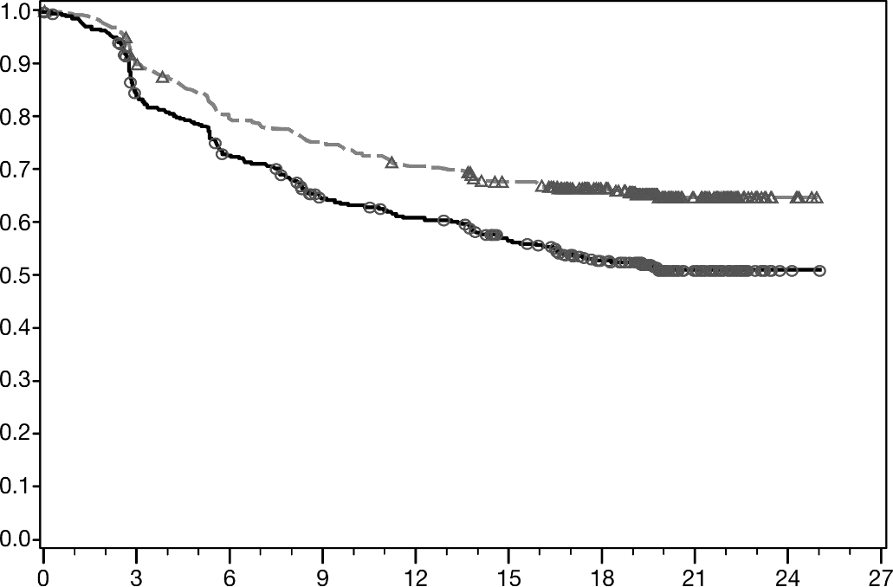

Recurrence-free survival (Months)
Probability of Recurrence-Free Survival

Number of Subjects at Risk
Nivolumab
453 | 399 | 353 | 332 | 311 | 291 | 249 | 71 | 5 | 0
Ipilimumab
453 | 364 | 314 | 269 | 252 | 225 | 184 | 56 | 2 | 0
──∆───Nivolumab - - - - - - Ipilimumab

Table 9 Efficacy results (CA209238)
 | nivolumab (n = 453) | ipilimumab 10 mg/kg^{c}  (n = 453)
Recurrence-free Survival
Events | 154 (34.0%) | 206 (45.5%)
Hazard ratioª | 0.65
97.56% CI | (0.51, 0.83)
p-value^{b} | p<0.0001
Median (95% CI) months | Not Reached | Not Reached (16.56, NR)
Rate (95% CI) at 12 months | 70.5 (66.1, 74.5) | 60.8 (56.0, 65.2)
Rate (95% CI) at 18 months | 66.4 (61.8, 70.6) | 52.7 (47.8, 57.4)
a Derived from a stratified proportional hazards model.
b P-value is derived from a log-rank test stratified by tumour PD-L1 expression and stage of disease; the corresponding O’Brien-Fleming efficacy boundary significance level is 0.0244.
c Not registered in Australia

RFS benefit was consistently demonstrated across subgroups, including tumour PD-L1 expression, BRAF status, and stage of disease.

Quality of life (QoL), was assessed by the European Organization for Research and Treatment of Cancer (EORTC) QLQ-C30, the EQ-5D utility index and visual analog scale (VAS). QoL with nivolumab remained stable and close to baseline values during treatment.

Previously untreated unresectable or metastatic melanoma - OPDIVO monotherapy
Randomised phase 3 study vs. dacarbazine (CA209066)
The safety and efficacy of nivolumab 3 mg/kg as monotherapy for the treatment of advanced (unresectable or metastatic) melanoma were evaluated in a phase 3, randomised, double-blind study (CA209066). The study included adult patients (18 years or older) with confirmed, treatment-naive, Stage III or IV BRAF wild-type melanoma and an ECOG performance-status score of 0 or 1. Patients with active autoimmune disease, ocular melanoma, or active brain or leptomeningeal metastases were excluded from the study.
A total of 418 patients were randomised to receive either nivolumab (n = 210) administered intravenously over 60 minutes at 3 mg/kg every 2 weeks or dacarbazine (n = 208) at 1000 mg/m² every 3 weeks. Randomisation was stratified by tumour PD-L1 status and M stage (M0/M1a/M1b versus M1c). Treatment was continued as long as clinical benefit was observed or until treatment was no longer tolerated. Treatment after disease progression was permitted for patients who had a clinical benefit and did not have substantial adverse effects with the study drug, as determined by the investigator. Tumour assessments, according to the Response Evaluation Criteria in Solid Tumours (RECIST), version 1.1, were conducted 9 weeks after randomisation and continued every 6 weeks for the first year and then every 12 weeks thereafter. The primary efficacy outcome measure was overall survival (OS). Key secondary efficacy outcome measures were investigator-assessed progression free survival (PFS) and objective response rate (ORR).
Baseline characteristics were balanced between the two groups. The median age was 65 years (range: 18-87), 59% were men, and 99.5% were white. Most patients had ECOG performance score of 0 (64%) or 1 (34%). Sixty-one percent of patients had M1c stage disease at study entry. Seventy-four percent of patients had cutaneous melanoma, and 11% had mucosal melanoma; 35% of patients had PD-L1 positive melanoma (>5% tumour cell membrane expression). Sixteen percent of patients had received prior adjuvant therapy; the most common adjuvant treatment was interferon (9%). Four percent of patients had a history of brain metastasis, and 37% of patients had a baseline LDH level greater than ULN at study entry.
The observed OS (Figure 2, Table 11) benefit was consistently demonstrated across subgroups of patients including baseline ECOG performance status, M stage, history of brain metastases, and baseline LDH level. Survival benefit was observed regardless of whether PD-L1 expression was above or below a PD-L1 tumour membrane expression cut-off of 5% or 10%.

Figure 2 Overall survival (CA209066)
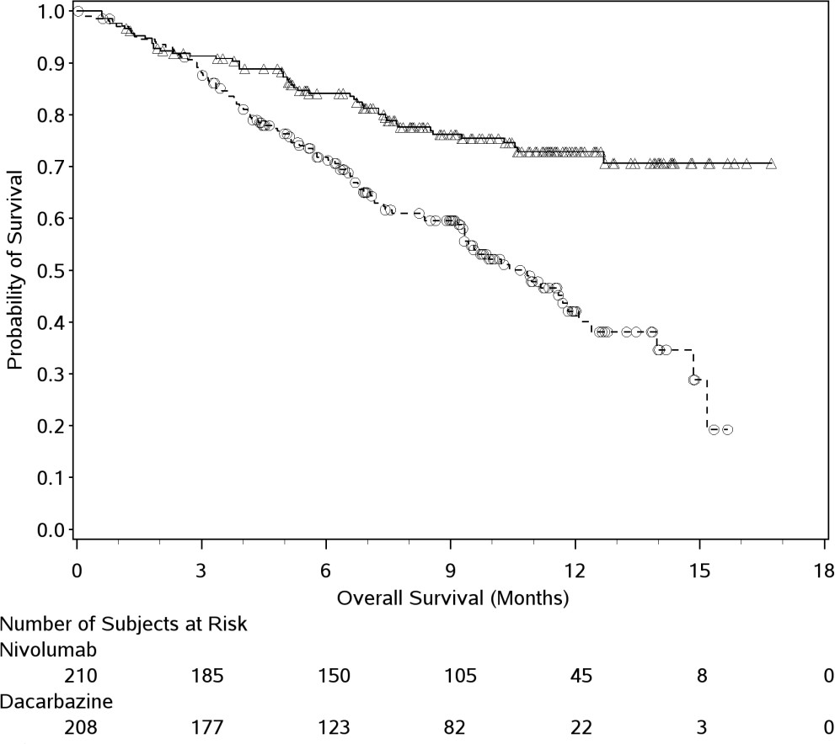

──∆─── Nivolumab (events: 50/210), median and 95% CI: N.A.
- - -- - - Dacarbazine (events: 96/208), median 10.84 months 95% CI: (9.33, 12.09)

Table 11 Efficacy results (CA209066)
 | nivolumab (n = 210) |  | dacarbazine (n = 208)
Overall survival
Events | 50 (23.8%) |  | 96 (46.2%)
Hazard ratio |  | 0.42
99.79% CI |  | (0.25, 0.73)
95% CI |  | (0.30, 0.60)
p-value |  | < 0.0001
Median (95% CI) | Not reached |  | 10.8 (9.33, 12.09)
Rate % (95% CI)
At 6 months | 84.1 (78.3, 88.5) |  | 71.8 (64.9, 77.6)
At 12 months | 72.9 (65.5, 78.9) |  | 42.1 (33.0, 50.9)
Progression-free survival
Events | 108 (51.4%) |  | 163 (78.4%)
Hazard ratio |  | 0.43
95% CI |  | (0.34, 0.56)
p-value |  | < 0.0001
Median (95% CI) | 5.1 (3.48, 10.81) |  | 2.2 (2.10, 2.40)
Rate % (95% CI)
At 6 months | 48.0 (40.8, 54.9) |  | 18.5 (13.1, 24.6)
At 12 months | 41.8 (34.0, 49.3) |  | NA
Objective response | 84 | (40.0%) | 29 | (13.9%)
(95% CI) | (33.3, 47.0) |  | (9.5, 19.4)
Odds ratio (95% CI) |  | 4.06 (2.52, 6.54)
p-value |  | < 0.0001
Complete response (CR) | 16 | (7.6%) | 2 | (1.0%)
Partial response (PR) | 68 | (32.4%) | 27 | (13.0%)
Stable disease (SD) | 35 | (16.7%) | 46 | (22.1%)
Median duration of response
Months (range) | Not reached | (0⁺- 12.5⁺) | 6.0 | (1.1 - 10.0⁺)
Median time to response
Months (range) | 2.1 | (1.2 - 7.6) | 2.1 | (1.8-3.6)

Previously untreated unresectable or metastatic melanoma - OPDIVO in combination with ipilimumab
Randomised phase 3 study of nivolumab in combination with ipilimumab or nivolumab as monotherapy vs. ipilimumab as monotherapy (CA209067)
The safety and efficacy of nivolumab in combination with ipilimumab and nivolumab monotherapy for the treatment of advanced (unresectable or metastatic) melanoma were evaluated in a phase 3, randomised, double-blind study (CA209067). The study included adult patients (18 years or older) with confirmed unresectable Stage III or Stage IV melanoma, regardless of PD-L1 expression. Patients were to have ECOG performance status score of 0 or 1. Patients who had not received prior systemic anticancer therapy for unresectable or metastatic melanoma were enrolled. Prior adjuvant or neoadjuvant therapy was allowed if it was completed at least 6 weeks prior to randomisation. Patients with active autoimmune disease, ocular/uveal melanoma, or active brain or leptomeningeal metastases were excluded from the study.

A total of 945 patients were randomised to receive nivolumab in combination with ipilimumab (n = 314), nivolumab as monotherapy (n = 316), or ipilimumab as monotherapy (n = 315). Patients in the combination arm received nivolumab 1 mg/kg over 60 minutes and ipilimumab 3 mg/kg over 90 minutes administered intravenously every 3 weeks for the first 4 doses, followed by nivolumab 3 mg/kg as monotherapy every 2 weeks. Patients in the nivolumab monotherapy arm received nivolumab 3 mg/kg every 2 weeks. Patients in the comparator arm received ipilimumab 3 mg/kg and nivolumab- matched placebo intravenously every 3 weeks for 4 doses followed by placebo every 2 weeks. Randomisation was stratified by PD-L1 expression (≥5% vs. <5% tumour cell membrane expression), BRAF status, and M stage per the American Joint Committee on Cancer (AJCC) staging system. Treatment was continued as long as clinical benefit was observed or until treatment was no longer tolerated. Tumour assessments were conducted 12 weeks after randomisation then every 6 weeks for the first year, and every 12 weeks thereafter. The co-primary outcome measures were PFS and OS. ORR and the duration of response were also assessed. This study evaluated whether PD-L1 expression was a predictive biomarker for the co-primary endpoints. The efficacy of nivolumab in combination with ipilimumab and nivolumab monotherapy was each compared with that of ipilimumab. In addition, the differences between the two OPDIVO-containing groups were evaluated descriptively, but not included in formal hypothesis testing.
Baseline characteristics were balanced across the three treatment groups. The median age was 61 years (range: 18 to 90 years), 65% of patients were men, and 97% were white. ECOG performance status score was 0 (73%) or 1 (27%). The majority of the patients had AJCC Stage IV disease (93%); 58% had M1c disease at study entry. Twenty-two percent of patients had received prior adjuvant therapy. Thirty-two percent of patients had BRAF mutation-positive melanoma; 26.5% of patients had PD-L1
≥5% tumour cell membrane expression. Four percent of patients had a history of brain metastasis, and 36% of patients had a baseline LDH level greater than ULN at study entry. Baseline tumour tissue specimens were systematically collected prior to randomisation in order to conduct planned analyses of efficacy according to PD-L1 expression. Quantifiable tumour PD-L1 expression was measured in 89% (278/314) of patients randomised to nivolumab in combination with ipilimumab, 91% (288/316) of patients randomised to nivolumab monotherapy, and 88% (277/315) of patients randomised to ipilimumab alone. Among patients with quantifiable PD-L1 expression, the distribution of patients was balanced across the three treatment groups at the predefined tumour PD-L1 expression level of ≥5% (24% in the nivolumab in combination with ipilimumab arm, 28% in the nivolumab monotherapy arm, and 27% in the ipilimumab arm). Tumour PD-L1 expression was determined using the PD-L1 IHC 28- 8 pharmDx assay.
Both nivolumab-containing arms demonstrated a significant PFS and OS benefit and greater ORR compared with ipilimumab monotherapy.
Efficacy results for all randomised patients are shown in Table and Figure 3 (PFS), and Figure 4 (OS).
Among 128 patients who discontinued nivolumab in combination with ipilimumab due to adverse reaction after 18 months of follow-up, median PFS was 16.7 months (95% CI: 10.2, NA). Among 131 patients who discontinued the combination due to adverse reaction after 28 months of follow-up, the ORR was 71% (93/131) with 20% (26/131) achieving a complete response and median OS was not reached.

Table 12 Efficacy results (CA209067)

 | nivolumab+ ipilimumab (n=314) | nivolumab (n=316) | ipilimumab (n=315)
Progression-free survival
Events, n (%) | 161 (51.3%) | 183 (57.9%) | 245 (77.8%)
Hazard ratio (vs. ipilimumab) (99.5% CI) | 0.42  (0.32, 0.56) | 0.55 (0.42, 0.73)
p-value | p<0.0001 | p<0.0001
Hazard ratio (vs. nivolumab monotherapy)  (95% CI) ^{c} | 0.76  (0.62, 0.95)
Median months  (95% CI) | 11.5  (8.9, 22.18) | 6.9  (4.3, 9.5) | 2.9  (2.8, 3.4)
Rate % (95% CI)
At 6 months | 62 (56, 67) | 52 (46, 57) | 29 (24, 34)
At 9 months | 49 (44, 56) | 42 (36, 47) | 18 (14, 23)
At 18 months | 46 (41, 52) | 39 (34, 45) | 14 (10, 18)
Overall survival^{b}
Events (%) | 128 (41%) | 142 (45%) | 197 (63%)
Hazard ratio (vs ipilimumab) | 0.55 | 0.63
(98% CI) | (0.42, 0.72) | (0.48, 0.81)
p-value | p<0.0001 | p<0.0001
Hazard ratio (vs nivolumab monotherapy) | 0.88
(95% CI) ^{c} | (0.69, 1.12)
Median months | Not reached | Not reached | 20.0
(95% CI) |  | (29.1, NE) | (17.1, 24.6)
Rate (95% CI)
At 12 months | 73% (68, 78) | 74% (69, 79) | 67% (61, 72)
At 24 months | 64% (59, 69) | 59% (53, 64) | 45% (39, 50)
Objective response rate | 185 (59%) | 141 (45%) | 60 (19%)
(95% CI) | (53.3, 64.4) | (39.1, 50.3) | (14.9, 23.8)
Odds ratio (vs ipilimumab) | 6.5 | 3.54
(95% CI) | (3.81, 11.08) | (2.1, 5.95)
Complete response (CR) | 54 (17%) | 47 (15%) | 14 (4%)
Partial response (PR) | 131 (42%) | 94 (30%) | 46 (15%)
Stable disease (SD) | 36 (12%) | 31 (10%) | 67 (21%)
Duration of Response
Median (range), months | Not reached (0⁺-33.3⁺) | 31.1 (0⁺-32.3⁺) | 18.2 (0⁺-31.5⁺)
Proportion ≥ 12 months in duration | 64% | 70% | 53%
Proportion ≥ 24 months in  duration | 50% | 49% | 32%
a Minimum follow up of 18 months .
b Minimum follow up of 28 months.
c Unadjusted for multiplicity NE=not estimable.
“+” denotes a censored observation.

Figure 3 Progression-free survival (CA209067)
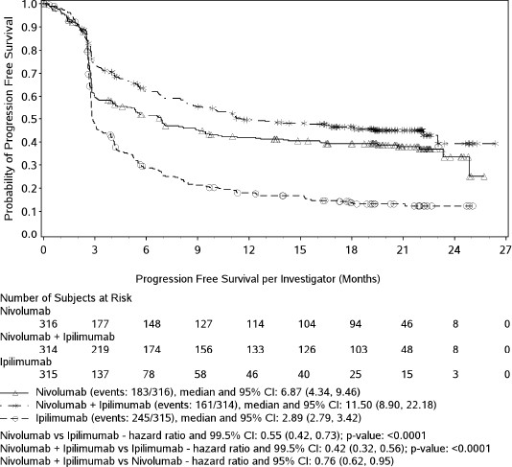

Figure 4 Overall survival(CA209067)
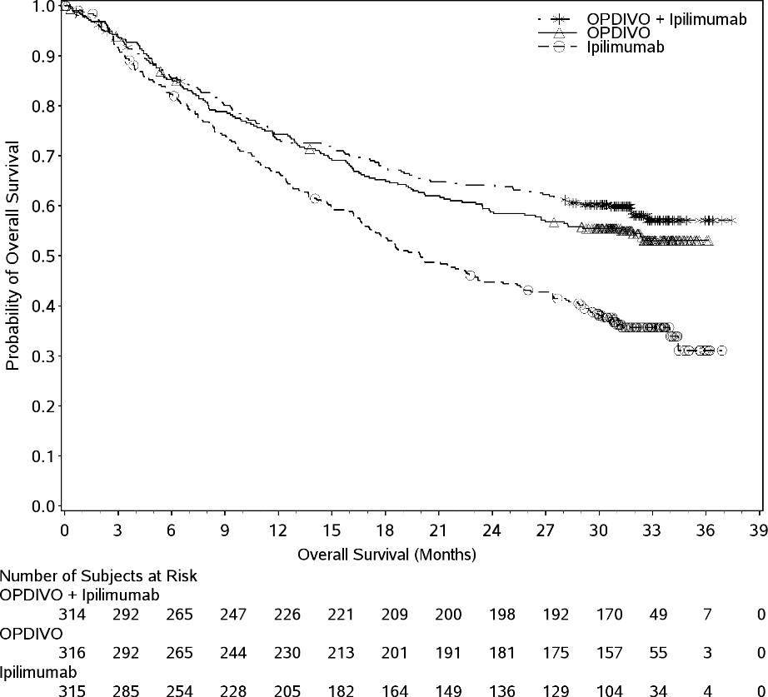
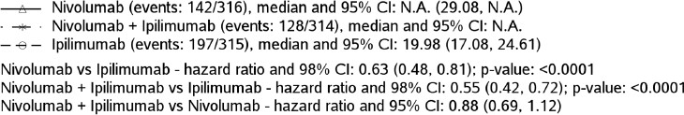

The improvements in PFS, OS, ORR and DOR that were seen in both nivolumab-containing arms compared to ipilimumab monotherapy (Table ) were consistent across patient subgroups including baseline ECOG performance status, BRAF status, M stage (7th Edition of AJCC melanoma of the skin staging classification system), age, history of brain metastases, baseline LDH level and tumour PD-L1 expression levels
Greater objective response rates were demonstrated for nivolumab in combination with ipilimumab relative to nivolumab monotherapy across tumour PD-L1 expression levels, with a best overall response of complete response correlating to an improved survival rate.
Analyses comparing nivolumab monotherapy to nivolumab in combination with ipilimumab were all descriptive. Kaplan-Meier plots of these exploratory subgroup analyses comparing PFS and OS in patients with tumour PD-L1 expression of <1% versus ≥1% are included below as Figure 5 and Figure 6.
No clear cut-off for PD-L1 expression can reliably be established when considering the relevant endpoints of tumour response, PFS and OS.

Figure 5 Progression-free survival by tumour PD-L1 expression level (CA209067) at 18 months of follow-up

< 1% ≥ 1%
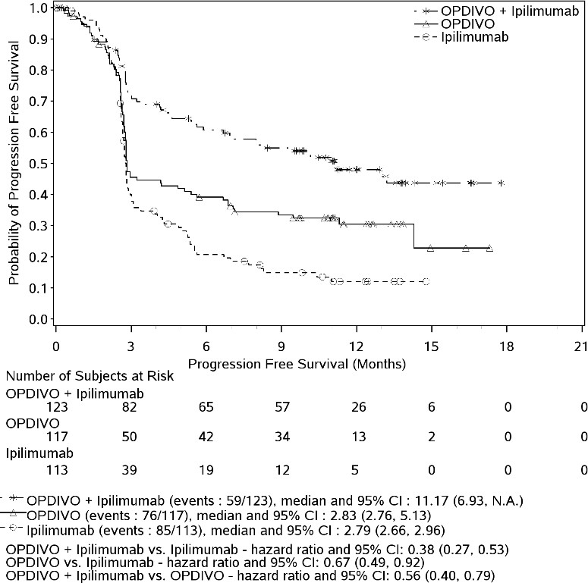
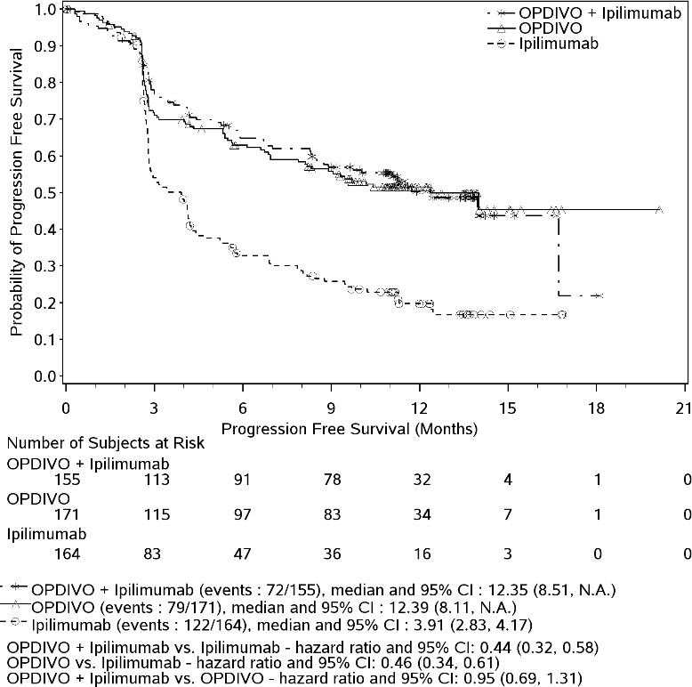

Figure 6 Overall survival by tumour PD-L1 expression level (CA209067) at 2 years of follow-up

< 1% ≥ 1%
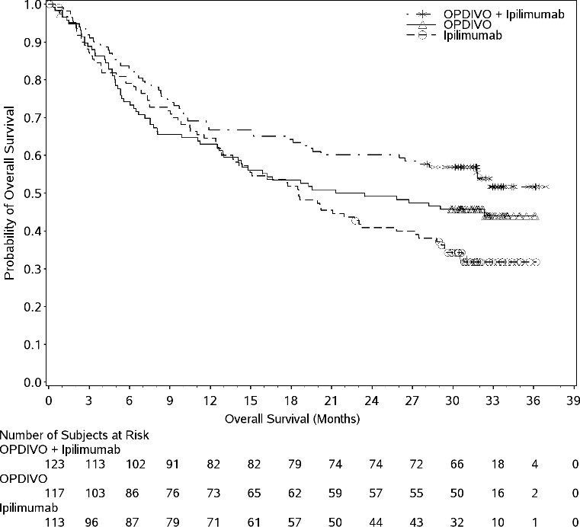
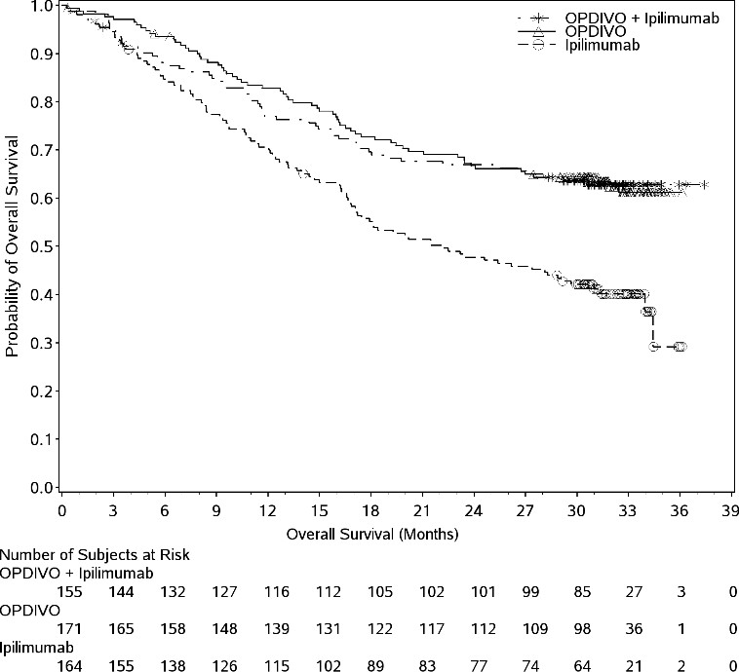

The safety of the combination of nivolumab and ipilimumab in patients across all pre-defined subgroups was consistent with that in all randomised patients.

Randomised phase 2 study of nivolumab in combination with ipilimumab vs ipilimumab (CA209069) Study CA209069 was a randomised, Phase 2, double-blind study comparing the combination of nivolumab and ipilimumab with ipilimumab alone in 142 patients with advanced (unresectable or metastatic) melanoma with similar inclusion criteria to study CA209067 and the primary analysis in patients with BRAF wild-type melanoma (77% of patients). Investigator assessed ORR was 61% (95% CI: 48.9, 72.4) in the combination arm (n=72) versus 11% (95% CI: 3.0, 25.4) for the
ipilimumab arm (n=37). The estimated 12 and 18 month OS rates were 79% (95% CI: 67, 87) and 73%
(95% CI: 61, 82) respectively for the combination and 62% (95% CI: 44, 75) and 56% (95% CI: 39, 70) respectively for ipilimumab.

Previously treated unresectable or metastatic melanoma - OPDIVO monotherapy
Randomised phase 3 study vs. chemotherapy (CA209037)
The safety and efficacy of OPDIVO 3 mg/kg as monotherapy for the treatment of advanced (unresectable or metastatic) melanoma were evaluated in a phase 3, randomised, open-label study (CA209037). The study included adult patients who had progressed on or after ipilimumab and if BRAF V600 mutation positive had also progressed on or after BRAF kinase inhibitor therapy. Patients with active autoimmune disease, ocular melanoma, or a known history of prior ipilimumab-related high- grade (Grade 4 per CTCAE v4.0) adverse reactions except for resolved nausea, fatigue, infusion reactions, or endocrinopathies were excluded from the study.
A total of 405 patients were randomised to receive either nivolumab (n = 272) administered intravenously over 60 minutes at 3 mg/kg every 2 weeks or chemotherapy (n = 133) which consisted of the investigator’s choice of either dacarbazine (1000 mg/m² every 3 weeks) or carboplatin (AUC 6 every 3 weeks) and paclitaxel (175 mg/m² every 3 weeks). Randomisation was stratified by BRAF and tumour PD-L1 status and best response to prior ipilimumab.
The co-primary efficacy outcome measures were confirmed ORR in the first 120 patients treated with nivolumab, as measured by independent radiology review committee (IRRC) using RECIST 1.1, and comparison of OS of nivolumab to chemotherapy. Additional outcome measures included duration and timing of response.
The median age was 60 years (range: 23-88). Sixty-four percent of patients were men and 98% were white. ECOG performance scores were 0 for 61% of patients and 1 for 39% of patients. The majority (75%) of patients had M1c stage disease at study entry. Seventy-three percent of patients had cutaneous melanoma and 10% had mucosal melanoma. The number of prior systemic regimen received was 1 for 27% of patients, 2 for 51% of patients, and > 2 for 21% of patients. Twenty-two percent of patients had tumours that tested BRAF mutation positive and 50% of patients had tumours that were considered PD- L1 positive. Sixty-four percent of patients had no prior clinical benefit (CR/PR or SD) on ipilimumab. Baseline characteristics were balanced between groups except for the proportions of patients who had a history of brain metastasis (19% and 13% in the nivolumab group and chemotherapy group, respectively) and patients with LDH greater than ULN at baseline (51% and 35%, respectively).
At the time of this final ORR analysis, results from 120 nivolumab-treated patients and 47 chemotherapy-treated patients who had a minimum of 6 months of follow-up were analysed. Efficacy results are presented in Table 13.

Table 13 Efficacy results (CA209037)
 | nivolumab (n=120) | chemotherapy (n=47)
Confirmed Objective Response (IRRC) | 38 (31.7%) | 5 (10.6%)
(95% CI) | (23.5, 40.8) | (3.5, 23.1)
Complete Response (CR) | 4 (3.3%) | 0
Partial Response (PR) | 34 (28.3%) | 5 (10.6%)
Stable Disease (SD) | 28 (23.3%) | 16 (34.0%)
Median Duration of Response
Months (range) | Not Reached | 3.6 (Not available)
Median Time to Response
Months (range) | 2.1 (1.6-7.4) | 3.5 (2.1-6.1)

Objective responses to nivolumab (according to the definition of the co-primary endpoint) were observed in patients with or without BRAF mutation-positive melanoma. Of the patients who received nivolumab, the ORR in the BRAF mutation-positive subgroup (n = 26) was 23% (95% CI: 9.0, 43.6), and 34% (95% CI: 24.6, 44.5) in patients whose tumours were BRAF wild-type (n = 94). Objective responses to nivolumab were observed regardless of whether patients had tumours that were designated PD-L1 negative or PD-L1 positive (tumour membrane expression cut off of 5% or 10%). However, the role of this biomarker (tumour PD-L1 expression) has not been fully elucidated.
The OS data were not mature at the time of the PFS analysis. There was no statistically significant difference between nivolumab and chemotherapy in the preliminary OS analysis that was not adjusted for the potentially confounding effects of subsequent therapy. It is of note that 42 (31.6%) patients in the chemotherapy arm subsequently received an anti-PD1 treatment.
PFS numerically favoured the nivolumab group vs. the chemotherapy group in all randomised patients, BRAF mutation positive patients, and BRAF wild-type patients (HRs 0.74 [95% CI: 0.57, 0.97], 0.98
[95% CI: 0.56, 1.70], and 0.63 [95% CI: 0.47, 0.85], respectively).
Phase 1 dose-escalation study (CA209003/MDX1106-03)
The safety and tolerability of OPDIVO were investigated in a phase 1, open-label dose-escalation study in various tumour types, including malignant melanoma. Of the 306 patients enrolled in the study, 107 had melanoma and received OPDIVO at a dose of 0.1 mg/kg, 0.3 mg/kg, 1 mg/kg, 3 mg/kg, or 10 mg/kg for a maximum of 2 years. In this patient population, objective response was reported in 33 patients (31%) with a median duration of response of 22.9 months (95% CI: 17.0, NR). The median PFS was
3.7 months (95% CI: 1.9, 9.3). The median OS was 17.3 months (95% CI: 12.5, 36.7), and the estimated
OS rates were 63% (95% CI: 53, 71) at 1 year, 48% (95% CI: 38, 57) at 2 years, and 41% (95% CI: 31,
51) at 3 years.

NON-SMALL CELL LUNG CANCER (NSCLC)

Neoadjuvant treatment of resectable NSCLC - OPDIVO in combination with chemotherapy
Randomised phase 3 study vs. platinum-doublet chemotherapy (CA209816)
CA209816 was a randomised, open label trial in patients with resectable NSCLC. The trial included patients with resectable, histologically confirmed Stage IB (≥4 cm), II, or IIIA NSCLC (per the 7th edition American Joint Committee on Cancer/Union for International Cancer Control (AJCC/UICC) staging criteria), ECOG performance status 0 or 1, and measurable disease (per RECIST version 1.1 ). Patients were enrolled regardless of their tumour PD-L1 status. Patients with unresectable or metastatic NSCLC, known EGFR mutations or ALK translocations, Grade 2 or greater peripheral neuropathy, active autoimmune disease, or medical conditions requiring systemic immunosuppression were excluded from the study.
Patients were randomised to receive either:

- OPDIVO 360 mg administered intravenously over 30 minutes and platinum-doublet chemotherapy administered intravenously every 3 weeks for up to 3 cycles, or
- platinum-doublet chemotherapy administered every 3 weeks for up to 3 cycles.
Platinum-doublet chemotherapy consisted of paclitaxel 175 mg/m² or 200 mg/m² and carboplatin AUC 5 or AUC 6 (any histology); pemetrexed 500 mg/m² and cisplatin 75 mg/m² (non-squamous histology); or gemcitabine 1000 mg/m² or 1250 mg/m² and cisplatin 75 mg/m² (squamous histology). In the platinum-doublet chemotherapy arm, two additional treatment regimen options included vinorelbine 25 mg/m² or 30 mg/m² and cisplatin 75 mg/m²; or docetaxel 60 mg/m² or 75 mg/m² and cisplatin 75 mg/m² (any histology). Stratification factors for randomisation were tumour PD-L1 expression level (≥1% versus <1% or non-quantifiable), disease stage (IB/II versus IIIA), and sex (male versus female). Tumour assessments were performed at baseline, within 14 days of surgery, every 12 weeks after surgery for 2 years, then every 6 months for 3 years, and every year for 5 years until disease recurrence or progression. The primary efficacy outcome measures were event-free survival (EFS) based on BICR assessment and pathologic complete response (pCR) as evaluated by blinded independent pathology review (BIPR). Secondary efficacy outcome measures included OS.
A total of 358 patients were randomised to receive either OPDIVO in combination with platinum doublet chemotherapy (n=179) or platinum-doublet chemotherapy (n=179). The median age was 65 years (range: 34 to 84) with 51% of patients ≥65 years and 7% of patients ≥75 years, 50% were Asian, 47% were White, 2% were Black, and 71% were male. Baseline ECOG performance status was 0 (67%) or 1 (33%); 50% had tumours with PD-L1 expression ≥1% and 43% had tumors with PD-L1 expression that was <1%; 5% had stage IB, 17% had stage IIA, 13% had stage IIB, and 64% had stage IIIA disease; 51% had tumours with squamous histology and 49% had tumours with non-squamous histology; and 89% were former/current smokers.
Numerically more patients in the OPDIVO in combination with platinum-doublet chemotherapy arm (83%) had definitive surgery compared to patients in the platinum-doublet chemotherapy arm (75%).
The study demonstrated statistically significant improvement in EFS and pCR. Efficacy results are presented in Table14 and Figure 7.

Table14: Efficacy Results - CA209816

 | OPDIVO and Platinum- Doublet Chemotherapy (n=179) | Platinum-Doublet Chemotherapy (n=179)
Event-free Survival (EFS) per BICR
Events (%) | 64 (35.8) | 87 (48.6)
Median (months)a | 31.6 | 20.8
(95% CI) | (30.2, NR) | (14.0, 26.7)
Hazard Ratiob | 0.63
(97.38% CI) | (0.43, 0.91)
Stratified log-rank p-valuec | 0.0052
Rate (95% CI) at 12 months | 76.1 (68.8, 81.9) | 63.4 (55.3, 70.4)
Rate (95% CI) at 24 months | 63.8 (55.7, 70.9) | 45.3 (37.0, 53.2)
Pathologic Complete Response (pCR) per BIPR
Responses (%) | 43 (24.0) | 4 (2.2)
95% CId | 18.0, 31.0 | 0.6, 5.6
Difference of pCR (99% CI)e | 21.6 (13.0, 30.3)
Odds ratio of pCR (99% CI)f | 13.9 (3.49, 55.75)

Table14: Efficacy Results - CA209816

 | OPDIVO and Platinum- Doublet Chemotherapy (n=179) | Platinum-Doublet Chemotherapy (n=179)
Stratified log-rank p-valueg | <0.0001
Minimum follow-up for EFS was 21 months.
a Kaplan-Meier estimate.
b Based on a stratified Cox proportional hazard model.
c Based on a stratified log-rank test. Boundary for statistical significance: p-value <0.0262.
d Based on Clopper and Pearson method.
e Strata-adjusted difference based on Cochran-Mantel-Haenszel method of weighting.
f Strata-adjusted using Mantel-Haenszel method.
g From stratified CMH test.

Figure 7: Event-Free Survival - CA209816
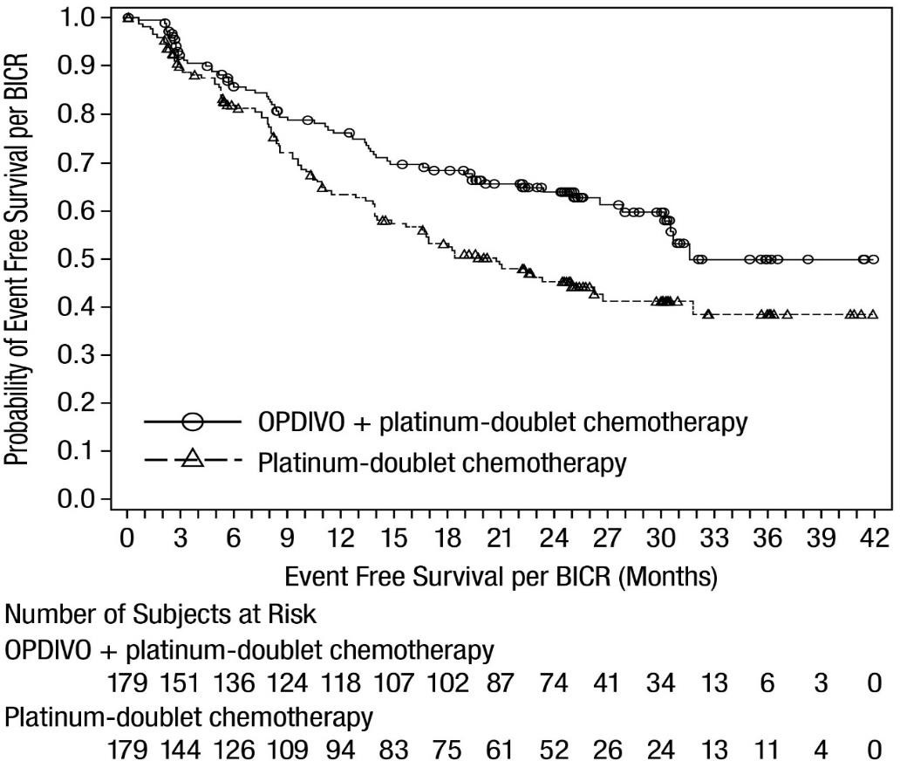

An exploratory subgroup analysis of EFS stratified according to level of PD-L1 expression in the patient’s tumour was performed with a minimum follow-up of 21 months. Greater EFS benefit was observed in patients treated with nivolumab in combination with chemotherapy who had PD-L1 expression ≥ 1% (HR [95% CI] 0.41 [0.24, 0.70]) than in patients with PD-L1 expression < 1% (HR
[95% CI] 0.85 [0.54, 1.32].

Previously untreated advanced or metastatic NSCLC - OPDIVO in combination with ipilimumab and chemotherapy
Randomised phase 3 study vs. platinum-doublet chemotherapy (CA2099LA)
CA2099LA was a randomised, open-label trial in patients with metastatic or recurrent NSCLC. The trial included patients (18 years of age or older) with histologically confirmed Stage IV or recurrent NSCLC (per the 7th International Association for the Study of Lung Cancer classification [IASLC]), ECOG performance status 0 or 1, and no prior systemic anticancer therapy (including EGFR and ALK

inhibitors) for metastatic disease. Patients were enrolled regardless of their tumor PD-L1 status. Patients with known EGFR mutations or ALK translocations sensitive to available targeted inhibitor therapy, untreated brain metastases, carcinomatous meningitis, active autoimmune disease, or medical conditions requiring systemic immunosuppression were excluded from the study. Patients with treated brain metastases were eligible if neurologically returned to baseline at least 2 weeks prior to enrollment, and either off corticosteroids, or on a stable or decreasing dose of <10 mg daily prednisone equivalents.
Patients were randomized 1:1 to receive either nivolumab 360 mg administered intravenously over 30 minutes every 3 weeks in combination with ipilimumab 1 mg/kg administered intravenously over 30 minutes every 6 weeks and platinum-doublet chemotherapy administered every 3 weeks for 2 cycles; or platinum-doublet chemotherapy administered every 3 weeks for 4 cycles. Patients with non- squamous NSCLC in the control arm could receive optional pemetrexed maintenance therapy. Stratification factors for randomisation were tumour PD-L1 expression level (≥1% versus <1% or non- quantifiable), histology (squamous versus non-squamous), and gender (male versus female). Platinum- doublet chemotherapy consisted of either:
  - carboplatin (AUC 5 or 6) and pemetrexed 500 mg/mg2; or cisplatin 75 mg/m2 and pemetrexed 500 mg/m2 for non-squamous NSCLC, or
  - carboplatin (AUC 6) and paclitaxel 200 mg/m2 for squamous NSCLC.
Study treatment continued until disease progression, unacceptable toxicity, or for up to 2 years. Treatment continued beyond disease progression if a patient was clinically stable and was considered to be deriving clinical benefit by the investigator. Patients who discontinued combination therapy because of an adverse event attributed to ipilimumab were permitted to continue nivolumab as a single agent. Tumour assessments were performed every 6 weeks from the first dose of study treatment for the first 12 months, then every 12 weeks until disease progression or study treatment was discontinued. The primary efficacy outcome measure was OS. Additional efficacy outcome measures included PFS, ORR, and duration of response as assessed by BICR.
A total of 719 patients were randomized to receive either nivolumab in combination with ipilimumab and platinum-doublet chemotherapy (n=361) or platinum-doublet chemotherapy (n=358). The median age was 65 years (range: 26 to 86) with 51% of patients ≥65 years and 10% of patients ≥75 years. The majority of patients were white (89%) and male (70%). Baseline ECOG performance status was 0 (31%) or 1 (68%), 57% of patients had tumours with PD-L1expression ≥1% and 37% had tumours with PD-L1 expression <1%, 31% had tumours with squamous histology and 69% had tumours with non- squamous histology, 17% had brain metastases and 86% were former or current smokers.
Efficacy results from the prespecified interim analysis when 351 events were observed (87% of the planned number of events for final analysis) demonstrated a statistically significant benefit in OS, PFS, and ORR, and a clinically meaningful benefit in duration of response (Table ). With an additional 4.6 months of follow-up, the hazard ratio for overall survival was 0.66 (95% CI: 0.55, 0.80) and median survival was 15.6 months (95% CI: 13.9, 20.0) and 10.9 months (95% CI: 9.5, 12.5) for patients receiving nivolumab and ipilimumab and platinum-doublet chemotherapy or platinum-doublet chemotherapy, respectively (Figure 8).

Figure 8: Overall Survival - updated analysis (CA2099LA)
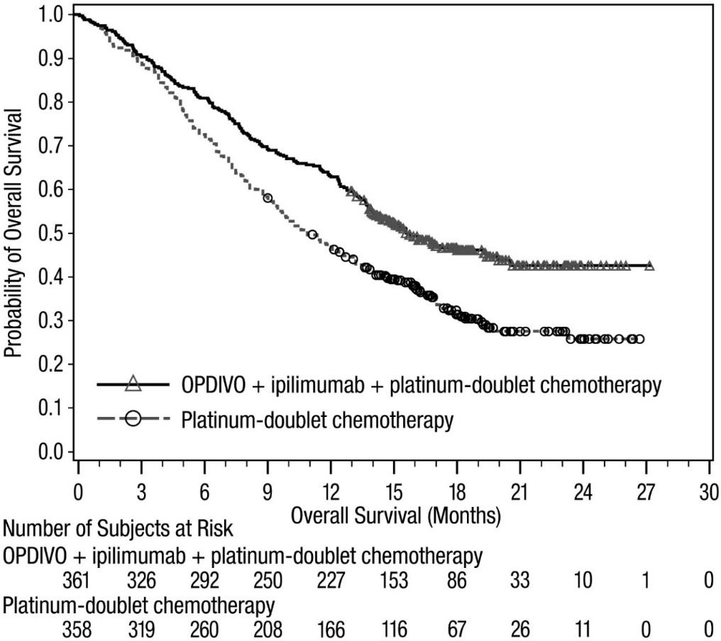

nivolumab in combination with ipilimumab and 2 cycles of platinum-doublet chemotherapy v/s platinum-doublet chemotherapy HR 0.66 (95% CI: 0.55, 0.80)

Table 15 Efficacy Results (CA2099LA)

 | Nivolumab and Ipilimumab and Chemotherapy  (n=361) | Chemotherapy (n=358)
Overall Survival
Events (%) | 156 (43.2) | 195 (54.5)
Median (months) (95% CI) | 14.1  (13.2, 16.2) | 10.7  (9.5, 12.5)
Hazard ratio (96.71% CI)a | 0.69 (0.55, 0.87)
Stratified log-rank p-valueb | 0.0006
Rate (95% CI) at 6 months | 80.9 (76.4, 84.6) | 72.3 (67.4, 76.7)
Progression-free Survival per BICR
Events (%) | 232 (64.3) | 249 (69.6)
Hazard ratio (97.48% CI)a | 0.70 (0.57, 0.86)
Stratified log-rank p-valuec | 0.0001
Median (months)d (95% CI) | 6.8  (5.6, 7.7) | 5.0  (4.3, 5.6)
Rate (95% CI) at 6 months | 51.7 (46.2, 56.8) | 35.9 (30.5, 41.3)
Overall Response Rate per BICR (%)e | 38 | 25

Table 15 Efficacy Results (CA2099LA)

 | Nivolumab and Ipilimumab and Chemotherapy  (n=361) | Chemotherapy (n=358)
(95% CI) | (33, 43) | (21, 30)
Stratified CMH test p-valuef | 0.0003
Duration of Response per BICR
Median (months) (95% CI)d | 10.0  (8.2, 13.0) | 5.1  (4.3, 7.0)
a Based on a stratified Cox proportional hazard model.
b p-value is compared with the allocated alpha of 0.0329 for this interim analysis.
c p-value is compared with the allocated alpha of 0.0252 for this interim analysis.
d Kaplan-Meier estimate.
e Proportion with complete or partial response; confidence interval based on the Clopper and Pearson Method.
f p-value is compared with the allocated alpha of 0.025 for this interim analysis.

Previously treated advanced or metastatic squamous (SQ) NSCLC - OPDIVO monotherapy
Randomised phase 3 study vs. docetaxel (CA209017)
The safety and efficacy of nivolumab 3 mg/kg as monotherapy for the treatment of advanced or metastatic SQ NSCLC were evaluated in a phase 3, randomised, open-label study (CA209017). The study included patients (18 years or older) who have experienced disease progression during or after one prior platinum doublet-based chemotherapy regimen. Patients were enrolled regardless of their PD- L1 status. Patients with active autoimmune disease, symptomatic interstitial lung disease, or untreated brain metastasis were excluded from the study. Patients with treated brain metastases were eligible if neurologically returned to baseline at least 2 weeks prior to enrolment, and either off corticosteroids, or on a stable or decreasing dose of <10 mg daily prednisone equivalents.
A total of 272 patients were randomised to receive either nivolumab 3 mg/kg (n = 135) administered intravenously over 60 minutes every 2 weeks or docetaxel (n = 137) 75 mg/m² every 3 weeks. Treatment was continued as long as clinical benefit was observed or until treatment was no longer tolerated. Tumour assessments, according to the RECIST, version 1.1, were conducted 9 weeks after randomisation and continued every 6 weeks thereafter. The primary efficacy outcome measure was OS. Key secondary efficacy outcome measures were investigator-assessed ORR and PFS. In addition, symptom improvement and overall health status were assessed using the Lung Cancer Symptom Score (LCSS) average symptom burden index and the EQ-5D Visual Analogue Scale (EQ-VAS), respectively.
Baseline characteristics were generally balanced between the two groups. The median age was 63 years (range: 39-85) with 44% ≥65 years of age and 11% ≥75 years of age. The majority of patients were white (93%) and male (76%). Thirty-one percent had progressive disease reported as the best response to their most recent prior regimen and 45% received nivolumab within 3 months of completing their most recent prior regimen. Baseline ECOG performance status score was 0 (24%) or 1 (76%).
The observed OS benefit (Figure 9, Table ) was consistently demonstrated across subgroups of patients. At the pre-defined PD-L1 tumour membrane expression cutoff levels of 1%, 5%, and 10%, similar survival was observed regardless of PD-L1 expression status.
Study CA209017 included a limited number of patients ≥ 75 years (11 in the nivolumab group and 18 in the docetaxel group). Nivolumab showed numerically less effect on OS (HR 1.85; 95% CI: 0.76, 4.51), PFS (HR 1.76; 95%-CI: 0.77, 4.05) and ORR (9.1% vs. 16.7%). Because of the small sample size, no definitive conclusions can be drawn from these data.

Figure 9 Overall survival (CA209017)
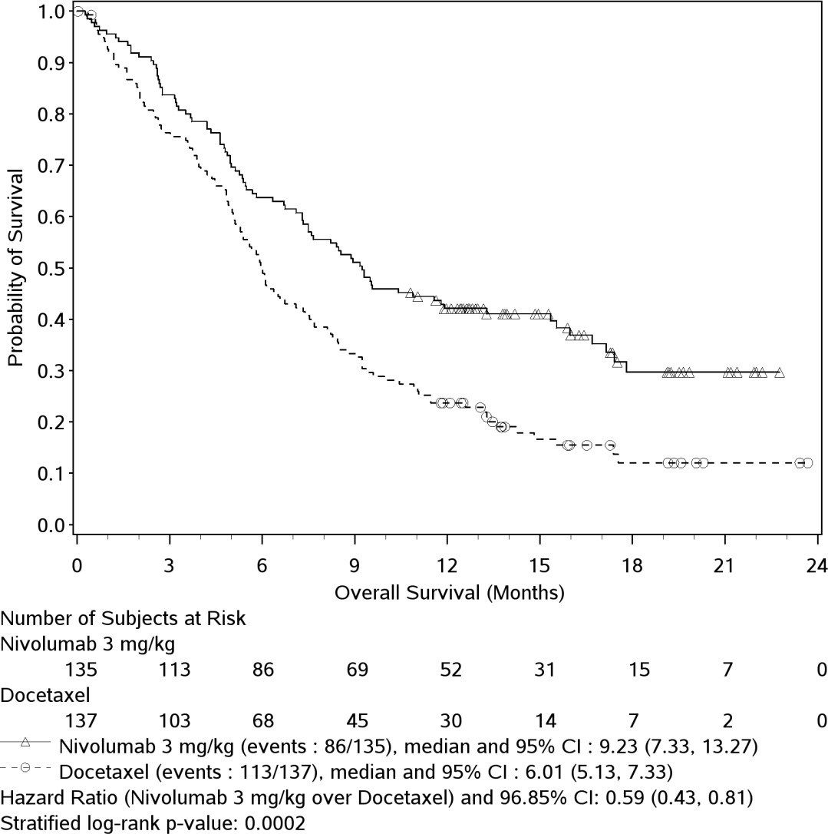

Table 16 Efficacy results (CA209017)
 | nivolumab (n = 135) |  | docetaxel (n = 137)
Overall survival
Events | 86 (63.7%) |  | 113 (82.5%)
Hazard ratio |  | 0.59
96.85% CI |  | (0.43, 0.81)
p-value |  | 0.0002
Median (95% CI) months | 9.23 (7.33, 13.27) |  | 6.01 (5.13, 7.33)
Rate % (95% CI) at 12 months | 42.1 (33.7, 50.3) |  | 23.7 (16.9, 31.1)
Confirmed objective response | 27 | (20.0%) | 12 | (8.8%)
(95% CI) | (13.6, 27.7) |  | (4.6, 14.8)
Odds ratio (95% CI) |  | 2.64 (1.27, 5.49)
p-value |  | 0.0083
Complete response (CR) | 1 | (0.7%) | 0
Partial response (PR) | 26 | (19.3%) | 12 | (8.8%)
Stable disease (SD) | 39 | (28.9%) | 47 | (34.3%)
Median duration of response
Months (range) | Not reached | (2.9 - 20.5⁺) | 8.4 | (1.4⁺ - 15.2⁺)
Median time to response
Months (range) | 2.2 | (1.6 - 11.8) | 2.1 | (1.8 - 9.5)
Progression-free survival
Events | 105 (77.8%) |  | 122 (89.1%)
Hazard ratio |  | 0.62
95% CI |  | (0.47, 0.81)
p-value |  | < 0.0004
Median (95% CI) (months) | 3.48 (2.14, 4.86) |  | 2.83 (2.10, 3.52)
Rate % (95% CI) at 12 months | 20.8 (14.0, 28.4) |  | 6.4 (2.9, 11.8)

The rate of disease-related symptom improvement, as measured by LCSS, was similar between the nivolumab group (18.5%) and the docetaxel group (21.2%). The average EQ-VAS increased over time for both treatment groups, indicating better overall health status for patients remaining on treatment.
The OS rates at 24 months were 22.9% (95% CI: 16.2, 30.3) for nivolumab and 8.0% (95% CI: 4.3,
13.3) for docetaxel. The PFS rate at 24 months for nivolumab was 15.6% (95% CI: 9.7, 22.7) and for docetaxel there were no patients at risk at 24 months as all patients had either progressed, were censored, or lost to follow-up. With minimum 24 months follow-up, objective response rates remain 20.0% for nivolumab and 8.8% for docetaxel with median durations of response 25.2 months (range: 2.9, 30.4) and 8.4 months (range: 1.4+, 18.0+), respectively.
Single-arm phase 2 study (CA209063)
Study CA209063 was a single-arm, open-label study conducted in 117 patients with locally advanced or metastatic squamous NSCLC after two or more lines of therapy; otherwise similar inclusion criteria as study CA209017 were applied. Nivolumab 3 mg/kg showed an overall response rate of 14.5% (95% CI: 8.7, 22.2%), a median OS of 8.21 months (95% CI: 6.05, 10.9), and a median PFS of 1.87 months (95% CI 1.77, 3.15). The PFS was measured by RECIST, version 1.1. The estimated 1-year survival rate was 41%.

Previously treated advanced or metastatic non-squamous (NSQ) NSCLC - OPDIVO monotherapy
Randomised phase 3 study vs. docetaxel (CA209057)
The safety and efficacy of nivolumab 3 mg/kg as a single agent for the treatment of advanced or metastatic non-squamous NSCLC were evaluated in a phase 3, randomised, open-label study (CA209057). The study included patients (18 years or older) who have experienced disease progression during or after one prior platinum doublet-based chemotherapy regimen which may have included maintenance therapy and who had an ECOG performance status score of 0 or 1. An additional line of TKI therapy was allowed for patients with known EGFR mutation or ALK translocation. Patients were enrolled regardless of their PD-L1 status. Patients with active autoimmune disease, symptomatic interstitial lung disease, or untreated brain metastasis were excluded from the study. Patients with treated brain metastases were eligible if neurologically returned to baseline at least 2 weeks prior to enrolment, and either off corticosteroids, or on a stable or decreasing dose of <10 mg daily prednisone equivalents.
A total of 582 patients were randomised to receive either nivolumab 3 mg/kg administered intravenously over 60 minutes every 2 weeks (n = 292) or docetaxel 75 mg/m² every 3 weeks (n = 290). Treatment was continued as long as clinical benefit was observed or until treatment was no longer tolerated. Tumour assessments, according to the RECIST version 1.1, were conducted 9 weeks after randomisation and continued every 6 weeks thereafter. The primary efficacy outcome measure was OS. Key secondary efficacy outcome measures were investigator-assessed ORR and PFS. In addition, symptom improvement and overall health status were assessed using the LCSS average symptom burden index and the EQ-5D Visual Analogue Scale (EQ-VAS), respectively.
The median age was 62 years (range: 21 to 85) with 34% ≥65 years of age and 7% ≥75 years of age. The majority of patients were white (92%) and male (55%). Baseline ECOG performance status was 0 (31%) or 1 (69%). Seventy-nine percent of patients were former/current smokers.
The Kaplan-Meier curves for OS are shown in Figure 10.

Figure 10 Overall survival (CA209057)
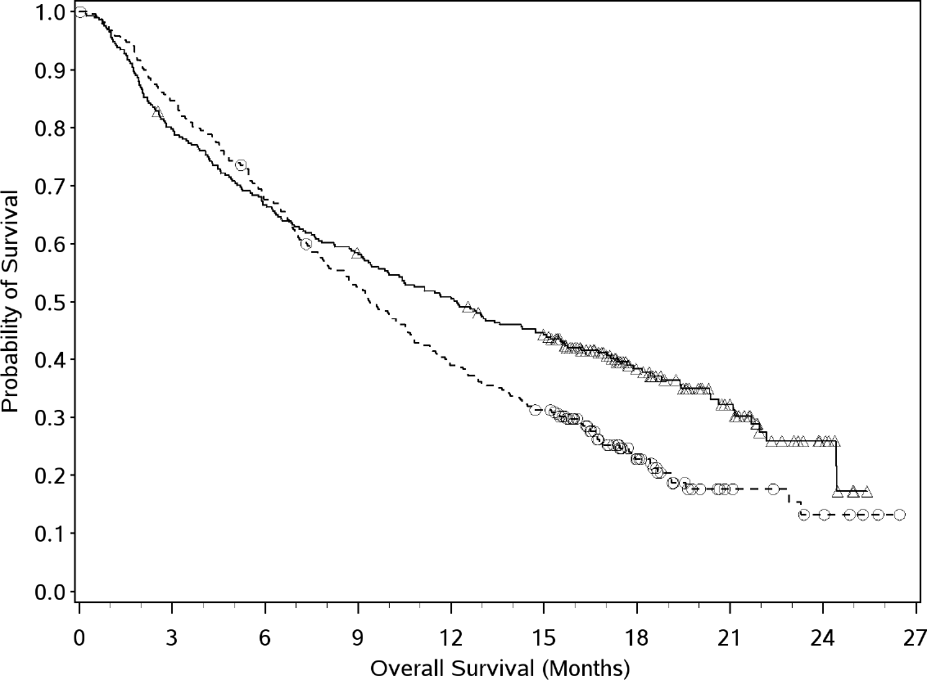
OPDIVO
Docetaxel
Number at Risk
OPDIVO

The trial demonstrated a statistically significant improvement in OS for patients randomised to nivolumab as compared with docetaxel at the prespecified interim analysis when 413 events were observed (93% of the planned number of events for final analysis). Efficacy results are shown in Table
. Within the first three months, a higher number of deaths was observed with nivolumab monotherapy compared to docetaxel, followed by a long-term survival benefit (see Figure 10). Factors associated with early deaths were poorer prognostic factors and/or more aggressive disease combined with low or no tumour PD-L1 expression.

Table 17 Efficacy Results (CA209057)
 | nivolumab (n = 292) | docetaxel (n = 290)
Prespecified interim analysis
Overall survival
Events (%) | 190 (65.1%) | 223 (76.9%)
Hazard ratioª | 0.73
(95.92% CI) | (0.59, 0.89)
p-value^{b} | 0.0015
Median (95% CI) months | 12.19 (9.66, 14.98) | 9.36 (8.05, 10.68)
Rate % (95% CI) at 12 months | 50.5 (44.6, 56.1) | 39.0 (33.3, 44.6)
Confirmed objective response | 56 (19.2%) | 36 (12.4%)
(95% CI) | (14.8, 24.2) | (8.8, 16.8)
Odds ratio (95% CI) | 1.68 (1.07, 2.64)
p-value | 0.0246
Complete response (CR) | 4 (1.4%) | 1 (0.3%)
Partial response (PR) | 52 (17.8%) | 35 (12.1%)
Stable disease (SD) | 74 (25.3%) | 122 (42.1%)
Median duration of response
Months (range) | 17.15 (1.8, 22.6+) | 5.55 (1.2+, 15.2+)
Median time to response
Months (range) | 2.10 (1.2, 8.6) | 2.61 (1.4, 6.3)
Progression-free survival
Events | 234 (80.1%) | 245 (84.5%)
Hazard ratio | 0.92
95% CI | (0.77, 1.11)
p-value | 0.3932
Median (95% CI) months | 2.33 (2.17, 3.32) | 4.21 (3.45, 4.86)
Rate % (95% CI) at 12 months | 18.5 (14.1, 23.4) | 8.1 (5.1, 12.0)
a Derived from a stratified proportional hazards model.
b P-value is derived from a log-rank test stratified by prior maintenance therapy and line of therapy; the corresponding O’Brien- Fleming efficacy boundary significance level is 0.0408.

The rate of disease-related symptom improvement, as measured by LCSS, was similar between the nivolumab group (17.8%) and the docetaxel group (19.7%). The average EQ-VAS increased over time for both treatment groups, indicating better overall health status for patients remaining on treatment.
The OS rates at 24 months were 28.7% (95% CI: 23.6, 34.0) for nivolumab and 15.8% (95% CI: 11.9,
20.3) for docetaxel. The PFS rates at 24 months were 11.9% (95% CI: 8.3, 16.2) for nivolumab and
1.0% (95% CI: 0.2, 3.3) for docetaxel. With minimum 24 months follow-up, objective response rates remain 19.2% for nivolumab and 12.4% for docetaxel with median durations of response 17.2 months (range: 1.8, 33.7+) and 5.6 months (range: 1.2+, 16.8), respectively.

MALIGNANT PLEURAL MESOTHELIOMA (MPM)

Previously untreated unresectable malignant pleural mesothelioma - OPDIVO in combination with ipilimumab
Randomised phase 3 study vs. chemotherapy (CA209743)
CA209743 was a randomised, open-label trial in patients with unresectable malignant pleural mesothelioma. The trial included patients (18 years of age and older) with histologically confirmed and previously untreated malignant pleural mesothelioma of epithelioid or non-epithelioid histology, ECOG performance status 0 or 1, and no palliative radiotherapy within 14 days of first trial therapy. Patients

with primitive peritoneal, pericardial, testis, or tunica vaginalis mesothelioma, interstitial lung disease, active autoimmune disease, medical conditions requiring systemic immunosuppression, and brain metastasis (unless surgically resected or treated with stereotaxic radiotherapy and no evolution within 3 months prior to inclusion in the trial) were excluded from the trial. Patients received nivolumab 3 mg/kg over 30 minutes by intravenous infusion every 2 weeks and ipilimumab 1 mg/kg over 30 minutes by intravenous infusion every 6 weeks for up to 2 years, or chemotherapy consisting of cisplatin 75 mg/m2 and pemetrexed 500 mg/m2 or carboplatin 5 AUC and pemetrexed 500 mg/m2 for up to 6 cycles (each cycle was 21 days). Stratification factors for randomisation were tumor histology (epithelioid vs. sarcomatoid or mixed histology subtypes) and gender (male vs. female). Study treatment continued until disease progression, unacceptable toxicity, or for up to 24 months. Patients who discontinued combination therapy because of an adverse reaction attributed to ipilimumab were permitted to continue nivolumab as a single agent as part of the study. Treatment continued beyond disease progression if a patient was clinically stable and was considered to be deriving clinical benefit by the investigator. Tumour assessments were performed every 6 weeks from the first dose of study treatment for the first 12 months, then every 12 weeks until disease progression or study treatment was discontinued. The primary efficacy outcome measure was OS. Additional efficacy outcome measures included PFS, ORR, duration of response, and disease control rate (DCR) as assessed by BICR utilizing modified RECIST criteria.
A total of 605 patients were randomised to receive either nivolumab in combination with ipilimumab (n=303) or chemotherapy (n=302). The median age was 69 years (range: 25 to 89) with 72% ≥65 and 26% ≥75 years, 85% White, and 77% male. Baseline ECOG performance status was 0 (40%) or 1 (60%), and 75% had epithelioid and 25% had non-epithelioid histology.
The trial demonstrated a statistically significant improvement in OS for patients randomized to nivolumab in combination with ipilimumab compared to chemotherapy with a minimum follow-up of 22 months. Efficacy results from the prespecified interim analysis when at least 403 events were observed (85% of the planned number of events for final analysis) are presented in Table and Figure 11.

Table 18 Efficacy Results (CA209743)

 | Nivolumab and Ipilimumab (n=303) | Chemotherapy (n=302)
Overall Survival
Events (%) | 200 (66) | 219 (73)
Median (months)ª (95% CI) | 18.1  (16.8, 21.5) | 14.1  (12.5, 16.2)
Hazard ratio (96.6% CI)^{b} | 0.74 (0.60, 0.91)
Stratified log-rank p-value^{c} | 0.002
Rate (95% CI) at 24 monthsª | 41% (35.1, 46.5) | 27% (21.9, 32.4)
Progression-free Survival
Events (%) | 218 (72) | 209 (69)
Hazard ratio (95% CI)^{b} | 1.0 (0.82, 1.21)
Median (months)ª (95% CI) | 6.8  (5.6, 7.4) | 7.2  (6.9, 8.1)
Overall Response Rate | 40% | 43%
(95% CI) | (34.1, 45.4) | (37.1, 48.5)
Complete response | 1.7% | 0
Partial response | 38% | 43%
Duration of Response
Median (months)ª (95% CI) | 11.0  (8.1, 16.5) | 6.7  (5.3, 7.1)
% with duration ≥6 months | 69% | 53%
Disease Control Rate (95% CI) | 77% (71.4, 81.2) | 85% (80.6, 88.9)
a Kaplan-Meier estimate.

b Stratified Cox proportional hazard model.
c p-value is compared with the allocated alpha of 0.0345 for this interim analysis.

Figure 11: Overall Survival (CA209743)
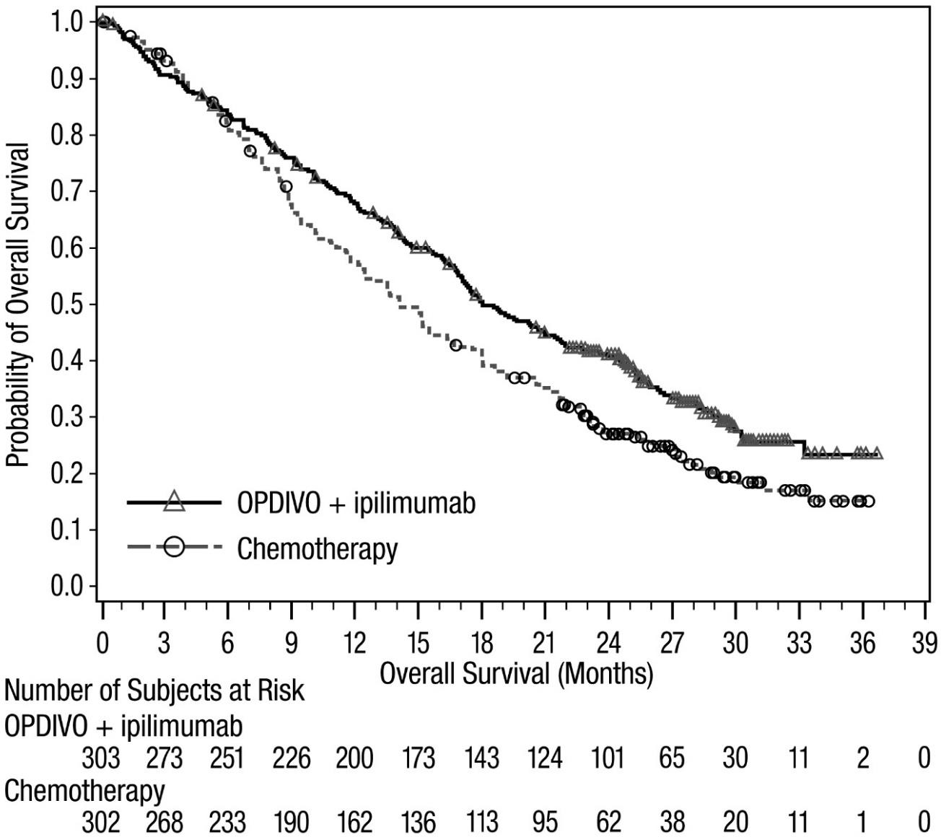
--○-- Nivolumab + ipilimumab (events: 200/303), median and 95% CI: 18.07 (16.82, 21.45)
--+-- Chemotherapy (events: 219/302), median and 95% CI: 14.09 (12.45, 16.23)
In a prespecified exploratory analysis based on histology, in the subgroup of patients with epithelioid histology, the hazard ratio (HR) for OS was 0.85 (95% CI: 0.68, 1.06), with median OS of 18.7 months in the OPDIVO and ipilimumab arm and 16.2 months in the chemotherapy arm. In the subgroup of patients with non-epithelioid histology, the HR for OS was 0.46 (95% CI: 0.31, 0.70), with median OS of 16.9 months in the OPDIVO and ipilimumab arm and 8.8 months in the chemotherapy arm.

RENAL CELL CARCINOMA (RCC)

Previously untreated advanced or metastatic RCC - OPDIVO in combination with ipilimumab
Randomised phase 3 study of nivolumab in combination with ipilimumab vs. sunitinib (CA209214) The safety and efficacy of nivolumab 3 mg/kg in combination with ipilimumab 1 mg/kg for the treatment of advanced RCC was evaluated in a Phase 3, randomised, open-label study (CA209214). The study included patients (18 years or older) with previously untreated, advanced or metastatic renal cell carcinoma and Karnofsky performance status ≥ 70%. Prior adjuvant or neoadjuvant therapy was

allowed if such therapy did not include an agent that targets vascular endothelial growth factor (VEGF) or VEGF receptors and recurrence occurred at least 6 months after the last dose of adjuvant or neoadjuvant therapy. The primary efficacy population includes those intermediate/poor risk patients with at least 1 or more of 6 prognostic risk factors as per the International Metastatic RCC Database Consortium (IMDC) criteria (less than one year from time of initial renal cell carcinoma diagnosis to randomization, Karnofsky performance status <80%, haemoglobin less than the lower limit of normal, corrected calcium of greater than 10 mg/dL, platelet count greater than the upper limit of normal, and absolute neutrophil count greater than the upper limit of normal). This study included patients regardless of their tumour PD-L1 status. Patients with any history of or concurrent brain metastases, active autoimmune disease, or medical conditions requiring systemic immunosuppression were excluded from the study. Patients were stratified by (IMDC) prognostic score and region.
A total of 1096 patients were randomised in the trial, of which 847 patients had intermediate/poor-risk RCC and received either nivolumab 3 mg/kg (n = 425) administered intravenously over 60 minutes in combination with ipilimumab 1 mg/kg administered intravenously over 30 minutes every 3 weeks for 4 doses followed by nivolumab monotherapy 3 mg/kg every 2 weeks or sunitinib (n = 422) 50 mg daily, administered orally for 4 weeks followed by 2 weeks off, every cycle. Treatment was continued as long as clinical benefit was observed or until treatment was no longer tolerated. The first tumour assessments were conducted 12 weeks after randomisation and continued every 6 weeks thereafter for the first year and then every 12 weeks until progression or treatment discontinuation, whichever occurred later. Treatment beyond initial investigator-assessed RECIST, version 1.1-defined progression was permitted if the patient had a clinical benefit and was tolerating study drug as determined by the investigator. The primary efficacy outcome measures were OS, ORR and PFS as determined by a Blinded Independent Central Review (BICR) in intermediate/poor risk patients.
Baseline characteristics were generally balanced between the two groups. The median age was 61 years (range: 21-85) with 38% ≥ 65 years of age and 8% ≥ 75 years of age. The majority of patients were male (73%) and white (87%), and 31% and 69% of patients had a baseline KPS of 70 to 80% and 90 to 100%, respectively. The median duration of time from initial diagnosis to randomisation was 0.4 years in both the nivolumab 3 mg/kg in combination with ipilimumab 1 mg/kg and sunitinib groups. The median duration of treatment was 7.9 months (range: 1 day- 21.4+ months) in nivolumab with ipilimumab- treated patients and was 7.8 months (range: 1 days- 20.2+ months) in sunitinib-treated patients. Nivolumab with ipilimumab was continued beyond progression in 29% of patients.
The Kaplan-Meier curves for OS in intermediate/poor risk patients is shown in Figure 12.

Figure 12 Overall survival in intermediate/poor risk patients with RCC (CA209214)
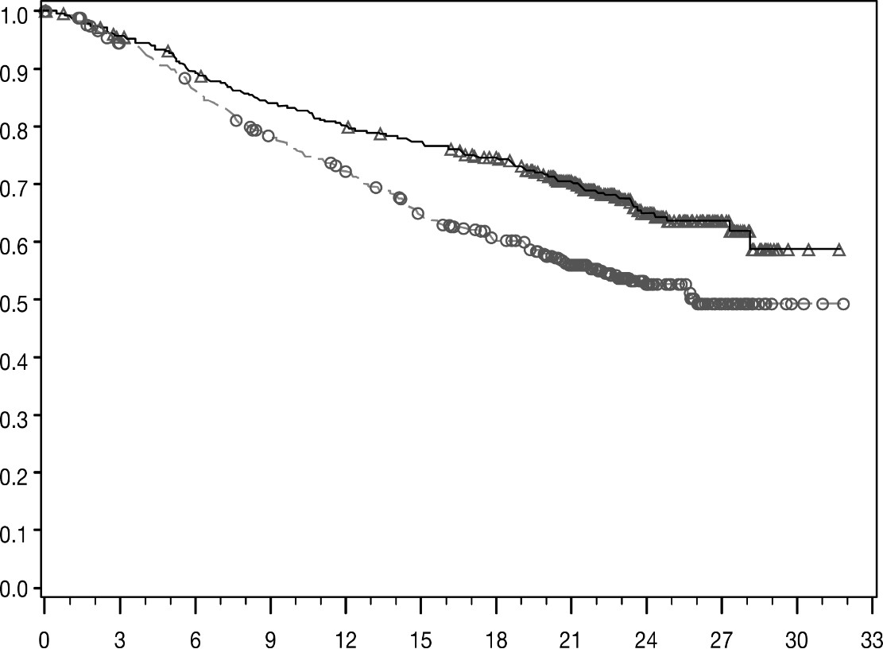
Overall Survival (Months)
Number of Subjects at Risk
Probability of Survival
Nivolumab + Ipilimumab
425 | 399 | 372 | 348 | 332 | 318 | 300 | 241 | 119 | 44 | 2 | 0
Sunitinib
422 | 387 | 352 | 315 | 288 | 253 | 225 | 179 | 89 | 34 | 3 | 0
Nivolumab + ipilimumab (events: 140/425), median and 95.0% CI: NE (28.2, NE)  Sunitinib (events: 188/422), median and 95.0% CI: 25.9 (22.1, NE)

The trial demonstrated superior OS and ORR and an improvement in PFS for intermediate/poor risk patients randomised to nivolumab plus ipilimumab as compared with sunitinib. (Table and Figure 12). OS benefit was observed regardless of tumour PD-L1 expression level.
Efficacy results are shown in Table .

Table 19 Efficacy results for intermediate/poor risk patients with RCC (CA209214)
 | nivolumab + ipilimumab (n = 425) |  | sunitinib (n = 422)
Overall survival
Events | 140 (33%) |  | 188 (45%)
Hazard ratioª |  | 0.63
99.8% CI |  | (0.44, 0.89)
p-value^{b,} ^{c} |  | <0.0001
Median (95% CI) | NE (28.2, NE) |  | 25.9 (22.1, NE)
Rate (95% CI)
At 6 months | 89.5 (86.1, 92.1) |  | 86.2 (82.4, 89.1)
At 12 months | 80.1 (75.9, 83.6) |  | 72.1 (67.4, 76.2)
Progression-free survival
Events | 228 (53.6%) |  | 228 (54.0%)
Hazard ratioª |  | 0.82
99.1% CI |  | (0.64, 1.05)
p-value^{b,h} |  | 0.0331
Median (95% CI) | 11.6 (8.71, 15.51) |  | 8.4 (7.03, 10.81)
Confirmed objective response  (BICR) | 177 | (41.6%) | 112 | (26.5%)
(95% CI) | (36.9, 46.5) |  | (22.4, 31.0)
Difference in ORR (95% CI)^{d} |  | 16.0 (9.8, 22.2)
p-value^{e,f} |  | < 0.0001
Complete response (CR) | 40 | (9.4%) | 5 | (1.2%)
Partial response (PR) | 137 | (32.2%) | 107 | (25.4%)
Stable disease (SD) | 133 | (31.3%) | 188 | (44.5%)
Median duration of response^{g}
Months (range) | NE | (1.4⁺-25.5⁺) | 18.17 | (11.3⁺-23.6⁺)
Median time to response
Months (range) | 2.8 | (0.9-11.3) | 3.0 | (0.6-15.0)
a Based on a stratified proportional hazards model.
b Based on a stratified log-rank test.
c p-value is compared to alpha 0.002 in order to achieve statistical significance.
d Strata adjusted difference.
e Based on the stratified DerSimonian-Laird text.
f p-value is compared to nominal alpha 0.001 in order to achieve statistical significance.
g Computed using Kaplan-Meier method.
h p-value did not meet the threshold of statistical significance is as compared to alpha 0.009 “⁺” denotes a censored observation.
NE = non-estimable

The median time to onset of objective response was 2.8 months (range: 0.9-11.3 months) after the start of nivolumab with ipilimumab treatment. One hundred seventy-seven (41.6%) responders had ongoing responses with a duration ranging from 1.4⁺-25.5⁺ months.
Disease related symptoms, cancer symptoms and non-disease specific Quality of Life (QoL) were assessed as an exploratory endpoint using the FKSI-19, FACT-G, and EQ-5D scales. Fewer patients in the nivolumab in combination with ipilimumab arm reported symptom deterioration than in the sunitinib arm, and scores for QoL were greater for nivolumab in combination with ipilimumab patients vs. those in the sunitinib arm at each assessment during the first six months of the study, when completion rates exceeded 80%. As patients were not blinded to treatment, interpretation of these patient-reported outcomes is limited.

Previously untreated advanced or metastatic RCC - OPDIVO in combination with cabozantinib
Randomised phase 3 study of nivolumab in combination with cabozantinib vs. sunitinib (CA2099ER) The safety and efficacy of nivolumab 240 mg in combination with cabozantinib 40 mg for the first-line treatment of advanced/metastatic RCC was evaluated in a phase 3, randomised, open-label study

(CA2099ER). The study included patients (18 years or older) with advanced or metastatic RCC with a clear cell component, Karnofsky Performance Status (KPS) ≥ 70%, and measurable disease as per RECIST v1.1 regardless of their PD-L1 status or IMDC risk group. Patients were stratified by IMDC prognostic score, PD-L1 tumour expression, and region.
A total of 651 patients were randomised to receive either nivolumab 240 mg (n = 323) administered intravenously every 2 weeks in combination with cabozantinib 40 mg once daily orally or sunitinib (n = 328) 50 mg daily, administered orally for 4 weeks followed by 2 weeks off. Treatment continued until disease progression or unacceptable toxcity with nivolumab administration for up to 24 months. Treatment beyond initial Investigator-assessed RECIST version 1.1-defined progression was permitted if the patient had a clinical benefit and was tolerating study drug, as determined by the investigator. First tumour assessment post-baseline was performed at 12 weeks (± 7 days) following randomisation. Subsequent tumour assessments occurred at every 6 weeks (± 7 days) until Week 60, then every 12 weeks (± 14 days) until radiographic progression, confirmed by the BICR.
Baseline characteristics were generally balanced between the two groups. The median age was 61 years (range: 28-90) with 38.4% ≥ 65 years of age and 9.5% ≥ 75 years of age. The majority of patients were male (73.9%) and white (81.9%), and 23.2% and 76.5% of patients had a baseline KPS of 70 to 80% and 90 to 100%, respectively. Patient distribution by IMDC risk categories was 22.6% favourable, 57.6% intermediate, and 19.7% poor. The median duration of treatment was 14.26 months (range: 0.2-27.3 months) in nivolumab with cabozantinib-treated patients and was 9.23 months (range: 0.8-27.6 months) in sunitinib-treated patients.
The primary efficacy outcome measure was PFS as determined by a BICR. Additional efficacy measures included OS and ORR as key secondary endpoints for hierarchical statistical testing.
The study demonstrated a statistically significant benefit in PFS, OS, and ORR for patients randomised to nivolumab in combination with cabozantinib as compared to sunitinib.
Consistent results were observed across pre-specified subgroups, IMDC risk categories, and PD-L1 tumour expression status.
The Kaplan-Meier curves for PFS and OS (with a minimum follow-up of 10.6 months) in all risk patients are shown in Figure 13 and Figure 14.

Figure 13 Kaplan-Meier curves of PFS (CA2099ER)
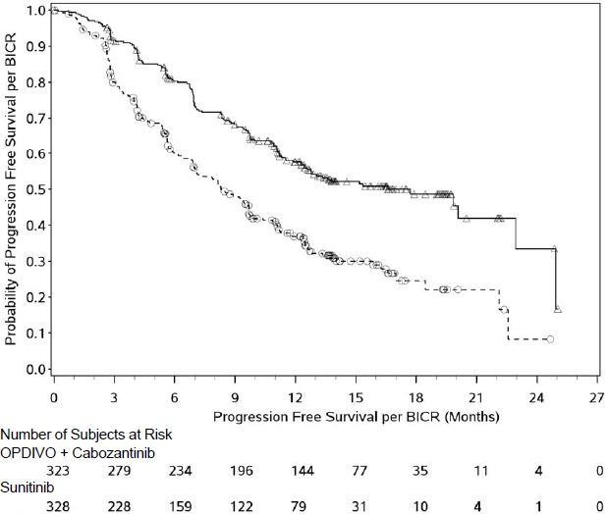
Nivolumab + cabozantinib (events: 142/323), median and 95.0% CI: 16.59 (12.45, 24.94)
Sunitinib (events: 191/328), median and 95.0% CI:8.31 (6.97, 9.69)

Figure 14 Kaplan-Meier curves of OS (CA2099ER)
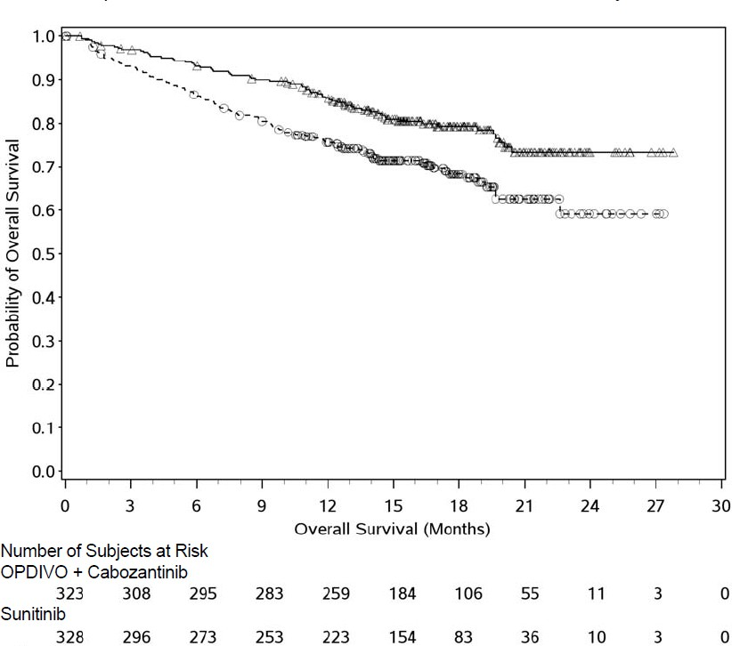
Nivolumab + cabozantinib (events: 67/323), median and 95% CI: NE Sunitinib (events: 99/328), median and 95% CI: NE (22.60, NE)
Efficacy results from the primary analysis (minimum follow-up 10.6 months) are shown in Table .

Table 20 Efficacy results (CA2099ER)
 | nivolumab + cabozantinib (n = 323) | sunitinib (n = 328)
Progression-free survival
Events | 144 (44.6%) | 191 (58.2%)
Hazard ratioª | 0.51
95% CI | (0.41, 0.64)
p-value^{b,} ^{c} | < 0.0001
Median (95% CI)^{d} | 16.6 (12.5, 24.9) | 8.3 (7.0, 9.7)
Overall survival
Events | 67 (20.7%) | 99 (30.2%)
Hazard ratioª | 0.60
98.89% CI | (0.40, 0.89)
p-value^{b,c,e} | 0.0010
Median (95% CI) | N.E. | N.E. (22.6, N.E.)
Rate (95% CI)
At 6 months | 93.1 (89.7, 95.4) | 86.2 (81.9, 89.5)
At 9 months | 89.9 (86.0, 92.8) | 80.5 (75.7, 84.4)
Confirmed objective response (BICR)^{f} | 180 (55.7%) | 89 (27.1%)
(95% CI) | (50.1, 61.2) | (22.4, 32.3)
Difference in ORR (95% CI)^{f} | 28.6 (21.7, 35.6)
p-value^{g} | < 0.0001
Complete response (CR) | 26 (8.0%) | 15 (4.6%)
Partial response (PR) | 154 (47.7%) | 74 (22.6%)
Stable disease (SD) | 104 (32.2%) | 138 (42.1%)
Median duration of response^{d}
Months (range) | 20.17 (17.31, N.E.) | 11.47 (8.31, 18.43)
Median time to response
Months (range) | 2.83 (1.0-19.4) | 4.17 (1.7-12.3)

a Stratified Cox proportional hazards model. Hazard ratio is nivolumab and cabozantinib over sunitinib.
b Based on Kaplan-Meier estimates.
c Log-rank test stratified by IMDC prognostic risk score (0, 1-2, 3-6), PD-L1 tumour expression (≥1% versus <1% or indeterminate) and region (US/Canada/W Europe/N Europe, ROW) as entered in the IRT.
d 2-sided p-values from stratified regular log-rank test.
e Boundary for statistical significance p-value <0.0111.
f CI based on the Clopper and Pearson method.
g 2-sided p-value from CMH test. NE = non-estimable

PFS benefit was observed in the nivolumab in combination with cabozantinib arm vs. sunitinib regardless of the IMDC risk category. Median PFS for the favourable risk group was not reached for nivolumab in combination with cabozantinib, and was 12.8 months in the sunitinib arm (HR = 0.60; 95% CI: 0.37, 0.98). Median PFS for the intermediate risk group was 17.7 months for nivolumab in combination with cabozantinib and was 8.4 months in the sunitinib arm (HR = 0.54; 95% CI: 0.41, 0.73). Median PFS for the poor risk group was 12.3 months for nivolumab in combination with cabozantinib and was 4.2 months in the sunitinib arm (HR = 0.36; 95% CI: 0.23, 0.58).

Previously treated advanced or metastatic RCC - OPDIVO monotherapy
Randomised phase 3 study of nivolumab vs everolimus (CA209025)
The safety and efficacy of nivolumab 3 mg/kg as a single agent for the treatment of advanced RCC was evaluated in a Phase 3, randomised, open-label study (CA209025). The study included patients (18 years or older) who have experienced disease progression during or after 1 or 2 prior anti- angiogenic therapy regimens and no more than 3 total prior systemic treatment regimens. Patients had to have a Karnofsky Performance Score (KPS) ≥70%. All patients had clear cell histology component. This study included patients regardless of their PD-L1 status. Patients with any history of or concurrent brain metastases, prior treatment with an mammalian target of rapamycin (mTOR) inhibitor, active autoimmune disease, or medical conditions requiring systemic immunosuppression were excluded from the study.
A total of 821 patients were randomised to receive either nivolumab 3 mg/kg (n = 410) administered intravenously over 60 minutes every 2 weeks or everolimus (n = 411) 10 mg daily, administered orally. Treatment was continued as long as clinical benefit was observed or until treatment was no longer tolerated. The first tumour assessments were conducted 8 weeks after randomisation and continued every 8 weeks thereafter for the first year and then every 12 weeks until progression or treatment discontinuation, whichever occurred later. Tumour assessments were continued after treatment discontinuation in patients who discontinued treatment for reasons other than progression. Treatment beyond initial investigator-assessed RECIST 1.1-defined progression was permitted if the patient had a clinical benefit and was tolerating study drug as determined by the investigator. The primary efficacy outcome measure was OS. Secondary efficacy assessments included investigator-assessed ORR and PFS.
Baseline characteristics were generally balanced between the two groups. The median age was 62 years (range: 18-88) with 40% ≥65 years of age and 9% ≥75 years of age. The majority of patients were male (75%) and white (88%), all Memorial Sloan Kettering Cancer Center (MSKCC) risk groups were represented, and 34% and 66% of patients had a baseline KPS of 70 to 80% and 90 to 100%, respectively. The majority of patients (72%) were treated with one prior anti-angiogenic therapy The median duration of time from initial diagnosis to randomisation was 2.6 years in both the nivolumab and everolimus groups. The median duration of treatment was 5.5 months (range: 0- 29.6⁺ months) in nivolumab-treated patients and was 3.7 months (range: 6 days-25.7⁺ months) in everolimus-treated patients.
Nivolumab was continued beyond progression in 44% of patients. The Kaplan-Meier curves for OS are shown in Figure 15.

Figure 15 Overall survival (CA209025)
Probability of Survival
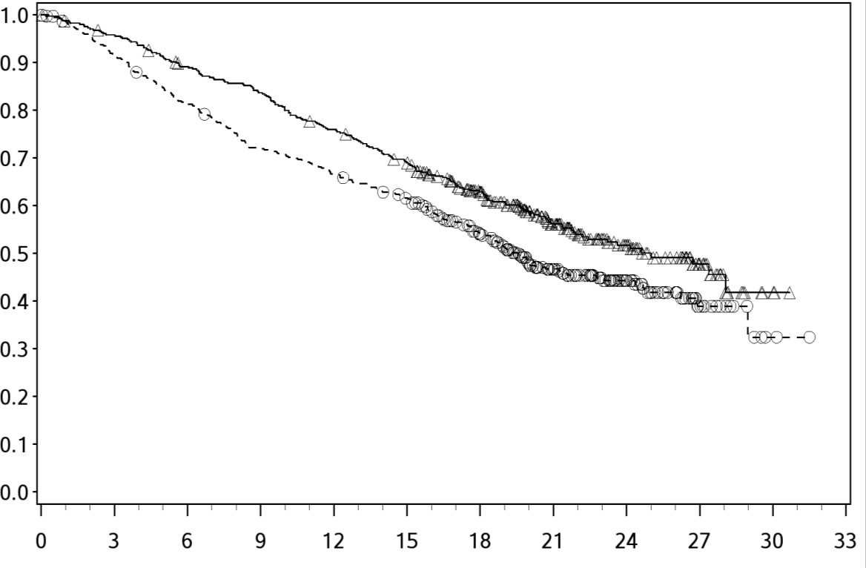
Overall Survival (Months)

Number of Subjects at Risk
Nivolumab
410 | 389 | 359 | 337 | 305 | 275 | 213 | 139 | 73 | 29 | 3 | 0
Everolimus
411 | 366 | 324 | 287 | 265 | 241 | 187 | 115 | 61 | 20 | 2 | 0
Nivolumab 3 mg/kg (events: 183/410), median and 95% CI: 25.00 (21.75, N.A.)
Everolimus 10 mg (events: 215/411), median and 95% CI: 19.55 (17.64, 23.06)

The trial demonstrated a statistically significant improvement in OS for patients randomised to nivolumab as compared with everolimus at the prespecified interim analysis when 398 events were observed (70% of the planned number of events for final analysis) (Table and Figure 15). OS benefit was observed regardless of PD-L1 expression level.
Efficacy results are shown in Table .

Table 21 Efficacy results (CA209025)
 | nivolumab (n = 410) |  | everolimus (n = 411)
Overall survival
Events | 183 (45) |  | 215 (52)
Hazard ratio |  | 0.73
95% CI |  | (0.57, 0.93)
p-value |  | < 0.0018
Median (95% CI) months | 25.0 (21.7, NE) |  | 19.6 (17.6, 23.1)
Rate % (95% CI)
At 6 months | 89.2 (85.7, 91.8) |  | 81.2 (77.0, 84.7)
At 12 months | 76.0 (71.5, 79.9) |  | 66.7 (61.8, 71.0))
Objective response | 103 | (25.1%) | 22 | (5.4%)
(95% CI) | (21.0, 29.6) |  | (3.4, 8.0)
Odds ratio (95% CI) |  | 5.98 (3.68, 9.72)
p-value |  | < 0.0001
Complete response (CR) | 4 | (1.0%) | 2 | (0.5%)
Partial response (PR) | 99 | (24.1%) | 20 | (4.9%)
Stable disease (SD) | 141 | (34.4%) | 227 | (55.2%)
Median duration of response
Months (range) | 11.99 | (0.0-27.6⁺) | 11.99 | (0.0⁺-22.2⁺)
Median time to response
Months (range) | 3.5 | (1.4-24.8) | 3.7 | (1,5-11,2)
Progression-free survival
Events | 318 (77.6) |  | 322 (78.3)
Hazard ratio |  | 0.88
95% CI |  | (0.75, 1.03)
p-value |  | 0.1135
Median (95% CI) months | 4.6 (3.71, 5.39) |  | 4.4 (3.71, 5.52)
Rate % (95% CI)
At 6 months | 39 (35, 44) |  | 39 (33, 44)
At 12 months | 23 (19, 27) |  | 19 (15, 23)
“⁺” denotes a censored observation.
The median time to onset of objective response was 3.5 months (range: 1.4-24.8 months) after the start of nivolumab treatment. Forty-nine (47.6%) responders had ongoing responses with a duration ranging from 0.0-27.6⁺ months.
Disease-related symptoms and non-disease specific quality of life (QoL) were assessed as a secondary endpoint using the Functional Assessment of Cancer Therapy-Kidney Symptom Index-Disease Related Symptoms (FKSI-DRS) and the EuroQoL EQ-5D scales. Patients in the nivolumab arm reported better symptom improvement and time to improvement than those in the everolimus arm. As patients were not blinded to treatment, interpretation of these patient-reported outcomes is limited.

CLASSICAL HODGKIN LYMPHOMA (cHL)

Previously treated relapsed or refractory cHL - OPDIVO monotherapy
Single-arm phase 2 study (CA209205) and phase 1 dose escalation study (CA209039)
Two open-label studies evaluated the safety and efficacy of nivolumab 3 mg/kg as a single agent for the treatment of relapsed or refractory cHL following autologous stem cell transplantation (ASCT).

Study CA209205 is an ongoing Phase 2, open-label, multi-cohort, single-arm study of nivolumab in cHL. It includes 243 patients who had ASCT; Cohort A included 63 (26%) patients who were brentuximab vedotin naïve; Cohort B included 80 (33%) patients who had received brentuximab vedotin after ASCT failure; and Cohort C included 100 (41%) patients who had received brentuximab vedotin before and/or after ASCT out of which 33 (14%) patients received brentuximab vedotin only prior to ASCT. Study CA209039 was an open-label, multicentre, dose escalation Phase 1 study that included 23 patients with cHL, 15 of whom received nivolumab following ASCT and brentuximab vedotin treatment and 5 of whom were ASCT naive.
Both studies included patients regardless of their tumour PD-L1 status and excluded patients with ECOG performance status of 2 or greater, autoimmune disease, hepatic transaminases more than 3 times ULN, creatinine clearance less than 40 mL/min, prior allogeneic haematopoietic stem cell transplant (HSCT), chest irradiation within 24 weeks or symptomatic interstitial lung disease.
In both studies, patients received 3 mg/kg of OPDIVO administered intravenously over 60 minutes every 2 weeks until disease progression or unacceptable toxicity (or maximal clinical benefit in CA209039). Dose reduction was not permitted. Tumour assessments were conducted 4 weeks (CA209039) or 9 weeks (CA209205) after the start of treatment and continued thereafter until disease progression or treatment discontinuation.
The primary efficacy outcome measure was Objective Response Rate (ORR). Additional efficacy measures included duration of response, PFS and OS. Data from post-ASCT patients in study CA209205 were pooled (Cohort A+B+C referred to as Combined Cohorts). The baseline and disease characteristics of the patients in each study were similar. In CA209205, the median age was 34 years with 7 subjects aged 65 years or older; 87% were white, 58% were male; 57.2% had Stage IV disease at study entry; the median number of prior systemic regimens was 4 (range 2 to 15); 84% had had a best response of CR or PR to regimen prior to ASCT. In CA209039, the median age was 35 years (range 20-54), 87% were white, the median number of prior systemic regimens was 5 (range 2 to 15).
Efficacy from both studies was evaluated by the same IRRC using the 2007 revised International Working Group criteria. Median duration of follow-up 22.7 months (range 1.9 to 27.2 months) in Cohort B in Study CA209205, 17.8 months (range 1.0 to 27.2 months) in the Combined Cohorts in Study CA209205 and 21.9 months (range 11.2 to 27.6 months) in Study CA209039. Follow-up was ongoing at the time of data submission. Results are shown in Table .

Table 22 Efficacy results (CA209205, CA209039)

Efficacy Parameter | CA209205  Cohort Bª  (n = 80) | CA209039  ASCT-Bren failed group  (n = 15) | CA209205 Combined Cohorts  (n=243) ^{b}
Objective Response Rate; (95%  CI) | 54 (68%); (56, 78) | 9 (60%); (32, 84) | 168 (69%); (63, 75)
Complete Remission Rate; (95%  CI) | 10 (13%); (6, 22) | 0 (0%); (0, 22) | 40 (17%); (12, 22)
Partial Remission Rate; (95% CI) | 44 (55%); (44, 66) | 9 (60%); (32, 84) | 128 (53%); (46, 59)
Stable disease, n (%) | 17 (21) | 5 (33) | 47 (19)
Median Duration of Response (months)  (95% CI)  Min, Max | 15.9  (7.8, 20.3)  0.0+, 21.0+ | 12.0  (1.8, N.A.)  1.8, 23.1+ | 16.6  (13.2, 20.3)  0.0+, 21.0+
Median Time to Response (months)  Min, Max | 2.2  1.6, 9.1 | 0.8  0.7, 4.1 | 2.1  0.8, 9.1
a Follow-up was ongoing at the time of data submission
b Patients in Cohort C (n = 33) who have received brentuximab vedotin only prior to ASCT had ORR of 70% (95% CI: 51, 84), CR of 15% (95% CI: 5, 32), PR of 55% (95% CI: 36, 72). Median duration of response was 13.2 months (95% CI: 8.2, NE)
N.A. = not available
PFS and OS were exploratory endpoints in these studies. The median PFS was 14.7 months (95% CI: 10.5, 19.6), 12.7 months (95% CI: 5.91, NA) and 14.7 months (11.3, 18.5) in CA209205 Cohort B,
CA209039 and CA209205 combined Cohorts, respectively. The PFS rate at 12 months was 51% (95% CI 38, 62), 69% (95% CI 37, 88) and 51% (95% CI 44, 58) in CA209205 Cohort B, CA209039 and
CA209205 combined Cohorts, respectively. At the time of database lock, OS data were immature and the median had not been reached in CA209205 and CA209039. The OS rate at 12 months was 95% (95% CI 87, 98), 93% (95% CI 61, 99) and 92% (CI 88, 95) in CA209205 Cohort B, CA209039 and
CA209205 combined Cohorts, respectively.
Objective response per IRRC with nivolumab was observed regardless of baseline tumour PD-L1 expression status.
B -symptoms were present in 22% (53/243) of the patients in CA209205 at baseline. Nivolumab treatment resulted in rapid resolution of B-symptoms in 88.7% (47/53) of the patients, with a median time to resolution of 1.9 months.
Health related Quality of Life (QoL) was assessed in CA209205 using the patient reported EQ 5D VAS and EORTC-QLQ-C30 (overall health status). There was a high rate of completion up to Week 33 of treatment. During this time, mean EQ-5D VAS scores increased from baseline and EORTC QLQ-C30 scores remained stable.
Data from cHL patients 65 years of age or older are too limited to draw conclusions on this population.

SQUAMOUS CELL CARCINOMA OF THE HEAD AND NECK (SCCHN)

Previously treated recurrent or metastatic SCCHN - OPDIVO monotherapy
Randomised phase 3 study vs. chemotherapy (CA209141)
The safety and efficacy of nivolumab 3 mg/kg as a single agent for the treatment of metastatic or recurrent SCCHN were evaluated in a phase 3, randomised, open-label study (CA209141). The study included patients (18 years or older) who have experienced disease progression during or within 6 months of receiving a prior platinum-based therapy regimen and had an Eastern Cooperative Oncology Group (ECOG) performance status score of 0 or 1. Prior platinum-based therapy was administered in

either the adjuvant, neo-adjuvant, primary, recurrent or metastatic setting. Patients were enrolled regardless of their PD-L1 or human papilloma virus (HPV) status.
Patients with active autoimmune disease, medical conditions requiring immunosuppression, recurrent or metastatic carcinoma of the nasopharynx, squamous cell carcinoma of unknown primary histology, salivary gland or non-squamous histologies (eg, mucosal melanoma), or untreated brain metastasis were excluded from the study. Patients with treated brain metastases were eligible if neurologically returned to baseline at least 2 weeks prior to enrolment, and either off corticosteroids, or on a stable or decreasing dose of <10 mg daily prednisone equivalents.
A total of 361 patients were randomised to receive either nivolumab 3 mg/kg (n=240) administered intravenously over 60 minutes every 2 weeks or investigator’s choice of either cetuximab (n=15), 400 mg/m² loading dose followed by 250 mg/m² weekly or methotrexate (n=52) 40 to 60 mg/m² weekly, or docetaxel (n=54) 30 to 40 mg/m² weekly. Randomisation was stratified by prior cetuximab treatment. Treatment was continued as long as clinical benefit was observed or until treatment was no longer tolerated. Tumour assessments, according to RECIST version 1.1, were conducted 9 weeks after randomisation and continued every 6 weeks thereafter. Treatment beyond initial investigator-assessed RECIST, version 1.1-defined progression was permitted in patients receiving nivolumab if the patient had a clinical benefit and was tolerating study drug as determined by the investigator. The primary efficacy outcome measure was OS. Key secondary efficacy outcome measures were investigator- assessed PFS and ORR.
Baseline characteristics were generally balanced between the two groups. The median age was 60 years (range: 28-83) with 31% ≥65 years of age and 5% ≥75 years of age, 83% were male, and 83% were white. Baseline ECOG performance status score was 0 (20%) or 1 (78%), 77% were former/current
smokers, 90% had Stage IV disease, 66% had two or more lesions, 45%, 34% and 20% received 1, 2, or 3 or more prior lines of systemic therapy, respectively.
With a minimum follow-up of 11.4 months, the trial demonstrated a statistically significant improvement in OS for patients randomised to nivolumab as compared with investigator’s choice.
The Kaplan-Meier curves for OS are shown in Figure 16. Efficacy results are shown in Table .

Figure 16 Overall survival (CA209141)
Probability of Survival
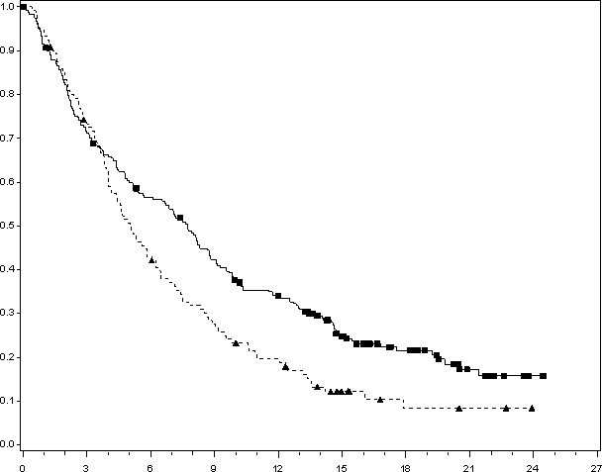

Overall Survival (Months)
Number of Subjects at Risk
Nivolumab
240 | 169 | 132 | 98 | 76 | 45 | 27 | 12 | 3
Investigator’s choice
121 | 88 | 51 | 32 | 22 | 9 | 4 | 3 | 0

Nivolumab (events: 184/240), median 7.72 months and 95% CI: (5.68, 8.77)
Investigator’s choice (events: 105/121), median 5.06 months and 95% CI: (4.04, 6.24).

Table 23 Efficacy results (CA209141)
 | nivolumab (n = 240) | investigator’s choice (n = 121)
Overall survival
Events | 184 (76.7%) | 105 (86.8%)
Hazard ratioª | 0.71
(95% CI) | (0.55,0.90)
p-value^{b} | 0.0048
Median (95% CI) months | 7.7 (5.7, 8.8) | 5.1 (4.04, 6.24 )
Rate % (95% CI) at 6 months | 56.5 (49.9, 62.5) | 43.0 (34.0, 51.7)
Rate % (95% CI) at 12 months | 34.0 (28.0, 40.1) | 19.7 (13.0, 27.3)
Rate % (95% CI) at 18 months | 21.5 (16.2, 27.4) | 8.3 (3.6, 15.7)
Progression-free survival
Events | 204 (85.0%) | 104 (86.0%)
Hazard ratio | 0.87
95% CI | 0.69, 1.11)
p-value | 0.2597
Median (95% CI) (months) | 2.04 (1.9, 2.1) | 2.3 ( 2.0 , 3.1)
Rate % (95% CI) at 6 months | 21.0 (15.9, 26.6) | 11.1 (5.9,18.3)
Rate % (95% CI) at 12 months | 9.5 (6.0, 13.9) | 2.5 (0.5,7.8)
Confirmed objective response | 32 (13.3%) | 7 (5.8%)
(95% CI) | (9.3, 18.3) | (2.4, 11.6)
Odds ratio (95% CI) | 2.49 (1.07, 5.82)
Complete response (CR) | 6 (2.5%) | 1 (0.8%)
Partial response (PR) | 26 (10.8%) | 6 (5.0%)
Stable disease (SD) | 55 (22.9%) | 43 (35.5%)
Median time to response
Months (range) | 2.1 (1.8, 7.4) | 2.0 (1.9, 4.6)
Median duration of response
Months (95% CI ) | 9.7 (5.6, NR) | 4.0 (2.9, NR)
a Derived from a stratified proportional hazards model.
b P-value is derived from a log-rank test stratified by prior cetuximab; the corresponding O’Brien-Fleming efficacy boundary significance level is 0.0227.

Patients with investigator-assessed primary site of oropharyngeal cancer were tested for HPV by p16 immunohistochemistry. OS benefit was observed regardless of p16 status (p16-positive status: HR= 0.63; 95% CI: 0.38, 1.04 and p16-negative status: HR = 0.64, 95% CI: 0.40, 1.03, and p16-unknown* HR= 0.78, (95% CI: 0.55, 1.10). * Unknown includes patients with non-oropharyngeal cancer of the head and neck in whom HPV testing was not required.

Safety and efficacy in elderly patients
No overall differences in safety or efficacy were reported between elderly (≥ 65 years) and younger patients (< 65 years). Data from SCCHN patients 75 years of age or older are too limited to draw conclusions on this population.

UROTHELIAL CARCINOMA (UC)

Adjuvant muscle invasive urothelial carcinoma at high risk of recurrence - OPDIVO monotherapy
Randomised phase 3 study of nivolumab vs placebo (CA209274)
The efficacy of nivolumab monotherapy for the adjuvant treatment of urothelial carcinoma was evaluated in a Phase 3 multicentre, randomised, placebo-controlled, double-blinded study (CA209274).

The study included patients (18 years or older) who have undergone radical resection of muscle invasive urothelial carcinoma (MIUC) originating in the bladder or upper urinary tract (renal pelvis or ureter) and are at high risk of recurrence. The MIUC pathologic staging criteria that defines high risk patients was ypT2-ypT4a or ypN+ for adult patients who received neo-adjuvant cisplatin chemotherapy, and pT3-pT4a or pN+ for adult patients who did not receive neo-adjuvant cisplatin chemotherapy and were not eligible or refused adjuvant cisplatin chemotherapy. The study included patients regardless of their PD-L1 status, who had an ECOG performance status score of 0 or 1 (2 for patients ineligible for neo- adjuvant cisplatin chemotherapy). Patients were within 120 days of radical resection (R0) of UC of the bladder or upper urinary tract (renal pelvis or ureter). The study excluded patients with active, known or suspected autoimmune disease, patients who had treatment with any chemotherapy, radiation therapy, biologics for cancer, intravesical therapy, or investigational therapy within 28 days of first administration of study treatment.

A total of 709 patients were randomised to receive either nivolumab 240 mg (n = 353) every 2 weeks or placebo (n = 356) every 2 weeks until recurrence or unacceptable toxicity for a maximum treatment duration of 1 year. Randomisation was stratified by pathologic nodal status (N+ vs. N0/x with < 10 nodes removed vs. N0 with ≥ 10 nodes removed), tumour PD-L1 expression (≥ 1% vs.< 1%/indeterminate), and use of cisplatin neo-adjuvant chemotherapy. Tumour imaging assessments were to be performed every 12 weeks from the date of first dose to week 96, then every 16 weeks from week 96 to week 160, then every 24 weeks until non-urothelial tract recurrence or treatment was discontinued (whichever occurred later) for a maximum of 5 years. The primary efficacy outcome measures were disease-free survival (DFS) in all randomised patients and DFS in randomised patients with tumours expressing PD-L1 ≥ 1%. DFS was defined as the time between the date of randomisation and the date of the first documented recurrence assessed by investigator (local urothelial tract, local non-urothelial tract or distant), or death (from any cause), whichever occurred first. Secondary efficacy outcome measures include overall survival (OS), non-urothelial tract recurrence free survival (NUTRFS) and disease-specific survival (DSS).

Baseline characteristics were generally balanced between the two groups. The median age was 67 years (range: 30 to 92), 76% were male and 76% were white. Twenty one percent had upper tract urothelial carcinoma, 43% of patients received prior cisplatin in the neo-adjuvant setting, 47% of patients were N+ at radical resection, patients had ECOG performance status of 0 (63%), 1 (35%), or 2 (2%), and 7% of patients had a haemoglobin < 10 g/dL.
Of the 709 patients, 40% had tumour cell PD-L1 expression of ≥ 1%, 59% had tumour cell PD-L1 expression of < 1%, and 1% had tumour cell PD-L1 expression indeterminate, not evaluable or not reported. Tumour PD-L1 expression was determined using the PD-L1 IHC 28-8 pharmDx assay.
In all randomised patients and all randomised patients with tumour cell PD-L1 expression ≥ 1%, the median follow-up for the primary analysis was 22.4 and 25.5 months for the nivolumab arm, respectively. With a minimum follow-up of 11.0 months in the all randomised patients and a minimum follow-up of 11.4 months in randomised patients with tumours expressing PD-L1 ≥ 1%, the study demonstrated a statistically significant improvement in DFS for patients randomised to nivolumab as compared to placebo, as shown in Table and Figure 17.

Figure 17 Disease-free Survival in All Randomised Patients (CA209274).

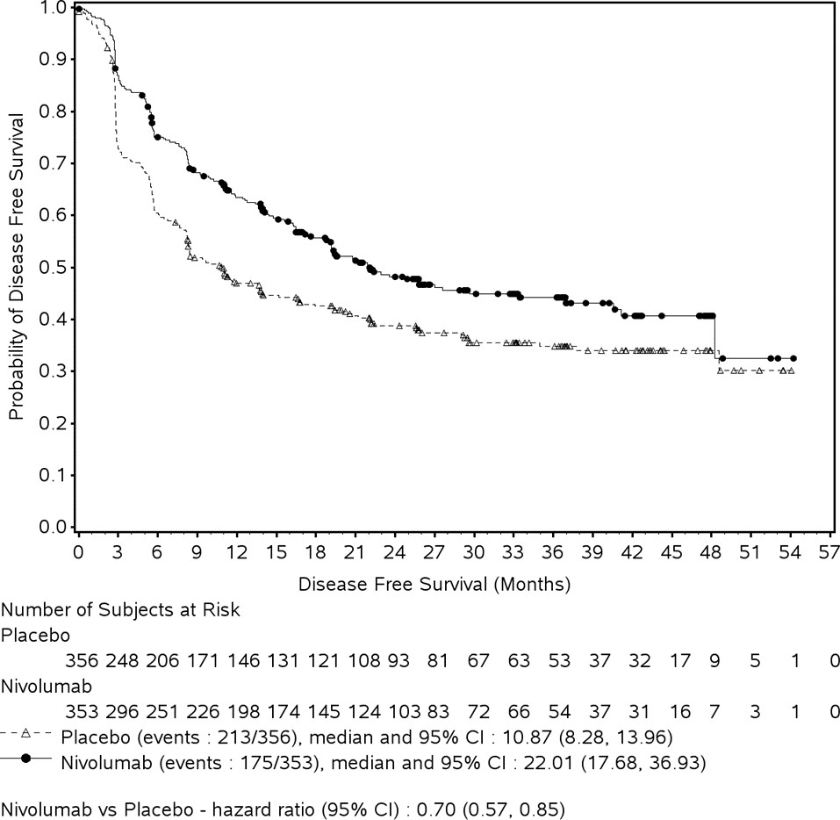

Table 24 Efficacy Results (CA209274)

 | All Randomised |  | PD-L1 ≥1%
 | OPDIVO  (n=353) | Placebo  (n=356) | OPDIVO  (n=140) | Placebo  (n=142)
Disease-free Survival, n (%)  Median DFS (months)ª (95% CI) | 175 (49.6%)  22.01  (17.68, 36.93) | 213 (59.8%)  10.87  (8.28, 13.96) | 56 (40.0%) N.R.  (22.11, N.E.) | 85 (59.9%)  8.41  (5.59, 20.04)
Hazard ratio^{b}  (95 % CI) | 0.70  (0.57, 0.85) |  | 0.53  (0.38, 0.75)
N.R. Not reached, N.E. Not estimable
ª Based on Kaplan-Meier estimates.
^{b} Stratified Cox proportional hazard model. Hazard ratio is nivolumab over placebo.
OS data are immature with 33% of deaths in the overall randomised population.
In an exploratory subgroup analyses in patients with PD-L1 < 1% median DFS with nivolumab vs placebo treatment was 17.68 months (95% CI: 14.06, 22.37) and 11.07 months (95% CI: 8.31, 16.89) respectively (HR of 0.80 (95% CI: 0.62,1.03). In an exploratory subgroup analyses in patients with upper tract UC the unstratified DFS hazard ratio estimate for Renal Pelvis was 1.25 (95% CI: 0.70, 2.25) and for Ureter was 1.54 (95% CI: 0.69, 3.44).

Previously treated metastatic or unresectable UC - OPDIVO monotherapy
Two open-label studies evaluated the safety and efficacy of nivolumab 3 mg/kg as a single agent for the treatment of locally advanced or metastatic urothelial carcinoma.
Single-arm phase 2 study (CA209275)
The safety and efficacy of nivolumab 3 mg/kg as a single agent for the treatment of patients with locally advanced or metastatic urothelial carcinoma was evaluated in a phase 2, multicentre, open-label, single- arm study (CA209275).
The study included patients (18 years or older) who had disease progression during or following platinum-containing chemotherapy for advanced or metastatic disease or had disease progression within 12 months of neoadjuvant or adjuvant treatment with platinum-containing chemotherapy. Patients had an ECOG performance status score of 0 or 1 and were enrolled regardless of their tumour PD-L1 status. Patients with active brain metastases or leptomeningeal metastases, active autoimmune disease, or medical conditions requiring systemic immunosuppression were excluded from the study.
Patients received nivolumab 3 mg/kg administered intravenously over 60 minutes every 2 weeks. Treatment was continued as long as clinical benefit was observed or until treatment was no longer tolerated. The first tumour assessments were conducted 8 weeks after the start of treatment and continued every 8 weeks thereafter up to 48 weeks, then every 12 weeks until disease progression or treatment discontinuation, whichever occurred later. Tumour assessments were continued after treatment discontinuation in patients who discontinued treatment for reasons other than progression. Treatment beyond initial investigator-assessed RECIST, version 1.1-defined progression was permitted if the patient had a clinical benefit, did not have rapid disease progression, and was tolerating study drug as determined by the investigator. The primary efficacy outcome measure was ORR as determined by Blinded Independent Central Review (BICR). Additional efficacy measures included duration of response, PFS and OS.
A total of 270 patients with a minimum follow-up of 21.3 months were evaluable for efficacy. The median age was 66 years (range: 38 to 90) with 55% ≥65 years of age and 14% ≥75 years of age. The majority of patients were white (86%) and male (78%). Baseline ECOG performance status was 0 (54%) or 1 (46%).

Table 25 Efficacy results (CA209275)
 | nivolumab (n = 270)
Confirmed objective response | 55 (20.4%)
(95% CI) | (15.7, 25.7)
Complete response (CR) | 17 (6.3%)
Partial response (PR) | 38 (14.1%)
Stable disease (SD) | 57 (21.1%)
Median duration of response
Months (range) | 17.7 (11.5-22.0)
Median time to response
Months (range) | 1.9 (1.6 - 13.8)
Progression Free Survival
Events (%) | 216 (80%)
Median (95% CI) months | 2.0 months (1.9, 2.6)
Rate (95% CI) at 12 months | 17.5% (13.2, 22.4)
Rate (95% CI) at 24 months | 7.9 (4.4, 12.8)
Overall survival
Events (%) | 154 (57%)
Median (95% CI) months | 8.6 (6.1, 11.3)
Rate (95% CI) at 12 months | 40.3 (34.4, 46.2)
Rate (95% CI) at 24 months | 29.4 (23.9, 35.1)

Objective response per IRRC with nivolumab was observed regardless of baseline tumour PD-L1 expression status.
In 77 patients who received prior systemic therapy only in the neoadjuvant or adjuvant setting, the ORR was 23.4% (95% CI: 14.5%, 34.4%).
Disease-related and non-disease specific quality of life (QoL) was assessed using the European Organization for Research and Treatment of Cancer (EORTC) QLQ-C30, and the EuroQoL EQ-5D scales. Overall QoL scores remained stable while Global Health Status (GHS) based on the EORTC- QLQ-C30, continued to improve through week 49. EQ-5D VAS scores showed clinically relevant improvement in QoL by Week 9, with continued improvement through Week 49. While both scales showed no detriment, QoL data should be interpreted cautiously in the context of the single arm study design.
Single-arm phase 1/2 study (CA209032)
CA209032 was a Phase 1/2 open-label multi-cohort study which included a cohort of 78 patients with similar inclusion criteria to study CA209275 treated with nivolumab monotherapy 3 mg/kg for urothelial carcinoma. At a minimum follow-up of 9 months, investigator-assessed confirmed ORR was 24.4% (95% CI: 15.3, 35.4). The median duration of response was not reached (range: 4.4-16.6⁺ months). The median OS was 9.7 months (95% CI:7.26, 16.16) and the estimated OS rates were 69.2% (CI: 57.7, 78.2) at 6 months and 45.6% (CI: 34.2, 56.3) at 12 months.

HEPATOCELLULAR CARCINOMA (HCC)

Previously treated advanced HCC - OPDIVO monotherapy
Single-arm phase 2 study of nivolumab(CA209040)
The safety and efficacy of nivolumab 3 mg/kg as a single agent for the treatment of advanced HCC in patients previously treated with sorafenib (patients had either progressed on or were intolerant to sorafenib) were evaluated in a 154-patient subgroup of a phase 2, open-label, multi-cohort study (CA209040) conducted in patients with advanced HCC.

Additional eligibility criteria included histologic confirmation of HCC and Child-Pugh Class A. The trial excluded patients with active autoimmune disease, brain metastasis, a history of hepatic encephalopathy, clinically significant ascites, infection with HIV, or active co-infection with hepatitis B virus (HBV) and hepatitis C virus (HCV) or HBV and hepatitis D virus (HDV); however, patients with only active HBV or HCV were eligible. Tumour assessments were conducted every 6 weeks for 48 weeks and every 12 weeks thereafter. The primary efficacy outcome measure was confirmed overall response rate (ORR), as determined by blinded independent central review (BICR) using RECIST version 1.1 and modified RECIST (mRECIST) for HCC. Duration of response (DOR) was also assessed.
A total of 154 patients received nivolumab 3 mg/kg monotherapy administered intravenously every 2 weeks until disease progression or unacceptable toxicity. This group consisted of 9 patients who were treated at a 3 mg/kg dose out of a dose-escalation cohort (n=37), plus all 145 patients who were treated at a 3 mg/kg dose in a dose-expansion cohort. All 154 patients had been previously treated with sorafenib, and either had progressed on or were intolerant to it. The median age was 63 years (range: 19 to 81), 77% were male, and 46% were white. Across the population, 31% had active HBV infection, 21% had active HCV infection, and 49% had no evidence of active HBV or HCV. The aetiology for HCC was alcoholic liver disease in 18% and non- alcoholic liver disease in 6.5% of patients. Baseline ECOG performance status was 0 (65%) or 1 (35%). Child-Pugh class and score was A5 for 68%, A6 for 31%, and B7 for 1% of patients. Seventy one percent (71%) of patients had extrahepatic spread, 29% had macrovascular invasion, and 37% had alpha-fetoprotein (AFP) levels ≥ 400 µg/L. Prior treatment history included surgical resection (66%), radiotherapy (24%), or locoregional treatment (58%). All patients had received prior sorafenib, of whom 36 (23%) were unable to tolerate sorafenib; h 19% of patients had received 2 or more prior systemic therapies.
The efficacy results after a minimum follow-up of 15 months are summarised in Table .

Table 26 Efficacy results (CA209040)

 | nivolumab (n = 154)
BICR-Assessed Overall Response Rateª, n(%), RECIST v1.1 | 22 (14.3%)
(95% CI)^{b} | (9.2, 20.8)
Complete response | 3 (1.9%)
Partial response | 19 (12.3%)
BICR-Assessed Duration of Response, RECIST v1.1 | (n=22)
Range (months) | (3.2, 38.2+)
% with duration ≥ 6 months | 91%
% with duration ≥ 12 months | 55%
BICR-Assessed Overall Response Rateª, mRECIST | 28 (18.2%)
(95% CI)^{b} | (12.4, 25.2)
Complete response | 5 (3.2%)
Partial response | 23 (14.9%)
ª Overall response rate confirmed by BICR
^{b} Confidence interval is based on the Clopper and Pearson method

OESOPHAGEAL SQUAMOUS CELL CARCINOMA (OSCC)

Previously treated OSCC - OPDIVO monotherapy
Randomised, open-label, multicentre Phase 3 study (CA209473)
The safety and efficacy of nivolumab monotherapy for the treatment of OSCC was evaluated in a Phase 3, multicenter, randomised (1:1), active-controlled, open-label study in patients with unresectable advanced, recurrent, or metastatic OSCC, refractory or intolerant to at least one fluoropyrimidine and

platinum based regimen who had previously received one treatment regimen (CA209473 also known as ONO-24 or ATTRACTION-3). The study included patients regardless of PD-L1 status. The study excluded patients with a baseline performance score ≥ 2, brain metastases that were symptomatic or required treatment, apparent tumour invasion on organs located adjacent to the oesophagus (eg, the aorta or respiratory tract), active autoimmune disease, or use of systemic corticosteroids or immunosuppressants. Patients received nivolumab 240 mg by intravenous infusion over 30 minutes every 2 weeks (n=210) or investigator’s choice taxane chemotherapy of either:
- docetaxel (n=65) 75 mg/m² intravenously every 3 weeks, or
- paclitaxel (n=144) 100 mg/m² intravenously once a week for 6 weeks followed by 1 week off.
Patients were treated until disease progression, assessed by the investigator per RECIST v1.1, or unacceptable toxicity. Treatment beyond initial investigator-assessed progression was permitted in patients receiving nivolumab or chemotherapy if there was no worsening of symptoms due to progression, treatment could be safely administered and there was an expectation continued treatment would lead to clinical benefit, as determined by the investigator.
The tumour assessments were conducted every 6 weeks for 1 year and every 12 weeks thereafter. The major efficacy outcome measure was OS. Additional efficacy outcome measures included ORR and PFS, as assessed by the investigator using RECIST v1.1, and DOR. The trial population characteristics were: median age 65 years (range: 33 to 87), 53% were ≥65 years of age, 87% were male, 96% were Asian, and 4% were White. Baseline ECOG performance status was 0 (50%) or 1 (50%).
The study demonstrated a statistically significant improvement in OS for patients randomised to nivolumab as compared with investigator’s choice taxane chemotherapy. OS benefit was observed regardless of PD-L1 expression level. The minimum follow-up was 17.6 months.
A higher proportion of patients experienced death within the first 2.5 months in the nivolumab arm (32/210, 15.2%) as compared to the chemotherapy arm (15/209, 7.2%). No specific factor(s) associated with early deaths could be identified.
Efficacy results are shown in Figure 18 and Table .

Figure 18 Overall Survival - CA209473
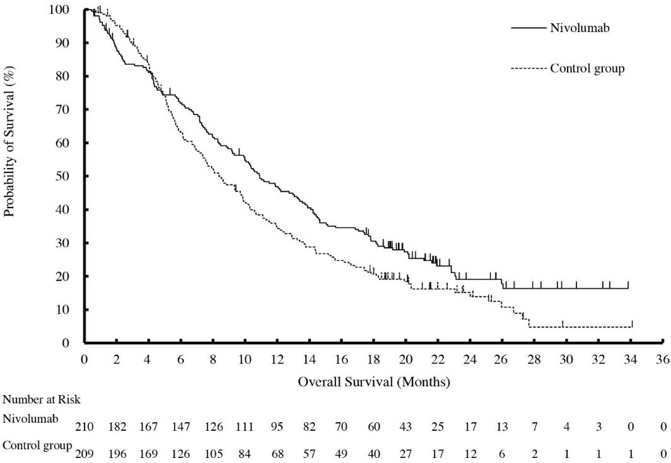

Table 27 Efficacy Results - CA209473
 | Nivolumab (n=210) | Chemotherapy (n=209)
Overall Survivalª
Deaths (%) | 160 (76%) | 173 (83%)
Median (months) (95% CI) | 10.9  (9.2, 13.3) | 8.4  (7.2, 9.9)
Hazard ratio (95% CI)^{b} | 0.77 (0.62, 0.96)
p-value^{c} | 0.0189
Progression-free Survivalª
Disease progression or death (%) | 187 (89) | 176 (84)
Median (months) (95% CI) | 1.7  (1.5, 2.7) | 3.4  (3.0, 4.2)
Hazard ratio (95% CI)b | 1.1 (0.9, 1.3)
Objective Response Rate^{d,e} | 33 (19.3) | 34 (21.5)
(95% CI) | (13.7, 26.0) | (15.4, 28.8)
Complete response (%) | 1 (0.6) | 2 (1.3)
Partial response (%) | 32 (18.7) | 32 (20.3)
Median duration of response (months)  (95% CI) | 6.9  (5.4, 11.1) | 3.9  (2.8, 4.2)
ª Based on ITT analysis.
^{b} Based on a stratified proportional hazards model.
^{c} Based on a stratified log-rank test.
^{d} Based on Response Evaluable Set (RES) analysis, n=171 in nivolumab group and n=158 in investigator’s choice group.
^{e} Not significant, p-value 0.6323.

ADJUVANT OESOPHAGEAL OR GASTRO-OESOPHAGEAL CANCER

Adjuvant treatment of oesophageal or gastro-oesophageal junction cancer - OPDIVO monotherapy
Randomised phase 3 study (CA209577)
CA209577 was a randomised, multicenter, double-blind trial in 794 patients with resected oesophageal or gastro-oesophageal junction cancer who had residual pathologic disease. Patients were randomised (2:1) to receive either nivolumab 240 mg or placebo by intravenous infusion over 30 minutes every 2 weeks for 16 weeks followed by 480 mg or placebo by intravenous infusion over 30 minutes every 4 weeks beginning at week 17. Treatment was until disease recurrence, unacceptable toxicity, or for up to 1 year in total duration. Enrollment required complete resection with negative margins within 4 to 16 weeks prior to randomisation. Randomisation was stratified by tumour PD-L1 status (≥1% vs. <1% or indeterminate or non-evaluable), pathologic lymph node status (positive ≥ypN1 vs. negative ypN0), and histology (squamous vs. adenocarcinoma). The major efficacy outcome measure was disease-free survival (DFS) defined as the time between the date of randomisation and the date of first recurrence (local, regional, or distant from the primary resected site) or death, from any cause, whichever occurred first as assessed by the investigator prior to subsequent anti-cancer therapy. Patients on treatment underwent imaging for tumour recurrence every 12 weeks for 2 years, and a minimum of one scan every 6 to 12 months for years 3 to 5.
The trial population characteristics were: median age 62 years (range: 26 to 86), 36.1% were ≥65 years of age, 84.5% were male, 14.7% were Asian, and 81.6% were White. Disease characteristics were AJCC Stage II (35%) or Stage III (64.7%) at initial diagnosis carcinoma, oesophageal cancer (59.8%) or gastro-oesophageal junction cancer (40.2%) at initial diagnosis, with pathologic positive lymph node status (57.6%) at study entry and histological confirmation of predominant adenocarcinoma (70.9%) or squamous cell carcinoma (29%). The baseline tumour PD-L1 status was positive for 16.2% patients,

defined as ≥1% of tumour cells expressing PD-L1, and negative for 71.8% of patients. Baseline ECOG performance status was 0 (58.4%) or 1 (41.6%).
CA209577 demonstrated a statistically significant improvement in DFS for patients randomised to the nivolumab arm as compared with the placebo arm. DFS benefit was observed regardless of tumor PD- L1 expression and histology.
Efficacy results are shown in Table and Figure 19.

Figure 19 Disease-free Survival - CA209577

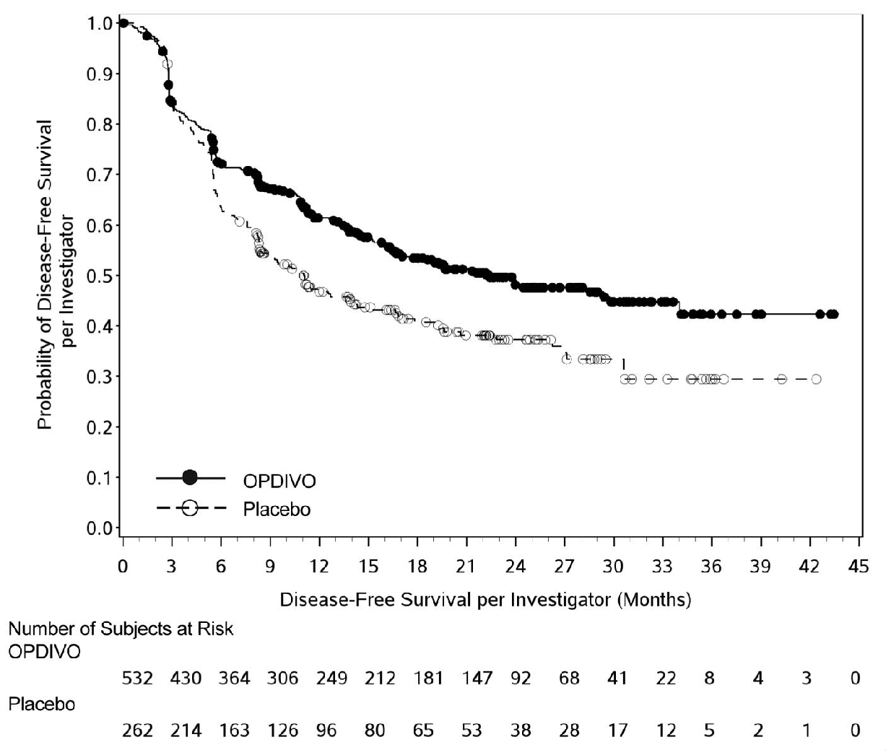

Table 28 Efficacy Results - CA209577
 | OPDIVO (n=532) | Placebo (n=262)
Disease-free Survivala
Number of events, n (%) | 241 (45.3%) | 155 (59.2%)
Median (months) (95% CI) | 22.41  (16.62, 34.00) | 11.04  (8.34, 14.32)
Hazard ratiob (vs. placebo) (96.4% CI) | 0.69 (0.56, 0.86)

Table 28 Efficacy Results - CA209577
 | OPDIVO (n=532) | Placebo (n=262)
p-valuec | 0.0003
ª Based on all randomised patients.
^{b} Based on a stratified proportional hazards model.
^{c} Based on a stratified log-rank test.

In adenocarcinoma subgroup, the hazard ratio (HR) for DFS was 0.75 (95% CI: 0.59, 0.96) with median survivals of 19.35 and 11.10 months for the nivolumab and placebo arms, respectively. In the squamous cell carcinoma subgroup, the HR for DFS was 0.61 (95% CI: 0.42, 0.88) with median survivals of 29.73 and 11.04 months for the nivolumab and placebo arms, respectively.

GASTRIC CANCER (GC), GASTRO-OESOPHAGEAL JUNCTION CANCER (GOJC), OR OESOPHAGEAL ADENOCARCINOMA (OAC)

Previously untreated advanced gastric cancer, gastro-oesophageal junction cancer, or oesophageal adenocarcinoma - OPDIVO in combination with chemotherapy
Randomised phase 3 study of nivolumab in combination with chemotherapy vs. chemotherapy (CA209649)
CA209649 was a randomised, multicentre, open-label trial in patients with previously untreated advanced or metastatic gastric cancer, gastro-oesophageal junction cancer, or oesophageal adenocarcinoma. The trial enrolled patients regardless of PD-L1 status, and tumour specimens were evaluated prospectively using the PD-L1 IHC 28-8 pharmDx assay at a central laboratory. The trial excluded patients who were known human epidermal growth factor receptor 2 (HER2) positive or had untreated CNS metastases. Patients were randomised to receive OPDIVO in combination with chemotherapy or chemotherapy. Patients received one of the following treatments:
  - OPDIVO 240 mg in combination with FOLFOX (fluorouracil, leucovorin and oxaliplatin) every 2 weeks or FOLFOX every 2 weeks.
  - OPDIVO 360 mg in combination with XELOX (capecitabine and oxaliplatin) every 3 weeks or XELOX every 3 weeks.
Patients were treated until disease progression, unacceptable toxicity, or up to 2 years. In patients who received OPDIVO in combination with chemotherapy and in whom chemotherapy was discontinued, OPDIVO monotherapy was allowed to be given at 240 mg every 2 weeks, 360 mg every 3 weeks, or 480 mg every 4 weeks up to 2 years after treatment initiation.
Randomisation was stratified by tumour cell PD-L1 status (≥1% vs. <1% or indeterminate), region (Asia vs. US vs. Rest of World), ECOG performance status (0 vs. 1), and chemotherapy regimen (FOLFOX vs. XELOX). The primary efficacy outcome measure, assessed in patients with PD-L1 CPS
≥5, were PFS assessed by BICR and OS. Secondary efficacy outcome measures tested hierarchically included OS in patients with PD-L1 CPS ≥ 1 and OS in all randomised patients. Other efficacy outcome measures included PFS in all randomised patients and ORR in PD-L1 CPS ≥5 and all randomised patients. The tumour assessments per RECIST v1.1 were conducted every 6 weeks up to and including week 48, then every 12 weeks thereafter.
A total of 1581 patients were randomised; 789 to the OPDIVO in combination with chemotherapy arm and 792 to the chemotherapy arm. The trial population characteristics were: median age 61 years (range: 18 to 90), 39% were ≥65 years of age, 70% were male, 24% were Asian, and 69% were White. Baseline ECOG performance status was 0 (42%) or 1 (58%). Seventy percent of patients had adenocarcinoma tumours in the stomach, 16% in the gastro-oesophageal junction, and 13% in the oesophagus.

CA209649 demonstrated a statistically significant improvement in OS and PFS for patients with PD- L1 CPS ≥5. Statistically significant improvement in OS was also demonstrated for all randomized patients. The minimum follow-up was 12.1 months.
The Kaplan-Meier curves for OS are shown in Figure 20 and Figure 21.

Figure 20 Kaplan-Meier curves of OS - All Patients (CA209649)
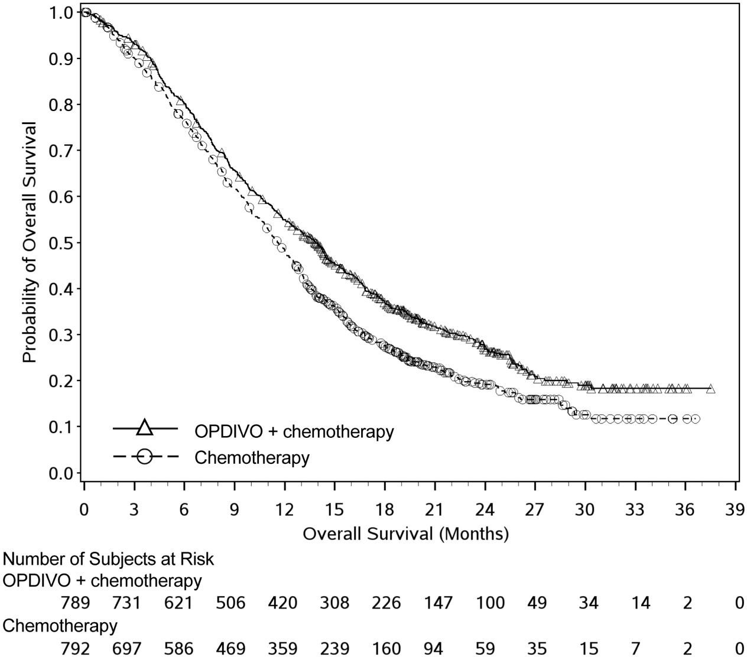

Figure 21 Kaplan-Meier curves of OS - PD-L1 CPS ≥5 (CA209649)
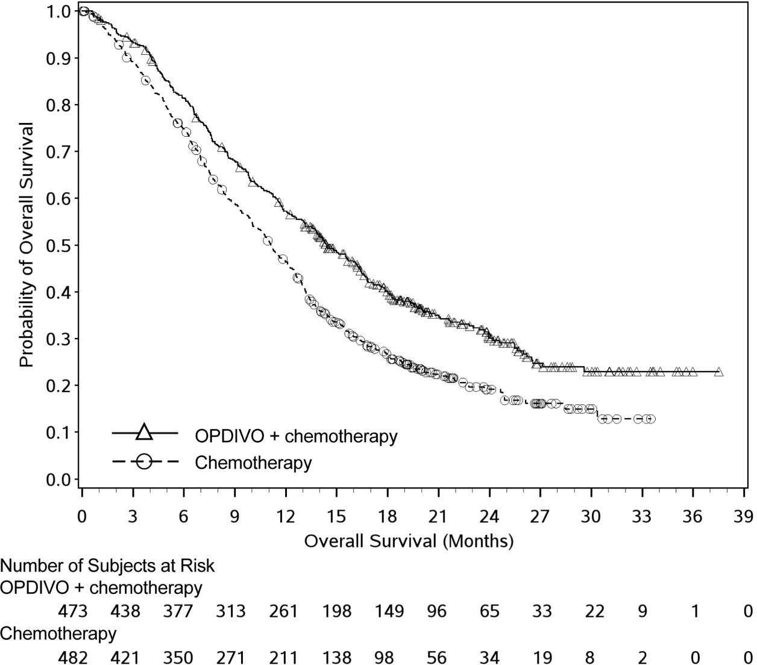
Efficacy results are shown in Table .

Table 29 Efficacy Results (CA209649)
 | OPDIVO and FOLFOX or XELOX (n=789) | FOLFOX or XELOX (n=792) | OPDIVO and FOLFOX or XELOX (n=473) | FOLFOX or XELOX (n=482)
 | All Patients |  | PD-L1 CPS ≥5
Overall Survival
Deaths (%) | 544 (69) | 591 (75) | 309 (65) | 362 (75)
Median (months)a (95% CI) | 13.8  (12.6, 14.6) | 11.6  (10.9, 12.5) | 14.4  (13.1, 16.2) | 11.1  (10.0, 12.1)
Hazard ratio (CI)b | 0.80 (99.3% CI: 0.68, 0.94) |  | 0.71 (98.4% CI: 0.59, 0.86)
p-valuec | 0.0002 |  | <0.0001
Progression-free Survivald
Disease progression or death (%) | 559 (70.8) | 557 (70.3) | 328 (69.3) | 350 (72.6)
Median (months)a (95% CI) | 7.66  (7.10, 8.54) | 6.93  (6.60, 7.13) | 7.69  (7.03, 9.17) | 6.05  (5.55, 6.90)
Hazard ratio (CI)b | 0.77 (95% CI: 0.68, 0.87) |  | 0.68 (98% CI: 0.56, 0.81)
p-valuec | Not tested |  | <0.0001
Number of patients with  measurable disease at baseline | n=603 | n=608 | n=378 | n=391
Overall Response Rate ^{d,e}, n (%)d,e | 350 (58) | 280 (46) | 226 (60) | 177 (45)
(95% CI) | (54, 62) | (42, 50) | (55, 65) | (40, 50)
Complete response (%) | 59 (10) | 39 (6) | 44 (12) | 27 (7)
Partial response (%) | 291 (48) | 241 (40) | 182 (48) | 150 (38)
Duration of Responsed,e
Median (months)a(95% CI) Range | 8.51 (7.23, 9.92)  1.0+, 29.6+ | 6.93 (5.82, 7.16)  1.2+, 30.8+ | 9.49 (7.98, 11.37)  1.1+, 29.6+ | 6.97 (5.65, 7.85)  1.2+, 30.8+

a Kaplan-Meier estimate.
b Based on stratified log Cox proportional hazard model.
c Based on stratified log-rank test.
d Confirmed by BICR.
e Not evaluated for statistical significance.

Immunogenicity
As with all therapeutic proteins, there is a potential for an immunogenic response to nivolumab.

Nivolumab Monotherapy:
In a pooled analysis of 2022 patients who were treated with nivolumab 3 mg/kg every 2 weeks and were evaluable for the presence of anti-product-antibodies, 231 patients (11.4%) tested positive for treatment-emergent anti-product-antibodies by an electrochemiluminescent (ECL) assay. Two (0.1%) patients were persistently positive. Neutralising antibodies were detected in only 15 (0.7% of the total) of the positive anti-product-antibody patients. There was no evidence of altered

pharmacokinetic profile, or toxicity profile associated with anti-product-antibody development. Neutralising antibodies were not associated with loss of efficacy.

Nivolumab in Combination with Ipilimumab:
Of the patients who were treated with nivolumab in combination with ipilimumab and were evaluable for the presence of anti-nivolumab antibodies, the incidence of anti-nivolumab antibodies was 26.0% with nivolumab 3 mg/kg and ipilimumab 1 mg/kg every 3 weeks and 37.8% with nivolumab 1 mg/kg and ipilimumab 3 mg/kg every 3 weeks and 25.7% with nivolumab 3 mg/kg every 2 weeks and ipilimumab 1 mg/kg every 6 weeks. Of the patients who were treated with nivolumab 360 mg every 3 weeks in combination with ipilimumab 1 mg/kg every 6 weeks and platinum-doublet chemotherapy and evaluable for the presence of anti-nivolumab antibodies, the incidence of anti-nivolumab antibodies was 33.8%. The incidence of neutralising antibodies against nivolumab was 0.5% with nivolumab 3 mg/kg and ipilimumab 1 mg/kg every 3 weeks, 4.6% with nivolumab 1 mg/kg and ipilimumab 3 mg/kg every 3 weeks, 0.7% with nivolumab 3 mg/kg every 2 weeks and ipilimumab 1 mg/kg every 6 weeks and 2.6% with nivolumab 360 mg in combination with ipilimumab 1 mg/kg and platinum-doublet chemotherapy. Of the patients who were treated with nivolumab in combination with ipilimumab and evaluable for the presence of anti-ipilimumab antibodies, the incidence of anti-ipilimumab antibodies ranged from 6.3 to 13.7% and neutralising antibodies against ipilimumab ranged from 0 to 0.4%.There was no evidence of altered toxicity profile associated with anti-product antibody development. Neutralising antibodies were not associated with loss of efficacy.

PHARMACOKINETIC PROPERTIES
Nivolumab pharmacokinetics (PK) was assessed using a population PK approach for both single-agent nivolumab and nivolumab in combination with ipilimumab.

Nivolumab monotherapy
The pharmacokinetics (PK) of nivolumab is linear in the dose range of 0.1 to 10 mg/kg. The exposure to nivolumab increased dose proportionally over the dose range of 0.1 to 10 mg/kg administered every 2 weeks.
Nivolumab clearance (CL) decreases over time, with a mean maximal reduction (% coefficient of variation [CV%]) from baseline values of 26% (32.6%) resulting in a geometric mean steady-state clearance (CLss) (CV%) of 7.91 mL/h (46%) in patients with metastatic tumours; the decrease in CLss is not considered clinically relevant. Nivolumab clearance does not decrease over time in patients with completely resected melanoma, as the geometric mean population clearance is 24% lower in this patient population compared with patients with metastatic melanoma at steady state. The geometric mean volume of distribution at steady state (Vss) (CV%) is 6.6 L (24.4%) and geometric mean elimination half-life (t1/2) is 25 days (55.4%). Steady-state concentrations of nivolumab were reached by 12 weeks when administered at 3 mg/kg every 2 weeks, and systemic accumulation was approximately 3-fold.
Nivolumab CL increased with increasing body weight. Body weight normalised dosing produced approximately uniform steady-state trough concentration over a wide range of body weights (34-162 kg).
The metabolic pathway of nivolumab has not been characterised. As a fully human IgG4 monoclonal antibody, nivolumab is expected to be degraded into small peptides and amino acids via catabolic pathways in the same manner as endogenous IgG.
Nivolumab baseline CL in adjuvant melanoma patients was approximately 40% lower and steady state CL approximately 20% lower relative to advanced melanoma. With available safety data, this decreases in CL were not clinically meaningful.
In patients with cHL, nivolumab CL was lower resulting in a 15 day increase in the half-life and a 43% increase in exposure (as measured by median Cavgss). The lower nivolumab CL was not considered clinically meaningful; there was a flat predicted exposure-response relationship.

Nivolumab in combination with ipilimumab
When nivolumab 1 mg/kg was administered in combination with ipilimumab 3 mg/kg, the CL of nivolumab was increased by 29% and the CL of ipilimumab was increased by 9%, which was not considered clinically relevant. When nivolumab 3 mg/kg every 2 weeks was administered in combination with ipilimumab 1 mg/kg, the CL of nivolumab was increased by 17% and the CL of ipilimumab was increased by 18%, which were not considered clinically relevant.
When administered in combination with ipilimumab, the CL of nivolumab increased by 20% in the presence of anti-nivolumab antibodies and the CL of ipilimumab increased by 5.7% in the presence of anti- ipilimumab antibodies. These changes were not considered clinically relevant.
When nivolumab 360 mg every 3 weeks was administered in combination with ipilimumab 1 mg/kg every 6 weeks and chemotherapy, the CL of nivolumab decreased approximately 10% compared to nivolumab administered alone and the CL of ipilimumab increased approximately 22% compared to ipilimumab administered alone.

Special populations
Population PK analysis suggested no difference in CL of nivolumab based on age, gender, race, solid tumour type, tumour size, and hepatic impairment. The majority of patients in this analysis were diagnosed with NSCLC. Although ECOG status, baseline glomerular filtration rate (GFR) and body weight had an effect on nivolumab CL, the effect was not clinically meaningful.
Patients with lower baseline serum albumin tended to have lower exposure to nivolumab. However, because of the flat exposure-response relationship between nivolumab exposure and overall survival, this effect is unlikely to be clinically meaningful and no dose adjustment is recommended for patients with lower serum albumin.

Renal impairment
The effect of renal impairment on the CL of nivolumab was evaluated in patients with mild* (n = 1399), moderate* (n = 651), or severe* (n = 6) renal impairment compared to patients with normal* renal function (n = 1354) in population PK analyses. No clinically important differences in the CL of nivolumab were found between patients with mild or moderate renal impairment and patients with normal renal function. There were insufficient data to determine the effect of severe renal impairment on the CL of nivolumab (see Section 4.2. Dose and method of administration and 4.4. Special warnings and precautions for use).
*Per National Kidney Foundation criteria of renal impairment: Normal: GFR ≥ 90 mL/min/1.73 m²; Mild: GFR < 90 and ≥ 60 mL/min/1.73 m²; Moderate: GFR < 60 and ≥ 30 mL/min/1.73 m²; Severe: GFR < 30 and ≥15 mL/min/1.73 m²

Hepatic impairment
The effect of hepatic impairment on the CL of nivolumab was evaluated in patients with mild* hepatic impairment (n=351) and in patients with moderate* hepatic impairment (n=10) compared to patients with normal* hepatic function (n = 3096) in the population PK analyses. No clinically important differences in the CL of nivolumab were found between patients with mild/moderate hepatic impairment and patients with normal hepatic function, although the number of patients with moderate hepatic impairment was limited Nivolumab has not been studied in patients with severe* hepatic impairment (see Section 4.2. Dose and method of administration and 4.4. Special warnings and precautions for use).
*Per National Cancer Institute criteria of hepatic dysfunction: Normal: total bilirubin and AST ≤ ULN; Mild: total bilirubin
- 1.0 to 1.5 times ULN or AST > ULN; Moderate: total bilirubin > 1.5 to 3 times ULN and any AST; Severe: total bilirubin
- 3 times ULN and any AST

Cardiac electrophysiology
The potential effect of nivolumab on QTc interval was evaluated in 146 patients at doses up to 10 mg/kg every three weeks. No changes in mean QT interval were detected in nivolumab-treated patients based on Fredericia correction method.

Ipilimumab did not have a clinically meaningful effect on the QTc interval at doses up to 10mg/kg. Thus, QT interval prolongation is not expected with the nivolumab and ipilimumab combination.

PRECLINICAL SAFETY DATA
The effects of OPDIVO on prenatal and postnatal development were evaluated in monkeys that received OPDIVO at 10 and 50 mg/kg twice weekly from the onset of organogenesis in the first trimester through delivery, at exposure levels 8 and 35 times, respectively, those observed at the clinical dose of 3 mg/kg of OPDIVO (based on AUC). There was a dose-dependent increase in foetal losses and increased neonatal mortality mainly in the 3rd trimester of pregnancy and after birth.
The remaining offspring of OPDIVO-treated females survived to scheduled termination, with no treatment-related clinical signs, alterations to normal development, organ-weight effects, or gross and microscopic pathology changes. Results for growth indices, as well as teratogenic, neurobehavioral, immunological and clinical pathology parameters throughout the 6-month postnatal period were comparable to the control group.

Genotoxicity
Studies to evaluate the genotoxic potential of OPDIVO have not been performed.

Carcinogenicity
Studies to evaluate the carcinogenic potential of OPDIVO have not been performed.

PHARMACEUTICAL PARTICULARS
  - LIST OF EXCIPIENTS
Sodium citrate dihydrate Sodium chloride Mannitol (E421)
Pentetic acid (diethylenetriaminepentaacetic acid) Polysorbate 80
Sodium hydroxide (for pH-adjustment) Hydrochloric acid (for pH-adjustment) Water for injections.
This medicinal product does not contain any preservatives.

INCOMPATIBILITIES
OPDIVO should not be infused concomitantly in the same intravenous line with other medicinal products.

SHELF LIFE
In Australia, information on the shelf life can be found on the public summary of the ARTG. The expiry date can be found on the packaging.

SPECIAL PRECAUTIONS FOR STORAGE
Store in a refrigerator (2°C to 8°C). Do not freeze.
Store in the original package in order to protect from light.
The unopened vial can be stored at controlled room temperature up to 25°C with room light for up to 48 hours.
After opening:

    - To reduce microbiological hazard, once opened, the medicinal product should be infused immediately.
    - After preparation of infusion: The administration of the OPDIVO infusion must be completed within 7 days of preparation. If not used immediately, the solution may be stored under refrigeration conditions: 2°-8°C and protected from light for up to 7 days (a maximum of 8 hours of the total 7 days can be at room temperature 20°-25°C and room light – the maximum 8 hour period under room temperature and room light conditions should be inclusive of the product administration period).
This medicinal product does not contain any preservatives.

NATURE AND CONTENTS OF CONTAINER
40 mg of nivolumab in 4 mL of concentrate solution for infusion is supplied in a 10 mL vial (Type I glass) with a stopper (coated butyl rubber) and an aluminium dark blue “flip off” seal. Pack of 1 vial containing 4 mL.
100 mg of nivolumab in 10 mL of concentrate solution for infusion is supplied in a 10mL vial (Type I glass) with a stopper (coated butyl rubber) and an aluminium grey “flip off” seal. Pack of 1 vial containing 10 mL.
240 mg of nivolumab in 10 mL of concentrate solution for infusion is supplied in a 25 mL vial (Type I glass) with a stopper (coated butyl rubber) and an aluminium red “flip off” seal. Pack of 1 vial containing 24 mL.
Not all presentations may be available.

SPECIAL PRECAUTIONS FOR DISPOSAL
EACH VIAL OF OPDIVO® IS FOR SINGLE USE IN ONE PATIENT ONLY. DISCARD ANY RESIDUE.
In Australia, any unused medicinal product or waste material should be discarded in accordance with local requirements.

PHYSICOCHEMICAL PROPERTIES
CAS number
CAS: 946414-94-4.

MEDICINE SCHEDULE (POISONS STANDARD)
Schedule 4- Prescription Only Medicine

SPONSOR
Bristol-Myers Squibb Australia Pty Ltd Level 2, 4 Nexus Court
MULGRAVE VIC 3170.
Toll free number: 1800 067 567 Email: MedInfo.Australia@bms.com

DATE OF FIRST APPROVAL (ARTG ENTRY)
11 January 2016

DATE OF REVISION OF THE TEXT
TBC.

SUMMARY TABLE OF CHANGES

Section Changed | Summary of new information
4.1 | Addition of a new indication for the use of nivolumab in combination with platinum- doublet chemotherapy as a neoadjuvant treatment for patients with resectable non-small cell lung cancer (NSCLC).
4.2 | Addition of dosing recommendations for the use of nivolumab in combination with platinum-doublet chemotherapy as a neoadjuvant treatment of patients with resectable non-small cell lung cancer (NSCLC).
4.8 | Addition of safety data for the use of nivolumab in combination with platinum-doublet chemotherapy as a neoadjuvant treatment of patients with resectable non-small cell lung cancer (NSCLC).
5.1 | Addition of clinical data from study CA209816 to support the use of nivolumab in combination with platinum-doublet chemotherapy as a neoadjuvant treatment of patients with resectable non-small cell lung cancer (NSCLC).
OPDIVO® is a registered trademark of Bristol-Myers Squibb Company.

