Australian Public Assessment Report for Mounjaro
  - Active ingredient: Tirzepatide
  - Sponsor: Eli Lilly Australia Pty Ltd
September 2024

About the Therapeutic Goods Administration (TGA)
- The Therapeutic Goods Administration (TGA) is part of the Australian Government Department of Health and Aged Care and is responsible for regulating therapeutic goods, including medicines, medical devices, and biologicals.
- The TGA administers the Therapeutic Goods Act 1989 (the Act), applying a risk management approach designed to ensure therapeutic goods supplied in Australia meet acceptable standards of quality, safety, and efficacy.
- The work of the TGA is based on applying scientific and clinical expertise to decision-making, to ensure that the benefits to the Australian public outweigh any risks associated with the use of therapeutic goods.
- The TGA relies on the public, healthcare professionals and industry to report problems with therapeutic goods. The TGA investigates reports received to determine any necessary regulatory action.
- To report a problem with a therapeutic good, please see the information on the TGA website.

About AusPARs
- The Australian Public Assessment Report (AusPAR) provides information about the evaluation of a prescription medicine and the considerations that led the TGA to approve or not approve a prescription medicine submission. Further information can be found in Australian Public Assessment Report (AusPAR) guidance.
- AusPARs are prepared and published by the TGA.
- AusPARs are static documents that provide information that relates to a submission at a particular point in time. The publication of an AusPAR is an important part of the transparency of the TGA’s decision-making process.
- A new AusPAR may be provided to reflect changes to indications or major variations to a prescription medicine subject to evaluation by the TGA.

Copyright
© Commonwealth of Australia 2024
This work is copyright. You may reproduce the whole or part of this work in unaltered form for your own personal use or, if you are part of an organisation, for internal use within your organisation, but only if you or your organisation do not use the reproduction for any commercial purpose and retain this copyright notice and all disclaimer notices as part of that reproduction. Apart from rights to use as permitted by the Copyright Act 1968 or allowed by this copyright notice, all other rights are reserved and you are not allowed to reproduce the whole or any part of this work in any way (electronic or otherwise) without first being given specific written permission from the Commonwealth to do so. Requests and inquiries concerning reproduction and rights are to be sent to the TGA Copyright Officer, Therapeutic Goods Administration, PO Box 100, Woden ACT 2606 or emailed to <tga.copyright@tga.gov.au>.

Contents
List of abbreviations 5
Mounjaro (tirzepatide) submission 7
Mounjaro (tirzepatide) – proposed indication 10
Obesity 10
Current treatment options for obesity 12
Non-pharmacological management 12
Pharmacological management 12
Bariatric surgery 13
Clinical rationale for Mounjaro use in obesity 13
Regulatory status 14
Australian regulatory status 14
International regulatory status 15
Registration timeline 18
Evaluation overview 19
Clinical evaluation summary 19
Summary of clinical studies 19
Pharmacology 20
Efficacy 23
Methods 24
Results 26
Results 34
Safety 36
Patient exposure 36
Key safety outcomes for CWM indication: Pooled SURMOUNT-1 and SURMOUNT-2 38
Post marketing experience 41
Risk Management Plan (RMP) evaluation summary 43
Risk/benefit analysis 43
Efficacy 44
Safety 44
Data limitations and uncertainties 45
Ongoing studies 45
Advisory Committee considerations 46
ACM conclusion 47
Outcome 47
Specific conditions of registration applying to these goods 48
Attachment 1. Product Information 49

List of abbreviations
Abbreviation | Meaning
ACM | Advisory Committee on Medicines
ADA | Anti-drug antibodies
ADRs | Adverse drug reactions
AE | Adverse events
ARGPM | Australian Regulatory Guidelines for Prescription Medicines
ARTG | Australian Register of Therapeutic Goods
ASA | Australia-specific annex
AUC | Area under the concentration-time curve
AUC_{0-tlast} | Area under the curve from time 0 to the last quantifiable sample
CI | Confidence intervals
Cl/F | Oral clearance
C_{max} | The maximum concentration that a drug attains in a specified compartment
CMI | Consumer Medicines Information
GLP-1 | Glucagon-like peptide-1
GIP | Glucose-dependent insulinotropic polypeptide
HR | Hazard ratio
ITT | Intention to treat
IV | Intravenous
LLOD | Lower limit of detection
LSM | Least Squares Means
mAb | Monoclonal antibody
MedDRA | Medical Dictionary for Medical Activities
OR | Odds ratio
ORR | Objective response rate
PBPK | Physiologically-based pharmacokinetic modelling
PD | Pharmacodynamics
PFS | Progression-free survival
PI | Product Information
PK | Pharmacokinetics
popPK | Population pharmacokinetics
PPS | Per protocol set
PSUR | Periodic safety update report
RMP | Risk management plan
SAEs | Serious adverse event(s)
SD | Standard deviation
SF-36v2 | Short-Form-36 Health Survey; a patient-reported assessment that measures the quality of life and the health and well-being of patients
t_{1/2} | Half life
T2DM | Type 2 diabetes mellitus
TEAE | Treatment emergent adverse event(s)
TGA | Therapeutic Goods Administration
V_{d} | volume of distribution
V_{ss}/F | Apparent volume of distribution at steady-state
V_{c}/F | Apparent central volume of distribution

Mounjaro (tirzepatide) submission
Type of submission: | Extension of indications
Product name: | Mounjaro
Active ingredient: | tirzepatide
Decision: | Approved
Approved therapeutic use for the current submission: | Chronic weight management  Mounjaro is indicated as an adjunct to a reduced-calorie diet and increased physical activity for chronic weight management, including weight loss and weight maintenance, in adults with an initial body mass index (BMI) of:  ≥30 kg/m² (obesity) or  ≥27 kg/m² to <30 kg/m² (overweight) in the presence of at least one weight-related comorbid condition (e.g., hypertension, dyslipidaemia, obstructive sleep apnoea, cardiovascular disease, prediabetes or type 2 diabetes mellitus).
Date of decision: | 9 September 2024
Date of entry onto ARTG: | 10 September 2024
ARTG numbers: | - 379333 - MOUNJARO tirzepatide 10 mg/0.5 mL solution for injection pre-filled pen  - 379332 - MOUNJARO tirzepatide 12.5 mg/0.5 mL solution for injection pre-filled pen  - 379334 - MOUNJARO tirzepatide 15 mg/0.5 mL solution for injection pre-filled pen  - 382625 - MOUNJARO tirzepatide 2.5 mg/0.5 mL solution for injection pre-filled pen  - 379330 - MOUNJARO tirzepatide 5 mg/0.5 mL solution for injection pre-filled pen  - 379331 - MOUNJARO tirzepatide 7.5 mg/0.5 mL solution for injection pre-filled pen  - 407050 - MOUNJARO tirzepatide 5 mg/0.5 mL solution for injection vial  - 407051 - MOUNJARO tirzepatide 7.5 mg/0.5 mL solution for injection vial  - 407052 - MOUNJARO tirzepatide 12.5 mg/0.5 mL solution for injection vial  - 407053 - MOUNJARO tirzepatide 10 mg/0.5 mL solution for injection vial  - 407054 - MOUNJARO tirzepatide 15 mg/0.5 mL solution for injection vial  - 407055 - MOUNJARO tirzepatide 2.5 mg/0.5 mL solution for injection vial  - 439430 - MOUNJARO KwikPen tirzepatide 4.17 mg/mL solution for injection multidose pre-filled pen  - 439690 - MOUNJARO KwikPen tirzepatide 8.33 mg/mL solution for injection multidose pre-filled pen  - 439691 - MOUNJARO KwikPen tirzepatide 12.5 mg/mL solution for injection multidose pre-filled pen  - 439692 - MOUNJARO KwikPen tirzepatide 16.67 mg/mL solution for injection multidose pre-filled pen  - 439693 - MOUNJARO KwikPen tirzepatide 20.83 mg/mL solution for injection multidose pre-filled pen  - 439694 - MOUNJARO KwikPen tirzepatide 25 mg/mL solution for injection multidose prefilled pen
Black Triangle Scheme | Yes
Sponsor’s name and address: | Eli Lilly Australia Pty Ltd, Level 9, 60 Margaret Street, Sydney, NSW 2000 AUSTRALIA
Dose form: | Clear, colourless to slightly yellow, sterile solution
Strength:
  Autoinjector (single dose pre-filled pen) and single-use vial | Four-dose pre-filled pen (KwikPen®)
  mg tirzepatide/0.5 mL | mg tirzepatide/mL | mg tirzepatide per 0.6 mL dose
  2.5 | 4.17 | 2.5
  5 | 8.33 | 5
  7.5 | 12.5 | 7.5
  10 | 16.67 | 10
  12.5 | 20.83 | 12.5
  15 | 25 | 15
Container: | Mounjaro is available in vials and as ready-to-use pre-filled pens:  - Single-use vial: the product is contained in a clear glass vial (Type I) with a bromobutyl elastomer stopper.  Trade packs of 1 vial and starter packs of 1 vial for the 2.5 mg/0.5 mL presentation.  - Multiple-dose, pre-filled pen (KwikPen): the product is contained in a clear glass cartridge (Type I) encased in a disposable multiple-dose pen.  Trade packs of 1 pre-filled pen and starter packs of 1 pre-filled pen for the 2.5 mg presentation.  - Single-use pre-filled pen (autoinjector): the product is contained in a glass syringe (Type I) encased in a disposable single-dose pen.  Trade packs of 2 or 4 pre-filled pens, and starter packs of 2 pre-filled pens for the 2.5mg/0.5mL presentation.
Route of administration: | Subcutaneous administration
Dosage: | Type 2 Diabetes Mellitus and Chronic Weight Management  Use in Adults (≥ 18 years)  - The starting dose of tirzepatide is 2.5 mg once weekly.  - After 4 weeks, increase the dose to 5 mg once weekly.  - If needed, dose increases can be made in 2.5 mg increments after a minimum of 4 weeks on the current dose.  - The recommended doses are 5 mg, 10 mg and 15 mg.  - The 2.5 mg, 7.5 mg and 12.5 mg are not maintenance doses.  - The maximum dose of tirzepatide is 15 mg once weekly.  For further information regarding dosage, such as dosage modifications to manage adverse reactions, refer to the Product Information.
Pregnancy category: | Category D: Drugs which have caused, are suspected to have caused or may be expected to cause, an increased incidence of human fetal malformations or irreversible damage. These drugs may also have adverse pharmacological effects.  The use of any medicine during pregnancy requires careful consideration of both risks and benefits by the treating health professional. The pregnancy database must not be used as the sole basis of decision making in the use of medicines during pregnancy. The TGA does not provide advice on the use of medicines in pregnancy for specific cases. More information is available from obstetric drug information services in your state or territory.

Mounjaro (tirzepatide) – proposed indication
Tirzepatide is an injectable glucagon-like peptide-1 (GLP-1)/glucose-dependent insulinotropic polypeptide (GIP) synthetic peptide receptor agonist.
This AusPAR describes the evaluation of the submission by Eli Lilly Australia Pty Ltd (the Sponsor) to register Mounjaro (tirzepatide) for the following proposed extension of indications:
Chronic Weight Management
Mounjaro is indicated as an adjunct to a reduced-calorie diet and increased physical activity for chronic weight management, including weight loss and weight maintenance, in adults with an initial body mass index (BMI) of:
  - ≥30 kg/m² (obesity) or
  - ≥27 kg/m² to <30 kg/m² (overweight) in the presence of at least one weight-related comorbid condition.

Obesity
Obesity is a common, complex, multi-factorial chronic disease with genetic, environmental, physiological, and behavioural determinants that requires long-term care. Obesity is a risk factor for long term health consequences, many of which represent the top causes of mortality globally. More than 200 health complications have been associated with obesity, including cardiometabolic, inflammatory, degenerative, mechano-physical, neoplastic, and psychological conditions. Obesity is associated with increased risk of morbidity and mortality, and a decreased quality of life.
The definitions of overweight and obesity used are in line with the World Health Organisation where a BMI of 25 or more is considered as having overweight, and BMI of 30 or more is having obesity, a figure which reflects general adiposity, is measured using the following formula:
BMI (kg/m²) = weight (kg)/height (m²)
Another commonly used measure is waist circumference, which reflects central adiposity.
Several major studies and meta-analyses have found strong associations between BMI and all-cause mortality with BMI showing a J-shaped association with overall mortality (Figure 1), with greater mortality at BMI <20 kg/m² and >25 kg/m². The risk is progressive in the high BMI range and particularly notable for those with severe obesity (BMI ≥ 35 kg/m²). In patients older than 65, a higher waist circumference is a predictor of decreased survival, but a higher BMI is not.
Figure 1. All-cause mortality vs. BMI in the range 15 to 50 kg/m² (excluding the first 5 years of follow-up)
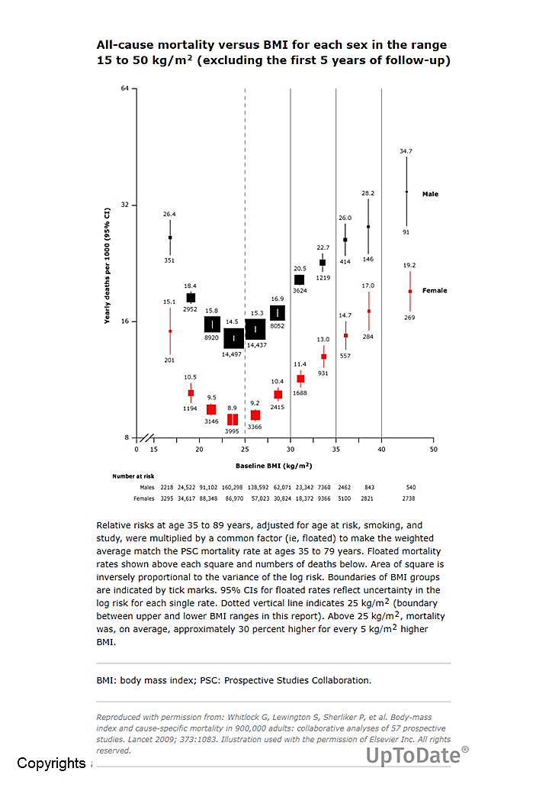
According to the latest available data from 2018, the Australian Institute of Health and Welfare has estimated that 31% of Australians have obesity and 36% have overweight but not obesity. In the Indigenous population the rates are higher; 45% living with obesity, and 40% overweight, without obesity.
Furthermore, 60% of adult men and 66% of adult women have a waist circumference that indicated an increased or substantially increased risk of metabolic complications. Overweight and obesity also have financial impacts. Generally, a higher level of obesity was associated with higher probability of health service use and work productivity loss. Both were higher with increasing levels of obesity. In 2018, obesity cost the Australian community and estimated 11.8 billion dollars, with the expectation of increasing costs over time.
Weight loss in people with obesity has proven medical benefits in reducing the risk of diabetes and other obesity-related complications. The goal of therapy is to prevent, treat, or reverse the complications of obesity and improve quality of life. While improvements in glycaemia and triglycerides begin at 3% and improvements in lipid and blood pressure at 5%, larger weight losses may be needed to produce benefits in some conditions such as obstructive sleep apnoea and non-alcoholic steatotic hepatitis. If sustained weight loss of > 15% is achievable, greater health benefits are likely to be seen as well as patients with obesity being more satisfied with the outcome.

Current treatment options for obesity

Non-pharmacological management
All patients should receive advice regarding diet and exercise, including structured programs. Diets include low-calorie, low-fat/low-calorie, moderate-fat/low-calorie, or low-carbohydrate diets, and may include meal replacement regimens, such as very low energy diet products. Diets can be consumed conventionally or on a time-restricted basis (intermittent fasting). Behavioural techniques may also be beneficial. The behavioural modification component facilitates adherence to diet and exercise regimens, and includes regular self-monitoring of food intake, physical activity, and weight. With non-pharmacological management, weight loss of 5% to 10% is typical but difficult to maintain.

Pharmacological management
For optimal weight loss, drug therapy should be used alongside non-pharmacological management. The choice of anti-obesity drug depends upon medication efficacy and adverse effects, patient comorbidities and preferences, and costs and availability. The following options have been indicated for patients with obesity or overweight in Australia:
Orlistat is a selective inhibitor of gastrointestinal (GI) lipase activity and reduces the absorption of dietary fat. According to the product information (PI) for both Prolistat and Xenical, orlistat is:
“indicated for the treatment of obese patients with a body mass index (BMI) ≥ 30, and overweight patients with a BMI ≥ 27 in the presence of other risk factors, in conjunction with a mildly hypocaloric diet”.
Phentermine is a sympathomimetic agent that suppresses appetite. According to the product PIs for the numerous phentermine products available in Australia, it is:
“an anorectic agent indicated in the management of obesity as a short-term adjunct in a medically monitored comprehensive regimen of weight reduction based, for example, on exercise, diet (caloric/kilojoule restriction) and behaviour modification in obese patients with a BMI of 30 kg/m² or greater. It can also be initiated in overweight patients with a lower BMI (25 to 29.9 kg/m²) if there is a higher risk due to comorbidities”.
Naltrexone-bupropion has been proposed to work in multiple pathways in the brain, including an increase in the firing rate of hypothalamic pro-opiomelanocortin neurons which are associated with the regulation of appetite. According to the product PI, it is:
“indicated, as an adjunct to a reduced-calorie diet and increased physical activity, for the management of weight in adult patients (≥18 years) with an initial body mass index (BMI) of ≥ 30 kg/m² (obese), or ≥27 kg/m² to < 30 kg/m² (overweight) in the presence of one or more weight-related co-morbidities (e.g., type 2 diabetes, dyslipidaemia, or controlled hypertension). Treatment should be discontinued after 16 weeks if patients have not lost at least 5% of their initial body weight.”
Liraglutide and semaglutide act as a GLP-1 receptor agonist. According to the product PIs, they are:
“indicated as an adjunct to a reduced-energy diet and increased physical activity for chronic weight management (including weight loss and weight maintenance) in adults with an initial BMI of ≥30 kg/m² (obesity), or ≥27 kg/m² to <30 kg/m² (overweight) in the presence of at least one weight related comorbidity”.

Bariatric surgery
Bariatric surgery is an effective strategy for weight reduction for people with severe obesity (BMI ≥ 35.0 kg m²), and long-term studies demonstrate that it is associated with improvements in several CVD risk factors. Procedures such as adjustable gastric banding, Roux-en-Y gastric bypass and sleeve gastrectomy occur. Surgery typically is reserved for patients with BMIs > 40 kg/m² or a BMI > 35 kg/m² with relevant comorbidities. Careful selection of patients is essential to both reduce the risk of peri- and post-operative complications and to also ensure favourable weight loss outcomes. Bariatric surgical approaches can achieve up to 40 percent weight loss at 12 to 18 months post-procedure, generally with better long-term weight loss maintenance than nonsurgical approaches.

Clinical rationale for Mounjaro use in obesity
Tirzepatide is a synthetic peptide, engineered from the native GIP peptide sequence and modified to bind to both GIP and GLP-1 receptors. GIP and GLP-1 are nutrient-stimulated gastrointestinal hormones known as incretins by virtue of their ability to stimulate insulin secretion post-prandially. They also regulate the physiological response to food, including sensation of satiety and nutrient disposal.
Tirzepatide was found to reduce overall appetite and food and caloric intake compared with placebo in a trial where participants had type 2 diabetes (T2DM). Tirzepatide led to greater weight reduction than the GLP-1 receptor agonist semaglutide, despite both agents having similar impact on food and caloric intake. Thus, tirzepatide may be promoting weight reduction through additional mechanisms beyond caloric intake reduction.
Activation of GLP-1 receptor signaling stimulates anorexigenic pathways in the brain, leading to loss of appetite, a reduction in food intake and a reduction in body weight. In preclinical models, stimulation of both the GIP and GLP-1 receptors reduces food intake and body weight more than selective GLP-1 receptor agonists.
Based on the known physiology and pharmacology of GIP and GLP-1, dual signaling by tirzepatide is expected to result in improved control of carbohydrate and lipid metabolism and body weight beyond that observed with selective GLP-1 receptor agonists alone. This is supported by both preclinical and clinical investigations of tirzepatide in T2DM and chronic weight management.

Regulatory status

Australian regulatory status
Mounjaro received initial registration in the Australian Register of Therapeutic Goods (ARTG) on 23 December 2022. It was approved for the treatment, in adults, of insufficiently controlled type 2 diabetes mellitus as an adjunct to diet & exercise, as monotherapy (metformin not tolerated/contraindicated), or in addition to other products.
There are several GLP-1 receptor agonists registered in Australia: these include liraglutide (first registered in 2010), dulaglutide (first registered in 2015) and semaglutide (first registered in 2019).

International regulatory status
Table 1: Marketing Authorisation Applications have been submitted in the following jurisdictions:
Region | Regulatory agency | Registration Status | Approval Date | Indications
United States of America | USA Food and Drug Administration (FDA) | Initiated rolling submission SURMOUNT-1 17 Nov 2022 submission completed with SURMOUNT-2 on 8 May 2023 | 08 November 2023 | NOTE: this has been submitted in the US as a new medicine under a new trade name.  ZEPBOUND is indicated as an adjunct to a reduced-calorie diet and increased physical activity for chronic weight management in adults with an initial BMI of:  - 30 kg/m² or greater (obesity) or  - 27 kg/m² or greater (overweight) in the presence of at least one weight-related comorbid condition (e.g., hypertension, dyslipidaemia, prediabetes, type 2 diabetes mellitus, obstructive sleep apnoea or cardiovascular disease).
European Union | European Medicines Agency (EMA)  Centralised Rapporteur: Martina Weise (Germany)  PRAC rapporteur: Menno van der Elst (Netherlands) | Submitted 8th March 2023 | 11 December 2023 | Chronic weight management  Mounjaro is indicated as an adjunct to a reduced-calorie diet and increased physical activity for weight management, including weight loss and weight maintenance, in adults with an initial BMI of:  - 30 kg/m² or greater (obesity) or  - 27 kg/m² or greater (overweight) in the presence of at least one weight-related comorbid condition (e.g., hypertension, dyslipidaemia, obstructive sleep apnoea, cardiovascular disease, prediabetes or type 2 diabetes mellitus,).
Switzerland | SwissMedic | 6 July 2023 | pending | Chronic weight management  Mounjaro is indicated as an adjunct to a reduced-calorie diet and increased physical activity for chronic weight management, including weight loss and weight maintenance, in adults with an initial Body Mass Index (BMI) of  - ≥30 kg/m² (obesity) or  - ≥27 kg/m² to < 30kg/m² (overweight) in the presence of at least one weight-related comorbid condition (e.g., hypertension, dyslipidaemia, obstructive sleep apnoea, cardiovascular disease, prediabetes or type 2 diabetes mellitus).
United Kingdom | Medicines and Healthcare products  Regulatory Agency  (MHRA) | Initiated submission with SURMOUNT-1 on 27th April 2023 SURMOUNT-2 submitted on 16th June 2023 | 08 November 2023 | Mounjaro is indicated as an adjunct to diet and exercise:  - For the treatment of adults with insufficiently controlled type 2 diabetes mellitus:  - as monotherapy when metformin is considered inappropriate due to intolerance or contraindications  - in addition to other medicinal products for the treatment of diabetes.  - For weight management, including weight loss and weight maintenance, as an adjunct to a reduced-calorie diet and increased physical activity in adults with an initial Body Mass Index (BMI) of:  - 30mg/ m² (obesity) or  - ≥ 27 kg/m² to < 30 kg/m² (overweight) in the presence of at least one weight-related comorbid condition (e.g., hypertension, dyslipidaemia, obstructive sleep apnoea, cardiovascular disease, prediabetes, or type 2 diabetes mellitus)

Registration timeline
This submission was evaluated under the standard prescription medicines registration process.
Table 2: Timeline for Mounjaro submission PM-2023-03723-1-5
Description | Date
Submission dossier accepted and first round evaluation commenced | 3 October 2023
Evaluation completed | 5 June 2024
Delegate’s Overall benefit-risk assessment and request for Advisory Committee advice | 2 July 2024
Advisory Committee meeting | 19 August 2024
Registration decision (Outcome) | 9 September 2024
Registration in the ARTG | 10 September 2024
Number of working days from submission dossier acceptance to registration decision (the statutory timeframe for standard submissions is 255 working days) | 230

Evaluation overview

Clinical evaluation summary

Summary of clinical studies
The following clinical studies have not been previously submitted to the TGA for evaluation.

Clinical pharmacology studies
- Study I8F-MC-GPHU – assessing the effect of tirzepatide on gastric emptying in participants with obesity.
- Study I8F-MC-GPHT – assessing safety, tolerability, pharmacokinetics (PK) and pharmacodynamics (PD) of tirzepatide in Chinese patients with T2DM.
- Study I8F-MC-GPHG – assessing the counter-regulatory response to hypoglycaemia in T2DM from tirzepatide and placebo.

Phase 3 studies
- Global, pivotal Phase 3 study in participants with obesity or overweight, without diabetes mellitus Study I8F-MC-GPHK (SURMOUNT-1).
- Placebo-controlled, double-blinded study of the safety and efficacy of tirzepatide 10 and 15 mg QW, compared with placebo, when used in conjunction with a reduced-calorie diet and increased physical activity for weight management Study I8F-MC-GPHL (SURMOUNT-2).
- Study I8F-MC-GPHO (SURPASS-AP-Combo) used the tirzepatide 5, 10, and 15 mg maintenance doses and the same tirzepatide dose-escalation scheme used in the global Phase 3 studies. Data not previously provided.
The Sponsor has also provided population PK analysis and exposure-response analyses of tirzepatide for chronic weight management, based on data from the SURMOUNT-1 study.
Nineteen completed clinical studies were included in the initial submission for Mounjaro and have been previously reviewed by the TGA.

Pharmacology

Pharmacokinetics

Study I8F-MC-GPHU
The Impact of Tirzepatide on Gastric Emptying (GE) in Overweight/Obese Non-diabetic Subjects and in Overweight/Obese Subjects with Type 2 Diabetes Mellitus
- The primary objective of this study was to assess the effect of tirzepatide on the PK profile of paracetamol, used in the study as a marker for gastric emptying (GE).
- A total of 36 participants with obesity or overweight (18 with /18 without T2DM) aged 28-65 years, with a BMI of 27.12 to 44.87 kg/m² were enrolled.

Results
- Peak plasma concentration of paracetamol (C_{max}) was reduced by 55% and 32% when paracetamol was administered in the presence of 5 mg (Day 2) or 15 mg (Day 37) tirzepatide, respectively, compared to dosing with when given alone (Day -1). This is indicative of tirzepatide delaying GE, and the effect diminishes with repeated dosing over time.
- The C_{max} of paracetamol was reduced by a similar extent when paracetamol was administered in the presence of 5 mg tirzepatide compared to when administered alone between non-diabetic and T2DM subjects on Day 2. The reduction was greater for T2DM subjects than non-diabetic subjects when paracetamol was administered in the presence of 15 mg tirzepatide compared to when administered alone (20% for non-diabetic versus 43% for T2DM subjects) on Day 37.
- Overall exposure to paracetamol, as measured by AUC(0-t_{last}), changed similarly for non-diabetic and T2DM subjects. The t_{max} changed similarly for non-diabetic and T2DM subjects.
This study demonstrated that the PK profiles and parameters of tirzepatide were generally similar between non-diabetic subjects and subjects with T2DM.

Study I8F-MC-GPHT
A Multiple Dose Titration Study in Chinese Patients with Type 2 DM to Investigate the Safety, Tolerability, Pharmacokinetics, Pharmacodynamics, and Efficacy of Tirzepatide.
- A total of 24 native Chinese participants with T2DM, (13 males,11 females), aged 50 - 66 years with a BMI of 23.1-31.2 kg/m² received a dose-escalation regimen or placebo.

Results
- Tirzepatide PK in Chinese participants with T2DM was consistent with findings from Study I8F-MC-GPGA (GPGA).
- The PD results were also consistent with Study GPGA.
The PK/PD profiles of tirzepatide at doses and escalation schemes investigated support the development of tirzepatide for once weekly dosing in Chinese participants with T2DM.
The PK/PD profiles based on Study GPHT were in accordance with expectations based on global Phase 1 Study GPGA in healthy participants.

Study I8F-MC-GPHG
A Randomised, Placebo-Controlled, Crossover Study to Investigate the Effect of Once-Weekly Tirzepatide on the Counter-Regulatory Response to Hypoglycaemia in Patients with Type 2 Diabetes Mellitus
- 42 participants with T2DM between aged 40 - 67 years, BMI 24.4 - 41.7 kg/m², participated.

Results
- The change in mean glucagon concentration in response to induced hypoglycaemia from the target PG plateau of 5.5 mmol/L to the nadir plateau of 2.5 mmol/L was not statistically significantly different when receiving tirzepatide compared to placebo.
- A sensitivity analysis including only those patients who reached the target PG nadir concentration of 2.5 mmol/L showed similar results.
- There was no statistically significant difference in change in glucagon concentration from the target PG plateau of 5.5 mmol/L to the target PG plateau of 3.5 mmol/L and recovery to 4.0 mmol/L when receiving tirzepatide compared to placebo.

Pharmacokinetics – summary
Tirzepatide PKs were generally similar between healthy participants and participants with obesity or overweight with or without T2DM.

Absorption
Following subcutaneous administration of tirzepatide, median T_{max} was achieved approximately 24 hours (range 8 to 72 hours) post dose. The absolute bioavailability of a 5-mg subcutaneous dose of tirzepatide in healthy participants was 80%. The exposure to tirzepatide increased proportionally with increasing doses in the 0.25- to 15-mg dose range.
Data from a relative bioavailability study demonstrated that tirzepatide can be injected subcutaneously in the abdomen, upper arm, or thigh, without need for any dose adjustment.
Accumulation after multiple-dose administration was approximately 1.75-fold and was predictable based on single-dose data, indicating that PK was time-independent.

Distribution
The mean apparent volume of distribution after multiple dosing in participants with obesity or overweight was 9.7L; for those with T2DM, the figure was 10.3L. Tirzepatide was highly protein bound in human plasma with a mean percent bound of 99.06%.

Metabolism
Tirzepatide was primarily metabolised via proteolytic cleavages of the peptide backbone, β-oxidation of the C20 fatty diacid moiety, and amide hydrolysis.

Elimination
Based on population PK post hoc parameters, the estimated apparent total body clearance of tirzepatide calculated after extravascular administration (CL/F) in T2DM patients following multiple doses was 0.0606 L/h resulting in a mean terminal half-life of 5.4 days. For those with obesity or overweight, the figure was calculated at 5.7 days. Renal excretion is the primary route of elimination.

Population Pharmacokinetics

Pop PK analysis VV-CLIN-062365
The population PK/PD model established based on data submitted in the original T2DM application served as the base model for the population PK/PD analysis for chronic weight management (CWM). SURMOUNT-1 was used for establishing population PK and exposure-response relationship for CWM.
The population PK modelling results from participants with obesity or overweight were comparable to the previous population PK analyses of patients with T2DM.
No patient-specific characteristics or tirzepatide administration conditions were associated with clinically relevant changes in tirzepatide PK, efficacy, tolerability, or safety. Based on the evaluation of the influence of intrinsic and extrinsic factors on tirzepatide PK concentrations and body weight across time, dose adjustments are not required for QW SC tirzepatide based on body weight, age, sex, race, renal impairment, or hepatic impairment in participants with obesity or overweight.
The results of the modelling and simulations supported that dose-escalation up to tirzepatide 5, 10, or 15 mg QW was well tolerated and associated with significant reductions in body weight. Changes to dose escalation scheme are not required for tirzepatide treatment for CWM.
Based on the evaluation of the influence of anti-drug antibodies (ADA) status and ADA titre on tirzepatide PK, dose adjustments are not required for tirzepatide QW SC doses.

Effect of intrinsic factors on tirzepatide PK
No dose adjustment of tirzepatide is needed based on body weight, age, sex, race, ethnicity, or renal or hepatic impairment.

Effect of extrinsic factors on tirzepatide PK
Concomitantly administered drugs are not expected to influence tirzepatide PK.

Effects of tirzepatide on oral concomitant drugs
The drug-drug interactions mediated by tirzepatide, if any, are expected only because the GLP-1 receptor agonist class is known to cause gastric emptying delay, which can influence the rate of absorption (C_{max,} t_{max}) without greatly influencing overall extent of absorption (AUC) of orally administered concomitant drugs. This impact is expected to diminish with subsequent doses of tirzepatide; thus, long-term impact of tirzepatide on the exposure of oral medications is not expected.

Pharmacodynamics
Tirzepatide, a synthetic peptide with agonist activity at both the human glucose-dependent insulinotropic polypeptide (GIP) and human glucagon-like peptide-1 (GLP-1) receptors. Tirzepatide reduces body weight and improves body weight control through multiple mechanisms. Tirzepatide reduces appetite, which is centrally regulated, thereby decreasing food and caloric intake (Table 3).
Table 3: Known physiological functions of GIP and GLP-1 in glucose metabolism and energy.
Location of action | GLP-1 | GIP
Pancreas (glucose-dependent actions)
β cells | Increased insulin synthesis, increased insulin secretion, increased β cell proliferation, increased glucose sensing under hyperglycaemic states.
α cells | Decreased glucagon secretion under hyperglycaemic states. | Increased glucagon secretion under euglycaemic or hypoglycaemic states.
Gastrointestinal system | Decreased GI motility, delayed gastric emptying | N/A
Adipose tissues | N/A | Increased intravascular lipolysis and increased fatty acid uptake.
Brain | Decreased appetite, increased satiety | N/A
- Effect on body weight: Tirzepatide reduces and controls body weight. Tirzepatide decreases appetite and food and caloric intake. There is an exposure-response relationship for body weight over the dose range of tirzepatide 5 to 15 mg QW.
- Effects on glucose sensitivity and insulin secretion β-cell glucose sensitivity: Tirzepatide enhances first- and second-phase insulin secretion and reduces glucagon levels, both in a glucose-dependent manner.
- Effects on gastric emptying: Tirzepatide delays gastric emptying. The delay is largest after the first dose and diminishes over time.

Efficacy
Two Phase 3, double-blind, placebo-controlled studies (SURMOUNT-1, SURMOUNT-2) are included in this submission. Both included 72 weeks of exposure and a 4-week safety follow-up period (Table 4).
Table 4: Study design features: SURMOUNT 1 and 2 studies.
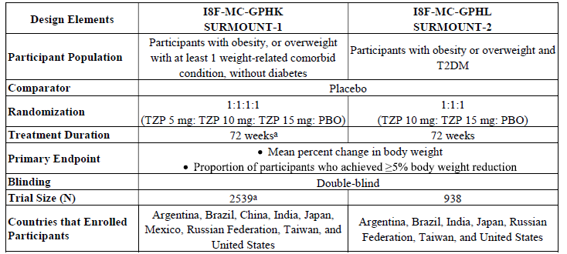
ªInformation in this table for SURMOUNT-1 is for the completed primary study period. N = number of participants in category; PBO = placebo; T2DM = type 2 diabetes mellitus; TZP = tirzepatide.

Methods

Patient populations
SURMOUNT-1 and SURMOUNT-2 included a broad and diverse target treatment population of patients with obesity or overweight, with (SURMOUNT-2) and without (SURMOUNT-1) T2DM. All participants were at least 18 years of age.
Participants were required to meet 1 of the criteria of:
- obesity, defined as having a BMI of 30 kg/m² or more, or
- overweight, defined as having a BMI of 27 kg/m² or more with at least 1 weight-related comorbid condition, including, but not limited to,
  - obstructive sleep apnoea
  - hypertension
  - dyslipidaemia, or
  - cardiovascular disease.
Participants in both SURMOUNT-1 and -2 were required to have a history of at least 1 self-reported unsuccessful dietary effort to reduce body weight.

Study treatments
Participants were randomised into four groups: tirzepatide QW 5 mg (SURMOUNT-1 only); 10 mg; 15 mg; or placebo. A dosing algorithm (Table 5) starting at a dose of 2.5 mg with dose escalation of 2.5-mg increments every 4 weeks up to the target dose was utilised. The maximum dose was 15mg weekly. The study intervention was provided in autoinjectors (single-dose pens).
Table 5: Tirzepatide Dose-Escalation Scheme in SURMOUNT-1 and SURMOUNT-2 studies.
Treatment Group – Tirzepatide (mg) | Treatment Period Intervals
Treatment Group – Tirzepatide (mg) | Weeks  0 to 4 | Weeks  4 to 8 | Weeks  8 to 12 | Weeks  12 to 16 | Weeks  16 to 20 | Week 20 through End of Treatment Period
5mg | 2.5 mg | 5 mg | 5 mg | 5 mg | 5 mg | 5 mg
10mg | 2.5 mg | 5 mg | 7.5 mg | 10 mg | 10 mg | 10 mg
15 mg | 2.5 mg | 5 mg | 7.5 mg | 10 mg | 12.5 mg | 15 mg
The longest dose-escalation period was 20 weeks. Therefore, the 72-week treatment duration allowed the evaluation of maintenance doses for 68 weeks (5 mg), 60 weeks (10 mg), and 52 weeks (15 mg).
For all participants, lifestyle modification was advised. This consisted of a hypocaloric diet with a 500-kcal/day deficit that was individually calculated, and an increase in physical activity to moderate intensity for ≥150 minutes per week. Lifestyle counselling was administered throughout the study.

Outcomes
The primary efficacy assessment in both studies was body weight: % change in body weight from randomisation and percentage of participants who achieve ≥5% body weight reduction at 72 weeks.
Additional clinical endpoints included:
- Percentage of patients reaching ≥ 10%, ≥ 15% and ≥20% body weight reduction
- Change in waist circumference.
- Change in triglycerides, non-HDL cholesterol, and HDL cholesterol.
- Change in systolic and diastolic blood pressure.
- Change in fasting insulin.
- Change in HbA1c.
Patient-reported outcomes assessments included:
- Short Form-36 (SF-36v2) and
- Impact of Weight on Quality of Life – Lite Clinical Trials Version (IWQOL-Lite-CT)

Description of analysis datasets
Treatment compliance in this study was defined as taking at least 75% of the required doses of the study drug. Data set definitions are shown in Table 6.
There were 2 estimands of interest in evaluating primary and key secondary outcomes.
- The efficacy estimand represents on-treatment efficacy not confounded by discontinuation of study drug. The efficacy analysis set was used. This estimand, reflects the effect of a treatment for patients who are willing and able to take the drug as prescribed. The analyses for the efficacy estimand were conducted using the EAS.
- The treatment-regimen estimand represents efficacy irrespective of adherence to study drug. This likely indicates how a drug will work in a more real-life setting, The analyses for the treatment-regimen estimand were conducted using the full analysis set.
Table 6: Description of Analysis Datasets
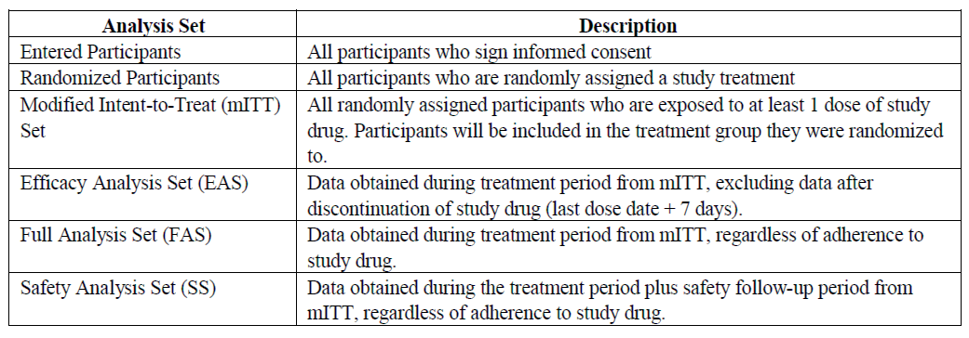
Disposition of participants: In SURMOUNT-1 and SURMOUNT-2, 2539 participants and 938 participants, respectively, were randomised. All randomised participants received at least 1 dose of study drug (Table 7).
Table 7: Summary of SURMOUNT-1 and SURMOUNT-2 participant disposition.
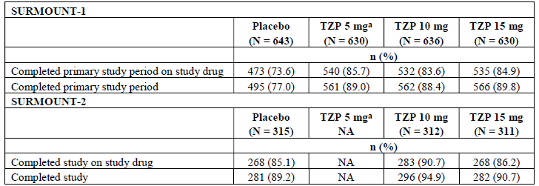
ª applies to SURMOUNT-1 only. n = number of participants within category; N = number of participants randomised; NA = not applicable; TZP = tirzepatide

Results

SURMOUNT-1 (Study I8F-MC-GPHK)
Demographic and baseline clinical characteristics were comparable across the treatment groups. The mean age was 45 years, mean BMI was 38 kg/m², mean weight was 104.8 kg, 94.5% of participants had a BMI 30.0 kg/m² or higher and 67.5% of participants were female.
At baseline, nearly 2/3 of participants had ≥ 1 weight-related comorbidities, including hypertension (32.3%), dyslipidaemia (29.8%), obstructive sleep apnoea (7.8%), and atherosclerotic cardiovascular disease (3.1%), and 40.6% had prediabetes (baseline FSG, HbA1c, and oral glucose tolerance test).
Tirzepatide 5, 10, and 15 mg achieved superiority over placebo on the coprimary endpoints and all key secondary endpoints, which were controlled for type 1 error, using the treatment-regimen and efficacy estimands. (Table 8, Figure 2).
Tirzepatide led to statistically and clinically meaningful weight reductions across doses. The mean % weight reduction for 5, 10, and 15 mg at 72 weeks was 15%, 19.5%, and 20.8%, respectively, for the treatment-regimen estimand and 16%, 21.4%, and 22.5%, respectively, for the efficacy estimand.
Significantly higher percentages of participants treated with tirzepatide 5, 10, or 15 mg compared to placebo achieved ≥ 5%, ≥ 10%, ≥ 15% and ≥20% body weight reductions at 72 weeks.
Table 8: Summary of Body Weight Measures at Week 72 in SURMOUNT-1 mITT Population Full Analysis Set; Efficacy Analysis Set
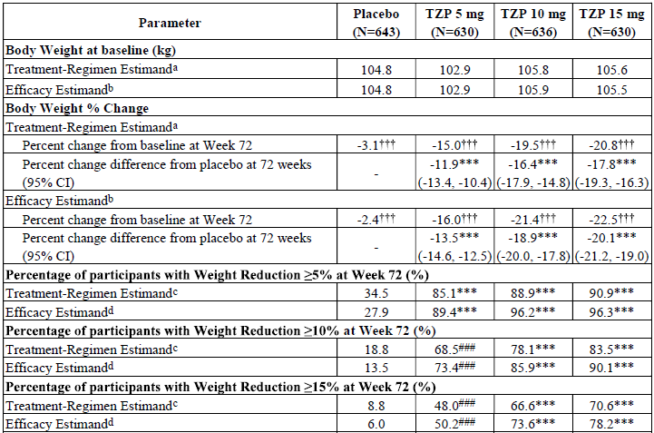
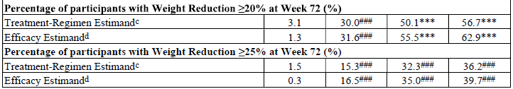
Abbreviations: ANCOVA = analysis of covariance; CI = confidence interval; mITT = modified intent-to-treat; MMRM = mixed model for repeated measures; N = number of participants who were randomly assigned and received at least 1 dose of study drug; TZP = tirzepatide.
ª ANCOVA with hybrid imputation for missing body weight data at 72 weeks. ^{b} MMRM analysis. ^{c} Logistic regression with missing body weight imputed using hybrid imputation at 72 weeks. ^{d} Logistic regression with missing value imputed using MMRM analysis at 72 weeks. Note: Shown are least squares mean. ***p-Value <.001 versus placebo for objectives controlled for type 1 error. ###p-Value <.001 versus placebo for objectives not controlled for type 1 error. p-Value <.001 versus baseline within each treatment group.
Figure 2: Percent change in body weight from baseline at Week 72: mITT Population Full Analysis Set; Efficacy Analysis Set
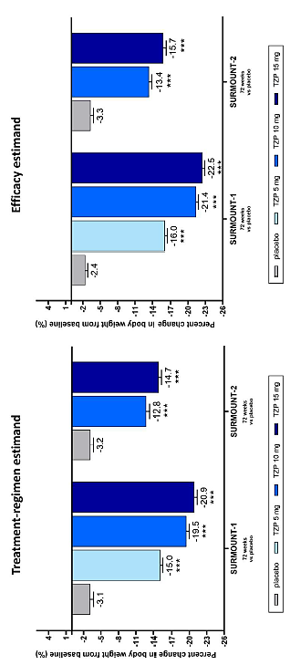
T2DM = type 2 diabetes mellitus; TZP = tirzepatide. ***p-value <.001 versus placebo, controlled for type 1 error.
Tirzepatide significantly reduced mean body weight from baseline and relative to placebo starting at Week 4, the first time point assessed on treatment. The body weight for participants in the tirzepatide 5-mg group continued to decrease through Week 60 and stabilised by Week 72. In the tirzepatide 10- and 15-mg groups, the weight reduction attenuated but continued through the 72-week primary endpoint visit (Figure 3).
Figure 3: Estimated cumulative distribution of percent change from baseline in body weight at 72 weeks in SURMOUNT-1 & 2: mITT population, efficacy analysis set.
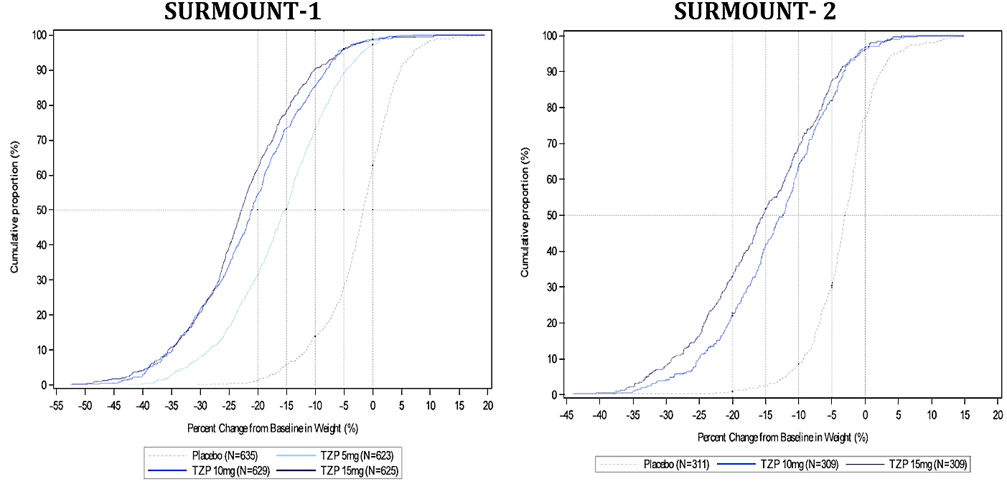
For tirzepatide 5, 10, and 15 mg there was a significant (p-value <0.001) difference from placebo at 72 weeks for mean change from baseline in the following parameters:
- Decrease in lipid parameters: triglycerides (-22.7%), non-high-density lipoprotein cholesterol (-9.7%) and an increase in high-density lipoprotein cholesterol (7.7%)
- Systolic blood pressure (-6.8 mmHg)
- fasting insulin (-41.2%).
- haemoglobin A1C from baseline compared with placebo (-0.3% [-3.6 mmol/mol], -0.4% [-4.6 mmol/mol], and -0.4% [-4.8 mmol/mol], respectively).
The estimated cumulative distribution of percent change from baseline in body weight at 72 weeks shows left-shifted curves favouring each tirzepatide dose (5, 10, and 15 mg) compared with placebo for body weight reduction (Figure 3).
The DXA addendum showed mean percent reduction from baseline in total body fat mass was significantly greater for pooled tirzepatide 5, 10, and 15 mg (-33.9) compared with placebo (-8.2).
All doses of tirzepatide showed significant improvements compared to placebo for all eight domains (physical functioning, role-physical, bodily pain, general health, vitality, social functioning, role-emotional, mental health) of the Short-Form-36 Health Survey, Version 2 (SF-36v)2, (Figure 4) and for both mental and physical component scores and in the IWQOL-Lite-CT (Physical Function, Physical, Psychosocial composites, total scores).
Figure 4: Change from baseline in SF-36v2 acute form domains and component summary scores at Week 72: mITT population, efficacy analysis set
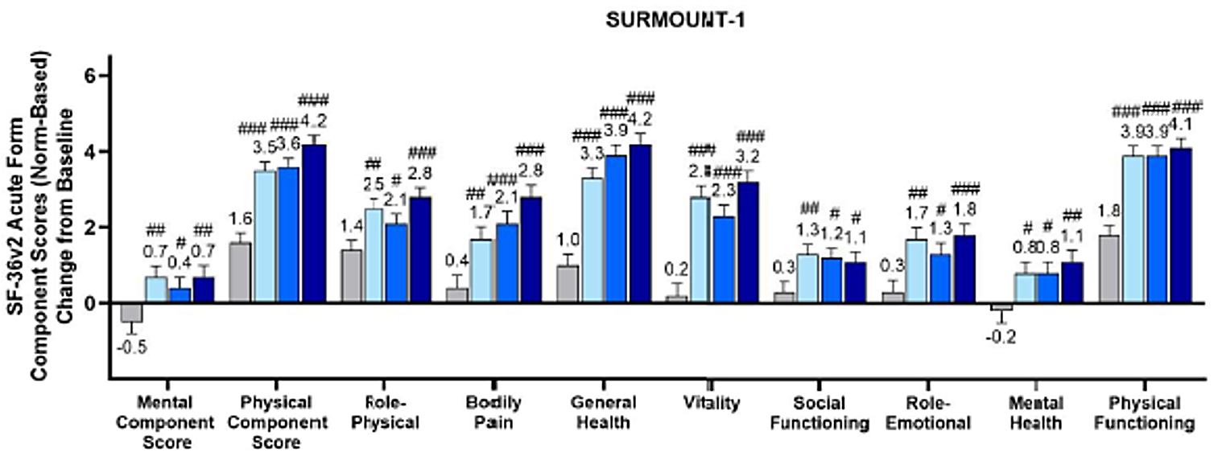
SF-36v2 = Short-Form-36 Health Survey, Version 2; T2DM = type 2 diabetes mellitus; TZP = tirzepatide. #p-Value <.05, ##p-value <.01, ###p-value <.001 versus placebo, not controlled for type 1 error.
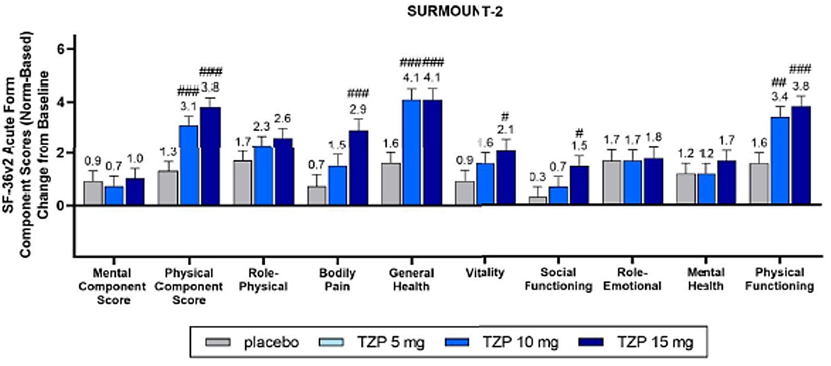
SF-36v2 = Short-Form-36 Health Survey, Version 2; T2DM = type 2 diabetes mellitus; TZP = tirzepatide. #p-Value <.05, ##p-value <.01, ###p-value <.001 versus placebo, not controlled for type 1 error.

Results

SURMOUNT 2 (Study I8F-MC-GPHL)
Demographic and baseline clinical characteristics were comparable across the treatment groups. The mean age was 54 years, mean BMI was 36.1 kg/m², mean weight was 100.7 kg, 82.6% of participants had a BMI 30.0 kg/m² or higher and 50.7% of participants were female. The mean duration of diabetes was 8.5 years, and the mean baseline glycated haemoglobin (HbA1c) was 8.0%.
At baseline, 87.4% of participants in SURMOUNT-2 had 1 or more weight-related comorbidities in addition to T2DM, including hypertension (66.1%), dyslipidaemia (61.1%), obstructive sleep apnoea (8.3%) and atherosclerotic cardiovascular disease (10.3%).
In comparison with placebo, tirzepatide 10 & 15 mg each achieved superiority with treatment-regimen and efficacy estimands on the type 1 error-controlled coprimary endpoints. (Table 9, Figure 2).
Tirzepatide led to statistically and clinically meaningful weight reductions across doses. The mean % weight reduction for tirzepatide 10, and 15 mg at 72 weeks was, 12.8%, and 14.7%, respectively, for the treatment-regimen estimand and 13.4%, and 15.7%, respectively, for the efficacy estimand.
Significantly higher percentages of participants treated with tirzepatide 10, or 15 mg compared to placebo achieved ≥ 5%, ≥ 10%, ≥ 15% and ≥20% body weight reductions at 72 weeks.
For tirzepatide 10, and 15 mg there was a significant (p-value <0.001) difference from placebo at 72 weeks for mean change from baseline in the following parameters:
- HbA1c (-1.97% [-21.57 mmol/mol] and -2.06% [-22.5 mmol/mol], respectively). At 72 weeks, up to 90.7%, 86.7%, and 55.3% of participants randomly assigned to tirzepatide and 29.3%, 15.5%, and 2.8% of participants randomly assigned to placebo achieved HbA1c targets of <7%, ≤6.5%, and <5.7%, respectively.
- Pooled tirzepatide 10 and 15 mg achieved superiority compared with placebo for mean percent change in lipid parameters, including decrease in triglycerides (-24.2%), decrease in non-high density lipoprotein cholesterol (non-HDL-C, -8.7%), and increase in HDL-C (7.0%). Superiority was also observed for pooled tirzepatide 10 and 15 mg compared with placebo for mean change in systolic blood pressure (-6.2 mm Hg).
The estimated cumulative distribution of percent change from baseline in body weight at 72 weeks shows left-shifted curves favouring tirzepatide compared with placebo, with a visually greater shift in the 15-mg dose compared with 10-mg dose. The beneficial effects of tirzepatide on reduction of body weight persisted over 72 weeks (Figure 3).
Both doses of tirzepatide showed significant improvements compared to placebo for all eight domains (physical functioning, role-physical, bodily pain, general health, vitality, social functioning, role-emotional, mental health) of the SF-36v2, (Figure 4) and for both mental and physical component scores, and in the IWQOL-Lite-CT (Physical Function composite, Physical composite, Psychosocial composite, and total scores).
Table 9: Summary of Body Weight Measures at Week 72 in SURMOUNT-2 mITT Population Full Analysis Set; Efficacy Analysis Set
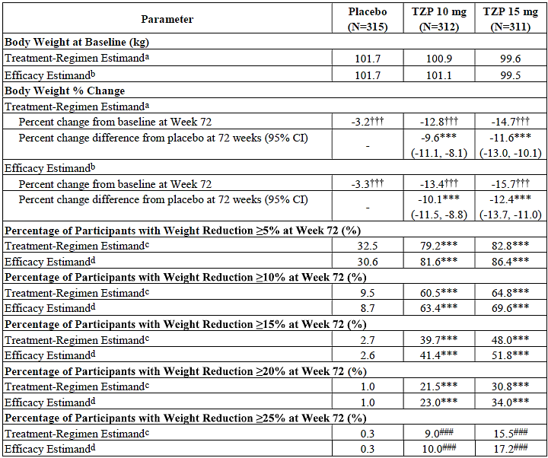
Abbreviations: ANCOVA = analysis of covariance; CI = confidence interval; mITT = modified intent-to-treat; MMRM = mixed model for repeated measures; N = number of participants who were randomly assigned and received at least 1 dose of study drug; TZP = tirzepatide.
ª ANCOVA with hybrid imputation for missing body weight data at 72 weeks. ^{b} MMRM analysis. ^{c} Logistic regression with missing body weight imputed using hybrid imputation at 72 weeks. ^{d} Logistic regression with missing value imputed using MMRM analysis at 72 weeks. Note: Shown are least squares mean. ***p-Value <.001 versus placebo for objectives controlled for type 1 error. ###p-Value <.001 versus placebo for objectives not controlled for type 1 error. p-Value <.001 versus baseline within each treatment group.

Comparison of results in subpopulations
Subgroup analyses were conducted to determine whether demographic features and other intrinsic and extrinsic factors at baseline affected the primary outcome treatment effect. Overall, all tirzepatide doses of 5 (SURMOUNT-1 only), 10, and 15 mg were efficacious in all subgroups, irrespective of age, race, sex, ethnicity, region of enrolment, baseline BMI, glycaemic status at randomisation (SURMOUNT-1 only), baseline HbA1c category (SURMOUNT-2 only), or type of antihyperglycemic medications used (SURMOUNT-2 only) for mean percent body weight change or percentage of participants achieving ≥5% body weight reduction at the primary endpoint visit, using the treatment-regimen and efficacy estimands.

Safety

Patient exposure
The safety profile of tirzepatide was assessed in all treated participants with baseline BMI > 27kg/m², and includes data from the following studies:
- Phase 3 Study I8F-MC-GPHK (SURMOUNT-1), in participants with obesity or overweight and without diabetes (primary study period; all enrolled participants).
- Phase 3 Study I8F-MC-GPHN (SURMOUNT-4), in participants with obesity or overweight and without diabetes (open-label lead-in period; all enrolled participants)
- two Phase 2, 7 Phase 3 SURPASS studies from original T2DM application (only participants with BMI ≥ 27kg/m²).
- Phase 3 Study I8F-MC-GPHO (SURPASS-AP-Combo), in participants with diabetes (only participants with BMI ≥27 kg/m²).
The total exposure to tirzepatide in Phase 2 and Phase 3 studies (excluding SURMOUNT-2; see table 6 for the list of included studies) was 7354 participants with obesity for a total of 7071 patient-years. 3492 participants received tirzepatide for at least 52 weeks in the Phase 2 and 3 studies, with 2027 receiving tirzepatide for at least 72 weeks. Of those participants who had received tirzepatide, there were 4676 (4167 patient-years) participants with overweight/obese with T2DM versus 2678 (2904 patient-years) participants with overweight/obese without T2DM (Table 10).
Table 10. Summary of Exposure to Tirzepatide and Comparators in Completed Phase 2 and 3 Studies (Safety Population, excluding SURMOUNT-2=study I8F-MC-GPHL) - Phase 2/3 Studies in Participants with Baseline BMI ≥27 kg/m².
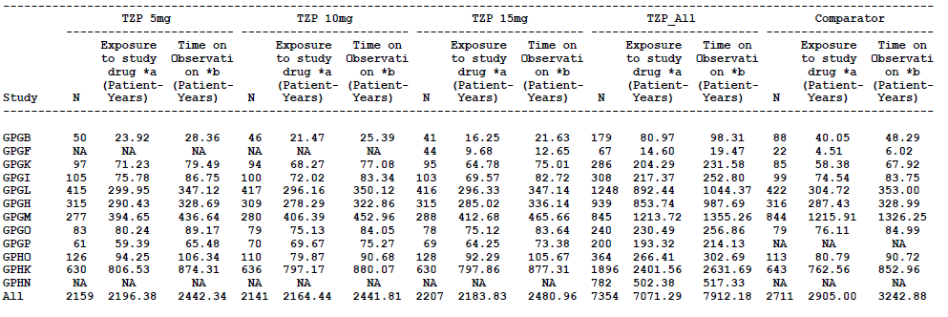
BMI = body mass index; N = number of participants; NA = not applicable; TZP = tirzepatide. *a - Exposure to study drug is defined as time in days from date of first dose of study treatment to date of last dose of study treatment plus 7 days for non-insulin treatments, and plus 1 day for insulin treatments. *b - Time on observation is defined as sum of time in days from date of randomisation to the end of study / 365.25.
The patient exposure to tirzepatide in the SURMOUNT-2 study was 623 (800.17 total patient years). This includes 564 participants who received tirzepatide for at least 52 weeks, and 481 who received tirzepatide for at least 72 weeks.
Study GPHO (SURPASS-AP-Combo) was a Phase 3, randomised, open-label, parallel-group study that investigated the effects of treatment with tirzepatide 5, 10, and 15 mg QW compared with titrated insulin glargine in participants with T2DM who had inadequate glycaemic control on stable doses of metformin with/without a sulfonylurea. The study has completed since the T2DM application. Of 907 participants exposed to study treatment for up to 40 weeks, 687 received ≥ 1 dose of tirzepatide. Of the 907 participants, 477 had a BMI of ≥ 27 kg/m², with 364 receiving at least 1 dose of tirzepatide.
SURMOUNT-4 (study GPHN), a Phase 3, randomised, double-blinded, placebo-controlled, 88-week study, is investigating the impact of MTD of tirzepatide (10 or 15 mg QW), compared with placebo, on the maintenance of weight reduction after an initial 36-week open-label tirzepatide lead-in treatment period. Participants in the study have obesity or are overweight with at least 1 weight-related comorbid condition and do not have diabetes mellitus. Safety data from the 36-week open-label period are included in safety assessments, while the double-blinded treatment period is still ongoing. A total of 782 participants were treated with tirzepatide for up to 36 weeks in the open-label period.
In all Phase 3 studies, participants were assigned to fixed dose groups (5, 10, and 15 mg) at randomisation except for SURMOUNT-4 where participants were required to escalate the dose to an MTD of 10 mg or 15 mg. All Phase 3 studies used the same dose-escalation scheme allowing for the integration and analyses of data for each tirzepatide dose group separately as necessary.

Key safety outcomes for CWM indication: Pooled SURMOUNT-1 and SURMOUNT-2
The pooling of SURMOUNT-1 and SURMOUNT-2 was appropriate given the similar safety profile observed across studies, similarity of study designs, and same BMI inclusion criteria for both studies. Treatment comparisons are made for tirzepatide 5, (Only in SURMOUNT 1) 10, 15 mg, and all tirzepatide doses pooled (TZP_ALL), compared with placebo.
Across SURMOUNT-1 and SURMOUNT-2, 2519 participants with obesity or overweight, with and without T2DM, received tirzepatide for 3201.7 patient-years of exposure. Of these, 2236 participants received tirzepatide for at least 52 weeks, and 1926 participants received tirzepatide for at least 72 weeks. Additionally, 958 participants received placebo for 1155.3 patient-years of exposure.

Adverse event profile
Across these 2 studies, the percentage of participants who reported at least 1 TEAE was higher in the TZP_ALL group (79.0%) than in the placebo group (73.3%) (Table 11). Among the most frequently reported TEAEs, the majority were GI related (TZP_ALL, 55.66%; placebo, 29.65%). (Table 12).
Table 11. Overview of Adverse Events Safety Population SURMOUNT-1 + SURMOUNT-2 Analysis Set
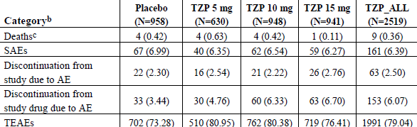
Table 12: TEAEs Occurring in ≥5% of Participants in Any Group (Safety Population: SURMOUNT-1 + SURMOUNT-2 Analysis Set)
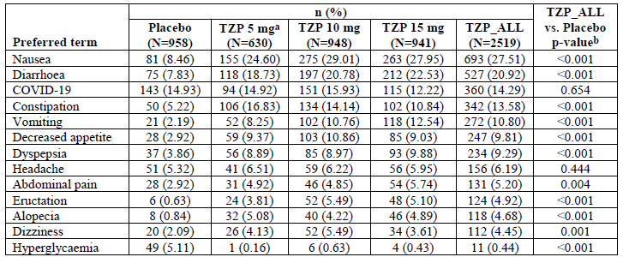
Abbreviations: COVID-19 = coronavirus disease 2019; N = number of participants in treatment group; n = number of participants with at least 1 treatment-emergent adverse event; TZP = tirzepatide. ª The TZP 5-mg group is only from SURMOUNT-1. ^{b} The p-values are from the Cochran-Mantel-Haenszel test of general association stratified by study.
The percentages of participants in the SURMOUNT-1 + SURMOUNT-2 Analysis Set who reported at least 1 SAE were similar in the TZP_ALL (6.39%) and placebo (6.99%) groups. The most frequently reported SAEs were in the SOC of Infections and infestations (TZP_ALL, 2.02%; placebo, 1.98%). SAEs reported by at least 0.2% (n=5) in the TZP_ALL group included COVID-19 pneumonia (TZP_ALL, 0.52%; placebo, 0.63%), COVID-19 (TZP_ALL, 0.36%; placebo, 0.63%), cholelithiasis (TZP_ALL, 0.48%; placebo, 0.42%), cholecystitis acute (TZP_ALL, 0.28%; placebo, 0.21%), appendicitis (TZP_ALL, 0.28%; placebo, 0.31%), acute kidney injury (TZP_ALL, 0.24%; placebo, 0.21%), and prostate cancer (TZP_ALL, 0.22%; placebo, 0.28%).
There were a total of 13 deaths (TZP_ALL, 9 [0.36%]; placebo, 4 [0.42%]) in the SURMOUNT-1 + SURMOUNT-2 Analysis Set. There was no pattern in the causes of death observed among tirzepatide-treated participants in SURMOUNT-1 and SURMOUNT-2.
The percentages of participants in the SURMOUNT-1 + SURMOUNT-2 Analysis Set who prematurely discontinued study drug due to an AE was higher for tirzepatide-treated participants [153 participants (6.07%)] compared to placebo-treated participants: [33 participants (3.44%)].
The additional clinical pharmacology studies I8F-MC-GPHU(n=36), I8F-MC-GPHT (n=22), and Study I8F-MC-GPHG (n=33) also provided safety data, with no unexpected safety concerns identified.

Adverse events of special interest
Based on the established safety profiles of Mounjaro and currently marketed incretin-based therapies for CWM in this population, mechanism of action of tirzepatide, and safety risks associated with the obesity and overweight population, several safety topics were considered in the determination of key risks, including, but not limited to,
- GI adverse events
- gallbladder disorders
- major depressive disorders/suicidality
- exocrine pancreas safety
- CV safety
- thyroid C-cell safety
- hypersensitivity reactions.
The most frequently reported AEs were in the gastrointestinal disorders system orders class. These events occurred more frequently during the dose-escalation period and were mostly mild to moderate in severity. Discontinuation from study drug due to GI AEs was less than 5%.
Across SURMOUNT-1 and SURMOUNT-2, TE gallbladder-related disorders were reported in 1.98% of the tirzepatide-treated participants and in 1.67% of the placebo-treated participants. A total of 28 tirzepatide-treated participants (1.11%) and 8 placebo-treated participants (0.84%) reported serious or severe gallbladder-related events.
Depression and depressive symptoms were common at baseline based on medical history and as assessed by depression score. In both SURMOUNT-1 and SURMOUNT-2, TEAEs for both the Depression and Suicide/Self-injury SMQ were similar in the tirzepatide groups and the placebo group. The percentage of participants with severe or serious events was 0.20% (5 participants) with tirzepatide and 0.10% (1 participant) with placebo. All had preexisting mental health issues.
Across SURMOUNT-1 and SURMOUNT-2, the frequency of acute pancreatitis cases was low; exposure-adjusted incidence rates were 0.14 patient per 100 patient-years for tirzepatide and 0.15 patient per 100 patient-years for placebo. All events were mild to moderate in severity. The risk of acute pancreatitis was similar to that reported with the GLP-1 receptor agonist class; 0.2 patients per 100 patient-years reported in the Wegovy label for semaglutide 2.4 mg-treated participants.
Treatment with tirzepatide resulted in mean increases from baseline in pancreatic amylase of 20% to 25% and lipase of 28% to 35%, in the absence of other signs and symptoms of acute pancreatitis. Elevations of pancreatic enzyme levels alone were not predictive of acute pancreatitis. Across SURMOUNT-1 and SURMOUNT-2, one case of pancreatic cancer was reported by a participant in the placebo group in SURMOUNT-1.
One known effect of GLP-1 receptor agonists is to increase heart rate, with either no change or a mild reduction in blood pressure. At the time of the safety follow-up, the mean pulse rate in the tirzepatide groups was approximately 2 to 3 bpm lower than placebo and baseline values. Treatment with all doses of tirzepatide is associated with decreases in blood pressure (systolic and diastolic) compared with placebo.
Across SURMOUNT-1 and SURMOUNT-2, participants in TZP_ALL (3.97%) and placebo (4.07%) experienced at least 1 TEAE of arrhythmia and cardiac conduction disorders. Of those, tirzepatide, 0.32%, and placebo, 0.21%, were classified as serious or severe. Fewer participants experienced at least 1 MACE with tirzepatide, 0.64%, compared with placebo, 0.94%.
Thyroid C-cell tumour is an important potential risk based on observations in rodents with tirzepatide and other selective long-acting GLP-1 receptor agonists in near-lifetime exposure carcinogenicity studies. No cases of MTC were observed in SURMOUNT-1 and SURMOUNT-2. Similarly, with other GLP-1 receptor agonists, clinical data to date have not demonstrated that the effect observed in rodents translates to humans. Thus, at this time, when considering clinical data across the GLP-1 receptor agonist class, there is insufficient evidence to attribute thyroid C-cell disease to tirzepatide.
The percentage of tirzepatide-treated participants in the SURMOUNT-1 and 2 Analysis Set that were treatment-emergent ADA+ was 64.5%. A higher % of tirzepatide-treated treatment-emergent ADA+ participants (6.2%) experienced hypersensitivity reactions compared to treatment-emergent ADA- participants (3.0%) during the planned treatment period. A higher percentage of tirzepatide-treated treatment-emergent ADA+ participants (11.3%) experienced injection site reactions compared to treatment-emergent ADA- participants (1.0%) during the planned treatment period.
Treatment-emergent hepatic events were reported for similar percentages of participants in the TZP_ALL and placebo groups (TZP_ALL, 1.95%; placebo, 2.09%).
For the SURMOUNT-1 + SURMOUNT-2 Analysis Set, a total of 19 (0.75%) tirzepatide-treated and 6 (0.63%) placebo-treated participants experienced at least 1 treatment-emergent renal event.
Of the 1896 participants exposed to tirzepatide in SURMOUNT-1, one (0.05%) participant reported one episode of severe hypoglycaemia, whilst an inpatient with multiorgan failure. There were 34 (1.8%) hypoglycaemic events in tirzepatide-treated participants in SURMOUNT-1, most (76%) were not associated with reported symptoms. No participants in SURMOUNT-2 reported severe hypoglycaemia, whilst non-severe hypoglycaemia was reported in TZP_ALL, 26 [4.17%]; and placebo, 4 [1.27%]).
Generally, the safety profile of tirzepatide as an adjunct to a reduced-calorie diet and increased physical activity for CWM in adults is consistent with the established safety profile of tirzepatide based on the T2DM program. Available evidence does not support a need for additional safety considerations in special populations. However, the duration of the clinical studies does not allow identification of long-latency events, such as malignant neoplasms. Women who were pregnant or breastfeeding were excluded from clinical studies. Although some women did become pregnant during clinical trial participation there are limited data in this population.

Post marketing experience
Since tirzepatide was first authorised on 13 May 2022 in the US as an adjunct to diet and exercise to improve glycaemic control in adults with type 2 diabetes mellitus, tirzepatide has been authorised for T2DM in 34 countries. Cumulatively, (up until 28 February 2023) there have been an estimated 1,461,200 patients exposed to tirzepatide (any dose) with 399,500 patient-years of exposure.
There have been 18,704 AEs reported from 8966 cases. Amongst these, 781 were SAEs reported from 509 cases based on spontaneous reports. The most frequently reported SAEs by individual MedDRA PT were pancreatitis (n = 69; reporting rate: 0.005%); vomiting (n = 44; reporting rate: 0.003%); diarrhea (n = 39; reporting rate: 0.003%); nausea (n = 33; reporting rate: 0.002%); dehydration (n = 31; reporting rate: 0.002%); and acute kidney injury (n = 23; reporting rate: 0.002%) (Table 13).
Table 13: Adverse Events of Special Interest in Post-Marketing Data
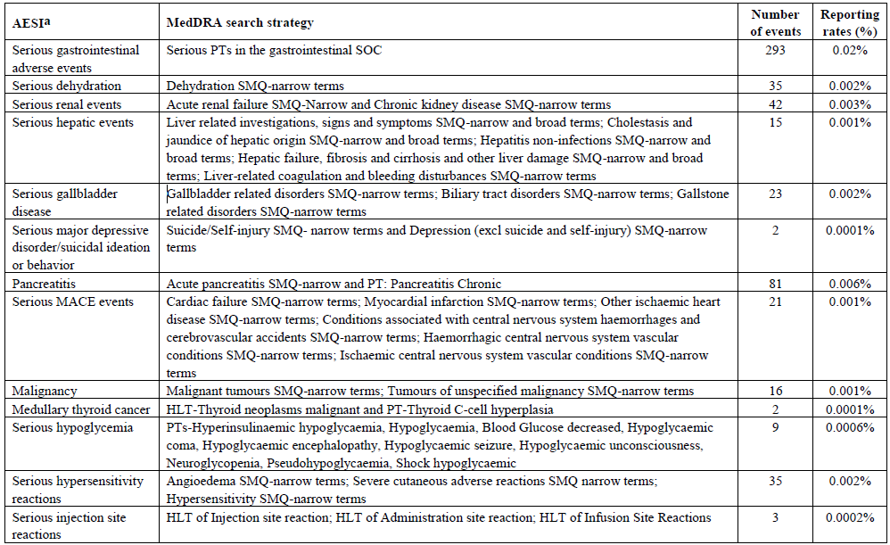
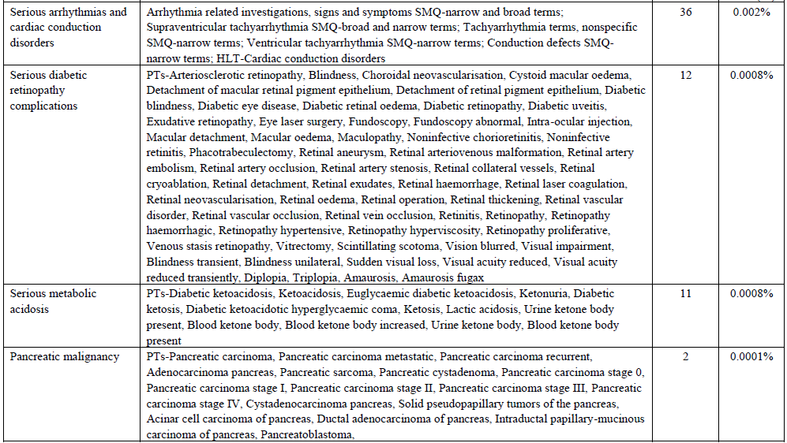
AESI = adverse event of special interest; HLT = High-Level Term; LSS = Lilly Safety System; MACE = major adverse cardiovascular event; MedDRA = Medical Dictionary for Regulatory Activities; PT = Preferred Term; SMQ = Standardised MedDRA Query; SOC = System Organ Class. ª Case reports with amputations/peripheral revascularisation could not be identified without a full text review of narratives in the LSS, as these are the surgical procedures and not coded as adverse events.
Whilst the overall post marketing safety profile is consistent with the safety observed in the completed clinical trial program, based on post-market data, anaphylaxis was identified as a safety signal.

Risk Management Plan (RMP) evaluation summary
In support of this application, the Sponsor has submitted EU-RMP version 2.1 (dated 03 Mar 2023; Data Lock Point 10 June 2022) and ASA version 2.0 (dated 17 August 2023). At Round 2, the Sponsor has submitted ASA version 3.0 (dated 26 March 2024). In its Milestone 5 response, the Sponsor has submitted ASA version 4.0 (dated 12 June 2024).
The proposed summary of safety concerns and their associated risk monitoring and mitigation strategies are summarised in Table 14.
Table 14: Summary safety concerns and risk monitoring and mitigation strategies
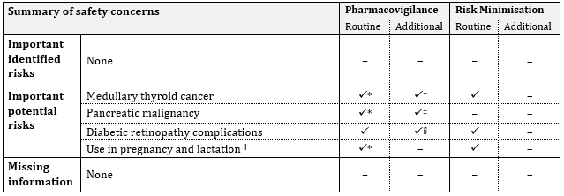
* Specific adverse reaction follow-up forms, † Medullary Thyroid Carcinoma Database Linkage Study (I8F-MC-B014), ‡ Pancreatic Malignancy Study (I8F-MC-B011), § Retinopathy addendum to SURPASS-CVOT (I8F-MC-GPGN) ^{ǁ} Categorised as ‘Missing information’ in the EU-RMP.
The summary of safety concerns in the ASA aligns with the EU-RMP. Additional safety concerns relating to the proposed extension of indication have not been identified. The summary of safety concerns is acceptable from an RMP perspective.
The Sponsor proposes routine pharmacovigilance for all safety concerns. This includes specific adverse reaction follow-up forms for the important potential risks of ‘Medullary thyroid cancer’ and ‘Pancreatic malignancy’ and for missing information ‘Use in pregnancy and lactation’ as routine pharmacovigilance activities. Additional pharmacovigilance activities have been proposed for the important potential risks of ‘Medullary thyroid cancer,’ ‘Pancreatic malignancy’ and ‘Diabetic retinopathy complications. The pharmacovigilance plan remains acceptable as no new safety concerns have been identified as a result of the proposed extension of indication.
The risk minimisation plan aligns with the EU-RMP and is acceptable.

Risk/benefit analysis
Obesity is a common, complex, disease and is associated with poorer long-term health, quality of life and has financial consequences for the affected person, as well as a significant financial cost to the Australian community. Weight loss in people with obesity has proven medical benefits in reducing obesity-related complications, and whilst improvements are seen with as little as 5% reduction in weight, larger amounts of weight losses may be needed to produce greater health benefits and assist patients with obesity being more satisfied with the outcome.
Tirzepatide is a single molecule that combines GIP and GLP-1 receptor agonism resulting in synergistic effects on appetite, food intake, and metabolic function. Tirzepatide is currently approved for use as an adjunct to diet and exercise to improve glycaemic control in adults with T2DM in Australia and many other countries. The present application is for the use of tirzepatide as an adjunct to a reduced-calorie diet and increased physical activity for chronic weight management in adults with obesity or overweight with weight-related comorbidities.

Efficacy
This submission included data from two pivotal Phase 3 studies: SURMOUNT-1 and SURMOUNT-2; both phase 3, multicentre, multinational, randomised, placebo-controlled, double-blinded studies that were designed to establish superiority of once-weekly tirzepatide compared with placebo on the coprimary efficacy endpoints and key secondary endpoints in participants with obesity, or overweight with weight-related comorbidities, with and without T2DM. The primary and secondary objectives and endpoints were satisfactory and clinically relevant. A total of 3477 participants (with 2519 randomised to treatment with tirzepatide) were included across the two studies. Participants were broad and diverse population of patients with obesity or overweight, likely reflecting those who would receive this treatment.
Both SURMOUNT-1 and SURMOUNT-2 have demonstrated statistically superior and clinically meaningful weight loss compared to placebo in patients (BMI ≥ 27 kg/m² to < 30 kg/m²) with at least one weight-related comorbidity and in patients with obesity (BMI ≥ 30 kg/m²) with or without T2DM. A higher proportion of patients achieved ≥5%, ≥10%, ≥15% and ≥20% weight loss with all doses of tirzepatide compared with placebo. Clinically meaningful reductions in body weight began early in treatment and continued through the end of study treatment (Figure 3).
The percent reductions in body weight increase with increasing dose of tirzepatide with more participants achieving higher % weight reductions on the highest dose. Other cardiometabolic markers also showed improvements, including waist circumstance, blood pressure, lipids and HbA1c. Patient reported outcomes were also improved by treatment with tirzepatide.
Percent body weight reductions, and cardiometabolic marker reductions were generally greater in participants with obesity or overweight without T2DM than in participants with obesity or overweight with T2DM, a finding which is consistent with other incretin-based therapy studies. (Figure 2) In SURMOUNT-1 and 2, 91% and 83% achieved a body weight reduction of at least 5%. Approximately half of participants in the 10- and 15-mg dose groups in SURMOUNT-1 and approximately one third of participants in the 15- mg dose group in SURMOUNT-2 reduced weight by at least 20%.

Safety
The safety profile of tirzepatide was characterised in 7354 participants with obesity or overweight treated with tirzepatide in the Phase 2 and 3 studies, representing 7071.3 patient-years of exposure to tirzepatide. Across the pivotal studies, SURMOUNT-1, and SURMOUNT-2, 2519 participants with obesity or overweight, with and without T2DM, received tirzepatide for 3201.7 patient-years of exposure, including 2236 participants who received tirzepatide for at least 52 weeks, and 1926 participants who received tirzepatide for at least 72 weeks.
In general, the safety profile of tirzepatide for chronic weight management appears similar to the effect seen in subjects with T2DM in the original application. Similar to the GLP-1 receptor agonist class, and the previous tirzepatide application, the most frequently reported adverse reactions (gastrointestinal disorders) were mostly mild or moderate in severity, occurred more frequently with dose escalation and eased over time. The % of patients with TEAS and discontinuations of study treatment due to AE (most commonly GI events) was low, but increased dose-dependently with tirzepatide. Serious adverse events were uncommon. A small number of deaths were recorded, however there was no clear relationship to treatment with tirzepatide.
Overall, the safety profile demonstrated across the tirzepatide Phase 3 studies is consistent with, and similar to, the known safety profile of the GLP-1 receptor agonist class in those with obesity and the safety profile of tirzepatide in the original T2DM application.
The post marketing safety data identified the additional risk of anaphylaxis. No other new risks or change of known risks were identified.

Data limitations and uncertainties
Limitations of the studies as mentioned previously are that those who participated in the study may have been more committed to weight management than those in the general population; and that it is also likely that the blinding within the study could have been undone by the more pronounced weight loss and/or gastrointestinal adverse effects in the tirzepatide treatment groups.
Because of protocol exclusion criteria, there are no data on patients with a history of chronic or acute pancreatitis, clinically significant gastric emptying abnormality, gastric outlet obstruction, or significant and/or unstable major depressive disorder or other severe psychiatric disorders.
Women who were pregnant or breastfeeding were excluded from clinical studies. Thus, there is no data in this population.
The duration of the clinical studies does not allow identification of long-latency events, such as malignancy.
It is unclear as to the duration of treatment required, but is likely to be long-term, given evidence that rebound weight gain is likely.
Whilst treatment with tirzepatide is associated with significant weight loss, and improved cardiometabolic measures, it is unclear how/if long-term morbidity and mortality will be impacted.

Ongoing studies
Tirzepatide is also being assessed in 13 ongoing studies across 4 indications.
- Chronic Weight Management: 8 studies, including two Phase 1 and six Phase 3 studies.
- T2DM: three Phase 3 studies, including 1 CV outcome trial and 1 study in paediatric participants.
- heart failure with preserved ejection fraction: one Phase 3 study,
- non-alcoholic steatohepatitis: one Phase 2 study.

Conclusions and recommendation
Existing treatments leave an unmet need for patients who have obesity or overweight with comorbidities. Treatment with tirzepatide demonstrated superior and clinically relevant efficacy on body weight reduction and cardiometabolic complications. The safety profile is well understood, and that for chronic weight management appears similar to the effect seen in subjects with T2DM in the original application. Apart from a new risk of anaphylaxis, no new concerns identified in this submission.
Pending advice from ACM, and completion of PI negotiations, the Delegate considers the benefit/risk profile for tirzepatide to be positive and recommends approval with the following indication:
Chronic Weight Management
Mounjaro is indicated as an adjunct to a reduced-calorie diet and increased physical activity for chronic weight management, including weight loss and weight maintenance, in adults with an initial body mass index (BMI) of:
≥30 kg/m² (obesity) or
≥27 kg/m² to <30 kg/m² (overweight) in the presence of at least one weight-related comorbid condition. (e.g., hypertension, obstructive sleep apnoea, cardiovascular disease or type 2 diabetes mellitus).
This would be in addition to the previously registered indication:
Mounjaro is indicated for the treatment of adults with insufficiently controlled type 2 diabetes mellitus as an adjunct to diet and exercise:
as monotherapy when metformin is not tolerated or contraindicated.
in addition to other medicinal products for the treatment of type 2 diabetes.

Advisory Committee considerations
The Advisory Committee on Medicines (ACM), having considered the evaluations and the Delegate’s overview, as well as the sponsor’s response to these documents, advised the following:
- What is the ACM’s advice regarding whether to approve/not approve the registration of tirzepatide for a chronic weight management (CWM) indication?
The ACM agreed there was sufficient evidence of clinical efficacy for use in CWM.
The ACM advised that registration of tirzepatide for CWM would be in line with other comparable jurisdictions.
The ACM noted the unknown impact of longer-term use of tirzepatide regarding malignancy and other serious adverse events. The ACM agreed with the delegate’s proposal to include tirzepatide for CWM in the Black Triangle Scheme.
The ACM was agnostic on inclusion of examples of comorbid conditions in the indication wording, as these are open to interpretation and relevance will vary for a particular patient. The ACM noted that both the USA and the EU include examples of comorbid conditions. The examples relate only to metabolic status, and do not include depression or respiratory conditions.
The ACM noted that the initial BMI criteria in the proposed indication are now typical of criteria for weight-loss medicines.
- Could the ACM provide advice on the level of risk they believe would be associated with the use of MOUNJARO for CWM in Australia?
The ACM considered the overall safety profile of tirzepatide to be acceptable, given the mechanism of action and clinical population.
The ACM were of the view that long-term efficacy and safety will require additional studies. The ACM noted the SURMOUNT-MMO study, a 5-year prospective, placebo-controlled trial, is ongoing and projected to be completed in 2027. This study is expected to provide robust data on long-term efficacy and safety, potential reduction in morbidity and mortality, and other clinical benefits.
The ACM raised concern about the potential for off-label use, especially in those with eating disorders and athletes, which the sponsor acknowledged in response to the clinical evaluation report.
- Does the ACM feel the proposed Risk Management Plan (RMP) is adequate to further characterise risks including long-term risks?
The ACM considered the proposed RMP to be adequate.
The ACM again noted the potential for off-label use, and that this may impact the adequacy of post market data and long-term monitoring. Additionally, the ACM noted that where patients take tirzepatide intermittently, this could impact post-market data and monitoring. Rebound weight gain may result in prolonged use and is an area with little data.
The ACM noted reports of pancreatitis in medical media. The ACM raised the need to inform clinicians about potential safety risks, including potential abdominal discomfort due to slowing down of gastric emptying. The ACM agreed that tirzepatide should not be prescribed to patients with existing steatohepatitis, gastroparesis, or similar comorbidities, it would likely worsen their symptoms.
- The ACM is also requested to provide advice on any other issues that may be relevant to a decision on whether or not to approve this application.
The ACM highlighted issues with use of the Black Triangle Scheme in practice. The ACM advised that there is no Black Triangle Scheme prompt in current prescribing software to alert clinicians. Clinicians are only aware a medicine is in the Black Triangle Scheme if they view the PI or CMI. Additionally, the ACM noted that there is no existing list of Black Triangle Scheme medicines on the TGA website.

ACM conclusion
The ACM considered this product to have an overall positive benefit-risk profile for the indication:
Mounjaro is indicated as an adjunct to a reduced-calorie diet and increased physical activity for chronic weight management, including weight loss and weight maintenance, in adults with an initial body mass index (BMI) of:
- ≥30 kg/m² (obesity) or
- ≥27 kg/m² to <30 kg/m² (overweight) in the presence of at least one weight-related comorbid condition.

Outcome
Based on a review of quality, safety, and efficacy, the TGA decided to register MOUNJARO (tirzepatide) indicated for the following extension of indications:
Chronic Weight Management
MOUNJARO is indicated as an adjunct to a reduced-calorie diet and increased physical activity for chronic weight management, including weight loss and weight maintenance, in adults with an initial body mass index (BMI) of:
  - ≥30 kg/m² (obesity) or
  - ≥27 kg/m² to <30 kg/m² (overweight) in the presence of at least one weight-related comorbid condition (e.g., hypertension, dyslipidaemia, obstructive sleep apnoea, cardiovascular disease, prediabetes or type 2 diabetes mellitus).
The full indications are now:
Type 2 Diabetes Mellitus:
MOUNJARO is indicated for the treatment of adults with insufficiently controlled type 2 diabetes mellitus as an adjunct to diet and exercise
  - as monotherapy when metformin is not tolerated or contraindicated.
  - in addition to other medicinal products for the treatment of type 2 diabetes.
Chronic Weight Management
MOUNJARO is indicated as an adjunct to a reduced-calorie diet and increased physical activity for chronic weight management, including weight loss and weight maintenance, in adults with an initial body mass index (BMI) of:
  - ≥30 kg/m² (obesity) or
  - ≥27 kg/m² to <30 kg/m² (overweight) in the presence of at least one weight related comorbid condition (e.g., hypertension, dyslipidaemia, obstructive sleep apnoea, cardiovascular disease, prediabetes or type 2 diabetes mellitus).

Specific conditions of registration applying to these goods
Mounjaro (Tirzepatide) is to be included in the Black Triangle Scheme. The PI and CMI for Mounjaro must include the black triangle symbol and mandatory accompanying text for five years, which starts from the date the new indication is registered.
The Tirzepatide EU-Risk Management Plan (RMP) (version 2.1, dated 03 Mar 2023, data lock point 10 June 2022), with Australian Specific Annex (version 4.0, dated 12 June 2024), and any subsequent revisions, as agreed with the TGA will be implemented in Australia.
An obligatory component of risk management plans is routine pharmacovigilance. Routine pharmacovigilance includes the submission of periodic safety update reports (PSURs).
Reports are to be provided in line with the current published list of EU reference dates and frequency of submission of PSURs until the period covered by such reports is not less than three years from the date of this approval letter. Each report must be submitted within ninety calendar days of the data lock point for that report.
The reports are to at least meet the requirements for PSURs as described in the European Medicines Agency’s Guideline on good pharmacovigilance practices (GVP) Module VII-periodic safety update report (Rev 1), Part VII.B Structures and processes. Note that submission of a PSUR does not constitute an application to vary the registration.

Attachment 1. Product Information
The Product Information (PI) approved with the submission for Mounjaro which is described in this AusPAR can be found as Attachment 1. It may have been superseded. For the most recent PI and Consumer Medicines Information (CMI), please refer to the TGA PI/CMI search facility.

Therapeutic Goods Administration
PO Box 100 Woden ACT 2606 Australia
Email: info@tga.gov.au Phone: 1800 020 653 Fax: 02 6203 1605
https://www.tga.gov.au

World Health Organization. Obesity and overweight. 1 March 2024. https://www.who.int/news-room/fact-sheets/detail/obesity-and-overweight
Wilding JPH, Batterham RL, Calanna S, et al.; STEP 1 Study Group. Once-weekly semaglutide in adults with overweight or obesity. NEJM. 2021;384(11):989-1002
Poon JL, Marshall C, Johnson C, Pegram HC, Hunter M, Kan H, Ahmad NN. A qualitative study to examine meaningful change in physical function associated with weight-loss. Qual Life Res. 2023 May;32(5):1329-1340. doi: 10.1007/s11136-022-03191-2. Epub 2022 Jul 22. PMID: 35867321; PMCID: PMC9305034.
Prospective Studies Collaboration; Whitlock G, Lewington S, Sherliker P, Clarke R, Emberson J, Halsey J, Qizilbash N, Collins R, Peto R. Body-mass index and cause-specific mortality in 900 000 adults: collaborative analyses of 57 prospective studies. Lancet. 2009 Mar 28;373(9669):1083-96. doi: 10.1016/S0140-6736(09)60318-4. Epub 2009 Mar 18. PMID: 19299006; PMCID: PMC2662372.
Australian Institute of Health and Welfare (AIHW). Overweight and Obesity. 14 June 2024. https://www.aihw.gov.au/reports/overweight-obesity/overweight-and-obesity/contents/about
Ishida M, D'Souza M, Zhao Y, et al. The association between obesity, health service use, and work productivity in Australia: a cross-sectional quantile regression analysis [published correction appears in Sci Rep. 2023 May 31;13(1):8839. doi: 10.1038/s41598-023-35911-0].
Commonwealth of Australia 2022. The National Obesity Strategy 2022-2032. Health Ministers Meeting. https://www.health.gov.au/sites/default/files/documents/2022/03/national-obesity-strategy-2022-2032_0.pdf
Perreault L, Apovian C 2024, Obesity in adults: Overview of management. UptoDate www.uptodate.com/contents/overweight-and-obesity-in-adults
Higuera-Hernández MF, Reyes-Cuapio E, Gutiérrez-Mendoza M, Rocha NB, Veras AB, Budde H, Jesse J, Zaldívar-Rae J, Blanco-Centurión C, Machado S, Murillo-Rodríguez E. Fighting obesity: Non-pharmacological interventions. Clin Nutr ESPEN. 2018 Jun;25:50-55. doi: 10.1016/j.clnesp.2018.04.005. Epub 2018 Apr 18. PMID: 29779818.
Chakhtoura M, Haber R, Ghezzawi M, Rhayem C, Tcheroyan R, Mantzoros CS. Pharmacotherapy of obesity: an update on the available medications and drugs under investigation. EClinicalMedicine. 2023 Mar 20;58:101882. doi: 10.1016/j.eclinm.2023.101882. PMID: 36992862; PMCID: PMC10041469.+9
Colquitt JL, Pickett K, Loveman E, Frampton GK. Surgery for weight loss in adults. Cochrane Database Syst Rev. 2014 Aug 8;2014(8):CD003641. doi: 10.1002/14651858.CD003641.pub4. PMID: 25105982; PMCID: PMC9028049.
Baggio LL, Drucker DJ. Biology of incretins: GLP-1 and GIP. Gastroenterology. 2007;132(6):2131-2157. https://doi.org/10.1053/j.gastro.2007.03.054
Heise T, De Vries H, Coskun T, et al. 338-OR: Tirzepatide reduces appetite, energy intake, and fat mass in people with T2D [abstract]. Diabetes. 2022;71(Suppl 1):338-OR. https://doi.org/10.2337/db22-338-OR
Andersen A, Lund A, Knop FK, Vilsboll T. Glucagon-like peptide 1 in health and disease. Nat Rev Endocrinol. 018;14(7):390-403. https://doi.org/10.1038/s41574-018-0016-2.
Zaffina I, Pelle MC, Armentaro G, Giofrè F, Cassano V, Sciacqua A, Arturi F. Effect of dual glucose-dependent insulinotropic peptide/glucagon-like peptide-1 receptor agonist on weight loss in subjects with obesity. Front Endocrinol (Lausanne). 2023 Feb 22;14:1095753. doi: 10.3389/fendo.2023.1095753. PMID: 36909312; PMCID: PMC9992880.
Coskun T, Urva S, Roell WC, Qu H, Loghin C, Moyers JS, O'Farrell LS, Briere DA, Sloop KW, Thomas MK, Pirro V, Wainscott DB, Willard FS, Abernathy M, Morford L, Du Y, Benson C, Gimeno RE, Haupt A, Milicevic Z. LY3437943, a novel triple glucagon, GIP, and GLP-1 receptor agonist for glycemic control and weight loss: From discovery to clinical proof of concept. Cell Metab. 2022 Sep 6;34(9):1234-1247.e9. doi: 10.1016/j.cmet.2022.07.013. Epub 2022 Aug 18. PMID: 35985340.
Australian Public Assessment Report for Mounjaro (Tirzepatide), November 2023
The ‘Delegate’ refers to the Delegate of the Secretary of the Department of Health and Aged Care who made the final decision to either include the new medicine/indication on the ARTG or reject the submission, under section 25 of the Therapeutic Goods Act
Mounjaro AusPAR, initial submission, 13 November 2023

