Australian Public Assessment Report for Lokelma
  - Active ingredient: sodium zirconium cyclosilicate
  - Sponsor: AstraZeneca Pty Ltd
September 2024

About the Therapeutic Goods Administration (TGA)
- The Therapeutic Goods Administration (TGA) is part of the Australian Government Department of Health and Aged Care and is responsible for regulating therapeutic goods, including medicines, medical devices, and biologicals.
- The TGA administers the Therapeutic Goods Act 1989 (the Act), applying a risk management approach designed to ensure therapeutic goods supplied in Australia meet acceptable standards of quality, safety, and efficacy.
- The work of the TGA is based on applying scientific and clinical expertise to decision-making, to ensure that the benefits to the Australian public outweigh any risks associated with the use of therapeutic goods.
- The TGA relies on the public, healthcare professionals and industry to report problems with therapeutic goods. The TGA investigates reports received to determine any necessary regulatory action.
- To report a problem with a therapeutic good, please see the information on the TGA website.

About AusPARs
- The Australian Public Assessment Report (AusPAR) provides information about the evaluation of a prescription medicine and the considerations that led the TGA to approve or not approve a prescription medicine submission. Further information can be found in Australian Public Assessment Report (AusPAR) guidance.
- AusPARs are prepared and published by the TGA.
- AusPARs are static documents that provide information that relates to a submission at a particular point in time. The publication of an AusPAR is an important part of the transparency of the TGA’s decision-making process.
- A new AusPAR may be provided to reflect changes to indications or major variations to a prescription medicine subject to evaluation by the TGA.

Copyright
© Commonwealth of Australia 2024
This work is copyright. You may reproduce the whole or part of this work in unaltered form for your own personal use or, if you are part of an organisation, for internal use within your organisation, but only if you or your organisation do not use the reproduction for any commercial purpose and retain this copyright notice and all disclaimer notices as part of that reproduction. Apart from rights to use as permitted by the Copyright Act 1968 or allowed by this copyright notice, all other rights are reserved and you are not allowed to reproduce the whole or any part of this work in any way (electronic or otherwise) without first being given specific written permission from the Commonwealth to do so. Requests and inquiries concerning reproduction and rights are to be sent to the TGA Copyright Officer, Therapeutic Goods Administration, PO Box 100, Woden ACT 2606 or emailed to <tga.copyright@tga.gov.au>.

Contents
List of abbreviations 4
Lokelma (sodium zirconium cyclosilicate hydrate) submission 6
Lokelma (sodium zirconium cyclosilicate hydrate) - proposed indication 7
Hyperkalaemia 7
Current treatment options for hyperkalaemia 8
Clinical rationale for Lokelma use in hyperkalaemia 9
Regulatory status 9
Australian regulatory status 9
International regulatory status 9
Registration timeline 10
Submission overview and risk/benefit assessment 10
Quality evaluation summary 10
Nonclinical (toxicology) evaluation summary 12
Clinical evaluation summary 13
Pharmacokinetics 13
Pharmacodynamics 13
Dosage selection for the pivotal studies 14
Clinical efficacy 14
Safety 22
Risk management plan evaluation summary 26
Risk-benefit analysis 27
Clinical efficacy 27
Clinical safety 28
Advisory Committee considerations 29
Outcome 30
Specific conditions of registration applying to these goods 30
Attachment 1. Product Information 30

List of abbreviations
Abbreviation | Meaning
ACM | Advisory Committee on Medicines
ADR | Adverse drug reaction
AE | Adverse event
ARTG | Australian Register of Therapeutic Goods
ASA | Australia-specific annex
AUC | Area under the curve
CKD | Chronic kidney disease
C_{max} | Maximum concentration
CMI | Consumer Medicines Information
DLP | Data lock point
DP | Drug product
DS | Drug substance
ECG | Electrocardiogram
eGFR | Estimated glomerular filtration rate
FAS | Full analysis set
ITT | Intention to treat
LIDI | Long interdialytic interval (3-day interval [Friday/Saturday to Monday/Tuesday] in thrice weekly dialysis scheme)
NMT | No more than
PD | Pharmacodynamic
PET/LDPE/Al /LLDPE | Polyethylene terephthalate/Low density polyethylene/Aluminium/Linear low-density polyethylene
PI | Product information
PK | Pharmacokinetic
PSUR | Periodic safety update report
RMP | Risk management plan
PT | Preferred terms
QD | Once daily
RAAS | Renin-angiotensin-aldosterone system
SAE | Serious adverse event
SIDI | Short interdialytic interval (2-day interval [Monday/Tuesday to Wednesday/Thursday, Wednesday/Thursday to Friday/Saturday] in thrice weekly dialysis scheme)
SK | Serum potassium
SOC | System organ classification
t_{1/2} | Elimination half life
TEAE | Treatment emergent adverse event
TGA | Therapeutic Goods Administration
TID | Three times daily
T_{max} | Time required to achieve maximum concentration
ZS | sodium zirconium cyclosilicate hydrate (Lokelma)

Lokelma (sodium zirconium cyclosilicate hydrate) submission
Type of submission: | New chemical entity
Product name: | Lokelma
Active ingredient: | sodium zirconium cyclosilicate hydrate
Decision: | Approved
Approved therapeutic use for the current submission: | Lokelma is indicated for the treatment of hyperkalaemia in adult patients
Date of decision: | 4 April 2024
Date of entry onto ARTG: | 9 April 2024
ARTG number: | 405541, 405542,
Black Triangle Scheme  | Yes
Sponsor’s name and address: | AstraZeneca Pty Ltd, 66 Talavera Road, Macquarie Park NSW 2113
Dose form: | Powder for oral administration
Strength: | 5 g powder for oral suspension: Each sachet contains 5 g of sodium zirconium cyclosilicate hydrate (contains approximately 400 mg sodium).  10 g powder for oral suspension: Each sachet contains 10 g sodium zirconium cyclosilicate hydrate (contains approximately 800 mg sodium).
Container: | Laminate sachets made of a PET/alu/LLDPE or PET/LDPE/alu/EAA/LLDPE laminate
Pack size: | Cartons of 3 or 30 sachets
Route of administration: | Oral
Dosage: | For patients with hyperkalaemia (serum potassium level is >5.0 millimoles per litre (mmol/L)) the recommended starting dose of Lokelma is 10 g, administered three times a day (TID) orally as a suspension in water, to achieve normokalaemia (normal potassium levels between 3.5 and 5.0 mmol/L). Typically, normokalaemia is achieved within 24 to 48 hours. If the measured serum potassium is still above 5.0 mmol/L at the end of 48 hours, an additional day (24 hours) of 10 g three times a day dosing may be given, prior to initiation of the maintenance dose. If normokalaemia is not achieved at the end of day 3, other treatment approaches should be considered.  For further information regarding dosage, such as dosage modifications to manage adverse reactions, refer to the Lokelma Product Information.
Pregnancy category: | Category B1: Drugs which have been taken by only a limited number of pregnant women and women of childbearing age, without an increase in the frequency of malformation or other direct or indirect harmful effects on the human fetus having been observed.  Studies in animals have not shown evidence of an increased occurrence of fetal damage.  No clinical study has been conducted in pregnant women.  No adverse effects on embryofetal development were observed in rats and rabbits receiving oral doses of sodium zirconium cyclosilicate of up to 6000 mg/kg/day, 0 times higher than the maximum recommended human dose. Because animal reproduction studies are not always predictive of a human response, Lokelma should be used during pregnancy only if the potential benefit to the mother justifies any potential risks to the fetus.  The use of any medicine during pregnancy requires careful consideration of both risks and benefits by the treating health professional. The pregnancy database must not be used as the sole basis of decision making in the use of medicines during pregnancy. The TGA does not provide advice on the use of medicines in pregnancy for specific cases. More information is available from obstetric drug information services in your state or territory.

Lokelma (sodium zirconium cyclosilicate hydrate) - proposed indication
This AusPAR describes the submission by AstraZeneca Pty Ltd (the Sponsor) to register Lokelma (sodium zirconium cyclosilicate hydrate) for the following proposed indication:
Lokelma is indicated for the treatment of hyperkalaemia in adult patients.

Hyperkalaemia
Hyperkalaemia is the presence of an abnormally high concentration of potassium in the blood to greater than 5.0 mmol/L. The extracellular potassium concentration is normally tightly regulated within a serum potassium range between 3.5 mmol/L and 5.0 mmol/L in adults. Potassium homeostasis is essential for maintaining the cellular membrane potential and thus, hyperkalaemia impairs neuromuscular, cardiac and gastrointestinal function.
The underlying mechanisms leading to hyperkalaemia are reduced urinary potassium excretion, transcellular shifts of potassium, and/or excessive intake of potassium,. Hyperkalaemia often presents without symptoms or with non-specific symptoms including malaise, confusion, muscle weakness or signs of cardiac arrhythmias such as palpitations, bradycardia, or tachycardia.
Hyperkalaemia is rare in the general population. It occurs with increased frequency in patients with chronic kidney disease (CKD), heart failure (HF) and/or diabetes mellitus, particularly when treated with medications known to raise serum potassium, such as renin-angiotensin-aldosterone system (RAAS) inhibitors. A prevalence of 3% to 4% of hyperkalaemia has been reported in hospitalised patients,,. The use of RAAS inhibitors has been shown to delay disease progression and extend survival in patients with CKD and/or HF, but drug-induced hyperkalaemia significantly limits the use of these medications.,,

Current treatment options for hyperkalaemia
The current Australian Therapeutic Guidelines lists several approaches to hyperkalaemia, depending on the severity, presence of medical conditions including kidney failure, metabolic acidosis, primary adrenal insufficiency, or suspected drug toxicity.
In circumstances where hyperkalaemia is extreme (e.g., due to rhabdomyolysis), dialysis may be necessary. A medication review should also be performed to identify and stop any medications suspected of causing or aggravating hyperkalaemia. In cases where hyperkalaemia is a result of adrenal insufficiency and hypoaldosteronism, corticosteroid replacement is the main treatment.
In circumstances where short term emergency treatment is required, intravenous methods to reduce serum potassium concentrations may be used and include short-acting insulin intravenous bolus with glucose infusion.
Insulin promotes cellular uptake of potassium and is the treatment of choice when severe hyperkalaemia is associated with chronic kidney failure when a sodium load is contraindicated.
Sodium bicarbonate promotes cellular uptake of potassium and is indicated when severe hyperkalaemia is present with metabolic acidosis and volume depletion. Sodium bicarbonate infusion is less effective when given as a monotherapy.
Methods to remove potassium from the bowel lumen include sodium or calcium polystyrene sulfonate taken as an oral suspension or rectally as a retention enema.
Potassium is exchanged for either sodium or calcium. Due to the cation exchange mechanism, this may increase the risk of hypernatremia or hypercalcaemia respectively. These exchange resins are non-specific for potassium and may decrease serum levels of other electrolytes.
Other methods to lower serum potassium not listed in the Therapeutic Guidelines include the use of thiazide diuretics (unpredictable method to increase the urinary excretion of potassium), inhaled salbutamol (increases cellular uptake of potassium, useful for emergency short term use with infusion methods), dietary modification, and patiromer sorbitex calcium (bowel lumen exchange resin with a calcium counter-ion that is non-specific for potassium).

Clinical rationale for Lokelma use in hyperkalaemia
Lokelma, sodium zirconium cyclosilicate (ZS) is a non-absorbed, insoluble, free-flowing, odourless, tasteless, white crystalline mixable powder with a specific particle size distribution profile >3 µm (mean particle size 20 µm) and no inactive ingredients. It is an inorganic cation exchange agent with a high capacity to selectively entrap monovalent cations, including potassium ions, in exchange for sodium ions, as it traverses the GI tract. It does not trap divalent cations such as calcium and magnesium. ZS exerts its effect locally by binding potassium in the gastrointestinal tract and it is not absorbed systemically, thereby minimising or eliminating the risk of systemic toxicity.

Regulatory status

Australian regulatory status
This product is considered a new chemical entity for Australian regulatory purposes.

International regulatory status
Lokelma is registered in the EU, USA, Canada, Singapore and Switzerland.
Table 1: International regulatory status
Region | Submission date | Approval date | Approved indication
Canada | 31 July 2018 | 25 July 2019 | Lokelma is indicated for the treatment of hyperkalaemia in adult patients.
European Union | 03 Dec 2015 | 22 Mar 2018
Singapore | 29 March 2019 | 22 June 2020
Switzerland | 31 Jan 2020 | 16 Apr 2021
United States | 29 Jul 2015 | 18 May 2018

Registration timeline
This submission was evaluated under the standard prescription medicines registration process.
Table 2: Timeline for Lokelma submission PM-2023-00671-1-5
Description | Date
Submission dossier accepted and first round evaluation commenced | 31 March 2023
Evaluation completed | 19 December 2023
Delegate’s Overall benefit-risk assessment and request for Advisory Committee advice | 12 January 2024
Advisory Committee meeting | 2 February 2024
Registration decision (Outcome) | 4 April 2024
Registration in the ARTG | 9 April 2024
Number of working days from submission dossier acceptance to registration decision* | 255
*Statutory timeframe for standard submissions is 255 working days

Submission overview and risk/benefit assessment

Quality evaluation summary
Lokelma is a non-absorbed, non-polymer inorganic powder with a uniform micropore structure that preferentially captures potassium in exchange for hydrogen and sodium cations (Figure 1).
Figure 1. Unit cell structural representation, stick-and-ball (left) and polyhedral (right) of main framework of microporous sodium zirconium cyclosilicate. Red: zirconium, Green: silicon, Blue: oxygen atoms. Cations are not pictured.
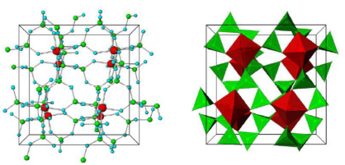

Drug substance
The drug substance (DS) ‘sodium zirconium cyclosilicate hydrate’ is a white to grey crystalline powder. The structure of ZS has a cubic cell arrangement of octahedrally coordinated zirconium Zr ([ZrO6]²⁻) and tetrahedrally coordinated silicon Si ([SiO4]⁰) units that interconnect through oxygen bridges as Zr-O-Si and Si-O-Si. The two types of units are observed in a ratio of 1:3, respectively, and repeat orderly to form a three-dimensional framework characteristic of the compound. The framework acquires its negative charge from the octahedral fractions, [ZrO6]²⁻ and features channels and cavities that interconnect and locate the positive ions (sodium, Na⁺, and hydrogen, H⁺) that counterbalance the negative charge of the framework.
The DS is manufactured using a hydrothermal synthesis process where sodium hydroxide, zirconium acetate, colloidal silica, and purified water are combined in a reactor and reacted at high temperature and high pressure. The resulting slurry is transferred to a filter dryer, where the cake is rinsed, partially protonated with hydrochloric acid and the resultant DS is rinsed and dried.
The manufacturer assessed the critical steps and controls for the DS and identified the critical process parameters. It is noted that the manufacturing process is tightly controlled in terms of order of addition of starting material, reaction temperatures, mixing speeds and times, and minimum number of rinses, in order to meet expected yields of the DS of an expected quality. In-process control tests for pH end point during partial protonation and moisture content are employed to ensure the desired potassium exchange capacity (KEC) and water content in the DS.
There are two alternate zirconium silicate crystalline phases which may be formed in the reaction process: Crystalline Phase A (CPA) and Crystalline Phase B (CPB). These layered, two-dimensional structures also exhibit ion exchange properties, although their ion selectivity is less specific for the potassium K⁺ cations compared to the desired DS. Powder X-ray Diffraction techniques are used to differentiate between the desired DS and levels of CPA and CPB. CPB is controlled in the DS specification (no more than 0.10 weight fraction) and CPA formation has been minimised as part of manufacturing process development, whereby agitation speed was optimised ensure that there is no settling in the reaction mixture and thus CPA does not form. The formation of either of these to crystalline phases, will result in a lower-than-expected KEC and thus will be easily identified.
The quality of the DS is controlled by tests for identification (by Fourier transform infrared spectroscopy and X-Ray Powder Diffraction), KEC, impurities (CPB), zirconium content, silicon content, sodium content, hafnium content, pH, moisture content, appearance, particle size distribution and elemental impurities (arsenic, cadmium, mercury, lead and nickel). The provided specifications can satisfactorily control the quality of the DS.

Drug product
Sodium zirconium cyclosilicate is a non-sterile white to grey solid, oral dosage form (powder). The drug product (DP) is available in 2 strengths as pure DS, 5 g and 10 g, filled in sachets. The DP is formulated as the active pharmaceutical ingredient in a sachet with no excipients present.
The DP specifications include tests for identification (by Fourier transform infrared spectroscopy), KEC, moisture content, appearance, particle size determination, average delivered weight and microbiological quality. The limits at release and shelf-life are acceptable to ensure DP quality. KEC (3.0-3.8 mEq/g at release and shelf-life) is the key stability-indicating test, where decomposition of the ZS framework or changes to its crystalline form would result in a reduction in the KEC in the final DP. The limit for particle size determination (no more than 3%), which is also included in the DS is used to ensure that there is low systemic absorption and has been observed to not change on storage of the DP.
The analytical methods used to analyse the product were adequately described and validated.
The stability data provided support a shelf-life of 36 months when stored below 30 °C in 3 layer (PET/Al/LLDPE) and 5-layer (PET/LDPE/Al/LLDPE) laminate sachets.

Recommendation
Approval for registration of Lokelma is recommended from a pharmaceutical chemistry and quality control perspective.

Nonclinical (toxicology) evaluation summary
The overall quality of the nonclinical dossier was high, with all pivotal safety-related studies GLP-compliant. The toxicology dossier contained no major deficiencies.
Sodium zirconium cyclosilicate was shown to sequester K⁺ ions in vitro. It lowered serum K⁺ in rats and dogs, but not consistently, reflecting that the studies were performed in normokalaemic animals. Decreased absorption of potassium was chiefly evident as reduced urinary K⁺ excretion instead.
Studies examining ion selectivity revealed that sodium zirconium cyclosilicate also binds ammonium (K⁺: NH₄⁺ selectivity, 1.25-fold), calcium (K⁺:Ca²⁺ selectivity, 15-fold) and lithium (K⁺:Li⁺ selectivity, 16-fold).
ZS is not absorbed systemically, and, as an insoluble inorganic compound, is not subject to enzymatic degradation. Excretion is entirely by the faecal route.
In vitro studies indicate a likely increase in stomach pH of up to 2 pH units with administration of ZS, giving rise to potential pharmacokinetic interactions with co-administered drugs similar to those encountered with antacids. Direct binding of other drugs by ZS was not seen, except for calcium and lithium. This occurred at high concentrations of these cations and under conditions where there was no or little competition by K⁺; no clinically relevant interaction with calcium or lithium is predicted.
ZS displayed a low order of acute toxicity by the oral route in rats and dogs.
Repeat-dose toxicity studies by the oral route were conducted in rats (up to 6 months) and dogs (up to 9 months). No treatment-related microscopic lesions were observed in rats treated with sodium zirconium cyclosilicate at up to 6000 mg/kg/day for 6 months (10 times the maximum recommended clinical dose on a mg/kg basis). Treated dogs showed inflammatory and degenerative changes in the kidney, and atrophy and vacuolation in the adrenal gland, but these were shown to be secondary to hypokalaemia rather than a direct toxic effect of the drug. As such, they are not expected in patients.
ZS was not genotoxic in the standard battery of tests. Carcinogenicity studies were not conducted, in line with ICH guidance where there is no or minimal systemic exposure and general repeat-dose toxicity studies give no cause for concern.
Fertility (rats), embryofetal development (rats and rabbits) and pre/post-natal development (rats) were unaffected by treatment with sodium zirconium cyclosilicate at oral doses up to 10 times higher than the maximum recommended clinical dose. Assignment to Pregnancy Category B1, as the Sponsor proposes, is supported.
There are no nonclinical objections to the registration of Lokelma for the proposed indication.

Clinical evaluation summary

Pharmacokinetics
ZS is a non-absorbed, non-polymer inorganic powder with a uniform micropore structure that preferentially captures potassium in exchange for hydrogen and sodium cations. Therefore, traditional phase 1 studies of the pharmacokinetics of ZS in healthy subjects were not conducted since ZS is not systemically absorbed.
The human studies ZS-004 (n=29) and ZS-005 (n=27) reported that zirconium concentrations in blood were below the lower level of quantification in all but one sample from two participants (one each from ZS-004 and ZS-005; both participants reported an outlier sample result where the source of zirconium was unknown).
The Sponsor provided two pharmacokinetic (PK) studies for evaluation new to this submission, ZS-009 and D9480C00012, both of which were PK interaction studies. Across both PK studies, ZS did not appear to have clinically meaningful effects on the co-administered drugs tested. Most observed effects were likely due to the effect that ZS has on gastric pH, likely affecting the absorption of some drugs.

Pharmacodynamics
Only the pharmacodynamic information from a previous submission is discussed here. No dedicated clinical biopharmaceutic studies were conducted for ZS. Blood and urine samples taken during the ZS-004 and ZS-005 studies were consistent with ZS not being systemically absorbed following oral administration.

Primary pharmacodynamic effects
The primary pharmacodynamics effect of ZS is to bind potassium within the intestinal lumen. This was demonstrated in Study ZS-006 in healthy participants receiving a standardised intake of sodium and potassium. Compared with baseline measurements, administration of ZS led to a statistically significant increase in faecal excretion of potassium, which is numerically greater for the 10 g dose than the 5 g dose, although no direct statistical comparison has been carried out. Serum potassium is then reduced because of the equilibrium between serum and intestinal fluid in relation to electrolytes. In this study, serum potassium was significantly reduced in the group receiving 10 mg ZS but not in the group receiving 5 g.
There is a clear dose-response relationship in the maintenance phase of management of hyperkalaemia.

Dosage selection for the pivotal studies
Dose-ranging studies were carried out in the acute phases of three clinical studies (ZS-002, ZS-003, and ZS-004). The choice of initial doses in Study ZS-002 was based on the in vitro finding that ZS was approximately 10 times more effective than sodium polystyrene sulfonate (SPS), a potassium binding resin used for the management of hyperkalaemia, in exchanging potassium cations in the presence of physiological levels of magnesium and calcium. The recommended oral dose of SPS in mild hyperkalaemia is 15 g once daily, and the extrapolated dose of ZS for initial investigation in hyperkalaemic participants (0.3 g TID) is therefore less than 10% of the daily dose of SPS, thus providing an adequate safety margin. The additional doses tested in ZS-002 were 3 g and 10 g TID.
In Study ZS-002, doses of 0.3 g TID, 3 g TID and 10 g TID were used. Only the highest dosage resulted in statistically significantly greater mean reductions in serum potassium (the primary outcome) compared with placebo. Secondary outcomes supported the results of the primary outcome. The time to first reduction in serum potassium by 0.5 mmol/L was significantly lower for the high dose group than placebo, but not so for the other two dosage groups. Following administration of the fourth dose, a statistically significantly larger number of participants in the high dose group (58.3%) had achieved a ≥ 0.5 mmol/L reduction in serum potassium, compared to the placebo (17.2%), lowest dose (16.7%) and middle dose (26.1%). The pivotal efficacy studies used a range of doses, from 1.25 g to 10 g TID in Study EUZS-003 and 10 g TID in Study ZS-004. This dose is adequately supported by the early phase studies.

Clinical efficacy
Three pivotal double blind, placebo-controlled, randomised studies assessed the effect of ZS on serum potassium in participants with hyperkalaemia during the correction phase (acute phase) of treatment (ZS-002 and ZS-003) and maintenance phase of treatment (ZS-004).
Other studies included ZS-004: Acute phase (previously submitted), ZS-004E (Long term extension phase), ZS-005 (Extended phase) D9480C00006 (DIALIZE, Treatment of hyperkalaemia in dialysis patients) and ZS-006 (Healthy Subject PD and PK/PD Study).

Acute phase treatment

Study ZS-003
This study was designed to examine both the acute lowering of serum potassium (SK) (using a TDS dose for 48 hours) and the maintenance of normokalaemia (using a daily dose). It had a randomised, double-blind, placebo-controlled design for the acute phase, with four different doses of ZS being given, and a randomised, double-blind, placebo-controlled withdrawal design for the subacute phase, again testing four different doses of ZS. The subacute phase included subjects who had completed the acute phase and were normokalaemic after 48 hours of treatment with ZS or placebo. Those subjects who had received ZS in the acute phase were randomised to receive the same dose of ZS once daily or placebo, while those who had received placebo in the acute phase were randomised to receive ZS at a dose of either 1.25g or 2.5g daily.
Inclusion criteria and monitoring were similar to study ZS-002.
Results
Acute phase
The percentage of subjects in each group who achieved normokalaemia at 48 hours showed a dose-response relationship and was statistically significantly different for the three higher ZS dosing groups compared with placebo (Table 3).
Table 3: Acute phase: percentage of normokalaemic subjects at 48 hours-ITT population
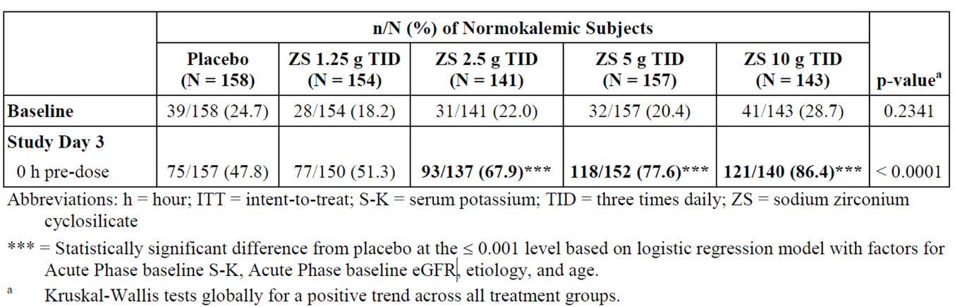
Subacute phase
The total number of days of normokalaemia during the subacute phase was statistically significantly higher for the three higher ZS dosing groups compared with the corresponding placebo group. Patients with higher baseline potassium (K) have greater reductions in K with ZS (Table 4).
Table 4. Subacute Phase: Total Number of Days Normokalaemic – Acute Phase ZS Subjects - ITT Population
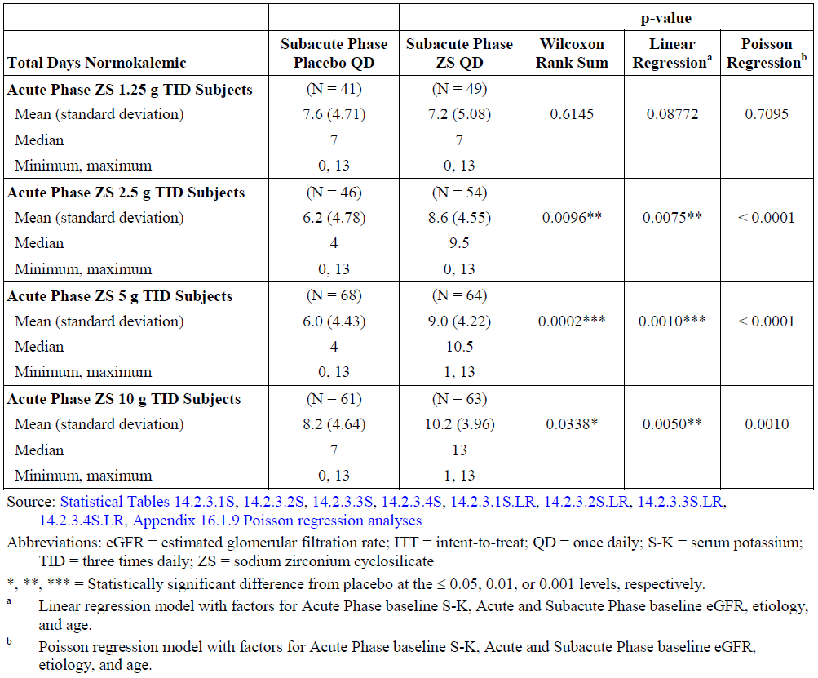
Table 5. Acute Phase: Mean Change (Absolute and Percent) From Baseline in Serum Potassium (mmol/L) Over Initial 48 Hours – ITT Population
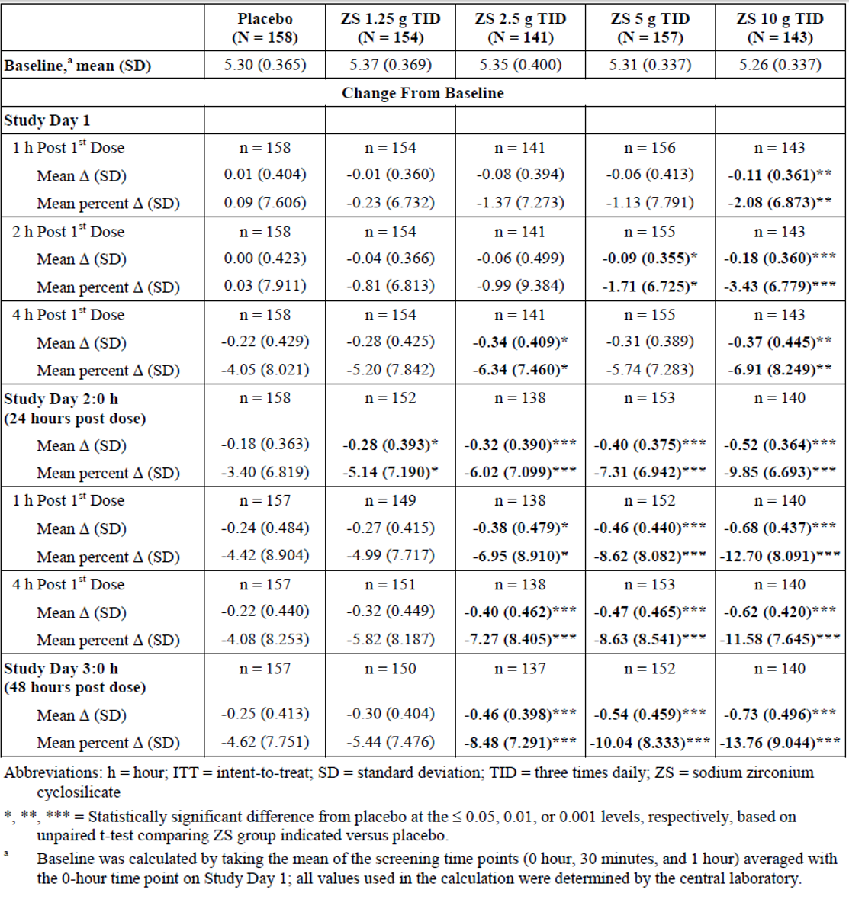
Figure 2. Mean change to potassium from baseline at selected time-points for ZS 10g TID in subjects with baseline serum potassium ≥ 6.0 mmol/l (acute phase for study ZS-003 and ZS004- intent to treat ITT population.
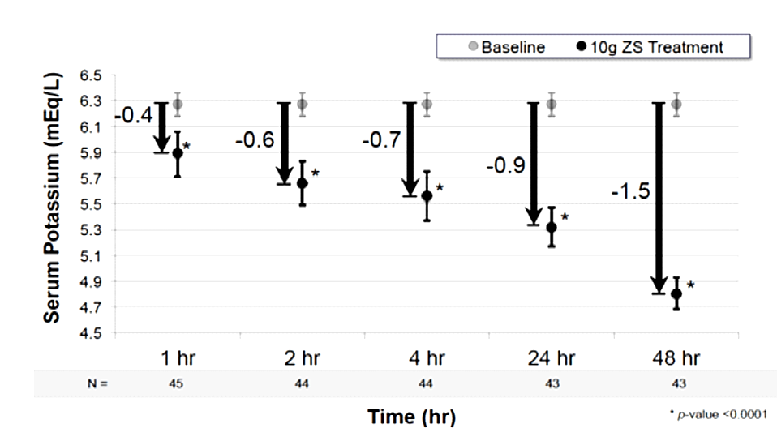

Study ZS-004
This study had an open-label design in the acute phase to allow the safe enrolment of subjects with more severe hyperkalaemia than had been possible in the studies with a placebo group. In the acute phase, patients had daily bloods and ECG. Patients with serum potassium levels over 6.1 mmol/L were not able to leave the clinic and were discontinued if the potassium had not responded to ZS after 48 hours. Subjects with serum K> 5.1mmol/L (no maximum) were enrolled in the study. All were treated with 10g of ZS three times a day for 2 days. Results showed that 66.1% of subjects had normal SK values by 24 hours after the first dose of ZS, and 88% had normal SK values at 48 hours after the first dose. The median time to normalisation of SK values was approximately 2.2 hours after the first dose of ZS.

Supportive studies
Supportive studies include a phase 2 study, ZS-002, and the DIALIZE study (patients with end stage renal disease who are undergoing dialysis).

Study ZS-002
Study ZS-002 is a randomised, placebo-controlled, double-blind, dose-escalating study investigating safety, tolerability and pharmacodynamics of three different doses of ZS administered 3 times daily to patients with mild hyperkalaemia and moderate kidney dysfunction.
Patients had serum K 5-6mmol/L and moderate kidney dysfunction (GFR 40-60ml/min). Patients with ECG changes were excluded.
Treatments included ZS 0.3g, 3g, 10g or placebo three times a day. The placebo was a silicated microcrystalline cellulose (a common excipient).
Patients fasted day 1, then ZS was administered with meals. The duration of treatment was for 48-96 hours or until K normalised. Patients had blood taken at baseline then every 30 minutes for 2 hours then every 4 hours until K normalised. They were monitored in a clinic setting and had daily ECGs.
The efficacy endpoint was serum K.
Results
In total, 196 patients (mean [standard deviation (SD)] age =58.1 [13.7] years old) were randomised to ZS or placebo. Of 97 patients receiving ZS, 41.2% met the primary end point and were deemed treatment responders compared with 1.0% of 99 patients receiving placebo (P<0.001). Rescue therapy to reduce serum potassium during the treatment period was required by 2.1% of patients taking ZS versus 5.1% taking placebo.
Figure 3. Study ZS-002: mean serum potassium (mmol/L) over the initial 48 hours of treatment.
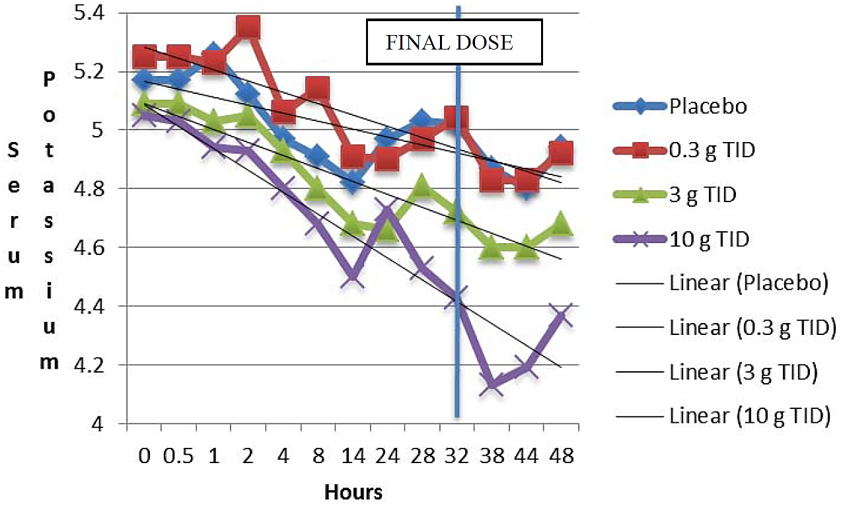
Other efficacy outcomes supported the result of the primary outcome. At 48 hours, the mean reduction in SK (placebo-subtracted) was 0.15 and 0.48 mmol/L for the medium and high dose groups, respectively. The proportion of subjects with a >1 mmol/L reduction in SK was 41.7% for the high dose group, compared with 3.4% of the placebo subjects at the 38-hour time point. The time to a decrease of 0.5mmol/L in SK was significantly shorter in the high dose group compared with the placebo group, such that by 24 hours, over 70% of the ZS subjects had achieved this, compared with about 55% of the placebo group. Normalisation of SK levels also occurred statistically significantly more rapidly in the ZS 10g group compared with the placebo group.

Study D9480C00006 (DIALIZE)
This Phase 3b, randomised, double-blinded, placebo-controlled study evaluated the efficacy and safety of using ZS for the treatment of hyperkalaemia in participants on chronic haemodialysis. Participants were randomised to receive either ZS or placebo at a starting dose of 5 g once daily on non-dialysis days, which could be adjusted to a maximum of 15 g once daily over a four-week dose-adjustment period, aiming to maintain a pre-dialysis serum potassium between 4.0 and 5.0 mmol/L inclusive, after the long inter-dialytic (LIDI). After this, the last dosage was continued for another four weeks (evaluation period). All participants who were randomised were included in the full analysis set (FAS) (ZS n=97, placebo n=99).
Dosage data was available for visit 10 (study day 22, dose-adjustment period). Among the ZS treatment group, 36.7% were prescribed 5 g once daily, 43.3% were prescribed 10 g once daily, and 18.9% were prescribed 15 g once daily.
The primary efficacy outcome was the proportion of participants that maintained pre-dialysis serum potassium between 4.0 and 5.0 mmol/L on three out of four dialysis treatments following the LIDI during the evaluation period, and that did not receive rescue therapy (i.e., ‘responder’ status). A clear, statistically significant difference (p < 0.001) was observed, with 41.2% of participants in the ZS group were responders, compared to 1.0% of the placebo. This was supported by post hoc analyses which observed that ZS lead to more pre-dialysis LIDI instances where serum potassium was below 5.5 mmol/L than placebo. Few participants required rescue therapy, which was similar between ZS (2.1%) and placebo (5.1%) groups.
Table 6. DIALIZE: Proportion of responders (Fisher's exact test, FAS).
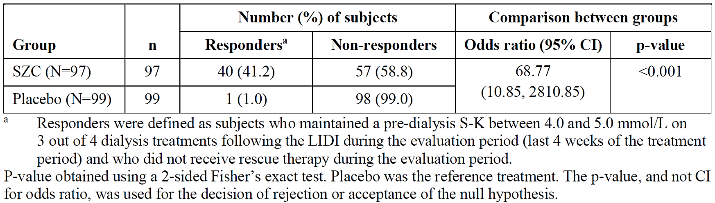

Subacute (extended) treatment of hyperkalaemia
Studies ZS-004, ZS-004E and ZS-005 extended phase provided data for subacute management of hyperkalaemia.

Study ZS-004
The study design to assess ongoing therapy was a randomised, placebo-controlled, double-blind withdrawal approach. The objectives of the study were to evaluate the safety and efficacy of three different doses of ZS administered daily for 28 days in maintaining normokalaemia (3.5-5.0 mmol/L) in subjects who had achieved normokalaemia following 2 days of acute therapy with ZS 10g TID. The dose in the chronic phase was randomised as 5, 10 or 15g once daily. The dose was decreased to every second day if serum potassium was 3-3.4mmol/L. Patients were withdrawn if the potassium was > 6.1 or < 3.0 or there were ECG changes or arrhythmias.
Mean age ranged from 61.5-64.9 years, 51.8-71.4% male, 58.8-70.6% had CKD, 57.8-74.5% had diabetes mellitus, 58.9-73.3% on RAAS inhibitor medication.
The main efficacy endpoint was the mean change in serum potassium from day 8-29.
The mean SK for the period between Days 8 and 29 of the maintenance phase was statistically significantly lower in all ZS groups compared with placebo, with an apparent dose-response relationship.
Table 7. Mean SK Between Maintenance Phase Study Days 8 and 29 - ITT Population, Study ZS-004
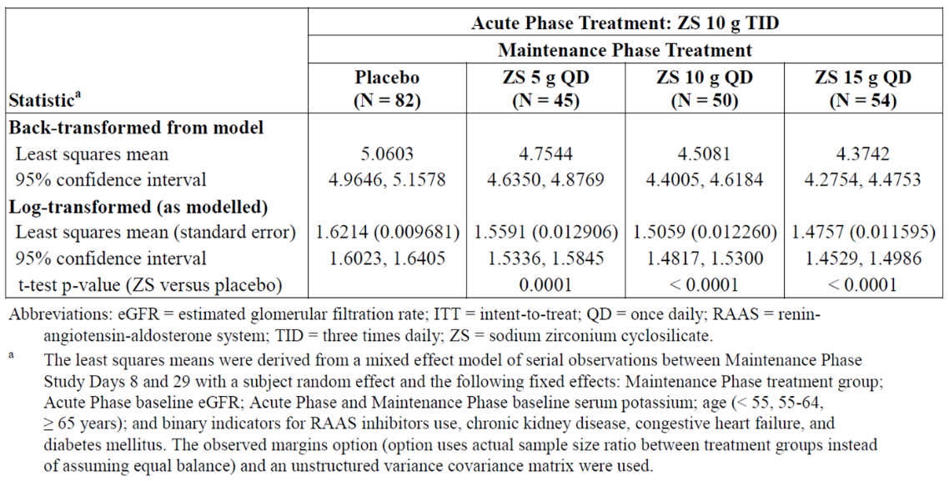

Long term treatment of hyperkalaemia

Study ZS-004E
This study was available to subjects who completed Study ZS-004 and continued treatment for up to eleven months. The initial protocol specified treatment duration of 56 days; 15 subjects terminated at this point. An amendment increased the duration to 140 days and 7 completed the study at this point; 57 subjects completed 336 days of treatment under a third amendment.
The primary efficacy endpoint was the proportion of participants with a mean serum potassium ≤ 5.1 mmol/L between study days 8 to 337, which was observed in 88.3% of participants. This was supported by the secondary outcome, where 100% of participants reported a mean serum potassium ≤ 5.5 mmol/L between study days 8 to 337.

Study ZS-005: Extended phase
This was a phase 3, open-label, multi-phase, multi-dose maintenance study with the primary objective to evaluate the safety and tolerability of ZS for up to 12 months. Efficacy endpoints were included in the secondary objectives. Participants were hyperkalaemic on enrolment and commenced an acute phase involving treatment with ZS 10g TID for up to 72 hours.
In the correction phase, adult outpatients with plasma potassium ≥5.1 mmol/L (i-STAT Point-of-Care) received ZS 10 g three times daily for 24-72 hours until normokalaemic (potassium =3.5-5.0 mmol/L). Qualifying participants entered the ≤12-month maintenance phase and received ZS 5 g once daily titrated to maintain normokalaemia without dietary or medication restrictions. Overall, 734 participants were included in the extended dosing ITT population, of which 466 (62.5%) participants completed the study.
The primary efficacy outcome for the acute phase was the proportion of participants who achieved normokalaemia (serum potassium between 3.5 and 5.0 mmol/L inclusive), which was achieved by 66% of participants at 24 hours, and 77.9% at 72 hours. The primary efficacy outcome for the extended dosing phase was the proportion of participants with a mean serum potassium ≤ 5.1 mmol/L across extended dosing study days 85 to 365 (Month 3 to 12), which was achieved by 88.4% of participants. Additionally, 98.8% had mean serum values ≤ 5.5 mmol/L.

Safety
No pivotal studies assessed safety as the sole primary outcome.
A total of 1009 participants in the pivotal studies (ZS-002, ZS-003, ZS-004/ZS-004E), 751 participants in the open label study ZS-005, and 96 participants in the DIALIZE study were exposed to at least one dose of ZS.
Across all studies, 869 participants took part in the long-term dosing regimens in the open-label studies ZS-004E and ZS-005, with 652 participants receiving treatment for at least six months, and 507 received treatment for at least 12 months.
A total of 222 healthy participants were exposed to ZS during the Phase 1 studies ZS-006 and ZS-009.
Table 8. Exposure of participants (including healthy volunteers) exposed to at least one dose of ZS for all completed studies (except DIALIZE, 96 subjects).
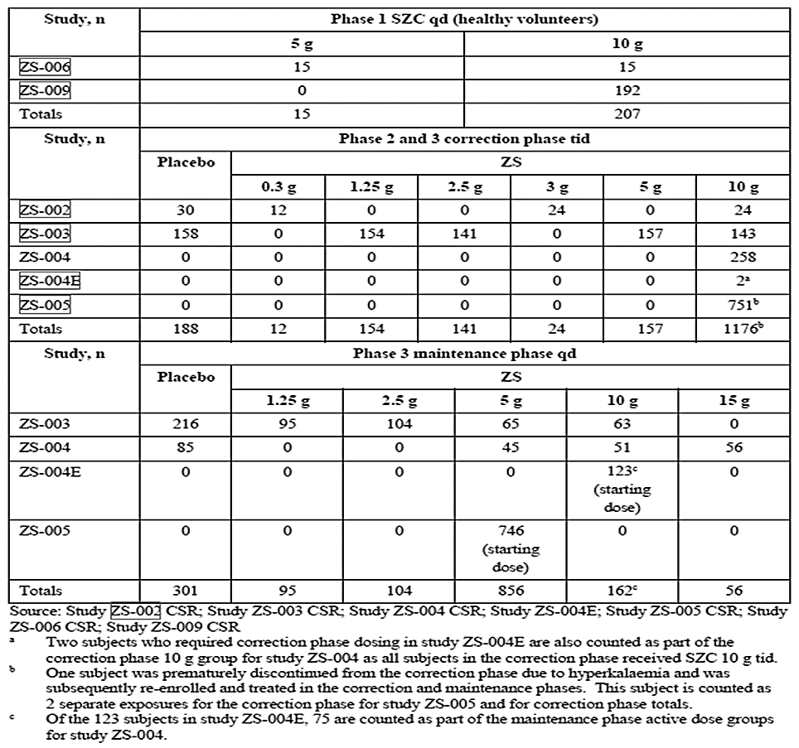

Adverse events

Acute phase
A summary of the acute phase treatment emergent AEs (TEAEs) by system organ class (SOC) are shown in Table 9.
Table 9: Acute phase TEAEs by system organ class (ZS-002, ZS-003, ZS-004; safety population)
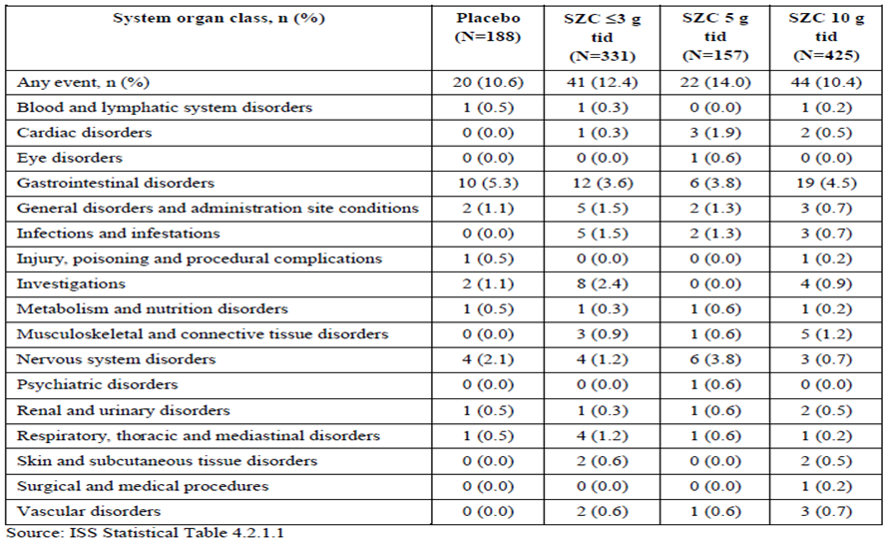

Maintenance phase
Study ZS-003 and ZS-004
Table 10. Maintenance phase TEAEs by SOC (ZS-003 and ZS-004; safety population).
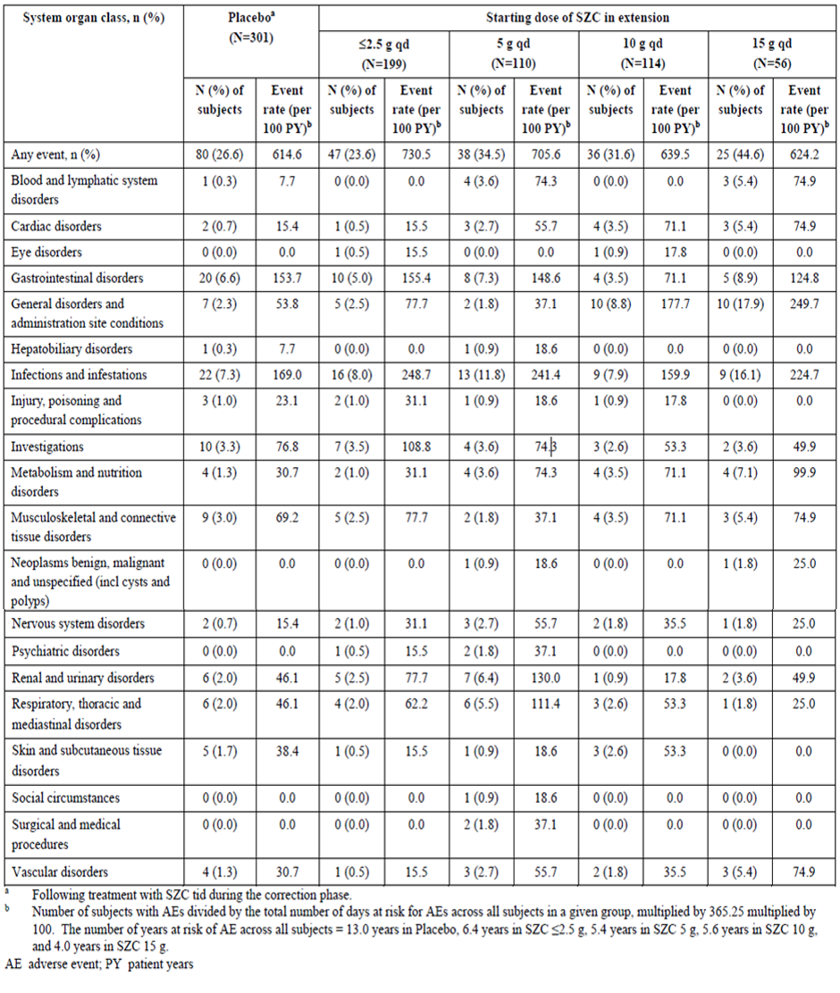
Study ZS-004E
A total of 82 (66.7%) of participants in the ZS-004E study at least one TEAE (event rate per 100 patient years of 114.4). The most common by SOC were infections and infestations (31.7%; event rate 54.4), gastrointestinal disorders (18.7%; event rate 32.1), vascular disorders (15.4%; event rate 26.5), investigations (13.8%; event rate 23.7), and metabolism and nutrition disorders (13.8%; event rate 23.7). The most common PTs were hypertension (12.2%; event rate 20.9), urinary tract infection (8.9%; event rate 15.3), and oedema peripheral (8.1%; event rate 14.0). Overall, there was no increased rate of TEAEs observed with increased exposure to ZS compared to the shorter maintenance phases in ZS-003 and ZS-004, and no new safety findings were observed.
Study ZS-005
A total of 489 (65.5%) of participants reported at least one TEAE (event rate per 100 patient years of 83.7). The most common by SOC were infections and infestations (29.4%; event rate 37.5), gastrointestinal disorders (22.4%; event rate 28.6), general disorders and administration site conditions (19.2%; event rate 24.5), and metabolism and nutrition disorders (17.3%; event rate 22.1). The most common PTs were similar to ZS-004E, with peripheral oedema (9.7%, event rate 12.3], hypertension (11.0%; event rate 14.0), and urinary tract infection (7.9%; event rate 10.1).

Additional studies
Study ZS-006
There was one TEAE reported in the short-term study with healthy participants (mild headache), but no serious AEs, deaths, or discontinuations due to an AE.
DIALIZE study
AEs were balanced across treatment groups, with 40 (41.7%) participants in the ZS group and 46 (46.5%) in the placebo group reporting any AE. The most commonly reported AEs among the ZS group were constipation (4.2%) and diarrhoea (4.2%), and among the placebo group were diarrhoea (6%) and hyperkalaemia (6%). The Evaluator notes that the cases of hypokalaemia were not reported as AEs.

Treatment related adverse events (adverse drug reactions)
During acute phase, gastrointestinal disorders were the most commonly reported TEAEs related to the study drug in these studies (placebo (n=188): 3.2%; ZS ≤ 3 g TID (n=331): 1.8%; ZS 5 g TID (n=157): 3.2%, ZS 10 g TID (n=425): 2.1%).
During the maintenance phase, PTs reported in ≥ 2% were anaemia, dyspepsia, and vomiting.

Deaths and other serious adverse events
Deaths
In the pooled analysis of the ZS-002, ZS-003, and ZS-004 studies, two (0.2%) unrelated deaths Eight unrelated deaths reported during the maintenance phase of ZS-005. No deaths were reported during the ZS-004E study, or the acute phase of ZS-005.
One unrelated death was reported in DIALIZE study.

Serious adverse events
Acute phase treatment
No related SAEs were reported in the ZS groups.
Maintenance phase treatment
In the pooled analysis of the ZS-003, ZS-004 and ZS-004E studies, only one SAE was considered related to the study drug (gastroenteritis), which was reported by a participant receiving ZS 5 g ONCE DAILY in ZS-003.
In the ZS-005 study, two SAE events were considered related to the study drug (pulmonary oedema and cardiac failure congestive).
Additional studies
The SAE incidence rate was higher in the DIALIZE study, reported in 7.3% (7/96) and 8.1% (8/99) of patients in the ZS and placebo groups, respectively. One SAE (peripheral arterial occlusive disease) had a fatal outcome. All SAEs were considered not related to the study drug.

Laboratory (clinical chemistry) results
No dose related, consistent clinically important changes were observed in any study for liver or renal function.
No clinically meaningful changes for calcium, sodium, magnesium, or phosphate observed in ZS treated participants.
A dose-related increase in the incidence of hypokalaemia (< 3.5 mmol/L) was observed in ZS-002, ZS-003, and ZS-004, and incidence over all studies except D9480C00006 was low at 4.0%, with no cases of severe hypokalaemia (<2.5 mmol/L) reported.
No clinically important trends in calcium, sodium, phosphate, or magnesium were observed in DIALIZE study.

Electrocardiograph findings and cardiovascular safety
ECGs performed in the placebo-controlled studies ZS-002 ZS-003, and ZS-004 showed minor and dose-dependent mean increases in QTc during the acute phase treatment, corresponding to a rapid decrease in serum potassium and negligible additional change in QTc during the maintenance phase of treatment.
No serious cases of cardiac arrythmias or sudden unexpected cardiac death were reported across studies.

Risk management plan evaluation summary
AstraZeneca Pty Ltd has submitted EU-RMP version 2 succession 2 (16 Oct 2019; DLP 21 Mar 2019) and ASA version 4 succession 1 (14 Feb 2023) in support of this application. The Sponsor did not submit an updated EU-RMP or ASA at round 2.
The proposed summary of safety concerns and their associated risk monitoring and mitigation strategies are summarised below:
The Sponsor has not proposed any safety concerns in the ASA. This aligns with the currently approved EU-RMP. As such, there are no proposed additional pharmacovigilance or risk management activities. The Sponsor has proposed routine pharmacovigilance activities. This is acceptable.
Wording for conditions of registration
Any changes to which the Sponsor has agreed should be included in a revised RMP and ASA. However, irrespective of whether or not they are included in the currently available version of the RMP document, the agreed changes become part of the risk management system.
The suggested wording is:
The Lokelma EU-Risk Management Plan (RMP) (version 2 succession 2, dated 16 Oct 2019, data lock point 21 Mar 2019), with Australian Specific Annex (version 4 succession 1, dated 14 Feb 2023), included with submission PM-2023-00671-1-5, and any subsequent revisions, as agreed with the TGA will be implemented in Australia.
The following wording is recommended for the PSUR requirement:
An obligatory component of risk management plans is routine pharmacovigilance. Routine pharmacovigilance includes the submission of periodic safety update reports (PSURs).
Reports are to be provided in line with the current published list of EU reference dates and frequency of submission of PSURs until the period covered by such reports is not less than three years from the date of this approval letter.
The reports are to at least meet the requirements for PSURs as described in the European Medicines Agency’s Guideline on good pharmacovigilance practices (GVP) Module VII-periodic safety update report (Rev 1), Part VII.B Structures and processes. Note that submission of a PSUR does not constitute an application to vary the registration. Each report must have been prepared within ninety calendar days of the data lock point for that report.
As Lokelma is a new chemical entity it should be included in the Black Triangle Scheme as a condition of registration. The following wording is recommended for the condition of registration:
Lokelma (sodium zirconium cyclosilicate) is to be included in the Black Triangle Scheme. The PI and CMI for Lokelma must include the black triangle symbol and mandatory accompanying text for five years, which starts from the date that the Sponsor notifies the TGA of supply of the product.

Risk-benefit analysis

Clinical efficacy
Five main completed clinical studies (one phase 2 study, and four phase 3 studies) were presented to evaluate efficacy in the target population for acute, subacute and maintenance phases of hyperkalaemia. DIALIZE study was submitted to provide data to support use in end stage renal disease patients with hyperkalaemia.
A dose-related SK decreasing effect of ZS for the acute treatment of hyperkalaemia was achieved in mild to moderate hyperkalaemia in the presented studies. It was seen in more than two thirds of patients in acute phase during (84% in first 24h), when the therapy is started (either 2.5 or 5 or 10 g is started in TID regimen) and this response rate is higher than is seen in placebo group (in half of population). For patients who were still hyperkalaemic at 24 hours, another 48 hours of ZS 10 g TID dosing restored normokalaemia in most of the remaining patients.
With regards to long term maintenance treatment, extended dosing with ZS (5 g once daily, 10 g once daily and 15 g once daily) for up to 12 months was effective in maintaining normokalaemia. Across Extended dosing study Days 8 to 337, 88.3% (95% conf. int: 81.2%, 93.5%) of subjects had average serum potassium values ≤ 5.1 mmol/L.).
These effects have onset in one to 4 few hours.
However, the effects of Lokelma in more severe hyperkalaemia cases (>6.5 mmol/l) and cases showing ECG changes, when the urgent effect is needed, is not fully determined. Co-administration of ZS with other potassium lowering agents such as Insulin+ glucose infusion in acute cases has also not been studied.
The Sponsor has not specified any upper range of hyperkalaemia in the proposed indication.

Clinical safety
The combined safety data across acute phase treatment studies and longer-term maintenance studies for ZS dosing up to one year indicate that ZS is generally well tolerated.
Serum potassium below 3.5 mmol/L was observed in 4 (0.4%) patients (n=913) during the acute phase treatment. Three of the subjects received 10 g TID and one 3 g TID.
Gastrointestinal ADRs were observed in 1 to 3% of subjects during the extended phase. They mainly included the constipation, vomiting, diarrhoea, dyspepsia, and nausea. Hyperkalaemia (inefficiency, especially during long-term use) and hypokalaemia were also observed, suggesting a possible under- or over-dose.
Events related to the QTc interval (electrocardiogram QT prolonged and long QT syndrome) were the most common cause of the premature discontinuation of study drug in both, acute and extended dosing in ZS-treated subjects. Electrocardiogram QT prolonged led to premature discontinuation of study drug in 4 ZS-treated subjects in the study ZS-004.
Common events of muscle spasms and oedema were also observed. Pooled analyses of extended dosing from studies ZS-003 and ZS-004 showed a higher incidence of oedema-related events that was observed with the 15 g ONCE DAILY dose (14.3%). Lower rates were observed in patients receiving placebo (1.7%, 5 subjects), 2.5 g ONCE DAILY (1.0%, 2 subjects), 5 g ONCE DAILY (1.8%, 2 subjects) and 10 g ONCE DAILY (5.3%, 6 subjects). In the acute phase, the incidence of oedema was lower at 0.4% (4 subjects). Over half of these cases resolved without treatment, the remaining resolved after change in medication, e.g., increase in diuretics dose.
Safety data from the DIALIZE study indicates that the use of SZ to treat persistent hyperkalaemia on non-dialysis days for patients requiring dialysis for CKD is also generally well tolerated.
The majority of TEAEs, deaths, SAEs, and withdrawals were likely a result of underlying characteristics of the study population. There are no specific safety concerns related to this submission, except the risk of hypokalaemia if patients receiving treatment are inadequately monitored in relation to their serum potassium, which is particularly important during the acute phase of treatment, when ZS is administered three times daily. Oedema related events have also been identified as ADRs for ZS.
Data limitation
- Lack of data on concomitant administration with other acute potassium lowering treatments e.g. Insulin+ glucose infusion
- No substantive data if Lokelma can be used in patients with ECG changes or severe hyperkalaemia.
- No data on patients with existing QTc abnormalities.
- No substantive data in hypertensive patients. This can be an issue due to increase in serum sodium with Lokelma use.

Delegate’s proposed action and recommendation
Overall, the submitted data and subsequent responses by the Sponsor support the registration for Lokelma.
The Sponsor’s proposed therapeutic indication for Lokelma is:
Lokelma is indicated for the treatment of hyperkalaemia in adult patients.
The Delegate’s recommendation for the indication is:
Lokelma is indicated for the treatment of mild to moderate hyperkalaemia in adult patients with no ECG changes.

Advisory Committee considerations
The Advisory Committee on Medicines (ACM) having considered the evaluations and the Delegate’s overview, as well as the Sponsor’s response to these documents, advised the following.
Does the ACM agree with proposed open-ended indication for use of Lokelma in Hyperkalaemia? Especially in view of lack of data in severe hyperkalaemia and hyperkalaemia with ECG changes. The PI does mention for it not to be used in life threatening hyperkalaemia, under section 4.4 (SPECIAL WARNINGS AND PRECAUTIONS FOR USE).
The ACM was of the view that the data provided has sufficiently established safety and efficacy to support the proposed open-ended indication.
In providing this view, the ACM noted that Lokelma will be used with consideration of other acute treatments e.g. insulin/glucose, bicarbonates, and dialysis, taking into account the potassium level and ECG changes, in patients under the care of nephrologists/physicians.
The ACM supported the inclusion in the PI of the statement highlighting that Lokelma should not be used alone as an emergency treatment of life-threatening hyperkalaemia.
Does ACM agree with the overall efficacy and safety profile of Lokelma.
The ACM agreed that the overall efficacy and safety profile of Lokelma is favourable. The ACM advised that the totality of the reported adverse events in the clinical trials were acceptable and did not lead to any specific safety concerns.
The committee is also requested to provide advice on any other issues that it thinks may be relevant to this application
The ACM advised the trial data did not provide adequate data to support the further use of Lokelma should a patient remain hyperkalaemic (with a serum potassium level of <6.0 mmol/L) after 48 hours of treatment. However, the ACM noted that treatment would be initiated and monitored by experts, and individual patients needs and associated treatment options appropriately considered.

ACM conclusion
The ACM considered this product to have an overall positive benefit-risk profile for the indication:
Lokelma is indicated for the treatment of hyperkalaemia in adult patients.

Outcome
Based on a review of quality, safety, and efficacy, the TGA decided to register Lokelma (sodium zirconium cyclosilicate), for the following:
LOKELMA is indicated for the treatment of hyperkalaemia in adult patients.

Specific conditions of registration applying to these goods
Lokelma (sodium zirconium cyclosilicate) is to be included in the Black Triangle Scheme. The PI and CMI for Lokelma must include the black triangle symbol and mandatory accompanying text for five years, which starts from the date that the sponsor notifies the TGA of supply of the product.
The Lokelma EU-Risk Management Plan (RMP) (version 2 succession 2, dated 16 Oct 2019, data lock point 21 Mar 2019), with Australian Specific Annex (version 4 succession 1, dated 14 Feb 2023) and any subsequent revisions, as agreed with the TGA will be implemented in Australia.
An obligatory component of risk management plans is routine pharmacovigilance. Routine pharmacovigilance includes the submission of periodic safety update reports (PSURs).
Reports are to be provided in line with the current published list of EU reference dates and frequency of submission of PSURs until the period covered by such reports is not less than three years from the date of this approval letter. The reports are to at least meet the requirements for PSURs as described in the European Medicines Agency’s Guideline on good pharmacovigilance practices. Module VII-periodic safety update report (Rev 1), Part VII.B Structures and
processes. Note that submission of a PSUR does not constitute an application to vary the registration. Each report must have been prepared within ninety calendar days of the data lock point for that report.

Attachment 1. Product Information
The Product Information (PI) approved with the submission for Lokelma which is described in this AusPAR can be found as Attachment 1. It may have been superseded. For the most recent PI and Consumer Medicines Information (CMI), please refer to the TGA PI/CMI search facility.

Therapeutic Goods Administration
PO Box 100 Woden ACT 2606 Australia
Email: info@tga.gov.au Phone: 1800 020 653 Fax: 02 6203 1605
https://www.tga.gov.au

Nyirenda MJ, Tang JI, Padfield PL, Seckl JR. Hyperkalaemia. BMJ 2009;339:b4114.
Palmer BF, Clegg DJ. Hyperkalemia. JAMA 2015;314(22):2405-6.
Henneman A, Guirguis E, Grace Y, Patel D, Shah B. Emerging therapies for the management of chronic hyperkalemia in the ambulatory care setting. Am J Health Syst Pharm 2016;73(2):33-44.
Einhorn LM, Zhan M, Hsu VD, Walker LD, Moen MF, Seliger SL, et al. The frequency of hyperkalemia and its significance in chronic kidney disease. Arch Intern Med. 2009;169(12):1156-62.
Fleet JL, Shariff SZ, Gandhi S, Weir MA, Jain AK, Garg AX. Validity of the International Classification of Diseases 10th revision code for hyperkalaemia in elderly patients at presentation to an emergency department and at hospital admission. BMJ Open 2012;2(6). pii: e002011. doi: 10.1136/bmjopen-2012-002011.
Palmer and Clegg (2015).
Jain N, Kotla S, Little BB, et al. Predictors of hyperkalemia and death in patients with cardiac and renal disease. Am J Cardiol 2012;109:1510-3.
McCullough PA, Costanzo MR, Silver M, Spinowitz B, Zhang J, Lepor NE. Novel agents for the prevention and management of hyperkalemia. Rev Cardiovasc Med 2015;16(2):140-55
Vardeny O, Claggett B, Anand I, Rossignol P, Desai AS, Zannad F, et al. Incidence, predictors, and outcomes related to hypo- and hyperkalemia in patients with severe heart failure treated with a mineralocorticoid receptor antagonist. Circ Heart Fail 2014;7(4):573-9
Electrolyte abnormalities: Treating hyperkalaemia. Therapeutic Guidelines. March 2014 (amended March 2021). Topic | Therapeutic Guidelines (tg.org.au)
The ‘Delegate’ is the Delegate of the Secretary of the Department of Health and Aged Care who made the final decision to either include the new medicine/indication on the ARTG or reject the submission, under section 25 of the Therapeutic Goods Act
International Conference on Harmonisation of Technical Requirements for Registration of Pharmaceuticals for Human Use. Guideline on the need for carcinogenicity studies of pharmaceuticals S1A. 29 November 1995
Microcrystalline cellulose is a bulking agent used in supplements to fill capsules when the medicinal agents are too small. It is an ideal filler as it is naturally occurring and derived primarily from wood pulp. Its glucose units bound together by a beta 1-4 linkage which creates cellulose a fibre indigestible to humans. It enters and leaves the digestive tract unchanged and is chemically inert.

