▼This medicinal product is subject to additional monitoring in Australia. This will allow quick identification of new safety information. Healthcare professionals are asked to report any suspected adverse events at www.tga.gov.au/reporting-problems.
AUSTRALIAN PRODUCT INFORMATION LOKELMA™
(sodium zirconium cyclosilicate hydrate) powder for oral suspension
- NAME OF THE MEDICINE
Sodium zirconium cyclosilicate hydrate

QUALITATIVE AND QUANTITATIVE COMPOSITION
LOKELMA 5 g powder for oral suspension: Each sachet contains 5 grams (g) of sodium zirconium cyclosilicate hydrate (contains approximately 400 mg sodium).
LOKELMA 10 g powder for oral suspension: Each sachet contains 10 g sodium zirconium cyclosilicate hydrate (contains approximately 800 mg sodium).
For the full list of excipients, see Section 6.1 List of excipients.

PHARMACEUTICAL FORM
Powder for oral suspension.
Sodium zirconium cyclosilicate hydrate is a white to grey, crystalline, insoluble powder.

CLINICAL PARTICULARS

THERAPEUTIC INDICATIONS
LOKELMA is indicated for the treatment of hyperkalaemia in adult patients.

DOSE AND METHOD OF ADMINISTRATION

Dose

Treatment of hyperkalaemia correction phase
For patients with hyperkalaemia (serum potassium level is >5.0 millimoles per litre (mmol/L)) the recommended starting dose of LOKELMA is 10 g, administered three times a day (TID) orally as a suspension in water, to achieve normokalaemia (normal potassium levels between 3.5 and 5.0 mmol/L). Typically, normokalaemia is achieved within 24 to 48 hours. If the measured serum potassium is still above 5.0 mmol/L at the end of 48 hours, an additional day (24 hours) of 10 g three times a day dosing may be given, prior to initiation of the maintenance dose. If normokalaemia is not achieved at the end of day 3, other treatment approaches should be considered.

Treatment of hyperkalaemia maintenance phase
For continued maintenance treatment, the minimal effective dose to prevent recurrence of hyperkalaemia should be established. A dose of 5 g once daily is recommended, with possible titration up to 10 g once daily, or down to 5 g once every other day, as needed, to maintain a normal potassium level. No more than 10 g once daily should be used for maintenance therapy.

Missed dose
If a patient misses a dose they should be instructed to take the next usual dose at their normal time.

Special Populations

Patients with renal impairment
No changes from the normal doses are required for patients with renal impairment who are not on chronic haemodialysis.
For patients on dialysis LOKELMA should only be dosed on non-dialysis days. The recommended starting dose is 5 g once daily. To establish normokalaemia (4.0-5.0 mmol/L), the dose may be titrated up or down weekly based on the pre-dialysis serum potassium value after the long inter-dialytic interval (LIDI). The dose could be adjusted at intervals of one week in increments of 5 g up to 15 g once daily on non-dialysis days. To maintain normokalaemia it is recommended to monitor serum potassium regularly (e.g. monthly).

Patients with hepatic impairment
No dose adjustment required for patients with hepatic impairment.

Elderly patients
Dose adjustment is not required in the elderly.

Paediatric patients
Safety and efficacy of LOKELMA in paediatric patients have not been established.

Method of administration
For oral use.

Patients should be instructed to empty the entire contents of the sachet(s) into a drinking glass containing approximately 45 mL of water. Stir well and drink immediately while the powder, which does not dissolve, is still suspended. The suspension is tasteless and will appear as a cloudy liquid. If the powder settles the water should be stirred again. Ensure all product is taken.
LOKELMA can be taken with or without food.

CONTRAINDICATIONS
Hypersensitivity to the active substance.

SPECIAL WARNINGS AND PRECAUTIONS FOR USE

Hypokalaemia
Hypokalaemia (serum potassium level < 3.5 mmol/L) may be observed. Dose titration as described under maintenance dose may be required in such cases to prevent moderate to severe hypokalaemia. In patients with serum potassium levels <3.0 mmol/L, LOKELMA should be discontinued and the patient re-evaluated. Serum potassium should be monitored when clinically indicated, for example, if changes are made to medications that affect serum potassium levels (e.g. use of renin-angiotensin- aldosterone system [RAAS] inhibitors or diuretics) and the LOKELMA dose titrated if necessary.

X-ray Imaging Interference
LOKELMA may be opaque to X-rays and may therefore affect the interpretation of radiographic results.

Use in patients with ileus or obstructive bowel disease
LOKELMA has not been studied in patients with ileus or obstructive bowel disease.

Life-threatening hyperkalaemia
LOKELMA should not be used alone as an emergency treatment of life-threatening hyperkalaemia, as rapid potassium reduction is not achievable by oral agents.

QT Prolongation
During correction of hyperkalaemia, a lengthening of the QT interval can be observed as the physiologic result of a decline in serum potassium concentration.

Intestinal perforation
The risk for intestinal perforation with the use of LOKELMA is currently unknown. Since intestinal perforation has been reported with potassium binders including LOKELMA, specific attention should be paid to signs and symptoms related to intestinal perforation.

Sodium Content
This medicinal product contains approximately 400 mg sodium per 5 g dose, equivalent to 20% of the WHO recommended maximum daily intake of 2 g sodium for an adult. LOKELMA is considered high in sodium. This should be taken into account particularly for those on a low salt diet.

Use in the elderly
No data available.

Paediatric use
No data available.

Effects on laboratory tests
No data available.

INTERACTIONS WITH OTHER MEDICINES AND OTHER FORMS OF INTERACTIONS

Effect of other medicinal products on LOKELMA
As LOKELMA is not absorbed or metabolised by the body, there are no expected effects of other medicinal products on the pharmacological action of LOKELMA.

Effect of LOKELMA on other medicinal products
LOKELMA can transiently increase gastric pH by absorbing hydrogen ions that can lead to changes in solubility and absorption kinetics for co-administrated drugs with pH-dependent bioavailability. Therefore, LOKELMA should be administered at least 2 hours before or 2 hours after oral medications with clinically meaningful gastric pH dependent bioavailability.

Examples of drugs that should be taken 2 hours before or after LOKELMA to avoid possible raised gastric pH drug interaction are listed below:

Table 1: Drugs that should be taken 2 hours before or after LOKELMA to avoid a possible gastric pH drug interaction

Class of Drug | Drugs
Azole antifungals | Ketoconazole, Itraconazole, Posaconazole
Anti-HIV drugs | Atazanavir, Nelfinavir, Indinavir, Ritonavir,  Saquinavir, Raltegravir, Ledipasvir, Rilpivirine
Tyrosine kinase inhibitors | Erlotinib, Dasatinib, Nilotinib

LOKELMA can be co-administered without spacing of dosing times with oral medications that do not exhibit pH-dependent bioavailability. As LOKELMA is not absorbed or metabolised by the body, there is limited potential for interactions with other medical products. Because of the potential to bind lithium, LOKELMA should be administered at least 3 hours before or 3 hours after lithium- based medicines to avoid a possible drug interaction.
In a clinical drug-drug interaction study conducted in healthy subjects, co-administration LOKELMA with amlodipine, dabigatran, clopidogrel, atorvastatin, furosemide, glipizide, warfarin, losartan, or levothyroxine did not result in clinically meaningful drug-drug interactions. No dose adjustments or separation of the time of dosing are required for these drugs.

In another drug-drug interaction study in healthy volunteers, co-administration of LOKELMA 15 g with tacrolimus 5 mg resulted in a decreased tacrolimus AUC and Cmax by 37% and 29% respectively. Therefore, tacrolimus should be taken at least 2 hours before or after LOKELMA. In the same study, co-administration of LOKELMA and cyclosporin did not show a clinically meaningful interaction.

FERTILITY, PREGNANCY AND LACTATION

Effects on fertility
No human data on the effect of sodium zirconium cyclosilicate on fertility are available. Male and female fertility were unaffected in rats at oral doses of sodium zirconium cyclosilicate of up to 6000 mg/kg/day, 10 times higher than the maximum recommended human dose on a mg/kg basis (assuming 50 kg patient body weight).

Use in pregnancy – Category B1
No clinical study has been conducted in pregnant women.
No adverse effects on embryofetal development were observed in rats and rabbits receiving oral doses of sodium zirconium cyclosilicate of up to 6000 mg/kg/day, 10 times higher than the maximum recommended human dose. Because animal reproduction studies are not always predictive of a human response, LOKELMA should be used during pregnancy only if the potential benefit to the mother justifies any potential risks to the fetus.

Use in lactation
Due to its physicochemical properties, sodium zirconium cyclosilicate is not absorbed systemically and is not expected to be excreted in breast milk. While no clinical studies have been conducted in lactating women, no effects on the breastfed newborn/infant are anticipated given systemic exposure is negligible.

EFFECTS ON ABILITY TO DRIVE AND USE MACHINES
The effects of this medicine on a person's ability to drive and use machines were not assessed as part of its registration.

ADVERSE EFFECTS (UNDESIRABLE EFFECTS)

Clinical trials
The safety of LOKELMA was evaluated in clinical trials for the reduction of hyperkalaemia involving over 1,500 patients.
The most commonly reported adverse reaction was oedema related events which were reported by 5.7% LOKELMA patients; 1.7, 2.7, 5.2, and 14.3% of patients randomised to placebo, LOKELMA 5 g, 10 g, or 15 g once daily up to one month, respectively. Fifty-three percent were managed with initiating a diuretic or adjusting a diuretic dose; the remainder did not require treatment.
In clinical trials, 4.1% of LOKELMA patients developed hypokalaemia with a serum potassium value less than 3.5 mmol/L, which was resolved with dose adjustment or discontinuation of LOKELMA.

Tabulated list of adverse reactions
The following convention was used for frequency of adverse drug reactions: Very common (≥1/10); Common (≥1/100 to <1/10); Uncommon (≥1/1,000 to <1/100); Rare (≥1/10,000 to <1/1,000); Very rare (<1/10,000), not known (cannot be estimated from the available data).

Table 2: List of adverse reactions in clinical studies

System Organ Class Common

Metabolism and nutrition disorders Hypokalaemia

Gastrointestinal disorders Constipationª

General disorders and administration Oedema related events ^{b,} ^{c}
conditions

a In clinical studies conducted in countries with a predominantly Asian population, constipation with an estimated frequency of 8.9% occurred in patients receiving LOKELMA; and was resolved with dose adjustment or treatment discontinuation.
b Includes Fluid retention, Generalised oedema, Hypervolaemia, Localised oedema, Oedema,
Oedema peripheral, Peripheral swelling
c Adverse reaction only in the maintenance phase

Reporting suspected adverse effects
Reporting suspected adverse reactions after registration of the medicinal product is important. It allows continued monitoring of the benefit-risk balance of the medicinal product. Healthcare professionals are asked to report any suspected adverse reactions at www.tga.gov.au/reporting- problems.

OVERDOSE
Overdose with LOKELMA could lead to hypokalaemia. Serum potassium should be checked and potassium supplemented as needed.
For information on the management of overdose, contact the Poison Information Centre on 131126 (Australia).

PHARMACOLOGICAL PROPERTIES

PHARMACODYNAMIC PROPERTIES

Mechanism of action
Sodium zirconium cyclosilicate is a non-absorbed, non-polymer inorganic powder with a uniform micropore structure that preferentially captures potassium in exchange for hydrogen and sodium cations. Sodium zirconium cyclosilicate is highly selective for potassium ions, even in the presence of other cations, such as calcium and magnesium. In vitro studies with media formulated to mimic the fluid contents of the stomach, small intestine and large intestine indicate that the exchange of potassium occurs throughout the entire intestinal tract, with no or only limited potassium exchange occurring in the low pH environment of the stomach. Trapping of potassium ions by sodium zirconium cyclosilicate reduces the concentration of free potassium in the GI lumen, thereby lowering serum potassium levels and increasing faecal potassium excretion to resolve hyperkalaemia.

Pharmacodynamic effects
LOKELMA reduces serum potassium levels as soon as 1 hour after ingestion and serum potassium concentrations continue to decline over the 48-hour treatment period. Sodium zirconium cyclosilicate hydrate has no clinically meaningful effect on serum calcium, magnesium, and sodium levels. In patients not continuing treatment, potassium levels increase. There is a close correlation between starting serum potassium levels and effect size; patients with higher starting serum potassium levels have greater reductions in serum potassium.

In a study of healthy subjects given LOKELMA 5 g or 10 g once daily for four days, dose-dependent reduction in serum potassium concentration and total urinary potassium excretion were accompanied by mean increases in faecal potassium excretion. No statistically significant changes in urinary sodium excretion were observed.
LOKELMA has also been shown to bind ammonium in vitro and in vivo, thereby removing ammonium and increasing serum bicarbonate levels. LOKELMA treated-patients experienced an increase of 1.1 mmol/L at 5 g once daily, 2.3 mmol/L at 10 g once daily, and 2.6 mmol/L at 15 g once daily in bicarbonate compared with a mean increase of 0.6 mmol/L for those receiving placebo. LOKELMA demonstrated a change in serum aldosterone levels (range: -30% to -31%) compared with the placebo group (+14%). No clinically meaningful effect on systolic and diastolic blood pressure has been observed.

In addition, mean reductions in BUN (blood urea nitrogen) were observed in the 5 g (-1.1 mg/dl) and 10 g (-2.0 mg/dl) three times daily groups compared with small mean increases in the placebo (0.8 mg/dl) and low dose LOKELMA (0.3 mg/dl) groups.

Clinical trials
The potassium-lowering effects of LOKELMA have been demonstrated in three randomised, double- blind, placebo-controlled trials in patients with hyperkalaemia. All three studies tested the initial effect of LOKELMA to correct hyperkalaemia during a 48-hour period and two studies also tested maintenance of normokalaemia effect obtained. The maintenance studies included patients with chronic kidney disease (58%), heart failure (10%), diabetes mellitus (62%), and RAAS inhibitor therapy (68%). One thousand seven hundred sixty patients have received doses of LOKELMA; 507 exposed for at least 360 days. In addition, the efficacy and safety of LOKELMA was studied in a double-blind placebo-controlled trial of 196 chronic haemodialysis patients with hyperkalaemia, who received doses of LOKELMA for 8 weeks. In the studies, LOKELMA reduced serum potassium and maintained normal serum potassium levels regardless of the underlying cause of hyperkalaemia, age, sex, race, comorbid disease, or concomitant use of RAAS inhibitors. No dietary restrictions were imposed; patients were instructed to continue their usual diet without any specified alterations.

A two-phase, randomised, double-blind placebo-controlled study
In this study, 753 patients (mean age 66 years, range 22 to 93 years) with hyperkalaemia (5.0 - ≤6.5 mmol/L, baseline potassium average 5.3 mmol/L) were randomised to receive LOKELMA 1.25 g,
2.5 g, 5 g, or 10 g or placebo three times a day for the initial 48 hours.

LOKELMA showed dose-dependent reductions in serum potassium at the 2.5 g, 5 g, and 10 g doses within hours of administration of the first dose (Table 2). Statistically significant reductions in potassium were observed 1 hour after the first 10 g dose of LOKELMA. Mean serum potassium reduction was 0.7 mmol/L and 86% of patients had normal potassium values within 48 hours at the 10 g dose. Patients with higher starting potassium levels had a greater response to LOKELMA. Patients with pre-treatment potassium levels in excess of 5.5 mmol/L (average baseline 5.8 mmol/L) saw an average decrease of 1.1 mmol/L at 48 hours while those with starting potassium levels at or below 5.3 mmol/L had an average decrease of 0.6 mmol/L at the highest dose. Potassium reduction was similar among patients with chronic kidney disease, heart failure, diabetes mellitus, and those taking RAAS inhibitor therapy (angiotensin receptor blockers, angiotensin converting enzyme inhibitors, aldosterone antagonists).

Table 3: Acute phase potassium change from baseline at 48 hours

Mean serum potassium change mmol/L (95% Confidence intervals) Sample size | Placebo | 1.25 g TID | 2.5 g TID | 5 g TID | 10 g TID
All Patients | -0.2  (-0.3, -0.2) n=158 | 0.3  (-0.4, -0.2) n=150 | -0.5*  (-0.5, -0.4) n=137 | -0.5*  (-0.6, -0.5) n=152 | -0.7*  (-0.8, -0.7) n=140
Baseline serum potassium | -0.2 | -0.2 | -0.4* | -0.4* | -0.6*
<5.3 mmol/L | (-0.2, -0.1) | (-0.3, -0.1) | (-0.5, -0.3) | (-0.5, -0.3) | (-0.7, -0.5)
 | n=95 | n=73 | n=71 | n=87 | n=92
Baseline serum potassium | -0.4 | -0.4 | -0.5 | -0.7* | -1.0*
5.4-5.5 mmol/L | (-0.5, -0.2) | (-0.5, -0.2) | (-0.6, -0.4) | (-0.8, -0.5) | (-1.1, -0.8)
 | n=22 | n=37 | n=29 | n=36 | n=26
Baseline serum potassium | -0.4 | -0.3 | -0.6 | -0.9* | -1.1*
>5.5 mmol/L | (-0.6, -0.3) | (-0.5, -0.2) | (-0.7, -0.4) | (-1.0, -0.7) | (-1.3, -0.9)
 | n=40 | n=40 | n=37 | n=29 | n=22
*= p-value <0.05

A multi-phase, placebo-controlled maintenance study with extension
In the correction phase of the study, 258 patients with hyperkalaemia (baseline average 5.6, range 4.1-7.2 mmol/L) received 10 g of LOKELMA administered three times daily for 48 hours. Reductions in potassium were observed 1 hour after the first 10 g dose of LOKELMA. Median time to normokalaemia was 2.2 hours with 84% of patients achieving normokalaemia within 24 hours and 98% within 48 hours. Responses were larger in patients with more severe hyperkalaemia; serum potassium fell 0.8, 1.2, and 1.5 mmol/L in patients with baseline serum potassium <5.5, 5.5-5.9, and
≥6.0 mmol/L, respectively.
Patients who achieved normokalaemia (potassium levels between 3.5 and 5.0 mmol/L) were randomised in a double-blind fashion to one of three doses of LOKELMA (5 g (n=45), 10 g (n=51), or 15 g (n=56)), or placebo (n=85) administered once daily for 28 days (the double-blind randomised withdrawal phase).
The proportion of subjects with average serum potassium <5.1 mmol/L from Study Day 8 to 29 was greater at the 5 g, 10 g, and 15 g once daily doses of LOKELMA (80%, 90%, and 94%, respectively), compared with placebo (46%). There was a mean decrease in serum potassium of 0.77 mmol/L, 1.10 mmol/L, 1.19 mmol/L, and 0.44 mmol/L in the 5 g, 10 g, 15 g once daily doses of LOKELMA and placebo groups, respectively. Extend maintenance phase (open-label) results: 123 patients entered the 11-month open-label phase. Average serum potassium levels were 4.66 mmol/L throughout the extension. Treatment was discontinued on study exit (Day 365). Figure 1 illustrates the mean serum potassium levels over the correction and maintenance phase of the study.

Figure 1: Correction and maintenance phase: Mean serum potassium levels
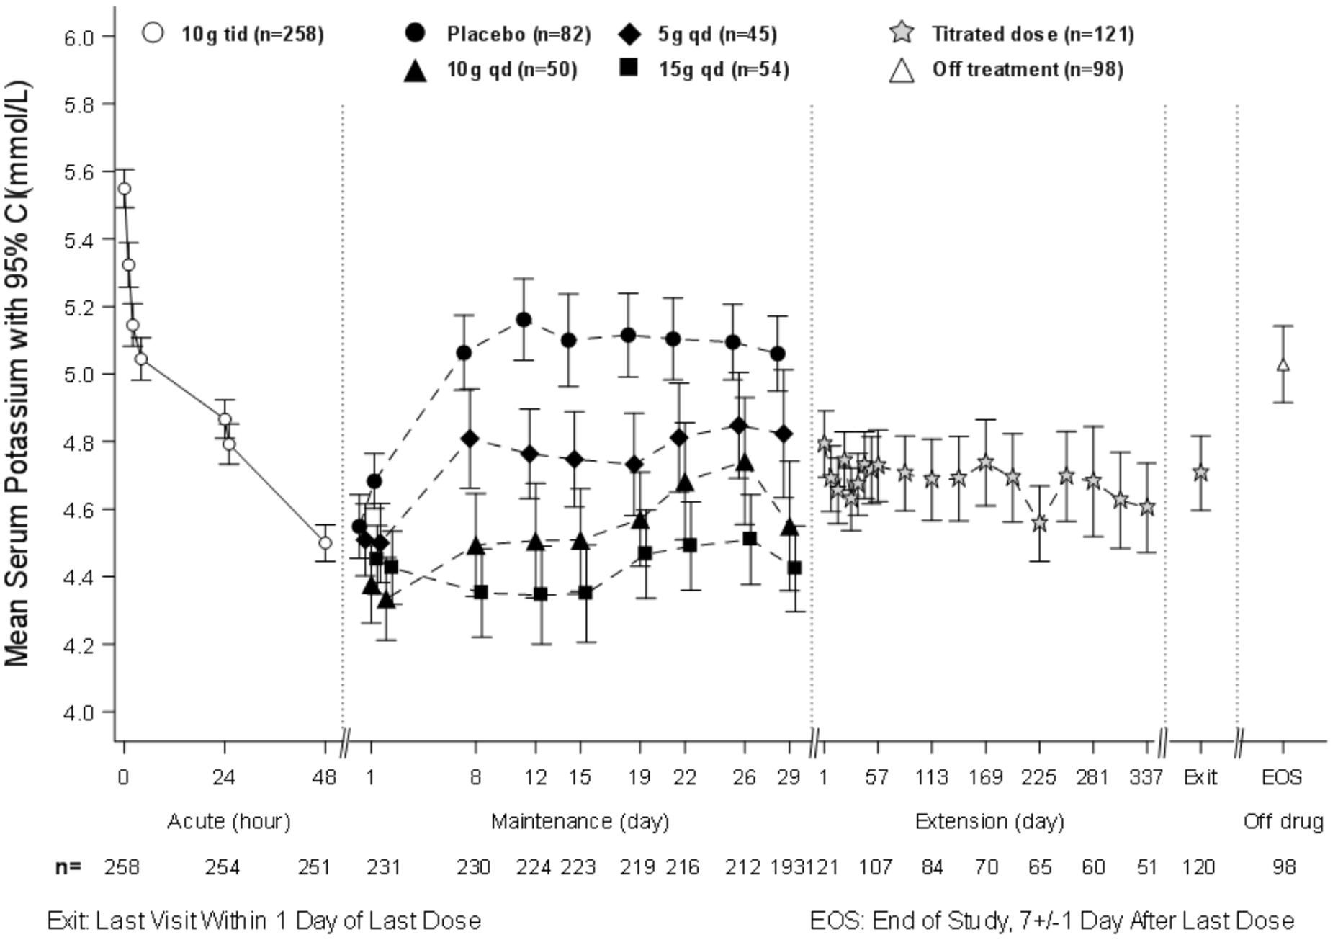
Intent-to-Treat population includes subjects with at least one valid Serum Potassium (SK) measurement on or after Day 8. The displayed error bars correspond to 95% confidence intervals.

A two-phase, multi-center, multi-dose, open-label safety and efficacy study
The long term (up to 12 months) effects of LOKELMA were assessed in this study in 751 subjects with hyperkalaemia (baseline average 5.59 mmol/L; range 4.3-7.6 mmol/L). Comorbid conditions included CKD (65%), diabetes mellitus (64%), heart failure (15%), and hypertension (83%). Use of diuretics and RAAS inhibitors was reported by 51% and 70% of subjects, respectively. During the correction phase, LOKELMA was administered 10 g TID for at least 24 hours and up to 72 hours. Subjects who achieved normokalaemia (3.5-5.0 mmol/L, inclusive) within 72 hours (n=746; 99%) entered the maintenance phase of the study. All subjects in the maintenance phase received LOKELMA at a starting dose of 5 g QD which could be increased in increments of 5 g QD (to a maximum of 15 g QD) or decreased (to a minimum of 5 g QOD) based upon the titration regimen.
The average reduction in serum potassium was 0.81 mmol/L, 1.02 mmol/L and 1.10 mmol/L at 24 (n=748), 48 (n=104) and 72 (n=28) hours, respectively. One hundred and twenty-six patients had a baseline serum potassium ≥ 6.0 mmol/L (mean baseline potassium 6.28 mmol/L) and these patients had a mean reduction of 1.37 mmol/L at the end of the acute phase.
The proportion of subjects with a mean serum potassium ≤ 5.1 mmol/L across the Maintenance Phase Days 85-365 was 88% (95% CI 0.857, 0.908) and ≤ 5.5 mmol/L across the Maintenance Phase Days
85-365 was 99% (95% CI 0.976, 0.995). Normokalaemia was maintained while patients remained on drug and the mean serum potassium increased following discontinuation. Among those patients using RAAS inhibitors at baseline, 89% did not discontinue RAASi therapy, 74% were able to maintain the same dose during the maintenance phase and among those not on RAAS inhibitors at baseline, 14% were able to initiate this therapy.

Figure 2: 12-Month Open-Label Study with Correction and Maintenance Phases – Mean Serum Potassium
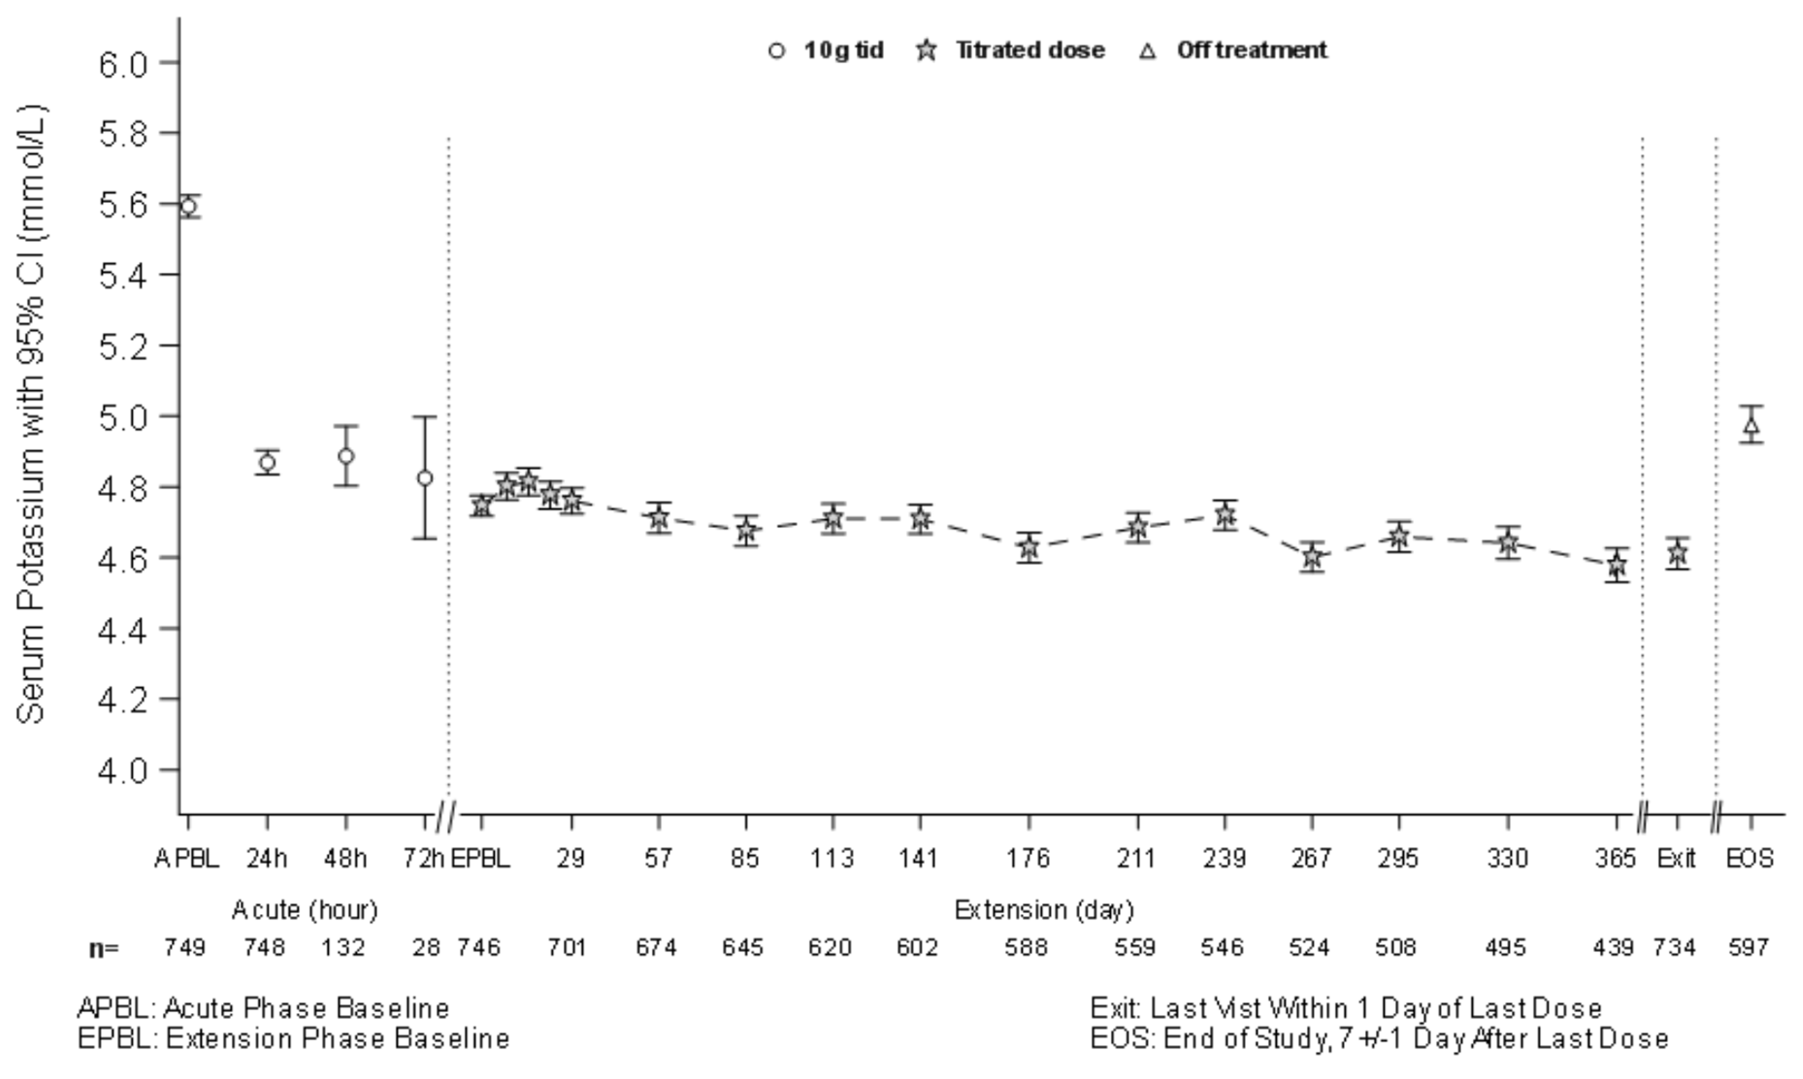
Intent-to-Treat population includes subjects with at least one valid Serum Potassium (SK) measurement on or after Day 8. The displayed error bars correspond to 95% confidence intervals.

A study in chronic kidney disease patients with hyperkalaemia
This study was a double-blind placebo-controlled dose-escalating study in 90 patients (60 LOKELMA patients; 30 controls) with baseline eGFR between 30-60 ml/min/1.73m2 and hyperkalaemia (baseline serum potassium 5.2 mmol/L, range 4.6-6.0 mmol/L). Patients were randomised to receive escalating doses of LOKELMA (0.3 g, 3 g, and 10 g) or placebo, administered three times a day with meals for two to four days. The primary endpoint was the rate of change in serum potassium from baseline throughout the initial 2 days of treatment. The trial met the primary efficacy endpoint at the 3 g and 10 g doses of LOKELMA compared to placebo. LOKELMA at the 10 g dose and the 3 g dose resulted in mean maximal reductions of 0.92 mmol/L and 0.43 mmol/L, respectively. Twenty-four-hour urine collections showed that LOKELMA decreased urinary potassium excretion from baseline by 15.8 mmol/24 hours compared to placebo increase by 8.9 mmol/24 hours (p <0.001). Sodium excretion was unchanged relative to placebo (10 g TID, increase by 25.4 mmol/24 hours compared to placebo increase by 36.9 mmol/24 hours (NS)).

A randomised, double-blind, placebo-controlled study in patients on chronic haemodialysis
In this study, 196 patients (mean age 58 years, range 20 to 86 years) with end stage renal disease on stable dialysis for at least 3 months and persistent pre-dialysis hyperkalaemia were randomised to receive LOKELMA 5 g or placebo once daily on non-dialysis days. At randomization, mean serum potassium levels were 5.8 mmol/L (range 4.2-7.3 mmol/L) in the LOKELMA group and 5.9 mmol/L (range 4.2-7.3 mmol/L) in the placebo group. To achieve pre-dialysis serum potassium level between 4.0-5.0 mmol/L during the dose adjustment period (initial 4 weeks), the dose could be adjusted weekly in 5 g increments up to 15 g once daily based on pre-dialysis serum potassium measurement after the LIDI. The dose reached at the end of the dose-adjustment period was maintained throughout the subsequent 4-week evaluation period. The proportion of responders, defined as those subjects who maintained a pre-dialysis serum potassium between 4.0 and 5.0 mmol/L on at least 3 out of 4 dialysis treatments after LIDI and who did not receive rescue therapy during the evaluation period, was 41% in the LOKELMA group, and 1% in the placebo group (p < 0.001) (see Figure 3).

In post-hoc analyses the number of times patients had serum potassium between 4.0 and 5.0 mmol/L after the LIDI during the evaluation period was higher in the LOKELMA group. 24% of patients were within this range at all 4 visits in the LOKELMA group and none in the placebo group. The number of patients who maintained serum potassium level between 3.5 and 5.5 mmol/L after LIDI during the evaluation period was higher in the LOKELMA group. At all 4 visits serum potassium value was within this range for 52% of patients in the LOKELMA group and for 5% of patients in the placebo group, and for at least 3 visits serum potassium value was within this range for 70% of patients in the LOKELMA group and 21% of patients in the placebo group.

At the end of treatment, the mean post-dialysis serum potassium level was 3.6 mmol/L (range 2.6-5.7 mmol/L) in the LOKELMA group and 3.9 mmol/L (range 2.2-7.3 mmol/L) in the placebo group. There were no differences between LOKELMA and placebo groups in interdialytic weight gain (IDWG), a marker of the sodium and fluid retention. IDWG was defined as pre-dialysis weight minus post-dialysis weight on the previous dialysis session and was measured after the LIDI.

Figure 3: Mean pre-dialysis serum potassium levels over time in patients on chronic dialysis
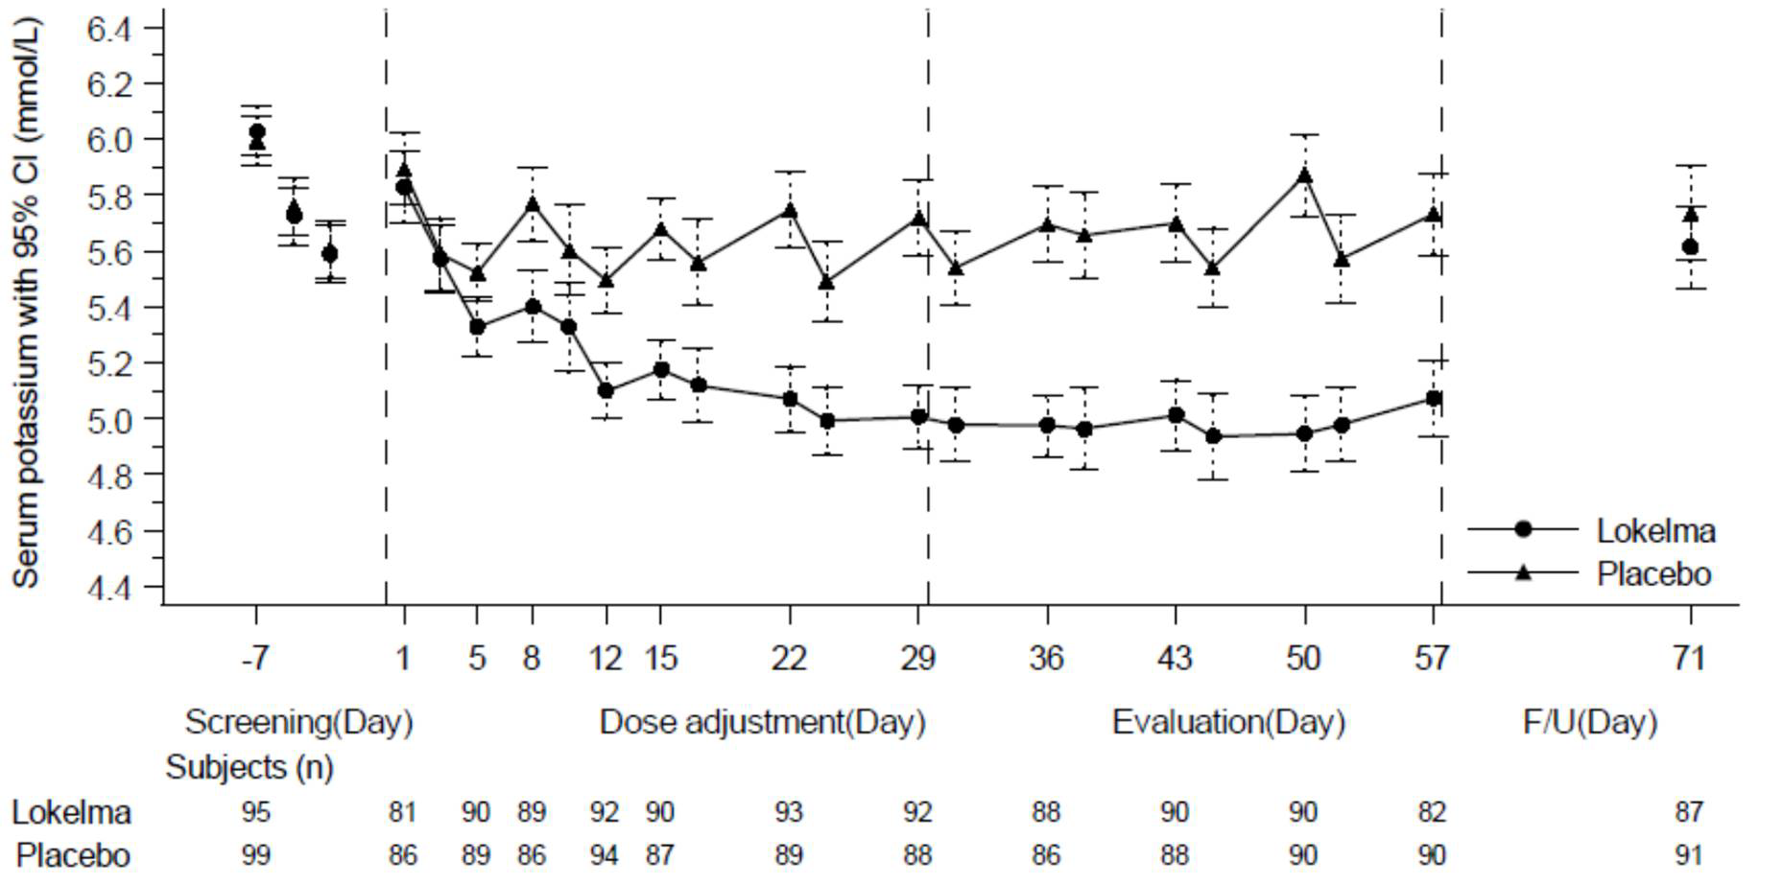
F/U- follow-up period
The displayed error bars correspond to 95% confidence intervals.
n = Number of patients with non-missing potassium measurements at a particular visit.

PHARMACOKINETIC PROPERTIES
Sodium zirconium cyclosilicate is an inorganic, insoluble compound that is not absorbed systemically and is not subject to enzymatic metabolism. Due to these factors, no in vivo or in vitro studies have been performed to examine its effect on cytochrome P450 (CYP450) enzymes or transporter activity. An in vivo mass balance study in rats showed that sodium zirconium cyclosilicate was recovered entirely in the faeces.

PRECLINICAL SAFETY DATA

Genotoxicity
Sodium zirconium cyclosilicate was not mutagenic in bacteria (Ames test), and was not clastogenic
in vitro (in Chinese hamster ovary cells) or in vivo (rat bone marrow micronucleus test).

Carcinogenicity
Carcinogenicity studies have not been conducted with sodium zirconium cyclosilicate. Based on the absence of systemic absorption, the lack of genotoxic activity, and the absence of hyperplastic and pre-neoplastic lesions in general repeat-dose toxicity studies in animals, sodium zirconium cyclosilicate is not expected to pose a carcinogenic hazard to patients.

PHARMACEUTICAL PARTICULARS

LIST OF EXCIPIENTS
LOKELMA contains no excipients.

INCOMPATIBILITIES
Please refer to Section 4.5 – Interactions with other medicines and other forms of interactions for effect of LOKELMA on other medicinal products

SHELF LIFE
In Australia, information on the shelf life can be found on the public summary of the Australian Register of Therapeutic Goods (ARTG). The expiry date can be found on the packaging.

SPECIAL PRECAUTIONS FOR STORAGE
Store below 30°C.

NATURE AND CONTENTS OF CONTAINER
5 g oral powder in foil laminate sachets made of a PET/alu/LLDPE or PET/LDPE/alu/EAA/LLDPE laminate

10 g oral powder in foil laminate sachets made of a PET/alu/LLDPE or PET/LDPE/alu/EAA/LLDPE laminate

Pack sizes: Cartons of 3 or 30 sachets. Not all pack sizes may be available in Australia.

SPECIAL PRECAUTIONS FOR DISPOSAL
In Australia, any unused medicine or waste material should be disposed of by taking to your local pharmacy.

PHYSICOCHEMICAL PROPERTIES

Chemical structure
The chemical structure of sodium zirconium cyclosilicate hydrate is:

Figure 4 General structure of sodium zirconium cyclosilicate hydrate

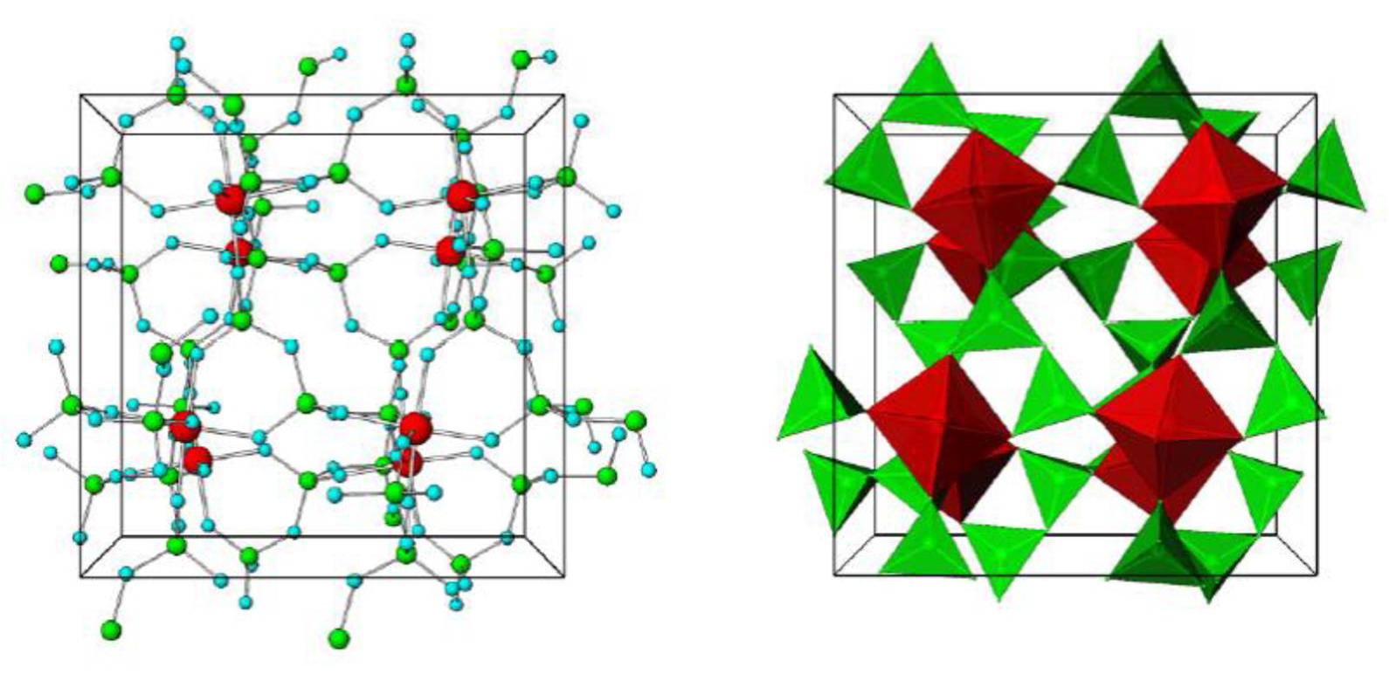
Unit cell structural representation, stick-and-ball (left) and polyhedral (right) of main framework of microporous sodium zirconium cyclosilicate hydrate. Red = Zirconium, Green = Silicon, Blue = Oxygen atoms. Cations are not pictured.

The chemical formula of sodium zirconium cyclosilicate hydrate is Na~1.5H~0.5ZrSi3O9•2–3H2O.
CAS number: 242800-27-7

MEDICINE SCHEDULE (POISONS STANDARD)
Prescription only medicine (Schedule 4)

SPONSOR
AstraZeneca Pty Ltd ABN 54 009 682 311
66 Talavera Road
MACQUARIE PARK NSW 2113
Telephone: 1800 805 342

DATE OF FIRST APPROVAL
DD MMM YYYY

DATE OF REVISION
Not applicable.

SUMMARY TABLE OF CHANGES

Section changed | Summary of new information
N/A | New product

© AstraZeneca, 2024 Doc ID-005096198, v8.0

