AUSTRALIAN PRODUCT INFORMATION – KYPROLIS® (CARFILZOMIB)
- NAME OF THE MEDICINE
Carfilzomib

QUALITATIVE AND QUANTITATIVE COMPOSITION
Kyprolis (carfilzomib) is a modified tetrapeptidyl epoxide, isolated as the crystalline free base supplied as powder for injection for intravenous infusion.
Kyprolis is available as a single-use vial containing 10 mg, 30 mg or 60 mg of carfilzomib. After reconstitution, 1 mL of solution contains 2 mg of carfilzomib.
For the full list of excipients, see Section 6.1 List of excipients.

PHARMACEUTICAL FORM
Kyprolis is supplied as a sterile, white to off-white lyophilised powder.

CLINICAL PARTICULARS

Therapeutic indications
Kyprolis is indicated for the treatment of patients with relapsed or refractory multiple myeloma who have received at least one prior therapy as part of combination therapy with:
    - dexamethasone, or
    - lenalidomide and dexamethasone, or
    - daratumumab and dexamethasone, or
    - isatuximab and dexamethasone

Dose and method of administration Dosage (dose and interval)
Kyprolis is administered intravenously (IV) as a 10 minute or a 30 minute infusion either
once or twice weekly based on the selected regimen (see Table 1 ). Treatment may be continued until disease progression or until unacceptable toxicity occurs.

Table 1. Kyprolis Dosing Information

Regimen | Kyprolis starting dose | If tolerated, increase Kyprolis dose on day 8 of cycle1 to | Kyprolis infusion timeª
Kyprolis in combination with lenalidomide and dexamethasone | 20 mg /m² | 27 mg /m² twice weekly | 10 minutes
Kyprolis in combination with  - dexamethasone OR | 20 mg /m² | 56 mg /m² twice weekly | 30 minutes
- daratumumab and dexamethasone | 20 mg /m² | 70 mg /m² once weekly | 30 minutes
Kyprolis in combination with isatuximab and dexamethasone | 20 mg /m² | 56 mg /m² twice weekly | 30 minutes
ª Infusion time remains consistent throughout each regimen
Therapeutic equivalence between once and twice weekly dosing of carfilzomib in combination with daratumumab and dexamethasone has not been established in a pivotal clinical trial.
The dose is calculated using the patient’s baseline body surface area (BSA). Patients with a body surface area > 2.2 m² should receive a dose based upon a body surface area of
2.2 m². Dose adjustments do not need to be made for weight changes of ≤ 20%.

Kyprolis in combination with Lenalidomide and Dexamethasone
Twice weekly dosing
Kyprolis is administered at a starting dose of 20 mg/m² in cycle 1 on days 1 and 2. If tolerated, the dose should be increased to 27 mg/m² on day 8 of cycle 1 (Table 2). Kyprolis 27 mg/m² is administered intravenously on two consecutive days each week for three weeks (days 1, 2, 8, 9, 15 and 16), followed by a 12 day rest period (days 17 to 28). Each 28 day period is considered one treatment cycle.
When given in combination with lenalidomide and dexamethasone, Kyprolis is omitted on days 8 and 9 of cycles 13 and higher. Lenalidomide is administered as 25 mg orally on days 1 to 21 and dexamethasone is administered as 40 mg orally or intravenously on
days 1, 8, 15 and 22 of the 28 day cycles. Appropriate dose reduction for the starting dose of lenalidomide should be considered according to the recommendations in the lenalidomide Product Information, for example, with baseline renal impairment.
Dexamethasone should be administered 30 minutes to 4 hours before Kyprolis.

Table 2. Recommended Dosage Regimen for Kyprolis When Used in Combination With Lenalidomide and Dexamethasone

 | Cycle 1
 | Week 1 |  |  | Week 2 |  |  | Week 3 |  |  | Week 4
Kyprolisa  (20-27 mg/m2) | Day 1 | Day 2 | Days 3-7 | Day 8 | Day 9 | Days 10-14 | Day 15 | Day 16 | Days 17-21 | Days 22-28
Kyprolisa  (20-27 mg/m2) | 20 | 20 | - | 27 | 27 | - | 27 | 27 | - | -
lenalidomideb  (25 mg) | Days 1-21
dexamethasonec  (40 mg) | Days 1, 8, 15, & 22
 | Cycles 2-12
 | Week 1 |  |  | Week 2 |  |  | Week 3 |  |  | Week 4
Kyprolisa  (27 mg/m2) | Day 1 | Day 2 | Days 3-7 | Day 8 | Day 9 | Days 10-14 | Day 15 | Day 16 | Days 17-21 | Days 22-28
Kyprolisa  (27 mg/m2) | 27 | 27 | - | 27 | 27 | - | 27 | 27 | - | -
lenalidomideb  (25 mg) | Days 1-21
dexamethasonec  (40 mg) | Days 1, 8, 15, & 22
 | Cycles 13 on
 | Week 1 |  |  | Week 2 |  |  | Week 3 |  |  | Week 4
Kyprolisa  (27 mg/m2) | Day 1 | Day 2 | Days 3-7 | Day 8 | Day 9 | Days 10-14 | Day 15 | Day 16 | Days 17-21 | Days 22-28
Kyprolisa  (27 mg/m2) | 27 | 27 | - | - | - | - | 27 | 27 | - | -
lenalidomideb  (25 mg) | Days 1-21
dexamethasonec  (40 mg) | Days 1, 8, 15, & 22
a The dose is calculated using the patient’s baseline body surface area (BSA). Patients with a body surface area > 2.2 m2 should receive a dose based upon a body surface area of 2.2 m2.
Dose adjustments do not need to be made for weight changes of ≤ 20%. Infusion time is 10 minutes.
b Appropriate dose reduction for the starting dose of lenalidomide should be considered according to the recommendations in the current lenalidomide Product Information, for example with baseline renal impairment. c Dexamethasone should be administered 30 minutes to 4 hours before Kyprolis.

Kyprolis in combination with Dexamethasone
Once weekly dosing
Kyprolis is administered at a starting dose of 20 mg/m² in cycle 1 on day 1. If tolerated, the dose should be increased to 70 mg/m² on day 8 of cycle 1 (Table 3). Kyprolis 70 mg/m² is administered intravenously once weekly for three weeks (days 1, 8 and 15), followed by a 13 day rest period (days 16 to 28). Each 28 day period is considered one treatment cycle.
When Kyprolis is combined with dexamethasone alone, dexamethasone is administered as 40 mg orally or intravenously on days 1, 8 and 15 of all cycles and day 22 of cycles 1 to 9. Dexamethasone should be administered 30 minutes to 4 hours before Kyprolis.

Table 3. Once Weekly Kyprolis When Used in Combination with Dexamethasone

 | Cycle 1
 | Week 1 |  | Week 2 |  | Week 3 |  | Week 4
Kyprolisa  (20-70 mg/m2) | Day 1 | Days 2-7 | Day 8 | Days 9-14 | Day 15 | Days 16-21 | Days 22-28
Kyprolisa  (20-70 mg/m2) | 20 | - | 70 | - | 70 | - | -
dexamethasoneb  (40 mg) | Days 1, 8, 15, & 22
 | Cycle 2 and Beyond
 | Week 1 |  | Week 2 |  | Week 3 |  | Week 4
Kyprolisa  (70 mg/m2) | Day 1 | Days 2-7 | Day 8 | Days 9-14 | Day 15 | Days 16-21 | Days 22-28
Kyprolisa  (70 mg/m2) | 70 | - | 70 | - | 70 | - | -
dexamethasoneb  (40 mg) | Days 1, 8, 15, & 22 for cycles 2 to 9  Days 1, 8, & 15 for cycles beyond cycle 9
a The dose is calculated using the patient’s baseline body surface area (BSA). Patients with a body surface area > 2.2 m2 should receive a dose based upon a body surface area of 2.2 m2.
Dose adjustments do not need to be made for weight changes of ≤ 20%. Infusion time is 30 minutes and remains consistent throughout the regimen.
b Dexamethasone should be administered 30 minutes to 4 hours before Kyprolis.

Twice weekly dosing
Kyprolis is administered at a starting dose of 20 mg/m² in cycle 1 on days 1 and 2. If tolerated, the dose should be increased to 56 mg/m² on day 8 of cycle 1 (Table 4). Kyprolis 56 mg/m² is administered intravenously on two consecutive days each week for three weeks (days 1, 2, 8, 9, 15 and 16), followed by a 12 day rest period (days 17 to 28). Each 28 day period is considered one treatment cycle.
When Kyprolis is combined with dexamethasone alone, dexamethasone is administered as 20 mg orally or intravenously on days 1, 2, 8, 9, 15, 16, 22 and 23 of the 28 day cycles.
Dexamethasone should be administered 30 minutes to 4 hours before Kyprolis.

Kyprolis in combination with Isatuximab and Dexamethasone
Twice weekly dosing
Kyprolis is administered at a starting dose of 20 mg/m² in cycle 1 on days 1 and 2. If tolerated, the dose should be increased to 56 mg/m² on day 8 of cycle 1 (Table 4 ). Kyprolis 56 mg/m² is administered intravenously on two consecutive days each week for three weeks (days 1, 2, 8, 9, 15 and 16), followed by a 12 day rest period (days 17 to 28). Each 28 day period is considered one treatment cycle.
Dexamethasone 20 mg (IV on the days of Kyprolis and/or isatuximab infusions, and orally (PO) on the other days): when administered in combination with Kyprolis and isatuximab.
For dosing instructions of combination agents administered with Kyprolis, see Section 5 PHARMACOLOGICAL PROPERTIES; Clinical Studies and the manufacturer’s Product Information.

Table 4. Twice Weekly Kyprolis When Used in Combination with Dexamethasone or Isatuximab and Dexamethasone

 | Cycle 1
 | Week 1 |  |  | Week 2 |  |  | Week 3 |  |  | Week 4
Kyprolisa  (20-56 mg/m2) | Day 1 | Day 2 | Days 3-7 | Day 8 | Day 9 | Days 10-14 | Day 15 | Day 16 | Days 17-21 | Days 22-28
Kyprolisa  (20-56 mg/m2) | 20 | 20 | - | 56 | 56 | - | 56 | 56 | - | -
dexamethasoneb  (20 mg) | Days 1, 2, 8, 9, 15, 16, 22, & 23
Isatuximabe  (10 mg/kg body weight) | Days 1, 8, 15, & 22 (weekly)
 | Cycle 2 and Beyond
 | Week 1 |  |  | Week 2 |  |  | Week 3 |  |  | Week 4
Kyprolisa  (56 mg/m2) | Day 1 | Day 2 | Days 3-7 | Day 8 | Day 9 | Days 10-14 | Day 15 | Day 16 | Days 17-21 | Days 22-28
Kyprolisa  (56 mg/m2) | 56 | 56 | - | 56 | 56 | - | 56 | 56 | - | -
dexamethasoneb  (20 mg) | Days 1, 2, 8, 9, 15, 16, 22, & 23
Isatuximabe  (10 mg/kg body weight) | Days 1, & 15 (every 2 weeks)
a The dose is calculated using the patient’s baseline body surface area (BSA). Patients with a body surface area > 2.2 m2 should receive a dose based upon a body surface area of 2.2 m2.
Dose adjustments do not need to be made for weight changes of ≤ 20%. Infusion time is 30 minutes and remains consistent throughout the regimen.
b Dexamethasone should be administered 30 minutes to 4 hours before Kyprolis.

e For isatuximab dosage instruction see section 5 PHARMACOLOGICAL PROPERTIES; Clinical Studies and the manufacturer’s Product Information.

Kyprolis in Combination with Daratumumab and Dexamethasone
For the combination regimen with daratumumab and dexamethasone, administer Kyprolis intravenously once weekly or twice weekly as a 30 minute infusion as described in Table 5 and Table 6 below.
Once weekly dosing
Kyprolis is administered intravenously as a 30 minute infusion each week for three weeks followed by a 13 day rest period as shown in Table 5 . Each 28 day period is considered one treatment cycle.
Administer Kyprolis at a starting dose of 20 mg/m² in cycle 1 on day 1. If tolerated, escalate the dose to 70 mg/m² on day 8 of cycle 1 and thereafter.
Dexamethasone is taken orally or intravenously at a dose of 20 mg in cycles 1 and 2 on days 1, 2, 8, 9, 15, 16, 22 and 23. In cycles 3-6, dexamethasone is taken at a dose of
20 mg on days 1, 2, 15 and 16 and at a dose of 40 mg on day 8 and 22. In cycles 7 and thereafter, dexamethasone is taken at a dose of 20 mg on days 1 and 2 and at a dose of 40 mg on days 8, 15, and 22. For patients > 75 years of age, administer 20 mg of dexamethasone orally or intravenously weekly after the first week.
Administer dexamethasone 30 minutes to 4 hours before Kyprolis. Daratumumab is administered intravenously at a dose of 16 mg/kg actual body weight; with a split dose of 8 mg/kg in cycle 1 on days 1 and 2. Administer 16 mg/kg once weekly on days 8, 15 and
22 of cycle 1 and days 1, 8 and 15 and 22 of cycle 2, then every 2 weeks for 4 cycles (cycles 3 to 6) and then every 4 weeks for the remaining cycles or until disease progression.

Table 5. Once Weekly Kyprolis When Used in Combination With Daratumumab and Dexamethasone

 | Cycle 1
 | Week 1 |  | Week 2 |  | Week 3 |  | Week 4
 | Day 1 | Days 2-7 | Day 8 | Days 9-14 | Day 15 | Days 16-21 | Days 22-28
Kyprolis (20-70 mg/m2)a | 20 | - | 70 | - | 70 | - | -
Dexamethasone (20 mg)b | Days 1, 2, 8, 9, 15, 16, 22 & 23
Daratumumab (8-16 mg/kg) | 8 mg Days 1 and 2,16 mg Days 8, 15 & 22

 | Cycle 2
 | Week 1 |  | Week 2 |  | Week 3 |  | Week 4
 | Day 1 | Days 2-7 | Day 8 | Days 9-14 | Day 15 | Day 16-21 | Day 22-28
Kyprolis (70 mg/m2)a | 70 | - | 70 | - | 70 | - | -
Dexamethasone (20 mg)b | Days 1, 2, 8, 9, 15, 16, 22 & 23
Daratumumab (16 mg/kg) | Days 1, 8, 15 & 22
 | Cycles 3-6
 | Week 1 |  | Week 2 |  | Week 3 |  | Week 4
 | Day 1 | Days 2-7 | Day 8 | Days 9-14 | Day 15 | Day 16-21 | Day 22-28
Kyprolis (70 mg/m2)a | 70 | - | 70 | - | 70 | - | -
Dexamethasone (20-40 mg)b | 20 mg Days 1 & 2, 40 mg Day 8, 20 mg Days 15 & 16, 40 mg Day 22
Daratumumab (16 mg/kg) | Days 1, & 15
 | Cycles 7 and later
 | Week 1 |  | Week 2 |  | Week 3 |  | Week 4
 | Day 1 | Days 2-7 | Day 8 | Days 9-14 | Day 15 | Day 16-21 | Day 22-28
Kyprolis (70 mg/m2)a | 70 | - | 70 | - | 70 | - | -
Dexamethasone (20-40 mg)b | 20 mg Days 1 & 2, 40 mg Days 8,15, & 22
Daratumumab (16 mg/kg) | Day 1
a The dose is calculated using the patient’s baseline body surface area (BSA). Patients with a body surface area > 2.2 m2 should receive a dose based upon a body surface area of 2.2 m2.
Dose adjustments do not need to be made for weight changes of ≤ 20%. Infusion time is 30 minutes and remains consistent throughout the regimen.
b Dexamethasone should be administered 30 minutes to 4 hours before Kyprolis. For patients > 75 years of age, administer 20 mg of dexamethasone orally or intravenously weekly after the first week.

Treatment may be continued until disease progression or unacceptable toxicity occurs. Refer to the dexamethasone and daratumumab Product Information for other information on these products.
Twice weekly dosing
Kyprolis is administered intravenously as a 30 minute infusion on two consecutive days, each week for three weeks followed by a 12 day rest period as shown in Table 6. Each 28 day period is considered one treatment cycle. Administer Kyprolis at a starting dose of 20 mg/m² in cycle 1 on days 1 and 2. If tolerated, escalate the dose to 56 mg/m² on day 8 of cycle 1 and thereafter.
Dexamethasone 20 mg is taken orally or intravenously on days 1, 2, 8, 9, 15 and 16 and 40 mg orally or intravenously on day 22 of each 28 day cycle. For patients > 75 years of
age, administer 20 mg of dexamethasone orally or intravenously weekly after the first week. Administer dexamethasone 30 minutes to 4 hours before Kyprolis.
Daratumumab is administered intravenously at a dose of 16 mg/kg actual body weight; with a split dose of 8 mg/kg in cycle 1 on days 1 and 2. Administer 16 mg/kg once weekly on days 8, 15 and 22 of cycle 1 and days 1, 8 and 15 and 22 of cycle 2, then every 2 weeks for 4 cycles (cycles 3 to 6) and then every 4 weeks for the remaining cycles or until disease progression.

Table 6. Twice Weekly Kyprolis When Used in Combination With Dexamethasone and Daratumumab

 | Cycle 1
 | Week 1 |  |  | Week 2 |  |  | Week 3 |  |  | Week 4
 | Day 1 | Day 2 | Days 3–7 | Day 8 | Day 9 | Days 10-14 | Day 15 | Day 16 | Days 17-21 | Day 22-28
Kyprolis (20-56 mg/m2)a | 20 | 20 | - | 56 | 56 | - | 56 | 56 | - | -
Dexamethasone (20-40 mg)b | 20 mg Days 1, 2, 8, 9, 15 & 16, 40 mg Day 22
Daratumumab (8-16 mg/kg) | 8 mg Days 1, & 2, 16 mg Days 8, 15, & 22
 | Cycle 2
 | Week 1 |  |  | Week 2 |  |  | Week 3 |  |  | Week 4
 | Day 1 | Day 2 | Days 3–7 | Day 8 | Day 9 | Days 10–14 | Day 15 | Day 16 | Days 17–21 | Day 22-28
Kyprolis (56 mg/m2)a | 56 | 56 | - | 56 | 56 | - | 56 | 56 | - | -
Dexamethasone (20-40 mg)b | 20 mg Days 1, 2, 8, 9, 15 & 16, 40 mg Day 22
Daratumumab (16 mg/kg) | Days 1, 8, 15, & 22
 | Cycles 3-6
 | Week 1 |  |  | Week 2 |  |  | Week 3 |  |  | Week 4
 | Day 1 | Day 2 | Days 3–7 | Day 8 | Day 9 | Days 10–14 | Day 15 | Day 16 | Days 17–21 | Day 22-28
Kyprolis (56 mg/m2)a | 56 | 56 | - | 56 | 56 | - | 56 | 56 | - | -
Dexamethasone (20-40 mg)b | 20 mg Days 1, 2, 8, 9, 15 & 16, 40 mg Day 22
Daratumumab (16 mg/kg) | Days 1, & 15
 | Cycles 7 and onwards
 | Week 1 |  |  | Week 2 |  |  | Week 3 |  |  | Week 4
 | Day 1 | Day 2 | Days 3–7 | Day 8 | Day 9 | Days 10–14 | Day 15 | Day 16 | Days 17–21 | Day 22-28
Kyprolis (56 mg/m2)a | 56 | 56 | - | 56 | 56 | - | 56 | 56 | - | -
Dexamethasone (20-40 mg)b | 20 mg Days 1, 2, 8, 9, 15 & 16, 40 mg Day 22
Daratumumab (16 mg/kg) | Day 1
a The dose is calculated using the patient’s baseline body surface area (BSA). Patients with a body surface area > 2.2 m2 should receive a dose based upon a body surface area of 2.2 m2.
Dose adjustments do not need to be made for weight changes of ≤ 20%. Infusion time is 30 minutes and remains consistent throughout the regimen.
b Dexamethasone should be administered 30 minutes to 4 hours before Kyprolis. For patients > 75 years of age, administer 20 mg of dexamethasone orally or intravenously weekly after the first week.

Refer to the daratumumab and dexamethasone Product Information for additional details on administration and concomitant medications.

Concomitant medication
To decrease the risk of herpes zoster reactivation, consideration should be given to antiviral prophylaxis in patients being treated with Kyprolis. The majority of patients included in studies with Kyprolis received antiviral prophylaxis; due to this fact it is not possible to calculate the true incidence of herpes zoster infection in patients treated with Kyprolis.
Thromboprophylaxis is recommended in patients being treated with Kyprolis in combination with lenalidomide and dexamethasone, and should be based on an assessment of the patient’s underlying risks and clinical status. For other concomitant medications that may be required, such as the use of antacid prophylaxis, refer to the current lenalidomide and dexamethasone Product Information.

Hydration, fluid and electrolyte monitoring
Adequate hydration is required before dose administration in cycle 1, especially in patients at high risk of tumour lysis syndrome (TLS) or renal toxicity. All patients should be monitored for evidence of volume overload and fluid requirements should be tailored to individual patient needs. The total volume of fluids may be adjusted as clinically indicated in patients with baseline cardiac failure or who are at risk for cardiac failure (see
Section 4.4 Special warnings and precautions for use, Cardiac disorders).
Recommended hydration includes both oral fluids (30 mL/kg/day for 48 hours before day 1 of cycle 1) and intravenous fluids (250 mL to 500 mL of appropriate intravenous fluid before each dose in cycle 1). Give an additional 250 mL to 500 mL of intravenous fluids as needed following Kyprolis administration. Continue oral and/or intravenous hydration, as needed, in subsequent cycles.
When given in combination with IV daratumumab, oral and/or intravenous hydration is not required on days when IV daratumumab is dosed.

Serum potassium levels should be monitored monthly, or more frequently, during treatment with Kyprolis as clinically indicated and will depend on the potassium levels measured before the start of treatment, concomitant therapy used (eg medicinal products known to increase the risk of hypokalaemia) and associated comorbidities.

Method of administration
Administer intravenously as a 10 or a 30 minute infusion. The 20/27 mg/m² dose is administered over 10 minutes (Table 2 ). The 20/56 mg/m² and 20/70 mg/m² doses must be administered over 30 minutes (Table 3, Table 4, Table 5 and Table 6).
Kyprolis should not be administered as a bolus.

The intravenous administration line should be flushed with normal saline or 5% w/v glucose injection immediately before and after Kyprolis administration.
Do not mix Kyprolis with or administer as an infusion with other medicinal products.

Reconstitution and preparation for intravenous administration
Kyprolis vials contain no antimicrobial preservatives and are for single use in one patient only. Discard any residue. Proper aseptic technique must be observed.
The reconstituted solution contains carfilzomib at a concentration of 2 mg/mL. Read the complete preparation instructions prior to reconstitution.
- Remove vial from refrigerator just prior to use.
- Calculate the dose (mg/m²) and number of vials of Kyprolis required using the patient’s body surface area (BSA) at baseline. Patients with a BSA greater than
2.2 m² should receive a dose based upon a BSA of 2.2 m². Dose adjustments do not need to be made for weight changes of ≤ 20%.
- Use a 21G or larger gauge needle only to aseptically reconstitute each vial by slowly injecting Sterile Water for Injections through the stopper and directing the solution onto the inside wall of the vial to minimise foaming.
  - 10 mg (10 mL) vial: reconstitute with 5 mL Sterile Water for Injections
  - 30 mg (30 mL) vial: reconstitute with 15 mL Sterile Water for Injections
  - 60 mg (50 mL) vial: reconstitute with 29 mL Sterile Water for Injections Do not reconstitute Kyprolis with normal saline.
- Gently swirl and/or invert the vial slowly for approximately 1 minute, or until complete dissolution. Do not shake. If foaming occurs, allow the solution to settle in the vial until foaming subsides (approximately 5 minutes) and the solution is clear.
It is not necessary to protect the reconstituted product from light.
- Parenteral drug products should be inspected visually for particulate matter and discolouration prior to administration; if particulates or discolouration are observed, the contents of the container should not be used. The reconstituted product should be a clear, colourless to slightly yellow solution.
- Discard any unused portion left in the vial.
- Kyprolis can be administered directly by IV infusion, or optionally administered in an IV bag. Do not administer as an IV push or bolus.

- When administering Kyprolis using an IV bag, use a 21G or larger gauge needle only to withdraw the calculated dose from the vial and dilute into a 50 or 100 mL IV bag containing 5% w/v glucose injection. Do not dilute Kyprolis into normal saline. It is not necessary to protect the diluted product from light.

Dosage adjustment
Dosing should be modified based on toxicity. The recommended actions and dose modifications are presented in Table 7. Dose level reductions are presented in Table 8 .

Table 7. Dose Modifications During Kyprolis Treatment

Haematological toxicity | Recommended action
- Absolute neutrophil count (ANC)  < 0.5 x109/L  (see Section 4.4 Special warnings and precautions for use) | - Stop dose  - If recovered to ≥ 0.5 x109/L, continue at same dose level  - For subsequent drops to < 0.5 x109/L, follow the same  recommendations as above and consider 1 dose level reduction when restarting Kyprolisa
- Febrile neutropenia  ANC < 0.5 x109/L and an oral temperature > 38.5°C or two consecutive readings of > 38.0°C  for 2 hours | - Stop dose  - If ANC returns to baseline grade and fever resolves, resume at the same dose level
- Platelet count < 10 x109/L or evidence of bleeding with thrombocytopenia  (see Section 4.4 Special warnings and precautions for use) | - Stop dose  - If recovered to ≥ 10 x109/L and/or bleeding is controlled, continue at the same dose level  - For subsequent drops to < 10 x109/L, follow the same  recommendations as above and consider 1 dose level reduction when restarting Kyprolisa
Non-haematological toxicity (renal) | Recommended action
- Serum creatinine ≥ 2x baseline; or  - Creatinine clearance  < 15 mL/min (or creatinine clearance decreases to ≤ 50% of baseline) or need for dialysis  (see Section 4.4 Special warnings and precautions for use) | - Stop dose and continue monitoring renal function (serum creatinine or creatinine clearance)  - If attributable to Kyprolis, resume when renal function has recovered to within 25% of baseline; start at 1 dose level reductiona  - If not attributable to Kyprolis, dosing may be resumed at the discretion of the physician  - If tolerated, the reduced dose may be increased to the previous dose at the discretion of the physician  - For patients on dialysis receiving Kyprolis, the dose is to be administered after the dialysis procedure
Other non-haematological toxicity | Recommended action
- All other grade 3 or 4 non- haematological toxicities  (see Section 4.4 Special warnings and precautions for use) | - Stop until resolved or returned to baseline  - Consider restarting the next scheduled treatment at 1 dose level reductiona  - If tolerated, the reduced dose may be increased to the previous dose at the discretion of the physician
a see Table 8 for dose level reductions

Table 8. Dose Level Reductions for Kyprolis

Regimen | Kyprolis dose | 1st Kyprolis dose reduction | 2nd Kyprolis dose reduction | 3rd Kyprolis dose reduction
Kyprolis, lenalidomide and dexamethasone (twice weekly) | 27 mg/m2 | 20 mg/m2 | 15 mg/m2 a | -
Kyprolis and dexamethasone  (twice weekly)  OR  Kyprolis, dexamethasone and daratumumab (twice weekly)  OR  Kyprolis, isatuximab, and dexamethasone (twice weekly) | 56 mg/m2 | 45 mg/m2 | 36 mg/m2 | 27 mg/m2 a
Kyprolis and dexamethasone  (once weekly)  OR  Kyprolis, dexamethasone and daratumumab (once weekly) | 70 mg/m2 | 56 mg/m2 | 45 mg/m2 | 36 mg/m2 a
Note: Kyprolis infusion times remain unchanged during dose reduction(s).
a If symptoms do not resolve, discontinue Kyprolis treatment.

Patients with renal impairment
Patients with moderate or severe renal impairment were excluded from Kyprolis- lenalidomide combination studies.
No starting dose adjustment is required in patients with baseline mild, moderate, or severe renal impairment or patients on chronic dialysis. Since dialysis clearance of Kyprolis concentrations has not been studied, the drug should be administered after the dialysis procedure (see Section 5.2 Pharmacokinetic properties, Special populations). In phase 3 clinical studies the incidence of adverse events of acute renal failure was higher in subjects with lower baseline creatinine clearance than that among subjects with higher baseline creatinine clearance.
Renal function should be monitored at least monthly or in accordance with accepted clinical practice guidelines, particularly in patients with lower baseline creatinine clearance.

Patients with hepatic impairment
No starting dose adjustment is required in patients with mild or moderate hepatic impairment. The pharmacokinetics of Kyprolis have not been evaluated in patients with severe hepatic impairment (see Section 5.2 Pharmacokinetic properties, Special populations). Liver enzymes and bilirubin should be monitored at treatment initiation and monthly during treatment with Kyprolis, regardless of baseline values.

Contraindications
Kyprolis is contraindicated in patients with hypersensitivity to the active substance or any of the excipients (see Section 6.1 List of excipients).
When Kyprolis is administered in combination with other medicinal products, refer to their Product Information before starting therapy.

Special warnings and precautions for use
When Kyprolis is administered in combination with other medicinal products, refer to their Product Information before starting therapy. When Kyprolis is used in combination with lenalidomide and dexamethasone, particular attention to the lenalidomide pregnancy prevention requirements is needed.

Cardiac disorders
New or worsening cardiac failure (eg congestive cardiac failure, pulmonary oedema, decreased ejection fraction), myocardial ischaemia and infarction have occurred following administration of Kyprolis. Death due to cardiac arrest has occurred within a day of Kyprolis administration and fatal outcomes have been reported with cardiac failure and myocardial infarction (see Section 4.8 Adverse effects (Undesirable effects), Cardiac failure, myocardial infarction and myocardial ischaemia).
While adequate hydration is required prior to dosing in cycle 1, all patients should be monitored for evidence of volume overload, especially patients at risk for cardiac failure. The total volume of fluids may be adjusted as clinically indicated in patients with baseline cardiac failure or who are at high risk for cardiac failure (see Section 4.2 Dose and method of administration, Hydration, fluid and electrolyte monitoring).
Kyprolis should be stopped following Grade 3 or 4 cardiac events until recovery. Consideration should be given to reducing the dose of Kyprolis by 1 dose level when recommencing Kyprolis, based on an assessment of the benefit/risk (see Section 4.2 Dose and method of administration, Dosage adjustment, Table 7 and Table 8.
The risk of cardiac failure is increased in elderly patients (≥ 75 years). The risk of cardiac failure is also increased in Asian patients.
Patients with New York Heart Association Class III and IV heart failure, recent myocardial infarction, conduction abnormalities and angina or arrhythmias uncontrolled by medications were not eligible for the clinical trials. As these patients may be at greater risk for cardiac complications, a comprehensive medical assessment (particularly blood pressure control and fluid management) should be conducted prior to starting treatment with Kyprolis.
These patients should remain under close follow up.

Pulmonary toxicity
Acute respiratory distress syndrome (ARDS), acute respiratory failure and acute diffuse infiltrative pulmonary disease such as pneumonitis and interstitial lung disease have occurred in patients receiving Kyprolis. Some of these events have been fatal. Pulmonary toxicity should be evaluated and Kyprolis should be stopped until resolved. Consideration on whether to restart Kyprolis should be based on a benefit/risk assessment (see
Section 4.2 Dose and method of administration, Dosage adjustment, Table 7 and Table 8).

Pulmonary hypertension
Pulmonary hypertension has been reported in patients treated with Kyprolis. Some of these events have been fatal. Pulmonary hypertension should be evaluated as appropriate. Kyprolis should be stopped for pulmonary hypertension until resolved or returned to baseline and consider whether to restart Kyprolis based on a benefit/risk assessment (see Section 4.2 Dose and method of administration, Dosage adjustment, Table 7 and Table 8).

Dyspnoea
Dyspnoea was commonly reported in patients treated with Kyprolis. Dyspnoea should be evaluated to exclude cardiopulmonary conditions including cardiac failure and pulmonary syndromes. Kyprolis should be stopped for grade 3 and 4 dyspnoea until resolved or returned to baseline and consider whether to restart Kyprolis based on a benefit/risk assessment (see Section 4.2 Dose and method of administration, Dosage adjustment, Table 7 and Table 8, and Section 4.8 Adverse effects (Undesirable effects), Dyspnoea).

Hypertension
Hypertension, including hypertensive crisis and hypertensive emergency, has been observed with Kyprolis. Some of these events have been fatal (see Section 4.8 Adverse effects (Undesirable effects), Hypertension including hypertensive crises). It is recommended to control hypertension prior to starting Kyprolis. All patients should be routinely evaluated for hypertension whilst on Kyprolis and treated as needed. If the hypertension cannot be controlled, the Kyprolis dose should be reduced. In case of hypertensive crises, Kyprolis should be stopped until resolved or returned to baseline, and consider whether to restart Kyprolis based on a benefit/risk assessment (see Section 4.2 Dose and method of administration, Dosage adjustment, Table 7 and Table 8).

Acute renal failure
Cases of acute renal failure have been reported in patients administered Kyprolis. Some of these events have been fatal. Acute renal failure was reported more frequently in patients with advanced relapsed and refractory multiple myeloma who received Kyprolis

monotherapy. In phase 3 clinical studies the incidence of adverse events of acute renal failure was higher in subjects with lower baseline creatinine clearance than that among subjects with higher baseline creatinine clearance. Creatinine clearance was stable over time for the majority of patients. Renal function should be monitored at least monthly or in accordance with accepted clinical practice guidelines, particularly in patients with lower baseline creatinine clearance, and the dose reduced or stopped as appropriate (see Section 4.2 Dose and method of administration, Dosage adjustment, Table 7 and Table 8).

Tumour lysis syndrome
Tumour lysis syndrome (TLS) has been reported with Kyprolis use, including some fatal cases. Patients with a high tumour burden should be considered to be at greater risk for TLS. Patients should be well hydrated before administration of Kyprolis in cycle 1, and in subsequent cycles as needed (see Section 4.2 Dose and method of administration, Hydration, fluid and electrolyte monitoring). Uric acid lowering drugs should be considered in patients at high risk for TLS. Evidence of TLS during treatment should be monitored, including regular measurement of serum electrolytes, and managed promptly. Kyprolis should be stopped until TLS is resolved (see Section 4.2 Dose and method of administration, Dosage adjustment, Table 7 and Table 8).

Electrocardiographic changes
There have been cases of QT interval prolongation reported in clinical studies and
post-marketing. Cases of ventricular tachycardia have been reported in patients receiving Kyprolis.

Infusion reactions
Infusion reactions, including life-threatening reactions, have been reported in patients administered Kyprolis (see Section 4.8 Adverse effects (Undesirable effects), Table 11). Signs and symptoms may include fever, chills, arthralgia, myalgia, facial flushing, facial oedema, laryngeal oedema, vomiting, weakness, shortness of breath, hypotension, syncope, bradycardia, chest tightness, or angina. These reactions can occur immediately following or up to 24 hours after administration of Kyprolis. Dexamethasone should be administered 30 minutes to 4 hours prior to Kyprolis to reduce the incidence and severity of reactions (see Section 4.2 Dose and method of administration).

Haemorrhage and thrombocytopenia
There have been cases of haemorrhage (eg gastrointestinal, pulmonary and intracranial haemorrhage) reported in patients treated with Kyprolis, often associated with thrombocytopenia. Some of these events have been fatal (see Section 4.8 Adverse effects (Undesirable effects), Thrombocytopenia).

Kyprolis causes thrombocytopenia with platelet nadirs observed on day 8 or day 15 of each 28 day cycle. Platelet counts recovered to baseline levels by the start of the next cycle.
Platelet counts should be monitored frequently during treatment with Kyprolis and the dose reduced or stopped as appropriate (see Section 4.2 Dose and method of administration, Dosage adjustment, Table 7 and Table 8.

Venous thrombosis
There have been cases of venous thromboembolic events, including deep vein thrombosis and pulmonary embolism with fatal outcomes, reported in patients who received Kyprolis (see Section 4.8 Adverse effects (Undesirable effects), Venous thromboembolic events).

Patients with known risk factors for thromboembolism, including prior thrombosis, should be closely monitored. Action should be taken to try to minimise all modifiable risk factors (eg smoking, hypertension and hyperlipidaemia). Caution should be used in the concomitant administration of other agents that may increase the risk of thrombosis (eg erythropoietic agents or hormone replacement therapy). Patients and physicians are advised to be observant for the signs and symptoms of thromboembolism. Patients should be instructed to seek medical care if they develop symptoms such as shortness of breath, chest pain, haemoptysis, arm or leg swelling or pain.
Thromboprophylaxis should be considered based on an individual benefit/risk assessment.

Hepatic toxicity
There have been cases of hepatic failure, including fatal cases, reported in patients administered Kyprolis. Since Kyprolis can cause elevations of serum transaminases, liver enzymes should be monitored regularly, regardless of baseline values, and the dose reduced or stopped as appropriate (see Section 4.2 Dose and method of administration, Dosage adjustment, Table 7 and Table 8).

Thrombotic microangiopathy
There have been cases of thrombotic microangiopathy, including thrombotic thrombocytopenic purpura and haemolytic uraemic syndrome (TTP/HUS) reported in patients who received Kyprolis. Some of these events have been fatal. Patients receiving Kyprolis should be monitored for signs and symptoms of TTP/HUS. If the diagnosis is suspected, stop Kyprolis and evaluate patients for possible TTP/HUS. If the diagnosis of TTP/HUS is excluded, Kyprolis can be reinitiated. The safety of reinitiating Kyprolis therapy in patients previously experiencing TTP/HUS is not known.

Posterior reversible encephalopathy syndrome
There have been cases of posterior reversible encephalopathy syndrome (PRES) reported in patients receiving Kyprolis. PRES, formerly termed reversible posterior leukoencephalopathy syndrome (RPLS), is a rare neurological disorder, which can present with seizure, headache, lethargy, confusion, blindness, altered consciousness, and other visual and neurological disturbances, along with hypertension; and the diagnosis is confirmed by neuro-radiological imaging. Kyprolis should be discontinued if PRES is suspected. The safety of reinitiating Kyprolis therapy in patients previously experiencing PRES is not known.

Hepatitis B virus reactivation
There have been cases of hepatitis B virus (HBV) reactivation reported in patients receiving Kyprolis. Patients should be tested for HBV infection before treatment with Kyprolis is initiated. For patients who are carriers of HBV, prophylaxis with antivirals should be considered. Carriers of HBV receiving Kyprolis should be closely monitored for signs and symptoms of active HBV infection throughout and following the end of treatment. Consider consulting a specialist for patients who test positive for HBV infection prior to or during treatment with Kyprolis.
The safety of resuming Kyprolis treatment after HBV reactivation is adequately controlled is not known. Therefore, prescribers should weigh the risks and benefits when considering resumption of therapy in this situation.

Progressive Multifocal Leukoencephalopathy
There have been cases of Progressive Multifocal Leukoencephalopathy (PML) reported in patients treated with Kyprolis who have had prior or concurrent immunosuppressive therapy. The causal relationship with Kyprolis is unknown.
Patients should be monitored for any new or worsening neurologic, cognitive or behavioural signs or symptoms that may be suggestive of PML as part of the differential diagnosis of central nervous system (CNS) disorders.
If PML is suspected, withhold administration of Kyprolis; patients should be promptly referred to a specialist and appropriate diagnostic testing should be initiated. Kyprolis should be discontinued if the PML diagnosis is confirmed.

Increased incidence of fatal and serious adverse events in combination with melphalan and prednisone in newly diagnosed transplant-ineligible multiple myeloma patients
In a clinical trial of 955 transplant-ineligible patients with newly diagnosed multiple myeloma randomised to Kyprolis (20/36 mg/m² by 30 minute infusion twice weekly for four weeks of each six week cycle), melphalan and prednisone (KMP) or bortezomib, melphalan and prednisone (VMP), a higher incidence of fatal adverse events (6.5% versus 4.3%), a higher incidence of serious adverse events (49.6% versus 42.1%) and a higher incidence of any grade adverse events involving cardiac failure (10.8% versus 4.3%), hypertension (24.7% versus 8.1%), acute renal failure (13.9% versus 6.2%), and dyspnoea (18.1% versus 8.5%) were observed in patients in the KMP arm compared to patients in the VMP arm. This study did not meet its primary outcome measure of superiority in progression-free survival (PFS) for the KMP arm. Kyprolis in combination with melphalan and prednisone is not indicated for transplant-ineligible patients with newly diagnosed multiple myeloma.

Cardiac impairment
Patients with New York Heart Association Class III and IV heart failure were not eligible for the clinical trials. The safety and efficacy in this population have not been evaluated.

Use in the elderly
Overall, the subject incidence of certain adverse events (including cardiac failure, see Section 4.4 Special warnings and precautions for use, Cardiac disorders) in clinical trials was higher for patients who were ≥ 75 years of age compared to patients who were
< 75 years of age. In the CANDOR study (see Section 5.1 Pharmacological properties (clinical trials)), 146 (47%) of the 308 patients who received KDd 56 mg/m² twice weekly were ≥ 65 years of age and 28 (9%) were ≥ 75 years of age. In the KDd arm of the study, fatal treatment-emergent adverse events (TEAEs) occurred in 6% of patients < 65 years of age and 14% of patients ≥ 65 years of age. In the Kd arm, fatal TEAEs occurred in 8% of patients < 65 years of age and 3% of patients ≥ 65 years of age (see Section 4.8 Adverse effects (undesirable effects)). Fatal TEAEs occurred in 14% and 0% of patients ≥ 75 years of age in the KDd and Kd arms respectively.

Paediatric use
The safety and effectiveness of Kyprolis in children have not been established.

Effects on laboratory tests
No data available.
  - Interactions with other medicines and other forms of interactions Carfilzomib is primarily metabolised via peptidase and epoxide hydrolase activities, and as a result, the pharmacokinetic profile of carfilzomib is unlikely to be affected by concomitant administration of cytochrome P450 inhibitors and inducers. Carfilzomib is not expected to influence exposure of other drugs.

Based on in vitro and in vivo data, carfilzomib is not expected to inhibit CYP3A4/5 activities and/or affect the exposure to CYP3A4/5 substrates. A clinical trial using oral midazolam as a CYP3A probe demonstrated that the pharmacokinetics of midazolam were unaffected by concomitant carfilzomib administration.
Carfilzomib is a P-glycoprotein (P-gp) substrate, and inhibited organic anion transport protein OATP1B1 in vitro. However, given that Kyprolis is administered intravenously and is rapidly and extensively metabolised, pharmacokinetic interaction with P-gp inhibitors or inducers, or OATP1B1 substrates is unlikely.

Fertility, pregnancy and lactation Effects on fertility
Fertility studies with carfilzomib have not been conducted. No effects on reproductive
tissues were noted during 28 day repeat dose toxicity studies conducted in rats and monkeys, or in chronic toxicity studies conducted in rats for 6 months and for 9 months in monkeys.

Use in pregnancy

Pregnancy Category: C
There are no data on the use of carfilzomib in pregnant women.
Female patients of child bearing potential treated with Kyprolis, and/or their partners, must use effective contraception measures during and for one month following treatment.
Male patients must use effective contraception measures during and for 3 months following treatment if their partner is pregnant or of childbearing potential and not using effective contraception.
If Kyprolis is used during pregnancy, or if the patient becomes pregnant while receiving this drug, the patient should be informed of the potential hazard to the fetus. Kyprolis should only be used during pregnancy if the potential benefits to the mother outweigh the potential risks.
It is not known if the efficacy of oral contraceptives may be reduced during Kyprolis treatment. In addition, due to an increased risk of venous thrombosis associated with Kyprolis, patients currently using oral contraceptives or a hormonal method of contraception that is associated with a risk of thrombosis should consider an alternative method of effective contraception.
Based on its mechanism of action and findings in animals, Kyprolis can cause fetal harm when administered to a pregnant woman. Carfilzomib caused embryo-fetal toxicity in

pregnant rabbits at doses that were lower than in patients receiving the recommended dose. Carfilzomib administered during the period of organogenesis was not teratogenic at doses up to 2 mg/kg/day in rats and 0.8 mg/kg/day in rabbits. The doses of 2 mg/kg/day in rats and 0.8 mg/kg/day in rabbits are approximately 20%, respectively, of the recommended dose in humans of 56 mg/m² based on body surface area.

Use of Kyprolis with lenalidomide
Lenalidomide (Pregnancy Category: X) is associated with risk of fetal harm, including severe life-threatening birth defects. Refer to the lenalidomide Product Information for additional information. When Kyprolis is used in combination with lenalidomide and dexamethasone, patients should adhere to the lenalidomide pregnancy prevention programme.

Use in lactation
It is unknown whether carfilzomib or its metabolites are excreted in human milk. Kyprolis should not be administered to women who are breastfeeding. As the risk to newborns or infants cannot be excluded, either breastfeeding should be discontinued, or treatment with Kyprolis should be discontinued or withheld, with consideration given to the benefit of breastfeeding for the child and the benefit of therapy to the mother.

Effects on ability to drive and use machines
No studies on the effects of carfilzomib on the ability to drive or use machines have been performed. Fatigue, dizziness, fainting and/or a drop in blood pressure have been observed in clinical trials. Patients being treated with Kyprolis should therefore be advised not to drive or operate machinery if they experience any of these symptoms.

Adverse effects (Undesirable effects) Adverse events

Results from Study PX-171-009 (ASPIRE) and Study 2011-003 (ENDEAVOR)
The following table (Table 9) describes the overall incidence of adverse events from study PX-171-009 (ASPIRE), in 392 patients with relapsed multiple myeloma who received Kyprolis in combination with lenalidomide and dexamethasone, and study 2011-003 (ENDEAVOR), in 464 patients with relapsed multiple myeloma who received Kyprolis in combination with dexamethasone. Adverse events are shown in decreasing frequency of events reported in patients receiving Kyprolis in the 2011-003 study.

Table 9. Adverse Events Reported in ≥ 10% of Patients Treated with Kyprolis in Studies PX-171-009 and 2011-003

Preferred Term | PX-171-009 |  | 2011-003
Preferred Term | Rd  (n = 389) n (%) | KRd (n = 392)  n (%) | Vd  (n = 456) n (%) | Kd  (n = 463) n (%)
Number of subjects reporting AEs | 381 (97.9) | 384 (98.0) | 451 (98.9) | 457 (98.7)
Anaemia | 158 (40.6) | 169 (43.1) | 129 (28.3) | 197 (42.5)
Diarrhoea | 145 (37.3) | 174 (44.4) | 185 (40.6) | 168 (36.3)
Pyrexia | 84 (21.6) | 117(29.8) | 70 (15.4) | 150 (32.4)
Fatigue | 124 (31.9) | 131 (33.4) | 140 (30.7) | 149 (32.2)
Dyspnoea | 59 (15.2) | 78 (19.9) | 62 (13.6) | 149 (32.2)
Hypertension | 31 (8.0) | 62 (15.8) | 45 (9.9) | 149 (32.2)
Cough | 70 (18.0) | 116 (29.6) | 72 (15.8) | 128 (27.6)
Insomnia | 65 (16.7) | 81 (20.7) | 122 (26.8) | 125 (27.0)
Upper respiratory tract infection | 81 (20.8) | 118 (30.1) | 83 (18.2) | 119 (25.7)
Oedema peripheral | 66 (17.0) | 78 (19.9) | 87 (19.1) | 116 (25.1)
Nausea | 56 (14.4) | 82 (20.9) | 91 (20.0) | 109 (23.5)
Bronchitis | 59 (15.2) | 79 (20.2) | 48 (10.5) | 108 (23.3)
Asthenia | 57 (14.7) | 73 (18.6) | 79 (17.3) | 107 (23.1)
Back pain | 83 (21.3) | 73 (18.6) | 81 (17.8) | 107 (23.1)
Thrombocytopenia | 94 (24.2) | 115 (29.3) | 84 (18.4) | 100 (21.6)
Headache | 32 (8.2) | 56 (14.3) | 49 (10.7) | 95 (20.5)
Muscle spasms | 82 (21.1) | 106 (27.0) | 28 (6.1) | 92 (19.9)
Nasopharyngitis | 2 (0.5) | 12 (3.1) | 61 (13.4) | 81 (17.5)
Vomiting | 33 (8.5) | 49 (12.5) | 45 (9.9) | 77 (16.6)
Constipation | 70 (18.0) | 81 (20.7) | 127 (27.9) | 75 (16.2)
Hypokalaemia | 58 (14.9) | 116 (29.6) | 51 (11.2) | 60 (13.0)
Arthralgia | 58 (14.9) | 57 (14.5) | 52 (11.4) | 60 (13.0)
Bone pain | 36 (9.3) | 39 (9.9) | 40 (8.8) | 55 (11.9)

Preferred Term | PX-171-009 |  | 2011-003
Preferred Term | Rd  (n = 389) n (%) | KRd (n = 392)  n (%) | Vd  (n = 456) n (%) | Kd  (n = 463) n (%)
Pain in extremity | 43 (11.1) | 48 (12.2) | 50 (11.0) | 55 (11.9)
Hyperglycaemia | 39 (10.0) | 50 (12.8) | 42 (9.2) | 54 (11.7)
Blood creatinine increased | 20 (5.1) | 27 (6.9) | 28 (6.1) | 53 (11.4)
Pneumonia | 66 (17.0) | 91 (23.2) | 53 (11.6) | 53 (11.4)
Respiratory tract infection | 42 (10.8) | 46 (11.7) | 32 (7.0) | 51 (11.0)
Decreased appetite | 35 (9.0) | 47 (12.0) | 62 (13.6) | 50 (10.8)
Neuropathy peripheral | 28 (7.2) | 34 (8.7) | 130 (28.5) | 49 (10.6)
Dizziness | 44 (11.3) | 53 (13.5) | 70 (15.4) | 42 (9.1)
Rasha | 60 (15.4) | 52 (13.3) | 35 (7.7) | 41 (8.9)
Hypophosphataemia | 33 (8.5) | 57 (14.5) | 28 (6.1) | 32 (6.9)
Neutropenia | 136 (35.0) | 157 (40.1) | 26 (5.7) | 28 (6.0)
Hypocalcaemia | 48 (12.3) | 66 (16.8) | 19 (4.2) | 27 (5.8)
Viral upper respiratory tract infection | 68 (17.5) | 80 (20.4) | 4 (0.9) | 7 (1.5)
Cataract | 37 (9.5) | 44 (11.2) | 17 (3.7) | 32 (6.9)
Hypomagnesaemia | 29 (7.5) | 40 (10.2) | 8 (1.8) | 8 (1.7)
AE = adverse event; Kd = carfilzomib and dexamethasone; KRd = carfilzomib, lenalidomide
and dexamethasone; Rd = lenalidomide and dexamethasone; Vd = bortezomib and dexamethasone.
a Preferred term ‘Rash’ excludes maculo-papular rash

Combination with daratumumab and dexamethasone
In the CANDOR study, in which Kyprolis 56 mg/m² twice weekly was administered in both trial arms, deaths due to adverse events within 30 days of the last dose of any study treatment occurred in 30/308 (10%) patients in the KDd arm compared with 8/153 (5%) patients in the Kd arm. The most common cause of death occurring in patients in the two arms (KDd versus Kd) was infections, 14 (5%) versus 4 (3%). The risk of fatal treatment- emergent adverse events was higher among subjects ≥ 65 years of age (see Section 4.4 Special warnings and precautions for use, use in the elderly).
Serious adverse events were reported in 56% of the patients in the KDd arm and 46% of the patients in the Kd arm. The most common serious adverse events reported in the KDd arm as compared with the Kd arm were pneumonia (12% versus 9%), pyrexia (4% versus 2%), influenza (4% versus 1%), sepsis (4% versus 1%), anaemia (2% versus 1%),
diarrhoea (2% versus 0%), and bronchitis (2% versus 0%). Grade ≥ 3 adverse events occurred in 82% of patients in the KDd arm as compared with 74% in the Kd arm. The most frequently reported (occurring in ≥ 10% of subjects in either treatment group [KDd, Kd]) grade ≥ 3 adverse events included thrombocytopenia (24%, 16%), hypertension (18%,
13%), anaemia (17%, 14%), and pneumonia (13%, 9%). Discontinuation of any study treatment due to any adverse events occurred in 22% of patients in the KDd arm versus 25% in the Kd arm.

Table 10. Summary of Subject Incidence of Treatment-emergent Adverse Events (in the Kd and KDd Arms Safety Population of CANDOR)

 | Kd  (N = 153) n (%) | KDd (N = 308)  n (%)
All treatment-emergent adverse events | 147 (96.1) | 306 (99.4)
Grade ≥ 3 | 113 (73.9) | 253 (82.1)
Serious adverse events | 70 (45.8) | 173 (56.2)
Fatal adverse events | 8 (5.2) | 30 (9.7)
Kd = carfilzomib and dexamethasone and KDd = carfilzomib, daratumumab and dexamethasone.
Treatment-emergent adverse events are defined as any adverse event with an onset after the administration of the first dose and within 30 days of the last dose of any investigational product. Adverse events were coded using MedDRA (version 22.0) and graded using NCI-CTCAE (version 4.03).

Kyprolis in Combination with Isatuximab and Dexamethasone
The safety of Kyprolis in combination with isatuximab and dexamethasone was evaluated in IKEMA, a randomised, open-label clinical trial in patients with previously treated multiple myeloma.
The most frequent adverse reactions (in ≥ 20% of Isa-Kd patients) were infusion reactions (45.8% with Isa-Kd vs 3.3% with Kd) , hypertension (36.7% with Isa-Kd vs 31.1% with Kd), diarrhoea (36.2% with Isa-Kd vs 28.7% with Kd) , upper respiratory tract infection (36.2% with Isa-Kd vs 23.8% with Kd), fatigue (28.2% with Isa-Kd vs 18.9% with Kd), dyspnoea (27.7% with Isa-Kd vs 21.3% with Kd), insomnia (23.7% with Isa-Kd vs 23.0% with Kd), pneumonia (28.8% with Isa-Kd vs 23.0% with Kd) , bronchitis (22.6% with Isa-Kd vs 12.3% with Kd), and back pain (22.0% with Isa-Kd vs 20.5% with Kd). Adverse reactions with a grade > 3 occurred in 76.8% of patients receiving Isa-Kd and in 67.2% of patients receiving Kd.

Serious adverse reactions occurred in 59.3% of patients receiving Isa-Kd and in 57.4% of patients receiving Kd. The most frequent serious adverse reaction (in ≥ 5% of patients) was pneumonia (21.5% with Isa-Kd vs 13.9% with Kd). Adverse reactions with a fatal outcome during treatment were reported in 3.4% of patients in the Isa-Kd group and in 3.3% of patients in the Kd group (those occurring in more than 1% of patients were pneumonia and cardiac failure both occurring in 1.1% of patients in the Isa-Kd group, and pneumonia occurring in 0.8% of patients in the Kd group). Permanent discontinuation of treatment because of adverse reactions was reported in 8.5% of patients treated with Isa- Kd and in 13.9% of patients treated with Kd.

Adverse reactions

Serious adverse reactions that may occur during Kyprolis treatment include: cardiac failure, myocardial infarction, cardiac arrest, myocardial ischaemia, interstitial lung disease, pneumonitis, ARDS, acute respiratory failure, pulmonary hypertension, dyspnoea, hypertension including hypertensive crises, acute kidney injury, tumour lysis syndrome, infusion related reaction, gastrointestinal haemorrhage, intracranial haemorrhage, pulmonary haemorrhage, thrombocytopenia, hepatic failure, hepatitis B virus reactivation, PRES, thrombotic microangiopathy and TTP/HUS. In clinical studies with Kyprolis, cardiac toxicity and dyspnoea typically occurred early in the course of Kyprolis therapy. The most common adverse reactions (occurring in > 20% of subjects) were: anaemia, fatigue, diarrhoea, thrombocytopenia, nausea, pyrexia, dyspnoea, respiratory tract infection, cough and neutropenia.
Adverse reactions are presented below by system organ class and frequency category (Table 11). Frequency categories were determined from the crude incidence rate reported for each adverse reaction from a dataset of pooled clinical studies (n = 3878). Within each system organ class and frequency category, adverse reactions are presented in order of decreasing seriousness.

Table 11. Tabulated Summary of Adverse Reactions

MedDRA system organ class | Very common (≥ 1/10) | Common (≥ 1/100 to  < 1/10) | Uncommon (≥ 1/1000 to  < 1/100) | Rare  (≥ 1/10000 to  < 1/1000)
Infections and infestations | Pneumonia Bronchitis Respiratory tract infection Nasopharyngitis | Sepsis  Lung infection Influenza  Urinary tract infection Gastroenteritis  Viral infection Rhinitis | Septic shock Clostridium difficile colitis Hepatitis B virus reactivation
Immune system disorders |  |  | Drug hypersensitivity
Blood and lymphatic system disorders | Thrombocytopenia Neutropenia Anaemia Lymphopenia Leukopenia | Febrile neutropenia | Thrombotic microangiopathy Thrombotic thrombocytopenic purpura
Metabolism and nutrition disorders | Hypokalaemia Hyperglycaemia Decreased appetite | Dehydration Hyperkalaemia Hypomagnesaemia Hyponatraemia Hypercalcaemia Hypocalcaemia Hypophosphataemia  Hyperuricaemia Hypoalbuminaemia | Tumour lysis syndrome
Psychiatric disorders | Insomnia | Anxiety
Nervous system disorders | Dizziness Peripheral neuropathy Headache | Paraesthesia Hypoaesthesia | Intracranial haemorrhage Cerebrovascular accident  PRES
Ear and labyrinth  disorders |  | Tinnitus
Eye disorders |  | Cataract Blurred vision
Cardiac disorders |  | Myocardial infarction Cardiac failure  Atrial fibrillation Tachycardia Palpitations | Cardiac arrest Cardiomyopathy Myocardial ischaemia Pericardial effusion Decreased  ejection fraction
Vascular disorders | Hypertension | Deep vein thrombosis Hypotension  Flushing | Hypertensive crisis Haemorrhage | Hypertensive emergency
Respiratory, thoracic and mediastinal disorders | Dyspnoea Cough | Pulmonary embolism Pulmonary oedema Epistaxis Oropharyngeal pain Dysphonia Wheezing Pulmonary  hypertension | ARDS  Acute respiratory failure Pulmonary haemorrhage Interstitial lung disease  Pneumonitis
Gastro intestinal disorders | Vomiting Diarrhoea Constipation Nausea | Abdominal pain Dyspepsia Toothache | Gastrointestinal haemorrhage Intestinal obstruction Pancreatitis  acutea
Hepatobiliary disorders |  | Increased alanine aminotransferase Increased aspartate aminotransferase Increased gamma-  glutamyltransferase Hyperbilirubinaemia | Hepatic failure Cholestasis
Skin and subcutaneous tissue disorders |  | Rash Pruritus Erythema  Hyperhidrosis
Musculoskeletal and connective tissue disorders | Back pain Arthralgia  Pain in extremity Muscle spasms | Musculoskeletal pain Musculoskeletal chest pain  Bone pain Myalgia  Muscular weakness
Renal and urinary disorders | Increased blood creatinine | Acute kidney injury Renal failure Renal impairment  Decreased creatinine renal clearance
General disorders and administration site conditions | Pyrexia  Peripheral oedema Asthenia  Fatigue | Chest pain Pain  Infusion site reaction Influenza-like illness Malaise  Chills | Multi-organ dysfunction syndrome
Investigations |  | Increased C-reactive protein  Increased blood uric acid
Injury, Poisoning and Procedural Complications |  | Infusion related reaction
PRES = posterior reversible encephalopathy syndrome; ARDS = Acute respiratory distress syndrome
a ‘Pancreatitis acute’ includes Pancreatitis and Pancreatitis acute.

Cardiac failure, myocardial infarction and myocardial ischaemia
In clinical studies with Kyprolis, cardiac failure was reported in approximately 7% of subjects (< 5% of subjects had grade ≥ 3 events), myocardial infarction was reported in approximately 2% of subjects (< 1.5% of subjects had grade ≥ 3 events) and myocardial ischaemia was reported in approximately 1% of subjects (< 1% of subjects had grade ≥ 3 events). In study 2011-003, the incidence of cardiac failure events for the Kyprolis and dexamethasone (Kd) arm was 21% (11/53) for subjects from Asian countries and 10% (40/410) for subjects from non-Asian countries. Grade ≥ 3 cardiac failure events were reported in 11% of subjects from Asian countries and 5% of subjects from non-Asian countries. These events typically occurred early in the course of Kyprolis therapy (< 5 cycles). For clinical management of cardiac disorders during Kyprolis treatment, see Section 4.4 Special warnings and precautions for use, Cardiac disorders.
In CANDOR study, the overall incidence of cardiac disorders (any and all grade events) in the subgroup of patients with baseline vascular disorders or baseline hypertension was 29.9% versus 19.8% (KDd versus Kd), and 30.6% versus 18.1%, respectively. For fatal cardiac events, the incidence was 1.9% versus 0.0% (KDd versus Kd) and 1.5% versus 0.0%, respectively. No single type of cardiac event accounted for the difference reported between the KDd versus Kd arms in the subgroup of patients with baseline vascular disorders or baseline hypertension.

Dyspnoea
Dyspnoea was reported in approximately 30% of subjects in clinical studies with Kyprolis. The majority of dyspnoea adverse reactions were non-serious (< 5% of subjects had grade ≥ 3 events), resolved, rarely resulted in treatment discontinuation and had an onset early in the course of study (< 3 cycles). For clinical management of dyspnoea during Kyprolis treatment, see Section 4.4 Special warnings and precautions for use, Dyspnoea.

Hypertension including hypertensive crises
Hypertensive crises (hypertensive urgency or hypertensive emergency) have occurred following administration of Kyprolis. Some of these events have been fatal. In clinical studies, hypertension adverse events occurred in approximately 20% of subjects and approximately 7% of subjects had grade ≥ 3 hypertension events, but hypertensive crises occurred in < 0.5% of subjects. The incidence of hypertension adverse events was similar between those with or without a prior medical history of hypertension. For clinical management of hypertension during Kyprolis treatment, see Section 4.4 Special warnings and precautions for use, Hypertension.

Thrombocytopenia
Thrombocytopenia was reported in approximately 34% of subjects in clinical studies with Kyprolis and approximately 20% of subjects had grade ≥ 3 events. Kyprolis causes thrombocytopenia through inhibition of platelet budding from megakaryocytes resulting in a classic cyclical thrombocytopenia with platelet nadirs occurring around day 8 or 15 of each 28 day cycle and usually associated with recovery to baseline by the start of the next cycle. For clinical management of thrombocytopenia during Kyprolis treatment, see Section 4.4 Special warnings and precautions for use, Haemorrhage and thrombocytopenia.

Venous thromboembolic events
Cases of venous thromboembolic events, including deep vein thrombosis and pulmonary embolism with fatal outcomes, have been reported in patients who received Kyprolis (see Section 4.4 Special warnings and precautions for use, Venous thrombosis). The overall incidence of venous thromboembolic events was higher in the Kyprolis arms of two phase 3 studies. In study PX-171-009 the incidence of venous thromboembolic events was 15.3% in the Kyprolis, lenalidomide and dexamethasone (KRd) arm and 9.0% in the lenalidomide and dexamethasone (Rd) arm. Grade ≥ 3 venous thromboembolic events were reported in 5.6% of patients in the KRd arm and 3.9% of patients in the Rd arm. In study 2011-003 the incidence of venous thromboembolic events was 12.5% in the Kd arm and 3.3% in the bortezomib and dexamethasone (Vd) arm. Grade ≥ 3 venous thromboembolic events were reported in 3.5% of patients in the Kd arm and 1.8% of patients in the Vd arm.

Peripheral neuropathy
In the ENDEAVOR study, a randomised, open-label multicentre study in patients receiving Kyprolis 20/56 mg/m² infused over 30 minutes in combination with dexamethasone (Kd,
n = 464) versus bortezomib plus dexamethasone (Vd, n = 465), cases of grade 2 and higher peripheral neuropathy were reported in 7% of patients with relapsed multiple myeloma in the Kd arm, compared with 35% in the Vd arm at the time of the pre-planned OS analysis. In CANDOR study, cases of grade 2 and higher peripheral neuropathy were reported in 10.1% of patients with relapsed multiple myeloma in the KDd arm compared with 3.9% in the Kd arm.

Infusion reaction
In the CANDOR study, there was a higher risk of infusion reaction when carfilzomib is administered with daratumumab.

Respiratory tract infections
In the CANDOR study, respiratory tract infections reported as serious adverse reactions occurred in each treatment group (27.6% in KDd arm and 15.0% in Kd arm), pneumonia reported as serious adverse reactions occurred in each treatment group (15.3% in KDd arm and 9.8% in Kd arm). 1.3% and 0% events have been fatal in the KDd and Kd arms, respectively.

Post-marketing experience
The following adverse reactions have been reported during post-approval use of Kyprolis.
Blood and lymphatic system disorders Rare: haemolytic uremic syndrome Cardiac disorders
Uncommon: cardiomyopathy, ventricular tachycardia Rare: pericarditis
Gastrointestinal disorders Rare: gastrointestinal perforation Infections and infestations
Rare: cytomegalovirus chorioretinitis

Respiratory, thoracic and mediastinal disorders
Rare: laryngeal oedema

Reporting suspected adverse effects
Reporting suspected adverse reactions after registration of the medicinal product is important. It allows continued monitoring of the benefit-risk balance of the medicinal product. Healthcare professionals are asked to report any suspected adverse reactions at http://www.tga.gov.au/reporting-problems.

Overdose
Acute onset of chills, hypotension, renal insufficiency, thrombocytopenia and lymphopenia have been reported following administration of 200 mg Kyprolis in error.
There is no known specific antidote for carfilzomib overdose. In the event of an overdose, the patient should be monitored, specifically for the side effects and/or adverse drug reactions (see Section 4.8 Adverse effects (Undesirable effects)).
For information on the management of overdose, contact the Poison Information Centre on 131126 (Australia).

PHARMACOLOGICAL PROPERTIES

Pharmacodynamic properties Mechanism of action
Carfilzomib is a tetrapeptide epoxyketone proteasome inhibitor that selectively and
irreversibly binds to the N-terminal threonine containing active sites of the 20S proteasome, the proteolytic core particle within the 26S proteasome and displays little to no activity against other protease classes. Carfilzomib had antiproliferative and proapoptotic activities in preclinical models in solid and haematological tumours. In animals, carfilzomib inhibited proteasome activity in blood and tissue and delayed tumour growth in models of non- Hodgkin’s lymphoma and colorectal adenocarcinoma.

Pharmacodynamics
Intravenous carfilzomib administration resulted in suppression of proteasome
chymotrypsin-like (CT-L) activity when measured in blood 1 hour after the first dose. Doses of ≥ 15 mg/m² consistently induced an (≥ 80%) inhibition of the CT-L activity of the proteasome. In addition, administration of 20 mg/m² carfilzomib resulted in inhibition of the low molecular mass polypeptide 2 (LMP2) and multicatalytic endopeptidase complex-like 1 (MECL1) subunits of the immunoproteasome ranging from 26% to 32% and 41% to 49%, respectively. Proteasome inhibition was maintained for ≥ 48 hours following the first dose of carfilzomib for each week of dosing. Combination dosing with lenalidomide and dexamethasone did not affect the pharmacodynamics (proteasome activity) of carfilzomib in subjects.

Clinical trials

Kyprolis in combination with daratumumab and dexamethasone in multiple myeloma Study 0160275 (CANDOR)
CANDOR was a randomised, open-label, multicentre superiority Phase 3 trial of Kyprolis with daratumumab and dexamethasone (KDd) twice weekly (20/56 mg/m²) versus Kyprolis and dexamethasone (Kd) twice weekly (20/56 mg/m²) in patients with relapsed or refractory multiple myeloma who had received 1 to 3 prior lines of therapy. Patients were excluded if they had known moderate or severe persistent asthma within the past 2 years, known chronic obstructive pulmonary disease (COPD) with a forced expiratory volume (FEV1)
< 50% of predicted normal, and active congestive heart failure. A total of 466 patients were enrolled and randomised in a 2:1 ratio (312 in KDd arm and 154 in Kd arm).
Randomisation was stratified by the International Staging System (ISS) (stage 1 or 2 vs stage 3) at screening, prior proteasome inhibitor exposure (yes vs no), number of prior lines of therapy (1 vs ≥ 2), and prior cluster differentiation antigen 38 (CD38) antibody therapy (yes vs no).
In the KDd and Kd arms, Kyprolis was evaluated at a starting dose of 20 mg/m², which was increased to 56 mg/m² on cycle 1, day 8 onward. Kyprolis was administered twice weekly as a 30 minute infusion on days 1, 2, 8, 9, 15 and 16 of each 28 day cycle. In the KDd arm, daratumumab was evaluated at a 16 mg/kg split dose of 8 mg/kg in cycle 1 on days 1 and
2. Thereafter, daratumumab was administered 16 mg/kg once weekly on days 8, 15 and 22 of Cycle 1 and Days 1, 8 and 15 and 22 of cycle 2, then every 2 weeks for 4 cycles (cycles 3 to 6) and then every 4 weeks for the remaining cycles or until disease progression. In both arms, dexamethasone 20 mg was administered on days 1, 2, 8, 9, 15 and 16 and then 40 mg orally or intravenously on day 22 of each 28 day cycle. The demographics and baseline characteristics are summarised in Table 12.

Table 12. Demographics and Baseline Characteristics

Characteristics | KDd Arm (N = 312) | Kd Arm (N = 154)
Age at randomisation (years)
Median (min, max) | 64 (29,84) | 65 (35,83)
Age group – n (%)
18 – 64 years | 163 (52.2) | 77 (50.0)
65 – 74 years | 121 (38.8) | 55 (35.7)
75 – 84 years | 28 (9.0) | 22 (14.3)
≥ 85 years | 0 (0.0) | 0 (0.0)
Sex – n (%)
Male | 177 (56.7) | 91 (59.1)
Female | 135 (43.3) | 63 (40.9)
Race – n (%)
Asian | 46 (14.7) | 20 (13.0)
Black or African American | 7 (2.2) | 2 (1.3)
White | 243 (77.9) | 123 (79.9)
Other | 16 (5.1) | 9 (5.8)
Geographic region – n (%) | 21 (6.7) | 12 (7.8)
North America | 207 (66.3) | 103 (66.9)
Europe | 84 (26.9) | 39 (25.3)
Asia Pacific
ECOG performance status – n (%)
0 or 1 | 295 (94.6) | 147 (95.5)
2 | 15 (4.8) | 7 (4.5)
Missing | 2 (0.6) | 0 (0.0)
Risk group as determined by fluorescent in situ hybridisation – n (%)
High risk | 48 (15.4) | 26 (16.9)
Standard risk | 104 (33.3) | 52 (33.8)
Unknown | 160 (51.3) | 76 (49.4)
ISS stage per IxRS at screening – n (%)
I or II | 252 (80.8) | 127 (82.5)
III | 60 (19.2) | 27 (17.5)
Number of prior regimens – n (%)*
1 | 144 (46.2) | 70 (45.5)
2 | 99 (31.7) | 46 (29.9)
3 | 69 (22.1) | 37 (24.0)
Prior Therapies
Lenalidomide | 123 (39.4) | 74 (48.1)
Refractory to lenalidomide | 99 (31.7) | 55 (35.7)
Bortezomib | 287 (92) | 134 (87)
Prior CD38 antibody therapy – n (%) | 1 (0.3) | 0 (0.0)
Prior stem cell transplant (ASCT) – n (%) | 195 (62.5) | 75 (48.7)
ASCT = autologous/allogenic stem cell transplant, ECOG = Eastern Cooperative Oncology Group, ISS = International Staging System, Kd = Kyprolis and dexamethasone and KDd = Kyprolis, daratumumab and dexamethasone.
*Subjects with number of prior regimens >3 was 0 in the KDd arm and 1 in Kd arm.

The efficacy of Kyprolis was evaluated by PFS using International Myeloma Working Group (IMWG) response criteria (see Figure 1). The trial demonstrated an improvement in PFS in the KDd arm as compared to the Kd arm (hazard ratio [HR] = 0.630; 95% CI: 0.464, 0.854; p = 0.0014) representing a 37% reduction in the risk of disease progression or death in patients treated with KDd. At the time of the primary PFS analysis, the median PFS had not been reached in the KDd arm and was 15.8 months in the Kd arm.
The overall response rate (ORR) was 84.3% for patients in the KDd arm and 74.7% in the Kd arm (see Table 13). The median duration of response (DOR) was not estimable for the KDd arm and was 16.6 months (13.9, NE) for the Kd arm. The median time to response (TTR) was 1.0 (1, 14) months for the KDd arm and 1.0 (1, 10) months for the Kd arm.
Overall survival (OS) data were not mature, however, there was a trend toward longer OS in the KDd arm compared with Kd arm (see Figure 2).
Limited data are available in patients ≥ 75 years of age. A total of 43 patients ≥ 75 years of age were enrolled in study 20160275 (25 patients in the KDd group and 18 patients in the Kd group). A HR of 1.459 (95% CI: 0.504, 4.223) in PFS was observed. The risk of fatal treatment emergent adverse events was higher among subjects ≥ 65 years of age (see Section 4.8 Adverse effects (Undesirable effects). KDd should be used with caution in patients ≥ 75 years of age after careful consideration of the potential benefit/risk on an individual basis.

Table 13. Summary of Efficacy Analysis

 | Twice Weekly KDd 56 mg/m² Arm (N=312) | Twice weekly Kd 56 Kd mg/m² Arm (N=154)
PFS
Number of events, (n%) | 110 (35.3) | 68 (44.2)
Median, Months (95% CI) | NE (NE,NE) | 15.8 (12.1, NE)
Hazard Ratio | 0.630 (0.464, 0.854)
p-value (1-sided) | 0.0014
Overall Response
N with Response | 263 | 115
ORR (%) (95% CI) | 84.3 (79.8, 88.1) | 74.7 (67.0, 81.3)
Response category, n(%)
Complete Response (CR) | 89 (28.5) | 16 (10.4)
MRD [-] CR | 43 (13.8) | 5 (3.2)
VGPR | 127 (40.7) | 59 (38.3)
PR | 47 (15.1) | 40 (26.0)
Odds Ratio | 1.925 (1.184, 3.129)
p-value (1-sided) | 0.0040
MRD [-] CR at 12 months | 12.5 (9.0, 16.7) | 1.3 (0.2, 4.6)
Odds Ratio | 11.329 (2.703, 47.476)
p-value (1-sided) | <0.0001
CR = complete response, MRD [-] CR = minimal residual disease negative complete response, Kd = Kyprolis and dexamethasone, KDd = Kyprolis, daratumumab and dexamethasone, NE = not-estimable, ORR = overall response rate, PFS = progression-free response, PR = partial response, VGPR = very good partial response

Figure 1. Kaplan-Meier Plot of Progression-Free Survival
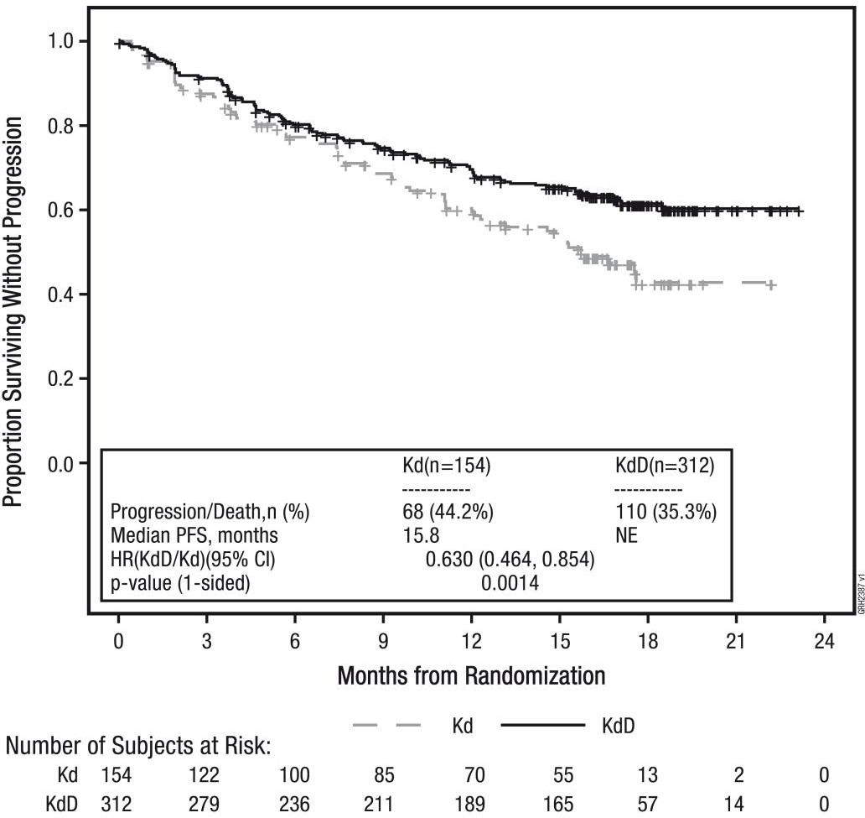
CI = confidence interval, HR = hazard ratio, Kd = carfilzomib and dexamethasone, KDd = carfilzomib, daratumumab and dexamethasone, NE = not-estimable, PFS = progression-free survival

Figure 2. Kaplan-Meier Plot of Overall Survival
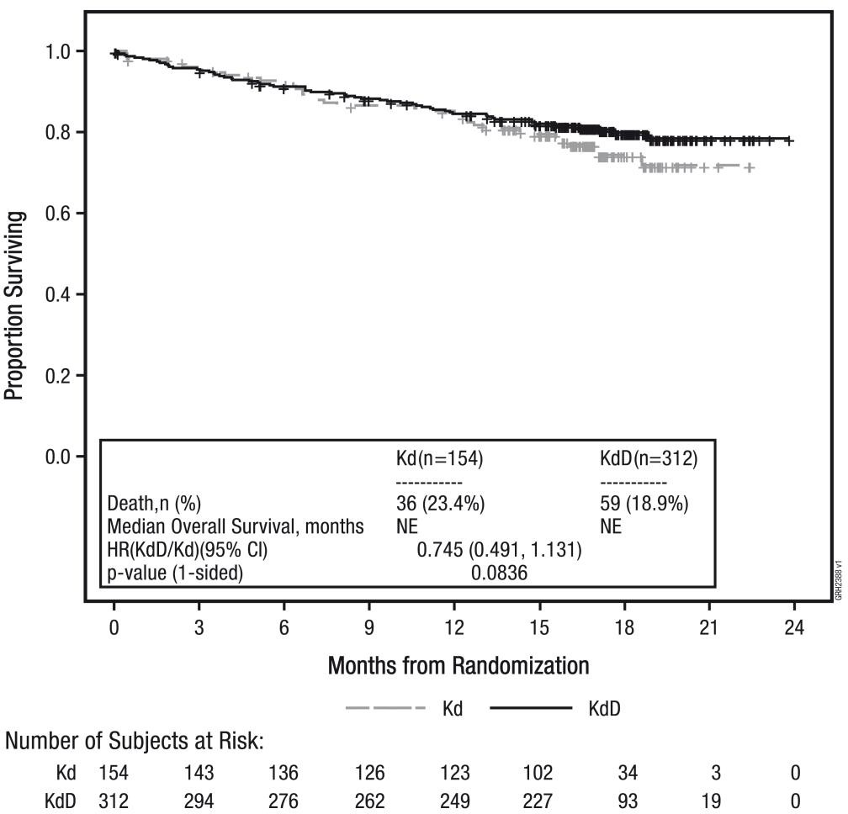
CI = confidence interval, HR = hazard ratio, Kd = Kyprolis and dexamethasone, KDd = Kyprolis, daratumumab and dexamethasone, NE = not-estimable

Kyprolis in combination with daratumumab and dexamethasone in multiple myeloma (EQUULEUS)
EQUULEUS was a Phase 1b open-label, non-randomised, multi-arm trial of daratumumab in combination with multiple myeloma therapy to evaluate the safety of 20/70 mg/m² once weekly Kyprolis in combination with daratumumab. The arm evaluating weekly Kyprolis with daratumumab and dexamethasone (KDd) included 85 patients with relapsed or refractory multiple myeloma. Patients were excluded if they had known moderate or severe persistent asthma within the past 2 years, known COPD with a FEV1 < 50% of predicted normal, and active congestive heart failure. Kyprolis was administered at a starting dose of 20 mg/m², which was increased to 70 mg/m² on cycle 1, day 8 and onward. Kyprolis was administered once weekly as a 30 minute infusion on days 1, 8, and 15 of each 28 day cycle. Ten patients were administered a single first dose of daratumumab at 16 mg/kg on cycle 1, day 1. The remaining 75 patients were administered a split first dose of daratumumab at 8 mg/kg per day on cycle 1, day 1 and 2.

Thereafter, a single 16 mg/kg dose was administered on days 8, 15 and 22 of cycle 1 and days 1, 8, 15 and 22 of cycle 2, every 2 weeks for 4 cycles (cycles 3-6) and then every 4 weeks for the remaining cycles of each 28 day cycle. Dexamethasone was taken orally or intravenously at a dose of 20 mg in cycle 1 and 2 on days 1, 2, 8, 9, 15, 16, 22 and 23. In cycles 3-6, dexamethasone was taken at a dose of 20 mg on days 1, 2, 15 and 16 and at a dose of 40 mg on day 22. In cycles 7 and thereafter, dexamethasone was taken at a dose of 20 mg on days 1 and 2 and at a dose of 40 mg on days 8, 15, and 22. Patients > 75 years of age were administered 20 mg of dexamethasone orally or intravenously weekly after the first week.
Dexamethasone 40 mg was administered 30 minutes to 4 hours before Kyprolis. on days 1, 8, 15 and 22 of each 28 day cycle. Treatment continued until disease progression or unacceptable toxicity.

Table 14. Demographics and Baseline Characteristics

Characteristics | KDd Arm (N = 85)
Age (years)
Median (min, max) | 66 (38,85)
Age group – n (%)
<65 years | 36 (42.4%)
65 - <75 years | 41 (48.2%)
- 75 years | 8 (9.4%)
Sex – n (%)
Male | 46 (54.1%)
Female | 39 (45.9%)
Race – n (%)
Asian | 3 (3.5%)
Black or African American | 3 (3.5%)
White | 68 (80.0%)
ECOG Score, n (%)
0 | 32 (37.6)
1 | 46 (54.1)
2 | 7 (8.2)
FISH, n (%)
N | 67
Standard Risk | 54 (80.6)
High Risk | 13 (19.4)
Number of Prior regimens
1 | 20 (23.5)
2 | 40 (47.1)
3 | 23 (27.1)
>3 | 2 (2.4)
Prior Therapies
Bortezomib | 85 (100)
Lenalidomide | 81 (95.3)
Prior stem cell transplant (ASCT) | 62 (72.9)
Refractory to lenalidomide | 51 (60)
ASCT = autologous/allogenic stem cell transplant, ECOG = Eastern Cooperative Oncology Group, FISH = Fluorescence in situ hybridization, Kd = Kyprolis and dexamethasone, KDd = Kyprolis, daratumumab and dexamethasone.

Efficacy was a secondary objective of the study. The efficacy of Kyprolis, evaluated by ORR using IMWG response criteria was 81%. The median time to response was 0.95 months (range: 0.9, 14.3). The median duration of response was 28 months (95% CI: 20.5, not estimable).

Table 15. Summary of Efficacy Analysis

 | Once weekly KDd 70 mg/m² Arm (N=85)
Overall Response
N with Response | 69
ORR (%) (95% CI) | 81 (71, 89)
Response category, n(%)
sCr | 18 (21.2)
CR | 12 (14.1)
VGPR | 28 (32.9)
PR | 11 (12.9)
CI = confidence interval, CR = complete response, Kd = Kyprolis and dexamethasone, KDd
= Kyprolis, daratumumab and dexamethasone, ORR = overall response rate, PR = partial response, sCR = stringent complete response, VGPR = very good partial response

Kyprolis in Combination with Isatuximab and Dexamethasone for Relapsed or Refractory Multiple Myeloma (IKEMA (EFC15246))
The efficacy and safety of Kyprolis in combination with isatuximab and dexamethasone were evaluated in IKEMA, a multicentre, multinational, randomised, open-label, 2-arm, phase 3 study in patients with relapsed and/or refractory multiple myeloma. Patients had received one to three prior lines of therapy.
A total of 302 patients were randomised in a 3:2 ratio to receive either Kyprolis in combination with isatuximab and dexamethasone (Isa-Kd, 179 patients) or Kyprolis and dexamethasone (Kd, 123 patients).

Treatment was administered in both groups in 28 day cycles until disease progression or unacceptable toxicity. Isatuximab 10 mg/kg was administered as an intravenous infusion weekly in the first cycle and every two weeks thereafter. Kyprolis was administered as an intravenous infusion at the dose of 20 mg/m² on days 1 and 2; 56 mg/m² on days 8, 9, 15, and 16 of cycle 1; and at the dose of
56 mg/m² on days 1, 2, 8, 9, 15, and 16 for subsequent cycles of each 28 day cycle. Dexamethasone (intravenously on the days of isatuximab and/or Kyprolis infusions, and orally on the other days) 20 mg was given on days 1, 2, 8, 9, 15, 16, 22, and 23 for each 28 day cycle. On the days where both Kyprolis and isatuximab were administered, dexamethasone was administered first, followed by isatuximab infusion, then followed by Kyprolis infusion.
Overall, demographic and disease characteristics at baseline were similar between the two treatment groups. The median patient age was 64 years (range 33-90), 8.9% of patients were ≥ 75 years. The proportion of patients with renal impairment (eGFR
< 60 mL/min/1.73 m²) was 24% in the Isa-Kd group versus 14.6% in the Kd group. The International Staging System (ISS) stage at study entry was I in 53.0%, II in 31.1%, and III in 15.2% of patients. Overall, 24.2% of patients had high-risk chromosomal abnormalities at study entry; del(17p), t(4;14), t(14;16) were present in 11.3%, 13.9%, and 2.0% of patients, respectively. In addition, gain(1q21) was present in 42.1% of patients.
The median number of prior lines of therapy was 2 (range 1-4) with 44.4% of patients who received 1 prior line of therapy. Overall, 89.7% of patients received prior proteasome inhibitors, 78.1% received prior immunomodulators (including 43.4% who received prior lenalidomide), and 61.3% received prior stem cell transplantation. Overall, 33% of patients were refractory to prior proteasome inhibitors, 45.0% were refractory to prior immunomodulators (including 32.8% refractory to lenalidomide), and 20.5% were refractory to both a proteasome inhibitor and an immunomodulator.
The median duration of treatment was 80.0 weeks for the Isa-Kd group compared to
61.4 weeks for the Kd group.
Progression-free survival (PFS) was the primary efficacy endpoint of IKEMA. The improvement in PFS represented a 46.9% reduction in the risk of disease progression or death in patients treated with Isa-Kd compared to patients treated with Kd. Efficacy results are presented in Table 16.

Table 16^{a*}. Efficacy of Kyprolis in Combination with Isatuximab and Dexamethasone versus Kyprolis and Dexamethasone in the Treatment of Multiple Myeloma (IKEMA)

Endpoint | Isa-Kd  N =179 | Kd  N = 123
Progression-Free Survivala Median (months)  [95% CI] | NR [NR -NR] | 19.15 [15.77-NR]
Hazard ratiob [95% CI] | 0.531 [0.318-0.889]
p-value (Stratified Log-Rank test)b | 0.0007
Overall Response Ratec Responders (sCR+CR+VGPR+PR) [95% CI]d | 86.6%  [0.8071-0.9122] | 82.9%  [0.7509-0.8911]
p-value (stratified Cochran-Mantel-  Haenszel)b | 0.3859
Complete Response (CR) | 39.7% | 27.6%
Very Good Partial Response (VGPR) | 33.0% | 28.5%
Partial Response (PR) | 14.0% | 26.8%
VGPR or better (sCR+CR+VGPR) [95% CI]d | 72.6% [0.6547-  0.7901] | 56.1%  [0.4687 -  0.6503]
p-value (stratified Cochran-Mantel-  Haenszel) b e | 0.0021
CRf  [95% CI]d | 39.7% [0.3244-  0.4723] | 27.6% [0.1996  to 0.3643]
Minimal Residual Disease negative rateg  [95% CI]d | 29.6%  [0.2303-0.3688] | 13.0%  [0.0762-0.2026]
p-value (stratified Cochran-Mantel-  Haenszel)b e | 0.0008
Duration of Responseh *(PR or better) Median in months [95% CI] i | NR [NR-NR] NR |  | [14.752-NR]
Hazard ratiob [95% CI] | 0.425 [0.269-0.672]
*Results are based on a prespecified interim analysis
a PFS results were assessed by an Independent Response Committee based on central laboratory data for M- protein and central radiologic imaging review using the International Myeloma Working Group (IMWG) criteria.
b Stratified on number of previous lines of therapy (1 versus >1) and R-ISS (I or II versus III versus not classified) according to IRT.
c sCR, CR, VGPR, and PR were evaluated by the IRC using the IMWG response criteria.
d Estimated using Clopper-Pearson method.
e Nominal p-value.
f CR to be tested with final analysis.
g Based on a sensitivity level of 10-5 by NGS in ITT population.
h Based on Responders in the ITT population. Kaplan-Meier estimates of duration of response.
i CI for Kaplan-Meier estimates are calculated with log-log transformation of survival function and methods of Brookmeyer and Crowley.
* Cut-off date of 7 February 2020. Median follow-up time=20.73 months. HR<1 favors Isa-Kd arm.
CI=confidence interval, Isa-KD = isatuximab, carfilzomib and dexamethasone, Kd = carfilzomib and dexamethasone, sCR=stringent complete response, NR: not reached.
PFS improvements in the Isa-Kd group were observed in patients with high-risk cytogenetics (central laboratory assessment, HR = 0.724; 95% CI: 0.361 to 1.451) , with gain(1q21) chromosomal abnormality (HR=0.569; 95% CI: 0.330 to 0.981) , ≥ 65 years (HR = 0.429; 95% CI: 0.248 to 0.742), with baseline eGFR (MDRD) < 60 mL/min/1.73 m²
(HR = 0.273; 95% CI: 0.113 to 0.660), with > 1 prior line of therapy (HR = 0.479; 95% CI: 0.294 to 0.778) , with ISS stage III at study entry (HR = 0.650; 95% CI: 0.295 to 1.434), and in patients refractory to prior therapy with lenalidomide (HR = 0.598; 95% CI: 0.339 to 1.055).
The median time to first response was 1.08 months in the Isa-Kd group and 1.12 months in the Kd group. The median time to progression was not reached in the Isa-Kd group and was 20.27 months (95% CI: 16.986-NR) in the Kd group (HR = 0.495; 95% CI:
0.324-0.757). With a median follow-up time of 20.73 months, 17.3% patients in the Isa-Kd arm and 20.3% patients in the Kd arm had died.

Figure 3. Kaplan-Meier Plot of PFS – ITT Population – IKEMA (assessment by the IRC)
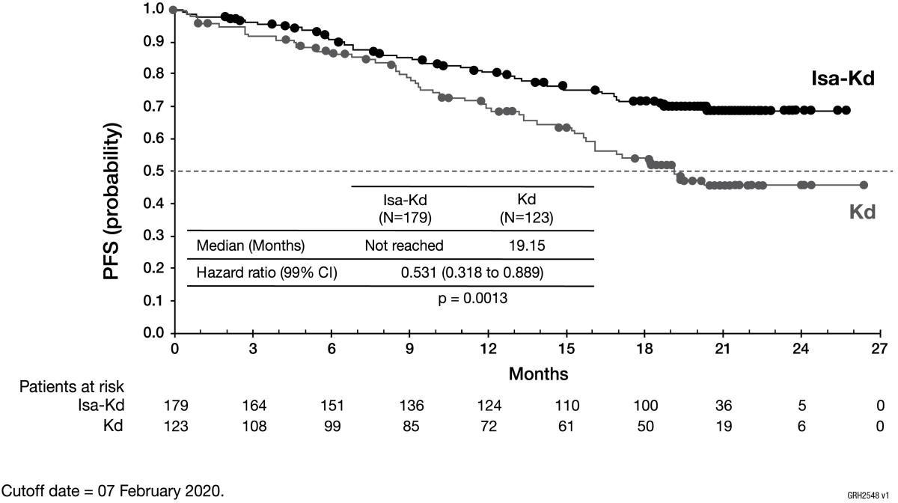
CI = confidence interval, Isa-Kd = isatuximab, Kyprolis and dexamethasone, Kd = Kyprolis and dexamethasone, PFS = progression-free survival

Among patients with eGFR (MDRD) < 50 mL/min/1.73 m² at baseline, complete renal response (≥ 60 mL/min/1.73 m² at ≥ 1 postbaseline assessment) was observed for 52.0% of patients in the Isa-Kd group and 30.8% in the Kd group. Sustained complete renal response (≥ 60 days) occurred in 32.0% of patients in the Isa-Kd group and in 7.7% in the Kd group. In the 4 patients in the Isa-Kd group and the 3 patients in the Kd group with severe renal impairment at baseline (eGFR (MDRD) > 15 to < 30 mL/min/1.73 m²), minimal renal response (≥ 30 to < 60 mL/min/1.73 m² at ≥ 1 postbaseline assessment) was observed for 100% of patients in the Isa-Kd group and 33.3% of patients in the Kd group.
Overall, the quality of life assessed by Global Health Status Score (QLQ-C30) was maintained during the treatment period.

Study PX-171-009 (ASPIRE)
The safety and efficacy of Kyprolis were evaluated in a phase 3, randomised, open-label, multicentre study of 792 patients with relapsed multiple myeloma who had received 1 to 3 prior lines of therapy (median of 2), which evaluated the combination of Kyprolis with lenalidomide (25 mg) and dexamethasone (40 mg) versus lenalidomide and dexamethasone alone, randomised 1:1. Patients who had the following were excluded from the trial: creatinine clearance rates < 50 mL/min, New York Heart Association Class III to IV congestive heart failure, or myocardial infarction within the last 4 months. Kyprolis treatment was administered for a maximum of 18 cycles unless discontinued early for disease progression or unacceptable toxicity. Lenalidomide and dexamethasone administration could continue until progression or unacceptable toxicity.
The demographics and baseline characteristics for study PX-171-009 were well-balanced between the two arms. The study enrolled a representative relapsed multiple myeloma population; disease and other baseline characteristics were well-balanced between the two arms, including age (64 years), gender (56% male), Eastern Cooperative Oncology Group (ECOG) performance status (48% with performance status 1), high-risk genetic mutations (13%, based on FISH analysis), unknown-risk genetic mutations (47%, based on FISH analysis) and baseline ISS stage III disease (20%).
The primary endpoint of this study was progression free survival (PFS). The secondary endpoints included overall survival (OS), overall response rate (ORR), disease control rate (DCR), duration of response (DOR), time to response (TTR) and duration of clinical benefit (DCB). The rate of clinical benefit (CBR) was an exploratory endpoint.
The results of study PX-171-009 are summarised in Table 17; results other than for OS are from the interim analysis performed when the primary endpoint was met.

Table 17. Summary of Efficacy Analysis in Study PX-171-009

 | KRd combination therapy
 | KRd armª (n = 396) | Rd armª (n = 396)
PFS months, median (95% CI) | 26.3 (23.3, 30.5) | 17.6 (15.0, 20.6)
HR (95% CI); 1 sided p-valueb | 0.69 (0.57, 0.83); < 0.0001
OS months median (95% CI)c | 48.3 (42.4, 52.8) | 40.4 (33.6, 44.4)
HR (95% CI); 1 sided p-valuec | 0.79 (0.67, 0.95); 0.0045
ORR n (%)d | 345 (87.1) | 264 (66.7)
sCR | 56 (14.1) | 17 (4.3)
CR | 70 (17.7) | 20 (5.1)
VGPR | 151 (38.1) | 123 (31.1)
PR | 68 (17.2) | 104 (26.3)
95% CI of ORRd | 83.4, 90.3 | 61.8, 71.3
1 sided p-valued | < 0.0001
DOR months, median (95% CI)d | 28.6 (24.9, 31.3) | 21.2 (16.7, 25.8)
TTR months, median (min, max)e | 1 (1, 14) | 1 (1, 16)
CBR n (%)d | 360 (90.9) | 302 (76.3)
95% CI of CBRd | 87.6, 93.6 | 71.8, 80.4
DCB months, median (95% CI)d | 28.3 (24.3, 30.5) | 20.3 (16.6, 24.0)
DCR n (%)d | 367 (92.7) | 345 (87.1)
95% CI of DCRd | 89.7, 95.0 | 83.4, 90.3
CI = confidence interval; CBR = clinical benefit rate; CR = complete response; DCB = duration of clinical benefit; DCR = disease control rate; DOR = duration of response; EBMT = European blood and marrow transplantation; HR = hazard ratio; IMWG = international myeloma working group; KRd = Kyprolis, lenalidomide and dexamethasone; NE = not estimable; ORR = overall response rate; OS = overall survival;
PFS = progression-free survival; PR = partial response; Rd = lenalidomide and dexamethasone; sCR = stringent complete response; TTR = time to response; VGPR = very good partial response
a As determined by an Independent Review Committee using standard objective IMWG/EBMT response criteria
b Statistically significant
c Results are from the OS analysis
d Results are from the interim analysis performed when primary endpoint met; ORR p-value is provided for descriptive purposes only
e Sample median

Patients in the Kyprolis, lenalidomide and dexamethasone (KRd) arm demonstrated improved PFS compared with those in the lenalidomide and dexamethasone (Rd) arm (HR = 0.69, 1 sided p-value < 0.0001; see Figure 4). This represents a 45% improvement in PFS or a 31% reduction in the risk of event as determined using standard objective IMWG/European Blood and Marrow Transplantation (EBMT) response criteria by an Independent Review Committee (IRC).
The median PFS was 26.3 months (95% CI: 23.3, 30.5 months) in the KRd arm versus
17.6 months (95% CI: 15.0, 20.6 months) in the Rd arm, a difference of 8.7 months at the median (Figure 4). The PFS benefit of KRd was consistently observed in all subgroups, including patients ≥ 75 years of age, patients with high risk or unknown risk genetic mutations, and patients with baseline creatinine clearance of 30 to < 50 mL/min (see Figure 5).

Figure 4. Kaplan-Meier Plot of Progression-free Survival in Study PX-171-009

CI = confidence interval; EBMT = European blood and marrow transplantation; HR = hazard ratio; IMWG = International Myeloma Working Group; KRd = Kyprolis, lenalidomide and dexamethasone; PFS = progression-free survival; Rd = lenalidomide, dexamethasone
Note: The response and Progressive Disease outcomes were determined using standard objective IMWG/EBMT response criteria.

Figure 5. Subgroup Analyses of Progression-Free Survival as Determined by Independent Review Committee (Selected Subgroups) Intent-to-Treat Population
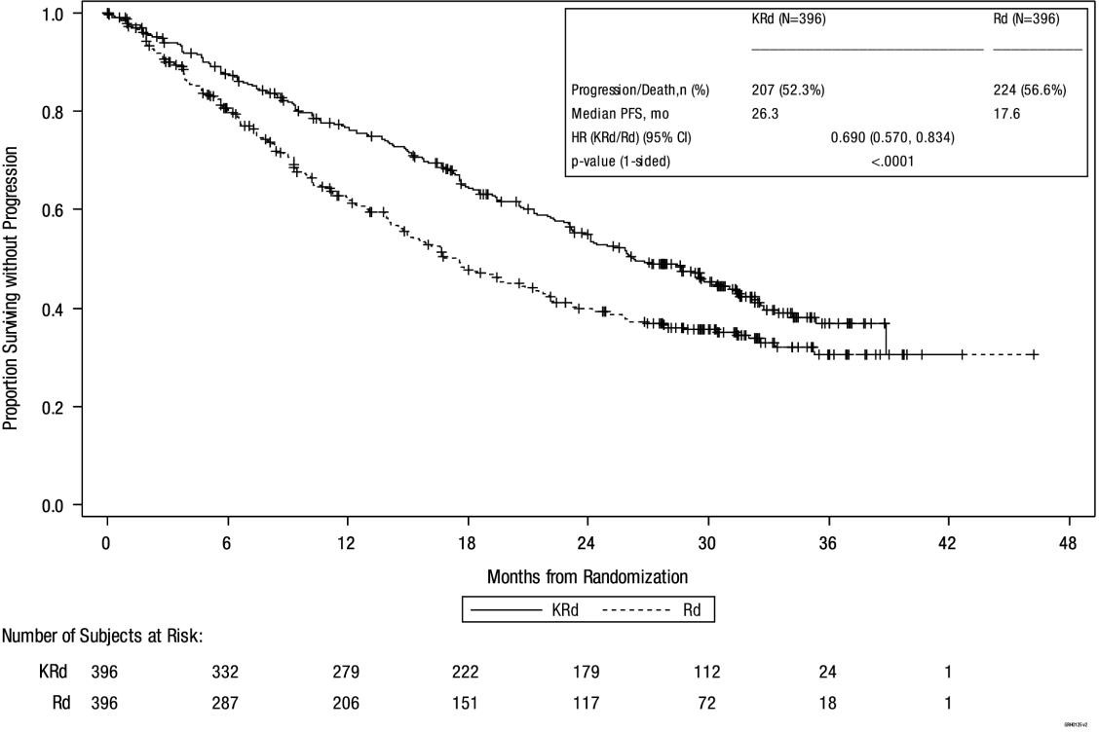
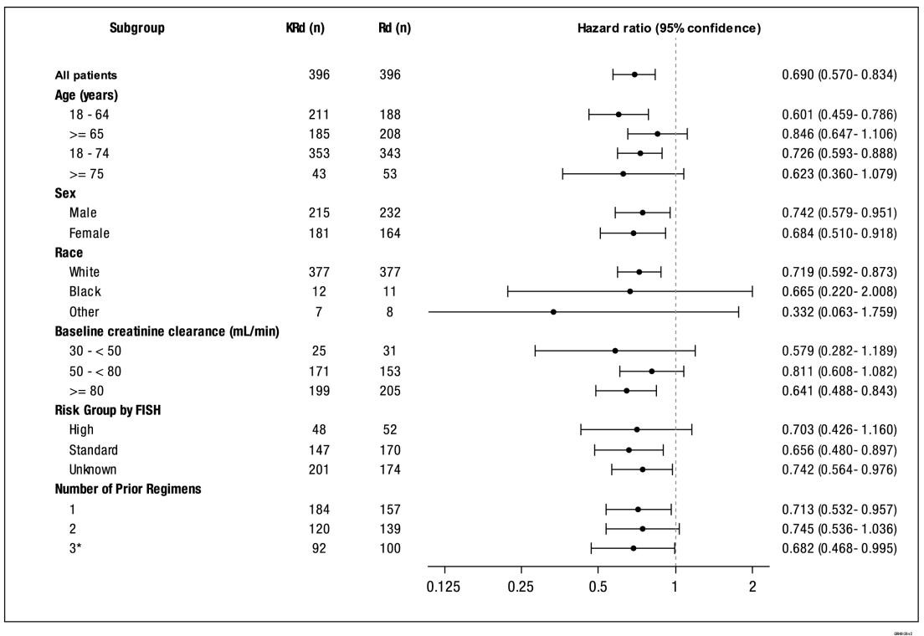

A pre-planned OS analysis was performed after 246 deaths in the KRd arm and 267 deaths in the Rd arm. The median follow-up was approximately 67 months. A statistically significant advantage in OS was observed in patients in the KRd arm compared to patients in the Rd arm. Patients in the KRd arm had a 21% reduction in the risk of death compared with those in the Rd arm (HR = 0.79; 95% CI: 0.67, 0.95; p-value = 0.0045). The median OS improved by 7.9 months in patients in the KRd arm compared with those in the Rd arm (see Table 17and Figure 6). 49.6% of patients were treated with at least 1 antimyeloma therapy after investigational product (n = 182 (46.0%) KRd arm; n = 211 (53.3%) Rd arm). Subsequent antimyeloma therapies were generally balanced across treatment groups.

Figure 6. Kaplan-Meier Plot of Overall Survival in Study PX-171-009
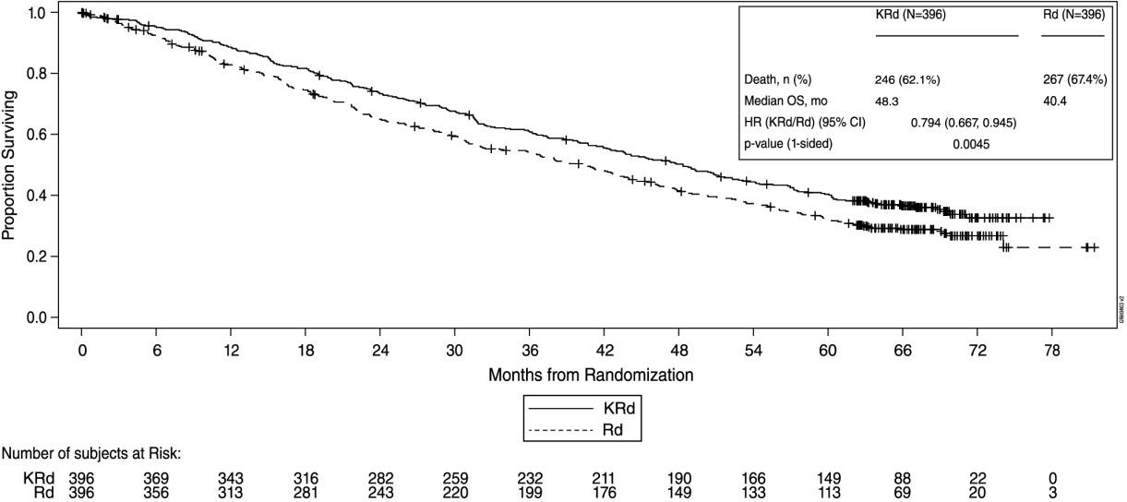
CI = confidence interval; HR = hazard ratio; KRd = Kyprolis, lenalidomide and dexamethasone; mo = months; OS = overall survival; Rd = lenalidomide and dexamethasone

The ORR was higher in the KRd versus the Rd arm (87.1% versus 66.7%; 1 sided p-value
< 0.0001). Rate and depth of response were increased in the KRd versus Rd arm with 31.8% complete response (CR) and higher in the KRd arm (including 14.1% stringent complete response [sCR]) versus 9.3% CR and higher in the Rd arm (including 4.3% sCR).

Study 2011-003 (ENDEAVOR)
The safety and efficacy of 56 mg/m² Kyprolis twice weekly were evaluated in a phase 3, randomised, open-label, multicentre study of Kyprolis and dexamethasone (Kd) versus bortezomib and dexamethasone (Vd). A total of 929 patients with relapsed multiple myeloma who had received 1 to 3 prior lines of therapy were enrolled and randomised (464 in the Kd arm; 465 in the Vd arm). Patients randomised to the Vd arm could receive bortezomib either by the intravenous (n = 108) or subcutaneous (n = 357) route. Patients who had the following were excluded from the trial: creatinine clearance rates < 15 mL/min, New York Heart Association Class III to IV congestive heart failure, myocardial infarction within the last 4 months or those with left ventricular ejection fraction (LVEF) < 40%. This study evaluated Kyprolis at an initial dose of 20 mg/m², which was increased to 56 mg/m² on day 8 of cycle 1, administered twice weekly for 3 out of 4 weeks as a 30 minute infusion until progression or unacceptable toxicity.
The study enrolled a representative relapsed multiple myeloma population; disease and other baseline characteristics were well-balanced between the two arms, including prior treatment with bortezomib (54%), prior treatment with lenalidomide (38%), age (47%
< 65 years), gender (51% male), ECOG performance status (45% with performance status 1), high-risk genetic mutations consisting of genetic subtypes t(4;14) or t(14;16) in ≥ 10% of screened plasma cells, or deletion of 17p in ≥ 20% of plasma cells (23%, based on FISH analysis), unknown-risk genetic mutations (9%, based on FISH analysis) and baseline ISS stage III disease (24%).
The primary endpoint of this study was PFS as determined by an IRC using standard objective IMWG/response criteria. The key secondary endpoints were OS, ORR and incidence of peripheral neuropathy events (≥ grade 2).
The results of study 2011-003 are summarised in Table 18.

Table 18. Summary of Key Results by IRC (Intent-to-Treat Population) Study 2011-003

 | Kd Arm (n = 464) | Vd Arm (n = 465)
PFS (months)a median (95% CI) | 18.7 (15.6, -) | 9.4 (8.4, 10.4)
1 sided p-value | < 0.0001
HR (Kd/Vd) (95% CI) | 0.533 (0.44, 0.65)
OS (months) median (95% CI) | 47.6 (42.5, -) | 40.0 (32.6, 42.3)
HR (Kd/Vd) (95% CI) | 0.791 (0.65, 0.96)
1 sided p-value | 0.010
ORRa Nb | 357 | 291
ORR (95% CI) | 76.9  (72.8, 80.7) | 62.6  (58.0, 67.0)
1 sided p-value | < 0.0001
Odds ratio (Kd/Vd) (95% CI) | 2.032 (1.519, 2.718)
≥ CRc N | 58 | 29
CR or better (95% CI) | 12.5 (9.6, 15.9) | 6.2 (4.2, 8.8)
1 sided p-value | 0.0005
Odds ratio (Kd/Vd) (95% CI) | 2.140 (1.344, 3.408)
≥ VGPRc N | 252 | 133
VGPR or better (95% CI) | 54.3  (49.7, 58.9) | 28.6  (24.5, 32.9)
1 sided p-value | < 0.0001
Odds ratio (Kd/Vd) (95% CI) | 3.063 (2.322, 4.040)
DOR (months)a, median (95% CI)a | 21.3 (21.3, -) | 10.4 (9.3, 13.9)
Grade 2+ peripheral neuropathy eventsd | 463e | 456e
N (%) with PN | 32 (6.9) | 159 (34.9)
95% CI | 4.6, 9.2 | 30.5, 39.2
1 sided p-value | < 0.0001
Odds Ratio (Kd/Vd) (95% CI) | 0.139 (0.092, 0.208)
CI = confidence interval; CR = complete response; DOR = duration of response; Kd = Kyprolis and dexamethasone; ORR = overall response rate; OS = overall survival; PFS = progression-free survival; PN = peripheral neuropathy; Vd = bortezomib and dexamethasone; VGPR = very good partial response
a These endpoints were determined by an Independent Review Committee.
b Overall response is defined as achieving a response of PR or above. Analysis of duration of response includes patients achieving an overall response only.
c The p-values presented are provided for descriptive purposes only as they are not pre-specified secondary endpoints with statistical testing.
d Analysis of Grade 2 or higher PN events is based on safety population, the sample size of which is listed for each arm.
e The safety population was used to determine peripheral neuropathy events.

The study showed significant improvement in PFS for patients in the Kd arm over those in the Vd arm (HR: 0.53, 95% CI: 0.44, 0.65 [p-value < 0.0001]), with a difference in median PFS of 9.3 months (18.7 months [95% CI: 15.6, NE] in the Kd arm versus 9.4 months [95% CI: 8.4, 10.4] in the Vd arm) (see Figure 7). Similar PFS results were observed in patients who had received prior treatment with bortezomib (HR: 0.56, 95% CI: 0.44, 0.73)
and patients who had not received prior treatment with bortezomib (HR: 0.48, 95% CI: 0.36, 0.66).

Figure 7. Kaplan-Meier Plot of Progression-free Survival as Determined by the IRC (Intent-to-Treat Population) Study 2011-003

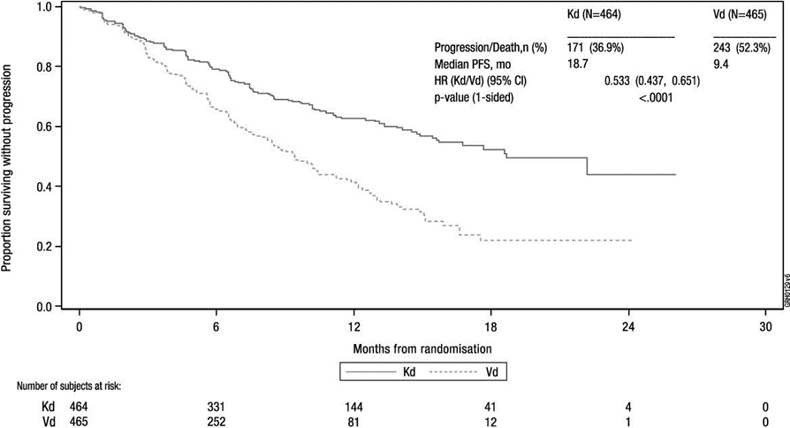

HR = hazard ratio; Kd = Kyprolis and dexamethasone; PFS = progression-free survival; mo = months; Vd = bortezomib and dexamethasone

Figure 8. Subgroup Analyses of Progression-Free Survival as Determined by Independent Review Committee (Selected Subgroups) Intent-to-Treat Population
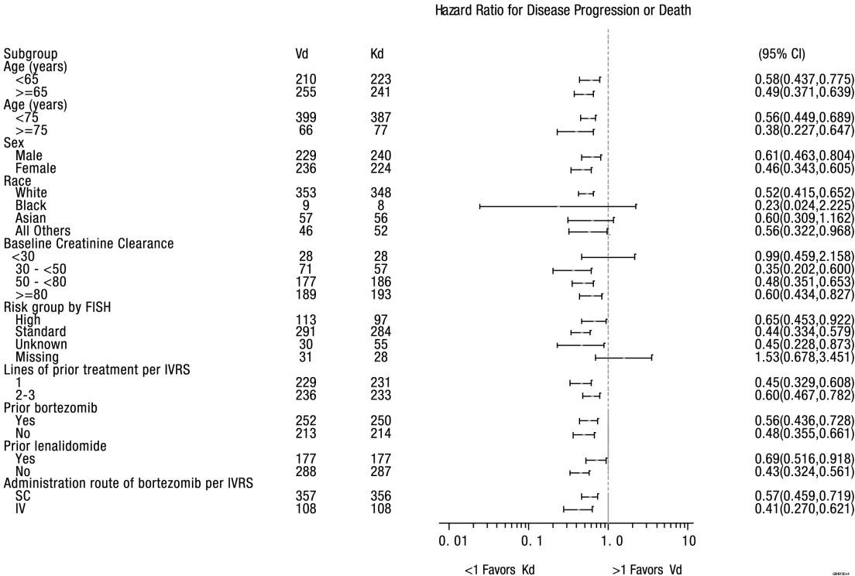

CI = confidence interval; FISH = fluorescent in situ hybridization; IV = intravenous; IVRS = interactive voice response system; SC = subcutaneous

A pre-planned OS analysis was performed after 189 deaths in the Kd arm and 209 deaths in the Vd arm. The median follow-up was approximately 37 months. A statistically significant advantage in OS was observed in patients in the Kd arm compared to patients in the Vd arm (HR = 0.79, 95% CI: 0.65, 0.96 [p-value = 0.010]) (see Table 18 and Figure 9).
ORR was 76.9% (95% CI: 72.8, 80.7) for patients in the Kd arm and 62.6% (95% CI: 58.0,
67.0) for patients in the Vd arm (odds ratio = 2.032, 95% CI: 1.519, 2.718
[p-value < 0.0001]).

Figure 9. Kaplan-Meier Plot of Overall Survival in Study 2011-003
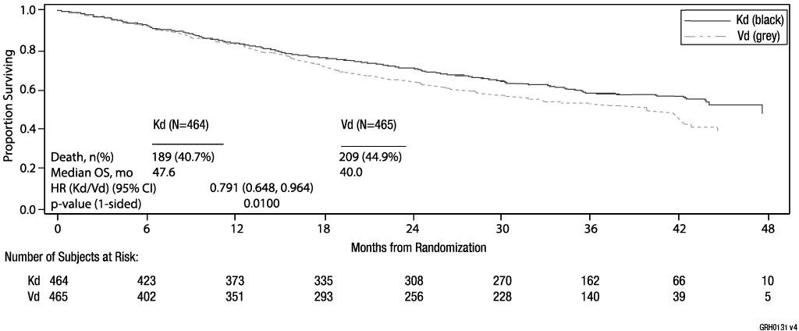

CI = confidence interval; HR = hazard ratio; Kd = Kyprolis and dexamethasone; OS = overall survival; mo = months; Vd = bortezomib and dexamethasone

Study 20140355 (A.R.R.O.W)
The safety and efficacy of 70 mg/m² Kyprolis once weekly were evaluated in a phase 3, randomised, open-label, multicentre study of Kyprolis and dexamethasone (Kd) versus Kd 27 mg/m² twice weekly. A total of 478 patients with relapsed multiple myeloma who had received 2 to 3 prior lines of therapy were enrolled and randomised (240 in the Kd
70 mg/m² arm; 238 in the Kd 27 mg/m² arm). This study evaluated Kyprolis at an initial dose of 20 mg/m², which was increased to 70 mg/m² on day 8 of cycle 1, administered once weekly as a 30 minute infusion until progression or unacceptable toxicity.
The study enrolled a representative relapsed multiple myeloma population; disease and other baseline characteristics were well-balanced between the two arms, including prior treatment with bortezomib (99%), prior treatment with lenalidomide (84%), age (43.5%
< 65 years), gender (54% male), ECOG performance status (50.4% with performance status 1), high-risk genetic mutations consisting of genetic subtypes t(4;14) or t(14;16), or deletion of 17p (17%, based on FISH analysis), and unknown-risk genetic mutations (62%, based on FISH analysis).
The primary endpoint of this study was PFS. The key secondary endpoints were OS and ORR.
The efficacy of Kd once weekly is summarised in Table 19.

Table 19. Summary of Key Results by IRC (Intent-to-Treat Population) Study 20140355

 | Kd 70 mg/m² Once Weekly Armª  (n = 240) | Kd 27 mg/m² Twice Weekly Armª
 |  | (n = 238)
PFS (months)a median (95% CI) | 11.3 (8.6, 13.2) | 7.6 (5.7,8.7)
1 sided p-value | 0.0010
HR (Kd 70 mg/m2 once weekly/ Kd 27 mg/m2 twice weekly) (95% CI) | 0.68 (0.54, 0.87)
ORR Nb | 153 | 98
ORR | 63.8 | 41.2
(95% CI) | (57.3, 69.8) | (34.9, 47.7)
1 sided p-value | < 0.0001
Odds Ratio (Kd 70 mg/m2 once weekly/ Kd 27 mg/m2 twice weekly) (95% CI) | 2.53 (1.75, 3.66)
CI = confidence interval; CR = complete response; DOR = duration of response; Kd = Kyprolis and dexamethasone; ORR = overall response rate; OS = overall survival; PFS = progression-free survival; PN = peripheral neuropathy; Vd = bortezomib and dexamethasone; VGPR = very good partial response
a As determined by an Independent Review Committee.
b Overall response is defined as achieving a best overall response of PR, VGPR, CR or sCR or above.

The study showed significantly longer duration of PFS for patients treated with Kd 70 mg/m² once weekly than those treated with Kd 27 mg/m² twice weekly (HR: 0.68,
95% CI: 0.54, 0.87 [p-value = 0.0010]), with a difference in median PFS of 3.7 months (11.3 months in the Kd 70 mg/m² once weekly arm versus 7.6 months in the Kd 27 mg/m² twice weekly arm) (see Figure 10).
ORR was 63.8% (95% CI: 57.3, 69.8) for patients in the Kd 70 mg/m² once weekly arm and 41.2% (95% CI: 34.9, 47.7) for patients in the Kd 27 mg/m² twice weekly arm (odds
ratio = 2.53; 95% CI: 1.75, 3.66; p-value < 0.0001) (see Table 19).
At the time of primary analysis of PFS, the HR for OS was 0.80 (95% CI: 0.56, 1.14; 1- sided p = 0.1070).

Figure 10. Kaplan-Meier Plot of Progression-Free Survival (Intent-to-Treat Population)
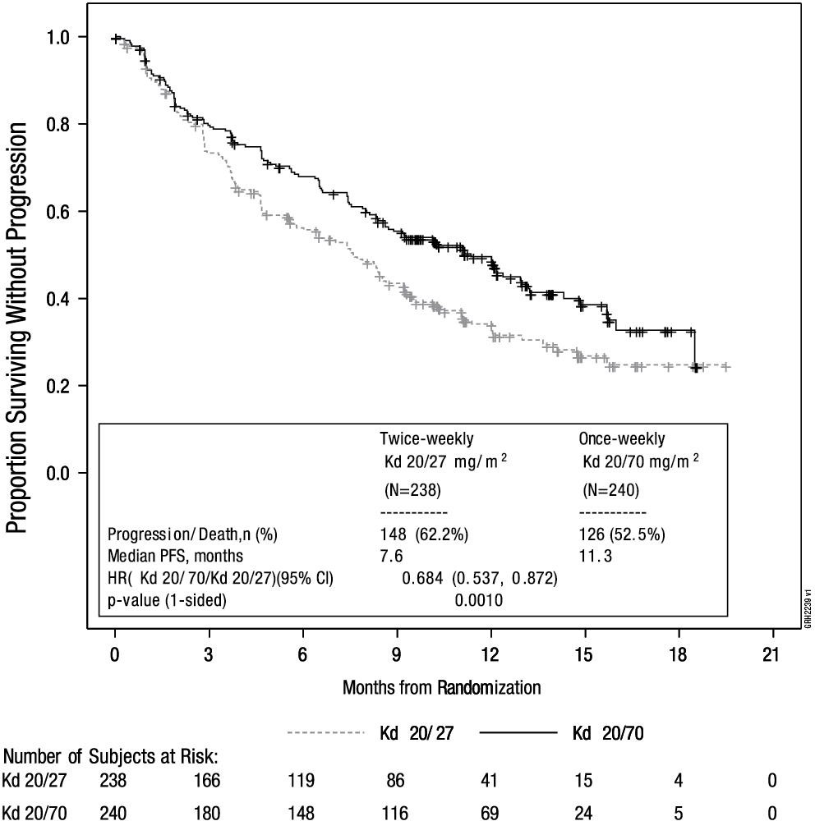

CI = confidence interval; HR = hazard ratio; Kd = Kyprolis and dexamethasone; PFS = progression-free survival
a Study 20140355
b As determined by Independent Review Committee

Pharmacokinetic properties Absorption
At doses between 20 and 70 mg/m², carfilzomib administered as a 30 minute infusion
resulted in dose-dependent increases in maximum plasma concentrations (Cmax) and concentration-time curve (AUC). Following repeated administration of carfilzomib at
70 mg/m², systemic exposure (AUC) and half-life were similar on day 15 of cycles 1 and 2, suggesting there was no systemic carfilzomib accumulation.

A 30 minute infusion resulted in a similar half-life and AUC, but 2 to 3 fold lower Cmax compared to that observed with a 2 to 10 minute infusion of the same dose.

Distribution
The mean steady-state volume of distribution of a 20 mg/m² dose of carfilzomib was 22 L. When tested in vitro, the binding of carfilzomib to human plasma proteins averaged 97% over the concentration range of 0.4 to 4 micromolar.

Metabolism
Carfilzomib was rapidly and extensively metabolised. The predominant metabolites measured in human plasma and urine, and generated in vitro by human hepatocytes, were peptide fragments and the diol of carfilzomib, suggesting that peptidase cleavage and epoxide hydrolysis were the principal pathways of metabolism. Cytochrome P450 mediated mechanisms played a minor role in overall carfilzomib metabolism. The metabolites have no known biological activity.

Excretion
Following intravenous administration of doses ≥ 15 mg/m², carfilzomib was rapidly cleared from the systemic circulation with a half-life of ≤ 1 hour on day 1 of cycle 1. The systemic clearance ranged from 151 to 263 L/h, and exceeded hepatic blood flow, suggesting that carfilzomib was largely cleared extrahepatically. Carfilzomib is eliminated primarily via metabolism with subsequent excretion in urine. In the first 24 hours, approximately 25% of the administered dose of carfilzomib was excreted in urine as metabolites. Urinary and faecal excretion of the parent compound was negligible (0.3% of total dose).

Special populations
Population pharmacokinetic analyses indicate that the pharmacokinetics of carfilzomib are not influenced by age, gender, or race.
The pharmacokinetics of carfilzomib were studied in patients with relapsed or progressive advanced malignancies with mild or moderate chronic hepatic impairment relative to those with normal hepatic function. No marked differences in exposures (AUC and Cmax) were observed between patients with normal hepatic function and those with mild or moderate baseline hepatic impairment. The pharmacokinetics of carfilzomib have not been studied in patients with severe hepatic impairment (see Section 4.2 Dose and method of administration, Patients with hepatic impairment).
The pharmacokinetics of carfilzomib were studied in relapsed multiple myeloma patients with normal renal function, mild, moderate or severe renal impairment, and patients with end-stage renal disease requiring haemodialysis. Exposures of carfilzomib (AUC and Cmax) in patients with renal impairment were similar to those with normal renal function. No starting dose adjustment is required in patients with baseline renal impairment (see Section 4.2 Dose and method of administration, Patients with renal impairment).

Preclinical safety data Genotoxicity
Carfilzomib was clastogenic in the in vitro chromosomal aberration test in peripheral blood
lymphocytes. Carfilzomib was not mutagenic in the in vitro bacterial reverse mutation (Ames) test and was not clastogenic in the in vivo mouse bone marrow micronucleus assay.

Carcinogenicity
Carcinogenicity studies have not been conducted with carfilzomib.

PHARMACEUTICAL PARTICULARS

List of excipients
Each single-use vial contains:

    - 10 mg vial: sulfobutyl betadex sodium (500 mg), citric acid (9.6 mg) and sodium hydroxide (for pH adjustment).
    - 30 mg vial: sulfobutyl betadex sodium (1.5 g), citric acid (28.8 mg) and sodium hydroxide (for pH adjustment).
    - 60 mg vial: sulfobutyl betadex sodium (3 g), citric acid (57.7 mg) and sodium hydroxide (for pH adjustment).

Incompatibilities
Normal saline should not be used for reconstitution of carfilzomib. Reconstituted carfilzomib for injection should not be diluted into a 0.9% sodium chloride IV bag for IV administration.

Shelf life
In Australia, information on the shelf life can be found on the public summary of the Australian Register of Therapeutic Goods (ARTG). The expiry date can be found on the packaging.

Special precautions for storage
Unopened vials should be stored at 2°C to 8°C (Refrigerate. Do not freeze). Store in the original carton in order to protect from light.

Reconstituted solution
To reduce microbiological hazard, use as soon as practicable after reconstitution. If storage of the reconstituted solution is necessary, hold at 2°C to 8°C for not more than 24 hours, or below 25°C for not more than 4 hours.
It is not necessary to protect the reconstituted or diluted product from light.

Nature and contents of container
Kyprolis is supplied in a 10 mL, 30 mL or 50 mL Type I clear glass vial, fluoropolymer laminated elastomeric stopper and aluminium seal with plastic flip off cap. Each pack of Kyprolis contains a single vial.
Presentations available in Australia:
10 mL single-use vial containing 10 mg of carfilzomib 30 mL single-use vial containing 30 mg of carfilzomib 50 mL single-use vial containing 60 mg of carfilzomib

Special precautions for disposal
Any unused medicinal product or waste material should be disposed of in accordance with local requirements.

Physicochemical properties Chemical structure
The chemical name for carfilzomib is (2S)-N-((S)-1-((S)-4-methyl-1-((R)-2-methyloxiran-
2-yl)-1-oxopentan-2-ylcarbamoyl)-2-phenylethyl)-2-((S)-2-(2-morpholinoacetamido)- 4-phenylbutanamido)-4-methylpentanamide.
Carfilzomib has five chiral centres at 3R, 5S, 10S, 17S and 22S. It is practically insoluble in water at pH 5 (1 µg/mL) and more soluble at lower pH (10 µg/mL at pH 3 and 1.8 mg/mL at pH 1) and organic solvents (eg methanol).
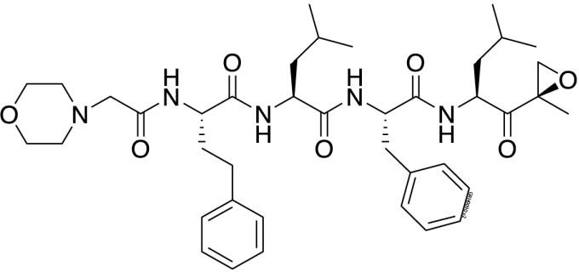
C40H57N5O7 MW: 719.9 g/mol

ATC code
L01XG02

CAS number
CAS Registry No. 868540-17-4

MEDICINE SCHEDULE (POISONS STANDARD)
Prescription Only Medicine (S4)

SPONSOR
Amgen Australia Pty Ltd ABN 31 051 057 428
Level 11, 10 Carrington Street
Sydney, NSW 2000
Medical Information: 1800 803 638 Email: medinfo.JAPAC@amgen.com

DATE OF FIRST APPROVAL
19 December 2016

DATE OF REVISION
TBD

Summary table of changes

Section changed | Summary of new information
4.1 | Change to indication to include use of carfilzomib in combination with daratumumab and dexamethasone and isatuximab and dexamethasone.
4.2 | Inclusion of dosing information for use in combination with daratumumab and dexamethasone and isatuximab and dexamethasone.  Inclusion of advice to note IV hydration is not required on days when IV daratumumab is dosed.
4.8 | Update to adverse events and adverse reactions in line with new combination data. Addition of isatuximab and dexamethasone, no change in safety profile.
5.1 | Inclusion of clinical trial data for use of carfilzomib in combination with daratumumab and dexamethasone and IKEMA for isatuximab and dexamethasone.
6.7 | Addition of ATC code
4.2, 4.4, 4.8 and  5.1 | Editorial changes made to tables and text.
Kyprolis® is the registered trademark of Onyx Pharmaceuticals, Inc., a subsidiary of Amgen Inc.
© 2016-2022 Amgen Inc. All rights reserved.

