Australian Public Assessment Report for Amvuttra
  - Active ingredient: Vutrisiran
  - Sponsor: Medison Pharma Australia Pty Ltd
August 2024

About the Therapeutic Goods Administration (TGA)
- The Therapeutic Goods Administration (TGA) is part of the Australian Government Department of Health and Aged Care and is responsible for regulating therapeutic goods, including medicines, medical devices, and biologicals.
- The TGA administers the Therapeutic Goods Act 1989 (the Act), applying a risk management approach designed to ensure therapeutic goods supplied in Australia meet acceptable standards of quality, safety, and efficacy.
- The work of the TGA is based on applying scientific and clinical expertise to decision-making, to ensure that the benefits to the Australian public outweigh any risks associated with the use of therapeutic goods.
- The TGA relies on the public, healthcare professionals and industry to report problems with therapeutic goods. The TGA investigates reports received to determine any necessary regulatory action.
- To report a problem with a therapeutic good, please see the information on the TGA website.

About AusPARs
- The Australian Public Assessment Report (AusPAR) provides information about the evaluation of a prescription medicine and the considerations that led the TGA to approve or not approve a prescription medicine submission. Further information can be found in Australian Public Assessment Report (AusPAR) guidance.
- AusPARs are prepared and published by the TGA.
- AusPARs are static documents that provide information that relates to a submission at a particular point in time. The publication of an AusPAR is an important part of the transparency of the TGA’s decision-making process.
- A new AusPAR may be provided to reflect changes to indications or major variations to a prescription medicine subject to evaluation by the TGA.

Copyright
© Commonwealth of Australia 2024
This work is copyright. You may reproduce the whole or part of this work in unaltered form for your own personal use or, if you are part of an organisation, for internal use within your organisation, but only if you or your organisation do not use the reproduction for any commercial purpose and retain this copyright notice and all disclaimer notices as part of that reproduction. Apart from rights to use as permitted by the Copyright Act 1968 or allowed by this copyright notice, all other rights are reserved and you are not allowed to reproduce the whole or any part of this work in any way (electronic or otherwise) without first being given specific written permission from the Commonwealth to do so. Requests and inquiries concerning reproduction and rights are to be sent to the TGA Copyright Officer, Therapeutic Goods Administration, PO Box 100, Woden ACT 2606 or emailed to <tga.copyright@tga.gov.au>.

Contents
List of abbreviations 4
Amvuttra (vutrisiran) submission 5
Amvuttra (vutrisiran) – proposed indication 6
Hereditary transthyretin-mediated amyloidosis (hATTR amyloidosis) 6
Current treatment options for hATTR amyloidosis 6
Clinical rationale for vutrisiran in hATTR amyloidosis 6
Regulatory status 7
Australian regulatory status 7
International regulatory status 7
Registration timeline 8
Evaluation overview 8
Quality evaluation summary 8
Nonclinical (toxicology) evaluation summary 10
Clinical evaluation summary 11
Summary of clinical studies 11
Pharmacology 12
Efficacy 18
Safety 22
Risk management plan evaluation summary 25
Risk/benefit assessment 26
Outcome 27
Specific conditions of registration applying to these goods 27
Attachment 1. Product Information 27

List of abbreviations
Abbreviation | Meaning
ACM | Advisory Committee on Medicines
ADRs | Adverse drug reactions
ARTG | Australian Register of Therapeutic Goods
ASA | Australia-specific annex
CMI | Consumer Medicines Information
COR-B | Comparable Overseas Regulator
DLP | Data lock point
GalNAc | N-acetylgalactosamine
hATTR amyloidosis | Hereditary transthyretin-mediated amyloidosis
ISRs | Injection site reactions
mNIS+7 | Modified Neuropathy Impairment Score + 7
NIS | Neurological Impairment Scale
PD | Pharmacodynamics
PI | Product Information
PK | Pharmacokinetics
PSUR | Periodic safety update report
RMP | Risk management plan
RNAi | RNA interference
RTE | Randomised treatment extension period
SC | Subcutaneous
siRNA | small (or short) interfering RNA
TGA | Therapeutic Goods Administration
TTR | transthyretin gene
wt | wild-type

Amvuttra (vutrisiran) submission
Type of submission: | New chemical entity
Product name: | Amvuttra
Active ingredient: | Vutrisiran
Decision: | Approved
Date of decision: | 18 June 2024
Date of entry onto ARTG: | 21 June 2024
ARTG number: | 422290
Black Triangle Scheme | Yes
Sponsor’s name and address: | Medison Pharma Australia Pty Ltd, 1 Bligh Street. Sydney, NSW 2000
Dose form: | Solution for injection.
Strength: | Each pre-filled syringe contains vutrisiran sodium equivalent to 25 mg vutrisiran in 0.5 mL solution
Container: | Pre-filled syringe (Type I glass with a bromobutyl rubber, fluoropolymer coated, plunger stopper) with stainless steel 29-gauge needle with a needle shield.
Pack size: | One single-use pre-filled syringe per pack
Approved therapeutic use for the current submission: | Amvuttra is indicated for the treatment of hereditary transthyretin-mediated amyloidosis (hATTR amyloidosis) in adult patients with stage 1 or stage 2 polyneuropathy
Route of administration: | Subcutaneous injection
Dosage: | 25 mg once every 3 months.  For further information regarding dosage, such as dosage modifications to manage adverse reactions, refer to the Product Information.
Pregnancy category: | Category D: Drugs which have caused, are suspected to have caused or may be expected to cause, an increased incidence of human fetal malformations or irreversible damage. These drugs may also have adverse pharmacological effects.  The use of any medicine during pregnancy requires careful consideration of both risks and benefits by the treating health professional. The pregnancy database must not be used as the sole basis of decision making in the use of medicines during pregnancy. The TGA does not provide advice on the use of medicines in pregnancy for specific cases. More information is available from obstetric drug information services in your state or territory.

Amvuttra (vutrisiran) – proposed indication
This AusPAR describes the submission by Medison Pharma Australia Pty Ltd (the Sponsor) to register Amvuttra (vutrisiran) for the following proposed indication:
Amvuttra is indicated for the treatment of hereditary transthyretin mediated amyloidosis (hATTR amyloidosis) in adult patients with stage 1 or stage 2 polyneuropathy

Hereditary transthyretin-mediated amyloidosis (hATTR amyloidosis)
Hereditary transthyretin-mediated amyloidosis (hATTR amyloidosis), also known as variant transthyretin-mediated amyloidosis, is a rare, autosomal dominant, rapidly progressive, multi systemic disease caused by variants in the transthyretin (TTR) gene that results in debilitating morbidity and high mortality. In hATTR amyloidosis, inherited variants in the TTR gene lead to destabilization of the tetrameric protein and disassociation of the TTR subunits into dimers and individual variant and wild-type (wt) monomers, which subsequently misfold. These misfolded TTR monomers can then self-assemble into oligomers and form amyloid fibrils and plaques in the extracellular space of various tissues. The continued deposition of liver-derived TTR and formation of amyloid fibrils in multiple tissues, including the peripheral nervous system, gastrointestinal tract, and heart, results in debilitating polyneuropathy, malnutrition, and/or cardiomyopathy, respectively.

Current treatment options for hATTR amyloidosis
There are currently three approved therapies in the EU also for the treatment of hATTR amyloidosis, patisiran and inotersen, which target the production of TTR synthesis in the liver by acting on mRNA (through RNAi and RNAse H-mediated cleavage respectively), and tafamidis, which acts by binding to the thyroxine-binding site on TTR to reduce its dissociation into misfolded amyloidogenic monomers. Other treatment options include orthotopic liver transplantation and another TTR tetramer stabiliser (diflunisal). The clinical Evaluator stated it was considered that Amvuttra is not similar to patisiran based on principal molecular structure and not similar to tafamidis and inotersen based on mechanism of action and principal molecular structure. Patisiran is administered intravenously once every 3 weeks, whereas vutrisiran is administered via subcutaneous (SC) injection once every 3 months and is suggested not to be associated with the same infusion-related reactions (and need for premedication) as patisiran.

Clinical rationale for vutrisiran in hATTR amyloidosis
Vutrisiran is an RNA interference (RNAi) therapeutic comprised of a synthetic, chemically modified, double-stranded small (or short) interfering RNA (siRNA) that specifically targets variant and wt TTR mRNA. Reduction of both variant and wtTTR production in the liver, which are the fundamental pathogenic proteins causing hATTR amyloidosis, will reduce ongoing deposition of amyloid deposits, thus halting disease progression.

Regulatory status

Australian regulatory status
This product is considered a new chemical entity for Australian regulatory purposes.

International regulatory status
This submission was submitted through the TGA’s Comparable Overseas Regulator (COR-B) process, using evaluation reports from the European Medicines Agency. The full dossier was submitted to the TGA.
Table 1. The current worldwide regulatory status for Amvuttra.
Country | Date of submission | Status | Indications
USA | 14 April 2021 | Approved 13 June 2022 | Treatment of the polyneuropathy of hATTR amyloidosis in adults
European Union (centralised) | 10 September 2021 | Approved 15 September 2022 | Treatment of hATTR amyloidosis in adult patients with stage 1 or stage 2 polyneuropathy
Brazil | 27 September 2021 | Approved 2 December 2022 | Treatment of hATTR amyloidosis in adults
Japan | 20 December 2021 | Approved 26 September 2022 | Treatment of TTR type familial amyloidosis with polyneuropathy
UK | 28 July 2022 | Approved 16 September 2022 | Treatment of hATTR amyloidosis in adult patients with stage 1 or stage 2 polyneuropathy
Switzerland | 31 October 2022 | Approved 23 June 2023 | Treatment of hATTR amyloidosis in adult patients with stage 1 or stage 2 polyneuropathy
Canada | 31 October 2022 | Under assessment
Argentina | 30 November 2022 | Approved 26 July 2023 | Treatment of hATTR amyloidosis in adult patients with stage 1 or stage 2 polyneuropathy
Mexico | 15 December 2022 | Under assessment
Israel | 11 June 2023 | Under assessment

Registration timeline
Table 2 captures the key steps and dates for this submission.
This submission was evaluated under the standard prescription medicines registration process.
The active ingredient with its proposed indication was given orphan drug designation.
Table 2: Timeline for Amvuttra (vutrisiran) submission PM-2023-04200-1
Description | Date
Designation (Orphan) | 28 August 2023
Submission dossier accepted and first round evaluation commenced | 31 October 2023
Evaluation completed | 22 April 2024
Delegate’s Overall benefit-risk assessment and request for Advisory Committee advice. | 15 May 2024
Registration decision (Outcome) | 18 June 2024
Registration in the ARTG | 21 June 2024
Number of working days from submission dossier acceptance to registration decision* | 207
* The COR-B process has a 175 working day evaluation and decision timeframe.

Evaluation overview

Quality evaluation summary
Vutrisiran is a chemically synthesized, double-stranded small interfering RNA (siRNA) that specifically targets variant and wild-type transthyretin (wtTTR) messenger RNA (mRNA). The siRNA is covalently linked to a ligand containing 3 N-acetylgalactosamine (GalNAc) residues to enable specific uptake in hepatocytes. All nucleosides are 2’-O-methyl or 2’-fluro modified and are connected through 3’-5’ phosphodiester linkages. The antisense strand contains four phosphorothioate linkages and the sense strand contains two phosphorothioate linkages.
The structure can be represented using an expanded structural formula showing the phosphate backbone (Figure 1). The bases involved in base pair formation are connected with a dotted line. All phosphodiester groups are negatively charged with sodium as the counter ion. The structure of R1, the GalNAc containing moiety, is also shown.
Figure 1: Expanded structural formula of vutrisiran
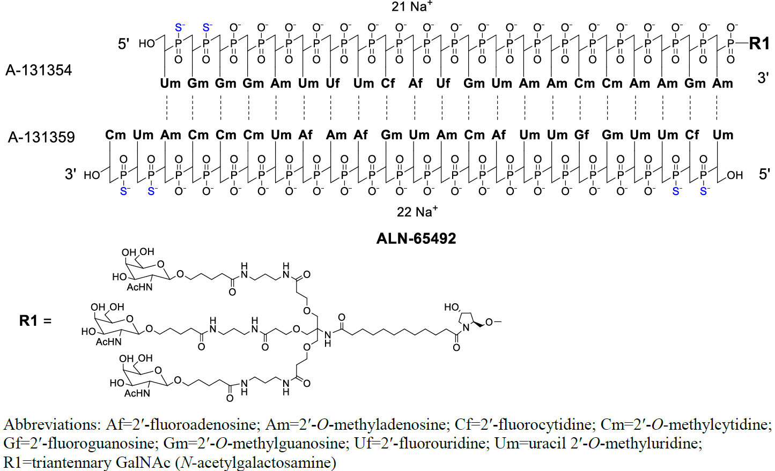
The eight step manufacturing process was deemed acceptable and adequately controlled.
The analytical methods used for the routine quality control assessment of the drug substance were all adequately validated and appropriate for use.
The formulation and manufacturing process have been adequately developed and optimised. Attributes of the final drug product such as osmolality, pH, viscosity and thermal stress have been adequately considered.
There are no overages used in the formulation and the chosen target expelled volume of 0.54 mL ensures that an expelled volume of no less than 0.5 mL is achieved.
The manufacturing process includes sterile filtration and syringe filling under aseptic conditions.
GMP clearances for the drug substance and drug product manufacturing and testing sites are all current and valid past the expected decision date for the submission.
The quality of the drug product is controlled by an acceptable specification that includes tests and limits for appearance, identification (by duplex retention time), identification (by single strand molecular mass), assay (by UV), purity (by ion-pair reversed phase high performance liquid chromatography -UV – non-denaturing), purity (by Anion Exchange-HPLC UV – denaturing), purity (by Ion-pair reversed phase high performance liquid chromatography - UV – denaturing), pH, osmolality, particulate matter, bacterial endotoxins, sterility, volume in container, dose uniformity, container closure integrity and mechanical syringe performance (break loose force, glide force).
The analytical methods used to analyse the drug products were adequately described and validated.
The proposed shelf life of 36 months when stored below 30°C is adequately supported.
The Product Information (PI) document is finalised from a pharmaceutical chemistry and quality perspective.
Product labelling has been finalised from a pharmaceutical chemistry perspective and complies with the applicable requirements of Therapeutic Goods Order (TGO) 91 (except for the syringe label).
The drug product will be marketed in an Australian specific and TGO 91 compliant carton. However, as this is an orphan designation medicine with a small patient population in Australia, the Sponsor is proposing to use the EU-approved syringe label which does not comply with two aspects of TGO 91. Given the non-compliance issues for the syringe label, the Sponsor’s request for a 2 year exemption under section 14 of the Act from compliance with TGO 91 Sections 9(1)(a), 9(3)(a)(i), 9(3)(b) and 11(2)(f)(v), is considered reasonable and should be granted.
Approval is recommended from a pharmaceutical chemistry and quality control perspective.

Nonclinical (toxicology) evaluation summary
The nonclinical Evaluator raised no objections to the registration of Amvuttra for the proposed indication.
The scope and quality of the submitted nonclinical dossier was mostly acceptable, with studies consistent with the principles of the International Council for Harmonisation of Technical Requirements for Pharmaceuticals for Human Use (ICH) guidance for the nonclinical testing of pharmaceuticals. All pivotal safety-related studies were conducted according to Good Laboratory Practice (GLP). Carcinogenicity studies are expected to be submitted post-market by the Sponsor upon completion.
In vitro, vutrisiran inhibited TTR mRNA in primary monkey hepatocytes. Vutrisiran is not pharmacologically-active in rodents or rabbits, but is active in humans and cynomolgus monkeys. Studies with vutrisiran given to mice expressing the human TTR gene and monkeys showed treatment-related reductions in serum TTR protein levels, thus supporting the proposed clinical indication. No studies were submitted to determine if vutrisiran could suppress disease progression or ameliorate disease symptoms. Therefore, no comment in regard to efficacy can be given based on nonclinical data.
Of the non-TTR transcripts identified as sharing some complementarity with the antisense strand of vutrisiran, none of those target genes were affected by vutrisiran in vitro. In vivo, vutrisiran decreased circulating vitamin A and thyroxine (T4) in monkeys. This was not associated with signs of vitamin A deficiency or effects on the thyroid or pituitary.
A specialised safety pharmacology study conducted in cynomolgus monkeys that covered the cardiovascular and respiratory systems did not reveal any adverse or treatment-related effects. As well, no adverse effects on neurological parameters were observed in monkeys from repeat-dose toxicity studies of up to 9 months.
The pharmacokinetic profile of vutrisiran in rats and monkeys was qualitatively similar to humans. Plasma half-life was similar between monkeys and humans. Plasma protein binding was moderate in humans and animal species (75–87%). Tissue distribution of drug-related material was wide but showed localised distribution to the intended target tissue (liver), the main route of elimination (kidneys) and site of administration (injection site in rats). Vutrisiran is metabolised by exonucleases in all species, which degrade vutrisiran to shorter nucleotides of varying length.
Vutrisiran did not exhibit any appreciable inhibitory activity against Cytochromes P450 isozymes. The induction of Cytochromes P450 enzymes and drug transporter substrate/inhibition was not investigated, however in vitro data from other siRNA-GaINAc conjugates indicate that this class of drugs does not act as a substrate, inhibitor or inducer of major CYPs or drug transporters.
Vutrisiran had a low order of acute toxicity following subcutaneous injection in rats and monkeys. Repeat-dose toxicity studies using the clinical route (subcutaneous) were conducted in mice (up to 13 weeks), rats (up to 6 months) and cynomolgus monkeys (up to 9 months). Target organs for vutrisiran were associated with areas of high localisation of the drug. These included the liver – the intended pharmacological target, through its GalNAc linker, the kidneys – the main excretory pathway, the injection site – site of administration, and the lymph nodes. All of the effects were non-adverse, showing reversal in recovery animal groups.
Vutrisiran was not mutagenic in the bacterial reverse mutation assay or clastogenic in vitro (human peripheral blood lymphocytes) or in vivo (rat micronucleus test).
Carcinogenicity studies with vutrisiran were not submitted. The Sponsor indicates that a 2-year carcinogenicity study in CD-1 mice and a 2-year carcinogenicity study in rats are currently ongoing and will be submitted once completed.
Studies on fertility, embryofetal development and pre/postnatal development were conducted with vutrisiran in the pharmacologically-unresponsive species, rats and/or rabbits. Fertility was unaffected in male and female rats treated with vutrisiran. A rat-specific surrogate (pharmacologically active) had no effect on female fertility or embryofetal development in rats. No clinically relevant effects were seen in the embryofetal development and pre/postnatal studies. The negative embryofetal development findings are not considered reliable, given the important roles of thyroid hormones and vitamin A in fertility and embryofetal development. A pregnancy category D is warranted given the potential adverse embryofetal development effects associated with an imbalance in vitamin A levels.
Dedicated local tolerance studies were not conducted but repeat-dose toxicity studies showed injection site reactions (minimal/slight mononuclear or mixed inflammatory cell infiltrates with vacuolated macrophages) to vutrisiran in mice, rats and monkeys.
In summary, in vivo effects of vutrisiran in mice expressing the human TTR gene and monkeys lend some support for the proposed indication. No clinically relevant organ system hazards were identified in the set of animal safety studies. Injection site reactions may be seen in patients. The proposed pregnancy category for vutrisiran (Category D) is acceptable.

Clinical evaluation summary

Summary of clinical studies
The submission provided an assurance that the received clinical dossier is the same as that received by the COR at the time of initial submission, while at the same time, also being inclusive of updated changes (e.g. Pharmacovigilance Risk Assessment Committee (PRAC) consideration of a subsequent Periodic safety update report (PSUR)). Given the epidemiology and typical age of onset of hATTR amyloidosis, a product-specific paediatric investigation plan waiver had been granted. Similarly, requirements under the US Paediatric Research Equity Act were waived, given the rarity of the disease. All studies included in the clinical dossier were reported to have been conducted in compliance with Good Clinical Practice guidelines and to have also met the requirements of the Declaration of Helsinki.
The vutrisiran clinical development program includes a:
- Phase 1 single-dose study in healthy volunteers (Study 001),
- a pivotal Phase 3 study in hATTR amyloidosis patients with polyneuropathy (HELIOS-A) and
- a Phase 3 study in patients with ATTR amyloidosis with cardiomyopathy (HELIOS-B).
Study 001 and HELIOS-A were used to submit a marketing authorisation application for the treatment of hATTR amyloidosis patients with polyneuropathy.

Pharmacology

Pharmacokinetics

Phase 1 Study in Healthy Subjects
ALN-TTRSC02-001 (Study 001): A phase 1, randomised, single-blind, placebo-controlled, single- ascending dose, safety, tolerability, pharmacokinetics, and pharmacodynamics study of subcutaneously administered ALN-TTRSC02 (vutrisiran) in healthy subjects.
Study 001 was a phase 1, randomised, single-blind, placebo-controlled study of vutrisiran administered SC to healthy adult subjects, including subjects of Japanese descent, at 1 centre in the UK. The study was designed to evaluate the safety, tolerability, pharmacokinetics (PK), and pharmacodynamics (PD) of single doses of vutrisiran. Single ascending doses of vutrisiran (25, 50, 100, 200, and 300 mg) were investigated in 5 sequential cohorts, followed by the enrolment of 3 additional cohorts (5, 25, and 50 mg), and then 2 additional cohorts of subjects of Japanese descent (25 and 50 mg).
Vutrisiran plasma PK samples were taken predose and 10 minutes, 30 minutes, and 1, 2, 4, 6, 8, 12, 24 and 48 h post-dose. Urine samples were taken predose and 6, 12, and 24 h post-dose, and on days 3, 8, 15, 22, 29, 43, 57, and 90. Urine was pooled from 0-6, 6-12, and 12-24 h.
TTR and vitamin A sampling was at baseline and on days 1, 3, 8, 15, 22, 29, 43, 57, 90, 118, 146,
174, 202, 230, 258, 286 and 314 with an additional vitamin A sample at screening.
In total, 80 subjects, including 16 subjects of Japanese descent, were enrolled across 10 study cohorts and randomised 6:2 to receive a single dose of either vutrisiran (60 subjects) or placebo (20 subjects).

Phase 3 study in patients with hereditary transthyretin amyloidosis
ALN-TTRSC02-002 (HELIOS-A): A phase 3 global, randomized, open-label study to evaluate the efficacy and safety of ALN-TTRSC02 in patients with hATTR amyloidosis
Vutrisiran plasma PK samples were taken on Days 1 and 253 predose and 3, 6, and 24 h post-dose as well as on Days 85, 169, 337, 421, and 505 predose and 3 hours post-dose. TTR and Vitamin A sampling was at baseline and in weeks 3, 6, 12, 18, 24, 30, 36, 42, 48, 54, 60, 66, 72, 78, and month 18.
There were 164 patients who were randomised to vutrisiran (122 patients) or patisiran (42 patients).
The key pharmacokinetic results for single (Study 001) and multiple dose (HELIOS-A) administration of vutrisiran are presented in Tables 3 and 4.
Table 3. Study 001: Summary of single-dose plasma and urine PK parameters for vutrisiran (PK analysis set)
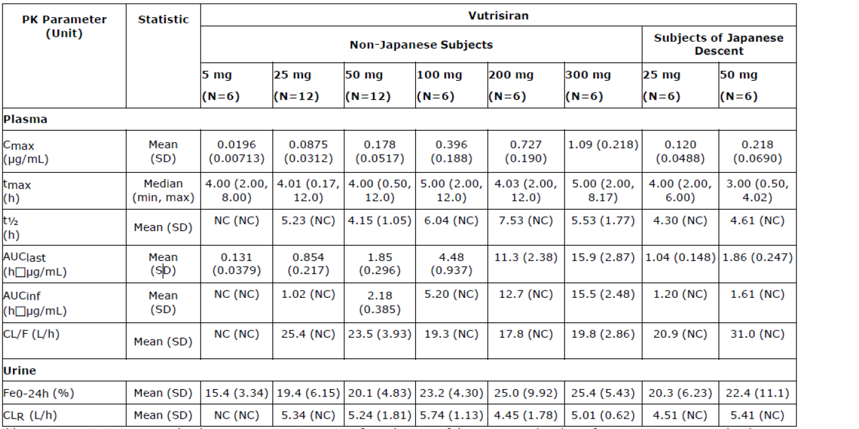
Table 4. HELIOS-A: Summary of plasma pharmacokinetic parameters for vutrisiran on Day 1 and Day 253 (PK population)
Following a single SC dose of 5 to 300 mg vutrisiran in healthy subjects, the median t_{max} ranged from 3 to 5 hours post-dose. When administered at a dose of 25 mg SC to patients, vutrisiran was rapidly absorbed with individual t_{max} values ranging from 2 to 6.6 hours.
Vutrisiran plasma exposure is predominantly driven by liver uptake. In both, patients and healthy volunteers, vutrisiran was rapidly absorbed after SC injection. Patients showed a slightly higher variability in their t_{max} values than healthy volunteers. Results were in line with values that were to be expected based on the non-clinical data and the clinical experience with similar drug products.
Plasma protein binding of vutrisiran showed a dose-dependent effect, with significantly lower
binding at higher concentration, however in clinical practice a fixed dose of 25 mg will be used. Therefore, a high plasma bound ratio of about 80% of drug substance can be expected.
After absorption vutrisiran is rapidly eliminated from the plasma with a half-life between the
range of 2 to 7.5 hours. Values for t_{1/2}were comparable between healthy volunteers and patients. Only a small fraction of the drug is excreted in urine. Elimination from plasma is assumed to be mainly driven by distribution of the drug to the liver. Due to the long residence time in the liver, there is no correlation between drug plasma concentrations and efficacy.
There were no unexpected metabolites identified in the clinical studies. These results are in-line with what could be expected based on experience with similar RNA-based drug products and with general data on nucleotide metabolism.

Population PK data (popPK)
Population pharmacokinetic analysis of vutrisiran was performed using data from 182 participants (60 healthy subjects and 122 patients with hereditary ATTR amyloidosis) from Study 001 and HELIOS-A), including single and multiple dose administration of SC vutrisiran.
Vutrisiran plasma concentration-time profiles were best fit by a 2-compartment model, with absorption from the SC injection site via a first-order process with rate constant Ka. Total plasma clearance was the sum of hepatic clearance and renal clearance. Final PK parameters are given in the table below.
Table 5: Parameter Estimates for the Final Vutrisiran Population PK Model
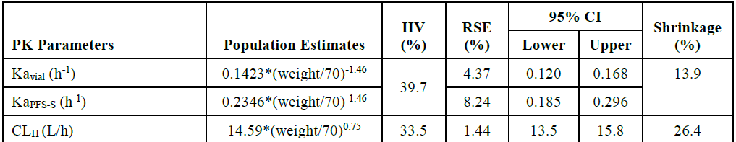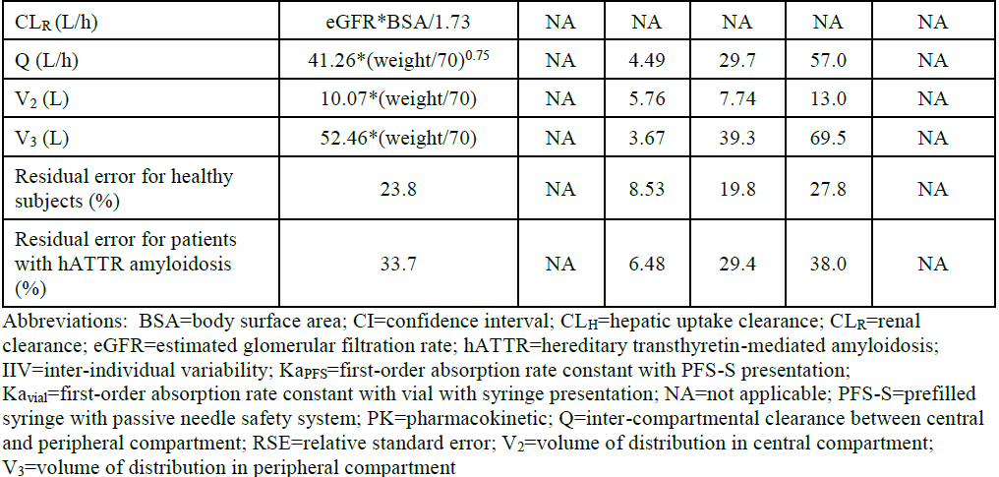
The EU Assessor commented “The PPK model for plasma concentrations has been evaluated with standard plots and is considered acceptable.”

Pharmacodynamics (PD)
Pharmacodynamic effects of vutrisiran have been investigated in a single-ascending dose first-in-human trial as well as the pivotal study in patients. The clinical development rationale for vutrisiran was to find a dosing schedule that shows PD activity that is comparable to patisiran but where the drug is given less frequently. Pronounced and prolonged primary and secondary pharmacodynamic effects were observed even after single doses as low as 5 mg. The biomarkers of pharmacodynamic activity confirmed that 25 mg vutrisiran given subcutaneously once every three months provides stable and durable reduction of TTR comparable to patisiran.

Mechanism of action
Vutrisiran is an RNAi therapeutic comprised of a synthetic, chemically modified, double-stranded siRNA. It contains an GalNAc ligand allowing rapid and specific delivery to hepatocytes via uptake by the asialoglycoprotein receptor. Following delivery to the liver, vutrisiran uses the naturally occurring RNAi pathway to specifically target and silence TTR mRNA. Reduction of both variant and wt TTR production in the liver reduces ongoing deposition of amyloid deposits and potentially allows for clearance of existing deposits, thus halting or reversing disease progression. The clinical data from the patisiran APOLLO study supports the therapeutic hypothesis for vutrisiran.

Primary pharmacology
Single SC doses of vutrisiran (5 to 300 mg) in healthy adult subjects reduced serum TTR in a dose-dependent manner, with higher doses achieving a faster onset and more durable suppression of serum TTR levels. The PD effect of 25 mg vutrisiran was comparable across Study 001 and HELIOS‑A, with a similar magnitude of TTR reduction from baseline at 90 days post dose (median of 81.8% in Study 001 versus 73.6% in HELIOS-A). With repeat q3M dosing in HELIOS‑A, further TTR reductions were achieved, though it is not clear if at the time of the endpoint, Modified Neuropathy Impairment Score + 7 (Ionis Version) (mNIS+7) (9 months, not formally the primary endpoint for EU) a true steady state was already achieved. In healthy volunteers TTR reductions were comparable between Japanese and Non-Japanese subjects.

Secondary pharmacology
Since TTR serves as a carrier for vitamin A, a secondary effect of treatment may be dose-dependent decreases in serum vitamin A levels. Serum vitamin A profiles paralleled changes in serum TTR and a significant correlation was found between TTR and vitamin A reduction (correlation coefficient of 0.9388; p<0.0001). Vitamin A reductions in Japanese subjects were similar to those in the Non-Japanese population.
Across Study 001 and HELIOS-A, the incidence of treatment-emergent anti-drug antibodies (ADA) due to vutrisiran was 2.2% (4/179). The presence of ADA had no impact on the PK, PD, efficacy, or safety of vutrisiran.
Results from Study 001 showed that vutrisiran has no effect on QTc interval at supratherapeutic plasma concentrations approximately 12-fold higher than the mean Cmax of vutrisiran at the clinically relevant dose of 25 mg.

Dose-response relationship
Single SC doses of vutrisiran reduced serum TTR in a dose-dependent manner, with higher doses achieving faster, greater magnitude, and more durable suppression of serum TTR levels with reduced inter-patient variability. A semi-mechanistic population PK/PD model was developed with data from healthy subjects to examine the relationship between vutrisiran dose and serum TTR reduction. With repeat dosing, at steady state the 25 mg q3M regimen was predicted to achieve median trough TTR reduction of 86.2%. This is similar to the observed median trough TTR reductions of 81% with patisiran at Months 9 and 18. In HELIOS-A, the observed median trough TTR percent reduction at Month 9 was 84.8%.

PK/PD and PD-Efficacy Relationship
Population PK/PD analyses in healthy subjects and hATTR amyloidosis patients (n=202) demonstrated a relationship between predicted vutrisiran liver concentrations and reductions in serum TTR. Covariate analyses showed similar TTR reductions in patients with mild to moderate renal impairment or mild hepatic impairment, as well as by sex, race, prior use of TTR stabilisers, TTR genotype, ADA status, delay in dosing due to COVID-19 pandemic, vutrisiran presentation (vial with syringe versus prefilled syringe), and across a wide age and body weight range.

The EU Assessor concluded: “The population PK/PD model supports the use of vutrisiran 25 mg administered q3M in all patients with ATTR amyloidosis.”

A disease progression model to quantitatively describe mNIS+7 change over time as a function of serum TTR levels in patients with hATTR amyloidosis was developed. Over 9 months, a median +12.9 change in mNIS+7 is predicted in placebo treated patients and a median -0.654 change in mNIS+7 is predicted in vutrisiran-treated patients (median TTR reduction 85.4%). Over 18 months, a median +27.4 change in mNIS+7 is predicted in placebo-treated patients and a median -2.15 change in mNIS+7 is predicted in vutrisiran-treated patients (median TTR reduction 88.7%).
Vutrisiran significantly reduced disease progression across all subgroups evaluated in the model, which included sex, race, TTR genotype, prior TTR stabilisers use, symptom onset age at less than 50 years, treatment group (vutrisiran versus patisiran), delay in dosing due to COVID-19 pandemic, age, body weight, baseline serum TTR, and baseline mNIS+7.
The EU Assessor concluded: “The disease progression model supports the use of 25 mg vutrisiran administered q3M in all patients with hATTR amyloidosis.”
In terms of pharmacodynamics the overall conclusions of the EU Assessor were:
“Primary and secondary pharmacodynamic effects of vutrisiran have been investigated in two clinical trials. A dose dependent reduction of TTR with a prolonged effect even after single doses was found. The clinical development rational that was used for vutrisiran was to achieve similar TTR reduction as found with patisiran. Overall, a durable and stable reduction of TTR has been established with corresponding secondary reductions of vitamin A, although some uncertainties about long-term steady state effects require some clarification. (OC) Overall, however, the pharmacodynamic effects as well as the dose-response relationship have been well characterized and support use of vutrisiran at the 25 mg 3qM dose.”
Within the Sponsor’s response to the Day 150 Clinical Assessment Report, they stated that based on the vutrisiran PK-PD model and predicted half-life of vutrisiran in the liver, approximately 90%, 95% and 99% of steady state is expected by month 6, 9 and 18, respectively. Hence the Week 36 median trough levels were reported to achieve a value as close to steady state as possible in the initial study cut off point of 9 months. The Sponsor’s reasoning for a median range reduction level at month 9 being below the trough reduction at month 6 was due to the incremental difference in vutrisiran’s steady state TTR lowering from month 6 to month 9, shown in Figure 2.
Figure 2. Observed percentage change in TTR from baseline at month 6 (week 24) and month 9 (week 36) following the first dose of vutrisiran (25mg q3M) – HELIOS A.
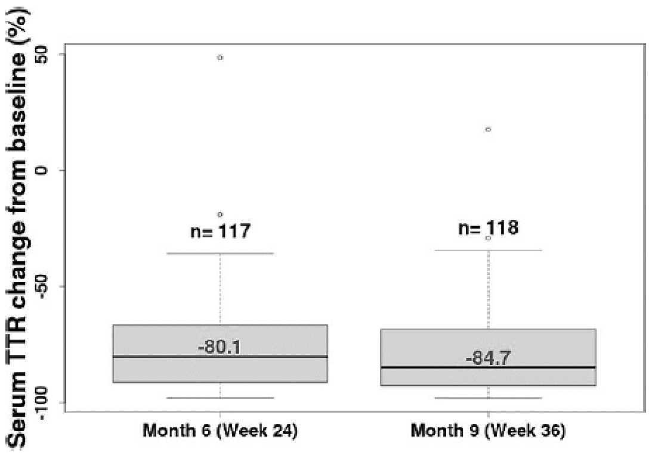
The Sponsor submitted data available from month 18 which indicated that the median peak, trough and average TTR reductions (%) between weeks 60 and 72 from baseline were 91.6%, 86.2% and 86.9%, respectively. This was consistent with modelling predictions; that month 18 TTR lowering would be slightly greater (predicted 99% from 95%) than month 9 results. Additionally, the time-averaged TTR at month 18 fell within the peak and trough TTR values, which as the Sponsor proposed, was more reflective of true steady state TTR reductions expected with chronic therapy. Similarly increased reductions at month 18 were observed for vitamin A levels, however the differences had not translated into any observed adverse events or impact on the safety profile of vutrisiran.

Efficacy
The HELIOS-A Study was the one available study for the evaluation of efficacy, safety, PK and PD of vutrisiran in adult patients with hATTR amyloidosis with polyneuropathy. The placebo group was derived from the APOLLO study, a completed study investigating patisiran. In relation to the HELIOS-A study confirmatory primary analysis and the formal primary and secondary endpoints review at 18 months was considered by the EU, not 9 months as reviewed by the US.
HELIOS-A is a Phase 3 global, randomised, open-label study to evaluate the efficacy and safety of vutrisiran in patients with hATTR amyloidosis. The primary objective is to determine the efficacy of vutrisiran in patients with hATTR amyloidosis by evaluating the effect on neurologic impairment. The secondary objectives are 1) to determine the efficacy of vutrisiran on quality of life, gait speed, neurologic impairment, nutritional status, and disability, and 2) to demonstrate the noninferiority of vutrisiran compared to patisiran with respect to serum transthyretin levels.
The study was conducted at 57 centres in 22 countries in North America, South America, Europe, Asia, and Australia between February 2019 and August 2021.
The study included 2 parts: an 18-month treatment period, with primary efficacy analysis at month 9 and additional efficacy analyses at month 18, and an 18-month treatment extension period. Subjects were randomised 3:1 to receive vutrisiran or patisiran for the duration of the 18-month treatment period. Randomisation stratifications included TTR genotype (V30M vs non-V30M) and baseline Neurological Impairment Scale (NIS) score (<50 and ≥50). All patients included in the randomised treatment extension period (RTE), upon completion of the 18-month treatment period, were randomised 1:1 to receive vutrisiran 25mg 3 monthly or vutrisiran 50mg 6 monthly. During this RTE, safety assessments occurred quarterly, and efficacy assessments occurred at month 9 and month 18.
Eligibility was limited to adults aged 18 to 85 years, with a documented TTR mutation, and a confirmed diagnosis of symptomatic hATTR amyloidosis with a NIS of 5 to 130 (inclusive) a polyneuropathy disability score of ≤ 3b, and Karnofsky Performance Scale Index ≥ 60%.
160 subjects were planned, and 164 subjects were enrolled. 122 patients were randomised to the vutrisiran group and 42 patients to the patisiran group. 164 subjects were included in the analyses. These patients were reported to broadly represent the disease demographic typical of hATTR amyloidosis.
Within the Day 150 Critical Assessment Report, the Sponsor responded to the following major efficacy concerns:
Comparison of the vutrisiran group in HELIOS-A with the placebo group in APOLLO.
The Sponsor stated that the HELIOS-A and APOLLO studies had similar inclusion and exclusion criteria, and the same assessments, definitions, and timing of endpoints. They considered that it was not ethical to conduct a placebo-controlled study when effective therapy was known, and that a non-inferiority design with patisiran as a control arm was not considered feasible given the required large sample size.
Provision of 18 Month data
The analyses at Month 18 were to be considered the confirmatory analyses. A second CSR for HELIOS-A with a data cutoff date of the 26th of August 2021, was finalised and presented for evaluation. The Sponsor suggested that at Month 18, vutrisiran had demonstrated persistent efficacy and HELIOS-A met all secondary endpoints. A summary of these results is presented in the table below. The COR-Evaluator acknowledged these findings and agreed that based on primary, key secondary and secondary endpoints, that vutrisiran demonstrated in HELIOS-A statistically significant differences from an external placebo group and that efficacy had been shown at Month 9 and maintained until Month 18. A limitation of these results was that analyses of the mITT population should be updated and provided. A summary of major efficacy results is included in the tables and figures below.
Table 6. Clinical efficacy results summary for HELIOS-A at month 9 and month 18
Figure 3. mNIS+7 change from baseline over time (mITT population)
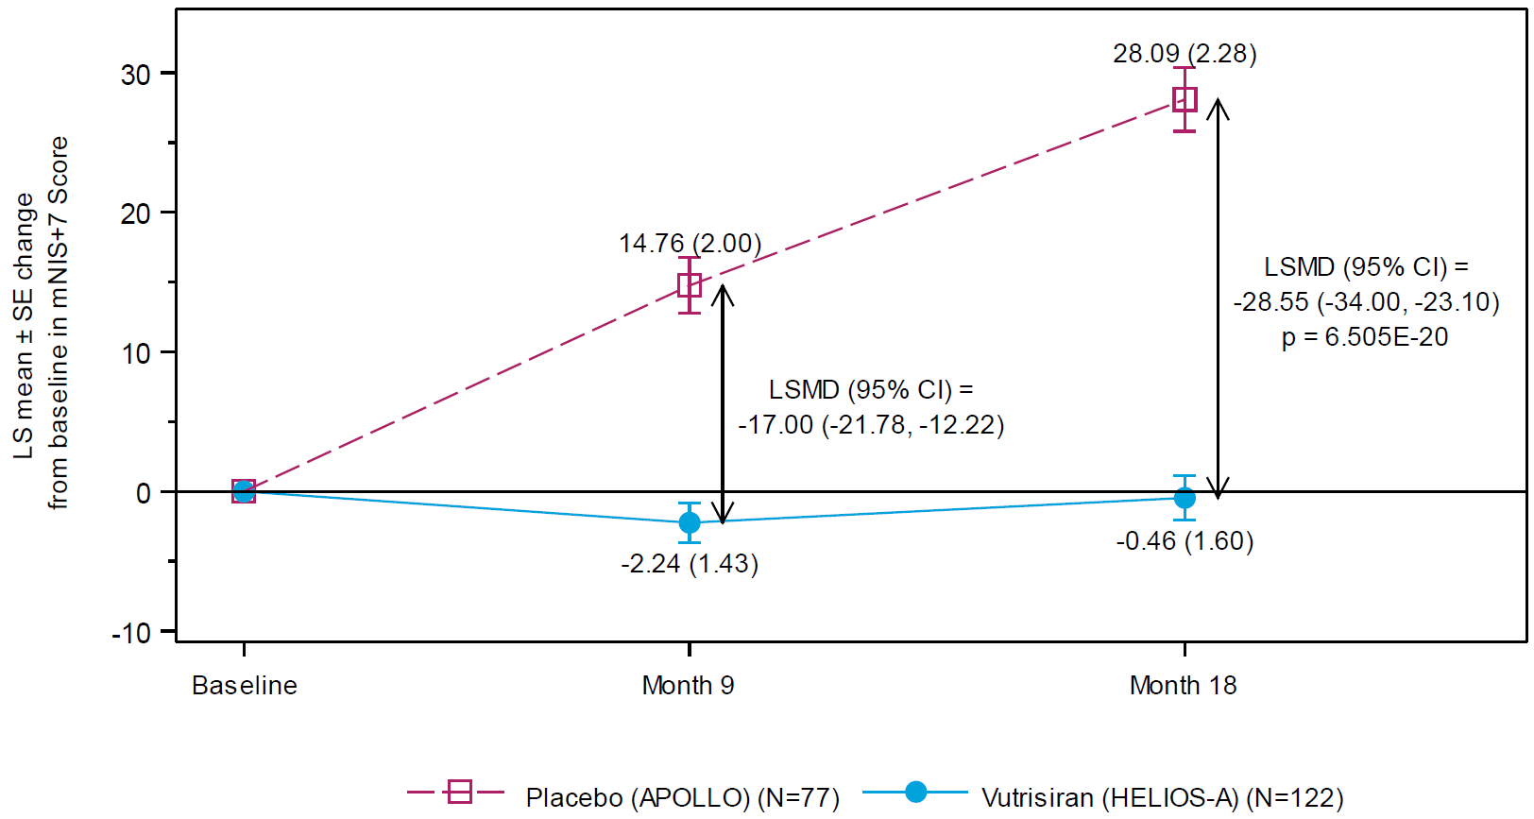
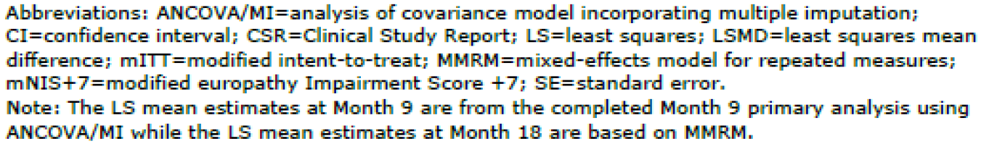
Figure. 4 Norfolk Quality of Life - Diabetic Neuropathy (QoL-DN) Total Score: Change from Baseline Over Time Series Plot (mITT population)
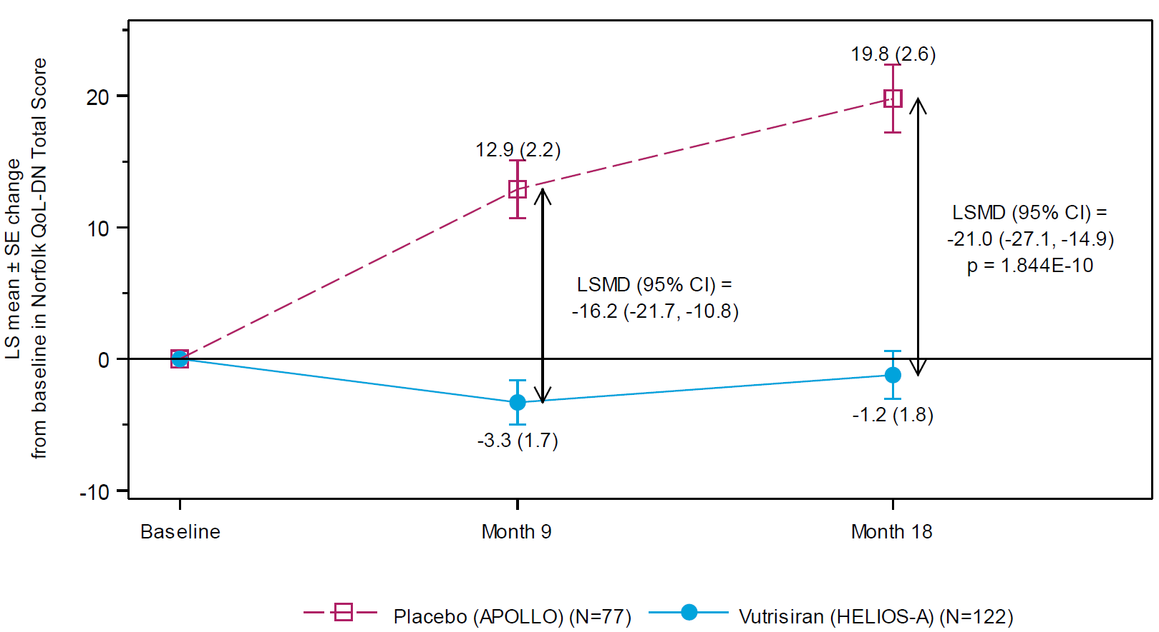
Table 7. Serum TTR (mg/L) percent reduction from baseline through month 18 (TTR PP population)
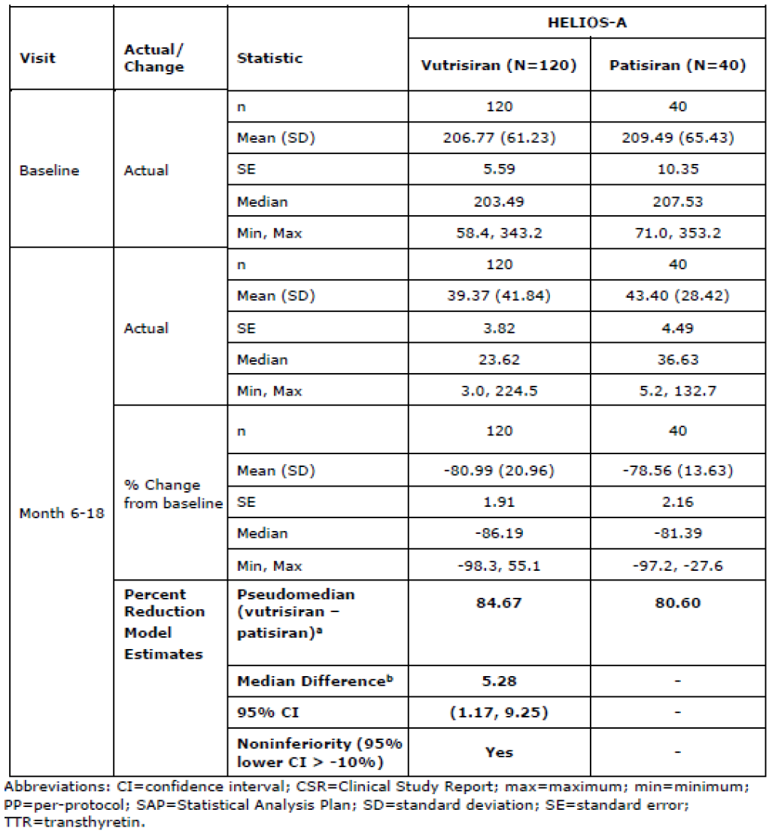
Extension of indication to include patients with stage 3 polyneuropathy.
The Sponsor presented several arguments for the inclusion of patients with stage 3 neuropathy in the treatment indication, despite the lack of patients with this disease severity included in the HELIOS-A study design. The COR Evaluator acknowledged these arguments, however maintained the position that no stage 3 patients had been recruited in HELIOS-A and that certain selective analyses based on neuropathy impairment score (NIS) quartiles could not substitute for the absence of data for these patients. The issue was considered unresolved and the request to narrow the therapeutic indication was maintained by the COR Evaluator. The restriction of the treatment indication to patients with only stage 1 or stage 2 polyneuropathy was accepted by the Sponsor.
There were no unresolved efficacy issues at the conclusion of the day 195 Critical Assessment Report

Safety
During the initial COR-assessment process, HELIOS-A was the primary source of safety information for vutrisiran, where 133 patients with hATTR amyloidosis with polyneuropathy were exposed to vutrisiran, with a cumulative exposure of 181.6 person years as of the safety cut off (9th of April 2021). The main safety comparison within this study occurred with the placebo group derived from the APOLLO Study. Some concerns were raised in relation to the APOLLO placebo population group having more advanced diseased related to hATTR amyloidosis (including the baseline severity of disease-associated cardiomyopathy), and that HELIOS-A was an open-label study.
In the Day 150 Clinical Assessment Report an updated clinical study report for the HELIOS-A 18-month treatment period was provided, including safety data (as of 26th of August 2021). This represented a cumulative vutrisiran exposure increased from 131.3 patient years to 233.0 patient-years. Adverse events occurring in >5% of vutrisiran-treated patients during the extended treatment period are included in the table below.
Table 8. Adverse events in ≥5 of vutrisiran-treated patients by preferred term during the treatment period (safety population)
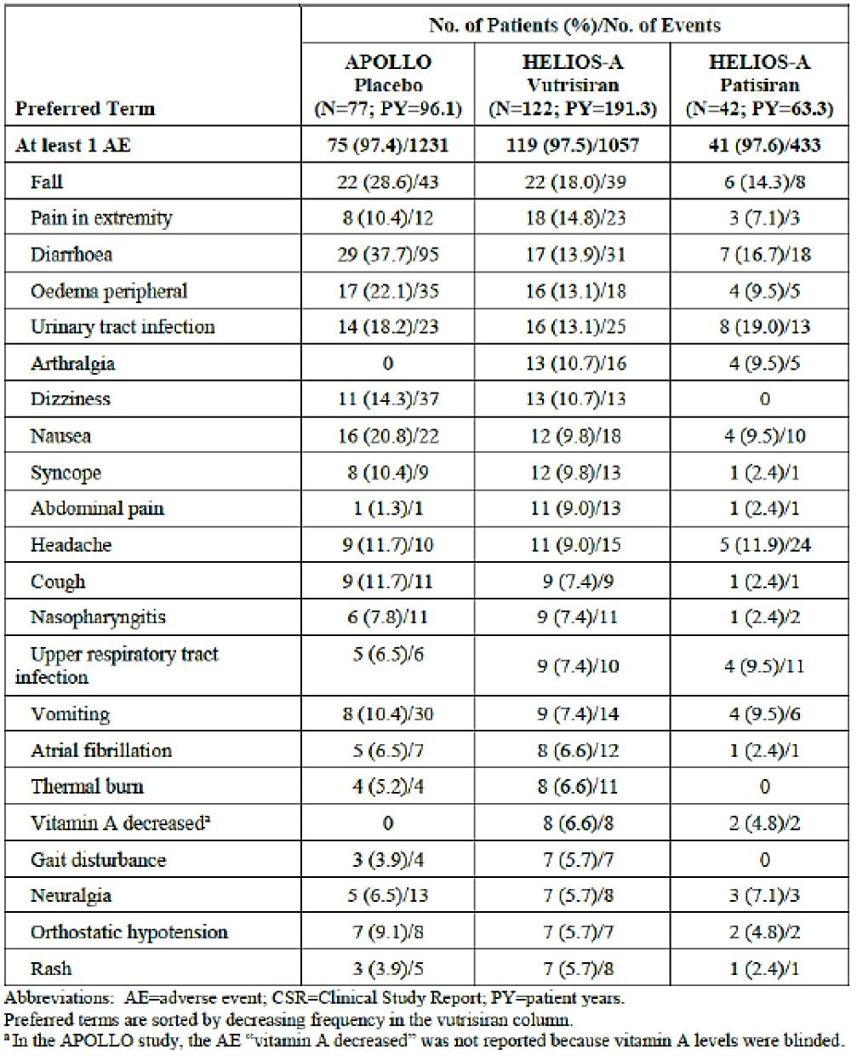
Injection site reactions (ISRs) were reviewed during both the treatment and treatment extension period. ISRs were reported in 4.1% of patients in the vutrisiran group and in 0.6% of the 836 total doses of vutrisiran administered in the original study period. In the treatment extension period, ISRs were reported in 3.9% of patients in the vutrisiran group (6 patients) and in 0.6% of the 1079 doses of vutrisiran administered. All were nonserious, transient and considered mild in severity, with no ISRs leading to treatment discontinuation.
The Sponsor also provided an analysis of the safety profile of the HELIOS-A vutrisiran group compared to that of the pooled (HELIOS-A and APOLLO) patisiran group and presented all TEAEs that occurred with ≥ 2% higher frequency in the HELIOS-A vutrisiran vs pooled patisiran group and that had also displayed a higher incidence vs the APOLLO placebo group. In these analyses, pain in extremity, injection site reaction, and arthralgia were proposed as adverse drug reactions (ADRs). ADRs that occurred with a ≥ 2% higher frequency in the HELIOS-A vutrisiran vs the pooled patisiran group were ISRs, decreased vitamin A and dry eye.
There were nine medical concept groups that had ≥ 2% higher incidence in the vutrisiran compared with the pooled patisiran group, including pain in extremity, vitamin A decreased, visual impairment, with six groupings with a lower or similar incidence in HELIOS-A vutrisiran vs APOLLO placebo group.
It was considered that no additional safety concerns were observed from the presented comparison of the safety profile of the HELIOS-A vutrisiran group with that of the pooled (HELIOS-A and APOLLO) patisiran group.
The Sponsor was requested to also comment on the following issues specifically:
Influenza like illness and rash with possible association with hypersensitivity reactions
The Sponsor indicated that during the 18-month treatment period, AEs of influenza like illness were reported at a similar frequency in the vutrisiran group (3.3%) versus the APOLLO placebo group (2.6%), and the clinical features of the reported events were inconsistent with systemic hypersensitivity reactions. Rash was observed during the 18-month treatment period at comparable rates in the vutrisiran group (5.7%) and the APOLLO placebo group (3.9%) The COR Evaluator’s overall conclusion was that there was currently insufficient data to justify the inclusion of influenza like illness (or rash) as an ADR in the SmPC.
Potential systemic hypersensitivity reactions
The Sponsor was asked to comment on severe AEs reported in two subjects concerning potential systemic hypersensitivity reactions. The first patient developed dizziness, dry mouth, hyperhidrosis, hyperthermia, scleral discolouration, and dyspepsia on day 1 of the first dose of study drug. All of the AEs were transient. The second patient developed peripheral oedema related to vutrisiran on Day 317 however this case was not considered related to a potential hypersensitivity reaction.
The COR Evaluator noted that there was no clear concern regarding hypersensitivity events and there was no requirement for specific conditions to facilitate safe home administration. However, it is noted in the SmPC that vutrisiran should still be administered by a healthcare professional.
Raised alkaline phosphatase levels.
The Sponsor was requested to discuss the clinical relevance of alkaline phosphatase (ALP) level increases found in the HELIOS-A study, where ALP increases (>1.5 ULN) were reported in 11 (9.0%) vutrisiran vs 1 (2.4%) patisiran subjects and in 1 (1.3%) APOLLO placebo subjects.
In their response, the Sponsor provided brief details regarding each of these 11 vutrisiran treated cases. The Sponsor suggested at least 4 of the cases, in which the ALP was elevated at baseline, had a confounding factor, or had ALP levels that were relatively stable from baseline. Of the other 7 cases where ALP levels were normal at baseline, the concurrent rises in other liver function tests were reportedly transient and mild, with no pattern in the time of onset of the ALP elevation.
Despite these findings, the COR Evaluator noted that there appeared to be a steady increase in ALP levels over time, which appeared to develop similarly in the HELIOS-A patisiran group, constituting a mean relative change from Day 1 to Day 673 of 36.71% for vutrisiran and 32.24% for patisiran, respectively. The clinical relevance of this continuous relative increase was thought to be currently unclear.
Within their submission, the Sponsor discusses their past review of cumulative data (from May 10th, 2016, onwards) that informed their analysis of the abnormal liver function tests signal within the PBRER 01 dated 13th of February 2023. All AEs coding to the SMQ Drug related hepatic disorders were searched. Ultimately, the entire signal was reportedly closed as refuted. The Sponsor also provided findings from a search of all SAEs and AECIs from vutrisiran clinical trials and post-marketing event reports (SAEs/AEs/AECIs) through to the 5th of March 2024. Of the 6229 identified events coding to the MedDRA SOC hepatobiliary disorders, there was only 1 event with PT blood alkaline phosphatase increased. The Evaluator considers this long-term monitoring and reporting to be adequate. Additionally, the Evaluator suggests that a statement regarding the average trend of ALP elevation could be considered as an inclusion to Section 4.4 of the PI ‘Effects on laboratory tests.’
Cardiac arrhythmia HLGT adverse events
It was noted that there was a three times higher incidence of cardiac arrhythmia HLGT AEs in the HELIOS-A vutrisiran vs patisiran group, which was found in the overall safety population and cardiac subpopulation, including a higher incidence of syncope in the HELIOS-A vutrisiran group. The Sponsor adequately addressed the apparent higher frequency in the HELIOS-A vutrisiran group vs the patisiran group and the COR Evaluator accepted the findings and found that the currently available information did not raise any serious cardiac safety concerns.
ECG changes from baseline, including QTcF abnormalities.
Although infrequent, it was noted that clinically significant ECG changes from baseline had occurred only in the vutrisiran group and not in the patisiran group. Despite this finding, at both Month 9 and Month 18, the incidence of clinically significant changes from baseline were substantially lower in the vutrisiran group compared with the APOLLO placebo group at both timepoints. The COR Evaluator felt that no clear safety signal could be derived from this data.
Other AEs
The COR Evaluator determined that pain in extremity (noted in the above table) met the frequency criteria for it to be added to Section 4.8 of the SmPC. In addition, it was noted that the incidence of arthralgia had raised from common to very common (9.8% to 10.7%), and for this to be reflected as such in the SmPC.
An updated detailed subgroup analysis was provided, and there was only a higher incidence of SAEs and TEAEs in the subgroup aged ≥ 65 years, representing adverse events typically expected with advancing age. Therefore, the safety profile was otherwise considered consistent across the evaluated subgroups (age, sex, race, weight, genotype, FAP stage and geographic region). In addition, the dose of Vitamin A supplementation that was recommended within the HELIOS-A study was clarified to be 2500IU to 3000IU daily, and this was advised to be reflected in the product documentation.
Overall, in the CHMP Final Assessment Report, it was agreed that the listed very common frequency adverse events would be arthralgia and pain in extremity, with dyspnoea, blood alkaline phosphatase increase and injection site reactions as common frequency adverse events.
Post-marketing experience not assessed by COR report
Since initial approval in the EU on the 15th of September 2022, the first PSUR was submitted and assessed by the EMA PRAC, with recommendations that there be no change to the EU marketing authorisation. This PSUR covered the period between 13th of June 2022 and the 12th of December 2022. Within that interval period, HELIOS-A study and HELIOS-B study were ongoing, along with the completion of a carcinogenicity study in rats (with another study in mice still ongoing). No new safety findings had been reported from these carcinogenicity studies.
Cumulatively, since the Development International Birth Date for vutrisiran on the 10th of May 2016 and the data lock point for the first PSUR reporting period, 898 subjects had been enrolled and 897 subjects dosed in 3 clinical trials. During the PSUR reporting period, 723 prefilled syringes of Amvuttra had been sold worldwide, equating to an estimated 180.75 patient-years exposure, with an estimated 435 patients treated.
In total, 158 unblinded SAEs had been reported for vutrisiran in clinical studies, of which the most frequently reported were infections and infestations (n=28) and cardiac disorders (n=25), both not considered to be important risks with vutrisiran use. No fatal cases were deemed to be related to treatment. In one fatal case in an 83 year old women no causality assessment was made.
The Sponsor found there were no new safety signals or information elicited from a periodic review of the literature or reported cases of off-label use. The PRAC, based on consideration of the PSUR, recommended the maintenance of the terms, and no changes to the annexes, of the marketing authorisation.
The clinical Evaluator endorses the Sponsor’s proposal to register Amvuttra (vutrisiran) as part of a COR-B Type A application pathway.

Risk management plan evaluation summary
The Sponsor has submitted EU-Risk Management Plan (RMP) version 1.0 (dated 19 July 2022; DLP26 August 2021) and ASA version 0.1 (dated 19 September 2023) in support of this application. At round 2, the Sponsor submitted EU RMP version 1.2 (dated 13 October 2023; DLP 26 August 2021) in association with ASA version 0.2 (dated 20 March 2024).
The proposed summary of safety concerns and their associated risk monitoring and mitigation strategies are summarised in Table 9.
Table 9. Summary of safety concerns.
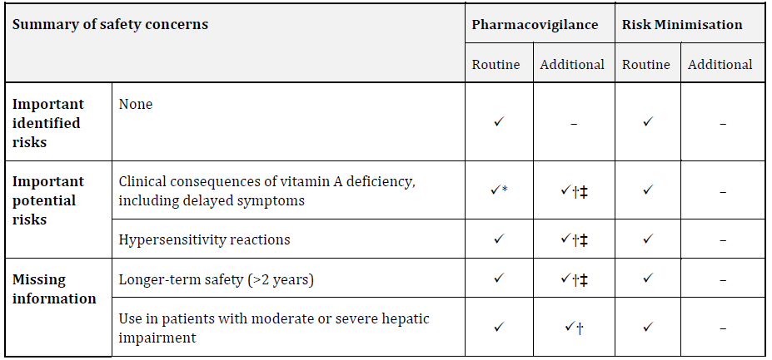
The Sponsor has proposed routine pharmacovigilance for all safety concerns including specific targeted follow-up questionnaire for reports of vitamin A deficiency/ocular toxicity.

Risk/benefit assessment
The HELIOS-A Study was the one available study for the evaluation of efficacy, safety, PK and PD of vutrisiran in adult patients with hATTR amyloidosis with polyneuropathy. The placebo group was derived from the APOLLO Study, a completed study investigating patisiran.
HELIOS-A is a Phase 3 global, randomised, open-label study to evaluate the efficacy and safety of vutrisiran in patients with hATTR amyloidosis. The primary objective is to determine the efficacy of vutrisiran in patients with hATTR amyloidosis by evaluating the effect on neurologic impairment.
At month 18, vutrisiran had demonstrated persistent efficacy and HELIOS-A met all secondary endpoints. The COR Evaluator acknowledged these findings and agreed that based on primary, key secondary and secondary endpoints, that vutrisiran demonstrated in HELIOS-A statistically significant differences from an external placebo group and that efficacy had been shown at month 9 and maintained until month 18.
A large and statistically significant reduction in TTR levels was noted in the pivotal trial, the HELIOS-A study, and indicates that vutrisiran appears to be a safe and efficacious treatment for an otherwise progressive, rare illness associated with significant morbidity and mortality.
Vutrisiran and patisiran, the only currently registered treatment for hATTR amyloidosis share the same mechanism of action. However, the longer interval between dosing, and SC rather than IV administration, are favourable features of vutrisiran compared to patisiran.
The treatment indication was narrowed to those patients that had been studied within the HELIOS-A study (i.e. only patients with stage 1 or 2 polyneuropathy).
Arthralgia, pain in the extremities, dyspnoea and injection site reactions have been identified as ADRs, and most reported ADRs tended to be mild or moderate in severity.

Outcome
Based on a review of quality, safety, and efficacy, the TGA decided to register Amvuttra (vutrisiran) for the following indication:
Amvuttra is indicated for the treatment of hereditary transthyretin-mediated
amyloidosis (hATTR amyloidosis) in adult patients with stage 1 or stage 2
polyneuropathy

Specific conditions of registration applying to these goods
Amvuttra (vutrisiran) is to be included in the Black Triangle Scheme. The PI and CMI for Amvuttra must include the black triangle symbol and mandatory accompanying text for five years, which starts from the date of first supply of the product.
The Amvuttra EU-Risk Management Plan (RMP) (version 1.2, dated 13 October 2023, data lock point 26 August 2021), with Australian Specific Annex (version 0.2, dated 20 March 2024), included with submission PM-2023-04200-1-1, to be revised to the satisfaction of the TGA, and any subsequent revisions, will be implemented in Australia.
An obligatory component of risk management plans is routine pharmacovigilance. Routine pharmacovigilance includes the submission of periodic safety update reports (PSURs).
Reports are to be provided in line with the current published list of EU reference dates and frequency of submission of PSURs until the period covered by such reports is not less than three years from the date of this approval letter. Each report must be submitted within ninety calendar days of the data lock point for that report.
The reports are to at least meet the requirements for PSURs as described in the European Medicines Agency’s Guideline on good pharmacovigilance practices (GVP) Module VII-periodic safety update report (Rev 1), Part VII.B Structures and processes. Note that submission of a PSUR does not constitute an application to vary the registration.

Attachment 1. Product Information
The Product Information (PI) approved with the submission for Amvuttra which is described in this AusPAR can be found as Attachment 1. It may have been superseded. For the most recent PI and Consumer Medicines Information (CMI), please refer to the TGA PI/CMI search facility.

Therapeutic Goods Administration
PO Box 100 Woden ACT 2606 Australia
Email: info@tga.gov.au Phone: 1800 020 653 Fax: 02 6203 1605
https://www.tga.gov.au

The ‘Delegate’ is the Delegate of the Secretary of the Department of Health and Aged Care who made the final decision to either include the new medicine/indication on the ARTG or reject the submission, under section 25 of the Therapeutic Goods Act

