▼ This medicinal product is subject to additional monitoring in Australia. This will allow quick identification of new safety information. Healthcare professionals are asked to report any suspected adverse events at www.tga.gov.au/reporting-problems.

AUSTRALIAN PRODUCT INFORMATION
TUKYSA® (tucatinib) Tablets
- NAME OF THE MEDICINE
Tucatinib

QUALITATIVE AND QUANTITATIVE COMPOSITION
TUKYSA film-coated tablets contain either 50 mg or 150 mg of tucatinib.
TUKYSA 50 mg contains 9.2 mg sodium and 10 mg potassium per tablet and TUKYSA 150 mg contains 27.6 mg sodium and 30 mg potassium per tablet.
For the full list of excipients, see Section 6.1 List of excipients.

PHARMACEUTICAL FORM
Film coated tablet.
TUKYSA 50 mg tablets are round, yellow, film-coated, debossed with “TUC” on one side and “50” on the other side.
TUKYSA 150 mg tablets are oval-shaped, yellow, film-coated, debossed with “TUC” on one side and “150” on the other side.

CLINICAL PARTICULARS

Therapeutic indications
TUKYSA is indicated in combination with trastuzumab for the treatment of adult patients with RAS wild-type HER2 positive unresectable or metastatic colorectal cancer that has progressed following treatment with fluoropyrimidine, oxaliplatin, and irinotecan based chemotherapy. This indication was approved via the provisional approval pathway based on confirmed objective response rate (cORR) in a single arm trial. Continued approval of this indication depends on verification and description of benefit in confirmatory trials.
TUKYSA is indicated in combination with trastuzumab and capecitabine for treatment of patients with advanced unresectable or metastatic HER2-positive breast cancer, including patients with brain metastases, who have received one or more prior anti-HER2-based regimens in the metastatic setting.

Dose and method of administration
TUKYSA treatment should be initiated and supervised by a physician experienced in the administration of anti-cancer medicinal products.
Metastatic Breast Cancer

The recommended dose of TUKYSA is 300 mg taken orally twice daily in combination with trastuzumab and capecitabine until disease progression or unacceptable toxicity (see Section 5.1 Pharmacological properties – Clinical trials).
Unresectable or Metastatic Colorectal Cancer
The recommended dose of TUKYSA is 300 mg taken orally twice daily in combination with trastuzumab until disease progression or unacceptable toxicity (see Section 5.1 Pharmacological properties – Clinical trials).

TUKYSA tablets should be swallowed whole, and not chewed, crushed, or split prior to swallowing. Advise patients not to take any tablet that is broken, cracked or otherwise not intact.
TUKYSA should be taken approximately 12 hours apart, at the same times every day, and can be taken with or without a meal. In the case of a missed dose, the next dose should be taken at the regularly scheduled time.
When given in combination with TUKYSA, the recommended dosage of capecitabine is 1000 mg/m² orally twice daily taken within 30 minutes after a meal. TUKYSA and capecitabine can be taken at the same time.
Refer to the Product Information for trastuzumab administered in combination with TUKYSA for recommended dosing.

Dose modifications
Dose modifications for adverse reactions
The recommended TUKYSA dose modifications for patients with adverse reactions are provided in Tables 1 and 2. Refer to the full Product Information for co-administered trastuzumab and capecitabine for dose modifications for toxicities suspected to be caused by these therapies.

Table 1: TUKYSA dose reduction schedule

Dose level | TUKYSA dose
Recommended starting dose | 300 mg twice daily
First dose reduction | 250 mg twice daily
Second dose reduction | 200 mg twice daily
Third dose reduction | 150 mg twice daily
Permanently discontinue TUKYSA in patients unable to tolerate 150 mg orally twice daily.

Table 2: Recommended TUKYSA dose modifications for adverse reactions

Adverse Reaction¹ | Severity | TUKYSA Dose Modification
Diarrhoea  (see Section 4.4 Special Warnings and Precautions for Use) | Grade 3 without anti-diarrhoeal treatment | Initiate or intensify appropriate medical therapy. Hold TUKYSA until recovery to ≤ Grade 1, then resume TUKYSA at the same dose level.
 | Grade 3 with anti-diarrhoeal treatment | Initiate or intensify appropriate medical therapy. Hold TUKYSA until recovery to ≤ Grade 1, then resume TUKYSA at the next  lower dose level.
 | Grade 4 | Permanently discontinue TUKYSA.
Hepatotoxicity² (see Section 4.4 Special Warnings and Precautions for Use) | Grade 2 bilirubin (>1.5 to 3 × ULN) | Hold TUKYSA until recovery to  ≤ Grade 1, then resume TUKYSA at the same dose level.
 | Grade 3 ALT or AST (> 5 – ≤ 20 x ULN) OR  Grade 3 bilirubin (> 3 – ≤ 10 x ULN) | Hold TUKYSA until severity  ≤ Grade 1. Then resume TUKYSA at the next lower dose level.
 | Grade 4 ALT or AST (> 20 x ULN) OR  Grade 4 bilirubin (> 10 x ULN) | Permanently discontinue TUKYSA.
 | ALT or AST > 3 x ULN AND  Bilirubin > 2 x ULN | Permanently discontinue TUKYSA.
Other adverse reactions (see Section 4.8 Adverse Effects) | Grade 3 | Hold TUKYSA until recovery to  ≤ Grade 1, then resume TUKYSA at the next lower dose level.
Other adverse reactions (see Section 4.8 Adverse Effects) | Grade 4 | Permanently discontinue TUKYSA.
- Grades based on National Cancer Institute Common Terminology Criteria for Adverse Events Version 4.03
- Abbreviations: ULN = upper limit of normal; ALT = alanine aminotransferase; AST = aspartate aminotransferase

Dose modifications in special patient populations
Patients with renal impairment
No dose adjustment is required in patients with mild or moderate renal impairment. The use of TUKYSA in combination with capecitabine and trastuzumab is not recommended in patients with severe renal impairment (creatinine clearance [CLcr] < 30 mL/min estimated by Cockcroft-Gault Equation), because capecitabine is contraindicated in patients with severe renal impairment. Refer to the Prescribing Information of capecitabine for additional information in severe renal impairment.
Patients with hepatic impairment

No dose adjustment is required in patients with mild or moderate hepatic impairment. For patients with severe hepatic impairment (Child-Pugh C), reduce the recommended dosage to 200 mg orally twice daily.
Elderly
No dose adjustment is required in patients ≥ 65 years of age.
Paediatrics
The safety and effectiveness of TUKYSA in paediatric patients has not been established.
Concomitant use with strong CYP2C8 inhibitors
Avoid concomitant use of strong CYP2C8 inhibitors with TUKYSA. If concomitant use with a strong CYP2C8 inhibitor cannot be avoided, reduce the recommended dosage to 100 mg orally twice daily. After discontinuation of the strong CYP2C8 inhibitor for 3 elimination half- lives, resume the TUKYSA dose that was taken prior to initiating the inhibitor (see Section 4.5 Interactions with other Medicines).

Contraindications
Hypersensitivity to tucatinib or to any of the excipients listed in section 6.1.

Special warnings and precautions for use
Diarrhoea
TUKYSA can cause severe diarrhoea, leading to dehydration, hypotension, acute kidney injury and death (see Section 4.8 Adverse effects [undesirable effects]). If diarrhoea occurs, administer anti-diarrhoeal treatment as clinically indicated. Perform diagnostic tests as clinically indicated to exclude other causes of diarrhoea. Based on the severity of the diarrhoea, interrupt dose, then dose reduce or permanently discontinue TUKYSA (see Section 4.2 Dose and method of administration).

Hepatotoxicity
TUKYSA can cause severe hepatotoxicity. Assess ALT, AST, and bilirubin prior to starting TUKYSA, every three weeks during treatment, and as clinically indicated. Based on the severity of hepatotoxicity, interrupt dose, then dose reduce or permanently discontinue TUKYSA. (see Section 4.2 Dose and method of administration).

Embryo-fetal toxicity
Based on findings from animal studies and its mechanism of action, TUKYSA may cause fetal harm when administered to a pregnant woman. In animal reproduction studies, administration of tucatinib to pregnant rats and rabbits during organogenesis caused embryo-fetal mortality, reduced fetal weight and fetal abnormalities at maternal exposures ≥ 1.3 times the human exposure (AUC) at the recommended dose. Advise pregnant women and patients of reproductive potential of the potential risk to a fetus. Advise patients of reproductive potential to use effective contraception during treatment with TUKYSA and for at least 1 week after the last dose (see Section 4.6 Fertility, Pregnancy & Lactation).
TUKYSA is used in combination with trastuzumab and capecitabine. Refer to the full Product Information of trastuzumab and capecitabine for reproductive toxicity information.

Interactions with other medicines and other forms of interactions

Effects of other substances on TUKYSA
Tucatinib is metabolised primarily by CYP2C8 and to a lesser extent via CYP3A. Co- administration of the strong CYP2C8 inhibitor gemfibrozil resulted in a 3.0-fold increase in the plasma exposure of tucatinib in healthy volunteers. Co-administration of tucatinib with rifampin, a strong CYP3A/moderate CYP2C8 inducer, decreased the plasma exposure of tucatinib by 50% in healthy volunteers. Tucatinib was identified as a substrate for P-gp and BCRP in vitro. Co-administration of tucatinib with itraconozole, a strong CYP3A and strong P-gp inhibitor, resulted in a 30% increase in the plasma exposure of tucatinib in healthy volunteers. Table 3 summarises drug interactions that affect the pharmacokinetics of tucatinib.

Table 3: Drug interactions that affect TUKYSA

Strong CYP3A inducers or moderate CYP2C8 inducers
Clinical impact | Concomitant use of TUKYSA with a strong CYP3A or moderate CYP2C8 inducer decreases tucatinib plasma concentration, which may reduce tucatinib efficacy.
Prevention or management | Avoid concomitant use of TUKYSA with a strong CYP3A or a moderate CYP2C8 inducer.
Strong or moderate CYP2C8 inhibitors
Clinical impact | Concomitant use of TUKYSA with a strong CYP2C8 inhibitor increases tucatinib plasma concentration, which may increase the risk of tucatinib toxicity.
Prevention or management | Avoid concomitant use of TUKYSA with strong CYP2C8 inhibitors. Increase monitoring for TUKYSA toxicity with moderate CYP2C8 inhibitors.

Effects of TUKYSA on other substances
In in vitro studies, tucatinib had inhibitory activity on CYP2C8, CYP3A, OCT2, MATE1, and MATE2-K and on intestinal BCRP and P-gp at clinically relevant concentrations. Tucatinib may increase plasma concentrations of drugs that are substrates of these enzymes or transporters. In healthy volunteers, co-administration of tucatinib with repaglinide (CYP2C8 substrate), midazolam (CYP3A substrate), digoxin (P-gp substrate), or metformin (MATE1/2- K substrate) increased the plasma exposure of the respective substrates 1.7-fold, 5.7-fold, 1.5- fold, and 1.4-fold. Table 4 summarises the effect of TUKYSA on other drugs.

Table 4: TUKYSA drug interactions that affect other drugs

CYP3A substrates
Clinical impact | Concomitant use of TUKYSA with a CYP3A substrate increased the plasma concentrations of CYP3A substrate, which may increase the toxicity associated with a CYP3A substrate.
Prevention or management | Avoid concomitant use of TUKYSA with CYP3A substrates for which minimal plasma concentration changes may lead to serious or life-threatening toxicities. If concomitant use is unavoidable, decrease the CYP3A substrate dose as described in the medication’s prescribing information.
P-glycoprotein (P-gp) substrates
Clinical impact | Concomitant use of TUKYSA with P-gp substrates increased the plasma concentrations of P-gp substrate, which may increase the toxicity associated with a P-gp substrate.
Prevention or management | Be cautious about concomitant use of TUKYSA with P-gp substrates for which minimal plasma concentration changes may lead to serious or life-threatening toxicities (such as digoxin), and consider reducing the dosage of such P-gp substrates as described in the medication’s prescribing information.

  - Fertility, pregnancy and lactation
TUKYSA is indicated in combination with trastuzumab and capecitabine for breast cancer and in combination with trastuzumab for colorectal cancer (see Section 4.1 Therapeutic indications). Refer to the Product Information of trastuzumab and of capecitabine for fertility, pregnancy and lactation information specific to those drugs.

Females and males of reproductive potential
Based on findings in animal studies and its mechanism of action, TUKYSA can cause fetal harm when administered to a pregnant woman (see Use in Pregnancy, below). Verify the pregnancy status of females of reproductive potential prior to initiating treatment with TUKYSA.
Advise females of reproductive potential to use effective contraception during treatment with TUKYSA and for at least 1 week after the last dose.
Advise males with female partners of reproductive potential to use effective contraception during treatment with TUKYSA and for at least 1 week after the last dose of TUKYSA.

Effects on fertility
No dedicated fertility studies have been conducted in humans or animals, however, based on findings from other animal studies, TUKYSA may impair fertility in males and females of reproductive potential.
In repeat-dose toxicity studies up to 13 weeks duration, decreased corpora lutea/corpus luteum cyst, increased interstitial cells of the ovary, atrophy of the uterus, and mucification of the vagina were observed in female rats at doses of ≥6 mg/kg/day (0.1 times the human exposure at the recommended dose based on AUC). Atrophy and oedema in the testes and oligospermia/germ cell debris in the epididymides were observed in male rats at doses ≥120 mg/kg/day (13 times the human exposure at the recommended dose based on AUC).

Use in pregnancy – pregnancy category D
Based on findings in animal studies and its mechanism of action, TUKYSA can cause fetal harm when administered to a pregnant woman. There are no available human data on TUKYSA use in pregnant women. Advise pregnant patients and patients of reproductive potential of the potential risk to the fetus.
In pilot embryo-fetal development studies, pregnant rats and rabbits received oral doses of tucatinib up to 150 mg/kg/day during the period of organogenesis.
In rats, maternal toxicity (body weight loss, reduced body weight gain, low food consumption) was observed at doses ≥90 mg/kg/day (3.5 times the human exposure at the recommended dose based on AUC). Fetal effects also occurred at maternal doses ≥90 mg/kg/day, including reduced number of live fetuses, decreased fetal weights and fetal abnormalities (increase in skeletal variations, incomplete ossification).
In rabbits, increased resorptions, decreased percentages of live fetuses, and skeletal, visceral, and external malformations in fetuses were observed at maternal doses ≥90 mg/kg/day (1.3 times the human exposure at the recommended dose based on AUC). Fetal abnormalities included domed head, brain dilation, incomplete ossification of frontal and parietal bones, and a hole in the parietal bone.

Use in lactation
No data are available regarding the presence of tucatinib or its metabolites in human or animal milk or its effects on the breastfed child or on milk production. Because of the potential for serious adverse reactions in a breastfed child, advise women not to breastfeed during treatment with TUKYSA and for at least 1 week after the last dose.

Effects on ability to drive and use machines
TUKYSA has no influence on the ability to drive and use machines. The clinical status of the patient should be considered when assessing the patient’s ability to perform tasks that require judgment, motor, or cognitive skills.

Adverse effects (undesirable effects)
Summary of the safety profile
HER2-Positive Metastatic Breast Cancer
HER2CLIMB
The safety of TUKYSA in combination with trastuzumab and capecitabine was evaluated in HER2CLIMB (see Section 5.1 Pharmacodynamic properties – Clinical trials). Patients received either TUKYSA 300 mg twice daily plus trastuzumab and capecitabine (n=404) or placebo plus trastuzumab and capecitabine (n=197). The median duration of treatment was 5.8 months (range: 3 days, 2.9 years) for the TUKYSA arm.
Serious adverse reactions occurred in 26% of patients who received TUKYSA. Serious adverse reactions in ≥ 2% of patients who received TUKYSA were diarrhoea (4%), vomiting (2.5%), nausea (2%), abdominal pain (2%), and seizure (2%). Fatal adverse reactions occurred in 2% of patients who received TUKYSA including sudden death, sepsis, dehydration, and cardiogenic shock.

Adverse reactions leading to treatment discontinuation occurred in 6% of patients who received TUKYSA. Adverse reactions leading to treatment discontinuation of TUKYSA in ≥1% of patients were hepatotoxicity (1.5%) and diarrhoea (1%).
Adverse reactions leading to dose reduction occurred in 21% of patients who received TUKYSA. Adverse reactions leading to dose reduction of TUKYSA in ≥2% of patients were hepatotoxicity (8%) and diarrhoea (6%).
The most common adverse reactions in patients who received TUKYSA (≥20%) were diarrhoea, palmar-plantar erythrodysaesthesia, nausea, hepatotoxicity, vomiting, stomatitis, decreased appetite, anaemia, and rash.
Table 5 summarises the adverse reactions in HER2CLIMB.

Table 5: Adverse reactions in HER2CLIMB with an incidence ≥10% in the TUKYSA arm and with an incidence at least 5% higher in the TUKYSA arm compared to placebo

Adverse reaction | TUKYSA + trastuzumab  + capecitabine  N = 404 |  |  | Placebo + trastuzumab  + capecitabine  N = 197
 | All Grades  % | Grade 3  % | Grade 4  % | All Grades  % | Grade 3  % | Grade 4  %
Gastrointestinal disorders
Diarrhoea | 81 | 12 | 0.5 | 53 | 9 | 0
Nausea | 58 | 3.7 | 0 | 44 | 3 | 0
Vomiting | 36 | 3 | 0 | 25 | 3.6 | 0
Stomatitis¹ | 32 | 2.5 | 0 | 21 | 0.5 | 0
Skin and subcutaneous tissue disorders
Palmar-plantar erythrodysaesthesia syndrome | 63 | 13 | 0 | 53 | 9 | 0
Rash² | 20 | 0.7 | 0 | 15 | 0.5 | 0
Hepatobiliary disorders
Hepatotoxicity³ | 42 | 9 | 0.2 | 24 | 3.6 | 0
Metabolism and nutrition disorders
Decreased appetite | 25 | 0.5 | 0 | 20 | 0 | 0
Blood and lymphatic system disorders
Anaemia⁴ | 21 | 3.7 | 0 | 13 | 2.5 | 0
Musculoskeletal and connective tissue disorders
Arthralgia | 15 | 0.5 | 0 | 4.6 | 0.5 | 0
Investigations
Creatinine increased⁵ | 14 | 0 | 0 | 1.5 | 0 | 0
Weight decreased | 13 | 1 | 0 | 6 | 0.5 | 0
Nervous system disorders
Peripheral neuropathy⁶ | 13 | 0.5 | 0 | 7 | 1 | 0
Respiratory, thoracic, and mediastinal disorders
Epistaxis | 12 | 0 | 0 | 5 | 0 | 0
    - Stomatitis includes stomatitis, oropharyngeal pain, oropharyngeal discomfort, mouth ulceration, oral pain, lip ulceration, glossodynia, tongue blistering, lip blister, oral dysaesthesia, tongue ulceration, and aphthous ulcer
    - Rash includes rash maculo-papular, rash, dermatitis acneiform, erythema, rash macular, rash papular, rash pustular, rash pruritic, rash erythematous, skin exfoliation, urticaria, dermatitis allergic, palmar erythema, plantar erythema, skin toxicity, and dermatitis
    - Hepatotoxicity includes hyperbilirubinemia, blood bilirubin increased, bilirubin conjugated increased, alanine aminotransferase increased, transaminases increased, hepatotoxicity, aspartate aminotransferase increased, liver function test increased, liver injury, and hepatocellular injury
    - Anaemia includes anaemia, haemoglobin decreased, and normocytic anaemia
    - Due to inhibition of renal tubular transport of creatinine without affecting glomerular function
    - Peripheral neuropathy includes peripheral sensory neuropathy, neuropathy peripheral, peripheral motor neuropathy, and peripheral sensorimotor neuropathy

Table 6: Laboratory abnormalities worsening from baseline in HER2CLIMB with an incidence ≥20% in the TUKYSA arm and with an incidence at least 5% higher in the TUKYSA arm compared to placebo

 | TUKYSA + Trastuzumab  +Capecitabine1 |  | Placebo + Trastuzumab  +Capecitabine1
 | All Grades  % | Grade ≥3  % | All Grades  % | Grade ≥3  %
Haematology
Decreased haemoglobin | 59 | 3.3 | 51 | 1.5
Chemistry
Decreased phosphate | 57 | 8 | 45 | 7
Increased bilirubin | 47 | 1.5 | 30 | 3.1
Increased ALT | 46 | 8 | 27 | 0.5
Increased AST | 43 | 6 | 25 | 1
Decreased magnesium | 40 | 0.8 | 25 | 0.5
Decreased potassium² | 36 | 6 | 31 | 5
Increased creatinine³ | 33 | 0 | 6 | 0
Decreased sodium⁴ | 28 | 2.5 | 23 | 2
Increased alkaline phosphatase | 26 | 0.5 | 17 | 0
- The denominator used to calculate the rate varied from 351 to 400 in the TUKYSA arm and 173 to 197 in the control arm based on the number of patients with a baseline value and at least one post-treatment value. Grading was based on NCI- CTCAE v.4.03 for laboratory abnormalities, except for increased creatinine which only includes patients with a creatinine increase based on the upper limit of normal definition for grade 1 events (NCI CTCAE v5.0).
- Laboratory criteria for Grade 1 is identical to laboratory criteria for Grade 2.
- Due to inhibition of renal tubular transport of creatinine without affecting glomerular function.
- There is no definition for Grade 2 in CTCAE v.4.03.

RAS Wild-Type, HER2-Positive Unresectable or Metastatic Colorectal Cancer
MOUNTAINEER
The safety of TUKYSA in combination with trastuzumab was evaluated in 86 patients enrolled in MOUNTAINEER with unresectable or metastatic colorectal cancer (see Section 5.1 Pharmacodynamic properties – Clinical trials). The median duration of exposure to TUKYSA was 6.9 months (range 0.7, 49.3).
Serious adverse reactions occurred in 22% of patients. Serious adverse reactions that occurred in ≥ 2% of patients were intestinal obstruction (7%), urinary tract infection (3.5%), pneumonia (2.3%), abdominal pain (2.3%) and rectal perforation (2.3%).
Permanent discontinuation of TUKYSA due to an adverse reaction occurred in 6% of patients. The adverse reaction which resulted in permanent discontinuation of TUKYSA in ≥2% of patients was increased ALT (2.3%). Dosage interruptions of TUKYSA due to an adverse reaction occurred in 23% of patients. Adverse reactions which required dosage interruption in
≥3% of patients were increased ALT (3.5%) and diarrhoea (3.5%). Dose reductions of TUKYSA due to an adverse reaction occurred in 9% of patients. Adverse reactions which required dose reductions in ≥2% of patients were increased ALT (2.3%) and diarrhea (2.3%).

The most common adverse reactions reported in ≥ 20% of patients treated with TUKYSA and trastuzumab were diarrhoea, fatigue, rash, nausea, abdominal pain, infusion related reactions, and pyrexia. The most common laboratory abnormalities reported in ≥ 20% of patients were increased creatinine, increased glucose, increased ALT, decreased haemoglobin, increased AST, increased bilirubin, increased alkaline phosphatase, decreased lymphocytes, decreased albumin, decreased leukocytes, and decreased sodium.
Table 7 summarises the adverse reactions in MOUNTAINEER.

Table 7: Adverse Reactions (≥10%) in Patients with Unresectable or Metastatic Colorectal Cancer (MOUNTAINEER)

Adverse Reaction | TUKYSA + Trastuzumab N= 86*
Adverse Reaction | All Grades  % | Grade 3  % | Grade 4  %
Gastrointestinal disorders
Diarrhoea | 64 | 3.5 | 0
Nausea | 35 | 0 | 0
Vomiting | 16 | 0 | 0
Abdominal pain¹ | 21 | 2.3 | 0
Constipation | 14 | 1.2 | 0
General disorders
Fatigue | 44 | 2.3 | 0
Pyrexia | 20 | 0 | 0
Chills | 19 | 1.2 | 0
Skin and subcutaneous disorders
Rash² | 37 | 0 | 0
Injury, poisoning, and procedural complications
Infusion related reaction | 21 | 0 | 0
Metabolism and nutrition disorders
Decreased appetite | 19 | 0 | 0
Blood and lymphatic system disorders
Anaemia | 10 | 0 | 0
Vascular disorders
Hypertension | 17 | 7 | 0
Musculoskeletal and connective tissue disorders

Back pain | 17 | 2.3 | 0
Arthralgia | 16 | 1.2 | 0
Myalgia | 13 | 0 | 0
Respiratory, thoracic and mediastinal disorders
Cough | 16 | 0 | 0
Dyspnoea | 14 | 0 | 0
Psychiatric disorders
Anxiety | 10 | 0 | 0
*Includes 1 patient who only received trastuzumab.
- Abdominal pain includes abdominal discomfort, abdominal pain, and abdominal pain upper.
- Rash includes acne, dermatitis acneiform, dermatitis contact, erythema, erythema multiforme, rash, rash macular, rash maculo-papular, rash papular, rash pustular, skin exfoliation, and urticaria.

Other adverse reactions (<10%) include epistaxis (7%), weight decreased (7%), oropharyngeal pain (5%), oral dysesthesia (1%), and stomatitis (1%).

Table 8: Laboratory abnormalities (≥15%) worsening from baseline in patients with unresectable or metastatic colorectal cancer (MOUNTAINEER)

Laboratory Abnormality | TUKYSA + Trastuzumab N=85¹
Laboratory Abnormality | All Grades  % | Grade 3  % | Grade 4  %
Haematology
Decreased haemoglobin | 46 | 3.5 | 0
Decreased lymphocytes | 39 | 12 | 0
Decreased leukocytes | 22 | 0 | 0
Decreased platelets | 15 | 0 | 0
Chemistry
Increased creatinine^{2,3} | 58 | 0 | 0
Increased glucose | 56 | 2.4 | 0
Increased ALT | 46 | 2.4 | 2.4
Increased AST | 33 | 2.4 | 3.5
Increased bilirubin | 28 | 3.5 | 2.4
Increased alkaline phosphatase | 25 | 1.2 | 0
Decreased albumin | 24 | 1.2 | 0
Decreased sodium | 20 | 6 | 0
Decreased potassium | 16 | 1.2 | 0
Number of patients with both baseline and post-baseline results for each test
- NCI CTCAE v5.0 was used for creatinine increased NCI CTCAE v4.03 was used for all other laboratory parameters.
- Due to inhibition of renal tubular transport of creatinine without affecting glomerular function

Description of selected adverse reactions
Diarrhoea Breast Cancer
In HER2CLIMB, 81% of patients who received TUKYSA experienced diarrhoea, including 12% with Grade 3 diarrhoea and 0.5% with Grade 4 diarrhoea. Both patients who developed Grade 4 diarrhoea subsequently died, with diarrhoea as a contributor to death. The median time to onset of the first episode of diarrhoea was 12 days and the median time to resolution was 8 days. Diarrhoea led to dose reductions of TUKYSA in 6% of patients and discontinuation of TUKYSA in 1% of patients. Prophylactic use of antidiarrheal treatment was not required in HER2CLIMB.
Colorectal Cancer
In MOUNTAINEER, diarrhoea occurred in 64% of patients; the majority of events were low grade, including Grade 1 (50%) and Grade 2 (10.5%). Grade 3 events occurred in 3.5% of patients. No Grade 4 or higher diarrhoea events were reported and no patients discontinued treatment due to diarrhoea. Prophylactic use of antidiarrheals was not required.
Hepatotoxicity Breast Cancer
In HER2CLIMB, 8% of patients who received TUKYSA had an ALT increase > 5 × ULN, 6% had an AST increase > 5 × ULN, and 1.5% had a bilirubin increase > 3 × ULN (Grade
≥3). Hepatotoxicity led to dose reduction of TUKYSA in 8% of patients and discontinuation of TUKYSA in 1.5% of patients.
The median time to onset of any episode of increased ALT, AST, or bilirubin was 36 days and the median time to resolution was 22 days.
Colorectal Cancer
In MOUNTAINEER, any grade increased ALT, AST, or bilirubin occurred in 9% of patients. Grade 3 or 4 events occurred in 5% of patients. The median time to onset of any grade increased ALT, AST, or bilirubin was 141 days; 69% of events resolved, with a median time to resolution of 27 days. Hepatotoxicity led to dose reduction of TUKYSA in 3.5% of patients and discontinuation of TUKYSA in 2.3% of patients.
Creatinine increased
In HER2CLIMB, the mean increase in serum creatinine was 32% within the first 21 days of treatment with TUKYSA. Elevated serum creatinine levels were persistent but stable throughout treatment and were reversible upon treatment discontinuation. Consider alternative markers that are not based on creatinine (such as BUN, cystatin C, or calculated GFR) if assessment of renal function is required (see Section 5.2 Pharmacokinetic properties).
In MOUNTAINEER, the mean increase in serum creatinine was 32% within the first 21 days of treatment with TUKYSA. The serum creatinine increases persisted throughout treatment and were reversible in 87% of patients with values outside normal lab limits upon treatment completion. Consider alternative markers of renal function if persistent elevations in serum creatinine are observed (see Section 5.2 Pharmacokinetic properties).

Reporting suspected adverse effects
Reporting suspected adverse reactions after registration of the medicinal product is important. It allows continued monitoring of the benefit-risk balance of the medicinal product. Healthcare professionals are asked to report any suspected adverse reactions at www.tga.gov.au/reporting- problems.

Overdose
There is no known antidote for overdosage with TUKYSA. In case of overdosage, the patient should be closely monitored for adverse reactions, and supportive treatment should be administered as appropriate.
For information on the management of overdose, contact the Poisons Information Centre on 13 11 26 (Australia).

PHARMACOLOGICAL PROPERTIES

Pharmacodynamic properties
Mechanism of action
Tucatinib is a tyrosine kinase inhibitor of HER2. In vitro, tucatinib inhibits phosphorylation of HER2 and HER3, resulting in inhibition of downstream MAPK and AKT signalling and cell proliferation, and showed anti-tumour activity in HER2-expressing tumour cells. In vivo, tucatinib inhibited the growth of HER2-expressing tumours. The combination of tucatinib and trastuzumab showed increased anti-tumour activity in vitro and in vivo compared to either drug alone.

Clinical trials
HER2-Positive Metastatic Breast Cancer
HER2CLIMB
The efficacy of TUKYSA in combination with trastuzumab and capecitabine was evaluated in HER2CLIMB: a randomised (2:1), double-blind, placebo-controlled trial conducted in 612 patients with HER2-positive, unresectable locally advanced or metastatic breast cancer, with or without brain metastases. Patients were required to have had prior treatment with trastuzumab, pertuzumab, and ado-trastuzumab emtansine (T-DM1), separately or in combination, in the neoadjuvant, adjuvant or metastatic setting. HER2-positivity (defined as HER2 IHC 3+ or ISH positive) was confirmed by central laboratory analysis prior to enrolment.
Patients with brain metastases, including those with progressing or untreated lesions, were eligible provided they were neurologically stable and did not require immediate radiation or surgery. Patients who required immediate local intervention could receive local therapy and be subsequently enrolled. The trial excluded patients with leptomeningeal disease. Randomisation was stratified by the presence or history of brain metastases (yes vs. no), Eastern Cooperative Oncology Group (ECOG) performance status (0 vs. 1), and region (U.S., Canada, or rest of world).
Patients were randomised to receive TUKYSA 300 mg (N=410) or placebo (N=202) orally twice per day, with trastuzumab given either intravenously (a loading dose of 8 mg/kg on Day 1 of Cycle 1, then a maintenance dose of 6 mg/kg on Day 1 of each subsequent 21-day cycle) or subcutaneously (a fixed dose of 600 mg on Day 1 of each 21-day cycle) and with capecitabine 1000 mg/m² given orally twice per day on Days 1 through 14 of each 21-day cycle. Treatment was continued until disease progression or unacceptable toxicity.
The primary endpoint was progression-free survival (PFS) in the first 480 randomised patients assessed by blinded independent central review (BICR) using Response Evaluation Criteria in Solid Tumours (RECIST) v1.1. Secondary endpoints were evaluated in all randomised patients and included overall survival (OS), PFS among patients with a history or presence of brain metastases (PFSBrainMets), and confirmed objective response rate (ORR).
The median age was 54 years (range: 22 to 82); 116 (19%) patients were age 65 or older. The majority were white (73%) and female (99%), and 51% had an ECOG performance status of
1. Sixty percent had estrogen and/or progesterone receptor-positive disease. Forty-eight percent of patients had a presence or history of brain metastases; of these, 23% had untreated brain metastases, 40% had treated but stable brain metastases, and 37% had treated but radiographically progressing brain metastases. Seventy-four percent of patients had visceral metastases. Patients had received a median of 4 (range, 2 to 17) prior lines of systemic therapy in any setting, and a median of 3 (range, 1 to 14) prior lines of systemic therapy in the metastatic setting.
Efficacy results are summarised in Table 9 and Figures 1 to 3. Efficacy results were consistent across patient subgroups defined by stratification factors (presence or history of brain metastases, ECOG status, region of world) and hormone receptor status.

Table 9. Efficacy results in HER2CLIMB

 | TUKYSA + trastuzumab  + capecitabine | Placebo + trastuzumab  + capecitabine
PFS¹ | N=320 | N=160
Number of events (%) | 178 (56) | 97 (61)
Median, months (95% CI) | 7.8 (7.5, 9.6) | 5.6 (4.2, 7.1)
Hazard ratio (95% CI)² | 0.54 (0.42, 0.71)
P-value³ | <0.00001
OS | N=410 | N=202
Number of deaths (%) | 130 (32) | 85 (42)
Median, months (95% CI) | 21.9 (18.3, 31.0) | 17.4 (13.6, 19.9)
Hazard ratio (95% CI)² | 0.66 (0.50, 0.87)
P-value⁴ | 0.00480
PFSBrainMets5 | N=198 | N=93
Number of events (%) | 106 (53.5) | 51 (54.8)
Median, months (95% CI) | 7.6 (6.2, 9.5) | 5.4 (4.1, 5.7)

Hazard ratio (95% CI)² | 0.48 (0.34, 0.69)
P-value⁶ | <0.00001
Confirmed ORR for patients with measurable disease | N=340 | N=171
ORR (95% CI)⁷ | 40.6 (35.3, 46.0) | 22.8 (16.7, 29.8)
CR (%) | 3 (0.9) | 2 (1.2)
PR (%) | 135 (39.7) | 37 (21.6)
P-value³ | 0.00008
DOR
Median, months (95% CI)⁸ | 8.3 (6.2, 9.7) | 6.3 (5.8, 8.9)
BICR=blinded independent central review; CI=confidence interval; PFS=progression-free survival; OS=overall survival; ORR=objective response rate; CR=complete response; PR=partial response; DOR=duration of response.
- Primary PFS analysis conducted in first 480 randomised patients.
- Hazard ratio and 95% confidence intervals are based on stratified Cox proportional hazards regression model controlling for stratification factors (presence or history of brain metastases, ECOG status, and region of world)
- Two-sided p-value based on re-randomisation procedure (Rosenberger and Lachin 2002) controlling for stratification factors, compared with the allocated alpha of 0.05
- Two-sided p-value based on re-randomisation procedure (Rosenberger and Lachin 2002) controlling for stratification factors, compared with the allocated alpha of 0.0074 for this interim analysis (with 60% of the planned number of events for final analysis)
- Analysis includes patients with history or presence of parenchymal brain metastases at baseline, including target and non-target lesions. Does not include patients with dural lesions only.
- Two-sided p-value based on re-randomisation procedure (Rosenberger and Lachin 2002) controlling for stratification factors, compared with the allocated alpha of 0.0080 for this interim analysis (with 71% of the planned number of events for final analysis)
- Two-sided 95% exact confidence interval, computed using the Clopper-Pearson method (1934)
- Calculated using the complementary log-log transformation method (Collett, 1994)

Figure 1: PFS per BICR

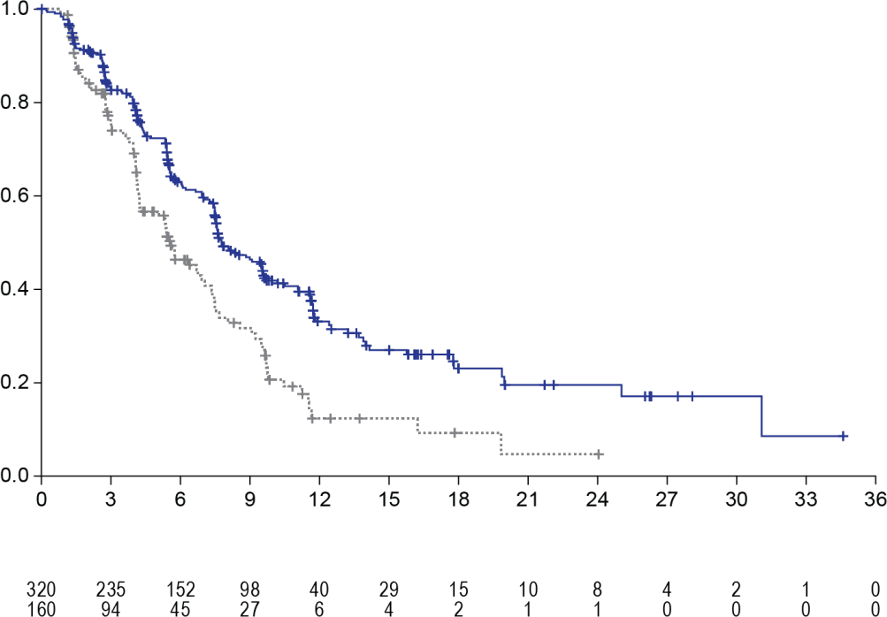
No. at Risk TUC+Tras+Cape Pbo+Tras+Cape
TUC+Tras+Cape
Pbo+Tras+Cape
Months since Randomisation
Progression free survival (%)

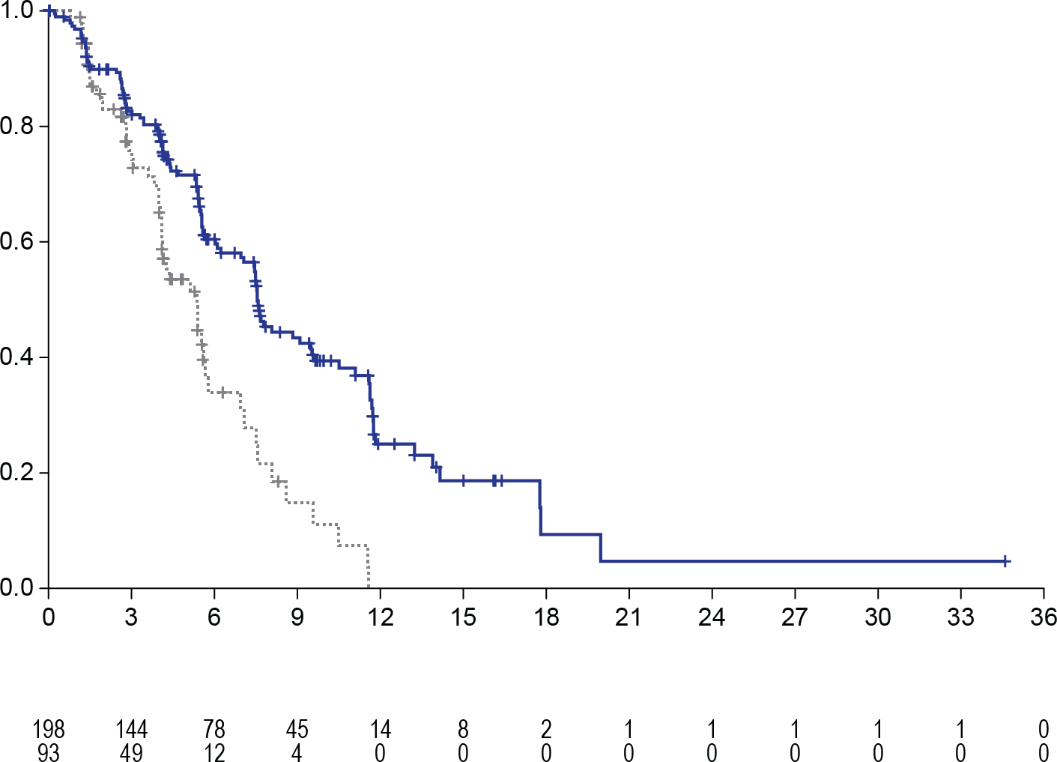
Figure 2: Overall survival
Pbo+Tras+Cape
TUC+Tras+Cape
Months since randomisation

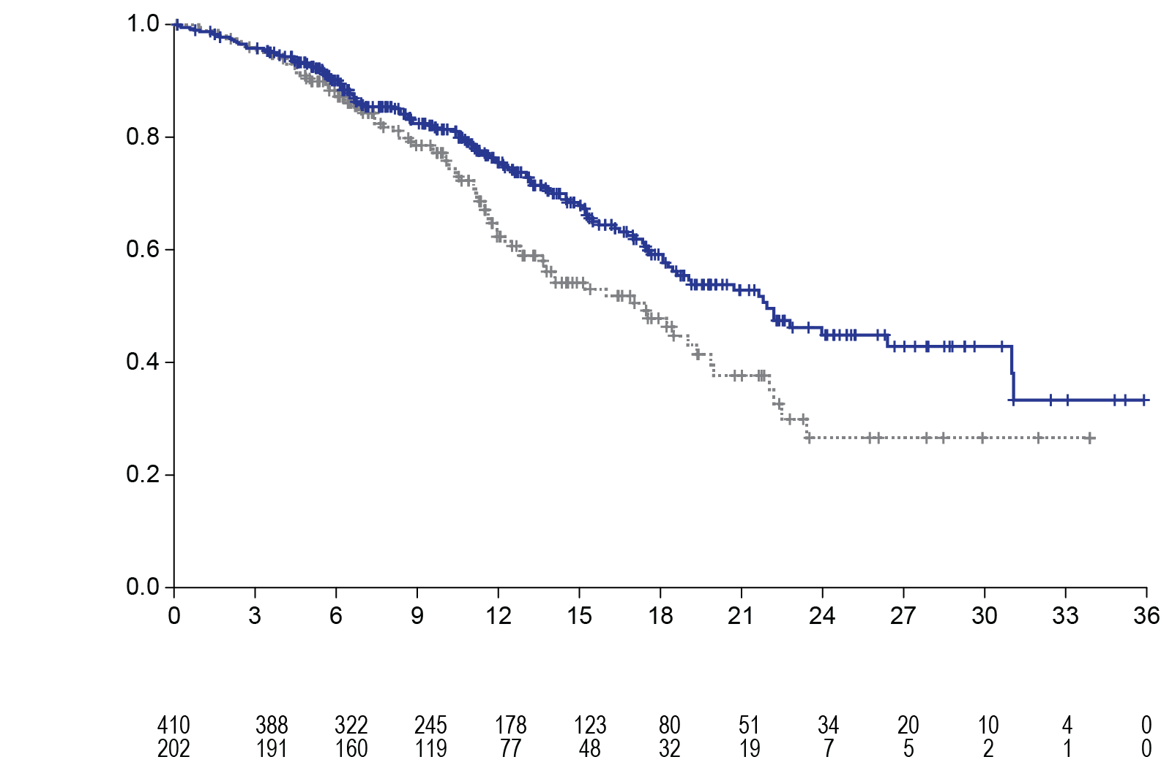
TUC+Tras+Cape
Overall survival (%)

Pbo+Tras+Cape

Months since Randomisation
No. at risk TUC+Tras+Cape Pbo+Tras+Cape

Figure 3: PFS per BICR in patients with brain metastases

No. at risk TUC+Tras+Cape Pbo+Tras+Cape
Progression free survival (%)
HER2-Positive Metastatic Colorectal Cancer
MOUNTAINEER
The efficacy of TUKYSA in combination with trastuzumab was evaluated in an open label, multicenter trial (MOUNTAINEER) in 84 patients with HER2-positive, RAS wild type, unresectable or metastatic colorectal cancer. Patients were required to have previously received, unless contraindicated, systemic therapy with fluoropyrimidines, oxaliplatin, irinotecan, and anti-vascular endothelial growth factor (VEGF) monoclonal antibody (mAb). Patients whose disease had deficient mismatch repair (dMMR) proteins or Microsatellite instability-High (MSI-H) must have also received an anti-programmed death ligand 1 (PD[L]1) mAb, if indicated. Patients who received prior anti-HER2 targeting therapy were excluded. HER2 positivity was prospectively determined in local laboratories using immunohistochemistry (IHC), in situ hybridization (ISH), and/or next generation sequencing (NGS) on tumour tissue. RAS status was performed as standard of care prior to study entry based on expanded RAS testing including KRAS exons 2, 3, and 4 and NRAS exons 2, 3, and 4.
The median age was 55 years (range: 24 to 77); 12 (14%) patients were age 65 or older. Seventy-seven percent of patients were White, 4% were Black, 4% were Asian, and 4% were Hispanic or Latino. Sixty-one percent of patients were male. Seventy percent of patients had lung metastases, 64% had liver metastases, 60% had an ECOG performance status of 0, 36% had an ECOG performance status of 1, and 4% had an ECOG performance status of 2. Twenty- three percent of patients had received one prior treatment regimen in the metastatic or unresectable setting; the median was 2 (range, 1 to 5). Ninety-nine percent of patients received prior treatment with fluoropyrimidine, oxaliplatin, and irinotecan and 83% and 52% received anti-VEGF antibodies and anti-EGFR antibodies respectively; 23%, 38%, and 39% received 1, 2, or ≥3 prior lines of therapy, respectively.
Patients received TUKYSA 300 mg orally twice per day. Trastuzumab was administered intravenously as a loading dose of 8 mg/kg on Day 1 of Cycle 1, followed by a maintenance dose of 6 mg/kg on Day 1 of each subsequent 21-day cycle. Patients were treated until disease progression or unacceptable toxicity.
The primary endpoint was confirmed objective response rate (cORR) as assessed by blinded independent central review (BICR) according to RECIST version 1.1.
Efficacy results are summarised in Table 10.

Table 10: Efficacy Results in MOUNTAINEER (BICR Assessment)

Endpoint | TUKYSA+ trastuzumab  N=84
Confirmed ORR (%) (95% CI) | 38.1 (27.7, 49.3)
CR (%) | 3 (3.6)
PR (%) | 29 (34.5)
Median DOR*, months (95% CI) | 12.4 (8.5, 20.5)
*DOR is based on median duration of follow-up of 21 months.

Pharmacokinetic properties
The pharmacokinetics of tucatinib were characterized in patients with solid tumours, including metastatic colorectal cancer and metastatic breast cancer, and in healthy volunteers. The pharmacokinetics of tucatinib were similar between patients with metastatic breast and metastatic colorectal cancer.
Plasma tucatinib exposure (AUC0-INF and Cmax) demonstrated dose proportional increases at oral doses from 50 to 300 mg (0.17 to 1 times the recommended dose). Based on population pharmacokinetic model estimates, tucatinib was predicted to have a 1.8-fold accumulation ratio for AUC and 1.7-fold accumulation ratio for Cmax following administration of 300 mg tucatinib twice daily for 7 days. Time to steady state was approximately 4 days.

Absorption
Following a single oral dose of 300 mg tucatinib, the median time to peak plasma concentration was approximately 2 hours post dose (range 1 to 4 hours).
Following administration of a single dose of tucatinib in 11 subjects after a high-fat meal (approximately 58% fat, 26% carbohydrate, and 16% protein), the mean AUCinf increased by 1.5-fold, the Tmax shifted from 1.5 hours to 4 hours, and the Cmax was unaltered. The effect of food on the PK of tucatinib was not clinically meaningful.

Distribution
The apparent volume of distribution of tucatinib at steady state based on population pharmacokinetic model estimates was predicted to be 995L. The plasma protein binding was 97.1% at clinically relevant concentrations.
Tucatinib and its metabolite ONT-993 have been detected in the cerebrospinal fluid after the first tucatinib dose and are comparable to steady-state unbound plasma concentrations.

Elimination
Based on population pharmacokinetic model estimates at steady-state, following twice daily doses of 300 mg, tucatinib was predicted to be cleared from plasma with a mean effective half- life of approximately 10.6 hours and apparent clearance of 86.11 L/h.

Metabolism
Tucatinib is metabolised primarily by CYP2C8 and to a lesser extent via CYP3A

Excretion
Following a single oral dose of 300 mg [14C]-tucatinib, 86% of the total radiolabelled dose was recovered in faeces (16% of the administered dose as unchanged tucatinib) and 4% in urine with an overall total recovery of 90% within 13 days post-dose. In plasma, 76% of the plasma radioactivity was unchanged, 19% was attributed to identified metabolites, and 5% was unassigned.

Pharmacokinetics in specific populations
Metastatic Breast Cancer Age (< 65 (n =211); ≥ 65 (n = 27)), albumin (25 to 52 g/L), (CLcr 60 to 89 mL/min (n = 89); 30 to 59 mL/min (n = 5)), body weight (41 to 138 kg), and race (White (n=168), Black (n=53), or Asian (n=10)) did not have a clinically meaningful effect on tucatinib exposure.
Metastatic Colorectal Cancer
Age (29 to 77), albumin (19 to 49 g/L), and race (White (n=52), Black (n=4), or Asian (n=1)) did not have a clinically meaningful effect on tucatinib exposure.
Renal Impairment
No clinically significant differences in the pharmacokinetics of tucatinib were observed in patients with mild to moderate renal impairment (CLcr: 30 to 89 mL/min by Cockcroft-Gault). The effect of severe renal impairment (CLcr: < 30 mL/min) on the pharmacokinetics of tucatinib is unknown.
Hepatic Impairment
Mild (Child-Pugh A), moderate (Child-Pugh B) and severe (Child-Pugh C) hepatic impairment had no clinically relevant effect on tucatinib exposure. Tucatinib AUCinf was increased 1.6- fold and tucatinib Cmax was increased 1.2-fold in subjects with severe (Child-Pugh C) hepatic impairment compared to subjects with normal hepatic function.

Preclinical safety data
Genotoxicity
Tucatinib was not genotoxic in bacterial reverse mutation assays, an in vitro mammalian chromosome aberration assay and an in vivo mouse micronucleus assay.

Carcinogenicity
Carcinogenicity studies have not been conducted with tucatinib.

PHARMACEUTICAL PARTICULARS

List of excipients
Copovidone, crospovidone, sodium chloride, potassium chloride, sodium bicarbonate, silicon dioxide, magnesium stearate, microcrystalline cellulose, Opadry II Yellow 85F9272

Incompatibilities
Incompatibilities were either not assessed or not identified as part of the registration of this medicine.

Shelf life
In Australia, information on the shelf life can be found on the public summary of the Australian Register of Therapeutic Goods (ARTG). The expiry date can be found on the packaging.

Special precautions for storage
Store below 25ºC.

Nature and contents of container
150 mg blister presentation: 4 tablets per blister pack and 21 packs per carton. 50 mg blister presentation: 8 tablets per blister pack and 11 packs per carton. oPA/ALU/PVC blister sealed with aluminium foil. Not all pack sizes may be marketed.

Special precautions for disposal
In Australia, any unused medicine or waste material should be disposed of in accordance with local requirements.

Physicochemical properties
The chemical name for tucatinib is (N4-(4-([1,2,4]triazolo[1,5-a]pyridin-7-yloxy)-3- methylphenyl)-N6-(4,4-dimethyl-4,5-dihydrooxazol-2-yl)quinazoline-4,6-diamine. The molecular formula is C26H24N8O2 and the molecular weight is 480.52 g/mol.

Chemical structure

CAS number
937263-43-9

MEDICINE SCHEDULE (POISONS STANDARD)
Prescription Only Medicine (Schedule 4)

SPONSOR
Merck Sharp & Dohme (Australia) Pty Limited Level 1, Building A, 26 Talavera Road Macquarie Park, NSW 2113, Australia http://www.msd-australia.com.au
Tel (61) 02 8988 8000

DATE OF FIRST APPROVAL
13 August 2020

DATE OF REVISION
TBC

Summary table of changes

Section Changed | Summary of new information
4.1 | Added new indication for patients with HER2-positive colorectal cancer

4.2 | Revised dosage information for clarity
4.8 | Updated to include MOUNTAINEER safety data
5.1 | Added subsection Colorectal Cancer with MOUNTAINEER efficacy data
5.2 | Revised pharmacokinetics

RCN: 000024603-AU
Copyright © 2023 Merck & Co., Inc., Rahway, NJ, USA and its affiliates. All rights reserved.

