Australian Public Assessment Report for Tevimbra
  - Active ingredient: Tislelizumab
  - Sponsor: BeiGene AUS Pty Ltd
August 2024

About the Therapeutic Goods Administration (TGA)
- The Therapeutic Goods Administration (TGA) is part of the Australian Government Department of Health and Aged Care and is responsible for regulating therapeutic goods, including medicines, medical devices, and biologicals.
- The TGA administers the Therapeutic Goods Act 1989 (the Act), applying a risk management approach designed to ensure therapeutic goods supplied in Australia meet acceptable standards of quality, safety, and efficacy.
- The work of the TGA is based on applying scientific and clinical expertise to decision-making, to ensure that the benefits to the Australian public outweigh any risks associated with the use of therapeutic goods.
- The TGA relies on the public, healthcare professionals and industry to report problems with therapeutic goods. The TGA investigates reports received to determine any necessary regulatory action.
- To report a problem with a therapeutic good, please see the information on the TGA website.

About AusPARs
- The Australian Public Assessment Report (AusPAR) provides information about the evaluation of a prescription medicine and the considerations that led the TGA to approve or not approve a prescription medicine submission. Further information can be found in Australian Public Assessment Report (AusPAR) guidance.
- AusPARs are prepared and published by the TGA.
- AusPARs are static documents that provide information that relates to a submission at a particular point in time. The publication of an AusPAR is an important part of the transparency of the TGA’s decision-making process.
- A new AusPAR may be provided to reflect changes to indications or major variations to a prescription medicine subject to evaluation by the TGA.

Copyright
© Commonwealth of Australia 2024
This work is copyright. You may reproduce the whole or part of this work in unaltered form for your own personal use or, if you are part of an organisation, for internal use within your organisation, but only if you or your organisation do not use the reproduction for any commercial purpose and retain this copyright notice and all disclaimer notices as part of that reproduction. Apart from rights to use as permitted by the Copyright Act 1968 or allowed by this copyright notice, all other rights are reserved and you are not allowed to reproduce the whole or any part of this work in any way (electronic or otherwise) without first being given specific written permission from the Commonwealth to do so. Requests and inquiries concerning reproduction and rights are to be sent to the TGA Copyright Officer, Therapeutic Goods Administration, PO Box 100, Woden ACT 2606 or emailed to <tga.copyright@tga.gov.au>.

Contents
List of abbreviations 5
Product submission 9
Submission details 9
Product background 10
Oesophageal squamous cell carcinoma 11
Non-small cell lung cancer 11
Current treatment options 12
Oesophageal squamous cell carcinoma 12
Non-small cell lung cancer 13
Clinical rationale 15
Regulatory status 15
Australian regulatory status 15
International regulatory status 16
Registration timeline 16
Submission overview and risk/benefit assessment 17
Quality 17
Nonclinical 18
Clinical 19
Pharmacology 19
Efficacy 20
Safety 46
Risk management plan 60
Risk-benefit analysis 61
2L OSCC Indication (Study 302) 61
Efficacy 61
Safety 62
Risk-benefit balance and proposed regulatory action 63
2L NSCLC Indication (Study 303) 63
Questions for the Sponsor 71
Advisory Committee on Medicines (ACM) 71
Outcome 74
Specific conditions of registration applying to these goods 74
Quality conditions 75
Attachment 1. Product Information 75

List of abbreviations
Abbreviation | Meaning
1/L | First-line treatment
2/3L | Second- (or third-) line treatment
ACM | Advisory Committee on Medicines
ADA | Anti-drug antibody
ADCC | Antibody-dependent cellular cytotoxicity
ADCP | Antibody-dependent cellular phagocytosis
ADI | Actual dose intensity
AE | Adverse event
ALB | Albumin
ALK | Anaplastic lymphoma kinase
ALP | Alkaline phosphatase
ALT | Alanine aminotransferase
AM | Arithmetic mean
ANC | Absolute neutrophil count
aPPT | Activated partial thromboplastin time
AST | Aspartate aminotransferase
AUC | Area under the concentration-time curve
AUC_{0-tau} | Area under the concentration curve over the dosing interval
AUC_{ss} | Area under curve at steady state
Auto-SCT | Autologous stem cell transplantation
BIL | Bilirubin
BL | Baseline
BLQ | Limit of quantification
BMI | Body mass index
BOR | Best overall response
C_{avg,dose1} | Average concentration after first dose
C_{avg,ss} | Average steady state plasma (or serum or blood) concentration during multiple dosing
CBR | Clinical benefit rate
CC | Cholangiocarcinoma
CCP | Cholangiocarcinoma, colorectal carcinoma or pancreatic cancer
CDC | Complement-dependent cytotoxicity
cHL | Classical Hodgkin lymphoma
CI | Confidence interval
CL | Clearance
CLCR | Serum creatinine clearance
C_{max} | Maximum observed concentration
C_{max,ss} | Maximum concentration at steady state
C_{min,ss} | Trough concentration at steady state
CR | Complete response
CRC | Colorectal carcinoma
CTCAE | Common Terminology Criteria for Adverse Events
cuSCC | Cutaneous squamous cell carcinoma
CV | Coefficient of variation
DCR | Disease control rate
DDI | Drug-drug interaction
dMMR | Deficient mismatch repair
DOR | Duration of Response
DP | Drug product
DS | Drug substance
EC | Oesophageal carcinoma
ECG | Electrocardiogram
ECL | Electrochemiluminescent
ECOG | Eastern cooperative oncology group
EGFR | Epidermal growth factor receptor
eGFR | Estimated glomerular filtration rate
EGFR | Epidermal growth factor receptor
ELISA | Enzyme-linked immunosorbent assay
ESCC | Oesophageal squamous cell carcinoma
FFPE | Formalin-fixed paraffin-embedded
FIH | First-in-human
FOCEI | First-order conditional estimation with interaction
GC | Gastric cancer
GGT | Gamma-glutamyl transferase
GHS | Global health status
GIST | Gastrointestinal stromal tumour
GM | Geometric mean
GMR | Geometric mean ratio
HC | Heavy chain
HCC | Hepatocellular carcinoma
HER2 | Human epidermal growth factor receptor 2
HNSCC | Head and neck squamous cell carcinoma
ICC | Investigator-chosen chemotherapy
ICH | International Council for Harmonisation of Technical Requirements for Pharmaceuticals for Human Use
IgG | Immunoglobulin G
IgG4 | Immunoglobulin subclass 4
IHC | Immunohistochemistry
IIV | Inter-individual variability
imAE | Immune-mediated adverse event
imTEAE | Immune-mediated adverse event/treatment-emergent adverse event
INR | International normalized ratio
IRR | Infusion-related reactions
ITT | Intent-to-Treat
IV | Intravenous
LC | Light chain
LDH | Lactate dehydrogenase
LTE | Long term extension
MAB | Monoclonal antibody
MSD | Meso Scale Discovery
MSI-H | Microsatellite instability-high
MTD | Maximum tolerated dose
nAB | Neutralising antibody
NPC | Numerical predictive check
NSCLC | Non-small cell lung cancer
NSQ | Non squamous
OC | Ovarian cancer
OR | Overall response
ORR | Overall response rate
ORR | Objective response rate
OS | Overall survival
OSCC/ESCC | Oesophageal squamous cell carcinoma
PBRER | Periodic Benefit-Risk Evaluation Report
PC | Pancreatic cancer
pcVPC | Prediction-corrected visual predictive check
PICO | Patient/population, intervention, comparison/control and outcomes
PD | Pharmacodynamic
PD-1 | Programmed cell death protein 1
PD-L1 | Programmed death ligand 1
PDS | PD analysis set
PFS | Progression free survival
PK | Pharmacokinetic
PKS | PK analysis set
PopPK | Population pharmacokinetic
PR | Partial response
PS | PS Scores
Q2 and Q3 | Clearance of distribution from the central to the peripheral compartment
Q2W | Every 2 weeks
Q3W | Every 3 weeks
QTc | QT interval corrected for heart rate
RCC | Renal cell carcinoma
RECIST | Response Evaluation Criteria in Solid Tumours
RPSFT | Rank-preserving structural failure time
RP2D | Recommended Phase 2 dose
SAF | Safety analysis set
SCC | Squamous cell carcinoma
SD | Standard deviation
SQ | Squamous
StD | Stable disease
SUMPPD | Sum of products of perpendicular diameters
t_{1/2} | half-life
t_{1/2,ss} | Steady-state half-life
TEAE | Treatment emergent adverse event
TGR | Tumour growth rate
Tislelizumab | BGB-A317/Tevimbra
T_{max} | Time to maximum observed concentration.
TNBC | Triple negative breast cancer
TUMSZ | Tumour size at baseline
TUMTP | Tumour type
UBC | Urothelial bladder cancer
ULN | Upper limit of normal
V2 and V3 | Volume of the peripheral compartment
Vc | Volume of distribution in central compartment
vCPS | Visually-estimated combined positive score
VPC | Visual predictive check
WFI | Water for injection
WT | Body weight

Product submission

Submission details
Type of submission: | New chemical entity
Product name: | Tevimbra
Active ingredient: | Tislelizumab
Decision: | Approved for registration in the Australian Register of Therapeutic Goods (ARTG)
Date of decision: | 24 May 2024
Date of entry into ARTG: | 30 May 2024
ARTG number: | 391176
 Black Triangle Scheme | Yes
Sponsor’s name and address: | Beigene Aus Pty Ltd  Level 4, 275 George Street, Sydney, NSW, 2000 Australia
Dose form: | Concentrate for solution for infusion.
Strength: | 10mL single dose vial containing 10mg/mL of tislelizumab
Container: | Vial
Pack: | 1 x carton containing 1 x single-dose vial
Approved therapeutic use for the current submission: | Oesophageal squamous cell carcinoma (OSCC)  Tevimbra as monotherapy is indicated for the treatment of adult patients with unresectable, recurrent, locally advanced or metastatic oesophageal squamous cell carcinoma after prior chemotherapy.  Non-small cell lung cancer (NSCLC)  Tevimbra in combination with pemetrexed and platinum containing chemotherapy is indicated for the first-line treatment of patients with locally advanced or metastatic non-squamous non-small cell lung cancer (NSCLC), with PD-L1 expression ≥ 50% but no epidermal growth factor receptor (EGFR) or anaplastic lymphoma kinase (ALK) genomic tumour aberrations.  Tevimbra in combination with carboplatin and either paclitaxel or nab-paclitaxel is indicated for the first-line treatment of patients with locally advanced or metastatic squamous NSCLC.  Tevimbra as monotherapy is indicated for the treatment of patients with locally advanced or metastatic NSCLC after prior chemotherapy.
Route of administration | Intravenous infusion
Pregnancy Category | Category D  Drugs which have caused, are suspected to have caused or may be expected to cause, an increased incidence of human fetal malformations or irreversible damage. These drugs may also have adverse pharmacological effects

Product background
Tevimbra (tislelizumab) is a humanized IgG4 variant monoclonal antibody against PD-1. It targets the immune checkpoint-inhibitory receptor PD-1 with high specificity and affinity and competitively blocks the binding of both PD-L1 and PD-L2, thereby inhibiting PD-1-mediated negative signaling and enhancing the functional activity of T cells.
This AusPAR summarises the assessment of Tevimbra (Tislelizumab) 100 mg/10mL for 4 proposed indications as follows:
Oesophageal squamous cell carcinoma (OSCC)
As monotherapy for the treatment of adult patients with unresectable, recurrent, locally advanced or metastatic, oesophageal squamous cell carcinoma after prior systemic therapy (2L OSCC).
Non-small cell lung cancer (NSCLC)
As monotherapy for the treatment of patients with locally advanced or metastatic non-small cell lung cancer (NSCLC) after prior chemotherapy (2L NSCLC).
In combination with pemetrexed and platinum-containing chemotherapy for the first-line treatment of patients with locally advanced or metastatic non-squamous, non-small cell lung cancer, with no epidermal growth factor receptor (EGFR) or anaplastic lymphoma kinase (ALK), genomic tumour aberration (1L non-squamous NSCLC).
In combination with carboplatin and either paclitaxel or nab-paclitaxel for the first-line treatment of patients with locally advanced or metastatic squamous NSCLC (1L squamous NSCLC).

Oesophageal squamous cell carcinoma
While oesophageal cancer is an uncommon condition, it is the eighth most common cause of cancer morbidity and the sixth most common cause of cancer-related death worldwide with an estimate of over 600,000 new cases and 500,000 deaths seen in 2020. Oesophageal cancers are classified as squamous cell carcinoma or adenocarcinoma, squamous cell carcinoma (SCC) being the dominant subtype worldwide (~90%). The prevalence of OSCC is greater in Eastern or Central Asia, East Africa and South Africa. It is also more common in the elderly (>60 years) and has a mean male to female ratio of 3:1 to 4:1. Major risk factors include tobacco, alcohol, ingestion of hot liquids and poor nutritional status.
Assessment of various global cancer registries found 1-year relative survival rates for oesophageal cancer of 54.8%, 32.8% and 18.2% in patients with local, regional and distant metastatic disease, respectively. Five-year relative survival rates were 24.5%, 8.4% and 3.8%, respectively.
Diagnosis is often made late and up to one third of patients with OSCC have lymphatic spread to regional lymph nodes and 39% have distant metastases at presentation.
The TNM Classification of Malignant Tumours staging system of the American Joint Committee on Cancer (AJCC) is used universally.

Non-small cell lung cancer
Lung cancer is common worldwide with approximately 2.2 million new cases and 1.8 million deaths globally. As is well established, the leading association of lung cancer is smoking, and lung cancer is often diagnosed at an advanced stage.
Non-small cell lung cancer (NSCLC) accounts for 80-85% of all lung cancers. The main histological subtypes are adenocarcinoma, squamous cell carcinoma and large cell carcinoma occurring in ~40%, 25% and 10%, respectively of NSCLC cases.

Current treatment options

Oesophageal squamous cell carcinoma
For newly diagnosed OSCC, neo-adjuvant chemoradiation (chemoradiation before primary course of treatment) followed by surgery is recommended for patients with resectable tumours (able to be removed with surgery).
Chemoradiation alone is recommended for patients who decline surgery, are poor surgical candidates or have unresectable locally advanced tumours.
As more than 30% of patients with OSCC are diagnosed at an advanced or metastatic stage, many are ineligible for curative treatment.
In patients with advanced OSCC receiving first-line palliative chemotherapy, platinum-based chemotherapy doublets are recommended. These include either platinum agents (cisplatin, oxaliplatin or carboplatin) plus 5-FU or capecitabine or taxanes (paclitaxel or docetaxel).
First-line palliative chemotherapy is associated with an objective response rate of 29-58% and a median overall survival (OS) of 8.8-13.5 months.,,
In patients with good PS scores (0 or 1) following first-line therapy, second-line palliative chemotherapy is recommended, which consists of single agent taxane or irinotecan.
The OS from taxanes or irinotecan in second-line therapy is typically <6 months and associated with significant toxicity.
More recently, immune checkpoint inhibitors have shown survival improvement over previous second-line chemotherapy.
The National Comprehensive Cancer Network (NCCN) guidelines (Figure 1) recommend the following first-line and second-line therapies for unresectable locally advanced, recurrent, or metastatic OSCC disease where local therapy is not indicated.
Figure 1: NCCN Guidelines V3.2023 – First-line therapy and second-line therapy for OSCC
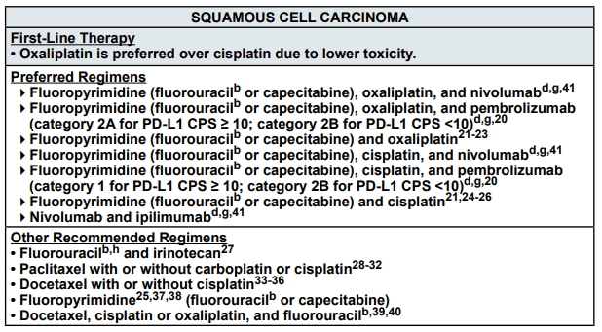
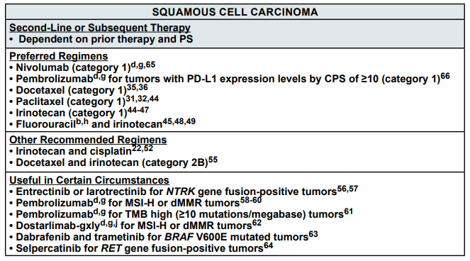
Most preferred first-line options in the NCCN guidelines include either nivolumab or pembrolizumab.
In Australia, nivolumab is registered in the ARTG for second-line treatment of recurrent or metastatic OSCC.
Pembrolizumab is registered for first line-treatment of patients with locally advanced or metastatic carcinoma of the oesophagus or human epidermal growth factor receptor 2 (HER2) negative gastroesophageal junction adenocarcinoma.

Non-small cell lung cancer
Improved understanding of various subtypes of NSCLC has led to novel biomarker-targeted therapies for patients with metastatic disease (including therapies that target epidermal growth factor receptor (EGFR) mutations, anaplastic lymphoma kinase (ALK) rearrangements and other molecular changes).
For patients with metastatic NSCLC and no actionable oncogenic driver, immune checkpoint inhibitors show survival benefit. The benefit is seen when given as monotherapy following disease progression on platinum-based chemotherapy or when given with or without chemotherapy as first-line therapy.
The use of immune checkpoint inhibitors has now been extended as first-line therapy for NSCLC with no actionable oncogenic driver, either as monotherapy or in combination with chemotherapy.
Prior to immune checkpoint inhibitors, there were 2 main chemotherapies used in locally advanced or metastatic NSCLC with no actionable oncogenic driver after prior chemotherapy. These are docetaxel for non-squamous or squamous NSCLC and pemetrexed for non-squamous NSCLC patients who had not received pemetrexed as first-line treatment. Erlotinib can also be given in patients who cannot receive cytotoxic chemotherapy due to poor PS.
In Australia, the checkpoint inhibitors, nivolumab, pembrolizumab and atezolizumab are recommended in this context as first-line treatment in accordance with NCCN Guidelines (2023). Checkpoint inhibitors are not used as first-line treatment options only in the context of contraindication to checkpoint inhibitor use. These therapies are used irrespective of PD-L1 status and are used as monotherapy if PD-L1 level is >50% or as combination therapy with chemotherapy if <50%. Pemetrexed is restricted to non-squamous cell carcinoma in first or later lines of treatment in advanced disease.
The NCCN recommendations for treatment of NSCLC are listed in Figure 2.
Figure 2: NCCN Guidelines V3.2023 – First-line therapy and second-line therapy for NSCLC
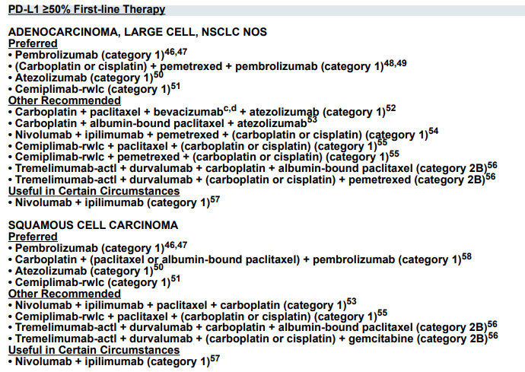
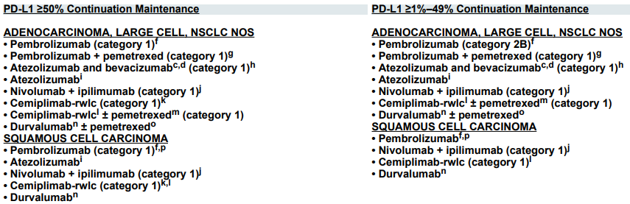

Clinical rationale
Tislelizumab (BGB-A317/VDT482) is a humanised immunoglobulin G4 (IgG4) monoclonal antibody against PD-1, binding to the extracellular domain of human PD-1 with high specificity and affinity, thereby blocking binding of PD-L1 and PD-L2, inhibiting PD-1-mediated negative signalling and enhancing the functional activity of T-cells in in vitro cell based assays. Tislelizumab does not bind to the Fcγ receptors and C1q and thus does not induce antibody-dependent cellular cytotoxicity (ADCC), antibody-dependent cellular phagocytosis (ADCP) or complement-dependent cytotoxicity (CDC).
Oesophageal squamous cell carcinoma (OSCC)
In view of recent evidence of PD-1 inhibitors demonstrating survival improvement over chemotherapy in patients with advanced or metastatic oesophageal squamous-cell carcinomas previously treated with systemic therapy, it is reasonable to assess a new PD-1 inhibitor, tislelizumab, as presented in this submission.
Non-small cell lung cancer (NSCLC)
It is reasonable to assess a new checkpoint inhibitor for NSCLC as other therapeutic agents in this class show efficacy in NSCLC.

Regulatory status

Australian regulatory status
This product is considered a new biological entity for Australian regulatory purposes.

International regulatory status
Table 1: International regulatory status
Region | Submission date | Status | Approved indications
USA | 9 July 2021 | Submitted | TEVIMBRA is a programmed death receptor-1 (PD-1) blocking antibody indicated for the treatment of adult patients with unresectable or metastatic esophageal squamous cell carcinoma (ESCC) after prior systemic chemotherapy.
EU –Centralised Procedure Rapporteur: Jan Müller-Berghaus (PEI); Corapporteur: Sinan Bardakci Sarac (DKMA) | 3 March 2022 |  | TRADENAME as monotherapy is indicated for the treatment of locally advanced or metastatic non-small cell lung cancer after prior chemotherapy in adults  TRADENAME in combination with carboplatin and either paclitaxel or nab-paclitaxel is indicated for the first-line treatment of locally advanced or metastatic squamous non-small cell lung cancer in adults TRADENAME in combination with pemetrexed and platinum-containing chemotherapy is indicated for the first-line treatment of locally advanced or metastatic non-squamous non-small cell lung cancer in adults whose tumours have no epidermal growth factor receptor (EGFR) or anaplastic lymphoma kinase (ALK) positive mutation  TRADENAME as monotherapy is indicated for the treatment of patients with advanced or metastatic  oesophageal squamous cell carcinoma (OSCC) after prior systemic chemotherapy.
Canada | N/A | Planned | N/A
Switzerland | N/A | Planned | N/A
Singapore | N/A | Planned | N/A

Registration timeline
This submission was assessed under the standard prescription medicines registration process.
Table 2 captures the key steps and dates of the assessment and registration process for this submission.
Table 2: Timeline for assessment and registration of Tevimbra
Description | Date
Submission dossier accepted and first round evaluation commenced | 1 August 2022
First round evaluation completed | 17 February 2023
Second round evaluation completed | 17 October 2023
Delegate’s Overall benefit-risk assessment and request for Advisory Committee advice | 9 October 2023
Advisory Committee meeting | 22 April 2024
Registration decision (Outcome) | 24 May 2024
Administrative activities and registration in the ARTG completed | 30 May 2024
Number of working days from submission dossier acceptance to registration decision* | 266 days
*Statutory timeframe for standard submissions is 255 working days

Submission overview and risk/benefit assessment

Quality
There were no significant issues identified from the quality evaluation of the submitted data that would indicate the product should not be registered on the basis of quality, or safety-related issues arising from the quality of the product. The Evaluator was satisfied that the Sponsor had satisfied all requirements with respect to:
- stability and release specifications (which dictate the medicine’s physicochemical properties, biological activity, immunochemical properties and purity)
- validation of analytical procedures,
- appropriate choice of reference standards and reference materials
- consistency of medicine manufacture as demonstrated by appropriate in-process acceptance criteria and action limits
- medicine sterility
- appropriate/compatible container closure systems.
- labelling that conformed to relevant Therapeutic Goods Orders.
These requirements, where applicable, were met for the drug substance and the drug product.
The quality Evaluator had no objections on quality grounds to the approval of tislelizumab.

Nonclinical
The submitted nonclinical dossier was in general accordance with relevant ICH guidelines.
In vitro, tislelizumab bound to human PD-1 with nanomolar potency (K_{D} 0.15 nM, well below the clinical steady state Ctrough level of 279 nM). Results of cell-based functional studies supported the proposed use of tislelizumab. Tislelizumab bound to cynomolgus monkey PD-1 with similar potency to human PD-1, thus supporting use of this species in safety studies. In vivo efficacy models (e.g., allogeneic xenograft mouse model and hPD-1 transgenic mouse model) demonstrated moderate tumour growth inhibition by tislelizumab.
Secondary pharmacodynamic studies examined tislelizumab binding to Fc gamma receptors (FcγRs) and the Cq1 receptor and included in vitro assays on antibody-dependent cellular cytotoxicity (ADCC) and complement-dependent cytotoxicity (CDC). There was no evidence that tislelizumab elicited either ADCC or CDC; however, concentrations tested were below those expected clinically (10-30 μg/mL cf. steady state clinical Cmax, 110 μg/mL). No notable off-target binding was observed with tislelizumab in a cell-based protein binding screen.
No stand-alone safety pharmacology studies were conducted. In the single and repeated dose toxicity studies in cynomolgus monkeys, tislelizumab had no effect on ECG parameters, respiratory rate, or body temperature. Assessment of effects on the central nervous system (CNS) was limited; however, effects are not anticipated due to limited access to the CNS.
The pharmacokinetics of tislelizumab in cynomolgus monkeys and humans were consistent with the protein nature of the drug: long half-lives and limited extravascular distribution. The pharmacokinetic profile of tislelizumab was considered sufficiently similar in cynomolgus monkeys and humans. Antidrug antibody (ADA) development to tislelizumab in cynomolgus monkeys affected exposures. In the pivotal 13-week toxicity study, the incidence and strength of neutralising ADAs was higher at the low dose than at the mid and high doses.
Single-dose toxicity studies with a 28-day observation period were conducted by the IV route in mice and cynomolgus monkeys. Tislelizumab had a low order of acute IV toxicity.
A repeated dose toxicity study (13-weeks with a 6-week recovery period) was conducted by the IV route (fortnightly infusion) in cynomolgus monkeys at doses up to 30 mg/kg, achieving acceptable animal to human exposure ratios (8.7× the clinical AUC at the high dose). Tislelizumab did not elicit any notable effects or toxicity in any of the treated animals, which may have been due to ADA development. Findings were like those seen in the original 13-week study with no notable toxicity findings at the no-observed-adverse-effect level NOAEL (30 mg/kg IV, 7.2× the clinical AUC). A higher dose (60 mg/kg IV; 17× the clinical AUC) was associated with moderate to severe immunogenic reactions in several animals.
No genotoxicity or carcinogenicity studies were conducted, which is acceptable.
No reproductive and developmental toxicity studies were conducted. Antibodies are known to cross the placenta and to be excreted into human milk. Based on published literature, tislelizumab may cause embryofetal lethality in pregnant patients, as well as adverse effects in newborns and infants.
There was no evidence of notable local reactions at the injection site in the single or repeated dose studies, and tislelizumab was not found to be haemolytic or cause aggregation of rabbit red blood cells.
The potential risk of tislelizumab to enhance immune responses to concomitantly administrated vaccines/antigens was investigated in a T-cell-dependent antibody response (TDAR) assay in mice and in an assay of the production of interferon-γ (IFN-γ) in human PBMCs. The results were inconsistent (former assay negative, latter assay positive) and the risk of enhanced immune responses cannot be ruled out. Findings from in vitro studies on cytokine release potential suggested that tislelizumab is unlikely to elicit cytokine release syndrome (CRS).
Primary pharmacology studies support the proposed indication and clinical dose.
No discernible toxicological effects or changes to ECG parameters, respiratory rate and body temperature were observed in pivotal 13-week repeated dose toxicity studies in cynomolgus monkeys.
Based on known actions of PD-1 inhibitors, potential effects of tislelizumab that may be of potential clinical relevance include:
- Autoimmune reactions
- Embryofetal lethality if used during pregnancy.
From a nonclinical perspective tislelizumab is concluded to have an acceptable safety profile. There are no objections to registration.

Clinical
Four pivotal clinical studies, one in support of each proposed indication, were included in the dossier of submission documents.
- BGB-A317-302 (Study 302) – OSCC indication
- BGB-A317-303 (Study 303) – 2L NSCLC indication
- BGB-A317-304 (Study 304) –1L non-squamous NSCLC indication
- BGB-A317-307 (Study 307) – 1L squamous NSCLC indication.
The dossier also included 6 additional PK studies, a PopPK analysis, and 3 exposure-response analyses.

Pharmacology
All PK studies were conducted in patients with advanced cancers of various types.

Pharmacokinetics (PK)
Following the recommended dose of 200mg tislelizumab IV q3weekly, Tmax was 1.4 hours after the first treatment cycle, and 0.78 hours after the 4th or 5th cycle.
Cmax and AUC were dose proportional across the dosage range of 0.5mg/kg – 10mg/kg. There was no correlation between clearance and body weight, which supports the fixed dose regimen. After a 200mg dose of tislelizumab q3weekly, Cmax was 1.21 and AUC0-tau was 1.60.
Vc, V2 and V3 were estimated to be 3.05L, 1.27L and 2.10L respectively.
The primary elimination pathway for tislelizumab is protein catabolism, similar to other antibodies. Clearance is estimated to be 0.153L/day.
Steady-state trough concentrations of tislelizumab were similar for all types of cancer, suggesting that tumour type did not have a meaningful effect on PK.

Population PK data (popPK)
A three-compartment model with first order elimination best characterised the data. According to the popPK analysis, time to reach 90% steady stage was approximately 84 days (12 weeks).
Steady-state volume of distribution according to the popPK analysis was 6.42L.
There was no clinically meaningful effect of age, weight, gender, race, mild to moderate renal impairment, mild to moderate hepatic impairment, or tumour burden on the PK of tislelizumab.
The PK section of the PI appropriately reflects this information.

Pharmacodynamics
Tislelizumab is a humanised IgG4 variant monoclonal antibody that binds to the T-cell surface receptor PD-1 and blocks PD-1 mediated inhibitory signalling.
In the PK/PD studies, efficacy in terms of ORR ranged from 10-15%. Median duration of response ranged from 12 – 16 months.
In terms of immunogenicity, the incidence of treatment emergent anti-drug antibodies (ADAs) was 16.5%. 0.6% of these were identified as neutralising antibodies (NAbs). ADA incidence rates were similar across all dose regimens, genders, and levels of PD-L1 expression.
There were no meaningful differences in efficacy and safety between ADA positive and ADA negative patients.
Exposure-Response analyses in patients with OSCC demonstrated longer OS in patients with higher tislelizumab exposure, and PD-L1 positive patients appear to have better outcomes than PD-L1 negative patients.
In 2L/3L NSCLC, baseline LDH, PD-L1 status, weight and disease stage were statistically significant covariates for OS. For patients with solid tumours administered weight based or a fixed dose, there was no relationship between tislelizumab exposure and ORR. In addition, no relationship between exposure and safety parameters were identified.

Dose selection
Weight based dosing of 2-5mg/kg q2weekly and q3weekly, and a flat dose of 200mg q3weekly were investigated, and a 200mg q3weekly IV dose of tislelizumab was selected for the phase II and III studies. This was based on the popPK analysis, which showed no clinically meaningful effect of any covariates on exposure, and the lack of relationship between exposure and efficacy or safety outcomes.

Efficacy

2L OSCC indication
As monotherapy for the treatment of adult patients with unresectable, recurrent, locally advanced or metastatic, oesophageal squamous cell carcinoma after prior systemic therapy.

Pivotal study: BGB-A317-302 (Study 302)
Study 302 is the pivotal study supporting the OSCC indication. This is an ongoing, randomised controlled, open-label phase III study conducted at 132 study sites in Belgium, France, Germany, Italy, Japan, Korea, Spain, China, Taiwan, the UK and the US.
The study start date was 26 January 2018 and the data cut off for the primary (final) analysis was 1 December 2020. Study 302 is summarised in patient/population, intervention, comparison/control and outcomes (PICO) format in Table 3.
Table 3: Study BGB-A317-302 PICO table
Population | Patients with advanced, unresectable or metastatic oesophageal squamous cell carcinoma that has progressed during or after first-line systemic treatment. Patients were enrolled at centres in Asia, the US, and Europe.  - 1:1 Randomisation to tislelizumab or ICC, stratified by:  - Region (Asia excluding Japan vs Japan vs EU/US)  - ECOG score (0 vs 1)  - ICC option (paclitaxel vs docetaxel vs irinotecan)  - Patients were required to have >1 evaluable lesion per RECIST v1.1; an ECOG PS of <1; and adequate organ function  - First-line treatment must have been a platinum-based combination regimen, and may have included surgery and radiotherapy
Intervention | Tislelizumab  - 200mg q3weekly starting on day 1
Control | Investigator Chosen Chemotherapy (ICC) – one of the following:  - Paclitaxel 135-175mg/m² q3weekly starting on day 1  - Docetaxel 75mg/m² q3weekly starting on day 1  - Irinotecan 125mg/m² on days 1 and 8, given every 3 weeks
Outcome | Primary endpoint:  - Overall Survival (OS) in ITT population  Key secondary endpoint:  - OS in PD-L1 positive cohort (vCPS >10% per SP263 assay, central testing)  Other secondary endpoints:  - Overall Response Rate (ORR)  - Progression free survival (PFS)  - Duration of Response (DOR)  - Health related quality of life (HRQoL)  - Safety and tolerability  The primary and key secondary endpoints were tested sequentially at a 1-sided alpha of 0.025. No statistical inference was planned for the other secondary endpoints.

Demographic and baseline characteristics
684 patients were screened, and 512 patients were enrolled and randomised 1:1 (256 in each arm) to tislelizumab or ICC, stratified by region, ECOG score and ICC option.
The median age was 62 years (range 35 – 86), and the majority of patients in both arms were male (approximately 84%). 26.6% of patients in the tislelizumab arm and 24.6% in the ICC arm had never smoked.
PD-L1 status was analysed using a cut-off of 10% according to vCPS. Patients with PD-L1 vCPS >10% were considered positive, and those with PD-L1 vCPS < 10% were considered negative. The Sponsor’s justification for the choice of 10% as the cut-off is explained by the clinical Evaluator:
It is stated in the report that PD-L1 expression in tumour and tumour-infiltrating immune cells in OSCC occur at a prevalence of 18.4% to 82.8% that a 10% cut-off was based on post hoc analysis of tumours from patients with OSCC who were treated in the tislelizumab cohort from studies BGB-A317-001 and BGB-A317-102, based on “pathological feasibility, assay reproducibility, assay performance (sensitivity, specificity, positive predictive value and negative predictive value) and clinical outcomes in patients with PD-L1 vCPS >10% as well as PD-L1 positive prevalence. It was furthermore stated in the report that vCPS >10% had been analytically validated for OSCC before PD-L1 scoring in study 302.

Results for the primary endpoint
At the data cut-off date of 1 December 2020, 410 of 512 patients (80.1%) had died, 197 in the tislelizumab arm and 213 in the ICC arm. The hazard ratio (HR) for the primary endpoint of OS was 0.70 (95% CI: 0.57-0.85; p=0.0001). Median OS was 8.6 months (95% CI: 7.5 to 10.4 months) in the tislelizumab arm and 6.3 months (95% CI: 5.3 to 7.0 months) in the ICC arm. As shown in the K-M curve (Figure 3), the curves separate at approximately 3 months and remain separated, showing a benefit in favour of tislelizumab.
Figure 3: Study BGB-A317-302. K-M Curve, Overall Survival, ITT Analysis Set (1 December 2020 Data Cut)
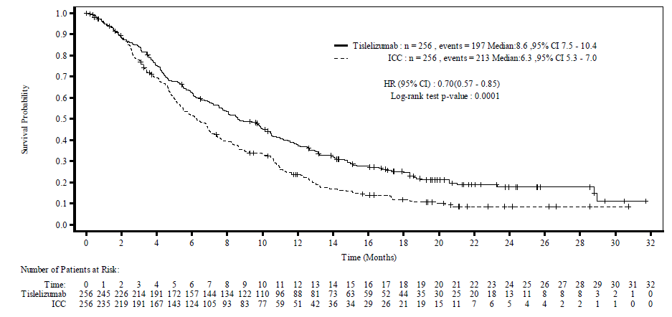
At the request of the clinical Evaluator, the Sponsor provided an updated analysis of OS with a data cut-off date of 28 December 2022 (last patient visit, closeout analysis). Results were consistent with the primary endpoint with a very similar HR of 0.71 (95%CI: 0.59-0.86) favouring tislelizumab. The K-M curve is shown in Figure 4.
Figure 4: Study BGB-A317-302. K-M Curve, Overall Survival Follow-up (28 December 2022 Data Cut)
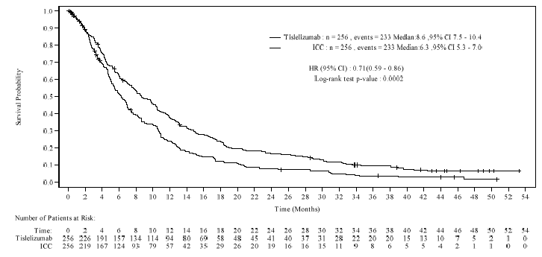
In the interpretation of this K-M curve, the Delegate holds a different view to the clinical Evaluator. The clinical Evaluator stated:
While there remains a small OS benefit seen in the final report, survival curves appeared to become non-parallel by months 48 to 52. Thus, there is uncertainty of the durability of survival benefit vs. comparator arms.
However, the Delegate notes the small number of patients remaining in the study by 48 months, making interpretation of the curve at this point of very limited value. Given the poor prognosis of OSCC, this K-M curve is not unexpected, and it is the Delegate’s view that it is supportive of the efficacy of tislelizumab in OSCC, as it shows a clear and consistent difference in survival between the tislelizumab and ICC arms. The Sponsor’s response to the Round 2 clinical evaluation report provides a similar interpretation.
Subgroup analyses for all pre-specified subgroups including PD-L1 status, age, gender, smoking status, ICC option, ECOG PS, region, and race were consistent with the primary analysis at the 1 December 2020 data cut (Figure 5).
Figure 5: Study BGB-A317-302. Subgroup analysis: Forest Plot of OS, ITT Analysis Set (1 December 2020 Data Cut)
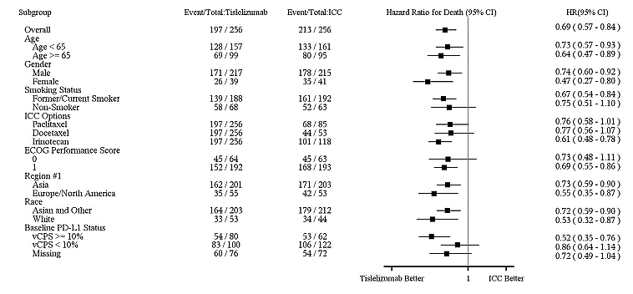
Subgroup analyses with the 28 December 2022 data cut were consistent with the primary analysis.

Results for the key secondary endpoint
The key secondary endpoint of OS in the PD-L1 positive (vCPS >10%) subgroup was alpha controlled. In the original dossier, it was stated that there were more PD-L1 positive patients in the tislelizumab arm (n=89, 34.8%) compared to the ICC arm (n=68, 26.6%).
The analysis presented in the original dossier was later found to include 49 invalid PD-L1 samples. The Sponsor corrected this and submitted a revised CSR at round 2, with the invalid PD-L1 results re-classified as missing, and all analyses re-run. Based on the corrected CSR, in the tislelizumab arm, 80 subjects (31.3%) were PD-L1 positive, 100 (39.1%) were PD-L1 negative, and 76 (29.7%) were classed as ‘missing.’ In the ICC arm, 62 patients (24.2%) were PD-L1 positive, 122 (47.7%) were PD-L1 negative, and 72 (28.1%) were classed as missing.
The corrected analysis of the key secondary endpoint produced a HR of 0.49 (95% CI 0.33-0.74; p=0.0003) in the PD-L1 positive group. Median OS was 10.0 months (95% CI: 8.5 – 15.1) in the tislelizumab arm and 5.1 months (95% CI 3.8-8.2) in the ICC arm. The K-M curve shows a clear benefit of tislelizumab (Figure 6).
Figure 6: Study BGB-A317-302. K-M Curve, Overall Survival, PD-L1 Positive Analysis Set
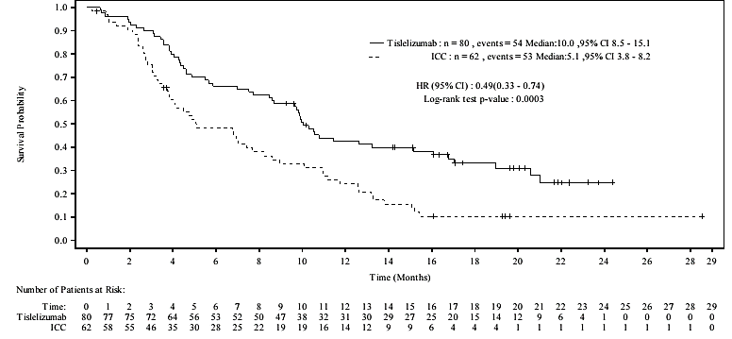
Post-hoc OS analyses were performed for patients with PD-L1 vCPS <10% and PD-L1 ‘missing.’ For the PD-L1<10% cohort, the HR was 0.83 (95%CI: 0.62-1.12). Median survival was 7.5 months (95% CI: 5.5-8.9) in the tislelizumab arm and 5.8 months (95% CI: 4.8-6.9) in the ICC arm. For the PD-L1 ‘missing’ cohort, the HR was 0.72 (95% CI: 0.49-1.06). Median OS was 8.5 months (95% CI: 6.2-12.1) in the tislelizumab arm and 7.0 months (95% CI 5.8-8.6) in the ICC arm.
Results of the follow-up analysis of the key secondary endpoint with a data cut of 28 December 2022 were consistent with the primary analysis.

Other secondary endpoints
Results for the secondary endpoint of progression-free survival (PFS) showed a less substantial benefit for tislelizumab. The HR for PFS was 0.83 (95% CI: 0.67 to 1.01). ORR was higher in the tislelizumab arm at 20.3% (95% CI: 15.6% to 25.8%) compared to 9.8% in the ICC arm (95% CI: 6.4% to 14.1%). The median duration of response in the tislelizumab arm was 7.1 months (95% CI: 4.1 to 11.3 months) compared to 4.0 months (95% CI: 2.1 to 8.2 months) in the ICC arm. Quality of life endpoints were variable.

2L NSCLC indication
As monotherapy for the treatment of patients with locally advanced or metastatic non-small cell lung cancer (NSCLC) after prior chemotherapy.

Pivotal study: BGB-A317-303 (Study 303)
Study 303 is the pivotal study supporting the proposed indication ’as monotherapy for the treatment of patients with locally advanced or metastatic non-small cell lung cancer (NSCLC) after prior chemotherapy’. It is an ongoing phase III, open-label randomised study comparing tislelizumab with docetaxel. The start date was 30 November 2017, and the data cut-off was 10 August 2020. The study is being conducted in 109 centres in China, Brazil, Bulgaria, Lithuania, Mexico, New Zealand, Poland, Russia, Slovakia and Turkey. 14 patients were enrolled at trial sites in New Zealand.
Details of the study are summarised in Table 4.
Table 4: Study BGB-A317-303 PICO table
Population | Patients with histologically confirmed Stage IIIB or IV NSCLC (EGFR and ALK wild-type) who had received at least 1 platinum-containing doublet regimen and no more than 2 lines of systemic treatment were enrolled.  - Randomisation 2:1 stratified by:  - Squamous vs non-squamous  - Line of therapy (2 vs 3)  - PD-L1 expression in (≥ 25% vs <25% in tumour cells)
Intervention | Tislelizumab 200mg IV q3weekly
Control | Docetaxel 75mg/m² IV q3weekly
Outcome | Primary endpoints:  - OS in the ITT population  - OS in the PD-L1 ≥ 25% population (per Ventana SP263 assay)  Secondary endpoints (in ITT and PD-L1≥ 25%)  - ORR in PD-L1 ≥ 25%  - DOR  - PFS  - HRQoL  Exploratory endpoints:  - Disease Control Rate (DCR)  - Clinical Benefit Rate (CBR)  - Immunogenicity  - Safety and tolerability  Multiplicity adjustment:  - Sequential testing with alpha splitting approach; overall type 1 error = 0.025 for primary endpoints (OS in ITT and OS in PD-L1 ≥ 25%)  - Then sequentially to ORR, DoR, PFS in PD-L1 ≥ 25% then PFS ORR and DoR in ITT; then PROs.  - One pre-specified interim analysis of OS in ITT population

Demographic and baseline characteristics
805 patients were randomised 2:1 to receive tislelizumab (n=535) or docetaxel (n=270). All 805 patients were included in the ITT analysis set. 42.4% in the tislelizumab arm and 43.0% in the docetaxel arm were in the PD-L1≥ 25% analysis set. At the data cut (10 August 2020), 20.2% of patients in the tislelizumab arm remained on study treatment compared to 4.4% in the docetaxel arm.
In the ITT population, median follow-up was 13.339 months (range: 0.30 - 32.36 months) in the tislelizumab arm and 9.741 months (range: 0.03 - 30.78 months) in the docetaxel arm. Demographics and baseline characteristics were well balanced, including ECOG status, smoking history, histology and PD-L1 expression. Median age was 61 years in both arms; 68% in the tislelizumab arm and 66.7% in the docetaxel arm were aged under 65 years. 77.8% of the tislelizumab arm and 76.3% of the docetaxel arm were male. 79.1% of the tislelizumab arm and 80.7% of the docetaxel arm were enrolled at trial sites in China. In the Tislelizumab arm, 79.3% were Asian, and 17.6% Caucasian, with similar proportion in the docetaxel arm (81.1% Asian; 16.3% Caucasian).
By the 10 August 2020 data cut, 441 deaths had occurred in the ITT population. The stratified HR was 0.64 (95% CI: 0.527, 0.778). The median OS was 17.2 months (95% CI: 15.28, 20.04 months) and 11.9 months (95% CI: 10.18, 13.93 months) for the tislelizumab and docetaxel arms, respectively. As shown in Figure 7, the 2 arms separate at approximately 2 months and remain separated.
Figure 7: Study BGB-A317-303 – Kaplan-Meier Plot of Overall Survival (ITT analysis set)
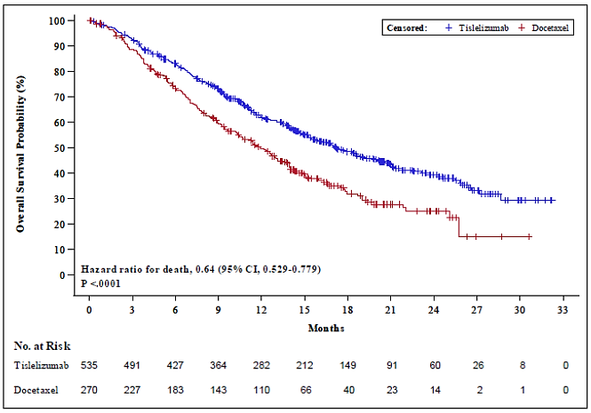
Results for the PD-L1-positive (>25%) analysis set with tislelizumab were more favourable with a stratified HR of 0.52 (95% CI: 0.384, 0.713). The K-M curve for this population is shown in Figure 8.
Figure 8: Study BGB-A317-303 – Kaplan-Meier Plot of Overall Survival (PD-L1 positive analysis set)
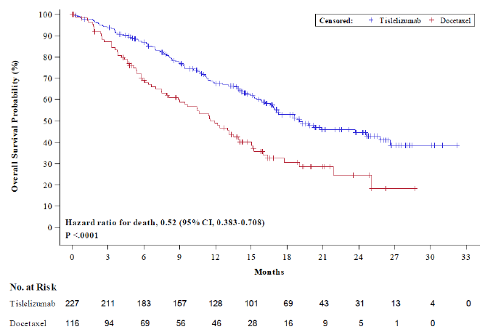
Sensitivity analysis based on the stratification factors was comparable to that of the primary analysis.
Subgroup analyses are shown in Figure 9.
Figure 9: Study BGB-A317-303 – Subgroup analysis – forest plot of OS, ITT population
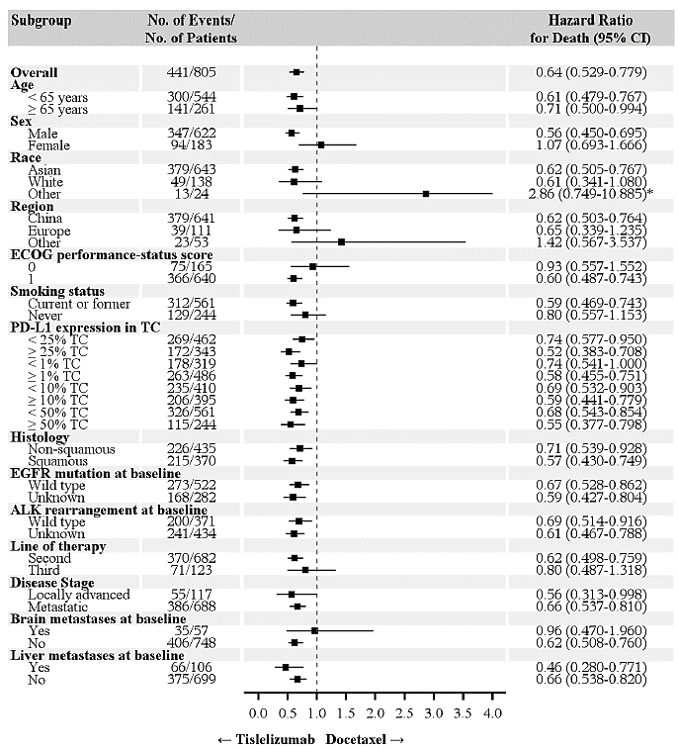
Subgroup analysis showed consistent effect with different PD-L1 cut-offs, different histologies (squamous vs non-squamous) and wild type or unknown EGFR and ALK status. Observed HRs above 1 for race ‘other,’ region ‘other,’ and brain metastases at baseline may be due to small numbers in these subgroups.
HRs above 1 also occurred in the ECOG status 0 and female subgroups. The Sponsor performed an additional analysis and found that baseline covariates had minimal impact on the HR observed. However, the Sponsor notes in their summary of clinical efficacy that for the female subgroup, the HR of 1.07 may be confounded by smoking status (approximately 80% of the female subgroup were non-smokers compared with 15% in the male subgroup) or histology (non-squamous histology in approximately 83% female vs 45% male subgroups.) In the ECOG 0 subgroup, the HR of 0.93 may have been confounded by third line patients (4% in docetaxel arm vs 14% in tislelizumab arm) or post ICI usage (30% vs 17.3%).
At the request of the Evaluator, the Sponsor provided the final OS analysis for study 303, with a data cut-off of 15 July 2021. Results were consistent with the primary analysis: the HR for OS at the final analysis was 0.66 (95% CI: 0.56, 0.79) for the ITT population and 0.53 (95% CI: 0.41, 0.70) in the PD-L1 >25% population.
Updated subgroup analysis was consistent with the primary subgroup analysis. The OS HR for the female subgroup had improved slightly from 1.07 (95% CI: 0.693-1.666) at the interim analysis to 0.95 (95% CI: 0.650-1.383) at the final analysis. For the ECOG 0 subgroup, the OS HR also improved slightly from 0.93 (95% CI: 0.557-1.552) at the interim analysis to 0.76 (95% CI: 0.497-1.160) at the final analysis.

Results for secondary efficacy endpoints
In the ITT population at the 10 August data cut, investigator assessed ORR was 21.9% in the tislelizumab arm and 7.0% in the docetaxel arm. Median DOR was 13.5 months (95% CI: 8.54, 21.78 months) in the tislelizumab arm and 6.2 months (95% CI: 2.10, 7.16 months) in the docetaxel arm. The HR for DOR, Median PFS was 4.1 months (95% CI: 3.75, 5.03 months) for the tislelizumab arm and 2.6 months (95% CI: 2.17, 3.78 months) for the docetaxel arm and the HR for PFS was 0.64 (95% CI: 0.533, 0.758).

1L non-squamous NSCLC Indication
In combination with pemetrexed and platinum-containing chemotherapy for the first-line treatment of patients with locally advanced or metastatic non-squamous, non-small cell lung cancer, with no epidermal growth factor receptor (EGFR) or anaplastic lymphoma kinase (ALK), genomic tumour aberration.

Pivotal study: BGB-A317-304 (Study 304)
Study 304 is a phase III, open-label, randomised study comparing tislelizumab combined with platinum and pemetrexed with platinum and pemetrexed alone in patients with stage IIIB or IV non-squamous NSCLC. All 47 study centres are located in China. The study started on 24 July 2018 and the DCO for the interim analysis was 23 January 2020. Table 5 shows details of study 304.
Table 5. Study BCB-A317-304 (Study 304) PICO table
Population | Patients with histologically confirmed stage IIIB (locally advanced, not amenable to curative treatment) or stage IV (metastatic) non-squamous NSCLC (EGFR and ALK wild-type) were enrolled. Patients with mixed tumours were permitted to enrol if non-squamous histology was the major component.  Patients who had received prior neoadjuvant, adjuvant chemotherapy radiotherapy or chemoradiotherapy with curative intent for non-metastatic disease must have experienced disease-free interval of >6 months from the last chemotherapy and/or radiotherapy prior to randomisation.  Randomisation 2:1 stratified by:  - Stage (IIIB vs IV)  - PD-L1 expression (<1% vs 1-49% vs ≥ 50%)
Intervention | Induction phase:  Tislelizumab 200mg IV D1, q3weekly  + cisplatin 75mg/m² OR carboplatin AUC 5, q3weekly (4-6 cycles per investigator)  + pemetrexed 500mg/m²  Maintenance phase:  Tislelizumab 200mg IV D1 q3weekly  + pemetrexed 500mg/m² q3weekly
Control | Induction phase:  cisplatin 75mg/m² OR carboplatin AUC 5, q3weekly (4-6 cycles per investigator)  + pemetrexed 500mg/m²  Maintenance phase:  Pemetrexed 500mg/m² q3weekly  Patients randomised to the control group had the option to cross-over to tislelizumab upon disease progression.
Outcome | Primary endpoint:  - PFS in ITT population (assessed by independent review committee; multiplicity adjustment for interim and final analysis)  Secondary endpoints:  - ORR  - DOR  - OS  - PFS (investigator assessed)  - HRQoL  - Safety and tolerability  - Correlation between PD-L1 expression and efficacy  Multiplicity adjustment  - Overall one-sided alpha of 0.025 for primary endpoint (PFS in ITT)  - One alpha controlled pre-specified analysis of PFS  - no pre-specified formal testing for OS.

Patients
At the data cut off for the interim analysis (23 January 2020), 223 patients were randomised to the tislelizumab arm, and 111 to control (total n=334). One patient in each arm did not receive treatment due to a major protocol deviation. At the data cut, a higher proportion of patients remained on study treatment in the tislelizumab arm (43.5%) compared to control (18.0%). The primary reason for treatment discontinuation was radiographic progression in 37.7% of the tislelizumab arm and 52.3% of the control arm. 37.8% of patients in the control arm crossed over on disease progression to receive tislelizumab, and 52.3% of the control arm received any subsequent immune checkpoint inhibitor. The median study follow-up time was 9.8 months (95% CI: 9.23 to 10.38 months) in the ITT analysis set.

Demographics and baseline characteristics
All patients were of Asian ethnicity. The median age of all randomised patients was 61.0 years (range: 25 to 75 years). There was a slight imbalance in age distribution: 26.9% of the tislelizumab arm were aged ≥ 65 years, compared to 33.3% of the control arm. Male patients represented 74.0% of the study population, (75.3% in the tislelizumab and 71.2% in the control arms). The majority of patients had an ECOG status of 1 (75.8% in the tislelizumab and 78.4% in the control group). 36.2% of the overall study population were never-smokers (34.1% in the tislelizumab arm and 40.5% in control). 80 patients (24.0%) in the ITT analysis set (including 53 patients [23.8%] in the tislelizumab arm and 27 [24.3%] in control), had a PD-L1 expression level of 1% to 49%. Two patients (0.6%) had missing EGFR mutation status, the remainder were negative. A higher proportion (26.6%) had missing ALK rearrangement status, the remainder being negative. 73.3% of the tislelizumab group and 87.5% of the control group had received prior adjuvant anticancer drug therapy.

Results for the primary endpoint
The stratified HR for the primary endpoint of PFS in the ITT population was 0.651 (95% CI: 0.465, 0.912). The 1-sided stratified log-rank test p-value was 0.0054, less than pre-specified p-value boundary of 0.0092. Median PFS was 9.7 months (95% CI: 7.72, 11.53 months) in the tislelizumab arm, and 7.6 months (95% CI: 5.55, 8.02 months) in the control arm. The K-M curve for PFS is shown in Figure 10.
Figure 10: Study BCB-A317-304 (Study 304), Kaplan-Meier Curve of PFS in the ITT population
The final PFS analysis with DCO of 26 Oct 2020 showed similar results: HR 0.632 (95% CI: 0.47-0.86, p=0.0013).
Subgroup analyses showed HRs above 1 for the never smokers’ group, and for patients with PD-L1 expression 1-49%. The HR was also close to 1 for female patients. Results from subgroup analyses of the primary endpoint are shown in Figure 11.
Figure 11: Study BCB-A317-304 (Study 304), Subgroup analysis of PFS in ITT population
The clinical Evaluator noted that the PFS benefit was only evident in patients with adenocarcinoma histology. Given that only 0.9% and 2.7% of the study population had adenosquamous and ‘other’ histologies respectively, it is difficult to draw any conclusions from these subgroup analyses.

Results for key secondary endpoints
At the DCO for the interim analysis, OS data were not mature. 71 deaths had occurred in the ITT analysis set, including 44 (19.7%) in the tislelizumab arm and 27 (24.3%) in the control arm. The stratified HR was 0.685 (95% CI: 0.422, 1.110). ORR was 57.4% in the tislelizumab arm, and 36.9% in the control arm.
At the final analysis, with DCO of 26 Oct 2020, the HR for OS was 0.9 (95% CI: 0.63-1.28). Median OS was very similar in both arms: 21.4 months in the tislelizumab arm and 21.3 months in the control arm.
At the request of the Evaluator, the Sponsor provided an updated analysis of OS based on a DCO of 15 July 2022. The median study follow-up time was 19.3 months, and the HR for OS was 0.85 (95% CI: 0.63-1.14) in the tislelizumab vs control arm. Median OS was 21.6 months in the tislelizumab arm, and 20.1 months in the control arm. The K-M curve is shown n Figure 12:
Figure 12: Study BCB-A317-304 (Study 304), Kaplan-Meier Curve of OS in the ITT population (DCO 15 July 2022)
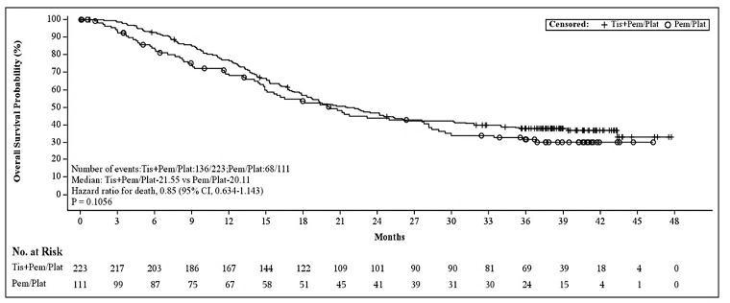
The Sponsor conducted two additional analyses of OS to adjust for the 37.8% of patients in the control arm who crossed over to tislelizumab. The adjusted HR using the Rank Preserving Structure Failure Time method was 0.80 (95% CI: 0.52-1.21). Using the two-stage approach, the adjusted HR was 0.68 (95% CI: 0.50-0.92).
The clinical Evaluator commented:
Although there were small trends in improved OS with tislelizumab vs. the comparator treatment arm and after supplementary OS analyses adjusting for tislelizumab cross-over effect, despite the initial report for the primary efficacy analysis reflecting statistically significantly PFS improvement of tislelizumab vs. comparator arms in study 304, subsequent follow-up data revealed small but not significant differences in improved OS in patients with non-squamous NSCLC i.e., no translation of initial improved PFS with improved OS despite secondary efficacy analyses. Moreover, there remained a possibility of greater adverse outcomes with tislelizumab because the upper bound of the 95% CI was 1.21.
The Sponsor’s response to the clinical Evaluator emphasised that study 304 met its primary endpoint, with a significant PFS result at the interim and final analysis. The study included crossover and thus was not designed to demonstrate superiority in terms of OS. The Delegate is of the view that the OS data is of limited use due to the number of patients who crossed over to tislelizumab or received other checkpoint inhibitors. Analyses of OS were not alpha controlled. PFS results therefore provide more robust efficacy data for this indication.

1L squamous NSCLC indication
In combination with carboplatin and either paclitaxel or nab-paclitaxel for the first-line treatment of patients with locally advanced or metastatic squamous NSCLC.

Pivotal study: BGB-A137-307 (Study 307)
Study 307 is the pivotal study supporting the first-line use of tislelizumab in patients with squamous NSCLC. It is a phase III, multicentre, randomised, open-label 3-arm study comparing the efficacy and safety of tislelizumab in combination with paclitaxel/nab-paclitaxel and carboplatin compared to paclitaxel and carboplatin alone. This study was conducted at 46 study centres in China, from 30 July 2018-6 December 2019. Study 307 is summarised in Table 6.
Table 6: Study BGB-A317-307 PICO Summary
Population | Patients with untreated stage IIIB/IV squamous NSCLC (EGFR and ALK wild-type) were enrolled. Patients who have received prior neoadjuvant or adjuvant chemo or radiotherapy or therapy with curative intent for non-metastatic disease must have experienced a disease-free interval of ≥ 6 months since last chemo or radiotherapy.  Randomisation 1:1:1 stratified by:  - Stage (IIIB vs IV)  - PD-L1 expression (<1% vs 1-49% vs ≥ 50%)
Intervention | Arm A (T+PC):  Tislelizumab 200mg q3weekly  + paclitaxel 175mg/m² q3weekly (4-6 cycles)  + carboplatin AUC 5 q3weekly (4-6 cycles)  Arm B (T+nPC):  Tislelizumab 200mg q3weekly  + nab-paclitaxel 100mg/m², D1, 8, 15 q3weekly (4-6 cycles)  + carboplatin AUC5 q3weekly (4-6 cycles)
Control | Arm C (PC):  Paclitaxel 175mg/m² q3weekly (4-6 cycles)  + carboplatin AUC 5 q3weekly (4-6 cycles)  Control subjects were permitted to cross over to receive Tislelizumab on disease progression
Outcome | Primary endpoint:  - PFS per IRC in ITT population (Arm A vs C and B vs C; 1 sided alpha = 0.025)  Secondary endpoints:  - OS  - ORR per IRC and per investigator  - DOR per IRC and per investigator  - PFS per investigator  - HRQoL  - Safety and tolerability  - Correlation between PD-L1 expression and efficacy  Multiplicity Adjustment:  Alpha was controlled at 0.025 using sequential testing. PFS was tested first in arm A vs C, followed by Arm B vs C, each at one-sided alpha of 0.025. One interim analysis of PFS in each comparison in the ITT analysis set.

Patients
360 subjects were randomised, 120 to the T+PC arm, 119 to the T+nPC arm, and 121 to the control arm. 1 patient in the T+nPC arm, and 4 in the control arm did not receive treatment. At the 6 December 2019 data cut, 96.7% of the control arm had discontinued treatment, compared to 47.5% of the T+PC arm and 43.7% of the T+nPC arms; the difference being partially due to the 6 cycle limit on the chemotherapy treatments. Completing chemotherapy was the primary reason for treatment discontinuation in the control arm (66.9%), and progressive disease was the primary reason for treatment discontinuation in the T+PC arm (26.7%) and T+nPC (23.5%). 58.7% of patients in the control arm crossed over to receive tislelizumab on disease progression. Median follow-up time was 8.36 months (range 0.1-16.3 months).

Demographics and baseline characteristics
As this study was conducted in China, all patients were of Asian ethnicity. Study 307 had a very small proportion of female patients, with only 5-10% of subjects in each arm being female. This may be partly due to the exclusion of patients with EGFR mutations. However, the proportion of female patients is even lower than in study 304, which had similar exclusion criteria. The median age of the total population was 62.0 years (range 34-74), and the proportion of patients ≥ 65 was higher in the T+nPC arm (43.7%) compared to the T+PC arm (32.5%) and control arm (29.8%). In the total population, median BMI was 22.29 (range 15.2-34.9), and was very similar between arms. 76.4% of patients had an ECOG PS of 1, the remainder having a status of 0. A smaller proportion of the T+nPC arm (10.1%) compared to the T+PC arm (20.0%) and control arm (19.0%) were never smokers. 8.1% of the total population had received prior anticancer drug therapy.

Results for the primary efficacy endpoint
Results for the primary endpoint of PFS per IRC in the ITT population demonstrated favourable results for both treatment arms. At the 6 December 2019 data cut, the stratified HR for T+PC vs control was 0.483 (95% CI: 0.340 - 0.686, p <0.0001). The stratified HR for T+nPC vs control was 0.450 (95% CI: 0.316 - 0.642, p <0.0001). Median PFS in the T+PC arm was 7.6 months (95% CI: 5.95 - 9.79); median PFS was also 7.6 months (95% CI: 5.75 - 11.01) in the T+nPC arm; compared to 5.4 months (95% CI: 4.21 - 5.59) in the control arm. Kaplan-Meier curves for the primary endpoint of PFS are shown in Figure 13.
Figure 13: Study BGB-A317-307 K-M Plot of PFS by IRC, ITT analysis set
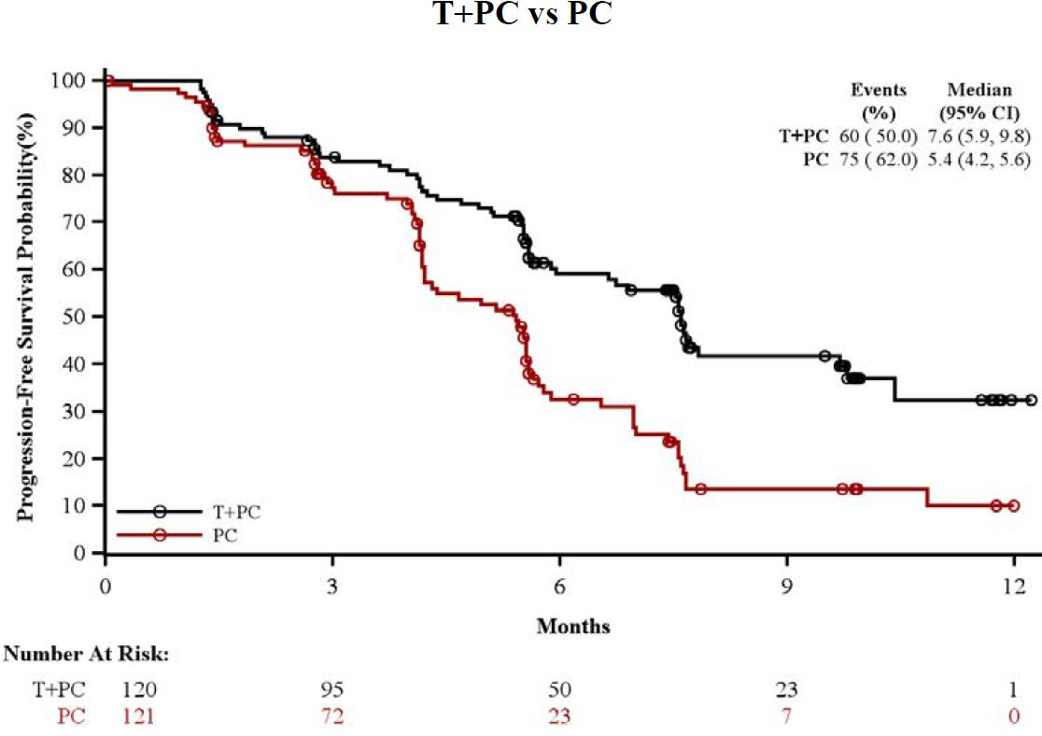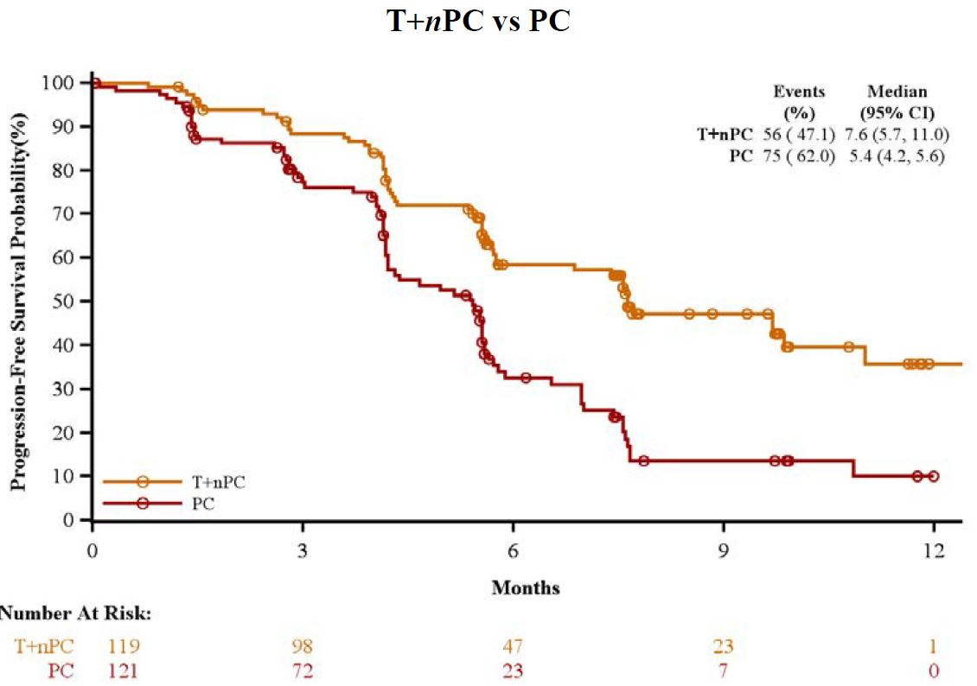
Subgroup analyses of PFS were generally consistent with the primary analysis. The wide confidence intervals around the point estimates for female patients, patients with ECOG PS of 0, and patients with liver metastases at baseline may be due to the low numbers of patients in these groups and reflect the consequent uncertainty in these patient populations. The results of the subgroup analyses are shown in Figure 14.
Figure 14: Study BGB-A317-307 Subgroup analysis: Forest Plot of PFS per IRC, ITT analysis set. T+PC vs control (first plot) and T+nPC vs control (second plot)
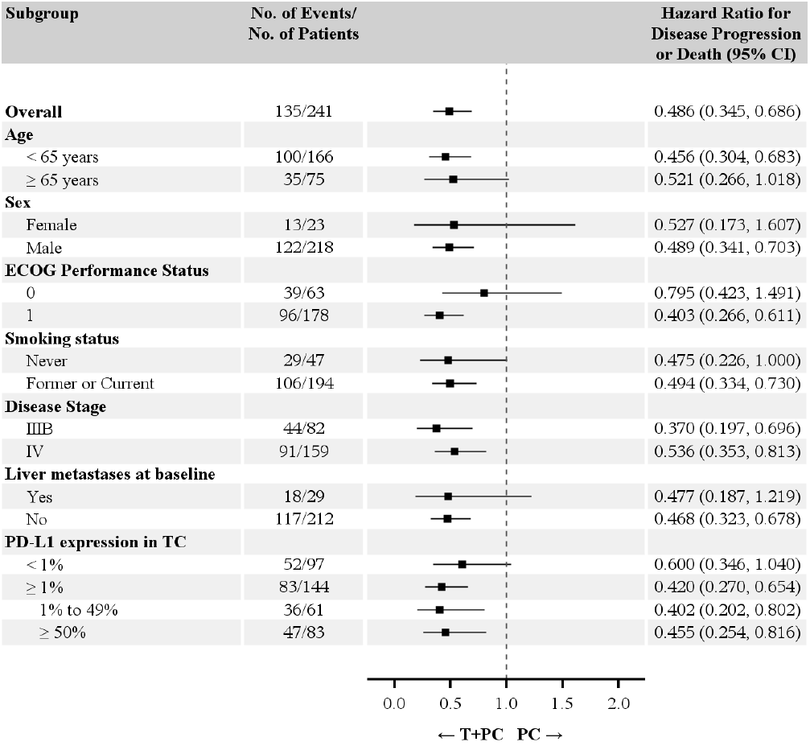
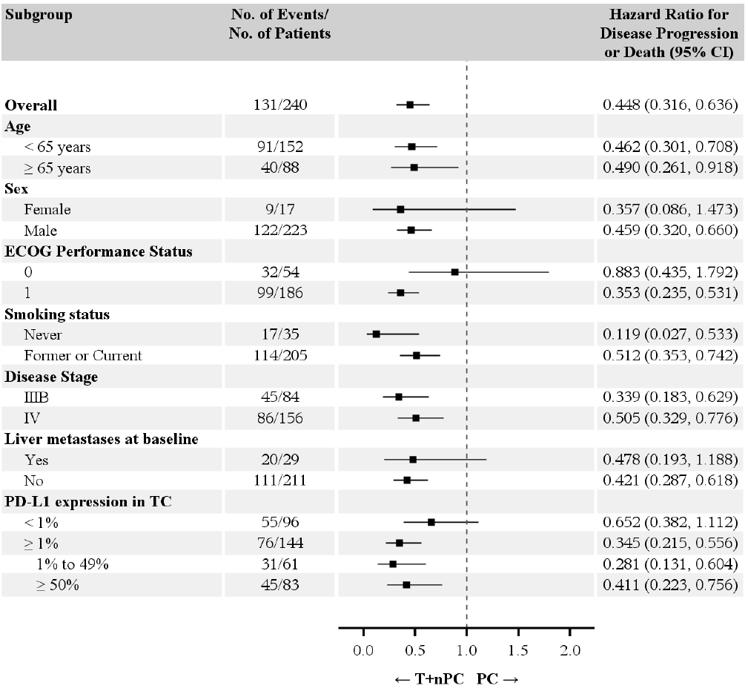
Updated PFS results with a later data cut off of 15 July 2022 were provided by the Sponsor at the request of the clinical Evaluator. Results of the final analysis were as follows: PFS HR for Arm T+PC vs. Arm PC was 0.45 (95% CI: 0.329 - 0.620) and 0.45 (95% CI: 0.327- 0.620) for Arm T+nPC vs. Arm PC. Median PFS was 7.7 months in the T+PC arm, 9.5 months in the T+nPC arm, and 5.5 months in the control arm.

Results for key secondary endpoints
OS data were not mature at the interim analysis DCO of 6 December 2019. A total of 54 deaths had occurred in the ITT analysis set; 20 in the T+PC arm; 16 in the T+nPC arm; and 18 in the control arm. ORR assessed by IRC was 72.5% in arm T+PC; 74.8% in arm T+nPC, and 47.9% in the control arm.
At the request of the clinical Evaluator, the Sponsor provided additional data from the final analysis of study 307, with DCO of 15 July 2022.
In terms of overall survival, the HRs were 0.69 (95% CI: 0.50, 0.95) for Arm T+PC vs. Arm PC and 0.84 (95% CI: 0.61, 1.14) for Arm T+nPC vs. Arm PC. Median OS was 26.1 months in Arm T+PC, 23.3 months in Arm T+nPC, and 19.4 months in Arm PC. These results are not adjusted for the 58.7% of patients in the control arm who crossed over to receive tislelizumab. The Sponsor performed two additional analyses to adjust for crossover. Using the rank-preserving structural failure time (RPSFT) model, the HRs were 0.59 (95% CI: 0.381, 0.925) for Arm T+PC vs. Arm PC, and 0.68 (95% CI: 0.347, 1.331) for Arm T+nPC vs. Arm PC. Using the two-stage approach, the adjusted HRs were 0.57 (95% CI: 0.409, 0.790) for Arm T+PC vs. Arm PC, and 0.65 (95% CI: 0.468, 0.896) for Arm T+nPC vs. Arm PC.
The clinical Evaluator commented:
The adjusted HR for OS was not evenly seen across 2 methods addressing cross-over to tislelizumab having an impact on the control arm performance. Thus, the adjusted HR from the rank-preserving structural failure time model showed benefit for Arm T + PC vs. Arm PC (95% CI: 0.381, 0.925), but not for Arm T + nPC vs. Arm PC (0.68, 95% CI: 0.347, 1.331). However, the adjusted HR from the 2-stage approach did show consistent benefit for Arm T + PC and Arm T + nPC vs. respective comparator arms, i.e., 0.57 (95% CI: 0.409, 0.790) and 0.65 (95% CI: 0.468, 0.896), respectively. This uneven benefit in OS introduces uncertainty in the generalisability of treatment and is partly explained by the limitation of the rank-preserving structural failure time model that assumes each patient proceeds through the disease at his/her own speed and that tislelizumab might slow this speed down by the same factor regardless of when administered.
The Sponsor’s response to the Round 2 clinical evaluation report emphasised that study 307 was designed to demonstrate PFS superiority, and due to the cross-over design, it was not designed to demonstrate superiority of OS. Study 307 met its primary endpoint, with PFS in both treatment arms being superior to control.

Safety

2L OSCC indication (Study 302)
Data from the following safety populations in study 302 were provided:
- Study 302 population (n=495; [255 in the tislelizumab arm, and 240 in the ICC arm])
- OSCC population (n=307; [255 from study 302, 26 from study 102 and 26 from study 001])
- All doses all indications population (n=1972 [from studies 302, 102, 001, 303, 208, 204 and 203])
Safety data for the OSCC population were very similar to the study 302 population, therefore the latter is the focus of this overview, with reference to the ‘all doses all indications’ population where relevant.
In study 302, exposure was greater in the tislelizumab arm compared to ICC. Median duration of exposure was 2.76 months vs. 1.49 months, respectively, and the proportion of patients with >6 months of exposure was 25.5% in the tislelizumab arm compared to 8.8% in the ICC arm. Thus, exposure adjusted AE rates were provided as well as unadjusted rates. Rates discussed here are unadjusted, unless specifically stated to be exposure adjusted.
Overall adverse events (AEs)
The overall safety profile of tislelizumab was comparable and in some instances better than ICC. In terms of patient disposition in study 302, a higher proportion of patients remained on study treatment with tislelizumab vs. ICC (6.3% vs. 0.4%) as of the data cut-off date of 1 December 2020. Disease progression was the primary reason for treatment discontinuation in both arms and a higher rate of discontinuation was seen in the tislelizumab vs. ICC arms (69.4% vs. 55.4%). AEs were the second most common reason for treatment discontinuation in both arms and a lower proportion of patients reported discontinuation due to AEs in the tislelizumab vs. ICC arms (12.2% vs. 18.3%). A summary of TEAEs is shown in Figure 15:
Figure 15: Overall summary of treatment emergent AEs, Study 302, Safety Analysis Set
The majority of patients had a TEAE: 95.7% and 98.3% for the tislelizumab and ICC arms, respectively. The incidence of treatment related TEAEs was higher in the ICC arm (93.8%) compared to the tislelizumab arm (73.3%). Most AEs in the tislelizumab arm were grades 1 or 2; although grade >3 AEs occurred in 46.3% of the tislelizumab arm, compared with 67.9% of the ICC arm. Overall, TEAEs across categories were lower in the tislelizumab vs. ICC arm.
Fewer patients in the tislelizumab vs. ICC arm had AEs leading to treatment discontinuation (19.2% vs. 26.7%, respectively) or AEs leading to dose modification (22.7% vs. 47.9%, respectively). SAEs occurred in similar incidence in both arms (41.2% vs. 43.8%) although there were fewer SAEs after exposure-adjustment for the tislelizumab vs. ICC arms (12.5/100 person-months, vs. 28.9/100 person-months, respectively).
Frequent AEs
In the tislelizumab arm, the most frequently occurring AEs were anaemia, fatigue, and weight decreased. In the ICC arm, the incidence of anaemia and fatigue was higher, however the incidence of weight decreased was lower. These data are summarised in Figure 16:
Figure 16: Adverse events occurring in ≥ 10% patients receiving tislelizumab (study 302, safety analysis set)
The most frequently reported grade >3 AEs by preferred term in the tislelizumab arm were dysphagia, anaemia and hyponatraemia. However, the overall incidence of grade >3 AEs was lower in the tislelizumab arm (46.3%) vs. the ICC arm (67.9%).
In exposure-adjusted analyses, tislelizumab was associated with a lower rate of AEs of any grade compared to ICC (171.8/100 person-months vs. 442.3/100 person-months).
Deaths
TEAEs leading to death were reported in 35 patients (13.7%) in the tislelizumab arm and 28 patients (n=11.7%) in the ICC arm. Most of these were judged by the investigators to be attributable to the underlying disease. Deaths attributable to AEs were reported with similar incidence in both arms (5.5% [14 patients] in the tislelizumab arm vs. 5.8% [14 patients] in the ICC arm). With exposure-adjusted assessment of AEs leading to death, this had a lower rate in the tislelizumab arm (2.8 deaths/100 person-months) vs. the ICC arm (4.7 deaths/100 person-months). TEAEs leading to death are summarised in Figure 17:
Figure 17: TEAEs leading to death by SOC and PT, Study 302, safety analysis set
Serious adverse events (SAEs)
Serious AEs were reported with a similar overall incidence in the 2 treatment arms (41.2% vs. 43.8% for tislelizumab and ICC, respectively). By preferred term, pneumonia was the most common SAE reported for both treatment arms (7.1% in both arms). Dysphagia was the only SAE that occurred with >2% higher incidence in the tislelizumab arm compared with the ICC arm (4.7% vs. 1.7%, respectively).
Immune-mediated adverse events (imAEs)
Immune-mediated AEs occurred in 21.2% (n=54) of tislelizumab-treated patients in study 302. The majority were grade 1 or 2, with 3.5% (n=9) of patients experiencing grade >3 imAEs, and 5.9% (n=15) SAEs. Some were managed with treatment modification (6.3%, n=16) or discontinuation (n=8; 3.1%). There were no imAEs leading to death in study 302.
The most frequent imAEs were hypothyroidism, pneumonitis and skin reactions. High dose systemic corticosteroids (>40mg/day prednisone equivalent) were given as an intervention in 22/54 (40.7%) of patients who experienced immune-mediated AEs. No patient received any other immunosuppressive therapy. In the “all doses all indications” population, 4 patients (0.2%) died from an immune-mediated AE (3 from immune-mediated pneumonitis and 1 from immune-mediated hepatitis). The overall incidence of immune-mediated AEs was higher in the female vs. male group (28.2% vs. 19.9%), mainly due to pneumonitis (12.8% female vs. 6.0% male).
Immune mediated AEs are shown in Figure 18.
Figure 18: Immune mediated TEAEs, study 302, safety analysis set
The PI approved with this submission contains appropriate information about the occurrence and suggested management of imAEs.

2L NSCLC Indication (Study 303)
The following populations contributed safety data for the 2L NSCLC indication.
- Study 303 population (n=792 [534 patients in the tislelizumab arm; 258 in the docetaxel arm])
- 2L + NSCLC population (n=636 from tislelizumab arm of Study 303, plus cohorts from Studies 001 and 102)
- All doses all indications population (n=1972 [from studies 302, 102, 001, 303, 208, 204 and 203])
In Study 303, the median duration of exposure was longer in the tislelizumab arm (5.36 months) compared to the docetaxel arm (2.10 months). Median exposure was similar in the tislelizumab arms in the 2L+NSCLC population (4.8 months) and ‘all doses and all indications’ pool (4.11 months).
At the 10 August 2020 data cut, 78.8% of the tislelizumab arm and 95.3% of the docetaxel arm had discontinued study treatment. Disease progression was the most common reason for treatment discontinuation in all groups, and death was the most common reason for study discontinuation.
Overall AEs
The overall summary of TEAEs (Figure 19) demonstrates a safety profile of tislelizumab that is comparable to that of docetaxel. In study 303, over 95% of the tislelizumab arm and over 98% of the docetaxel arm had at least one AE. Treatment related TEAEs were higher in the docetaxel arm (93.8%) compared to the tislelizumab arm (73.0%), however the overall incidence of serious TEAEs was similar between both treatment arms (tislelizumab 32.6%, docetaxel 32.2%). 12.5% of the tislelizumab arm and 22.9% of the docetaxel arm had a treatment related serious TEAE. 22.3% of patients in the tislelizumab arm vs. 34.5% of patients in the docetaxel arm in study 303 had TEAEs that led to dose modification including infusion interruptions and dose delays (dose reductions not permitted).
Figure 19: Overall Summary of TEAEs, Study 303, 2L + NSCLC and all dose all indications populations
Similar proportions of patients discontinued study treatment due to TEAEs in the tislelizumab and docetaxel arms (10.5% and 12.4% respectively). Grade >3 events in study 303 were higher in the docetaxel vs. tislelizumab arm (74.8% vs. 38.6%) with the largest differences (>10% higher in the docetaxel arm) seen for leukopenia (-15.7%) and white blood cell count decrease (-18.0%), neutropenia (-27.3%), febrile neutropenia (-12.8%) and neutrophil count decrease (-26.9%).
Frequent AEs
The most commonly reported AEs by preferred term in the tislelizumab arm of study 303 (>15% of patients) were anaemia, increases in ALT and AST, cough, decreased appetite and weight loss. Differences between treatments of >10% in the reported incidence of preferred terms for the tislelizumab vs. docetaxel arm were seen for anaemia (-14.9%), leukopenia (-23.9%) and white blood cell count decrease (-25.0%), neutropenia (-29.7%), febrile neutropenia (-12.8%) and neutrophil count decrease (-34.0%) and alopecia (-46.4%), i.e., all were reported at a higher incidence in the docetaxel arm (Figure 20).
Figure 20: TEAEs with incidence ≥ 10% by PT, Study 303, 2L + NSCLC and all dose all indications populations
The higher incidence of serious respiratory, thoracic and mediastinal disorders in the tislelizumab arm (13.3%) vs. the docetaxel arm (6.6%) was driven by differences seen for preferred terms representing immune-mediated pneumonitis [pneumonitis (2.8% vs. 0%), immune-mediated pneumonitis [1.3% vs. 0%] and interstitial lung disease (1.3% vs. 0%)], other serious respiratory events occurring at similar incidences in both arms.
In the docetaxel arm, serious blood and lymphatic disorders occurred at a higher incidence vs. tislelizumab (14.0% vs. 0.9%) as did investigations (4.3% vs. 0.9%).
Deaths
The most common reason for death was due to underlying disease. Most deaths occurred more than 30 days after the last dose of study medication. In study 303, the most common TEAE that led to death in the tislelizumab arm were respiratory, thoracic and mediastinal disorders (most commonly respiratory failure), general disorders and administration site conditions and infections and infestations. These were also the most common TEAEs that led to death in the docetaxel arm.
SAEs
While serious AEs occurred in similar proportions between arms in Study 303, an exposure-adjusted analysis of serious TEAEs in study 303 showed a lower incidence of serious TEAEs with tislelizumab vs. docetaxel (6.3 vs. 15.7 per 100 person-months, respectively). The most common SAEs (>2% of patients) were pneumonia, anaemia and hypertension, reported at similar incidences in the docetaxel arm as well as other populations.
imAEs
In terms of immune-mediated AEs, ~18% of patients in the tislelizumab arm of study 303 had an immune-mediated TEAE. Of these, 6.9% were serious TEAEs or grade >3 immune-mediated TEAEs (5.6%). A total of 21 patients (3.9%) had immune-mediated TEAEs that led to treatment discontinuation and 2 patients (0.4%) had immune-mediated TEAEs leading to death (1 each of pneumonia and pneumonitis). The most common categories of immune-mediated TEAEs in the tislelizumab arm were immune-mediated hypothyroidism (7.9%) and immune-mediated pneumonitis (5.8%). There were no cases of Guillain-Barre Syndrome, Stevens-Johnson Syndrome, toxic epidermal necrolysis or myasthenia gravis reported. Approximately 10% of all patients who had immune-mediated TEAEs were treated with systemic steroids (54/534) in the tislelizumab arm of study 303 (Figure 21).
Figure 21: Immune-mediated TEAEs, Study 303, 2L + NSCLC and all dose all indications populations
As previously stated, the PI contains detailed information about imAEs, as would be expected for a PD-1 inhibitor.

1L non-squamous (Study 304) and squamous (Study 307) NSCLC
Safety data from studies in both first-line NSCLC indications (squamous and non-squamous) are summarised in this section, as they were presented together in the dossier. Safety data comes from the following populations:
From Study 304 (total of 332 patients with non-squamous NSCLC):
T+PP (n=222 in the tislelizumab arm)
PP (n=110 in the control arm)
From Study 307 (total of 355 patients with squamous NSCLC):
- T+PC (n=120 in the tislelizumab, paclitaxel and carboplatin arm)
- T+nPC (n=118 in the tislelizumab, nab-paclitaxel and carboplatin arm)
- PC (n=117 in the control arm).
Combined safety populations:
- T+ chemo (n= 497 patients from studies 304, 307 and 206 who received tislelizumab and chemotherapy)
- Chemo only (n=227 patients from studies 304 and 307 who received chemotherapy only).
In study 304, median duration of exposure to tislelizumab was 7.9 months in the tislelizumab arm. Median duration of exposure to cisplatin in study 304 was similar in both arms (2.8-2.9 months). In study 307, median duration of exposure to tislelizumab was 9.3 months in arm T+PC and 10.2 months in arm T+nPC. Median exposure to paclitaxel/nab-paclitaxel was similar across the three arms (3.1-3.4 months), as was median exposure to carboplatin (3.1-3.5 months).
Overall AEs
Almost all patients in each study population experienced at least 1 TEAE, and the vast majority of these were treatment related. The rates of chemotherapy related events were slightly higher than tislelizumab related events in the relevant populations. Across both studies 304 and 307, serious TEAEs, and TEAEs leading to treatment discontinuation or modification were higher in the tislelizumab groups. Figure 22 provides an overall summary of TEAEs in the 1L NSCLC safety analysis populations.
Figure 22: Overall Summary of TEAEs, 1L NSCLC Safety Analysis Set
Grade ≥ 3 TEAEs were higher in the squamous NSCLC patients (study 307, approximately 85-90%) compared to non-squamous (study 304, approximately 55-70%). Treatment differences of at least 5% higher incidence of grade >3 TEAEs for the combined T+chemo group relative to the chemo group were seen for neutrophil count decrease and platelet count decrease, while neutropenia was higher in the chemo group.
In study 307, there were more TEAEs leading to treatment discontinuation in the T+nPC arm (32.2%) compared to the T+PC arm (17.5%) and PC arm (15.4%), predominantly due to haematological toxicity. In addition, pneumonitis, interstitial lung disease and haemoptysis were among the more common reasons for treatment discontinuation. TEAEs leading to tislelizumab dose modification (>5% patients in the T+chemo group) were anaemia, leukopenia, neutropenia and thrombocytopaenia; decreased neutrophil count, total white cell count and platelet count; increased ALT; and pneumonia.
Frequent AEs
The most commonly reported TEAEs in either the T+chemo or chemo groups (>30% of patients) were anaemia, neutrophil count decrease, white blood cell count decrease, platelet count decrease, increases in ALT and AST, nausea, decreased appetite, leukopenia, neutropenia, alopecia and thrombocytopaenia, a similar profile being seen across treatment arms within the individual studies. Figure 23 shows TEAEs occurring in ≥ 10% of patients in 1L NSCLC. TEAEs with incidence ≥ 10% in the tislelizumab group compared to the chemo group were neutrophil count decreased, platelet count decreased, ALT increased and AST increased.
Figure 23: Most common TEAEs by PT (≥ 10% of patients) 1L NSCLC safety analysis set
Deaths
The total number of deaths was similar across all groups of both studies, ranging from 40%-44%. Disease progression was the cause of the majority of these deaths, and most occurred more than 30 days after the last dose of study treatment.
In study 304, TEAEs leading to death occurred in 4.1% of the tislelizumab arm compared to 1.8% of the chemotherapy arm. However, the Sponsor conducted an exposure-adjusted analysis which demonstrated similar event rates for TEAEs leading to death (0.4 per 100 person months in the tislelizumab arm compared to 0.3 in the chemotherapy arm). TEAEs leading to death occurred at a similar incidence in the three arms of study 307. The most common TEAE leading to death was pneumonitis, which occurred in 2% of the T+chemo population compared to 0.4% of the chemo population.
SAEs
In the pooled population, SAEs were more common in the T+chemo group (40.0%) compared to the chemo group (23.8%). However, the exposure-adjusted analysis showed more similar results (study 307: 6.3 and 5.9 events/100 person-months in T+PC and T+nPC respectively vs. 10 events/100 person-months in arm PC and study 304: 6.4 events/100 person-months in arm T+PP vs 5.5 events/100 person-months in arm PP). Similar SAE profiles were seen in squamous and non-squamous NSCLC patients. These included pneumonia, pneumonitis, haemoptysis, neutrophil count decrease and febrile neutropenia and dyspnoea.
imAEs
24.3% of the pooled tislelizumab group experienced imAEs. The majority of these were grade 1-2, and the most common being hypothyroidism and pneumonitis. Only one patient was treated with immunosuppressants for imAE, while a slightly higher proportion were managed with systemic steroids or hormone therapy.
There were 5 imAEs leading to death, 4 in study 304 (1.8%) and one in study 307 (0.8%). There was one case of Guillain-Barre Syndrome in study 304, grade 3, leading to dose interruption, and one case of immune-mediated encephalitis in study 307, grade 3, leading to treatment discontinuation.
A small proportion of patients experienced infusion related reactions (2.8% in the T+chemo group and 2.2% in the chemo only group).
Immune mediated adverse events (imAEs) are summarised in Figure 24.
Figure 24: Immune mediated TEAEs, 1L NSCLC Safety Analysis Set
In response to the clinical Evaluator’s request, the Sponsor provided an additional 9 months of safety follow-up data from study 307. No new safety signals were detected in these data.
Immunogenicity
The Sponsor provided a summary of immunogenicity data from studies 001, 102, 203, 204, 206, 208, 302, 303, 304 and 307. Detection of immunogenicity was a secondary objective in studies 001 and 102, and exploratory objective for the other studies. A range of tislelizumab doses were evaluated in study 001, and various combinations and tumour types were included in the immunogenicity assessment (Figure 25):
Figure 25: Summary of patients evaluated for immunogenicity to Tislelizumab in clinical studies
- Tislelizumab-treated patients (Safety analysis set)
- Serum samples from tislelizumab-treated patients
- Evaluable patients are those who had both baseline and at least one post-baseline sample
- The total number of serum samples of Studies 001, 102, 203 and 204 is presented.
- Not available, no. of serum samples evaluated was not indicated on Study 206 CSR.
2486 patients had serum samples tested for anti-drug antibodies (ADAs), of whom 2277 were considered ADA evaluable. Of these, 413 (18.1%) had treatment-emergent ADA and 400 (17.6%) had treatment-induced ADA and 18 (0.8%) had neutralising antibodies.
The incidence of ADA ranged from 13.7% to 37.4% across the 3 studies of tislelizumab given in combination with platinum-containing doublet chemotherapy.
For the tislelizumab 200mg every 3 weeks dose regimen, a higher incidence of ADA seen for the combination therapy studies vs. monotherapy studies (24.0% vs. 16.3%) was mainly driven by the higher incidence of transient ADA in the combination studies (14.8% vs. 6.1%), while the incidence of persistent ADA was similar (8.3% vs. 9.6%).
The overall incidence of ADA was higher in Caucasian patients vs. Asian patients (21.0% vs. 14.3%). Exposure-response analyses however showed that race was not a significant covariant of exposure-response relationships for efficacy and safety endpoints in the tislelizumab clinical studies.
Efficacy was comparable between patients with and without ADAs, as was safety, specifically, the proportion of imAEs.
Post-market data
The Sponsor initially provided a Periodic Benefit-Risk Evaluation Report (PBRER) dated 19 February 2021, and on request, supplied a more recent PBRER dated 26 December 2021-25 December 2022. Tislelizumab is approved for a variety of indications in China, and as of 25 December 2022, 3 787 545 vials of tislelizumab had been supplied (equivalent to approximately 1 893 772 infusions). During the reporting period, septic shock was added as an important potential risk in the China RMP. No new safety signals were detected.

Risk management plan
The following European Union Risk Management Plans (EU-RMPs) and Australian-Specific Annex (ASA) have been submitted and evaluated by the TGA.
- NSCLC version 0.1; 7 Feb 2022 and version 0.11; 9 Jan 2023
- OSCC version 0.2; 16 Feb 2022 and version 0.21; 9 Jan 2023
- ASA version 0.2; 10 Aug 2022 and version 0.2; 28 Feb 2023
The summary of safety concerns and their associated risk monitoring and mitigation strategies are outlined in Table 8. The TGA may request an updated RMP at any stage of a product's lifecycle, during both the pre-approval and post-approval phases.
Table 8: Summary of safety concerns
Summary of safety concerns |  | Pharmacovigilance |  | Risk minimisation
 |  | Routine | Additional | Routine | Additional
Important identified risks | Immune-mediated adverse reactions# | * | None |  | †
Important potential risks | Reproductive and development toxicity |  | None |  | None
Missing information | None‡ | - | - | - | -
*Targeted follow-up checklist
† Patient alert card and Caregiver guide
#Merged all important identified risks of immune mediated reactions into a single risk named ‘Immune-mediated adverse reactions’. In addition, upgraded important potential risk ‘Other immune-mediated reactions” to important identified risk and included into the single risk of “Immune-mediated adverse reactions”.
‡Removed missing information ‘Use in patient with autoimmune diseases’.

RMP Evaluator recommendations regarding conditions of registration
The suggested wording is:
The Tevimbra EU-Risk Management Plans (RMPs) (versions 0.11 and 0.21, dated 9 January 2023, data lock point 1 December 2020), with Australian Specific Annex (version 0.2, dated 28 February 2023), included with submission PM-2022-02507-1-4, and any subsequent revisions, as agreed with the TGA will be implemented in Australia.
The following wording is recommended for the PSUR requirement:
An obligatory component of risk management plans is routine pharmacovigilance. Routine pharmacovigilance includes the submission of periodic safety update reports (PSURs).
Unless agreed separately between the supplier who is the recipient of the approval and the TGA, the first report must be submitted to TGA no later than 15 calendar months after the date of this approval letter. The subsequent reports must be submitted no less frequently than annually from the date of the first submitted report until the period covered by such reports is not less than three years from the date of this approval letter. The annual submission may be made up of two PSURs each covering six months. If the Sponsor wishes, the six monthly reports may be submitted separately as they become available.
If the product is approved in the EU during the three years period, reports can be provided in line with the published list of EU reference dates no less frequently than annually from the date of the first submitted report until the period covered by such reports is not less than three years from the date of this approval letter.
The reports are to at least meet the requirements for PSURs as described in the European Medicines Agency’s Guideline on good pharmacovigilance practices (GVP) Module VII-periodic safety update report (Rev 1), Part VII.B Structures and processes. Note that submission of a PSUR does not constitute an application to vary the registration. Each report must have been prepared within ninety calendar days of the data lock point for that report.
As Tevimbra is a new chemical entity, it should be included in the Black Triangle Scheme as a condition of registration. The following wording is recommended for the condition of registration.
Tevimbra (Tislelizumab) is to be included in the Black Triangle Scheme. The PI and CMI for Tevimbra must include the black triangle symbol and mandatory accompanying text for five years, which starts from the date that the Sponsor notifies the TGA of supply of the product.

Risk-benefit analysis

2L OSCC Indication (Study 302)

Efficacy
The phase III open-label RCT study 302 is the pivotal study supporting the OSCC indication. This multicentre study was conducted in Asia, the US and Europe and consequently, the patient population consisted of approximately 80% Asian and 20% Caucasian subjects. While this may not be representative of the Australian population, it is in keeping with the epidemiology of OSCC, which is more common in Eastern and Central Asia. The predominance of male subjects (84%) is also in keeping with OSCC being more common in men. The Sponsor has provided a population comparison to support generalisability. While there are differences between the study population and Australian population, the Delegate is of the view that this is justifiable given the epidemiology of OSCC, and the results of study 302 are therefore considered generalisable to the Australian population. It is reassuring that subgroup analysis produced significant results by region, race and gender. Importantly, these baseline characteristics are documented in the PI to assist clinicians in making their own assessment of generalisability to each individual patient.
In the 302 study, 3 chemotherapy options were used as a comparator. This may have been appropriate at the time the study started in 2017-2018. However, since then nivolumab as monotherapy has become available in Australia for second line treatment of oesophageal cancer, and in combination with other agents for first-line treatment. Pembrolizumab is also registered for first-line treatment of oesophageal carcinoma in combination with chemotherapy. The Sponsor has provided a justification for the choice of comparator, which is based on chemotherapy being standard of care at the time the trial started. While this may be the case, now that nivolumab and pembrolizumab are available in Australia, the use of chemotherapy as a comparator in study 302 means there is remaining uncertainty regarding the place of tislelizumab in the treatment algorithm. Patients in study 302 had not received prior PD-1/PD-L1 inhibitor therapy, however, it is likely that many Australian patients will now receive such therapy first-line. The applicability of study 302 results to Australian patients is therefore uncertain. The lack of a direct comparison between tislelizumab and other PD-1/PD-L1 inhibitors introduces further uncertainty. From a regulatory perspective, it is not necessary for a new product to establish equal or superior efficacy compared to other products on the register; rather, the efficacy and safety of the product must be established for the proposed indication, and the benefits of registration on the ARTG must outweigh the risks. Importantly, the comparators used in the trial are clearly documented in the PI, allowing clinicians and patients to make an informed choice.
Efficacy was demonstrated in study 302 in the primary endpoint at the final analysis (DCO 1 December 2020), with a HR of 0.70 (95% CI: 0.57-0.85; p=0.0001) in favour of tislelizumab. Median OS was 2.3 months longer in the tislelizumab arm (8.6 months; 95% CI: 7.5 to 10.4) compared to the ICC arm (6.3 months; 95% CI: 5.3 to 7.0). This is clinically meaningful in the second line setting for OSCC, which has an extremely poor prognosis.
A closeout analysis of OS with the later DCO of 28 December 2022 was conducted at the request of the clinical Evaluator. The result was a HR of 0.71 (95%CI: 0.59-0.86), which is very similar to the HR for the primary analysis. The Delegate believes that results from this analysis were supportive of the primary analysis results, despite the different view held by the clinical Evaluator.
Notably, randomisation was not stratified by PD-L1 status. There was a slight imbalance of PD-L1 status between study arms, with 31.1% of the tislelizumab arm, and 24.2% of the ICC arm being PD-L1 positive (these are the corrected figures after the re-classification of 49 subjects with invalid samples to the ‘missing’ category), which introduces the risk of bias in favour of tislelizumab. However, the imbalance is relatively minor, and the magnitude of the treatment effect is clinically meaningful.
The results for the key secondary endpoint of OS in the PD-L1 positive cohort (vCPS≥10%) were substantially better than the primary endpoint results, with a HR of 0.49 (95% CI 0.33-0.74; p=0.0003). The post-hoc OS analyses of PD-L1 negative patients and PD-L1 missing patients produced HRs of 0.83 (95% CI: 0.62-1.12) and 0.72 (95% CI: 0.49-1.06) respectively, with confidence intervals including 1. This is in keeping with the mechanism of action of tislelizumab as a PD-1 inhibitor, however, as these are post-hoc analyses, they must be interpreted with caution. Study 302 demonstrated a modest but clinically meaningful survival benefit in the overall population. ACM advice is requested on the suitability of this evidence for the Australian clinical setting, and the wording of the indication.

Safety
In study 302, the safety profile of tislelizumab was comparable to that of chemotherapy in the ICC arm. For some safety measures such as treatment related TEAEs and grade >3 TEAEs, tislelizumab fared better than ICC.
In the tislelizumab arm, the most frequently occurring AEs were anaemia, fatigue, and weight decreased. These are common in oncology patients and may be associated with the underlying disease as well as treatment effects.
Deaths attributable to TEAEs occurred with similar frequency in both arms, however, there were more deaths in the ‘respiratory, thoracic and mediastinal disorders’ system organ class in the tislelizumab arm (n=5, 2.0%) compared to ICC (n=1, 0.4%).
Immune mediated adverse events (imAEs) were of special interest during the trial, as these are known to be associated with PD-1 inhibitors. 21.2% of patients in the tislelizumab arm experienced an imAE. Hypothyroidism, pneumonitis and skin reactions were most common. Although there were no deaths from imAEs in study 302, the ‘all doses all indications population’ included 4 deaths from imAE, which illustrates the seriousness of these AEs. In line with this severity, the PI contains detailed information about imAEs, including instructions to provide the patient with a Patient Alert Card and Patient/Caregiver guide. Specific paragraphs on immune-mediated pneumonitis, hepatitis, skin reactions, colitis, endocrinopathies, thyroid disorders, adrenal insufficiency, hypophysitis/hypopituitarism, T1DM, nephritis with renal dysfunction and solid organ transplant rejection are included in the PI. The ‘dose and method of administration’ section also provides suggested dose adjustments or treatment interruptions or discontinuations for imAEs. Although the risk of imAEs is serious, these events are well documented in the PI.
The use of chemotherapy as the comparator is problematic for the safety assessment as well as the efficacy assessment of tislelizumab. While tislelizumab appears to have a favourable safety profile when compared to ICC, there is uncertainty as to how it compares to other PD-1 inhibitors such as nivolumab, which is now registered for oesophageal cancer. This uncertainty will need to be managed in clinical practice. Nevertheless, a patient group with incurable advanced oesophageal cancer will be managed by highly experienced clinicians in Australia who are adept at managing side effects of PD-1 inhibitors. The risks of common AEs such as anaemia, fatigue and weight loss, and immune mediated AEs are appropriately documented in the PI, and dose modifications or interruptions were successful in controlling most AEs in study 302. The risk of fatal imAEs is documented in the PI and is balanced against the incurable nature and poor prognosis of oesophageal cancer. The ACM’s advice on the overall risk-benefit balance of tislelizumab in the proposed OSCC indication is requested.

Risk-benefit balance and proposed regulatory action
Study 302 provides evidence that tislelizumab improves overall survival compared to chemotherapy in the second line treatment of OSCC. The overall safety profile of tislelizumab is in keeping with what is known about this drug class, and while there are high rates of AEs and imAEs, these risks are acceptable when weighed against the survival benefit in this incurable disease. The higher proportion of Asian patients in the trial compared to the Australian population is considered an ‘enhanced’ population, given that OSCC occurs more frequently in Asian patients.
The trial is considered generalisable to the Australian population. Assuming that GCP and GMP issues are resolved to the satisfaction of the TGA, and pending ACM advice, the Delegate proposed to approve the 2L OSCC indication for tislelizumab.

2L NSCLC Indication (Study 303)

Efficacy
Study 303 is the pivotal study supporting the efficacy of tislelizumab in second line or later treatment of NSCLC. The original dossier contained results from an interim analysis of this study (DCO 10 August 2020), and at the request of the Evaluator, the final analysis was provided (DCO 15 July 2021). Both the interim and final analysis demonstrated a favourable overall survival benefit for tislelizumab compared to docetaxel. The OS HR was 0.64 (95% CI: 0.527, 0.778) and 0.66 (95% CI: 0.56, 0.79) at the interim and final analysis respectively. Median OS at the final analysis was 16.9 months (95% CI: 15.24, 19.09 months) in the tislelizumab arm and 11.9 months (95% CI: 9.63, 13.54 months) in the docetaxel arm. Based on these results alone, tislelizumab confers a clinically meaningful survival benefit when used in 2L NSCLC. However, there are a number of issues with study 303, as discussed below.
Firstly, in terms of generalizability, Study 303 did not have any study centres in Australia but did include 14 patients from New Zealand. The remaining study sites were located in China, where approximately 80% of the study population were enrolled, with other study sites in Brazil, Bulgaria, Lithuania, Mexico, New Zealand, Poland, Russia, Slovakia and Turkey. Approximately 80% of the study population in both arms were Asian, with approximately 16-17% Caucasian patients. This differs from the epidemiology of NSCLC, which is more evenly spread across ethnicities and geographic regions. Approximately 75% of the trial population in study 303 were male, whereas in Australia, NSCLC is more evenly distributed between the sexes. The Sponsor’s justification for this difference highlights further population differences: smoking prevalence is low in Chinese women; and EGFR mutations (and consequent exclusion from study 303) occur more commonly in Asian patients, particularly women.
The Sponsor’s justification for the generalisability of study 303 to the Australian population is based on the fact that study 303 included 137 (17%) non-Asian patients, results from a PK analysis showing that race is not a significant covariate on tislelizumab PK, subgroup analysis of study 303 showing comparable results for Asian and non-Asian subgroups, and a population comparison between study 303 and a real-world population of advanced NSCLC patients. In addition, the Sponsor has provided a comparison of the health systems of Australia and China suggesting that standards of care are comparable. The evaluator considers that the sponsor’s response to similar standards of care with regard to conduct of clinical studies in China are satisfactory and reasonably applicable to the Australian setting. Nevertheless, with approximately 80% of patients enrolled in China and no trial sites in Australia, uncertainty about the applicability of study 303 to the Australian population remains.
The choice of comparator (docetaxel) is another source of uncertainty in this study. In January 2016, nivolumab was approved for second line treatment of NSCLC in Australia, followed by the Pharmaceutical Benefits Advisory Committee (PBAC) recommendation in August 2017. Study 303 began in 2017, so while it may have been reasonable to use docetaxel at the time, nivolumab and many other PD-1/PD-L1 inhibitors are now registered for various NSCLC indications. Thus, there is uncertainty regarding the efficacy of tislelizumab compared to other PD-1/PD-L1 inhibitors. Furthermore, patients enrolled in study 303 had not received prior PD-1/PD-L1 therapy.
Now that pembrolizumab, nivolumab, and atezolizumab are indicated in various combinations for first-line treatment of NSCLC in Australia, the applicability of the study population in study 303 to the Australian population is unclear. The TGA adopted EMA guidelines state that reference therapy should be ‘best available…but not necessarily licensed.’ Thus, registration status should not be the only consideration in the choice of reference therapy. The Sponsor has provided a justification for the use of docetaxel as the comparator, which included reference to other 2L NSCLC trials which used docetaxel as a comparator, and the fact that docetaxel was commonly used at the time the trial started. For standard registration, it is not necessary for a Sponsor to demonstrate superiority of their product to other products on the register. Nevertheless, the efficacy, safety and quality of the product must be satisfactorily established, and the benefits for the Australian population of registering a particular indication must outweigh the risks.
Results from study 303 in the PD-L1 >25% group were slightly better than in the overall population, with an OS HR of 0.52 (95% CI: 0.384, 0.713) at the interim, and 0.53 (95% CI: 0.41, 0.70) at the final analysis. The choice of 25% as the PD-L1 cutoff was questioned by the Evaluator. The Sponsor provided the following explanation.
At the initiation of Study 303, the 25% PD-L1 expression cutoff in Study 303 was originally selected based on external publications for the PDL1 inhibitor durvalumab, in which PD-L1 expression ≥ 25%, as evaluated by the VENTANA SP263 assay was associated with greater antitumor response and longer survival in the NSCLC cohort of Study 1108 (NCT01693562). To further support the 25% cutoff selection, PD-L1 expression and clinical efficacy were closely monitored in BGB-A317-001, a Phase I open-label, dose escalation, and expansion study investigating the safety, tolerability, PK, and antitumor activity of tislelizumab in patients with advanced tumors. At the data cutoff of 27-October-2018, PD-L1 ≥ 25% was considered the optimal cutoff based on statistical parameters relative to clinical response, as summarized in Figure 26.
Figure 26. Assay performance at different PD-L1 cut-offs in NSCLC cohort of study 001
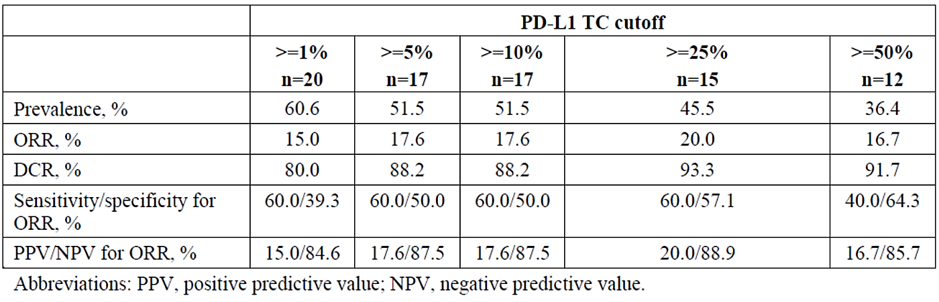
Acknowledging that subgroup analysis must be interpreted with caution, the OS HR for varying levels of PD-L1 expression ranged from 0.55-0.75, suggesting some degree of survival benefit in favour of tislelizumab for all levels. Concerns about HRs above 1 in the female and ECOG 0 subgroups at the interim analysis remain, although results from the final analysis in which the HRs improved to below 1 are somewhat reassuring. Secondary efficacy endpoints including ORR and DOR in the ITT population also showed a benefit in favour of tislelizumab. ACM advice is requested on the generalisability of study 303 to the Australian population and suitability of tislelizumab for registration in the 2L NSCLC indication.

Safety
Overall, the safety profile of tislelizumab in Study 303 was comparable to that of docetaxel. In some measures, such as treatment-related TEAEs, and grade ≥ 3 or higher TEAEs, there were considerably less events in the tislelizumab arm compared to the docetaxel arm. While the proportion of SAEs was similar between arms, an exposure-adjusted analysis which accounted for the lower exposure in the docetaxel arm revealed substantially less SAEs in the tislelizumab arm. While the overall safety profile of tislelizumab may be favourable compared to that of docetaxel, there is no direct comparison with other PD-1/PD-L1 inhibitors that are already registered for NSCLC. In this way, the choice of comparator in study 303 has led to uncertainty regarding the safety of tislelizumab as well as its efficacy for NSCLC.
The most frequent AEs in the tislelizumab arm of Study 303 were anaemia, raised ALT and AST, cough, decreased appetite and weight loss. There were more treatment related TEAEs in the docetaxel arm (93.8%) compared to the tislelizumab arm (73.0%), and an exposure adjusted analysis also showed a higher incidence of SAEs in the docetaxel arm. The tislelizumab arm experienced higher rates of serious respiratory, thoracic and mediastinal disorders. These were also the most common TEAEs leading to death in both arms.
As is expected for a PD-1 inhibitor, immune-mediated AEs were reported more frequently in the tislelizumab arm compared to the docetaxel arm. 21 patients (3.9%) had imAEs leading to treatment discontinuation, and 2 patients (0.4%) had imAEs leading to death As discussed previously, such events are well documented in the PI and well understood by Australian clinicians. The patient alert card is a further risk mitigation step designed to alert clinicians to the potential for imAEs in patients treated with tislelizumab. Neutropenia and related events were more frequent in the docetaxel arm, which is expected for a chemotherapy treatment.
Infusion related reactions known to be associated with PD-1 inhibitors, however the incidence of such reactions was lower in the tislelizumab arm (0.9%) compared to the docetaxel arm (3.5%). The PI contains appropriate information about infusion related reactions in the warnings and precautions sections, along with options for treatment modifications.

Risk-benefit balance and proposed regulatory action
Study 303 appears to provide evidence that tislelizumab is associated with a clinically meaningful survival benefit when associated with docetaxel. However, substantial uncertainty remains due to the use of docetaxel as the comparator, when many PD-1/PD-L1 inhibitors are now approved for NSCLC in Australia. It is not clear how the safety or efficacy of tislelizumab compares to these already registered therapies. In addition, differences between the study population and the Australian patient population in terms of prior therapies, ethnicity, gender distribution, EGFR mutation prevalence, and smoking prevalence, raise further questions about the generalisability of this study to the Australian population, and the positioning of tislelizumab in the treatment of NSCLC in Australia.
The Delegate was undecided as to the proposed regulatory action on the 2L NSCLC indication for tislelizumab. Assuming that GCP and GMP issues are resolved to the satisfaction of the TGA, the ACM’s advice is requested on the relevance of study 303 to an Australian patient population, and the risk-benefit balance of the proposed 2L NSCLC indication.

1L non-squamous NSCLC indication (Study 304)

Efficacy
Study 304 is the pivotal study supporting the first-line non-squamous NSCLC indication. This study was conducted exclusively in China from 2018-2022. Once again, there are a number of issues with this study such as difficulty in the interpretation of OS results due to crossover, the choice of comparator, and uncertainty regarding generalisability to the Australian patient population.
In terms of efficacy results, the HRs for the primary endpoint of PFS were statistically significant at the interim analysis [0.651 (95% CI: 0.465, 0.912, p=0.0054)] and final analysis [0.632 (95% CI: 0.47-0.86, p=0.0013)]. This suggests a clinically meaningful benefit for patients in terms of PFS, however, there is substantial uncertainty as to whether this translates into an overall survival benefit. Patients in the control arm were allowed to cross over to receive tislelizumab at disease progression, and many patients received other checkpoint inhibitors after progression. This complicates interpretation of the OS data. At the interim analysis, the HR for OS was not significant, at 0.685 (95% CI: 0.422, 1.110). At the final analysis, the HR for OS was 0.9 (95% CI: 0.63-1.28), and median OS was 21.4 and 21.3 months in the treatment and control arms respectively, suggesting no survival benefit for tislelizumab.
A later analysis of OS (DCO 15 July 2022) also produced a non-significant HR of 0.85 (95% CI: 0.63-1.14), with very similar median OS of 21.6 months in the tislelizumab arm compared to 20.1 months in the control arm. The Sponsor performed two additional analyses to adjust for the 37.8% of patients in the control arm who crossed over to tislelizumab. While a two-stage approach analysis produced a statistically significant HR, the RPSFT analysis did not. Due to the confounding of crossover and subsequent therapies, it is difficult to draw any meaningful conclusions from these OS results. In the absence of a clearly demonstrated OS benefit, the possibility that tislelizumab does not confer an OS benefit must be considered.
Another major issue with this study is the lack of generalisability to the Australian population. All study sites were located in China, and consequently, there are some key differences between the study population and the Australian population.. Because study 304 was conducted exclusively in China, 100% of the study population were of Asian ethnicity, whereas only approximately 7-12% of the Australian population are Asian, with Caucasians making up 68-83% of the Australian population. Patients in Study 304 were slightly younger than the Australian patient population. This is not a major concern, and probably reflects the trial eligibility criteria. The gender imbalance is more problematic, as 74% of the study population were male, compared with 56-65% of the Australian patient population. The Sponsor provided the following explanation.
EGFR mutations in advanced stage adenocarcinoma are known to have significant geographical variability, with a much higher prevalence in Asian patients (40% to 60%) compared with Western NSCLC patients (10% to 15%), and these mutations are also more common in female patients compared with male patients (~70% vs 30% to 40%). Because Study 304 was a China-only trial, it is expected that a large proportion of female patients with tumors harboring EGFR mutations would have been ineligible due to the high prevalence of EFGR mutations in Asian women.
While the low proportion of female patients may be explained by the exclusion of patients with EGFR mutations, this explanation does not address the uncertainty inherent in the key differences in ethnicity and gender between the study population and the Australian population. In fact, the geographical variability of EGFR mutations and associated population characteristics highlight the need for global clinical trials. Differences in smoking history, disease stage, EGFR negative and ALK rearrangement negative status were also noted between the study population and Australian patient population. The February 2022 FDA’s Oncologic Drugs Advisory Committee outcome for Sintilimab indicated that a study conducted exclusively in China was not applicable to the US population. It follows that study 304, conducted exclusively in China, similarly may not be generalisable to the Australian population.
The use of cisplatin/carboplatin and pemetrexed as the comparator for this study is problematic for reasons similar to those discussed for the other studies. The Sponsor has provided a justification for this choice of comparator, which notes that when study 304 began in 2018, pembrolizumab was approved for the treatment of first-line metastatic NSCLC but was not listed on the Pharmaceutical Benefits Scheme (PBS) until 2019. Other PD-1/PD-L1 inhibitors such as nivolumab and atezolizumab are also now registered for first-line treatment of NSCLC. As discussed previously and in accordance with EMA guidance, registration status should not be the only consideration in the choice of comparator. The opportunity for a direct comparison between tislelizumab and another checkpoint inhibitor has not been taken. Consequently, there is substantial uncertainty regarding the efficacy of tislelizumab in comparison with the many checkpoint inhibitors already registered for NSCLC. The benefits of tislelizumab in the first-line treatment of NSCLC in the current Australian clinical landscape are uncertain.

1L squamous NSCLC (Study 307)

Efficacy
Study 307 is the pivotal study supporting the first-line squamous NSCLC application. Like study 304, study 307 was also conducted exclusively in China, and many of the issues discussed in relation to study 304 also apply to study 307. The study demonstrated a statistically significant improvement in the primary endpoint of PFS at the interim and final analysis. At the final analysis, the PFS HR for the T+PC arm compared to control was 0.45 (95% CI: 0.329, 0.620) and for the T+nPC arm compared to control, the HR was very similar: 0.45 (95% CI: 0.327, 0.620). Median PFS was 7.7 months in the T+PC arm, 9.5 months in the T+nPC arm, and 5.5 months in the control arm. This suggests a PFS benefit of approximately 2.2 months for the T+PC combination and approximately 4 months in the T+nPC arm. This difference between the two treatment arms was not seen at the interim analysis, where median PFS was 7.6 months in both tislelizumab arms, compared with 5.4 months in the control arm. The reasons for the difference in median PFS at the final analysis between the paclitaxel and nab-paclitaxel treatment arms has not been addressed by the Sponsor.
OS data was not mature at the interim analysis; therefore, the Sponsor provided OS results from a later data cut (15 July 2022), at the request of the clinical Evaluator. These results are difficult to interpret, due to the cross-over of 58.7% of patients in the control arm to receive tislelizumab on disease progression. Similarly to the Sponsor’s analyses of OS data in study 304, the Sponsor performed two additional analyses of OS data in study 307 to adjust for cross-over. While the model produced a non-significant HR for T+nPC vs PC, the HR for T+PC vs PC was significant. The two-stage approach, which is the more appropriate method, produced significant HRs for both comparisons. Nevertheless, these were post-hoc analyses and while results are suggestive of an OS benefit, uncertainty remains. While tislelizumab confers a PFS benefit, it is unclear whether this translates into an overall survival benefit for patients. The possibility of a lack of OS benefit must therefore be taken into consideration.
The fact that Study 307 was conducted entirely in China once again raises concerns about the generalisability of the study results to the Australian population. The Sponsor has provided the following data comparing demographics and baseline characteristics of patients in studies 304 and 307 with the Australian patient population (Figure 27).
Figure 27: Summary of the BGB-A317-304 and BGB-A317 baseline characteristics versus Australian NSCLC patient population and considerations for the differences
The clinical Evaluator asked the Sponsor to comment on whether the demographics of the study population were relevant to the Australian population. In addition to what was provided for study 304, the Sponsor provided additional justification for study 307, stating that the very low percentage of female patients in study 307 (8.3%) may have been due to the much lower prevalence of smoking in the female population in China (2%) compared to Australia (12.8%). Of all lung cancers, squamous NSCLC has one of the highest associations with tobacco smoking,. Thus, the lower proportion of female patients in study 307 reflects the Chinese population. The Sponsor’s response highlights two key differences between the Australian population and the Chinese population, being the prevalence of smoking in women, and the proportion of female patients with EGFR mutations in non-squamous NSCLC. To address these population differences, the Sponsor performed additional indirect treatment comparison analysis, and states that the PK of tislelizumab is insensitive to intrinsic and extrinsic factors, with preliminary data showing comparable exposure between Asian and Caucasian patients in studies 001 and 102. The Sponsor also references Asia extension studies of pembrolizumab in NSCLC, which show that efficacy and safety were consistent with the global population. It follows that this would also be the case for other ICIs such as tislelizumab. In addition, study 303 of tislelizumab in 2L NSCLC showed similar OS in Asian and white subgroups. While this may be the case, across-trial comparisons and subgroup analyses must be interpreted with caution and cannot overcome the uncertainty associated with the differences between the study population and the Australian population.
In terms of the choice of comparator, the Sponsor states that when study 307 was initiated in July 2018, paclitaxel + carboplatin was widely used in Australia for 1L NSCLC patients. Pembrolizumab was approved in Australia for 1L squamous NSCLC in March 2017, however PBS listing was not until December 2019, therefore the change in standard of care was not widespread until after study 307 was initiated. Nevertheless, there are now many PD-1/PD-L1 inhibitors registered for the treatment NSCLC. The absence of a head-to-head comparison between tislelizumab and pembrolizumab means that there is uncertainty regarding the efficacy of tislelizumab in first-line treatment of squamous NSCLC. The position of tislelizumab in the current NSCLC treatment landscape in Australia is therefore unclear.

1L squamous and non-squamous NSCLC (Studies 304 and 307)

Safety
Safety data for both first-line NSCLC indications (from studies 304 and 307) were presented together in the dossier due to the similarity in study populations. Almost all patients in all study arms experienced at least one TEAE, there were more serious TEAEs, and TEAEs leading to any treatment discontinuation or modification in the tislelizumab + chemotherapy arms compared to chemotherapy alone.
The most frequent AEs across both studies with ≥ 10% higher incidence in the tislelizumab arms were neutrophil count decreased, platelet count decreased, ALT increased and AST increased. This reflected the additional haematological and hepatotoxicity associated with the addition of tislelizumab to chemotherapy and is in keeping with the tislelizumab safety data from the 2L OSCC and 2L NSCLC studies.
TEAEs leading to death occurred more frequently in the tislelizumab arm of study 304, however this difference was not apparent after exposure adjusted analysis. The small numbers of TEAEs leading to death make the interpretation of such a comparison difficult.
Across both studies, imAEs were experienced by 24.3% of the tislelizumab population. Hypothyroidism and pneumonitis were most common, and most were low grade. Nevertheless, there were 5 imAEs leading to death, illustrating the seriousness of this group of adverse reactions known to be associated with PD-1 inhibitors. In the first-line setting, such deaths attributed to tislelizumab are of concern.
In terms of immunogenicity, the Sponsor’s assessment of 2277 patients revealed a high number of patients with anti-drug antibodies (17.6%), with a smaller proportion of patients developing neutralizing antibodies (0.8%). Reassuringly, there were no major differences in efficacy or safety between ADA positive and ADA negative patients.
The overall safety profile of tislelizumab in combination with chemotherapy was inferior to chemotherapy alone in both studies 304 and 307, which is not unexpected for a combination therapy in comparison with chemotherapy alone. The use of chemotherapy as the comparator in both studies precludes a direct safety comparison between tislelizumab and other registered PD-1/PD-L1 inhibitors, thus, there is ongoing uncertainty as to the comparative safety of tislelizumab in relation to other drugs in the same class.

Risk-benefit balance and proposed regulatory action
Study 304 and 307 appear to show a benefit of tislelizumab in terms of PFS when compared to chemotherapy in the first-line treatment of NSCLC. However, it is unclear whether these PFS benefits will translate into an OS benefit. Due to crossover in the trials, and the post-hoc nature of the adjusted analyses of OS data, it is not clear whether there is a long-term survival benefit for patients. While PFS data may be sufficient for registration in some situations, in this case where there are multiple other checkpoint inhibitors already registered in Australia, a PFS benefit alone, without convincing evidence that this will translate into an OS benefit, is not compelling evidence of efficacy. In terms of safety, the addition of tislelizumab to chemotherapy increases toxicity. While this is not unexpected, the additional risks cannot be justified in the context of the lack of evidence of an overall survival benefit.
The use of chemotherapy as the comparators in studies 304 and 307 has prevented the opportunity for a direct comparison between tislelizumab and other registered checkpoint inhibitors. Without such a comparison, there is substantial uncertainty regarding the efficacy and safety of tislelizumab specifically in the Australian clinical setting. If tislelizumab were to be used in the first-line setting instead of another checkpoint inhibitor, there is the potential risk that patients may be receiving a less efficacious or less safe treatment (or more efficacious/safe treatment) that other available therapies: this cannot be known without a direct head-to-head comparison. Furthermore, as studies 304 and 307 were conducted exclusively in China, there are substantial differences between the study populations and the Australian NSCLC patient population in terms of gender, ethnicity, EGFR status and smoking prevalence, and differences in health care systems. Consequently, results from study 304 and 307 are not directly applicable to the Australian population. Based on the evidence provided in study 304 and 307, I am of the view that the efficacy and safety of tislelizumab for the proposed use in the first-line treatment of NSCLC in the Australian clinical setting has not been established. I propose to reject both the first-line non-squamous and first-line squamous NSCLC indications, pending ACM advice.

Questions for the Sponsor
The Sponsor provided the following response to questions from the Delegate.
- Please provide an update on GMP inspections and clearance relevant to tislelizumab.
All TGA-conducted GMP inspections have been completed and await the issue of
TGA certification/clearance.
- Please provide GCP inspection reports from all inspections of studies 302, 303, 304 and 307 conducted by the EMA or FDA in 2023 and 2024 as soon as they become available.
BeiGene confirms that the available reports from GCP inspections conducted by the FDA & EMA in October & November 2023, were submitted for the TGA’s consideration on 04 March 2024. For the two inspections performed by the EMA no critical or major findings were noted. Minor GCP concerns have been addressed to the satisfaction of the relevant inspecting authorities.

Advisory Committee on Medicines (ACM)
The Advisory Committee on Medicines (ACM) advised the following:

OSCC Indication
- Is the evidence from Study 302 sufficient to support registration of tislelizumab for the 2L OSCC indication in an Australian clinical setting?
The ACM was of the view that the evidence from Study 302 is sufficient to support registration of tislelizumab for a 2L OSCC indication in an Australian clinical setting. The ACM was of the view that the results of study 302 are on balance generalisable to the Australia population.
The ACM noted that the Australian clinical landscape has changed since Study 302 was designed and PD-1/PD-L1 inhibitor therapy is available as first-line therapy for OC. Given that the study did not include patients who had received first-line immunotherapy there is uncertainty regarding the place in therapy for tislelizumab. It is not known if tislelizumab is efficacious after prior immunotherapy, non-platinum-containing chemotherapy, or other non-chemotherapy agents. Considering this, the ACM advised that the indication should include ‘after prior chemotherapy,’ rather than the Sponsor’s proposed wording of ‘after prior systemic therapy’.
The ACM was of the view that a higher PD-1 Tumour Area Positivity Score was associated with greater efficacy outcomes and suggested that this could be considered for inclusion in the indication and/or PI.
- If so, please comment on your preferred wording of the indication.
As monotherapy for the treatment of adult patients with unresectable, recurrent, locally advanced or metastatic, oesophageal squamous cell carcinoma after prior chemotherapy.

2L NSCLC Indication
- Is the evidence from Study 303 sufficient to support registration of tislelizumab for the 2L NSCLC indication in an Australian clinical setting?
The ACM was of the view that the evidence from study 303 is sufficient to support registration of an 2L NSCLC indication in an Australian clinical setting. The ACM noted the ethnicity differences between the study population and the Australian population however on balance was of the view that this should not significantly affect efficacy.
The ACM noted that the study comparator was docetaxel and this is not currently standard of care in Australia. The ACM also noted no prior PD-1 monoclonal antibody treatment was given in the study. Comparison with other currently available PD-1/PD-L1 inhibitors would provide a greater understanding of the role and place in therapy of tislelizumab.
The ACM was of the view that there is a relatively strong association between PD-1 expression and efficacy and suggested that this could be included within the indication and/or PI.
- If so, please comment on your preferred wording of the indication
As monotherapy for the treatment of patients with locally advanced or metastatic non-small cell lung cancer (NSCLC) after prior chemotherapy.

1L non-squamous NSCLC Indication
- Is the evidence from Study 304 sufficient to support registration of tislelizumab for the 1L non-squamous NSCLC indication in an Australian clinical setting?
The ACM was of the view that on balance the evidence provided is sufficient for a first-line indication. The ACM agreed that efficacy has been demonstrated and there is likely to be clinical value in having another PD-1/PD-L1 inhibitor available. In making this recommendation, the ACM noted that there is a well-known / established class effect for PD-1/PD-L1 inhibitors.
The ACM again noted ethnicity differences between the study population and the Australian population however on balance was of the view that this should not significantly affect efficacy.
The ACM was again also of the view that there is a particularly strong association for this proposed indication between PD-1 expression and efficacy and suggested that PD-1 expression ≥ 50% should be included within the indication.
- If so, please comment on your preferred wording of the indication
In combination with pemetrexed and platinum-containing chemotherapy for the first-line treatment of patients with locally advanced or metastatic non-squamous, non-small cell lung cancer, with PD-1 expression ≥ 50% and no epidermal growth factor receptor (EGFR) or anaplastic lymphoma kinase (ALK), genomic tumour aberration.

1L squamous NSCLC Indication
- Is the evidence from Study 307 sufficient to support registration of tislelizumab for the 1L non-squamous NSCLC indication in an Australian clinical setting?
The ACM was of the view that on balance the evidence provided is sufficient for a first-line indication. The ACM agreed that efficacy has been demonstrated and there is likely to be clinical value in having another PD-1/PD-L1 inhibitor available. In making this recommendation, the ACM noted that there is a well-known / established class effect for PD-1/PD-L1 inhibitors.
The ACM again noted demographic differences between the study population and the Australian population however on balance was of the view that this should not significantly affect efficacy.
The ACM was of the view that there is an association between PD-1 expression and efficacy, however, this association was not as strong as for the other first-line indications. The ACM suggested that this could be considered for inclusion in the indication and/or PI.
- If so, please comment on your preferred wording of the indication
In combination with carboplatin and either paclitaxel or nab-paclitaxel for the first-line treatment of patients with locally advanced or metastatic squamous NSCLC.

ACM conclusion
The ACM considered this product to have an overall positive benefit-risk profile for the following indications:
Oesophageal squamous cell carcinoma (OSCC)
As monotherapy for the treatment of adult patients with unresectable, recurrent, locally advanced or metastatic, oesophageal squamous cell carcinoma after prior chemotherapy.
Non-small cell lung cancer (NSCLC):
As monotherapy for the treatment of patients with locally advanced or metastatic non-small cell lung cancer (NSCLC) after prior chemotherapy.
In combination with pemetrexed and platinum-containing chemotherapy for the first-line treatment of patients with locally advanced or metastatic non-squamous, non-small cell lung cancer, with PD-1 expression ≥ 50% but no epidermal growth factor receptor (EGFR) or anaplastic lymphoma kinase (ALK), genomic tumour aberration.
In combination with carboplatin and either paclitaxel or nab-paclitaxel for the first-line treatment of patients with locally advanced or metastatic squamous NSCLC.

Outcome
Based on a review of quality, safety, and efficacy, the TGA decided to register Tevimbra (tislelizumab) for the following indications:
Oesophageal squamous cell carcinoma (OSCC)
Tevimbra as monotherapy is indicated for the treatment of adult patients with unresectable, recurrent, locally advanced or metastatic oesophageal squamous cell carcinoma after prior chemotherapy.
Non-small cell lung cancer (NSCLC)
Tevimbra in combination with pemetrexed and platinum containing chemotherapy is indicated for the first-line treatment of patients with locally advanced or metastatic non-squamous non-small cell lung cancer (NSCLC), with PD-L1 expression ≥ 50% but no epidermal growth factor receptor (EGFR) or anaplastic lymphoma kinase (ALK) genomic tumour aberrations.
Tevimbra in combination with carboplatin and either paclitaxel or nab-paclitaxel is indicated for the first-line treatment of patients with locally advanced or metastatic squamous NSCLC.
Tevimbra as monotherapy is indicated for the treatment of patients with locally advanced or metastatic NSCLC after prior chemotherapy.

Specific conditions of registration applying to these goods
Tevimbra (Tislelizumab) is to be included in the Black Triangle Scheme. The PI and CMI for Tevimbra must include the black triangle symbol and mandatory accompanying text for five years, which starts from the date that the sponsor notifies the TGA of supply of the product.
The Tevimbra EU-Risk Management Plans (RMPs) (versions 0.11 and 0.21, dated 9 January 2023, data lock point 1 December 2020), with Australian Specific Annex (version 0.2, dated 28 February 2023), included with submission PM-2022-02507-1-4, and any subsequent revisions, as agreed with the TGA will be implemented in Australia.
An obligatory component of risk management plans is routine pharmacovigilance. Routine pharmacovigilance includes the submission of periodic safety update reports (PSURs). Unless agreed separately between the supplier who is the recipient of the approval and the TGA, the first report must be submitted to TGA no later than 15 calendar months after the date of this approval letter. The subsequent reports must be submitted no less frequently than annually from the date of the first submitted report until the period covered by such reports is not less than three years from the date of this approval letter. The annual submission may be made up of two PSURs each covering six months. If the sponsor wishes, the six monthly reports may be submitted separately as they become available.
If the product is approved in the EU during the three years period, reports can be provided in line with the published list of EU reference dates no less frequently than annually from the date of the first submitted report until the period covered by such reports is not less than three years from the date of this approval letter.
The reports are to at least meet the requirements for PSURs as described in the European Medicines Agency’s Guideline on good pharmacovigilance practices (GVP) Module VII-periodic safety update report (Rev 1), Part VII.B Structures and processes. Note that submission of a PSUR does not constitute an application to vary the registration. Each report must have been prepared within ninety calendar days of the data lock point for that report.

Quality conditions

Laboratory testing & compliance with Certified Product Details (CPD)
- All batches of Tevimbra tislelizumab supplied in Australia must comply with the product details and specifications approved during evaluation and detailed in the Certified Product Details (CPD).
- When requested by the TGA, the Sponsor should be prepared to provide product samples, specified reference materials and documentary evidence to enable the TGA to conduct laboratory testing on the Product. Outcomes of laboratory testing are published biannually in the TGA Database of Laboratory Testing Results and periodically in testing reports on the TGA website.

Certified Product Details
The Certified Product Details (CPD), as described in Guidance 7: Certified Product Details of the Australian Regulatory Guidelines for Prescription Medicines (ARGPM), for the above products should be provided upon registration of these therapeutic goods. In addition, an updated CPD should be provided when changes to finished product specifications and test methods are approved in a Category 3application or notified through a self-assessable change.

Attachment 1. Product Information
The Product Information (PI) approved with the submission for Tevimbra which is described in this AusPAR can be found as Attachment 1. It may have been superseded. For the most recent PI and Consumer Medicines Information (CMI), please refer to the TGA PI/CMI search facility.

Therapeutic Goods Administration
PO Box 100 Woden ACT 2606 Australia
Email: info@tga.gov.au Phone: 1800 020 653 Fax: 02 6203 1605
https://www.tga.gov.au
Reference/Publication #

This is the original indication proposed by the Sponsor when the TGA commenced the evaluation of this submission. It may differ to the final indication approved by the TGA and registered in the Australian Register of Therapeutic Goods
Morgan E, Soerjomataram I, Rumgay H, Coleman H, Thrif AP, Vignat J, Laversanne M, Ferlay J, Arnold M. The global landscape of esophageal squamous cell carcinoma and esophageal adenocarcinoma incidence and mortality in 2020 and projections to 2040: new estimates from GLOBOCAN 2020. Gastroenterology. 2022; 163(3): 649-658
Abnet CC, Arnold M, Wei WC. Epidemiology of esophageal squamous cell carcinoma. Gastroenterology. 2018; 154(2): 360-373
Lagergren J, Smyth E, Cunningham D, Lagergren P. Oesophageal cancer. Lancet. 2017; 390(10110): 2383-2396
Sung H, Ferlay J, Siegal RL, Laversanne M, Soerjomataram I, Jemal A, Bray F. Global cancer statistics 2020: GLOBOCAN Estimates of Incidence and Mortality Worldwide for 36 cancers in 185 countries. CA: A Cancer Journal for Clinicians. 2021; 71(3): 209-249
Bareschino MA, Schettino C, Rossi A, Maoine P, Sacco PC, Zeppa R, Gridelli C.. Treatment of advanced non-small cell lung cancer. Journal of Thoracic Disease. 2011; 3(2): 122-133
Lee et al. Capecitabine in combination with either cisplatin or weekly paclitaxel as a first-line treatment for metastatic esophageal squamous cell carcinoma: a randomized phase II study. BMC Cancer. 2015; 15: 693
Liu J, Blake SJ, Yong MCR, Harjunpaa H, Ngiow SF, Takeda K, Young A, O’Donnell JS, Allen S, Smyth MJ, Teng MWL. Improved Efficacy of Neoadjuvant Compared to Adjuvant Immunotherapy to Eradicate Metastatic Disease. Cancer Discovery. 2016; 6(12): 1382-1399
Kato K, Sun JM, Shah MA, Shah S, Bhagia P, Shen L. LBA8_PR Pembrolizumab plus chemotherapy versus chemotherapy as first-line therapy in patients with advanced esophageal cancer: The phase 3 KEYNOTE-590 study. Annals of Oncology. 2020; 31(Suppl 4): S1192-S1193
In this report the ‘Delegate’ is the Delegate of the Secretary of the Department of Health and Aged Care who decided the submission under section 25 of the Act.
Guo W, Wang P, Li N, Shao F, Zhang H, Yang Z, Li R, Gao Y, He J. Prognostic value of PD-L1 in esophageal squamous cell carcinoma: a meta-analysis. Oncotarget. 2017 Dec 27;9(17):13920-13933. doi: 10.18632/oncotarget.23810. PMID: 29568405; PMCID: PMC5862626.
EMA Guideline on the Evaluation of Anticancer Medicinal Products in Man. Available from: https://www.ema.europa.eu/en/documents/scientific-guideline/guideline-evaluation-anticancer-medicinal-products-man-revision-4_en.pdf Accessed 15 August 2023.
Australian Bureau of Statistics. Population: Census 2021. Released 28 June 2022. Retrieved from https://www.abs.gov.au/statistics/people/population/population-census/latest-release
Barbone F, Bovenzi M, Cavallieri F, et al. Cigarette smoking and histologic type of lung cancer in men. Chest. 1997;112(6):1474-9.
Khuder SA. Effect of cigarette smoking on major histological types of lung cancer: A metaanalysis. Lung Cancer. 2001;31(2-3):139-148.

