Australian Public Assessment Report for Sohonos
  - Active ingredient: Palovarotene
  - Sponsor: Ipsen Pty Ltd
August 2024

About the Therapeutic Goods Administration (TGA)
- The Therapeutic Goods Administration (TGA) is part of the Australian Government Department of Health and Aged Care and is responsible for regulating therapeutic goods, including medicines, medical devices, and biologicals.
- The TGA administers the Therapeutic Goods Act 1989 (the Act), applying a risk management approach designed to ensure therapeutic goods supplied in Australia meet acceptable standards of quality, safety, and efficacy.
- The work of the TGA is based on applying scientific and clinical expertise to decision-making, to ensure that the benefits to the Australian public outweigh any risks associated with the use of therapeutic goods.
- The TGA relies on the public, healthcare professionals and industry to report problems with therapeutic goods. The TGA investigates reports received to determine any necessary regulatory action.
- To report a problem with a therapeutic good, please see the information on the TGA website.

About AusPARs
- The Australian Public Assessment Report (AusPAR) provides information about the evaluation of a prescription medicine and the considerations that led the TGA to approve or not approve a prescription medicine submission. Further information can be found in Australian Public Assessment Report (AusPAR) guidance.
- AusPARs are prepared and published by the TGA.
- AusPARs are static documents that provide information that relates to a submission at a particular point in time. The publication of an AusPAR is an important part of the transparency of the TGA’s decision-making process.
- A new AusPAR may be provided to reflect changes to indications or major variations to a prescription medicine subject to evaluation by the TGA.

Copyright
© Commonwealth of Australia 2024
This work is copyright. You may reproduce the whole or part of this work in unaltered form for your own personal use or, if you are part of an organisation, for internal use within your organisation, but only if you or your organisation do not use the reproduction for any commercial purpose and retain this copyright notice and all disclaimer notices as part of that reproduction. Apart from rights to use as permitted by the Copyright Act 1968 or allowed by this copyright notice, all other rights are reserved and you are not allowed to reproduce the whole or any part of this work in any way (electronic or otherwise) without first being given specific written permission from the Commonwealth to do so. Requests and inquiries concerning reproduction and rights are to be sent to the TGA Copyright Officer, Therapeutic Goods Administration, PO Box 100, Woden ACT 2606 or emailed to <tga.copyright@tga.gov.au>.

Contents
List of abbreviations 4
Product submission 6
Submission details 6
Sohonos (palovarotene) 7
Fibrodysplasia ossificans progressiva (FOP) 7
Current treatment options for FOP 8
Clinical rationale for Sohonos use in FOP 9
Regulatory status 9
Australian regulatory status 9
Foreign regulatory status 9
Registration timeline 10
Submission overview and risk/benefit assessment 11
Quality 11
Nonclinical 12
Clinical 13
Summary of clinical studies 13
Pharmacology 16
Pharmacodynamics 23
Efficacy 23
Safety 48
Risk management plan 65
Risk-benefit analysis 67
Delegate’s considerations 67
Questions for the sponsor 72
Advisory Committee considerations 76
Outcome 77
Specific conditions of registration applying to these goods 77
Attachment 1. Product Information 78

List of abbreviations
Abbreviation | Meaning
ACM | Advisory Committee on Medicines
ADR | Adverse drug reaction
AE | Adverse event
ARTG | Australian Register of Therapeutic Goods
ASA | Australia-specific annex
AUC_{0-∞} | Area under the curve from time 0 extrapolated to infinite time
ACVR1 | Activin A Receptor Type 1
CL/F | Apparent clearance
C_{max} | Maximum observed serum concentration
CMI | Consumer Medicines Information
DDI | Drug-drug interactions
DEXA | Dual-energy x-ray absorptiometry scan
DLP | Data lock point
FAS | Principal Full Analysis Set
FOP | Fibrodysplasia ossificans progressiva
HO | Heterotopic ossification
ITT | Intention to treat
NHS | Natural History Study
PBPK | Physiologically-based pharmacokinetic modelling
PD | Pharmacodynamics
PI | Product Information
PK | Pharmacokinetics
PPC | Premature physeal closure
PPS | Per-Protocol Set
PSUR | Periodic safety update report
PVO | Palovarotene
RAR | Retinoic acid receptor
RMP | Risk management plan
RXR | Retinoid X receptor
T_{½} | Terminal half-life
TEAE | Treatment emergent adverse event
TGA | Therapeutic Goods Administration
T_{max} | Time to maximum concentration
Vss/F | Apparent volume of distribution at steady-state
WBCT | Whole body computed tomography
wLME | Weighted linear mixed-effects

Product submission

Submission details
Type of submission: | New chemical entity
Product name: | Sohonos
Active ingredient: | Palovarotene
Decision: | Approved
Date of decision: | 27 November 2023
Date of entry onto ARTG: | 28 November 2023
ARTG numbers: | 393999, 394000, 394001, 394002, 394003
Black Triangle Scheme | Yes
Sponsor’s name and address: | Ipsen Pty Ltd, Level 5, 627 Chapel Street, South Yarra, VIC 3141
Dose form: | Hard capsule
Strengths: | 1 mg, 1.5 mg, 2.5 mg, 5 mg, 10 mg
Container: | Blister pack
Pack size: | 28
Approved therapeutic use for the current submission: | Sohonos is indicated to reduce the formation of heterotopic ossification (HO) in adults and children aged 8 years and above for females and 10 years and above for males with fibrodysplasia ossificans progressiva (FOP).
Route(s) of administration: | Oral
Dosage: | Dosage in adults and children aged 14 years and over.  Chronic treatment dose  Recommended dose: 5 mg once daily.  Flare-up treatment dose  Recommended dose: 20 mg once daily for 4 weeks, followed by 10 mg once daily for 8 weeks for a total of 12 weeks (20/10 mg flare-up treatment) even if symptoms resolve earlier.  In the presence of persistent flare-up symptoms, treatment may be extended in 4-week intervals with 10 mg Sohonos and continued until the flare-up symptoms resolve.  Should the patient experience another flare-up (new flare-up location or marked worsening of the original flare-up) at any time during flare-up treatment, the flare-up 12-week treatment should be restarted.  Dose adjustment in children under 14 years of age  Sohonos dosing is weight-adjusted in patients under 14 years of age (Table 1). The physician should prescribe the most appropriate dosage based on weight for children aged from 8 years (females) and 10 years (males) to less than 14 years.  Table 1: Weight-adjusted dosage for children < 14 years  *All children ≥14 years of age and adults receive the dose in the ≥ 60 kg weight category  For further information regarding dosage, such as dosage modifications to manage adverse reactions, refer to the Product Information.
  Chronic Dosing | Chronic Dosing | Flare up  (Weeks 1 to 4) | Flare up  (Weeks 5 to 12)
  ≥60kg* | 5 mg | 20 mg | 10 mg
  40-<60kg | 4 mg | 15mg | 7.5 mg
  20-<40kg | 3 mg | 12.5 mg | 6 mg
  10-<20kg | 2.5 mg | 10 mg | 5 mg
Pregnancy category: | Category X  Drugs which have such a high risk of causing permanent damage to the fetus that they should not be used in pregnancy or when there is a possibility of pregnancy.  The use of any medicine during pregnancy requires careful consideration of both risks and benefits by the treating health professional. The pregnancy database must not be used as the sole basis of decision making in the use of medicines during pregnancy. The TGA does not provide advice on the use of medicines in pregnancy for specific cases. More information is available from obstetric drug information services in your state or territory.

Sohonos (palovarotene)
This AusPAR describes the submission by Ipsen Pty Ltd (the sponsor) to register Sohonos (palovarotene) 1 mg, 1.5 mg, 2.5 mg, 5 mg, 10 mg, hard capsule, blister pack, for the following proposed indication:
Sohonos is indicated to reduce the formation of heterotopic ossification in adults and children aged 8 years and above for females and 10 years and above for males with fibrodysplasia ossificans progressiva (FOP).

Fibrodysplasia ossificans progressiva (FOP)
Fibrodysplasia ossificans progressiva (FOP) (Münchmeyer disease) is a rare, genetic connective tissue disorder in which fibrous tissues (including muscles and tendons, but sparing certain muscles, such as cardiac smooth muscle) are gradually ossified (typically cumulative and irreversible). This is caused by Activin A Receptor Type 1 (ACVR1) gene mutations responsible for changes in a bone morphogenetic protein receptor.
FOP is a highly penetrant congenital disease with early clinical onset, often causing severe deformity and disability during childhood in affected individuals. Flare-up episodes and HO formation typically begins at around 2 to 4 years of age, with the median age of FOP diagnosis of 5 years. Restricted mobility of the neck and shoulder, and spine immobility, are present by age 10; hip immobility is present by age 18; FOP patients are commonly confined to a wheelchair by age 24. The condition is also characterised by a weight loss, difficulty speaking and eating, and thoracic insufficiency syndrome. Trauma or other insults may lead to episodes of swelling and inflammation leading to ossification (known as ‘flare-up’).
Life-threatening complications result from cumulative HO in FOP including severe weight loss due to ankylosis of the jaw, and respiratory insufficiency due to ankylosis of the costovertebral joints, ossification of the intercostal and paravertebral muscles, and progressive spinal deformity including kyphoscoliosis or thoracic lordosis. Ankyloses of the temporomandibular joints result in severe tooth decay and malnutrition. Asymmetric HO in the rib cage and subsequent contralateral growth can lead to a rapid progression in spinal deformity and cause thoracic insufficiency.
Respiratory insufficiency causes complications such as pneumonia and right-sided heart failure, leading to a markedly shortened median survival of 56 years. Cardiac conduction abnormalities have been observed in 45% of baseline electrocardiograms recorded from patients participating in a natural history study of FOP. These abnormalities were not correlated with chest wall deformities, scoliosis, pulmonary tests, indicating potential elevated cardiovascular risk in patients with FOP.
The International FOP Association, a US-based patient group organisation, reports approximately 800 to 900 confirmed cases of FOP globally. The prevalence is estimated at approximately 1.36 per million individuals, with no geographic, ethnic, racial, or gender preference.

Current treatment options for FOP
- Currently, there are no effective medical treatment options to prevent flare-ups, HO, or disease progression in FOP.
- Current pharmacologic intervention for FOP is limited to palliative management and is not known to be disease modifying.
- Short course (4 days), high-dose corticosteroids administered within 24 to 48 hours of the onset of flare-up symptoms is typically used to reduced flare-up inflammation and tissue oedema in FOP.
- Presently there are medications available for use off-label, with theoretical or anecdotal support for beneficial effects in FOP that are used with caution, at the discretion of a treating physician. These include montelukast, a leukotriene inhibitor; cromolyn, a mast cell stabilizer; imatinib, a tyrosine kinase inhibitor; and amino-bisphosphonates such as pamidronate and zoledronate.
- Radiation therapy has been reported as helpful in impeding ossification in FOP, based on a single case study.

Clinical rationale for Sohonos use in FOP
Receptor-binding and transactivation assays indicate that palovarotene and its major metabolites are selective for retinoic acid receptor-γ (RARγ) over RARα or β. Retinoic acid receptors are transcription factors that are controlled by ligands that function together with retinoid X receptors (RXRs) as heterodimers to regulate various cellular processes, including growth, differentiation, survival, and cell death. Compared to other RARs, RARγ are highly and selectively expressed in chondrogenic cells and chondrocytes where they operate as unliganded transcriptional repressors. The rationale for testing retinoids as inhibitors of HO was based on the observation that retinoid signalling is a strong inhibitor of chondrogenesis and that unliganded RAR transcriptional repressor activity is needed for chondrogenic differentiation. The activities of the primary oxidative metabolites of palovarotene determined in a cell-based RARα, β, and γ transactivation assay ranged from 1.2% to 14% of the parent compound. RARγ agonist treatment inhibits BMP2-mediated Smad signalling in chondrogenic cells in addition to chondrogenic differentiation in both cell-based assays and a BMP-implant HO mouse model. Palovarotene inhibits BMP4-mediated Smad signalling in a human FOP fibroblast cell line carrying the overactive mutant ALK2.
Palovarotene was evaluated in distinct injury-based mouse models of HO and FOP. The results consistently demonstrated dose-dependent decreases of HO with palovarotene across the models and suggest that a human equivalent dose of 20 mg palovarotene should provide maximal inhibition of HO across all injury conditions. Palovarotene treatment was also observed to reduce aberrant inflammatory and fibroproliferative responses at the site of incipient HO. Furthermore, animals treated with palovarotene maintained joint mobility typically lost at the site of HO in vehicle-treated animals. In addition to the injury-based models, palovarotene was also effective in reducing HO in a mouse model of FOP that recapitulated many of the phenotypic features of FOP seen in patients, including spontaneous HO and malformed great toes.

Regulatory status

Australian regulatory status
This product is considered a new chemical entity for Australian regulatory purposes.

Foreign regulatory status
At the time the TGA considered this submission, a similar submission had been considered by other regulatory agencies. Table 2 summarises these submissions and provides the indications where approved.
Table 2: International regulatory status at the time of product registration.
Region | Submission date | Status | Approved indications
Canada | 23 April 2021 | Approved 21 January 2022 | Sohonos (palovarotene capsules) is indicated to reduce the formation of heterotopic ossification in adults and children aged 8 years and above for females and 10 years and above for males with Fibrodysplasia Ossificans Progressiva
United States of America | Initial submission:  31 March 2021 Withdrawn: August 2021  Resubmission: 29 April 2022 | Approved 16 August 2023 | Sohonos is indicated for the reduction in volume of new heterotopic ossification in adults and pediatric patients aged 8 years and older for females and 10 years and older for males with fibrodysplasia ossificans progressiva (FOP)
EU (Centralised Procedure) | Initial submission: 15 April 2021  CHMP negative opinion: 26 Jan 2023  Request for re-examination of CHMP opinion: 07 Feb 2023  Re-examination submission: 27 March 2023  CHMP negative opinion: 25 May 2023 | Rejected  17 July 2023  (EC Decision date) | N/A
Switzerland | Initial submission: 13 April 2021  Withdrawn: November 2021  Resubmission: 16 June 2022 | Withdrawn 23 October 2023 | N/A

Registration timeline
Table 3 captures the key steps and dates for this submission.
The active ingredient with its proposed indication was given orphan drug designation.
Table 3: Timeline for Submission PM-2022-03518-1-5
Description | Date
Designation (Orphan) | 13 July 2022
Submission dossier accepted and first round evaluation commenced | 30 September 2022
First round evaluation completed | 13 April 2023
Sponsor provides responses on questions raised in first round evaluation | 23 April 2023
Second round evaluation completed | 16 August 2023
Sponsor’s notification to the TGA of errors/omissions in evaluation reports | 3 August 2023
Delegate’s Overall benefit-risk assessment and request for Advisory Committee advice | 6 September 2023
Sponsor’s pre-Advisory Committee response | 18 September 2023
Advisory Committee meeting | 5-6 October 2023
Registration decision (Outcome) | 27 November 2023
Administrative activities and registration in the ARTG completed | 28 November 2023
Number of working days from submission dossier acceptance to registration decision* | 202
*Statutory timeframe for standard submissions is 255 working days

Submission overview and risk/benefit assessment

Quality
Palovarotene is a retinoid derived conceptually from retinoic acid with the addition of rigidifying aromatic rings and a pyrazolylmethyl substitutent. The principal mechanism of action is inhibition of RARγ.
Figure 1: Structural formula of palovarotene.
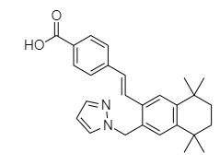
The drug product is presented as white, opaque, elongated hard gelatin capsules containing a white to off white powder. The capsules are marked in black ink with a marking indicative of the strength. The product will be supplied in a 14-capsule blister pack. Two blister packs are further packaged into a cardboard carton. The proposed shelf life for the product is 36 months when stored below 25 ᵒC and protected from light.
Approval for registration of the proposed product is acceptable from a pharmaceutical chemistry perspective.

Nonclinical
Non-clinical evaluation results were of high overall quality and adequate in scope, broadly consistent with ICH M3 (R2). All pivotal safety-related studies were Good Laboratory Practice-compliant.
Palovarotene is a RARγ selective agonist. In vitro, palovarotene was shown to bind to and activate RARγ with nanomolar affinity/potency and to inhibit the Smad signalling pathway that is aberrantly activated in FOP. Supporting utility for the proposed indication, inhibition of injury-induced and spontaneous heterotopic ossification was demonstrated with palovarotene in transgenic mouse models of FOP. Retention of joint mobility and reductions in mast cell infiltration and local fibroproliferative response were also found.
No notable secondary pharmacological targets were identified for palovarotene.
Safety pharmacology and other studies indicated no likely adverse effects on the central nervous system, cardiovascular, respiratory, renal or gastrointestinal function in patients.
The pharmacokinetic profile of palovarotene in the key laboratory animal species used in the nonclinical program — rats and dogs — was characterised by rapid to moderately fast absorption after oral administration, low to moderate (rats) or high (dogs) bioavailability, and short plasma half-life. Plasma protein binding was high in all laboratory animal species, as in humans. No particular distribution of palovarotene into red blood cells was evident. Slow but wide tissue distribution of 14C-palovarotene-derived radioactivity was demonstrated in rats, including ready penetration of the blood-brain barrier; there was no evidence of melanin binding.
Metabolism of palovarotene yields four major circulating metabolites in humans. These were also formed in laboratory animal species, but generally at lower levels relative to the parent cf. humans. CYP3A4 was identified as the major CYP isozyme involved in the metabolism of palovarotene, with an additional minor contribution by CYP2C19 and very minor contribution by CYP2C8. The metabolites retain only limited pharmacological activity. Excretion is primarily via the faeces, with biliary involvement.
Palovarotene was shown not to inhibit CYPs 1A2, 2B6, 2C8, 2C9, 2C19, 2D6 and 3A4; UGTs 1A1, 1A3, 1A4, 1A6, 1A9 and 2B7; or P-glycoprotein, BCRP, BSEP, OATP1B1, OATP1B3, OAT1, OAT3, OCT1, OCT2, MATE1 and MATE2-K at clinically relevant concentrations in vitro. Accordingly, interactions with other medicinal products caused through enzyme and transporter inhibition by palovarotene are not expected.
Palovarotene showed a low to moderate order of acute toxicity by the oral route in mice, rats and dogs.
Repeat-dose toxicity studies by the oral route were conducted in rats (up to 6 months duration), rabbits (4 weeks) and dogs (up to 9 months). To compensate for lower metabolite formation in animals, studies involving direct metabolite administration were additionally performed (up to 13 weeks duration in rats and dogs). Skin and skeleton were identified as the key targets for palovarotene toxicity, with the effects observed recognised as classic retinoid toxicities (e.g., as in hypervitaminosis A) and to represent exaggerated pharmacology.
Studies in juvenile rats revealed more extensive skeletal effects cf. that seen in adult animals and indicate a risk of premature physeal closure in still growing children.
Palovarotene and its four major metabolites were not mutagenic in bacteria and not directly clastogenic in human lymphocytes in vitro. Negative results for clastogenicity were also obtained for palovarotene in vivo in the mouse bone marrow micronucleus test.
No carcinogenicity studies have been conducted with palovarotene, with the sponsor submitting a waiver request. Their absence is considered to be acceptable, but the most compelling justification for the absence of carcinogenicity studies was not identified by the sponsor: negative mouse and rat carcinogenicity studies with the existing RARγ-selective agonist, trifarotene.
Studies in rats identified no effects on male or female fertility at tolerable doses. Classic retinoid-type malformations (e.g., cleft palate, misshapen skull bones, shortened long bones) were demonstrated with palovarotene in rats at doses yielding exposure well below that in patients. The findings justify assignment to Pregnancy Category X, and contraindication in women who are pregnant or may become pregnant, as the Sponsor proposes. Palovarotene and its major metabolites were shown to not be phototoxic in an in vitro assay.
There are no nonclinical objections to the registration of Sohonos for the proposed indication.

Clinical

Summary of clinical studies

Pharmacology studies
The clinical dossier consisted of 13 Phase 1 clinical pharmacology studies in healthy subjects and 4 population pharmacology studies. The efficacy and safety studies 201, 202, and 301 also provided pharmacokinetic (PK) data in the FOP population (Table 4).
- Study RB16327 (Report 1005298): a single ascending dose study (fed/fasted).
- Study RB16328 (Report 1006914): a multiple ascending dose study.
- Study NP17056 (Report 1016529): a [14C]-radiolabelled single-dose mass balance study.
- Study NP17584 (Report 1016091): a bioequivalence study (capsule vs. tablet formulation).
- Study NP17726 (Report 1016632): a single-dose age and sex study.
- Study 101 (PVO-1A-101): a single-dose bridging study in Japanese and non-Asian subjects.
- Study 102 (PVO-1A-102): a food-effect/mode of administration study (combined with a midazolam DDI study).
- Study 103 (PVO-1A-103): a thorough QT/QTc study.
- Study 104 (PVO-1A-104): a study evaluating the PK of palovarotene in seminal fluid.
- 5 drug-drug interaction (DDI) studies:
  - Study NP17041B (Report 1010705): DDI with ketoconazole (strong CYP3A4 inhibitor).
  - Study NP17040 (Report 1010704): DDI with rifampicin (strong CYP3A4 inducer).
  - Study NP17055 (Report 1015528): Effect (inhibition) of palovarotene on midazolam (CYP3A4 substrate).
  - Study 102 (PVO-1A-102): Effect (induction) of palovarotene on midazolam (CYP3A4 substrate).
  - Study NP21025 (Report 1026186): DDI with prednisone (weak CYP3A4 inhibitor).
- Population pharmacology studies:
  - Study PVO-PopPK-001: original population pharmacokinetics (PopPK) model.
  - Study PVO-PopPK-002 (Addenda 1 and 2 to PVO-PopPK-001: PopPK model refinement).
  - Study PVO-PopPK-003: PK in renal and hepatic impairment.
  - Study IPN-3B (with an ad hoc component for the FDA): Physiologically-based pharmacokinetic (PBPK) model for evaluation of CYP3A4, CYP2C8, and CYP2C19 DDI and PK in renal and hepatic impairment.

Efficacy and safety studies
To support the efficacy and safety, one pivotal phase 3 trial, two supportive phase 2 studies, and a Natural History Study (NHS) were submitted:
- Study 301 (PVO-1A-301): A pivotal phase 3, 24-month (with a 24 month extension), non-randomised, open-label, multi-centre, single-arm study with historical controls (from Study 001) to assess the efficacy and safety of oral palovarotene for the treatment of FOP (chronic and flare-up) in 107 treatment-naïve adult and paediatric patients aged ≥4 years.
- Study 201 (PVO-1A-201): Phase 2, multicentre, randomised, double-blind, placebo-controlled 12-week study (with open-label extension) in 40 female or male patients aged ≥6 years with FOP and an active flare-up.
- Study 202 (PVO-1A-202): Phase 2, multicentre, open-label, uncontrolled study in 40 (Part A) or 56 (Parts B) or 48 (Part C) male or female patients with FOP (chronic or flare-up) aged ≥6 years to investigate different dosing regimens of palovarotene.
- Study 101 (PVO-1A-101) Natural History Study (NHS): Multicentre, 3-year natural history, non-interventional (observational), longitudinal study.
FOP is an extremely rare disease, and thus patients have typically participated in more than one study. Study 203 (PVO-1A-203) has not been presented, as terminated early, and 5 of 6 participants were enrolled in Study 202.
Table 4. Overview of efficacy studies
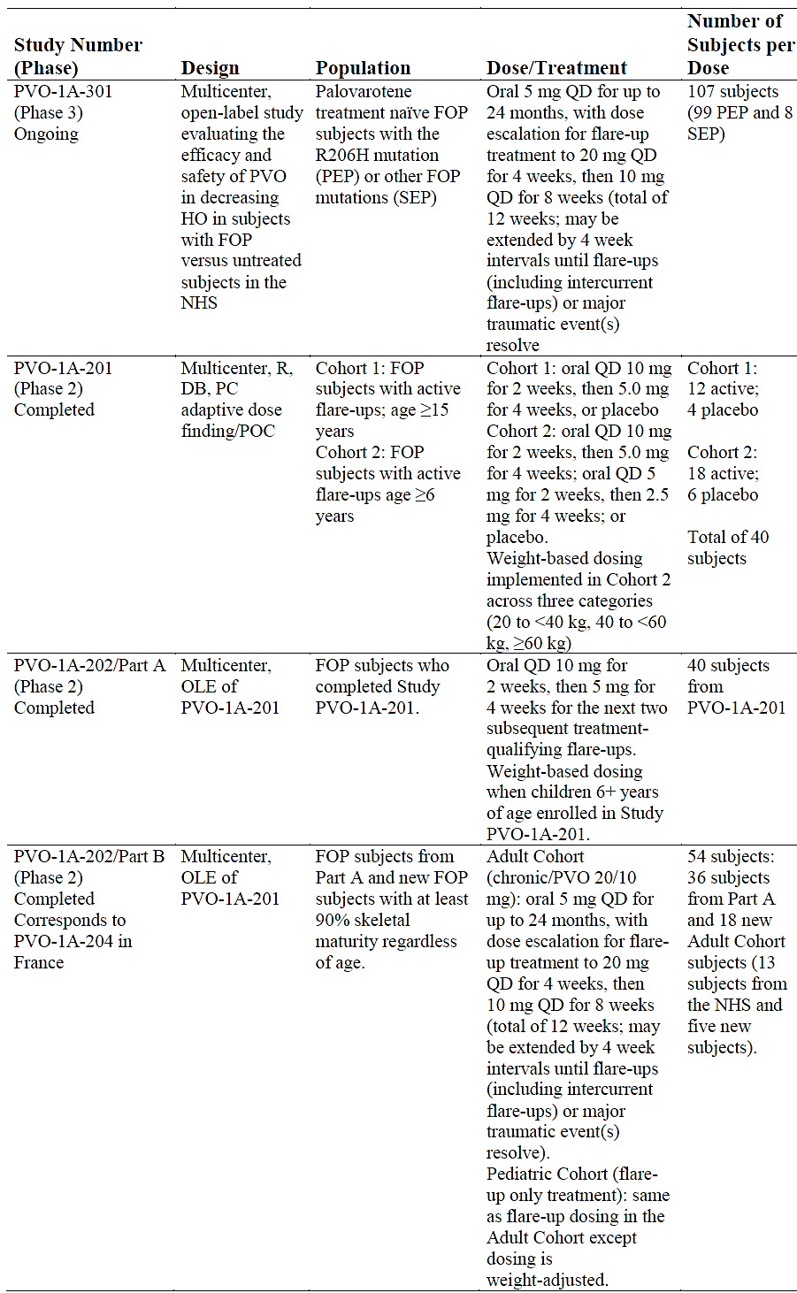
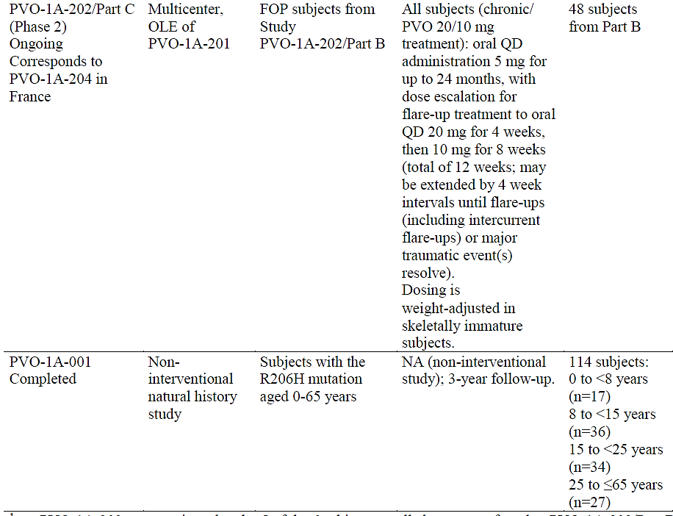
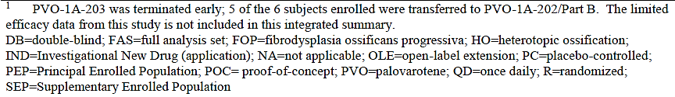

Pharmacology

Pharmacokinetics
An overview of PK parameters is presented in Table 5. The PK characteristics, as informed by PK studies are summarised below.
Table 5. Clinical pharmacology studies. Palovarotene PK parameters at steady state.
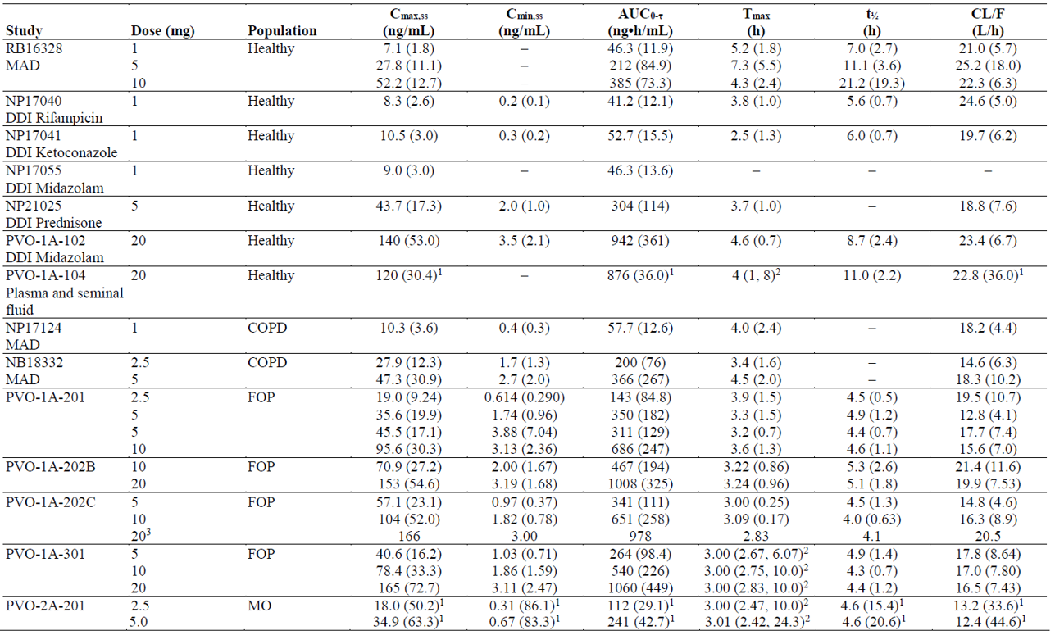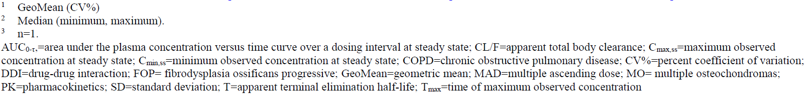

Absorption
After fed administration of 20 mg palovarotene once daily for 14 days in healthy subjects, the median Tmax was 4.6 hours, the mean Cmax was 140 ng/mL, and the average AUC0-τ was 942 ng*hr/mL.
Administration of a 20 mg single dose after a high-fat, high-calorie meal increased the mean AUC0-∞ by 40% and the mean Cmax by 16% compared with administration under fasting conditions. Tmax increased from approx. 2 to 4 hours.
From a population PK analysis, derived AUC0-τ and Cmax,ss were 37% and 32% higher, respectively, under fed conditions compared to fasted conditions for a typical adult.

Distribution
Palovarotene is highly bound (ranging from 97.9 to 99.6%) to human plasma proteins (in vitro data). The mean apparent volume of distribution at steady-state (Vdss/F) is 319 L following 20 mg once daily doses.

Metabolism
Palovarotene is extensively metabolised by primarily CYP3A4 and to a minor extent by CYP2C8 and CYP2C19 in vitro.
Five metabolites were observed: M1 (6,7-dihydroxy), M2 (6-hydroxy), M3 (7-hydroxy), M4a (6-oxo), and M4b (7-oxo) which reached steady-state by Day 4 with a large plasma concentration variability. M3 was the major metabolite based on AUC (50% to 60% of parent AUC) and with approx. 2% activity of the parent drug based on an in vitro transactivation assay.
Following administration of [¹⁴C]-radiolabelled palovarotene, the contribution of palovarotene and its major metabolites (M2, M3, M4a, and M4b) collectively represented 40% of the total plasma exposure.
In vitro data suggest that palovarotene is not a significant substrate of any of the uridine 5'- diphospho-glucuronosyltransferases (UGTs).

Excretion and elimination
Palovarotene has a terminal half-life (T½) of approx. 8-13 hours and an estimated apparent clearance (CL/F) of 19.9 L/h. The hepatic extraction ratio of palovarotene appears to be <30%.

Dose proportionality
Following oral administration under fed conditions, palovarotene appeared to exhibit linear PK with dose-proportional increases in plasma exposure from doses of 0.02 to 50 mg (single dose), and 0.1 to 10 mg (multiple doses) in healthy volunteers. In the FOP studies, the range was 2.5 to 20 mg. In the target population, dose proportionality was observed following chronic (5 mg) and flare-up (20 mg and 10 mg) dosing.

Excretion
Following administration of [¹⁴C]-radiolabelled palovarotene (54.5 μCi/mg), 97.1% of the dose was recovered in the faeces and 3.2% in the urine. Palovarotene and its four known major metabolites accounted for 67.2% of the dose in faeces and six other unidentified metabolites accounted for 28.4%. More than 92% of the dose was recovered in the first 6 days post-dose and mass balance was achieved with 100% of the dose recovered by Day 14.
Little or no accumulation was observed following once daily dosing. The mean steady-state trough plasma concentration was 3.5 ng/mL after once daily 20 mg palovarotene.

Interactions
In vitro, palovarotene did not significantly inhibit CYP1A2, CYP3A4, CYP2B6, CYP2C8, CYP2C9, CYP2C19, and CYP2D6. In vitro, palovarotene did not significantly inhibit UGT1A1, UGT1A3, UGT1A4, UGT1A6, UGT1A9, or UGT2B7.
Palovarotene appears not to be a substrate of P-gp, BCRP, OATP1B1, OATP1B3, or OCT1; or to be an inhibitor of P-gp, OAT1, OAT3, OCT2, MATE1, or MATE2-K.
A clinical DDI evaluation for CYP2B6 was not conducted, as the sponsor considered the risk of induction low. Palovarotene appears not to have a clinically significant effect regarding the induction of CYP1A2, CYP2C8, CYP2C9, or CYP2C19.
Clinical drug-drug interaction (DDI) study results:
- DDI with ketoconazole (strong CYP3A4 inhibitor): Strong CYP3A4 inhibitors increase the systemic exposure of palovarotene (2-to 3-fold based on Cmax and AUC). Concomitant use with strong CYP3A4 inhibitors should be avoided.
- DDI with erythromycin (moderate CYP3A4 inhibitor) (simulated PBPK model): A moderate inhibition (AUC GMR ≥2 and <5) was observed in the simulation. Concomitant use with moderate CYP3A4 inhibitors should be avoided.
- DDI with prednisone (weak CYP3A4 inhibitor): In the presence of prednisone, mean palovarotene Cmax,ss and AUC0-τ were both reduced by approximately 14% (not considered clinically significant).
- DDI with rifampicin (strong CYP3A4 inducer): Co-administration of palovarotene with rifampicin decreased the exposure of palovarotene approximately 10-fold. Concomitant use with strong CYP3A4 inducers should be avoided.
- DDI with efavirenz (moderate CYP3A4 inducer) (simulated PBPK model): A moderate induction (AUC GMR ≤0.5 and >0.2) was observed in the simulation. Concomitant use with moderate CYP3A4 inducers should be avoided.
- DDI with midazolam (CYP3A4 substrate): Co-administration with multiple doses of palovarotene resulted in less than 15% decrease in midazolam exposure. Palovarotene did not significantly induce CYP3A4 in healthy subjects.
- Smoking appeared to have no significant effect on the PK.

Intra- and inter-individual variability
Following single-dose fed administration conditions in healthy subjects, inter-individual variability (%CV) for AUC and Cmax was low to moderate (typically 30% to 40%). High inter-individual variability appears to have been observed in the Population PK simulations. Intra-individual variability appears not to have been considered.

Special populations
Effect of hepatic impairment: In a PopPK covariate analysis (PVO-PopPK-003) (n=701), there was no evidence that mild hepatic impairment (n=47, 6.7%) affected palovarotene PK and did not suggest that moderate hepatic impairment affected the PK, noting that the number of patients with hepatic impairment was low (e.g., n=2 for moderate impairment), and did not include severe impairment.
Simulation results from a PBPK model suggested that patients with Child-Pugh classifications A, B, and C had an AUC0-τ which was 1.10, 1.61-, and 1.85-fold greater, respectively, and a Cmax which was 1.07-, 1.42-, and 1.53-fold greater, respectively, compared to healthy subjects.
No dose adjustment is required in patients with mild hepatic impairment. The use in moderate and severe hepatic impairment has not been specifically studied. Palovarotene may be used with caution in moderate hepatic impairment, and but should not be used in severe hepatic impairment.
Effect of renal impairment: Palovarotene is not mainly renally eliminated. In a PopPK covariate analysis (PVO-PopPK-003) (n=701), there was no evidence that that mild (n=158, 22.5%) or moderate (n=24, 3.4%) renal impairment clinically affected palovarotene PK, and no dose adjustment is needed. Use in severe renal impairment is not recommended.

Population PK (popPK) and PBPK data
This consisted of: Population pharmacology studies PVO-PopPK-001 (original analysis), PVO-PopPK-002 (Addenda 1 and 2 of PVO-PopPK-001), PVO-PopPK-003, and Study IPN-3B (PBPK).

Methods
PK clinical data source: 15 studies, including 8 studies in healthy volunteers, 3 studies in patients with symptomatic emphysema secondary to COPD (NA17598 (Tier 2), NP17124 and NB18332), 3 studies in patients with FOP (201, 202 and 301) and 1 study in patients with multiple osteochondromas (MO) (Study PVO-2A-201).
PVO-PopPK-002 included 9088 concentrations from 701 subjects, of which 184 (26%) were aged <18y. This generated the final model (run 082) that was also used for Study PVO-PopPK-003, and Study IPN-3B.
Model: The following covariates were evaluated for their impact on the palovarotene PK: age, body weight, biological sex, race, smoking status, health status, administration with food, formulation, method of administration (sprinkled on food or swallowed whole), administration of prednisone, albumin, ALT, AST, ALP, creatinine, and bilirubin.
The evaluation used nonlinear mixed effects modelling with a Monte Carlo Importance Sampling Expectation Maximization method implemented in NONMEM (v.7.30. and 7.4.3).
The population PK models were evaluated using a prediction corrected visual predictive check (pc-VPC) method. The final model was used to perform simulations in adults, and subsequently in skeletally immature children (250 males and 250 females were simulated using CDC growth chart data) to assess the proposed weight-based dosing.
The weight-adjusted equivalent doses used in the simulation for skeletally immature subjects were:
For each subject, a 24-hour steady-state concentration-time profile was simulated following a once daily dose of 5, 10, and 20 mg (or weight-adjusted equivalent). Steady-state peak concentration (Cmax), trough concentration (Cmin) and area under the curve (AUC) were calculated using non-compartmental methods and compared by weight group.

Results and conclusions
Model: The final PK model (run067 (original analysis), run080 (Addendum 1) and run082 (Addendum 2)) was a two-compartment lagged model with first-order absorption (six transit compartments were used to describe the delay in absorption) and first-order elimination. VPCs confirmed the predictive capability of the model and showed good agreement between observations and model predictions over the range of the data.
The PK model development process was rigorous and the final PK model was robust and adequately described the PK data collected in 16 studies in healthy subjects and patients with COPD, FOP and MO. The predictive performance of the model was adequate to predict exposures in a paediatric population.
Dose-proportionality: The model supported palovarotene PK dose-proportionality for the dose range tested (0.02 to 50 mg).
Covariate modelling: Population PK parameter estimates are summarised in Table 6.
Table 6. Population PK Study PVO-PopPK-002 (Addendum 2). Parameter Estimates of Final PopPK Model (run082)
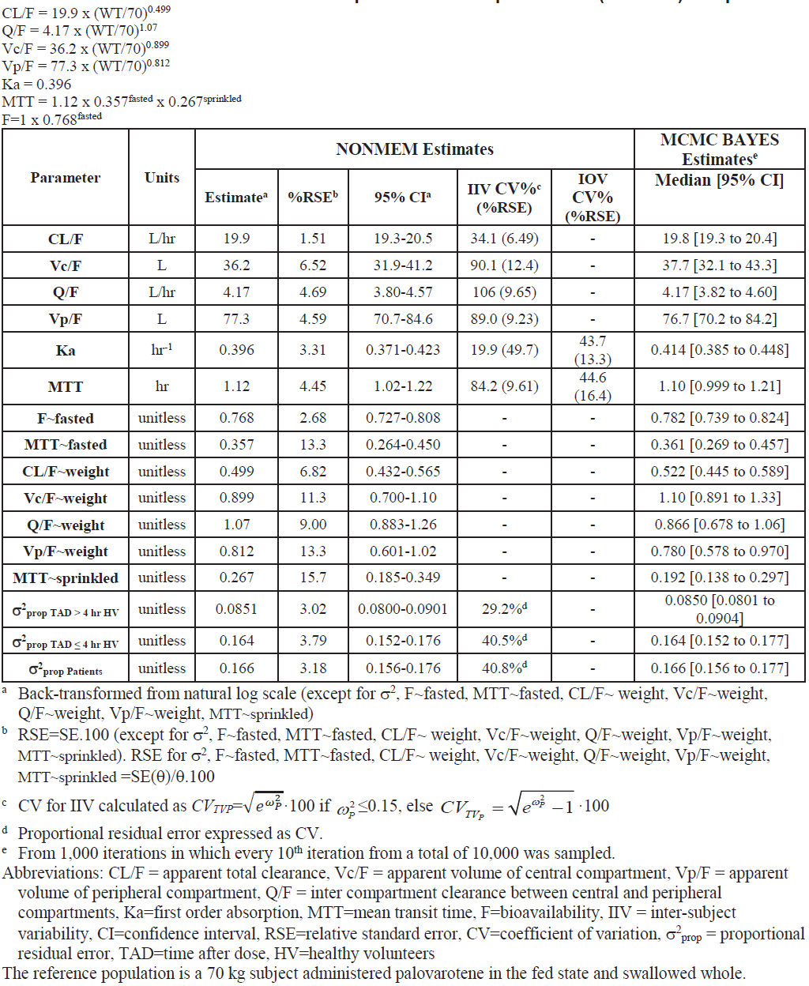
CL/F, Vc/F, Q/F and Vp/F all increased with weight, with estimated allometric scalars. The MTT and relative bioavailability were decreased in the fasted state (64% shorter and 23% lower, respectively, compared to fed). Sprinkling (vs. swallowing the capsule whole) had little impact on palovarotene exposure (Cmax or AUC) (12-15% lower).
After inclusion of the investigated covariate effects, graphical evaluations showed no residual trends with other covariates, suggesting no effect of, age, biological sex, race, smoking status, health status, administration of prednisone, albumin, ALT, AST, ALP, creatinine or bilirubin on palovarotene PK.
Weight covariate: Body weight had a significant impact on PK (increasing exposure with decreasing body weight at the same dose). In adult simulations, derived AUC24,ss and Cmax,ss were 8% and 12% greater for a 51-kg (5th percentile) adult, and 18% and 26% lower for a 98-kg adult (95th percentile), respectively, compared to a typical 70-kg subject.
Weight-based paediatric dosing: Although Cmax was higher and Cmin was lower for paediatric subjects <20 kg, the overall exposure (AUC) was comparable between the weight groups and the proposed paediatric weight-based dosing scheme was considered appropriate. Consistent results were obtained across the successive analyses.
The sponsor proposes weight-adjusted dosing in patients aged ≤14y (with <90% skeletal maturity), but not in adults or skeletally mature children, in order to provide the highest tolerated dose to minimise HO formation. But dose adjustments may occur based on clinical tolerability.
Effects in patients with reduced renal or hepatic function.
At baseline, the study included:
- 519 (74%), 158 (23%) and 24 (3%) subjects with normal renal function, mild renal impairment and moderate renal impairment, respectively
- 652 (93%) and 47 (7%) subjects with normal hepatic function and mild hepatic impairment, respectively.
Based on the renal and hepatic function groups represented in the study:
- There was no apparent effect of mild renal impairment or moderate renal impairment on palovarotene clearance.
- There was no apparent effect of mild hepatic impairment on palovarotene clearance.

Pharmacodynamics

Mechanism of action
Palovarotene is a selective retinoic-acid receptor gamma agonist that inhibits heterotopic ossification.

Pharmacodynamic variables
Exposure-efficacy analyses: Using data from Studies PVO-1A-001, 201, and 202, no consistent ER trends for response measures vs exposure metrics could be found.
Using pivotal phase 3 data in FOP patients, the sponsor claims that there was a statistically significant relationship between change from baseline in HO volume and cumulative AUC at Month 12 (but not at Week 12).
Exposure-safety analyses: No data available.

Efficacy

Study 301 (PVO-1A-301) (MOVE study) (pivotal phase 3 study)

Design
A pivotal, 24-month (Part A) (with a 24 month extension (Part B)), phase 3, non-randomised, open-label, multi-centre (16 centres in 11 countries), single-arm study with historical controls (from Study 101) to assess the efficacy and safety of oral palovarotene for the treatment of FOP (chronic and flare-up) in 107 treatment-naïve adult and paediatric patients aged ≥4 years.
The study evaluated the efficacy and safety of the chronic/flare-up regimen on annualised change in new HO as assessed by WBCT compared to the external control group of ‘untreated’ subjects from Study 001.
The study period commenced on 30 November 2017 (first subject signed informed consent form) with 28 February 2020 being the data cut-off for the interim CSR. The study was completed in September 2022.
Based on the serious identified risk of premature physeal closure (PPC), a partial clinical hold was implemented on subjects aged <14 years. At the time of this report, the partial clinical hold remained in place for subjects <14 years of age.
Interim analyses assessed annualised new HO volume in the chronic/flare-up regimen in Study 301 and compared them with those from untreated subjects in Study 001 (as external control).

Primary efficacy objective
- To evaluate the efficacy of palovarotene in decreasing heterotopic ossification (HO) in adult and paediatric subjects with FOP as assessed by low-dose whole body computed tomography (WBCT), excluding head, as compared to untreated subjects (in Study 001).
- To evaluate the safety of palovarotene in adult and paediatric subjects with FOP.

Secondary efficacy objectives
- To evaluate the effect of palovarotene on flare-up rate and proportion of subjects reporting at least one flare-up.
- To evaluate the effect of palovarotene on range of motion (ROM) as assessed by the Cumulative Analogue Joint Involvement Scale (CAJIS) for FOP.
- To evaluate the effect of palovarotene on physical function using age-appropriate forms of the FOP-Physical Function Questionnaire (FOP-PFQ).
- To evaluate the effect of palovarotene on physical and mental health using age-appropriate forms of the Patient Reported Outcomes Measurement Information System (PROMIS) Global Health Scale.

Inclusion criteria included
- FOP diagnosis:
  - subjects from Study 001.
  - clinical FOP diagnosis with the R206H activin receptor type IA (ACVR1) mutation or other FOP variants reported to be associated with progressive HO.
  - subjects from Study 202/204 who could not receive the chronic/flare-up regimen in the Phase 2 trial (due to practical reasons).
- Other criteria: Age ≥4 years; no flare-up symptoms within the past 4 weeks; negative pregnancy test; abstinence from heterosexual sex or use of two effective birth control methods during and for one month before/after treatment; ability to undergo low-dose WBCT without sedation.
Up to a maximum of 110 subjects were to be enrolled (up to 99 with a R206H mutation and no previous palovarotene exposure, and up to 11 with other mutations or previous participation in the Phase 2 trials).
Exclusion criteria included (full list in Table 22): weight <10 kg; exposure to synthetic oral retinoids (except palovarotene) 4 weeks prior to screening; concurrent treatment with tetracycline or its derivatives; concomitant use of strong CYP3A4 inhibitors or inducers; amylase or lipase >2x ULN or history of chronic pancreatitis; AST or ALT >2.5x ULN; fasting triglycerides >400 mg/dL; breastfeeding; uncontrolled cardiovascular, hepatic, pulmonary, gastrointestinal, endocrine, metabolic, ophthalmologic, immunologic, psychiatric, or other significant disease; suicidal ideation (Type 4 or 5)/suicidal behaviour within the past month (C-SSRS definition).

Treatments
- Dosing:
  - Chronic treatment: Palovarotene 5 mg daily (or weight-adjusted) for up to 24 months.
  - Flare-up treatment (12 weeks):
- Palovarotene 20 mg daily (or weight-adjusted) for 4 weeks; then
- Palovarotene 10 mg daily (or weight-adjusted) for 8 weeks.
- Flare-up treatment triggers:
  - Flare-up symptoms (only one symptom needed) including pain, swelling, redness, decreased range of motion, stiffness, and warmth; or
  - Substantial high-risk traumatic events including surgery, intramuscular immunisations, mandibular blocks for dental work, muscle fatigue, blunt muscle trauma from bumps, bruises, falls, or influenza-like viral illnesses.
- Flare-up treatment duration: a 12 week cycle but could be extended in 4-week intervals. Once all flare-ups/traumatic events had been resolved and flare-up-based treatment completed, the chronic treatment dosing regimen was resumed. Another flare-up/event prior to resolution of a previous event could restart a flare-up treatment cycle.
- Weight adjustment dosing in <18 years with <90% skeletal maturity on hand-wrist radiography at Screening (ceased once growth plate 100% closed at both knee and hand-wrist locations):
- Adverse effect dose adjustment: reduction to the next lower dose, or if on the lowest dose, discontinuation.

Baseline characteristics
39 patients from the NHS transitioned to Study 301 (i.e., they were part of the treatment and the historical control group, but at different ages).
- Patient demographics are summarised in Table 7. Both groups were reasonably balanced except for age category. In Study 301, 75.8% were <18y compared to 59.5% in the control group. The patients age ranged between 4 and 61 years with a median of 13.0 and 15.0 years, respectively.
Table 7. Study 301. Baseline Demographic Characteristics (Principal Safety Set).
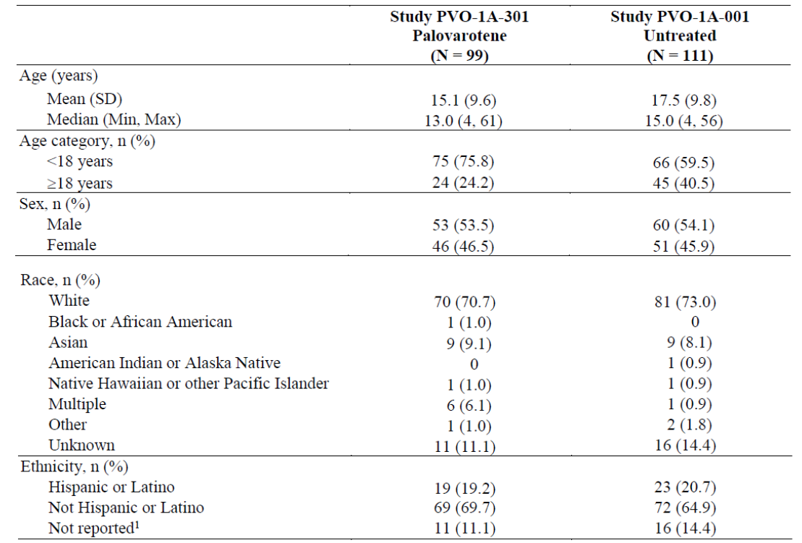
Disease characteristics are summarised in Table 8 and Table 9: Both groups were generally balanced regarding FOP history. In both groups, nearly all patients were born with great toe malformation (not surgically repaired in most). Approximately half had thumb malformations and cervical spine malformations. Osteochondromas of the tibia were present in 38% and 36% of active and control group patients, respectively. Almost all patients had experienced a flare-up. In the treatment group, the most common (>10%) last flare-up location was head/neck, upper back, hip, lower spine/abdomen, or shoulder. In the control group, this was the upper back, elbow, hip, or shoulder. The cause of last flare-up was unknown in 75% vs. 48%.
Table 8. Study 301. Baseline Disease Characteristics (Principal Safety Set).
Table 9. Study 301. Baseline Flare-up History (Principal Safety Set).
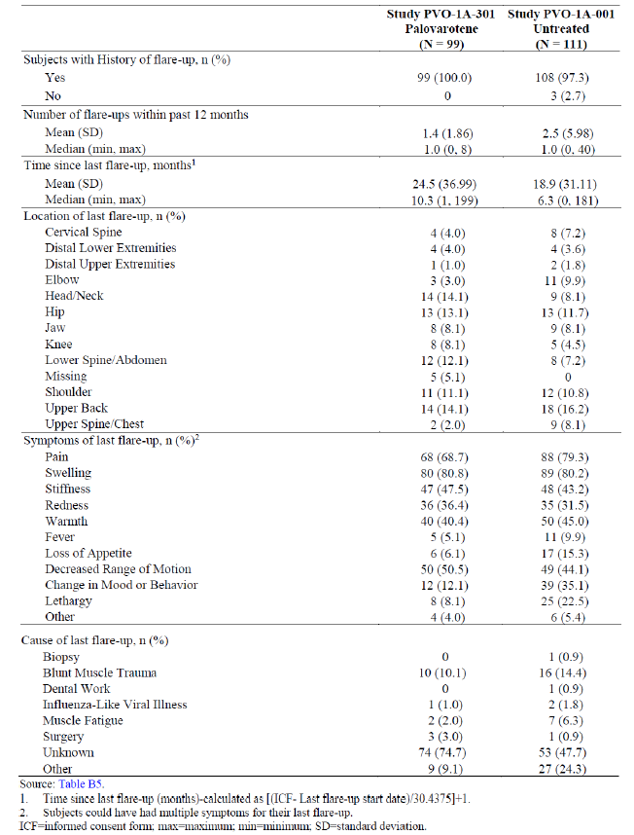
Flare-up data:
- 69/99 patients had at least one flare-up treated with palovarotene; they experienced a median of 3 flare-ups overall (range: 1, 23; mean: 4.0 ± 4.2). Dose reductions occurred during high-dose flare-up treatment in 31 (44.9%) patients compared to 8 (11.6%) patients during low-dose flare-up treatment (Table 10).
- 128 flare-up cycles occurred in patients treated for at least one flare-up with a median of 1.0 (range: 0, 23) flare-up treated per cycle (mean: 2.2 ±3.0). The duration of flare-up treatment cycles lasted a median of 84 days (range: [1, 530]; mean:110 days [79.6]). Most flare-up cycles had 1 flare-up (61.7%) (Table 11).
Table 10. Study 301. Subjects with Flare-up Treatment (Principal Safety Set).
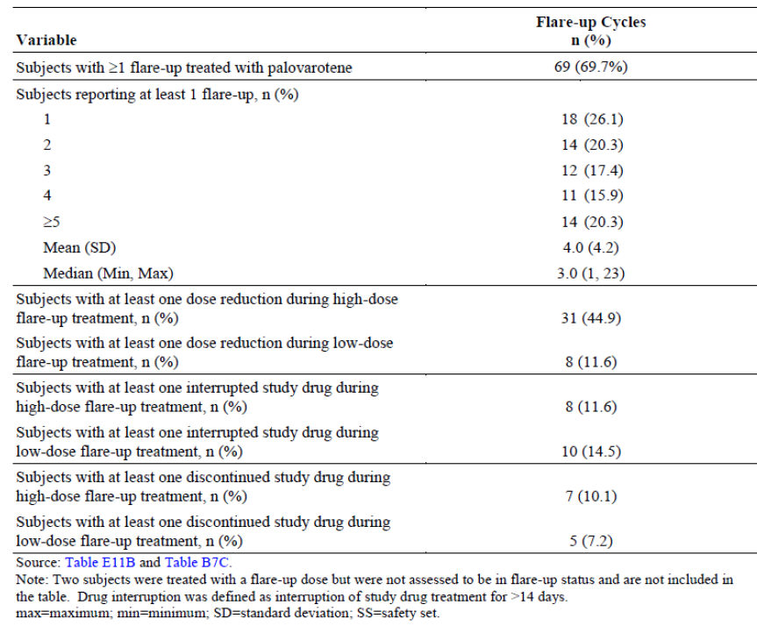
Table 11. Study 301. Number of Flare-up Treatment Cycles (Principal Safety Set).

Initial analysis and post hoc change of methodology
The original protocol primary efficacy analysis intended to compare the annualised change in new HO volume between subjects treated with palovarotene and untreated subjects using a wLME model in the FAS (without transformation or zeroing negative values).
A protocol amendment changed this to a Bayesian compound Poisson model with a square root transformation of HO volume per region and negative new HO values being set to zero (either by body region; or overall). In IA2, that analysis indicated that the futility boundary (<5% posterior probability of ≥30% reduction in annualised new HO volume) had been crossed. Consequently, as pre-specified, dosing was interrupted, and data were unblinded for post hoc analyses. These post hoc analyses (Bayesian model without square root transformation and a wLME model with and without square root transformation) revealed a clinically meaningful benefit when used without square root transformation.
Consequently, the applicant believed that the most appropriate analysis is the simpler wLME analysis without square root transformation (as per original protocol). The wLME analysis without transformation accommodates the annualised new HO as reported (including any observed reductions). A subject-level random effect was used to account for the correlation among repeated measures on the same subject. The model was fitted using only a subject’s observations associated with the longest follow-up in Studies 301 and 001 with weights used to account for the different lengths of observed follow-up. Baseline HO volume divided by age was the only included covariate, in addition to the factor identifying study of origin. No imputation of missing data was performed.
Additionally, Wilcoxon rank-sum tests were performed (dependent only on the numeric rank order of the observed new HO volumes rather than their magnitudes) which are less influenced by extreme values.
Thus, only the original/latest protocol wLME analysis has been considered in this overview as the primary analysis. The Bayesian model result are shown in the sponsor documentation.

Analysis sets
- Principal FAS (Principal Full Analysis Set): all enrolled subjects in the Principal EP who had a baseline and at least one post-baseline HO volume measurement.
- Principal PPS (Principal Per-Protocol Set): subset of the Principal FAS including subjects with no major protocol deviations that were expected to interfere with assessments of the primary endpoint, and with at least 80% compliance to the study drug regimen over the first 24 months of participation in the study.
ITT Set (Intention-to-Treat Set): all subjects regardless of whether they restarted palovarotene treatment or remained off treatment until study completion due to the partial clinical hold or other reason. This Set was not part of the original application and is less representative of the treatment effect, as it includes off-treatment periods. A Wilcoxon rank-sum analysis is not available for this set.

Magnitude of the treatment effect and its clinical significance

Primary efficacy results
- Total study population: The primary analysis showed a 60.3% reduction in the mean annualised new HO volume of palovarotene-treated (9427.1 mm3) vs. untreated (23720.2 mm3) patients. The primary analysis using weighted linear mixed-effects models (wLME) showed a 53.8% reduction in the LSM annualised new HO volume of palovarotene-treated (9366.8 mm3) vs. untreated (20273.0 mm3) patients (wLME treatment p=0.0392; Wilcoxon rank-sum p=0.0003) (Principal FAS). The primary analysis using the PPS and ITT showed similar results, noting that the ITT Set included treatment breaks.
- Target population of patients aged ≥8y/10y (female/male) (i.e., the subgroup for which the FOP indication is sought by the sponsor): The primary analysis showed a 55.7% reduction in the mean annualised new HO volume of palovarotene-treated (11418.8 mm3) vs. untreated (25796.0 mm3) patients. The primary analysis using wLME, showed a 48.6% reduction in the LSM annualised new HO volume of palovarotene-treated (11033.2 mm3) vs. untreated (21476.0 mm3) patients (wLME treatment p=0.1124; Wilcoxon rank-sum p=0.0107) (Principal FAS).
- Other analyses using square root transformation or negative HO volumes set to zero are shown in Table 12.
- A graphical representation of the primary results is shown in Figure 2.
Table 12. Study 301. Summary of main results (primary and other analyses).
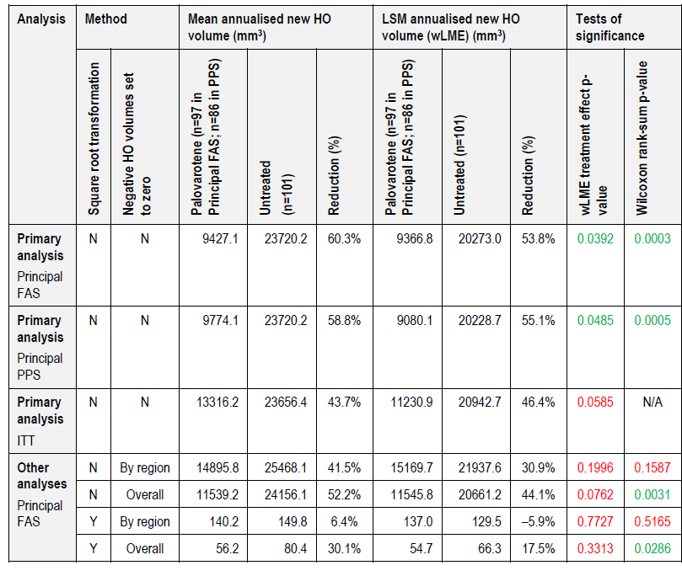
Reductions are shown as positive values. Negative reduction values indicate an increase. HO = heterotopic ossification; LSM = least squares mean; wLME = weighted linear mixed effects; FAS = Full Analysis Set; PPS = Per-protocol Set
Figure 2. Study 301. Graphical representation of primary endpoint results (primary and other analyses) (Principal FAS).
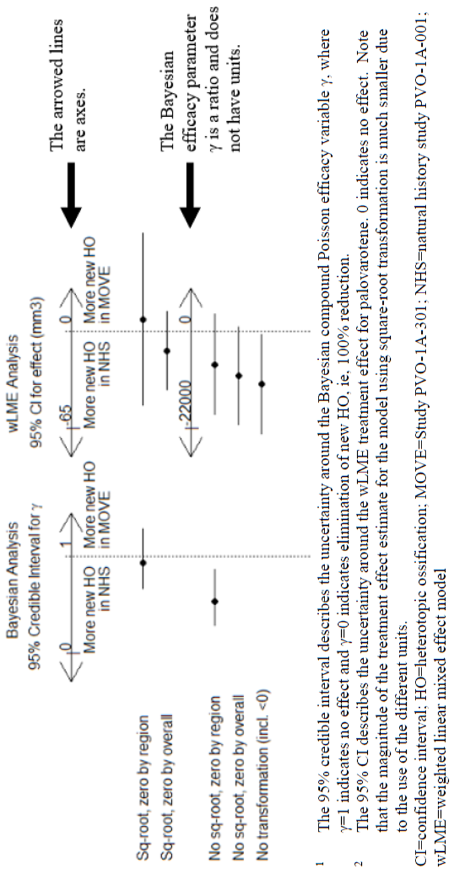
Late in the application period (post-Round 2), the sponsor provided additional data on the post-pause treatment period and the off-treatment period:
- Post-pause treatment (i.e., post-restart) period: subjects who restarted palovarotene treatment after a pause, if two or more WBCT scans were obtained during this period. All analyses that include this post-pause time period used the first scan obtained after palovarotene restart as post-pause baseline through to the last observation after palovarotene restart. This time period includes all subjects that were on active treatment. A comparison with the Principal FAS is shown in Table 13.
- Post-off-treatment period: period from first WBCT scan off treatment secondary to dosing interruption to Last-Patient-Last-Visit for patients who remained off treatment. This period therefore solely represents time off treatment.
Table 13. Study 301. Comparison of the main endpoint results to the post-pause treatment period.
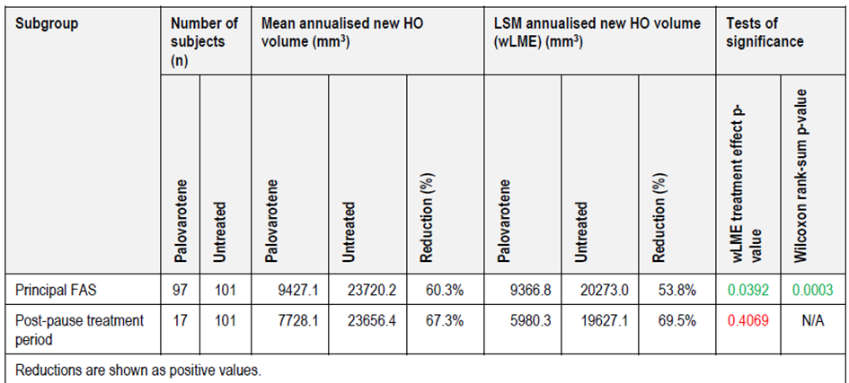
Table 14. Study 301. Annualised New HO Volume (mm3) results for the post-off-treatment period.

Primary efficacy endpoint subgroup analyses (original application)
Selected subgroup/sensitivity analyses are shown in Table 15 below. Notable examples include:
- Female patients: The primary analysis showed a 25.8% reduction in the mean annualised new HO volume of palovarotene-treated (10617.5 mm³) vs. untreated (14317.1 mm³) patients. The primary analysis using wLME, showed a 11.3% increase in the LSM annualised new HO volume of palovarotene-treated (10105.9 mm³) vs. untreated (9078.0 mm³) patients (wLME treatment p=0.8740; Wilcoxon rank-sum p=0.0211) (Principal FAS) (Table 15).
- Asian patients: The primary analysis showed a 259.5% increase in the mean annualised new HO volume of palovarotene-treated (5885.1 mm³) vs. untreated (1636.8 mm³) patients. The primary analysis using wLME, showed a 280.3% increase in the LSM annualised new HO volume of palovarotene-treated (8960.0 mm³) vs. untreated (2355.8 mm³) patients (wLME treatment p=0.6309; Wilcoxon rank-sum p=0.8125) (Principal FAS) (Table 15).
- Flare-up status: In patients without a flare-up, there was a 48.2% reduction in new HO volume (wLME: 44.6%), vs. 69.4% in those with a flare-up (wLME: 71.9%) (Table 15).
Many of the subgroup analyses are underpowered or do not reach statistical significance otherwise and need to be interpreted with caution.
However, it appears that, in Study 301, the treatment effect of palovarotene was mainly driven by the results in males, the age cohort below 18 years, and those with flare-ups. These may be the groups that appear to benefit most from palovarotene treatment based on a HO volume efficacy variable.
Table 15. Study 301. Summary of primary endpoint analyses by subgroup (Principal FAS).
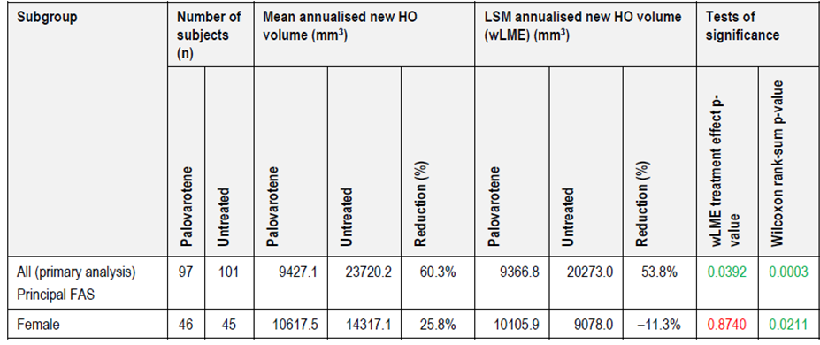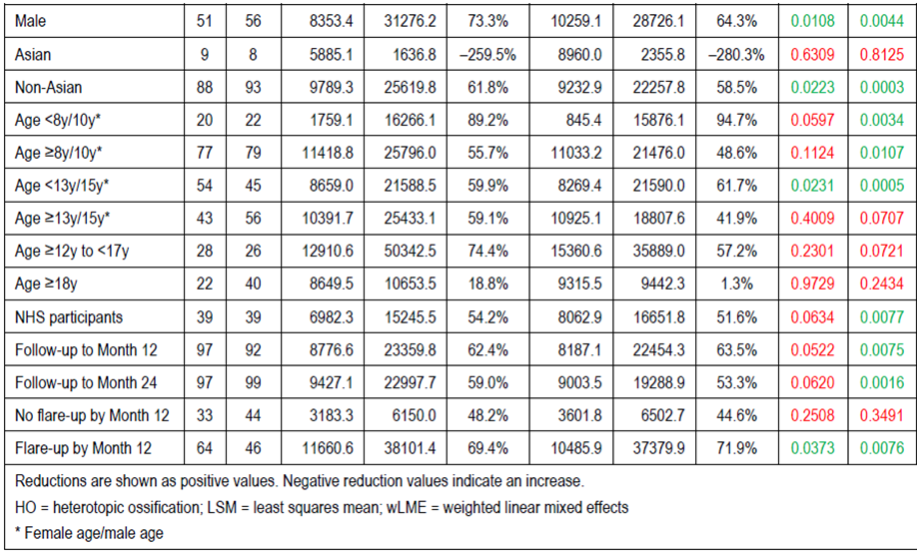

Secondary endpoints
- Key secondary endpoint: The proportion of subjects with any new HO (volume >0 mm3) at Month 12 was similar in palovarotene-treated patients (64.1%) vs. untreated (62.2%). At 18 months, the gap widened to 70.3% vs. 90.9%.
- Other secondary endpoints: The mean number of body regions with new HO at Month 12 was similar between treated and untreated patients. A higher proportion in the palovarotene group reported flare-ups (defined as having at least two symptoms) at month 12: 65% vs. 54%. Overall, the flare-up rates per subject-month of exposure were 0.13 in palovarotene-treated patients vs. 0.07 in untreated patients. Details are shown in Table 16.
Table 16. Study 301. Summary of secondary endpoint results (Principal FAS).
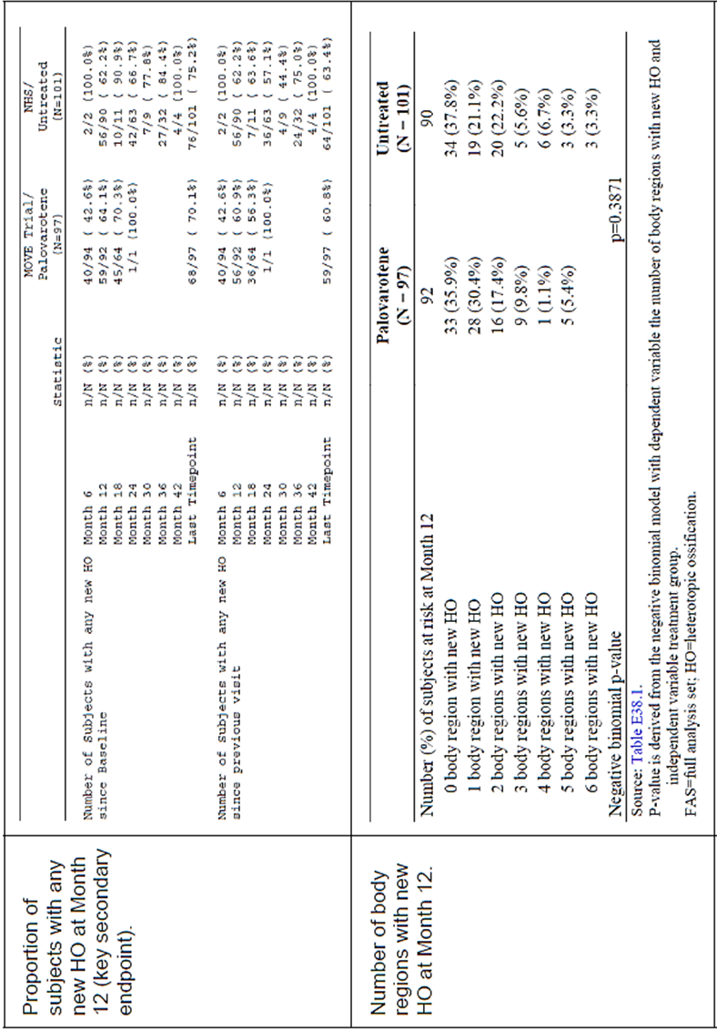
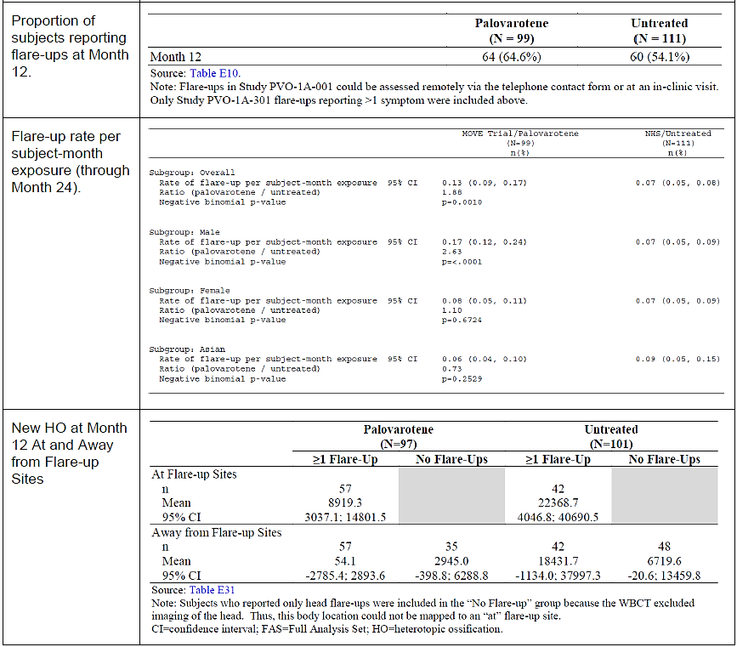
Exploratory results: Exploratory endpoint results are shown in Table 17.
- The proportion of patients with catastrophic new HO was lower in the palovarotene group vs. the control group for all categories of catastrophic new HO (>100,000, >50,000, and >30,000 mm3) at Month 12 and at the last timepoint assessed.
CAJIS, FOP-PFQ and PROMIS score differences were minimal.
Table 17. Study 301. Exploratory endpoint results (Principal Safety Set).
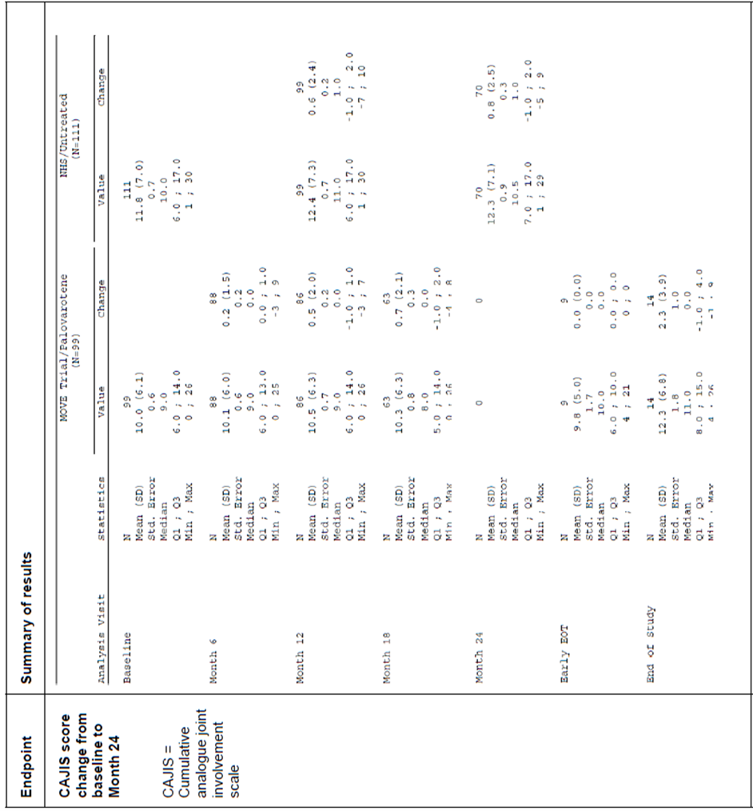
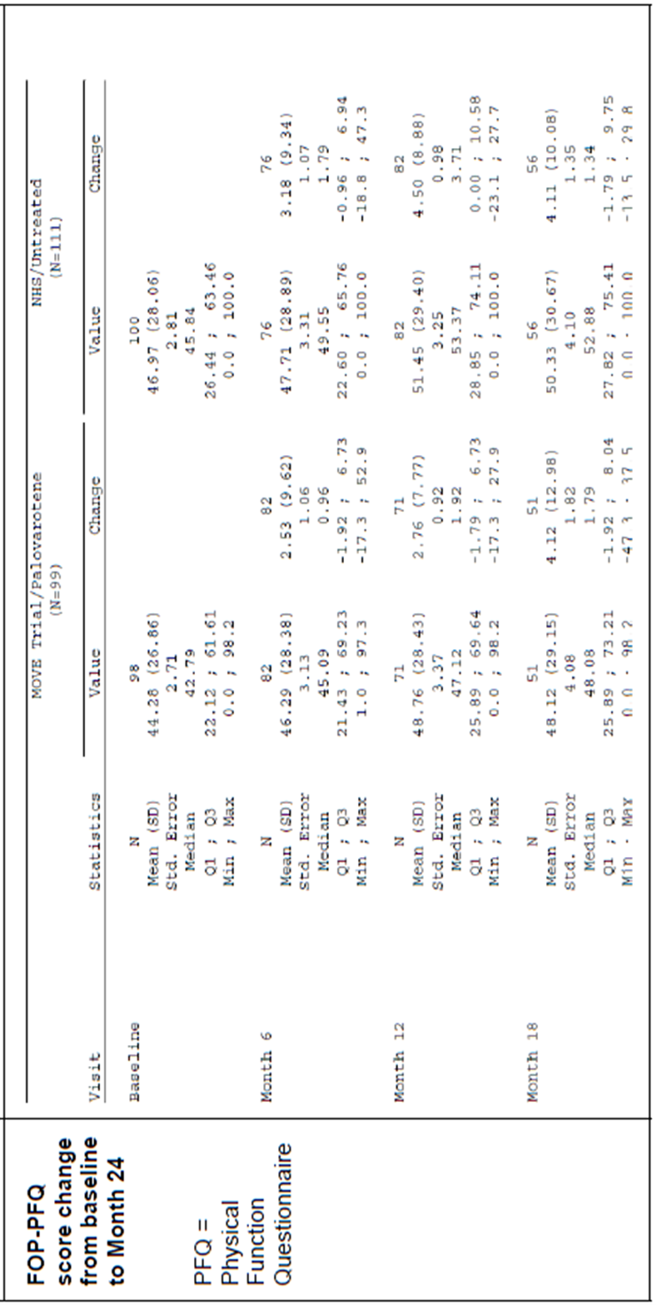
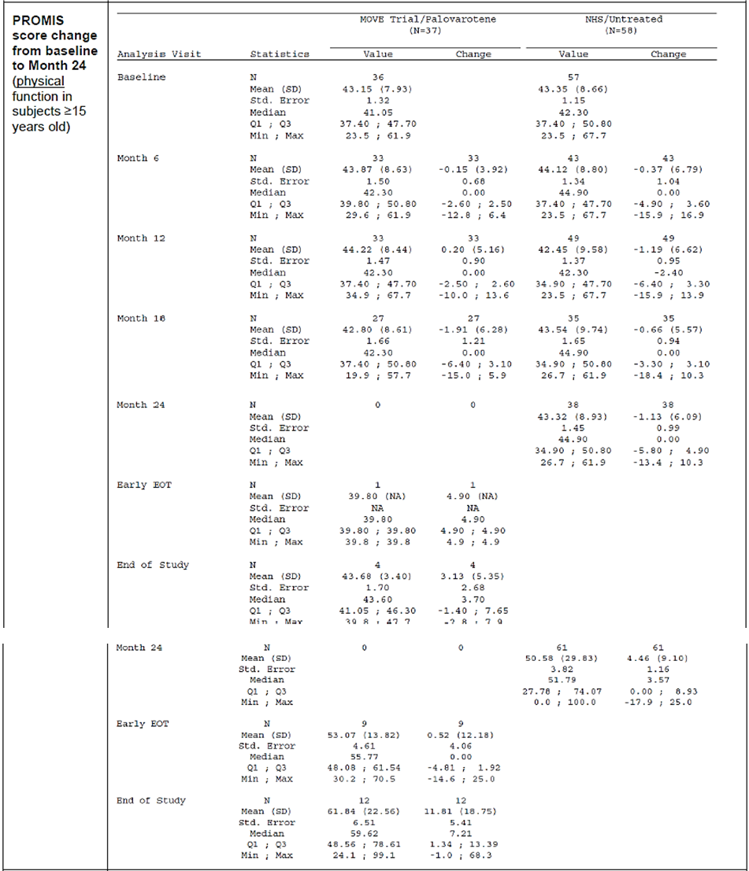
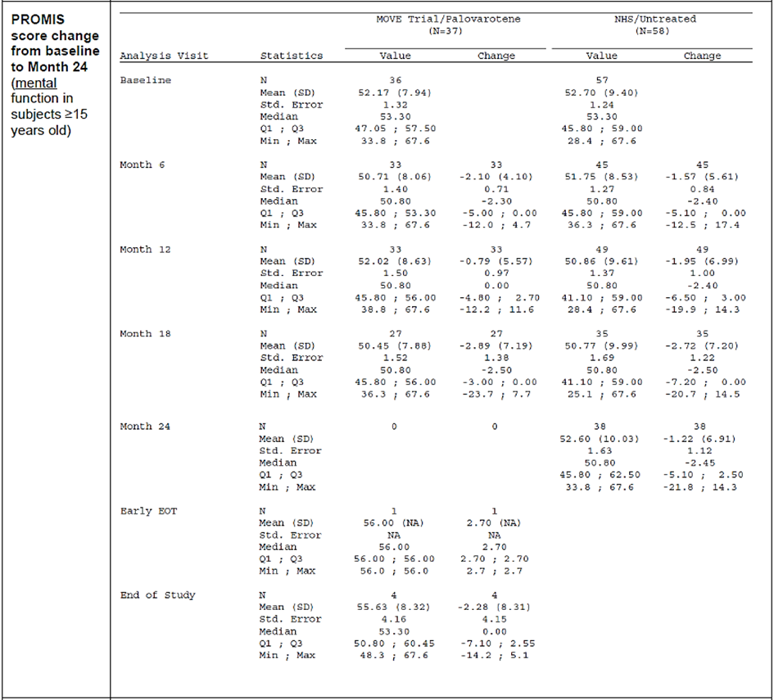
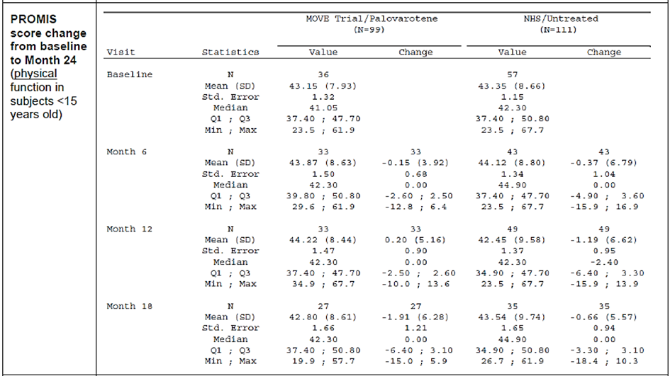
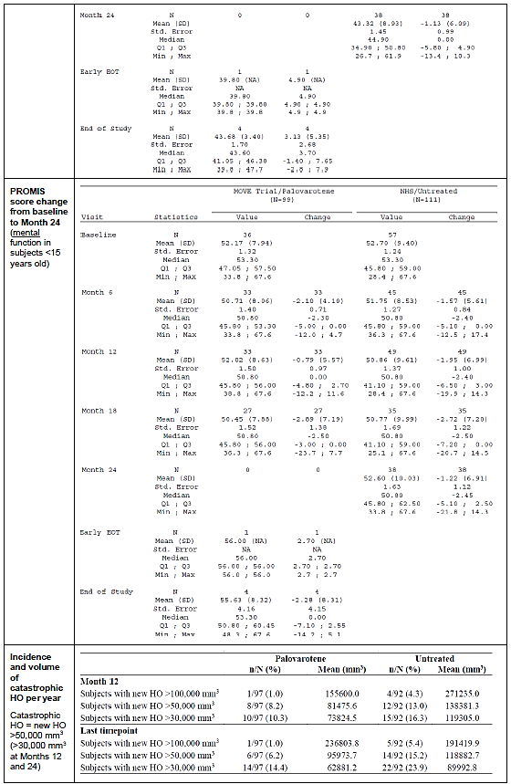

Study 201 (PVO-1A-201) (supportive phase 2 study)

Design
Phase 2, multicentre, randomised, double-blind (investigator and subject), sponsor-unblinded, placebo-controlled 12-week study (with open-label extension) in 40 female or male patients aged ≥6 years with FOP and an active flare-up.
The study was conducted between 14 July 2014 and 23 May 2016. It had three periods: a screening period within 7 days of a distinct (acute) flare-up (2 symptoms needed), a 6-week double-blind treatment period, and 6-week follow-up period.
Cohort 1: Patients were randomised 3:1 to either PVO 10/5 mg (10 mg for 2 weeks, then 5 mg for 4 weeks), or placebo daily for 6 weeks, after which unblinding occurred and dosing for Cohort 2 was determined.
Cohort 2: Additional patients were randomised 3:3:2 to PVO 10/5 mg (10 mg for 2 weeks, then 5 mg for 4 weeks) and PVO 5/2.5 mg (5 mg for 2 weeks, then 2.5 mg for 4 weeks), or placebo daily for 6 weeks. Weight-adjusted equivalent doses were given.
The primary objective was to evaluate the ability of different doses of PVO to prevent HO at the flare-up site as assessed by plain radiographs in subjects with FOP.

Magnitude of the treatment effect and its clinical significance
The primary endpoint was the responder proportion (defined as patients with no/minimal new HO at the flare-up site at Week 6): 89% in the placebo group and the PVO 5/2.5 mg group, and 100% in the PVO 10/5 mg group.
At Week 12, the proportion of patients with any new HO was lower in the PVO 10/5 mg group (15%) compared to PVO 5/2.5 mg (44%) or placebo (40%).
The results were not statistically significant for either treatment group, but a favourable trend could be observed.

Study 202 (PVO-1A-202) (supportive phase 2 study)

Design
Phase 2, multicentre, open-label, uncontrolled study in 40 (Part A) or 56 (Parts B) or 48 (Part C) male or female patients with FOP aged ≥6 years to investigate different dosing regimens of palovarotene.
Cohorts: Adult Cohort: all subjects with ≥90% skeletal maturity (regardless of age); Paediatric Cohort: all subjects with <90% skeletal maturity.
Part A: enrolled all 40 patients aged ≥6 years from Study 201 and assessed the original flare-up treated in that study plus up to two, new, distinct flare-ups. The Flare-up Component consisted of three periods: a Screening period within 7 days of a new, distinct flare-up; a 6-week treatment period, and a 6-week follow-up period. Any new flare-ups during the 12-week flare-up assessment period were captured as AEs.
- Flare-up treatment: palovarotene 10 mg daily for 2 weeks followed by 5 mg daily for 4 weeks (or equivalent weight-adjusted doses) (PVO 10/5 mg).
- No chronic treatment.
Part B: enrolled patients who successfully completed Study 201 (including any subject who participated in Part A or in Study 203) and 18 additional Adult Cohort subjects were followed for up to 24 months.
- Flare-up treatment: palovarotene 20 mg daily for 4 weeks followed by 10 mg daily for 8 weeks (or equivalent weight-adjusted doses) (PVO 20/10 mg), and could be extended in 4-week intervals.
- Chronic treatment:
  - Adult Cohort: 5 mg palovarotene daily for up to 24 months (including after resolved flare-ups).
  - Paediatric Cohort: no chronic treatment.
Part C: an additional 36 months for Part B patients (no new patients); only one symptom was needed to define a flare-up, and an intercurrent flare-up would restart the PVO 20/10 mg regimen. The dosing regimen was aligned with Study 301.

Magnitude of the treatment effect and its clinical significance
Analyses were limited to descriptive statistics, and due to the lack a control group, not relevant comparisons can be made.
Part A: There was an increase in mean volume in new HO for flare-ups with new HO, from 5,204 mm3 (Week 6) to 7,506 mm3 (Week 12) and likely reflects the end of treatment after 6 weeks.
Part B: Proportions of flare-ups with no new HO: PVO 10/5 mg: 35.7%; PVO 20/10 mg: 41.2%; Chronic/PVO 20/10 mg: 20.6%; Combined PVO 20/10 mg: 27.5% (Table 18).
Part B/C: The mean volume of new HO (for flare-ups with new HO) was 9,134 mm3 (PVO 20/10 mg), 30,934 mm3 (chronic/PVO 20/10 mg), and 21,025 mm3 (combined PVO 20/10 mg) at Week 12 (Table 19).
Pooled phase 2 data: Additionally, the sponsor has combined the phase 2 data (Studies 201 and 202) to compare efficacy in relation to flare-ups in the target population (patients aged ≥8y/10y (female/male)) The placebo data were derived from the placebo group in Study 201 and untreated patients in Study 101 (Table 20).
Noting the small sample size and methodological limitations, the flare-up new volumes were lower in each treatment group compared to: 11,712 mm3 (placebo/untreated); 1,524 mm3 (PVO 5/2.5); 2,807 mm3 (PVO 10/5) and 3,262 mm3 (PVO 20/10).
Table 18. Study 202. Primary efficacy analysis: Incidence of New HO (Part A Efficacy Population, Part B Flare-up Population – Imaged Flare-ups).
Table 19. Study 202. Volume of new HO for flare-ups with new HO (Part A Efficacy Population, Part B Flare-up Population).
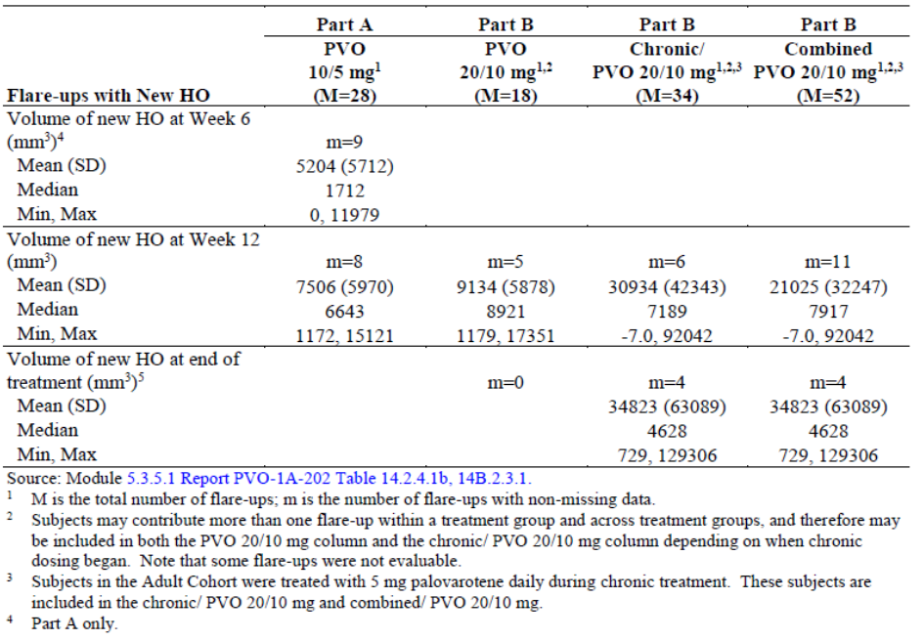
Table 20. Pooled phase 2 data (Study 201 and 202). Flare-up new HO volume at Week 12 for the placebo/untreated and palovarotene-treated flare-ups (IF-FAS).
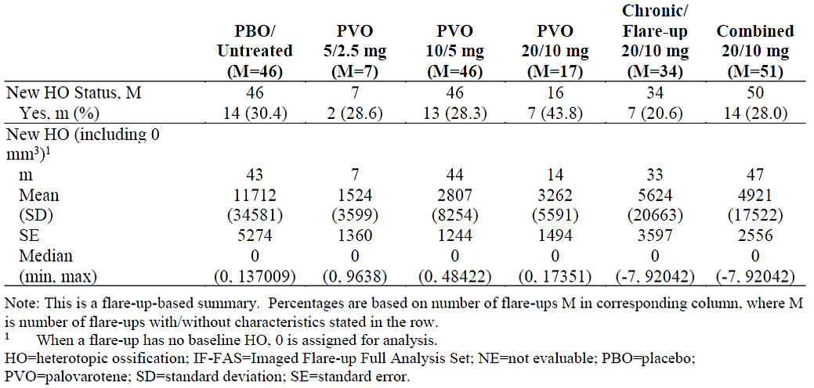

Study 001 (PVO-1A-001) (observational Natural History Study (NHS))

Design
3-year natural history, non-interventional (observational), longitudinal, multicentre (7 sites in 6 countries), two-part study in 114 male or female subjects with FOP caused by the R206H mutation of the ACVR1 gene:
- Part A: subjects aged ≥18 years were enrolled and completed baseline imaging using low-dose WBCT scans (excluding head) and DEXA scans, to determine the optimal imaging modality for HO assessment. WBCT was chosen.
- Part B: additional subjects aged ≤65 years of age were enrolled; baseline WBCT imaging was performed; Subjects were followed for up to 36 months with annual clinic visits and by telephone every 6 months, except when annual clinic visits were scheduled to evaluate disease progression, impact on physical function, and clinical features that may be useful to diagnose the disease, monitor subjects’ disease progression, and assess potential treatment effects in subsequent interventional studies.
Primary objectives: to characterise demographics and disease characteristics in untreated subjects, identify demographic and disease variables that correlate with progression and severity of the disease in the absence of treatment; identify potential endpoints that may be valuable in assessing clinically meaningful response(s) to treatments; and to assess the optimal imaging modality to define total body burden of HO.

Study results
This study did not provide efficacy results, but information on the natural progression of the disease, and an evaluation of imaging and other assessments (e.g., CAJIS, FOP-PFQ, PROMIS, FPS-R, and biomarkers). Summary of the results:
- Heterotopic ossification (HO) was identified a clinically meaningful endpoint with low-dose WBCT scans (excluding head) as the preferred imaging modality (over DEXA scans).
- HO volume increases correlated with worse CAJIS total scores (a 100,000 mm3 HO volume increase corresponded to a 1.1-point CAJIS total score increase; r=0.39, p<0.0001).
- HO volume increases correlated with worse FOP-PFQ scores (r=0.28, p<0.0001).
- Patient age correlated with worsening CAJIS total scores (r=0.44, p<0.0001) and FOP-PFQ percent of worst total scores (r=0.19, p<0.0001). However, the functional scores may be too insensitive and too variable to detect changes over 1-2 years (i.e., a typical clinical trial time period).
- Flare-up characteristics are summarised in Table 21.
Table 21. Study 101. Flare-up characteristics (Imaged Flare-up Analysis Set).
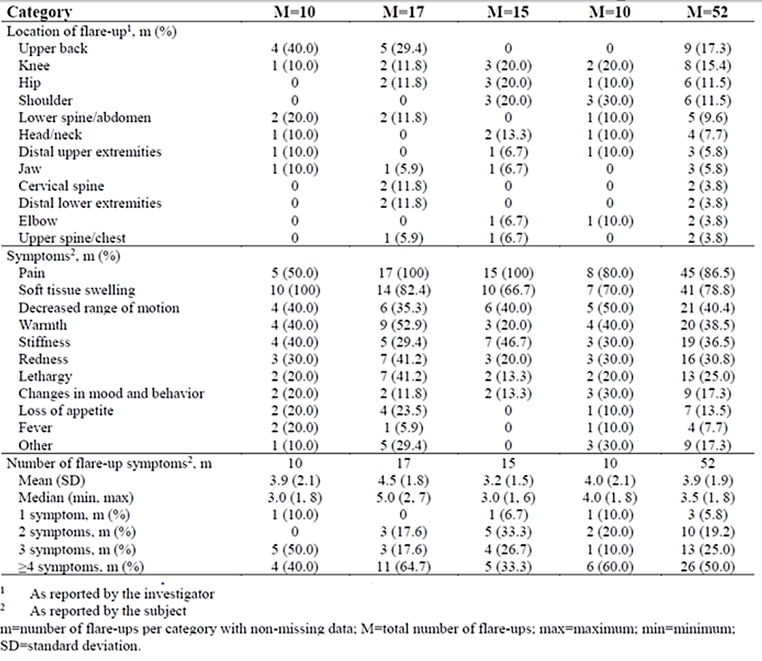
Participant data from Study 101 were used as historical control data in Study 301. 60 participants in Study 101 transferred to other studies: 8 to Study 201, 13 to Study 202, and 39 to Study 301.

Safety
The main safety population is the FOP Full Analysis Set (FOP-FAS), i.e., all subjects enrolled or dosed in FOP clinical studies, including the natural history study. Most relevant to this application is the age group of ≥8 years for females and ≥10 years for males (FOP-FAS ≥8/10y).

Exposure
FOP-FAS (≥8/10y) (Table 22):
- The mean duration of treatment overall (mean total doses) was: 94.1 weeks (4348.0 mg).
- The mean duration of chronic dosing treatment (mean total doses) was: 72.6 weeks (2370.6 mg).
- The mean duration of flare-up treatment (mean total doses during flare-up treatment) was:
  - 5.9 weeks for 5/2.5 mg (122.9 mg).
  - 11.0 weeks for 10/5 mg (482.3 mg).
  - 33.2 weeks for the 20/10 mg (2832.8 mg).
Table 22 Overview of palovarotene exposure (FOP-FAS)
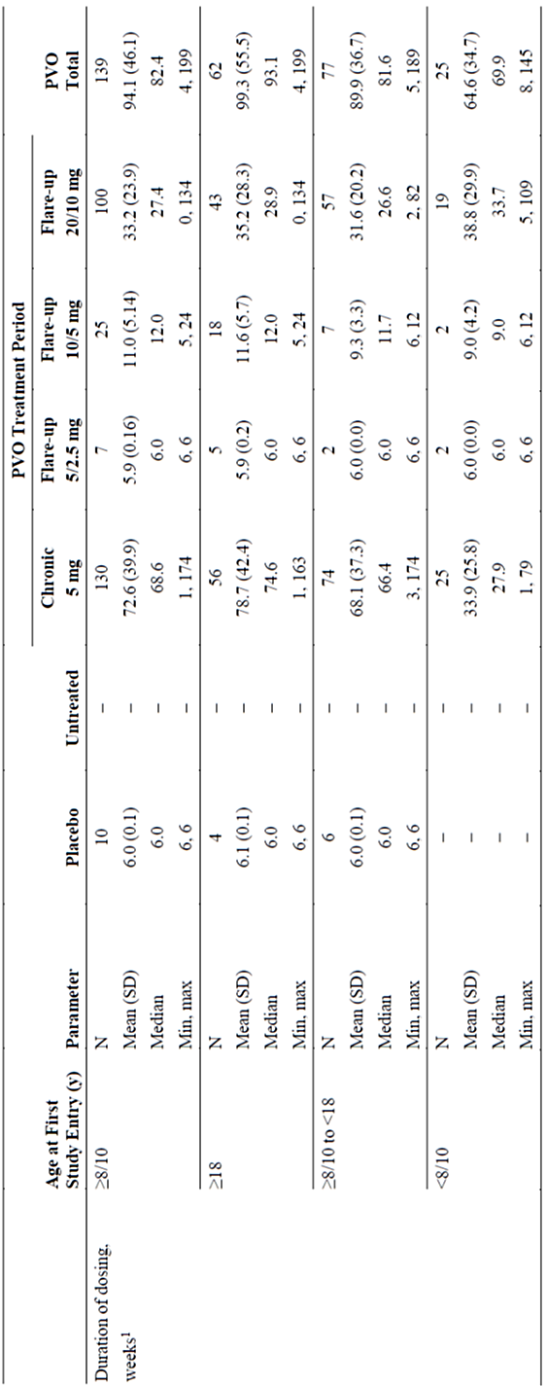
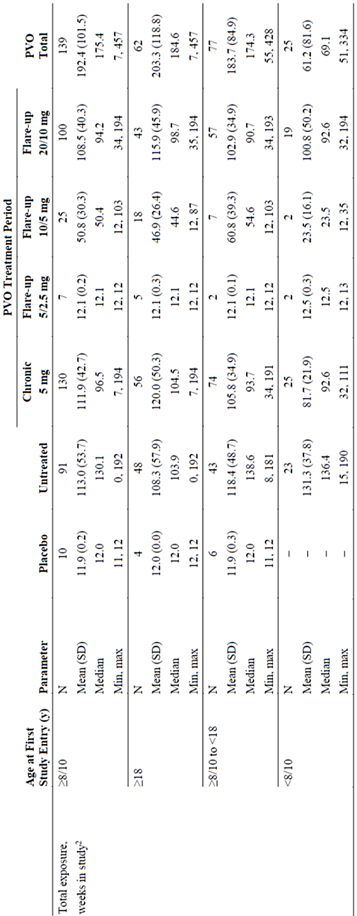
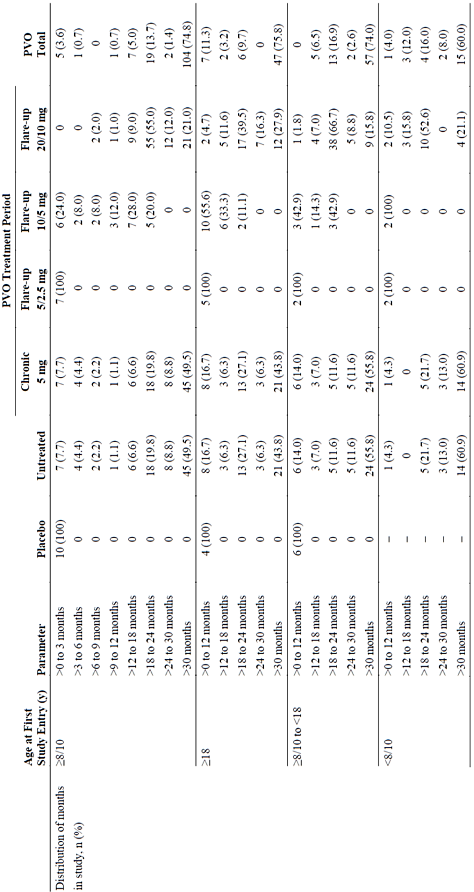
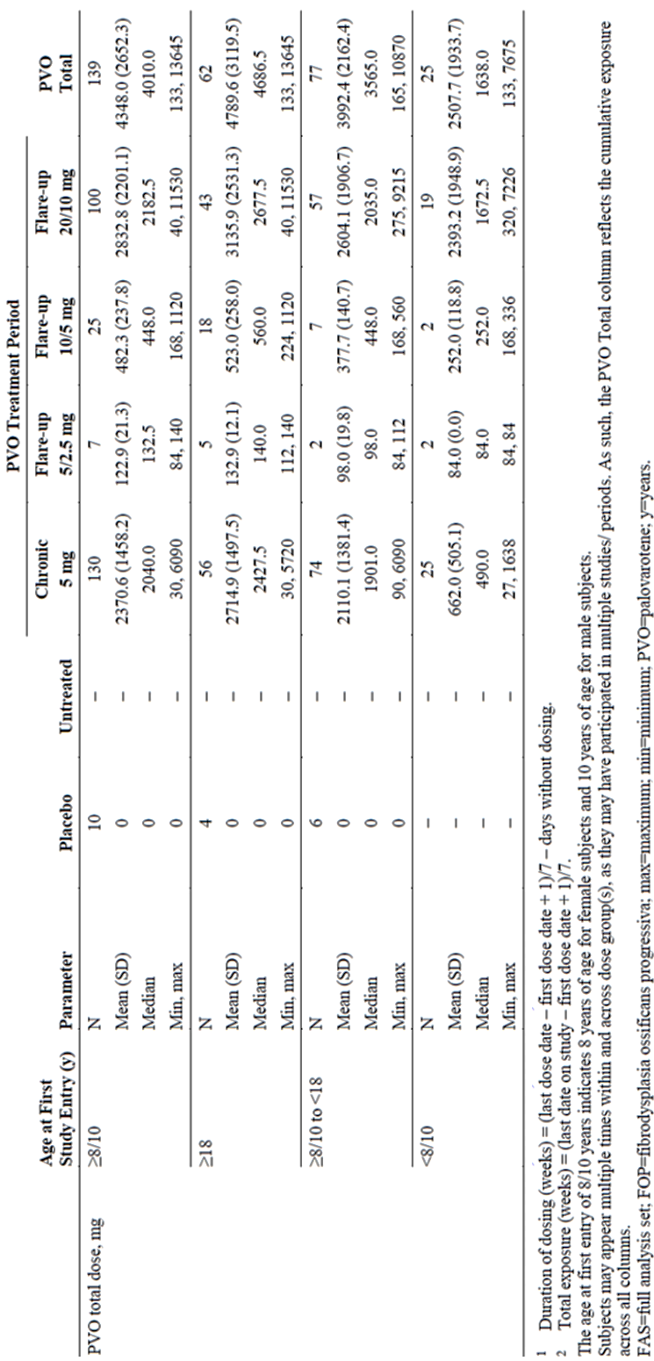

Adverse event overview
FOP-FAS (≥8/10y): An overview of AEs is in Table 23. Most TEAEs were mild (25%) or moderate (54%). Severe TEAEs occurred in 22%. 7% discontinued study drug due to a TEAE, mostly due to mucocutaneous TEAEs.
Table 23 Overview of TEAEs and Post-Treatment AEs (FOP-FAS ≥8/10y).
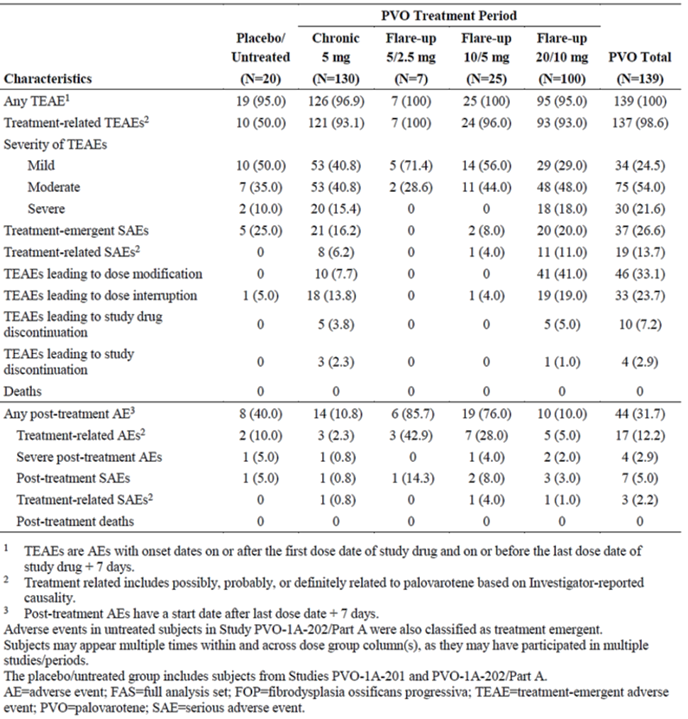
The most common TEAEs (≥10% of subjects) are shown in Table 24, and included mucocutaneous AEs (e.g., dry skin, dry lips, alopecia, pruritis, and erythema), or musculoskeletal AEs (e.g., arthralgia and extremity pain).
Table 24. TEAEs in ≥10% of subjects (FOP-FAS (≥8/10y)).
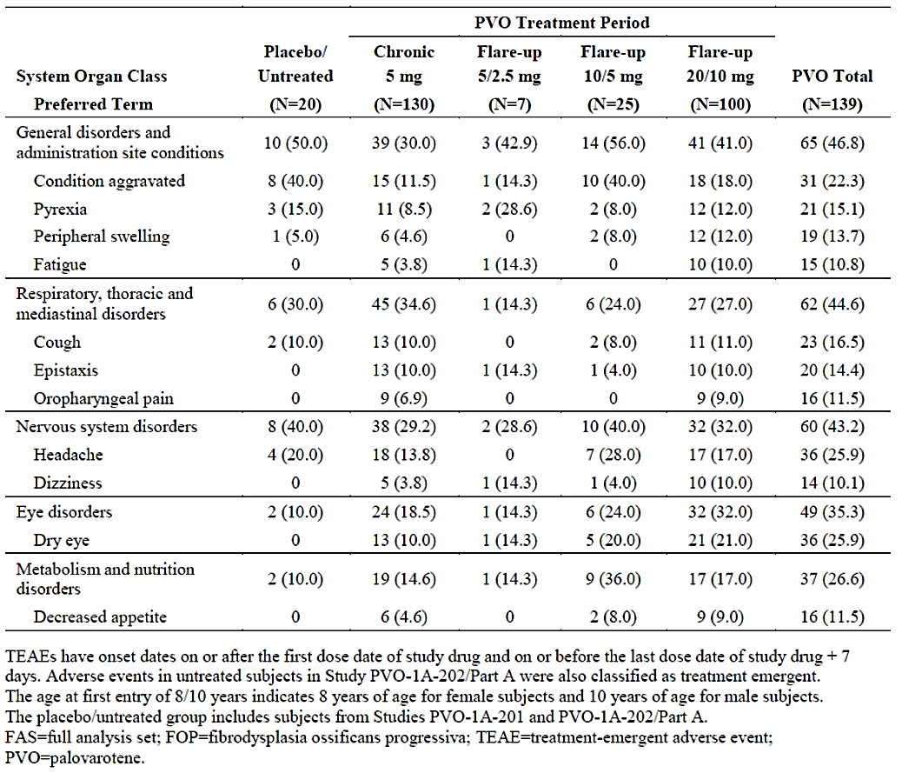
Chronic vs flare-up treatment: some mucocutaneous AEs (e.g., alopecia, skin exfoliation, and pruritis) were more frequent during the 20/10 mg flare-up treatment (41% vs 8% for chronic dosing) and may be dose-dependent.
Biological sex: Some Skin and Subcutaneous Tissue Disorders and Musculoskeletal and Connective Tissue Disorders TEAEs occurred more frequently in females, e.g., alopecia (females, 58.0%; males, 25.7%), rash (37.7% vs. 25.7%), skin exfoliation (39.1% vs. 22.9%), arthralgia (50.7% vs. 37.1%), and pain in extremity (43.5% vs. 31.4%).
Ethnicity: no significant differences.

Most common TEAEs by FOP-FAS age subgroup
- Adults (≥18 years) (n=62): dry skin (87.1%), alopecia (48.4%), dry lips (54.8%), arthralgia (51.5%), pain in extremity (46.8%), erythema (43.5%), headache (43.5%), rash (41.9%), pruritus (40.3%)/generalized pruritus (40.3%), skin exfoliation (38.7%), dry eye (37.1%), skin abrasion (37.1%), nausea (35.5%), vomiting (33.9%) and condition aggravated (33.9%).
- ≥8/10 years to <18 years (n=77): dry skin (71.4%), dry lip (57.1%), pruritus (40.3%), arthralgia (37.7%), and alopecia (36.4%).
- <8/10 years subgroup (n=25): similar to those in the ≥8/10 to <18 years population except for PPC and childhood infections (e.g., impetigo). The most common TEAEs included dry skin, dry lips, PPC, rash, arthralgia, erythema, alopecia, drug eruption, pruritis, and URTI.
There were some notable differences between age groups (≥18 year group vs. ≥8/10 to <18 year group vs. <8/10 year group):
- Tachycardia: 11.3% vs. 3.9% vs. 0%
- Nausea: 35.5% vs. 14.3% vs. 0%
- Drug eruption: 9.7% vs. 21.1% vs. 24.0%
- PPC: 0% vs. 13.0% vs. 56.0%.

Treatment related adverse event (adverse drug reaction) overview
The most common treatment-related TEAEs (≥10% of subjects in the palovarotene group) in the FOP-FAS ≥8/10 years population are presented in Table 25 and were mainly mucocutaneous events.
Table 25. Treatment-related TEAEs in ≥10% of subjects (FOP-FAS ≥8/10y).
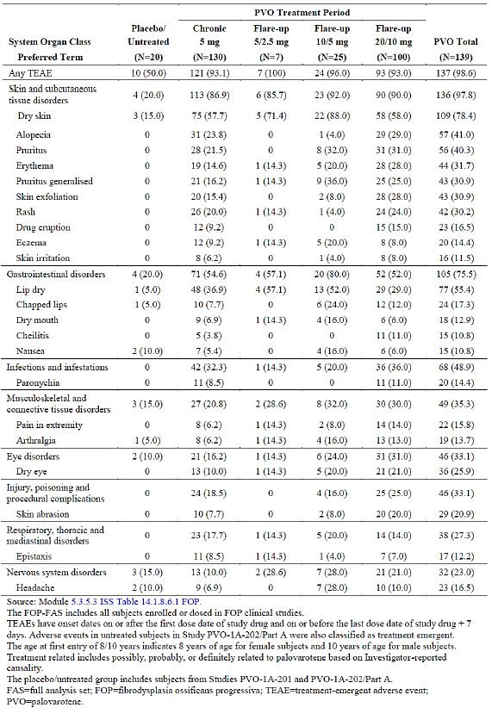
In FOP-FAS ≥8/10 year group, the incidence of treatment-related TEAEs was 98.6% (palovarotene) vs. 50.0% (placebo).
The most common treatment-related TEAEs were in the SOCs of Skin and subcutaneous tissue disorders (97.8%) and Gastrointestinal disorders (75.5%), including dry skin, dry lips, alopecia, and pruritis. In most cases, there was no significant difference between the chronic and flare-up treatment periods, except for erythema, skin exfoliation, cheilitis, pain in the extremity, arthralgia, and skin abrasion (approx. twice as frequent in the 20/10 mg flare-up group vs. untreated).
The common treatment-related TEAEs (≥1% to <10% of subjects in the palovarotene group) in the FAS-FOP ≥8/10 years population are presented in Table 26.
Table 26. Treatment-related TEAEs in ≥1% to <10% of subjects (FOP-FAS ≥8/10 Years).
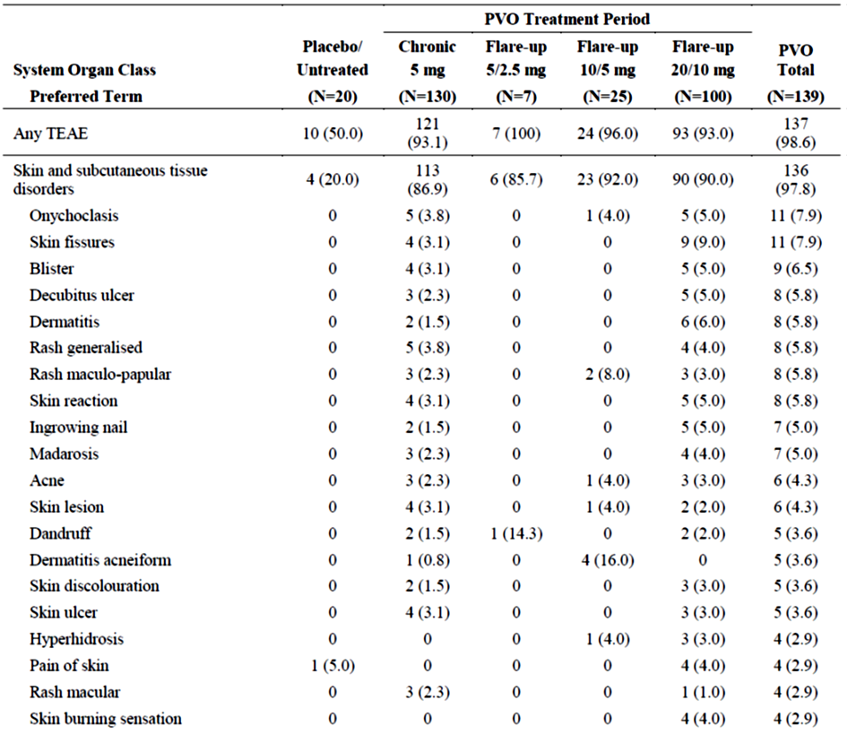
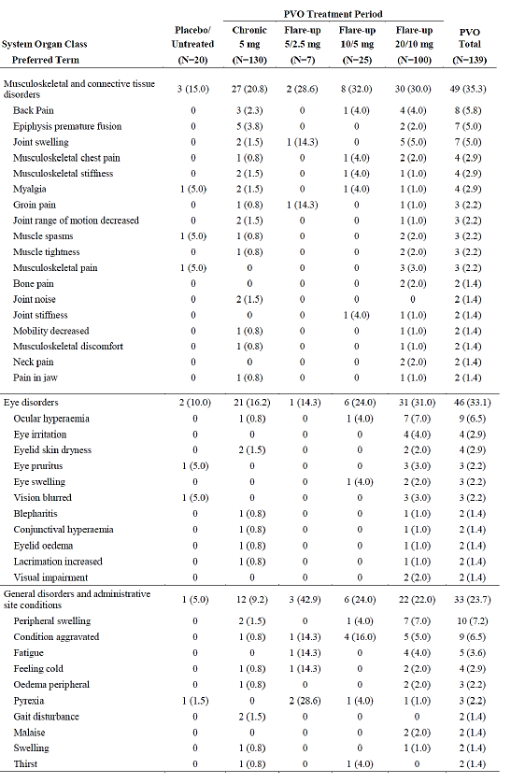
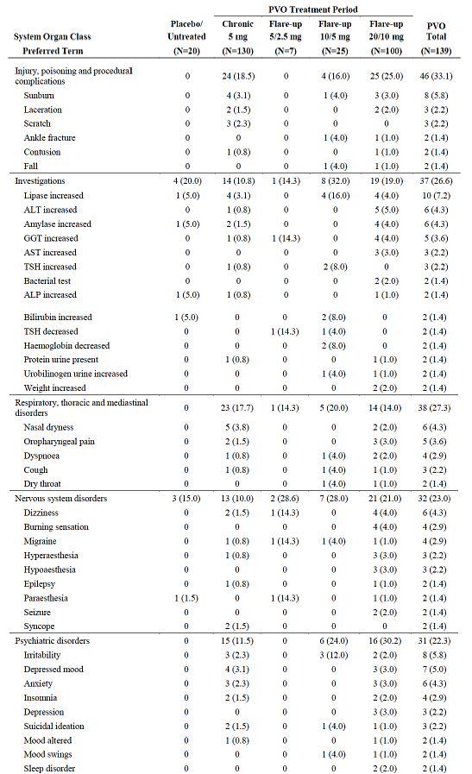
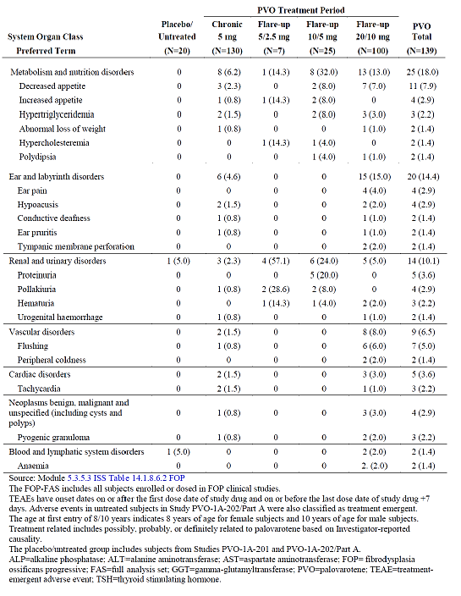

Deaths
FOP-FAS: No deaths were reported during treatment or for 30 days post-treatment. In Study 301, a 13-year-old patient with a history of restrictive lung disease died 2.5 months after discontinuing palovarotene treatment. The cause of death was restrictive lung disease from complications of FOP.

Serious adverse events
FOP-FAS (≥8/10y): Treatment-emergent SAEs occurred in 27% of subjects (25% for placebo in FOP-FAS), and post-treatment SAEs in 5%. The SAE incidence was similar during the chronic and 20/10 mg flare-up treatment periods (16% and 20%, respectively), and lower in the off-treatment period (11%).
The most common SAEs included PPC (5.0%); condition aggravated (3.6%); pneumonia and arthralgia (each 2.2%); and extremity pain, abdominal pain, impacted teeth, cellulitis, local swelling, syncope, and respiratory distress, each in 1.4% of subjects.
14% had treatment-emergent SAE at least possibly related to palovarotene, including PPC, pain in extremity, condition aggravated, peripheral swelling, and cellulitis.

Adverse events of special interest
Linear growth data: Linear height generally increased over time in most paediatric patients (treated or untreated groups). Height z-scores declined in all groups but were greater in magnitude in the palovarotene group (Table 27), noting the small sample size.
Clinical trial data suggest that in younger children (<8/10 years), palovarotene may affect linear growth independent of PPC. In older children, linear growth effects are mostly evident in those with PPC. Knee height, femur/tibia length measurements were fairly similar between groups.
Growth monitoring is generally limited by spinal abnormalities (e.g., scoliosis or kyphosis). These should be considered during monitoring.
Table 27. Studies 301 and 101 (NHS). Summary of linear height z-scores and growth velocity at Month 12 in patients with age <18 years at first entry (FOP-FAS).
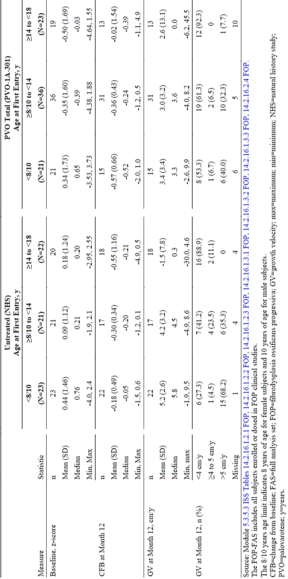
Avascular Necrosis/Osteonecrosis: No cases identified.
Premature physeal closure (PPC): All PPC events (MedDRA PT: epiphyses premature fusion) were categorised as SAEs (in both treatment-emergent and post-treatment periods). PPC occurred in 23.5% (24/102) of subjects aged <18 years and was more common in younger patients:
- Age <8/10 years: 56.0% (14/25)
- Age ≥8/10 to <14 years: 25.6% (10/39)
- Age ≥8/10 to <18 years: 13.0% (10/77).
Consistent with other retinoids, PPC typically affected the lower extremities first and was symmetric.
PPC primarily occurred during exposure to both the chronic and flare-up treatment regimens, but also in 5 patients on chronic dosing only. There appeared to be a slight trend for longer duration and greater total palovarotene flare-up exposure in the <8/10 year population with PPC (vs. without PPC), but no exposure threshold could be established.
Bone mineral density: A retrospective analysis of WBCT scans in Study 301 and the NHS showed greater decreases in vertebral bone strength, bone mineral content (BMC), bone mineral density (BMD) and an increased risk of vertebral fractures in palovarotene-treated subjects compared with untreated subjects.
Fractures: At 12 months, 11.76% of untreated subjects had a new-onset vertebral fracture compared with 24.24% of palovarotene-treated subjects. In the FOP-FAS (≥8/10y), the risk of vertebral fractures was 2.98 times higher in palovarotene-treated subjects (vs. untreated) suggesting a causal association, even though not statistically significant for moderate/severe vertebral fractures. The consistent effect was still present when adjusted for potential confounders (e.g., age, glucocorticoid use).
Mental health: There appeared to be no treatment-related increase in suicide ideation/suicidal behaviour (based on a C-SSRS assessment) in the FOP-FAS.
Hepatic: In the FOP-FAS, no subjects met PCS criteria for Hy’s Law.
Teratogenicity: Teratogenicity is an important identified risk and a class effect of systemic retinoids. Pregnant and breastfeeding females were excluded from all palovarotene clinical studies. No pregnancies occurred. Appropriate risk minimisation activities need to be present (including appropriate labelling and a potential prescriber restriction).
Breastfeeding: Breastfeeding females were excluded from all palovarotene clinical studies. There are no data on the presence of palovarotene or its main metabolites in human breast milk. At this stage, breastfeeding is contraindicated while on palovarotene and for at least 1 month following drug cessation.

Risk management plan
The summary of safety concerns and their associated risk monitoring and mitigation strategies are presented in Table 28. The TGA may request an updated RMP at any stage of a product's life-cycle, during both the pre-approval and post-approval phases.
Table 28: Summary of safety concerns
Summary of safety concerns |  | Pharmacovigilance |  | Risk minimisation
 |  | Routine | Additional | Routine | Additional
Important identified risks | Teratogenicity
Important identified risks | Premature Physeal Closure including inhibition of long bone growth (in growing children)
Important identified risks | Radiological observed vertebral fractures
Important identified risks | Mucocutaneous effects
Important potential risks | Fractures and impaired fracture healing |  |  |  | -
Missing information | Long term safety |  |  |  | -
The RMP evaluation recommended conditions of registration relating to the versions of the risk management plan, requirement for periodic safety update reports, and inclusion of the medicine in the Black Triangle Scheme.
The summary of safety concerns is acceptable from an RMP perspective. The sponsor has stated in its Milestone 5 response that at a maximal frequency of 4 X-rays per year the radiation exposure is equivalent to about 4 days of normal environmental background radiation exposure (or ~0.004 mSv), or approximately 7 times less than an airplane ride. Therefore, “increased risk of cancer from more frequent imaging” will not be included in the summary of safety concerns. However, the sponsor will monitor reports of neoplasms as part of routine pharmacovigilance and signal detection activities. This is satisfactory.
Pharmacovigilance plan
Routine and additional pharmacovigilance activities have been proposed. Additional pharmacovigilance activities include a Voluntary Registry Study, which will include Australian patients. The sponsor also proposes to conduct KAB (Knowledge, Attitude and Behaviour) surveys to test the awareness of the additional risk minimisation activities. This is acceptable, however, the KAB survey test is considered to be additional pharmacovigilance and the sponsor has agreed to include this in the ASA.
Risk minimisation plan
Routine and additional risk minimisation activities have been proposed. Additional risk minimisation activities include educational materials for HCPs and patients. The patient additional risk minimisation material includes specific information regarding the prevention of pregnancy and premature physeal closure. The educational material also provides advice on expected side effects. The risk minimisation plan is acceptable.

Recommended conditions of registration
The suggested wording is:
The Sohonos EU-Risk Management Plan (RMP) (version 5.0, dated 7 April 2023, data lock point 27 April 2022), with Australian Specific Annex (version 3.0 dated 25 July 2023), included with submission PM-2022-03518-1-5, and any subsequent revisions, as agreed with the TGA will be implemented in Australia.
The following wording is recommended for the PSUR requirement:
An obligatory component of risk management plans is routine pharmacovigilance. Routine pharmacovigilance includes the submission of periodic safety update reports (PSURs).
Unless agreed separately between the supplier who is the recipient of the approval and the TGA, the first report must be submitted to TGA no later than 15 calendar months after the date of this approval letter. The subsequent reports must be submitted no less frequently than annually from the date of the first submitted report until the period covered by such reports is not less than three years from the date of this approval letter. The annual submission may be made up of two PSURs each covering six months. If the sponsor wishes, the six monthly reports may be submitted separately as they become available.
If the product is approved in the EU during the three years period, reports can be provided in line with the published list of EU reference dates no less frequently than annually from the date of the first submitted report until the period covered by such reports is not less than three years from the date of this approval letter.
The reports are to at least meet the requirements for PSURs as described in the European Medicines Agency’s Guideline on good pharmacovigilance practices (GVP) Module VII-periodic safety update report (Rev 1), Part VII.B Structures and processes. Note that submission of a PSUR does not constitute an application to vary the registration. Each report must have been prepared within ninety calendar days of the data lock point for that report.
The following wording is recommended for the Black Triangle Scheme condition of registration:
Sohonos (palovarotene) is to be included in the Black Triangle Scheme. The PI and CMI for Sohonos must include the black triangle symbol and mandatory accompanying text for five years, which starts from the date that the sponsor notifies the TGA of supply of the product.
The TGA may request an updated RMP at any stage of a product's life-cycle, during both the pre-approval and post-approval phases. Further information regarding the TGA’s risk management approach can be found in risk management plans for medicines and biologicals and the TGA's risk management approach. Information on the Australia-specific annex (ASA) can be found on the TGA website.

Risk-benefit analysis

Delegate’s considerations

Clinical trial program

Clinical trial overview and study contributions
There are approximately 800 confirmed cases of FOP worldwide. The clinical trial program included 219 patients. 164 of those patients received at least one dose of study drug. The reliance on a single phase 3 trial was not ideal, but given the extreme rarity of the disease, this considered acceptable.
Study 301 was the single, pivotal, open-label phase 3 trial and used historical controls (discussed below). It contributed the most clinical data for this application, in particular for a combined chronic and flare-up regimen.
Studies 201 and 202 (incorporating Study 204) were rather small studies with incompletely refined endpoints that make interpreting the data difficult. They act as supportive studies.
Study 001 was a prospective, non-interventional natural history study. It characterised demographics and disease characteristics in untreated subjects (including information on flare-ups) and identified heterotopic ossification (HO) as a clinically meaningful endpoint with low-dose WBCT scans (excluding head) as the preferred imaging modality (over DEXA scans). Furthermore, it correlated HO with other CAJIS and FOP-PFQ.

Endpoints and clinical relevance
No definite regulatory guidance is available for FOP. As a consequence, no guidance with regard to endpoints is available. In such a case, endpoints and endpoint variables are typically derived from the scientific medical literature considering clinical factors.
Potential FOP study endpoints/variables include heterotopic ossification (HO), assessments of physical function (e.g., CAJIS score), and patient-reported outcomes of functional impairment and flare-up symptoms (e.g., FOP-PFQ).
To assess the chronic/flare-up regimen (Study 301, and Study 202 Part B and C), the main endpoint was the annualised change in new HO volume as assessed by low-dose WBCT (excluding head) imaging compared with similar data from untreated patients.
To assess the flare-up only regimen (Study 201, and Study 202 Part A), the main endpoint was the formation of HO following a flare-up (assessed by low-dose CT of the flareup site).
HO volume was chosen as the main endpoint variable due to the following: (1) HO formation is the pathognomonic feature of FOP and an objective measure (noting limitations with regard to inter-rater- or intra-rater-reliability, and variations due to bone remodelling); (2) measurable changes in whole body HO in untreated subjects are demonstrated over a clinical trial timeframe (more than one year); (3) changes in functional and patient-reported outcomes may not demonstrate sufficient disease progression over this timeframe; and (4) correlations between whole body HO and functional and patient-reported outcomes (e.g., CAJIS or FOP-PFQ scores).

Use of an external control group in Study 301
The use of a historical control group is adequately justified and support the validity of Study 301. For rare diseases, it may not be feasible to have access to a sufficiently large control group, including for ethical reasons. Biases may be introduced through this but can be sufficiently minimised.
The natural history of the disease was adequately investigated in Study 101. With regard to baseline characteristics, the two groups were reasonably balanced, and both studies had similar inclusion/exclusion criteria. The small differences in baseline characteristics seen in Study 301 are not dissimilar to minor differences experienced by trials with a contemporaneous control group. With regard to standard of care treatment received additionally to Sohonos, it can be reasonably assumed that this would have been reasonably consistent in Studies 301 and 101.
39 patients in Study 301 had participated in Study 101 previously, and essentially were their own control, but in a different age range. With regard to endpoints/endpoint variables, Studies 301 and 101 had been sufficiently similar. The reading method of the WBCT scans was sufficiently robust with blinded readings, and acceptable inter-rater and intra-rater-reliability.
However, in Study 301, WBCT scan were conducted at Months 6, 12, 18, and 24 while in Study 001 at Months 12, 24, and 36 (or study termination). To investigate this, the sponsor conducted sensitivity analysis to assess a potential impact of the differences in length of follow-up (e.g., results at Month 12, additional covariates, and a propensity score derived from a logistic regression model using the additional covariates).

Clinical trial post hoc analyses
The sponsor’s favourable primary analysis in Study 301 relies on a post hoc wLME analysis rather than a Bayesian compound Poisson model with a square root transformation of HO volume per region and negative new HO values being set to zero (either by body region; or overall). The changes are described in section 2.4.2.1.
Post hoc changes are not ideal, but in this case, the provided post hoc analysis is considered acceptable. It was adequately justified by the sponsor. The wLME analysis could be considered as the original prespecified analysis, as it was the analysis in the original protocol. Its simpler approach without transformation and inclusion of negative values was a more appropriate analysis. Additionally, Wilcoxon rank-sum tests were performed (dependent only on the numeric rank order of the observed new HO volumes rather than their magnitudes) which are less influenced by extreme values.

Efficacy
Study 301 (MOVE) was the pivotal phase 3 trial, and instrumental to this application.

Treatment of acute flare-ups
In Study 201, at Week 12, the proportion of patients with any new HO was lower in the PVO 10/5 mg group (15%) compared to PVO 5/2.5 mg (44%) or placebo (40%). The was not statistically significant for either treatment group, but a favourable trend could be observed.
In Study 202 Part A, there was an increase in mean volume in new HO for flare-ups with new HO, from 5,204 mm3 (Week 6) to 7,506 mm3 (Week 12) and likely reflects the end of treatment after 6 weeks. This indicated that a higher dose than the used PVO 10/5 mg regimen and for a longer period of time may be more efficacious.

Efficacy of the proposed chronic/flare-up regimen
In Study 202 Part B, the proportions of flare-ups with no new HO were (at Week 12): PVO 10/5 mg: 35.7%; PVO 20/10 mg: 41.2%; Chronic/PVO 20/10 mg: 20.6%; Combined PVO 20/10 mg: 27.5%. This provided some support for an additional chronic dosing regimen. In Part B/C, the mean volume of new HO (for flare-ups with new HO) was 9,134 mm3 (PVO 20/10 mg), 30,934 mm3 (chronic/PVO 20/10 mg), and 21,025 mm3 (combined PVO 20/10 mg) at Week 12. It has been postulated the increased HO volume may be due to oedema associated with flare-ups.
In Study 301, in the total study population, the primary analysis showed a 60.3% reduction in the mean annualised new HO volume of palovarotene-treated (9427.1 mm3) vs. untreated (23720.2 mm3) patients. The primary analysis using wLME, showed a 53.8% reduction in the LSM annualised new HO volume of palovarotene-treated (9366.8 mm3) vs. untreated (20273.0 mm3) patients (wLME treatment p=0.0392; Wilcoxon rank-sum p=0.0003) (Principal FAS).
In the target population of patients aged ≥8y/10y (female/male) (i.e., the subgroup for which the FOP indication is sought by the sponsor), the primary analysis showed a 55.7% reduction in the mean annualised new HO volume of palovarotene-treated (11418.8 mm3) vs. untreated (25796.0 mm3) patients. The primary analysis using wLME, showed a 48.6% reduction in the LSM annualised new HO volume of palovarotene-treated (11033.2 mm3) vs. untreated (21476.0 mm3) patients (wLME treatment p=0.1124; Wilcoxon rank-sum p=0.0107) (Principal FAS).
Overall, these are clinically meaningful reductions of new HO in a relevant population. Study 301 (MOVE) used the same dosing regimen as proposed for this application. Population PK data have supported this dosing, including the weight-based dose adjustment.
There were no statistically significant differences in functional or patient reported outcomes (FOP-PFQ, PROMIS, or CAJIS scores) or range of motion at flare-up locations.
Potential issues with regard to efficacy are outlined below.

Efficacy in certain subgroups
Notable subgroup analyses include the following:
- Female patients: The primary analysis showed a 25.8% reduction in the mean annualised new HO volume of palovarotene-treated (10617.5 mm3) vs. untreated (14317.1 mm3) patients. The primary analysis using wLME, showed a 11.3% increase in the LSM annualised new HO volume of palovarotene-treated (10105.9 mm3) vs. untreated (9078.0 mm3) patients (wLME treatment p=0.8740; Wilcoxon rank-sum p=0.0211) (Principal FAS).
- Asian patients: The primary analysis showed a 259.5% increase in the mean annualised new HO volume of palovarotene-treated (5885.1 mm3) vs. untreated (1636.8 mm3) patients. The primary analysis using wLME, showed a 280.3% increase in the LSM annualised new HO volume of palovarotene-treated (8960.0 mm3) vs. untreated (2355.8 mm3) patients (wLME treatment p=0.6309; Wilcoxon rank-sum p=0.8125) (Principal FAS). It is noted that the untreated HO values were significantly lower than for other subgroups and even though a large relative increase is shown, the absolute increase is low.
More information is requested from the sponsor on the potential implications on efficacy in certain subgroups.

Flare up triggers
Comparing Studies 301 and 101, the baseline mean number of flare-ups (in the last 12 months) was 1.4 vs. 2.5. Study 301 collected flare-up data as part of the secondary endpoints. Proportion of subjects reporting flare-ups at Month 12 was 64.4% vs. 54.1%. Flare-up rate per subject-month exposure is shown in Table 29.
Table 29. Study 301. Flare-up rate per subject-month exposure (through Month 24).
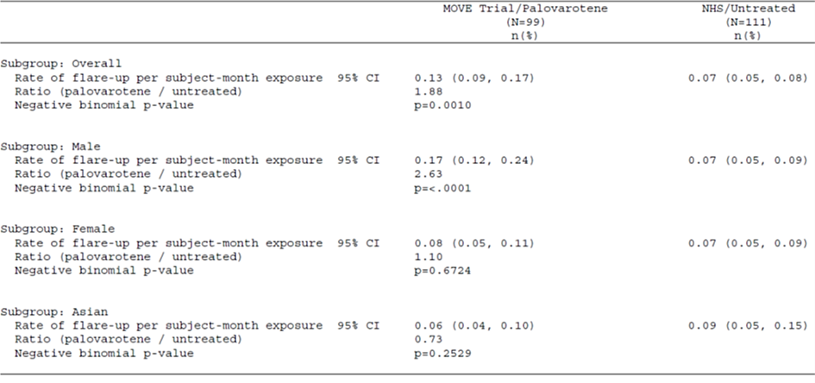
It appears that the flare-up rate was greater in the treated group compared to the historical control. It is unclear whether this is associated with palovarotene treatment.
69/99 patients had at least one flare-up treated with palovarotene; they experienced a median of 3 flare-ups overall (range: 1, 23; mean: 4.0 ± 4.2). Dose reductions occurred during high-dose flare-up treatment in 31 (44.9%) patients compared to 8 (11.6%) patients during low-dose flare-up treatment.

Safety
The safety profile has been outlined in section 2.4.3. There are known class effects of retinoids, including palovarotene. These include teratogenicity, PPC, reduced bone mineral density, osteoporosis, arthralgia, and myositis.
Initially, in Study 301, patients aged 4 years or older were eligible to participate. However, after the emergence of a high incidence of premature physeal closure (PPC), a partial clinical hold was implemented for patients under the age of 14 years. At the time of this report, the partial clinical hold remained in place for subjects <14 years of age.
Overall, there were no deaths related to treatment. In Study 301, a 13-year-old patient with a history of restrictive lung disease died 2.5 months after discontinuing palovarotene treatment. The cause of death was restrictive lung disease from complications of FOP.
The most common TEAEs (≥10% of subjects) included mucocutaneous AEs (e.g., dry skin, dry lips, alopecia, pruritis, and erythema), or musculoskeletal AEs (e.g., arthralgia and extremity pain). Some mucocutaneous AEs (e.g., alopecia, skin exfoliation, and pruritis) were more frequent during the 20/10 mg flare-up treatment (41% vs 8% for chronic dosing) and may be dose-dependent requiring dose reductions.

Bone safety (including premature physeal closure)
A retrospective analysis of WBCT scans in Study 301 and the NHS showed greater decreases in vertebral bone strength, bone mineral content (BMC), bone mineral density (BMD) and an increased risk of vertebral fractures in palovarotene-treated subjects compared with untreated subjects.
Premature physeal closure (PPC) is a known risk with retinoid treatment in growing patients. All PPC events were categorised as SAEs. PPC occurred in 23.5% (24/102) of subjects aged <18 years and was more common in younger patients: Age <8/10 years: 56.0% (14/25); Age ≥8/10 to <14 years: 25.6% (10/39); Age ≥8/10 to <18 years: 13.0% (10/77). PPC primarily occurred during exposure to both the chronic and flare-up treatment regimens, but also in 5 patients on chronic dosing only.
This is an important identified risk in the RMP. Monitoring with imaging (including a baseline assessment) is required to mitigate the risk. The sponsor is currently proposing additional risk minimisation activities including educational materials for HCPs and patients. The proposed PI contains a boxed warning with regard to PPC and teratogenicity.
At this stage, the proposed PI contains no specified frequency for the imaging to monitor for PPC.

Teratogenicity
The teratogenicity of systemic retinoids is well established. Classic retinoid type malformations (e.g., cleft palate, misshapen skull bones, short long bones) were demonstrated with palovarotene in rats at doses yielding exposure well below that in patients. The findings justify assignment to Pregnancy Category X, and a contraindication in women who are pregnant or may become pregnant.
Appropriate risk minimisation activities are required. At this stage, the sponsor is not proposing a strict pregnancy prevention program, but prescriber and patient education, and enhanced labelling in the PI.

Translation to clinical practice
Based on the clinical data presented, palovarotene appears to be efficacious for chronic use, flare-up use, and also to reduce or prevent catastrophic HO.
The age group 8 years and older for females and 10 years and older for males to 18 years of age appears to benefit most from palovarotene, even though simultaneously is at the greatest risk for PPC.
Some subgroups may benefit to a lesser extent from palovarotene, but it can be a useful tool in the armamentarium against FOP. Monitoring for effectiveness and safety issues is essential.
Based on the evidence available, it would not be unreasonable to register Sohonos for a FOP indication, as long as appropriate conditions are in place to maintain a positive benefit-risk balance. These conditions include: an appropriate indication, appropriate risk minimisation activities, and appropriate reporting of the remaining clinical study data.
Given the complexities, appropriate risk minimisation activities may take the form of specialist use restriction, and prescriber education and training. It is desirable that only clinicians experienced in the treatment of FOP in conjunction with best practice guidelines would use palovarotene for treatment after a careful, individual benefit-risk assessment.

Questions for the sponsor
The sponsor provided the following response to the question from the Delegate.
- Noting that subgroup analyses are typically not sufficiently powered and may not produce meaningful results, the following subgroup analyses in Study 301 (MOVE trial) appear notable:
  - Female patients: The primary analysis showed a 25.8% reduction in the mean annualised new HO volume of palovarotene-treated (10617.5 mm3) vs. untreated (14317.1 mm3) patients. The primary analysis using wLME, showed a 11.3% increase in the LSM annualised new HO volume of palovarotene-treated (10105.9 mm3) vs. untreated (9078.0 mm3) patients (wLME treatment p=0.8740; Wilcoxon rank-sum p=0.0211) (Principal FAS).
  - Asian patients: The primary analysis showed a 259.5% increase in the mean annualised new HO volume of palovarotene-treated (5885.1 mm3) vs. untreated (1636.8 mm3) patients. The primary analysis using wLME, showed a 280.3% increase in the LSM annualised new HO volume of palovarotene-treated (8960.0 mm3) vs. untreated (2355.8 mm3) patients (wLME treatment p=0.6309; Wilcoxon rank-sum p=0.8125) (Principal FAS).
The sponsor should comment on these results, in particular with regard to efficacy of palovarotene in those subgroups. Are there other factors (e.g., disease or demographic factors) that may have contributed to these results specifically?

Gender subgroup analysis
To illustrate the difference in HO volume between male and female patients Table 30 summarises the annualised new HO volume by gender in treated and untreated patients.
Table 30: Annualised New HO Volume by gender Study PVO-1A-301 and NHS
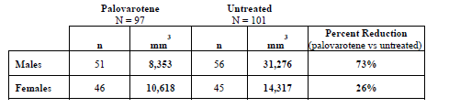
The potential reasons for these results include the fact that untreated females formed 54% less new HO compared with untreated male patients. It has been established in the NHS that adolescent patients have the greatest increases in total HO volume, which decreased in adulthood. As such the differences observed could be due to differences in mean age of untreated female patients (18.7 years) compared with untreated male patients (16.5 years). Additionally, treated females were even younger (13.6 years) compared with untreated females (18.7 years) and thus more likely to form HO. There was minimal difference in HO formation between treated male and female patients.
The Wilcoxon rank-sum test, which depends only on the numeric rank order of the observed volumes of new HO and is thus less influenced by extreme values, yields evidence of a difference in annualised new HO volume between palovarotene-treated- female subjects and untreated female subjects (nominal p=0.0211). This is also supported when looking at median annualised new HO where in treated patients it was 66 mm3 and in untreated patients it was 3992 mm3.
Given what is known about FOP, and the mechanism of action of palovarotene in preventing new HO, it is unlikely that these apparent differences in mean new HO reflect a true differential response to palovarotene based on sex.

Asian subgroup analysis
There are nine treated patients and eight untreated patients in the Asian subgroup analysis. The mean annualised new HO volume in treated compared with untreated patients was 5885 mm3 and 1637 mm3 respectively while the median was 164 mm3 and 1657 mm3 respectively. Given such a small number of patients, means are highly influenced by outliers. The waterfall plot (Figure 3: Waterfall plot Asian Subjects in PVO-1A301 and NHS) demonstrates that one treated patient formed a large amount of HO. It is important to note that this patient had experienced a flare-up that was not treated, which may account for this result.
Additionally, this sub-group for both treated and untreated patients formed relatively smaller volumes of HO compared with the total population (9427 mm3 and 23720 mm3 respectively), making it challenging to interpret any differences. In conclusion, given that this is a small subset of the total population with one patient who was undertreated driving the mean, this observation is likely spurious as opposed to a differential effect of palovarotene based on race. Additionally, given the high variability in HO formation in this small subset, median values of HO volume may be better suited for comparison, which were lower in treated compared with untreated patients.
Figure 3: Waterfall plot Asian Subjects in PVO-1A301 and NHS
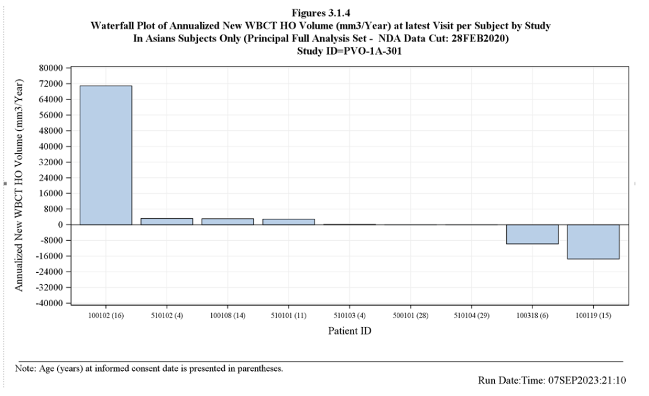

Advisory Committee considerations
The Advisory Committee on Medicines (ACM), having considered the evaluations and the Delegate’s overview, as well as the sponsor’s response to these documents, advised the following.

Specific advice to the Delegate
- Sufficient data for registration: Can the ACM comment on whether the provided data are sufficient to support registration for the proposed indication?
The ACM was of the view that the provided data are sufficient to support registration for the proposed indication noting that FOP is a rare life limiting condition.
The ACM agreed the clinical trial program is appropriate to address a rare condition. The ACM noted that the trials included 219 patients, of whom 164 received at least 1 dose of palovarotene. Given that there are appropriately 800 cases of FOP globally, the ACM was of the view there was a sufficient number of patients to assess efficacy and safety in this rare condition. The ACM also noted that the trial program included chronic and flare regimens and included patients across the age spectrum and phases of the condition.
The ACM also commented that the mechanism of action for palovarotene is biologically plausible and the clinical trials sufficiently demonstrated a reduction in new bone growth.
- Monitoring for effectiveness and safety: Assuming Sohonos were registered for the sponsor-proposed or a similar indication, can the ACM comment on the need to monitor for effectiveness (e.g., for disease progression) and safety (e.g., for PPC, or vertebral fractures)?
The ACM advised that patients with FOP would be treated by specialist physicians familiar with this condition and they would likely have specialist visits appropriately every 3 months.
The ACM discussed the use of radiological evaluation for HO and PPC and was of the view that it would be used when considered appropriate (i.e. symptoms present) rather than routinely, as cumulative WBCT and X-ray exposure risks need to be considered.
The ACM recommended clinical outcome monitoring at least every 12 months including new HO (number and sites), flare-ups, cumulative analogue joint involvement scale (CAJIS) and FOP physical function questionnaire (PFQ) assessments.
From a safety perspective the ACM noted the importance of monitoring and recording growth parameters and assessing for spinal abnormalities until the end of puberty. The ACM also highlighted the importance of (at least) yearly documented discussions about contraception for females of childbearing age.
- Risk minimisation activities: Assuming Sohonos were registered for the sponsor-proposed or a similar indication, can the ACM comment on the need for specific risk minimisation activities (e.g., prescriber restriction and education, or a specific pregnancy prevention program)?
On balance, the ACM agreed that a prescriber restriction in the PI would be appropriate and suggested the following wording:
prescription of Sohonos is restricted to paediatricians, endocrinologists, rheumatologists and other specialist medical practitioners with expertise in managing metabolic bone disease.
The ACM noted the importance of equitable access, particularly for rural and remote areas however agreed that these patients would be under the care of a specialist who would work in partnership with the GP.
The ACM was also supportive of targeted education to relevant prescribers.
The ACM acknowledged the importance of pregnancy prevention however did not consider a specific pregnancy prevention program was warranted. Rather, the ACM reiterated the importance of regular documented discussions about pregnancy and contraception with relevant patients.
- General: The committee is also requested to provide advice on any other issues that it thinks may be relevant to a decision on whether or not to approve this application.
The ACM noted that patients with this condition have no effective treatment for this extremely debilitating, life limiting disorder, resulting in a risk benefit profile that supports use, with an appropriate RMP and prescriber and patient education.
The ACM agreed that the age restriction within the indication wording is appropriate (children aged 8 years and above for females and 10 years and above for males), noting that younger children have significantly increased rates of PPC that make the risk benefit of this drug unclear.

Conclusion
The ACM considered this product to have an overall positive benefit-risk profile for the indication:
Sohonos is indicated to reduce the formation of heterotopic ossification in adults and children aged 8 years and above for females and 10 years and above for males with fibrodysplasia ossificans progressiva (FOP).

Outcome
Based on a review of quality, safety, and efficacy, the TGA decided to register Sohonos (palovarotene) 1 mg, 1.5 mg, 2.5 mg, 5 mg, 10 mg, hard capsule, blister pack, indicated for:
Sohonos is indicated to reduce the formation of heterotopic ossification in adults and children aged 8 years and above for females and 10 years and above for males with fibrodysplasia ossificans progressiva (FOP).

Specific conditions of registration applying to these goods
Sohonos (palovarotene) is to be included in the Black Triangle Scheme. The PI and CMI for Sohonos must include the black triangle symbol and mandatory accompanying text for five years, which starts from the date that the sponsor notifies the TGA of supply of the product.
The Sohonos EU-Risk Management Plan (RMP) (version 5.0, dated 7 April 2023, data lock point 27 April 2022), with Australian Specific Annex (version 3.0 dated 25 July 2023), included with submission PM-2022-03518-1-5, and any subsequent revisions, as agreed with the TGA will be implemented in Australia.
An obligatory component of risk management plans is routine pharmacovigilance. Routine pharmacovigilance includes the submission of periodic safety update reports (PSURs). Unless agreed separately between the supplier who is the recipient of the approval and the TGA, the first report must be submitted to TGA no later than 15 calendar months after the date of this approval letter. The subsequent reports must be submitted no less frequently than annually from the date of the first submitted report until the period covered by such reports is not less than three years from the date of this approval letter. The annual submission may be made up of two PSURs each covering six months. If the sponsor wishes, the six monthly reports may be submitted separately as they become available.
If the product is approved in the EU during the three years period, reports can be provided in line with the published list of EU reference dates no less frequently than annually from the date of the first submitted report until the period covered by such reports is not less than three years from the date of this approval letter.
The reports are to at least meet the requirements for PSURs as described in the European Medicines Agency’s Guideline on good pharmacovigilance practices (GVP) Module VII-periodic safety update report (Rev 1), Part VII.B Structures and processes. Note that submission of a PSUR does not constitute an application to vary the registration. Each report must have been prepared within ninety calendar days of the data lock point for that report.

Attachment 1. Product Information
The Product Information (PI) approved with the submission for Sohonos which is described in this AusPAR can be found as Attachment 1. It may have been superseded. For the most recent PI and Consumer Medicines Information (CMI), please refer to the TGA PI/CMI search facility.

Therapeutic Goods Administration
PO Box 100 Woden ACT 2606 Australia
Email: info@tga.gov.au Phone: 1800 020 653 Fax: 02 6203 1605
https://www.tga.gov.au

This is the original indication proposed by the sponsor when the TGA commenced the evaluation of this submission. It may differ to the final indication approved by the TGA and registered in the Australian Register of Therapeutic Goods.
In this report the ‘Delegate’ is the Delegate of the Secretary of the Department of Health and Aged Care who decided the submission under section 25 of the Act.

