Australian Public Assessment Report for Rinvoq
  - Active ingredient: Upadacitinib
  - Sponsor: AbbVie Pty Ltd
August 2024

About the Therapeutic Goods Administration (TGA)
- The Therapeutic Goods Administration (TGA) is part of the Australian Government Department of Health and Aged Care and is responsible for regulating therapeutic goods, including medicines, medical devices, and biologicals.
- The TGA administers the Therapeutic Goods Act 1989 (the Act), applying a risk management approach designed to ensure therapeutic goods supplied in Australia meet acceptable standards of quality, safety, and efficacy.
- The work of the TGA is based on applying scientific and clinical expertise to decision-making, to ensure that the benefits to the Australian public outweigh any risks associated with the use of therapeutic goods.
- The TGA relies on the public, healthcare professionals and industry to report problems with therapeutic goods. The TGA investigates reports received to determine any necessary regulatory action.
- To report a problem with a therapeutic good, please see the information on the TGA website.

About AusPARs
- The Australian Public Assessment Report (AusPAR) provides information about the evaluation of a prescription medicine and the considerations that led the TGA to approve or not approve a prescription medicine submission. Further information can be found in Australian Public Assessment Report (AusPAR) guidance.
- AusPARs are prepared and published by the TGA.
- AusPARs are static documents that provide information that relates to a submission at a particular point in time. The publication of an AusPAR is an important part of the transparency of the TGA’s decision-making process.
- A new AusPAR may be provided to reflect changes to indications or major variations to a prescription medicine subject to evaluation by the TGA.

Copyright
© Commonwealth of Australia 2024
This work is copyright. You may reproduce the whole or part of this work in unaltered form for your own personal use or, if you are part of an organisation, for internal use within your organisation, but only if you or your organisation do not use the reproduction for any commercial purpose and retain this copyright notice and all disclaimer notices as part of that reproduction. Apart from rights to use as permitted by the Copyright Act 1968 or allowed by this copyright notice, all other rights are reserved and you are not allowed to reproduce the whole or any part of this work in any way (electronic or otherwise) without first being given specific written permission from the Commonwealth to do so. Requests and inquiries concerning reproduction and rights are to be sent to the TGA Copyright Officer, Therapeutic Goods Administration, PO Box 100, Woden ACT 2606 or emailed to <tga.copyright@tga.gov.au>.

Contents
List of abbreviations 4
Product submission 6
Submission details 6
Rinvoq (upadacitinib) background 7
Non-radiographic axial spondyloarthritis 8
Current treatment options 8
Clinical rationale 9
Regulatory status 9
Australian regulatory status 9
International regulatory status 10
Registration timeline 11
Submission overview and risk/benefit assessment 11
Quality 12
Nonclinical 12
Clinical 12
Summary of clinical studies 12
Pharmacology 12
Efficacy 13
Safety 22
Risk management plan evaluation 29
Discussion 29
Conclusions 30
Advisory Committee considerations 30
Outcome 30
Specific conditions of registration applying to these goods 31
Attachment 1. Product Information 31

List of abbreviations
Abbreviation | Meaning
ACM | Advisory Committee on Medicines
AE | Adverse event(s)
AESI | Adverse event(s) of special interest
ARTG | Australian Register of Therapeutic Goods
AS | Ankylosing spondylitis
ASDAS | Ankylosing Spondylitis Disease Activity Score
ASAS20 | Assessment of Spondyloarthritis International Society (ASAS)20
ASAS40 | Assessment of Spondyloarthritis International Society (ASAS)40
AUC | Area under the curve
axSpA | Axial spondyloarthritis
BASDAI | Bath Ankylosing Spondylitis Disease Activity Index
bDMARD | Biologic Disease-Modifying Anti-Rheumatic Drugs
bDMARD -IR | Inadequate Response to Biologic Disease-Modifying Anti-Rheumatic Drugs
C_{avg} | Average concentration
CL/F | Oral clearance
C_{max} | Maximum concentration
C_{min} | Trough concentration
CMI | Consumer Medicines Information
csDMARDs | Conventional synthetic disease-modifying anti-rheumatic drugs
CRP | C-reactive protein
CSR | clinical safety report
DB | Double-blind
ER | Exposure-Response
JAK | Janus associated kinase proteins
JAKi | Janus associated kinase inhibitor
LTE | Long-term extension
MACE | Major adverse cardiovascular events
MedDRA | Medical Dictionary for Medical Activities
nr-axSpA | Non-radiographic axial spondyloarthritis
NSAIDs | Nonsteroidal anti-inflammatory drugs
OL | Open-label (OL)
OLE | Open-label (OL), long-term extension (LTE) period
PBO | Placebo
PC | Placebo-controlled
PG | Parallel-group
PI | Product Information
PYs | Patient Years
QD | Once daily
SOC | System Organ Classifications
SPARCC | Spondyloarthritis Research Consortium of Canada scoring system
TEAEs | Treatment emergent adverse events
TGA | Therapeutic Goods Administration
TNFi | Tumour Necrosis Factor inhibitor
UPA | Upadacitinib
Vc/F | Apparent central volume of distribution

Product submission

Submission details
Type of submission: | Extension of indication
Product name: | Rinvoq
Active ingredient: | upadacitinib
Decision: | Approved
Date of decision: | 6 January 2023
Date of entry onto ARTG: | 11 January 2023
ARTG number: | 312687, 346215, 375857
Black Triangle Scheme | Yes
Sponsor’s name and address: | AbbVie Pty Ltd  241 O’Riordan Street  Mascot NSW 2020
Dose form: | Tablet
Strength: | upadacitinib hemihydrate, equivalent to 15 mg, 30 mg, or 45 mg of upadacitinib
Container: | PVC/PE/PCTFE/Aluminium blister
Pack size: | Starter Pack (7 tablets), Monthly Pack (28 tablets)
Approved therapeutic use for the current submission: | Non-radiographic Axial Spondyloarthritis  Rinvoq is indicated for the treatment of adults with active non-radiographic axial spondyloarthritis with objective signs of inflammation as indicated by elevated C-reactive protein (CRP) and/or magnetic resonance imaging (MRI) change, who have responded inadequately to, or are intolerant to nonsteroidal anti-inflammatory drugs (NSAIDs).
Route of administration: | Oral
Dosage: | For further information regarding dosage, including dosage modifications to manage adverse reactions, refer to the Product Information.
Pregnancy category: | Category D: Drugs which have caused, are suspected to have caused or may be expected to cause, an increased incidence of human fetal malformations or irreversible damage. These drugs may also have adverse pharmacological effects. Accompanying texts should be consulted for further details.  Rinvoq should not be used during pregnancy. There are limited human data on the use of upadacitinib in pregnant women. Based on findings in animal studies, Rinvoq may cause fetal harm when administered to a pregnant woman. Administration of upadacitinib to rats and rabbits during organogenesis caused increases in fetal malformations. Pregnant women should be advised of the potential risk to a fetus. Advise females of reproductive potential that effective contraception should be used during treatment and for 4 weeks following the final dose of Rinvoq.  The use of any medicine during pregnancy requires careful consideration of both risks and benefits by the treating health professional. The pregnancy database must not be used as the sole basis of decision making in the use of medicines during pregnancy. The TGA does not provide advice on the use of medicines in pregnancy for specific cases. More information is available from obstetric drug information services in your state or territory.

Rinvoq (upadacitinib) background
Upadacitinib (UPA) is an oral targeted synthetic anti-cytokine therapy, which inhibits the function of Janus associated kinase (JAK) proteins. The JAK family of enzymes are intracellular molecules involved in signal transduction of type I and II cytokine receptors including the IL-6 receptor. There are four JAK isoforms, JAK1, JAK2, JAK3 and tyrosine kinase 2 (TYK2), which act in pairs to phosphorylate other intracellular proteins including members of the signal transducer and activator of transcription (STAT) family of DNA binding proteins. Phosphorylation of STATs promotes their translocation to the cell nucleus and subsequent gene transcription. Through this process JAKs are directly and indirectly involved in a range of immune and homeostatic functions, including the acute inflammatory response to infections and tissue injury, and innate and adaptive immune responses. The sponsor states that UPA has preferential affinity for the JAK1 isoform over JAK2, JAK3 and TYK2. This is the first JAKi requesting registration for the treatment of non-radiographic axial spondyloarthritis (nr-axSpA).
This submission includes a Type C application to extend the indications for UPA to the treatment of nr-axSpA in adult patients, and a Type J application to update efficacy data for patients with active ankylosing spondylitis (AS, r-axSpA) who have had Inadequate Response to Biologic Disease-Modifying Anti-Rheumatic Drugs (bDMARD-IR) and patients with active AS naïve to bDMARDs.
This AusPAR describes the submission by AbbVie Pty Ltd (the sponsor) to register Rinvoq (upadacitinib) for the following proposed extension of indications:
Rinvoq is indicated for the treatment of adults with active non-radiographic axial spondyloarthritis with objective signs of inflammation.
The sponsor also has submitted a Product Information revision to update long-term efficacy and safety data for upadacitinib in patients with ankylosing spondylitis (radiographic axial spondylitis, AS) including new data from a study with patients with AS who have had an inadequate response to biological (b)DMARDs.

Non-radiographic axial spondyloarthritis
Non-radiographic axial spondyloarthritis and AS are subtypes of the broader inflammatory arthropathy named axial spondyloarthritis (axSpA), which typically presents as chronic back pain and progressive spinal stiffness before the age of 45 with peak onset between 20 and 30 years of age. Both follow a similar pathologic course but are distinguished, as implied by the naming convention, by the presence or absence of abnormalities on plain radiography that are consistent with sacroiliitis. While sacroiliitis may not be detected on plain radiography in nr-axSpA it is confirmed by evidence of inflammation on (MRI) in addition to at least one other clinical feature typical of axSpA or may be diagnosed if two or more typical clinical features of axSpA are present in the absence of conventional radiographic evidence (depending on the classification criteria applied). Patients with either form of axSpA may also develop peripheral articular features including enthesitis, synovitis and dactylitis, or extra-articular features including uveitis, psoriasis inflammatory bowel disease, heart, lung or renal complications.

Current treatment options
In both AS and nr-axSpA, the mainstay of treatment is lifestyle management (weight management, physical activity and physical therapy, smoking cessation, social integration) coupled with symptom relief. Regular monitoring to prevent complications, prevent or identify extraspinal and extraarticular manifestations early and minimize comorbidities is essential .
Pharmacotherapy ranges from nonsteroidal anti-inflammatory drugs (NSAIDs) for mild symptoms and functional limitation, to bDMARDs and more recently, JAK inhibitors (currently only approved for AS). Conventional synthetic (cs)DMARDs (for example methotrexate (MTX), sulfasalazine (SSZ), and hydroxychloroquine (HCQ) are considered of little value to patients with exclusively axial symptoms. The preferred bDMARD for the treatment of axSpA may vary, depending on the presence and nature of other clinical manifestations of disease.
Biological DMARDs currently registered in Australia with specific indications for active AS include the tumour necrosis factor (TNF) inhibitors adalimumab, etanercept, golimumab, infliximab, and certolizumab pegol (the last restricted to patients “who have been intolerant to or have had inadequate response to at least one nonsteroidal anti-inflammatory drug (NSAID)”), the interleukin (IL)-17i secukinumab, the IL-17Ai ixekizumab, and the IL-12/23i ustekinumab. Among targeted synthetic DMARDs only upadacitinib is currently registered in Australia for active AS in adults.
Registered bDMARDs for active nr-axSpA include all those listed above except adalimumab, infliximab and ustekinumab. All of them share the same effective indication with minor editorial differences:
For the treatment of adults with active non-radiographic axial spondyloarthritis (nr-axSpA) with objective signs of inflammation as indicated by elevated C-reactive protein (CRP) and /or MRI change, who have had an inadequate response to, or are intolerant to, nonsteroidal anti-inflammatory drugs (NSAIDs).
To date, no JAKi has been registered in Australia for the treatment of nr-axSpA.

Clinical rationale
Inhibition of JAK-mediated pathways is a promising approach for the treatment of patients with chronic inflammatory diseases such as AS. The JAK family is composed of 4 family members: JAK1, 2, 3, and Tyrosine kinase 2 (Tyk2). Activation of JAK pathways initiates expression of survival factors, cytokines, chemokines, and other molecules that facilitate leukocyte cellular trafficking and cell proliferation, which contribute to inflammatory and autoimmune disorders. Hence, the JAK family has evoked considerable interest in the area of inflammatory diseases, leading to the development of various JAK inhibitors with different selectivity profiles against JAK1, JAK2, JAK3, and Tyk2. Consequently, Janus kinase inhibitors have been recognised in treatment guidelines as a potential treatment option for AS

Regulatory status

Australian regulatory status
Upadacitinib has a relatively short regulatory history in Australia. The 15mg formulation was first registered on the Australian Register of Therapeutic Goods (ARTG) on 17 January 2020 for the treatment of active rheumatoid arthritis in adults:
Rinvoq is indicated for the treatment of moderate to severe active rheumatoid arthritis in adult patients who have responded inadequately to, or who are intolerant to, one or more disease-modifying anti-rheumatic drugs (DMARDs).Rinvoq may be used as monotherapy or in combination with methotrexate or other conventional synthetic disease-modifying anti-rheumatic drugs (csDMARDs).
Extensions of indications were approved in May 2021 for the treatment of psoriatic arthritis in adults and for the treatment of AS in adults and in September 2021 a 30mg formulation was approved with an extension of indication to the treatment of atopic dermatitis in adults and adolescents aged 12 years and older. In September 2022, a 45mg formulation was approved with an extension of indication to the treatment of ulcerative colitis in adults. The full indications are:
Crohn’s Disease
Rinvoq is indicated for the treatment of adult patients with moderately to severely
active Crohn’s disease, who have had an inadequate response, lost response or were
intolerant to either conventional therapy or a biological medicine.
Rheumatoid Arthritis
Rinvoq is indicated for the treatment of moderate to severe active rheumatoid arthritis
in adult patients who have responded inadequately to, or who are intolerant to, one or
more disease-modifying anti-rheumatic drugs (DMARDs).
Rinvoq may be used as monotherapy or in combination with methotrexate or other
conventional synthetic disease-modifying anti-rheumatic drugs (csDMARDs).
Psoriatic Arthritis
Rinvoq is indicated for the treatment of moderate to severe active psoriatic arthritis in
adult patients who have responded inadequately to, or are intolerant to one or more
DMARDs.
Rinvoq may be used as monotherapy or in combination with a non-biological DMARD.
Non-radiographic Axial Spondyloarthritis
Rinvoq is indicated for the treatment of adults with active non-radiographic axial
spondyloarthritis with objective signs of inflammation as indicated by elevated C-reactive
protein (CRP) and/or magnetic resonance imaging (MRI) change, who have responded inadequately to, or are intolerant to nonsteroidal anti-inflammatory drugs (NSAIDs).
Ankylosing Spondylitis
Rinvoq is indicated for the treatment of adults with active ankylosing spondylitis.
Atopic Dermatitis
Rinvoq is indicated for use in adults and adolescents aged 12 years and above who
weigh at least 40 kg, for the treatment of moderate to severe atopic dermatitis which is
inadequately controlled with active topical pharmacotherapies and for whom systemic
therapy is indicated.
Ulcerative Colitis
Rinvoq is indicated for the treatment of adult patients with moderately to severely
active ulcerative colitis, who have had an inadequate response, lost response or were
intolerant to either conventional therapy or a biological medicine.

International regulatory status
Upadacitinib for the treatment of nr-axSpA has been approved by the FDA in October 2022. Currently approved indications for UPA in the US have been restricted to second-line therapy after “inadequate response to one or more TNF blockers.” This restriction aligned with a FDA drug safety communication in December 2021, following review of a safety trial with another JAKi, tofacitinib. That trial concluded that patients taking tofacitinib had higher rates of serious heart-related events such as heart attack and stroke, cancer, blood clots, and death, compared to patients taking TNFi. The FDA noted that other JAKi including upadacitinib, had not been studied in similar large safety clinical trials but as they share mechanisms of action with tofacitinib, may have similar risks as seen in the safety trial with tofacitinib.
In July 2022 the EMA (centralized procedure) gave marketing approval to upadacitinib for the indication “for the treatment of active non-radiographic axial spondyloarthritis in adult patients with objective signs of inflammation as indicated by elevated C-reactive protein (CRP) and/or magnetic resonance imaging (MRI), who have responded inadequately to nonsteroidal anti-inflammatory drugs (NSAIDs)”.
In the same month, the New Zealand Medicines and Medical Devices Safety Authority approved the indication “Rinvoq is indicated for the treatment of adults with active non-radiographic axial spondyloarthritis with objective signs of inflammation”. Canada received approval for the treatment of nr-axSpA in May 2023.

Registration timeline
Table 1 captures the key steps and dates for this submission.
This submission was evaluated under the standard prescription medicines registration process.
Table 1: Timeline for Submission PM-2022-00116-1-3
Description | Date
Submission dossier accepted and first round evaluation commenced | 28 February 2022
Evaluation valuation completed | 21 October 2022
Delegate’s Overall benefit-risk assessment and request for Advisory Committee advice | 4 November 2022
Advisory Committee meeting | 2 December 2022
Registration decision (Outcome) | 6 January 2023
Administrative activities and registration in the ARTG completed | 11 January 2023
Number of working days from submission dossier acceptance to registration decision* | 223
*Statutory timeframe for standard submissions is 255 working days

Submission overview and risk/benefit assessment
A summary of the TGA’s assessment for this submission is provided below.
Relevant guidelines or guidance documents referred to by the Delegate are listed below:
- EMA/CPMP/EWP/4891/03 Rev.1, Corr 1* Guideline on the Clinical Investigation of Medicinal Products for the Treatment of Axial Spondyloarthritis-12 October 2017 https://www.ema.europa.eu/documents/scientific-guideline/guideline-clinical-investigation-medicinal-products-treatment-axial-spondyloarthritis-revision-1_en.pdf
- CPMP/ICH 375/95 ICH Topic E1, Note for Guidance on Population Exposure: The extent of population exposure to assess clinical safety – June 1995 https://www.ema.europa.eu/en/documents/scientific-guideline/ich-e-1-population-exposure-extent-population-exposure-assess-clinical-safety-step-5_en.pdf

Quality
Quality evaluation is not required for this submission as there are no proposed changes to the quality of the currently approved product in Australia. The quality of the currently approved product is suitable for the proposed changes in this submission. A full quality evaluation was conducted at the time this product received initial registration.

Nonclinical
No new nonclinical data or further nonclinical evaluation were required for this submission. The TGA considers that previously submitted and evaluated data satisfactorily address nonclinical aspects of safety/efficacy relating to this submission.

Clinical

Summary of clinical studies
The following studies were submitted to support the proposed indication:
- Phase 3 Randomized, Placebo-Controlled, Double-Blind Program to Evaluate Efficacy and Safety of Upadacitinib in Adult Subjects with Axial Spondyloarthritis Followed by a Remission-Withdrawal Period – M19-944- Study 1
- Phase 3 Randomized, Placebo-Controlled, Double-Blind Program to Evaluate Efficacy and Safety of Upadacitinib in Adult Subjects with Axial Spondyloarthritis Followed by a Remission-Withdrawal Period- M19-944-Study 2
- Population Pharmacokinetics and Exposure-Response (ER) Analyses of Upadacitinib in Adult Subjects with Axial Spondyloarthritis from Phase 3 Study M19-944
- The pivotal study reports were supplemented with a summary of data accumulated over two years in Study M16098 (A Multicenter, Randomized, Double-Blind, Placebo-Controlled Study Evaluating the Safety and Efficacy of Upadacitinib in Subjects with Active Ankylosing Spondylitis).

Pharmacology

Population PK data
The specific objectives of the population PK and exposure-response (ER) analyses were to
- evaluate upadacitinib PK in subjects with bDMARD-IR AS and nr-axSpA to ensure similarity with previous study population,
- evaluate ER efficacy relationships in subjects with bDMARD-IR AS and nr-axSpA, and
- evaluate ER safety relationships in subjects with bDMARD-IR AS and nr-axSpA.
Efficacy endpoints were Assessment of Spondyloarthritis International Society (ASAS)20 and ASAS40 at week 14. Specific safety endpoints were serious infections, any infection, pneumonia, herpes zoster infection and change from baseline in laboratory variables including platelet count, haemoglobin, lymphopenia and neutropenia at week 14.
Parameter estimates for a population PK model previously developed in healthy adults and adults with rheumatoid arthritis were updated using data from Study M16-098, a Phase 2/3 study of 15 mg daily UPA in subjects with bDMARD-naïve AS. PK data from Study M16-098 comprised 447 PK samples from 92 subjects. Only CL/F, Vc/F and random effects terms were re-estimated using the Study M16-098 data. The study population covariate effect in the original population PK model was modified to include RA and AS subjects; none of the covariate effects were re-estimated.
Individual PK parameter values for adults with bDMARD-IR AS or with nr-axSpA enrolled in Study M19-944 were estimated by applying Bayesian methods in the updated population PK model (R&D 20/0181) and comparing these to individual PK data from Study M19-944 (81 participants with bDMARD-IR AS and 71 participants with nr-axSpA with at least one measurable UPA concentration). The adequacy of the model to describe the data was assessed using goodness of fit plots and a visual predictive check. The individual PK parameter estimates were used to estimate steady-state exposures (maximum concentration (C_{max}), trough concentration (C_{min}), average concentration (C_{avg}) and area under the curve (AUC) during a 24-hour dosing interval at steady state) for ER analysis.
The analysis concluded that steady state exposures of upadacitinib were similar in the adults with bDMARD-IR AS and nr-axSpA and adults with bDMARD-naïve AS. In addition, C_{avg} was noted to be similar in Asian and non-Asian populations, although the number of participants of Asian descent was small (N=26).
ER efficacy and safety analyses were exploratory in nature and limited to graphical evaluations of the data by study population. The efficacy analyses in each study population compared the frequency distributions of ASAS20 and ASAS40 responders at week 14 by quartiles of C_{avg}. In both the bDMARD-IR AS (81 participants in the UPA group and 71 participants in the placebo (PBO) group and nr-axSpA populations (71 and 72 participants, respectively), there was a higher percentage of responders in the UPA group than in the PBO group but there was no dose-response trend with increasing quartile of C_{avg}. The safety analyses in each study population applied graphical evaluations of any infection, changes from baseline in platelet counts or decreases in haemoglobin from baseline by C_{avg} quartiles. Other safety endpoints had too few or no events to evaluate. There were no clear dose-response trends in the frequency distributions of adverse events by quartile of C_{avg}. The evaluator noted that there was a numerically higher percentage of subjects with > 1 g/dL decrease in haemoglobin in the nr-axSpA UPA group than in the PBO group, which was not noted in the study report.
There was no data presented to support claims for lack of covariate effects in AS or nr-axSpA populations.

Efficacy
The two pivotal studies included in this submission (M19-994 Study 1 and Study 2) shared a common design and protocol, but all randomization, data collection and analyses for the double-blind (DB) and open-label (OL) long-term extension (LTE) periods were completed independently. Only the results of the first 14 weeks of the DB placebo-controlled (PC) period were presented with the initial submission. Data up to week 52 were included with a response to a request for information. The treatment dosage of 15 mg QD was informed by the results of previous studies in adults with rheumatoid arthritis and ankylosing spondylitis.
The basic study schema for the two pivotal studies is outlined in Figure 1.
Figure 1: Common study schema for M19-994
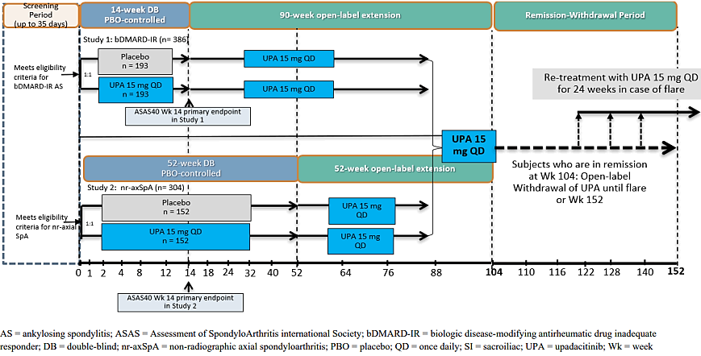

Non-radiographic axial spondyloarthritis
The pivotal efficacy and safety study in nr-axSpA is M19-994 Study 2. The study includes a 35-day screening period; a 52-week randomized, double-blind (DB), parallel-group, placebo-controlled (PC) period (DB Period); a 52-week open-label (OL), long-term extension (LTE) period (OLE Period); and follow up visit 30 days after completion of the OLE period. Active nr-axSpA is defined by meeting the 2009 ASAS classification criteria for axSpA but not meeting the radiologic criterion of the modified New York criteria for AS; and having objective signs of active inflammation on MRI of the SI joints or a high-sensitivity measurement of CRP (hsCRP) in blood > upper limit of normal (ULN).
In the 52-week DB period, adults with active nr-axSpA are randomized in a 1:1 ratio to treatment with UPA 15 mg once daily (QD) or placebo (PBO) QD. In the OLE, participants in the PBO group are switched to OL UPA15 mg QD at Week 52 and participants in the UPA group continue with the same dose.
Participants in the OLE who are in remission at week 104 (after 52 weeks of OL UPA), as defined by Ankylosing Spondylitis Disease Activity Score (ASDAS)-CRP < 1.3 at Week 104 and ASDAS-CRP < 2.1 at Week 88, are eligible for further treatment in a Remission-Withdrawal Period. This group will be followed over a further 48 weeks (through to Week 152) without study drug treatment and assessed for disease flare.
Those participants who are not in remission at Week 104 complete the study after the 30-day follow-up visit or, according to local requirements may have the option to enter further OL treatment with UPA for a predefined period.
Inclusion and exclusion criteria are outlined in the TGA clinical evaluation report (CER p. 22 et seq). Inclusion criteria at baseline include age 18 years or older with active nr-axSpA as described above; a Bath Ankylosing Spondylitis Disease Activity Index (BASDAI) score ≥ 4 and BASDAI Total Back Pain score ≥ 4 at both the screening and baseline visits; permitted concomitant medication(s) must be at a stable dose for a minimum period specified for the specific medication. Participants should have experienced an inadequate response to at least two NSAIDs over at least four weeks in total at maximum recommended or tolerated doses or should have had an intolerance to or contraindication for NSAIDs (as defined by the Investigator). Between 20% and 35% of participants may have been treated previously with no more than one bDMARD (either a TNFi or an IL-17i). The bDMARD must have been discontinued owing to either lack of efficacy after at least 12 weeks with treatment at an adequate dose, or to intolerance irrespective of treatment duration. Minimum medication specific washout periods were applied. Major exclusion criteria were prior exposure to two or more bDMARDs (regardless of response or intolerance), prior exposure to any JAKi including upadacitinib, prior exposure within specific limited time frames to a range of medicines including other DMARDs, intra-articular injections, parenteral corticosteroids and strong CYP3A inhibitors (as outlined in the CER). History of chronic, recurrent or recent severe infections, recent history of major adverse cardiovascular events (MACE), malignancy, or other inflammatory arthritic conditions were also among the exclusion criteria.
Overall, 156 participants were randomized to UPA (156 treated) and 158 participants to PBO (157 treated) in the DB phase. Randomization was stratified by MRI evidence of sacroiliitis and hsCRP status (MRI+/hsCRP > ULN, MRI+/hsCRP ≤ ULN, MRI–/hsCRP > ULN) and by prior exposure to bDMARDs (yes/no).
At week 14, 142 in the UPA group and 159 in the PBO group had completed the DB phase of the study. Discontinuation for lack of efficacy was reported by three participants in each treatment group, for adverse events was reported by two participants in the PBO group and four participants in the UPA group. Other reasons for discontinuation included withdrawal by subject and “other” in the PBO group (one each), and withdrawal by subject (two), COVID-19 logistics (one) and “other” (one) in the UPA group. Protocol deviations were reported for around 20% of all participants, the most frequent reports were eligibility criteria not met (19.6% in the PBO group, 14.7% in the UPA group) and use of prohibited concomitant medication (3.2% and 7.1%, respectively). The sponsor stated that the protocol deviations did not substantially affect the clinical outcomes.
The primary efficacy outcome was ASAS40 response at week 14. The multiplicity-controlled secondary endpoints at Week 14 (unless otherwise noted) are change from baseline (△) in ASDAS (△ASDAS), △MRI SPARCC score (SI joint), BASDAI 50 response; ASDAS inactive disease (ASDAS score < 1.3), △ in patient's assessment of total back pain (△total back pain); △ in patient's assessment of nocturnal back pain (△nocturnal back pain); ASDAS low disease activity (LDA, ASDAS score < 2.1); ASAS partial remission (PR) ; △BASFI; △ASQoL; △ in ASAS Health Index (HI); ASAS20 response; △BASMI linear; △MASES; ASAS40 response at Week 52.
Several additional outcomes were also described for the DB and OL phases. The key efficacy outcome in the remission-withdrawal period was time to flare.
The demographic data at baseline for the UPA and PBO populations were generally comparable, exceptions were a slightly higher preponderance of Hispanic or Latino ethnicity in the UPA group (15.4%) vs the PBO group (9.6%), and moderately more current alcohol drinkers in the PBO group (49.7%) than in the UPA group (38.7%). Baseline disease characteristics were also comparable in the two groups, although slightly more participants in the PBO group (73.2%) than in the UPA group (64.1%) had been diagnosed less than five years previously. Overall, 32.9% of participants had previously used a bDMARD (mainly TNFi). Most of those had discontinued owing to lack of efficacy. Opioid use at baseline was higher in the PBO group (n=18, 11.5%) compared to the UPA group (n=6, 3.8%). Small numbers limit interpretation of this difference. Screening assessments of disease activity were comparable in the two treatment groups, although mean [SD] hsCRP concentrations were higher in the UPA group (13.61 [24.79] mg/L) than in the PBO group (10.52 [13.52] mg/dL). In the two groups hsCRP data were not normally distributed - although approximately similar proportions of participants in each group had hsCRP levels > ULN, more participants in the UPA group (63.5%) than in the PBO group (53.5%) had hsCRP measures > 5mg/L at baseline.
Upadacitinib 15mg QD was statistically significantly superior to PBO in achieving the primary efficacy outcome with 44.9% of participants in the UPA group achieving ASAS40 response at week 14, compared to 22.5% of participants in the PBO group (Table 2). The results of the primary efficacy outcome were supported by the key secondary and additional secondary outcomes down to the △linear BASMI, where a numerical superiority (point estimate -0.29, 95% CI [-0.40, -0.18]) in the UPA treatment group was not statistically significantly different from the results in the PBO group (point estimate -0.19, 95% CI [-0.29, -0.08]). The result was also supported by sensitivity analyses. Although the study did not include analyses by subgroups in the ranked outcomes, it is noted that UPA showed numerical superiority over PBO in MRI+/hsCRP > ULN, MRI+/hsCRP ≤ ULN, MRI–/hsCRP > ULN groups, although the confidence intervals for the difference in effect in the MRI+/hsCRP ≤ ULN included 0. Regarding prior exposure to bDMARDs, participants who had previously been treated with bDMARDs generally had lower response rates than bDMARD naïve participants. No results were available for the OL or remission-withdrawal periods of the study.
Table 2: M19-994 Study 2 (nr-axSpA) ASAS40 response at week 14
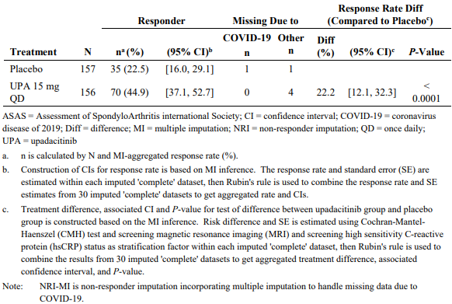
Additional efficacy data in nr-axSpA up to week 52 submitted with a response to a request for information reported that a greater percentage of participants in the UPA group (62.8%) than in the placebo group (42.7%) had an ASAS40 response at week 52, resulting in a placebo-adjusted difference of 20.1%. Supplementary analyses at week 52 were supportive. At week 52, the rates of concomitant medication use were similar to those reported at Week 14. Specifically, 81.4% participants in the UPA group and 77.7% in the PBO group took one or more concomitant NSAIDs; 28.8% of the UPA group and 35.7% of the PBO group took concomitant csDMARD therapy; and 14.7% and 11.5% of the UPA and PBO groups, respectively, took one or more concomitant oral corticosteroid.

Ankylosing spondylitis (bDMARD-IR)
The pivotal efficacy and safety study in bDMARD-IR AS is M19-994 Study 1. The study shares a similar overall design with M19-994 Study 2, with a 35-day screening period; only a 14-week randomized, parallel-group, PC, DB Period; a longer 90-week OLE period; and follow up visit 30 days after completion of the OLE period. Patients enrolled in Study 1 were men and women aged 18 years and over who had a clinical diagnosis of AS that was confirmed by modified New York Criteria, did not have evidence of total spinal ankylosis, and had an inadequate response to bDMARD treatment.
In the DB period, adults with bDMARD-IR AS were randomized in a 1:1 ratio to treatment with UPA 15 mg QD (n=193) or placebo (n=193). In the OLE, participants in the PBO group were switched to OL UPA 15 mg QD at Week 14 and participants in the UPA group continued with the same dose.
Participants in the OLE who are in remission at week 104 (ASDAS-CRP < 1.3 at Week 104 and ASDAS-CRP < 2.1 at Week 88), are eligible for further treatment in a remission-withdrawal period. This group will be followed over a further 48 weeks (through to Week 152) without study drug treatment and assessed for disease flare. Participants who experience a flare will recommence OL UPA 15 mg QD from the time of flare for 24 weeks (re-treatment) or longer according to local requirements. Participants who do not experience a flare, will be followed until Week 152.
Those participants who are not in remission at Week 104 complete the study after the 30-day follow-up visit or, according to local requirements may have the option to enter further OL treatment with UPA for a predefined period.
In general, the inclusion and exclusion criteria for Study 1 were the same as those applied to the nr-axSpA population in Study 2 including the requirement for BASDAI and BASDAI total back pain scores ≥ 4 at both the screening and baseline visits. Inclusion criteria specific to the bDMARD-IR population were previous exposure to no more than two bDMARDs, at least one of which was a TNFi or IL-17i. The participant must have discontinued a bDMARD owing to either lack of efficacy after at least 12 weeks treatment at an adequate dose, or intolerance irrespective of the duration of treatment. Patients who had experienced two bDMARDs were restricted to a maximum of 30% of the study population, and patients who had experienced inadequate response to both a TNFi and IL-17i were excluded.
Overall, 420 participants were randomized in Study 1; 211 participants in the UPA group and 209 participants in the PBO group received study drug in the DB phase. Randomization was stratified by hsCRP status (hsCRP > ULN, hsCRP ≤ ULN), type of bDMARDs previously experienced (TNFi, IL-17i, other) and geographic region (US/Canada vs Rest of World, not including China or Japan (ROW)). At week 14, 206 in the UPA group and 203 in the PBO group had completed the DB phase of the study. Discontinuations in the DB period were uncommon: in the UPA group two participants discontinued for “other reasons” and one each for “lack of efficacy”, COVID-19 logistical reasons and loss to follow up; in the PBO group three participants discontinued for adverse events and one each for “lack of efficacy”, withdrawal by subject and loss to follow up. Protocol deviations were reported for around 10% of all participants. The sponsor stated that the protocol deviations did not substantially affect the clinical outcomes.
The primary efficacy outcome was ASAS40 response at week 14. The multiplicity-controlled secondary endpoints at Week 14 were △ASDAS-CRP, △MRI SPARCC score (spine), BASDAI 50 response; ASAS20 response; ASDAS-CRP inactive disease (ID); △total back pain; △nocturnal back pain; ASDAS-CRP LDA; △BASFI; ASAS PR; △ASQoL; △ASAS HI; △BASMI linear; △MASES; △MRI SPARCC score (SI joints).
The demographic data at baseline for the UPA and PBO groups in the bDMARD-IR AS population were generally comparable, an exception was slightly more current alcohol drinkers in the UPA group (41.6%) than in the PBO group (34.1%). Baseline disease characteristics were also comparable in the two groups, although slightly more participants in the PBO group (51.7%) than in the UPA group (45.5%) had been diagnosed less than five years previously. Overall, 74.3% of participants had previously used one TNFi with inadequate response, 12.6% had previously used one IL-17i with inadequate response and 12.9% had used two prior bDMARDs with inadequate response to one.
The study met its primary endpoint based on a statistically significantly greater percentage of subjects in the UPA group (44.5%) achieving an ASAS40 response compared with subjects in the PBO group (18.2%) at Week 14 (Table 3). Secondary and sensitivity analyses supported the primary endpoint analysis.
Table 3: M19-944 Study 1 (bDMARD-IR AS) Primary and Multiplicity-Controlled Secondary Endpoints, Full Analysis Set
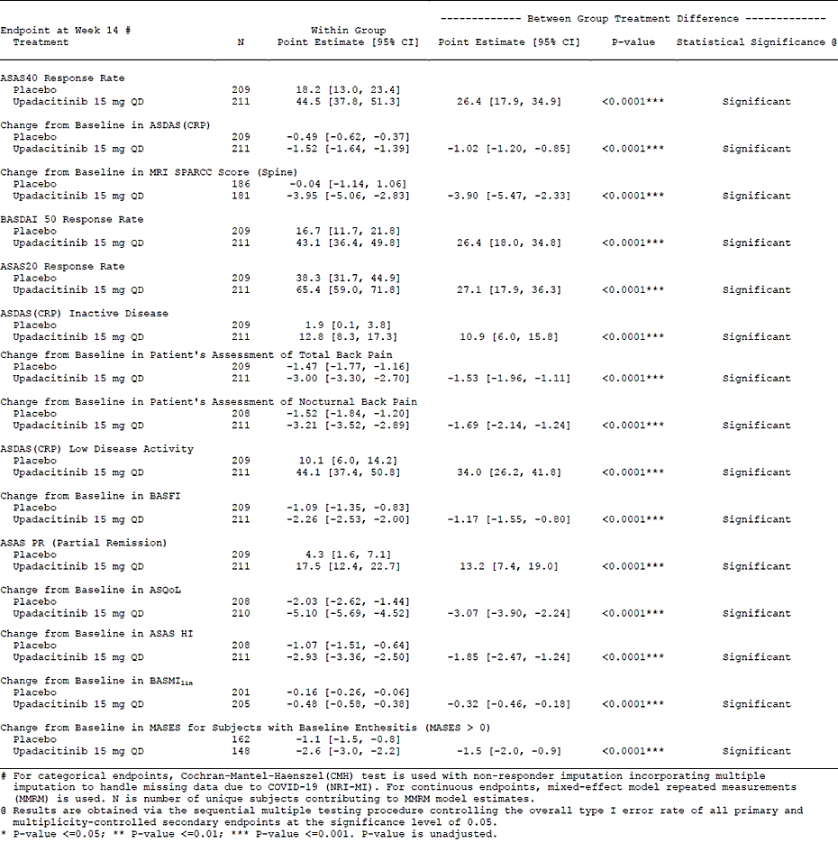

Ankylosing spondylitis (bDMARD-naïve)
Long-term efficacy data from study M16-098 in adults with AS were included in the submission. The primary efficacy data from this study were presented in submission PM-2020-02479-1-3. Participants were randomised to 15mg UPA daily or matching PBO, for an initial period of 14 weeks (Period 1), after which PBO patients were switched to 15mg UPA daily. All patients were then reviewed regularly up to a total of 104 weeks treatment (Period 2, OL), with an additional safety follow-up period of 30 days. Participants who did not achieve an ASAS20 response at two consecutive visits by week 16 were allowed additional or modified doses of NSAIDS, paracetamol, low potency opioids, and/or modifed doses of MTX or SSZ from week 20. Participants who did not achieve at least ASAS20 response at two consecutive visits by week 24 were discontinued from study treatment. The primary endpoint, the proportion of participants achieving ASAS40 response at week 14, was statistically significantly higher in the UPA arm than in the PBO treated arm.
A total of 179 participants (90 PBO, 89 UPA) entered the OL, LTE study and at the time of the report 123 participants had completed the initial DB study and the OL study to 104 weeks. Of all participants exposed to UPA in this study, 35 discontinued in either the DB or OL phases. The most common reasons for discontinuation were lack of efficacy (n=12, 6.7% of the study population) and adverse event (n=11, 6.2%), followed by withdrawal by subject (n=8, 4.5%).
The LTE provided convincing evidence of maintenance of efficacy, with ASAS40 responses over 60% from 12 to 16 weeks after commencing treatment and achieving 88.7% after 104 weeks of treatment (Figure 2). Consistent improvements were also reported for other efficacy outcomes.
Figure 2: M16-098 (bDMARD naïve AS) ASAS40 to week 104 on open-label treatment
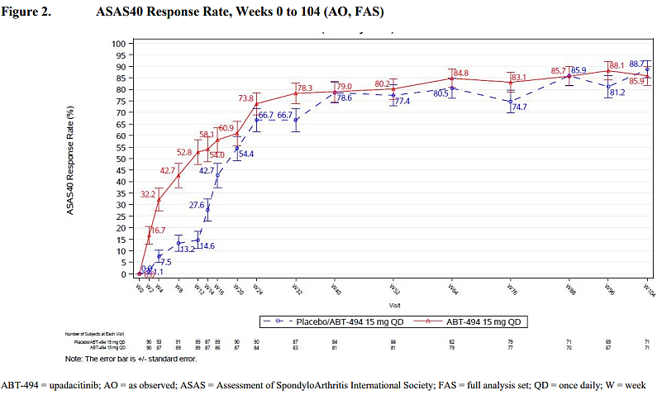
Overall, the presented studies in AS and nr-AxSpA demonstrated statistically significant and clinically meaningful improvements in clinical response, pain, physical function, health-related quality of life outcomes, enthesitis, spinal mobility, and objective measures of inflammation.

Safety

Non-radiographic axial spondyloarthritis
The assessment of safety of UPA in adults with active nr-axSpA included evaluation of adverse events (AEs), laboratory parameters (hematology, chemistry, and urinalysis), and vital signs. Adverse events of special interest (AESI) were identified based on safety concerns reported for other JAKi products, as well as data from preclinical studies and other UPA development programs. The mean durations of exposure of adults with nr-axSpA to UPA and PBO up to week 14 in the PBO-controlled period were approximately equivalent (96.4 days and 96.8 days, respectively). Incomplete datasets for the period to 52 weeks were provided with the initial submission. Additional data was accepted for evaluation at round 2. Duration of exposure to UPA in the 52-week DB period is summarised in Table 4. At the week 52 clinical safety report (CSR), 123 adults with nr-axSpA had been exposed to 15mg UPA daily for at least 12 months in this study.
Table 4: M19-994 Study 2 (nr-axSpA) Extent of exposure 52-week double-blind period (Safety Analysis Set)
Adverse event data up to 14 weeks in the DB phase are summarised in Table 5.
Table 5: M19-994 Study 2 (nr-axSpA) Overview of Treatment emergent adverse events (TEAEs) in the DB period up to 14 weeks.
Up to Week 14, the most frequently reported treatment emergent adverse events (TEAEs; ≥ 2% of participants) in the UPA group were headache, COVID-19, nasopharyngitis, nausea, abdominal pain, diarrhea, and neutropenia (Table 6). The frequency of headache, nausea, abdominal pain, diarrhea, and neutropenia was numerically higher in the UPA group compared with the placebo group.
Table 6: M19-994 Study 2 (nr-axSpA) TEAE in the DB period up to 14 weeks in ≥ 2% of participants
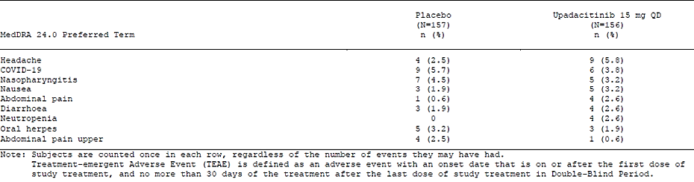
The System Organ Classifications (SOC) with the highest proportion of participants with TEAEs (≥ 5% of participants in either group) were infections and infestations, GI disorders, investigations, nervous system disorders, musculoskeletal and connective tissue disorders, and skin and subcutaneous tissue disorders. Reports of TEAE in the infections and infestations SOC by Preferred Terms (PT) reported in > 2% participants included COVID-19, nasopharyngitis, oral herpes, and upper respiratory tract infection. Serious AEs reported in the UPA group included one report each of COVID-19 pneumonia, pyelonephritis, foot fracture and osteoarthritis, in the PBO group one report each pancreatitis and haemorrhagic fever with renal syndrome. Adverse events of special interest (AESI) reported in the DB period up to week 14 are summarised in Table 7. Hepatic disorders were generally mild to moderate increases in serum transaminases and were not considered serious. No events satisfied Hy’s Law. There were no reported events of treatment-related major adverse cardiovascular events (MACE), venous or arterial thrombotic events, malignancy or GI perforations.
Table 7: M19-994 Study 2 (nr-axSpA) AESI in the DB period up to 14 weeks
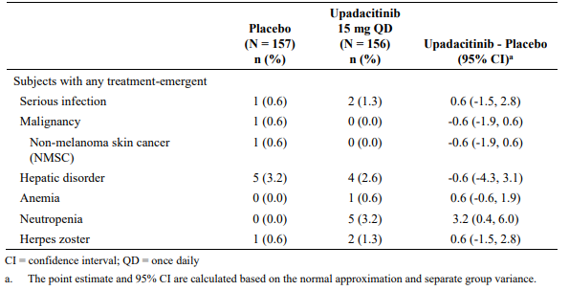
Safety data up to 52 weeks in the DB phase submitted in the initial sequence were incomplete with around 20% of participants overall having completed to week 52. Additional data were submitted in response to a request for information in a second clinical study report dated 26 August 2022. The last patient last visit for this report was 19 May 2022, at which time 129 participants in the UPA group and 130 participants in the PBO group had completed study drug up to week 52; and 27 participants in each group had discontinued study drug. The most frequent primary reasons for discontinuation of study drug were “lack of efficacy” (n=10), “withdrawal by subject” (n=8) and “other” (n=6) in the PBO group; "other" (n=8), “adverse event” (n=6), “withdrawal by subject” and “lack of efficacy” (each n=5) in the UPA group. Adverse event data up to 52 weeks in the DB phase are summarised in Table 9. Report rates of related TEAE, severe AE and AE leading to discontinuation of study drug were slightly higher in the UPA group.
Table 8: M19-994 Study 2 (nr-axSpA) TEAE and All Deaths – By Week 52 in DB Period (Safety Analysis Set)
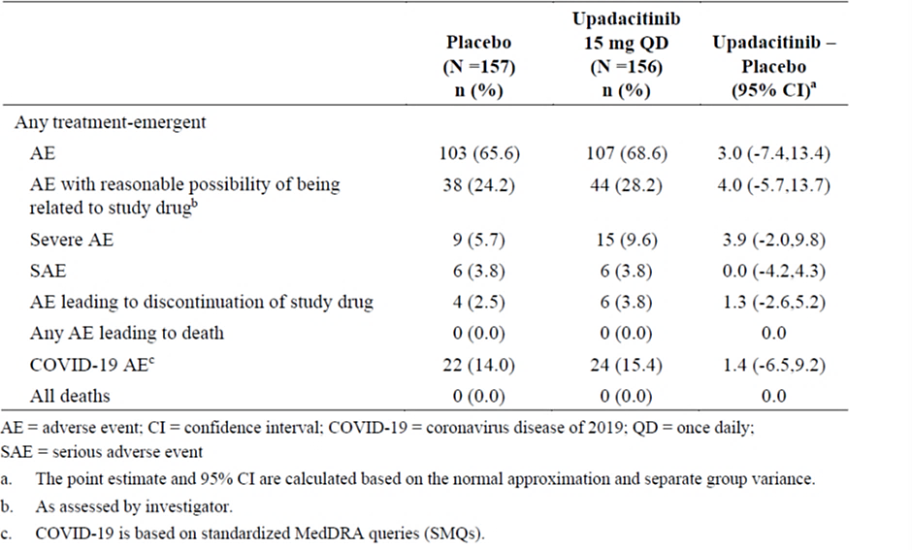
During the 52-week DB period, the most frequently reported TEAEs (≥ 5% of study participants) were COVID-19, nasopharyngitis, and headache in the UPA group, and COVID-19, nasopharyngitis and upper respiratory tract infection in the placebo group. At least 5% of study participants in either group experienced TEAEs in the SOCs infections and infestations; musculoskeletal and connective tissue disorders; GI disorders; nervous system disorders; skin and subcutaneous tissue disorders; respiratory, thoracic, and mediastinal disorders; injury, poisoning, and procedural complications; investigations; metabolism and nutrition disorders; psychiatric disorders; general disorders and administrative site conditions; blood and lymphatic system disorders; and vascular disorders.
The most frequently reported TEAEs considered by the investigator as having a reasonable possibility of being related to study drug are summarised in Table 8. Headache, nasopharyngitis, neutropenia, herpes zoster and urinary tract infection were more common in the UPA group than in the PBO group. Severe TEAEs were reported in 16 (11.6 E/100 patient years (PYs)) participants who received UPA and 13 (9.3 E/100 PYs) participants in the placebo group. Six of the severe events in the UPA group were also SAEs: COVID-19 pneumonia, pyelonephritis, foot fracture, osteoarthritis, ureterolithiasis, and nasal polyps. Six of the severe events in the placebo group were also SAEs: cataract, pancreatitis, pancreatitis acute, haemorrhagic fever with renal syndrome, femur fracture, and meniscus injury.
Table 9: M19-994 Study 2 (nr-axSpA) Related TEAE by Week 52 in DB Period, > 2 events/100 PYs by Decreasing Frequency in Upadacitinib Group (Safety Analysis Set)
No new concerns were identified with the safety data up to 52 weeks in the DB period and in the OL period of the study to data lock. The overall safety profile of UPA observed in the nr-axSpA study was consistent with the known safety profile of UPA in rheumatoid arthritis, psoriatic arthritis and AS programs in adults.

Ankylosing spondylitis
The assessment of safety of UPA in adults with bDMARD-IR AS addressed the same safety parameters described in the nr-axSpA study. In M19-994 Study 1, the mean durations of exposure to UPA and PBO in the PBO-controlled period (total 14 weeks) were approximately equivalent (97.8 days and 97.6 days, respectively). Additional safety data is described as “long-term data” and includes data from study participants switched from PBO to UPA at 14 weeks. Up to the data cut-off date, 414 adults with bDMARD-IR had received at least one dose of UPA, of which 279 participants (67.4%) had at least six months exposure and 68 participants (16.4%) had at least 12 months exposure to UPA (Table 10).
Adverse event data in the DB phase are summarised in Table 11. The proportion of participants with TEAE, SAE, TEAEs with a reasonable possibility of being related to study drug, and COVID-19 related TEAE were higher in the UPA group compared with the PBO group. A similar proportion of participants in each treatment group had severe TEAEs. No subjects in the UPA group had a TEAE leading to discontinuation of study drug, and no deaths were reported.
In the DB period the most frequently reported TEAEs (≥ 2% of participants) in the UPA group were headache, COVID-19, neutropenia, hyperuricemia, nasopharyngitis and diarrhoea (Table 12). The frequency of COVID-19, headache, neutropenia, hyperuricemia and nasopharyngitis was numerically higher in the UPA group compared with the placebo group, but diarrhoea was higher in the PBO group.
Table 10: M19-994 Study 1 (bDMARD-IR AS) Total duration of exposure to upadacitinib to data lock 26 August 2021.
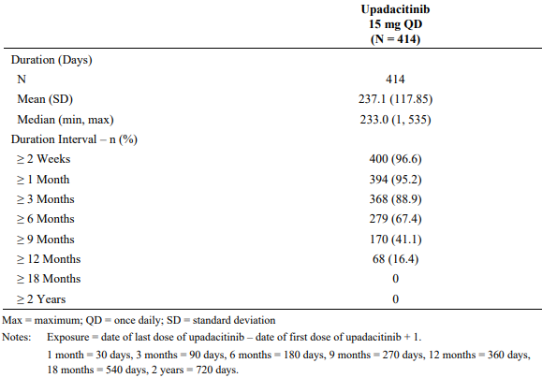
Table 11: M19-994 Study 1 (bDMARD-IR AS) Overview of TEAE in the DB period
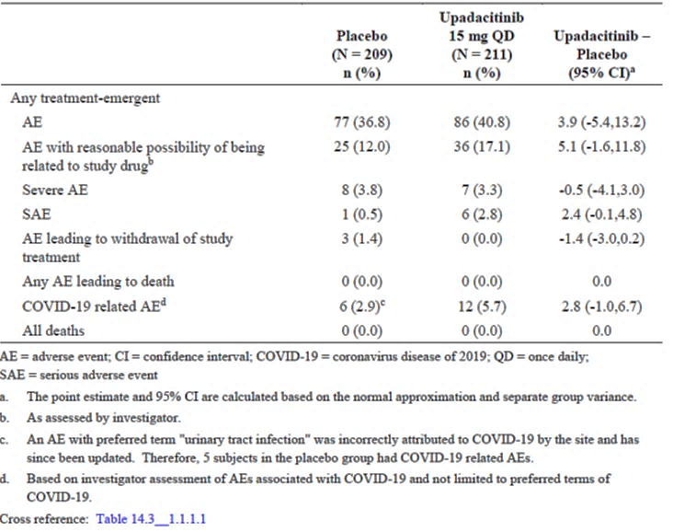
Table 12: M19-994 Study 1 (bDMARD-IR AS) TEAE in the DB period in ≥ 2% of participants
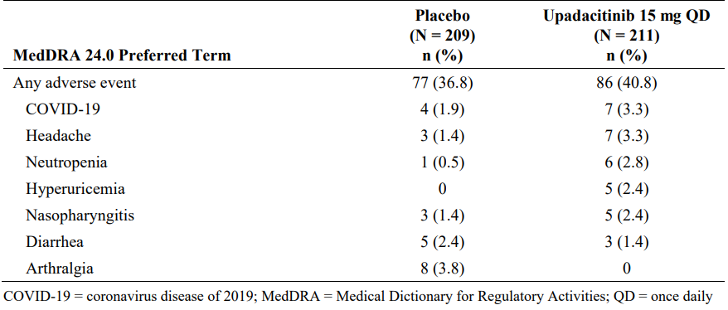
The System Organ Classifications (SOC) with the highest proportion of participants with TEAEs (≥ 5% of participants in either group) were infections and infestations, GI disorders, blood and lymphatic system disorders, musculoskeletal and connective tissue disorders, investigations, and metabolism and nutrition disorders. Reports of TEAE in the infections and infestations SOC by Preferred Terms (PT) reported in > 2% participants were COVID-19 and nasopharyngitis.
Six participants in the UPA group reported serious AEs including one report of uveitis, one report of acute cholangitis, and four reports of COVID-19 pneumonia (one with COVID-19 also recorded). One serious AE (tonsil cancer) was reported in the PBO group.
Severe TEAEs were reported in seven participants in the UPA group (COVID-19, n=3; COVID 19 pneumonia, n=2; lymphopenia, neutropenia, and cholangitis acute, each n=1) and eight participants in the PBO group (axSpA, n=2; folliculitis, COVID-19, inguinal hernia, bronchitis, AST increased, and transaminases increased, each n=1).
Adverse events of special interest (AESI) reported in the DB period are summarised in Table 13.
Table 13: M19-994 Study 1 (bDMARD-IR AS) AESI in the DB period
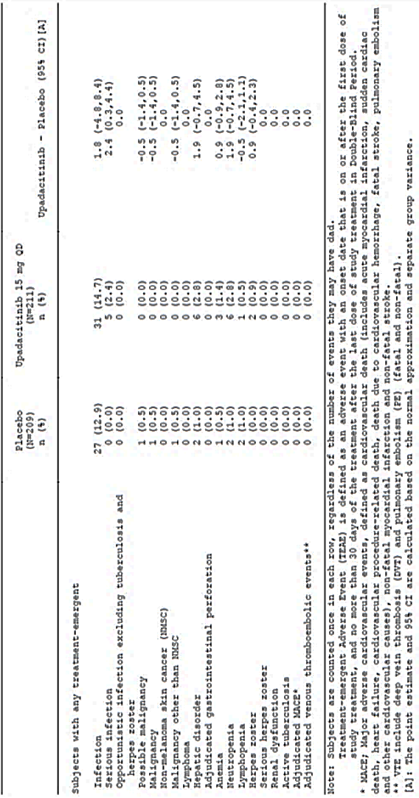
Consistent with reports in other studies with UPA, and other JAKi, reports of serious infection, hepatic disorders (predominantly mild or moderate elevations in serum transaminases), anaemia, neutropenia and herpes zoster were more frequent in the UPA treated group during the DB period. No events satisfied Hy’s Law. There were no reported events of treatment-related major adverse cardiovascular events (MACE), venous or arterial thrombotic events, malignancy or GI perforations in the UPA treated group.
The overall safety profile observed in the additional study in the bDMARD-IR AS population, and in the longer-term data from the pivotal AS study (M16-098, not detailed in this overview) was consistent with what is known for UPA. No new safety risks were identified compared to the known safety profile of UPA from the related RA, PsA and AS programs. Of note, no increased risk of MACE, death and malignancy has been identified in the provided data.

Risk management plan evaluation
A RMP was provided by the sponsor but did not require evaluation. The ongoing pharmacovigilance and risk management measures proposed with the approval of upadacitinib in the treatment of AS are considered appropriate for the new related indication in nr-axSpA.

Discussion
Notwithstanding the relatively short regulatory history of upadacitinib (first registered in Australia in January 2020 as a 15mg tablet for the treatment of adults with rheumatoid arthritis), the drug has been shown to be efficacious in the treatment of several chronic inflammatory disorders including psoriatic arthritis, ankylosing spondylitis, atopic dermatitis and most recently, with higher doses during the initiation phase of treatment, ulcerative colitis.
Appropriate endpoints were assessed to demonstrate efficacy in the treatment of adults with nr-axSpA and bDMARD-IR AS, commonly acknowledged to share similar underlying pathology. The choice of multiple secondary and exploratory efficacy outcomes allowed the sponsor to examine different aspects of efficacy, but also raised concerns with potentially inflated risks of alpha type errors, notwithstanding the application of multiplicity adjusting analyses. Numerically better responses to upadacitinib over placebo for several pre-defined outcomes including ASAS40 rates at week 52 could not claim statistical significance in light of failures at other hierarchically prioritised endpoints. Randomization of the study population was stratified by MRI evidence of sacroiliitis and hsCRP status (MRI+/hsCRP > ULN, MRI+/hsCRP ≤ ULN, MRI–/hsCRP > ULN) and by prior exposure to bDMARDs (yes/no), analysis by subgroups was not included in the hierarchical analytical strategy but numerically supported claims for efficacy of upadacitinib over placebo.
The relationship between nr-axSpA and AS as subgroups of the broader category of inflammatory spondyloarthropathies formed the basis of arguments by the sponsor that safety data from earlier programs, particularly in bDMARD naïve AS, should be considered appropriate to support safety claims in nr-axSpA despite the relatively limited (at initial submission) direct longer-term safety data for patients with nr-axSpA.
The adverse event data provided throughout the evaluation period of this submission was consistent with safety data already identified for upadacitinib. Warnings and precautions currently included in the Australian product information are generally appropriate for the known risks of upadacitinib at this point in its clinical history. As has been seen with other JAKi registered for use in chronic inflammatory disorders, longer exposure periods may reveal potential safety concerns that are yet to be realised. TGA has engaged with sponsors of JAKi to develop appropriate approaches to potential long-term risks. While these potential concerns are not sufficient to reject this application for registration, it is appropriate that these continue to be addressed in the product information.

Conclusions
At this time, presuming that patients were enrolled into the pivotal study based on adequately collected and reported MRI and/or hsCRP evidence, the benefit-risk balance for upadacitinib in the treatment of adults with active non-radiographic axial spondyloarthritis who have had inadequate responses or intolerance to at least two NSAIDs, and who are either bDMARD naïve or have had inadequate response or intolerance to no more than one bDMARD (TNFi or IL-17i) is positive.
The benefit-risk balance for upadacitinib in the treatment of adults with ankylosing spondylitis who have received prior treatment with no more than two bDMARDS (TNFi or IL-17i) and experienced inadequate response to no more than one bDMARD is also positive.
No new safety signals have been identified with up to 104 weeks treatment with upadacitinib in patients with AS.

Advisory Committee considerations
The Advisory Committee on Medicines (ACM), having considered the evaluations and the Delegate’s overview, as well as the sponsor’s response to these documents, advised the following:
- What is the opinion of the Committee regarding registration of upadacitinib for the treatment of nr-axSpA following failure of at least two NSAIDs, in the context of relatively limited long-term safety information?
The ACM noted that failure of two NSAIDs was a feature of most early studies of AS.
The ACM acknowledged that there is limited long-term safety data for Rinvoq collected directly in nr-axSpA patients. However, the ACM noted that there is a large volume of safety data for AS patients for highly similar patient populations. The ACM was of the view that this data can be considered supplemental for nr-axSpA patients.
Furthermore, the ACM noted that JAK inhibitors as a drug class do not appear to exhibit the same safety risks in axial SpA patients (in particular, malignancy and major adverse cardiac events [MACE]) as those observed in rheumatoid arthritis patients, although the ACM noted this may be due to patient age, lower cardiovascular risk profile and less steroid use.
Other advice
The ACM noted that for treatment of nr-axSpA the current practice in Australia is biological medicines. A JAK inhibitor presents an oral administration therapeutic option for patients for whom parenteral treatment is not an option.

Outcome
Based on a review of quality, safety, and efficacy, the TGA decided to register Rinvoq (upadacitinib) for the following extension of indications:
Non-radiographic Axial Spondyloarthritis
Rinvoq is indicated for the treatment of adults with active non-radiographic axial
spondyloarthritis with objective signs of inflammation as indicated by elevated C-reactive
protein (CRP) and/or magnetic resonance imaging (MRI) change, who have responded inadequately to, or are intolerant to nonsteroidal anti-inflammatory drugs (NSAIDs).

Specific conditions of registration applying to these goods
Rinvoq is to be included in the Black Triangle Scheme. The PI and CMI for Rinvoq must include the black triangle symbol and mandatory accompanying text for five years. The Black Triangle Scheme identifies new prescription medicines with a black triangle on all associated medicine information documents and serves as a visual reminder to encourage health practitioners and patients to report a problem or side effect they have experienced with the medicine.

Attachment 1. Product Information
The Product Information (PI) approved with the submission for Rinvoq which is described in this AusPAR can be found as Attachment 1. It may have been superseded. For the most recent PI and Consumer Medicines Information (CMI), please refer to the TGA PI/CMI search facility.

Therapeutic Goods Administration
PO Box 100 Woden ACT 2606 Australia
Email: info@tga.gov.au Phone: 1800 020 653 Fax: 02 6203 1605
https://www.tga.gov.au
Reference/Publication #

This is the original indication proposed by the sponsor when the TGA commenced the evaluation of this submission. It may differ to the final indication approved by the TGA and registered in the Australian Register of Therapeutic Goods.
Yu DT, van Tubergen A (2022) Diagnosis and differential diagnosis of axial spondyloarthritis (ankylosing spondylitis and nonradiographic axial spondylitis) in adults, UpToDate, updated Feb 28, 2022, accessed Oct 4, 2022
Ward MM, Deodhar A, Gensler LS, et al. 2019 Update of the American College of Rheumatology/Spondylitis Association of America/Spondyloarthritis Research and Treatment Network Recommendations for the Treatment of Ankylosing Spondylitis and Nonradiographic Axial Spondyloarthritis. Arthritis Rheumatol. 2019;71(10):1599- 613.
AusPAR for initial Rinvoq submission: https://www.tga.gov.au/resources/auspar/auspar-upadacitinib
In patients with atopic dermatitis, who are not routinely treated with TNF blockers, the restriction is to “disease [that] is not adequately controlled with other systemic drug products, including biologics, or when use of those therapies are inadvisable.”
The ‘Delegate’ is the Delegate of the Secretary of the Department of Health and Aged Care who made the final decision to either include the new medicine/indication on the ARTG or reject the submission, under section 25 of the Therapeutic Goods Act
Landewé R, van Tubergen A. Clinical Tools to Assess and Monitor Spondyloarthritis. Curr Rheumatol Rep. 2015 Jul;17(7):47. doi: 10.1007/s11926-015-0522-3. PMID: 26063534; PMCID: PMC4464370.
Flare is defined as an ASDAS-CRP ≥ 2.1 at two consecutive visits at least two weeks apart, or an ASDAS-CRP > 3.5 at one visit. Participants who experience a flare recommence OL UPA 15 mg QD from the time of flare for 24 weeks (re-treatment) or longer according to local requirements. Participants who do not experience a flare, are followed until Week 152.
At least a 40% improvement and an absolute improvement of ≥ 2 units (on a scale of 0 to 10) from Baseline in at least 3 of the 4 assessed domains, with no worsening at all in the remaining domain: Patient's Global Assessment of Disease Activity (PtGA); Patient's Assessment of Total Back Pain NRS score; Bath Ankylosing Spondylitis Functional Index (BASFI) score; The mean of the two-morning stiffness-related BASDAI items (Questions 5 and 6).
Spondyloarthritis Research Consortium of Canada magnetic resonance imaging index for assessment of spinal and SI joint inflammation in ankylosing spondylitis
An absolute score of ≤ 2 units for each of the 4 domains identified in ASAS40
Ankylosing Spondylitis-specific Quality of Life measure
Maastricht Ankylosing Spondylitis Enthesitis Score
Assessment of Spondyloarthritis International Society (ASAS) measure of disease activity and severity

