Australian Public Assessment Report for Lynparza
  - Active ingredient: Olaparib
  - Sponsor: AstraZeneca Pty Ltd
July 2024

About the Therapeutic Goods Administration (TGA)
- The Therapeutic Goods Administration (TGA) is part of the Australian Government Department of Health and Aged Care and is responsible for regulating therapeutic goods, including medicines, medical devices, and biologicals.
- The TGA administers the Therapeutic Goods Act 1989 (the Act), applying a risk management approach designed to ensure therapeutic goods supplied in Australia meet acceptable standards of quality, safety, and efficacy.
- The work of the TGA is based on applying scientific and clinical expertise to decision-making, to ensure that the benefits to the Australian public outweigh any risks associated with the use of therapeutic goods.
- The TGA relies on the public, healthcare professionals and industry to report problems with therapeutic goods. The TGA investigates reports received to determine any necessary regulatory action.
- To report a problem with a therapeutic good, please see the information on the TGA website.

About AusPARs
- The Australian Public Assessment Report (AusPAR) provides information about the evaluation of a prescription medicine and the considerations that led the TGA to approve or not approve a prescription medicine submission. Further information can be found in Australian Public Assessment Report (AusPAR) guidance.
- AusPARs are prepared and published by the TGA.
- AusPARs are static documents that provide information that relates to a submission at a particular point in time. The publication of an AusPAR is an important part of the transparency of the TGA’s decision-making process.
- A new AusPAR may be provided to reflect changes to indications or major variations to a prescription medicine subject to evaluation by the TGA.

Copyright
© Commonwealth of Australia 2024
This work is copyright. You may reproduce the whole or part of this work in unaltered form for your own personal use or, if you are part of an organisation, for internal use within your organisation, but only if you or your organisation do not use the reproduction for any commercial purpose and retain this copyright notice and all disclaimer notices as part of that reproduction. Apart from rights to use as permitted by the Copyright Act 1968 or allowed by this copyright notice, all other rights are reserved and you are not allowed to reproduce the whole or any part of this work in any way (electronic or otherwise) without first being given specific written permission from the Commonwealth to do so. Requests and inquiries concerning reproduction and rights are to be sent to the TGA Copyright Officer, Therapeutic Goods Administration, PO Box 100, Woden ACT 2606 or emailed to <tga.copyright@tga.gov.au>.

Contents
List of abbreviations 4
Product submission 8
Submission details 8
Product background 9
The disease/condition 9
Current treatment options 11
Clinical rationale 12
Regulatory status 13
Australian regulatory status 13
International regulatory status 14
Registration timeline 17
Submission overview and risk/benefit assessment 18
Quality Evaluation Summary 18
Nonclinical (Toxicology) Evaluation Summary 19
Clinical Evaluation Summary 21
Pharmacology 21
Efficacy 23
Safety 42
Risk management plan 54
Risk-benefit analysis 55
Delegate’s considerations 55
Proposed action 61
Questions for the sponsor 61
Advisory Committee considerations 64
Risk/benefit assessment (post-Advisory Committee Meeting) 65
Advisory Committee considerations (on additional questions) 65
Decision Outcome 67
Product Information 68

List of abbreviations
Abbreviation | Meaning
acAUC | Average cumulative AUC at day of occurrence
ADR | Adverse drug reaction
ADT | Androgen deprivation therapy
AE | Adverse event
AESI | Adverse event of special interest
ALP | Alkaline phosphatase
ALT | Alanine transaminase
AML | Acute myeloid leukaemia
AR | Androgen receptor
AST | Aspartate aminotransferase
AUC | Area under the plasma concentration time curve
AUC₍₀₋₈₎ | Area under the plasma concentration time curve from time 0 to 8 hours
AUC_{ss} | Area under the plasma concentration time curve at steady state
AZD2281 | Lynparza =trade name of olaparib
bd | Twice a day
BICR | Blinded independent central review
BIG | Breast International Group
BMI | Body mass index
BPI-SF | Brief Pain Inventory – Short Form
BRCA | Breast cancer susceptibility gene (in accordance with scientific convention, gene and mutation is italicised whereas protein is not italicised)
BRCAm | gBRCA or sBRCA mutated
CHMP | Committee for Medicinal Products for Human Use (EU)
CI | Confidence interval
CL/F | Apparent clearance
Clinical N2-3 | TMN classification. Signs of cancer in the lymph nodes identified following scans and physical examination
C_{max, ss} | Maximum plasma concentration at steady state
C_{min,ss} | Minimum plasma concentration at steady state
COVID-19 | Coronavirus disease – 2019
CPS&EG | Clinical stage (CS), oestrogen receptor status (E), nuclear grade (G) and post treatment pathologic state (PS) – a disease scoring system
CRPC | Castration resistant prostate cancer
CSP | Clinical Study Protocol
CR | Complete response
CSR | Clinical study report
CT | Computerised tomography
CTCAE | Common Technical Criteria for Adverse Events
CV | Coefficient of variation
CYP-34A | Cytochrome P450 3A4 enzyme
DAE | Discontinuation due to AE
dAUC | AUC on day of occurrence
dC_{max} | C_{max} on day of occurrence of safety event
DCO | Data cut-off
DDFS | Distant disease free survival
DDR | DNA damage response
DFS | Disease free survival
DLT | Dose limiting toxicity
DNA | Deoxyribonucleic acid
DoR | Duration of response
DSB | Double stand break
ECOG | Eastern Cooperative Oncology Group
EFA | Evaluable for response
EFR | Evaluable for response
EMA | European Medicines Agency
EORTC | European Organisation for Research and Treatment of Cancer
EORTC QLQ-30 | European Organisation for Research and Treatment of Cancer quality of life questionnaire
ER | Oestrogen receptor
ESMO | European Society for Medical Oncology
FACIT | Functional Assessment of Chronic Illness Therapy
FACT-P | Functional Assessment of Cancer Therapy – Prostate Cancer
FAS | Full analysis set
FDA | Food and Drug Administration (USA)
FISH | Fluorescence in-situ hybridisation
FMI | Foundation Medicine Inc.
gBRCAm | Germline BRCA mutated
GCP | Good Clinical Practice
HER2 | Human epidermal growth factor receptor 2
HR | Hazard ratio
HRD | Homologous recombination deficiencies
HRQoL | Health related quality of life
HRR | Homologous recombination repair
HRR15 | A panel of 15 HRR genes
HRRm | Homologous recombination repair gene mutation
ICH | International Council for Harmonisation
IDFS | Invasive disease-free survival
IHC | Immunohistochemistry
ITT | Intent-to-treat
LC-MS/MS | Liquid chromatography with tandem mass spectrometry
LLOQ | Lower limit of quantification
KM | Kaplan-Meier
LS | Least squares
mBC | Metastatic breast cancer
mCRPC | Metastatic castration resistant prostate cancer
MDS | Myelodysplastic syndrome
MedDRA | Medical Dictionary for Regulatory Activities
mHSPC | Metastatic hormone sensitive prostate cancer
MRI | Magnetic resonance imaging
N | Number of patients in treatment
n | Number of patients analysed
NCCN | National Comprehensive Cancer Network
NCI | National Cancer Institute (USA)
NCTN | National Clinical Trial Network
NRG | NCI supported National Clinical Trials Network Group
NHA(s) | New hormonal agent(s)
ORR | Objective response rate
OS | Overall survival
PARP | Polyadenosine 5’diphosphororibose polymerase
PARPi | Polyadenosine 5’diphosphororibose polymerase inhibitor
PBRER / PSUR | Periodic Benefit Risk Evaluation Report / Periodic Safety Update Report
pCR | Pathological complete response
PCWG-2 / 3 | Prostate Cancer Working Groups 2 / 3
PD | Pharmacodynamics
PFS | Progression free survival
PFS2 | Time from randomisation to second progression or death
PgR | Progesterone receptor
PI | Product Information (Aust)
PK | Pharmacokinetic
pNo | Axillary node negative
pN1 | Axillary node positive
pN1a | TMN classification. Surgically identified metastasis in 1 to 3 axillary lymph nodes, with at least 1 metastasis greater than 2.0 mm
PopPK | Population pharmacokinetics
PR | Partial response
PRO | Patient reported outcome
PS | Performance status
PSA | Prostate specific antigen
PSR | Platinum sensitive relapsed
PT | Preferred Term
qd | Once daily
QLC-C30 | Quality of life questionnaire core 30 item module
QoL | Quality of life
RECIST 1.1 | Response Evaluation Criteria for Solid Tumours, version 1.1
rPFS | Radiological progression free survival
RMP | Risk Management Plan
RMST | Restricted mean survival time
SAE | Serious adverse event
SCS | Summary of Clinical Safety
SD | Standard deviation
SmPC | Summary of Product Characteristics (EU)
SOC | System Organ Class
SSB | Single strand break
SSRE | Symptomatic skeletal related event
STEEP | Standardised terms for efficacy endpoints
TFST | Time from randomisation to start of first subsequent therapy or death
TNBC | Triple negative breast cancer
TSST | Time from randomisation to start of second subsequent therapy or death
TTPP | Time to pain progression
ULN | Upper limit of normal
VTE | Venous thromboembolism

Product submission

Submission details
Type of submission: | Extension of indication
Product name: | Lynparza
Active ingredient: | Olaparib
Decision: | Approved
Date of decision: | 29 September 2023
Date of entry onto ARTG: | 5 October 2023
ARTG numbers : | 288613, 288614
Black Triangle Scheme | No
Sponsor’s name and address: | AstraZeneca Pty Ltd, PO Box 131, NORTH RYDE, NSW, 1670 Australia
Dose form: | Tablet, film coated
Strengths: | 100 mg, 150 mg
Container: | Blister pack
Pack size: | 56
Proposed new indications for the current submission: | Breast cancer  Lynparza is indicated as monotherapy for the adjuvant treatment of adult patients who have HER2-negative, high-risk early breast cancer with a deleterious or suspected deleterious germline BRCA mutation (gBRCAm), for which they have previously been treated with neoadjuvant or adjuvant chemotherapy.  Prostate cancer  Lynparza in combination with abiraterone and either prednisone or prednisolone is indicated for the treatment of adult patients who have mCRPC with a deleterious or suspected deleterious BRCA mutation (germline or somatic).
Route of administration: | Oral
Dosage: | The recommended dose of Lynparza (whether as monotherapy or in combination) is 300 mg twice a day, taken orally.  For further information regarding dosage, such as dosage modifications to manage adverse reactions, refer to the Product Information.
Pregnancy category: | D  Drugs which have caused, are suspected to have caused or may be expected to cause, an increased incidence of human fetal malformations or irreversible damage. These drugs may also have adverse pharmacological effects.  The use of any medicine during pregnancy requires careful consideration of both risks and benefits by the treating health professional. The pregnancy database must not be used as the sole basis of decision making in the use of medicines during pregnancy. The TGA does not provide advice on the use of medicines in pregnancy for specific cases. More information is available from obstetric drug information services in your state or territory.

Product background
This AusPAR describes the submission by AstraZeneca Pty Ltd (the sponsor) to register Lynparza (olaparib) for the following proposed extension of indications:
Breast cancer: for the adjuvant treatment of adult patients with BRCA-mutated HER2-negative high risk early breast cancer who have previously been treated with neoadjuvant or adjuvant chemotherapy

Prostate cancer: In combination with abiraterone and prednisone or prednisolone for the treatment of adult patients with metastatic castration-resistant prostate cancer.

The disease/condition

Breast cancer
Breast cancer is the most common cancer in the world, with an estimated 2.2 million new cases in 2020 globally (11.7% of all new cancers). Breast cancer is also the fifth most common cause of death from cancer, with an estimated 684,000 deaths in 2020.
Despite advances in the diagnosis and treatment of breast cancer, approximately 6% of women diagnosed with breast cancer in the USA have metastatic disease at initial presentation, and up to 30% of women with early-stage non-metastatic breast cancer will develop metastatic disease. Metastatic breast cancer remains an incurable disease with an estimated 5-year overall survival (OS) of 28%.
Breast cancer is a heterogeneous disease and optimal treatment depends on pathological and molecular characterisation of the tumour. Early-stage breast cancer (Stages I to III) is defined as disease confined to the breast with or without regional lymph node involvement and in the absence of metastatic disease.
In the general population, germline BRCA mutation carriers have an increased relative risk of breast cancer. Onset of gBRCAm associated breast cancer is early. BRCAm breast cancer is most frequently HER2 negative (IHC 0, 1+ or 2+/FISH non-amplified) breast cancer, which can be either ER and/or PgR positive (ER and/or PgR IHC nuclear staining ≥1%) or TNBC (ER and/or PgR IHC nuclear staining <1%). The development of HER2 positive BRCAm breast cancer, whilst it does occur, is rare^{6,,}.
Approximately 3% to 5% of patients with breast cancer carry BRCA1/2 mutations,. Approximately 70% of BRCA1 mutation carriers who develop breast cancers present with TNBC. In contrast, breast cancer patients carrying mutations in the BRCA2 gene are more likely to be positive for expression of the ER and/or PgR^{6,}.
BRCAm breast cancer is associated with high-risk features with a poor prognosis for patients. BRCA1/2 breast cancer hallmarks include high histological grade, continuous pushing margins, TP-53 mutations, loss of RAD51 focus information, extreme genomic instability and sensitivity to DNA crosslinking agents, with BRCA1 tumours additionally more frequently basal-like and ER-negative. Triple-negative breast cancer (TNBC), which is more frequently associated with BRCA1m, generally has a poor prognosis despite high sensitivity to chemotherapywith early recurrence between the first and third year after diagnosis, frequently in association with visceral and/or brain metastases and a shorter period between time of recurrence and death. Germline BRCA-associated hormone receptor–positive breast cancer is also associated with intrinsically less favourable biology with more high- and intermediate-risk disease and less low-risk disease compared to controls. Within BRCAm tumours, the proportions with high-risk features are very similar for each gene, regardless of the mutation being germline or somatic⁸. When compared to BRCA wildtype primary breast carcinomas, tumours harbouring a BRCA1/2 mutation (gBRCA1 n=10, gBRCA2 n=10, sBRCA1 n=4, sBRCA2 n=5), showed a higher proportion of patients with higher risk features including N1-N3, grade 3 tumours, ER/PR negative disease and basal subtype⁸.
BRCA mutations in breast cancer can be of germline (around 3% to 5%) or somatic origin (2% to 3%). Multiple lines of translational evidence point to biological equivalence of germline and somatic BRCA mutations in breast cancer. The clinical characteristics for patients with germline and somatic BRCAm breast cancer are generally similar, with the exception of age (median age being lower in patients with gBRCAm). The natural history in terms of disease outcomes, given the similar clinical features of gBRCAm and sBRCAm, and limited available data in patients with sBRCA mutated early breast cancer also suggest that patients with germline or somatic BRCA mutations have similar prognosis and long-term survival outcomes. Tumour characteristics at first diagnosis, high risk features present at diagnosis, and the natural history in terms of disease outcomes are similar, regardless of the origin of the BRCA mutation studied.

Prostate cancer
Prostate cancer is the second most common newly diagnosed cancer in men worldwide, ranking as the fifth leading cause of cancer death among males. In the USA and Europe, prostate cancer is the leading male cancer diagnosis, ranking as the second and third most common cause of cancer death, respectively⁴.
A systematic literature review identified that among patients with non-metastatic CRPC, nearly 60% developed metastatic disease during the first 5 years, with most of the metastases occurring within the first 3 years and one-third of patients developed bone metastases within 2 years.
Prostate cancer is a heterogeneous disease and androgen deprivation therapy with luteinising hormone releasing hormone analogues or orchiectomy is usually initially effective at controlling metastatic disease. However, patients inevitably progress from an androgen sensitive to a castration resistant phenotype, which is not curable, and is associated with 90% of overall mortality being attributable to the underlying malignant disease. For patients diagnosed with metastatic disease, the 5-year survival rate is 30%⁴.
Symptoms of mCRPC can have an impact on daily lives and contribute to diminished levels of HRQoL observed in this population. Since curative therapy is not possible in the metastatic setting, reducing disease burden and symptoms are critical objectives of any therapeutic intervention.

Current treatment options

Breast cancer
Treatment for Stages I to III breast cancer usually includes surgery and radiation therapy, with the addition of chemotherapy for patients with high risk of recurrence, either before (neoadjuvant) or after (adjuvant) surgery. Other drug therapies including endocrine and anti-HER2 therapy are additionally given depending on ER and/or PgR and HER2 status. Unfortunately, nearly 30% of women with cancer confined to the breast and 75% of women with nodal involvement will ultimately relapse.

Prostate cancer
Available therapy for patients with mCRPC includes docetaxel, enzalutamide, abiraterone, cabazitaxel, Radium-223, and olaparib. For patients who have not received prior treatment with docetaxel or a new hormonal agents (NHA) the preferred NCCN and ESMO regimens, for systemic treatment for M1 CRPC include abiraterone, docetaxel, and enzalutamide.
Abiraterone and enzalutamide remain preferred Category 1 NHAs after systemic treatment with docetaxel in the M1 CRPC disease state. (A Category 1 designation signifies that, based upon high-level evidence, there is uniform NCCN consensus that the intervention is appropriate).
New hormonal agents are potent, orally available treatment options with a favourable tolerability profile. Abiraterone and enzalutamide are authorised in the US, EU and Australia for the treatment of patients with mCRPC who have received prior chemotherapy containing docetaxel and also for use in the first-line metastatic (pre-chemotherapy) setting. NHAs have increasingly replaced docetaxel globally as the preferred choice of first-line therapy for mCRPC^{,20}.

Clinical rationale

Breast cancer
Olaparib is a potent oral human polyadenosine 5’diphosphororibose polymerase (PARP) inhibitor (PARP-1, PARP-2, and PARP-3). The antitumour effects of the PARP inhibitor (PARPi) olaparib is dependent on an underlying defect in a cancer cell’s DNA damage response (DDR) mechanisms, rather than a direct interaction with a mutated gene or protein. These defects in DDR mechanisms arise from cells with homologous recombination deficiencies (HRD), of which BRCA mutations are one subtype. Olaparib traps PARP at the sites of single-strand DNA damage and prevents their repair. During replication, the single strand breaks (SSBs) trapped with PARP are converted to double strand breaks (DSBs). These DSBs are normally repaired by a high-fidelity process known as homologous recombination repair (HRR). BRCA mutated tumours with HRD cannot accurately repair the DNA damage, which may become lethal to cells as it accumulates. In such tumour types, olaparib offers a potentially efficacious and less toxic cancer treatment.

Prostate cancer
Although there are several treatment options for mCRPC, the disease is incurable. A median PFS of approximately 16-20 months is obtained with early treatment initiation with NHAs,, and they are the preferred treatment choice in the first-line setting^{20,21}.
However, following progression after first-line NHA therapy, the current treatment paradigm is either to re-treat with another NHA or to use a taxane-based chemotherapy agent (docetaxel or cabazitaxel). There is also evidence of significantly diminishing efficacy with subsequent lines of NHA therapy with no additional efficacy benefit of taxane-based therapies,. As such, evaluation of a new treatment option that would allow for early intervention in the course of mCRPC and that could also prolong the treatment duration of available therapies, delay disease progression, and improve long-term outcomes in this setting is warranted.

Regulatory status

Australian regulatory status
Lynparza received initial registration in the Australian Register of Therapeutic Goods (ARTG) on 7 January 2016. It was approved for the following indications:
Olaparib is indicated as monotherapy for the maintenance treatment of patients with platinum-sensitive relapsed BRCA-mutated (germline or somatic) high grade serous epithelial ovarian, fallopian tube or primary peritoneal cancer who are in response (complete response or partial response) after platinum-based chemotherapy. Prior treatment must have included at least 2 courses of platinum-based regimens.
On 23 May 2018, Lynparza was registered on ARTG for the following extension of indications:
Lynparza (tablets) is now also indicated as a monotherapy for the maintenance treatment of adult patients with platinum- sensitive relapsed high grade epithelial ovarian, fallopian tube or primary peritoneal cancer who are in response (complete response or partial response) after platinum-based chemotherapy. Prior treatment must have included at least 2 courses of platinum-based regimens.
On 7 August 2018, Lynparza was registered for the following extension of indications:
Lynparza (tablets) is now indicated as monotherapy for the treatment of adult patients with germline BRCA mutated HER2-negative metastatic breast cancer who have previously been treated with chemotherapy in the neoadjuvant, adjuvant or metastatic setting. Germline BRCA mutation (gBRCAm) status should be determined by an experienced laboratory using a validated test method.
On 21 June 2019, Lynparza was registered for the following extension of indications:
Lynparza (film coated tablets) is now also indicated as monotherapy for the:
maintenance treatment of adult patients with advanced BRCA-mutated (germline or somatic) high-grade epithelial ovarian, fallopian tube or primary peritoneal cancer who are in response (complete response or partial response) to first-line platinum-based chemotherapy. BRCA mutation status should be determined by an experienced laboratory using a validated test method.
On 10 March 2021, Lynparza was registered for the following extensions of indications:
Lynparza (tablet) in combination with bevacizumab is now also indicated for the maintenance treatment of adult patients with advanced epithelial ovarian, fallopian tube or primary peritoneal cancer who are in complete or partial response to first-line platinum-based chemotherapy and whose cancer is associated with homologous recombination deficiency (HRD)-positive status defined by either: a deleterious or suspected deleterious BRCA mutation (germline or somatic), and/or
genomic instability.
HRD status should be determined by an experienced laboratory using a validated test method.
Lynparza is now also indicated as monotherapy for the:
maintenance treatment of adult patients with deleterious or suspected deleterious gBRCAm metastatic pancreatic adenocarcinoma whose disease has not progressed on at least 16 weeks of a first-line platinum-based chemotherapy regimen. Germline BRCA mutation (gBRCAm) status should be determined by an experienced laboratory using a validated test method.
On 23 March 2021, Lynparza was registered for the following extension of indications:
Lynparza (tablet) is now also indicated as monotherapy for the
treatment of adult patients with BRCA-mutated (germline and/or somatic) metastatic castration-resistant prostate cancer who have progressed following prior therapy that included a new hormonal agent. BRCA mutation status should be determined by an experienced laboratory using a validated test method.

International regulatory status
This evaluation was facilitated through Project Orbis, an initiative of the United States Food and Drug Administration (FDA) Oncology Center of Excellence. Under this project, the FDA, Health Sciences Authority (Singapore) and the TGA collaboratively reviewed the submission. This evaluation process provided a framework for process alignment and management of evaluation issues in real-time across jurisdictions. Each regulator made independent decisions regarding approval (market authorisation) of the new medicine.
At the time the TGA considered this submission, similar submissions had been considered by other regulatory agencies for the treatment of patients with BRCA1/2 Mutations in HER2-Negative High Risk Early Breast Cancer, and the treatment of Metastatic Castration Resistant Prostate Cancer (mCRPC) in combination with abiraterone and prednisone or prednisolone. Table 1 and 2 summarise these submissions and provides the indications where approved.
Table 1: International regulatory status for Adjuvant Treatment of Patients with BRCA1/2 Mutations in HER2-Negative High Risk Early Breast Cancer at the time of product registration.
Region | Submission date | Status | Approved indications
Canada | 9 December 2021 | Approved on 27 July 2022 | Lynparza (olaparib) indicated as adjuvant treatment of adult patients with deleterious or suspected deleterious germline BRCA mutated (BRCAm), human epidermal growth factor receptor 2 (HER2)-negative high risk early breast cancer who have been treated with neoadjuvant or adjuvant chemotherapy. Patients must have confirmation of germline BRCA mutation before Lynparza treatment is initiated.
European Union | 11 October 2021 | Approved on 2 August 2022 | Breast cancer  Lynparza is indicated as monotherapy or in combination with endocrine therapy for the adjuvant treatment of adult patients with germline BRCA1/2-mutations who have HER2-negative, high risk early breast cancer previously treated with neoadjuvant or adjuvant chemotherapy
New Zealand | 19 May 2022 | Under consideration | Under consideration
Singapore | 17 March 2022 | Approved on 12 September 2022 | Lynparza is indicated:  • for the adjuvant treatment of adult patients with germline BRCA-mutated HER2-negative high risk early breast cancer who have previously been treated with neoadjuvant or adjuvant chemotherapy (see sections 4.2 and 5.1).
Switzerland | 10 November 2021 | Approved on 26 July 2022 | HER2-negative early high risk breast cancer with gBRCA-mutation  Lynparza film-coated tablets are indicated as monotherapy for the adjuvant treatment of adult patients with gBRCA-mutated HER2-negative early high risk breast cancer who have previously been treated with neoadjuvant or adjuvant chemotherapy
United Kingdom | 30 June 2022 | Approved on 2 September 2022 | Breast cancer  Lynparza is indicated as monotherapy or in combination with endocrine therapy for the adjuvant treatment of adult patients with germline BRCA1/2-mutations who have HER2-negative, high risk early breast cancer previously treated with neoadjuvant or adjuvant chemotherapy
United States of America | 24 September 2021 | Approved on 11 March 2022 | Adjuvant Treatment of Germline BRCA-mutated HER2-negative High Risk Early Breast Cancer  Lynparza is indicated for the adjuvant treatment of adult patients with deleterious or suspected deleterious gBRCAm human epidermal growth factor receptor 2 (HER2)-negative high risk early breast cancer who have been treated with neoadjuvant or adjuvant chemotherapy. Select patients for therapy based on an FDA-approved companion diagnostic for Lynparza
Brazil | 30 November 2021 | Approved on 18 July 2022 | Lynparza TABLETS is indicated as monotherapy for the:  • adjuvant treatment of adult patients with BRCA-mutated HER2-negative high risk early breast cancer who have previously been treated with neoadjuvant or adjuvant chemotherapy
Japan | 30 November 2021 | Approved on 24 August 2022 | Adjuvant treatment for patients with BRCA-mutated HER2 negative high recurrent risk breast cancer
Table 2: International regulatory status for treatment of Metastatic Castration Resistant Prostate Cancer (mCRPC) in combination with Abiraterone and Prednisone or Prednisolone at the time of product registration.
Region | Submission date | Status | Approved indications
Canada | 22 June 2022 | Under consideration | Under consideration
European Union | 17 December 2021 | Approved on 16 December 2022 | Lynparza is indicated in combination with abiraterone and prednisone or prednisolone for the treatment of adult patients with mCRPC in whom chemotherapy is not clinically indicated
New Zealand | 19 May 2022 | Under consideration | Under consideration
Singapore | 21 May 2022 | Approved on 16 March 2023 | Lynparza is indicated in combination with abiraterone and prednisone or prednisolone for the treatment of adult patients with metastatic castration resistant prostate cancer in whom chemotherapy is not clinically indicated (see Section 5.1).
Switzerland | 27 January 2022 | Withdrawn on 17 March 2023 | Withdrawn
United Kingdom | 16 November 2022 | Approved on 15 March 2023 | Lynparza is indicated in combination with abiraterone and prednisone or prednisolone for the treatment of adult patients with mCRPC in whom chemotherapy is not clinically indicated (see section 5.1).
United States of America | 16 June 2022 | Approved on 31 May 2023 | Approved indication: Lynparza TABLETS is indicated in combination with abiraterone and prednisone or prednisolone for:  • treatment of adult patients with metastatic castration-resistant prostate cancer.
Brazil | 24 February 2022 | Approved on 23 January 2023 | Approved indication: Lynparza TABLETS is indicated in combination with abiraterone and prednisone or prednisolone for:  • treatment of adult patients with metastatic castration-resistant prostate cancer.
Japan | 10 February 2022 | Under consideration | Under consideration

Registration timeline
This submission was evaluated under the standard prescription medicines registration process.
Table 3 captures the key steps and dates for this submission.
Table 3: Registration timeline for Lynparza (submission no. PM-2022-00987-1-4) – Key Dates.
Description | Date
Submission dossier accepted and first round evaluation commenced | 2 May 2022
First round evaluation completed | 12 October 2022
sponsor provides responses on questions raised in first round evaluation | 2 December 2022
Second round evaluation completed | 17 May 2023
delegate’s Overall benefit-risk assessment and first request for Advisory Committee advice | 27 February 2023
sponsor’s first pre-Advisory Committee response | 8 March 2023
First Advisory Committee meeting | 30 March 2023
delegate’s second request for Advisory Committee advice | 2 June 2023
sponsor’s second pre-Advisory Committee response | 14 July 2023
Second Advisory Committee meeting | 3 August 2023
Registration decision (Outcome) | 29 September 2023
Administrative activities and registration in the ARTG completed | 5 October 2023
Number of working days from submission dossier acceptance to registration decision* | 226
*Statutory timeframe for standard submissions is 255 working days

Submission overview and risk/benefit assessment

Quality evaluation summary
Quality evaluation is not required for this submission as there are no proposed changes to the manufacture of the currently approved product in Australia. A full quality evaluation was conducted at the time this product received initial registration.

Nonclinical (toxicology) evaluation summary
The sponsor proposed to add new text (bold, below) to the existing Australian PI text, regarding hypothetical mechanism of action (MOA) for addition of a PARP inhibitor to NHA treatment, based on published literature., , ,
“Olaparib is an orally active inhibitor of human poly (ADP-ribose) polymerase enzymes (PARP-1, PARP-2, and PARP-3), and has been shown to inhibit the growth of selected tumour cell lines in vitro and tumour growth in mice either as a standalone treatment or in combination with established chemotherapies or new hormonal agents (NHA).
Pre-clinical studies in prostate cancer models reported a combined anti-tumour effect when PARP inhibitors and new hormonal agents are administered together. PARP is involved in positive coregulation of androgen receptor (AR) signalling, which leads to enhanced AR target gene suppression when PARP/AR signalling is co-inhibited. Other pre-clinical studies reported that treatment with NHAs inhibit the transcription of some HRR genes, therefore, inducing HRR deficiency and increased sensitivity to PARP inhibitors via non-genetic mechanisms.”
The proposed biological rationale for addition of PARP inhibitor treatment to NHA treatment in biomarker-agnostic prostate cancer incorporates two mechanisms through which olaparib may have efficacy:
PARP inhibition may add to the effect of an NHA, by inhibiting transcription downstream of androgen receptor signalling:
Beyond its function in DNA repair, PARP-1 is implicated in modulation of transcription. PARP-1’s transcriptional functions may be especially relevant in hormone-dependent cancers such as prostate cancer, as nuclear hormone receptors have been reported to require catalytically active PARP-1 as a positive co-regulator of target gene expression. The proposed PARP-1 co-regulation of the androgen receptor pathway is supported by the observations that PARP inhibition may suppress transcription of several AR targets.
Anti-androgen treatment (such as with an NHA) may induce a phenotype of homologous repair deficiency (HRD), thereby inducing sensitivity to PARP inhibition:
Inhibition of AR signalling may induce an HRD phenotype through non-genetic mechanisms. Several lines of evidence have been reported that support this possibility, including downregulation of HRR gene transcripts and protein levels in response to inhibition of AR signalling in prostate cancer correlated with deficient DNA repair and increased DNA damage sensitivity.13, This is a mechanism through which anti-androgen treatment (reducing DNA repair capacity) is thought to synergise with radiation therapy (which causes DNA damage).
In support of the second hypothesis, i.e. of a synergistic effect where a tumour is not already HRR-deficient, treatment of a prostate cancer xenograft with PARP inhibitors plus castration resulted in a larger decrease in tumour volume compared with castration or PARP inhibitor alone.13
Figure 1. Biological rationale as proposed by the sponsor for PARP inhibitor and NHA combination, based on preclinical models (adapted from references 34, 35 and 36).
AR = androgen receptor; HRR = homologous recombination repair; HRRm = homologous recombination repair gene mutation; NHA = novel hormonal agent; PARP = polyadenosine 5’diphosphoribose polymerase.

Delegate comment
Whether a monotherapy PARP inhibitor would achieve similar efficacy to NHA+PARPi in patients with BRCAm has not been addressed by the submitted data.
While the submitted hypotheses around mechanism of action and contribution of effect for NHA and PARP inhibitor combination treatment in prostate cancer are reasonable, the text proposed by the sponsor for inclusion in the PI implies a higher level of certainty around these pathways as established mechanisms than is supported. Their relevance is unclear, in the context of spurious clinical efficacy amongst patients without BRCAm in large, randomised studies.

Clinical evaluation summary

Pharmacology

General pharmacology data: steady-state metabolite exposure
The metabolism of olaparib had previously been studied for a single dose (Study D0810C00010) in female patients, in which three metabolites (M12, M15 and M18) were identified, each comprising approximately 10% of the radioactive circulating material.
The submission included a new ‘Metabolite PK Analysis Report,’ describing additional metabolite analyses conducted using plasma samples taken from patients receiving olaparib 300 mg twice a day in the PROfound study., that is, steady-state exposure.
The same three metabolites were found to comprise 8.5%, 2.4% and 15.8% of the total drug-related exposure at steady state, respectively. Thus, M18 (but not M12 or M15) met the threshold (10%) for being considered a major metabolite according to FDA guidance. The guidance advises nonclinical testing with the drug metabolite where human exposure is more than 10% and exposure in animal studies does not approach human exposure. Plasma M18 exposure was 8% in male rats (n=3) and 0% in female rats (n=3). These levels appear lower than in humans, though the small sample size limits interpretation.
The sponsor concluded:
It has been shown that there is one major metabolite in humans (M18) which is greater than 10% of total drug-related exposure at steady state when measured with a specific LC-MS/MS assay. This metabolite does not contribute significantly to efficacy and is not human unique as detected in similar proportions in rats. However, absolute concentrations of this metabolite have not been measured in preclinical safety studies and therefore safety margins could not be determined. Like olaparib itself, it is considered likely that exposure of this metabolite in the preclinical safety studies is lower than observed in humans therefore AstraZeneca considers that additional nonclinical studies in line with ICH M3 (R2) will be of limited use. It is AstraZeneca’s view that further nonclinical safety studies on the metabolites are not warranted given the wealth of clinical safety data available across a range of tumour types and durations of therapy.
The delegate agreed with the sponsor’s conclusions on this.

Pharmacology relevant to early breast cancer
The submission included a dedicated PK report from VIOLETTE which found the exposure to olaparib at a 300 mg BD dose in patients with metastatic breast cancer was similar to that seen in previous studies.
The potential for drug-drug interactions (DDI) with anti-hormonal agents that are relevant to EBC (anastrozole, letrozole and tamoxifen) has been evaluated previously in Study D081CC00001 (an open label, non-randomised, parallel group, Phase I study in patients with advanced solid cancer).
While coadministration of olaparib (300 mg twice daily) with anastrozole (1 mg daily) or letrozole (2.5 mg daily) caused no significant effect on the PK of either drug, coadministration with tamoxifen (20 mg daily) decreased mean exposure to olaparib at steady state (20% for C_{max,ss} and by 27% for AUC_{ss}). Tamoxifen induces CYP3A4, and the effect of tamoxifen on the PK of olaparib was apparent in the PK data from the OlympiA study in EBC. Among 69 patients with PK data, 8 received tamoxifen during olaparib treatment. Olaparib steady state exposure was slightly decreased amongst this group (geometric mean decrease of 22% and 29% for C_{max,ss} and AUC_{ss}, respectively). Despite the lower exposure, the rate of invasive disease-free survival (IDFS) events amongst this group of HR+ patients on tamoxifen (12.5%) was similar to the rate of IDFS events amongst HR+ patients not taking tamoxifen (10.4%) and amongst all patients in the olaparib arm (11.5%).
In OlympiA, Kaplan-Meier curves for IDFS stratified by the tertile exposure for any of the exposure metrics showed no apparent exposure-response trend. In addition, Cox proportional hazard analysis based on AUC_{ss} values spanning over the range of 13.2 μg.h/mL to 101 μg.h/mL could not detect a statistically significant correlation between this exposure metric and IDFS. In patients with PK data who received concomitant tamoxifen and were demonstrated to have lower exposure of olaparib, the Kaplan Meier curve was similar to that of patients with PK data who did not receive concomitant tamoxifen. The hormone receptor positive patients who did not receive concurrent tamoxifen includes hormone receptor positive patients on other endocrine therapies and patients on none. The proportion of patients with IDFS events in the olaparib treatment arm was similar in all groups, demonstrating no increase in IDFS events for patients receiving olaparib in the presence of tamoxifen. Similarly, graphical analyses in OlympiA did not reveal any apparent relationship in breast cancer patients between olaparib exposure metrics and progression-free survival (PFS), overall survival (OS), or PFS2. The results, while exploratory, suggest that the exposure response for efficacy in breast cancer is flat at the 300 mg BD dose level and the reduction in olaparib exposure due to co-administration of tamoxifen does not impact olaparib efficacy.
The submission contained a new population PK report updating the previously developed model to incorporate PK data from 69 patients who received olaparib in the pivotal clinical study, OlympiA. Olaparib PK in these patients was similar to described in previous studies of olaparib tablets at a 300 mg BD dose. PK was adequately described by a two-compartment model with linear elimination from the central compartment and consecutive zero and first order absorption. Olaparib clearance was 20% lower for steady-state administration compared to single doses and the addition of adjuvant data had no influence on the overall PK of olaparib.
Relevant covariates were consistent with those previously described, i.e., disease severity affects clearance, and tablet strength affects absorption. No additional covariate relationships were detected, including for BRCA mutation type. At the recommended dose, the geometric mean AUC, C_{max}, and C_{min} at steady state based on post-hoc individual parameter estimates were 47.2 µg*hour/mL, 7.37 µg/mL, and 1.48 µg/mL respectively.
Based on the popPK analysis, there is no need to consider different dosing for any special populations amongst the proposed EBC population.
An exposure-response (ER) relationship for efficacy in patients from OlympiA was not fully characterised, due to the limited number of patients (n=69) and the narrow therapeutic exposure range (from one studied dose level). The analysis was unable to identify statistically significant associations between IDFS and any exposure metric based on Cox proportional hazard regression analysis.
The exposure-response analysis for safety (n=645) reported statistically significant ER relationships (p<0.001) between daily AUC or daily C_{max} and anaemia, decreased appetite, fatigue, nausea and vomiting, which are consistent with previous analyses. No ER relationship was detected for any of the exposure metrics for dysgeusia, headache or neutropenia event rate.

Pharmacology relevant to first-line prostate cancer
The submission included a dedicated PK report from PROpel, which found the exposure to olaparib at a 300 mg BD dose in patients with metastatic prostate cancer was similar to that seen in previous studies and was not affected by co-administration with abiraterone in PROpel.

Efficacy

Efficacy data relevant to the proposed early breast cancer (EBC) indication

Olympia (D081CC00006) – pivotal study for proposed early breast cancer (EBC) indication

Design
OlympiA is a randomised, double-blind, placebo-controlled, international trial (546 centres in 23 countries) in patients with a gBRCAm who had HER2-negative, high-risk EBC, and who had completed definitive local treatment as well as neoadjuvant or adjuvant chemotherapy. The study commenced in April 2014 and the last patient was enrolled in April 2019.
A summary of the study design is contained in Figure 2, the main inclusion/exclusion criteria of OlympiA are presented in Table 4, and more detail regarding some definitions can be found below.
Figure 2. Schema of the OlympiA study design
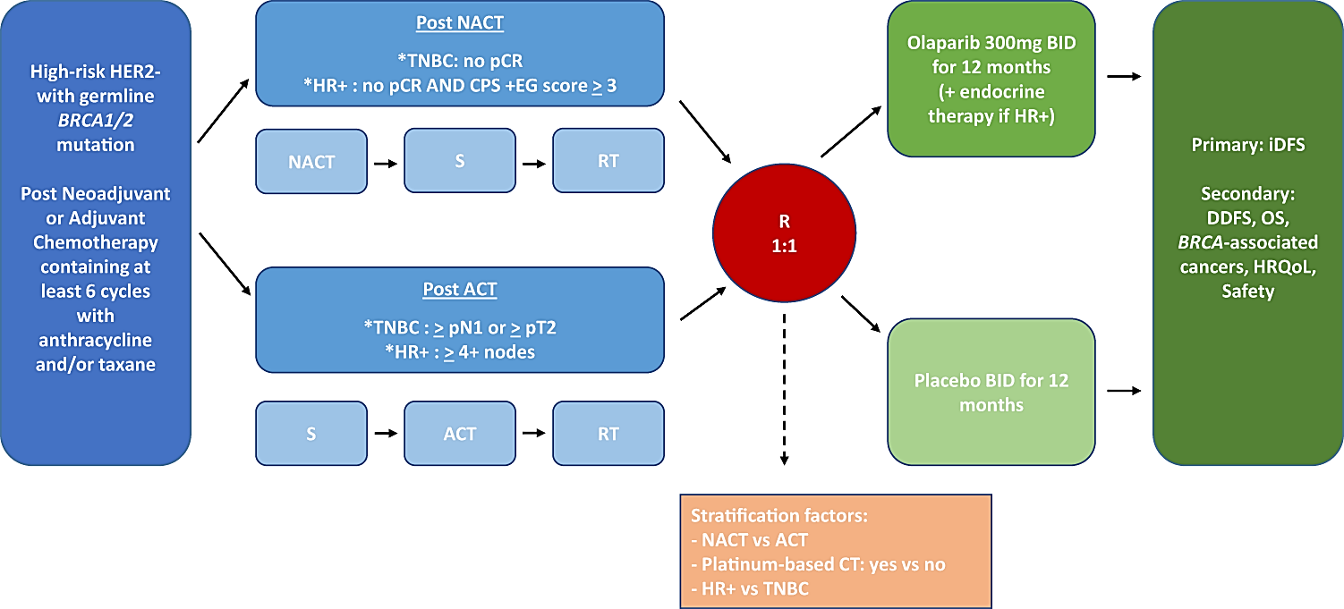
NACT = neoadjuvant chemotherapy, ACT = adjuvant chemotherapy, S = surgery, RT = radiation therapy, HR+ = hormone receptor-positive, TNBC = triple-negative breast cancer, R = randomised, iDFS = invasive disease-free survival, DDFS = distant disease-free survival, OS = overall survival, HRQoL = health-related quality of life, CT = chemotherapy.
Table 4. The main inclusion and exclusion criteria of OlympiA
Inclusion | Exclusion
- Consenting, compliant adults (age 18+), with WHO PS 0-1 and adequate organ function  - Histologically confirmed, non-metastatic, HER2-negative, primary invasive adenocarcinoma of the breast  - High-risk disease after the completion of surgery and neoadjuvant or adjuvant therapy  - Presence of gBRCAm | - Pregnancy or breastfeeding  - HR+ disease, until a protocol amendment ~18 months after study start, when 408 patients with TNBC had already been enrolled

Patients were required to have completed at least 6 cycles of neoadjuvant or adjuvant chemotherapy containing anthracyclines, taxanes, or both, in addition to having completed adequate primary breast and axilla surgery. Prior platinum as potentially curative treatment for prior cancer (e.g., ovarian) or as adjuvant or neoadjuvant treatment for breast cancer was allowed. Patients with HR+ breast cancer were allowed to continue concurrent treatment with endocrine therapy according to local guidelines.
High-risk EBC was defined as that meeting all the following criteria:
- If treated with initial surgery prior to adjuvant chemotherapy, and
  - was hormone receptor positive (HR+), had at least 4 pathologically confirmed positive lymph nodes.
  - was TNBC, had axillary node-positive disease and/or a ≥2cm primary tumour.
  - If treated with neoadjuvant therapy prior to initial surgery, and had residual invasive cancer in the breast and/or the resected lymph nodes at time of surgery (i.e. a lack of pathological complete response; pCR), and if HR+, had a CPS&EG score ≥3 (This is a scored based on the pretreatment clinical stage and post-treatment pathological stage (CPS score) as well as oestrogen receptor status and tumour grade (EG score).
Only patients with a deleterious or suspected deleterious gBRCAm (in BRCA1 or BRCA2) were eligible for enrolment. Those enrolled based on a local testing result required confirmation by central testing using the Myriad gBRCA test, except for patients enrolled in China as samples were not able to be exported.
A total of 1836 patients were randomised (1:1) to receive either olaparib (n=921) 300mg twice daily (with or without food) or matching placebo (n=915). This dose regimen for olaparib is in line with that previously approved for other indications (ovarian, breast, pancreatic and prostate cancer).
Randomisation was stratified by hormone receptor status (ER and/or PR positive/HER2-negative vs TNBC), prior neoadjuvant vs adjuvant chemotherapy, and prior platinum use for breast cancer (yes vs no).
Treatment was continued for up to 1 year or until disease recurrence or unacceptable toxicity. Dose modifications were allowed, but no re-escalation. Treatment was permanently discontinued if a delay of >4 weeks occurred for any reason.
The primary efficacy endpoint was invasive disease-free survival (IDFS), defined as the time from randomisation to date of first recurrence (defined as invasive loco-regional, distant recurrence, or contralateral invasive breast cancer), new cancer, or death from any cause. Alpha-controlled secondary endpoints included distant disease-free survival (DDFS) and overall survival (OS).
Hierarchical testing was used to control type 1 error, with IDFS followed by DDFS then OS (see Figure 3).
Figure 3. Multiplicity and OS assumptions in OlympiA
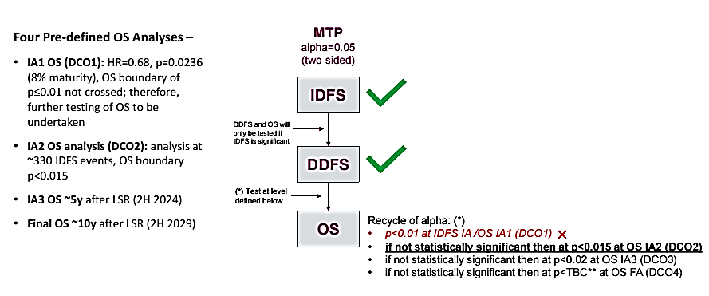
Exploratory analyses were conducted but were not alpha controlled so have not contributed significantly to the regulatory decision. These included IDFS, DDFS and OS in the subset of the study population in whom gBRCAm was confirmed by a central Myriad (BRCAAnalysis) test.

Population
The primary efficacy endpoint was tested in the full analysis set (FAS) [n=1836] on an intention-to-treat (ITT) basis.
Ten patients in the olaparib arm and 11 in the placebo arm did not receive treatment. More patients on the olaparib arm compared the placebo arm discontinued treatment due to patient decision (60 patients vs 32 patients).
Amongst the FAS, there were 6 male patients (2 randomised to olaparib and 4 to placebo). The median age was 42 (range 22 to 78) years, in keeping with the inclusion requirement for a gBRCAm. Most patients (61%) were pre-menopausal, and of the 38% who were postmenopausal, around half (19% of the FAS) were so due to prophylactic bilateral oophorectomy. Most patients (67%) were Caucasian and 29% were Asian; 89% had an ECOG PS of 0; and half had received prior neoadjuvant treatment while the other half had received prior adjuvant treatment: almost all (94%) had received an anthracycline and taxane regimen.
The majority of patients (72%) had a BRCAm in the BRCA1 gene, in keeping with the higher proportion of TNBC in the study. Of the 18% (n=325) who had HR+ disease, 291 (89.5%) received adjuvant endocrine therapy per local guidelines. Of the 34 who did not, most were either PR+/ER- (whether this represents a testing artefact has been debated, but it appears at least reasonably possible this represents a true biological entity) or ER-low. This is in keeping with the study protocol, and with clinical guidelines that state that the use of adjuvant endocrine therapy in patients with low or no ER-positivity is clinical judgement call to be made based on individual circumstances.
The subset in whom gBRCAm status was confirmed centrally using the Myriad test (the Myriad-confirmed subset) included 1539 patients from the FAS. Their baseline characteristics were similar, though a higher proportion were Caucasian (77%) relative to Asian (18%), as many of the patients for whom this testing couldn’t be conducted had samples that couldn’t be exported from China.

Results
Key efficacy results for the OlympiA study are summarised in Table 5 and Figure 4. A statistically significant improvement in IDFS and DFS (at DCO1) and OS (at DCO2) was demonstrated in patients in the olaparib arm compared with the placebo arm.
The results of four sensitivity analyses of IDFS (including only patients with central results for HR status, using unadjusted analysis, using interval censoring, and using the restricted mean survival time [RMST] method) were consistent with the primary analysis.
Subgroup analyses of IDFS and OS are presented as forest plots in Figure 6 and Figure 14. Nine out of 49 pre-planned subgroup analyses for IDFS were not conducted due to low event numbers (<5 events in a subgroup within a treatment arm). The subgroup analyses did not raise concerns about differential treatment effects or harm in the examined subgroups.
PARPi following recurrence was received by 6 patients (<1%) in the olaparib arm and 36 patients (4%) in the placebo arm.
Table 5. Key efficacy results for the FAS in OlympiA
 | Olaparib (n=921) | Placebo (n=915)
IDFS (DCO1: 27 MAR 2020) ª
Events, n (%) | 106 (12%) | 178 (19%)
HR ^{b} (95% CI) ^{c} | 0.58 (0.46, 0.74)
99.5% CI for the HR ^{d} | 0.41, 0.82
p-value ^{e} | 0.0000073
Percentage (95% CI) of patients free of invasive disease rate at: ^{f}
1 year | 93% (91, 95) | 88% (86, 90)
2 years | 89% (87, 91) | 82% (79, 84)
3 years | 86% (83, 88) | 77% (74, 80)
DDFS (DCO1: 27 MAR 2020)
Events, n (%) | 89 (10%) | 152 (17%)
HR ^{b} (95% CI) ^{c} | 0.57 (0.44, 0.74)
99.5% CI for the HR ^{d} | 0.39, 0.83
p-value ^{e} | 0.0000257
Percentage (95% CI) of patients free of invasive disease rate at:
1 year | 94% (92, 96) | 90% (88, 92)
2 years | 90% (88, 92) | 84% (81, 86)
3 years | 87% (85, 90) | 80% (77, 83)
OS at 2nd interim analysis (DCO2: 12 JUL 2021) ^{g}
Deaths, n (%) | 75 (8%) | 109 (12%)
HR ^{b} (95% CI) ^{c} | 0.68 (0.50, 0.91)
98.5% CI for the HR ^{d} | 0.47, 0.97
p-value ^{h} | 0.0091
Percentage (95% CI) of patients alive at:
1 year | 98% (97, 99) | 97 (96, 98)
2 years | 95% (93, 96) | 93% (91, 94)
3 years | 93% (91, 94) | 89% (87, 91)
4 years | 90% (87, 92) | 86% (84, 89)
CI = confidence interval; DCO = data cut-off; FAS = full analysis set; HR = hazard ratio; IDFS = invasive disease-free survival; OS = overall survival
Median duration of follow-up (calculated using the reverse censoring method): 2.3 years in the olaparib arm and 2.5 years in the placebo arm. IDFS data at 16% maturity.
Cox proportional hazards model stratified by chemotherapy type (2 levels: adjuvant versus neoadjuvant), hormone receptor status (2 levels: ER and/or PR positive, HER2 negative versus TNBC), and prior platinum therapy (2 levels: yes versus no). Stratification factors were based upon the categories used in the randomisation system and were chosen by pooling strategy. Once the pooling strategy was applied, only the hormone receptor status stratification factor was selected.
Exploratory, estimated using the profile likelihood approach.
Inferential, according to the alpha spending rules for the interim analysis. Estimated using the profile likelihood approach.
Log-rank test, stratified as for the Cox PH model above. 2-sided significance level = 0.005
Non alpha-controlled KM estimates, with 95% Cis calculated using Greenwood’s formula
Median duration of follow-up: 3.5 years in the olaparib arm and 3.6 years in the placebo arm. OS data at 10% maturity.
Log-rank test, stratified as for the Cox PH model above. 2-sided significance level = 0.015

Figure 4. Kaplan-Meier plot of IDFS in the FAS of OlympiA at the primary analysis (DCO 27 March 2020)
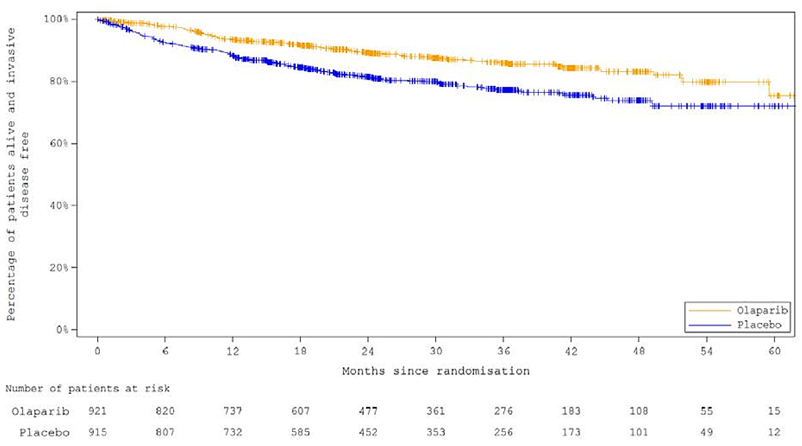
DCO = data cut-off; FAS = full analysis set; IDFS = invasive disease-free survival.
Figure 5. Kaplan-Meier plot of OS in the FAS of OlympiA at the planned 2nd interim analysis (DCO 12 JUL 2021)
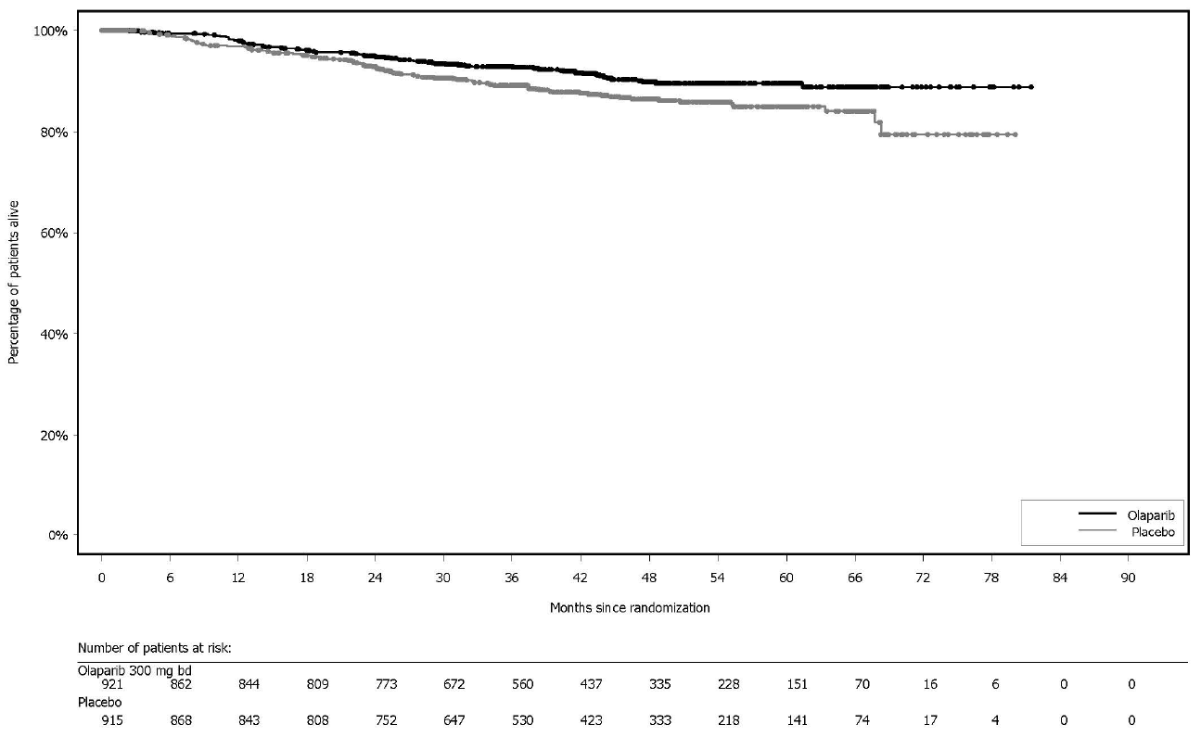
DCO = data cut-off; FAS = full analysis set; OS = overall survival.
Figure 6. Forest plot of subgroup analyses for the primary endpoint (IDFS) in OlympiA at data cut-off 27 MAR 2020
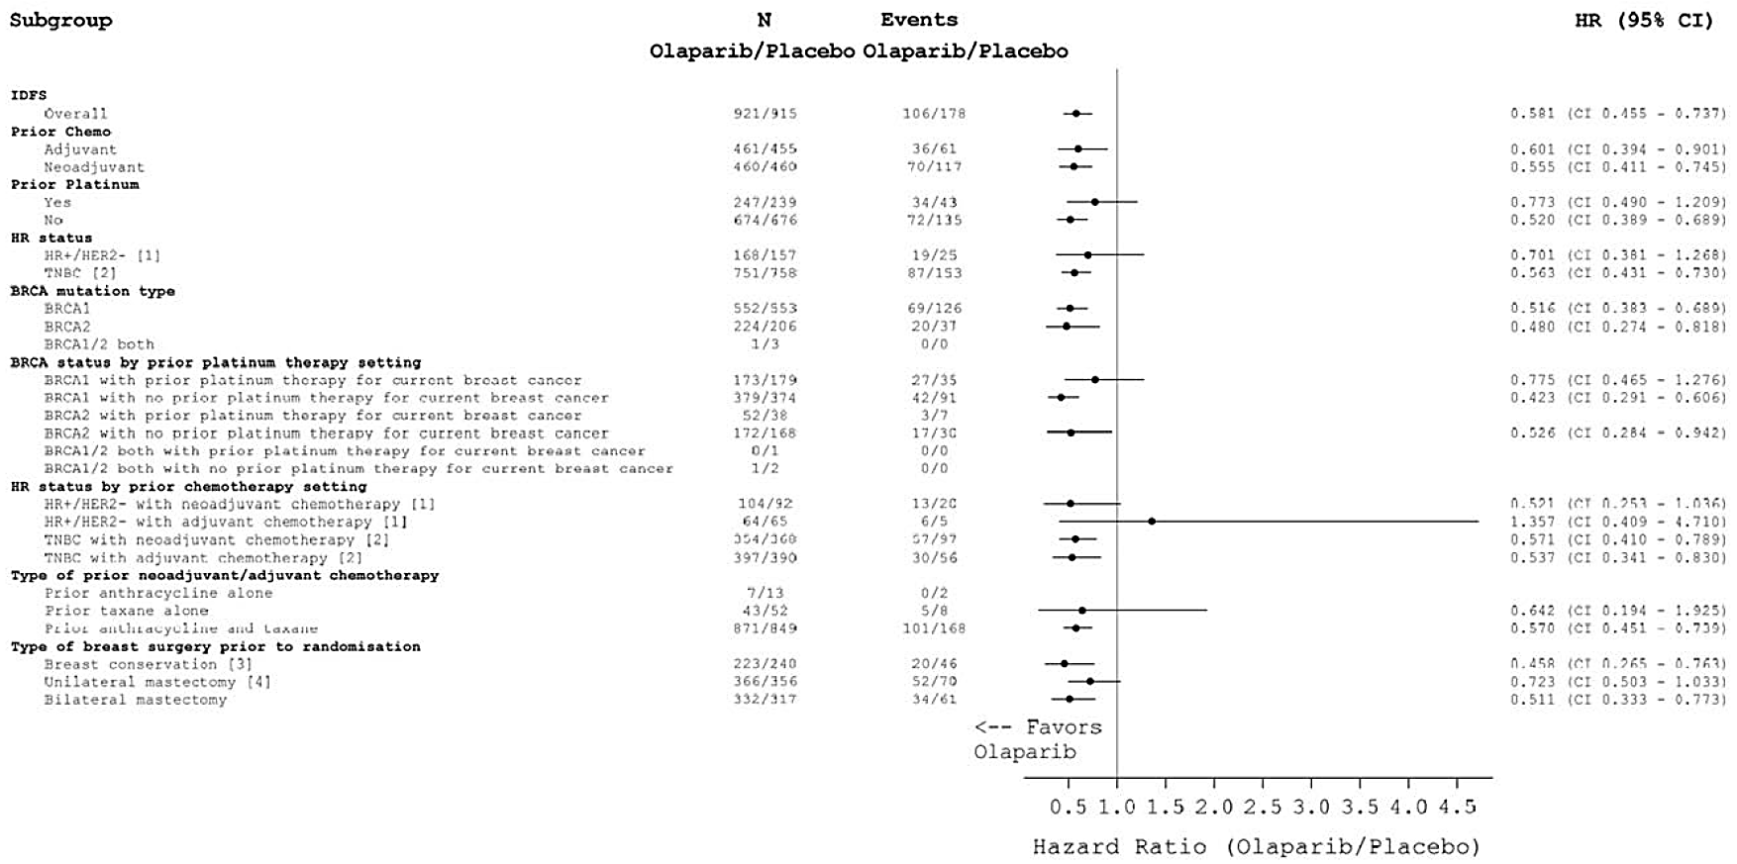
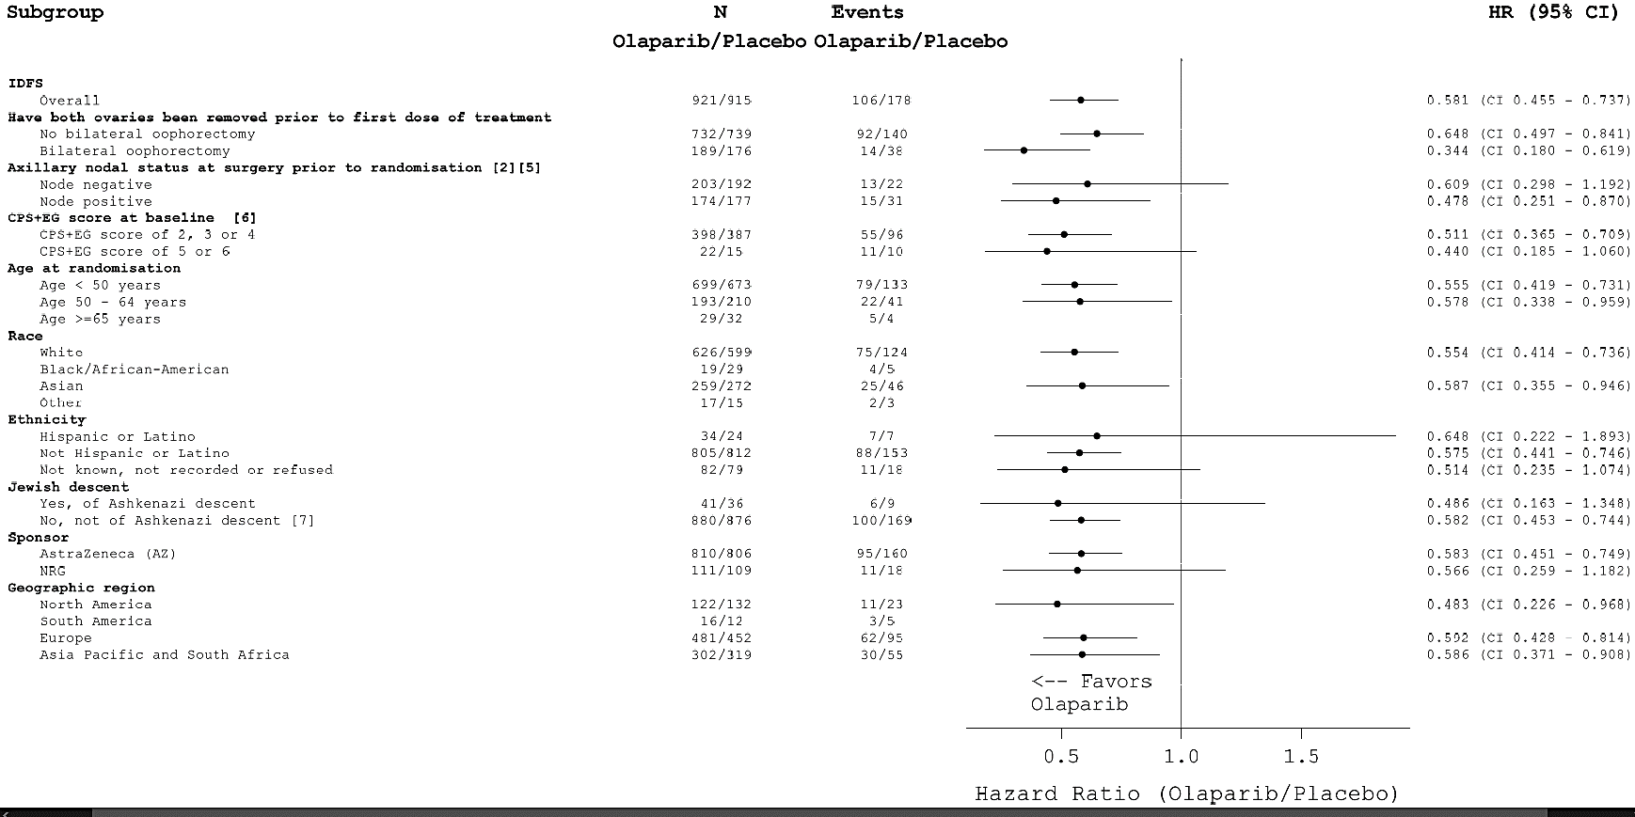
1 HR+ was defined as ER positive and/or PgR positive.
2 Two patients were excluded from the summary of the TNBC subset because they did not have confirmed negative HER2 status.
3 Breast conservation was defined as partial mastectomy/breast quadrantectomy/breast segmentectomy/breast lumpectomy and breast re-excision of margins.
4 Unilateral mastectomy was defined as modified radical mastectomy, radical mastectomy (Halsted), or simple mastectomy.
5 Triple negative breast cancer, adjuvant patients only, with sentinel node sampling or axillary node dissection.
6 Post-neoadjuvant group only.
7 Not Ashkenazi Jewish means that the patient was either Jewish but not Ashkenazi Jewish, not Jewish, or descent recorded as unknown.
Note: Ten olaparib-treated patients and 8 placebo-treated patients in the missing race category were analysed in race subgroup "other".
Note: According to data collected on the eCRF for prior platinum use, 485 patients in total received prior platinum therapy. However, this output takes prior platinum use data from the stratification eCRF which incorrectly indicates one additional patient in the placebo arm received prior platinum (the site confirmed this was not the case). As the database was not updated to amend this discrepancy at this DCO, this output incorrectly shows that 486 patients received prior platinum therapy.
BRCA = breast cancer susceptibility gene; CI = confidence interval; CPS+EG = clinical stage (CS), oestrogen receptor status (E), nuclear grade (G), and posttreatment pathologic stage (PS) – a disease scoring system; ER = oestrogen receptor; FAS = full analysis set; HER2 = human epidermal growth factor receptor 2; HR = hazard ratio; HR+ = hormone receptor positive; HR status = hormone receptor status; IDFS = invasive disease free survival; PgR = progesterone receptor; TNBC = triple negative breast cancer.

Figure 7 Forest plot of OS in subgroups in OlympiA at data cut-off 12 JUL 2021
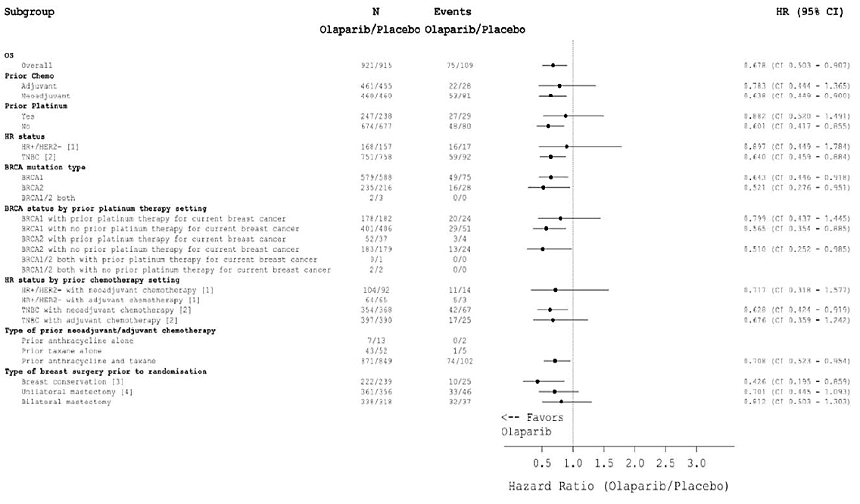
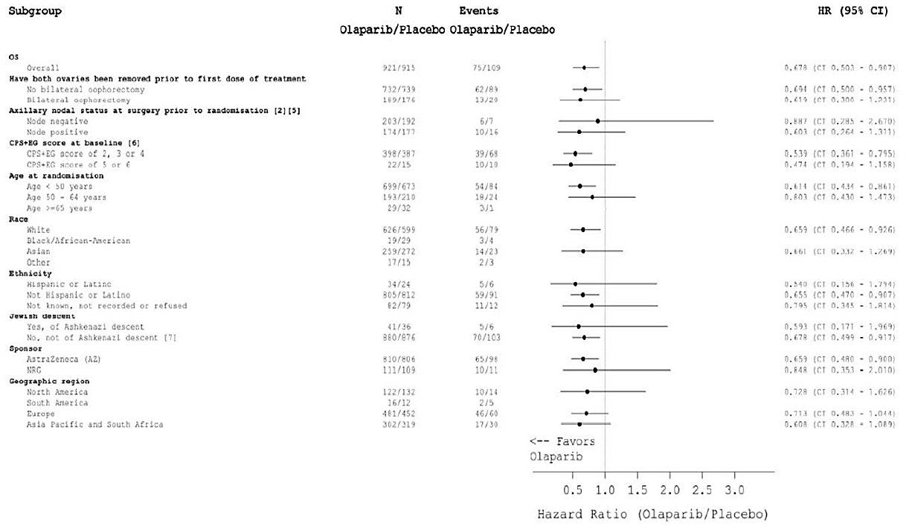
BRCA = breast cancer susceptibility gene; CI = confidence interval; CPS+EG = clinical stage (CS), oestrogen receptor status (E), nuclear grade (G), and post-treatment pathologic stage (PS) – a disease scoring system; ER = oestrogen receptor; FAS = full analysis set; HER2 = human epidermal growth factor receptor 2; HR = hazard ratio; HR+ = hormone receptor positive; HR status = hormone receptor status; N = total number of patients; OS = overall survival; PgR = progesterone receptor; TNBC = triple negative breast cancer.
Hormone receptor positive was defined as ER positive and/or PgR positive.
Two patients were excluded from the summary of the TNBC subset because they did not have confirmed negative HER2 status.
Breast conservation was defined as partial mastectomy/breast quadrantectomy/breast segmentectomy/breast lumpectomy and breast re-excision of margins.
Unilateral mastectomy was defined as modified radical mastectomy, radical mastectomy (Halsted), or simple mastectomy.
Triple negative breast cancer, adjuvant patients only, with sentinel node sampling or axillary node dissection.
Post-neoadjuvant group only.
Not Ashkenazi Jewish means that the patient was either Jewish but not Ashkenazi Jewish, not Jewish, or descent recorded as unknown.
Note: Ten olaparib-treated patients and 8 placebo-treated patients in the missing race category were analysed in race subgroup "other".

Efficacy data relevant to the proposed prostate cancer indication

PROpel (D081SC00001) – pivotal study for proposed first-line prostate cancer indication

Design
PROpel is a randomised, double-blind, placebo-controlled, international phase III trial (126 centres in 17 countries) of olaparib as an add-on to first-line abiraterone (plus steroid) treatment for men with metastatic castration-resistant prostate cancer (mCRPC). Enrolment commenced in October 2018 and the last patient was enrolled in March 2020. Figure 6 shows a summary of the study design, including the main selection criteria.
Eligible patients had not received chemotherapy or NHA for a prostate adenocarcinoma that was metastatic and castration-resistant. Patients had to be candidates for abiraterone therapy, with documented evidence of progressive disease defined by PSA progression and/or radiological progression. Patients were eligible regardless of presence of symptomatic disease or visceral metastases (except brain metastases). An archival formalin-fixed, paraffin-embedded tumour tissue sample, or a new biopsy taken during the screening window, was required before randomisation.
Patients were randomised 1:1 to either olaparib 300 mg BD or matching placebo, in addition to background of abiraterone 1000 mg daily and either prednisone or prednisolone 5 mg orally BD. Randomisation was stratified by site of distant metastases (bone only v. visceral v. other) and receipt of prior taxane for metastatic hormone-sensitive disease (yes v. no).
Randomisation was not stratified based on HRR status. HRR mutation status for all randomised patients was determined retrospectively by central testing, performed by Foundation Medicine Inc. using the FoundationOne®CDx (F1CDx) test on tumour tissue samples and the FoundationOne®Liquid CDx (F1LCDx) on whole blood samples.
Treatment was continued until disease progression or unacceptable toxicity. Crossover from placebo+abiraterone to olaparib+abiraterone was not allowed.
The primary endpoint was radiologically-determined PFS (rPFS) per investigators according to RECIST v1.1 (soft tissue) and PCWG-3 (bone) criteria, in the full analysis set (FAS). Blinded independent central review (BICR) was also conducted. The key secondary endpoint was OS. The remaining endpoints were not controlled for multiplicity.
Figure 8. Schema of the PROpel study design
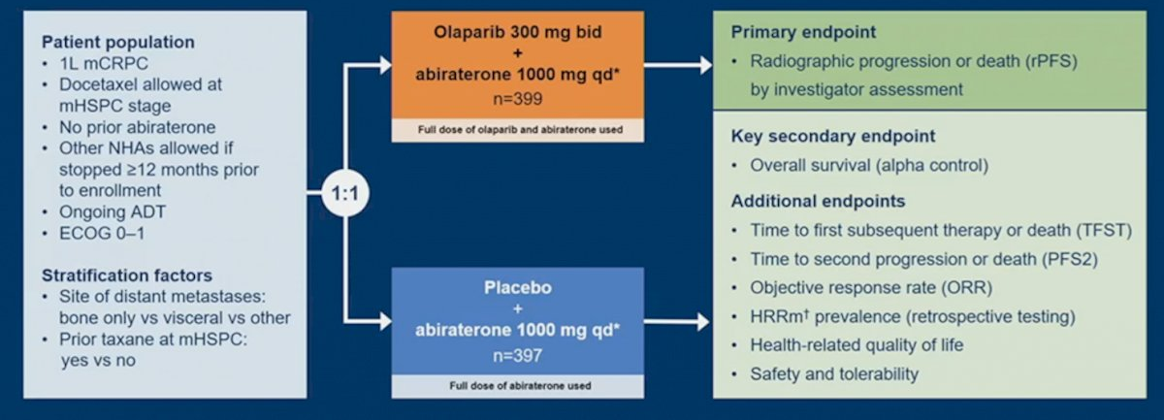
ADT = androgen deprivation therapy; ECOG = Eastern Cooperative Oncology Group performance status; mCRPC = metastatic castration-resistant prostate cancer; mHSPC = metastatic hormone-sensitive prostate cancer; NHA = new hormonal agent; qd* = daily, in combination with steroid.

Population
A total of 796 patients were randomised in the study: 399 to receive olaparib and 397 to receive the matching placebo. One patient in each arm did not continue to receive treatment.
Amongst the FAS, the median age was 69 (range 43 to 91) years, and 71% were over 65. Most patients (17%) were Caucasian and 17% were Asian; 70% had an ECOG PS of 0; 79% had received prior hormonal therapy, 25% had received prior cytotoxic chemotherapy, and 50% had received prior radiation therapy. Most had bone involvement at enrolment (86%), and for 54%, bone was the only metastatic site at enrolment.
HRR status was defined as HRRm (where a deleterious variant was detected either F1CDx or F1LCDx), non-HRRm (where non-deleterious variants were detected) or HRRm unknown (where test failure occurred or where no sample was tested). Results of FoundationOne testing are summarised in Table 6.
For tissue testing, success rates were 68% at both patient and sample level, consistent with what was seen in the PROfound study. For ctDNA (blood sample) testing, success rates were 92% at a patient level and 84% at a sample level.
There were 85 patients (10.7% of the randomised population) who were BRCAm according to either test.
Table 6. HRRm and BRCAm status in PROpel
 | FoundationOne CDx (tissue) | FoundationOne Liquid Cdx (ctDNA)
Total, n (%) | 796 (100) | 796 (100)
BRCAm, n (%) | 50 (6.3) | 69 (8.7)
Non-BRCAm, n (%) | 485 (60.9) | 665 (83.5)
HRRm, n (%) [prevalence] | 118 (14.8) [22.1] | 198 (24.9) [27.0]
Non-HRRm | 417 (52.4) | 536 (67.3)
Test failure, n (%) | 247 (31) | 60 (7.5)
No sample, n (%) | 14 (1.8) | 2 (0.3)

Results
Key efficacy results for the PROpel study are summarised in Table 7 and Figure 7. At the first data cut-off (DCO1), a statistically significant improvement in rPFS was demonstrated in patients in the olaparib arm compared with the placebo arm. A sensitivity analysis using BICR assessment concurred, reporting an rPFS HR (95% CI) of 0.61 (0.49, 0.74).
Table 7. Key efficacy results for the FAS in PROpel
 | Olaparib (n=399) | Placebo (n=397)
rPFS (DCO1: 30 JUL 2021) ª per Investigator
Events, n (%) | 168 (42%) | 226 (57%)
Median (95% CI), months | 24.8 (20.5, 27.6) | 16.6 (14.0, 19.2)
HR (95% CI) ^{b} | 0.66 (0.54, 0.81)
2-sided p-value ^{c} | < 0.0001
OS (DCO3: 14 MAR 2022)
Deaths, n (%) | 176 (44%) | 205 (52%)
HR (95% CI) | 0.81 (0.67, 1.00)
CI = confidence interval; DCO = data cut-off; FAS = full analysis set; HR = hazard ratio; rPFS = radiographic progression-free survival; OS = overall survival
Median duration of follow-up 16.5 months in the olaparib arm and 14.0 months in the placebo arm. rPFS data at 49.5% maturity.
Cox proportional hazards model stratified by same categories used in the randomisation system.
Log-rank test, stratified as for the Cox PH model above. 2-sided significance level = 0.0324
Figure 7. Kaplan-Meier plot of rPFS per Investigator in the FAS of PROpel at the primary analysis (DCO 30 JUL 2021)
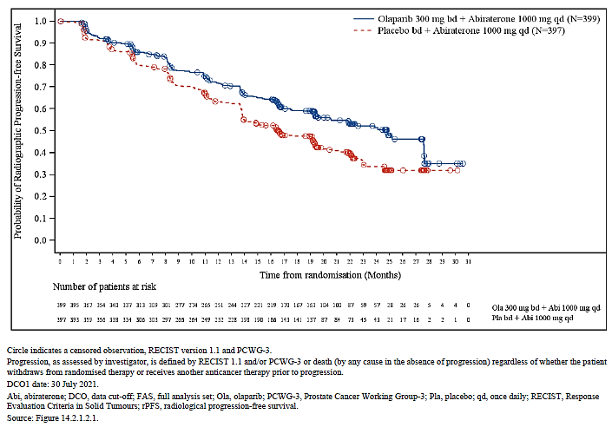

Figure 8. Kaplan-Meier plot of OS in the FAS of PROpel at the planned 3rd interim analysis (DCO 12 OCT 2022)
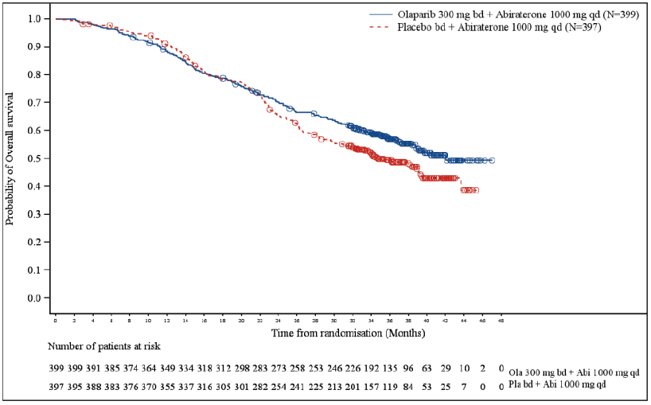
DCO = data cut-off; FAS = full analysis set; OS = overall survival.
Source: CSR Addendum 2 for PROpel, “Figure 4”

Subgroup analysis of PROpel results
Subgroup analyses of rPFS were presented in the CSRs for all pre-planned subgroups, which included a category of HRR based on grouping a set of HRR genes, but not BRCAm independently.

Study 8 (D081DC00008) – supporting study for proposed first-line prostate cancer indication
This was a randomised phase 2 study (NCT01972217) that preceded PROpel (patients were enrolled between APR 2014 and JUL 2015) and appears to have contributed to the design of PROpel. It was undertaken to investigate the value of adding olaparib to NHA treatment in prostate cancer, in light of the accumulating evidence that NHA treatment may induce “BRCA-ness.”
Part A was safety-focussed.
In Part B, 142 patients with mCRPC who had previously received prior docetaxel received abiraterone 1000 mg daily (plus steroid) and were randomised 1:1 to additionally receive either olaparib 300 mg BD or a matching placebo.
As for PROpel, the primary endpoint was rPFS. The primary outcome found a HR (95% CI) of 0.65 (0.44, 0.17), justifying further study of this combination in PROpel. At the time of DCO for the submitted report (2 SEP 2017), OS data remained at 61% maturity (88 of 142 events), and the HR (95% CI) for OS was 0.79 (0.51, 1.2).
In Study 8, tBRCA was tested in archival tissue where available. Due to the relatively low prevalence of BRCA and ATM mutations in mCRPC, the sponsor made changes to the planned analyses first to include a new subgroup containing 12 other (non-ATM, non-BRCA) HRR gene mutations, and then to merge these with the ATM and BRCA mutations to form a 15-gene HRR group.
The following text are the reasons given for these changes, respectively:
- Prevalence of BRCA/ATM mutation carriers in the all-comer mCRPC population is too low to enable subgroup analysis. The subgroup analysis was extended to include a further 12 HRR genes in order to incorporate additional genes beyond BRCA1, BRCA2 and ATM that were expected to respond to olaparib based on preclinical evidence and limited clinical evidence. Inclusion of these additional genes expanded the subgroups, enabling interpretation of the study results with regards to relationship between HRR deficiency and response.
- The new classification provides a more comprehensive patient profile.
Where a subgroup had less than 5 events in each treatment arm, no statistical comparison was performed. Whilst this reflected the pre-specified analysis plan, no descriptive statistics appear to have been included.
The results of the subgroup analysis of rPFS by HRR status are summarised in Table 8.
Table 8. Exploratory rPFS subgroup results of study 8 according to HRR status (15-gene composite)
 | Olaparib | Placebo
rPFS in the overall population
Number of patients | 71 | 71
Events, n (%) | 46 (65%) | 54 (76%)
Median (95% CI), months | 13.8 | 8.2
HR (95% CI) | 0.651 (0.44, 0.97)
Nominal 2-sided p-value | 0.034
rPFS in HRRm
Number of patients | 11 | 10
Events, n (%) | 8 (73%) | 7 (70%)
Median (95% CI), months | 17.8 | 6.5
HR (95% CI) | 0.744 (0.26, 2.12)
Nominal 2-sided p-value | 0.581
rPFS in non-HRRm
Number of patients | 15 | 20
Events, n (%) | 8 (53%) | 17 (85%)
Median (95% CI), months | 15.0 | 9.7
HR (95% CI) | 0.521 (0.24, 1.15)
Nominal 2-sided p-value | 0.106
rPFS in HRR unknown
Number of patients | 45 | 41
Events, n (%) | 30 (67%) | 30 (73%)
Median (95% CI), months | 13.1 | 6.4
HR (95% CI) | 0.669 (0.40, 1.13)
Nominal 2-sided p-value | 0.130
CI = confidence interval; HR = hazard ratio; HRR = homologous recombination repair; rPFS = radiographic progression-free survival.

The report concludes:
Efficacy in relation to rPFS was shown in an exploratory analysis of patient subgroups for composite HRR mutations including BRCA1, BRCA2, ATM and a panel of 12 additional genes (15 genes in total). The results in the 3 subgroups analysed (HRRm positive, negative and partly characterised) were consistent with the primary analysis, showing no notable differences in efficacy. These results support the study hypothesis that in a setting where olaparib is combined with abiraterone, added clinical benefit as assessed by PFS is observed irrespective of HRRm status, a finding unlike that seen with olaparib monotherapy, for which a strong dependency on HRRm status was observed. The results must, however, be viewed with caution due to the small sample size in these subgroups.

Safety

Olympia (D081CC00006)
The main safety data supporting the proposed indication come from the OlympiA study, in which 1836 patients who received at least one dose of study treatment, including 911 patients in the olaparib arm and 905 patients in the placebo arm. Adverse events reported in the study were graded using CTCAE Version 4.03. If olaparib was interrupted due to an adverse event (AE), dosing was held ≤Grade 1 unless specified otherwise in the dose modification instructions.
Overall, no new safety findings were reported in OlympiA following 12 months of olaparib treatment in the adjuvant setting, and the safety observations are consistent with the established safety profile of olaparib.
The sponsor also submitted a pooled dataset across tumour types for olaparib monotherapy at the proposed dose (300 mg BD). This pool was highly heterogeneous, and included patients with advanced ovarian, fallopian tube, or primary peritoneal (45%), breast (39%), prostate (9%), pancreatic (3%), or colorectal (<1%) cancer. Patients were generally heavily pre-treated.

Exposure
In OlympiA, the median total intended exposure was 364 days (12 months) in both treatment arms. The actual median number of days on 300 mg BD treatment was 338 days, and the median actual treatment duration was 350 days.

Overview of safety
Table 9 contains a summary of safety data in OlympiA.
Table 9. Overview of safety in OlympiA
 | Olaparib (N=911), % | Placebo (N=904), %
All-grade TEAEs | 92 | 83
Grade 3-4 | 18 | 9
Grade 5 | 0.1 | 0
Serious AEs (SAEs) | 9 | 8
Drug withdrawn due to AEs | 10 | 4.2
Drug interrupted due to AEs | 31 | 10
Dose reduced due to AEs | 23 | 3.5
AE = adverse event; N = number of patients; TEAE = treatment-emergent adverse event

Adverse events in OlympiA
In the olaparib arm, the most common (incidence at least 10%) treatment-emergent adverse events (TEAEs) were nausea, fatigue, anaemia, vomiting, headache, diarrhoea, leukopenia, neutropenia, decreased appetite, dysgeusia, dizziness, and stomatitis. The most common severe (grade 3-4) TEAEs were anaemia, neutropenia, leukopenia, lymphopenia and fatigue. Table 10 contains the table of common AEs from the approved FDA label, and Table 11 contains the table of common laboratory abnormalities in OlympiA (also from the FDA label).

Table 10. Adverse Reactions* in OlympiA (≥10% of Patients Who Received Lynparza) [table from approved FDA label]
Adverse Reactions | Lynparza tablets n=911 |  | Placebo n=904
Adverse Reactions | Grades 1-4 (%) | Grades 3-4 (%) | Grades 1-4 (%) | Grades 3-4 (%)
Gastrointestinal Disorders
Nausea | 57 | 0.8 | 23 | 0
Vomiting | 23 | 0.7 | 8 | 0
Diarrhea | 18 | 0.3 | 14 | 0.3
Stomatitis† | 10 | 0.1 | 4.5 | 0
General Disorders and Administration Site Conditions
Fatigue (including asthenia) | 42 | 1.8 | 28 | 0.7
Blood and Lymphatic Disorders
Anaemia‡ | 24 | 9 | 3.9 | 0.3
Leukopenia§ | 17 | 3 | 6 | 0.3
Neutropenia¶ | 16 | 5 | 7 | 0.8
Nervous System Disorders
Headache | 20 | 0.2 | 17 | 0.1
Dysgeusia# | 12 | 0 | 4.8 | 0
Dizziness | 11 | 0.1 | 7 | 0.1
Metabolism and Nutrition Disorders
Decreased appetite | 13 | 0.2 | 6 | 0
* Graded according to the National Cancer Institute Common Terminology Criteria for Adverse Events (NCI CTCAE), version 4.03
† Includes aphthous ulcer, mouth ulceration, stomatitis.
‡ Includes anaemia, anaemia macrocytic, erythropenia, haematocrit decreased, haemoglobin decreased, normochromic anaemia, normochromic normocytic anaemia, normocytic anaemia, red blood cell count decreased.
§ Includes leukopenia, white blood cell count decreased.
¶ Includes agranulocytosis, febrile neutropenia, granulocyte count decreased, granulocytopenia, idiopathic neutropenia, neutropenia, neutropenic infection, neutropenic sepsis, neutrophil count decreased.
# Includes dysgeusia, taste disorder.
TEAEs in OlympiA that occurred in <10% of patients receiving olaparib were cough (9.2%), lymphopenia (7%), dyspepsia (6%), upper abdominal pain (4.9%), rash (4.9%), dyspnoea (4.2%), thrombocytopenia (4.2%), increase in creatinine (2%), VTE (0.5%), hypersensitivity (0.9%), dermatitis (0.5%), increase in mean corpuscular volume (0.2%), and MDS/AML (0.1%).
Table 11. Laboratory Abnormalities Reported in ≥25% of Patients in OlympiA [table from approved FDA label]
Laboratory Parameter* | Lynparza tablets n†= 911 |  | Placebo n†=904
Laboratory Parameter* | Grades 1-4 (%) | Grades 3-4 (%) | Grades 1-4 (%) | Grades 3-4 (%)
Decrease in lymphocytes | 77 | 13 | 59 | 3.7
Decrease in haemoglobin | 65 | 8 | 31 | 0.9
Decrease in leukocytes | 64 | 5 | 42 | 0.7
Increase in mean corpuscular volume‡ | 67 | 0 | 4.8 | 0
Decrease in absolute neutrophil count | 39 | 7 | 27 | 1.1
* Patients were allowed to enter clinical studies with laboratory values of CTCAE Grade 1.
† This number represents the safety population. The derived values in the table are based on the total number of evaluable patients for each laboratory parameter.
‡ Represents the proportion of subjects whose mean corpuscular volume was > ULN.
Abnormal laboratory values were predominantly low grade apart from decrease in lymphocytes (grade 3-4 decrease occurred in 13% of the olaparib and 4% of the placebo arm) and haemoglobin (grade 3-4 decrease occurred in 8% of the olaparib and 1% of the placebo arm).
No hepatobiliary or renal safety concerns were identified from review of the laboratory and adverse event (AE) data.
A higher percentage of patients in the olaparib arm compared with the placebo arm reported AEs of CTCAE Grade ≥3 (24% vs 11%, respectively), AEs leading to discontinuation (10% vs 4%, respectively), AEs leading to dose interruption (31% vs 11%, respectively), and AEs leading to dose reduction (23% vs 4%, respectively). Serious AEs occurred in a similar proportion of patients in the olaparib and placebo arms (9% vs 8%, respectively). The most common serious adverse reactions in patients in the olaparib arm were nausea, fatigue and anaemia.
The most common AE in the olaparib arm of all these categories was anaemia, except for AEs leading to discontinuation, where nausea was the most common.
The sponsor identified myelodysplastic syndrome/acute myeloid leukaemia (MDS/AML), pneumonitis, and secondary malignancies as adverse events of special interest (AESI) for OlympiA, based on toxicity concerns throughout the olaparib development program. These events were all more common in the placebo arm than the olaparib arm:
- There were 5 patients with events of MDS/AML (2 patients [0.2%] in the olaparib arm and 3 patients [0.3%] in the placebo arm).
- There were 46 patients with events of new primary malignancies (16 patients [1.8%] in the olaparib arm and 30 patients [3.3%] in the placebo arm).
- There were 20 patients with events of pneumonitis (9 patients [1.0%] in the olaparib arm and 11 patients [1.2%] in the placebo arm).
No new adverse drug reactions were identified from OlympiA.

Deaths
The majority of deaths in the study were attributed to breast cancer recurrence. There were 4 patients with fatal AEs (1 patient [1.7%] in the olaparib arm [cardiac arrest] and 3 patients [3.5%] in the placebo arm [acute myeloid leukaemia, leukaemia, and ovarian cancer]) during study treatment or after the 30-day follow up. These cases were:
- Olaparib arm:
  - A Caucasian female who was in the olaparib arm presented to the emergency department with dyspnoea on study day 76 and was diagnosed with influenza H1N1. On study day 79, the patient presented again to ED with severe respiratory insufficiency and cardiac arrest. She was resuscitated and admitted to the intensive care unit where she experienced another cardiac arrest which she did not survive. This adverse event was felt to not be related to study drug given underlying influenza, advanced age and underlying cardiac disease.
- Placebo arm:
  - An Asian female who was in the placebo arm presented on the last day of treatment (study day 369) with a platelet count of 103 with blast cells noted in the periphery. Acute myeloid leukemia (AML) was diagnosed by bone marrow biopsy and cytogenetic testing. The patient received induction chemotherapy with idarubicin and cytarabine but died due to complications of bone marrow transplantation. This patient’s AML is likely related to 5 months of neoadjuvant chemotherapy she completed around 14 months prior.
  - A BRCA-positive Caucasian female who was in the placebo arm presented with abdominal pain. Endoscopy a month later was normal, but CT abdomen/pelvis showed ascites and peritoneal carcinomatosis. Abdominal laparotomy with biopsy identified ovarian adenocarcinoma. Study drug was stopped on Day 142. The patient died secondary to ovarian adenocarcinoma which was felt to be related to her BRCA positivity.
  - A female in the placebo arm had an SAE of leukaemia 85 days after the last dose of study treatment and died 660 days after the last dose of study treatment. A patient narrative was not included as the patient died after the 30 day follow-up period.

PROpel (D081SC00001)
The TGA clinical evaluator’s review focussed on the sponsor’s summary of clinical safety which used a data cut-off date of 30 July 2021. The below data reflects the later cut-off (14 MAR 2022).

Exposure
In PROpel, at time of DCO, the median duration of exposure to olaparib was 18.5 months and to placebo was 15.7 months.
The median duration of exposure to abiraterone was 20.1 months in the olaparib-containing arm and 15.7 months in the placebo-containing arm.

Overview of safety
Table 12 contains a summary of safety data in PROpel.
Table 12. Overview of safety in PROpel
 | Olaparib (N=398), % | Placebo (N=396), %
All-grade TEAEs | 389 (98) | 378 (95)
Grade 3-4 | 187 (47) | 142 (36)
Grade 5 | 23 (6) | 18 (5)
Serious AEs (SAEs) | 154 (39) | 117 (30)
Olaparib/placebo discontinued due to AEs | 63 (16) | 32 (8)
Any study drug discontinued due to AEs | 65 (16) | 41 (10)
Olaparib/placebo dose reduced due to AEs | 85 (21) | 22 (6)
Dose of any study drug discontinued due to AEs | 107 (27) | 54 (14)
AE = adverse event; N = number of patients; TEAE = treatment-emergent adverse event

Adverse events in PROpel
The most common TEAEs in PROpel were anaemia, fatigue and nausea (Table 13).
AEs led to dose interruption, reduction or permanent discontinuation of olaparib in 48%, 21% and 16%, and of placebo in 27%, 6% and 8% of patients, respectively.
Serious AEs occurred in 39% of patients who received olaparib and 30% of those who didn’t. The most common serious adverse reactions in patients in the olaparib arm were anaemia (5.8%), COVID-19 (3.5%), and pulmonary embolism (3.5%).
AEs of Common Terminology Criteria for Adverse Events (CTCAE) Grade ≥3 were reported for 53% of patients receiving olaparib and 40% of those who did not. The most common Grade ≥3 AEs with olaparib were anaemia (15.8%) and pulmonary embolism (7.0%). Venous thromboembolism (VTE) was investigated as a safety signal after DCO1.
Table 13. Most common adverse events* in PROpel (≥25% of patients in either arm)
Adverse Reactions | Olaparib (N=398) |  | Placebo (N=396)
Adverse Reactions | Grades 1-4 (%) | Grades 3-4 (%) | Grades 1-4 (%) | Grades 3-4 (%)
Anaemia | 48 | 26 | 18 | 3
Fatigue | 38 | 2 | 30 | 2
Nausea | 30 | 0.3 | 14 | 0.3
* Graded according to the National Cancer Institute Common Terminology Criteria for Adverse Events (NCI CTCAE), v 4.03
Percentages under 1 shown to one decimal place.
Grouped term incorporating: anaemia, anaemia macrocytic, erythropenia, haematocrit decreased, haemoglobin decreased, normochromic anaemia, normochromic normocytic anaemia, normocytic anaemia, and red blood cell count decreased.
Grouped term incorporating fatigue and asthenia
Anaemia was the most common higher grade and serious event, and the AE that most commonly led to dose interruption, dose reduction or permanent discontinuation (16%, 11% and 4% of olaparib-treated patients, respectively, compared to 3%, <1% and <1% of placebo-treated patients, respectively).
Nausea was also more common with olaparib treatment and led to dose interruption in 3% and dose reduction in 1% of olaparib-treated patients, and to permanent discontinuation for one patient. Vomiting (14%) and decreased appetite (16%) were also more common with olaparib.
Neutropenia is a known risk of olaparib treatment. Neutropenia (febrile neutropenia, granulocyte count decreased, neutropenia, neutropenic infection, neutropenic sepsis, neutrophil count decreased, idiopathic neutropenia, or agranulocytosis) occurred in 9% of the olaparib arm and 4% of the placebo arm. Events were at least grade 3 severity for 4% and 2% of patients, respectively. There were no fatal events of neutropenia. Neutropenia led to dose interruption, dose reduction and permanent discontinuation in 2.5%, 0.3% and 0.3% of olaparib-treated patients, and in 0.3%, 0% and 0% of placebo-treated patients, respectively.
Myelodysplastic syndrome/acute myeloid leukaemia (MDS/AML), pneumonitis, and secondary malignancies are adverse events of special interest (AESI) for olaparib, based on toxicity concerns throughout the olaparib development program. There was one patient with MDS in the olaparib arm in PROpel, and none in the placebo arm. This patient died from COVID-19 in the setting of MDS-related pancytopenia. New primary malignancies and pneumonitis in PROpel occurred in a similar proportion of both arms (4.8% and 1.3% of the olaparib arm, and 4.3% and 0.8% of the placebo arm, respectively).
Prolongation of the QT interval on ECG is a known risk of androgen deprivation therapy (ADT) and abiraterone. ECGs were taken but QT segment length was not systematically collected. Adverse events of electrocardiogram QT prolonged were reported in 3.5% of patients in the olaparib+abiraterone arm versus 0.5% in the placebo+abiraterone arm.
No new safety concerns were identified in the safety laboratory data. There were five patients (3 receiving olaparib and 2 receiving placebo) who met the Hy’s law criteria; one was confirmed to be drug-induced liver injury, and as they were in the placebo arm it was attributed to abiraterone. The other four cases were attributable to other causes (new hepatic metastases, cholecystitis, cholangitis and choledocholithiasis).

Deaths
The majority of deaths in the study in both arms were attributed to prostate cancer. TEAEs with a fatal outcome were reported in 17 patients [4.4%] in the olaparib arm and 17 patients [4.3%] in the placebo arm during study treatment or after the 30-day follow-up period. Individual review of the case narratives did not reveal a particular pattern amongst fatal events (except for a significant proportion of deaths due to COVID-19) or suggest new safety concerns for olaparib.

Venous thromboembolism (VTE) safety signal
A new safety signal for VTE arose from the PROpel study.
VTE is common in patients with metastatic prostate cancer, especially in those receiving ADT. However, the rate of AEs within the standard MedDRA query for thrombotic or embolic events was higher amongst patients receiving olaparib (8% at DCO2) than those receiving placebo (3% at DCO2) in PROpel. This was noted at DCO1, and the sponsor conducted a dedicated safety signal analysis as a result.
VTEs in PROpel at DCO1 are summarised in Table 12. One of the events was fatal: an 80-year-old male with medical history of hypertension, hypercholesterolaemia and ischaemic heart disease was diagnosed with PE 582 days after first dose of olaparib and abiraterone as an incidental finding on a re-evaluation CT scan. When recalled for admission based on the incidental finding, the patient reported he’d been experiencing asthenia and exertional dyspnoea. The patient’s condition deteriorated following admission for management. He developed renal failure and hypotension, became comatose, and died seven days after diagnosis of PE. An autopsy was not performed.
Table 14. Study D081SC00001 (PROpel): Summary of VTEs
MedDRA  SMQ/preferred term | Olaparib + abiraterone  (N=398) |  | Placebo + abiraterone  (N=396)
MedDRA  SMQ/preferred term | Number (%) of patients | Event rate  (per 1000 patient years) | Number (%) of patients | Event rate  (per 1000 patient years)
Patients with any VTEs | 29 (7.3) | 55.1 | 13 (3.3) | 25.8
Pulmonary embolism | 26 (6.5) | 49.1 | 7 (1.8) | 13.8
Deep vein thrombosis | 7 (1.8) | 12.8 | 3 (0.8) | 5.9
Portal vein thrombosis | 0 | 0 | 1 (0.3) | 2.0
Thrombophlebitis superficial | 0 | 0 | 2 (0.5) | 3.9
A summary of VTE data across pivotal studies and amongst a pool of patients who received olaparib as monotherapy at a dose of 300 mg BD (Olaparib monotherapy 300 mg bd pool) is contained in Table 15.
Table 15. Summary of VTE AEs occurring across the olaparib program (DCO 2 October 2020)
 |  | Olaparib |  | Comparator ª
 |  | Number of patients  n (%) | Event rate  (per 1000 patient- years) | Number of patients  n (%) | Event rate  (per 1000 patient- years)
OlympiAD  N=205 olaparib  N=91 chemotherapy | Breast cancer | 2 (1.0) | 10.5 | 3 (3.3) | 72.0
SOLO2  N=195 olaparib  N=99 placebo | Ovarian cancer | 9 (1.6) | 19.0 | 1 (1.0) | 8.7
SOLO3  N=178 olaparib  N=76 chemotherapy | Ovarian cancer | 13 (7.3) | 53.2 | 4 (5.3) | 96.0
SOLO1  N=260 olaparib  N=130 placebo | Ovarian cancer | 7 (2.7) | 15.0 | 2 (1.5) | 11.5
PAOLA-1  N=535 olaparib and bevacizumab  N=267 placebo and bevacizumab | Ovarian cancer | 25 (4.7) | 35.3 | 5 (1.9) | 14.2
POLO  N=90 olaparib  N=61 placebo | Pancreatic cancer | 3 (3.3) | 28.0 | 1 (1.6) | 27.4
PROfound  N=256 olaparib  N=130 investigators choice of NHA | Prostate cancer | 20 (7.8) | 101.8 | 4 (3.1) | 66.0
Study 8  N=71 olaparib + abiraterone  N=71 placebo + abiraterone | Prostate cancer | 2 (2.8) | NC | 2 (2.8) | NC
PROpel  N=398 olaparib and abiraterone  N=396 placebo and abiraterone | Prostate cancer | 29 (7.3) | 55.1 | 13 (3.3) | 25.8
Olaparib monotherapy 300 mg bd pool  N=2134 olaparib |  | 87 (4.1) | 37.8 | NA | NA
a The comparator was physician’s choice of chemotherapy in OlympiAD (which consisted of either capecitabine, eribulin or vinorelbine) and SOLO3 (which consisted of either pegylated liposomal doxorubicin, paclitaxel, gemcitabine or topotecan). The comparator was NHA (enzalutamide or abiraterone acetate with prednisone) in PROfound.
NC: not calculated
The sponsor also provided details of 423 VTE events (in 405 patients) in their “Global patient safety database” (of spontaneous post-market reports, cumulative to 6 October 2021. Per their report:
The age of patients ranged from 18 to 86 years (median age was 63 years), 35.1% of patients were 65 years or above. The majority of patients were females (325, 80.2%) but most related to patients with ovarian or breast cancer. Time to onset ranged from less than one day (N=6, 1.4%) to up to one year (N=216, 53.3%), and was missing in 167 cases (39.5%). Thirty-four (8.0%) patients reported a VTE event over a year on treatment. Where outcome was reported (259 cases), the majority of events resolved or were resolving (151, 58.3%), 8 (2.0%) recovered with sequelae, 84 (32.4%) had not recovered and 16 (6.2%) were fatal. Outcome was not known in 149 cases.
The number of patients exposed to olaparib across its clinical development program as at 15 JUN 2021 is 17923 (8536 in clinical trials, 1904 through marketing access programs, and 7483 in investigator initiated studies).
Across the pooled safety population presented by the sponsor in their company data sheet (and in the Australian PI at present), there have been 135 events (3.3%) of VTE at any grade of severity, and 67 (1.6%) at CTCAE Grade 3 or higher amongst 4098 patients in the pool. They therefore propose to include VTE in the pooled table in the PI under the frequency “Common.”
Based on their signal analysis, the sponsor concluded as follows:
There was a higher incidence of VTEs including PE in the olaparib arm of PROfound, PROpel and PAOLA-1 studies.
Although the observed incidence of VTEs across these phase III studies is similar to the background rate in the respective patient populations, due to the weight of evidence across several well controlled, randomised, phase IIII studies which demonstrate a trend towards an increased incidence of VTEs and the lack of apparent alternative explanation, AstraZeneca considers that that there is a reasonable possibility of a causal relationship between olaparib and VTEs.
Venous thromboembolism has been identified as a new adverse drug reaction for olaparib as a result of this review. Venous thromboembolism is a well known comorbidity in oncology clinical practice, especially in patients with metastatic disease and can be a potentially life-threatening event. The reviewed data demonstrates that the majority of patients recovered from the event and were able to continue olaparib with the introduction of anticoagulant treatment based on standard medical practice. The evidence from these cases is not sufficient to indicate severe harm and additional patient monitoring or management guidance in the prescribing information, beyond routine medical practice. However, the higher incidence of events in the prostate cancer population is considered to be worth explicitly highlighting in the prescribing information. The benefits of treatment with olaparib, when used in accordance with the revised prescribing information, continue to outweigh the risks.

Delegate comment
I agree with the sponsor’s analysis in general, particularly that detailed management advice is not helpful, as oncologists are well familiar with management of VTE.
The purpose of including PI text on this risk is not to give clinicians instructions on management, but to provide data around which clinicians and patients can have adequately informed consent discussions when deciding whether to initiate treatment.
The sponsor proposes changes to the Australian PI that remove quantitative safety information regarding the incidence of VTE in the PROfound study and introducing a cross-reference to section 4.8 of the PI.
The current section 4.8 content of the Australian PI does not provide study-specific safety data, and instead provides a summary of events pooled across all studies. Data is also presented using CIOMS terms. Whilst such data presentation may be logical for contexts in which pooling may be appropriate due to low-precision nature of estimates (pharmacovigilance data, for example), it does not make sense for clinical study data to be presented this way. By introducing extensive heterogeneity into the safety population through pooling data across unrelated studies, granular indication-specific knowledge may be lost.
Whilst the pooling of safety data across studies has been accepted for olaparib in the past based on the broadly similar safety profile across indications, and in acceptance of continuing an approach that was taken historically/when the product was first registered in Australia, VTE (and MDS/AML – see following section) are good examples of where separate presentation of safety data across indications – particularly for monotherapy versus combinations – has clinical merit.
PI revision discussions will need to include consideration of this issue. The Warnings and Precautions section will require revision for consistency and clinical utility.

Myelodysplastic syndrome/acute myeloid leukaemia (MDS/AML)
A causal link between PARP inhibitors and new myeloid neoplasms including myelodysplastic syndromes and acute myeloid leukaemia (MDS/AML) is suspected as the rate of MDS/AML has been showed to be higher with PARP inhibitor compared to placebo treatment in a 2021 meta-analysis. It is not clear from the abstract whether the meta-analysis incorporated an adjustment for differences in duration of observation between arms.
The following passage from a review article in the literature outlines the possible pathophysiology of the suspected association:
Therapy-related myeloid neoplasms, which include therapy-related AML, MDS, and MDS/MPN overlap, are typically encountered as a late complication of chemotherapy or radiation therapy. Different subtypes of therapy-related myeloid neoplasms have varying latency periods from the time of exposure to chemotherapy or radiation therapy. For instance, alkylating agents and radiation therapy are associated with myeloid neoplasms that often present as MDS with subsequent progression to AML and are characterized by deletions of chromosome five or seven, changes that are associated with an unfavourable response to therapy. Topoisomerase II inhibitors are associated with another subtype of therapy-related myeloid neoplasms that emerge within 1–2 years of exposure, present as acute leukemia without antecedent MDS, are associated with translocations involving MLL or RUNX1 and have higher rates of response to leukemia-directed therapy.
Several processes might contribute to the development of therapy-related myeloid neoplasms, including therapy-induced increases in genomic instability with subsequent accumulation of aberrations and the selection of a founder population of hematopoietic stem cells with predisposing clonal haematopoiesis (CH) mutations, such as TP53 mutations. In this context, CH refers to the clonal expansion of a subpopulation of hematopoietic stem cells with a preexisting somatic mutation in the absence of overt signs of MDS or AML. While older age is an established risk factor for CH, exposure to DNA-damaging modalities, including the chemotherapy that often precedes treatment with PARPi, may facilitate the emergence of clones exhibiting improved fitness in the face of DNA damage. Moreover, when compared to de novo myeloid malignancies, therapy-related myeloid neoplasms are more likely to harbor mutations in components of the DDR pathway, such as TP53 and PPM1D. Similar to chemotherapy and radiation therapy, PARPi therapy may select for and promote the expansion of hematopoietic stem cell clones with mutations in TP53 and PPM1D.
The association of PARPi therapy with the emergence of myeloid neoplasms, specifically MDS and AML, has been examined since the early clinical studies of PARPi. PARPi therapy-related myeloid neoplasms have been reported to have an incidence of 1–3%. While the individual clinical trials studying PARPi, including SOLO2, did not show a statistically significant difference in the rate of myeloid neoplasms in the PARPi group when compared with the placebo group, those studies were underpowered to examine this particular adverse event. As a result, the relatively higher rates of myeloid neoplasms observed in those trials were initially thought to be related to platinum-based therapy. A subsequent meta-analysis, however, not only confirmed the increased risk of myeloid neoplasms with increased platinum therapy, but also showed that PARPi therapy is associated with a two- to three-fold increased risk of AML and MDS relative to patients with the same diagnoses treated with the same therapy but without the PARPi.
This possible risk of MDS and AML becomes highly relevant as the use of PARPi expands to arenas where cancer is curable. For instance, the growing use of PARPi for prolonged maintenance therapy following first-line platinum-based chemotherapy in ovarian cancer highlights the need of better understanding this risk, especially when considering that therapy-related myeloid neoplasms are associated with high morbidity and mortality. In this context, there are several questions regarding the pathogenesis of PARPi-emergent myeloid neoplasms that must be answered to better inform clinical decisions (Box 1).
Box 1
Outstanding Questions About PARPi-Emergent Myeloid Neoplasms That Need to be Answered.
- Is there a subset of patients who are at a particularly high risk of developing therapy-related MDS or AML while receiving treatment with a PARPi?
- If so, how can we identify this group of high-risk patients to better stratify the risks and benefits of PARPi therapy?
- Do germline mutations in BRCA1, BRCA2, BARD1, RAD51, TP53, or PALB2—which are commonly encountered in patients with ovarian or breast cancer—confound the picture by increasing the risk of therapy-related MDS and AML?
- Is the risk of therapy-related myeloid neoplasms cumulative with continued PARPi therapy?
- What is the contribution of other DNA-damaging modalities—including conventional chemotherapy and radiation therapy—to the emergence of therapy-related myeloid neoplasms?

During a prior submission to TGA, the question of whether a boxed warning was warranted for MDS/AML with olaparib treatment was referred to the Advisory Committee on Medicines (ACM) for consideration. The concern was elicited by the doubled rate of MDS/AML seen in SOLO2 with olaparib treatment compared to placebo. In short, the ACM agreed that this was likely a class effect but advised that use of a black box was not appropriate in this instance based on prescriber familiarity with the risk, both associated with the PARP inhibitor class, and also with chemotherapy. They advised that a warning/precaution was adequate to convey this risk.
For reference, a summary provided by the sponsor of incidence of MDS/AML across the olaparib clinical development program (at the time the ACM advice was obtained) is contained in Table 16.
Table 16. Summary of AEs of MDS/AML across the olaparib clinical development program at the time of referral to ACM for advice on that subject (December 2021)
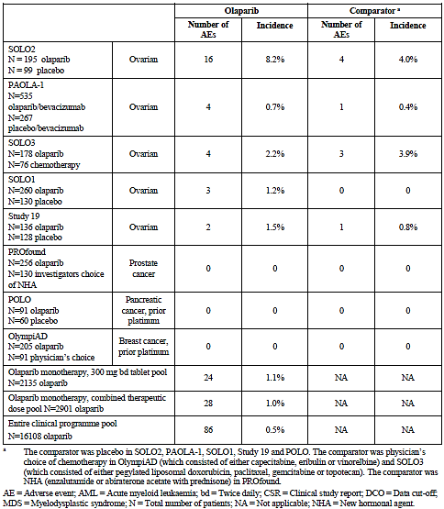

OlympiA
The rate of MDS/AML was lower in the olaparib arm than in the placebo arm.

PROpel
There was one patient with MDS in the olaparib arm in PROpel, and none in the placebo arm. This patient died from COVID-19 in the setting of MDS-related pancytopenia.

Companion diagnostics considerations

Companion diagnostic testing for the proposed EBC indication
Patients were required to have a gBRCAm according to local testing to enrol in OlympiA.
Central confirmation using the Myriad BRACAnalysis CDx test was intended to be required for all patients, but this could not be enacted for a subset of patients from China, for whom samples were not able to be exported from China for central testing.
An exploratory subgroup analysis of the results of OlympiA was conducted in the subset of patients with confirmed germline BRCA status (1623 patients) based on either prospective or retrospective testing with the BRACAnalysis CDx. Results (IDFS, DDFS and OS) in this subgroup (88% of the study population) were comparable to those seen in the overall population (FAS).
At the initial DCO of 27 MAR 2020, the HR (9% CI) for IDFS in this subgroup was 0.51 (0.39, 0.66), and was 0.58 (0.41, 0.82) in the FAS.
The FDA have approved the BRACAnalysis CDx test as a companion diagnostic for the analogous olaparib indication in the USA.
If the Australian indication is limited to patients with gBRCAm, a companion diagnostic will be required to select those patients for treatment. If a diagnostic test was seeking Australian registration as a companion diagnostic test, it would need to establish adequate comparability to either the local testing used to enrol patients in OlympiA, or to the Myriad BRACAnalysis CDx test.

Companion diagnostic testing for the proposed prostate cancer indication
In the pivotal study, PROpel, HRR mutation status was determined for all randomised patients where samples were available through central tumour tissue testing using FoundationOne®CDx and plasma ctDNA testing using FoundationOne®Liquid CDx, both performed centrally by Foundation Medicine Inc.
These assays test for a large number of genetic abnormalities including BRCA1 and BRCA2 (as well as 12 other genes with products involved in recombination repair pathways (ATM, BARD1, BRIP1, CDK12, CHEK1, CHEK2, FANCL, PALB2, RAD51B, RAD51C, RAD51D, and RAD54L).
The sponsor’s proposed indication is biomarker-agnostic. Efficacy outside patients that had a BRCA mutation (whether according to circulating tumour DNA [ctDNA] or tissue-based testing) is of concern based on a large volume and strength of contextual information, and this concern has not been adequately addressed by the data from the pivotal study PROpel due to design limitations. Therefore, an indication limited to patients with a BRCA mutation (according to either test) is proposed.
If an Australian indication is approved for first-line prostate cancer that is limited to patients with a BRCAm, a companion diagnostic will be required to select those patients for treatment. If a diagnostic test was seeking Australian registration as a companion diagnostic test, it would need to establish adequate comparability to either FoundationOne CDx or FoundationOne Liquid CDx.

Risk management plan
The sponsor is required to comply with product vigilance and risk minimisation requirements.
The TGA decided a RMP was not required as:
The proposed EOI did not constitute a materially different population to the already approved patient population from an RMP perspective as olaparib is already approved for use in adult patients with breast cancer and prostate cancer. Furthermore, abiraterone and prednisone or prednisolone are currently used for the treatment of patients with metastatic castration-resistant prostate cancer and the updated RMP submitted did not suggest any changes to the summary of safety concerns as a result of the combination treatment.
See TGA’s guidance on ‘when an RMP is required’.
The TGA may request an updated RMP at any stage of a product's life-cycle, during both the pre-approval and post-approval phases. Further information regarding the TGA’s risk management approach can be found in risk management plans for medicines and biologicals and the TGA's risk management approach. Information on the Australia-specific annex (ASA) can be found on the TGA website.

Risk-benefit analysis

Delegate’s considerations

Breast cancer indication

Comparator in pivotal study (OlympiA)
The comparator arm with placebo (+ endocrine therapy for patients with hormone receptor positive disease) is considered acceptable. Adjuvant capecitabine is now considered for patients with high-risk TNBC patients not achieving pCR after standard neoadjuvant chemotherapy (a population similar to that enrolled in the OlympiA trial), though this treatment is off-label in Australia. Data supporting adjuvant capecitabine post-neoadjuvant chemotherapy in non pCR TNBC patients was not published until 2017 (3 years after the OlympiA study was initiated) and therefore adjuvant capecitabine was not permitted in OlympiA. From 2017-2019, some patients with high-risk TNBC patients not achieving pCR after standard neoadjuvant chemotherapy may have chosen to access adjuvant capecitabine over enrolling in OlympiA, but there is no reason this would be expected to impact the clinical relevance of the OlympiA study finding, generated by the patients who did choose to enrol in OlympiA.
Neo/adjuvant pembrolizumab (reported 2020) for patients with high risk TNBC patients and adjuvant abemaciclib (reported 2020) for patients with high-risk early stage hormone receptor breast cancer were not approved until after the OlympiA trial had completed enrolment.

Efficacy
The data from OlympiA indicate that adjuvant treatment with olaparib for patients with high-risk EBC with a gBRCAm is associated with a PFS and OS benefit compared to placebo. This data provides evidence against which toxicity can be weighed by patients and prescribers when making treatment decisions.

Safety
The data from OlympiA are adequate to characterise the safety profile of olaparib for the treatment of high-risk early breast cancer. Overall, the safety profile is acceptable for the intended usage, in context of the high risk of recurrence of a serious and life-threatening condition. Toxicities appear to be manageable with the use of temporary treatment discontinuations, supportive therapies or standard medical care. The proposed dose modification scheme is consistent with previously approved indications.
New toxicities were not observed.
The majority of patients (87%) experienced a treatment-emergent adverse event (TEAE) and the overall incidence of TEAEs was higher in the olaparib arm than the placebo arm. In the olaparib arm, the most common adverse events (occurring in ≥20% patients) were nausea, fatigue, anaemia, and vomiting. These events were generally low grade and led to permanent discontinuation of study treatment in a small proportion of patients.
Rates of significant AEs were higher in the olaparib arm compared with the placebo arm:
- Severe AEs i.e. CTCAE Grade ≥3 (24% vs 11%, respectively)
  - The most common severe AEs in the olaparib arm of OlympiA were anaemia, neutropenia, leukopenia, lymphopenia and fatigue.
- AEs leading to discontinuation (10% vs 4%, respectively)
- AEs leading to dose interruption (31% vs 11%, respectively)
- AEs leading to dose reduction (23% vs 4%, respectively)
- Serious AEs (9% vs 8%, respectively)
  - The most common serious AEs in the olaparib arm of OlympiA were nausea, fatigue and anaemia.
The most common AE in the olaparib arm of all these categories was anaemia, except for those leading to discontinuation, where nausea was the most common (2% incidence).
Adverse events of special interest for olaparib include MDS/AML and pneumonitis, which are already included in the Warnings/Precautions section of the Australian PI. In OlympiA:
- MDS/AML occurred in 5 patients (2 patients [0.2%] in the olaparib arm and 3 patients [0.3%] in the placebo arm)
- Pneumonitis occurred in 20 patients (9 patients [1.0%] in the olaparib arm and 11 patients [1.2%] in the placebo arm).
Few deaths occurred in the OlympiA, consistent with the adjuvant indication under study (one in the olaparib arm, four in the placebo arm). The death in the olaparib arm occurred in the setting of H1N1 influenza infection. An association with treatment is not considered likely based on the available information.
The safety profile for olaparib is acceptable in this EBC patient population with a high-risk of recurrence of life-threatening disease.

Proposed extrapolation to patients with sBRCAm EBC
There is no direct data to support adjuvant treatment with olaparib for patients with high-risk EBC and a sBRCAm.
Very limited data is available from the metastatic sBRCAm breast cancer setting, consisting of two single-arm cohorts. The data from VIOLETTE are affected by significant missing data regarding somatic versus germline status of the mutation and therefore can only be interpreted to show that olaparib can have anti-tumour activity against an sBRCAm breast tumour – nothing about the expected magnitude of response rate. The publication from TBCRC 048 provides data for 16 patients with sBRCAm metastatic breast cancer, amongst whom the response rate was 50% (objective tumour responses per RECIST v1.1 were seen in 4 BRCA1m and 4 BRCA2m patients, 4 ER+/HER2-negative and 4 TNBC). This data supports that olaparib has activity against sBRCAm breast cancer. Response rates appear to be similar to those seen in gBRCAm breast cancer. PFS data were provided comparing gBRCAm and sBRCAm cohorts across studies, and these did not indicate large differences between the cohorts, however, time-to-event endpoints can’t be relied on without a randomised comparison. The available data are not able to directly inform whether activity should be expected to translate to a survival benefit if the same treatment was given to similar patients at an earlier stage of disease.
In the absence of direct data or randomised comparisons providing interpretable survival data for sBRCAm breast cancer patients, the rationale for a broadened indication relies on extrapolation from translational science data, paired with clinical data in the ovarian cancer setting. The rationale incorporates the following:
- BRCA mutations were discovered through the study of familial syndromes that involve an increased lifetime risk of cancer – particularly breast and ovarian cancer. The mechanism of pathogenesis is considered to be the same for this syndrome in both tissue types. The rational for efficacy of PARP inhibitors in BRCAm cancer is linked to the same proposed mechanism of pathogenesis.
- By definition, the difference between germline and somatic mutations of BRCA is the timing in the life of the organism at which the mutation occurs. Germline BRCm are present from the moment of conception, having initially been present in one of the two germ cells that has then formed the embryo. Somatic mutations may occur at any timepoint after. Therefore, if monoallelic, it is possible that an sBRCAm could be an incidental finding in a breast or ovarian tumour. Where biallelic, an sBRCAm in a breast or ovarian tumour is very unlikely to be incidental and matches the proposed rationale for efficacy of PARP inhibition and mechanism of proposed pathogenesis of BRCA as a tumour suppressor gene.
- Mutation of BRCA1 or BRCA2, whether germline or somatic, is strongly associated with a cellular phenotype of impaired HRR and genomic instability.
- Across the class, pre-clinical and clinical data has consistently suggested BRCA deficiency to predict for greater efficacy of treatment with PARP inhibitors (where assessed).
- Based on SOLO-1, SOLO-2, Study-19 and OlympiAD, treatment of gBRCAm breast and ovarian cancer with olaparib monotherapy in the metastatic setting is associated with increased PFS.
  - The magnitude of PFS benefit seen (hazard ratios around 0.3) was so large that it is very likely to have driven post-study use of PARP inhibitors by patients in the comparator arms after trial discontinuation, such that OS findings are very likely to have been confounded by this and the absolute effect of treatment on OS remains unproven. PFS in this clinical setting is expected to translate to OS, and the lack of demonstrated OS benefit is not surprising in the circumstances.
  - Based on the findings of Study 19, PFS benefit was seen outside of patients with gBRCAm. This was further explored in OPINION, in which the PFS was far longer in patients with a sBRCAm than patients with no HRR mutation.
- Treatment of sBRCAm ovarian cancer with olaparib monotherapy in the metastatic setting is strongly suspected to be associated with increased PFS, based on scientific rationale and the totality of data. The main pieces of information are:
  - There is no biochemical rationale or evidence to support different pathophysiology of sBRCAm compared to gBRCAm. The main question is the likelihood of a sBRCAm being an incidental finding, which seems low, and particularly so in the setting of biallelic BRCA loss.
  - The combined findings of Study 19 and OPINION strongly suggest a PFS benefit in maintenance treatment of metastatic sBRCAm ovarian cancer.
  - Exploratory cross study analyses submitted to the Pharmaceutical Benefits Advisory Committee strongly suggest that PARP inhibitors confer a PFS advantage over placebo in the treatment of metastatic sBRCAm ovarian cancer, which did not appear to be different from that associated with gBRCAm.
- Based on OlympiA, treatment of gBRCAm breast cancer with olaparib monotherapy in the adjuvant setting is associated with increased IDFS and OS at a population level.
  - As the HRs for IDFS and OS are not of such striking magnitude as the HR for PFS seen in the metastatic setting, this adds some uncertainty about extrapolation of a meaningful benefit to the sBRCAm population.
- Single arm data in the metastatic setting indicates that olaparib monotherapy is associated with objective tumour responses in sBRCAm metastatic breast cancer.
- The sponsor has indicated that they do not intend to proceed with randomised study of olaparib versus placebo in the adjuvant treatment of sBRCAm breast cancer.
  - The main barrier to feasibility appears to be the anticipated required duration of study: adequate time for follow-up (3-4 years) on top of likely very slow recruitment due to the testing paradigm in breast cancer on top of the existing uncommon incidence (an estimated 2-3% of breast tumours at maximum)
  - The sponsor alluded to a possibility that sBRCAm data from the metastatic breast cancer setting might be considered to translate into the EBC setting, however, it is not clear the nature of the further expected data – if it is more single arm data, as it appears, then I am not sure this data will be of much additional assistance in answering the question of whether there is a benefit at population level to adjuvant treatment.
To summarise, the rationale is strongly dependent on preclinical/translational evidence and clinical evidence from the ovarian cancer setting, in light of the known association between breast and ovarian cancer in being linked to a genetic syndrome that involves loss of this exact gene. Whilst the lack of direct clinical data is not ideal, I am unsure what further data can realistically be expected to become available in future.
This uncertain benefit must be weighed against the risks of treatment. As the proposed indication is for adjuvant use, the toxicities can’t be weighed against efficacy on an individual basis, as there is no known tumour mass to assess for response. Of note – whilst usually in the metastatic setting there is a tumour response that can be used as a measure of whether an individual patient is benefitting, for olaparib in metastatic ovarian cancer, the treatment is maintenance. That is: it is only given if the tumour is already in response to platinum. So the only thing you really can know is if a patient’s tumour progresses, that there is probably a lack of benefit in terms of tumour size. And this was the setting in which extrapolation from gBRCAm to sBRCAm was undertaken previously.
There appears to be an increased chance of developing MDS/AML (which are usually fatal) with PARP inhibitor treatment. The incidence was approximately 2.6 times higher with PARP inhibitor treatment in the metastatic setting, based on a recent meta-analysis.126 In OlympiA, however, there was one more such case in the placebo arm than the olaparib arm, and thus the incidence was very similar between the two arms (0.3% with placebo; 0.2% with olaparib). It is possible that the magnitude of risk (if present) is different for patients in the adjuvant setting compared to the metastatic platinum-sensitive setting, based on cumulative exposure to other DNA-damaging treatments including radiation and chemotherapies.
The remainder of the toxicities associated with olaparib treatment are essentially chemotherapy-like. There were no deaths that occurred during OlympiA that were clearly attributable to treatment. There is no reason to expect toxicities to be significantly different in sBRCAm compared to gBRCAm patients, with the possible exception that the difference in median age may also translate to differences in frailty, concurrent medication use and co-morbidities, which could be hypothesised to entail an overall increase in toxicities.

Prostate cancer indication

Study 8 was hypothesis-generating with regard to efficacy in the absence of BRCA or other HRR mutation
BRCA status is critical as a predictive marker of PARP inhibitor efficacy across multiple tumour settings. In the setting of prostate cancer and co-administered NHA, the sponsor postulates a different mechanism of action to sensitise the overall population to PARP inhibitor treatment - including patients without BRCA mutations. Whilst this is a reasonable hypothesis and the phase 2 clinical data was supportive, Study 8 was not of adequate design to confirm this hypothesis or to reasonably exclude a differential effect:
- Study 8 was underpowered for evaluation of differential effects based on BRCA mutation status or HRR mutation status. The lack of precision is reflected in very wide confidence intervals (such as 0.26 to 2.12 for the HRRm subgroup).
- HRR status was missing for 60% of patients in an already very small group.
- HRR mutations were considered all together as a group. There is vast heterogeneity amongst the HRR gene group with highly variable levels of support for inclusion of each gene in terms of data to support predictiveness of PARP inhibitor sensitivity – preclinical and clinical. This has been analysed in depth in a prior review of a submission based on PROfound which similarly relied on grouping of HRR mutations. Whilst overall, HRR mutations vary widely in their predictiveness of effect for PARP inhibitors across clinical settings, BRCAm has predicted for effect across settings with a high level of consistency.
- Despite all of the above, the difference between median PFS for patients who did versus did not receive olaparib was 11.3 months for patients with HRRm and around 5 months in both the overall population and the non-HRRm subgroup.
On the basis of the above, I do not agree with the conclusion that “there was no clear evidence of the predictive value of HRRm for the treatment effect of the olaparib + abiraterone combination” based on Study 8. With the benefit of hindsight, the promising results in the non-HRRm group should have been treated as hypothesis-generating, tempered by the strong biological plausibility for a potential difference between BRCA and non-BRCA or HRR and non-HRR patients, and the high level of uncertainty in the phase 2 data. The hypothesis could have been tested rigorously in the subsequent phase 3 study, PROpel.

PROpel does not support statistically robust assessment of efficacy in patients without a BRCA mutation
Subgroup analyses of the data from PROpel based on BRCA status according to ctDNA and tissue testing are summarised in Table 23 (page 109) and Table 24 (page 110). There were higher levels of missing data for tissue testing than for ctDNA testing. Results are considered most robust for the group of patients who were BRCAm according to any test, versus who were BRCA-wild type according to both tests. Whilst this group does not reflect real-world testing (i.e. ‘double’ testing for mutation status), the question arising is not real-world usage but clinical validity.
The subgroup results raise a concern that there is no detectable survival benefit and no clinically meaningful (if any real) difference in rPFS associated with the addition of olaparib to first-line NHA therapy for patients with prostate cancer who are known with a high level of certainty to not have a BRCA mutation (no BRCA mutation on either ctDNA or tissue testing):
- The OS HR was 1.06 (0.81, 1.39)
- The rPFS HR was 0.81 (0.63, 1.05), with 3 months’ difference between medians
In many scenarios, regulatory approval is granted on the basis of data from an ITT population despite non-reassuring subgroup results. Interpretation of subgroup results must be cautious, due to statistical limitations and uncertainty. In PROpel, randomisation was not stratified using BRCA or HRR status, so subgroups based on presence or absence of BRCA/HRR may be imbalanced with regard to prognostic factors, confounding comparison between arms. In the current scenario, the following factors increase the potential relevance of the subgroup findings based on BRCA status:
- There is very strong preclinical and clinical evidence of the importance of BRCA as a biomarker, further than HRR more generally, and the PROpel findings are consistent with findings in other settings.
- Relevant contextual information is available from the MAGNITUDE study: a large, randomised phase 3 study of very similar design to PROpel except that it was essentially stratified by HRR status. MAGNITUDE showed no benefit of adding a PARP inhibitor (niraparib) to abiraterone plus steroid in mCRPC for patients without a HRR mutation, and enrolment into this cohort was ceased early based on a planned futility analysis. In agreement with the data from PROpel, significant toxicity was associated with the addition of the PARP inhibitor to treatment in MAGNITUDE.
Overall, the lack of stratification of randomisation in PROpel by BRCA (or HRR) status is a critical design flaw and prevents PROpel data from robustly supporting a conclusion of meaningful efficacy in patients without such mutations. The subgroup results (in context of pre-clinical and clinical data for this drug and for PARP inhibitors as a class) are unable to address serious concerns that this drug may have negligible efficacy for patients without a BRCA (or HRR) mutation. The toxicity of PARP inhibitors, however, is not negligible. As an add-on treatment to an existing, very effective first line regimen (i.e. new hormonal agents), for a very common condition, such a level of uncertainty is not consistent with satisfactory establishment of efficacy of the product for the intended usage. There is an onus of proof which has not been met by the submitted data.
I therefore am unable to support approval of a biomarker-agnostic population despite the overall results of the PROpel study.

A BRCA-limited indication could be considered
Approval of a BRCA-specific indication could be considered, based on exploratory interpretation of data from this small subgroup (around 10% of the study) that is not congruent with a randomisation stratum. Whilst this may not be a statistically pure frequentist approach, it would rely on a totality-of-evidence approach in a more Bayesian fashion. There is extensive supporting evidence in terms of mechanism of action, and pre-clinical and clinical data in prostate cancer and other settings, and with other PARP inhibitors. This approach is in keeping with the recent outcomes of an expert Oncology Drugs Advisory Committee (ODAC) meeting, convened by FDA, at which 11 experts voted that approval of a BRCA-limited indication, based on PROpel as pivotal data, was warranted. One expert voted no, believing a HRR-limited indication would be more appropriate, and one expert abstained from voting, believing that no approval of any indication could be robustly justified, due to the study design limitations hampering its interpretation.

Contribution of components
For patients with BRCA mutations, the relative contribution of abiraterone to the efficacy of the combination has not been fully described. However, in a randomised phase 2 study, patients with BRCA1, BRCA2 or ATM mutation who were randomised to abiraterone plus prednisone (n=17) or to olaparib monotherapy (n=17) had a shorter PFS than those randomised to a combination of all three (n=19). The rationale around NHA treatment inducing BRCA-ness is also supportive of the combination.

Histology
Only patients with adenocarcinoma were enrolled. The clinical trial description should note this if the indication is approved.
As the vast majority of mCRPC is adenocarcinoma, and other histologies tend to be specified as they are the exception, I do not consider specification of adenocarcinoma histology in the indication to be necessary.

Proposed action

Breast cancer indication
The benefit-risk balance of approval of an EBC indication was considered positive.

Prostate cancer indication
The benefit-risk balance of approval of the proposed first line prostate cancer indication is considered unsupported, due to inadequate characterisation of efficacy in a majority subgroup of the ‘all-comers’ population, defined by absence of a critically important biomarker.

SOLO3 final OS results
No changes to the existing ovarian cancer indication are warranted based on the final OS from SOLO3.

VTE precaution
The sponsor’s review suggests VTE may be a risk associated with olaparib treatment. The wording in the PI was planned to be reviewed.

Metabolite PK analysis report from PROfound
Olaparib is the major circulating drug species in plasma at steady state. Metabolite M18 exhibited exposure above the regulatory threshold of 10% of total drug related circulating AUCss. The sponsor has not indicated any intention for further specific study of M18, which is considered acceptable.

Mutagenic impurities risk assessment
The updated assessment was acceptable. No changes are required to existing drug control strategies or existing text in the Product Information.

Questions for the sponsor
The sponsor provided the following response to questions from the delegate.
Could the sponsor please provide a rationale as to why it was decided to exclude enrolment of patients with sBRCAm EBC from OlympiA?
The OlympiA study was the first study to investigate the effectiveness of PARP inhibitor treatment in patients with BRCAm early breast cancer. At the time of study initiation, in 2014, a tumour BRCA mutation diagnostic test to detect both germline and somatic variants of BRCA was not available to support prospective testing and guide enrolment onto the study; the only central diagnostic test suitable for prospective testing in a registrational trial was Myriad’s BRACAnalysis CDx® blood-based germline BRCA1/2 assay. Furthermore, there was very limited knowledge around sBRCAm disease biology, and there was no robust evidence for the use of PARP inhibitors in this population, since the olaparib studies at that time had only included germline BRCAm (gBRCAm) participants. Thus, the OlympiA study only included patients with gBRCAm breast cancer. Given the high unmet need to assess the potential benefit of PARP inhibitor treatment in patients with BRCA mutations in the early breast cancer setting, this approach was the most feasible option at the time of study start.
There is currently no direct data to support a survival benefit with adjuvant Olaparib treatment for sBRCAm EBC. No specific studies are planned to obtain such. Could the sponsor please provide:
- A summary of what further data they expect will be available in future from studies of PARP inhibitors in sBRCAm metastatic breast cancer.
The sponsor confirmed that there are no ongoing adjuvant studies with olaparib for sBRCAm breast cancer patients. Somatic BRCA mutations are relatively rare at around 2% to 3% of breast cancers; therefore, it is challenging to recruit these patients to clinical studies. Somatic BRCA patients are included in several studies as part of selection for tumour BRCA mutations, with 2 olaparib studies (TBCRC 048 and LYNK-002) recruiting sBRCAm breast cancer patients. The expected future data in the metastatic setting is limited to the studies summarised in Table 20.
Table 20 Ongoing PARP Inhibitor Studies including sBRCA Mutated Breast Cancer
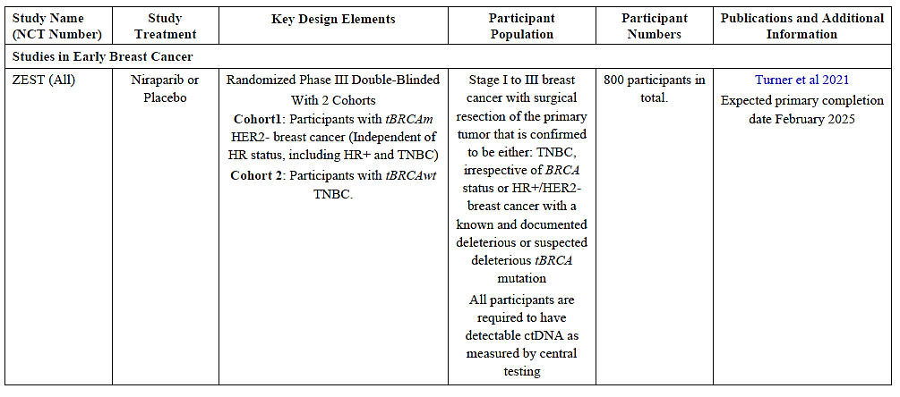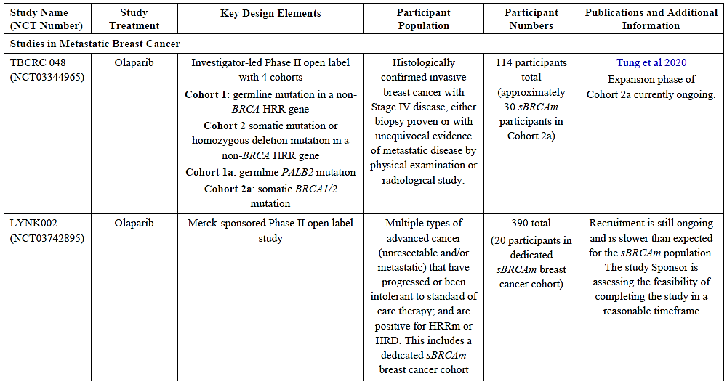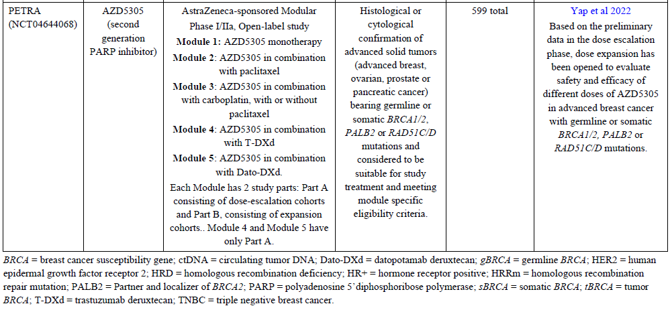
- How the expected data from the metastatic setting might inform adjuvant usage.
Data from both the OlympiA (adjuvant setting) and OlympiAD (metastatic setting) studies
support that BRCA mutations are the main driver for treatment benefit from olaparib/PARP
inhibitors in breast cancer patients regardless of hormone receptor status or treatment setting.
In the metastatic setting, the OlympiAD data show that olaparib treatment in gBRCAm
patients provides a significant benefit over standard chemotherapy and led to the approval of
olaparib in Australia for the treatment of gBRCAm patients who have HER2-negative,
metastatic breast cancer. In the adjuvant setting, the OlympiA data provide robust evidence of clinically meaningful and statistically significant treatment benefit from one year of adjuvant olaparib in a patient population where there is high unmet medical need and limited adjuvant treatment options, meaningfully reducing the risk of invasive and distant disease recurrence and death.
There is currently no direct data to support a survival benefit with adjuvant olaparib treatment
for sBRCAm in early breast cancer. Data support high biallelic inactivation of both germline
and somatic BRCA1/2 in early breast cancer, which suggest that somatic BRCA mutation is an
early event in breast cancer tumorigenesis, in line with its driving role. High biallelic
inactivation of BRCA genes suggests that they are inactivated regardless of germline or
somatic origin of BRCAm in both early and metastatic breast cancer samples, and would
therefore be predicted to confer sensitivity to PARP inhibition similarly. Additional clinical
evidence, along with a strong biological rationale, indicate that tumours with somatic BRCA
mutations are phenotypically indistinguishable from those of germline origin.

Table 19 summarises efficacy data for olaparib and other PARP inhibitor treatments in gBRCAm, tumour BRCAm (tBRCAm), and sBRCAm metastatic breast cancer patients and allows a comparison of the treatment benefits relative to that reported in the OlympiAD Phase III Study. Collectively, the treatment benefit reported with olaparib and other PARP inhibitors for patients with sBRCAm metastatic breast cancer is comparable to and consistent with that for patients with gBRCAm metastatic breast cancer in OlympiAD, LUCY and Phase III studies with other PARP inhibitors in patients with gBRCAm metastatic breast cancer.

Based on the above evidence, the sponsor believed that patients with either germline or
somatic BRCAm tumours, identified using either a blood or tumour test, are expected to
benefit equally from Olaparib in the metastatic disease setting. Given the clinical benefit of
olaparib in gBRCAm patients in OlympiA, the available data supporting gBRCAm and
sBRCAm breast cancer similarities with respect to biological and clinical characteristics,
natural history, unmet need, the targeted mechanism of action of Olaparib, and clinical benefit
in the metastatic setting, it is therefore expected that the data provided in the metastatic setting on somatic BRCA mutations will also inform adjuvant usage - support that patients with high risk early breast cancer and sBRCAm should not be excluded from the potential to benefit from adjuvant Olaparib.

Advisory Committee considerations
The Advisory Committee on Medicines (ACM), having considered the evaluations and the delegate’s overview, as well as the sponsor’s response to these documents, advised the following:

Specific advice to the delegate
- Should the sponsor’s proposed Australian indication be accepted – that is, indicating olaparib monotherapy as adjuvant treatment of high-risk BRCAm EBC, agnostic of whether the BRCAm is germline or somatic?
The ACM discussed the study design, noting that only subjects with a germline BRCA mutation were enrolled in the study.
The ACM was of the view that Lynparza showed significant benefit of treatment for patients with germline BRCA. The invasive and distant disease-free and overall survival outcomes were generally very good with stratified hazard ratios versus placebo of 0.58, 0.57 and 0.68, respectively and were maintained over 3.5 years. There were no new safety concerns and olaparib was generally well tolerated in this population. In particular, the ACM noted that MDS or AML incidences were less for treatment with Lynparza that for placebo. The ACM agreed that the proposed indication for patients with high-risk germline BRCAm HER2-negative early breast cancer was acceptable.
The ACM noted that the study excluded patients with somatic BRCAm HER2-negative early breast cancer and acknowledged the proposed alternative strategy to support the inclusion of somatic BRCAm within the indication via translational evidence. However, the ACM expressed concern that the limited clinical data available was based on unrandomised studies involving a very low number of patients with metastatic breast cancer only. The ACM acknowledged that the infrequent testing for somatic BRCAm makes the data unlikely to be generated. The ACM noted that such testing is unlikely to occur for patients with early breast cancer and currently is more likely to be conducted for patients with metastatic breast cancer.
Overall on balance, the ACM advised that there was insufficient data to support the inclusion of patients with somatic BRCA HER2-negative high risk early breast cancer in the indications at this time.

ACM Conclusion
The ACM considered this product to have an overall positive benefit-risk profile for the indication:
Lynparza is indicated as monotherapy for the adjuvant treatment of adult patients with germline BRCA-mutated HER2-negative high risk early breast cancer who have previously been treated with neoadjuvant or adjuvant chemotherapy.

Risk/benefit assessment (post-Advisory Committee Meeting)

Breast cancer indication
Advisory committee input was requested as to whether extension of the indication to sBRCAm is appropriate. In short, the ACM advised that the indication should be restricted to gBRCAm based on a lack of direct clinical data for use in neoadjuvant treatment of sBRCAm breast cancer.

Prostate cancer indication
Advisory committee input is requested as to whether approval of a BRCA-limited indication is supported.

Advisory Committee considerations (on additional questions)
Based on the above information and analysis, the ACM has been requested to provide advice on additional questions. The ACM have considered the evaluations and the delegate’s second overview, as well as the sponsor’s response to these documents, and provided advice given below.

Specific advice to the delegate
- Can the ACM please comment on whether the submitted data are adequate to support usage of this medicine in a biomarker-agnostic manner?
The ACM advised that while there is the appearance of benefit to all groups in the PROpel study, the post hoc analysis shows the driver for benefit is BRCA status. Among 85 patients with BRCAm (10.7% of the randomised population) the HR for rPFS was 0.20 (0.10, 0.36) at data cut-off 2 (14 March 2022), and for OS was 0.29 (0.14, 0.56) at data cut-off 3 (12 October 2022). Among 427 patients who did not have a BRCA mutation, the rPFS HR was 0.81 (0.63, 1.05) and the OS HR was 1.06 (0.81, 1.39) at these time points.
The ACM advised that the submitted data are not adequate to support a biomarker-agnostic indication and the new indication should be limited to patients with BRCA mutation.
The ACM noted that the data are not yet sufficiently mature to demonstrate benefit in overall survival in the ITT population.
The ACM noted that patient selection by BRCA status is already part of the approved indications for olaparib for prostate cancer as monotherapy, as well as ovarian cancer, breast cancer and adenocarcinoma of the pancreas.
The ACM noted that the mCRPC population in Australia is likely to be similar to the randomised population in PROpel with about 10% of patients having BRCA mutation.

Can the ACM please comment on whether a totality-of-evidence approach is supported, such that an indication similar to the following could be approved:
Lynparza, in combination with abiraterone and either prednisone or prednisolone, is indicated for the treatment of patients who have metastatic castration-resistant prostate cancer with a deleterious or suspected deleterious BRCA mutation.
The ACM supported the totality of evidence approach and advised that the indication proposed by the delegate is appropriate. There is benefit in progression-free survival and overall survival in patients with BRCA mutations. In patients without BRCA mutations there is no evidence of survival benefit.
mCRPC can progress rapidly. The wording allows for commencement of therapy pending test results on BRCA status.
Can the ACM please comment on the clinical implications of the testing requirements?
The ACM noted that the Medicare Benefits Schedule includes testing of tumour tissue for BRCA status in patients with mCRPC, to determine eligibility for PBS access to olaparib under the currently approved (second-line) indication. The ACM commented that gene sequencing has become increasingly common for all patients to guide treatment and predict prognosis. Testing for circulating tumour DNA is not routinely available at present.
The ACM advised that no particular barrier to testing was expected, other than those related to obtaining the biopsy sample. Test results may take several weeks.

ACM Conclusion
The ACM considered this product to have an overall positive benefit-risk profile for the indication:
Lynparza, in combination with abiraterone and either prednisone or prednisolone, is indicated for the treatment of patients who have metastatic castration-resistant prostate cancer with a deleterious or suspected deleterious BRCA mutation

Decision outcome
Based on a review of quality, safety, and efficacy, the TGA decided to register Lynparza (olaparib) for the following extension of indications:
Breast cancer
Lynparza is indicated as monotherapy for the:
• adjuvant treatment of adult patients who have HER2-negative, high-risk early breast cancer with a deleterious or suspected deleterious germline BRCA mutation (gBRCAm), for which they have previously been treated with neoadjuvant or adjuvant chemotherapy.
Prostate cancer
Lynparza in combination with abiraterone and either prednisone or prednisolone is indicated for the:
• treatment of adult patients who have mCRPC with a deleterious or suspected deleterious BRCA mutation (germline or somatic).

As such, the full indications at this time are:
Ovarian cancer
Lynparza is indicated as monotherapy for the:
• maintenance treatment of adult patients who have advanced, high-grade, epithelial ovarian, fallopian tube or primary peritoneal cancer with a deleterious or suspected deleterious, breast cancer susceptibility gene (BRCA) mutation (germline or somatic), which is in response (complete or partial) to first-line platinum-based chemotherapy.
• maintenance treatment of adult patients who have platinum-sensitive relapsed, high-grade epithelial ovarian, fallopian tube or primary peritoneal cancer which is in response (complete or partial) after platinum-based chemotherapy. Prior treatment must have included at least 2 courses of platinum-based regimens.

Lynparza in combination with bevacizumab is indicated for the:
• maintenance treatment of adult patients who have advanced, epithelial ovarian, fallopian tube or primary peritoneal cancer which is in response (complete or partial) to first-line platinum based chemotherapy and whose cancer is associated with homologous recombination deficiency (HRD)-positive status defined by either:
- a deleterious or suspected deleterious BRCA mutation (germline or somatic), and/or
- genomic instability

Breast cancer
Lynparza is indicated as monotherapy for the:
• adjuvant treatment of adult patients who have HER2-negative, high-risk early breast cancer with a deleterious or suspected deleterious germline BRCA mutation (gBRCAm), for which they have previously been treated with neoadjuvant or adjuvant chemotherapy.
• treatment of adult patients who have HER2-negative metastatic breast cancer with a deleterious or suspected deleterious gBRCAm, for which they have previously been treated with chemotherapy in the neoadjuvant, adjuvant or metastatic setting.

Adenocarcinoma of the pancreas
Lynparza is indicated as monotherapy for the:
• maintenance treatment of adult patients who have metastatic pancreatic adenocarcinoma with a deleterious or suspected deleterious gBRCAm, which has not progressed on at least 16 weeks of a first-line platinum-based chemotherapy regimen.
Prostate cancer
Lynparza is indicated as monotherapy for the:
• treatment of adult patients who have metastatic castration-resistant prostate cancer (mCRPC) with a deleterious or suspected deleterious BRCA mutation (germline or somatic), which has progressed following prior therapy that included a new hormonal agent.
The above extension of indications is inclusive of the previous approved indications.

Product Information
The Product Information (PI) approved with this submission for Lynparza which is referred to in this AusPAR (and can be accessed on this AusPAR’s webpage) may have been superseded. For the most recent PI and Consumer Medicines Information (CMI), please refer to the TGA PI/CMI search facility.

Therapeutic Goods Administration
PO Box 100 Woden ACT 2606 Australia
Email: info@tga.gov.au Phone: 1800 020 653 Fax: 02 6203 1605
https://www.tga.gov.au

This is the original indication proposed by the sponsor when the TGA commenced the evaluation of this submission. It may differ to the final indication approved by the TGA and registered in the Australian Register of Therapeutic Goods.
Globocan 2020. World Health Organization. Breast cancer fact sheet. Accessed 21 OCT 2022 at: https://gco.iarc.fr/today/data/factsheets/cancers/20-Breast-fact-sheet.pdf
O'Shaughnessy J. Extending survival with chemotherapy in metastatic breast cancer. Oncologist. 2005;10 Suppl 3:20-9.
Siegel RL, Miller KD, Fuchs H, Jemal A. Cancer Statistics, 2021. CA Cancer J Clin. 2021: 71:7‐33.
Kuchenbaecker KB, Hopper JL, Barnes DR, Phillips K-A, Mooij TM, Roos-Blom M-J, et al. Risks of breast, ovarian, and contralateral breast cancer for BRCA1 and BRCA2 mutation carriers. JAMA 2017;317(23):2402-16.
Mavaddat N, Barrowdale D, Andrulis IL, Domchek SM, Eccles D, Nevanlinna H, et al. Pathology of breast and ovarian cancers among BRCA1 and BRCA2 mutation carriers: results from the Consortium of Investigators of Modifiers of BRCA1/2 (CIMBA) Cancer Epidemiol Biomarkers Prev. 2012 January; 21(1): 134–147
Evans DG, Lalloo F, Howell S, Verhoef S, Woodward ER, and Howell A. Low prevalence of HER2 positivity amongst BRCA1 and BRCA2 mutation carriers and in primary BRCA screens. Breast Cancer Res Treat 2016;155:597–601.
Winter C, Nilsson MP, Olsson E, George AM, Chen Y, Kvist A, et al. Targeted sequencing of BRCA1 and BRCA2 across a large unselected breast cancer cohort suggests that one-third of mutations are somatic. Ann Oncol. 2016 Aug;27(8):1532-8.
Dorling C, et al. Breast Cancer Risk Genes – Association Analysis in More than 113,000 Women. N Engl J Med 2021;384:428-39.
Malone KE, Daling JR, Doody DR, Hsu L, Bernstein L, Coates RJ, et al. Prevalence and predictors of BRCA1 and BRCA2 mutations in a population-based study of breast cancer in white and black American women ages 35 to 64 years. Cancer Res 2006;66:8297-308.
Song Y, Barry WT, Seah DS, Tung NM, Garber JE, Lin NU. (2020) Patterns of Recurrence and Metastasis in BRCA1/BRCA2-Associated Breast Cancers. Cancer 2020;271-80
Turner N, Tutt A, and Ashworth A. (2004) Hallmarks of BRCAness in Sporadic Cancers. Nature Reviews 2004;4:1-6.
Metzger-Filho O, Tutt A, de Azambuja E, Saini KS, Viale G, Loi S, et al. (2012) Dissecting the heterogeneity of triple negative breast cancer. J Clin Oncol. 2012 May 20;30 915:1879-87.
Dent R, Trudeau M, Pritchard KI, Hanna WM, Kahn HK, Sawka CA, et al. (2007) Triple-negative breast cancer: clinical features and patterns of recurrence. Clin Cancer Res. 2007;13:4429-34.
Shah PD, Patil S, Dickler MN, Offit K, Hudis CA, Robson ME. Twenty-One-Gene Recurrence Score Assay in BRCA-Associated Versus Sporadic Breast Cancers: Differences Based on Germline Mutation Status. Cancer 2016;122:1178-84.
Kirby M, Hirst C, Crawford ED. Characterising the castration-resistant prostate cancer population: a systematic review. Int J Clin Pract. 2011;65(11):1180–92.
Scher HI, Solo K, Valant J, Todd MB, Mehra M. (2015) Prevalence of prostate cancer clinical states and mortality in the United States: estimates using a dynamic progression model. PLoS One. 2015;10(10):e0139440.
Eton DT and Lepore SJ. Prostate cancer and health-related quality of life: a review of the literature. Psychooncology. 2002;11(4):307-26.
Rosen PR, Groshen S, Saigo PE, Kinne DW, Hillman S. A long-term follow-up study of survival in stage I (T1N0M0) and stage II (T1N1M0) breast carcinoma.J Clin Oncol 1989;7:355-66.
NCCN Prostate Cancer Guidelines 2021
Parker C, Castro E, Fizazi K, Heidenreich A, Ost P, Procopio G, et al. Prostate cancer: ESMO clinical practice guidelines for diagnosis, treatment and follow-up. Ann Oncol. 2020;31(9):1119-34.
Flaig TW, Potluri RC, Ng Y, Todd MB, Mehra M. Treatment evolution for metastatic castration-resistant prostate cancer with recent introduction of novel agents: retrospective analysis of real-world data. Cancer Med. 2016;5(2):182-91
Murai J, Huang SN, Das BB, Renaud A, Zhang Y, Doroshaw JH, et al. Trapping of PARP1 and PARP2 by Clinical PARP Inhibitors. AACR 2012; 72(21); 5588–99.
Ryan CJ, Smith MR, de Bono JS, Molina A, Logothetis CJ, de Souza P, et al. Abiraterone in metastatic prostate cancer without previous chemotherapy. N Engl J Med. 2013;368(2):138-48.
Beer TM, Armstrong AJ, Rathkopf D, Loriot Y, Sternberg CN, Higano CS, et al. Enzalutamide in men with chemotherapy-naïve metastatic castration-resistant prostate cancer: extended analysis of the phase 3 PREVAIL study. Eur Urol. 2017;71(2):151-54.
Castro E, Romero-Laorden N, del Pozo A, Lozano R, Medina A, Puente J, et al. (2019) PROREPAIR-B: A prospective cohort study of the impact of germline DNA repair mutations on the outcomes of patients with metastatic castration-resistant prostate cancer. J Clin Oncol. 2019; 37(6):490-503.
Swami U, Sinnott JA, Haaland B, Maughan BJ, Rathi N, McFarland TR, et al. Overall survival with docetaxel vs novel hormonal therapy with abiraterone or enzalutamide after prior NHT in patients with metastatic prostate cancer (mPC): Results from a real-world dataset. J Clin Oncol. 2020;38(suppl 15):5537.
AusPAR for PM-2014-04684-1-4 at https://www.tga.gov.au/sites/default/files/auspar-olaparib-190211.pdf
AusPAR for PM-2017-01451-1-4 at https://www.tga.gov.au/sites/default/files/auspar-olaparib-191016.pdf
AusPAR for PM-2020-00161-1-4 is at https://www.tga.gov.au/sites/default/files/auspar-olaparib-190211.pdf
In this report the ‘delegate’ is the delegate of the Secretary of the Department of Health and Aged Care who decided the submission under section 25 of the Act.
AusPAR for PM-2014-04684-1-4 at https://www.tga.gov.au/sites/default/files/auspar-olaparib-190211.pdf
Schiewer M.J., Goodwin J.F., Han S., Brenner J.C., Augello M.A., Dean J.L. et al. (2012) Dual roles of PARP-1 promote cancer growth and progression. Cancer Discov. 2: 1134–1149.
Schiewer M.J. and Knudsen K.E. (2014) Transcriptional roles of PARP1 in cancer. Mol. Cancer Res. 12: 1069–1080.
Asim M., Tarish F., Zecchini H.I., et al. (2017) Synthetic lethality between androgen receptor signalling and the PARP pathway in prostate cancer. Nat. Commun. 8: 374.
Li L, Karanika S, Yang G, et al. Androgen receptor inhibitor-induced "BRCAness" and PARP inhibition are synthetically lethal for castration-resistant prostate cancer. Sci Signal. 2017 May 23;10(480):eaam7479. doi: 10.1126/scisignal.aam7479. PMID: 28536297; PMCID: PMC5855082.
Polkinghorn WR, Parker JS, Lee MX, et al. Androgen receptor signaling regulates DNA repair in prostate cancers. Cancer Discov. 2013 Nov;3(11):1245-53. doi: 10.1158/2159-8290.CD-13-0172. Epub 2013 Sep 11. PMID: 24027196; PMCID: PMC3888815.
Maxwell, K. N. et al. BRCA locus-specific loss of heterozygosity in germline BRCA1 and BRCA2 carriers. Nat. Commun 8, 319 (2017).
Goodwin JF, Schiewer MJ, Dean JL, et al. A hormone-DNA repair circuit governs the response to genotoxic insult. Cancer Discov. 2013 Nov;3(11):1254-71. doi: 10.1158/2159-8290.CD-13-0108. Epub 2013 Sep 11. PMID: 24027197; PMCID: PMC3823813.
FDA guidance on safety testing of drug metabolites. Rev 2 (MAR 2020). Accessed 21 FEB 2023 at: https://www.fda.gov/media/72279/download
Polkinghorn WR, Parker JS, Lee MX, et al. Androgen receptor signaling regulates DNA repair in prostate cancers. Cancer Discov. 2013 Nov;3(11):1245-53. doi: 10.1158/2159-8290.CD-13-0172. Epub 2013 Sep 11. PMID: 24027196; PMCID: PMC3888815.
FDA guidance on safety testing of drug metabolites. Rev 2 (MAR 2020). Accessed 21 FEB 2023 at: https://www.fda.gov/media/72279/download
Desai PB, Nallani SC, Sane RS, et al. Induction of cytochrome P450 3A4 in primary human hepatocytes and activation of the human pregnane X receptor by tamoxifen and 4-hydroxytamoxifen. Drug Metab Dispos 2002;(5):608-12.
Tung N, Garber JE. PARP inhibition in breast cancer: progress made and future hopes. NPJ Breast Cancer. 2022 Apr 8;8(1):47. doi: 10.1038/s41523-022-00411-3. PMID: 35396508; PMCID: PMC8993852.
Morice PM, Leary A, Dolladille C, et al. Myelodysplastic syndrome and acute myeloid leukaemia in patients treated with PARP inhibitors: a safety meta-analysis of randomised controlled trials and a retrospective study of the WHO pharmacovigilance database. Lancet Haematol. 2021 Feb;8(2):e122-e134. doi: 10.1016/S2352-3026(20)30360-4. Epub 2020 Dec 18. Erratum in: Lancet Haematol. 2021 Feb;8(2):e105. PMID: 33347814.
Csizmar CM, Saliba AN, Swisher EM, Kaufmann SH. PARP Inhibitors and Myeloid Neoplasms: A Double-Edged Sword. Cancers (Basel). 2021 Dec 20;13(24):6385. doi: 10.3390/cancers13246385. PMID: 34945003; PMCID: PMC8699275.
Robson M, Im SA, Senkus E, Xu B, Domchek SM, Masuda N, et al. Olaparib for metastatic breast cancer in patients with a germline BRCA mutation. N Engl J Med 2017;377:523-33.

