Australian Public Assessment Report for Cibinqo
  - Active ingredient/s: Abrocitinib
  - Sponsor: Pfizer Australia Pty Ltd
July 2024

About the Therapeutic Goods Administration (TGA)
- The Therapeutic Goods Administration (TGA) is part of the Australian Government Department of Health and Aged Care and is responsible for regulating therapeutic goods, including medicines, medical devices, and biologicals.
- The TGA administers the Therapeutic Goods Act 1989 (the Act), applying a risk management approach designed to ensure therapeutic goods supplied in Australia meet acceptable standards of quality, safety, and efficacy.
- The work of the TGA is based on applying scientific and clinical expertise to decision-making, to ensure that the benefits to the Australian public outweigh any risks associated with the use of therapeutic goods.
- The TGA relies on the public, healthcare professionals and industry to report problems with therapeutic goods. The TGA investigates reports received to determine any necessary regulatory action.
- To report a problem with a therapeutic good, please see the information on the TGA website.

About AusPARs
- The Australian Public Assessment Report (AusPAR) provides information about the evaluation of a prescription medicine and the considerations that led the TGA to approve or not approve a prescription medicine submission. Further information can be found in Australian Public Assessment Report (AusPAR) guidance.
- AusPARs are prepared and published by the TGA.
- AusPARs are static documents that provide information that relates to a submission at a particular point in time. The publication of an AusPAR is an important part of the transparency of the TGA’s decision-making process.
- A new AusPAR may be provided to reflect changes to indications or major variations to a prescription medicine subject to evaluation by the TGA.

Copyright
© Commonwealth of Australia 2024
This work is copyright. You may reproduce the whole or part of this work in unaltered form for your own personal use or, if you are part of an organisation, for internal use within your organisation, but only if you or your organisation do not use the reproduction for any commercial purpose and retain this copyright notice and all disclaimer notices as part of that reproduction. Apart from rights to use as permitted by the Copyright Act 1968 or allowed by this copyright notice, all other rights are reserved and you are not allowed to reproduce the whole or any part of this work in any way (electronic or otherwise) without first being given specific written permission from the Commonwealth to do so. Requests and inquiries concerning reproduction and rights are to be sent to the TGA Copyright Officer, Therapeutic Goods Administration, PO Box 100, Woden ACT 2606 or emailed to <tga.copyright@tga.gov.au>.

Contents
List of abbreviations 5
Background and proposed indications 6
Registration decision 6
Atopic dermatitis 6
Current treatment options 8
Clinical rationale 9
Evaluation overview 10
Quality evaluation summary 10
Nonclinical (toxicology) evaluation summary 10
Lack of characterisation of the M1 metabolite of abrocitinib 11
Bone dystrophy 11
Carcinogenicity 12
Clinical evaluation summary 12
Pharmacology 12
Pharmacodynamics 14
Efficacy 14
Phase II dose finding study B7451006 14
Study B7451012 (pivotal study) 14
Study B7451013 (pivotal study) 17
Study B7451029 18
Study B7451015 23
Study B7451036 25
Safety 26
Cohort studies 32
Study B7451044 32
The Health Improvement Network (THIN) study 35
Incidence of venous thromboembolic events in patients with atopic dermatitis cohort study 36
Risk management plan evaluation 37
Risk-benefit assessment 39
Advisory committee considerations – December 2021 42
Risk/benefit assessment post-ACM December 2021 44
Advisory Committee considerations – April 2022 46
Risk/benefit assessment post-ACM April 2022 49
Section 60 review 49
Appeal to the Administrative Appeals Tribunal 49
Registration decision 50
Submission details 50
Specific conditions of registration applying to these goods 51
Product Information (PI) and Consumer Medicine Information (CMI) 52
Regulatory status 52
Australian regulatory status 52
International regulatory status 52
Assessment and registration timeline 54
Attachment 1. Product Information 54

List of abbreviations
Abbreviation | Meaning
ACM | Advisory Committee on Medicines
AD | Atopic dermatitis
ARTG | Australian Register of Therapeutic Goods
ASA | Australia-specific annex
AUC_{inf} | Area under the curve from time 0 extrapolated to infinite time
AUC_{inf, u} | Area under the curve from time 0 extrapolated to infinite time for unbound drug
C_{max} | The maximum concentration that a drug attains in a specified compartment
CMI | Consumer Medicines Information
EASI | Eczema Area and Severity Index
HR | Hazard ratio
IGA | Investigator Global Assessment
IR | Incidence ratio
MACE | Major adverse cardiovascular event
NMSC | Non-melanoma skin cancer
PE | Pulmonary embolism
PI | Product Information
Pop-PK | Population pharmacokinetics
PP-NRS | Peak Pruritus Numerical Rating Scale
PSAAD | Pruritus and Symptoms Assessment for Atopic Dermatitis
PSUR | Periodic safety update report
Q.D. | Once daily dosing
RMP | Risk management plan
SAE | Serious adverse events
TEAE | Treatment-emergent Adverse Events
TGA | Therapeutic Goods Administration
T_{max} | Time to maximum concentration
ULN | Upper limit of normal
VTE | Venous thromboembolism

Background and proposed indications
Cibinqo (abrocitinib) is a Janus Kinase (JAK) 1 inhibitor. There is evidence that JAK1 mediates inflammatory signals that exacerbate atopic dermatitis (AD).
This AusPAR summarises the assessment of Cibinqo (abrocitinib) for the following proposed indication:
Cibinqo (abrocitinib) is indicated for the treatment of patients 12 years and older with moderate-to-severe atopic dermatitis, including the relief of pruritus, who have had an inadequate response to prescribed topical therapy or for whom these treatments are not advisable. Cibinqo (abrocitinib) can be used with or without topical therapies.

Registration decision
The Administrative Appeals Tribunal decided to approve the registration of Cibinqo (abrocitinib) on the ARTG for the following indication:
“Cibinqo is indicated for the treatment of moderate-to-severe atopic dermatitis in adults who are candidates for systemic therapy. Cibinqo can be used with or without medicated topical therapies for atopic dermatitis.”

Atopic dermatitis
Atopic dermatitis (AD), also called eczema, is a chronic, relapsing, pruritic, inflammatory skin disease that occurs more frequently in children than adults. The diagnosis of AD is made clinically and is based on history, morphology and distribution of skin lesions, and associated clinical signs and symptoms. Because of the broad differential diagnosis, it is important to exclude other conditions when diagnosing AD, such as other forms of eczema, psoriasis, and scabies; biopsy may be necessary in these cases. Various criteria have been developed to aid in classification. The most widely used diagnostic criteria are those developed by Hanifin and Rajka, which require that 3 of 4 major criteria and 3 of 23 minor criteria be met (Table 1).
Table 1. Hanifin and Rajka Diagnostic Criteria for Atopic Dermatitis in Adults and Children
The severity of AD is usually determined based on clinician assessment, including estimation of the proportion of body surface area involved and subjective assessment of signs and symptoms. One-third of AD patients have moderate to severe disease, which manifests as an itchy skin eruption, that is often accompanied by negative impact on health-related quality of life, including increased incidence of attention deficit disorders in children, depression, suicidal ideation, sleep disturbance, consequent fatigue, work productivity, and everyday activities,,. Approximately 8% – 14% of patients with moderate to severe AD are estimated to be adolescents.
Certain age-related variations in disease presentation are characteristic of AD. Infants generally experience highly pruritic erythematous lesions on the face and scalp, whereas older children exhibit more lichenified lesions typical of chronic disease involving the extremities. In adolescents and adults, disease typically involves flexural folds, face, neck, upper arms and back, and dorsal surfaces of the hands and feet. Generally, severe lesions are more frequent in adults than in children,.
Atopic dermatitis generally begins in childhood as indicated by its higher prevalence rate among children (6% – 14%) relative to adults (3.2% – 10.2%),. The prevalence of eczema varies widely between populations and countries and is said to have doubled or tripled in industrialised countries in recent decades. The population prevalence of eczema in Australia was estimated to be 16% in 4‐year olds and 20.3% in 1‐year‐olds.
Activation of T lymphocytes, dendritic cells, macrophages, keratinocytes, mast cells, and eosinophils results in a release of numerous proinflammatory cytokines and chemokines. This amplification cycle sustains the inflammatory responses characteristic of AD lesions. This influx of proinflammatory cytokines triggers release of IL-31, which is strongly associated with the non-histamine-related itch that develops in AD. The intense and unrelenting pruritus of AD is considered to be the most unbearable symptom of AD by many patients, which results in extensive scratching and compromises the skin’s barrier function. The mechanical trauma and skin barrier disruption induced by the patient scratching pruritic skin therefore has the potential to introduce viral or bacterial skin infections, which may progress to extracutaneous infections if left un- or under-treated.

Current treatment options
Management of AD in adults and children primarily consists of trigger avoidance, careful attention to skin care, and both pharmacologic and nonpharmacologic treatment. The goal of treatment is control of symptoms and reduction of disease flares, not cure of the disease. In the majority of cases, disease flares will occur despite appropriate nonpharmacologic skin care and trigger avoidance.
Treatment of AD in adolescent and adult patients depends on the extent and severity of disease. The most commonly used topical agents are corticosteroids, calcineurin inhibitors, and moisturisers (emollients). Pimecrolimus is the only topical calcineurin inhibitor registered in Australia for AD. Tacrolimus is used off label in Australia for treatment of AD. Crisaborole 2% ointment, a topical phosphodiesterase-4 inhibitor has been approved for the topical treatment of mild to moderate AD in patients 2 years and older.
When topical therapies are insufficient for treating AD, phototherapy or systemic therapy are generally added to topical agents. While systemic corticosteroids lead to rapid clearing of AD, their side-effect profile and the risk of severe rebound flares after discontinuation limit their use to short-course therapy only. Their use should be restricted to bridging, rescue of flares, anticipation of a major life event or in patients with severe AD. The use of systemic corticosteroids is generally discouraged in most international and local clinical practice guidelines. Systemic immunomodulatory drugs used to treat AD include the older medications cyclosporine, methotrexate, azathioprine and mycophenolate which are not suitable for long-term use. Only cyclosporine is indicated for treatment of AD. These drugs carry significant risks of immunosuppression, hepatotoxicity, nephrotoxicity, hypertension, and the risk of rebound and tachyphylaxis.
Dupilumab, a monoclonal antibody that inhibits IL-4 and IL-13 signalling, has been approved in the US, EU, Japan, Canada, and in Australia for the treatment of moderate to severe AD in adults and paediatric patients > 6 years of age. Recent Australian consensus recommendations based on the safety profiles of systemic therapies and currently available data recommended that dupilumab could be considered prior to other systemic treatment options in adults with moderate-to-severe AD who are uncontrolled with topical therapies. Although dupilumab has shown efficacy in terms of reduction in pruritus it is also associated with risks of ocular AEs (including conjunctivitis), protracted onset of action and need for subcutaneous administration. Hence, there is a need for oral treatments which provide rapid itch relief, clearance of skin lesions and have a safety profile suitable for long-term use.

Clinical rationale
Abrocitinib is orally bioavailable small molecule (Figure 1) that reversibly and selectively inhibits the enzyme Janus kinase 1 (JAK1) by blocking the ATP binding site.
Figure 1. Chemical structure of abrocitinib
The relative specificity of JAK1 inhibition by abrocitinib was demonstrated in in vitro experiments. In a cell-free isolated enzyme assay, abrocitinib had biochemical selectivity for JAK1 over the other three JAK isoforms JAK2 (28-fold), JAK3 (>340-fold) and TYK2 (43-fold). In cellular settings, where JAK kinases signal in pairs, abrocitinib preferentially inhibited cytokine-induced STAT phosphorylation mediated by receptors utilising JAK1 relative to receptors utilising JAK2 only or JAK2/TYK2 pairs.
The JAK-STAT signalling pathway is the common transduction pathway for Type 1 and Type 2 cytokine receptors in response to inflammatory and proliferative signals. AD is driven by pro-inflammatory cytokines including IL-4, IL-13, IL- 22, TSLP, IL-31 and IFN-Υ via the JAK1 pathway ,, and inhibiting JAK1 with upadacitinib reduces the signaling of many mediators which drive the signs and symptoms of AD. Nonclinical data have reported the importance of the JAK/STAT pathway in inflammatory conditions like AD.

Evaluation overview

Quality evaluation summary
The application and the supporting data relating to the composition, development, manufacture, quality control, stability and bioavailability of the product were assessed and checked for compliance, as applicable, with Australian legislation and requirements for new medicines and in accordance with pharmacopoeial standards and the technical guidelines adopted by the TGA.
The overall high quality of the active substance and drug product was demonstrated via adequate control of the starting material, control of critical steps and intermediates, process validation, extensive physicochemical characterisation, control of impurities and contaminants, batch analyses that covered multiple manufacturing campaigns, generation of robust reference materials, release and shelf life specifications and appropriate container closure systems.
The Product Information (PI) document is finalised from a quality perspective.
The product labelling has been finalised and complies with the applicable requirements of Therapeutic Goods Order 91.
The quality Evaluator recommended approval.

Nonclinical (toxicology) evaluation summary
The non-clinical Evaluator’s recommendation: “Due to the major deficiencies (uncertainties regarding safety) and the identified safety signals (risks), registration of abrocitinib is not supported from a nonclinical perspective for the proposed indication in the proposed patient group; the benefit-risk balance is unfavourable when considering the uncertainties and identified risks.”
Critical issues:
- Safety of M1 metabolite has not been assessed
- Important safety data for M2 and M4 are missing
- Carcinogenicity has not been adequately assessed.
- Lack of quantitative data for the in vivo metabolic mass balance studies in mouse, rat, monkey and human.
Limitations in the secondary pharmacodynamic studies submitted:
- The kinase screen is considered inadequate.
- Given metabolites M1 and M2 have been shown to demonstrate a profile of cytokine inhibition via JAK-1-dependent pathways similar to that of abrocitinib, it is unclear why potential off-target effects were not assessed for these major active human metabolites.
- The other major human metabolite, M4, was not assessed for activity at other sites.
The Evaluator considered all of the above as major deficiencies of this submission.

Lack of characterisation of the M1 metabolite of abrocitinib
The Evaluator has considered that M1, M2 and M4 are major human metabolites of abrocitinib. The Sponsor has stated in the clinical overview that: Three metabolites of abrocitinib are identified as M1(3 hydroxypropyl, 11%), M2 (2 hydroxypropyl, 12%), and M4 (pyrrolidinone pyrimidine, 14%). Of the 3 metabolites in circulation, M1 and M2 have similar JAK inhibitory profile as abrocitinib, M4 is inactive. The pharmacologic activity of abrocitinib is attributable to its active moiety exposures, calculated as the combined unbound exposures of abrocitinib, M1, and M2 in systemic circulation adjusted for relative potencies.
M1 levels fluctuated between 9-11% of drug related material in human plasma. When calculating the total exposure to M1, the Evaluator considers that the Sponsor should take into consideration the free fraction molar basis (e.g., 11% of the total drug exposure for M1), as it is the free fraction of M1 that can readily enter tissues and have an effect. When considering the free fractions, all 3 metabolites are considered significant human metabolites according to the criteria in ICH M3(R2).
In vitro, M1 and M2 were reversible ATP competitive inhibitors of JAK1; while M4 showed no inhibition of JAKs, indicating that M1 and M2 are active human metabolites, with M2 contributing significantly to efficacy. Similarly to abrocitinib, M1 and M2 were more potent at inhibiting JAK1-dependent pathways than JAK2 (26 and 49 times, respectively), JAK3 (230 and 559 times, respectively) and TYK2 (74 and 68 times, respectively). M1 has been included by the Sponsor as part of the “active moiety” of the drug and therefore was considered significant by the Evaluator.
The Sponsor’s rationale of not considering the M1 metabolite as a major metabolite was based on the steady state exposure to M1 metabolite following multiple doses (Study B7451043). “M1 contributed 6.9% to “active moiety”, while abrocitinib and M2 contribute 63.5% and 29.6% respectively”. The Sponsor states that they have followed the ICH M3(R2) guidance for the assessment of the total exposure and not exposure to free fraction of M1 minor metabolite using the 10% threshold.

Bone dystrophy
In adult rats, adverse bone dystrophy was observed at the interface of the growth plate and primary spongiosum. Effects on bone growth and development were seen in the definitive juvenile rat study with treated animals having mal-rotated limbs, necessitating premature euthanasia. Impaired growth, bent, misshapen or abnormal morphology were seen in several bones. These effects were irreversible. Fractures were also evident. The Evaluator has mentioned that the effects on bone development were not seen in juvenile animal studies with other JAK inhibitors, although there is some evidence that JAK-STAT signalling plays a role in bone development and effects on bone development were seen with in rats and juvenile animals treated with some JAK inhibitors.
The Evaluator has concluded that as the proposed indication includes paediatric patients whose skeletal system is still developing, the irreversible effects on bone development at subclinical exposures is of particular concern and use in this age group is not supported.

Carcinogenicity
Maximum exposures to M1 and M2 were considered by the Evaluator to be subclinical in rats and mice. Furthermore, the relative exposures to abrocitinib at the highest doses were subclinical in mice (ER_{AUC} 0.36/0.86× [M/F]) and low in rats (ER_{AUC} 14), suggesting the carcinogenic potential of abrocitinib has also not been adequately assessed. The relative exposure for active and metabolites should be at least 25 to adequately assess the carcinogenic risk to humans, which was not achieved in non-clinical studies with abrocitinib.
A higher incidence of benign thymomas were seen in treated females at all tested doses. An increased incidence and severity of the pre-neoplastic lesion, thymic hyperplasia, was also seen in these dose groups. The Sponsor claims that these effects are secondary to the immunosuppressive action of abrocitinib and its metabolites. The Evaluator considered this assumption as a possibility.
Benign thymomas have been reported in rat carcinogenicity studies with other immunosuppressive agents, but unlike in this submission, adequate safety margins were demonstrated for those medicines.
The Evaluator concluded that as there is no safety margin for tumours established with abrocitinib and there are limitations with the submitted carcinogenicity studies, suggesting carcinogenicity risk has not been adequately assessed, registration is not supported for the intended indication in the intended patient group.

Clinical evaluation summary

Pharmacology
The pharmacologic activity of Cibinqo is attributable to the unbound exposures of parent molecule (~60%) as well as the metabolites M1 (~10%) and M2 (~30%) in systemic circulation, i.e. the “active moiety of abrocitinib”.
Following a single, oral, 200 mg dose of abrocitinib tablets under fasting conditions to healthy subjects, T_{max} occurred at 1 h after dosing. The absolute bioavailability of abrocitinib was approximately 60%. Compared to fasting conditions, a high-fat meal increased abrocitinib exposure by approximately 26% to 29%. The Evaluator considered that the magnitude of the increase the effect of food on abrocitinib PKs is unlikely to be clinically relevant.
The metabolism of abrocitinib is mediated by multiple CYP enzymes, CYP2C19 (~53%), CYP2C9 (~30%), CYP3A4 (~11%) and CYP2B6 (~6%). The half-life of 100 mg and 200 mg abrocitinib is approximately 5 hours. Following QD (once a day) administration to steady state, the observed accumulation ratio was about 1.5.
Abrocitinib is eliminated primarily by metabolism. <1% of the dose is excreted unchanged in urine. The metabolites of abrocitinib are excreted predominantly in urine.
Exposure to abrocitinib is approximately 30% higher in AD subjects compared with healthy volunteers.
Drug interaction between abrocitinib and other drugs that are metabolised through CYP2C19/CYP2C9 pathway was evident. Around 200% increase in AUC was observed when abrocitinib was co administered with the CYP2C19/CYP2C9 inhibitors. Meanwhile, adjusted geometric mean (90% CI) for AUC_{inf,u} was 43.86% (40.94%, 46.98%), when administered with inducer of CYP2C19 and CYP2C9. Statements to indicate dose reduction to 50mg, when co-administered with CYP2C19/CYP2C9 inhibitors are included in the PI. The co-administration of abrocitinib with strong inducers of CYP2C19/2C9 is not recommended in the PI.
Renal impairment
In clinical studies, patients with severe (estimated glomerular filtration rate, eGFR <30 mL/min) and moderate (eGFR 30 to <60 mL/min) renal impairment had approximately 191% and 110% increase in systemic exposure to the active moiety (AUC_{inf}), respectively, compared to patients with normal renal function. Precautionary statements for reduction of dose to 50mg/day are included in the PI.
Hepatic impairment
Patients with mild and moderate hepatic impairment had approximately 4% decrease and 15% increase in active moiety AUC_{inf}, respectively, compared to patients with normal hepatic function. These changes are not clinically significant, and no dose adjustment is required in patients with mild or moderate hepatic impairment. In clinical studies, Cibinqo was not evaluated in patients with severe hepatic impairment.
Systemic exposure in adolescents
Mean values of abrocitinib C_{max} and AUC in adolescent subjects in Phase 3 studies were estimated to be approximately 30% lower at steady state compared to adults of the same weight. However, the distribution of exposures was similar between adult and adolescent subjects. This difference in estimates of mean exposure was not considered by the Sponsor as clinically relevant based on exposure-response analysis of efficacy.
The Sponsor submitted exposure data across age ranges (Table 3). Population pharmacokinetic (Pop-PK) analysis demonstrates that adolescent patients weighing > 40kg have similar exposures to abrocitinib compared with adults. However, it is noted that abrocitinib exposure in adolescents with lower body weight (25 kg) is almost twice that in heavier adolescents and in adults. Interpretation may be limited by smaller number of adolescents in the lower body weight category:
Table 3. Cibinqo exposure (AUC₂₄) data across age and weight ranges.
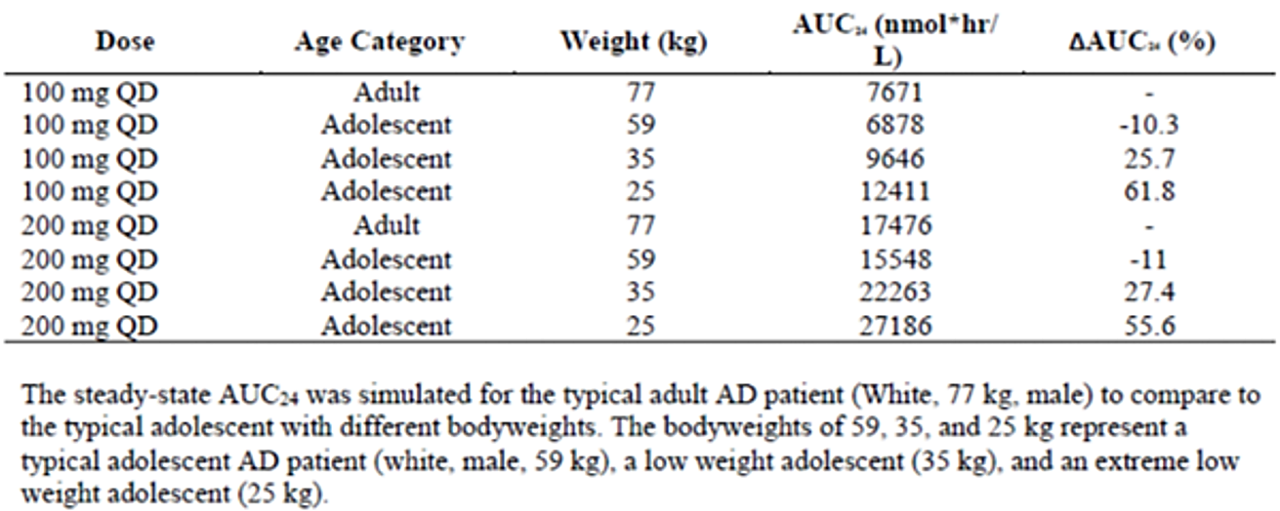

Pharmacodynamics
Pop PK modelling identified that the Investigator Global Assessment (IGA) score EC₅₀ value was 403 ng/mL. Treatment with 100 mg QD and 200 mg QD demonstrated clinically meaningful improvements in efficacy over placebo at 12 weeks of treatment.
Open-label studies with 100 mg and 200 mg QD showed a dose dependent increase in the percent of subjects achieving Eczema Area and Severity Index (EASI) responses compared with placebo.

Efficacy

Phase II dose finding study B7451006
The Phase 2b double-blind, parallel group RCT assessed the efficacy and safety of 4 QD dose levels of abrocitinib (10, 30, 100 and 200 mg) compared to placebo over 12 weeks in 267 adults with moderate to severe AD. A dose-dependent response in terms of IGA response and change in EASI score was reported. Statistically significant differences compared with placebo for these endpoints were reported for the 100 and 200mg doses only.
The safety and efficacy of abrocitinib were assessed with two pivotal studies with abrocitinib as monotherapy and one study with abrocitinib in comparison with dupilumab in adult subjects with moderate to severe AD.

Study B7451012 (pivotal study)
Study design
Phase 3 double-blind, RCT parallel-group study to evaluate the efficacy and safety of abrocitinib monotherapy in subjects aged 12 years and older with moderate-to-severe AD and a body weight >40 kg.
Subjects were randomised in a 2:2:1 ratio to receive abrocitinib 200 mg once daily (QD), abrocitinib 100 mg QD, or placebo. The treatment duration was 12 weeks with 4 weeks’ follow-up. Non-medicated emollients/ moisturisers and antihistamines were allowed to be used concomitantly and medicated agents such as low and medium potency topical corticosteroids and topical calcineurin inhibitors were allowed during flare ups.
Key inclusion criteria:
- ≥ 12 years old and ≤ 75 years old and a body weight of 40kg.
- Recent history of inadequate response to treatment with topical medications for at least 4 weeks, or for whom topical treatments are otherwise medically inadvisable ( because of important side effects or safety risks), or who have required systemic therapies for control of their disease.
- Moderate to severe AD (affected body surface area (BSA) >10%, IGA >3, EASI >16, and pruritus numeric rating scale [NRS] >4 at the baseline visit).
Key exclusion criteria:
- History of conditions associated with thrombocytopenia, coagulopathy or platelet dysfunction
- Have any malignancies or have a history of malignancies with the exception of adequately treated or excised non-metastatic basal cell or squamous cell cancer of the skin, or cervical carcinoma in situ.
At baseline, the median age of study population was 29 years, majority were aged 18-65 years (74%) and 22% (84/387) of the subjects were adolescents. 4.1% of subjects were >65 years of age. The median BMI was 25.8 kg/m2. Randomised subjects showed characteristics representing moderate-to-severe AD population at baseline, 59.2% and 40.8% of the study population had IGA moderate and severe respectively. Median EASI score was 25.6 and median body surface area (BSA) affected was 45%. Overall, 47.8% had received topical agents only (mainly topical corticosteroids and about 12.9% had received topical calcineurin inhibitors). 48.3% of the study population had received systemic agents including 8% treated with prior dupilumab).
The Co-Primary Endpoints were:
- Treatment response based on IGA score of clear (0) or almost clear (1) and a reduction from baseline of >2 points.
- Treatment response based on the EASI 75% improvement from baseline (EASI-75) response.
The Key Secondary Endpoints were:
- Response based on at least 4-points improvement in the severity of pruritus numerical rating scale (NRS) from baseline at Weeks 2, 4, and 12.
- Change from Baseline in Pruritus and Symptoms Assessment for Atopic Dermatitis (PSAAD) total score.
Treatment response assessment for improvement in the severity of pruritus numerical rating scale (NRS) from baseline was one of the other secondary efficacy endpoints.
Results
At week 12 of treatment period, a greater proportion of subjects in both abrocitinib 200mg and a100 mg arms achieved IGA response of ‘clear’ or ‘almost clear’ and > 2 points improvement from baseline, compared to placebo arm. The treatment difference was 15% and 36% for the 100 mg and 200 mg abrocitinib arms and was statistically significant (Table 4).
Table 4. Proportion of subjects with IGA responses at week 12
A greater proportion of subjects in abrocitinib 200mg (51.0%) and 100mg (27.9%) arms achieved a 75% reduction from baseline in the Eczema Area and Severity Index (EASI-75) score, compared to placebo. The treatment difference was statistically significant (Table 5).
Table 5. Proportion of subjects achieving EASI 75 at week 12
Key secondary endpoints
At Week 12, both abrocitinib 100 and 200mg arms had greater proportions of subjects achieving ≥4 points improvement from baseline in NRS for severity of pruritus (PP-NRS4) responders compared with the placebo group. The onset of pruritus relief was evident at week 2 and plateauing by Week 4. Compared to placebo, both abrocitinib treatment groups showed statistically significant decreases from baseline at Week 12 in the PSAAD scores (Table 6).
Table 6. Proportion of subjects achieving >4= points improvement from baseline in numeric rating scale for severity of pruritus
A greater improvement in “other secondary endpoints” was also reported in abrocitinib arms, compared to placebo. The treatment differences were statistically significant.

Study B7451013 (pivotal study)
The study design and objectives for this Phase 3 study were identical to the study B7451012.
391 subjects were randomised to the study. The median age of randomised subjects was 31.0 years. 10.2% of the subjects were adolescents. 4.9% of subjects were >65 years of age.
Baseline disease characteristics were balanced across treatment groups. The median disease duration was approximately 19.6 years, 67.8% had moderate and 32.2% had severe AD by IGA scores. The median EASI score of randomised subjects was 25.2, median %BSA was 44.0% and median PP-NRS was 7.0. 99.2% of subjects had received prior treatments for AD, with topical agents by about 58% of subjects. Overall, 41% of subjects received prior systemic agents that included corticosteroids (29%) and cyclosporine (13%). Biologics were used by 25 subjects (6.4%) overall, including 14 subjects (3.6%) using dupilumab.
Results
Both co-primary endpoints were met. Both abrocitinib 200 mg QD and 100 mg QD treatment groups demonstrated statistically significantly greater IGA and EASI-75 responses compared with the placebo group (Table 7, 8).
Table 7. Proportion of subjects achieving IGA response of ‘clear’ or ‘almost clear’ and > 2 points improvement from baseline at week 12
Table 8. Proportion of subjects achieving EASI 75 at week 12
Both key secondary endpoints were met. At week 12, a greater proportion of subjects in abrocitinib arms achieved improvement inPP-NRS-4 (≥ 4 points). A greater improvement in PSAAD score was reported in abrocitinib arms, compared to placebo. The treatment difference was statistically significant (Table 9, 10).
Table 9. Proportion of subjects with ≥ 4 points improvement from baseline in NRS score for pruritis.
Table 10. Least squares mean of change from baseline in pruritus and symptoms assessment for atopic dermatitis (PSAAD) at week 12 – MMRM (PPAS, OD).
Subjects in abrocitinib arms achieved a greater improvement in other secondary endpoints and patient reported outcomes, compared to placebo. The treatment differences were statistically significant.

Study B7451029
Study design and primary endpoints
Phase 3, double-blind, double-dummy RCT to evaluate the efficacy and safety of abrocitinib (100mg and 200mg QD) and dupilumab compared with placebo in adults on background topical therapy with moderate to severe AD (Figure 2). Non-medicated topical therapy (i.e., emollients) were required to be used at least twice daily for the last 7 days prior to Day 1 and standardised background topical therapy was used as per protocol guidelines, throughout the duration of the study. Primary endpoints were measured at week 12.
Figure 2. Study B7451029 design schematic
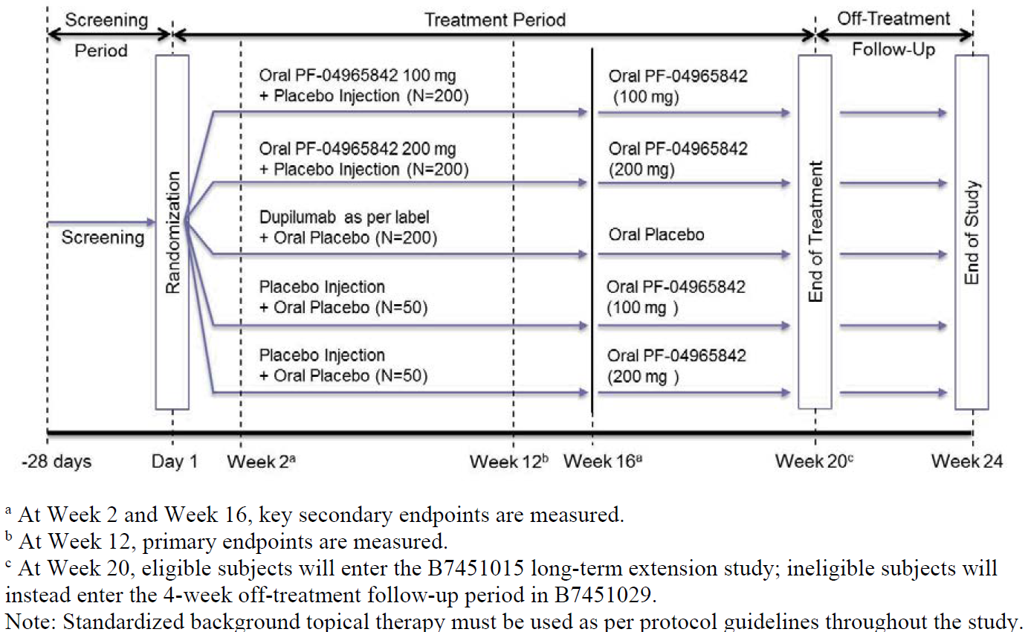
The study objective was for the co-primary and key secondary endpoints were to demonstrate superiority of all active treatments compared to placebo.
The co-primary endpoints were IGA and EASI-75 responses for all active treatments at Week 12
Key Secondary Endpoints
The three key secondary end points were itch response (defined as ≥4-point improvement from baseline in the score on the PP-NRS) at week 2 and IGA and EASI-75 responses at week 16.
838 subjects were randomised to study treatments. The median age was 34 years and 54 of the subjects (6.5%) were elderly aged > 65 years. Overall, 64.3% had moderate and 35.4% had severe AD (IGA); the median EASI was 27.2 and median BSA involvement was 45.6%. Most of the subjects (93.1% to 95.6%) used concomitant medicated topical therapy. Overall, 43.2% had received systemic agents (non-biologic or biologic, excluding dupilumab) and 2.3% had used biologic agents.
Results
The study met both co-primary endpoints of IGA and EASI-75 responses at Week 12. responses in the abrocitinib 200mg QD group were numerically greater than those observed in the abrocitinib 100mg and dupilumab groups for both co-primary endpoints of IGA (14%, 36.6%, 48.4% and 36.5% in the placebo, abrocitinib 100mg QD, abrocitinib 200mg QD, dupilumab 300mg Q2W groups, respectively) and EASI-75 (27.1%, 58.7%, 70.3% and 58.1%, respectively; Table 11,12)
Table 11. Proportion of Subjects Achieving IGA Response of 'Clear' or 'Almost Clear' and >=2 Points Improvement from Baseline.
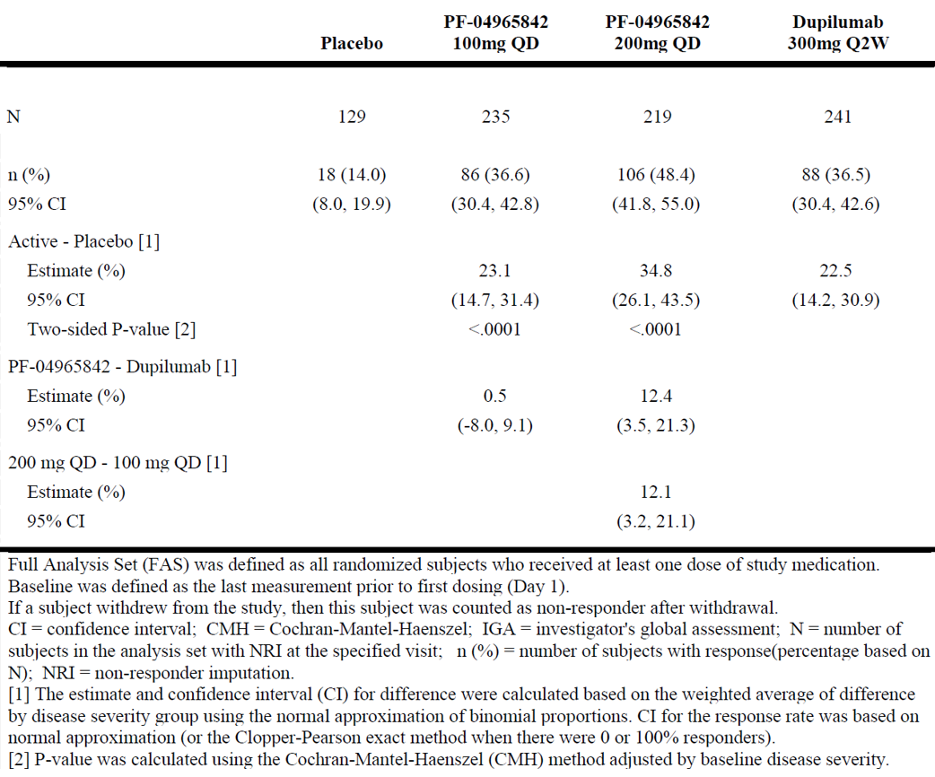
Table 12. Proportion of Subjects Achieving EASI Response >= 75% improvement from Baseline.
At week 2, treatment difference for improvement in pruritus severity was statistically significant for subjects in 200mg abrocitinib arm, but not for those in abrocitinib 100mg arm, when compared to dupilumab arm.
A greater proportion of subjects in abrocitinib 200mg arm achieved greater improvement in IGA and EASI 75 response at week 16, compared to dupilumab. A similar treatment benefit was not reported for subjects in 100 abrocitinib arm. The treatment responses for both abrocitinib arms were statistically significant, when compared to placebo (Table 13, 14 and 15) .
Table 13. Proportion of subjects achieving pruritus NRS severity response >=4 points improvement from baseline at week 2
Table 14. Proportion of subjects achieving IGA response of ‘clear’ or ‘almost clear’ and >=2 points improvement from baseline at week 16.
Table 15. Proportion of subjects achieving EASI response >=75% improvement from baseline at week 16.

Study B7451015
Study B7451015 was a phase 3 long-term extension study to examine the efficacy and safety of abrocitinib, with or without topical medications. Subjects included those completed pivotal studies or other phase III studies and their long-term extension periods.
The proportion of subjects discontinued was similar in both abrocitinib dose groups (100mg vs 200mg: 22.9% vs 20%); discontinuations due to lack of efficacy were more common in the lower dose group (5.9% vs 2.5%) while those due to AEs were slightly higher in the 200mg dose group (6.2% vs 8.6%):
Overall, 1116 subjects (including 107 adolescents) were treated with abrocitinib (595 and 521 with abrocitinib 100mg and 200mg QD, respectively); 502 subjects were treated for > 48 >weeks, including 73 adolescents (Data cut-off of April 2020).
Overall, the proportion of week 12 responders who maintained their response at week 48 was higher in subjects treated with abrocitinib 200mg group (70% to 83%) compared with 100mg (60% to 79%):

Study B7451036
Study design
Double blind phase 3 RCT in adolescent subjects (12-18 years of age) with moderate to severe AD. Abrocitinib was co-administered with topical therapy. 287 subjects were randomised in a 1:1:1 ratio to receive abrocitinib QD at 200 mg, 100 mg, or placebo for 12 weeks.
The median age was 15 years. Median duration since onset of AD was 11.6 years. Overall, 73.3% of subjects had received only topical agents (mostly topical corticosteroids) and 25.6% had received systemic agents (mostly non-biologic agents) prior to screening with similar proportions similar across the treatment groups.
Results
Co-primary endpoints: A greater proportion of subjects in both abrocitinib 100 and 200 mg achieved a greater improvement in IGA and EASI at week 12 of treatment period (Table 16, 17).
Table 16: Co-primary endpoint: IGA response
Table 17: Co-primary endpoint: EASI response
The 100mg abrocitinib arm did not demonstrate statistically significant change in PSAAD total score at week 12 compared with placebo. Hence, based on pre-specified testing sequence, all subsequent hypotheses (after the comparison of PP-NRS4 for abrocitinib 100 mg versus placebo at Week 4) were not considered statistically significant.

Safety
Across placebo-controlled studies and safety studies, the median duration of treatment in adults with the 200 mg group was 89 days, compared to 501 days for the100 mg abrocitinib group. In children, the exposure for treatment with 200mg abrocitinib was 195 days, compared to 492 days for the 100mg abrocitinib.
The median age was 31.0 years, 12.7% were adolescents, and 5.1% were aged > 65 years (Table 18, 19 and 20).
Table 18. Treatment exposure in adults (summary of clinical safety)
Table 19. Treatment exposure in adolescents (Summary of clinical safety)
Table 20. Total exposure to abrocitinib
In the primary safety pool, 342, 608 and 590 subjects were included in the placebo, abrocitinib 100mg and 200mg groups, respectively. The median age was 33.0 years, 124 (8.1%) were adolescents, and 94 (6.1%) were aged > 65 years. Overall, 61.4% were randomised in the monotherapy studies.
Delegate’s comments: The lower proportion of adolescents and adults in the >65 years of age across studies was noted. The lower median treatment exposure for 200mg, compared to 100mg dose was also noted.
Treatment-emergent adverse events
The incidence of treatment-emergent adverse events (TEAE) was higher in the abrocitinib groups compared to placebo (14.3%, 25.6% and 38.3% in placebo, abrocitinib 100mg and 200mg groups, respectively). Nausea, nasopharyngitis and headache were reported most frequently. Nausea was the most frequently reported TEAE. The majority of TEAEs were mild or moderate in severity (Table 21).
Low incidence of serious adverse events (SAEs) was reported across treatment groups. The conditions reported were expected in a patient group with atopic dermatitis.
Table 21. TEAEs comparative data between abrocitinib and dupilumab arms.
Deaths
There were 3 deaths in the abrocitinib clinical program.
None of the deaths were considered as related to treatment with abrocitinib.
MACE events
There were 5 adjudicated MACE events during clinical studies (April 2021 data cut) with abrocitinib. Three out of five events occurred in abrocitinib 200mg arm (Table 22).
Table 22. MACE events.
Overall, the incidence ratio (IR) for MACE events was comparable across 100 and 200 mg abrocitinib arms (Table 23).
In adults, the hazard ratio (HR) for 200mg vs 100mg abrocitinib for MACE events was >2 (Table 24).
Table 23. Incidence ratio (IR) for MACE events.
Table 24: HR for MACE events in adults.
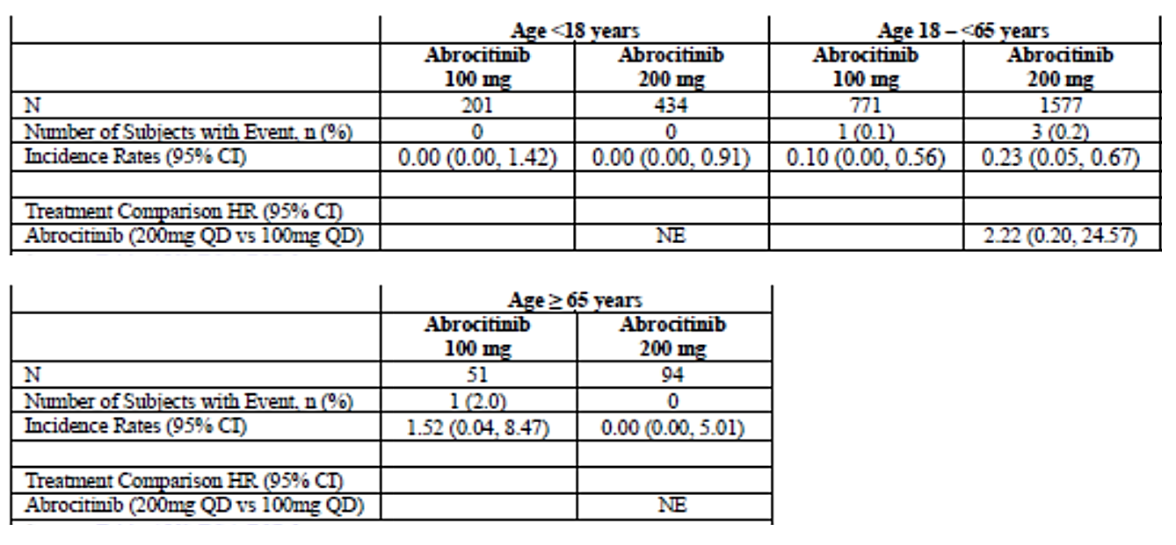
A 39 year old female subject in the abrocitinib 100mg developed retinal vein occlusion on day 632 of treatment with abrocitinib. There was no prior history of risk factors. The event was considered to be related to treatment with abrocitinib. The event did not recover until the last day of follow-up and the subject was withdrawn from the study.
Other MACE events were reported in subjects with history of risk factors. The events were not confined to >65 years of age (42 year old male developed cardiac failure, in addition to the 39 year old female with retinal vein occlusion).
No MACE events were reported in the placebo arm.
Venous thromboembolism events
There were 7 VTE events (4 events of PE, 3 events of DVT) during the treatment period with abrocitinib (Table 25). Except for one event of PE, all other events occurred in the abrocitinib 200mg arm. A dose-proportionate incidence of VTE events was noted. All subjects who developed PE were withdrawn from the study.
The IR for pulmonary embolism in the abrocitinib arms were higher than the background rates in patients with AD in the cohort studies. In clinical studies with abrocitinib, the IR for VTE events was [1.44/ 100 PY (95% CI: 0.17, 5.18)] in the subjects 65 years and older and [0.17/100 PY (95% CI: 0.05, 0.45)] in adults 18-<65 years.
A 55 year old male with no history of risk factors developed VTE on day 80 of treatment period. He received treatment and the event resolved on day 155. Treatment was withdrawn.
No VTE events were reported in the placebo arm. Two events of VTE occurred within the first 100 days of treatment.
Table 25: Venous thromboembolism events
The HR for VTE events in the 200mg was 5.24 and PE was 2.89, compared to 100mg abrocitinib arm. There were insufficient events in each age category to determine any difference in HR across age groups (Table 26).
Table 26. HR for VTE events.
Infections
There was a dose-related increase in the IR of herpes zoster events (placebo: 0.00, abrocitinib 100 mg QD: 1.90/100 PY; abrocitinib 200 mg QD: 5.16/100 PY) (Table 27):
Table 27. Incidence ratios (IR) of infections.
Malignancy
Eighteen events of malignancy were reported in subjects treated with abrocitinib and none in the placebo arm. Seven events of “other malignancy” (Table 28) and 11 events of non-melanoma skin cancer (Table 29) were reported. The IR was 0.23/100PY.
Four additional events of malignancy were reported in the safety data up to April 2021 data cut.
Table 28. Other events of malignancy
A 59 year old subject in the abrocitinib 200mg arm developed lymphoma on day 748. The event was considered related to treatment with abrocitinib. The subject did not have any history of malignancy or medical history of Epstein-Barr virus infection or known history of exposure to certain chemicals or radiation. Treatment was withdrawn and chemotherapy was initiated.
Table 29. Non-Melanoma skin cancer
It should be noted that subjects with any malignancies or have a history of malignancies with the exception of adequately treated or excised non-metastatic basal cell or squamous cell cancer of the skin, or cervical carcinoma in situ were excluded from clinical studies with abrocitinib.
Squamous cell carcinoma (44 year old male subject from Australia) and sebaceous carcinoma (70 year old female from US) were reported in subjects treated with 200 mg abrocitinib that were considered to be related to the study treatment.
Effect on platelets
There was a dose-related reduction in the platelets, with a nadir in median values at week 4 following initiation of abrocitinib treatment. Most values remained above the LLN (140,000/mm3). The levels reached a plateau at week 12 that was below the original baseline (Table 30).
There were no bleeding-related AEs. The level of platelets rebounded to pre-treatment levels once treatment with abrocitinib was ceased.
Table 30. Effect of abrocitinib treatment on platelets.
The magnitude of reduction of platelets was higher in the > 65 year age group, compared to the rest of the patient population.
There was a dose-proportionate reduction in the neutrophil count in subjects with a neutrophil level <2000/mm3 at baseline (3.6%, 9.1% and 20.0% in the placebo, abrocitinib 100mg and 200mg groups, respectively). No subjects met the threshold for discontinuation (<1000/mm3).
A dose-related increase in creatinine phosphokinase (CPK) beginning at week 4 and showing plateau at Week 8 was reported. The median change at the last observation was much greater in the abrocitinib 100 mg QD and 200 mg QD groups (53 U/L and 88 U/L, respectively) relative to the placebo group (-2 U/L). A dose-related increase was also reported in the proportions of subjects exceeding a threshold of 2 x the upper limit of normal (ULN) and 5x ULN. Overall, <5% of subjects experienced > 5x ULN.
A dose-dependent increase in the markers of lipid profile for subjects treated with abrocitinib. No major safety events were reported that were related.
In adolescents, a dose-dependent increase was observed for TEAEs, especially nausea and acne.

Cohort studies
The Sponsor conducted retrospective cohort studies in patients with moderate to severe AD to evaluate incidence rates of adverse events in this population.

Study B7451044
Study B7451044 was a retrospective cohort study conducted in ‘8197 The Kaiser Permanente Northern California health plan members’ aged > 12 years diagnosed with moderate to severe AD between 2000 and 2018.
Incidence rates among AD patients were 0.08 (TB) to 0.76 (HZ) for infections, 0.01 (lymphoproliferative disorders), 0.44 (malignancy, except non-melanoma skin cancer (NMSC) and cervical carcinoma in situ) for malignancies, 0.07 (PE) and 0.91 (thromboembolism) for CV events (Table 31).
Table 31. Incidence Rates and 95% Confidence Intervals for Safety Events of Interest Within the Kaiser Permanente Northern California Database (2007 to 2018)
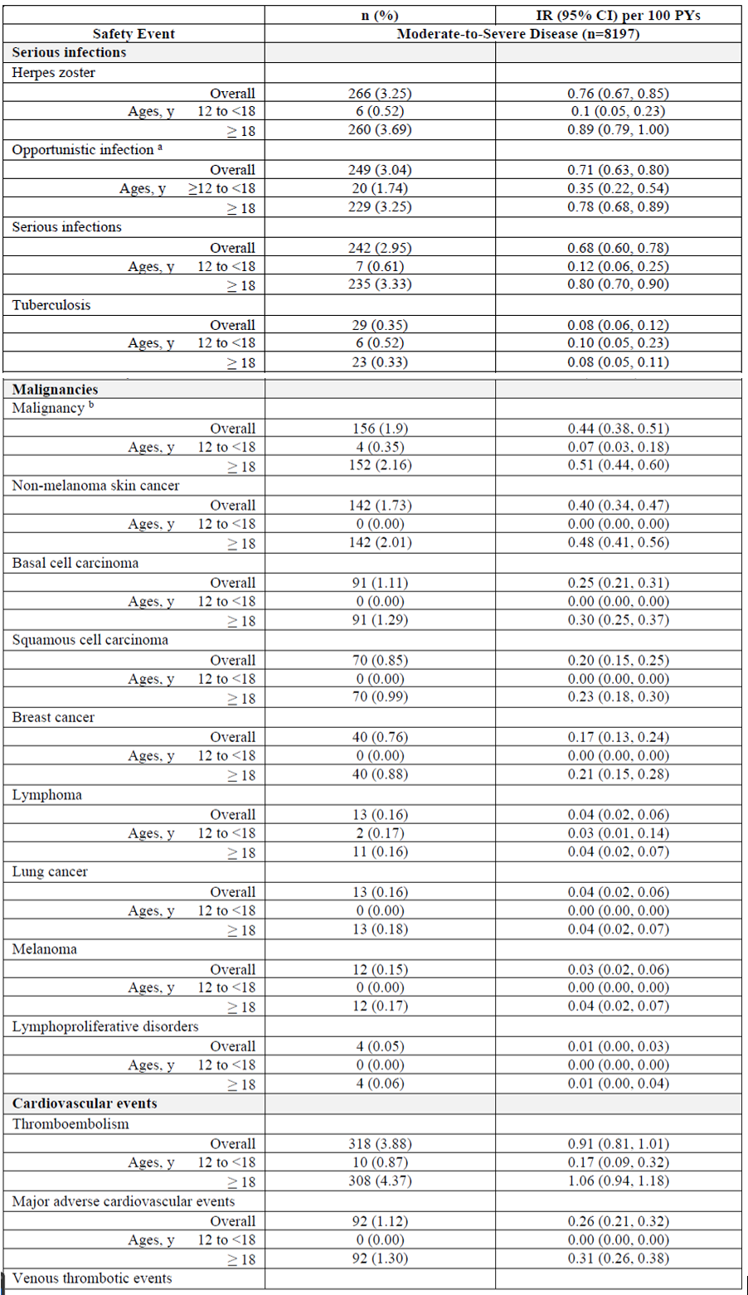
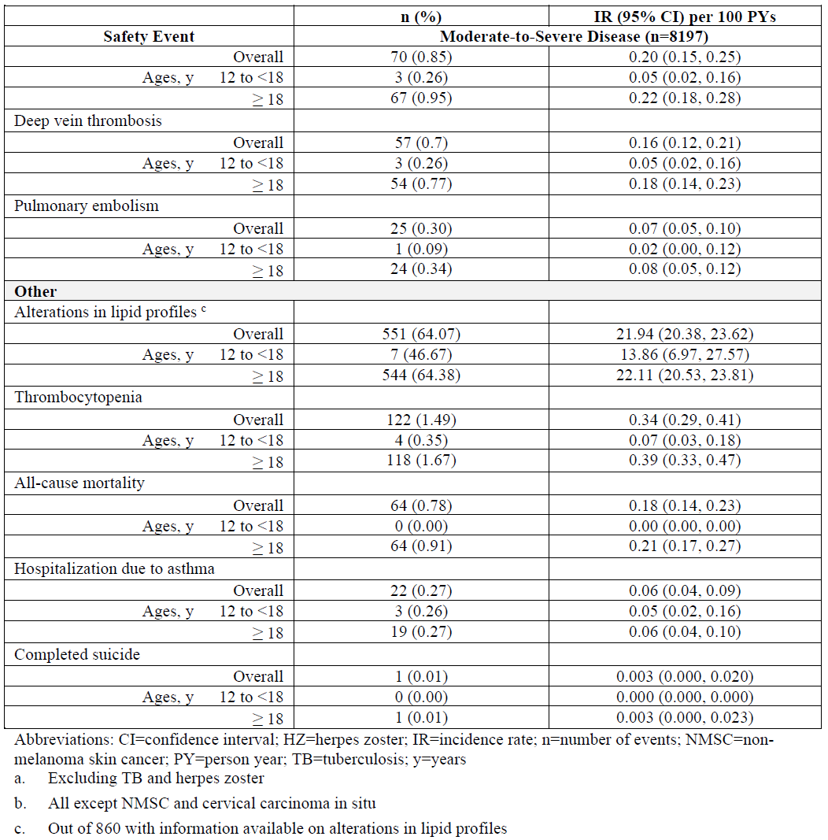

The Health Improvement Network (THIN) study
A retrospective cohort of adult and paediatric patients with AD (1.1 million patients) were matched with patients without AD (4.7 million) within the THIN database. The HR for pulmonary embolism (PE; overall) was 1.05 and for DVT was 1.22. In clinical studies with abrocitinib, the HR for PE in subjects in 200mg, compared to 100mg abrocitinib arm was 2.89 (Table 32).
Table 32. HRs in the THIN study.

Incidence of venous thromboembolic events in patients with atopic dermatitis cohort study
A population-based cohort study with data drawn from the Danish administrative longitudinal registries. All individuals aged 12 years or older were identified between January 1st, 2000, and December 31st, 2018. Patients with AD served as study cases and were matched 1:10 on age and sex with general population controls. 17,341 AD patients and 173,410 general population reference subjects matched on age and sex. Median (interquartile range) age was 27.9 (18.8-43.1), majority were females (60.5%). There were 3,909 patients aged 12 to <18 years, 12,408 aged 18 to <65 years, and 1,024 patients with AD aged 65 years or older.
The overall IR (per 10,000 person-years) for VTE in individuals with AD (14.25) was largely comparable to the general population (11.47). The IR for VTE in clinical studies with abrocitinib was higher than the IR in individuals with AD (Table 33):
Table 33. IRs for VTEs

Risk management plan evaluation
From an RMP perspective, the Evaluator considers that the uncertainty regarding the potential effects on bone formation and development has not been adequately addressed through routine risk minimisation measures and it is recommended that strengthening of information in the PI regarding this important potential risk should be considered.
Herpes simplex is a common adverse event for abrocitinib and episodes of eczema herpeticum were seen in clinical trials. The Evaluator has recommended precautionary statements in the PI and CMI.
The summary of safety concerns and their associated risk monitoring and mitigation strategies are presented in Table 34. The TGA may request an updated RMP at any stage of a product's life-cycle, during both the pre-approval and post-approval phases.
Table 34: Summary of safety concerns
Summary of safety concerns |  | Pharmacovigilance |  | Risk minimisation
 |  | Routine | Additional | Routine | Additional
Important potential risks | Venous thrombotic events including pulmonary embolism | P | P | P | P
Important potential risks | Herpes zoster | P | P | P | P
Important potential risks | Serious and opportunistic infections | P | P | P | P
Important potential risks | Eczema herpeticum | P | - | P | P
Important potential risks | Malignancy (including non-melanoma skin cancer) | P | P | P | P
Important potential risks | MACE as a result of hyperlipidaemia | P | P | P | P
Important potential risks | Myopathies (including rhabdomyolysis) | P | P | P | -
Important potential risks | Gastrointestinal perforation | P | P | - | -
Important potential risks | Embryofoetal toxicity following exposure in utero | P | P | P | P
Important potential risks | Impaired bone growth and development in adolescent subjects | P | P | P | P
Important potential risks | Impaired bone growth and development in patients if used off label in patients < 12 years of age. | P | P | P | -
Missing information | Long-term safety | P | P | - | -
Missing information | Use in the very elderly (≥ 75 years) | P | P | P | -
Missing information | Use in breast feeding | P | - | P | P
Missing information | Use in patients with evidence of hepatitis B or hepatitis C infection | P | P | P | P
Missing information | Effect on vaccination efficacy | P | P | P | -
Missing information | Effect on female fertility | P | - | P | -
RMP Evaluator recommendations regarding conditions of registration:
- The Cibinqo EU-Risk Management Plan (RMP) (version 0.2, dated 07 April 2021, data lock point 24 July 2020), with Australian Specific Annex (version 3.0; dated 20 August 2021), included with submission PM-2020-05286-1-1, and any subsequent revisions, as agreed with the TGA will be implemented in Australia.
- As Cibinqo is a new chemical entity it should be included in the Black Triangle Scheme as a condition of registration. The following wording is recommended for the condition of registration:
- Cibinqo (abrocitinib) is to be included in the Black Triangle Scheme. The PI and CMI for Cibinqo must include the black triangle symbol and mandatory accompanying text for five years, which starts from the date that the Sponsor notifies the TGA of supply of the product.

Risk-benefit assessment
After 12 weeks of treatment, the pivotal phase 3 monotherapy studies with abrocitinib in adolescent and adult patients with moderate to severe AD demonstrated greater overall improvement in the signs and symptoms of AD when compared with placebo and met co-primary endpoints and key secondary endpoints. The treatment differences were statistically significant. Overall, compared to placebo, the 200 mg of abrocitinib appears to have achieved better efficacy outcomes after 12 weeks of treatment, compared to 100mg abrocitinib. However, these studies were neither designed nor powered for comparative assessment of abrocitinib 200 mg and 100 mg doses. The 12-week treatment period of both pivotal studies did not provide long-term placebo-controlled efficacy and safety data for abrocitinib.
In the pivotal studies B7451012 and B7451013, 22% and 10% of the study population, respectively, were adolescents and subjects >65 years of age formed <5% of the population. Moreover, in the long-term pooled data, only 73 adolescents had ≥ 48 weeks exposure to abrocitinib, thus limiting both short- and long-term efficacy and safety data for both these patient groups. The Delegate has also noted that the median duration of treatment with 200mg abrocitinib was much shorter, compared to 100 mg abrocitinib both in children (195 vs 492 days) and adults (89 vs 501 days), thus limiting long-term safety data for 200mg. In view of the increased incidence of safety events for 200mg described below, compared to 100mg abrocitinib, the Delegate considers this limitation as a critical issue.
Compared to the dupilumab arm, at week 12, around 10% greater proportion of subjects achieved IGA and EASI 75 responses in 200 mg abrocitinib arm. At week 12 and at week 16, in comparison with dupilumab, no greater treatment benefits were observed for the 100 mg abrocitinib arm (CI included zero for IGA and EASI-75). This study was neither powered nor designed for a statistical comparative assessment between abrocitinib arms and the dupilumab arm. A 200-mg dose of abrocitinib was superior to dupilumab with respect to itch response at week 2 and the treatment difference was statistically significant. It is unclear why the Sponsor has chosen 2 weeks as a timepoint to assess this endpoint. Long-term treatment benefit in terms of itch reduction were not examined and hence unknown. AD is a chronic disease and long-term treatment benefit assessment is critical.
Secondary endpoints for this study were not adjusted for multiplicity and hence not taken into consideration for the comparison of treatment benefit. Overall, the incidence rate of AEs was either similar (100mg) or higher (200mg) in abrocitinib arms, compared to the dupilumab arm. This study only included adults; comparative data is lacking in adolescents. The Delegate has considered the benefits of oral administration of abrocitinib, compared to subcutaneous administration for dupilumab, particularly from a patient’s perspective. However, based on the data in this submission, no conclusion could be drawn regarding greater overall treatment benefit with abrocitinib, particularly the 100mg strength, compared to dupilumab.
In contrast to the pivotal studies, abrocitinib was used concomitantly with topical therapy in adolescents (Study B7451036). Hence, the treatment benefit with abrocitinib as a monotherapy in adolescents is limited. After 12 weeks of treatment in adolescents, both abrocitinib doses resulted in greater IGA and EASI-75 response rates compared with placebo. The treatment difference was statistically significant. The magnitude of treatment difference in the IGA and EASI-75 response rates between the abrocitinib 200-mg and abrocitinib 100-mg group doses at week 12 were much smaller than that observed in pivotal studies with abrocitinib as monotherapy (around 4% vs around 9.7- 23%). Background therapy with topical agents needs to be considered in this comparative assessment. However, topical therapy was allowed for both treatment arms and hence unlikely to influence this comparative assessment. A higher incidence of nausea was reported among adolescents in the abrocitinib 200 mg arm. Precautionary statements are included in the proposed PI.
Long-term data on growth and development (safety) in adolescents is lacking in this submission. The assessment of growth and development was limited to measurement of height (SDS) at one year of treatment with abrocitinib. Increase in height in adolescent children is known to be associated with a great degree of variability, thus having a negative impact on the external validity of the measures of height SDS performed at one year. This approach also dampens the availability of clinical data to address one of the major safety concerns that was highlighted by the non-clinical Evaluator: the irreversible bone changes such as impaired growth and abnormal morphology in juvenile rats. The non-clinical Evaluator has highlighted this issue as a major concern. The clinical Evaluator has highlighted the lack of measures of, such as Tanner grading, in children. Imaging studies in children are planned by the Sponsor.
In terms of the issue of M1 as an active metabolite of abrocitinib, the Delegate has noted the similar JAK inhibitory profile of M1 and M2 (highlighted by the non-clinical Evaluator) and considered the non-clinical Evaluator’s conclusions that the pharmacologic activity of abrocitinib is attributable to both M1 and M2 metabolites. The Delegate has also considered the Evaluator’s scientific rationale behind the recommendation that the free fraction molar basis of all metabolites should be taken into account. In consideration of all the above facts, the Delegate agrees with the non-clinical Evaluator’s conclusion that the safety profile of abrocitinib has not been well characterised, particularly the M1 metabolite.
In non-clinical studies, the sub-optimal relative exposure to abrocitinib, even when administered at the highest dose, limits the ability to make any safety-related conclusions. The inadequately assessed potential for carcinogenicity and the unknown safety margin for tumours were major concerns for the non-clinical Evaluator and one of the key reasons to recommend rejection of this application. The impact of this critical issue on the safety profile of abrocitinib was compounded by the incidence rate of events of malignancy in clinical studies, particularly the higher incidence of events of malignancy in the 200mg, compared to the 100mg abrocitinib arm. In clinical studies, the incidence rate of malignancy events (excluding NMSC) was around 4 times higher in the subjects treated with 200 mg abrocitinib, compared to those treated with 100 mg abrocitinib (0.34 vs 0.08, HR= 4.65), with none reported in the placebo arm. The incidence rate of NMSC was largely comparable across 100mg and 200 mg abrocitinib arms (0.38 vs 0.34, HR 0.74). It should be noted that the event of lymphoma that developed in a subject in abrocitinib arm with no prior history or risk factors was considered to be related to treatment with abrocitinib.
Australia has the highest incidence of NMSC in the world. All of the NMSC events were reported in subjects treated with abrocitinib, without any history of cancer or risk factors (these were exclusion criteria). Moreover, an event of squamous cell carcinoma was reported in a subject from Australia and considered as related to treatment with abrocitinib. The safety data from the clinical studies in this submission were inadequate to assess a mechanistic plausibility between abrocitinib and these events. However, the dose dependent increase in the incidence of these events across abrocitinib arms requires further evaluation with non-clinical studies in animal models at appropriate relative exposures, to exclude a plausible association of malignancy and treatment with abrocitinib.
Taken together, the Delegate considers that the risk of carcinogenicity in patients potentially treated with abrocitinib is poorly defined. Precautionary statements are added in the PI: The risks and benefits of Cibinqo treatment should be considered prior to initiating in patients with a known malignancy other than a successfully treated NMSC or cervical cancer in situ or when considering continuing Cibinqo therapy in patients who develop a malignancy. However, considering all these events of malignancy were reported in subjects with no prior history or risk factors for malignancy, and the event of lymphoma was considered to be related to treatment with abrocitinib, the Delegate considers that PI statements are not adequate to mitigate the risk of malignancy in patients who may be potentially treated with abrocitinib.
The relative risk for MACE events for adults <65 years of age treated with 200mg abrocitinib was two times higher, compared to those treated with 100mg abrocitinib. An event of retinal vein occlusion (MACE) that developed in a female subject with no prior risk factors was considered to be related to treatment with abrocitinib. MACE events were marginally higher in abrocitinib 200mg arm, compared to 100mg arm (3 vs 2 events, HR = 1.16). A dose-dependent increase in VTE and subset of PE events was noted, with a much higher incidence of both VTE (6 vs 1 event) and PE (3 vs 1 event) events in 200mg, compared to 100mg abrocitinib arm and no events in placebo (HR for VTE = 5.24, HR for PE = 2.89, 200mg vs 100mg abrocitinib). Events of PE, DVT and bilateral leg oedema were also considered as related to treatment with abrocitinib. In addition, the incidence rates for both PE and VTE in subjects treated with abrocitinib were higher than the subjects with AD in cohort studies (PE = 0.13 vs 0.07 and VTE = 0.23 vs 0.14 (VTE cohort study)). This is a major safety concern. The Delegate does not consider the precautionary statements in the PI and the pharmacovigilance measures are adequate to mitigate the cardiovascular risk in patients who may be treated with abrocitinib.
The Delegate has considered that the MACE, carcinogenicity and VTE events have been reported for other JAK inhibitors that are approved by TGA and there are related warnings and precautions in those PIs. However, all the previously TGA approved JAK inhibitors had a defined carcinogenicity risk established with non-clinical studies in animal models. This is lacking in this submission. In clinical studies with baricitinib in subjects with atopic dermatitis, three cases of VTE were reported (2 reports of pulmonary embolism in baricitinib 4 mg arm and one event of DVT in 2 mg arm).
In summary, based on the data provided in the dossier and the facts described above, the Delegate has concluded that the critical safety concerns from non-clinical studies appear to be compounded by the findings (carcinogenicity, MACE and VTE events) and lack of data (growth and development of adolescents) from the clinical studies. Considering the increase in MACE,
VTE (dose dependent) and carcinogenicity events, together with the shorter median duration of treatment for 200mg, compared to 100mg abrocitinib, the increased treatment benefit with 200mg abrocitinib does not outweigh the risks associated with treatment with this dose. Due to the lack of comparative data, no overall conclusions can be made in terms of greater overall treatment benefit for abrocitinib (both 100 and 200mg) compared with dupilumab.
Conclusion
At this stage, based on the data provided in the dossier, the Delegate is not convinced that there is enough evidence to support an acceptable benefit-risk balance for abrocitinib for the proposed indication.

Advisory committee considerations – December 2021
The proposed indication that was considered at the Advisory Committee on Medicines (ACM) was:
“Cibinqo is indicated for the treatment of patients 12 years of age and older with moderate-to-severe atopic dermatitis who are candidates for systemic therapy. Cibinqo can be used with or without medicated topical therapies for atopic dermatitis.”
The ACM, having considered the evaluations and the Delegate’s overview, as well as the Sponsor’s response to these documents, advised the following:
- What is the committee’s opinion about the nonclinical findings and its impact on the overall evidence to support abrocitinib for the proposed indication?
The ACM noted that the nonclinical data suggests that abrocitinib has an adverse effect on the mineralisation of growing bone, with the most severe effects visible during active bone formation (as evidenced by prenatal and juvenile studies). The ACM commented that there was a focus on limb growth in the animal studies, however, there is no evidence provided to suggest that vertebral growth (or any other joints) is unaffected. While the majority of limb growth occurs before 12 years of age, after age 13 in girls and 15 in boys’ growth occurs predominantly in sitting height (for example bone mass gain in L2-4).1 The ACM commented that many adolescents will still have open growth plates at other joints and the long-term effects of abrocitinib on these areas are unknown.
In regard to carcinogenicity in the nonclinical studies, the ACM advised that failure to achieve X 25 exposure ratio based on the area under the curve (ERAUC) in rodent carcinogenesis assays should not preclude registration, noting that the ICH S1C(R2) guidance suggests 25 X exposure ratio (ER) is only applicable if the maximum tolerated dose (MTD) is not achieved for non-genotoxic compounds (abrocitinib is a non-genotoxic compound). The ACM also advised that despite the sub-clinical exposure ratio (> 0.4 X ERAUC), the thymomas observed in female rats may not be clinically relevant. The ACM was of the view that there are appropriate warnings in the PI and RMP regarding carcinogenic potential based on the nonclinical studies, however they commented that carcinogenicity findings in the clinical studies are of significant concern (see response to Question 3, below).
The ACM agreed that the Sponsor should use the free fraction molar to calculate proportions of metabolites. In this case M1 qualifies as a significant human metabolite according to the criteria in ICH M3(R2). These guidelines also suggest that nonclinical characterisation is warranted when that metabolite is observed at significantly greater levels in humans than the maximum exposure seen in the toxicity studies. Based on the limited data presented, the M1 metabolite is poorly, if at all, produced in the selected animal species. Therefore, the ACM was of the view the safety of this metabolite has not been assessed in the nonclinical studies. Additionally, the ACM noted that important safety data for M2 and M4 was not available.
- Please comment on the safety profile of abrocitinib, specifically regarding MACE, VTE and cardiovascular events.
The ACM expressed concern about the safety profile of abrocitinib based on the data that was included in the dossier.
The ACM commented while the 5 incidences of major adverse cardiovascular events (MACE) are too small in number to draw firm conclusions from, the events were still considered to be a concern given the previous experience with other JAK inhibitors.
The ACM commented that the VTE events are similarly small in numbers but also concerning.
The ACM noted that many JAK inhibitors are known to raise LDL-C and HDL-C. While some animal studies of abrocitinib reflect 20-50% increases in LDL-C and HDL-C, the ACM noted that in the clinical studies the LDL/HDL ratio remains fairly constant and the elevations in LDL-C are only 5-10% (dose dependent). Triglycerides were unaffected.
The ACM advised that the malignancy risk has been poorly defined, noting in particular an event of squamous cell carcinoma (SCC) and an event of lymphoma considered as related to abrocitinib. The ACM also expressed concern that the dose-dependent risk for malignancy has not been studied.
The ACM noted that there are no long-term safety data on growth and development in adolescents, with this safety data being limited to height measurement at 1 year. The ACM also noted the irreversible effects on bone development at subclinical exposures in the nonclinical studies.
The ACM summarised that there are currently many limitations in the known safety profile of abrocitinib, which is a cause for concern.
- Please comment on the abrocitinib’s benefit-risk balance for the proposed indication.
The ACM acknowledged that the pivotal studies provided evidence for the efficacy of abrocitinib 100 mg and 200 mg doses in atopic dermatitis. However, they advised that evidence of treatment benefit for abrocitinib as a monotherapy is limited, as it was used concomitantly with topical therapy in adolescents.
The ACM commented on the higher incidence of nausea in 200 mg abrocitinib arm and upper respiratory tract infection in the 100 mg abrocitinib arm.
The ACM expressed concerns about the limitations in the current safety profile of abrocitinib, especially in adolescents, as highlighted in the response to Question 2, (above). In particular, the ACM expressed concern that the malignancy risk has been poorly characterised. The ACM noted that all previously approved JAK inhibitors had defined carcinogenicity risk established with nonclinical studies in animal models.
The ACM advised that there are currently many other treatment options available for the treatment of atopic dermatitis. Therefore, the ACM agreed that there is no significant clinical need to justify the safety risks of abrocitinib for the proposed indication, additionally noting that this is a childhood disease that tends to improve over time / into adulthood.
On balance, the ACM was of the view that the risks outweigh the benefits of abrocitinib for the proposed indication in atopic dermatitis in light of the uncertainties in the safety profile and the lack of unmet clinical need.
- Please comment on the adequacy of the precautionary statements in the PI and the pharmacovigilance measures to mitigate the risks identified in clinical studies with abrocitinib.
The ACM discussed the precautionary statement:
‘The risks and benefits of Cibinqo treatment should be considered prior to initiating in patients with a known malignancy other than a successfully treated NMSC or cervical cancer in situ or when considering continuing Cibinqo therapy in patients who develop a malignancy.’
The ACM was not supportive of this statement, noting that all events of malignancy were reported in subjects with no prior history or risk factor and that prior successful treatment of malignancy does not negate the risk.
The ACM commented that the risks of MACE and VTE could potentially be somewhat mitigated by prophylactic measures such as precautionary statements in the PI and CMI.
ACM Conclusion - December 2021
The proposed indication considered by the ACM was:
“Cibinqo is indicated for the treatment of patients 12 years of age and older with moderate-to-severe atopic dermatitis, including the relief of pruritus, who have had an inadequate response to prescribed topical therapy or for whom these treatments are not advisable. Cibinqo can be used with or without medicated topical therapies for atopic dermatitis”.
The ACM agreed that Cibinqo had an overall negative benefit-risk profile for the proposed indication as the evidence submitted did not satisfactorily establish the risk benefit profile of the product. The ACM expressed concern about the safety profile of abrocitinib, in particular the clinical malignancy findings and the nonclinical uncertainties. The ACM also highlighted the lack of unmet clinical need in atopic dermatitis.

Risk/benefit assessment post-ACM December 2021
Further to the Delegate’s proposed decision to reject this application, the Sponsor requested to re-consider a modified (proposed) indication, along with additional PI changes. The adolescent age group was removed from the targeted patient population.
The Sponsor’s modified (proposed) indication was:
“Cibinqo is indicated for the treatment of moderate-to-severe atopic dermatitis in adults who are candidates for systemic therapy. Cibinqo can be used with or without medicated topical therapies for atopic dermatitis”.
The Delegate reviewed the data in consideration of the revised indication.
Efficacy
The Delegate has considered the greater overall improvement in the signs and symptoms of AD following 12-weeks duration of treatment with abrocitinib, compared with placebo. The pivotal studies met co-primary endpoints and key secondary endpoints.
Safety
Non-clinical findings, along with the events of carcinogenicity that were reported across clinical studies were the basis of the concerns regarding the carcinogenicity events. The non-clinical Evaluator concluded that: Benign thymomas have been reported in rat carcinogenicity studies with other immunosuppressive agents (tofacitinib and pimecrolimus), but adequate safety margins were demonstrated for both drugs. As there is no safety margin for tumours with abrocitinib and there are limitations with the submitted carcinogenicity studies, suggesting carcinogenicity risk has not been adequately assessed, registration is not supported for the intended indication in the intended patient group.
No new data was submitted to address the limitations that were highlighted by the non-clinical Evaluator.
The Sponsor has highlighted abrocitinib as a non-genotoxic drug and in that regard, the non-clinical characterisation is adequate. The Sponsor has supported this argument with the following:
- Established a maximal tolerated dose.
- Achieved exposures well above that of the maximum recommended human dose (MRHD) of 200 mg once daily in rats and demonstrated a dose-response for thymoma (not clinically relevant), and
- Comparability with assessment of approved JAK inhibitors in the same class.
The non-clinical Evaluator considered the details submitted and has concluded that the recommendation to reject this application still stands.
The Sponsor considers that abrocitinib’s carcinogenicity profile is adequately defined and the observed incidence is consistent with other JAK inhibitors approved for treatment of AD. The Delegate agrees that carcinogenicity has been reported in clinical studies with other JAK inhibitors. The Delegate has also noted that FDA has imposed precautionary statements and boxed warnings to highlight malignancy, along with other treatment-related risks in the PIs of JAK inhibitors, including abrocitinib. If approved, the Delegate considers that a similar approach with the proposed PI might be able to mitigate the risks associated with carcinogenicity to a certain extent.
In line with the proposed indication that included adolescents and the safety signals related to carcinogenicity, from a clinical perspective, the potential prolonged use in adolescents was highlighted by the ACM as a critical safety issue. The revised (proposed) indication does not include adolescents and may have an effect on the benefit-risk profile; hence warrants reassessment. Based on short term data, no apparent dose-dependent effects were noted for carcinogenicity. Long-term effects are unknown. Dose-related changes are recommended in the PI. The ACM agreed with the Delegate regarding the fact that all the carcinogenicity events in the clinical studies were reported in subjects with no prior history or risk factors and that prior successful treatment of malignancy does not negate the risk. In consideration of these aspects, if approvable, further PI changes will also be recommended in the precaution and adverse events sections of the PI.
The Delegate considers that excluding the adolescent patient population from the proposed indication has also addressed one of the critical safety concerns (potential treatment-related effect on vertebral growth). However, the dose dependent increase of MACE events that was noted across clinical studies is still a safety concern. The Delegate has recommended dosage-related PI changes to mitigate this risk to a certain extent.
Summary
Considering the safety issues and uncertainties that are still present, at this point in time, based on the data provided, the Delegate has concluded a negative benefit-risk balance for the use of abrocitinib for the Sponsor’s revised (broad) indication for use in adults and for the use of 200 mg abrocitinib as the starting dose.
The Delegate has considered the greater treatment benefits of abrocitinib that was demonstrated across clinical studies, compared to placebo and the risk profile, based on the m…
Conclusion
In consideration of all the above facts and a revised risk-benefit assessment, the Delegate has proposed a revised indication, subject to ACM’s advice, as below:
“Cibinqo is indicated for the treatment of adults with refractory, moderate-to-severe atopic dermatitis whose disease is not adequately controlled with other systemic drug products, including biological medicines, or when use of those therapies is inadvisable.”
The Delegate concludes that the use of abrocitinib needs to be further restricted to a targeted patient population, along with restricted use of 200mg abrocitinib.
The Delegate has considered the greater treatment benefit with 200 mg, compared to 100mg abrocitinib across clinical studies. The dose-dependent MACE events that were reported was also noted. Taken together, the Delegate recommends restriction of the use of 200mg abrocitinib to those patients not responding to 12 weeks treatment with 100 mg abrocitinib.
100mg is recommended as the starting dose and 200 mg abrocitinib should only be used in patients not responding to treatment with 100 mg dose for 12 weeks and will be recommended to down-titrate to 100mg dose once a clinical response is achieved. Treatment with 200mg abrocitinib is recommended to be discontinued if no treatment response is achieved after 12 weeks of treatment. Maximum recommended daily dose is 200mg. Lowest effective dose should be considered. At any stage, treatment with 200mg is recommended only if the prescriber considers that the treatment benefit outweighs the associated risk. These measures are in addition to the PI statements that describes the dose dependent adverse effects.
The Delegate proposed a modified indication and PI changes and sought ACM advice.

Advisory Committee considerations – April 2022
The ACM advised the following in response to the Delegate’s specific request for advice:
- Please comment on the safety profile of abrocitinib for the revised indication for use in adults.
The ACM reiterated their previous concerns regarding the safety profile of Cibinqo, particularly in relation to the uncertainties regarding the risk of MACE, VTE and malignancy. The ACM commented that the pooled safety data is mostly limited to short term studies up to 12 weeks duration which is an insufficient length of exposure to determine the true effects of this therapy on the cardiovascular system (CVS) and malignancy. However, it was clarified that a Phase 3 long-term extension study of ≥ 48 weeks duration of treatment exposure with abrocitinib was included in the dossier.
The ACM agreed that the mechanism of action for CVS side effects is unknown, although cholesterol increase is likely to play a role.
The ACM again advised that the malignancy risk has been poorly defined and that the dose-dependent risk for malignancy has not been well established.
In regard to carcinogenicity findings in the nonclinical studies, the ACM reiterated their view that failure to achieve ×25 exposure ratio based on the area under the curve (ER_{AUC}) in rodent carcinogenesis assays should not preclude registration and that the thymomas observed in female rats are of some concern but may not be clinically relevant.
Despite these uncertainties, the ACM commented that the potential benefit for a small subgroup of patients may justify the risks when considered on an individual basis and in discussion between the doctor and the patient, inclusive of a signed contract of care (see advice to Question 2, below).
The ACM discussed the recent cardiovascular safety signal with JAK inhibitors as a class effect and advised that further investigations of this signal may inform an effective way of understanding this risk across the class, including CINIBQO.
- In consideration of the Sponsor’s revised indication, does the ACM consider the risks associated with the treatment with Cibinqo still outweigh the benefits. If so, what is the ACM’s advice regarding the Delegate’s suggested indication?
The ACM cited several uncertainties for the proposed revised indication including limited evidence of an unmet clinical need, higher incidence of nausea and VTE events in the 200 mg arm, compared to 100 mg arm, poorly defined malignancy risk, and uncertainties regarding CVS risks. The ACM highlighted that atopic dermatitis is predominately a disease of the younger age group that is mostly self-limiting with age, with approximately 10% of childhood atopic dermatitis continuing to adulthood.
However, the ACM acknowledged that a small subgroup of adults with refractory moderate to severe disease may benefit from having an additional treatment option, noting the negative impacts severe manifestations of this disease can have on quality of life. The ACM advised that the risk benefit profile for these patients will need to be considered in the context of the uncertainties with the safety profile.
The ACM strongly emphasised that due to the uncertainties in the safety profile Cibinqo should not be used as a first line therapy given that there are effective and safer treatment options available. The ACM advised to restrict the use of Cibinqo to after a trial of a biological medicine and possibly a trial of other JAK inhibitors approved for the treatment of atopic dermatitis.
On balance, the ACM agreed that there is potential benefit for Cibinqo as a third -line treatment in adult patients with refractory moderate to severe atopic dermatitis, with strengthening of the warnings in the PI and CMI (as outlined in the advice to Question 4, below).
The ACM recommended the following indication wording:
”Cibinqo is indicated for the treatment of moderate-to-severe atopic dermatitis in adult patients with refractory disease, for whom biological medicines are either contraindicated or have achieved an inadequate response.”
The ACM expressed uncertainty regarding why a 50 mg presentation has been proposed for registration, noting this presentation is not mentioned in the dosing instructions.
- What is the ACM’s advice on instigating a boxed warning in the proposed abrocitinib PI to highlight the risks associated with carcinogenicity and MACE?
Considering the recent safety signal for JAK inhibitors as a class, the ACM was of the view that it is premature to include a boxed warning at this time for Cibinqo only. The ACM commented that this is a rapidly evolving space and that the initiation of a boxed warning may become necessary as further information becomes available.
- Please comment on the adequacy of the precautionary statements in the PI and the pharmacovigilance measures to mitigate the risks associated with the use of abrocitinib.
To ensure that the risks are appropriately managed, the ACM agreed that initiation and supervision of Cibinqo treatment for the proposed indication should be limited to dermatologists.
The ACM emphasised that clear dose escalation and discontinuation criteria are a crucial part of risk management for this therapy. The ACM advised that dosage should be initiated at 100 mg, increased to 200 mg at 12 weeks if there is an inadequate response to 100 mg, followed by a reassessment of the 200 mg dose at 16 weeks, from the start of the treatment. The ACM agreed Cibinqo should be discontinued if no treatment benefit is seen by 24 weeks from the start of the treatment.
Given the concerns around thrombotic events, including pulmonary embolism (PE), the ACM advised that a statement such as the following should be included in the PI:
‘Consider discontinuation around long-haul flights, post orthopaedic surgery or in the setting of immobilisation. VTE risk with co administration of other medications that increase VTE risk, such as the COCP and HRT, is unstudied, but likely represents an even greater increased risk.’
The ACM advised that ‘has been studied in adolescents 12 to < 18’ should be removed from the PI as the proposed indication is in adults only and there are concerns regarding the impact on bone growth within children.
The ACM was of the view that ‘The effect of these lipid parameter elevations on cardiovascular morbidity and mortality has not been determined’ is misleading as there is no physiological reason to doubt that increased lipids will result in CVS disease. The ACM advised that a more appropriate statement would be ‘The mechanism of MACE remains unclear, however the rise in lipids is postulated to be contributory’.
The ACM advised that, given the uncertainty about the mechanism of action behind the occurrence of MACE, the Important Potential Risk of ‘MACE as an outcome of hyperlipidaemia’ should be revised to ‘MACE as an outcome of hyperlipidaemia or other mechanisms.’
The ACM was of the view that the proposed safety surveillance reports should include MACE.
The ACM agreed that treatment should be interrupted if the absolute neutrophil count (ANC) is
<1000/mm³, noting this is also in line with advice for other JAK inhibitors.
The ACM reiterated their previous advice that they were not supportive of the following statement regarding malignancy in the PI, noting that all events of malignancy were reported in subjects with no prior history or risk factor and that prior successful treatment of malignancy does not negate the risk:
‘The risks and benefits of Cibinqo treatment should be considered prior to initiating in patients with a known malignancy other than a successfully treated NMSC or cervical cancer in situ or when considering continuing Cibinqo therapy in patients who develop a malignancy.’
The ACM also advised that malignancy should be included on the proposed patient card, noting that it is currently only proposed for the prescriber card. A patient card was recommended to be developed as a risk mitigation strategy.
The ACM emphasised that periodic skin examination is important for all patients on Cibinqo therapy, not just those at increased risk of skin cancer, and that this recommendation should also be included in the CMI.
The ACM advised that the following sentence in the CMI should be modified to list medical conditions of particular interest:
‘Talk to your doctor if you have any other medical conditions (particularly CVS disease or risk factors; VTE/PE history/ risk factors; malignancy), take any other medicines, or plan to become pregnant.’
The ACM was of the view that the side effects in the CMI should include ‘cancers, including skin cancers, increased cholesterol, increased CVD events. The risk of cancer is higher if you are, or have ever been, a smoker.’
The ACM advised that the risk factors for DVT and PE should be listed in the CMI, such as:
‘Abrocitinib increases the risk for DVT and PE. There are known risk factors that increase your baseline risk, these are: older age, obesity, past PE/DVT, clotting disorder, use of the OCP or HRT, if you are having major surgery or prolonged immobilisation.’
ACM Conclusion – April 2022
The ACM considered this product to have an overall positive benefit-risk profile for the indication in a small number of individuals:
“Cibinqo is indicated for the treatment of moderate-to-severe atopic dermatitis in adult patients with refractory disease, for whom biologic agents are either contraindicated or have achieved an inadequate response.”

Risk/benefit assessment post-ACM April 2022
The Delegate recommended a modified indication, along with PI changes, as outlined above. This proposal was not accepted by the Sponsor. Subsequently, the TGA did not include the product on the ARTG.

Section 60 review
Following the initial decision to exclude Cibinqo from the ARTG, the sponsor sought a review under the provisions of Section 60 of the Therapeutics Goods Act 1989. The Delegate of the Minister for the review noted that paragraph 25(1)(d) of the Therapeutic Goods Act 1989, which requires the goods to be evaluated with regard to whether the quality, safety, and efficacy of the goods for the purposes for which they are to be used have been satisfactorily established, is of particular relevance. At the conclusion of the Section 60 review, the Evaluator confirmed the initial decision (rejection) that was made by the Delegate. The basis for this decision, as outlined by the Evaluator, was that the evidence presented by the Sponsor was not sufficient to satisfactorily establish the safety of the Medicine for the purpose for which it is to be used. In addition, the Evaluator concluded that the applicant’s PI did not adequately describe measures for the mitigation of the identified risks associated with the use of the product, for the proposed indication, at the proposed dosage.

Appeal to the Administrative Appeals Tribunal
Following the Section 60 review, and subject to the Administrative Appeals Tribunal Act 1975, the Sponsor made an application to the Administrative Appeals Tribunal (AAT) for a review of this decision. The principal issues in dispute between the parties were whether the safety of the medicine had been satisfactorily established for the Sponsor’s proposed indication at the proposed dosage and whether the PI for the medicine adequately addressed the risks associated with its use.
The AAT review process included the submission of additional and longer-term clinical trial data, real-world use information from overseas jurisdictions, involvement of subject matter experts across multiple fields including Australian dermatologists, and updated PI and CMI documentation.

Registration decision
On 8 April 2024, the AAT decided to approve Cibinqo (abrocitinib) for registration on the ARTG. This decision was made after the parties reached an agreement, based on additional data and agreed updates to the PI, that the final negotiated draft PI was acceptable and that the safety of Cibinqo was satisfactorily established for the purposes for which it is to be used as outlined in the draft PI.
The approved indication for Cibinqo is:
“Cibinqo is indicated for the treatment of moderate-to-severe atopic dermatitis in adults who are candidates for systemic therapy. Cibinqo can be used with or without medicated topical therapies for atopic dermatitis.”

Submission details
Type of submission: | New chemical entity
Product name: | Cibinqo
Active ingredients: | Abrocitinib
Decision: | Approved
AAT decision: | The Administrative Appeals Tribunal decided to approve Cibinqo (abrocitinib) for registration on the Australian Register of Therapeutic Goods (ARTG) on the 8th of April 2024
Date of entry onto ARTG: | 16 April 2024
ARTG numbers: | Cibinqo abrocitinib 100 mg tablet blister pack (346350)  Cibinqo abrocitinib 200 mg tablet blister pack (346351)  Cibinqo abrocitinib 50 mg tablet blister pack (346349)
Black Triangle Scheme | Yes. The PI and CMI for Cibinqo must include the black triangle symbol and mandatory accompanying text for five years, which starts from the date that the Sponsor notifies the TGA of supply of the product.
Sponsor’s name and address: | Pfizer Australia Pty Ltd  Level 17, 151 Clarence Street  Sydney NSW 2000
Dose form: | Tablet
Strengths: | 50 mg, 100 mg and 200 mg
Container: | Blister packs
Pack size: | 7 film coated tablet Starter Packs and 28 film coated tablet Commercial Packs.
Approved therapeutic use for the current submission: | For the treatment of moderate-to-severe atopic dermatitis in adults who are candidates for systemic therapy. Cibinqo can be used with or without medicated topical therapies for atopic dermatitis.
Routes of administration: | Oral
Dosage: | The recommended starting dose is 100 mg or 200 mg once daily based on individual patient characteristics:  • A starting dose of 100 mg once daily is recommended for patients at higher risk of venous thromboembolism (VTE), major adverse cardiovascular event (MACE) and malignancy.  • A dose of 200 mg once daily may be appropriate for patients with high disease burden who are not at higher risk of VTE, MACE and malignancy or for patients with an inadequate response to 100 mg once daily. Upon disease control, dose should be decreased to 100 mg once daily. If disease control is not maintained after dose reduction, re-treatment with 200 mg once daily can be considered.  The lowest effective dose for maintenance should be considered.  Discontinuation of treatment should be considered in patients who show no evidence of therapeutic benefit after 24 weeks.  For further information regarding dosage, such as dosage modifications to manage adverse reactions, refer to the Product Information.
Pregnancy category: | D.  Drugs which have caused, are suspected to have caused or may be expected to cause, an increased incidence of human fetal malformations or irreversible damage. These drugs may also have adverse pharmacological effects. Accompanying texts should be consulted for further details.  The use of any medicine during pregnancy requires careful consideration of both risks and benefits by the treating health professional. The pregnancy database must not be used as the sole basis of decision making in the use of medicines during pregnancy. The TGA does not provide advice on the use of medicines in pregnancy for specific cases. More information is available from obstetric drug information services in your state or territory.

Specific conditions of registration applying to these goods
Cibinqo is to be included in the Black Triangle Scheme. The PI and CMI for Cibinqo must include the black triangle symbol and mandatory accompanying text for five years, or the product’s entire period of provisional registration, whichever is longer. The Black Triangle Scheme identifies new prescription medicines with a black triangle on the medicine information documents. The scheme also applies to prescription medicines being used in new ways, such as a medicine that is now being used for children. The black triangle is a visual reminder to encourage health practitioners and patients to report a problem or side effect.
The Cibinqo EU- Risk Management Plan (RMP) (version 3.2, dated 27 October 2022, data lock point 16 April 2021), with Australian Specific Annex (version 6.0; dated 26 January 2024), and any subsequent revisions, as agreed with the TGA will be implemented in Australia.
An obligatory component of risk management plans is routine pharmacovigilance. Routine pharmacovigilance includes the submission of periodic safety update reports (PSURs).
Unless agreed separately between the supplier who is the recipient of the approval and the TGA, the first report must be submitted to TGA no later than 15 calendar months after the date of approval. The subsequent reports must be submitted no less frequently than annually from the date of the first submitted report until the period covered by such reports is not less than three years from the date of this approval letter. The annual submission may be made up of two PSURs each covering six months. The six monthly reports may be submitted separately as they become available.
Final versions of the additional risk minimisation materials referred to in the RMP and Australia Specific Annex to the TGA for review and acceptance must be provided at least 6 weeks before the product is supplied in Australia.

Product Information (PI) and Consumer Medicine Information (CMI)
The Product Information (PI) approved with this submission for Cibinqo which is referred to in this AusPAR (and can be accessed on this AusPAR’s webpage) may have been superseded. For the most recent PI and Consumer Medicines Information (CMI), please refer to the TGA PI/CMI search facility.

Regulatory status

Australian regulatory status
This product is considered a new chemical entity medicine for Australian regulatory purposes.

International regulatory status
The UK MHRA approved abrocitinib in September 2021. The indications and posology as of June 2024 are as follows:
“Cibinqo is indicated for the treatment of moderate-to-severe atopic dermatitis in adults and adolescents 12 years and older who are candidates for systemic therapy.”
Dose and method of administration:
The recommended starting dose of Cibinqo is 100 mg or 200 mg once daily based on individual patient characteristics:
- A starting dose of 100 mg once daily is recommended for adolescents (12 to 17 years old), and for patients at higher risk of venous thromboembolism (VTE), major adverse cardiovascular event (MACE) and malignancy. If the patient does not respond adequately to 100 mg once daily, the dose can be increased to 200 mg once daily (see below).
- A dose of 200 mg once daily may be appropriate for patients who are not at higher risk of VTE, MACE and malignancy with high disease burden or for patients with an inadequate response to 100 mg once daily. Upon disease control, dose should be decreased to 100 mg once daily. If disease control is not maintained after dose reduction, re-treatment with 200 mg once daily can be considered. The lowest effective dose for maintenance should be considered. Discontinuation of treatment should be considered in patients who show no evidence of therapeutic benefit after 24 weeks.
- Cibinqo can be used with or without medicated topical therapies for atopic dermatitis.
The EMA approved abrocitinib on the 17th of December 2021. The indications and posology as of June 2024 are as follows:
“Cibinqo is indicated for the treatment of moderate-to-severe atopic dermatitis in adults and adolescents 12 years and older who are candidates for systemic therapy.”
Dose and method of administration:
- The recommended starting dose is 100 mg or 200 mg once daily based on individual patient characteristics:
- A starting dose of 100 mg once daily is recommended for patients at higher risk of venous thromboembolism (VTE), major adverse cardiovascular event (MACE) and malignancy (see section 4.4). If the patient does not respond adequately to 100 mg once daily, the dose can be increased to 200 mg once daily.
- A dose of 200 mg once daily may be appropriate for patients who are not at higher risk of VTE, MACE and malignancy with high disease burden or for patients with an inadequate response to 100 mg once daily. Upon disease control, dose should be decreased to 100 mg once daily. If disease control is not maintained after dose reduction, re-treatment with 200 mg once daily can be considered. In adolescents (12 years to 17 years of age), weighing 25 kg to < 59 kg, a starting dose of 100 mg once a day is recommended. If the patient does not respond adequately to 100 mg once daily, the dose can be increased to 200 mg once daily. In adolescents weighing at least 59 kg, a starting dose of 100 mg or 200 mg once daily may be appropriate.
- The lowest effective dose for maintenance should be considered.
- Discontinuation of treatment should be considered in patients who show no evidence of therapeutic benefit after 24 weeks.
- Cibinqo can be used with or without medicated topical therapies for atopic dermatitis.
The FDA approved abrocitinib on the 14th of January 2022. The indications and posology as of June 2024 are as follows:
Cibinqo is indicated for the treatment of adults and paediatric patients 12 years of age and older with refractory, moderate-to-severe atopic dermatitis whose disease is not adequately controlled with other systemic drug products, including biologics, or when use of those therapies is inadvisable.
Dose and method of administration
- The recommended dose is 100 mg once daily.
- If an adequate response is not achieved with Cibinqo 100 mg once daily, consider increasing the dosage to 200 mg once daily.
- Discontinue Cibinqo if an adequate response is not achieved with 200 mg once daily.
- Use the lowest efficacious dose to maintain response.
- Cibinqo can be used with or without topical corticosteroids.
- If a dose is missed, administer the dose as soon as possible unless it is less than 12 hours before the next dose, in which case skip the missed dose. Thereafter, resume dosing at the regular scheduled time.

Assessment and registration timeline
This submission was evaluated under the standard prescription medicines registration process.
Table 35 outlines the key steps and dates for this submission.
Table 35. Registration timeline for Cibinqo (submission no. PM-2020-05286-1-1) – key dates
Description | Date
Submission dossier accepted and first round evaluation commenced | 30 November 2020
First round evaluation completed | 18 May 2021
Second round evaluation completed | 22 November 2021
Delegate’s overall benefit-risk assessment and request for Advisory Committee advice | 27 October 2021
Advisory Committee meeting 1 | December 2021
Advisory Committee meeting 2 | April 2022
Registration decision (rejection) | 13 September 2022
Review sought of the initial decision under section 60 of the Therapeutic Goods Act. | 18 October 2022
Registration decision (Administrative Appeals Tribunal outcome) | 12 April 2024
Administrative activities and registration in the ARTG completed | 16 April 2024
Number of working days from submission dossier acceptance to registration decision* | 858
*Statutory timeframe for standard submissions is 255 working days

Attachment 1. Product Information
The Product Information (PI) approved with the submission for Cibinqo which is described in this AusPAR can be found as Attachment 1. It may have been superseded. For the most recent PI and Consumer Medicines Information (CMI), please refer to the TGA PI/CMI search facility.

Therapeutic Goods Administration
PO Box 100 Woden ACT 2606 Australia
Email: info@tga.gov.au Phone: 1800 020 653 Fax: 02 6203 1605
https://www.tga.gov.au
Reference/Publication #

This is the original indication proposed by the sponsor when the TGA commenced the evaluation of this submission. It may differ to the final indication approved by the TGA and registered in the Australian Register of Therapeutic Goods.
Australasian Society of Clinical Immunology and Allergy. Eczema (Atopic Dermatitis). 2019 27 June 2019 (Accessed 1 July 2019); Available from: https://www.allergy.org.au/patients/skin-allergy/eczema.
Silverberg JI. Public health burden and epidemiology of atopic dermatitis. Dermatol Clin. 2017;35(3):283-9.
Drucker AM, Wang AR, Li WQ, et al. The Burden of Atopic Dermatitis: Summary of a Report for the National Eczema Association. J Invest Dermatol. 2017;137(1):26-30.
Reed B, Blaiss MS. The burden of atopic dermatitis. Allergy Asthma Proc. 2018;39(6):406-10.
Bureau UC. National Population by Characteristics: 2010-2019 Washington, DC: US Census Bureau; 2020 [cited 2020 May 20 2020]. Available from: https://www.census.gov/data/tables/timeseries/demo/popest/2010s-nationaldetail.html.
Akdis CA, Akdis M, Bieber T, et al. Diagnosis and treatment of atopic dermatitis in children and adults: European Academy of Allergology and Clinical Immunology/American Academy of Allergy, Asthma and Immunology/PRACTALL Consensus Report. Allergy. 2006;61(8):969-87.
Kunz B, Oranje AP, Labreze L, et al. Clinical validation and guidelines for the SCORAD index: consensus report of the European Task Force on Atopic Dermatitis. Dermatology. 1997;195(1):10-9.
Ring J, Alomar A, Bieber T, et al. Guidelines for treatment of atopic eczema (atopic dermatitis) part I. J Eur Acad Dermatol Venereol. 2012;26(6):1045-60.
Garg N, Silverberg JI. Epidemiology of childhood atopic dermatitis. Clin Dermatol. 2015;33(3):281-8.
Langan SM, Irvine AD, Weidinger S. Atopic dermatitis. Lancet. 2020;396(10247):345-60.
Nutten S. Atopic dermatitis: global epidemiology and risk factors. Ann. Nutr. Metab. 2015.
Martin PE, Koplin JJ, Eckert JK et al. The prevalence and socio-demographic risk factors of clinical eczema in infancy: a population-based observational study. Clin. Exp. Allergy 2013; 43: 642–51.
Homey B, Steinhoff M, Ruzicka T, et al. Cytokines and chemokines orchestrate atopic skin inflammation. J Allergy Clin Immunol 2006;118(1) (Jul):178-89.
Eichenfield LF, Tom WL, Chamlin SL, Feldman SR, Hanifin JM, Simpson EL, Berger TG, Bergman JN, Cohen DE, Cooper KD, Cordoro KM, Davis DM, Krol A, Margolis DJ, Paller AS, Schwarzenberger K, Silverman RA, Williams HC, Elmets CA, Block J, Harrod CG, Smith Begolka W, Sidbury R. Guidelines of care for the management of atopic dermatitis: section 1. Diagnosis and assessment of atopic dermatitis. J Am Acad Dermatol. 2014 Feb;70(2):338-51. doi: 10.1016/j.jaad.2013.10.010. Epub 2013 Nov 27. PMID: 24290431; PMCID: PMC4410183.
Werfel T, Heratizadeh A, Aberer W, et al. S2k guideline on diagnosis and treatment of atopic dermatitis – short version. Allergo J Int 2016; 25:82–95.
Elidel (pimecrolimus 1% w/w) Product Information https: //www.ebs.tga.gov.au/
https://www.tga.gov.au/sites/default/files/auspar-crisaborole-190814-pi.pdf
Smith S, Baker C, Gebauer K, Rubel D, Frankum B, Soyer H P, Weightman W, Sladden M, Rawlin M, Headley AP, Somerville C Beuth J, Logan N, Mewton E, Foley P. Atopic dermatitis in adults: An Australian management consensus. Australasian Journal of Dermatology 2019.
Renert-Yuval Y, Guttman-Yassky E. New treatments for atopic dermatitis targeting beyond IL-4/IL-13 cytokines. Ann Allergy Asthma Immunol. 2020;124(1):28-35.
O'Shea JJ, Schwartz DM, Villarino AV, et al. The JAK-STAT pathway: impact on human disease and therapeutic intervention. Annu Rev Med. 2015;66: 311-28.
He H, Guttman-Yassky E. JAK Inhibitors for Atopic Dermatitis: An Update. Am J Clin Dermatol. 2019;20(2):181-92.

