EU MDR Transition – Online assessment tool and notification form
  - User guide for sponsors and agents
Version 2.2, June 2024

Copyright
© Commonwealth of Australia 2024
This work is copyright. You may reproduce the whole or part of this work in unaltered form for your own personal use or, if you are part of an organisation, for internal use within your organisation, but only if you or your organisation do not use the reproduction for any commercial purpose and retain this copyright notice and all disclaimer notices as part of that reproduction. Apart from rights to use as permitted by the Copyright Act 1968 or allowed by this copyright notice, all other rights are reserved and you are not allowed to reproduce the whole or any part of this work in any way (electronic or otherwise) without first being given specific written permission from the Commonwealth to do so. Requests and inquiries concerning reproduction and rights are to be sent to the TGA Copyright Officer, Therapeutic Goods Administration, PO Box 100, Woden ACT 2606 or emailed to <tga.copyright@tga.gov.au>.

Contents
Overview of the online assessment tool 4
Note on IVDD to IVDR transition 4
Step by step guide on using the online assessment tool 4
Overview of the online notification form 10
When to use the online notification form 10
Step by step guide on using the online notification form 10
Non-transitioning devices 23
More information about the Online Notification Form 28
Purpose 29
Additional guidance 29

Overview of the online assessment tool
The Online Assessment Tool is optional. You can use it at any time to assist you in determining the appropriate actions required and to assist you to meet obligations for your devices transitioning to the EU MDR.

Note on IVDD to IVDR transition
This guidance relates to non-IVD medical devices only and does not cover the transition of IVD medical devices to the EU IVD Regulation (IVDR). A separate guide will be provided for the transition of IVD medical devices to the EU IVDR.

Step by step guide on using the online assessment tool
Access the Online Assessment Tool at the TGA – Citizen Space website.
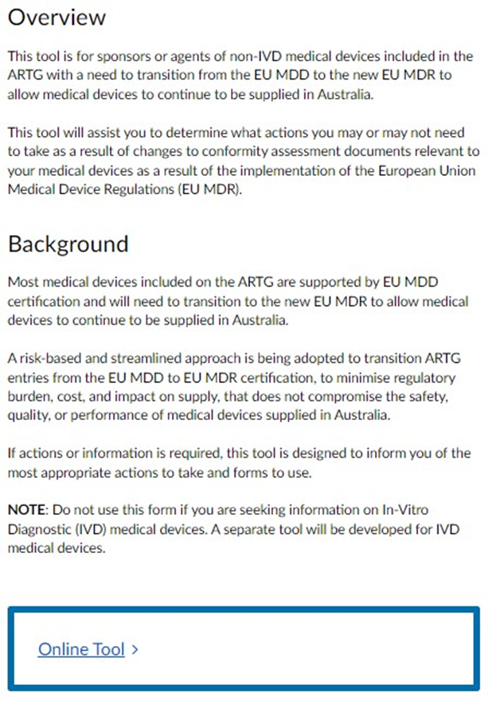
Click on ‘Online Tool’ to begin.
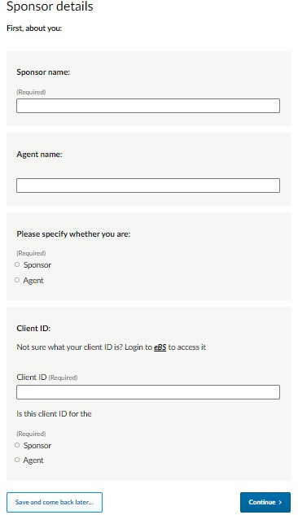

Enter your details, including your TGA eBusiness Services (eBS) client ID. Please contact TGA eBS if you do not know these details.
Click on ‘Continue’ to go to the next page.

If you would like to update your manufacturer evidence in TGA’s certificate repository to your new EU MDR certification, submit an ME variation application.
Click on ‘Continue’ to go to the next page.
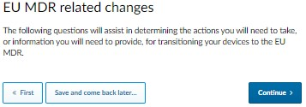

This is the start of a questionnaire to help you decide what actions you will need to take to ensure that your devices remain compliant under the Australian regulatory framework as you transition your devices to the EU MDR.
Click on ‘Continue’ to go to the next page.
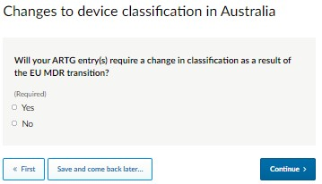
If your ARTG entry requires a change in classification under the Australian regulatory framework, select ‘Yes’. Click on ‘Continue’ to go to the next page, where you will be advised that you will need to lodge a new application of inclusion for your device(s).
A change in classification means your device is a different kind and will require a new ARTG entry.
Click on ‘Continue’ to go to the next page, where you can enter your email address to be sent a copy of your responses. Click on ‘Submit Response’. This will end the session.
If your ARTG entry does not require a change in classification under the Australian regulatory framework, select ‘No’. Click on ‘Continue’ to go to the next page.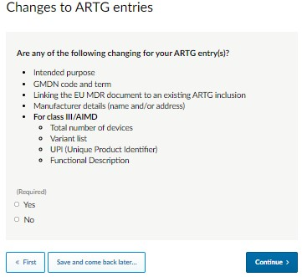
This question helps you to determine if a device change request (DCR) or variation is required for your ARTG entry. Select your response and click on ‘Continue’ to go to the next page.
If you select ‘Yes’, you will be advised that you will need to lodge a DCR or Variation application for your ARTG entry.
If you select ‘No’, you will be advised that no action is required for this response.
Click on ‘Continue’ to go to the next page.
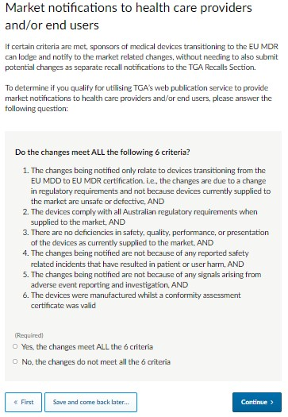
This question helps you to decide whether you qualify for streamlined market notifications for your devices. Select your response and click on ‘Continue’ to go to the next page.
If you select ‘Yes’, you will be advised that you can use the TGA’s EU MDR Transition web publication service to notify end users of device changes, without needing to follow the full TGA recall process.
If you select ‘No’, you will be advised that you need to submit new recall notifications following the TGA’s established recalls procedure.
Click on ‘Continue’ to go to the next page.
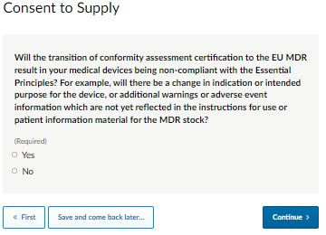
This question helps you to determine whether consent to supply is required for your device. To import, export or supply a product that does not comply with the essential principles, you must submit a consent to supply to the TGA for consideration.
If you select ‘Yes’, you will be advised that you will require consent to supply your device as your device is non-compliant with the Essential Principles.
If you select ‘No’, you will be advised that no action is required for this response.
Click on ‘Continue’ to go to the next page.

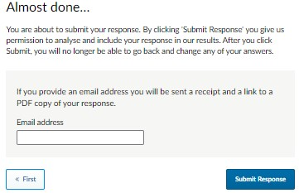

To review the entire form before selecting ‘Submit Response’, click on ‘<< First’ this will return you to the start of your filled out form for review. To go forward through the form, select ‘Continue >>’ until you get to the final window ‘Almost done…’. If you would like to receive a copy of your response, enter your email address and click on ‘Submit Response’. This will end the session.

Overview of the online notification form
The Online Notification Form is available for sponsors and agents. You can use the TGA’s EU MDR Transition web publication service to notify health care providers and users of changes to their devices due to the implementation of the EU MDR and about nontransitioning devices.

When to use the online notification form
You can use this form when you know the details of changes to your devices following European regulatory changes. You will need to be ready to enter details of the changes, for health professionals and consumers. These will be published on the TGA’s website.

Step by step guide on using the online notification form
Access the Online notification form at the TGA – Citizen Space website.
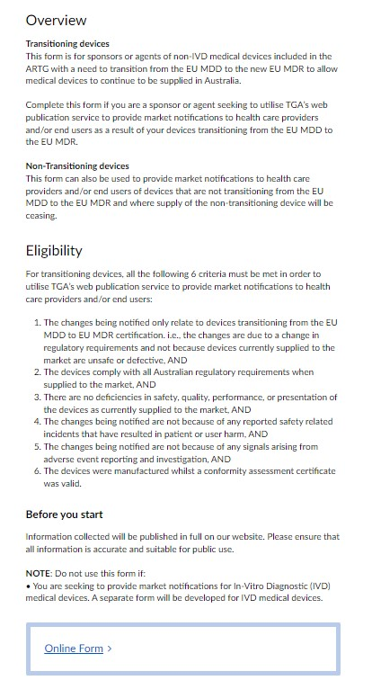
Click on ‘Online Form’ to begin.
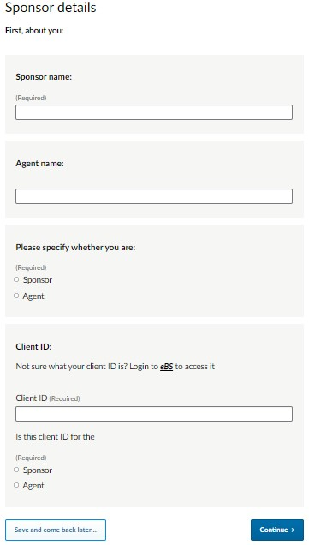
Enter your details, including your TGA eBusiness Services (eBS) client ID. Please contact TGA eBS if you do not know these details.
Click on ‘Continue’ to go to the next page.
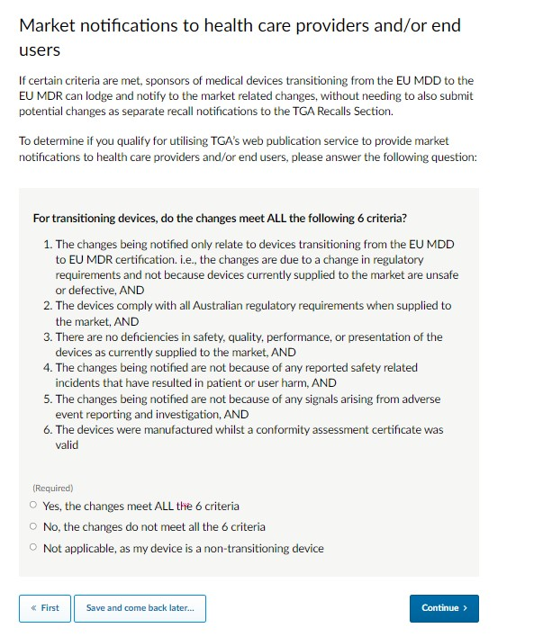
This question helps you in deciding whether changes made to your device are suitable to use the streamlined market notifications for your devices. Select your response and click on ‘Continue’ to go to the next page.
For transitioning devices, if you select ‘No’, you will be advised you do not qualify to use the TGA’s EU MDR Transition web publication service to provide market notifications to health care providers and/or end users. You will need to submit a new recall notification(s) following the TGA’s established recalls procedure.
Click on ‘Continue’ to go to the next page, where you can provide your email address to be sent a copy of your responses. Click on ‘Submit Response’. This will then end the session.
If you select ‘Yes’, you will qualify to use the TGA’s EU MDR Transition web publication service to provide market notifications to health care providers and end users. Click on ‘Continue’ to go to the next page.
For non-transitioning devices, please select ‘Not applicable’. Detailed instructions can be found on page 24 of this document.
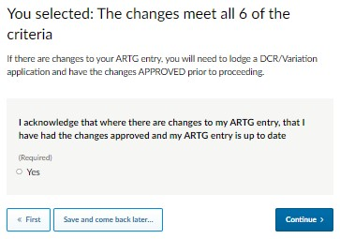
You are asked to confirm that if there are changes to your ARTG entry, you have had the changes approved (e.g., via a device change request application) and that your ARTG entry is up to date. If there are changes to your ARTG entry and your changes have not been approved, please exit the form. Return to this form, after your changes have been approved.
Click on ‘Continue’ to go to the next page.
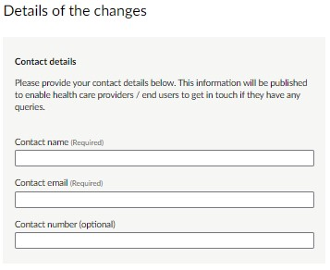
Provide a contact name, email address and phone number (optional) that health service providers or end users can contact for any further details or enquiries on the changes.

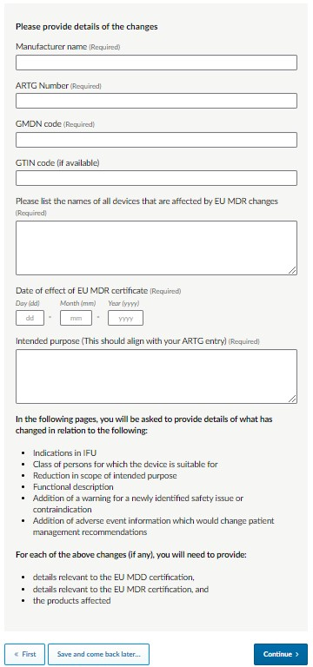
Enter your Manufacturer name, ARTG number, GMDN code, and GTIN code (if available).
You are also required to list the names of all devices which are affected by the EU MDR changes. Also enter the issue date of the EU MDR certificate, along with the intended purpose which aligns with your ARTG entry.
Click on ‘Continue’ to go to the next page.
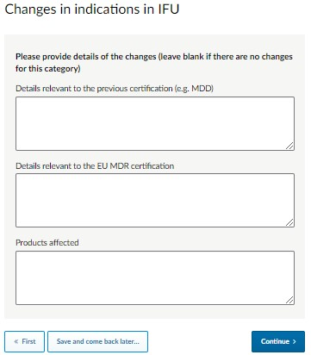
This question allows you to input what has changed regarding the indications in the Instructions for use (IFU).
If nothing has changed, leave all fields blank.
If indications in the IFU have changed after new certification was received, provide details on what the indications in the IFU were under the previous (MDD) certification, what the indications in the IFU are under the current (MDR) certification, and which products are affected (all or certain model numbers).
Click on ‘Continue’ to go to the next page.
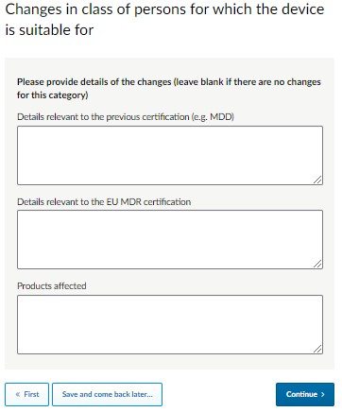
This question allows you to input any change to the class of persons for which the device is suitable for. For instance, the device was previously suitable for adult and paediatric patients under the EU MDD certification but is only suitable for adult patients under the EU MDR certification.
If there is no change, leave all fields blank.
If there are changes to the class of persons for which the device is suitable for, provide details on what was in the previous certification (MDD), what is in the current certification (MDR), and which products are affected. Enter ‘all’ or certain model numbers.
Click on ‘Continue’ to go to the next page.
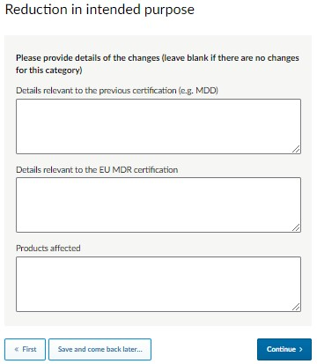
Enter any change to the intended purpose.
If there is no change, leave all fields blank.
If there is a reduction in the scope of the intended purpose, provide details on what was in the previous (MDD) certification, what is in the current (MDR) certification, and which products are affected (all or certain model numbers).
Click on ‘Continue’ to go to the next page.
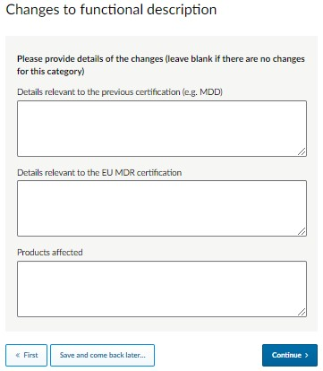
This question allows you to input any changes to the functional description (for a class III/AIMD device only).
If there is no change, leave all fields blank.
If there is a change to the functional description, provide details on what was in the previous (MDD) certification, what is in the current (MDR) certification, and which products are affected (all or certain model numbers).
Click on ‘Continue’ to go to the next page.
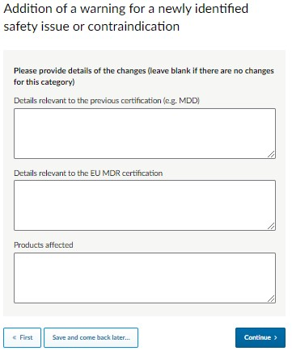
Enter any additional warnings for a newly identified safety issue or contraindication.
If there are no additions of a warning for a newly identified safety issue or contraindication, leave all fields blank.
If there are additions of a warning for a newly identified safety issue or contraindication, provide details on what was in the previous (MDD) certification, what is in the current (MDR) certification, and which products are affected (all or certain model numbers).
Click on ‘Continue’ to go to the next page.
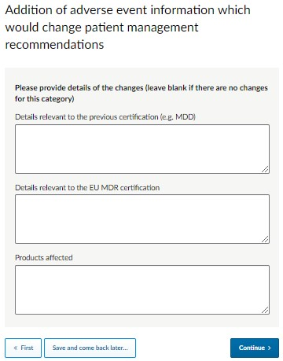
Enter any additional adverse event information which would change patient management recommendations.
If there are no additions of adverse event information which would change patient management recommendations, leave all fields blank.
If there are additions of adverse event information which would change patient management recommendations, provide details on what was in the previous (MDD) certification, what is in the current (MDR) certification, and which products are affected (all or certain model numbers).
Click on ‘Continue’ to go to the next page.
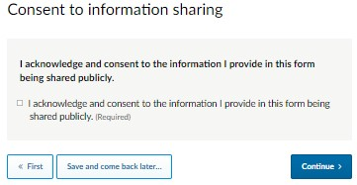
Tick the box if you acknowledge that you have the authority and provide your consent to the information you have provided being shared publicly.
Click on ‘Continue’ to go to the next page.
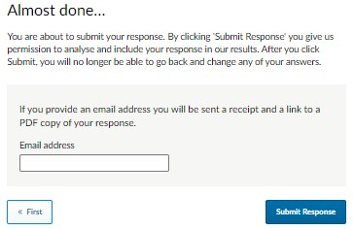

If you would like to review the information you have provided before you select ‘Submit Response’, please click on ‘<< First’ to return to the start of your filled out form for review, then select ‘Continue >>’ to move through the form.
If you would like to receive a copy of your response, enter your email address and click on ‘Submit Response’. This will then end the session.

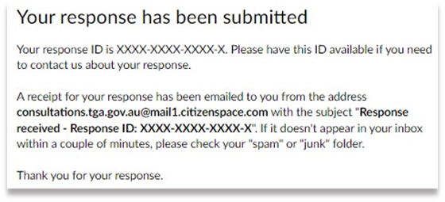

Non-transitioning devices
This form can also be used to provide market notifications to health care providers or end users about devices that are not transitioning from the EU MDD to the EU MDR and where the supply of the non-transitioning device will be ceasing.
Click on ‘Online Form’ to begin.

Enter your details, including your TGA eBusiness Services (eBS) client ID. Please contact TGA eBS if you do not know these details.
Click on ‘Continue’ to go to the next page.
If your device is a non-transitioning device, select the third option and click on ‘Continue’ to go to the next page.

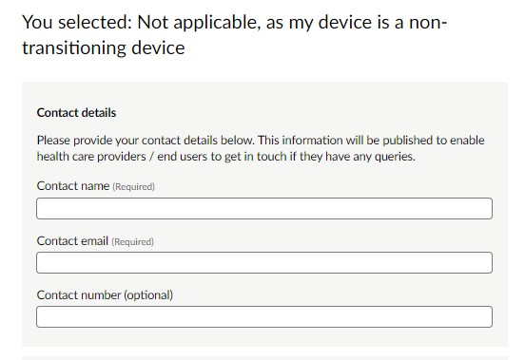
Provide a contact name, email address and phone number (optional) that health service providers or end users can contact for any further details or enquiries on the changes.

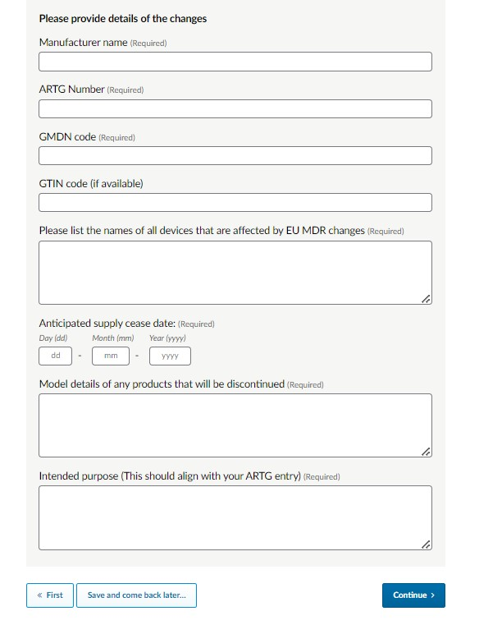
Enter your Manufacturer name, ARTG number, GMDN code, and GTIN code (if available).
Then list the names of all devices that are affected by the EU MDR changes. Also enter the anticipated supply will cease and the model details and intended purpose of any products that will be discontinued. These details should align with the details in your ARTG entry.
Click on ‘Continue’ to go to the next page.
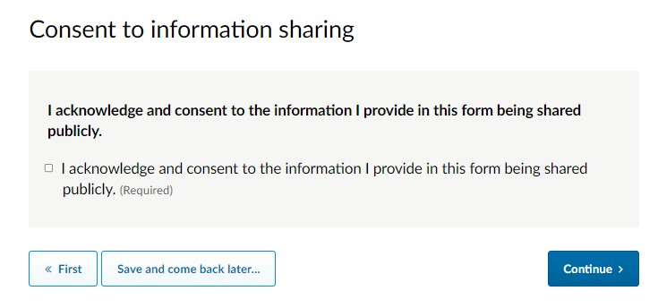
Tick the box if you acknowledge that you have the authority and provide your consent to the information you have provided being shared publicly.
Click on ‘Continue’ to go to the next page.

If you would like to review the information you have provided before you select ‘Submit Response’, please click on ‘<< First’ to return to the start of your filled out form for review, then select ‘Continue >>’ to move through the form.
If you would like to receive a copy of your response, enter your email address and click on ‘Submit Response’. This will then end the session.
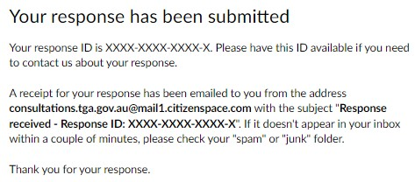

Once you have submitted the form it cannot be amended or changed. To amend or add any details after you have submitted the form, you can contact us by email at the following address devices@tga.gov.au.
 | Fees and Charges  The online tool and form are provided to assist sponsors and does not incur a fee. If you are required to submit a new device application, a Device Change Request (DCR) application, Variation application or Consent to Supply application, applicable fees will apply.
The information you have submitted will be published on the TGA’s EU MDR Transition web publication service when it is next updated. Updates will occur weekly on a Tuesday. Sponsors are responsible for advising health care providers or end users to access the TGA’s EU MDR Transition web publication service for information on device changes.

More information about the Online Notification Form
The Online Notification Form is provided to assist sponsors and agents seeking to utilise TGA’s EU MDR Transition web publication service to streamline the provision of market notifications to health care providers and users. It is not compulsory.
The Online Notification Form can be used by sponsors who have not undertaken market notification activities and have already transitioned devices and the inclusions in the Register to the EU MDR.
If the market notification is identified as the correct pathway for any changes required, you have fulfilled obligations to notify users about the changes to my medical device. However, if the changes do not meet any of the six eligibility criteria, then sponsors must submit new recall notifications via the TGA Business Systems portal.
You can choose to use this tool if there are multiple ARTG entries covered by one MDD certificate transitioning to the MDR at different times to work through the changes as you become aware of them. You may decide to wait until you have all of the information for the certificates before using the tool. The aim of the tool is to assist you with compliance under the regulatory framework.
Manufacturers and Sponsors have a range of options relating to system or procedure pack (SOPP)that are transitioning to EU MDR certification:
Option 1: The manufacturer of a system or procedure pack may obtain market authorisation evidence, issued by an independent assessment body or regulator for the system or procedure pack; or
Option 2: Use the special conformity assessment procedure set out in clause 7.5 of Schedule 3 of the Therapeutic Goods (Medical Devices) Regulations 2002 (the ‘Regulations’) if they meet the eligibility criteria defined in Regulation 3.10.
If using option 1, sponsors should use the tool when the MDR certification is received, and they are aware of all device changes.
If using option 2, sponsors must ensure that all relevant conformity assessment procedures are applied to the individual components and if applicable, the sterility aspect of the SOPP, and ensure that other requirements stipulated in the Regulation 3.10 are met. If there are staggered MDR certification of the individual components, whereby there are changes to the kit configurations, there may be multiple changes required to the inclusion in the ARTG and the kit. Sponsors should be aware of all device changes, conformity assessment requirements and SOPP configurations before using the tool.
For further information, please refer to the guidance document EU MDR Transition – Manufacturer evidence – Case studies and scenarios.

Purpose
This user guide is to assist Australian sponsors and agents of non-in vitro diagnostic (IVD) medical devices included in the Australian Register of Therapeutic Goods (the Register) who need to transition to the new European Union Medical Device Regulations (EU MDR) under the Australian regulatory framework. This will allow continued supply of their medical devices in Australia.
This user guide also helps Australian sponsors and agents of non-IVD medical devices who are not transitioning to the new EU MDR and where the supply of the device will be ceasing.

Additional guidance
The TGA has published additional guidance to assist you to manage your obligations under the Australian regulatory framework while transitioning to EU MDR:
EU MDR Transition – Overview and management under the Australian regulatory framework - guidance for manufacturers and sponsors
EU MDR Transition – Manufacturer evidence – case studies and scenarios (pdf)
EU MDR Transition – DCRs and variations – case studies and scenarios (pdf)
EU MDR Transition – Recalls and market notifications - case studies and scenarios (pdf)
EU MDR Transition - Conformity assessment, Essential Principles and consent to supply
- case studies and scenarios (pdf)

Version history
Version | Description of change | Author | Effective date
V1.0 | Draft publication for feedback | Medical Devices Authorisation Branch | 16 June 2022
V1.1 | Publication for beta release | Medical Devices Authorisation Branch | 29 June 2022
V1.2 | Publication for stakeholder review | Medical Devices Authorisation Branch | 31 October 2022
V2.0 | Publication for final release | Medical Devices Authorisation Branch | 1 December 2022
V2.1 | Addition of non-transitioning devices | Medical Devices Authorisation Branch | December 2023
V2.2 | Updated template | Medical Devices Authorisation Branch | June 2024

Therapeutic Goods Administration
PO Box 100 Woden ACT 2606 Australia
Email: info@tga.gov.au Phone: 1800 020 653 Fax: 02 6203 1605
https://www.tga.gov.au
Reference/Publication #

