Australian Public Assessment Report for WEZLANA
  - Active ingredient: Ustekinumab
  - Sponsor: Amgen Australia Pty Ltd
June 2024

About the Therapeutic Goods Administration (TGA)
- The Therapeutic Goods Administration (TGA) is part of the Australian Government Department of Health and Aged Care and is responsible for regulating therapeutic goods, including medicines, medical devices, and biologicals.
- The TGA administers the Therapeutic Goods Act 1989 (the Act), applying a risk management approach designed to ensure therapeutic goods supplied in Australia meet acceptable standards of quality, safety, and efficacy.
- The work of the TGA is based on applying scientific and clinical expertise to decision-making, to ensure that the benefits to the Australian public outweigh any risks associated with the use of therapeutic goods.
- The TGA relies on the public, healthcare professionals and industry to report problems with therapeutic goods. The TGA investigates reports received to determine any necessary regulatory action.
- To report a problem with a therapeutic good, please see the information on the TGA website.

About AusPARs
- The Australian Public Assessment Report (AusPAR) provides information about the evaluation of a prescription medicine and the considerations that led the TGA to approve or not approve a prescription medicine submission. Further information can be found in Australian Public Assessment Report (AusPAR) guidance.
- AusPARs are prepared and published by the TGA.
- AusPARs are static documents that provide information that relates to a submission at a particular point in time. The publication of an AusPAR is an important part of the transparency of the TGA’s decision-making process.
- A new AusPAR may be provided to reflect changes to indications or major variations to a prescription medicine subject to evaluation by the TGA.

Copyright
© Commonwealth of Australia 2024
This work is copyright. You may reproduce the whole or part of this work in unaltered form for your own personal use or, if you are part of an organisation, for internal use within your organisation, but only if you or your organisation do not use the reproduction for any commercial purpose and retain this copyright notice and all disclaimer notices as part of that reproduction. Apart from rights to use as permitted by the Copyright Act 1968 or allowed by this copyright notice, all other rights are reserved and you are not allowed to reproduce the whole or any part of this work in any way (electronic or otherwise) without first being given specific written permission from the Commonwealth to do so. Requests and inquiries concerning reproduction and rights are to be sent to the TGA Copyright Officer, Therapeutic Goods Administration, PO Box 100, Woden ACT 2606 or emailed to <tga.copyright@tga.gov.au>.

Contents
List of abbreviations 4
Product submission 5
Submission details 5
Product background 7
The disease/condition 7
Current treatment options 8
Clinical rationale 8
Regulatory status 8
Australian regulatory status 8
Foreign regulatory status 8
Registration timeline 9
Submission overview and risk/benefit assessment 9
Quality 9
Nonclinical 10
Clinical 11
Summary of clinical studies 11
Pharmacology 11
Efficacy 14
Safety 17
Immunogenicity – incidence, PK, efficacy, safety 21
Other – extrapolation to other indications and patient groups 24
Recommendation following the clinical evaluation 25
Risk management plan 25
Risk-benefit analysis 25
Delegate’s considerations 25
Proposed action 27
Advisory Committee considerations 27
Outcome 29
Specific conditions of registration applying to these goods 29
Attachment 1. Product Information 29

List of abbreviations
Abbreviation | Meaning
ACM | Advisory Committee on Medicines
ADA | Adenosine deaminase
AE | Adverse event
ARTG | Australian Register of Therapeutic Goods
ASA | Australia-specific annex
CMI | Consumer Medicines Information
DLP | Data lock point
EOI | Event of interest
GMR | Geometric mean ratio
IP | Investigational product
PASI | Psoriasis Area and Severity Index
PI | Product Information
PSUR | Periodic safety update report
PK | Pharmacokinetic
RMP | Risk management plan
SAE | Serious adverse event
TGA | Therapeutic Goods Administration

Product submission

Submission details
Type of submission: | Biosimilar medicine
Product name: | WEZLANA
Active ingredient: | Ustekinumab
Decision: | Approved
Date of decision: | 18 January 2024
Date of entry onto ARTG: | 22 January 2024
ARTG numbers: | 403011, 403012, 403013 and 403014
The Black Triangle Scheme: | Yes.
Sponsor’s name and address: | Amgen Australia Pty Ltd, PO Box H 125, 38-40 Pitt Street, Sydney, NSW, 2000
Dose forms: | Solution for injection and solution for infusion
Strengths: | 90 mg/1.0 mL, 45 mg/0.5 mL, and 5 mg/1.0 mL
Containers: | Vial and pre-filled syringe
Pack size: | One
Approved therapeutic use for the current submission: | Plaque Psoriasis  Adults  WEZLANA is indicated for the treatment of adult patients (18 years or older) with moderate to severe plaque psoriasis who are candidates for phototherapy or systemic therapy.  Paediatric population, 6 years and older  WEZLANA is indicated for the treatment of moderate to severe plaque psoriasis in children and adolescent patients from 6 years of age who are inadequately controlled by, or are intolerant to, other systemic therapies or phototherapies.  Psoriatic Arthritis (PsA)  WEZLANA, alone or in combination with methotrexate, is indicated for the treatment of signs and symptoms of active psoriatic arthritis in adult patients (18 years and older) where response to previous non-biological Disease-Modifying Antirheumatic Drug (DMARD) therapy has been inadequate.  Crohn’s Disease  WEZLANA is indicated for the treatment of adult patients with moderately to severely active Crohn’s disease who have had an inadequate response, lost response, or were intolerant to either conventional therapy or a TNFα antagonist or have medical contraindications to such therapies.  Ulcerative Colitis  WEZLANA is indicated for the treatment of adult patients with moderately to severely active ulcerative colitis.
Routes of administration: | Subcutaneous administration and intravenous infusion
Dosage: | Plaque Psoriasis  Adults  For the treatment of plaque psoriasis, WEZLANA is administered by subcutaneous injection. The recommended dose of WEZLANA is 45 mg administered at Weeks 0 and 4, then every 12 weeks thereafter. Alternatively, 90 mg administered over Weeks 0 and 4, then every 12 weeks thereafter may be used in patients with a body weight greater than 100 kg.  Paediatric population, 6 years and older  For the treatment of plaque psoriasis, WEZLANA should be administered by subcutaneous injection. The recommended dose of WEZLANA based on body weight is shown below (Table 1). WEZLANA should be administered at Weeks 0 and 4, then every 12 weeks thereafter.  Table 1. Recommended dose of WEZLANA for paediatric psoriasis  Psoriatic Arthritis  For the treatment of psoriatic arthritis, WEZLANA is administered by subcutaneous injection. The recommended dose of WEZLANA is 45 mg administered at Weeks 0 and 4, then every 12 weeks thereafter. Some patients with a body weight greater than 100 kg received a 90 mg dose in clinical trials and observed a clinical benefit.  Crohn’s Disease and Ulcerative Colitis  For the treatment of Crohn’s disease and ulcerative colitis, the recommended treatment regimen is to initiate WEZLANA with a single intravenous (IV) tiered dose based on body weight (Table 2). The infusion solution is to be composed of the number of vials of WEZLANA 130 mg as specified in Table 2.  Table 2. Initial IV dosing of WEZLANA  For further information regarding dosage, such as dosage modifications to manage adverse reactions, refer to the Product Information.
  Body weight at the time of dosing | Recommended Dose | Dosage Form
  < 60 kg | 0.75 mg/kg* | vial
  ≥ 60 to ≤100 kg | 45 mg | Pre-filled syringe, vial
  > 100 kg | 90 mg | Pre-filled syringe, vial
  * To calculate the volume of injection (mL) for patients < 60 kg, use the following formula: body weight (kg) × 0.0083 (mL/kg). The calculated volume should be rounded to the nearest 0.01 mL and administered using a 1 mL graduated syringe. A 45 mg vial is available for paediatric patients who need to receive less than the full 45 mg dose.
  Body weight of patient at the time of dosing | Dose | Number of 130 mg WEZLANA Vials
  ≤ 55 kg | 260 mg | 2
  > 55 kg to ≤ 85 kg | 390 mg | 3
  > 85 kg | 520 mg | 4
Pregnancy category: | B1  Drugs which have been taken by only a limited number of pregnant women and women of childbearing age, without an increase in the frequency of malformation or other direct or indirect harmful effects on the human fetus having been observed.  Studies in animals have not shown evidence of an increased occurrence of fetal damage.  The use of any medicine during pregnancy requires careful consideration of both risks and benefits by the treating health professional. The pregnancy database must not be used as the sole basis of decision making in the use of medicines during pregnancy. The TGA does not provide advice on the use of medicines in pregnancy for specific cases. More information is available from obstetric drug information services in your state or territory.

Product background
This AusPAR describes the submission by Amgen Australia Pty Ltd (the sponsor) to register WEZLANA (ustekinumab), a biosimilar candidate to STELARA® (ustekinumab) for the treatment of:
- moderate to severe plaque psoriasis in adults, adolescents and in children
- active psoriatic arthritis in adults
- severely active Crohn’s disease in adults, and
- moderately to severely active ulcerative colitis.

The disease/condition
The Sponsor considered psoriasis as the most appropriate indication to demonstrate clinical equivalence. Psoriasis outcomes would be the most sensitive for detecting any differences between WEZLANA and STELARA. Psoriasis is a common chronic inflammatory skin disease. The most common subtype is plaque psoriasis, which is characterised by scaly erythematous plaques. Other subtypes include guttate psoriasis, pustular psoriasis and erythrodermic psoriasis. Psoriasis can also affect tissues other than the skin, including joints (that is, psoriatic arthritis).

Current treatment options
Topical therapies include corticosteroids, tar, calcipotriol and combinations thereof.
Phototherapy is also used.
Oral systemic therapies include methotrexate, acitretin, apremilast and ciclosporin.
Biological drugs are usually used in moderate to severe disease, where other treatments are not suitable. These drugs target IL-17 (sekucinumab, ixekizumab), IL-12/IL-23 (ustekinumab), IL-23 (guselkumab, tildrakizumab, risankizumab) and TNF-alpha (adalimumab, etanercept, infliximab).

Clinical rationale
WEZLANA is being developed as a biosimilar candidate to STELARA. WEZLANA has a primary amino acid sequence identical to STELARA. Both WEZLANA and STELARA are recombinant human immunoglobulin isotype class G subclass 1 kappa monoclonal antibodies that bind with specificity to the p40 protein subunit of the IL-23 and IL-12 cytokines to neutralise IL-23- and IL-12-mediated signalling and cytokine cascades. Both WEZLANA and STELARA are manufactured by recombinant DNA technology. While WEZLANA is expressed in a glyco-engineered Chinese hamster ovary cell line system, STELARA is expressed in a murine myeloma (Sp2/0) cell line system. The sponsor states that these minor structural differences observed between WEZLANA and STELARA due to the different cell lines used in production are not expected to impact clinical efficacy or safety because the results from the comprehensive set of analytical similarity studies together with the nonclinical and clinical similarity data demonstrated that WEZLANA is similar to ustekinumab in the mechanism relevant to efficacy and safety.
Demonstration of biosimilarity for WEZLANA in the indications and patient populations approved for STELARA was based on the data relating to WEZLANA quality, non-clinical, and clinical programs submitted within this application, in addition to the Agency’s previous findings of safety and efficacy for the approved indications of STELARA and from an extensive survey of available, relevant, published information in the conditions of use regarding mechanisms of action, pharmacokinetics (PK), toxicities, immunogenicity, and safety of ustekinumab.

Regulatory status

Australian regulatory status
This product is considered a new biosimilar medicine for Australian regulatory purposes.

Foreign regulatory status
The countries in which a similar application has been submitted, along with details of the status, are provided in the table below:
Country | Date of submission | Status | Type of application
USA | 31 October 2022 | Under review | Biologics License Application
Canada | 15 November 2022 | Under review | New drug submission
Great Britain | January 2023 | TBC | Market authorisation application

Registration timeline
This submission was evaluated under the standard prescription medicines registration process.
Table 3 captures the key steps and dates for this submission.
Table 3: Timeline for Submission PM-2023-00167-1-1
Description | Date
Submission dossier accepted and first round evaluation commenced | 28/2/2023
First round evaluation completed | 11/8/2023
Sponsor provides responses on questions raised in first round evaluation | 7/9/2023
Second round evaluation completed | 17/10/2023
Delegate’s Overall benefit-risk assessment and request for Advisory Committee advice | 31/10/2023
Sponsor’s pre-Advisory Committee response | 11/2023
Advisory Committee meeting | 1/12/2023
Registration decision (Outcome) | 18/1/2024
Administrative activities and registration in the ARTG completed | 22/1/2024
Number of working days from submission dossier acceptance to registration decision* | 196
*Statutory timeframe for standard submissions is 255 working days
* The COR-A process has a 120 working day evaluation and decision timeframe.
* The COR-B process has a 175 working day evaluation and decision timeframe.

Submission overview and risk/benefit assessment

Quality
The active ingredient in WEZLANA is ustekinumab. WEZLANA ustekinumab is a recombinant human IgG1kappa monoclonal antibody with a molecular weight of 145 kDa (not including glycans) comprising two heavy chain and two light chain molecules linked by disulfide bonds.
Figure 1: Structural formula of ustekinumab
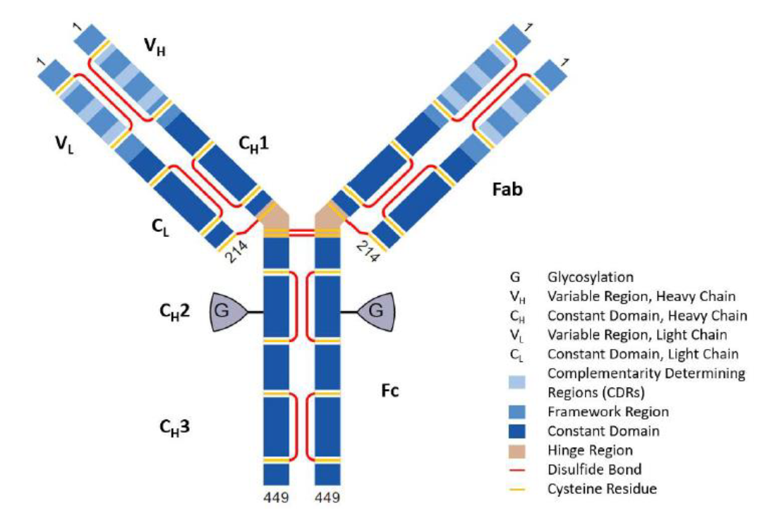
The primary container for the 45mg and 90mg prefilled syringe consists of a 1mL type I glass syringe with a staked-in-place stainless steel needle. It is assembled with an elastomeric needle shield and plunger-stopped laminated with a fluoropolymer film on the product contact surface. The primary container closure system for the 45mg and 130mg vial consists of a Type I glass vial with elastomeric stopper and aluminium seal with flip-off cap. The product contact surface is laminated with a fluoropolymer film. The pre-filled syringes and vials have a shelf life of 18 months, and a storage condition of 5°C ± 3°C (protected from light),
There were no objections on quality grounds to the approval WEZLANA.

Nonclinical
There were no nonclinical objections to registration of WEZLANA.
The non-clinical evaluator noted that analytical studies undertaken indicated glycosylation differences between STELARA (EU-sourced) and WEZLANA, which required further clinical pharmacology studies, as presented below. The pharmacological assessments were considered acceptable to cover all proposed indications. The only notable difference was in binding to two FcγRs which is not significant from an in vivo perspective. It was acceptable to not include comparative toxicity studies.
Comparative pharmacology studies were included. Four in vitro pharmacology studies were undertaken, assessing inhibition of IL-12 and IL-23 induced STAT4 signalling. All studies included WEZLANA and the EU and US sourced STELARA. All studies showed similar inhibitory activity.
There were no toxicological comparative studies bridging the Australia-sourced STELARA to the overseas sourced versions used in the clinical trials. This was considered acceptable as long as the dossier adequately bridged the Australian and overseas products.
No animal studies were conducted due to non-human primates being the only sensitive species. Non-human primate studies are usually not recommended and of limited sensitivity due to small group sizes and inter-individual variability.

Clinical

Summary of clinical studies
The clinical dossier consisted of:
- one Phase I study: 2019230 (safety, immunogenicity)
- two Phase III studies: 2019230 (pharmacokinetics), 20190232 (efficacy, safety)

Pharmacology

Pharmacokinetics
Study 20190230 was a randomised, double-blind, single-dose, three arm, parallel group study to investigate the pharmacokinetic equivalence of WEZLANA (designated as ABP 654 during development) and STELARA (both the US and EU products) in healthy adults. It was conducted at 3 centres in the US. Study duration was 140 days, including a 28-day screening period and a 112 day on-study period. The study was to include 16% first- or second-generation Japanese subjects.
The primary objective was to compare the PK of ABP 654 and STELARA (EU and US) following a single subcutaneous dose of 90mg. The secondary objective was to compare the PK of STELARA (US) and STELARA (EU) and to determine the safety, tolerability and immunogenicity of all 3 treatments.
Major inclusion criteria included being a healthy man or woman, aged 18 to 45 years, body weight 50 – 90kg, BMI 18-30 (non-Japanese) or 18-25 (Japanese) with clinically acceptable physician exam, laboratory tests, vital signs and ECG. Major exclusion criteria were being pregnant, not using highly effective contraception if of childbearing potential, recent or serious infections, tuberculosis exposure, history of malignancy and positive tests for HIV, hepatitis B surface antigen, hepatitis B core antibody or hepatitis C antibody.
The sample size of 231 (n=77 per treatment group) was calculated to provide > 90% power, including assumptions of a true geometric mean ratio (GMR) of 1 with margins 0.80 – 1.25 and alpha = 0.05 (two 1-sided tests).
PK parameters were estimated using noncompartmental methods with Phoenix WinNonlin using best fit regression. During the study, 237 subjects were dosed with study drug, including 40 Japanese subjects. Of these, 10 discontinued (withdrawal by subject, lost to follow up and other). Demographics were comparable between the groups. Overall, 50.6% were female, 56.5% were white and 16.9% were first- or second-generation Japanese. The mean age was 32 years. Frequent protocol deviations were noted, with the most common being either related to “visit window/other” or “study procedures/safety assessment”.
Pharmacokinetic samples were to be collected at pre-dose, 8 hours, 24 hours and days 3, 7, 9, 11, 13, 21, 28, 35, 49, 56, 70, 98 and 112. As can be seen from the time-concentration curves, similar PK was seen for ABP 654 and STELARA (US) and STELARA (EU) (Figure 2). Peak concentrations were observed at about 7 days and then declined in a monophasic manner with a t_{1/2} of about 23 days. These data are consistent with what is known for STELARA. PK sampling was shown to be adequate to define the AUCinf.
Figure 2. Mean (+/- SD) concentrations over time (PK concentration Analysis set)
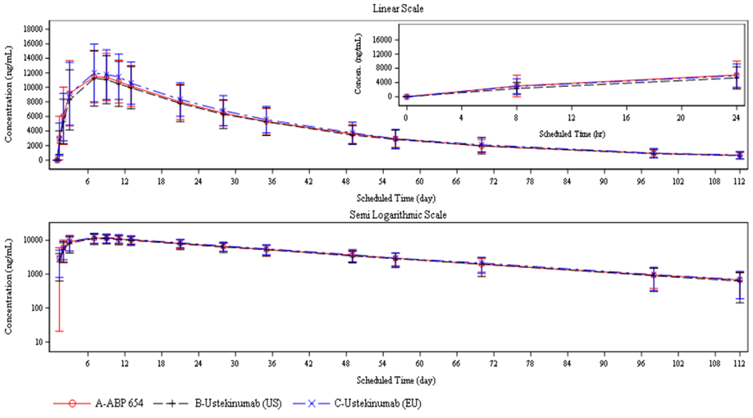
The exposure and t_{1/2} for each arm of the trial are shown in Table 4.
Table 4: Exposure and t_{1/2} values
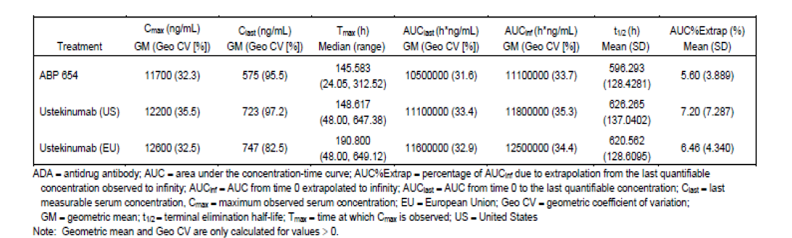
The primary study outcomes – that is, the least squared GMR of ABP 654 and both STELARA (US) and STELARA (EU) for AUC_{last}, AUC_{inf} and C_{max} – were consistent with bioequivalence given the 90% confidence intervals that were within the pre-specified range (that is, -0.80 – 1.25) (Table 5). Note that the PK parameters analysis set included nearly all subjects who received ustekinumab. Subgroup analysis of Japanese subjects as well as binding ADA negative subjects also confirmed bioequivalence.
Table 5: Summary of statistical assessment of PK parameters
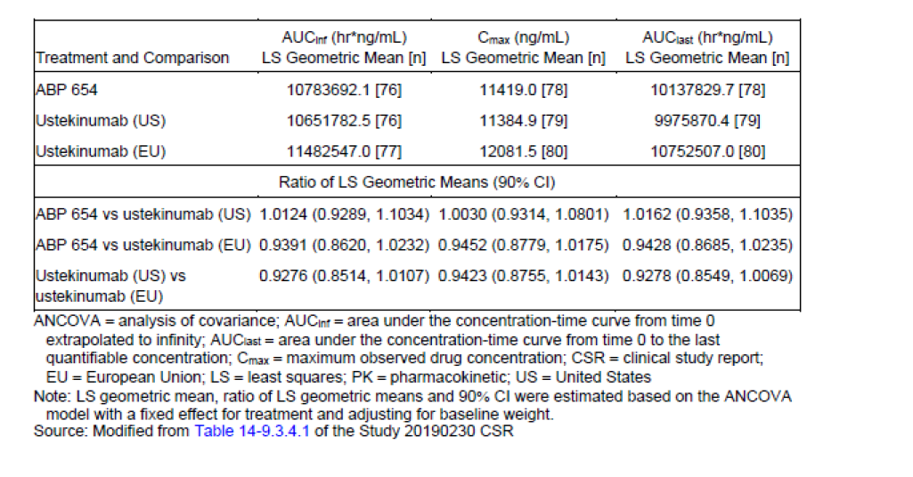
The pivotal phase 3 study 20190232 also investigated the PK of ABP 654 in the target patient population of moderate to severe plaque psoriasis. Serum samples for concentration measurement were collected at baseline and weeks 4, 12, 28, 32, 40 and 52 (EOS) (subjects undergoing dose intensification did not have a week 40 sample collected). Through week 28, trough concentrations were similar for each treatment group (Figure 3), although tended to be slightly higher for ABP 654. For example, at week 28 the geometric LS mean concentration was 608.38 ng/mL for ABP 654 and 539.67 ng/mL for STELARA. Also, the 90% confidence interval for the ratio of these means was 1.00 – 1.27 (that is, just above the upper limit usually set at 1.25). Post week 28, trough serum concentrations were similar for both re-randomised subjects and dose intensification subjects.
Figure 3: Boxplot of trough concentrations through week 28
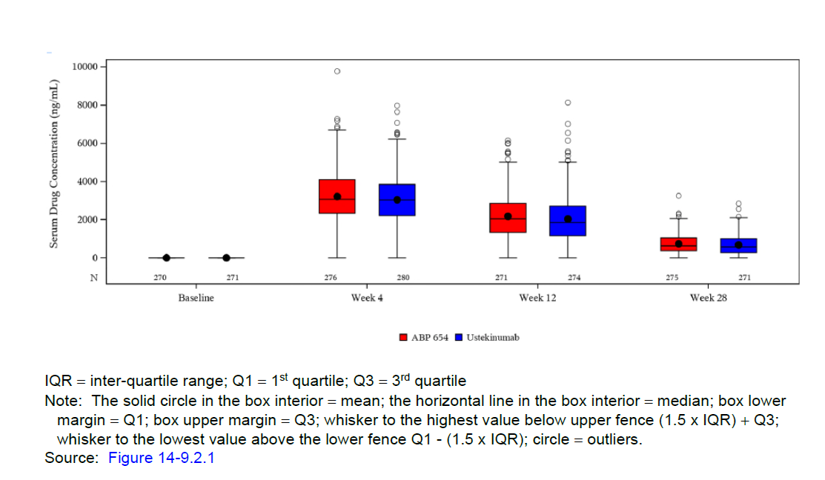

Efficacy
Study 20190232 was a randomised, double blind, active controlled phase 3 study of ABP 654 and STELARA (the EU product was used in this study) in adult patients with moderate to severe psoriasis. The study was conducted in Europe and North America. Subjects were randomised 1:1 to receive either ABP 654 or STELARA at a dose of 45mg (weight ≤ 100kg) or 90mg (weight >100kg) subcutaneously on day 1, week 4 and week 16. The primary objective was to compare the efficacy of the treatment arms and the secondary objective was to compare their safety and immunogenicity.
At week 28 (that is, after the first three doses of study drug) subjects were assessed and either discontinued or continued with the study, according to the following (Figure 4):
- Subjects receiving ABP 654 who achieved PASI50 or better continued either at same dose or intensified dose, according to specified criteria.
- Subjects receiving STELARA who achieved PASI50 – 75 and required dose intensification, continued with an intensified dose (that is, dosing frequency changed to every 8 weeks).
- Subjects receiving STELARA who achieved PASI50 or better, and did not require dose intensification, were rerandomized to either continue or switch to ABP 654 at same dose, dosing every 12 weeks.
- Subjects who did not achieve PASI50 were considered to have completed the study.
Figure 4: Study design
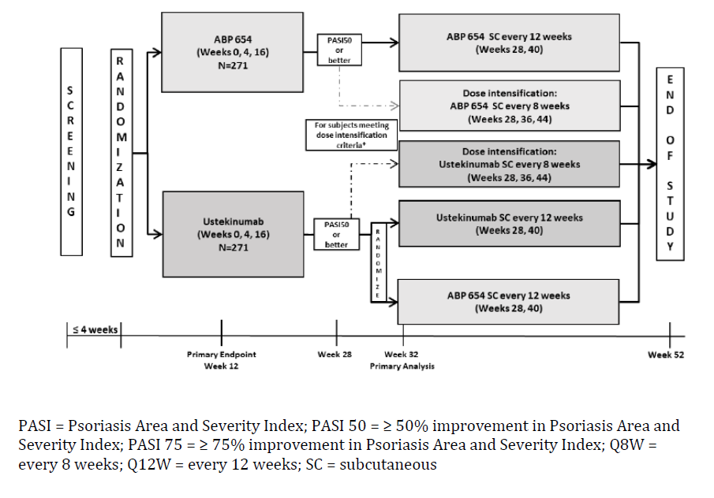
The primary endpoint was Psoriasis Area and Severity Index (PASI) percent improvement from baseline and was evaluated at week 12. Secondary endpoints were:
- PASI percent improvement at other timepoints
- ≥75% improvement in PASI (PASI 75) response throughout the study
- 100% improvement in PASI (PASI 100) response throughout the study
- Static Physician’s Global Assessment (sPGA) response (0/1) at week 12 and week 52
- Body surface area (BSA) change from baseline at week 12 and week 52
Major inclusion criteria included age 18 – 75 inclusive, moderate to severe psoriasis for at least 6 months, baseline BSA ≥ 10% / PASI ≥ 12 / sPGA ≥ 3, candidate for systemic therapy or phototherapy, and a previous inadequate response/intolerance/contraindication to conventional anti-psoriatic systemic therapy. Major exclusion criteria included erythrodermic / pustular / guttate / medication-induced psoriasis or other skin conditions that could interfere with study evaluations and previous treatment with IL-23 or IL-12 targeted agents, recent biologic or other systemic treatment, recent phototherapy or recent topical treatment (within 2 weeks). Allowed concomitant treatments included moisturizers and up to mid-strength topical steroids.
A sample size of 542 subjects was calculated to provide greater than 95% power to demonstrate equivalence of the two treatments at a significance level of 0.025 for the primary efficacy outcome (similarity margin -15 to +15) assuming a true mean difference of 0 and a 10% dropout rate. The primary efficacy outcome was to be determined using the full analysis set (FAS) with missing PASI score imputed by multiple imputation. Secondary outcomes were analysed descriptively, and sensitivity analyses were performed using the per protocol analysis set. Subjects were stratified by prior biologic use, baseline weight and geographic region.
Overall, 280 (281 randomised) subjects were treated with ABP 654 and 282 with STELARA. Nearly all randomised subjects (94.8%) completed scheduled dosing over the first 3 doses. In terms of those discontinuing the study, 33 (5.9%) discontinued during the initial part and 15 (3.1%) during the re-randomised part. At week 28, 480 subjects were re-randomised (247 in ABP 654 / ABP 654 group; 116 in STELARA / STELARA group; 117 in STELARA / ABP 654 group). Approximately 10% of subjects underwent dose intensification after week 28.
In terms of demographics, most of the subjects were male (65.4%), white (88.3%) and below the age of 65 (92%). The mean age was 44.4, mean weight was 92.2kg and mean BMI was 30.8. In terms of disease characteristics 98.8% had a disease duration ≥ 1 year with a mean baseline PASI of 20.9 and sPGA category of either moderate or severe/very severe. Characteristics were generally balanced between the treatment groups.
In terms of the primary outcome, at week 12 the mean PASI improvement from baseline was 81.92% in the ustekinumab group and 81.91% in the ABP 654 group (Table 6). The difference between the means was 0.14 (90% confidence interval -2.6 – 2.9; 95% CI -3.2 – 3.4). The 95% confidence interval was within the prespecified margin and therefore the study demonstrated clinical equivalence between ABP 654 and STELARA.
Table 6: Primary analysis of PASI improvement to week 12 (using multiple imputation)
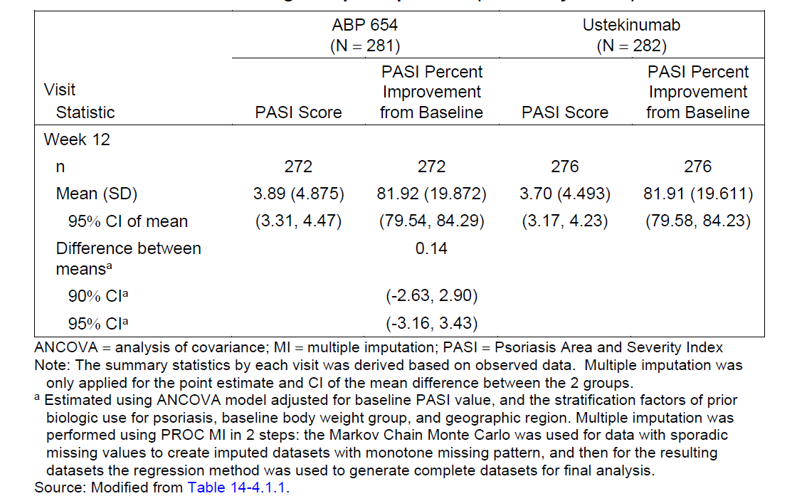
Sensitivity analyses showed results consistent with the primary outcome. Secondary outcomes also demonstrated clinical equivalence and the week 28 timepoint. For the first of the secondary endpoints, PASI percent improvements were similar at each timepoint from week 4 to week 28.
Both the dose intensification groups and the re-randomized groups (that is, ABP 654 / ABP 654, STELARA / ABP 654, STELARA / STELARA) all demonstrated very similar % changes in PASI at all timepoints (that is, the first secondary outcome), with the 95% confidence intervals being within the prespecified range. Importantly, the group that received STELARA and then was re-randomised to ABP 654, showed maintenance of the % improvement in PASI compared with baseline over the course of the study.
Other secondary outcomes from the full analysis set (that is, including dose intensification and re-randomised subjects as indicated) are summarised as follows:
- PASI 75 and PASI100 responses were similar between treatment groups (that is, ABP 654 and STELARA) at weeks 4, 12, 16 and 28. The 95% confidence intervals for the mean differences were within -15 and +15.
- Considering the re-randomized full analysis sets (that is, ABP 654 / ABP 654, STELARA / ABP 654 and STELARA / STELARA), PASI75 and PASI100 tended to be similar between the arms exposed to ABP 654 and the arm only exposed to STELARA. Although at some time points the 95% confidence intervals for differences exceeded -15 to +15, it should be noted that this interval was only truly required for the primary outcome analysis.
- sPGA for the full analysis set (that is, ABP 654 vs. STELARA) at week 12 were similar between the 2 arms with 95% confidence interval for difference contained within the prespecified range.
- For the re-randomised full analysis set, sPGA was similar between arms exposed to ABP 654 and the STELARA / STELARA arm at week 12 and 52.
- BSA changes from baseline to weeks 12 and 52 were similar across the treatment groups over the entire study for each dataset analysed.

Safety
The safety evaluation is based on the phase 1 study 20190230 and the phase 3 study 20190232.
A total of 475 subjects were exposed to ABP 654 during clinical development (78 in study 20190230 and 397 in study 20190232). Other subjects in those studies were only exposed to STELARA. In study 20190230 subjects were only exposed to a single 90mg subcutaneous dose.
In study 20190232, through week 28, 280 subjects received a mean total dose of 179.5mg ABP 654, for a mean duration of 27.92 weeks. After week 28, 117 subjects were randomised to ABP 654 (following initial dosing with STELARA) and received a mean total dose of 118.8mg for a mean further duration of 23.99 weeks. Of subjects initially randomised to ABP 654, 25 underwent dose intensification. Exposure to STELARA was very similar across the different parts of the study, allowing for appropriate comparison.
Study 20190230
Overall, 22 (28.2%) of subjects in the ABP 654 arm, 18 (22.8%) in the STELARA (US) arm and 29 (36.3%) in the STELARA (EU) arm experienced any adverse event (AE). There were no deaths. Very few AE of grade 3 or higher or serious adverse events occurred, none were in the ABP 654 arm.
Across the three arms, headache was the most common reported AEs. Other AEs by preferred term occurred in three or less participants and there was no discernible pattern across the treatment arms. Table 7 shows the frequency of AEs by system organ class and by preferred term in the three arms.
Table 7: Treatment emergent adverse events occurring in at least two subjects.
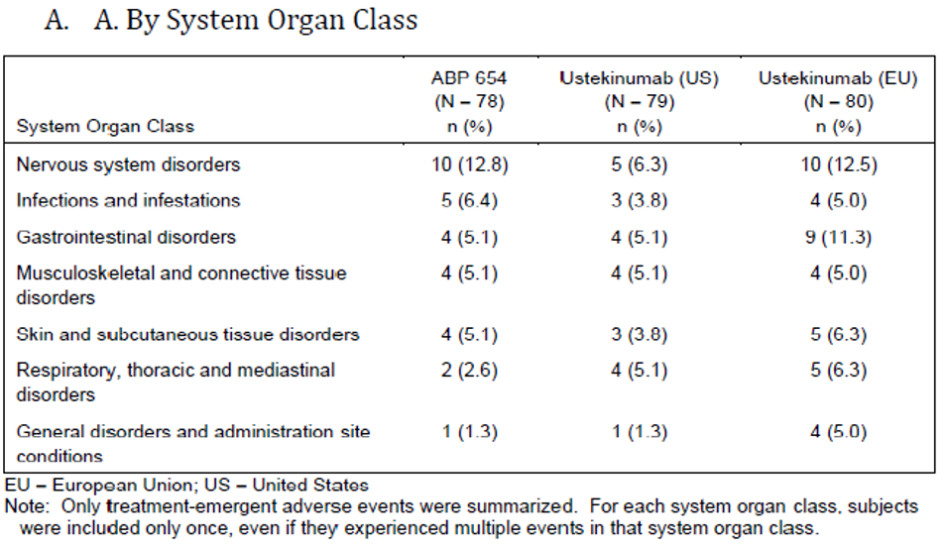
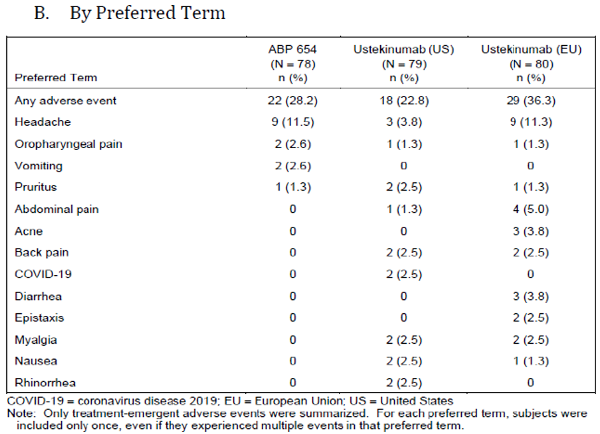
Two events of interest occurred during the study – one serious infection / appendicitis (STELARA (EU)) and one somnolence (STELARA (US)).
Study 20190232 – through week 28
Adverse events (AEs) were reported by 106 (37.9%) in the ABP 654 arm and 99 (35.1%) in the STELARA arm. Grade ≥ 3AEs were reported in 8 (2.9%) in the ABP 654 arm and 5 (1.8%) in the STELARA arm. COVID-19 adverse events were infrequent and occurred at similar frequency across the arms. A fatal COVID related AE occurred in a subject receiving STELARA. Frequency of different categories of AE through to week 28 are shown in Table 8.
Table 8: Summary of Adverse Events - week 12 and 28
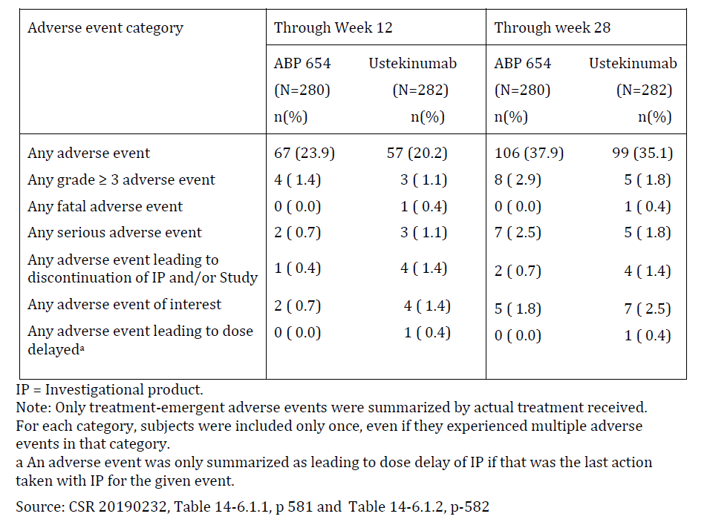
The most frequent system organ class for AEs was infection and infestations, followed by musculoskeletal and connective tissue disorders. By preferred term hypertension and nasopharyngitis were the most frequent. There were no meaningful differences between ABP 654 and STELARA during the first 28 weeks of the study.
Out to week 28, two subjects (cardiac failure, breast carcinoma) in the ABP 654 group and four subjects (COVID-19, clear cell renal carcinoma, psoriatic arthropathy, purpura) in the STELARA group discontinued treatment due to treatment emergent adverse events.
Serious adverse events (SAEs) occurring in seven subjects randomised to ABP 654 were breast carcinoma, uterine leiomyoma, cholelithiasis, anaphylactic reaction, COVID pneumonia, femoral neck fracture and hypertension. SAEs occurring in five subjects randomised to STELARA were clear cell renal carcinoma, renal neoplasm, COVID19, cellulitis, congestive cardiac failure and cardiac ventricular thrombosis.
Events of interest were experienced by five subjects in the ABP 654 arm (two cardiovascular events, two malignancies, one serious infection) and seven in the STELARA arm (two cardiovascular events, two malignancies, two serious infections, one reversible posterior leukoencephalopathy syndrome).
Regarding subjects who underwent dose intensification more subjects in the ABP 654 arm compared with the STELARA arm experienced any AEs (48% vs. 26.5%), serious AEs (1 subjects /4% vs. 0%) and COVID related AEs (20% vs. 2.9%). The serious AE in the ABP 654 subject was hip dysplasia requiring arthroplasty. Grade ≥ 3 AEs occurred in 1 subject from each group and no fatal events were recorded. Four subjects in the ABP 654 arm had AEs related to hepatic enzymes. Whilst these were only up to grade 2 and generally associated with other factors, they were not reported in the STELARA arm. None of the AEs in the dose intensified treatment groups were considered related to investigational product. The sample sizes were relatively small (n=25 for ABP 654 and n=34 for STELARA).
Study 20190232 – re-randomised set post week 28
As can be seen from Table 9 the incidence of any AE, grade 3 or greater AEs, serious AEs, AEs leading to discontinuation and events of interest were comparable across the three arms (that is, ABP 654 / ABP 654, STELARA / ABP 654, STELARA/ STELARA). This held true when considering the post re- randomisation period or the entire study.
Table 9: Summary of safety in the re-randomised safety set
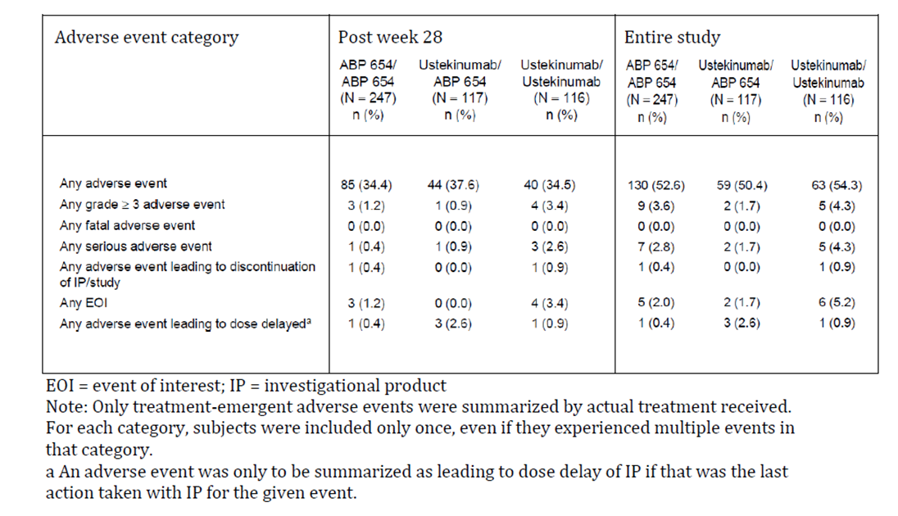
Table 10: Re-randomised safety data by system organ class and preferred term
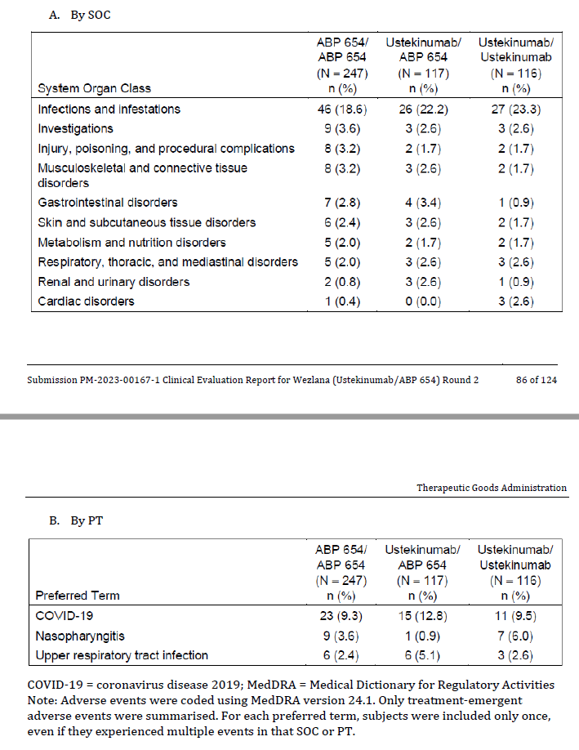
Post week 28 in the re-randomised group, one subject receiving ABP 654 / ABP 654 stopped treatment due to an ALT enzyme increase and one subject receiving STELARA/ STELARA stopped due to Bipolar 1 disorder.
There were relatively few SAEs post week 28, occurring in one subject in the ABP 654 / ABP 654 group (ovarian cancer), one in the STELARA / ABP 654 group (intervertebral disc disorder), and three in the STELARA / STELARA group (myocardial infarction, COVID19, infected cyst, post operative wound infection, sepsis, bipolar 1 disorder).
Events of interest were experienced by three subjects in the ABP 654 / ABP 654 group (serious infection, cardiovascular event, malignancy), zero in the STELARA / ABP 654 group and four in the STELARA / STELARA group (three serious infections, three cardiovascular events).
Overall grade ≥ 3 changes in haematology or biochemistry were uncommon in the re-randomised safety analysis set (i.e. all data points except for subjects who dose intensified or discontinued at week 28), as shown in Table 11.
Table 11: Incidence of post-baseline at least grade 3 serum biochemistry results (re-randomised safety analysis set)
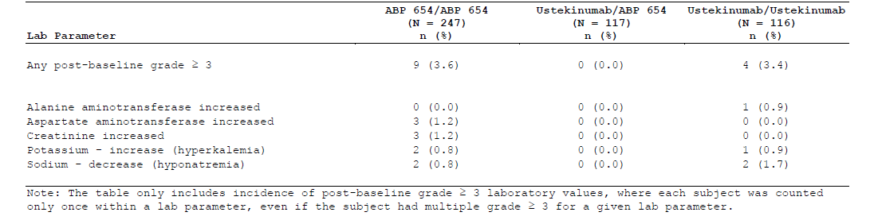

Immunogenicity – incidence, PK, efficacy, safety
Study 20190230
ADA enzyme samples were collected pre-dose and on days 11, 35 and 112/EOS. Assessment involved screening, confirmation and testing for neutralising activity. All subjects in the safety analysis set had at least 1 on-study ADA result. Two subjects tested positive pre-dose, however their antibodies were without neutralising activity. Overall, more subjects in the STELARA arms developed ADAs compared to the ABP 654, with most antibodies detected being non-neutralising. From post-baseline to the end of the study, 12 subjects (15.4%) in the ABP 654 group, 30 (38%) in the STELARA (US) group and 29 (36.3%) in the STELARA (EU) group developed ADAs. Of these, 2 (2.6%) in the ABP 654 group, 10 (12.7%) in the STELARA (US) group and 6 (7.5%) in the STELARA (EU) group tested positive for neutralising ADAs.
Additional analyses are consistent with binding ADAs having an effect on exposure by increasing clearance and decreasing t_{1/2}. In the phase 1 study 20190230, the presence of binding ADAs increased CL/F (16-35%) and reduced t_{1/2} (12-32%), with a tendency for least pronounced effects with ABP 654 (Table 12). In fact, analysis showed a statistically significant (p=0.0172) difference in t_{1/2} according to ADA status between STELARA (US) and ABP 654 (that is. different magnitude of effect for the different treatments). This was not observed when comparing ABP 654 and STELARA (EU).
Table 12: Changes in clearance and half-life according to ADA status
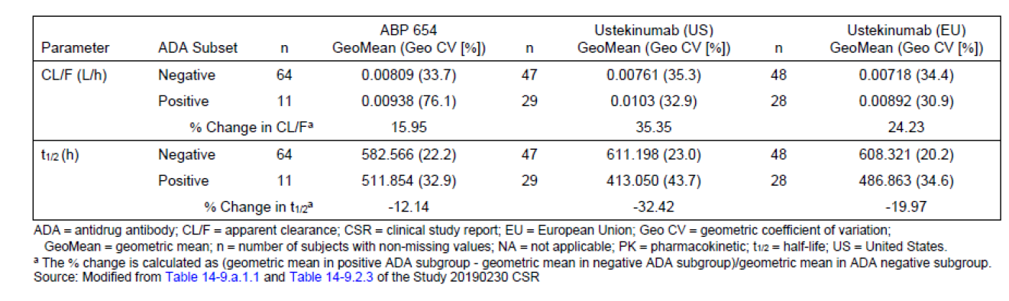
Study 20190232
Bloods samples for ADA analysis were collected at baseline and at weeks 4, 12, 28, 32, 40 and 52 (EOS).
Through week 28, the following was observed:
- All subjects had at least a single on-study result
- At baseline, 18 (6.5%) of subjects in the ABP 654 arm were positive, with one of these being neutralising. In the STELARA arm, 8 (2.9%) subjects were positive at baseline.
- Over time, the incidence of subjects with any positive result increased, such that by week 28, 52 (18.6%) of subjects in the ABP 654 arm had a positive ADA result and 24 (8.5%) had a neutralising antibody found. In the STELARA arm, 104 (37.1%) had a positive ADA result and 50 (17.9%) had a neutralising antibody found.
- Results for other timepoints are shown in Table 13.
Table 13: ADA results through to week 28
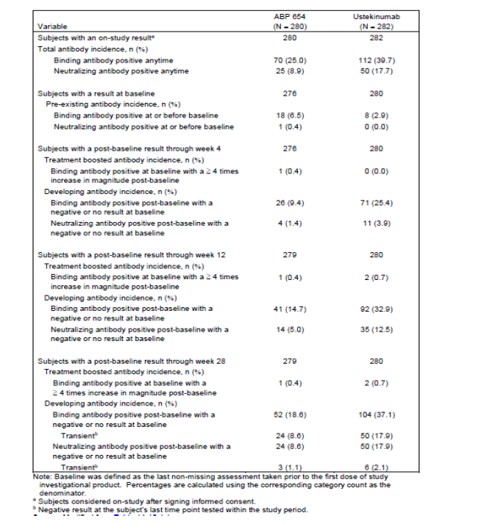
Amongst the re-randomized subjects, the following results through to week 52 were noted:
- ABP 654 / ABP 654 – for subjects with a negative or no result prior to re-randomization, 11 (4.5%) developed ADA positivity and 5 (2.0%) developed neutralizing ADAs.
- STELARA / ABP 654 – for subjects with a negative or no result prior to re-randomization, 4 (3.4%) developed ADA positivity and 1 (0.9%) developed neutralizing ADAs.
- STELARA / STELARA – for subjects with a negative or no result prior to re-randomization, 2 (1.7%) developed ADA positivity and 1 (0.9%) developed neutralizing ADAs.

Amongst the dose intensification subjects, the following results through to week 52 were noted:
- ABP 654 – for subjects with a negative or no result prior to this period, 0 developed ADA positivity.
- STELARA – for subjects with a negative or no result prior to this period, 2 (5.9%) developed ADA positivity and 1 (2.9%) developed neutralizing ADAs.
Considering the re-randomised safety set across the entire study, the incidence of either binding or neutralising antibodies at any time was higher for subjects exposed to STELARA at some point (Table 14- note the percentage for neutralising antibody positive at any time in ustekinumab/ustekinumab appears to be incorrect and the Sponsor has been asked about this).
Table 14. ADA results entire study (re-randomised cohort)
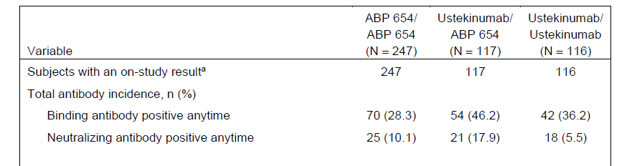
In study 20190232, the presence of binding ADA significantly reduced the trough concentrations of drug, even as early as week 4. The degree of reduction was similar for both ABP 654 and STELARA.
In terms of efficacy, the 12 week PASI score was slightly higher in subjects with positive ADA binding status. Both ABP 654 and STELARA showed similar changes, with no significant difference between them in mean PASI scores at 12 weeks. This data suggest that the binding ADAs have the same level of effects, at least out to 12 weeks. No difference was seen out to 28 weeks as well. The clinical evaluator has noted that no data beyond this time have been provided and the numbers in the treatment groups were insufficient and therefore a robust conclusion regarding the impact of ADA on efficacy cannot be drawn.
ADA status did not appear to influence safety in either the ABP 654 or the STELARA arms, including immune-mediated adverse events.
In both clinical studies it is apparent that ABP 654 was associated with a lower incidence of both binding and neutralizing ADAs when compared with the innovator product, STELARA. This issue has been raised by the clinical evaluator and addressed by the Sponsor. ABP 654 does not contain non-human glycans which may enhance immunogenicity. Based on scientific literature referred to by the Sponsor, non-human glycans that are present in STELARA enhance immune reactivity to its protein backbone. The different glycan profiles of ABP 654 and STELARA are due to the different expression systems (i.e. CHO and Sp2/0, respectively).

Other – extrapolation to other indications and patient groups
As ABP 654 is not being subject to additional clinical trials, its use in indications other than plaque psoriasis and in children with plaque psoriasis is extrapolated. The Sponsor has provided the following evidence in support of extrapolation:
- The mechanism of action of ustekinumab is the same across the approved indications of psoriasis, psoriatic arthritis, Crohn’s disease and ulcerative colitis.
- The role of IL-23/IL-12 mediated inflammation in these diseases is supported by the data summarised in the STELARA PI and published scientific literature.
- The various structural assessments of ABP 654 undertaken demonstrate its similarity to STELARA, as do in vitro biological and pharmacology studies.
- PK similarity between ABP 654 and STELARA has been demonstrated in a phase 1 study which showed the 90% confidence intervals for the geometric mean ratios of AUCinf, Cmax and AUClast to be within the prespecified range of -0.8 – 1.25.
- STELARA is known to show similar PK characteristics across its different indications, thus supporting extrapolation for ABP 654.
- The safety profile of ABP 654 was found to be comparable to STELARA, further supporting an extrapolation across indications.
The differences in incidence of both binding and neutralising ADAs between ABP 654 and STELARA have been described previously. It is not possible to confidently extrapolate what may be expected (such as incidence and clinical / safety effects) with ADAs in non-psoriasis indications for ABP 654. This uncertainty is noted and should be addressed in the post market space.
The use of psoriasis as the population in which to demonstrate comparable efficacy is appropriate given the expected robust treatment effects. Furthermore, the lack of comorbidities and other immunosuppressant use compared with the other indications, makes the psoriasis population sensitive for detecting safety signals and immunogenicity.

Recommendation following the clinical evaluation
The Clinical Evaluator considered the benefit-risk balance as favourable and supported registration. There were some relatively minor outstanding issues.

Risk management plan
An EU-RMP (version 0.1 dated 9 SEP 2022, DLP 8 MAR 2022; under review by EMA) and ASA (version 1.0 dated 11 JAN 2023) were submitted by the Sponsor.
An RMP evaluation was not required for this submission and therefore the above documents were not reviewed.

Risk-benefit analysis

Delegate’s considerations
Proposed indications
The proposed indications for WEZLANA are the same as those for STELARA. This is appropriate for a biosimilar. The Sponsor has justified extrapolation across indications, mainly on the basis of the same mechanism of action operating across all of them. Extrapolation is also made to paediatric patients on the basis that pharmacokinetics of WEZLANA are expected to be equivalent to STELARA in this population as well. This is acceptable.
PK equivalence
Equivalence of WEZLANA to STELARA (EU and US products) was demonstrated in the phase 1 study 20190230. The 90% confidence interval of the geometric mean ratios of the primary PK parameters (AUCinf and Cmax) were within the prespecified -0.8 to 1.25 margin. The PK obtained from the phase 3 study 20190232 also demonstrated similar PK of WEZLANA and STELARA.
As noted in the report, there was an effect of binding ADA on t_{1/2} observed in the phase 1 study and the magnitude of effect was different between WEZLANA and STELARA (US). The Sponsor has been asked about this and suggested that the difference between the groups be “interpreted with caution due to the small number of subjects testing positive for binding ADAs within the PK parameter analysis set” (i.e. 12 subjects in WEZLANA arm and 30 subjects in STELARA (US) arm). The Sponsor also pointed out that the PK equivalence (which is in terms of AUC and Cmax) has been clearly met and no clinical differences were detected in the phase 3 study. The Delegate considers it likely that the overall difference incidences in development of binding ADAs leads to modest effects on the PK. At this stage, no clinically significant difference has been observed.
PK data obtained during study 20190232 also tended to show slightly higher trough concentrations for WEZLANA compared with STELARA, as explained in the body of the overview. The Delegate thinks this is likely due to the overall difference in incidence of binding antibodies between the treatment arms. Although not detected in the clinical study, clinical sequalae are theoretically possible (especially if certain populations had an increased tendency to develop binding ADAs).
Efficacy
The efficacy of WEZLANA in treating adults with moderate to severe psoriasis is demonstrated in study 20190232. The study was of appropriate size and duration and the endpoints were acceptable and supported by the EU guideline. The magnitude of efficacy appeared very similar to the comparator (STELARA). This was the only efficacy study submitted. Plaque psoriasis was an appropriate choice for the single phase 3 study due to the expected robust treatment effect (i.e. better sensitivity to detect any difference) and fewer patient comorbidities and concomitant immunosuppressant use.
In Study 20190232 some subjects in the STELARA arm were re-randomised to receive WEZLANA (i.e. switching from innovator to biosimilar). This did not result in a clinically meaningful impact on efficacy, safety or immunogenicity. The Sponsor has advised that a dedicated switching study in moderate to severe plaque psoriasis has recently completed. At this stage, the issue of switching is not dealt with in the PI.
Safety
The safety data were comparable between WEZLANA and STELARA. This includes no signal for differences in the most concerning adverse events such as malignancy, serious and opportunistic infection, COVID19 and tuberculosis.
The main clinical difference observed in the studies was the incidence of ADAs, which was lower with WEZLANA compared with STELARA. The Sponsor believes this is due to the glycan profiles of the different products. They have pointed out that neutralising ADAs (as a percentage of total) were similar between the products. Additional analyses to look for differences in PK, efficacy or safety were conducted and presented in the dossier, with the conclusion that “observed differences are not clinically impactful”.
Risk-benefit-uncertainty assessment
The risk-benefit assessment is generally supportive of WEZLANA as a STELARA biosimilar. There is residual uncertainty around the extrapolation to other indications and potential undetected clinical sequelae, including those due to differences in ADA development and drug exposure. This uncertainty is probably acceptable, although it forms the basis for questions to the Sponsor and ACM.

Proposed action
Overall adequate evidence has been presented to support WEZLANA as a STELARA biosimilar for all indications. Before a final decision is made, further input from the Sponsor and ACM is sought, including in relation to the uncertainties discussed above.

Advisory Committee considerations
The Advisory Committee on Medicines (ACM) having considered the evaluations and the Delegate’s overview, as well as the sponsor’s response to these documents, advised the following.

Specific advice to the Delegate
1. Provide opinion on the immunogenicity differences being observed and whether there are any associated clinical concerns.
The ACM was of the view that the immunogenicity differences are of minimal impact clinically. The ACM advised that the reduced apparent immunogenicity of WEZLANA is numerical and could be explainable by the structural differences between WEZLANA and STELARA or as a chance occurrence.
The ACM advised that WEZLANA demonstrated similar pharmacokinetics, efficacy and no additional safety signals compared to STELARA. Further noting that there is a lack of clear evidence that immunogenicity differences are associated with clinically important changes in biosimilar monoclonal antibodies and other large protein medicines to date.
2. Provide opinion on the difference in incidence of binding ADAs being potentially responsible for the small differences in drug exposure observed during the first 28 weeks.
The ACM noted the difference in incidence of binding ADAs and was of the view that this is unlikely to have a clinical impact.
The ACM examined the pharmacokinetic data and noted that the exposures are numerically greater in the ADA negative population for all tested products (WEZLANA, STELARA (EU) and STELARA (US)). The ACM advised that this is likely related to an increased half-life and is consistent with the known effects of immunogenicity on clearance of monoclonal antibodies.
The ACM noted that within the full cohort and for the ADA negative cohort the prespecified margins of the geometric mean ratio (GMR) were met.
The ACM also examined the post hoc estimations of ADA and noted that there was less variability in WEZLANA compared to the innovator product, however a high CV% was noted in the full cohorts.
The ACM advised that clinician assessment and routine pharmacovigilance activity are unlikely to have discriminatory ability to detect expected differences in response rates related to pharmacokinetic differences from ADAs given expected variability related to other factors, including the presence of non-responder cohort in population.
3. Are there any specific concerns around extrapolation to other indications (psoriatic arthritis, Crohn’s disease, ulcerative colitis)?
The ACM did not highlight any specific concerns around extrapolation to other indications. The ACM noted that STELARA is known to show similar pharmacokinetic characteristics across its different indications.
4. Are there any specific concerns around extrapolation to paediatric patients (plaque psoriasis only)?
The ACM did not highlight any specific concerns around extrapolation to paediatric patients for the plaque psoriasis indication.
The ACM also noted that the extrapolation approach is justifiable and in alignment with biosimilar guidelines.
5. What is the committee’s perspective on the safety data?
Overall, the ACM advised that the safety profile is similar to STELARA, noting there is currently less long-term data.
The ACM noted that there are currently no signals for malignancy or serious infection (when compared to STELARA).

Conclusion
The ACM considered this product to have an overall positive benefit-risk profile for the indication:
Plaque Psoriasis
Adults
WEZLANA is indicated for the treatment of adult patients (18 years or older) with moderate to severe plaque psoriasis who are candidates for phototherapy or systemic therapy.
Paediatric population, 6 years and older
WEZLANA is indicated for the treatment of moderate to severe plaque psoriasis in children and adolescent patients from 6 years of age who are inadequately controlled by, or are intolerant to, other systemic therapies or phototherapies.
Psoriatic Arthritis (PsA)
WEZLANA, alone or in combination with methotrexate, is indicated for the treatment of signs and symptoms of active psoriatic arthritis in adult patients (18 years and older) where response to previous non-biological DMARD therapy has been inadequate.
Crohn’s Disease
WEZLANA is indicated for the treatment of adult patients with moderately to severely active Crohn’s disease who have had an inadequate response, lost response, or were intolerant to either conventional therapy or a TNFα antagonist or have medical contraindications to such therapies.
Ulcerative Colitis
WEZLANA is indicated for the treatment of adult patients with moderately to severely active ulcerative colitis.

Outcome
Based on a review of quality, safety, and efficacy data, the TGA resolved to register WEZLANA.

Specific conditions of registration applying to these goods
All batches of WEZLANA-ustekinumab supplied in Australia must comply with the product details and specifications approved during evaluation and detailed in the Certified Product Details (CPD).
When requested by the TGA, the Sponsor should be prepared to provide product samples, specified reference materials and documentary evidence to enable the TGA to conduct laboratory testing on the Product. Outcomes of laboratory testing are published biannually in the TGA Database of Laboratory Testing Results http://www.tga.gov.au/ws-labs-index and periodically in testing reports on the TGA website.
The CPD, as described in Guidance 7: Certified Product Details of the Australian Regulatory Guidelines for Prescription Medicines (ARGPM) for the above products should be provided upon registration of these therapeutic goods. In addition, an updated CPD should be provided when changes to finished product specifications and test methods are approved in a Category 3 application or notified through a self-assessable change.

Attachment 1. Product Information
The Product Information (PI) approved with the submission for WEZLANA which is described in this AusPAR can be found as Attachment 1. It may have been superseded. For the most recent PI and Consumer Medicines Information (CMI), please refer to the TGA PI/CMI search facility.

Therapeutic Goods Administration
PO Box 100 Woden ACT 2606 Australia
Email: info@tga.gov.au Phone: 1800 020 653 Fax: 02 6203 1605
https://www.tga.gov.au
Reference/Publication #

In this report the ‘Delegate’ is the Delegate of the Secretary of the Department of Health and Aged Care who decided the submission under section 25 of the Act.

