 This medicinal product is subject to additional monitoring in Australia. This will allow quick identification of new safety information. Healthcare professionals are asked to report any suspected adverse events at https://www.tga.gov.au/reporting-problems.

AUSTRALIAN PRODUCT INFORMATION – WEZLANATM (USTEKINUMAB)
- NAME OF THE MEDICINE
Ustekinumab.
WEZLANA is a biosimilar medicine to STELARA® (ustekinumab). The evidence for comparability supports the use of WEZLANA for the listed indication(s).

QUALITATIVE AND QUANTITATIVE COMPOSITION

For Subcutaneous Administration
WEZLANA 45 mg solution for injection
Each vial contains 45 mg ustekinumab in 0.5 mL. WEZLANA 45 mg solution for injection in pre-filled syringe
Each pre-filled syringe contains 45 mg ustekinumab in 0.5 mL. WEZLANA 90 mg solution for injection in pre-filled syringe Each pre-filled syringe contains 90 mg ustekinumab in 1 mL

For Intravenous Infusion Only
WEZLANA 130 mg concentrated solution for infusion
Each vial contains 130 mg ustekinumab in 26 mL (5 mg/mL).
Excipient(s) with known effect
For the full list of excipients, see section 6.1 List of excipients.

PHARMACEUTICAL FORM

For Subcutaneous Administration
Solution for subcutaneous injection.
The solution is clear to opalescent, colourless to light yellow.

For Intravenous Infusion Only
Concentrate for solution for infusion.
The solution is clear to opalescent, colourless to light yellow.

CLINICAL PARTICULARS

Therapeutic indications Plaque Psoriasis

Adults
WEZLANA is indicated for the treatment of adult patients (18 years or older) with moderate to severe plaque psoriasis who are candidates for phototherapy or systemic therapy.

Paediatric population, 6 years and older
WEZLANA is indicated for the treatment of moderate to severe plaque psoriasis in children and adolescent patients from 6 years of age who are inadequately controlled by, or are intolerant to, other systemic therapies or phototherapies.
Psoriatic Arthritis (PsA)
WEZLANA, alone or in combination with methotrexate, is indicated for the treatment of signs and symptoms of active psoriatic arthritis in adult patients (18 years and older) where response to previous non-biological DMARD therapy has been inadequate.
Crohn’s Disease
WEZLANA is indicated for the treatment of adult patients with moderately to severely active Crohn’s disease who have had an inadequate response, lost response, or were intolerant to either conventional therapy or a TNFα antagonist or have medical contraindications to such therapies.
Ulcerative Colitis
WEZLANA is indicated for the treatment of adult patients with moderately to severely active ulcerative colitis.

Dose and method of administration
Dosage (dose and interval)
Plaque Psoriasis

Adults

For the treatment of plaque psoriasis, WEZLANA is administered by subcutaneous injection. The recommended dose of WEZLANA is 45 mg administered at Weeks 0 and 4, then every 12 weeks thereafter. Alternatively, 90 mg administered over Weeks 0 and 4, then every 12 weeks thereafter may be used in patients with a body weight greater than 100 kg.
Dose Adjustment
For patients who inadequately respond to dosing every 12 weeks, consideration may be given to treating as often as every 8 weeks. Treatment should be discontinued in patients who have shown no response after 28 weeks of treatment.
Re-treatment
After interruption of therapy, re-treatment with a dosing regimen of Weeks 0 and 4, then every 12 weeks thereafter has been shown to be safe and effective.

Paediatric population, 6 years and older
For the treatment of plaque psoriasis, WEZLANA should be administered by subcutaneous injection. The recommended dose of WEZLANA based on body weight is shown below (Table 1). WEZLANA should be administered at Weeks 0 and 4, then every 12 weeks thereafter.

Table 1. Recommended dose of WEZLANA for paediatric psoriasis

Body weight at the time  of dosing | Recommended Dose | Dosage Form
< 60 kg | 0.75 mg/kg* | vial
≥ 60 to ≤100 kg | 45 mg | Pre-filled syringe, vial
> 100 kg | 90 mg | Pre-filled syringe, vial
* To calculate the volume of injection (mL) for patients < 60 kg, use the following formula: body weight (kg) × 0.0083 (mL/kg) or see Table 2. The calculated volume should be rounded to the nearest 0.01 mL and administered using a 1 mL graduated syringe. A 45 mg vial is available for
paediatric patients who need to receive less than the full 45 mg dose.
Table 2. Injection volumes of WEZLANA for paediatric psoriasis patients < 60 kg
Body weight at time of  dosing (kg) | Dose (mg) | Volume of injection (mL)
15 | 11.3 | 0.12
16 | 12.0 | 0.13

Body weight at time of dosing (kg) | Dose (mg) | Volume of injection (mL)
17 | 12.8 | 0.14
18 | 13.5 | 0.15
19 | 14.3 | 0.16
20 | 15.0 | 0.17
21 | 15.8 | 0.17
22 | 16.5 | 0.18
23 | 17.3 | 0.19
24 | 18.0 | 0.20
25 | 18.8 | 0.21
26 | 19.5 | 0.22
27 | 20.3 | 0.22
28 | 21.0 | 0.23
29 | 21.8 | 0.24
30 | 22.5 | 0.25
31 | 23.3 | 0.26
32 | 24.0 | 0.27
33 | 24.8 | 0.27
34 | 25.5 | 0.28
35 | 26.3 | 0.29
36 | 27.0 | 0.30
37 | 27.8 | 0.31
38 | 28.5 | 0.32
39 | 29.3 | 0.32
40 | 30.0 | 0.33
41 | 30.8 | 0.34
42 | 31.5 | 0.35
43 | 32.3 | 0.36
44 | 33.0 | 0.37
45 | 33.8 | 0.37
46 | 34.5 | 0.38
47 | 35.3 | 0.39
48 | 36.0 | 0.40
49 | 36.8 | 0.41
50 | 37.5 | 0.42
51 | 38.3 | 0.42
52 | 39.0 | 0.43
53 | 39.8 | 0.44
54 | 40.5 | 0.45
55 | 41.3 | 0.46
56 | 42.0 | 0.46
57 | 42.8 | 0.47
58 | 43.5 | 0.48
59 | 44.3 | 0.49
Treatment should be discontinued in patients who have shown no response after 28 weeks of treatment.

Psoriatic Arthritis
For the treatment of psoriatic arthritis, WEZLANA is administered by subcutaneous injection. The recommended dose of WEZLANA is 45 mg administered at Weeks 0 and

4, then every 12 weeks thereafter. Some patients with a body weight greater than 100 kg received a 90 mg dose in clinical trials and observed a clinical benefit.
Treatment should be discontinued in patients who have shown no response after 28 weeks of treatment.

Crohn’s Disease and Ulcerative Colitis
For the treatment of Crohn’s disease and ulcerative colitis, the recommended treatment regimen is to initiate WEZLANA with a single intravenous (IV) tiered dose based on body weight (Table 3). The infusion solution is to be composed of the number of vials of WEZLANA 130 mg as specified in Table 3.

Table 3. Initial IV dosing of WEZLANA

Body Weight of Patient at  the time of dosing | Dose | Number of 130 mg  WEZLANA Vials
≤ 55 kg | 260 mg | 2
> 55 kg to ≤ 85 kg | 390 mg | 3
> 85 kg | 520 mg | 4
After the initial IV dose, WEZLANA should then be administered subcutaneously. The first subcutaneous dose of 90 mg WEZLANA should be administered 8 weeks after the initial intravenous dose, then every 8 weeks thereafter.
For some patients, the single IV dose followed by a 90 mg subcutaneous dose 8 weeks later, then every 12 weeks thereafter may be acceptable according to clinical judgment. Patients who inadequately respond to 90 mg subcutaneous dosing every 12 weeks may benefit from an increase in dosing frequency to every 8 weeks (see 5.1 Pharmacodynamic properties - Clinical trials).
Immunomodulators and/or corticosteroids may be continued during treatment with WEZLANA. In patients who have responded to treatment with WEZLANA corticosteroids may be reduced or discontinued in accordance with standard of care.
If therapy in Crohn’s disease or Ulcerative Colitis is interrupted, treatment may be resumed with subcutaneous dosing every 8 weeks (see 5.1 Pharmacodynamic properties - Clinical trials).
Consideration should be given to discontinuing treatment in patients who show no evidence of therapeutic benefit by week 16.

Use in hepatic impairment
Ustekinumab has not been studied in patients with hepatic impairment. No dose recommendations can be made (see 5.2 Pharmacokinetic properties - Population Pharmacokinetic Analysis).

Use in renal impairment
Ustekinumab has not been studied in patients with renal impairment. No dose recommendations can be made (see 5.2 Pharmacokinetic properties - Population Pharmacokinetic Analysis).
Method of administration

Subcutaneous administration
WEZLANA 45 mg vials or 45 mg and 90 mg pre-filled syringes are for subcutaneous injection only. If possible, areas of the skin that show psoriasis should be avoided as injection sites.
Each vial or pre-filled syringe is for single use only and any unused medicinal product should be disposed of in accordance with local requirements.
WEZLANA is intended for use under the guidance and supervision of a health care professional. In paediatric patients, it is recommended that WEZLANA be administered by a health care provider. Patients or their caregivers may inject WEZLANA if a physician determines that it is appropriate and with medical follow-up as necessary, after proper training in subcutaneous injection technique.
Comprehensive instructions for the subcutaneous administration of WEZLANA are given in the Instructions for Use. Patients should be instructed to inject the full amount of WEZLANA according to the directions provided in the Instructions for Use. When using the single-use vial, a 27 gauge, 13 mm needle is recommended.
Following administration of WEZLANA, the syringe should be disposed of in accordance with accepted medical practices for used syringes.

Intravenous infusion (Crohn’s Disease and Ulcerative Colitis)
WEZLANA 130 mg vial is for IV infusion only.

Instructions for dilution and intravenous infusion of WEZLANA 130 mg for IV infusion (Crohn’s disease and ulcerative colitis)
WEZLANA 130 mg solution must be diluted and prepared for IV infusion by a healthcare professional using aseptic technique. The IV infusion should be administered by qualified healthcare professionals.
    - Calculate the dose and the number of WEZLANA vials needed based on patient’s body weight (see Table 3). Each 26 mL vial of WEZLANA contains 130 mg of ustekinumab.
    - Withdraw and then discard a volume of the 0.9% w/v sodium chloride solution from the 250 mL infusion bag equal to the volume of WEZLANA to be added. (Discard 26 mL sodium chloride for each vial of WEZLANA needed, for 2 vials-discard 52 mL, for 3 vials-discard 78 mL, for 4 vials-discard 104 mL).
    - Withdraw 26 mL of WEZLANA from each vial needed and add it to the
250 mL infusion bag. The final volume in the infusion bag should be 250 mL. Gently invert or swirl the bag to mix the solution. Do not shake.
    - Once diluted, the infusion solution may be stored for up to eight hours prior to infusion.
    - Visually inspect the diluted solution before administration. Do not use if visibly opaque particles, discoloration, or foreign particles are observed.
    - Administer the diluted solution over a period of at least one hour.
    - Use only an infusion set with an in-line, sterile, non-pyrogenic, low protein-binding filter (pore size 0.2 micrometer).
    - Do not infuse WEZLANA concomitantly in the same intravenous line with other agents.
    - Each vial is for single use only and any unused medicinal product should be disposed of in accordance with local requirements.

Contraindications
Severe hypersensitivity to ustekinumab or to any of the excipients (see 4.4 Special warnings and precautions for use).
WEZLANA should not be given to patients with a clinically important, active infection.

Special warnings and precautions for use Serious Infections
WEZLANA is a selective immunosuppressant and may have the potential to increase the risk of infections and reactivate latent infections.
In clinical studies, serious bacterial, fungal, and viral infections have been observed in patients receiving ustekinumab. Caution should be exercised when considering the use of WEZLANA in patients with a chronic infection or a history of recurrent infection.
Prior to initiating treatment with WEZLANA, patients should be evaluated for tuberculosis infection. WEZLANA should not be given to patients with active tuberculosis. Treatment of latent tuberculosis infection should be initiated prior to administering WEZLANA. Anti-tuberculosis therapy should also be considered prior to initiation of WEZLANA in patients with a past history of latent or active tuberculosis in whom an adequate course of treatment cannot be confirmed. Patients receiving WEZLANA should be monitored closely for signs and symptoms of active tuberculosis during and after treatment.
Patients should be instructed to seek medical advice if signs or symptoms suggestive of an infection occur. If a patient develops a serious infection, they should be closely monitored and WEZLANA should not be administered until the infection resolves (see
4.8 Adverse effects (Undesirable effects)).
Non-infectious Pneumonia
Cases of interstitial pneumonia, eosinophilic pneumonia and cryptogenic organizing pneumonia have been reported during post-approval use of ustekinumab. Clinical presentations included cough, dyspnoea, and interstitial infiltrates following one to three doses. Serious outcomes have included respiratory failure and prolonged hospitalisation. Patients improved with discontinuation of therapy and in certain cases administration of corticosteroids. If diagnosis is confirmed, discontinue WEZLANA and institute appropriate treatment.
Malignancies
WEZLANA is a selective immunosuppressant. Immunosuppressive agents have the potential to increase the risk of malignancy. Some patients who received ustekinumab in

clinical studies developed cutaneous and non-cutaneous malignancies (see 4.8 Adverse effects (Undesirable effects)).
Ustekinumab has not been studied in patients with a history of malignancy. Caution should be exercised when considering the use of WEZLANA in patients with a history of malignancy or when considering continuing treatment in patients who develop a malignancy.
All patients, in particular those greater than 60 years of age, patients with a medical history of prolonged immunosuppressant therapy or those with a history of PUVA treatment, should be monitored for the appearance of non-melanoma skin cancer (see 4.8 Adverse effects (Undesirable effects)).
Hypersensitivity and infusion-related reactions
In post-marketing experience, serious hypersensitivity reactions, including anaphylaxis and angioedema, have been reported. Infusion-related reactions were observed in clinical trials (see section 4.8 Adverse effects (undesirable effects)). Serious infusion-related reactions including anaphylactic reactions to the infusion have been reported in the
post-marketing setting.
If an anaphylactic or other serious hypersensitivity or infusion-related reaction occurs, appropriate therapy should be instituted and administration of WEZLANA should be discontinued immediately (see 4.8 Adverse effects (Undesirable effects)).
Immunisations
It is recommended that live viral or live bacterial vaccines (such as Bacillus of Calmette and Guérin [BCG]) not be given concurrently with WEZLANA.
Before live viral or live bacterial vaccination, treatment with WEZLANA should be withheld for at least 15 weeks after the last dose and can be resumed at least 2 weeks after vaccination. Prescribers should consult the Product Information for the specific vaccine for additional information and guidance on concomitant use of immunosuppressive agents post vaccination and considering the benefit risk of ustekinumab treatment in the patient.
No data are available on the secondary transmission of infection by live vaccines in patients receiving ustekinumab. Caution is advised when administering some live

vaccines to household contacts of patients receiving WEZLANA because of the potential risk for shedding from the household contact and transmission to the patient.
Patients receiving WEZLANA may receive concurrent inactivated or non-live vaccinations.
Long term treatment with ustekinumab does not suppress the humoral immune response to pneumococcal polysaccharide or tetanus vaccines (see 5.1 Pharmacodynamic properties).
Infant exposure in utero
For infants exposed in utero to ustekinumab, a six month waiting period following birth is recommended before the administration of live vaccines. Administration of a live vaccine prior to 6 months of age may be considered if ustekinumab serum levels are undetectable in the infant and the benefit of the vaccination clearly outweighs the theoretical risk of administration of live vaccines to the infant (see section 4.6 Fertility, pregnancy and lactation).
Immunosuppression
In psoriasis studies, the safety and efficacy of ustekinumab in combination with immunosuppressive agents or phototherapy have not been evaluated. In psoriatic arthritis studies, concomitant methotrexate (MTX) use did not appear to influence the safety or efficacy of ustekinumab. In Crohn’s disease and ulcerative colitis studies, concomitant use of immunomodulators (6-mercaptopurine (6-MP), azathioprine (AZA), MTX) or corticosteroids did not appear to influence the safety or efficacy of ustekinumab. Caution should be exercised when considering concomitant use of immunosuppressive agents and WEZLANA or when transitioning from other biologic agents.
Immunotherapy
Ustekinumab has not been evaluated in patients who have undergone allergy immunotherapy. WEZLANA may affect allergy immunotherapy. Caution should be exercised in patients receiving or who have received allergy immunotherapy particularly for anaphylaxis.

Posterior Reversible Encephalopathy Syndrome (PRES)
Posterior reversible encephalopathy syndrome (PRES), also known as reversible posterior leukoencephalopathy syndrome (RPLS), is a neurological disorder, which is not caused by demyelination or a known infectious agent. Conditions with which it has been associated include preeclampsia, eclampsia, acute hypertension, cytotoxic agents and immunosuppressive therapy. Fatal outcomes have been reported in this condition.
Two cases of PRES were reported in clinical trials. Cases have also been reported in postmarketing experience in patients with psoriasis, psoriatic arthritis and Crohn’s disease. Clinical presentation included headaches, seizures, confusion, visual disturbances, and imaging changes consistent with PRES a few days to several months after ustekinumab initiation. A few cases reported latency of a year or longer. Patients recovered with supportive care following withdrawal of ustekinumab. Monitor all patients treated with WEZLANA for signs and symptoms of PRES.
If PRES is suspected, promptly administer appropriate treatment and discontinue WEZLANA.
Serious skin conditions
In patients with psoriasis, exfoliative dermatitis has been reported following ustekinumab treatment. Patients with plaque psoriasis may develop erythrodermic psoriasis, with symptoms that may be clinically indistinguishable from exfoliative dermatitis, as part of the natural course of their disease. As part of the monitoring of the patient’s psoriasis, physicians should be alert for symptoms of erythrodermic psoriasis or exfoliative dermatitis. If these symptoms occur, appropriate therapy should be instituted.
WEZLANA should be discontinued if a drug reaction is suspected.
General
Use in the elderly
Of the 6709 patients exposed to ustekinumab, a total of 353 were 65 years or older (183 patients with psoriasis, 69 patients with psoriatic arthritis, 58 with Crohn’s disease and 43 patients with ulcerative colitis). No major age-related differences in clearance or volume of distribution were observed in clinical studies. Although no overall differences in efficacy or safety were observed between older and younger patients in clinical studies in

approved indications, the number of patients aged 65 and over is not sufficient to determine whether they respond differently from younger patients.
Paediatric use
Specific studies of ustekinumab in paediatric patients below 6 years of age have not been conducted. The pharmacokinetics of ustekinumab in paediatric psoriasis patients, 6 to 17 years of age, treated with the recommended dose was generally comparable to that in the adult psoriasis population. No pharmacokinetic, safety or efficacy data are available in paediatric patients with psoriatic arthritis, Crohn’s disease, or ulcerative colitis.
Effects on laboratory tests
No data available.

Interaction with other medicines and other forms of interaction
Specific drug interaction studies have not been conducted with ustekinumab (See 5.2 Pharmacokinetic properties).
Live vaccines should not be given concurrently with WEZLANA. Recommendations for infants exposed to ustekinumab in utero are provided (see 4.4 Special warnings and precautions for use - Immunisations).
CYP450 Substrates
The formation of CYP450 enzymes can be altered by increased levels of certain cytokines (e.g. IL-1, IL-6, IL-10, TNFα, IFN) during chronic inflammation. Thus, WEZLANA, an antagonist of IL-12 and IL-23, could normalise the formation of CYP450 enzymes. Upon initiation of WEZLANA in patients who are receiving concomitant CYP450 substrates, particularly those with a narrow therapeutic index, monitoring for therapeutic effect (e.g. for warfarin) or drug concentration (e.g. for ciclosporin) should be considered and the individual dose of the drug adjusted as needed.
The effects of IL-12 or IL-23 on the regulation of CYP450 enzymes were evaluated in an in vitro study using human hepatocytes, which showed that IL-12 and/or IL-23 at levels of 10 ng/mL did not alter human CYP450 enzyme activities (CYP1A2, 2B6, 2C9, 2C19, 2D6, or 3A4). However, the clinical relevance of this in vitro data has not been established.

Fertility, pregnancy and lactation
Effects on fertility
In a male fertility study in cynomolgus monkeys, no ustekinumab-related effects on mating behaviour, sperm parameters, or serum concentrations of male hormones were observed following twice weekly subcutaneous administration of ustekinumab at doses up to 45 mg/kg.
The effect of ustekinumab on female fertility has not been evaluated. A female fertility toxicity study was conducted in mice using an analogous antibody that binds to and inhibits IL-12 and IL-23 activity in mice. Twice weekly subcutaneous administration of the anti-mouse IL-12/23 antibody was well tolerated at doses up to 50 mg/kg and no adverse effects on female fertility parameters were observed.
Use in pregnancy
Category B1.
It is not known whether ustekinumab can cause foetal harm when administered to a pregnant woman or can affect reproduction capacity. WEZLANA should be given to a pregnant woman only if the benefit clearly outweighs the risk.
Women of childbearing potential should use effective methods of contraception during treatment and for at least 15 weeks after treatment.
Developmental toxicity studies of ustekinumab were conducted in cynomolgus monkeys. No evidence of maternal toxicity, embryotoxicity or teratogenicity was observed at doses up to 45 mg/kg following weekly or twice weekly administration via the IV or SC routes, respectively, during the period of organogenesis. However, animal reproductive and developmental studies are not always predictive of human response.
Use in lactation
Limited data from published literature suggests that ustekinumab is excreted in human breast milk in very small amounts. While systemic exposure to a breastfed infant is expected to be low because ustekinumab is a large molecule and is likely degraded in the gastrointestinal tract, it is not known if ustekinumab is absorbed systemically after ingestion. Because of the potential for adverse reactions in nursing infants from

ustekinumab, a decision on whether to discontinue breast-feeding during treatment and up to 15 weeks after treatment or to discontinue therapy with WEZLANA must be made, taking into account the benefit of breast-feeding to the child and the benefit of WEZLANA therapy to the woman.
Maternal treatment of monkeys with ustekinumab at doses up to 45 mg/kg twice weekly SC from gestation Day 20 to post-partum Day 33 had no adverse effects on offspring development. However, animal reproductive and developmental studies are not always predictive of human response.

Effects on ability to drive and use machines
The effects of this medicine on a person’s ability to drive and use machines were not assessed as part of its registration.

Adverse effects (Undesirable effects) Summary of safety profile
Clinical Studies Experience in Adult Patients with Psoriasis, Psoriatic Arthritis, Crohn’s Disease and ulcerative colitis
The safety data described below in Table 4 reflect exposure to ustekinumab in 14 Phase 2 and Phase 3 studies in 6709 patients (4135 with psoriasis and/or psoriatic arthritis, 1749 for Crohn’s disease, and 825 with ulcerative colitis in UC-1 and UC-2 clinical trials), with duration of exposure to ustekinumab presented in Table 4.

Table 4. Long term exposure to ustekinumab in Phase 2 and Phase 3 clinical studies
Exposure | Number of patients
6 months | 4577ª
1 year | 3253ª
≥ 4 years | 1482^{b}
≥ 5 years | 838^{b}
a Total number of patients in the psoriasis, psoriatic arthritis. Crohn’s disease studies and ulcerative colitis
b Number of patients with psoriasis
The most common adverse reactions (> 5%) in controlled periods of the clinical studies with ustekinumab among all indications were nasopharyngitis and headache. Most were considered to be mild and did not necessitate drug discontinuation. The overall safety profile of ustekinumab was similar for patients among all indications.

Tabulated list of adverse events
Table 5 provides a summary of Adverse Drug Reactions from the clinical studies. The frequency of these adverse reactions was based on those that occurred during the initial controlled periods of the clinical studies. The adverse drug reactions are ranked by frequency, using the following convention:
Very common (> 1/10)
Common (frequent) (> 1/100, < 1/10) Uncommon (infrequent) (> 1/1,000, < 1/100) Rare (> 1/10,000, < 1/1,000)

Table 5. Summary of ADRs in Clinical Studies

Infections and infestations | Common: Upper respiratory tract infection, nasopharyngitis, sinusitis  Uncommon: Herpes zoster, cellulitis, dental infections, viral upper respiratory tract infection, vulvovaginal mycotic infection
Psychiatric disorders | Uncommon: Depression
Nervous system disorders | Common: Dizziness, headache
Respiratory, thoracic and mediastinal disorders | Common: Oropharyngeal pain Uncommon: Nasal congestion
Gastrointestinal disorders | Common: Diarrhoea, nausea, vomiting
Skin and subcutaneous tissue disorders | Common: Pruritus  Uncommon: Acne
Musculoskeletal and connective tissue disorders | Common: Back pain, myalgia, arthralgia
General disorders and administration site conditions | Common: Fatigue, injection site erythema, injection site pain Uncommon: Injection site  reactions (including haemorrhage, haematoma, induration, swelling and pruritus), asthenia
Infections
In the placebo-controlled studies of patients with psoriasis, psoriatic arthritis Crohn’s disease, and ulcerative colitis, the rates of infection or serious infection were similar between ustekinumab-treated patients and those treated with placebo. In the
placebo-controlled period of the clinical studies of patients with psoriasis, patients with psoriatic arthritis, patients with Crohn’s disease, and patients with ulcerative colitis, the rate of infection was 1.36 per patient-year of follow-up in ustekinumab-treated patients, and 1.34 per patient-year of follow-up in placebo-treated patients. Serious infections occurred at a rate of 0.03 per patient-year of follow-up in ustekinumab-treated patients (30 serious infections in 930 patient-years of follow-up) and 0.03 per patient-year of

follow-up in placebo-treated patients (15 serious infections in 434 patient-years of follow-up) (see 4.4 Special warnings and precautions for use).
In the controlled and non-controlled portions of psoriasis, psoriatic arthritis, Crohn’s disease and ulcerative clinical studies representing 11581 patient-years of exposure in 6709 patients, the median follow-up was 1.0 years; 1.1 years for psoriatic disease studies,
0.6 year for Crohn’s disease studies and 1.0 years for ulcerative colitis studies. The rate of infection was 0.91 per patient-year of follow-up in ustekinumab-treated patients. The incidence of serious infections was 0.02 per patient-year of follow-up in
ustekinumab-treated patients (199 serious infections in 11581 patient-years of follow-up) and included pneumonia, anal abscess, cellulitis, diverticulitis, osteomyelitis, viral infections, gastroenteritis, and urinary tract infections.
In clinical studies, patients with latent tuberculosis who were concurrently treated with isoniazid did not develop tuberculosis. One case of tuberculosis reactivation occurred in a subject with abnormal baseline chest X-Ray and without treatment for latent TB while on ustekinumab therapy. The subject fully recovered with appropriate treatment.
Malignancy
In the placebo-controlled period of the psoriasis, psoriatic arthritis, Crohn’s disease and ulcerative colitis clinical studies, the incidence of malignancies excluding non-melanoma skin cancer was 0.11 per 100 patient-years of follow-up for ustekinumab-treated patients (1 patient in 929 patient-years of follow up) compared with 0.23 per 100 patient-years of follow-up for placebo-treated patients (1 patient in 434 patient-years of follow-up).
The incidence of non-melanoma skin cancer was 0.43 per 100 patient-years of follow-up for ustekinumab-treated patients (4 patients in 929 patient-years of follow-up) compared with 0.46 per 100 patient-years of follow-up for placebo-treated patients (2 patients in 433 patient-years of follow-up).
In the controlled and non-controlled periods of the psoriasis, psoriatic arthritis, Crohn’s disease and ulcerative colitis clinical studies representing 11561 patient-years of exposure in 6709 patients, the median follow-up was 1.0 years; 1.1 years for psoriatic disease studies, 0.6 years for Crohn’s disease studies, and 1.0 years for ulcerative colitis studies. Malignancies excluding non-melanoma skin cancers were reported in 62 patients in

11561 patient-years of follow-up (incidence of 0.54 per 100 patient-years of follow-up for ustekinumab-treated patients). The rate of malignancies reported in ustekinumab-treated patients was comparable to the rate expected in the general population (standardised incidence ratio = 0.93 [95% confidence interval: 0.71,1.20]). The most frequently observed malignancies, other than non-melanoma skin cancer, were prostate, colorectal, melanoma in situ and breast. The incidence of non-melanoma skin cancer was 0.49 per 100 patient-years of follow-up for ustekinumab-treated patients (56 patients in
11545 patient-years of follow-up). The ratio of patients with basal versus squamous cell skin cancers (3:1) is comparable with the ratio expected in the general population (see 4.4 Special warnings and precautions for use).
Hypersensitivity and Infusion-Related Reactions
Subcutaneous administration
During the controlled periods of the psoriasis and psoriatic arthritis clinical studies of ustekinumab, rash and urticaria have each been observed in < 1% of patients.
IV administration
In Crohn’s disease and ulcerative colitis intravenous induction studies, no events of anaphylaxis or other serious infusion reactions with ustekinumab were reported. In these studies, 2.2% of 785 placebo treated patients and 1.9% of 790 patients treated with the recommended dose of ustekinumab reported adverse events occurring during or within an hour of the infusion. Serious infusion-related reactions including anaphylactic reactions have been reported in the post-marketing setting (see section 4.4 Special warnings and precautions for use).
Immunogenicity of STELARA
In psoriasis and psoriatic arthritis clinical studies, up to 12.4% of patients treated with STELARA developed antibodies to ustekinumab. Patients positive for antibodies to ustekinumab tended to have lower efficacy, however, antibody positivity did not preclude a clinical response. In psoriasis studies, the majority of patients who were positive for antibodies to ustekinumab had neutralising antibodies.
In Crohn’s disease and ulcerative colitis clinical studies, 2.9 and 4.6% of patients, respectively, developed antibodies to ustekinumab when treated with ustekinumab for

approximately one year. No apparent association between the development of antibodies to ustekinumab and the development of injection site reactions was observed.
Immunogenicity of WEZLANA
All therapeutic proteins have the potential for immunogenicity; therefore, antidrug antibodies (ADA) were assessed in Study 20190230 on PK similarity and in Study 20190232 on comparative clinical similarity. Subjects in both studies were monitored for the development of anti-WEZLANA and anti-ustekinumab antibodies using the validated 2-tiered immunoassay, which consisted of a screening assay and a confirmatory (specificity) assay. Samples positive for binding antibodies were then tested for neutralising activity using a target binding assay.
In Study 20190230, the development of binding and neutralising ADAs was numerically lower in the WEZLANA treatment group compared with both ustekinumab treatment groups, but the data shows that the observed differences are not clinically impactful.
All subjects (100%) in the safety analysis set had at least 1 on-study ADA result. One subject (1.3%) each in the WEZLANA and ustekinumab (EU) treatment groups tested positive for pre-existing binding ADAs at or before baseline; no subjects in any treatment group tested positive for pre-existing neutralising ADAs at or before baseline.
Of the subjects with a postbaseline result through EOS, 12 (15.4%) subjects in the WEZLANA treatment group, 30 (38.0%) subjects in the ustekinumab (US) treatment group, and 29 (36.3%) subjects in the ustekinumab (EU) treatment group tested positive for the development of binding ADAs. Of these, the results were transient (ie, negative results at the subject’s last time point tested within the study period) for 8 (10.3%), 14 (17.7%), and 10 (12.5%) subjects, respectively. Of the subjects with a postbaseline result through EOS, 2 (2.6%) subjects in the WEZLANA treatment group, 10 (12.7%) subjects in the ustekinumab (US) treatment group, and 6 (7.5%) subjects in the ustekinumab (EU) treatment group tested positive for the development of neutralising ADAs. Of those, the results were transient (ie, negative results at the subject’s last time point tested within the study period) for 0, 1 (1.3%), and 0 subjects, respectively.
Of the 2 subjects who tested positive for pre-existing binding ADAs at or before baseline, the subject in the WEZLANA treatment group tested positive for treatment boosted

antibodies (ie, binding antibody positive at baseline with a ≥ 4x increase in magnitude postbaseline) by day 11; treatment-boosted antibodies were not detected in the subject in the ustekinumab (EU) treatment group through the EOS.
In Study 20190232, the development of binding and neutralising ADAs was numerically lower in the WEZLANA treatment group compared with the ustekinumab treatment group through week 28, but the data shows that the observed differences are not clinically impactful.
Through week 28, all subjects (100%) had at least 1 on-study ADA result. A total of 18 (6.5%) subjects in the WEZLANA treatment group and 8 (2.9%) subjects in the ustekinumab treatment group tested positive for pre-existing binding ADAs at baseline; 1 (0.4%) subject in the WEZLANA treatment group tested positive for neutralising ADAs at baseline.
Through week 28, 279 (99.6%) subjects in the WEZLANA treatment group and 280 (99.3%) subjects in the ustekinumab treatment group had a post baseline result. Of subjects with a post baseline result through week 28, 52 (18.6%) subjects in the WEZLANA treatment group and 104 (37.1%) subjects in the ustekinumab treatment group tested positive for the development of binding ADAs. Of these, the results were transient (ie, negative result at the subject’s last time point tested within the study period) for 24 (8.6%) and 50 (17.9%) subjects, respectively. Of subjects with a post baseline result through week 28, 24 (8.6%) subjects in the WEZLANA treatment group and 50 (17.9%) subjects in the ustekinumab treatment group tested positive for the development of neutralising ADAs. Of those, the results were transient (ie, negative result at the subject’s last time point tested within the study period) for 3 (1.1%) and 6 (2.1%) subjects, respectively.
Of subjects with a post baseline result through week 28, 1 (0.4%) subject in the WEZLANA treatment group and 2 (0.7%) subjects in the ustekinumab treatment group tested positive for treatment boosted ADAs (ie, binding antibody positive at baseline with a ≥ 4x increase in magnitude post baseline). Overall, the development of binding and neutralising ADAs was numerically lower in the WEZLANA treatment group compared with the ustekinumab treatment group, but the data shows that the observed differences are not clinically impactful.

Clinical Studies Experience in paediatric patients with Psoriasis
The safety of ustekinumab has been studied in two phase 3 studies of paediatric patients with moderate to severe plaque psoriasis. The first study was in 110 patients from
12 to 17 years of age treated for up to 60 weeks (CADMUS) and the second study was in 44 patients from 6 to 11 years of age treated for up to 56 weeks (CADMUS Jr.). In general, the adverse events reported in these two studies with safety data up to 1 year were similar to those seen in previous studies in adults with plaque psoriasis (see Clinical Studies Experience in Adult Patients with Psoriasis, Psoriatic Arthritis, Crohn’s Disease and ulcerative colitis' section above).
Adverse reactions
The following adverse events have been reported in patients treated with ustekinumab. A causal relationship to ustekinumab is uncertain.
In psoriasis clinical trials of ustekinumab, serious cardiovascular events, including cardiovascular death, myocardial infarction, and stroke, were reported in 0.3% of patients who received ustekinumab compared with 0% of patients treated with placebo, during the placebo-controlled period. Individuals with chronic inflammatory diseases, such as psoriasis, have higher rates of cardiovascular risk factors and cardiovascular events.
Rates of myocardial infarction and stroke reported in ustekinumab-treated patients were comparable to rates expected in the general population.
In clinical trials for Crohn’s disease, there is no consistent evidence that ustekinumab increases cardiovascular risk in patients treated with ustekinumab through approximately 1 year of treatment. Results from the Crohn’s disease studies, up to 1 year, did not change the previous assessment of the impact of ustekinumab on serious major adverse cardiovascular event (MACE).
Adverse events of depression were reported in some patients who received ustekinumab in psoriasis clinical trials, including rare events of suicidality. Individuals with psoriasis have higher rates of depression, and it is not known if ustekinumab may have contributed to these events since ustekinumab also resulted in improvements of the Hospital Anxiety and Depression Scale (see 5.1 Pharmacodynamic properties - Clinical trials).

Post-marketing Data
The adverse drug reactions in Table 6 are ranked by frequency* using the following convention:
Very common ≥ 1/10
Common ≥ 1/100 and < 1/10
Uncommon ≥ 1/1,000 and < 1/100
Rare ≥ 1/10,000 and < 1/1,000
Very rare < 1/10,000, including isolated reports

Table 6. Post-Marketing Reports

Immune system disorders | Uncommon: Hypersensitivity reactions (including rash, urticaria) Rare: Serious hypersensitivity reactions (including anaphylaxis and angioedema)
Infections and infestations | Uncommon: Lower respiratory tract infection
Respiratory, thoracic and mediastinal disorders | Rare: Allergic alveolitis  Unknown: Interstitial pneumonia, eosinophilic pneumonia, cryptogenic organizing pneumonia
Skin and subcutaneous tissue disorders | Uncommon: Pustular psoriasis, exfoliative dermatitis Rare: Erythrodermic psoriasis; hypersensitivity vasculitis Very rare: Bullous pemphigoid
* Post-marketing adverse reaction frequency is derived from clinical trials if the adverse reaction was observed during trials or is estimated to be lower than a certain frequency given the exposure in adequately designed clinical trials where the adverse reaction was not observed.

There have been reports of rapidly growing and/or multiple squamous cell carcinomas of the skin in patients receiving ustekinumab who had multiple pre-existing risk factors for developing non-melanoma skin cancer. A causal relationship of these adverse events to ustekinumab is uncertain.

Comparability of WEZLANA with Stelara®
Adverse events were determined based on data from Studies 20190232 (See 5.1 Pharmacodynamic properties, Comparability of WEZLANA with Stelara®). The frequency, type, and severity of adverse events were similar across treatment groups with no clinically meaningful differences and were consistent with the safety profile of ustekinumab.
The adverse events reported by 2% or more of patients in any treatment group through week 28 are presented in Table 7.

Table 7. Adverse Events Experienced by ≥ 2% of Patients in Any Treatment Group by Preferred Term Through Week 28
(Safety Analysis Set)

Preferred Term | WEZLANA (N = 280) n (%) | Ustekinumab (N = 282) n (%)
Hypertension | 7 (2.5) | 6 (2.1)
Nasopharyngitis | 7 (2.5) | 3 (1.1)
COVID-19 | 6 (2.1) | 5 (1.8)
Headache | 6 (2.1) | 7 (2.5)
Upper respiratory tract infection | 6 (2.1) | 7 (2.5)
COVID-19 = coronavirus disease 2019; MedDRA = Medical Dictionary for Regulatory Activities
Note: Adverse events were coded using MedDRA version 24.1. Only treatment-emergent adverse events were summarised. For each preferred term, patients were included only once, even if they experienced multiple events in that preferred term.
There were no notable differences in frequency of adverse events by treatment groups. The adverse events reported by 2% or more of patients in any treatment group for the entire study are presented in Table 8.

Table 8: Adverse Events Experienced by ≥ 2% of Subjects in Any Treatment Group by Preferred Term – Entire Study (Re-randomized Safety Analysis Set)

Preferred Term | WEZLANA/ WEZLANA  (N = 247) n (%) | Ustekinumab/ WEZLANA  (N = 117) n (%) | Ustekinumab/ Ustekinumab (N = 116) n (%)
COVID-19 | 29 (11.7) | 16 (13.7) | 12 (10.3)
Nasopharyngitis | 14 (5.7) | 1 (0.9) | 10 (8.6)
Upper respiratory tract infection | 11 (4.5) | 7 (6.0) | 6 (5.2)
Hypertension | 8 (3.2) | 2 (1.7) | 5 (4.3)
Headache | 6 (2.4) | 5 (4.3) | 2 (1.7)
COVID-19 = coronavirus disease 2019; MedDRA = Medical Dictionary for Regulatory Activities
Note: Adverse events were coded using MedDRA version 24.1. Only treatment-emergent adverse events were summarized. For each preferred term, subjects were included only once, even if they experienced multiple events in that preferred term.

Reporting suspected adverse effects
Reporting suspected adverse reactions after registration of the medicinal product is important. It allows continued monitoring of the benefit-risk balance of the medicinal product. Healthcare professionals are asked to report any suspected adverse reactions at https://www.tga.gov.au/reporting-problems.

Overdose
Single doses up to 6 mg/kg intravenously have been administered in clinical studies without dose-limiting toxicity. In case of overdose, it is recommended that the patient be monitored for any signs or symptoms of adverse reactions or effects and appropriate symptomatic treatment be instituted immediately.
For advice on the management of overdose contact the Poisons Information Centre on 131126 (Australia).

PHARMACOLOGICAL PROPERTIES

Pharmacodynamic properties
Mechanism of action
Ustekinumab is a human IgG1kappa monoclonal antibody that specifically binds to the shared p40 protein subunit of the human cytokines interleukin (IL)-12 and IL-23.
Ustekinumab inhibits the bioactivity of human IL-12 and IL-23 by preventing p40 from binding to the IL-12Rbeta1 receptor protein expressed on the surface of immune cells. Ustekinumab cannot bind to IL-12 or IL-23 that is already bound to IL-12Rbeta1 cell surface receptors. Thus, Ustekinumab is not expected to contribute to complement- or antibody-mediated cytotoxicity of cells with IL-12 and/or IL-23 receptors.
IL-12 and IL-23 are heterodimeric cytokines secreted by activated antigen presenting cells, such as macrophages and dendritic cells. IL-12 stimulates natural killer (NK) cells and drives the differentiation of CD4+ T cells toward the T helper 1 (Th1) phenotype and stimulates interferon gamma (IFNγ) production. IL-23 induces the T helper 17 (Th17) pathway and promotes secretion of IL-17A, IL-21, and IL-22. Levels of IL-12 and IL-23 are elevated in the skin and blood of patients with psoriasis, and serum IL-12/23p40 distinguishes patients with psoriatic arthritis from healthy individuals, implicating IL-12 and IL-23 in the pathophysiology of psoriatic inflammatory diseases. Genetic polymorphisms in IL-23A, IL-23R and IL-12B genes confer susceptibility to these disorders. IL-12 and IL-23 are highly expressed in lesional psoriatic skin, and
IL-12-mediated induction of IFNγ correlates with psoriasis disease activity. IL-23 responsive T-cells have been found in the enthuses in a mouse model of inflammatory arthritis, where IL-23 drives entheseal inflammation. In addition, there is pre-clinical

evidence implicating IL-23 and downstream pathways in bone erosion and destruction through up-regulation of receptor activator of nuclear factor κB ligand (RANKL), which activates osteoclasts.
In patients with Crohn’s disease, IL-12 and IL-23 are elevated in the intestines and lymph nodes. This is accompanied by increases in serum IFNγ and IL-17A levels, suggesting that IL-12 and IL-23 promote Th1 and Th17 activation in Crohn’s disease. Both IL-12 and IL-23 can also stimulate TNFα production by T cells, resulting in chronic intestinal inflammation and epithelial cell injury. Significant associations have been found between Crohn’s disease and genetic polymorphisms in the IL-23R and IL-12B genes, suggesting a potential causal role for IL-12/23 signalling in the disease. This is supported by
pre-clinical data demonstrating that IL-12/23 signalling is required for intestinal injury in mouse models of inflammatory bowel disease.
By binding the shared p40 subunit of IL-12 and IL-23, WEZLANA may exert its clinical effects in psoriasis, psoriatic arthritis, Crohn’s disease, and ulcerative colitis through interruption of the Th1 and Th17 cytokine pathways, which are central to the pathology of these diseases.

Pharmacodynamics
Treatment with ustekinumab resulted in significant improvement in histological measures of psoriasis including epidermal hyperplasia and cell proliferation. These results are consistent with the clinical efficacy observed.
In patients with psoriasis and/or psoriatic arthritis, ustekinumab had no apparent effect on the percentages of circulating immune cell populations including memory and naive
T cell subsets or circulating cytokine levels. Systemic markers of inflammation were measurable in the serum at baseline and 4 markers (MDC, VEGF, MCSF-1 and YKL-40) showed modest differences in concentration post-treatment in ustekinumab-treated patients as compared to placebo.
In psoriasis and psoriatic arthritis studies, clinical response (improvement in Psoriasis Area and Severity Index [PASI] or ACR measurements, respectively) appeared to be related to serum ustekinumab levels. Patients with psoriasis with PASI response had higher median serum concentrations of ustekinumab than those with lower clinical

responses. In psoriasis studies, the proportion of patients with psoriasis who achieved PASI 75 response increased with increasing serum levels of ustekinumab. The proportion of patients who achieved PASI 75 response at Week 28 increased with increasing serum ustekinumab trough levels at Week 28. In psoriatic arthritis studies, patients achieving an ACR 20 response had higher median serum concentrations of ustekinumab than ACR 20 non-responders. The proportion of patients who achieved ACR 20 and ACR 50 response increased with increasing serum levels of ustekinumab.
In patients with Crohn’s disease, treatment with ustekinumab resulted in a significant decrease in inflammatory markers including C-Reactive Protein (CRP) and faecal calprotectin. CRP was assessed during the study extension and the reductions observed during maintenance were generally sustained through week 252. Reductions in serum IFNγ and IL-17A, which are IL-12 and IL-23 regulated pro-inflammatory cytokines, were achieved and maintained in ustekinumab treated patients through Week 44 compared to placebo (52 weeks since the first dose of ustekinumab). At week 6, expression of genes such as IL-12Rβ1 and IL-23 were reduced in inflamed colon tissue from Crohn’s disease patients, who were responders to ustekinumab treatment while no significant changes were observed in placebo treated patients.
In patients with ulcerative colitis, treatment with ustekinumab resulted in a decrease in inflammatory markers including CRP and faecal calprotectin during the induction phase, which were maintained throughout the maintenance phase and study extension through week 92.

Immunisation
During the long-term extension of a Phase 3 psoriasis study (PHOENIX 2), patients treated with ustekinumab for at least 3.5 years mounted similar antibody responses to both pneumococcal polysaccharide and tetanus vaccines as a
non-systemically treated psoriasis control group. Similar proportions of patients developed protective levels of anti-pneumococcal and anti-tetanus antibodies and antibody titres were similar among ustekinumab-treated and control patients.

Clinical trials

Plaque Psoriasis (Adults)
The safety and efficacy of ustekinumab was assessed in two Phase 3 studies (A Phase 3 multicentre, randomised, double-blind, placebo-controlled trial evaluating the efficacy and safety of CNTO 1275 in the treatment of patients with moderate to severe
plaque-type psoriasis followed by long term extension PHOENIX 1 and PHOENIX 2). A total of 1996 patients were enrolled in these studies.
The safety and efficacy of ustekinumab have not been established beyond 4 years.
The studies enrolled adults (≥ 18 years) with chronic (> 6 months) plaque psoriasis who had a minimum body surface area (BSA) involvement of 10%, and PASI score ≥ 12 and who were candidates for systemic therapy or phototherapy. Patients with guttate, erythrodermic, or pustular psoriasis were excluded from the studies. No concomitant anti-psoriatic therapies were allowed during the study, with the exception of low-potency topical corticosteroids on the face and groin after week 12.
The Psoriasis Area and Severity Index (PASI) is a composite score that assesses the fraction of body surface area involved with psoriasis and the severity of psoriatic changes within the affected regions (plaque thickness/induration, erythema, and scaling). PASI numeric scores range from 0 to 72, with higher scores representing more severe disease.
Patients achieving ≥ 75% improvement in PASI from baseline (PASI 75) were considered PASI 75 responders. Patients originally randomised to ustekinumab who were PASI 75 responders at both Weeks 28 and 40 were considered long-term PASI 75 responders.
Patients achieving ≥ 90% improvement in PASI from baseline (PASI 90) were considered PASI 90 responders and patients with ≥ 50% improvement in PASI from baseline
(PASI 50) were considered PASI 50 responders. Patients who achieved ≥ 50% but less than 75% improvement in PASI from baseline were considered partial responders.
Patients with < 50% improvement in PASI from baseline were considered non-responders.
Other key efficacy assessments included:
- The Physician’s Global Assessment (PGA), a 6-category scale focusing on plaque thickness/induration, erythema, and scaling.

- The Dermatology Life Quality Index (DLQI), a dermatology-specific quality of life instrument, with a lower score indicating an improved quality of life.
- The SF-36, a health survey questionnaire consisting of multi-item scales measuring 8 health concepts (PHOENIX 1 only).
- The Nail Psoriasis Severity Index (NAPSI), a physician-assessed score that measures the severity of nail involvement (PHOENIX 1 only).
- The Hospital Anxiety and Depression Scale (HADS), a self-rating tool developed to evaluate psychological measures in patients with physical ailments (PHOENIX 2 only).
- The Work Limitations Questionnaire (WLQ), a 25-item, self-administered questionnaire that was used to measure the impact of chronic health conditions on job performance and work productivity among employed populations (PHOENIX 2 only).
- The Itch Visual Analogue Scale, (Itch VAS) used to assess the severity of itch at the time of the assessment (PHOENIX 1 only).

PHOENIX 1
PHOENIX 1 evaluated the safety and efficacy of ustekinumab versus placebo in
766 patients with plaque psoriasis and the efficacy of every 12 week dosing for patients who were PASI 75 responders.
Patients randomised to ustekinumab received 45 mg or 90 mg doses at Weeks 0 and 4 followed by the same doses every 12 weeks. Patients randomised to receive placebo at Weeks 0 and 4 crossed over to receive ustekinumab (either 45 mg or 90 mg) at Weeks 12 and 16 followed by the same dose every 12 weeks.

Maintenance Dosing (every 12 weeks)
To evaluate the therapeutic benefit of maintenance dosing with ustekinumab, patients originally randomised to ustekinumab who were PASI 75 responders at both Weeks 28 and 40 were re-randomised to either maintenance dosing of ustekinumab every 12 weeks or to placebo (i.e., withdrawal of therapy). Patients who were re-randomised to placebo at Week 40 reinitiated ustekinumab at their original dosing regimen when they experienced at least a 50% loss of their PASI improvement obtained at Week 40.

Dose Adjustment (every 8 weeks)
At Week 28, patients who were non-responders discontinued treatment and patients who were partial responders were adjusted to every 8 week dosing. PASI 75 responders at week 28 who became partial responders or non-responders at Week 40 were adjusted to every 8 week dosing. All patients were followed for at least 52 weeks following first administration of study treatment.

PHOENIX 2
PHOENIX 2 evaluated the safety and efficacy of ustekinumab versus placebo in
1230 patients with plaque psoriasis. Patients randomised to ustekinumab received 45 mg or 90 mg doses at Weeks 0 and 4 followed by an additional dose at Week 16. Patients randomised to receive placebo at Weeks 0 and 4 crossed over to receive ustekinumab (either 45 mg or 90 mg) at Weeks 12 and 16. Patients were followed for 28 weeks.

Baseline Disease Characteristics: PHOENIX 1 and 2
Baseline disease characteristics across PHOENIX 1 and 2 were similar (Table 9).

Table 7. Baseline Disease Characteristics

 | PHOENIX 1 |  | PHOENIX 2
 | Placebo | Ustekinumab | Placebo | Ustekinumab
Patients randomised at Week 0 | N = 255 | N = 511 | N = 410 | N = 820
Median BSA | 22.0 | 21.0 | 20.0 | 21.0
Patients with BSA ≥ 20% | 145 (57%) | 276 (54%) | 217 (53%) | 445 (54%)
Median PASI | 17.80 | 17.40 | 16.90 | 17.60
PASI ≥ 20 | 91 (36%) | 169 (33%) | 133 (32%) | 300 (37%)
PGA of marked or severe | 112 (44%) | 223 (44%) | 160 (39%) | 328 (40%)
History of psoriatic arthritis | 90 (35%) | 168 (33%) | 105 (26%) | 200 (24%)
Prior phototherapy | 150 (59%) | 342 (67%) | 276 (67%) | 553 (67%)
Prior conventional systemic therapy excluding biologics | 142 (56%) | 282 (55%) | 241 (59%) | 447 (55%)
Prior conventional systemic or biologic therapy | 189 (74%) | 364 (71%) | 287 (70%) | 536 (65%)
Failed to respond to, had contraindication for, or intolerant to  ≥ 1 conventional therapy | 139 (55%) | 270 (53%) | 254 (62%) | 490 (60%)
Failed to respond to, had contraindication for, or intolerant to  ≥ 3 conventional therapies | 30 (12%) | 54 (11%) | 66 (16%) | 134 (16%)

Efficacy at the Primary Endpoint, PHOENIX 1 and 2
In both the PHOENIX 1 and PHOENIX 2 studies, a significantly greater proportion of patients randomised to treatment with ustekinumab were PASI 75 responders compared with placebo at Week 12 (Table 9). In the PHOENIX 1 study, 67% and 66% of patients receiving ustekinumab 45 mg and 90 mg, respectively, achieved a PASI 75 response at Week 12 compared with 3% of patients receiving placebo. In the PHOENIX 2 study, 67% and 76% of patients receiving ustekinumab 45 mg and 90 mg respectively achieved a PASI 75 response at Week 12 compared with 4% of patients receiving placebo.
All 3 components of the PASI (plaque thickness/induration, erythema, and scaling) contributed comparably to the improvement in PASI.
The efficacy of ustekinumab was significantly superior (p < 0.001) to placebo across all subgroups defined by baseline demographics, clinical disease characteristics (including patients with a history of psoriatic arthritis) and prior medication usage. While

pharmacokinetic modelling suggested a trend towards higher CL/F in patients with diabetes, a consistent effect on efficacy was not observed.

Other Efficacy Measures at Week 12
In both PHOENIX 1 and PHOENIX 2, compared with placebo, significantly greater proportions of patients randomised to 45 mg or 90 mg ustekinumab achieved a cleared or minimal PGA score, and significantly greater proportions of patients randomised to 45 mg or 90 mg ustekinumab were PASI 90 and PASI 50 responders at Week 12 (Table 10). In the PHOENIX 1 study, 60% and 62% of the patients treated with 45 mg and 90 mg ustekinumab, respectively, achieved PGA scores of cleared or minimal compared with 4% of placebo-treated patients. In PHOENIX 2, 68% and 73 % of patients receiving 45 mg or 90 mg ustekinumab, respectively, had cleared or minimal PGA scores compared with 5% of the placebo patients. In PHOENIX 1, PASI 90 was achieved by 42% and 37% of the patients treated with 45 mg and 90 mg ustekinumab, respectively, compared with 2% of placebo-treated patients. In PHOENIX 2, the percentage of patients achieving PASI 90 was 42% in the 45 mg ustekinumab group, 51% in the 90 mg ustekinumab group and 1% in the placebo group. The percentage of patients achieving PASI 50 in PHOENIX 1 was 84% and 86% in the 45 mg and 90 mg ustekinumab groups, respectively, compared with 10% in the placebo group. Similarly, 84% of patients treated with 45 mg ustekinumab, 89% ofpatients treated with 90 mg ustekinumab and 10% of patients treated with placebo reached PASI 50 in PHOENIX 2 (Table 10).

Table 8. Key psoriasis endpoints – PHOENIX 1 and PHOENIX 2

Response |  | PHOENIX 1 |  |  |  |  | PHOENIX 1
Response |  | Ustekinumab |  |  |  |  | Ustekinumab
Response | Placebo | 45 mg |  | 90 mg |  | Placebo | 45 mg |  | 90 mg
Response | n = 255 | n = 255 | n = 250 | n = 256 | n = 243 | n = 410 | n = 409 | n = 397 | n = 411 | n = 400
Response | Week  12 | Week  12 | Week  28 | Week  12 | Week  28 | Week  12 | Week  12 | Week  28 | Week  12 | Week  28
PASI
response
PASI 50 (%) | 26 (10) | 213  (84)ª | 228  (91)^{b} | 220  (86)ª | 234  (96)^{b} | 41 (10) | 342  (84)ª | 369  (93)^{b} | 367  (89)ª | 380  (95)^{b}
PASI 75 (%) | 8 (3) | 171  (67)ª | 178  (71)^{b} | 170  (66)ª | 191  (79)^{b} | 15 (4) | 273  (67)ª | 276  (70)^{b} | 311  (76)ª | 314  (79)^{b}
PASI 90 (%) | 5 (2) | 106 (42)ª | 123 (49)^{b} | 94 (37)ª | 135 (56)^{b} | 3 (1) | 173 (42)ª | 178 (45)^{b} | 209 (51)ª | 217 (54)^{b}
PGA Cleared or Minimalª | 10 (4) | 151 (59)ª | 146 (58)^{b} | 156 (61)ª | 160 (66)^{b} | 18 (4) | 277 (68)ª | 241 (61)^{b} | 300 (73)ª | 279 (70)^{b}
PASI 75
response by weight
≤ 100 kg
n | 166 | 168 | 164 | 164 | 153 | 290 | 297 | 287 | 289 | 280
PASI 75 (%) | 6 (4) | 124  (74) | 130  (79) | 107  (65) | 124  (81) | 12 (4) | 218  (73) | 217  (76) | 225  (78) | 226  (81)
> 100 kg
n | 89 | 87 | 86 | 92 | 90 | 120 | 112 | 110 | 121 | 119
PASI 75 (%) | 2 (2) | 47 (54) | 48 (56) | 63 (68) | 67 (74) | 3 (3) | 55 (49) | 59 (54) | 86 (71) | 88 (74)
PGA Cleared or Minimal by weight
≤ 100 kg
n | 166 | 168 | 164 | 164 | 153 | 290 | 297 | 287 | 289 | 280
PGA response  (%) | 7 (4) | 108  (64) | 106  (65) | 103  (63) | 106  (70) | 14 (5) | 220  (74) | 192  (67) | 216  (74) | 207  (74)
> 100 kg
n | 89 | 87 | 86 | 92 | 90 | 120 | 112 | 110 | 121 | 119
PGA response  (%) | 3 (3) | 44 (51) | 40 (47) | 54 (59) | 54 (60) | 4 (3) | 59 (53) | 49 (45) | 85 (70) | 71 (60)
a p < 0.001 for 45 mg or 90 mg comparison with placebo at Week 12.
b No statistical comparisons to placebo were made at Week 28 because the original placebo group began receiving ustekinumab at Week 12.

Response Over Time
In PHOENIX 1, significantly greater proportions of ustekinumab-treated patients had PASI 50 responses (9% and 10% for the 45 mg and 90 mg groups, respectively) compared with placebo (2%) by Week 2 (p < 0.001). Significantly greater proportions of patients treated with ustekinumab achieved PASI 75 responses (9% and 12% for the
45 mg and 90 mg ustekinumab groups, respectively) compared with placebo (0.4%) by Week 4 (p < 0.001). Maximum response was generally achieved by Week 24 in the 45 mg and 90 mg ustekinumab treatment groups, and response rates were generally
sustained through Week 36 (Figure 3). In PHOENIX 1, PASI 75 rates at Week 24 were 76% for the 45 mg group, and 85% for the 90 mg group. Higher response rates were observed in patients receiving ustekinumab 90 mg than in those receiving ustekinumab 45 mg by Week 16 and these higher response rates were sustained through Week 36 (Figure 3). Similar results were observed in the PHOENIX 2 study through Week 28.
In pre-specified analyses of efficacy by body weight in PHOENIX 1 and PHOENIX 2, no consistent pattern of dose response was seen in patients ≤ 100 kg. In patients who weighed > 100 kg, higher PASI 75 response rates were seen with 90 mg dosing compared with 45 mg dosing, and a higher proportion of patients receiving 90 mg dosing had PGA scores of cleared or minimal compared with patients receiving 45 mg dosing (Table 10). Figure 3 shows PASI 75 response over time in PHOENIX 1 and 2.

Figure 1. PASI 75 response over time in PHOENIX 1 and 2
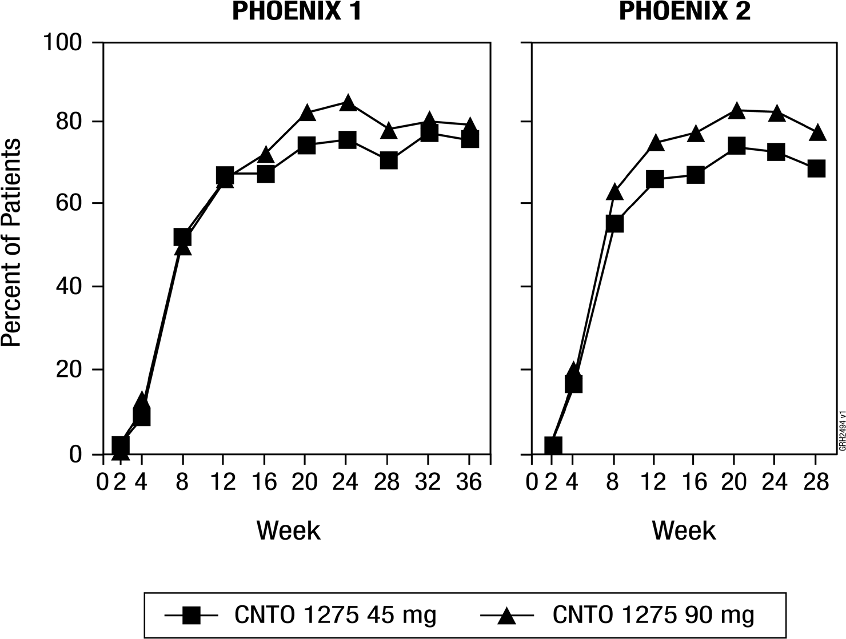
Therapeutic Benefit of Long-Term Continuous Use
At Week 40 in PHOENIX 1,162 patients were randomised to receive ustekinumab (maintenance) and 160 patients were randomised to receive placebo (treatment withdrawal). Maintenance of PASI 75 was significantly superior with continuous treatment compared with treatment withdrawal (p < 0.001). Similar results were seen with each dose of ustekinumab. At Week 52, 89% of patients re-randomised to maintenance treatment were PASI 75 responders compared with 63% of patients
re-randomised to placebo (treatment withdrawal) (p < 0.001).

Efficacy of Retreatment
In PHOENIX 1, after withdrawal from therapy, patients re-initiated their original ustekinumab treatment regimen after loss of ≥ 50% of PASI improvement.
Retreatment with ustekinumab resulted in 76% of evaluated patients regaining PASI 75 response within 8 weeks after reinitiating therapy.

Dosing Interval Adjustment
In PHOENIX 1, Week 28 and Week 40 partial responders and Week 40 non-responders were adjusted from every 12 week to every 8 week dosing. Approximately 40%-50% of Week 28 partial responders to every 12 week dosing achieved PASI 75 response after adjustment to every 8 week dosing and this proportion of PASI 75 responders was maintained through Week-52. A similar proportion of patients who were PASI 75 responders at Week 28 and subsequently became partial responders or non-responders at Week 40 achieved PASI 75 response following a dosing interval adjustment to every
8 weeks.

Quality of Life
In PHOENIX 1 and 2, the mean baseline DLQI scores ranged from 11 to 12. In PHOENIX 1, the mean baseline SF-36 Physical Component ranged from 47-49 and the mean baseline SF-36 Mental Component was approximately 50. Quality of life improved significantly in patients randomised to 45 mg or 90 mg ustekinumab compared with patients randomised to placebo as evaluated by DLQI in PHOENIX 1 and 2 and SF-36 in PHOENIX 1. Quality of life improvements were significant as early as 2 weeks in patients treated with ustekinumab (p < 0.001) and these improvements were maintained over time with continued dosing.
In PHOENIX 1, 65% and 71% of patients treated with 45 mg and 90 mg of ustekinumab, respectively, showed a clinically meaningful reduction (5 or more points) in DLQI from baseline at week 12 compared to 18% in placebo group (p < 0.001 for both groups compared with placebo). Furthermore, 33% and 34% of patients treated with 45 mg and 90 mg of ustekinumab, respectively, showed a DLQI score of 0 compared to 1% in the placebo group (p < 0.001 for both groups compared with placebo), indicating no impairment in QOL from disease or treatment in these patients. In PHOENIX 2, 72% and 77% of patients treated with 45 mg and 90 mg of ustekinumab, respectively, showed a clinically meaningful reduction (5 or more points) in DLQI from baseline at Week 12 compared to 21% in placebo group (p < 0.001 for both groups compared with placebo).
In addition, 37% and 39% of patients treated with 45 mg and 90 mg of ustekinumab, respectively, showed a DLQI score of 0 compared to 1% in the placebo group (p < 0.001 for both groups compared with placebo).
In PHOENIX 1, the median baseline NAPSI score for nail psoriasis was 4.0 and the median number of fingernails involved with psoriasis was 8.0. Nail psoriasis improved significantly in patients randomised to 45 mg or 90 mg ustekinumab compared with patients randomised to placebo when measured by the NAPSI score (p ≤ 0.001).

Improvements in physical and mental component summary scores of the SF-36 and in the Itch Visual Analogue Scale (VAS) were also significant in each ustekinumab treatment group compared with placebo (p < 0.001). In PHOENIX 2, the Hospital Anxiety and Depression Scale (HADS) and Work Limitations Questionnaire (WLQ) were also significantly improved in each ustekinumab treatment group compared with placebo
(p < 0.001).

ACCEPT
A multicentre, randomised, single-blind, active-controlled study (ACCEPT) compared the safety and efficacy of ustekinumab and etanercept in patients 18 years of age and older with chronic (> 6 months) plaque psoriasis who had a minimum BSA involvement of 10%, PASI score ≥ 12, PGA score ≥ 3, who were candidates for phototherapy or systemic therapy, and who had had an inadequate response to, intolerance to, or contraindication to ciclosporin, methotrexate, or PUVA therapy. A total of 903 patients were enrolled in the study.
The ACCEPT trial compared the efficacy of ustekinumab to etanercept and evaluated the safety of ustekinumab and etanercept in moderate to severe psoriasis patients. The active-controlled portion of the study was from Week 0 to Week 12, during which
patients were randomised to receive etanercept (50 mg twice a week) ustekinumab 45 mg at Weeks 0 and 4, or ustekinumab 90 mg at Weeks 0 and 4. This trial was powered to test the superiority of each ustekinumab dose to etanercept on the primary endpoint of the proportion of patients who achieved a PASI 75 at Week 12.
Significantly greater proportions of patients treated with ustekinumab 45 mg (67%;
p = 0.012) or 90 mg (74%; p < 0.001) were PASI 75 responders at Week 12 compared with the etanercept group (56.8%). PASI 90 response was observed in 36% and 45% of patients in the ustekinumab 45 mg and 90 mg groups, respectively, compared with 23% of patients receiving etanercept (p < 0.001 for each comparison versus etanercept).
PASI 100 response was observed in 12% and 21% of patients in the ustekinumab 45 mg and 90 mg groups, respectively, compared to 6% of patients receiving etanercept. In addition, a greater proportion of patients in the ustekinumab 45 mg and 90 mg treatment groups achieved a PGA score of “cleared” or “minimal” (65% and 71%, respectively) compared with patients in the etanercept treatment group (49%) (p < 0.001 for each comparison versus etanercept).
In pre-specified analyses of efficacy by body weight in ACCEPT, minimal dose response to ustekinumab was evident in patients ≤ 100 kg. In patients who weighed > 100 kg, higher PASI 75 response rates were seen with 90 mg dosing compared with 45 mg dosing, and a higher proportion of patients receiving 90 mg dosing had PGA scores of cleared or minimal compared with patients receiving 45 mg dosing (Table 11).

Table 9. Key psoriasis endpoints at Week 12: ACCEPT

 | ACCEPT
 | Etanercept (50 mg twice a week) | Ustekinumab (week 0 and week 4)
 | Etanercept (50 mg twice a week) | 45 mg | 90 mg
Patients randomised | 347 | 209 | 347
PASI response
PASI 50 response | 286 (82%) | 181 (87%) | 320 (92%)ª
PASI 75 response | 197 (57%) | 141 (67%)^{b} | 256 (74%)ª
PASI 90 response | 80 (23%) | 76 (36%)ª | 155 (45%)ª
PASI 100 response | 22 (6%) | 25 (12%)^{c} | 74 (21%)ª
PGA of Cleared or Minimalª | 170 (49%) | 136 (65%)ª | 245 (71%)ª
PASI 75 RESPONSE BY WEIGHT
≤ 100 kg
N | 251 | 151 | 244
PASI 75 response | 154 (61.4%) | 109 (72.2%) | 189 (77.5%)
> 100 kg
N | 96 | 58 | 103
PASI 75 response | 43 (44.8%) | 32 (55.2%) | 67 (65.0%)
PGA of Cleared or Minimal by weight
≤ 100 kg
N | 251 | 151 | 244
PGA response | 131 (52.2%) | 110 (72.8%) | 185 (75.8%)
> 100 kg
N | 96 | 58 | 103
PGA response | 39 (40.6%) | 26 (44.8%) | 60 (58.3%)
PASI 75 RESPONSE BY NUMBER OF UNSUITABLE CONVENTIONAL SYSTEMIC AGENTS^{g}
-at least one therapy
N | 347 | 209 | 346
PASI 75 Response | 197 (56.8%) | 141 (67.5%) ^{b} | 256 (74.0%) ª
-at least two therapies
N | 186 | 118 | 185
PASI 75 Response | 94 (50.5%) | 79 (66.9%) ^{d} | 137 (74.1%) ª
-at least three therapies
N | 52 | 31 | 47
PASI 75 Response | 20 (38.5%) | 17 (54.8%) ^{e} | 34 (72.3%) ^{f}
a p <0.001 for ustekinumab 45 mg or 90 mg comparison with etanercept.
b p =0.012 for ustekinumab 45 mg comparison with etanercept.
c p =0.020 for ustekinumab 45 mg comparison with etanercept
d p=0.004 for ustekinumab 45 mg comparison with etanercept.
e p=0.303 for ustekinumab 45 mg comparison with etanercept.
f p=0.001 for ustekinumab 90 mg comparison with etanercept.
g Conventional systemic agents include psoralen plus ultraviolet A, methotrexate, and cyclosporin. Unsuitable conventional systemic agents are defined as those to which patients had had an inadequate response, were intolerant, or had a contraindication.

Plaque Psoriasis (Adolescent patients -12 to 17 years of age)
The efficacy of ustekinumab was studied in 110 paediatric patients 12 to 17 years of age with moderate to severe plaque psoriasis, in a multicentre, Phase 3, randomised, double blind, placebo controlled study (CADMUS). Patients were randomised to receive either placebo (n = 37), or the recommended dose of ustekinumab (n = 36) (see 4.2 Dosage and administration) or half the recommended dose of ustekinumab (n = 37) by subcutaneous injection at Weeks 0 and 4 followed by every 12 week (q12w) dosing. At Week 12, placebo treated patients crossed over to either receive the recommended dose of ustekinumab (n = 18) or half the recommended dose of ustekinumab (n = 19).
Patients with PASI ≥ 12, PGA ≥ 3 and BSA involvement of at least 10%, who were candidates for systemic or phototherapy, were eligible for the study. Approximately 60% of the patients had prior exposure to conventional systemic therapy or phototherapy.
Approximately 11% of the patients had prior exposure to biologics.
The primary endpoint was the proportion of patients who achieved a PGA score of cleared (0) or minimal (1) at Week 12. Secondary endpoints included PASI 75, PASI 90, change from baseline in Children’s Dermatology Life Quality Index (CDLQI), and change from baseline in the total score of PedsQL (Paediatric Quality of Life Inventory) at Week 12. At Week 12, patients treated with ustekinumab showed significantly greater improvement in their psoriasis and health related quality of life compared with placebo (Table 12).
All patients were followed for efficacy for up to 52 weeks following first administration of study agent. The proportion of patients with a PGA score of cleared (0) or minimal (1) and the proportion achieving PASI 75 showed separation between the ustekinumab treated group and placebo at the first post-baseline visit at week 4, reaching a maximum by week 12. Improvements in PGA, PASI, CDLQI and PedsQL were maintained through Week 52 (Table 12).

Table 10. Summary of primary and secondary endpoints at week 12 and week 52

Paediatric psoriasis study (CADMUS) (Age 12-17)
 | Week 12 |  | Week 52
 | Placebo | Recommended dose of Ustekinumab | Recommended dose of Ustekinumab
 | N (%) | N (%) | N (%)
Patients randomised | 37 | 36 | 35
PGA
PGA of cleared (0) or minimal (1) | 2 (5.4%) | 25 (69.4%)ª | 20 (57.1%)
PGA of Cleared (0) | 1 (2.7%) | 17 (47.2%)ª | 13 (37.1%)
PASI
PASI 75 responders | 4 (10.8%) | 29 (80.6%)ª | 28 (80.0%)
PASI 90 responders | 2 (5.4%) | 22 (61.1%)ª | 23 (65.7%)
PASI 100 responders | 1 (2.7%) | 14 (38.9%)ª | 13 (37.1%)
CDLQI
CDLQI of 0 or 1^{b} | 6 (16.2%) | 18 (50.0%)^{c} | 20 (57.1%)
PedsQL
Change from baseline Mean (SD)^{d} | 3.35 (10.04) | 8.03 (10.44)^{e} | 7.26 (10.92)
a p < 0.001
b CDLQI: The CDLQI is a dermatology instrument to assess the effect of a skin problem on the health-related quality of life in the paediatric population. CDLQI of 0 or 1 indicates no effect on child’s quality of life.
c p = 0.002
d PedsQL: The PedsQL Total Scale Score is a general health-related quality of life measure developed for use in children and adolescent populations. For the placebo group at week 12,
N = 36
e p = 0.028
Onset of response was rapid; approximately one-third of patients in the ustekinumab group achieved a PASI 75 response at Week 4 compared with 1 (2.7%) patient in the placebo group. Maximum PASI 75 response rate was achieved by Week 12 and maintained through Week 52, as summarised in Figure 4 below.

Figure 2. Percent of Patients Achieving a PASI 75 Response Through Week 52 by Visit*; Patients Randomised at Week 0
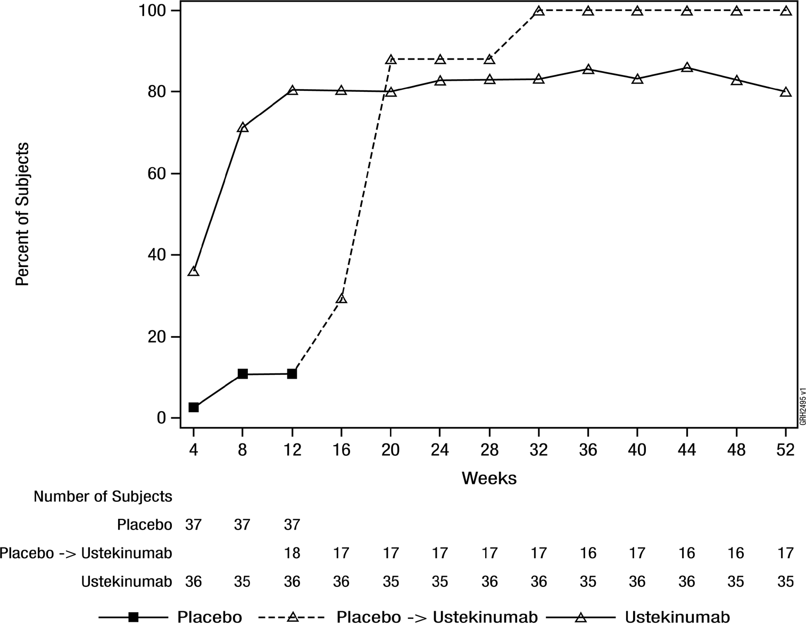
*Data presented for the recommended dose of ustekinumab
During the placebo controlled period through week 12, the efficacy of both the recommended and half of the recommended dose groups were generally comparable at the primary endpoint (69.4% and 67.6% respectively) although there was evidence of a dose response for higher level efficacy criteria (e.g. PGA of cleared (0), PASI 90).
Beyond week 12, efficacy was generally higher and better sustained in the recommended dose group compared with half of the recommended dosage group in which a modest loss of efficacy was more frequently observed toward the end of each 12 week dosing interval. The safety profiles of the recommended dose and half of the recommended dose were comparable.

Plaque Psoriasis (Children - 6 to 11 years of age)
The efficacy of ustekinumab was studied in 44 paediatric patients 6 to 11 years of age with moderate to severe plaque psoriasis in an open label, single-arm, multicentre, Phase 3 study (CADMUS Jr.). Patients were treated with the recommended dose of ustekinumab (n=44) (see 4.2 Dosage and administration) by subcutaneous injection at Weeks 0 and 4 followed by every 12 week (q12w) dosing.
Patients with PASI ≥ 12, PGA ≥ 3 and BSA involvement of at least 10%, who were candidates for systemic therapy or phototherapy, were eligible for the study.
Approximately 43% of the patients had prior exposure to conventional systemic therapy or phototherapy. Approximately 5% of the patients had prior exposure to biologics.
The primary endpoint was the proportion of patients who achieved a PGA score of cleared (0) or minimal (1) at Week 12. Secondary endpoints included PASI 75, PASI 90, and change from baseline in CDLQI at Week 12. At Week 12, patients treated with ustekinumab showed clinically meaningful improvements in their psoriasis and health related quality of life (Table 13).
All patients were followed for efficacy for up to 52 weeks following first administration of study agent. The proportion of patients with a PGA score of cleared (0) or minimal (1) at week 12 was 77.3%. Efficacy (defined as PGA 0 or 1) was observed as early as the first post-baseline visit at week 4 and the proportion of patients who achieved a PGA score of 0 or 1 increased through week 16 and then remained relatively stable through week 52. Improvements in PGA, PASI, and CDLQI were maintained through week 52 (Table 13).

Table 11. Summary of Primary and Secondary End-points at Week 12 and 52: CADMUS Jr. (Age 6 - 11)

 | Ustekinumab Week 12 | Ustekinumab Week 52
 | N (%) | N (%)
Patients enrolled at Week 0 | 44 | 41
Number of patients who achieved a PGA score of cleared (0) or minimal (1) | 34 (77.3%) | 31 (75.6%)
PGA of cleared (0) | 17 (38.6%) | 23 (56.1%)
PASI 75 responders | 37 (84.1%) | 36 (87.8%)
PASI 90 responders | 28 (63.6%) | 29 (70.7%)
PASI 100 responders | 15 (34.1%) | 22 (53.7%)
Patients with a CDLQI >1 at baseline | N = 39 | N = 36
CDLQI of 0 or 1* | 24 (61.5%) | 21 (58.3%)
* The CDLQI is a dermatology instrument to assess the effect of a skin problem on the health-related quality of life in the paediatric population. CDLQI of 0 or 1 indicates no effect on child’s quality of life.

Figure 3. Percent of Patients Achieving a PASI 75 Response Through Week 52.
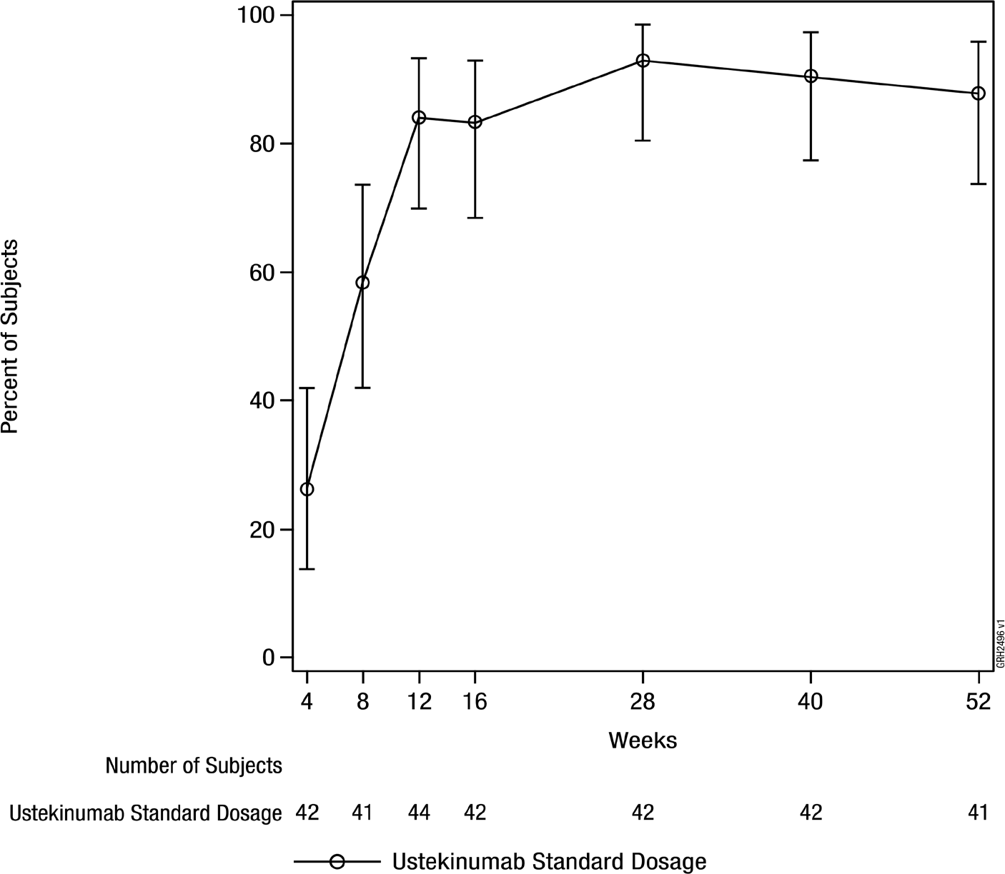
Note: 95% confidence intervals were based on exact method.

Psoriatic Arthritis (PsA)
The safety and efficacy of ustekinumab was assessed in two multicentre, randomised, double-blind, placebo-controlled, phase 3 studies PSUMMIT I and PSUMMIT II, in patients with active psoriatic arthritis. Patients were randomised to receive treatment with either ustekinumab 45 mg, 90 mg, or placebo subcutaneous injections at Weeks 0 and 4 followed by every 12 week (q12w) dosing. The primary endpoint in these studies was the reduction in the signs and symptoms of psoriatic arthritis (PsA) as measured by the percentage of ACR 20 responders at Week 24. Secondary endpoints included change from baseline in Disability Index of the Health Assessment Questionnaire (HAQ-DI), PASI 75, ACR 50, ACR 70 and change in baseline in total radiographic scores of the hands and feet, at Week 24. Efficacy data were collected and analysed through Week 52.
These studies included 927 (PSUMMIT I, n = 615; PSUMMIT II, n = 312) adult patients
(≥ 18 years) who had active psoriatic arthritis (≥ 5 swollen joints and ≥ 5 tender joints,
despite DMARD and/or nonsteroidal anti-inflammatory (NSAID) therapy). Methotrexate use was allowed during the studies but was not mandatory. Approximately 50% of patients continued on stable doses of MTX (≤ 25 mg/week). In PSUMMIT I and PSUMMIT II, 80% and 86% of the patients, respectively, had been previously treated with DMARDs.
In PSUMMIT I, patients who had been previously treated with anti-TNFα therapy, prior to the first study dose, were excluded. In PSUMMIT II, the majority of patients (58%, n = 180) had been previously treated with one or more anti-TNFα agent(s) for at least
8 weeks (14 weeks with infliximab) or had discontinued anti-TNFα for intolerance at any time. Among the patients who had been previously treated with an anti-TNFα agent, over 70% had discontinued their anti-TNFα treatment for lack of efficacy or intolerance.
Patients with each subtype of psoriatic arthritis were enrolled, including polyarticular arthritis with no evidence of rheumatic nodules (39%, n = 362), spondylitis with peripheral arthritis (28%, n = 255), asymmetrical peripheral arthritis (21%, n = 193), distal interphalangeal (DIP) arthritis (12%, n = 112) and arthritis mutilans (0.5%, n = 5). Over 70% and 40% of the patients in both studies had enthesitis and dactylitis at baseline, respectively.
In both studies, a significantly greater proportion of patients achieved ACR 20 and
ACR 50 responses at Week 24 in the ustekinumab 45 mg and 90 mg groups compared to placebo (see Table 14). In PSUMMIT I, a significantly greater proportion of patients and in PSUMMIT II a numerically greater proportion of patients (p = NS) achieved ACR 70 responses in the ustekinumab 45 mg and 90 mg groups compared to placebo (see
Table 14).
In both studies, the proportion of patients achieving a modified PsA response criteria (PsARC) or a Disease Activity Score 28 using C-reactive protein (DAS28-CRP) response was significantly greater in the ustekinumab 45 mg and 90 mg groups compared to placebo. In PSUMMIT I the proportion of patients achieving DAS28-CRP remission was significantly greater in the ustekinumab 45 mg and 90 mg groups compared to placebo.
In PSUMMIT II, the proportion of patients who achieved DAS28-CRP remission was significantly greater in the ustekinumab 90 mg group compared to placebo (see Table 14). DAS28-CRP and PsARC responses were maintained through Week 52.

Table 12. Number of patients who achieved ACR 20, ACR 50, ACR 70, PsARC,
DAS28-CRP response and DAS28-CRP remission at Week 24

 | PSUMMIT I |  |  | PSUMMIT II
 |  | Ustekinumab |  |  | Ustekinumab
 | Placebo (N = 206) | 45 mg  (N = 205) | 90 mg  (N = 204) | Placebo (N = 104) | 45 mg  (N = 103) | 90 mg  (N = 105)
ACR 20 | 47 (23%) | 87 (42%) ª | 101 (50%) ª | 21 (20%) | 45 (44%)ª | 46 (44%) ª
ACR 50 | 18 (9%) | 51 (25%) ª | 57 (28%) ª | 7 (7%) | 18 (17%) ^{b} | 24 (23%) ª
ACR 70 | 5 (2%) | 25 (12%) ª | 29 (14%) ª | 3 (3%) | 7 (7%) ^{c} | 9 (9%) ^{c}
PsARC | 77 (37%) | 115 (56%) ª | 132 (65%) ª | 32 (31%) | 57 (55%)ª | 54 (51%)^{b}
DAS28-CRP* | 71 (34%) | 135 (66%) ª | 138 (68%) ª | 31 (30%) | 56 (54%)ª | 56 (53%)ª
DAS28  Remission** | 17 (8%) | 42 (20%) ª | 40 (20%) ª | 4 (4%) | 11 (11%)^{c} | 16 (15%)^{b}
a p<0.001
b p<0.05
c p= NS
* Combining tender joints (28 joints), swollen joints (28 joints), CRP, and the Patient Global Assessment of disease activity using CRP.
DAS28 responders include patients with moderate or good response.
** DAS28 remitters include patients with a DAS28 value of < 2.6 at a visit. An ACR 20 response (Felson et al, 1995) was defined as:
- ≥ 20% improvement in swollen joint count (66 joints) and tender joint count (68 joints); and
- ≥ 20 % improvement in 3 of the following 5 assessments:
  - Patient’s assessment of pain [Visual Analog Scale (VAS)]
  - Patient’s global assessment of disease activity (VAS)
  - Physician’s global assessment of disease activity (VAS)
  - Patient’s assessment of physical function as measured by the HAQ-DI
  - CRP
ACR 50 or ACR 70 are similarly defined.
The time course for ACR 20 response rates during the first 24 weeks in both studies for patients receiving ustekinumab or placebo are summarised in Figure 6. ACR 20 responses showed improvement at the first assessment (Week 4). ACR 20, 50 and 70 responses continued to improve or were maintained through Week 52 (see Table 15).

Figure 4. Percent of patients achieving ACR 20 response through Week 24
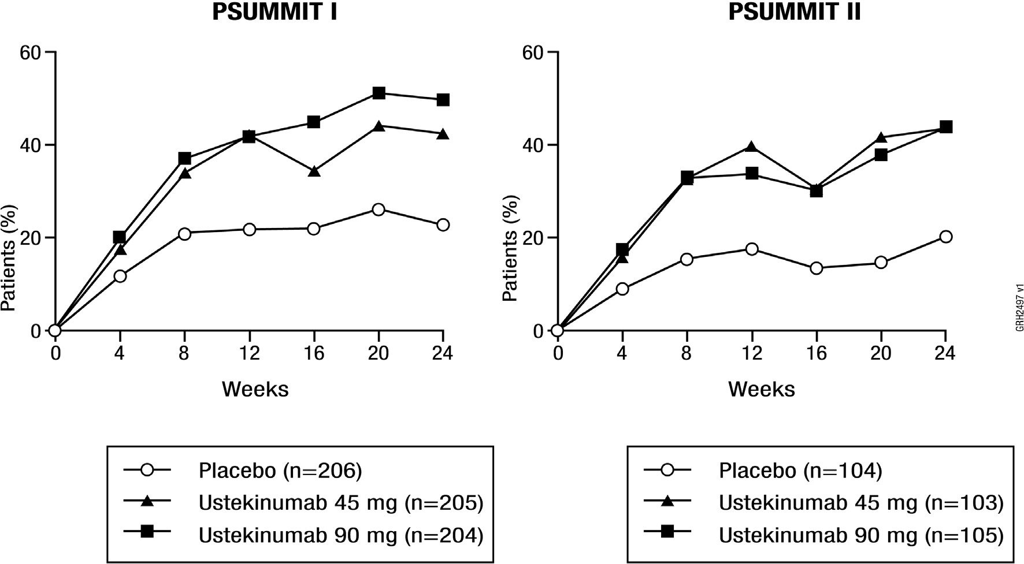

Table 13. Proportion of patients who achieved ACR 20, ACR 50, ACR 70 response at Week 52

 | PSUMMIT I |  | PSUMMIT II
 | Ustekinumab |  | Ustekinumab
 | 45 mg | 90 mg | 45 mg | 90 mg
N | 194 | 189 | 94 | 95
ACR response
ACR 20 | 55.7% | 60.3% | 46.8% | 48.4%
ACR 50 | 31.4% | 37.0% | 27.7% | 26.3%
ACR 70 | 18.0% | 21.2% | 12.8% | 17.9%
In PSUMMIT I, of 205 patients randomised to ustekinumab 45 mg, 153 patients continued the same dose and were available for evaluation at Week 52. Among those, ACR 20, 50 and 70 responses were achieved by 99 (64.7%), 57 (37.3%) and 34 (22.2%) patients respectively. Of 204 patients randomised to ustekinumab 90 mg, 185 were available for evaluation at Week 52. Among those, ACR 20, 50 and 70 responses were achieved by 120 (64.9%), 74 (40%) and 41 (22.2%) patients respectively.
In PSUMMIT II, of 103 patients randomised to ustekinumab 45 mg, 68 patients continued the same dose and were available for evaluation at Week 52. Among those, ACR 20, 50 and 70 responses were achieved by 41 (60.3%), 23 (33.8%) and 11 (16.2%) patients respectively. Of 105 patients randomised to ustekinumab 90 mg, 83 patients were available for evaluation at Week 52. Among those, ACR 20, 50 and 70 responses were achieved by 49 (59%), 26 (31.3%) and 17 (20.5%) patients respectively.
Additionally, within each weight group, (≤ 100 kg and > 100 kg), ACR 20, ACR 50 and ACR 70 responses were consistently higher in the ustekinumab 45 mg and 90 mg groups than in the placebo group (see Table 16).

Table 14. Number of patients who achieved ACR 20, ACR 50 and ACR 70 responses by weight through Week 24

 | PSUMMIT I |  |  | PSUMMIT II
 |  | Ustekinumab |  |  | Ustekinumab
 | Placebo  (N = 206) | 45 mg  (N = 205) | 90 mg  (N = 204) | Placebo  (N = 104) | 45 mg  (N = 103) | 90 mg  (N = 105)
Patients randomised with weight ≤ 100 kg at baseline | 154 | 153 | 154 | 74 | 74 | 73
ACR 20 | 39 (25%) | 67 (44%) | 78 (51%) | 17 (23%) | 32 (43%) | 34 (47%)
ACR 50 | 14 (9%) | 38 (25%) | 48 (31%) | 6 (8%) | 15 (20%) | 21 (29%)
ACR 70 | 5 (3%) | 20 (13%) | 26 (17%) | 3 (4%) | 6 (8%) | 8 (11%)
Patients randomised with weight > 100 kg at baseline | 52 | 52 | 50 | 30 | 29 | 31
ACR 20 | 8 (15%) | 20 (38%) | 23 (46%) | 4 (13%) | 13 (45%) | 12 (39%)
ACR 50 | 4 (8%) | 13 (25%) | 9 (18%) | 1 (3%) | 3 (10%) | 3 (10%)
ACR 70 | 0 | 5 (10%) | 3 (6%) | 0 | 1 (3%) | 1 (3%)
Ustekinumab treatment resulted in significantly greater improvement compared with placebo for each ACR component (see Table 17).

Table 15. Summary of percent improvement from baseline in ACR components at Week 24

 | PSUMMIT I |  |  | PSUMMIT II
 |  | Ustekinumab |  |  | Ustekinumab
 | Placebo (N = 206) | 45 mg  (N = 205) | 90 mg  (N = 204) | Placebo (N = 104) | 45 mg  (N = 103) | 90 mg  (N = 105)
Number of swollen joints ^{d}
Median | 21.54 | 58.82ª | 60.00ª | 0.00 | 52.94^{b} | 50.00^{c}
Number of tender joints ^{e}
Median | 13.61 | 45.45ª | 51.51ª | 0.00 | 33.33ª | 35.00^{c}
Patient’s assessment of pain ^{f}
Median | 0.00 | 31.33ª | 42.58ª | 0.00 | 24.19ª | 24.29ª
Patient global assessment ^{f}
Median | 4.11 | 32.84ª | 42.44ª | 0.00 | 21.25ª | 22.54ª
Physician global assessment ^{f}
Median | 17.64 | 48.39ª | 55.91ª | 0.83 | 36.67ª | 36.11ª
Disability index (HAQ-DI)^{g}
Median | 0.00 | 22.22ª | 32.46ª | 0.00 | 12.50ª | 14.29ª
CRP (mg/dL) ^{h}
Median | 0.00 | 38.56ª | 48.30ª | 0.00 | 25.61^{c} | 33.69ª
a p < 0.001
b p < 0.05
c p < 0.01
d Number of swollen joints counted (0-66)
e Number of tender joints counted (0-68)
f Visual analogue scale; 0 = best, 10 = worst.
g Disability Index of the Health Assessment Questionnaire; 0 = best, 3 = worst, measures the patient’s ability to perform the following: dress/groom, arise, eat, walk, reach, grip, maintain hygiene, and maintain daily activity.
h CRP: (Normal Range 0.0-1.0 mg/dL)

Methotrexate(MTX) Use
The proportion of patients achieving ACR responses were consistently greater in patients treated with ustekinumab than those treated with placebo regardless of concomitant MTX use (see Table 18). Responses observed in the ustekinumab groups were similar in patients receiving or not receiving concomitant MTX. ACR responses were maintained through Week 52.

Table 16. Summary of patients achieving ACR 20, ACR 50 and ACR 70 responses through Week 24 by methotrexate usage

PSUMMIT I
 | Receiving MTX at baseline |  |  | Not receiving MTX at baseline
 |  | Ustekinumab |  |  | Ustekinumab
 | Placebo (N = 206) | 45 mg  (N = 205) | 90 mg  (N = 204) | Placebo (N = 206) | 45 mg  (N = 205) | 90 mg  (N = 204)
Patients randomised | 96 | 99 | 101 | 110 | 106 | 103
ACR 20 | 25 (26%) | 43 (43%) | 46 (46%) | 22 (20%) | 44 (42%) | 55 (53%)
ACR 50 | 8 (8%) | 23 (23%) | 27 (27%) | 10 (9%) | 28 (26%) | 30 (29%)
ACR 70 | 2 (2%) | 11 (11%) | 13 (13%) | 3 (3%) | 14 (13%) | 16 (16%)
PSUMMIT II
 | Receiving MTX at baseline |  |  | Not receiving MTX at baseline
 |  | Ustekinumab |  |  | Ustekinumab
 | Placebo (N = 104) | 45 mg  (N = 103) | 90 mg  (N = 105) | Placebo (N = 104) | 45 mg  (N = 103) | 90 mg  (N = 105)
Patients randomised | 49 | 54 | 52 | 55 | 49 | 53
ACR 20 | 14 (29%) | 27 (50%) | 21 (40%) | 7 (13%) | 18 (37%) | 25 (47%)
ACR 50 | 4 (8%) | 10 (19%) | 12 (23%) | 3 (5%) | 8 (16%) | 12 (23%)
ACR 70 | 2 (4%) | 4 (7%) | 3 (6%) | 1 (2%) | 3 (6%) | 6 (11%)

Prior Anti-TNFα Therapy
PSUMMIT II evaluated 180 patients who were previously treated with one or more anti-TNFα agents for at least 8 weeks (14 weeks with infliximab) or had documented intolerance of anti-TNFα therapy at any time in the past.
Among patients previously treated with anti-TNFα agents, a significantly greater proportion of ustekinumab-treated patients achieved an ACR 20 response at Week 24 compared to placebo (see Table 19). ACR 20, 50 and 70 responses were generally maintained through Week 52.

Table 17. Number of patients previously treated with anti-TNFα agent(s) who
achieved ACR 20, ACR 50 and ACR 70 responses through Week 24

PSUMMIT II
 |  | Ustekinumab
 | Placebo (N = 104) | 45 mg  (N = 103) | 90 mg  (N = 105)
Patients randomised | 62 | 60 | 58
ACR 20 | 9 (15%) | 22 (37%)ª | 20 (34%)^{b}
ACR 50 | 4 (6%) | 9 (15%)^{c} | 9 (16%)^{c}
ACR 70 | 1 (2%) | 3 (5%)^{c} | 3 (5%)^{c}
a p < 0.01
b p < 0.05
c p = NS

Enthesitis and Dactylitis
For patients with enthesitis and/or dactylitis at baseline, in PSUMMIT I, a significant improvement in enthesitis and dactylitis score was observed in the ustekinumab 45 mg and 90 mg groups compared to placebo. In PSUMMIT II, a significant improvement in enthesitis score and numerical improvement in dactylitis score were observed in the
90 mg group (p = NS) compared with the placebo group (see Table 20). In both studies, improvement in enthesitis score and dactylitis score were maintained at Week 52.

Table 18. Summary of percent change in enthesitis and dactylitis scores at Week 24

 | PSUMMIT I |  |  | PSUMMIT II
 |  | Ustekinumab |  |  | Ustekinumab
 | Placebo (N = 206) | 45 mg  (N = 205) | 90 mg  (N = 204) | Placebo  (N = 104) | 45 mg  (N = 103) | 90 mg  (N = 105)
Enthesitis score ^{d}
Patients randomised with enthesitis at baseline | 145 | 142 | 154 | 73 | 72 | 76
N | 137 | 140 | 148 | 68 | 70 | 70
Median | 0.00 | -42.86ª | -50.00^{b} | 0.00 | -33.33^{c} | -48.33ª
Dactylitis score ^{e}
Patients randomised with dactylitis at baseline | 96 | 101 | 99 | 38 | 48 | 41
N | 92 | 99 | 95 | 33 | 46 | 38
Median | 0.00 | -75.00^{b} | -70.83^{b} | 0.00 | 0.00^{c} | -64.58^{c}
a p<0.01
b p<0.001
c p=NS
d Enthesitis was assessed based on the Maastricht Ankylosing Spondylitis Enthesis Score (MASES) index modified for PSA (an instrument that counts 15 body sites).
e Dactylitis was assessed in both hands and feet using a scoring system from 0 to 60.

PASI Response
In PSUMMIT I and PSUMMIT II, the proportion of patients with psoriasis involvement of ≥ 3% BSA at baseline who achieved a ≥ 75% improvement in the PASI assessment at Week 24 was significantly greater in the ustekinumab 45 mg and 90 mg groups compared with the placebo group (see Table 21). In both studies the proportion of patients

achieving the PASI 75 response was maintained through Week 52 (PSUMMIT I, ustekinumab 45 mg - 70.1% and 90 mg - 68.1%; PSUMMIT II, ustekinumab
45 mg - 56.5% and 90 mg - 64.4%).
The proportion of patients who achieved both a PASI 75 response and an ACR 20 response was evaluated for those patients with ≥ 3% BSA psoriasis skin involvement at baseline. A significantly higher proportion of patients achieved the combined response in the ustekinumab 45 mg and 90 mg groups compared with the placebo group at Week 24 (see Table 21). In both studies, the proportion of patients achieving both a PASI 75 response and an ACR 20 response was maintained through Week 52 (PSUMMIT I, ustekinumab 45 mg - 44.8% and 90 mg - 44.3%; PSUMMIT II, ustekinumab
45 mg - 36.8% and 90 mg - 43.1%).

Table 19. Number of patients who achieved PASI 75, PASI 90 and PASI 100 responses as well as a combination of skin and joint responses at Week 24

 | PSUMMIT I |  |  | PSUMMIT II
 |  | Ustekinumabª |  |  | Ustekinumabª
 | Placebo (N = 206) | 45 mg  (N = 205) | 90 mg  (N = 204) | Placebo (N = 104) | 45 mg  (N = 103) | 90 mg  (N = 105)
Patients with ≥ 3% BSA psoriasis skin involvement at baseline | 146 | 145 | 149 | 80 | 80 | 81
PASI 75 | 16 (11%) | 83 (57%) | 93 (62%) | 4 (5%) | 41 (51%) | 45 (56%)
PASI 90 | 4 (3%) | 60 (41%) | 65 (44%) | 3 (4%) | 24 (30%) | 36 (44%)
PASI 100 | 2 (1%) | 29 (20%) | 41 (28%) | 1 (1%) | 13 (16%) | 17 (21%)
Combination of skin and joint responses
PASI 75 and ACR 20 | 8 (5%) | 40 (28%) | 62 (42%) | 2 (3%) | 24 (30%) | 31 (38%)
a p<0.001 for 45 mg or 90 mg comparison with placebo.
Additionally, within each weight group (≤ 100 kg and > 100 kg), PASI 75, 90 and 100 responses were consistently higher in the ustekinumab 45 and 90 mg groups than in the placebo group (see Table 22).

Table 20. Summary of patients who achieved PASI 75, PASI 90 and PASI 100 responses by weight through Week 24

 | PSUMMIT I |  |  | PSUMMIT II
 |  | Ustekinumab |  |  | Ustekinumab
 | Placebo (N = 206) | 45 mg  (N = 205) | 90 mg  (N = 204) | Placebo (N = 104) | 45 mg  (N = 103) | 90 mg  (N = 105)
Patients randomised with weight ≤100 kg at baseline* | 105 | 105 | 111 | 54 | 58 | 57
PASI 75 | 14 (13%) | 64 (61%) | 73 (66%) | 4 (7%) | 31 (53%) | 32 (56%)

 | PSUMMIT I |  |  | PSUMMIT II
 |  | Ustekinumab |  |  | Ustekinumab
 | Placebo (N = 206) | 45 mg  (N = 205) | 90 mg  (N = 204) | Placebo (N = 104) | 45 mg  (N = 103) | 90 mg  (N = 105)
PASI 90 | 4 (4%) | 46 (44%) | 48 (43%) | 3 (6%) | 20 (34%) | 27 (47%)
PASI 100 | 2 (2%) | 21 (20%) | 30 (27%) | 1 (2%) | 11 (19%) | 13 (23%)
Patients randomised with weight >100 kg at baseline* | 41 | 40 | 38 | 26 | 22 | 24
PASI 75 | 2 (5%) | 19 (48%) | 20 (53%) | 0 | 10 (45%) | 13 (54%)
PASI 90 | 0 | 14 (35%) | 17 (45%) | 0 | 4 (18%) | 9 (38%)
PASI 100 | 0 | 8 (20%) | 11 (29%) | 0 | 2 (9%) | 4 (17%)
* Patients randomised with ≥ 3% BSA psoriasis skin involvement at baseline

Methotrexate Use
In both PSUMMIT studies, the proportion of patients who achieved a PASI 75 response at Week 24 was consistently higher in ustekinumab 45 mg and 90 mg groups compared with placebo regardless of concomitant MTX use. PASI 75 responses were maintained through Week 52.

Prior Anti-TNFα Therapy
In PSUMMIT II, the proportion of patients who achieved a PASI 75 response at Week 24 was significantly greater in ustekinumab 45 mg and 90 mg groups compared with placebo in patients previously treated with an anti-TNFα agent.

Radiographic Response
Structural damage in both hands and feet was assessed by readers unaware of treatment group and order of visits and expressed as change in total van der Heijde-Sharp score (vdH-S score), modified for PsA by addition of hand distal interphalangeal (DIP) joints, compared to baseline. A pre-specified integrated analysis combining data from
927 patients in both PSUMMIT I and II was performed. At Week 24, based on this integrated analysis, the ustekinumab 45 mg or 90 mg treatment significantly inhibited progression of structural damage, when compared to placebo (see Table 23). Beyond Week 24, ustekinumab treatment continued to inhibit the progression of structural damage through Week 52. The mean change from Week 24 to 52 in total modified vdH-S score (0.18 and 0.26 in the ustekinumab 45 mg and 90 mg groups respectively) was less than the mean change from Week 0 to 24 (see Table 23).

Table 21. Summary of change from baseline in total modified vdH-S score at Week 24 (Integrated analysis of PSUMMIT I and PSUMMIT II)

Ustekinumab
 | Placebo | 45 mg | 90 mg
Total Modified vdH-S score at Baseline
N | 306 | 303 | 300
Mean ± SD | 28.01 ± 55.771 | 30.40 ± 50.688 | 27.97 ± 42.137
Change from Baseline
N | 310 | 308 | 309
Mean ± SD | 0.97 ± 3.852 | 0.40 ± 2.110^{b} | 0.39 ± 2.403ª
a p value < 0.001 for the difference between ustekinumab and Placebo, Week 24 (integrated analysis)
b p value < 0.05
At Week 24, patients treated with ustekinumab demonstrated less progression of structural damage compared to placebo, irrespective of concomitant MTX use.
The effect of ustekinumab on progression of structural damage in patients with prior anti-TNFα experience has not been established.

Physical Function and Health-Related Quality of Life
In PSUMMIT I and PSUMMIT II, physical function and health-related quality of life were assessed using the HAQ-DI, DLQI and the SF-36 health survey.
Patients treated with ustekinumab showed significant improvement in physical function as assessed by the HAQ-DI at Week-24. The proportion of patients achieving a clinically meaningful ≥ 0.3 improvement in HAQ-DI score from baseline at Week 24 was also significantly greater in the ustekinumab groups when compared with placebo (see
Table 24). Improvement was observed at the first assessment (Week 4), reached maximum at Week 12 and was maintained through Week 24. Improvement in HAQ-DI score from baseline was maintained at Week 52.
In both studies, the improvement in HAQ-DI at Week 24 was consistently greater in the ustekinumab 45 mg and 90 mg groups compared with placebo regardless of concomitant MTX use.
In PSUMMIT II, the improvement in HAQ-DI at Week 24 was significantly greater in the ustekinumab 45 mg and 90 mg groups compared with placebo in patients previously treated with anti-TNFα agents.

Table 22. Improvement in physical function as measured by HAQ-DI at Week 24

 | PSUMMIT I |  |  | PSUMMIT II
 |  | Ustekinumab |  |  | Ustekinumab
 | Placebo  (N = 206) | 45 mg  (N = 205) | 90 mg  (N = 204) | Placebo  (N = 104) | 45 mg  (N = 103) | 90 mg  (N = 105)
HAQ-DI Baseline Score
N | 204 | 205 | 204 | 104 | 103 | 104
Mean (SD) | 1.24 (0.647) | 1.22 (0.610) | 1.22 (0.634) | 1.25 (0.723) | 1.34 (0.704) | 1.29 (0.666)
Median | 1.25 | 1.25 | 1.25 | 1.25 | 1.38 | 1.25
Improvement in HAQ-DI
N | 206 | 205 | 204 | 104 | 103 | 105
Mean (SD) | 0.10 (0.390) | 0.31 (0.521) | 0.40 (0.514) | 0.03 (0.380) | 0.21 (0.461) | 0.22 (0.436)
Median | 0.00 | 0.25ª | 0.25ª | 0.00 | 0.13^{b} | 0.25ª
HAQ-DI  Responders* | 58 (28%) | 98 (48%)ª | 97 (48%)ª | 17 (16%) | 35 (34%)^{b} | 40 (38%)ª
a p < 0.001 * achieving a ≥0.3 improvement from baseline
b p < 0.01
In PSUMMIT I, of 205 patients randomised to ustekinumab 45 mg, 153 patients continued the same dose and were available for evaluation at Week 52. Among those, the HAQ-DI response was achieved by 83 (54.2%) patients. Of 204 patients randomised to ustekinumab 90 mg, 185 patients were available for evaluation at Week 52. Among those, HAQ-DI response was achieved by 102 (55.1%) patients.
In PSUMMIT II, of 103 patients randomised to ustekinumab 45 mg, 68 patients continued the same dose and were available for evaluation at Week 52. Among those, the HAQ-DI response was achieved by 29 (42.6%) patients. Of 105 patients randomised to ustekinumab 90 mg, 83 patients were available for evaluation at Week 52. Among those, HAQ-DI response was achieved by 44 (53%) patients.
The DLQI was assessed by comparing the change in DLQI scores from baseline for those patients with ≥ 3% BSA at baseline. In both studies at Week 24, there was a significant improvement from baseline in DLQI scores in both the ustekinumab 45 mg and 90 mg

groups as compared with placebo (see Table 25) and the improvement was maintained at Week 52.
In both PSUMMIT I and PSUMMIT II, at Week 24, the change from baseline in the SF-36 physical component summary (PCS) scores was significantly greater in the
ustekinumab 45 mg and 90 mg groups compared with the placebo group. In both studies, the change from baseline in the SF-36 mental component summary (MCS) scores at Week 24 was greater in both ustekinumab groups compared with the placebo group
(p < 0.001 for PSUMMIT I – 90 mg group, p = NS for other groups) (see Table 25). In both studies, the change from baseline in the SF-36 PCS and MCS scores was maintained at Week 52.
In PSUMMIT II, a significant change from baseline in Functional Assessment of Chronic Illness Therapy-Fatigue (FACIT-F) scores was observed at Week 24 in the ustekinumab 45 mg and 90 mg groups compared with the placebo group (median improvement, all 3.0 vs 0.0; p < 0.007). Similarly, the percentage of patients with clinically significant improvement in fatigue from baseline (4 points in FACIT-F) was significantly greater in the ustekinumab 45 mg (49% [p < 0.001]) and 90 mg groups (49% [p < 0.001]) compared with the placebo group (25.8%). The change from baseline in the FACIT-F scores was maintained at Week 52.

Table 23. Summary of change from baseline in DLQI and SF-36 and scores at Week 24

 | PSUMMIT I |  |  | PSUMMIT II
 |  | Ustekinumab |  |  | Ustekinumab
 | Placebo  (N = 206) | 45 mg  (N = 205) | 90 mg  (N = 204) | Placebo  (N = 104) | 45 mg  (N = 103) | 90 mg  (N = 105)
DLQI
Patients randomised with ≥ 3% BSA psoriasis skin involvement at baseline | 146 | 145 | 149 | 80 | 80 | 81
Baseline
N | 145 | 145 | 149 | 80 | 80 | 81
Mean (SD) | 11.68  (7.705) | 11.02  (7.308) | 10.54  (7.179) | 11.93  (7.622) | 12.09  (7.667) | 11.98  (7.754)
Median | 11.00 | 10.00 | 9.00 | 11.00 | 11.00 | 10.00
Change from baseline
N | 140 | 142 | 146 | 73 | 77 | 75
Mean (SD) | -1.40  (6.177) | -6.63  (6.776) | -7.54  (6.524) | -0.75  (5.666) | -6.95  (7.719) | -7.16  (6.748)
Median | -1.00 | -6.00ª | -6.00ª | 0.00 | -6.00ª | -6.00ª
SF-36
Physical component summary
Baseline
N | 203 | 203 | 204 | 104 | 102 | 104
Mean (SD) | 31.39  (8.785) | 31.16  (8.511) | 31.45  (8.152) | 30.28  (9.361) | 28.69  (8.501) | 28.93  (8.480)
Median | 30.40 | 29.80 | 29.70 | 29.35 | 27.95 | 28.15
Change from baseline
N | 196 | 200 | 197 | 97 | 99 | 97
Mean (SD) | 1.4  (7.094) | 4.89  (9.333) | 6.22  (8.747) | 1.09  (5.892) | 4.29  (8.594) | 4.67  (8.758)
Median | 1.15 | 3.90ª | 5.80ª | 0.00 | 2.70^{c} | 3.50ª
Mental component summary
Baseline
N | 203 | 203 | 204 | 104 | 102 | 104
Mean (SD) | 43.51  (10.848) | 42.77  (10.908) | 43.48  (11.608) | 42.11  (12.507) | 43.27  (12.911) | 42.81  (11.953)

 | PSUMMIT I |  |  | PSUMMIT II
 |  | Ustekinumab |  |  | Ustekinumab
 | Placebo  (N = 206) | 45 mg  (N = 205) | 90 mg  (N = 204) | Placebo  (N = 104) | 45 mg  (N = 103) | 90 mg  (N = 105)
Median | 43.90 | 42.00 | 41.65 | 41.80 | 43.70 | 41.40
Change from baseline
N | 196 | 200 | 197 | 97 | 99 | 97
Mean (SD) | 1.53  (9.582) | 3.35  (10.016) | 4.79  (10.054) | 0.63  (8.238) | 3.01  (11.144) | 3.52  (11.274)
Median | 0.25 | 2.65^{b} | 4.40ª | 0.00 | 0.70^{b} | 2.20^{b}
a p ≤ 0.001
b p = NS
c p < 0.05

Crohn’s Disease
The safety and efficacy of ustekinumab were evaluated in three randomised, double-blind, placebo controlled clinical trials in adult patients with moderately to severely active Crohn’s disease (Crohn’s Disease Activity Index [CDAI] score of
220 to 450). The clinical development program consisted of two 8 week IV induction studies (UNITI-1 and UNITI-2) followed by a 44 week subcutaneous randomised withdrawal maintenance study (IM-UNITI) representing 52 weeks of therapy.

Induction of Clinical Response and Remission
UNITI-1 and UNITI-2 studies included 1409 patients (UNITI-1 n = 769; UNITI-2
n = 640). In both studies, patients were permitted to concomitantly receive oral 5-ASA compounds, immunomodulators, corticosteroids, and/or antibiotics. Patients were randomised to receive a single IV administration of ustekinumab, designed as a tiered dose based on patient body weight (Table 3) or placebo at Week 0. The primary endpoint was clinical response (defined as a reduction in CDAI score of ≥ 100 points or CDAI score < 150) at Week 6. Secondary endpoints included clinical remission at Week 8, clinical response at Week 8, 70-point response at Week 3, and 70-point response at
Week 6. Efficacy data were collected and analysed through Week 8 for both studies.
In UNITI-1, patients had failed or were intolerant to prior anti-TNFα therapy. At baseline, approximately 46% (n = 340) patients were receiving corticosteroids (including budesonide) and 31.4% of patients were receiving immunomodulators.
Approximately 48% had failed 1 prior anti-TNFα therapy and 52% had failed 2 or 3 prior anti-TNFα therapies (40.8% and 10.4%, respectively). In this study, 29.1% patients had an inadequate initial response (primary non-responders), 69.4% responded but subsequently lost response (secondary non-responders), and 36.4% were intolerant to anti-TNFα therapies.
Patients in UNITI 2 had failed at least one conventional therapy (corticosteroids or immunomodulators) and were either anti TNFα naïve (68.6%) or had previously received but not failed anti-TNFα therapy (31.4%). At baseline, approximately 40% patients were receiving corticosteroids (including budesonide) and 35% patients were receiving immunomodulators.
In these induction studies, efficacy was higher and better sustained in the tiered dose (based on weight ranges) group compared to the 130 mg dose group. In both UNITI-1 and UNITI-2, a significantly greater proportion of patients were in clinical response and remission in the group treated with ustekinumab, compared to placebo (Table 26, Figure 7). Clinical response and remission were significant as early as Week 3 in ustekinumab treated patients and continued to improve through Week 8 (Figure 7).

Table 24. Induction of Clinical Response and Remission in UNITI-1* and UNITI-2**

 | UNITI-1 |  | UNITI-2
 | Placebo N = 247 | Recommended dose of Ustekinumab N = 249 | Placebo N = 209 | Recommended dose of Ustekinumab N = 209
Clinical Response (100 point), Week 6 | 53 (21.5%) | 84 (33.7%)ª | 60 (28.7%) | 116 (55.5%)^{b}
Clinical Response (100 point), Week 8 | 50 (20.2%) | 94 (37.8%)^{b} | 67 (32.1%) | 121 (57.9%)^{b}
70 Point Response, Week 3 | 67 (27.1%) | 101 (40.6%)ª | 66 (31.6%) | 106 (50.7%)^{b}
70 70 Point Response, Week  Week 6 | 75 (30.4%) | 109 (43.8%)ª | 81 (38.8%) | 135 (64.6%)^{b}
Clinical Remission, Week 8 | 18 (7.3%) | 52 (20.9%)^{b} | 41 (19.6%) | 84 (40.2%)^{b}
Clinical remission is defined as CDAI score < 150; Clinical response is defined as reduction in CDAI score by at least 100 points or being in clinical remission, 70 point response is defined as reduction in CDAI score by at least
70 points
* Anti-TNFα failures
** Conventional therapy failures
a p < 0.01
b p < 0.001

Figure 5. Proportion of Ustekinumab treated patients in clinical response (A, B) and remission (C, D) through Week 8 in UNITI-1 and UNITI-2 studies
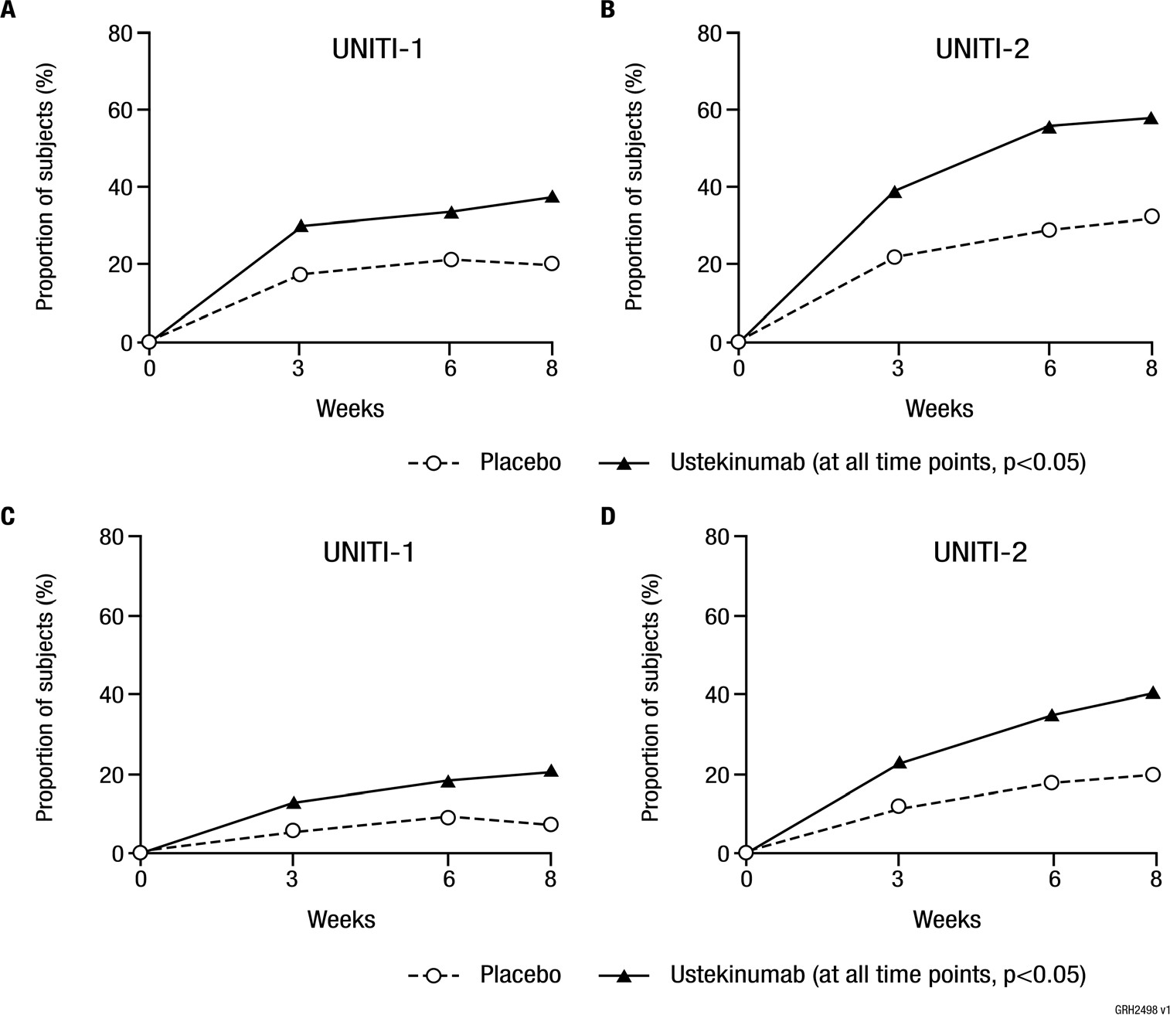

Maintenance of Response and Remission
The maintenance study (IM-UNITI) evaluated 388 patients who achieved clinical response (≥ 100 point reduction in CDAI score) at Week 8 of induction with ustekinumab in UNITI-1 or UNITI-2. Of those, approximately 60% of the patients entered the maintenance study in remission. Patients were randomised to receive a subcutaneous maintenance regimen of either 90 mg ustekinumab every 8 weeks, 90 mg ustekinumab every 12 weeks or placebo for 44 weeks.
Concomitant doses of oral 5-ASA compounds, immunomodulators corticosteroids and antibiotics were permitted. Corticosteroids were tapered at the start of the maintenance trial. The primary endpoint was clinical remission (CDAI < 150) at Week 44. Secondary endpoints assessed at Week 44 included clinical response, clinical remission among ustekinumab treated patients in clinical remission after induction, corticosteroid-free remission, and clinical remission in the subset of patients who were refractory or intolerant to anti-TNFα treatment.
Significantly higher proportions of patients maintained clinical remission and response in the ustekinumab treated groups as compared to placebo at Week 44 (Table 27, Figure 8). A higher proportion of ustekinumab treated patients compared to placebo achieved sustained clinical remission (clinical remission at Week 36, 40 and 44). Clinical remission was achieved in patients who had failed conventional therapy (anti-TNFα naïve) and in patients who had prior treatment experience with an anti-TNFα. A higher rate of clinical remission was observed in the anti-TNFα naïve patients compared to the anti-TNFα refractory/intolerant patients, but the overall treatment effect was consistent in both anti-TNFα refractory/intolerant patients and anti-TNFα naïve patients (Table 27).

Table 25. Maintenance of Clinical Response and Remission in IM-UNITI (Week 44; 52 weeks from initiation of the induction dose)

 | Placebo* N=131† | 90 mg Ustekimumab every 8 weeks  N = 128† | 90 mg Ustekinumab every 12 weeks  N = 129†
Clinical Remission | 36% | 53%ª | 49%^{b}
Clinical Response | 44% | 59%^{b} | 58%^{b}
Corticosteroid-Free Clinical Remission | 30% | 47%ª | 43%^{c}
Sustained Clinical Remission‡ | 26% | 46%^{c} | 40%^{c}
Clinical Remission in patients:
in remission at the start of maintenance therapy | 46% (36/79) | 67% (52/78)ª | 56% (44/78)
who are Anti-TNFα refractory/intolerant | 26% (16/61) | 41% (23/56) | 39% (22/57)
who failed conventional therapy but not anti-TNFα therapy | 44% (31/70) | 63% (45/72)^{c} | 57% (41/72)
who are Anti-TNFα naïve | 49% (25/51) | 65% (34/52)^{c} | 57% (30/53)
Clinical remission is defined as CDAI score < 150; Clinical response is defined as reduction in CDAI of at least 100 points or being in clinical remission
* The placebo group consisted of patients who were in response to ustekinumab and were randomised to receive placebo at the start of maintenance therapy.
† Patients who achieved a clinical response to ustekinumab at start of maintenance therapy
‡ Defined as clinical remission at Week 36, 40 and 44.
a p < 0.01
b p < 0.05
c nominally significant (p<0.05)

Figure 6. Proportion of patients in clinical remission at each visit through Week 44
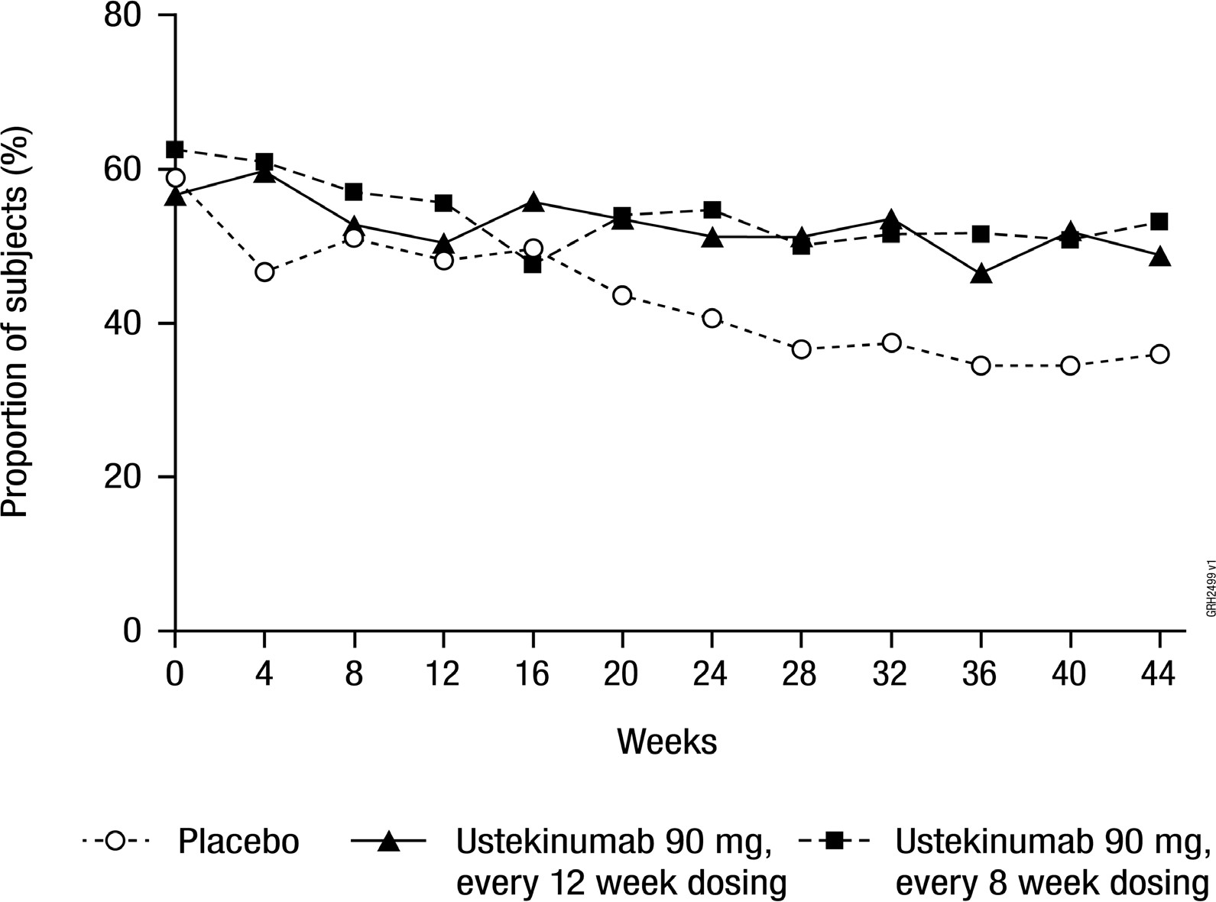

Delayed Response
Patients who were not in clinical response to ustekinumab induction (n = 467) received a 90 mg subcutaneous injection of ustekinumab at week 8 upon entry into the maintenance study. Eight weeks later, 50.5% of the patients achieved clinical response and continued to receive maintenance dosing every 8 weeks; among these patients with continued maintenance dosing, a majority achieved levels of response (68.1%) and remission (50.2%) similar to the patients who initially responded to ustekinumab induction.

Dosing in Patients with a Lower Inflammatory Burden
In patients with a lower inflammatory burden as reflected by CRP ≤ 10 mg/L at initiation of induction or initiation of maintenance therapy, the efficacy of the every 12 week dosing regimen was similar to that of the every 8 week dosing regimen.

Dosing Frequency Adjustment
In IM-UNITI, 29 of 129 patients (22%) did not maintain response to ustekinumab when treated every 12 weeks and were allowed to increase the frequency of dosing and receive ustekinumab every 8 weeks. In these patients, clinical remission was achieved in 41.4% of patients 16 weeks after dosing frequency adjustment.

Resumption of Treatment
Of 131 patients that responded to ustekinumab induction and who were randomised to the placebo group at the start of the maintenance study, 51 patients subsequently lost response and received 90 mg ustekinumab subcutaneously every 8 weeks. Of these
51 patients, 70.6% achieved clinical response and 39.2% achieved clinical remission 16 weeks after receiving the first subcutaneous dose of ustekinumab.

Long-Term Maintenance
In IM-UNITI, patients who completed the study through week 44 were eligible to continue treatment in a study extension. Among patients who entered the study extension, clinical remission and response were generally maintained through week 252. Results were consistent between patients who failed TNF-therapies versus those who did not.
No new safety concerns were identified in this study extension with up to 5 years of treatment in patients with Crohn’s Disease.

Corticosteroid Use in Maintenance
In patients that were in clinical response to ustekinumab induction therapy, a greater proportion of patients in the ustekinumab treated group were in remission and corticosteroid-free compared to the placebo group after 44 weeks of maintenance treatment (Table 27). In addition, a higher proportion of patients were in clinical response and not receiving corticosteroids in the ustekinumab treated group compared to placebo.

Endoscopic Healing of the Mucosa
Endoscopic healing of the mucosa was evaluated in 252 patients with baseline endoscopic disease activity in a substudy. At Week 8, after a single IV induction dose, reduction in mucosal inflammation, as measured by the Simplified Endoscopic Activity Score for Crohn’s Disease (SES CD), was greater in patients treated with ustekinumab (n = 83) compared with patients treated with placebo (n = 97) (-2.8 vs -0.7, p = 0.012). Similar reductions in histologic inflammation were also observed.
Fistula Response
In patients with draining fistulas at baseline (8.8%), a numerically greater proportion of ustekinumab treated patients achieved a fistula response (defined as ≥ 50% reduction from baseline of the induction study in the number of draining fistulas) compared with placebo over 44 weeks (p = NS). The proportion of patients in fistula response at
Week 44 was 45.5% (5/11) for placebo group, 71.4% (5/7) for ustekinumab 90 mg every 12 week dosing group, and 87.5% (7/8) for ustekinumab 90 mg every 8 week dosing group.

Health-Related Quality of Life Measures
Improvement in general and disease specific health-related quality of life was assessed using the SF-36 and Inflammatory Bowel Disease Questionnaire (IBDQ) respectively.
SF-36
A higher proportion of patients treated with ustekinumab showed clinically meaningful improvements in SF-36 PCS and MCS scores, and these improvements were significantly greater at week 8 compared with the placebo group in UNITI-1 (MCS) and UNITI-2 (PCS, MCS and all subscores). These improvements in the PCS and MCS scores were maintained in ustekinumab treated patients in the IM-UNITI maintenance study through Week 44.
IBDQ
At Week 8 in UNITI-1 and UNITI-2, significant improvement from baseline in the IBDQ total score and all subscales, was observed in the patients treated with ustekinumab compared to placebo. In both studies, a higher proportion of patients with clinically meaningful improvement in IBDQ total scores were observed in patients treated with ustekinumab compared to placebo. These improvements in the IBDQ total scores were maintained in ustekinumab treated patients in the IM-UNITI maintenance study through Week 44.

Long-term maintenance of health-related quality of life measures
The majority of patients maintained a 16 point improvement in IBDQ score and a 5 point improvement in SF-36 through week 252.

Ulcerative colitis
The safety and efficacy of ustekinumab was assessed in two randomised, double-blind, placebo-controlled, multicenter studies in adult patients with moderately to severely active ulcerative colitis (Mayo score 6 to 12; Endoscopy subscore ≥ 2 based on central review of the endoscopy). The clinical development program consisted of one intravenous induction study (referred to as UNIFI-induction) with treatment of up to 16 weeks followed by a 44 week subcutaneous randomised withdrawal maintenance study (referred to as UNIFI-maintenance) representing at least 52 weeks of therapy.
Efficacy results presented for UNIFI-induction and UNIFI-maintenance were based on central review of endoscopies.
UNIFI-induction included 961 patients. The primary endpoint for the induction study was the proportion of patients in clinical remission (defined as a Mayo score ≤ 2 points, with no individual subscore > 1) at Week 8. Patients were randomised to receive a single intravenous administration of either the recommended tiered dose of approximately
6 mg/kg (see Table 3; Initial IV dosing of ustekinumabª), a fixed dose of 130 mg ustekinumab, or placebo at Week 0.
Concomitant use of oral corticosteroids, immunomodulators, and aminosalicylates were permitted and 90% of patients continued to receive at least one of these medications.
Enrolled patients had to have failed conventional therapy (corticosteroids or immunomodulators) or at least one biologic (a TNFα antagonist and/or vedolizumab). 49% of patients had failed conventional therapy, but not a biologic (of which 94% where biological-naïve). 51% of patients had failed or were intolerant to a biologic.
Approximately 50% of the patients had failed at least 1 prior anti-TNFα therapy (of which 48% were primary non-responders) and 17% had failed at least 1 anti-TNFα therapy and vedolizumab.
In UNIFI-induction a significantly greater proportion of patients were in clinical response and remission in the ustekinumab treated group compared to placebo (Table 28). As early as Week 2, the earliest scheduled study visit, and at each visit thereafter, a higher proportion of ustekinumab patients had no rectal bleeding or achieved normal stool frequency (defined as a stool frequency subscore of 0 or 1) as compared with placebo patients.
Significant differences in partial Mayo score and symptomatic remission were observed between ustekinumab and placebo as early as Week 2. Efficacy was higher in the tiered dose group (6 mg/kg) compared to the 130 mg dose group in select endpoints, and tiered dosing is therefore the recommended intravenous induction dose.

Table 26. Summary of Key Efficacy Measures in UNIFI-Induction (Week 8)

Endpoint | Placebo N = 319 |  | Ustekinumab† N =322
 | N | % | N | %
Clinical Remission* | 17 | 5% | 50 | 16%ª
Biologic-naïve⸸ | 15/151 | 10% | 27/147 | 18%
Not biologic failure | 15/158 | 9% | 29/156 | 19%
Prior biological failure | 2/161 | 1% | 21/166 | 13%
Clinical Response§ | 100 | 31% | 199 | 62%ª
Biologic-naïve⸸ | 54/151 | 36% | 98/147 | 67%
Not biologic failure | 56/158 | 35% | 104/156 | 67%
Prior biological failure | 44/161 | 27% | 95/166 | 57%
Endoscopic Healing€ | 44 | 14% | 87 | 27%ª
Biologic-naïve⸸ | 32/151 | 21% | 49/147 | 33%
Not biologic failure | 33/158 | 21% | 52/156 | 33%
Prior biologic failure | 11/161 | 7% | 35/166 | 21%
Histo-Endoscopic Mucosal Healing‡ | 28/316 | 9% | 58/315 | 18%ª
Biologic-naïve⸸ | 21/148 | 14% | 33/140 | 24%
Not biologic failure | 22/155 | 14% | 36/149 | 24%
Prior biological failure | 6/161 | 4% | 22/166 | 13%
Symptomatic Remission£ | 72 | 23% | 144 | 45%^{b}
Combined Symptomatic Remission and Endoscopic Healing⸸ | 25 | 8% | 67 | 21%^{b}
† Infusion dose of ustekinumab using the weight-based dosage regimen specified in Table 2.
⸸ An additional 7 patients on placebo and 9 patients on ustekinumab (6 mg/kg) had been exposed to, but had not failed, biologics
*Clinical remission is defined as Mayo score ≤ 2 points, with no individual subscore > 1.
§ Clinical response is defined as a decrease from baseline in the Mayo score by ≥ 30% and ≥ 3 points, with either a
decrease from baseline in the rectal bleeding subscore ≥ 1 or a rectal bleeding subscore of 0 or 1.
€ Endoscopic healing is defined as a Mayo endoscopic subscore of 0 or 1 determined by central review of the endoscopy.
‡ Histo-endoscopic mucosal healing is defined as combined endoscopic healing (Mayo endoscopy subscore of 0 or 1) and histologic healing of the colon tissue (neutrophil infiltration in < 5% of crypts, no crypt destruction, and no erosions, ulcerations, or granulation tissue).
£ Symptomatic remission is defined as a stool frequency subscore of 0 or 1 and a rectal bleeding subscore of 0.
⸸ Combined symptomatic remission and endoscopic healing is defined as remission based on a stool frequency subscore of 0 or 1, a rectal bleeding subscore of 0, and an endoscopy subscore of 0 or 1.
a p < 0.001
b Nominally significant (p < 0.001)
UNIFI-maintenance evaluated 523 patients who achieved clinical response with single IV administration of ustekinumab in UNIFI-induction. Patients were randomised to receive a subcutaneous maintenance regimen of either 90 mg ustekinumab every 8 weeks, 90 mg ustekinumab every 12 weeks or placebo for 44 weeks.
Significantly greater proportions of patients were in clinical remission at Week 44 and maintained clinical response through Week 44 in both ustekinumab treated groups compared to the placebo group (see Table 29).

Table 27. Summary of Key Efficacy Measures in UNIFI-Maintenance (Week 44; 52 weeks from initiation of the induction dose)

 | Placebo* N = 175 | Ustekinumab 90 mg every 8 Weeks  N = 176 | Ustekinumab 90 mg every  12 Weeks  N = 172
Clinical Remission** | 24% | 44%ª | 38%^{b}
Biologic-naïve⸸ | 32% (27/84) | 51% | 47%
Biologic-naïve⸸ |  | (40/79) | (45/95)
Not biologic failure | 31% | 48% | 49%
 | (27/87) | (41/85) | (50/102)
Prior biologic failure | 17% | 40% | 23%
 | (15/88) | (36/91) | (16/70)
Maintenance of Clinical Response through Week 44§ | 45% | 71%ª | 68%ª
Biologic-naïve⸸ | 52% | 77% | 77%
Biologic-naïve⸸ | (44/84) | (61/79) | (73/95)
Not biologic failure | 51% | 78% | 76%
 | (44/87) | (66/85) | (78/102)
Prior biologic failure | 39% | 65% | 56%
 | (34/88) | (59/91) | (39/70)
Corticosteroids Free Clinical Remission‡ | 23% | 42% ª | 38% ^{b}
Biologic-naïve⸸ | 32% | 49% | 46%
Biologic-naïve⸸ | (27/84) | (39/79) | (44/95)
Not biologic failure | 31% | 47% | 48%
 | (27/87) | (40/85) | (49/102)
Prior biologic failure | 16% | 37% | 23%
 | (14/88) | (34/91) | (16/70)
Endoscopic Healing at Week 44† | 29% | 51%ª | 44%^{b}
Biologic-naïve⸸ | 36% | 58% | 55%
Biologic-naïve⸸ | (30/84) | (46/79) | (52/95)
Not biologic failure | 34% | 58% | 56%
 | (30/87) | (49/85) | (57/102)
Prior biologic failure | 23% | 45% | 26%
 | (20/88) | (41/91) | (18/70)
Maintenance of Clinical Remission through Week 44£ | 38% | 58% | 65%^{b}
Biologic-naïve⸸ | 36% | 75% | 70%
Biologic-naïve⸸ | (9/25) | (12/16) | (21/30)
Not biologic failure | 36% | 67% | 72%
 | (9/25) | (12/18) | (23/32)
Prior biologic failure | 40% | 50% | 38%
 | (8/20) | (10/20) | (3/8)
Durable Partial Mayo Remission  through Week 44‖ | 35% | 57%^{c} | 48%^{c}
Symptomatic Remission at Week 44£ | 45% | 68%^{c} | 62%^{c}
Combined Symptomatic Remission and Endoscopic Healing at Week 44€ | 28% | 48%^{c} | 41%^{c}

* The placebo group consisted of patients who were in response to ustekinumab IV and were randomised to receive placebo at the start of maintenance therapy.
**Clinical remission is defined as Mayo score ≤ 2 points, with no individual subscore > 1.
§ Clinical response is defined as a decrease from baseline in the Mayo score by ≥30% and ≥ 3 points, with either a
decrease from baseline in the rectal bleeding subscore ≥1 or a rectal bleeding subscore of 0 or 1.
⸸ An additional 3 patients on placebo and 6 patients on Q8W, 7 patients on Q12W ustekinumab had been exposed to, but had not failed, biologics
† Endoscopic healing is defined as a Mayo endoscopic subscore of 0 or 1 determined by central review of the endoscopy
‡ Corticosteroid-free clinical remission is defined as patients in clinical remission and not receiving corticosteroids at Week 44.
£ Maintenance of clinical remission is defined as patients in clinical remission at maintenance baseline through Week 44 among patients in clinical remission at maintenance baseline.
‖‖ Durable partial Mayo remission is defined as partial Mayo remission (i.e. a partial Mayo score of ≤ 2) at ≥80% of all
visits prior to Week 44 and in partial Mayo remission at last visit (Week 44).
£ Symptomatic remission is defined as a stool frequency subscore of 0 or 1 and a rectal bleeding subscore of 0.
€Combined symptomatic remission and endoscopic healing is defined as a stool frequency subscore of 0 or 1, a rectal bleeding subscore of 0, and an endoscopy subscore of 0 or 1.
a p < 0.001
b p <0.05
c Nominally significant (p < 0.05)

The beneficial effect of ustekinumab on clinical response, mucosal healing and clinical remission was observed in induction and in maintenance both in patients who failed conventional therapy but not a biologic therapy, as well as in those who had failed at least one prior TNFα antagonist therapy, and/or vedolizumab including in patients with a primary non-response to TNFα antagonist therapy.

Delayed Responders to Ustekinumab Induction
Ustekinumab treated patients who were not in response at Week 8 of UNIFI-induction received an administration of 90 mg SC ustekinumab at Week 8 (36% of patients). Of those patients, 9% of patients who were initially randomised to the recommended induction dose achieved clinical remission and 58% achieved clinical response at Week 16. When combining the delayed responders with the initial responders, 80% of patients randomised to the recommended induction dose in UNIFI-I achieved clinical
response and 18% achieved clinical remission within 16 weeks after initiating treatment with ustekinumab.
Patients who were not in clinical response to ustekinumab induction at Week 8 of the UNIFI-induction study but were in response at Week 16 (157 patients) entered in the non-randomised portion of UNIFI-maintenance and continued to receive maintenance dosing every 8 weeks; among these patients, a majority (62%) maintained response and 30% achieved remission at Week 44.

Long-Term Maintenance
In UNIFI (UCO3001), patients who completed the study through week 44 were eligible to continue treatment in a study extension. Among patients who entered the study extension, symptomatic remission was generally maintained through week 92 for patients who failed conventional therapy (but not a biologic therapy) and those who failed biologic therapy, including those who failed both anti-TNF and vedolizumab.
No new safety concerns were identified in this study extension with up to 2 years of treatment in patients with ulcerative colitis.

Endoscopic Normalisation
Normalisation of endoscopic appearance of the mucosa was defined as a Mayo endoscopic subscore of 0 and was observed as early as Week 8 of UNIFI-induction. At Week 44 of UNIFI-maintenance, it was achieved in 24% and 29% of patients treated with ustekinumab every 12 or 8 weeks, respectively, as compared to 18% of patients in the placebo group.

Histologic and Histo-Endoscopic Mucosal Healing
Histologic healing (defined as neutrophil infiltration in < 5% of crypts, no crypt destruction, and no erosions, ulcerations, or granulation tissue) was assessed at Week 8 of UNIFI-induction and Week 44 of UNIFI-maintenance. At Week 8, after a single intravenous induction dose, significantly greater proportions of patients in the recommended dose group achieved histologic healing (36%) compared with patients in the placebo group (22%). At Week 44 maintenance of this effect was maintained with significantly’ more patients in histologic healing in the every 12 week (54%) and every
8 week (59%) ustekinumab groups as compared to placebo (33%).
A combined endpoint of histo-endoscopic mucosal healing defined as patients having both mucosal healing and histologic healing was evaluated at week 8 of UNIFI-induction and Week 44 of UNIFI-maintenance. Patients receiving ustekinumab at the recommended dose showed significant improvements on the histo-endoscopic mucosal healing endpoint at Week 8 in the ustekinumab group (18%) as compared to the placebo group (9%). At Week 44, maintenance of this effect was observed with significantly more patients in histo-endoscopic mucosal healing in every 12 week (39%) and every
8 week (46%) ustekinumab groups as compared to placebo (24%).

Health-related quality of life
Health-related quality of life was assessed by IBDQ, SF-36 and EuroQoL-5D (EQ-5D) questionnaires. At Week 8 of UNIFI-induction, patients receiving ustekinumab showed significantly greater and clinically meaningful improvements on IBDQ total score,
EQ-5D and EQ-5D VAS, and SF-36 MCS Score and SF-36 PCS Score when compared to placebo. These improvements were maintained in ustekinumab-treated patients in
UNIFI-maintenance through Week 44.
Patients receiving ustekinumab experienced significantly more improvements in work productivity as assessed by greater reductions in overall work impairment and in activity impairment as assessed by the WPAI-GH questionnaire than patients receiving placebo.

Long-term maintenance of health-related quality of life measures
Improvement in health-related quality of life as measured by IBDQ and SF-36 was generally maintained during the extension through Week 92.

Hospitalisations and Ulcerative Colitis related surgeries
Through Week 8 of UNIFI-induction, the proportions of patients with ulcerative colitis disease related hospitalisations were significantly lower for patients in the ustekinumab recommended dose group (1.6%, 5/322) compared with patients in the placebo group (4.4%, 14/319) and no patients underwent ulcerative colitis disease related surgeries in patients receiving ustekinumab at the recommended induction dose compared to 0.6% (2/319) patients in the placebo group.
Through Week 44 of UNIFI-maintenance, a significantly lower number of ulcerative colitis disease related hospitalisations was observed in patients in the combined ustekinumab group (2.0%, 7/348) as compared with patients in the placebo group (5.7%, 10/175). A numerically lower number of patients in the ustekinumab group (0.6%, 2/348) underwent ulcerative colitis disease related surgeries compared with patients in the placebo group (1.7%, 3/175) through Week 44.

Comparability of WEZLANA with Stelara®
Study 20190232 was designed as a comparative phase 3 study to demonstrate clinical similarity between WEZLANA and ustekinumab in terms of efficacy, safety, and immunogenicity in patients with Ps. A total of 563 patients (281 patients in the
WEZLANA treatment group and 282 patients in the ustekinumab treatment group) were randomised, and 562 (99.8%) randomised patients were treated with investigational product (280 [99.6%] patients in the WEZLANA treatment group and 282 [100.0%] patients in the ustekinumab treatment group). Patients received WEZLANA or ustekinumab at a dose of 45 mg (baseline body weight [BW] ≤ 100 kg) or 90 mg (baseline BW > 100 kg) administered subcutaneously (SC) per the study dosing regimen.
At week 28:
- Subjects who did not achieve a PASI 50 response or better improvement were considered to have completed the study and were to complete the EOS procedures; subjects unable to complete the week 28 visit, or those that did not have a PASI assessment completed were discontinued from the study.
- Subjects with a PASI 75 response or better improvement continued on the study and were re-randomized in a blinded fashion such that subjects initially randomized to the ABP 654 treatment group continued to receive ABP 654 (ie, ABP 654/ABP 654 treatment group) and those initially randomized to the ustekinumab group were re-randomized in a 1:1 ratio to either continue on ustekinumab (ie, ustekinumab/ustekinumab treatment group) or switch to
ABP 654 (ie, ustekinumab/ABP 654 treatment group). Subjects received investigational product at week 28 and week 40.
- For subjects with PASI 50 response or better but less than PASI 75 response at week 28, dosing frequency may have been increased to every 8 weeks based on investigator discretion. Subjects with body weight at baseline ≤ 100 kg received 45 mg every 8 weeks and subjects with a body weight at baseline > 100 kg received 90 mg every 8 weeks at weeks 28, 36, and 44. These subjects continued on the original assigned treatment with dose intensification and were not
re-randomized. Subjects with PASI 50 response or better but less than PASI 75 response at week 28 who did not dose intensify were re-randomized as described above.

The EOS procedures were conducted at week 52.
The primary efficacy endpoint is the PASI percent improvement from baseline to
week 12. Clinical similarity of the primary efficacy endpoint was performed in the full analysis set (FAS) (all randomised patients) with missing post-baseline PASI scores at weeks 4 and 12 imputed by multiple imputation (MI).
Clinical similarity of the primary endpoint was evaluated by comparing the 2 sided 95% CI of the mean difference of PASI percent improvement from baseline to week 12 between WEZLANA versus ustekinumab with a similarity margin of (-15, +15). If the 2 sided 95% CI was within the prespecified similarity margin (-15, +15), then it was declared that WEZLANA and ustekinumab were clinically similar (Table 30).

Table 28. Analysis of PASI Percent Improvement From Baseline to Week 12 (Full Analysis Set)

Visit  Statistic | WEZLANA  (N = 281) |  | Ustekinumab  (N = 282)
Visit  Statistic | PASI Score | PASI Percent Improvement from Baseline | PASI Score | PASI Percent Improvement from Baseline
Week 12
n | 281 | 281 | 282 | 282
Mean (SD), MIª | 3.94 (4.855) | 81.46 (20.058) | 3.76 (4.511) | 81.45 (20.004)
n | 272 | 272 | 276 | 276
Mean (SD), observed^{b} | 3.89 (4.875) | 81.92 (19.872) | 3.70 (4.493) | 81.91 (19.611)
95% CI of mean^{b} | (3.31, 4.47) | (79.54, 84.29) | (3.17, 4.23) | (79.58, 84.23)
Difference between  means^{c} |  | 0.14
90% CI^{c} |  | (-2.63, 2.90)
95% CI^{c} |  | (-3.16, 3.43)
ANCOVA = analysis of covariance; CSR = clinical study report; MI = multiple imputation; PASI = Psoriasis Area and Severity Index
a The summary statistics by each visit were derived based on MI data.
b The summary statistics by each visit were derived based on observed data.
c Estimated using ANCOVA model adjusted for baseline PASI value, and the stratification factors of prior biologic use for psoriasis, baseline body weight group, and geographic region. Multiple imputation was performed using PROC MI in 2 steps: the Markov Chain Monte Carlo was used for data with sporadic missing values to create imputed datasets with monotone missing pattern, and then for the resulting datasets the regression method was used to generate complete datasets for final analysis.

Results from sensitivity analyses were consistent with results from the primary efficacy analysis.
PASI percent improvement from baseline was similar between the treatment groups through week 28 and over the entire study

Table 31: PASI Percent Improvement From Baseline to Week 28 (LOCF) (Full Analysis Set)

Visit  Statistic | WEZLANA (N = 281) |  | Ustekinumab (N = 282)
Visit  Statistic | PASI Score | PASI Percent Improvement from Baseline | PASI Score | PASI Percent Improvement from Baseline
Week 28
n | 280 | 280 | 281 | 281
Mean (SD) | 2.25 (3.322) | 89.41 (14.228) | 2.40 (3.903) | 88.18 (18.771)
Difference between meansa |  | 1.34
90% CIa |  | (-0.95, 3.63)
95% CIa |  | (-1.39, 4.07)
ANCOVA = analysis of covariance; LOCF = last observation carried forward; PASI = Psoriasis Area and Severity Index
a Estimated using ANCOVA model adjusted for baseline PASI value, and the stratification factors of prior biologic use for psoriasis, baseline body weight group, and geographic region.

Table 32: PASI Percent Improvement From Baseline – Entire Study (LOCF) (Re-randomized Full Analysis Set)
Visit  Statistic | WEZLANA/WEZLANA (N = 247) |  | Ustekinumab/WEZLANA (N = 117) |  | Ustekinumab/Ustekinumab (N = 116)
Visit  Statistic | PASI Score | PASI Percent Improvement from Baseline | PASI Score | PASI Percent Improvement from Baseline | PASI Score | PASI Percent Improvement from Baseline
Week 52
n | 247 | 247 | 117 | 117 | 116 | 116
Mean (SD) | 1.52 (2.472) | 92.54 (11.808) | 1.33 (2.348) | 93.90 (8.987) | 1.33 (3.099) | 93.23 (16.029)
Difference between m eansa |  | -0.56 |  | 0.70
90% CIa |  | (-2.85, 1.73) |  | (-1.95, 3.35)
95% CIa |  | (-3.29, 2.17) |  | (-2.46, 3.86)

ANCOVA = analysis of covariance; LOCF = last observation carried forward; PASI = Psoriasis Area and Severity Index Note: The differences for the mean percent improvement from baseline and the corresponding CIs in the
WEZLANA/WEZLANA and ustekinumab/WEZLANA columns were for WEZLANA/WEZLANA minus ustekinumab/ustekinumab and ustekinumab/WEZLANA minus ustekinumab/ustekinumab, respectively.

Secondary efficacy endpoints included the following:
- PASI percent improvement at other timepoints
- ≥75% improvement in PASI (PASI 75) response throughout the study.
- 100% improvement in PASI (PASI 100) response throughout the study.
- Static Physician’s Global Assessment (sPGA) response (0/1) at week 12 and week 52.
- Body surface area (BSA) change from baseline at week 12 and week 52.

Results indicate that investigational product exposure was similar between treatment groups in this subject population.

Pharmacokinetic properties
Absorption
The median time to reach the maximum serum concentration (tmax) was 8.5 days after a single 90 mg subcutaneous administration in healthy subjects. The median tmax values of ustekinumab following a single subcutaneous administration of either 45 mg or 90 mg in patients with psoriasis were comparable to that observed in healthy subjects.
The absolute bioavailability of ustekinumab following a single subcutaneous administration was estimated to be 57.2% in patients with psoriasis. Following the recommended intravenous induction dose, median peak serum ustekinumab concentration was 126.1 μg/mL in patients with Crohn’s disease, and 127.0 μg/mL in patients with ulcerative colitis.
Distribution
Median volume of distribution during the terminal phase (Vz) following a single intravenous administration to patients with psoriasis, ranged from 57 to 83 mL/kg. In a population pharmacokinetic analysis of ustekinumab, the volume of distribution at steady-state was 4.62 L in patients with Crohn’s disease and 4.44 L in patients with ulcerative colitis.
Metabolism
The exact metabolic pathway for ustekinumab is unknown. Excretion
Median systemic clearance (CL) following a single intravenous administration to patients with psoriasis ranged from 1.99 to 2.34 mL/day/kg. Median half-life (t1/2) of ustekinumab was approximately 3 weeks in patients with ulcerative colitis, Crohn’s
disease, psoriasis and/or psoriatic arthritis, ranging from 15 to 32 days across all psoriasis and psoriatic arthritis studies. In a population pharmacokinetic analysis of ustekinumab, the clearance was 0.19 L/day while the half-life was approximately 19 days in patients with Crohn’s disease and ulcerative colitis.
Dose Linearity
The systemic exposure of ustekinumab (Cmax and AUC) increased in an approximately dose-proportional manner after a single intravenous administration at doses ranging from
0.09 mg/kg to 4.5 mg/kg or following a single subcutaneous administration at doses ranging from approximately 24 mg to 240 mg in patients with psoriasis.
Single Dose vs. Multiple Doses
Serum concentration-time profiles of ustekinumab were generally predictable after single or multiple subcutaneous dose administrations. In patients with psoriasis, steady-state serum concentrations of ustekinumab were achieved by Week 28 after initial subcutaneous doses at Weeks 0 and 4, followed by doses every 12 weeks. The median steady-state trough concentration ranged from 0.21 μg/mL to 0.26 μg/mL (45 mg dose) and from 0.47 μg/mL to 0.49 μg/mL (90 mg dose).
Following the recommended IV induction dose, median peak serum ustekinumab concentration was 126.1 μg/mL in patients with Crohn’s disease and 127.0 μg/mL in patient with ulcerative colitis. Starting at Week 8, subcutaneous maintenance dosing of 90 mg ustekinumab was administered every 8 or 12 weeks. Steady state ustekinumab concentration was achieved by the start of the second maintenance dose. There was no apparent accumulation in serum ustekinumab concentration over time when given subcutaneously every 8 or 12 weeks.
Following subcutaneous maintenance dosing of 90 mg ustekinumab every 8 weeks, median steady-state trough concentrations ranged from 1.97 μg/mL to 2.24 μg/mL in patients with Crohn’s disease and 2.69 μg/mL to 3.09 μg/mL in patients with ulcerative colitis. Following subcutaneous maintenance dosing of 90 mg ustekinumab every
12 weeks, median steady state trough concentrations ranged from 0.61 μg/mL to
0.76 μg/mL in patients with Crohn’s disease and 0.92 μg/mL to 1.19 μg/mL in patients with ulcerative colitis. The steady-state trough ustekinumab levels resulting from 90 mg ustekinumab every 8 weeks were associated with higher clinical remission rates as compared to the steady-state trough levels following 90 mg every 12 weeks.

Dosing Frequency Adjustment
In patients with Crohn’s disease and ulcerative colitis, based on observed data and population PK analyses, randomised patients who lost response to treatment had lower serum ustekinumab concentrations over time compared with patients who did not lose response. In Crohn’s disease, dose adjustment from 90 mg every 12 weeks to 90 mg every 8 weeks was associated with an increase in trough serum ustekinumab concentrations and an accompanying increase in efficacy. In ulcerative colitis, population PK model based simulations demonstrated that adjusting dosing from 90 mg every 12 weeks to every 8 weeks would be expected to result in a 3-fold increase in steady-state trough ustekinumab concentrations. Additionally on the basis of clinical trial data in patients with ulcerative colitis, a positive exposure-response relationship was established between trough concentrations and clinical response, clinical remission, and mucosal healing.
Impact of Weight on Pharmacokinetics
Serum ustekinumab concentrations were affected by weight in patients with psoriasis and/or psoriatic arthritis. Within each dose (45 or 90 mg), patients of higher weight
(> 100 kg) had lower median serum ustekinumab concentrations compared with those in patients of lower weight (≤ 100 kg). However, across doses, the median trough serum concentrations of ustekinumab in patients with higher weight (> 100 kg) in the 90 mg group were comparable to those in patients with lower weight (≤ 100 kg) in the 45 mg group.
Population Pharmacokinetic Analysis
In a population pharmacokinetic analysis using data from patients with psoriasis, the apparent clearance (CL/F) and apparent volume of distribution (V/F) were 0.465 L/d and
15.7 L, respectively, and the t1/2 was approximately 3 weeks. The CL/F of ustekinumab was not impacted by sex, age, or race. The CL/F was impacted by body weight, with a trend toward higher CL/F in patients with higher body weight. The median CL/F in patients with weight > 100 kg was approximately 55% higher compared with patients with weight < 100 kg. The median V/F in patients with weight > 100 kg was approximately 37% higher as compared with patients with weight < 100 kg. Similar results were obtained from a confirmatory population pharmacokinetic analysis using data from patients with psoriatic arthritis.
In the population pharmacokinetic analysis using data from patients with psoriasis, the effect of comorbidities (past and current history of diabetes, hypertension, and hyperlipidaemia) on pharmacokinetics of ustekinumab was evaluated. The pharmacokinetics of ustekinumab were impacted by the comorbidity of diabetes, with a trend towards higher CL/F in patients with diabetes. The mean CL/F in patients with diabetes was approximately 29% higher compared with patients without diabetes.
No specific drug-drug interaction studies have been conducted in healthy subjects or patients with psoriasis, psoriatic arthritis, Crohn’s disease or ulcerative colitis.
In the population pharmacokinetic analyses, the effect of the most frequently used concomitant medications in patients with psoriasis (including paracetamol/acetaminophen, ibuprofen, acetylsalicylic acid, metformin, atorvastatin, naproxen, levothyroxine, hydrochlorothiazide, and influenza vaccine) on pharmacokinetics of ustekinumab was explored and none of the concomitant medications exerted significant impact. The pharmacokinetics of ustekinumab was not impacted by the prior use of MTX, ciclosporin, or other biological therapeutics for the treatment of psoriasis. The pharmacokinetics of ustekinumab was not impacted by concomitant use of NSAIDs or prior exposure to anti-TNFα agents in patients with psoriatic arthritis; or by the use of MTX, oral corticosteroids, 6-MP, AZA in patients with psoriatic arthritis or Crohn’s disease, or by prior exposure to biologics (i.e. anti-TNFα agents and/or vedolizumab) in patients with ulcerative colitis.
No pharmacokinetic data are available in patients with renal insufficiency. No pharmacokinetic data are available in patients with impaired hepatic function.
No specific studies have been conducted in elderly patients. The population pharmacokinetic analysis indicated there were no apparent changes in CL/F and V/F estimates in patients > 65 years.
The pharmacokinetics of ustekinumab were not impacted by the use of tobacco or alcohol.
Pharmacokinetic Similarity Data
The pharmacokinetics (PK) of WEZLANA are similar to Stelara (ustekinumab). Study 20190230 was conducted to evaluate the single dose pharmacokinetic (PK), safety, tolerability, and immunogenicity of WEZLANA compared with Stelara® sourced from the US or EU in healthy patients.
This was a randomised, double-blind, single-dose, 3-arm, parallel-group study. Patients were randomised in a 1:1:1 ratio to receive a single 90 mg subcutaneous injection of either WEZLANA, Stelara (US), or Stelara (EU).
238 subjects were randomized to: 79 in the WEZLANA treatment group, 79 in the ustekinumab [US] treatment group, and 80 in the ustekinumab [EU] treatment group. The primary objective of the study was to determine the PK similarity of WEZLANA (90 mg subcutaneous [SC] injection) compared with Stelara (US) and Stelara (EU) as assessed principally by area under the concentration-time curve (AUC) from time 0 extrapolated to infinity (AUCinf) and maximum observed serum concentration (Cmax) in healthy adult patients.
The secondary objective was to determine PK similarity of Stelara (US) compared with Stelara (EU), and the safety, tolerability, and immunogenicity of WEZLANA in healthy adult patients compared with Stelara (US) and Stelara (EU).
The primary PK endpoints were the PK parameters AUCinf and Cmax. Secondary PK endpoints included the following:
- AUC from time 0 to the last quantifiable concentration (AUClast)
- time at which Cmax is observed (Tmax)
- terminal elimination half-life (t1/2)
- apparent clearance (CL/F)
- mean residence time (MRT)
For the comparisons of WEZLANA to Stelara (US), WEZLANA to Stelara (EU), and Stelara (US) to Stelara (EU), the point estimates and 90% CIs of the GMRs were fully contained within the prespecified margin of -0.8 to 1.25 for both the primary PK endpoints (AUCinf and Cmax) and the secondary PK endpoint of AUClast for the PK parameter analysis set (Table 33). Therefore, PK similarity was demonstrated between WEZLANA and Stelara (US), WEZLANA and Stelara (EU), and Stelara (US) and Stelara (EU).

Table 33. Summary of Statistical Assessment of PK Parameters (ANCOVA with Baseline Weight) (PK Parameter Analysis Set)
Treatment and Comparison | AUCinf (hr*ng/mL) LS Geometric Mean [n] | Cmax (ng/mL)  LS Geometric Mean [n] | AUClast (hr*ng/mL) LS Geometric Mean [n]
WEZLANA | 10783692.1 [76] | 11419.0 [78] | 10137829.7 [78]
Ustekinumab (US) | 10651782.5 [76] | 11384.9 [79] | 9975870.4 [79]
Ustekinumab (EU) | 11482547.0 [77] | 12081.5 [80] | 10752507.0 [80]
Ratio of LS Geometric Means (90% CI)
WEZLANA vs ustekinumab (US) | 1.0124 (0.9289, 1.1034) | 1.0030 (0.9314, 1.0801) | 1.0162 (0.9358, 1.1035)
WEZLANA vs ustekinumab (EU) | 0.9391 (0.8620, 1.0232) | 0.9452 (0.8779, 1.0175) | 0.9428 (0.8685, 1.0235)
Ustekinumab (US) vs ustekinumab (EU) | 0.9276 (0.8514, 1.0107) | 0.9423 (0.8755, 1.0143) | 0.9278 (0.8549, 1.0069)
ANCOVA = analysis of covariance; AUCinf = area under the concentration-time curve from time 0 extrapolated to infinity; AUClast = area under the concentration-time curve from time 0 to the last quantifiable concentration; Cmax = maximum serum concentration observed; EU = European Union; LS = least squares; PK = pharmacokinetic; US = United States
Note: Geometric LS mean, ratio of geometric LS means, and 90% CI were estimated based on the ANCOVA model with a fixed effect for treatment and adjusting for baseline weight.

Study 20190232 (see 5.1 Pharmacodynamic properties - Comparability of WEZLANA with Stelara) randomisation was stratified based on prior biologic use for psoriasis (yes vs no), baseline BW group (≤ 100 kg vs > 100 kg), and geographic region (North America vs Europe). Serum WEZLANA and ustekinumab concentrations from PK sampling were summarised descriptively for each visit through week 28 for the safety analysis set and post week 28 for both the re-randomised safety analysis set and the patients who dose intensified. Boxplots for trough serum WEZLANA and ustekinumab concentrations were generated for each visit through week 28 (Figure 1). for the safety analysis set and post week 28 (Figure 2) for both the re-randomised safety analysis set and the patients who dose intensified.

From baseline to week 28, the geometric LS means of trough serum concentrations were similar between WEZLANA and ustekinumab treatment groups. Results indicate that investigational product exposure was similar between treatment groups in this subject population.

Figure 7. Boxplot of Trough Concentrations by Visit – Through Week 28 (Safety Analysis Set)
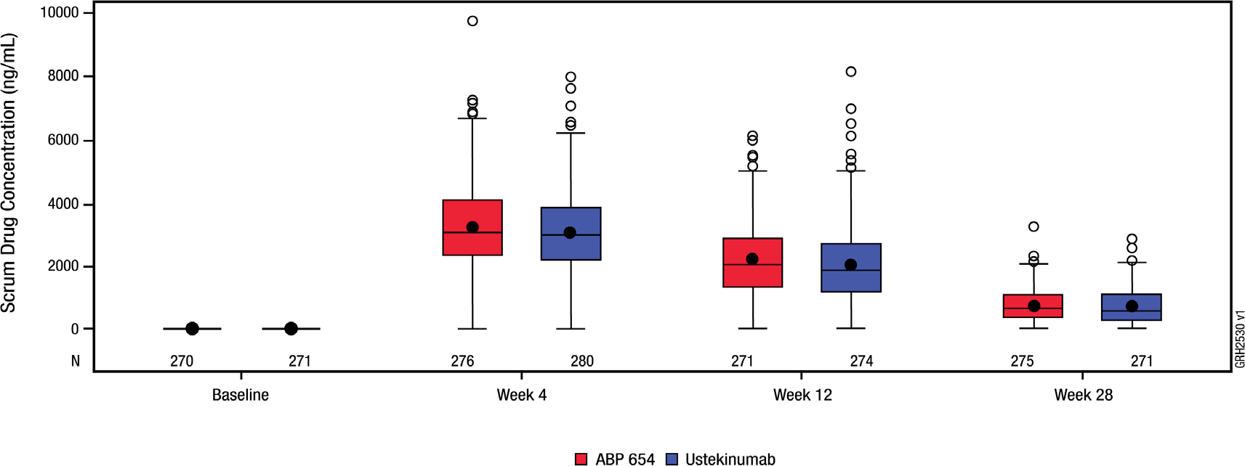

CSR = clinical study report; IQR = inter-quartile range; Q1 = 1st quartile; Q3 = 3rd quartile
Note: The solid circle in the box interior = mean; the horizontal line in the box interior = median; box lower margin = Q1; box upper margin = Q3; whisker to the highest value below upper fence (1.5 x IQR) + Q3; whisker to the lowest value above the lower fence Q1 - (1.5 x IQR); circle = outliers.

Figure 8. Boxplot of Concentrations by Visit – Post Week 28 (Re-randomised Safety Analysis Set)
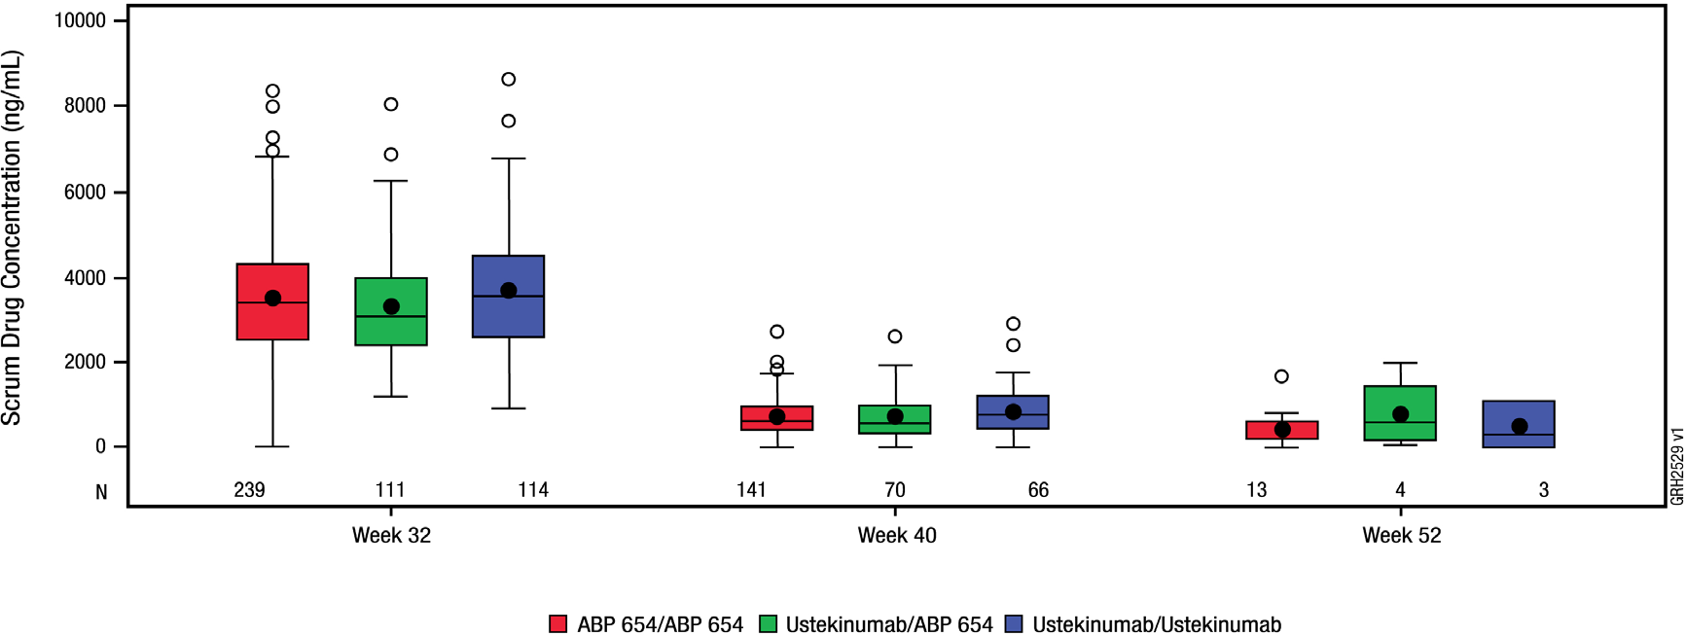

IQR = inter-quartile range; Q1 = 1st quartile; Q3 = 3rd quartile
Note: The solid circle in the box interior = mean; the horizontal line in the box interior = median; box lower margin = Q1; box upper margin = Q3; whisker to the highest value below upper fence (1.5 x IQR) + Q3; whisker to the lowest value above the lower fence Q1 - (1.5 x IQR); circle = outliers.

. The geometric LS means of trough serum concentrations were similar across treatment groups at the week 32, week 40, and week 52 time points.

Preclinical safety data
Genotoxicity
Ustekinumab has not been evaluated for genotoxic potential. Carcinogenicity
Ustekinumab has not been evaluated for carcinogenic potential, due to the lack of appropriate models for an antibody with no cross-reactivity to rodent IL-12/23 p40. Ustekinumab is a selective immunosuppressant agent. Immunosuppressive agents have the potential to increase the risk of malignancy (see 4.4 Special warnings and precautions for use – Malignancies).

PHARMACEUTICAL PARTICULARS

List of excipients
Each mL of WEZLANA solution for injection for subcutaneous administration contains: Ustekinumab 90 mg
Histidine/histidine hydrochloride monohydrate 1.0 mg Sucrose 76 mg
Polysorbate 80 0.04 mg
Water for injections qs
Each mL of WEZLANA solution for intravenous infusion contains: Ustekinumab 5.0 mg
Histidine 0.8 mg
Histidine hydrochloride monohydrate 1.0 mg Sucrose 85 mg
Polysorbate 80 0.40 mg
Methionine 0.40 mg
Disodium edetate 0.02 mg
Water for injections qs

Incompatibilities
In the absence of compatibility studies, this medicinal product must not be mixed with other medicinal products.

WEZLANA 130 mg concentrate for solution for infusion should only be diluted with sodium chloride 9 mg/mL (0.9%) solution. WEZLANA 130 mg concentrate for solution for infusion should not be administered concomitantly in the same intravenous line with other medicinal products.

Shelf life
In Australia, information on the shelf life can be found on the public summary of the Australian Register of Therapeutic Goods (ARTG). The expiry date can be found on the packaging.

Special precautions for storage
Store at 2°C to 8°C. Refrigerate. Do not freeze.
Protect from light by storing in original carton until time of use. Do not shake.
If necessary, the diluted infusion solution may be stored for up to eight hours at room temperature. Do not freeze. Discard any unused portion of the infusion solution.
WEZLANA – Room temperature storage
If needed, individual WEZLANA pre-filled syringes and 45 mg vial may be stored at room temperature up to a maximum of 30°C for a single period of up to 30 days in the original carton protected from light. Record the date when the pre-filled syringe or the 45 mg vial is first removed from the refrigerator. The new expiry date must not exceed the original expiry date printed on the carton. Once a syringe or vial has been stored at room temperature, it should not be returned to the refrigerator. Discard the pre-filled syringe or the 45 mg vial if not used within 30 days at room temperature storage.

Nature and contents of container For subcutaneous administration

45 mg/0.5 mL vial
WEZLANA 45 mg/0.5 mL vial is a sterile solution in a single-use (Type 1) glass vial, with a coated stopper and aluminium seal with flip-off cap.

45 mg/0.5 mL pre-filled syringe and 90 mg/1.0 mL pre-filled syringe
WEZLANA pre-filled syringe is also supplied as a single-use, sterile solution in a Type 1 glass syringe with a fixed 27G, 13 mm needle. The syringe is fitted with a passive needle safety guard and needle cover.
The vial and pre-filled syringe are not made with natural rubber latex.

The solution is clear to opalescent, colourless to light yellow. WEZLANA does not contain preservatives.
Each vial or pre-filled syringe is for single use only and any unused medicinal product should be disposed of in accordance with local requirements.
For intravenous infusion only

130 mg/26 mL vial
WEZLANA 130 mg vial is supplied as a sterile solution in a single-use (Type 1) glass vial, with a coated stopper and aluminium seal with flip-off cap.
The vial is not made with natural rubber latex.
The solution is clear to opalescent, colourless to light yellow. WEZLANA does not contain preservatives.
WEZLANA is for single use in one patient only. Discard any residue. Some strengths may not be currently marketed.

Special precautions for disposal
In Australia, any unused medicine or waste material should be disposed of by taking to your local pharmacy.

Physicochemical properties
Chemical structure

Figure 9. General structure of ustekinumab
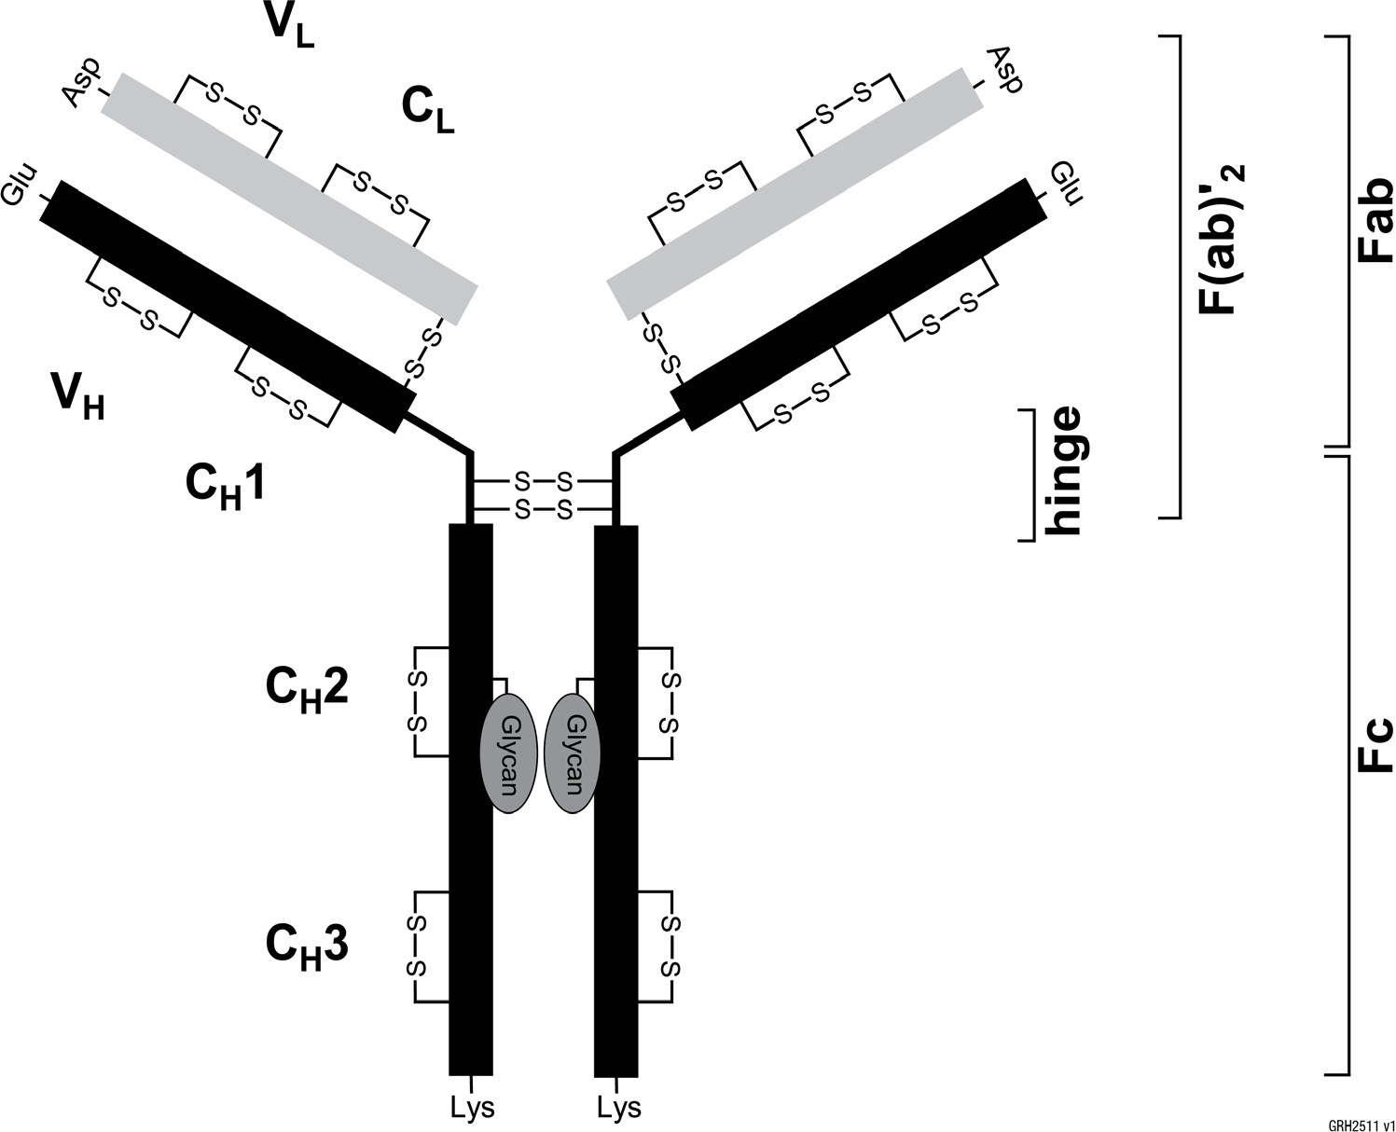
CAS number 815610-63-0
WEZLANA (ustekinumab) is a human IgG1kappa monoclonal antibody with an approximate molecular weight that ranges from 148kDa to 150kDa. WEZLANA is produced by a recombinant cell line cultured by continuous perfusion and is purified by a series of steps that includes measures to inactivate and remove viruses.

MEDICINE SCHEDULE (POISONS STANDARD)
S4 – Prescription Only Medicine

SPONSOR
Amgen Australia Pty Ltd Level 11, 10 Carrington St
Sydney NSW 2000
Ph: 1800 803 638
www.amgenmedinfo.com.au

Email: medinfo.JAPAC@amgen.com

DATE OF FIRST APPROVAL
Date of first inclusion in the Australian Register of Therapeutic Goods: {DD month YYYY}

DATE OF REVISION
DD month YYYY

SUMMARY TABLE OF CHANGES

Section changed | Summary of new information

© 2023 Amgen Inc. All rights reserved. WEZLANATM is a trademark of Amgen Inc

