Class 1-3 in-house IVD notification
  - Using the online application form
Version 1.3, May 2024

Copyright
© Commonwealth of Australia 2024
This work is copyright. You may reproduce the whole or part of this work in unaltered form for your own personal use or, if you are part of an organisation, for internal use within your organisation, but only if you or your organisation do not use the reproduction for any commercial purpose and retain this copyright notice and all disclaimer notices as part of that reproduction. Apart from rights to use as permitted by the Copyright Act 1968 or allowed by this copyright notice, all other rights are reserved and you are not allowed to reproduce the whole or any part of this work in any way (electronic or otherwise) without first being given specific written permission from the Commonwealth to do so. Requests and inquiries concerning reproduction and rights are to be sent to the TGA Copyright Officer, Therapeutic Goods Administration, PO Box 100, Woden ACT 2606 or emailed to <tga.copyright@tga.gov.au>.

Contents
Completing a new notification 4
TGA Business Services 4
The dashboard 4
Starting a new Class 1-3 in-house IVD notification 5
Verifying manufacturer and Address details 6
Selecting Accreditation body and QMS standard 6
Selecting IVD type and categories 7
Supporting documents and In-house IVD notification template 7
Submitting your notification 8
Updating an existing notification 10
TGA Business Services 10
The dashboard 10
Creating a ‘clone’ of the existing notification 11
Updating the draft notification application form 12
Submitting your notification 13

Completing a new notification

TGA Business Services
The online notification form is available in TGA Business Services.
- Before your organisation uses TGA Business Services for the first time, you need to apply for a client identification number. Complete the 'Organisation details form' and send it to ebs@health.gov.au. Once the form has been processed, you will be sent an email with the Organisation ID and an administrator guide.
- For help using the TGA Business Services, including resetting your password, go to TGA Business Services - how to use this site.
- If you are experiencing issues with TGA Business Services site, email ebs@health.gov.au or contact them on 1800 010 624

The dashboard
First, log in to TGA Business Services- external site, with the username provided to you by the TBS. When you first go to login, you will need to set your password by clicking on 'Forgotten your password' and following the instructions.
Across the top of the dashboard, there are three main menus: Application; Documents; and Your TGA. If you have a financial role, there is an additional Financials menu.
- To begin a new application, select the Applications menu.
- If you want to open an existing draft form, select Work on drafts from the My work menu.
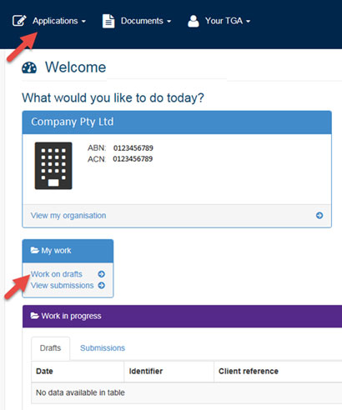

Starting a new Class 1-3 in-house IVD notification
- Select Applications from the top menu. This will open a list of application types.
- Select Class 1-3 In-house IVD Notification.
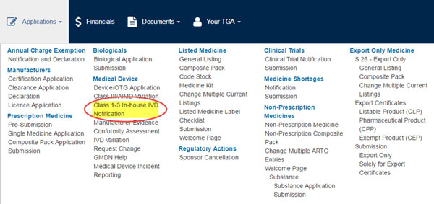
A new IVD Notification form, like the image below, is then displayed.

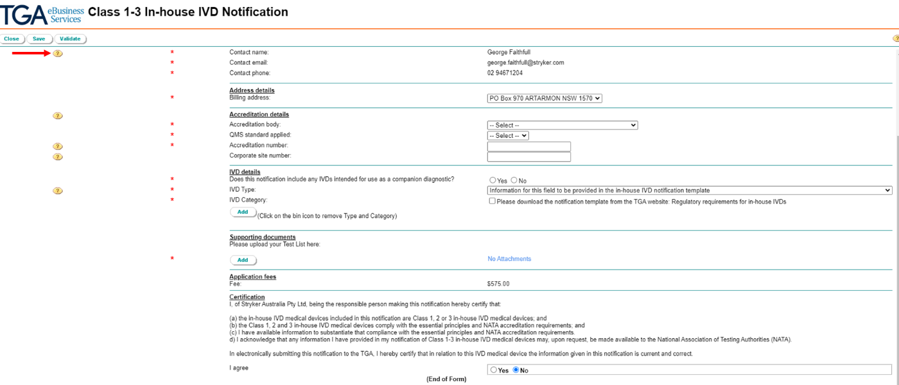Note that Help texts are available throughout the form, using the yellow "?" buttons on the left.

Verifying manufacturer and address details
At any stage you can save the notification form to your drafts by clicking the Save button at either the top or the bottom of the page.
The form will auto-populate Manufacturer and Address details, including Contact Details from your own client details.
- Verify the auto-populated details and when necessary, change them using the drop-down menus.
- Using the drop-down menu, select the Response Person details from the options available. Only persons with portal access will appear within the drop-down menu.
- If you want, you can enter in your own Client reference title into the free text box at the top of the page. This reference is for your own use to assist in identifying your notification, rather than trying to recall the assigned notification identifier.

Selecting accreditation body and QMS standard
Under this portion of the notification form, enter your laboratory's accreditation details.
Note that only one notification form needs to be submitted if multiple laboratories are accredited as a laboratory network under the one Corporate Accreditation number (i.e., the laboratories all operate under the one quality management system).
If your laboratories operate under the one quality management system, but you don't have a Corporate Accreditation number, enter one of your laboratory accreditation numbers in the form and then list the remaining accreditation numbers for your individual laboratories in a separate document and upload this along with your test list at Step 12.
Although, each laboratory can submit their own notification should they choose to do so. However, each notification will incur its own application fee.
If multiple laboratories are to be included under the one notification, it is recommended that each site has access to the TBS portal, so that they too can view the completed notification.
- Select the Accreditation body from the drop-down menu and then the QMS standard applied from the following drop down.
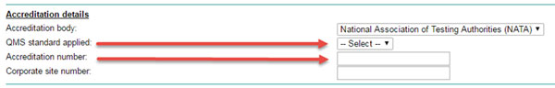
Both drop down menus only show accepted Accreditation bodies and QMS standards that cover Class 1-3 in-house IVDs.
- Enter the Accreditation number as listed on the certification and if available, the Corporate site number.

Selecting IVD type and categories
- The IVD type and category fields are no longer required as this information will be captured as part of the standardised In-house IVD notification template (Excel spreadsheet). Select the default options available for IVD type and category, click Add and proceed to Supporting documents.
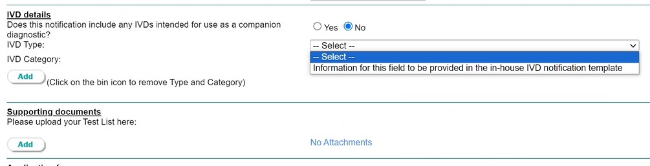
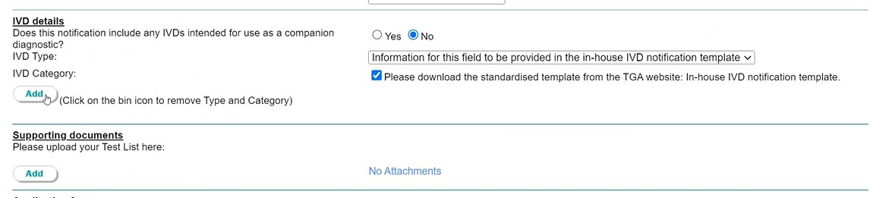
Note that the ‘Add’ button under IVD details is not required and you don’t need to click on it. The In-house notification template is to be added under Supporting documents in the next step.

Supporting documents and In-house IVD notification template
The Supporting documents section of the form is where you upload your completed In-house IVD notification template (Excel spreadsheet), which lists and details your in-house IVDs. Refer to Regulatory requirements for in-house IVDs for instructions on how to complete the In-house notification template. These test details will not be made publicly available.
Within your In-house notification template, attempt to classify your Class 1-3 in-house IVDs but note that your notification will not necessarily be refused if you don't get these entirely correct. For more information on the classification rules, refer to the Classification of IVD medical devices guidance document.
If you have more than one laboratory operating under the same quality management system, but do not hold corporate accreditation which covers all sites, you should include each laboratory and corresponding accreditation number in a different tab of the In-house notification template.
- Click the Add button to upload your supporting documents. A pop-up window should appear.
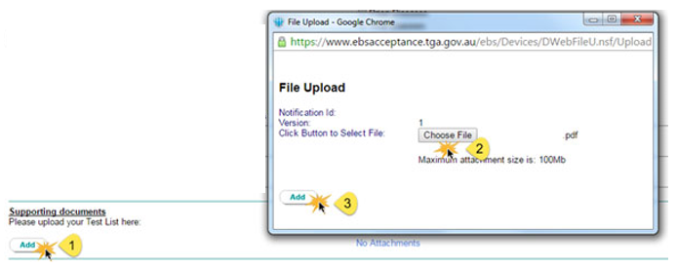
- Within this window, select Browser to search for your completed In-house notification template file. Select the file to be submitted and click the Add button once more to confirm. The file will appear under the Supporting documents heading.

Submitting your notification
- Read the Certification at the end of page and select Yes if you agree.
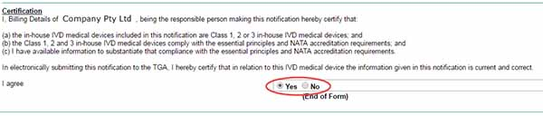
You will have to agree to the certification in order to submit your notification.
Note: Compliance with the NPAAC standard, Requirements for the development and use of in-house in vitro diagnostic medical devices (IVDs), will be taken as compliance with the relevant essential principles for the safety and performance of a Class 1-3 in-house IVD medical device.
- Click the Validate button at the bottom of the screen. This will run a check to see whether all mandatory questions have been answered.
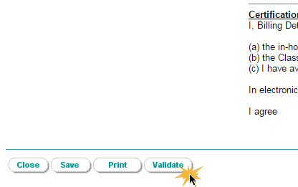
Once the validation is complete only someone with the submitter role can submit the application.
- If you only have drafter rights there will be no Submit button at either the top or bottom of your screen. Click the Save button at either the top or bottom of the screen. Ask a person in your organisation that has submitter rights to verify the application and submit.
- If you do have a submitter role click on the Submit button at either the top or the bottom of the screen.

- We will only process your notification once we have received payment. When you submit the notification, an invoice will be automatically generated and will be visible if you have the financial role. We will not send you a paper copy of the invoice by post.

Updating an existing notification
This section of the guidance is for sponsors who are seeking to update their existing Class 1-3 in-house IVD notification which has been previously notified to the TGA. Once any edits have been made to the form, including the attachment of the In-house IVD Notification Template, it can then be submitted to become your current Class 1-3 in-house IVD notification.

TGA Business Services
To vary the existing notification, you will need to login to the TGA Business Services portal.
- For help using TGA Business Services, including resetting your password, go to TGA Business Services – how to use this site.
- If you are experiencing issues with TGA Business Services site, email ebs@health.gov.au or contact them on 1800 010 624.

The dashboard
Once you have logged in the portal, the dashboard will appear. At the top of the page there are three main menus: Application; Documents; and Your TGA. If you have a financial role, there is an additional Financials menu.
- To access your existing notification, select the Your TGA menu.
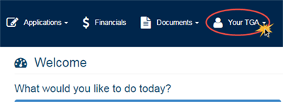
- From the drop-down menu, select Class 1-3 In-house IVD Notifications.
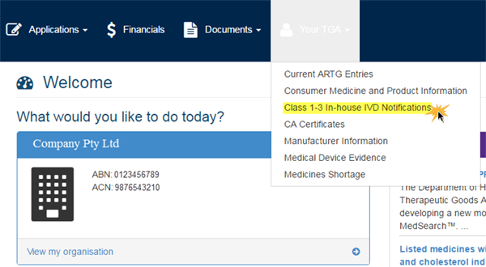
- A list of all accepted notifications will appear within the user portal page.

Creating a ‘clone’ of the existing notification
- Find the notification that you wish to update. Click on the small grey, down pointing arrow icon that is located to the left of the notification identifier.
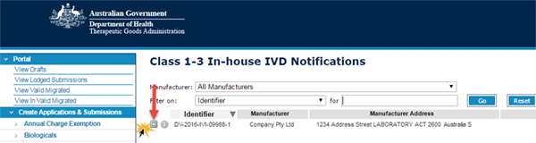
- From the drop down menu, select Create Variation.
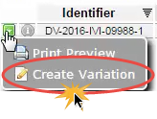
- When the pop-up box appears, click OK to initiate the cloning process. This may take some time.
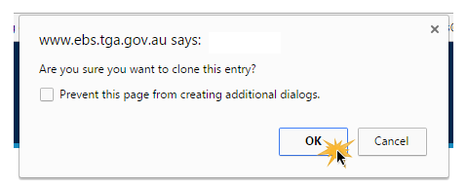
- An additional pop-up box (see below) will appear, informing that the new notification application from has been created. Click OK to close the box.
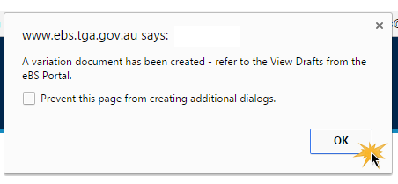
- Within the portal toolbar on the left-hand side of the page, click on View Drafts (Step 1 in the picture below) to pull up all draft applications.
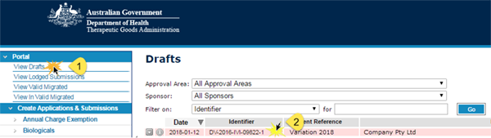
- Click on the newly created draft notification (step 2 in the above picture) to open the form. Note that it will keep the original notification application identifier number.

Updating the draft notification application form
Form will reflect the original notification, except for any attached documents – original attachments will not appear within the form. You must attach and upload the standardised In-house IVD Notification Template when completing the notification form.
- To amend any or all details in the form, refer to Steps 3 to 13 of the ‘Completing a new notification’ section of this guidance.
The IVD Type and Category details will be replicated from your previous notification. This does not need to be removed or amended. Simply select the only option available in this section of the form. Refer to Step 8 of the ‘Completing a new notification’ section of this guidance.
At any stage you can save the notification form to your drafts by clicking the Save button at either the top or the bottom of the page.
Note that any updates to the In-house IVD template need to be provided annually by 1 July of the next financial year. For more information, see Regulatory requirements for in-house IVDs.

Submitting your notification
- Read the Certification at the end of page and select Yes if you agree.
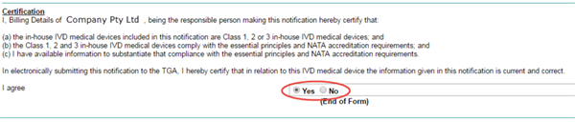
You will have to agree to the certification to submit your notification.
Note: Compliance with the NPAAC standard:” Requirements for the development and use of in-house in vitro diagnostic medical devices (IVDs)”, will be taken as compliance with the relevant essential principles for the safety and performance of a Class 1-3 in-house IVD medical device.
- Click the Validate button at the bottom of the screen. This will run a check to see whether all mandatory questions have been answered.
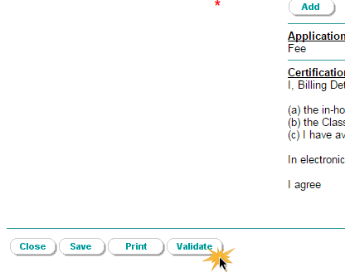
Once the validation is complete, only someone with the submitter role can submit the application.
- If you only have drafter rights, there will be no Submit button at either the top or bottom of your screen. Click the Save button at either the top or bottom of the screen. Ask a person in your organisation that has submitter rights to verify the application and submit.
- If you do have a submitter role, click on the Submit button at either the top or the bottom of the screen.

We will only process your notification once we have received payment. When you submit the notification, an invoice will be automatically generated and will be visible if you have the financial role. We will not send you a paper copy of the invoice by post.

Version history
Version | Description of change | Author | Effective date
V1.0 | Original publication | Medical Devices Branch | November 2016
V1.1 | Additional information included to clarify steps | Medical Devices Branch | March 2017
V1.2 | Additional step included (Step 4) due to IT upgrade. Additional information included to clarify steps | Medical Devices Branch | June 2017
V1.3 | Additional information included to update an existing notification and instructions to attach the In-house IVD notification template | Medical Devices Authorisation Branch | May 2024

Therapeutic Goods Administration
PO Box 100 Woden ACT 2606 Australia
Email: info@tga.gov.au Phone: 1800 020 653 Fax: 02 6203 1605
https://www.tga.gov.au
Reference/Publication #

