Australian Public Assessment Report for Veoza
  - Active ingredient: fezolinetant
  - Sponsor: Astellas Pharma Australia
April 2024

About the Therapeutic Goods Administration (TGA)
- The Therapeutic Goods Administration (TGA) is part of the Australian Government Department of Health and Aged Care and is responsible for regulating therapeutic goods, including medicines, medical devices, and biologicals.
- The TGA administers the Therapeutic Goods Act 1989 (the Act), applying a risk management approach designed to ensure therapeutic goods supplied in Australia meet acceptable standards of quality, safety, and efficacy.
- The work of the TGA is based on applying scientific and clinical expertise to decision-making, to ensure that the benefits to the Australian public outweigh any risks associated with the use of therapeutic goods.
- The TGA relies on the public, healthcare professionals and industry to report problems with therapeutic goods. The TGA investigates reports received to determine any necessary regulatory action.
- To report a problem with a therapeutic good, please see the information on the TGA website.

About AusPARs
- The Australian Public Assessment Report (AusPAR) provides information about the evaluation of a prescription medicine and the considerations that led the TGA to approve or not approve a prescription medicine submission. Further information can be found in Australian Public Assessment Report (AusPAR) guidance.
- AusPARs are prepared and published by the TGA.
- AusPARs are static documents that provide information that relates to a submission at a particular point in time. The publication of an AusPAR is an important part of the transparency of the TGA’s decision-making process.
- A new AusPAR may be provided to reflect changes to indications or major variations to a prescription medicine subject to evaluation by the TGA.

Copyright
© Commonwealth of Australia 2024
This work is copyright. You may reproduce the whole or part of this work in unaltered form for your own personal use or, if you are part of an organisation, for internal use within your organisation, but only if you or your organisation do not use the reproduction for any commercial purpose and retain this copyright notice and all disclaimer notices as part of that reproduction. Apart from rights to use as permitted by the Copyright Act 1968 or allowed by this copyright notice, all other rights are reserved and you are not allowed to reproduce the whole or any part of this work in any way (electronic or otherwise) without first being given specific written permission from the Commonwealth to do so. Requests and inquiries concerning reproduction and rights are to be sent to the TGA Copyright Officer, Therapeutic Goods Administration, PO Box 100, Woden ACT 2606 or emailed to <tga.copyright@tga.gov.au>.

Contents
List of abbreviations 4
Product submission 6
Submission details 6
Product background 7
The disease/condition 7
Current treatment options 7
Clinical rationale 7
Regulatory status 8
Australian regulatory status 8
Foreign regulatory status 8
Registration timeline 9
Submission overview and risk/benefit assessment 9
Quality 10
Nonclinical 10
Clinical 11
Summary of clinical studies 11
Pharmacology 12
Efficacy 16
Safety 33
Risk management plan 37
Risk-benefit analysis 38
Delegate’s considerations 38
Regulatory guidance 38
Efficacy 39
Safety 42
Proposed action 43
Advisory Committee considerations 44
Outcome 45
Specific conditions of registration applying to these goods 45
Attachment 1. Product Information 47

List of abbreviations
Abbreviation | Meaning
ACM | Advisory Committee on Medicines
ARTG | Australian Register of Therapeutic Goods
ASA | Australia-specific annex
AUC_{0-tau} | Area under the concentration-time curve during a dosing interval
AUC_{0-tlast} | Area under the curve from time 0 to the last quantifiable sample
Cl/F | Oral clearance
C_{max} | The maximum concentration that a drug attains in a specified compartment.
C_{max,ss} | Peak plasma concentration at steady state
CMI | Consumer Medicines Information
eGFR | Estimated glomerular filtration rate
FAS | Full analysis set
GLP | Good Laboratory Practice
HRT | Hormone replacement therapy
ICH M3 (R2) | Non-clinical safety studies for the conduct of human clinical trials for pharmaceuticals - Scientific guideline. Published by the International Conference on Harmonisation of Technical Requirements for Registration of Pharmaceuticals for Human Use.
KNDy | kisspeptin/neurokinin B/dynorphin neuron
LSM | Least Squares Mean
MENQOL | Menopause-Specific Quality of Life Questionnaire
MHT | Menopausal hormone therapy
NK3 | Neurokinin 3
NKB | Neurokinin B
PBPK | Physiologically-based pharmacokinetic modelling
PI | Product Information
PK | Pharmacokinetics
popPK | Population pharmacokinetics
PSUR | Periodic safety update report
RMP | Risk management plan
SNRIs | Serotonin and norepinephrine reuptake inhibitors
SSRIs | Selective serotonin reuptake inhibitors
TGA | Therapeutic Goods Administration
T_{max} | Time to maximum concentration
TQT | Thorough QT
VMS | Vasomotor symptoms
Vss/F | Apparent volume of distribution at steady-state

Product submission

Submission details
Type of submission: | New chemical entity
Product name: | Veoza
Active ingredient: | fezolinetant
Decision: | Approved
Date of decision: | 22 February 2024
Date of entry onto ARTG: | 26 February 2024
ARTG number: | 401401
Black Triangle Scheme  for the current submission: | Yes
Sponsor’s name and address: | Astellas Pharma Australia Pty Ltd, Level 2 / 2 Banfield Road, Macquarie Park, NSW 2113
Dose form: | Film coated tablet
Strength: | 45 mg
Container: | Blister pack
Pack sizes: | 10 tablets (starter pack)  30 tablets  100 tablets
Approved therapeutic use for the current submission: | VEOZA is indicated for the treatment of moderate to severe vasomotor symptoms (VMS) associated with menopause (see section 5.1 Pharmacodynamic Properties – Clinical  Trials).
Route(s) of administration: | Oral
Dosage: | The recommended dose of VEOZA is 45 mg once daily.  For further information regarding dosage, such as dosage modifications to manage adverse reactions, refer to the Product Information.
Pregnancy category: | B3  Drugs which have been taken by only a limited number of pregnant women and women of childbearing age, without an increase in the frequency of malformation or other direct or indirect harmful effects on the human fetus having been observed.  Studies in animals have shown evidence of an increased occurrence of fetal damage, the significance of which is considered uncertain in humans. The use of any medicine during pregnancy requires careful consideration of both risks and benefits by the treating health professional. The pregnancy database must not be used as the sole basis of decision making in the use of medicines during pregnancy. The TGA does not provide advice on the use of medicines in pregnancy for specific cases. More information is available from obstetric drug information services in your state or territory.

Product background
This AusPAR describes the submission by Astellas Pharma Australia Pty Ltd (the sponsor) to register Veoza (fezolinetant) 45 mg, oral, blister pack for the following proposed indication:
Veoza is a nonhormonal selective neurokinin 3 (NK3) receptor antagonist indicated for the treatment of moderate to severe vasomotor symptoms (VMS) associated with menopause.

The disease/condition
Vasomotor symptoms (VMS), or hot flushes and night sweats, are common in women during and in the first years after menopause. The hot flushes mainly occur at the head, neck, chest and upper back and may be associated with other symptoms, such as palpitations. VMS may be associated with sleep disturbances and may have an impact on quality of life.

Current treatment options
Management options for VMS include:
- Systemic menopausal hormone therapy (MHT) (hormone replacement therapy (HRT)) including oestrogen-only MHT, combined MHT (oestrogen + progestogen), or other hormone products or combinations (e.g., tibolone).
- Intravaginal oestrogen therapy (mainly for vulvovaginal atrophy).
- Non-hormonal therapies (including non-pharmacological options): Symptomatic therapy for vasomotor symptoms (e.g., SNRIs, SSRIs, or gabapentinoids) or for other symptoms.

Clinical rationale
Fezolinetant is a nonhormonal selective NK3 receptor antagonist that blocks neurokinin B (NKB) binding on kisspeptin/neurokinin B/dynorphin (KNDy) neurons to modulate neuronal activity in the thermoregulatory centre.
The thermoregulatory centre in the hypothalamus is innervated by KNDy neurons, which are inhibited by estrogen and stimulated by the neuropeptide NKB. Through the menopausal transition, declining estrogen disrupts the balance with NKB. Unopposed, NKB signalling increases KNDy neuronal activity leading to hypertrophy of KNDy neurons and altered activity on the thermoregulatory centre, resulting in VMS, also known as hot flashes and night sweats.

Regulatory status

Australian regulatory status
This product is considered a new chemical entity medicine for Australian regulatory purposes.

Foreign regulatory status
This submission was evaluated as part of the Australia-Canada-Singapore-Switzerland-United Kingdom (ACCESS) Consortium with work-sharing between the TGA and Swissmedic. Each regulator made independent decisions regarding approval (market authorisation) of the new medicine.
At the time the TGA considered this submission, a similar submission had been considered by other regulatory agencies. The following table summarises these submissions and provides the indications where approved.
Table 1: International regulatory status at the time of product registration.
Region | Submission date | Status | Approved indications
European  Union –  centralised  procedure | 24 Aug 2022 | Approved  7 Dec 2023 | Veoza is indicated for the treatment of moderate to severe vasomotor symptoms (VMS) associated with menopause.
United States of America | 22 Jun 2022 | Approved  12 May 2023 | VEOZAH is a neurokinin 3  (NK3) receptor antagonist  indicated for the treatment of  moderate to severe  vasomotor symptoms due to  menopause.
Switzerland | 9 Jan 2023 | Approved  5 Dec 2023 | Treatment of moderate to severe vasomotor symptoms (VMS) in postmenopausal patients.
Mexico | 12 May 2023 | Under consideration | Under consideration
Brazil | 23 May 2023 | Under consideration | Under consideration
Israel | 11 June 2023 | Under consideration | Under consideration
Colombia | 29 Sep 2023 | Under consideration | Under consideration
United Kingdom | 17 Oct 2023 | Approved  14 Dec 2023 | Veoza is indicated for the treatment of moderate to severe vasomotor symptoms (VMS) associated with menopause.
Canada | 30 Oct 2023 | Under consideration | Under consideration
South Africa | 29 Nov 2023 | Under consideration | Under consideration
Turkey | 21 Dec 2023 | Under consideration | Under consideration
Singapore | 29 Jan 2024 | Under consideration | Under consideration

Registration timeline
This submission was evaluated under the standard prescription medicines registration process.
Table 2 captures the key steps and dates for this submission.
Table 2: Timeline for Submission PM-2022-05510-1-5
Description | Date
Submission dossier accepted and first round evaluation commenced | 8 February 2023
First round evaluation completed | 8 June 2023
Sponsor provides responses on questions raised in first round evaluation | 4 August 2023
Second round evaluation completed | 21 September 2023
Sponsor’s notification to the TGA of errors/omissions in evaluation reports | 6 October 2023
Delegate’s Overall benefit-risk assessment and request for Advisory Committee advice | 31 October 2023
Sponsor’s pre-Advisory Committee response | 14 November 2023
Advisory Committee meeting | 30 November 2023 – 1 December 2023
Registration decision (Outcome) | 22 February 2024
Administrative activities and registration in the ARTG completed | 26 February 2024
Number of working days from submission dossier acceptance to registration decision* | 206
*Statutory timeframe for standard submissions is 255 working days

Submission overview and risk/benefit assessment
Relevant guidelines or guidance documents referred to by the Delegate are listed below:
- European Medicines Agency (13 October 2005, EMEA/CHMP/021/97 Rev. 1) Clinical investigation of medicinal products for hormone replacement therapy of oestrogen deficiency symptoms in postmenopausal women - Scientific guideline
- European Medicines Agency (9 December 2013, EMA/916292/2011 Rev 1*) Guideline on good pharmacovigilance practices (GVP) Module VII – Periodic safety update report (Rev 1)

Quality
The chemical structure of fezolinetant is shown in Figure 1.
Figure 1: Chemical formula of fezolinetant
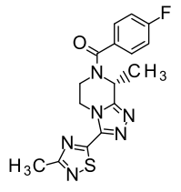
The final drug product presents as a round (approx. 7.1 mm diameter), light red, film-coated tablet debossed with the Astellas logo and ‘645’ on the same side, packaged in a PA/Al/PVC/Al blister pack with pack sizes of 10, 30, and 100 tablets. The 10 tablet pack is a starter pack.
A shelf life of 36 months when stored below 30°C is recommended. The drug product is not sensitive to light.
Approval is recommended for registration of the proposed product from a pharmaceutical chemistry perspective.

Nonclinical
Module 4 was of high overall quality and adequate in scope, consistent with ICH M3 (R2). All pivotal safety-related studies were GLP-compliant.
Fezolinetant is a neurokinin 3 (NK₃) receptor antagonist and represents a novel pharmacological class. Fezolinetant was shown to possess nanomolar affinity for the human NK₃ receptor, and block activation of the receptor in in vitro experiments. In vivo in ovariectomised rats, fezolinetant decreased skin tail (but not core) temperature and attenuated various other ovariectomy-induced changes. It was shown to decrease neuronal activity in the brain thermoregulatory centre (the median preoptic nucleus [MnPO] of the hypothalamus]) and to reduce circulating LH levels in ovariectomised rats. The pharmacology studies support fezolinetant for the proposed indication.
The major human metabolite of fezolinetant, ES259564 [referred to as M9 in this report], was shown to retain some pharmacological activity, displaying ~20-fold lower affinity for the NK₃ receptor compared to its parent. Its contribution to efficacy in patients is minimal.
No notable secondary pharmacological targets were identified for either fezolinetant or M9.
Safety pharmacology and other studies indicated no likely effects on CNS, cardiovascular or respiratory function in patients.
Rapid absorption of fezolinetant after oral administration was seen in laboratory animal species and humans. Oral bioavailability in rats and monkeys was high. Plasma protein binding was low in laboratory animal species (29–33%) and in humans (51%). No particular distribution of fezolinetant into red blood cells was apparent. Rapid and wide tissue distribution of ¹⁴C-fezolinetant-derived radioactivity was demonstrated in rats, with considerable penetration of the blood-brain barrier; there was also evidence of melanin binding. Excretion of fezolinetant and/or its metabolites was predominantly via the urine in rats and monkeys, as in humans.
From in vitro data, pharmacokinetic interactions mediated by CYP inhibition/induction or transporter interactions are not expected in patients. CYP1A2 inhibitors/inducers could alter the systemic exposure to fezolinetant given the major role of this CYP in fezolinetant metabolism.
Fezolinetant showed a low order of acute toxicity by the oral route in mice, rats and monkeys.
Repeat-dose toxicity studies by the oral route were conducted in mice (up to 4 weeks duration), rats (up to 6 months) and monkeys (up to 9 months). The female reproductive system, haematolymphoid system, central nervous system, liver and thyroid were identified as the key targets in these studies. The effects on the female reproductive system represent exaggerated primary pharmacology (occurring secondary to hormonal changes), and the effects on the other systems occurred only at very high multiples of the clinical exposure, and often in a single species. They are not considered to identify likely risks in patients.
Fezolinetant was negative in the standard battery of tests for genotoxicity, and metabolite M9 was shown to not be mutagenic or clastogenic in vitro.
Fezolinetant was not carcinogenic in a 6-month study in transgenic mice. An increased incidence of thyroid follicular cell adenoma was observed in a 2-year study in female rats. Occurring at a very high exposure margin and by a rat-specific mechanism (thyroid hormone perturbation secondary to hepatic enzyme induction), the finding is not regarded to indicate that fezolinetant poses a carcinogenic risk to patients.
There were no nonclinical objections to the registration of Veoza for the proposed indication.

Clinical

Summary of clinical studies
The clinical dossier consisted of:
- 11 Phase I studies
- Two Phase II studies
- Three Phase III studies

Pharmacology
Clinical pharmacology studies are shown in Table 3.
Table 3. Overview of clinical pharmacology studies.
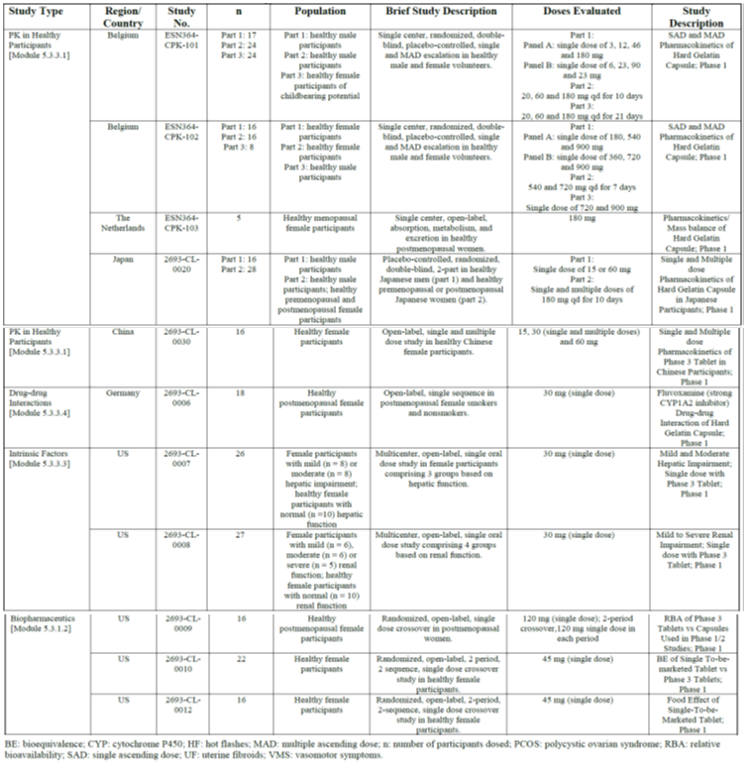
Eleven Phase 1 pharmacology studies (with intense PK sampling; Table 3) were conducted in healthy male and female adult participants, and participants with mild to moderate hepatic impairment or with mild to severe renal impairment. Single doses of up to 900 mg, or up to 720 mg once daily for 7 days were explored.
The following studies provided PK data with sparse sampling:
- 4 Phase 2 studies (Studies 204, 205, 201, and ESN364-UF-02) (up to 90 mg BD).
- 3 Phase 3 studies (Studies 301, 302, and 304) (30 mg or 45 mg once daily).
In the Phase 2 or 3 studies, PK parameters were derived by non-compartmental approaches or based on pooled concentration data in popPK analyses.

Pharmacokinetics (PK)

Absorption
Fezolinetant is rapidly absorbed with C_{max} usually achieved at 1 to 4 hours post-dose (Studies 101, 102, 0020 and 0030).
An absolute bioavailability study was not conducted, but a urinary recovery proportion of radioactivity of 76.9% indicates a high absolute bioavailability (Study 103).

Distribution
The volume of distribution at steady-state (Vss/F) was calculated to be 189 L (popPK analysis 2693-PK-0010).
The plasma protein binding of fezolinetant is low (51%) (in vitro study 20-193). Due to this low binding, unbound concentrations were not determined, in the special population studies 0007 (hepatic impairment) and 0008 (renal impairment). No protein binding information was generated for the main metabolite ES259564.

Metabolism
Fezolinetant is primarily metabolised by CYP1A2 (in vitro studies CYP0720 R2F and 0008) to form the main plasma metabolite ES259564 (also known as M9) (mass balance study ESN364-103) via oxidation of methyl group in the methylthiadiazole ring. ES259564 is approximately 20-fold less potent against the human NK3 receptor with no significant off-target activities. The metabolite-to-parent ratio ranges from 0.7 to 1.8. No other fezolinetant metabolites were identified in plasma.

Excretion and elimination
The apparent clearance at steady-state of fezolinetant is 10.8 L/h.
Following oral administration, fezolinetant is eliminated in urine (76.9%) and in faeces (14.0%) with 90.9% recovered up to 144h (mass balance study 103).
In urine, 1.1% of the administered dose was excreted unchanged and 55.9% as ES259564 (24h post-dose). The values were 1.1% and 61.7%, respectively, after extrapolation to infinity.
The elimination half-life for fezolinetant was calculated to be 9.6 h in a typical 70 kg, white, non-smoking female from Phase 3 studies (popPK analysis 2693-PK-0010). No popPK analysis was performed for the main metabolite ES259564, but typically, its elimination half-life would be 1-1.5 h longer than for the parent. The terminal elimination half-life (t1/2) of fezolinetant is less than 15 hours in healthy women.

Dose proportionality
In healthy women, fezolinetant C_{max} and AUC_{0-tau} increased proportionally with clinically relevant doses between 20 and 60 mg once daily (Study 101 and popPK analysis 2693-PK-0003).

Accumulation
Following once daily administration of 45 mg, steady-state is generally reached on day 2 of dosing with fezolinetant steady-state C_{max} and AUC_{0-tau} values of 458 ng/ml and 3855 ng*h/ml, respectively (popPK analysis 2693-PK-0010), minimal accumulation (generally 20 to 30%) given the 24-h dosing and the fezolinetant elimination half-life) and an absence of time-dependent fezolinetant PK (i.e., no fezolinetant-mediated auto-induction or inhibition).

Food effect
There was a 0.5-h delay in median T_{max} in the fed (high-calorie, high-fat meal) vs. the fasted state and a corresponding 23% decrease in C_{max} with no meaningful change in AUC with similar results for ES259564 (Study 0012). These are not clinically significant differences.

Special populations
Hepatic impairment: fezolinetant exposure (AUC_{0-tlast}) increases were observed for mild hepatic impairment (+56%) and for moderate impairment (+94%). For C_{max}, the values were +23% and –15%, respectively. The elimination half-life in moderate hepatic impairment was 19.3 h (12.2 h in the control). In both mild and moderate hepatic impairment, ES259564 exposure was increased up to 15%. Fezolinetant has not been studied in individuals with Child-Pugh Class C (severe) chronic hepatic impairment.
Renal impairment: Following a single-dose administration of 30 mg fezolinetant, C_{max} remained unchanged, and AUC was decreased (with the highest AUC_{0-t} decrease of 31% and AUC_{0-inf} decrease of 52% in the mild renal impairment group compared to the matched control group). But for ES259564, there was an AUC increase (approx. 1.7 to 4.8 fold) in moderate and severe renal impairment.
Based on these results, a mild or moderate renal impairment does not warrant a dose adjustment and use in patients with severe renal impairment is not recommended. There are no data for end-stage renal disease (eGFR <15 mL/min/1.73 m²).
Biological sex: There were significant decreases in C_{max} and AUC in male compared to female subjects after single and multiple dosing, but fezolinetant is only proposed for biological female patients.
Age, ethnicity, and body weight: There appear to be no clinically relevant PK effects of age (18 to 65 years), ethnicity, body weight (42 to 126 kg), or menopause status (based on popPK data).
Pharmacologically induced menopause: Fezolinetant has not been studied in individuals with VMS induced by pharmacologic treatment of malignancy (e.g., breast cancer treatment).

Population PK (popPK) data

popPK analyses
Two popPK analyses (reports 2693-PK-0003 and 2693-PK-0010 (pivotal as based on 14 phase 1, 2, and 3 trials) investigated the impact of additional covariates.
The final model included 13057 measurable fezolinetant concentrations from 1488 subjects (female subjects aged 19 to 65 years).
A two-compartment model with first order elimination and complex absorption adequately described the PK in healthy women and women with VMS, UF, or PCOS. Fezolinetant absorption was described by an Erlang distribution transit compartment model using 6 lag compartments.
Several covariates were identified:
- Smoking: 51% increase in oral clearance (Cl/F) compared to non-smoking => 33.9% decrease in AUC_{ss} and 8.6% decrease in C_{max ss}.
- Body weight: Large weight (100 kg): 17.2% decrease in C_{max}; low weight (55 kg): 25.6% increase in C_{max} compared to a 70-kg standard female.
- Ethnicity:
  - Black: 6.6% decrease in C_{max} compared to a standard Caucasian female.
  - Japanese: time-dependent clearance with an initial increase in Cl/F at time point 0 and a mono-exponential decline to a steady-state Cl/F; the higher initial Cl/F is thought to be caused by smoking and the subsequent smoking cessation during the study which caused a gradual decrease in Cl/F.
  - Asian (Chinese and Japanese populations combined) vs. non-Asian: 23% increase in AUC and a 10% increase in C_{max}.
- Formulation: Capsule: 16% decrease in C_{max} and 11.9% decrease in AUC, compared to the tablet.
- Food: 8% decrease in C_{max} with no effect on AUC (smaller than the food effect observed in Study 0012; but likely due to the variability of the food intake in the main studies).
There appears to be no statistically significant PK impact due to age (19 to 65 years) and menopausal status (pre- vs. post-menopause). No dose adjustments are necessary based on age, ethnicity, or body weight.

Physiologically based pharmacokinetic (PBPK) analyses
Two PBPK reports characterised the impact of weak and moderate CYP1A2 inhibitors on fezolinetant (report 2693-PK-0005) and the impact of fezolinetant on OAT1 / OAT 3 substrates (report 2693-PK-0009).
PBPK report 2693-PK-0005 investigated the potential impact of a mild or moderate CYP1A2 inhibition and complements the result of study 2693-CL-0006 (impact of strong CYP1A2 inhibition). In the absence of further data, concomitant use of fezolinetant with CYP1A2 inhibitors should be contraindicated.
PBPK report 2693-PK-0009 investigated the potential for a fezolinetant-mediated impact on OAT1 or OAT3 substrates (in vitro report 2693-ME-0007: IC50 values of 18.9 µM (OAT1) and 27.5 µM (OAT3)). It used the PBPK model established in 2693-PK-0005 as basis for this analysis and may suffer from the same methodological issues. Overall, for the OAT1 and OAT3 substrates no interaction was predicted, which was not sensitive to changes in K_{i} over a 100-fold range.

Pharmacodynamics (PD)

Mechanism of action
In oestrogen-deficient states (e.g., menopause), there appears to be a disturbance of the balance between oestrogens and NKB leading to increased KNDy neuron activity affecting heat regulation in the CNS thermoregulatory centre.
Fezolinetant is a non-hormonal selective antagonist of the NK3 receptor. It blocks binding NKB to the KNDy neurons with higher affinity (in vitro K_{i} of approximately 20 nM) and selectivity compared to other members of the tachykinin family (hNk+ and hNK2; in vitro K_{i} values of >10 µM) and other G-protein coupled receptors.

Interactions
Fezolinetant is extensively metabolised by the CYP1A2. Hence, the phase 1 Study 2693-CL-0006 was conducted to investigate this in healthy postmenopausal women. 30 mg on Day 1 and 7 were used.
The strong CYP1A2 inhibitor fluvoxamine (up to 100 mg daily – commonly tested in interaction studies, whereas doses up to 300 mg daily were not tested): An approximately 2-fold increase in C_{max} and 10-fold increase in AUC, and a T_{1/2} increase from 4h to 22.4h.
The strong CYP1A2 induction was investigated by comparing smokers to non-smokers: a 28% reduction in fezolinetant C_{max} and a 52% reduction in AUC was observed in smokers (smoking causes a CYP1A2 induction) vs. non-smokers when fezolinetant is given alone.
The CYP1A2 interaction study has not been ideal, in particular with regard to the doses tested, noting that a typical maximum fluvoxamine dose is 300 mg daily. In the absence of further data, concomitant use of fezolinetant with CYP1A2 inhibitors should be contraindicated.

Cardiac safety: QT study
No dedicated thorough QT (TQT) study was conducted, justified by an FDA TQT waiver based on the totality of evidence approach as described in ICH E14. There appear to be no relevant non-clinical signals.
ECG and PK data (fezolinetant and ES259564) from Study 102 only (a small database of 377 observations from 32 subjects) were used in report 2693-PK-0008. Overall, no clinically relevant prolongation of ΔΔQTcF was predicted at clinically relevant fezolinetant or ES259564 concentrations, and also not up to 10 times the clinically relevant concentration.

Exposure response
5 exposure-response analyses (MCP-MOD, 2693-PK-0004, 2693-PK-0011, 2693-PK-0012 and DILIsym) support the Phase 3 dosing regimen.

Dose-finding
Study 205 (efficacy results shown in the efficacy section) supported the results of the proof of concept study that fezolinetant is able to reduce the frequency and severity of moderate to severe VMS compared to placebo. In particular, despite a strong placebo effect in the co-primary endpoints, an advantage for active treatment was found regarding the time interval to a clinically relevant reduction of VMS compared to baseline. However, a clear dose-response effect could not be established, and the results of the study did not give a clear indication regarding the optimal dose for clinical practice.
In addition, modelling and simulations were conducted. It was noted that the baseline frequency of VMS in study 205 was lower than in historical studies with HRT. On the other hand, models and simulations suggested an impact of baseline values on the placebo-corrected change from baseline. According to the models, for a mean baseline consistent with historical studies, daily doses of 30 mg or 45 mg would lead to clinically meaningful reductions in the frequency of VMS.
Based on the totality of data, the 30mg daily dosing regimen was considered the lowest effective dose.

Efficacy
The efficacy and safety of fezolinetant is assessed from data from four global, randomised, double-blind, placebo-controlled phase 2 and phase 3 studies (Studies 204, 205, 301 and 302) (Table 4). The pivotal studies are Studies 301 and 302. They evaluated fezolinetant at doses of 30 mg and 45 mg administered orally once daily.
Table 4. Overview of efficacy studies.
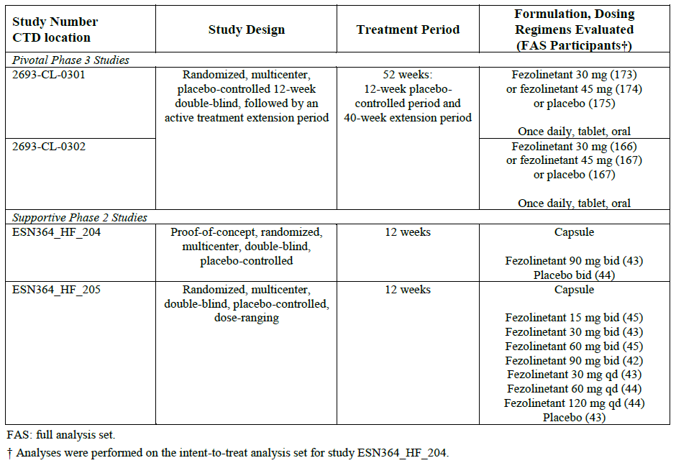
Additionally, Study 304, a long-term safety study had exploratory efficacy endpoints.

Pivotal phase 3 studies 301 (Skylight 1) and 302 (Skylight 2)

Design
Pivotal, 12-week (with a 40 week extension), phase 3, randomised, double-blind, multi-centre, 3-arm parallel-group (1:1:1), placebo-controlled studies to assess the efficacy and safety of fezolinetant (30 mg and 45 mg daily) in adult women aged ≥40 years and ≤65 years with moderate to severe VMS associated with menopause.
Study 301 (Skylight 1) was conducted in 522 patients between 11 Jul 2019 (date of first evaluation) and 11 Aug 2021 (date of last evaluation). This study was conducted at 96 centres in 8 countries (US, Canada, UK, Spain, Czech Republic, Poland, Hungary and Ukraine).
Study 302 (Skylight 2) was conducted in 500 patients between 11 Jul 2019 and 23 Apr 2021. This study was conducted at 91 centres in 7 countries (US, Canada, UK, Spain, Latvia, Czech Republic, Poland).
Primary efficacy objective: to evaluate the efficacy of fezolinetant vs. placebo on the frequency and severity of moderate to severe VMS.
Key secondary efficacy objective: to evaluate the efficacy of fezolinetant vs placebo on patient-reported sleep disturbance.
Secondary efficacy objectives: to evaluate the effect of fezolinetant vs placebo on the frequency and severity of moderate to severe VMS at weekly time points; to evaluate the safety and tolerability of fezolinetant.
Figure 2. Study 301 and 302. Study design schema.
Inclusion criteria (full list in Table 16): Women aged ≥40 to ≤65 years with moderate to severe VMS (associated with menopause; seeking treatment or relief for VMS associated with menopause; 7 to 8 hot flashes per day within the 10 days prior to randomisation; evaluable screening endometrial biopsy (only from 01 Jul 2020).
Exclusion criteria included (full list in Table 17): Prohibited therapy; unacceptable TVU result; endometrial biopsy confirming presence of disordered proliferative endometrium, endometrial hyperplasia, endometrial cancer; history (last 6 months) of undiagnosed uterine bleeding; partial or full hysterectomy (only from 01 Jul 2020).
Treatments (Figure 2):
- Initial 12 week period: Participants were randomised to placebo, fezolinetant 30 mg, or fezolinetant 45 mg (1:1:1).
- Active treatment extension period: After 12 weeks of treatment, participants on placebo were re-randomised in a 1:1 ratio to 30 mg or 45 mg of fezolinetant in a noncontrolled extension treatment period (i.e., extension period without a placebo control) for a further 40 weeks (52 study weeks in total). Patients originally randomised to fezolinetant 30 mg or 45 mg received the same treatment in the active treatment extension period.
- Study treatments were provided using tablets of identical appearance:
  - Fezolinetant 30 mg (one 30 mg tablet and one placebo tablet);
  - Fezolinetant 45 mg (one 15 mg tablet and one 30 mg tablet); or
  - Placebo (one 30 mg placebo tablet and one 15 mg placebo tablet) (only for 12 weeks).
Randomisation: Used Interactive Response Technology (IRT). Allocation concealment was not discussed.
Co-primary efficacy endpoint (Hochberg multiplicity adjustment) at the 5% significance level:
- Mean change in the frequency of moderate to severe VMS from baseline to week 4
- Mean change in the frequency of moderate to severe VMS from baseline to week 12
- Mean change in the severity of moderate to severe VMS from baseline to week 4
- Mean change in the severity of moderate to severe VMS from baseline to week 12
Other endpoints are shown in the Clinical Evaluation Report.
Baseline characteristics:
In both studies, demographics and baseline characteristics were reasonably balanced between groups (pooled study data):
- Patient demographics: The mean age was 54.3 years (range: 40-65 years), with approx. half the patients being aged ≥55 years (and 10% >60 years). 81% were Caucasian, 17% Black, and 24% Hispanic. The mean BMI was approx. 28kg/m². 32% of patients had had a hysterectomy, and 22% had had an oophorectomy. The median time interval since amenorrhoea/menopause was between 57.2 and 69.2 months with a high variability (range: 2 to 442 months).
- Disease characteristics: The median time interval since onset of VMS was 54.8 months (range: 1 to 422 months). 19-21% of patients had received HRT in the past despite the often long duration of symptoms (>4.5 years for approx. half of the patients) suggesting that many were either not suitable for or declining HRT. Of those with prior HRT use, 32% had ceased that treatment due to lack of efficacy. At baseline, patients had a mean 11 VMS episodes per 24h with a mean severity score of 2.4 points. Baseline values were reasonably balanced between treatment groups and the two studies.
- Co-morbidities were representative, and most commonly: hypertension, uterine fibroids, seasonal allergies, and gastroesophageal reflux being the most common conditions.

Magnitude of the treatment effect and its clinical significance
Co-primary efficacy endpoints:
The pooled results (Studies 301 and 302) were:
- The mean change in the frequency of moderate to severe VMS (Table 5):
  - from baseline to week 4:
- The Least Squares Means (LSM) difference (95% CI) for 30 mg was: -1.89 (-2.51, -1.26)
- The LSM difference (95% CI) for 45 mg was: -2.28 (-2.91, -1.66)
  - from baseline to week 12:
- The LSM difference (95% CI) for 30 mg was: -2.15 (-2.84, -1.45)
- The LSM difference (95% CI) for 45 mg was: -2.51 (-3.20, -1.82)
- The mean change in the severity of moderate to severe VMS (Table 6):
  - from baseline to week 4:
- The LSM difference (95% CI) for 30 mg was: -0.15 (-0.23, -0.06)
- The LSM difference (95% CI) for 45 mg was: -0.24 (-0.32, -0.15)
  - from baseline to week 12:
- The LSM difference (95% CI) for 30 mg was: -0.20 (-0.31, -0.08)
- The LSM difference (95% CI) for 45 mg was: -0.24 (-0.35, -0.13)
Table 5. Pooled data from Studies 301 and 302. Change from baseline in mean frequency of moderate to severe vasomotor symptoms per 24h at Week 4 and 12 (Full Analysis Set).
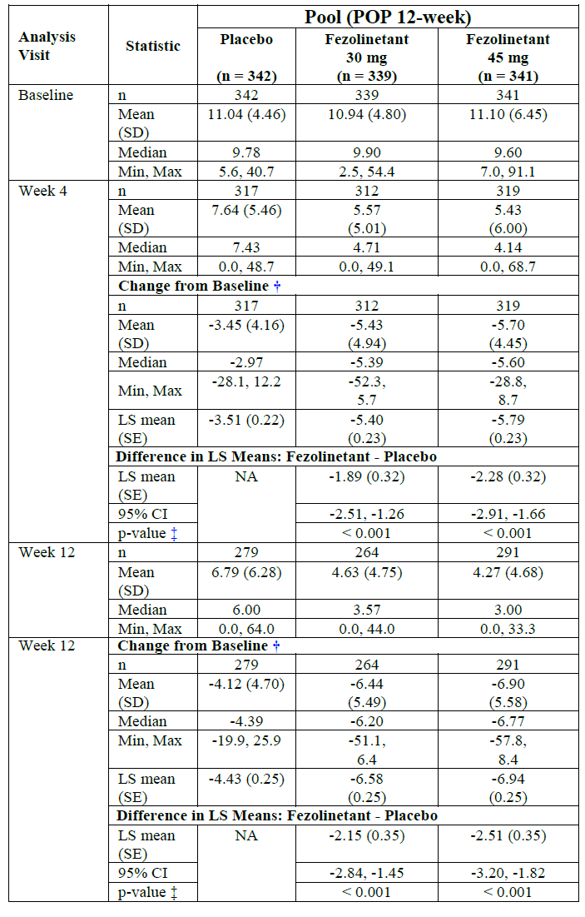
Table 6. Pooled data from Studies 301 and 302. Change from baseline in mean severity of moderate to severe vasomotor symptoms per 24h at Week 4 and 12 (Full Analysis Set).
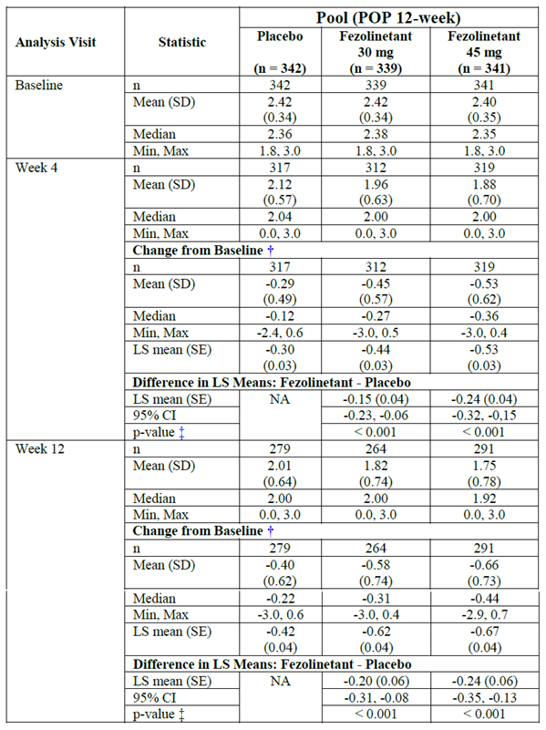
Individual results for Studies 301 and 302 are shown in Table 7 and Table 8. Sensitivity analyses using the Per-Protocol population showed similar results.
Table 7. Study 301. Primary analysis of co-primary endpoints (12-week double-blind period) (Full Analysis Set).
Table 8. Study 302. Primary analysis of co-primary endpoints (12-week double-blind period) (Full Analysis Set).
Key secondary endpoint: Mean change from baseline to week 12 in Patient-Reported Outcomes Measurement Information System Sleep Disturbance – Short Form 8b (PROMIS SD SF). In the pooled results, the LSM difference (95% CI) was -0.6 (-1.7, 0.4) for 30 mg, and -1.5 (-2.5, -0.5) for 45 mg. There was no statistically significant difference between fezolinetant 30 mg and placebo, but there was between fezolinetant 45 mg and placebo (Table 9).
Table 9. Individual and pooled data from Studies 301 and 302. Mean change in the PROMIS SD SF 8b total score from baseline to Week 12 (Full Analysis Set).
Further secondary endpoints and exploratory endpoints are shown in the CSR and are also outlined in the Summary of Clinical Efficacy (QoL measures at p. 52ff.). A graphical representation is at Figure 3 (Menopause-Specific Quality of Life Questionnaire (MENQOL) only) and at Figure 4.
Figure 3. Individual and pooled data from Studies 301 and 302. Mean change in the MENQOL Total and Domain Scores from Baseline to Week 12 (Full Analysis Set).
Figure 4. Individual and pooled data from Studies 301 and 302. Efficacy endpoint result overview (Full Analysis Set).

Subgroup analyses of the primary endpoints
The results in the PP population and the sensitivity analyses were generally consistent with those of the primary analyses. The results of the prior HRT therapy subgroup are shown below.
Prior HRT therapy: The median time interval since onset of VMS was relatively long (despite consideration of the high variability): >4.5 years in approx. half of the patients. Nevertheless, only approx. 20% had received prior HRT. In general, it appears that the treatment difference between active groups and placebo was larger in patients previously treated with HRT (Table 10).
Table 10. Pooled data from Studies 301 and 302. LSM differences in treatment effect (co-primary endpoints) at Week 12 by prior HRT status (Full Analysis Set).
Endpoint variable | Daily dose | LSM difference (95% CI) to placebo
Endpoint variable | Daily dose | All | Patients with prior HRT (n=56) | Patients without prior HRT (n=219)
Moderate to severe VMS frequency at Week 12 | 30 mg | -2.15 (-2.84; -1.45) | -3.19 (-4.77; -1.62) | -1.84 (-2.62; -1.05)
Moderate to severe VMS frequency at Week 12 | 45 mg | -2.51 (-3.20; -1.82) | -3.92 (-5.48; -2.36) | -2.20 (-2.98; -1.42)
Moderate to severe VMS severity at Week 12 | 30 mg | -0.20 (-0.31; -0.08) | -0.21 (-0.46; 0.04) | -0.19 (-0.31; -0.06)
Moderate to severe VMS severity at Week 12 | 45 mg | -0.24 (-0.35; -0.13) | -0.50 (-0.75; -0.25) | -0.20 (-0.32; -0.07)

Other subgroup results are at: Table 11, Table 12, Table 13, and Table 14.
Table 11. Pooled data from Studies 301 and 302. Change from baseline in mean frequency of moderate to severe vasomotor symptoms per 24h at Week 12 – Subgroup analysis of intrinsic factors (Full Analysis Set).
Table 12. Pooled data from Studies 301 and 302. Change from baseline in mean frequency of moderate to severe vasomotor symptoms per 24h at Week 12 – Subgroup analysis of extrinsic factors (Full Analysis Set).
Table 13. Pooled data from Studies 301 and 302. Change from baseline in mean severity of moderate to severe vasomotor symptoms per 24h at Week 12 – Subgroup analysis of intrinsic factors (Full Analysis Set).
Table 14. Pooled data from Studies 301 and 302. Change from baseline in mean severity of moderate to severe vasomotor symptoms per 24h at Week 12 – Subgroup analysis of extrinsic factors (Full Analysis Set).

Phase 3 safety study 304 (Skylight 4) (2693-CL-0304)

Design
52-week, phase 3, randomised, double-blind, multi-centre (108 centres in 8 countries), 3-arm parallel-group (1:1:1), placebo-controlled study to assess the long-term safety of fezolinetant (30 mg and 45 mg daily) in 1831 adult women aged ≥40 years and ≤65 years with VMS associated with menopause. The study was conducted between 11 Jul 2019 (date of first evaluation) and 21 Jan 2022 (date of last evaluation).
Primary objectives: to evaluate the long-term safety and tolerability of fezolinetant in female individuals seeking treatment for relief of VMS associated with menopause, and to evaluate the effect of fezolinetant on endometrial health after long-term treatment in female individuals seeking treatment for relief of VMS associated with menopause.
Exposure: The median exposure duration was 364 days in each treatment group. 1380 patients (75.4%) had an exposure of ≥252 days and 763 (41.7%) had an exposure of ≥365 days.

Magnitude of the treatment effect and its clinical significance
Exploratory efficacy endpoints: For the fezolinetant 30 mg or fezolinetant 45 mg compared to placebo:
- MENQOL VMS domain: statistically significant difference at all timepoints.
- MENQOL psychosocial, physical and sexual domains: No statistically significant differences.
- EQ-5D-5L VAS: No statistically significant differences.
- EQ-5D-5L dimension scores: No statistically significant differences at all timepoints.
The study did not have primary or secondary efficacy endpoints.

Phase 2 Study 204 (ESN364_HF_204)

Design
Supportive, 12-week, phase 2, randomised, double-blind, multi-centre (8 centres in Belgium), parallel-group (1:1), placebo-controlled proof-of-concept study to evaluate the effect of fezolinetant (90 mg twice daily) on the frequency and severity of hot flushes (HF) in 87 early postmenopausal women. The study was conducted between 21 September 2015 and 6 October 2016.
Figure 5. Study 204. Study design schema.
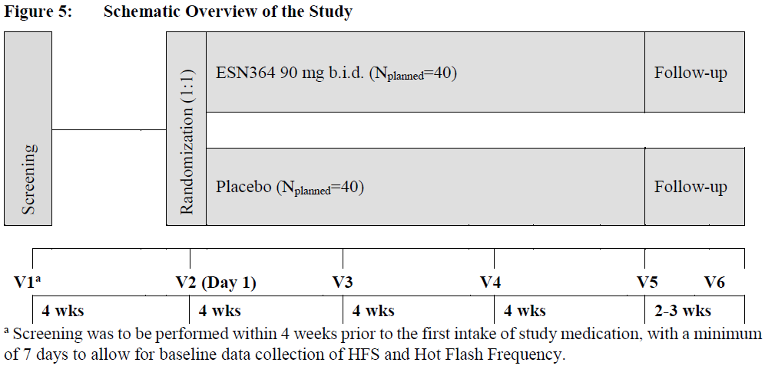
Patients were randomised to fezolinetant 90 mg bd or placebo bd. The rather high fezolinetant dose (180 mg daily) was chosen to enable maximal LH suppression, and through this maximal suppression of the KNDy neuron (as LH secretion is a surrogate for the KNDy neuron activity).

Magnitude of the treatment effect and its clinical significance
The change in Weekly General Hot Flash Score from Baseline to Week 12 (ITT Population) was -12.19 for placebo, and -26.51 for the active group. The LSM difference (95% CI) was -12.34 (-16.89; -7.79) (Table 15). Results of the two sensitivity analyses were consistent to the results of the primary analysis.
Table 15. Study 204. Primary endpoint: Changes in Weekly General Hot Flash Score from Baseline to Week 12 (ITT Population).

Phase 2 study 205

Design
Supportive, 12-week, phase 2b, randomised, double-blind, multi-centre (8 centres in Belgium), parallel-group, placebo-controlled dose-ranging study to evaluate the efficacy of fezolinetant in 352 women with VMS. The study was conducted between 19 July 2017 and 19 September 2018.
Participants were randomised (1:1:1:1:1:1:1:1) into 8 treatment groups: fezolinetant 15 mg bd; 30 mg bd; 60 mg bd; 90 mg bd; 30 mg daily; 60 mg daily; 120 mg daily; or placebo bd.
Figure 6. Study 205. Study design schema.

Magnitude of the treatment effect and its clinical significance
Primary endpoints:
- For the mean change from baseline in the frequency of moderate to severe VMS at Weeks 4 and 12, all active treatment groups showed a statistically significant change.
- For the mean change from baseline in the severity of moderate to severe VMS at:
  - Week 4: all active treatment groups showed a statistically significant change.
  - Week 12: only 60 mg bd, 90 mg bd and 60 mg daily groups showed a statistically significant change (Table 16).
Table 16. Study 205. Primary endpoint: Change in the Mean Severity of Moderate and Severe VMS per 24 h from Baseline to Week 4 and Week 12 (Full Analysis Set).
The dose-finding conclusions are described in the Pharmacodynamics section (section 2.4.1.3).

Safety

Exposure
3682 subjects were included in the global development program (3387 in Phase 2/3 studies and 295 health volunteers in Phase 1 studies). Of these study participants, 2884 were exposed to at least one dose of fezolinetant. Of those, 1836 were exposed to 30 mg or 45 mg of fezolinetant for at least 6 months in the Phase 3 studies, 809 for at least 12 months.
The main safety analysis populations were:
- POP1: 12-week data from studies 301 and 302 (n=1022 with at least one dose; median exposure: 84 days)
- POP2: 52-week data from studies 301, 302, and 304 (n=952 (placebo); n=951 (30 mg); n=949 (45 mg); n=152 (placebo/30 mg fezolinetant); n=151 (placebo/45 mg fezolinetant). Two additional groups were defined: ‘fezolinetant 30 mg total’ and ‘fezolinetant 45 mg total’ (both regardless of a previous placebo treatment in the first 12 weeks). More than 70% of patients completed study medication, and >75% of patients were exposed for at least 36 weeks. Median exposure: 364 days (for active treatment from Week 1) and 280 days (for those that switched from placebo in Week 12).
Table 17. Study Drug Exposure (POP2 Safety Analysis Set).

Adverse event overview
POP1 (12 week data): The overall adverse event (AE) incidence was 39-40% in any group (Table 18). The most common AEs in fezolinetant patients were headache (4.6%), URTI (2.2%), blood glucose increased (1.9%), dry mouth (1.8%) and arthralgia (1.8%). For most AEs, there were no relevant differences regarding treatment or dose, except for blood glucose increased (fezolinetant: 1.9%; placebo: 0.3%), dry mouth (1.8% vs. 0.3%) and dizziness (1.3% vs. 0.6%).
The most frequent AEs leading to discontinuation of study drug were upper abdominal pain (n=5), nausea (n=5), headache (n=4) and dizziness (n=4). There was neither a relevant difference between active treatment and placebo nor a dose-response. However, incidences were too small for meaningful conclusions.
The majority of AEs in all treatment groups were mild or moderate in severity, with 1.5% classified as severe in the active treatment groups.
Pharmacodynamic analyses showed no clear trend or clinically relevant changes for sex hormones (androstenedione, E2, estrone, FSH, LH, testosterone, DHEA, free testosterone) or SHBG. However, the same effect was observed as in Phase II: In samples taken 3 hours post-dose (at week 4), a transient decrease in LH compared to pre-dose values was detected in the active treatment groups.
Table 18. Treatment emergent adverse events (TEAEs) by SOC and PT ≥1% (POP1 Safety Analysis Set).
POP2 (52 week data): the overall AE incidence was higher than in POP1 (as expected given the longer exposure). It was lower in the placebo arm (55%) compared to active treatment (64%), but the difference in exposure duration needs consideration. Within the active groups, there was no evidence of a dose-response.
The most common AEs were headache (7.5%), COVID-19 (5.9%), back pain (3.4%), UTI (3.1%), arthralgia (3.0%), URTI (2.9%) and diarrhoea (2.7%).
For headache the AE incidence was comparable between active and placebo, but greater for the 45 mg dose (9.2%) than for 30 mg (8.0%). This difference was primarily due to patients of the former placebo arm, where headache was reported for 6.0% with 45 mg compared to only 2.6% with 30 mg. Headache should be considered as an adverse drug reaction (ADR), and not only as an AE.
Most AEs were mild or moderate in severity. With the exception of hot flush, headache (only for 45 mg), abdominal pain and COVID-19, no severe AE was reported for >2 fezolinetant patients.
AEs leading to discontinuation occurred in 4.6% vs. 3.9% with the most common being headache, abdominal pain, nausea and dizziness.
Overall, the results in patients switched from placebo to fezolinetant after Week 12 were comparable to those receiving active treatment for the total 52-week study period.
Pharmacodynamic results showed no clinically relevant changes or clear trends for serum concentrations of sex hormones or SHBG.
To account for the difference in the duration of exposure, an additional analysis was conducted: Considering exposure in patient years, the incidence rate of AEs was neither greater for active treatment than for placebo, nor was there a definite dose-response. However, for serious adverse events (SAEs), the incidence rate was greater for active treatment (4.8) compared to placebo (2.7). In addition, the incidence rate was slightly higher for 45 mg (4.9) than for 30 mg (4.6).
Subgroup analyses of safety data, despite some small differences between individual subgroups, did not reveal any results of concern.
Table 19. TEAEs by SOC and PT ≥2% (POP2 Safety Analysis Set).

Treatment related adverse event (adverse drug reaction) overview
POP1 (12 week data): The ADR incidence was slightly higher in the active groups (12%) compared to placebo (10%). The most frequent ADR SOC was gastrointestinal disorders (35 patients, 5.1%). The most frequent ADRs by PT were headache (9 participants, 1.3%), dry mouth (8 participants, 1.2%) and nausea (7 participant, 1.0%).
POP2 (52 week data): The ADR incidence was 15% for both active and placebo, without evidence of a dose-response. The most common ADRs were headache (2.4%) and nausea (1.0%). The most common ADR SOC was gastrointestinal disorders (4.5%) (Table 26).
Headache (7-8%) should be considered as an ADR, and not only as an AE.

Deaths
2 deaths were reported and not considered related to IP.

Serious adverse events
POP1 (12 week data): SAEs were more frequent in the active groups (1.3%) compared to placebo (0.3%, corresponding to n=1). However, there was no evidence of a dose-response, with an incidence of 1.5% in the 30 mg group, but 1.2% in the 45 mg group. Only 2 SAEs were considered treatment-related, both in the 30 mg group.
POP2 (52 week data): SAEs were more common in the active groups (3.9%) compared to placebo (1.6%; but for placebo there had been a shorter exposure). There was a small potential dose-response trend: 4.1% incidence for 45 mg group compared to 3.7% in the 30 mg group. Of the 7 SAEs in the active groups considered treatment related, 5 were reported in the higher dose group. Hepatic enzyme SAEs were more common with active treatment.

Adverse events of special interest
A summary of Adverse events of special interest is at Table 13.
Hepatic safety: No cases of Hy’s law were identified in any of the data pools. Elevations of transaminases (in particular ALT) appeared to be dose-dependent (there was a trend in the phase 3 study sets POP1 and POP2), and mainly in doses higher than investigated in the Phase 3 studies. However, patients with active liver disease, very high BMI, and concomitant treatment with drugs that strongly inhibit fezolinetant metabolism were excluded.
Endometrial safety: Given that fezolinetant did not impact serum concentrations of sex hormones (apart from LH, which is not considered causal to the development of endometrial cancer), an effect of endometrial health can be considered unlikely.
There was no clinically relevant impact of fezolinetant on endometrial thickness. Overall, there was a small decrease in endometrial thickness in all treatment groups (likely due to the postmenopausal status of the patients).
Patients with pre-existing endometrial abnormalities were excluded from the studies, and, in long-term use, progression of pre-existing endometrial abnormalities cannot be excluded.
Suicidality and CNS safety: fezolinetant crosses the blood brain barrier, but no clinically relevant findings were identified (including, withdrawal or rebound effects, or suicidal ideation). The most common AE in this organ class was headache (mostly mild to moderate). Overall, there was no evidence of serious CNS effects.
Neoplasms: Due to an imbalance in Study 304 in the incidence of SAEs in the organ class neoplasms, a post hoc review was performed. A causal relationship is rather unlikely, supported by the lack of respective non-clinical findings.
Bone safety: no unexpected findings in a postmenopausal population.
Cardiac safety (not a designated AESI): In the overall long-term population, there was only a very limited number of cases with QTcF intervals >450ms. Across the entire Phase III programme, there were no reported cases of ventricular tachycardia, ventricular fibrillation, T wave abnormal, QT prolongation or Torsades de pointes.
Renal safety (not a designated AESI): In patients with severe renal impairment, a substantial increase in the AUC of the metabolite ES259564 was observed. There are no sufficient long-term clinical data to support the safety of the higher metabolite/parent-ratio in patients with severe renal impairment. In addition, the metabolite was shown to be an inhibitor of the mitochondrial electron transport chain. Monitoring of renal toxicity does not seem to mitigate this. For end-stage renal disease, no data are available. As a consequence, due to the possible accumulation of the metabolite, fezolinetant should not be used in patients with severe or end-stage renal impairment.

Post-market experience
Fezolinetant 45 mg tablet was approved in the US on 12 May 2023 for the treatment of moderate to severe VMS due to menopause. It is estimated that the exposure during the period 12 May 2023 to 11 Aug 2023 (first PADER cut-off date) is 1,902 patient-years. The sponsor states that there have been no safety signals (including hepatotoxicity signals) detected in the population treated with fezolinetant since marketing approval in the US.
Table 20. Summary of treatment emergent adverse events of special interest (POP2 Safety Analysis Set).

Risk management plan
The summary of safety concerns and their associated risk monitoring and mitigation strategies are presented in 21 The TGA may request an updated RMP at any stage of a product's life-cycle, during both the pre-approval and post-approval phases.
Table 21. Summary of safety concerns
Summary of safety concerns |  | Pharmacovigilance |  | Risk minimisation
 |  | Routine | Additional | Routine | Additional
Important identified risks | None | - | - | - | -
Important potential risks | None | - | - | - | -
Missing information | Use in patients with severe chronic hepatic impairment |  | - |  | -

The RMP evaluation recommended conditions of registration relating to the versions of the risk management plan, requirement for periodic safety update reports, and inclusion of the medicine in the Black Triangle Scheme.
The Delegate suggested the following wording for the risk management plan:
The Veoza EU-Risk Management Plan (RMP) (version 1.0, dated 3 August 2022, data lock point 21 January 2022), with Australian Specific Annex (version 2.0, dated July 2023), included with submission PM-2022-05510-1-5, and any subsequent revisions, as agreed with the TGA will be implemented in Australia.
The Delegate recommended the following wording for the PSUR requirement:
An obligatory component of risk management plans is routine pharmacovigilance. Routine pharmacovigilance includes the submission of periodic safety update reports (PSURs).
Unless agreed separately between the supplier who is the recipient of the approval and the TGA, the first report must be submitted to TGA no later than 15 calendar months after the date of this approval letter. The subsequent reports must be submitted no less frequently than annually from the date of the first submitted report until the period covered by such reports is not less than three years from the date of this approval letter. The annual submission may be made up of two PSURs each covering six months. If the sponsor wishes, the six monthly reports may be submitted separately as they become available.
If the product is approved in the EU during the three years period, reports can be provided in line with the published list of EU reference dates no less frequently than annually from the date of the first submitted report until the period covered by such reports is not less than three years from the date of this approval letter.
The reports are to at least meet the requirements for PSURs as described in the European Medicines Agency’s Guideline on good pharmacovigilance practices (GVP) Module VII-periodic safety update report (Rev 1), Part VII.B Structures and processes. Note that submission of a PSUR does not constitute an application to vary the registration. Each report must have been prepared within ninety calendar days of the data lock point for that report.
The Delegate recommended the following wording for the Black Triangle Scheme condition of registration:
Veoza (fezolinetant) is to be included in the Black Triangle Scheme. The PI and CMI for Veoza must include the black triangle symbol and mandatory accompanying text for five years, which starts from the date that the sponsor notifies the TGA of supply of the product.
The TGA may request an updated RMP at any stage of a product's life-cycle, during both the pre-approval and post-approval phases. Further information regarding the TGA’s risk management approach can be found in risk management plans for medicines and biologicals and the TGA's risk management approach. Information on the Australia-specific annex (ASA) can be found on the TGA website.

Risk-benefit analysis

Delegate’s considerations

Regulatory guidance
Fezolinetant is a non-hormonal selective antagonist of the NK3 receptor. There is no specific guidance available other than for HRT in postmenopausal women (EMEA/CHMP/021/97 Rev. 1). In the absence of such a guidance, the evaluator and the applicant, in line with other regulatory agencies, have been guided by EMEA/CHMP/021/97 Rev. 1 whilst noting that many aspects do not necessarily apply to a non-hormonal treatment.
The applicant has received scientific advice from other regulatory authorities. The study design of the Phase 3 studies was developed considering the EMA and FDA guidance for the development of HRT products, and resulted in a placebo-controlled, rather than active-controlled study design.

Efficacy

Pooled Phase 3 results
The pooled results of the pivotal clinical trials 301 and 302 show a statistically significant treatment effect when compared to placebo. A rather extensive treatment effect was observed in the placebo group. A relevant reduction in frequency was observed during the first week of treatment (Figure 7). By week 4, the VMS frequency was reduced by approx. 50% in the active treatment groups, compared to 30% in the placebo arm.
Figure 7. Pooled Studies 301 and 302. Daily frequency of moderate to severe vasomotor symptoms during the first week of treatment (Full Analysis Set).
For moderate to severe VMS frequency at Week 12, for both active dose groups, the results showed a clinically meaningful treatment effect when compared to placebo:
- The LSM difference (95% CI) for 30 mg was: -2.15 (-2.84, -1.45)
- The LSM difference (95% CI) for 45 mg was: -2.51 (-3.20, -1.82)
The numerical difference between the different dose group results was rather small, and in a regulator-requested, exploratory post hoc analysis, there was no statistically significant difference between dose groups.
For moderate to severe VMS severity at Week 12, for both active dose groups, the results showed a statistically significant treatment effect when compared to placebo, but the clinical significance of this much smaller effect is uncertain:
- The LSM difference (95% CI) for 30 mg was: -0.20 (-0.31, -0.08)
- The LSM difference (95% CI) for 45 mg was: -0.24 (-0.35, -0.13)
The numerical difference between the different dose group results was smaller compared the dose group differences for frequency. In a regulator-requested, exploratory post hoc analysis, there was no statistically significant difference between dose groups. Comparing severity and frequency, the absolute treatment effect is much less pronounced for severity.

Subgroups
Based on a cautious interpretation of the phase 3 data (including subgroup analyses), the patients that benefitted the most were in the middle part of menopause, had a higher BMI, or were those with previous HRT. This has not been statistically tested but is based on observed trends.

Phase 3 study population and generalisability
VMS are associated with a large variability in individual perception, with a cultural component. The Phase 3 studies were conducted in US, Canada, UK, Spain, Czech Republic, Poland, Hungary, Latvia, and Ukraine. Most study centres were in North America. The population is largely generalisable to the Australian population (except for the large African American and Hispanic populations represented in the clinical trials, and the (largely) absent Australian Indigenous and Asian populations).
In the phase 3 clinical trial program, the mean age was 54.3 years (range: 40-65 years), with approx. half the patients being aged ≥55 years (and 10% >60 years). This is considered rather high and a larger proportion of younger women would have been beneficial.
Furthermore, the median time interval since amenorrhoea/menopause was between 57.2 and 69.2 months with a high variability (range: 2 to 442 months). A reduction of symptoms could have been due to the natural progression of menopause rather than a definite treatment effect, but this would have also affected the placebo group, and furthermore, additional data provided by the sponsor did not indicate this.

Extrapolation to populations not specifically studied
Breast cancer patients: Fezolinetant has not been studied in in breast cancer patients, and no study in such a population is planned. No data are available, even though fezolinetant will likely be efficacious in this population as well. However, the potential influence of fezolinetant on the course of the malignant disease or the treatment success of the antitumour therapy is unknown.
Pharmacologically induced menopause: Fezolinetant has only been studied in patients after natural or surgical menopause. For women with pharmacologically induced menopause, however, no data are available. This applies to breast cancer patients receiving estrogen-lowering treatment as well as patients treated with GnRH agonists for conditions such as endometriosis or uterine fibroma. It is noted that the mechanism of action of fezolinetant is independent from the cause of menopause.
Perimenopausal women: Fezolinetant has been only studied in women with confirmed postmenopausal status, i.e., at least one year after the last menstruation (unless post-hysterectomy or post-oophorectomy), or menopause confirmed by hormonal status. This has been justified by the need for a homogenous clinical trial population.
The proposed indication wording of vasomotor symptoms (VMS) associated with menopause may include perimenopausal women.
There is no definite reason to assume that the efficacy would significantly differ compared to the studied population, and a therapeutic need can be assumed in this population. However, no further studies in perimenopausal women are planned.
The sponsor states that fezolinetant reduces VMS frequency and severity through the modulation of neuronal activity in the thermoregulatory centre, and that this physiologic mechanism is consistent throughout the menopause transition. Furthermore, several therapeutic guidelines (e.g., by the European Menopause and Andropause Society or the NICE guideline) do not distinguish between different menopause phases.
By blocking NKB binding, fezolinetant indirectly decreases GnRH pulse frequency, and may adversely affect the menstruation cycle in perimenopausal women. This may lead to transiently lower LH levels, and also lead to reduced progesterone levels with associated effects on the endometrium. The clinical significance in perimenopausal women is uncertain.

Dosing
The two dosage regimens tested in the Phase 3 clinical trial program were 30 mg and 45 mg daily. There appeared to be a slight efficacy benefit 45 mg dose (most markedly for the exploratory endpoints), but the exploratory analysis of comparing the two dosage regimens did not show a statistically significant difference for the primary endpoints (noting the post hoc exploratory nature of that analysis).
The applicant only proposes a 45 mg daily dose and proposes to supply only the 45 mg tablet form. The applicant mainly justifies this with the statistically significant difference in treatment effect for the exploratory endpoints, and emphasises the importance of the QoL endpoints including the key secondary endpoint that used PROMIS SD SF. In the 30 mg group, a statistically significant difference in treatment effect was achieved for fewer of the exploratory endpoints. For the MENQOL Sexual domain score no significant treatment effect at either dose level.
A graphical representation comparing 30 mg and 45 mg daily doses is in Figure 8, noting a somewhat peculiar stratification by p-value into three strata ≤ 0.05 (i.e., a deeper purple does not indicate a greater treatment effect, but a smaller p-value).
Figure 8. Individual and pooled data from Studies 301 and 302. Efficacy endpoint result overview (Full Analysis Set).
The availability of a 30 mg dose would be desirable, i.e., the availability of both 30 mg and 45 mg dosage strengths due to:
- An only marginally smaller efficacy outcome trend for the 30 mg dose, and no statistically significant difference for the primary endpoints (in a requested, post hoc exploratory analysis).
- Typically, HRT regimens for similar indications are offered with several doses (noting that fezolinetant is not a hormonal therapy).
- The lowest effective dose is usually preferred to minimise adverse reactions, and a 30 mg strength would enable dose reductions. There has been trend regarding a dose-response relationship for hepatotoxicity, and potentially for headache.
- A large inter-individual variability of the severity of symptoms was observed, and many patients would benefit from a lower dose.

Safety
Fezolinetant is a first-in-class NCE. The safety data were generated from clinical trials, and there are no class effect data, and very limited post-market data. The safety data consist mainly of short-term data from the clinical trial program and appears to be satisfactory. For most AEs, there were no significant differences in incidence between active treatment and placebo. Only a small proportion of patients discontinued the study drug prematurely. Long-term data are only available up to a treatment duration of 12 months with no significant additional safety signals identified. However, rare events may not have been detected.
3682 subjects were included in the global development program (3387 in Phase 2/3 studies and 295 health volunteers in Phase 1 studies). Of these study participants, 2884 were exposed to at least on dose of fezolinetant. Of those, 1836 were exposed to 30 mg or 45 mg of fezolinetant for at least 6 months in the Phase 3 studies, 809 for at least 12 months.
But, the Phase 3 clinical trials, there were only approx. 340 patients per treatment group, and due to the relatively low incidence of AEs, differences between treatment groups were rather difficult to interpret, and small differences could probably not be identified. A larger safety database would have been beneficial.
The subjective tolerability appears to be satisfactory. AEs leading to discontinuation occurred in 4.6% vs. 3.9% (in the placebo group) with the most common being headache, abdominal pain, nausea and dizziness.
The incidence of SAEs was low, and in POP1, the only two SAEs considered treatment-related concerned hepatic safety. In POP2, SAEs concerning hepatic safety were more common in the active treatment groups than in the placebo arm.

Hepatic safety
No cases of Hy’s law were identified. Transaminase elevations (in particular ALT) appeared to be dose-dependent (there was a trend in the phase 3 study sets POP1 and POP2), and mainly in doses higher than investigated in the Phase 3 studies. However, patients with active liver disease, very high BMI, and concomitant treatment with drugs that strongly inhibit fezolinetant metabolism were excluded. An appropriate liver function monitoring regimen (e.g., through monitoring in the first months of treatment) will be required and communicated to prescribers.

Renal safety
In patients with severe renal impairment, a substantial increase in the AUC of the metabolite ES259564 was observed. There are only limited data for severe renal impairment, and no data for end-stage renal disease. Due to the possible accumulation of the metabolite, fezolinetant should not be used in patients with severe or end-stage renal impairment. An appropriate warning in the PI is required.

Long-term use and periodic re-evaluation
In many instances, treatment for VMS will be required for several years. At this stage, the currently available safety data cannot exclude the risk of rare (and potentially severe) side effects. If treatment is intended to be continued after the first year, a thorough re-evaluation is recommended, in order to confirm the further need for therapy und to exclude relevant adverse reactions. In particular, liver function should be monitored.

Rebound and withdrawal effects
The sponsor claims that there is no evidence for withdrawal or rebound effects. This appears to be based nonclinical data, and also on the analysis of symptoms in Studies 301 and 302 in the three week follow-up period after cessation of study drug. There appears to have been no further follow-up, or data derived from such a follow-up.
A specific study to investigate possible withdrawal or rebound effects was not conducted. However, there was no evidence of such effects in nonclinical studies, and results of the follow-up of the pivotal studies did not indicate either that such effects may be present. The applicant considers the probability of a withdrawal or rebound effect as low.

Proposed action
Hormone replacement therapy (HRT) has been used as first-line therapy in women with moderate to severe VMS. However, despite some additional beneficial effects on BMD, HRT is associated with certain safety issues (including some contraindications). An additional, non-hormonal treatment option for VMS would be useful, in particular for those patients for whom HRT is contraindicated. Breast cancer patients, in particular those on anti-oestrogen therapy, may also benefit from this.
Fezolinetant is the first NK3 antagonist for which registration is sought for any indication.
The clinical PK properties for fezolinetant and its main metabolite ES259564 were adequately characterised.
The pooled results of the pivotal clinical trials show a statistically significant treatment effect when compared to placebo for both frequency and severity of VMS symptoms at Week 12. A notable effect appears to already be present in the first week of treatment. For frequency, the effect could be considered clinically meaningful, but for severity, the clinical significance remains uncertain. Based on the above, the efficacy of fezolinetant for the treatment of post-menopausal moderate to severe VMS can be considered as sufficiently demonstrated.
The numerical difference between the different dose group results was rather small, and in a regulator-requested, exploratory post hoc analysis, there was no statistically significant difference between dose groups for the primary endpoints. The applicant only proposes a 45 mg daily dose, but the availability of an additional 30 mg dose would be desirable.
The safety profile of fezolinetant can be considered acceptable, but some uncertainties remain.
Uncertainties include:
- Fezolinetant has not been studied in breast cancer patients, in women with pharmacologically induced menopause, or in perimenopausal women, and no further studies are planned in these populations.
- By blocking NKB binding, fezolinetant indirectly decreases GnRH pulse frequency, and may adversely affect the menstruation cycle in perimenopausal women. This may lead to transiently lower LH levels, and also lead to reduced progesterone levels with associated effects on the endometrium. The clinical significance in perimenopausal women is uncertain.
- Long-term safety data are only available up to a treatment duration of 12 months, and rare events may not have been detected.
- The potential for hepatotoxicity.

Benefit-risk balance
Based on the clinical data presented, there appeared to be a positive benefit-risk balance of fezolinetant for the treatment of moderate to severe VMS in post-menopausal women.

Advisory Committee considerations
The Advisory Committee on Medicines (ACM), having considered the evaluations and the Delegate’s overview, as well as the sponsor’s response to these documents, advised the following.

Specific advice to the Delegate
- Sufficient data for registration: Can the ACM comment on whether the provided data are sufficient to support registration for the proposed indication?
The ACM was of the view that the provided data are sufficient to support registration. The efficacy of fezolinetant for the treatment of post-menopausal moderate to severe VMS can be considered as sufficiently demonstrated.
The inclusion/exclusion of additional groups within the indication is discussed within the responses to the questions below.
Inclusion/exclusion of patients with pharmacologically induced menopause: Can the ACM comment on the potential restriction of fezolinetant to patients with natural or surgical menopause only, that is, excluding patients with pharmacologically induced menopause?
The ACM noted that fezolinetant has not been studied in individuals with VMS induced by pharmacologic treatment including for malignancy. The ACM noted this is a population with a clinical need for safe and efficacious treatments and was supportive of additional studies in this population.
Considering the current lack of data in this population and the unknown impact on cancer treatment and disease progression, the ACM was of the view that Veoza should not be used in individuals with VMS induced by pharmacologic treatment of malignancy.
On balance the ACM was supportive of highlighting the data limitations in regard to pharmacologically induced menopause within the PI and retain the broader proposed indication.
Inclusion/exclusion of perimenopausal patients: Can the ACM comment on the appropriateness of including or excluding perimenopausal patients in the indication considering that this population has not been specifically studied, and also considering the potentially adverse effects on the endometrium?
The ACM discussed the challenges determining the start of menopause, noting it is often difficult to distinguish between perimenopause and menopause.
The ACM noted that within the studies, overall, there was a small decrease in endometrial thickness in all treatment groups. The ACM was of the view this was likely due to the postmenopausal status of the women rather that an effect of fezolinetant. The ACM noted that based on current data, fezolinetant adverse effects on the endometrium (including malignancy) are unlikely. The ACM advised that fezolinetant does not impact serum concentrations of sex hormones apart from luteinizing hormone (LH), which is not considered causal to the development of endometrial cancer. The ACM also noted that patients with pre-existing endometrial abnormalities were excluded from the studies, and, in long-term use, progression of pre-existing endometrial abnormalities cannot be excluded.
On balance the ACM was of the view that the indication could state:
VEOZA is indicated for the treatment of moderate to severe vasomotor symptoms (VMS) in menopausal women.
In providing this advice the ACM noted the challenges distinguishing between perimenopause and menopause, the impact of VMS during perimenopause, and the lack of current safety signals in relation to endometrium health. However, the ACM also advised that the data limitations be highlighted in the PI.
Additional 30 mg daily dose option: Can the ACM comment on a 30 mg daily dosing regimen (as an option additional to the proposed 45 mg daily dosing regimen)?
The ACM was of the view that it would be useful to have a 30 mg dose as well as the 45 mg dose available. The ACM noted that in the pivotal studies only marginally smaller efficacy outcome trends for the 30 mg dose were seen, and no statistically significant difference for the primary endpoint of frequency of VMS.
The ACM noted a large inter-individual variability of the severity of symptoms was observed, and many patients would likely benefit from a lower dose. The lowest effective dose is usually preferred to minimise adverse reactions, and the availability of the 30 mg strength would enable dose reductions. The ACM also noted the trend regarding a dose-response relationship for hepatotoxicity.
The ACM discussed the quality-of-life exploratory endpoints and noted that within the 30 mg group, a statistically significant difference in treatment effect was achieved for fewer of endpoints that with the 45 mg group. The ACM noted this but was of the view that having both the 30 mg and 45 mg dose would provide options to patients and clinicians.

Conclusion
The ACM considered this product to have an overall positive benefit-risk profile for the indication:
Veoza is indicated for the treatment of moderate to severe vasomotor symptoms (VMS) in menopausal women.

Outcome
Based on a review of quality, safety, and efficacy, the TGA decided to register Veoza (fezolinetant) 45 mg, oral, blister pack for the following proposed indication, indicated for:
Veoza is indicated for the treatment of moderate to severe vasomotor symptoms (VMS) associated with menopause (see section 5.1 Pharmacodynamic Properties – Clinical Trials).

Specific conditions of registration applying to these goods
Veoza (fezolinetant) is to be included in the Black Triangle Scheme. The PI and CMI for
Veoza must include the black triangle symbol and mandatory accompanying text for five
years, which starts from the date that the sponsor notifies the TGA of supply of the product.
The Veoza EU-Risk Management Plan (RMP) (version 1.0, dated 3 August 2022, data
lock point 21 January 2022), with Australian Specific Annex (version 2.0, dated July
2023), included with submission PM-2022-05510-1-5, and any subsequent revisions, as
agreed with the TGA will be implemented in Australia.
An obligatory component of risk management plans is routine pharmacovigilance.
Routine pharmacovigilance includes the submission of periodic safety update reports
(PSURs).
Unless agreed separately between the supplier who is the recipient of the approval
and the TGA, the first report must be submitted to TGA no later than 15 calendar
months after the date of this approval letter. The subsequent reports must be
submitted no less frequently than annually from the date of the first submitted report
until the period covered by such reports is not less than three years from the date of
this approval letter. The annual submission may be made up of two PSURs each
covering six months. If the sponsor wishes, the six monthly reports may be submitted
separately as they become available.
If the product is approved in the EU during the three years period, reports can be
provided in line with the published list of EU reference dates no less frequently than
annually from the date of the first submitted report until the period covered by such
reports is not less than three years from the date of this approval letter.
The reports are to at least meet the requirements for PSURs as described in the
European Medicines Agency’s Guideline on good pharmacovigilance practices (GVP)
Module VII-periodic safety update report (Rev 1), Part VII.B Structures and processes.
Note that submission of a PSUR does not constitute an application to vary the
registration. Each report must have been prepared within ninety calendar days of the
data lock point for that report.

Attachment 1. Product Information
The Product Information (PI) approved with the submission for Veoza which is described in this AusPAR can be found as Attachment 1. It may have been superseded. For the most recent PI and Consumer Medicines Information (CMI), please refer to the TGA PI/CMI search facility.

Therapeutic Goods Administration
PO Box 100 Woden ACT 2606 Australia
Email: info@tga.gov.au Phone: 1800 020 653 Fax: 02 6203 1605
https://www.tga.gov.au
Reference/Publication #

This is the original indication proposed by the sponsor when the TGA commenced the evaluation of this submission. It may differ to the final indication approved by the TGA and registered in the Australian Register of Therapeutic Goods.
In this report the ‘Delegate’ is the Delegate of the Secretary of the Department of Health and Aged Care who decided the submission under section 25 of the Act.

