Australian Public Assessment Report for TECVAYLI
  - Active ingredient: Teclistamab
  - Sponsor: Janssen-Cilag Pty Ltd
March 2024

About the Therapeutic Goods Administration (TGA)
- The Therapeutic Goods Administration (TGA) is part of the Australian Government Department of Health and Aged Care and is responsible for regulating therapeutic goods, including medicines, medical devices, and biologicals.
- The TGA administers the Therapeutic Goods Act 1989 (the Act), applying a risk management approach designed to ensure therapeutic goods supplied in Australia meet acceptable standards of quality, safety, and efficacy.
- The work of the TGA is based on applying scientific and clinical expertise to decision-making, to ensure that the benefits to the Australian public outweigh any risks associated with the use of therapeutic goods.
- The TGA relies on the public, healthcare professionals and industry to report problems with therapeutic goods. The TGA investigates reports received to determine any necessary regulatory action.
- To report a problem with a therapeutic good, please see the information on the TGA website.

About AusPARs
- The Australian Public Assessment Report (AusPAR) provides information about the evaluation of a prescription medicine and the considerations that led the TGA to approve or not approve a prescription medicine submission. Further information can be found in Australian Public Assessment Report (AusPAR) guidance.
- AusPARs are prepared and published by the TGA.
- AusPARs are static documents that provide information that relates to a submission at a particular point in time. The publication of an AusPAR is an important part of the transparency of the TGA’s decision-making process.
- A new AusPAR may be provided to reflect changes to indications or major variations to a prescription medicine subject to evaluation by the TGA.

Copyright
© Commonwealth of Australia 2023
This work is copyright. You may reproduce the whole or part of this work in unaltered form for your own personal use or, if you are part of an organisation, for internal use within your organisation, but only if you or your organisation do not use the reproduction for any commercial purpose and retain this copyright notice and all disclaimer notices as part of that reproduction. Apart from rights to use as permitted by the Copyright Act 1968 or allowed by this copyright notice, all other rights are reserved and you are not allowed to reproduce the whole or any part of this work in any way (electronic or otherwise) without first being given specific written permission from the Commonwealth to do so. Requests and inquiries concerning reproduction and rights are to be sent to the TGA Copyright Officer, Therapeutic Goods Administration, PO Box 100, Woden ACT 2606 or emailed to <tga.copyright@tga.gov.au>.

Contents
List of abbreviations 4
Product submission 6
Submission details 6
Product background 7
Current treatment options for relapsed or refractory multiple myeloma 8
Teclistamab 9
Regulatory status 10
Product Information 11
Registration timeline 11
Submission overview and risk/benefit assessment 12
Quality 12
Nonclinical 12
Clinical 13
Pharmacology 21
Efficacy 23
Safety 25
Risk management plan 29
Risk-benefit analysis 29
Advisory Committee considerations 32
Outcome 33
Specific conditions of registration applying to these goods 33
Attachment 1. Product Information 34

List of abbreviations
Abbreviation | Meaning
ACM | Advisory Committee on Medicines
ARTG | Australian Register of Therapeutic Goods
ASA | Australia specific annex
ASCT | Autologous stem cell transplant
AUC | Area under the concentration-time curve
AUC_{tau} | Area under the concentration-time curve during a dosing interval
BCMA | B-cell maturation antigen
CAR-T cell | Chimeric antigen receptor T-cell
CCDS | Company Core Data Sheet
CD38 | Cluster of differentiation 38
C_{max} | Maximum observed serum concentration
CMI | Consumer Medicines Information
CRS | Cytokine release syndrome
C_{trough} | Trough concentration (concentration of drug reached immediately before the next dose is administered)
FDA | Food and Drug Administration (United States of America)
ICANS | Immune effector cell therapy-associated neurotoxicity syndrome
Ig | Immunoglobulin
IMiD | Immunomodulatory drug
IMWG | International Myeloma Working Group
IV | Intravenous
MM | Multiple myeloma
MRD | Minimal residual disease
MSAG | The Medical and Scientific Advisory Group
ORR | Objective response rate
PFS | Progression-free survival
PI | Product Information
popPK | Population pharmacokinetic(s)
PSUR | Periodic safety update report
RMP | Risk management plan
RP2D | Recommended Phase II dose
RR | Relapsed or refractory
SC | Subcutaneous
SD | Standard deviation
TGA | Therapeutic Goods Administration
TEAE | Treatment emergent adverse event

Product submission

Submission details
Type of submission: | New biological entity
Product name: | Tecvayli
Active ingredient: | Teclistamab
Decision: | Approved for provisional registration
Date of entry onto ARTG: | 14 June 2023
ARTG numbers: | 387621 and 387622
Black Triangle Scheme | Yes  As a provisionally registered product, this medicine will remain in the Black Triangle Scheme for the duration of its provisional registration
Sponsor’s name and address: | Janssen-Cilag Pty Ltd  Locked Bag 2070,  North Ryde, NSW, 1670
Dose form: | Solution for injection
Strength: | 10mg/mL and 90mg/mL
Container: | Vial
Pack size: | One
Approved therapeutic use for the current submission: | Tecvayli as monotherapy has provisional approval in Australia and is indicated for the treatment of adult patients with relapsed or refractory multiple myeloma who have received at least three prior therapies, including a proteasome inhibitor, an immunomodulatory agent and an anti-CD38 monoclonal antibody.  The decision to approve this indication has been made on the basis of the overall response rate in a single arm study. Continued approval of this indication depends on verification and description of benefit in confirmatory trials.
Route of administration: | Subcutaneous
Dosage: | Treatment with Tecvayli should be initiated and supervised by physicians experienced in the treatment of multiple myeloma. Tecvayli should be administered by subcutaneous injection only.  Step-up doses of 0.06 mg/kg and 0.3 mg/kg followed by 1.5 mg/kg once weekly until disease progression or unacceptable toxicity.  For further information regarding dosage, refer to the Product Information.
Pregnancy category: | C  Drugs which, owing to their pharmacological effects, have caused or may be suspected of causing, harmful effects on the human fetus or neonate without causing malformations. These effects may be reversible.  The use of any medicine during pregnancy requires careful consideration of both risks and benefits by the treating health professional. This must not be used as the sole basis of decision making in the use of medicines during pregnancy. The TGA does not provide advice on the use of medicines in pregnancy for specific cases. More information is available from obstetric drug information services in your State or Territory.

Product background
This AusPAR describes the submission by Janssen-Cilag Pty Ltd (the sponsor) to register Tecvayli (teclistamab), 10 mg/mL and 90 mg/mL, solution for injection, vial, for the following proposed indication:
Tecvayli as monotherapy has provisional approval and is indicated for the treatment of adult patients with relapsed or refractory multiple myeloma who have received at least three prior therapies, including a proteasome inhibitor, an immunomodulatory agent and an anti-CD38 monoclonal antibody.
Multiple myeloma (MM) is a malignant plasma cell (B-cell) disorder in which there is clonal proliferation of terminally differentiated plasma cells in the bone marrow. Approximately 2,600 Australians are diagnosed annually, accounting for 13% of haematological malignancies and around 1% of all cancers. It most commonly affects patients aged 60 years and over and affects slightly more men than women. Australia has one of the highest age standardised incidence rates internationally at 7.6 cases per 100,000 persons.
The disease is a consequence of the proliferation of plasma cells and their production of paraprotein (also known as M-protein), abnormal immunoglobulin in serum and/or urine, or free immunoglobulin light chain.
There are two phases that precede MM, a premalignant phase termed monoclonal gammopathy of uncertain significance and smouldering (or asymptomatic) myeloma.
Multiple myeloma is defined by the evidence of end-organ harm. Hypercalcaemia, renal dysfunction, anaemia and bone lesions (CRAB) criteria constitute is the most common presentation of MM. The International Myeloma Working Group (IMWG) has set out criteria for the diagnosis of MM: 10% clonal bone marrow plasma cells or biopsy-proven bony or extra medullary plasmacytoma and evidence of end organ damage that can be attributed to the underlying plasma cell proliferative disorder, or biomarkers of malignancy (60% clonal bone marrow plasma cells or involved/uninvolved serum free light chain ratio > 100 provided the free light chain is ≥100 mg/L or >1 focal lesion on magnetic resonance imaging).
Bone lesions, either lytic lesions or diffuse osteopenia, are a hallmark of MM. Myeloma cells promote osteoclast differentiation and activation and there is a decrease in osteoblast activity. Hypercalcaemia can result from the increased osteoclast activity and can contribute to renal disease. Renal involvement is common and can include immunoglobulin related and immunoglobin unrelated mechanisms. A complex interplay between myeloma cells, bone marrow cells and cytokine regulation contribute to immune dysfunction and crowding of marrow with myeloma cells can result in cytopaenias.
Risk is stratified by the presence of del(17p), t(4:14), t(14:16), t(14:20), gain 1q, del13q/monosomy 13 or TP53 mutations, which are considered high-risk cytogenetic findings.
Multiple myeloma is a heterogenous disease with multiple clones or subclones that can emerge with dominance or develop drug resistance throughout its course. The disease typically has a period of control after the first therapy followed by relapse. With each subsequent therapy the duration of response (time to relapse) decreases, and with disease progression there is a greater likelihood of end organ damage (including renal and bone marrow damage). Newer treatments such as autologous stem cell transplants (ASCT) have improved life expectancy, but multiple myeloma is incurable. Cancer.net (2020) estimates the 4% of MM patients who have an early diagnosis have a 5-year survival of 77%, but if there is distant spread the 5-year survival for MM is 54%.

Current treatment options for relapsed or refractory multiple myeloma
The general principles of myeloma treatment are that the best treatment option should be used early in the disease and not saved for subsequent treatments.
There is no standard sequence or algorithm of treatment for patients with relapsed MM. The choice of regimen is influenced by patient age and frailty, the rate of relapse and disease risk factors, and the response to prior treatments. The Medical and Scientific Advisory Group (MSAG) guidelines noted ‘the first 3 lines of treatment are perhaps the most important in dictating a person’s overall survival, as less than 40% of people with MM reach 4th line therapy’⁷.
The main treatment options include an immunomodulatory drug (IMiD; thalidomide, lenalidomide or pomalidomide) and proteasome inhibitor (bortezomib or carfilzomib), anti-cluster of differentiation 38 (anti-CD38) monoclonal antibody (daratumumab), usually given in combination doublet or triplet regimens, or alkylating agents, anthracyclines, corticosteroids, and in some patients, high dose therapy followed by ASCT. Elotuzumab (a signalling lymphocytic activation molecule, family member 7, SLAMF7) in combination with lenalidomide and dexamethasone is a second line option. Selinexor is registered for use after 4 prior therapies.
In relapsed MM the Australian MSAG guidelines recommend:⁷
- Enrolment in a clinical trial (if available) as a first option
- Switching drug class, especially if remission to prior drug was short or the patient has concerning toxicity.
- If relapse occurs for over 12 months following cessation of the last treatment regimen, the same regimen can be considered although there is likely to be an inferior duration and quality of response.
- A second ASCT can be considered for patient who achieved at least a partial response and durable remission (for example, longer than 9 months) to the first ASCT.
- When all novel agents and different treatment combinations have been exhausted, conventional moderate doses of cyclophosphamide, non-myeloablative doses of melphalan, or low-modest doses of corticosteroids remain viable options as is palliation in patients who cannot tolerate any further therapy.
The proposed treatment is in patients with relapsed or refractory (RR) MM who have had three prior treatments. The MSAG guidelines note the options for these patients are limited. Carfilzomib + dexamethasone or pomalidomide + bortezomib + dexamethasone is suggested if the regimens have not been used in earlier treatment lines. The response rate and progression-free survival (PFS) gains are modest with these regimens in later lines of treatment.

Teclistamab
Teclistamab is a first-in-class, humanised immunoglobulin (Ig)G4 with proline, alanine, alanine substitutions in the hinge region to minimise Fc effector function. It is a bispecific antibody directed against the B-cell maturation antigen (BCMA) and CD3 receptors. BCMA is highly expressed on the surface of myeloma cells and less so on some healthy B-lineage cells. The CD3 complex is expressed on T-cells (Figure 1).
Figure 1. Teclistamab binding
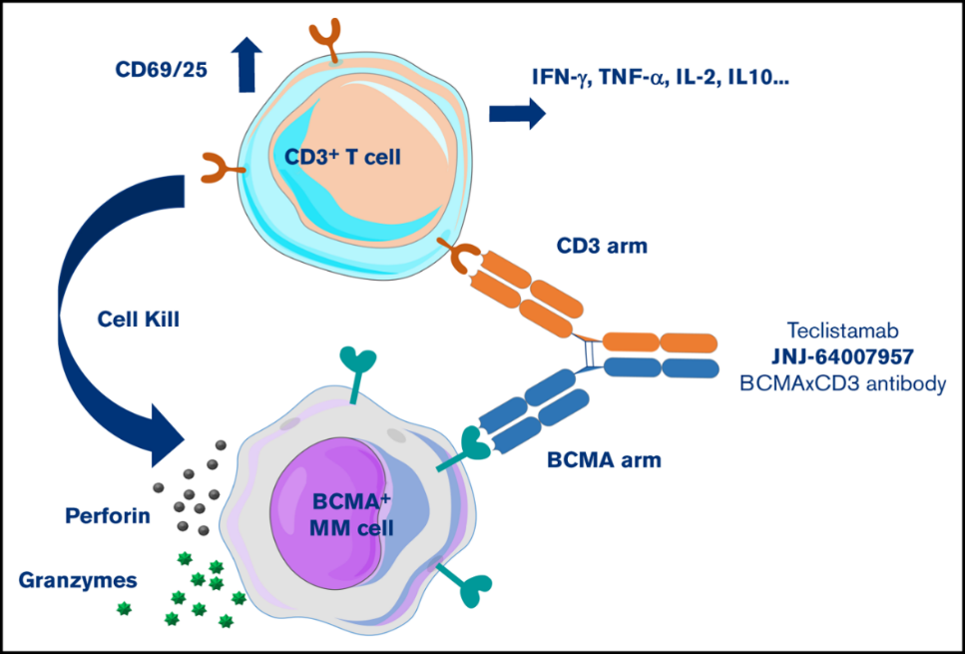
A number of clinical trials are planned or underway to continue the investigation of teclistamab, alone or in combination with or in sequence with other established treatment, in previously untreated and in relapsed and refractory multiple myeloma.
This evaluation was facilitated through Project Orbis, an initiative of the United States Food and Drug Administration (FDA) Oncology Center of Excellence. Under this project, the FDA, Health Canada, the National Health Surveillance Agency (Brazil), Swissmedic (Switzerland) and the TGA collaboratively reviewed the submission. This evaluation process provided a framework for process alignment and management of evaluation issues in real-time across jurisdictions. Each regulator made independent decisions regarding approval (market authorisation) of the new medicine.

Regulatory status
This product is considered a new biological entity for Australian regulatory purposes.
At the time the TGA considered this submission, a similar submission had been approved in the United States of America on 25 October 2022, the European Union on 23 August 2022, the United Kingdom on 9 November 2022, and Switzerland on 22 December 2022. A similar submission was under consideration in Brazil (submitted 25 February 2022), Singapore (submitted 1 November 2022), Canada (submitted 2 November 2022), and Israel (submitted 5 September 22).
The following table summarises these submissions and provides the indications where approved.
Table 1: International regulatory status
Region | Submission date | Status | Approved indications
United States of America | 28 December 2021 | Approved on 25 October 2022 | Tecvayli is indicated for the treatment of adult patients with relapsed or refractory multiple myeloma who have received at least four prior lines of therapy, including a proteasome inhibitor, an immunomodulatory agent and an anti-CD38 monoclonal antibody. This indication is approved under accelerated approval based on response rate. Continued approval for this indication may be contingent upon verification and description of clinical benefit in confirmatory trial(s).
European Union | 31 January 2022 | Approved on 23 August 2022 | Tecvayli is indicated as monotherapy for the treatment of adult patients with relapsed and refractory multiple myeloma, who have received at least three prior therapies, including an immunomodulatory agent, a proteasome inhibitor, and an anti-CD38 antibody and have demonstrated disease progression on the last therapy.
United Kingdom | 19 August 2022 | Approved on 9 November 2022 | Tecvayli is indicated as monotherapy for the treatment of adult patients with relapsed and refractory multiple myeloma, who have received at least three prior therapies, including an immunomodulatory agent, a proteasome inhibitor, and an anti-CD38 antibody and have demonstrated disease progression on the last therapy.
Switzerland | 27 January 2022 | Approved on 22 December 2022 | Tecvayli as monotherapy is indicated for the treatment of adult patients with relapsed or refractory multiple myeloma who have received at least three prior therapies including a proteasome inhibitor, an immunomodulatory agent and an anti-CD38 monoclonal antibody, and have demonstrated disease progression to the last line of therapy.

Product Information
The Product Information (PI) approved with the submission which is described in this AusPAR can be found as Attachment 1. For the most recent PI and Consumer Medicines Information (CMI), please refer to the TGA PI/CMI search facility.

Registration timeline
The following table captures the key steps and dates for this submission.
This submission was evaluated under the provisional registration process.
Table 2. Timeline for Submission PM-2022-01541-1-6
Description | Date
Determination (Provisional) | 9 March 2022
Submission dossier accepted and first round evaluation commenced | 31 May 2022
First round evaluation completed | 21 November 2022
Sponsor provides responses on questions raised in first round evaluation | 31 December 2022
Second round evaluation completed | 15 February 2023
Delegate’s Overall benefit-risk assessment and request for Advisory Committee advice | 3 March 2023
Sponsor’s pre-Advisory Committee response | 16 March 2023
Advisory Committee meeting | 30 and 31 March 2023
Registration decision (Outcome) | 2 June 2023
Administrative activities and registration on the ARTG completed | 14 June 2023
Number of working days from submission dossier acceptance to registration decision* | 209
*Statutory timeframe for standard submissions is 255 working days

Submission overview and risk/benefit assessment

Quality
There were no objections on quality grounds to the registration of teclistamab.
Teclistamab is a glycosylated, humanised IgG4 bispecific antibody that binds to both BCMA on malignant B-cells and CD3 receptors on T-cells. The molecular weight is approximately 146 kilodaltons comprising two heavy chain molecules and two light chain molecules joined by inter-chain disulfide bonds.
The active ingredient was produced using recombinant DNA technology in Chinese hamster ovary cells. The teclistamab active substance is comprised of two parental monoclonal antibodies. The teclistamab active substance is generated by fragment antigen-binding-arm exchange. Details and specifications of the containers, compatibility of the container and a summary of an extractable and leachable study was presented, and it was concluded that the risk for patients due to substances leaching into teclistamab active substance is negligible.
The overall quality of the active substance was demonstrated via adequate control of the starting material, control of critical steps and intermediates, process validation, extensive characterisation using orthogonal and state-of-the-art analytical methods, control of impurities and contaminants, generation of robust reference materials and batch analyses that covered multiple manufacturing campaigns.
The finished product is a sterile liquid for subcutaneous (SC) administration presented in a 3 mL or 1.7 mL solution for injection in a Type I glass vial with an elastomeric closure and aluminium seal with a flip off button. One vial of 3.0 mL or 1.7 mL solution for injection contains 30 mg (10 mg/mL) or 153 (90 mg/mL) of teclistamab, respectively. All excipients are well characterised pharmaceutical ingredients, and their quality is compliant with international pharmacopeial. The container closure is considered suitable for its intended use as demonstrated by compatibility and stability studies.
All analytical methods used for testing of the finished product are satisfactorily described in the dossier and non-compendial methods have been validated.
The proposed release specification for the active substance is found acceptable, with respect to test methods chosen. The proposed specification limits are based on batch analysis and stability study results. This approach is considered acceptable.
Following evaluation, the recommended storage condition is 18 months, when stored at 5 ± 3°C and protected from light. The product is not photostable. The proposed ARTG record will include the instruction ‘Do not freeze’. Sufficient stability data were provided to permit in-use storage at 2°C to 8°C or up to 30°C for a maximum of 20 hours. The product should be discarded after 20 hours if not used.
Good manufacturing practice certification has been provided for all proposed sites.

Nonclinical
The primary pharmacology studies provided an adequate demonstration of in vitro activity of teclistamab against the proposed target (BCMA) and an adequate in vivo mouse model demonstrated efficacy. The pharmacokinetics in cynomolgus monkeys and human patients were acceptably similar and consistent with a protein antibody (long half-life and limited distribution).
No specific organ toxicity was predicted from animal studies. However, the evaluation noted that cytokine release and its sequelae were not seen in animal studies. While teclistamab was well tolerated in cynomolgus monkeys, this observation may relate to the lower cytotoxic potential of teclistamab in monkeys than in humans and a significantly higher load of BCMA+ cells in MM patients compared with normal monkeys.
A Proliferation-Inducing Ligand (APRIL), but not B-cell activating factor (BAFF), inhibited the binding of teclistamab to BCMA+ cells. Circulating soluble BCMA can be found in MM patients, and this could potentially bind to teclistamab, reducing its potency. The evaluation found that at circulating levels APRIL and soluble BCMA may affect teclistamab potency in vivo, however, this is likely to be low.
There is no significant binding to Fcγ receptors, so antibody-dependent cellular phagocytosis and antibody dependent cellular cytotoxicity are unlikely. Similarly, no binding to complement component 1q is expected, so complement dependent cytotoxicity is also unlikely.
Cytokine release syndrome (CRS) from teclistamab treatment may reduce CYP450 expression resulting in an increase in exposure to co-administered CYP450 substrates.
No genotoxicity studies were conducted. This is acceptable for a biotechnology-derived pharmaceutical. No carcinogenicity studies were conducted. This was accepted because of the proposed advanced cancer indication.
The nonclinical evaluation accepted the sponsor’s proposal of Pregnancy Category C. Reproductive and developmental toxicity studies were not conducted. Teclistamab did not bind to reproductive tissue in cross-reactivity studies. It does bind neonatal Fc receptor, and while placental transfer in the third trimester is expected it is not expected to be teratogenic. T-cell activation and cytokine release syndrome in a mother may potentially adversely affect a fetus.
There were no nonclinical objections to the registration of teclistamab for the proposed indication.

Clinical
The clinical pharmacology, clinical efficacy and safety data are all derived from study 64007957MMY1001 (MAJESTEC-1), an ongoing, single arm, phase 1/2, open-label, multicentre study conducted in three parts (Figure 2).
Figure 2. Study MMY1001 (MajesTEC-1) Study Schematic
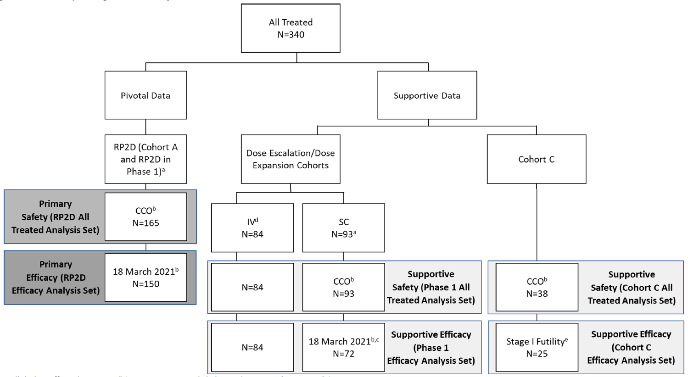
Abbreviations: CCO=clinical cut=off; IV=intravenous; RP2D=recommended Phase 2 dose, SC=subcutaneous(ly)
a. Subjects treated at RP2D (1.5 mg/kg teclistamab SC weekly) in Phase 1 are presented in both pivotal RP2D data and Phase 1 (dose escalation/dose expansion) data.
b. A subject must have received the first dose of teclistamab on or before this date to be included in the indicated population.
c. One subject in the 6 mg/kg SC cohort who received their first step-up dose on 17 March 2021 was excluded from the efficacy analyses for Phase 1 (dose escalation/dose expansion) because the cohort was incomplete at the time of the data cutoff for inclusion in efficacy analysis and the only subject enrolled in it had not yet received a treatment dose.
d. All subjects treated with teclistamab IV received their first dose prior to 18 March 2021.
e. As described in this section, subjects evaluated in Stage 1 of the analysis for Cohort C were included in the efficacy analysis, all of whom received at least 1 dose of teclistamab on or before 23 March 2021.
Parts 1 and 2 were the phase 1 components of the study, that aimed to determine the maximum tolerated dose and the recommended phase 2 dose (RP2D). Significant anti-myeloma activity was part of the hypothesis for the Phase 2 Part 3 of the study. The Phase 1 parts of the study were designed for dose finding.
Part 1 had two components, an intravenous (IV) dose escalation phase, and a SC escalation phase. Dosing in the IV dose escalation phase included dosing ranging from 0.0003 to 0.0192 mg/kg once every two weeks at start and switched to weekly dosing range of 0.0192 to 0.72 mg/kg. Half of all IV treatment doses were preceded by step-up dosing. Cycles were 21 days in length. In the SC dosing cohort, dosing ranged from 0.08 to 6 mg/kg weekly dosing. All SC treatment doses were preceded by step-up dosing.
Part 2 was a dose expansion study at the proposed dose of either 0.72 mg/kg IV or 1.5 mg/kg SC.
Part 3 was the Phase 2 component of the study. It enrolled two cohorts of patients each dosed at 1.5 mg/kg SC.
- Cohort A enrolled 110 patient who had received at least 3 prior lines of therapy including a proteasome inhibitor, an immunomodulatory drug, and an anti-CD38 monoclonal antibody but excluded a BCMA-targeting treatment.
- Cohort C enrolled 25 patients who had received at least 3 prior lines of therapy, as above but whose prior treatment must have included a prior anti-BCMA treatment, as an antibody drug conjugate or a chimeric antigen receptor (CAR) T-cell therapy.
The study inclusion and exclusion criteria are summarised below (Table 3).
Table 3. Study MMY1001 Inclusion and Exclusion Criteria
Inclusion Criteria | Exclusion Criteria
≥18 years of age  Documented MM diagnosis per IMWG diagnostic criteria.  Part 1 and Part 2  Measurable MM that is RR MM to established therapies with known clinical benefit in RR MM or be intolerant of those established MM therapies, and a candidate for teclistamab treatment in the opinion of the treating physician.  Prior lines of therapy must include a proteasome inhibitor, an IMiD, and an anti-CD38 monoclonal antibody in any order during the course of treatment. Patients intolerant of a proteasome inhibitor, IMiD, or an anti-CD38 monoclonal antibody allowed.  Part 2 (dose expansion), in addition, MM must be measurable per current IMWG guidelines by central laboratory assessment (if not available, relevant local laboratory measurement must be ≥ 25% greater than minimum required level).  Part 3  Measurable disease Cohorts A, B, & C: MM measurable by central laboratory assessment:  − Serum monoclonal paraprotein (M-protein) level ≥1.0 g/dL or urine M-protein level ≥200 mg/24 hours; or  − Light chain MM without measurable disease in the serum or the urine: Serum immunoglobulin (Ig) FLC ≥10 mg/dL and abnormal serum Ig kappa lambda FLC ratio. If central laboratory assessments unavailable, local laboratory measurements be ≥ 25% greater than minimum required level  Prior treatment  − Cohort A: 1) ≥3 prior lines of therapy and 2) previously received a proteasome inhibitor, an IMiD, an anti-CD38 monoclonal antibody.  − Cohort B: ≥4 prior lines of therapy and disease is penta-drug refractory to an anti-CD38 monoclonal antibody, ≥2 PIs, ≥2 IMiDs (refractory MM as defined by IMWG consensus criteria).  − Cohort C: ≥3 prior lines of therapy including a proteasome inhibitor, an IMiD, an anti-CD38 monoclonal antibody, an anti-BCMA treatment (with CAR-T cells or an ADC).  ECOG 0 or 1.  Haemoglobin ≥8 g/dL (no RBC transfusion ≤ 7 days before laboratory test; ESA use permitted)  Platelets ≥75×10⁹ /L if 50% of bone marrow nucleated cells are plasma cells; otherwise platelet count ≥50×10⁹ /L (no transfusion support ≤ 7 days before laboratory test)  Absolute Neutrophil Count ≥1.0×10⁹ /L (prior growth factor support is permitted but no support ≤ 7 days before laboratory test)  AST and ALT ≤3.0×ULN  Creatinine or Creatinine clearance/ glomerular filtration rate Serum creatinine: ≤1.5 mg/dL or Creatinine clearance: ≥40 mL/min/1.73 m2 or estimated glomerular filtration rate ≥40 mL/min/1.73 m2 based upon calculation.  Total bilirubin ≤2.0×ULN; unless congenital bilirubinemia, e.g. Gilbert syndrome (then direct bilirubin ≤1.5×ULN)  Corrected serum calcium ≤3.5 mmol/L or free ionised calcium <1.6 mmol/L | Prior treatment with any BCMA-targeted therapy, except Cohort C in Part 3.  Prior antitumour therapy before the first dose of study drug with:  - Targeted therapy, epigenetic therapy, or treatment with investigational drug or used invasive investigational medical device within 21 days or ≥ 5 half-lives, whichever is less.  - Monoclonal antibody treatment for MM within 21 days.  - Cytotoxic therapy within 21 days.  - Proteasome inhibitor therapy within 14 days.  - Immunomodulatory agent therapy within 7 days.  - Gene modified adoptive cell therapy (e.g., CAR-T cells, natural killer [NK] cells) within 3 months.  - Radiotherapy within 14 days or focal radiation within 7 days.  Toxicities from previous anticancer therapies not resolved to baseline levels or to ≤Grade 1 except alopecia or peripheral neuropathy.  Cumulative corticosteroid dose equivalent to ≥140 mg of prednisone ≤ 14-days before the first dose of study drug (not including pre-treatment medication).  Stem cell transplantation:  - Allogeneic stem cell transplant within 6 months. Recipients must be off all immunosuppressive medications for 6 weeks with no signs of GvHD disease.  - Autologous stem cell transplant ≤12 weeks before the first dose of study drug.  Known active CNS involvement or clinical signs of meningeal involvement of MM  Stroke or seizure within 6 months.  Plasma cell leukaemia (>2.0×10⁹ /L plasma cells by standard differential), Waldenström’s macroglobulinemia, POEMS syndrome (polyneuropathy, organomegaly, endocrinopathy, monoclonal protein, and skin changes), or primary amyloid light-chain amyloidosis.  Seropositive for HIV or AIDS.  Hepatitis B infection or at risk for hepatitis B virus (HBV) reactivation. Active Hepatitis C infection.  Pulmonary compromise requiring supplemental oxygen use to maintain adequate oxygenation.  Known allergies, hypersensitivity, or intolerance to the study drug (teclistamab) or its excipients.

Across the RP2D pooled efficacy set, the median age was 64 years (range 33, 84 years), 58.2% were male, and 81.2% were White. Baseline ECOG score was 0 for 33.3% and 1 for 66.1%.
The baseline patient and disease characteristics are described in the tables that follow.
Table 4. Study MMY1001 Patient Baseline Characteristics, RP2D
Table 5. Study MMY1001 Baseline Disease Characteristics RP2D Set
Table 6. Study MMY1001 Baseline Treatment History RP2D Set
Some additional features of the prior treatments in the pooled RP2D population include:
- 100% of the Phase 1 patients and 99.2% of the Phase 2 patients were refractory at any point in therapy.
- 82.5% of the Phase 1 patients and 80% of the Phase 2 patients were double refractory (to proteasome inhibitor + IMiD)
- 80% of the Phase 1 patients and 76% of the Phase 2 patients were triple refractory (to PI+IMiD+anti-CD38)
- 40% of the Phase 1 patients and 27% of the Phase 2 patients were penta-refractory (to 2 PI, 2 IMiD, anti-CD38)

Treatments
Patients commenced teclistamab with a step-up dosing schedule:
- Step-up dose 1: Day 1 0.06 mg/kg SC single dose
- Step-up dose 2: Day 3 (or between 2 and 7 days) 0.3 mg/kg SC single dose
- First maintenance dose: Day 5 (or between 2 and 7 days) 1.5 mg/kg SC single dose.
Followed by a weekly dosing schedule: one week after maintenance dose and weekly thereafter: 1.5 mg/kg once weekly.
All patients received dexamethasone 16 mg, diphenhydramine 50 mg or equivalent, and paracetamol 650 to 1000 mg or equivalent as pre-treatment before each of the step-up doses and the first full teclistamab dose.
The protocol also required pre-treatment with corticosteroids prior to the next dose in any patients who experienced Grade 2 or higher CRS or infusion-related reactions and before the next dose in patients with any grade CRS or infusion-related reactions.
Hospitalisation was mandated during the step-up dosing schedule. Some patients recommenced with step-up dosing after prolonged delays. Hospitalisation was at the discretion of the treating physician if a repeat step-up dose was needed.

Protocol amendments
There were 11 protocol amendments to the study. At Protocol Amendment 10, the Phase I patients were required to have been exposed to an anti-CD38 antibody, and to have had three prior lines of therapy. At Amendment 11, there was a decision that Cohort B would not be opened. Major protocol deviations were reported for 9.1%, of which around half (4.8%) were not meeting eligibility criteria.
At Protocol Amendment 11, biweekly dosing could be considered for certain patient groups. In Phase I, patients treated at RP2D who achieved a response of confirmed PR or better and who had received a minimum of 4 cycles of therapy could switch to biweekly dosing. The decision was based on investigator assessment of the response. In Phase II, patients with a CR or better for a minimum of 6 months could switch to biweekly dosing. The decision was based on investigator assessment of the response.

Pharmacology
The initial population pharmacokinetic (popPK) and exposure response analyses dated 9 December 2021 used data from a 14 June 2021 data cut for concentration data and a cut-off date of 7 September 2021 for dosing, covariate efficacy and safety data. A cut-off date of 9 November 2021 was used for an efficacy analysis and an updated exposure response analysis using a cut-off date of 9 November 2021.

Pharmacokinetics
The typical value of bioavailability with SC dosing was 62.7% from the popPK modelling.
The mean (SD) distribution half-life at first treatment was 3.9 (2.0) days and 6.1 (2.6) days at steady state. The mean (SD) elimination half-life at first treatment was 26.3 (8.2) days and 28.2 (8.7) days at steady state.
C_{max}, 21.1 µg/mL (63%) for C_{trough}, and 3,838 µg*h/mL (57%) for AUC_{tau}.
In the Phase I SC dosing cohort, C_{max} and AUC increased in a dose proportional manner across the dosing range of 0.08 mg/kg to 3 mg/kg weekly.
The mean (CV%) volume of distribution was 5.63 L (29%) and increased with increasing body weight.
Teclistamab clearance decreased over time, and at Dose 13 was a mean (CV%) of 40.8% (56%) reduced compared to baseline. Following multiple weekly 1.5 mg/kg SC doses the mean accumulation (cycle 3: cycle 1) was 2.71-fold for C_{max} and 3.05-fold for AUC_{tau}.
The C_{trough} at Cycle 1 Day 8 was 7.67 (3.52) µg/mL and at Cycle 3 Day 8 was 22.1 (10.9). C_{trough} was maintained above the maximum EC₉₀ identified in an ex vivo cytotoxicity assay.
The distribution for SC and IV administration was explained by a 2-compartment model with first order absorption and time-independent and time dependent elimination pathways. The final population pharmacokinetics model included effects of body weight on time-independent clearance (CL1), volume of distribution of the central compartment (V1), and volume of distribution of the peripheral compartment (V2), the effect of ISS on CL1, and the effect of type of myeloma (IgG versus non-IgG) on CL1 and clearance associated with time-dependent clearance (CL2).
For a patient with a median weight of 74kg, the typical population values of time-independent clearance (CL1), clearance associated with time-dependent clearance (CL2), inter-compartmental clearance (Q), volume of distribution of the central compartment (V1), and volume of distribution of the peripheral compartment (V2) were 0.545 L/day, 0.327 L/day, 0.0473 L/day, 4.09 L, and 1.29 L, respectively. The rate constant for CL2 decrease over time (KDES) was 0.0328/day.
From the popPK modelling, 100% steady state exposure is achieved after Dose 24, and 90% of the steady state exposure is reached at Dose 12.
Within the limitations of the data set, age (range: 24 to 84 years), sex, race, (ethnicity (Hispanic/Latino or not), renal function (individualised estimated glomerular filtration rate by Modification of Diet in Renal Disease 30 to 89 mL/min) and liver function (bilirubin <1.5 × ULN and any AST), no intrinsic factors appeared to contribute to the PK of teclistamab. Whether the PK differs in patients with an individualised CrCL of < 30 mL/min or with moderate or severe hepatic impairment is unknown. Patients with these baseline characteristics were excluded from the study.
No drug-drug interaction studies were conducted. Teclistamab causes the release of cytokines (IL-6, IL-10, TNF-α, and IFN-γ). IL-6 and IL-10 could impact the function of CYP450 enzymes and may be of relevance if cytokine levels are high. Physiologically based pharmacokinetic modelling and simulation suggest the highest risk of drug-drug interaction is from initiation of teclistamab Step-up Dose 1 to 7 days after the first treatment dose or during a CRS event.

Pharmacodynamics
The primary pharmacodynamic data are from the nonclinical studies.
The proposed dose achieved exposure consistently above the maximum EC₉₀, with optimal activation of T-cells and induction of cytokines.
Overall decrease in soluble BCMA was more frequently seen in responders (40 of 59 at Cycle 2 Day 1, 63 of 72 at Cycle 4 Day 1 (response = PR or better)] and was more frequently seen to increase in non-responders (27 of 28 at Cycle 2 Day 1, 9 of 9 at Cycle 4 Day 1). However, higher baseline soluble BCMA was associated with a lower CRS response and a lower objective response rate (ORR).
No exposure-response analyses for efficacy using ORR as the efficacy parameter for the proposed 1.5 mg/kg SC dose, but an exposure response relationship for ORR was seen for below median exposures using data from the SC Phase I dosing from 0.08 mg/kg to 3 mg/kg. Baseline soluble BCMA and baseline PD-1 expression were significantly associated with ORR in the multivariate analysis.
There were no clear exposure response relationships found for safety parameters of Grade 3 of higher cytopaenias and infection by teclistamab exposure quartile.
The evaluation further considered exposure response relationships for CRS. The modelling showed that CRS at Dose 1 predicted a higher risk of CRS at Dose 2, however tocilizumab given at dose appeared to reduce the risk of CRS at Dose 2, possibly because of because of the presence of tocilizumab at Dose 2 (which could be given 2 to 7 days after Dose 1), and/or due to the residual inhibition of IL-6 signalling.
A dedicated QT study was not conducted and was not required per ICH E14 Q&A (R3).

Efficacy
The main efficacy results are from Part 3 Cohort A but the sponsor has included results from the earlier parts of the study. The sponsor however pooled results given the RP2D dosing from Phases I and II for the efficacy analysis set. The Delegate considered baseline characteristics and prior treatments were sufficiently similar for this approach to be accepted given the study design.
There were 150 patients in the efficacy analysis set (40 from Phase I and 110 from Phase II) who had received their first dose of teclistamab by 18 March 2021.
At the 9 November 2021 clinical data cut-off, of the 46 (30.6%) patients who discontinued the study, 42 (28%) had died, and 4 (2.7%) withdrew consent. Half the patients had discontinued teclistamab at the clinical cut-off for the analysis.

Key efficacy results
The primary endpoint was ORR. The key secondary endpoints were VGPR or better, CR, sCR, DOR, minimal residual disease (MRD)-negativity and time to response. The primary hypothesis of efficacy was set at 30%, based on the ORR for belantamab mafodotin from the DREAMM-2 trial (ORR 31%) and selinexor from the STORM study (ORR 26%) (see Table 7 below).
In data provided in response to questions from an analysis dated 15 February 2022, the median duration of follow-up by Kaplan Meier product limit estimate was 9.8 months (range: 0.5 to 20.3 months).
Table 7. Study MMY1001 Efficacy RP2D Efficacy Analysis Set
Parameter | 15 February 2022 analysis result %, (95% CI)
Analysis set: efficacy | 150
Median follow up | 9.8 months
Response category
Stringent complete response (sCR)  Complete response (CR)  Very Good Partial Response (VGPR)  Partial response (PR)  Minimal response (MR)  Stable response (SD)  Progressive Disease (PD)  Not evaluable | 25.3% (18.6%, 33.1%)  6.7% (3.2%, 11.9%)  26.7% (19.8%, 34.5%)  4.0% (1.5%, 8.5%)  0.7% (0%, 3.7%)  17.3% (11.6%, 24.4%)  16.0% (10.5%, 22.9%)  3.3% (1.1%, 7.6%)
Overall response (sCR + CR + VGPR + PR) | 62.7% (54.4%, 70.4%)
VGPR or better (sCR + CR + VGPR) | 58.7% (50.3%, 66.6%)
CR or better (sCR + CR) | 32.0% (24.6%, 40.1%)

Of the 94 responders:
- median time to response was 1.18 months (range: 0.2 to 5.5 months).
- 75 maintained their responses until the clinical cut-off date.
- 14 had disease progression after initial response.
- 5 died without documented disease progression.
Subgroups with adequate numbers for meaningful assessment had results concordant with the main efficacy population. Patients with Baseline revised international staging system or international staging system of III or at least one extramedullary plasmacytomas may not have as favourable results, however, the numbers in each of these subgroups were small and the point estimates for ORR were greater than the pre-specified 30% threshold for efficacy.
The median duration of response was not reached in the December 2021 and the February 2022 analyses. At 12 months, it was estimated that 67.2% were still response, and of the 48 patients with CR, an estimated 83.2% were still in response at 12 months.
Of the 45 patients who met the criteria for a change to biweekly dosing, around 29% went on to have disease progression events. There were similar proportions of events between those who met the criteria for a change to biweekly dosing and did change, and those who met the criteria but did not change dosing schedule. The numbers of patients in each group were small, therefore it is difficult to draw firm conclusions about biweekly dosing from the results.
In the 13 December 2021 CSR addendum and the 15 February 2022 responses to questions, MRD negativity was reported for 39 patients in the RP2D efficacy analysis set and MRD negativity was reported for 20 of 48 patients with a CR. MRD negativity required a baseline sample to be available for testing. The high rate of calibration failure of the assay that was used resulted in missing MRD status for 29.3% of all responders and 31.6% of patients achieving CR or sCR. Due to the uncertainty, the Delegate agrees with the evaluation and does not consider this result sufficiently robust for inclusion in the efficacy results in the PI for Tecvayli.
Time to event endpoints (PFS and OS) were included in the analysis but these are difficult to interpret from a single arm study. Patients reported outcome data were included in the submission, and while there was improvement in scores patients were unblinded to the treatment and there is no comparator arm to the study.
The primary endpoint was also assessed for all patients regardless of when they received their first dose. This added a further 15 patients to the efficacy analysis. The ORR (sCR + CR + VGPR + PR) was 64.2% (95% CI: 56.4%, 71.5%), for VGPR or better was 58.2% (95% CI:50.3%, 65.8%) and CR or better 30.3% (23.4%, 37.9%).
The sponsor included a swimmer’s plot for all treated patients (efficacy analysis set plus 15 additional patients; see Figure 3 below).
Figure 3. Study MMY1001 Swimmers Plot RP2D All Patients Treated
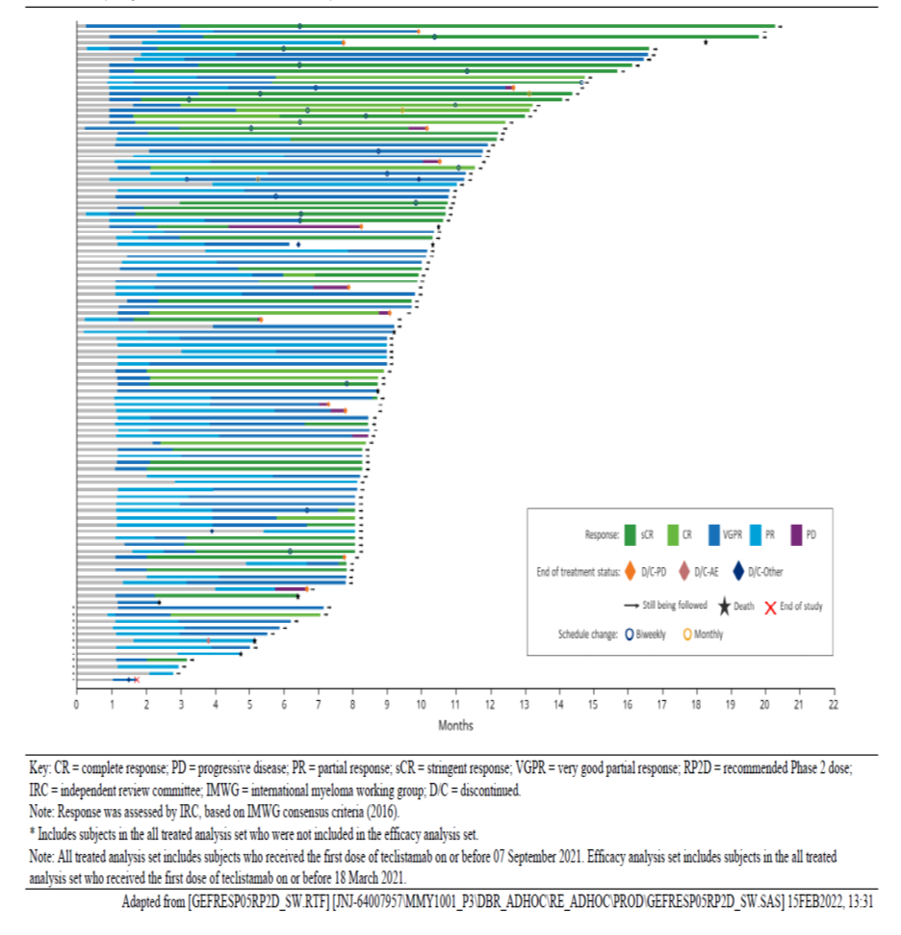

Safety
The teclistamab safety information is also derived from Study MMY1001 and totalled 165 patients who had received the RP2D dose, and a total of 340 patients who had received teclistamab monotherapy (both SC and IV). Across the study the median duration of follow-up for the RP2D set was 6.4 months. The median relative dose intensity was 94.5%.

Treatment emergent adverse events
In the evaluation it was noted the TEAE window for the Phase I patients was 100 days, but the window was 30 days or until the start of subsequent therapy (if earlier) for the Phase II patients. There were also differences in the way Grade 5 events were handled. In Phase I, Grade 5 events could be entered per investigator discretion for patient who had progressive disease as the cause of death during the treatment window. In Phase II, Grade 5 events (including signs or symptoms of progressive disease) were requested to be entered if the death occurred in the treatment emergent window.
All patients experienced at least one adverse event. Among the patients treated with the RP2D dose, 29.1% had Grade 3 events and 52.1% had Grade 4 events.
The most frequent adverse events (≥15%) were hypogammaglobulinaemia (75%), cytokine release syndrome (72%), neutropenia (71%), anaemia (55%), musculoskeletal pain (52%), fatigue (41%), thrombocytopaenia (40%), injection site reaction (38%), upper respiratory treat infection (37%), lymphopenia (35%), diarrhoea (29%), pneumonia (28%), nausea (27%), pyrexia (27%), headache (24%), cough (24%), constipation (21%), pain (21%), COVID-19 (18%), peripheral neuropathy (16%).
Of those events, Grade 3 or 4 events occurring in more than one patient were pneumonia (19%), COVID-19 (12%), musculoskeletal pain (9%), diarrhoea (3.6%), fatigue (3%) haemorrhage (3%), upper respiratory tract infection (2.4%), pain (1.8%), and dyspnoea (1.8%).

Dose interruptions and discontinuations
Dose interruptions (dose delays or dose skips) were reported in 65% of patients. The most frequent adverse events leading to dose interruptions were neutropenia (26%), COVID-19 (12%), pneumonia (10%), CRS (8%) and pyrexia (7%).
At the 19 April 2022 analysis, cycle delays for any reason were reported for 72 (44%) patients, of whom 65 were delayed outside the pre-specified window for cycle delay. The median duration of cycle delay was 5 days (range: 1 to 96 days).
Dose reduction due to an adverse reaction occurred in one patient. Permanent discontinuation of teclistamab due to adverse reactions occurred in 1.2% due to infections, that included one fatal event of progressive multifocal leukoencephalopathy. Dose reduction due to an adverse event occurred in a patient with neutropenia.

Deaths
Within the TEAE window, the sponsor determined 9 patients (5.5%) had died due to PD, and 18 patients (10.9%) due to TEAEs. The sponsor reported deaths due to AEs from COVID-19 (7.3%), pneumonia (1.2%), PML (0.6%), haemoperitoneum (0.6%), hepatic failure (0.6%), and hypovolaemic shock (0.6%).

Serious adverse events
In the CCDS update, adverse drug reactions were reported. Serious adverse drug reactions occurred in 65% of patients. The most common events (>5%) were pneumonia (16%), COVID-19 (16%), cytokine release syndrome (8%), sepsis (7%). Of note, febrile neutropenia was reported for 2.4% and acute kidney injury for 4.8%.

Adverse events of clinical interest

Cytokine release syndrome
Cytokine release syndrome is a supraphysiological response following and immune therapy that results in the activation or engagement of endogenous or infused T-cells and/or other immune effector cells. Symptoms can be progressive, must include fever at the onset and may include hypotension, capillary leak, hypoxia, and end-organ dysfunction.⁴
Teclistamab T-cell activated T-cells cause the release of proinflammatory cytokines, including IL-6, IL-10, TNF-alfa and IFN gamma and IL-2R.
The evaluation noted the grading of CRS for the Phase I patients was per the Lee (2014) criteria and for Phase II patient was per the ASTCT patients in Phase II. It was also noted that immune effector cell therapy-associated neurotoxicity syndrome was formally assessed in Phase II and retrospectively analysed in Phase I.
Using the sponsor’s criteria, 119 patients (72%) had experienced at least one CRS event, with a total of 195 events. Most events occurred at step-up Dose 1 (44%), step-up Dose 2 (35%), or initial (full) treatment dose (24%), and less than 3% had their first event at a subsequent dose. The CRS events were Grade 1 (50%), Grade 2 (21%), and Grade 3 (0.6%). No Grade 4 or fatal CRS events occurred. Of the 18 patients with a repeated step-up dose using the RP2D dosing schedule, two developed CRS symptoms during the repeat step up (one Grade 1 event and one Grade 2 event).
The most common CRS-associated events in the study were pyrexia (72%), hypoxia (13%), chills (12%), hypotension (12%), sinus tachycardia (7%) and elevated liver enzymes (3.6%).
Tocilizumab was used to treat 32%, corticosteroids to treat 11% and tocilizumab plus steroid for 3% of the CRS events. Intravenous fluids were needed in 13.9% and vasopressors in 0.6%.
Events occurred a median of 2.0 days (range :1 (3.8 hours) to 6 days) from the last teclistamab dose and lasted from 1 to 9 days. Immune effector cell-associated neurotoxicity syndrome
Immune effector cell therapy-associated neurotoxicity syndrome (ICANS) is a disorder characterised by a pathologic process involving the central nervous system following any immune therapy that results in the activation or engagement of endogenous or infused T cells and/or other immune effector cells. Symptoms or signs can be progressive and may include aphasia, altered level of consciousness, impairment of cognitive skills, motor weakness, seizures and cerebral oedema.⁴
Five of 165 patients experience a total of 9 ICANS events, all Grade 1 or 2. Among the 38 patients in Cohort C, one experienced one event of ICANs. Most events were associated with step-up doses or the first full treatment dose, and two of the three events that occurred after the first step-up regimen occurred after prolonged drug interruption. These data are limited because ICANS was not formally part of the prospective safety information collected in Phase I of Study MMY1001.
Across the RP2D group ICANS was reported for 3% of patients with the most frequent preferred terms (2 or more patients) confused state (1.2%) and dysgraphia (1.2%).
77.8% of ICANs occurred concurrently with a CRS event. All resolved, but symptoms lasted up to 20 days.

Neurological
Neurotoxicity events were reported in 15% of patients with the most common event of headache (8.5%). Within the TEAE window, most were Grade 1 in severity but 5.5% were Grade 2 events (5.5%) and one Grade 4 event were reported. Most occurred after Cycle 1 and were of variable duration from 1 day to 291 days.
In the sponsor’s responses to questions dated 20 April 2022, in the RP2D safety set, 51.5% of patients had a neurological TEAE, and 12.7% had a neurotoxicity adverse event.
However, using all the Medical Dictionary for Regulatory Activities Preferred Terms in the sensory neuropathy, encephalopathy and Motor Dysfunction and all terms for headache including migraine, any Grade 1 events was reported for 42.4% of the RP2D set.
The US FDA review document notes two additional serious neurological TEAEs (Grade 4 seizure and Grade 5 Guillain Barre syndrome) in the 120-day report occurred with longer follow-up.

Cytopaenias
Cytopaenias were common. In the RP2D safety set Grade 3 or 4 neutropenia, anaemia, thrombocytopaenia and lymphopenia were reported in 57%, 34.5%, 21.2%, 32.1%, respectively. Although there were no Grade 5 events, febrile neutropenia was reported in 5 patients (3%).

Infections
Eight patients had Grade 5 infections. The evaluation found that in addition, 30% had serious infections, 35% Grade 3 or 4 infections and 30% opportunistic infections.

Injection site reactions
Injection site reactions were reported for 58 patients (35.2%), most were Grade 1 (30.3%) or Grade 2 (4.8%). Topical steroids were administered for 14 patients (8.5%) and antihistamines for 6 patients (3.6%).

Hypogammaglobulinaemia
Hypogammaglobulinaemia was very common (119 patients (72%)) and occurred either as a TEAE or a laboratory abnormality. The most severe events were Grade 3 and occurred in 2 of 119 patients. 41 patients received IV gammaglobulin. The evaluation noted that 40% of patients had IgG < 500 mg/dL at baseline, therefore these results are more difficult to interpret.

Immunogenicity
No antidrug antibodies (ADA) were identified in results from 150 patients who had received 1.5 mg/kg SC and at least one post-dose ADA test, from the 79 patients with ADA assessment at ≥6 months or the 9 patients with ADA assessment at ≥12 months. Across the study an analysis of data from 238 patients including other dosing cohorts, one patient from the IV dosing and one patient form the SC dosing groups had a positive ADA titre and one patient had neutralising antibodies of low titre (0.5%). Samples collected during CRS events or systemic administration -related reactions were not positive for teclistamab ADA.

Laboratory abnormalities
Laboratory abnormalities are summarised in Table 8 below.
Table 8: Study MMY 1001 Laboratory abnormalities worsening from Baseline in at least 20% of patients treated.
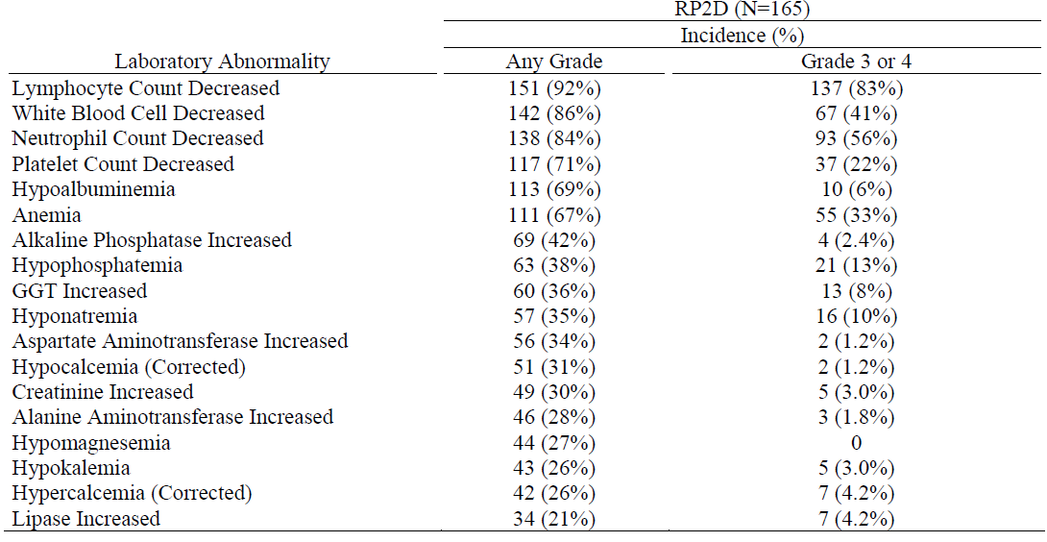
Although elevations of liver enzymes were noted and there was a fatal event with elevated liver enzymes, and while there was insufficient evidence to support drug-induced liver injury a contribution from teclistamab could not be entirely excluded.

Risk management plan
The summary of safety concerns and their associated risk monitoring and mitigation strategies are summarised in Table 9.
Table 9: Summary of safety concerns
Summary of safety concerns |  | Pharmacovigilance |  | Risk Minimisation
 |  | Routine | Additional | Routine | Additional
Important identified risks | Cytokine release syndrome |  | * |  | †
Important identified risks | Neurologic toxicity |  | * |  | –
Important identified risks | Serious infections |  | * |  | –
Important potential risks | None | – | – | – | –
Missing information | Long term safety |  | * | – | –
* Study 64007957MMY1001; † Patient Alert Card
The summary of safety concerns in the ASA is consistent with the EU-RMP.

Risk-benefit analysis
Delegate’s considerations
Teclistamab is a first-in-class, humanised IgG4-proline, alanine, alanine bispecific antibody directed against the BCMA and CD3 receptors, with a proposed use in later line relapsed and refractory multiple myeloma. Unlike CAR-T cells, teclistamab is an off-the shelf product, administered subcutaneously so it is likely to have broad interest.
The proposed registration is supported by data from one single arm Phase I and Phase II study conducted in patients with RR MM who had been exposed to at least three lines of therapy and three classes of drugs.
The Phase I part of the study is most relevant for understanding the human pharmacology and the RP2D and Cohort A of Part 3 (Phase II) is more relevant for this submission. There were protocol amendments that changed the inclusion criteria, however the patients included in the efficacy analysis and sufficiently similar baseline characteristics and exposure to teclistamab. The Delegate has accepted the sponsor’s approach of combining efficacy from some of the Phase I patients who received the RP2D of 1.5 mg/kg SC. Single arm data can be accepted in the provisional registration setting, in this late line of RR MM, where there is no established single standard of care regimen against which to randomise.
The efficacy set included 150 patients who had all previously received a PI, a IMiD and an anti-CD38 antibody, and who had received their first dose by March 2021.The patients had a median age of 64 years, were mostly White, with around 4% Asian patients. Most patients had an international staging system or revised international staging system staging of I or II, over half had ≤30% plasma cells on bone-marrow biopsy or aspirate and almost ¾ had standard cytogenetic risk. Patients were a median of 6 years from diagnosis, most were penta-exposed (2 × PI, 2 × IMiD and anti-CD30 antibody) and had received a median of 5 prior lines of therapy. In addition, around 68% had had an autologous stem cell transplant. It is not unexpected that the majority had an ECOG Performance Status of 1. It is considered these patients adequately represent patients who could be offered teclistamab if it were to be provisionally approved.
The dose taken forward for Phase II study and beyond was identified in the Phase I part of the study. The dose chosen for the RP2D was chosen to ensure exposure at trough levels would be at or near maximum concentration for teclistamab to kill MM mononuclear cells in an ex vivo and for optimal activity of T-cell activation, induction of cytokines and T-cell redistribution. Because of the risk of CRS teclistamab treatment commenced with a step-up dosing regimen to the target of 1.5 mg/kg, as is proposed for registration.
The primary endpoint was ORR. This is reasonable given the non-randomised nature of the study. The sponsor’s primary hypothesis of efficacy was for an ORR of 30% based on studies with other agents in this late line multiple class refractory MM patient group. The threshold for efficacy is accepted and the observed ORR of 62.7% exceeded the efficacy threshold. The response appears to occur early in treatment, and in some patients deepens with time. The sCR of 25.3% and VGPR of 26.37% are promising results in this late line setting. Subgroups are generally supportive of the primary endpoint, although the results for some groups are limited by small numbers. MRD-negativity may have been a useful endpoint, but the limitations of the assay add uncertainty to the results. The durability of the response remains uncertain. The median DOR has not been reached in any of the analyses provided by the sponsor. Study MMY1001 is ongoing, and the provision of final study outcomes for evaluation is proposed as a condition of registration.
Teclistamab is early in its clinical development and its safety profile is still emerging. All studied patients reported at least one TEAE, and around half the patients had a grade 4 event. Serious ADRs occurred in 65% of patients and deaths due to AEs in 10.9%, with COVID-19 and pneumonia the most common of these but there were deaths within the TEAE window of single events that included one event of hepatic failure and one event of PML.
Based on the mechanism of action, and from experience with CAR-T cell therapy CRS and ICANS are anticipated events. CRS is a potentially life-threatening event. The sponsor has put in place strategies to reduce the risk, including patient premedication, the step-up dosing regimen. In the MMY1001 study patients were required to remain in the health facility for the initiation of treatment. CRS events still occurred and in 72% of patient but were mostly Grade 1 and 2. Other risks include ICANS, which again was mostly of lower grade in the study. Other neurological events, but mostly headache, were reported. One late, fatal event of Guillain-Barre syndrome was noted in the evaluation.
As with many other treatments for MM, cytopaenias were commonly and included Grade 3 and 4 events. Infections also were common and included serious and severe infections occurred in 30% to 35% of patients. These included some fatal events and opportunistic infections. The PI provides specific instructions about Herpes zoster virus reactivation prophylaxis, and Hepatitis B reactivation.
As a SC injection, injection site reactions are an event of interest. While they were reported in 38% of patients and were Grade 1 or 2 and if treatment was required, local treatment was sufficient.
Hypogammaglobulinaemia was common, and 41 of 165 patients received IV immunoglobulins. It has not been included as a precautionary statement because some patients contributing data to this finding had low immunoglobulins pre-treatment.
Teclistamab does not appear strongly immunogenic but as only relatively small numbers of patients have been exposed, no firm conclusions can be drawn about any possible impact of ADAs on efficacy or safety.
There is a RMP. Much of the risk mitigation from a regulatory perspective in Australia relies on the PI, with additional information available to be provided to the patient in the form of a downloadable Patient Alert Card. The RMP evaluation has not favoured a boxed warning regarding CRS however it is noted that a Boxed warning is in place for CAR-T cell therapies with similar toxicities. The US FDA has required a REMS with a restricted access program that restricts distribution of, and access to teclistamab that includes dispensing only by trained pharmacists and prescription only by trained physicians. Teclistamab is a new, subcutaneously administered medicine with significant and potentially life-threatening toxicities that may begin with non-specific symptoms and where a high index of suspicion is needed to recognise these conditions early. The health professionals first assessing and treating patients in an out-patient and emergency setting are unlikely to be representatives of the patient’s haematology team, therefore the Tecvayli PI needs to quickly alert treating health professionals to the urgently actionable and potentially unexpected adverse events for teclistamab.
The sponsor has included instructions in the PI regarding strategies to prevent CRS, but these are largely medication based. The PI recommends the patient remain within proximity of a healthcare facility with daily monitoring for 48 hours. This is a new product its SC dosing regimen means it will be deliverable in a wider range of clinical contexts. Therefore, clear safety information for health professionals and patients will be critical for the safe use of the product. In the Australian context that instruction is ambiguous, proximity is a relative concept and not all healthcare facilities have staff trained in the recognition and management of CRS or are equipped to deal with it. The draft Tecvayli PI does include premedication dosing instructions and clear, tabulated, and detailed recommendations for the management of CRS and ICANS. It also includes precaution statements regarding these risks. It is noted that eviQ has guidance and learning modules about CRS, which also may have applicability for this medicine.⁵
The sponsor’s position is that the benefits outweigh the harms when teclistamab is used in accordance with the proposed PI dosing instructions. The ACM will be asked if the proposed risk minimisation strategies are sufficient to support the safe use of teclistamab in Australia, or whether specific measures, including a boxed warning about CRS and ICANS are needed to mitigate the risks.
A plan to provide confirmatory data is a necessary component of a provisional registration. The sponsor has proposed a comprehensive clinical development plan that is designed to confirm the activity of teclistamab in multiple myeloma. The sponsor has included several studies in the clinical study plan. The MAJESTEC-3 trial is proposed to support the conversion from provisional to full registration. The clinical development plan is expanding, and the MAJESTEC-7 and MAJESTEC-9 trials have been recently added in the Australian specific annex of the RMP. The Delegate proposes to include study reports from Study MMY1001 in the conditions of registration.
Proposed action
This submission includes preliminary single arm data to support a benefit in RR MM after three therapies including three classes of commonly medicines in the MM setting. The magnitude of benefit for ORR is persuasive in this setting but how durable the response is and any impact on subsequent therapy are both currently unknowns. This is a new medicine with an emerging safety profile in which the risks are significant, potentially life-threatening and deaths have occurred. The risks require active management. Teclistamab is proposed for provisional registration, which is a recognition of the uncertainties in the submission, the ongoing nature of the clinical development plan, the emerging safety information and the preliminary evidence supporting benefit for patients late in the disease trajectory of multiple myeloma.

Advisory Committee considerations
The Advisory Committee on Medicines (ACM), having considered the evaluations and the Delegate’s overview, as well as the sponsor’s response to these documents, advised the following.

Specific advice to the Delegate
- Please comment on whether the risk minimisation activities proposed by the sponsor are sufficient to minimise the risks of teclistamab in Australia.
  - Please consider whether a boxed warning relating to cytokine release syndrome is warranted.
The ACM was of the view that a boxed warning for CRS is warranted. The ACM also supported the inclusion of a boxed warning for ICANS.
The ACM noted that 72% of study participants experienced CRS and while most events were mild there is potential for severe and life-threatening events and awareness is important.
In providing this advice the ACM noted that patients with CRS or ICANS symptoms are likely to initially present to health professionals other than their haematologist. Teclistamab is a new medicine with new toxicities that can present with non-specific symptoms and reiterated that awareness is important to ensure appropriate management of significant adverse events. The ACM also noted that a boxed warning for both CRS and ICANS is included within the US PI.
  - Is prescriber education prior to access to teclistamab needed?
The ACM agreed that health professional education could be beneficial noting this is a new medicine undergoing provisional registration with a new toxicity profile.
The ACM discussed strategies to ensure that healthcare professionals managing a serious or life-threatening adverse event, including CRS, outside of the haematology service have the appropriate and timely information available. The ACM noted that the patient alert card and/or letter from the treating haematologist is the most appropriate tool for providing this timely information. The ACM also highlighted that the key message should be to contact the haematology service immediately.

Conclusion
The ACM considered this product to have an overall positive benefit-risk profile for the indication:
Tecvayli as monotherapy has provisional approval and is indicated for the treatment of adult patients with relapsed or refractory multiple myeloma who have received at least three prior therapies, including a proteasome inhibitor, an immunomodulatory agent and an anti-CD38 monoclonal antibody.
The decision to approve this indication has been made on the basis of the overall response rate in a single arm study. Continued approval of this indication depends on verification and description of benefit in confirmatory trials.

Outcome
Based on a review of quality, safety, and efficacy, the TGA approved the registration of Tecvayli (teclistamab), 10mg/mL and 90mg/mL, solution for injection, vial, for the proposed indication:
Tecvayli as monotherapy has provisional approval and is indicated for the treatment of adult patients with relapsed or refractory multiple myeloma who have received at least three prior therapies, including a proteasome inhibitor, an immunomodulatory agent and an anti-CD38 monoclonal antibody.

Specific conditions of registration applying to these goods
- Tecvayli (teclistamab) is to be included in the Black Triangle Scheme. The PI and CMI for Tecvayli must include the black triangle symbol and mandatory accompanying text for five years, or the product’s entire period of provisional registration, whichever is longer.
- The Tecvayli EU-risk management plan (RMP) (version 1.5, dated 26 August 2022, data lock point 16 March 2022), with Australian specific annex (version 3.0, dated 20 February 2023), included with Submission PM-2022-01541-1-6, and any subsequent revisions, as agreed with the TGA will be implemented in Australia. An obligatory component of risk management plans is routine pharmacovigilance. Routine pharmacovigilance includes the submission of periodic safety update reports (PSURs). Unless agreed separately between the supplier who is the recipient of the approval and the TGA, the first report must be submitted to TGA no later than 15 calendar months after the date of the approval letter. The subsequent reports must be submitted no less frequently than annually from the date of the first submitted report until the period covered by such reports is not less than three years from the date of the approval letter, or the entire period of provisional registration, whichever is longer.
- The reports are to at least meet the requirements for PSURs as described in the European Medicines Agency’s Guideline on good pharmacovigilance practices (GVP) Module VII-periodic safety update report [Revision 1], Part VII.B Structures and processes. Note that submission of a PSUR does not constitute an application to vary the registration. Each report must have been prepared within ninety calendar days of the data lock point for that report.
- Laboratory testing and compliance with Certified Product Details (CPD)
  - All batches of Tecvayli (teclistamab) supplied in Australia must comply with the product details and specifications approved during evaluation and detailed in the Certified Product Details (CPD).
  - When requested by the TGA, the sponsor should be prepared to provide products ampules, specified reference materials and documentary evidence to enable the TGA to conduct laboratory testing on the Product. Outcomes of laboratory testing are published biannually in the TGA Database of Laboratory Testing Results http://www.tga.gov.au/ws-labs-index and periodically in testing reports on the TGA website.
- The Certified Product Details (CPD), as described in Guidance 7: Certified Product Details of the Australian Regulatory Guidelines for Prescription Medicines (ARGPM), in PDF format, for the above products should be provided upon registration of these therapeutic goods. In addition, an updated CPD should be provided when changes to finished product specifications and test methods are approved in a Category 3 application or notified through a self-assessable change. A template for preparation of CPD for biological prescription medicines can be obtained from the TGA website
  - [for the form] https://www.tga.gov.au/form/certified-product-details-cpd-biological-prescription-medicines
  - [for the CPD guidance] https://www.tga.gov.au/guidance-7-certified-product-details
- The sponsor must conduct studies as described in the clinical study plan in version 2.0 (dated 15 December 2022) of the Australia-specific annex.
- Final study reports for the following studies should be submitted to TGA for evaluation:
  - 64007957MMY3001 (MAJESTEC-3)
  - 64007957MMY1001 – Updated safety report expected [Quarter]4 2023 and final report expected [Quarter]4 2028
- For all injectable products the Product Information must be included with the product as a package insert.

Attachment 1. Product Information
The PI for Tecvayli approved with the submission which is described in this AusPAR is at Attachment 1. For the most recent PI, please refer to the TGA PI/CMI search facility.

Therapeutic Goods Administration
PO Box 100 Woden ACT 2606 Australia
Email: info@tga.gov.au Phone: 1800 020 653 Fax: 02 6203 1605
https://www.tga.gov.au
Reference/Publication #

This is the original indication proposed by the sponsor when the TGA commenced the evaluation of this submission. It may differ to the final indication approved by the TGA and registered on the Australian Register of Therapeutic Goods.
Palumbo A, Anderson K Multiple Myeloma N Engl J Med 2011;364(11):1046-1060
Myeloma: Cancer Council https://www.cancercouncil.com.au/myeloma/about-myeloma/
MSAG Myeloma Clinical Practice Guideline 2022 myeloma_clinical_practice_guideline_oct19.pdf
Rajukumar SV , Merlini G San Miguel JF Haematological cancer: Redefining Myeloma Nat Rev Clin Oncol 2012;9:494-496
Landgren O, Kyle RA, Pfeiffer RM et al Monoclonal Gammopathy of undetermined significance (MGUS) consistently precedes multiple myeloma: a prospective study Blood 2009;113:5412-5417
Multiple Myeloma statistics Cancer.net last accessed 19 February 2023
Pillarisetti K, Powers G, Luistro L et al Teclistamab is an active T cell-directing bispecific antibody against B-cell maturation antigen for multiple myeloma Blood Adv 2020;4(18):4538-4549
Teclistamab Clinicaltrials.gov Search of: teclistamab - List Results - ClinicalTrials.gov search dated 19 February 2023
Induction with or without hematopoietic stem cell transplant and with or without maintenance therapy is considered a single line of therapy. Have undergone ≥1 complete cycle of treatment for each line of therapy, unless progressive disease was the best response to the line of therapy. Patient must have documented evidence of progressive disease based on investigator’s determination of response by the IMWG 2016 criteria on or within 12 months of their last line of therapy. Also patient with documented evidence of progressive disease (as above) within 6 months and who are refractory or non-responsive to their most recent line of therapy afterward are eligible.
Lee DW, Santomasso BD, Locke FL, et al ASTCT Consensus Grading for Cytokine Release Syndrome and Neurological Toxicity Associated with Immune Effector CellsBiol Bone Marrow Transplant 2019;25:625-638

