Australian Public Assessment Report for Omvoh
  - Active ingredient: Mirikizumab
  - Sponsor: Eli Lilly Australia Pty Ltd
March 2024

About the Therapeutic Goods Administration (TGA)
- The Therapeutic Goods Administration (TGA) is part of the Australian Government Department of Health and Aged Care and is responsible for regulating therapeutic goods, including medicines, medical devices, and biologicals.
- The TGA administers the Therapeutic Goods Act 1989 (the Act), applying a risk management approach designed to ensure therapeutic goods supplied in Australia meet acceptable standards of quality, safety, and efficacy.
- The work of the TGA is based on applying scientific and clinical expertise to decision-making, to ensure that the benefits to the Australian public outweigh any risks associated with the use of therapeutic goods.
- The TGA relies on the public, healthcare professionals and industry to report problems with therapeutic goods. The TGA investigates reports received to determine any necessary regulatory action.
- To report a problem with a therapeutic good, please see the information on the TGA website.

About AusPARs
- The Australian Public Assessment Report (AusPAR) provides information about the evaluation of a prescription medicine and the considerations that led the TGA to approve or not approve a prescription medicine submission. Further information can be found in Australian Public Assessment Report (AusPAR) guidance.
- AusPARs are prepared and published by the TGA.
- AusPARs are static documents that provide information that relates to a submission at a particular point in time. The publication of an AusPAR is an important part of the transparency of the TGA’s decision-making process.
- A new AusPAR may be provided to reflect changes to indications or major variations to a prescription medicine subject to evaluation by the TGA.

Copyright
© Commonwealth of Australia 2024
This work is copyright. You may reproduce the whole or part of this work in unaltered form for your own personal use or, if you are part of an organisation, for internal use within your organisation, but only if you or your organisation do not use the reproduction for any commercial purpose and retain this copyright notice and all disclaimer notices as part of that reproduction. Apart from rights to use as permitted by the Copyright Act 1968 or allowed by this copyright notice, all other rights are reserved and you are not allowed to reproduce the whole or any part of this work in any way (electronic or otherwise) without first being given specific written permission from the Commonwealth to do so. Requests and inquiries concerning reproduction and rights are to be sent to the TGA Copyright Officer, Therapeutic Goods Administration, PO Box 100, Woden ACT 2606 or emailed to <tga.copyright@tga.gov.au>.

Contents
List of abbreviations 4
Product submission 6
Submission details 6
Product background 7
The disease/condition 7
Current treatment options 7
Assessing disease and response in clinical trials 8
Clinical rationale 9
Regulatory status 10
Australian regulatory status 10
Foreign regulatory status 10
Registration timeline 11
Submission overview and risk/benefit assessment 12
Quality 12
Nonclinical 13
Clinical 15
Summary of clinical studies 15
Pharmacology 15
Efficacy 21
Safety 30
Risk management plan 37
Risk-benefit analysis 38
Delegate’s considerations 38
Proposed action 40
Advisory Committee considerations 40
Outcome 41
Specific conditions of registration applying to these goods 41
Attachment 1. Product Information 42

List of abbreviations
Abbreviation | Meaning
5ASA | 5-aminosalicylates
ACM | Advisory Committee on Medicines
ADA | Antidrug antibody
ARTG | Australian Register of Therapeutic Goods
BMI | Body mass index
CI | Confidence interval
CL | Clearance
CMI | Consumer Medicines Information
CPD | Certified Product Details
CRP | C-reactive protein
CYP | Cytochrome P450
DLP | Data lock point
eCOA | Electronic clinical outcome assessment
EMA | European Medicines Agency
ES | Endoscopic score
EU | European Union
FDA | United States Food and Drug Administration
IL | Interleukin
ITT | Intent to treat
IV | Intravenous
JAK | Janus kinase
mITT | Modified intent to treat
mMs | Modified Mayo score
PD | Pharmacodynamic(s)
PI | Product Information
PK | Pharmacokinetic(s)
PopPK | Population pharmacokinetic(s)
RB | Rectal bleeding
RMP | Risk management plan
SC | Subcutaneous
SF | Stool frequency
T_{1/2} | Half-life
TEAE | Treatment-emergent adverse event
TGA | Therapeutic Goods Administration
TNF | Tumour necrosis factor
UC | Ulcerative colitis

Product submission

Submission details
Type of submission: | New biological entity
Product name: | Omvoh
Active ingredient: | Mirikizumab
Decision: | Approved
Date of decision: | 26 September 2023
Date of entry onto ARTG: | 27 September 2023
ARTG numbers: | 391347, 391348 and 391349
Black Triangle Scheme  for the current submission: | Yes
Sponsor’s name and address: | Eli Lilly Australia Pty Ltd  Level 9, 60 Margaret Street, Sydney NSW 2000
Dose forms: | Concentrate for solution for infusion and solution for injection
Strengths: | 100 mg/mL and 300 mg/15 mL
Containers: | Autoinjector (pre-filled pen), pre-filled syringe and vial
Pack sizes: | One vial  2, 4, 6 autoinjector and pre-filled syringe
Approved therapeutic use for the current submission: | Omvoh is indicated for the treatment of moderately to severely active ulcerative colitis (UC) in adult patients who have had an inadequate response with, lost response to, or were intolerant to conventional therapy or a biological medicine, or have medical contraindications to such therapies.
Routes of administration: | Subcutaneous, and intravenous infusion
Dosage: | Therapy with Omvoh is intended for use under the guidance and supervision of a healthcare professional experienced in the diagnosis and treatment of ulcerative colitis.  Omvoh is single use in one patient on one occasion only.  Recommended dose regimen is different for induction and maintenance dose.  For further information regarding dosage, such as dosage modifications to manage adverse reactions, refer to the Product Information.
Pregnancy category: | B1  Drugs which have been taken by only a limited number of pregnant women and women of childbearing age, without an increase in the frequency of malformation or other direct or indirect harmful effects on the human fetus having been observed.  Studies in animals have not shown evidence of an increased occurrence of fetal damage.  The use of any medicine during pregnancy requires careful consideration of both risks and benefits by the treating health professional. The pregnancy database must not be used as the sole basis of decision making in the use of medicines during pregnancy. The TGA does not provide advice on the use of medicines in pregnancy for specific cases. More information is available from obstetric drug information services in your state or territory.

Product background
This AusPAR describes the submission by Eli Lilly Australia Pty Ltd (the sponsor) to register Omvoh (mirikizumab) 100 mg/mL and 300 mg/15 mL, concentrate for solution for infusion and solution for injection, autoinjector (pre-filled pen), pre-filled syringe and vial, for the following proposed indication:
Treatment of moderately to severely active ulcerative colitis (UC) in patients who have had an inadequate response with, lost response to, or were intolerant to conventional therapy or a biologic treatment or a Janus kinase (JAK) inhibitor, or have medical contraindications to such therapies.

The disease/condition
One of two major forms of inflammatory bowel disease, ulcerative colitis (UC) is characterised by episodes of mucosal colonic inflammation extending proximally from the rectum in a continuous fashion. Common symptoms include diarrhoea, which may be bloody, as well as urgency, abdominal pain and tenesmus. Severity of symptoms ranges from mild (for example, four or fewer bowel motions daily) to severe, with frequent episodes of bloody diarrhoea and systemic toxicity (for example, fever, fatigue, weight loss). Fulminant colitis requiring colectomy can occur.
Extraintestinal manifestations include arthritis, uveitis and primary sclerosing cholangitis. Complications, aside from those related to fulminant colitis, include stricturing and colorectal cancer. Despite the significant morbidity described, overall mortality rates in UC are only slightly higher than the general population (hazard ratio 1.2). Other studies show overall mortality rates that are the same as the general population.

Current treatment options
Treatment aims to achieve disease modification, rather than just symptom control. There is an emphasis on earlier use of effective therapies to achieve and maintain corticosteroid-free remission and endoscopic healing. Distal disease may be treated with topical 5-aminosalicylate (5ASA) agents or corticosteroids. Mild, but more proximal disease, may be treated with oral 5ASA agents. Moderate disease usually requires oral corticosteroids, but they are not suitable for long term use due to toxicity. In patients who have not responded adequately to the above treatments or in whom corticosteroids are unable to be weaned, as well as those with more severe disease, further lines of therapy include oral drugs (for example, azathioprine) and biological medicines (for example, infliximab).
The Australian Register of Therapeutic Goods (ARTG) entries for drugs with an indication for ulcerative colitis are as follows:
- Topical agents given per rectum:
  - 5ASA drug - mesalazine
  - Corticosteroids - budesonide, hydrocortisone, prednisolone
- Small molecule oral drugs:
  - 5ASA drugs - mesalazine, sulfasalazine, balsalazide, olsalazine
  - Corticosteroids - prednisolone, dexamethasone, budesonide
  - Janus kinase (JAK) inhibitors - tofacitinib, upadacitinib
  - Sphingosine 1-phosphate receptor modulator - ozanimod
  - Whilst commonly used, thiopurine drugs do not have specific UC indications in the ARTG.
- Biological drugs:
  - Tumour necrosis factor (TNF) - antagonist drugs - infliximab, adalimumab, golimumab
  - α4β7 integrin inhibitor - vedolizumab
  - Combined interleukin (IL) 12/IL-23 inhibitor - ustekinumab
Ustekinumab is the Australian registered biological medicine most similar to mirikizumab and is ‘indicated for the treatment of adult patients with moderately to severely active ulcerative colitis’.

Assessing disease and response in clinical trials
Many scoring tools for UC have been developed, beginning with Truelove and Witt’s 1955 study, which included clinical symptoms, laboratory values and endoscopic assessment. Since 1987, one of the most utilised scoring systems has been the Mayo Score, shown in Table 1. Due to concerns about assessment of mucosal friability (part of endoscopic score) and physician’s global assessment, a modified Mayo score has been developed which excludes these problematic components. The modified Mayo Score (mMS) gives a maximum score of 9 and consists of stool frequency, rectal bleeding and endoscopic components (Figure 1).
The United States Food and Drug Administration (FDA) recommends mMS use to define the primary efficacy assessment in clinical trials of clinical remission, which is an mMS 0 to 2 (stool frequency 0 or 1; rectal bleeding 0; endoscopy score 0 or 1). The FDA defines clinical response, an important secondary endpoint for trials, as a decrease from Baseline mMS of at least 2 points and 30%, as well a decrease in rectal bleeding score of at least 1 or an absolute rectal bleeding score of 0 out of 1. The TGA adopted European Medicines Agency (EMA) guideline does indicate that remission should be the primary outcome, however does not advocate a particular scoring system to use.
Table 1: Mayo score
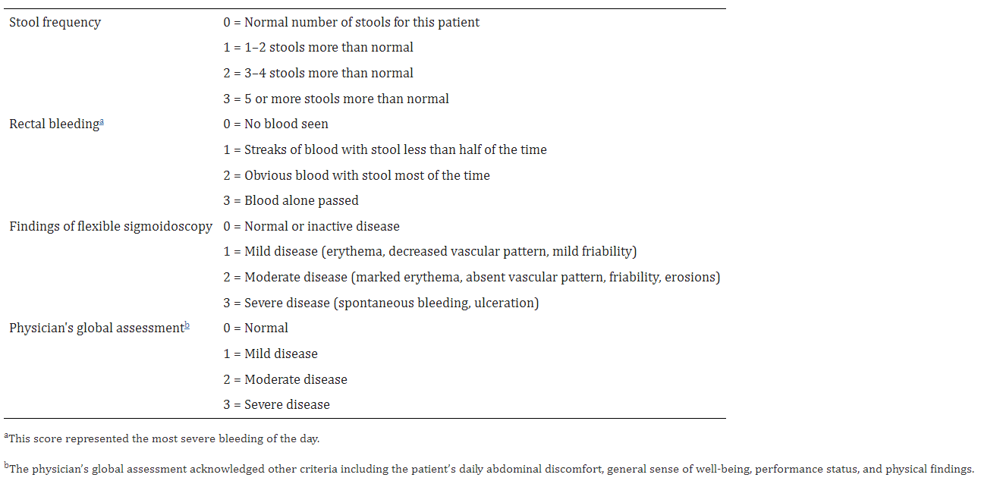
Figure 1: Endoscopic components of Mayo score
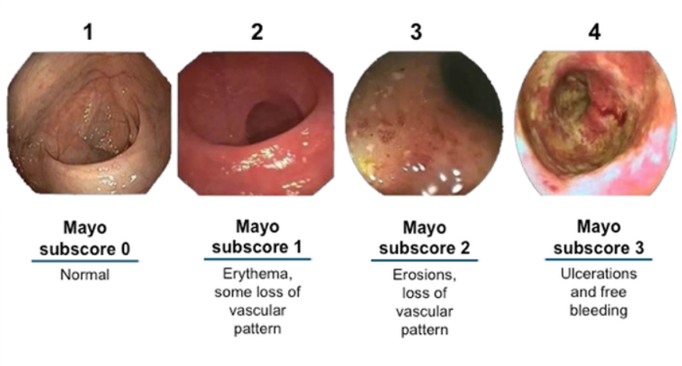
In addition to these clinical/endoscopic systems, commonly used biomarkers, both in research and clinical care, include C-reactive protein (CRP) and faecal calprotectin.

Clinical rationale
Mirikizumab is a humanised immunoglobulin G4 monoclonal antibody that inhibits interleukin-23p19 (IL-23p19). It binds with high affinity and specificity to the p19 subunit of IL-23, a proinflammatory cytokine implicated in various inflammatory diseases, including ulcerative colitis. IL-23 has two components, the p40 and p19 subunits. As it shares p40 with IL-12, targeting p19 results in specificity for IL-23, which may improve clinical safety. This is on the basis that IL-12 is important for tumour immunity and protection from infection.
Three other monoclonal antibodies that appear on the ARTG selectively inhibit IL-23. Risankizumab is indicated for psoriasis, psoriatic arthritis and Crohn’s disease. Guselkumab is indicated for plaque psoriasis and psoriatic arthritis. Tildrakizumab is indicated for plaque psoriasis. Another monoclonal antibody efficacious in ulcerative colitis, ustekinumab, targets both IL-12 and IL-23. As well as infections and hypersensitivity reactions, rare serious toxicities associated with these agents have included non-infectious pneumonia and reversible posterior leukoencephalopathy syndrome (ustekinumab) and hepatotoxicity (risankizumab). There may be concern for malignancy on the basis of immunosuppression effects and some clinical trial data.

Regulatory status

Australian regulatory status
This product is considered a new biological entity for Australian regulatory purposes.

Foreign regulatory status
This submission was evaluated as part of the Australia-Canada-Singapore-Switzerland-United Kingdom (ACCESS) Consortium with work-sharing between the TGA and Swissmedic. Each regulator made independent decisions regarding approval (market authorisation) of the new medicine.
At the time the TGA considered this submission, a similar submission had been considered by other regulatory agencies. The following table summarises these submissions and provides the indications where approved.
Table 2: International regulatory status at the time of product registration.
Region | Submission date | Status | Approved indications
European Union | 27 April 2022 | Approved on 26 May 2023 | Omvoh is indicated for the treatment of adult patients with moderately to severely active ulcerative colitis who have had an inadequate response with, lost response to, or were intolerant to either conventional therapy or a biologic treatment.
United Kingdom | 16 September 2022 | Approved on 28 June 2023 | Omvoh is indicated for the treatment of adult patients with moderately to severely active ulcerative colitis who have had an inadequate response with, lost response to, or were intolerant to either conventional therapy or a biologic treatment.
Japan | 27 May 2022 | Approved on 27 March 2023 | For moderate to severe ulcerative colitis who have inadequate response to conventional therapy(ies).  (Conventional therapy(ies): existing therapy(ies), which include biologics and JAK inhibitors)
United States of America | 23 March 2022 | 26 October 2023 | OMVOH is indicated for the treatment of moderately to severely active ulcerative colitis in adults
Switzerland | 28 June 2022 | Under consideration | Under consideration
Canada | 27 July 2022 | 20 July 2023 | OMVOH (mirikizumab) is indicated for the treatment of adult patients with moderately to severely active ulcerative colitis who have had an inadequate response, loss of response, or were intolerant to conventional therapy, a biologic treatment, or a Janus kinase (JAK) inhibitor

Registration timeline
The following table captures the key steps and dates for this submission.
This submission was evaluated under the standard prescription medicines registration process.
Table 3: Timeline for Submission PM-2022-02424-1-1
Description | Date
Submission dossier accepted and first round evaluation commenced | 28 July 2022
First round evaluation completed | 25 November 2022
Sponsor provides responses on questions raised in first round evaluation | 20 January 2023
Second round evaluation completed | 15 March 2023
Sponsor’s notification to the TGA of errors/omissions in evaluation reports | 6 April 2023
Delegate’s Overall benefit-risk assessment and request for Advisory Committee advice | 21 June 2023
Sponsor’s pre-Advisory Committee response | 17 July 2023
Advisory Committee meeting | 3 and 4 August 2023
Registration decision (Outcome) | 26 September 2023
Administrative activities and registration in the ARTG completed | 27 September 2023
Number of working days from submission dossier acceptance to registration decision* | 191
*Statutory timeframe for standard submissions is 255 working days

Submission overview and risk/benefit assessment
A summary of the TGA’s assessment for this submission is provided below.
This section is a TGA summary of wording used in TGA’s evaluation report, which discussed numerous aspects of overseas evaluation reports and included some information that was commercial-in-confidence.
The following guideline was referred to by the Delegate as being relevant to this submission:
- EMA: Guideline on the Development of New Medicinal Products for the Treatment of Ulcerative Colitis (CHMP/EWP/18463/2006)
TGA-adopted, effective date: 8 April 2009
Note: Although not TGA-adopted, the EMA released a revision to the above guideline in 2018 (CHMP/EWP/18463/2006 Rev.1)

Quality
A primary evaluation, as well as, evaluations of infectious disease/viral safety, container safety, microbiology (sterility) and endotoxin, have been undertaken.
The molecular weight of mirikizumab is approximately 143,766 Da comprising two identical kappa light chains and two identical gamma heavy chains. It is produced using recombinant DNA technology and a cultivation process with nutritive feeds. Purification following bioreactor harvest includes two chromatography steps, viral inactivation/clearance, ultrafiltration/diafiltration, final formulation and final filtration. The purification process has been described in sufficient detail and is acceptable. The overall quality of the active substance has been demonstrated. Active substance manufacturing is in Ireland.
Specification for the active substance, including testing for appearance, purity, identity, quantity, potency, charge heterogeneity, endotoxins/bioburden and polysorbate 80, was acceptable. At the request of the TGA, the sponsor will submit active substance specifications after results for an additional 30 batches are available. This will be submitted to the TGA in a minor variation at the conclusion of the study.
The drug product is manufactured into three presentations:
- 300 mg/15 mL (20 mg/mL) concentrated injection vial for intravenous infusion in 20 ml vial (type I glass) with a synthetic rubber stopper, an aluminium seal and a polypropylene flip-off cap.
- 100 mg/mL solution in autoinjector (pre-filled pen) for subcutaneous injection in 1 ml syringe (type 1 glass) with attached 27G x 1/2” needle, polypropylene needle shield, and elastomer polymer plunger stopper.
- 100 mg/mL solution in pre-filled syringe for subcutaneous injection in 1 ml syringe (type 1 glass) with attached 27G x 1/2” needle, polypropylene needle shield, and elastomer polymer plunger stopper.
The excipients are sodium citrate dihydrate, citric acid, sodium chloride, polysorbate 80 and water for injection. All the excipients are standard pharmaceutical ingredients.
The manufacturing has been adequately described and consists of buffer excipient solution compounding, drug product formulation compounding, sterile filtration, aseptic filling, stoppering and sealing and visual inspection. Of note, the drug product is consistent with what was used in the Phase III clinical trials. The manufacturing of this stage takes place at Eli Lily and Company in Indiana, USA. Swissmedic and the TGA have asked the sponsor to provide additional batch data for drug product manufactured from drug substance manufactured at the Kinsale, Ireland, site. The results of this will be submitted to the TGA in a minor variation application.
Batch release quality control includes testing of identity, quantity, potency, purity, charge heterogeneity, sterility, bacterial endotoxin and several other general tests.
The recommended storage condition (drug product) is 24 months when stored at 2 to 8 °C and protected from light. The in-use recommended storage conditions are:
- 14 days for the pre-filled syringe and autoinjector at no more than 30 °C
- 96 total hours (including a maximum of 10 hours at temperature up to 25 °C) at 2 to 8 °C when diluted in 0.9% sodium chloride solution.
- 48 total hours (including a maximum of 5 hours at temperature up to 25 °C) at 2 to 8 °C when diluted in 5% dextrose solution.
The quality evaluation had no objection on quality grounds for approval of mirikizumab.
The quality evaluation recommended conditions of registration relating to the Certified Product Details (CPD) and product samples for laboratory testing.
Although not conditions of registration, the sponsor has agreed to submit two post-registration minor variation applications, as mentioned above.

Nonclinical
The submitted nonclinical dossier was in accordance with the relevant International Council for Harmonisation (European Medicine Agency, European Union) guideline. The overall quality of the nonclinical dossier was generally high and all safety studies were Good Laboratory Practice (GLP) compliant. There were no nonclinical objections to the registration of Omvoh. Amendments to the initially submitted Product Information (PI) were requested.
Mirikizumab binds with picomolar affinity to the p19 domain of IL-23 and inhibits binding to the IL-23 receptor. IL-23 can still interact with the IL-12 receptor (via its p40 domain). Mirikizumab did not bind to IL-12 or related interleukins (IL-27 or IL-35). In mouse splenocytes and human peripheral blood mononuclear cells, mirikizumab inhibited IL-23 induced IL-17 production, and this is thought to represent at least part of its mechanism of action in ulcerative colitis. In vitro efficacy was observed in the picomolar range, which is well below the maintenance trough concentration of 12 nm.
Cynomolgus monkey was the only suitable pre-clinical species for mirikizumab. A murine anti IL-23 specific antibody was developed and used for proof-of-concept studies. The surrogate antibody showed efficacy in a T-cell transfer model of ulcerative colitis. A higher dose showed limited efficacy and the reason for these findings was not explored.
As expected, in vitro mirikizumab did not bind FcγI, IIa or IIIa or C1q, indicating limited ability to induce cell dependant or antibody dependant cytotoxicity or complement activation. Mirikizumab can however bind to the neonatal Fc receptor. No mirikizumab specific staining was seen in cynomolgus monkey or human tissues. Secondary pharmacology studies did not identify potential for off-target effects.
Safety pharmacology was evaluated in the repeat dose toxicity studies in cynomolgus monkeys and did not have significant findings. No pharmacologically mediated toxicity was seen in monkeys dosed to an Area under the concentration time curve exposure 116-fold higher than expected in humans. One animal at the highest dose experience haematological and biochemical findings consistent with haemolytic anaemia.
There were no specific carcinogenicity studies and no signal from the 6 month cynomolgus monkey toxicology studies. There are mechanistic arguments for both pro- and anticarcinogenic effects. The carcinogenic potential is therefore currently inconclusive, and malignancy should be identified as an important potential risk in the risk management plan (RMP; nonclinical safety specification). Warnings in the PI are also warranted.
An enhanced pre- and postnatal study in cynomolgus monkeys was conducted, which included ultrasound during pregnancy and assessment of infants from birth to age 6 months. The exposure ratio was 79 compared with humans. There was significant infant exposure to mirikizumab as detected after birth. There were no significant findings in this study and immune system development appeared normal (although infant exposure could cause immune suppression). No effects on fertility were found in the toxicology studies (based on reproductive organ assessment).
The sponsor proposed a pregnancy category D; and the nonclinical evaluation considered B1 as the appropriate category.
The nonclinical evaluation proposed changes to the Product Information in sections 4.6, 5.1, 5,2 and 5.3.
The changes made to the PI and RMP by the sponsor have been found to be acceptable and no further action is required.

Clinical

Summary of clinical studies
The clinical dossier consisted of:
- Thirteen Phase I studies
- Three Phase II studies
- Eight Phase III studies

Pharmacology
Four mirikizumab formulations were used in clinical development:
- Initial lyophilised formulation (Phase I and Phase II studies).
- 300 mg/15 mL solution for intravenous infusion.
- 100 mg/mL solution for subcutaneous injection.
- 125 mg/mL, which was developed for the psoriasis indication but identical to the above solution except for concentration (Phase I biopharmaceutical bridging study).
A 100 mg/mL solution in single-use prefilled syringe and a single-use prefilled autoinjector have been developed for maintenance dosing.
The lyophilized and solution formulations, as well as the syringe and autoinjector presentations, were appropriately bridged (Studies AMAE, AMAL and AMBW). Of note, the absolute bioavailability of the subcutaneous solution formulation was found to be 31% (two times 1 mL of 125 mg/mL solution). Administration into various sites (upper arm, abdomen, thigh) resulted in a maximum of 22% difference in mean exposure.
Human factor evaluations of the pre-filled syringe and autoinjector were not conducted for this submission, as they have already been evaluated and approved for other sponsor products (Taltz and Emgality).

Pharmacokinetics
The submitted Phase I studies included both healthy volunteers and subjects with psoriasis.
Other formulation related studies, assessing safety, tolerability and exposure, submitted in the dossier, but not referenced here further, were Studies AABA, AMBV, AABC, AMAQ, AMAR and AMBE.
Study AMAA was a single dose study in 40 patients with psoriasis and five healthy subjects to investigate the safety, tolerability, pharmacokinetics (PK) and pharmacodynamics (PD) of subcutaneous and intravenous mirikizumab. Patients with psoriasis received single intravenous doses of 5 mg, 20 mg, 60 mg, 120 mg, 200 mg, 350 mg or 600 mg. Healthy subjects received a single subcutaneous 120 mg dose. Mirikizumab concentrations followed a bi-exponential decline following intravenous dosing. Exposure was dose proportional and the geometric mean half-life (t_{1/2}) was 10.5 days. The subcutaneous bioavailability of the 120 mg dose was 40%.
Study AMAD was a single dose study in 51 healthy Japanese subjects and 25 healthy Caucasian subjects to investigate the safety, tolerability, PK and PD of mirikizumab. Intravenous doses studied were 60 mg, 200 mg, 600 mg, 1200 mg and 2400 mg, as well as a 200 mg subcutaneous dose. Mirikizumab concentrations showed a bi-exponential decline following intravenous administration (Figure 2). Exposure was dose proportional and a geometric mean t_{1/2} was 10.7 days. The bioavailability of the 200 mg subcutaneous dose was 40%. Time to maximum concentration following subcutaneous administration was 72 hours. Pharmacokinetic parameters were comparable between Japanese and Caucasian subjects.
Figure 2: Mirikizumab concentration-time profile following single dose in healthy Japanese and Caucasian subjects
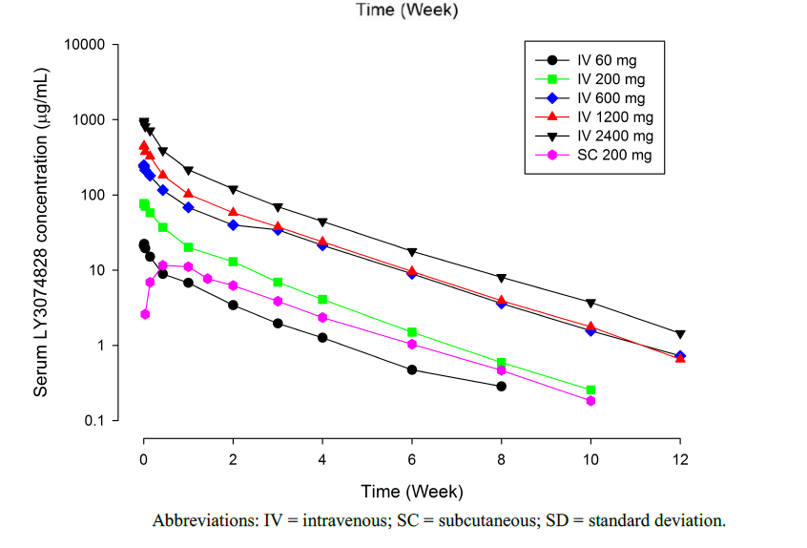
Study AMBD was a single dose study in 60 healthy Chinese subjects to investigate the safety, tolerability, PK and PD of mirikizumab. Intravenous doses studied were 300 mg, 600 mg and 1200 mg. In addition, 200 mg and 400 mg subcutaneous doses were studied. Bioavailability of the 200 mg subcutaneous dose was 42.8% and of the 400 mg dose was 34.2%.
Study AMBP investigated the effect of five 250 mg every 4 weeks subcutaneous doses of mirikizumab on the exposure to a drug cocktail of Cytochrome P450 (CYP) substrates in 29 patients with moderate-to-severe psoriasis. The CYP cocktail included midazolam (CYP3A), warfarin (S-warfarin CYP2C9), dextromethorphan (CYP2D6), omeprazole (CYP2C19) and caffeine (CYP1A2). Pre- and post-mirikizumab probe drug exposures were comparable, consistent with no clinically meaningful effect on CYP activity.
Based on data from these studies, the pharmacokinetics in healthy volunteers following either 300 mg intravenous (IV) or 200 mg subcutaneous (SC) are as summarised in Table 4.
Table 4: Summary of mirikizumab pharmacokinetics in healthy subjects
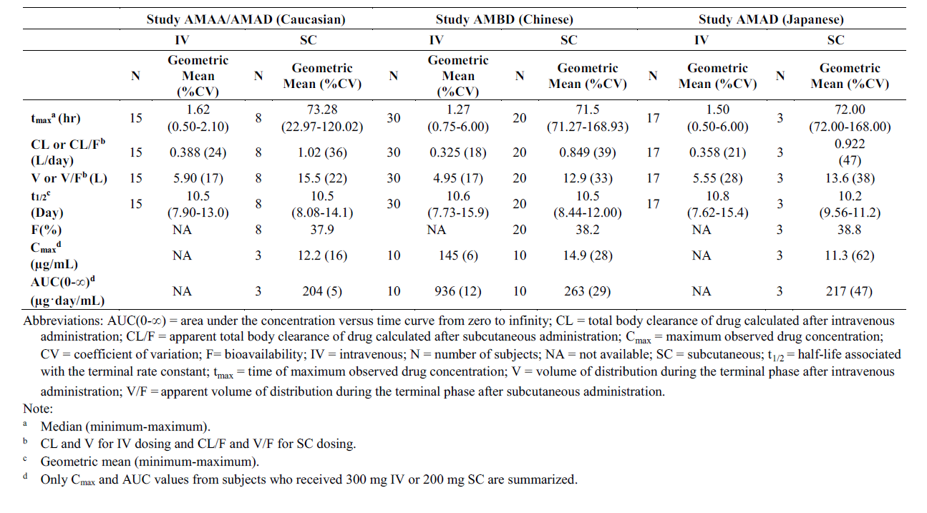

Population pharmacokinetics data
Studies AMAC, AMAN and AMBG were the pivotal studies submitted in support of the UC indication and are described in detail below. These studies provided the mirikizumab time concentration dataset that was subjected to population pharmacokinetics (popPK) analysis. The sponsor developed a PopPK model based on the Phase II study (Study AMAC) and another one based on the Phase III studies (Study AMAN and Study AMBG). Both models produced similar results.
The PK was described using a 2-compartment model with first-order absorption. Covariates retained in the final popPK model were body weight (increased body weight -> increased clearance and volume of distribution), time-varying albumin concentration (reduced albumin -> increased clearance) and body mass index (BMI) (lower BMI -> increased bioavailability). The model predicted influence of body weight on exposure are shown in Figure 3. These covariates were not considered clinically relevant and do not require dose adjustment. The residual error in the Phase III analysis was 19.6%.
Simulation of 1000 patients receiving the proposed induction dose (300 mg intravenous (IV) every 4 weeks) and the proposed maintenance dose (200 mg subcutaneous (SC) every 4 weeks) was conducted, as shown in Figure 4 (the figure also demonstrates the predicted overlap in exposure between the regimens).
Figure 3: Box plot of relationship between mirikizumab exposure and body weight with 300 mg intravenous every 4 weeks from the Phase III population pharmacokinetics analysis
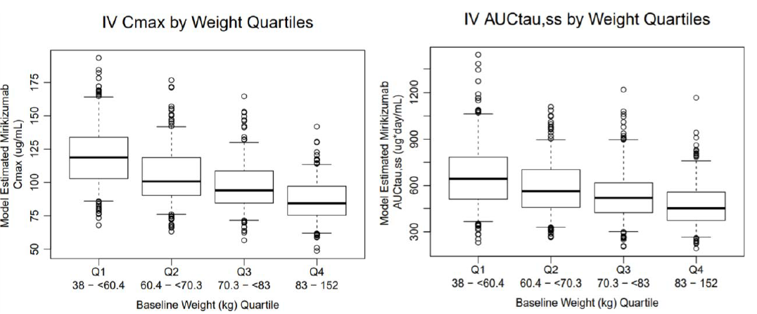
Abbreviations: AUC_{tau,ss} = area under the concentration versus time curve during 1 dosing interval at steady state, C_{max} = maximum concentration during a dosing interval at steady state, IV = intravenous, PK = pharmacokinetics, PopPK = population pharmacokinetics, Q = quartile, Q4W = every 4 weeks.
Note: The horizontal line in each box represents the median; the top and bottom sides of the box represent the 75th and 25th percentiles; the whiskers extend to the 95th and 5th percentiles; and circles represent data points outside of 5th or 95th percentile.
Figure 4: Model predicted concentration-time profiles for induction and maintenance dosing
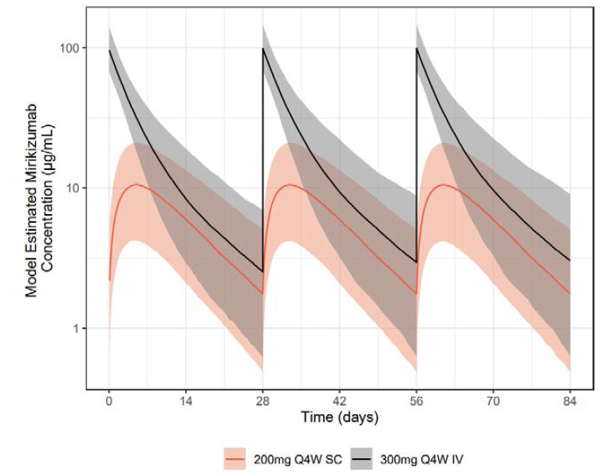
Abbreviations: IV = intravenous, PK = pharmacokinetics, Q4W = every 4 weeks, SC = subcutaneous.
Note: Simulation of 1000 patients was conducted using baseline covariates in the AMAN/AMBG dataset. The solid black and beige line depict the median predicted concentration profile for 300 mg intravenous dose Q4W from Weeks 0 to 12 and 200 mg subcutaneous dose Q4W from Weeks 24 to 36 respectively, and the shaded area defines the 90% prediction interval of the simulated data.

Model predicted pharmacokinetic parameters in patients with ulcerative colitis
The estimated geometric mean bioavailability of 200 mg SC dose in patients with UC was 44%. The model did not predict differences in exposure based on injection site. The estimated geometric mean volume of distribution was 4.83 L (3.19 in the central compartment). The estimated geometric mean systemic clearance was 0.0229 L/h. The geometric mean t_{1/2} was 9.3 days.
Immunogenicity was not found to be a statistically significant factor affecting mirikizumab clearance. The low numbers of patients with high titre antidrug antibodies could potentially influence the ability of the model to detect an effect.
Age, sex and race were not significant covariates for mirikizumab exposure.

Pharmacodynamics
Several studies provided PD data during the development program. This section includes only those details necessary to appreciate the PD effects.
Phase II Study AMAC demonstrated statistically significant reductions in IL-17A and IL-22 (downstream cytokines following IL-23 activation) with mirikizumab 50 mg, 200 mg and 600 mg IV every 4 weeks, consistent with its mechanism of action.
Phase III induction Study AMAN demonstrated a statistically significant reduction in CRP at Week 12 compared with placebo (least squares mean difference of -3.7 mg/L). Among patients with a CRP greater than 6 mg/L at Baseline, there was an absolute difference of 24.8% between mirikizumab and placebo, in the percentage of patients achieving a CRP 6 mg/L or less. There were comparable differences found in Phase III maintenance Study AMBG.
Study AMAN demonstrated a statistically significant reduction in faecal calprotectin at Week 12 compared with placebo (least squares mean difference of -936 mg/kg). Among patients with calprotectin greater than 250 mg/kg at Baseline, there was an absolute difference of 14.6% between mirikizumab and placebo, in the percentage of patients achieving a calprotectin 250 mg/kg or less at Week 12. In Study AMBG, among patients who initially responded to mirikizumab induction and were then randomised to either maintenance mirikizumab or placebo, the mean calprotectin at Week 40 was 1023 mg/kg with mirikizumab and 1863 mg/kg with placebo.
Dose finding Study AMAC was a Phase II, randomised, double blind, placebo controlled study of exposure-based mirikizumab dosing at 50 mg, 200 mg and 600 mg. The study involved 249 patients. Mirikizumab was given by IV infusion every 4 weeks. Doses were adjusted upwards in 73% of the 50 mg group and 43.5% of the 200 mg group, such as that the average dose in the latter group was 250 mg. Patients in the 200 mg group achieved superior efficacy for clinical response, clinical remission and endoscopic improvement (same as the pivotal studies).
The 12 week induction phase was followed by a maintenance phase, whereby responders were re-randomised to either mirikizumab 200 mg every 4 weeks or every 12 weeks. Whilst efficacy was observed in both groups, the every 4 weeks treatment group had a numerically greater treatment effect with less fluctuation in symptom scores. The every 4 weeks regimen also resulted in trough concentrations that were comparable to those in the 200 mg IV induction study. The induction period demonstrated benefit on the major efficacy measures (clinical remission, clinical response, endoscopic response, symptomatic response) that tended to be maximal at the 200 mg IV every 4 weeks dose (Figure 5). This study supported the use of 300 mg as the Phase III induction dose (note that the 200 mg cohort actually received an average dose of 250 mg due to protocol-defined dose adjustments).
Figure 5: Rates at Week 12 for efficacy endpoints relative to average concentration in patients receiving placebo, 50 mg, 200 mg or 600 mg
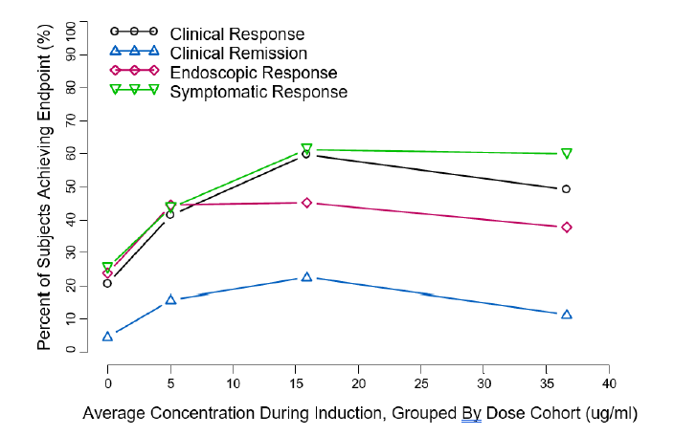
Abbreviation: PK = pharmacokinetics.
Note: Concentration points are at the median of the PK model-estimated average concentration in the placebo, 50 mg, 200 mg, and 600 mg cohorts from left to right.
Exposure-response analysis of Study AMAC using both observed values and model estimated values indicated a plateauing of effect (change in modified Mayo score) between 200 mg and 600 mg every 4 weeks, further supporting the Phase III doses (Figure 6).
Figure 6: Study AMAC, observed and model predicted change in modified Mayo score at Week 12
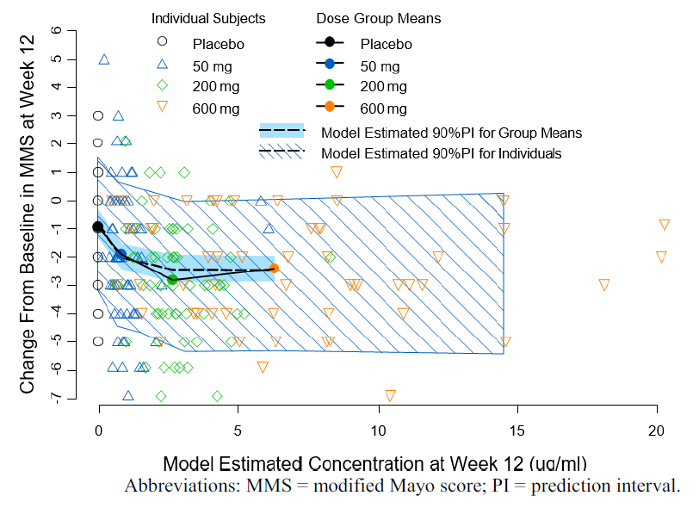
The two maintenance regimens studied in Study AMAC (200 mg every 4 weeks or every 12 weeks) were analysed for response in terms of symptomatic remission and symptomatic score (based on stool frequency and rectal bleeding). Every 4 weeks dosing was associated with better control of the symptom score, which tended to increase (that is, symptoms became worse) prior to dosing with every 12 weeks dosing frequency. As well as providing pharmacodynamic information, Study AMAC is considered as a supportive efficacy study.

Population pharmacokinetics/pharmacodynamics
A linear relationship (rather than maximum effect relationship) between average concentration and various efficacy endpoints was found to best describe the observed data. The following covariates were found to have a negative impact on placebo effect parameters, prior biologic experience, higher baseline scores for endoscopy, rectal bleeding and stool frequency. No covariates were found to impact the mirikizumab effect parameters.

Efficacy
The pivotal efficacy studies were induction Study AMAN, multiple arm maintenance/withdrawal/reinduction/rescue Study AMBG and open label long term extension Study AMAP (Figure 7).
Figure 7: Pivotal Phase III clinical studies
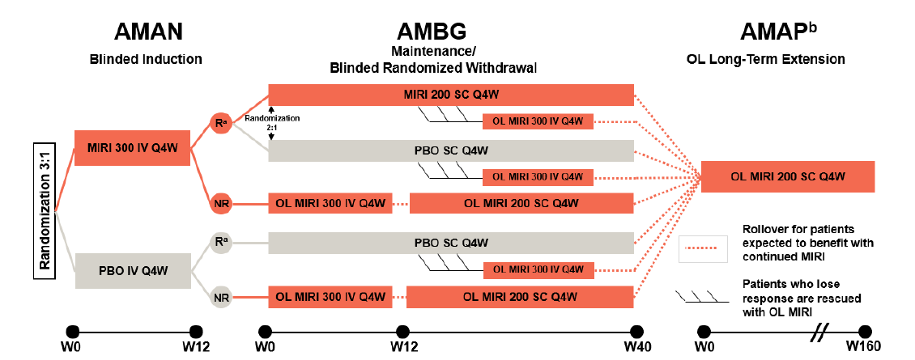
Abbreviations: IV = intravenous, LOR = loss of response, MIRI = mirikizumab, MMS = modified Mayo score, NR = non-responder, OL = open-label, PBO = placebo, Q4W = every 4 weeks, R = responder, RB = rectal bleeding, SC = subcutaneous, W = week.
a Responders at Week 12 of Study AMAN are defined as achieving a decrease in the MMS of at least 2 points and at least 30% decrease from Baseline, and a decrease of at least 1 point in the RB subscore from Baseline or an RB score of 0 or 1.
b Includes patients who completed the Phase II Study I6T-MC-AMAC (not shown).

Pivotal induction study
Study AMAN (also known as LUCENT 1) was a Phase III, multicentre, randomised, double blind, placebo controlled induction study of mirikizumab in conventional-failed and biologic/JAK inhibitor-failed patients with moderately to severely active ulcerative colitis. It was conducted at 471 centres in Australia, the United States of America (USA), Mexico, Canada, the United Kingdom (UK), multiple European Union (EU) states, China, Japan, South Korea and other countries.
The primary endpoint was the proportion of patients in clinical remission at Week 12. Clinical remission was defined according to the following modified Mayo score (mMs) components:
- Stool frequency (SF) = 0 or 1, with 1 point or greater decrease from Baseline
- Rectal bleeding (RB) = 0
- Endoscopic score (ES) = 0 or 1 (excluding friability)
The secondary endpoints were:
- Proportion of patients in alternate clinical remission at Week 12, with alternate clinical remission defined by
  - stool frequency sub-score = 0 or 1, and
  - rectal bleeding sub-score = 0, and
  - endoscopic score = 0 or 1 (excluding friability)
- Proportion of patients in clinical response at Week 12, based on the mMs and defined as:
  - a decrease in the mMs of 2 points or greater and 30% or greater decrease from Baseline, and
  - a decrease of 1 point or more in the RB sub-score from Baseline or an RB score of 0 or 1
- Proportion of patients with endoscopic remission at Week 12, defined as EB = 0 or 1 (excluding friability)
- Proportion of patients in symptomatic remission at Week 4, defined as SF = 0 or 1 with a 1 point or greater decrease from Baseline and RB = 0
- Proportion of patients in symptomatic remission at Week 12, defined as SF = 0 or 1 with a 1 point or greater decrease from Baseline and RB = 0
- Proportion of patients in the biologic-failed population in clinical response at Week 12. Clinical response is based on the mMs and is defined as:
  - a decrease in the mMs of 2 points or greater and 30% or greater decrease from Baseline, and
  - a decrease of 1 point or greater in the RB sub-score from Baseline or an RB score of 0 or 1
- Change from Baseline in the urgency numeric rating scale score
- Proportion of patients with histologic-endoscopic mucosal improvement at Week 12, defined as achieving both:
  - histologic improvement, defined using Geboes scoring system with neutrophil infiltration in 5% of crypts, no crypt destruction, and no erosions, ulcerations, or granulation tissue, and
  - endoscopic remission, defined as ES = 0 or 1 (excluding friability)
Multiple other (that is, exploratory) endpoints were included.
Major inclusion criteria were:
- Males and females between 18 and 80 years of age
- Ulcerative colitis diagnosis of 3 months or longer duration
- Modified Mayo score of 4 to 9, including an ES of 2 or greater within 14 days of Baseline
- Inadequate response, loss of response or intolerance to conventional or biologic (anti-TNF or anti-integrin) therapies, or tofacitinib
Major exclusion criteria were:
- Ulcerative colitis limited to the rectum
- Extensive colonic resection
- Stricture/stenosis of small bowel or colon
- Toxic megacolon
- Unresected colonic adenoma
- Colonic dysplasia
- Gastrointestinal cancer
- Prior treatment with three or more biologic therapies
Stable concomitant therapy was permitted with oral 5ASA, oral corticosteroids, azathioprine, 6-MP or methotrexate.
Following screening and eligibility, patients were randomised 3:1 to receive either mirikizumab 300 mg IV every 4 weeks or placebo every 4 weeks for a 12 week period. Patients who did not continue on to Study AMBG were followed for 16 weeks following their treatment.
There were a number of mitigations implemented as emergency measures (subsequently formalised as amendments) to manage the impact of COVID-19 on the running of the study. An error in the device used to capture patient reported information led to incorrectly transcribed data from Turkey and Poland (using electronic clinical outcome assessment (eCOA) devices) and the exclusion of 117 patients from the primary efficacy analysis (they were, however, included in the safety analysis). Sensitivity analyses were conducted to investigate the impact of these events on the results.
The primary efficacy population was the modified intent to treat (mITT) population. The primary and major secondary endpoints were analysed using the Cochran-Mantel-Haenszel test at a significance level of 0.00125. The study intended to randomise 1160 patients, with 1044 completers. Half of the group would be conventional failed and half biologic failed. The predicted remission rates were 23% versus 7.8% in the overall population. The sample size would provide 90% power to demonstrate superiority of mirikizumab at a 2-sided significance of 0.00125. The major secondary endpoints were controlled for multiplicity through a prespecified graphical multiple testing approach to control overall type 1 error rate at 2-sided alpha of 0.00125.
The intent to treat (ITT) population consisted of 1281 patients and the mITT population, following removal of the subjects from Poland and Turkey affected by the transcription error, consisted of 1162 subjects. A per protocol population was also analysed. Baseline demographics were similar across the treatment groups, with mean age 41.3 to 42.9, mean weight 70.9 kg to 72.6 kg and mean BMI 24.50 to 25. Subjects were mainly male (56.1 to 61.1%), White (71.5 to 74.7%) or Asian (23.2 to 26%).
Baseline disease characteristics included a mean modified Mayo score of 6.5, left sided colitis in 62.7 to 64.2% and an endoscopic score of 3 (indicating severe disease) in 66.1 to 68.3%. In terms of prior therapy, 42.5% had received biological medicines, 3.8% tofacitinib, 78.4% systemic corticosteroids and 43.5% immunomodulators (that is, thiopurines and methotrexate). Table 5 shows the proportion of subjects in the mITT population who had failed various therapies. Of note is the small proportion of subjects with tofacitinib failure. Concomitant use of oral 5ASA drugs was common (74%), as was systemic corticosteroids (38.4 to 40.4%) and immunomodulators (24%) or combinations of the latter two classes.
Table 5: Prior ulcerative colitis therapies failed, modified intent to treat
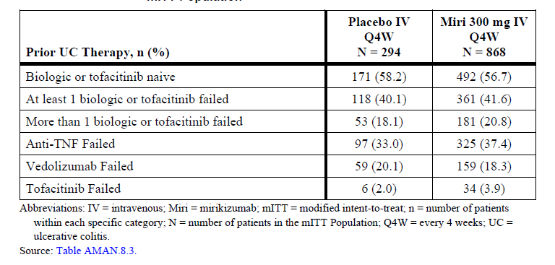
In the mITT population (that is, main efficacy population) the primary efficacy outcome of clinical remission occurred in 24.2% in mirikizumab arm and 13.3% in placebo arm, leading to a risk difference of 11.1% (confidence interval (CI) 3.2 to 19.1%; p = 0.00006). Statistically significant results were found for all major secondary endpoints as well (Table 6).
Table 6: Summary of primary and major secondary endpoints, modified intent to treat
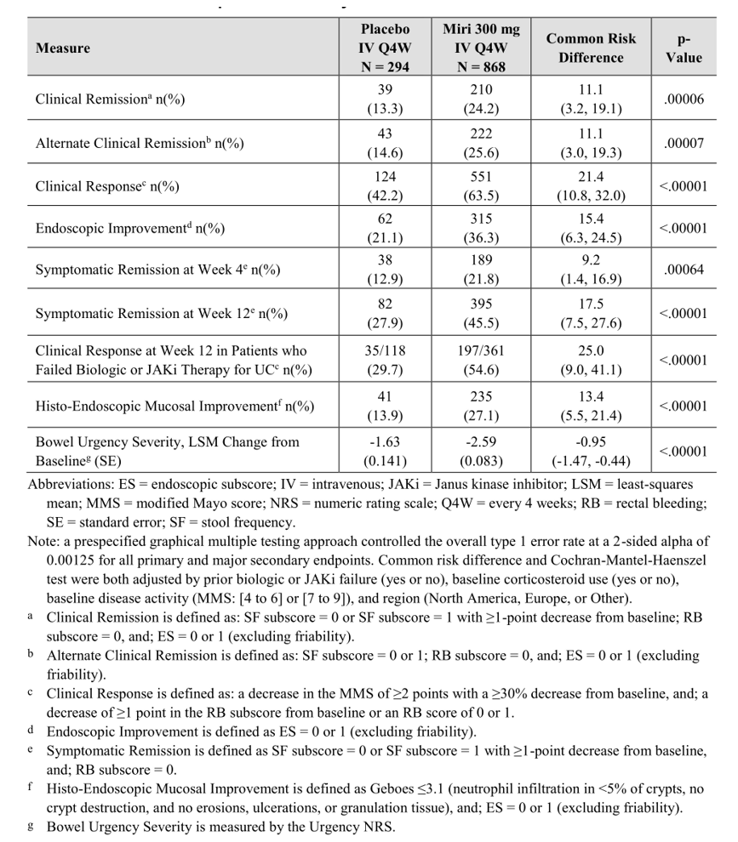
Subgroup analysis of patients who were biologic/JAK inhibitor naïve, failed at least one biologic/JAK inhibitor and failed more than one biologic/JAK inhibitor, mirikizumab generally remained superior to placebo for primary and major secondary endpoints. There tended to be a reduction in effect size in the biologic/JAK inhibitor experienced subgroup. For the primary outcome, the risk difference was 15.1% (CI 8.3 to 21.9%) in the naïve group, 6.8% (CI 0.5 to 13%) in the failed at least one biologic/JAK inhibitor group and 7.6% (CI -0.3 to 15.5%) in the failed more than one biologic/JAK inhibitor.
Sensitivity analyses looking at the impact of eCOA transcription errors in Poland and Turkey, missed endoscopies, loss to follow-up and protocol deviations (that is, comparing the mITT to the ITT population) found results consistent with the primary efficacy population described above.

Pivotal maintenance study
Study AMBG (also known as LUCENT2) was a Phase III, multicentre, randomised, double blind, placebo controlled maintenance study of mirikizumab in patients with moderately to severely active ulcerative colitis. It was conducted in 368 centres across Europe, North America, South America, Asia and Oceania. The duration of the study for the primary efficacy outcome was 40 weeks and the dossier contained data until this point.
Whilst it was primarily a maintenance study in those who had responded to mirikizumab induction, it also addressed other questions related to ongoing therapy post initial induction (that is, extended induction and rescue therapy). Accordingly, the following groups were studied (Figure 8):
- Responders to mirikizumab in induction study were randomised 2:1 to blinded mirikizumab 200 mg SC every 4 weeks or placebo for 40 weeks. This was the only fully blinded, placebo controlled cohort in Study AMBG. Patients in this cohort could receive open label rescue mirikizumab 300 mg IV every 4 weeks if they experienced loss of response between Weeks 12 and 28.
- Responders to placebo in induction study, continued on blinded placebo for 40 weeks. If patients in this group lost response between Weeks 12 and 28, they received open label mirikizumab 300 mg IV every 4 weeks for 12 weeks (that is, an induction dose, essentially their first experience with active drug).
- Non-responders following the induction study were treated with open label mirikizumab 300 mg IV every 4 weeks (that is, first induction for those who had received placebo and repeat induction for those who had received mirikizumab). Responders in this cohort could then continue maintenance dosing.
Figure 8: Study AMBG design
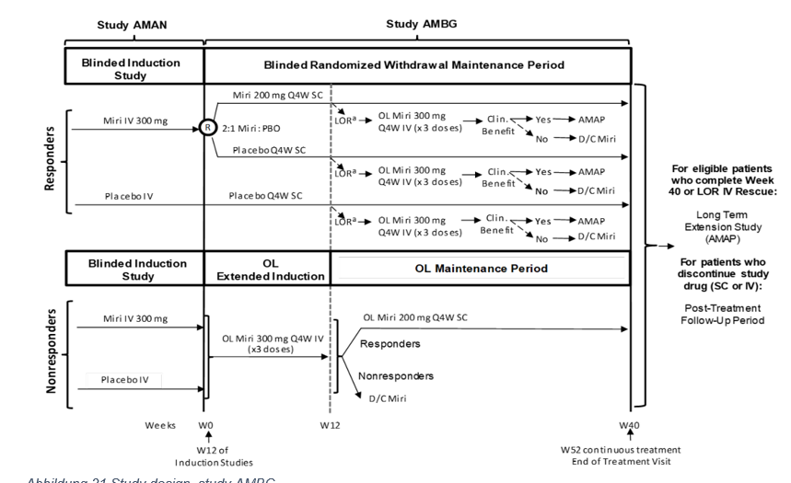
The primary outcome was the proportion of patients in clinical remission at Week 40 who were responders to mirikizumab at Week 12 in the induction study. Clinical remission was defined using the mMs as in the induction study (and therefore represents equivalent ongoing disease control):
- Stool frequency (SF) = 0 or 1, with 1 point or greater decrease from Baseline
- Rectal bleeding (RB) = 0
- Endoscopic score (ES) = 0 or 1 (excluding friability)
The secondary endpoints were:
- Proportion of patients in alternate clinical remission at Week 40, defined as
  - stool frequency (SF) sub-score = 0 or 1, and
  - rectal bleeding (RB) sub-score = 0, and
  - endoscopic score (ES) = 0 or 1 (excluding friability)
- Proportion of patients with endoscopic remission at Week 40, defined as EB = 0 or 1 (excluding friability)
- Change from induction baseline in the urgency numeric rating scale score
- Proportion of patients with histologic-endoscopic mucosal remission at Week 40, defined as:
  - histologic remission with resolution of mucosal neutrophils, defined using the Geboes scoring system with sub-scores of 0 for grades: 2b (lamina propria neutrophils), 3 (neutrophils in epithelium), 4 (crypt destruction), 5 (erosion or ulceration), and
  - endoscopic remission, defined as ES = 0 or 1 (excluding friability)
- Corticosteroid-free remission without surgery at Week 40, defined as
  - clinical remission at Week 40
  - symptomatic remission at Week 28, and
  - no corticosteroid use for more than 12 weeks prior to Week 40
- Proportion of patients with Urgency Remission at Week 40, defined as
  - urgency numeric rating scale = 0 or 1
- Proportion of patients who were in clinical remission at Week 40 among patients in clinical remission at Week 12 in Study AMAN, with clinical remission is defined as:
  - stool frequency (SF) sub-score = 0 or 1 with a 1 point or greater decrease from Baseline, and
  - rectal bleeding (RB) sub-score = 0, and
  - endoscopic score (ES) = 0 or 1 (excluding friability)
A large number of other endpoints were also included.
As patients entered this study from Study AMAN, inclusion and exclusion criteria from that study are applicable. Patients were required to have received at least one dose of study drug in Study AMAN and to have had a Week 12 endoscopy. Further exclusions were applied based on events during Study AMAN, including being diagnosed with Crohn’s or indeterminate colitis, a bowel resection, colonic dysplasia or gastrointestinal cancer, an unresected adenomatous polyp, clinically important infection, latent tuberculosis, a prohibited medication or pregnancy.
In terms of concomitant medications, of note was a requirement for patients who were taking oral corticosteroids during the induction study and were responders (or became responders following a further every 4 weeks IV dosing, according to the second and third cohorts described above) to undertake a taper. Instructions for tapering are found in the protocol and it was to be completed by Week 12 in Study AMBG.
Similar to Study AMAN, there were transcription errors using the eCOA device for patients in Turkey and Poland, who were excluded from the primary efficacy population (that is, the mITT population). As with the induction study, they were included in the safety population and also included in sensitivity analyses (using the ITT population).
In terms of sample size 1044 patients were expected to enter Study AMBG, with 459 as clinical responders to mirikizumab. Of these 459, 306 would then be randomised to 200 mg SC every 4 weeks and 153 to placebo. Within this group of responders (n = 169), 113 being randomised to mirikizumab maintenance would be classified as in remission, and 56 randomised to placebo would be classified as in remission. The study would detect a difference between mirikizumab and placebo in the primary efficacy outcome (assuming a difference of 35% between the groups) in this group of 169 remitters with power greater than 90% and 2-sided 0.05 significance level. Categorical endpoints were assessed with the Cochran-Mantel-Haenszel chi-squared test and continuous variables using the mixed-effects model of repeated measures. For the secondary endpoints, multiplicity was controlled using a prespecified scheme at overall type 1 error rate of 0.05 (Figure 9).
Figure 9: Study AMBG multiplicity control
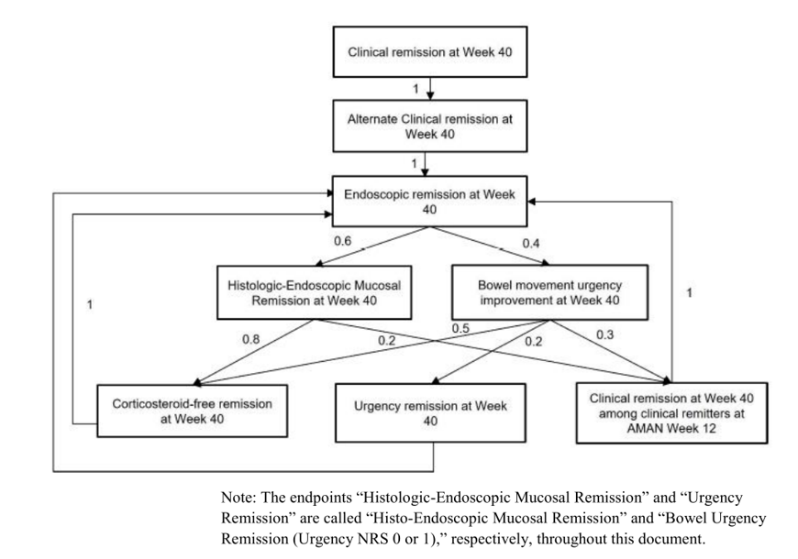
In total 1177 patients comprised the ITT population and 1073 comprised the mITT population (that is, 104 patients excluded due to eCOA transcription error). For the primary efficacy analysis (that is, the first cohort described above), 544 mirikizumab induction responders were randomised to maintenance placebo (n = 179) or mirikizumab (n = 365). Of the placebo group 60.9% completed treatment, 16.8% discontinued treatment and 22.3% entered the loss of response rescue period. Of the mirikizumab group, 88.8% completed treatment, 6% discontinued treatment and 5.2% entered the loss of response period.
Baseline demographics were generally well balanced across the new treatment groups in Study AMBG. Concomitant medication use included oral aminosalicylates (75.4% overall), systemic corticosteroids (39.1% overall) and immunomodulators (23% overall).
For the primary efficacy outcome, 25.1% of the placebo arm and 49.9% of the mirikizumab arm, were in clinical remission at Week 40. The risk difference was 23.2% (CI 15.2 to 31.2; p <0.001). All of the secondary endpoints showed statistically significant differences (Table 7). Of note and favouring mirikizumab, there was a 21.3% difference in corticosteroid-free remission without surgery, a 19.9% difference in histo-endoscopic mucosal remission and an 18.1% difference in bowel urgency remission.
Table 7: Study AMBG primary and major secondary endpoints at Week 40
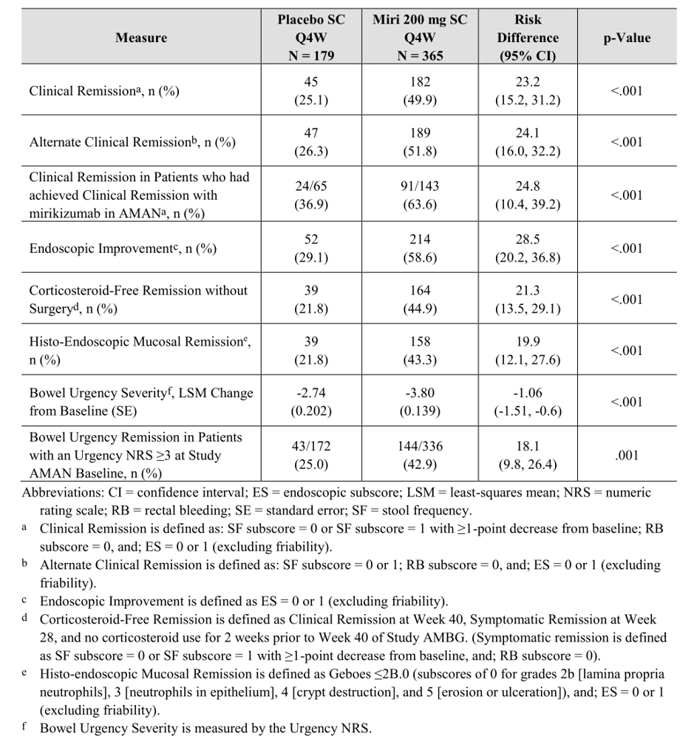
Note the similar efficacy in terms of the primary outcome, regardless of the patient’s prior experience with biologics or JAK inhibitors (Table 8). Also note the similar risk difference for patients entering the study, regardless of whether they were a responder or a remitter.
Table 8: Primary efficacy outcome based on prior treatment experience
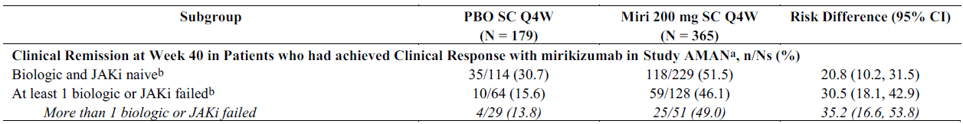

Placebo non-responders in induction study
Of 133 placebo induction non-responders 20.3% achieved clinical remission at Week 12 following open label mirikizumab 300 mg IV every 4 weeks (that is, similar as primary efficacy outcome in Study AMAN). Patients who were at least responders at Week 12 could continue in an open label maintenance study. Of 86 in this maintenance study 39.5% achieved clinical remission at Week 40.

Mirikizumab non-responders in induction study
Of 272 mirikizumab induction non-responders, 11.4% achieved clinical remission at Week 12 after open label mirikizumab 300 mg IV every 4 weeks (that is, six 300 mg every 4 weeks doses). Of those achieving at least clinical response at Week 12, 36.1% had achieved clinical remission at Week 40.

Rescue therapy for loss of response
In the placebo controlled maintenance study, amongst those that experienced loss of response (40 in placebo arm and 19 in the mirikizumab arm), re-induction with three mirikizumab 300 mg IV every 4 weeks doses led to symptomatic response (77.5% in placebo loss of response group and 63.2% in mirikizumab loss of response group) or remission (60% in placebo loss of response group and 36.8% in mirikizumab loss of response group).
Sensitivity analyses, including the potential influence of excluding the patients in Turkey and Poland affected by eCOA errors, were consistent with the primary mITT analysis.
Supportive efficacy Study AMAC has been described above in the Pharmacodynamics section.

Safety
The core safety data has been obtained from Studies AMAC, AMAN and AMBG, all previously described. Limited data from the long-term extension Study AMAP has also been considered. Further safety data from two studies in Crohn’s disease (Studies AMAG and AMAX) and five studies in psoriasis (Studies AMBP, AMAF, AMAK, AMAJ and AMAH) were screened for potentially prohibitive safety signals.
The all UC data set includes 1442 patients who were exposed to any dose of mirikizumab during clinical development. It represents 2250.9 patient years of exposure. The UC treatment regimen set includes patients who were exposed to mirikizumab for induction followed by maintenance over 52 weeks and consists of 389 patients (88.9% of whom were dosed to at least 52 weeks). It represents 391.8 patient years of exposure and is the long-term dataset required for registration. The all mirikizumab exposure set, with 3798 patients (7801 patient years), includes patients from the UC, Crohn’s and psoriasis clinical development programs.
Treatment-emergent adverse events (TEAEs) were common. There was one death in the UC program whilst receiving active treatment (in placebo arm of maintenance study, but had received mirikizumab for induction prior) and 11 in the overall clinical program (including Crohn’s and psoriasis). Serious adverse events occurred at a higher rate in placebo arms versus the mirikizumab arms of both the induction study (24 per 100 patient years versus 12.3 per 100 patient years, respectively) and maintenance study (12.8 per 100 patient years versus 4.6 per 100 patient years). Discontinuation due to adverse events was also more common in placebo arms versus mirikizumab arms (Table 9). In Study AMAN and Study AMBG, severe adverse events were more common with placebo than with mirikizumab.
Table 9: Adverse events across all ulcerative colitis clinical studies
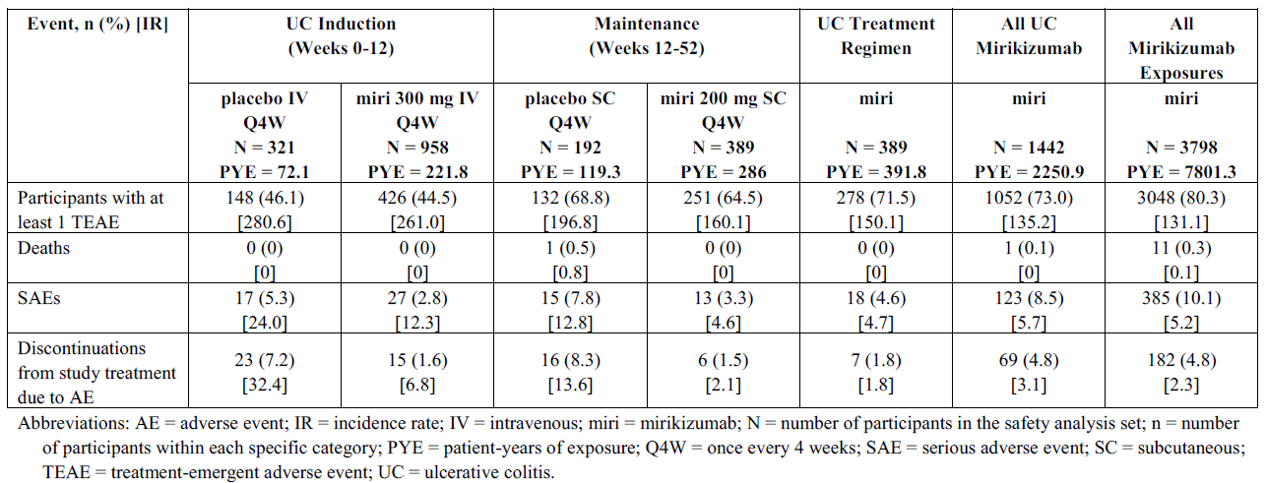
In terms of serious adverse events in Study AMAN, all were single cases except for ulcerative colitis (3.1% with placebo and 0.8% with mirikizumab). In Study AMBG all were single cases except for ulcerative colitis. For patients discontinuing in Study AMAN, 20% (3 out of 15) assigned to mirikizumab stopped due to infusion-related hypersensitivity (0 in the placebo group). In Study AMBG, of those discontinuing, one discontinued (1 out of 6) due to autoimmune hepatitis and one discontinued (1 out of 6) due to gastric cancer.
During the induction study (Study AMAN), common TEAEs by system order class occurring with noticeably different frequencies in the placebo versus mirikizumab arm were gastrointestinal disorders (15% and 10.5%, respectively), blood and lymphatic disorders (9.3% and 6.3%, respectively) and reproductive system and breast disorders (0.3% and 0.9%, respectively).
During placebo-controlled maintenance study (Study AMBG), common TEAEs by system organ class occurring with noticeably different frequencies in the placebo versus mirikizumab arms were gastrointestinal disorders (36.5% and 21.3%, respectively), general disorders and administration site conditions (9.9% and 16.7%, respectively), skin and subcutaneous disorders (6.8% and 11.3%, respectively), nervous system disorders (4.7% and 8%, respectively), respiratory, thoracic and mediastinal disorders (3.1% and 6.9%, respectively), blood and lymphatic system disorders (6.3% and 3.9%, respectively), eye disorders (1% and 3.1%, respectively), surgical and medical procedures (0% and 2.1%, respectively) and reproductive system and breast disorders (0% and 1.5%, respectively).
The specific TEAEs from the above system organ class (Study AMBG) that contributed most to differences between placebo versus mirikizumab, were ulcerative colitis (20.8% versus 6.7%), diarrhoea (0.5% versus 2.6%), gastroesophageal reflux (0.5% versus 2.6%), injection site pain (3.1% versus 4.4%), injection site reaction (0.5% versus 3.3%), arthralgia (4.2% versus 6.7%), rash (0% versus 3.6%) and hypertension (0.5% versus 2.3%).

Laboratory findings and vital signs
One subject treated with mirikizumab in Study AMBG (a mirikizumab induction non-responder) met biochemical and clinical criteria for Hy’s Law (that is, there was no alternative explanation). The changes in liver function included a peak alanine aminotransferase of 609, aspartate aminotransferase 336, alkaline phosphatase 187 and bilirubin 51. These values returned to normal after discontinuing mirikizumab. An additional 10 cases with alanine aminotransferase and/or aspartate aminotransferase five times or greater than the upper limit of normal were assessed by the sponsor as having a possible association with mirikizumab. All of these either improved or normalised and none resulted in death, a serious outcome or other sequelae.
Hypertension occurred in 6.2% in the mirikizumab arm of Study AMAN (0 in placebo) and 4.2% in the mirikizumab arm of Study AMBG (2.4% in placebo arm).

Hypersensitivity and infusion site reactions
In Study AMAN, 1% in the mirikizumab arm reported immediate hypersensitivity, compared to 0.3% in the placebo arm. Non-immediate reactions were comparable in both arms (2.5% with mirikizumab, 2.2% with placebo). In Study AMBG, 1.8% in the mirikizumab arm reported immediate hypersensitivity, compared to 1% in the placebo arm. Non-immediate hypersensitivity was more common with mirikizumab compared to placebo (6.9% and 2.6%, respectively). Injection site reactions were more common with mirikizumab compared to placebo (Study AMBG, 8.7% versus 4.2%).

Infections
The incidence of infections in the placebo controlled data sets was similar between the mirikizumab and placebo arms. Five (0.5%) subjects receiving mirikizumab experienced opportunistic infections (oesophageal candidiasis, cytomegalovirus colitis (two), herpes zoster, intestinal tuberculosis) and one (0.3%) receiving placebo (herpes zoster) during the induction study. During the placebo controlled maintenance study, five subjects (1.3%) in the mirikizumab (oral candidiasis, herpes zoster (four)) arm and 0 in the placebo arm experience opportunistic infections. In the all UC data set (that is, all subjects who received mirikizumab during any of the UC studies) the incidence rate for herpes zoster was 0.6 per 100 patient years. There did not appear to be a meaningful difference in serious infections between placebo and mirikizumab arms in the clinical studies.

Deaths
In the overall (multiple indications) mirikizumab development program 17 deaths have been reported. Five deaths were reported in the UC program, 11 in the psoriasis program and one in the Crohn’s clinical program. The deaths during the UC studies were as follows:
- Mirikizumab arm of Study AMAN during follow-up – event occurred 147 days after last dose, participant with a history of obesity, and diabetes and had prolonged hospital admission with worsening UC and terminal event of disseminated intravascular coagulation.
- Mirikizumab arm of Study AMAN during follow-up – event occurred 117 days after last dose, participant had proctocolectomy and ileostomy for UC and adenocarcinoma of the rectum that culminated in sudden cardiac death, past history of atrial fibrillation, hypercholesterolaemia and dual chamber cardiac pacemaker.
- Placebo arm of Study AMBG – event occurred 171 days after the last dose of mirikizumab, the participant had a history of obesity, cause of death was COVID-19.
- Mirikizumab arm of Study AMBG during follow-up – the participant had received the final dose of SC mirikizumab and was then diagnosed with and died of COVID-19 after another 97 days.
- Mirikizumab in Study AMAP long-term extension study – the participant with a history of hypertension died of COVID-19 pneumonia 26 days after the final dose of mirikizumab.
An additional three deaths have subsequently been reported during the long-term extension Study AMAP:
- A participant receiving maintenance mirikizumab (834 days since first mirikizumab dose) died of thrombotic thrombocytopenic purpura and with a longstanding history of thrombotic thrombocytopenic purpura.
- A participant receiving maintenance mirikizumab (892 days since first mirikizumab dose) died of multi-organ failure following a complicated COVID-19 infection and with multiple risk factors for severe COVID-19.
- A participant on maintenance mirikizumab (1119 days since first mirikizumab dose) died following a head injury.
Briefly, the deaths in the non-UC clinical development program were as follows:
- Psoriasis (all subjects received mirikizumab)
  - Participant died of acute myocardial infarction.
  - Participant died of myocardial infarction.
  - Participant died of intracranial haemorrhage.
  - Participant died of COVID-19 (respiratory failure).
  - Two participants died of COVID-19 pneumonia.
  - Participant died of COVID-19.
  - Participant died of lung cancer.
  - Participant died of metastatic colon cancer.
  - Participant died of lymphoma.
  - Participant died of unknown cause.
- Crohn’s disease
  - Participant died of sepsis (treatment allocation still blinded).

Malignancies
Malignancies occurred during the UC development program, mostly those of the gastrointestinal tract and skin. Table 10 shows the incidence rate in the placebo controlled mirikizumab data sets, as well as the all UC dataset. Table 11 shows the updated incidence rate, which is similar across the various indications, occurring at an overall rate of 0.6 per 100 patient years (including non-melanoma skin cancers). It is noted that the malignancies included a diffuse large B cell lymphoma (plasmablastic) after approximately 13 months of mirikizumab treatment and colonic in a participant without human immunodeficiency virus (HIV) after 12 weeks mirikizumab induction therapy.
Table 10: Studies AMAN and AMBG exposure-adjusted incidence rates of malignancy
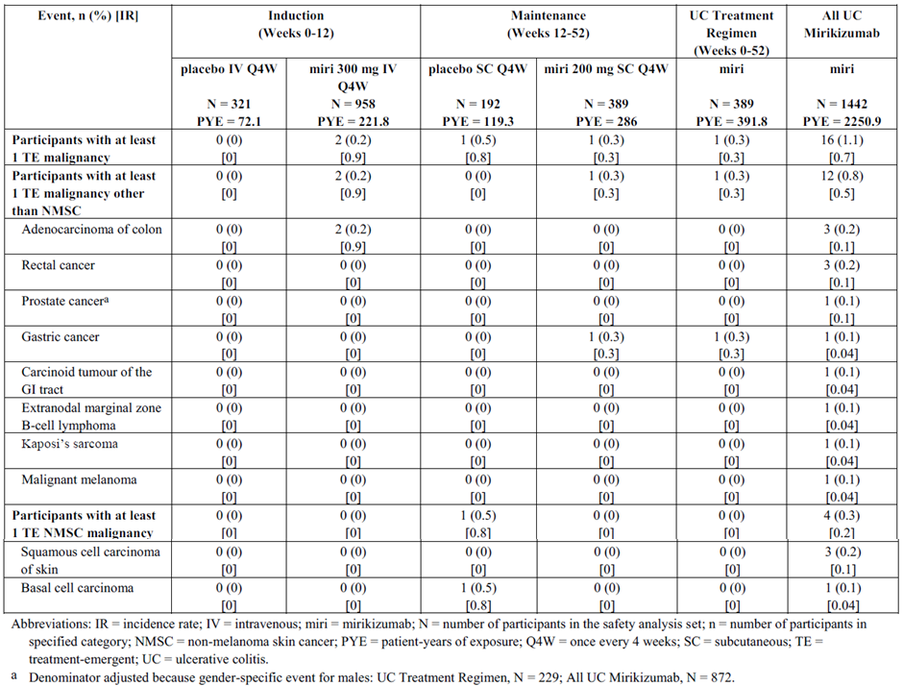
Table 11: Exposure-adjusted incidence rates of malignancy across the ulcerative colitis and all indication data sets with recent update
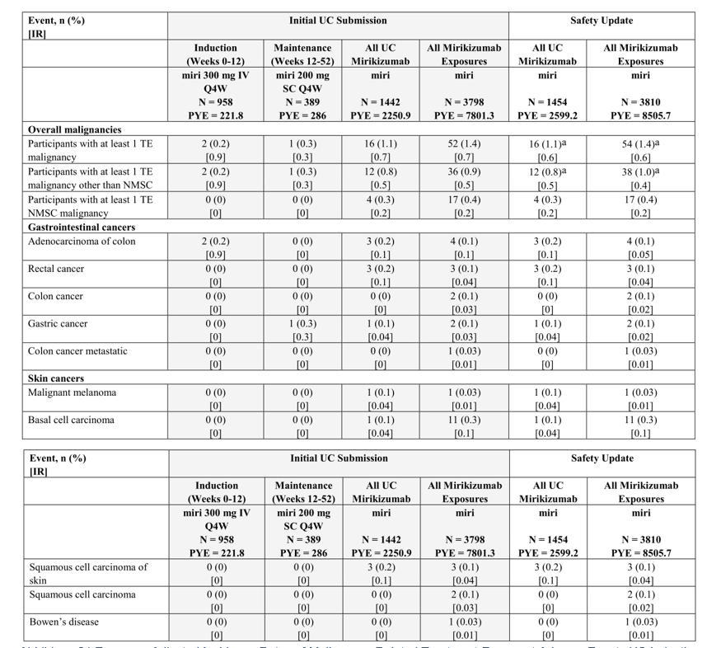
Abbreviations: IR = incidence rate, IV = intravenous, miri = mirikizumab, N = number of participants in the safety analysis set, n = number of participants in specified category, NMSC = non-melanoma skin cancer, PYE = patient-years of exposure, Q4W = once every 4 weeks, SC = subcutaneous, TE = treatment-emergent, UC = ulcerative colitis.

Vascular events
In Study AMAN, one patient (0.1%) in the mirikizumab group reported a case of hypertension that lead to hospitalisation. In the placebo group, one patient (0.3%) reported a serious arrhythmia, and one patient (0.3%) reported unstable angina pectoris with consecutive coronary revascularization. In Study AMBG, one patient (0.5%) in the mirikizumab-responder placebo group reported a stroke (that is, exposed to mirikizumab induction and subsequently randomised to placebo in the maintenance study).
In the whole mirikizumab exposure set (Table 12), two cardiac deaths, 16 myocardial infarctions, three heart failures, three cases of hypertension, 24 cases of serious arrhythmia, 22 cases of coronary revascularization procedures, five transient ischemic attacks, nine strokes, and one peripheral arterial event were reported. Most of these events occurred in subjects with psoriasis. The higher rate of cardiovascular events in the psoriasis trials could be related to differences in underlying risk between indications. The sponsor has stated that the rate of major adverse cerebro-cardiovascular event in the all mirikizumab set (0.3 events per 100 patient years) is within background incidence ratios for the respective populations and for other drugs acting through IL23-p19.
The sponsor’s view is that there is no current signal relating to vascular events.
Table 12: Exposure-adjusted incidence rates of cerebrovascular and cardiovascular treatment-emergent adverse events
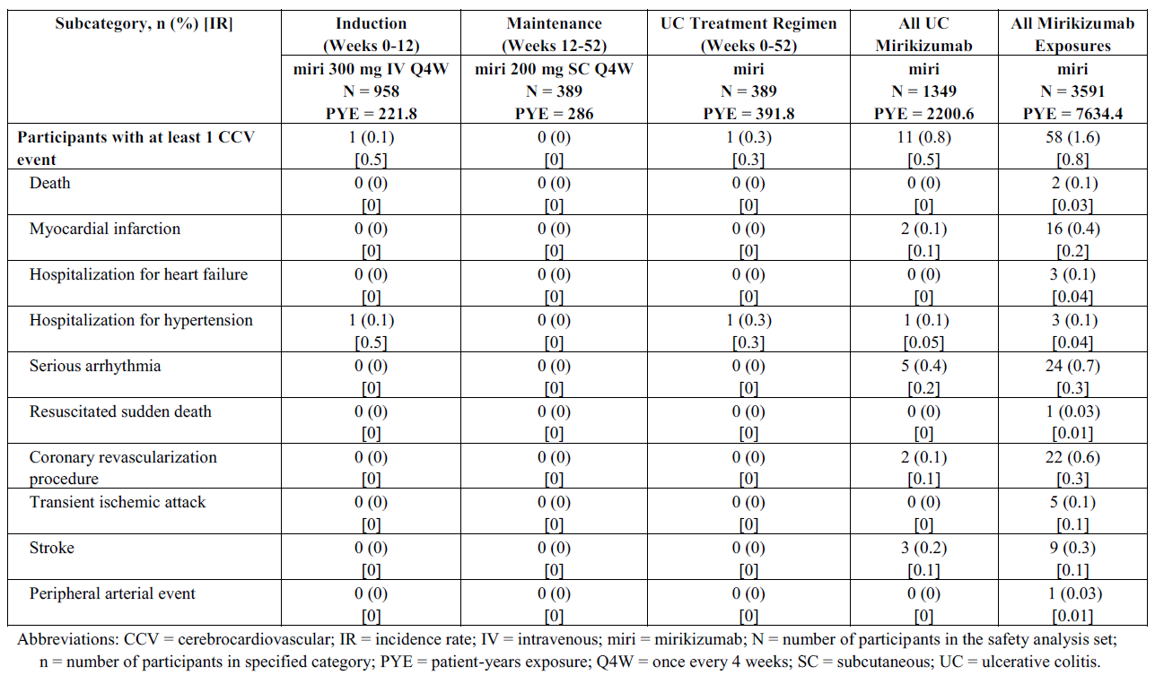
Phase II Study AMAC did not raise additional safety signals or concerns from those seen in the pivotal efficacy trials.

Immunogenicity
A total of 378 patients on the UC treatment regimen through 52 weeks (across Studies AMAN and AMBG) were evaluable for treatment-emergent antidrug antibody (ADA). At Baseline:
- 11 (2.9%) patients had ADA present
- three (0.8%) patients were neutralising antibody positive
- titres ranged from 1:10 to 1:320 with a median titre of 1:10
Of the 378 evaluable patients across Studies AMAN and AMBG through 52 weeks:
- 88 (23.3%) patients had treatment emergent ADA positivity
- 86 (22.8%) patients were treatment-induced
- two (0.5%) patients were treatment-boosted
- 82 (21.7%) patients were neutralising antibody positive
- more than half (50 out of 88, 56.8%) of treatment-emergent ADA positive patients had their titres decline over time, including 29.5% (n = 26) of patients whose ADA returned to baseline levels at their last sample.
In the maintenance study there was some evidence for reduced clinical efficacy in the presence of ADAs, with numerically lower number of patients with treatment-emergent ADA titres 1:160 or greater in clinical remission at Week 40. Of note, in 2.0% (7 of 356) of patients treated with mirikizumab 300 mg IV Q4W in induction followed by 200 mg SC Q4W through Study AMBG, higher titer TE ADA was associated with reduced PK and loss of efficacy.
The dossier included four additional studies in Crohn’s disease (a single Phase II Study AMAG) and plaque psoriasis (one Phase II Study AMAF and two Phase III studies, Study AMAJ and Study AMAK). The significant safety data from those studies (as well as from some other studies not included in the dossier at all, that is, Study AMAX and Study AMAH) were incorporated into the integrated safety analysis, including the ‘all mirikizumab’ set.

Risk management plan
The sponsor has submitted EU-risk management plan (RMP) version 0.1 (date 21 April 2022; data lock point (DLP) 6 December 2021) and Australia-specific annex (ASA) version 1.0 (date June 2022) in support of this application.
The summary of safety concerns and their associated risk monitoring and mitigation strategies are presented in Table 13. The TGA may request an updated RMP at any stage of a product's life cycle, during both the pre-approval and post-approval phases.
Table 13: Summary of safety concerns
Summary of safety concerns |  | Pharmacovigilance |  | Risk Minimisation
 |  | Routine | Additional | Routine | Additional
Important identified risks | None | – | – | – | –
Important potential risks | Serious infections | * | † |  | –
Important potential risks | Severe liver injury | * | † |  | –
Missing information | Use in pregnancy# | * | † |  | –
Missing information | Use in lactating women# | * |  |  | –
Missing information | Long-term safety of mirikizumab for events with a low frequency and/or long latency, including MACE, malignancy, serious and opportunistic infections, and severe liver injury | * | † |  | –
*Follow-up questionnaires
†Observational database study (Planned)
#The summary of safety concerns of the EU RMP states these risks as ‘Safety of mirikizumab in special populations, including pregnant women and lactating women’
The RMP evaluation recommended conditions of registration relating to the versions of the risk management plan, requirement for periodic safety update reports, and inclusion of the medicine in the Black Triangle Scheme.
The sponsor did not agree to include ‘malignancy’ as an important potential risk in the summary of safety concerns, as recommended by the RMP evaluation. This was raised to the delegate’s attention and decision.
Pharmacovigilance activities have been proposed as indicated in the above table. The pharmacovigilance plan is acceptable from an RMP perspective.
Only routine risk minimisation measures have been proposed. This approach is acceptable from an RMP perspective.

Risk-benefit analysis

Delegate’s considerations

Proposed Indication
The proposed indication is:
Omvoh is indicated for the treatment of moderately to severely active ulcerative colitis (UC) in patients who have had an inadequate response with, lost response to, or were intolerant to conventional therapy or a biologic treatment or a Janus kinase (JAK) inhibitor, or have medical contraindications to such therapies.
The indication should be changed to specify that the treatment is for adult patients. As very few subjects had actually failed JAK inhibitor therapy, there is limited data about the efficacy of mirikizumab in this setting. The sponsor and the Advisory Committee on Medicines (ACM) were asked about this. The Delegate considers it reasonable not to specify JAK inhibitor in the indication as it may imply that mirikizumab is of particular clinical utility in the population that has not responded adequately to JAK inhibitor therapy, whereas this is unknown.

Efficacy
Studies AMAN and AMBG demonstrated efficacy for the primary endpoint (that is, remission) for a 12 week induction followed by at least 40 weeks of maintenance dosing. Of note, subjects who were responding to mirikizumab at 12 weeks continued to see clinical improvement until Week 40 of the maintenance study (that is, progressed from being a responder to being a remitter). This is also consistent with the non-randomised subsets of subjects who either underwent extended induction (for another 12 weeks if they had not responded initially) or rescue treatment (12 weeks of 300 mg IV every 4 weeks) deriving benefit. The primary endpoint of clinical remission defined by the modified Mayo score was appropriate and consistent with the most recent guideline.
Noteworthy secondary endpoint findings in the maintenance study with mirikizumab versus placebo were increased proportion of corticosteroid-free remission without surgery (44.49% versus 21.8%) and bowel urgency remission with baseline Numeric Rating Scale 3 or greater (42.9% versus 25%). These two endpoints have significant benefits for patient’s long-term health (reduced steroid exposure) and quality of life (reduced bowel urgency).
Importantly, both induction and maintenance studies included a substantial number of subjects who had failed at least one biologic/JAK inhibitor and that they achieved the primary outcomes as well as important secondary outcomes, as shown in the subgroup analyses. It is worth noting that very few (2.0 to 3.9%) of the subjects entering the induction study had failed tofacitinib and that most of the inadequate therapy responses amongst the biologic/JAK inhibitor failures had actually been to tumour necrosis factor (TNF) inhibitors (33 to 37.4%) and vedolizumab (18.3 to 20.1%). Approximately 58% had failed conventional therapy (generally corresponding to the group that was ‘biologic or tofacitinib’ naïve).
There was data suggesting that the development of ADAs (specifically, neutralising antibodies at titre 1:160 or greater which affected 2% of subjects) was associated with reduced mirikizumab exposure and loss of efficacy. Thus, there is a small risk of ADA compromising mirikizumab efficacy and the PI should describe this.

Safety
The four deaths in subjects exposed to mirikizumab had significant mitigating factors (mainly remoteness from last dose, presence of comorbidities or COVID-19 infection). Serious adverse events and severe TEAEs occurred more frequently with placebo than with mirikizumab.
Generally manageable adverse events that were associated with mirikizumab during the clinical trials include arthralgia, injection site reaction, rash/other skin disorders, hypersensitivity, hypertension and gastro-oesophageal reflux. Serious infections were not more common with mirikizumab.
Reversible elevations of aminotransferases occurred and some were adjudicated as ‘possibly’ related. In addition, there was one case that met criteria for Hy’s law. This represents a signal for hepatotoxicity and is appropriately included in the RMP.
There are scientific data consistent with a role for IL-23 in both oncogenesis and tumour suppression, so it is unclear in what direction to expect any malignancy signal. Concern for increased incidence of malignancy was raised during the course of the evaluation. There were three cases of adenocarcinoma of the colon during the induction with mirikizumab and none with placebo. The short lead time, possibility of better detection of pre-existing tumours following mucosal healing and fewer events with ongoing treatment, somewhat reduces the level of concern with these events. Overall malignancy events occurred at a similar rate during the mirikizumab program compared with the program across all indications (both 0.6 per 100 patient years in the updated data sets) and were comparable with incidence rates for the general UC population. Given the trial data, theoretical risk and limited long-term experience with mirikizumab, the true malignancy risk is currently unknown, and this should be reflected in the PI.
The occurrence of cardiovascular events, in particular myocardial infarction, coronary revascularisation and serious arrythmias, are noted. They nearly all occurred in the psoriasis studies. In the placebo controlled psoriasis sets there was some imbalance (more frequent events with mirikizumab). The serious arrythmias were mainly atrial fibrillation with none of the events described as ventricular. The sponsor has advanced that there may be higher cardiovascular risk with psoriasis, that the placebo sets were comparatively small in those studies and that the overall rates are consistent with expected. There does not appear to be a signal in the ulcerative colitis indication and this issue will be monitored as per sponsor correspondence. The sponsor has also been asked to add this to the RMP and a statement in the adverse effects section.
The presence of ADA did not appear to affect drug safety.
The sponsor has been asked to provide more detailed safety information in the PI (for example, TEAEs listings for the placebo controlled parts of the trials).

Deficiencies in the data
Deficiencies in the data include the efficacy of mirikizumab for acute ulcerative colitis of less than 3 months duration or as a first-line therapy (that is, together with corticosteroids). There are also few data for long-term use and durability of effect beyond 1 to 2 years. Both of these areas may be addressed through further clinical trials or registry data.
On the safety side, the nature of long-term risks, including of malignancy, will become apparent through the extension study and pharmacovigilance activities.

Risk-benefit-uncertainty assessment
The benefit-risk evaluation for mirikizumab to treat moderately to severely active ulcerative colitis is positive, based on the statistically and clinically significant efficacy, and reasonably well defined and acceptable toxicity profile. The uncertainties described above may become better understood with both clinical use and additional studies.

Proposed action
The Delegate considers that mirikizumab has a positive risk-benefit balance for the treatment of moderately to severely active ulcerative colitis.

Advisory Committee considerations
The Advisory Committee on Medicines (ACM), having considered the evaluations and the Delegate’s overview, as well as the sponsor’s response to these documents, advised the following.

Specific advice to the Delegate
- What is ACM’s view on removing JAK inhibitor failure from the indication? Is the current indication otherwise acceptable?
The ACM noted patient demographics and disease characteristics in the mirikizumab induction trial showed the number of patients who had received previous therapy for ulcerative colitis (UC) with JAK inhibitors was proportionately very small and prior treatments were mainly with biological drugs such as anti-TNF agents and vedolizumab. The ACM supported removing JAK inhibitor failure from the indication. The ACM agreed that the indication is otherwise acceptable.
- Does the PI need to address the use of concomitant therapies? Should the PI specify that JAK inhibitors should not be used concomitantly with mirikizumab (the Delegate considers it probably unnecessary to state that other biological medicines should not be used at the same time as mirikizumab)?
The ACM noted it is not likely that JAK inhibitors and mirikizumab would be used together, and concomitant use of JAK inhibitors was prohibited in the mirikizumab UC Phase III (LUCENT) program. The ACM also noted that pharmacokinetic data indicated that the clearance of mirikizumab was not impacted by the administration of 5-aminosalicylic acids (5ASAs), corticosteroids or oral immunomodulators (for example, azathioprine, mercaptopurine, thioguanine, and methotrexate) in patients with UC.
The ACM concluded that a statement regarding the use of concomitant therapies, specifically that JAK inhibitors should not be used together with mirikizumab is not required and is not stipulated in other Product Information for biologics.

Conclusion
The ACM considered this product to have an overall positive benefit-risk profile for the indication:
Omvoh is indicated the treatment of moderately to severely active ulcerative colitis (UC) in adult patients who had had an inadequate response with, lost response to, or were intolerant to conventional therapy or a biologic treatment, or have medical contraindications to such therapies.

Outcome
Based on a review of quality, safety, and efficacy, the TGA decided to register Omvoh (mirikizumab) 100 mg/mL and 300 mg/15 mL, concentrate for solution for infusion and solution for injection, autoinjector (pre-filled pen), pre-filled syringe and vial, indicated for:
Omvoh is indicated for the treatment of moderately to severely active ulcerative colitis (UC) in adult patients who have had an inadequate response with, lost response to, or were intolerant to conventional therapy or a biological medicine, or have medical contraindications to such therapies.

Specific conditions of registration applying to these goods
- Omvoh (mirikizumab) is to be included in the Black Triangle Scheme. The PI and CMI [Consumer Medicines Information] for Omvoh must include the black triangle symbol and mandatory accompanying text for five years, which starts from the date that the sponsor notifies the TGA of supply of the product.
- The Omvoh EU-risk management plan (RMP) (version 0.4, date 28 March 2023; DLP 6 December 2021), with Australia-specific annex (version 1.2, 04 April 2023), included with Submission PM-2022-02424-1-1, and any subsequent revisions, as agreed with the TGA will be implemented in Australia.
An obligatory component of risk management plans is routine pharmacovigilance. Routine pharmacovigilance includes the submission of periodic safety update reports (PSURs).
Unless agreed separately between the supplier who is the recipient of the approval and the TGA, the first report must be submitted to TGA no later than 15 calendar months after the date of the approval letter. The subsequent reports must be submitted no less frequently than annually from the date of the first submitted report until the period covered by such reports is not less than three years from the date of the approval letter. The annual submission may be made up of two PSURs each covering six months. If the sponsor wishes, the six monthly reports may be submitted separately as they become available.
If the product is approved in the EU during the three years period, reports can be provided in line with the published list of EU reference dates no less frequently than annually from the date of the first submitted report until the period covered by such reports is not less than three years from the date of the approval letter.
The reports are to at least meet the requirements for PSURs as described in the European Medicines Agency’s Guideline on Good Pharmacovigilance Practices (GVP) Module VII-periodic safety update report (Rev 1), Part VII.B Structures and processes. Note that submission of a PSUR does not constitute an application to vary the registration. Each report must have been prepared within ninety calendar days of the data lock point for that report.
- Laboratory testing & compliance with Certified Product Details (CPD)
i. All batches of Omvoh mirikizumab supplied in Australia must comply with the product details and specifications approved during evaluation and detailed in the Certified Product Details (CPD).
ii. When requested by the TGA, the sponsor should be prepared to provide product samples, specified reference materials and documentary evidence to enable the TGA to conduct laboratory testing on the Product. Outcomes of laboratory testing are published biannually in the TGA Database of Laboratory Testing Results http://www.tga.gov.au/ws-labs-index and periodically in testing reports on the TGA website.
- Certified Product Details
The Certified Product Details (CPD), as described in Guidance 7: Certified Product Details of the Australian Regulatory Guidelines for Prescription Medicines (ARGPM), in PDF format, for the above products should be provided upon registration of these therapeutic goods. In addition, an updated CPD should be provided when changes to finished product specifications and test methods are approved in a Category 3 application or notified through a self-assessable change. A template for preparation of CPD for biological prescription medicines can be obtained from the TGA website [for the form] https://www.tga.gov.au/form/certified-product-details-cpd-biologicalprescription-medicines [for the CPD guidance] https://www.tga.gov.au/guidance-7-certified-product-details

Attachment 1. Product Information
The Product Information (PI) approved with the submission for Omvoh which is described in this AusPAR can be found as Attachment 1. It may have been superseded. For the most recent PI and Consumer Medicines Information (CMI), please refer to the TGA PI/CMI search facility.

Therapeutic Goods Administration
PO Box 100 Woden ACT 2606 Australia
Email: info@tga.gov.au Phone: 1800 020 653 Fax: 02 6203 1605
https://www.tga.gov.au
Reference/Publication #

This is the original indication proposed by the sponsor when the TGA commenced the evaluation of this submission. It may differ to the final indication approved by the TGA and registered in the Australian Register of Therapeutic Goods.
M Peppercorn, S. K. (2022, Mar). Clinical manifestations, diagnosis and prognosis of ulcerative colitis in adults. Retrieved from UpToDate: https://www.uptodate.com/contents/clinical-manifestations-diagnosis-and-prognosis-of-ulcerative-colitis-inadults?search=ulcerative%20colitis&source=search_result&selectedTitle=1~150&usage_type=default&display_rank=1#H3924972038
B Pabla, D. S. (2020). Assessing Severity of Disease in Patients with Ulcerative Colitis. Gastroenterol Clin North Am, 671-688.
K Schroeder, W. T. (1987). Coated Oral 5-Aminosalicylic Acid Therapy for Mildy to Moderately Active Ulcerative Colitis. N Eng J Med, 1625-1629.
FDA. (2022, April). Ulcerative Colitis: Developing Drugs for Treatment Guidance for Industry. Retrieved from FDA: https://www.fda.gov/media/158016/download
EMA. (2008, Jan). EMA Guideline on the Development of New Medicinal Products for the Treatment of Ulcerative Colitis. Retrieved from TGA: https://www.tga.gov.au/resources/resource/international-scientific-guidelines/international-scientific-guideline-guideline-development-new-medicinal-products-treatment-ulcerative-colitis
In this report the ‘Delegate’ is the Delegate of the Secretary of the Department of Health and Aged Care who decided the submission under section 25 of the Act.
Pregnancy category D: Drugs which have caused, are suspected to have caused or may be expected to cause, an increased incidence of human fetal malformations or irreversible damage. These drugs may also have adverse pharmacological effects. Accompanying texts should be consulted for further details.
Pregnancy category B1: Drugs which have been taken by only a limited number of pregnant women and women of childbearing age, without an increase in the frequency of malformation or other direct or indirect harmful effects on the human fetus having been observed. Studies in animals have not shown evidence of an increased occurrence of fetal damage.
Hy’s Law: Evidence of hepatocellular injury with a rise in alanine aminotransferase (ALT) and/or aspartate aminotransferase (AST) > 3 x the upper limit of normal (ULN) and total bilirubin > 2 x ULN, and no other reason to explain rise in aminotransferases and total bilirubin. Hy's law is a rule of thumb that a patient is at high risk of a fatal drug-induced liver injury if given a medication that causes hepatocellular injury with jaundice.

