Australian Public Assessment Report for Abrysvo
  - Active ingredient/s: RSVpreF
  - Sponsor: Pfizer Australia Pty Ltd
April 2024

About the Therapeutic Goods Administration (TGA)
- The Therapeutic Goods Administration (TGA) is part of the Australian Government Department of Health and Aged Care and is responsible for regulating therapeutic goods, including medicines, medical devices, and biologicals.
- The TGA administers the Therapeutic Goods Act 1989 (the Act), applying a risk management approach designed to ensure therapeutic goods supplied in Australia meet acceptable standards of quality, safety, and efficacy.
- The work of the TGA is based on applying scientific and clinical expertise to decision-making, to ensure that the benefits to the Australian public outweigh any risks associated with the use of therapeutic goods.
- The TGA relies on the public, healthcare professionals and industry to report problems with therapeutic goods. The TGA investigates reports received to determine any necessary regulatory action.
- To report a problem with a therapeutic good, please see the information on the TGA website.

About AusPARs
- The Australian Public Assessment Report (AusPAR) provides information about the evaluation of a prescription medicine and the considerations that led the TGA to approve or not approve a prescription medicine submission. Further information can be found in Australian Public Assessment Report (AusPAR) guidance.
- AusPARs are prepared and published by the TGA.
- AusPARs are static documents that provide information that relates to a submission at a particular point in time. The publication of an AusPAR is an important part of the transparency of the TGA’s decision-making process.
- A new AusPAR may be provided to reflect changes to indications or major variations to a prescription medicine subject to evaluation by the TGA.

Copyright
© Commonwealth of Australia 2024
This work is copyright. You may reproduce the whole or part of this work in unaltered form for your own personal use or, if you are part of an organisation, for internal use within your organisation, but only if you or your organisation do not use the reproduction for any commercial purpose and retain this copyright notice and all disclaimer notices as part of that reproduction. Apart from rights to use as permitted by the Copyright Act 1968 or allowed by this copyright notice, all other rights are reserved and you are not allowed to reproduce the whole or any part of this work in any way (electronic or otherwise) without first being given specific written permission from the Commonwealth to do so. Requests and inquiries concerning reproduction and rights are to be sent to the TGA Copyright Officer, Therapeutic Goods Administration, PO Box 100, Woden ACT 2606 or emailed to <tga.copyright@tga.gov.au>.

Contents
List of abbreviations 5
Product submission 8
Submission details 8
Product background 10
The disease/condition 10
Current treatment options 11
Clinical rationale 12
Regulatory status 13
Australian regulatory status 13
Foreign regulatory status 13
Registration timeline 15
Submission overview and risk/benefit assessment 16
Quality 16
Nonclinical 17
Clinical 17
Summary of clinical studies 17
Clinical Efficacy 26
Clinical Safety 43
Risk management plan 49
Risk-benefit analysis 50
Delegate’s considerations 50
Proposed action 50
Questions for the sponsor 51
Advisory Committee considerations 58
Outcome 61
Specific conditions of registration applying to these goods 61
Attachment 1. Product Information 62

List of abbreviations
Abbreviation | Meaning
ACV | Advisory Committee on Vaccines
ADR | Adverse drug reaction
AE | Adverse events
AESI | Adverse event of special interest
Al(OH₃) | Aluminium hydroxide
Apgar | Appearance, pulse, grimace, activity, respiration (actually named after Virginia Apgar who devised the score)
ARI | Acute respiratory disease
ARTG | Australian Register of Therapeutic Goods
ASA | Australia-specific annex
CI | Confidence interval
CHO-K1 | Chinese Hamster Ovary K1
CLD | Chronic lung disease
CMI | Consumer Medicines Information
COPD | Chronic obstructive pulmonary disease
COVID-19 | Coronavirus disease 2019
CpG | CpG 24555
CPD | Certified Product Details
EAC | Endpoint adjudication committee
EMA | European Medicines Agency
EU | European Union
EU RMP | European risk management plan
FHA | Filamentous haemagglutinin
GA | Gestational age
GBS | Guillain-Barrè syndrome
GM | Geometric mean
GMC | Geometric mean concentration
GMFR | Geometric mean fold rise
GMR | Geometric mean ratio
GMT | Geometric mean titre
GVP | Good pharmacovigilance practices
H1N1 | Swine flu
H3N2 | Subtype of influenza A virus
HAI | Haemagglutination inhibition
ICU | Intensive care unit
LL | Lower limit
LLOD | Lower limit of detection
ITT | Intention to treat
IVF | In vitro fertilisation
LRT | Lower respiratory tract
LRTI | Lower respiratory tract illness
LRTI-RSV | RSV-associated lower respiratory tract illness
MA-LRTI | Medically attended lower respiratory tract illness
MA-RTI | Medically attended respiratory tract illness
mITT | Modified intention to treat
NA | Not applicable
NDCMC | Newly diagnosed chronic medical condition
OCABR | Official Control Authority Batch Release
OR | Odds ratio
OTC | Over the counter
PI | Product Information
PRN | Pertactin
PSUR | Periodic safety update report
PT | Pertussis toxin
qRT-PCR | Qualitative reverse transcription-polymerase chain reaction
RMP | Risk management plan
RSV | Respiratory syncytial virus
RSV A | Respiratory syncytial virus subgroup A
RSV B | Respiratory syncytial virus subgroup B
RSVpreF | Respiratory syncytial virus stabilised prefusion F subunit vaccine
SAE | Serious adverse event
SD | Standard deviation
SIIV | Seasonal inactivated influenza virus
Tdap | Tetanus toxoid, reduced diphtheria toxoid and acellular pertussis vaccine adsorbed
TGA | Therapeutic Goods Administration
UK | United Kingdom
URT | Upper respiratory tract
USA | United States of America
VE | Vaccine efficacy

Product submission

Submission details
Type(s) of submission: | New Biological Entity
Product name(s): | Abrysvo
Active ingredient(s): | Recombinant respiratory syncytial virus pre-fusion F protein
Decision: | Approved
Date of decision: | 20 March 2024
Date of entry onto ARTG: | 20 March 2024
ARTG number(s): | 406624
Black Triangle Scheme | Yes  This product will remain in the scheme for 5 years, starting on the date the product is first supplied in Australia.
Sponsor’s name and address: | Pfizer Australia Pty Ltd  Level 17 151 Clarence Street  Sydney, NSW, 2000  Australia
Dose form(s): | Powder for injection plus diluent
Strength(s): | After reconstitution, 1 dose (120 μg/0.5 mL) contains:  - Respiratory syncytial virus (RSV) subgroup A stabilised prefusion F protein: 60 μg  - Respiratory syncytial virus (RSV) subgroup B stabilised prefusion F protein¹: 60 μg
Container(s): | Vial, pre-filled syringe, and vial adapter
Pack size(s): | Multiple:  - Carton containing 1 vial of powder for injection, 1 pre-filled syringe of diluent, 1 vial adapter.  - Carton containing 5 vials of powder for injection, 5 pre-filled syringes of diluent, 5 vial adapters.  - Carton containing 10 vials of powder for injection, 10 pre-filled syringes of diluent, 10 vial adapters.
Approved therapeutic use for the current submission: | Abrysvo is indicated for:  - Active immunisation of pregnant women between 24-36 weeks of gestation for prevention of lower respiratory tract disease caused by respiratory syncytial virus (RSV) in infants from birth through 6 months of age.  - Active immunisation of individuals 60 years of age and above for prevention of lower respiratory tract disease caused by respiratory syncytial virus (RSV).  Abrysvo should be used in accordance with official recommendations.
Route(s) of administration: | Intramuscular injection
Dosage: | Pregnant women  Abrysvo is administered as a single dose (0.5 mL) in late second or third trimester of pregnancy (24 to 36 weeks of gestation).  Individuals 60 years of age and older  Abrysvo is administered as a single dose (0.5 mL).  Method of administration  Abrysvo is for intramuscular injection only, preferably in the deltoid region of the upper arm.  Abrysvo is not to be administered intravascularly, intradermally or subcutaneously.  Do not mix Abrysvo with other vaccines/medicinal products in the same syringe.  Abrysvo is for single use in one patient only. Discard any residue.  For further information regarding dosage, such as dosage modifications to manage adverse reactions, refer to the Product Information.
Pregnancy category: | Category A: Drugs which have been taken by a large number of pregnant women and women of childbearing age without any proven increase in the frequency of malformations or other direct or indirect harmful effects on the fetus having been observed.  The use of any medicine during pregnancy requires careful consideration of both risks and benefits by the treating health professional. The pregnancy database must not be used as the sole basis of decision making in the use of medicines during pregnancy. The TGA does not provide advice on the use of medicines in pregnancy for specific cases. More information is available from obstetric drug information services in your state or territory.

Product background
This AusPAR describes the submission by Pfizer Australia Pty Ltd (the sponsor) to register Abrysvo (recombinant respiratory syncytial virus pre-fusion F protein) 120 mg/0.5 mL powder for injection vial and prefilled diluent syringe for the following proposed indications:
Abrysvo is indicated for:
- Active immunisation of pregnant women between 24-36 weeks of gestation for prevention of lower respiratory tract disease caused by respiratory syncytial virus (RSV) in infants from birth through 6 months of age.
- Active immunisation of individuals 60 years of age and above for prevention of lower respiratory tract disease caused by respiratory syncytial virus (RSV).
Abrysvo should be used in accordance with official recommendations.

The disease/condition
Respiratory Syncytial Virus (RSV) is an RNA virus that can cause respiratory tract infections at any age. However, serious infections predominantly occur in the very young, the older population and in patients with comorbidities such as chronic lung disease (CLD), chronic heart disease or patients undergoing cancer treatment. In Victoria, the proportion of positive viral isolates in respiratory disease that were RSV was 52% in the <5 years age group, 2.1% in the 5 to 19 years, 26.1% in the 20 to 64 years and 16.4% in the ≥65 years. The majority of RSV infections (66%) occur in winter and the RSV outbreak usually precedes the annual influenza outbreak.
There are two strains of RSV that cause infection in humans: A and B, with infections occurring at similar rates for the two strains.³ Severity and outcomes are also similar for the two strains: in adults, supplemental oxygen is required in approximately 45% of individuals; intensive care unit (ICU) admission in 25%; non-invasive positive pressure ventilation in 12%; intubation in 12%; and death in 4%.
In Australia, there are over 6,000 hospitalisations per year due to RSV, with 95% of these admissions being children <5 years of age. In Australia, from 2006 to 2015 the hospitalisation rate for children <5 years was 418 per 100,000 population; for children <6 months of age it was 2224 per 100,000 population; and the highest rate was for infants aged 0 to 2 months (2,778 per 100 000 population).⁵ The rate of hospitalisation with RSV infection was 2,468 per 100,000 population for children <6 months of age. Hospitalisation rates with RSV were three times higher for Indigenous Australians than other Australians.
There were approximately 14 deaths per year attributable to RSV, with 59% of the deaths in adults ≥65 years age. In Australia, from 2006 to 2015, 21 children <5 years of age died in hospital from RSV bronchiolitis or pneumonia, with seven of these deaths occurring in children <6 months of age.
Poorer outcome for children with RSV-associated lower respiratory tract infection is associated with: any comorbid condition, OR (95% CI) 2.69 (1.89 to 3.83); congenital heart disease, 3.40 (2.14 to 5.40); prematurity with gestational age <37 weeks, 1.75 (1.31 to 2.36); prematurity with gestational age ≤32 weeks, 2.68 (1.43 to 5.04); age <3 months, 4.91 1.64 to 14.71); and age <6 months, 2.02 (1.73–2.35). For death from RSV-associated lower respiratory tract infection, the primary risk factor is prematurity: the OR (95% CI) for gestational age <37 weeks is 3.81 (1.68 to 8.63). The risk of hospitalisation with acute respiratory illness increases with increasing prematurity: extremely preterm infants (<28 weeks gestation at birth) are 6.5 (95% CI: 6.0 to 7.0) times more likely, and those with CLD, a complication of respiratory support in premature neonates, are 5.0 (95% CI: 4.7 to 5.4) times more likely to be subsequently admitted for acute respiratory illness than those in neonatal intensive care who were not preterm or had CLD after adjusting for age at hospital admission.
In addition to acute morbidity and mortality, RSV infection may have long-term sequelae. Lower respiratory tract infection with RSV doubles the risk of subsequent wheezing illness, although there did not appear to be a strong preventive effect for RSV immuno-prophylaxis. Approximately 20% of children hospitalised with RSV infection will develop asthma in the first five years of life. However, this effect decreases with longer follow-up times, suggesting an improvement over time.⁹

Current treatment options
There is an unmet need for treatments for RSV in vulnerable populations.
Currently, there is no licensed vaccine to prevent RSV disease.
- In infants and pregnant individuals, treatment of RSV disease consists primarily of supportive care (for example, nutrition/hydration for infants who cannot maintain hydration, and supplemental oxygen). The benefit of antiviral therapy (egg, ribavirin) for RSV is unclear. Therefore, it is rarely used to treat RSV, except in the context of severe immunosuppression, because of inconvenient administration, questionable benefit in immunocompetent patients, teratogenicity concerns based on nonhuman animal data, and high cost. Acetaminophen and over-the-counter (OTC) cold medications may be used to relieve milder symptoms.
- In older adults, treatment of RSV disease consists primarily of supportive care (for example, fluids, supplemental oxygen, or mechanical ventilation). Acetaminophen and OTC cold medications may be used to relieve milder symptoms. RSV disease in older adults is associated with increased morbidity and mortality either caused by the virus itself, due to bacterial superinfection, or deterioration of already existing chronic medical conditions. Older adults hospitalised due to RSV infection have a high morbidity and health-resource utilisation.
In the majority of cases RSV infection is self-limiting and the treatment is supportive. This can include respiratory support, such as oxygen, continuous positive airway pressure, non-invasive positive pressure ventilation and intubation with positive pressure ventilation. Heliox (oxygen-helium mixture) has been investigated where there is increased airways resistance. Feeds and fluids are provided as clinically appropriate.
Ribavirin (a broad-spectrum nucleoside analogue that inhibits replication of DNA and RNA viruses) has been used to treat RSV lower respiratory tract infections, but is limited by the difficulties in administration, its cost and its availability. It is also limited by adverse effects and foetal toxicity. Usage appears to be predominantly in transplant patients with RSV infection. Ribavirin is currently approved in Australia for the treatment of chronic hepatitis C infection.
Palivizumab and motavizumab are monoclonal antibodies used to provide passive immunity for RSV. Palivizumab is approved in Australia and is indicated in children at high risk of RSV infection and is administered monthly during periods of high RSV risk. Motavizumab is not currently approved for marketing.
There are a number of other vaccines in development, with several different mechanisms of action.¹⁰ These include protein (antigen)-based vaccines (such as with the present application), recombinant vector-based vaccines, nucleic acid-based vaccines and live attenuated vaccines.

Clinical rationale
Abrysvo is a bivalent formulation containing two recombinant stabilised RSV prefusion F antigens, each representing the two major virus subgroups and based on the genotype of major circulating strains: RSV A (Ontario) and RSV B (Buenos Aires). RSV F can exist in two antigenically distinct forms: prefusion and postfusion.
Unlike postfusion F, prefusion F is the active form of the protein and is capable of mediating fusion of virus and host cell membranes during cell entry. Therefore, prefusion F is the primary target of the most potent neutralising antibodies that block RSV infection. Higher serum neutralising antibodies are associated with reduced risk of disease. Following intramuscular administration, the prefusion F antigens elicit an immune response, which protects against RSV-associated lower respiratory tract disease.
In pregnant individuals, the action of neutralising antibodies conferring protection is mediated through passive transfer of these antibodies from mother to infant. Adults 60 years of age and older are protected by active immunisation.

Regulatory status

Australian regulatory status
This product is considered a new biological entity for Australian regulatory purposes.

Foreign regulatory status
At the time the TGA considered this submission, similar submissions had been approved in the European Union (EU) on 23 August 2023; the United Kingdom (UK) on 21 November 2023; the United States of America (USA) on 31 May 2023 for older adults and 21 August 2023 for the maternal population; and Canada on 21 December 2023.
A similar submission was under consideration in Singapore (submitted on 8 December 2023) and Switzerland (submitted on 30 November 2023).
Table 1 summarises these submissions and provides the indications where approved.
Table 1: International regulatory status at the time of product registration
Region | Submission date | Status | Approved indications
European Union^ | 22 December 2022 | Approved on  23 August 2023 | Abrysvo is indicated for:  - Passive protection against lower respiratory tract disease caused by respiratory syncytial virus (RSV) in infants from birth through 6 months of age following maternal immunisation during pregnancy.  - Active immunisation of individuals 60 years of age and older for the prevention of lower respiratory tract disease caused by RSV.
United Kingdom | 10 July 2023 | Approved on  21 November 2023 | Abrysvo is indicated for:  - Passive protection against lower respiratory tract disease caused by respiratory syncytial virus (RSV) in infants from birth through 6 months of age following maternal immunisation during pregnancy.  - Active immunisation of individuals 60 years of age and older for the prevention of lower respiratory tract disease caused by RSV.
United States  of America | Older Adults:  30 September 2022  Maternal:  21 December 2022 | Approved on  Older Adults:  31 May 2023  Maternal:  21 August 2023 | Abrysvo is a vaccine indicated for  - Active immunization of pregnant individuals at 32 through 36 weeks gestational age for the prevention of lower respiratory tract disease (LRTD) and severe LRTD caused by respiratory syncytial virus (RSV) in infants from birth through 6 months of age.  - Active immunization for the prevention of LRTD caused by respiratory syncytial virus (RSV) in individuals 60 years of age and older.
Canada | 27 February 2023 | Approved on  21 December 2023 | Abrysvo (Respiratory Syncytial Virus Bivalent Stabilized Prefusion F Subunit Vaccine) is a bivalent vaccine indicated for:  - Active immunization of pregnant individuals from 32 through 36 weeks gestational age for the prevention of lower respiratory tract disease (LRTD) and severe LRTD caused by respiratory syncytial virus (RSV) in infants from birth through 6 months of age.  - The prevention of lower respiratory tract disease caused by RSV in individuals 60 years of age and older by active immunization.
New Zealand | Not yet submitted | N/A | N/A
Singapore | 8 December 2023 | Under consideration | Under consideration
Switzerland | 30 November 2023 | Under consideration | Under consideration
^ The application in the EU was via the Centralised Procedure. Ireland was the Rapporteur and Austria was the Co-Rapporteur.

Registration timeline
Table 2 captures the key steps and dates for this submission.
This submission was evaluated under the standard prescription medicines registration process.
Table 2: Timeline for Submission PM-2023-01210-1-2
Description | Date
Submission dossier accepted and first round evaluation commenced | 1 May 2023
First round evaluation completed | 27 September 2023
Sponsor provides responses on questions raised in first round evaluation | 31 October 2023  14 December 2023
Second round evaluation completed | 30 November 2023
Sponsor’s notification to the TGA of errors/omissions in evaluation reports | 22 January 2024
Delegate’s Overall benefit-risk assessment and request for Advisory Committee advice | 2 January 2024
Sponsor’s pre-Advisory Committee response | 16 January 2024
Advisory Committee meeting | 31 January 2024
Registration decision (Outcome) | 20 March 2024
Administrative activities and registration in the ARTG completed | 21 March 2024
Number of working days from submission dossier acceptance to registration decision* | 197
*Statutory timeframe for standard submissions is 255 working days

Submission overview and risk/benefit assessment
A summary of the TGA’s assessment for this submission is provided below.
Relevant guidelines or guidance documents referred to by the Delegate are listed below:
- European Medicines Agency (EMA) Guideline on Clinical Evaluation of New Vaccines EMEA/CHMP/VWP/164653/2005
- EMA Guideline on adjuvants in vaccines for human use EMEA/CHMP/VEG/134716/2004
- EMA Guideline on the clinical evaluation of medicinal products indicated for the prophylaxis or treatment of respiratory syncytial virus (RSV) disease EMA/CHMP/257022/2017

Quality
RSV has two subgroups, A and B, which co-circulate and can cause severe disease. Abrysvo consists of equal amounts (60 μg) of two stabilised RSV F antigen drug substances, denoted 847A and 847B, representing these two major subgroups. The drug substances are produced by recombinant DNA technology in Chinese Hamster Ovary K1 (CHO-K1) cells. The drug substances are formulated into final bulk ethylene vinyl acetate flexible containers and the drug product is aseptically filled and lyophilised in 2 mL vial containers.
Abrysvo is presented in a composite pack containing the lyophilised powder for injection vial, a 1 mL sterile water diluent prefilled syringe and a single-use vial adapter, stored at the recommended temperature of 2 to 8°C.
The recommended shelf life for Abrysvo vaccine kits containing a powder for injection vial, a diluent pre-filled syringe and a vial adapter (most restrictive of the two components that constitute the composite pack):
- Shelf life: 24 months
- Storage condition: 2 to8°C.
There were no objections from a quality perspective to the approval of Abrysvo.

Nonclinical
The primary pharmacology studies support the proposed clinical use. However, the preF formulation without an adjuvant induced significantly lower neutralising antibody titres and conferred less protection in the upper airways in cotton rats than the formulation containing an aluminium adjuvant.
Repeated intramuscular administration of RSVpreF without aluminium hydroxide [Al(OH)₃] with doses 400 times the clinical dose on a mg/kg basis to rats was well tolerated with little local and systemic findings; hence, no safety concern is predicted in clinical scenarios. Formulation with Al(OH)₃ in the study resulted in local and systemic effects consistent with findings typically observed with the intramuscular administration of vaccines (especially aluminium-containing vaccines).
No effects on fertility in female rabbits or on embryofetal or postnatal development in the F1 offspring were noted in the combined fertility, embryofetal and postnatal development study in NZW rabbits with RSVpreF with or without Al(OH)₃. There are no nonclinical objections to the proposed pregnancy category A provided it is supported by clinical data.
There are no nonclinical objections to registration.
Nonclinical recommendations for amendments to the Product Information (PI) were noted by the Delegate.

Clinical

Summary of clinical studies
The clinical dossier comprised nine studies as listed in Table 3.
Table 3: Studies submitted in support of this submission
Maternal indication
C3671008 | Pivotal efficacy | Phase 3 Vaccine Efficacy; final formulation
C3671003 | Supportive | Phase 2 efficacy; multiple formulations
Aged ≥60 years indication
C3671013 | Pivotal efficacy | Phase 3 Vaccine Efficacy; final formulation
W1257521 | Supportive | Virus challenge study in humans
Studies contributing to both indications
C3671001 | immunogenicity | Phase 1-2 dose finding; multiple formulations
C3671002 | immunogenicity | Phase 1-2 dose finding; multiple formulations
C3671004 | Tdap interaction | Phase 2-3 formulations in non-pregnant females
C3671006 | SIIV interaction | Phase 3 formulation
C3671014 | immunogenicity | Phase 3 manufacturing Lots consistency study

These are briefly discussed below.

Dose selection

Study C3671001
This was a placebo-controlled Phase I-II study in young adults and elderly participants (n = 1,235 including 168 in the sentinel cohort and 1,067 in the expanded cohort) which investigated three dose levels of RSVpreF (60, 120 and 240 µg) with and without aluminium Al(OH)₃ adjuvant. The principal immunogenicity assessment was at one month post-vaccination after a single dose. The study was conducted in the USA.
The study also included revaccination and interaction with the influenza vaccine.
At one month after vaccination 1, there was a significant and similar increase in neutralising antibody titres against RSV A and RSV B in all RSVpreF groups compared to placebo, that is, dose or adjuvant effects were not demonstrated. The results were similar in the 18 to 49 years (Figures 1a and 1c) and 50 to 85 years age groups (Figures 1b and 1d).
The neutralising antibody titres to RSV A and RSV B peaked at one month after vaccination and were maintained at above baseline levels to 12 months.
Figure 1: Neutralising antibody titre levels against RSV A and RSV B in all RSVpreF groups compared to placebo at one month after vaccination.
Figure 1.a
Figure 1.b

Figure 1.c
Figure d

Study C3671002
This was a placebo-controlled Phase I-II study (n = 313) which investigated three dose levels of RSVpreF (60 µg, 120 µg and 240 µg) with Al(OH)₃ or CpG/Al(OH)₃ adjuvants in adults 65 to85 years of age. There was a single unadjuvanted vaccine group at the 240 µg dose level.
The study also included revaccination and interaction with the influenza vaccine. This was an Australian study.
The neutralising antibody titres to RSV A and RSV B peaked at one month after vaccination and were maintained above baseline levels to 12 months. The neutralising antibody titres against RSV A and RSV B increased in all of the RSVpreF groups to a similar extent at one month post-dose compared to the placebo. The addition of adjuvant Al(OH)₃ or CpG/Al(OH)₃ did not result in enhancement of immune response compared to the unadjuvanted 240 μg group. These formulations were not considered further for development.

Study WI257521
This was a Phase II, proof-of-concept, virus challenge study in adult (18 to 50 years of age) human volunteers (n = 70) conducted in the UK. The vaccine efficacy (VE) of RSVpreF 120 µg against challenge with RSV-A Memphis 37b (inoculum titre approximately 4.5 log₁₀ plaque forming units) was assessed at 28 days after vaccination. After viral inoculum the participants were isolated for 12 days.
The qRT-PCR-confirmed detectable symptomatic RSV infection (variant 1) was a primary endpoint for which the VE was shown (see Table 4).
Table 4: qRT-PCR-confirmed symptomatic RSV infection (variant 1, Day 2 to Day 12) (primary [Day 28] analysis): ITT challenge analysis set
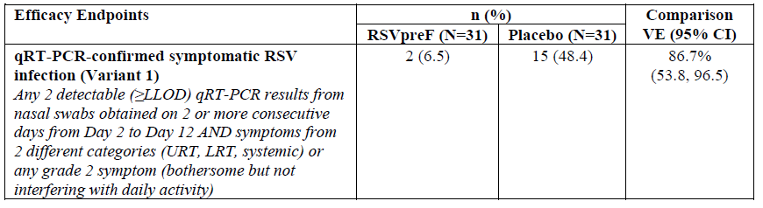
A number of secondary endpoints (including immunogenicity) were assessed and were consistent with the primary endpoint.

Study C3671003
This was a Phase IIb, randomised, placebo-controlled, multinational, observer-blinded study of safety, tolerability, immunogenicity and efficacy in pregnant women and their infants once born, for vaccination across the gestational age range of 24 to 36 weeks in study groups randomised 1:1:1:1:1 as follows:
- RSVpreF 120 μg unadjuvanted
- RSVpreF 120 μg adjuvanted with Al(OH)₃
- RSVpreF 240 μg unadjuvanted
- RSVpreF 240 μg adjuvanted with Al(OH)₃
- Placebo (saline).
Demographic details
Demographic characteristics of maternal participants at Baseline are shown in Table 5.
Table 5: Demographic characteristics of maternal participants – safety population
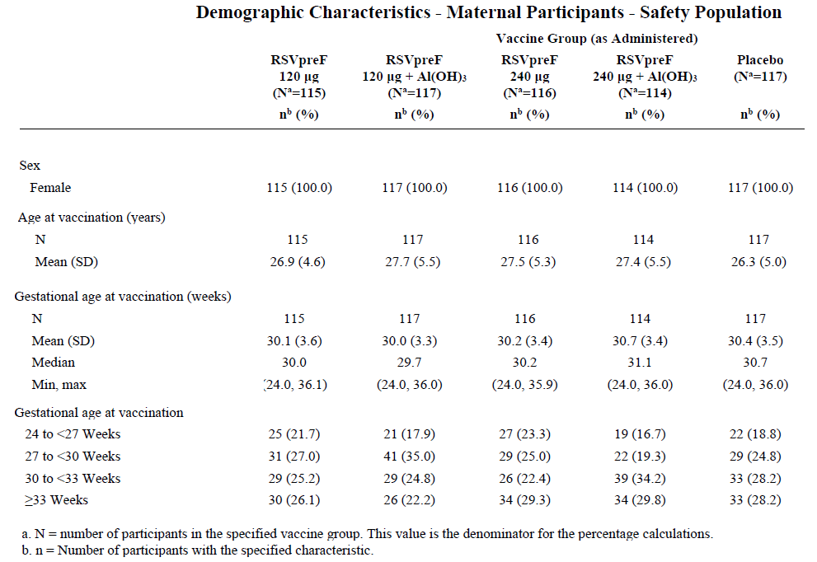
Demographic characteristics of the infant participants at Baseline are shown in Table 6.
Table 6: Demographic characteristics of infant participants – safety population
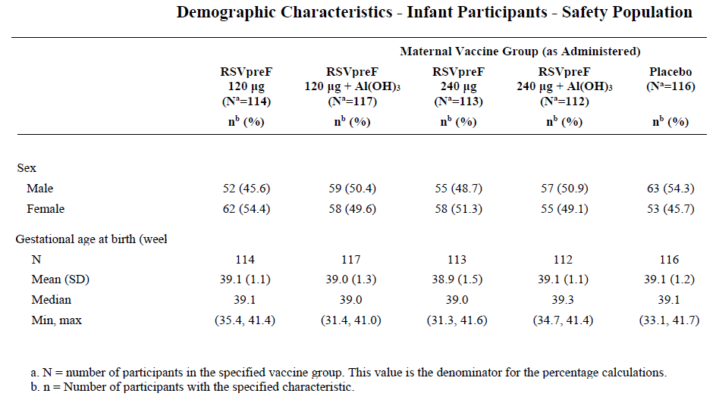
Immunogenicity
Maternal RSV neutralising titres (combined A and B) peaked at two weeks after vaccination and were maintained to six months after delivery. There was no dose or adjuvant effects (see Figure 2).
Figure 2: Line plot for RSV 50% neutralising titres – maternal participants – evaluable immunogenicity population
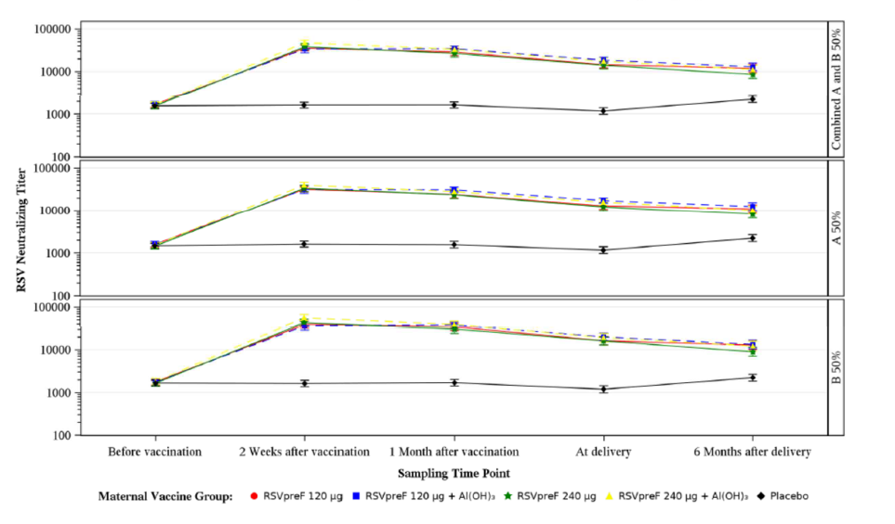
The placental transfer ratio of combined RSV A and B neutralising antibodies in the120 μg group (unadjuvanted)was 1.83 (95%CI 1.44, 2.31). This was similar for the other treatment groups (see Table 7).
Table 7: Maternal-to-infant placental transfer ratio of RSV 50% neutralising titres – evaluable immunogenicity population
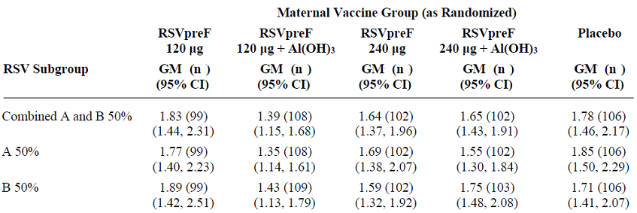
Infant RSV neutralising titres (combined A and B) decreased progressively from birth to six months. In the 120 μg group (unadjuvanted), at birth titres in infants approached maternal levels and were at maternal pre-vaccination levels by six months (see Figure 3).
Figure 3: Line plot for RSV 50% neutralising titres – infant participants – evaluable immunogenicity population
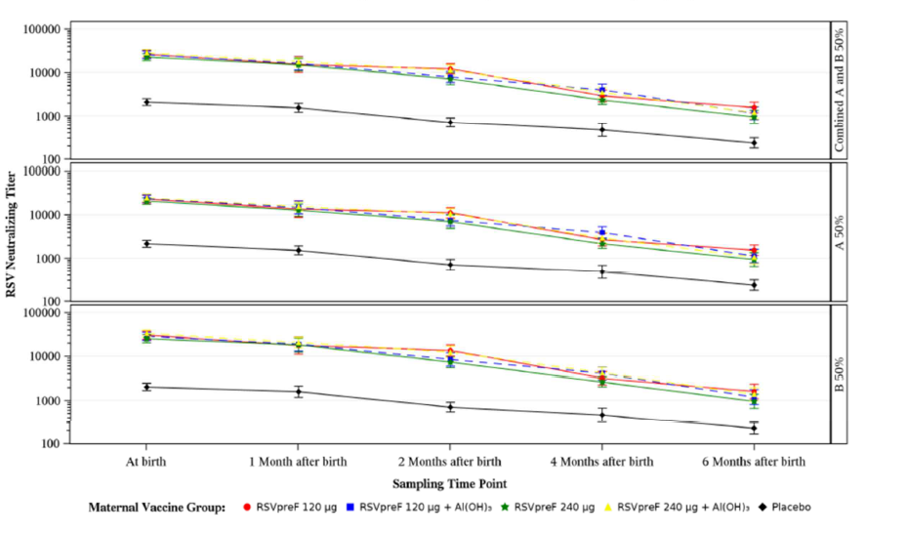
Vaccine efficacy in infants with vaccinated mothers
The preliminary estimates of VE for prevention of RSV disease in infants with vaccinated mothers in this Phase II study ranged from 75% for medically significant and medically attended lower respiratory tract illness (LRTI) to 83% for medically attended severe LRTI (see Table 8).
Figure 3: Line plot for RSV 50% neutralising titres – infant participants – evaluable immunogenicity population
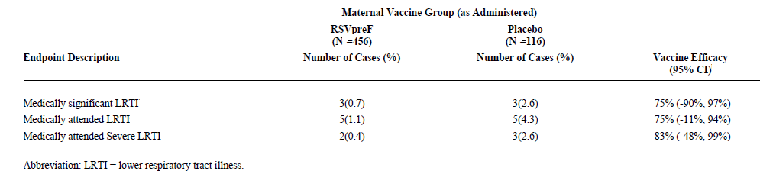
Adverse events
Overall, the number of maternal adverse events (AEs) reported in this study were similar to those reported in the placebo group (see Table 9).
Figure 3: Line plot for RSV 50% neutralising titres – infant participants – evaluable immunogenicity population
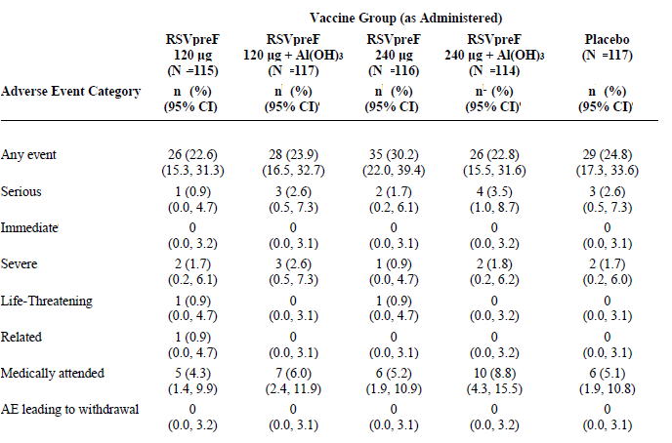
Overall, infant AEs reported in this study were also similar for the vaccinated groups versus the placebo group (see Table 10).
Table 10: Number (%) of participants reporting adverse events, by category, within one month of age – infant participants -safety population.
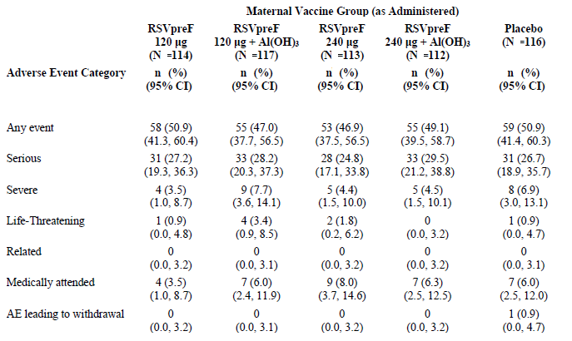
The final dose and formulation (120 μg unadjuvanted, henceforth called the 120 μg formulation) for use in the subsequent pivotal VE trials is supported by the observed results in these Phase I-II studies (1001 and 1002), human virus challenge study (WI257521) and the Phase II study (1003).

Clinical efficacy
There was one pivotal VE trial for each of the two proposed indications:
- Study C3671008 for the maternal indication.
- Study C3671013 for the older adults (≥60 years of age) indication.
Both studies were impacted by the concurrent COVID-19 pandemic at the time.

Study C3671008 (Maternal study)
This was the pivotal Phase III, randomised, double-blind, placebo-controlled, multinational (including Australia and New Zealand) trial to assess VE of RSVpreF 120 µg for prevention of RSV-related illness in infants born to women vaccinated during pregnancy. A single dose of the study vaccine (RSVpreF 120 µg or placebo) was administered intramuscularly to maternal participants between 24 and 36 weeks of gestation.
Inclusion criteria
The inclusion criteria were, among others, healthy women ≤49 years of age who were between 24 and 36 weeks of gestation on the day of vaccination, with uncomplicated, singleton pregnancy, who were receiving prenatal, country specific, standard of care and who had no known risk factor for complications.
Exclusion criteria
The exclusion criteria were, among others, current IVF pregnancy, previous preterm delivery (≤34 weeks gestation), previous stillbirth or neonatal death, prior infant with known genetic disorder or significant congenital anomaly, major maternal illness or conditions of the foetus.
Immunosuppressants were prohibited. Blood products and immunoglobulins were prohibited for 60 days after the study vaccine administration. Non-study vaccines were not allowed for seven days after the study vaccine administration. Licensed vaccines containing pertussis were permitted up to 14 before and from 14 days after the administration of ABRYSVO.
The randomisation and disposition of maternal participants in the study is shown in Table 11.
Table 11: Disposition of all maternal participants
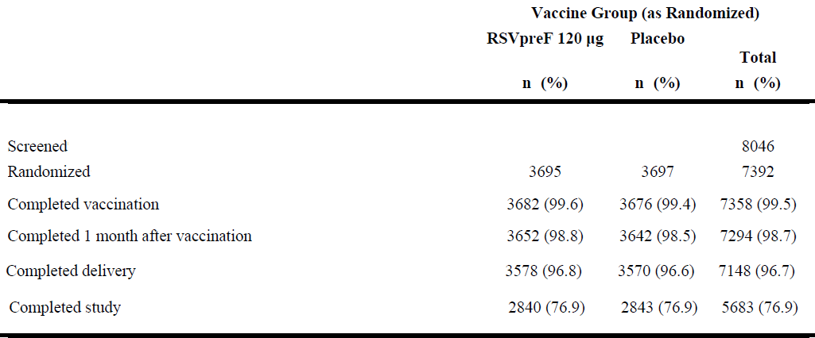
The disposition of infant participants in this study is shown in Table 12.
Table 12: Disposition of all infant participants
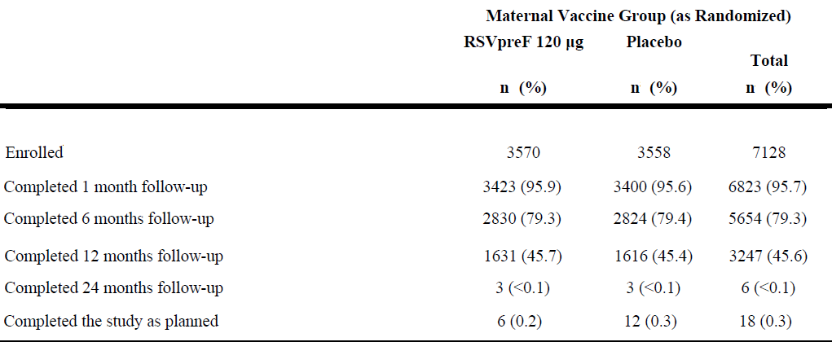
Analysis population details
The primary efficacy population was per protocol infant population and was designated as the evaluable efficacy population. This analysis set included all eligible infant participants born to maternal participants who received the randomised study vaccine (RSVpreF or placebo) at least 14 days prior to delivery, did not receive palivizumab or other RSV-targeting monoclonal antibody, had no major protocol violation and did not receive transfusion >20 mL/kg of any blood products within 180 days.
A secondary analysis was performed using the modified intention to treat (mITT) population which included all infant participants who were born to vaccinated maternal participants. The infant safety population included all infant participants who were born to vaccinated maternal participants (see Table 13).
Table 13: Analysis populations – infant participants
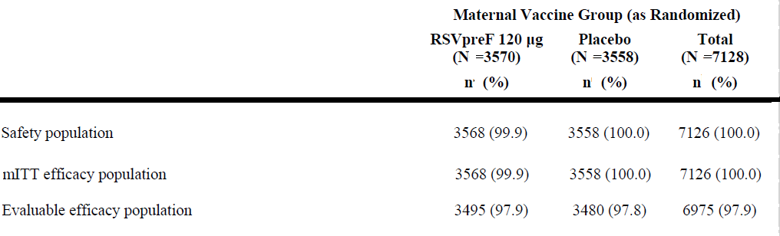
The maternal safety population included all randomised maternal participants who received investigational product. The maternal groups were well balanced at Baseline. The mean age was 29 ± 5 years and mean gestational age at vaccination was 30 ± 3 weeks (see Table 14).
Table 14: Demographic characteristics – maternal participants – safety population
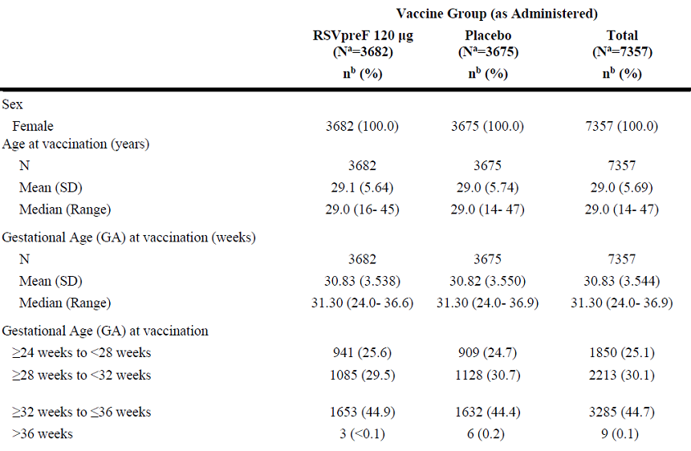
The racial representation was White (64.7% versus 64.4%), Black/African American (19.6% versus 19.7%) and Asian (12.3% versus 12.6%) RSVpreF and placebo groups, respectively, with other groups ≤1% individually. A pertussis-containing vaccine (including Tdap) was administered antenatally in approximately 40% participants in each of the two comparator groups (RSVpreF and placebo).
The infant groups were well balanced at Baseline. Most (93% to 94%) were born from 37 to <42 weeks of gestation but there was some imbalance towards more births <37 weeks of gestation in the RSVpreF group compared to the maternal placebo recipients. Selected Baseline features are shown in Table 15.
Table 15: Demographic characteristics – infants
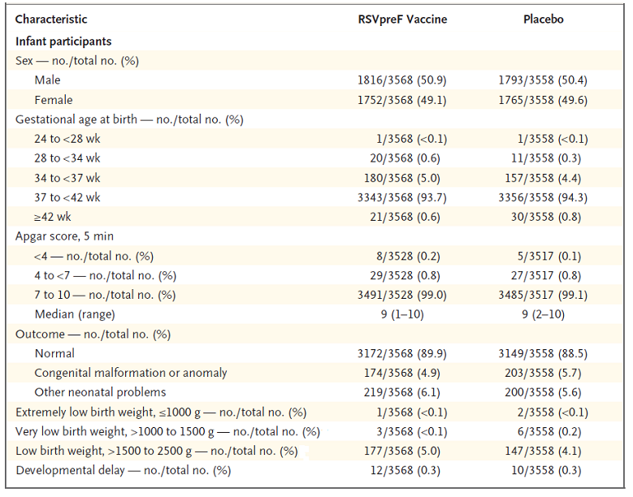
Efficacy outcomes
There were two primary VE outcomes for infants as follows:
- Medically attended-lower respiratory tract illness (MA-LRTI) due to RSV at 90, 120, 150 and 180 days after birth, and
- Severe MA-LRTI due to RSV at 90, 120, 150 and 180 days after birth.
The results were as follows:
- VE (%) for MA-LRTI due to confirmed RSV was 57.1% (99.5% CI: 14.7% to 79.8%) at 90 days and 51.3% (97.58% CI: 29.4% to 66.8%) at six months. Note the CIs are 99.5% at 90 days and 97.58% at later timepoints to control alpha error (see Figure 4a).¹²
- VE for severe MA-LRTIs due to confirmed RSV was 81.8% (99.5% CI: 40.6% to 96.3%) at 90 days and 69.4% (97.58% CI: 44.3% to 84.1%) at six months after birth (see Figure 4b).^{12.}
Figure 4: Vaccine Efficacy for medically attended LRTI (a) and medically attended severe LRTI (b) due to confirmed RSV in infants.
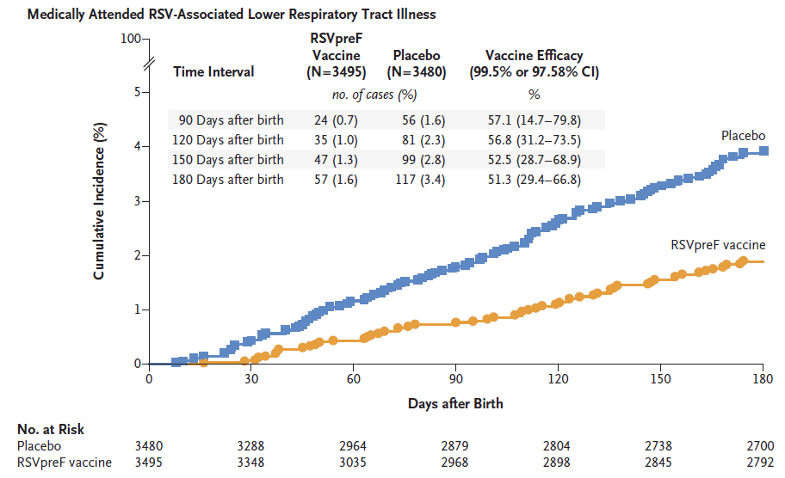
Figure 4a
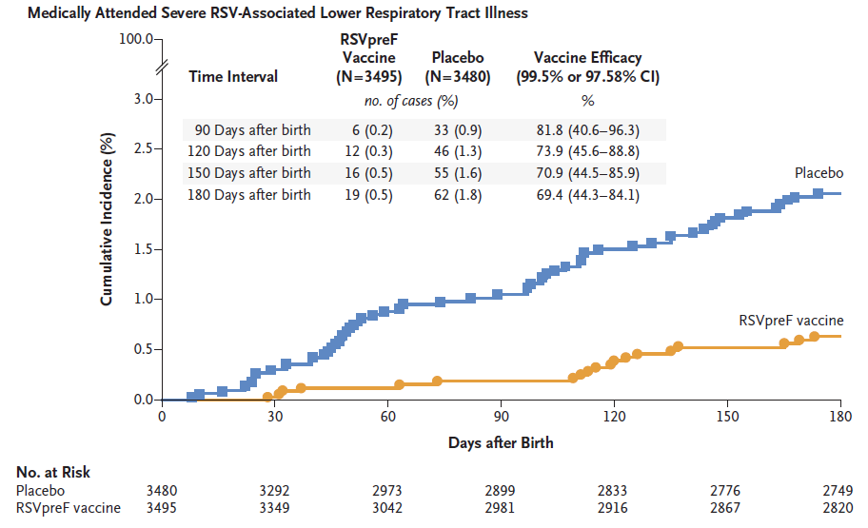
Figure 4b
Most infections were caused by the RSV B subgroup. VE (%) by the RSV A or RSV B subgroups for MA-LRTI within 180 days after birth is shown in Table 16.
Table 16: Medically attended LRTIs confirmed by the EAC, shown by RSV subgroup A and subgroup B, occurring within 180 days after birth – infant participants – evaluable efficacy population.
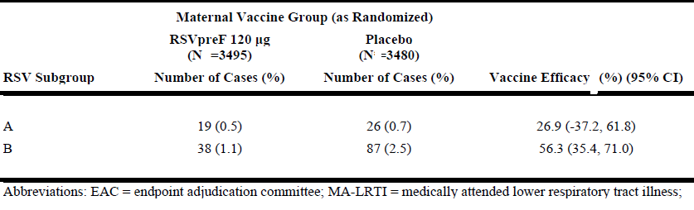
VE (%) by the RSV A or RSV B subgroups for severe MA-LRTI within 180 days after birth is shown in Table 17.
Table 17: Severe medically attended LRTIs confirmed by the EAC, shown by RSV subgroup A and subgroup B, occurring within 180 days after birth – infant participants – evaluable efficacy population.
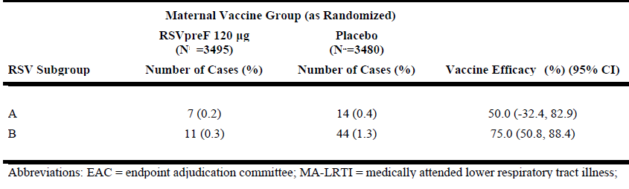
VE (%) for RSV-specific hospitalisations in infants after birth were significantly reduced in infants born to vaccinated mothers compared to infants born to mothers who received the placebo, and the advantage was maintained to six months after birth (see Table 18).
Table 18: Hospitalisation due to RSV, confirmed by the EAC, occurring within 90, 120, 150, 180, and 360 days after birth – infant participants – evaluable efficacy population.
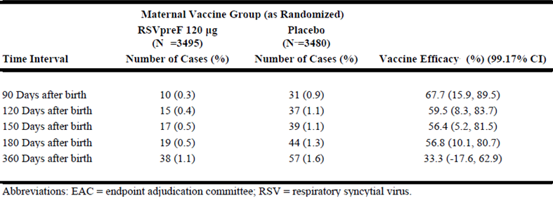
The results for all cause hospitalisations were not included. However, VE (%) for MA-LRTI due to any cause was not significantly different between the two groups at any timepoint after birth as shown in Table 19.
Table 19: Medically attended LRTIs due to any cause with protocol defined criteria, per investigator, occurring within 90, 120, 150, 180 and 360 days after birth – infant participants – evaluable efficacy population.
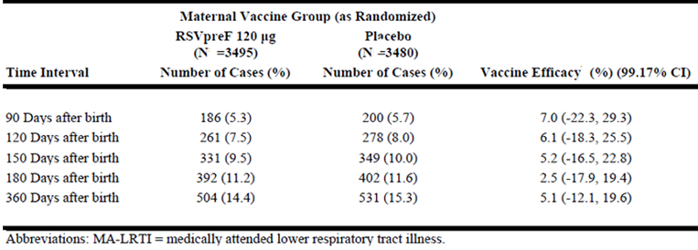
There were too few cases of RSV to allow a reliable estimate of VE within the prematurely born (<37 weeks gestation) subgroup of infants.
A secondary/exploratory outcome was incidence of maternal all-cause medically attended-respiratory tract illnesses (MA-RTIs) at 180 days after delivery. This incidence was similar (6.7% versus 6.6%) in maternal RSVpreF recipients versus maternal placebo recipients (see Table 20).
Table 20: Incidence of all cause MA-RTIs from vaccination up to 180 days after delivery – maternal participants – safety population.
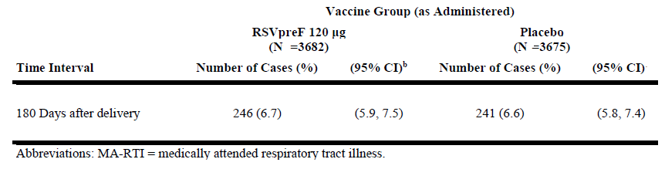A numerical imbalance in the premature birth rate of 5.7% (95% CI 4.9%, 6.5%) in the RSVpreF group versus 4.8% (95% CI 4.1%, 5.5%) in the placebo group was reported in the study. Similarly, there was a numerical imbalance in the rate of low-birth weight babies, with 5.1% (95% CI 4.4%, 5.8%) reported in the RSVpreF group versus 4.3% (95% CI 3.7%, 5.0%) in the placebo group. Results stratified by high- and low -income countries indicate that the imbalance was not observed in high-income countries implying that this may be related to antenatal care.
Furthermore, no increase in overall infant mortality or increased mortality in prematurely born infants was observed. However, a very small imbalance in overall neonatal hospitalisations (391 [11%] in the RSVpreF group versus 353 [9.9%] in the placebo group), and hospitalisations in those born prematurely (83 [2.3%] in the RSVpreF group versus 80 [2.2%] in the placebo group) were reported. Of the infants born prematurely, the majority in both groups (180/201 [89.5%] in the RSVpreF group versus 157/169 [92.9%] in the placebo group) were born late preterm between ≥34 to <37 weeks. Further, no differences were observed between the RSVpreF and placebo groups with respect to various time intervals from vaccination to birth among preterm and term infants versus Placebo.
There is some evidence, based on analysis of subgroups by maternal gestational age at vaccination, that reduced VE at 90 days post vaccination is related with earlier vaccination (before 28 weeks gestation) as shown in Table 21.
Table 21: RSV-positive, confirmed by the EAC, occurring within 90, 120, 150, and 180 days after birth by subgroups – infant participants – evaluable efficacy population.
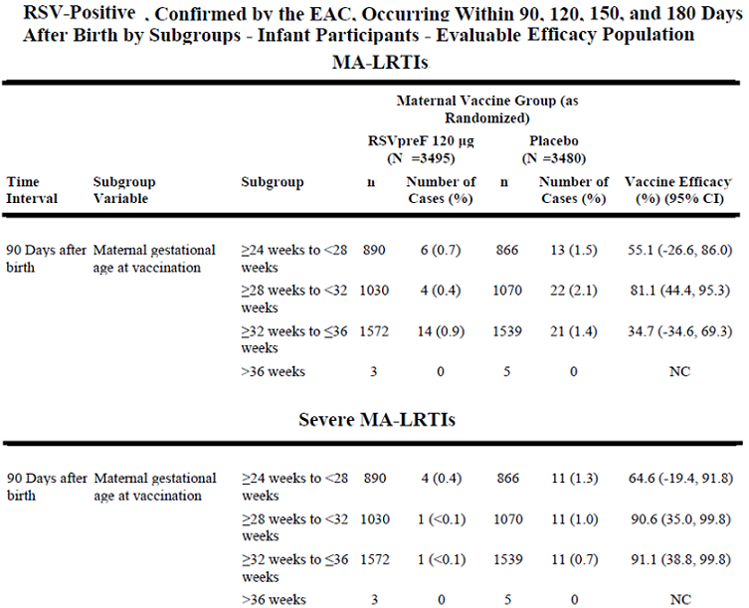
Further clarification will be sought from the sponsor in its pre-ACV response with respect to VE and birth outcomes (premature births) by maternal gestational age at the time of vaccination.
Coadministration of pertussis vaccine
A pertussis-containing vaccine was given antenatally to approximately 40% participants in each group. This was administered across the gestational age range from 24 weeks onwards, with the majority receiving the pertussis vaccine between 28 and 34 weeks of gestation. The protocol specified that the RSVpreF and pertussis vaccines be separated by 14 days. However, 2.2% RSVpreF versus 2.0% placebo participants received the pertussis vaccine ≤14 days before the study vaccine, and 1.4% RSVpreF versus 1.6% placebo participants received the pertussis vaccine ≤14 days after the study vaccine.
The assessment of timing of pertussis-containing vaccine relative to RSVpreF was not an objective of the study and no immunogenicity data were collected. No cases of pertussis were reported in infants <6 months of age in either the RSVpreF or the placebo groups. Two cases (one in the placebo group) were reported outside of this timeframe: an infant reported with whooping cough (at day 584 of life) in the RSVpreF group was born to a maternal participant who received RSVpreF at 27 weeks and DPT at 18 days after RSVpreF vaccination. The infant’s vaccination status is not known.

Study C3671013 (Older Adults study)
This was the pivotal Phase III, randomised, double-blind, placebo-controlled, multinational study in adults ≥60 years to assess VE of RSVpreF 120μg for prevention of RSV-related respiratory illness. The study vaccines were single dose of RSVpreF 120 μg or placebo administered by intramuscular injection. This submission focuses on efficacy after season 1. The study is ongoing to cover RSV season 2.
The disposition of randomised participants is shown in Table 22.
Table 22: Disposition of randomised participants
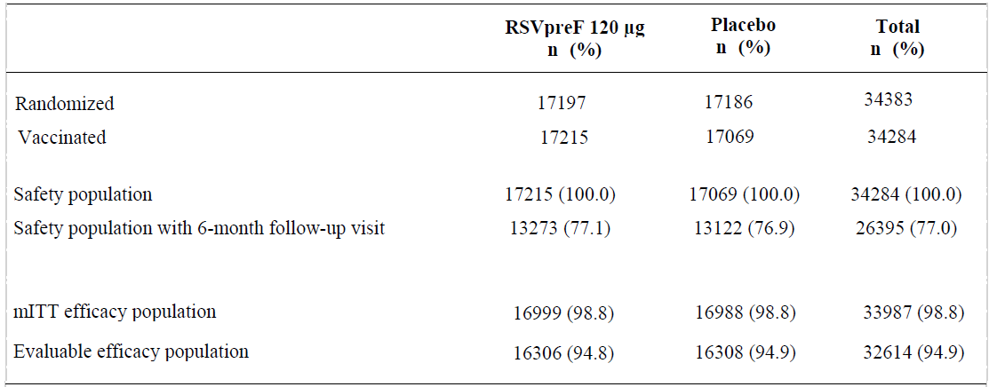
The assessment of VE was based on the evaluable efficacy population, that is per protocol population. Definitions of the populations are outlined in Table 23.
Table 23: Definitions of populations
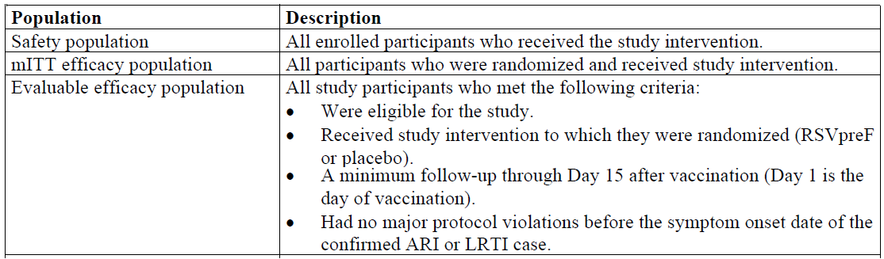
The study was event driven with a target of 59 first episodes of evaluable RSV-associated lower respiratory tract illness (LRTI-RSV) with ≥2 symptoms starting from Day 15 after the study vaccination, as the primary efficacy outcome. The two groups were well balance at Baseline. The mean age of the participants was 68 ± 8 years. Selected baseline features are shown in Table 24.¹²
Table 24: Demographic and clinical characteristics of the participants at Baseline (safety population).
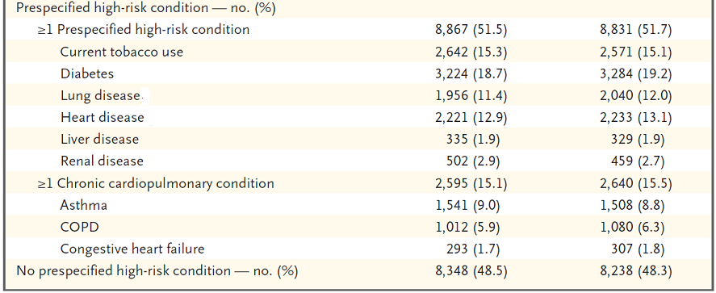
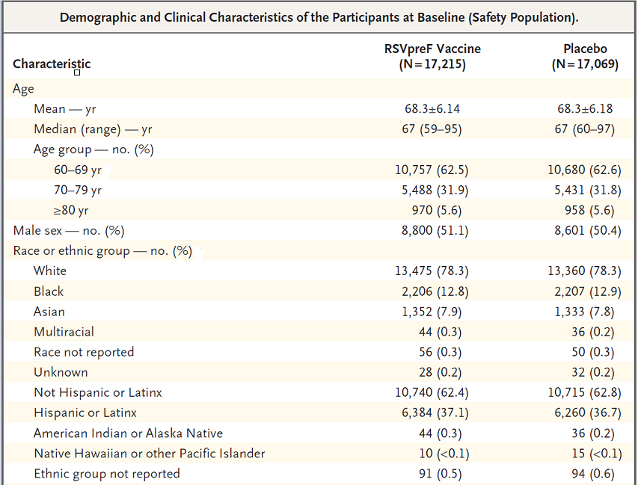

At the cut-off date of 8 July 2022, with an average surveillance of 6.8 months, using the evaluable efficacy population there were 45 participants with 46 episodes of LRTI-RSV with ≥2 symptoms reported after vaccination. Of these, one episode was reported before Day 15; therefore, 44 reported episodes qualified for inclusion in the efficacy analysis.
The 44 cases comprised 11 LRTI-RSV cases in the RSVpreF group and 33 cases in the placebo group corresponding to an overall VE (%) of 66.7% (96.66% CI: 28.8%, 85.8%) as shown in Table 25.
Table 25: Vaccine efficacy of RSVpreF against first episode of LRTI-RSV with ≥2 symptoms – evaluable efficacy population.
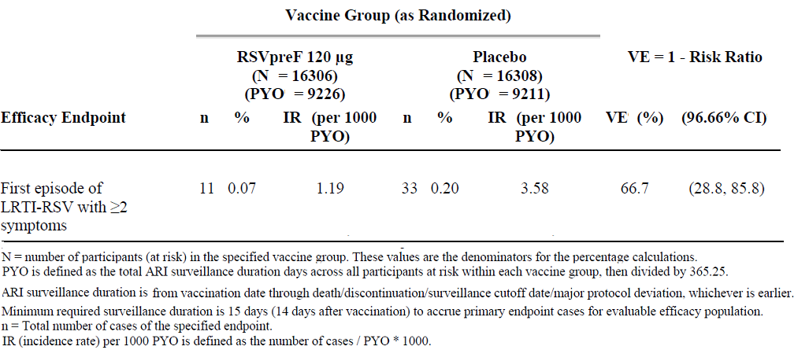
Most cases were RSV subgroup B. The VE (%) for RSV subgroups A and B are shown in Table 26.
Table 26: Vaccine efficacy of RSVpreF against first episode of LRTI-RSV with ≥2 symptoms – evaluable efficacy population.
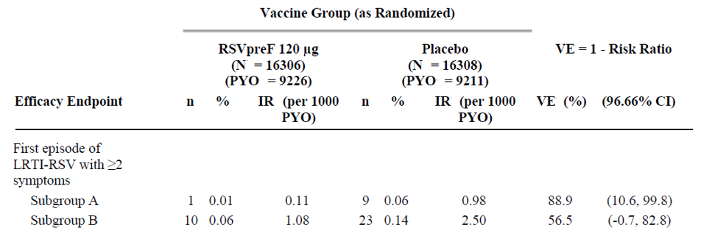
Analyses by baseline subgroups showed, in general, a homogeneous effect in favour of RSVpreF efficacy, except in the Black/African American population with an expected lack of statistical power in all subgroups (see Figure 5).
Figure 5: Forest plot of vaccine efficacy of RSVpreF against first episode of LRTI-RSV with ≥2 symptoms by demographic and baseline characteristic subgroups – evaluable efficacy population.
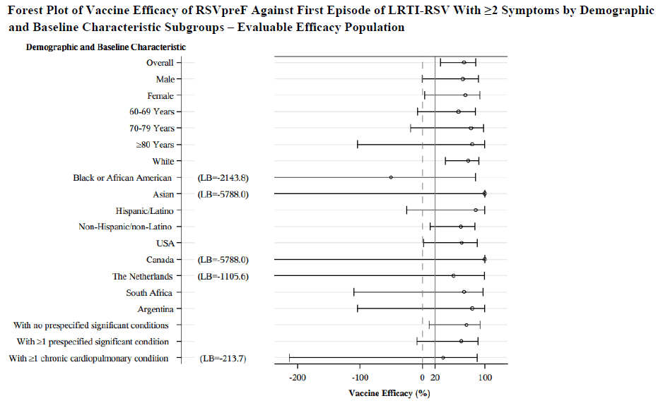
Analysis of primary VE outcome, that is, ≥2 RSV symptoms using the mITT population, was consistent with the evaluable efficacy population (see Table 28).
Table 27: Vaccine efficacy of RSVpreF against first episode of LRTI-RSV with ≥2 symptoms – mITT efficacy population.
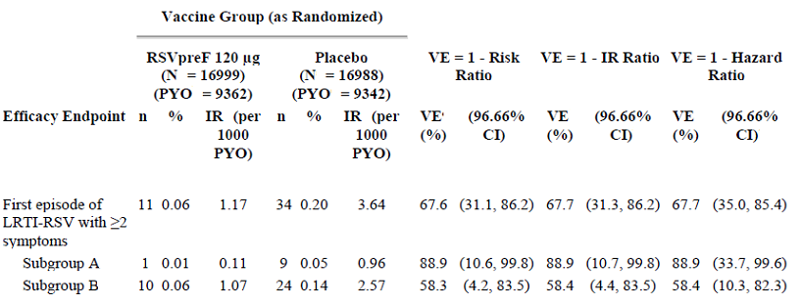
VE (%) for RSV-associated LRTI with ≥3 LRTI signs/symptoms was 58.7% (96.99% CI: 32.0% to 98.7% as shown in Figure 6.¹²
Figure 6: RSV-associated lower respiratory tract illness with ≥3 signs or symptoms
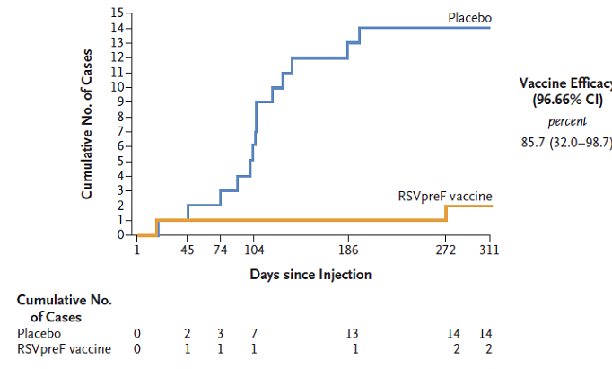
VE (%) for RSV associated acute respiratory illness (ARI) was 62.1% (95%CI: 37.1% to 77.9%) as shown in Figure 7.¹²
Figure 7: RSV-associated acute respiratory illness
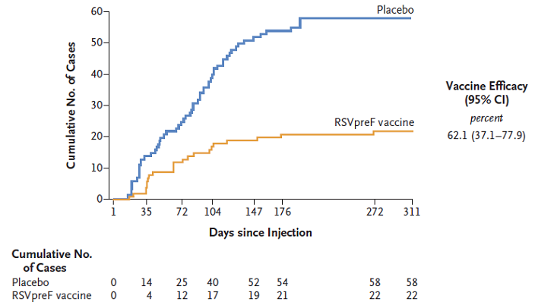
A preliminary analysis into the second RSV season (mid-season 2) was conducted from ARI surveillance in the Northern hemisphere (largely the USA) to a cut-off date of 31 January 2023. The average duration of ARI surveillance was 5.67 months. The total average duration from vaccination to the mid-season 2 cut-off was 13.9 months. The VE (%), along with updated VE (%) at the end of season 1 (average duration of follow up of 7.05 months) was reported as shown in Table 28.
Table 28: RSVpreF vaccine efficacy against LRTI-RSV at end of season 1 and mid-season 2
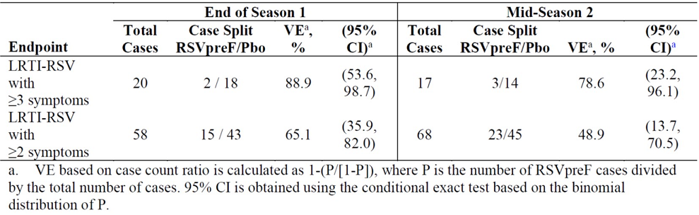
Study C3671013 is ongoing and planned to run through two RSV seasons. The season 2 efficacy, safety and immunogenicity data from the Northern and Southern hemispheres are expected to become available in the second half of 2024, and additional immunogenicity data from season 3 are expected in 2025.

Other studies

SIIV interaction study C3671006
This study examined the immunogenicity of RSVpreF on coadministration with seasonal inactivated influenza vaccine (SIIV) in adults ≥65 years age. The results indicated that RSV neutralising antibody titres and anti-haemagglutination inhibition (HAI) antibodies were all nominally higher with sequential administration compared to coadministration, although non-inferiority is claimed based on predefined criterion of a lower limit of 95% CI for geometric mean ratio (GMR) (coadministration/sequential) to be no worse than 0.667 (see Table 29).
Table 29: SIIV HA1 and RSV neutralising titre GMT/GMRs at one month after vaccination – evaluable SIIV immunogenicity population and evaluable RSV immunogenicity population (study C3671006).
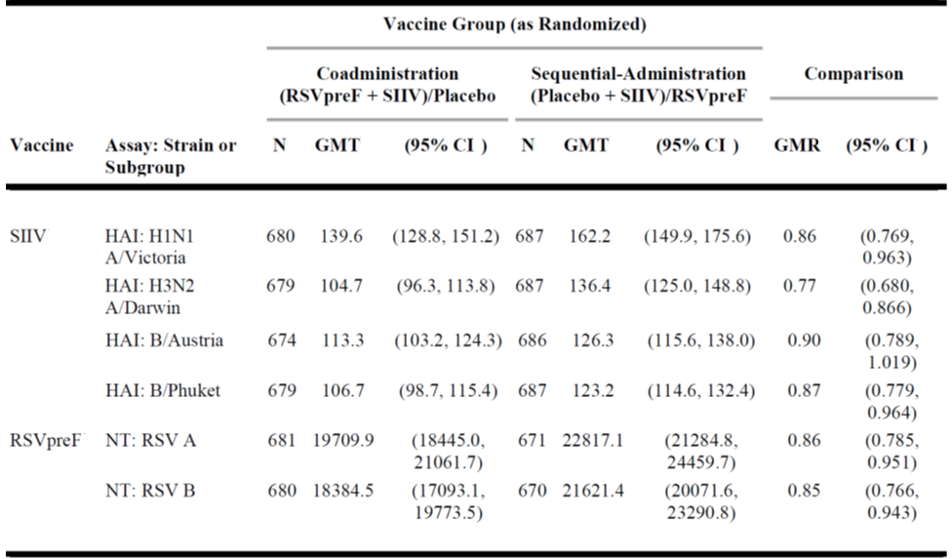
SIIV interaction was also assessed in studies C3671001 and C3671002. In study C3671001 concomitant SIIV did not affect response to RSV A or RSV B. There was no difference in response for the two age groups. There was a tendency for RSVpreF to interfere with SIIV titres at the higher dose levels in the 18 to 49 years age group. This was not apparent in the 50 to 89 years age group. In study C3671002 RSVpreF did not influence response to SIIV.

Interaction with COVID-19 vaccine
In Round 2, the sponsor provided summary results of a coadministration study of Abrysvo with the Pfizer-BioNTech mRNA vaccine (Omicron/BA 4-5), which satisfactorily demonstrated a lack of immune interference on coadministration.

Tdap interaction study C3671004
This placebo-controlled study was conducted in non-pregnant females to examine the immune interaction on concomitant administration of RSVpreF and Tdap. The results were indicative of a similar response to tetanus, diphtheria and RSVpreF components. However, a significantly reduced response to the pertussis components particularly against FHA and PRN was found on coadministration compared to placebo (see Table 30).
Table 30: Antipertussis component antibody GMRs of combined RSVpreF/Tdap groups GMCs to placebo/Tdap group GMCs – evaluable immunogenicity population (study C3781004).
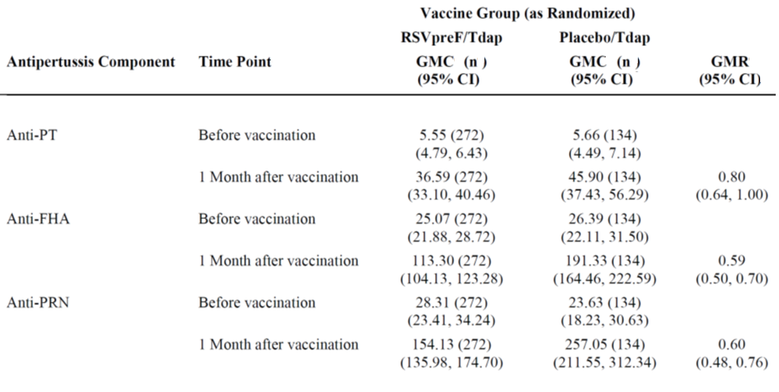
Based on these findings, administration of a pertussis vaccine (including Tdap) within 14 days of RSVpreF vaccine was not allowed in the subsequent pivotal maternal study 1008. Summary clinical data on pertussis outcomes in study 1008 was noted earlier. However, immunogenicity data were not collected in study 1008. Therefore, no data on optimal timing of a pertussis-containing vaccine relative to RSVpreF during pregnancy are currently available.

Lot consistency study C3671014
This study satisfactorily demonstrated equivalent immunogenicity for three separate production batches of RSVpreF.

Clinical safety

Participant exposure
A total of 4,144 pregnant women were exposed to RSVpreF in the two maternal studies of which 3,797 were exposed to the unadjuvanted 120 µg formulation between 24 and 36 weeks of gestation. All were exposed to a single vaccine dose (see Table 31).
Table 31: Maternal participants exposed to RSVpreF
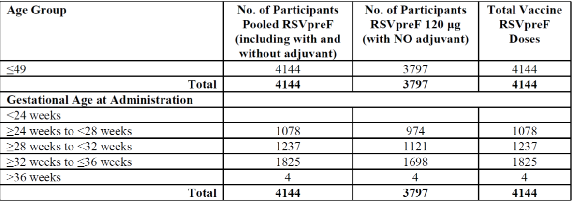
A total of 9,046 males and 9,208 females were exposed to the unadjuvanted 120 µg RSVpreF formulation in all clinical studies (other than the two maternal studies). The age distribution is shown in Table 32.
Table 32: Age distribution of male and female participants exposed to 120 µg RSVpreF
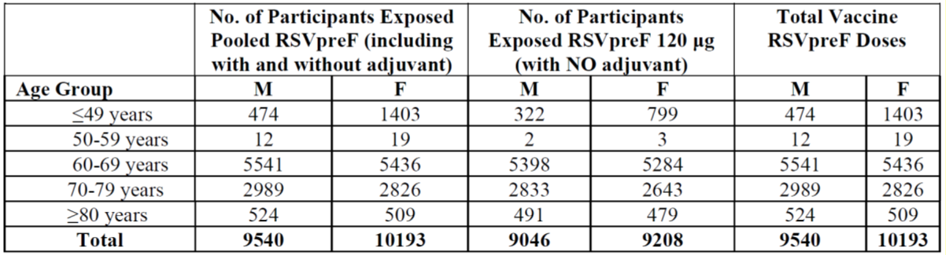
The description below focuses on the two pivotal studies.

Maternal study C3671008
Solicited local and systemic reactions were separately reported within seven days of vaccination and showed consistently higher incidence in the RSVpreF group compared to placebo.
Local reactions reported by maternal participants within seven days of vaccination are shown in Figure 8.
Figure 8: Participants reporting local reactions by maximum severity within seven days after vaccination – maternal participants – safety population.
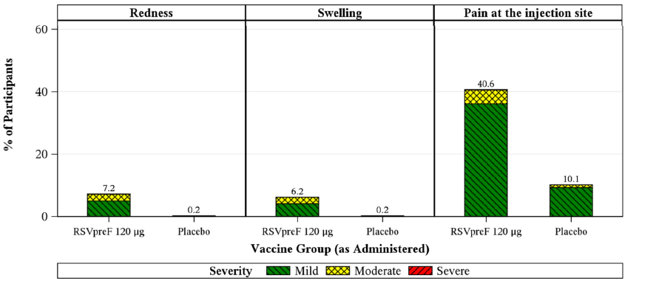
Systemic reactions reported by maternal participants within seven days of vaccination are shown in Figure 9.
Figure 9: Participants reporting systemic events by maximum severity – maternal participants – safety population.
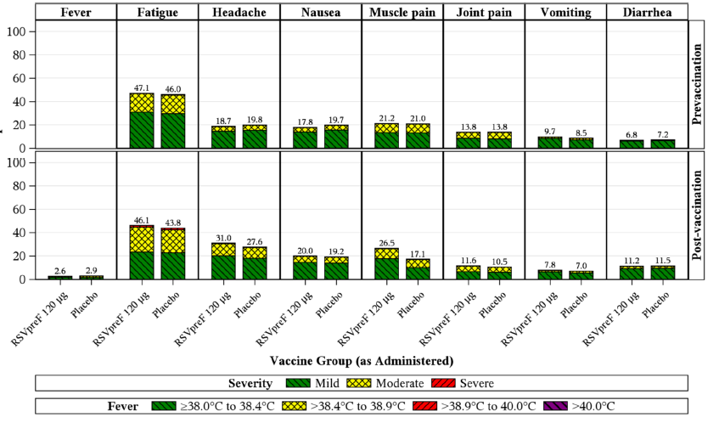
In maternal participants, AEs were reported in 13.8% RSVpreF 120 μg versus 13.1% in placebo participants. Adverse events of special interest (AESIs) were reported in 2.7% in RSVpreF 120μg versus 2.5% placebo participants (see Table 33).
Table 33: Number (%) of participants reporting adverse events by category within one month after vaccination – maternal participants -safety population.
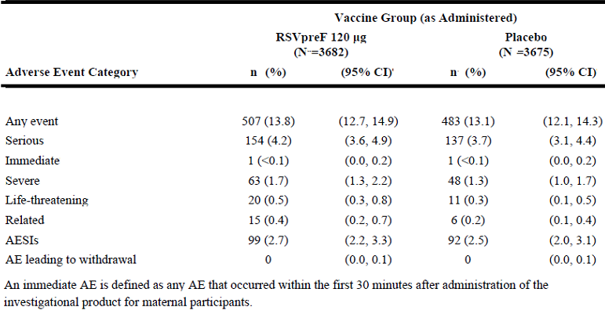
In infants, AEs were reported in 37.1% RSVpreF versus 34.5% placebo participants. The most frequently reported infant AE was neonatal hyper-bilirubinaemia in 3.0% infants in the RSVpreF group versus 2.9% in the placebo group. The reported rate was 10.8% versus 9.7% for AESIs and 0.2% versus 0.2% for newly diagnosed chronic medical conditions (NDCMC) in the two groups respectively (see Table 35).
Table 34: Number (%) of participants reporting adverse events by category within one month after birth – infant participants – safety population.
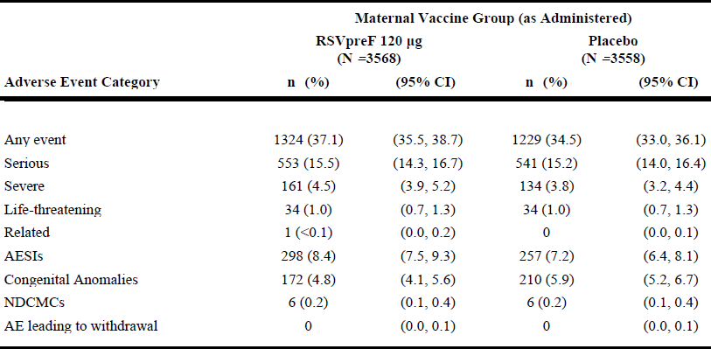
In maternal participants, ADRs (adverse drug reactions) were reported in 0.4% RSVpreF 120 μg versus 0.2% placebo participants. Two women were reported with injection site bruising, and two with lymphadenopathy, in RSVpreF group. In infants, one ADR was reported in the RSVpreF group (premature baby).
In maternal participants, serious AEs (SAEs) were reported in 4.2% women in RSVpreF 120 μg group versus 3.7% in placebo group. SAEs in the pregnancy, puerperium and perinatal conditions category were reported in 12.1% women in RSVpreF group versus 11.2% in placebo.
In infants, SAEs were reported in 15.5% infants in the RSVpreF group versus 15.2% in the placebo group. Congenital anomalies were reported in 5.0% infants in the RSVpreF group versus 6.2% infants in the placebo group. Neonatal jaundice as an SAE was reported in 2.1% infants in the RSVpreF group versus 1.9% in the placebo group and respiratory distress as an SAE was reported in 1.3% infants in the RSVpreF group versus 1.2% in the placebo group.
One maternal death was reported in RSVpreF group due to postpartum haemorrhage and shock. There were 11 (0.3%) intrauterine deaths in the RSVpreF group versus 10 (0.3%) in the placebo group. There were five (0.1%) infant deaths in RSVpreF group versus 12 (0.3%) in the placebo group.

Older adults study C3671013
Solicited local and systemic reactions were separately reported within seven days of vaccination and showed consistently higher incidence in the RSVpreF group compared to placebo.
Overall, any local reaction within seven days of vaccination was reported in 12.1% RSVpreF versus 6.6% placebo participants. Systemic reactions within seven days of vaccination were reported in 27.4% RSVpreF versus 25.7% in placebo participants (see Figures 10a and 10b, respectively).
Figure 10: Local reactions (Figure 10a) and systemic events (Figure 10b), by maximum severity, within seven days after vaccination – E-diary subset safety population
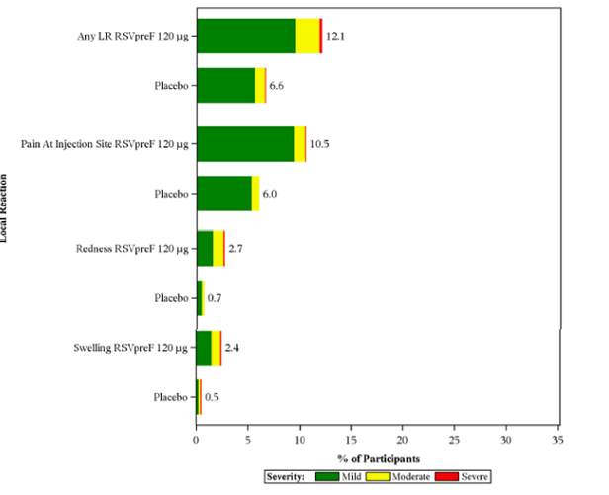
Figure 10a
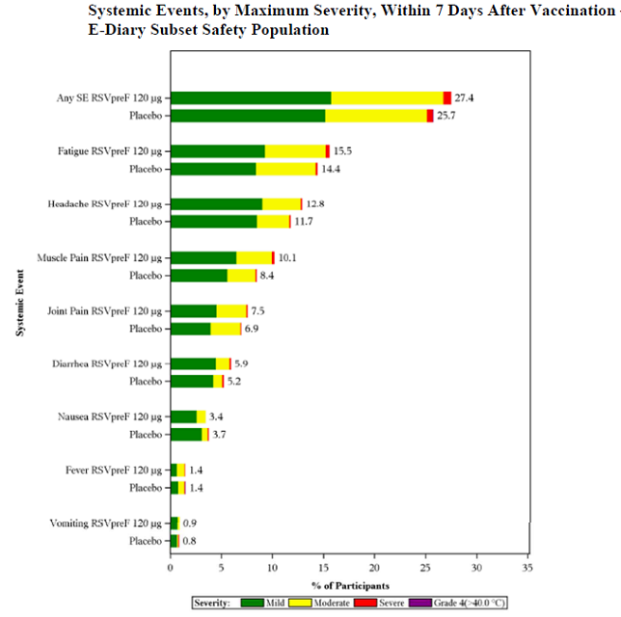
Figure 10b
AEs were reported in 13.0% RSVpreF versus 12.8% placebo participants and were generally balanced between the vaccinated and the placebo group (see Table 36).
Table 35: Adverse events, by category, reported from vaccination through data cutoff (14 July 2022) – safety population.
SAEs leading to death was reported for 69 (0.4%) RSVpreF versus 71 (0.4%) placebo participants. None of the deaths were attributed to the study vaccines.

Three SAEs in the RSVpreF group were considered related to the study vaccine as follows:
- Allergic reaction on the day of administration
- Guillain-Barrè Syndrome (GBS) with onset seven days after administration
- Miller Fisher Syndrome with onset eight days after administration.
Two more events of GBS were subsequently reported that included one in the RSVpreF group eight months after administration and one in the placebo group 14 months after administration and are not considered related to study interventions. A new study (C3671031) is planned to further evaluate the risk of GBS, other immune-mediated demyelinating conditions and polyneuropathies following RSVpreF administration among older adults.
Some of the reported incidence rates could not be reconciled between the sponsor’s dossier and the clinical evaluation report. The sponsor will be requested to provide an updated summary. A summary of safety data to mid-season 2 was included at Round 2 and showed the incidence of any AE was 10.6% versus 10.4% in the RSVpreF and placebo groups respectively (see Table 37).
Table 36: Adverse events, by category, from vaccination through one-month follow up visit and through data cutoff (31 January 2023) – mid-season 2 safety analysis
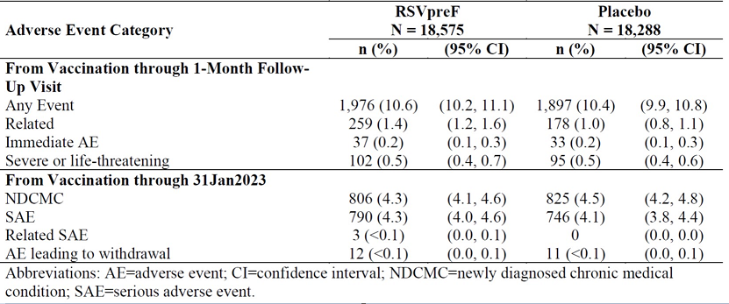
Overall, the updated summary continues to show comparable safety outcomes in RSVpreF recipients versus placebo recipients. The incidence of related AEs (1.4% versus 1.0%) and SAEs (4.3% versus 4.1%) in the two groups respectively are noted.

Other studies
In the dose finding study C3671001, six deaths were reported in expanded and sentinel cohorts, none related to study treatments. In the dose finding study C3671002, one participant in the RSVpreF 240 μg+CpG/Al(OH)₃ group in the primary cohort died due to myocardial infarction 210 days after administration, and a second participant died after the final visit. There was one SAE in the RSVpreF 240 μg group (lymphadenopathy/device breakage).
In study C3671006, one death was reported following the placebo + SIIV vaccination 1 at 29 days after vaccination from cardiac failure. Within one month of vaccination 1, SAEs were reported in eight (1.1%) of the RSVpreF + SIIV versus six (0.9%) of the placebo + SIIV group participants; and within one month of vaccination 2, SAEs were reported in two (0.3%) of the placebo group and five (0.7%) of the RSVpreF group. Coadministration did not result in a significant increase in local reactions or systemic reactions.

Risk management plan
The summary of safety concerns and their associated risk monitoring and mitigation strategies are presented in Table 38.
Table 37: Summary of safety concerns
Summary of safety concerns |  | Pharmacovigilance |  | Risk minimisation
 |  | Routine | Additional | Routine | Additional
Important identified risks | None | - | - | - | -
Important potential risks | Guillain-Barrè syndrome | ü | ü*†‡ | - | -
Missing information | Use in immunocompromised pregnant women and high-risk pregnancies | ü | ü† | ü | -
Missing information | Use in immunocompromised or renally or hepatically impaired older adults ≥60 years old | ü | ü* | ü | -
* C3671038
† C3671026
‡ C3671031
Pfizer Australia Pty Ltd has submitted European RMP (EU RMP) version 0.3 (dated 27 June 2023; data lock point 2 September 2022 [for the maternal indication] and 13 October 2022 [for the older adult indication]) in association with Australia-specific annex (ASA) version 1.1 (dated 31 October 2023) in support of this application.
The safety concerns in the ASA are consistent with the approved EU-RMP safety concerns for Abrysvo, and the summary of safety concerns are acceptable from an RMP perspective.
Routine and additional pharmacovigilance activities which align with the EU RMP have been proposed in the ASA. Additional pharmacovigilance activities include three planned post-authorisation safety studies (C3671026, C3671038 and C3671031). The studies do not include Australian patients; however, the results from the studies will be considered generalisable to the Australian population.
Routine risk minimisation activities only are proposed for missing information ‘use in immunocompromised pregnant women and high-risk pregnancies’ and ‘use in immunocompromised or renally or hepatically impaired older adults ≥60 years old’. No risk minimisation activities are proposed for the important potential risk of ‘Guillain-Barré syndrome’. This has been raised to the Delegate to consider regarding a statement in the PI. The risk minimisation plan is acceptable from an RMP perspective.
The RMP evaluation recommended conditions of registration relating to the versions of the RMP, requirement for periodic safety update reports (PSURs), and inclusion of the medicine in the Black Triangle Scheme.
There are no outstanding RMP recommendations. The conditions of registration have been provided to the Delegate.
The TGA may request an updated RMP at any stage of a product’s life-cycle, during both the pre-approval and post-approval phases. Further information regarding the TGA’s risk management approach can be found in risk management plans for medicines and biologicals and the TGA’s risk management approach. Information on the Australia-specific annex (ASA) can be found on the TGA website.

Risk-benefit analysis

Delegate’s considerations
Abrysvo (recombinant respiratory syncytial virus pre-fusion F protein [RSVpreF]) 120 μg/0.5 mL, bivalent vaccine powder for injection plus diluent, has a favourable benefit-risk balance for the proposed therapeutic indication:
Abrysvo is a bivalent vaccine indicated for:
- The prevention of lower respiratory tract disease and severe lower respiratory tract disease caused by respiratory syncytial virus (RSV) in infants from birth through 6 months of age by active immunisation of pregnant individuals.
- The prevention of acute respiratory disease and lower respiratory tract disease caused by RSV in individuals 60 years of age and older by active immunisation.
The benefit-risk balance may become even more favourable if RSVpreF has efficacy beyond one RSV season. This would increase the benefit without further risks of revaccination. The longer the duration of effect without requiring revaccination, the more favourable the benefit-risk balance becomes.

Proposed action
Pending advice from ACV, the Delegate is of the view that the supplied data supports approval for the following indications:
Abrysvo is indicated for:
- Active immunisation of pregnant women between 24-36 weeks of gestation for prevention of severe lower respiratory tract disease caused by respiratory syncytial virus (RSV) in infants from birth through 6 months of age.
- Active immunisation of individuals 60 years of age and above for prevention of lower respiratory tract disease caused by respiratory syncytial virus (RSV).
Abrysvo should be used in accordance with official recommendations.
Vaccination in both indications comprises a single 0.5 mL dose (120 µg RSVPreF) by intramuscular injection. At present there are no data on revaccination. There are no data for use in children for active immunisation.
Further data on VE beyond RSV season 1 and comprehensive immunogenicity data should be made available in a future submission for appropriate PI update.

Questions for the sponsor
The sponsor provided the following response to questions from the Delegate.
- Please provide summary results of Vaccine Efficacy in infants (MA-LRTI and severe MA-LRTI at 90 and 180 days) and pregnancy outcomes (premature births <37 weeks gestation) by subgroups of women vaccinated at <28 weeks and ≥28 weeks, and vaccinated at <32 weeks and ≥32 weeks in Study C3671008.
The requested tables are provided below (Tables 39 to 50).
It is important to note that these are all post-hoc exploratory analyses and are not powered for significance, therefore should be interpreted with caution given the limited case numbers. Overall, analyses of VE by gestational age are consistent with the overall efficacy analyses, with high VE against severe MA-LRTI through 180 days among the different gestational age ranges. RSVpreF was also efficacious against MA-LRTI in each of the requested gestational age ranges, albeit with wide CIs due to the lower case numbers, particularly for maternal vaccination between 24 to <28 weeks gestation.
Pregnancy outcomes tables presented show that the majority of infants overall had favourable birth outcomes, irrespective of maternal gestational age at vaccination. As previously noted in the response to Clinical Evaluation Question 9, Sequence 0001, there were no statistically meaningful imbalances between RSVpreF and placebo recipients in the overall AE rates of preterm birth. As described in the sponsor response, a numerical imbalance in preterm births was observed in upper-middle income countries, while no imbalances were observed in high income countries including the USA, EU countries, Australia, New Zealand and Japan, with no differences observed between the RSVpreF and placebo groups with respect to time from vaccination to birth, and no imbalances in other adverse pregnancy outcomes such as neonatal and infant deaths.
- A number of adverse effect incidences could not be reconciled between the clinical evaluation report and the dossier for the Study C3671013. Please provide updated higher level summary of adverse events/reactions.
Only season 1 data for Study C3671013 were provided in the dossier as the complete season 2 data are not yet available. At the request of the Clinical Evaluator at Milestone 3, mid-season 2 data through the data cutoff date of 31 January 2023 were provided (see response to Clinical Evaluation Question 8 in Sequence 0003, along with the referenced ACIP presentation). Mid-season 2 data represent the most up to date summary of adverse events/reactions from the C3671013 study. C3671013 clinical study report including the entire season 2 data will be submitted to the TGA in 2024.
Table 38: RSV-positive MA-LRTIs, confirmed by the EAC in maternal gestational age at vaccination of 24 to <28 weeks – infant participants - evaluable efficacy population.
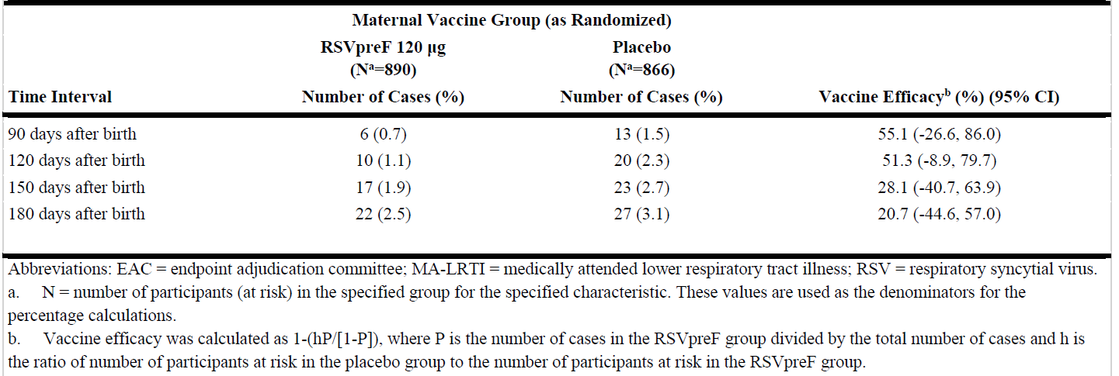
Table 39: RSV-positive MA-LRTIs, confirmed by the EAC in maternal gestational age at vaccination of 28 to <37 weeks – infant participants - evaluable efficacy population.
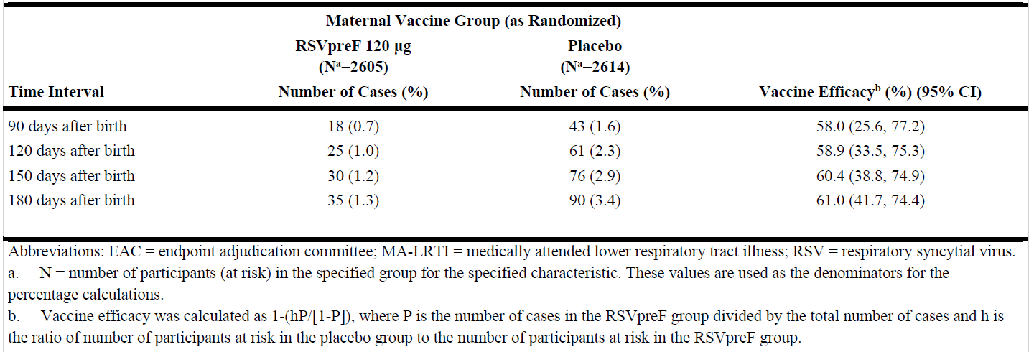
Table 40: RSV-Positive MA-LRTIs, confirmed by the EAC in maternal gestational age at vaccination of 24 to <32 weeks – infant participants - evaluable efficacy population.
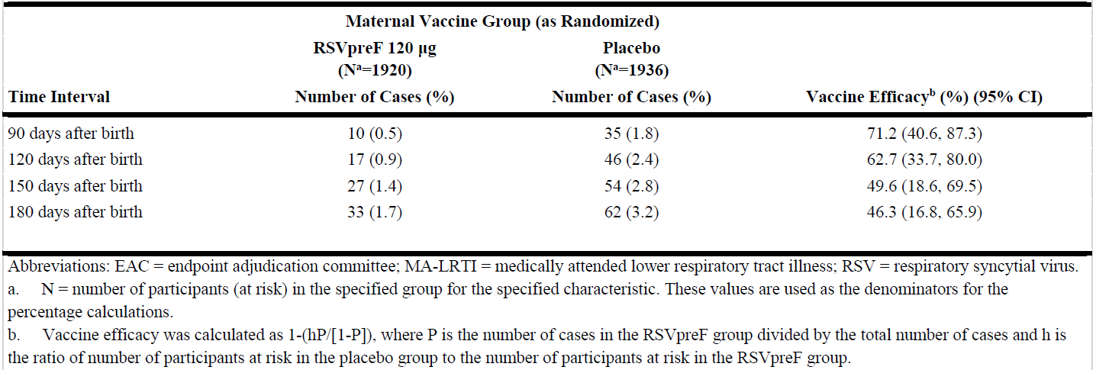

Table 41: RSV-positive MA-LRTIs, confirmed by the EAC in maternal gestational age at vaccination of 32 to <37 weeks – infant participants - evaluable efficacy population.
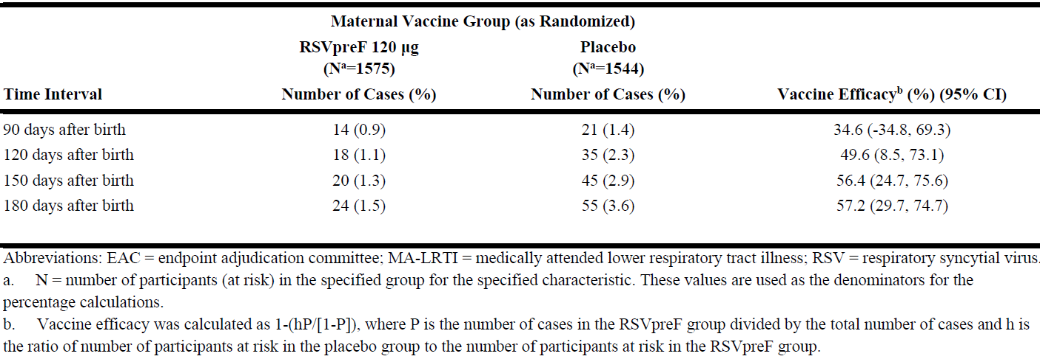
Table 42: Severe MA-LRTIs due to RSV, confirmed by the EAC in maternal gestational age at vaccination of 24 to <28 weeks - infant participants - evaluable efficacy population
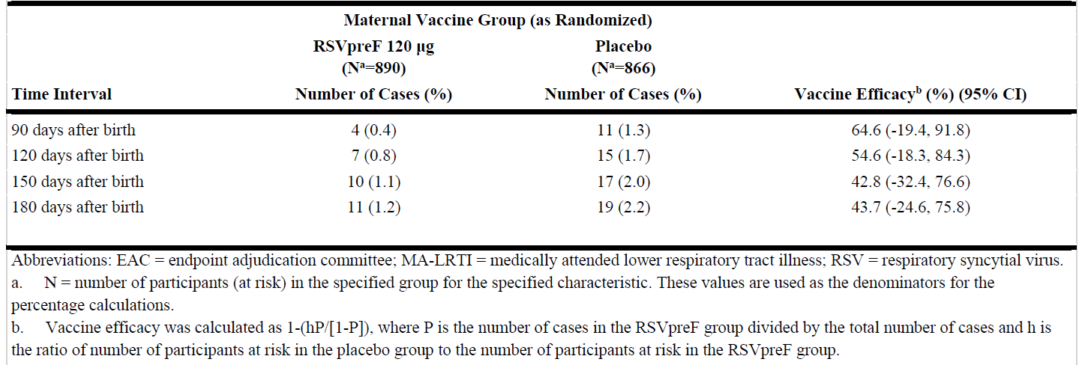
Table 43: Severe MA-LRTIs due to RSV, confirmed by the EAC in maternal gestational age at vaccination of 28 to <37 weeks - infant participants - evaluable efficacy population.
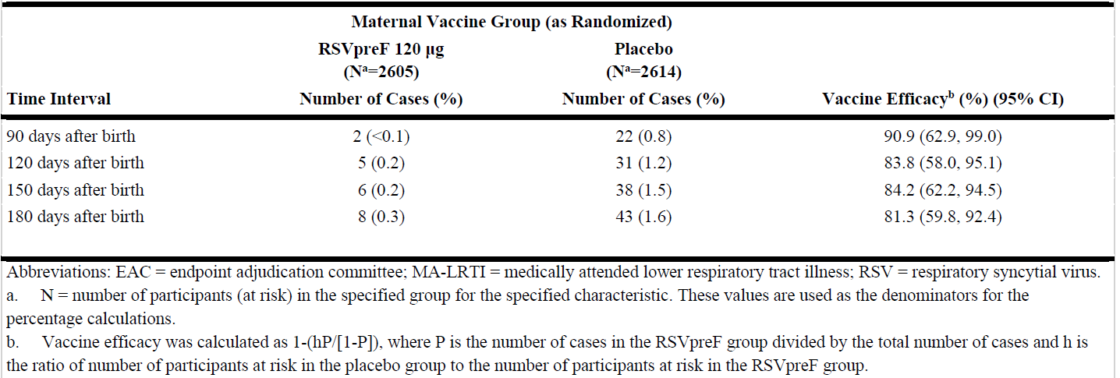

Table 44: Severe MA-LRTIs due to RSV, confirmed by the EAC in maternal gestational age at vaccination of 24 to <32 weeks - infant participants - evaluable efficacy population.
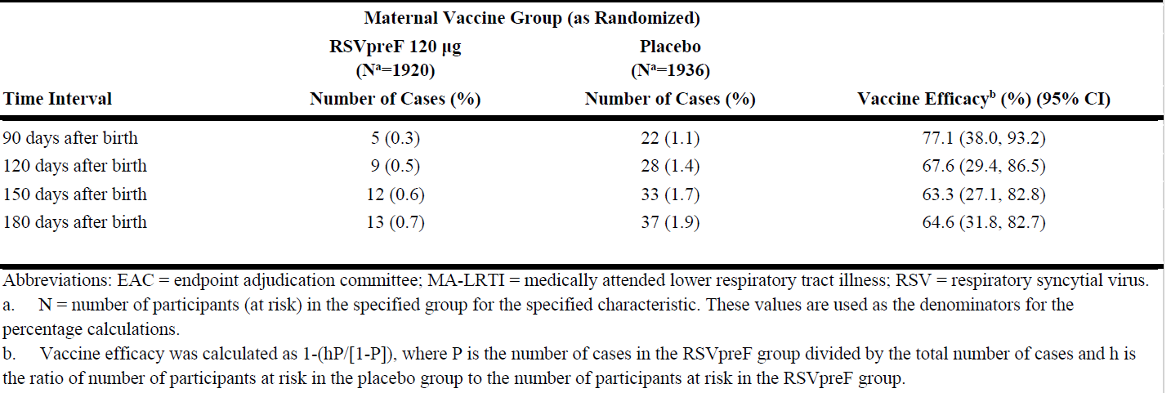
Table 45: Severe MA-LRTIs due to RSV, confirmed by the EAC in maternal gestational age at vaccination of 32 to <37 weeks - infant participants - evaluable efficacy population.
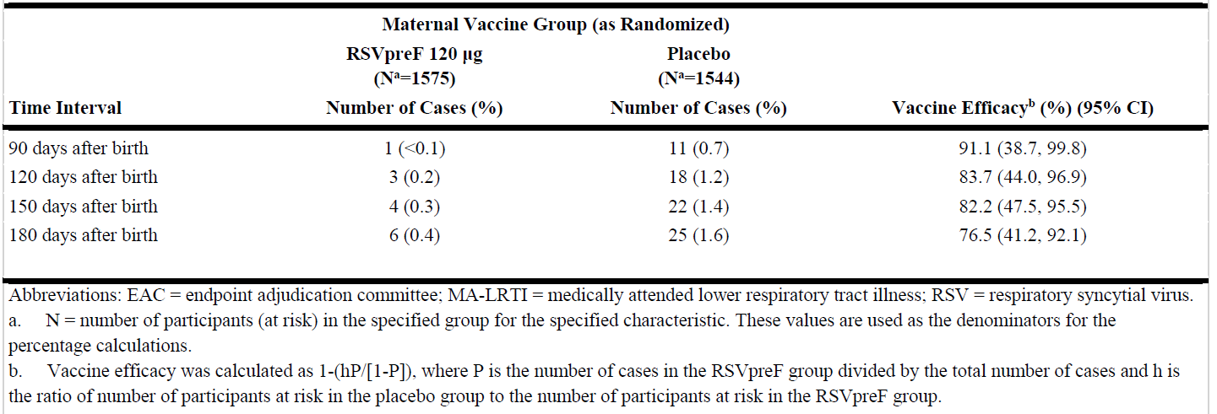
Table 46: Live birth outcomes in maternal gestational age at vaccination of 24 to <28 weeks - infant participants – safety population.
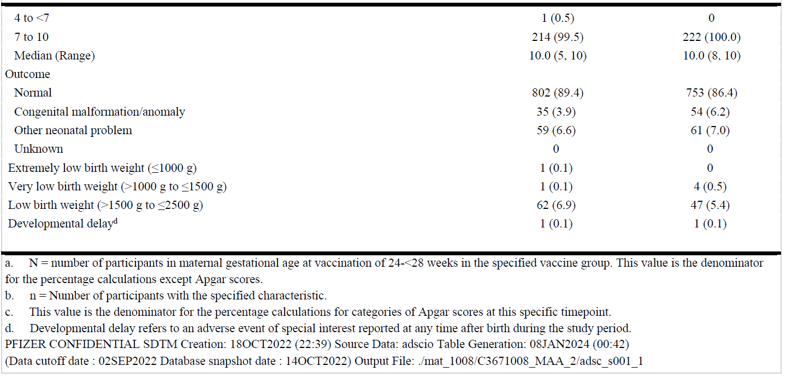
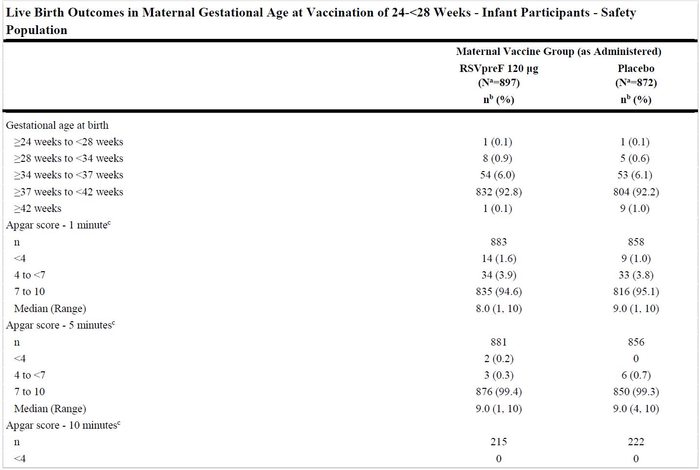

Table 47: Live birth outcomes in maternal gestational age at vaccination of 28 to <37 weeks - infant participants – safety population.
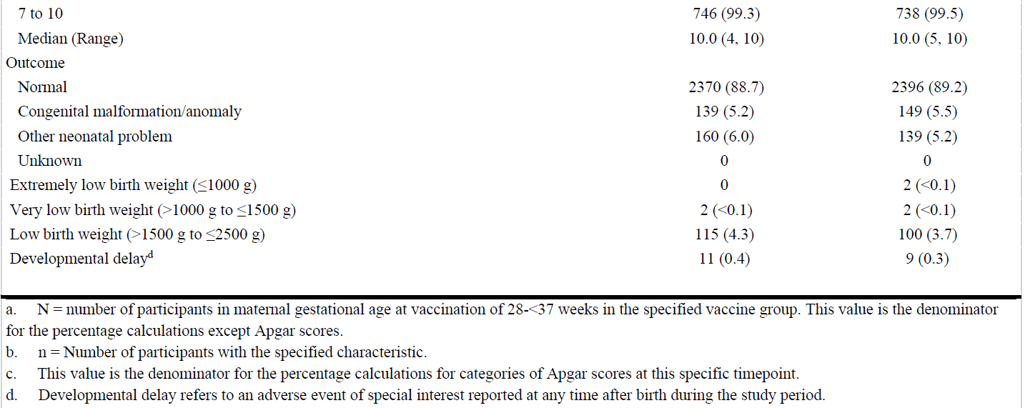
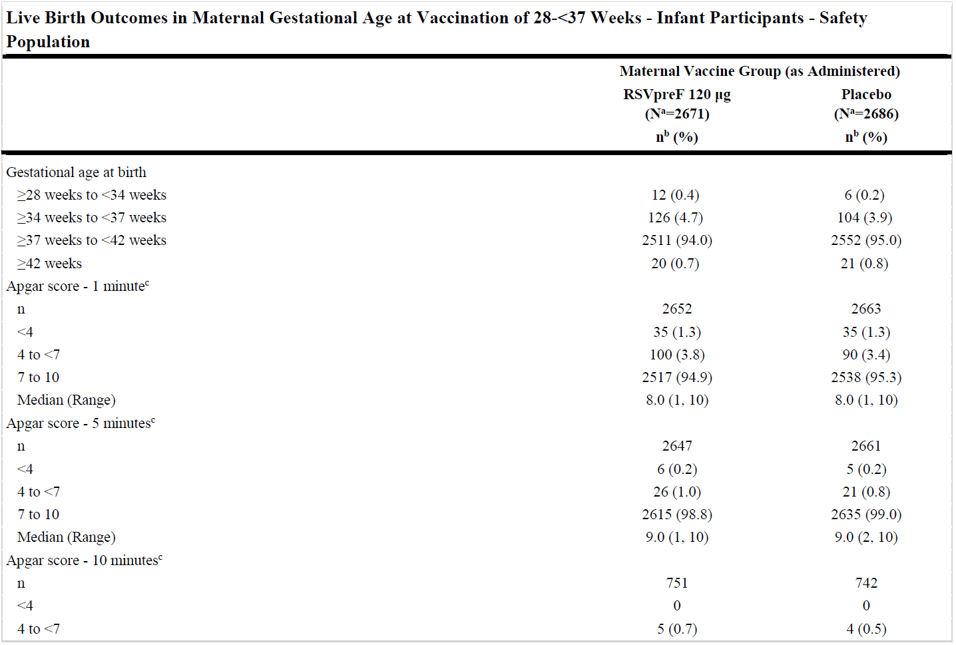

Table 48: Live birth outcomes in maternal gestational age at vaccination of 24 to <32 weeks - infant participants – safety population.
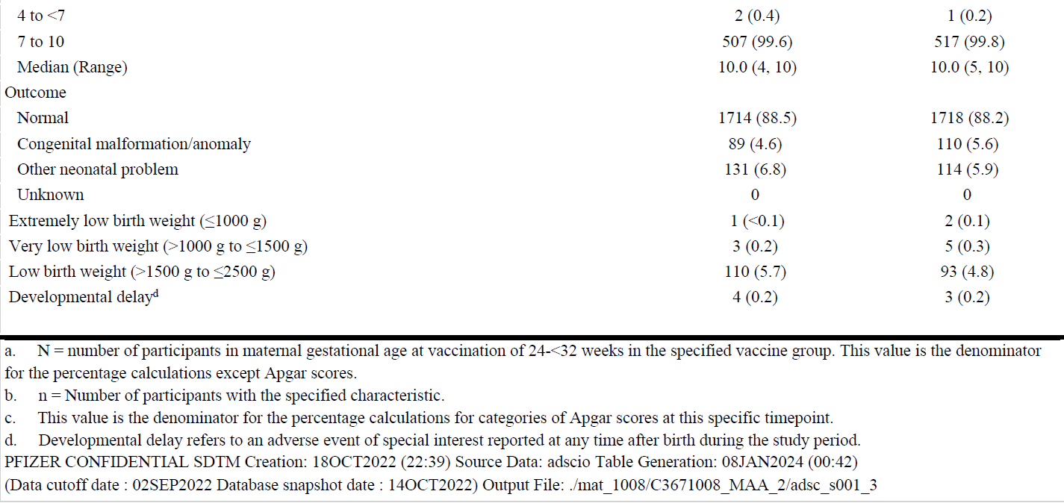
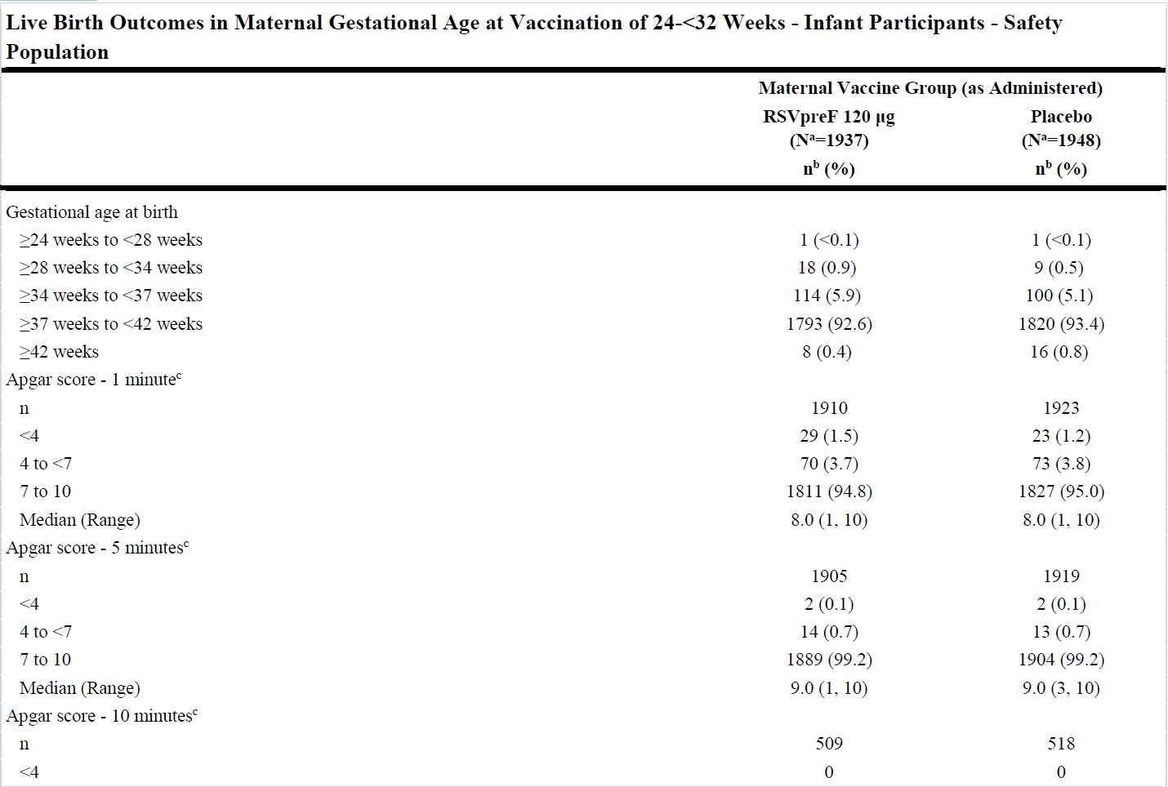

Table 49: Live birth outcomes in maternal gestational age at vaccination of 32 to <37 weeks - infant participants – safety population.
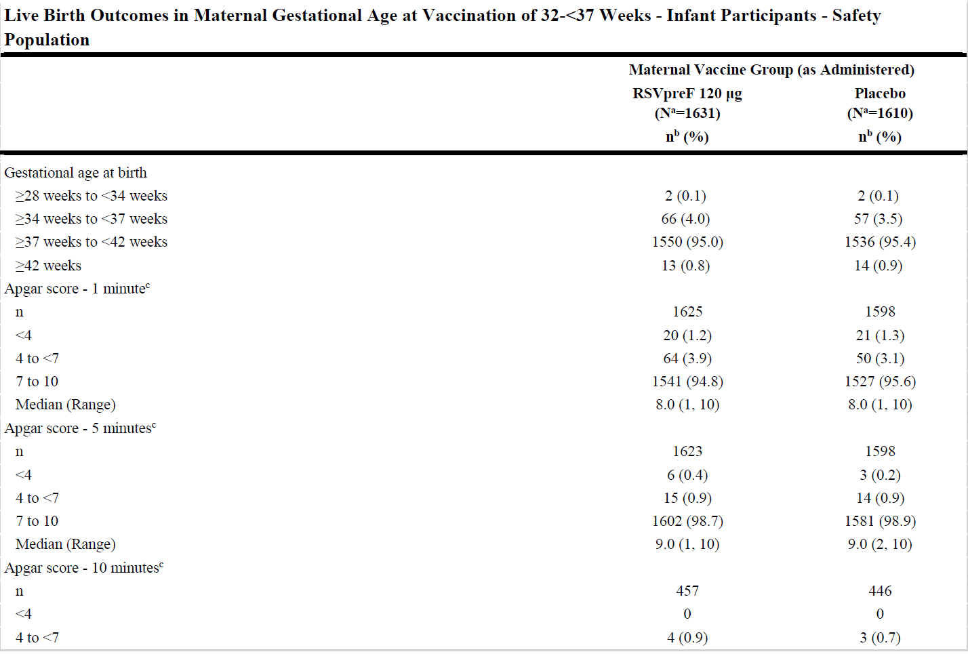
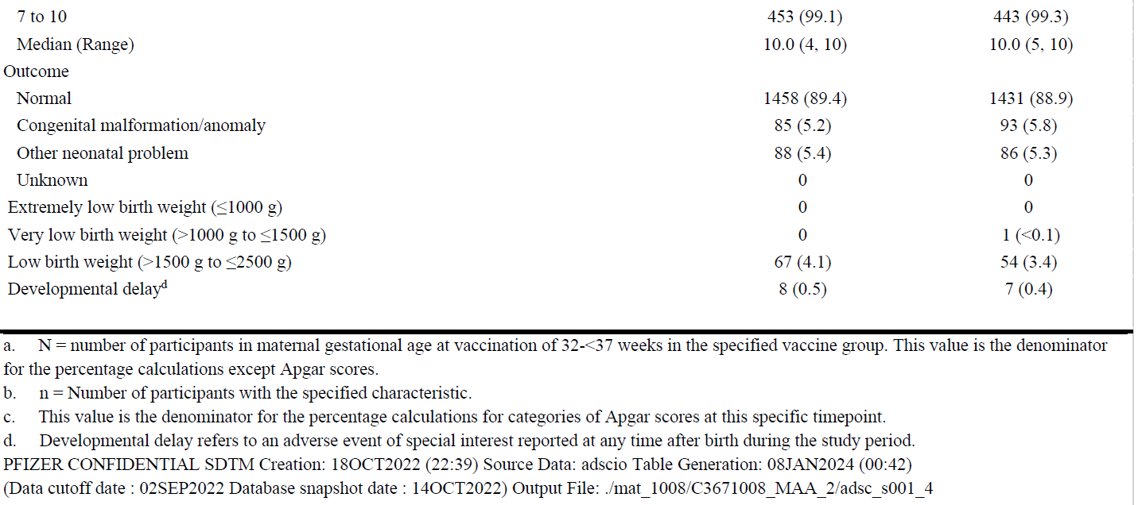

Advisory Committee considerations
The Advisory Committee on Vaccines (ACV), having considered the evaluations and the Delegate’s overview, as well as the sponsor’s response to these documents, advised the following.

Specific advice to the Delegate
The ACV advised the following in response to the Delegate’s specific request for advice:
- The ACV is requested to advise on the optimal timing of Abrysvo for antenatal vaccination in relation to the gestational age for prevention of RSV disease in infants.
The ACV advised that data support that the optimal timing for administration commences from 28 weeks gestational age with respect to vaccine efficacy. Administration from 24 weeks can be considered for exceptional circumstances, but as vaccine effectiveness appeared lower when administered at 24-28 weeks, there was discussion that approving administration to this earlier gestational age may lead to unexpected negative outcomes (reduced efficacy and potential for temporal association with preterm labour) if pregnant women are routinely vaccinated at 24-28 weeks gestation.
The ACV advised that although optimal timing extends to 36 weeks gestational age, later administration may occur if missed in the optimal gestational window and could still offer benefit if adequate time to delivery occurs to allow maternal immune response and transplacental antibody transfer. The ACV did not feel there were safety reasons if the vaccine was administered closer to full-term. In the pivotal study few women were administered the vaccine beyond 36 weeks gestational age and vaccine efficacy was unable to be calculated.
The ACV noted the lower effectiveness of protection for infants whose mothers were vaccinated earlier in pregnancy. Protection of infants to 6 months of age against severe medically-attended LRTIs due to RSV (vaccine efficacy) was 64.6% (95% CI: −19.4, 91.8) for mothers vaccinated at ≥24 to <28 weeks gestational age, increasing to 90.6 % (95% CI: 35.0, 99.8) for mothers vaccinated at ≥28 to <32 weeks gestational age and 91.1 % (95% CI: 38.8, 99.8) for mothers vaccinated at ≥32 to <36 weeks gestational age. The Product Information should include the stratified analysis of vaccine efficacy (VE) based on gestational age at time of maternal vaccination, and clarity that vaccination should not routinely be provided at 24-28 weeks gestational age as vaccine effectiveness appeared lower when administered at 24-28 weeks.
An overall imbalance in infants born before 37 weeks of gestation (5.6%) compared to infants born at or after 37 weeks of gestation (4.7%) in vaccinated versus placebo groups respectively was reported in the maternal study. This small increase in relative risk was not statistically significant.
Maternal RSV neutralising antibody titres peaked at two weeks after vaccination and were maintained to six months post-vaccination.
Infant RSV neutralising antibody titres decreased progressively from birth to six months.
Pertussis vaccination (as reduced antigen diphtheria-tetanus-acellular pertussis, Tdap) is recommended in Australia in pregnancy from 20 to 32 weeks gestational age. As Tdap is administered primarily for protection of mother and young infant from pertussis, the Product Information should give more emphasis on the lower immune response to the pertussis antigen when Tdap and Abrysvo are co-administered. The ACV advised that at least two weeks could ideally elapse between administration of Tdap and Abrysvo.
- The ACV is requested to advise on the suitability of approval of Abrysvo for vaccination in older adults given the modest efficacy and potentially lower effectiveness in the Indigenous Australian population.
The ACV advised that the vaccine efficacy of a single 120 microgram dose of Abrysvo is clinically useful. Vaccine efficacy in older adults was 85.7% (96.66% CI: 32.0, 98.7) against RSV confirmed LRTI with at least three signs or symptoms, over a follow-up period of about six months.
The clinical studies included good representations of people with chronic illnesses.
The safety profile appears acceptable at this time, with surveillance and further studies to address any link with GBS and immune-mediated disease.
The pivotal study C3671013 in older adults did not include Australian study sites. Subgroup analyses of efficacy by demographic baseline characteristics, including race, ethnicity, age and prespecified significant medical conditions, did not identify clinically meaningful differences from the main analyses or between subgroups, noting wide confidence intervals where the number of participants or cases of RSV infection were few.
Study C3671006 study to evaluate RSVpreF coadministration with seasonal inactivated influenza vaccine was conducted in over 1,400 Australian adults 65 years of age and older, including nine participants who were Aboriginal or Torres Strait Islander people. Overall, robust immune responses to RSVpreF were demonstrated in an Australian population with RSV-A and RSV-B neutralising titre geometric mean fold rise above 10, consistent with the immune responses observed in the global pivotal efficacy study C3671013. Findings in Black or African American people do not necessarily imply that Indigenous Australians will also have lower protection than other Australians.
- The ACV is requested to provide advice on any additional matter it considers relevant to this submission.
Concomitant vaccination using any new vaccine in vulnerable populations (older adults, pregnant women) can make post-market monitoring and attribution of adverse effects to Abrysvo more difficult to confirm. Hence suitable proposals for active surveillance, that compare adverse events following immunisation with concomitant and non-concomitant vaccination are highly recommended.
The ACV noted the USA experience of inappropriate administration to children of RSV vaccines that have no paediatric indication. Additional effort to reduce vaccination errors should be further considered. The Product Information should explicitly state that Abrysvo is not approved for use in infants and children.
There were too few premature infants to explore with precision efficacy for infants born before 37 weeks gestational age. Areas of additional study should include outcomes in premature infants, the timing and effect on efficacy of other vaccines administered during pregnancy, pregnancies with complications; and efficacy in Indigenous Australians.
The ACV noted that Study C3671013 clinical study report including the entire season 2 data will be submitted to the TGA in 2024.
The ACV agreed that Abrysvo should be used in accordance with official recommendations.

Conclusion
The ACV considered this vaccine to have an overall positive benefit-risk profile for the indication:
Abrysvo is indicated for:
- Active immunisation of pregnant women between 24-36 weeks of gestation for prevention of lower respiratory tract disease caused by respiratory syncytial virus (RSV) in infants from birth through 6 months of age.
- Active immunisation of individuals 60 years of age and above for prevention of lower respiratory tract disease caused by respiratory syncytial virus (RSV).
Abrysvo should be used in accordance with official recommendations.

Outcome
Based on a review of quality, safety, and efficacy, the TGA decided to register Abrysvo (recombinant respiratory syncytial virus pre-fusion F protein) 120 mg/0.5 mL powder for injection vial and prefilled diluent syringe, indicated for:
Abrysvo is indicated for:
- Active immunisation of pregnant women between 24-36 weeks of gestation for prevention of lower respiratory tract disease caused by respiratory syncytial virus (RSV) in infants from birth through 6 months of age.
- Active immunisation of individuals 60 years of age and above for prevention of lower respiratory tract disease caused by respiratory syncytial virus (RSV).
Abrysvo should be used in accordance with official recommendations.

Specific conditions of registration applying to these goods
- Abrysvo (recombinant respiratory syncytial virus pre-fusion F protein) is to be included in the Black Triangle Scheme. The PI and Consumer Medicines Information (CMI) for Abrysvo must include the black triangle symbol and mandatory accompanying text for five years, which starts from the date of first supply of the product.
- The Abrysvo EU-RMP (version 0.3, dated 27 June 2023, data lock point 2 September 2022 [for the maternal indication] and 13 October 2022 [for the older adult indication]), with ASA (version 1.1, dated 31 October 2023), included with submission PM-2023-01210-1-2, and any subsequent revisions, as agreed with the TGA will be implemented in Australia.
An obligatory component of risk management plans is routine pharmacovigilance. Routine pharmacovigilance includes the submission of PSURs.
Reports are to be provided in line with the current published list of EU reference dates and frequency of submission of PSURs until the period covered by such reports is not less than three years from the date of this approval letter.
The reports are to at least meet the requirements for PSURs as described in the EMA’s Guideline on good pharmacovigilance practices (GVP) Module VII-PSUR (Rev 1), Part VII.B Structures and processes. Note that submission of a PSUR does not constitute an application to vary the registration. Each report must have been prepared within ninety calendar days of the data lock point for that report.
- Batch Release Testing and Compliance
It is a condition of registration that all independent batches of Abrysvo recombinant respiratory syncytial virus pre-fusion F protein 120 μg/0.5 mL bivalent vaccine powder for injection vial plus diluent syringe imported into Australia are not released for sale until samples and the manufacturer’s release data have been assessed and you have received notification acknowledging release from the Laboratories Branch, TGA.
For each independent batch of the product imported into Australia, the sponsor must supply the following:
  - A completed Request for Release Form, available from vaccines@health.gov.au.
  - Complete summary protocols for manufacture and quality control, including all steps in production in the agreed format.
  - At least ten samples (vials plus syringes) of each manufacturing batch of Abrysvo recombinant respiratory syncytial virus pre-fusion F protein 120 μg /0.5 mL bivalent vaccine powder for injection vial plus diluent syringe with the Australian approved labels, PI and packaging (unless an exemption to supply these has been granted) representative of all batches of product seeking distribution in Australia.
  - If the manufacturing batch has been released in Europe or UK a copy of the EU Official Control Authority Batch Release (OCABR) certificate (or equivalent from the UK) must be provided.
  - Any reagents, reference material and standards required to undertake testing, as requested by Laboratories Branch, TGA.
Sponsors must provide all requested samples and data in sufficient time (at least five business days) prior to any distribution date to allow the TGA to perform testing and review. Distribution of each batch of vaccine is conditional upon fulfilment of these conditions and receipt of a letter from the Laboratories Branch acknowledging release.
- Certified Product Details
An electronic copy of the Certified Product Details (CPD) as described in Guidance 7: Certified Product Details of the Australian Regulatory Guidelines for Prescription Medicines (ARGPM) https://www.tga.gov.au/resources/resource/guidance/guidance-7-certified-product-details should be provided upon registration of the therapeutic good. In addition, an updated CPD, for the above products incorporating the approved changes is to be provided within one month of the date of approval letter.

Attachment 1. Product Information
The Product Information (PI) approved with the submission for Abrysvo which is described in this AusPAR can be found as Attachment 1. It may have been superseded. For the most recent PI and Consumer Medicines Information (CMI), please refer to the TGA PI/CMI search facility.

Therapeutic Goods Administration
PO Box 100 Woden ACT 2606 Australia
Email: info@tga.gov.au Phone: 1800 020 653 Fax: 02 6203 1605
https://www.tga.gov.au

Produced in Chinese Hamster Ovary cells by recombinant DNA technology.
This is the original indication proposed by the sponsor when the TGA commenced the evaluation of this submission. It may differ to the final indication approved by the TGA and registered in the Australian Register of Therapeutic Goods.
Schmidt H, et al. Epidemiology and outcomes of hospitalized adults with respiratory syncytial virus: A 6‐year retrospective study, Influenza Other Respir Viruses, 2019; 13: 331–338.
Price OH, et al. Using routine testing data to understand circulation patterns of influenza A, respiratory syncytial virus and other respiratory viruses in Victoria, Australia, Epidemiol Infect, 2019; 147: e221.
Saravanos GL, et al. Respiratory syncytial virus-associated hospitalisations in Australia, 2006–2015, Med J Aust, 2019; 210(10): 447–53.
Shi T, et al. Risk Factors for Poor Outcome or Death in Young Children With Respiratory Syncytial Virus-Associated Acute Lower Respiratory Tract Infection: A Systematic Review and Meta-Analysis. J Infect Dis, 2022; 226(Suppl 1): S10-S16.
Stevenson PG, et al. Health service utilisation for acute respiratory infections in infants graduating from the neonatal intensive care unit: a population‑based cohort study, BMC Pediatrics, 2023; 23: 335.
Brunwasser SM, et al. Assessing the strength of evidence for a causal effect of respiratory syncytial virus lower respiratory tract infections on subsequent wheezing illness: a systematic review and meta-analysis. Lancet Respir Med, 2020; 8(8): 795-806.
Régnier SA and Huels J. Association between respiratory syncytial virus hospitalizations in infants and respiratory sequelae: systematic review and meta-analysis. Pediatr Infect Dis J, 2013; 32(8):820-826.
Gatt D, et al. Prevention and Treatment Strategies for Respiratory Syncytial Virus (RSV). Pathogens, 2023; 12: 154.
In this report the ‘Delegate’ is the Delegate of the Secretary of the Department of Health and Aged Care who decided the submission under section 25 of the Act.
Adapted from: Kampmann, B. et al. Bivalent prefusion F vaccine in pregnancy to prevent RSV illness in infants. NEJM, 2023; 388: 1451-1464.

