This vaccine is subject to additional monitoring in Australia. This will allow quick identification of new safety information. Healthcare professionals are asked to report any suspected adverse events at www.tga.gov.au/reporting-problems.
▼

AUSTRALIAN PRODUCT INFORMATION –ABRYSVO® (RECOMBINANT RESPIRATORY SYNCYTIAL VIRUS PRE-FUSION F PROTEIN) VACCINE

1. NAME OF THE MEDICINE
Recombinant respiratory syncytial virus pre-fusion F protein
Water for injections diluent

2. QUALITATIVE AND QUANTITATIVE COMPOSITION
After reconstitution, 1 dose (0.5 mL) contains:
Respiratory syncytial virus (RSV) subgroup A stabilised prefusion F protein¹ 60 micrograms
Respiratory syncytial virus (RSV) subgroup B stabilised prefusion F protein¹ 60 micrograms

¹ Produced in Chinese Hamster Ovary cells by recombinant DNA technology.

Excipient(s) with known effect
After reconstitution, 1 dose (0.5 mL) contains 11.3 milligrams of sucrose, 22.5 milligrams of mannitol and 0.43 milligrams of elemental sodium (as chloride).
For the full list of excipients, see Section 6.1 List of excipients.

3. PHARMACEUTICAL FORM
Powder and diluent for solution for injection.
The powder or cake is white.
The diluent is a clear, colourless liquid.

4. CLINICAL PARTICULARS

4.1 Therapeutic indications
ABRYSVO is indicated for:
- Active immunisation of pregnant women between 24-36 weeks of gestation for prevention of lower respiratory tract disease caused by respiratory syncytial virus (RSV) in infants from birth through 6 months of age.
- Active immunisation of individuals 60 years of age and above for prevention of lower respiratory tract disease caused by respiratory syncytial virus (RSV).
ABRYSVO should be used in accordance with official recommendations.

4.2 Dose and method of administration

Dosage

Pregnant women
ABRYSVO is administered as a single dose (0.5 mL) in late second or third trimester of pregnancy (24-36 weeks of gestation).
Revaccination in subsequent pregnancies has not been studied.

Individuals 60 years of age and older
ABRYSVO is administered as a single dose (0.5 mL).
The need for revaccination has not been established.

Paediatric population
The safety and efficacy of ABRYSVO in children (from birth to less than 18 years of age) via active immunisation have not yet been established.

Method of administration
ABRYSVO is for intramuscular injection only, preferably in the deltoid region of the upper arm.
ABRYSVO is not to be administered intravascularly, intradermally or subcutaneously.
Do not mix ABRYSVO with other vaccines/medicinal products in the same syringe.
ABRYSVO is for single use in one patient only. Discard any residue.

Preparation for Administration.
The lyophilised vaccine (powder) must be reconstituted only with the diluent provided using the vial adapter to form ABRYSVO.
Vial containing lyophilised ABRYSVO (RSVpreF) vaccine |  | Pre-filled syringe containing diluent |  |  | Vial adapter
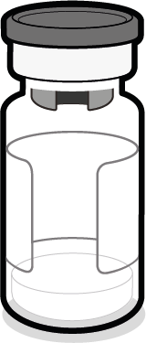 |  | 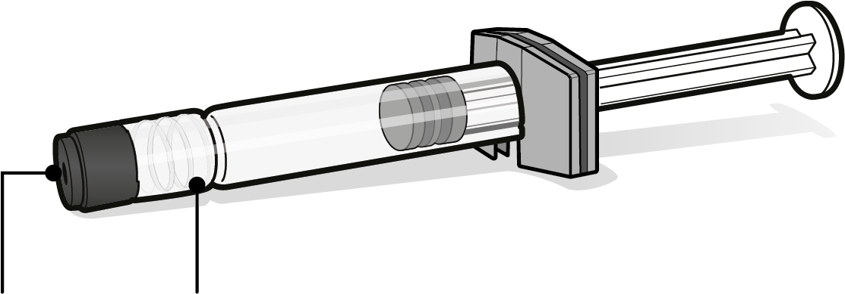 |  |  | 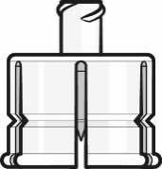
 | Syringe cap |  |  | Luer lock adapter
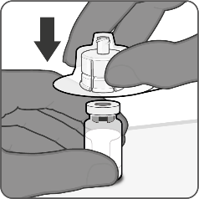 |  |  | Step 1. Attach vial adapter
- Peel off the top cover from the vial adapter packaging and remove the flip off cap from the vial.
- While keeping the vial adapter in its packaging, centre over the vial’s stopper and connect with a straight downward push. Do not push the vial adapter in at an angle as it may result in leaking. Remove the packaging.
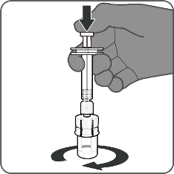 |  |  | Step 2. Reconstitute lyophilised vaccine component to form ABRYSVO
- For all syringe assembly steps, hold the syringe only by the Luer lock adapter. This will prevent the Luer lock adapter from detaching during use.
- Twist to remove the syringe cap, then twist to connect the syringe to the vial adapter. Stop turning when you feel resistance.
- Inject the entire contents of the syringe into the vial. Hold the plunger rod down and gently swirl the vial until the powder is completely dissolved (less than 1 minute). Do not shake.

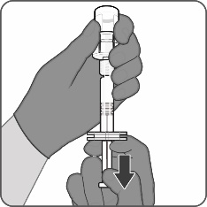 |  |  | Step 3. Withdraw reconstituted vaccine
- Invert the vial completely and slowly withdraw the entire contents into the syringe to ensure a 0.5 mL dose of ABRYSVO.
- Twist to disconnect the syringe from the vial adapter.
- Attach a sterile needle suitable for intramuscular injection.
The prepared vaccine is a clear and colourless solution. Visually inspect the vaccine for large particulate matter and discolouration prior to administration. Do not use if large particulate matter or discolouration is found.

4.3 Contraindications
Hypersensitivity to the active substances or to any of the excipients listed in Section 6.1.

4.4 Special warnings and precautions for use

Hypersensitivity and anaphylaxis
Medical treatment and supervision should always be readily available in case of a rare anaphylactic event following the administration of the vaccine.

Thrombocytopenia and coagulation disorders
ABRYSVO should be given with caution to individuals with thrombocytopenia or any coagulation disorder since bleeding may occur following an intramuscular administration to these individuals.

Concurrent illness
Vaccination with ABRYSVO should be postponed in individuals suffering from an acute febrile illness. However, the presence of a minor infection, such as a cold, should not result in the deferral of vaccination.

Anxiety-related reactions
Anxiety-related reactions, including vasovagal reactions (syncope), hyperventilation or stress-related reactions may occur in association with vaccination as a psychogenic response to the needle injection. It is important that procedures are in place to avoid injury from fainting.

Immunocompromised individuals
There are no data on the use of ABRYSVO in immunocompromised individuals. Immunocompromised individuals, including individuals receiving immunosuppressant therapy, may have a diminished immune response to ABRYSVO.

Individuals less than 24 weeks of gestation
ABRYSVO has not been studied in pregnant individuals less than 24 weeks of gestation.

Limitations of vaccine effectiveness
As with any vaccine, vaccination with ABRYSVO may not protect all vaccine recipients.

Excipients
This medicinal product contains less than 1 mmol sodium (23 mg) per dose, that is to say essentially ‘sodium-free’.

Use in the elderly
See Section 4.8 Adverse effects (undesirable effects).

Paediatric use
ABRYSVO is not for active immunisation in children.

Effects on laboratory tests
No data available.

4.5 Interactions with other medicines and other forms of interactions

Use with other vaccines
Different injectable vaccines should always be given at different vaccination sites.
Do not mix ABRYSVO with other vaccines/medicinal products in the same syringe. See Section 6.2 Incompatibilities.
Data on concomitant administration of ABRYSVO and vaccines other than those listed below are not available.
For further guidance on vaccine interactions, please consult the most recent edition of the Australian Immunisation Handbook.

Use with Tetanus, diphtheria and acellular pertussis vaccine (dTpa)
Immunogenicity data in healthy non-pregnant women who received concomitant administration of ABRYSVO and dTpa indicated the immune response induced by ABRYSVO when administered concomitantly with dTpa was non-inferior to the immune response induced by ABRYSVO alone. In addition, immunogenicity data indicated non-inferiority in immune response to the diphtheria and tetanus components. Immune response to the pertussis component of dTpa was lower when ABRYSVO and dTpa were administered concomitantly as compared to dTpa administered alone. The clinical relevance of this observation is unknown. No safety concerns were identified in this concomitant administration study. See Table 1 below.
Table 1 Comparison of dTpa and ABRYSVO Responses, 1 Month Post-Vaccination – Evaluable Immunogenicity Population – Study C3671004
 | Vaccine Group (As Randomised) |  | Comparison
 | ABRYSVO/dTpa | Placebo/dTpa
 | nª/N^{b} (%)  (95% CI)^{c} | nª/N^{b} (%)  (95% CI)^{c} | Difference^{d}  (95% CI)^{e}
Anti-DTd | 265/272 (97.4)  (94.8, 99.0) | 133/134 (99.3)  (95.9, 100.0) | -1.8 (-4.6, 1.7)
Anti-TTd | 272/272 (100.0)  (98.7, 100.0) | 134/134 (100.0)  (97.3, 100.0) | 0.0 (-1.4, 2.8)
 | ABRYSVO/dTpa | Placebo/dTpa
 | GMC^{f} (n^{b})  (95% CI)^{g} | GMC^{f} (n^{b})  (95% CI)^{g} | GMR^{h}  (95% CI)^{j}
Anti-PT | 36.59 (272)  (33.10, 40.46) | 45.90 (134)  (37.43, 56.29) | 0.80 (0.64, 1.00)
Anti-FHA | 113.30 (272)  (104.13, 123.28) | 191.33 (134)  (164.46, 222.59) | 0.59 (0.50, 0.70)
Anti-PRN | 154.13 (272)  (135.98, 174.70) | 257.05 (134)  (211.55, 312.34) | 0.60 (0.48, 0.76)
 | ABRYSVO/dTpa | ABRYSVO/Placebo
 | GMT^{f} (n^{b})  (95% CI)^{g} | GMT^{f} (n^{b})  (95% CI)^{g} | GMR^{h}  (95% CI)^{j}
RSV Subgroup A | 22339.0 (272)  (20362.3, 24507.6) | 22980.1 (270)  (20371.3, 25922.9) | 0.97 (0.84, 1.13)
RSV Subgroup B | 21509.7 (272)  (19279.4, 23997.9) | 22486.0 (271)  (19696.2, 25671.0) | 0.96 (0.81, 1.14)
Abbreviations: DTd = Diphtheria toxoid; TTd = Tetanus toxoid; FHA = filamentous hemagglutinin; PRN = pertactin; PT = pertussis toxin; GMC = geometric mean concentration; GMR = geometric mean ratios; GMT = geometric mean titre; LLOQ = lower limit of quantitation.
The LLOQ values for each antibody were: Anti-DTd = 0.037 IU/mL, Anti-TTd = 0.05 IU/mL, Anti-PT = 0.9 EU/mL, Anti-FHA = 2.9 EU/mL, Anti-PRN = 3.0 EU/mL, RSV-A = 50, RSV-B = 70. Assay results below the LLOQ were set to 0.5 × LLOQ.
ª n = Number of subjects with valid and determinate assay results ≥0.1 IU/mL.
^{b} N = number of subjects with valid and determinate assay results for the specified serotype at the specified time point.
^{c} Exact 2-sided CI, calculated using the Clopper and Pearson method.
^{d} Difference in proportions, expressed as a percentage (ABRYSVO/dTpa – Placebo/dTpa).
^{e} 2-Sided CI based on the Miettinen and Nurminen method for the difference in proportions expressed as a percentage. Noninferiority required a CI lower bound greater than -10.
^{f} GMT/GMCs were calculated using all subjects with available data collected within the specified window for the specified blood draw.
^{g} CIs were back transformations of CIs based on the Student t distribution for the mean logarithm of the titres/concentrations.
^{h} GMRs were calculated as the group mean difference of logarithmically transformed titres/concentrations and back transformed to the original units.
^{j} CIs were back transformations of CIs based on the Student t distribution for the mean difference of logarithm of the titres/concentrations. Noninferiority required a CI lower bound greater than 0.67 for pertussis antigens and greater than 0.5 for RSV subgroup A/B.

Use with seasonal influenza vaccine
ABRYSVO can be administered concomitantly with seasonal influenza vaccine. In an Australia-based randomised study in adults 65 years of age and older who were co-administered ABRYSVO with an inactivated adjuvanted quadrivalent influenza vaccine, the criteria for non-inferiority of the immune responses elicited by both vaccines in the co-administration versus the separate administration group were met. See Table 2 and Figure 1 below.
Table 2 SIIV HAI and RSV Neutralising Titre GMTs/GMRs, 1 Month Post-Vaccination – Evaluable SIIV Immunogenicity Population and Evaluable RSV Immunogenicity Population – Study C3671006
 |  | Vaccine Group (as Randomised)
 |  | Coadministration  (ABRYSVO + SIIV)/Placebo |  | Sequential-Administration  (Placebo + SIIV)/ABRYSVO |  | Comparison
Vaccine | Assay: Strain or Subgroup | Nª | GMT^{b}  (95% CI^{b}) | Nª | GMT^{b}  (95% CI^{b}) | GMR^{c}  (95% CI^{c})
SIIV^{d} | HAI: H1N1 A/Victoria | 680 | 139.6  (128.8, 151.2) | 687 | 162.2  (149.9, 175.6) | 0.86  (0.769, 0.963)
 | HAI: H3N2 A/Darwin | 679 | 104.7  (96.3, 113.8) | 687 | 136.4  (125.0, 148.8) | 0.77  (0.680, 0.866)
 | HAI: B/Austria | 674 | 113.3  (103.2, 124.3) | 686 | 126.3  (115.6, 138.0) | 0.90  (0.789, 1.019)
 | HAI: B/Phuket | 679 | 106.7  (98.7, 115.4) | 687 | 123.2  (114.6, 132.4) | 0.87  (0.779, 0.964)
ABRYSVO^{e} | NT: RSV A | 681 | 19709.9  (18445.0, 21061.7) | 671 | 22817.1  (21284.8, 24459.7) | 0.86  (0.785, 0.951)
 | NT: RSV B | 680 | 18384.5  (17093.1, 19773.5) | 670 | 21621.4  (20071.6, 23290.8) | 0.85  (0.766, 0.943)
Abbreviations: GMR = geometric mean ratio; GMT = geometric mean titre; HAI = hemagglutination inhibition assay; LLOQ = lower limit of quantitation; NT= neutralising titre; RSV = respiratory syncytial virus; SIIV = seasonal inactivated influenza vaccine.
Note: The LLOQ values were 10 for HAI titre, 242 for RSV A NT, and 99 for RSV B NT. Assay results below the LLOQ were set to 0.5 × LLOQ.
- N = number of participants with valid and determinate assay results for the specified assay in respective evaluable immunogenicity population.
- GMTs and the corresponding 2-sided confidence intervals (CIs) were calculated by exponentiating the mean logarithm of the titres and the corresponding confidence intervals (CIs) (based on the Student t distribution).
- GMRs and 2-sided confidence intervals (CIs) were calculated by exponentiating the mean differences of the logarithms of the titres (coadministration minus sequential-administration) and the corresponding confidence intervals (CIs) (based on Student's t distribution).
- Based on evaluable SIIV immunogenicity population.
- Based on evaluable RSV immunogenicity population.
- Fluad Quad 2022 southern hemisphere season, with MF59C.1 adjuvant
Figure 1 Forest Plot: Geometric Mean Ratios with 95% CIs -- Evaluable RSV Immunogenicity Population and Evaluable SIIV Immunogenicity Population
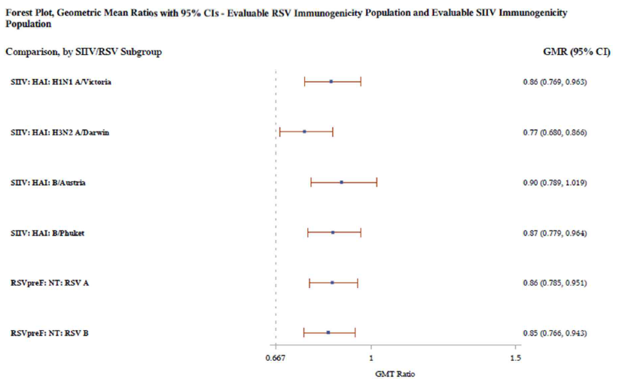Abbreviations: GMR = geometric mean ratio; GMT = geometric mean titre; HAI = hemagglutination inhibition assay; NT = neutralising titre; RSV = respiratory syncytial virus
GMRs and 2-sided confidence intervals (CIs) were calculated by exponentiating the mean differences of the logarithms of the titres (coadministration minus sequential-administration) and the corresponding confidence intervals (CIs) (based on Student’s t distribution).

Use with COVID-19 mRNA vaccines
ABRYSVO can be administered concomitantly with COVID-19 mRNA vaccines. See Table 3 and Figure 2 below.
Table 3. Comparison of RSV and SARS-CoV-2 Neutralising GMTs for ABRYSVO Coadministered With BNT162b2 vs ABRYSVO or BNT162b2 alone, 1 Month Post-Vaccination – Evaluable Immunogenicity Population – Study C5481001
 | Reference Group and GMTs |  |  | Intervention Group:  (ABRYSVO + BNT162b2^{d} + Placebo) |  | Comparison
Assay: Strain or Subgroup | Vaccine Group (as Randomised) | Nª | GMT^{b}  (97.5% CI^{b}) | Nª | GMT^{b} (97.5% CI^{b}) | GMR^{c}  (97.5% CI^{c})
SARS-CoV-2 NT50: Omicron BA.4/BA.5 | BNT162b2 + Placebo | 145 | 3667  (2861.9, 4697.5) | 148 | 3430  (2756.9, 4267.7) | 0.94  (0.673, 1.300)
SARS-CoV-2 NT50: Reference strain | BNT162b2 + Placebo | 145 | 12439  (10185.9, 15190.1) | 148 | 12111  (10010.3, 14652.1) | 0.97  (0.740, 1.281)
NT50: RSV A | ABRYSVO + Placebo | 147 | 18498  (15570.0, 21975.9) | 149 | 26452  (22515.2, 31076.8) | 1.43  (1.131, 1.808)
NT50: RSV B | ABRYSVO + Placebo | 147 | 16677  (13884.0, 20031.4) | 148 | 22859  (19040.4, 27442.5) | 1.37  (1.060, 1.773)
Abbreviations: GMR = geometric mean ratio; GMT = geometric mean titre; LLOQ = lower limit of quantitation; NT50 = 50% neutralising titre; SARS-CoV-2 = severe acute respiratory syndrome coronavirus 2.
Note: The LLOQ values were 242 for RSV A NT50, 99 for RSV B NT50, 71 for SARS-CoV-2 BA.4/BA.5 NT50, and 87 for SARS-CoV-2 reference strain NT50. Assay results below the LLOQ were set to 0.5 × LLOQ.
a N = number of participants with valid and determinate assay results for the specified assay in evaluable immunogenicity population.
b GMTs and the corresponding 2-sided CIs were calculated by exponentiating the mean logarithm of the titres and the corresponding CIs (based on the Student t distribution).
c GMRs and 2-sided CIs were calculated by exponentiating the mean differences of the logarithms of the titres (Intervention Group minus Reference Group) and the corresponding CIs (based on the Student t distribution).
^{d} Comirnaty (BNT162b2)

Figure 2 Forest Plot: RSV and SARS-CoV-2 Neutralising Titre GMRs for ABRYSVO Coadministered With BNT162b2 and Placebo vs ABRYSVO or BNT162b2 Coadministered With Placebo, 1 Month Post-Vaccination – Evaluable Immunogenicity Population – Study C5481001
Abbreviations: GMR = geometric mean ratio, LLOQ = lower limit of quantitation; NT50 = 50% neutralising titre; SARS-CoV-2 = severe acute respiratory syndrome coronavirus 2.
Note: [ABRYSVO+BNT162b2] denotes admixture of ABRYSVO and bivalent BNT162b2 (original/Omi BA.4/BA.5) vaccines.
Note: The LLOQ values were 242 for RSV A NT50, 99 for RSV B NT50, 71 for SARS-CoV-2 BA.4/BA.5 NT50, and 87 for SARS-CoV-2 reference strain NT50. Assay results below the LLOQ were set to 0.5 × LLOQ.
Note: GMRs and 2-sided CIs were calculated by exponentiating the mean differences of the logarithms of the titres (Intervention Group minus Reference Group) and the corresponding Cis (based on the Student t distribution).

Paediatric population
Interaction studies have only been performed in adults. ABRYSVO is not intended for active immunisation in children.

4.6 Fertility, pregnancy and lactation

Effects on fertility
No human data on the effect of ABRYSVO on fertility are available.
A fertility and embryofetal and postnatal development study was conducted in female New Zealand White rabbits. The rabbits were administered IM 4 doses (twice prior to mating and twice during gestation) of a bivalent vaccine formulation containing F glycoproteins of RSV A and RSV B strains (120 micrograms of each preF protein). There were no effects on female fertility or embryofetal or postnatal development. Effects on male fertility have not been evaluated.

Use in pregnancy – Pregnancy Category A
A large amount of data on pregnant women (more than 4,000 exposed outcomes) indicate no malformative nor feto/neonatal toxicity.
No effects on embryofetal development were observed in rabbits (see Effects on fertility section above for details).

See Section 5.1 Pharmacodynamic properties – Clinical trials.

Use in lactation
It is unknown whether ABRYSVO is excreted in human milk.

4.7 Effects on ability to drive and use machines
ABRYSVO has no or negligible influence on the ability to drive and use machines.

4.8 Adverse effects (undesirable effects)

Summary of the safety profile
The safety of ABRYSVO was evaluated in 4,144 pregnant individuals ≤49 years of age in two clinical trials (one Phase 3 and one Phase 2b). It was also evaluated in 18,575 participants 60 years of age and older in a Phase 3 clinical trial.

Tabulated list of adverse drug reactions
The following adverse reactions have been observed during clinical studies.
Adverse reactions are listed by system organ class, in decreasing order of seriousness.
The frequency is defined as follows:
Very common (≥1/10)
Common (≥1/100 to <1/10)
Uncommon (≥1/1,000 to <1/100)
Rare (≥1/10,000 to <1/1,000)
Very rare (<1/10,000)
Not known (cannot be estimated from available data)
Table 4 Adverse reactions from ABRYSVO clinical trials
System Organ Class | Very Common | Common | Rare | Very Rare
Immune system disorders |  |  |  | Hypersensitivity^{b}
Nervous system disorders | Headacheª |  | Guillain-Barré syndrome^{c}
Musculoskeletal and connective tissue disorders | Myalgiaª
General disorders and administration site conditions | Vaccination site pain^{a, b} | Vaccination site redness^{a, b};  Vaccination site swelling^{a, b}
ª Study C3671008: pregnant individuals ≤49 years
^{b} Study C3671013: individuals ≥60 years
^{c} In Study C3671013 (individuals ≥60 years), one case of Guillain-Barré syndrome and one case of Miller Fisher syndrome were reported with onset of 7 and 8 days, respectively, after receiving Abrysvo and assessed by the investigator as possibly related to the administered vaccine. Both cases had either confounding factors or an alternative aetiology. One additional case, with onset 8 months after receiving Abrysvo, was assessed as not related to the administered vaccine by the investigator. One case of Guillain-Barré syndrome was reported in the placebo group 14 months after administration.

Vaccinated maternal participants
The safety profile of ABRYSVO in maternal and infant participants was characterised in two clinical studies. Study C3671008 is a Phase 3 study of the efficacy, safety and immunogenicity of a single dose (120 micrograms) of ABRYSVO administered to pregnant women to protect their infants against RSV disease. In Study C3671008, ABRYSVO was administered to 3,682 maternal participants and there were 3,568 infants born to the maternal participants at the time of data cut-off. A Phase 2b study (C3671003) in pregnant women and their infants investigated the safety, tolerability and immunogenicity of two dose levels (120 micrograms and 240 micrograms, formulated with or without Al(OH)₃) of ABRYSVO. In this study, ABRYSVO (120 micrograms, without Al(OH)₃) was administered to 115 maternal participants and 114 infants were born to the maternal participants.
For all maternal participants, solicited local reactions and systemic events were collected for 7 days after vaccination (see Tables 5 and 6), adverse events for 1 month and obstetric complications, serious adverse events (see Table 7) and adverse events of special interest for the duration of the study. For infant participants, the collection period for nonserious adverse events was from birth to 1 month. Serious adverse events were monitored for at least 1 year for all infant participants and for up to 2 years for half of the infants in Study C3671008.
The most frequently reported adverse reactions in Study C3671008 were vaccination site pain, headache and myalgia.
The majority of solicited local and systemic reactions in maternal participants were mild to moderate in severity and resolved within 2-3 days of onset.
Solicited local and systemic reaction rates were similar among participants who received ABRYSVO in Study C3671003.
Table 5 Percentage of Maternal Participants with Local Reactions Reported by, Maximum Severity, within 7 days after Vaccination – Study C3671008
Local Reactions | ABRYSVO N=3,663ª  % | PLACEBO N=3,639ª  %
Injection site pain^{b}
Any^{c} | 40.6 | 10.1
Mild | 36.1 | 9.3
Moderate | 4.4 | 0.9
Severe | 0.1 | 0
Redness^{d}
Any^{c} | 7.2 | 0.2
Mild | 5.0 | 0.1
Moderate | 2.1 | 0.1
Severe | 0.1 | 0
Swelling^{d}
Any^{c} | 6.2 | 0.2
Mild | 4.1 | 0.1
Moderate | 2.0 | <0.1
Severe | <0.1 | 0
ª N = number of participants who provided e-diary data for a specific reaction after vaccination.
^{b} Mild: does not interfere with activity; moderate: interferes with activity; severe: prevents daily activity.
^{c} Any includes all participants who reported a reaction as mild, moderate, or severe during Day 1 to Day 7 after vaccination.
^{d} Mild: >2 cm to 5 cm; moderate: >5 cm to 10 cm; severe: >10 cm.

Table 6 Percentage of Maternal Participants with Systemic Reactions Reported, by Maximum Severity, within 7 Days after Vaccination - Study C3671008
Systemic Reactions | ABRYSVO  N=3,663ª  % | PLACEBO  N=3,638-3,639ª  %
Fever (≥38.0℃)
≥38.0°C | 2.6 | 2.9
≥38.0°C to 38.4°C | 1.7 | 1.5
>38.5°C to 38.9°C | 0.8 | 1.2
>39.0°C to 40.0°C | <0.1 | 0.1
>40.0°C | <0.1 | 0.1
Fatigue^{b}
Any^{c} | 46.1 | 43.8
Mild | 23.4 | 22.8
Moderate | 21.4 | 19.6
Severe | 1.3 | 1.4
Headache^{b}
Any^{c} | 31.0 | 27.6
Mild | 20.2 | 17.9
Moderate | 10.4 | 9.3
Severe | 0.4 | 0.4
Muscle pain^{b}
Any^{c} | 26.5 | 17.1
Mild | 17.6 | 10.0
Moderate | 8.6 | 6.8
Severe | 0.4 | 0.3
Nauseaª
Any^{b} | 20.0 | 19.2
Mild | 14.4 | 13.8
Moderate | 5.4 | 5.2
Severe | 0.2 | 0.2
Joint painª
Any^{b} | 11.6 | 10.5
Mild | 6.5 | 6.0
Moderate | 4.9 | 4.4
Severe | 0.2 | <0.1
Diarrhoea^{c}
Any | 11.2 | 11.5
Mild | 9.1 | 9.4
Moderate | 2.0 | 1.9
Severe | 0.1 | 0.2
Vomiting^{d}
Any | 7.8 | 7.0
Mild | 6.4 | 5.4
Moderate | 1.3 | 1.5
Severe | 0.2 | <0.1
ª N = number of participants who provided e-diary data for a specific reaction after vaccination.
^{b} Mild: does not interfere with activity; moderate: some interference with activity; severe: prevents daily routine activity.
^{c} Any includes all participants who reported a reaction as mild, moderate, or severe during Day 1 to Day 7 after vaccination.
^{d} Mild: 2 to 3 loose stools in 24 hours; moderate: 4 to 5 loose stools in 24 hours; severe: 6 or more loose stools in 24 hours.
^{e} Mild: 1 to 2 times in 24 hours; moderate: >2 times in 24 hours; severe: requires intravenous hydration.

Table 7 Select Pregnancy-Related Serious Adverse Events in Pregnant Individuals Occurring at Any Time Following Vaccination^{a -} Study C3671008
Serious Adverse Reaction | ABRYSVO  N=3,682  n (%) | 95% CI | Placebo N=3,675 n (%) | 95% CI
All Maternal SAEs | 598 (16.2) | (15.1, 17.5) | 558 (15.2) | (14.0, 16.4)
Pre-eclampsia | 68 (1.8) | (1.4, 2.3) | 53 (1.4) | (1.1, 1.9)
Gestational hypertension | 41 (1.1) | (0.8, 1.5) | 38 (1.0) | (0.7, 1.4)
Premature rupture of membranes | 15 (0.4) | (0.2, 0.7) | 16 (0.4) | (0.2, 0.7)
Preterm premature rupture of membranes | 15 (0.4) | (0.2, 0.7) | 10 (0.3) | (0.1, 0.5)
Hypertension | 13 (0.4) | (0.2, 0.6) | 6 (0.2) | (0.1, 0.4)
Maternal death^{b} | 1 (<0.1) | (0.0, 0.2) | 0 | (0.0, 0.1)
Fetal Death^{c} | 10 (0.3) | (0.1, 0.5) | 8 (0.2) | (0.1, 0.4)
ª Includes all SAEs from vaccination to 6 months post-delivery (up to approximately 10 months, depending on the gestational age at the time of vaccination). In Study C3671008, eclampsia occurred in 5 participants (3 in the ABRYSVO group and 2 in the placebo group) and HELLP syndrome occurred in 5 participants (2 in the ABRYSVO group and 3 in the placebo group).
^{b} There was one maternal death in the ABRYSVO group due to postpartum hemorrhage that was not likely to be associated with vaccination.
^{c} A total of 18 intrauterine deaths were reported for the index pregnancy: 10 intrauterine deaths in the ABRYSVO group (0.3%) and 8 intrauterine deaths in the placebo group (0.2%). The intrauterine deaths represented various clinical conditions and presentations resulting in fetal demise without clear evidence of a common pathophysiology.

Individuals 60 years of age and older by active immunisation
The safety profile of ABRYSVO was characterised in Study C3671013 in which approximately 18,500 participants received a single dose (120 micrograms) of ABRYSVO. Local reaction and systemic event data were collected for 7 days after study vaccination in a subset of 7,114 participants (see Tables 8 and 9). For all participants, adverse events were collected for one month after study vaccination, and serious adverse events were collected throughout study participation.
The most frequently reported adverse reaction in Study C3671013 was vaccination site pain. The majority of solicited local and systemic reactions were mild to moderate in severity and resolved within 1-2 days of onset.
Table 8 Percentage of Participants 60 Years of Age and Older with Local Reactions Reported, by Maximum Severity, within 7 Days after Vaccination – Study C3671013
Local Reactions | ABRYSVO N=3,619-3,621ª  % | PLACEBO N=3,532-3,539ª  %
Injection site pain^{b}
Any^{c} | 10.5 | 6.0
Mild | 9.4 | 5.3
Moderate | 1.1 | 0.7
Severe | <0.1 | 0
Redness^{c, d}
Any^{c} | 2.7 | 0.7
Mild | 1.5 | 0.5
Moderate | 1.1 | 0.2
Severe | 0.1 | 0
Swelling^{c, d}
Any^{c} | 2.4 | 0.5
Mild | 1.5 | 0.2
Moderate | 0.9 | 0.2
Severe | 0.1 | <0.1
ª N = number of participants who provided e-diary data for a specific reaction after vaccination.
^{b} Mild: does not interfere with activity; moderate: some interference with activity; severe: prevents daily activity.
^{c} Any includes all participants who reported a reaction as mild, moderate, or severe during Day 1 to Day 7 after vaccination.
^{d} Mild: 2.5 cm to 5 cm; moderate: >5 cm to 10 cm; severe: >10 cm (for data reported from e-diaries).

Table 9 Percentage of Participants 60 Years of Age and Older with Systemic Reactions Reported, by Maximum Severity, within 7 Days after Vaccination – Study C3671013
Systemic Reactions | ABRYSVO N=3,619-3,621ª  % | PLACEBO  N=3,532-3,539ª  %
Fever (≥38.0℃)
≥38.0°C | 1.4 | 1.4
≥38.0°C to 38.4°C | 0.6 | 0.8
>38.4°C to 38.9°C | 0.8 | 0.6
>38.9°C to 40.0°C | <0.1 | <0.1
>40.0°C | 0 | <0.1
Fatigue^{b}
Any^{c} | 15.5 | 14.4
Mild | 9.3 | 8.4
Moderate | 5.9 | 5.8
Severe | 0.3 | 0.1
Headache^{b}
Any^{c} | 12.8 | 11.7
Mild | 9.0 | 8.4
Moderate | 3.7 | 3.2
Severe | 0.1 | <0.1
Muscle pain^{b}
Any^{c} | 10.1 | 8.4
Mild | 6.5 | 5.5
Moderate | 3.5 | 2.8
Severe | 0.2 | <0.1
Joint pain^{b}
Any^{c} | 7.5 | 6.9
Mild | 4.5 | 3.9
Moderate | 2.9 | 2.9
Severe | <0.1 | <0.1
Nausea^{b}
Any^{c} | 3.4 | 3.7
Mild | 2.5 | 3.1
Moderate | 0.9 | 0.6
Severe | 0 | <0.1
Vomiting^{d}
Any^{c} | 0.9 | 0.8
Mild | 0.7 | 0.7
Moderate | 0.2 | 0.1
Severe | 0 | <0.1
Diarrhoea^{e}
Any^{c} | 5.9 | 5.2
Mild | 4.4 | 4.2
Moderate | 1.3 | 0.9
Severe | 0.1 | 0.1
ª N = number of participants who provided e-diary data for a specific reaction after vaccination.
^{b} Mild: does not interfere with activity; moderate: some interference with activity; severe: prevents daily routine activity.
^{c} Any includes all participants who reported a reaction as mild, moderate, or severe during Day 1 to Day 7 after vaccination.
^{d} Mild: 1 to 2 times in 24 hours; moderate: >2 times in 24 hours; severe: requires intravenous hydration.
^{e} Mild: 2 to 3 loose stools in 24 hours; moderate: 4 to 5 loose stools in 24 hours; severe: 6 or more
loose stools in 24 hours.

Influenza vaccine interaction study - Study C3671006
The safety profile of ABRYSVO was similar when administered with or without Fluad Quad. See Table 10.
Table 10 Local Reactions and Systemic Events, by Maximum Severity, Within 7 Days After Each Vaccination – Safety Population - Study C3671006
 | Coadministration Group |  | Sequential-Administration Group
Local Adverse Reactions | ABRYSVO  N=701 | Placebo  N=681 | Placebo  N=693 | ABRYSVO  N=686
Pain, Any | 11.4 | 7.3 | 8.4 | 12.4
Pain, Grade 3 | 0 | 0 | 0 | 0
Erythema, >20mm | 3 | 0.4 | 0.7 | 1.6
Erythema, >100 mm | 0 | 0 | 0 | 0
Swelling, >20 mm | 2.9 | 0.3 | 0.1 | 1.9
Swelling, >100 mm | 0 | 0 | 0 | 0.1
Systemic Adverse Reactions | Coadministration Group  N=701 |  | SIIV and Placebo  N=693 | ABRYSVO  N=686
Fatigue, Any | 30 |  | 27.1 | 19.1
Fatigue, Grade 3 | 0.9 |  | 0.3 | 0.6
Myalgia, Any | 15.8 |  | 12.3 | 9.5
Myalgia, Grade 3 | 0.1 |  | 0 | 0.1
Headache, Any | 19.7 |  | 20.9 | 16.2
Headache, Grade 3 | 0.1 |  | 0.6 | 0.1
Arthralgia, Any | 11.6 |  | 9.2 | 7.1
Arthralgia, Grade 3 | 0.4 |  | 0 | 0.1
Fever, >=38C | 1.9 |  | 1.4 | 1.2
Fever, >=39C | 0.4 |  | 0.3 | 0

Reporting suspected adverse effects
Reporting suspected adverse reactions after registration of the medicinal product is important. It allows continued monitoring of the benefit-risk balance of the medicinal product. Healthcare professionals are asked to report any suspected adverse reactions at www.tga.gov.au/reporting-problems.

4.9 Overdose
Overdose with ABRYSVO is unlikely due to its single dose presentation.
There is no specific treatment for an overdose with ABRYSVO. In the event of an overdose, the individual should be monitored and provided with symptomatic treatment as appropriate.
For information on the management of overdose, contact the Poisons Information Centre on 13 11 26 (Australia).

5. PHARMACOLOGICAL PROPERTIES

5.1 Pharmacodynamic properties

Mechanism of action
ABRYSVO is a bivalent formulation containing two recombinant stabilised RSV prefusion F antigens, each representing the two major virus subgroups and based on the genotype of major circulating strains, RSV A (Ontario) and RSV B (Buenos Aires). RSV F can exist in two antigenically distinct forms – prefusion and postfusion. Unlike postfusion F, prefusion F is the active form of the protein and is capable of mediating fusion of virus and host cell membranes during cell entry. Therefore, prefusion F is the primary target of the most potent neutralising antibodies that block RSV infection. Higher serum neutralising antibodies are associated with reduced risk of disease. Following intramuscular administration, the prefusion F antigens elicit an immune response, which protects against RSV-associated lower respiratory tract disease.
In pregnant individuals, the action of neutralising antibodies conferring protection is mediated through passive transfer of these antibodies from mother to infant. Adults 60 years of age and older are protected by active immunisation.

Clinical trials

Infants from birth through 6 months of age by active immunisation of pregnant individuals
Study C3671008 is a Phase 3, multicentre, randomised, double-blind, placebo-controlled study to assess the efficacy, safety and immunogenicity of ABRYSVO in the prevention of RSV-associated medically attended lower respiratory tract disease in infants born to healthy individuals vaccinated during pregnancy, and safety and immunogenicity in pregnant individuals. This is a global study, including study sites in both the northern and southern hemispheres, and spanned multiple RSV seasons. Maternal participants received a single dose of ABRYSVO or placebo (1:1 ratio) in the late second or third trimester of pregnancy. The dose of RSV prefusion F antigen in ABRYSVO was 120 micrograms (60 micrograms A and 60 micrograms B, without Al(OH)₃). Revaccination for subsequent pregnancies has not been studied.
RSV-associated lower respiratory tract disease was defined as a medically attended visit with a reverse transcription-polymerase chain reaction (RT-PCR) confirmed RSV disease with one or more of the following respiratory symptoms: fast breathing, low oxygen saturation (SpO₂ <95%) and chest wall indrawing. RSV-associated severe lower respiratory tract disease was a subset defined as meeting the lower respiratory tract disease -RSV criteria plus at least one of the following: very fast breathing, low oxygen saturation (SpO₂ <93%), high-flow nasal cannula or mechanical ventilation, ICU admission for >4 hours and/or failure to respond/unconscious.
The study enrolled healthy individuals ≤49 years of age who were between 24 and 36 weeks of gestation, with uncomplicated, singleton pregnancies. In the study, 3,695 maternal participants were randomised to the ABRYSVO group and 3,697 to the placebo group. Maternal participants with certain high risk pregnancies were excluded from the study (BMI>40 kg/m² prior to pregnancy, pregnancies resulting after in vitro fertilisation, preeclampsia, eclampsia, or uncontrolled gestational hypertension, placental abnormalities, polyhydramnios or oligohydramnios, significant bleeding or blood clotting disorder, unstable endocrine disorders, including untreated hyperthyroidism, untreated hypothyroidism or untreated disorders of glucose intolerance).
The study objective was assessment of vaccine efficacy (VE), defined as the relative risk reduction of the endpoint in the ABRYSVO group compared to the placebo group, for infant participants born to maternal participants receiving 1 dose of ABRYSVO. There were two primary efficacy endpoints, assessed in parallel, severe RSV-positive medically attended lower respiratory tract disease and RSV-positive medically attended lower respiratory tract disease, occurring within 90/120/150/180 days after birth. Other efficacy endpoints included medically attended lower respiratory tract disease due to RSV in infants up to 360 days after birth, hospitalisation due to RSV up to 360 days after birth and medically attended respiratory tract disease due to RSV in infants occurring within 90/120/150/180 days after birth.
Demographic characteristics in Study C3671008 were generally similar with regard to age, race and ethnicity among participants who received ABRYSVO and those who received placebo. Of the participants who received ABRYSVO, 65% were White, 20% were Black or African American and 29% were Hispanic/Latino. The median age of participants was 29 years (range 16-45 years). There were 15 pregnant adolescents enrolled in the study (8 in the ABRYSVO group and 7 in the placebo group). The median gestational age at vaccination was 31 weeks and 2 days. The median infant gestational age at birth was 39 weeks and 1 day (range 27 weeks and 3 days to 43 weeks and 6 days). Among the infants born to maternal participants 51% were male and 49% were female.

The VE results met the statistical criterion for success (a CI lower bound >20%) for reducing severe medically attended lower respiratory tract disease due to RSV, at all timepoints through 180 days. The VE results did not meet the statistical criterion for success (a CI lower bound >20%) for reducing medically attended lower respiratory tract disease due to RSV at 90 days; however, clinically meaningful efficacy was observed from 90 days through 180 days after birth.

The VE results met the statistical criterion for success (a CI lower bound >0%) for RSV-positive medically attended lower respiratory tract disease in infants, at all timepoints within 210 to 360 days after birth and for hospitalisation due to RSV in infants at all timepoints through 180 days; the statistical criterion for success was not met for hospitalisation at 360 days. VE was observed for RSV-positive medically attended respiratory tract disease, at all timepoints through 180 days after birth.
Vaccine efficacy information is presented in Tables 11 to 15.
Table 11 Vaccine efficacy of ABRYSVO against severe medically attended lower respiratory tract disease caused by RSV – infants from birth through 6 months of age by active immunisation of pregnant individuals – Study C3671008
Time period | ABRYSVO  Number of cases  N=3,495 | Placebo  Number of cases  N=3,480 | VE (%)  (CI) ª
90 days | 6 | 33 | 81.8 (40.6, 96.3)
120 days | 12 | 46 | 73.9 (45.6, 88.8)
150 days | 16 | 55 | 70.9 (44.5, 85.9)
180 days | 19 | 62 | 69.4 (44.3, 84.1)
Abbreviations: CI = confidence interval; VE = vaccine efficacy
ª 99.5% CI at 90 days; 97.58% CI at later intervals; CI lower bound >20%
Table 12 Vaccine efficacy of ABRYSVO against medically attended lower respiratory tract disease caused by RSV – infants from birth through 6 months of age by active immunisation of pregnant individuals – Study C3671008
Time period | ABRYSVO  Number of cases  N=3,495 | Placebo  Number of cases  N=3,480 | VE (%)  (CI) ª
90 days | 24 | 56 | 57.1 (14.7, 79.8)
120 days | 35 | 81 | 56.8 (31.2, 73.5)
150 days | 47 | 99 | 52.5 (28.7, 68.9)
180 days | 57 | 117 | 51.3 (29.4, 66.8)
Abbreviations: CI = confidence interval; VE = vaccine efficacy
ª 99.5% CI at 90 days; 97.58% CI at later intervals; CI lower bound >20%

Table 13 Vaccine efficacy of ABRYSVO against medically attended lower respiratory tract disease caused by RSV – infants from birth through 12 months of age by active immunisation of pregnant individuals – Study C3671008
Time period | ABRYSVO  Number of cases  N=3,495 | Placebo  Number of cases  N=3,480 | VE (%)  (CI) ª
210 days | 70 | 127 | 44.9 (17.9, 63.5)
240 days | 76 | 133 | 42.9 (16.1, 61.6)
270 days | 82 | 137 | 40.1 (13.0, 59.2)
360 days | 92 | 156 | 41.0 (16.2, 58.9)
Abbreviations: CI = confidence interval; VE = vaccine efficacy
ª 99.17% CI; CI lower bound >0%
Table 14 Vaccine efficacy of ABRYSVO against hospitalisation due to RSV - infants from birth through 12 months of age by active immunisation of pregnant individuals - Study C3671008
Time period | ABRYSVO  Number of cases  N=3,495 | Placebo  Number of cases  N=3,480 | VE (%)  (CI) ª
90 days | 10 | 31 | 67.7 (15.9, 89.5)
120 days | 15 | 37 | 59.5 (8.3, 83.7)
150 days | 17 | 39 | 56.4 (5.2, 81.5)
180 days | 19 | 44 | 56.8 (10.1, 80.7)
360 days | 38 | 57 | 33.3 (-17.6, 62.9)
Abbreviations: CI = confidence interval; VE = vaccine efficacy
ª 99.17% CI; CI lower bound >0%

Table 15 Vaccine efficacy of ABRYSVO against medically attended respiratory tract disease caused by RSV - infants from birth through 6 months of age by active immunisation of pregnant individuals - Study C3671008
Time period | ABRYSVO  Number of cases  N=3,495 | Placebo  Number of cases  N=3,480 | VE (%)  (CI) ª
90 days | 67 | 110 | 39.1 (16.7, 55.7)
120 days | 98 | 160 | 38.7 (20.8, 52.9)
150 days | 126 | 209 | 39.7 (24.4, 52.1)
180 days | 157 | 253 | 37.9 (24.0, 49.5)
Abbreviations: CI = confidence interval; VE = vaccine efficacy
ª 95% CI; CI lower bound >0%

Immunogenicity in pregnant individuals and their infants from birth through to 6 months of age
Immunogenicity data from a Phase 2b study (C3671003) in pregnant women (n=107) and their infants (n=100) demonstrated that a single dose of ABRYSVO (120 micrograms, without Al(OH)₃) administered between 24 and 36 weeks gestation elicited strong RSV A and RSV B neutralising responses at delivery in maternal participants. RSV A and RSV B neutralising geometric mean titres (GMTs) in maternal participants who received ABRYSVO were higher than participants who received placebo from 2 weeks after vaccination through 6 months after delivery. Maternal-to-infant placental transfer ratio of RSV A and RSV B neutralising antibodies was >1.
Maternal vaccination with ABRYSVO yielded high RSV A- and B-neutralising titres in infants. Combined RSV A/B neutralising GMTs at birth and through 6 months of life were higher in infants whose mothers had received ABRYSVO compared to infants whose mothers had received placebo.
In the pivotal maternal vaccine efficacy study (C3671008) a pertussis containing vaccine was allowed up to 14 days before and from 14 days after the administration of ABRYSVO.

Vaccine efficacy by timing of vaccination according to weeks of gestation
A post-hoc analysis of VE by maternal gestational age was conducted. See Table 16 below.
Table 16 Severe MA-LRTDs Due to RSV, Confirmed by the EAC, by Maternal Gestational Age at Vaccination - Infant Participants - Evaluable Efficacy Population – Study C3671008
Maternal Vaccine Group
(as Randomised)
GA at Vaccination | ABRYSVO 120 μg | Placebo
Time Interval | Number of Cases (%) | Number of Cases (%) | Vaccine Efficacy^{b} (%) (95% CI)
24 to <28 weeks | (Nª=890) | (Nª=866)
90 days after birth | 4 (0.4) | 11 (1.3) | 64.6 (-19.4, 91.8)
120 days after birth | 7 (0.8) | 15 (1.7) | 54.6 (-18.3, 84.3)
150 days after birth | 10 (1.1) | 17 (2.0) | 42.8 (-32.4, 76.6)
180 days after birth | 11 (1.2) | 19 (2.2) | 43.7 (-24.6, 75.8)
28 to < 37 weeks | (Nª=2605) | (Nª=2614)
90 days after birth | 2 (<0.1) | 22 (0.8) | 90.9 (62.9, 99.0)
120 days after birth | 5 (0.2) | 31 (1.2) | 83.8 (58.0, 95.1)
150 days after birth | 6 (0.2) | 38 (1.5) | 84.2 (62.2, 94.5)
180 days after birth | 8 (0.3) | 43 (1.6) | 81.3 (59.8, 92.4)
24 to <32 weeks | (Nª=1920) | (Nª=1936)
90 days after birth | 5 (0.3) | 22 (1.1) | 77.1 (38.0, 93.2)
120 days after birth | 9 (0.5) | 28 (1.4) | 67.6 (29.4, 86.5)
150 days after birth | 12 (0.6) | 33 (1.7) | 63.3 (27.1, 82.8)
180 days after birth | 13 (0.7) | 37 (1.9) | 64.6 (31.8, 82.7)
32 to <37 weeks | (Nª=1575) | (Nª=1544)
90 days after birth | 1 (<0.1) | 11 (0.7) | 91.1 (38.7, 99.8)
120 days after birth | 3 (0.2) | 18 (1.2) | 83.7 (44.0, 96.9)
150 days after birth | 4 (0.3) | 22 (1.4) | 82.2 (47.5, 95.5)
180 days after birth | 6 (0.4) | 25 (1.6) | 76.5 (41.2, 92.1)
Abbreviations: EAC = endpoint adjudication committee; MA-LRTD = medically attended lower respiratory tract disease; RSV = respiratory syncytial virus.
ª N = number of participants (at risk) in the specified group for the specified characteristic. These values are used as the denominators for the percentage calculations.
^{b} Vaccine efficacy was calculated as 1-(hP/[1-P]), where P is the number of cases in the ABRYSVO group divided by the total number of cases and h is the ratio of number of participants at risk in the placebo group to the number of participants at risk in the ABRYSVO group.

Incidence of birth rate <37 weeks of gestation
A numerical imbalance in preterm births (infants born <37 weeks of gestation) was observed in the pivotal maternal vaccine efficacy study. The preterm birth rate in ABRYSVO group was 202/3568 (5.7%) compared to 169/3558 (4.7%) in the placebo group. The overall and the stratified analysis by timing of maternal vaccination is presented in Table 17 below.
Table 17 Incidence of Birth < 37 weeks Gestation – Overall and Stratified by Timing of Maternal Vaccination by Weeks of Gestation – Infant Participants - Safety Population – Study C3671008
 | Maternal Vaccine Group (as Administered)
 | ABRYSVO 120 μg |  | Placebo
GA at Vaccination | nª/N^{b} | % | nª/N^{b} | % | RR^{c}  (95%CI)
24 to <37 weeks | 201/3568 | 5.6% | 169/3558 | 4.7% | 1.19  (0.97, 1.45)
24 to <28 weeks | 63/897 | 7.0% | 59/872 | 6.8% | 1.04  (0.74, 1.46)
28 to <37 weeks | 138/2671 | 5.2% | 110/2686 | 4.1% | 1.26  (0.99, 1.61)
24 to <32 weeks | 133/1937 | 6.9% | 110/1948 | 5.6% | 1.22  (0.95, 1.55)
32 to <37 weeks | 68/1631 | 4.2% | 59/1610 | 3.7% | 1.14  (0.81, 1.60)
Abbreviations: GA = gestational age; RR = relative risk
ª n = number of infant participants in the specified group with GA at birth < 37 weeks
^{b} N = number of infant participants in the specified group. These values are used as the denominators for the percentage calculations.
^{c} RR is the percentage in the ABRYSVO group divided by the percentage in the placebo group.

Please note that pregnant women considered to have increased risk of pregnancy complications and preterm birth were excluded from the trial. (See Section 4.8 Adverse effects (undesirable effects).

Other birth outcomes in the pivotal maternal study
The infant safety population included 3,568 and 3,558 infants born to individuals in the ABRYSVO or placebo group, respectively. There were 10 (0.3%) fetal deaths in the ABRYSVO group and 8 (0.2%) in the placebo group. Among the infants born to individuals in the ABRYSVO group and in the placebo group, 202 (5.7%) and 169 (4.7%), respectively, were born preterm (see Sections 4.4 Warnings and Precautions, 4.8 Adverse effects (undesirable effects) and 5.1 Clinical trials). Low birth weight was observed in 5.1% of participants in the ABRYSVO group versus 4.4% in the placebo group, and neonatal jaundice was observed in 7.2% in the ABRYSVO group versus 6.7% in the placebo group. (see Section 4.8 Adverse effects (undesirable effects)). For mortality in the neonatal period among infants born to pregnant individuals in Study C3671008, there were 2 deaths in the ABRYSVO group and 5 in the placebo group, and for overall mortality including after the neonatal period there were 5 deaths in the ABRYSVO group and 12 in the placebo group. Congenital abnormalities were reported in 5.0% in the ABRYSVO group and 6.2% in the placebo group. In infants born preterm, 83 infants in the ABRYSVO group and 80 infants in the placebo group remained hospitalised or were readmitted to the hospital in the neonatal period (up to 30 days after birth). Available data are insufficient to establish a causal relationship between preterm birth and ABRYSVO.

Individuals 60 years of age and older by active immunisation
Study C3671013 is a Phase 3, multicentre, randomised, double-blind, placebo-controlled study to assess the efficacy, immunogenicity and safety of ABRYSVO in the prevention of RSV-associated lower respiratory tract disease in individuals 60 years of age and older during the first RSV season and the long-term efficacy and immunogenicity of ABRYSVO across two RSV seasons. The need for revaccination with a subsequent dose of ABRYSVO has not been established.
RSV-associated acute respiratory tract disease was defined as RT-PCR confirmed RSV disease with one or more of the following respiratory symptoms within 7 days of symptom onset and lasting more than 1 day during the same disease - new or increased sore throat, nasal congestion, nasal discharge, cough, wheezing, sputum production or shortness of breath.
RSV-associated lower respiratory tract disease was defined as RT-PCR confirmed RSV disease with two or more, or three or more, of the following respiratory symptoms within 7 days of symptom onset and lasting more than 1 day during the same illness - new or increased cough, wheezing, sputum production, shortness of breath or tachypnea (≥25 breaths/min or 15% increase from resting baseline). RSV-associated severe lower respiratory tract disease was defined as meeting the lower respiratory tract disease-RSV criteria plus at least one of the following - hospitalisation due to RSV-associated lower respiratory tract disease, new or increased oxygen supplementation or mechanical ventilation including Continuous Positive Airway Pressure (CPAP).
The dose level of RSV prefusion F antigen in ABRYSVO for this study was 120 micrograms (60 micrograms A and 60 micrograms B, without Al(OH)₃). Participants were randomised (1:1) to receive ABRYSVO (n=18,488) or placebo (n=18,479). Enrollment was stratified by age, 60-69 years (63%), 70-79 years (32%) and ≥80 years (5%). Healthy adults and adults with stable chronic diseases were included. Participants (16%) were enrolled with stable chronic cardiopulmonary conditions such as chronic obstructive pulmonary disease (COPD), asthma or congestive heart failure (CHF).
The primary objective was assessment of vaccine efficacy (VE), defined as the relative risk reduction of first episode of RSV-associated lower respiratory tract disease in the ABRYSVO group compared to the placebo group in the first RSV season. Secondary objectives were assessment of VE, defined as the relative risk reduction of first episode of RSV-associated severe lower respiratory tract disease and acute respiratory disease in the ABRYSVO group compared to the placebo group in the first RSV season. Other efficacy endpoints include the efficacy of ABRYSVO in preventing RSV-associated lower respiratory tract disease and acute respiratory disease across two RSV seasons following vaccination.
Demographic characteristics in Study C3671013 were generally similar with regard to age, gender, race and ethnicity among participants who received ABRYSVO and those who received placebo. Of the participants who received ABRYSVO, 51% were male and 80% were White, 12% were Black or African American and 41% were Hispanic/Latino. The median age of participants was 67 years (range 59-95 years). No overall differences in the safety or effectiveness of ABRYSVO were observed between age groups.
The study met the primary objectives of reduction of lower respiratory tract disease RSV cases with ≥2 symptoms and lower respiratory tract disease RSV cases with ≥3 symptoms.
Vaccine efficacy information at the end of the first RSV season is presented in Table 18 and Figures 3 to 7. The average surveillance duration was 7.05 months.
Table 18 Vaccine efficacy of ABRYSVO against RSV disease – active immunisation of individuals 60 years of age and older – Study C3671013
Efficacy endpoint | ABRYSVO  Number of cases  N=18,058 | Placebo  Number of cases  N=18,076 | VE (%)  (95% CI)
First episode of RSV-associated acute respiratory diseaseª | 37 | 98 | 62.2 (44.4, 74.9)
First episode of RSV-associated lower respiratory tract disease with ≥2 symptoms^{b} | 15 | 43 | 65.1 (35.9, 82.0)
First episode of RSV-associated lower respiratory tract disease with ≥3 symptoms^{c} | 2 | 18 | 88.9 (53.6, 98.7)
Abbreviations: CI = confidence interval; RSV = respiratory syncytial virus; VE = vaccine efficacy
ª In an exploratory analysis in RSV subgroup A (ABRYSVO n=11, placebo n=35) VE was 68.6% (CI 36.8, 85.6); and in RSV subgroup B (ABRYSVO n=26, placebo n=63) VE was 58.7% (CI 33.9, 74.9).
^{b} In an exploratory analysis in RSV subgroup A (ABRYSVO n=3, placebo n=16) VE was 81.3% (CI 34.5, 96.5); and in RSV subgroup B (ABRYSVO n=12, placebo n=26) VE was 53.8% (CI 5.2, 78.8).
^{c} In an exploratory analysis in RSV subgroup A (ABRYSVO n=1, placebo n=5) VE was 80.0% (CI -78.7, 99.6); and in RSV subgroup B (ABRYSVO n=1, placebo n=12) VE was 91.7% (CI 43.7, 99.8).
Figure 3 Cumulative Case Accrual Curve From Day of Vaccination, First Episode of LRTD-RSV With ≥2 Symptoms From Day 15 Through End of Season 1 – Evaluable Efficacy Population – Study C3671013
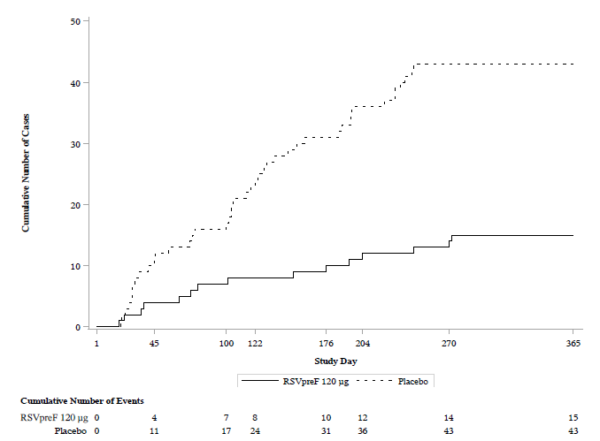
Abbreviations: LRTD-RSV = lower respiratory tract disease associated with RSV; RSV = respiratory syncytial virus
Figure 4 Cumulative Case Accrual Curve From Day of Vaccination, First Episode of LRTD-RSV With ≥3 Symptoms From Day 15 Through End of Season 1 – Evaluable Efficacy Population– Study C3671013
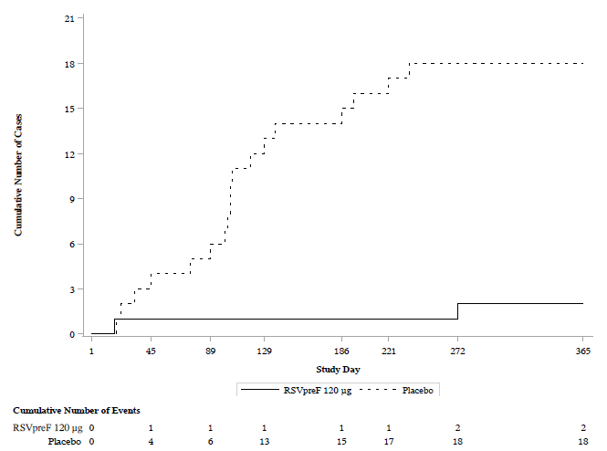
Abbreviations: LRTD-RSV = lower respiratory tract disease associated with RSV; RSV = respiratory syncytial virus
Figure 5 Forest Plot: VE Against LRTD-RSV with ≥2 and LRTD-RSV with ≥3 symptoms – Study C3671013
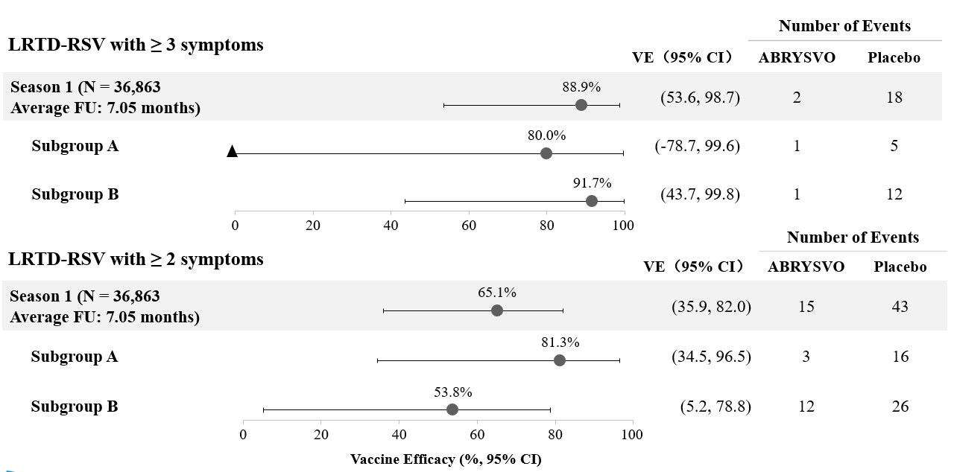
Abbreviations: CI = Confidence Interval; FU = follow up duration; LRTD-RSV = lower respiratory tract disease associated with RSV
Figure 6 Forest Plot: VE Against First Episode of LRTD-RSV With ≥2 Symptoms by Demographic and Baseline Characteristic Subgroups From Day 15 Through End Season 1 – Evaluable Efficacy Population – Study C3671013
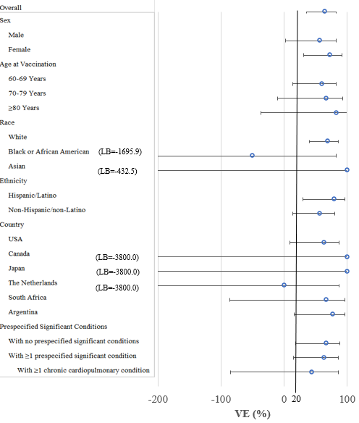
Abbreviations: VE = vaccine efficacy; LB = lower bound
Figure 7 Forest Plot: VE Against First Episode of LRTD-RSV With ≥3 Symptoms by Demographic and Baseline Characteristic Subgroups From Day 15 Through End Season 1 – Evaluable Efficacy Population – Study C3671013
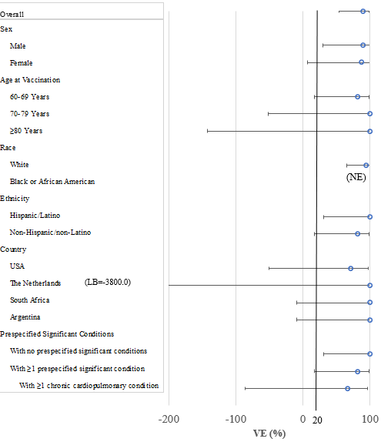
Abbreviations: VE = vaccine efficacy; LB = lower bound; NE = not estimable
At the end of the first RSV season, subgroup analyses of VE by age and prespecified significant underlying conditions in ABRYSVO recipients were consistent with the main analyses and support consistent VE across different age and risk groups.
VE against first episode RSV-associated lower respiratory tract disease (LRTD-RSV) with ≥2 symptoms was 60.0% (95% CI 13.8, 82.9), 66.7% (95% CI -10.0, 92.2) and 83.3% (95% CI -37.4, 99.6) in the 60-69, 70-79 and ≥80 years age groups, respectively, and 63.6% (95% CI 15.2, 86.0) in recipients with >1 significant underlying condition.
VE against first episode LRTD-RSV with ≥3 symptoms was 81.8% (95% CI 16.7, 98.0), 100% (95% CI -51.5, 100.0) and 100% (95% CI -142.0, 100.0) in the 60-69, 70-79 and ≥80 years age groups, respectively, and 81.8% (95% CI 16.7, 98.0) in recipients with >1 significant underlying condition.
VE against first episode acute respiratory disease was 63.2% (95% CI 41.1, 77.7), 59.1% (95% CI 7.6, 83.4) and 62.5% (95% CI -56.2, 93.6) in the 60-69, 70-79 and ≥80 years age groups, respectively, and 66.0% (95% CI 38.9, 82.0) in recipients with >1 significant underlying condition.
Immunogenicity in individuals 60 years of age and older
Immunogenicity data demonstrated that a single dose of ABRYSVO elicited strong RSV A and RSV B neutralising responses at 1 month after vaccination. In the ABRYSVO group (n=534), geometric mean fold rises (GMFRs) of neutralising titres (NTs) for RSV A, RSV B and combined RSV A/B were 11.6, 12.7 and 12.1, respectively.
Subgroup analyses by age and prespecified high risk groups in ABRYSVO recipients were consistent with the main analyses and support consistent VE observed across different age and risk groups. GMFRs of NTs for RSV A, RSV B and combined RSV A/B were 11.4, 12.6 and 12.0, respectively, in the 60-69 years age group, 12.1, 12.8 and 12.4 in the 70-79 years age group and 11.2, 15.2 and 13.0 in the ≥80 years age group. GMFRs of NTs for RSV A, RSV B and combined RSV A/B were 12.3, 13.8 and 13.0, respectively, in recipients with >1 significant underlying condition.

5.2 Pharmacokinetic properties
Not applicable.

5.3 Preclinical safety data

Genotoxicity
No data available.

Carcinogenicity
No data available.

6. PHARMACEUTICAL PARTICULARS

6.1 List of excipients

Powder for injection
Trometamol
Trometamol hydrochloride
Sucrose
Mannitol
Polysorbate 80
Sodium chloride
Hydrochloric acid (for pH adjustment)

Diluent
Water for injections

6.2 Incompatibilities
In the absence of compatibility studies, this medicinal product must not be mixed with other medicinal products.

6.3 Shelf life
In Australia, information on the shelf life can be found on the public summary of the Australian Register of Therapeutic Goods (ARTG). The expiry date can be found on the packaging.

After reconstitution
ABRYSVO should be administered immediately (within 4 hours) after reconstitution.
Do not store above 30ºC. Do not store in a refrigerator (2ºC - 8ºC). Do not freeze.

6.4 Special precautions for storage
Store in a refrigerator (2ºC - 8ºC).
Do not freeze. Discard if the carton has been frozen.
Store in the original package.
For storage conditions after reconstitution of the medicinal product, see Section 6.3.

6.5 Nature and contents of container
Powder for injection: for 1 dose in a 2 mL vial (type 1 glass or equivalent) with a stopper (synthetic chlorobutyl rubber)
Diluent: for 1 dose in a 1 mL pre-filled syringe (type 1 glass) with a stopper (synthetic chlorobutyl rubber) and a tip cap (synthetic isoprene/bromobutyl blend rubber)

Pack size
Carton containing 1 vial of powder for injection, 1 pre-filled syringe of diluent, 1 vial adapter
Carton containing 5 vials of powder for injection, 5 pre-filled syringes of diluent, 5 vial adapters
Carton containing 10 vials of powder for injection, 10 pre-filled syringes of diluent, 10 vial adapters
No needles are included in the packs.
Not all pack sizes may be marketed.

6.6 Special precautions for disposal
In Australia, any unused medicine or waste material should be disposed of in accordance with local requirements.

7. MEDICINE SCHEDULE (POISONS STANDARD)
S4 – Prescription Only Medicine

8. SPONSOR
Pfizer Australia Pty Ltd
Level 17, 151 Clarence Street
SYDNEY NSW 2000
Toll Free Number: 1800 675 229
www.pfizermedicalinformation.com.au

9. DATE OF FIRST APPROVAL
20 March 2024

10. DATE OF REVISION
Not applicable.

Summary Table of Changes
Section changed | Summary of new information
- | -

