Regulatory basics on medical devices for health practitioners
  - Guidance

Version 1.0, March 2024

Copyright

© Commonwealth of Australia 29/04/2024
This work is copyright. You may reproduce the whole or part of this work in unaltered form for your own personal use or, if you are part of an organisation, for internal use within your organisation, but only if you or your organisation do not use the reproduction for any commercial purpose and retain this copyright notice and all disclaimer notices as part of that reproduction. Apart from rights to use as permitted by the Copyright Act 1968 or allowed by this copyright notice, all other rights are reserved and you are not allowed to reproduce the whole or any part of this work in any way (electronic or otherwise) without first being given specific written permission from the Commonwealth to do so. Requests and inquiries concerning reproduction and rights are to be sent to the TGA Copyright Officer, Therapeutic Goods Administration, PO Box 100, Woden ACT 2606 or emailed to <tga.copyright@tga.gov.au>.

Contents
Overview 5
What is a medical device? 7
The legislative definition 7
Accessories 8
Specified Articles 8
Excluded Goods 9
More information 10
Products that are not a medical device 12
Starting materials 12
Manufacturing equipment 13
How are medical devices regulated? 15
Classification of medical devices 15
Advertising a medical device 16
More information 17
Manufacturing a medical device 18
Who is the manufacturer? 18
Adaptable medical devices 19
Modification, alteration or adjustment of a medical device 19
Off-label use 20
Manufacturer responsibilities 22
The Essential Principles 22
Conformity assessment documentation 23
More information 23
Supplying a medical device 24
Who is the sponsor? 24
Exempt medical devices 25
Sponsor responsibilities 26
More information 26
Sector-specific examples for health practitioners 27
Radiation therapy examples 27
Dental examples 31
Podiatry examples 35
Orthotics and prosthetics examples 38
Occupational therapy and rehabilitation examples 41

Overview
This guidance by the Therapeutic Goods Administration (TGA) is to help Australian health practitioners that manufacture, supply, and use medical devices identify whether they are regulated by the TGA, and if they are, how to comply with the existing requirements of the therapeutic goods legislation.
The information contained in this document is indicative guidance only intended to help you identify:
- how regulatory concepts might apply to you, and
- the specific features of a medical device and how circumstances of your own practice/business may impact the way it is regulated in Australia.
If you are a health practitioner, we encourage you to familiarise yourself with the legislative and regulatory requirements in Australia. It is your responsibility to ensure you meet all relevant regulatory obligations when you manufacture, import, supply and use medical devices.
If necessary, seek professional advice from a regulatory affairs consultant to assist you to comply with these requirements.
This document will evolve over time and updates and clarifications will be included as required. Feedback on this guidance is always welcome, please send any comments to: devices@tga.gov.au.
There are seven sections to this document:
- What is a medical device?
Intended to help you understand what products are regulated as medical devices, this section includes information about:
- The legislative definition of a medical device
- Accessories
- Specified Articles
- Excluded goods
- Products that are not a medical device
Intended to help you understand where products may be used in a therapeutic setting, or by a healthcare practitioner or professional, but are not regulated as medical devices, this section includes information about:
- Starting materials
- Manufacturing equipment
- How are medical devices regulated?
Intended to help you understand regulatory basics about how medical devices are regulated in Australia, this section includes information about:
- Classification of a medical device
- Advertising a medical device
- Manufacturing a medical device
Intended to help you understand who meets the definition of a manufacturer and which manufacturing activities are regulated by the TGA, this section includes information about:
- Who is the manufacturer?
- Adaptable medical devices
- Adaptation or modification of a medical device
- Off-label use
- Manufacturer’s responsibilities?
Intended to provide you with more information about what responsibilities you may have if you are the manufacturer of a medical device, this section includes information about:
- The Essential Principles
- Conformity assessment documentation
- Supplying a medical device
Intended to explain what supply is, help you determine if you are a sponsor and explain the responsibilities you may have for the medical devices you are supplying, this section includes information about:
- Who is the sponsor?
- Exempt devices
- Sponsor responsibilities
- Sector-specific examples for health practitioners
More information and examples demonstrating how the regulatory concepts in this guidance may apply to medical devices and products in the following sectors:
- Radiation therapy
- Dental
- Podiatry
- Orthotics and prosthetics
- Occupational therapy and rehabilitation

Is it regulated as a medical device?
Whether a product is regulated as a medical device will depend on several factors, including if the product:
meets the legislative definition of a medical device;
is an accessory to a medical device;
has been specified to be a medical device, or
is excluded from therapeutic goods regulation.

The legislative definition
The first step is to determine whether your product meets the legislative definition of a medical device under section 41BD of the Act.
In short, a medical device is an instrument, apparatus, appliance, material or other article intended to be used on a human being for:
diagnosis, prevention, monitoring, treatment or alleviation of disease
diagnosis, monitoring, treatment, alleviation of or compensation for an injury or disability
investigation, replacement, or modification of the anatomy or of a physiological process
control of conception
in vitro examination of a human specimen for a medical purpose.

To determine whether a product meets the legislative definition of a medical device, you need to consider the intended purpose of the device, as determined by the manufacturer.
The intended purpose of a product can be ascertained by looking at the manufacturer’s instructions for use, advertising material, technical documentation and any other information provided with, or about, the medical device such as product labels. The intended purpose is not limited to what the medical device does, it also includes who the medical device is for and under what circumstances it should be used.
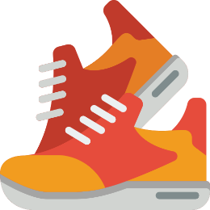
Easy Peasy Feeties manufacture a range of products including insoles for supply both directly to the consumer and to health practitioners including podiatrists.

Yes, regulated as a medical device
One of the insoles sold by Easy Peasy Feeties is identified on the package as a “medical grade insole”. The label contains a claim that the product will “soothe the painful symptoms of arthritis”.
This product will meet the definition of a medical device and must be included in the ARTG before it can be supplied because:
the use of the term “medical grade” implies the product is for a therapeutic purpose
arthritis is a medical condition
the information on the label includes a claim that the product is for the treatment of symptoms associated with a medical condition

No, not regulated as a medical device
Easy Peasy Feeties also manufacture an insole called “Disco Feeties” that is marketed as a cushioned insole to “keep you on your feet for longer”. The label on the package shows a graphic of people dancing at a disco and states that the product is “designed to provide extra cushioning for comfort”.
The Disco Feeties insole will not meet the definition of a medical device because:
general discomfort is not a disease, illness, injury, disability or medical condition
the product is not designed to modify the anatomy of the person using it.

Accessories
Accessories are products “specifically intended to be used together with the device to enable or assist the device to be used as the manufacturer of the device intended.” Accessories are regulated as medical devices.
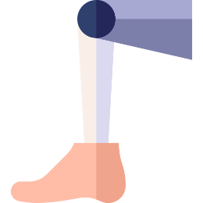
Sockets 2U manufacture a range of pre-made limb sockets that are available in a range of sizes. Sockets are sold to prosthetists who cut and heat them before shaping them to fit individual patients.
Sockets 2U sell a heating unit that allows the socket to be heated to the correct temperature before it is shaped to fit the patient. The heating unit will meet the definition of an accessory to a medical device because:
the limb socket meets the definition of a medical device at the time it is supplied to the prosthetist
the heating unit is specifically intended to be used with the socket to allow it to be adapted as intended by the manufacturer
Sockets 2U will need to include the heating unit in the ARTG before it is supplied.

Specified Articles
In some circumstances products that don’t meet the legislative definition of a medical device will be specified to be a medical device. This is generally because they do not meet the definition of a medical device but do have a therapeutic purpose that warrants regulation by the TGA.
For health practitioners it is important to know that starting materials and components used in the manufacture of some medical devices are specified articles under the Therapeutic Goods (Medical Devices—Specified Articles) Instrument 2020.
This means they are regulated as medical devices and must meet all relevant regulatory requirements including:
ARTG inclusion by the sponsor before they can be imported and/or supplied
meeting all relevant Essential Principles as well as the requirements for labelling
reporting of any adverse events
meeting the advertising requirements for medical devices
Starting materials and components intended by the manufacturer to be used by a health practitioner for the following purposes are specified articles:
the direct or indirect restoration of teeth
the manufacture of an externally-applied orthopaedic device
the manufacture of a non-implantable dental appliance
obtain a dental impression
An exemption is available for health practitioners, or people working to instructions received from a health practitioner, who make their devices using specified articles that have been included in the ARTG for use on a patient within the health practitioner’s practice.

Amira is a dentist who, in addition to using dental products for chair-side practice also makes devices for use on her patients including:
Crowns
Bridges
Splints
The materials used to make these kinds of devices are specified articles when they are intended for use in the manufacture of non-implantable dental devices. This means Amira’s regulatory responsibilities will depend on where she sources her materials and whether they have been included in the ARTG by the person she buys them from.
If Amira decides to source materials intended for the manufacture of these kinds of devices directly from an overseas supplier, she will be the sponsor of the products and must include the specified materials in the ARTG before she imports them.
If Amira decides to use a generic product that is not intended for use in the manufacture of dental devices, the product is not a specified article. The devices Amira makes with the generic product will therefore not be eligible for exemption and Amira must include the devices she is making in the ARTG before she can supply them to her patients.
If Amira sources materials intended to make these kinds of devices from an Australian-based supplier, the supplier will be the sponsor and must include it in the ARTG before supplying it to Amira. Amira’s devices will be exempt from ARTG inclusion.

Excluded Goods
The Therapeutic Goods (Excluded Goods) Determination 2018 (the Determination) excludes products from regulation by the TGA.
If a product has been excluded, it will not be regulated as a medical device by the TGA, and therefore will not be required to:
meet any of the Australian regulatory requirements for medical devices
be assessed in any way by the TGA before they are supplied
be included in the ARTG
report adverse events to the TGA
 | Excluded goods remain subject to other regulatory requirements, such as consumer protection laws administered by the Australian Competition and Consumer Commission (ACCC), and state or territory consumer protection laws.
For health practitioners, the most common exclusions to be aware of are:
anatomical models intended by the manufacturer to be used for educational or record-keeping purposes
physical impressions of a patient’s anatomy and casts made from those impressions
cosmetic finishing components for orthoses and prostheses
craniofacial prostheses that are:
  - spectacle-retained; or
  - adhesive-retained
dental bleaches and whiteners
dental impression trays
ear moulds intended to anchor hearing aids in place
It is important to note that the intended purpose of the medical device may determine whether a product is excluded as outlined in the examples below.

In the Determination “mouthguards intended by the manufacturer to be used to protect teeth from external forces including, but not limited to, mouthguards used in contact sports” are excluded.
If the manufacturer of a mouthguard is advertising their product for this purpose, it will be excluded from regulation by the TGA. If the manufacturer decides to package, label, or otherwise advertise the mouthguard for the treatment of bruxism, the product will no longer be excluded and will need to be included in the ARTG before it can be imported, exported or supplied.

Jane is a certified orthotist/prosthetist working for Perfect Prosthetics where she manufactures hard footshell components for transfemoral prostheses. The footshell is designed to bear the weight of the patient and is a critical component allowing the medical device to function as intended. Jane makes footshells in fashion colours, as well as in several shades of nude tones to match an individual’s skin.
The footshells are not excluded from regulation. Although they incorporate a cosmetic element, their primary purpose is to replace a part of the patient’s anatomy and compensate for the loss of their foot by providing stability when the patient walks.

As part of her work Jane also manufactures silicon sleeves for prosthetic arms in a range of colours, patterns and designs. The intended purpose of the covers is cosmetic and is not intended to contribute to the safety, quality or performance of the device itself. The silicon cover is an excluded good and is not regulated by the TGA.

More information
Further guidance and information on excluded software:
Overview of regulation of software based medical devices
Is my software regulated?

Products that are not a medical device
The following sections provide an overview, including examples, of products that are commonly mistaken for medical devices. Broadly, these products can be grouped as:
starting materials; and
manufacturing equipment

Starting materials
The basic materials or components a medical device is made from are known as “starting materials”.
Your product is likely to be a starting material if it:
can be used to manufacture more than one kind of product;
does not meet the definition of a medical device;
cannot be used on a consumer or patient until a manufacturing process is undertaken; or
requires modification through one or more manufacturing processes (including the addition of other materials and/or components) to become a medical device.
Starting materials generally do not meet the definition of a medical device, and don’t need to be included in the ARTG before they are supplied. Examples of common starting materials are listed below.
If a starting material is intended by the manufacturer to be used in the manufacture of a medical device for a particular purpose, they are specified articles. This means they are regulated as a medical device and must meet all regulatory requirements, as outlined in the specified articles section of this document.

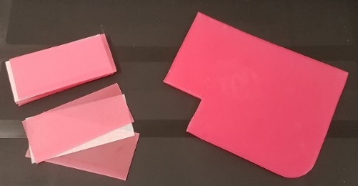
Wax
Wax can be supplied in sheets, sticks or blocks. It is used for a range of applications, including to take impressions of a patient’s anatomy or to make try-in versions of medical devices. When the wax is sold in a generic format with no indications for use in circumstances that would cause it to be specified article, the wax will not meet the definition of a medical device and does not need to be included in the ARTG.

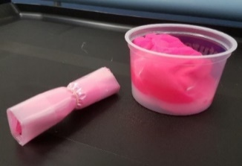
Moulding putty
Moulding putty may be sold ready to use or in a form that requires the user to mix into a malleable material before it can be used.

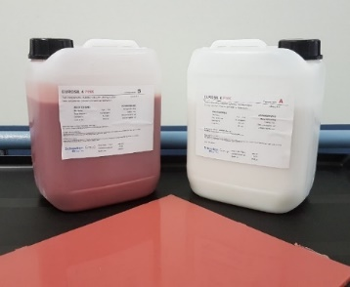
Silicone
Silicone can be supplied in many forms including as a fluid, liquid, putty, or sheet. In some instances, silicone is supplied in two parts that must be mixed and allowed to cure before it can be used. Uses and applications include for use as a bolus in radiation therapy.

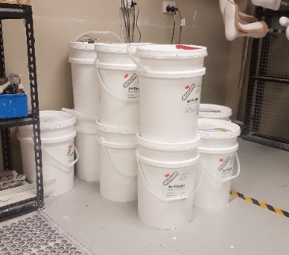
Plaster
Plaster has a range of applications in medical device manufacture and can be used both as a starting material and a step in the manufacturing process for a medical device. It generally does not meet the definition of a medical device when used for either purpose.

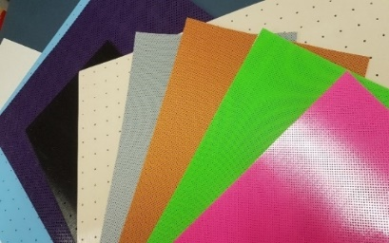
Thermoplastic sheets
Thermoplastic sheets become pliant when heated to a certain temperature and have a range of applications, including for use in splinting and the manufacture of orthoses.

Thermoplastic filaments used in 3D printing
There are a wide range of thermoplastic filaments used in 3D printing. Examples of filament types include Polylactic acid (PLA) and Acrylonitrile Butadiene Styrene (ABS). Thermoplastic filaments are heated and melted and used to print products that can be used for a wide variety of applications, including anatomical models.

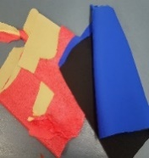
High performance microcellular polyurethane and EVA foams
Microcellular polyurethane and EVA foams are extremely versatile raw materials with multiple uses and applications. These foams may be found in all types of manufacture and appliances, including orthopaedic devices.

Manufacturing equipment
Products and equipment used in the manufacture of a medical device generally do not meet the legislative definition of a medical device because:
they are not intended to be used on a human being; and
their intended purpose is not therapeutic (i.e. it is intended to be used to manufacture a medical device and does not diagnose, monitor, treat, etc).
Examples of products used in the manufacturing process that are not regulated as medical devices are included below.
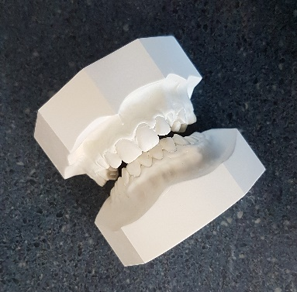
Anatomical impressions and casts made from impressions
Anatomical impressions and casts made from direct impressions of a patient’s anatomy are often used as part of manufacturing personalised medical devices for patients. These kinds of models are excluded from regulation by TGA, no matter what purpose they are being used for.

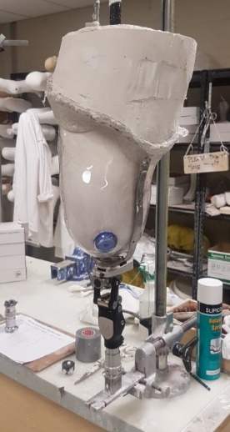
Try-ins and try-ons
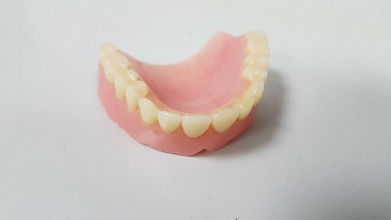
In some cases, an example product known as a try-in or try-on will be manufactured to demonstrate how a final device will fit the patient or look once fitted. These kinds of products are part of the manufacturing process for a medical device. They are not intended to be used by the patient for a purpose that will meet the definition of a medical device and they are therefore not regulated as a medical device.

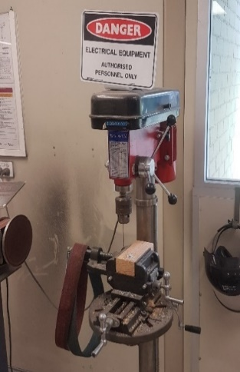
Equipment used to process or finish a medical device
Equipment and tools used to manufacture or finish a medical device (outside the body) generally do not meet the definition of a medical device.
This includes, but is not limited to:
grinders
vacuum and pressure forming equipment
furnaces and kilns
3D printers
curing devices
milling machines
furnaces

Equipment or tools intended by the manufacturer to be used with a medical device to enable or assist the device to be used as intended will meet the definition of an accessory to a medical device and will require inclusion in the ARTG.

How are medical devices regulated?

Classification of medical devices
In Australia, devices are classified using classification rules stepped out in Schedule 2 of the Therapeutic Goods (Medical Devices) Regulations 2002. There are seven different classifications for non-IVD medical devices:
Classification | Risk profile | Examples
Class I non-sterile, non-measuring | Low risk | Tongue depressor  Bandages  Splints  Medical grade insoles  3D-printed radiation therapy bolus
Class I (sterile) | Low-medium risk | Sterile dressings
Class I (measuring) | Low-medium risk | Thermometers
Class IIa | Low-medium risk | Crowns
Class IIb | Medium-high risk | Dental implants  Infant incubators
Class III | High risk | Antibiotics-coated dental implant  Orthopaedic joints  Pacemaker
The classification of a medical device is determined by factors including:
How long the device will be continuously used for:
  - Transient use: less than 60 minutes
  - Short-term use: more than 60 minutes but less than 30 days
  - Long-term use: more than 30 days
- How invasive the device is:
  - Non-invasive: intended to be used outside the body
  - Invasive: intended to penetrate a body orifice
  - Surgically invasive: intended to be used with the aid or in the context of a surgical operation, or to penetrate the body other than through a body orifice
Specific uses or features of the medical device including, but not limited to, whether the medical device;
  - is connected to an active medical device
  - comes into direct contact with the heart, central circulatory system or central nervous system of a patient
  - is intended to undergo a chemical change in a patient’s body
  - is intended to be a motion-preserving device for the spine
When classifying a medical device, all relevant classification rules should be considered and the highest classification rule that applies to the device will determine its classification.
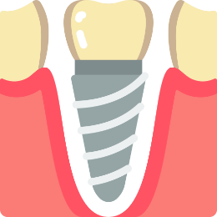
Jaheem’s dental laboratory makes dental implants and he wants to know what classification they are. Jaheem reviews Schedule 2 of the Regulations and notes the following rules that will apply to the dental implants the laboratory makes:
because the implant is intended to be implanted and will remain in the patient for more than 30 days, it is intended for long-term use
the device is implantable and will enter the gum or bone in a patient beyond the tooth, making it a Class IIb medical device
Jaheem has also been considering coating his implants in an antibiotic coating to improve the osseointegration of the titanium dental implants he is making. If Jaheem does decide to coat his implants in a medicine, the implants will then be Class III medical devices.
If you are required to include your medical device in the ARTG before it can be supplied, the classification of a medical device will determine what conformity assessment documentation or market authorisation evidence you need to support your application.

Advertising a medical device
In Australia there are rules governing the advertising of medical devices that must be followed. These rules are set out in:
- The Therapeutic Goods Act 1989 (the Act)
- The Therapeutic Goods Advertising Code (the Code)
- Other relevant laws including the Competition and Consumer Act 2010.
These rules must be followed in all advertising material, which includes any statement, image, or design aimed to promote the use or supply of a therapeutic good. Examples include:
- statements, images, and designs promoting a device
- device information (label and packaging)
- electronic material posted on the internet (websites, social media)
- articles and advertorials published in magazines and newspapers (digital or hard copy)
- displays on posters and notices
- photographs, film, broadcast material and video recordings.

More information
Classification of medical devices: information about how medical devices, including in vitro diagnostics (IVDs), are classified.
Online classification tool: an interactive tool to assist you with determining the classification of your medical device.
TGA Advertising Hub: links to more information about advertising requirements for therapeutic goods, including medical devices.
Advertising personalised medical devices: information and examples of advertising relevant for healthcare practitioners and professionals.

Manufacturing a medical device
The following section of guidance is designed to help you identify whether you are the manufacturer of a medical device. It includes information about:
Who is the manufacturer of a medical device
Adaptable medical devices;
Adaptation or modification of a medical device
Off label use

Who is the manufacturer?
Generally, the manufacturer of a medical device is responsible for the design, production, packaging, labelling and first point of supply of a medical device under their name. This includes:
health practitioners who undertake these activities as a component of their practice;
anyone who supplies a medical device under their own name after assembling, packaging, processing, fully refurbishing, labelling or assigning a different intended purpose to the medical device beyond the scope of the original manufacturer’s instructions or intent without their express permission.
You will not meet the definition of a manufacturer:
if you are using an adaptable medical device in accordance with the instructions for use supplied with the medical device
if you are modifying, altering or adjusting a medical device to suit a patient without changing the intended purpose
if you are a health practitioner using a medical device for an off-label purpose
if you are undertaking a manufacturing activity at the instruction or with the permission of the original manufacturer


Jinxd Podiatry Supplies import medical devices for use by podiatrists around Australia. The company is keen to establish their own brand and intend to source medical devices made by manufacturers around the world for rebranding and sale under their own name.
If Jinxd relabel and repackage the device without the knowledge and consent of the original manufacturer, they will meet the legislative definition of a manufacturer and be required to undertake all regulatory responsibilities associated with manufacturing a medical device including ensuring the device meets the Essential Principles.
If Jinxd establish an agreement with the original manufacturers of the medical devices which includes approval to relabel and repackage the medical devices, Jinxd will not meet the definition of a manufacturer and will not need to undertake any of the activities a manufacturer is expected to undertake. Jinxd would still have responsibilities as a sponsor.

Adaptable medical devices
Adaptable medical devices are intended by the manufacturer to be modified, adapted or assembled to suit a specific individual after they are supplied. Examples of adaptable medical devices that meet the definition of a medical device in the form they are supplied, even though they require a preparatory process to be undertaken in accordance with the instructions for use before they can be used, include:
plaster-infused or thermoplastic bandages;
materials used in tooth fillings such as composite resins; and
bone cements.
Adaptable medical devices must be supplied with instructions for use explaining how to safely modify, prepare, assemble or adapt them. When adapted or assembled in accordance with the manufacturer’s instructions:
- the person responsible for the adaptation or assembly will not meet the definition of a manufacturer; and
- the finished device does not need to be included in the ARTG as a separate device by the person responsible for the adaptation or assembly.

Dr Balu works at a fracture clinic using plaster-infused bandages to treat patients with broken bones. The plaster-infused bandages Dr Balu uses are an adaptable medical device. They are supplied with instructions for use explaining how to use the device to form a cast for a patient with a fractured limb.
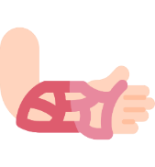
If Dr Balu follows the instructions for use supplied by the manufacturer (soaking the bandages in water, applying them to a patient’s limb to immobilise the bones, allowing the cast to cure, etc) Dr Balu will not meet the definition of a manufacturer as their use of the product falls within the original intended purpose.
If the fracture clinic where Dr Balu works decides to move away from using plaster-infused bandages for forming casts and invests in a new 3D printer, design software and materials to make patient-matched splints based on scans of the patient’s anatomy, the fracture clinic will meet the legislative definition of a manufacturer. The clinic will need to meet all regulatory obligations associated with manufacturing a medical device including ensuring the devices meet the Essential Principles.

Modification, alteration or adjustment of a medical device
Health practitioners often modify, alter or adapt medical devices to suit an individual patient even where the medical device does not meet the definition of an adaptable medical device and the manufacturer has not provided explicit instructions for the adaptation. In these cases the modification, alteration, adjustment or assembly of the device is not a manufacturing process provided the:
medical device is assembled, modified or adapted for an individual patient;
technical documentation describing the mechanism of action of the medical device;
medical device’s intended purpose does not change during the process or in any piece of information supplied by the person who has modified the medical device including:
    - the labelling for the medical device
    - the instructions for using the medical device
    - any advertising material for the medical device

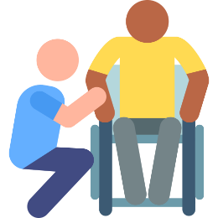
Adrian modifies and adapts wheelchairs to suit individual clients. Adrian’s client, Femi, has purchased a new power-assisted wheelchair but needs additional customised cushioning added so he can use the wheelchair comfortably all day.
The wheelchair is included in the ARTG by the sponsor who supplied it to Adrian and the intended purpose is “a power-assisted, non-collapsible wheelchair.”
Adrian adds cushioning to the existing seat to suit Femi’s needs. This modification does not change the intended purpose of the wheelchair. Adrian is therefore not the manufacturer of the device, and will not have any regulatory obligations to the TGA.
Femi returns to Adrian after six months of using the chair to ask if he can make some additional modifications. Femi’s new car doesn’t fit his wheelchair and he would like Adrian to modify the chair to allow it to be collapsible.
Adrian can make the modifications for Femi but doing so will change the original manufacturer’s intended purpose for the product from a ‘non-collapsible’ wheelchair to a ‘collapsible’ wheelchair. Adrian will meet the definition of a manufacturer and will need to ensure he meets all regulatory obligations for medical devices including ensuring the devices meet the Essential Principles.

Off-label use
‘Off-label use’ is the term used to describe a health practitioner’s decision to use a medical device for a purpose other than the manufacturer’s original indication or intended purpose. The decision to use a medical device for a purpose other than the intended purpose is a clinical decision made at the discretion of the treating clinician and is not regulated by the TGA providing:
the clinician has identified the medical device is the appropriate treatment option and carries a positive risk-benefit profile; and
informed consent is obtained from the patient.
The decision to use a medical device in this manner is considered to be a facet of clinical practice and is not regulated by the TGA.
 | Off-label use is only free from regulation by the TGA when utilised by a clinician for particular patients or presentations that cannot be addressed with a medical device that has been included in the ARTG.  Medical devices cannot be advertised, labelled or promoted for off-label use, even by clinicians who have used the medical device for that purpose.


Caleb is 15 years old and has an osteosarcoma tumour in his leg. In order to preserve his leg, Caleb will need a bone graft implant to replace the bone that will be removed with the tumour. The implant Caleb’s surgeon has chosen is intended by the manufacturer for use in adults only, because the implant is not designed to be implanted into an individual who is still growing.
Caleb’s surgeon discusses treatment options with Caleb and his parents, and the decision is made to give Caleb treatment to fuse his bones and prevent further growth so the bone graft can be implanted safely. Caleb’s surgeon determines that with this option the bone graft will be the most appropriate treatment for Caleb and no suitable alternatives exist.
The surgeon’s decision to use this medical device for a purpose other than the one intended by the manufacturer is an example of off-label use because:
the device is the best option available; and
informed consent has been received from the patient.

Manufacturer responsibilities
If you meet the definition of a manufacturer of a medical device, you are responsible for:
- establishing the intended purpose of a device; and
- ensuring the device you manufacture is safe and fit for its intended purpose; and
- that the device will perform as intended throughout its lifecycle.
There are several key components associated with meeting your responsibilities as a manufacturer including:
- Meeting the Essential Principles
- Obtaining required conformity assessment documentation

The Essential Principles
In Australia, manufacturers are required to demonstrate that medical devices comply with the Essential Principles. The Essential Principles are legislative requirements set out in Schedule 1 of the Regulations relating to the following specific characteristics of medical devices:
General principles
  - Use of medical devices not to compromise health and safety
  - Design and construction of medical devices to conform with safety principles
  - Medical devices to be suitable for intended purpose
  - Long-term safety
  - Medical devices not to be adversely affected by transport or storage
  - Benefits of medical devices to outweigh any undesirable effects
Principles about design and construction
  - Chemical, physical and biological properties
  - Infection and microbial contamination
  - Construction and environmental properties
  - Medical devices with a measuring function
  - Protection against radiation
  - Medical devices connected to or equipped with an energy source
  - Information to be provided with medical devices
  - Clinical evidence
Manufacturers must ensure they meet, and can demonstrate they meet, all relevant Essential Principles.

Conformity assessment documentation
The documentation demonstrating that a medical device meets all relevant Essential Principles is collectively known as conformity assessment documentation or market authorisation evidence. If you are the manufacturer of a medical device, you will need to:
- provide this documentation to the TGA before submitting an application for inclusion in the ARTG; or
- have this documentation available to provide to the TGA when requested if your device is exempt from ARTG inclusion.
The kind of evidence you are required to hold will depend on the classification of your device. A declaration of conformity signed by the manufacturer is acceptable manufacturer’s evidence for devices with the following classifications:
Class I non-sterile, non-measuring
Class I IVD medical device
Class I (export only)
Class I IVD (export only)
All other classifications of medical device are required to have conformity assessment documentation that has been issued by a third-party, independent body. The kind of evidence required will depend on the classification of the device, and the third party the manufacturer engages to assess their devices.

More information
Manufacture a medical device: detailed information about the regulatory responsibilities and expectations for manufacturers of medical devices.
Personalised medical devices (including 3D-printed devices): guidance explaining how personalised medical devices are regulated, including more examples of adaptable medical devices.
Essential Principles checklist (medical devices): a checklist for manufacturers to help them identify, and meet, all relevant Essential Principles.
Manufacturer Evidence for medical devices including IVD medical devices: more information on what is acceptable manufacturer’s evidence and how to submit it to the TGA.
Use of market authorisation evidence from comparable overseas regulators and assessment bodies for medical devices (including IVDs): guidance and detailed information about what certification, documentation or pre-market approval can be used as manufacturer’s evidence.
Conformity assessment overview: more information on conformity assessment for medical devices
Australian declaration of conformity templates (medical devices): information and templates by device classification for manufacturers making an Australian declaration of conformity.

Supplying a medical device
The following section of guidance is designed to help you identify whether you are supplying a medical device. It includes guidance about:
who is the sponsor of a medical device; and
exempt medical devices.

Who is the sponsor?
A sponsor is the Australian-based legal entity responsible for the import into, export from, or supply of therapeutic goods (including medical devices) within Australia. Supplying a medical device includes where a device is:
sold
exchanged
gifted
leased, loaned, hired or hire-purchased
donated
administrated, or applied in the treatment of a person
If you are a health practitioner you will meet the definition of a sponsor if you are:
importing finished medical devices from overseas (even if they require minor adjustment or finishing)
importing materials and/or components that are specified articles from overseas
manufacturing medical devices and supplying them to your patients/clients
You will not be the sponsor if you are:
- buying finished medical devices from an Australian-based sponsor who has included the medical device in the ARTG
- utilising starting materials and components included in the ARTG by an Australian-based sponsor to make finished medical devices under the instruction of a registered health practitioner
- using an ARTG-included device for an off-label use
- distributing medical devices that have been supplied to you by the sponsor through a formal agreement (a pharmacy selling medical devices, for example)
- an agent of the sponsor acting within the boundaries of a legal agreement between you and the sponsor

John is a dentist who sources (imports) crown and bridge work directly from an overseas dental laboratory. John is the sponsor of the medical device, and he will need to include the devices in the ARTG before he imports them.
Danuta is a dental technician and is the Australian sponsor for an overseas dental laboratory. Danuta includes the crown and bridge work in the ARTG.
If John buys the crown and bridge work from Danuta, John will not need to include the medical devices in the ARTG himself.
John may also make an agreement with Danuta that allows him to use Danuta’s ARTG inclusion to import the devices directly himself.
If John imports the medical devices himself without his own ARTG inclusion or a legal agreement with Danuta, John will be in breach of the Act and may face both civil and criminal penalties. John’s medical devices may also be seized by Border Force and either returned to the overseas dental laboratory or destroyed.

Exempt medical devices
Medical devices that are exempt are generally not required to undergo pre-market approval or be included in the ARTG before they are imported, exported or supplied. Exemptions are generally used to reduce regulatory burdens, particularly where:
- A medical device is manufactured in circumstances where there are other measures in place to manage risks associated with the medical device, such as where a device is manufactured as a component of clinical practice;
- The supply of medical devices may be restricted if an exemption is not introduced (e.g. supply is not for a commercial purpose)
- Documentation needed to support an ARTG inclusion is not available (e.g. medical devices used in clinical trials)
- Where a medical device is transitioning to ARTG inclusion (e.g. patient-matched, reclassification etc)
Exemptions can be made on a conditional or unconditional basis. A comprehensive list of the current exemptions for medical devices is available in Schedule 4 of the Therapeutic Goods (Medical Devices) Regulations 2002.
While they are exempt from pre-market approval and inclusion in the ARTG, exempt medical devices are not exempt from regulation. Exempt medical devices must continue to meet all regulatory requirements for medical devices including:
ensuring the medical device(s) meets all relevant Essential Principles, including supplying the devices with adequate labelling and instructions for use
ensuring advertising complies with the advertising requirements
reporting adverse events to the TGA.
In some cases, exempt medical devices must also meet specific conditions to be eligible for exemption. Examples of exempt medical devices include, but are not limited, to the following:
custom-made medical devices
low-volume exemption for patient-matched medical devices – patient-matched medical devices supplied in volumes of no more than five (5) devices of a given kind per financial year are exempt from ARTG inclusion
conditional exemption for certain clinical decision support systems (CDSS)
externally applied orthopaedic devices and non-implantable dental devices manufactured by:
  - a health practitioner practising within Australia; or
  - a technical professional operating in Australia, at the direction of a relevant health practitioner practising within Australia, using products specified to be medical devices that have been included in the ARTG

Ahpra-registered or licensed medical practitioners and other health practitioners may be able to access “unapproved” therapeutic goods via:
the Authorised Prescriber Scheme
the Special Access Scheme
Australian clinical trial sponsors may import into and/or supply in Australia 'unapproved' medical devices for use in a clinical trial.
Those seeking to use these pathways to access unapproved medical devices should be aware that access requires notification to, or approval from, the TGA prior to accessing an unapproved device using these pathways.

Sponsor responsibilities
If you are the Australian-based legal entity responsible for supplying a medical device, before you start importing and/or supplying medical devices, you must meet all relevant regulatory obligations for sponsors including:
- have (and maintain) a relationship with the device’s manufacturer so you can access information about the device to satisfy regulatory requirements when needed
- have conformity assessment documentation demonstrating the device is safe and fit for its intended purpose
- ensure the device is included in the ARTG using the correct classification (unless it is either excluded or exempt)
- ensure material advertising the medical device is compliant with the Therapeutic Goods Advertising Code
After you have ensured you have met your regulatory responsibilities as a sponsor and commenced importing and/or supplying a medical device, you will have ongoing responsibilities including:
- Allowing entry and inspection of any premises where the medical devices are manufactured or located
- Delivering samples to the TGA when requested
- Providing information about the medical devices when requested
- Reporting certain events involving the medical devices

More information
Meet your ongoing responsibilities as a medical device sponsor: guidance about the responsibilities associated with supplying a medical device.

Sector-specific examples for health practitioners
The following section provides more information, guidance, case studies and examples that demonstrate the regulatory concepts that may apply to health practitioners. Use of the term “health practitioner” incorporates both the legislative definition of a health practitioner in the Act, a health professional as defined in the Regulations as well as professionals or suitably qualified people involved in the delivery of health care or practice either within a healthcare facility, an aged care service provider or in private settings who may not be captured under these definitions.

Radiation therapy examples
Facilities, clinics and practitioners using radiation therapy as part of their practice are likely to have medical devices that will be regulated by the TGA.
The following provides examples of key regulatory concepts that will impact the manufacture, supply and use medical devices as part of radiation therapy in a healthcare facility, and examples of how medical devices may be regulated depending on:
what they are
how they are used
what they are made from
who they are made by

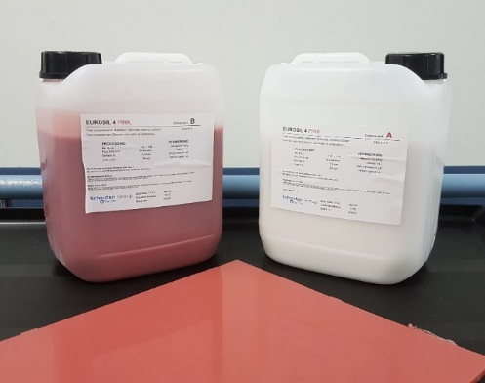
Silicone (or similarly, other starting materials such as wax and gels) used to manufacture a bolus for use in radiotherapy
Silicone boli are manufactured at the point of care using two liquids that are mixed together and poured to form a bolus of a particular size and thickness. The resultant sheet can then be used in different ways.
The two-part components supplied to make the bolus do not meet the definition of a medical device, are not specified articles and are therefore likely to be a starting material.
The bolus made from the silicone will meet the definition of a medical device, thereby making the health practitioner the manufacturer and sponsor of the medical device. These products will typically be classified Class I, non-sterile, non-measuring and must be included in the ARTG by the sponsor before they can be supplied.

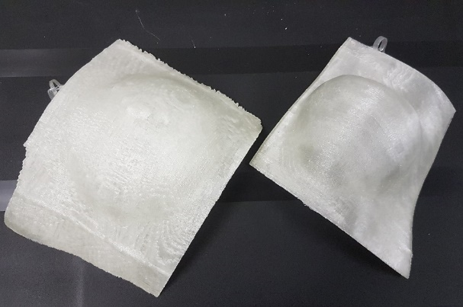
3D printed bolus
3D printed boli are manufactured using scans of a patient’s anatomy.
These products meet the definition of a medical device and will typically be classified as Class I, non-sterile, non-measuring. They must be included in the ARTG by a sponsor before they are supplied.

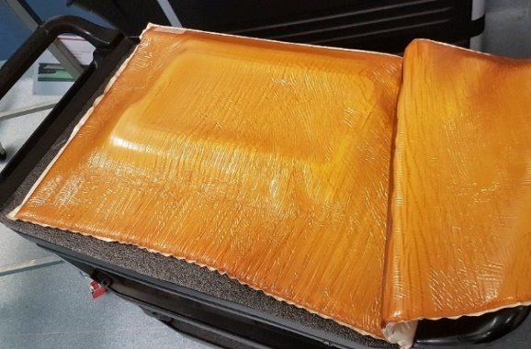
Non-adaptable pre-made bolus
Pre-made boli that are not intended to be adapted or cut will meet the definition of a medical device. These products will typically be classified as Class I non-sterile, non-measuring and must be included in the ARTG by the sponsor before they are supplied to the healthcare facility.

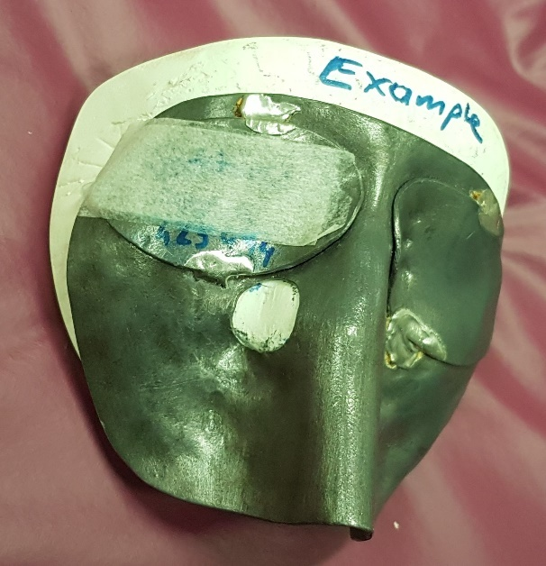
Shields
Shields to protect the patient during the delivery of radiation therapy are often manufactured at the point of care using sheets of lead to suit individual patients.
The lead sheets do not meet the definition of a medical device, are not specified articles and are therefore likely to be a starting material.
The shield made from the lead sheet will meet the definition of a medical device, thereby making the health practitioner the manufacturer and sponsor of the medical device. These products will typically be classified Class I, non-sterile, non-measuring and must be included in the ARTG by the sponsor before they can be supplied.

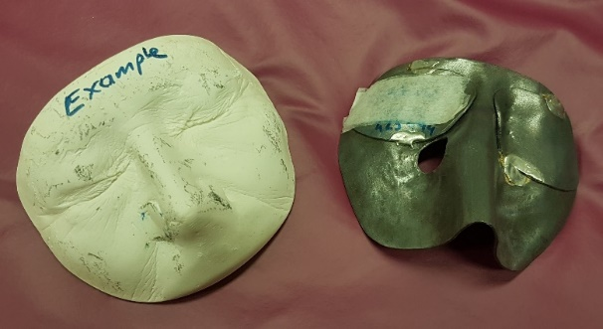
Anatomical models for radiology
Impressions taken of a patient’s face and the resultant cast which is used to manufacture a shield or similar medical device does not meet the definition of a medical device and does not need to be included in the ARTG.

Thermoplastic face mask
For patients who need radiotherapy delivered to their head or neck, a thermoplastic face mask is used to ensure the patient is positioned comfortable and reliably during treatment. There are two primary ways a face mask may be manufactured:
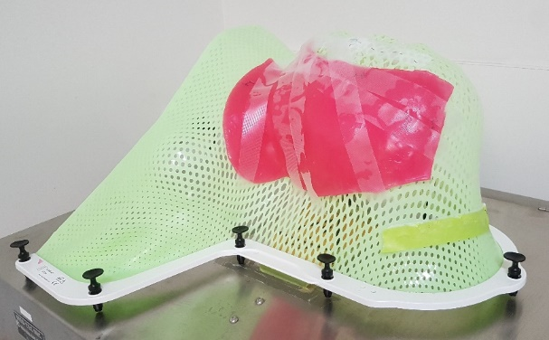
- Masks supplied in a pre-cut format with instructions for use for how to heat and apply to the patient to form an individually contoured mask. These kinds of products are adaptable medical devices. Generally they will be classified as a Class I non-sterile, non-measuring device and should be included in the ARTG by the sponsor before they are supplied to the healthcare facility where they are used.
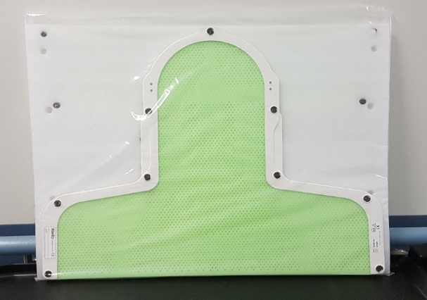
- Masks cut from a generic sheet of thermoplastic and shaped by a practitioner to fit the patient will also be a Class 1 non-sterile, non-measuring medical device, but in this case the manufacturer will be the practitioner who cuts and shapes the plastic to form it into a mask. These patient-matched devices must be included in the ARTG before they are used on patient.

Brachytherapy surface/skin applicator

Brachytherapy is a type of targeted radiation therapy used to treat cancer on a specific part of the body, such as the head, neck, cervix, or eye.

A brachytherapy applicator system comprises of an applicator, source, and a catheter. The applicator contains channels through which a brachytherapy catheter is placed. The radioactive source of a brachytherapy system would travel through this catheter, pausing at different positions to deliver a therapeutic dose to the target tissue of the patient.

These devices are generally classified as Class IIb medical devices.

Applicators are sometimes moulded to fit the anatomy of a patient before it is supplied to a patient and are a patient-matched medical device. The patient-matched medical device needs to be included in the ARTG by the sponsor before they are used on a patient.

Dental examples
There are a number of different kinds of entities in the dental sector that will be regulated by the TGA including dental and oral health practitioners and the technicians, laboratories and suppliers who support practitioners. The following guidance provides an overview of key regulatory concepts that will impact dental practice, and examples of how devices may be regulated depending on:
what they are
how they are used
what they are made from
who they are made by
Dental anatomical models
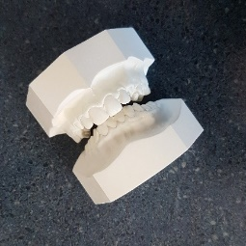
How an anatomical model is made and used will determine how it is regulated.
Anatomical impressions and casts made from direct impressions of a patient’s anatomy are excluded from regulation by TGA, no matter what purpose they are being used for.
A 3D digital, or 3D printed anatomical model intended to be used for a purpose that will meet the definition of a medical device (surgical or treatment planning, for example) will meet the definition of a medical device. These models are generally regulated as Class IIa medical devices and need to be included in the ARTG unless they are:
- manufactured by a health practitioner, or a person working to instructions received from a health practitioner; and
- made using a specified article that has been included in the ARTG before it was supplied to the person manufacturing the dental anatomical model.
Dental anatomical models made under these circumstances will be exempt.


Medicament and impression trays
Medicament and impression trays come in generic sizes and are intended to hold specific substances in the patient’s mouth while the substances are used for their intended purpose.
Medicament and impression trays are excluded goods. This means they are not regulated by the TGA.

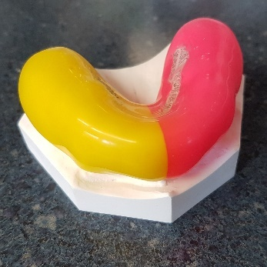
Mouthguards
How a mouthguard or splint is regulated will depend on its intended purpose.
Mouthguards used in sport are excluded under the Therapeutic Goods (Excluded Goods) Determination 2018 and are therefore not regulated by the TGA.
Mouthguards that are intended to be used to protect the teeth from the effects of medical conditions including bruxism will generally be classified as a Class I non-sterile, non-measuring medical device.
These medical devices will need to be included in the ARTG unless they are:
- manufactured by a health practitioner, or a person working to instructions received from a health practitioner; and
- made using a specified article that has been included in the ARTG before it was supplied to the person manufacturing the mouthguard.
Mouthguards made under these circumstances will be exempt.

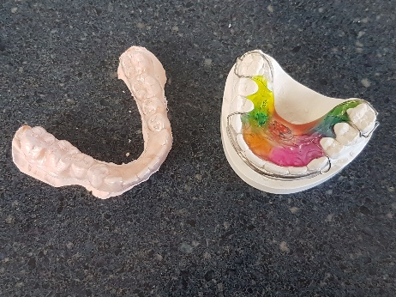
Splints, retainers and aligners
Splints, retainers and aligners are intended to retain teeth in their existing position, move teeth slightly from their existing position or treat conditions including bruxism.
Splints, retainers and aligners are generally regulated as Class I non-sterile, non-measuring medical devices. These devices need to be included in the ARTG before supply or importation unless they are:
manufactured by a health practitioner, or a person working to instructions received from a health practitioner; and
made using a specified article that has been included in the ARTG before it was supplied to the person manufacturing the splints, retainers, and aligners.
Splints, retainers, and aligners made under these circumstances will be exempt.

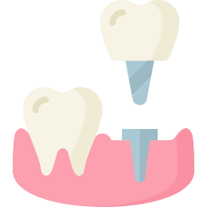
Dental implant systems
Dental implant systems can be used to replace missing teeth with a crown, to anchor fixed full and partial dentures, or to support other orthodontic appliances.
A dental implant system generally includes:
Dental implant: permanently implanted into the patient, this component of the system serves as a replacement root. Implants are generally mass-produced and regulated as a Class IIb medical device (permanently implantable medical device).
Abutment: a transmucosal component which rests on the implant, securing the prosthesis. Abutments are generally mass-produced and regulated as a Class IIa medical device. Implant abutments can incorporate an attachment mechanism, often referred to as a 'special or precision attachment’. This provides stability to retain dental appliances such as implant-supported removable dentures or implant-supported maxillofacial prostheses. These attachments can be a ball and socket, press stud or even a magnetic attachment (examples include ball attachments, locator attachments and OT-Equators).
Implant abutments with special/precision attachments are regulated the same way as an implant abutment without a special attachment. They are generally a Class IIb (implantable dental medical device intended for long-term use) and need to be included in the ARTG by the sponsor before they are supplied.
Note: implant abutments can also be milled by a dental laboratory to produce a size, shape or angle that may not be available with an off-the-shelf abutment

Prosthesis: Implant supported orthodontic appliances and prostheses include:
  - overdentures, partial dentures (both fixed and removeable)
  - crowns and bridges
  - palate expanders
  - maxillofacial prostheses
Removeable devices such as overlay dentures are generally regulated as Class I non-sterile, non-measuring medical devices. Non-removeable devices such as crowns are generally regulated as Class IIa medical devices. In both cases these devices may be exempt if they are made under certain conditions using specified articles that have been included in the ARTG.
Components of the system may be sold separately, or packaged together and sold as a patient-matched unit. Implanted dental devices (such as dental implants and implant abutments) are not exempt from ARTG inclusion even when made using materials included in the ARTG.

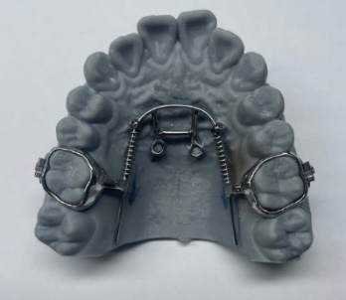
TADs and miniscrews
Orthodontic temporary anchorage devices (TADs) are inserted into the jaw to help control tooth movement during orthodontic treatment and are generally regulated as Class IIb medical devices.
TADs serve as an anchorage point to allow force to be exerted onto the teeth using either:
auxiliary devices such as palatal arches; or
accessories including elastics, elastic chain, springs and ligature wire.
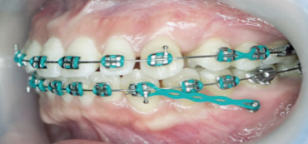
Accessories to TADs may be regulated as either Class I non-sterile, non-measuring (non-implantable short-term use in the oral cavity) or Class IIa (non-implantable long-term use in the oral cavity).
TADs and accessories to TADs must be included in the ARTG by the sponsor before they are supplied to the health practitioner.


Brackets and wires
Brackets and wires are dental appliances intended to be fitted to a patient by a dental practitioner to correct a wide range of issues including crooked, crowded or spaced teeth and malocclusion.
Brackets and wires are an adaptable medical device and must be included in the ARTG. They are generally regulated as Class IIa (long term use in the oral cavity) medical devices and need to be included in the ARTG by the sponsor before they are imported or supplied.
Subsequent assembly or adaptation for an individual patient is not an activity regulated by the TGA.

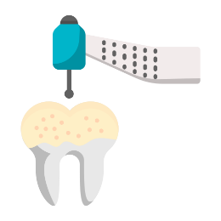
Dental surgical guides
Dental surgical guides are single-use appliances made to fit directly over a patient’s teeth with a hole that positions a surgical drill at the right location, angle, and depth to aid implant placement for patients. Dental surgical guides are commonly made via 3D printing, using resin as a starting material and they are generally regulated as Class I non-sterile, non-measuring medical devices.
These kinds of medical devices may be exempt if they are made under certain conditions using specified articles that have been included in the ARTG.

Podiatry examples
Health practitioners that use, manufacture and supply podiatry products as part of their practice are likely to have medical devices that will be regulated by the TGA.
The following provides examples and an overview of key regulatory concepts that will impact their healthcare facility, and examples of how devices may be regulated depending on:
what they are
how they are used
what they are made from
who they are made by
Anatomical models
Anatomical impressions and casts made from direct impressions of a patient’s anatomy are excluded from regulation by TGA, no matter what purpose they are being used for.
A 3D digital, or 3D printed anatomical model intended to be used for a purpose that will meet the definition of a medical device (surgical or treatment planning, for example) will meet the definition of a medical device. These models are generally regulated as Class IIa medical devices and need to be included in the ARTG by the sponsor before they are imported or supplied.

Metatarsal bars (or pads)
Metatarsal bars are manufactured using semi-firm pads made of EVA and are used to protect and support the metatarsal bones in the ball of the foot, bringing relief to most causes of forefoot pain. These kinds of products are generally regulated as Class I non-sterile, non-measuring medical devices.
Prefabricated metatarsal bars (or pads) meet the definition of an adaptable medical device and must be included in the ARTG by the sponsor before they are supplied.
Generic sheets of EVA do not meet the definition of a medical device but may be specified articles if they are intended for use in the manufacture of orthopaedic medical devices. If a health practitioner is using material that has been included in the ARTG to make these kinds of devices, the medical device they manufacture is likely to be exempt.
If a health practitioner uses a generic material that is not on the ARTG to make a metatarsal bar, then the health practitioner will meet the definition of both the manufacturer and the sponsor of a medical device, and they must include the metatarsal bar in the ARTG before it is supplied.

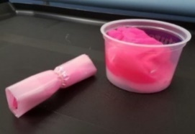
Podiatry products made from silicone putty
Silicone putty is often used to make medical devices that deflect, support, and aid in healing. Silicone putty is mixed with a catalyst and moulded into shape before it hardens. Silicone putty is used for moulding podiatry products including:
interdigital wedges,
separators
dorsal toe protectors
orthodigital splints
If a health practitioner moulds and shapes generic silicone putty to make a podiatry product, the health practitioner meets the definition of both a manufacturer and a sponsor of a medical device, and the medical devices the make must be included in the ARTG before they are supplied.
If a health practitioner uses silicone putty intended for use in podiatry to make a podiatry product, the silicone putty will be a specified article. Providing the putty has been included in the ARTG, the medical device made by the practitioner is likely to be an exempt Class I non-sterile, non-measuring medical device.

Total Contact Casts (TCCs)
A Total Contact Cast (TCC) is a special casting technique designed to immobilise and redistribute pressure on prominent areas of the foot. A TCC is made up of the following starting materials and components:
thin layer of stockinette
protective cast padding
thin cast padding
foam padding
plaster undercoat rolls
fiberglass rolls
a rocker bottom sole or curved sole
A TCC will meet the definition of a Class I non-sterile, non-measuring medical device and the health practitioner making it will meet the definition of both a manufacturer and a sponsor.
If:
the TCC is made from generic starting materials and components, the starting materials will not meet the definition of specified articles. In this instance, the health practitioner will need to include the device in the ARTG before it is supplied.
the TCC is made using only specified articles that have been included in the ARTG, then the medical device made by the health practitioner will be exempt.

Prefabricated foot orthoses / orthotics
Prefabricated foot orthoses (also referred to as ‘over the counter’ or ‘non-prescription’) are mass-produced products available in different sizes intended to be adapted to fit the patient’s foot by a health practitioner.
Prefabricated orthoses meet the definition of an adaptable medical device. They are Class I non-sterile, non-measuring and need to be included in the ARTG by the sponsor before they are supplied.

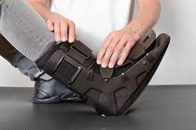
Moon boots/ CAM walkers
Moon Boots/ CAM walkers are an important part of the recovery process for patients with serious foot, ankle, or lower limb injuries.
Moon boots/CAM walkers are intended to be adjusted to fit the patient at the point-of-care by a practitioner. They meet the definition of an adaptable medical device and are generally regulated as a Class I non-sterile, non-measuring medical device. They will need to be included in the ARTG by the sponsor before they are supplied.
The assembly or adjustment of the moon boot is not an activity regulated by the TGA. This includes where a health practitioner adds padding or orthoses to the moon boot/ CAM walker.

Orthotics and prosthetics examples
Orthotists and prosthetists make medical devices to treat physical and functional limitations that arise from a range of health conditions and movement disorders. Orthoses are braces or other supportive devices that are used to correct alignment, reduce pain and/or provide additional support to any part of the body. Prostheses are devices that replace the function of a missing limb. The following guidance and examples are intended to provide an overview of key regulatory concepts most likely to impact orthotists and prosthetists including:
how devices made by orthotists and prosthetists are regulated
making devices from specified articles
Anatomical models
Anatomical impressions and casts made from direct impressions of a patient’s anatomy are excluded from regulation by TGA, no matter what purpose they are being used for.
A 3D digital, or 3D printed anatomical model intended to be used for a purpose that will meet the definition of a medical device (surgical or treatment planning, for example) will meet the definition of a medical device. These models are generally regulated as Class IIa medical devices and need to be included in the ARTG by the sponsor before they are imported or supplied.

Ankle Foot Orthoses (AFOs)
An Ankle Foot Orthosis (AFO) is a device that encompasses part of the foot, ankle shank and/or calf. It may support, immobilise, realign or provide energy return to the user. AFOs are generally manufactured by a health practitioner to suit a particular patient using raw starting materials and components such as:
sheet of thermoplastic padding
EVA padding around the ankles and on the straps for comfort
velcro straps
stainless steel rivets
An AFO will meet the definition of a Class I non-sterile, non-measuring medical device and the health practitioner making it will meet the definition of both a manufacturer and a sponsor.
If:
the AFO incorporates generic starting materials and components, the starting materials will not meet the definition of specified articles. In this instance, the health practitioner will need to include the device in the ARTG before it is supplied.
- the AFO is made using only specified articles that have been included in the ARTG, then the medical device made by the health practitioner will be exempt.

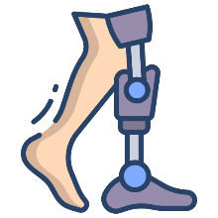
Prefabricated prostheses and components
A prosthesis is an artificial device attached or applied to the body to replace a missing part of a person’s anatomy. Prefabricated prostheses and components are mass-produced and come in different sizes and shapes with different functionalities. A prosthetist may prescribe and fit a prefabricated prosthesis (or components) to a patient.
Examples of prefabricated components for prostheses include:
prosthetic joints (knee unit, elbow unit)
terminal devices (hands, feet, hooks, running blades)
pylon/frame
A fully assembled prosthesis may be comprised of multiple components (e.g. prosthetic socket, elbow unit, wrist unit, hand). All components and adaptable medical devices that form the prosthesis, must meet the relative manufacturer’s specifications and requirements for each component/device.
Prefabricated prostheses and components may meet either the definition of an adaptable medical device or a patient-matched medical device. They are considered Class I non-sterile, non-measuring (inert and body-powered) or Class IIa (bionic/myoelectric/powered). In both instances, prefabricated prostheses and/or components need to be included in the ARTG by the sponsor before they are supplied.
Certain prostheses and components such as cosmetic ocular prostheses and cosmetic silicone gloves are excluded from regulation by TGA.

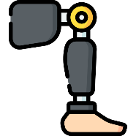
Transfemoral prosthetic socket
An above-knee prosthesis (transfemoral prosthesis) typically consists of a transfemoral prosthetic socket, knee unit, pylon, ankle/foot unit, and some means of attaching the prosthesis to the body.
A transfemoral prosthetic socket is the upper part of the prosthesis which fits around the patient’s residual limb. Prosthetic sockets are generally manufactured by a health practitioner to suit a particular patient using raw starting materials and components such as:
- nylon stocking
- carbon fibre bandaging
- resin
Where a prosthetic socket is made from generic starting materials and components, the starting materials do not meet the definition of a medical device until the health practitioner finishes manufacturing and assembling the prosthetic socket. In this case the health practitioner meets the definition of the manufacturer and the sponsor of a patient-matched Class I non-sterile, non-measuring medical device and will need to include the device in the ARTG before it is supplied.
Where a prosthetic socket is made in Australia by a health practitioner, using only starting materials and components intended by the manufacturer for use in orthopaedic devices, then all the starting materials and components are specified to be medical devices. In this case the health practitioner meets the definition of the manufacturer and the sponsor for the patient-matched medical device.
The prosthetic socket when made using starting materials and components that are specified articles, is exempt from ARTG inclusion, and the health practitioner will not need to include the device in the ARTG before it is supplied. The health practitioner will still need to meet all other regulatory requirements including documenting that the prosthetic socket meets the Essential Principles, reporting adverse events and complying with advertising requirements.
A fully assembled above-knee prosthesis consists of multiple components. All components that form the prosthesis must meet the relative manufacturer’s specifications and requirements for each component/device.

Occupational therapy and rehabilitation examples
Occupational therapists and rehabilitation health practitioners make a range of medical devices to treat injuries and physical and functional limitations that arise from a range of health conditions and movement disorders. The following guidance and examples are intended to provide an overview of key regulatory concepts most likely to impact occupational therapists and rehabilitation health practitioners including:
how devices made by occupational therapists are regulated
making devices from specified articles
how adaptable pre-fabricated or pre-made medical devices are regulated
Additional examples that may be relevant to occupational therapists and rehabilitation health practitioners and are provided elsewhere in this document include:
Anatomical models
Metatarsal bars (or pads)

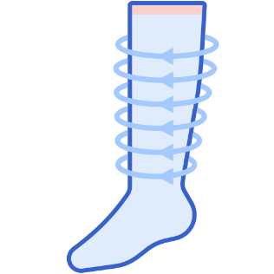
Compression garments for lymphoedema
Compression garments can be used to help reduce swelling and enable functional movement in patients with lymphoedema. Compression garments can also be used to apply pressure to burns to help reduce formation of thick scar tissue, which can tighten skin and restrict movement.
Compression garments can be prefabricated in set sizes or made to measure based on instruction by a health practitioner. Some compression garments have Velcro or other fastenings to allow for the fit to be modified and adapted to suit an individual patient.
Health practitioners can measure a patient and order compression garments that are made to suit the individual patient’s requirements. Taking a patient’s measurements to order a compression garment is not a manufacturing activity and is not regulated by the TGA.
Adjusting the compression garment to fit the patient according to the manufacturer’s instructions is not a manufacturing activity and is not regulated by the TGA.
Compression garments that are intended for a use that meet the definition of a medical device will generally be Class I non-sterile, non-measuring medical devices and will need to be included in the ARTG before they are supplied.

The classification of a compression garment may be higher if it is intended to be used on injured skin, such as during the treatment for burns and scar tissue.

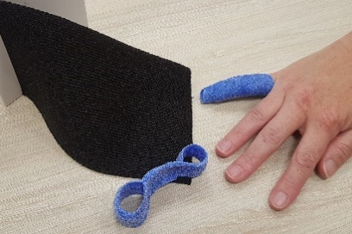
Thermoplastic bandages
Thermoplastic bandages are intended to be heated by a health practitioner and shaped into a splint for a patient.
Thermoplastic bandages meet the definition of an adaptable medical device. They are Class I non-sterile, non-measuring medical devices and need to be included in the ARTG by the sponsor before they are supplied.
The use of stockinette between the patient’s skin and the thermoplastic bandage to protect the patient’s skin from heat does not alter the original intended purpose of the thermoplastic bandage.
Using a stockinette before applying a thermoplastic bandage is a decision made by a health practitioner and is not a manufacturing activity regulated by the TGA.


Prefabricated or premade splints
Prefabricated splints are mass-produced and come in different sizes. They often buckle or Velcro together, allowing the fit to be adjusted to the patient by a healthcare practitioner or the patient themselves.
Prefabricated splints meet the definition of an adaptable medical device. They are a Class I non-sterile, non-measuring medical device and need to be included in the ARTG by the sponsor before they are supplied to health practitioners or consumers.
When a health practitioner follows the manufacturer’s instructions to adjust or modify a prefabricated splint to fit a patient, this activity is not a manufacturing activity regulated by the TGA.
As the addition of padding to improve patient comfort does not alter the original intended purpose of the prefabricated or premade splint, this type of modification is also not a manufacturing activity regulated by the TGA.

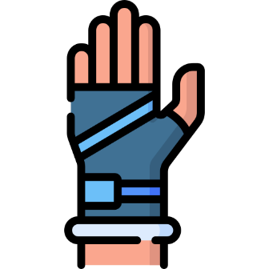
Splints
Splints (including static splints and dynamic splints with outriggers) can be used to support and protect broken bones and injuries such as strains, sprains, tendon ruptures and dislocations. Different types of splints are used depending on the type and location of the injury being treated. Splints may be constructed by a health practitioner using materials and components such as:
- thermoplastic sheets and glue
- outriggers
- elastomer splinting material
- pulley stoppers
- rubber bands
- Velcro
Where a splint is made from a generic silicone putty or sheet of thermoplastic, the product does not meet the definition of a medical device until the health practitioner moulds and shapes it. In this case the health practitioner will meet the definition of both a manufacturer and a sponsor of a medical device and will need to include the splints they make as a Class I non-sterile, non-measuring medical device in the ARTG, before they are supplied.
Materials intended by the manufacturer to be used in the manufacture of a splint are specified articles and need to be included in the ARTG before they are supplied. When a splint is made by a health practitioner exclusively from specified articles the splint will be exempt from ARTG inclusion and the health practitioner will NOT need to include the splints in the ARTG before they are supplied.
The health practitioner will still need to meet all other regulatory requirements including documenting that the splints meet the Essential Principles, reporting adverse events and complying with advertising requirements.
Where a splint is manufactured using a combination of any generic starting materials alongside specified articles, the resultant splint will need to be included in the ARTG

Version history
Version | Description of change | Author | Effective date
V1.0 | Original publication | Devices Emerging Technology, Medical Devices Surveillance Branch | March 2024

Section 41BD (1)(b) of the Act.
Schedule 2, Part 1, Clause 1.1(1)(c)
Schedule 2, Part 3, Clause 3.4 (1), (2) and (5)
Schedule 2, Part 5, Clause 5.1
The manufacturer of a medical device is defined in Section 41BG of the Act.
Adaptable medical devices are defined in the Therapeutic Goods (Medical Devices) Regulations 2002.
“Sponsor” is defined in the Therapeutic Goods Act 1989.
Section 41FN(1)
Section 41FN(2)
Section 41FN(3)
Section 41FN(3)(d) of the Act, Regulation 5.7 of the Regulations
The specific features of a device may impact its classification. If an implant incorporates a medicine, an antibiotic coating, for example, it will be a Class III medical device (Schedule 2, Clause 5.1 of the Regulations).

