Australian Public Assessment Report for BEYFORTUS
  - Active ingredient: nirsevimab
  - Sponsor: Sanofi-Aventis Australia Pty Ltd
March 2024

About the Therapeutic Goods Administration (TGA)
- The Therapeutic Goods Administration (TGA) is part of the Australian Government Department of Health and Aged Care and is responsible for regulating therapeutic goods, including medicines, medical devices, and biologicals.
- The TGA administers the Therapeutic Goods Act 1989 (the Act), applying a risk management approach designed to ensure therapeutic goods supplied in Australia meet acceptable standards of quality, safety, and efficacy.
- The work of the TGA is based on applying scientific and clinical expertise to decision-making, to ensure that the benefits to the Australian public outweigh any risks associated with the use of therapeutic goods.
- The TGA relies on the public, healthcare professionals and industry to report problems with therapeutic goods. The TGA investigates reports received to determine any necessary regulatory action.
- To report a problem with a therapeutic good, please see the information on the TGA website.

About AusPARs
- The Australian Public Assessment Report (AusPAR) provides information about the evaluation of a prescription medicine and the considerations that led the TGA to approve or not approve a prescription medicine submission. Further information can be found in Australian Public Assessment Report (AusPAR) guidance.
- AusPARs are prepared and published by the TGA.
- AusPARs are static documents that provide information that relates to a submission at a particular point in time. The publication of an AusPAR is an important part of the transparency of the TGA’s decision-making process.
- A new AusPAR may be provided to reflect changes to indications or major variations to a prescription medicine subject to evaluation by the TGA.

Copyright
© Commonwealth of Australia 2024
This work is copyright. You may reproduce the whole or part of this work in unaltered form for your own personal use or, if you are part of an organisation, for internal use within your organisation, but only if you or your organisation do not use the reproduction for any commercial purpose and retain this copyright notice and all disclaimer notices as part of that reproduction. Apart from rights to use as permitted by the Copyright Act 1968 or allowed by this copyright notice, all other rights are reserved and you are not allowed to reproduce the whole or any part of this work in any way (electronic or otherwise) without first being given specific written permission from the Commonwealth to do so. Requests and inquiries concerning reproduction and rights are to be sent to the TGA Copyright Officer, Therapeutic Goods Administration, PO Box 100, Woden ACT 2606 or emailed to <tga.copyright@tga.gov.au>.

Contents
List of abbreviations 4
Product submission 5
Submission details 5
Product background 6
The disease/condition 6
Current treatment options 7
Clinical rationale 7
Regulatory status 8
Australian regulatory status 8
Foreign regulatory status 8
Registration timeline 9
Submission overview and risk/benefit assessment 10
Quality 10
Nonclinical 10
Clinical 11
Summary of clinical studies 11
Risk management plan 31
Risk-benefit analysis 32
Delegate’s considerations 32
Advisory Committee considerations 32
Outcome 35
Specific conditions of registration applying to these goods 35
Attachment 1. Product Information 37

List of abbreviations
Abbreviation | Meaning
ACM | Advisory Committee on Medicines
ADA | Anit-drug antibodies
AE | Adverse event
AESI | Adverse event of special interest
ARTG | Australian Register of Therapeutic Goods
ASA | Australia-specific annex
CHD | Congenital heart disease
CLD | Chronic lung disease
CMH | Cochran–Mantel–Haenszel test
CMI | Consumer Medicines Information
DLP | Data lock point
IM | Intramuscular injection
ITT | Intention to treat
LRTI | Lower respiratory tract infection
mAb | Monoclonal antibody
MEDI18897 | Nirsevimab
NOCD | New onset of chronic disease
PD | Pharmacodynamics
PI | Product Information
popPK | Population pharmacokinetics
PSUR | Periodic safety update report
RMP | Risk management plan
RRR | Relative risk reduction
RSV | Respiratory syncytial virus
RTI | Respiratory tract infection
SAE | Serious adverse event
SD | Standard deviation
T_{1/2} | Half life
TEAE | Treatment emergent adverse event
TESAE | Treatment emergent serious adverse event
TGA | Therapeutic Goods Administration
UR | Uncertainty range

Product submission

Submission details
Type of submission: | New biological entity
Product name: | BEYFORTUS
Active ingredient: | Nirsevimab
Decision: | Approved
Date of decision: | 22 November 2023
Date of entry onto ARTG: | 24 November 2023
ARTG numbers: | 397898, 397899
Black Triangle Scheme | Yes
Sponsor’s name and address: | Sanofi-Aventis Australia Pty Ltd, Locked Bag 2227, North Ryde BC, NSW 1670
Dose form: | Solution for injection
Strengths: | 50 mg in 0.5 mL, 100 mg in 1 mL
Container: | Syringe
Pack sizes: | 5 prefilled syringes, 1 prefilled syringe
Approved therapeutic use for the current submission: | BEYFORTUS is indicated for the prevention of Respiratory syncytial Virus (RSV) lower respiratory tract disease in:  - Neonates and infants born during or entering their first RSV season.  - Children up to 24 months of age who remain vulnerable to severe RSV disease through their second RSV season.
Route of administration: | Intramuscular
Dosage: | The recommended dosage of BEYFORTUS for neonates and infants born during or entering their first RSV season is based on body weight and is administered as a single intramuscular (IM) injection.  For children up to 24 months of chronological age who remain at increased risk for severe RSV disease in their second RSV season, the recommended dosage of BEYFORTUS is a single 200 mg dose administered as two IM injections (2 x 100 mg) at the same visit.  For further information regarding dosage, such as dosage modifications to manage adverse reactions, refer to the Product Information.
Pregnancy category: | B2  Drugs which have been taken by only a limited number of pregnant women and women of childbearing age, without an increase in the frequency of malformation or other direct or indirect harmful effects on the human fetus having been observed.  Studies in animals are inadequate or may be lacking, but available data show no evidence of an increased occurrence of fetal damage.  The use of any medicine during pregnancy requires careful consideration of both risks and benefits by the treating health professional. The pregnancy database must not be used as the sole basis of decision making in the use of medicines during pregnancy. The TGA does not provide advice on the use of medicines in pregnancy for specific cases. More information is available from obstetric drug information services in your state or territory.

Product background
This AusPAR describes the submission by Sanofi-Aventis Australia Pty Ltd (the sponsor) to register BEYFORTUS (nirsevimab), 50 mg in 0.5 mL and 100 mg in 1 mL, solution for injection, syringe for the following proposed indication:

BEYFORTUS is indicated for the prevention of respiratory syncytial virus (RSV) lower respiratory tract disease in:
- Neonates and infants entering or during their first RSV season.
- Children up to 24 months of age who remain vulnerable to severe RSV disease through their second RSV season, which may include but is not limited to children with:
  - Chronic lung disease of prematurity (CLD)
  - Haemodynamically significant congenital heart disease (CHD)
  - Immunocompromised states
  - Down syndrome
  - Cystic fibrosis
  - Neuromuscular disease
  - Congenital airway anomalies

The disease/condition
RSV is the most common cause of lower respiratory tract infection among infants and young children globally and is the major cause of hospital admission, with an estimated 33 million clinical cases (uncertainty range [UR] 25·4–44·6 million), 3.6 million (2·9–4·6 million) hospitalisations in children <5 years of age and 26 300 (15 100–49 100) RSV-associated acute lower respiratory infection in-hospital deaths in 2019. In infants aged 0-6 months, the burden is greater, with an estimated 6·6 million RSV-associated acute lower respiratory infection episodes (4·6–9·7 million).

While the mortality rate due to RSV infection is low in high-income countries, inpatient disease burden is high, with the greatest burden occurring in young infants. It has been estimated that, in the absence of immunisation, there are approximately 590000 medically attended RSV LRTIs annually among US infants.

In Australia, RSV was made a nationally notifiable disease in July 2021. A community-based, birth cohort from Brisbane followed children until their second birthday and demonstrated that RSV incidence in the first 2 years of life was 0.46 (95% CI = 0.37–0.58) episodes per child-year. Of 82 episodes linked with symptom data, 60 (73.2%) were symptomatic, 28 (34.1%) received community-based medical care, and 2 (2.4%) led to hospitalisation.

Infants with serious underlying comorbidities remain vulnerable for severe RSV disease beyond their first RSV season. These include infants with prematurity, chronic lung disease, congenital heart disease, cystic fibrosis, neuromuscular conditions, Down syndrome, or immunocompromised states.

Current treatment options
Palivizumab (Synagis), a humanised IgG1 monoclonal antibody, is currently approved by the TGA for the following indications:
Synagis (palivizumab) is indicated for the prevention of serious lower respiratory tract disease caused by respiratory syncytial virus (RSV) in children at high risk of RSV disease. Safety and efficacy were established in children with bronchopulmonary dysplasia (BPD), infants with a history of prematurity (gestational age less than or equal to 35 weeks at birth) and children with haemodynamically significant congenital heart disease (CHD).
The recommended dose of palivizumab is 15 mg/kg, given once a month during anticipated periods of RSV risk in the community.

Palivizumab is not funded by the Pharmaceutical Benefits Scheme. It is provided at the discretion of individual hospitals. It is funded by the Western Australian Department of Health for infants and young children for certain categories.
Ribavirin is registered in Australia; however, it is not registered for use in RSV.

Clinical rationale
Prevention of severe RSV RTI is the main approach as there is still no registered vaccines despite decades of effort. Management of RSV infection as both an outpatient and inpatient is essentially supportive as there are no approved treatments. Bronchodilators and corticosteroids have not shown a benefit for RSV bronchiolitis. The only currently approved prophylaxis for RSV is palivizumab, registered only for infants at the highest risk for severe RSV disease.

Regulatory status

Australian regulatory status
This product is considered a new chemical entity for Australian regulatory purposes.

Foreign regulatory status
At the time the TGA considered this submission, a similar submission had been considered by other regulatory agencies. Table 1 summarises these submissions and provides the indications where approved.
Table 1 International regulatory status at the time of product registration.
Region | Submission date | Status | Approved indications
European Union (centralised procedure) | 28 January 2022 | 31 October 2022 | BEYFORTUS is indicated for the prevention of respiratory syncytial virus (RSV) lower respiratory tract disease in neonates and infants during their first RSV season.  BEYFORTUS should be used in accordance with official recommendations.
United States | 26 September 2022 | 17 July 2023 | BEYFORTUS is indicated for the prevention of respiratory syncytial virus (RSV) lower respiratory tract disease in:  -Neonates and infants born during or entering their first RSV season.  -Children up to 24 months of age who remain vulnerable to severe RSV disease through their second RSV season.
Canada | 3 November 2022 | 19 April 2023 | BEYFORTUS (nirsevimab injection) is indicated for the prevention of Respiratory Syncytial Virus (RSV) lower respiratory tract disease in:  1.Neonates and infants during their first RSV season.  2.Children up to 24 months of age who remain vulnerable to severe RSV disease through their second RSV season, which may include but is not limited to children with:  -Chronic lung disease of prematurity (CLD)  -Hemodynamically significant congenital heart disease (CHD)  -Immunocompromised states  -Down syndrome  - Cystic fibrosis  -Neuromuscular disease  -Congenital airway anomalies.

Registration timeline
The following table captures the key steps and dates for this submission.
This submission was evaluated under the standard prescription medicines registration process.
Table 2 Timeline for Submission PM-2022-04428-1-2
Description | Date
Submission dossier accepted and first round evaluation commenced | 30 November 2022
First round evaluation completed | 1 May 2023
Sponsor provides responses on questions raised in first round evaluation | 31 May 2023
Second round evaluation completed | 28 July 2023
Sponsor’s notification to the TGA of errors/omissions in evaluation reports | 13 July 2023
Delegate’s Overall benefit-risk assessment and request for Advisory Committee advice | 6 September 2023
Sponsor’s pre-Advisory Committee response | 20 September 2023
Advisory Committee meeting | 5-6 October 2023
Registration decision (Outcome) | 22 November 2023
Administrative activities and registration in the ARTG completed | 24 November 2023
Number of working days from submission dossier acceptance to registration decision* | 200
*Statutory timeframe for standard submissions is 255 working days

Submission overview and risk/benefit assessment

Quality
There were no objections on quality grounds to the approval of BEYFORTUS.
Nirsevimab is a is a human IgG1κ monoclonal antibody with a (M252Y/S254T/T256E) YTE mutation in the fragment crystallisable (Fc) Fc domain to prolong serum half-life. The Fab domains of nirsevimab bind specifically to the pre-fusion conformation of the RSV fusion (F) protein to prevent the infection of human cells by RSV. The molecular weight is approximately 150kDa comprising two heavy chain molecules and two light chain molecules. The final formulation intended for marketing was used in the phase 3 clinical trials. All excipients are well known pharmaceutical ingredients and their quality is compliant with European, US and Japanese pharmacopeial standards.
The recommended drug product storage condition is 18 months when stored at 2-8°C, protected from light. BEYFORTUS may be kept at room temperature for a maximum of 8 hours. After removal from the refrigerator, BEYFORTUS must be used within 8 hours or discarded, protected from light, not shaken or exposed to heat.

Nonclinical
There were no non-clinical objections to registration.
In vitro studies revealed variants with mutations at positions 68, 201 and 208 in the RSV binding site are resistant to nirsevimab. While naturally occurring mutations at these sites have not been observed in a clinical setting, viral resistance will need to be monitored clinically. Amino acid modification in nirsevimab development did not have any effect on effector function. It was concluded that the potential risk of treatment failure due to the development of viral variants that are resistant to nirsevimab would need to be monitored clinically.

Clinical

Summary of clinical studies
The clinical data package for this submission includes three pivotal, double-blind, randomised studies (Study 3 [D5290C00003], MELODY [D5290C00004] and MEDLEY [D5290C00005]) and an open-label study in immunocompromised infants/children (MUSIC [D5290C00008]).
In addition, there were two completed dose-escalation, safety, pharmacokinetics (PK) and ADA (anti-drug antibody) studies (Study 1 [D5290C00001] and Study 2 [D5290C00002]), which (along with MELODY, Study 3, and MEDLEY) contributed data for population PK (popPK) modelling. Australian sites participated in Study 3 and MELODY.

Pharmacology

Pharmacokinetics

Absorption
Following intramuscular (IM) administration, the median [range] time to maximum concentration was 6 [1 to 28] days. The estimated absorption t1/2 was 1.7 days, and the estimated absolute bioavailability was 84%.

Distribution
Volume of distribution – derived from PopPK:
The estimated central and peripheral volumes of distribution of nirsevimab were 216 mL and 261 mL, respectively, for a typical 5 kg infant aged 11.1 months.

Metabolism
Nirsevimab is degraded by proteolytic enzymes widely distributed in the body. Nirsevimab is not metabolised by hepatic enzymes. No clinical studies were conducted to investigate the effect of renal or hepatic impairment on nirsevimab. Monoclonal antibodies are not primarily cleared via the renal or hepatic pathway and changes in these functions are therefore not expected to influence nirsevimab clearance.

Excretion
As a typical mAb, nirsevimab is eliminated by intracellular catabolism with no evidence of target-mediated systemic clearance (note: the target of nirsevimab is exogenous). The estimated clearance for nirsevimab was 3.42 mL/day for a typical 5 kg infant with a postmenstrual age of 11.1 months. The predicted mean [SD] terminal elimination half-life in infants was 71.4 [11.4] days.

Pharmacokinetics according to age
Nirsevimab has been studied in adults and in preterm and term infants. An effect of postmenstrual age was estimated in the popPK analysis. There is a high correlation between age and body weight in children.

Pharmacokinetics in the target population
The PK of nirsevimab in healthy preterm infants born ≥32 to <35 weeks gestational age (GA) was evaluated in Study 2. Exposure increased in a less than dose-proportional manner from 10 mg to 25 mg and approximately dose-proportionally from 25 mg to 50 mg. The mean terminal t½ in serum ranged from 62.5 to 72.9 days across IM doses.

Drug-drug interactions
The EU public assessment report provided commentary on this, noting that due to the nature of the product, drug-drug interactions are not expected, and it is acceptable that no drug-drug interaction studies have been conducted. Interaction/ interference with the immune response for concomitantly administered routine paediatric vaccines is unlikely. It was noted that routine vaccines were given in the safety pool.

Population PK data (popPK)
The Population PK Modeling of Nirsevimab in Term and Pre-Term Children, and Extrapolation to Higher Risk Children report was evaluated for robustness of methodology, consistency with regulatory guidelines and validity of results.

The purpose of the analysis was to support the dosing strategy of nirsevimab and the extrapolation of efficacy to the high-risk population based on PK data. The proposed dosing strategy was 50 mg for infants < 5 kg in Season 1, 100 mg for infants ≥ 5 kg in Season 1 and 200 mg in Season 2.

The pharmacometrics evaluator noted that nirsevimab CL in Season 2 appeared to be lower than that in Season 1 resulting in higher observed serum concentrations. The reason for this was not clear. Possible explanations proposed were difference in the relationship between body weight and CL in the second year of life compared to the first year, an effect of CHD/CLD or delivery of the 200 mg dose in Season 2 as two injections, each 100 mg.

The model adequately predicted nirsevimab concentrations in immunocompromised children, suggesting comparable exposures in this population.

Extrapolation criteria for efficacy on the basis that similar nirsevimab exposures are expected to produce similar response were considered to be justified. As >90% of exposures in MEDLEY Season 2 were above the exposure threshold for efficacy, the criteria for extrapolation of efficacy in MEDLEY Season 2 were successfully met. In addition, distributions of Day 151 concentrations and AUC0-365 in MEDLEY Season 1 were comparable to those in MELODY (also Season 1) and were higher in MEDLEY Season 2 than those in MELODY (Season 1), confirming adequate exposures for efficacy in these populations.

The pharmacometrics evaluator concluded that the population PK model development and qualification methodology was sound and the predictive performance of the model was adequate to predict exposures across paediatric subgroups.

Assuming no safety risk at exposures for the 3000 mg IV dose in adults, the findings support the conclusion that the proposed dosing schedule (50 mg for < 5 kg infants and 100 mg for ≥ 5 kg infants in Season 1 and 200 mg dose in Season 2) is expected to result in safe and efficacious exposures.
Pharmacodynamics (PD)
The evaluator concluded that following administration of a single dose of nirsevimab in infants entering their first RSV season in Study 2 and 3, MELODY (Primary Cohort), and MEDLEY Season 1, dose dependent high increases in serum anti-RSV neutralising antibody levels were demonstrated. The fold increase in neutralising antibodies was greater than those induced by RSV infection itself. Durability of these high ‘protective’ levels was demonstrated and would provide protective levels for the average 5-month RSV season, supporting single dose in Season 1 of RSV. Boosting levels in RSV season 2 in those who are highly vulnerable was deemed to be safe. Serum anti-RSV neutralising antibody levels were correlated with nirsevimab serum concentrations across all dose levels, confirming anti-RSV-neutralising activity of nirsevimab.

Efficacy

Table 3: Overview of Phase 2 and 3 studies
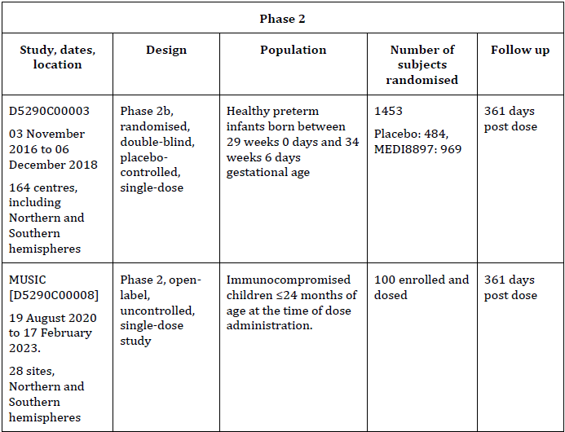
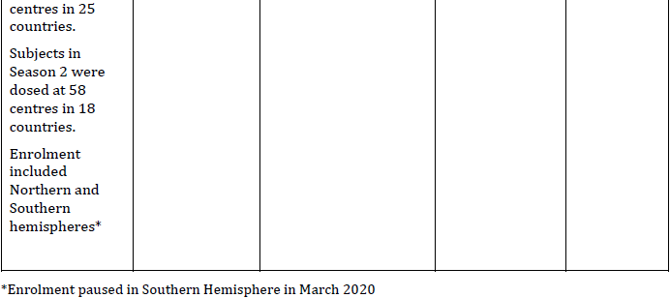
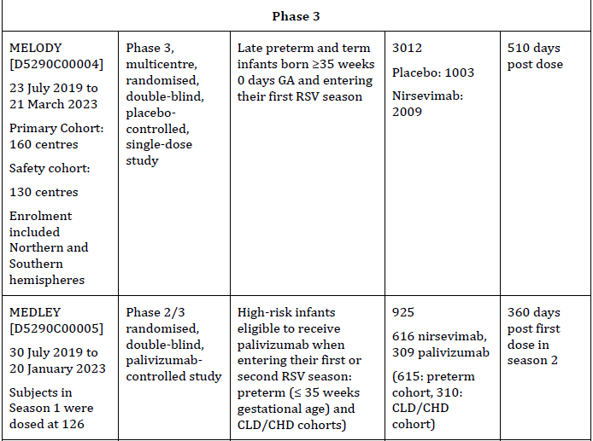
Study D5290C00003 (Study 3)
Study D5290C00003 (Study 3) was a Phase 2b, randomised, double-blind, placebo-controlled, single-dose study to determine if nirsevimab would be efficacious in reducing medically attended RSV-confirmed LRTI in healthy preterm infants entering their first RSV season. The population to be enrolled was healthy preterm infants born between 29 weeks 0 days and 34 weeks 6 days GA who would not receive RSV prophylaxis based on the American Academy of Pediatrics or other local or national guidelines.

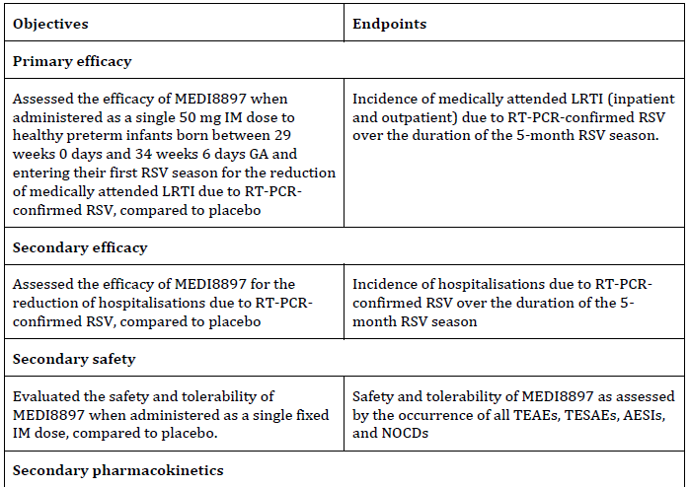
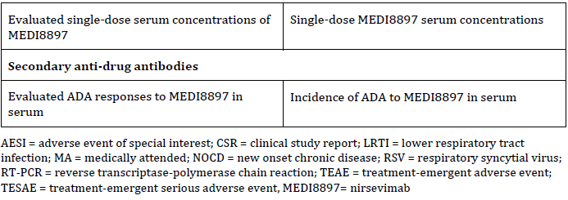
Table 4 Study D5290C00003 (Study 3) Objectives and Endpoints

Study design
Subjects were randomised 2:1 to receive a 50 mg IM (anterolateral thigh) nirsevimab dose (N = 1,000) or N-saline placebo (N = 500). Randomisation was stratified by hemisphere and subject age at randomisation (i.e. ≤3 months, >3 to ≤6 months, and >6 months). Enrolment of infants > 6 months of age was limited to ≈500. All infants followed for approximately 360 days after dosing.

Statistical methods and sample size
The sample size of 1,500 subjects was necessary based on advice from the U.S Food and Drug Administration (FDA) requesting that 1,000 preterm infants be exposed to nirsevimab in this Phase 2b study. This sample size had approximately > 99% power to detect 70% relative risk reduction (RRR), assuming a placebo group medically attended RSV LRTI incidence of 8%. Power calculations were based on a Poisson regression model with robust variance6 comparing nirsevimab 50 mg versus placebo, with 2-sided, α = 0.05.

Participant flow
1540 subjects were screened, of whom 1453 subjects were randomly assigned to placebo (n = 484) or nirsevimab (n = 969). Of the 1,453 randomised subjects, 481 in the placebo group and 966 in the NIRSEVIMAB group were dosed. The majority of subjects completed the Day 151 efficacy follow-up (472 subjects [97.5%], placebo; 945 subjects [97.5%], nirsevimab. A total of 454 subjects (93.8%) randomised to placebo and 913 subjects (94.2%) randomised to nirsevimab completed the study.

Efficacy results

Table 5 Incidence of Medically Attended RSV-confirmed LRTI Through 150 Days Post Dose (intention to treat [ITT] Population)

Single dose of 50 mg IM nirsevimab resulted in a RRR in the incidence of medically attended RSV-confirmed LRTI through 150 days post dose of 70.1% (95% CI: 52.3%, 81.2%) when compared to placebo (p <0.0001). Similar results were seen based on the same primary analysis model in the PP population and the supporting analysis models (Poisson regression with robust variance with adjustment of follow-up time and stratified Cochran–Mantel–Haenszel test (CMH) test) in the ITT population.

Subgroup analyses of the primary efficacy endpoint (incidence of medically attended RSV confirmed LRTI through 150 days post dose) showed consistent results for hemisphere, age at randomisation, weight at birth, weight at Day 1, GA, and siblings enrolled in the study. No statistically significant interactions were observed between each subgroup and treatment and RRRs through 150 days post dose, favouring nirsevimab vs. placebo across all subgroups. While efficacy was demonstrated for infants >5 kg, it was less than that seen for the smaller-weight infants. Additional PK exposure-efficacy analyses showed that a dose of 100 mg would give similar exposures for infants ≥5 kg with a predicted improvement in efficacy.

The incidence rates of the RSV-confirmed LRTI hospitalisation were lower in the nirsevimab group than the placebo group for all age at onset categories.

Pharmacokinetics
The serum concentrations decayed monoexponentially beyond the Day 91 sampling timepoint without any sign of PK nonlinearity. On Day 151, 97.8% (851/833) of nirsevimab serum concentrations were above the targeted 90% effective concentrations threshold of 6.8 μg/mL. Additionally, due to the overlapping exposures, there was no difference in serum concentrations profiles of individuals who were ADA-positive or negative at any time during the entire follow-up period.

Immunogenicity
Of those with samples available, ADA was detected post baseline in 3.8% (18/469) of subjects (placebo group) and 5.6% (52/929) (nirsevimab group).

Safety
In the as-treated population, adverse event (AE) rates for the nirsevimab group were generally comparable or lower than placebo group across the event categories. Overall, 86.8% of subjects in the placebo group and 86.2% of subjects in the nirsevimab group had ≥1 AE.
Five deaths (3 placebo group; 2 in nirsevimab group) were reported during the study through Day 361. One additional subject in the placebo group died on Day 367. None of these deaths were considered related to nirsevimab by the investigator.
There was no notable difference between the placebo and nirsevimab groups when adverse events were analysed by either post-baseline positive or post-baseline negative ADA status.

Conclusions
Study 3, conducted across both hemispheres, demonstrated a RRR of the incidence in medically attended (MA) RSV LRTI in this preterm infant population in RSV Season 1 given a single IM dose of 50mg of 70.1% (95% CI: 52.3%, 81.2%) (p <0.0001) through 150 days post dose. However, as demonstrated in the prespecified subgroup analysis of the primary endpoint by weight at dosing there was a significantly lower efficacy in the infants weighing >5 kg, with RRR of incident MA RSV LRTI through 150 days post dose of 58.5% for infants >5 kg vs. >80% for infants ≤5 kg.
For Studies 4, 5 and 8, a 100 mg dose was proposed to achieve the target exposure in infants weighing ≥5 kg in Season 1, and a 200 mg dose proposed in Season 2, based on the expected body weight range in older infants experiencing their second RSV season.

Study D5290C00004 (MELODY)
Study D5290C00004 (MELODY) was a Phase 3, multicentre, randomised, double-blind, placebo-controlled, single-dose study to determine if nirsevimab will prevent medically attended respiratory syncytial virus-confirmed lower respiratory tract infection (MA RSV LRTI) in late preterm and term infants born ≥ 35 weeks 0 days GA and entering their first RSV season.

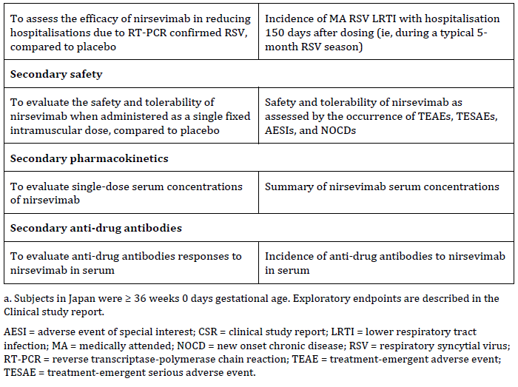
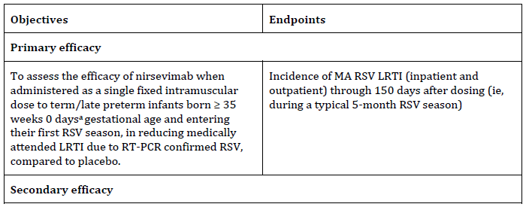
Table 6 Study D5290C00004 (MELODY) Objectives and Endpoints
Study design
Subjects were randomised 2:1 to receive a single fixed IM dose of nirsevimab (50 mg for subjects weighing < 5 kg or 100 mg for subjects weighing ≥ 5 kg at the time of dosing) or placebo. Randomisation was stratified by hemisphere (NH and SH) and by subject age at the time of randomisation (≤ 3.0 months, > 3.0 to ≤ 6.0 months, and > 6.0 months). All subjects were followed for approximately 510 days after dosing.

Sample size
The study was originally designed to analyse the primary endpoint on the full enrolment of approximately 3000 infants. However, the impact of the COVID-19 pandemic on RSV circulation led to a protocol amendment, in consultation with regulatory authorities (Type B meeting, Dec 2020), to analyse the primary endpoint of MA RSV LRTI based on the first 1500 subjects enrolled (primary cohort). The statistical power for the primary efficacy endpoint was maintained (above 90%) however the statistical power for the secondary efficacy endpoint, MA RSV LRTI with hospitalisation, was reduced. As a result, the study comprises two cohorts: a Primary Cohort (1490 randomised subjects) and a complementary Safety Cohort (1522 randomised subjects).

Participant flow
Primary cohort
1626 subjects were screened, with 1490 subjects randomly assigned to nirsevimab (n = 994) or placebo (n = 496). Of the 1490 randomised subjects, 987 in the nirsevimab group and 491 in the placebo group were dosed.
All subjects
3319 subjects were screened and 3012 randomly assigned to nirsevimab (n = 2009) or placebo (n = 1003). Of the 3012 randomised subjects, 1998 in the nirsevimab group and 996 in the placebo group were dosed.
In the Final Clinical study report, D5290C00004, it is reported that the majority of subjects completed the Day 151 follow-up (1977 subjects [98.4%] nirsevimab; 985 subjects [98.2%] placebo). A total of 1873 subjects (93.2%) randomised to nirsevimab and 923 subjects (92.0%) randomised to placebo completed the study.

Efficacy results
Primary efficacy

Table 7 Incidence of Medically attended RSV LRTI through 150 Days Post Dose in MELODY
For the primary efficacy endpoint for the Primary Cohort based on the Primary Analysis in Intention-to-treat Population 1 (ITT1), a single IM dose of nirsevimab demonstrated clinical and statistically significant efficacy with a RRR in the incidence of MA RSV LRTI through 150 days post dose of 74.53% (95% CI: 49.63%, 87.12%) versus placebo (p<0.0001). Similar results were seen based on the supporting analysis model using stratified CMH test and Poisson regression with robust variance with adjustment for follow-up time.
Secondary efficacy

Table 8 Incidence of Medically attended RSV LRTI with Hospitalisation through 150 Days Post Dose in MELODY

Pooled analysis (Study D5290C00003 and Study D5290C00004 (MELODY))
In the final study report, the sponsor stated that a pre-specified pooled analysis, including ITT1 from MELODY (Primary Cohort) and the ITT population from Study 3 (MELODY [Primary Cohort]/Study 3 Pool), was conducted to assess overall efficacy on RSV hospitalisations in both preterm and term infants. The pooled analysis was pre-specified to mitigate the risk that ITT1 from MELODY (Primary Cohort) alone would be underpowered to show a statistically significant treatment difference for this secondary efficacy endpoint, due to a shift in the management of more serious RSV disease to the outpatient setting.

MA RSV LRTI with hospitalisation through 150 days post dose was analysed according to the hierarchical testing strategy. Efficacy was clinically and statistically significant in the MELODY (Primary Cohort)/Study 3 Pool (RRR versus placebo 73.46% (95% CI 50.16%, 85.87%, p<0.0001) and the MELODY (Primary Cohort)/Study 3 (Proposed Dose) Pool (RRR 77.31%, 95% CI 50.26% to 89.65%; p=0.0002).

In MELODY (Primary Cohort), the efficacy estimate did not reach statistical significance (RRR vs. placebo 62.15%; 95% CI -8.57% to 86.80%; p=0.0708; CER, Table 13). Similar results were seen based on the supporting analysis model using stratified CMH test and Poisson regression with robust variance with adjustment for follow-up time.
Pharmacokinetics (MELODY study)
Mean serum concentrations of nirsevimab, administered as a single fixed IM dose (50 mg for <5 kg weight on Day 1, 100 mg for ≥5 kg weight on Day 1), decreased monoexponentially beyond the Day 31 sampling time point without any evidence of PK nonlinearity. Mean nirsevimab concentrations were similar in infants in the ≥5 kg weight group compared with the <5 kg weight group, with substantial overlap in nirsevimab serum concentrations between the two weight groups.

Immunogenicity (MELODY study)
Anti-drug antibody was detected post-baseline in 6.5% (127/1945) of subjects in the nirsevimab group and in 1.5% (14/962) of subjects in the placebo group. There was no apparent effect of ADA on PK through to Day 151. There was no apparent impact of ADA on nirsevimab safety through Day 361. Due to a limited number of ADA-positive subjects with MA RSV LRTI, the impact of ADA on efficacy could not be evaluated. (Final clinical study report, page 240)

Safety (MELODY study)
Nirsevimab was well tolerated. Similar types and frequencies of treatment emergent adverse events were reported in both the nirsevimab and placebo groups. Overall, 83.7% of nirsevimab group subjects and 81.8% of placebo group subjects had at least one AE. The most common AEs (>10% of subjects in any treatment group) reported with nirsevimab (vs. placebo) were URTI (29.4% vs. 28.5%), nasopharyngitis (20.4% vs. 21.5%), pyrexia (12.4% vs. 10.3%), and dermatitis diaper (nappy rash) (10.5% vs. 9.2%). The majority of AEs were Grade 1 or Grade 2 in severity. The most common Grade 3 AEs reported with nirsevimab vs. placebo were bronchiolitis (0.5% vs. 0.8%), RSV bronchiolitis (0.2% vs. 0.5%), bronchitis (0.1% vs. 0.3%), pneumonia (0.3% vs. 0.1%), and gastroenteritis (0.2% vs. 0.0%). Grade 4 or 5 events occurred in ≤1% of subjects in either group. (CER p38)

In their Milestone 5 response, the sponsor stated that in MELODY (All Subjects, AT population), safety data from both the Primary and Safety Cohorts combined included all available safety data through 360 days post dose for all subjects at the time of database lock. The incidences of AEs, AEs of ≥ Grade 3 severity, serious adverse events (SAEs), SAEs of ≥ Grade 3 severity, treatment-related skin reactions, and new onset chronic diseases (NOCDs) were similar in the nirsevimab and placebo groups. There were four adverse events of special interest (AESIs) in the nirsevimab group (all treatment related skin hypersensitivity events and none were SAEs) and none in the placebo group. Four treatment-emergent deaths due to medical conditions occurred in the nirsevimab group (none in the placebo group); one additional death occurred in a subject prior to randomisation/dosing and one further death occurred due to a road traffic accident after Day 360 in a subject who received nirsevimab. Treatment-emergent SAEs occurred in 7.5% of subjects in the nirsevimab group and 8.3% in the placebo group. No deaths or SAEs were considered by the investigator to be related to nirsevimab.

Season 2
Monitoring of disease incidence from the second RSV season (Day 362 to Day 511) in MELODY did not show any increase in cases of MA RSV LRTI and no increased severity of disease for subjects administered nirsevimab compared to subjects administered placebo. The Sponsor highlighted that there was no evidence to support the theoretical risk of antibody dependent enhancement of disease with nirsevimab.

Table 9 Summary of Incidence of Medically attended (MA) RSV LRTI (Protocol Defined), RSV LRTI Hospitalisation (Protocol Defined), MA RSV LRTI (Very Severe), All MA RSV LRTI, All MA RSV (Any Test) LRTI, All MA RSV Respiratory Illness with Hospitalisation, All MA RSV (Any Test) Respiratory Illness with Hospitalisation, All medically attended (MA) LRTI (Any Cause), All MA Respiratory Illness with Hospitalisation (Any Cause) from 361 through 510 Days Post Dose (All Subjects).
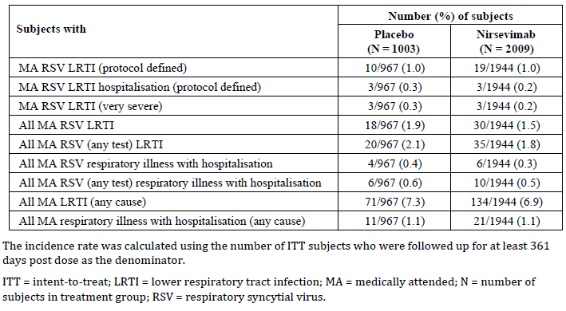
The Evaluator concluded that despite the challenges posed by the COVID-19 pandemic, and the amended sample size, the primary objective based on the Primary Cohort was met. In term and late preterm infants ≥35 weeks gestational age (MELODY [Primary Cohort]), nirsevimab demonstrated statistically significant clinical efficacy (RRR 74.5%; 95% CI 49.6%, 87.1%; p<0.0001) against the primary endpoint Medically attended RSV LRTI. Results were consistent in the exploratory analysis in MELODY (All Subjects).
Serum concentrations declined in a linear fashion after 31 days post dose in all subjects, with a substantial overlap in concentrations between weight groups. Safety analyses showed that nirsevimab was safe and well tolerated.

Study D5290C00005 (MEDLEY)
Study D5290C00005 (MEDLEY) was a pivotal Phase 2/3 randomised, double-blind, palivizumab-controlled study to evaluate the safety, PK, ADA response, and descriptive efficacy of nirsevimab in high-risk infants eligible to receive palivizumab when entering their first or second RSV season (Season 1 or Season 2, respectively).

Table 10 Study D5290C00005 (MEDLEY) Objectives and Endpoints
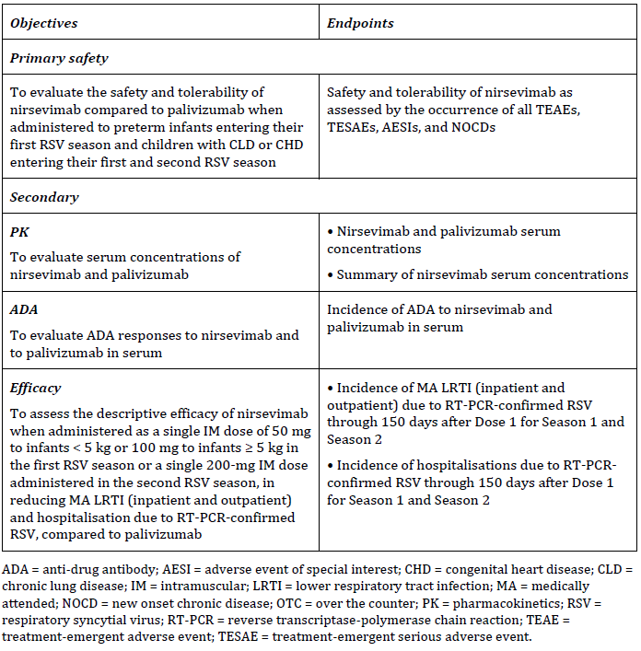

Study design
Approximately 900 palivizumab-eligible infants entering their first RSV season were planned to be enrolled into 1 of 2 cohorts: (1) preterm cohort, including approximately 600 preterm infants (≤ 35 weeks gestational age) without chronic lung disease (CLD)/congenital heart disease (CHD), or (2) CLD/CHD cohort, including approximately 300 infants with CLD of prematurity or haemodynamically significant CHD. A minimum of 100 infants with haemodynamically significant CHD were to be enrolled. Within each cohort, randomisation was stratified by hemisphere (northern, southern) and subject age at the time of Season 1 randomisation (≤ 3 months, > 3 to ≤ 6 months, > 6 months). In Japan, the CLD/CHD cohort included subjects with Down syndrome alone who are palivizumab-eligible in this country.

Statistical methods and sample size
There were three planned analyses for this study: primary analysis, Season 2, and the final analysis:
The primary analysis was conducted after all randomised subjects had completed follow-up through the first 5 month RSV season (i.e. Season 1 Day 151 visit) and included all available Season 1 safety, efficacy, PK, and ADA data at the time of data cut-off.

The Season 2 analysis was conducted after all CLD/CHD subjects had completed follow-up through the second 5 month RSV season (i.e. Season 2 Day 151 visit) and included all available Season 1 data and Season 2 safety, efficacy, PK, and ADA data at the time of data cut-off.
The final analysis presented safety, efficacy, PK, and ADA data at the time of the database lock (22 February 2023) and was triggered after all subjects from the CLD/CHD cohort completed follow-up through 360 days post first dose in Season 2 and also included all available Season 1 data (through 360 days post first dose in Season 1).

The global clinical study protocol was amended to update the sample size for target enrolment from that originally planned, due to the challenges of enrolment during the COVID-19 pandemic. The study was paused in the Southern Hemisphere in March 2020 and the clinical study protocol was amended in consultation with Health Authorities to reduce the sample size from the originally planned target of 1500 to 900. The study resumed in the Northern Hemisphere in October 2020 and enrolment subsequently concluded.

Season 1
In Season 1, all subjects were randomised 2:1 to either nirsevimab (approximately 600 subjects, including approximately 400 subjects in the preterm cohort and approximately 200 subjects in the CLD/CHD cohort) or palivizumab (approximately 300 subjects, including approximately 200 subjects in the preterm cohort and approximately 100 subjects in the CLD/CHD cohort). Subjects in the nirsevimab group received a single fixed IM dose of nirsevimab followed by 4 once-monthly IM doses of placebo. The nirsevimab dose level was stratified by weight band, i.e., 50 mg for infants weighing < 5 kg or 100 mg for infants weighing ≥ 5 kg. Subjects in the palivizumab group received 5 once-monthly IM doses of 15 mg/kg palivizumab.

Season 2
The Season 2 study population comprised approximately 300 subjects from the CLD/CHD cohort who had already participated in Season 1. Subjects from the CLD/CHD cohort who were randomised to nirsevimab in Season 1 received a second dose of nirsevimab in Season 2 (approximately 200 subjects) (referred to as the NIRS/NIRS group). Subjects from the CLD/CHD cohort who were randomised to palivizumab in Season 1 were re-randomised 1:1 to nirsevimab or palivizumab (approximately 50 subjects in each group) (referred to as the PALI/NIRS and PALI/PALI groups, respectively). Subjects in the Season 2 nirsevimab groups received a single fixed IM dose of 200 mg nirsevimab (as 2 injections of 1 ml at separate sites) followed by 4 once-monthly IM doses of placebo. Subjects in the palivizumab group received 5 once-monthly IM doses of 15 mg/kg palivizumab.

Participant flow
Season 1
A total of 925 high-risk subjects were randomised overall (616 to nirsevimab, 309 to palivizumab), including 615 subjects in the preterm cohort (612/615 were dosed) and 310 subjects in the CLD/CHD cohort (306/310 dosed).

Season 2
In Season 2, a total of 262 subjects from the Season 1 CLD/CHD cohort proceeded into the Season 2 phase of the study. Those subjects from the CLD/CHD cohort who had received nirsevimab in Season 1 received a second dose of nirsevimab in Season 2 (n = 180; the NIRS/NIRS group). Those subjects from the CLD/CHD cohort who received palivizumab in Season 1 were randomised 1:1 to a second course of palivizumab (n = 42; the PALI/PALI group) or to nirsevimab (n = 40; the PALI/NIRS group) in Season 2.

Safety
Primary analysis
Through to 360 days post first dose in Season 1, nirsevimab had a similar AE profile compared palivizumab, in the overall population and preterm and CLD/CHD cohorts, including infants with CLD, CHD, and those born <29 weeks GA. Types and frequencies of AEs were generally balanced between the nirsevimab and palivizumab groups, with a low incidence of IP-related events (including IP-related skin reactions), investigator assessed AESIs, and NOCDs.

Table 11 Overall Summary of treatment emergent adverse events for Overall Population, Preterm and CLD/CHD Cohorts through 360 Days Post in MEDLEY First Dose in Season 1 – As-treated Population (Season 1)

Season 2
The adverse event profile was similar across the treatment groups (NIRS/NIRS, PALI/NIRS, and PALI/PALI), with the types and frequencies of AEs being generally balanced.
The numbers of subjects in the as-treated population in the PALI/NIRS (n=40) and PALI/PALI (n=42) groups was lower than in the NIRS/NIRS group (n=180). The incidence of AESIs was low and balanced between treatment groups in the CLD/CHD Cohort in Season 2. The incidence of ≥Grade 3 events and SAEs was numerically higher in the NIRS/NIRS and PALI/NIRS groups than the PALI/PALI group; however, this was not observed within all analysed time points through 30 days post first dose.

In the final study report, it is stated that adverse events of special interest based on investigator assessment and NOCDs were reported in one subject each in the NIRS/NIRS group. There were no IP-related AEs, IP-related NOCDs, or investigator-assessed skin hypersensitivity in any treatment group. No deaths occurred in Season 2.

Summary of Season 2 Safety Results (Through 360 Days Post First Dose in Season 2),
Through 360 days post first dose in Season 2, the AE profile was similar across the treatment groups (NIRS/NIRS, PALI/NIRS, and PALI/PALI), with the types and frequencies of AEs being generally balanced. The number of subjects in the As-treated Population in the PALI/NIRS (n = 40) and PALI/PALI (n = 42) groups was lower than in the NIRS/NIRS group (n =180).
In the CLD and CHD subpopulations, the only notable difference between the treatment groups was that in the CHD subpopulation, AESIs based on selected MedDRA PTs occurred at a numerically higher rate in the NIRS/NIRS (26.8% [15/56 subjects]) and PALI/NIRS (21.4% [3/14 subjects]) treatment groups compared with PALI/PALI (9.1% [1/11 subjects]). However, this imbalance was not observed within all analysed time points through 30 days post first dose in Season 2.

Efficacy results

Primary analysis
Incidence of MA RSV LRTI through 150 days post first dose in Season 1 was low and balanced: 0.6% (4/616 subjects) nirsevimab group vs. 1.0% (3/309 subjects) palivizumab group. Overall disease incidence in each of the nirsevimab and palivizumab groups was distributed between the preterm cohort (0.5% [2/407 subjects] vs. 0.5% [1/208 subjects]) and CLD/CHD cohort (1.0% [2/209 subjects] vs 2.0% [2/101 subjects]). The incidence of MA RSV LRTI with hospitalisation through 150 days post first dose in Season 1 was 0.3% (2/616) nirsevimab group vs. 0.6% (2/309) palivizumab group. All of these events occurred in the CLD/CHD cohort (1.0% nirsevimab [2/209], 2.0% palivizumab [2/101]).

Season 2 analysis
In the overall population, there was no MA RSV LRTI or MA RSV LRTI with hospitalisation through 150 days post first dose in Season 2 in any treatment group. Season 2 MA LRTI (any cause) was low in all three treatment groups.

Final analysis
There were no instances of MA RSV LRTI through 150 days post first dose in Season 2 in any treatment group.
There were no instances of MA RSV LRTI with hospitalisation through 150 days post first dose in Season 2 in any treatment group. There was one subject with MA RSV LRTI with hospitalisation (subtype RSV B; 1/ 40 [2.5%] in the PALI/PALI group occurring from 151 through 361 days post first dose in Season 2.

Table 12 Incidence of Medically attended RSV LRTI by RSV Subtype and Reporting Period in Season 2 – ITT Population (Table 30, Final CSR)
Pharmacokinetics
In both Season 1 and 2, nirsevimab concentrations declined linearly over time. In Season 1, there was substantial overlap in serum concentrations between weight groups (<5 kg, ≥5 kg), with comparable serum concentrations in preterm and CLD/CHD subjects. In CLD/CHD subjects, serum concentrations were slightly higher in Season 2, with substantial overlap in the serum concentrations observed for the weight-band dose in Season 1 and the fixed dose in Season 2.

Immunogenicity
‘Safety was assessed in Season 2 and Season 1 + Season 2 combined in the NIRS/NIRS group by post-baseline ADA status. Anti-drug antibodies in either Season 1 or Season 2 in this group did not appear to impact safety through 360 days post first dose in Season 2. Additionally, no hypersensitivity or other AESI was reported in Season 2 for this group or any treatment group.
Amongst the 40 subjects who received palivizumab in their first RSV season followed by nirsevimab in their second RSV season and had samples available for analysis, post-baseline ADA against nirsevimab was observed in a single subject (2.5%); this subject completed the study and had no IP-related AEs, AESIs, or skin hypersensitivity reactions through 360 days post nirsevimab dose.

There was no apparent impact of ADA on PK through 150 days post dose. Due to a limited number of ADA-positive subjects with MA RSV LRTI in both seasons, the impact of ADA efficacy could not be evaluated.

Evaluator conclusions
The MEDLEY study using weight-based dosing of single dose 50mg or 100mg demonstrated that nirsevimab had comparable safety and tolerability profile to palivizumab, in the overall population of preterm infants, and those with CLD and/or CHD in Season 1, and with comparable safety findings for subjects with CLD/CHD who received nirsevimab (single IM dose of 200mg) in Season 2.

The evaluator highlighted that there was no evidence of immune priming in subjects who had received prior nirsevimab, and no evidence that the second dose of nirsevimab boosted ADA responses in those few subjects who were ADA positive to nirsevimab in Season 1. In both seasons, based on limited data, there was no apparent impact of ADA against nirsevimab on PK and efficacy.

The evaluator concluded that the lack of either MA RSV LRTI or MA RSV LRTI with hospitalisation through 150 days post the Season 2 Day 1 dose may reflect the impact of public health measures against COVID-19 impacting on lower rates of circulating RSV.

Study D5290C00008 (MUSIC)
Study D5290C00008 was a Phase II, open label, uncontrolled, single dose study to assess the safety and tolerability, PK, occurrence of ADA, and descriptive efficacy of nirsevimab in immunocompromised children who were ≤ 24 months of age at the time of dose administration.

Table 13 Study D5290C00008 (MUSIC) Objectives and Endpoints
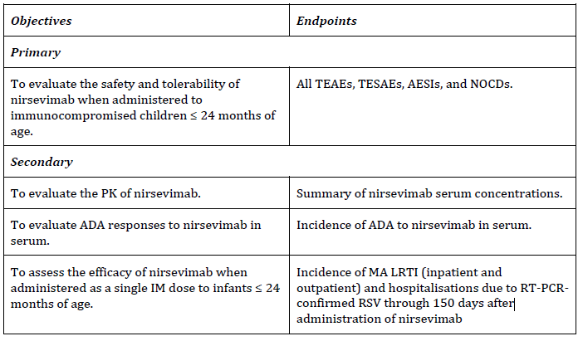
Study design
Inclusion criteria
1. Neonate, infant, or young child ≤24 months of age who, per Investigator judgment, are:
- In their first year of life AND entering their first RSV season at the time of dose administration OR
- In their second year of life AND entering their second RSV season at the time of dose administration

2. The subject must meet at least 1 of the following conditions at the time of informed consent:
- Diagnosed with combined immunodeficiency (severe combined immunodeficiency, cross-linked hyper IgM syndrome, etc.); antibody deficiency (crosslinked agammaglobulinemia, common variable immunodeficiency, non-crosslinked hyper IgM syndromes, etc.); or other immunodeficiency (Wiskott-Aldrich syndrome, DiGeorge syndrome, etc.).
- Diagnosed with HIV infection.
- History of organ or bone marrow transplantation.
- Subject was receiving immunosuppressive chemotherapy.
- Subject was receiving systemic high-dose corticosteroid therapy (prednisolone equivalents ≥ 0.5 mg/kg every other day, other than inhaler or topical use).
- Subject was receiving other immunosuppressive therapy (eg, azathioprine, methotrexate, mizoribine, mycophenolate mofetil, cyclophosphamide, cyclosporine, tacrolimus, cytokine inhibitors, etc.).

Statistical methods and sample size
Sample size was expanded to 100 planned to receive a single IM dose of nirsevimab to evaluate the safety, PK, ADA, and efficacy, and assessed descriptively. To evaluate risk, a sample size of 100 subjects exposed to nirsevimab in this Phase II study would provide a 95% probability of observing at least 1 AE if the true event rate is 3%; if no AEs were observed, this study provides 95% confidence that the true event rate is ≤3%. There were three planned analyses for this study: two interim analyses and a final analysis.

Participant flow
100 subjects were enrolled and dosed. Forty-eight (48.0%) subjects were enrolled and received 50 mg or 100 mg nirsevimab, and 52 (52.0%) subjects were enrolled and received 200 mg nirsevimab. Eighty-six (86.0%) subjects were enrolled at sites in the northern hemisphere, and 14 (14.0%) subjects were enrolled at sites in the southern hemisphere. At the time of dosing, 46 (46.0%) subjects were < 12 months of age and 54 (54.0%) subjects were ≥ 12 months of age.

Subjects could have had more than one immunocompromising condition. Approximately one third of the subjects (33 [33.0%] subjects) met inclusion criterion 2a (diagnosed with primary immunodeficiency); 29 (29%) subjects met inclusion criterion 2e (receiving systemic high-dose corticosteroid therapy), 20 (20.0%) subjects met inclusion criterion 2d (receiving immunosuppressive chemotherapy), 16 (16.0%) subjects met inclusion criterion 2c (history of organ or bone marrow transplantation), 15 (15.0%) subjects met inclusion criterion 2f (receiving other immunosuppressive therapy), and 8 (8.0%) subjects met inclusion criterion 2b (diagnosed with HIV).

Safety
In total, 81 (81.0%) subjects experienced at least 1 TEAE; the most commonly reported TEAEs were in the SOCs of Infections and infestations (73 [73.0%] subjects), Skin and subcutaneous tissue disorders (42 [42.0%] subjects), and gastrointestinal disorders (33 [33.0%] subjects).
Overall, the incidence of Grade 1 (22 [22.0%] subjects), Grade 2 (24 [24.0%] subjects), and Grade 3 (28 [28.0%] subjects) TEAEs was similar among the subjects. The incidence of Grade 4 and Grade 5 TEAEs was low (4 [4.0%] subjects and 3 [3.0%] subjects, respectively). Three (3.0%) subjects experienced a TEAE with the outcome of death (LRTI, septic shock, and tumour haemorrhage); these events were not considered related to nirsevimab. No subjects experienced a NOCD.

Five (5.0%) subjects experienced AESIs based on Investigator assessment; all of which were assessed as skin hypersensitivity reactions. None of the AESIs based on Investigator assessment occurred within 1 day of IP administration.

Efficacy results
In the final CSR, it is reported that none of the MA RSV LRTI met the criteria of a protocol-defined MA RSV LRTI during the study; there were no RSV positive events by either local or central testing reported through 150 days post dose.

Through 150 to 361 days post dose, there was a low incidence of other (non-protocol-defined) MA RSV LRTI.

Pharmacokinetics
Mean nirsevimab serum concentrations were higher in those subjects who received 200 mg nirsevimab than in those who received 50 mg or 100 mg nirsevimab, but with substantial overlap between the two groups. Fourteen (14.0%) subjects experienced a more rapid decline in serum nirsevimab concentration over time. The majority of these subjects had evidence of protein-losing conditions.

Immunogenicity
Of the 97 subjects with available samples for ADA assessment through to Day 361 post dose, 11/97 (11.3%) subjects developed treatment-emergent ADAs during the study. All 11 (11.3%) subjects were positive for ADA against the YTE substitution, and 1 (1.0%) subject was positive for neutralising ADAs.

The evaluator noted that there were no protocol-defined MA RSV LRTIs reported, which may be a reflection of the impact on public measures to curtail COVID-19 reducing RSV transmission. Efficacy results were descriptive only and it is noted that the Sponsor is seeking approval in children with certain conditions e.g., neuromuscular disease and congenital airway anomalies which were not included in this study.

Safety
The nirsevimab clinical development programme included a Phase I study in adults and a Phase Ib/IIa study in preterm infants, 3 pivotal studies in infants and children, and an open-label study in immunocompromised infants and children.

Safety data were available from 3680 subjects dosed with nirsevimab (3284 subjects receiving the proposed dose).

Integrated safety analyses (MELODY) (All Subjects)/Study 3 (Proposed Dose) Safety Pool
Safety data from MELODY and Study 3 were pooled, as these studies were placebo-controlled, randomised, double-blind, studies that used the same safety endpoints and included healthy infant populations. The inclusion/exclusion criteria of these two studies are also similar, except for gestational age. Subjects randomised to nirsevimab received a dose of 50 mg IM for subjects with weight <5 kg at dosing or 100 mg for subjects with weight ≥5 kg at time of dosing in MELODY. In Study 3, all subjects randomised to nirsevimab received a dose of 50 mg IM.

MELODY (All subjects)/Study 3 (Proposed Dose) Safety Pool (3854 subjects dosed with nirsevimab [N=2570] or placebo [N=1284])
A subpopulation of the pooled analysis included pooled data of all dosed subjects from MELODY Primary and Safety Cohorts and dosed subjects weighing <5 kg at the time of dosing from Study 3. This was considered the most relevant summaries of safety data to evaluate the adverse event profile.

In the safety pool of infants born at term and preterm (≥29 weeks GA), the percentage of subjects with AEs in the nirsevimab group was generally comparable to those in the placebo group across the event categories. Overall, 84.0% of nirsevimab group and 82.6% of placebo group had at least one AE.

The evaluator concluded that across the five studies (Studies 2 and 3, MELODY, MEDLEY and MUSIC) conducted in the target population, nirsevimab at the single doses administered (50mg or 100mg) IM appeared to be safe.
In the few infants entering their second RSV season in MEDLEY and MUSIC, the 200mg IM dose appeared safe. There were no safety concerns in the very and moderately pre-term infants (Study 2), preterm infants (<35wGA), infants with chronic heart or lung problems (MEDLEY) and immunocompromised infants (MUSIC).

ADA positivity to nirsevimab was generally low, and when it did occur was not associated with altered nirsevimab PK, or any safety signal.

In the small number of subjects who received a second dose on 200mg IM in Season 2, there was no evidence of priming if they had received nirsevimab in RSV Season 1 or boosting of an anamnestic response based on their Season 1 and Season 2 immunogenicity data.
The recently published FDA Integrated Review also highlighted that the available safety data from the clinical trials demonstrate that nirsevimab is safe for its intended use. ‘Severe or serious hypersensitivity reactions, such as anaphylaxis, and serious skin reactions were not reported in the nirsevimab clinical trials. Although a numerical imbalance in the incidence of death is noted in the nirsevimab clinical trials (12 deaths among subjects who received nirsevimab vs. 4 deaths in subjects who received the control), the overall incidence of deaths was similar between the two arms. No organ-specific toxicity was identified that could have contributed to or resulted in deaths. None of the deaths were considered related to Nirsevimab by the investigator.

Risk management plan
The summary of safety concerns and their associated risk monitoring and mitigation strategies are presented in Table 14. The TGA may request an updated RMP at any stage of a product's life-cycle, during both the pre-approval and post-approval phases.
Table 14 Summary of safety concerns
Summary of safety concerns |  | Pharmacovigilance |  | Risk minimisation
 |  | Routine | Additional | Routine | Additional
Important identified risks | None | - | - | - | -
Important potential risks | None | - | - | - | -
Missing information | Long term safety | P | P | - | -

The RMP evaluation recommended conditions of registration relating to the versions of the risk management plan, requirement for periodic safety update reports (PSUR), and inclusion of the medicine in the Black Triangle Scheme.
The suggested wording for conditions of registration is:

The BEYFORTUS EU-Risk Management Plan (RMP) (version 2 succession 1, dated 23 March 2023, data lock point 9 November 2022), with Australian Specific Annex (version 1 succession 1, dated 28 September 2022), included with submission PM-2022-04428-1-2, and any subsequent revisions, as agreed with the TGA will be implemented in Australia.

As BEYFORTUS is a new biological entity it should be included in the Black Triangle Scheme as a condition of registration. The following wording is recommended for the condition of registration:

BEYFORTUS (nirsevimab) is to be included in the Black Triangle Scheme. The PI and CMI for BEYFORTUS must include the black triangle symbol and mandatory accompanying text for five years, which starts from the date that the sponsor notifies the TGA of supply of the product.
The TGA may request an updated RMP at any stage of a product's life-cycle, during both the pre-approval and post-approval phases. Further information regarding the TGA’s risk management approach can be found in risk management plans for medicines and biologicals and the TGA's risk management approach. Information on the Australia-specific annex (ASA) can be found on the TGA website.

Risk-benefit analysis

Delegate’s considerations
The sponsor has submitted a comprehensive dossier to support registration of nirsevimab in Australia. Discussion of the wording of the indication is warranted, specifically the high-risk groups to be included, acknowledging the small number of infants in the MEDLEY and MUSIC studies and the extrapolation of efficacy to high-risk subgroups.

The impact of public measures to curtail COVID-19 reducing RSV transmission has been raised by the Clinical evaluator as potentially impacting the low rates of medically attended RSV in several of the clinical studies, with the COVID-19 pandemic significantly altering the epidemiology of RSV. Atypical RSV seasons have occurred in Australia with the COVID-19 pandemic and related lockdowns11 and highlighted by the clinical evaluator as a potential concern for efficacy of a single dose of nirsevimab in the event of a prolonged RSV season. This has been addressed satisfactorily by the sponsor but remains a concern for which ongoing epidemiological surveillance is needed.

The potential for resistance to nirsevimab and that variants with reduced susceptibility to nirsevimab will emerge and become prevalent in the future is an area of uncertainty. The sponsor has outlined sponsored RSV Molecular Surveillance Studies they are undertaking, including OUTSMART-RSV, INFORM-RSV (with one site in Australia), and SEARCH-RSV surveillance programs in their response to questions from TGA evaluators.

The FDA Integrated review has highlighted that with the development of maternal RSV vaccines for passive immunisation of infants, it is not known whether use of nirsevimab in such infants who have received passive immunisation by maternal RSV vaccination will provide added benefit. The FDA also noted that shifting of severe RSV disease to children’s second RSV season is a potential risk, with long term data needed to fully assess this.

It is not yet known which groups will meet eligibility criteria for funding for nirsevimab, which will ultimately guide implementation of a program for prevention of RSV in neonates, infants and children in Australia.

Advisory Committee considerations
The Advisory Committee on Medicines (ACM) having considered the evaluations and the Delegate’s overview, as well as the sponsor’s response to these documents, advised the following.

Specific advice to the Delegate

- Please comment on the findings of the MEDLEY study, in light of the proposed indication and dosing for children entering their second season of RSV and the low number of subjects in this study.
The ACM highlighted the need to protect children up to 24 months who remain vulnerable to severe RSV disease. While the ACM noted the low number of children receiving a second dose of nirsevimab in season 2 within the MEDLEY study, the ACM was of the view that this should not impact on the proposed indication.
The ACM noted that the MEDLEY study demonstrated comparable safety in season 2 and that there were no instances of medically attended RSV LRTI through to 150 days post first dose in season 2 in any treatment group. The ACM did however note that the outcomes were potentially impacted by the COVID-19 public health measures.
In providing this advice, the ACM highlighted the need for robust post market studies of safety and effectiveness post registration and effective long term RSV disease surveillance.
The ACM noted that the time of administration of the season 2 dose was able to be controlled in the MEDLEY study and agreed that in clinical practice administration may be dependent on the timing of the RSV season and/or the interpretation of what is an ‘RSV season’. Considering this, the ACM was supportive of the dosing recommendations not including a minimum interval between doses.

- Related to point 1, does the ACM agree with extrapolation of efficacy to each of the high-risk groups included in the proposed indication, based on the inclusion criteria and results of the MEDLEY and MUSIC studies? What is the view of the ACM regarding the alternative wording of the indication proposed by the Delegate?
The ACM supported the extrapolation of efficacy to each of the high-risk groups included in the proposed indication. The ACM advised that there is a favourable risk benefit profile for high-risk groups in both RSV season 1 and season 2.
The ACM noted that the population pharmacokinetic model adequately predicted nirsevimab concentrations in children, suggesting comparable exposures in high-risk groups. Further noting that these assumptions are biologically plausible (same virus, same mechanism of action, similar expected exposure response relationship and safety).
The ACM commented on the higher concentrations in season 2 and noted that this may reflect the different population, sparse sampling and differences in absorption from the injection site that are not appreciated in the model.
The ACM discussed the proposed indications and advised that simpler wording as proposed below could be appropriate assuming that ‘high risk / at risk children’ is clearly defined within clinical guidance.
Proposed indication:
BEYFORTUS is indicated for the prevention of Respiratory Syncytial Virus (RSV) lower respiratory tract disease in:
- Neonates and infants born during or entering their first RSV season.
- Children up to 24 months of age who remain vulnerable to severe RSV disease through their second RSV season.
BEYFORTUS should be used in accordance with official recommendations.
The ACM strongly supported the inclusion of the statement “used in accordance with official recommendations” and noted it would be important to have information available in the Australian context, e.g., in the Australian Immunisation Handbook and/or other guideline.
- Does the ACM have concerns with using BEYFORTUS routinely in all infants during their first RSV season?
The ACM stated that the safety and efficacy profile appears appropriate and does not have concerns with using BEYFORTUS routinely in all infants during their first RSV season.
The ACM indicated that the available data does not suggest ‘rebound’ of higher incidence or more severe disease later in infancy or in the second year of life and there is potential for broad impact on RSV disease within Australia. The ACM also advised that use in all infants is a suitable indication, as it can be challenging to identify infants at risk of RSV hospitalisation noting that many who require hospitalisation due to RSV do not have risk factors.
The ACM also noted emerging evidence that suggests that while nirsevimab protects from RSV disease new evidence suggests RSV infection still occurs, inducing immune response which can lay an important foundation for future immune boosting with infection in subsequent seasons.
- Related to point 3, in what settings does the ACM anticipate that BEYFORTUS will be administered to infants? Will this occur in hospital clinics, local immunisation clinics and general practices?
The ACM noted that it would be reasonable and most practical to administer BEYFORTUS at birth (for example, with the hepatitis B vaccine), or at routine immunisation visits at 2, 4 or 6 months. The ACM did not highlight any concerns with concomitant administration of BEYFORTUS with other vaccines, other than the need for an additional intramuscular injection.
The ACM noted that while it is likely suitable to administer BEYFORTUS at routine immunisation appointments, this practice has the potential to increase burden on GPs and vaccination clinics and this will need to be appropriately considered.
The ACM highlighted that the timing of the RSV seasons will also need to be considered to ensure timely administration. It is likely that systems and guidelines will need to be established to manage this appropriately.
The ACM reiterated the need for clear and up to date clinical guidelines that define high risk children and give consideration to administration timelines.
- The ACM is also requested to provide advice on any other issues that it thinks may be relevant.
The ACM suggested some updates to the Product Information, as proposed below:
Within the Dose and Method of Administration – Dosing recommendations section (page 2 of the annotated version dated 20Sep23) the ACM noted that it would be appropriate to more explicitly state that the two IM injections can be administered on the same day. The ACM proposed:
For children up to 24 months of chronological age who remain at increased risk for severe RSV disease in their second RSV season, the recommended dosage of BEYFORTUS is a single 200 mg dose administered as two IM injections (2 x 100 mg) at the same visit.
Within the same section (page 3 of the annotated version) the ACM proposed an update to the limited data statement as below:
Limited data or no data are available in infants with a range of underlying conditions, e.g. Down syndrome (n=13), Cystic fibrosis (n=5), Congenital airway anomalies (n=9), and Neuromuscular disease (n=0; not evaluated in clinical trials).
Within the Pharmacology Properties section (page 8 of the annotated version) the ACM indicates that the term ‘Virus resistance’ could be used instead of ‘Antiviral resistance’.
In the Consumer Medicines Information, the order of health professionals in Section 4 needs to match the order in Sections 3 and 6.

Conclusion
The ACM considered this product to have an overall positive benefit-risk profile for the indication:
BEYFORTUS is indicated for the prevention of Respiratory Syncytial Virus (RSV) lower respiratory tract disease in:
- Neonates and infants born during or entering their first RSV season.
- Children up to 24 months of age who remain vulnerable to severe RSV disease through their second RSV season.
BEYFORTUS should be used in accordance with official recommendations.

Outcome
Based on a review of quality, safety, and efficacy, the TGA decided to register BEYFORTUS (nirsevimab), 50 mg in 0.5 mL and 100 mg in 1 mL, solution for injection, syringe, indicated for:

BEYFORTUS is indicated for the prevention of Respiratory Syncytial Virus (RSV) lower respiratory tract disease in:
-Neonates and infants born during or entering their first RSV season.
-Children up to 24 months of age who remain vulnerable to severe RSV disease hrough their second RSV season.

Specific conditions of registration applying to these goods
BEYFORTUS (nirsevimab) is to be included in the Black Triangle Scheme. The PI and CMI for BEYFORTUS must include the black triangle symbol and mandatory accompanying text for five years, which starts from the date that the sponsor notifies the TGA of supply of the product.
The BEYFORTUS EU-RMP (version 2 succession 1, dated 23 March 2023, data lock point 9 November 2022), with Australian Specific Annex (version 1 succession 2, dated 13 July 2023), included with submission PM-2022-04428-1-2, and any subsequent revisions, as agreed with the TGA will be implemented in Australia. An obligatory component of risk management plans is routine pharmacovigilance. Routine pharmacovigilance includes the submission of periodic safety update reports (PSURs).
Reports are to be provided in line with the current published list of EU reference dates and frequency of submission of PSURs until the period covered by such reports is not less than three years from the date of this approval letter.
The reports are to at least meet the requirements for PSURs as described in the European Medicines Agency’s Guideline on good pharmacovigilance practices (GVP) Module VII-periodic safety update report (Rev 1), Part VII.B Structures and processes. Note that submission of a PSUR does not constitute an application to vary the registration. Each report must have been prepared within ninety calendar days of the data lock point for that report.
All batches of BEYFORTUS supplied in Australia must comply with the product details and specifications approved during evaluation and detailed in the Certified Product Details (CPD). When requested by the TGA, the Sponsor should be prepared to provide product samples, specified reference materials and documentary evidence to enable the TGA to conduct laboratory testing on the Product. Outcomes of laboratory testing are published biannually in the TGA Database of Laboratory Testing Resultshttps://www.tga.gov.au/resources/lab-test-reports and periodically in testing reports on the TGA website.
The CPD, as described in Guidance 7: Certified Product Details of the Australian Regulatory Guidelines for Prescription Medicines (ARGPM), in PDF format, for the above products should be provided upon registration of these therapeutic goods. In addition, an updated CPD should be provided when changes to finished product specifications and test methods are approved in a Category 3 application or notified through a self-assessable change.

Attachment 1. Product Information
The Product Information (PI) approved with the submission for [Tradename] which is described in this AusPAR can be found as Attachment 1. It may have been superseded. For the most recent PI and Consumer Medicines Information (CMI), please refer to the TGA PI/CMI search facility.

Therapeutic Goods Administration
PO Box 100 Woden ACT 2606 Australia
Email: info@tga.gov.au Phone: 1800 020 653 Fax: 02 6203 1605
https://www.tga.gov.au
Reference/Publication #

In this report the ‘Delegate’ is the Delegate of the Secretary of the Department of Health and Aged Care who decided the submission under section 25 of the Act.

