Clinical Trial Notification (CTN) form
  - User guide

Version 1.4, May 2024

Copyright

© Commonwealth of Australia 3/06/2024
This work is copyright. You may reproduce the whole or part of this work in unaltered form for your own personal use or, if you are part of an organisation, for internal use within your organisation, but only if you or your organisation do not use the reproduction for any commercial purpose and retain this copyright notice and all disclaimer notices as part of that reproduction. Apart from rights to use as permitted by the Copyright Act 1968 or allowed by this copyright notice, all other rights are reserved and you are not allowed to reproduce the whole or any part of this work in any way (electronic or otherwise) without first being given specific written permission from the Commonwealth to do so. Requests and inquiries concerning reproduction and rights are to be sent to the TGA Copyright Officer, Therapeutic Goods Administration, PO Box 100, Woden ACT 2606 or emailed to <tga.copyright@tga.gov.au>.

Contents
Accessing the online CTN form 5
Authorised Agent 5
How to login 6
Creating a new CTN form 7
Option 1 7
Option 2 7
Application tab 9
Trial details tab 9
Changing contact information 11
This Trial* 11
Trial Site Details* 25
Saving and editing drafts 27
Save a draft 27
View saved drafts 27
Option 1 27
Option 2 28
Edit a saved draft 29
Copying and deleting drafts 30
Delete a saved draft 30
Copy a saved draft 30
Validation and submission 32
Validating the form 32
Validation messages and automatic submission 32
Manual submission 33
Manually access submission page 34
Option 1 34
Option 2 34
Sponsor declaration 35
Paying for your CTN 36
Editing a submitted form or a ‘push back’ 38
Editing a submitted form 38
Editing a ‘push back’ 38
How to check the status of your CTN 38
View lodged submissions 38
Option 1 38
Option 2 39
View the Clinical Trials Repository 40
Option 1 40
Option 2 40
Varying trial details 41
Option 1 41
Option 2 42
Error messages 44
Submitting a completion advice 44
Option 1 45
Option 2 45
Printing 46
Print a CTN from within a draft 46
Print a CTN from the online portal 47
Print a TGA acknowledgement 49
How to use the online form 50
Full text of sponsor declaration 50
Declaration 50

Accessing the online CTN form
The Clinical Trial Notification (CTN) form is available online through our secure TGA Business Services (TBS) site.
If your organisation already has a TGA client ID and online access to TBS, please see your organisation's TBS administrator who can add you as a user. If your organisation has a TGA Client ID but does not have online access to TBS - please nominate an administrator via the Organisation details form to gain online access to TBS.
To apply for a TGA client ID and access to TBS, please see TGA Business Services: getting started with the TGA. Information regarding the various ‘roles’ within TBS can be found at TGA Business Services - how to use the site under Roles: what each user can do.
Any further questions can be directed to the TBS Helpdesk at ebs@tga.gov.au or 1800 010 624.

Authorised Agent
All clinical trials conducted in Australia must have a trial sponsor that is an Australian entity (an overseas company cannot be the sponsor of a trial in Australia). Sponsors of trials under the CTN or Clinical Trial Approval (CTA) schemes may include individuals, companies, institutions, or organisations. Within the context the Australian Clinical Trials Handbook, we recognise two distinct definitions for the term ‘sponsor’:
  - sponsor in relation to therapeutic goods: as defined in Section 3 of the Therapeutic Goods Act 1989
  - sponsor in relation to clinical trials: as defined in the International Council for Harmonisation of technical requirements for pharmaceuticals for human use (ICH) Guideline for Good Clinical Practice for medicines or biologicals or in ISO 14155 - Clinical investigation of medical devices for human subjects — Good Clinical Practice for medical devices
The trial sponsor is responsible for the initiation, management, and financing (or arranging the financing) of the trial and carries the medico-legal responsibility associated with its conduct. The Australian trial sponsor is also the entity that is responsible for submitting a CTN to the Therapeutic Goods Administration (TGA).
An authorised agent is whoever the sponsor chooses to delegate duties and correspondence with the TGA to. An authorised agent may be an organisation or individual such as Contract Research Organisation (CRO), regulatory affairs consultant and/or people external to the company.
The sponsor of a clinical trial may delegate any or all trial-related duties and functions, including adverse drug reaction reporting, to an authorised agent. However, the ultimate responsibility for the conduct of the trial resides with the sponsor.
An authorised agent will be able to:
  - view the sponsor’s acknowledged CTN in the Clinical Trials Repository if that CTN was submitted by the agent
  - create and submit a CTN on behalf of a sponsor
  - vary the sponsor’s CTN if that CTN was created by the agent
  - complete the sponsor’s CTN if that CTN was created by the agent
As the sponsor of a clinical trial, please be aware that if an agent has submitted a CTN on your behalf, you will NOT have access to view or vary this CTN. Access is only granted to the agent.
For further information, please refer to the TGA’s Add or remove an agent from your organisation page.

How to login
Once you have received your login details, go to the TGA Business Services (TBS) site. You will then be prompted to enter your login details on the right-hand side of the screen.
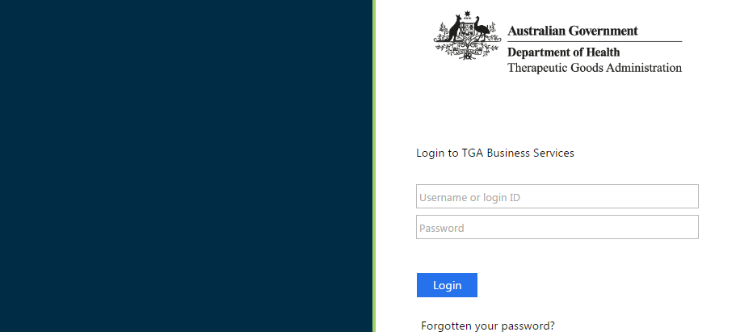
Once logged in, you will see a personalised work page or 'dashboard'. What you can see and do on the dashboard will depend on what user role (access level) you have been given.
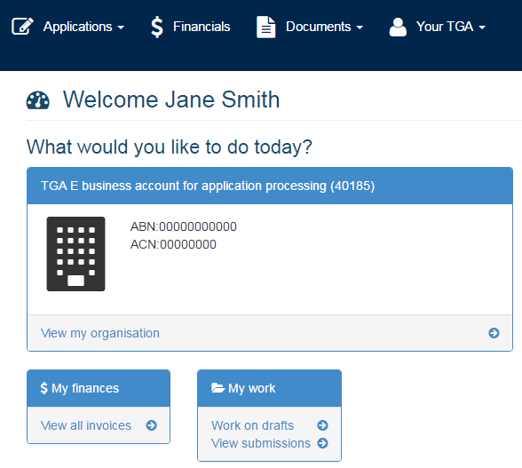
Across the top of the TGA Business Portal dashboard there are three main menus: Applications; Documents; and Your TGA. If you also have financial access, there will be an additional Financials menu displayed.
You will also find a My work menu on the dashboard with the options Work on drafts or View submissions.
You can select either Work on drafts or View submissions which will take you to the online Portal menu.

Creating a new CTN form
The two options below can be used to create a new CTN form.

Option 1
Access the dashboard as described in How to login.
Select Applications from the top menu on the dashboard.
Select Clinical Trial Notification.
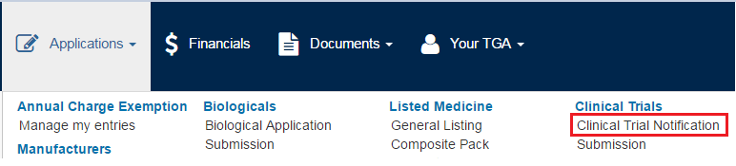

Option 2
Access the dashboard as described in How to login.
Select Work on drafts under the My work menu on the dashboard. The online Portal menu will be displayed on the left-hand side.
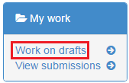
Select Portal at the top of the menu. This will open further menu options.
Select Create Applications & Submissions.
Select Clinical Trials and then select Clinical Trial Notification.
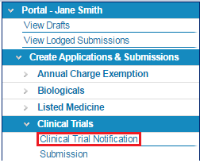
A blank CTN form will open.
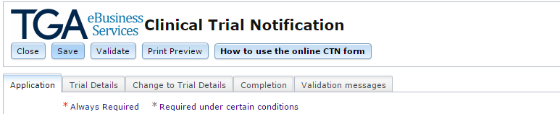
There are six (6) possible tabs that may appear through the CTN process: Application, Trial Details, Change to Trial Details, Completion, Validation messages and Changes made. Depending on the stage of the CTN, only the applicable tabs will display.
New:
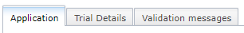
Only Trial Details is editable.
Variation:
Only the Change to Trial Details tab is editable. Any changes made will display in the Changes Made tab.
Completion:
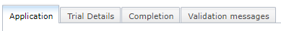
Only the Completion tab is editable. The top right-hand side of the CTN form displays:
the CTN Application ID and version number (this is generated when the form is first opened)
the Status of the CTN (for example, ‘Draft Loaded’)
the Client Reference field (this field can be used by the sponsor to enter notes or other additional identifying information. This field is not used as a reference by the TGA).
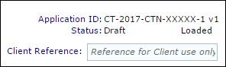
A red asterisk * indicates a mandatory field.
A grey * asterisk indicates a conditionally mandatory field (the field must be completed if certain conditions are met).
Data in certain drop-down lists is populated from TGA Code Tables. Sponsors can view the TGA Code Tables under the Public TGA Information tab in the online Portal menu.
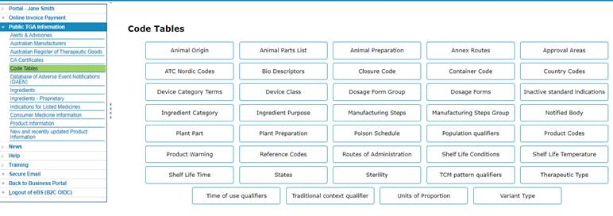
Select the Application tab to begin entering details in the form.

Application tab
Field Name | Information Required
Sponsor Name* | This field is pre-populated based on the TBS logon ID used.
Sponsor Address* | Select the address recorded in TBS for the sponsor from the drop-down list.
Notification Fee | This field will be automatically populated with a dollar amount by the system when the form is validated (see Paying for your CTN for further details).

Trial details tab
Field Name | Information Required
Contact Name* | The contact name is the name of the person nominated by your organisation to receive correspondence from TGA regarding the CTN.  Please note, the contact email address and phone number originally entered on the Electronic Business Services (eBS) account will auto-populate to the contact details. If you wish to edit the phone number, please refer to ‘Changing contact information’ for guidance.  An Australian contact number is required to be listed with either the primary sponsor contact, OR the alternate sponsor contact.
Contact Phone Number* | The phone number of the nominated person will auto-populate. If you wish to edit the phone number, please refer to ‘Changing contact information’ for guidance.
Contact Email* | The email address of the nominated person will auto-populate. If you wish to edit the email address, please refer to ‘Changing contact information’ for guidance.
Alternative Contact | An alternative contact may be chosen from the contacts for the agent or sponsor organisation submitting the CTN.  The ‘Alternative Contact’ option is non-mandatory and is available on the top right-hand side of the page.  An Australian contact number is required to be listed with either the primary sponsor contact, OR the alternate sponsor contact.
Protocol Number* | Enter the protocol number provided by the sponsor or principal investigator of the clinical trial. This is a unique reference number used to easily identify your trial. This number may be no fewer than 4 and no more than 20 characters.
Expected Trial Start Date* | Enter the date you estimate the trial will be initiated at the first Australian site in the format dd/mm/yyyy or select from the pop-up calendar.  The 'expected trial start date' indicated on the CTN form cannot be a retrospective date.
Expected Completion Date* | Enter the date you estimate the trial will be completed at all Australian sites in the format dd/mm/yyyy or select from the pop-up calendar.  The ‘expected completion date’ must be a date after the ‘expected trial start date’.
Potential use of restricted goods* | Select 'Yes' if the trial involves the use of substance(s) that require permission to import under the Customs (Prohibited Imports) Regulations 1956. Otherwise select 'No'.
Title of Study and Description* | Enter the title and description of the clinical trial.  The title should include the aim and provide a broad description of the trial. Include, for example: phase, indication(s) being treated, main investigational product and comparators, use of placebo-control, focus of the study, patient population and any other significant or novel aspects.  Must be a minimum of 250 characters (spaces included), up to a maximum of 2500 characters.
This Trial* | See information below.
Trial Type* | Select the check box on the left-hand side of the trial type(s). More than one check box may be selected.  Medicine or Biological:  Select the trial phase(s) for the medicine or biologicals under investigation.  Medical Device:  Select the trial phase(s) for the medical devices under investigation.  Bioequivalence:  If the trial is investigating bioequivalence, select the Bioequivalence check box.  Select the trial phase(s) for the bioequivalence under investigation.  The CTN form does not provide the option to select for clinical trial 'stages' of medical devices as per the Clinical Trials handbook. If you are currently trying to submit a CTN for a medical device clinical trial, please select the corresponding ‘phase’ that best aligns with your device clinical trial and indicate whether the trial is Pre-market pilot, Pre-market pivotal, or Post-market in the ‘Title of study and description’ field of the CTN form.
First in Human Trial* | Select ‘Yes’ if the trial is a first in human trial. Otherwise select ‘No’.
Has this trial, in part or as a whole, been halted/stopped/withdrawn or rejected in another country due to safety concerns?* | Select ‘Yes’ if the trial, in part or as a whole, has been halted/stopped/withdrawn or rejected in another country due to safety concerns. Otherwise select ‘No’.  If ‘Yes’ is selected, please ensure you have notified your Human Research Ethics Committee (HREC) of trial cessations and the outcome of review in another country.
Total number of participants* | Select a range of the estimated total number of participants to be enrolled in the trial in Australia from the drop-down list.
Therapeutic area* | Select the therapeutic area for the investigational product from the drop-down list.

Changing contact information
The contact information reflected in your eBS account will be auto-populated as per the contact details sections of your CTN submission. Instructions for editing the contact information are included below.
Once a user account has been created, the functionality to update the email address and/or contact name becomes a locked field. To update your email address or contact name, please send an email request to the TBS Helpdesk at ebs@health.gov.au. The TBS Helpdesk team will assist you and update these details on your behalf.
To update your contact number, select your name from the top right corner of your personalised work page or dashboard after signing in. (If you have already proceeded to the View drafts or Submissions page select Back to business portal from the left-hand drop-down menu).
Go to Account Settings, then Edit my Profile. From this screen you will be able to edit your title, phone, mobile, fax and change your listed address. Update the relevant fields and click Update Details. This may take up to 24 hours to reflect accurately on the CTN submission.

This Trial*
Select all of the check boxes relevant to your trial. More than one check box may be selected. When selected, check boxes may prompt an additional sub-form that you will need to complete. Additional sub-forms appear at the end of the Trial Details page (above Trial Site Details).
 | A therapeutic good must be selected in order for the CTN form to be processed. You must select one or more of the following check boxes:  Involves the use of a Medicine  Involves the use of a Medical Device  Involves the use of a Biological

Involves the use of a Medicine
Select the check box Involves the use of a Medicine to add medicine(s) to the CTN form.
Each 'separate and distinct' medicine must be entered in a separate sub-form. Each different strength of a product must also be entered in a different sub-form.
Refer to section 16 of the Therapeutic Goods Act 1989 for a definition of 'separate and distinct'.
Placebo details should be entered in the Placebo Details sub-form (see below).
Scroll down to the Medicine Details* sub-form
Select the Add Medicine button. This opens a pop-up form with the fields below.
Field Name | Information Required
Trade/Product/Code Name* | Enter identifying name(s) of the medicine. If the product has a trade name, product name and code name, enter all three names in this field.  When multiple generic products with the same active ingredient are used, trial sponsors do not need to enter each trade/brand name separately on the CTN. In addition, an existing CTN does not need to be varied if additional generic versions are used of already notified products e.g. paracetamol – generic  A generic product is defined in the Therapeutic Goods Regulations 1990.
Is this a combination product?* | Select 'Yes' if the product is comprised of two (or more) active ingredients. Each active ingredient should be entered under ‘Formulation’ (see below). Otherwise select ‘No’.
Is this a cannabis product?* | Select ‘Yes’ if the product is medicinal cannabis. Otherwise select ‘No’.
Is the cannabis plant used in the manufacture of the product?* | Select 'Yes' if the product contains, or is manufactured from, any part of the cannabis plant. Otherwise select ‘No’.  If ‘Yes’ is selected, please be aware that the sponsor of the medicinal cannabis product is legally responsible for ensuring that the product complies with the TGO 93, and all other relevant orders.
Type of container*  Type of container Other Description* | Select the type of container from the drop-down list.  The container means the vessel, bottle, tube, ampoule, syringe, vial, sachet, strip pack, blister pack, wrapper, cover or other similar article that immediately covers the goods, but does not include an article intended for ingestion.  ‘Other’ should only be used if the container is not in the drop-down list. The terms 'Various' or N/A are not acceptable.
Dosage Form* | Select a dosage form from the drop-down list.  Dosage form is the pharmaceutical form in which a product is presented for therapeutic administration, e.g., tablet, cream.
Route of Administration* | Select a route of administration from the drop-down list.  Route of administration means the route by which a therapeutic good is applied on or introduced into the body.
Formulation* | Formulation is a list of ingredients used in the manufacture of a dosage form and a statement of the quantity of each ingredient in a defined weight, volume, unit or batch.  An active ingredient is the therapeutically active component in a medicine's final formulation that is responsible for its physiological action.  An excipient is any component of a finished dosage form other than an active ingredient.  You must at least enter the active ingredient(s). We recommended that you list both the active ingredient(s) and excipient(s) if possible.  Each separate and distinct ingredient should be listed in separate Medicine Ingredient sub-forms.  Each distinct strength of the same active ingredient is required to be entered as a separate and distinct good in separate medicine sub-form.  Select the Add Ingredients button. This opens a pop-up form with the fields below.  - Ingredient name*: Enter one ingredient name.  - Quantity*: Enter the numeric part of the ingredient strength/concentration. For example, if the strength of the ingredient is 25 mg, enter 25.  - Unit*: Select a unit of measurement of the strength/concentration from the drop-down list. For example, if the strength of the ingredient is 25 mg, select milligram.  Select the Save and Close button.  The details will be added to the list on the Formulation sub-form.  Repeat this process for each ingredient you need to add.  To edit ingredients:  Select the Open button beside the ingredient you wish to edit.  To remove ingredients:  Select the check box next to the ingredient(s) you wish to remove.  Select the Remove Selected Ingredient(s) button.
Indication* | Enter the indication the medicine will be used for in the trial.  The indication means the specific therapeutic use(s) of the goods.
Dosage and Frequency* | Enter the dosage regimen.  The dosage regimen consists of the quantity of a medicine that is administered at each specific time of dosing (dosage), the number of doses per given time-period, and/or the time that elapses between doses (frequency).
Intended Use* | Select if the medicine is a Comparator; Investigational Medicinal Product; Standard Care Therapy or Other.  Please note, the TGA would expect to see at least one Investigational Medical Product per clinical trial notification.  Refer to the Note for Guidance on Good Clinical Practice (CPMP/ICH/135/95) for a definition of comparator or investigational product.
Intended Use ‘Other’ Description* | Please provide a description if 'Other' is selected under 'Intended Use’.
Is the medicine manufactured in Australia?* | Select ‘Yes’ if the medicine is manufactured in Australia. Otherwise select ‘No’.
GMP licence/clearance number of relevant exemption | Provide either the TGA issued GMP Licence, the GMP certification (overseas manufacturers), or relevant exemption.  For more information on manufacturing licences and certification, please see the TGA website.
Manufacturer(s)* | To add a manufacturer:  Select Add Manufacturer button.  - Manufacturer Name*: Enter the name of the manufacturer.  - Manufacturer Address*: Enter the address of the manufacturer.  Select the Save and Close button.  Repeat steps to add additional Manufacturers.  To edit manufacturer(s):  Select the check box next to the manufacturer(s) you wish to edit.  Select the Open button.  Edit the form.  Select the Save & Close button.  To remove manufacturer(s):  Select the check box next to the manufacturer(s) you wish to remove.  Select the Remove Manufacturer(s) button.
Attach the investigator’s Brochure or equivalent documentation | To add attachments:  Select Attach a Document,  This opens a pop-up form with the fields below.  Title*: Enter the title of the document.  Description: Enter a description of the document (if required).  Attachment: Select Choose file, then navigate to the location of the file in your computer. Please note that the Maximum file size is 100 MB.  Select Submit.  Select Close.  Repeat steps to attach additional documentation.  To remove a document:  Select the tick box next to the document you with to remove.  Select Remove Selected Document(s).
Select the Save and Close button.
The details will be added to the list on the Medicine Details* sub-form.
Repeat this process for each individual medicine and each medicine strength.
To edit a medicine:
Select the Open button beside the medicine you wish to edit.
Update any details as needed.
To remove a medicine(s):
Select the check box next to the medicine(s) you wish to remove.
Select the Remove Selected Medicine(s) button.
Please note that inclusion of the products Investigator’s Brochure (IB) is optional. If you choose to upload an IB and wish to provide an updated IB in the future, this can be done as part of a variation CTN. However, it is not a requirement that the IB is continually updated in the CTN form, and a fee is not charged to update the IB.
Information provided within the IB is treated as confidential by the TGA.

Involves the use of a Medical Device
Select the checkbox Involves the use of a Medical Device if the product is regulated by the TGA as a medical device.
A definition of a medical device can be found under section 41BD of the Therapeutic Goods Act 1989. Further information can be found on the TGA website under What is a medical device? and ‘In Vitro Diagnostic medical devices (IVDs)’.
Scroll down to the Device Details* sub-form.
Select the Add Device button.
Field Name | Information Required
Product Name* | Enter the product or trade name of the medical device.
Is this a:* | Select the most suitable option from:  Medical Device  In Vitro Diagnostic Medical Device (IVD)
Classification* | Select Medical Device Classification from the drop-down menu.  Include the medical device classification (such as Class I, Class III etc. – for guidance refer to Overview of medical devices and IVD regulation).
Is this device software or does it incorporate software (this may include firmware):* | Select ‘Yes’ if the device is software or if it incorporates software (may include firmware). Otherwise select ‘No’.  Software is regulated under the therapeutic goods legislation if it meets the definition of a medical device. Please refer to Regulation of software based medical devices for further information.
Is it an invasive device:* | Select ‘Yes’ if it is an invasive device. Otherwise select ‘No’.  An invasive medical device is a device which penetrates inside the body, either through a body orifice or through the surface of the body.
Is it an implantable medical device:* | Select ‘Yes’ if it is an implantable device. Otherwise select ‘No’.  An implantable medical device is a device that is intended by the manufacturer:  To be, by surgical intervention, wholly introduced into the body of a human being and to remain in place after the procedure.  To replace, by surgical intervention, an epithelial surface, or the surface of an eye, of a human being, and to remain in place after the procedure;  To be, by surgical intervention, partially introduced into the body of a human being, and to remain in place for at least 30 days after the procedure.
GMDN Search Context | To search for a Global Medical Device Nomenclature (GMDN), select either GMDN name or GMDN code.  Global Medical Device Nomenclature (GMDN Terms are an international naming and grouping convention used to identify and consistently describe medical devices. In Australia, GMDN Terms are a key factor in determining a 'kind of medical device' (see section 41BE of the Therapeutic Goods Act 1989).  Further information on GMDN is available on the TGA website.
GMDN | Once you have selected the search context above, type in the name or code in the GMDN search field.  Select the Search button.  A list of possible matches will be returned.  Select the correct GMDN from the drop-down list.  Select New Search to start again.  You may need to contact the manufacturer to ascertain which GMDN code is the most relevant for the device.  If a GMDN is not available then you are not required to enter it, however, a ‘Description’ must be entered in the field below in order for the form to validate.
Description and Intended purpose for Medical Device* | Provide a description of the device including details of design, characteristics, components, specification, materials, method of use, and anatomical site of use.  In the same field, please also include the intended purpose of the device.
Intended Purpose for Trial* | Select if the medical device in your trial is an Ancillary Product; Comparator; Investigational Product; Standard Care Therapy; or Other.  Please note, the TGA would expect to see at least one Investigational Product per clinical trial notification.  Comparator means the product is being used in the control group in the clinical trial.  Investigational product means the product is being assessed for clinical performance, effectiveness or safety in the clinical trial.  Standard Care Therapy means the treatment that is accepted by medical experts as a proper treatment for a certain type of disease and that is widely used by health care professionals.  Ancillary Products cover a large range of supporting products, such as testing kits, monitoring devices, collection and storage devices, etc
If 'Other' please provide a description* | Please provide a description if 'Other' is selected under 'Intended Purpose for Trial'.
Manufacturer Name* | Please enter the name of the manufacturer. Manufacturer is defined under section 41BG of the Therapeutic Goods Act 1989.
Manufacturer Address* | Please enter the address of the manufacturer.
Attach the Investigator’s Brochure or equivalent documentation | To add attachments:  Select Attach a document  This opens a pop-up form with the fields below.  - Title*: Enter the title of the document.  - Description: Enter a description of the document.  - Attachment: Select Choose file, then navigate to the location of the file in your computer. Please note that the Maximum file size is 100 MB.  Select Submit.  Select Close.  Repeat steps to attach additional documentation.  To open attachment:  Select the check box next to the attachment(s) you wish to open.  Select the Open button.  To remove attachment(s):  Select the check box next to the attachment(s) you wish to remove.  Select the Remove Selected Document(s) button.
Select the Save and Close button.
The details will be added to the list on the Device Details* sub-form.
Repeat this process for each different medical device you wish to add.
To edit a medical device:
Select the Open button beside the medical device you wish to edit.
Update any details as needed.
To remove a medical device:
Click on the check box next to the medical device(s) you wish to remove.
Select the Remove Selected Device(s) button.
Inclusion of the product’s Investigator’s Brochure (IB) is optional. However, it is highly recommended for first in human clinical trials that investigate invasive or implantable medical devices s it will minimise requests for further information. The choice to upload an IB has been included to assist with the medical devices reforms.
If you choose to upload an IB and wish to provide an updated IB in the future, this can be done as part of a variation CTN. However, it is not a requirement that the IB is continually updated in the CTN form, and a fee is not charged to update the IB.
Information provided within the IB is treated as confidential by the TGA.

Involves the use of a Biological
Select the check box Involves the use of a Biological to add biologicals to the CTN form.
Use the Biological Details sub-form to notify products that are regulated by the TGA as biologicals.
Review the information at ‘What is regulated as a biological’ to ensure that the product(s) meet the TGA definition of a biological. Further information on the scope of products that are regulated as biologicals can be found in Section 1.1 of the Australian Regulatory Guidelines for Biologicals (ARGB).
Use the Medicine Details sub-form to notify products that are regulated by the TGA as medicines (such as vaccines and recombinant products).
Scroll down to the Biological Details* sub-form.
Select the Add Biological button. This opens a pop-up form with the fields below.
Field Name | Information Required
Trade/Product/Code Name* | Enter the identifying name(s) of the biological. If the product has a trade name, product name and code name, enter all three names in this field.
Is this a combination product?* | Select 'Yes' if the product is comprised of two (or more) active ingredients. Each active ingredient should be entered under ‘Ingredients’ (see below).
Product Description* | Enter a description of the biological under clinical investigation, including a name, biological class (e.g. Class 2 etc.), intended use, indication, details of the design, composition, specifications, mode of action and application, list any associated devices and/or medicines and the method of use of the whole biological product.
Class of Biological* | Select a class of Biological from the drop-down list.  Biologicals are classified according to the level of risk to patients associated with their use. This is influenced by the level of processing applied to the biological and the intended use of the product, but also the level of external governance and clinical oversight.  Class 1 biologicals are low risk and have an appropriate level of external governance and clinical oversight.  Class 2 biologicals are low risk.  Class 3 biologicals are medium risk.  Class 4 biologicals are high risk.  For further information on the Classification of Biologicals, please visit the TGA website.
Type of container*  Type of container ‘Other’ Description | Select the type of container from the drop-down list.  The container means the vessel, bottle, tube, ampoule, syringe, vial, sachet, strip pack, blister pack, wrapper, cover or other similar article that immediately covers the goods, but does not include an article intended for ingestion.  ‘Other’ should only be used if the container is not in the drop-down list. The terms 'Various' or N/A are not acceptable.
Dosage Form* | Select a dosage form from the drop-down list.  Dosage form is the pharmaceutical form in which a product is presented for therapeutic administration, e.g. tablet, cream.
Route of Administration* | Select a route of administration from the drop-down list.  Route of administration means the route by which a therapeutic good is applied on or introduced into the body.
Ingredients* | Enter the ingredients used in the formulation of the biological.  You must at least enter the active ingredient(s). We recommended that you list both the active ingredient(s) and excipient(s) if possible.  Each separate and distinct therapeutic good also needs to be listed in separate biological sub-forms. You can find further information on the definition of Separate and distinct biologicals on the TGA’s website. Refer to section 32AB of the Therapeutic Goods Act 1989 and regulation 11A of the Therapeutic Goods Regulations 1990 for a definition of a 'separate and distinct biological'.  Select the Add Ingredients button. This opens a pop-up form with the fields below.  - Ingredient Name*: Enter one ingredient name.  - Quantity*: Enter the numeric part of the ingredient strength/concentration. For example, if the strength of the ingredient is 25 mg, enter 25.  - Unit*: Select a unit of measurement of the strength/concentration from the drop-down list. For example, if the strength of the ingredient is 25 mg, select milligram.  - Country of Origin: Select the country of origin from the drop-down list.  - Select the Add Country button to add the country to the list.  - To remove a country select the check box next to the country you wish to remove. Select the Remove Country(ies) button.  Select the Save and Close button.  The details will be added to the Ingredients* list.  Repeat this process for each ingredient you need to add.  To edit ingredients:  Select the Open button beside the ingredient you wish to edit.  Update any details as needed.  To remove ingredients:  Select the check box next to the ingredient(s) you wish to remove.  Select the Remove Selected Ingredient(s) button.
Indication* | Enter the indication the biological will be used for in the trial.  The indication means the specific therapeutic use(s) of the goods.
Dosage and Frequency* | Enter the dosage regimen.  The dosage regimen consists of the quantity of a biological that is administered at each specific time of dosing (dosage), the number of doses per given time period, and/or the time that elapses between doses (frequency).
Intended Use* | Select if the Biological is a Comparator; Investigational Medicinal Product; Standard Care Therapy or Other.  Please note, the TGA would expect to see at least one Investigational Medicinal Product per clinical trial notification.
Intended Use ‘other’ Description* | Please provide a description if 'Other' is selected under 'Intended Use’.
Is the Biological manufactured in Australia?* | Select ‘Yes’ if the Biological is manufactured in Australia. If not, select ‘No’.
Manufacturer Name* | Please enter the name of the manufacturer.
Manufacturer Address* | Please enter the address of the manufacturer.
GMP licence/clearance number or relevant exemption | Please provide the relevant licence number or exemption if available.
Attach the Investigator’s Brochure or equivalent documentation | To add attachments:  Select Attach a document  This opens a pop-up form with the fields below.  - Title*: Enter the title of the document.  - Description: Enter a description of the document.  - Attachment: Select Choose file, then navigate to the location of the file in your computer. Please note that the Maximum file size is 100 MB.  Select Submit.  Select Close.  Repeat steps to attach additional documentation.  To open attachment:  Select the check box next to the attachment(s) you wish to open.  Select the Open button.  To remove attachment(s):  Select the check box next to the attachment(s) you wish to remove.  Select the Remove Selected Document(s) button
Select the Save and Close button.
The details will be added to the list on the Biological Details* sub-form.
Repeat this process for each different biological and each different biological strength.
To edit a biological:
Select the Open button beside the biological you wish to edit.
Update any details as needed.
To remove a biological:
Select the check box next to the biological(s) you wish to remove.
Select the Remove Selected Biologicals(s) button.
The fields below also appear below the Biological Details* sub-form.
Please note that inclusion of the products Investigator’s Brochure (IB) is optional. If you choose to upload an IB and wish to provide an updated IB in the future, this can be done as part of a variation CTN. However, it is not a requirement that the IB is continually updated in the CTN form, and a fee is not charged to update the IB.
Information provided within the IB is treated as confidential by the TGA.

Involves a Genetically Modified Organism
Select the check box Involves a Genetically Modified Organism to add details of genetically modified organisms (GMOs).
Enter details of GMOs if any of the therapeutic goods you have listed on the CTN form contain, or are produced by, GMOs.
Refer to ‘Guidance 21: Medicines produced by genetic manipulation’ and ‘What is regulated as a biological’ for further guidance regarding the regulation of GMOs.
A single free text field Details of Genetically Modified Organism will open under the Therapeutic Area field.
Enter details of the GMO such as organism name, source, gene technology used.
In addition, you will then need to enter the GMO product as either a medicine or biological (as applicable) by selecting the check box Involves the use of a Medicine or Involves the use of a Biological.

Involves Gene Therapy
Select the check box Involves Gene Therapy to enter details of gene therapy.
Gene therapy involves the deliberate introduction of genetic material into somatic cells for therapeutic, prophylactic or diagnostic purposes.
Refer to ‘Guidance 21: Medicines produced by genetic manipulation’ and ‘Advanced therapies’ for further guidance regarding gene therapy.
Please note that the European Union (EU) guidelines relating to gene therapy have been adopted in Australia.
A single free text field Details of Gene Therapy* will open.
Enter a description of the gene therapy such as the origin of genetic material, delivery techniques etc.

Is Placebo Controlled
Select the check box Is placebo controlled to add placebos to the CTN form.
Scroll down to the Placebo Details* sub-form.
Select the Add Placebo button. This opens a pop-up form with the fields below.
Field Name | Information Required
Product Name* | Enter the product name of the placebo.
Route of Administration* | Select a route of administration from the drop-down list.  Route of administration means the route by which a therapeutic good is applied on or introduced into the body.
Description (including dosage form)* | Enter a description of the placebo including the dosage form, formulation (ingredients and quantity). You may also include indications, directions for use, and type of container information in this field.
Select the Save and Close button.
The details will be added to the list on the Placebo Details* sub-form.
Repeat this process for each placebo you need to add.
To edit a placebo:
Select the Open button beside the placebo you wish to edit.
Update any details as needed.
To remove a placebo:
Select the check box next to the placebo(s) you wish to remove.
Select the Remove Selected Placebo(s) button.

Is Comparator Controlled
Select the check box Is comparator controlled if your study is a comparator-controlled trial.
A comparator is an investigational or marketed product, or placebo, used as a reference in a clinical trial. If the trial sponsor determines a comparator to be an ‘unapproved’ therapeutic good, then a CTN or CTA must be in place before the product can be supplied for use in a clinical trial.
This check box does not open a new sub-form and no additional information is required to be entered at this stage.

Involves Animal Excipients
Select the check box Involves Animal Excipients to add animal excipients to the CTN form.
Enter animal excipient details if any of the therapeutic goods you have listed on the CTN form contain animal excipients.
An animal excipient is any component of a finished dosage form other than an active ingredient that contains animal products or is animal derived.
Scroll down to the Animal Excipient Details* sub-form.
Select the Add Animal Excipient button. This opens a pop-up form with the fields below.
Field Name | Information Required
Product Name* | Enter the name of the product that contains the animal excipient.
Species of Origin* | Select the species of origin from the drop-down list.
Tissue* | Select the tissue from which the animal excipient originated from the drop-down list.
Preparation* | Select the preparation of the animal excipient from the drop-down list.
Country of Origin* | Select the country of origin of the animal excipient from the drop-down list.
Select the Save and Close button.
The details will be added to the list on the Animal Excipient Details* sub-form.
Repeat this process for each animal excipient you need to add.
To edit animal excipients:
Select the Open button beside the animal excipient you wish to edit.
Update any details as needed.
To remove animal excipients:
Select the check box next to the animal excipient(s) you wish to remove.
Select the Remove Selected Excipient(s) button.

Has relevant preceding trials
Select the check box Has relevant preceding trials if applicable.
Relevant preceding trials may include trials involving the same investigational product conducted by the same sponsor or a follow-on trial conducted after a primary/parent study. The relevant preceding trials are populated from your Clinical Trials Repository.
Scroll down to the Preceding Trials* sub-form.
Select the check-box beside the relevant preceding trial(s) from the list. Please note that only clinical trials submitted by the sponsor will appear in this list.

Multicentre trial in Australia
Select the check box Is a multicentre trial in Australia if the trial is being conducted at more than one clinical trial site in Australia.
This check box does not open a new sub-form and no additional information is required to be entered at this stage.

Is being conducted in other countries
Select the check box Is being conducted in other countries if the trial is also being conducted overseas. This means countries where the trial has been approved for supply.
Scroll down to the This trial is being conducted in the following Countries* sub-form.
Select a country from the drop-down list.
Select the Add Country button to add the country to the sub-form.
Repeat this process for each country you need to add.
To Remove a Country:
Select the check box next to the country you wish to remove.
Select the Remove Country(ies) button.

Trial Site Details*
The Trial Site Details sub-form automatically appears at the bottom of the CTN form. You will need to use this sub-form to add details of each site the trial will be conducted at.
Select the Add Site button.
Field Name | Information Required
Site Name* | Enter the name of the trial site.
Physical Location* | Enter the physical address (street address) of the trial site, including postcode. A postal address, such as PO box, will not be accepted.  If multiple locations are required to be listed, please list the addresses in a separate trial site sub-form.
State/Territory* | Select the state/territory of the trial site from the drop-down list.
Expected Site Start Date* | Enter the date you estimate the trial will be initiated at this trial site in the format dd/mm/yyyy or select from the pop-up calendar.  This date must fall within the range determined by the Expected Trial Start Date and Expected Completion Date for the form to validate.
Principal Investigator Name* | Enter the full name and title of the Principal Investigator at this trial site.
Contact Phone Number* | Enter the phone number (including area code) of the Principal Investigator.
Contact Email* | Enter the email address of the Principal Investigator.
HREC Name and Code Search Context | To search for a Human Research Ethics Committee (HREC), select either HREC Name or HREC Code.
HREC Name and Code* | Enter either the HREC Name, or HREC Code; depending on what search context you have selected.  Select Search.  Select the correct HREC from the options available.  If you have attempted to search for a name, and the HREC you are trying to select does not appear, please try to search with the HREC code. Vice versa for Code and Name.  If your HREC does not appear in the list of HRECs in this field, please contact the clinical trials team at clinical.trials@health.gov.au and provide us with the details of the HREC, including the HREC name, the HREC code, the HREC organisation name, and the status of the HREC (registered/certified) so that we may add the HREC to this list. Please note that the CTN may not be submitted without the inclusion of the correct HREC in this field.  For your HREC to be listed in the selectable options in this list, they must be either Registered or Certified with the NHMRC.  A list of HRECs registered/Certified with NHMRC is published on the NHMRC website. The current list is available at Human Research Ethics Committees (HRECs).
HREC Contact Officer* | Enter the name of a member of the HREC named above. Where possible, this should be the chair or the deputy-chair of the HREC.
Position* | Enter the position description or title of the HREC contact officer.
Contact Phone* | Enter the phone number (including area code) of the HREC Contact Officer.
Contact Email* | Enter the email address of the HREC Contact Officer.
Name of Approving Authority* | Enter the name of the body, organisation or institution that is responsible for approving the conduct of the trial at the particular trial site.
Approving Authority Contact Officer* | Enter the name of the person authorised to represent the body, organisation or institution above.
Position* | Enter the position description or title of the Approving Authority contact officer.
Contact Phone* | Enter the phone number (including area code) of the Approving Authority Contact Officer.
Contact Email* | Enter the email address of the Approving Authority Contact Officer.
Select the Save and Close button.
The details will be added to the list on the Trial Site Details* sub-form.
Repeat this process for each trial site you wish to add.
To edit a trial site:
Select the Open button beside the trial site you wish to edit.
Update any details as needed.
To remove a trial site:
Click on the check box next to the site(s) you wish to remove.
Select the Remove Selected Site(s) button.

Saving and editing drafts

Save a draft
You can save a draft notification at any time by selecting the Save button on the top left-hand side of the form. We recommend you save the application at regular intervals to ensure no ongoing work is lost.
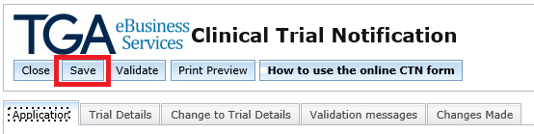
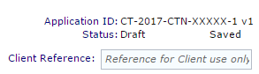
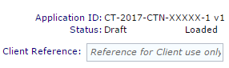
When the form is saved for the first time, the status will update from Draft Loaded to Draft Saved.

After saving the draft:
You can select the Close button to return to the Drafts page. You will be able to exit the online portal and return at any time to edit the draft.
Alternatively, if you have finished filling in the CTN form, skip to the Validation section for information on how to validate the CTN form prior to submitting it to us.

View saved drafts
The two options below can be used to view a list of saved drafts.

Option 1
Access the dashboard as described in How to login.
Select Work on drafts under the My work menu on the dashboard.

Option 2
If you are already working within the online Portal menu, select Portal at the top of the menu.
Select View Drafts.
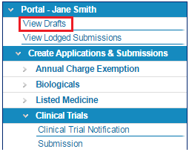
You will then see a list of all of the saved drafts that your access allows on the Drafts page.
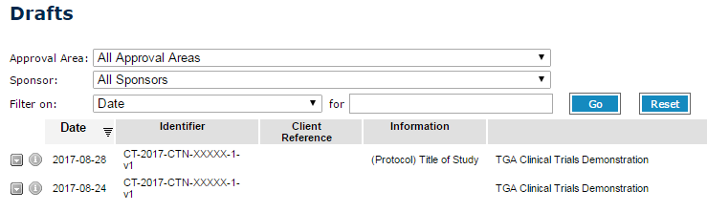
You may have more than one page of drafts in your online portal. If you are unable to see the draft notification you are looking for, select the next page in your drafts screen.
You can also search using the Filter on drop-down menu. You can filter drafts using parameters such as Date, Status, Client Reference or Identifier. Enter the parameters you wish to search on and then select the Go button.
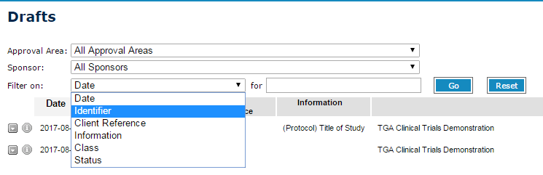

Edit a saved draft
You can edit your saved drafts at any time prior to submitting them.
Access a list of saved drafts as outlined in View saved drafts above.
Select the CTN you wish to edit. The CTN will open.
Select the Trial Details tab and go to the relevant fields to make any changes.
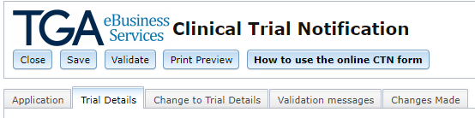
Once you have finished editing the draft, you will need to save the draft as outlined in the Save a draft section above.
After saving the draft:
You can select the Close button to return to the Drafts page. You will be able to exit the online portal and return at any time to edit the draft.
Alternatively, if you have finished filling in the CTN form, move on to the Validation section for information on how to validate the CTN form prior to submitting it to us.

Copying and deleting drafts

Delete a saved draft
You can delete a draft CTN any time before you submit it.
Access your list of Drafts as described in View saved drafts above.
Select the drop-down arrow (located at the far left of each draft notification - it will turn green when selected), then select Delete.
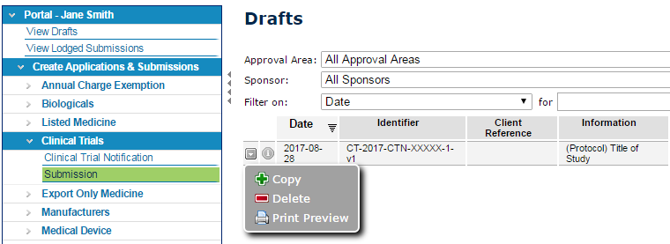
A dialog box will ask you if you are sure you want to delete this draft. Select OK and the draft will be deleted.
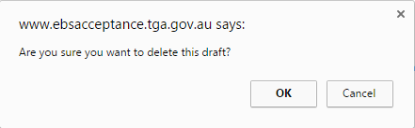

Copy a saved draft
You can copy any draft CTN form to create a new draft. Information from the copied draft is retained for every field.
Access your list of Drafts as described in View saved drafts above.
Select the drop-down arrow (located at the far left of each draft notification - it will turn green when selected), then select Copy.
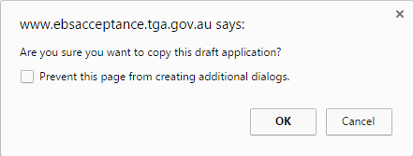
A dialog box will ask if you are sure you want to copy this draft.

Selecting OK creates a new draft CTN form which opens with a new Application ID.

Validation and submission
The CTN form must be validated before it can be submitted to us.
Before selecting validate, you will need to save your draft as described in the Save a draft section above.
All mandatory fields must be completed for the form to validate.

Validating the form
To validate the form, select the Validate button at the top left of the form.
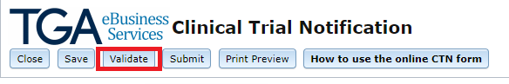
The validation process checks that all compulsory fields are completed, and that information has been entered in the correct format (e.g. email addresses).
Validation messages and automatic submission
After selecting the Validate button, you will be taken to the Validation messages tab.
The Validation messages tab displays a list of fields that need to be corrected before validation can proceed.
If there are validation messages displayed:
The status of the notification form will change to Draft Not Valid.
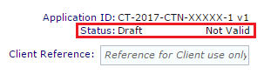
Select a validation message in the list. This will take you to the field in the form that requires editing.
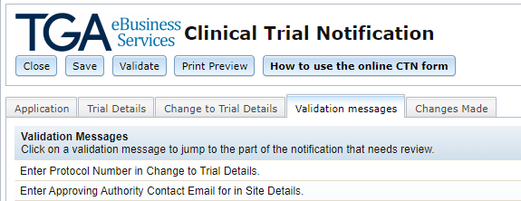
Once you have corrected all the invalid fields, save the form and validate again.
You will need to correct all errors and successfully validate your draft to be able to submit it.
If there are no validation messages:
The status of the notification form (top right of window) will change from Draft to Validated.
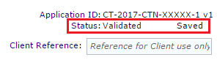
The validation messages tab will display the message ‘No validation messages to display’.
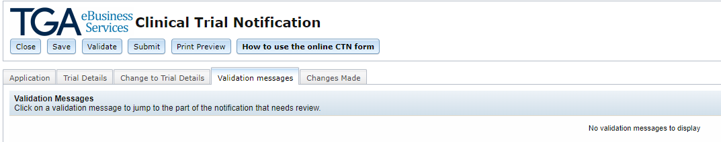
Once the form has validated, Submit will appear at the top of the page next to Validate. If you select this button, you will be automatically taken to the submissions page for submitting your CTN.
If you select the Save button again after successfully validating the form, it will revert back to draft status and you will need to validate the form again before you can submit it. Remember to complete the steps as follows:
After validating and submitting the form, you will be taken to the ‘Clinical Trials Submissions’ page as displayed in Option 2 of the Manual Submitting section below.
Alternatively, if you need to edit the validated form again for any reason (prior to submission), it can be accessed by selecting View Drafts on the Portal menu. See Edit a saved draft above for more information. You will be required to save and validate the CTN again to ensure the information has been updated before submitting.

Manual submission
Once the CTN form has been validated, the form can then be submitted to the TGA by a user with a ‘submitter role’.
Note: If you clicked Submit in the drafts section after validating, you will be automatically re-directed to the Submissions page.
If you are unable to select Submit or Submission in your online portal, you may not have a ‘submitter role’. You will need to contact your organisation's administrator to update your system role. See Roles: what each user can do and Drafter/submitter role specific information.

Manually access submission page
The two options below can be used to manually access the Clinical Trials Submissions page. If you selected Submit from the drafts screen you will automatically be taken to the Submission page.

Option 1
Access the dashboard as described in How to login.
Select Applications from the top menu on the dashboard.
Select Submission under the Clinical Trials heading.
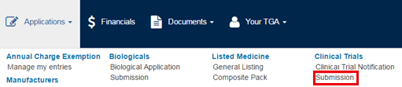

Option 2
If you are already working within the online Portal menu, select Portal at the top of the menu.
Select Create Applications & Submissions.
Select Clinical Trials and then select Submission.
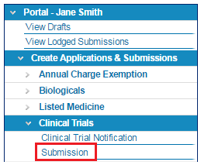
The Clinical Trials Submissions page will then open.
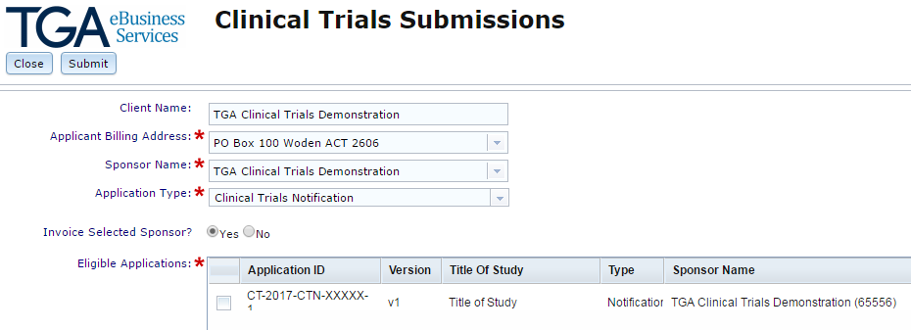
Choose the relevant details:
Field Name | Information Required
Client Name | This field is pre-populated based on the TBS logon ID used.
Applicant Billing Address* | Select the billing address from the drop-down list. This will auto-populate if there is only one option.
Sponsor Name* | Select the sponsor name from the drop-down list. This will auto-populate if there is only one option.
Application Type* | Select Clinical Trial Notification from the drop-down list.
Invoice Selected Sponsor? | Select ‘Yes’ or ‘No’ as applicable.
Eligible Applications* | Select the check box beside the CTN form you wish to submit. Select only one CTN form per submission. If you access this screen from the drafts submission the CTN you were working on will be automatically selected (ticked off) for submission.

When you have completed the required information, click the Submit button at the top of the form.

Sponsor declaration
After selecting submit, you will be required to accept (or decline) a declaration, which includes acknowledging that the sponsor is taking overall responsibility for the trial. The full text of the sponsor declaration can be found below.
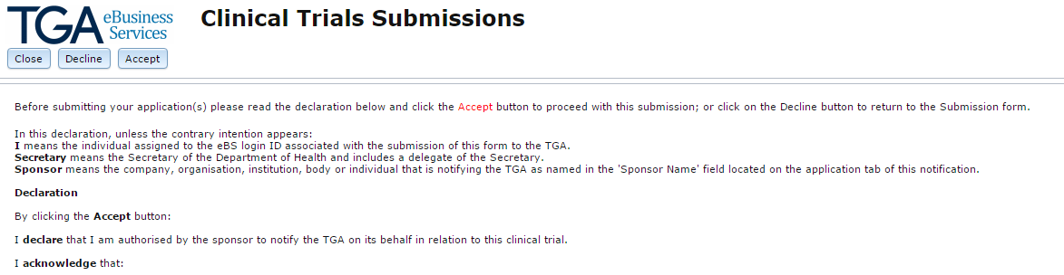
If you select the Decline button you will be taken back to the Clinical Trials Submissions page.
If you select the Close button you will be taken back to the online Portal.
If you select the Accept button you will be taken to a page which advises you the submission of your CTN has been successful.
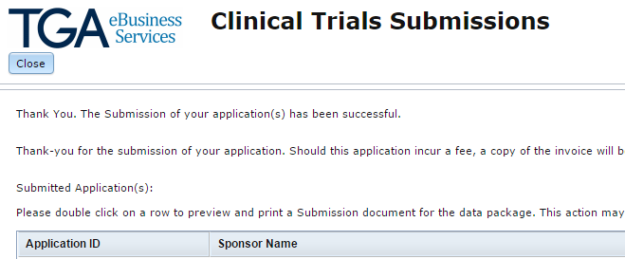
Select the Close button to exit. Your CTN has now been submitted to us for payment and processing. See How to check the status of your CTN below for information on checking the status of your CTN.
If you have submitted a notification and you need to make changes before it is processed, see Editing a submitted form or a push back.
Otherwise you can now move on to Paying for your CTN.
Once the CTN form has been submitted and paid for, we will check that the information in the form has been entered correctly and the correct fee has been paid. Once this has been confirmed, you will receive an email advising you that the CTN is ‘acknowledged’.

Paying for your CTN
A fee is charged for the following:
a new CTN.
a CTN submitted under a different sponsor.
certain variations to an existing CTN. The following variations to a previously notified trial will incur a fee:
  - addition of new site(s) to a previously notified trial.
  - change to previously notified therapeutic goods that creates separate and distinct goods
  - addition of a new therapeutic good to a previously notified trial.
  - The applicable fee is the same amount as the fee for a new CTN in the current financial year. The current fees for CTNs can be found on the TGA Schedule of fees and charges.
Once you have submitted your CTN, an invoice will be sent via email to the submitter of the CTN and to the billing contact of your organisation as provided to TGA Business Services.
If you have a 'financial role' you will also be able to view and print the invoice from the online portal. See Financial role specific information for more information on the ‘financial role’.
We recommend that you wait for the invoice before making payment as this ensures that there are no delays in matching payment.
The TGA provides a range of payment options as outlined at TGA Payment Options.
Payment through the online payment portal is the preferred option.
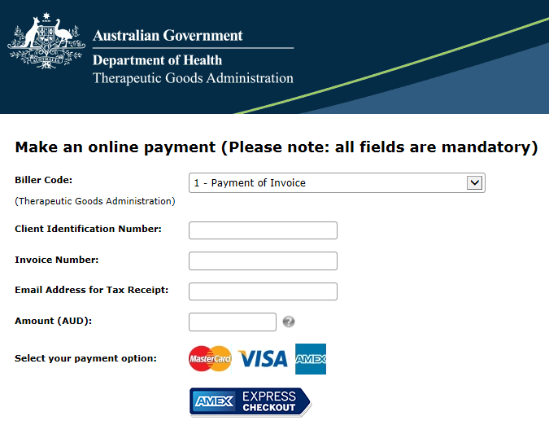
To make a payment of an invoice enter the following information:
Field Name | Information Required
Biller Code | Select Biller code 1 - Payment of Invoice from the drop-down list.
Client Identification Number | Enter your Client Identification Number (as shown on your invoice).
Invoice Number | Enter your Invoice Number (as shown on your invoice).
Email Address for Tax Receipt | Enter an email address for tax receipt.
Amount (AUD) | Enter the amount to be paid (this should correspond to the amount on your invoice).
Select your payment option | Select your payment option and follow the online prompts.

Editing a submitted form or a ‘push back’

Editing a submitted form
You can only edit a CTN when it is in Draft status. See Edit a saved draft for more information.
However, if you have submitted a CTN form with an administrative error and it has not been processed:
We can return the CTN form to your Drafts list for editing (called a ‘push back’) upon request. See Editing a ‘push back’ below.
If you have submitted a CTN form to us and it has been processed:
Any further changes will need to be made by varying the notification via your Clinical Trials Repository. Please refer to Varying trial details for further information.

Editing a ‘push back’
A submitted CTN form may be returned to your Drafts list for editing (called a ‘push back’) before it is processed. A ‘push back’ may occur upon request or may be initiated by us during processing.
If you have prematurely submitted a CTN and need to correct administrative errors, you may request that we 'push back' the notification. Such requests should be sent via email to the clinical trials team at clinical.trials@health.gov.au, providing details of the CTN such as the Application ID and the reason for the ‘push back’. However, please note that in order to action a push back request, payment of the invoice must be made.
During processing, we may initiate a ‘push back’ if it appears you have entered data incorrectly on the CTN form.
If any details of your trial have changed after the CTN has been processed, you need to submit a variation using the online portal. Please note that certain variations to a previously notified CTN incur a fee.
The returned CTN form will appear in red in your Drafts list.
To access your Drafts list, select View Drafts from within the Portal menu. See Edit a saved draft for information on how to access and edit a draft CTN.
Make the required changes to your draft. The returned CTN form will need to be saved and validated before it can be submitted again. See Validation above.

How to check the status of your CTN

View lodged submissions
The two options below can be used to view lodged submissions.

Option 1
Access the dashboard as described in How to login.
Select View Submissions under the My work menu on the dashboard.
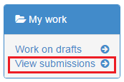

Option 2
If you are already working within the online Portal menu, select Portal at the top of the menu.
Select View Lodged Submissions.
A list of Submissions will be displayed.
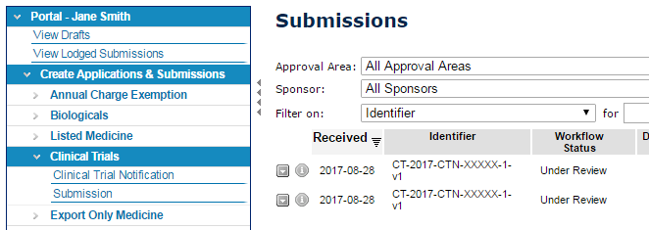
The status of your submitted CTN will be displayed in the Workflow Status column.
Submitted: This means that you have submitted your CTN but payment has not been received. If a fee is not applicable, which is the case for some CTN variations, the status will change from 'Submitted' to 'Under Review' within 24 hours.
Under Review (Being processed): The TGA is processing your submission. This occurs after payment (if applicable). Please note, the status ‘under review’ means that we are checking that the information in the form has been entered correctly and the correct fee has been paid.
Acknowledged: The TGA has confirmed that the information in the form is complete and the correct fee has been paid.
Withdrawn: Your CTN has been withdrawn by the TGA.
Pending Write to Repository: Your CTN is in the process of updating to your Clinical Trials Repository.
If you have submitted a notification and you need to make changes before it is processed, see Editing a submitted form or a push back above.
During processing, we review the CTN form to ensure data is entered correctly. If any corrections are required, the CTN form will be returned to you for editing. See Editing a submitted form or a push back for more information.
When the status of a CTN changes, the sponsor primary contact and alternate contact will automatically receive an email when the status of a CTN changes from:
‘Draft’ to ‘Submitted’
‘Submitted’ to ‘Under Review’
‘Under Review’ to ‘Acknowledged’
For pushbacks, multiple emails are NOT sent out.
NOTE: Item 3 of Schedule 5A of the Therapeutic Goods Regulations 1990 and Item 2.3 of Schedule 4 of the Therapeutic Goods (Medical Devices) Regulations 2002 specify that a clinical trial is deemed to have been notified once the CTN form has been submitted with payment of the relevant fee to the TGA. Once this occurs, the exemption under Section 18(1), 32CA(2) and 41HA of the Therapeutic Goods Act 1989 comes into effect, and the sponsor can supply the goods.

View the Clinical Trials Repository
When the TGA has processed your CTN and no further corrections are required, it will move from the Submissions list to the Clinical Trials Repository.
The two options below can be used to access the Clinical Trials Repository.

Option 1
Access the dashboard as described in How to login.
Select Work on drafts or View submissions under the My work menu on the dashboard.

The online Portal menu will be displayed on the left-hand side. Follow the steps in Option 2 below to access the Clinical Trials Repository.

Option 2
If you are already working within the online Portal menu, select Portal at the top of the menu.
Select Your TGA Information.
Select Clinical Trials Repository.
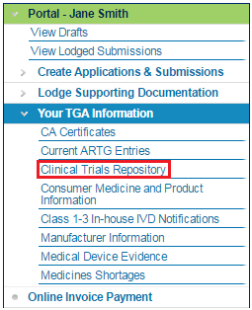
If your CTN appears in the Clinical Trials Repository, then it has been processed by the TGA.
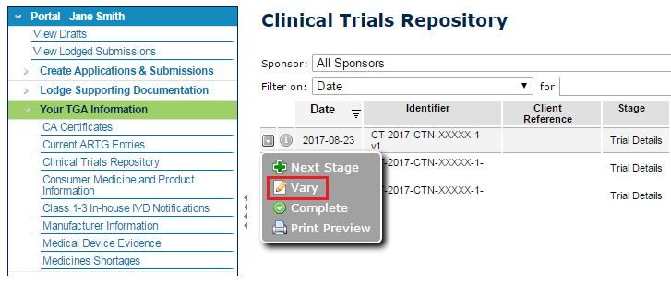
The status of your acknowledged CTN is displayed in the Stage column.
Trial Details: This is a new CTN.
Completion: This is a completed CTN.
Variation: This is a variation to an existing CTN.
Refer to the section Print a TGA acknowledgement below for details on printing a TGA acknowledgement from the Clinical Trials Repository.

Varying trial details
To vary or make changes to a CTN that has been processed by the TGA you will need to access the Clinical Trials Repository. The two options below can be used to access the Clinical Trials Repository.

Option 1
Access the dashboard as described in How to login.
Select Work on drafts or View submissions under the My work menu on the dashboard.
The online Portal menu will be displayed on the left-hand side. Follow the steps in Option 2 below to access the Clinical Trials Repository.

Option 2
If you are already working within the online Portal menu, select Portal at the top of the menu.
Select Your TGA Information.
Select Clinical Trials Repository.
You will then see a list of processed CTNs in the Clinical Trials Repository.
Select the drop-down arrow beside the CTN you want to vary (located at the far left of each CTN - it will turn green when selected), then select Vary.
After selecting Vary, a web page message will appear. Select OK to proceed.
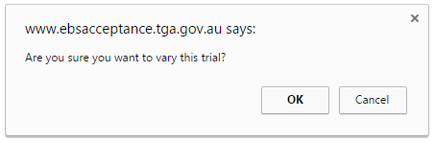
The CTN you wish to vary will then open as a draft.
To make changes to the CTN:
You can make changes to any of the fields displayed in the tab or add new details as required. The information required in each field is the same as described under the Trial details tab above.
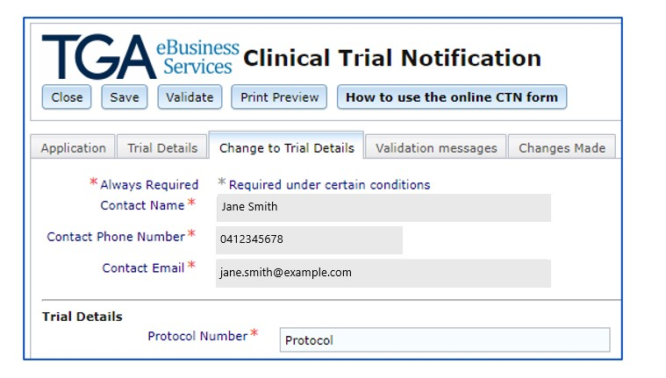
You will need to save and validate the CTN form and then submit the CTN form to us. Refer to the Validation and Submitting sections above.
Certain changes to an existing CTN incur a fee. See Paying for your CTN for more information.
See How to check the status of your CTN for information on checking the status of your CTN.
Once the CTN form has been submitted and paid for, we will review the CTN to ensure data has been entered correctly.

Error messages
If the submission is currently being processed by the TGA you will not be able to vary the trial and the following message will appear. You will need to wait until we have processed the previous submission for you to make a variation.
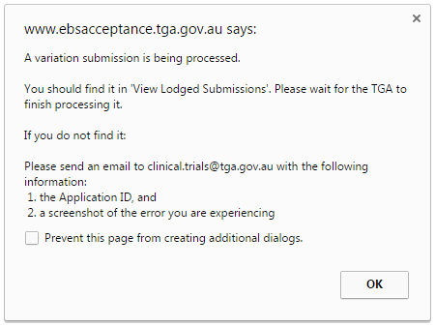
If a draft submission already exists for the CTN, then you will receive the error message below. You will need to find the existing draft in View Drafts.
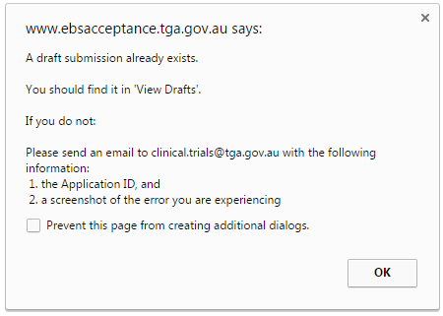

Submitting a completion advice
To submit a completion advice to us, you will need to access the Clinical Trials Repository.
The two options below can be used to access the Clinical Trials Repository.

Option 1
Access the dashboard as described in How to login.
Select Work on drafts or View submissions under the My work menu on the dashboard.
The online Portal menu will be displayed on the left-hand side. Follow the steps in Option 2 below to access the Clinical Trials Repository.

Option 2
If you are already working within the online Portal menu, select Portal at the top of the menu.
Select Your TGA Information.
Select Clinical Trials Repository.
You will then see a list of processed CTNs in the Clinical Trials Repository.
Select the drop-down arrow beside the CTN you wish to complete (located at the far left of each CTN - it will turn green when selected), then select Complete.
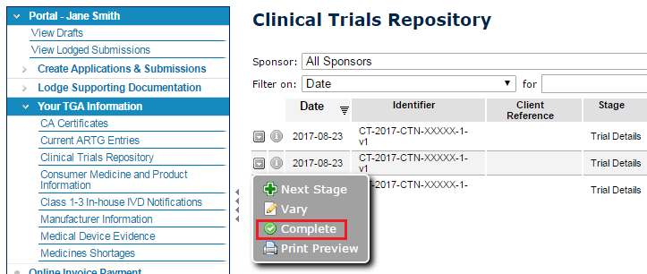
After selecting Complete, a web page message will appear. Select OK to proceed.
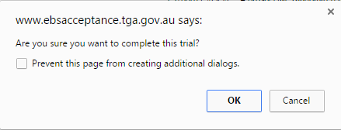
The CTN you wish to complete will then open as a draft.
Select the Completion tab and enter the following details:
Field Name | Information Required
Name* | Name will auto-populate.
Contact Phone Number* | Contact phone number will auto-populate.
Contact Email* | Contact email address will auto-populate.
Date Trial Completed* | Enter the date the trial was completed at all Australian sites in the format dd/mm/yyyy or select from the pop-up calendar.
Completion Reason* | Select the reason for trial closure from the drop-down list.
Note: If you need to make any changes to the CTN before submitting the completion advice, you will need to vary the CTN as described in Varying trial details.
Save and validate your notification and submit the completion advice to us. Refer to Validation and Submitting sections above.
See How to check the status of your CTN for information on checking the status of your CTN.

Printing
You can preview and print the CTN form at any time before or after submitting it.

Print a CTN from within a draft
You can preview and print a draft CTN while you are working on it:
Select the Save button at the top of the form.
Select the Print Preview button at the top of the form.
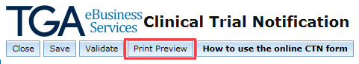
The print preview will open in a new window. Select the Print button at the top to print a copy of the CTN you are working on.
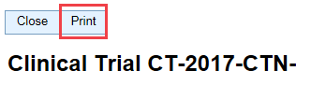

If the print preview does not open up, you may need to allow pop-ups in your browser settings.
If you require further instruction on how to do this, please feel free to contact the Clinical Trials team at clinical.trials@health.gov.au.

Print a CTN from the online portal
Within the online portal, there are three different stages during the CTN submission process at which you can preview and print the submission: Drafts, Lodged Submissions and Clinical Trials Repository.
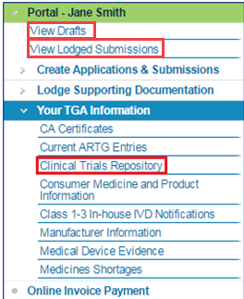
To preview and print a submission you will need to access the relevant area of the CTN form.
To access your list of Drafts see View saved drafts
To access your list of Lodged Submissions see View lodged submissions
To access your Clinical Trials Repository see View the Clinical Trials Repository
Once you have accessed your Drafts/Lodged Submissions/Clinical Trials Repository, select the drop-down arrow beside the CTN you wish to preview and print (located at the far left of each CTN - it will turn green when selected).
Select Print Preview.
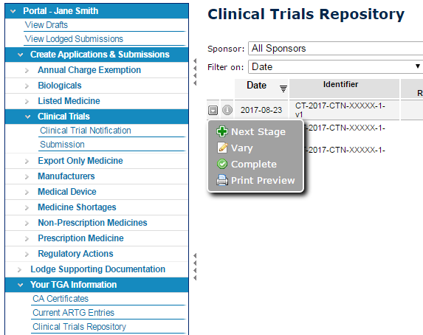
The print preview will open in a new window. Select the Print button at the top to print a copy of the CTN.
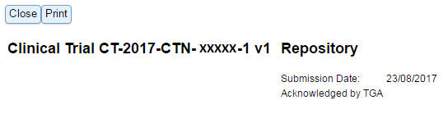
You can then print the CTN as a hard copy. Alternatively, you can create a PDF version by selecting the relevant PDF program (e.g. Adobe PDF) from your printer options.
You can then save this PDF file.
If the print preview does not open up, you may need to allow pop-ups in your browser settings. If you require further instruction on how to do this, please feel free to contact the Clinical Trials team at clinical.trials@health.gov.au.

Print a TGA acknowledgement
Access your Clinical Trials Repository as outlined in View the Clinical Trials Repository.
Select the drop-down arrow beside the CTN you wish to preview and print (located at the far left of each CTN - it will turn green when selected).
Select Print Preview.
The print preview will open in a new window. Select the Print button at the top to print a copy of the CTN.
You can then print the CTN as a hard copy. Alternatively, you can create a PDF version by selecting the relevant PDF program (e.g. Adobe PDF) from your printer options.
You can then save this PDF file.
Please note that the ‘Acknowledged by TGA’ will occur within 2 buisness days of the CTN being processed.
If the print preview does not open up, you may need to allow pop-ups in your browser settings. If you require further instruction on how to do this, please feel free to contact the Clinical Trials team at clinical.trials@health.gov.au.

How to use the online form
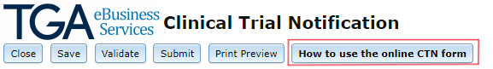
At the top of the online CTN form is the How to use the online CTN form button. This button will link you to the online CTN form user guide (this document) which is available on the TGA website.

Full text of sponsor declaration
Before submitting your application(s), please read the declaration below and click the Accept button to proceed with this submission; or click on the Decline button to return to the Submission form.
In this declaration, unless the contrary intention appears:
I means the individual assigned to the eBS login ID associated with the submission of this form to the TGA.
Secretary means the Secretary of the Department of Health and Aged Care and includes a delegate of the Secretary.
Sponsor means the company, organisation, institution, body or individual that is notifying the TGA as named in the 'Sponsor Name' field located on the application tab of this notification.

Declaration
By clicking the Accept button:
I declare that I am authorised by the sponsor to notify the TGA on its behalf in relation to this clinical trial.
I acknowledge that:
  - the sponsor is taking overall responsibility for the trial
  - the relevant goods only remain exempt by reason of their use in the clinical trial only for so long as:
  - the approval of the goods for the trial has been given by the sponsor (if the sponsor is conducting the trial), or by the body or organisation conducting the trial for the sponsor, having regard to the advice of the ethics committee responsible for monitoring the conduct of the trial, on terms no less restrictive than terms advised by that committee
  - the sponsor has not received advice from the ethics committee that is inconsistent with the continuation of the trial
  - the requirements in regulation 12AD of the Therapeutic Goods Regulations 1990 (in the case of therapeutic goods other than medical devices) and regulation 7.5 of the Therapeutic Goods (Medical Devices) Regulations 2002 (in the case of medical devices) are complied with, including that the use of therapeutic goods in the trial must be in accordance with the Guidelines for Good Clinical Practice and the National Statement on the Ethical Conduct in Research Involving Humans published by the National Health and Medical Research Council, as defined in the Therapeutic Goods Regulations 1990
  - the Secretary has not under Item 3 of Schedule 5A of the Therapeutic Goods Regulations 1990 (in the case of therapeutic goods other than medical devices) or Item 2.3 in Part 2 of Schedule 4 of the Therapeutic Goods (Medical Device) Regulations 2002 directed that the trial not be conducted on the basis that the Secretary has become aware that to conduct the trial would be contrary to the public interest
  - the Secretary can under the Therapeutic Goods Act 1989 (the Act), require the sponsor to provide specified information or documents relating to any exempt goods
  - the Secretary can provide information obtained in response to an authority or the Commonwealth, or a State or Territory that has functions in relation to therapeutic goods or the registration or medical practitioners or pharmacists in the relevant State or Territory
  - it is an offence under the Act to fail to provide that information or documents required by the Secretary, or to provide information or documents that are false or misleading in a material particular, to the Secretary
  - it is a requirement of the Guidelines on Good Clinical Practice that the sponsor report all serious and unexpected adverse reactions arising from the use of the relevant goods in the trial to the TGA
  - it is a serious offence under Commonwealth law to provide information for the purposes of this notification that is false or misleading in a material particular.
I declare that all information provided for the purposes of the notification is true and accurate and that all required information has been included.

Version history
Version | Description of change | Author | Effective date
V1.0 | Original publication | Therapeutic Goods Administration | December 2017
V1.1 | Updated to reflect changes to paying an invoice | Therapeutic Goods Administration | March 2018
V1.2 | Minor enhancements to the current online CTN form such auto-population of contact details, and updated submission process. | Therapeutic Goods Administration | August 2020
V1.3 | Enhancement to current online CTN forms to include high-risk devices and updated submission process | Therapeutic Goods Administration | March 2024
V1.4 | Minor additions to clarify non-mandatory requirement to upload investigational brochure. | Therapeutic Goods Administration | May 2024

