Authorised Prescriber
  - Special Access Scheme & Authorised Prescriber Scheme Online System guidance

Version 1.8, July 2024

Copyright

© Commonwealth of Australia 2024
This work is copyright. You may reproduce the whole or part of this work in unaltered form for your own personal use or, if you are part of an organisation, for internal use within your organisation, but only if you or your organisation do not use the reproduction for any commercial purpose and retain this copyright notice and all disclaimer notices as part of that reproduction. Apart from rights to use as permitted by the Copyright Act 1968 or allowed by this copyright notice, all other rights are reserved and you are not allowed to reproduce the whole or any part of this work in any way (electronic or otherwise) without first being given specific written permission from the Commonwealth to do so. Requests and inquiries concerning reproduction and rights are to be sent to the TGA Copyright Officer, Therapeutic Goods Administration, PO Box 100, Woden ACT 2606 or emailed to <tga.copyright@tga.gov.au>.

Contents
Online system overview 5
Terminology and definitions 5
Features of the SAS & AP Online System 6
Account management 6
Account registration 7
Medical practitioners 11
Change password 11
Forgotten your password 13
Updating account information 16
SAS/AP validation search tool 17
User dashboard 18
Authorised prescriber dashboard 18
Authorised prescriber reports 19
Submitting AP applications 20
Step 1: Prescriber details 21
Step 2: Product 22
Step 3: Approval/endorsement 25
Step 4: ARTG product consideration 26
Step 5: Summary 27
Submitting nicotine AP application 27
Step 1: New nicotine authorised prescriber application 28
Step 2: Submit a nicotine authorised prescriber application 29
Completed applications 31
Status of draft and completed applications 32
Downloading application receipts and outcome letters 33
System features 34
Cloning applications 34
Filtering dashboard information 34
Exporting submission data 36
Managing applications where consent to publish has been provided 37
Submitting six monthly patient data 38
TGA contact details 40

Online system overview
The Special Access Scheme (SAS) & Authorised Prescriber (AP) Online System (SAS & AP online system) allows medical practitioners to submit AP applications. The SAS & AP Online System is designed to reduce administrative burden and provide medical practitioners additional reporting and management functions to assist in the management of their AP applications.
This document provides information on how to register an account and submit AP applications and six monthly patient data reports via the SAS & AP Online System (the system).
If you wish to access information regarding the submission of SAS applications and notifications via the online system, please refer to the Special Access Scheme (SAS) Online System Guidance.
For information regarding the Authorised Prescriber Scheme, please refer to the Authorised Prescriber Scheme Guidance for Medical Practitioners, Human Research Ethics Committees, Specialist Colleges and Sponsors.

Terminology and definitions
Terminology | Definition
Account | Upon successful registration in the system, each user will have created an ‘account’ which is accessible using their credentials (username and password) selected as part of the registration process.
Outcome letter | The Approval or Rejection letter provided by the TGA in response to an Authorised Prescriber application.
Receipt | A copy of the AP application form which can be downloaded via a user’s dashboard.
Request for Information (RFI) | The process by which the TGA requests additional information to be provided by the user after submission of an application.

Features of the SAS & AP Online System
- Medical practitioners are required to register an account before they can begin drafting and submitting AP applications to the TGA.
- A searchable database of products (medicines, medical devices and biologicals) is available for users to select.
- Users have a dashboard within their account to:
  - Track the status of their application.
  - Search for previously submitted applications using parameters such as product, submission date and status (i.e. approved, rejected, withdrawn, completed).
  - Download a PDF copy of the application receipt.
  - Identify applications that are expiring or that have expired.
  - Download a copy of the TGA decision letter.
  - Clone (copy) previously submitted AP submissions.

Account management

Account registration
All users of the system are required to register a personal account. Unlike the Special Access Scheme Dashboard, only medical practitioners are able to access the Authorised Prescriber Dashboard and submit AP applications. As part of this registration process, users are required to provide the following information to successfully register an account:
- A new, unique username; password; email address (for the purposes of account registration).
- Personal information such as full name; health practitioner type; AHPRA registration number; and contact details (this will be used to populate the user’s profile).
Note: users who have registered with other systems hosted by the TGA should login (rather than register) using the username and password to which they registered with the first TGA system.
- In order to register a personal account, select Special Access Scheme (SAS) from the Regulatory and Compliance Portal home page.
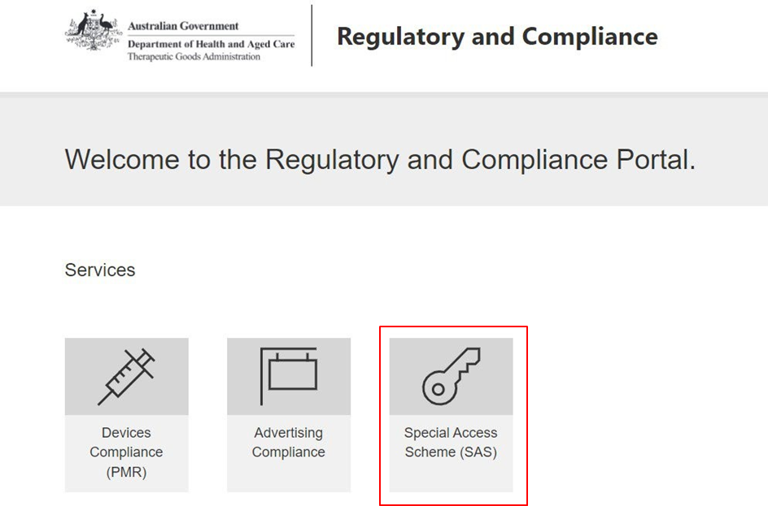

- Select Register Now
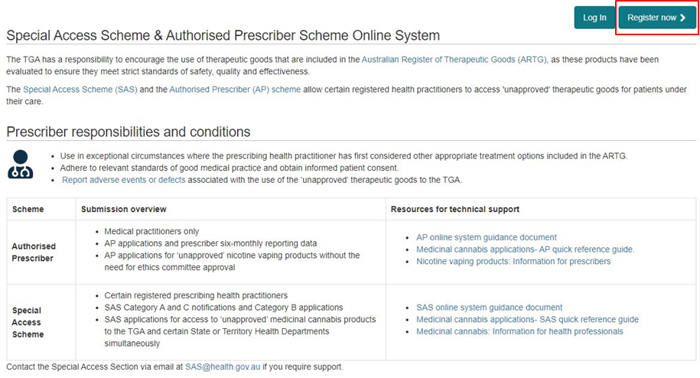

- Provide a new, unique username; password; email address (for the purposes of account registration).
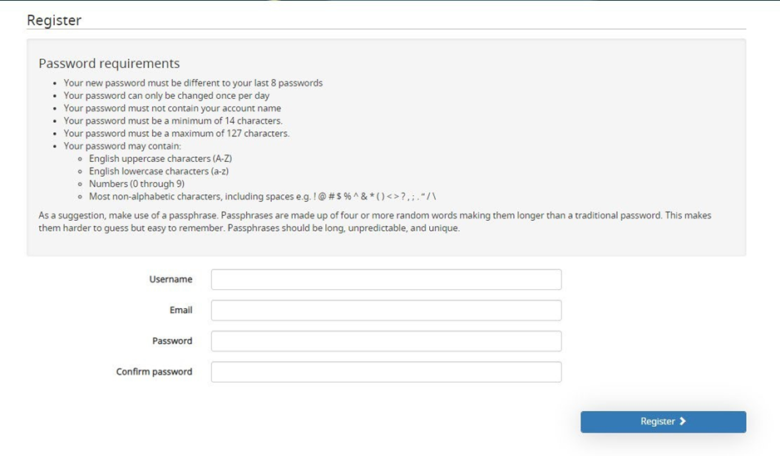
- A registration confirmation email will be sent to your nominated email address:


- Click on the hyperlink in the email (note this link will expire in 24 hours after receiving this email):
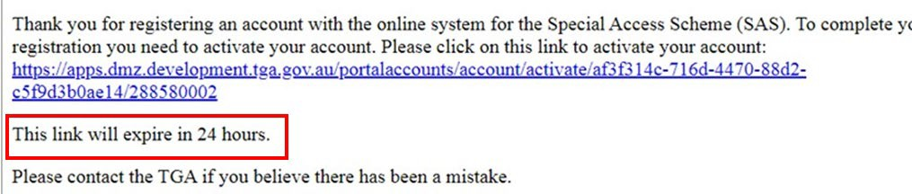

- Log in with your username and password
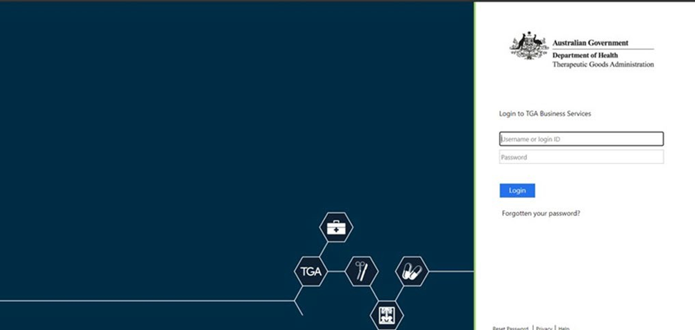

- Complete your profile information. Your account registration is not finalised until you complete this step and you will not be able to submit applications/notifications.
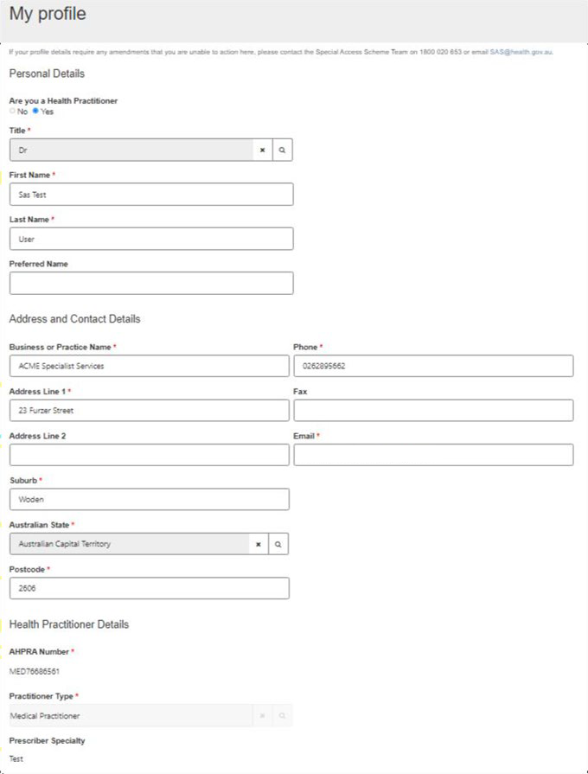

Medical practitioners


Unlike the Special Access Scheme Dashboard, only medical practitioners are able to access the Authorised Prescriber Dashboard and submit AP applications.
Upon registration of an account, medical practitioners will have the ability to draft and submit AP applications to the TGA. In the account registration process, users will be presented with the following question to determine their health practitioner status:

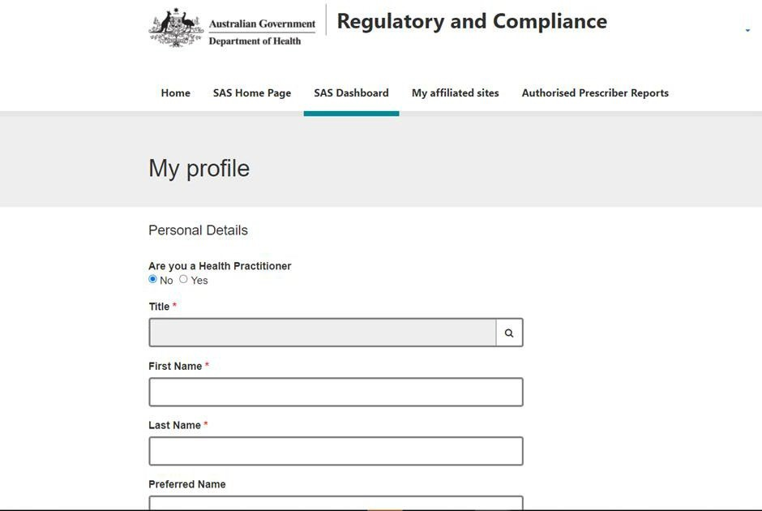
Medical practitioners registering an account in the system will be asked to provide their AHPRA registration number. The AHPRA registration number should be entered exactly as it appears in the AHPRA public register, including the three letter prefix (i.e. MED1234567890).

Change password
Passwords will expire every 90 days. This is as per security requirements policy of the Department of Health.
- Select the ‘Change password’ option from the dropdown menu in your user profile. Alternatively, this can also be done when attempting to login to the system
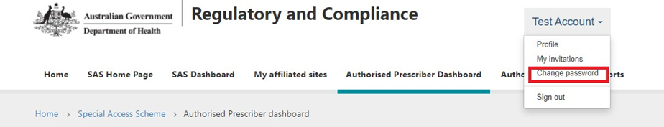
- Enter your new password
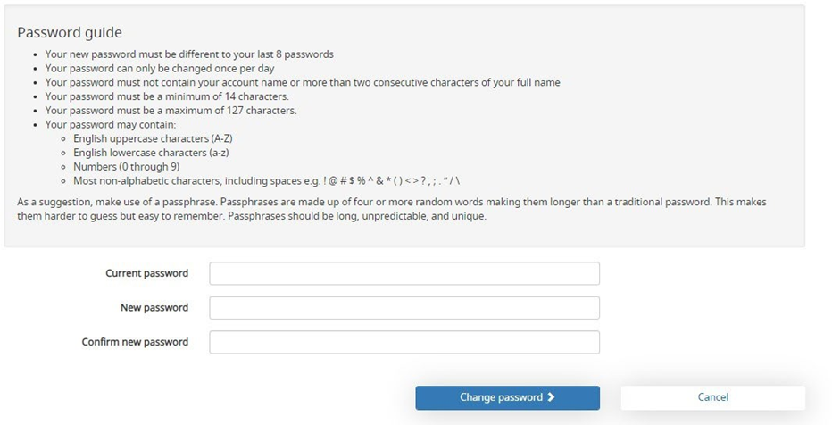
Note: Passwords cannot be reset or changed more than once in a 24 hour period.
If you are locked out of your account for 24 hours, please do not attempt to reset the password until after the time has lapsed otherwise the lockout period will be restart. Once the lockout has lapsed follow the steps to reset your password.

Forgotten your password
- If you have forgotten your password, select “log in”
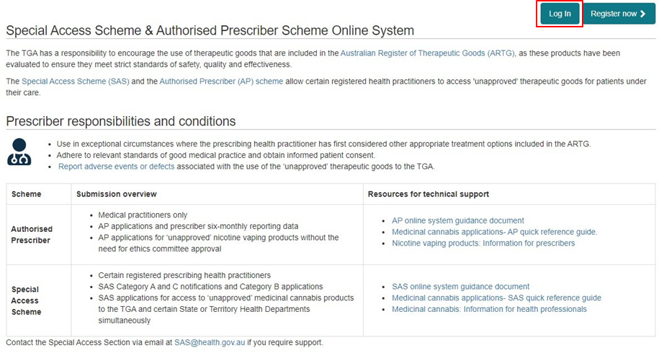

- Select – “Forgotten your password?”
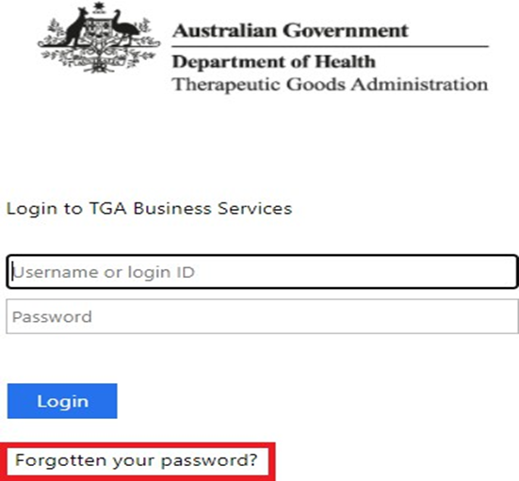

- Enter your username and select “reset”
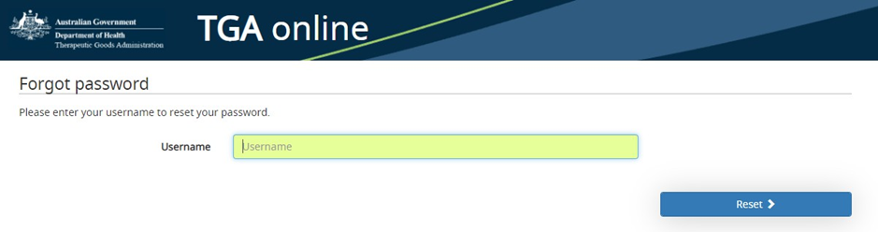
- A password reset email will be sent to the email address associated with your username.
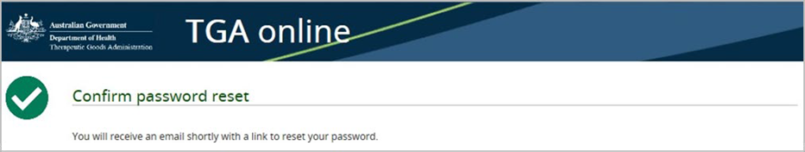

- Click on the hyperlink provided to reset your password (note this link will expire in 24 hours after receiving this email)
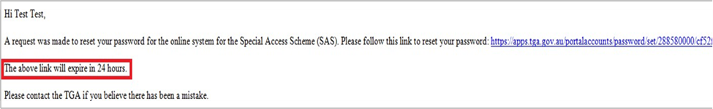

- Enter your new password
Note: Passwords cannot be reset or changed more than once in a 24 hour period.
If you are locked out of your account for 24 hours, please do not attempt to reset the password until after the time has lapsed otherwise the lockout period will be restart. Once the lockout has lapsed follow the steps to reset your password.

Updating account information
Once an account has been registered in the system, users will be able to update the information associated with their account (such as name, contact details, adding or removing practicing locations etc.) by updating their user profile:
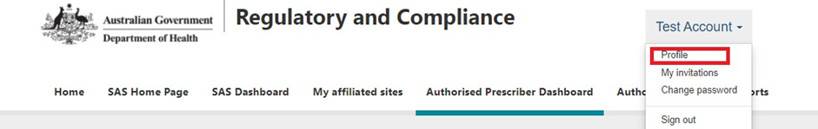

SAS/AP validation search tool
Health practitioners can use the SAS/AP submission validation search to view real-time information relating to the TGA status of SAS and AP submissions. If there is an active TGA authorisation or notification, the search tool will display the status of the submission and other relevant information.
If the search does not return any results, then the prescriber should be contacted. To access the validation tool:
- Open SAS & AP online system, login at the top right-hand corner.
- Click the ‘SAS/AP Submission Validation’ tab on the right-hand side
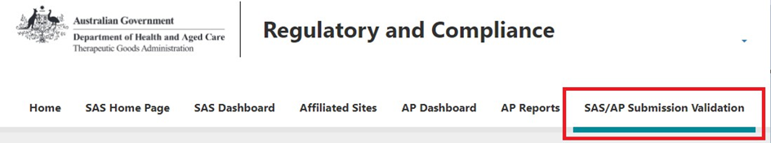

- Enter the submission number provided by the prescriber and click ‘Search’
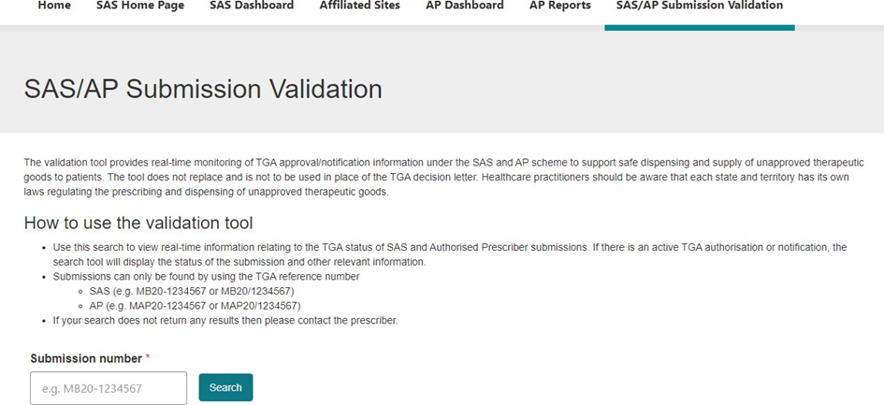
- If the approval/notification is valid you will be shown the relevant details of the submission including its status. If the submission is no longer valid or does not exist, an error message will appear. In these cases, please contact the prescriber.

User dashboard
All users who have registered an account in the system will have a personal SAS dashboard displaying details of their SAS applications and notifications drafted or submitted via the system. This is the default landing page when you log into the system.

Authorised prescriber dashboard
Users who are registered as medical practitioners will have an additional dashboard called ‘Authorised Prescriber Dashboard’. In order to view information specific to AP applications that have been drafted and submitted in the online system, users will need to select the Authorised Prescriber Dashboard from the ribbon.
Once selected, the Authorised Prescriber dashboard will appear as below. Additional features of the dashboard are discussed further in the ‘System Features’ section:
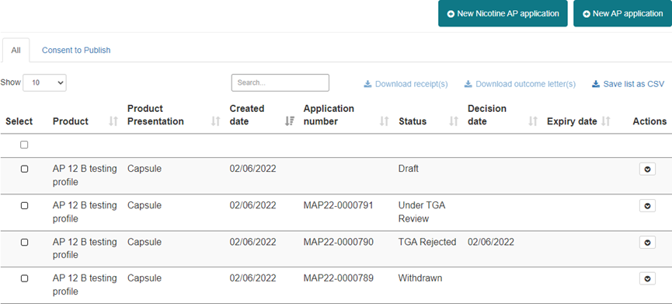

Authorised prescriber reports
Users who are registered medical practitioners will have an additional dashboard called ‘Authorised Prescriber Reports’. Users can submit six monthly patient data directly into the reports available by selecting the Authorised Prescriber Reports from the ribbon.
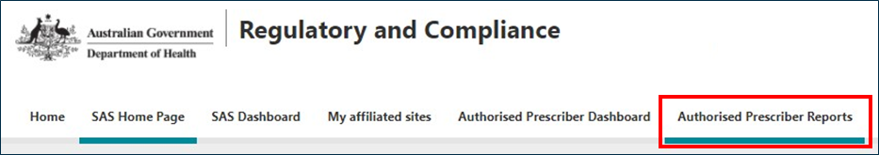
Once selected, the Authorised Prescriber reports will appear as below with the draft report for each reporting period. A reminder for outstanding reports will appear on your AP dashboard. A reminder email will also be sent to your nominated email address.
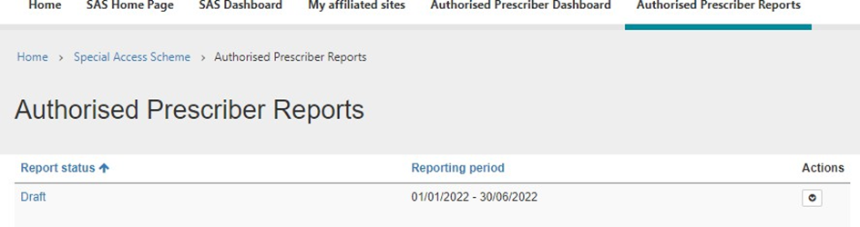

Submitting AP applications
The online system guides medical practitioners to provide the correct information when seeking Authorised Prescriber approval.
To start a new AP application, go to your AP dashboard and select ‘New AP application’:
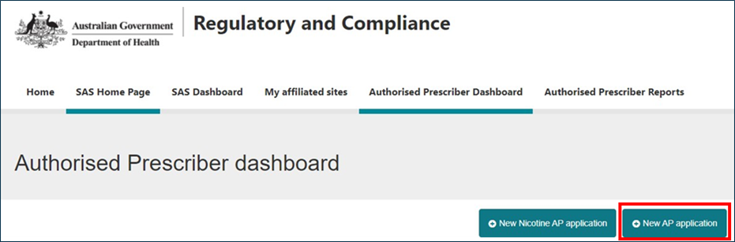

Step 1: Prescriber details
The prescriber details are pre-populated from the details in your account. For instructions on how to update your account details, please refer to the ‘Updating account information’ section. Please provide a preferred contact email to which all correspondence regarding this application will be sent. Both ‘Email 1’ and ‘phone number’ are mandatory fields.
1. Confirm your details.
The prescriber details are pre-populated from the details in your account. For instructions on how to update your account details, please refer to the ‘Updating account information’ section. Please provide a preferred contact email to which all correspondence regarding this application will be sent. Both ‘Email 1’ and ‘phone number’ are mandatory fields.
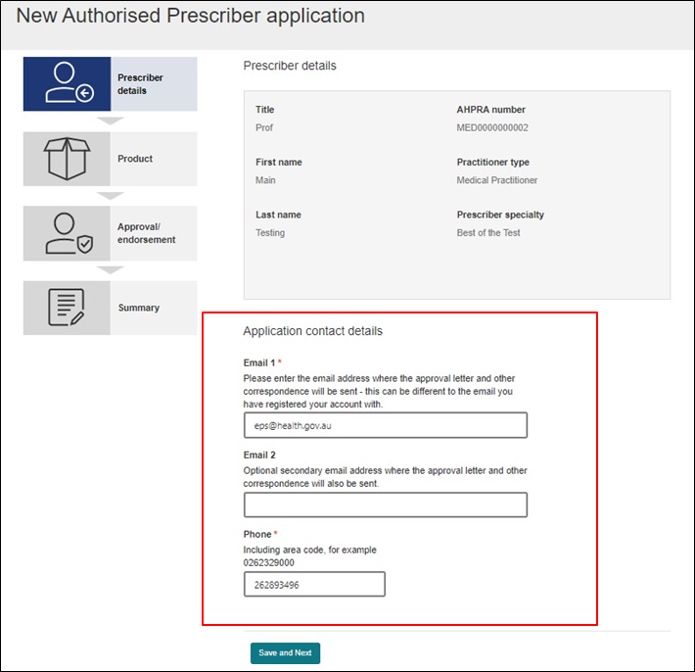

Step 2: Product
- Select the type of unapproved therapeutic good.
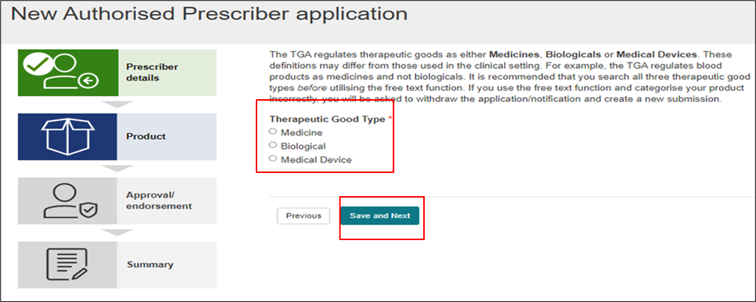
- After selecting the type of therapeutic good, the user will be prompted to select whether the product is included in the TGA’s list of medicines with an established history of use as specified in subregulation 12B(1B) or 12B(1C) of the Therapeutic Goods Regulations 1990. Please only select the unapproved good with an established history of use if the medicine/dosage form and indication is included in the above list. For all other unapproved goods please select ‘Any other unapproved therapeutic good’.
The user must then select the active ingredient, dosage form and indication. A look-up function is available to search TGA’s internal database of existing entries as shown below:
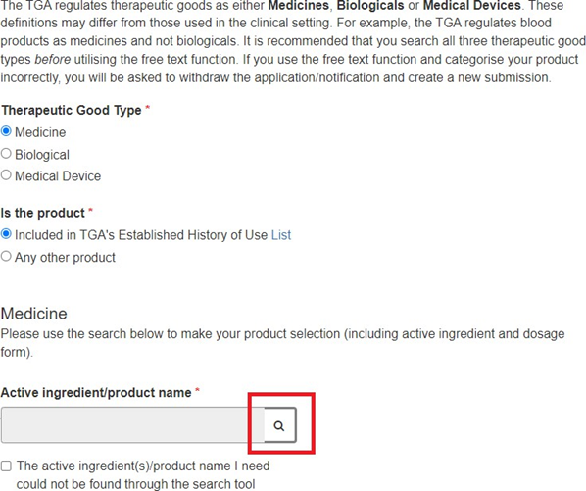

- Use the search bar to identify the active ingredient or product. To search on partial text, use the asterisk (*) wildcard character:
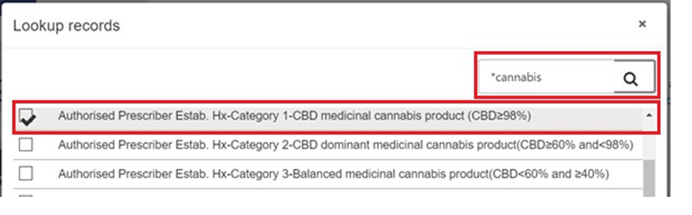
- If you are unable to identify the required information via the look-up function, select the check-box below the search field. This will allow users to manually enter details of the product. Please do not use the free text option for a medicinal cannabis product or a product listed in the 12B(1B) or 12B(1C) established history of use pathway. All of these products have a profile in the online database.
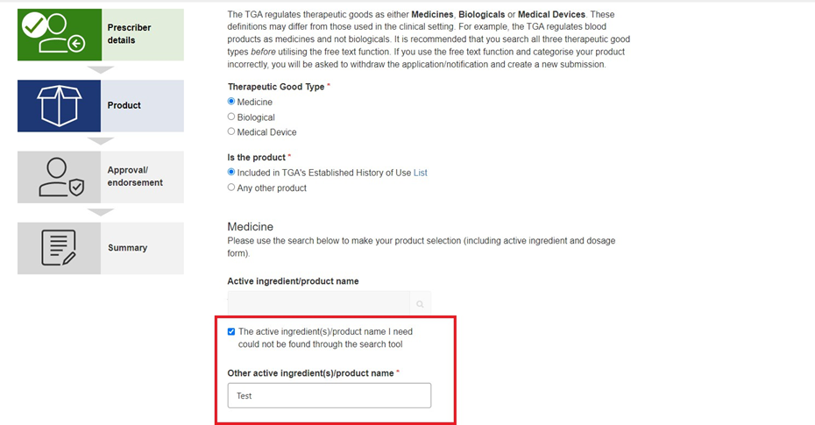
- The user is then prompted to provide details of dosage form, presentation or model number as well as details of the trade name and Sponsor if known. Please note that for medical devices, trade name and Sponsor/supplier details are mandatory. Product strength, trade name and sponsor/supplier details are not mandatory fields for medicinal cannabis.
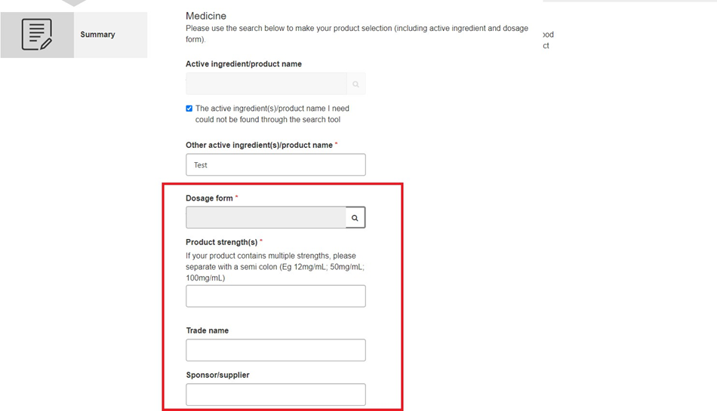

- The user is able to upload or free-text any additional information that may support their application. This can include, but is not limited to Instructions for Use (IFU) or Product Information.
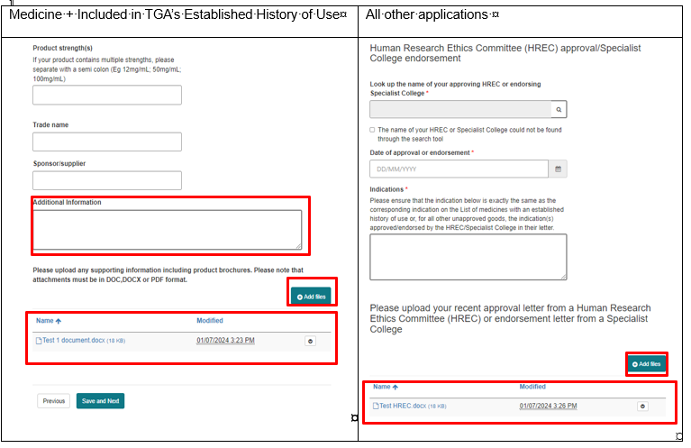

Step 3: Approval/endorsement
- Complete the ‘Indications’ field exactly as per the corresponding indication in the List of medicines with an established history of use; the indication(s) endorsed by the HREC or Specialist College in the approval letter. This is mandatory information.
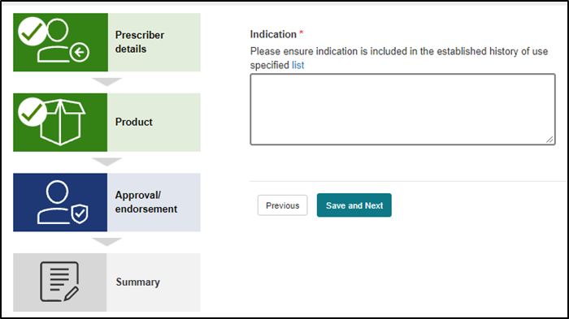

Step 4: ARTG product consideration
- Confirm that you will consider appropriate treatment options included in the Australian Register of Therapeutic Goods (ARTG) before supplying an “unapproved” good via the Authorised Prescriber Pathway for your patient.
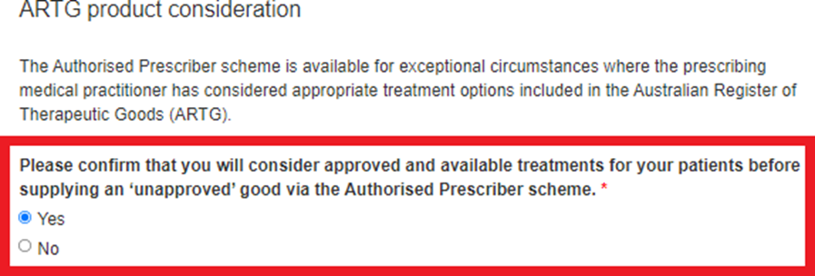

Step 5: Summary
- Acknowledge that you have read and understood the following disclaimer to submit the AP application to the TGA:
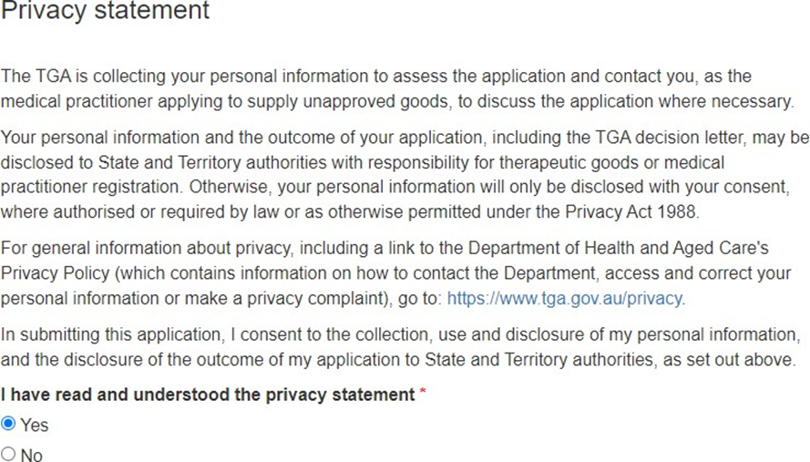

Submitting nicotine AP application
The online system provides a streamlined application process for medical practitioners to apply to be an Authorised Prescriber for unapproved nicotine products. The system guides medical practitioners to provide the correct information when seeking Nicotine Authorised Prescriber approval.

Step 1: New nicotine authorised prescriber application
To start a new Nicotine AP application, go to your AP dashboard and select ‘New Nicotine AP application’.
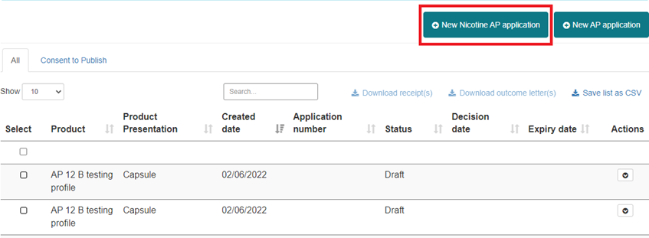

Step 2: Submit a nicotine authorised prescriber application
- The system will prefill the dosage form and indication based on the list of medicines with an established history of use.
- Read the consent to online publication of personal information section and select “Yes” or “No” for publishing the name of prescriber and practice details on the TGA website.

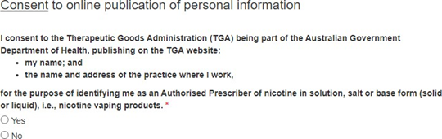
- If the user selects “Yes” for publication of information on the TGA website, the system will generate additional fields to be completed.
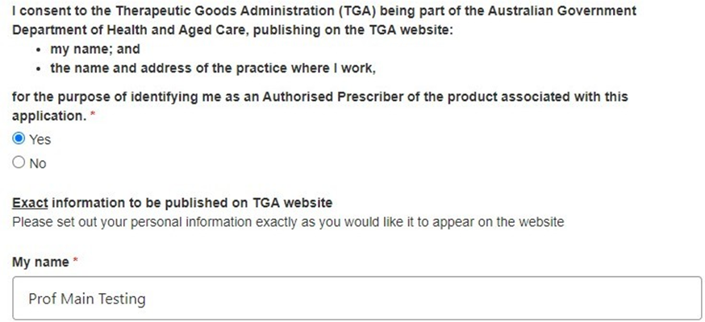

- The user has the option of providing a physical address or an online address for publication.
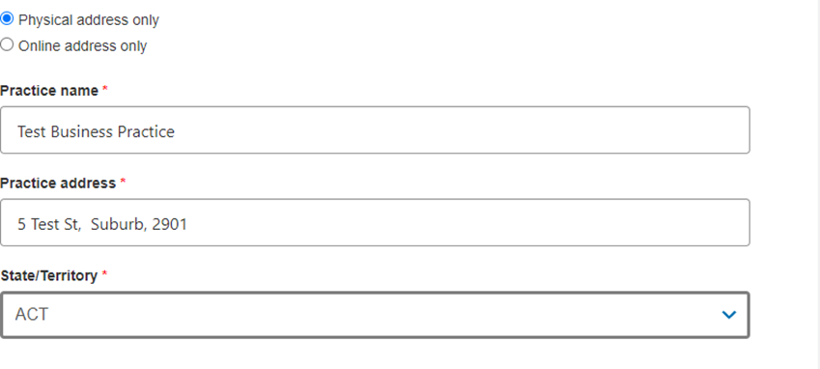
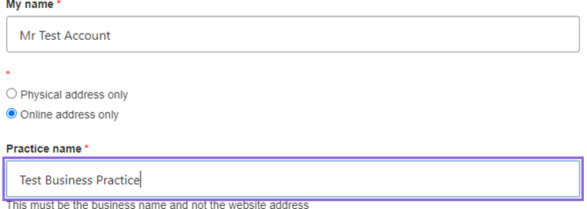
- Confirm that you will consider appropriate treatment options included in the Australian Register of Therapeutic Goods (ARTG) before supplying an “unapproved” good via the Authorised Prescriber Pathway for your patient.
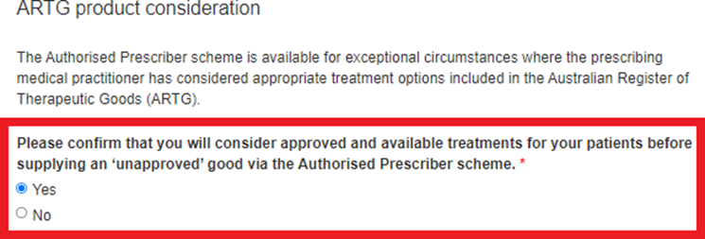
- Read the privacy statement and select “Yes” if you are satisfied.
- Submit your application by clicking “Submit”.
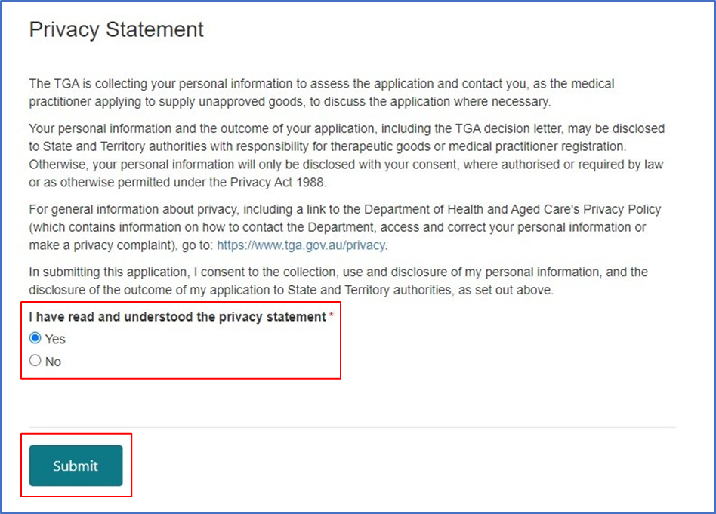

Completed applications

Status of draft and completed applications
All AP applications drafted or submitted via the system will appear in the AP Dashboard and include the current ‘status’ of the application.
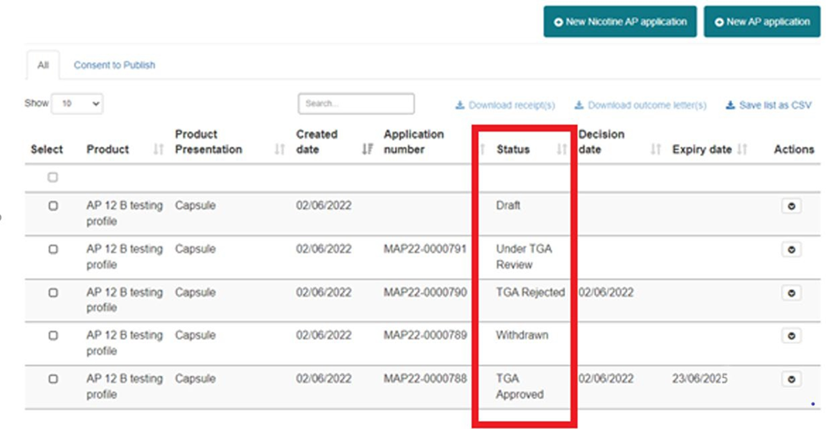
Status | Description
‘TGA Approved’ | Reflects TGA’s approval of an AP application.
‘TGA Rejected’ | Reflects TGA’s rejection of an AP application.
‘Under TGA Review’ | An AP application has been successfully submitted to the TGA, and a decision is pending or the TGA have received an application amendment and the application is being updated
‘Withdrawn’ | Reflects that an AP application that has been submitted via the system and subsequently withdrawn at the request of the  applicant.
‘Draft’ | Reflects a preliminary version of an AP application that has not yet been submitted via the system.
‘Expired’ | AP applications are only valid for specific period of time. The application status will change to expired once it has reached  the expiry date and the approval will no longer be valid.

Downloading application receipts and outcome letters
Application receipts may be downloaded once an application is submitted. Outcome letters may be downloaded following a TGA decision. Application receipts and outcome letters may be downloaded for individual applications or for multiple applications at a time.
To download application receipts and outcome letters, select the applications you wish to download the documents for in the left-hand column. Then select the report you wish to generate, either ‘Download receipt(s)’ or ‘Download outcome letter(s)’. These functions are shown in red below.
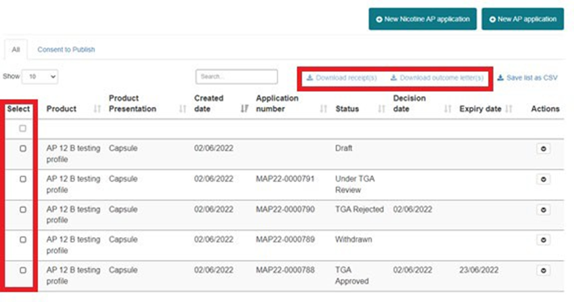

System features

Cloning applications
All AP submissions visible in a user’s dashboard can be cloned. The purpose of this function is to reduce the administrative burden of re-entering identical information into renewal submissions, or submissions for alternate dosage forms, etc.
When cloning a submission, previously entered information will be used to prepopulate a new draft AP application. It is the responsibility of the submitter to review the information copied into the cloned submission to ensure that the correct information is provided to the TGA.
Please be aware that the following information will not be prepopulated into the new draft by the cloning function, and will need to be provided before submitting to the TGA:
- Any attachments uploaded to the original submission (including letter of approval/endorsement).
- Answer to the privacy statement on the Summary step (‘yes/no’)
To clone an application, identify the submission that needs to be cloned by filtering in the user dashboard; click the ‘Actions’ tab and select ‘Clone’ from the dropdown:
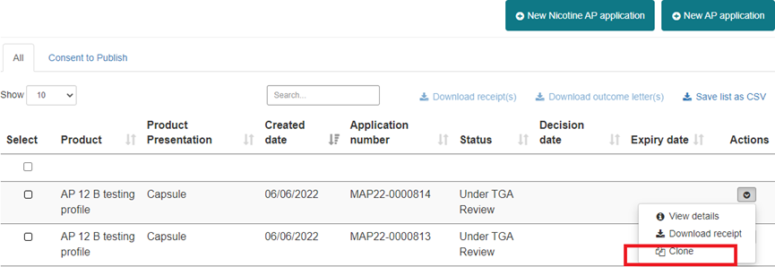

Navigate through the workflow and provide/update any relevant information specific to the new AP application before submitting to the TGA.

Filtering dashboard information
- The dashboard allows users to search and filter submissions based on the fields shown below:
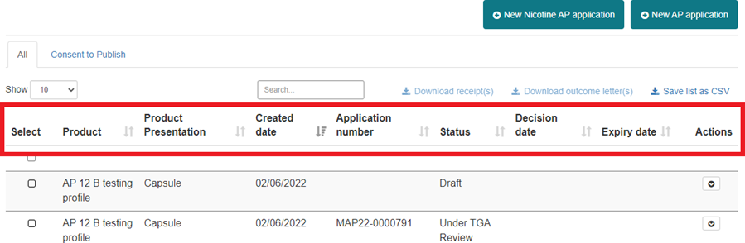
- Users can also apply a uniform search across all available data fields by typing in the ’search’ box:
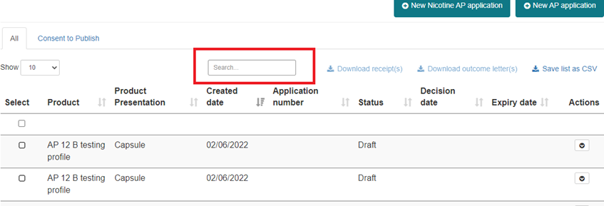

Exporting submission data
- Selecting submissions and clicking the ‘Save list as CSV’ link will download a local .csv copy of the available data fields contained in the dashboard for those submissions as shown below:
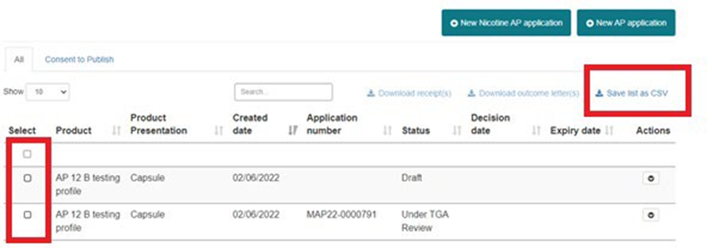

Managing applications where consent to publish has been provided
- On the dashboard there is a separate tab entitled ‘Consent to Publish’. This displays applications where consent can be provided to have prescriber details published on the TGA website. If an application exists for an eligible product it will display in this view.
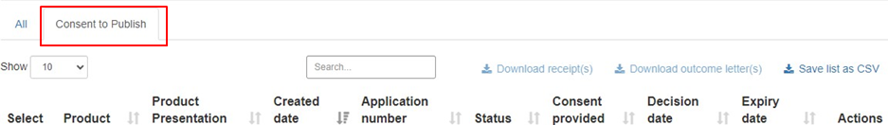

- Users have the ability to edit their response to the consent fields within the application by clicking ‘Manage consent’
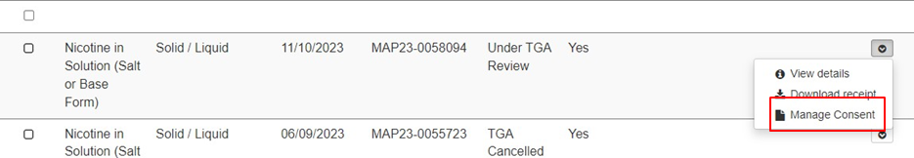
- Update the necessary fields
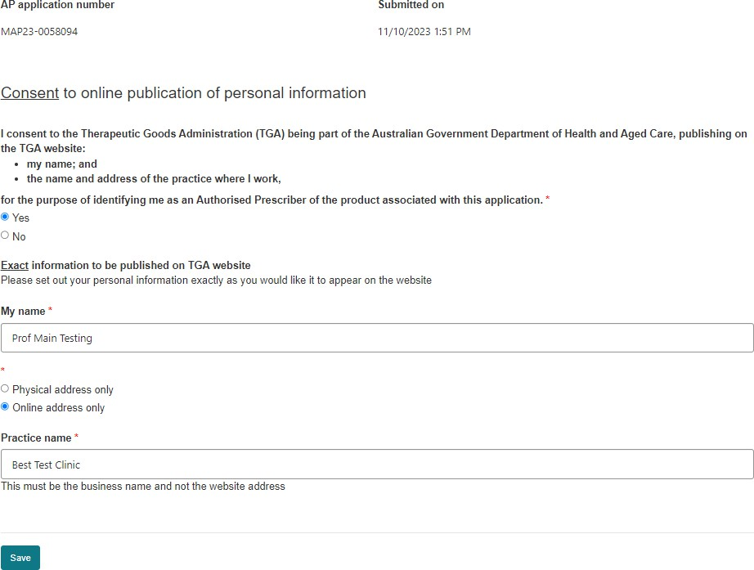

Submitting six monthly patient data
The online system guides medical practitioners to provide six monthly patient data.
- Go to the ‘Authorised Prescriber Reports’ to submit your six monthly patient data.
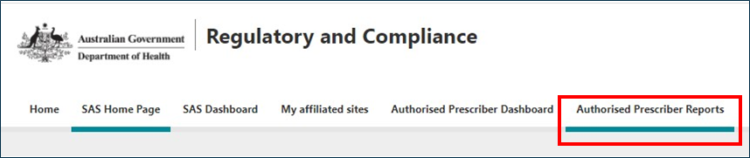
- Refer to the report for the current reporting period and select ‘Edit’.
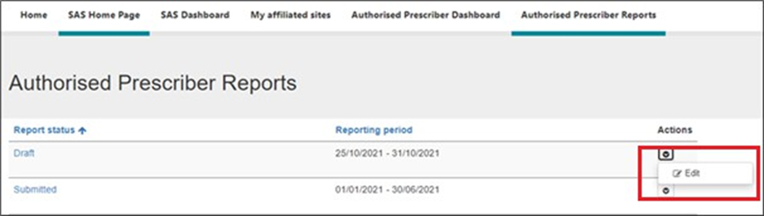
- To enter your patient data, select ‘Edit’ against the appropriate AP approval number/product.
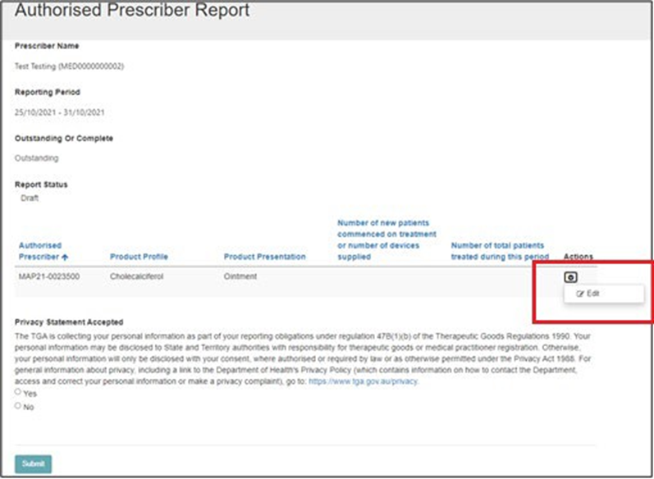

- Enter the ‘Number of new patients commenced on treatment or number of devices supplied’ during the six month period and the total ‘Number of total patients treated during this period,’ even if this number is zero. Note: Total patients is new patients plus patients who have been continued on treatment.
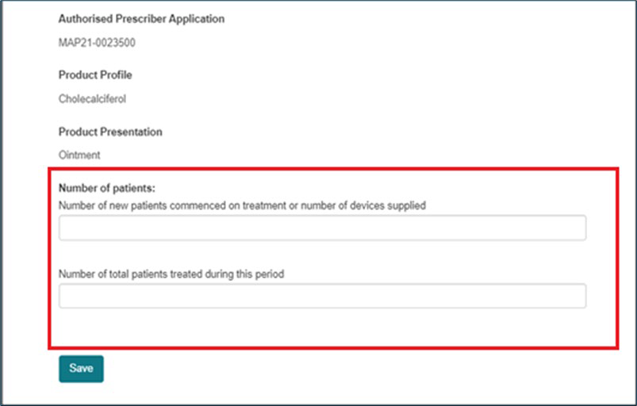
- You will be unable to submit your report until all fields have been completed. This includes adding zero in the fields where no unapproved products have been prescribed.
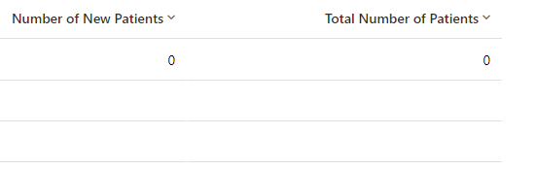
- Select ‘Yes’ once you have read the privacy statement and click ‘Submit’.
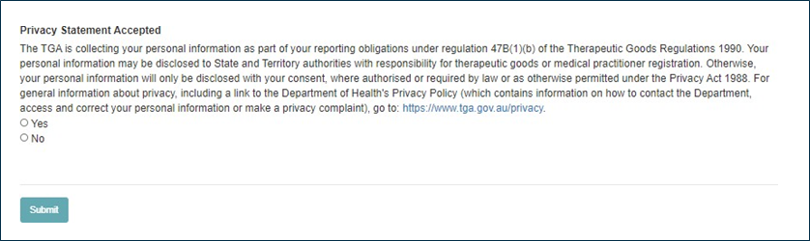

TGA contact details
Gather the following information before you ask for help with the SAS and AP Online System:
- description or screenshot of error
- submitting practitioner's name
- username for SAS and AP Online System
- email address used for SAS and AP Online System
- AHPRA number
- web browser used (for example Chrome or Edge)
- SAS/AP reference number (if applicable).
To get help email the above information to SAS.Support@health.gov.au.

Version history
Version | Description of change | Author | Effective date
V1.0 | Original publication | Experimental Products Section (EPS); Pharmacovigilance and Special Access Branch (PSAB)
V1.1 | Guidance updates based on system changes. | Experimental Products Section (EPS); Pharmacovigilance and Special Access Branch (PSAB) | 22 April 2021
V1.2 | Guidance updates based on new six-month reporting form | Experimental Products Section (EPS); International Regulatory Branch (IRB) | December 2021
V1.3 | Guidance updated based on system changes. | Experimental Products Section (EPS); International Regulatory Branch (IRB) | March 2021
V.1.4 | Guidance updated based on system changes. | Special Access Section (SAS); International Regulatory Branch (IRB) | June 2022
V1.5 | Guidance updated based on system changes | Special Access Section (SAS); International Regulatory Branch (IRB) | October 2023
V1.6 | Guidance updated based on system changes | Business Improvements and Compliance Section (BICS); International Regulatory Branch (IRB) | February 2024
V1.7 | Guidance updated based on system changes | Business Improvements and Compliance Section (BICS); International Regulatory Branch (IRB) | March 2024
V1.8 | Guidance updated for clarification | Business Improvements and Compliance Section (BICS); International Regulatory Branch (IRB) | July 2024

