This medicinal product is subject to additional monitoring in Australia. This will allow quick identification of new safety information. Healthcare professionals are asked to report any suspected adverse events at www.tga.gov.au/reporting-problems.
▼

AUSTRALIAN PRODUCT INFORMATION

ANDEXXA® (andexanet alfa) powder for solution for infusion

Name of the medicine
Andexanet alfa.

Qualitative and quantitative composition
Each 20 mL vial contains 200 mg of andexanet alfa.
After reconstitution, each 1 mL of solution contains 10 mg of andexanet alfa.
For the full list of excipients, see Section 6.1 List of excipients.

Pharmaceutical form
Powder for solution for infusion.
Sterile, white to-off-white lyophilised powder.
After reconstitution of the lyophilised powder with sterile water for injection the product is a clear, colourless to slightly yellow solution.

Clinical particulars

Therapeutic indications
ANDEXXA (andexanet alfa) has provisional approval in Australia for adult patients treated with a direct factor Xa (FXa) inhibitor (apixaban or rivaroxaban) when reversal of anticoagulation is needed due to life-threatening or uncontrolled bleeding.
The decision to approve this indication has been made on the basis of haemostatic efficacy and reduction in anti-FXa activity. Continued approval of this indication depends on verification and description of benefit in a confirmatory trial.

Dose and method of administration

Dosage
ANDEXXA is administered as an intravenous (IV) bolus at a target rate of approximately
30 mg/min over 15 minutes (low dose) or 30 minutes (high dose), followed by administration of a continuous infusion of 4 mg/min (low dose) or 8 mg/min (high dose) for 120 minutes (see Table 1). The continuous infusion is to be administered within two minutes following the bolus dose.
The safety and efficacy of additional doses have not been established.
Table 1 Dosing regimens

Dose | Initial IV bolus | Continuous IV infusion | Total number of 200 mg vials
Low dose | 400 mg at a target rate of 30 mg/min | 4 mg/min for 120 minutes  (480 mg) | 5  (2 vials bolus + 3 vials infusion)
High dose | 800 mg at a target rate of 30 mg/min | 8 mg/min for 120 minutes  (960 mg) | 9  (4 vials bolus + 5 vials infusion)
Abbreviation: IV = intravenous

Reversal of apixaban or rivaroxaban
The recommended dosing of ANDEXXA is based on the specific FXa inhibitor, last dose of FXa inhibitor, and time since the last dose of FXa inhibitor (see Table 2 and 3).
Table 2 Summary of dosing for reversal of apixaban

FXa inhibitor | Last dose | Time since last dose before  initiation of ANDEXXA
FXa inhibitor | Last dose | <8 hours or unknown | ≥8 hours
Apixaban | ≤5 mg | Low dose | Low dose
Apixaban | >5 mg or unknown | High dose | Low dose

Table 3 Summary of dosing for reversal of rivaroxaban

FXa inhibitor | Last dose | Time since last dose before  initiation of ANDEXXA
FXa inhibitor | Last dose | <8 hours or unknown | ≥8 hours
Rivaroxaban | ≤10 mg | Low dose | Low dose
Rivaroxaban | >10 mg or unknown | High dose | Low dose

Treatment with andexanet alfa should not be administered if more than 18 hours has elapsed since the last dose of apixaban or rivaroxaban

Restarting antithrombotic therapy
Patients being treated with FXa inhibitors have underlying disease states that predispose them to thromboembolic events. Reversing FXa inhibitor therapy exposes patients to the thrombotic risk of their underlying disease. To reduce this risk, resumption of anticoagulant therapy should be considered as soon as medically appropriate.

Method of administration
For intravenous (IV) use only.
After an appropriate number of vials of ANDEXXA has been reconstituted, the reconstituted solution (10 mg/mL) without further dilution is transferred to sterile large volume syringes in case a syringe pump is used for administration, or to suitable empty IV bags comprised of polyolefin (PO) or polyvinyl chloride (PVC) material. Prior to administration by IV infusion, a 0.2 or 0.22 micron in-line polyethersulfone (PES) or equivalent low protein- binding filter should be used.
ANDEXXA is administered as an IV bolus at a target rate of approximately 30 mg/min, followed by administration of a continuous IV infusion for 120 minutes (see Table 1). The continuous infusion is to be administered within two minutes following the bolus dose.
For instructions on reconstitution of the medicinal product before administration, see below.

Reconstitution
The following are needed before starting reconstitution:
- Calculated number of vials (see Table 1 and 2 or 3).
- Same number of 20 mL (or larger) solvent syringes equipped with a 20 gauge (or larger) needle.
- Alcohol swabs.
- Large (40 mL or larger) sterile syringe. If a syringe pump is used for administration, multiple syringes should be used to contain the final volume of reconstituted product.
- Empty intravenous polyolefin (PO) or polyvinyl chloride (PVC) bags (250 mL or less) to contain the final volume of reconstituted product (if administration is performed with an IV bag).
- Water for injection.
- 0.2 or 0.22 micron in-line polyethersulfone (PES) or equivalent low protein-binding filter.
ANDEXXA does not need to be brought to room temperature (≤25°C) before reconstitution or administration to the patient. Aseptic technique during the reconstitution procedure should be used. Product is for single use in one patient only. Discard any residue.
Each vial is reconstituted according to the following instructions:
- Remove the flip-top from each vial.
- Wipe the rubber stopper of each vial with an alcohol swab.
- Using a 20 mL (or larger) syringe and a 20 gauge (or larger) needle, withdraw 20 mL of water for injection.
- Insert the syringe needle through the centre of the rubber stopper.
- Push the plunger down to slowly inject the 20 mL of water for injection into the vial, directing the stream toward the inside wall of the vial to minimise foaming.
- Gently swirl each vial, until all of the powder is completely dissolved. DO NOT SHAKE the vials as this can lead to foaming. The dissolution time for each vial is approximately 3 to 5 minutes.
- The reconstituted solution should be inspected for particulate matter and/or discolouration prior to administration. Do not use if opaque particles or discolouration are present.
- For the most efficient reconstitution of the needed dose, and to minimise errors, inject each vial needed with 20 mL of water for injection before proceeding to the next step.
- Reconstituted ANDEXXA in vials is stable at room temperature (≤25°C) for up to 8 hours, or may be stored for up to 24 hours at 2°C to 8°C.

Administration using a syringe pump
- Once all required vials are reconstituted, the reconstituted solution is withdrawn from each vial, using the large volume (40 mL or larger) syringe equipped with a 20 gauge (or larger) needle.
- The bolus and infusion are prepared in separate large volume syringes.
- Due to the additional volume, the high dose bolus and infusion have to be further separated into additional syringes (2 syringes apiece for bolus and infusion).
- To prevent the inadvertent transfer of air, be careful to hold the syringe needle up, and do not set the syringe down between multiple withdrawals from vials.
- Attach ancillary equipment (i.e. extension tubing, 0.2 or 0.22 micron in-line polyethersulfone (PES) or equivalent low protein-binding filter, syringe pump) in preparation for administration.
- Administer the reconstituted solution at the appropriate rate.
- Discard all used syringes, needles, and vials, including any unused portion of reconstituted solution.

Administration using an intravenous bag
- Once all required vials are reconstituted, withdraw the reconstituted solution from each vial, using the large volume (40 mL or larger) syringe equipped with a 20 gauge (or larger) needle.
- Transfer the reconstituted solution from the syringe into an empty polyolefin (PO) or polyvinyl chloride (PVC) IV bag with a volume of 250 mL or less.
- Repeat steps 1 and 2 as necessary to transfer the complete volume of the bolus and the infusion into an IV bag.
- It is recommended that the bolus and infusion be split into 2 separate bags to ensure the correct administration rate. Although it is also permissible to use 1 PO or PVC IV bag for the bolus and infusion, the correct infusion rate must be ensured when switching from the bolus to the infusion.
- Attach ancillary equipment (i.e. extension tubing, 0.2 or 0.22 micron in-line polyethersulfone (PES) or equivalent low protein-binding filter, IV pump) in preparation for administration.
- Administer the reconstituted solution at the appropriate rate.
- Reconstituted ANDEXXA in IV bags is stable at room temperature (≤25°C) for up to 8 hours.

Special patient populations

Renal impairment
The effect of renal impairment on ANDEXXA exposure levels has not been evaluated. Based on the existing data on clearance, no dose adjustment is recommended.

Hepatic impairment
The safety and efficacy of ANDEXXA have not been studied in patients with hepatic impairment.

Use in the elderly
No dose adjustment is required in elderly patients (aged 65 years and over). Of the 477 subjects in the ANNEXA-4 study, 431 (90%) were 65 years of age or older, and 315 (66%) were over 75 years of age. No overall differences in safety or efficacy were observed between these patients and younger patients, and other reported clinical experience has not identified differences in responses between elderly and younger patients.

Paediatric use
The safety and efficacy of ANDEXXA in children and adolescents have not been established.

Contraindications
None.

Special warnings and precautions for use

Limitations of use
ANDEXXA has not been shown to be effective for, and is not indicated for, the treatment of bleeding related to any FXa inhibitors other than apixaban or rivaroxaban.
Commercial anti-FXa-activity assays are unsuitable for measuring anti-FXa activity following administration of ANDEXXA, see Section 5.1 Pharmacodynamic properties.
The efficacy and safety of ANDEXXA for reversal of anticoagulation before urgent surgery have not been established.

Thromboembolic and ischaemic risk
Thrombotic events have been reported following treatment of patients with ANDEXXA. Patients being treated with FXa inhibitors have underlying disease states that predispose them to thrombotic events. To reduce this risk, resumption of anticoagulant therapy should be considered as soon as medically appropriate after completion of treatment.
The thromboembolic and ischaemic risks were assessed in 477 patients with acute major bleeding associated with FXa inhibitor usage who received ANDEXXA. The median time to first event was 10 days, and patients were observed for these events for 30 days following the ANDEXXA infusion. A total of 50 of 477 patients (10.5%) experienced a thrombotic event. Of the 477 patients who received ANDEXXA, 326 (68.3%) received any form of re anticoagulation within 30 days after treatment. Of these 326 subjects, 18 received anticoagulation in response to a thrombotic event, while 308 received the anticoagulation as a prophylactic. Of these 308 subjects, 15 (4.9%) had a thrombotic event after resumption of anticoagulation. In the 169 of 477 patients who did not receive anticoagulation as a prophylactic, 35 (20.7%) had a thrombotic event.
Monitor patients treated with ANDEXXA for signs and symptoms of arterial and venous thromboembolic events, ischaemic events, and cardiac arrest. To reduce thromboembolic risk, resume anticoagulant therapy as soon as medically appropriate following treatment with ANDEXXA.
The safety of ANDEXXA has not been evaluated in patients who experienced thromboembolic events or disseminated intravascular coagulation within 2 weeks prior to the life-threatening bleeding event requiring treatment with ANDEXXA. Safety of ANDEXXA also has not been evaluated in patients who received prothrombin complex concentrates, recombinant factor VIIa, or whole blood products within 7 days prior to the bleeding event.

Use of heparin following administration of ANDEXXA
Andexanet alfa is a FXa decoy molecule capable of binding heparin-bound anti-thrombin III (ATIII) and neutralising the anticoagulant effect of heparin. Use of heparin during surgeries requiring anticoagulation after administration of ANDEXXA for reversal of a direct FXa inhibitor should be avoided. In such cases, consideration should be given to the use of an alternative to heparin, such as a direct thrombin inhibitor.

Use in the elderly
See Section 4.2 Dose and method of administration, Use in the elderly.

Paediatric use
No data available.

Effects on laboratory tests
No data available.

Interactions with other medicines and other forms of interactions
No interaction studies with andexanet alfa have been performed. The pharmacokinetics of andexanet alfa were not affected by steady-state levels of apixaban or rivaroxaban.
In vitro data suggest interaction of andexanet alfa with the heparin- anti-thrombin III (ATIII) complex and neutralisation of the anticoagulant effect of heparin. Post-marketing data suggest that the use of andexanet alfa pre-surgery with intended heparin-anticoagulation could cause unresponsiveness to heparin. Use of andexanet alfa as an antidote for heparin or low-molecular weight heparin is not recommended.

Fertility, pregnancy and lactation

Effects on fertility
There are no data on the effects of andexanet alfa on human fertility.

Use in pregnancy – Category B2
There are no data from the use of ANDEXXA in pregnant women. Animal reproductive and developmental studies have not been conducted with andexanet alfa. ANDEXXA is not recommended during pregnancy or in women of childbearing potential not using contraception.

Use in lactation
No studies have been conducted to assess the presence of ANDEXXA in human milk. A risk to breastfed newborns/infants cannot be excluded. Breast-feeding should be discontinued during treatment with ANDEXXA.

Effects on ability to drive and use machines
ANDEXXA has no or negligible influence on the ability to drive and use machines.

Adverse effects (Undesirable effects)

Summary of the safety profile
The safety of ANDEXXA has been evaluated in clinical trials including 417 healthy subjects administered a FXa inhibitor, as well as in 477 patients in a Phase 3b/4 study (ANNEXA-4), who had acute major bleeding and were under treatment with a FXa inhibitor (mostly apixaban and rivaroxaban).
In clinical studies in healthy subjects who were administered a FXa inhibitor and then received ANDEXXA. The frequency of treatment-emergent adverse events was similar in the ANDEXXA-treated group (16.8%) and in the placebo-treated group (12.2%).

Adverse reactions
Table 4 provides the list of adverse reactions from the results of the Phase 3b/4 ANNEXA- 4 study, including 477 patients with acute major bleeding treated with ANDEXXA.
Adverse reactions with ANDEXXA are listed by System Organ Class (SOC) and Preferred Term using Medical Dictionary for Regulatory Activities (MedDRA) frequency convention very common (≥1/10), common (≥1/100 to <1/10), uncommon (≥1/1,000 to <1/100), rare (≥1/10,000 to <1/1,000), very rare (<1/10,000), and not known (cannot be estimated from available data).
Table 4 Adverse reactions in bleeding patients receiving ANDEXXA

MedDRA System Organ Class | Very common  (≥1/10) | Common  (≥1/100 to  <1/10) | Uncommon  (≥1/1,000 to  <1/100) | Rare  (≥1/10,000 to  <1/1,000) | Very rare  (<1/10,000)
Nervous system disorders |  | Cerebrovascular accident,  ischaemic stroke | Transient ischaemic attack, cerebral infarction
Cardiac disorders |  | Acute myocardial infarction, myocardial  infarction | Cardiac arrest
Vascular disorders |  | Deep vein  thrombosis | Iliac artery  occlusion
Respiratory, thoracic mediastinal  disorders |  | Pulmonary embolism
General disorders  and administrative conditions |  | Pyrexia
Injury, poisoning and procedural complications |  |  | Infusion related reactionª
ª reported signs/symptoms (rigors, chills, hypertension, oxygen desaturation, agitation and confusion) were transient and mild to moderate in severity.

Description of selected adverse reactions
In the ANNEXA-4 study, 50/477 (10.5%) patients experienced one or more of the following thrombotic events: cerebrovascular accident (22/50), deep venous thrombosis (12/50), myocardial infarction (9/50), pulmonary embolism (5/50), and transient ischaemic attack (2/50). The median time to thrombotic event was 10 days. Nineteen of 50 patients with thrombotic events experienced the thrombotic event during the first 3 days. Of the 477 patients who received ANDEXXA, 308 received at least 1 anticoagulation dose within 30 days after treatment as a prophylactic measure. Of these 308, 15 (4.9%) patients had a thrombotic event after resumption of anticoagulation; while of the 169 patients who did not receive anticoagulation as a prophylactic, 35 (20.7%) had a thrombotic event.
No thrombotic events were observed in 417 healthy volunteers who received FXa inhibitors and were treated with ANDEXXA.

Adverse events
Table 5 provides the list of treatment-emergent adverse events (TEAE) regardless of causality occurring in at least ≥3% of patients from the Phase 3b/4 ANNEXA- 4 study, including 477 patients with acute major bleeding treated with ANDEXXA.
Table 5 Treatment-emergent adverse events that occurred in ≥3% of bleeding patients receiving ANDEXXA
Preferred term | All patients  (N=477)  %
Urinary tract infection | 10.5
Pneumonia | 8.2
Delirium | 4.4
Hypotension | 4.0
Pyrexia | 4.0
Headache | 3.8
Hypertension | 3.6
Nausea | 3.4
Pneumonia aspiration | 3.4
Constipation | 3.1

Reporting suspected adverse effects
Reporting suspected adverse reactions after registration of the medicinal product is important. It allows continued monitoring of the benefit-risk balance of the medicinal product. Healthcare professionals are asked to report any suspected adverse reactions at www.tga.gov.au/reporting-problems.

Overdose
There is no clinical experience with overdose of ANDEXXA. No dose-limiting toxicities have been observed during clinical trials.
For information on the management of overdose, contact the Poison Information Centre on 131126 (Australia).

Pharmacological properties

Pharmacodynamic properties

Mechanism of action
Andexanet alfa is a recombinant form of human FXa protein that has been modified to lack FXa enzymatic activity. The active site serine was substituted with alanine, rendering the molecule unable to cleave and activate prothrombin, and the gamma-carboxyglutamic acid (Gla) domain was removed to eliminate the ability of the protein to assemble into the prothrombinase complex, thus removing any anti-coagulant effects.
Andexanet alfa is a specific reversal agent for FXa inhibitors. The predominant mechanism of action is the binding and sequestration of the FXa inhibitor. In addition, andexanet alfa has been observed to bind to, and inhibit tissue factor pathway inhibitor (TFPI). Inhibition of TFPI activity can increase tissue factor-initiated thrombin generation inducing a pro-coagulant effect.

Pharmacodynamic effects
The effects of andexanet alfa can be measured using assays for its anti-FXa activity, free fraction of FXa inhibitor, and thrombin generation. In addition to its ability to sequester the FXa inhibitors, rivaroxaban and apixaban, andexanet alfa has been shown to inhibit TFPI activity.
Current commercial clinical anti-FXa activity assays are unsuitable for measuring FXa activity following administration of ANDEXXA. Due to the reversible binding of andexanet alfa to the FXa inhibitor, the high sample dilution currently used in commercial clinical assays promotes dissociation of the inhibitor from andexanet alfa, resulting in detection of erroneously elevated anti-FXa activity levels, thereby causing a substantial underestimation of the reversal activity of andexanet alfa.
The dose and dosing regimen of ANDEXXA that are required to reverse anti-FXa activity and to restore thrombin generation were determined in dose-ranging studies on healthy volunteers.
Dosing of ANDEXXA, as a bolus followed by a 2-hour continuous infusion, resulted in a rapid decrease in anti-FXa activity (within 2 minutes after the completion of the bolus administration) followed by reduced anti-FXa activity that was maintained throughout the duration of the continuous infusion. The anti-FXa activity returned to the placebo levels approximately 2 hours after completion of a bolus or continuous infusion whereas TFPI activity in plasma returned to the pre-treatment levels between 72 and 93 hours following ANDEXXA administration.
Restoration of thrombin generation following administration was dose- and dose-regimen-dependent and did not correlate with anti-FXa activity beyond approximately 4 hours.
Elevation of tissue factor (TF)-initiated thrombin generation above the baseline range (prior to anticoagulation) occurred within 2 minutes following a bolus administration of ANDEXXA and was maintained throughout the duration of the continuous infusion. The TF-initiated thrombin generation was elevated above placebo for at least 22 hours for direct FXa inhibitors rivaroxaban and apixaban. The sustained elevation of thrombin generation over the baseline range and the sustained elevation over placebo were not observed in a contact- activated thrombin generation assay (an assay that is not affected by TF-TFPI interaction).

Immunogenicity
A total of 573 healthy subjects (417 in the ANDEXXA-treated group and 156 in the placebo group) were tested for antibodies cross reacting with ANDEXXA and antibodies to factor X and FXa. Treatment-emergent, non-neutralizing antibodies to ANDEXXA were detected in approximately 6.4% (21/329) of subjects. These antibodies were generally low titre, and no clinical consequences were observed. No neutralising antibodies or antibodies to factor X or FXa were detected. The occurrence of positive, non-neutralising antibodies to ANDEXXA following treatment in patients in the study ANNEXA-4 (8% or 25/314 patients) has been similar to that observed in healthy subjects.

Clinical trials
The efficacy of ANDEXXA was evaluated in 2 prospective, randomised, placebo-controlled studies conducted in healthy volunteers (Study 1 [ANNEXA-A] and Study 2 [ANNEXA-R]). These studies examined the percent change in anti-FXa activity, from baseline to nadir, for the low-dose and high-dose regimens of bolus followed by continuous infusion. Low-dose ANDEXXA was administered as a 400 mg IV bolus followed by a 4 mg/min continuous infusion for 120 minutes (infusion total 480 mg; total bolus plus continuous infusion 880 mg). High-dose ANDEXXA was administered as an 800 mg IV bolus followed by an 8 mg/min continuous infusion for 120 minutes (infusion total 960 mg; total bolus plus continuous infusion 1760 mg). Nadir was defined as the smallest value measured within 5 minutes after the end of the continuous infusion.
The efficacy of ANDEXXA was evaluated in a multinational, prospective, single-arm, open-label Phase 3b/4 study (Study 4 [ANNEXA-4]) in patients presenting with acute major bleeding and who have recently received a FXa inhibitor. This study examined the percent change in anti-FXa activity from baseline to the on-treatment nadir between end of the bolus and end of the infusion. The study also examined the rate of effective haemostasis at 12 hours after treatment, as rated by an independent endpoint adjudication committee blinded to anti-FXa activity levels.

Study 1 (ANNEXA-A) – Apixaban reversal
In Study 1, healthy subjects (median age: 57 years; range: 50 to 73 years) received apixaban 5 mg twice daily for 3.5 days to achieve steady state. At 3 hours after the last apixaban dose (~C_{max}), ANDEXXA or placebo was administered. Eight subjects received placebo and 24 received ANDEXXA administered as low dose IV bolus plus infusion.

Study 2 (ANNEXA-R) – Rivaroxaban reversal
In Study 2, healthy subjects (median age: 57 years; range: 50 to 68 years) received rivaroxaban
20 mg once per day for 4 days to achieve steady state. At 4 hours after the last rivaroxaban dose (~Cmax), ANDEXXA or placebo was administered. Thirteen subjects received placebo and 26 received ANDEXXA administered as high dose IV bolus plus infusion.

Reduction in anti-FXa activity
The primary endpoint evaluating the percent change from baseline in anti-FXa activity at its nadir was statistically significant (p<0.0001) in favour of the ANDEXXA groups compared to placebo in both Studies 1 and 2. The results of Study 1 and Study 2 are provided in Table 6 and Table 7.
The time courses of anti-FXa activity before and after ANDEXXA administration are shown in Figure 1.
Table 6 Change in anti-FXa activity – Study 1 (apixaban)

Anti-FXa activity | Low dose  ANDEXXA  N=23 | Placebo  N=8
Mean (± SD) at baseline, ng/mL | 173.0  (50.5) | 191.7  (34.4)
Mean (± SD) change from baseline to nadirª, ng/mL | -160.6  (49.3) | -63.2  (18.1)
Mean % (± SD) change from baseline to nadirª | -92.3  (2.8) | -32.7  (5.6)
Median difference and associated 95% confidence interval (CI)^{b} | -59.5  (-64.1; -55.2)
p-value | <0.0001^{c}
Note: Baseline is the last assessment obtained prior to the first dose of ANDEXXA or placebo.
ª Nadir is the smallest value for anti-FXa activity at the 110-minute (10 minutes prior to the end of the infusion) time point, 2-minute time point before completion of the infusion, or the 5-minute time point after the completion of the infusion for each subject.
^{b} The CI is for the Hodges-Lehman estimate of shift.
^{c} p-value obtained from a 2-sided exact Wilcoxon rank-sum test.
Abbreviations: FXa = factor Xa; SD = standard deviation

Table 7 Change in anti-FXa activity – Study 2 (rivaroxaban)

Anti-FXa activity | High dose  ANDEXXA  N=26 | Placebo  N=13
Mean (± SD) at baseline, ng/mL | 335.3  (91.0) | 317.2  (91.0)
Mean (± SD) change from baseline to nadirª, ng/mL | -324.5  (89.2) | -143.4  (58.8)
Mean % (± SD) change from baseline to nadirª | -96.7  (1.8) | -44.6  (11.8)
Median difference and associated 95% confidence interval (CI)^{b} | -51.9  (-58.0; -47.0)
p-value | <0.0001^{c}
Note: Baseline is the last assessment obtained prior to the first dose of ANDEXXA or placebo.
ª Nadir is the smallest value for anti-FXa activity at the 110-minute (10 minutes prior to the end of the infusion) time point, 2-minute time point before completion of the infusion, or the 5-minute time point after the completion of the infusion for each subject.
^{b} The CI is for the Hodges-Lehman estimate of shift.
^{c} p-value obtained from a 2-sided exact Wilcoxon rank-sum test.
Abbreviations: FXa = factor Xa; SD = standard deviation

Figure 1 Change in anti-FXa activity (ng/mL) in healthy subjects anticoagulated with apixaban (A) and rivaroxaban (B)
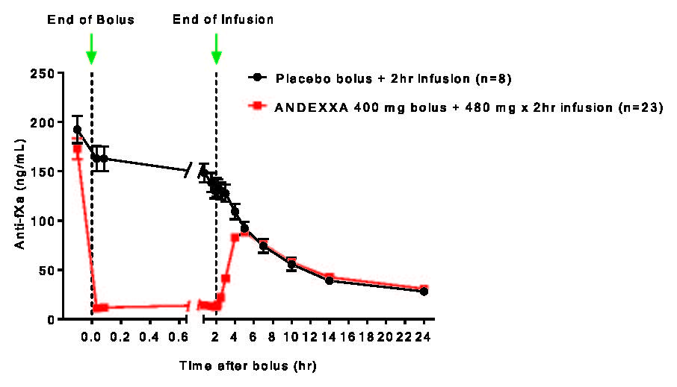
(A)

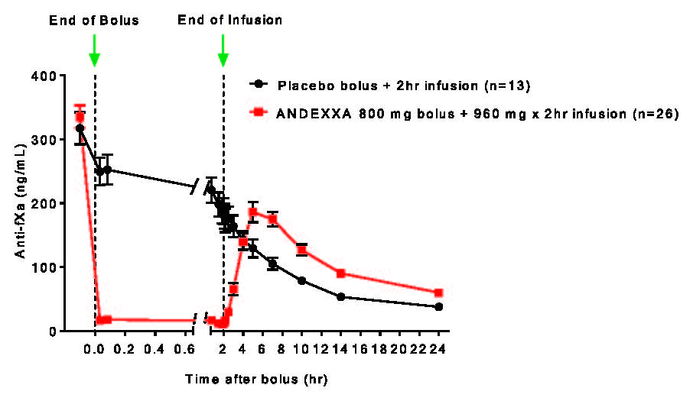
(B)
Note: Anti-FXa activity was measured prior to and after ANDEXXA or placebo administration.
Dashed lines indicate the end of the bolus or infusion. A break in the x-axis is added to better visualise the immediate, short-term dynamics of anti-FXa activity following ANDEXXA treatment. The points on the graph represent the mean anti-FXa activity level; error bars illustrate standard error. There was a statistically significant difference (p <0.05) in the percent change of anti-FXa activity normalised to pre-bolus between ANDEXXA and placebo until 2 hours after administration of infusion.
A. Apixaban with ANDEXXA 400 mg IV bolus plus 4 mg/min infusion for 120 minutes.
B. Rivaroxaban with ANDEXXA 800 mg IV bolus plus 8 mg/min infusion for 120 minutes.
Abbreviations: FXa = factor Xa; IV = intravenous.

Study 4 (ANNEXA-4)
In a multinational, prospective, single-arm, open-label study, ANDEXXA was administered to 477 patients taking FXa inhibitors who presented with acute major bleeding. In the majority of patients, ANDEXXA was used to reverse anticoagulant therapy following either an intracranial haemorrhage (329; 69.0%) or a gastrointestinal bleed (109; 22.9%), with the remaining 39 subjects (8.2%) experiencing bleeding at other sites. The coprimary endpoints were: a) percent change in anti-FXa activity from baseline to the on-treatment nadir between the end of the bolus up until the end of the infusion; and b) rate of effective haemostasis at 12 hours after infusion, as rated by an independent endpoint adjudication committee blinded to anti-FXa activity levels.
Key inclusion criteria were: acute major bleeding requiring urgent reversal of anticoagulation, in a patient who had received or was believed to have received a Factor Xa inhibitor within 18 hours prior to dosing with ANDEXXA, either with signs or symptoms of haemodynamic compromise, a haemoglobin ≤ 80g/L or drop in haemoglobin of ≥ 20g/L, or acute bleeding in a critical area or organ (eg, pericardial, intracranial, or intraspinal). Key exclusion criteria were: patients scheduled to undergo surgery in less than 12 hours after the end of ANDEXXA infusion, patients with ICH and GCS < 7 or haematoma volume > 60 mL, patients with a recent history of a thrombotic event, and patients with sepsis.
Of the 477 patients dosed with ANDEXXA, 347 patients were considered efficacy-evaluable. Of these 347 patients, 172 (49.6%) patients taking apixaban and 130 (37.5%) patients taking rivaroxaban were efficacy-evaluable, defined as patients 1) who had a baseline anti-FXa activity at or above 75 ng/mL for apixaban- or rivaroxaban-treated patients; and 2) were adjudicated as meeting eligibility criteria for acute major bleeding.
For anti-Fxa activity, the median (95% confidence interval [CI]) decrease from baseline to nadir in anti-Fxa activity for apixaban was -93% (-94%, -92%) and for rivaroxaban was -94% (-95%, -93%). A total of 128 patients in the ANNEXA-4 study were anticoagulated and had elevated baseline levels of anti-FXa (>150 ng/mL for apixaban and >300 ng/mL for rivaroxaban). After administration of ANDEXXA, these patients experienced decreased anti-FXa activity levels, with median reductions of 92% for apixaban and 96% for rivaroxaban.
Of the 340 patients in the efficacy population that were determined by the Endpoint Adjudication Committee to be evaluable for effective haemostasis, there were 169 apixaban-treated patients and 127 rivaroxaban-treated patients. Overall, effective haemostasis was reported as 80% and for apixaban- and rivaroxaban-treated patients, it was 79.3% and 80.3% respectively. Effective haemostasis was defined as the proportion of patients with excellent or good haemostasis as adjudicated by an independent Endpoint Adjudication Committee.
In the ANNEXA-4 study, of the 477 patients in the safety population, there were 81 (17%) deaths. There were 41 cardiovascular deaths related to bleeding, 20 deaths that were cardiovascular and not related to bleeding, 15 that were non-cardiovascular, and 5 deaths had an uncertain or unknown cause. The average time to death was 15 days after treatment. All deaths occurred before Day 45. Of the 81 patients who died, the bleeding type was intracranial bleeding in 60 (74%), gastrointestinal bleeding in 15 (19%), and other bleeding types in 6 (7%) patients.
An improvement in haemostasis has not been established in a controlled trial. ANDEXXA has not been shown to be effective for bleeding related to any FXa inhibitors other than apixaban and rivaroxaban.

Time course of reversal of anti-FXa activity
The time course of ANDEXXA administration was consistent among the healthy volunteer studies and the ANNEXA-4 study in bleeding patients. Compared to baseline, there was a rapid and substantial decrease in anti-FXa activity corresponding to the ANDEXXA bolus. This decrease was sustained through the end of the ANDEXXA continuous infusion. The anti-FXa activity returned to the placebo levels approximately 2 hours after completion of a bolus or continuous infusion. Subsequently, the anti-FXa activity decreased at a rate similar to the clearance of the FXa inhibitors.

Pharmacokinetic properties
The exposure of andexanet alfa at the high and low dose are dose proportional based on assessment of AUC_{0-∞}, AUC_{0-last}, and C_{max}.
A summary of the pharmacokinetic (PK) properties of ANDEXXA in healthy subjects is shown in Table 8.
Table 8 Summary of PK parameters with high and low doses

PK parameters | Low dose  N=11 | High dose  N=10
AUC_{0-∞}  (hr*µg/mL) | 200.5 (16.3)  [153.4; 255.6] | 572.9 (16.0)  [467.1; 783.9]
Cmax (µg/mL) | 76.6 (17.5)  [61.1; 100.1] | 206.6 (18.8)  [158.9; 280.5]
Clearance (L/hr) | 4.4 (16.3)  [3.4; 5.7] | 3.1 (16.0)  [2.3; 3.8]
T_{1/2} (hr) | 3.3 (15.0)  [2.3; 4.0] | 2.7 (20.0)  [1.9; 3.4]
V_{ss} (L) | 4.4 (17.6)  [3.3; 5.7] | 3.0 (23.3)  [2.2; 5.0]
Data presented are geometric mean (Geometric mean % coefficient of variation), [range].

Special populations

Elderly patients
In a study comparing andexanet alfa pharmacokinetics in elderly (65-69 years) and younger
(26-42 years) healthy subjects who had received apixaban, the pharmacokinetics of andexanet alfa in the elderly subjects were not statistically different than those in the younger subjects.

Renal impairment
No trials have been conducted to investigate the pharmacokinetics of andexanet alfa in patients with renal impairment. Based on the available PK data, andexanet alfa has little to no renal clearance, and thus would not require dose adjustment for patients with renal impairment.

Hepatic impairment
No trials have been conducted to investigate the pharmacokinetics of andexanet alfa in patients with hepatic impairment. Biliary and/or faeces elimination of protein therapeutics is not a known route of protein elimination. Therefore, dose adjustment is not considered needed for patients with hepatic impairment.

Gender
Based on population pharmacokinetics analysis, gender does not have an effect on the pharmacokinetics of andexanet alfa.

Preclinical safety data

Genotoxicity
No animal studies were performed to evaluate the effects of andexanet alfa on genotoxicity.

Carcinogenicity
No studies were performed to evaluate the effects of andexanet alfa on carcinogenesis.

Pharmaceutical particulars

List of excipients
Trometamol, trometamol hydrochloride, arginine hydrochloride, sucrose, mannitol, and polysorbate 80.

Incompatibilities
In the absence of compatibility studies, this medicinal product must not be mixed with other medicinal products.

Shelf life
In Australia, information on the shelf life can be found on the public summary of the Australian Register of Therapeutic Goods (ARTG). The expiry date can be found on the packaging.

Special precautions for storage
Unopened vials should be stored refrigerated at 2°C to 8°C. Do not freeze. Protect from light.

Reconstituted medicinal product
To reduce microbiological hazard, use as soon as practicable after reconstitution/preparation. If storage is necessary, hold at 2°C to 8°C for not more than 24 hours or intermittent storage at room temperature (≤25°C) for not more than 8 hours.

Nature and contents of container
Powder in a 20 mL vial (Type I glass) with a stopper (butyl rubber) and aluminium. Pack size of 4 vials.

Special precautions for disposal
In Australia, any unused medicine or waste material should be disposed of in accordance with local requirements.

Physicochemical properties

Chemical structure
Andexanet alfa is a recombinant modified version of a human FXa protein expressed in Chinese hamster ovary (CHO) cells. The protein is a two-chain molecule comprised of a 105 amino acid light chain (approximately 12 kDa) and a 254 amino acid heavy chain (approximately 28 kDa). The chains are connected by a single inter-chain disulphide bond. Andexanet alfa has a total of 359 amino acid residues and an approximate molecular weight of 41 kDa.
Figure 2 Structure of andexanet alfa
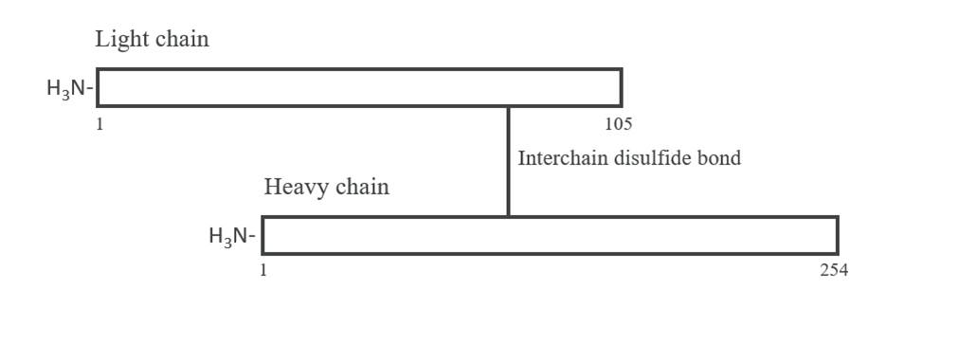

CAS number
1262449-58-0

Medicine schedule (Poisons Standard)
Prescription only medicine (Schedule 4).

Sponsor
AstraZeneca Pty Ltd
ABN 54 009 682 311
66 Talavera Road
Macquarie Park NSW 2113
Telephone: 1800 805 342

Date of first approval
3 July 2023

Date of revision
Not applicable.

Summary table of changes
Section changed | Summary of new information
N/A | New product.

ANDEXXA is a registered trade mark of the AstraZeneca group of companies.
© AstraZeneca 2023
Doc ID-005215182 v1

