Australian Public Assessment Report for Nuvaxovid
  - Active ingredient: SARS-CoV-2-rS
  - Sponsor: Biocelect Pty Ltd
November 2023

About the Therapeutic Goods Administration (TGA)
- The Therapeutic Goods Administration (TGA) is part of the Australian Government Department of Health and Aged Care and is responsible for regulating therapeutic goods, including medicines, medical devices, and biologicals.
- The TGA administers the Therapeutic Goods Act 1989 (the Act), applying a risk management approach designed to ensure therapeutic goods supplied in Australia meet acceptable standards of quality, safety, and efficacy.
- The work of the TGA is based on applying scientific and clinical expertise to decision-making, to ensure that the benefits to the Australian public outweigh any risks associated with the use of therapeutic goods.
- The TGA relies on the public, healthcare professionals and industry to report problems with therapeutic goods. The TGA investigates reports received to determine any necessary regulatory action.
- To report a problem with a therapeutic good, please see the information on the TGA website.

About AusPARs
- The Australian Public Assessment Report (AusPAR) provides information about the evaluation of a prescription medicine and the considerations that led the TGA to approve or not approve a prescription medicine submission. Further information can be found in Australian Public Assessment Report (AusPAR) guidance.
- AusPARs are prepared and published by the TGA.
- AusPARs are static documents that provide information that relates to a submission at a particular point in time. The publication of an AusPAR is an important part of the transparency of the TGA’s decision-making process.
- A new AusPAR may be provided to reflect changes to indications or major variations to a prescription medicine subject to evaluation by the TGA.

Copyright
© Commonwealth of Australia 2023
This work is copyright. You may reproduce the whole or part of this work in unaltered form for your own personal use or, if you are part of an organisation, for internal use within your organisation, but only if you or your organisation do not use the reproduction for any commercial purpose and retain this copyright notice and all disclaimer notices as part of that reproduction. Apart from rights to use as permitted by the Copyright Act 1968 or allowed by this copyright notice, all other rights are reserved and you are not allowed to reproduce the whole or any part of this work in any way (electronic or otherwise) without first being given specific written permission from the Commonwealth to do so. Requests and inquiries concerning reproduction and rights are to be sent to the TGA Copyright Officer, Therapeutic Goods Administration, PO Box 100, Woden ACT 2606 or emailed to <tga.copyright@tga.gov.au>.

Contents
List of abbreviations 4
Product submission 5
Submission details 5
Product background 6
Regulatory status 8
Australian regulatory status 8
International regulatory status 9
Product Information 13
Registration timeline 13
Submission overview and risk/benefit assessment 13
Quality 13
Quality related proposed conditions of registration 14
Nonclinical 15
Nonclinical conclusions 16
Clinical 16
Study 2019nCoV-302 (Study 302) 16
Study 2019nCoV-301 (Study 301) 19
Study 2019nCoV-501 (Study 501) 24
Study 2019nCoV-101 (Study 101) 29
Risk management plan 33
Risk management plan wording for conditions of registration 34
Risk-benefit analysis 34
Delegate’s considerations 34
Proposed action 34
Outcome 35
Specific conditions of registration applying to these goods 35
Attachment 1. Product Information 37

List of abbreviations
Abbreviation | Meaning
ASA | Australia specific annex
CMI | Consumer Medicines Information
COVID-19 | Coronavirus disease 2019
DLP | Data lock point
EU | European Union
GMP | Good Manufacturing Practice
HIV | Human immunodeficiency virus
IgG | Immunoglobulin G
PCR | Polymerase chain reaction
PI | Product Information
RMP | Risk management plan
TGA | Therapeutic Goods Administration
SARS-CoV-2-rS | Severe acute respiratory syndrome coronavirus 2 recombinant spike protein
UK | United Kingdom

Product submission

Submission details
Type of submission: | Transition from provisional registration to full registration
Product name: | Nuvaxovid
Active ingredient: | SARS-CoV-2-rS (NVX-CoV2373)
Decision: | Approved
Date of decision: | 26 October 2023
Date of entry onto ARTG: | 30 October 2023
ARTG number: | 355139
Black Triangle Scheme  for the current submission: | Yes  This product will remain in the scheme for 5 years from initial provisional approval
Sponsor’s name and address: | Biocelect Pty Ltd  Level 29, 66 Goulburn Street  Sydney NSW 2000
Dose form: | Suspension for injection
Strengths: | 5 μg/0.5 mL
Container: | Multidose vial
Pack sizes: | 2 and 10 vials
Approved therapeutic use for the current submission: | Active immunisation to prevent coronavirus disease 2019 (COVID-19) caused by SARS-CoV-2 in individuals 12 years of age and older.  The use of this vaccine should be in accordance with official recommendations.
Route of administration: | Intramuscular
Dosage: | Primary series  Nuvaxovid is administered intramuscularly as a course of 2 doses of 0.5 mL each. It is recommended that the second dose is to be administered 3 weeks after the first dose, see section 5.1 Pharmacodynamic Properties.  Additional Dose  An additional dose of Nuvaxovid (0.5 mL) may be administered intramuscularly approximately 6 months after completion of a primary series in individuals 18 years of age and older.  The decision when and for whom to implement an additional dose of Nuvaxovid should be made based on available vaccine safety and effectiveness data (see sections 4.8 Adverse Effects and 5.1 Pharmacodynamic Properties), in accordance with official recommendations.  The use of this vaccine should be in accordance with clinical recommendations in Australia, made by ATAGI in the Australian Immunisation Handbook.  For precautions for administering the vaccine, see section 4.4 Special Warnings and Precautions for Use.  For further information regarding dosage, refer to the Product Information.
Pregnancy category: | B1  Drugs which have been taken by only a limited number of pregnant women and women of childbearing age, without an increase in the frequency of malformation or other direct or indirect harmful effects on the human fetus having been observed.  Studies in animals have not shown evidence of an increased occurrence of fetal damage.  The use of any medicine during pregnancy requires careful consideration of both risks and benefits by the treating health professional. This must not be used as the sole basis of decision making in the use of medicines during pregnancy. The TGA does not provide advice on the use of medicines in pregnancy for specific cases. More information is available from obstetric drug information services in your state or territory.

Product background
This AusPAR describes the submission by Biocelect Pty Ltd (the sponsor) to register Nuvaxovid (SARS-CoV-2-rS (NVX-CoV2373)) 5 μg/0.5 mL suspension for injection, multidose vials for the transition from provisional registration to full registration for the following proposed indication:
Active immunisation to prevent coronavirus disease 2019 (COVID-19) caused by SARS-CoV-2 in individuals 12 years of age and older.
The use of this vaccine should be in accordance with official recommendations.
Several applications regarding Nuvaxovid gave been evaluated by the TGA, with one application (PM-2023-00909-1-2) currently ongoing in parallel to this submission.
Table 1: Summary of Nuvaxovid applications evaluated by the TGA
Application | Purpose | Indication/dosing | Main Clinical studies included
PM-2021-00623-1-2 | Provisional registration | Active immunisation to prevent COVID-19 caused by SARS-CoV-2 in individuals 18 years of age and older.  The use of this vaccine should be in accordance with official recommendations.  The decision has been made on the basis of short term efficacy and safety data. Continued approval depends on the evidence of longer term efficacy and safety from the ongoing and post-market assessment. | 2019nCoV-301  2019nCoV-302
PM-2022-00638-1-2 | Provisional registration of an adult booster indication | Booster Dose  A booster dose of NUVAXOVID (0.5 mL) may be administered intramuscularly approximately 6 months after completion of a primary series in individuals 18 years of age and older. | 2019nCoV-101  2019nCoV-501
PM-2022-01431-1-2 | Provisional registration of adolescent indication | Active immunisation to prevent coronavirus disease 2019 (COVID-19) caused by SARS-CoV-2 in individuals 12 years of age and older. | 2019nCoV-301
PM-2023-00909-1-2 | Provisional registration of adolescent booster | Ongoing | Ongoing
PM-2023-01692-1-2 | Application to transition to full registration | Ongoing | See Table 2

In the provisional approval and subsequent applications the sponsor was required to provide updated reports for the studies evaluated.
Post-authorisation safety studies in the United Kingdom (UK) and the United States of America (USA), as well as a global surveillance study of pregnancy outcomes, were to be submitted but are not anticipated to be available until 2025-2027.
In this application the sponsor has made reference to data TGA has evaluated in previous submissions and has provided new data.
Table 2: Study reports submitted in support of Nuvaxovid full registration
The Delegate has compared the data previously evaluated by TGA with that submitted in this application. A detailed review of the studies has not been re-presented as this is contained in the original evaluation reports and AusPAR documents. Comment has been made to either confirm the equivalence of findings between the originally evaluated data and the updated information provided in his application or, where appropriate, to update salient information.
The updated report of Study 2019nCoV-301 (Study 301) has been submitted in support of the application (PM-2023-00909-1-2) to provisionally register a booster schedule for 12 to 17 year olds as well as in this application. This part of Study 301 has therefore not been evaluated in this submission. The Delegate will consider the outcome of application PM-2023-00909-1-2 separately and make a decision regarding transition to full registration when the application for provisional registration of the adolescent booster dose has been completed.

Regulatory status

Australian regulatory status
Nuvaxovid is currently provisionally registered in Australia for:
Active immunisation to prevent coronavirus disease 2019 (COVID-19) caused by SARS-CoV-2 in individuals 12 years of age and older.
The use of this vaccine should be in accordance with official recommendations.
The decision has been made on the basis of short-term efficacy and safety data. Continued approval depends on the evidence of longer term efficacy and safety from ongoing clinical trials and post-market assessment.
Figure 1: Nuvaxovid provisional approval dosage information

International regulatory status
At the time the TGA considered this submission, a similar submission had been approved in the European Union (EU) on 4 July 2023 (full marketing authorisation), the United Kingdom (UK) on 2 October 2023 (full marketing authorisation), Singapore on 17 October 2023 (approved new drug application), Canada on 17 February 2022 (full approval) and Switzerland on 21 September 2023 (approved marketing authorisation without special requirements). At time of TGA consideration, the respective approval in the United States of America (USA) (13 July 2022) is for emergency use authorisation and in New Zealand (4 February 2022) is for provisional consent.
The following table summarises these submissions and provides the indications where approved, current as of the date of approval of this application, 26 October 2023.
Table 3: International regulatory status
Region | Submission date | Status | Approved indications
European Union | 29 October 2021 | Approved for conditional marketing authorisation on 20 December 2021 | Nuvaxovid is indicated for active immunisation to prevent COVID-19 caused by SARS-CoV-2 in individuals 12 years of age and older.  The use of this vaccine should be in accordance with official recommendations.  Populations:  • Primary series in individuals 12 years of age and older.  • A booster dose in individuals 18 years of age and older.
European Union | 4 April 2023 | Approved for full marketing authorisation on 04 July 2023 | Nuvaxovid is indicated for active immunisation to prevent COVID-19 caused by SARS-CoV-2 in individuals 12 years of age and older.  The use of this vaccine should be in accordance with official recommendations
United Kingdom | 7 May 2021 | Approved for conditional marketing authorisation on 3 February 2022 | Nuvaxovid is indicated for active immunisation to prevent COVID-19 caused by SARS-CoV-2 in individuals 12 years of age and older.  The use of this vaccine should be in accordance with official recommendations.  Populations:  • Primary series in individuals 12 years of age and older.  • A booster dose in individuals 18 years of age and older.
United Kingdom |  | Approved for full marketing authorization on 02 October 2023 | Nuvaxovid is indicated for active immunisation to prevent COVID-19 caused by SARS-CoV-2 in individuals 12 years of age and older.  The use of this vaccine should be in accordance with official recommendations
New Zealand | 17 February 2021 | Approved for provisional consent on 4 February 2022 | Active immunisation to prevent coronavirus disease 2019 (COVID-19) caused by SARS-CoV-2 in individuals 12 years of age and older.  The use of this vaccine should be in accordance with official recommendations.  Populations:  • Primary series in individuals 12 years of age and older.  • A booster dose in individuals 18 years of age and older.
Singapore | 17 November 2021 | Approved for interim authorisation on 3 February 2022 | Nuvaxovid is indicated for active immunisation to prevent COVID-19 caused by SARS-CoV-2 in individuals 18 years of age and older.  The use of this vaccine should be in accordance with official recommendations.  Populations:  • Primary series in individuals 18 years of age and older.
Singapore | 28 February 2023 | Approved new drug application on 17 October 2023 | Nuvaxovid is indicated for active immunisation to prevent COVID-19 caused by SARS-CoV-2 in individuals 12 years of age and older.  The use of this vaccine should be in accordance with official recommendations
Canada | 1 November 2021 | Full approval received 17 February 2022 | Nuvaxovid (COVID-19 Vaccine (Recombinant protein, Adjuvanted)) is indicated for active immunisation to prevent coronavirus disease 2019 (COVID-19) caused by the severe acute respiratory syndrome coronavirus 2 (SARS-CoV-2) in individuals 12 years of age and older.  Populations:  • Primary series in individuals 12 years of age and older.  • A booster dose in individuals 18 years of age and older.
United States of America | 31 January 2022 | Approved for emergency use authorisation on 13 July 2022 | Primary Series  The Novavax COVID-19 Vaccine, Adjuvanted is authorised for emergency use to provide a two-dose primary series to individuals 12 years of age and older. The primary series of the Novavax COVID-19 Vaccine, Adjuvanted is two doses (0.5 mL each) given 3 weeks apart.  Booster Dose  The Novavax COVID-19 Vaccine, Adjuvanted is authorised for emergency use to provide a first booster dose to individuals 18 years of age and older for whom an FDA-authorised mRNA bivalent1 COVID-19 booster vaccine is not accessible or clinically appropriate, and to individuals 18 years of age and older who elect to receive the Novavax COVID-19 Vaccine, Adjuvanted because they would otherwise not receive a booster dose of a COVID-19 vaccine.  For these individuals, a booster dose (0.5 mL) of Novavax COVID-19 Vaccine, Adjuvanted may be administered at least 6 months after completion of primary vaccination with an authorised or approved COVID-19 vaccine.
Switzerland | 11 February 2022 | Approved for temporary product authorisation on 12 April 2022 | Nuvaxovid is indicated for active immunisation to prevent COVID-19 caused by SARS-CoV-2 in individuals 12 years of age and older.  The use of this vaccine should be in accordance with official recommendations.  Populations:  • Primary series in individuals 12 years of age and older.  • A booster dose in individuals 18 years of age and older.
Switzerland | 31 August 2023 | Approved for marketing authorisation without special requirements on 21 September 2023 | Active immunisation for the prevention of the Coronavirus 2019 disease (COVID-19) caused by the SARS-CoV-2 virus from 12 years of age and older.

Product Information
The Product Information (PI) approved with the submission which is described in this AusPAR can be found as Attachment 1. For the most recent PI and Consumer Medicines Information (CMI), please refer to the TGA PI/CMI search facility.

Registration timeline
The following table captures the key steps and dates for this submission.
Data were provided as a rolling submission. Under normal circumstances, TGA's assessment (for both provisional and general registration) begins once all information to support registration is available. As part of the Department of Health and Aged Care's response to the pandemic, the TGA has agreed to accept rolling data for COVID-19 vaccines and treatments, to enable early evaluation of data as it becomes available.
Description | Date
Determination (Provisional) | 19 January 2021
Submission dossier accepted and first round evaluation commenced | 4 May 2023
Evaluation completed | 23 October 2023
Delegate’s Overall benefit-risk assessment | 20 October 2023
Sponsor’s pre-Advisory Committee response | Not applicable
Advisory Committee meeting | Not applicable
Registration decision (Outcome) | 26 October 2023
Administrative activities and registration on the ARTG completed | 30 October 2023
Number of working days from submission dossier acceptance to registration decision* | 123
*Statutory timeframe for standard submissions is 255 working days

Submission overview and risk/benefit assessment
A summary of the TGA’s assessment for this submission is provided below.

Quality
The quality evaluation reviewed the quality aspects of the provisionally registered product and any outstanding issues. The quality evaluation has recommended that Nuvaxovid is appropriate for transition for full registration.

Quality related proposed conditions of registration
Quality
- Good Manufacturing Practice (GMP) clearance for listed manufacturers: All relevant manufacturing sites require approved and current GMP Clearances prior to Australian supply. A commitment is required from the sponsor that they maintain the validity of all manufacturer GMP Clearances for the duration of product supply to Australia. Additionally, that adherence to the conditions of GMP Clearance approval is upheld.
- Post-approval stability protocol and stability commitment: The manufacturer has provided commitment to continue the ongoing stability studies presented in the stability studies protocol. Additionally, 1 batch of drug product per year for all relevant products will be placed on long-term stability program and on accelerated stability testing where significant changes are made to the manufacturing process. The manufacturer has committed to communicate any out of specifications stability test results to the TGA.
Batch Release Testing and Compliance
It is a condition of registration that all independent batches of Nuvaxovid (SARS-CoV-2 rS [NVX-CoV2373]) COVID-19 vaccine imported into Australia are not released for sale until samples and the manufacturer’s release data have been assessed and you have received notification acknowledging release from the Laboratories Branch, TGA.
For each independent batch of the product imported into Australia, the sponsor must supply the following:
- A completed Request for Release Form, available from vaccines@health.gov.au.
- Complete summary protocols for manufacture and QC, including all steps in production in the agreed format.
- At least a 2 mL sample (as at least 4 × 500 μL aliquots) of each bulk drug substance batch used in the manufacture of the given drug product batch.
- At least twenty (20) vials (samples) of each manufacturing batch of Nuvaxovid (SARS-CoV-2 rS [NVX-CoV2373]) COVID-19 vaccine with the Australian approved labels, PI and packaging (unless an exemption to supply these has been granted) representative of all batches of product seeking distribution in Australia.
- At least five (5) vials (samples) of any further consignments of a manufacturing batch of Nuvaxovid (SARS-CoV-2 rS [NVX-CoV2373]) COVID-19 vaccine with the Australian approved labels, PI and packaging (unless an exemption to supply these has been granted). Further consignments cover batches previously supplied to TGA for the purposes of batch release testing but are seeking to be supplied again.
- If the manufacturing batch has been released in Europe or United Kingdom, a copy of the EU Official Control Authority Batch Release (OCABR) certificate (or equivalent from the UK) must be provided.
- Any reagents, reference material and standards required to undertake testing, as requested by Laboratories Branch, TGA.
Sponsors must provide all requested samples and data in sufficient time (at least 5 business days) prior to any distribution date to allow the TGA to perform testing and review. Distribution of each batch of vaccine is conditional upon fulfilment of these conditions and receipt of a letter from the Laboratories Branch acknowledging release.
Samples and data should be forwarded to the Biotherapeutics Section, Laboratories Branch before release of each batch and with sufficient lead time to allow for Laboratories Branch testing. The address for courier delivery is:
ATTN: Batch Release Coordinator
Biotherapeutics Section
TGA Laboratories Branch
1 Tindal Lane
Canberra Airport, ACT 2609
The shipments (including reagents) to TGA are the responsibility of the Australian sponsor/agent who will be required to facilitate the import and customs clearance process.
Certified Product Details
An electronic copy of the Certified Product Details (CPD) as described in Guidance 7: Certified Product Details of the Australian Regulatory Guidelines for Prescription Medicines (ARGPM) [https://www.tga.gov.au/guidance-7-certified-product-details] should be provided upon registration of the therapeutic good. In addition, an updated CPD, for the above products incorporating the approved changes is to be provided within one month of the date of approval letter. A template for preparation of CPD for biological prescription medicines and vaccines can be obtained from the TGA website [https://www.tga.gov.au/form/certified-product-details-cpd-biological-prescription-medicines]. The CPD should be sent as a single bookmarked PDF document to Vaccines@health.gov.au as soon as possible after registration/approval of the product or any subsequent changes as indicated above.

Nonclinical
The nonclinical evaluation reviewed the submission for any outstanding issues regarding the provisionally registered product.
The sponsor has submitted final reports of nonclinical studies which were ongoing or planned at the time of provisional registration of Nuvaxovid SARS-CoV-2 rS [NVX-CoV2373], a SARS-CoV-2 recombinant (r) spike (S) protein antigen (SARS-CoV-2 rS) with Matrix-M1 adjuvant.
The sponsor submitted final reports for two immunogenicity studies with the vaccine and one tissue distribution study with the adjuvant Matrix-M1. The studies were well conducted.
Immunogenicity (anti-S immunoglobulin G (IgG) titers and hACE2 receptor blocking titers in mice) of commercial GMP vaccine drug product vials were qualitatively similar to freshly prepared drug product formulated from drug substance produced in Novavax Discovery Lab (that were used in nonclinical studies).
In an immunogenicity study, olive baboons received an initial vaccination regimen (Days 0 and 21) with Prototype SARS-CoV-2 recombinant spike protein nanoparticle vaccine (BV2373/Prototype rS), one or two booster vaccinations approximately 45 weeks later with Beta SARS-CoV-2 rS (BV2426/beta rS), and a booster vaccination 49 weeks later with BV2373 or Omicron BA.1 SARS-CoV-2 rS (BV2509/Omicron BA.1 rS). Immune responses were evaluated until study Day 917, approximately 37 weeks after the final immunisation. Immunogenic responses up to Day 353 were evaluated in the original submission. Robust cross-reactive anti-S IgG response and hACE2 receptor inhibition responses were induced against Omicron BA.1 rS by a Beta rS booster dose, and this response was maintained until Day 618. Robust cross-reactive anti-S IgG response and hACE2 receptor inhibition responses were induced against all variants evaluated (Alpha rS, Delta rS, and Omicron BA.1, BA.2, and BA.5 variant rS) following the boost with Prototype rS or Omicron BA.1 rS, and this response was maintained until Day 917. Boost immunisation with Prototype rS or Omicron BA.1 rS resulted in robust Th1-skewed T-cell responses against Prototype rS, Beta rS, and Omicron BA.1 rS as well as cross-reactive responses to Delta rS.
In a biodistribution study mice received intramuscular injections of Matrix-M1 adjuvant: (1) radiolabeled saponins only, (2) radiolabeled saponins together with a viral glycoprotein antigen (SARS-CoV-2 rS), or (3) radiolabeled cholesterol. Radiolabeled saponins (± viral glycoprotein antigen) and cholesterol appeared quickly in the injection site and iliac lymph nodes (draining lymph nodes for the injection site), followed by slower appearance and protracted presence in the inguinal lymph nodes. Lymph node groups not providing drainage to the injection site (mesenteric, mandibular) did not accumulate saponin counts. Radiolabeled saponin (± viral glycoprotein antigen), appeared in plasma and urine within one hour and was almost completely cleared from the body within 24 hours, while radiolabeled cholesterol had higher concentrations in tissues than in plasma and urine and levels remained significantly elevated in most tissues 7 days after administration (consistent with normal cholesterol pharmacokinetics). The distribution of radiolabeled saponin was unaffected by the presence of the viral glycoprotein antigen.

Nonclinical conclusions
Drug product vials manufactured at commercial GMP scale and Novavax Discovery lab, exhibited qualitatively similar immunogenicity in mice.
SARS-CoV-2 rS vaccine (that is, SARS-CoV-2 rS antigen + Matrix-M1 adjuvant) was immunogenic in baboons. SARS-CoV-2 rS vaccine induced both humoral (anti-S, hACE2 receptor binding blocking and virus neutralising antibodies) and cellular immune (Th-1 biased) response. The long-term immunity following immunisation with SARS-CoV-2 rS + Matrix-M1 adjuvant vaccine (Prototype rS) was demonstrated in baboons. Boost immunisations on Day 660 (with Prototype rS or Omicron BA.1 rS), almost one year after boost immunisation with Beta rS, induced strong immune response against Alpha rS, Delta rS, and Omicron BA.1, BA.2, and BA.5 variant rS.
After intramuscular injection in mice, the saponin components of the adjuvant Matrix-M1 were quickly eliminated, and this elimination was not affected by the presence of a glycoprotein antigen. The cholesterol components of the adjuvant remained in tissues for 7 days, resembling normal cholesterol pharmacokinetics.
There is no change to the safety profile of the vaccine. No nonclinical issue is outstanding and there are no nonclinical objections to the transition from provisional registration to full registration of the Nuvaxovid SARS-CoV-2 rS [NVX-CoV2373] vaccine.

Clinical

Study 2019nCoV-302 (Study 302)

Summary of prior evaluation
Study 302 was submitted as one of two Phase III trials to support the first application to register Nuvaxovid for vaccination of adults as a two-dose primary schedule.
Study 302 was a Phase III cross-over trial which examined the safety, efficacy and immunogenicity of two doses of Nuvaxovid administered 21 days apart in participants between 18 and 84 years of age. The primary objective was the vaccine efficacy of Nuvaxovid in preventing symptomatic polymerase chain reaction (PCR)-confirmed COVID-19 in participants who were seronegative at Baseline.
Figure 2: Study 302 patient disposition
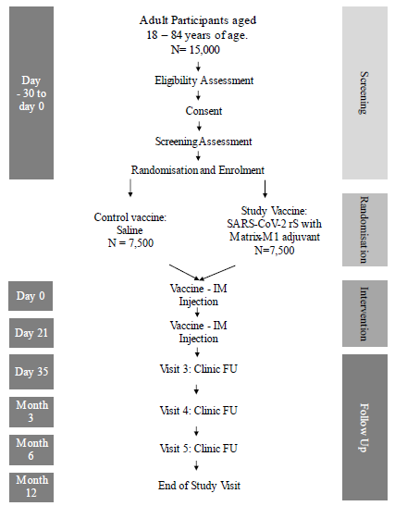
Abbreviations: FU = follow up, IM = intramuscular, N = number of participants.
Note: the 3 month follow up and Day 1 crossover visits can be consolidated if they occur within 30 days of each other. The Day 35 crossover visit is only for participants in the anti-S immunogenicity subgroup.

New data submitted
The sponsor has submitted both the 6 month and 12 month (final) clinical study report for Study 302. This evaluation will only consider the final clinical study report as it subsumes the interim report.

Overview of new data submitted
The final analysis of vaccine efficacy was not different in the final clinical report than in the interim report.
Safety analysis was provided in the final report with a median follow-up of 362 days compared to 90 days in the interim report. The numbers of patients observed were essentially the same (n = 15138 final report and n = 15139 interim report).
There was no substantial difference in rates of local adverse or systemic adverse events observed within 7 days between the interim and final report.
There were five deaths in the final report, an increase from three in the interim report. One of these received the placebo, and the other was a 65 year old woman who died of liver metastases.
Table 4: Study 302 First occurrence of PCR confirmed symptomatic mild, moderate or severe COVID-19 with onset from at least seven days after second vaccination (Day 28) in the initial vaccination period in serologically negative (to SARS-CoV-2) adult participants at Baseline for the emergency use authorisation interim and final analysis, per-protocol efficacy analysis set
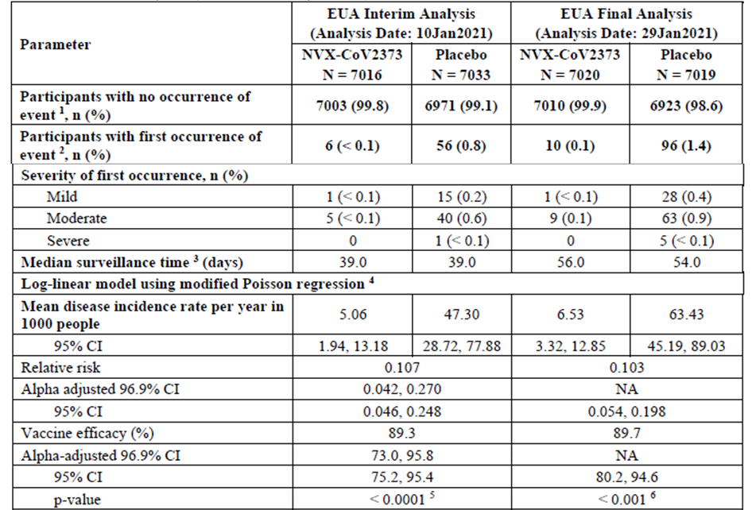
Abbreviations: CI = confidence interval, COVID-19 = coronavirus disease 2019, EUA = emergency use authorisation, LBCI = lower bound confidence interval, NA = not applicable, NVX-CoV2373 = 5 μg SARSCoV-2 rS with 50 μg Matrix-M adjuvant, PCR = polymerase chain reaction, PP-EFF = per-protocol efficacy, SARS-CoV-2 rS = severe acute respiratory syndrome coronavirus 2 recombinant spike protein nanoparticle vaccine, VE = vaccine efficacy.
¹ Includes participants with PCR-confirmed infection who did not meet mild, moderate, or severe COVID-19 criteria.
² Event = first occurrence of PCR-confirmed mild, moderate, or severe COVID-19 with onset of illness episode from at least 7 days after second vaccination within the surveillance period.
³ Surveillance time was defined as the difference between the date at end of surveillance period (onset of first occurrence of event or follow up contact at 12 months after last vaccination, or censoring) and date at start of surveillance period (from at least 7 days after second vaccination) + 1.
⁴ Log-linear model of occurrence using modified Poisson regression with logarithmic link function, treatment group and strata (age-group and pooled region) as fixed effects and robust error variance.
⁵ For the interim analysis, the one-sided p-value was compared to the prespecified one-sided nominal alpha (0.01550) for evaluating the success criteria, which was equivalent to using the LBCI (alpha adjusted) greater than 30%. The prespecified alpha (0.01550) for the interim analysis was determined using Pocock Spending Function.
⁶ Defined as the unadjusted one-sided p-value from the modified Poisson regression model to test the null hypothesis of VE less than or equal to 30%.
Note: Analysis dates represented the data cut-off date for purposes of deriving surveillance times.
Note: Participants were censored at the earliest of i) date of major protocol variation; ii) date of death; iii) date of unblinding for any reason or date of receipt of an approved or deployed SARS-CoV-2 vaccine; iv) early withdrawal or study completion; or v) date of first vaccination in the blinded crossover vaccination period.
There were three more potential immune mediated medical conditions in the final report. This did not change the overall pattern that all conditions were only reported once in the treatment group.
The final report reported two cases of myocarditis/pericarditis, both of which were considered related to Nuvaxovid. These occurred 11 and 24 days after receiving the vaccine respectively, and both events resolved.
Table 5: Study 302 Summary of potential immune mediated medical conditions reported by the investigator during the initial vaccination period, safety analysis set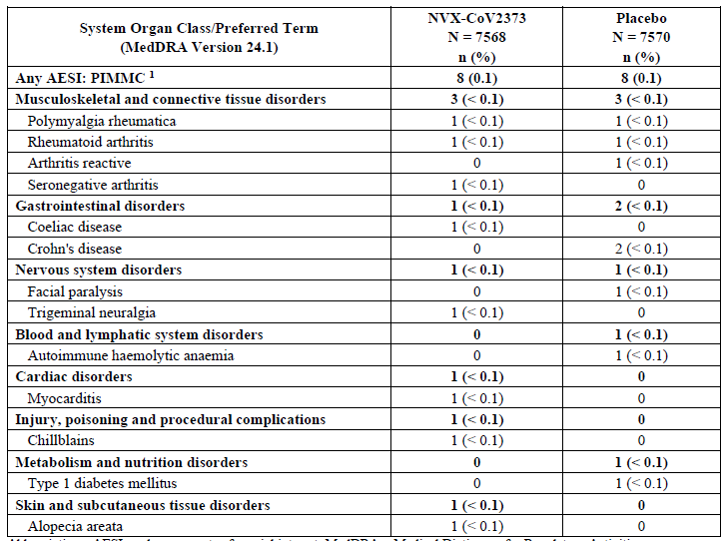
Abbreviations: AESI = adverse events of special interest, MedDRA = Medical Dictionary for Regulatory Activities, NVX-CoV2373 = 5 μg SARS-CoV-2 rS with 50 μg Matrix-M adjuvant, PIMMC = potential immune-mediated medical condition, SARS-CoV-2 rS = severe acute respiratory syndrome coronavirus 2 recombinant spike protein nanoparticle vaccine.
¹ Defined as an adverse event and captured on the Adverse Event Case Report Form. Based on revised PIMMC definition: PIMMC events identified via preferred term, per protocol.

Study 2019nCoV-301 (Study 301)

Summary of prior evaluation
Study 301 was a larger Phase III cross-over trial submitted in the first application to register Nuvaxovid for vaccination of adults as a two-dose primary schedule. It included an adult portion, which was submitted, and an adolescent expansion in 12 to 18 year olds which was ongoing at the time of the provisional application.
The primary endpoint of the trial was the rate of PCR confirmed symptomatic COVID-19 more than 7 days after the completion of the two-dose schedule.
Figure 3: Study 301 Patient disposition in interim report

New data submitted
The sponsor has submitted a 6 month report relating to the adult primary series.
The 6 month report relating to the adolescent indication has been submitted as part of an ongoing application and was not reviewed as part of this application.

Overview of new data submitted
Vaccine efficacy in the 6 month report was not meaningfully different from that reported in the interim report, being 90.58% compared to 90.40% respectively.
A safety analysis was provided in the 6 month report contained similar numbers of subjects as the interim report and a slightly longer duration of follow-up of 4.4 months for those completing the cross-over period compared to 98 days post active vaccination in the interim report.
There was no substantial difference in rates of solicited local adverse or systemic adverse events observed within 7 days between the interim and 6 month report.
Table 6: Study 301 Vaccine efficacy against PCR confirmed symptomatic mild, moderate, or severe COVID-19 with onset from at least seven days after second vaccination of the initial vaccination period in serologically negative adult participants, per-protocol efficacy analysis set
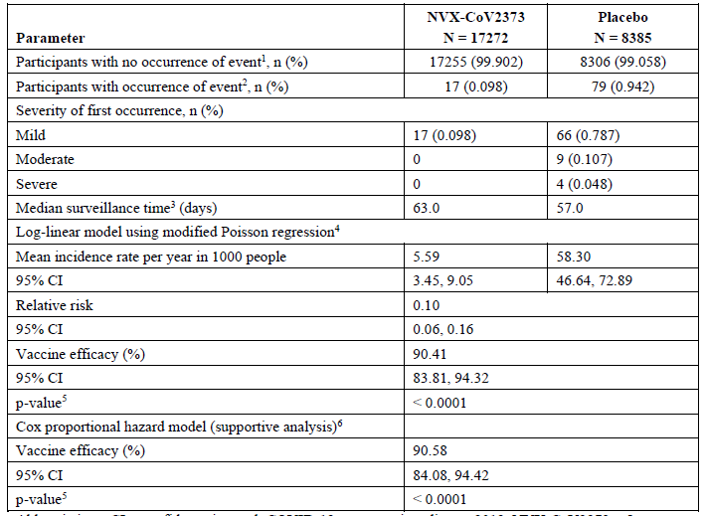
Abbreviations: CI = confidence interval, COVID-19 = coronavirus disease 2019, NVX-CoV2373 = 5 μg SARS-CoV-2 rS with 50 μg Matrix-M adjuvant, PCR = polymerase chain reaction, PP-EFF = per-protocol efficacy, VE = vaccine efficacy.
¹ Includes participants with PCR-confirmed infection who did not meet mild, moderate, or severe COVID- 19 criteria.
² Event = first occurrence of PCR-confirmed mild, moderate, or severe COVID-19 with onset of illness episode from at least 7 days after second vaccination within the surveillance period.
³ Surveillance time was defined as the difference between the date at end of surveillance period (onset of first occurrence of event/ censoring) and date at start of surveillance period (7 days after the Second Injection) + 1.
⁴ Modified Poisson regression with logarithmic link function, treatment group and age strata as fixed effects and robust error variance. Mean incidence was calculated with weighting for 18 to under 65-year and 65-year or older groups reflective of the distribution seen in the study population (that is, observed margins [OM] option for LSMEANS statement in SAS PROC GENMOD).
⁵ This p-value corresponds to a one-sided hypothesis test with significance level 0.025. If the vaccine efficacy p-value is less than 0.025, then reject H0: VE less than or equal to 30%.
⁶ Cox-proportional hazard model with Efron’s method for tie handling with vaccine group and age strata as covariates. Hazard ratio was used to estimate relative risk.
None of the deaths in Nuvaxovid recipients were considered related to treatment.
There were no previously undescribed adverse events of special interest in the 6 month report and the rates were not substantially different from those observed in the interim report.
Table 7: Study 301 Summary of adverse events resulting in death by system organ class and preferred term during initial vaccination period, safety analysis set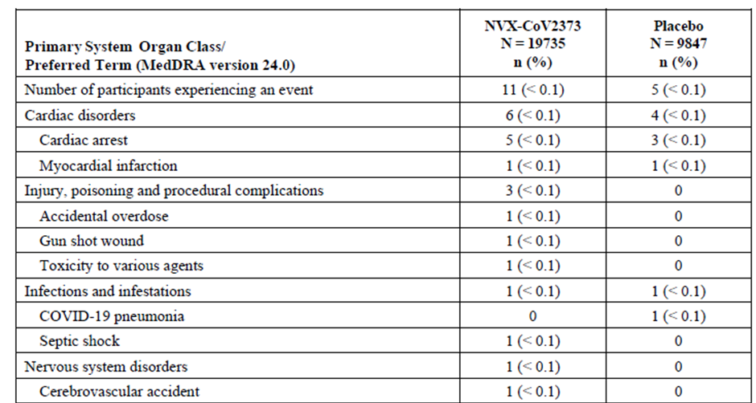
Abbreviations: n = unique number of participants experiencing the adverse event, N = number of participants in the safety analysis set within each treatment.
Note: Percentages or incidence proportion is based on n/N*100.
Table 8: Study 301 Summary of adverse events resulting in death by system organ class and preferred term during the blinded crossover vaccination period, safety analysis set
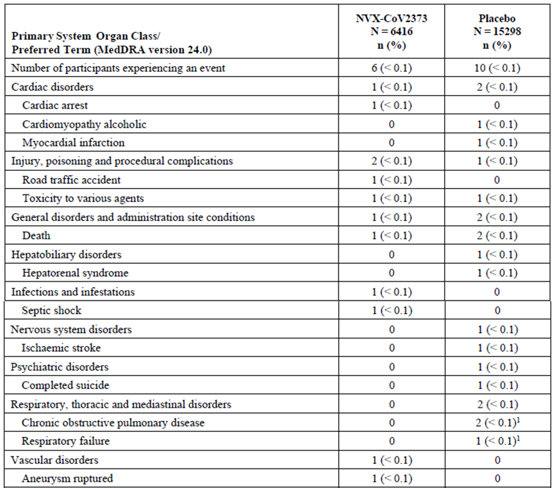
Abbreviations: n = unique number of participants experiencing the adverse event, N = number of participants in the safety analysis set within each treatment.
Note: Percentages or incidence proportion is based on n/N*100.
¹ One participant was included under both preferred terms of chronic obstructive pulmonary disease and respiratory failure.

Study 2019nCoV-501 (Study 501)

Summary of prior evaluation
Study 501 was a randomised controlled study conducted in two cohorts, people without human immunodeficiency virus (HIV) and people living with HIV. The data was submitted to support the provisional registration of a booster dose of Nuvaxovid in adults.
The study comprised a first period in which subjects were randomised to receive two doses of Nuvaxovid or placebo 21 days apart. Following this, subjects were re-randomised to receive one or two doses of Nuvaxovid (with placebo control) at 6 months post the first dose. This latter period provides the booster-dose efficacy analysis.
Table 9: Study 501 trial design
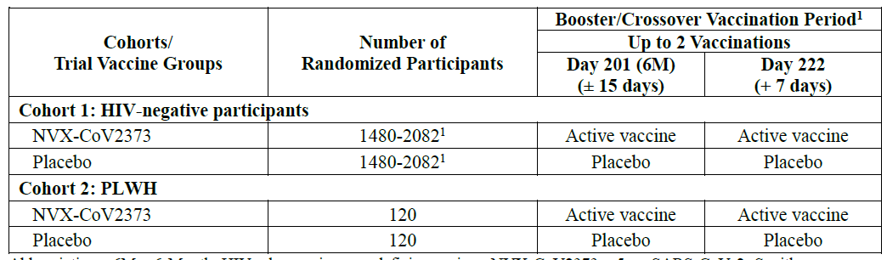
Abbreviations: 6M = 6 month, HIV = human immunodeficiency virus, NVX-CoV2373 = 5 μg SARS-CoV-2 rS with 50 μg Matrix-M adjuvant, SARS-CoV-2 rS = severe acute respiratory syndrome coronavirus 2 recombinant spike protein nanoparticle vaccine.
¹ Following the demonstration of statistically significant vaccine efficacy and satisfactory safety in an analysis of the primary efficacy endpoint, participants were administered two injections of the alternate study material 21 days apart (‘blinded booster/crossover’). That is, initial recipients of placebo received two injections of NVX-CoV2373 and initial recipients of NVX-CoV2373 received one booster dose of NVX-CoV2373 and then later received placebo. The first dose of the booster/crossover vaccination period was administered at Day 201 (that is, to coincide with the visit at 6 months after the last vaccination in the initial vaccination period), and the second dose of the booster/crossover vaccination period was administered at Day 222 (that is, 21 days after the 6-month/Day 201 visit).
The primary endpoint of Study 501 was the rate of PCR confirmed symptomatic COVID-19 in vaccinated and control individuals. Immunological and safety endpoints were also examined.

New data submitted
In this application a final report for Study 501 was submitted (12 month report) as well as a 6 month report. These both include clinical efficacy endpoints which were not available in the interim report – booster results submitted in application PM-2022-00638-1-2, which was evaluated on the basis of immunogenicity endpoints.

Overview of new data submitted
The final report estimates vaccine efficacy after a two-dose booster schedule at 6 months in seronegative/HIV negative subjects to be 55.4%, having dropped to less than 40% at 6 months after a two-dose primary schedule. This protection was against the ancestral and beta strains of COVID-19.
Table 10: Study 501 Comparison of vaccine efficacy of PCR confirmed SARS-CoV-2 positivity with symptomatic mild, moderate or severe COVID-19 from seven days after second vaccination (Day 28) (pre-crossover) and after both booster/crossover (post-crossover) doses with NVX-CoV2373 or placebo overall and in healthy HIV negative participants and medically stable people living with HIV stratified by baseline serostatus and regardless of baseline serostatus
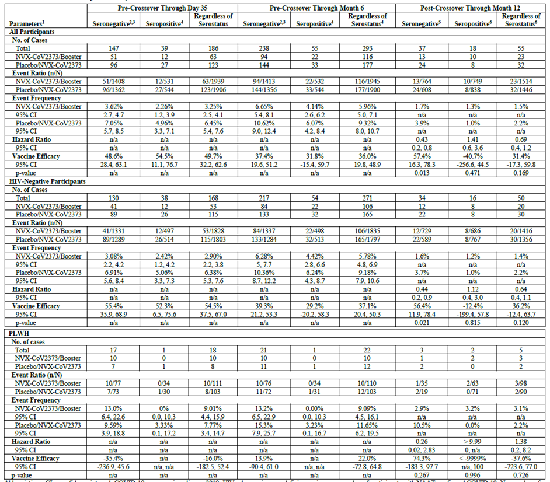
Abbreviations: CI = confidence interval, COVID-19 = coronavirus disease 2019, HIV = human immunodeficiency virus, n = number of participants with NAAT-confirmed COVID-19, N = number of participants, NAAT = nucleic acid amplification test, NVX-CoV2373 = 5 μg SARS-CoV-2 rS with 50 μg Matrix-M adjuvant, PCR = polymerase chain reaction, PLWH = people living with HIV, PP-EFF = per-protocol efficacy, SARS-CoV-2 rS = severe acute respiratory syndrome coronavirus 2 recombinant spike protein nanoparticle vaccine, VE = vaccine efficacy.
¹ Percentage of participants with COVID-19 calculated as n/N × 100.
² Primary efficacy endpoint.
³ Based on PP-EFF analysis set.
⁴ Based on second PP-EFF analysis set.
⁵ Post-crossover PP-EFF analysis set.
⁶ Second post-crossover PP-EFF analysis set.
Note: (Pre-crossover) The 95% CI for PCR-confirmed COVID-19 infection was calculated using the exact Clopper-Pearson method. Participants were counted as a COVID-19 case only for the first PCR+ illness episode. Once that case had been determined, it was further classified to a severity level.
Note: (Pre-crossover) Log-linear model of PCR-confirmed COVID-19 infection incidence rate using Poisson regression with treatment group as fixed effects and robust error variance.
Note: (Pre-crossover) VE = 100 × (1 – relative risk).
Note: (Post-crossover) VE, defined as 1 - hazard ratio (Active to Booster vs Placebo to Active), and 95% CI are estimated using a Cox proportional hazard model with Efron's method of tie handling and with the treatment group as the model term.
Note: (Post-crossover) Two-sided p-value from Cox proportional hazard model.
Note: Cases that occurred beyond Day 201 are those for participants that never crossed over. ‘Pre-crossover’ is only restricted to that period for participants that entered crossover; if a participant never crossed over, then his/her data are considered ‘pre-crossover’ for the entire study.
The safety analysis in the final report included 4408 subjects, 86% (n = 3793) entered the crossover period and received third and fourth doses of the vaccine.
Table 11: Study 501 Study vaccine administration, entire study, safety analysis set
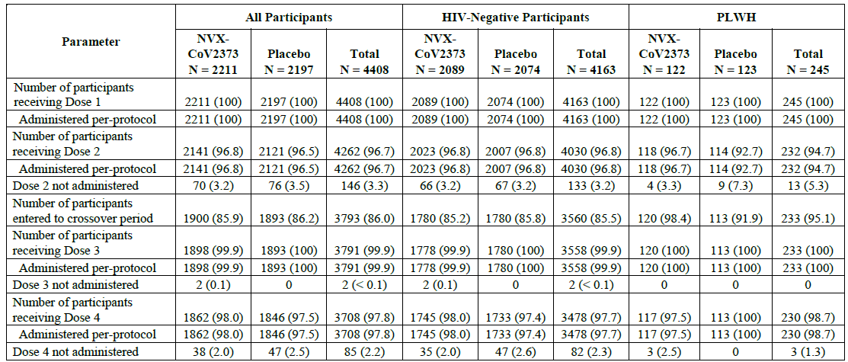
Abbreviations: HIV = human immunodeficiency virus, NVX-CoV2373 = 5 μg SARS-CoV-2 rS with 50 μg Matrix-M adjuvant, PLWH = people living with HIV, SARS-CoV-2 rS = severe acute respiratory syndrome coronavirus 2 recombinant spike protein nanoparticle vaccine.
Note: n represents the number of participants at each level of summarisation. Percentages were based on the number of participants in the safety analysis set within each treatment and overall.
Note: Data are presented as number and percentage of participants, as n (%).
There was a low rate of treatment-emergent adverse events following the first two doses of vaccine (22.3% and 20%) respectively, which dropped after the third and fourth doses of vaccine (2.7% and 2.6% respectively).
Figure 4a: Study 501 Summary of solicited adverse events by maximum grade for seven days following vaccination (entire study), safety analysis set
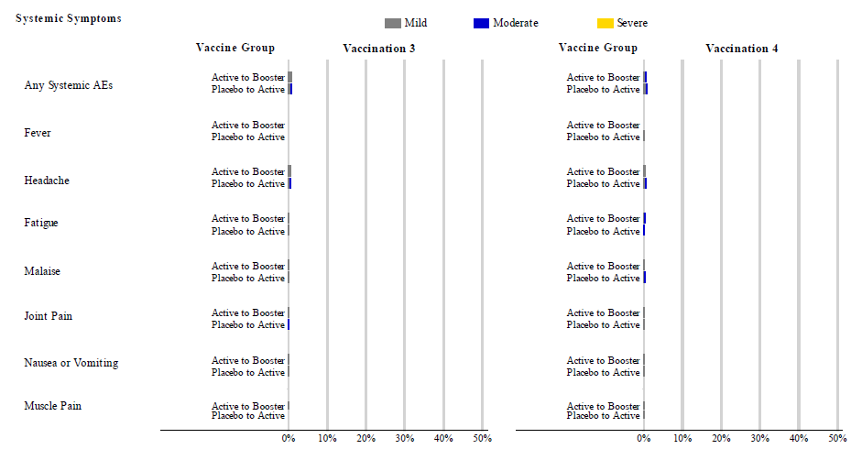
Abbreviation: Active = SARS-CoV-2 rS (5 μg) + Matrix-M1 adjuvant (50 μg).
For vaccinations three and four, subjects were monitored on site for reactogenicity on the vaccination day only. Subjects that received four active doses are excluded from vaccination dose four.
Figure 4b: Study 501 Summary of solicited adverse events by maximum grade for seven days following vaccination (entire study), safety analysis set
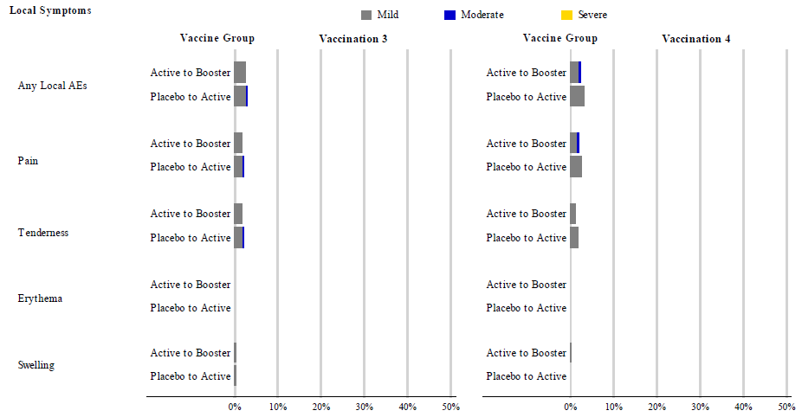
Abbreviation: Active = SARS-CoV-2 rS (5 μg) + Matrix-M1 adjuvant (50 μg).
For vaccinations three and four, subjects were monitored on site for reactogenicity on the vaccination day only. Subjects that received four active doses are excluded from vaccination dose four.
Unsolicited treatment-emergent adverse events were observed in 17.3% of Nuvaxovid and 16.6% of placebo subjects in the baseline negative group.
Table 12: Study 501 Summary of unsolicited treatment-emergent adverse events through end of study after third vaccination (post-crossover ‒ booster) with NVX-CoV2373 or placebo by preferred term in all participants regardless of baseline serostatus, safety analysis set
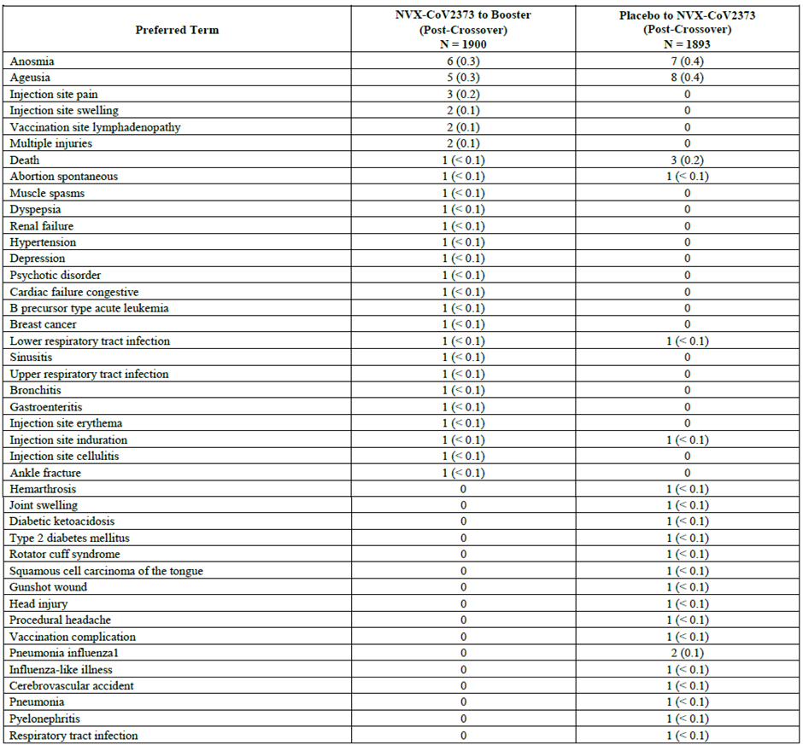
Abbreviations: EoS = end of study, MedDRA = Medical Dictionary for Regulatory Activities, NVX-CoV2373 = 5 μg SARS-CoV-2 rS with 50 μg Matrix-M adjuvant, SARS-CoV-2 rS = severe acute respiratory syndrome coronavirus 2 recombinant spike protein nanoparticle vaccine, TEAE = treatment-emergent adverse event.
Note: n represents the number of participants at each level of summarisation. Percentages were based on the number of participants in the safety analysis set within each treatment and overall.
Note: Data are presented as number and percentage of participants, as n (%).
Note: TEAEs were coded using MedDRA v24.1.
There were no clear patterns of new adverse events emerging after the booster doses that is, after the third dose.
There were 20 deaths reported by the end of Study 501, of which 10 occurred in each of the Nuvaxovid/Nuvaxovid booster and Placebo/Nuvaxovid booster arms. All deaths were assessed as not related to active treatment.
In the entire study one subject developed Type 1 diabetes (in the primary series) and one developed facial paralysis (in the primary series). There were no adverse events of special interest reported after the crossover (booster doses).

Study 2019nCoV-101 (Study 101)

Summary of prior evaluation
Study 101 was a two-part Phase I/II randomised observer blinded study submitted as part of the application to provisionally register an adult booster schedule for Nuvaxovid. The study was conducted in two parts which examined the safety and immunogenicity of Nuvaxovid in healthy adults 18 to 59 years of age. Part 2 of the study is of particular relevance as it includes a third booster at Day 189 using the marketed 5 μg dose.
Table 13: Study 101 Part 2 protocol design
Abbreviations: SARS-CoV-2 rS = severe acute respiratory syndrome coronavirus 2 recombinant spike protein nanoparticle vaccine.
The primary endpoints for this study were immunological and aimed at dose finding for the optimal formulation and schedule.

New data submitted
A 385 day interim report has been submitted, which provides an update on the 189 day interim report evaluated in the provisional registration application.

Overview of new data submitted
The salient data submitted was the Day 371 data follow-up of immunoglobulin G (IgG) levels post the six month booster (third dose) delivered in the originally submitted interim study report at Day 189 and a booster (fourth dose) administered at Day 357.
Figure 5: Study 101 Phase II (unblinded) Day 0 though Day 371, line plots of immunoglobulin G geometric mean ELISA unit values with 95% confidence interval, per-protocol subjects, boosting phase subjects only, overall age group
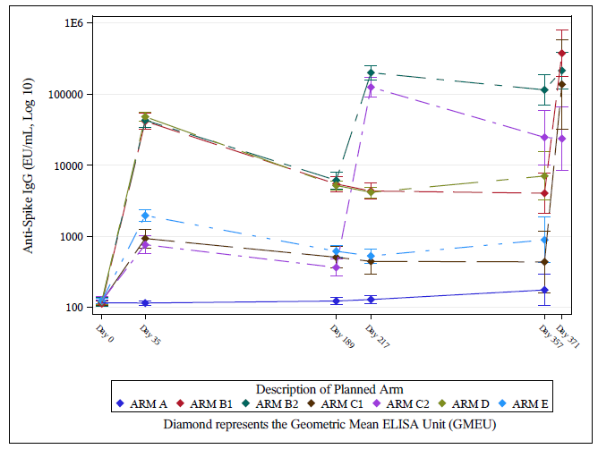
Figure 6: Study 101 Phase II (unblinded) Day 0 though Day 371, line plots of immunoglobulin G geometric mean ELISA unit values with 95% confidence interval, per-protocol subjects, boosting phase subjects only, 18 to 59 years age group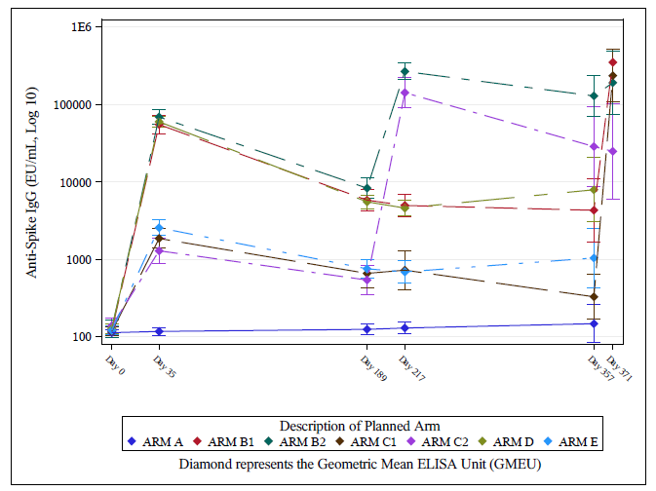
Figure 7: Study 101 Phase II (unblinded) Day 0 though Day 371, line plots of immunoglobulin G geometric mean ELISA unit values with 95% confidence interval, per-protocol subjects, boosting phase subjects only, 60 to 84 years age group
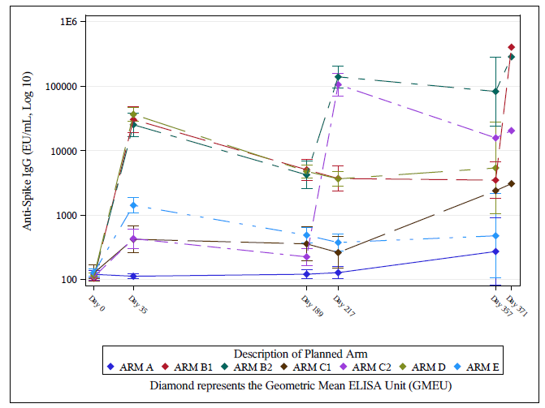
The geometric mean ELISA unit (GMEU) figures (Figure 5, Figure 6 and Figure 7) are consistent with those observed at Day 189 in the provisional registration submission. They indicate a boost in IgG levels following a third dose which generally remains elevated to post-dose two levels over the year of observation. There is shorter term data for a similar boost in IgG levels after a fourth dose, but there is no long term data on the duration of this effect.
Table 14: Overall summary of solicited and unsolicited adverse events following vaccination in all participants, safety analysis set
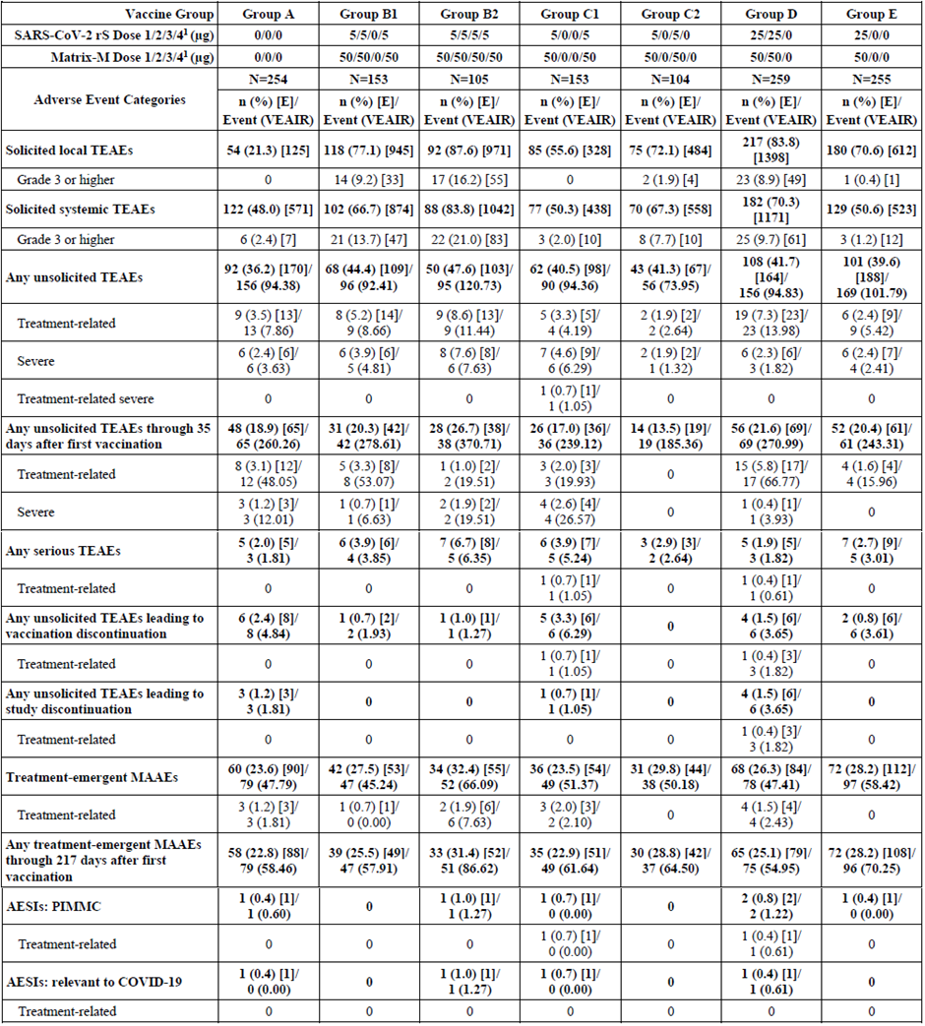
Abbreviations: AESI = adverse events of special interest, COVID-19 = coronavirus disease 2019, [E] = represents the number of events at each level of summarisation, FDA = United States Food and Drug Administration, MAAE = medically attended adverse events, MedDRA = Medical Dictionary for Regulatory Activities, PIMMC = potential immune-mediated medical conditions, SARS-CoV-2 rS = severe acute respiratory syndrome coronavirus 2 recombinant spike protein nanoparticle vaccine, TEAE = treatment-emergent adverse event, VEAIR = vaccine-exposure adjusted incidence rate per 100 person-years.
Note: Toxicity grading for solicited TEAEs are based on FDA toxicity grading scales in Section 16.3 of Protocol 2019nCoV-101.
Event = total number of events before any unblinding or non-study drug COVID-19 vaccination. VEAER was calculated as Event × 100 / sum of risk exposure in years for participants in each treatment group. The exposure to risk was from the date of dose indicated to 1 day prior to the date of an approved vaccine or date of unblinding or 28 days after booster dose, whichever was earlier. For participants who did not have an approved vaccine or date of unblinding the exposure period was from the date of dose indicated to date of study discontinuation or one day prior to next dose or data cut-off or 28 days after booster dose, whichever was earlier.
¹ Dose four was only administered at Day 357 to consenting participants from Groups B1, B2, C1, and C2.
The most relevant arm of the study for adverse events for Australian clinical use is B2, in which all the doses of Nuvaxovid used were 5 μg (See Table 14).
There was no pattern of adverse events which indicated a new or unreported safety issue from the previously characterised profile of Nuvaxovid.

Risk management plan
The most recently reviewed EU- Risk Management Plan (RMP) was version 2.1 (dated 1 September 2022; data lock point (DLP) 31 July 2022) and Australia specific annex ASA version 1.6 (dated 14 October 2022), through the updated RMP pathway. The sponsor has submitted EU-RMP version 3.1 (dated 6 February 2023; DLP 22 December 2022) and ASA version 1.8 (dated 26 April 2023) in support of this application.
There is an ongoing parallel submission, PM-2023-00909-1-2, to vary the PI to include booster dose instructions for adolescents 12 to less than 18 years of age. The sponsor provided ASA version 1.7 (dated 20 March 2023) for this submission.
The sponsor has provided an updated ASA version 1.8 (dated 26 April 2023) with the response to TGA questions to ensure that the tracked and clean copies have the same date.
The summary of safety concerns and their associated risk monitoring and mitigation strategies are summarised in Table 15. The TGA may request an updated RMP at any stage of a product's lifecycle, during both the pre-approval and post-approval phases.
Table 15: Summary of safety concerns
Summary of safety concerns |  | Pharmacovigilance |  | Risk Minimisation
 |  | Routine | Additional | Routine | Additional
Important identified risks | Myocarditis and/or pericarditis | ü¹ | ü^{2,3} | ü | –
Important potential risks | Vaccine-associated enhanced disease (VAED), including vaccine associated enhanced respiratory disease (VAERD) | ü¹ | ü^{2,3} | – | –
Missing information | Use in pregnancy and while breastfeeding | ü | ü⁴ | ü | –
Missing information | Use in immunocompromised patient | ü | ü^{2,3} | ü | –
Missing information | Use in frail patients with comorbidities (e.g., chronic obstructive pulmonary disease (COPD), diabetes, Chronic neurological disease, cardiovascular disorders) | ü | ü^{2,3} | – | –
Missing information | Use in patients with autoimmune or inflammatory disorders | ü | ü^{2,3} | ü | –
Missing information | Interaction with other vaccines | ü | ü^{2,3} | ü | –
Missing information | Long term safety | ü | ü^{2,3} | – | –
¹ Targeted follow-up questionnaires
² Post authorisation safety study (PASS) in UK and USA
³ Clinical trials
⁴ Global safety surveillance study (pregnancy and infant outcome) using pregnancy registry (GSSS)

The summary of safety concerns was previously reviewed and accepted. The summary of safety concerns continues to be acceptable from an RMP perspective.
The sponsor has proposed routine and additional pharmacovigilance activities for all safety concerns. In this submission the sponsor has included two new clinical studies to the previously evaluated and approved plan. This is acceptable. The fulfilment of the clinical study plan is for the Delegate to consider.
Only routine risk minimisation activities are proposed for this submission. The plan was approved during the provisional registration of this product. There are risk minimisation measures implemented for COVID-19 vaccines by the Department of Health and Aged Care and State and Territory Governments. The changes proposed in this application do not warrant updates to the currently approved risk minimisation plan.

Risk management plan wording for conditions of registration
Any changes to which the sponsor has agreed should be included in a revised RMP an ASA.
However, irrespective of whether or not they are included in the currently available version of the RMP document, the agreed changes become part of the risk management system.
The suggested wording is:
The NUVAXOVID EU-Risk Management Plan (RMP) (version 3.1, dated 6 February 2023, data lock point 22 December 2022), with Australian Specific Annex (version 1.8, dated 26 April 2023), included with submission PM-2023-01692-1-2, and any subsequent revisions, as agreed with the TGA will be implemented in Australia.

Risk-benefit analysis

Delegate’s considerations
The sponsor has provided adequate responses to the quality, nonclinical and clinical post-market commitments made when Nuvaxovid was provisionally registered.
The clinical information provided comprises later reports from the same clinical trials submitted in the original applications. These generally confirm immunological response observed in the initial trials is valid out to one year of observation. There is no substantial difference in the initially reported safety profile of the product, and there were no new safety concerns identified in the updated clinical trials. The Delegate notes that there is post-market experience with Nuvaxovid in addition to clinical trial data given Nuvaxovid has been provisionally marketed.
The Delegate notes that there is an ongoing application (PM-2023-00909-1-2) to provisionally register a booster dose in the adolescent population. The Delegate will make a decision regarding transition of this age-cohort to full-registration when this application is finalised. The Delegate notes that such transition may still involve specific conditions on the full registration if these are considered necessary by the provisional application Delegate.

Proposed action
The Delegate proposes to move the registration of Nuvaxovid from provisional to standard registration for use in patients 12 years and older as a primary series, or 18 years and older as third and subsequent doses. The Delegate will delay making a decision on the full registration of Nuvaxovid for use in adolescents as a third or subsequent dose until the resolution of application PM-2023-00909-1-2.
The Product Information document for Nuvaxovid will be amended from the draft provided on 20th October (version 9-1) as follows:
- Reference in the Dosage and Administration to ‘Booster Dose’ will be changed to ‘Additional Dose’.
- The statement ‘The use of this vaccine should be in accordance with clinical recommendations in Australia, made by ATAGI in the Australian Immunisation Handbook.’ will be inserted under the current paragraph ‘Booster dose’ as a separate paragraph.
- The ‘Interchangeability’ section will be removed, and the Delegate notes it is redundant as it provides the current ATAGI usage advice referred to in (2).

Outcome
Based on a review of quality, safety, and efficacy, the TGA approved the registration of Nuvaxovid (SARS-CoV-2-rS (NVX-CoV2373)) 5 μg/0.5 mL suspension for injection, multidose vials for the transition from provisional registration to full registration indicated for:
Active immunisation to prevent coronavirus disease 2019 (COVID-19) caused by SARS-CoV-2 in individuals 12 years of age and older.
The use of this vaccine should be in accordance with official recommendations.

Specific conditions of registration applying to these goods
RMP conditions:
- Nuvaxovid COVID-19 Vaccine (adjuvanted) (SARS-CoV-2-rs (NVX-CoV-2373)) is to be included in the Black Triangle Scheme. The PI and CMI for Nuvaxovid must include the black triangle symbol and mandatory accompanying text for five years from initial provisional approval.
- The Nuvaxovid EU-Risk Management Plan (RMP) (version 3.1, dated 6 February2023, data lock point 22 December 2022), with Australia specific annex (version1.8, dated 26 April 2023), included with submission PM-2023-01692-1-2, and any subsequent revisions, as agreed with the TGA will be implemented in Australia.
Quality Conditions:
- GMP [Good Manufacturing Practice] clearance for listed manufacturers: All relevant manufacturing sites require approved and current GMP Clearances prior to Australian supply. A commitment is required from the sponsor that they maintain the validity of all manufacturer GMP Clearances for the duration of product supply to Australia. Additionally, that adherence to the conditions of GMP Clearance approval is upheld.
- Post-approval stability protocol and stability commitment: The manufacturer has provided commitment to continue the ongoing stability studies presented in the stability studies protocol. Additionally, 1 batch of drug product per year for all relevant products will be placed on long-term stability program and on accelerated stability testing where significant changes are made to the manufacturing process. The manufacturer has committed to communicate any out of specifications stability test results to the TGA.
- Batch Release Testing and Compliance
It is a condition of registration that all independent batches of Nuvaxovid (SARS-CoV-2 rS [NVX-CoV2373]) COVID-19 vaccine imported into Australia are not released for sale until samples and the manufacturer’s release data have been assessed and you have received notification acknowledging release from the Laboratories Branch, TGA.
For each independent batch of the product imported into Australia, the sponsor must supply the following:
  - A completed Request for Release Form, available from vaccines@health.gov.au.
  - Complete summary protocols for manufacture and QC, including all steps in production in the agreed format.
  - At least a 2 mL sample (as at least 4 × 500 μL aliquots) of each bulk drug substance batch used in the manufacture of the given drug product batch.
  - At least twenty (20) vials (samples) of each manufacturing batch of Nuvaxovid (SARS-CoV-2 rS [NVX-CoV2373]) COVID-19 vaccine with the Australian approved labels, PI and packaging (unless an exemption to supply these has been granted) representative of all batches of product seeking distribution in Australia.
  - At least five (5) vials (samples) of any further consignments of a manufacturing batch of Nuvaxovid (SARS-CoV-2 rS [NVX-CoV2373]) COVID-19 vaccine with the Australian approved labels, PI and packaging (unless an exemption to supply these has been granted). Further consignments cover batches previously supplied to TGA for the purposes of batch release testing but are seeking to be supplied again.
  - If the manufacturing batch has been released in Europe or United Kingdom a copy of the EU Official Control Authority Batch Release (OCABR) certificate (or equivalent from the UK) must be provided.
  - Any reagents, reference material and standards required to undertake testing, as requested by Laboratories Branch, TGA.
Sponsors must provide all requested samples and data in sufficient time (at least 5 business days) prior to any distribution date to allow the TGA to perform testing and review. Distribution of each batch of vaccine is conditional upon fulfilment of these conditions and receipt of a letter from the Laboratories Branch acknowledging release.
Samples and data should be forwarded to the Biotherapeutics Section, Laboratories Branch before release of each batch and with sufficient lead time to allow for Laboratories Branch testing. The address for courier delivery is:
ATTN: Batch Release Coordinator
Biotherapeutics Section
TGA Laboratories Branch
1 Tindal Lane
Canberra Airport, ACT 2609
The shipments (including reagents) to TGA are the responsibility of the Australian Sponsor/Agent who will be required to facilitate the import and customs clearance process.
- Certified Product Details
An electronic copy of the Certified Product Details (CPD) as described in Guidance 7:Certified Product Details of the Australian Regulatory Guidelines for Prescription Medicines (ARGPM) [https://www.tga.gov.au/guidance-7-certified-product-details]should be provided upon registration of the therapeutic good. In addition, an updated CPD, for the above products incorporating the approved changes is to be provided within one month of the date of the approval letter. A template for preparation of CPD for biological prescription medicines and vaccines can be obtained from the TGA website[https://www.tga.gov.au/form/certified-product-details-cpd-biological-prescription-medicines]. The CPD should be sent as a single bookmarked PDF document to Vaccines@health.gov.au as soon as possible after registration/approval of the productor any subsequent changes as indicated above.

Attachment 1. Product Information
The PI for Nuvaxovid approved with the submission which is described in this AusPAR is at Attachment 1. For the most recent PI, please refer to the TGA PI/CMI search facility.

Therapeutic Goods Administration
PO Box 100 Woden ACT 2606 Australia
Email: info@tga.gov.au Phone: 1800 020 653 Fax: 02 6203 1605
https://www.tga.gov.au
Reference/Publication #

This is the original indication proposed by the sponsor when the TGA commenced the evaluation of this submission. It may differ to the final indication approved by the TGA and registered on the Australian Register of Therapeutic Goods.

