Australian Public Assessment Report for Mounjaro
  - Active ingredient: Tirzepatide
  - Sponsor: Eli Lilly Australia Pty Ltd
November 2023

About the Therapeutic Goods Administration (TGA)
- The Therapeutic Goods Administration (TGA) is part of the Australian Government Department of Health and Aged Care and is responsible for regulating therapeutic goods, including medicines, medical devices, and biologicals.
- The TGA administers the Therapeutic Goods Act 1989 (the Act), applying a risk management approach designed to ensure therapeutic goods supplied in Australia meet acceptable standards of quality, safety, and efficacy.
- The work of the TGA is based on applying scientific and clinical expertise to decision-making, to ensure that the benefits to the Australian public outweigh any risks associated with the use of therapeutic goods.
- The TGA relies on the public, healthcare professionals and industry to report problems with therapeutic goods. The TGA investigates reports received to determine any necessary regulatory action.
- To report a problem with a therapeutic good, please see the information on the Therapeutic Goods Administration (TGA) website.

About AusPARs
- The Australian Public Assessment Report (AusPAR) provides information about the evaluation of a prescription medicine and the considerations that led the TGA to approve or not approve a prescription medicine submission. Further information can be found in Australian Public Assessment Report (AusPAR) guidance.
- AusPARs are prepared and published by the TGA.
- AusPARs are static documents that provide information that relates to a submission at a particular point in time. The publication of an AusPAR is an important part of the transparency of the TGA’s decision-making process.
- A new AusPAR may be provided to reflect changes to indications or major variations to a prescription medicine subject to evaluation by the TGA.

Copyright
© Commonwealth of Australia 2023
This work is copyright. You may reproduce the whole or part of this work in unaltered form for your own personal use or, if you are part of an organisation, for internal use within your organisation, but only if you or your organisation do not use the reproduction for any commercial purpose and retain this copyright notice and all disclaimer notices as part of that reproduction. Apart from rights to use as permitted by the Copyright Act 1968 or allowed by this copyright notice, all other rights are reserved and you are not allowed to reproduce the whole or any part of this work in any way (electronic or otherwise) without first being given specific written permission from the Commonwealth to do so. Requests and inquiries concerning reproduction and rights are to be sent to the TGA Copyright Officer, Therapeutic Goods Administration, PO Box 100, Woden ACT 2606 or emailed to <tga.copyright@tga.gov.au>.

Contents
List of abbreviations 4
Product submission 5
Submission details 5
Product background 6
Regulatory status 7
Product Information 10
Registration timeline 10
Submission overview and risk/benefit assessment 10
Quality 11
Nonclinical 11
Adverse effects 11
Pregnancy category 12
Conclusion 12
Clinical 12
Summary of clinical studies 12
Pharmacology 13
Efficacy 21
Safety 35
Immunogenicity and antidrug antibodies 46
Post-market experience 46
Risk management plan 46
Product information 48
Risk-benefit analysis 48
Delegate’s considerations 48
Proposed action 51
Advisory Committee considerations 51
Outcome 53
Specific conditions of registration applying to these goods 53
Attachment 1. Product Information 53

List of abbreviations
Abbreviation | Meaning
ACM | Advisory Committee on Medicines
ADA | Antidrug antibody
ARTG | Australian Register of Therapeutic Goods
ASA | Australia specific annex
AUC | Area under the concentration versus time curve
AUC_{inf} | Area under the concentration versus time curve from time zero to infinity
AUC_{last} | Area under the concentration versus time curve from time zero to the last measurable time point
BMI | Body mass index
CMI | Consumer Medicines Information
CNS | Central nervous system
DPP-4 | Dipeptidyl peptidase 4
EASD | European Association for the Study of Diabetes
eGFR | Estimated glomerular filtration rate
GIP | Glucose-dependent insulinotropic polypeptide
GLP-1 | Glucagon-like peptide-1
HbA1c | Haemoglobin A1c
LSM | Least-squares means
MACE | Major adverse cardiovascular event
OC | Oral contraceptives
PD | Pharmacodynamics
PI | Product Information
PK | Pharmacokinetics
PSUR | Periodic safety update report
RMP | Risk management plan
SAE | Serious adverse event
SGLT2 | Sodium-glucose co-transporter 2
TEAE | Treatment-emergent adverse event
TGA | Therapeutic Goods Administration
T2DM | Type 2 diabetes mellitus

Product submission

Submission details
Type of submission: | New chemical entity
Product name: | Mounjaro
Active ingredient: | Tirzepatide
Decision: | Approved
Date of decision: | 22 December 2022
Date of entry onto ARTG: | 23 December 2022
ARTG numbers: | 379330, 379331, 379332, 379333, 379334 and 382625
Black Triangle Scheme | Yes  This product will remain in the scheme for 5 years, starting on the date the product is first supplied in Australia.
Sponsor’s name and address: | Eli Lilly Australia Pty Ltd  Level 9, 60 Margaret Street  Sydney NSW 2000
Dose forms: | Solution for injection
Strengths: | 2.5 mg/0.5 mL, 5 mg/0.5 mL, 7.5 mg/0.5 mL, 10 mg/0.5 mL, 12.5 mg/0.5 mL, 15 mg/0.5 mL
Container: | Syringe (pre-filled pen autoinjector)
Pack sizes: | 2 and 4 pre-filled pens (all strengths)  2 pre-filled pens as starter pack (2.5 mg/0.5 mL only)
Approved therapeutic use for the current submission: | Mounjaro is indicated for the treatment of adults with insufficiently controlled type 2 diabetes mellitus as an adjunct to diet and exercise  •as monotherapy when metformin is not tolerated or contraindicated  •in addition to other medicinal products for the treatment of type 2 diabetes
Route of administration: | Subcutaneous injection
Dosage: | The starting dose of tirzepatide is 2.5 mg once weekly.  After 4 weeks, increase the dose to 5 mg once weekly. If needed, dose increases can be made in 2.5 mg increments after a minimum of 4 weeks on the current dose.  The recommended doses are 5 mg, 10 mg and 15 mg.  The maximum dose of tirzepatide is 15 mg once weekly.  Self-monitoring of blood glucose is not needed in order to adjust the dose of tirzepatide.  For further information regarding dosage, refer to the Product Information.
Pregnancy category: | D  Drugs which have caused, are suspected to have caused or may be expected to cause, an increased incidence of human fetal malformations or irreversible damage. These drugs may also have adverse pharmacological effects. Accompanying texts should be consulted for further details.  The use of any medicine during pregnancy requires careful consideration of both risks and benefits by the treating health professional. This must not be used as the sole basis of decision making in the use of medicines during pregnancy. The TGA does not provide advice on the use of medicines in pregnancy for specific cases. More information is available from obstetric drug information services in your state or territory.

Product background
This AusPAR describes the submission by Eli Lilly Australia Pty Ltd (the sponsor) to register Mounjaro (tirzepatide) in 6 strengths (2.5 mg/0.5 mL, 5 mg/0.5 mL, 7.5 mg/0.5 mL, 10 mg/0.5 mL, 12.5 mg/0.5 mL, 15 mg/0.5 mL) of solution for injection in pre-filled pens for the following proposed indication:
Mounjaro is indicated for the treatment of adults with type 2 diabetes mellitus as an adjunct to diet and exercise
- as monotherapy when metformin is not tolerated or contraindicated
- in addition to other medicinal products for the treatment of type 2 diabetes.
Type 2 diabetes mellitus (T2DM) is a metabolic disorder characterised by insulin resistance and relative insulin deficiency leading to hyperglycaemia. Type 2 diabetes mellitus comprises the majority of people with diabetes and is largely the result of excess body weight and physical inactivity. The course of T2DM is marked by deteriorating beta-cell function and increasing insulin resistance.
The primary goal of treatment is to maximise the control of blood sugar concentrations, whilst minimising the risk of hypoglycaemia. Secondary goals are to manage cardiovascular risk factors and microvascular complications of diabetes.
Treatments for T2DM include: lifestyle modification (including dietary advice with regard to weight loss and increased physical activity); metformin (as monotherapy or in combination); dipeptidyl peptidase 4 (DPP-4) inhibitors; sulfonylureas; sodium-glucose co-transporter 2 (SGLT2) inhibitors; glucagon-like peptide-1 (GLP-1) receptor agonists; thiazolidinediones; acarbose; insulin therapy.
Tirzepatide has agonist activity at both the glucose-dependent insulinotropic polypeptide (GIP) receptor and the GLP-1 receptor. There is no GIP receptor agonist approved in Australia. Registered GLP-1 receptor agonists include liraglutide, dulaglutide, and semaglutide.
This submission was evaluated as part of the Australia-Canada-Singapore-Switzerland-United Kingdom (Access) Consortium with work-sharing between the TGA, Health Canada, Health Sciences Authority Singapore and Swissmedic. Each regulator made independent decisions regarding approval (market authorisation) of the new medicine.

Regulatory status
This product is considered a new chemical entity for Australian regulatory purposes.
At the time the TGA considered this submission, a similar submission had been approved in the United States of America on 13 May 2022, the European Union on 15 September 2022, Switzerland on 2 November 2022, and Canada on 24 November 2022. A similar submission was under consideration in Singapore (submitted on 29 November 2021).
The following table summarises these submissions and provides the indications where approved.
Table 1: International regulatory status
Region | Submission date | Status | Approved indications
United States of America | 14 September 2021 | Approved on 13 May 2022 | Mounjaro is indicated as an adjunct to diet and exercise to improve glycemic control in adults with type 2 diabetes mellitus.  Limitations of Use  - Mounjaro has not been studied in patients with a history of pancreatitis [see Warnings and Precautions (5.2)].  - Mounjaro is not indicated for use in patients with type 1 diabetes mellitus.
European Union | 6 October 2021 | Approved on 15 September 2022 | Mounjaro is indicated for the treatment of adults with insufficiently controlled type 2 diabetes mellitus as an adjunct to diet and exercise  - as monotherapy when metformin is considered inappropriate due to intolerance or contraindications  - in addition to other medicinal products for the treatment of diabetes.  For study results with respect to combinations, effects on glycaemic control and the populations studied, see sections 4.4, 4.5 and 5.1.
Switzerland | 30 November 2021 | Approved on 2 November 2022 | Mounjaro is indicated for the treatment of adults with insufficiently controlled type 2 diabetes mellitus as an adjunct to diet and exercise  - as monotherapy when metformin is contraindicated or not tolerated;  - in combination with other drugs that lower blood glucose.  See “Clinical efficacy” section for results on the combinations examined in clinical studies.
Canada | 29 November 2021 | Approved on 24 November 2022 | Mounjaro (tirzepatide injection) is indicated for once-weekly administration as an adjunct to diet and exercise to improve glycemic control for the treatment of adult patients with type 2 diabetes mellitus.  - As monotherapy when metformin is inappropriate due to contraindication or intolerance.  - In combination with:  - metformin, or  - metformin and a sulfonylurea (see 4.1 Dosing Considerations and 7 WARNINGS AND PRECAUTIONS), or  - metformin and a sodium-glucose cotransporter 2 inhibitor (SGLT2i), or  - basal insulin with or without metformin (see 4.1 Dosing Considerations and 7 WARNINGS AND PRECAUTIONS).  Limitations of Use  - Mounjaro has not been studied in combination with short-acting, medium-acting, or dual formulation insulins.  - Mounjaro is not a substitute for insulin.  - Mounjaro should not be used in patients with type 1 diabetes mellitus (formerly known as insulin-dependent diabetes mellitus or IDDM).  - Mounjaro should not be used for the treatment of diabetic ketoacidosis.
Singapore | 29 November 2021 | Under consideration | Under consideration

Registration timeline
The following table captures the key steps and dates for this submission.
This submission was evaluated under the standard prescription medicines registration process.
Table 2: Timeline for Submission PM-2021-05212-1-5
Description | Date
Submission dossier accepted and first round evaluation commenced | 14 January 2022
First round evaluation completed | 13 May 2022
Sponsor provides responses on questions raised in first round evaluation | 29 June 2022
Second round evaluation completed | 26 August 2022
Delegate’s Overall benefit-risk assessment and request for Advisory Committee advice | 31 October 2022
Sponsor’s pre-Advisory Committee response | 9 November 2022
Advisory Committee meeting | 1 and 2 December 2022
Registration decision (Outcome) | 22 December 2022
Administrative activities and registration on the ARTG completed | 23 December 2022
Number of working days from submission dossier acceptance to registration decision* | 194
*Statutory timeframe for standard submissions is 255 working days

Submission overview and risk/benefit assessment
This section is a TGA summary of wording used in TGA’s evaluation report, which discussed numerous aspects of overseas evaluation reports and included some information that was commercial-in-confidence.
The following guideline was referred to by the Delegate as being relevant to this submission:
- Committee for Medicinal Products for Human Use (CHMP). Guideline on clinical investigation of medicinal products in the treatment or prevention of diabetes mellitus.

Quality
Tirzepatide is an amino acid sequence with a molecular weight of 4,813 Daltons. The following figure shows the chemical structure of tirzepatide with the standard single letter amino acid codes with the exception of residues aminoisobutyric acid2, aminoisobutyric acid13, and lysine20, where the structures of these amino acid residues are depicted. The secondary structure of tirzepatide is predominantly α-helical, the tertiary structure is consistent with a natively folded peptide. The drug substance is manufactured by standard solid-phase peptide synthesis, followed by several purification steps. There is no ICH guideline available for the synthetic peptides.
Figure 1: Chemical structure of tirzepatide
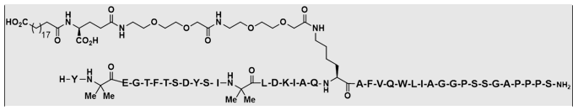
Mounjaro is manufactured as a sterile solution, using aseptic filtration, and contains no novel excipients.
The solution is contained in a glass barrel syringe (Type 1) with elastomeric plunger encased in a disposable single-dose pen (autoinjector).
Mounjaro has a shelf life of 24 months, based on real time data obtained at the proposed storage condition of 2°C to 8°C (refrigerate; do not freeze). In-use, Mounjaro may be stored unrefrigerated for up to 21 days at temperatures not above 30°C.
Approval is recommended for registration of the proposed product from a pharmaceutical chemistry perspective.

Nonclinical
The nonclinical dossier was in accordance with the relevant ICH guidelines on the nonclinical assessment of pharmaceuticals, and biotechnology -derived pharmaceuticals. No major deficiencies were noted in the nonclinical dossier.
The nonclinical studies confirmed the proposed mechanism of action and support the proposed indication.

Adverse effects
Increased heart rate was observed in monkeys at low exposures. Tirzepatide -induced increase in heart rate is likely to be of clinical significance. Adverse effects on the central nervous system (CNS) and respiratory systems are not predicted in patients.
The pharmacokinetics of tirzepatide was adequately similar in the animal species used in the toxicity program and patients.
No direct target organ toxicity was identified but heart (increased heart rate) and thyroid (C-cell hyperplasia) effects were noted in monkeys and rats, respectively, at low exposures (as determined by area under the concentration versus time curve (AUC)); these effects are likely to occur at clinical doses.
Tirzepatide is not expected to pose a genotoxic concern.
In a 2-year rat carcinogenicity study, tirzepatide-related proliferative lesions and neoplastic findings were observed in thyroid C-cells at subclinical exposures. Thyroid C-cell tumour is considered a potential clinical risk.

Pregnancy category
The sponsor proposed Pregnancy Category D. Given that drug related increased incidences of post implantation loss, impaired growth and fetal malformations were observed at subclinical exposure ratios, in rats, this is considered appropriate. The mechanisms underlying these adverse embryofetal development effects have not been fully elucidated. Tirzepatide should not be used during pregnancy.

Conclusion
There are no nonclinical objections to registration from the nonclinical perspective.

Clinical

Summary of clinical studies
The clinical dossier consisted of 19 completed clinical studies:
- 3 biopharmaceutic studies (Studies GPHI, GPGS, and GPGE)
- 7 clinical pharmacology studies (including one mechanism of action study) (Studies GPGR, GPGA, GPGG, GPGQ, GPHX, GPGT, and GPGC) designed to assess the pharmacokinetics (PK), pharmacodynamics (PD), the effects of extrinsic and intrinsic factors on tirzepatide PK, the impact of tirzepatide on PK of orally administered drugs, and safety and tolerability of tirzepatide
- 2 Phase II studies (Studies GPGB and GPGF): multicentre, double blind studies conducted to provide assessments of the efficacy, safety, and tolerability of tirzepatide between 1 and 15 mg to support dose selection and optimisation of the dose escalation scheme for Phase III studies.
- 5 global (pivotal) Phase III studies: SURPASS-1 (Study GPGK), SURPASS-2 (Study GPGL), SURPASS-3 (Study GPGH), SURPASS-4 (Study GPGM), and SURPASS-5 (Study GPGI)
- 2 regional Phase III studies (SURPASS J-mono (Study GPGO) and SURPASS J-combo (Study GPGP), conducted in Japan): 52-week, multicentre studies. The data from these studies are not included in the efficacy assessment but contribute to the safety assessment.
As at 2 June 2021, tirzepatide is under assessment in 15 ongoing studies to further evaluate the potential cardiovascular benefit, safety, and mechanism of action; and support potential other indications, including chronic weight management, heart failure with preserved ejection fraction and non-alcoholic steatohepatitis.

Pharmacology
The pharmacokinetic (PK) and pharmacodynamics (PD) properties of tirzepatide in healthy subjects and in patients with T2DM following single (0.25 mg to 8 mg) and multiple doses (0.5 mg to 15 mg) were evaluated in 10 Phase I studies (3 biopharmaceutic studies and 7 clinical pharmacology studies).
Pharmacokinetic data collected in the 2 Phase II and the 7 Phase III studies was used exclusively for population PK as well as PK/PD analyses.

Pharmacokinetics (PK)

Absorption
Following single and multiple once weekly doses of tirzepatide, the peak plasma concentrations were reached after approximately 24 hours (median). The absolute bioavailability was approximately 80% based on the area under the concentration versus time curve from time zero to infinity (AUC_{inf}) ratio following subcutaneous and intravenous administration (Study GPGE). Based on this, the sponsor proposes subcutaneous administration without dose adjustment. Furthermore, an additional relative bioavailability study demonstrated comparability of tirzepatide injections administered with either the prefilled syringe or the single-dose pen.
Graphical analyses suggest that a steady state is reached after approximately 4 once weekly doses. Following the proposed dose escalation regimen, steady state tirzepatide exposures were predicted (Table 3 and Figure 2).
Table 3: Population pharmacokinetic study Model predicted steady-state tirzepatide exposure indices for the T2DM population
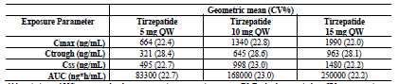
Abbreviations: AUC = area under the concentration versus time curve; CV = geometric coefficient of variation; Cmax = maximum observed drug concentration; Css = concentration at steady state; Ctrough = trough concentration; QW = once weekly.
Note: Simulations using distributions of baseline body weight, baseline body mass index, and sex from patients with type 2 diabetes mellitus in the population pharmacokinetics analysis dataset. Simulation mean body weight=89.6 kg.
Figure 2: Population pharmacokinetic study results showing tirzepatide concentration over time following tirzepatide single dose administration or once weekly dose administration with dose escalation
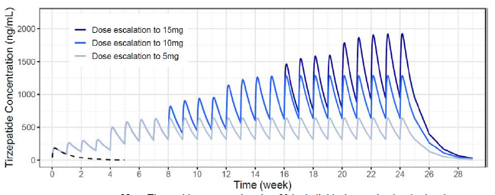
Note: Tirzepatide concentrations in a 90 kg individual were simulated using the tirzepatide population pharmacokinetic model. The solid lines denote concentrations following dose escalation up to 5, 10, or 15 mg. Dose escalation started with 2.5 mg and dose amount was increased by a 2.5 mg increment every 4 weeks. The dashed line denotes concentrations following a single 2.5 mg dose. Tirzepatide doses were administered once weekly. Tirzepatide lower limit of quantitation is 2 ng/mL.

Distribution
Based on in vitro findings, tirzepatide was highly bound in human plasma with a mean bound of 99.06%. The blood/plasma ratio of 0.5 suggests that tirzepatide is confined to the plasma compartment (Study GPHX). The estimated apparent volume of distribution at steady state in T2DM patients is 10.3 L.

Metabolism
Tirzepatide was primarily metabolised via proteolytic cleavages of the peptide backbone, β-oxidation of the C20 fatty diacid moiety, and amide hydrolysis.

Excretion and elimination
Based on population PK post hoc parameters, the estimated apparent total body clearance of tirzepatide calculated after extravascular administration (CL/F) in T2DM patients following multiple doses was 0.0606 L/h resulting in a mean terminal half-life of 5.4 days.

Dose proportionality
Overall, tirzepatide exposures increased with increasing dose. Following a single dose, a less than dose-proportional increase was observed. Following multiple doses, slightly more than dose-proportional increases were observed (Study GPGA).

Accumulation
There was moderate accumulation based on population PK post hoc parameters having an accumulation factor of 1.7.
Based on sparse sampling mass balance data with a recovery of 70%, tirzepatide was excreted via urine and faeces (50% and 20%, respectively) suggesting primarily renal excretion (Study GPHX). The sponsor explained the lack of full recovery with the sparse sampling approach. After an extrapolation procedure, the estimated total recovery was 99% (66% in urine and 33% in faeces). This extrapolation approach was considered acceptable by the clinical evaluator.
The predominant circulating entities were unchanged tirzepatide (80%), and 4 minor metabolites (less than 5.7%). No parent drug was detected in urine or faeces.

Immunogenicity
Based on the population PK analysis, there appeared to be no statistically significant relationship between antidrug antibodies (ADA) and clearance.

Population PK (popPK) data

Methods
Data: The PK clinical data source were the 6,248 subjects from all 19 completed clinical studies: 5% were participants without T2DM (for PK analysis only) and 95% were T2DM patients (for all analyses). The final population PK dataset consisted of 39,644 sample records from 5,802 subjects.
Model: Measurements of tirzepatide concentration, fasting glucose, haemoglobin A1c (HbA1c), and body weight following treatment with tirzepatide were analysed using nonlinear mixed-effects modelling with NONMEM and R. The models were evaluated using standard methods, including bootstrap analysis and visual predictive checks.

Results and conclusions
Model: The PK of tirzepatide was well described by a 2-compartment model with first-order absorption and interindividual variability on absorption rate, clearance, central volume of distribution, and proportional residual error. The final model included the following covariates: study effect on bioavailability, body weight on clearance, body weight and fraction fat mass on volume of distribution, and lyophilised formulation on absorption rate. Time-independent PK are likely.
The 95% confidence intervals of PK model parameters derived from bootstrap analysis showed adequate precision in parameter estimation. Goodness-of-fit and other diagnostic plots indicate adequate fidelity between model predictions and observed data and the absence of overt bias. The prediction-corrected visual predictive check for the final population PK model showed good agreement between observed and model-predicted tirzepatide concentrations. However, no prediction-corrected visual predictive checks for different subsets such as dose and study were submitted. A summary of PK parameters is in Table 4.
Table 4: Population pharmacokinetics study Summary of tirzepatide post hoc pharmacokinetic parameters
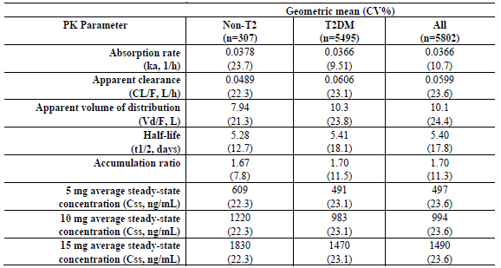
Abbreviations: CV = geometric coefficient of variation; n = number of subjects contributing to analysis; non-T2 = without T2DM; PK = pharmacokinetics; T2DM = type 2 diabetes mellitus
Impact of body weight: Tirzepatide exposure changed by 1.1% per kg over a body weight range of 70 to 120 kg (Figure 3). Relative to a typical 90 kg patient, there was approximately a 22% higher and 33% lower difference in exposure for a 70 or 120 kg patient, respectively. Based on the moderate differences in exposure, no dose adjustment is required based on body weight.
Figure 3: Population pharmacokinetics study results showing relationship between AUC and body weight for 5 mg, 10 mg and 15 mg tirzepatide
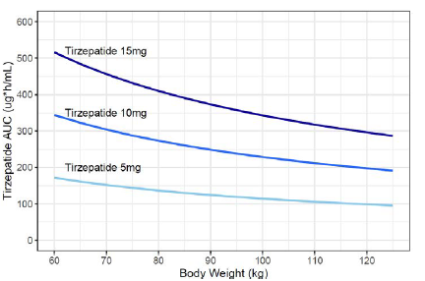
Abbreviation: AUC = area under the concentration versus time curve
Impact of dose interval: The simulation results suggested that in the event of a missed dose, it should be administered as soon as possible within 4 days (96 hours) which would result in a less than 20% increase in exposure associated with the subsequent scheduled dose. If more than 4 days have passed, it is recommended that the missed dose be skipped and to resume the regular once weekly dosing schedule.
Impact of intrinsic factors: After accounting for body weight in the population PK model, intrinsic factors were not associated with any statistically significant differences in tirzepatide PK. Based on the moderate differences in exposure (median ratios within 30% of reference value) primarily associated with variability of body weight, dose adjustments are not required based on age, sex, ethnicity, race, renal impairment, or hepatic impairment (Figure 4).
Furthermore, there appeared to be no statistically significant relationship between ADA status and clearance.
Figure 4: Population pharmacokinetic study results showing relative ratio of tirzepatide AUC and Cmax based on intrinsic factors
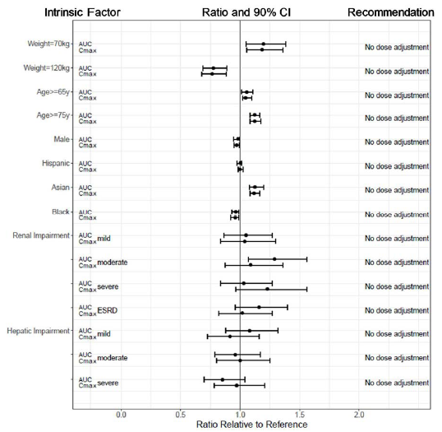
Abbreviations: AUC = area under the concentration versus time curve; CI = confidence interval; Cmax = maximum observed drug concentration; ESRD = end stage renal disease.
Note: Reference values for weight, age, sex, and race comparisons are 88 kg, 55 years old, female, and white, respectively; reference groups for renal and hepatic impairment data are subjects with normal renal and hepatic function from the respective clinical pharmacology studies. The body weights 70 and 120 kg were the 10th and 90th percentiles of the Phase III population. The median body weight for groups: (Age 65 years and older) 82 kg; (Age 75 years and older) 76 kg; (Male) 89 kg; (Hispanic) 86 kg; (Asian) 76 kg; (Black) 91 kg.

Pharmacodynamics (PD)

Mechanism of action
Tirzepatide is an amino acid sequence with agonist activity at both the human GIP and GLP-1 receptors. A fatty-diacid portion was attached at position C20 to optimise uptake and metabolism (see Figure 1). This arrangement enables albumin binding, which eventually leads to a longer half-life accommodating a once weekly dosing regimen.
Table 5: Summary of physiological mechanisms of GLP1 and GIP in glucose and energy metabolism
Location of action | Glucagon-like peptide-1 (GLP-1) | Glucose-dependent insulinotropic polypeptide  (GIP)
Pancreas (glucose-dependent actions)
Beta-Cells | Increased insulin synthesis, increased insulin secretion, increased beta-cells proliferation; increased glucose sensing under hyperglycaemic states
Alpha-Cells | Decreased glucagon secretion under hyperglycaemic states | Increased glucagon secretion under euglycaemic or hypoglycaemic states
Gastrointestinal system | Decreased gastrointestinal motility, delayed gastric emptying | not applicable
Adipose Tissues | not applicable | Increased intravascular lipolysis, increased fatty acid update
Brain | Decreased appetite, increased satiety | not applicable
Source: adapted from Min and Bain 2021

Exposure response analyses
Exposure-efficacy and exposure-safety analyses were conducted in patients with T2DM using data from 7 Phase III studies.
Exposure-efficacy analyses: The PD relationship between tirzepatide exposure and efficacy (fasting glucose, HbA1c, and body weight) were investigated in healthy subject and T2DM patients (Studies GPGA, GPGC, and GPGT) including the mechanistic aspects of tirzepatide based on the primary PD endpoint total clamp disposition index (cDI) (Study GPGT):
HbA1c: The time course of HbA1c was described using an indirect response model dependent on fasting glucose.
Body weight: The relationship between tirzepatide exposure and body weight was best described by a linear drug effect model (Figure 5). Biological sex and Japanese race were identified as significant covariates and were included in the final model. The model predicted a clear dose-response relationship, and no plateau was observed across the administered doses.
Fasting glucose: A statistically significant relationship between body weight change over time and tirzepatide concentration led to a reduced drug concentration that produces 50% of maximum effect on fasting glucose, suggesting that weight loss was associated with an improved effect of tirzepatide. The model predicted significant glycaemic improvements following the administration of 5 mg, 10 mg, or 15 mg once weekly doses. The largest effect was achieved with the 5 mg dose, plateauing with higher doses (Figure 6).
Figure 5: Pharmacodynamic analysis showing dose/exposure response relationship of tirzepatide
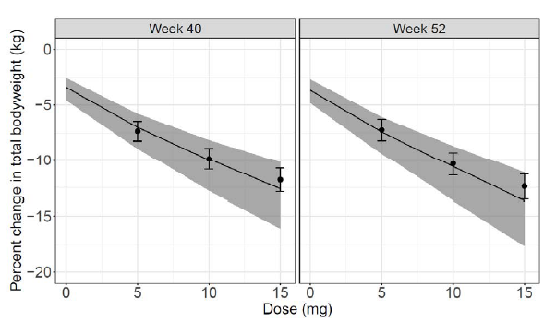
Note: The continuous line is the median prediction. The shaded area is the 95% confidence interval of the prediction. The points and error bars are the observed mean and 95% confidence interval respectively.
Figure 6: Pharmacodynamic analysis showing model-predicted tirzepatide dose-response at Week 52 for fasting glucose and HbA1c
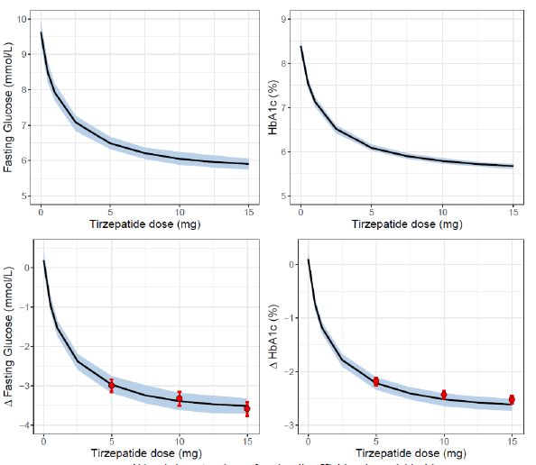
Abbreviations: Δ = change from baseline; HbA1c = haemoglobin A1c.
Note: Y-axis as absolute (top row) and change from baseline (bottom row). Solid black lines denote the simulation median and the shaded areas denote the 90% confidence interval. Red circles and error bars denote the mean and 95% confidence interval of observed data.
Exposure-safety analyses: A discrete-time Markov model was used to estimate transition probabilities between nausea, vomiting, and diarrhoea adverse event (AE) states (none, mild, or moderate/severe event) and to investigate the impact of tirzepatide effects and covariates on these probabilities.
Covariates: Biological sex, Japanese race, and Hispanic ethnicity were identified as significant covariates.
Gastrointestinal adverse events: Overall, the dose escalation regimen may have mitigated the incidence of gastrointestinal AEs, as the incidence rate was substantially decreased once steady state concentrations for any of the 3 proposed maintenance doses (5 mg, 10 mg, or 15 mg) were reached.
Cardiac safety: No thorough QT (tQT) study investigating the effect of supratherapeutic tirzepatide doses on cardiac repolarisation was conducted. Instead, a concentration effect analysis was performed. Further details are in the Safety section.

Oral contraception interaction
In an interaction study with oral contraceptives (Study GPGR), in the presence of 5 mg tirzepatide, the maximum observed concentrations of ethinyl oestradiol and norgestimate were decreased by 55% and 66%, respectively. As a consequence of gastric emptying delay, delays in time to maximum concentrations of 2.5 hours to 4.5 hours were observed when the oral contraceptive was administered. The impact on area under the concentration time curve from time zero to the last measurable time point (AUC_{last}) was less pronounced (16% and 20%), but greater in value compared to other GLP-1 receptor agonists. The higher proposed tirzepatide doses (10 mg and 15 mg) were not tested.
In their response, the sponsor essentially states that AUC and not maximum observed drug concentration is the driver of contraception efficacy, and that an approximately 20% decrease may not be clinically meaningful in the presence of a coefficient of variation percentage (CV%) of a similar magnitude. Some further statements with regard to contraceptive patches or gastric emptying data are not definitely relevant, as actual interaction PK data are available from Study GPGR.
With regard to the doses tested, the sponsor claims that the tested 5 mg dose can be considered representative with regard to impact on gastric emptying delay. This may be the case, but even though gastric emptying delay may be the main driver, it may not be the only driver for decreased oral contraceptive exposure. The other proposed doses should have been tested as well.
Overall, the sponsor’s explanations are not entirely satisfactory to the Delegate, and a relevant PI statement on appropriate contraception should be included, in particular given the Pregnancy Category D.⁹

Efficacy

Overview
The efficacy of Mounjaro was primarily assessed from data from the SURPASS trials. In all those trials, the primary endpoint was HbA1c change from baseline at Week 40 or 52. Table 6 summarises primary endpoints, trial populations, and study designs.
Table 6: Overview of the pivotal SURPASS Phase III efficacy trials
Abbreviations: HbA1C = haemoglobin A1c; n = number of subjects; NI – non-inferior; mITT = modified intent-to-treat; OAM = oral antihyperglycaemic medication; S = superiority; SEMA = semaglutide; SGLT2i = sodium-glucose co-transporter 2 inhibitor; SU = sulfonylurea; TZP = tirzepatide
§ Treatment-naïve for injectable therapies and no use of OAMs for 3 months or longer.
§§§ Tirzepatide doses were double-blinded; sponsor study team was blinded to treatment group.
* In SURPASS-3 and -4, patients in the tirzepatide 10 and 15 mg dose groups were permitted to de-escalate dose of study drug one time during the dose-escalation period if persistent intolerable gastrointestinal symptoms occurred.
Patients started with tirzepatide 2.5 mg once weekly for 4 weeks, then the dose was increased by 2.5 mg every 4 weeks until the treatment dose was reached and maintained for the duration of the study.

Design
The pivotal SURPASS trials were Phase III, randomised, double-blind (SURPASS-1 and SURPASS-5) or open-label (SURPASS-2, SURPASS-3 and SURPASS-4), multi-centre, parallel-group, controlled studies to assess the efficacy and safety of tirzepatide in a combined total of 6,263 adult patients (aged 18 to 91 years) with T2DM.

Primary efficacy objectives
- SURPASS-1: to demonstrate that tirzepatide 5, 10, and/or 15 mg once weekly are superior to placebo for change from baseline in HbA1c
- SURPASS-2: to demonstrate that tirzepatide 10 and/or 15 mg once weekly are noninferior to semaglutide 1 mg once weekly for change from baseline in HbA1c
- SURPASS-3: to demonstrate that tirzepatide 10 and/or 15 mg once weekly are noninferior to insulin degludec for change from baseline in HbA1c
- SURPASS-4: to demonstrate that tirzepatide 10 and/or 15 mg once weekly are noninferior to insulin glargine for change from baseline in HbA1c
- SURPASS-5: to demonstrate that tirzepatide 10 and/or 15 mg once weekly are superior to placebo, when added to titrated basal insulin glargine, for change from baseline in HbA1c.
The primary endpoint was change in HbA1c (%) from baseline to Week 40 (SURPASS-1, SURPASS-2, SURPASS-5) or Week 52 (SURPASS-3, SURPASS-4).
The key secondary endpoint was change from baseline in body weight (controlled for Type 1 error). Additional clinical endpoints included: proportions of patients reaching glycaemic and body weight loss targets, change from baseline in fasting serum glucose, self-monitored blood glucose, waist circumference, change from baseline in lipid profile, and patient-reported outcomes.
All studies consisted of an initial 2 week lead-in period following screening, the main treatment period, and a 4 week safety follow-up period. Differences between the individual trials relate to the comparator, the duration of the main treatment period, prior antidiabetic treatment (background antihyperglycemic medications) allowed, and open-label or double-blind design.
The inclusion criteria were mainly based on HbA1c, body mass index (BMI), and renal function and cardiovascular risk:
- HbA1c: the typical inclusion criterion was HbA1c in the range 7.0% to 10.5%, except in SURPASS-1 (range 7.0 to 9.5%, due to the placebo comparator) and SURPASS-5 (range 7.5 to 10.5%, to minimise the risk of hypoglycaemia with sulfonylurea). However, subjects with baseline values well below the eligibility threshold were included (less than 10% of subjects), but sensitivity analyses provided no definite evidence for a clinically relevant impact of this.
- BMI: patients needed to be of stable weight for at least 3 months prior to screening. SURPASS-2, SURPASS-3, and SURPASS-4 required a BMI of at least 25 kg/m² at screening. SURPASS-1 and SURPASS-5 allowed a BMI as low as 23 kg/m² at screening (due to the inclusion of Japanese patients).
- Renal function: The inclusion criteria were designed to accommodate country-specific estimated glomerular filtration rate (eGFR) thresholds for use of some background therapy, but SURPASS-4 had no exclusion criteria based on eGFR level and metformin use. It also included patients with an increased risk of cardiovascular events.

Treatments
Tirzepatide dose initiation and escalation is shown in Table 7. Dose escalation was followed by at least 16 weeks at steady state for all treatment groups, including tirzepatide 15 mg, which had the longest dose-escalation period. Treatment durations were 40 weeks (SURPASS-1, SURPASS-2, SURPASS-5), 52 weeks (SURPASS-3), or 52 to 104 weeks (SURPASS-4).
Patients were randomly assigned to one of the 3 maintenance doses (5 mg, 10 mg, or 15 mg once weekly).
Tirzepatide dose de-escalation (for tolerability) was permitted during the first 24 weeks of SURPASS-3 and SURPASS-4 once only for once weekly doses of 10 mg and above. This occurred in 14.4% and 15.1% of patients, respectively.
Table 7: SURPASS efficacy trials tirzepatide dose escalation scheme
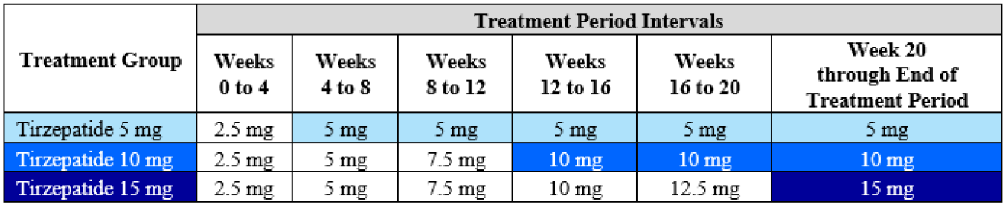
Figure 7: SURPASS efficacy trials Study design schema
Study | Schema
SURPASS-1  Study  GPGK | 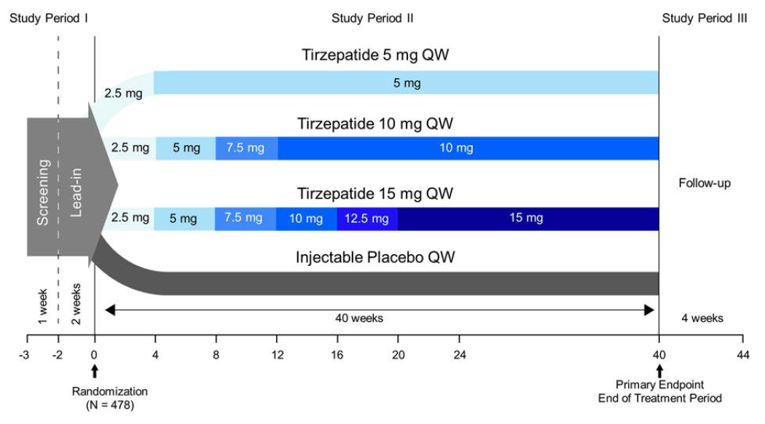
SURPASS-2  Study  GPGL | 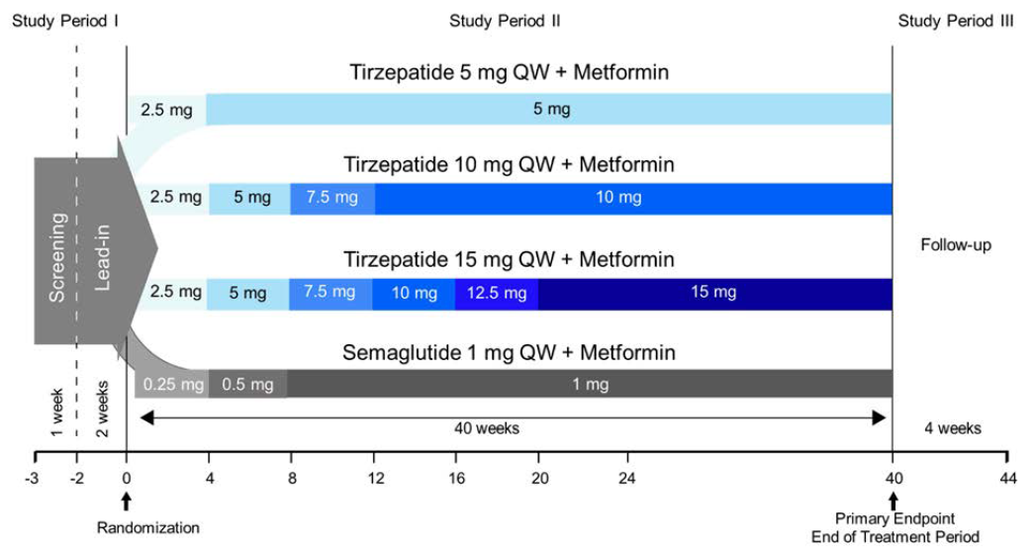
SURPASS-3  Study  GPGH | 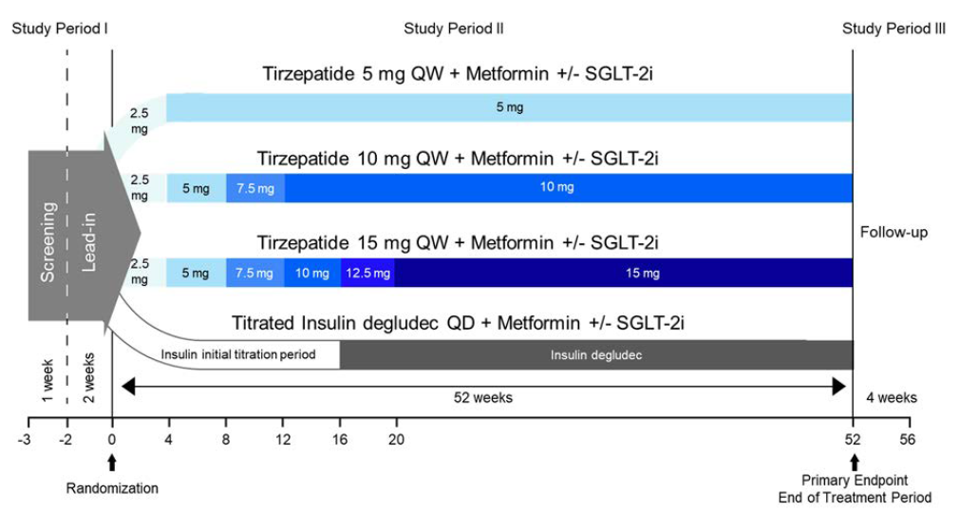
SURPASS-4  Study  GPGM | 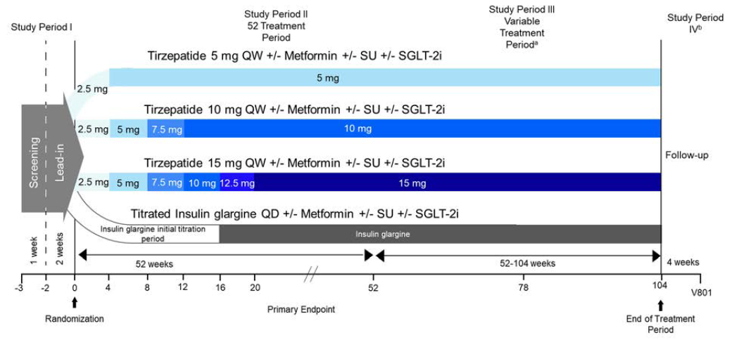
SURPASS-5  Study  GPGI | 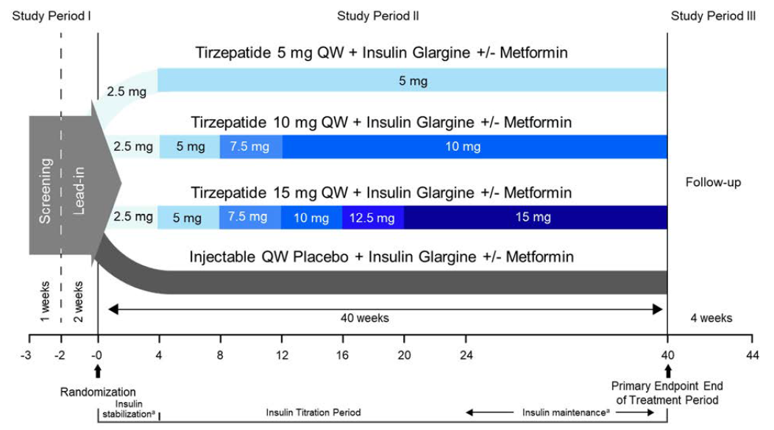
Abbreviations: N = number of patients randomised; QD = once daily; QW = once weekly; SGLT-2i = sodium-glucose cotransporter-2 inhibitor; SU = sulfonylurea; V = visit.
Study GPGM note a. The planned duration of treatment for the primary endpoint was 52 weeks, followed by a variable treatment duration of up to but not longer than 104 weeks.
Study GPGM note b. All patients performed a Visit 801 at 4 weeks after their last treatment visit.
Study GPGI note a. Stabilization Period = first 4 weeks after randomization, with restricted insulin dose adjustments. Insulin Glargine Escalation Period Weeks 4 to 40 (end of treatment/end of study), with unrestricted insulin dose adjustments. Maintenance Period = Weeks 24 to 40 (end of treatment/end of study), the period when insulin glargine dose is expected to be stable.

Patient demographics: There were 6263 patients randomly assigned and treated with at least one dose of study drug (modified intent-to-treat (ITT) population). Patients were 45% female; 46.6% were Hispanic or Latino, 3.6% were Black or African American, and 6.8% were Asian.
There was no upper age limit. At baseline, 33.2% were aged at least 65 years, and 5.1% were aged at least 75 years. Tirzepatide was not studied in children.
Disease characteristics: In the 5 SURPASS trials, at baseline, the mean HbA1c ranged from 7.94% to 8.52%, the mean age ranged from 54.1 to 63.6 years, the mean BMI ranged from 31.9 to 34.2 kg/m², the mean weight ranged from 85.9 to 95.2 kg, and the mean duration of T2DM ranged from 4.7 to 13.3 years. SURPASS-4 had the highest proportion of CV disease patients (86.8%).

Summary of main findings
Overall, for the main endpoints of change in HbA1c or body weight, there was a statistically significant difference between tirzepatide and tested comparator groups for all 3 tirzepatide doses (Table 8, Figure 8 and Figure 9).
Table 8: SURPASS efficacy trials Summary of main results (treatment-regimen estimand)
Abbreviations: CI = confidence interval; HbA1c = haemoglobin A1c; LSM = least-squares means.; QW = once weekly.

Figure 8: SURPASS efficacy trials Summary of least-squares means differences in HbA1c change from baseline (treatment-regimen estimand)
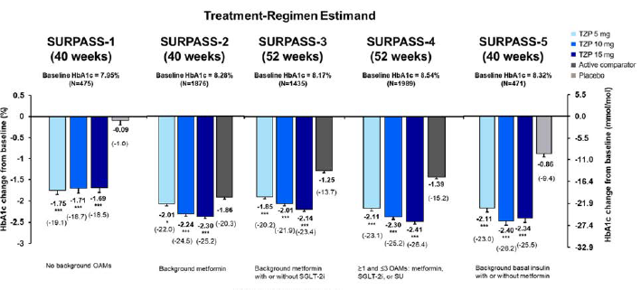
Abbreviations: HbA1c = haemoglobin A1c; LSM = least-squares means.; N = number of subjects; OAM = oral antihyperglycaemic medication; SGLT-2i = sodium-glucose co-transporter 2 inhibitor; SU = sulfonylurea; TZP = tirzepatide
Figure 9: SURPASS efficacy trials Summary of least-squares means differences in body weight change from baseline (treatment-regimen estimand)
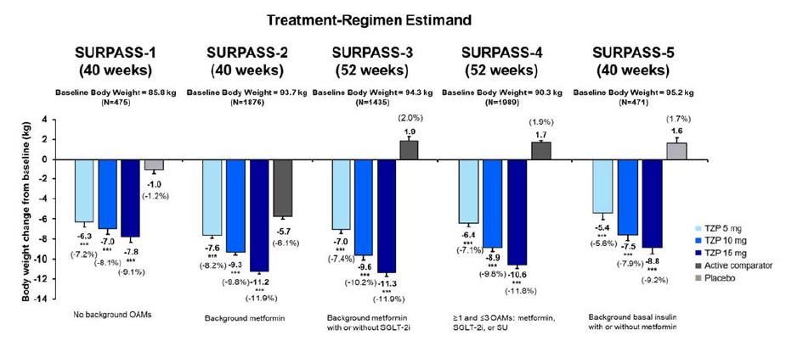
Abbreviations: LSM = least-squares means.; N = number of subjects; OAM = oral antihyperglycaemic medication; SGLT-2i = sodium-glucose co-transporter 2 inhibitor; SU = sulfonylurea; TZP = tirzepatide

Study SURPASS-1 (GPGK) main findings
The LSM differences in HbA1C (%) change from baseline to Week 40 compared to placebo were (treatment-regimen estimand [95% CI]): −1.66 [−1.96, −1.36] (5 mg), −1.62 [−1.92, −1.32] (10 mg), and −1.60 [−1.91, −1.30] (15 mg) (Table 8).
The LSM differences in body weight (kg) change from baseline to Week 40 compared to placebo were (treatment-regimen estimand [95% CI]): −5.3 [−6.8, −3.9] (5 mg), −6.0 [−7.4, −4.6] (10 mg), and −6.8 [−8.3, −5.4] (15 mg) (Table 8).
The glucose-lowering effect was consistent across the examined subgroups. The clinical relevance of the statistically significant treatment-by-subgroup differences observed for the primary endpoint depending on age (below 65 years; 65 years and older), duration of T2DM (5 years or less; 5 to 10 years; more than10 years) appears to be negligible (no qualitative differences).
The secondary endpoint results were generally consistent with the primary endpoint results. The responder rates (proportion of patients achieving a HbA1c less than 7.0%) were 81.8% (tirzepatide 5 mg), 84.5% (10 mg), and 78.3% (15 mg) compared with 23.0% for placebo.
In SURPASS-1, 30.9%, 26.8%, and 38.4% of patients in the 5 mg, 10 mg and 15 mg groups, respectively, reached normoglycemia (HbA1c less than 5.7%), compared to 1.4% for the placebo group.

Study SURPASS-2 (GPGL) main findings
The LSM differences in HbA1c (%) change from baseline to Week 40 compared to semaglutide 1 mg once weekly were (treatment-regimen estimand [95% CI]): −0.15 [−0.28, −0.03] (5 mg), −0.39 [−0.51, −0.26] (10 mg), and −0.45 [−0.57, −0.32] (15 mg) (Table 8).
The LSM differences in body weight (kg) change from baseline to Week 40 compared to semaglutide 1 mg once weekly were (treatment-regimen estimand [95% CI]): −1.9 [−2.8, −1.0] (5 mg), −3.6 [−4.5, −2.7] (10 mg), and −5.5 [−6.4, −4.6] (15 mg) (Table 8).
The above results were statistically significant, but semaglutide doses greater than 1 mg once weekly were not tested.
The responder rate (proportion of patients achieving HbA1c less than 7.0%) was 82.0% [5 mg] [no statistically significant difference to semaglutide], 85.6% [10 mg], and 86.2 [15 mg] compared to 79.0% for semaglutide 1 mg once weekly.
In SURPASS-2, 27.1%, 39.8%, and 45.7% of patients in the 5 mg, 10 mg and 15 mg groups, respectively, reached normoglycemia (HbA1c less than 5.7%), compared to 18.9% for the semaglutide 1 mg once weekly group.
Moreover, tirzepatide-treated patients appeared to reach glycaemic targets, HbA1c reductions or weight reductions earlier than patients treated with semaglutide 1 mg once weekly.
The glucose-lowering activity was generally consistent across subgroups. The results stratified by race are inconclusive due to the low number of Black or Asian participants.

Study SURPASS-3 (GPGH) main findings
The LSM differences in HbA1C (%) change from baseline to Week 52 compared to insulin degludec were (treatment-regimen estimand [95% CI]): −0.60 [−0.74, −0.45] (5 mg), −0.76 [−0.90, −0.61] (10 mg), and −0.89 [−1.03, −0.74] (15 mg) (Table 8).
The LSM differences in body weight (kg) change from baseline to Week 52 compared to insulin degludec were (treatment-regimen estimand [95% CI]): −8.9 [−10.0, −7.8] (5 mg), −11.5 [−12.6, −10.4] (10 mg), and −13.2 [−14.3, −12.1] (15 mg) (Table 8 and Table 9).
The results were statistically significant. The weight loss from baseline was slightly lower than the comparison to insulin degludec, as the patients in the insulin group experienced a slight weight gain (Table 9).
Table 9: Study SURPASS-3 (GPGH) Summary of body weight change from baseline to Week 52 by treatment group (treatment-regimen estimand)
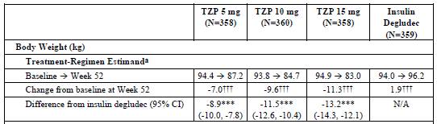
Abbreviations: ANCOVA = analysis of covariance; ANOVA = analysis of variance; CI = confidence interval; N = number of patients in the efficacy analysis set and full analysis set; N/A = not applicable; TZP = tirzepatide.
a Shown are the least-squares means; ANCOVA with multiple imputation of missing data at the primary endpoint visit using retrieved dropouts; ANOVA used at baseline.
*** p-Value <0.001 versus insulin degludec under graphical testing procedure.
††† p-Value <0.001 versus baseline.
The responder rate (proportion of patients achieving HbA1c less than 7.0%) was 79.2% (tirzepatide 5 mg), 81.5% (10 mg), and 83.5% (15 mg) compared to 58.0% in the insulin degludec group.
In SURPASS-3, 23.6%, 33.9%, and 40.7% of patients in the 5 mg, 10 mg and 15 mg groups, respectively, reached normoglycemia (HbA1c less than 5.7%), compared to 5.1% for the insulin degludec group.
The glucose-lowering activity was generally consistent across subgroups, but the results suggest a gradual decrease in efficacy most prominent for patients aged 75 years and older, but the number of participants was too low for a definite conclusion.

Study SURPASS-4 (GPGM) main findings
The LSM differences in HbA1c (%) change from baseline to Week 52 compared to insulin glargine were (treatment-regimen estimand [95% CI]): −0.72 [−0.86, −0.58] (5 mg), −0.91 [−1.05, −0.77] (10 mg), and −1.02 [−1.15, −0.89] (15 mg) (Table 8).
The LSM differences in body weight (kg) change from baseline to Week 52 compared to placebo were (treatment-regimen estimand [95% CI]): −8.1 kg [−8.9, −7.3] (5 mg), −10.6 kg [−11.4, −9.8] (10 mg), and −12.2 kg [−13.0, −11.5] (15 mg) (Table 8 and Table 10). The results were statistically significant. The weight loss from baseline was slightly lower than values in the comparison to insulin, as the patients in the insulin group experienced a slight weight gain (Table 10).
Table 10: Study SURPASS-4 (GPGM) Summary of body weight change from baseline to Week 52 by treatment group (treatment-regimen estimand)
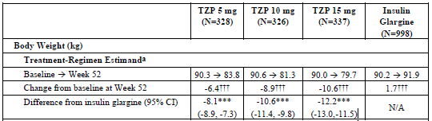
Abbreviations: ANCOVA = analysis of covariance; ANOVA = analysis of variance; CI = confidence interval; N = number of patients in the efficacy analysis set and full analysis set; N/A = not applicable; TZP = tirzepatide.
a Shown are the least-squares means; ANCOVA with multiple imputation of missing data at the primary endpoint visit using retrieved dropouts; ANOVA used at baseline.
*** p-Value <0.001 versus insulin degludec under graphical testing procedure.
††† p-Value <0.001 versus baseline.
The responder rate (proportion of patients achieving HbA1c less than 7.0%) was 75.1% (tirzepatide 5 mg), 82.9% (10 mg), and 84.9% (15 mg) compared to 48.8% in the insulin glargine group.
In SURPASS-4, 21.7%, 31.1%, and 38.0% (for the 5, 10, and 15 mg groups, respectively) achieved HbA1c levels less than 5.7% compared to 3.5% in the insulin glargine group.
The glucose-lowering effect appeared to be sustained up to 104 weeks. The glucose-lowering activity was generally consistent across subgroups, but the results suggest a gradual decrease in efficacy most prominent for patients aged 75 years and older, but the number of participants was too low for a definite conclusion.
Baseline BMI, baseline antihyperglycemic therapy, and biological sex appeared not to have a significant (qualitative) impact on efficacy.

Study SURPASS-5 (GPGI) main findings
SURPASS-5 had a larger proportion of patients with advanced disease (mean duration of T2DM more than 13 years) and a large proportion (over 80%) of overweight/obese subjects (mean BMI approximately 33 kg/m²).
The LSM differences in HbA1C (%) change from baseline to Week 40 compared to placebo were (treatment-regimen estimand [95% CI]): −1.24% [−1.48, −1.01] (5 mg), −1.53% [−1.77, −1.30] (10 mg), and −1.47% [−1.71, −1.23] (15 mg) (Table 8).
The LSM differences in body weight (kg) change from baseline to Week 40 compared to placebo were (treatment-regimen estimand [95% CI]): −7.1 kg [−8.7, −5.4] (5 mg), −9.1 kg [−10.7, −7.5] (10 mg), and −10.5 kg [−12.1, − 8.8] (15 mg) (Table 8).
The glucose-lowering effect was generally consistent across the examined subgroups. Differences in efficacy observed for specific subgroups are unlikely of clinical relevance.
The responder rate (proportion of patients achieving HbA1c less than 7.0%) was 87.3% (tirzepatide 5 mg), 89.6% (10 mg), and 84.7% (15 mg) compared with 34.5% for placebo.
In SURPASS-5, 24.4%, 41.6% and 49.6% of patients treated with tirzepatide 5 mg, 10 mg and 15 mg, respectively, reached normoglycemia (HbA1c less than 5.7%), compared to 2.7% for the placebo group.

Subgroup analyses
For subgroup analyses for pooled Phase III studies, only Studies GPGH, GPGL, and GPGM were pooled, as the sponsor claimed that Studies GPGK and GPGI were relatively small trials resulting in smaller subgroups.
Age: Efficacy appeared to be reduced in patients aged 65 years and older, but a lower mean HbA1c at baseline in that group may have contributed to this.
BMI: There were no clinically meaningful differences in efficacy between the subgroups with a BMI in the range 30 to less than 35 kg/m²; or 35 kg/m² and higher. However, patients with a BMI less than 30 kg/m² showed no well-defined dose-response relationship for efficacy. The reason remains unclear at present.
Ethnicity: There is likely no significant efficacy difference across different ethnicities. The relative dose-response of the mean change from baseline in HbA1c was comparable in studies conducted in Japan and the international Studies GPGH, GPGL, and GPGM. Studies GPGL and GPGM revealed no meaningful differences in the efficacy between American Indian, Alaskan Native patients, and white patients. In Study GPGM, HbA1c reduction for black or African American patients was comparable to white patients.
ADA status: A comparison of HbA1c change from baseline showed no apparent pattern relative to treatment-emergent antidrug antibody (ADA) status, ADA titres, or neutralising antibody status.
Concomitant antiemetic or antidiarrhoeal medications: The majority (75 to 94%, dependent on the study) of patients randomised to tirzepatide did not initiate either antiemetic or antidiarrhoeal medications. Antiemetics were more often initiated that antidiarrhoeals. There was no definite dose-related trend, and in most studies, the patient numbers on those medications were too small for meaning conclusions regarding efficacy.

Phase III pivotal trial substudies

Study SURPASS-3 CGM
SURPASS-3 CGM was a substudy of SURPASS-3 investigating the 24-hour glucose profile in 243 patients (64 [tirzepatide 5 mg], 51 [tirzepatide 10 mg], 73 [tirzepatide 15 mg], 55 [insulin degludec]) using continuous glucose monitoring.
The population had a mean age of approximately 57 years. The mean duration of diabetes was 8.3 to 9.3 years, the mean HbA1c was 7.9% to 8.3%, and the mean body weight 92.2 kg to 97.4 kg.
There was a clinically relevant improvement of glycaemic control compared with basal insulin degludec. Tirzepatide-treated patients spent a higher percentage of the time in the target range (3.9 to 7.8 mmol/L) compared to the insulin degludec group. The estimated treatment difference [95% confidence interval (CI)] was 24.55% [15.77%, 33.34%].

Study SURPASS-3 MRI
SURPASS-3 MRI was a substudy of SURPASS-3 investigating changes in the liver fat content of 296 study participants from SURPASS-3 (71 [tirzepatide 5 mg], 79 [tirzepatide 10 mg], 72 [tirzepatide 15 mg], 74 [insulin degludec]).
The population had a mean age of approximately 56 years. The mean duration of diabetes was 7.0 to 9.4 years, the mean HbA1c was approximately 8.25%, and the mean body weight 91.2 kg to 98.0 kg.
The study showed that treatment with any of the tirzepatide doses (5 mg, 10 mg, and 15 mg) resulted in a significantly lower liver fat content at Week 52 (8.2% to 10.1%) as compared with insulin degludec (13.2%).

Supportive Phase III studies

Study SURPASS J-mono (GPGO)
SURPASS J-mono (Study GPGO) was a 52 week Phase III double-blind, parallel, active-controlled trial randomising 636 patients in 46 centres in Japan. Eligible were patients with T2DM either oral antihyperglycaemic medication (OAM)-naïve or treated with OAM monotherapy. The latter had to be discontinued prior to initiation of study treatment (tirzepatide 5 mg, 10 mg, or 15 mg once weekly, or dulaglutide 0.75 mg once weekly). Primary and key endpoints were the mean change in HbA1c and mean change in body weight from baseline to Week 52.
Demographics and relevant baseline characteristics were well balanced between treatment arms (mean age approximately 56 years, mean duration of diabetes approximately 5.9 years, mean HbA1c approximately 8.2%, and mean body weight approximately 78.5 kg). The completion rate was 95.6 to 97.5%.
SURPASS J-mono showed superiority of all 3 doses of tirzepatide to the GLP-1 receptor-agonist dulaglutide with regard to mean change in HbA1c and mean change in body weight.
Table 11: Study SURPASS J-mono Summary of main results
Tirzepatide dose (mg) | Least-squares mean difference at Week 52 [95% CI] treatment-regimen estimand
Tirzepatide dose (mg) | Change in HbA1c (%) | Change in Body Weight (kg)
5 mg | −1.09 [−1.27, −0.90] | −5.2 [−6.4, − 4.1]
10 mg | −1.27 [−1.45, −1.08] | −7.9 [−9.1, −6.8]
15 mg | −1.53 [−1.71, −1.35] | −10.1 [−11.3, −9.0]
Abbreviations: CI = confidence interval; HbA1c = haemoglobin A1c.

Study SURPASS J-combo (GPGP)
SURPASS J-combo (Study GPGP) was a 52 week, 3-arm (tirzepatide 5 mg, 10 mg, 15 mg) ‘add-on treatment’ study randomising 443 patients in 34 centres in Japan. Eligible were patients with T2DM currently treated with OAMs (including metformin, SGLT2 inhibitors, alpha-glucosidase inhibitors, thiazolidinediones, sulfonylureas, or glinides). Primary and key endpoints were the change in HbA1c and body weight from baseline to Week 52.
The study had no control arm. The completion rate was 98.0% (tirzepatide 5 mg), 94.6% (tirzepatide 10 mg), and 89.9% (tirzepatide 15 mg), while the number of patients completing the study drug in these groups was 137 (9.26%), 136 (92.5%), and 125 (84.5%), respectively.
The study population had a mean age of approximately 57 years. The mean duration of diabetes was 9.5 to 10.21 years, the mean HbA1c was 8.53% to 8.59%, and the mean body weight 76.58 kg to 78.29 kg.
The results showed favourable effects for Week 52 for all 3 doses of tirzepatide (Table 12).
Table 12: SURPASS J-combo (Study GPGP) Summary of main results
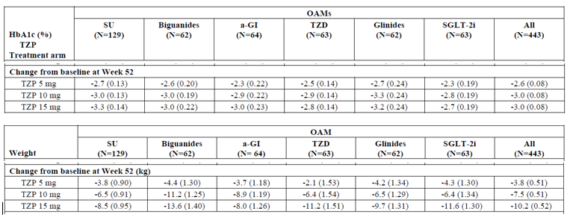
Abbreviations: a-GI = alpha-glucosidase inhibitors; HbA1c = glycated haemoglobin; LSMean = least-squares mean; mITT = modified intent-to-treat; MMRM = mixed model repeated measures; N = number of patients who were randomized and received at least 1 dose of study drug; OAMs = oral antihyperglycemic medications; SE = standard error; SGLT-2i = sodium-glucose cotransporter type 2 inhibitors; SU = sulfonylureas; TZD = thiazolidinedione; TZP = tirzepatide.
Note: Shown are the LSMean (SE).

Dose-finding studies
The dose finding was based on 2 Phase II studies, Study GPGB and Study GPGF.

Study GPGB
Study GPGB was a 26 week multicentre, randomised, double-blind trial investigating 4 tirzepatide doses (1 mg, 5 mg, 10 mg and 15 mg once weekly) as compared with dulaglutide 1.5 mg once weekly and placebo in patients with T2DM who had inadequate glycaemic control. Patients were treatment-naïve or have received metformin.
The primary efficacy endpoint was the change in HbA1c from baseline to Week 26. The mITT population consisted of 316 patients (51 [placebo], 52 [tirzepatide 1 mg], 55 [tirzepatide 5 mg], 51 [tirzepatide 10 mg], 53 [tirzepatide 15 mg], and 54 [dulaglutide 1.5 mg]). Demographics and other baseline characteristics matched well between study arms (mean age of 57 years, mean duration of T2DM of 8.5 years, and mean baseline HbA1c of 8.1%).
Tirzepatide’s glucose-lowering effect (change in HbA1c) was superior compared to placebo for all doses tested. The change in HbA1c induced by tirzepatide doses 5 mg and higher was superior to that of dulaglutide 1.5 mg (Table 13).
Table 13: Study GPGB Summary of main results

Similar results were obtained for the change in fasting plasma glucose and body weight.
Study GPGB revealed no prohibitive safety issue for the doses tested. Safety characteristics of tirzepatide were similar to that of GLP-1 receptor-agonists with nausea, vomiting, and diarrhoea being the most common AEs. There was a dose response dependency of gastrointestinal AEs (that is, tirzepatide 15 mg showed the highest rate and more patients in this group discontinued study treatment). No episodes of severe hypoglycaemia occurred throughout Study GPGB. Injection site reactions were similar across all treatment groups, although treatment-emergent antidrug antibodies (ADA) were detected in a relatively large proportion of the tirzepatide treated patients (approximately 40%).
Overall, the data support use of tirzepatide at a dose range from 5 to 15 mg. The higher incidence of gastrointestinal AEs with tirzepatide 15 mg may compromise its use in clinical practice.

Study GPGF
Study GPGF was a 12 week, 4 arm, placebo-controlled Phase II study investigating 3 dose escalation schemes in patients with T2DM and a BMI of at least 23 to maximum of 45 kg/m²; see figure below.
Figure 10: Study GPGF Study design schema
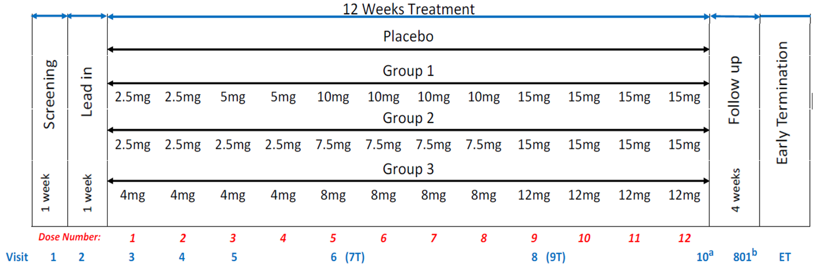
Abbreviations: ET = early termination visit; T = telephone visit; Visit 801 = end of study visit.
a Visit 10 occurs 1 week after the last dose (Dose 12) of study drug.
b Visit 801 (follow-up visit) occurs 4 weeks after Dose 12 or 3 weeks after Visit 10.
Prior antidiabetic treatment of these patients could include metformin. The primary efficacy endpoint was the change in HbA1c from baseline to Week 12.
Study GPGF enrolled 111 patients who had a mean age of 57.4 years, T2DM duration of 9.13 years, and baseline HbA1c of 8.35%. The glucose-lowering effect in all tirzepatide groups was greater than the effect for placebo (0.2%), and numerically the largest with the dose of tirzepatide 15 mg.
Table 14: Study GPGF Summary of main results
Treatment | Modified Intent-to-Treat on Efficacy Analysis Set
Treatment | Baseline HbA1c (%) |  | Week 12 |  | p-Value
Treatment | n | Least-squares mean [standard error] | n | Least-squares mean change in HbA1c [standard error] | p-Value
Placebo | 24 | 8.2 [0.22] | 20 | 0.2 [0.21]
Group 1 | 28 | 8.5 [0.21] | 23 | −2.0 [0.20] | P<0.001
Group 2 | 27 | 8.4 [0.21] | 26 | −1.8 [0.19] | P<0.001
Group 3 | 28 | 8.4 [0.21] | 28 | −1.7 [0.19] | P<0.001

Similar results in favour of tirzepatide were obtained for the responder rate, the change in fasting plasma glucose and body weight.
Study GPGF revealed no prohibitive safety issue for the doses tested. In line with the findings from Study GPGB, the safety profile of tirzepatide observed in Study GPGF largely resembled the profile of GLP-1 receptor-agonists in general.
Collectively, the studies showed tirzepatide has an acceptable tolerability up to a dose of 15 mg once weekly. Step-wise dose titration appeared to ameliorate the prevailing gastrointestinal AEs.

Safety

Exposure
The safety evaluation was based on 19 clinical studies (cut-off date 2 June 2021): 10 biopharmaceutic and clinical pharmacology studies, 2 Phase II clinical studies, 5 global Phase III studies, and 2 regional Phase III studies conducted in Japan only, covering a spectrum of comparators and background antihyperglycemic therapy as summarised below.
- Phase II studies
  - Study GPGB : comparators of placebo and dulaglutide 1.5 mg once weekly, with nil background antidiabetic medication during the study
  - Study GPGF: comparator of placebo, with nil background antidiabetic medication during the study
- Phase III studies
  - SURPASS-1 (Study GPGK): comparator of placebo, with nil background antidiabetic medication during the study
  - SURPASS-2 (Study GPGL): comparator of semaglutide 1 mg once weekly, with background antidiabetic medication of metformin
  - SURPASS-3 (Study GPGH): comparator of insulin degludec, with background antidiabetic medication during the study of metformin with or without SGLT2 inhibitor
  - SURPASS-4 (Study GPGM): comparator of placebo, with background antidiabetic medication during the study of insulin glargine with or without metformin
  - SURPASS-5 (Study GPGI): comparator of insulin glargine, with background antidiabetic medication during the study of metformin with or without sulfonylurea or SGLT2 inhibitor
  - SURPASS J-mono (Study GPGO): comparator of dulaglutide 0.75 mg once weekly, with nil background antidiabetic medication during the study
  - SURPASS J-combo (Study GPGP): no control arm, with nil background antidiabetic medication during the study of metformin, SGLT2 inhibitor, alpha-glucosidase inhibitor, thiazolidinedione, sulfonylurea, or glinide.
In the 9 completed Phase II and Phase III studies, 7,769 patients received any study drug. Of those, 5,415 patients received tirzepatide in the Phase II and III studies for 4833.1 patient-years. There were 2,375 patients who received tirzepatide for at least 52 weeks in the Phase II and Phase III studies, with 535 receiving tirzepatide for at least 78 weeks.
The treatment duration ranged from 12 to 26 weeks (Phase II studies), and from 40 to 104 weeks (Phase III studies) (all with a 4 week safety follow-up).
Assessment of cardiovascular safety was based on the CV Meta-Analysis Set comprising all placebo- or active-controlled Phase II and Phase III studies with a treatment period lasting at least 26 weeks.

Primary safety analysis sets
The 2 primary analysis sets to detect drug and dose effects were the Phase III Placebo-Controlled Analysis Set (comparison against placebo) and the Phase III Dose Effect Analysis Set (comparison of the different tirzepatide doses).

Adverse event overview

Phase III Placebo-controlled analysis set
The percentage of patients with serious adverse events (SAEs) and treatment-emergent adverse events (TEAEs) was similar across tirzepatide doses, all tirzepatide dose groups combined, and placebo groups (Table 15).
Treatment-emergent AEs most frequently reported for tirzepatide-treated patients were gastrointestinal (GI) disorders (40.1% for all tirzepatide dose groups combined versus 20.4% for placebo). Using MedDRA System Organ Class (SOC) terms, most TEAEs in the Gastrointestinal Disorders SOC were reported as mild or moderate, with similar percentages reporting severe TEAEs across groups (1.1% and 0.9%, respectively) except for the following reported as severe:
- nausea (all tirzepatide dose groups combined, 0.3%; placebo, 0)
- diarrhoea (all tirzepatide dose groups combined, 0.4%; placebo, 0.4%)
- dyspepsia (all tirzepatide dose groups combined, 0.1%; placebo, 0.4%)
- vomiting (all tirzepatide dose groups combined, 0.3%; placebo, 0).
Other treatment differences with more events reported in tirzepatide-treated patients were:
- general disorders and administration site conditions (all tirzepatide dose groups combined, 8.8%; placebo, 3.8%) driven primarily by the MedDRA Preferred Terms (PTs) injection site reactions (all tirzepatide dose groups combined, 2.5%; placebo, 0%), fatigue (all tirzepatide dose groups combined, 1.5%; placebo, 0%), and asthenia (all tirzepatide dose groups combined, 1.3 %; placebo, 0%)
- investigations (all tirzepatide dose groups combined, 7.9%; placebo, 4.3%) driven primarily by the PTs lipase increased (all tirzepatide dose groups combined, 3.2%; placebo, 2.6%), amylase increased (all tirzepatide dose groups combined, 1.4%; placebo, 0.4%), blood calcitonin increased (all tirzepatide dose groups combined, 1.1%; placebo, 0%), and heart rate increased (all tirzepatide dose groups combined, 1.1%; placebo, 0.4%)
- blood and lymphatic system disorders (all tirzepatide dose groups combined, 2.8%; placebo, 0.4%) driven primarily by the PT anaemia (all tirzepatide dose groups combined, 1.1%; placebo, 0%).
Other imbalances between tirzepatide-treated and placebo-treated patients with p<0.05 or odds ratio of 2 or more were:
- eructation (all tirzepatide dose groups combined, 2.9%; placebo, 0.4%)
- flatulence (all tirzepatide dose groups combined, 2.2%; placebo, 0%)
- abdominal pain (all tirzepatide dose groups combined, 2.2%; placebo, 0.4%)
- gastroesophageal reflux disease (all tirzepatide dose groups combined, 1.9%; placebo, 0.4%)
- gastritis (all tirzepatide dose groups combined, 1.7%; placebo, 0.4%)
- abdominal distension (all tirzepatide dose groups combined, 1.4%; placebo, 0.4%)
- contusion (all tirzepatide dose groups combined, 1.1%; placebo, 0.4%)
- gastroenteritis (all tirzepatide dose groups combined, 1.1%; placebo, 0.4%)
- gastrointestinal disorder (all tirzepatide dose groups combined, 1.1%; placebo, 0%).
For anaemia, more patients in the ‘all tirzepatide dose groups combined’ group than in the placebo group (16.3% versus 9.2%,) shifted from normal/high haemoglobin to low haemoglobin in the Phase III placebo-controlled analysis set. No dose effect was seen in the Phase III dose effect analysis set (tirzepatide 5 mg, 13.96%; tirzepatide 10 mg, 14.44%; tirzepatide 15 mg, 15.61%). The clinical meaning of these findings is uncertain.
Table 15: Phase III placebo-controlled analysis set Overview of adverse events
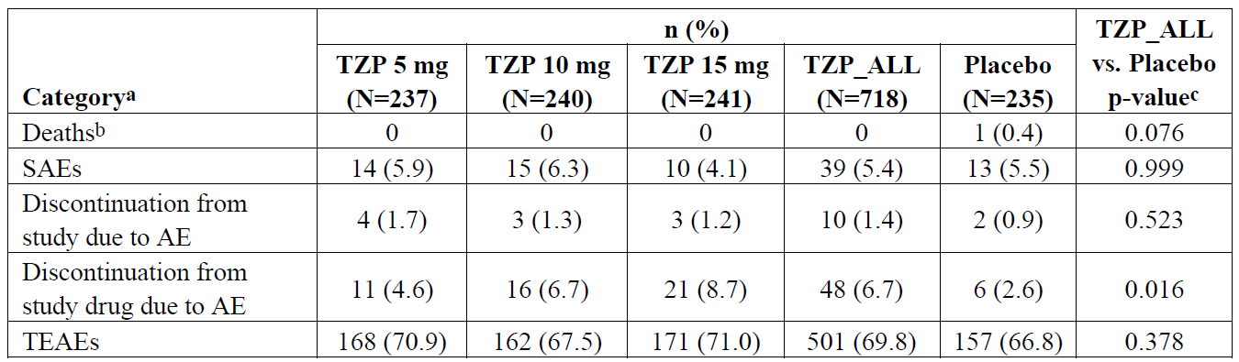
Abbreviations: AE = adverse event; N = number of patients in treatment group; n = number of patients with at least 1 AE per event type; SAE = serious adverse event; TEAE = treatment-emergent adverse event; TZP = tirzepatide; TZP_ALL = all tirzepatide dose groups combined.
a Patients may be counted in more than 1 category.
b Deaths are also included as SAEs and discontinuations due to AEs.
c P-values are from Cochran-Mantel-Haenszel test of general association stratified by study.
Table 16: Phase III placebo-controlled analysis set treatment-emergent adverse events occurring in at least 5% of patients
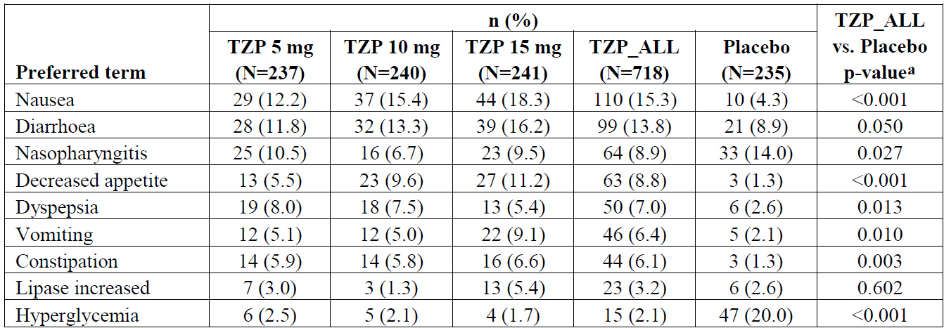
Abbreviation: N = number of patients in treatment group; n = number of patients with at least 1 treatment-emergent adverse event; TZP = tirzepatide; TZP_ALL = all tirzepatide dose groups combined.
a P-values are from the Cochran-Mantel-Haenszel test of general association stratified by study.
Figure 11: Phase III placebo-controlled studies Plot of treatment-emergent adverse events occurring in at least 5% of patients
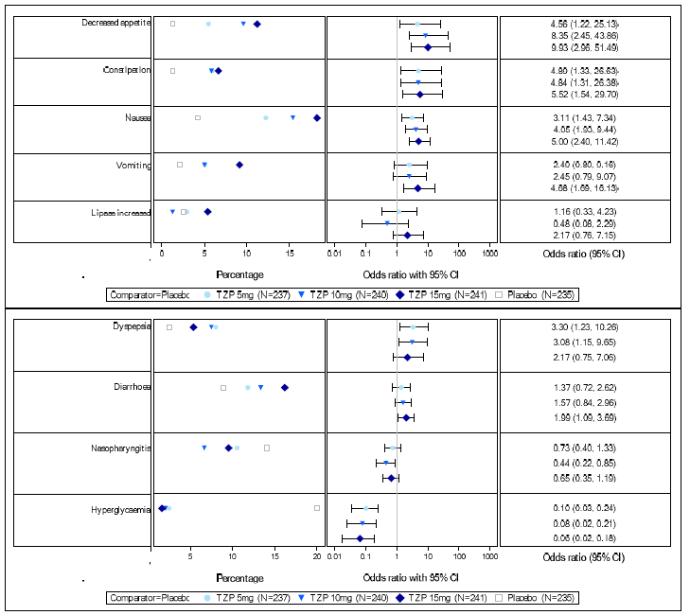
Abbreviations: CI = confidence interval; N = number of patients in treatment group; TZP = tirzepatide.
Note: Odds ratio is Mantel-Haenszel odds ratio, stratified by study. Order of events is based on descending odds ratio in the TZP 15-mg group.

Phase III Dose Effect Analysis Set
For TEAEs, there appeared to be an incremental increase with higher dose (Table 17).
Table 17: Phase III dose effect analysis set Overview of adverse events
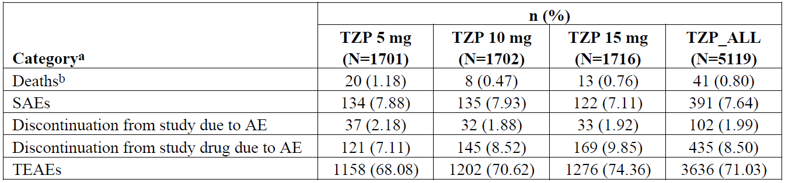
Abbreviations: AE = adverse event; N = number of patients in treatment group; n = number of patients with at least 1 AE per event type; SAE = serious adverse event; TEAE = treatment-emergent adverse event; TZP = tirzepatide; TZP_ALL = all tirzepatide dose groups combined.
a Patients may be counted in more than 1 category.
b Deaths are also included as SAEs and discontinuations due to AEs.
The most frequently reported TEAEs were within the Gastrointestinal Disorders SOC (5 mg, 38.04%; 10 mg, 43.83%; 15 mg, 48.78%) with an incremental increase with higher doses. The TEAEs that showed an incremental increase with higher dose groups were nausea, decreased appetite, and vomiting (Table 18).
Other reported TEAEs affecting at least 5% of subjects were in the following SOCs:
- infections and infestations (5 mg, 25.28%; 10 mg, 23.03%; 15 mg, 23.37%)
- metabolism and nutrition disorders (5 mg, 13.87%; 10 mg, 15.86%; 15 mg, 16.96%)
- investigations (5 mg, 10.64%; 10 mg, 11.93%; 15 mg, 13.58%) driven primarily by:
  - lipase increased (5 mg, 3.76%; 10 mg, 3.53%; 15 mg, 5.24%)
  - weight decreased (5 mg, 1.47%; 10 mg, 2.17%; 15 mg, 2.45%)
- general disorders and administration site conditions (5 mg, 8.29%; 10 mg, 9.81%; 15 mg, 13.00%) driven primarily by:
  - asthenia (5 mg, 1.59%; 10 mg, 1.35%; 15 mg, 2.97%)
  - fatigue (5 mg, 1.29%; 10 mg, 1.65%; 15 mg, 2.27%)
  - injection site reaction (5 mg, 1.06%; 10 mg, 1.70%; 15 mg, 2.27%)
- nervous system disorders (5 mg, 8.58%; 10 mg, 10.34%; 15 mg, 11.19%) driven primarily by dizziness (5 mg, 1.18%; 10 mg, 2.70%; 15 mg, 3.44%).
Other TEAEs affecting at least 1% of subjects with a dose trend were:
- Abdominal pain (5 mg, 2.70%; 10 mg, 3.41%; 15 mg, 4.43%)
- Eructation (5 mg, 2.12%; 10 mg, 2.94%; 15 mg, 3.50%)
- Gastroesophageal reflux disease (5 mg, 1.59%; 10 mg, 2.53%; 15 mg, 2.68%).
Table 18: Phase III dose effect analysis set Treatment-emergent adverse events occurring in at least 5% of patients
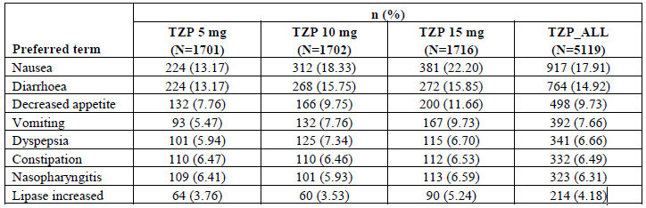Abbreviation: N = number of patients in treatment group; n = number of patients with at least 1 treatment-emergent adverse event; TZP = tirzepatide; TZP_ALL = all tirzepatide dose groups combined.

Treatment related adverse event (adverse drug reaction) overview
The sponsor-determined adverse drug reactions are listed in the following table.
Table 19: Overview of adverse drug reactions
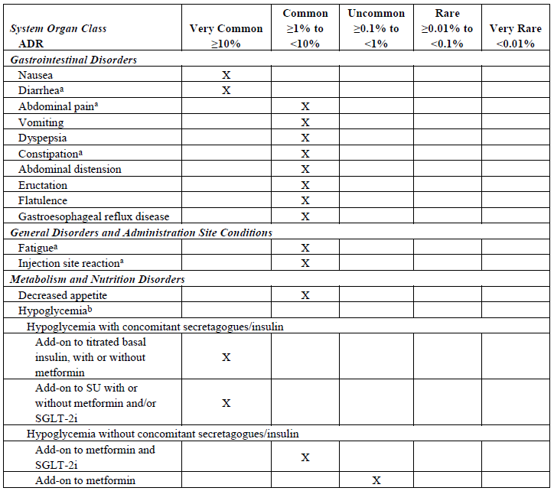
Abbreviations: ADR = adverse drug reaction; AE = adverse event; CDS = core data sheet; CSI = core safety information; N/A = not available; PT= preferred term; SGLT-2i = sodium-glucose co-transporter 2 inhibitor; SU = sulfonylurea.
a Clusters:
Diarrhea: diarrhea, frequent bowel movements
Abdominal Pain: abdominal pain, abdominal pain upper, abdominal discomfort, abdominal pain lower,
abdominal tenderness, gastrointestinal pain
Constipation: constipation, faeces hard
Fatigue: fatigue, asthenia, malaise, lethargy
Injection Site Reaction: injection site reaction, injection site erythema, injection site pruritus, injection site bruising, injection site hypersensitivity, injection site pain, injection site haemorrhage, injection site irritation, injection site rash, injection site dermatitis, injection site eczema, injection site mass, injection site oedema, injection site swelling.
b Hypoglycaemia with blood glucose less than 3 mmol/L or severe. The frequency of hypoglycaemic episodes was based on individual study data dependent on background therapy. There were no cases reported in patients on tirzepatide monotherapy (Study GPGK).

Deaths
Phase III placebo-controlled analysis set: One death was reported in the placebo group.
Phase III dose effect analysis se: Overall, 41 deaths were reported in tirzepatide-treated patients in the Phase III studies. During the Phase II and Phase III studies, 80 deaths occurred in patients exposed to at least one dose of study drug: 41 (0.76%) in the tirzepatide groups and 39 (1.66%) in the comparator groups.

Serious adverse events
Phase III placebo-controlled analysis set: The percentage of patients with SAEs was similar across tirzepatide doses, all tirzepatide dose groups combined, and placebo groups.
Phase III dose effect analysis set: The percentages of patients reporting SAEs due to an AE was similar across the 3 tirzepatide dose groups.

Discontinuations
Phase III placebo--controlled analysis set: 1.4% of tirzepatide-treated patients and 0.9% of placebo-treated patients discontinued from the study due to an AE. The percentage of discontinuations from study drug due to an AE was higher in the ‘all tirzepatide dose groups combined’ (6.7%) group compared to placebo (2.6%). In most cases, this was due to gastrointestinal disorders (5.0% versus 0.4%) (Table 20). Additionally, there was an incremental increase in study drug discontinuation due to an AE with higher dose groups.
Table 20: Phase III placebo-controlled analysis set Discontinuation from study drug due to adverse effects
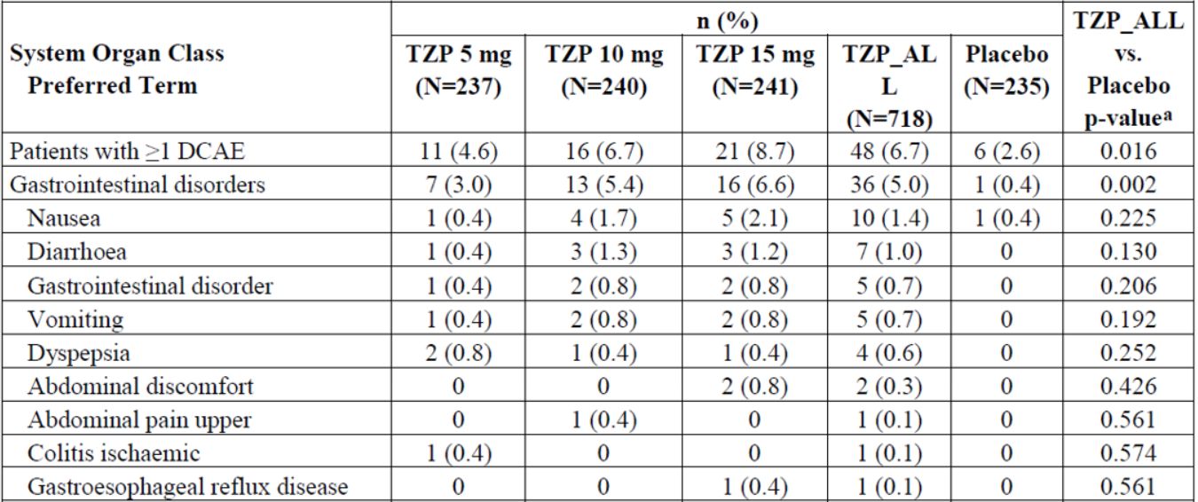|
Abbreviations: DCAE = discontinuation of study drug due to adverse event; N = number of patients in treatment group; n = number of patients with at least 1 adverse event reported as the primary reason for permanent discontinuation of study drug; TZP = tirzepatide; TZP_ALL = all tirzepatide dose groups combined.
a P-values are from Cochran-Mantel-Haenszel test of general association stratified by study.
Phase III dose effect analysis set: The percentages of patients reporting discontinuations from study due to an AE was similar across the 3 tirzepatide dose groups.

Adverse events of special interest
Thyroid safety: No cases of medullary thyroid cancer or C-cell hyperplasia were identified across all Phase II and Phase III studies. However, given their relatively short duration definitive conclusions cannot be made with regard to thyroid malignancy risks related to tirzepatide. Tirzepatide treatment was not associated with marked increases of calcitonin.
Malignancies: In all Phase II and Phase III studies (with 5,415 tirzepatide-treated patients) the incidences of malignancies were rather small: tirzepatide (1.02%), semaglutide (0.64%), insulin degludec (0.28%), insulin glargine (1.90%), dulaglutide (1.88%), and placebo (1.60%).
There were 3 cases of pancreatic cancer, 2 in tirzepatide-treated patients and one in the placebo group (reported after study completion and not captured in the database). In addition, there was one case reported as pancreatic neoplasm from the tirzepatide 10 mg group that was a pancreatic cyst.
The sponsor is committed to further investigations of the potential for malignancies in the ongoing studies and post-marketing pharmacovigilance.
Diabetic Retinopathy Complications: Across the Phase III trials, 18 (0.35%) tirzepatide-treated patients showed worsening of fundoscopic findings (none were SAEs). The incidence in individual trials ranged from 0% (Study GPGK) to 1.13% (Study GPGP) with no meaningful differences.
A customised MedDRA search in the Phase III placebo-controlled analysis set revealed no ‘potential diabetic retinopathy’ event in tirzepatide treated patients versus 2 event (0.9%) in the placebo control group. The same search in the Phase III dose effect analysis set detected 37 (0.7%) tirzepatide-treated patients with potential diabetic retinopathy complication, but without dose-dependency. Four of those 37 patient has serious or severe TEAEs.
An ongoing dedicated addendum study to Study I8F-MC-GPGN will further investigate this potential safety issue.
Cardiac safety in Phase I and II studies: No thorough QT study investigating the effect of supratherapeutic tirzepatide doses on cardiac repolarisation was conducted. Instead, a concentration effect analysis was performed.
- As per ICH E14 guidance, a concentration effect analysis for QTcF and PR interval based on data from Phase I and Phase II studies was performed. Using the data from healthy participants and patients with T2DM who were given either placebo or tirzepatide in Phase I Study GPGA and Phase II Studies GPGB and GPGF and a direct response linear mixed effects model, the relationship between changes in QTcF or the PR interval and tirzepatide concentration was investigated. Overall, this analysis suggests the absence of an unacceptable prolongation in cardiac repolarisation or any impact on PR interval compared to placebo across the therapeutic dose range of tirzepatide.
- The relationships of QTcF and PR intervals matched by date to the observed tirzepatide concentration at Week 40 and Week 52 in the Phase III studies were assessed. Overall, the QTcF and PR intervals were within clinically acceptable limits.
- Transient heart rate increases were observed following tirzepatide treatment, particularly during the early dose-escalation period, using linear regression analysis.
- With regard to supratherapeutic dosing, the sponsor identified 31 of 5,415 patients who received an overdose defined as taking more than 15 mg of tirzepatide in less than 72 hours and these cases were not associated with cardiac safety concerns.
Cardiac safety in Phase II and Phase III: The Cardiovascular Meta-Analysis Set comprised all placebo-controlled or active-controlled Phase II and Phase III studies with a treatment period lasting at least 26 weeks. The CV meta-analysis included patients with a wide variety of T2DM disease stages, background antidiabetic medications, and renal impairment.
The primary endpoint was a 4 point composite clinical endpoint of major adverse cardiovascular events (MACE) of cardiovascular death, myocardial infarction, stroke, and hospitalisation for unstable angina.
Baseline demographics and CV risk characteristics in the integrated analysis population were comparable between the pooled tirzepatide group and pooled comparator group.
The final analysis used 142 primary endpoint events (adjudicated 4 point MACE). The hazard ratio [95% CI] for primary endpoint was 0.80 [0.57, 1.11]. SURPASS-4 (Study GPGM) provided the majority of events (109) with a study hazard ratio [95% CI] of 0.74 [0.51, 1.08].
In Phase III trials, small differences in PR interval (tirzepatide versus placebo) were observed (2.7 to 4.5 ms) but were not considered clinically meaningful.
An evaluator-requested analysis of MACE in the placebo-controlled Studies GPGK and GPGI revealed 4 MACE events, insufficient for meaningful statistical analyses.
Additional data on cardiovascular safety will be provided from the currently ongoing SURPASS cardiovascular outcome trial (Study I8F-MC-GPGN) using dulaglutide as an active comparator.
Gastrointestinal: generally common with GLP-1 receptor agonists, gastrointestinal adverse events were the most common TEAEs reported with tirzepatide. The prevalence of nausea, vomiting, or diarrhoea was 5% to 10% throughout (mostly mild or moderate) resulting in dose-dependent permanent treatment discontinuation rates from 3% to 7%. The incidence was highest during the dose-escalation period of tirzepatide and saturated after reaching the maintenance dose at Week 24 (Figure 12).
In Phase III Study GPGL (SURPASS-2), gastrointestinal AEs were similar between groups, but the rate of permanent study drug discontinuation due to gastrointestinal AEs was slightly higher with tirzepatide 10 mg and 15 mg (each 4.3%) than with semaglutide 1 mg (3.2%). In SURPASS J-mono (Study GPGO) in a Japanese population this was more pronounced: 6.9% for tirzepatide 15 mg versus 0.6% for dulaglutide 0.75 mg.
Figure 12: Phase III dose effect analysis set showing time to onset of nausea, vomiting and diarrhoea
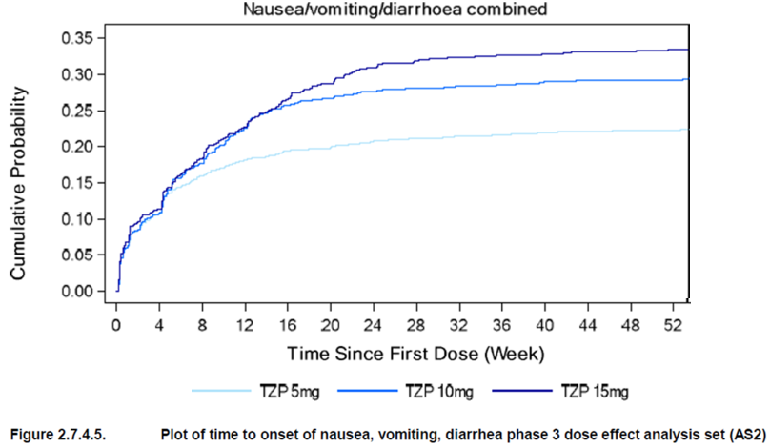
Abbreviation: TZP = tirzepatide
Dehydration: In the Phase III placebo-controlled analysis set, no treatment-emergent dehydration events occurred, and the incidence was low in the Phase III dose effect analysis set with 16 event (0.31%) overall, with 5 (0.29%) events in patients taking tirzepatide 5 mg, 3 events (0.18%) in patients taking tirzepatide 10 mg, and 8 events (0.47%) in patients taking tirzepatide 15 mg. Three of the 16 events were serious or severe. Most cases of dehydration had a multifactorial aetiology (12 in patients with chronic kidney disease at baseline and 8 in patients with acute infection in temporal coincidence).
Renal safety: 65 (1.27%) tirzepatide-treated patients reported a treatment-emergent renal event without dose-dependency (Phase III dose effect analysis set). At Week 40, the drop in eGFR from baseline was slightly larger in the tirzepatide groups. However, the proportions of tirzepatide-treated patients maintaining their eGFR category or shifting to a lower eGFR category were comparable to those in the Phase III placebo-controlled analysis set as well as across the 3 tirzepatide dose groups (Phase III dose effect analysis set). The urine albumin-creatinine ratio decreased in all tirzepatide groups, while it increased for placebo in the Phase III placebo-controlled analysis set.
Metabolic acidosis: Overall, 3 metabolic acidosis TEAEs occurred across Phase II and III studies, unlikely related to study drug.
Exocrine pancreas safety: Overall, 64 events of suspected pancreatitis occurred in 61 (1.13%) tirzepatide-treated patients. Fourteen events of acute pancreatitis (mild to moderate severity) in 13 (0.24%) tirzepatide-treated patients were adjudication-confirmed (no cases adjudicated as chronic pancreatitis or unknown) and comparable across the dose groups. However, pancreatic enzyme elevations were numerically largest in the tirzepatide 15 mg group.
Exposure-adjusted incidence rate (patients/100 patient-years) for treatment-emergent adjudication-confirmed pancreatitis was 0.23 patients per 100 patient-years for tirzepatide (all doses) and 0.14 patients per 100 patient-years for the pooled comparators.
Hypoglycaemia: European Association for the Study of Diabetes (EASD) guidance typically distinguishes 3 hypoglycaemia levels: Level 1 as blood glucose at or below 3.9 mmol/L; Level 2 as blood glucose below 3.0 mmol/L; and Level 3 (severe hypoglycaemia) as any blood glucose value associated with severe cognitive impairment requiring external assistance for recovery.
In all Phase II and Phase III trials, 12 episodes of severe hypoglycaemia (in 10 patients) occurred. Five episodes were on background therapies with insulin glargine or sulfonylurea. The risk of severe hypoglycaemia was comparable to that of semaglutide (Study GPGL (SURPASS-2)). EASD Level 2 or 3 events were numerically more frequent in tirzepatide-treated patients (especially in patients taking 15 mg tirzepatide) versus GLP-1 receptor agonist-treated patients (Study GPGL (SURPASS-2) and Study GPGO (SURPASS-J combo)).
EASD Level 2 or 3 events were further analysed with regard to their diurnal relationship (nocturnal events). EASD Level 2 or 3 events were comparable between treatment groups and potentially numerically lower in tirzepatide-treated patients.
Amputation and peripheral revascularisation: No TEAEs were identified based on the prespecified MedDRA search. Outside of the MedDRA search, 21 amputation cases (13 for tirzepatide, 2 for insulin degludec, and 6 for insulin glargine), and 11 peripheral revascularisation cases (8 cases (0.15%) for tirzepatide, 1 case (0.21%) for semaglutide, and 2 cases (0.20%) for insulin glargine) were identified. All except one patient had pre-existing peripheral vascular disease. The incidence rate of peripheral revascularisation was 0.14 and 0.4 events per 100 patient-years, in tirzepatide-treated patients, and T2DM patients in general, according to IBM MarketScan database.
Hypersensitivity: No anaphylactic reactions were observed. The percentage of patients reporting potential immediate hypersensitivity reactions was similar in tirzepatide-treated and placebo-treated patients (0.6% versus 0.4%) but increased in tirzepatide patients for non-immediate reactions (2.6% versus 1.3%), driven by allergic rhinitis. There was no evidence for dose dependence.
Injection site reactions: A higher percentage of injection site reactions occurred in tirzepatide-treated patients (3.2% versus 0.4% for placebo). This also correlated with the tirzepatide dose (1.94% for tirzepatide 5 mg; 2.70% for tirzepatide 10 mg; 3.50% for tirzepatide 15 mg). Injection site reactions caused discontinuation of the study drug in 4 tirzepatide-treated patients (0.08%). No injection site reaction was severe or serious. Based on electronic case report form information, the majority of injection site reaction patients experienced 2 or more such events and these occurred between 6 hours and 14 days after tirzepatide injection. The most common symptoms were erythema and pruritus. The number of patients reporting more than 5 events increased with higher tirzepatide dose. Collectively, the findings support an association, but no critical safety concern.
Hepatobiliary Disorders: In the Phase III placebo-controlled analysis set, the incidences of hepatobiliary events were comparable between tirzepatide and placebo groups (1.7% versus 1.3%). The most common disorders were hepatic steatosis, cholelithiasis, and elevation of hepatic enzyme. Treatment-emergent gallbladder-related disorders were reported in 4 tirzepatide-treated patients (0.6%) versus none in placebo.
In the Phase III dose effect analysis set, 51 tirzepatide-treated patients (1%) reported treatment-emergent gallbladder disorders, without dose-dependence. Cholelithiasis was the most common disorder, at 0.55 events per 100 patient-years, a rate lower than in T2DM populations from historical comparisons. No correlation between cholelithiasis and weight reduction was observed.
Tirzepatide treatment resulted in a mean decrease in alanine aminotransferase and aspartate aminotransferase, but the percentage of patients with alanine aminotransferase or aspartate aminotransferase at or exceeding 3 times upper limit of normal was similar in tirzepatide-treated and placebo-treated patients, and there was no difference across the 3 tirzepatide dose groups in the Phase III dose effect analysis set. Furthermore, there were no cases of Hy’s law across all Phase II and Phase III studies.
Major Depressive Disorders/Suicidal Ideation: The Phase III placebo-controlled analysis set revealed no meaningful imbalances in the frequency of ‘depression and suicide or self-injury’ TEAEs. The incidence was less than 1% across all groups in the Phase III placebo-controlled analysis set. In the Phase III dose effect analysis set, the highest incidence was in the tirzepatide 15 mg group (1.28% versus 0.78% in placebo). There was no definite dose-dependency. Three of the 4 serious events of suicide or self-injury reported for tirzepatide-treated patients occurred in the tirzepatide 15 mg group (incidence 0.17%). For 3 of the 4 patients reporting ‘depression and suicide or self-injury’ TEAEs, a depression at baseline or current depressive disorder was known. There appears to be a weak signal in the highest tirzepatide dose of 15 mg, but this may not be clinically relevant.
Spermatogenesis: GLP-1 receptor agonists may have a negative effect on spermatogenesis. This aspect was not investigated in vivo as part of the clinical studies. No evidence of a tirzepatide-dependant effect on spermatogenesis was observed in rats.

Immunogenicity and antidrug antibodies
There was a marked increase in the percentage of treatment-emergent ADA-positive patients in the tirzepatide groups compared to placebo. The percentage of treatment-emergent ADA-positive patients was similar across the 3 tirzepatide dose groups. Hypersensitivity reactions occurred with similar frequencies in treatment-emergent ADA-positive and treatment-emergent ADA-negative patients. Injection site reactions were more frequent in treatment-emergent ADA-positive than treatment-emergent ADA-negative patients. All of these events were non-serious and non-severe.

Post-market experience
No data available.

Risk management plan
The sponsor submitted draft European (EU) risk management plan (RMP) version 0.1 (12 September 2021; data lock point 2 June 2021) and Australia specific annex (ASA) version 1.0 (26 October 2021) in support of this application. At round 2 the sponsor submitted EU RMP version 0.3 (27 June 2022; data lock point 2 June 2021) and ASA version 1.1 (12 August 2022).
Safety concerns and their associated risk monitoring and mitigation strategies are summarised in Table 21.
The TGA may request an updated RMP at any stage of a product's life-cycle, during both the pre-approval and post-approval phases.
Table 21: Summary of safety concerns
Safety concern |  | Pharmacovigilance |  | Risk minimisation
 |  | Routine | Additional | Routine | Additional
Important identified risks | Nil
Important potential risks | Thyroid C-cell tumours | * | † |  | -
Important potential risks | Pancreatic malignancy | * | ‡ | - | -
Important potential risks | Diabetic retinopathy complications |  | § |  | -
Missing information | Use in pregnancy and lactation | * | - |  | -
* Specific adverse reaction follow-up questionnaires
† Medullary Thyroid Carcinoma Surveillance Study
‡ Pancreatic Malignancy Study
§ Retinopathy addendum to Study I8F-MC-GPGN
The proposed summary of safety concerns in the draft EU RMP and ASA were the same. At round 1 the sponsor was asked to add the following safety concerns as missing information in the ASA: ‘Use in pregnant and lactating women’, ‘use in children and adolescents’, ‘long-term safety’, ‘off-label use for weight reduction’ and ‘gastrointestinal reactions leading to deterioration in renal function, including acute renal failure’. At round 2 the sponsor added the important potential risk of ‘diabetic retinopathy complications’ and the missing information ‘use in pregnancy and lactation’ to the summary of safety concerns. The safety specification aligns with the EU-RMP and is acceptable.
Routine pharmacovigilance activities are proposed, and these activities are aligned in the EU RMP and ASA, including use of specific adverse event follow-up questionnaires for the important potential risks of ‘thyroid C-cell tumours’ and ‘pancreatic malignancy’. No additional pharmacovigilance activities are proposed. At round 2 the sponsor also included questionnaires for the new missing information safety concern ‘use in pregnancy and lactation’. Additional pharmacovigilance activities have been included in the EU RMP for all important potential risks. The sponsor is requested to include these studies in the ASA in a post market update. The pharmacovigilance plan is acceptable.
Routine risk minimisation is proposed in the EU RMP and ASA. No additional risk minimisation activities are proposed. At round 1, the sponsor was asked to respond to clarification questions on the PI and CMI. At round 2, the PI aligned with the European Summary of Product Characteristics and with the PIs of other similar products in Australia. The CMI and instructions for use will be included in the product packaging. Routine risk minimisation is proposed for the new safety concerns. The ‘instructions for use’ document links to a video which should be submitted for review prior to marketing of Mounjaro in Australia. The risk minimisation plan is acceptable.
The RMP evaluation recommended conditions of registration relating to the risk management plan, requirement for periodic safety update reports, and inclusion of the product in the Black Triangle Scheme.

Product information
The nonclinical evaluation considered the safety specification to adequately reflect nonclinical study findings. However, there are no routine risk minimisation measures for the important potential risk ‘thyroid C-cell tumours’. The sponsor was requested to revise the PI to align with other GLP-1 receptor agonists and include information about carcinogenic potential in the ‘Preclinical Data’ section of the PI.
The Australian PI for other similar products also includes the following further comments:
The findings in mice and rats are mediated by a specific GLP-1 receptor-mediated mechanism to which rodents are particularly sensitive. The relevance for humans is likely to be low but cannot presently be completely excluded.
This discrepancy was referred to the Delegate for review and decision.
The clinical evaluation did not comment on the RMP, however the clinical evaluation report has been reviewed for issues relevant to the safety specification. The clinical evaluation considered the safety profile of tirzepatide to be fairly typical of other GLP-1 receptor agonists. Swissmedic requested the following warnings to be included in the product information:
- potential risk of medullary thyroid cancer
- potential worsening of diabetic retinopathy following initiation of treatment
- acute gall bladder disease.
The Australian PI includes information about thyroid cancer and diabetic retinopathy but not gallbladder disease. Information on gallbladder disease is not included in the European Summary of Product Characteristics for Mounjaro or for other GLP-1 receptor agonists. This issue was referred to the Delegate for review and decision.

Risk-benefit analysis

Delegate’s considerations

Regulatory context
Type 2 diabetes mellitus (T2DM) is a progressive disease typically associated with a stepwise intensification of treatments. Novel medications should ideally demonstrate a robust and sustained glucose-lowering effect at different stages of the disease, ideally in combination with benefits related to CV risk, kidney function, or body weight. In addition, slowing down or reversing progressive insulin resistance is desirable.

Clinical data

Pharmacology
The clinical pharmacology data were comprehensive. The pharmacokinetic and pharmacodynamic properties of tirzepatide were comparable to those of other GLP-1 receptor agonists. Population pharmacokinetic analyses suggested that no dose adjustments are necessary based on body weight, age, sex, and race. The drug-drug interaction risk can be considered low. No unacceptable prolongation in cardiac repolarisation or any impact on PR interval compared to placebo was observed across the therapeutic dose range of tirzepatide. To further characterise cardiovascular safety a cardiovascular outcome trial, Study I8F-MC-GPGN, is ongoing.

Efficacy
Tirzepatide treatment showed favourable efficacy with regard to reductions in HbA1c and body weight (Table 8). This finding was consistent across patient populations with different disease-related baseline characteristics including duration of T2DM (mean approximately 4.7 years to approximately 13.3 years), background antihyperglycemic treatment, and CV risk. The treatment effect on HbA1c and body weight was consistent across major subgroups. The clinical relevance of potential differences in efficacy for specific subgroups (age, BMI, race) observed across the Phase III trials remains uncertain.
In the SURPASS clinical trials, patients were randomly assigned one of the 3 maintenance doses. In clinical practice, an individualised dosing approach will likely lead to more favourable results.
The clinical trial program had appropriate comparators. However, in SURPASS-2, for semaglutide, the full dosing range was not used, but restricted to a maximum of 1 mg once weekly. Higher doses of semaglutide (for example, 2 mg once weekly) may have led to a different outcome.
With regard to tirzepatide dosing, 5 mg, 10 mg, and 15 mg once weekly doses were tested in the clinical trial program based on the Phase II dose finding studies. In-between doses (for example, 7.5 mg once weekly) appeared not to have been considered in Phase III trials.
The clinical evaluation raised the issue of the potential non-necessity of a tirzepatide 15 mg once weekly dose given that for HbA1c endpoints, there appears to be not necessarily a benefit compared to tirzepatide 10 mg once weekly dose, in particular in the placebo-controlled studies SURPASS-1 and SURPASS-5. Efficacy results for different doses of tirzepatide were not statistically tested. Furthermore, treatment-emergent AEs appeared to be dose-dependent. The sponsor provided a comprehensive response to this point, mainly based on greatest numerical weight loss seen in the tirzepatide 15 mg once weekly group. Furthermore, the maintenance doses in the SURPASS trials were randomly assigned to the study participants and were not based on individual patients’ needs. Tirzepatide 15 mg once weekly dose will likely be used in a minority of patients but should be available to prescribers as an option.

Safety
The safety profile of tirzepatide, established in an extensive clinical program, was similar to the known profile for GLP-1 receptor agonists. It was dominated by gastrointestinal adverse events, mainly nausea, emesis, and diarrhoea. Severity was mostly mild to moderate, and incidence was greatest immediately after initiation and typically decreased towards the end of the dose-escalation period. The modified dose-escalation scheme used in the Phase III studies improved the gastrointestinal tolerability compared with that observed in the Phase II Study GPGB.
Tirzepatide treatment of T2DM is associated with a small risk of hypoglycaemia comparable with, but potentially slightly exceeding, the risk of other marketed GLP-1 receptor agonists. Severe hypoglycaemia events were rare.
Exposure-adjusted incidence rates for adjudication-confirmed treatment-emergent pancreatitis in tirzepatide-treated patients was low, but increased compared to pooled comparators (0.23 versus 0.14 patients per 100 patient-years). Tirzepatide was associated with increases in p-amylase and lipase (most prominent in the tirzepatide 15 mg group) and similar to those observed for GLP-1 receptor agonist comparators.
Tirzepatide treatment-emergent renal events occurred at an incidence of 1.27% without dose dependency. There was no critical imbalance compared to any of the comparators including placebo (Phase III placebo-controlled analysis set). Compared with placebo, tirzepatide treatment was associated with a larger eGFR decline which was not dose-dependent, but at the same time, all doses of tirzepatide improved urine albumin-creatinine ratio, while this ratio worsened in placebo control. The clinical relevance of this remains uncertain.
There was no clear association of tirzepatide treatment with diabetic retinopathy progression. An ongoing dedicated addendum study to Study I8F-MC-GPGN (a cardiovascular outcome trial) will further investigate this issue.
The safety data from the Phase II and Phase III studies provided no evidence for an increased risk of medullary thyroid cancer or C-cell hyperplasia with tirzepatide treatment, which has been observed in rats exposed to the drug. The Phase II and Phase III programs did not examine patients with medullary thyroid cancer or multiple endocrine neoplasia syndrome type 2. The PI statement (as at 31 October 2022, the date of the Delegate’s Overview) on medullary thyroid cancer and multiple endocrine neoplasia syndrome type 2 is not sufficient and needs to be strengthened.
Approximately 50% of tirzepatide-treated patients were treatment-emergent ADA-positive post-baseline with no evident association with hypersensitivity reactions, with a similar frequency in treatment-emergent ADA-positive and treatment-emergent ADA-negative patients. However, injection site reactions were more frequent in treatment-emergent ADA-positive patients than treatment-emergent ADA-negative patients, but all injection site reactions were not serious or severe.
No safety data related to bone function and muscle disorders (for example, creatine kinase increase) have been described. However, a meta-analysis for GLP-1 receptor agonists and preclinical data for tirzepatide suggested no harmful effects on bone function.
The placebo-controlled Phase II and Phase III studies revealed a minor imbalance for acute gall bladder disease AEs. The clinical relevance is uncertain, but the PI should contain an appropriate warning (not present in the proposed PI as at 31 October 2022, the date of the Delegate’s Overview).
Worsening of diabetic retinopathy with rapid improvement in systemic glucose control has been described in the literature, including in T2DM patients. Given that tirzepatide was associated with typically reaching glycaemic targets sooner than comparator drugs, there should be an appropriate warning statement in the PI.
Oral contraceptives co-administered with tirzepatide led to an AUC decrease which was more pronounced compared to other GLP-1 receptor agonists.
The safety profile of tirzepatide is comparable to other GLP-1 receptor agonists. No additional critical or prohibitive safety signal has been detected.

Labelling issues
As outlined above, appropriate labelling (PI statements) with regard to co-administered oral contraceptives, worsening of diabetic retinopathy, medullary thyroid cancer and multiple endocrine neoplasia syndrome type 2, and cholecystitis should be implemented. These risks have been acknowledged as Important Potential Risks in the RMP.

Proposed action
At this stage, the benefit-risk ratio is considered positive, subject to relevant outstanding issues to be satisfactorily addressed. This includes pharmacovigilance and risk minimisation activities (for example, implementation of the PI changes proposed by the Delegate, including precautionary statements on oral contraceptives, medullary thyroid cancer and multiple endocrine neoplasia syndrome type 2, acute cholecystitis, and diabetic retinopathy).

Proposed indication
The indication proposed by the sponsor is:
Mounjaro is indicated for the treatment of adults with type 2 diabetes mellitus as an adjunct to diet and exercise
- as monotherapy when metformin is not tolerated or contraindicated.
- in addition to other medicinal products for the treatment of type 2 diabetes.
Based on the data available, a more precise and desirable indication would be:
Mounjaro is indicated for the treatment of adults with insufficiently controlled type 2 diabetes mellitus as an adjunct to diet and exercise:
- as monotherapy when metformin is not tolerated or contraindicated.
- in addition to other medicinal products for the treatment of type 2 diabetes.
Furthermore, this would align with the indication wording of comparable antidiabetics.

Advisory Committee considerations
The Advisory Committee on Medicines (ACM) having considered the evaluations and the Delegate’s overview, as well as the sponsor’s response to these documents, advised the following.

Specific advice to the Delegate
- Can the ACM comment on whether there are sufficient data for a T2DM indication and whether the indication wording is appropriate?
The ACM advised that there are sufficient data for the T2DM indication in the wording proposed by the Delegate.
Inclusion of ‘insufficiently controlled’ in the indication was supported. This aligns with the approved indication in Europe and other medicines of this type, including other GLP-1 receptor agonists.
- In the currently proposed PI, statements with regard to the following are not present or considered insufficient. Can the ACM comment on the inclusion of relevant statements in the PI?
- Co-administration of oral contraceptives: currently no recommendation with regard to switching to a non-oral contraceptive method, or adding a barrier method for 4 weeks after initiation and for 4 weeks after each dose escalation.
The ACM advised that the PI should provide a precaution that a woman’s current contraceptive choices should be reviewed at the initiation of tirzepatide (and the commencement of treatment for T2DM generally) and that contraceptive choices should be individualised to the patient’s needs.
Noting the range of contraceptive choices available, the ACM advised that no particular alternative method(s) should be recommended in the PI.
The ACM noted that specific data are likely to be available on the effectiveness of oral contraceptives when there is an approximately 20% reduction in exposure to the oral contraceptive.
The ACM noted that the PI advises women of childbearing potential to use contraception during treatment with tirzepatide and that tirzepatide is Pregnancy Category D.
- Worsening of diabetic retinopathy: no statement; the worsening is not inherently associated with tirzepatide, but with rapid improvement in systemic glucose control
The ACM advised the worsening of diabetic retinopathy that occurs with rapid improvement in systemic glucose control (generally, within 3 months) should be included as a special warning in the PI. Such a statement should be in place for all medicines in the class.
- medullary thyroid cancer and multiple endocrine neoplasia type 2: no statement
The ACM advised that appropriate statements could be added to the PI, which would be consistent with the inclusion in the Risk Management Plan of ‘Thyroid C-cell tumours’ as an important potential risk requiring a Medullary Thyroid Carcinoma Surveillance Study.
However, at this time, in the absence of data for tirzepatide, there is no basis to differentiate the warning for tirzepatide from other similar agents.
- Cholecystitis: no statement.
The ACM noted that ‘cholelithiasis’ will be added to the tabulation of adverse effect in the PI, as advised in the pre-ACM update from the sponsor. This is appropriate.

Conclusion
The ACM considered this product to have an overall positive benefit-risk profile for the indication:
For the treatment of adults with insufficiently controlled type 2 diabetes mellitus as an adjunct to diet and exercise:
    - as monotherapy when metformin is not tolerated or contraindicated
    - in addition to other medicinal products for the treatment of type 2 diabetes.

Outcome
Based on a review of quality, safety, and efficacy, the TGA approved the registration of Mounjaro (tirzepatide) in 6 strengths (2.5 mg/0.5 mL, 5 mg/0.5 mL, 7.5 mg/0.5 mL, 10 mg/0.5 mL, 12.5 mg/0.5 mL, 15 mg/0.5 mL) of solution for injection in pre-filled pens, indicated for:
Mounjaro is indicated for the treatment of adults with insufficiently controlled type 2 diabetes mellitus as an adjunct to diet and exercise
- as monotherapy when metformin is not tolerated or contraindicated
- in addition to other medicinal products for the treatment of type 2 diabetes.

Specific conditions of registration applying to these goods
- Mounjaro (tirzepatide) is to be included in the Black Triangle Scheme. The PI and CMI for Mounjaro must include the black triangle symbol and mandatory accompanying text for 5 years, which starts from the date that the sponsor notifies the TGA of supply of the product.
- The tirzepatide European risk management plan (RMP) (version 0.3, dated 27 June 2022, data lock point 2 June 2021), with Australia specific annex (version 1.1, dated 12 August 2022), included with submission PM-2021-05212-1-5, to be revised to the satisfaction of the TGA, and any subsequent revisions, will be implemented in Australia.
An obligatory component of risk management plans is routine pharmacovigilance. Routine pharmacovigilance includes the submission of periodic safety update reports (PSURs).
Unless agreed separately between the supplier who is the recipient of the approval and the TGA, the first report must be submitted to TGA no later than 15 calendar months after the date of the approval letter. The subsequent reports must be submitted no less frequently than annually from the date of the first submitted report until the period covered by such reports is not less than 3 years from the date of the approval letter. The annual submission may be made up of 2 PSURs each covering 6 months. If the sponsor wishes, the 6-monthly reports may be submitted separately as they become available.
If the product is approved in the EU during the 3-year period, reports can be provided in line with the published list of EU reference dates no less frequently than annually from the date of the first submitted report until the period covered by such reports is not less than 3 years from the date of the approval letter.
The reports are to at least meet the requirements for PSURs as described in the European Medicines Agency’s Guideline on Good Pharmacovigilance Practices (GVP) Module VII-periodic safety update report (Revision 1), Part VII.B Structures and processes. Note that submission of a PSUR does not constitute an application to vary the registration. Each report must have been prepared within 90 calendar days of the data lock point for that report.

Attachment 1. Product Information
The PI for Mounjaro approved with the submission which is described in this AusPAR is at Attachment 1. It may have been superseded. For the most recent PI, please refer to the TGA PI/CMI search facility.

Therapeutic Goods Administration
PO Box 100 Woden ACT 2606 Australia
Email: info@tga.gov.au Phone: 1800 020 653 Fax: 02 6203 1605
https://www.tga.gov.au
Reference/Publication #

This is the original indication proposed by the sponsor when the TGA commenced the evaluation of this submission. It may differ to the final indication approved by the TGA and registered on the Australian Register of Therapeutic Goods.
Liraglutide was first registered in Australia on 26 August 2010 (ARTG number: 153980).
Dulaglutide was first registered in Australia on 19 January 2015 (ARTG number: 217965).
Semaglutide was first registered in Australia on 28 August 2019 (ARTG number: 308324).
In this report the ‘Delegate’ is the Delegate of the Secretary of the Department of Health and Aged Care who approved the product under section 25 of the Act.
The International Council for Harmonisation of Technical Requirements for Registration of Pharmaceuticals for Human Use (ICH) brings together regulatory authorities and the pharmaceutical industry. It makes recommendations towards achieving greater harmonisation in the interpretation and application of technical guidelines and requirements for pharmaceutical product registration.
ICH guideline M3 (Revision 2) on non-clinical safety studies for the conduct of human clinical trials and marketing authorisation for pharmaceuticals. EMA/CPMP/ICH/286/1995.
ICH guideline S6 (Revision 1) Preclinical safety evaluation of biotechnology-derived pharmaceuticals. EMA/CHMP/ICH/731268/1998.
Prescribing medicines in pregnancy Category D: Drugs which have caused, are suspected to have caused or may be expected to cause, an increased incidence of human fetal malformations or irreversible damage. These drugs may also have adverse pharmacological effects. Accompanying texts should be consulted for further details.
Haemoglobin A1c or glycated haemoglobin (HbA1c) is a minor component of haemoglobin chemically linked to glucose. Levels of HbA1c vary and are relative to the overall blood glucose concentration. Unlike a blood glucose concentration, levels of HbA1c are not influenced by daily fluctuations in the blood glucose concentration but reflect the average glucose levels over the prior 6 to 8 weeks. Measurement of HbA1c is used in the diagnosis of diabetes mellitus and is a useful indicator of how well the blood glucose level has been controlled in the recent past and may be used to monitor the effects of diet, exercise, and drug therapy on blood glucose in patients with diabetes. In healthy people without diabetes, the HbA1c level is less than 7% of total haemoglobin.
Min T, Bain SC. The role of tirzepatide, dual GIP and GLP-1 receptor agonist, in the management of type 2 diabetes: the SURPASS clinical trials. Diabetes Ther 2021; 12(1): 143-157. doi: 10.1007/s13300-020-00981-0.
Clamp disposition index (cDI) is defined as the product of the M-value derived from the hyperinsulinaemic euglycaemic clamp over the last 30 minutes and total insulin secretion (ISR_{0-120min}) derived from the insulin secretion rate based on C-peptide using the using the deconvolution technique divided by the total glucose AUC_{0-120min} from the hyperglycaemic clamp portion of the study: cDI = [(ISR_{0-120min})/(glucose AUC_{0-120min})] × M-value.
The QT interval is the time from the start of the Q wave to the end of the T wave of an electrocardiogram. It represents the time taken for ventricular depolarisation and repolarisation, effectively the period of ventricular systole from ventricular isovolumetric contraction to isovolumetric relaxation. The QT shortens at faster heart rates. An abnormally prolonged QT is associated with an increased risk of ventricular arrhythmias, especially Torsades de Pointes.
Randomised clinical trials analysed by the intent-to-treat (ITT) approach provide the unbiased comparisons among the treatment groups. In the ITT population, none of the patients are excluded and the patients are analysed according to the randomisation scheme.
The Medical Dictionary for Regulatory Activities (MedDRA) is an internationally used set of terms relating to medical conditions, medicines and medical devices. It was created to assist regulators to share information. It is also used by industry, academics, health professionals and other organisations that communicate medical information. In MedDRA, System Organ Classes (SOC) is the highest (most general) level grouped by aetiology, manifestation site or purpose. There are 27 terms at the SOC level.
In MedDRA, Preferred Terms (PT) are single concepts for symptoms, signs, disease diagnosis, therapeutic indications, investigations, procedures, and characteristics. There are over 20,000 Preferred Terms.
ICH note for guidance E14 The Clinical Evaluation of QT/QTc Interval Prolongation and Proarrhythmic Potential for Non-Antiarrhythmic Drugs. CHMP/ICH/2/04.
The QT interval is the time from the start of the QRS wave complex to the end of the corresponding T wave on an electrocardiogram. The corrected QT interval (QTc) estimates the QT interval at a standard heart rate. This allows comparison of QT values over time at different heart rates and improves detection of patients at increased risk of arrhythmias. The QTcF is the QT interval corrected for heart rate according to Fridericia’s formula. The PR interval is the period that extends from the beginning of the P wave (the onset of atrial depolarization) until the beginning of the QRS complex (the onset of ventricular depolarization) on an electrocardiogram.
IBM MarketScan databases integrate deidentified US patient-level health data with other data for research purposes. Between 2015-2020, administrative claims of about 5 million adults with T2DM and 60 million adults without diabetes contributed data.
Hy's law is a rule of thumb that a patient is at high risk of a fatal drug-induced liver injury if given a medication that causes hepatocellular injury with jaundice. Criteria are: evidence of hepatocellular injury with a rise in alanine aminotransferase (ALT) and/or aspartate aminotransferase (AST) more than 3-fold the upper limit of normal (ULN) and total bilirubin more than 2-fold ULN, and no other reason to explain the rise in aminotransferases and total bilirubin.
At the time of the conduct of the SURPASS-2 trial the maximal dose approved of semaglutide for treatment of T2DM world wide was 1 mg once weekly. The maximum recommended dosage is now 2 mg once weekly in the European Union, USA (approved October 2022) and Canada.

