Australian Public Assessment Report for Korsuva
  - Active ingredient: Difelikefalin
  - Sponsor: Vifor Pharma Pty Ltd
November 2023

About the Therapeutic Goods Administration (TGA)
- The Therapeutic Goods Administration (TGA) is part of the Australian Government Department of Health and Aged Care and is responsible for regulating therapeutic goods, including medicines, medical devices, and biologicals.
- The TGA administers the Therapeutic Goods Act 1989 (the Act), applying a risk management approach designed to ensure therapeutic goods supplied in Australia meet acceptable standards of quality, safety, and efficacy.
- The work of the TGA is based on applying scientific and clinical expertise to decision-making, to ensure that the benefits to the Australian public outweigh any risks associated with the use of therapeutic goods.
- The TGA relies on the public, healthcare professionals and industry to report problems with therapeutic goods. The TGA investigates reports received to determine any necessary regulatory action.
- To report a problem with a therapeutic good, please see the information on the TGA website.

About AusPARs
- The Australian Public Assessment Report (AusPAR) provides information about the evaluation of a prescription medicine and the considerations that led the TGA to approve or not approve a prescription medicine submission. Further information can be found in Australian Public Assessment Report (AusPAR) guidance.
- AusPARs are prepared and published by the TGA.
- AusPARs are static documents that provide information that relates to a submission at a particular point in time. The publication of an AusPAR is an important part of the transparency of the TGA’s decision-making process.
- A new AusPAR may be provided to reflect changes to indications or major variations to a prescription medicine subject to evaluation by the TGA.

Copyright
© Commonwealth of Australia 2023
This work is copyright. You may reproduce the whole or part of this work in unaltered form for your own personal use or, if you are part of an organisation, for internal use within your organisation, but only if you or your organisation do not use the reproduction for any commercial purpose and retain this copyright notice and all disclaimer notices as part of that reproduction. Apart from rights to use as permitted by the Copyright Act 1968 or allowed by this copyright notice, all other rights are reserved and you are not allowed to reproduce the whole or any part of this work in any way (electronic or otherwise) without first being given specific written permission from the Commonwealth to do so. Requests and inquiries concerning reproduction and rights are to be sent to the TGA Copyright Officer, Therapeutic Goods Administration, PO Box 100, Woden ACT 2606 or emailed to <tga.copyright@tga.gov.au>.

Contents
List of abbreviations 4
Product submission 6
Submission details 6
Product background 7
Chronic kidney disease-associated pruritus 7
Current treatment options 8
Clinical rationale 8
Regulatory status 8
Product Information 9
Registration timeline 9
Submission overview and risk/benefit assessment 10
Quality 10
Nonclinical 11
Clinical 12
Summary of clinical studies 12
Pharmacology 12
Efficacy 22
Safety 56
Recommendation following the clinical evaluation 57
Risk management plan 57
Risk-benefit analysis 58
Delegate’s considerations 58
Proposed action 60
Advisory Committee considerations 61
Outcome 64
Specific conditions of registration applying to these goods 64
Attachment 1. Product Information 65

List of abbreviations
Abbreviation | Meaning
ACM | Advisory Committee on Medicines
ANCOVA | Analysis of covariance
ARTG | Australian Register of Therapeutic Goods
ASA | Australia specific annex
AUC | Area under the concentration-time curve
AUC_{0-inf} | Area under the concentration time curve from time zero to infinity
AUC_{0-last} | Area under the concentration-time curve from time zero to time of last quantifiable concentration
CI | Confidence interval
CKD | Chronic kidney disease
CKD-aP | Chronic kidney disease-associated pruritus
C_{max} | Maximum concentration
CMI | Consumer Medicines Information
CNS | Central nervous system
CV | Coefficient of variation
CYP | Cytochrome P450
DLP | Data lock point
DRESS | Drug reaction with eosinophilia and systemic symptoms
eq | Equivalent(s)
ESRD | End stage renal disease
ESRF | End stage renal failure
EU | European Union
FDA | Food and Drug Administration (United States of America)
HD | Haemodialysis
IDMC | Independent Data Monitoring Committee
ITT | Intention to treat
IV | Intravenous
KOR | Kappa opioid receptor
LD | Loading dose
LS | Least squares
MD | Maintenance dose
MDRD | Modification of diet in renal disease
PI | Product Information
popPK | Population pharmacokinetic(s)
RMP | Risk management plan
TGA | Therapeutic Goods Administration
T_{max} | Time to reach maximum concentration
PD | Pharmacodynamic(s)
PK | Pharmacokinetic(s)
US(A) | United States (of America)
Vd | Volume of distribution
WI-NRS | Worst itching intensity numerical rating scale

Product submission

Submission details
Type of submission: | New chemical entity
Product name: | Korsuva
Active ingredient: | Difelikefalin
Decision: | Approved
Date of decision: | 9 November 2022
Date of entry onto ARTG: | 10 November 2022
ARTG number: | 374062
Black Triangle Scheme  for the current submission: | Yes  This product will remain in the scheme for 5 years, starting on the date the product is first supplied in Australia
Sponsor’s name and address: | Vifor Pharma Pty Ltd  Level 9 140 William Street  Melbourne, VIC 3000
Dose form: | Solution for injection
Strength: | 50 µg/mL
Container: | Vial
Pack sizes: | 3 and 12
Approved therapeutic use for the current submission: | Korsuva is indicated for the treatment of moderate-to-severe pruritus associated with chronic kidney disease in adult patients on haemodialysis.
Route of administration: | Intravenous
Dosage: | The recommended dose of Korsuva is 0.5 µg/kg dry body weight (that is the target post-dialysis weight) by intravenous bolus injection three times per week. The total dose volume (mL) required from the vial should be calculated as follows: 0.01 x prescription dry body weight (kg), rounded to the nearest tenth (0.1 mL).  For further information regarding dosage, refer to the Product Information.
Pregnancy category: | B1  Drugs which have been taken by only a limited number of pregnant women and women of childbearing age, without an increase in the frequency of malformation or other direct or indirect harmful effects on the human fetus having been observed.  Studies in animals have not shown evidence of an increased occurrence of fetal damage.  The use of any medicine during pregnancy requires careful consideration of both risks and benefits by the treating health professional. This must not be used as the sole basis of decision making in the use of medicines during pregnancy. The TGA does not provide advice on the use of medicines in pregnancy for specific cases. More information is available from obstetric drug information services in your State or Territory.

Product background
This AusPAR describes the submission by Vifor Pharma Pty Ltd (the sponsor) to register Korsuva (difelikefalin) 50 μg/mL, solution for injection vial for the following proposed indication:
Korsuva is indicated for the treatment of moderate-to-severe pruritus associated with chronic kidney disease in adult patients on haemodialysis.

Chronic kidney disease-associated pruritus
Chronic kidney disease-associated pruritus (CKD-aP; also known as uraemic pruritus) is a condition characterised by a generalised and intractable itch. This systemic pruritus does not originate from skin lesions, but rather is a persistent itch sensation that often leads to considerable mechanical skin damage due to a continuous and uncontrollable urge to scratch. The pathophysiology of CKD-aP is likely multi-factorial and includes abnormalities related to uraemia, immune system dysfunction, opioid dysregulation and neuropathic changes; it is unlikely that histamine plays a major pathogenic role.
Patients with CKD-aP suffer from severely impaired physical and mental health. Chronic kidney disease-associated pruritus (CKD-aP) entails sleep disturbance, insomnia, chronic fatigue, shame, social isolation, and an increased incidence of depression. In addition, scratching often leads to an increased risk of infections (for example, cellulitis, sepsis, bacteraemia, and infections of the dialysis access site).
Patients with CKD undergoing haemodialysis have a lower quality of life and shorter life expectancy than the general population. Their quality of life and life expectancy may be further reduced when they suffer from CKD-aP.
Of the over 460,000 patients undergoing haemodialysis in the United States of America (USA), more than 60% have some degree of pruritus, with 20 to 40% suffering from moderate to severe pruritus. Comparable proportions are reported worldwide and in countries of the European Union (EU). A large international, observational study on CKD-aP in haemodialysis patients in 12 countries including Australia, New Zealand, Japan, Canada, Sweden, the United Kingdom, and the United States found that up to 70% of haemodialysis patients reported pruritus and 41.7% of patients reported moderate to extreme pruritus.

Current treatment options
There are currently no specific therapies approved for the treatment of CKD-aP in Europe or in the USA. Current treatment options included:
- Topical therapies such as lotions or creams which have little efficacy.
- Ultraviolet light therapy may sometimes help but is inconvenient and often not available.
- Several oral medications have been used as off-label treatments for CKD-aP (for example, antihistamines, corticosteroids, gabapentin, and pregabalin). However, these therapies are neither specifically suited to treat CKD-aP nor generally effective in this condition:
  - The limited role of histamine in the pathophysiology of CKD-aP could explain why the condition is commonly unresponsive to antihistamines.
  - Gabapentinoids and antidepressants may help alleviating the suffering of CKD-aP patients, but they have central actions that are associated with considerable side effects. In addition, the evidence of their antipruritic efficacy is limited and lacking support from randomised, well controlled studies.

Clinical rationale
Taking together the impact and consequence of CKD-aP on patients and the lack of proven efficacious treatment options, the sponsor considered that there is an unmet medical need for safe and efficacious treatment options for CKD-aP.
The small synthetic peptide difelikefalin is a novel, highly selective, peripherally restricted, full kappa opioid receptor (KOR) agonist, with no identified off-target activity. The pharmacological actions of difelikefalin on peripheral sensory neurons and immune cells are considered mechanistically responsible for the antipruritic and anti-inflammatory effects and were the basis for the development of difelikefalin to treat CKD-aP in adult patients undergoing haemodialysis.
This submission was evaluated as part of the Australia-Canada-Singapore-Switzerland-United Kingdom (ACCESS) Consortium with work-sharing between the TGA, Health Canada, Health Sciences Authority Singapore and Swissmedic. Each regulator made independent decisions regarding approval (market authorisation) of the new medicine.

Regulatory status
This product is considered a new chemical entity for Australian regulatory purposes.
At the time the TGA considered this submission, similar submissions had been approved in European Union on 25 April 2022, United States of America on 23 August 2021, and Great Britain on 29 April 2022. Similar submissions were under consideration in Switzerland (submitted on 6 September 2021), Singapore (submitted on 10 September 2021), and Canada (submitted on 9 September 2021).
The following table summarises these submissions and provides the indications where approved (Table 1).
Table 1: International regulatory status
Region | Submission date | Status | Approved indications
European Union | 8 March 2021 | Approved on 25 April 2022 | Kapruvia is indicated for the treatment of moderate-to-severe pruritus associated with chronic kidney disease in adult patients on haemodialyis (see Section 5.1)
United States of America | 23 December 2021 | Approved on 23 August 2021 | Korsuva is indicated for the treatment of moderate-to-severe pruritus associated with chronic kidney disease (CKD-aP) in adult patients undergoing hemodialysis (HD).
Great Britain | 1 March 2022 | Approved on 29 April 2022 | Kapruvia is indicated for the treatment of moderate-to-severe pruritus associated with chronic kidney disease in adult patients on haemodialyis (see Section 5.1)
Switzerland | 6 September 2021 | Under consideration as part of ACCESS Consortium | Under consideration
Singapore | 10 September 2021 | Under consideration as part of ACCESS Consortium | Under consideration
Canada | 9 September 2021 | Under consideration as part of ACCESS Consortium | Under consideration

Product Information
The Product Information (PI) approved with the submission which is described in this AusPAR can be found as Attachment 1. For the most recent PI and Consumer Medicines Information (CMI), please refer to the TGA PI/CMI search facility.

Registration timeline
The following table captures the key steps and dates for this submission (Table 2).
This submission was evaluated under the standard prescription medicines registration process.
Table 2: Timeline for Submission PM-2021-04071-1-1
Description | Date
Submission dossier accepted and first round evaluation commenced | 21 October 2021
First round evaluation completed | 22 February 2022
Sponsor provides responses on questions raised in first round evaluation | 19 April 2022
Second round evaluation completed | 8 June 2022
Delegate’s Overall benefit-risk assessment and request for Advisory Committee advice | 8 July 2022
Sponsor’s pre-Advisory Committee response | 22 July 2022
Advisory Committee meeting | 4 and 5 August 2022  6 and 7 October 2022 (referred for additional advice)
Registration decision (Outcome) | 9 November 2022
Administrative activities and registration on the ARTG completed | 10 November 2022
Number of working days from submission dossier acceptance to registration decision* | 211
*Statutory timeframe for standard submissions is 255 working days

Submission overview and risk/benefit assessment
A summary of the TGA’s assessment for this submission is provided below.
This section is a TGA summary of wording used in TGA’s evaluation report, which discussed numerous aspects of overseas evaluation reports and included some information that was commercial-in-confidence.

Quality
Difelikefalin is a small synthetic peptide that is a highly selective, peripherally acting, full kappa opioid receptor (KOR) with limited permeability into the central nervous system (CNS). The product contains 55 µg/mL difelikefalin acetate, which is equivalent to 50 µg/mL difelikefalin. The structure of difelikefalin is shown in Figure 1, below.
Figure 1: Structure of difelikefalin
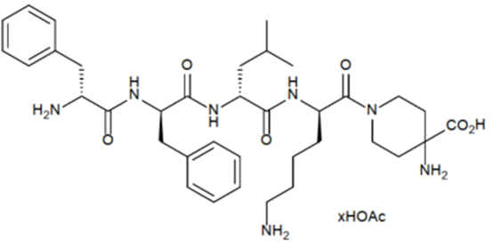
Difelikefalin acetate is a white to off-white amorphous powder. The drug substance is freely soluble in the solvent aqueous acetate buffer which enables the drug product dosage form to be a solution. Particle size of the drug substance was not considered to be a critical test parameter, given that the drug substance is freely soluble in water.
The drug substance is produced by chemical synthesis. Final purification is through column chromatography, followed by lyophilisation.
The drug product is a sterile, clear, buffered aqueous solution and is presented as ‘ready-to-use’ for intravenous administration at a concentration of 50 µg of difelikefalin free base (anhydrous and acetic acid-free substance) per mL.
The product is packaged in clear glass vials with an inert rubber closure that is laminated with a fluoro-resin film. The product is stable in the packaging, and the packaging does not impact the quality of the product. Pack sizes of 3 x 1 mL and 12 x 1 mL vials are proposed for registration.
The drug product is stable upon storage and stability data supplied supported a shelf life of 30 months for the unopened product when stored at or below 30°C (do not freeze).
Approval is recommended for registration of the proposed product from a quality perspective.

Nonclinical
No major deficiencies were identified in the nonclinical dossier. The primary pharmacology studies support the proposed indication and proposed dose. No off-target effects are predicted based on the secondary pharmacodynamic screens.
Adverse effects on cardiovascular and respiratory function are not predicted in patients.
The clinical relevance of the delay in gastrointestinal transit is difficult to interpret given the high doses tested in animals. It is noted that constipation was not a frequent side effect in clinical trials. Similarly, CNS effects were a feature in all toxicity studies at the lowest tested doses. However, exposures were high. The US Food and Drug Administration (FDA) label indicated CNS effects were apparent in patients.
Pharmacokinetic drug interactions are not predicted based on available in vitro information. Aside from the CNS above, the submitted repeat-dose toxicity studies did not reveal any safety concerns of clinical relevance.
Difelikefalin is not expected to pose a genotoxic or carcinogenic concern. No clinically relevant reproductive or developmental risks were identified.
There are no nonclinical objections to registration.

Clinical

Summary of clinical studies
The clinical dossier consisted of:
- eleven Phase I clinical pharmacology studies examining the intravenous formulation of difelikefalin: CR845-CLIN1001, CR845-CLIN1003, CR845-CLIN1004, CR845-CLIN1005, CR845-CLIN1006, CR845-CLIN1009, CR845-100201, CR845-100302, CR845-100303, PR-13A9-P1-A and PR-13A9-P1-B
  - nine of these studies contained data relating to difelikefalin pharmacokinetics (PK)
  - seven had data relating to the pharmacodynamics (PD)
- one population pharmacokinetic (popPK) study investigated difelikefalin PK following intravenous and oral dosing: Study CTX0201F
- two pivotal Phase III efficacy and safety studies: Studies CR845-CLIN3102 and CR845-CLIN3103
- seven supportive efficacy and safety studies:
  - three Phase II studies: Studies CR845-CLIN2005, CR845-CLIN2101 and PR-13A9-P2-A
  - two Phase III studies: Studies CR845-CLIN3101 and CR845-CLIN3105
  - two extension studies of the pivotal studies: Studies CR845-CLIN3102-OLE and CR845-CLIN3103-OLE.

Good clinical practice
The clinical studies reviewed in this evaluation were in compliance with TGA guidelines.

Pharmacology

Pharmacokinetics
Table 3: Submitted pharmacokinetic studies
PK topic | Subtopic | Study ID | Primary PK aim of study
PK in healthy adults | General PK single dose | Study CR845-100201 | Effects of single IV doses of difelikefalin on the QTc interval in healthy subjects.
PK in healthy adults | General PK single dose | Study CR845-CLIN1001 | Placebo controlled, ascending single IV dose study to evaluate the safety, PK and PD of difelikefalin in healthy subjects.
PK in healthy adults | Multi-dose | Study CR845-CLIN1004 | Multiple ascending dose study to evaluate the safety, tolerability and PK of IV difelikefalin in healthy subjects.
PK in healthy adults | Mass balance | Study CR845-100302 | PK and metabolism of [¹⁴C] difelikefalin in patients with ERSD on haemodialysis and in healthy subjects.
PK in special populations | Target populations | Study PR-13A9-P1-B | Placebo-controlled human pharmacology study to evaluate PK and safety of difelikefalin in haemodialysis patients.
PK in special populations | Target populations | Study CR845-CLIN1003 | Placebo controlled ascending single dose study to evaluate the safety and PK of IV difelikefalin in haemodialysis patients.
PK in special populations | Renal impairment | Study CR845-CLIN1005 | Comparison the PK and safety of a single IV dose of difelikefalin in patients with renal impaired function to matched healthy control subjects.
PK in special populations | Other special population | Study CR845-CLIN1006 | Relative abuse potential of IV difelikefalin in healthy, recreational polydrug users.
PK in special populations | Japanese | Study PR-13A9-P1-A | PK, PD parameters and safety of difelikefalin in Japanese healthy male subjects.
Population PK analyses | Healthy and target population | Study CTX0201F | PopPK modelling and simulation for difelikefalin.
Abbreviations: [¹⁴C] = Carbon-14, ERSD = end stage renal disease, IV = intravenous, PD = pharmacodynamic(s), PK = pharmacokinetic(s), popPK = population pharmacokinetic(s).

Healthy subjects and patients on haemodialysis

Absorption
Following a single intravenous (IV) dose of 0.5 µg/kg difelikefalin (that is, the proposed recommended dose) to 58 healthy subjects (16 males and 32 females), the median time to maximum concentration (T_{max}) was 0.08 hours, that is, 4.8 minutes.
In Japanese patients receiving haemodialysis and administered a single IV dose of 0.5 µg/kg, the median T_{max} was 0.083 hours, that is, 4.98 minutes.

Bioavailability

Dose proportionality
Some studies have examined difelikefalin PKs following single ascending doses. For instance, in Study CR845-CLIN1001, the pharmacokinetics of difelikefalin was examined following single IV doses, infused over 15 minutes of 2, 4, 6, 8, 10, 16, 24 and 40 µg/kg to healthy subjects. The finding was that the maximum concentration (C_{max}) and the area under the concentration-time curve (AUC) values for difelikefalin increased linearly with dose, that is, the slopes of the dose proportionality assessments were close to 1, across the dose range of 2 to 40 µg/kg.
Similarly, in 36 healthy Japanese males administered single IV doses of 1, 3, 5, 10, 20 or 40 µg/kg difelikefalin, C_{max}, AUC from time zero to time of last quantifiable concentration (AUC_{0-last}), and AUC from time zero to infinity (AUC_{0-inf}) increased proportionally with dose. By contrast, following administration of 1, 3 or 6 µg/kg difelikefalin doses to haemodialysis patients, increases in the latter PK parameters were slightly less than dose proportional.
There were increases in the PK parameters in healthy, recreational polydrug users administered either a single IV dose of 5 or 15 µg/kg difelikefalin.
Overall, the studies suggest that following single doses, difelikefalin exposure increases with dose in a dose proportional or slightly less than dose proportional manner.

Bioavailability during multiple dosing
Part A of Study CR845-CLIN1004 evaluated difelikefalin PKs following multiple ascending IV doses in healthy subjects to identify the maximum tolerated dose under repeat dose conditions. In this study, increasing doses of difelikefalin were administered as an IV loading dose followed by IV maintenance doses, ranging from 5 to 15 µg/kg repeated every 3 hours for a period of 24 hours in six cohorts. Although, exposure in terms of PK parameters increased with maintenance dose in this study, dose proportionality could not be established; the mean accumulation ratios for difelikefalin (dose normalised for the difference in loading and maintenance dose) ranged from 1.43 to 2.05. Steady state was achieved prior to the administration of the second infusion for all dose levels except for the 17 µg/kg loading dose followed by 13 µg/kg maintenance dose group, where steady state was attained prior to the third infusion.
Similarly, in Japanese haemodialysis patients, who were administered 0.5 or 1 µg/kg difelikefalin IV within 15 min following the completion of haemodialysis on Days 1, 3 and 5, the accumulation ratios of the study drug on Day 5 compared to those on Day 1 for difelikefalin C_{max}, AUC from time zero to 48 hours and the lowest concentration of a drug just prior to the following dose(trough concentration) ranged from 0.97 to 1.58. Although increases in concentration at time zero and C_{max} were slightly less than dose proportional following the third dose of difelikefalin, increases in AUC were proportional with dose.
In the repeated dose component of Study PR-13A9-P1-A, difelikefalin was administered at doses of 1, 3, 5, 10 or 20 µg/kg every 3 hours, for 21 hours for a total eight doses. In this study, increases in C_{max} and AUC were dose proportional following the first and last administrations of study drug.
The Delegate noted that dose proportionality is not linear in haemodialysis patients, following single dose administration. While PK parameters of C_{max} and AUC might increase with multiple dosing in both healthy and haemodialysis patients, dose proportionality is not strictly established in both situations, especially for C_{max}. Although time to reach steady state seems to occur soon after the second dose in both healthy subjects and haemodialysis patients, there is potential for drug accumulation, the latter being dependent on the ratio of the loading dose to maintenance dose.

Distribution

Volume of distribution
Following a single IV dose of 0.5 µg/kg difelikefalin to healthy subjects, the geometric mean volume of distribution (Vd) was 0.169 L/kg or approximately 11.8 L for a 70 kg subject.
The corresponding values in Japanese haemodialysis patients after the third IV dose of 0.5 µg/kg difelikefalin following dialysis was 0.341 L/kg or approximately 23.9 L for a 70 kg haemodialysis patient.
For comparison, the Vd was 18 L in healthy subjects administered a single 3 µg/kg IV dose, whereas in subjects with mild to severe renal failure Vd ranged from 17.1 to 18.8 L.
The Delegate noted that capacitance, as mirrored by Vd for difelikefalin, can go up with repeat dosing in CKD haemodialysis subjects. The latter will influence the half-life of difelikefalin and the dosing interval. The Delegate requested the sponsor to state how the above had been factored in when calculating the proposed doing interval in its pre-ACM response.

Plasma protein binding
In subjects with normal renal function and in those with mild, moderate and severe renal impairment, difelikefalin binding to the proteins in human plasma was low to moderate, ranging from 24 to 32% across the four groups. Therefore, the degree of renal impairment did not appear to have a meaningful effect on the degree of difelikefalin protein binding. Similarly, in haemodialysis patients, administered 1 to 6 µg/kg IV difelikefalin, binding to protein in human plasma ranged from 23% to 28%.
The Delegate noted that difelikefalin plasma protein binding is relatively low without relevance to the degree of kidney function, including CKD. The clinical implication is that it will be relatively cleared from plasma at dialysis.

Erythrocyte distribution
In Study CR845-100302, for patients with end stage renal disease (ESRD) on haemodialysis and healthy subjects, the total radioactivity blood to plasma ratios, based on mean area under concentration-time curve from time zero to the time of last measurable concentration values, were 0.62 and 0.55, respectively.

Tissue distribution
The low Vd suggests that difelikefalin is not distributed to the tissues. Moreover, in vitro autoradiographic studies in nonhuman primate tissue indicate that difelikefalin is:
- highly distributed to the blood, intestinal contents, kidney and intracystic urine, liver, lung and skin
- moderately distributed to the adrenal gland, bone marrow, heart, pancreas, skeletal muscle, spleen, testis and thyroid gland
- poorly distributed to the other tissues including cerebrum, cerebellum, eyeball and spinal cord.

Metabolism

Sites and mechanisms/enzyme systems involved with metabolism
Study CR845-100302 indicates that difelikefalin undergoes limited metabolism, as it accounted for greater than 99% (that is, un-metabolised/unchanged difelikefalin) of the total systemic exposure in both subjects with normal renal function and, patients with ESRD undergoing haemodialysis.
Moreover, following a 3 µg/kg IV dose to subjects with normal renal function and those with mild and moderate renal impairment, 84.3%, 86.4% and 81.3% of difelikefalin respectively, was excreted as unchanged drug in the urine, the primary excretion pathway (responsible for 80.5% of excretion in healthy subjects).
The Delegate noted that there is no elimination data on severe renal impairment.
Furthermore, in vitro studies indicate that difelikefalin is metabolically stable, and it is not an inhibitor or substrate for clinically relevant enzymes and transporters. In addition, difelikefalin has minimal to no potential for induction of human cytochrome P450 (CYP) subunits (CYP1A2, CYP2B6 or CYP3A4). Therefore, difelikefalin is unlikely to interact with co-administered drugs.

Non-renal clearance
In healthy subjects, following a single, theoretical, IV, solution dose of 230 µg containing 100 microcurie (µCi) of carbon-14 [¹⁴C] difelikefalin administered as a bolus 11.3% of the radioactive dose was recovered in faeces. In comparison, patients with ESRD undergoing haemodialysis where 58.8% of the radioactive dose was recovered in faeces, and 19.5% was recovered in dialysate.

Metabolites (active and other) identified in humans
In healthy subjects, the most prevalent metabolite (MP1) in systemic circulation accounted for 0.48% of the total exposure, whereas, AUC_{0-last} could not be estimated for three additional metabolites (MP2, MP3 and MP4). In patients with ESRD undergoing haemodialysis, MP1 accounted for 0.10% and MP3 accounted for 0.02% of the total exposure, whereas AUC_{0-last} could not be estimated for MP2 and MP4 metabolites.

Excretion

Routes and mechanisms
The primary route of elimination for difelikefalin in subjects with normal renal function is renal, with 80.5% of a single, theoretical, IV solution dose of 230 µg containing 100 µCi of [¹⁴C] difelikefalin eliminated in urine and further 11.3% recovered in faeces.
By contrast, in ESRD patients undergoing haemodialysis (that is, with non-functioning kidneys), renal excretion was considered a minor route of elimination as only 11.2% of the radioactive dose was recovered in urine, 58.8% was recovered in faeces and 19.5% was recovered in dialysate.

Mass balance studies
In healthy subjects, following an IV bolus dose of 100 µCi of [¹⁴C] difelikefalin (Study CR845-100302):
- Radioactivity was first detected in urine during the 0 to 4 hour collection interval and quantifiable radioactivity was observed through the 60 to 72 hour collection interval up to the 168 to 192 hour collection interval.
- Most of the radioactive dose that was recovered in urine occurred within 24 h of dosing and approximately 54% of the administered radioactive dose was recovered during the first collection interval (0 to 4 hours).
- In faeces, radioactivity was first detected during the 24 to 48 hour collection interval and quantifiable radioactivity was observed through the 96 to 120 hour collection interval up to the 144 to 168 hour collection interval.
- Most of the radioactive dose that was recovered in faeces occurred within 120 hours of dosing.
In ESRD patients undergoing haemodialysis:
- Radioactivity was detected in the urine of only 50% of subjects and it was first detected during the 12 to 24 hour collection interval. Radioactivity was quantifiable through the 144 to 168 hour collection interval up to the 264 to 288 hour collection interval.
- For this 50% cohort, most of the radioactive dose that was recovered in urine occurred within 72 hours of dosing.
- In faeces, radioactivity was identified in all subjects and was first detected during the 0 to 24 hour collection interval. Quantifiable radioactivity in faeces was observed through the 288 to 312 hour collection interval up to the 432 to 456 hour collection interval and, most of the radioactive dose that was recovered in faeces occurred within 192 hours of dosing.
- For dialysate, radioactivity was detected in all six haemodialysis subjects during the first and second dialysis sessions and, for four haemodialysis subjects during the third dialysis session, whereas no radioactivity was detected in dialysate for the other two subjects following the third dialysis session.
- During the first dialysis session (Day 4), 14.7% of the radioactive dose was recovered, 3.86% was recovered during the second session (Day 6) and 0.932% was recovered during the third session (Day 11).

Interindividual variability of pharmacokinetics
The popPK analysis (Study CTX0201F) provided estimates of the interindividual variability, as % coefficients of variation (CV) for:
- clearance = 43.5%
- central volume = 43%
- intercompartmental clearance from central volume = 92.3%
- peripheral volume 1 = 62%
- intercompartmental clearance from peripheral volume = 83.6%
- peripheral volume 2 = 59.8%
The corresponding %CV on the proportional error was 18.4%.

Pharmacokinetics in the target population
Study CR845-100302 examined difelikefalin PKs following a single, theoretical, IV solution dose of 230 µg containing 100 µCi of [¹⁴C] difelikefalin to healthy subjects and patients with ESRD undergoing haemodialysis.
In Study CR845-100302:
- the mean plasma C_{max} and T_{max} for total radioactivity were similar for both haemodialysis patients (mean C_{max} = 25.6 ng-equivalents(eq)/mL) and healthy subjects (24.8 ng-eq)/mL) and T_{max} occurred 5 minutes post dose in both groups.
- By contrast, mean AUC was approximately 11-fold higher for haemodialysis patients compared to healthy subjects with mean AUC_{0-inf} values of 474 ng.h-eq/mL and 44.3 ng.h-eq/mL in the two groups, respectively. Moreover, mean half-life was appreciably longer for haemodialysis patients (38 hours) than for healthy subjects (2.6 hours) and mean clearance (CL) was lower (0.448 L/h versus 4.7 L/h). Mean volume of distribution (Vd) values in haemodialysis patients and healthy subjects were approximately 23 to 24 L and 11.8 to 17 L, respectively.

Pharmacokinetics in special populations

Pharmacokinetics in subjects with impaired hepatic function
No clinical studies specifically examined the effects of hepatic impairment on difelikefalin PKs. However, the analysis dataset used to generate the IV popPK model (Study CTX0201F) included subjects classified as having normal (n = 418), mild (n = 17) and moderate (n = 1) hepatic impairment. The analysis indicated that difelikefalin exposure in mild and moderate hepatic impairment subjects was contained within the region of practical equivalence and therefore, the sponsor concluded no dose adjustments were warranted based on hepatic impairment status.
The clinical evaluation noted that the sponsor’s claim that no dose adjustments are required based on hepatic impairment status cannot be considered conclusive given the small number of subjects with moderate hepatic impairment (n = 1) included in the analysis and the complete absence of subjects with severe hepatic impairment.
The Delegate noted that while it is stated that difelikefalin is mostly eliminated unmetabolised, there is still a degree of metabolism taking place, albeit minimal. The latter cannot, therefore, be neglected in the presence of hepatic impairment.

Pharmacokinetics in subjects with impaired renal function
Study CR845-CLIN1005 compared the PKs and safety of a single 3 µg/kg IV dose of difelikefalin in patients with various levels of renal impairment to matched healthy control subjects. For this study, patients had a clinical diagnosis of impaired renal function, based on estimated glomerular filtration rate and stratification, based on the screening estimated glomerular filtration rate values. The results identified no clear trend between C_{max} and Vd versus degree of renal function. By contrast, linear regression analyses indicated that difelikefalin AUC_{0-inf}, clearance and renal clearance were strongly correlated with renal function. Total exposure and plasma half-life of difelikefalin were inversely correlated with renal function (that is, increased exposure is associated with decreased renal function), while clearance and renal clearance are directly correlated with renal function (that is, decreased clearance is associated with decreased renal function).
The Delegate noted that following a 3 µg/kg IV dose to subjects with normal renal function and those with mild and moderate renal impairment, 84.3%, 86.4% and 81.3% of difelikefalin respectively, was excreted as unchanged drug in the urine, the primary excretion pathway (responsible for 80.5% of excretion in healthy subjects).

Pharmacokinetics in other special populations
A range of covariates were screened for inclusion into the popPK ‘IV only’ model developed in Study CTX0201F. The covariates include the following variables:
- gender
- age
- race
- baseline body weight
- modification of diet in renal disease (MDRD)
- baseline hepatic function using laboratory values such as baseline bilirubin and baseline aspartate aminotransferase.
In this study, MDRD was used to classify renal function as it estimates glomerular filtration rate and is influenced by age. The final IV popPK model identified aspartate aminotransferase and bilirubin as covariates on clearance and, the MDRD effect was a covariate of both clearance and Vd. Inclusion of these covariates allowed the final IV model to explain more than 50% of the observed interindividual variability on difelikefalin elimination, which had been identified in the base model (base model CV% = 139 versus final model CV% = 43.5). By contrast, the final IV model showed no effect of subject race or gender on difelikefalin exposure.

Population pharmacokinetic analysis
Study CTX0201F represented a popPK analysis based on the results of 17 clinical trials that provided PK data. This dataset included healthy subjects and patients that had been administered either IV or oral difelikefalin. Therefore, only the outcomes pertaining to the IV administered subjects will be discussed as part of this report.
The final ‘IV only’ analyses identified that a three compartment popPK model provided the best and most parsimonious fit to the data and included fixed effects of body weight on all clearance and volume terms. As mentioned previously, aspartate aminotransferase and bilirubin were identified as covariates on clearance and, the MDRD effect was a covariate of both clearance and V.

Pharmacokinetic interactions
Given the metabolic stability of difelikefalin in humans and the in vitro evidence indicating it is not an inducer, inhibitor or substrate for clinically relevant enzymes and transporters, difelikefalin is unlikely to interact with co-administered medications.

Overall conclusions on pharmacokinetics
The conduct of the studies that were provided in support of the current submission was satisfactory, the data analyses undertaken were appropriate and the analytical methods used to measure exposure levels were validated.
Absorption, distribution, metabolism, and excretion:
- Difelikefalin solution for injection is to be administered via IV bolus injection.
- Following the proposed recommended IV dose to healthy subjects or Japanese patients receiving haemodialysis, the T_{max} was approximately 0.08 hours.
- Following single and multiple IV doses of difelikefalin at a range of strengths, difelikefalin exposure increased with dose in a linear or slightly less than linear fashion in both healthy subjects and haemodialysis patients. Steady state was achieved prior to the administration of the second or third infusion.
- Following administration of a single IV dose of 0.5 µg/kg difelikefalin to a 70 kg healthy subject, the geometric mean Vd was approximately 11.8 L and the corresponding value in a Japanese haemodialysis patient after their third IV dose of 0.5 µg/kg difelikefalin following dialysis was 23.9 L.
- In subjects with normal renal function and mild, moderate and severe renal impairment, binding to protein in human plasma was low to moderate, ranging from 24% to 32%. Similarly, in haemodialysis patients, binding to protein in human plasma ranged from 23% to 28%.
- The total radioactivity blood to plasma ratios, were 0.62 and 0.55 for patients with ESRD on haemodialysis and healthy subjects, respectively.
- Difelikefalin undergoes limited metabolism as it accounted for greater than 99% of the total systemic exposure and is primarily excreted as unchanged drug.
- In healthy subjects and patients with ESRD on haemodialysis, MP1 is the most prevalent metabolite in systemic circulation and represents between 0.1 to 0.48% of total exposure.
- In healthy subjects, difelikefalin is primarily excreted via the urine (80.5%) and a further 11.3% is recovered in faeces. By contrast, in ESRD patients on haemodialysis, only 11.2% is recovered in urine, whereas 58.8% was recovered in faeces and 19.5% from dialysate.
Variability:
- PopPK estimates of the interindividual variability on clearance, central volume, intercompartmental clearance from central volume, peripheral volume 1, intercompartmental clearance from peripheral volume and peripheral volume 2 were 43.5%, 43%, 92.3%, 62%, 83.6% and 59.8%, respectively and the %CV on the proportional error was 18.4%.
In the target population:
- Following an IV dose containing 100 µCi of [¹⁴C] difelikefalin, the C_{max} and T_{max} for total radioactivity were similar for both haemodialysis patients and healthy subjects, whereas the AUC was approximately 11-fold higher for haemodialysis patients. Moreover, mean half-life was appreciably longer for haemodialysis patients (38 hours) than for healthy subjects (2.6 hours) and mean clearance was lower (0.448 L/h versus 4.7 L/h).
In the special populations:
- Based on small group of patients in the PopPK dataset, the sponsor concluded that no dose adjustments were warranted based on hepatic impairment status.
- Difelikefalin exposure and half-life were inversely correlated with renal function, whereas clearance and renal clearance were directly correlated with renal function.
- The final IV popPK model identified age, aspartate aminotransferase and bilirubin as covariates on clearance and the MDRD effect was a covariate of both clearance and Vd. By contrast, the final IV model showed no effect of subject race or gender on difelikefalin exposure.
For popPK:
- The final popPK analysis identified that a three-compartment population PK model provided the best and most parsimonious fit to the IV dose PK data and included fixed effects of body weight on all clearance and volume terms.

Pharmacodynamics

Overall conclusions on pharmacodynamics
- Pharmacology-wise, difelikefalin is a highly selective, peripherally acting, full kappa opioid receptor (KOR) agonist with limited permeability into the central nervous system (CNS).
- Difelikefalin, at the doses tested, had no effect on cardiac repolarisation, respiratory drive or sedation.
- The relative abuse potential of difelikefalin is significantly lower than that of pentazocine.
- At the proposed dose, the potential of physical withdrawal from difelikefalin upon treatment discontinuation after three weeks was similar to that of the placebo.
- Following a range of IV doses of up to 40 µg/kg difelikefalin, but not the 2 µg/kg dose, there were statistically significant increases compared with placebo in prolactin exposure. By contrast, there were no statistically significant differences in the PD parameters of vasopressin between placebo and any of the difelikefalin doses examined.
- On the whole, maximum urine flow rates and cumulative urine volumes excreted from 0 to 12 hours were statistically significantly higher for all doses of difelikefalin in comparison to placebo. By contrast, the cumulative volumes of fluid consumed following all doses of difelikefalin and placebo were similar.
- Increases in prolactin levels appeared to be positively correlated with difelikefalin concentrations up to the level of approximately 20 ng/mL difelikefalin.
- The decreased urine osmolarity, slight increase in serum osmolarity and a reduction in urinary excretion of electrolytes following difelikefalin doses greater than 6 µg/kg are supportive of difelikefalin having an aquaretic effect in healthy subjects.

Dosage selection for pivotal studies

Pharmacokinetic and pharmacodynamic findings
In Study CR845-CLIN1001, the maximum tolerated dose in healthy subjects was identified, based on the pre-set maximum tolerated dose stopping criterion of asymptomatic, mild orthostatic tachycardia at 40 µg/kg difelikefalin in two out of six subjects. Moreover, at the proposed dose of 0.5 μ/kg difelikefalin, no effect on cardiac repolarisation, respiratory drive or sedation is expected.

Phase II dose finding studies
Study CR845-CLIN2101 examined the efficacy of three doses of difelikefalin (0.5, 1.0, and 1.5 µg/kg) IV treatment after each haemodialysis session (three times per week) over an eight-week period. This study included a post-hoc evaluation of the percentage of subjects achieving a 3 or 4 point or greater improvement in the worst itching intensity numerical rating scale (WI-NRS).
The percentage of subjects with 3 point or greater improvement in the weekly mean WI-NRS score by Week 8 was significantly higher for the 0.5 µg/kg dose group compared with placebo (62.4% versus 29.5%, P = 0.003).
The percentage of subjects with 4 point or greater improvement in the weekly mean WI-NRS score by Week 8 was also significantly higher for the 0.5 µg/kg difelikefalin group compared with placebo (48% versus 23.6%, P = 0.019).
No apparent dose response in antipruritic efficacy was observed among the three doses (0.5, 1.0, and 1.5 µg/kg) studied in Study CR845-CLIN2101. In addition, difelikefalin 0.5 µg/kg IV was found to be well tolerated in the study.
Based on the similar efficacy across dose groups and dose response trends observed in the safety results, a difelikefalin dose of 0.5 µg/kg appeared to achieve the most favourable benefit-risk profile and was thus selected as the dose to be further evaluated in the Phase III studies.

Overall conclusions on dose finding for pivotal studies
The rationale for the dose selection and dosing regimen for the pivotal studies was sound.

Efficacy

Pivotal efficacy studies

Study CR845-CLIN3102
Study CR845-CLIN3102 is a Phase III, multicentre, double blind, randomised, placebo controlled study to evaluate the safety and efficacy of intravenous difelikefalin in haemodialysis patients, with moderate to severe pruritus. The study also has an open label extension phase.

Study design
The study design consists of four periods (see Figure 2):
- Screening visit
  - Occurred 7 to 28 days prior to randomisation to assess eligibility
- Seven day run-in period
  - Eligible subjects completed a 7-day run-in period during the week prior to randomisation, starting at the first haemodialysis session of that week (that is, Monday for subjects on a Monday, Wednesday and Friday dialysis schedule or Tuesday for subjects on a Tuesday, Thursday and Saturday dialysis schedule).
  - The purpose of the run-in period was to confirm that each subject had moderate to severe pruritus (that is, weekly average score 4 or greater on the 24 hour worst itching intensity numerical rating scale (WI-NRS)7) and to establish a baseline itch intensity. If subjects continued to meet all inclusion and exclusion criteria at the end of the 7-day run-in period, they were randomised in a 1:1 ratio to receive either difelikefalin 0.5 µg/kg or placebo in the double blind treatment period.
- Twelve week double blind treatment period
  - Difelikefalin was evaluated relative to placebo
- Two week discontinuation period
  - Subjects did not receive any study drug and were monitored for potential signs or symptoms of physical dependence.
At the end of the discontinuation period, subjects who had received at least 30 doses of study drug (either difelikefalin or placebo) during the 12-week double blind treatment period, had the option to receive open label difelikefalin for up to an additional 52 weeks in the open label extension phase.
Figure 2: Study CR845-CLIN3102 Study design
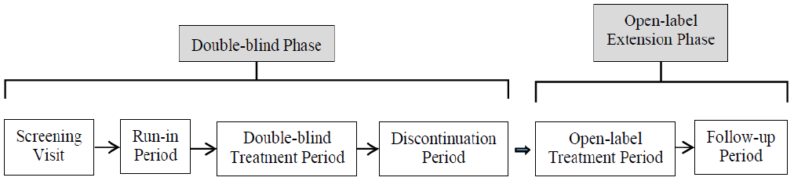

Study objectives
Assessment of difelikefalin at a dose of 0.5 µg /kg compared with placebo, in subjects undergoing haemodialysis and experiencing moderate to severe pruritus.
The primary objective was to evaluate efficacy in reducing the intensity of itch.
The secondary objectives were to evaluate efficacy in improving itch related quality of life measures and difelikefalin safety.

Inclusion criteria
- Eligible patients were male and female adults (18 years or older).
- Subjects had end stage renal disease (ESRD) and had been undergoing haemodialysis three times per week for at least three months prior to the start of screening.
  - Subjects who required an occasional additional haemodialysis treatment to manage fluid overload could be enrolled as long as it was anticipated that no more than one such treatment would be required in any given week.
  - Subjects undergoing in home dialysis could participate as long as they had switched to in centre haemodialysis at least two weeks prior to screening and planned to remain on in centre haemodialysis for the duration of the study.
- Prior to randomisation, subjects had to have completed at least four WI-NRS worksheets during the run-in period and have a mean baseline WI-NRS score of 4 or greater.7
- If subject was female:
  - was not pregnant or nursing during any period of the study
  - was surgically sterile; or
  - had been amenorrheic for at least one year and was over the age of 55 years; or
  - had a negative serum pregnancy test at screening and agreed to use acceptable contraceptive measures (for example, hormonal contraceptives, barrier with spermicide, intrauterine device, vasectomised partner, or abstinence) from the time of informed consent until seven days after the last dose of study drug.
- If subject was male:
  - had agreed not to donate sperm after the first dose of study drug until seven days after the last dose of study drug
  - had agreed to use a condom with spermicide or abstain from heterosexual intercourse during the study until seven days after the last dose of study drug.
- Subjects had a prescription dry body weight between 40 and 135 kg, inclusive.
The clinical evaluation considered the inclusion and exclusion criteria were appropriate. Overall the study aimed to recruit adult ESRD patients on haemodialysis with a mean baseline WI-NERS score greater than 4.

Study treatments
Subjects received either difelikefalin at a dose of 0.5 µg/kg or placebo as an IV bolus after each haemodialysis session (generally three times per week) for up to 12 weeks.
Treatment was administered as an IV bolus into the venous line of the haemodialysis circuit at the end of each haemodialysis session and could be given either during or after rinse back of the haemodialysis circuit. If study drug was given after rinse back, the venous line was to be flushed with at least 10 mL of normal saline.
If a subject received additional haemodialysis during a given week for any reason, an additional dose of difelikefalin or placebo was administered following haemodialysis. A maximum of four doses per week was allowed. No further additional doses were given for subjects receiving further additional unscheduled ultrafiltration treatments. If a subject missed a haemodialysis visit and the planned dose of difelikefalin or placebo for that visit, dosing was to resume at the next haemodialysis visit.
The subject’s prescription dry body weight (that is, the target post dialysis weight, as determined by the subject’s nephrologist or dialysis unit during screening) was used to calculate the dose of study drug to be administered throughout the double blind treatment period.

Concomitant medications
Prior concomitant antihistamines (oral, IV, or topical), corticosteroids (oral, IV, or topical), opioids, gabapentin and pregabalin were allowed to be continued, but changes to current prescription were to be avoided from screening to the end of the double blind treatment period except for the acute treatment of an adverse event or emergent medical condition.
The Delegate noted that the probable use of concomitant opioid is a confounder in the reported adverse effects.
Ultraviolet light-B treatments and naloxone, naltrexone, or mixed agonist-antagonists (for example, buprenorphine and nalbuphine) were not allowed during study treatment period. No new medication to treat itch was to be initiated during the study.
Subject compliance with study drug was documented as part of standard procedures at the dialysis units where study drug was administered.
The clinical evaluation noted that the study dose regimen is appropriate and the sponsor’s rationale for the dose selection in this study is considered acceptable.

Randomisation and blinding methods
Randomisation was performed using an interactive web response system. Subjects were randomised in a 1:1 ratio to receive either difelikefalin 0.5 µg/kg or matching placebo during the double blind treatment period.
Randomisation was stratified based on the:
- use or non-use of concomitant medications to treat the itch during the pre-randomisation week (run-in period).
- presence or absence of specific medical conditions
  - history of fall or fracture (related to fall)
  - confusional state or mental status change or altered mental status or disorientation
  - gait disturbance or movement disorder.
During the double blind treatment period, subjects, investigators, and study staff were blinded to study drug assignment.

Efficacy parameters and endpoints

Primary efficacy parameters/endpoints
The proportion of subjects achieving a 3 point or greater improvement from Baseline with respect to the weekly mean of the daily 24 hour WI-NRS score at Week 12 of the double blind treatment period.7

Secondary efficacy parameters/endpoints
- Change from Baseline in itch related quality of life at the end of Week 12 of the double blind treatment period, as assessed by the 5-D itch scale.
- Change from Baseline in itch related quality of life at the end of Week 12 of the double blind treatment period, as assessed by the total Skindex-10 scale score.
- Proportion of subjects achieving a 4 point or greater improvement from Baseline with respect to the weekly mean of the daily 24 hour WI-NRS at Week 12 of the double blind treatment period.
Efficacy endpoints were assessed according to the schedule below:
Table 4: Study CR845-CLIN3102 Double blind phase schedule of assessments
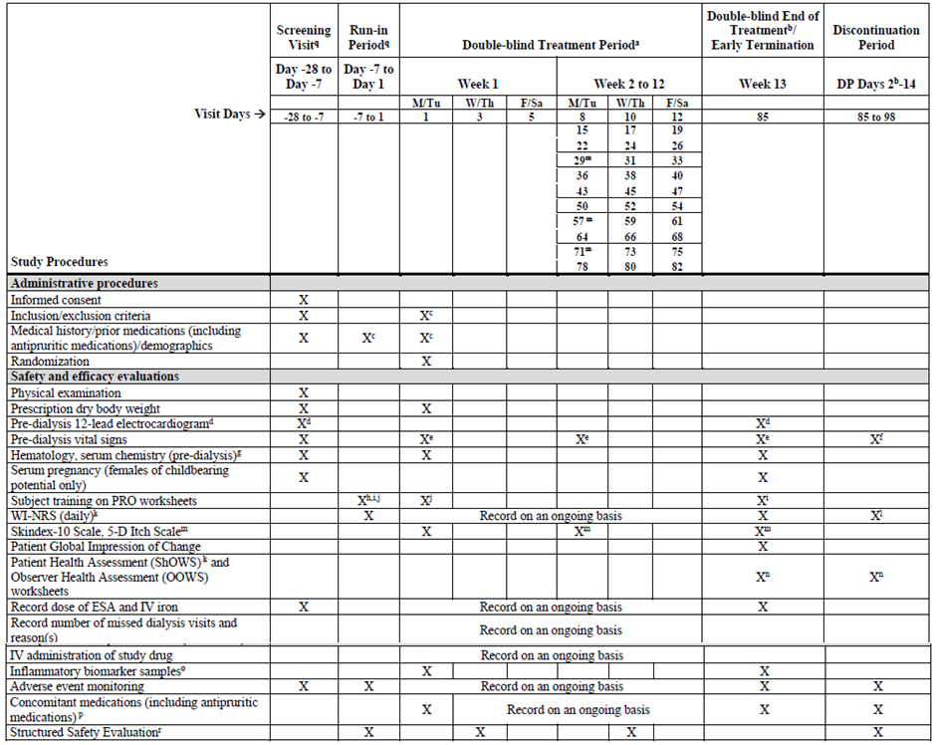
Abbreviations: DP = discontinuation period, ESA = erythropoiesis stimulating agent, F = Friday, IV = intravenous, M = Monday, OOWS = objective opiate withdrawal scale; PRO = patient reported outcome, Sa = Saturday, ShOWS = short opiate withdrawal scale, Th = Thursday, Tu = Tuesday, W = Wednesday, WI-NRS = worst itching intensity numerical rating scale.
a. Each visit during the double blind treatment period coincided with the subject’s normal dialysis treatments.
b. The end of treatment visit in the double blind phase was the first dialysis visit following the last dose of study drug (that, first dialysis on Week 13 (Day 85)), which also corresponded to Day 1 of the discontinuation period (DP Day 1).
c. Medical history was updated on Day 1 with any changes since the screening visit, and inclusion/exclusion criteria were confirmed prior to randomisation. Antipruritic medication was updated at each dialysis visit during the run-in period.
d. Electrocardiogram had to be performed prior to the start of dialysis at screening and on Day 85 (end of treatment; or at the early termination visit).
e. Pre-dialysis vital signs, including body temperature, heart rate, and blood pressure, were recorded on Days 1, 15, 29, 43, 57, 71 and 85 (end of treatment; or at early termination visit) only when the subject was in a sitting or semi-recumbent position. Heart rate was measured at each dialysis; if heart rate was clinically significant and outside the prespecified visits per schedule of assessments, the heart rate was recorded on the relevant case report form page.
f. Pre-dialysis vital signs, including body temperature, heart rate, and blood pressure, were recorded at each dialysis visit during the discontinuation period. Heart rate was measured at each dialysis.
g. Blood samples for clinical laboratory evaluation were taken at screening and on Days 1 and 85 (end of treatment; or at early termination visit).
h. Training on WI-NRS was conducted on the first day of the run-in period (Day -7).
i. Training on ShOWS on Day -7 and first day of Week 13.
j. Training on Skindex-10 scale and 5-D itch scale could be performed at any time during the week prior to randomisation or on Day 1 of the double blind treatment period.
k. Subjects were requested to complete their WI-NRS worksheets each day at a similar time (either at home on non-dialysis days around the normal start time of their dialysis or in the dialysis unit). On dialysis days, the worksheets were to be completed prior to or during dialysis but had to be completed prior to dosing.
l. During the discontinuation period, WI-NRS worksheets were completed on dialysis days only.
m. 5-D itch scale and Skindex-10 scale were completed on Day 1 and the first visit of Weeks 5, 9, and 11 (on Days 29, 57, and 71) and Week 13 (Day 85). 5-D itch scale was preferably completed first. If the first visit of the week was missed, the subject could complete the worksheets at their next visit for the same week. The worksheets were to be completed prior to or during dialysis (preferably within one hour of the dialysis) but had to be completed prior to dosing.
n. ShOWS worksheets were completed daily through the entire discontinuation period starting on Day 85. The OOWS worksheets were completed at each dialysis visit during the discontinuation period starting on Day 85. On the day of a dialysis visit, the OOWS and ShOWS were to be completed during the first hour (additional one hour window allowed) of dialysis so that dialysis associated fatigue and other potential side effects related to the dialysis procedure would minimally interfere with the completion of the scales.
o. Biomarker samples had to be collected prior to the start of dialysis on Day 1 and Day 85.
p. Concomitant medications, including antipruritic medications, were updated at each dialysis visit during the double blind treatment period and until the end of the discontinuation period.
q. Sites had the option to conduct the screening visit during the run-in period at the discretion of the investigator.
r. A list of specific signs/symptoms were verified with the subject by qualified site staff, preferably on Wednesday/Thursday each week during the run-in period, the double blind treatment period, and the discontinuation period. Was not to be completed on Monday/Tuesday.
Overall, the clinical evaluation considered the primary and secondary endpoints of this study to be appropriate. The primary and secondary efficacy endpoints allowed assessment of the effect of difelikefalin on the intensity of itch (the proportion of subjects achieving a 3 or 4 point or greater improvement from Baseline in WI-NRS at Week 12) and on itch related quality of life (change from Baseline in the 5-D itch scale and total Skindex-10 scale score at Week 12). The sponsor has justified the use of WI-NRS as the primary efficacy endpoint. The WI-NRS has been widely used for evaluation of chronic itch, including CKD-aP.
In addition, qualitative and quantitative validation of the 24 hour WI-NRS item consistent with standards outlined by FDA guidance was undertaken, supporting robust performance of the measure for the target population (that is, haemodialysis patients with moderate to severe CKD-aP).
Results from the Phase II Study CR845-CLIN2101 showed that a 3 point difference in the WI-NRS from Baseline was a clinically meaningful improvement.

Participant flow
A total of 378 subjects were randomised for Study CR845-CLIN3102, n = 189 for difelikefalin and n = 189 for placebo (see Figure 3).
Of these, 377 subjects received at least one treatment with difelikefalin or the placebo (one subject was randomised to placebo group but did not receive any study drug).
A total of 332 subjects completed the double blind treatment period (162 in the difelikefalin group, and 170 in the placebo group).
The most common reasons for early discontinuation from the double blind treatment period were adverse events (4.8% and 7.4% respectively in the placebo and difelikefalin groups) and subject withdrawal of consent (3.2% and 4.2% respectively in the placebo and difelikefalin groups).
Figure 3: Study CR845-CLIN3102 Disposition flow
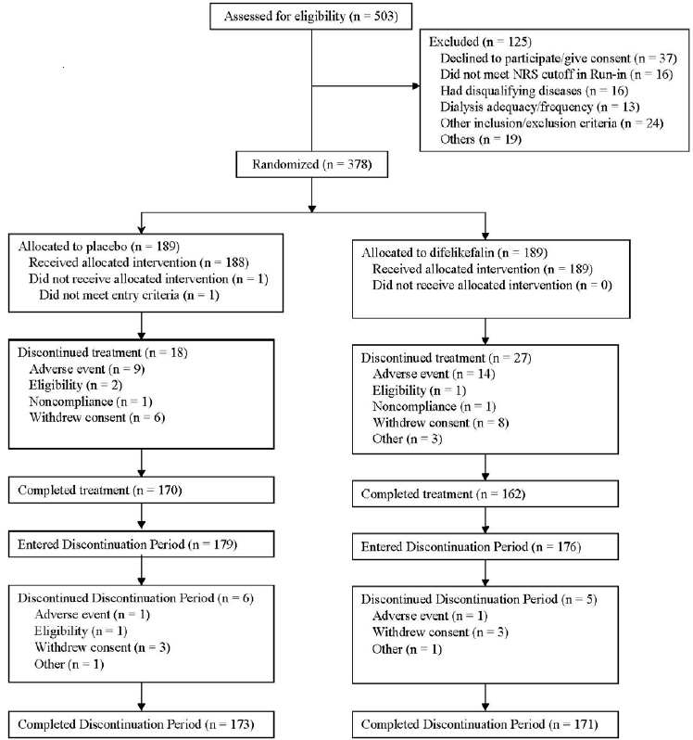
Abbreviations: NRS = numerical rating scale

Analysis of populations
Several analysis sets were defined in the study.
- The intent to treat (ITT) population comprised of all subjects who were randomised to a treatment group.
- Subjects in the ITT population were analysed according to their randomised treatment, regardless of the actual treatment received.
- The ITT population was used to analyse all efficacy endpoints collected during the double blind treatment phase.
- The double blind safety population comprised all randomised subjects who received at least one dose of double blind study drug during the double blind treatment period.
- Subjects in the double blind safety population were analysed according to the actual treatment received. This population was used to analyse all safety endpoints collected during the double blind phase.
- The per-protocol population was a subset of subjects in the ITT population who did not have any major protocol deviations that could have affected the efficacy analyses of the double blind data.
- The per-protocol population was used for supportive efficacy analyses.
The clinical evaluation concluded the definitions of the analysis populations and the efficacy analyses on the intent to treat population are in keeping with TGA adopted guidelines and with the intent to treat principle of efficacy analyses.

Sample size
The planned sample size for the study was 350 (175 per treatment group) male and female subjects undergoing haemodialysis and experiencing moderate to severe pruritus. The sample size could be increased to 500 subjects (250 per treatment group) based on the results of a planned unblinded interim assessment conducted, when approximately 50% of the planned first 350 subjects had been randomised and had either completed the 12 week double blind treatment period or had discontinued from treatment early.
The sample size calculation was based on the results of a completed Phase II, double blind, placebo controlled study (Study CR845-CLIN2101) of difelikefalin in subjects with ESRD who were undergoing haemodialysis and experiencing moderate to severe pruritus. In this study, 30% of subjects randomised to the placebo group reported a 3 point or greater improvement from Baseline with respect to the 24 hour WI-NRS at the end of treatment (Week 8). The proportion of subjects who received difelikefalin and reported a similar improvement in itch scores ranged from approximately 60% to 45% (that is, 30% to 15% difference from placebo), depending on the dose of active study drug (0.5 µg/kg, 1 µg/kg, or 1.5 µg/kg).
Given a sample size of 350 subjects (175 per treatment group) and assuming a true response rate of 30% for the placebo group and a true response rate of 50% for the difelikefalin group (defining response as a 3 point or greater improvement from Baseline with respect to the WI-NRS at Week 12), a 2-sided continuity corrected Chi square would have 96% power to detect a treatment difference. The power of this test statistic would be 84% or greater for differences from placebo as low as 0.16. Based on the results of the planned interim assessment, the sample size could be increased to up to 500 subjects (250 per treatment group). Given this maximum sample size, and assuming a true response rate of 30% in the placebo group, a 2-sided continuity corrected Chi square would have approximately 90% power to detect a treatment difference with a difelikefalin response rate of 45% (that is, a 15% difference from placebo).
An unblinded interim analysis for sample size re-estimation was conducted when approximately 50% of the first 350 subjects had been randomised and had either completed the 12 week treatment period or had discontinued from treatment early. The planned interim assessment was conducted by the Independent Data Monitoring Committee (IDMC). Based on the recommendation of the IDMC, there were no changes to the original enrolment target of 350 subjects.

Statistical methods
The primary efficacy endpoint was the proportion of subjects achieving a 3 point or greater improvement from Baseline with respect to the weekly mean of the daily (24 hour) WI-NRS at Week 12 of the double blind treatment period.
Differences between difelikefalin and placebo with respect to the primary endpoint were compared using a logistic regression model containing terms for treatment group, baseline WI-NRS score, region, use of anti-itch medication during the week prior to randomisation, and presence of specific medical conditions.
The 5-D itch scale and the Skindex-10 scale scores were analysed at Week 12 using an analysis of covariance (ANCOVA). The model contained treatment as a fixed effect, with baseline score and the randomisation stratification variables as covariates.

Baseline data
Baseline demographic characteristics were generally comparable between difelikefalin and placebo groups. The majority of patients were male (61%: placebo = 62.8%, difelikefalin = 59.3%), and the median age was 58 years (placebo = 57.5 years, difelikefalin = 59 years). The predominant races were White (48.8%: placebo = 49.5%, difelikefalin = 48.1%) and Black/African American (41.6%: placebo = 39.9%, difelikefalin = 43.4%).
Table 5: Study CR845-CLIN3102 Subject demographics
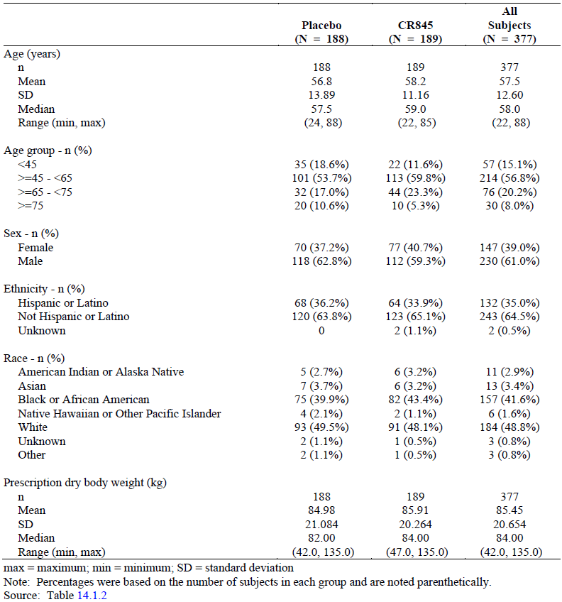
Abbreviations: max = maximum, min = minimum, SD = standard deviation

Baseline disease characteristics
The baseline disease characteristics were generally comparable between treatment groups. The median duration of CKD-aP for all subjects was 2.5 years (placebo = 2.57, difelikefalin = 2.2) and the median WI-NRS score at Baseline was 7.14 (placebo = 7.44, difelikefalin = 7).
Table 6: Study CR845-CLIN3102 Subject baseline characteristics
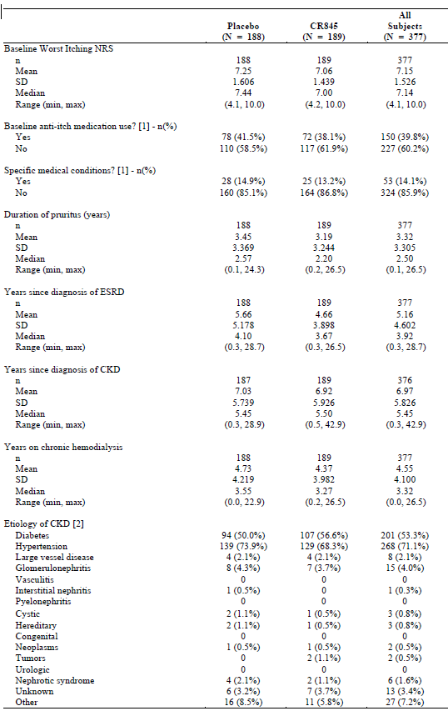
Abbreviations: CKD = chronic kidney disease, ESRD = end stage renal disease, max = maximum, min = minimum, NRS = numerical rating scale, SD = standard deviation.
[1] Observed stratum values.
[2] More than one item may have been checked.
The clinical evaluation concluded overall, the baseline demographic and disease characteristics were comparable between treatment groups and were consistent with the target patient population.

Major protocol violations/deviations
Overall, 29.4% of subjects reported at least one major protocol deviation (29.6% and 29.3% in the difelikefalin and placebo groups, respectively).
The most frequently identified categories of major deviations were:
- informed consent (5.3%)
- investigational product accountability management (4.5%)
- delegation of authority (4.5%)
- twenty five percent (25%) or more WI-NRS scores missing (4.5%).

Results for other efficacy outcomes

Primary efficacy outcomes
At Week 12, the least squares (LS) mean percentage of subjects with a 3 point or greater improvement from Baseline in the WI-NRS score was 51% in the difelikefalin group, compared with 27.6% in the placebo group. The odds ratio for a 3 point or greater improvement from Baseline with difelikefalin versus placebo was 2.72 (95% confidence interval (CI): 1.72 to 4.30), which was statistically significant (P < 0.001) (see Table 7).
Table 7: Study CR845-CLIN3102 Primary analysis, subjects with a 3 point or greater improvement from Baseline at Week 12 with respect to the worst itching intensity numerical rating scale score, multiple imputation with missing at random assumption (intention to treat population)
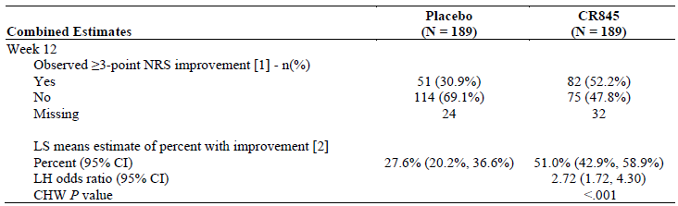
Abbreviations: CHW = Cui, Hung, Wang, CI = confidence interval, ITT = intention to treat, LH = Lawrence, Hung, LS = least squares, NRS = numerical rating scale.
[1] Counts and percentages were based on non-missing data.
[2] Estimated percent, odds ratio, and P value used a logistic regression model with terms for treatment group, baseline worst itching intensity numerical rating scale score, use of anti-itch medication during the week prior to randomisation, and the presence of specific medical conditions. Missing values were imputed using multiple imputation under missing at random missing data assumption for interim subjects and post-interim subjects separately.
Note: Combined analysis used the separate interim and post-interim results to generate an adjusted overall estimate and P value using the LH/CHW methodology.
Supportive and sensitivity analyses findings were consistent with those of the primary efficacy
analysis for the percentage of subjects with a 3 point or greater improvement in WI-NRS score at Week 12 for the ITT and per-protocol populations (see Table 8).
Table 8: Study CR845-CLIN3102 Key results of supportive and sensitivity analyses of the primary efficacy endpoint, percentage of subjects with a 3 point or greater improvement in worst itching intensity numerical rating scale at Week 12 (intention to treat and per-protocol populations)
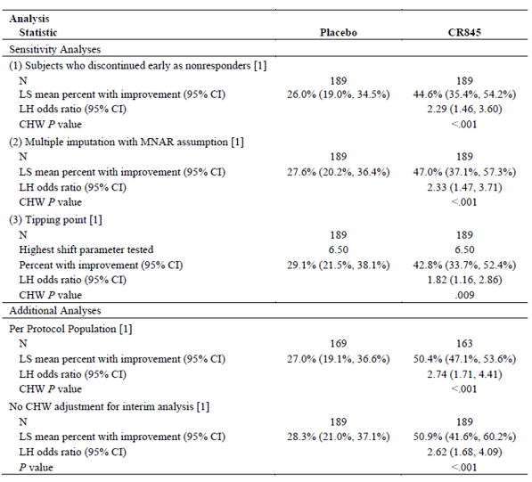
Abbreviations: CHW = Cui, Hung, Wang, CI = confidence interval, ITT = intention to treat, LH = Lawrence, Hung, LS = least squares, MNAR = missing not at random.
[1] Analysis based on interim and post-interim subjects combined.
Analyses of the LS mean percentage of ITT subjects with a 3 point or greater improvement from Baseline in WI-NRS score by study week, showed that a statistically significant treatment group difference favouring difelikefalin was observed as early as Week 3 (P < 0.001) and was maintained throughout the remainder of the double blind treatment period. At Week 8, the LS mean percentage of subjects in the difelikefalin group with a 3 point or greater improvement from Baseline in WI-NRS score was 42.7% versus 25.1% for the placebo group (P < 0.001), and at Week 4, the respective percentages were 33.5% versus 16.7% (P < 0.001) (see Figure 4).
Figure 4: Study CR845-CLIN3102 Percentage of subjects with a 3 point or greater improvement in worst itching intensity numerical rating scale score by week (intention to treat population)
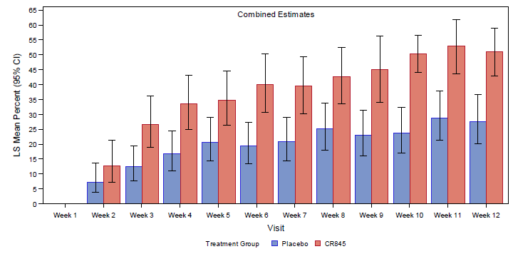
Abbreviations: CI = confidence interval, ITT = intention to treat, LS = least squares.
Note: Estimated percentages and CIs used a logistic regression model with terms for treatment group, baseline worst itching intensity numerical rating scale score, use of anti-itch medication during the week prior to randomisation, and the presence of specific medical conditions. Missing values were imputed using multiple imputation under a missing at random missing data assumption for interim subjects and post-interim subjects separately.
Note: Combined analysis used the separate interim and post-interim results to generate an adjusted overall estimate and P value using the Lawrence, Hung/Cui, Hung, Wang methodology.

Secondary efficacy outcomes
At Week 12, the LS mean percentage of subjects with a 4 point or greater improvement in WI-NRS score from Baseline was statistically significantly higher in the difelikefalin group compared to the placebo group (38.9% versus 18%; odds ratio of 2.89 (95% CI: 1.75 to 4.76, P < 0.001) (see Table 9).
Table 9: Study CR845-CLIN3102 Subjects with a 4 point or greater improvement from Baseline at Week 12 in worst itching intensity numerical rating scale score, multiple imputation with missing at random assumption (intention to treat population)
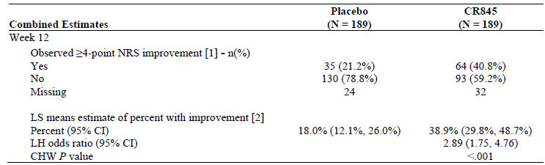
Abbreviations: CHW = Cui, Hung, Wang, CI = confidence interval, ITT = intention to treat, LH = Lawrence, Hung, LS = least squares, NRS = numerical rating scale.
[1] Counts and percentages were based on non-missing data.
[2] Estimated percent, odds ratio, and P value use a logistic regression model with terms for treatment group, baseline worst itching intensity numerical rating scale score, use of anti-itch medication during the week prior to randomisation, and the presence of specific medical conditions. Missing values were imputed using multiple imputation under missing at random missing data assumption for interim subjects and post-interim subjects separately.
Note: Combined analysis used the separate interim and post-interim results to generate an adjusted overall estimate and P value using the LH/CHW methodology.
Analyses of the LS mean percentage of ITT subjects with a 4 point or greater improvement from Baseline in the WI-NRS score by study week, showed that a statistically significant treatment group difference favouring difelikefalin was observed by Week 4 (P = 0.003) and maintained throughout the remainder of the double blind treatment period. At Week 8, the LS mean percentage of subjects in the difelikefalin group with a 4 point or greater improvement from Baseline in WI-NRS score was 26.9% versus 14.9% for the placebo group (P = 0.005), and at Week 4, the respective percentages were 16.4% versus 6.6% (P = 0.003) (see Figure 5).
Figure 5: Study CR845-CLIN3102 Percentage of subjects with a 4 point or greater improvement in worst itching intensity numerical rating scale score by week (multiple imputation with missing at random assumption in the intention to treat population)
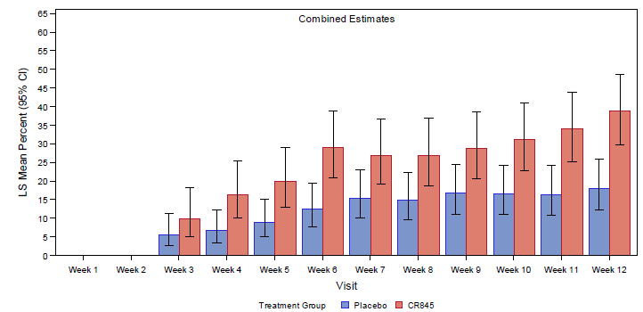
Abbreviations: CI = confidence interval, ITT= intention to treat, LS = least squares.
Note: Estimated percentages and CIs used a logistic regression model with terms for treatment group, baseline worst itching intensity numerical rating scale score, use of anti-itch medication during the week prior to randomisation, and the presence of specific medical conditions. Missing values were imputed using multiple imputation under a missing at random missing data assumption for interim subjects and post-interim subjects separately.
Note. Combined analysis used the separate interim and post-interim results to generate an adjusted overall estimate and P value using the Lawrence, Hung/Cui, Hung, Wang methodology.
Analyses of the change from Baseline in total 5-D itch scale score at the end of Week 12 using ANCOVA, showed that there was a statistically significant reduction in total 5-D itch scale score at the end of Week 12 with difelikefalin compared to placebo (-5 versus -3.7; LS mean treatment group difference of -1.3 (95% CI: -2 to -0.5), P < 0.001) (see Table 10).
Table 10: Study CR845-CLIN3102 Analysis of covariance of change from Baseline in total 5-D itch score at Week 12, multiple imputation (intention to treat population)
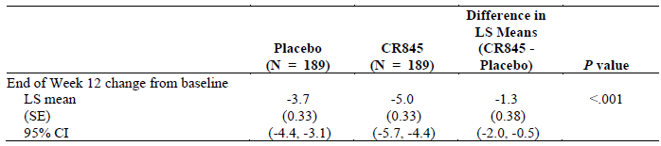
Abbreviations: ANCOVA = analysis of covariance, CI = confidence interval, ITT = intention to treat, LS = least squares, SE = standard error.
Note: LS means, SEs, and 95% CIs were based on ANCOVA with fixed effects for treatment, with baseline score and the randomisation stratification variables as covariates. Missing values were imputed using multiple imputation under missing-at-random missing data assumption.
Analyses of the change from Baseline in total Skindex-10 scale score at the end of Week 12 using ANCOVA, showed that there was a statistically significant reduction in total Skindex-10 scale score at the end of Week 12 with difelikefalin compared to placebo (-17.2 versus -12; LS mean treatment group difference of -5.1 (95% CI: -8 to -2.3), P < 0.001) (see Table 11).
Table 11: Study CR845-CLIN3102 Analysis of covariance of change from Baseline in total Skindex-10 scale at Week 12, multiple imputation (intention to treat population)
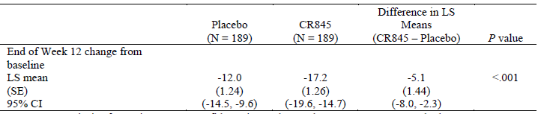
Abbreviations: ANCOVA = analysis of covariance, CI = confidence interval, LS = least squares, SE = standard error, ITT = intention to treat.
Note: LS means, SEs, and 95% CIs were based on ANCOVA with fixed effects for treatment, with baseline score and the randomisation stratification variables as covariates. Missing values were imputed using multiple imputation under missing at random missing data assumption.

Study CR845-CLIN3103
Study CR845-CLIN3103 is a Phase III, multicentre, double blind, randomised, placebo controlled study to evaluate the safety and efficacy of intravenous difelikefalin in haemodialysis patients, with moderate to severe pruritus. The study also has an open label extension phase.

Study design
The study design consists of three periods (see Figure 6):
- screening visit
- seven day run-in period
- twelve week double blind treatment period.
Subjects who had received at least 30 doses of study drug (either difelikefalin or placebo) during the 12 week double blind treatment period, had the option to receive open label difelikefalin for up to an additional 52 weeks in the open label extension phase.
Figure 6: Study CR845-CLIN3103 Study design
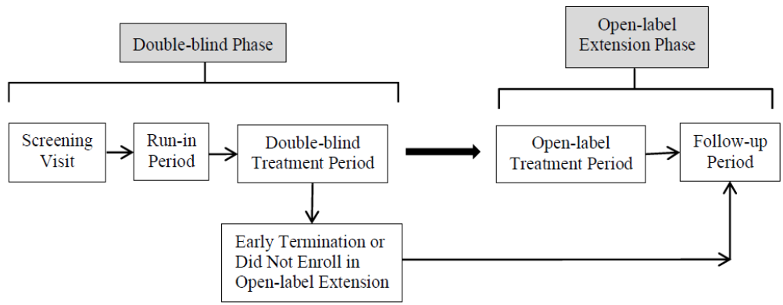

Study objectives
Assessment of difelikefalin at a dose of 0.5 µg/kg compared with placebo, in subjects undergoing haemodialysis and experiencing moderate to severe pruritus.
The primary objective was to evaluate efficacy in reducing the intensity of itch.
The secondary objectives were to evaluate the efficacy in improving itch related quality of life measures and safety of difelikefalin.

Inclusion criteria
The inclusion criteria were as per Study CR845-CLIN3102 (see Inclusion criteria) except for the statement ‘prior to randomisation, subjects had to have completed at least four WI-NRS worksheets during the run-in period and have a mean baseline WI-NRS score 5 or greater’. In Study CR845-CLIN3102, the mean baseline WI-NRS score 4 or greater.
The clinical evaluation concluded the inclusion and exclusion criteria were appropriate. Overall, the study aimed to recruit adult ESRD patients on haemodialysis with mean baseline WI-NRS score 5 or greater.
The Delegate noted the above change in the inclusion criteria would suggest that patients in Study CR845-CLIN3102 experienced more itch at Baseline than those in Study CR845-CLIN3103.

Study treatments
As per Study CR845-CLIN3102 above (see Study treatments).

Randomisation and blinding methods
As per Study CR845-CLIN3102 above (see Randomisation and blinding methods).

Efficacy parameters/endpoints

Primary efficacy parameters/endpoints
The proportion of subjects achieving a 3 point or greater improvement from Baseline with respect to the weekly mean of the daily 24 hour WI-NRS score at Week 12 of the double blind treatment period.

Key secondary efficacy parameters/endpoints
The proportion of subjects achieving a:
- Greater than or equal to 4 point improvement from Baseline with respect to the weekly mean of the daily 24 hour WI-NRS score at Week 12 of the double blind treatment period.
- Greater than or equal to 3 point improvement from Baseline with respect to the weekly mean of the daily 24 hour WI-NRS score at Week 8 of the double blind treatment period.
- Greater than or equal to 3 point improvement from Baseline with respect to the weekly mean of the daily 24 hour WI-NRS score at Week 4 of the double blind treatment period.
- Greater than or equal to 4 point improvement from Baseline with respect to the weekly mean of the daily 24 hour WI-NRS score at Week 8 of the double blind treatment period.
- Greater than or equal to 4 point improvement from Baseline with respect to the weekly mean of the daily 24 hour WI-NRS score at Week 4 of the double blind treatment period.

Other secondary efficacy parameters/endpoints
- change from Baseline in itch related quality of life at the end of Week 12 of the double blind treatment period, as assessed by the:
  - total Skindex-10 scale score
  - 5-D itch scale score
Efficacy endpoints were assessed according to the schedule below:
Table 12: Study CR845-CLIN3103 Schedule of assessments double blind phase
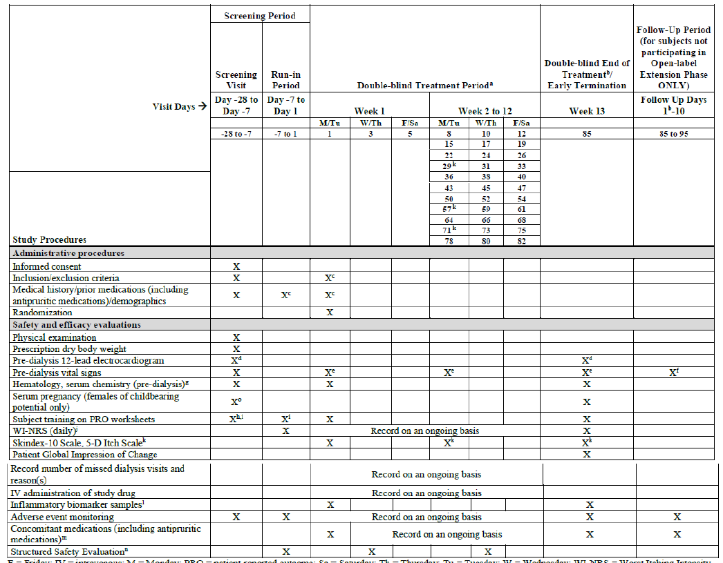
Abbreviations: F = Friday, IV = intravenous, M = Monday, PRO = patient reported outcome, Sa = Saturday, Th = Thursday, Tu = Tuesday, W = Wednesday, WI-NRS = worst itching intensity numerical rating scale
a. Each visit during the double blind treatment period coincided with the subject’s normal dialysis treatments.
b. The end of treatment visit in the double blind phase was the first dialysis visit following the last dose of study drug (that is, first dialysis on Week 13 (Day 85)), which also corresponded to Day 1 of the follow up period (follow up Day 1). Only subjects not participating in the open label extension phase were required to complete the follow up period.
c. Medical history was updated on Day 1 with any changes since the screening visit, and inclusion/exclusion criteria were confirmed prior to randomisation. Antipruritic medication was updated at each dialysis visit during the run-in period.
d. Electrocardiogram had to be performed prior to the start of dialysis at screening and Day 85 (end of treatment), or early termination visit.
e. Pre-dialysis vital signs, including body temperature, heart rate, and blood pressure, were recorded on Days 1, 15, 29, 43, 57, 71, and 85 (end of treatment), or at early termination visit, only when the subject was in a sitting or semirecumbent position. Heart rate was measured at each dialysis; if heart rate was clinically significant and outside the prespecified visits per schedule of assessments, the heart rate was recorded on the relevant case report form page.
f. Pre-dialysis vital signs, including body temperature, heart rate, and blood pressure, were recorded at the follow up visit (7-10 days after end of treatment/early termination visit).
g. Blood samples for clinical laboratory evaluation were taken at screening, Day 1, and Day 85 (end of treatment), or early termination visit.
h. Training on WI-NRS was conducted prior to the first day of the run-in period (Day -7).
i. Training on Skindex-10 scale and 5-D itch scale could be performed at any time during screening prior to randomisation on Day 1 of the double blind treatment period.
j. Subjects were requested to complete their WI-NRS worksheets each day at a similar time (either at home on non-dialysis days around the normal start time of their dialysis or in the dialysis unit). On dialysis days, the worksheets were to be completed prior to or during dialysis but had to be completed prior to dosing.
k. 5-D itch scale and Skindex-10 scale were completed on Day 1 and the first visit of Weeks 5, 9, and 11 (on Days 29, 57, and 71) and Week 13 (Day 85). 5-D itch scale was preferably completed first. If the first visit of the week was missed, the subject could complete the worksheets at their next visit for the same week. The worksheets were to be completed prior to or during dialysis (preferably within 1 hour of the dialysis) but had to be completed prior to dosing.
l. Biomarker samples had to be collected prior to the start of dialysis on Day 1 and Day 85.
m. Concomitant medications, including antipruritic medications, were updated at each dialysis visit during the double blind treatment period and until the end of the follow up period.
n. A list of specific signs/symptoms were verified with the subject by qualified site staff, preferably on Wednesday/Thursday each week during the run-in period, the double blind treatment period, and the follow up period. It was not to be completed on Monday/Tuesday.
o. The serum pregnancy test had to be performed within 7 days prior to the first study dose.
The clinical evaluation concluded overall, the primary and secondary endpoints of Study CR845-CLIN3103 are appropriate.
The primary and secondary efficacy endpoints allowed assessment of the effect of difelikefalin on the intensity of itch (the proportion of subjects achieving a 3 point or 4 point or greater improvement from Baseline in WI-NRS at Week 12) and on itch-related quality of life (change from Baseline in the 5-D itch scale and total Skindex-10 scale score at Week 12).
The sponsor has justified the use of WI-NRS as the primary efficacy endpoint. The WI-NRS has been widely used for evaluation of chronic itch, including CKD-aP.
In addition, qualitative and quantitative validation of the 24 hour WI-NRS item consistent with standards outlined by FDA guidance was undertaken, supporting robust performance of the measure for the target population (that is, haemodialysis patients with moderate to severe CKD-aP).
Results from the Phase II Study CR845-CLIN2101 showed that a 3 point difference in the WI-NRS from Baseline was a clinically meaningful improvement.

Participant flow
A total of 473 subjects were randomised as per Figure 7 below (n = 237 for difelikefalin and n = 236 for placebo).
Figure 7: Study CR845-CLIN3103 Disposition flow
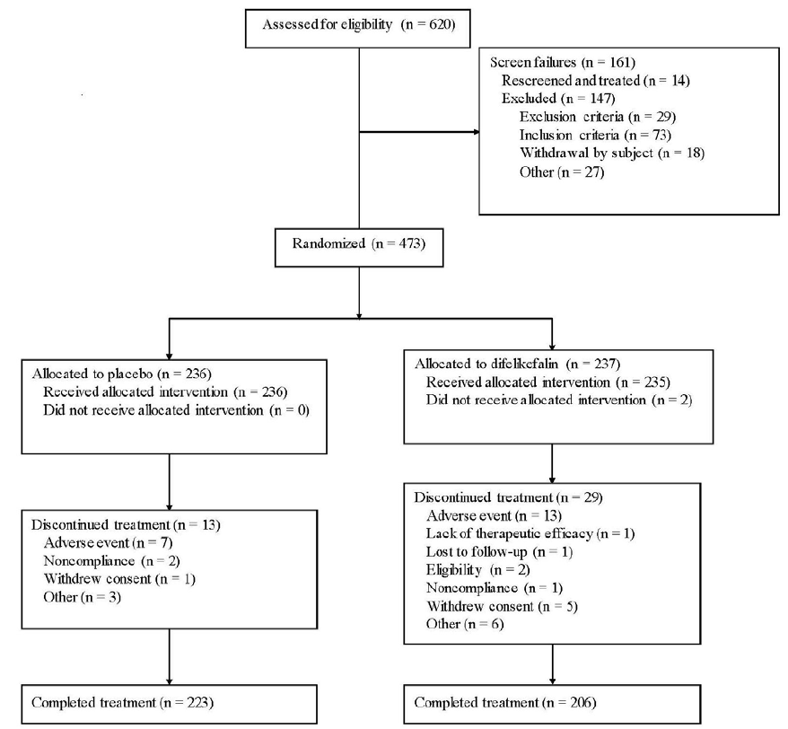
Of these, 471 subjects received at least one treatment with difelikefalin or placebo (two subjects were randomised to difelikefalin group but did not receive any study drug).
A total of 429 subjects completed the double blind treatment period (206 in the difelikefalin group, and 170 in the placebo group).
The most common reasons for early discontinuation from the double blind treatment period were adverse events (2.9% and 5.5% respectively in placebo and difelikefalin groups) and subject withdrawal of consent (0.42% and 2.1% respectively in placebo and difelikefalin groups).

Analysis of populations
As per Study CR845-CLIN3102 above (see Analysis of populations).

Sample size
As per Study CR845-CLIN3102 above (see Sample size).
An unblinded interim analysis for sample size re-estimation was conducted when approximately 50% of the first 350 subjects had been randomised and had either completed the 12 week treatment period or had discontinued from treatment early. The planned interim assessment was conducted by the Independent Data Monitoring Committee (IDMC). Based on the recommendation of the IDMC, there were no changes to the original enrolment target of 350 to 450 subjects.

Statistical methods
Essentially as per Study CR845-CLIN3102 above (see Statistical methods).
The key secondary efficacy endpoints were analysed in a hierarchical testing order as specified below.
- The proportion of subjects achieving a 4 point or greater improvement from Baseline with respect to the weekly mean of the daily 24 hour WI-NRS at Week 12 of the double blind treatment period was tested first.
- The proportion of subjects achieving a 3 point or greater improvement from Baseline with respect to the WI-NRS at Week 8 was tested next, followed by Week 4.
- Testing continued with the proportion of subjects achieving a 4 point or greater improvement at Week 8, followed by Week 4, in an identical manner.
- Change from Baseline in Skindex-10 scale total score at Week 12 of the double blind treatment period using the ANCOVA approach.
- Change from Baseline in 5-D itch scale total scores at Week 12 of the double blind treatment period using the ANCOVA approach.
If the test of an endpoint in the sequence was not statistically significant, the P value for the tests corresponding to the remaining endpoints in the sequence were not considered inferential and the null hypotheses for the subsequent tests were not rejected.

Baseline data
Baseline demographic characteristics were generally comparable between difelikefalin and placebo groups. The majority of patients were male (58.2%: placebo = 58.9%, difelikefalin = 57.4%), and the median age was 60 years (placebo = 60 years, difelikefalin = 61 years). The predominant races were White (70.3%: placebo = 71.6%, difelikefalin = 68.9%) and Black/African American (19.3%: placebo = 16.1%, difelikefalin = 22.6%) (see Table 13).
Table 13: Study CR845-CLIN3103 Subject demographics
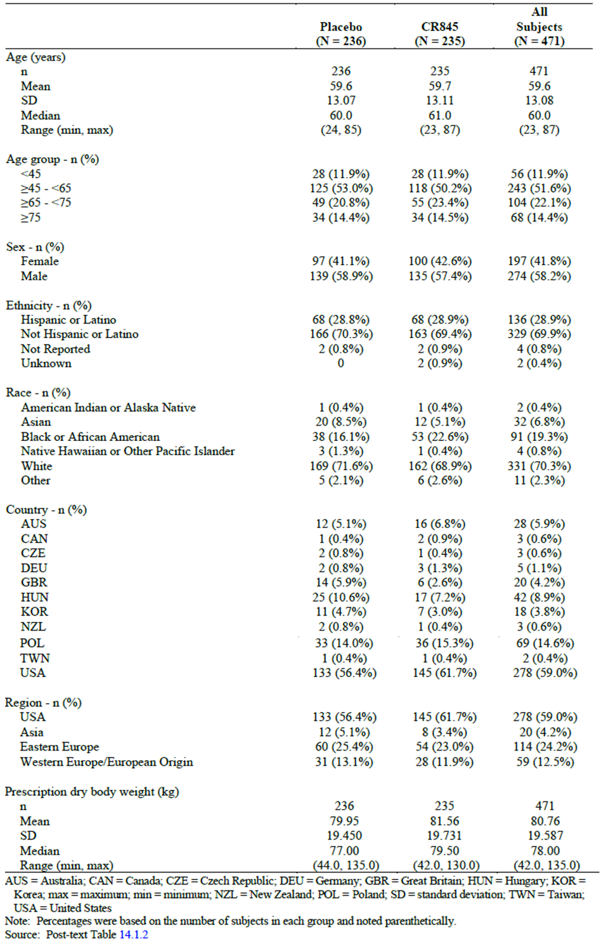
Abbreviations: AUS = Australia, CAN = Canada, CZE = Czech Republic, DEU = Germany, GBR = Great Britain, HUN = Hungary, KOR = Korea, max = maximum, min = minimum, NZL = New Zealand, POL = Poland, SD = standard deviation, TWN = Taiwan, USA = United States
Note: Percentages were based on the number of subjects in each group and noted parenthetically.

Baseline disease characteristics
The above were also generally comparable between treatment groups. The median duration of chronic kidney disease associated pruritus (CKD-aP) for all subjects was 2.28 years (placebo = 2.50, difelikefalin = 2.03) and the median WI-NRS score at Baseline was 7.13 (placebo = 7, difelikefalin = 7.20) (see Table 14).
Table 14: Study CR845-CLIN3103 Subject baseline characteristics
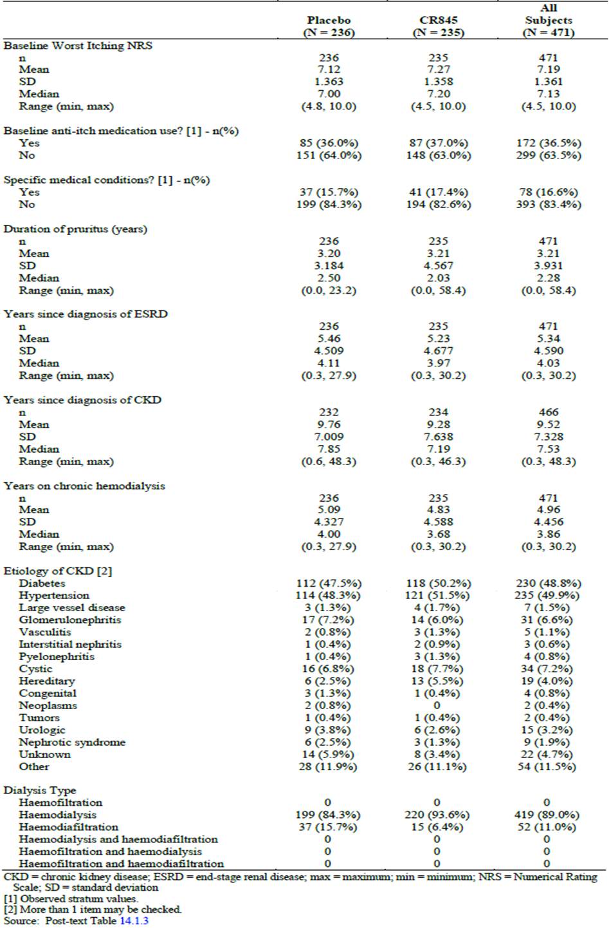
Abbreviations: CKD = chronic kidney disease, ESRD = end stage renal disease, max = maximum, min = minimum, NRS = numerical rating scale, SD = standard deviation
[1] Observed stratum values.
[2] More than one item may be checked.
The clinical evaluation concluded overall, the baseline demographic and disease characteristics were comparable between treatment groups and were consistent with the target patient population.

Major protocol violations/deviations
Overall, 34.2% of subjects reported at least one major protocol deviation (37.9% and 30.5% in the difelikefalin and placebo groups, respectively).
The most frequently identified categories of major deviations were:
- dosing non-compliance (17.4%)
- procedure not performed (15.3%)
- procedure performed out of window (6.2%).
Subjects who had deviations categorised as ‘other’ represented 14% of the double blind safety population (examples included):
- error in stratification of subject by medical history
- incorrect recording of use of anti-itch medication at the time of randomisation
- adverse event/serious adverse event not reported within 24 hours
- incomplete laboratory sample processing
- inadequate informed consent administration
- incorrect handling of investigational product
- insufficient subject training on questionnaires and other documentation.

Results for efficacy outcome

Primary efficacy outcomes
At Week 12, the least squares (LS) mean percentage of subjects with a 3 point or greater improvement from Baseline in the WI-NRS score was 54% in the difelikefalin group, compared with 42.2% in the placebo group. The estimated odds ratio for a 3 point or greater improvement from Baseline with difelikefalin versus placebo was 1.61 (95% confidence interval (CI): 1.08 to 2.41), which was statistically significant (P < 0.020) (see Table 15).
Table 15: Study CR845-CLIN3103 Primary analysis, subjects with 3 point or greater improvement from Baseline at Week 12 with respect to the worst itching intensity numerical rating scale score, multiple imputations with missing at random assumption (intention to treat population)
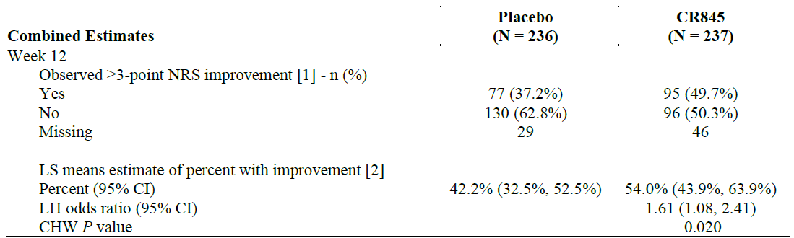
Abbreviations: CHW = Cui, Hung, Wang, CI = confidence interval, ITT = intention to treat, LH = Lawrence, Hung, LS = least squares, NRS = numerical rating scale
[1] Counts and percentages were based on non-missing data.
[2] Estimated percentage, odds ratio and P value used a logistic regression model with terms for treatment group, baseline NRS score, region, use of anti-itch medication during the week prior to randomisation, and the presence of specific medical conditions. Missing values were imputed using MI under MAR missing data assumption for interim subjects and post-interim subjects separately.
Note: Combined analysis used the separate interim and post-interim results to generate an adjusted overall estimate and P value using the LH/CHW methodology.
Regarding other analysis of the primary efficacy endpoint, supportive and sensitivity analyses findings were consistent with those of the primary efficacy analysis for the percentage of subjects with a 3 point or greater improvement in WI-NRS score at Week 12 for intention to treat and per-protocol populations.
Table 16: Study CR845-CLIN3103 Key results of sensitivity and supportive analyses of the primary efficacy endpoint, percentage of subjects with a 3 point or greater improvement in worst itching intensity numerical rating scale at Week 12 (intention to treat and per-protocol population)
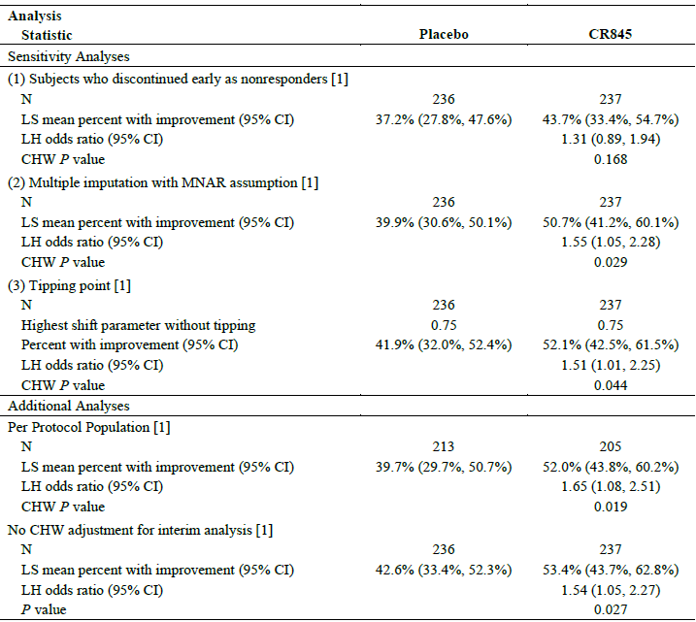
Abbreviations: CHW = Cui, Hung, Wang, CI = confidence interval, ITT = intention to treat, LH = Lawrence, Hung, LS = least squares, MNAR = missing not at random
[1] Analysis based on interim and post-interim subjects combined.

Key secondary efficacy outcomes
Percentage of subjects with a 3 point or greater improvement from Baseline in WI-NRS score:
- At Week 8, the LS mean percentage of subjects in the difelikefalin group with a 3 point or greater improvement from Baseline in WI-NRS score was statistically significantly higher in the difelikefalin group compared to the placebo group (49% versus 36.2%; odds ratio of 1.69 (95% CI: 1.13 to 2.53), P = 0.010). At Week 4, the LS mean percentage of subjects in the difelikefalin group with a 3 point or greater improvement from Baseline in WI-NRS was also statistically significantly higher in the difelikefalin group compared to the placebo group (38.3% versus 23.8%; odds ratio of 1.99 (95% CI: 1.29 to 3.06), P = 0.002) (see Table 17).
- Analyses of the LS mean percentage of ITT subjects with a 3 point or greater improvement from Baseline in WI-NRS by study week, showed that a statistically significant treatment group difference favouring difelikefalin was observed as early as Week 2 (P = 0.003) and was maintained throughout the remainder of the double blind treatment period (see Figure 8).
Table 17: Study CR845-CLIN3101 Subjects with a 3 point or greater improvement from Baseline at Weeks 8 and 4 in worst itching intensity numerical rating scale score, multiple imputation with missing at random assumption (intention to treat population)
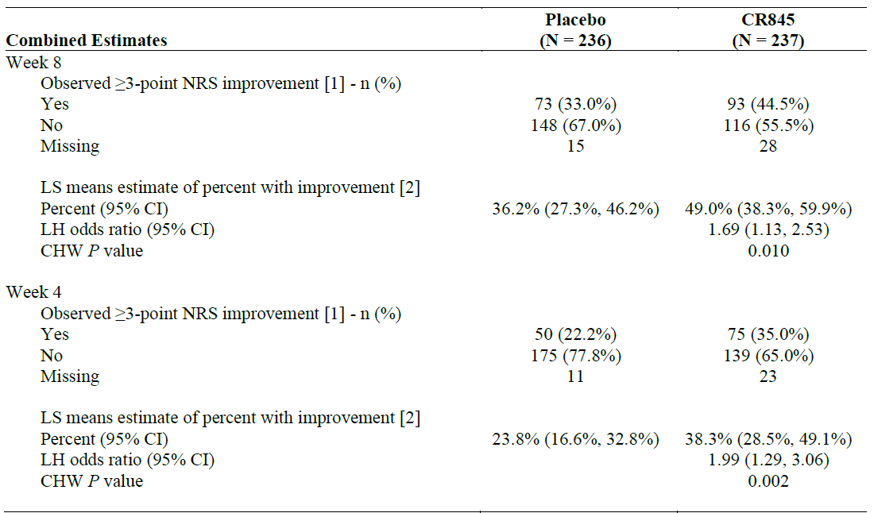
Abbreviations: CHW = Cui, Hung, Wang, CI = confidence interval, ITT = intention to treat, LH = Lawrence, Hung, LS = least squares, NRS = numerical rating scale
[1] Counts and percentages were based on non-missing data.
[2] Estimated percentage, odds ratio, and P value used a logistic regression model with terms for treatment group, baseline NRS score, region, use of anti-itch medication during the week prior to randomisation, and the presence of specific medical conditions. Missing values were imputed using MI under MAR missing data assumption for interim subjects and post-interim subjects separately.
Note: Combined analysis used the separate interim and post-interim results to generate an adjusted overall estimate and P value using the LH/CHW methodology.
Figure 8: Study CR845-CLIN3103 Percentage of subjects with a 3 point or greater improvement in worst itching intensity numerical rating scale score by week (primary efficacy imputation, intention to treat population)
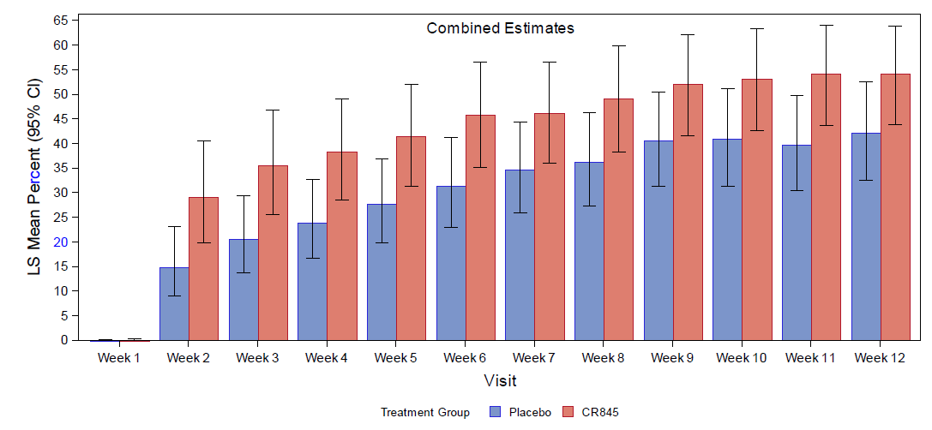
Abbreviations: CI = confidence interval, ITT = intention to treat, LS = least squares
Note: Estimated percentages and CIs used a logistic regression model with terms for treatment group, baseline worst itching intensity numerical rating scale score, region, use of anti-itch medication during the week prior to randomisation, and the presence of specific medical conditions. Missing values were imputed using multiple imputation under a missing at random missing data assumption for interim subjects and post-interim subjects separately.
Note: Combined analysis used the separate interim and post-interim results to generate an adjusted overall estimate and P value using the Lawrence, Hung/Cui, Hung, Wang methodology.
Percentage of subjects with a 4 point or greater improvement from Baseline in WI-NRS score:
- At Week 12, the LS mean percentage of subjects with a 4 point or greater improvement in WI-NRS from Baseline was statistically significantly higher in the difelikefalin group compared to the placebo group (41.2% versus 28.4%; odds ratio of 1.77 (95% CI: 1.14 to 2.74), P = 0.010) (see Table 18).
Table 18: Study CR845-CLIN3103 Subjects with a 4 point or greater improvement from Baseline at Week 12 in worst itching intensity numerical rating scale score, multiple imputation with missing at random assumption (intention to treat population)
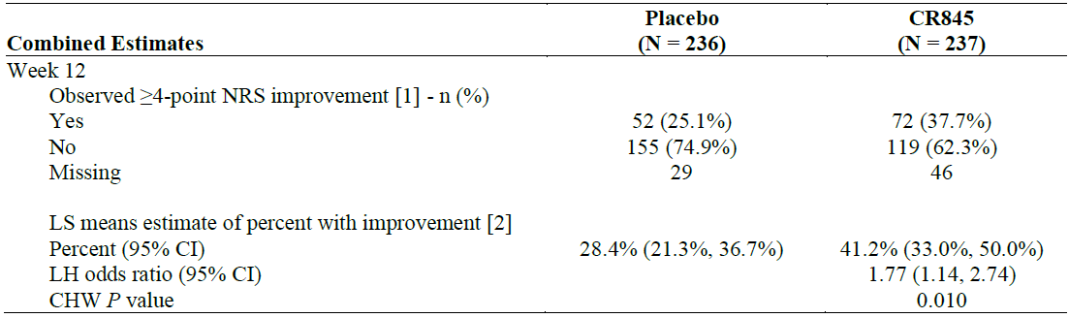
Abbreviations: CHW = Cui, Hung, Wang, CI = confidence interval, ITT = intention to treat, LH = Lawrence, Hung, LS = least squares, NRS = numerical rating scale
[1] Counts and percentages were based on non-missing data.
[2] Estimated percent, odds ratio, and P value use a logistic regression model with terms for treatment group, baseline worst itching intensity numerical rating scale score, region, use of anti-itch medication during the week prior to randomisation, and the presence of specific medical conditions. Missing values were imputed using multiple imputation under missing at random missing data assumption for interim subjects and post-interim subjects separately.
Note: Combined analysis used the separate interim and post-interim results to generate an adjusted overall estimate and P value using the LH/CHW methodology.
- At Week 8, the LS mean percentage of subjects in the difelikefalin group with a 4 point or greater improvement from Baseline in WI-NRS was statistically significantly higher in the difelikefalin group compared to the placebo group (36.1% versus 23.7%; odds ratio of 1.82 (95% CI: 1.16 to 2.86), P = 0.010). At Week 4, the LS mean percentage of subjects in the difelikefalin group with a 4 point or greater improvement from Baseline in WI-NRS was also statistically significantly higher in the difelikefalin group compared to the placebo group (26.1% versus 16.7%; odds ratio of 1.76 (95% CI: 1.04 to 2.98), P = 0.036) (see Table 19).
Table 19: Study CR845-CLIN3103 Subjects with a 4 point or greater improvement from Baseline at Weeks 8 and 4 in worst itching intensity numerical rating scale score, multiple imputation with missing at random assumption (intention to treat population)
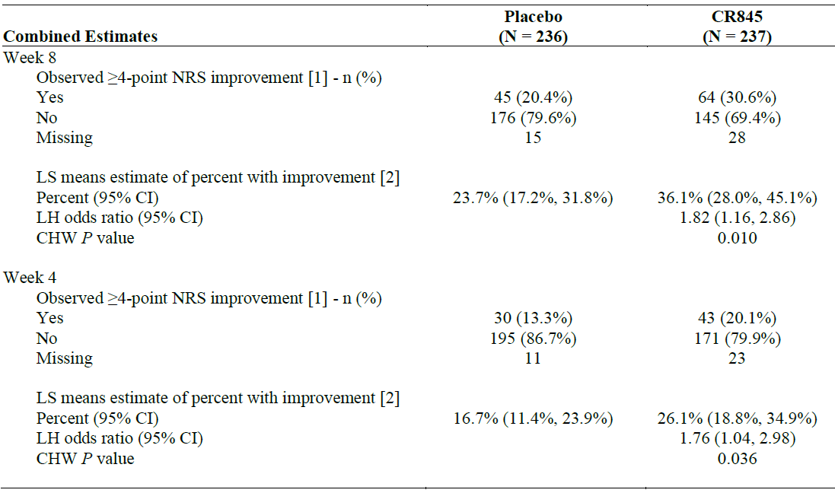
Abbreviations: CHW = Cui, Hung, Wang, CI = confidence interval, ITT = intention to treat, LH = Lawrence, Hung, LS = least squares, NRS = numerical rating scale
[1] Counts and percentages were based on non-missing data.
[2] Estimated percent, odds ratio, and P value use a logistic regression model with terms for treatment group, baseline worst itching intensity numerical rating scale score, region, use of anti-itch medication during the week prior to randomisation, and the presence of specific medical conditions. Missing values were imputed using multiple imputation under missing at random missing data assumption for interim subjects and post-interim subjects separately.
Note: Combined analysis used the separate interim and post-interim results to generate an adjusted overall estimate and P value using the LH/CHW methodology.
- Analyses of the LS mean percentage of ITT subjects with a 4 point or greater improvement from Baseline in the WI-NRS by study week showed that a statistically significant treatment group difference favouring difelikefalin was observed by Week 3 (P = 0.018) and maintained throughout the remainder of the double blind treatment period (see Figure 9).
Figure 9: Study CR845-CLIN3103 Percentage of subjects with a 4 point or greater improvement in worst itching intensity numerical rating scale score by Week, multiple imputation with missing at random assumption (intention to treat population)
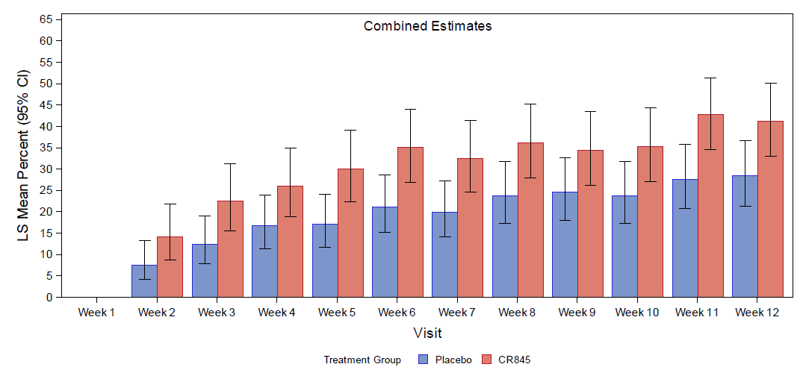
Abbreviations: CI = confidence interval, ITT = intention to treat, LS = least squares
Note: Estimated percentages and CIs used a logistic regression model with terms for treatment group, baseline worst itching intensity numerical rating scale score, region, use of anti-itch medication during the week prior to randomisation, and the presence of specific medical conditions. Missing values were imputed using multiple imputation under a missing at random missing data assumption for interim subjects and post-interim subjects separately.
Note. Combined analysis used the separate interim and post-interim results to generate an adjusted overall estimate and P value using the Lawrence, Hung/Cui, Hung, Wang methodology.

Other secondary efficacy outcomes
Change from Baseline in total Skindex-10 scale score: Analyses of the change from Baseline in total Skindex-10 scale score at the end of Week 12 using ANCOVA showed, that there was a numerically greater reduction in LS mean total Skindex-10 scale score with difelikefalin compared to placebo (-16.6 versus -14.8), but the difference was not statistically significant (LS mean treatment group difference of -1.8 (95% CI: -4.3 to 0.8), P = 0.171) (see Table 20).
Table 20: Study CR845-CLIN3103 ANCOVA analysis of change from Baseline in total Skindex-10 scale at Week 12, multiple imputation under missing at random assumption (intention to treat population)
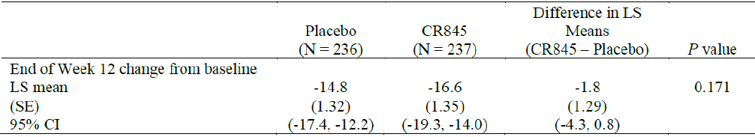
Abbreviations: ANCOVA = analysis of covariance, CI = confidence interval, LS = least squares, SE = standard error, ITT = intention to treat
Note: LS means, SEs, and 95% CIs were based on ANCOVA with fixed effects for treatment, with baseline score and the randomisation stratification variables as covariates. Missing values were imputed using multiple imputation under missing at random missing data assumption.
Change from Baseline in total 5-D itch scale score: Analyses of the change from Baseline in total 5-D itch scale score at the end of Week 12 using ANCOVA showed that there was a numerically greater reduction in total 5-D itch scale score at the end of Week 12 with difelikefalin compared to placebo (-4.9 versus -3.8; LS mean treatment group difference of -1.1 (95% CI: -1.7 to -0.4), P = 0.002). Although the nominal P value was 0.002, this difference could not be declared as statistically significant based on the hierarchical testing order, as the prior secondary endpoint (Skindex-10 at Week 12) was not statistically significant (see Table 21)
Table 21: Study CR845-CLIN3103 Analysis of covariance of change from Baseline in total 5-D itch score at Week 12, multiple imputation (intention to treat population)
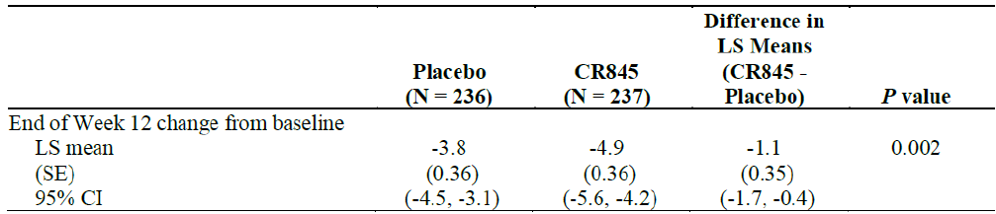
Abbreviations: ANCOVA = analysis of covariance, CI = confidence interval, ITT = intention to treat, LS = least squares, MAR = missing at random, SE = standard error
Note: LS means, SEs, and 95% CIs were based on ANCOVA with fixed effects for treatment, with baseline score, region, and the randomisation stratification variables as covariates. Missing values were imputed using multiple imputation under MAR missing data assumption.

Other studies
The sponsor has indicated that the following three randomised Phase II Studies CR845-CLIN2005, CR845-CLIN2101 and PR-13A9-P2-A were submitted to provide supportive clinical safety data and not efficacy data.
Study CR845-CLIN2005: a double blind, randomised, placebo controlled study to evaluate the safety and pharmacokinetics of intravenous difelikefalin in haemodialysis patients (Part A), and its safety and efficacy in haemodialysis patients with uraemic pruritus (Part B).
Study CR845-CLIN2101: a multicentre, randomised, double blind, placebo controlled study to evaluate the safety and efficacy of IV difelikefalin administered for 8 weeks after each of three dialysis sessions per week in haemodialysis subjects with moderate to severe pruritus.
Study PR-13A9-P2: a placebo controlled, randomised, double blind, parallel group comparative trial investigating the efficacy and safety of difelikefalin (0.25 µg/kg, 0.5 µg/kg, 1.0 µg/kg, or 1.5 µg/kg) on haemodialysis patients with pruritus.
The efficacy results of the above three Phase II studies were evaluated as part of the clinical evaluation and did not raise any concerns.

Analyses performed across trials: pooled and meta-analyses
Subgroup analyses conducted using the pooled data from Studies CR845-CLIN3102 and CR845-CLIN3103 with respect to 3 or greater and 4 or greater point changes from Baseline in the WI-NRS at Week 12 showed results generally consistent with those in the overall population.
Figure 10: Studies CR845-CLIN3102 and CR845-CLIN3103 Subjects with 3 point or greater improvement from Baseline to Week 12 with respect to the WI-NRS score by subgroup (intention to treat population, pooled dataset)
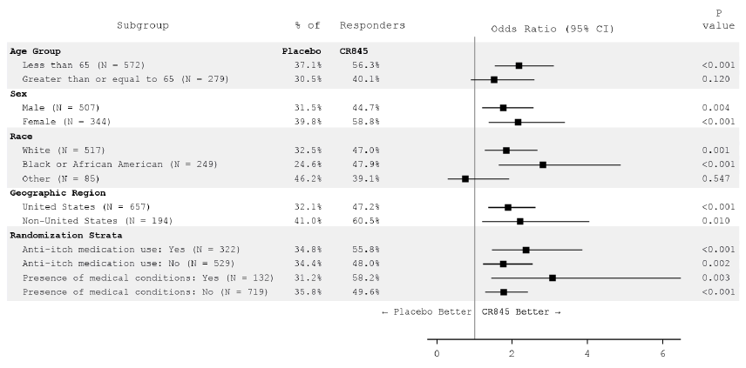
Abbreviations: CI = confidence interval, ITT = intention to treat, MAR = missing at random, MI = multiple imputation, WI-NRS = worst itching numerical rating scale
Estimated percentages, odds ratio, and confidence intervals were based on a logistic regression with terms for treatment group, baseline WI-NRS score, region/study, use of anti-itch medication during the week prior to randomisation, and the presence of specific medical conditions. For the analysis by geographic region and randomisation strata, the corresponding subgroup variables were removed from the model, and Study ID was included in the model of United States. Missing values were imputed using MI under MAR missing data assumption for interim subjects and post-interim subjects separately.
Figure 11: Studies CR845-CLIN3102 and CR845-CLIN3103 Subjects with 4 point or greater improvement from Baseline to Week 12 with respect to the WI-NRS Score by subgroup (intention to treat population, pooled dataset)
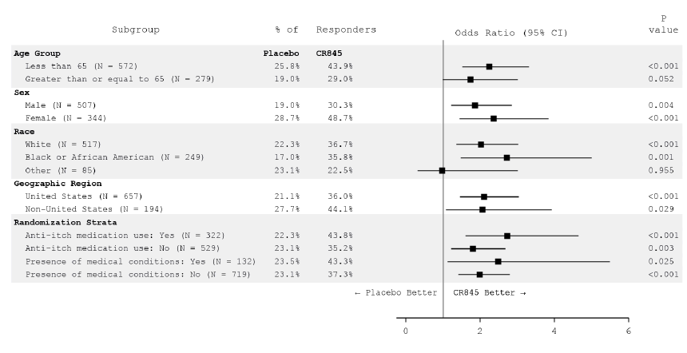
Abbreviations: CI = confidence interval, ITT = intention to treat, MAR = missing at random, MI = multiple imputation, WI-NRS = worst itching numerical rating scale
Estimated percentages, odds ratio, and confidence intervals were based on a logistic regression with terms for treatment group, baseline WI-NRS score, region/study, use of anti-itch medication during the week prior to randomisation, and the presence of specific medical conditions. For the analysis by geographic region and randomisation strata, the corresponding subgroup variables were removed from the model, and Study ID was included in the model of United States. Missing values were imputed using MI under MAR missing data assumption for interim subjects and post-interim subjects separately.
Efficacy results in the pooled population in Studies CR845-CLIN3102 and CR845-CLIN3103 were generally consistent with results in the individual studies.
Figure 12: Studies CR845-CLIN3102 and CR845-CLIN3103 Percentage of subjects with 3 point or greater improvement with respect to the WI-NRS at Week 12 (Intention to treat population, multiple imputation with missing at random assumption)
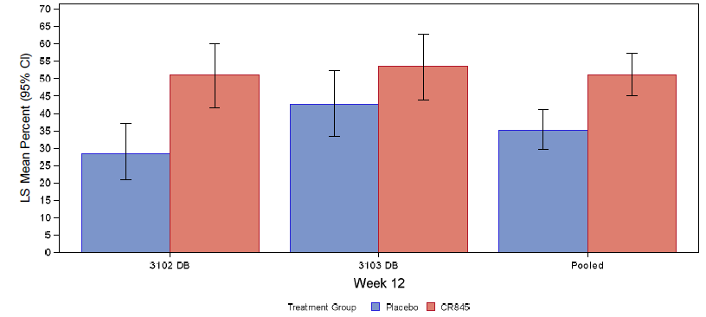
Abbreviations: CI = confidence interval, DB = double blind, ITT = intention to treat, LS = least squares, MAR = missing at random, MI = multiple imputation, WI-NRS = worst itching numerical rating scale
Estimated percent and confidence interval used logistic regression model with terms for treatment group, baseline score, use of anti-itch medication during the week prior to randomisation, and the presence of specific medical conditions. Missing values were imputed using MI under MAR missing data assumption for interim subjects and post-interim subjects separately. Region was also included in the model for the 3103 DB analysis, while a region/study combined variable was also included in the model for the pooled analysis.
Table 22: Studies CR845-CLIN3102 and CR845-CLIN3103 Analysis of covariance of change from Baseline in total 5-D itch scale (intention to treat population, multiple imputation with missing at random assumption)
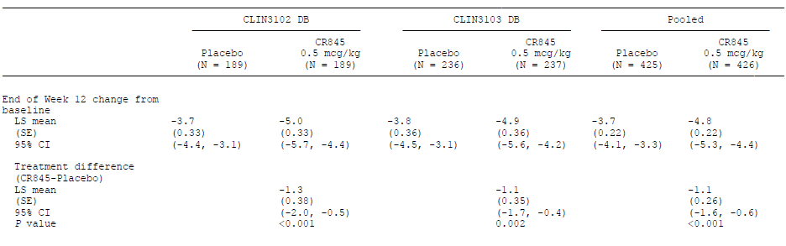
Abbreviations: ANCOVA = analysis of covariance, CI = confidence interval. DB = double blind, LS = least squares, MAR = missing at random, MI = multiple imputation, SE = standard error
Note: Least squares means, SEs, and 95% CIs were based on ANCOVA with fixed effects for treatment, baseline score, use of anti-itch medication during the week prior to randomisation, and the presence of specific medical conditions as covariates. Missing values are imputed using multiple imputation under MAR missing data assumption. Region was also included in the model for the 3103 DB analysis, while a region/study combined variable was also included in the model for the pooled analysis.
Table 23: Studies CR845-CLIN3102 and CR845-CLIN3103 Analysis of covariance of change from Baseline in total Skindex-10 scale Week 12 (intention to treat population, multiple imputation with missing at random assumption)
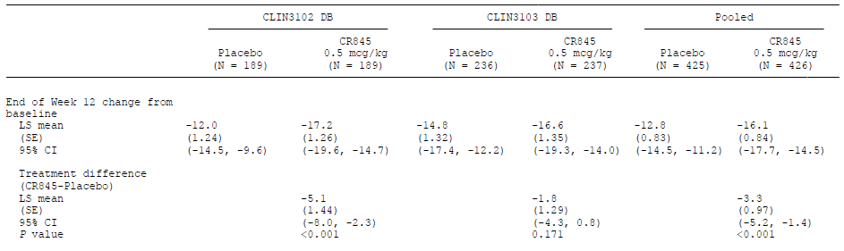
Abbreviations: ANCOVA = analysis of covariance, CI = confidence interval, DB = double blind, LS = least squares, MAR = missing at random, MI = multiple imputation, SE = standard error
Note: Least squares means, SEs, and 95% CIs were based on ANCOVA with fixed effects for treatment, baseline score, use of anti-itch medication during the week prior to randomisation, and the presence of specific medical conditions as covariates. Missing values are imputed using multiple imputation under MAR missing data assumption. Region was also included in the model for the 3103 DB analysis, while a region/study combined variable was also included in the model for the pooled analysis.

Overall conclusions on efficacy
Overall, the study design, inclusion and exclusion criteria, and study endpoints of the pivotal efficacy Studies CR845-CLIN3102 and CR845-CLIN3103 were appropriate.
The primary and secondary efficacy endpoints allowed assessment of the effect of difelikefalin on the intensity of itch (the proportion of subjects achieving a 3 point or greater or 4 point or greater improvement from Baseline in WI-NRS) and on itch-related quality of life (change from Baseline in the 5-D itch scale and total Skindex-10 scale score).
Baseline demographic and disease characteristics were comparable between treatment groups in the respective studies and were consistent with the target patient population of CKD patients on haemodialysis with moderate to severe CKD-associated pruritus.
Efficacy results were generally supportive of a positive effect of difelikefalin in the treatment of moderate to severe pruritus associated with chronic kidney disease in adult patients on haemodialysis.
Primary efficacy analyses showed that the:
- The LS mean percentage of subjects with a 3 point or greater improvement from Baseline in the WI-NRS Score at Week 12 was statistically significantly greater with difelikefalin compared to placebo (Study CR845-CLIN3102: 51% versus 27.6% (odds ratio of 2.72, P < 0.001); Study CR845-CLIN3103: 54% versus 42.2% (odds ratio of 1.62, P = 0.020)).
- The LS mean percentage of subjects with a 4 point or greater improvement from Baseline in the WI-NRS Score at Week 12 was also statistically significantly greater with difelikefalin compared to placebo (Study CR845-CLIN3102: 38.9% versus 18% (odds ratio of 2.89, P < 0.001); Study CR845-CLIN3103: 41.2% versus 28.4% (odds ratio of 1.7, P = 0.010)).
Analyses over time showed that a statistically significant treatment group difference favouring difelikefalin over placebo in the LS mean percentage of subjects with a 3 point or greater improvement from Baseline in WI-NRS score was observed as early as Week 3 (Study CR845-CLIN3102) or Week 2 (Study CR845-CLIN3103) and was maintained throughout the remainder of the double blind treatment period.
- The LS mean percentage of subjects with a 3 point or greater improvement from Baseline in the WI-NRS score was statistically significantly greater with difelikefalin compared to placebo at Week 4 (Study CR845-CLIN3102: 33.5% versus 16.7% (P < 0.001); Study CR845-CLIN3103: 38.3% versus 23.8% (P = 0.020)) as well as at Week 8 (Study CR845-CLIN3102: 42.7% versus 25.1% (P < 0.001); Study CR845-CLIN3103: 49% versus 36.2% (P = 0.010)).
Also, analyses over time showed statistically significant treatment group difference favouring difelikefalin over placebo in the LS mean percentage of subjects with a 4 point or greater improvement from Baseline in WI-NRS was observed as early as Week 4 (Study CR845-CLIN3102) or Week 3 (Study CR845-CLIN3103) and was maintained throughout the remainder of the double blind treatment period.
- The LS mean percentage of subjects with a 4 point or greater improvement from Baseline in the WI-NRS was statistically significantly greater with difelikefalin compared to placebo at Week 4 (Study CR845-CLIN3102: 16.4% versus 6.6% (P = 0.003); Study CR845-CLIN3103: 26.1% versus 16.7% (P = 0.036)) as well as at Week 8 Study CR845-CLIN3102: 26.9% versus 14.9% (P = 0.005); Study CR845-CLIN3103: 36.1% versus 23.7% (P = 0.010)).
Results on the effect of difelikefalin on itch-related quality of life showed that there was greater reduction (improvement) from Baseline in the total Skindex-10 scale score at the end of Week 12 with difelikefalin compared to placebo; the treatment difference was statistically significant in study CR845-CLIN3102 but was not statistically significant in Study CR845-CLIN3103 (Study CR845-CLIN3102: -17.2 versus -12.0 (P < 0.001); Study CR845-CLIN3103: -16.6 versus -14.8 (P = 0.171)).
There was also greater reduction (improvement) from Baseline in the total 5-D itch scale score at the end of Week 12 with difelikefalin compared to placebo; the treatment difference was statistically significant in Study CR845-CLIN3102 but was not considered inferential in Study CR845-CLIN3103 due to hierarchical testing rules (Study CR845-CLIN3102: -5.0 versus -3.7 (P < 0.001); Study CR845-CLIN3103: -4.9 versus -3.8 (nominal P = 0.002)).

Safety
Overall, the safety data showed that difelikefalin was generally well tolerated.
In the pivotal Phase III Studies CR845-CLIN3102 and CR845-CLIN3103, the incidence of treatment-emergent adverse events (TEAEs) was low (Study CR845-CLIN3102: 6.9% with difelikefalin versus 5.3% with placebo; Study CR845-CLIN3103: 9.4% with difelikefalin versus 6.8% with placebo).
The most commonly reported TEAEs with difelikefalin were:
- dizziness (1.6% difelikefalin versus 0% placebo) and somnolence (1.6% difelikefalin versus 0% placebo) in Study CR845-CLIN3102.
- somnolence (1.7% difelikefalin versus 1.7% placebo), nausea (1.3% difelikefalin versus 1.3% placebo), vomiting (1.3% difelikefalin versus 0.4% placebo), gait disturbance (1.3% difelikefalin versus 0% placebo) and dizziness (1.3% difelikefalin versus 0.8% placebo) in Study CR845-CLIN3103.
- somnolence (1.9% difelikefalin and 0.9% placebo) and dizziness (1.4% difelikefalin and 0.2% placebo, respectively) in the pooled analyses of Studies CR845-CLIN3102 and CR845-CLIN3103.
The majority of the TEAEs were mild or moderate severity.
No study drug related deaths were reported in the two pivotal studies.
The incidence of all causality serious adverse events was generally comparable between difelikefalin and placebo (Study CR845-CLIN3102: 25.9% difelikefalin versus 21.8% placebo; Study CR845-CLIN3103: 24.7% difelikefalin versus 21.6% placebo). The incidence of treatment related serious adverse events was low (Study CR845-CLIN3102: 0% in both difelikefalin and placebo; Study CR845-CLIN3103: 0.4% (1 out of 235) difelikefalin versus 0% placebo).
Analyses of long term safety data in the difelikefalin exposure safety pool did not raise major safety concerns. The incidence of TEAEs was low (6.6%) in the pooled difelikefalin group. The most commonly reported TEAE was somnolence (1.1%). The majority of the TEAEs were mild or moderate severity. There were no study drug related deaths in this safety pool.

Recommendation following the clinical evaluation
Overall, the clinical evaluation concluded the benefit-risk balance for the use of difelikefalin for the treatment of moderate to severe pruritus associated with chronic kidney disease (CKD-aP) in adult patients on haemodialysis is positive.
Efficacy results were generally supportive of a positive effect of difelikefalin on moderate to severe CKD-aP. Safety results showed that difelikefalin was well tolerated.
The benefit-risk balance is also assessed in the context that there are currently no specific therapies with proven efficacy approved for CKD-aP.
It is recommended that the application for the registration of difelikefalin for the treatment of moderate to severe pruritus associated with chronic kidney disease in adult patients on haemodialysis be approved.

Risk management plan
The sponsor has submitted European Union (EU) risk management plan (RMP) version 1.0 (date 12 February 2021; data lock point (DLP) 15 May 2020) and Australia specific annex (ASA) version 0.1 (date 20 August 2021) in support of this application. In response to a TGA request for information, the sponsor has submitted EU-RMP version 1.5 (dated 8 March 2022; DLP 15 May 2020) and ASA version 1.0 (dated 14 April 2022) to support its application. In response to an additional TGA request for information, the sponsor has submitted ASA version 1.0 (dated 17 June 2022) to support its application.
The summary of safety concerns and their associated risk monitoring and mitigation strategies are summarised in Table 24. The TGA may request an updated RMP at any stage of a product's life cycle, during both the pre-approval and post-approval phases.
Table 24: Summary of safety concerns
Summary of safety concerns |  | Pharmacovigilance |  | Risk Minimisation
 |  | Routine | Additional | Routine | Additional
Important identified risks | None | – | – | – | –
Important potential risks | Cardiac failure and arrhythmias including AF in haemodialysis patients with a medical history of AF | ü** | ü† | ü | –
Missing information | Use in pregnant and lactating women | ü* | – | ü | –
Missing information | Use in patients with impaired blood brain barrier | ü | – | ü | –
Missing information | Use in patients with severe hepatic impairment | ü | – | ü | –
*Pregnancy follow-up form
**Targeted Questionnaire
† Three Phase 3 clinical trials of oral difelikefalin in other indications, including pruritus associated with atopic dermatitis and pruritus associated with earlier stages of CKD not dependent on dialysis
- The sponsor has not proposed any important identified risks. ‘Cardiac failure and arrhythmias including AF (atrial fibrillation) in haemodialysis patients with a medical history of AF’ has been added as an important potential risk and ‘Use in patients with severe hepatic impairment’ has been added as missing information in EU-RMP version 1.5 and ASA version 1.0. No new safety concerns have been identified by the clinical and nonclinical evaluations. Therefore, the safety concerns are acceptable.
- Routine and additional pharmacovigilance activities have been proposed by the sponsor. A pregnancy follow-up form has been included as enhanced routine pharmacovigilance for missing information ‘use in pregnant and lactating women’. There is also a targeted questionnaire for the important potential risk ‘Cardiac failure and arrhythmias including AF in haemodialysis patients with a medical history of AF’. Both include a field for the collection of ethnicity data for the Aboriginal and Torres Strait Islander population.
- Additional pharmacovigilance activities include three Phase III clinical trials of oral difelikefalin in other indications, including pruritus associated with atopic dermatitis and pruritus associated with earlier stages of CKD not dependent on dialysis. Whilst the oral preparation may not have the same bioavailability as the intravenous form, the ongoing trials will provide further evidence regarding potential cardiac side effects despite not including patients receiving dialysis and being an oral formulation. The pharmacovigilance plan is consistent with the EU-RMP and is acceptable.
- Routine risk minimisation activities only have been proposed. This is acceptable as the PI has been updated and the information in the PI is now adequate to mitigate the risks associated with the administration with difelikefalin.

Risk-benefit analysis

Delegate’s considerations
Chronic kidney disease-associated pruritus (CKD-aP; also known as uraemic pruritus) is a distressing medical condition characterised by a generalised and intractable itch. The ensuing systemic pruritus manifests as a persistent itch sensation that often leads to considerable mechanical skin damage, due to a continuous and uncontrollable urge to scratch. The pathophysiology of CKD-aP is likely multi-factorial and includes abnormalities related to uraemia, immune system dysfunction, opioid dysregulation and neuropathic changes. It is unlikely that histamine plays a major pathogenic role.
Patients with CKD undergoing haemodialysis have a lower quality of life and shorter life expectancy than the general population. Their quality of life and life expectancy may be further reduced when they suffer from CKD-aP.
A large international, observational study on CKD-aP in haemodialysis patients in 12 countries including Australia, New Zealand, Japan, Canada, Sweden, the United Kingdom, and the United States found that up to 70% of haemodialysis patients reported pruritus and 41.7% of patients reported moderate to extreme pruritus.2
There are currently no specific therapies approved for the treatment of CKD-aP. Current treatment options include:
- Topical therapies such as lotions or creams which have little efficacy.
- Ultraviolet light therapy may sometimes help but is inconvenient and often not available.
- Use of several oral medications as ‘off-label treatments’ for CKD-aP (for example, antihistamines, corticosteroids, gabapentin, and pregabalin). However, these therapies are neither specifically suited to treat CKD-aP nor generally effective in this condition.
  - The limited role of histamine in the pathophysiology of CKD-aP could explain why the condition is commonly unresponsive to antihistamines.
  - Gabapentinoids and antidepressants may help alleviating the suffering of CKD-aP patients, but they have central actions that are associated with considerable side effects. In addition, the evidence of their antipruritic efficacy is limited and lacking support from randomised, well controlled studies.
The impact and consequence of CKD-aP on patients and the lack of proven efficacious treatment options, led the sponsor to consider that there is an unmet medical need for safe and efficacious treatment options for CKD-aP.
The small synthetic peptide difelikefalin is a novel, highly selective, peripherally restricted, full kappa-opioid receptor (KOR) agonist, with no identified off-target activity. The pharmacological actions of difelikefalin on peripheral sensory neurons and immune cells are considered mechanistically responsible for its antipruritic and anti-inflammatory effects and, were the basis for its development to treat CKD-aP in adult patients undergoing haemodialysis.
The clinical evaluation has recommended approval of difelikefalin for the treatment of moderate to severe pruritus associated with chronic kidney disease in adult patients on haemodialysis. This is based on the evaluation outcomes of two Phase III pivotal studies, Studies CR845-CLIN3102 and CR845-CLIN3103. Both studies are Phase III, multicentre, double blind, randomised, placebo controlled studies evaluating the safety and efficacy of intravenous difelikefalin in haemodialysis patients, with moderate to severe pruritus. The studies also have open label extension phases.
The delegate agrees with the clinical evaluation, that there is adequate documented evidence for the efficacy of intravenous difelikefalin in haemodialysis patients, with moderate to severe pruritus, as per Studies CR845-CLIN3102 and CR845-CLIN3103. The studies revealed significant improvements over placebo from Baseline.
Primary efficacy analyses showed that the:
- The least squares (LS) mean percentage of subjects with a 3 point or greater improvement from Baseline in the WI-NRS score at Week 12 was statistically significantly greater with difelikefalin compared to placebo (Study CR845-CLIN3102: 51% versus 27.6% (odds ratio of 2.72, P < 0.001); Study CR845-CLIN3103: 54% versus 42.2% (odds ratio of 1.62, P = 0.020)).
- The LS mean percentage of subjects with a 4 point or greater improvement from Baseline in the WI-NRS score at Week 12 was also statistically significantly greater with difelikefalin compared to placebo (Study CR845-CLIN3102: 38.9% versus 18% (odds ratio of 2.89, P < 0.001); Study CR845-CLIN3103: 41.2% versus 28.4% (odds ratio of 1.7, P = 0.010)).
Analyses over time showed that a statistically significant treatment group difference favouring difelikefalin over placebo in the LS mean percentage of subjects with a 3 point or greater improvement from Baseline in WI-NRS score was observed as early as Week 3 (Study CR845-CLIN3102) or Week 2 (Study CR845-CLIN3103) and was maintained throughout the remainder of the double blind treatment period.
- The LS mean percentage of subjects with a 3 point or greater improvement from Baseline in the WI-NRS score was statistically significantly greater with difelikefalin compared to placebo at Week 4 (Study CR845-CLIN3102: 33.5% versus 16.7% (P < 0.001); Study CR845-CLIN3103: 38.3% versus 23.8% (P = 0.020)) as well as at Week 8 (Study CR845-CLIN3102: 42.7% versus 25.1% (P < 0.001); Study CR845-CLIN3103: 49% versus 36.2% (P = 0.010)).
Also, analyses over time showed statistically significant treatment group difference favouring difelikefalin over placebo in the LS mean percentage of subjects with a 4 point or greater improvement from Baseline in WI-NRS was observed as early as Week 4 (Study CR845-CLIN3102) or Week 3 (Study CR845-CLIN3103) and was maintained throughout the remainder of the double blind treatment period.
- The LS mean percentage of subjects with a 4 point or greater improvement from Baseline in the WI-NRS was statistically significantly greater with difelikefalin compared to placebo at Week 4 (Study CR845-CLIN3102: 16.4% versus 6.6% (P = 0.003); Study CR845-CLIN3103: 26.1% versus 16.7% (P = 0.036)) as well as at Week 8 Study CR845-CLIN3102: 26.9% versus 14.9% (P = 0.005); Study CR845-CLIN3103: 36.1% versus 23.7% (P = 0.010)).
Results on the effect of difelikefalin on itch related quality of life showed that there was greater reduction (improvement) from Baseline in the total Skindex-10 scale score at the end of Week 12 with difelikefalin compared to placebo; the treatment difference was statistically significant in Study CR845-CLIN3102 but was not statistically significant in Study CR845-CLIN3103 (Study CR845-CLIN3102: -17.2 versus -12 (P < 0.001); Study CR845-CLIN3103: -16.6 versus -14.8 (P = 0.171)).
There was also greater reduction (improvement) from Baseline in the total 5-D itch scale score at the end of Week 12 with difelikefalin compared to placebo; the treatment difference was statistically significant in Study CR845-CLIN3102 but was not considered inferential in Study CR845-CLIN3103 due to hierarchical testing rules (Study CR845-CLIN3102: -5 versus -3.7 (P < 0.001); Study CR845-CLIN3103: -4.9 versus -3.8 (nominal P = 0.002)).
The safety sections of the draft PI were evaluated by the clinical evaluation and found to be appropriate.
The proposed indication, as per the sponsor, is acceptable to both the clinical evaluation and the Delegate:
For the treatment of moderate-to-severe pruritus associated with chronic kidney disease in adult patients on haemodialysis.

Proposed action
The efficacy and safety of difelikefalin in the management of moderate to severe pruritus associated with chronic kidney disease in adult patients on haemodialysis have been documented in two pivotal trials, to warrant a positive risk/balance analytical outcome.

Advisory Committee considerations
The Advisory Committee on Medicines (ACM), having considered the evaluations and the Delegate’s overview, as well as the sponsor’s response to these documents, advised the following.

Specific advice to the Delegate
- Approvability or otherwise of the submission, bearing in mind the outstanding issues, as in the [quality module (Primary)] and in relation to the suggested modifications to the draft PI.
- Minor deficiencies: sponsor’s response yet to be reviewed by overseas regulator
The ACM were informed that the quality issues related to assurances of nitrosamine quality control, quality of the starting materials, and incomplete reference to drug substance secondary packaging (aluminium pouch) for storage.
The ACM was advised that all quality issues had been resolved and approval was now recommended from a TGA quality perspective.
- Approvability considering draft PI modifications
The pharmacokinetics of intravenous difelikefalin are dose proportional over a single and multiple dosage range of 0.5 to 2.5 µg/kg (1 to 5 times the recommended dosage) in chronic kidney disease patients undergoing haemodialysis. Steady state was reached after the second administered dosage and the mean accumulation ratio was up to 1.6.
The ACM recommended replacement of the ‘Linearity/non-linearity’ heading with ‘Dose proportionality’.
Based on available evidence, there is no indication that factors such as age, sex, ethnicity, or mild to moderate hepatic impairment have any impact on the pharmacokinetics of difelikefalin. However, the ACM considered that data from a single subject with moderate hepatic impairment is not justified for inclusion in the PI. The ACM recommended a comment stating ‘not examined in this population’ would be more appropriate.
The ACM considered that concurrent administration of medicinal products such as sedating antihistamines, opioid analgesics, or other central nervous system (CNS) depressants (for example, clonidine, ondansetron, gabapentin, pregabalin, zolpidem, alprazolam, sertraline, trazodone) may increase the likelihood of dizziness and somnolence (see Sections 4.4 Special Warnings and Precautions for Use and 4.8 Undesirable Effects (Adverse Effects) [of the PI]) had been satisfactorily addressed.
Regarding the draft PI, the Delegate would support the clinical evaluations recommendation on the hepatic issue statement
No dose adjustment is required for patients with mild hepatic impairment. Clinical data following IV dosing in patients with moderate hepatic impairment is currently limited and therefore, difelikefalin treatment should be used with caution in this population group. In addition, Korsuva has not been studied in subjects with severe hepatic impairment and is therefore, not recommended for use in this patient population.
The ACM were supportive of the clinical evaluations proposed statement regarding hepatic impairment but considered additional words (underlined) be included to further clarify the currently available data: ‘Clinical data following IV dosing in patients with moderate hepatic impairment is currently limited. The influence of severe hepatic impairment on the pharmacokinetics of difelikefalin in HD patients has not been evaluated; therefore, use in this population is not recommended’.
The majority of end stage renal failure (ESRF) patients have a degree of functional hepatic impairment affecting drug clearance with reversibility post-dialysis. Given that difelikefalin is largely excreted without being metabolised, mild to moderate hepatic impairment is not likely to represent a significant clinical risk. The ACM considered that the main perceivable risk would be the cumulative potential sedative effects in patients at risk of hepatic encephalopathy. In the absence of clinical data, including a precaution against use in severe hepatic impairment is considered appropriate and also consistent with US PI.
The Delegate has suggested that apart from the sponsor’s proposal, to include the information regarding use in patients with hepatic impairment under the Dose and Method of Administration Section, the information ought to be put in the Precaution Section as well for completeness.
The ACM agreed that this would be sensible and did not see an issue if this statement was included twice in the PI.
On pharmacokinetics Delegate suggests the following statement for the PI:
While the pharmacokinetics of intravenous difelikefalin appear to be dose proportional over a single and multiple dosage range of 0.5 to 2.5 µg/kg (1 to 5 times the recommended dosage) in chronic kidney disease patients undergoing HD, the latter does not refer to all the PK parameters, such as C_{max}. Steady state was reached after the second administered dosage and the mean accumulation ratio was up to 1.6. The latter appears to be a ratio factor of the loading dose (LD) to the maintenance dose (MD).
The ACM noted that for an IV administration, C_{max} dose proportionality has less relevance as assessing the dose proportionality of C_{max} is primarily to assess for linearity/saturability of absorption. The apparent less than dose proportionality for C_{max}, specific to the HD population study, is noted but given the more relevant AUC is dose proportional, it is reasonable to claim dose proportionality is present without qualification.
The ACM further noted that dose accumulation is not unexpected given the dosing interval (every 2 to 4 days) and half-life (38 hours in ESRF, outside of dialysis) for some individuals, given 70 to 80% of the remaining concentration is cleared by dialysis and otherwise approaching approximately 4 half-lives (non-dialysis half-lives), the observation of steady state like condition after 2 dialysis sessions is also expected. The clinically relevant parameters for drugs with dose accumulation are time to steady state (monitoring period) and maximum potential dose accumulation (probability of delayed adverse events). From the Japanese HD study 1.6 was the maximum observed accumulation ratio. The comment regarding low dose/mid dose ratios is not pharmacologically or clinically meaningful as this is an apparent observation of a multi-dose escalation study in healthy individuals assessing maximum dose tolerance, not dose accumulation with the recommended dosing schedule.
The ACM therefore recommended the following wording: The pharmacokinetics of intravenous difelikefalin in chronic kidney disease patients undergoing HD appear to be dose proportional over a single and multiple dosage range of 0.5 to 2.5 µg/kg (1 to 5 times the recommended dosage). Steady state was observed after the second administered dosage and the mean accumulation ratio was up to 1.6. The ACM was comfortable that this provided enough advice for the treating physician.
- Any other advice from expert that does not fit under the specific questions, including proposed changes to the PI and CMI.
The ACM noted that there is a high clinical need in these patients.
The ACM noted that it may be beneficial for the sponsor to provide education regarding the use of difelikefalin in the hospital setting. The ACM advised the PI should clearly state difelikefalin is to be used only for the approved indication as off-label use may not be appropriate due to the complex nature of the drug.
The ACM recommended that the text proposed by the sponsor in the draft PI regarding the abuse/dependence potential for difelikefalin ‘The abuse and dependence potential studies in the rat suggest that difelikefalin is not likely to present a risk of physical dependence or abuse potential clinically’ either be omitted or replaced with ‘Abuse and dependence potential has only been examined in rat studies, which do not indicate likely potential for physical dependence or abuse in rats.’ It needs to be clearly spelt out that this has only been examined in rat studies which do not sufficiently describe the full range of human drug seeking behaviours and although there may not be concerns in the proposed patient population, such claims should be avoided. The PI should reflect objective facts for example, limited CNS exposure and a description of the degree of observed CNS effects such as hallucinations. low CNS penetration and claimed lack of euphoria are not barriers to known wide-spread abuse of opioids/gabapentinoids that have similarly been subject to claims of low dependency potential.
The ACM discussed the Delegate’s note that the observed difelikefalin associated hyperprolactinaemia be mentioned in the draft PI. The ACM noted that hyperprolactinaemia is present in the vast majority of ESRF patients without evidence that it has a clinical meaningful impact that is, does not appear to cause adverse events such as galactorrhoea or amenorrhoea. Measuring/monitoring would not be beneficial in this population. The ACM recommended that if it is mentioned in the PI, hyperprolactinaemia should be clearly qualified for example ‘non clinically significant hyperprolactinaemia…’ so that unnecessary testing for example, brain magnetic resonance imaging etcetera are not conducted.
The ACM noted that the breastfeeding advice is vague in the draft PI as it currently states ‘cease or abstain’. The ACM recommended that if the advice is kept as abstaining, this might need more specific advice in terms of timelines for abstaining. The Consumer Medicine Information states that ‘not known if can pass into milk’ and advises patients to talk to their doctor. The ACM considered this inappropriate with the knowledge of the rat data and recommended this be amended and include a statement that excretion in breast milk is likely and patients should cease or abstain from breastfeeding.
The ACM recommended that it should be highlighted and reiterate that the medication must be discarded if incomplete dialysis occurs as difelikefalin is only stable for an hour after syringe preparation.
The ACM also recommended that the statement in the draft PI ‘Doctor or Nurse must administer’ should be changed to ‘under HCP supervision or care’ or similar, as many patients are well trained to do their own drug administration and dialysis and therefore this statement may disadvantage some patients, particularly those living in remote areas who do their own home care with frequent healthcare professional (HCP) check-ups.

Additional advice
At ACM 35 (October 2022) the ACM considered whether newly emergent safety signals should be included in the difelikefalin (Korsuva) PI.
The ACM considered the following documents:
- Delegate Request for Advice
- Sponsor’s response to Delegate’s request dated 19 September 2022
- Module 1.0.3 Adverse reactions Update, Summary of Serious unexpected adverse drug reactions
The ACM discussed the safety data regarding drug reaction with eosinophilia and systemic symptoms (DRESS), cardiovascular disorders, hallucination, and failure to thrive.
The ACM noted that it is important to highlight emerging safety signals and was of the view that DRESS should be included in the PI. The ACM noted that this reaction may not have been present within the clinical trial due to its rare occurrence.
The ACM suggested the following wording for the PI:
In patients receiving difelikefalin DRESS has been reported in only two individual case reports, and a causal relationship is yet to be established.
The ACM was of the view that the inclusion of DRESS would not cause confusion among health care professionals but rather it would add value to the PI.
The ACM advised that hallucinations and failure to thrive may not be included in the PI at this stage. These adverse effects are less serious than DRESS. It is plausible that Korsuva being a narcotic, could cause hallucination. The expression ‘failure to thrive’ is more commonly applied in paediatric, rather than adult medicine. The ACM also noted that ‘cardiovascular disorders’ is already included in the PI.

Conclusion
The ACM considered this product to have an overall positive benefit-risk profile for the indication:
- For the treatment of moderate-to-severe pruritus associated with chronic kidney disease in adult patients on haemodialysis
The ACM recommended amendments to the PI and CMI be made if approved.

Outcome
Based on a review of quality, safety, and efficacy, the TGA approved the registration of Korsuva (difelikefalin) 50 µg/mL, solution for injection vial, indicated for:
Korsuva is indicated for the treatment of moderate-to-severe pruritus associated with chronic kidney disease in adult patients on haemodialysis.

Specific conditions of registration applying to these goods
- Korsuva (difelikfalin) is to be included in the Black Triangle Scheme. The PI and CMI for Korsuva must include the black triangle symbol and mandatory accompanying text for five years, which starts from the date that the sponsor notifies the TGA of supply of the product.
- The Korsuva EU-risk management plan (RMP) (version 1.5, dated 8 March 2022, data lock point 15 May 2020), with Australia specific annex (version 1.0, dated 17 June 2022), included with submission PM-2021-04071-1-1, and any subsequent revisions, as agreed with the TGA will be implemented in Australia.
An obligatory component of risk management plans is routine pharmacovigilance. Routine pharmacovigilance includes the submission of periodic safety update reports (PSURs).
Reports are to be provided in line with the current published list of EU reference dates and frequency of submission of PSURs until the period covered by such reports is not less than three years from the date of the approval letter.
The reports are to at least meet the requirements for PSURs as described in the European Medicines Agency’s Guideline on Good Pharmacovigilance Practices (GVP) Module VII-periodic safety update report (Rev 1), Part VII.B Structures and processes. Note that submission of a PSUR does not constitute an application to vary the registration.
- For all injectable products the Product Information must be included with the product as a package insert.

Attachment 1. Product Information
The PI for Korsuva approved with the submission which is described in this AusPAR is at Attachment 1. For the most recent PI, please refer to the TGA PI/CMI search facility.
Therapeutic Goods Administration
PO Box 100 Woden ACT 2606 Australia
Email: info@tga.gov.au Phone: 1800 020 653 Fax: 02 6203 1605
https://www.tga.gov.au
Reference/Publication #

This is the original indication proposed by the sponsor when the TGA commenced the evaluation of this submission. It may differ to the final indication approved by the TGA and registered on the Australian Register of Therapeutic Goods.
Pisoni, R, L. et al. Pruritus in haemodialysis patients: international results from the Dialysis Outcomes and Practice Patterns Study (DOPPS), Nephrology Dialysis Transplantation, 2006: 21; 3495-3505.
EMA: Integrated Addendum to ICH E6(R1): Guideline for Good Clinical Practice (E6(R2)). TGA-adopted, effective date: 9 November 2016.
The QT interval is the time from the start of the QRS wave complex to the end of the corresponding T wave. It approximates to the time taken for ventricular depolarisation and repolarisation, that is to say, the period of ventricular systole from ventricular isovolumetric contraction to isovolumetric relaxation. The corrected QT interval (QTc) estimates the QT interval at a standard heart rate. This allows comparison of QT values over time at different heart rates and improves detection of patients at increased risk of arrhythmias.
Cytochrome P450 (CYP) enzymes are the major enzymes involved in drug metabolism, accounting for large part of the total metabolism. Most drugs undergo deactivation by CYPs, either directly or by facilitated excretion from the body. Also, many substances are bioactivated by CYPs to form their active compounds. Many drugs may increase or decrease the activity of various CYP isozymes either by inducing the biosynthesis of an isozyme (enzyme induction) or by directly inhibiting the activity of the CYP (enzyme inhibition). This is a major source of adverse drug interactions, since changes in CYP enzyme activity may affect the metabolism and clearance of various drugs. Such drug interactions are especially important to take into account when using drugs of vital importance to the patient, drugs with important side-effects and drugs with small therapeutic windows, but any drug may be subject to an altered plasma concentration due to altered drug metabolism.
ng-equivalents/mL or ng-eq/mL is a unit for radioactive equivalent concentration.
The worst itching intensity - numerical rating scale (WI-NRS) is a numerical rating scale used to evaluate the intensity of itch. Subjects were asked to fill out a paper worksheet to indicate the intensity of the worst itching they experienced over the past 24 hours by marking one of 11 numbers from a numerical rating scale (NRS), from 0 (labelled with the anchor phrase ‘no itching’) to 10 (labelled as ‘worst itching imaginable’), that best described it. Subjects were provided with these worksheets to record their 24 hour worst itching assessment scores, both at the clinic on haemodialysis days and at home on non-haemodialysis days.
The 5-D itch scale is a brief multidimensional questionnaire designed to be useful as an outcome measure in clinical studies of pruritus. The 5 dimensions of itch assessed by the scale are degree, duration, direction, disability, and distribution. Study subjects were asked to mark boxes that best described the impact of their itch over the past two weeks. The total score is the sum of the individual scores from the five dimensions and ranges from 5 to 25. The scale has been validated in patients with chronic pruritus of different origins, including patients undergoing haemodialysis, and it has been shown to be sensitive to changes in pruritus over time. A psychometric analysis of the data collected from the supportive Phase II Study CR845-CLIN2101 demonstrated that a 5 point or greater reduction in total 5-D itch scale score from Baseline represents clinically meaningful improvement for this patient population.
Developed specifically for chronic kidney disease-associated pruritus (CKD-aP), the Skindex-10 scale is a brief multidimensional questionnaire for measurement of itch condition (disease) as well as impact of itch on wellbeing (mood/emotional distress) and functioning that correlates with itch intensity. The scale includes 10 questions that evaluate three domains: disease domain (questions 1 to 3), mood/emotional distress domain (questions 4 to 6), and social functioning domain (questions 7 to 10). Scores on the scale range from 0 (labelled with the anchor phrase ‘never bothered’) to 6 (labelled as ‘always bothered’) for each of 10 questions, and subjects were asked to select responses based on the impact of itch over the past week. The total score is the sum of the numeric value of each answered question and ranges from 0 to 60. The content validity of this scale was evaluated by qualitative interviews in haemodialysis patients with CKD-aP. A psychometric analysis of the data collected from the supportive Phase II Study CR845-CLIN2101 demonstrated that a 15 point or greater reduction in the total Skindex-10 scale score from Baseline represents an improvement that is meaningful to this patient population.
The randomised clinical trials analysed by the intention-to-treat (ITT) approach provide unbiased comparisons among the treatment groups. In the ITT population, none of the subjects are excluded, regardless of treatment compliance or attrition due to dropout or crossover, and the subjects are analysed according to the randomisation scheme
The per-protocol (PP) analysis is restricted to the participants who strictly adhered to the protocol. Also known as ‘on-treatment’ analysis.
EMA: Note for Guidance on Statistical Principles for Clinical Trials (CPMP/ICH/363/96). TGA-adopted, effective date: 1 October 1999.

